

Automotive Electrical & Electronics
Level-II
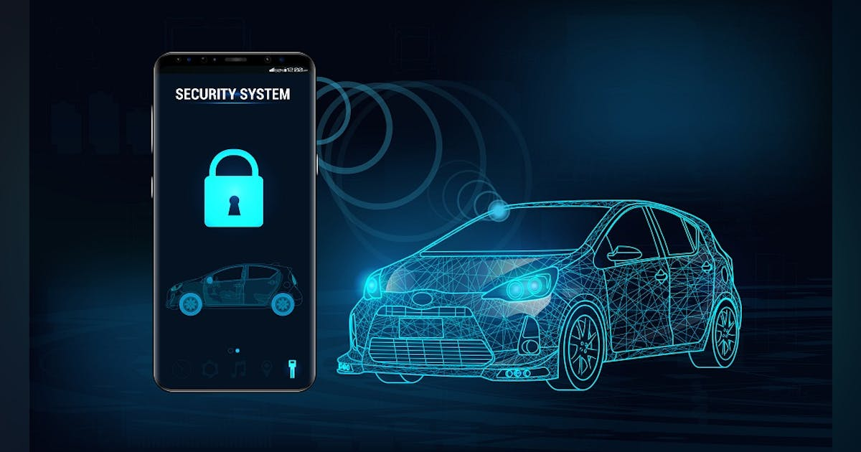
Based on March 2022, Curriculum Version 1

Module Title: - Repairing and Installing Electrical Security System
Module code: EIS AEE2 M09 0322

Nominal duration: 30Hours

Prepared by: Ministry of Labor and Skill
September, 2022
Addis Ababa, Ethiopia
Table of Contents
Acknowledgment 3
Introduction to the module 4
Unit one: overview of Vehicle Security system components 5
1.1 Introduction 5
1.2 Vehicle Security system components 6
1.2.1 Locks and Keys: 6
1.2.2 Alarm Systems 10
1.2.3 Disabling devices 13
1.3 WHS requirements 15
1.4 Identifying tools and equipment 16
Self-check-1 17
Operation Sheet - 1 18
Lap test: 1 19
Unit Two: Repair and Install electrical door locking system and engine immobilizers 20
2.1 Installation of electrical door locking 20
2.2 Installation of security/alarm system 23
2.3 Trouble shooting of security system 28
2.4 Electrical door locking 32
2.5 Engine immobilizers 35
Self-check-2 39
Operation sheet 2 47
Lap test: 2 51
Unit Three Clean up work area and maintain equipment 52
3.1 Collecting and storing reused material 52
3.2 Tagging methods of Unserviceable equipment 54
3.3 Maintain tools and equipment’s 55
Self-Check -3 56
Reference 57

Acknowledgment

Ministry of Labor and Skills wish to extend thanks and appreciation to the many representatives of TVET instructors and respective industry experts who donated their time and expertise to the development of this Teaching, Training and Learning Materials (TTLM).

Introduction to the module
In the Automotive Electrical & Electronics field study, Repairing and Installing Electrical Security Systems covers information and practices in Repairing and Installing Electrical Security Systems. This includes definite instructions on how to install components, perform testing of possible defects and carry out repairs. Clear instructions and techniques are required.
You need to complete this module by learning the theories and principles required closely coupled with practical activities to master the skills required in this module. Desirable values and altitude must also be taken into consideration.
This module is designed to meet the industry requirements under the Automotive Electrical & Electronics occupational standard, particularly for the unit of competency: Repairing and Installing Electrical Security Systems.
This module covers the units:
- Overview electrical security system
- Testing, Repairing and Install alarm system, electrical door locking system and engine immobilizers
- Clean up work area and maintain equipment
Learning Objective of the Module
- Understand Overview electrical security system
- Test, Repair and Install alarm system, electrical door locking system and engine immobilizers
- Clean up work area and maintain equipment
Module Instruction
For effective use this modules trainees are expected to follow the following module instruction:
- Read the information written in each unit
- Accomplish the Self-checks at the end of each unit
- Perform Operation Sheets which were provided at the end of units
- Do the “LAP test” giver at the end of each unit and
- Read the identified reference book for Examples and exercise

Unit one: overview of Vehicle Security system components
This unit is developed to provide you the necessary information regarding the following content coverage and topics:
- Vehicle Security system components
- Alarm system
- Electrical Door locking system
- Engine immobilizers
- WHS requirements
- Identifying tools and equipment
This unit will also assist you to attain the learning outcomes stated on the cover page. Specifically, upon completion of this learning guide, you will be able to:
- Understand Vehicle Security system components
- Alarm system
- Electrical Door locking system
- Engine immobilizers
- Apply WHS requirements
- Identify tools and equipment


1.1 Introduction
Automobile theft is a serious problem.
In this era of technology security has become a big question in all over the world. Wherever a developed technology is used, the question of its security also arises. In response to this problem vehicle manufacturers are offering antitheft systems as optional or standard equipment
General Description of Theft Deterrent System
- Content Theft Deterrent (CTD) System: CTD is the vehicle alarm system which discourages unauthorized entry into the vehicle
- Vehicle Theft Deterrent (VTD) System: VTD prevents drive away theft by keeping the vehicle from starting

Vehicle security systems can offer protection at different level
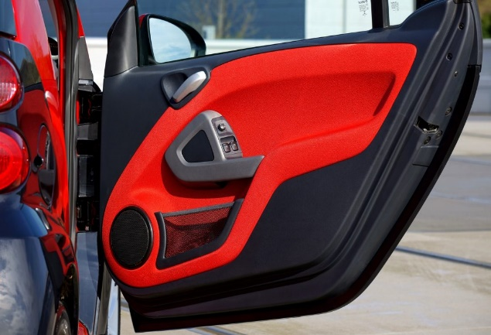
Parametric protection:
The system protects the vehicle by using switches to monitor the position of the opening panels of the vehicle (doors, boot, bonnet, etc.) A siren is activated if tampering is detected the level of protection may be enhanced by adding sensors to detect movements of the body.
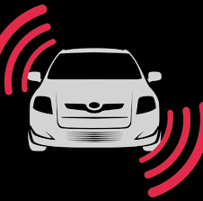
Volumetric protection:
Volumetric protection systems use ultrasonic, microwave or infra-red sensors to detect unauthorized movements within the passenger compartment of the vehicle.

1.2 Vehicle Security system components
Three basic types of security and warning devices available are:
  - Locking devices,
  - Disabling devices, and
  - Alarm systems.

1.2.1 Locks and Keys:
- Locks are designed to deny entry to the car as well as to prevent a thief from driving it away.
- Most locks move a mechanical block between the vehicle’s body and the door. Keys simply move those blocks.
- Manufacturers use specially cut keys that cannot be easily duplicated and lock mechanisms that are difficult to pick.
- The door lock system locks and unlocks all the doors when a door lock control switch is operated.
- The door lock system has various functions which differ depending on the vehicle model, grade and destination.
- Lock and unlock control operated by door lock control switch
- Door key-linked lock and unlock function

- Two-step unlock function (In the door key-linked unlock function, with the one-step unlock operation, only the door in which the key is inserted is unlocked mechanically. The two-step unlock operation causes the other doors to be unlocked also.)
- Key confine prevention function (Keyless locking of the doors is prevented while the key is inserted in the ignition switch.)
Components
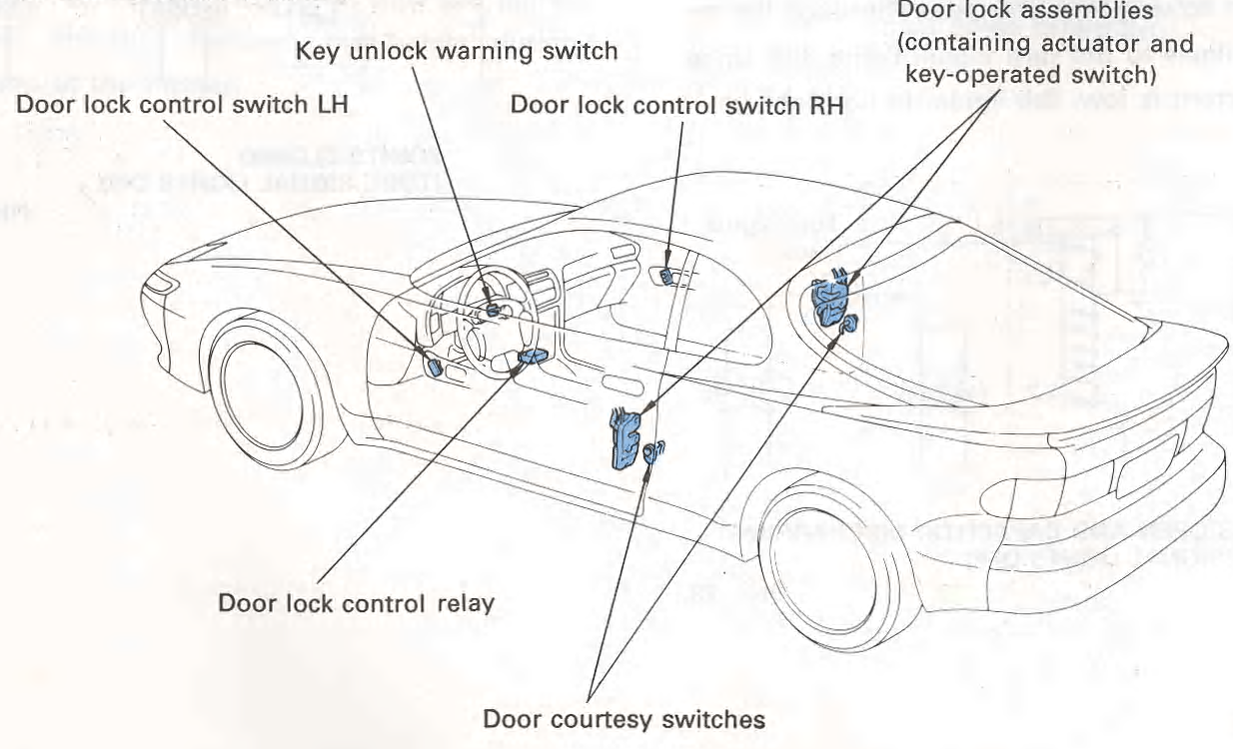
The door lock system consists of the following components:
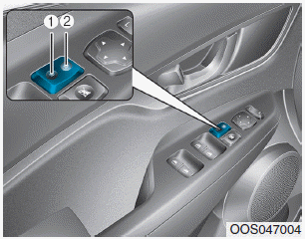
Door lock control switch
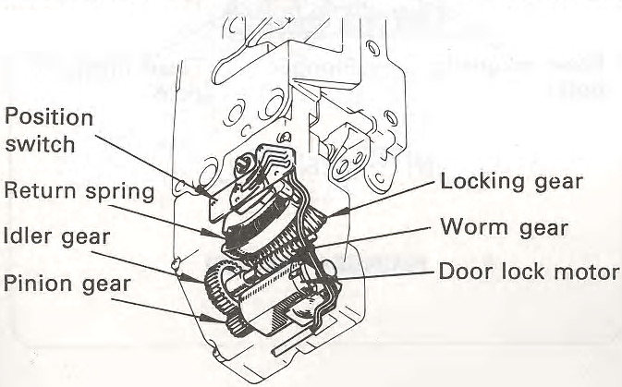
The door lock control switch allows one-touch locking and unlocking of all doors simultaneously. Generally, the door lock control switch is mounted in the door trim on the driver’s side, but in some models and grades, and for some destinations, one is also mounted in the door trim on the passenger’s side.
Door lock motor
The door lock motors act as door lock actuators.
A door lock motor is built into the door lock assembly in each door.

When the door lock motor rotates, the rotation is transmitted via the pinion, idler and worm gears to the locking gear, causing the door to lock or unlock.
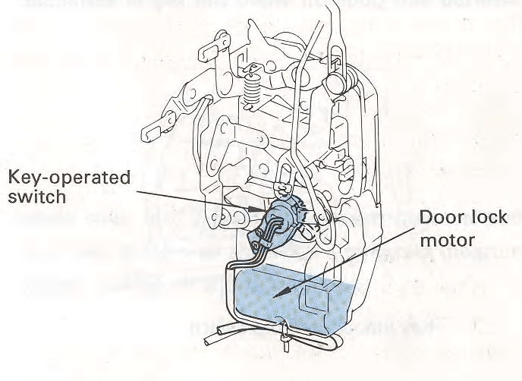
Once the door lock or unlock operation is completed, the locking gear is returned by a return spring to a neutral position. This prevents motor operation when the door lock knob is operated and improves the operating feeling. Changing the direction of flow of current to the motor changes the motor’s direction of rotation. This causes the motor to either lock or unlock the door.
Key-operated switch
The key-operated switch is built into the door lock assembly. It sends a lock or unlock signal to the door lock control relay, when the door key cylinder is operated from outside.
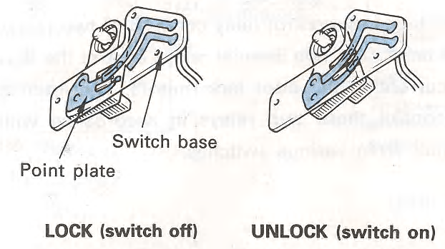
- Door lock position switch
The door lock position switch is built into the door lock assembly. This switch detects the lock condition of the door.
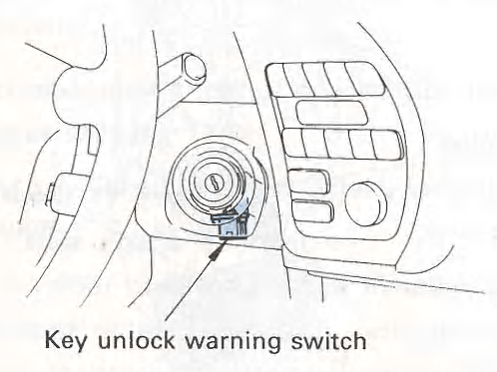
The position switch consists of a point plate and a switch base. When the locking gear is on the lock side, the switch turns off and when the locking gear is on the unlock side, the switch turns on.
- Key unlock warning switch (For key confine prevention function) this switch is mounted on the steering main shaft upper bracket. It detects whether or not the key is inserted into the ignition switch. It goes on when the key is inserted and goes off when the key is extracted.
- Door courtesy switch
(For key confine prevention, security, and key-off power window operation functions) This switch detects whether or not a door is open. It goes on when a door is opened and off when a door is closed.

- Door lock control relay
The door lock control relay consists of two relays and an IC. The two internal relays control the flow of current to the door lock motors. The internal IC controls these two relays in accordance with signals from various switches.
Door lock solenoid
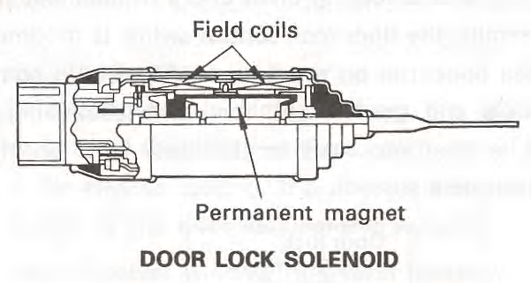
In some models, a door lock solenoid is used as the door lock actuator.
When a current passes through the electromagnet in one direction, the permanent magnet is attracted by it and moves toward it, causing the plunger (attached to the permanent magnet) to also move in the same direction, locking the door.
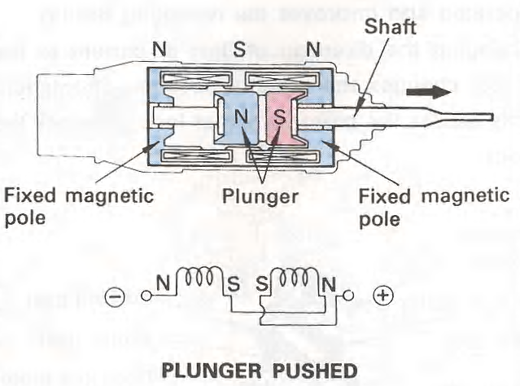
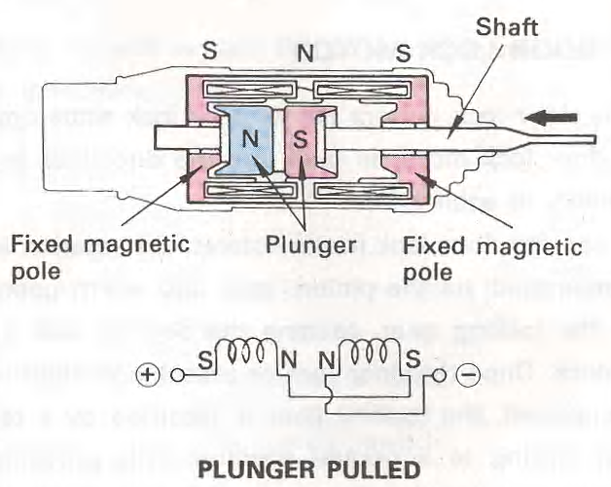
When the current reverses, the permanent magnet and plunger moves in the opposite direction, unlocking the door.

1.2.2 Alarm Systems
- Many alarm systems are designed to sound an alarm, turn on the hazard lights, and cause the high beams to flash along with the hazard lamps.
- The two methods for activating alarm systems are:
  - Passive systems: switch on automatically when the ignition key is removed or the doors are locked.
  - Active systems: are activated with a key fob transmitter or key.
- When a door, hood, or trunk is opened, the switch closes and trigger the alarm sounds.
- Ultrasonic sensors are used to detect motion and will trigger the alarm if there is movement inside the vehicle.
- Current sensitive sensors activate the alarm if there is a change in current within the electrical system, such as when a courtesy light goes on or the ignition starts.
- Motion detectors monitor changes in the vehicle’s tilt, such as when someone is attempting to steal the tires.
Component of alarm system
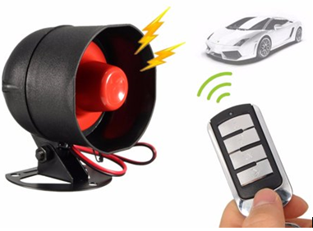
The main purpose of a car alarm is to prevent the theft of your personal belongings within the vehicle and to prevent the theft of the vehicle itself.
Car alarms work by emitting high-volume sound (often a vehicle-mounted siren, pre-recorded verbal warning, the vehicle's own horn, or a combination of these) when the conditions necessary for triggering it are met.
Alarm brain/control unit
The module will be the control center of the security system. The car alarm brain is essentially a computer that receives and sends commands, and is the main component in an alarm system. The brain gets its power from the ignition harness or the battery but can also be protected with a battery backup for extra security.

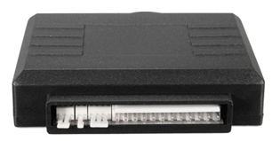
All of the components in the system are connected to the brain; and the brain monitors all of them constantly. The alarm brain will have included plugs or ports for inputs and outputs. Mounting the module in the vehicles interior compartment, secure, and not easily accessible is ideal. Moisture, vibration and temperature are factors in placement of the module.
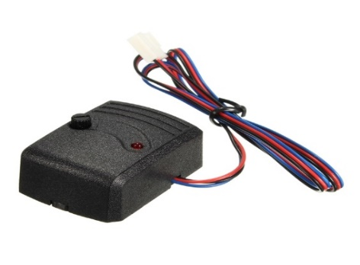
Tilt/shock sensor
- The tilt/shock sensor detects impact and vehicle tilt. The shock sensor will be triggered when there is impact to vehicle.
- The tilt sensor is will trigger the alarm if vehicle is being towed or jacked up.
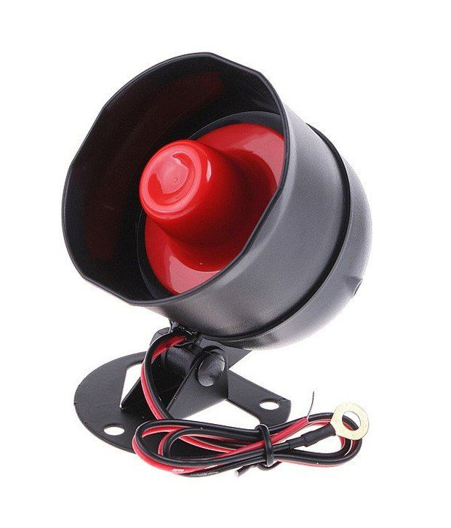
Siren
A siren provides a significantly louder noise in the alarm system. This will bring more attention and lessen the chance of a thief sticking around while the siren is going off. Sirens will come in different decibels rating, the average type used in security systems will be 120 decibels. Installing the siren under the hood and away from as much element exposure as possible enhances the sirens performance.
LED light

An interior LED light will indicate that have a security system. Car thieves are not as likely to attempt theft of the vehicle if they know vehicle have a security system installed.
A Light Emitting Diode is a visual status of the security system plus a deterrent notifying that the vehicle is secured. The LED emits blinking sequences for status and programming purposes. The install will require drilling an opening, highly visible, to mount and wire it to the main module.
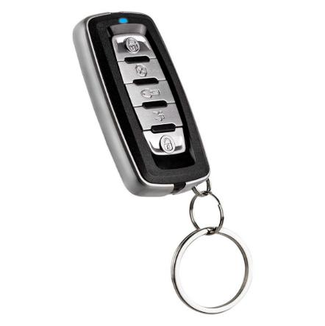
Remote transmitter Remotes are used to send lock, unlock, and trunk release commands to the vehicle. A 2-way remote can receive confirmations back from the brain confirming commands or alerting to driver possible theft in progress.
The device needed to control the security system would a coded transmitter that would arm and disarm the system and in some applications used to operate the stand alone keyless entry, unlock and lock operation.
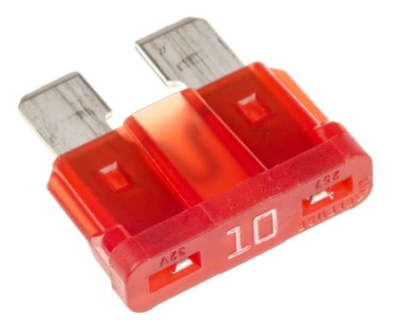
Fuse: Fuses should be used in every circuit to protect the wiring from overheating and damage caused by excessive current flow as a result of a short circuit or other
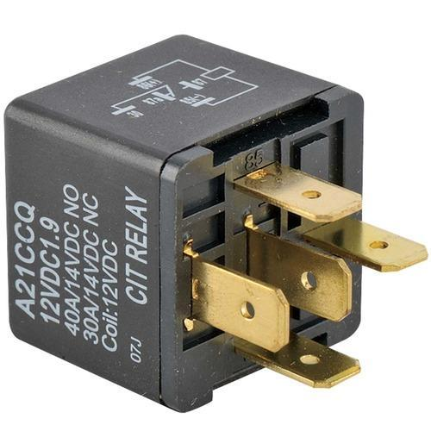
Relay
- A relay is a magnetic switch that uses a movable armature to control a high-amperage circuit by using a low-amperage electrical switch.
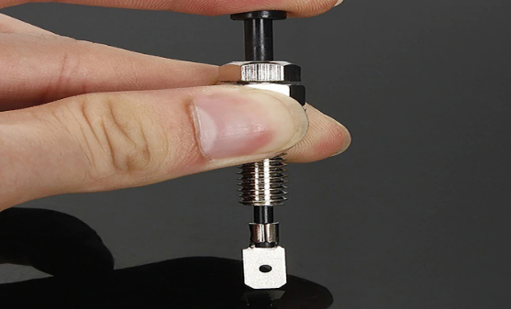
Pin Switches
- Pin switches are used on doors, hood, trunk and any opening that can accommodate them.
- Often these are optional switches added for additional protection of the vehicle.
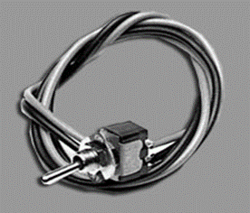
Valet/override switch: these switches are usually mounted in the interior area, out of view, and easy accessible. The switch will control the valet feature and possible programming. Activating this switch will place the system in bypass mode in the event for repair or lost transmitters.

1.2.3 Disabling devices
The main ways to disable the vehicle are ignition circuit cut off, starter circuit cut off or engine ECU code lock.
I. Passkey Systems
The passkey is a specially designed key that is programmed just for one vehicle. Although another key may fit into the ignition switch or door lock, the system will not allow the engine to start without the correct electrical signal from the key
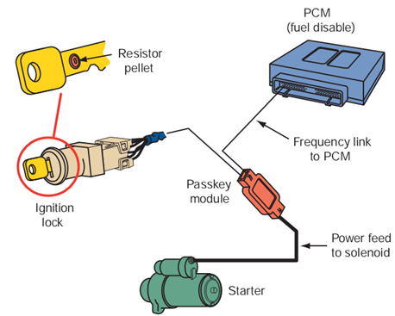
- A resistance key is a normal key with a small resistor bonded to it. When the key is inserted into the ignition switch, the circuit must recognize that resistance as being the correct amount for the vehicle before the engine will start.

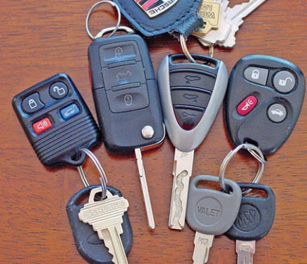
- Transponder key systems are based on a communication scheme between the vehicle’s PCM and the transponder in the key. Each time the key is inserted into the ignition switch, the PCM sends out a different radio signal. If the key’s transponder is not capable of returning the same signal, the engine will not start.

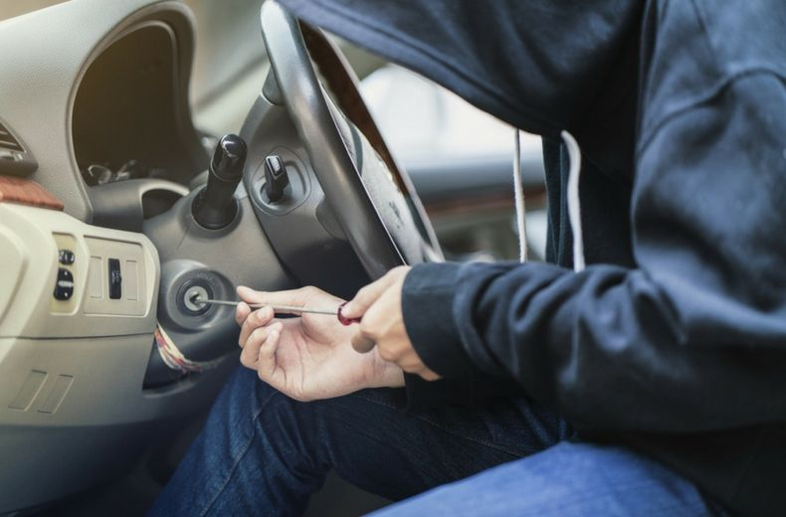
Engine immobilization:
Engine immobilization Operates by having the security ECU inhibit the operation of the engine starting system when the alarm is activated

II. Keyless Entry Systems
- A keyless entry system allows the driver to unlock the doors or trunk lid from outside of the vehicle without using a key.
- It has two main components: an electronic control module and a coded button keypad on the driver’s door or a key fob.
- The electronic control module typically can unlock all doors, unlock the trunk, lock all doors, lock the trunk, turn on courtesy lamps, and illuminate the keypad or keyhole after any button on the keypad is pushed or either front door handle is pulled.
- Remote keyless entry systems rely on a handheld transmitter, frequently part of the key fob. With a press of the unlock button on the transmitter from 25 to 50 feet away (depending on the type of transmitter) in any direction range, the interior lights turn on, the driver’s door unlocks, and the theft security system is disarmed. The trunk can also be unlocked.
- Pressing the lock button locks all doors and arms the security system. For maximum security, some remote units and their receiver change access codes each time the remote is used.
III. Smart Keys
- Many new vehicles do not come with a key; rather a transponder is used to perform all of the functions of a key.
- On some systems the transponder (Figure A) is inserted into a slot in the instrument panel (Figure B). To start the engine, the transponder is pressed (Figure C).
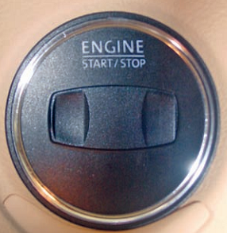
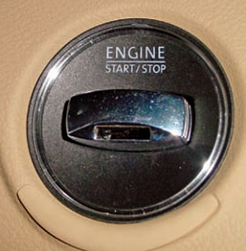
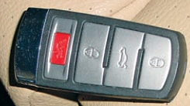
- On others, after the transponder is inserted into its slot, a start button is pressed. The system is based on a communication link between the transponder and the vehicle. If the codes of the transponder and the vehicle do not match, the engine will not start.
Some smart keys (A) are inserted into a slot (B), and then depressed (C) to start the engine.

- A few vehicles have smarter smart keys. The transponder does not need to be inserted. It merely needs to be close to the vehicle. This system is normally called a smart access system.
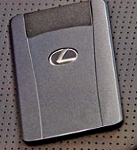
- The system can perform many functions without inserting a key or pressing a button. It can lock and unlock the doors, allow the engine to start by pressing the engine switch while depressing the brake pedal.
Figure a real smart key
- When the electronic key enters into zones around the vehicle, a certification control module certifies the ID code from the key.
- Once the signal is certified, the control module transmits a steering unlock signal to the steering lock ECU. The BCM also receives a certification signal and actuates the door lock motor to unlock or lock the door.
- The actuation zone is normally about 1 meter.

WHS requirements
Work health and safety (WHS) – sometimes called occupational health and safety (OH&S) involves the management of risks to the health and safety of everyone in your workplace.
Safety-related incidents can affect overall productivity, quality of work, and employee morale. In many cases, workplace accidents are preventable. Here are 10 rules for workplace safety that you can start implementing today.
1. Preventing workplace incidents is everyone’s job, and your personal safety is your responsibility.
2. Dress appropriately, from clothing to footwear.
3. Keep work areas neat and tidy.
4. Follow the rules.
5. Report workplace accidents or safety incidents.
6. Know and follow emergency procedures.
7. Lift, bend, and stretch with care to avoid injury.
8. Don’t operate tools or machinery that you haven’t been trained for.
9. Avoid drugs and alcohol at work.
10. Take breaks appropriately.

WHS requirements are to be in accordance with legislation/regulations/codes of practice and enterprise safety policies and procedures, and may include: protective clothing and equipment, use of tooling and equipment, workplace environment and safety, handling of material, use of firefighting equipment, enterprise first aid, hazard control and hazardous materials and substances
Safe operating procedures are to include, but are not limited to: the conduct of operational risk assessment and treatments associated with vehicular movement, toxic substances, electrical safety, machinery movement and operation, manual
Personal protective equipment Personal protective equipment is to include that prescribed under legislation/regulations/codes of practice and workplace policies and practices Safe operating procedures

Identifying tools and equipment
Tooling and equipment may include: hand tooling, power tooling, specialist tooling for removal, adjustment and testing equipment, including multi meters and test lamp and soldering equipment Materials may include: spare parts, soldering consumables and fluids, and cleaning material
Panel removal tool: to remove behind the trims of dash and door.
Wire cutter/ stripper: To cut and remove the insulation from the wire.
Crimping tool: To make secure wire connections, termination.
Heat-shrink tubing electrical tape to protect your connections.
MultiMate (voltmeter): to verify the test resistance, voltage drop, continuity.
Solder: is a mixture of lead and tin plus traces of other substances.
Electric drill: drill is a tool primarily used for making round holes or driving fasteners.
Soldering Flux: Soldering heats the wires.
Soldering Irons: The soldering iron should be the right size for the job. An iron that is too small will require excessive time to heat the work and may never heat it properly. A low- wattage (25-100 W) iron works best for wiring repairs.

Self-check-1
Part I: Fill the black space
Instruction: Fill the black space with the correct answers. You have given 1 Minute for each question. Each question carries 2 Point.
1. The main purpose of a is to prevent the theft of your personal belongings within the vehicle and to prevent the theft of the vehicle itself.
2, is a device in a car which makes a loud noise if anyone tries to break into the vehicle.
3, is an electronic security device and is fitted in vehicles such as cars, motorbikes and trucks to prevent driving by unauthorized people.
4. The is essentially a computer that receives and sends commands, and is the main component in an alarm system.
5, are a technologically advanced version of traditional door locks.
Part: II write short answer for the given question. You are provided 3 minute for each question and each point has 5 Points.
- How do you protect yourself in the workplace
- What are the main purpose of a car alarm?
- What an immobilizer means?

Operation Sheet - 1
Identify, select and prepare Components, tools and equipment
Procedures:
- Identify, select and prepare tools and equipment’s
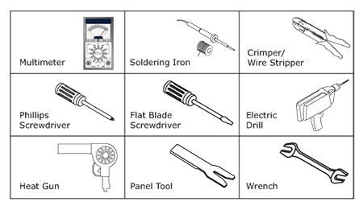
- Identify select and prepare components
  - Car alarm system components
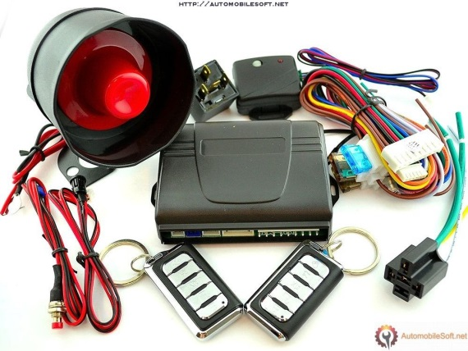

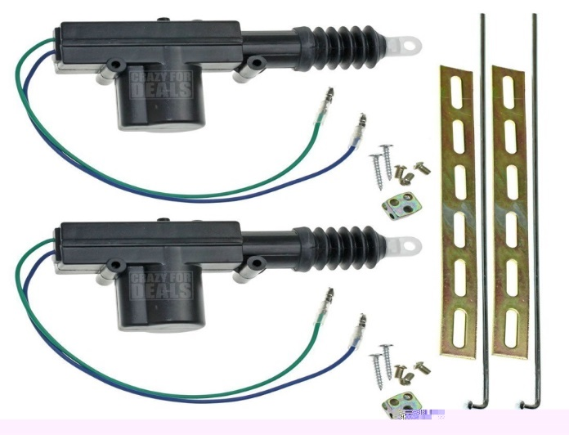
  - Door lock system components

Lap test: 1
Task 1. Identify, select and prepare components, tools and equipment’s
Task 2. Identify alarm system/ components and central door lock components

Unit Two: Repair and Install electrical door locking system and engine immobilizers
This unit is developed to provide you the necessary information regarding the following content coverage and topics:
- Installation of electrical door locking
- Installation of security/alarm system
- Trouble shooting of security system
- Electrical door locking
- Engine immobilizers
This unit will also assist you to attain the learning outcomes stated in the cover page. Specifically, upon completion of this learning guide, you will be able to:
- Install electrical door locking
- Install security/alarm system
- Describe Trouble shooting of security system
- Recognize Electrical door locking
- Know Engine immobilizers

Installation of electrical door locking
ACTUATORS INSTALLATION
- Remove door panels carefully
- Install actuator in correct direction as shown in figures 1-a, 1-b and figure 2. Make sure that actuator will not block other moving parts inside of door (screen and its mechanism). Also make sure that actuator is moving parallel to door lock bolt.
- Choose two holes inside of door or drill new (3/16”) and screw controller on.
- Using suitable joint connect door lock bolt lever to actuator lever. Tighten joint screws making sure that actuator can move easily. See figure 3 and 4.
CAUTION:
- Make sure that actuator is moving parallel to door lock bolt. See figure 2. Otherwise closing/opening movement will be incorrect and/or actuator lifetime will be shortened.
- Before tightening joint screws make sure that stroke of front door actuator (5 cables) and front door lock bolt is set to middle range position. See figure 4.
- Before tightening joint screws make sure that stroke of rear door actuator (2 cables) is set to maximum or minimum range position and move it about 1/16” up or down.
See figure 4. Then push and pull door lock bolt to make sure that actuator is working correctly and make adequate corrections if not.

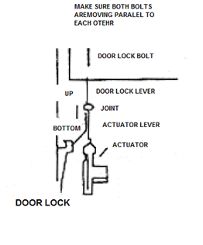

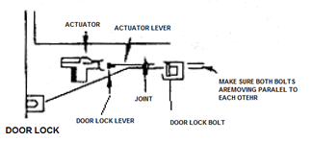

Figure1-a. Actuator installation example Figure 1-b. Actuator installation example

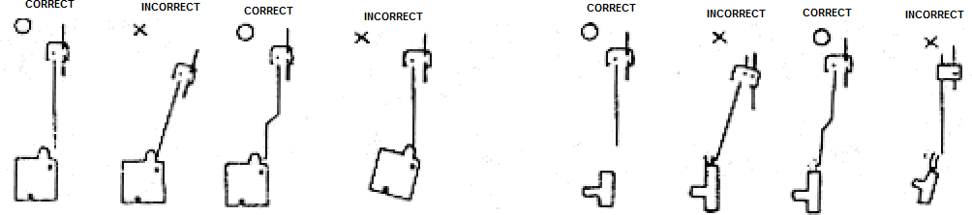
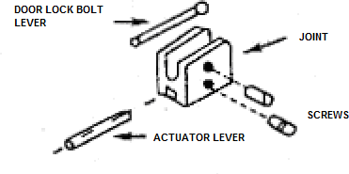
Figure 2. Actuator and door lock levers position
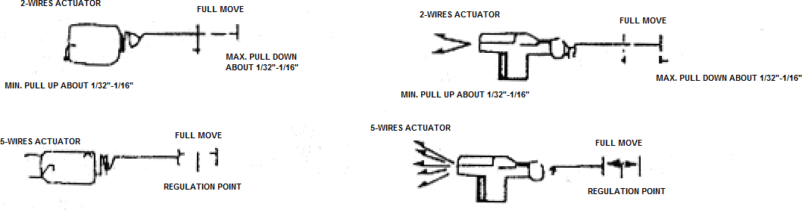
Figure 3. Connecting levers with joint
Figure 4. Actuator stroke regulation
- Each drive unit has a small length of wiring attached to it which terminates in a multi-plug.
- The master drive unit is identified by having two extra wires connected to it.
- These are the feed and earth return for the entire door lock system.
- Start by disconnecting the battery to avoid any short circuits.
- Join the terminal connectors to the ends of all the wires leading to the drive units.
- Remember there are four wires to the master drive unit and only two to the drive units.
- Connect the wires to the multi-plug terminals making sure the wiring colors correspond. Route the feed wire to a permanent live feed such as the battery terminal or the battery side of the fuse box.
- Fit an in-line fuse (16 amp) to this wire.
- Run the earth wire to a suitable earthing point and secure it firmly.
- Reconnect the battery terminal and test the lock is working correctly.
- Finally refit the door trim panel and window controls.
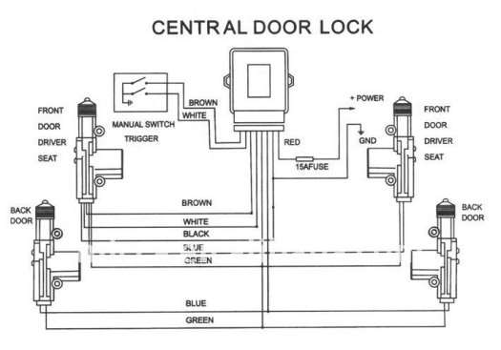

2.2 Installation of security/alarm system
- Attach the siren to any solid metal surface under the hood. ...
- Drill a hole in the rubber firewall of the car. ...
- Place the alarm's power line near the car battery ready to be attached later. ...
- Attach a fuse to the wire mentioned above, that you will be attaching to the battery later.
You're probably eager to add a security system to your vehicle. That's great. And you'll save a lot of money by installing it yourself. That's smart. But, please do not turn the first screw before you map out a complete, step-by-step plan of attack. "Ready, Fire, Aim" is no way to install a security system.
Verify that each segment of the system works as intended before moving on. For example:
- Step 1 — Find a spot to mount the "brain" (control module) and siren. Hook the siren, LED indicator and valet switch to the brain, taking great care to route and connect the wires in a safe, secure way. Connect the power and ground leads to the brain. Test.
- Step 2 — Position your sensors in their intended mounting locations and connect them to the brain. Test the coverage area of the sensors and make final adjustments before you fasten them down.
- Step 3 — Tie into your door triggers and your power door lock circuit for keyless entry. Tie into your dome light and parking light circuits. Test these functions. When everything is working properly, secure the brain to the mounting surface.
If you have time to do it all in one day, fine. But don't rush it. And don't drive your vehicle until you've secured any loose wiring. Remember to disconnect your negative battery cable before you start mounting and connecting your system components. That will keep you from running your battery down or short-circuiting any of your components.
You'll need to have the battery cable connected while you test wire functions or switches. But don't forget to unhook it before you splice wires. Check your vehicle owner's manual to see if there are any special procedures to follow when disconnecting the battery cables.

Car alarms are an effective way to insure your investment and give you peace of mind. While many cars come standard with some kind of alarm system, some do not. It is no surprise that many people want to install an aftermarket alarm system either because they don’t have one or because they feel that they need to upgrade. Installing a car alarm might seem like a difficult task, but with a little bit of preparation and information, it becomes nothing more than a series of small tasks.
Fitting Instruction
- Gather required materials. You’ll need a scissors or a knife, soldering iron and soldering material, lamp test, power drill, screwdriver, double duct tape and a voltmeter.
- Read the manual with installation instructions.
- Be sure you understand what is writing in the manual. If you bought the alarm from a specialized shop, then you can always ask for advice and installation modes.
- To properly fit a system: you must have a good understanding of tools, equipment electrical procedures and systems, along with proficiency in the installation and use of safety warning equipment.
- When drilling into a vehicle structure, be sure that both sides of the surface are clear of anything that could be damaged.
- Locate system so it will operate safely under all conditions. The location must provide protection from impact and adverse weather conditions while allowing unobstructed sound projection to the target hazard area.
- Ensure that the vehicle’s supply voltage is within the voltage rating specified on the system operating voltage
- You should frequently inspect the system to ensure that it is operating properly and that it is securely attached to the vehicle.
- It is important that you fully understand how to safely operate the systems before use.
- Check your vehicle owner's manual to see if there are any special procedures to follow when disconnecting the battery cables.
- Use properly safe use of tools and equipment’s

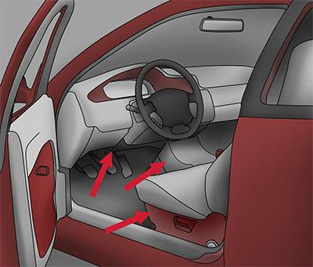
Fitting Alarm System Components
Fitting alarm brain: Under the dash near the steering column is a likely spot: The alarm brain should be installed somewhere close to the center of the car and out of sight. Under a seat, under the dash near the steering column, even under a center console are good locations.
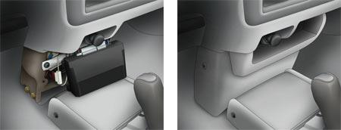
Under a front seat is another suitable location: Fitting alarm brain under a center console is good locations.

If the brain is under a seat, do not cover it with carpeting because too much heat could build up inside the brain. If the car has a stereo amplifier under a seat, do not put the brain nearby. Electromagnetic radiation from the amp could interfere with the operation of the brain.
Wherever you decide to fit the brain, remember to check what's behind the mounting surface, so the screw won't accidentally penetrate fuel lines or any wiring. The alarm brain has a built-in pigtail-type antenna wire. It is important that the wire point straight away from the brain or at a right angle to the brain. Do not cut or ground this wire.
Fitting the siren
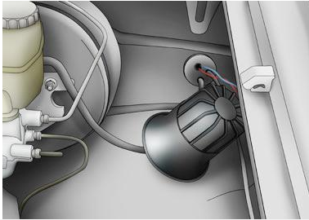
Mount the siren under the hood, far from heat sources such as exhaust manifolds, radiators and heater cores. Aim it parallel to the ground, or toward the ground. Never mount it with the horn facing up water can collect in the horn, causing the siren to malfunction.
If siren mounts to a metal surface, use sheet metal screws.
Do not use drywall screws. If siren mounts to a plastic inner fender, use nuts and bolts to secure it. Determine what's behind the mounting surface, so that the screws won't accidentally penetrate fuel lines, brake lines, vacuum lines, control cables or wire bundles.

Fitting the flashing LED
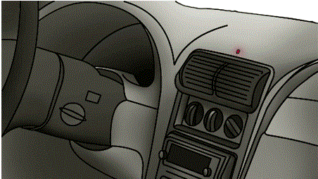
Mounts in your dash or center console. Its purpose is to warn would be thieves that a car security system is armed and ready to wail if they try to break in.
Mount the LED in an area that is highly visible from both sides of the vehicle. Check the hole-size requirement before drilling. Inspect the area behind the mounting surface to make sure there is sufficient clearance and a path for the wire.
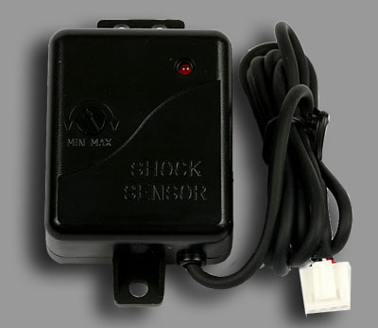
Fitting shock Sensors
Fit shock sensors solidly to a metal surface, using screws. Mount shock sensor relatively close to the center of the vehicle (under the dash is good), so it can detect shocks from both front and rear equally well. When you adjust your shock sensor's sensitivity, apply impact from all sides of the vehicle.
Fitting Pin switches
Pin (plunger-type) switches are sensors that trigger the siren when a door, hood or trunk opens. Look for the switches that turn on the dome light when you open doors. Tap into the wires leading away from the switches. They can usually be found behind the kick panels.
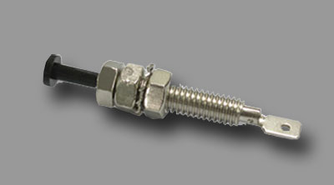
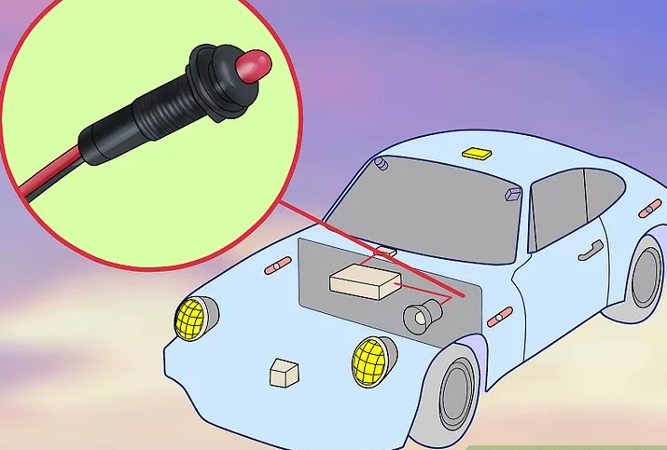
Generally, the easiest place to tie into pin switches is at a floor-level courtesy light or a pin-switch wire behind a kick panel. Pin switches can have either a negative (-) trigger or a positive (+) trigger. Run the valet switch. This will be a wire off of the car alarm module. This switch will allow you to disable the alarm features while it is engaged. This will make it easier when someone else has your car, like when you leave it with mechanic.

Figure 1.18: Running the valet switch
Methods of fitting Systems
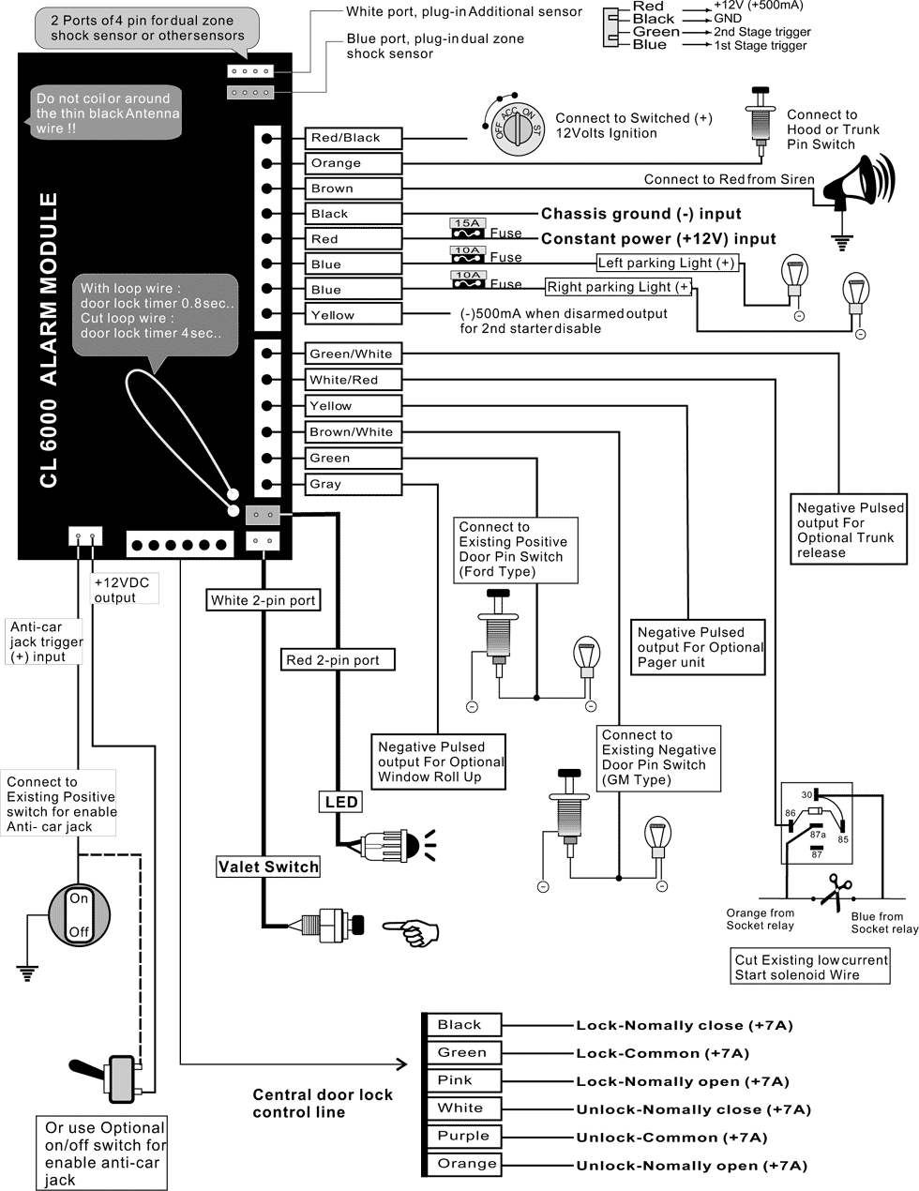
Reading/interpreting wiring diagrams

2.3 Trouble shooting of security system
Car safety is an integral part of your concern as a car owner and having a durable car alarm will always be of good help. In this short post will discuss few ways to troubleshoot common car alarm problems, such as: keyless entry alarms, wiring problems and programming.
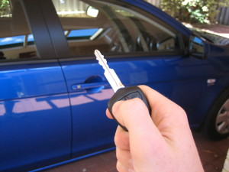
Figure 1.32: keyless entry alarms, wiring problems and programming.
Keyless Entry Alarms
Cars with remote entry systems can become faulty if the battery inside the remote starts to die down. If your find that you cannot activate or deactivate the alarm via the remote control, start with replacing the battery and see if it makes a difference.
Wiring Problems
there could be myriad problems in the internal circuit of the alarm console when this happens. In this situation, the alarm goes off even when there is not a single soul approaching your car. You can stop the alarm by simply putting on the ignition. Else, you may also try switching off the button for the alarm, located beneath your steering wheel. However, if this does not solve the problem, you might have to remove the fuse of alarm. Usually, the fuse box for the alarm is located below the steering wheel on the left side. However, if your alarm system happens to be an after-market one, then you will find your alarm fuse in the hood. Check the user’s manual for the diagram of the fuse box. Your alarm fuse is likely to be marked with a symbol. Using a needle nose plier, pull out the fuse out of the box. However, if you cannot decide which of the fuses the alarm fuse is, then you may perform trial and error, until you pull out the right fuse and get the alarm disabled.
If this solution does not seem to work, you may have to disconnect the negative terminal of the car battery, to disable it. However, use this option only as a last resort, as disconnecting the negative terminal means you cannot start your car.
Programming
Disconnect the battery. This option is a last-case scenario. Turn off your car and remove the keys. Two cords that power your car run up to the top of the battery where they are screwed on (think of the positive and negative connectors you use when you jump start your car). Use a wrench to unscrew the side nut of each connector. (Do the negative side first, and when you reconnect the battery put the negative side back on first.) You should be able to lift the connector up and off of the battery. This method is most helpful when you have a car alarm that is going off at night, or when you are not actively using the car.
How to Reset a Factory Car Alarm
Although helpful, car alarms often seem like more of a nuisance than an aid. They go off unpredictably, refuse to turn off, and startle the entire neighborhood. Because the safety of your vehicle is important, you can learn a few methods to troubleshoot car-alarm issues. With a few simple processes, you can ensure both the safety and function of your vehicle.
Unlock the car manually. If the alarm remote is not working, use the key directly. Often times opening up the door will stop the alarm. If the driver's side door won't unlock, try the passenger door.
Turn on your car. Put the key in the ignition, and turn the car on. If this doesn't turn off the alarm, try turning on and off the dashboard lights a few times without revving up the engine.
Utilize common tricks. Factory car alarms have some simple reset protocols to help turn off an alarm. Most of the tricks rely on using the key in the door; simply put, a lot of factory car alarms have a door sensor, so working with the door might be the go-to for a quick fix.
- Put the key in the driver's door and turn it twice to the right, then twice to the left. Then insert your key into the ignition and start the car.
- Turn the key into the unlock position and hold it for two seconds before opening the door. Disconnect the battery. If the alarm is still sounding after the initial troubleshooting, you'll want to silence the siren as quickly as possible. Car alarms rely on the electronic component of the vehicle, and disconnecting the battery should both silence the siren and reset your alarm. Open up the hood, locate the battery, and with a wrench, remove the negative terminal. Then reconnect it after a minute has passed.
- If it is more easily accessible you can also unplug the wiring harness that connects to the car's horn or siren. If the horn or siren gets unplugged it can no longer make noise.
Reset the alarm unit. Locate the alarm and transmitter system; refer to your owner's manual for the exact location. Hit the reset switch or turn it off and on.
Remove the alarm fuse. This should both silence and take the alarm out of commission until the fuse is replaced. Find the alarm fuse in the fuse box. Remove it, and put the fuse in a plastic bag. You can store it in your glove compartment for safe keeping.
- If you cannot locate the alarm fuse right away, remove fuses to see if the alarm will stop. Doing this will not cause damage to the car, but make sure you return the fuses after you've determined they are not for the alarm.
- Some car alarms, when tampered with, prevent a car from starting as an anti-theft function. If you remove the fuse and cannot start the vehicle, you will have to take the car to a mechanic or dealer.
Press the "panic" or buttons on your keychain remote to stop the alarm. Because the "panic" button can sound the car alarm, it can also stop it. Pressing "unlock" or the "trunk" button can stop the car alarm because it disarms the car's security system.
Cheek a mechanic if problems persist. If none these reset methods work, try speaking with a mechanic or dealer. If they can recognize the issues over the phone, the fix might be simple. However, further diagnosis might be needed in person.
Speak with a dealer or mechanic. Disabling a car alarm can be a temporary fix before seeking professional auto assistance. However, keep in mind, car alarms are meant to be anti-theft, and when tampered with, some systems prevent a vehicle from starting as a security measure.
- Disconnect the battery. Open up the hood and locate the battery. Using a socket wrench, unscrew the negative terminal (-) of the battery and pull it off. This is a safety measure; messing around with a vehicle's electronics can be dangerous.
Find the alarm system. If you have a factory car alarm, check in your owner’s manual as a guide. The alarm system is usually under the hood near the steering wheel. If you have an after-market car alarm, it may be installed in any part of the car, but companies usually install them under the steering wheel.
Disconnect wires. Some alarm control units have labels for each wire. Removing the wires attached to the control unit and removing the wires attached to the siren are two ways to disable and silence your alarm.
- Pull the wire of the siren. This will silence the alarm and might be a good temporary fix before seeking professional assistance.
- Remove the control unit. If you pull out the brain, there will be no alarm in the car. However, depending on the way your car alarm was set up, this might disable your vehicle from starting.
Reconnect the battery and test the car. After you pull a wire, plug the battery back in to make sure the alarm isn't going off again. Turn on your car and give the engine a rev. You want to make sure the car can still function.
Fix an alarm that starts when you turn the car on. You could need a new battery. Disable the alarm by removing the alarm fuse, and then bring the car to the shop. They can check your battery and move on from there if the problem is the alarm system.
Diagnose an alarm that never sets. Lock your car electronically using the remote, if you have one. Push down the locking pin on the door manually if the remote does not engage the lock or if you don't have a remote. Use your remote key or click the "lock" button on the driver's side door to engage the lock. If this does not work:
- Disconnect the negative battery terminal.
- Turn the key to on position.
- Reattach the negative battery terminal.
- Turn the key to off position.
- Start the car.
Fix an alarm that goes off randomly. Your alarm sensors are poorly calibrated. You'll need to adjust them so that they do not continue to cause problems whenever a dog brushes up against the car. To do so, refer to your owner's manual under the heading "Alarm System." Most cars can be re-calibrated to be less sensitive without going into the shop. There are two types of alarm sensor controls:
- DIP Switches: These are a series of toggles that control how much electricity runs through the sensors. Turning a few off will make your alarm system less touchy. These are built into the main control unit of the alarm system.
- Rheostat: Using a small screwdriver, you can loosen up a bolt that adjusts the resistance in the sensor, making it more or less sensitive. These sensors are mounted externally.
Check if the alarm is the reason your car won't stop. When a car refuses to start, most people go through a series of checks to find the issue. After all the checks lead to no solution, consider checking the car alarm. Some alarms are wired with the ignition as an anti-theft measure. Attempt to disable or reset the alarm, and then try starting your car.

2.4 Electrical door locking
Central door lock system
It is the means via which the vehicle doors and boot lid are locked and unlocked and the engine is started. The locking system is operated with a key or remote control. A key with infrared or wireless remote control. This means that they can be triggered remotely, i.e. without contact between key and vehicle. Today, most vehicle manufacturers only fit a lock which can be operated with a key in one door, so the car can be unlocked in an emergency. The very latest systems enable entirely keyless vehicle access. Drivers only need to have the transmitter in their pockets, for example. The doors are then unlocked when the driver touches a door handle which has a built-in contact point.
Central door locking is available in two types
1. Electric -motor central locking system
2. electro-pneumatic central locking system
The locking system comprises the following components:
Door handle/Handle strip
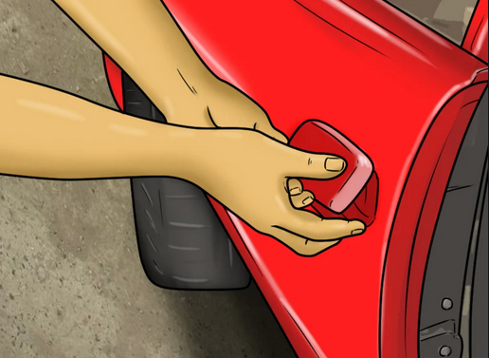
The door handle is the traditional means by which a vehicle is opened and closed from inside or outside. The external door strip usually houses the door lock. Door strips are increasingly used as design elements in modern cars. They can be chrome-plated or paint-finished in the same color as the vehicle.
Door lock/Actuator
Figure Door handle/Handle strip
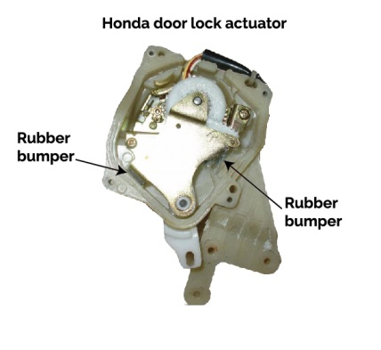
The latching mechanism in a vehicle is installed directly in its doors.
It contains both a latch and an electric motor (actuator) which controls the central locking. The latch opens or closes the doors, whereas the door lock locks or unlocks the vehicle. Today, all door latches are powered by electric drives.

Figure Door lock/Actuator

Fuel filler cap
The fuel filler cap must securely seal the fuel tank. Some fuel filler caps have locks, others do not. Fuel filler caps with locks are usually found on vehicles which have either a fuel filler flap which does not lock or no fuel filler flap at all. Fuel filler caps without locks are found on vehicles whose fuel filler flap is locked automatically via the central locking system.
Door triggers sensing
Door trigger sensing will trigger the alarm if the doors of your vehicle are opened when the security system is armed. Door trigger sensing is not just limited to driver and passenger doors; it can also be used to detect trunk/hatch entry as well as hood entry.
Remote control
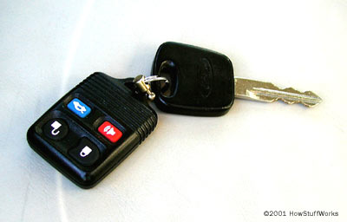
Remote controls are being used with increasing frequency in small cars, replacing the functions of a conventional key to all intents and purposes. A signal transmitter sends a signal or a coded order instruction to a receiver inside the vehicle, which usually controls a number of functions. Infrared remote controls have a range of up to 15 m. They rely on direct "visual" contact between transmitter and receiver.
Today, infrared remote controls are only used rarely as they have been overtaken by other technologies. Wireless remote controls transmit on radio frequencies and have a range of up to approximately 100 m.
Figure 1.35: Remote control

Keys
The basic function of keys and remote controls is the locking and unlocking of doors, luggage compartments, fuel filler caps, etc. they are also used to control the interior lighting, electronic immobilizer, alarm system and the window lifters.
The keys comprise two units: the milled, toothed key blade and the key bow. The latter is home to an increasing number of electronic functions such as the remote control for the central locking system or the boot lid.

Start/stop system
Traditionally, a vehicle key was needed to unlock the steering lock and to start the engine. Subsequently, the vehicle key was enhanced with the addition of a transponder-based release mechanism for the electronic immobilizer. Today, keyless systems are increasingly being used to start engines. In a keyless system, a transmitter – which usually also houses the controller for the central locking – is inserted into a reader in the vehicle and the engine is then started by pressing a button. A more recent development has seen the use of systems that work without any contact at all. Here, it is sufficient to simply "take along" the transmitter (carrying it in a trouser pocket, for example) and press the pedals before starting the engine by pressing a button.
Steering lock
They provide protection against theft. They are the means by which the steering column is unlocked and the engine is started – either electrically or in by conventional mechanical means.
Central door lock wiring diagram

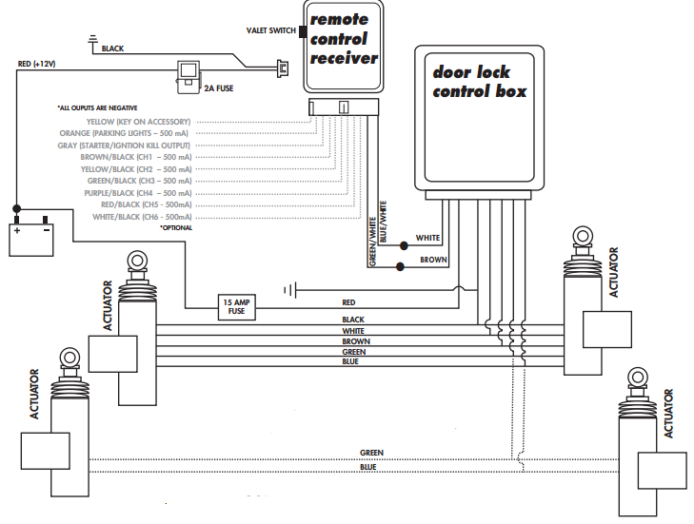

2.5 Engine immobilizers
The engine immobilizer system is a theft deterrent system for vehicles. This system prohibits the engine from starting by igniting the engine and injecting fuel when any keys other than the ignition key with an ID code* previously registered in the vehicle is used.
While the engine immobilizer system is set, the security indicator light flashes to indicate that the system is set.
The engine immobilizer system consists of the transponder chip, transponder key coil, transponder key amplifier, transponder key ECU, engine ECU, etc. There are two types of engine immobilizer systems:
- Controls by a separate ECU (transponder key ECU), and
- Controls by an ECU (engine ECU) that is integrated with the transponder key ECU.
An immobilizer is an electronic security device fitted to an automobile that prevents the engine from running unless the correct transponder car key is present.
The transponder key ECU control type engine immobilizer system consists of the following components.
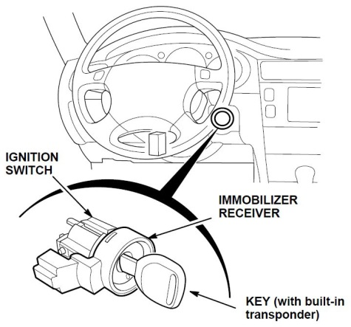
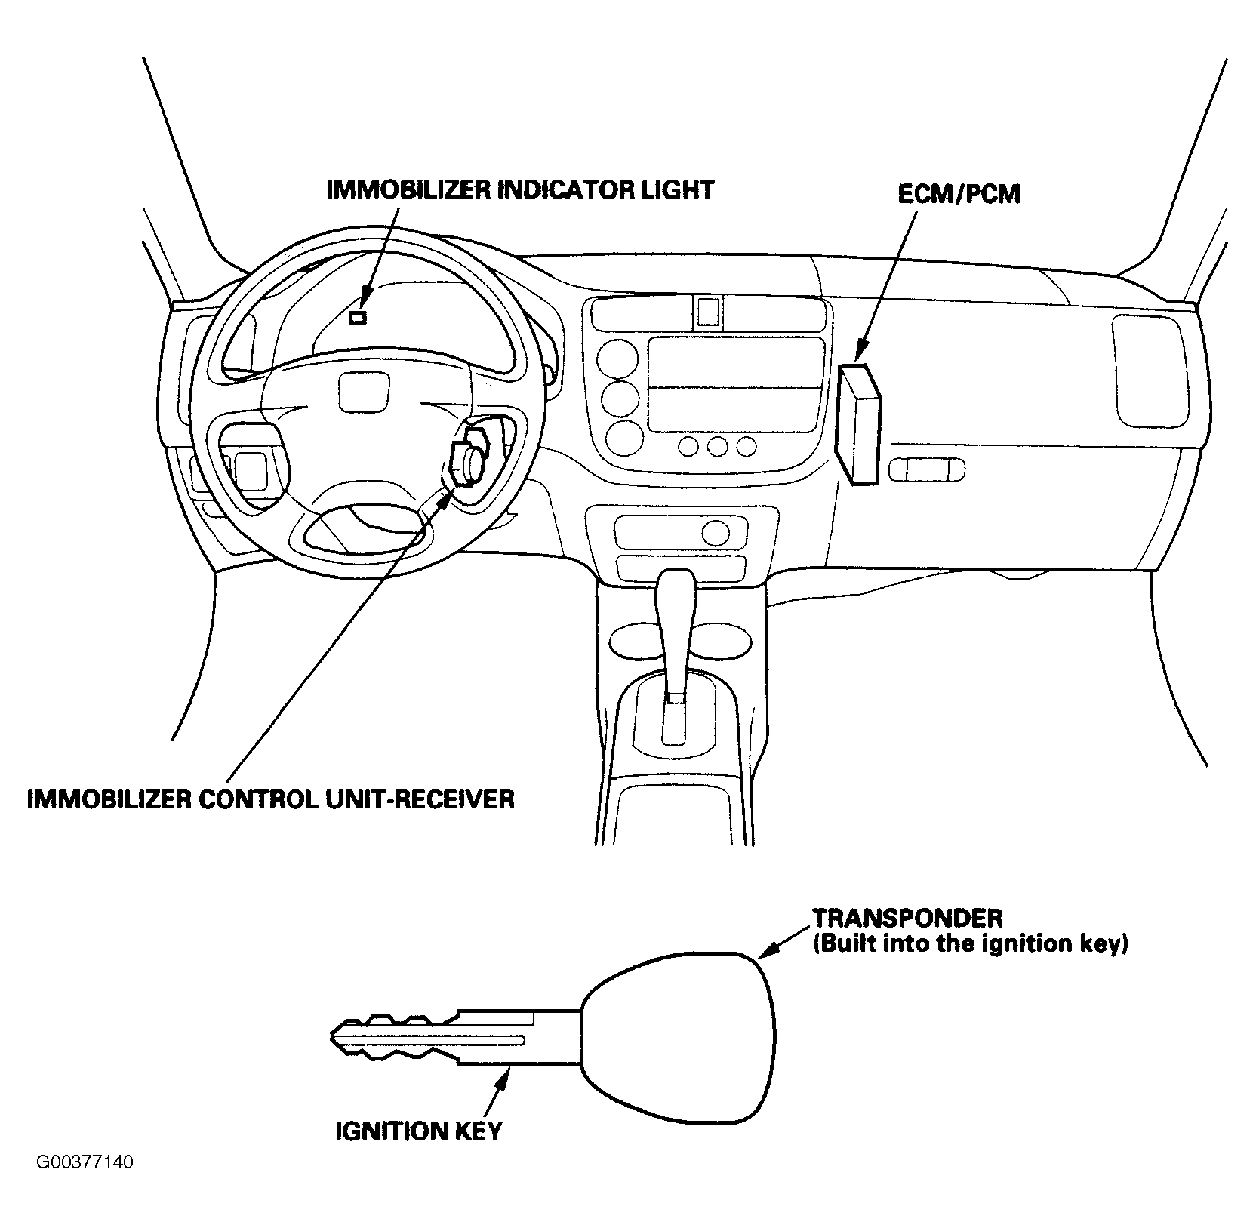
Figure 1.37: engine immobilizer indicator light
Transponder
The transponder is usually integrated inside the key bow. It is the means by which the electronic immobiliser identifies that the correct key is being used. The transponder's code is read out as the key nears the ignition lock. If the code is correct, the electronic immobiliser sends the start enable to the engine.
Ignition key (Transponder chip is built in)
The coil in the transponder chip built in the key reacts to the magnetic field produced by the transponder key coil. As a result, electricity is charged and an ID code is transmitted. Therefore, it is not necessary for the transponder chip to use a battery. Ignition keys are classified into ignition key all-in-one type and separate type. The transponder chip of the separate type is built in the transmitter.
Transponder key coil
The transponder key coil produces a magnetic field around the ignition key cylinder and receives the ID code of the key.
Transponder key amplifier
According to the signal from the transponder key ECU, the transponder key amplifier allows the current to flow into the key coil and makes it produce a magnetic field. The transponder key amplifier outputs the ID code of key received by the transponder key coil to the transponder key ECU.
Transponder key ECU
Transponder key ECU receives the ID code of key from the transponder key amplifier and checks it with the registered ID code. According to the result of the check, it determines whether the engine can be started and transmits the signal to the engine ECU. This ECU controls the security indicator light to flash/go off.
Engine ECU
According to the engine start permission signal from the transponder key ECU, the engine ECU starts the engine.
Key unlock warning switch
This switch detects that the key is inserted into the ignition key cylinder and outputs the signal to the transponder key ECU.

Principle operation
- When turning the ignition key to ON position, the ECU transmits the challenge message to the immobilizer unit (to verify whether the key is valid).
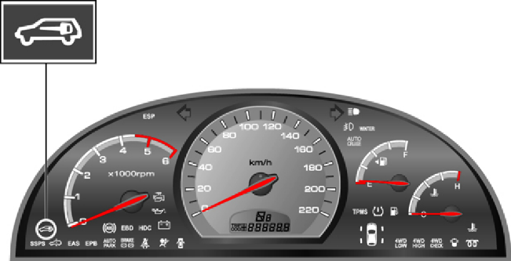
Figure 1.38: Immobilizer and Warning Lamp
Immobilizer and Warning Lamp:
This indicator comes on when the ignition key is communicating with the engine control unit (during engine starting) and goes out after starting the engine.
- Lamp ON: in communication
- Blinking twice for one second: immobilizer system failure
- Blinking once for two seconds: immobilizer unit is not coded
- The immobilizer unit transmits the encrypted code to the transponder.
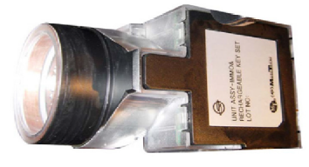
Figure 1.39: The immobilizer unit transmitter
- The transponder sends an encrypted signal to the unit as a response.
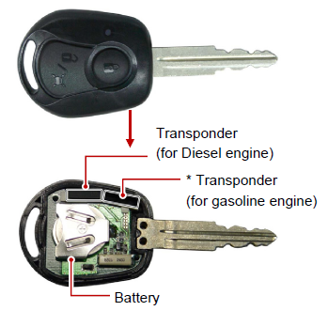
Figure 1.40: transponder sender

- The transmitted code is changed to an encrypted signal in the unit.
- The system compares the signal from transponder and the encrypted signal in immobilizer unit.
- Only when the two signals are identical, it recognizes the key as the authorized one and transmits the positive message to the ECU.
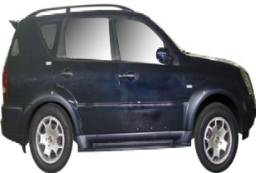

- The ECU enables the engine to be started.

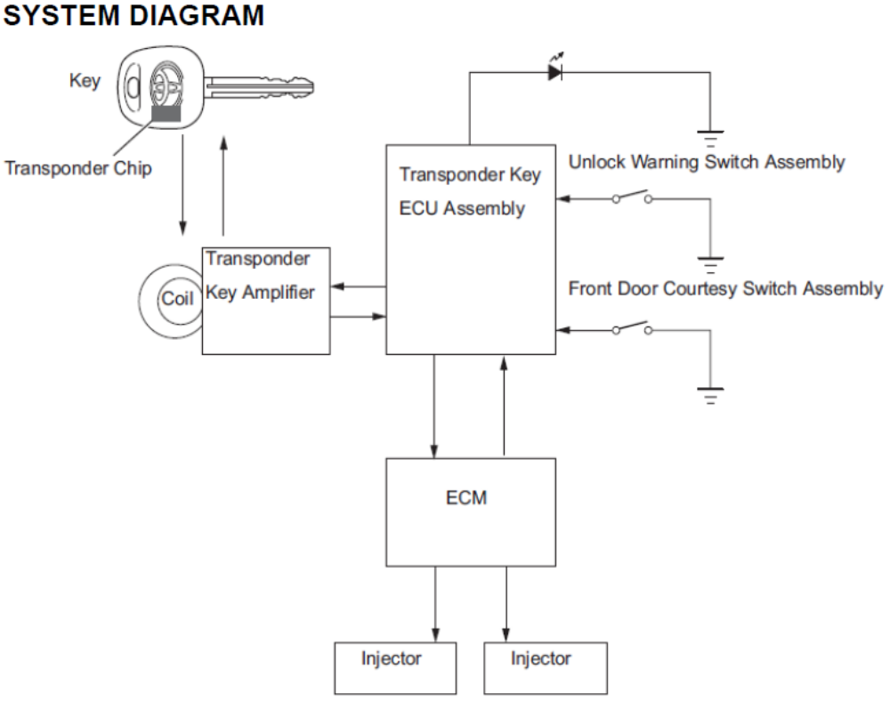

Self-check-2
Test I: Fill the black space
Instruction: Fill the black space with the correct answers. You have given 1 Minute for each question. Each question carries 2 Point.

1, The engine immobilizer system consists of the ....................................................., .,,,,,,,,,,,,,,,,,,,,,,,,,,,,,,,,,,,,,,,,,,,,,,,,,,,,,,,,,,,,,,,,,,,,,... and ,
2, Write the two types of engine immobilizer systems:
A ,
B ,
3, provide protection against theft.
4, an electronic security device fitted to a motor vehicle that prevents the engine from being started unless the correct key (transponder or smart key) is present.
5, is built into the door lock assembly.
6, in some models is used as the door lock actuator.
7, is a magnetic switch that uses a movable armature to control a high-amperage circuit by using a low-amperage electrical switch.
8, is an integral part of your concern as a car owner and having a durable car alarm will always be of good help.
9, is the traditional means by which a vehicle is opened and closed from inside or outside.
10, is usually integrated inside the key bow.

Operation Sheet: 2.1 installing alarm components and wiring
Procedures:
- Consider the locations, where to mount the component parts.
- Remove the necessary panels
- Drill through the firewall
- Mount the car alarm
  - Mount the brain
- Install the siren under the hood on a solid surface. Place the siren face down to avoid the accumulation of moisture. Make connections for power supply.
- Connect alarm powered correctly to the battery.
- Put a fuse on the power cord near the battery. Read instructions about fuse type and measure.
  - Mount the siren
  - Mount the shock sensor
- Mount the vibration sensor in the place specified by handbook
- Make a hole in the dashboard where you want to place the LED for status indication. Connect the LED to the system and put it over the hole.
- Find the wires that act closure system of the doors.
- Connect these wires to the alarm system.
- Using manual found the wires from the hazard warning lights.
- Connect the alarm to these lights.
- Localize central locking of the doors.
- Connect the circuit for central locking to alarm.
- From the starting system, connect the wires to the alarm to be able to interrupt starting in case the alarm is triggered.
- Mount the command panel under the dashboard.
- Connect all the wires to the alarm module.
- Mount the alarm module under the dashboard on a solid surface.
- Use duct tape to insulate the wires and tying them in bunches.
- Arms the alarm and test it.

Operation sheet 2.2 Test alarm system
Procedures:
- Turn off the ignition key and exit the vehicle closing all protected entrances.
- Press the arm/disarm or lock button on the transmitter.
Notify the following:
- Hear a horn/siren chirp,
- The parking lights will flash one time and
- The LED status indicator will flash at normal speed.
- Wait 5 seconds, and then open a protected entrance.
- The horn/siren will begin to sound.
- Press the arm/disarm or unlock button once again and the horn/siren will stop sounding.
- (No Disarm Chirp Indicator)
Note: If you disarm the alarm when the horn/siren is sounding, there are no disarming chirps. When you disarm the alarm when the siren is off, there will be disarming chirps.
- Follow procedures 2 and 3 for all other protected entrances.

Operation Sheet 2.3 Fitting central door locking parts
Procedures
- Remove trim
The door trim panels should be removed first to gain access to the inside. Remove all the handles and winders before releasing the panel securing clips and lifting the panel away. Carefully remove the condensation sheet fitted behind the trim.

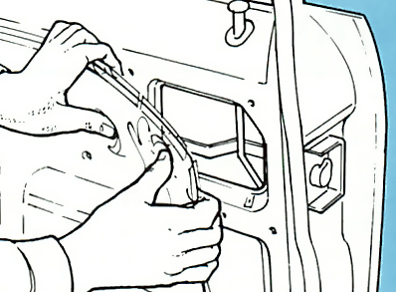
- Fitting position
Each drive unit should be mounted on the inside of the inner door skin so that its own slave rod can join to the link rod between the door locking buttons and lock assembly. If you can, mount it across one of the holes in the skin to make fitting easier. The unit should not obstruct the glass or opening mechanism.
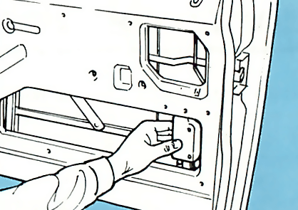

- Mark and drill
Offer up the mounting bracket to the inner door skin. Mark the position of the screw securing holes with a felt-tip pen then remove the bracket. Using a drill of a suitable size, drill out the holes. Secure the bracket with the screws and securing clips provided, fitting the clips behind the door skin.
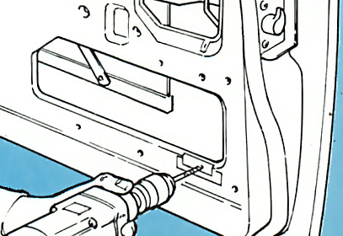

- Fit drive unit
Secure the drive unit to the bracket using the screws provided. The screws pass through the mounting bracket and into the two holes located in the drive unit body. Route the condensation vent pipe to the bottom of the door and the wiring towards the hinged end of the door ready to connect up later.

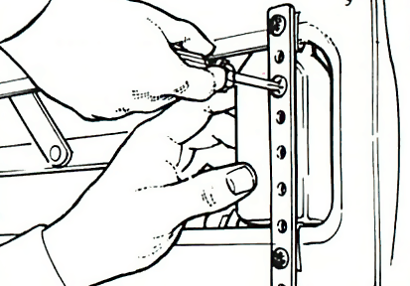

- Slave rod
Bend the slave rod into shape. It should run from the drive unit, parallel to part of the existing link rod. Join the slave rod to the drive unit with the clip provided. The two rods are connected together with a clamp and screw. Position the rods in the clamp and secure them with the grub screws.
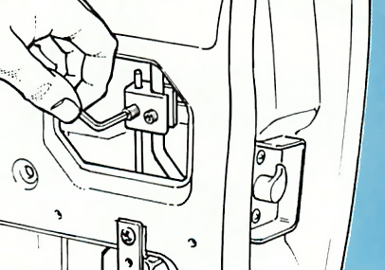

- Route wiring
A small wiring loom is provided with the kit to connect the master control unit with the drive units. If possible route the loom besides any existing wiring. If necessary drill small holes in the door and bodywork, fit grommets to them and then route the loom wires through the holes into the doors.

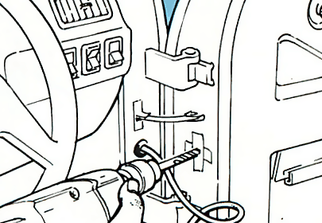

Operation Sheet 2.4 Install door lock actuator
Procedures:
- Remove door panel
- Carefully remove the door panel of the lock you are replacing/adding
- Figureout the best position for the new actuator (parallel to the door lock shaft)making sure not to interefare with the window mechanism.
- Prepare the actuator for mounting
- Insert the connecting rod through the swivel hole on the actuator.
- Insert the connecting rod and the vehicles existing door locksrod into the rods connecting rod adapter.
- Insert the included small adapter screw into connecting adapter.
- Mount the actuator
- Position the actuator best suited for functionality and mounting
- Position the actuator parallel to the existing door lock rod
- Slightily bend the connecting rodto position the connecting adapter with the vehicles door lock rod
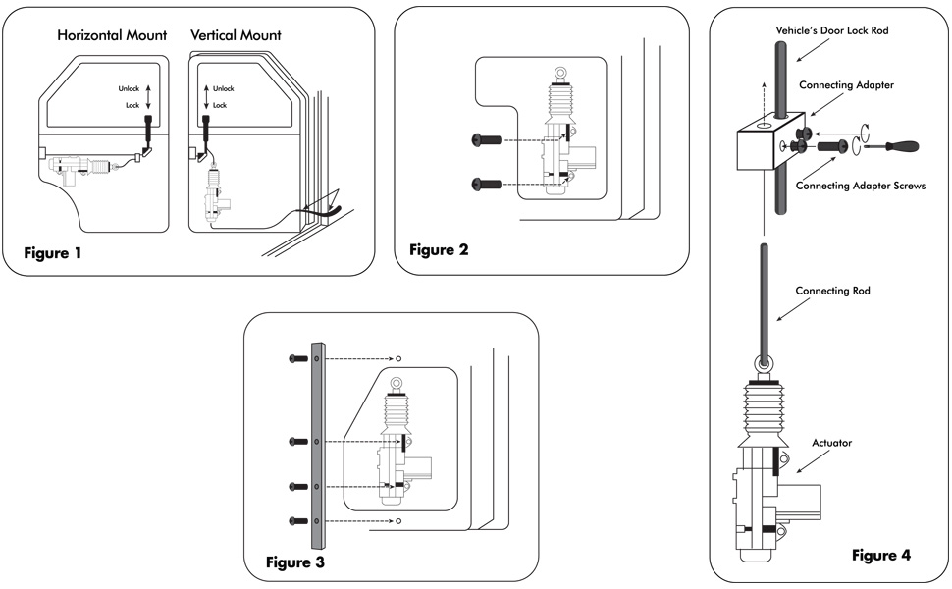
- Mount the actuator to the vehicles door with the supplied mounting screws or use the included mounting strap if not enough surface area.
- Final adjustment
- Position both the actuator and the vehicles door lock rod in the locked/down position.
- Adjust the connecting adapter and connecting rod then tighten the adapter screws using a philips head screw driver.

Operation Sheet 2.5 Door lock actuator: problems, testing, replacement
The door lock actuator is an electric actuator that operates the door latch mechanism in cars with power door locks. In many cars, the door lock actuator is built with the latch mechanism into one assembly in below fig. For this reason, the whole door lock assembly is often called door lock actuator.
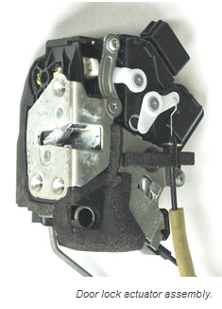
Door lock actuator problems
There are several reasons why a door lock actuator may need to be replaced.
- One of the door lock actuator stops working completely.
- A door lock actuator becomes noisy and produces a squeaking or buzzing noise when power door locks are locked or unlocked.
- Wear out the electric motor or the mechanism inside the door lock actuator out,
- The door lock may lock or unlock slowly or work sometimes, but not all the time. In some cars,
- A failed door lock actuator may lock but won't unlock or the other way around.

Operation sheet 2.6 : Test door lock actuator
Instructions: Given necessary templates, tools and materials you are required to perform the following tasks within 3hour.
Procedures:
- Take of the door cover or trim
- Test the voltage at the door lock actuator following wiring diagram.
- Press the power lock button and measure the voltage.
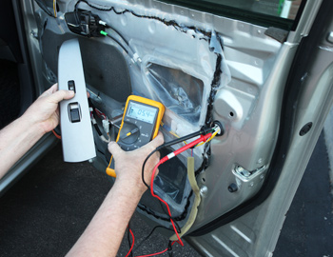
- Check the following:
- If there is a voltage, but the actuator doesn't work, the door look actuator may need to be replaced.
- If there is no voltage present when the power lock switch is operated, the problem must be further traced using the electrical diagram. It could be
- Main door lock switch,
- Broken door wiring harness,
- Bad connector,
- Failed control module or simply a blown fuse.

Operation sheet 2.7 Replace door lock actuator
Procedures:
- Remove door cover or trim.
- Use flashlight to see inside the door and access the door actuator connection and fitting
- In some cars, the window regulator or the outer door handle may also need to be removed, which is often tricky.
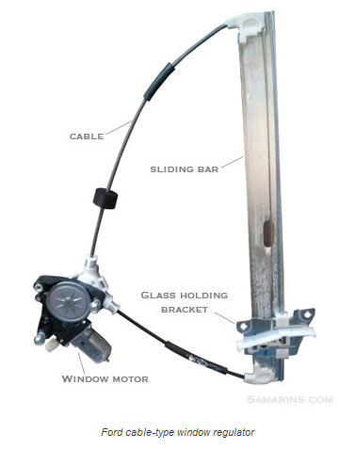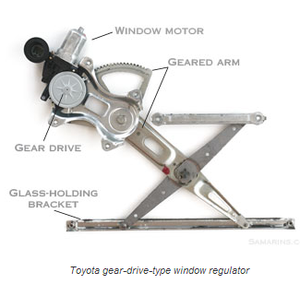
- Remove the existing door lock actuator.
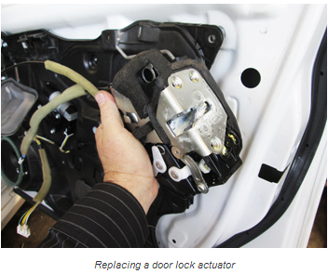
- Replace properly connect all the cables and levers after the new door lock actuator and installed.

Operation sheet 2.7 Test car security system
Purpose: ensure the proper diagnoses of the car security system to pin point the exact location of the trouble without affecting the vehicle systems.

Condition and situation for the operation: Low voltage wiring/lighting system in the vehicle is used to operate all lights and some accessories. The circuit for all is connected and extended in wire harness, but the color code for each circuit is different

Equipment, Tools and Materials:
Battery, multi-tester, volt meter, Test light Personal protective device, Wires Screw driver, pliers

Procedure:

- Prepare the tools and materials
- Ensure safety in your working area
- Gather information from the driver or the service history of the vehicle
- Identify the test locations by which most trouble or failure may appear
- Carry out visual inspection for loose connection, blown and disconnected parts
- Test the individual system and its components by using appropriate test instrument as specified on owner’s manual
- Record the information and data collected and prepare the failed system or component for repair

Operation sheet 2.8 Troubleshoot Electric Door Locks
Procedures:
- Check the fuses and circuit breakers, especially if none of the power door locks work.
- Activate the power lock switch to its lock and unlock positions while listening for a distinctive click sound coming from the relay. If you cannot hear the click, go to the next step. If you can hear the click sound, go to Step 7.
- Lift the power switch off the door panel and check for voltage at the switch using a voltmeter. On some models, you might have to remove a cover or the door panel first. If there is no voltage present, go to Step 4. If there is voltage go to Step 5.
- Inspect the wire running from the switch to the fuse panel and look for an open or short.
- Check the switch for continuity using a multi meter. If there is no continuity, replace the switch. If the switch has continuity, go to the next step.
- Inspect the wire running from the switch to the relay and make sure there is continuity and good connections at both ends. Fix any open or short and test again.
- Test the power relay to make sure it is receiving voltage from the switch and it is functioning properly. Check the ground connection also. If the relay is receiving voltage but voltage is not coming out, replace the relay. If voltage is coming out of the relay go to the next step.
- Remove the door panel with the failed power lock if you have not done so already.
- Activate the switch to its lock and unlock positions while checking both wires for voltage at the solenoid. If there is no voltage reaching the solenoid go to the next step. If there is voltage present at the solenoid, replace it.
- Check both wires between the solenoid and the relay. Fix any open or short and test again.

Lap test: 2
Task 1.Install and test car alarm system wiring diagram
Task 2 Perform testing on car alarm system wiring diagram
Task 3 Perform Installation, testing, repairing and replace door lock actuator
Task 4 Trouble shoot security system

Unit Three Clean up work area and maintain equipment

This unit is developed to provide you the necessary information regarding the following content coverage and topics:
- Collecting and storing reused material
- Tagging methods of Unserviceable equipment
- Maintain tools and equipment
This unit will also assist you to attain the learning outcomes stated in the cover page. Specifically, upon completion of this learning guide, you will be able to:
- Understand Collecting and storing reused material
- Apply Tagging methods of Unserviceable equipment
- Understand Maintain tools and equipment

3.1 Collecting and storing reused material
Automotive recycling industry is continuously implementing creative ways to reuse components, reduce waste and increase recycling rates from the process of manufacturing Separating wastes allows for easier recycling and may reduce disposal costs.
- Keep hazardous wastes separate, do not mix used oil solvents, and keep chlorinated solvents (like, tricolor ethane) separate from non-chlorinated solvents (like kerosene and mineral spirits)
- Promptly transfer used fluids to the proper waste or recycling drums. Don’t leave full drip pans or other open containers lying around.
- Provide cover and secondary containment until these materials can be removed from the site.
- Oil filters can be recycled. Ask your oil supplier or recycler about recycling oil filters.
- Do not dispose of extra paints and coatings by dumping liquid onto the ground or throwing it into dumpsters.
- Allow coatings to dry or harden before disposal into covered dumpsters. Store cracked batteries in a non-leaking secondary container. Do this with all cracked batteries, even if you think all the acid has drained out. If you drop a battery, treat it as if it is cracked. Put it into the containment area until you are sure it is not leaking. Vehicles are through their end-of-life recycling.
Recycling
Auto recyclers remove parts such as engines, transmissions, doors and bumpers for reuse in other vehicles.
Other parts that can also be remanufactured include starters, alternators and water pumps.
Batteries, catalytic converters, tires and some plastics are removed and their materials are recycled into new products.
Fluids such as engine oil, coolant, and gasoline are carefully managed to prevent releases by storing them in double-walled tanks and/or secondary containment prior to being reused or recycled.
The automotive recycling industry also saves energy, conserves natural resources, reduces air and water pollution and greenhouse gas (GHG) emissions, and recycles environmentally sensitive substances including lead, mercury, oil and unspent fuel.
Using recycled scrap iron and steel reduces the use of virgin iron ore, among other environmental benefits. Every ton of new steel made from scrap steel conserves
Cleaning and maintenance
Cleaning is the removal of all visible soil in an approved way with the use of mechanical and chemical action or both, so that all areas are cleaned and sanitized to a high standard. Cleaning is maintenance that up keep of body, seat interior and dashboard fittings and equipment to an exacting standard within the property so that all areas look consistently new and pristine.

Why do we clean?
There are many reasons why we clean but the most important ones are Health Regulations If your local government authority has health regulations regarding cleaning and sanitizing, then you must know these and follow their recommendations at all times. It is important when you are cleaning that you clean to a high standard that has been set for you by your supervisor or manager.
Use dry clean, soft and stain free cloth for cleaning. If necessary moisten the cloth with pure alcohol. Use no other liquids.

Kinds of Cleaning Solvents
Solutions are homogeneous mixture of two or more components. They can be gaseous, liquid or solid. When we speak of a solution, we usually think of a solid dissolved in water. While water is the most common solvent, other liquids are frequently employed as solvents for certain substances – for example wax maybe dissolved in gasoline. The dissolved material in a solution is termed as solute (e.g. wax) while the dissolving medium is called solvent (e.g. gasoline). However, the term can be interchanged depending on which substance is of greater amount.
Solvent is a component of a solution that dissolves solute and is usually present in large proportion or amount. It can be classified as polar or nonpolar. Polar solvents are solvents which dissolve/are soluble in water; while nonpolar solvents are solvents which do not dissolve/are insoluble in water.
Solvents usually used for cleaning in automotive shops are: water, gasoline, kerosene, thinner and detergent soap.

3.2 Tagging methods of Unserviceable equipment
Safe work procedures are a means of briefly documenting the risks associated with a work task and incorporating appropriate controls into a sequence of steps for doing the task safely. These documents are most effective when developed in consultation with your workers, and they provide a useful tool for training and supervising your workers. They should be reviewed if you have an incident at your workplace and/or changes occur in the workplace.
Ticks in the RED zone indicate that you need to take action immediately to identify the tasks your workers do that may expose them to safety risks. Work with them to develop simple procedures to do their work safely. A person conducting a business or undertaking has a duty to consult workers on health and safety issues directly affecting them.
Machinery Tag Out
Program: It governs lock out and/or tag out procedures to be used to verify that equipment or machines are isolated from all potentially hazardous energy. Machinery is to be locked out or tagged out before employees perform any servicing or maintenance activities where the unexpected start up or release of stored energy could cause injury.
Policy:
- Procedures described apply to all electrical equipment and machinery connected to an energy source by either hard wire or other permanent connection (hydraulic lines, electrical, etc.) that is repaired, serviced, or maintained by personnel.
- The machinery tag out program applies to all equipment or machinery operated by mechanical, hydraulic, pneumatic, chemical, thermal, or other energy resources where the unexpected energizing could cause injury to employees or customers. Circuit breakers disconnect switches, and other energy isolating devices used to control the flow of energy to the machine/equipment must be operated in such a manner as to shut off or “isolate” all energy to the machine.

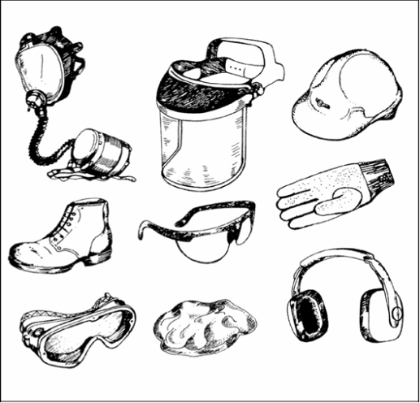

3.3 Maintain tools and equipment’s
- Inspect vehicles and equipment daily at startup for leaks, and repair immediately
- Keep vehicles and equipment clean; do not allow excessive build-up of oil and grease.
- Segregate and recycle wastes, such as greases, used oil or oil filters, antifreeze, cleaning solutions, automotive batteries, hydraulic and transmission fluids. Provide secondary containment and covers for these materials if stored onsite.
- Consider use of new, alternative greases and lubricants, such as adhesive greases, for chassis lubrication and fifth-wheel lubrication.
- Properly dispose of used oils, fluids, lubricants, and spill cleanup materials.
- Do not place used oil in a dumpster or pour into a storm drain or watercourse.
- Properly dispose of or recycle used batteries.
- Do not bury used tires

Self-Check -3
Directions: Answer all the questions listed below. Use the Answer sheet provided in the next page:
Written Test
  - Describe briefly how to collect and store material that can be reused in automotive industry?
  - Write the wastes and scrapes recycled in automotive industry?
  - What is cleaning and maintenance?
  - What is machinery tag out program?
  - What does it mean when we say maintain tools and equipment’s?

Reference

        - AUTOMOTIVE TECHNOLOGY A SYSTEMS APPROACH 5th Edition Jack Erjavec, © 2010 Delmar, Cengage Learning (website at www.cengage.com.)
        - Classroom Manual for Automotive Electricity and Electronics Fifth Edition Barry Hollem beak © 2011 Delmar, Cengage Learning
        - AUTOMOTIVE TECHNOLOGY Principles, Diagnosis, and Service FOURTH EDITION by James D. Haldeman, publishing as Pearson Education, in 2012
        - Automobile Mechanical and Electrical Systems First published 2011, Copyright © 2011 Tom Denton. Published by Elsevier Ltd. All rights reserved
        - Bob Goodman and Rodney G. Brown (3M). "Electrical Taping Skills: A Lost Art?", EC&M, p.2
        - Automotive Mechanics 10th ed. By Anglin,
        - Automotive Lighting System (CD)

Participants of this Module (training material) preparation
No | Name | Qualification (Level) | Field of Study | Organization/ Institution | Mobile number | E-mail
1 | Fadli Aman | BSc. B-Level | Automotive Technology | General Wingate PTC | 0927283100 | Fadli.ziyad@gmail.com
2 | Gashaw Zewde | MSc. A-Level | Automotive Technology | AKPTC | 0910730747 | Gashawgashaw69@gmail .com
3 | Muna Gabrie | MSc. A-Level | Automotive Technology | Dire PTC | 0910511196 | Munamulunhe@gmail.com
4 | Sisay Dawit | MSc. A-Level | Automotive Technology | Harar PTC | 0910672115 | Sisaydawit058@gmail.com
5 | Yohannes Negatie | MSc. A-Level | Automotive Technology | W/ro Siheen PTC | 0922094453 | Yohannes2013n@ gmail.com

