

Automotive Electrical and Electronic Level -II
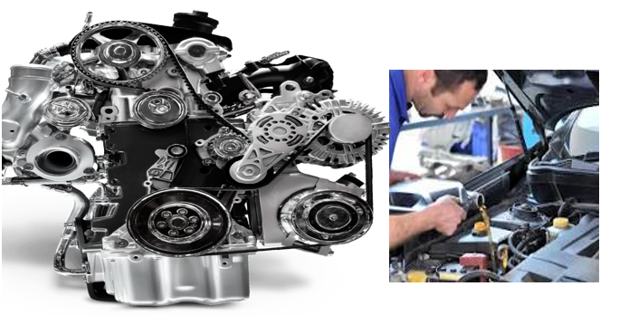
Based on March 2022, Curriculum Version- 1
MODULE TITLE : Performing Engine Tune up
MODULE CODE : EIS AEE2 M10 0322
NOMINAL DURATION : 70 Hours
Prepared by: Ministry of Labor and Skill

September, 2022
Addis Ababa, Ethiopia

Acknowledgment
Ministry of Labor and Skills wish to extend thanks and appreciation to the many representatives of TVET instructors and respective industry experts who donated their time and expertise to the development of this Teaching, Training and Learning Materials (TTLM).

Acronym
OHC Overhead camshaft
PCV Positive crankcase ventilation
EGR Exhaust gas recirculation
TTLM Teaching, Training and Learning Materials

Table of contents
Acknowledgment 2
Acronym 3
Introduction to module 5
Unit one: Overview of engine maintenance & tune- up 6
1.1. Safety on engine maintenance & tune -up 6
1.2. Purpose of engine maintenance & tune -up 8
1.3. Identify Tools & equipment’s 15
Self-check-1 20
Unit Two: Checking fuel system components 21
2.1. Checking fuel system 21
2.2.Bleeding fuel system 29
Operation Sheet: 2 31
LAP Test -2 32
Unit Three: Checking/Adjusting spark plug 33
3.1. Adjusting spark plug clearance 33
3.2. Testing spark plug 36
Operation sheet:3 38
Operation title: Gapping the Spark Plug 38
LAP Test -3 39
Unit Four: Check/replace fuel filter, air cleaner, contact point & condenser 40
4.1. Replacing fuel filter & air cleaner 40
4.2. Inspecting contact point gap 47
4.3. Testing & replacing condenser 50
Operation sheet:4 53
LAP Test -4 54
Unit Five: Testing/adjusting dwell angle, ignition setting, engine idle speed & mixture 55
5.1. Adjusting dwell angle 55
5.2. Set ignition timing 57
Operation sheet: 5-1 61
Operation sheet: 5-2 62
LAP Test -5 63
Unit Six: Adjusting / Checking advance mechanism of ignition system 64
6.1. Adjusting Mechanical /Centrifugal advance mechanism 64
6.2. Adjusting Vacuum advance mechanism 65
Operation sheet: 6 67
LAP Test -6 68
Reference 69

Introduction to module

The purpose of engine tune up is checking all phases of engine operation and making any adjustments, repairs and replacements required for the engine auxiliaries and accessories to conform to the car manufacturers’ specifications.
In this module identify engine maintenance and perform engine tune up. You will be performing activities to develop your skill, inspecting/testing and replacing spark plugs; checking/replacing fuel filter and air cleaner; inspecting/replacing contact point condenser; testing/adjusting dwell angle and ignition setting; adjusting engine idle speed and mixture; checking advance mechanism and adjusting ignition timing.
This module covers the units:
- Overview of engine maintenance & tune- up
- Checking fuel system components
- Checking/Adjusting spark plug
- Checking/replacing fuel filter, air cleaner, contact point & condenser
- Testing/adjusting dwell angle, ignition setting, engine idle speed & mixture
- Adjusting / Checking advance mechanism of ignition system
Learning Objective of the Module
- Understand Overview of engine maintenance & tune- up
- Perform Check fuel system components
- Carry out Check/Adjust spark plug
- Perform Check/replace fuel filter, air cleaner, contact point & condenser
- Perform Test/adjust dwell angle, ignition setting, engine idle speed & mixture
- Adjust / Check advance mechanism of ignition system
Module Instruction
For effectively use this modules trainee are expected to follow the following module instruction:
- Read the information written in each unit
- Accomplish the Self-checks at the end of each unit
- Perform Operation Sheets which were provided at the end of units
- Do the “LAP test” giver at the end of each unit and
- Read the identified reference book for Examples and exercise

Unit one: Overview of engine maintenance & tune- up
This unit is developed to provide you the necessary information regarding the following content coverage and topics:
  - Safety on engine maintenance & tune -up
  - Purpose of engine maintenance & tune -up
  - Identify Tools & equipment’s
  - Types/classification of gasket & sealant application use
This unit will also assist you to attain the learning outcomes stated in the cover page. Specifically, upon completion of this learning guide, you will be able to:
  - Apply Safety on engine maintenance & tune -up
  - Explain & discuss the Purpose of engine maintenance & tune -up
  - Select Tools & equipment’s
  - Identify Types/classification of gasket & sealant application use

1.1. Safety on engine maintenance & tune -up
Safety measures help protect employees from accidental injuries to themselves, their co-workers, customers, and the vehicles they are repairing. However, repair shop owners and their staff need to ensure the proper safety precautions and rules are implemented and followed at all times. Always wear proper clothing and eye and ear protection while operating small machines. Make sure the area is clear of other people where you will be working. Always keep all safety shields in place. An automotive technician must adhere to the following shop safety guidelines when using all tools and equipment.
Hand Tool Safety
Careless use of simple hand tools such as wrenches, screwdrivers, and hammers cause many shop accidents that could be prevented. Keep in mind the following tips when using hand tools:
- Keep all hand tools grease-free. Oily tools can slip out of your hand, causing broken fingers or at least cut or skinned knuckles.
- Inspect your tools for cracks, broken parts, or other dangerous conditions before you use them.
- Hand tools should only be used for the purpose they were designed for. Use the right tool for the job.
- Make sure the tool is of professional quality.
- Never use broken or damaged tools.
- When using a wrench, always pull it, not push it, toward you.
- Always use the correct size of wrench.
- Use a box-end or socket wrench whenever possible.
- Do not use deep-well sockets when a regular size socket will work. The longer socket develops more twist torque and tends to slip off the fastener.
- Use an adjustable wrench only when it is absolutely necessary; pull the wrench so that the force of the pull is on the nonadjustable jaw.
Always hand a pointed or sharp tool to someone else with the handle toward the person to whom you are handing the tool. Never touch moving parts.
Always inspect the engine when maintenance work is completed. Engine Room Staff. Operation and maintenance of engines is to be carried out exclusively.
Power Tool Safety
Power tools are operated by an outside power source, such as electricity, compressed air, or hydraulic pressure. Always respect the tool and its power source. Carelessness can result in serious injury. Also, always wear safety glasses when using power tools. Never try to use a tool beyond its stated capacity.
Safe work with engines
- Remove rings, metal watches, bracelets and any loose clothing before beginning work.
- Tie back long hair.
- Keep hands clear of all moving parts.
- Use extreme caution around engine fans, as these may strike you, fling objects, start unexpectedly, or catch dangling leads or strings.

1.2. Purpose of engine maintenance & tune -up
A. Engine maintenance
Engine maintenance is the process of routinely checking the various systems and components that compose a car engine, and performing any repairs or upgrades that are necessary to keep the engine in proper running condition or
- Keep your engine clean and tuned properly. ...
- Check the oil and fluid levels before every outing. ...
- Tighten battery connections. ...
- Inspect the engine for anything that shows signs of wear or requires tightening, such as hoses, belts, and bolts. ...
- Never use automotive electrical parts.
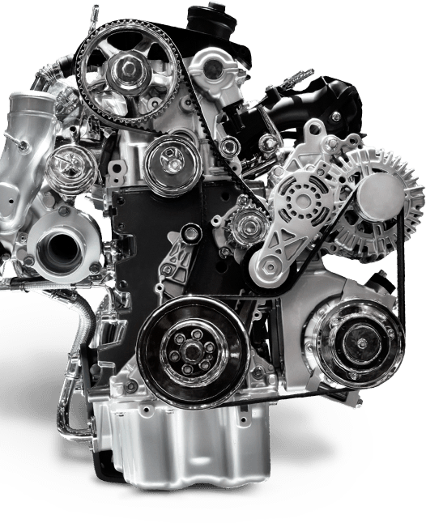
Figure 1.1 Engine maintenance


Requirement of engine maintenance
Adhering to a routine maintenance schedule is essential for prolonging the life of any machine, and your car's engine is no exception. Allowing dirt, old oil, and small incidents of damage to build up without proper care will likely cause your car's engine to die prematurely.
Every engine needs regular oil changes. The oil is responsible for keeping the different components of your engine moving cohesively with minimal friction. Over time, oil gets dirty and needs to be changed to keep your engine healthy
Importance of engine maintenance
1) Inspection and Compliance. ...
2) Budgeting and Capital Expenditures. ...
3) Replacing Equipment. ...
4) Labor. ...
Since maintenance history is recorded, work can be easily transferred to the next team or individual when the staff changes.
Engine maintenance principle will help:
- Plan, rather than react. Focus resources on preventing downtime, not on reacting to downtime you should have prevented. ...
- Be equipped to do the job. ...
- Follow the plan. ...
- Actively seek feedback and advice. ...
- Adjust as needed. ...
- Keep others in the loop.
Maintenance planning
Maintenance planning can be defined as the process used to develop a course of action. Effective maintenance planning involves the development of a course of action that includes all maintenance, repair, and construction work.
B. Engine tune up
“Tune-up” means checking all phases of engine operation and making any adjustments, repairs and replacements required for the engine auxiliaries and accessories to conform to the car manufacturers’ specifications.
An engine tune-up is the process of inspecting and replacing components of the engine that are essential to ignition and engine operation. A comprehensive tune-up can include:
- Replace spark plugs and wires/coil boots
- Set ignition timing - if applicable
- Replace engine air filter
- Replace fuel filter - if applicable
- Clean the throttle body - if applicable
- Perform a fuel system cleaning
- Replace distributor cap and rotor - if applicable
- Replace PCV valve - if applicable
Today, engine tune-ups include checking, diagnosing, and replacing bad spark plugs, spark plug wires, distributor caps, fuel filters, air filters, and oil filters. Tune-ups can also include checking emission levels, fuel lines, wiring, coolant hoses, and serpentine belts. Tuning an engine does not mean rebuilding or performing repair operations on the engine itself even though these may be required. However, checkup operations which are a part of every tune-up job may reveal serious engine defects which require corrective measures. It is as essential to check engine operation after adjustments are made as it is to test before doing corrective work.
The only assurance of a corrective adjustment is a double check after work has been completed. Trying to tune on engine that has poor bearings, rings, pistons or valves is difficult if not impossible. Tune-up as it will be used here means re-establishing original factory specifications as nearly as possible. This can be done satisfactorily only on engines that are in reasonably good condition so that proper tuning will cause a noticeable improvement.
The three fundamental divisions of tune-up procedure can also be considered as:
1.The engine
2.Electrical system
3.The fuel system
These three designations cover the same items as the term’s compression, ignition and carburetion.
The tune-up man must first detect the faulty parts and units whose deterioration is affecting the proper functioning of the engine. He must then report engine faults and correct defects of auxiliary units by adjustment, repair, or replacement, restoring the units as near to their original condition as possible.
Diagnosis of the engine and its auxiliary systems is an important element of tune-up, since without knowing what is needed; it is difficult to know what should be done.
A good tune-up job, therefore, consists of two parts.

1. Diagnosis, analysis or troubleshooting
2. Correction, which may be adjustment, replacement or repair
Troubleshooting principles
The following sections are a method, or checklist, to help you troubleshoot engine performance problems.
1. Ask the Driver
Even if an owner brings you a car for routine maintenance (change oil, filters, spark plugs, and so on), he or she may have a general complaint about performance or a vague idea that, “It’s not running the way it should.” Ask the driver about specific problems. Also ask about overall performance. Even a general answer such as, “Well, sometimes it’s hard to start,” or “Mileage isn’t too good,” can be a helpful clue for your testing.
If the car has a specific problem, it’s helpful to talk to the person who was driving when it occurred. Ask questions such as:
- Does the problem occur at specific times or temperatures – idle, cruising, acceleration, at night with heavy electrical loads, cold starting, hot starting, or any combination?
- Does the problem occur regularly or at random?
- What are all the symptoms – noises, smells, vibrations, or combination of signs?
- Has the problem occurred before and what was done to fix it?
- When was the car last serviced, and what was done then?
Many large shops have service writers who prepare work orders and get information from customers. If you can’t talk to the owner directly, read the work order carefully and ask the service writer for details.
2. Ask the Car
Equally important, drive the car and check performance for yourself. The owner may complain about a rough idle and never notice the mushy automatic transmission shifting and slight high – speed surge caused by the same vacuum leak. Combined clues that lead to a single cause can save you time. Also, by driving the car to analyze the owner’s comments, you will get an idea of what the owner expects in the way of drivability. A “hard – starting” problem may occur because the driver does not follow specific starting instructions for the vehicle. You may operate the car immediately or later during your testing. You may have to let it cool down to check a cold – engine problem. When you do drive it, observe the symptom carefully to be sure when it does occur and when it doesn’t.
If the problem is a “rough idle,” does it happen with the engine hot or cold, or both? Does it happen with the air conditioner on or off, or both? Does the car overheat? Does it smoke? Are there other related symptoms?
3.Know the Car, Know the Specifications
Before you start troubleshooting, be sure you know what you are working on. That sounds simple, but the same type of vehicle can have different engines. It can have different transmissions. It may or may not have air conditioning. It may be designed for different countries with specific differences. Start to identify the car by checking the vehicle identification number on the VIN plate. Then check the engine “emission control” decal for basic specifications, such as timing, idle speed, and spark plug gap. The engine decal also has summary instructions for idle and timing adjustments and, along with other calibration labels, will identify a car with running changes made during the model year. The VIN and engine decals will lead you to detailed specifications and procedures in reference manuals. You also may need electrical and vacuum diagrams. Look them up, using the VIN and engine decal numbers. Most cars have a decal under the hood that shows engine vacuum hose connections.
4.Identify the Possible Causes and Cures
You actually start this step when you learn the owner’s complaint, and you continue identifying and eliminating causes until you finish the job. Make a list, in your head or on paper, of the symptoms and possible causes. Then check the possibilities one at a time. Begin with the simplest.
Don’t condemn an alternator for a low – voltage problem without checking for a loose drive belt first.
5.Test from the General to the Specific
Testing is a process of elimination. If you immediately look for the cause of a rough idle in the ignition system, you eliminate other possible causes in the fuel and emission systems without checking them. To isolate a problem accurately, you must begin by checking general engine condition and performance. Then, test each system – fuel, electrical, emission – for overall operation. Finally, check individual components. Start by general tests of overall system operation which are also called area tests. These tests allow you to narrow down the cause of a problem. Detailed, or pinpoint tests, then allow you to isolate a bad component. Carmakers follow the same principle with their test procedures.

- Know the System, Isolate the Problem
Suppose the driver’s complaint is a rough acceleration when cold, and your testing shows that the exhaust gas recirculation (EGR) valve is opening when it should not. You then must ask yourself, “Why?” Is vacuum to the valve controlled by a coolant temperature vacuum valve or by a solenoid? If a solenoid is used, how is it switched, by a coolant switch or an engine computer? Is the EGR valve broken and stuck open? To isolate the problem, you must know what parts are in the system and how they work. This is another way to identify possible causes. The EGR valve may open at the wrong time because of:
- A mechanical problem – broken valve
- A wrong electric signal to a solenoid
- A broken coolant temperature sensor
- A cooling system problem – over – heating
- Incorrect vacuum hose connections
- Test Logically and Systematically
Now that you have isolated the problem to one system, you can use vacuum diagrams to determine hose connections and vacuum sources. Use electrical diagrams to determine the power source, the ground connection, and how a solenoid is energized.
You can determine when vacuum should and should not be present at the valve and when a solenoid should be energized and deenergized. If engine roughness occurs only on cold acceleration, the problem probably is not a bad EGR valve. If the valve were stuck open, performance also would suffer at hot and cold idle and at full throttle.If you find vacuum at the valve as you accelerate a cold engine, you must check the vacuum control devices. If a solenoid is energized to open a vacuum valve, check for voltage at the solenoid. If voltage is not present, but the solenoid valve is open, you probably have a bad solenoid.
If voltage is present when it should not be, you must check the electrical circuit. Check the electrical diagram and manufacturer’s test procedures to trace voltage to the source.
- Double-check Your Test Results
Suppose your tests in step 7 seem to show that a vacuum solenoid is permanently grounded and energized. The specific cause could be:
- A ground inside the solenoid
- A grounded wire between the switch and the solenoid
- A defective switch
- An overheating engine that closes the switch too soon
Disconnect the switch wire, first at the solenoid and then at the switch, to see if the solenoid stays energized. Check for voltage and short circuits to ground at the solenoid, in the wire, and at the switch. Check the switch itself to see if it is closing when it should not. The important principle, whether you are testing electrical, vacuum, hydraulic, or mechanical systems, is to test systematically from one point to another and double-check your results before making repairs. You often work with several systems – vacuum and electrical, for example – to isolate a problem. The symptom may come from a vacuum component, but the final cause may be an electrical fault.
- Repair and Retest
Suppose your results in steps 7 and 8 show that the coolant switch is bad. Replace the switch and reconnect and check all vacuum and electrical connections in the system. Then, retest the complete system. Be sure the EGR valve opens only when it should and that the switch and solenoid work properly. Most importantly, be sure you have cured the original “roughness on cold acceleration” problem. You may have replaced one bad part and eliminated a problem in one system. But if you haven’t corrected the owner’s original complaint, you haven’t finished the job. If the roughness still exists, there is another problem, or problems, in another system that you must find and fix, using these same steps.
Summary
To test engine performance, you must listen to what the driver and the car tell you. You also must be able to read and understand diagrams for electrical and vacuum systems. You should begin by testing the general area, or complete system; then go to specific tests to pinpoint a problem. Begin with the simplest tests and adjustments; then go to the more complex tasks. Beware of multiple causes for one general complaint. You must understand specifications and be able to interpret results in relation to specifications. Make adjustments, repairs, or replacements one at a time.
Then, check the results of one change before making another. Finally, test the results of your complete repairs and adjustments. Be sure you have cured the problem and satisfied the owner’s complaint.

1.3. Identify Tools & equipment’s
A tool can be any item that is used to achieve a goal. Equipment usually denotes a set of tools that are used to achieve a specific objective. A tool can be non-mechanical as well. However, when one says equipment, there is a certain mechanical aspect to it that cannot be ignored.
Tooling and equipment used on engine maintenance & engine tune up may include hand tooling, multi meter, vehicle lifting devices, power tooling, specialist tooling for removal/replacement, test light, ignition timing light, dwell angle tester, spark plug tester, electronic testing equipment, oscilloscope and scan tooling, Service Manual.
Basic Tools for Engine Repair and Maintenance
- Torque Wrench. nut or bolt. ...
- Socket & Ratchet Set. ...
- Breaker Bar. ...
- Screwdrivers. ...
- Wrench Set. ...
- Pliers. ...
- Hammers. ...
- Impact Wrench.
Tools & equipment needed to perform a tune-up
- 1/2" Breaker bar.
- 1/2" to 3/8" socket step.
- 12" long socket extension 1/2" or 3/8" drive.
- Spark plug socket.
- Spark plug gap tool.
- Spark plug wire puller tool.
- Coil pack puller tool.
- Torque wrench

1.4. Types/classification of gasket & sealant application use
Functions of seals and gaskets
Functions of seals and gaskets used between parts to prevent leakage of engine oil, coolant, transmission fluid, and other fluidsIt is used to create a seal between two or more surfaces which prevents leakage of air and/or liquid. However, a gasket can prove useful in maintaining a strong seal when the surfaces are weakened or under pressure.
Gaskets
Soft, flexible material placed between parts to prevent leakage
Made of fiber materials, rubber, neoprene (synthetic rubber), cork, treated paper, or thin steel
When parts are fastened together, the gasket material fills small gaps, dents, or scratches in the mating surface.Gaskets are normally made from a flat material, a sheet such as paper, rubber, silicone, metal, cork, felt, neoprene, nitrile rubber, fiberglass, poly tetra fluoro ethylene (otherwise known as PTFE or Teflon) or a plastic polymer (such as polychlorotrifluoroethylene).
Types of gaskets
1.Non-metallic. Example: PTFE gasket & Rubber gasket
2.Metallic-ring gasket. Example: Organic -ring gasket
3.Camprofile gasket. Example: Metal jacketed gasket
Cut Gaskets
Gaskets made of paper, fiber, and cork are normally called soft, cut gaskets. Each gasket is cut to the desired size and shape from a sheet of material.
Paper/Fiber Gaskets
These are made of a fiber rein forced paper like material. This treated paper seals low-pressure, low-temperature areas well. commonly used between the different housings and covers in a transmission or for some water pumps.
Cork Gaskets
Cork gaskets are used to seal low pressure areas like valve covers and oil pans.
Molded Rubber Gaskets
Molded rubber gaskets provide excellent sealing and are commonly used to seal intake manifolds, some thermostat or water pump housings, valve covers, and oil pans.

Gasket Rules
- Inspect for leaks before dis assembly
- Be careful not to damage mating surfaces while removing parts
- Clean off old gaskets carefully
- Wash and dry parts thoroughly
- Compare the new gasket to the shape of the mating surface
SPECIFIC ENGINE GASKETS
There is a wide variety of gaskets used on engines, each with its own purpose, and each is designed for that application. The following is a discussion of the most common ones.
Cylinder Head Gaskets
Cylinder head gaskets seal the gap between the cylinder head and the block. The head gasket has a very demanding job. It must seal the combustion chambers and the coolant and oil passages between the head and the block.
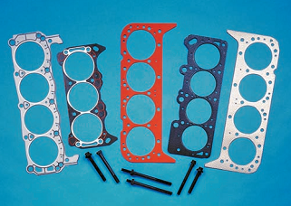

Figure 1.2 Cylinder head gasket

Manifold Gaskets
There are three basic types of manifold gaskets—the intake manifold, exhaust manifold, and a combination intake and exhaust. Combination gaskets are often used on inline engines without cross-flow heads. Manifold gaskets are made of a variety of materials, depending on the application. Each type of manifold gasket has its own sealing characteristics and problems. Therefore, be sure to follow the manufacturer’s instructions when installing them.
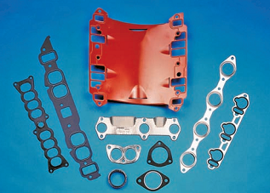
Figure 1.3Manifoldgasket

Assorted intake and exhaust manifold gaskets for diverse applications. Courtesy of Detroit Gaskets.
Valve Cover Gaskets
Valve cover gaskets must seal between a steel, aluminum, magnesium, or molded plastic cover and a cylinder head surface that might not be machined.
On OHC engines, the valve cover may be called the cam or cylinder head cover. Cam covers are normally made of die-cast aluminum. Some cylinder cover gaskets have spark plug gaskets integrated into the gasket. When installing these, make sure, the gasket is perfectly aligned.
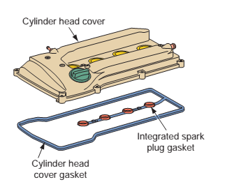
Figure 1.4 cover gasket
A cylinder cover gasket with integrated spark plugs gaskets.
Oil Pan Gaskets
An oil pan gasket seals the joint between the oil pan and the bottom of the block. The gasket might also seal the bottom of the timing cover and the lower section of the rear main bearing cap. Gaskets can be classified in many different ways, for example: by material, by function, or by application. A gasket is basically a part cut from a (usually) flexible material, which sits in between two other surfaces.
Typical Applications: Ideal for heavy-duty projects and repairs. Repairing figurines, costume jewelry, cameras, toys, metal car parts, wiper blades, rubber seals and O-rings.
Sealants
Manufacturers sometimes specify the use of sealants to assist a gasket or seal or to form a new gasket. These sealants should only be used when specified by the manufacturer. Also make sure to use the specific sealant recommended by the manufacturer.

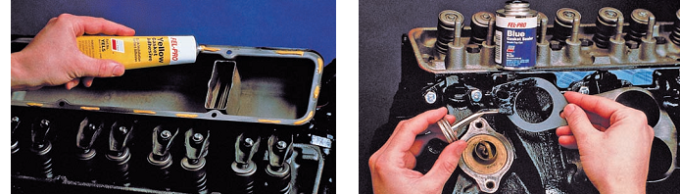
Figure 1.5 Applying gasket sealer with a brush gasket in place during assembly.
Seals
Gaskets are often coated with a sealer to help prevent leakage and to hold the gasket in place during assembly. Manufacturers sometimes specify the use of sealants to assist a gasket or seal or to form a new gasket. These sealants should only be used when specified by the manufacturer.
Types of seal
1.Static. A seal used between two parts that do not move in relationship to each other, such as the pan and oil pump-to-case gaskets.
2.Dynamic. A seal used between two parts that do move in relationship to each other. This movement is either a rotating or reciprocating (up and down) motion. The seal of a clutch piston is an
example of this type of seal.
3.SealRules
Inspect these al for leakage before disassembly if the seal is leaking, look for a bent shaft, misaligned seal housing, or damaged parts Remove the old seal carefully, without scratching the seal housing.
4.OIL SEALS
Seals keep oil and other fluids from escaping around a rotating shaft. There are three basic oil seal designs: the fiber packing, the two-piece split lip design, and the one-piece radial design
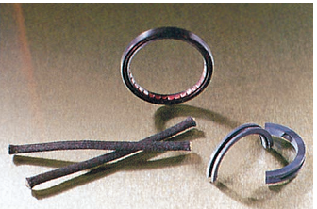

Figure 1.6 Oil seal

Self-check-1
Test-I.
Instruction: Give a short answer for the following question.
- What is the purpose of taking precaution during engine maintenance?
- What is the purpose of gasket?
- What is the purpose of sealants?
- Write types of bearing?
- Write types of fuel?
- Write types of sealants.
- What is the purpose of engine tune up?
- What is the purpose of engine maintenance?

Unit Two: Checking fuel system components
This unit to provide you the necessary information regarding the following content coverage and topics:
- Checking fuel system
- Bleeding fuel system
This guide will also assist you to attain the learning outcomes stated in the cover page. Specifically, upon completion of this learning guide, you will be able to:
- Check fuel system components
- Bleed fuel system

2.1. Checking fuel system
Fuels for engines are typically of two types
- Gasoline
- Diesel

Purpose of a Fuel system

The purpose of the fuel system is to store and supply fuel, and to provide some means of mixing it with air to give a combustible mixture for delivery to the engine under all operating conditions.
The petrol engine (Gasoline) produces a homogeneous air- fuel mixture in the cylinders, with the quantity of air, or air and petrol mixture, permitted to enter the cylinders being restricted by a throttle valve. The engine torque characteristics (the brake mean effective pressure characteristics are similar) produce a family of curves which show an increased droop with reduced throttle opening. These curves illustrate the self. limiting speed characteristics of the spark ignition petrol engine; that is, the rapid fall off in engine torque as the throttle opening is reduced.

Component parts of a gasoline (carbureted) fuel system

The gasoline (carbureted) fuel system consists of the fuel tank, fuel line, fuel pump, fuel filter and carburetor.

Fuel Tanks
An automotive fuel tank must safely hold an adequate supply of fuel for prolonged engine operation.
Purpose. The fuel tank is for storage of gasoline in liquid form.
The location of the fuel tank is dependent upon using an area that is protected from flying debris, shielded from collision damage, and not subject to bottoming of the vehicle. A fuel tank can be located just about anywhere in the vehicle that meets these requirements.
After removing the tank, you can clean it, or replace it as required. Remove the fuel gauge sending unit, any electrical pumps or water separators and other reusable parts from the old tank (if you replace the tank). You can clean some tanks by steam cleaning or with special cleaning solutions.
Warning: do not try to repair by welding. Fuel vapors trapped in the tank may explode.
A leak tank can sometimes be repaired by soldering because passenger car fuel tanks are usually inexpensive, it is advisable to replace a defective tank rather than repair it.
      - Fuel Filters
Purpose. The fuel filter traps foreign material that may be present in the fuel, preventing it from entering the carburetor or sensitive fuel injection components. At least one fuel filter is used in any fuel system.
A fuel filter can be located in any accessible place along the fuel delivery line. Filters also can be located inside fuel tanks, carburetors, and fuel pumps.
The gasoline (carbureted) intake system consists of the air cleaner, part of a carburetor and intake manifold.
Inspect fuel filter
The fuel filter helps prevent the sediment from the bottom of your fuel tank and other contaminates from clogging your carburetor or fuel injectors. When the fuel filter gets old and dirty it may clog up preventing fuel from flowing through it properly. Symptoms of a dirty fuel filter include
- Hard starting,
- Poor fuel economy,
- Hesitation, or loss of power, particularly at higher loads (such as when trying to accelerate while climbing a steep hill), when fuel demand is higher.
A clogged fuel filter can make the pump work harder, potentially leading to early fuel pump failure, an expensive repair.
There are several ways to check the fuel filter, but the easiest is to figure out when it was last changed. Fuel filters are relatively inexpensive and easy to change, so if it has been longer than the manufacturer's recommended replacement interval, it is probably best to just change it. Look at the condition of the paper filter inside, if possible (Some filters will have a window that let you see inside the filter) if it looks dark, dirty (gummed up) or any sediment it should be replaced. If there is no window you can still take a look at the outside of the filter and check its condition. If it is rusty or looks like it has been on the vehicle for a long time, consider a replacement.
      - Air cleaners are employed in the intake system to purify the air drawn in for combustion effectively without impeding the incoming airflow rate.
Air cleaners also perform the following functions: -
- It captures moisture and carbon soot that are present in the atmospheric air.
- It acts as a silencer and reduces the noise caused by the intake air as the intake valves open and close.
- It acts as a flame arrestor if the engine backfires through the air-intake systems. Backfiring causes a momentary flashback through the carburetor. Without air cleaner, the flame could erupt from the carburetor or air intake system and cause a fire in the engine compartment. Several types of air cleaners are available commercially including the dry paper type, pre air cleaner, oil-wetted type, oil bath type, cyclone type, thermostatic air cleaner and so on. The paper type is most often used.
Procedure to check air filter
- remove a filter
- Unscrew the wing nut and release the clips.
- Remove the air cleaner cover and take out the element.
- Remove the filter and inspect it for dirt or oil contamination.
- cleaning air cleaner
Paper type:
- The filter is cleaned by holding a compressed air nozzle about 50mm away from the inside and blowing from the center of the element outward.
Oil bath filter type
- The filter is cleaned by deposing of the used oil, washing the chamber with kerosene, and refilling it to the proper oil level with engine oil.
- The gauze element is cleaned in kerosene and dried with compressed air.
4. Fuel Lines and Hoses
Fuel lines and hoses carry fuel from the tank to the filter and fuel injection assembly. They can be made from either metal tubing or flexible nylon or synthetic rubber hoses. The latter must be able to resist gasoline. The hoses must be no permeable so gas and gas vapors cannot evaporate through the hose. Fuel supply lines from the tank to the injectors usually follow the frame of the vehicle along the under chassis.
Generally, rigid lines are used from the tank to the fuel pump or filter. To absorb vibration, these lines can be joined with short lengths of flexible hose.
Inspecting fuel line
Procedure
- Blow clean compressed air through the fuel line in the opposite direction to the flow of fuel until it is clean.
- If the fuel lines seem to be restricted at all, check for dents or slightly kinked spots. If it is damaged at all it must be replaced.
- If no damage can be detected, then continue with the process of cleaning until the compressed air makes the fuel line clean.
5. Fuel pump
Gasoline fuel pump is a device, which delivers fuel from the tank to the carburetor.
The Problem the Fuel or the fuel pump
If the engine lags during acceleration after having idled for a long time, then you may be experiencing vapor lock. Also, other symptoms include lack of fuel pressure, no accelerator pump discharge, or dry carburetor air horn. You can also experience this on a hot day while driving. If, after filling the tank the engine lags or jerks repeatedly, fuel foaming could be the cause. Fuel foaming happens when cold gas comes in contact with a hot carburetor fuel bowl. Gasoline that contains octane boosters or alcohol may alter volatility, which can cause drivability problems or hard starting. As a result, Alcohols can corrode components throughout the fuel system. This will result in particles that clog the fuel filter and alter the air/fuel mixture. An engine that misfires, runs lean, hesitates, or stalls could have a leaking diaphragm or valve within the fuel pump. Both of these problems cause the fuel pressure to drop, starving the carburetor of gasoline and creating the above symptoms. If the pump dies the car will not start or run.
Check (inspect) fuel Pump
Check a leak in the diaphragm or one-way valve inside a mechanical fuel pump will cause a loss of fuel pressure and starve the carburetor for fuel. This may cause the engine to run lean, misfire, hesitate or stall. If the pump fails entirely, no fuel will be delivered to the carburetor and the engine will not start or run.
- Fuel leaks are another common problem, usually due to cracks or holes in the rubber diaphragm, or loose inlet or outlet fittings. Remove the air cleaner, look into the throat of the carburetor and pump the throttle linkage. You should see fuel squirt into the carburetor if the pump is working. If you do not see any fuel squirting into the carburetor, the fuel pump has probably failed (or the fuel line or fuel filters are blocked, or the tank is out of gas).
- Visually inspect the pump. If you see any fuel dripping from the pump, the diaphragm inside has failed and the pump needs to be replaced.
If there is leaks install a new gasket on the pump. Apply gasket sealer to both sides of the gasket for a leak-free seal. Apply a dab of grease on the tip of the pump lever where it contacts the camshaft, and then mount the pump on the engine. Make sure the pump lever is correctly aligned with the lobe on the camshaft otherwise the pump lever may be damaged when the engine is cranked.
WARNING: A leaky fuel pump is dangerous because the fuel may ignite and start a fire! Another way to check the pump is to disconnect the fuel line at the carburetor and place the end of the line into a container. Crank the engine to see if the pump is pushing any fuel through the line. Strong steady spurts of fuel mean the pump is working. No fuel or a weak stream means a bad pump, a plugged fuel filter, fuel line blockage or no fuel in the tank.
WARNING: Do not smoke near gasoline, and do not allow any sparks near the carburetor or open fuel line as this may ignite the fuel causing a fire! Do not spill gasoline on a hot engine. Wait until the engine has cooled to work on the fuel system. Also, avoid skin contact with gasoline and do not breathe the vapors.
6. Carburetor
Carburetor is a mixing device to supply the engine with the air fuel mixtures. It atomizes and vaporizes the fuel and mixes it with air in varying proportions to meet the changing operating conditions of automotive engines.
Procedure to check carburetor
- Inspect float and needle valve
- Inspect the pivot pin for scratches and excessive wear
- Inspect float for broken lip or wear in the pivot pin holes
- Inspect for the needle valve and plunger for wear or damage
- With the engine operating check, the fuel level through the fuel level sight glass.
- Adjust fuel level by bending the float stopper or seal lip in proper direction
- Inspect choke system
- Sticking or not fitting properly
- With the chock valve fully closed, measure the clearance between throttle valve and wall of throttle bore.
- Check for cracked bi metal cover or incorrect spring tension on bimetal.
- Check the choke heater resistance with an ohmmeter
- Inspect chock break diaphragm by applying vacuum
- Service main fuel system
- Inspect leaking fuel and air
- Damaged gasket
- Cracks on gasket surface
- Damaged, clogged or loose jets
- Accelerating pump system service
- Check for wear on the sliding surface and damaged
- Pump accelerate plunger and look in to the carburetor bore fuel should spray from the nozzle when the throttle is depressed quickly. If not check for worn check ball and weight valve or damaged acceleration pump.
- Power piston
- Inspect and make sure that power piston moves smoothly
- Check for faulty opening and closing action
- Inspect fuel cut of solenoid
- Connect the terminals to the battery terminal
- You should feel a click from the solenoid valve when the battery power is connected and disconnected.
- If the solenoid valve is not operating properly, replace it.
- Replace the o ring
Diesel-Engine Fuel Systems
It uses injection nozzles or injectors similar to the fuel injectors in gasoline fuel-injection systems. The gasoline injectors are solenoid operated. When high pressure is applied, they open and spray fuel. The diesel fuel system must:
1. Deliver the right amount of fuel to meet the operating requirements.
2. Time the opening of the injection nozzles so the fuel enters the engine cylinders at the proper instant. As engine speed increases, fuel injection must start earlier. This gives the fuel enough time to burn and produce pressure on the pistons. Without the advance, the pistons would be over TDC and moving down before the fuel fully ignites. This wastes fuel and power.
3. Deliver the fuel to the cylinders under high pressure. Injection pressure must be high enough to overcome the high compression pressure in the diesel engine. At the end of the compression stroke, compression pressure may be 500 psi [3447 kPa] or high
1. Fuel tank
The fuel tank on commercial vehicles is often made of aluminum or plastic for reasons of weight. It must be corrosion resistant and remain tight at double its operating pressure (legally specified minimum value = 0.3 bar overpressure). Larger tanks often incorporate baffle plates to prevent the fuel from being displaced excessively when cornering, braking and moving away. The drain plug is positioned at the lowest point in the tank.
  - Fuel lines
Steel pipes or plastic fuel lines are used on the diesel engines of commercial vehicles.
  - Fuel supply pump
The fuel supply pump transfers the fuel from the tank to the injection pump. On the inline injection pumps often used on commercial vehicles, the fuel supply pump is a piston-type pump. It is flanged onto the injection pump and usually equipped with a hand-operated pump for venting the fuel system. Its task is to deliver the fuel to the injection pump at a pressure of approx. 1 - 2.5 bar. The supply pump is driven by a cam located on the injection pumps camshaft. The higher the pressure in the supply line, the less fuel is pumped. This is known as flexible delivery. Distributor pumps have integral supply pumps which take the form of vane pumps or separate diaphragm pumps.
  - Fuel filter
For optimum operation and service life of the diesel fuel injection system, it is essential that the diesel fuel be carefully filtered. The components of the injection pump and the injectors themselves are manufactured to a precision of a few thousandths of a millimetre.
Fuel filters must filter out impurities of even this small size if the efficiency of the fuel injection system is not to be impaired.
The filter element must be changed at the specified interval (approx. 30,000 km).
  - Fuel injection system
Depending on the diesel combustion method used, the fuel must be injected into the combustion chamber at a pressure of between 350 and 1600 bar. The fuel must in addition be metered with extreme accuracy. The principal defining characteristics of a modern commercial-vehicle diesel engine are its fuel consumption, pollutant emissions and noise emissions.
For these parameters to be ideally matched, the start of delivery has to take place with an accuracy of approx. +-1 °CS. Important criteria for the fuel injection processes are:
- Timing and duration of fuel injection,
- Fuel distribution in the combustion chamber,
- Timing of start of combustion,
- Amount of fuel metered per °CS,
- Overall amount of fuel metered.
Inline injection pumps
Inline injection pumps have a separate camshaft and one pump element per engine cylinder. The stroke of the pistons always remains the same. The pump rate is regulated via metering ramps. The fuel is pumped through a separate high-pressure line to the corresponding injector for each cylinder of the engine. The injection pumps camshaft, driven by the engine, controls the injection processes in the individual injectors. A mechanical injection timing device adjusts the start of delivery according to engine speed, as necessary. It rotates the camshaft in relation to the engine crankshaft,
Distributor-type pumps
Unlike the inline injection pump, the distributor-type pump has only one pump element with one piston for all cylinders. The piston operates as many strokes as there are cylinders for every revolution of the crankshaft. The simultaneous movement of the piston during the stroke distributes the fuel to the various inlets and pumps it to the corresponding injectors. A mechanical speed governor and a hydraulic injection timing device are integrated into the distributor pumps housing. Distributor-type pumps are used on high-speed passenger-car and commercial vehicle diesel engines with an output per cylinder of up to 25 kW. The injection pressure is approximately 700 bars. Distributor type pumps with electronic control are capable of injection pressures as high as 1400 bar.
6. FUEL INJECTORS:
Fuel injectors should be removed and taken to a qualified diesel engine repair center to be tested for leakage and spray pattern, if poor engine performance such as loss of power, rough or uneven running, sudden notice of dark exhaust, or engine becomes hard to start.

REMOVING INJECTORS:
1. Clean the area around the injectors before removing.
2. Loosen nuts holding fuel lines to injector pump and injector nozzle and remove fuel lines.
3. Loosen nuts on return line adapters and remove adapters.
4. Loosen injectors and remove injectors.
REPLACING INJECTORS:
1. Check to be sure contacts surfaces and area around injectors is clean.
2. Replace injectors in the same cylinder from which they were removed.
3. Torque required to properly seat the injectors will be between 43 and 58 ft./lbs.
4. Replace fuel return lines and secure nuts.
5. Replace all fuel lines and secure all nuts.
6. After all injectors, fuel lines and hoses have been replaced and are secured, the fuel system will have to be bled.
The fuel injection pump has been set at the factory and should need no adjustment. Any apparent problem with the pump should be referred to a qualified diesel mechanic or to a Universal Diesel dealer as advised.
2.2 Bleeding fuel system
The diesel fuel system should be bleed whenever components had been removed, repaired or replaced in order to avoid malfunction. Air also enters the system when the vehicle runs out of fuel, and the tank becomes completely empty. It will be necessary to bleed the fuel system to achieve a steady air free-flow of fuel if any of the following have occurred.
- Running out of fuel.
- If fuel shut off valve is left closed and engine runs out of fuel.
- Replacing fuel filter.
- Fuel injector nozzle or injector pump repair/service.
- After repairing or replacing any fuel line.
- Replacement of electric or mechanical fuel pump.
- Any time air is permitted to enter the fuel system.
Various manufactures describe different procedures for venting the fuel system. The following steps describe a general procedure.
Note: Manufactures specification and recommendations should always be taken into consideration when executing any kind of work on diesel equipment!

System with In-Line pumps:
In general, bleeding is executed with the help of a priming pump, and follows certain steps of procedure.
- Loosen the priming pumps by turning it counterclockwise.
- Loosen the air vent screw positioned nearest to the priming pumps in the system (usually found on the fuel filter unit)
- Operate the priming pumps by hand until pure diesel fuel, free from air bubbles, comes out of the air vent screw.
- Tighten the air vent screw-
- Now, open the air vent plug on the fuel injection pump.
- Close the air vent screw when air bubbles disappear from fuel coming out of the plug
- Tighten the priming pump by pushing it down wards and turning it clockwise at the same time. With fuel systems provided with suction-side scavenging of the injection pump, the fuel manifold can be bled without opening the air vent plug on the injunction pump, by cranking the engine at starter motor speed. The air escapes via the check valve and the fuel tank. Pull the stop lever back completely to ensure that the engine will not run.
System with Distributor (VE) pump:
- Usually, the bleeding procedure is the same as mentioned above
- The priming pump is usually positioned on the filter unit or fit to a pre-delivery pump which is placed between filter unit and tank-
- Often the distributor pump does not require venting. In this case no priming pump and pre-delivers feed pump is found in these fuel systems. The injection pump is “self-venting” when the engine operates. If high pressure injection lines where loosened or dismounted, execute the following procedure
- Loosen injection lines at nozzle side and crank engine with pressed down accelerator pedal
- Crank engine until fuel escapes from the loosen pressure pipes
- After this, tighten injection pipe flare nuts and run the engine

Operation Sheet: 2
Operation title: Bleeding fuel system
Purpose: To bleed the air from fuel system
Instruction: Perform the test by applying the steps which is listed below
Tools and requirement: Live engine (Diesel), Wrenches, screw driver & Engine service manuals.
Precaution: Excessive cranking with seal cock valve open can cause water accumulation in the muffler and possibly back up into the engine. Drain muffler as needed.
Procedures in doing the task:
Step-1: Running out of fuel.
Step-2: If fuel shut off valve is left closed and engine runs out of fuel.
Step-3: Replacing fuel filter.
Step-4: Fuel injector nozzle or injector pump repair.
Step-5: After repairing or replacing any fuel line.
Step-6: Before putting engine back into service in the spring, if fuel system has been drained. Various manufactures describe different procedures for venting the fuel system. The following steps describe a general procedure.
Quality Criteria: Use the specified tools & service manual

LAP Test -2 | Practical Demonstration
Task-1: Measure fuel pressure of the system
Task-3: Bleed the air by applying correct technical steps
Task-4: Replace fuel filter by applying correct technical steps

Unit Three: Checking/Adjusting spark plug
This learning guide is developed to provide you the necessary information regarding the following content coverage and topics:
- Adjusting spark plug clearance
- Testing spark plug
This guide will also assist you to attain the learning outcomes stated in the cover page. Specifically, upon completion of this learning guide, you will be able to:
- Adjust spark plug clearance
- Test spark plug

3.1. Adjusting spark plug clearance
Spark Plug Gapping Basics
Since the gap size has a direct effect on the spark plug's tip temperature and on the voltage necessary to ionize (light) the air/fuel mixture, careful attention is required. While it is a popular misconception that plugs are pre-gapped from the factory, the fact remains that the gap must be adjusted for the vehicle that the spark plug is intended for. Those with modified engines must remember that a modified engine with higher compression or forced induction will typically require a smaller gap setting (to ensure ignitability in these denser air/fuel mixtures). As a rule, the more power you are making, the smaller the gap you will need. A spark plugs voltage requirement is directly proportionate to the gap size. The larger the gap, the more voltage is needed to bridge the gap. Most experienced tuners know that opening gaps up to present a larger spark to the air/fuel mixture maximizes burn efficiency. It is for this reason that most racers add high power ignition systems. The added power allows them to open the gap yet still provide a strong spark.
- Proper gapping of the spark plug is necessary to get maximum spark energy, lowest RFI release as well as what is best for the longevity of the secondary ignition components (coil, cap, rotor, wires, and plugs).
- When checking plug gaps, the correct way is to use ONLY wire gauges, though many of us are using the slider style gapping tools. These flat or feeler gauge style gauges do not accurately measure true width of spark plug gap.
- When increasing the gap size for our high-performance applications utilizing advanced ignition systems such as Mallory, Accel, Jacobs, Crane and Holley ... it is important never to go more than plus or minus .008". This is to maintain parallel surfaces between ground and the center electrodes.
- Something many people do not know is that with Higher Compression ratios and Superchargers as well as Nitrous, in many cases smaller spark plug gaps must be used as well as the use of a much hotter ignition system (see above). These higher cylinder pressures require more energy to jump the spark plug gap.
- The rule of thumb on plug gaps is to open them up in .002" increments at a time. When the car (race vehicle) begins to lose power or slow down then go back .001-.002" and this in most cases is the optimum gap.
Remembering that the Ignition Unit, plug brand as well as heat range, cap and/or rotor styles and in many cases fuel type or brand will change the optimum spark plug gap settings.
Lastly, NEVER use the porcelain insulator as a fulcrum point when setting these gaps. This can cause damage to the spark plug. The correct spark plug air gap isessential for achieving optimum engine performance and long plug life. A gap that is too wide requires higher voltage to jump the gap. If the required voltage is greater than what is available, the result is misfiring. Misfiring results from the inability of the ignition to jump the gap or maintain the spark. A gap that is too narrow requires lower voltages and can lead to rough idle and prematurely burned electrodes, due to higher current flow.
Checking Spark Plug
Spark plug replacement is part of the preventive maintenance program for all vehicles. The recommended replacement interval depends on a number of factors but ranges from 20,000 to 100,000 miles (32,000 to 160,000 km). Removal of an engine’s spark plugs is pretty straightforward. Remove the cables from each plug, being careful not to pull on the cables. Instead, grasp the boot and gently twist it off. (To save time and avoid confusion later, use masking tape to mark each of the cables with the number of the plug it attaches to.
Removing spark plugs from vehicle
1. Disconnect the cables from the plugs by grasping the boots and twisting gently while pulling. Do not jerk on the cables, or you will damage them. Use insulated spark plug cable pliers.
2. Loosen each plug one or two turns and then blow dirt away from the plugs with compressed air.
3. Remove the spark plugs and place them in a tray or holder in cylinder number sequence.
- If the plugs have gaskets, be sure that the old gaskets come out with the plugs.

Spark Plug Cleaning
1. Wipe dirt, oil, and grease from the plugs with a clean cloth. Blow loose deposits away with compressed air.
2. Place the plug in a spark plug blaster and rotate the plug while applying short bursts of abrasive material.
3. After blasting, use compressed air to remove all traces of abrasive from the plug.
4. Clean the threads and gasket or seat area with a soft-bristled cable brush.
5. Carefully file the center electrode to get a flat, shiny surface.
Adjusting spark plug gap/ Re-gapping Spark Plugs
Both new and used spark plugs should have their air gaps set to manufacturer’s specifications.
1. Always use round wire gauges when checking and setting the gap.
2. After the gap has been adjusted, make sure that the ground electrode is as horizontal as it can be.
3. Always check the air gap of a new spark plug before installing it. Never assume the gap is correct just because the plug is new.
4. Do not try to reduce a plug’s air gap by tapping the side electrode on a bench. Use a spark plug gapping tool to bend the ground electrode to its correct height. When doing this, be careful not to contact or put pressure on the center electrode.
5. Some engines are equipped with spark plugs that have more than one ground electrode. The gap between the center electrode and each ground electrode should be checked. If the gap between the center electrode and one of the ground electrodes is less than that of the others, spark will occur only at the smallest gap.
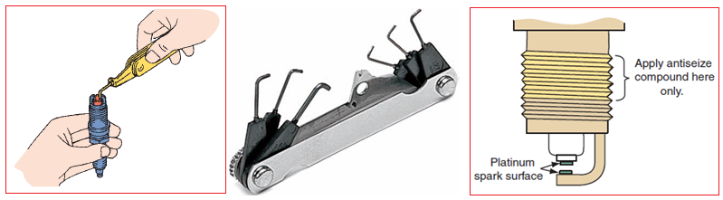

Figure 3.7Check & adjusting spark plug gap

Installing Spark plug on vehicle
1. Remove dirt and grease from the engine plug seats with a clean cloth. Do not let dirt fall into the combustion chambers.
2. If the engine requires spark plugs with gaskets, be sure the gaskets are in good condition and correctly installed on the plugs. Be sure there is only one gasket on each plug.
3. If the engine requires gasket – type plugs in metal cylinders, remove the gaskets before installing the plugs.
4. Be sure that tapered seats of cylinder heads and plugs are clean and free from nicks.
5. Install the plugs into the engine by hand. Use nylon or rubber tubing on the plug terminals or insulators to turn hand-to-reach plugs. Be sure the plugs turn freely in their holes and are not cross threaded. If the plugs do not turn easily, you may have to clean the cylinder head threads with a thread chaser.
6. If possible, use a torque wrench to tighten the plugs to the values listed below
Table 3.1 Spark plug torque wrench specification
Plug type | Cast Iron Head (Nm) | Aluminum Head (Nm)
14mm gasketed | 34-40 | 20-30
14mm tapered seat | 9-20 | 9-20
18mm tapered seat | 20-27 | 20-27
7. If you can’t use a torque wrench, install the plugs finger tight. Then tighten 14mm gasketed plugs an additional ¼ turn, 14mm and 18mm tapered – seat plugs – 1/16 turn.

3.2. Testing spark plug
SPARK TEST
When an engine cranks normally but does not start, make a spark test. This quick check of the ignition system determines if high-voltage surges from the coil secondary winding reach the spark plugs.
Step 1. Start by disconnecting each spark plug wire on your engine one at a time while the engine is running. If the engine drops speed or starts running rough when one is disconnected, you know that spark plug is good. If you disconnect a spark plug and no significant change happens in the engine, you have found a bad spark plug.
Step 2. Test the spark plug ignition by disconnecting the spark plug wire from the spark plug. Hold the end of the spark plug wire close to a metal surface. If the spark plug is good, you will see a spark or you'll hear a crackling noise. This means that voltage is getting through the wire to the spark plug.
Step 3. Using insulated pliers, hold the extender about3/8 inch [10 mm] from the cylinder head or block. Or attach the cable terminal to a spark tester.
See if there is a spark on each one of your sparks plug wires when the engine is cranked. If compression is good, you will have spark on each one of your sparks plug cylinders. No spark would mean that a spark plug wire is dead.
Step 4. Remember that each link connected to your spark plugs needs to be hooked up securely. Links
Include battery cable, ignition wires and coil wires, not just the spark plug wires.
Step 5. Wiggle the link connections from your spark plugs. Then test again. Sometimes it's just a matter of a line connection being loose.
Step 6. Check to make sure that the end of each of the spark plugs is clean and free of any dirt, oil or grease deposits. Sometimes you can just clean them thoroughly and they'll pass the test. But if they still don't test well after cleaning, you'll need to replace them.
CAUTION~
Hold secondary cables with insulated pliers made of nonconductive material. Do not use metal pliers with insulated handles. The spark in a high-energy ignition system can jump an inch [25.4 mm] or more. It could jump around or through the insulation and give you a dangerous shock. Be sure there is no fuel or fuel vapor near where the spark will occur. The spark could ignite the fuel causing a fire or explosion. Probably in the fuel system. No sparking indicates trouble in the ignition system. Make a triggering test of the primary circuit. This will show if the primary circuit is opening and closing.

Operation sheet: 3

Operation title: Gapping the Spark Plug
Purpose: The added power allows them to open the gap yet still provide a strong spark.
Instruction: Adjust spark plug gap by applying the steps which is listed below
Tools and requirement: Running condition engine, Vehicle service/repair manual Spark plug socket wrench (magnetic) and handle, Wire gauge, ramp gauge or feeler gauge, Ignition spark tester & Spark plug tester
Precaution: When adjusting spark plug gap always follow the manufacturer’s specification and service manual
Procedures in doing the task
Step-1: Find the chart listing the proper "gap" for your plugs in your car's repair manual. The spark plug gap may also be on the sticker on the inside of the car's hood. The parts store can provide you with this specification as well or read the basics below.
Step-2: Insert the spark plug gapping tool in the gap between the metal center electrode and the metal side electrode of the plug's tip.
Step-3: Look at the tools ruled edge and find the gap's measurement. If it is too big, bend the spark plug's end with the tool to widen the gap. To make the gap smaller, push the side electrode (the metal part at the very top) against a hard surface.
Step-4: After adjusting, measure again. Repeat this procedure until the gap matches the specification listed in your car's manual.
Step-5: Repeat with each plug.
Quality Criteria: Use the specified tools & use service manual

LAP Test -3 | Practical Demonstration

Task-1: Adjust the gap by applying correct technical steps
Task-2: Test the spark plug by applying correct technical steps

Unit Four: Check/replace fuel filter, air cleaner, contact point & condenser
This learning guide is developed to provide you the necessary information regarding the following content coverage and topics:
- Replacing fuel filter & air cleaner
- Inspecting contact point gap
- Testing & replacing condenser
This guide will also assist you to attain the learning outcomes stated in the cover page. Specifically, upon completion of this learning guide, you will be able to:
- Replace fuel filter & air cleaner
- Inspect contact point gap
- Test & replace condenser

4.1. Replacing fuel filter & air cleaner
A. Fuel filter
A clogged air or fuel filter can cause poor performance, cost you at the fuel pump, and shorten engine life. This simple procedure guards against that. A good rule of thumb is once or twice a year, or roughly once every 12,000 miles (19,320 km).
Steps:
            - Rest the vehicle for 24 hours to let any remaining fuel pressure bleed off.
Check valves in the fuel lines are meant to maintain pressure to help prevent vapor lock.
            - Locate the fuel filter.
Note: The fuel filter is located on the right side of the engine bay just in front of the power steering fluid reservoir. To provide room to work it is highly recommended you remove the entire air cleaner housing.
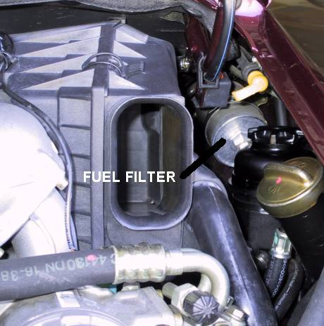

            - Remove the "snorkel tube" from the front of the air cleaner housing. This is a friction fit and if you squeeze the sides, you should be able to easily pop it out. Undo the two clips holding the air cleaner housing cover on and remove the cover and air filter inside the housing.
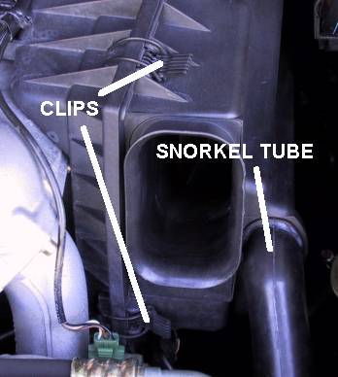

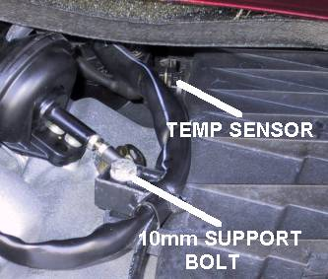
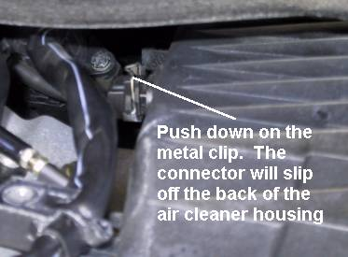
      - Using the 3/8" ratchet and 10mm socket remove the support bolt for the left half of the air cleaner housing. Remove the temperature sensor connector by pushing and holding down the metal clip and gently pulling the connector off the back of the air cleaner housing. The temperature sensor will remain attached to the air cleaner housing.

      - The mass air flow sensor has to be rotated forward towards the front of the car to unlock the bayonet lock that holds the air cleaner housing and mass air flow sensor together. To allow the mass air flow sensor to rotate the hose clamp holding it in position must be loosened and the electrical connector to the mass air flow sensor removed. First use the 8" #2 Phillips screwdriver to loosen the hose clamp. The clamp can only be accessed by inserting the screwdriver just to the right of the Idle Speed Control unit which is located on top of the intake manifold near the top center of the engine bay.

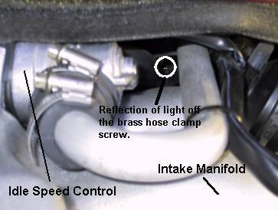
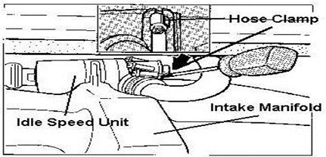
I was able to use my right hand to reach around over the top of the air cleaner housing and use my right-hand fingers to guide the screwdriver in my left hand to the hose clamp behind the Idle Speed Control. Doing this also ensures the hose clamp doesn't rotate making it very difficult to put everything back together.

      - Disconnect the electrical connector to the mass air flow sensor by turning the plastic locking ring and then gently pulling the connector off of the mass air flow sensor. The connector is shape coded so you don't have to worry about remembering proper pin alignment.
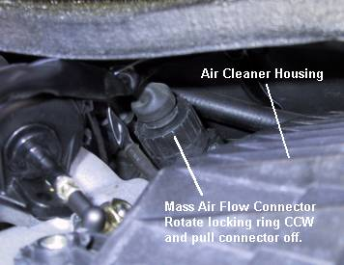

      - The mass air flow sensor can now be rotated forward towards the front of the car to unlock the bayonet lock between it and the air cleaner housing. Rotate the mass air flow sensor forward about 1 inch to completely disengage the lock.
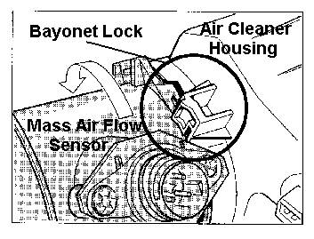

8. The air cleaner housing sits on two rubber mounts. The housing can now be lifted up about 3/4" to clear these mounts and then it can be separated from the mass air flow sensor.
There is a sealing gasket between the air flow sensor and the air cleaner housing. The gasket is held in place on the air cleaner housing by three plastic fingers and should not come out, but use care to ensure the gasket isn't lost or damaged. The last step to removing the air cleaner housing is to disconnect the rubber hose connected at the lower left corner of the housing. With the air cleaner housing in place the house clamp is pretty well hidden behind the forward right cylinder intake runner.
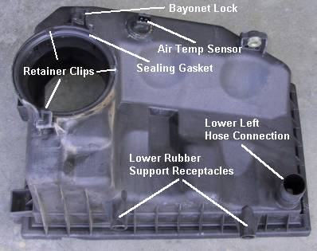
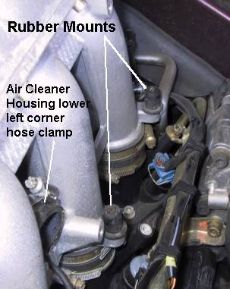
By waiting until the air cleaner housing is off of the rubber mounts and disconnected from the mass air flow sensor you can maneuver the air cleaner housing and rubber hose to a position that will allow you to loosen the hose clamp and separate the hose from the air cleaner housing. Removing the air cleaner housing from the engine bay is somewhat of a jigsaw puzzle because of the tight fit. Be patient.
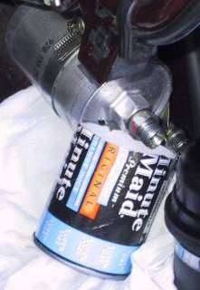
- Now that the air cleaner housing is out of the way there is plenty of room in which to work. You'll need a good supply of rags and a small can to catch the gas that will inevitably come out of the filter. Remove the connection near the rear of the car first. Used a 19mm open wrench on the filter side nut to hold the filter steady and a 19mm flare wrench on the fuel line nut to break the connection. This connection was not particularly tight and the leverage angle of the wrenches is not too awkward. Once the fuel line was off, enough gas came out to fill the can up about 1/3 of the way.
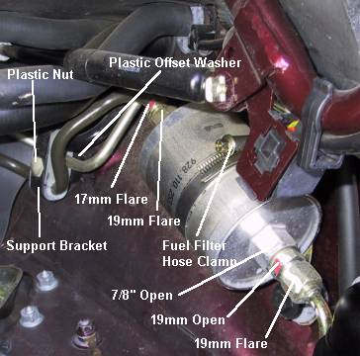

- Theoretically, you should be able to use a 17mm and 19mm flare wrench on the connection towards the front of the car. However, it is up underneath the front of the engine bay and the leverage angles are awkward. After 5 minutes of grunting and groaning with no obvious movement of the two nuts I chose a different approach. First, loosen the fuel filter hose clamp. Then put the 17mm flare wrench on and braced it against the side of the engine bay to hold the fuel line steady. Finally, use the 7/8" open wrench on the nut shaped portion of the fuel filter (side facing rear of car) where the first connection had already been undone. This allowed a much better leverage angle on the 7/8" wrench / fuel filter. Using this method, you will be able to get the fuel filter off. However, it left the 19mm nut that was originally part of the fuel filter connected to the 17mm fuel line nut. Also, once the fuel filter started to come loose another 1/3 of a cup of gas came pouring out from the already open end of the filter (like opening the vent plug of a 5-gallon gas can). The fuel line is supported by a bracket a few inches farther forward in the engine bay (see previous pictures). A few inches farther upstream from the bracket, the metal fuel line changes to a rubber line. By loosening the fuel line support bracket, you can now move the fuel line into a position that you could use the 17mm and 19mm flare wrenches with a good leverage angle and will be able to finally separate the two nuts.
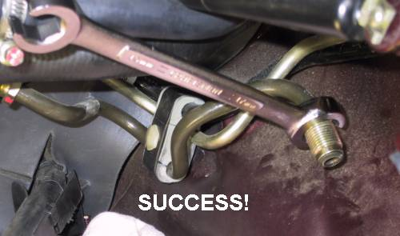

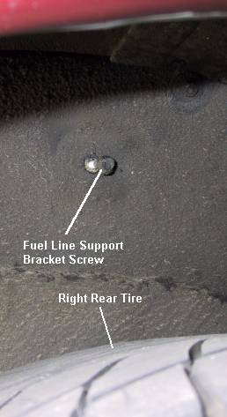
11.The fuel line support bracket is freed up by loosening a 10mm bolt in the right rear wheel well that screws into the six-sided plastic nut on the support bracket (see previous pictures). One final note, there is a black plastic offset washer between the fuel support bracket and the side of the engine bay. Don't forget to put this back in place when putting everything back together.

All that remain is to put everything back together again pretty much in the reverse order you took it all apart. The order was:
1. Reattach the fuel line support bracket (remembering the offset plastic washer!).
2. Insert new fuel filter and attach to the forward 17mm fuel line nut. Be careful to get the filter oriented the proper direction. There should be an arrow on the fuel filter itself (should point to the rear of the car) and the nut arrangement between the fuel lines and filter are one directional, but just be sure.
3. Attach the other fuel line (19mm nut).
4. Secure the fuel filter hose clamp. Mark the mileage and date on the filter for future reference.
5. Attach the rubber hose to the lower left corner of the air cleaner housing.
6. Set the air cleaner housing onto the two lower rubber support mounts and work the mass air flow sensor into the back of the air cleaner housing being cognizant of the sealing gasket.
7. Rotate the mass air flow sensor to the rear of the car to re-engage the bayonet lock between the air flow sensor and the air cleaner housing.
8. Secure the 10mm support bolt on the upper left half of the air cleaner housing.
9. Tighten the mass air flow sensor hose clamp with the 8" #2 Phillips screwdriver. Use your right hand to hold the clamp in place while using a screwdriver in your left hand to tighten the hose clamp.
10. Reattach the mass air flow sensor connector and the air cleaner housing temperature sensor connector.
11. Replace the air filter, the air cleaner housing cover and the "snorkel tube."
Finally, start the car and check for leaks. It will probably take a couple tries before the car will start up.
B. Air cleaner
Changing the air filter should be part of any major tune-up, but if you drive on dirt roads or in other dusty conditions, you will need to replace it more frequently. On most cars, this is a fairly simple procedure. You should change your car's air filter every 15,000 miles.

Steps:
1. Open the hood.
2. Locate your air filter, usually found on top of the engine. On cars with carburetors, it is in a round piece of metal about the size of a medium pizza; fuel-injected cars have square or rectangular air filter housings that may be off to the side of the engine.
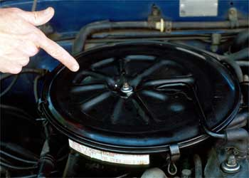

3. Unscrew or unclamp the top to the air filter housing.
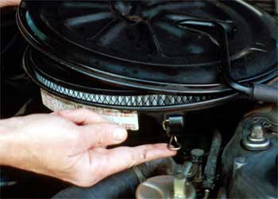

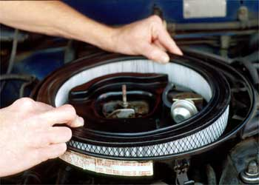
4. Lift out the air filter. It should be a round or rectangular filter made of paper or plastic, with a rubber rim.

5.Clean the area with a vacuum cleaner or seal the top of the carburetor. This will keep debris out of the carburetor as you continue to clean the housing.
6. Clean out any dirt or bugs from the inside of the air filter housing with a rag.
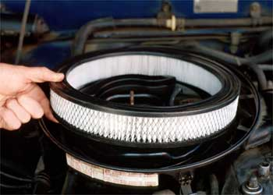
7. Replace the filter with a new filter. Consult your manual to determine the proper filter for your car. Check your old filter element for dirt, oil or moisture, cracks and proper sealing at the gasket.

8. Replace the cover and close the hood.
Warning: Avoid using the wrong size air filter. Your engine will run less efficiently.
Note: Reusable air filters cost more than disposable filters, but if cared for correctly, they can last for over 50,000 miles. Another good way to make your air filter last is to actually use a vacuum cleaner. Simply take the filter out and with the small attachments from the vacuum, suck out the dust and dirt. Good as new and it will make your filter last a little longer

4.2. Inspecting contact point gap
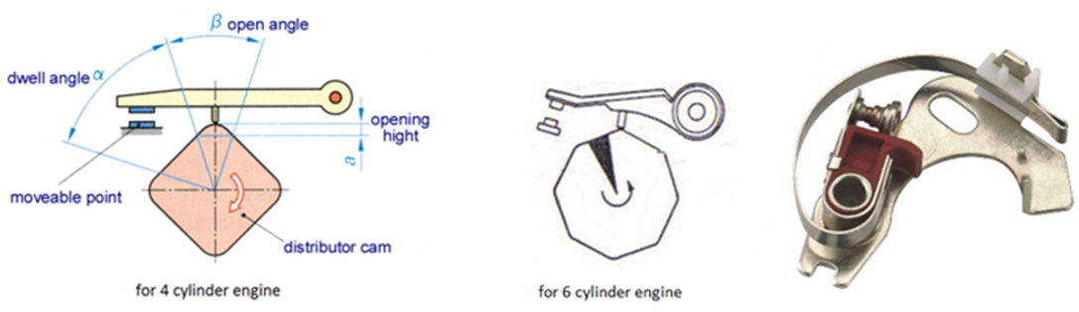
It is mechanically designed breaker point. It’s one end is fixed and another end is movable. It is attached to the breaker assembly. Its main function is to makes and breaks the primary circuit current. The contact-point set mounts on a breaker plate in the distributor. The points are operated by a breaker cam on top of the distributor shaft. The cam has the same number of lobes as there are cylinders in the engine. As the cam revolves, the points close and open, they act as a mechanical switch to make and break the primary circuit.

Figure 3.8Contact Breaker/ Contact Point
A. Inspecting Contact breaker points
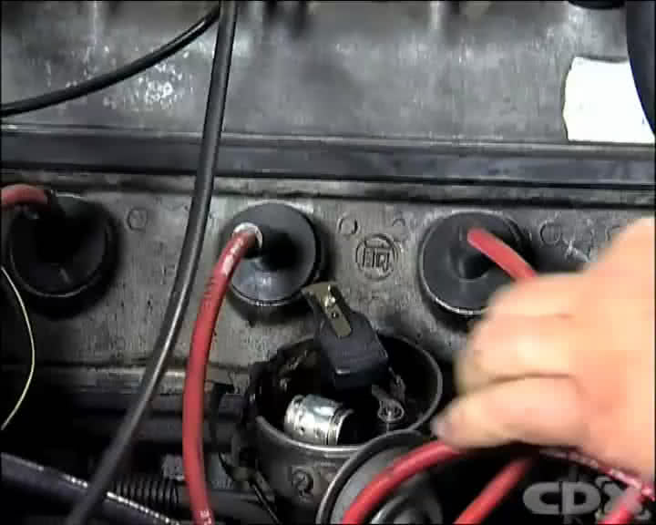
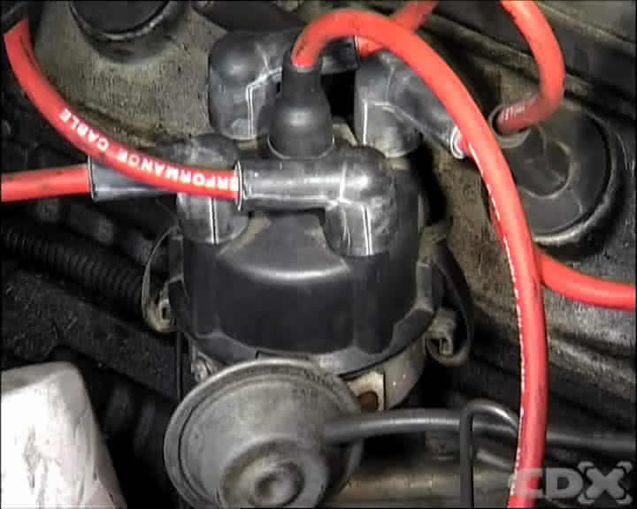
Step 1 - Locate the Distributor and Remove the Cap

The contact breaker points are found in the base of the distributor, below the distributor cap and the rotor. Remove the cap by unclipping the fasteners and carefully locate the cap in a position adjacent to the distributor. Remove the rotor making note of its position and locating method
Step 2 - Rotate the Engine
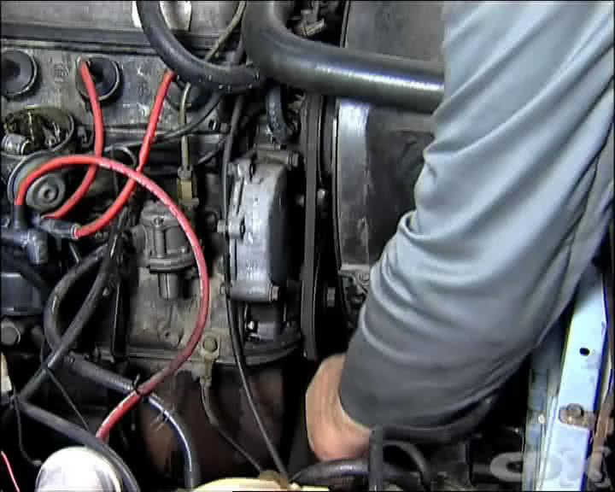
With the vehicle in neutral, carefully rotate the engine by hand using an appropriate tool on the engine pulley until the points are at their widest opening. This is where the heel of the rubbing block of the contact breaker points rides on the cams of the distributor shaft, opening the points as it rotates.

Step 3 - Remove Brake Pads and Caliper
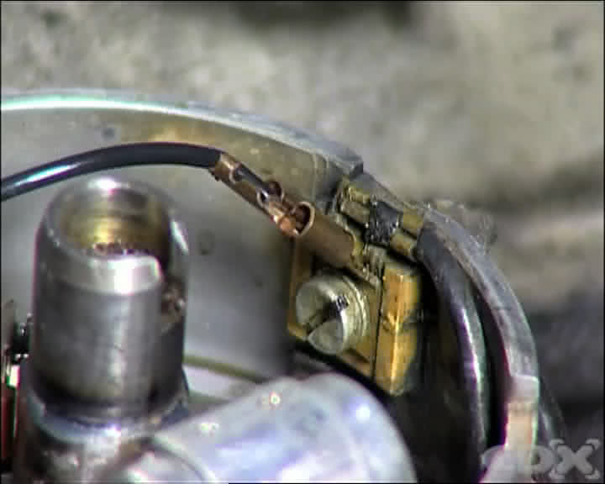
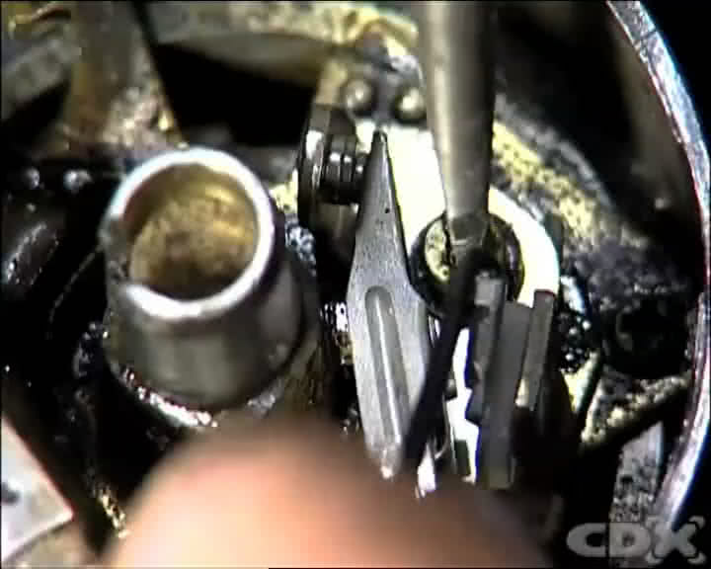
Unclip the small electrical leads from the ignition coil and capacitor at the back of the points. There are various ways to fix these so follow the instructions in the manual. Remove the locating screw from the contact breaker point base plate, and then remove the points from the base of the distributor.
Step 4 - Inspect the Points
Inspect the contact breaker points for their condition. Small indications of pitting are quite normal, however a transfer of more than 1mm of tungsten material from one side of the points to the other indicates that the capacitor may also need changing.
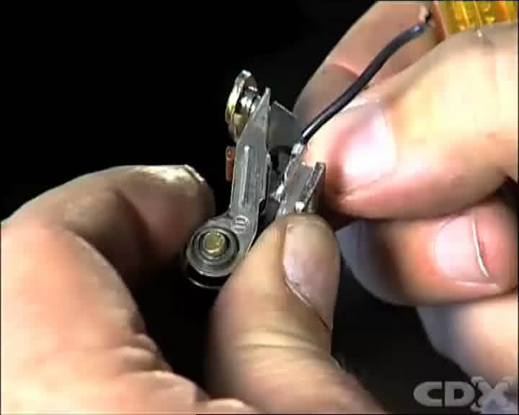

Step 5 - Check Mechanical Advance and Retard Weights
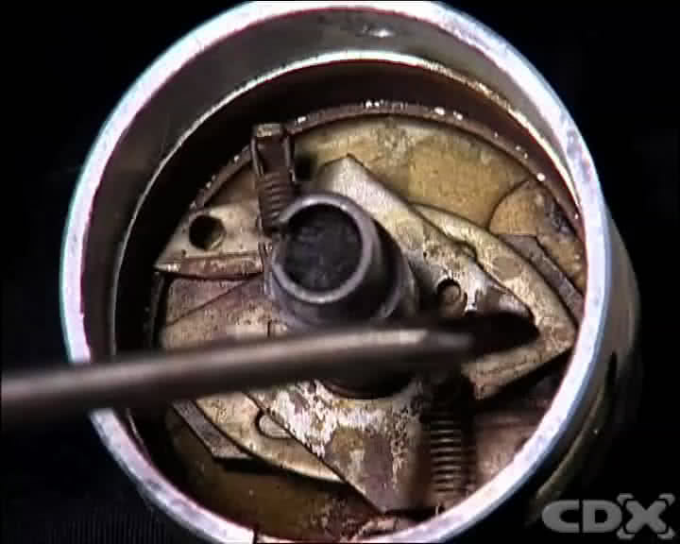
Next, inspect the condition of the mechanical advance and retard units balance weights.
Remove the distributor base plate, and check to see that the weights can be moved on their locating points freely, and that the restraining springs are in place and in good order. If necessary, apply a small amount of the manufacturer’s specified lubricant. Refit the distributor base plate in its correct location and ensure that the capacitor, if located on the base plate, is secure.
Step 6 - Check the Vacuum Advance Unit
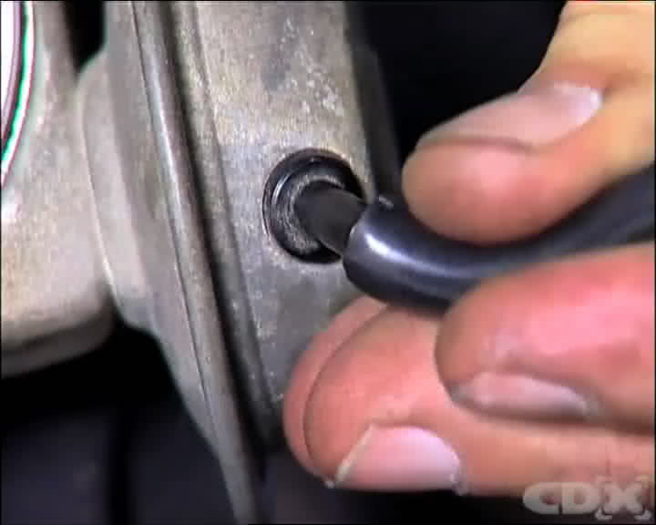

Vacuum load sensitive advance and retard units can be checked by attaching a vacuum source to the end of the unit and watching to see if the base plate moves in relation to its reference points. When the vacuum source is removed the base plate should move back to its static position
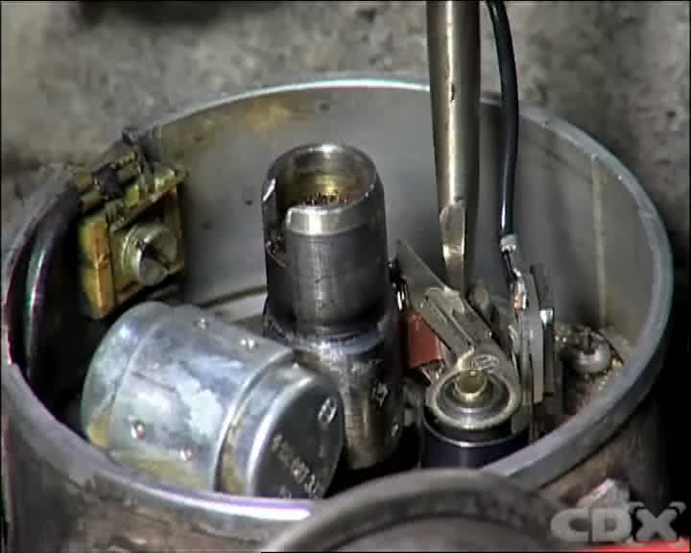
Step 7 - Fit the Contact Breaker Points
Clean the new points to remove the protective coating, then locate the new contact breaker points on the base plate and replace the locating screw.
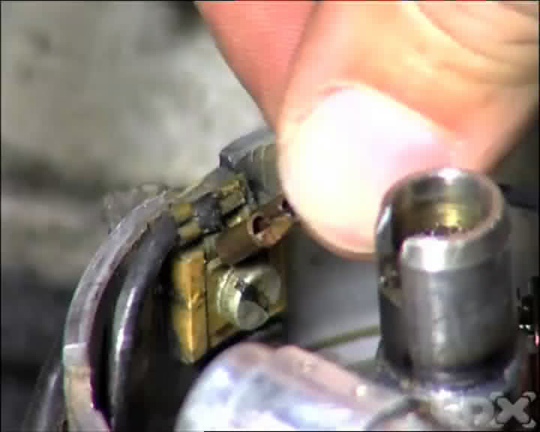

Leave it loose enough to allow the points to be moved in relation to the base plate. Refit the electrical connections from the ignition coil and the capacitor.

Step 8 - Adjust the Contact Breaker Points
B. Procedure for adjusting contact point
Adjusting contact point gap
1. Remove the distributor cap and rotor.
2. Rotate the engine with the starter or by turning the belt until the points are fully open.
3. Measure the gap with feeler gauge
4. Loosen the point hold – down screw and move the points if adjustment is necessary.
5. Tighten the screw and check the gap
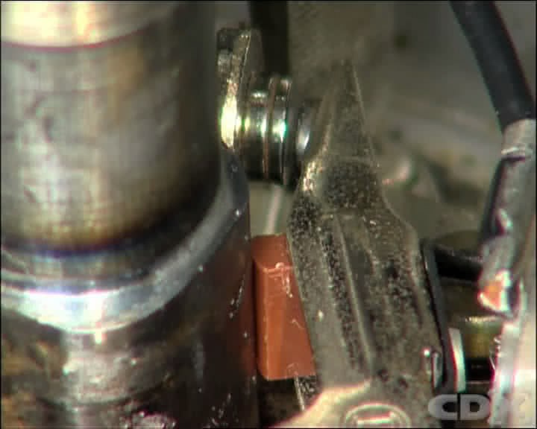
Apply cam grease on the distributor cam

Adjust the points by locating the heel of the rubbing block of the contact breaker points so it rides on the cam of the distributor shaft. Using a feeler gauge of the correct manufacturers’ specifications, gently adjust the points with a screwdriver until the points gap is in accordance with specifications. Then tighten the locating screw and recheck the gap setting.

4.3. Testing & replacing condenser
Checking condition of condenser
There are different methods of checking condenser. The following are only three of them.
By observing spark length
1. First, check the length of the existing spark. Operate the points manually. Use a screwdriver.
2. With the other hand, hold the high-tension cable about 10mm away from a metallic part of the engine.
3. If you find that there is a good spark, increase the distance until the spark begins to miss. As soon as this happens, estimate the distance and record it.
4. If no spark appears at a distance of 10mm, then reduce the distance until you get a proper spark. Again, estimate and record it.
5. Switch off the ignition, then disconnect and remove the condenser. Replace it by a new one, or one which still appears to be serviceable and connect it between the distributor low-tension terminal and earth.
6. Now switch on the ignition again and repeat the operation described in step 1, 2 and 3.
7. If you receive a better result with a longer and more powerful spark, then the condenser was faulty.
8. If you cannot see any change and the length of the spark is still less than 10mm, then it shows that the condenser is in good condition.
Note
The method described above is not a real test, only a comparison and does not reveal the capacity of the condenser.
B. By using ohmmeter
Another possible way of checking the condenser is to use an ohmmeter. The ohmmeter must have a measurement range of up to 400 kΩ = 400000 (ohm).
1. Disconnect the condenser from the cable.
2. Open the contact breaker points. The best thing to do is to put a strip of cardboard about 1mm thick between both points, to ensure that no contact can be made.
3. Now carefully read the instructions on how to operate the ohmmeter and set it at zero.
4. With one tip of the ohmmeter touch the housing (ground). With the other tip, touch the cable of the condenser.
5. Now check the reading of the ohmmeter and record it.
6. The reading, which means the resistance of the insulation, should not be less than 200 kΩ (200000 ohms).
7. A condenser with less than 200 kΩ resistance must be replaced
Note
This test will only give you the condition of insulation of the condenser. It will not tell you whether its capacity is correct for a particular ignition system, or whether it matches the ignition coil. Always ensure that the capacity which is written on the condenser, corresponds to the manufacturer’s data.
C. using capacity tester
Read carefully the manual of the tester before trying to use it.
Keep the selector of the tester to capacity test position.
Connect one terminal of the tester to the body of the condenser.
Connect the other terminal to pig tail (insulated terminal) of the condenser.
Take the reading from the meter and compare it with the specification.

Procedure for Testing & replacing condenser
It's good practice to replace the condenser at the same time. When you replace the points, you then must check and, if necessary, re-set the timing to specification.
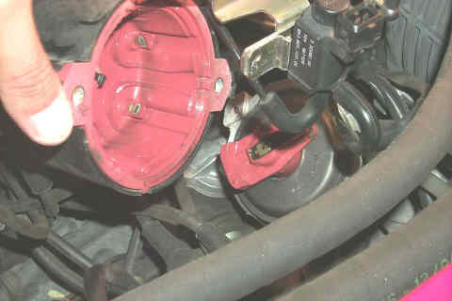
1. Remove the distributor cap. You will find that there are two spring clips which hold it on.

2. Insert a screwdriver between each clip and the distributor case, and pry them off the cap. The cap then simply lifts off. Do not remove the spark plug wires from the distributor cap.
3. Remove the rotor by pulling it straight up off the distributor shaft.
4. Remove the plastic dust cover by lifting it off the distributor.
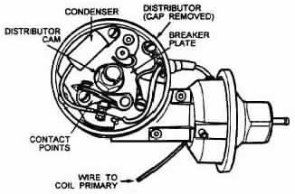
5. Remove the old contact points. You will see that there is a screw that holds the points unit to a plate inside the distributor.

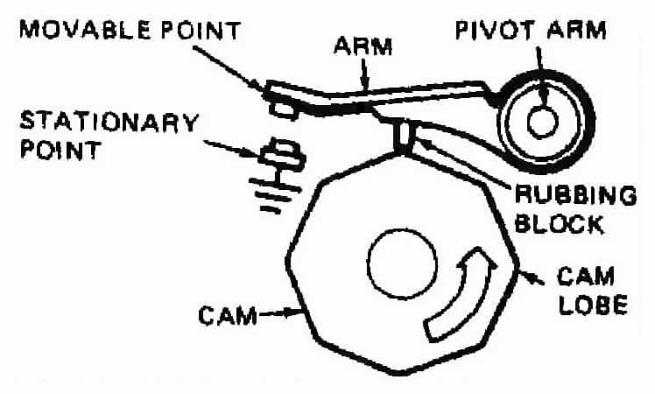

6. Loosen and remove this screw. Unplug the wire from the points from the black plastic plug that it's connected to. Just pull it straight off.
7. Now withdraw the points and if they are pitted/excessively worn, replace them. If they look good, keep them as your spare for an emergency
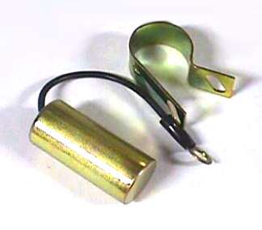
8. Remove the condenser. The condenser is that little metal can inside or outside of the distributor. There is one screw that holds the condenser on itself, and there is another which holds the black plastic plug to the distributor body. Both of these screws are readily accessible, so remove them and the little metal plug clip, and then remove the condenser and plug from the distributor.

Operation sheet: 4
Operation title: - Testing/Replacing condenser
Purpose: -To check the capacity of the condenser for the ignition system
Instruction: - Perform the test by following the proper procedure, using relevant tools & measuring equipment as specified by the manufacturer.
Tools and requirement: - Live Engine (gasoline), Screw driver, Condenser tester & Engine service manual
Precaution: - Always ensure that the capacity which is written on the condenser, corresponds to the manufacturer’s data.
Procedures in doing the task:
Step 1: Remove the distributor cap
Step 2: Insert a screwdriver between each clip and the distributor case, and pry them off the cap.
Step 3: Remove the rotor by pulling it straight up off the distributor shaft.
Step 4: Remove the plastic dust cover by lifting it off the distributor.
Step 5: Remove the old contact points. You will see that there is a screw that holds the points unit to a plate inside the distributor.
Step 6: Loosen and remove this screw
Step 7: Now withdraw the points and if they are pitted/excessively worn, replace them.
Quality Criteria: Test the condenser in accordance with the manual of specifications and instruction.

LAP Test -4 | Practical Demonstration

- Test Condenser by applying correct technical step
- Measure the resistance of the condenser
- Test the insulated terminal of the condenser

Unit Five: Testing/adjusting dwell angle, ignition setting, engine idle speed & mixture
This learning guide is developed to provide you the necessary information regarding the following content coverage and topics:
- Adjusting dwell angle
- Setting ignition timing
- Adjusting idle speed & mixture
This guide will also assist you to attain the learning outcomes stated in the cover page. Specifically, upon completion of this learning guide, you will be able to:
- Adjust dwell angle
- Set ignition timing
- Adjust idle speed & mixture

5.1. Adjusting dwell angle
Dwell or dwell angle is the number of degrees the distributor shaft rotates measured from the point where the ignition contacts close to the point where they open again.
Dwell angle is inversely proportional to point gap, that is, increasing the gap decreases the dwell, and vice versa. Insufficient dwell may cause ignition failure at high speed, while too much dwell increases the total average current which the points must handle, particularly at low speed. This usually leads to very short point life.
After a distributor is initially timed for a given engine, any change in dwell will result in a change in timing, requiring re-timing of the distributor since the rubbing block of the moving arm will contact the cam in a different place.
Set the point dwell to the lower limit for new points to allow for rubbing-block wear when a dwell specification is given with a high and low limit.

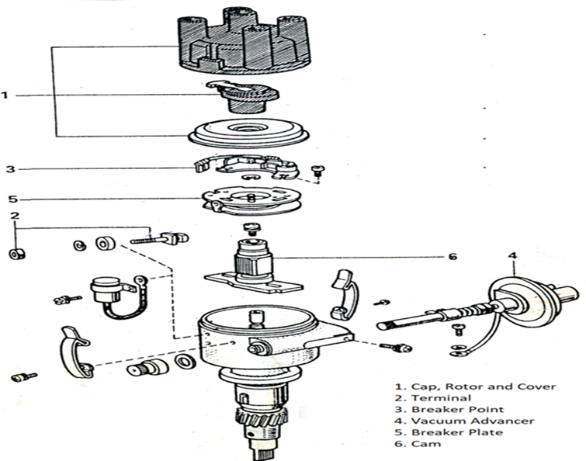

Figure 5.9 Distributor Assembly
The percent of dwell is the percentage of the actual dwell angle of the points as compared to the maximum, dwell angle possible (100 percent dwell). The 100 percent dwell for 4-, 6-, and 8-cylinder engines, and some examples of percent of dwell are listed in Table 1.
TABLE 5.2
No. of Maximum cylinders dwell angle (100% dwell)
4 cylinders = 90° | 6 cylinders = 60° | 8 cylinders = 45°

Comparison of percent of dwell and dwell angle
Percent of Calculation | Corresponding dwell | dwell angle
60% (.60) | (90°) | 54°
60% (.60) | (60°) | 36°
60% (.60) | (45°) | 27°

CHECKING/ADJUSTING FOR PROPER DWELL ANGLE
1. Connect the dwell meter as per its manufacturer's instructions: Generally, one of two leads is connected to the positive terminal of the battery and the other lead to the negative terminal of the coil.
2). Start the engine and read the dwell angle (making sure meter is set on 4 cylinder).
3). If dwell angle is too high (points closed for too many degrees of rotation), you will have to carefully reset your points to a slightly larger gap. If the dwell angle is too low, the points will need to be set slightly closer. Adjust the gap .002" or .003" at a time for best control.
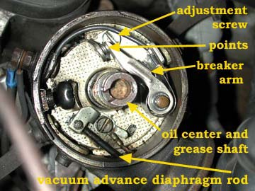
4). Restart the engine and re-measure dwell angle. Repeat as above until dwell angle is correct.

Figure 5.10Top view of distributor (cap removed) showing contact breaker points.

5.2. Set ignition timing
In any sort of timing advance system, there must be a starting point. This is called the Basic Timing Setting. It is the position of the distributor plate and cam at idle speed when none of the advance systems are in operation. In older engines the basic timing is usually 5 to 10 degrees before TDC. Newer, pollution - control engines, often operate at 0⁰ TDC or as much 4⁰ after TDC.
Timing advance is usually fixed, unless the mechanism breaks. However, basic timing is adjustable according to manufacturer's specifications. Basic timing is usually adjusted by loosening the distributor lock - down bolts and moving the distributor housing clockwise or counter clockwise. The correctness of the adjustment can be determined by shining a timing light marking inscribed on one of the crankshaft pulleys or on a plate alongside the pulley.
Correct ignition timing is essential for optimum engine performance and fuel efficiency.

A. Static timing adjustment
Procedures for adjusting Static ignition timing
During installation, the distributor must be timed to the engine if the crankshaft has turned while the distributor was out. Locate the firing order and cylinder numbering illustration for the engine. This is in the vehicle service manual and auto repair manuals. Note the position of the cap latches or screws.
- Install the distributor in the engine in the same position. Also note the location of the number one terminal on the distributor cap. When the number one piston is at TDC ending the compression stroke, the rotor tip should point to the number one terminal in the cap.
To time the distributor to the engine,
- Remove the number one spark plug. Locate the timing marks. Most engines have a rotating mark that aligns with a specified stationary mark when ignition timing is correct. The timing marks are usually on the crankshaft vibration damper and the engine front cover. Some are on the flywheel and the housing.
- Place a shop towel over your finger and cover the sparkplug hole. Do not allow your finger to enter the spark-plug hole! Crank the engine with the starting motor until you feel compression pressure push against your finger.
- Continue bumping the engine with the starting motor until the timing marks align. This shows that the number one piston is in firing position.
- Install the distributor, making sure the rotor tip aligns with the cap terminal for the number one spark plug.
- Install but do not tighten the distributor clamp and bolt.
- Rotate the distributor until the primary trigger opens the primary circuit. This occurs when:
- The contact points start to open.
- The reflector tip passes alignment with the pole piece.
- The shutter leaves the air-gap in the Hall-effect switch.
- The rotating disk interrupts the light beam striking the photodiode.
- Hold the cap in its mounting position above the distributor.
- Check that the rotor tip aligns with the number one terminal on the cap. Install the cap.
- Connect the primary lead.
- Start the engine and check that the oil light in the instrument panel goes out.
- If not, stop the engine and check for proper seating of the distributor.
B. Dynamic timing
Procedures for adjusting Dynamic ignition timing
Check distributor breaker point dwell and if necessary, adjust to manufacturer's specification. Replace breaker points if needed.
Disconnect vacuum hose from distributor vacuum advance unit and plug hose to insure proper operation of the carburetor.
Connect timing light battery leads to a 12 Volt vehicle battery; red to positive (+) and black to negative.
Connect timing light inductive pickup or clip lead to No. one spark plug cable as follows: Place the inductive Pickup around the appropriate spark plug wire.
For best results the pickup should be hooked up with its label side facing toward the spark plug end of the wire, but placed near the distributor and away from the spark plug. This provides a" cleaner" electrical signal and keeps away from the hot manifold.
Initial Dynamic ignition Timing check
1. Start engine and adjust speed to that specified for ignition timing.
2. With timing light aimed at timing pointer, press trigger and observe position of timing mark when light flashes. Refer to manufacturer's specifications for correct setting.
NOTE: For the Timing-Advance Tester, be sure that the control knob is fully counterclockwise in the timing position.
Be sure to view the timing mark from a position that allows your eyes to be squarely in line with the timing mark and measurement scale. An error in timing could result if the mark is viewed from another angle.
3. To adjust, loosen distributor-locking screw and turn distributor until specified timing mark is lined up with pointer.
4. Tighten the distributor locking screw, and recheck timing.

5.3. Adjusting idle speed & mixture
Procedure for adjusting idle mixture and idle speed
1. Bring the engine to operation temperature.
(How, if it doesn't run at idle? …………………………………………….. )
2. Stop the engine
3. Identify the idle mixture and the idle speed adjusting screws.
4.Close the idle mixture adjusting screw completely (do not use force!).
5.Re-open the idle mixture adjusting screw 2 ½ - 3 rotations.
6.Close the throttle completely using the idle speed adjusting screw.
7.Re-open the throttle by 2 ½ - 3 rotations.
8.Start the engine.
9.Bring the engine to its operation temperature.
10. Connect the tachometer according to the manual.
11. Close the idle mixture adjusting screw until the engine RPM begins to drop.
12. Re-open the idle mixture control screw until the increment of the engine RPM.
just stops.
13. By using the idle speed adjusting screw, adjust the idle speed to the given
specification (i.e., 800 rpm)
14. Raise the speed again by some RPM above the specification (i.e., to 850 rpm).
15. Close the mixture adjusting screw until the engine RPM reaches again its
specification (i.e., 800 rpm)
Most problems with the fuel system are mechanical problems, but some cases of trouble involve problems caused by the fuel itself.

Operation sheet: 5-1
Operation title: Ignition Timing Adjustment "static”
Purpose: To prepare cylinder number for a power
Instruction: Perform the adjustment by following the proper procedure, using relevant tools & measuring equipment as specified by the manufacturer.
Tools and requirement: Live engine(gasoline), Gasoline fuel, wrenches, Engine service manual, Multi meter, Test Light12v, Extension Lamp,12v70AH car battery, Feeler gauge, cleaning rug & other tools as specified by the manufacturer
Precaution: When testing any ignition system, always follow the manufacturer’s suggested diagnosis and service procedure or (Make sure that you use the proper tool in the proper manner! Do not spoil the screws!
Procedures in doing the task:
Step-1: Identify advance & TDC mar
Step-2: Identify direction of distributer shaft rotation
Step-3: Know engine firing order
Step-4: Mount distributor shaft while cylinder number one is at the end of compression stroke & advance mark aligned with timing mark.
Step-5: Crank the engine to start it
Quality Criteria: Use specified tools & service manual
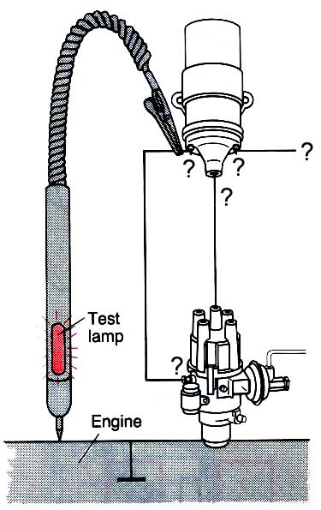

Figure 5.11Ignition Timing Adjustment "static”

Operation sheet: 5-2
Operation title: Dwell Angle (point gap) Adjustment
Purpose: To allow primary current to reach an acceptable value, then open long enough to discharge & produce a spark
Instruction: Perform the adjustment by following the proper procedure, using relevant tools & measuring equipment as specified by the manufacturer.
Tools and requirement: Dwell angle tester, Manual of dwell angle meter, screwdrivers & Engine service manual
Precaution: When testing any ignition system, always follow the manufacturer’s suggested diagnosis and service procedure or (Make sure that you use the proper tool in the proper manner! Do not spoil the screws!)
Procedures in doing the task
Step-1: Adjust the point gap to 0.3 mm.
Step-2: Connect the dwell meter to the engine.
Step-3: Crank the engine and measure the dwell angle at cranking speed
Step-4: Now determine (check) the static ignition timing
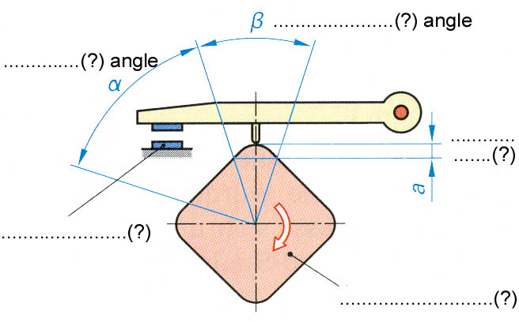
Quality Criteria: Dwell angle is adjusted / set in accordance with the manual of specifications and instruction.

Figure 5.12Dwell Angle (point gap) Adjustment

LAP Test -5 | Practical Demonstration
Task-1: Measure ignition coil secondary winding resistance by applying correct technical steps
Task-2: Test coil current draw by applying correct technical steps
Task-3: Adjust ignition timing statically
Task-4: Measure voltage drop test by using a multi meter
Task-5: Test power supply for the circuit

Unit Six: Adjusting / Checking advance mechanism of ignition system
This learning guide is developed to provide you the necessary information regarding the following content coverage and topics:
- Mechanical /Centrifugal advance mechanism
- Vacuum advance mechanism
This guide will also assist you to attain the learning outcomes stated in the cover page. Specifically, upon completion of this learning guide, you will be able to:
- Adjust Mechanical /Centrifugal advance mechanism
- Adjust Vacuum advance mechanism

6.1. Adjusting Mechanical /Centrifugal advance mechanism
The centrifugal-advance mechanism advances the spark by pushing the breaker cam ahead as engine speed increases. Two advance weights, two weight springs, and a cam assembly provide this action. The cam assembly includes the breaker cam and an oval-shaped advance cam. At low speed, the springs hold the weights in. As engine speed increases, centrifugal force causes the weights to overcome the spring force and pivot outward. This pushes the cam assembly ahead. The contact points open and close earlier and advancing the spark.

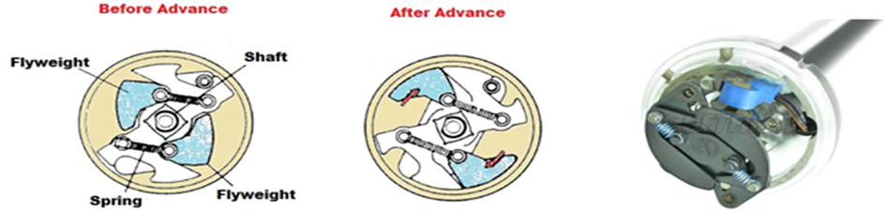

Figure6.13centrifugal advance

Procedure for adjusting Mechanical /Centrifugal advance mechanism
1.With engine operating at specified timing speed and distributor vacuum line disconnected, aim timing light at timing pointer and press trigger while watching position of timing mark.
2. Slowly increase and decrease engine speed from timing speed to about 2000RPM while watching position of timing mark.
- If the timing mark moves away from and returns to its original position, gradually and without hesitation as speed is increased and decreased, the centrifugal advance mechanism is operating satisfactorily.
- If the timing mark moves away from its original position rapidly with little change in engine speed, or moves very little with considerable change in speed, or fails to return to its original position when speed is decreased, the centrifugal advance mechanism is in need of service.
- Jerky changes may indicate sticking advance weights in the distributor.
Computerized engine controllers may require special conditions for this test.

6.2. Adjusting Vacuum advance mechanism
When the throttle valve is only partly open, a partial vacuum develops in the intake manifold. Less air-fuel mixture gets into the engine cylinders. Then the fuel bums slower after it is ignited. The spark must be advanced at part throttle to give the mixture more time to burn. The vacuum-advance mechanism advances spark timing by shifting the position of the breaker plate. The vacuum-advance unit has a diaphragm linked to the breaker plate. A vacuum passage connects the diaphragm to a port just above the closed throttle valve. When the throttle valve moves past the vacuum port, the intake-manifold vacuum pulls on the diaphragm. This rotates the breaker plate so the contact points open and close earlier. Any vacuum port above the throttle valve provides ported vacuum.
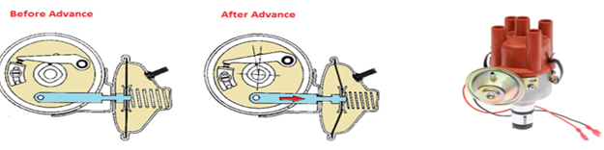
Figure 6. 14 Vacuum advance

Procedure for adjusting Vacuum advance mechanism
1. With engine speed adjusted to idle at about 1000 rpm and distributor vacuum line connected, aim timing light at timing pointer and press trigger while observing timing mark.
NOTE: Be aware that some engines equipped with emission control devices may prevent the vacuum advance mechanism from operating when the transmission is in the neutral position.
Refer to manufacturer's specifications for special instructions.
2. Suddenly open and close the throttle, causing the manifold vacuum to momentarily fall, while observing the position of the timing mark.
- If the timing retards when the throttle is opened and advances when the throttle is closed, the vacuum advance mechanism is operating satisfactorily.
- If the timing mark moves very little or there is no change other than that caused by the centrifugal advance, operation of the vacuum advance mechanism is in need of service.

Operation sheet: 6
Operation title: - Adjusting Mechanical /Centrifugal advance mechanism
Purpose: -To allow the contact points open and close earlier and advancing the spark.
Instruction: - Perform the adjustment by following the proper procedure, using relevant tools & measuring equipment as specified by the manufacturer.
Tools and requirement: - Live Engine(gasoline), Distributor tester, Timing light with advance meter, Tachometer, Engine service manual & Lubricant
Precaution: - Read and interpret manuals which guide you how to Adjusting Mechanical /Centrifugal advance mechanism
Procedures in doing the task:
Step 1: With engine operating at specified timing speed and distributor vacuum line disconnected, aim timing light at timing pointer and press trigger while watching position of timing mark.
Step 2: Slowly increase and decrease engine speed from timing speed to about 2000RPM while watching position of timing mark.
Quality Criteria: Mechanical /Centrifugal advance mechanism set in accordance with the manual of specifications and instruction.

LAP Test -6 | Practical Demonstration
Task 1. Adjust centrifugal advance mechanism
Task 2. Test functionality after Adjust centrifugal advance mechanism

Reference
1.Automotive Mechanics 10th Edition by Cruise and Anglin (Textbook)
2.Auto service & repair, Stochel,1969
3.Motor repair manual
4.Igntion & cranking system, Delco Remy
5.Auto mechanic, Glenn
6.Vehicle service manual
7.Auto Mechanics, Theory and Service by: de Kryger, Kobacik. Bono

8.Corolla, Service and Repair Manual by: Gregory’s Scientific Publication

9.Lancer, Service and Repair Manual by: Gregory’s Scientific Publication

Participants of this Module (training material) preparation
No | Name | Qualification (Level) | Field of Study | Organization/ Institution | Mobile number | E-mail
1 | Fadli Aman | BSc. B-Level | Automotive Technology | General Wingate PTC | 0927283100 | Fadli.ziyad@gmail.com
2 | Gashaw Zewde | MSc. A-Level | Automotive Technology | AKPTC | 0910730747 | Gashawgashaw69@gmail .com
3 | Muna Gabrie | MSc. A-Level | Automotive Technology | Dire PTC | 0910511196 | Munamulunhe@gmail.com
4 | Sisay Dawit | MSc. A-Level | Automotive Technology | Harar PTC | 0910672115 | Sisaydawit058@gmail.com
5 | Yohannes Negatie | MSc. A-Level | Automotive Technology | W/ro Siheen PTC | 0922094453 | Yohannes2013n@ gmail.com

