
Automotive Electricity and Electronics
Level-III
Based on October, 2023 Curriculum Version II
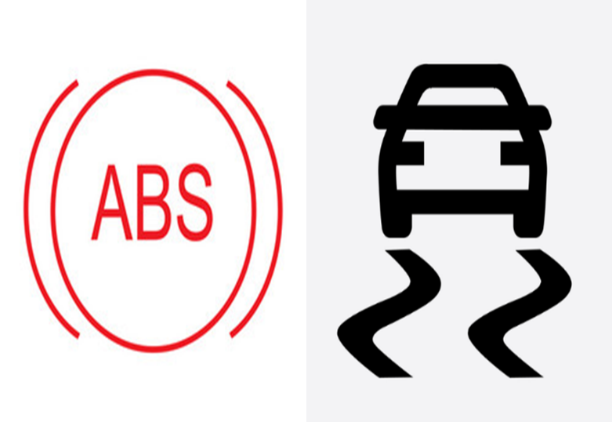
Module Title: - Electronically Controlled Braking and Stability control Systems
Module code: EIS AEE3 M04 1023
Nominal duration: 60 Hours
Prepared by: Ministry of Labor and Skill
October, 2023
Addis Ababa, Ethiopia

Table of Contents
Acknowledgment 5
Acronym 6
Introduction to module 7
Unit one: Introduction to electronic brake system 8
1.1 Tools And Equipment 9
1.1.1 Jack And Jack Stand Safety 9
1.1.2 Safety Stands 9
1.1.3 Multi-Meters 10
1.1.4 Scan Tools 10
1.1.5 socket wrench set 11
1.1.6 Screwdrivers 11
1.1.7 ABS tester 12
1.2 Types and channels of anti-lock brake system (ABS) 12
1.2.1 Integral systems 12
1.2.2 Non integral system 12
1.2.3 ABS channels 13
1.3 Operating principles of ABS 14
1.4 Components part and operation of ABS 17
1.5 Modes of ABS 24
1.6 Electric/electronic brake system 30
1.7 OHS requirement 35
Self-Check 1 39
Unit Two: Traction and Electronic Stability Control System 40
2.1. Traction control system 41
2.1.1 Operating principle 41
2.1.2 Function of Traction control system 42
2.1.3 Basic components and their function 44
2.1.4 Traction control hydraulic and wiring diagram 49
2.1.5 System diagram 53
2.2 Electronic stability control system 58
2.2.1 Operating principle 58
2.2.2 Function of electronic stability control 59
2.2.3 Major components of electronic stability control 60
Self-check 2 65
Operation sheet-2 66
LAP- Test 67
Unit Three: Servicing and Repairing Electronic Brake System, Traction & Stability System 68
3.1 Testing & diagnosis electronic brake system 69
3.1.1 ABS test and diagnosis 69
Operation sheet 3.1 73
Operation sheet-3-2 74
Operation sheet-3-3 75
LAP-Test 76
3.2 Testing and diagnosis traction control and stability system 77
3.1.2 Testing Traction and Stability Control Systems 77
Operation sheet-3-4 78
Operation sheet-3-5 79
3.3 Road test 80
Operation sheet-3-6 80
3.4 Clean-up work and maintenance equipment 82
3.4.1 Occupational Health and Safety Practices in Handling Cleaning Solvents 82
3.4.2 Prepare ABS components for Storage 84
3.4.3 Finalizing Job Card Process 84
Self-check -3 85
LAP- Test 87
Reference 88

Acknowledgment
The Ministry of Labor and skill wishes to thank and appreciation to MoLS leaders and experts, Regional Labor and skill/training Bureaus leader, experts, TVT College Deans, Instructors and industry experts who contribute their time and professional experience to the development of this Training Module.

Acronym
ECM | Electronic control module
ESC | Electronic stability control
ECU | Electronic control unit
DMM | Digital multi meter
AC | Alternative current
DC | Direct current
DTC | Data trouble code
OBD | On-board diagnosis
LAP | Learning Activity Performance
EBD | Electronic brake distribution
OHS | Occupational Health Safety
TCS | Traction control system
BA | Brake assist
LED | Light emitting diode
TTLM | Teaching, Training and Learning Materials
ABS | Anti lock brake system
CAS | Collision avoidance system
RSC | Rolling stability control
LAS | Lane keep assist
DSC | Dynamic stability control
EBCM | Electronic brake control module

Introduction to module
This section describing the principles and applications of Electronically Controlled Braking and stability control Systems intended to explain their detailed operation. an understanding of anti-lock brake system, traction control and stability control system will help to show how systems operate. The electronic stability control (ESC) system is an integral part of maintaining control of a potentially out-of-control automobile. Using various sensors and electrohydraulic control modules helps the driver maintain control. This chapter will explore the different aspects of the ESC system
This module is designed to meet the industry requirement under the light duty and heavy-duty vehicles level III occupational standard, particularly for the unit of competency: Electronically Controlled Braking and stability control Systems
This module covers the units:
- Introduction to electronic brake system
- Traction and Stability control system
- Servicing and repairing electronic brake system, traction and stability system
Learning Objective of the Module
- Comprehend to electronic brake system
- Distinguish Traction and Stability control system
- Service and repair electronic brake system, traction and stability system
Module Instruction
For effective use these modules trainees are expected to follow the following module instruction:
- Read the information written in each unit
- Accomplish the Self-checks at the end of each unit
- Perform Operation Sheets which were provided at the end of units
- Do the “LAP test” giver at the end of each unit and
- Read the identified reference book for Examples and exercise

Unit one: Introduction to Electronic Brake System
This unit is developed to provide you the necessary information regarding the following content coverage and topics
  - Introduction to Electronic Brake System
  - Traction and Stability Control System
  - Servicing and Repairing Electronic Brake System, Traction and Stability System
This unit will also assist you to attain the learning outcomes stated in the cover page. Specifically, upon completion of this learning guide, you will be able to:
  - Comprehend to Electronic Brake System
  - Distinguish Traction and Stability Control System
  - Service and Repair Electronic Brake System, Traction and Stability System

Tools And Equipment

Jack And Jack Stand Safety
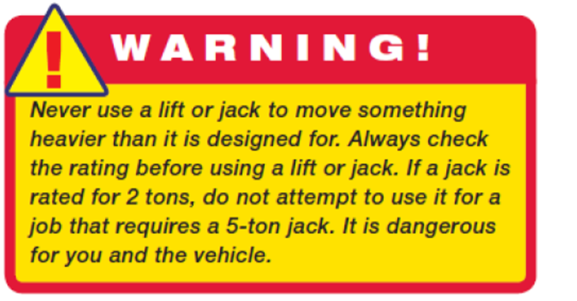
A vehicle can be raised off the ground by a hydraulic jack. A handle on the jack is moved up and down to raise part of a vehicle and a valve is turned to release the hydraulic pressure in the jack to lower the part. At the end of the jack is a lifting pad. The pad must be positioned under an area of the vehicle’s frame or at one of the manufacturer’s recommended lift points. Never place the pad under the floor pan or under steering and suspension components, because they can easily be damaged by the weight of the vehicle. Always position the jack so that the wheels of the vehicle can roll as the vehicle is being raised.
Figure 1.1 Jack and Jack Stand Safety

Safety Stands
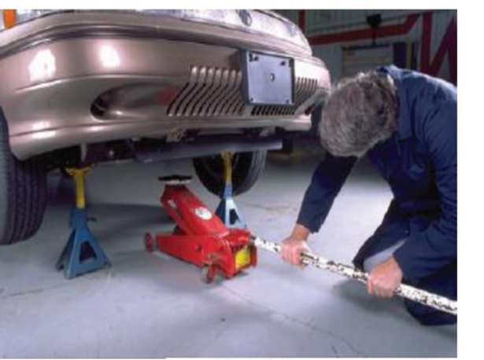
Safety stands, also called jack stands, are supports of various heights that sit on the floor. They are placed under a sturdy chassis member, such as the frame or axle housing, to support the vehicle. Once the safety stands are in position, the hydraulic pressure in the jack should be slowly released until the weight of the vehicle is on the stands. Like jacks, jack stands also have a capacity rating. Always use a jack stand of the correct rating.
Figure 1.2 Safety Stand
Never move under a vehicle when it is supported by only a hydraulic jack. Rest the vehicle on the safety stands before moving under the vehicle. The jack should be removed after the jack stands are set in place. This eliminates a hazard, such as a jack handle sticking out into a walkway. A jack handle that is bumped or kicked can cause a tripping accident or cause the vehicle to fall.

1.1.3 Multi-Meters
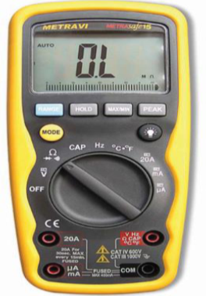
A multi-meter is a must for diagnosing the individual components of an electrical system. A digital multi-meter (DMM) can measure volts, ohms, and low current such as direct current (DC) and alternating current (AC) amperes, diode continuity. DMMs provide great accuracy by measuring volts, ohms, or amperes in tenths, hundredths, or thousandths of a unit
Figure 1.3 Multi-Meter

Scan Tools
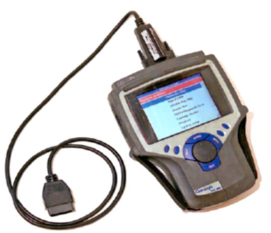
A scan tool is a microprocessor designed to communicate with the vehicle’s computer. Connected to the computer through diagnostic connectors, a scan tool can access diagnostic trouble codes (DTCs), run tests to check system operations, and monitor the activity of the system. Trouble codes and test results are displayed on a screen or printed out on the scanner printer.
The scan tool is connected to specific diagnostic connectors on the vehicle. It must be programmed for the model year, make of vehicle, and type of engine. With OBD-II, the diagnostic connectors (commonly called Data Link Connector or DLCs) are located in the same place on all vehicles
Figure 1.4 Scan Tools

1.1.5 socket wrench set
The socket wrench is used in combination with different types of handles and extension bars for safe and speedy loosening and tightening in difficult positions.
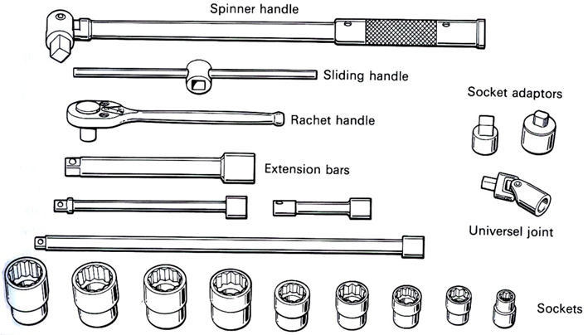
Figure 1.5 Socket Wrench Set

Screwdrivers
Used for loosing and tightening screws. The screwdriver tip comes in various shapes to match the screw head
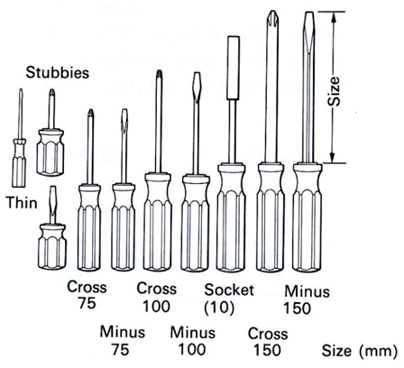
Figure 1.6 Screw Drivers

1.1.7 ABS tester
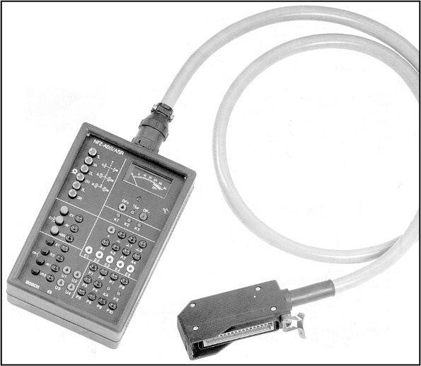
ABS tester is a device used to test the anti-lock braking system (ABS) of a vehicle. It can be used to check the operation of the ABS sensors, solenoid valves, and control unit. The tester will typically display a series of codes that indicate the status of the ABS system.
Figure 1.7 ABS Tester
Here are some tips for using an ABS tester:
- Make sure the tester is compatible with your vehicle.
- Follow the instructions provided with the tester.
- Be careful not to damage the ABS sensors or control unit.
- If you are not sure how to use the tester, consult a qualified technician.

1.2 Types and Channels of Anti-lock brake System (ABS)

1.2.1 Integral Systems
The exact manner in which hydraulic pressure is controlled depends on the ABS design. A great majority of the earlier ABSs were integrated or integral systems. They combine the master cylinder, hydraulic booster, and ABS hydraulic circuitry into a single hydraulic assembly

Non-Integral System
Nearly all of today’s systems are nonintegral. They use a conventional vacuum-assist booster and master cylinder. The ABS hydraulic control unit is a separate mechanism. In some nonintegrated systems, the master cylinder supplies brake fluid to the hydraulic unit. Although the hydraulic unit is a separate assembly, it still uses a high-pressure pump/motor, an accumulator, and fast-acting solenoid valves to control hydraulic pressure to the wheels Both integral and nonintegral systems operate in much the same way; therefore, an understanding of one system will lend itself to the understanding of the other systems. Vacuum power booster and master brake cylinder. But it does not use a high-pressure pump/motor, an accumulator, and fast-acting solenoid valves to control hydraulic pressure. Instead, it uses motors in a hydraulic modulator. In addition to being classified as integral and nonintegral ABSs, systems can be broken down into the level of control they provide.

ABS Channels
Different schemes of anti-lock braking system use depending upon the types of brakes use. Depending upon the channel (valve) and number of speed sensors the antilock brake are classified
- Four-channel. Four-sensor ABS: - This is the best scheme, there is speed sensor and a separated valve for all the four wheels.
- Three-channel. Three-sensor ABS: - This scheme is the commonly found on pickup trucks with four wheels ABS has a speed sensor and valve for each of the front wheel with one for both rear wheels.
- One-channel, One-sensor ABS: - it has one valve which controls both rear wheels and one speed sensor located in the rear axle.
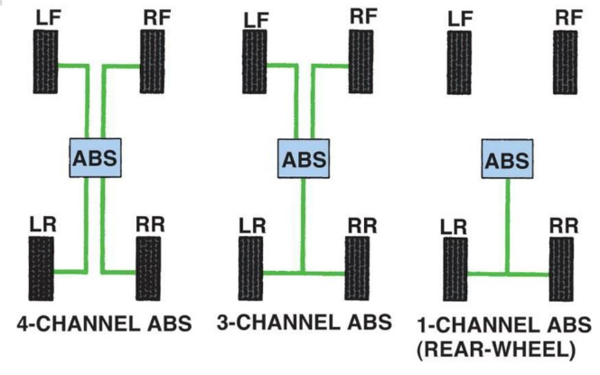
Figure 1.8 ABS Channel

1.3 Operating Principles of ABS
Modern antilock brake systems can be thought of as electronic/hydraulic pumping of the brakes for straight-line stopping under panic conditions. Good drivers have always pumped the brake pedal during panic stops to avoid wheel lockup and the loss of steering control. Antilock brake systems simply get the pumping job done much faster and in a much more precise manner than the fastest human foot. Keep in mind that a tire on the verge of slipping produces more friction with respect to the road than one that is locked and skidding. Once a tire loses its grip, friction is reduced and the vehicle takes longer to stop.
When compared to the electronic systems required to manage a transmission or an engine, an ABS is simple. An input circuit is used so that ABS can monitor individual wheel speeds under braking. The wheel sensors use a pulse generator principle. This consists of a toothed ring located at the axle ends (on the wheel assembly) or within the axle. The analog alternating current (AC) voltage output from these sensors is transmitted to an ECU. The ECU ignores the voltage value and, instead, uses the AC frequency to determine wheel speed.
When a vehicle is being driven at a constant speed, the speed of the vehicle and that of the wheels are the same (in other words, the tires are not skidding). However, when the driver steps on the brake pedal in order to slow the vehicle, the speed of the wheels gradually decreases and no longer matches the speed of the vehicle’s body which is now traveling along under its own inertia. (That is, a small amount of slippage may occur between the tires and the road surface.)
The difference in ratio between the vehicle’s body speed and the speed of the wheels is known as the „slip ratio.”
The slip ratio can be determined by the following calculation

A slip ratio of 0% reflects a state in which the wheels are turning freely with no resistance. A slip ratio of 100% reflects a state in which the wheels are completely locked up and the tires are skidding along the road’s surface. When the difference between the wheel speed and vehicle speed becomes too large, slipping occurs between the tires and the road surface. This also creates friction and may eventually act as a braking force and slow the speed of the vehicle, the range of 10 to 30% at all times. ABS is designed to utilize this slip ratio to maximize brake performance regardless of road conditions.
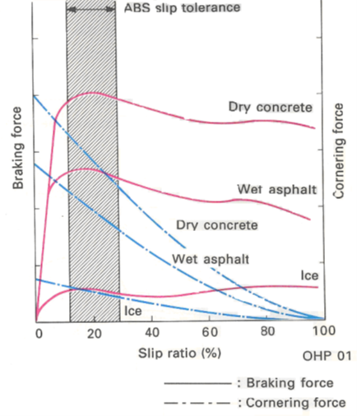
Figure 1.9 Frictional Coefficient

NB. On rough roads, or on gravel or snow-covered roads, operation of the ABS may result in a longer stopping distance than for vehicles not fitted with an ABS.
In a panic braking situation, the wheel speed sensors detect any sudden changes in wheel speed.
• The ABS ECU calculates the rotational speed of the wheels and the change in their speed, then calculates the vehicle speed from this. The ECU then instructs the actuators to provide the optimum hydraulic pressure to each brake.
• The brake hydraulic control units operate on commands from the ECU, reducing or increasing the hydraulic pressure, or holding the hydraulic pressure steady as necessary, in order to maintain the optimum slip ratio (10 to 30%) and avoid wheel lock-up

- Case I
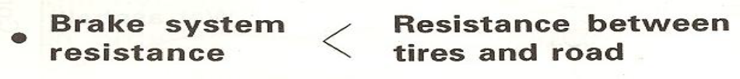
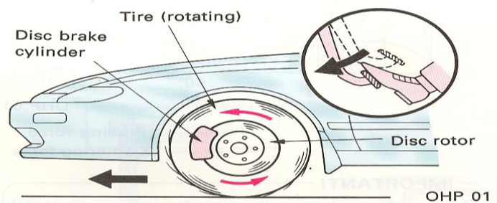
Figure 1.10 Case I
Ordinary brakes work to slow or stop a vehicle by utilizing two types of resistance. These are the resistance between the brake pads and discs (or brake shoes and drums) and the resistance between the tires and the road surface. Braking can be controlled in a stable manner if the following relationship between the resistance in the brake system and the resistance between the road and tires exists.
- Case II
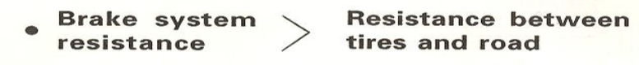
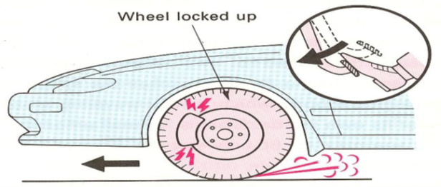
Figure 1.11 Case II

As a result, if the front wheels lock up, it will become impossible to steer the car. If the rear wheels lock up, the differences in the coefficients of friction (µ) between the left and right sides on the road surface will cause a tire spin to occur. However, if this relationship is reversed, the tires will lock up and the vehicle will begin skidding

1.4 Components Part and Operation of ABS
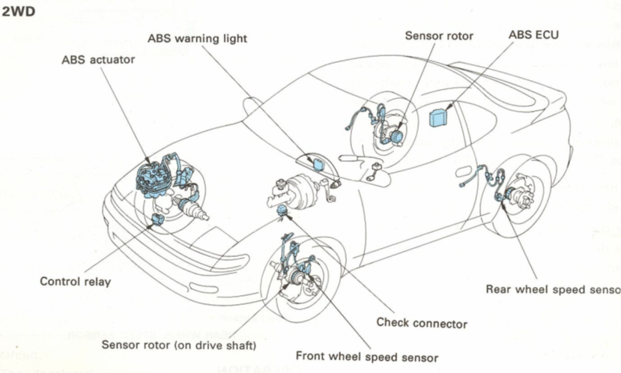
Figure 1.12 ABS Components

1.4.1 Wheel Speed Sensor
The wheel-speed sensors are mounted near the different toothed rings. As the ring’s teeth rotate past the sensor, an AC voltage is generated. As the teeth move away from the sensor, the signal is broken until the next tooth comes close to the sensor. The end result is a pulsing signal that is sent to the control module. The control module translates the signal into wheel speed. The sensor is normally a small coil of wire with a permanent magnet in its center
- Construction
The front and rear wheel speed sensors consist of a permanent magnet, coil and yoke. The front wheel speed sensors are fitted to the steering knuckle, and the rear speed sensors are fitted to the rear axle carrier. Serrated rotors (sensor rotors) are fitted to the front drive shafts and rear wheel hubs, and thus rotate as a unit with them.

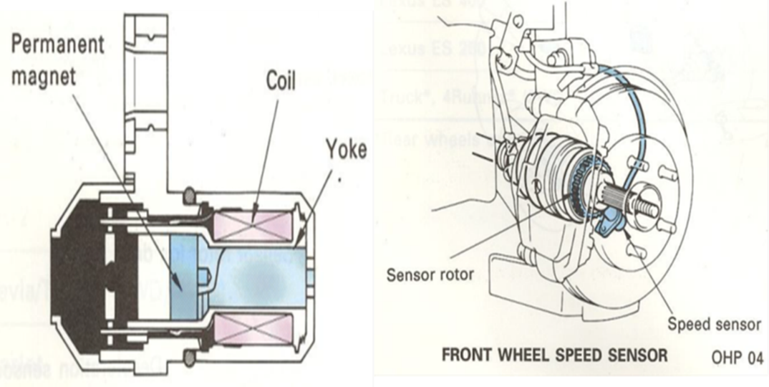
Figure 1.13 Wheel Speed Sensor

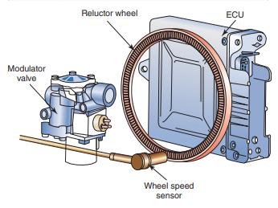
When the reluctor wheel rotates, it cuts through a permanent magnetic field located in the stationary sensor. This makes it act like a generator, producing a simple AC signal. It shares operating principles with other shaft speed sensors on the chassis, including the road speed (transmission tail shaft) sensor and engine rpm sensor. A reluctor or exciter ring can be integral with the drum or disc or isolated.
Figure 1.14 Wheel Speed Sensor

- Operation
There are serrations in the outer circumference of each rotor, so when the rotor is turning, an AC voltage with a frequency that is proportional to the rotor’s rotational speed is generated. This AC voltage is used to inform the ECU of the wheel speed.
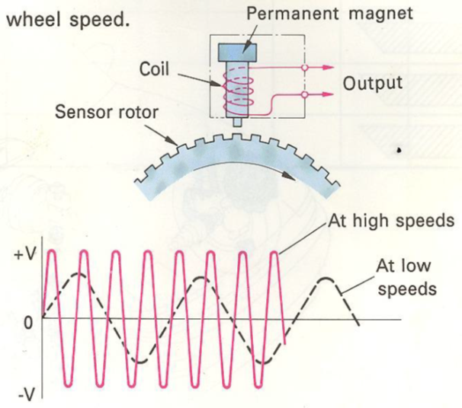
Figure 1.15 Wheel Speed Sensor
- Construction
The deceleration sensor is composed of two pairs of LEDs (light-emitting diodes) and phototransistors, a slit plate, and a signal conversion circuit. The deceleration sensor senses the vehicle’s rate of deceleration and sends signals to the ABS ECU. The ECU judges the precise road surface conditions using these signals and takes appropriate control measures.
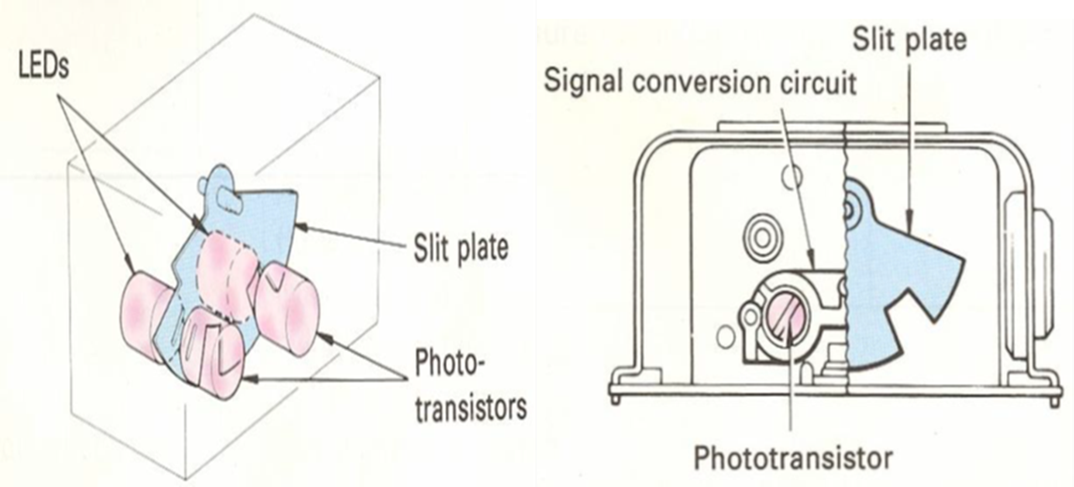
Figure 1.16 Deceleration sensor
- Operation
When the vehicle’s rate of deceleration changes, the slit plate swings in the vehicle’s longitudinal direction in accordance with the deceleration rate. The slits in the slit plate act to cut off the light from the LEDs to the phototransistors, and this switches the phototransistors on and off. Two pairs of LEDs and phototransistors are used. The combinations formed by these phototransistors switching on and off divide the rate of deceleration into four levels, which are sent as signals to the ABS ECU.
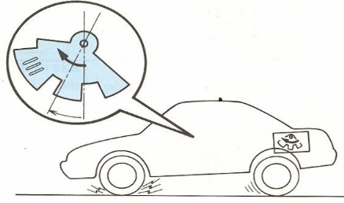
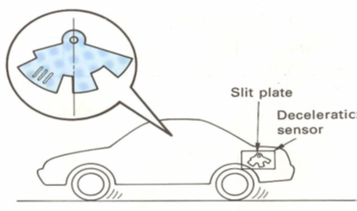
Figure 1.18 During Deceleration
Figure 1.17 @Constant Speed

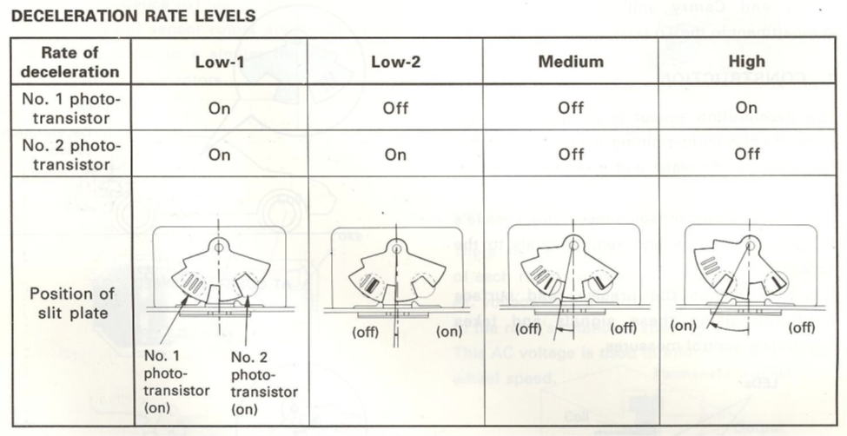
Figure 1.19 Deceleration Rate level

1.4.2 Hydraulic Modulator
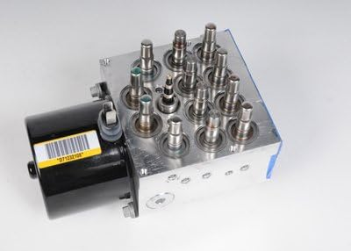
The modulator unit controls the flow of pressurized brake fluid to the individual wheel circuits. Normally the modulator is made up of solenoids that open and close valves, several valves that control the flow of fluid to the wheel brake units, and electrical relays that activate or deactivate the solenoids through the commands of the control module. This unit may also be called the hydraulic actuator, hydraulic power unit, or the electrohydraulic control valve
Figure 1.20 Hydraulic modulator

1.4.3 Accumulator
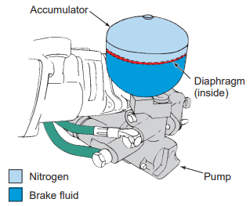
An accumulator is used to store hydraulic fluid to maintain high pressure in the brake system and to provide residual pressure for power-assisted braking. Normally, the accumulator is charged with nitrogen gas and is an integral part of the modulator unit. This unit is typically found on vehicles with a hydraulically assisted brake system.
Figure 1.21 Accumulator

1.4.4 Solenoid
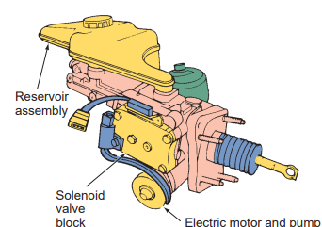
Solenoid Valves The solenoid valves are located in the modulator unit and are electrically operated by signals from the control module. The control module switches the solenoids on or off to increase, decrease, or maintain the hydraulic pressure to the individual wheel units.
Figure 1.22 Solenoid

1.4.5 ABS Control Module
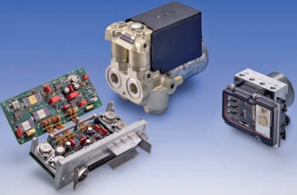
This small control computer is normally mounted inside the trunk on the wheel housing, mounted to the master cylinder or is part of the hydraulic control unit. It monitors system operation and control’s antilock function when needed. The module relies on inputs from the wheel speed sensors and feedback from the hydraulic unit to determine if the antilock brake system is operating correctly and to determine when the antilock mode is required. The module has a self-diagnostic function including numerous trouble codes. This module may also be called the ECU (electronic control unit), EBCM (electronic brake control module), the antilock brake controller, or the ECM (electronic control module).
Figure 1.23 ABS Control Module

1.4.6 Dash Warning Indicator Light

Most ABS have a warning light. The warning light may be mounted on the dash or above the windshield. This light is used to indicate to the driver that the system is properly operating on startup, to alert the driver in the event of a malfunction, and to signal diagnostic codes to the technician.
Figure 1.24 Dash Warning Indicator

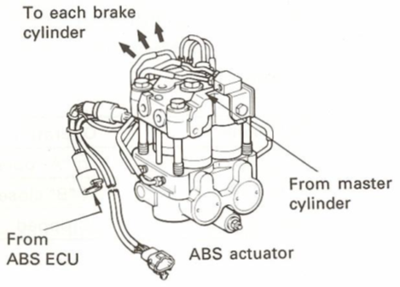
1.4.7 ABS Actuator
Figure 1.25 ABS Actuator
The actuator applies or stops applying hydraulic pressure from the brake master cylinder to each disc brake cylinder in accordance with the signals from the ECU, in this way controlling the wheel speed.

- Construction
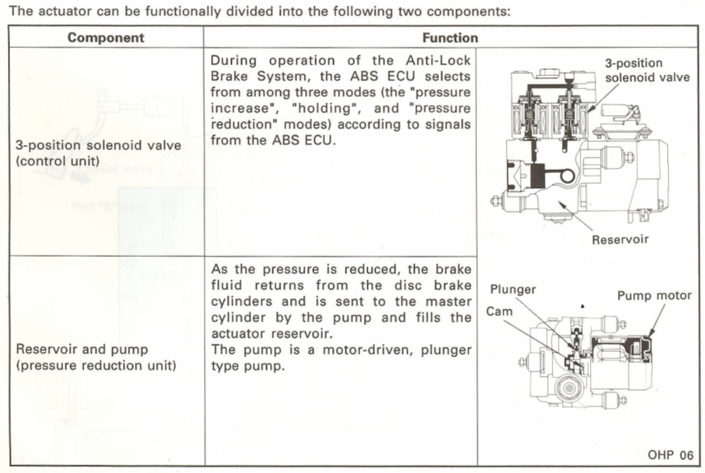
Figure 1.26 Construction of ABS Actuator

1.5 Modes of ABS
Three modes of ABS operation are used:
- Isolation Mode
- Dump Mode
- Reapply Mode
Isolation Mode
- The control module detects that a tire is starting to slip
- The module energizes a modulator solenoid to isolate that hydraulic circuit from the other brake lines
- The fluid is trapped in the wheel brake at the current apply pressure
Dump Mode
- The control module detects that the tire is continuing to slip and slow down
- The module energizes a solenoid to release the fluid pressure from the wheel brake assembly to reduce braking effort
- The tire speed will tend to increase
Reapply Mode
- The control module detects that the tire speed has increased, so more braking is required
- The module de-energizes the dump solenoid and isolation solenoid to allow fluid pressure to build in the brake circuit again, restoring braking effort

- ABS operation
- During normal braking (abs not activated)
The ABS is not activated during normal braking and the ABS‟s ECU does not send electricity to the solenoid coil. Therefore, the three-position valve is pushed down by a return spring and port “A” remains open while port “B” remains closed. When the brake pedal is depressed, the master cylinder fluid pressure rises, and brake fluid passes from port “A” to port “C” in the three- position solenoid valve, and is sent to the disc brake cylinder. Brake fluid is prevented from flowing into the pump by the No. 1 check valve located in the pump circuit. When the brake pedal is released, the brake fluid returns from the disc brake cylinder to the brake master cylinder through port “C” to port “A” and the No. 3 check valve in the three- position solenoid valve
Part name | Operation
3-position  solenoid valve | Port “A” open
3-position  solenoid valve | Port “B” closed
Pump motor | Stopped
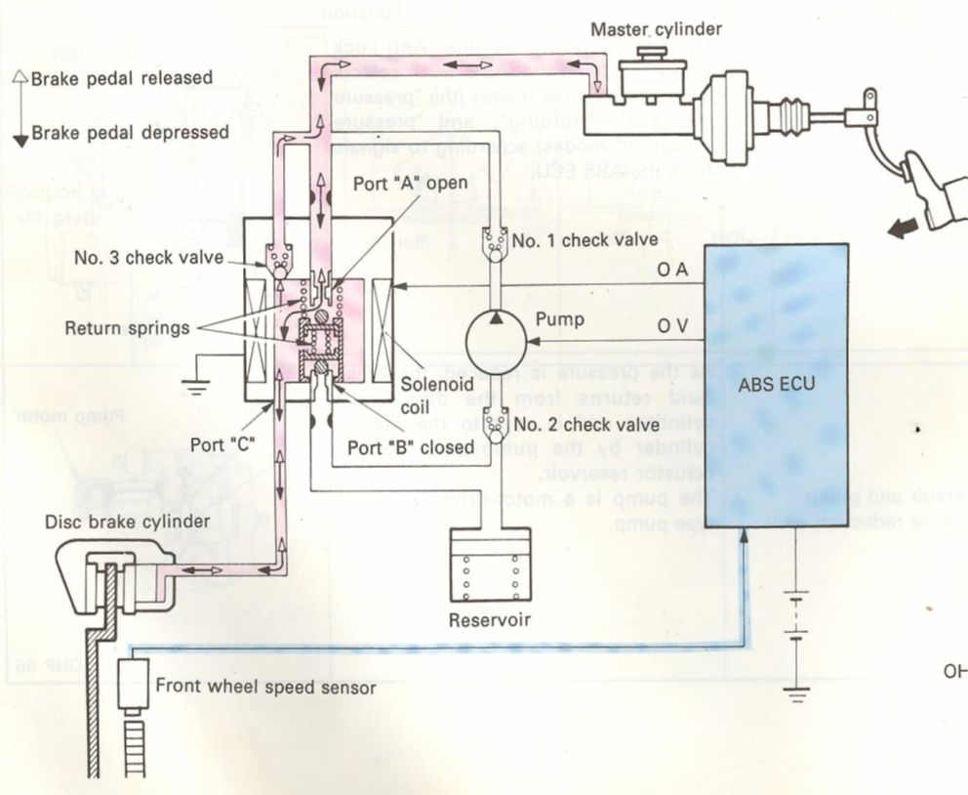
Figure 1.27 During normal braking

1.5.1 ABS (Pressure Increase Mode)
When the pressure in the disc brake cylinder needs to be increased to apply more braking force, the ECU stops sending current to the solenoid coil. This opens port “A” of the three- position valve and closes port “B”. This allows the fluid in the master cylinder to pass from port “C” in the three-position solenoid valve to the disc brake cylinder. The hydraulic pressure increase rate is controlled by the repetition of the “pressure increase” and “holding” modes.
Part name | Operation
3-position  solenoid valve | Port “A” open
3-position  solenoid valve | Port “B” closed00a
Pump motor | on

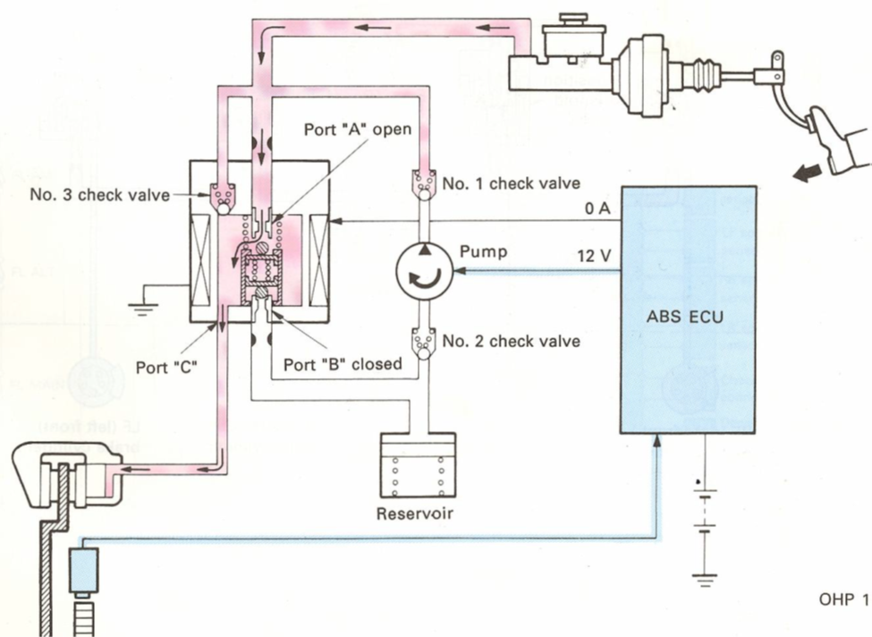
Figure 1.28 Pressure Increase Mode

1.5.2 ABS (Holding)
As the pressure inside the disc brake cylinder is reduced or increased, and the speed sensor sends a signal indicating that the speed is at the target level, the ECU supplies current (2 A) to the solenoid coil to hold the pressure in the disc brake cylinder at that level. When the current being supplied to the solenoid coil is reduced from 5 A (in the pressure reduction mode) to 2 A (in holding mode), the magnetic force generated in the solenoid coil also decreases. The three-position solenoid valve then is made to move down to the middle position by the force of the return spring, closing port “B” as a result.
Part name | Operation
3-position  solenoid valve | Port “A” closed
3-position  solenoid valve | Port “B” closed
Pump motor | on
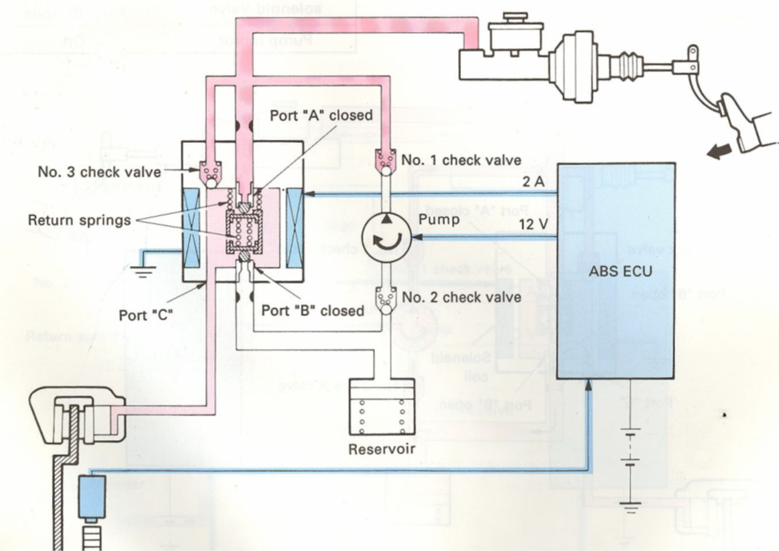
Figure 1.29 Holding mode

1.5.3 ABS (Pressure Reduction Mode)
When a wheel is about to lock up the ECU sends current (5 A) to the solenoid coil, generating a strong magnetic force. The three-position valve moves upward and port “A” closes as port “B” opens. As a result, brake fluid from the disc brake cylinder passes through port “C” to port “B” in the three-position solenoid valve and flows into the reservoir. At the same time, the pump motor is turned on by a signal from the ECU, and brake fluid is sent back to the master cylinder from the reservoir. Brake fluid coming from the master cylinder, on the other hand, is prevented from entering the three-position solenoid valve by port „A”, which is closed, and by check valves No. 1 and No. 3. As a result, the hydraulic pressure inside the disc brake cylinder decreases, preventing the wheel from locking up. The hydraulic pressure reduction rate is regulated by the repetition of the “pressure reduction” and “holding” modes.
Part name | Operation
3-position  solenoid valve | Port “A” closed
3-position  solenoid valve | Port “B” open
Pump motor | on

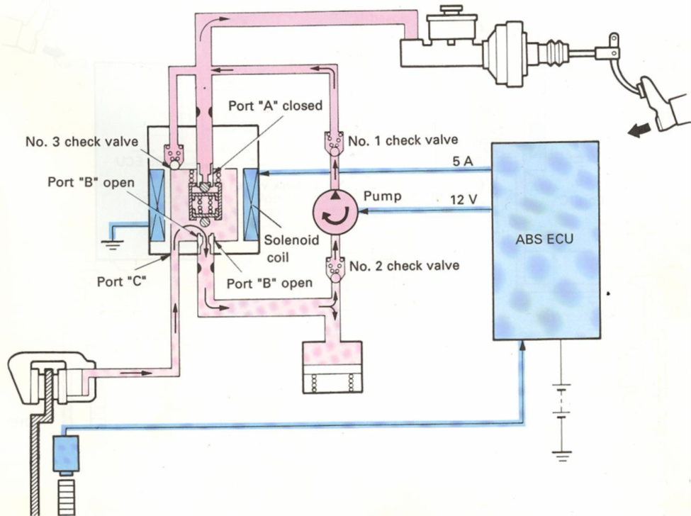
Figure 1.30 Pressure Reduction Mode

1.5.4 ABS System Diagram and ABS Wiring Diagram
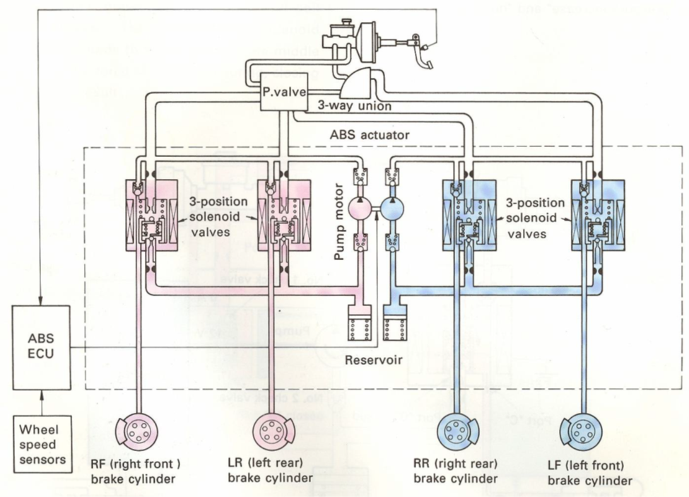
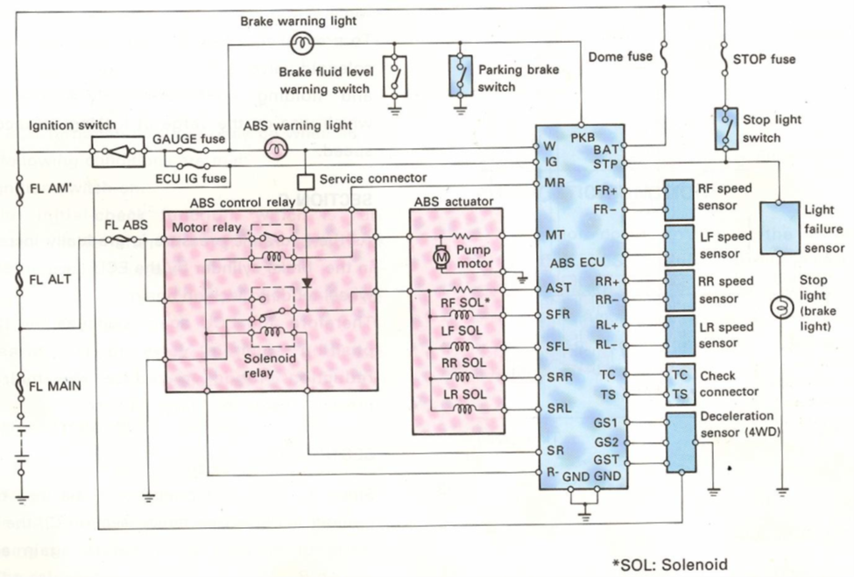
Figure 1.31 ABS system and wiring

1.6 Electric/Electronic Brake System

1.6.1 Function of Electric Retarder

The electric retarder uses electromagnetic induction to provide a retardation force. An electric retardation unit can be placed on an axle, transmission, or driveline and consists of a rotor attached to the axle, transmission, or driveline - and a stator securely attached to the vehicle chassis. There are no contact surfaces between the rotor and stator, and no working fluid. When retardation is required, the electrical windings in the stator receive power from the vehicle battery, producing a magnetic field through which the rotor moves. This induces eddy currents in the rotor, which produces an opposing magnetic field to the stator. The opposing magnetic fields slows the rotor, and hence the axle, transmission or driveshaft to which it is attached. The rotor incorporates internal vanes (like a ventilated brake disk) to provide its own air cooling,
Figure 1.32 Electric Brake Retarder

1.6.2 Construction
The construction of the permanent magnet type retarder is very simple. There are two main components: a rotor and a stator. The stator is attached at the rear of the transmission. It has a series of magnets with strong magnetic force on its interior.
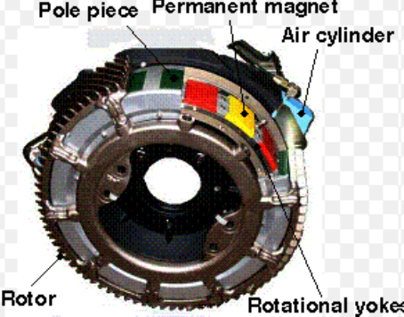
Figure 1.33 Retarder Construction

- Stator
The stator plays the role of the inductor; it contains several electromagnets, which generate magnetic fields when electricity continuously flows through the stator coils, thereby producing eddy currents in the mass of the rotor.
- Rotors
The rotors play the role of the armature. Manufactured with a specially designed conducting material, the rotors are subjected to eddy currents generated when they rotate through the magnetic fields created by the stator
The stator and the rotors are mounted coaxially, opposite to one another, and are separated by a narrow air gap, thereby avoiding any friction

1.6.3 Operation
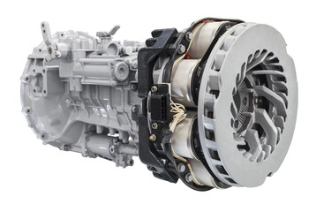
The operation of the permanent magnet-type retarder is also simple. It is switched ON and OFF by compressed air supplied by the vehicle itself. The operating principle of the permanent magnet-type retarder is also simple. A series of magnets inside the stator is arranged so that any given magnetic pole faces the opposite magnetic pole of the adjacent magnet. When the retarder is switched OFF, no force is exerted on the rotor because the magnets are positioned straddling the pole pieces, and the magnetic circuit moves only through the pole pieces. When the retarder is switched ON, a compressed-air cylinder rotates the magnet series by one-half magnet length, repositioning all the magnets directly beneath the pole pieces. When this happens, the magnetic circuit bridges the pole pieces and passes through the rotor, generating an eddy current on the inner surface of the rotor. This becomes the source of the braking force.
Figure 1.34 Retarder Assembly
Telma induction brakes, commonly known as electrical or electromagnetic retarders, offer an endurance braking system. They dissipate a large part of the braking energy, thus relieving conventional braking systems. Telma induction braking systems dissipate the braking energy by generating eddy currents.
The Telma is comprised of a fixed stator and a pair of rotors that are attached to and rotate with the driveline. By definition, eddy currents originate from conducting metallic masses when the latter are placed in variable magnetic fields. In the case of Telma induction braking systems, the variability of the magnetic fields to which rotors are subjected is a result of the rotation of the rotors. Eddy currents, also known as swirling currents, wrap around the magnetic flow lines. The generation of eddy currents in the mass of the rotor leads to the appearance of Laplace forces that counteract with the rotation of the rotor. The braking torque that is thus generated and applied to the drive shaft slows the vehicle. The eddy currents produce a gradual rise in rotor temperature and the heat is then dissipated into the air through the rotor cooling vanes. With Telma induction braking systems, it is thus possible to effectively slow down a rotating shaft without friction and therefore without wear Although induction braking systems might seem simple in principle, they involve complex physical laws such as materials resistance principles, electromagnetism, thermodynamics and fluid mechanics. Telma’s recognized expertise in the field of electromagnetic induction braking systems is based on the detailed modelling of all physical laws involved in the operation of induction braking systems. This modelling has been enhanced by years of practical experience and laboratory testing that have proven to make the difference.

1.6.4 Electronic Brake Distribution (EBD)
EBD work in conjunction with ABS and electronic stability control (ESC) to minimize yaw accelerations during turns. ESC compares the steering wheel angle to vehicle turning rate using a yaw rate sensor. "Yaw" is the vehicle's rotation around its vertical center of gravity (turning left or right). If the yaw sensor detects less(more) yaw than the steering wheel angle should create, the car is understeering(oversteering) and ESC activates one of the front or rear brakes to rotate the car back onto its intended course. For example, if a car is making a left turn and begins to understeer (the car plows forward to the outside of the turn) ESC activates the left rear brake, which will help turn the car left. The sensors are so sensitive and the actuation is so quick that the system may correct direction before the driver reacts. ABS helps prevent wheel lock-up and EBD helps apply appropriate brake force to make ESC work effectively and easily

1.6.5 Emergency Brake Assist
Brake assist (BA or BAS) or emergency brake assist (EBA) is a term for an automobile braking technology that increases braking pressure in an emergency. By interpreting the speed and force with which the brake pedal is pushed, the system detects if the driver is trying to execute an emergency stop, and if the brake pedal is not fully applied, the system overrides and fully applies the brakes until the anti-lock braking system (ABS) takes over to stop the wheels locking up. This is a lower level of automation than advanced emergency braking which is a collision avoidance system, which may initiate braking on its own if the onboard computer detects an imminent collision

1.6.6 Regenerative Braking
Regenerative braking is a mechanism found on most hybrid and full-electric vehicles. It captures the kinetic energy from braking and converts it into the electrical power that charges the vehicle’s high voltage battery. Regenerative braking also slows the car down, which assists the use of traditional brakes. In a conventional braking system, a car slows down due to friction between the brake pads and rotors. But this system is highly inefficient when it comes to conserving energy. Nearly all of the kinetic energy propelling your car forward is lost as heat when you apply the brakes. That’s a lot of wasted energy!
Regenerative braking solves this problem by recapturing upwards of 70% of the kinetic energy that would otherwise be lost during braking. The amount of energy recovered depends on your car model and driving behavior.
- Operation
Regenerative braking turns kinetic energy into electricity by reversing the process that drives the car forward. In electric cars, the drivetrain is powered by a battery pack that powers a motor (or motors), creating torque rotational force on the wheels. In other words, electrical energy from the battery becomes mechanical energy that spins the wheels.
With regenerative braking, the energy from your spinning wheels is used to reverse the direction of electricity - from the electric motor(s) to the battery. All you have to do is remove your foot from the accelerator or, in some cases, press the brake pedal to activate regenerative braking. The electric motor not only acts as an electric generator, but it also helps slow your car down because energy is consumed by the wheels as they rotate the shaft in the electric motor.
There are two conditions when regeneration occurs:
1. When the driver applies the brake pedal
2. When the driver releases the accelerator pedal, and the vehicle is coasting
In both cases, the system creates electricity to recharge the battery. Drivers can view this regenerative effect on the vehicle's charging gauge, which shows it as energy flowing from the wheels to the battery. The amount of electricity the system generates is proportional to the level of braking force. That means the stronger the braking force, the greater the electrical current. Ultimately, the amount of energy the system captures is dependent on the vehicle's speed and the duration of brake application. When braking, the system automatically allocates some portion of the braking force to energy regeneration and some to the conventional brake system. This way, the system simultaneously achieves the dual purpose of slowing the vehicle down and recharging the battery for improved efficiency and greater electric driving range.
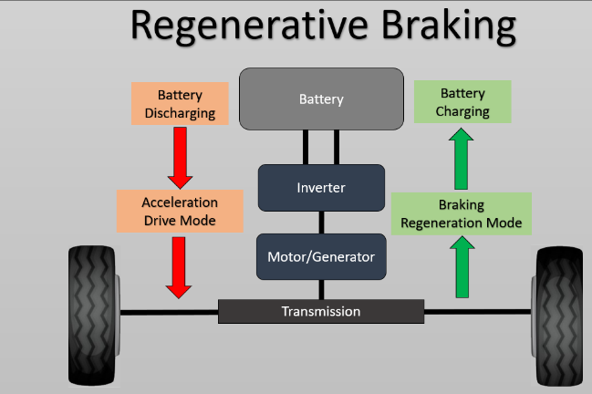
Figure 1.35 Regenerative Braking

- Advantages
- Extends range
- Reduction of Pollution
- Improves the efficiency of braking
- It reduces wear
- As seen the improvement in the conservation of energy
- Disadvantages
- Impossible to recover all energy while decelerating from high speeds because while decelerating quickly some of the energy has to be transferred to heat.
- As discussed with the driving conditions, the variation of torque will cause inefficiencies and may damage the system as well
- The additional systems required to install and maintain increase the cost of vehicle
- Regenerative Braking Motor for Electric Vehicles
- Components
- Brake drum (which is attached to wheels)
- Friction lining
- Controller
- Electric Generator (DC Motor)
- Linking mechanism

1.7 OHS Requirement
When doing heavy lifting, always get assistance and lift with your knees, not your back.
When lifting any object follow these steps:
Clean equipment and tools
- Part cleaning is a necessary step in most repair procedures. Cleaning automotive parts can be divided into three basic categories.
- Chemical cleaning relies primarily on some type of chemical action to remove dirt, grease, scale, paint, or rust.
- Abrasive cleaning relies on physical abrasion to clean the surface. This includes everything from a wire brush to glass bead blasting, airless steel shot blasting, abrasive tumbling, and vibratory cleaning. Chemical in-tank solution sonic cleaning might also be included here because it relies on the scrubbing action of ultrasonic sound waves to loosen surface contaminants.
Clean up procedures
- Clean up every time whenever you leave an area, including sweeping the floor.
- Clean and return all tools to where you got them.
- Use compressed air sparingly; never aim it at another person or use it to clean hair or clothes.
- Shut off and unplug machines when cleaning, repairing, or oiling.
- Never use a rag near moving machinery.
- Use a brush, hook, or a special tool to remove chips, shavings, scraps etc. from the work area. Never use the hands.
- Keep fingers clear of the point of operation of machines by using special tools or devices, such as, push sticks, hooks, pliers, etc.
- Keep the floor around machines clean, dry, and free from trip hazards. Do not allow chips to accumulate.
Hazards in the work shop
- Faulty work habits
- Misuse of equipment
- Misuse of hand tools
Select the work place depending on: -
- Environmental condition
- Free from flammable things
- Events around the work campus is closer together
- Climatic condition
- Working area events

Safety Precautions
- When replacing brake lines and/or hoses, always use lines and hoses designed for and specifically labeled for use on ABS vehicles.
- Never use silicone brake fluids in ABS vehicles. Use only the brake fluid type recommended by the manufacturer (normally DOT 3 or 4).
- Never begin to bleed the hydraulic brake system on a vehicle equipped with ABS until you have checked the service information for the proper procedure.
- Never open a bleeder screw or loosen a hydraulic brake line or hose while the ABS is pressurized.
- Disconnect all vehicle computers, including the ABS control unit, before doing any electrical welding on the vehicle.
- Never disconnect or reconnect electrical connectors while the ignition switch is on.
- Never install a telephone or CB antenna close to the ABS control unit or any other control module or computer.
- Check the wheel-speed sensor to sensor ring air gap after any parts of the wheel-speed circuit have been replaced.
- Keep the wheel sensor clean. Never cover the sensor with grease unless the manufacturer specifies doing so; in those cases, use only the recommended type.
- When replacing speed (toothed) rings, never beat them on with a hammer. These rings should be pressed onto their flange. Hammering may result in a loss of polarization or magnetization.

Relieving Accumulator Pressure
Some services require that brake tubing or hoses be disconnected. Many ABSs use hydraulic pressures as high as 2,800 psi (19,300 kPa) and an accumulator to store this pressurized fluid. Before disconnecting any lines or fittings in many systems, the accumulator must be fully depressurized. A common method of depressurizing the ABS follows:
- Turn the ignition switch to the off position.
- Pump the brake pedal between twenty-five and fifty times.
- The pedal should be noticeably harder when the accumulator is discharged.
Procedures for depressurizing the system vary with the design of the system. Always refer to the service information.
- Pre diagnostic Inspection
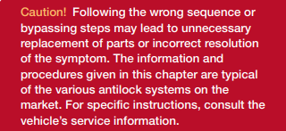
Before undertaking any actual checks, take a few minutes to talk with the customer about his or her ABS complaint. The customer is a very good source of information, especially when diagnosing intermittent problems. Make sure you find out what symptoms are present and under what conditions they occur. All ABSs have some sort of self-test. This test is activated each time the ignition switch is turned on. You should begin all diagnosis with this simple test
Figure 1.36 Pre-Diagnostic Inspection

Self-Check 1
Instruction: Answer the question stated below based on information sheet. If your progress is unsatisfactory discuss with your trainer and do this work again. Time given 15 min.
1. Tech A says that the purpose of an anti-lock braking system is to prevent the wheels from locking during braking, especially on low-friction surfaces such as wet, icy, or snowy roads. Tech B says that the anti-lock braking system does not mean a vehicle can stop quickly on all road surfaces. Who is correct?

    - Tech A
    - Tech B
    - Both techs A and B
    - Neither tech A nor B

2. Both Techs A and B are correct. Tech A is correct in stating that the purpose of an anti-lock braking system is to prevent the wheels from locking during braking, particularly on low-friction surfaces. This helps to maintain steering control and prevent skidding. Tech B is correct in stating that the anti-lock braking system does not guarantee that a vehicle can stop quickly on all road surfaces. Other factors such as road conditions, tire quality, and vehicle weight also play a role in stopping distance.

- A. Brake light
- B. Electronic brake control module
- C. Both A and B
- D. None of the above

3. Wheel speed sensors should be checked for which of the following with a DVOM?

- A. open
- B. Ground
- C. high resistance
- D. All of the above

4. True or False. Wheel speed sensors send electric signals to the electronic brake control module to determine speed and rate of deceleration of each wheel.

A True
B. false

5. Tech A says that if the yellow warning lamp is illuminated indicating a fault in the electronic brake control system, you should retrieve the diagnostic trouble codes and follow the procedure listed in the service information. Tech B says that if the yellow warning lamp is not illuminated and the brakes are not functioning properly on a vehicle with an electronic brake control system, you should suspect a problem that is not monitored by the electronic brake control module. Who is correct?

A. Tech A
B. Tech B
C. Both Tech A and Tech B
D. Neither Tech A nor B

Unit Two: Traction and Electronic Stability Control System
This unit to provide you the necessary information regarding the following content coverage and topics:
- Traction Control System
- Electronic Stability Control System
Overview
This guide will also assist you to attain the learning outcomes stated in the cover page. Specifically, upon completion of this learning guide, you will be able to:
- Identify and Explain Traction Control System
- Differentiate Electronic Stability Control System

2.1. Traction control system

2.1.1 Operating principle
On roads with a low coefficient of friction (µ), such as snowy, icy or wet roads, the drive wheels spin if the vehicle is started or accelerated quickly, resulting in loss of torque and possibly causing vehicle skidding.
The maximum torque that can be transmitted to the wheels is determined by the coefficient of the friction generated between the road and the tires. If the attempt is made to transmit torque exceeding that level to the wheels, it will become easy for the wheels to spin.
Maintaining the torque at a level appropriate to the coefficient of friction at such times is sometimes difficult for the driver. In most cases, when attempting to start the vehicle quickly, the driver presses the accelerator pedal too hard and the wheels spin, causing a loss of traction and of torque.
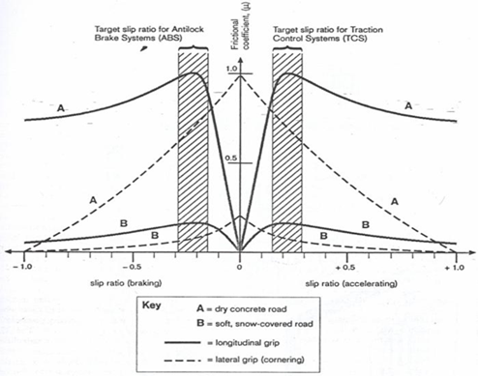
Figure 2. 1 Slip Ratio

2.1.2 Function of Traction control system
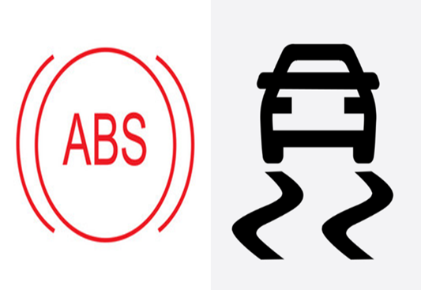
The aim of a traction control system (TCS/TRC) is to limit wheel spin when starting off or accelerating on a slippery road surface. In many ways TCS is the opposite of ABS, working to maximize grip when accelerating, rather than when braking. It intervenes to limit the torque applied to the driving wheels, thereby maximizing the friction coefficient, by maintaining the tractive slip ratio at an optimum value.
Figure 2. 2 ABS & TCS
TCS/TRC is a useful safety feature in that it increases the lateral stability of the vehicle in slippery conditions, making the vehicle much easier to handle. On a front wheel drive car, it permits acceleration with full steering control, and on a rear-wheel-drive car it stops the tail breaking away when the driver uses too much power. There are a variety of TCS/TRC systems in production. They all function by electronically reducing the driving wheel torque when excessive slip is detected. This is achieved by one, or more, of the following interventions:
• Partially closing the throttle valve to reduce engine torque.
• Reducing the quantity of injected fuel to reduce engine torque.
• Retarding or canceling the ignition spark to reduce engine torque.
• Applying the brakes to the driven wheels
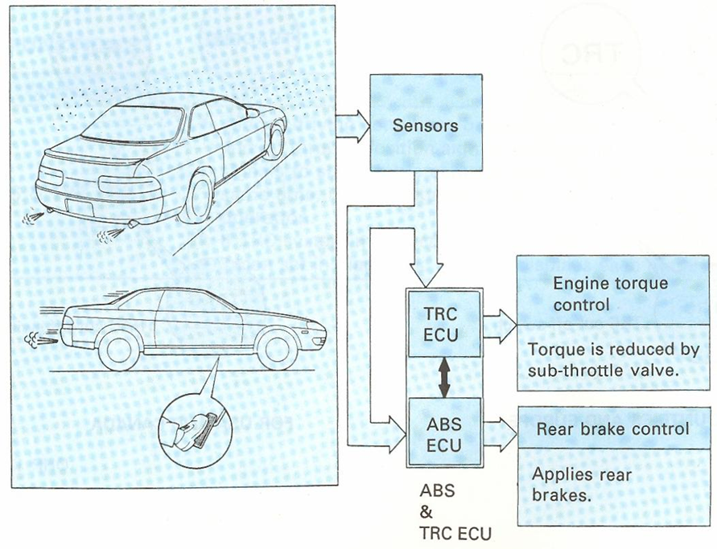
Figure 2. 3 TRC &ABS Lay out

- TCS via Throttle and Brake Control
In this configuration TCS/TRC is provided by electronic control of the throttle and application of the brakes. Brake application is particularly effective since under split conditions it can provide the level of traction control offered by a limited slip differential, but with better precision. TCS/TRC using the braking system is also cost efficient in that many components can be shared with the ABS system. Specifically, the wheel speed sensors, hydraulic actuator unit and ECU can be made to perform a dual function. It is unfortunate that although elegant, this strategy is not particularly well suited to vehicles fitted with automatic transmission. Applying a braking torque to the driven wheels of an automatic car could cause excessive engine power to be dissipated in the transmission’s torque converter, leading to overheating and damage. Cars fitted with automatic transmission are therefore often only equipped with TCS/TRC Systems that control engine torque. This leads to poorer performance when accelerating on split Surfaces since no limited-slip facility is provided.
- TCS/TRC Brake Control
When a front wheel drive car sets off on a slippery surface, the driven wheels will start to spin. The TCS/TRC ECU computes a target driven wheel speed by taking a vehicle reference speed from the (undriven) rear wheels and adding an amount for the required slip ratio (say, 20%). If either front wheel exceeds this target speed, then it is deemed to be suffering excessive slip and the appropriate brake is applied. This reduces slip on the low-grip side and transfers some torque, via the action of the differential, to the higher grip side to give maximum traction. As a refinement, some TCS/TRC systems allow a small amount of wheel spin when accelerating at low speeds. This gives the car a sporting feel and can be useful in that it may allow the spinning tire to bum through thin ice and grip the road beneath. During TCS/TRC operation, some engine power is dissipated in the braking components which become hot. Since excessive use of TCS /TRC could lead to over- heating of the brakes, the TCS/TRC ECU may limit brake application to a certain length of time within a set Period. If TCS is required beyond this time then engine intervention alone is used.

- TRC/TCS (Traction Control System) With Sub-Throttle Actuator and Brake Control
This TCS/TRC (Traction Control) system lowers the engines torque, regardless of the drivers’ intentions, when the wheels start to spin, while at the same time controlling the brake system, thereby reducing the torque transmitted to the road surface to appropriate levels. In this way, stable and rapid starting and acceleration can be achieved.
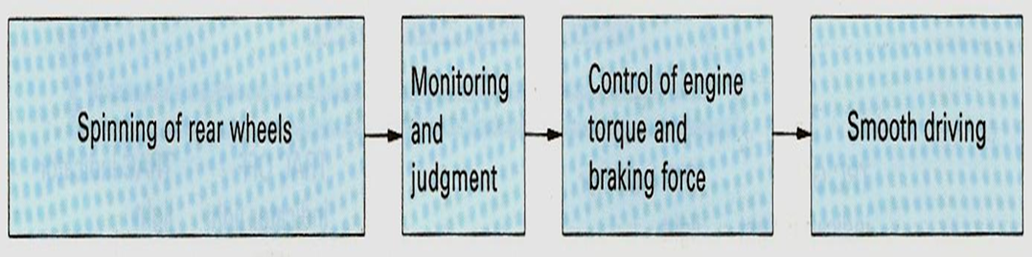
Figure 2. 4 TCS Flow

2.1.3 Basic Components and Their Function
The main components of the system include sub-throttle actuator, sub-throttle position sensor, brake actuator, wheel speed sensors and the ABS & TCS/TRC ECU.
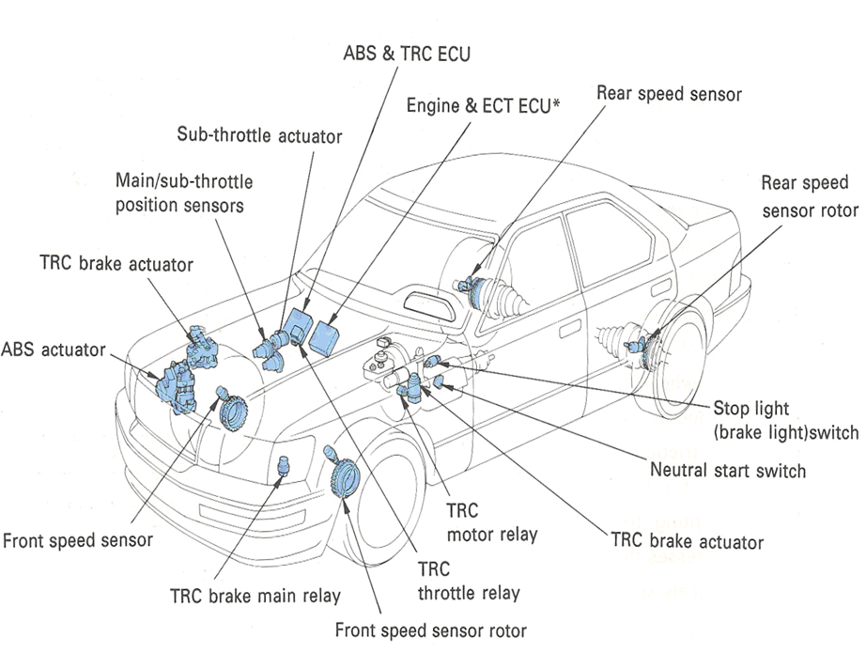
Figure 2. 5 ABS & TCS Components
Table 1.1 Function of Components TCS
Components | Function
Front and rear speed  sensors | Detect wheel speeds and send wheel speed signals to ABS & TRC ECU.
Neutral start switch | Inputs shift lever position signals UP” and “N”) to ABS & TRC ECU.
Brake fluid level  warning switch | Detects level of fluid in brake master cylinder reservoir and sends signals to  ABS & TRC ECU.
Stop light switch  (Brake light switch) | Detects brake signal (whether brake pedal is depressed or not) and sends this  data to ABS & TRC ECU.
TRC cut-off switch | Allows driver to make TRC system inoperative.
Engine & ECT ECU | Receives main and sub-throttle valve position signals and sends them to ABS &  TRC ECU.
Main throttle position  sensor | Detects main throttle valve opening angle and sends it to Engine & ECT ECU.
Sub-throttle position  sensor | Detects sub-throttle valve opening angle and sends it to Engine & ECT ECU.
TRC  brake actuator | Generates, accumulates and supplies hydraulic pressure to ABS actuator  according signals from ABS & TRC ECU.
ABS actuator | Controls hydraulic pressure to right and left rear disc brake cylinders separately  according to signals from ABS & TRC ECU.
Sub-throttle actuator | Controls sub-throttle valve opening angle according to signals from ABS & TRC ECU
TRC indicator light | Informs driver that TRC system is operative, and warns driver of a system  malfunction.
TRC off indicator light | Informs driver that TRC system is inoperative due to a malfunction in ABS or  engine control system, or that TRC cut-off switch has been turned off.
TRC brake main relay | Supplies current to TRC brake actuator and TRC motor relay.
TRC motor relay | Supplies current to TRC pump motor.
TRC throttle relay | Supplies current to sub-throttle actuator via ABS & TRC ECU.

- Sub-Throttle Actuator
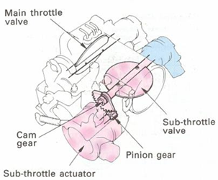
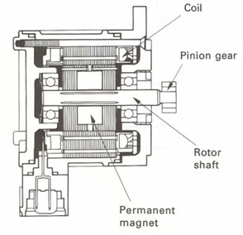
This actuator is fitted on the throttle body. It controls the sub-throttle valve opening angle according to signals from the ABS & TRC ECU, thus controlling the engine output.

- Construction
The sub-throttle actuator consists of a permanent magnet, a coil and a rotor shaft. This actuator is a stepping motor that is caused to rotate by a signal from the ABS & TRC ECU. A pinion gear is fitted on the rotor shaft end and rotates the cam gear, fitted on the sub-throttle valve shaft end, thereby controlling the sub- throttle valve opening angle.
Figure 2. 6 Sub Throttle Actuator
- Operation
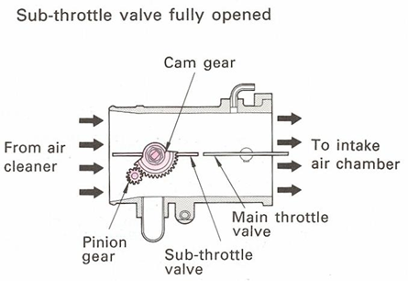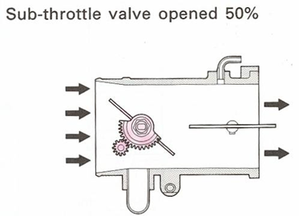
Figure 2. 8 TRC not operative Figure 2. 7 Partially operative

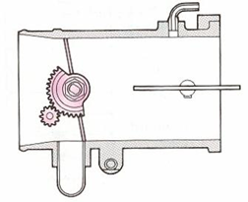
Figure 2. 8 TRC Fully Operative

- Sub-Throttle Position Sensor
This sensor is fitted to the sub-throttle valve shaft. It converts the sub-throttle valve opening angle to a voltage signal and sends this signal to the ABS & TRC ECU via the Engine & ECT ECU.
- TCS/TRC brake actuator
- Construction
The TRC brake actuator consists of a pump assembly that produces hydraulic pressure and a brake actuator that transmits the hydraulic pressure to and releases it from the disc brake cylinders. The hydraulic pressure in the disc brake cylinders of the right and left rear wheels are controlled separately for this typical system by the ABS actuator according to signals from the ABS & TRC ECU.
- Pump assembly
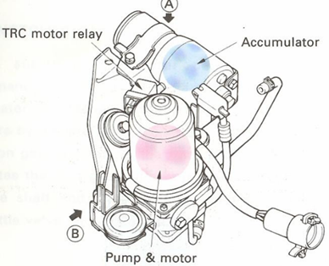
Pump - Draws brake fluid from master cylinder reservoir, increases its pressure and sends it to accumulator. This is a motor driven, plunger type pump.
Figure 2. 9 Pump Assembly
Accumulator - Accumulates pressurized brake fluid and supplies it to disc brake cylinders during TRC system operation. Accumulator is also filled with high-pressure nitrogen gas which absorbs changes in brake fluid volume.

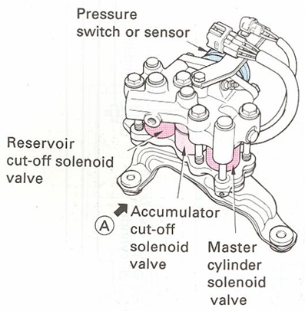
- Brake Actuator
- Accumulator Cut-Off Solenoid Valve - Transmits hydraulic pressure from accumulator to disc brake cylinders during TRC system operation.
- Master cylinder Cut-Off Solenoid Valve - When hydraulic pressure in accumulator is being transmitted to disc brake cylinders, this solenoid valve prevents brake fluid from returning to master cylinder.
- Reservoir Cut-Off Solenoid Valve - During TRC system operation, this solenoid valve returns brake fluid from disc brake cylinders to master cylinder reservoir.
Figure 2. 10 Brake Actuator
- Pressure switch or pressure sensor - Monitors pressure in accumulator and sends this data to ABS & TRC ECU. ECU controls pump operation based on this data.

2.1.4 Traction Control Hydraulic and Wiring Diagram
- Hydraulic Circuitry
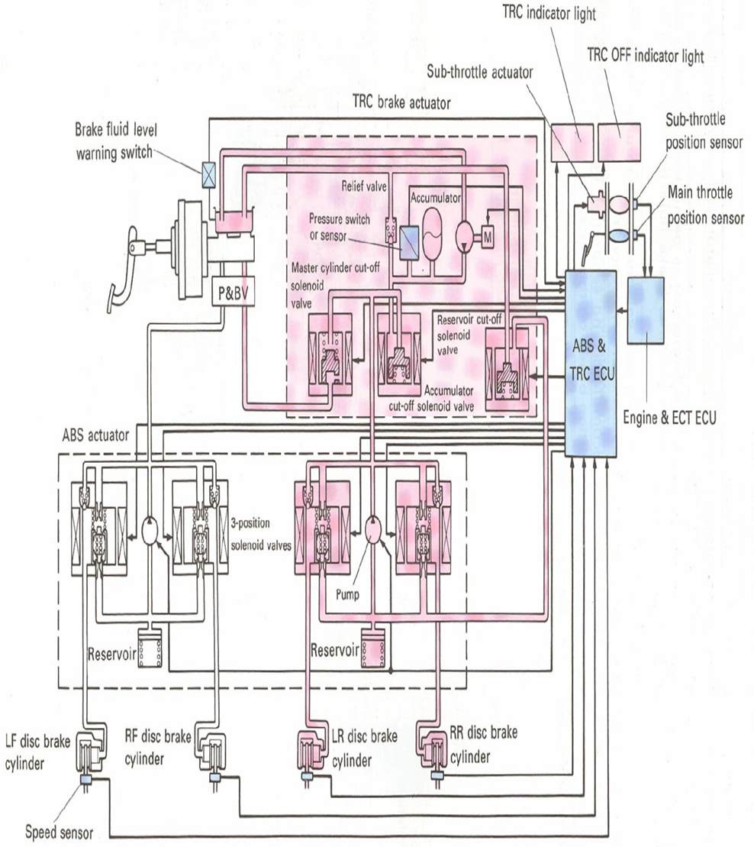
Figure 2. 11 Hydraulic Circuitry

- Wiring Diagram
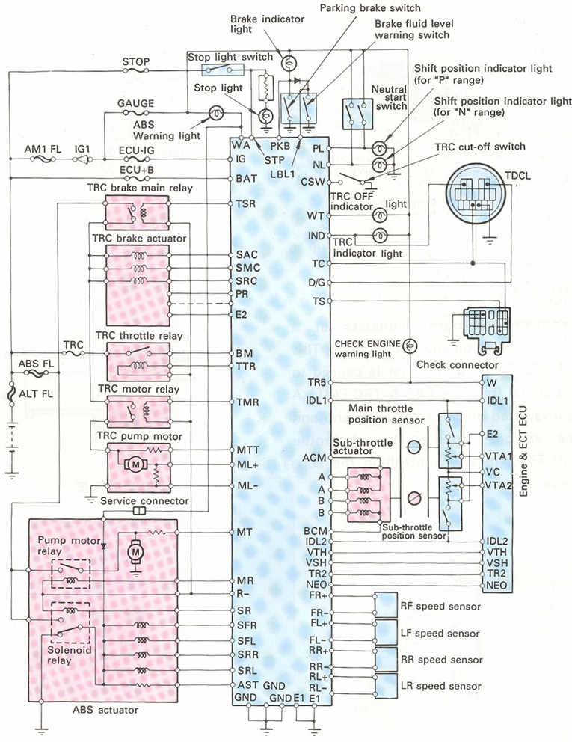
Figure 2. 12 Wiring Diagram

- Control Of Relays
TRC Brake Main Relay and TRC Throttle Relay
As long as there is no malfunction in the TIRC, the ABS, or the electronic engine control system, the ECU turns on the TAC brake main relay and throttle relay when the ignition switch is turned on. These relays are turned off when the ignition switch is turned off. If a malfunction is detected by the ECU, the ECU switches these relays off
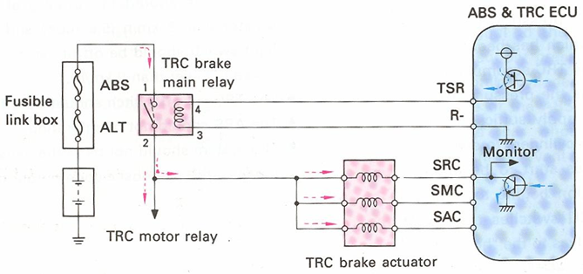
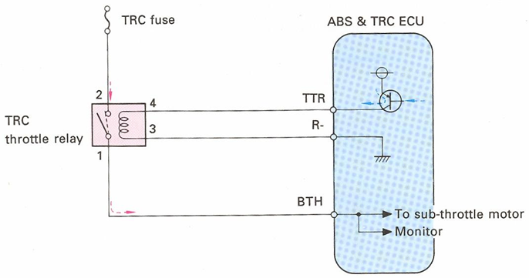
Figure 2. 13 Control Relay Circuit

- TRC Pump Motor Relay
The ABS & TRC ECU switches the pump motor relay on when the following conditions are met:
- TRC main relay on
- Engine speed more than 500 rpm
- Shift lever in position other than “P‟ or “N”
- IDL1 signal off
- pressure switch signal on
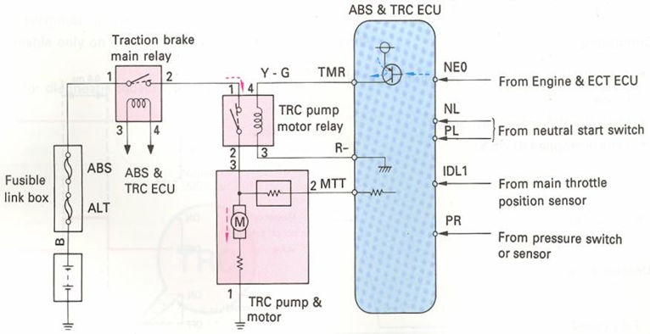
Figure 2. 14 Pump Motor Relay

2.1.5 System Diagram
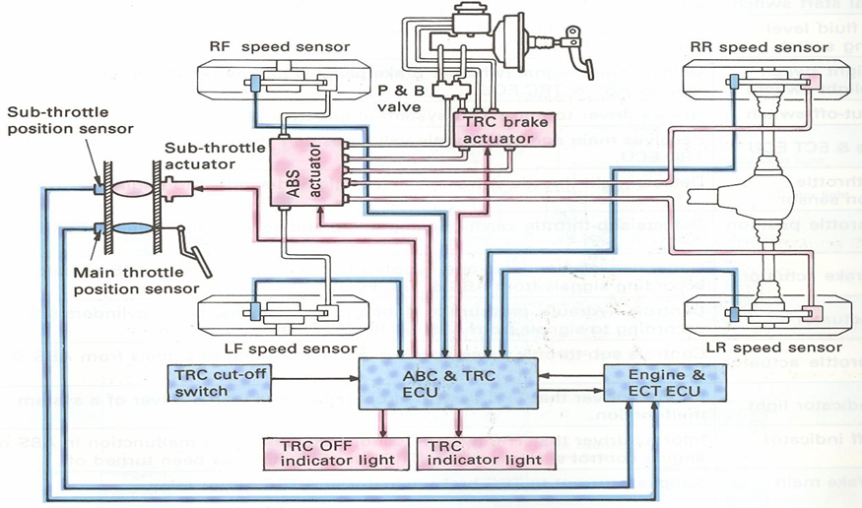
Figure 2. 15 System Diagram
- During Normal Braking (TRC not activated)
All solenoid valves in the TRC brake actuator are turned off when the brakes are applied. When the brake pedal is depressed with the TRC in this condition, the hydraulic pressure produced in the master cylinder acts on the disc brake cylinders via the master cylinder cut-of solenoid valve and the three-position solenoid valve of the ABS actuator. When the brake pedal is released, fluid returns from the disc brake cylinders to the master cylinder.

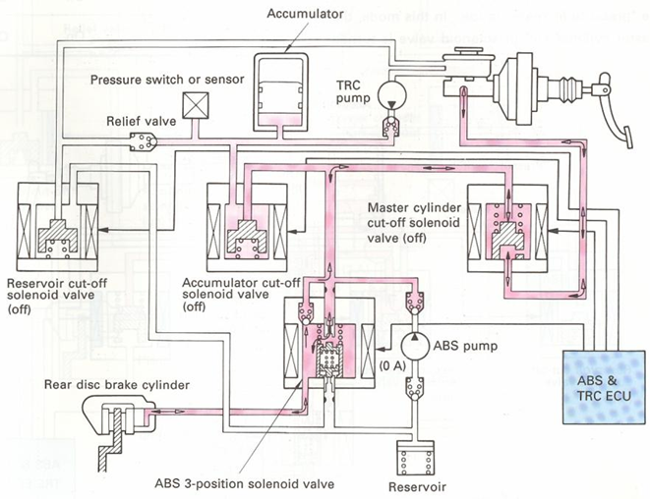
Figure 2. 16 During Normal Braking
- During Vehicle Acceleration (TRC activated)
If a rear wheel spins during acceleration, the ABS & TRC ECU controls the engine torque and braking of the rear wheels to help avoid this. The hydraulic pressure in the right and left rear brakes is controlled separately in three control modes (“pressure increase”, “holding” and “pressure reduction”), as explained below.
When the accelerator pedal is depressed and a rear wheel starts to spin, all solenoid valves of the TRC actuator are turned on by signals from the ECU. At the same time, the three-position solenoid valve of the ABS actuator is also switched to the “pressure increase” mode. In this mode, the master cylinder cut-off solenoid valve is turned on (closed) and the accumulator cut-off solenoid is turned on (opened). This causes the pressurized fluid in the accumulator to act on the disc brake cylinders via the accumulator cutoff solenoid valve and the three-position solenoid valves in the ABS. When the pressure switch detects a pressure drop in the accumulator (regardless the of the TRC operation) the ECU turns on the TRC pump to increase the hydraulic pressure.

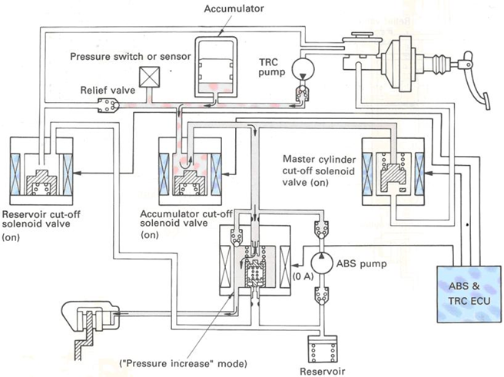
Figure 2. 17 During Vehicle Acceleration
- Holding Mode
When the hydraulic pressure in the rear disc brake cylinders has been increased or reduced to the required level, the system is switched to the “holding mode. The mode change is done by switching the three- position solenoid valve of the ABS actuator. As result, the accumulator pressure is prevented from escaping, holding the hydraulic pressure in the disc brake cylinder.

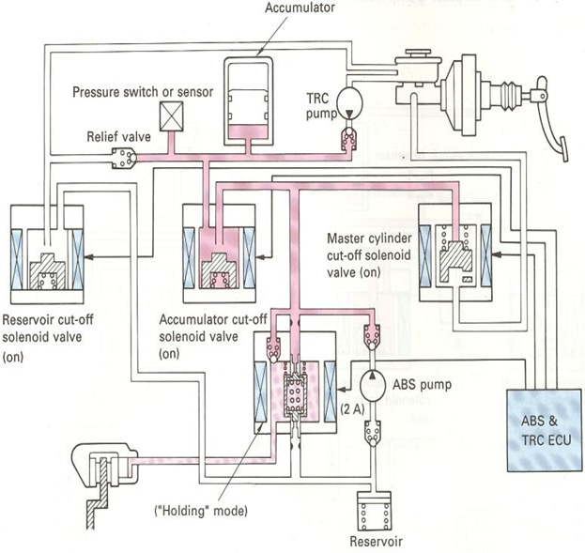
Figure 2. 18 Holding Mode
- Pressure Reduction Mode
When it becomes necessary to reduce the hydraulic pressure in the rear disc brake cylinders, the ABS & TRC ECU switches the three-position solenoid valve of the ABS actuator to the “pressure reduction” mode. This causes the hydraulic pressure in the disc brake cylinder to be returned to the master cylinder reservoir via the ABS three-position solenoid valve and the reservoir cut-off solenoid valve. As a result, the hydraulic pressure is reduced. At this time, the ABS actuator pump remains inoperative. Very clear and self-explanatory pictures of each mode of operation are attached.

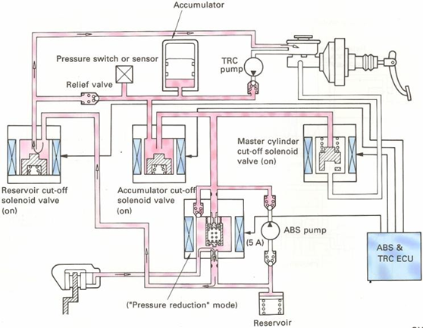
Figure 2. 19 Pressure Reduction Mode

2.2 Electronic Stability Control System
Electronic Stability Control ESC is an active safety system that reduces the risk of a driver losing control of the vehicle when it skids, swerves suddenly or when road conditions change. ESC builds upon features such as Anti-lock Braking Systems ABS and traction control to stabilize the vehicle when it deviates from the driver’s steered direction Using a number of intelligent sensors, ESC immediately identifies when a car has deviated from the driver’s steered direction and the driver has lost control of the vehicle.

2.2.1 Operating Principle
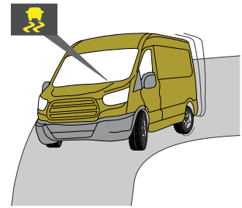
Over steering or under steering are registered, ESC stabilizes the vehicle by selectively braking individual wheels and reducing engine torque to bring it back on course. ESC uses components of ABS and traction control to stabilize the vehicle, but unlike ABS and traction control which only operate in the driving direction, ESC also helps the driver control sideways movements which create instability.
Figure 2. 20 Stability Control System

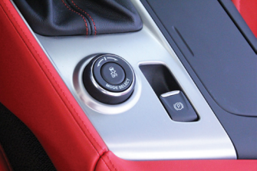
If the ESC system is activated, the EBCM monitors the yaw sensor signal, the steering angle sensor signal, and the roll-rate sensor signal, as well as the wheel speed sensor signals. If the vehicle is beginning to understeer, oversteer, or roll, the EBCM detects it in the signal values. It then applies up to three-wheel brake units to help bring the vehicle back within proper stability parameters. If that does not stop the stability issue, the EBCM will request a reduction in engine power through the powertrain control module to help slow the vehicle further. On most vehicles, the EBCM illuminates a warning lamp on the dash or sounds a beeper that signifies when the ESC system has detected the start of a skid and reacted to it. This way the driver will be informed that he or she is on the verge of losing control of the vehicle.
Figure 2. 21 ESC Switch

2.2.2 Function of Electronic Stability Control
The antilock brake system ABS do a good job of preventing wheels from locking up under hard braking or poor traction conditions and allows the driver to maintain directional control of the vehicle. The traction control system TCS also does a good job of maintaining traction when the vehicle is driven in a relatively straight line. However, drivers can lose directional control of the vehicle while driving aggressively, while taking emergency steering actions, or when there are sudden changes in the traction of the road surface while in a turn. These situations can cause the vehicle to understeer push or oversteer loose.
- Hill assist holds the brake pressure until the throttle is depressed and the vehicle starts to move forward.
- All-wheel-drive traction control applies brake pressure as needed to any of the four individual wheels that may be slipping to maintain power to the wheels with the most traction.
- Engine braking control increases the engine torque if the ESC system detects wheel slippage during deceleration.
- Panic-stop assist detects a driver’s rapid throttle release and lightly applies the brakes to dry the rotors and prepare the brakes for a panic stop.
- Accident avoidance works in conjunction with adaptive cruise control to monitor objects in front of the vehicle. If the ESC system detects an imminent collision, it can apply the brakes or boost the brake pressure above driver pressure
- Hill descent control works in conjunction with the ESC system to control the speed of the vehicle when going down loose, rough, or slippery slopes.
- Trailer sway control detects trailer sway and uses the ESC system to keep it under control.
- Optimized hydraulic braking monitors brake pressure in each brake circuit and increases it above boosted pressure if deemed necessary
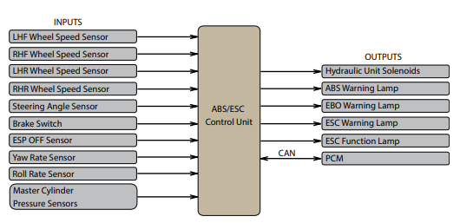
Figure 2. 22 lay out ESC

2.2.3 Major Components of Electronic Stability Control
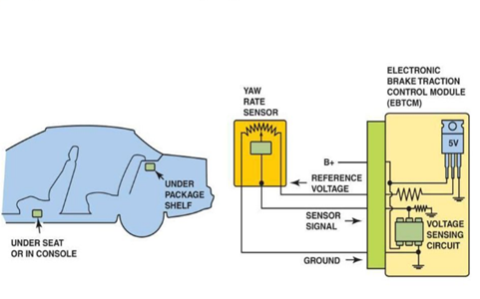
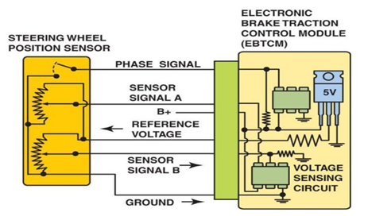
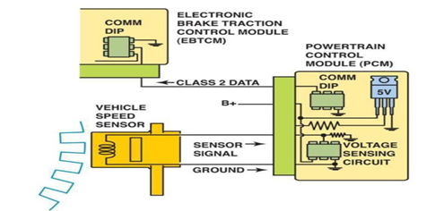
The ESC system integrates a yaw sensor, a steering angle sensor, a lateral acceleration sensor, and sometimes a roll-rate sensor into the basic ABS &TCS.
Figure 2. 23 Components of ESC
- Yaw Sensor measures the amount of directional rotation of the vehicle on its vertical axis.
- Steering Angle Sensor tells the computer what the driver’s directional sensor tells the computer the rate of roll and the amount of roll that the vehicle is experiencing.
- Lateral Acceleration Sensor is used to measure the lateral acceleration acting on the car to help calculate its actual position. The lateral acceleration acts on a car sideways to the direction of travel, usually when the vehicle is approaching a spin.
- EBCM monitors these signals and compares them to preprogrammed scenarios, and it decides which, if any, brake units need to be applied and whether engine torque needs to be reduced to keep the vehicle stable.
- Collision Avoidance Systems (CASs)
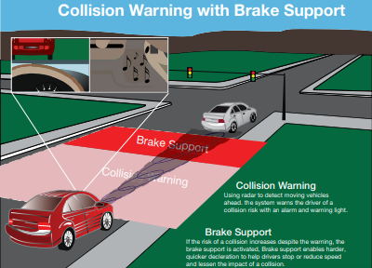
Collision avoidance systems (CASs) are an integrated structure that alerts the driver and may provide further assistance to help the driver avoid a collision. Using radar, GPS, cameras, and other sensors, the collision avoidance computer (CAC) determines whether the vehicle is getting close to another object where there may be an impact. When it is determined that a collision is eminent, the CAC will alert the driver
Figure 2. 24 CASs
- Rolling Stability Control System (RSC)
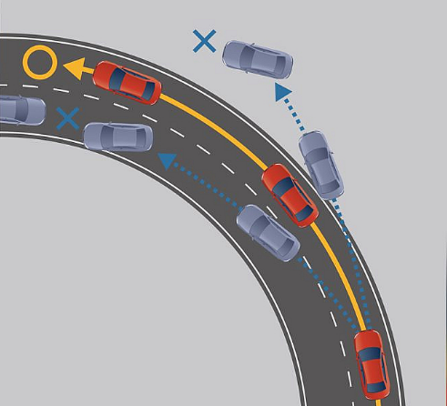
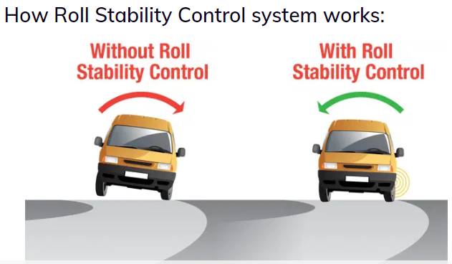
Roll Stability Control is active safety system which reduces the risk of rollover of the passenger vehicles in some critical maneuvers such as severe cornering and during steering suddenly. This system is especially useful for the vehicles having the high center of gravity (C.G.) like SUVs as they are more prone to rolling over. While taking a turn, it may happen that the vehicle fails to keep contact with the ground & maintaining proper ground clearance resulting in a rollover, if the maneuver is critical and is done at very high speed. In such a situation, Roll Stability Control comes into action.
Figure 2. 25 RSC
- Dynamic Stability Control (DSC)
Dynamic stability control is an electronic system that helps maintain the stability of a car while driving. It is especially useful in situations where driving conditions deteriorate due to slippery roads, sudden braking, or steering maneuvers that can cause the car to lose control and skid. DSC monitors various sensors on the car to detect when the vehicle is losing traction or stability. It then takes action by applying the brakes or adjusting the power to different wheels, ensuring that the car remains stable and under control while driving.
Figure 2. 26 DSC
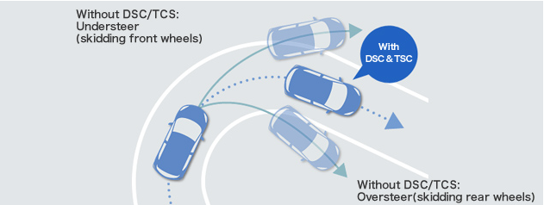
The basic principle behind dynamic stability control (DSC) is to keep the car stable and on course. To achieve this, DSC sensors detect any wheel slippage or spin, and the system applies the brake to the slipping wheel and reduces the engine power to that wheel, redistributing power to the remaining wheels. The system also takes into account the driver's steering actions. If the driver oversteers or understeers, DSC corrects the steering input to prevent the car from slipping or skidding.
Figure 2. 27 DSC
- The importance of dynamic stability control
- Dynamic stability control plays a vital role in enhancing car safety and driver experience.
- DSC is incredibly helpful in ensuring that cars remain stable and on course during challenging driving conditions. Whether it's slippery roads, sudden braking, or sharp turns,
- DSC helps keep the car on track and reduces the chances of accidents.
- Improving driving performance
- DSC helps maintain vehicle stability while still allowing the driver to retain full control.
- Reducing the risk of accidents caused by driver fatigue or distraction. If a driver is tired or distracted, they may unintentionally steer the car off course. However, DSC can detect any deviation from the intended course and apply the brakes to specific wheels, keeping the car on track and preventing accidents.

- LAS（lane keep assist system）
To keep the driver aware of where their vehicle is at any given moment the vehicle manufactures have developed a lane departure and lane keeping assist systems (LKAS). These systems use a camera that is usually mounted on the front of the vehicle, a lot of the time at the top of the windshield. As the driver drives down the road, the camera recognizes the lines on the road and when the vehicle crosses those lines, it alerts the diver to pay attention to maintain their lane. The alert could be a visual light coming on that the driver can see without taking their eyes off of the road, or it could be a vibrating seat The whole point of this system is to make the driver pay attention to where the vehicle is without taking the driver’s attention away from driving
Lane-Keep Assist System (LAS) promotes safer driving by providing appropriate steering assistance. The system allows drivers to choose between Lane-Trace, which provides steering assistance early in order to help keep the vehicle centered in the lane and Lane Departure Avoidance, which only comes into play if the vehicle begins to leave its lane. LAS uses a windshield-mounted camera to recognize lane-markings on the road and activates at speeds above 60 km/h.
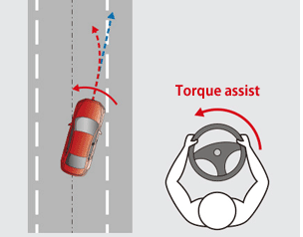
- Helping to avoid unintentional lane departures
Figure 2. 28 LAS
When Lane Departure Avoidance is selected, the system works to prevent unintentional lane departures due to driver inattention. If the system predicts that the vehicle is about to stray from its lane, it provides steering assistance to return the car toward the center of the lane.

- Lane Trace
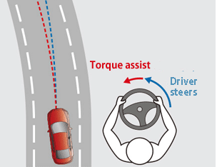
When Lane Trace is selected the system reduces the burden of driving by providing continuous steering assistance to help keep the vehicle centered in its lane. On bends the systems help the driver to drive more safely by guiding them toward a steering angle that matches the curvature of the road. Lane Trace is achieved simply by having LAS provide steering assistance from an earlier stage than with Lane Departure Avoidance.
Figure 2. 29 Lane Trace

Self-check 2
Instruction: Answer the question stated below based on information sheet. If your progress is unsatisfactory discuss with your trainer and do this work again. Time given 15 min.
- Multiple choice
- Which of the following is a typical sensor used by the electronic stability control system?

    - Yaw sensor
    - Steering angle
    - Roll rate sensor
    - All of the above

- Tech A says that all traction control systems apply the brakes as a first step and reduce engine power. Tech B says that some traction control systems do not apply the brakes as a first step but reduce engine power. Who is correct?

  - Tech A
  - Tech B
  - Both Tech A and Tech B
  - Neither Tech A nor B

- Which of the following measures the amount of directional rotation of the vehicle on its vertical axis.

  - Yaw sensor
  - Steering angle sensor
  - Lateral acceleration sensor
  - None of the above

- What is the function of traction control system.
  - Partially closing the throttle valve to reduce engine torque.
  - Reducing the quantity of injected fuel to reduce engine torque.
  - Applying the brakes to the driven wheels
  - All
- Supplies current to TRC pump motor

  - Front and rear speed
  - Sensors Sub-throttle actuator
  - TRC motor relay
  - TRC throttle relay

- Matching

Column A
Column B

- Neutral start switches A. Allows driver to make TRC system inoperative
- TRC cut-off switch B. Supplies current to TRC brake actuator and TRC motor relay
- Sub-throttle position C. Supplies current to sub-throttle actuator via ABS & TRC ECU
- TRC throttle relay D. Inputs shift lever position signals UP” and “N”) to ABS & TRC ECU
- TRC brake main relay E. Detects sub-throttle valve opening angle and sends it to Engine & ECT ECU.

Operation sheet-2
Operation sheet 2-1
Title: Perform Traction Control Components Removal
Objectives: Perform traction control components removal. All activity should be done using service manual guide. When you are accomplishing this job, you are highly recommended to perform safely and following suppliers repairing manuals/specification.
Required resources: Live Vehicle, complete tool box and equipment, multi meter, scan tool etc.
Instructions:
- Park and block the vehicle
- Drain and remove brake fluid.
- Remove all bolts and nuts traction control hydraulic modulator assembly.
- Remove wheel speed, brake pressure, acceleration sensors.
- Remove hydraulic hoses if needs repaired
- Detach all electrical connections and accessories.
- Finally clean make ready to repair work.
- Lower vehicle and add correct amount of new engine oil. Start engine and watch oil pressure warning light or gauge until normal pressure is indicated. Check for leaks around filter and drain plug. Shut off engine.
- Wait five minutes, then check engine oil dipstick for proper oil level.

LAP- Test
Instructions:
You are required to perform at least three of the following tasks:
Task-1: Check ABS and TCS troubles?
Task-2: Check, if you see ABS warning lamp lights on, what will be the cause?
Task-3: Analyze test results?
Task-4: Perform Test control system, diagnose faults and determine service/repair requirements.
Task-5: Replace wheel speed sensor.

Unit Three: Servicing and Repairing Electronic Brake System, Traction & Stability System
This unit to provide you the necessary information regarding the following content coverage and topics:
- Testing & Diagnosis Electronic Brake System
- Testing & Diagnosis Traction Control & Stability System
- Conducting Post-Service/Pre-Delivery Check
- Clean Up Work Area & Maintain Equipment
This guide will also assist you to attain the learning outcomes stated in the cover page. Specifically, upon completion of this learning guide, you will be able to:
- Test & Diagnosis Electronic Brake System
- Test & Diagnosis Traction Control & Stability System
- Conduct Post-Service/Pre-Delivery Check
- Clean Up Work Area & Maintain Equipment

3.1 Testing & Diagnosis Electronic Brake System

3.1.1 ABS Test and Diagnosis
When the truck is operating, the ABS module continually monitors its own circuitry and performance. If a fault is detected, ABS will alert the driver and shut down either the entire system or a portion of the system. In the event of any type of ABS failure, a warning lamp alerts the driver as to the status of the system. This warning lamp may also be used to display blink code diagnostics. Because the ABS module is capable of self-diagnosis, the technician can then troubleshoot the system using the diagnostics written to the system software
- ABS Voltage Check
- Voltage should measure between 11 and 14 volts on a 12-volt system (18 and 30 volts for a 24-volt system).
- Remember, the ignition key must be turned on for this test.
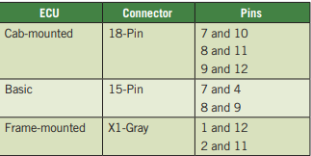
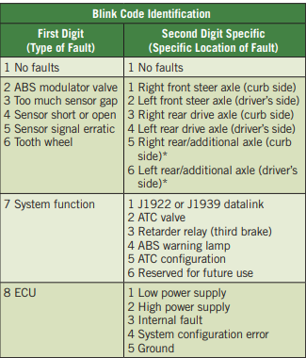
- Measure voltage at the pins indicated in
- Sensor Adjustment
- Push the sensor in until it contacts the tooth wheel.
- Do not pry or push sensors with sharp objects.
- Sensors will self-adjust during wheel rotation.

- Sensor Signal (Output) Voltage Test
Voltage should typically be 0.200-volt AC at 30 rpm.
- Turn the ignition off.
- Disconnect the ECU (see the wiring diagram).
- Raise the wheel from the ground and release the brakes.
- Use a DMM on AC volts mode range set to read up to 1 V-AC.
- Rotate the wheel by hand at 30 rpm (one revolution per 2 seconds).
- Measure voltage at the pins indicated
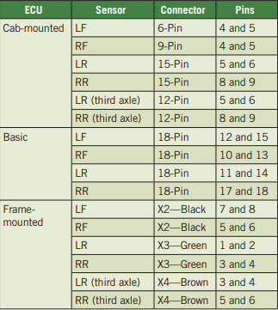
- Sensor Resistance
The sensor circuit resistance should be between 300 and 2,200 ohms. Resistance can be measured at the sensor connector or at the pins on the ECU connector using a DMM. To measure resistance:
- Turn the ignition off.
- Set the DMM to read ohms/resistance.
- To measure resistance at the sensor connector, disconnect the ECU connector from the ECU.
- Measure resistance at the pins indicated and check to specification
- Testing an ABS Modulator Valve
Measure the resistance across each valve solenoid coil terminal and ground on the ABS valve to ensure 4 to 8 ohms for a 12-volt system (8 to 16 ohms for a 24-volt system).
- If the resistance is greater than 8 ohms for a 12-volt system (16 ohms for a 24-volt system), clean the electrical contacts in the solenoid. Check the resistance again.
- To check the cable and the ABS valve as one unit, measure resistance across the pins on the ECU connector of the harness. Check the diagram of the system you are testing for pin numbers
- Diagnosis and Testing
Always follow the vehicle manufacturer’s procedures
when diagnosing an ABS. In general, ABS diagnostics requires three to five different types of testing that must be performed in the specified order listed in the service information. Types of testing may include the following:
- Pre diagnostic inspections and test drive
- Warning light symptom troubleshooting
- On-board ABS control module testing (trouble code reading)
- Individual trouble code or component troubleshooting
- Testers and Scanning Tools
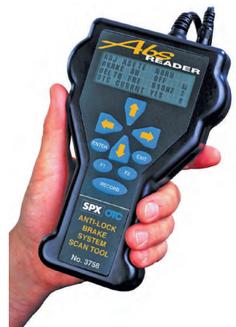
Different vehicle manufacturers provide ABS test and scan tools with varying capabilities Some testers are used simply to access the digital trouble codes. Others may also provide functional test modes for checking wheel sensor circuits, pump operation, solenoid testing, and so forth. Current ABSs are tied to the CAN bus and do not require special testers
Figure 2. 30 Scanning Tool

Once all system malfunctions have been corrected, clear the ABS’ DTCs. Codes cannot be erased until all codes have been retrieved, all faults have been corrected, and the vehicle has been driven above a set speed (usually 18 to 25 mph [30 to 40 km/h]). It may be necessary to disconnect a fuse for several seconds to clear the codes on some systems. After service work is performed on the ABS, repeat the previous test procedure to confirm that all codes have been erased

Operation sheet 3.1
Title: Testing wheel speed sensor
Objectives: Test wheel speed sensor
Instructions and procedures:
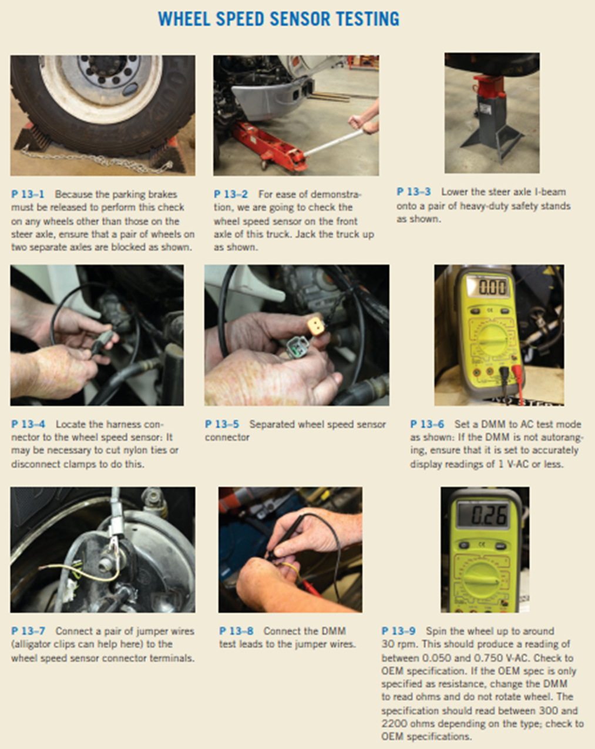

Operation sheet-3-2
Title: Visual Inspection
Objectives: The pre diagnosis inspection consists of a quick visual check of system components. Problems can often be spotted during this inspection, which can eliminate the need to conduct other more time-consuming procedures. This inspection should include the following
Instructions and procedures:
- Check the master cylinder fluid level.
- Inspect all brake hoses, lines, and fittings for signs of damage, deterioration, and leakage. Inspect the hydraulic modulator unit for any leaks or wiring damage.
- Inspect the brake components at all four wheels. Make sure that no brake drag exists and that all brakes react normally when they are applied.
- Inspect for worn or damaged wheel bearings that may allow a wheel to wobble.
- Check the alignment and operation of the outer CV joints.
- Make sure the tires meet the legal tread depth requirements and that they are the correct size.
- Inspect all electrical connections for signs of corrosion, damage, fraying, and disconnection.
- Inspect the wheel-speed sensors and their wiring. Check the air gaps between the sensor and ring, and make sure these gaps are within the specified range.
- Also check the mounting of the sensors and the condition of the toothed ring and wiring to the sensor

Operation sheet-3-3
Title: ABS diagnostic procedure
Objectives: Customer concerns about a fault with the antilock braking system
can be best handled by performing the following:
Instructions and procedures:
- Verify the customer concern. This step is very important because often a problem with the base brakes is thought by the customer to be a fault with the antilock braking system. It is helpful for the owner to drive the vehicle with a service technician if the problem is not readily apparent.
- Perform a visual inspection. If both the red and the amber brake warning lights are on, look for
a fault in the hydraulic system, including leaks or faults at the following locations:
- Master cylinder
- Electrohydraulic control unit
- Flexible brake hoses
- Brake lines and fittings
- Calipers and/or wheel cylinders
- Check for stored diagnostic trouble codes (DTCs). Use a scan tool or other necessary methods to retrieve diagnostic trouble codes. If found, follow the specified factory procedures to isolate and determine the cause.
- Complete the repair. This step may involve replacing a hydraulic component. If so, then the hydraulic system should be bled using the factory-specified procedure. Clear all diagnostic trouble codes.
- Verify the repair. Always test drive the vehicle under the same conditions that were needed to verify the problem to be sure that the cause has been corrected.

LAP-Test
Instruction: -perform necessary traction and stability system activity with the guide of specification.
Task-1 Based on information sheet above, perform required servicing ABS.
Task-2 Inspect malfunction parts
Task-3 Diagnose TCS and stability system components as necessary.
Task-4 Write the result and compare with specification.
Task-5 Analyze the fault.
Task-6 Prepare result report and compiled the activity documents.
Task-7 Jot dawn work recommendations and necessary spare part acquisition.
Required resources; live vehicle, scan tool, multimeter, specification, complete tool box, equipment and Manuals, etc.…
Time given 2 hrs.
Perform the following checking:
• Wheel speed sensor, brake pressure sensor and yaw sensor
• TCS Hydraulic modulator
• TCS and stability control module
• Check electronic circuit of traction and stability

Testing And Diagnosis Traction Control and Stability System

3.2.1 Testing Traction and Stability Control Systems
When troubleshooting a traction or stability control system, it is important to remember that the systems will be automatically disabled by the control unit if a fault occurs. Because TCS and ESC are combined with ABS and share many input signals and output functions, TCS and ESC will be disabled if an ABS fault occurs.
Traction and stability control systems add very few, if any, extra components to a vehicle. The operation of these systems is principally based on altering the control programs of the brake and engine control systems. It follows then that TCS and ESC testing should be based on retrieving DTCs and then testing individual components. Scan tools can read trouble codes and operating system data. The scan tool will also identify any communications errors that may be present. Proper communications is important for both traction and stability control systems. As with other electronic tests, you should refer to the manufacturer’s troubleshooting procedures for the vehicle you are servicing.

Operation sheet-3-4
Title: ABS diagnostic procedure
Objectives: Quick and Easy Wheel Speed Sensor Diagnosis A fault in a wheel speed sensor (WSS) is a common ABS problem. A quick and easy test that works on most Bosch ABS systems (and perhaps others) involves the following
Instructions and procedures:
- Hoist the vehicle safely.
- Turn the ignition on (engine off).
- Spin a tire by hand as fast as possible.
- The ABS amber warning light should come on, indicating that a speed was detected but not by all the wheel speed sensors.
- Turn the ignition off to reset the ABS warning light.
- Repeat the test on each of the remaining wheels.
If any wheel fails to turn on the ABS light, carefully inspect the wheel speed sensor for proper resistance and the tone ring and wiring. If the ABS light is on all the time and does not reset when the ignition is turned off, the problem is not caused by a wheel speed sensor.

Operation sheet-3-5
Title: Electronic stability control diagnostic procedure
Objectives: Because the electronic stability control (ESC) and traction control (TC) systems use some of the same sensors and controllers, the diagnosis for them is about the same. To diagnose faults with either system, follow the recommended procedures found in service information. The usual procedure involves the following
Instructions and procedures:
- Verify the customer concern (complaint). This step includes trying to duplicate what the customer or driver is concerned about the system. If the traction control or ESC light is flashing, this indicates that it is trying to bring the vehicle under control. This may be normal operation if the following conditions exist:
- Icy or slippery road conditions
- Worn tires that lack traction
- Perform a thorough visual inspection including:
- Check that all tires are the same size and tread depth.
- Check service information for the specified procedure to follow to retrieve diagnostic trouble codes as well as any related technical service bulletins (TSBs). Most vehicles require the use of a factory-brand scan tool
- Follow the troubleshooting procedure as specified to fix the root cause of the problem. This means following the instructions displayed on the scan tool or service information. The steps usually include all or many of the following:
- Brake fluid level
- Wheel speed sensor resistance
- Fault with the base brake system, such as air in the lines that could prevent the traction control controller from applying the wheel brakes
- Repair the fault.
- Road test the vehicle under the same conditions that were performed to verify the fault to be sure that the fault has been repaired.

3.3 Conducting Post-Service/Pre-Delivery Check

Operation sheet-3-6
Title: Testing Road Drive
Objectives: Road Test Drive for final inspection
Instructions and procedures:
- After the visual inspection is completed, test drive the vehicle to evaluate the performance of the entire brake system. Begin the test drive with a feel of the brake pedal while the vehicle is sitting still. Then accelerate to a speed of about 20 mph (32 km/h). Bring the vehicle to a stop using normal braking procedures. Look for any signs of swerving or improper operation. Next, accelerate the vehicle to about 25 mph (40 km/h) and apply the brakes with firm and constant pressure. You should feel the pedal pulsate if the antilock brake system is working properly.
- Perform several low-speed parking maneuvers while turning the wheels. This places the front wheel bearings under load. Many front wheel speed sensors are built into the front wheel bearings and hubs and worn bearings can cause unwanted ABS activation at low speeds. If the ABS activates when parking, check for loose and worn wheel bearings
- During the test drive, both brake warning lights should remain off. If either of the lights turns on, take note of the condition that may have caused it. After you have stopped the vehicle, place the gear selector into park or neutral and observe the warning lights
- If the control module detects a problem with the system, the amber ABS indicator lamp will either flash or light continuously to alert the driver of the problem. In some systems, a flashing ABS indicator lamp indicates that the control unit detected a problem but has not suspended ABS operation. However, a flashing ABS indicator lamp is a signal that repairs must be made to the system as soon as possible
- A solid ABS indicator lamp indicates that a problem has been detected that affects the operation of ABS. No antilock braking will be available, but normal, non-anti-lock, brake performance will remain. In order to regain ABS braking ability, the ABS must be serviced
- The red brake warning lamp will be illuminated when the brake fluid level is low, the parking brake switch is closed, the bulb test switch section of the ignition switch is closed, or when certain ABS trouble codes are set
- Intermittent problems can often be identified during the test drive. If the scan tool is equipped with a “snap-shot” feature, use it to capture system performance during normal acceleration, stopping, and turning maneuvers. If this does not reproduce the malfunction, perform an antilock stop on a low coefficient surface such as gravel, from approximately 30 to 50 mph (48 to 80 km/h) while triggering the snapshot mode on the scan tool.

3.4 Clean-Up Work and Maintenance Equipment
Cleaning and making ready workplace for next work is not just a measure of respect for the workspace, it also removes hazards. Plan to easily and regularly remove trash and debris. Enforce a strict clean up policy throughout the workspace. Keep work areas tidy as well by minimizing the number of wires running around. Extension cords quickly become tripping hazards, and power strips also cause trouble on the ground or as they tumble erratically on a desktop. We suggest you provide access to grounded outlets all along the perimeter of the room and/or dropped from the ceiling for each workbench.

3.4.1 Occupational Health and Safety Practices
A great percentage of eye injury and cuts results from a disregard for the simplest of rules in handling cleaning solvents. You should never use compressed air to clean your clothes, hands or body. The pressure could cause the cleaning solvents and dirt particles to penetrate your skin, resulting in infection and /or blood poisoning. Do not use compressed air to clean an object immediately after it has been removed from a hot cleaning tank. First, rinse the cleaning solvents away with water. Do not use carbon tetrachloride as a cleaning solution. The fumes, when inhaled can cause serious internal injury and possibly result in death. When steam-cleaning, place the object to be cleaned on a pallet and wear a face shield and rubber gloves for protection against loose debris.
If a job or cleaning task requires the use of gloves, use the appropriate gloves. Do not for instance use welding gloves when removing an object from a hot tank, or rubber gloves when welding. If you have cut, nicked, or burned yourself, or something has got into your eyes, report immediately to the first-aid person. Keep all inflammable cleaning solvents in closed tin containers and whenever possible, store them in a separate area.
Cleaning procedures are: -
• Clean up every time whenever you leave an area, including sweeping the floor.
• Clean and return all tools to where you got them.
• Use compressed air sparingly; never aim it at another person or use it to clean hair or clothes.
• Shut off and unplug machines when cleaning, repairing, or oiling.
• Never use a rag near moving machinery.
• Use a brush, hook, or a special tool to remove chips, shavings, etc. From the work area. Never use the hands.
• Keep fingers clear of the point of operation of machines by using special tools or devices, such as, push sticks, hooks, pliers, etc.
• Keep the floor around machines clean, dry, and free from trip hazards. Do not allow chips to accumulate.
• Mop up spills immediately and put a chair or cone over them if they are wet enough to cause someone to slip.
Safety Precautions
When replacing brake lines and/or hoses, always use lines and hoses designed for and specifically labeled for use on ABS vehicles.
- Never use silicone brake fluids in ABS vehicles. Use only the brake fluid type recommended by the manufacturer (normally DOT 3 or 4).
- Never begin to bleed the hydraulic brake system on a vehicle equipped with ABS until you have checked the service information for the proper procedure.
- Never open a bleeder screw or loosen a hydraulic brake line or hose while the ABS is pressurized.
- Disconnect all vehicle computers, including the ABS control unit, before doing any electrical
welding on the vehicle
- Never disconnect or reconnect electrical connectors while the ignition switch is on.
- Never install a telephone or CB antenna close to the ABS control unit or any other control module or computer.
- Check the wheel-speed sensor to sensor ring air gap after any parts of the wheel-speed circuit have been replaced.
- Keep the wheel sensor clean. Never cover the sensor with grease unless the manufacturer specifies doing so; in those cases, use only the recommended type.
- When replacing speed (toothed) rings, never beat them on with a hammer. These rings should be pressed onto their flange. Hammering may result in a loss of polarization or magnetization

3.4.2 Prepare ABS Components for Storage
• Check / make sure that all ABS components and circuits are fitted properly.
• With the help testing tools ensure ABS systems are connected, tighten, installed with the right ways and specification.
• Use proper tools and equipment to support and make easy controlling of the electronically controlled anti-lock brake system.
• After installing the ABS components, attach all removed parts and connect electrical wires
• Fill brake fluid and watch for leakage
• Check all required connection and fittings
• Bleed and check braking performance
• Check brake effectiveness
• Performing final road test and over all condition finalizing checkup.
• cleaning vehicle
• The vehicle should ready to submit to the customer.

3.4.3 Finalizing Job Card Process
• Complete work documentation that perform during the practical repairing work.
• Processing Job card based on workplace procedures.
• Forwarding report based on the work place procedure to the customer.

Self-check -3
Instruction: Answer the question stated below based on information sheet. If your progress is unsatisfactory discuss with your trainer and do this work again. Time given 15 min.
Direction: Discuss the following questions briefly
- What are the kinds of Cleaning Solvents use ABS, TCS and stability control system?
- When are the similarity of electrical properties?
- How do we Uses of Cleaning Solvents for ABS, TCS and stability control system?
- What are the OHS practices in Cleaning Solvents
- What are the cleaning procedures?
- Explain the procedure of TCS, stability, hydraulic and electronic components mounting to the vehicle.
- Explain how to confirm finalizing TCS and stability system work

Instruction: Answer the question stated below based on information sheet.
    - Which of the following is a true statement?
- In some antilock brake systems, the power brake assist is provided by pressurized brake fluid supplied by the hydraulic accumulator.
- The accumulator is a small, sealed chamber mounted to the pump/motor assembly.
- The accumulator holds a highly pressurized nitrogen gas that is used to generate a charging pressure.
- All of the statements are true.
    - What is the name for the gas-filled pressure chamber that is part of the antilock braking system’s pump and motor assembly?

- Control module
- Accumulator
- Sensor
- Reservoir

    - When inspecting wheel-speed sensors, check for all of the following except ___.

- buildup of metal or rust on the sensor
- proper contact between the pole piece and tone ring
- secure sensor mounting
- condition of the tone ring teeth

4. Which type of ABS is not commonly used on modern vehicles?

- Four-wheel nonintegral
- Two-wheel nonintegral
- Four-wheel integral
- None of the above

    - Technician A says that a malfunction of the ABS causes the control module to shut off or
inhibit the system. Technician B says that a loss of hydraulic fluid or power booster pressure disables the antilock brake system. Who is correct?

- Technician A only
- Technician B only
- Both A and B
- Neither A nor B

LAP- Test
Instructions:
You are required to perform at least three of the following tasks:
Task-1: Testing Components with ABS Scan Tools
Task-2: Inspect/Test a Wheel-Speed Sensor
Task-3: Adjusting wheel speed sensor adjustment
Task -4: Confirm finalizing installation work
Task -5 Conduct Road test and cleaning the vehicle
Task -6 Finalize document preparation and forwarding report.

Reference
- Jack Erjavec, Automotive Technology: a systems approach, 5 t h Edition, 2010 Delmar, Cengage Learning
- James D. Haldeman, Automotive technology Principles, Diagnosis, and Service fourth edition
- Crouse, W.H. and Anglin D.L, Auto motive mechanics 10th edition
- R.K Rajput, Automobile Engineering
- Prof. Dr.-Ing. Konrad Reif, Brakes, Brake Control and Driver Assistance Systems
- Nunney, M. J.Rutledge, 2007, Light and Heavy Vehicle Technology 4th ed.

Participants of this Module (training material) preparation
No | Name | Qualification (Level) | Field of Study | Organization/ Institution | Mobile Number | E-mail
 | Fadli Aman | BSc. | Automotive Technology | General Wingate PTC | 0927283100 | Fadli.ziyad@gmail.com
 | Habtamu Deresso | PHD Candidate | Automotive Technology | ASTU | 0945853269 | habtamu.deresso@gmail.com
 | Israel Taye | MSC | Automotive Technology | General Wingate PTC | 0913424100 | isra.taye@gmail.com
 | Natnael Genene | MSC | Automotive Technology | Athlete kenenisa PTC | 0920397105 | natnealgenene143@gmail.com
 | Robsan Tesfaye | MSC | Automotive Technology | Burayu PTC | 0920117175 | robsantesfaye4@gmail.com
 | Sisay Tufa | MSC | Automotive Technology | M/G/M/Buli | 0912065407 | knbntf@gmail.com
 | Tagay Tesfaye | MSC | Automotive Technology | Bishoftu PTC | 0975971391 | tagotagotago37@gmail.com

