

Automotive Electrical and Electronics Level-III
Based on October 2023 Curriculum Version II

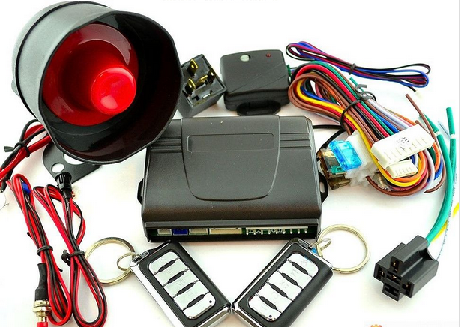

Module Title: Electronic Body Management Systems
Module Code: EIS AEE3 M08 1023
Nominal Duration: 40 Hours
Prepared by: Ministry of Labor and Skill
October, 2023
Addis Ababa, Ethiopia
Table of Contents
Acknowledgment 4
Acronym 5
Introduction to Module 6
Unit one: Introduction to Electronic Body Management Systems 7
1.1. Operating Principles Of Electronic Body Management Systems 8
1.1.1. Central door Locking and alarm systems 8
1.1.2. Power Windows 24
1.1.3. Electric side mirrors 29
1.1.4. Electronic seat adjustment 31
1.1.5. Electronic Seat belt 34
1.1.6. Supplemental and restraint system/ SRS/ 40
1.1.7. Engine immoblizer 47
1.2. OHS requirements on electronic body management systems 49
: Unit Two: Installing and testing electronic body management system 54
2.1. Installing electronic body management system 55
Operation Sheet 2.1 56
Operation Sheet 2.2 60
Operation sheet 2.3 62
Operation Sheet 2.4 63
Operation sheet 2.6 66
Operation sheet 2.7 68
2.2. Testing Sensors and Actuators 70
Self-check 2.1 77
LAP Test 78
Unit Three: Service/repair body management systems 79
3.1. Servicing , repairing and retesting body management components 79
3.2. Cleaning work area and Maintaining tools and equipment 89
Self-check 3.1 91
Operation Sheet 3.1 92
Operation Sheet 3.2 93
LAP Test 94
Reference 95

Acknowledgment
The Ministry of Labor and skill wishes to thank and appreciation to MoLS leaders and experts, Regional Labor and skill/training Bureaus leader, experts, TVT College Deans, Instructors and industry experts who contribute their time and professional experience to the development of this Training Module.

Acronym

ABL | Active Buckle Lifter
ABS | Anti-Lock Brake System
BCMs | Body Control Module
LED | Light Emmitt Diode
PCM | Power Control Module
SDM | Sensing And Diagnostic Module
SRS | Supplemental And Restraint System
VIN | Vehicle Identification Module

Introduction to Module
In automotive electrical electronics field, removing and installing automotive electrical electronics system components helps to identify and remove electrical electronics components from the vehicle and install back according to manufacturer’s service manual.
This module covers the knowledge, skill and attitude to service/repair electronic body management systems and/or associated components which include electric mirror, central locking, power windows, electric mirrors, electronic seat adjustment with memory and security systems .The module includes identification and confirmation of work requirement, preparation for work, testing and diagnosis of faults, servicing, repair and retesting of systems and completion of work finalisation processes, including clean-up and documentation.
This module covers the units:
- Introduction to Electronic Body Management Systems
- Installing and testing electronic body management system
- Service/repair body management systems
Learning Objective of the Module
- Understand Electronic Body Management Systems
- Perform Install and test electronic body management system
- Perform Service/repair body management systems
Module Instruction
For effective use this modules trainees are expected to follow the following module instruction:
- Read the information written in each unit
- Accomplish the Self-checks at the end of each unit
- Perform Operation Sheets which were provided at the end of units
- Do the “LAP test” giver at the end of each unit and
- Read the identified reference book for Examples and exercise

Unit one: Introduction to Electronic Body Management Systems
This unit is developed to provide you the necessary information regarding the following content coverage and topics:
- Operating principles of electronic body management systems
  - OHS requirements on electronic body management systems
This unit will also assist you to attain the learning outcomes stated in the cover page. Specifically, upon completion of this learning guide, you will be able to:
  - Understand Operating principles of electronic body management systems
- Perform OHS requirements and personal protection needs

Operating Principles Of Electronic Body Management Systems
A modern car has to do more than just providing a means of transportation. It has become a small living room with numerous comfort and safety functions. BCMs are the hardware and software core component for these functions. They interconnect and control comfort and safety functions as well as the power management system. BCMs also provide the diagnostic interface when repairing or servicing the vehicle. Whenever the driver turns on the lights, heats up his seat or uses the windscreen wipers, the BCM functions as the control center. Inside a well-equipped mid-range car, the BCM communicates with about 60 different electronic modules.

Central door Locking and alarm systems
Central door locking systems are convenience features which allow all of a vehicle’s door locks to be simultaneously actuated from either the driver’s or front passenger’s door lock. Most systems also incorporate a boot/tailgate lock and some provide additional functions such as lock disablement if the key is left in the ignition, or automatic central locking when the car first exceeds a preset speed after driving away.
For operation of the central locking system there are four different systems:
- Mechanical key system
- Infrared remote control system
- Radio-frequency remote control system
- Radio-frequency remote control system with self- actuation (keyless-go)
Mechanical key system: With this system the key is inserted at one location (usually a front door or the boot lid) and then rotated within the lock’s tumbler mechanism to manually engage or release the lock at this location. At the same time, an electric switch supplies the control signal for the servo-motors or pneumatic actuators. These lock or unlock the other vehicle opening points.
Infrared remote control system - Here, the locking or opening procedure can be initiated via an infrared signal up to a distance of approx. 6 meters.
The system (Fig. 1) can consist of the following components:
- Transmitter key
- Infrared control unit
- Control unit with combined functions

- Relay for lock status
- Receiver unit e.g. in interior rearview mirror
- Pneumatic control unit
- Actuators
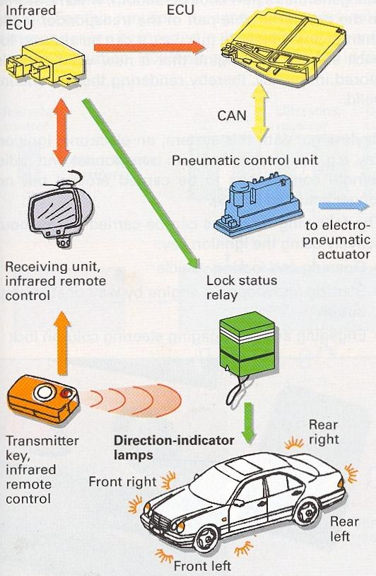
Figure 1-1Structure of infrared remote control system
Operating principle: The infrared sender, e.g. to the key, sends light signals within the infrared frequency range to the receiver. The receiver is connected to the infrared control unit. It detects via the lock response relay whether the vehicle door locks are engaged or disengaged. If the vehicle is unlocked, the driver is informed of this fact for example, by flash code via the direction-indicator lamps.
This information is also sent to the actual control unit with combined functions. It is joined via a CAN bus to the pneumatic control unit. On the electro-pneumatic central locking system, this generates the pressure or vacuum necessary to make the locking/unlocking procedures possible.
Radio-frequency remote control system: For actuation of the positioning elements, a radio-wave signal can also be used. With radio waves, the sender need not be directed at the receiver. Initiation of the locking procedure and activation of the alarm system can be carried out covertly. Radio waves offer higher protection against decoding of the signal by un authorized persons. The code itself can also be given a more complex structure.

Radio-frequency remote control with self-actuation (keyless-go): The driver does not have to touch the key to gain access. All that is required is for the electronic key to be on his/her person and one of the door handles to be touched. The capacitive sensor in the door handle detects an attempt to gain access to the vehicle and sends a signal to the access and start authorization control unit This starts an inductive interrogation of the transponder in the electronic key. If access authorization is granted, the vehicle is opened. The locking procedure is triggered by pressing the locking button.
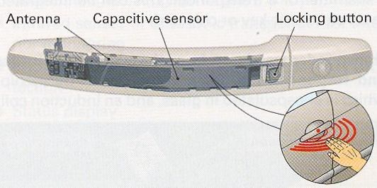

Figure 1-2 Unlocking by touching door handle

Most central locking systems fall into one of the following categories:
1. Electro-mechanical systems operated by switching contacts to earth (earth switched systems)
2. Electro-mechanical systems operated by switching contacts to 12 volts (positive (+ 12V) switched systems).
2. Electro-pneumatic systems operated by connection to earth or 12 volts. Switch contacts driving an air pressure pump (pneumatic)
Some vehicles are not fined with an actuator in the driver’s door as the driver door is mechanically locked with a key and a signal is sent to the vehicles central locking control unit which locks the other doors.
If all the doors lock and unlock from the passenger door, then no actuator is required for the driver door and the wiring will all take place at the central locking control unit of your vehicle.
If the doors can only be locked and unlocked at the driver’s door, then an actuator is required for the driver door and all the interface wiring will be connected to this actuator as follows.

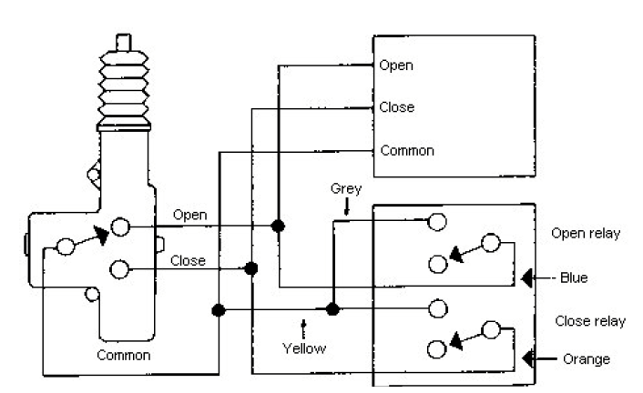
Figure 1-3 central locking system

The central locking system may either be operated by a dedicated controller or by a CCU. Where a CCU is used it often links the door locking system to a remote-controlled anti-theft facility and automatic sunroof/window closure (‘lazy-locking’ system).
Operation of the door locks system
The construction of the door lock control relay connector and the numbering of the terminal may differ depending on the destination, so be sure to refer to the appropriate repair manual or electrical wiring diagram
- Door lock locking operation
When the doors are locked in accordance with signals from various switches, Tr1 inside the door lock control relay is switched on by the IC. When Trl goes on, current flows to the coil of relay No.1, turning relay No.1 on.
When relay No.1 goes on, current flows to the door lock motors as shown in the circuit diagram below, locking all the doors.

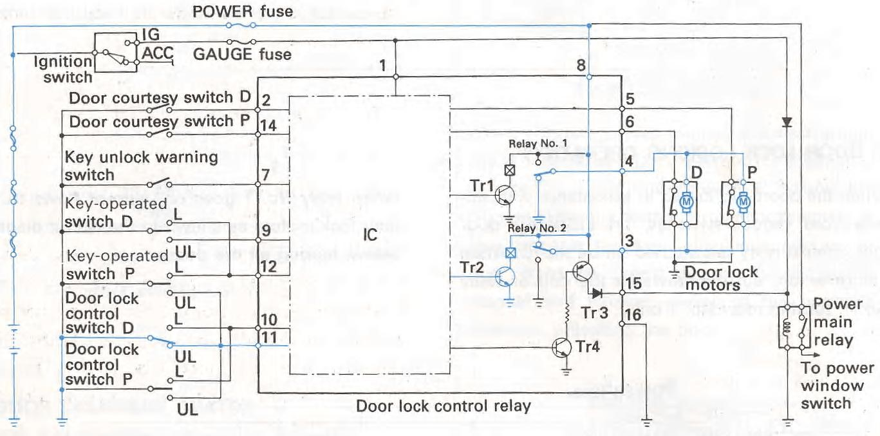
Figure4 Door lock locking operation
- Door lock unlocking operation
When the doors are unlocked, Tr2 is turned on by the IC. When Tr2 goes on, relay No. 2 goes on and current flows to the door lock motors as shown in the circuit diagram below, unlocking all the doors. 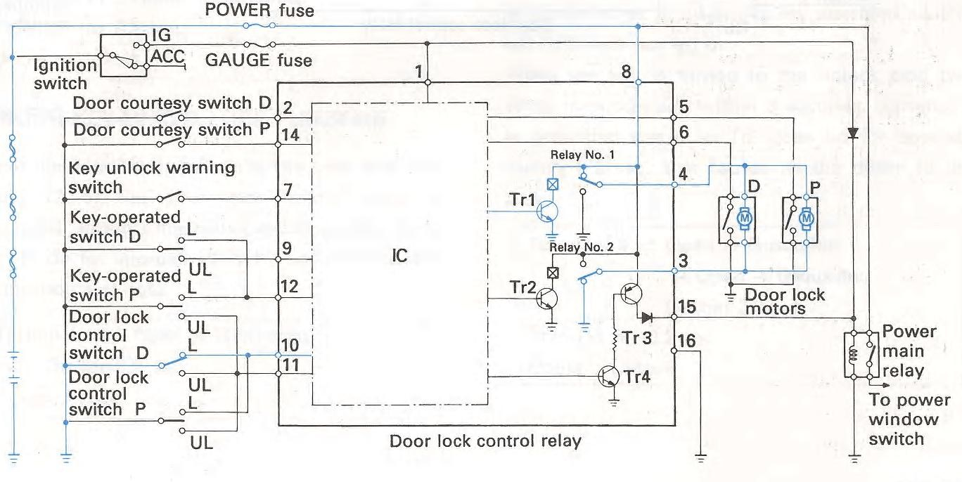 Figue 5 Door lock locking operation

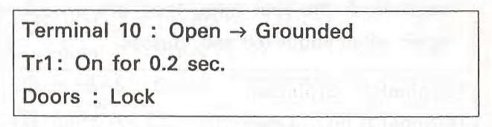
Lock control operated by door lock control switch
When the door lock control switch is moved to the Lock side, terminal 10 of the door lock control relay is grounded through the door lock control switch, turning Trl on for approximately 0.2 seconds. This causes all the doors to lock.
- Unlock control operated by door lock control switch
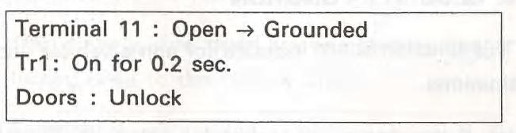
When the door lock control switch is moved to the Unlock side, terminal 11 of the door lock control relay is grounded through the door lock control switch, turning Tr2 on for approximately 0.2 sec. This causes all the doors to unlock.
- Door key-linked lock function
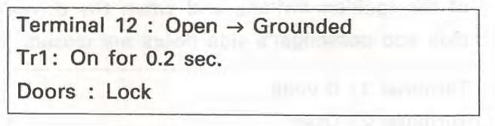
When the door key is turned to the Lock side, terminal 12 of the door lock control relay is grounded through the keyoperated switch, turning Trl on for approximately 0.2 sec. This causes all the doors to lock.
- Door key-linked unlock function
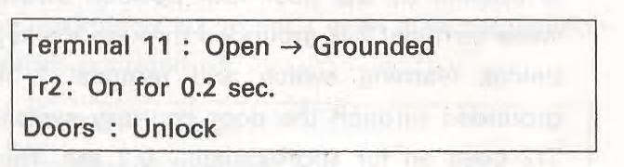
Depending on the destination, the driver’s side door may include a two-step unlock function. When the door key is turned to the Unlock side, terminal 11 of the door lock control relay is grounded through the key-operated switch, turning Tr2 on for approximately 0.2 sec. This causes all the doors to unlock.
- Two-step unlock function (driver’s side)
This function is not included for some destinations. When the key is turned to the Unlock side in the driver’s side door one time, it mechanically unlocks the driver’s side door only. At this time, terminal 9 of the door lock control relay is grounded once through the key operated switch, but Tr2 does not go on.
- Door key-linked unlock function
Depending on the destination, the driver’s side door may include a two-step unlock function. When the door key is turned to the Unlock side, terminal 11 of the door lock control relay is grounded through the key-operated switch, turning Tr2 on for approximately 0.2 sec. This causes all the doors to unlock.
- Two-step unlock function (driver’s side)
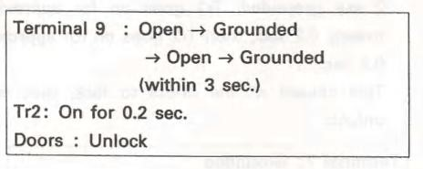
This function is not included for some destinations. When the key is turned to the Unlock side in the driver’s side door one time, it mechanically unlocks the driver’s side door only. At this time, terminal 9 of the door lock control relay is grounded once through the key operated switch, but Tr2 does not go on.
Page
8
When the key is turned to the unlock side two times in succession within 3 seconds, terminal 9 is grounded twice, so Tr2 goes on for approximately 0.2 sec. This causes all the doors to unlock.
- Key confine prevention function
This function is not included in the passenger side door for some destinations.
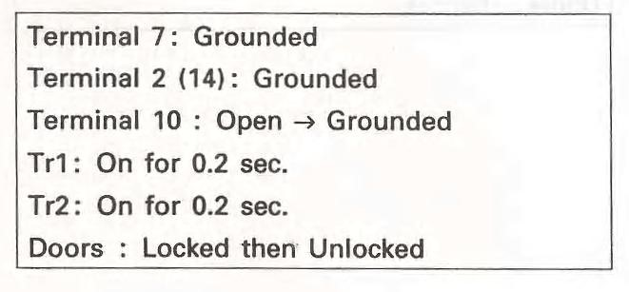
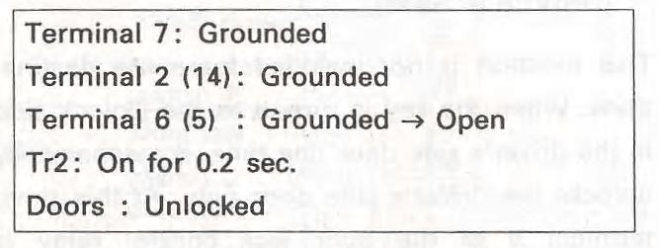
- When the key is inserted in the ignition switch and the door lock lever is pressed while the door is open, all the doors are unlocked. That is, if terminal 6 of the door lock control relay is opened by the door lock position switch while terminal 7 is grounded through the key unlock warning switch and terminal 2 is grounded through the door courtesy switch, Tr2 goes on for approximately 0.2 sec. This causes all the doors to unlock.
- When the door lock control switch is moved to the Lock side with the key inserted in the ignition switch and the door open, all the doors lock temporarily, then unlock. That is, if terminal 10 of the door lock control relay is grounded through the door lock control switch while terminal 7 and terminal 2 are grounded, Trl goes on for approximately 0.2 sec., then Tr2 goes on for approx. 0.2 sec. This causes all the doors to lock, then to unlock.
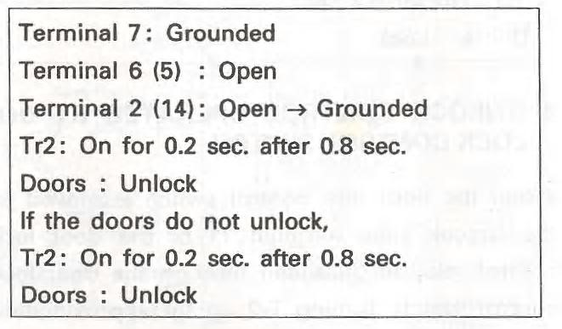
C. lf the door is closed with the key inserted in the ignition switch and the door lock lever pushed in (locked), that is, if the door lock lever is pushed in for 0.2 sec. or longer while the doors are unlocked through the operation in (a), then closed, the doors are unlocked after approximately 0.8 sec. lf the doors do not unlock the first time, they are unlocked again after about 0.8 sec. passes
8. Security function
This function is not included for some vehicle destinations.
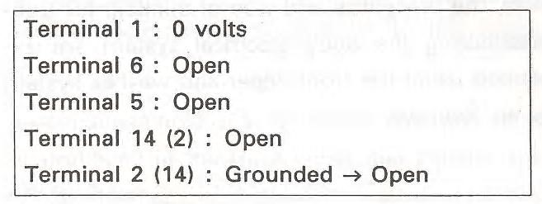
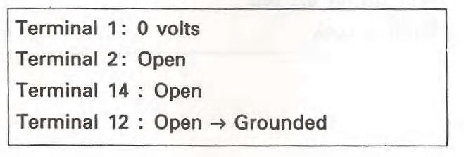
- If the doors are locked by either of the following operations, the doors do not unlock even when the door lock control switch is moved to the unlock side. The door is locked with the key when the ignition switch is in a position other than the ON position (ordinarily, when the key is pulled out of the ignition switch), and when the drivers side and passenger’s side doors are closed.
- The driver’s side (or passenger’s side) door is locked by the keyless locking method when the ignition switch is in a position other than the ON position, the lock levers on the driver’s side and passenger’s side doors are pushed in and the passenger’s side door (or driver’s side door) is closed.
- The security function is released when any of the following operations are performed:
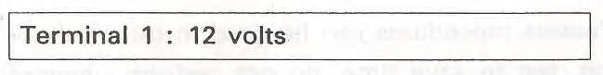

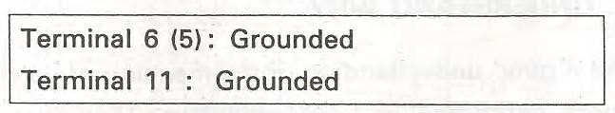
  - The ignition switch is turned to the ON position.
  - The driver’s side door key-operated
switch is turned once to the Unlock side.
  - The door lock control switch is moved to the unlock side with the driver’s side or passenger’s side door’s lock lever pulled out.
9.. Key-off power window operation function
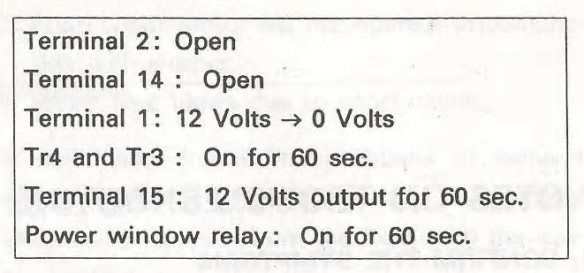
This function is not included for some vehicle destinations.
Ordinary power windows operate with the ignition switch in the ON position. However, with this function, before any door is opened, the power windows can be operated for approximately 60 seconds even after the ignition switch is turned off.
In order that the locks in the doors, the boot lid/tailgate and fuel filler door can be locked and unlocked, actuators, or servo-motors, are necessary.
Depending on actuation, a distinction is made between the:
- Electric central locking system
- Electro-pneumatic central locking system
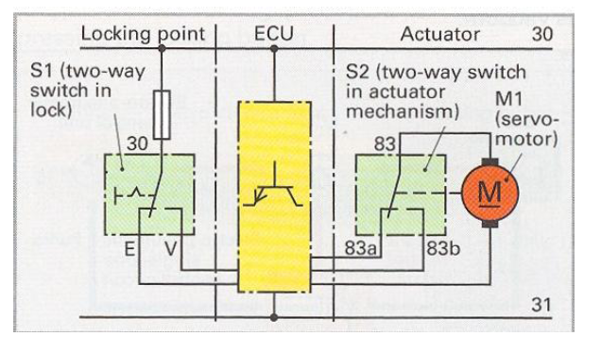
- . Electric central locking system
With this system, the basic lock engagement and release functions, for instance, at vehicle doors through activation of the servo-motors, are carried out by the electrically controlled actuators.

Figure 1. 4 circuit diagram of servo-motor with two two-way switches

Actuation is often by way of two change over contacts, whereby one is located in the door lock and the other in the actuator.

The simplified circuit diagram of the electrical central locking system in Fig. 6 shows how they work together. When the key is turned, the lock and changeover contact S1 are actuated mechanically. It can be found at the respective locking points, e.g. driver and front passenger door. In this way, all servo-motors that are part of the central
locking system can be actuated via the control unit. The changeover contact S1 has two switch positions: Lock (V) and unlock (E).The changeover contact S2 is often integrated in the actuator and activated by the servo-motor via a linkage or a gear mechanism. The changeover contact switches the servo-motor on or off with two switching positions as an end point switch. The control signals are transmitted via wiring or a bus system (CAN bus, multiplexer) to a control unit.
Operation
Principle of locking With a turn of the key, Terminal 30 and Terminal V in the changeover contact are joined together. This control pulse causes the control unit to supply Terminal 83a with voltage. The servo-motor M1 runs. In changeover contact S2, Terminal 83a and 83 remain connected until the locking process has reached its end position and the connection between 83a and 83 is interrupted by servo-motor M1. The servo-motor stops.
Principle of unlocking - With a turn of the key in the opposite direction, Terminal 30 and Terminal E in the changeover contact are joined together. This control pulse causes the control unit to supply Terminal 83b with voltage. Servo-motor M1 now runs in the opposite direction. In changeover contact S2, Terminals 83b and 83 remain connected until the unlocking process reaches its end position and the connection between 83b and 83 is interrupted by servo-motor M1. The servo-motor stops.
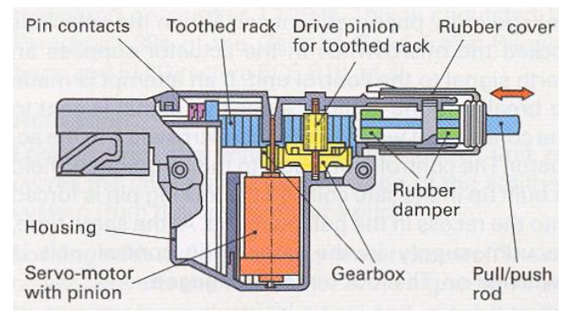
Electric actuator this controls locking and unlocking. The pinion of the servo-motor is joined mechanically via a gear mechanism to the drive pinion of the toothed rack. If the lock is actuated mechanically by means of the key in the locking point of the central locking system, e.g. unlocked, the pull/push rod transfers the movement via a toothed rack and several gear wheels in the actuator. When this happens, the two-way switch (S2) is set mechanically in end position to unlock. The servo-motor remains un energized.
Figure 1-4Electric actuator
Electro-pneumatic central locking system
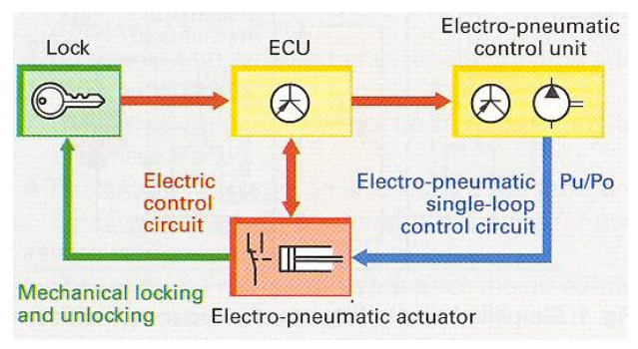
Figure 1-5 diagram of electro-pneumatic central locking system
Electric control unit
This controls the pneumatic single-loop control circuit. When the key is turned in the door lock, a micro switch is actuated. The control unit receives this signal and activates the pneumatic control unit of all other locks (electro-pneumatic control circuit).
Pneumatic single-loop control circuit.
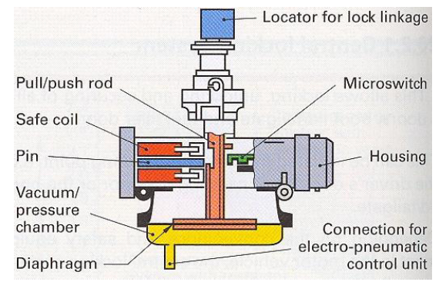
This actuates the actuators by way of vacuum or pressure in a line. When the vehicle is unlocked, for example, there is pressure in the line, when the vehicle is locked, there is vacuum.
Electro-pneumatic actuator
This is designed to carry out the locking procedure and is present at every door that needs to be closed. If, depending on the lock unlock procedure, pressure or vacuum is generated by the pneumatic control unit, this affects the diaphragm in the vacuum or pressure chamber of the actuator. The diaphragm and the lock are joined to the pull/push rod. In this way, the locking procedure can be carried out by using a key to activate the linkage or by pneumatic means. When the vehicle is locked the micro switch in the actuator supplies an earth signal to the control unit. If an attempt is made to break into the vehicle, a positive signal is sent to the control unit via the relevant micro switch in the actuator. The control unit reacts to this. A magnetic field is built up in the safe coil and the locking pin is forced into the recess in the pull/push rod. At the same time, vacuum supply in the pneumatic control unit is switched on. The lock remains engaged.
Figure 1-6Electro-pneumatic actuator
Pneumatic unlocking - The vacuum displaces the diaphragm to press the pull/push rod upwards. In this way, the lock is disengaged mechanically via a linkage.
Pneumatic locking - The vacuum affects the diaphragm and pulls the pull/push rod down wards. The lock is engaged mechanically via the linkage.
Pneumatic control unit - This comprises an electronic circuit (interface) and a dual-pressure pump. The electronic circuit receives the commands from the control unit and passes them onto the dual-pressure pump.
Dual-pressure pump - This is a vane pump that generates either pressure or vacuum by reversing the impeller’s direction of rotation. Anticlockwise rotation causes pressure, for example, and clockwise rotation generates vacuum.
Alarm Systems
The alarm system can only be armed and disarmed with original car remote control. Theprotection of your car is assured by interior movement and perimetric sensors. The alarm system is self-protected against system attack.During an alarm, the alarm siren, the vehicle horn (if applicable on your car), the blinkers, and the interior light are activated.
The Alarm system performs the following functions:
- Perimetric protection (doors, boot, and bonnet).
- Interior and window breakage protection (by interior movement sensor).
- Alarm system tampering protection.
- Unauthorised engine starting car protection.
- Acoustic and visual alarm signalization.
- Alarm system status and diagnostic indication light (LED).
- Additional protection features can be added (Lift-up monitor module).

Alarm operation
The alarm is activated in the following situations:
- A locked door or boot is opened in any way other than using the smart entry function or original remote control.
- The bonnet is opened while the car is locked.
- The intrusion sensor is activated: When the sensor detects something moving inside the car, or a window is broken.
- The battery terminal is disconnected while the alarm system is activated
The two methods for activating alarm systems are:
- Passive systems: switch on automatically when the ignition key is removed or the doors are locked.
- Active systems: are activated with a key fob transmitter or key.
When a door, hood, or trunk is opened, the switch closes and trigger the alarm sounds.
Ultrasonic sensors are used to detect motion and will trigger the alarm if there is movement inside the vehicle.
Current sensitive sensors activate the alarm if there is a change in current within the electrical system, such as when a courtesy light goes on or the ignition starts.
Motion detectors monitor changes in the vehicle’s tilt, such as when someone is attempting to steal the tires.
Three basic types of security and warning devices available are:
  - Locking devices,
  - Disabling devices, and
  - Alarm systems.
Many of the devices are available as optional equipment from the manufacturers and also installed aftermarket.
1. Locks and Keys:
  - Locks are designed to deny entry to the car as well as to prevent a thief from driving it away.
  - Most locks move a mechanical block between the vehicle’s body and the door. Keys simply move those blocks.
  - Manufacturers use specially cut keys that cannot be easily duplicated and lock mechanisms that are difficult to pick.
- 2. Disabling devices
The main ways to disable the vehicle are ignition circuit cut off, starter circuit cut off or engine ECU code lock.
- Passkey Systems
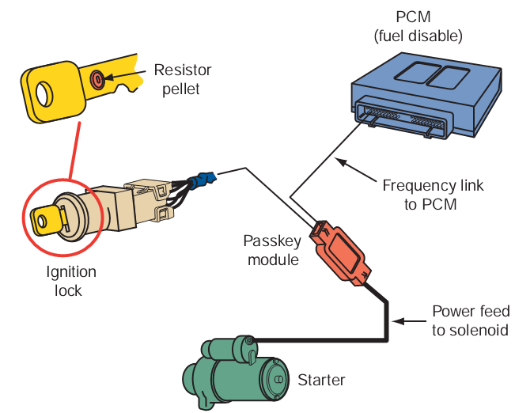
The passkey is a specially designed key that is programmed just for one vehicle. Although another key may fit into the ignition switch or door lock, the system will not allow the engine to start without the correct electrical signal from the key.
A resistance key is a normal key with a small resistor bonded to it. When the key is inserted into the ignition switch, the circuit must recognize that resistance as being the correct amount for the vehicle before the engine will start.

Figure 1-7 Resistance key Systems
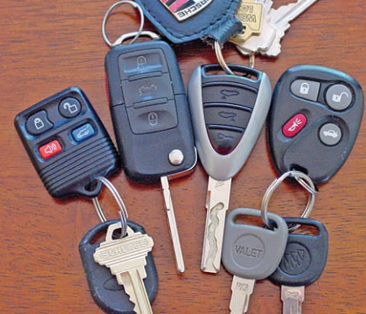
Transponder key systems are based on a communication scheme between the vehicle’s PCM and the transponder in the key. Each time the key is inserted into the ignition switch, the PCM sends out a different radio signal. If the key’s transponder is not capable of returning the same signal, the engine will not start.

Figure 1-8 An assortment of electronic keys andkey fobs.

Keyless Entry Systems
A keyless entry system allows the driver to unlock the doors or trunk lid from outside of the vehicle without using a key.
It has two main components:
- an electronic control module and a coded button keypad on the driver’s door
- a key fob.
The electronic control module typically can unlock all doors, unlock the trunk, lock all doors, lock the trunk, turn on courtesy lamps, and illuminate the keypad or keyhole after any button on the keypad is pushed or either front door handle is pulled.
Remote keyless entry systems rely on a handheld transmitter, frequently part of the key fob. With a press of the unlock button on the transmitter from 25 to 50 feet away (depending on the type of transmitter) in any direction range, the interior lights turn on, the driver’s door unlocks, and the theft security system is disarmed. The trunk can also be unlocked. Pressing the lock button locks all doors and arms the security system. For maximum security, some remote units and their receiver change access codes each time the remote is used.
Smart Keys
Many new vehicles do not come with a key; rather a transponder is used to perform all of the functions of a key. On some systems the transponder (Figure A)is inserted into a slot in the instrument panel (Figure B). To start the engine, the transponder is pressed (Figure C). On others, after the transponder is inserted into its slot, a start button is pressed. The system is based on a communication link between the transponder and the vehicle. If the codes of the transponder and the vehicle do not match, the engine will not start.
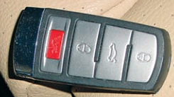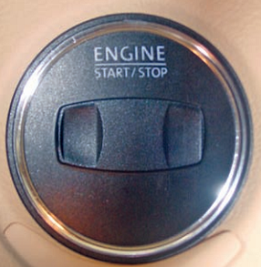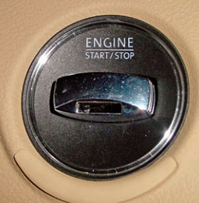
Some smart keys (A) are inserted into a slot (B), and then depressed (C) to start the engine
Figure 1-9 Some smart keys
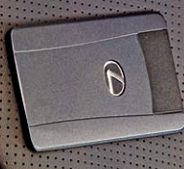
A few vehicles have smarter smart keys. The transponder does not need to be inserted. It merely needs to be close to the vehicle. This system is normally called a smart access system. The system can perform many functions without inserting a key or pressing a button. It can lock and unlock the doors, allow the engine to start by pressing the engine switch while depressing the brake pedal. When the electronic key enters into zones around the vehicle, a certification control module certifies the ID code from the key.
Once the signal is certified, the control module transmits a steering unlock signal to the steering lock ECU. The BCM also receives a certification signal and actuates the door lock motor to unlock or lock the door.The actuation zone is normally about 1 meter.
Figure 1-10A real smart key
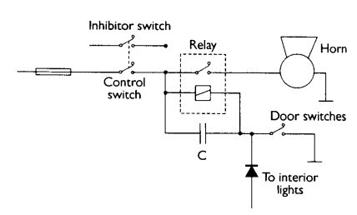
Figure 1-11 Simple alarm system
When a door is opened, the switches make an earth connection. This will be used to trigger the relay, which in turn will operate the horn. The delay must be built in using a capacitor, which will keep the relay energized even after the door closes, for a further 15 seconds. An external key switch is to be used to arm and disarm.

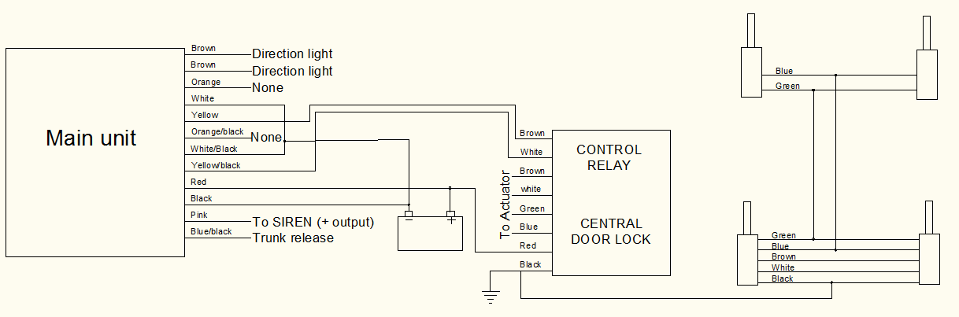
Figure 1-12 Car Alarm Central Door Lock circuit

Power Windows
The purpose of any power window system is to raise and lower windows. This allows electric opening and closing of the windows and, where fitted, sliding sunroof via a rocker switch (push button switch). Power windows or electric windows are automobile windows which can be raised and lowered by depressing a button or switch, as opposed to using a hand-turned crank handle.
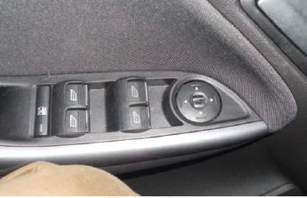
The master control switch provides overall system control. Power for the system comes directly from the fuse panel. Depending on the vehicle, there may be one fuse or circuit breaker for the system or a fuse for each door. Power for the individual window control switches comes through the master control switch . When the master switch allows, the other windows can be controlled by the switches located on the associated doors.
Window Lockout Systems
A lock switch included on four-door master control switches is a safety device to prevent children from opening windows at the individual window switches without the driver’s knowledge. When the lockout function has been activated, the passenger door windows can still be operated from the driver door by using the central control switch.
Figure 1-13 The master window switch located in thedriver’s door
The mechanism that moves the window up and down is called the window regulator. In cars with power windows, the window regulator is powered by an electric motor, called the window motor. In some cars, the window motor comes with the window regulator as one unit; in others, the window motor can be replaced separately. There are two basic types of window regulators: the gear-drive type (in the photo) and the cable type (see photo below).
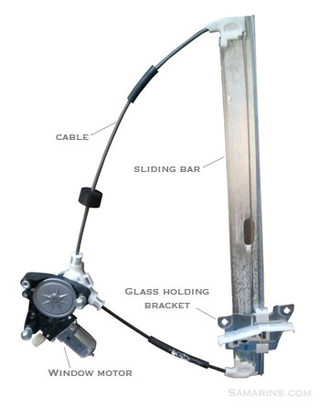
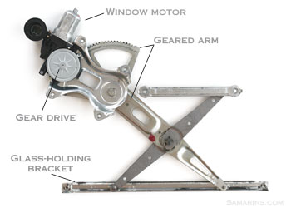

Figure 1-14 The gear-drive type (in the photo) and the cable type
The major components of the power window are:
- The master control switch
- Individual window control switch
- Reversible electric motor
- Circuit breaker
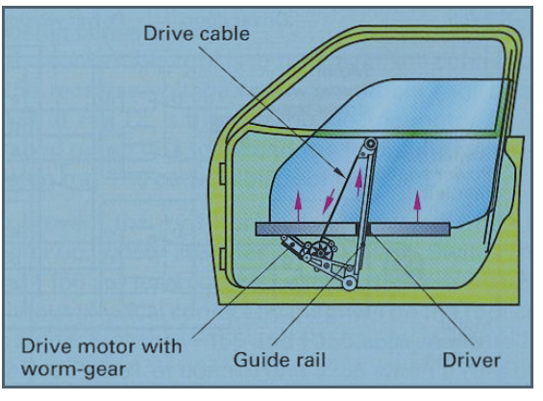
- Fuse and related wiring
To power the windows up and down, a cable drive system is normally used. The drive motor actuates a cable via a worm gear mechanism, which will open or close the window depending on the direction of motor rotation. The self-locking effect of the worm gear mechanism prevents the window from opening in response to application of force.
Figure 1-15 Cable Drive
Electric actuation of the windows
This can be performed by :
- Rocker switch (manual actuation)
- Control electronics combined with rocker switch
Actuation via rocker switch: Using the rocker switch, which is allocated to the relevant power window motor, the window can be closed or opened. On a central locking system, all windows can also be closed at the same time .
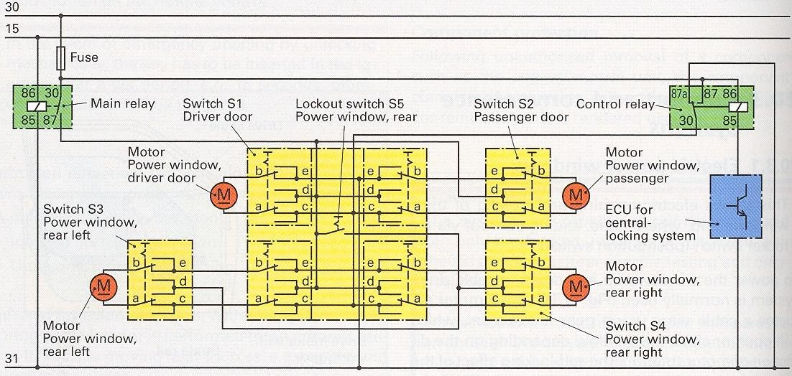
Figure 1-16 Circuit diagram for rocker switch actuation
Operation
Operating principle : The main relay receives power from Terminal 15 whenever the ignition switch is on. It pulls in and connects Terminal 30 with Terminal 87 and applies voltage to Terminal d from switch S₁ and S₂. With the aid of switch S₅, which is integrated in switch S₁ of the driver’s door, switches S₃ and S₄ for the rear doors can be supplied with energy or the power supply can be switched off.
Switch position: Open window . On actuation of the rocker switch (S1, S2, S3, 54) Terminal d (+) is joined to Terminal b and Terminal c (—) to Terminal a. The power window drive unit lowers the respective window.
Switch position: Close window . If the window is to be closed, Terminal d (+) in the rocker switch is joined to Terminal a and Terminal e (—) to Terminal b. The drive motor is driven in the opposite direction because the terminal polarity of a and b is reversed. The window closes.
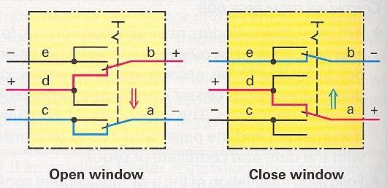
Figure 1-17 Switch positions for rocker switch window actuation
Closing windows on central locking system: The central locking control unit connects the control coil of the control relays Terminal 85 to earth. In this way, Terminal 87 and Terminal 30 are joined in the relay. Switch terminal a is connected to positive via Terminal c. This earths the circuit through Terminals b and e. The windows are closed.
Combination of window control by rocker switch and control electronics: The control electronics can be housed centrally in one control unit for this purpose. In order to keep the wiring as simple as possible, it can be integrated in the power window motor. If the control button of the power window motor is touched briefly, the control electronics cause the window to close. If the control button is pressed for a longer period, the window can be moved to the desired position. If the vehicle is locked via central locking, all windows close at the same time or are closed up to a ventilation gap.
Finger-protection feature: To prevent body parts such as hands and arms from becoming trapped, the force with which the window closes is limited to a specified level. The finger-protection feature functions electrically, by deactivating the electric motor once current draw reaches a specific level, or mechanically, using load-sensitive couplings in the drive system.

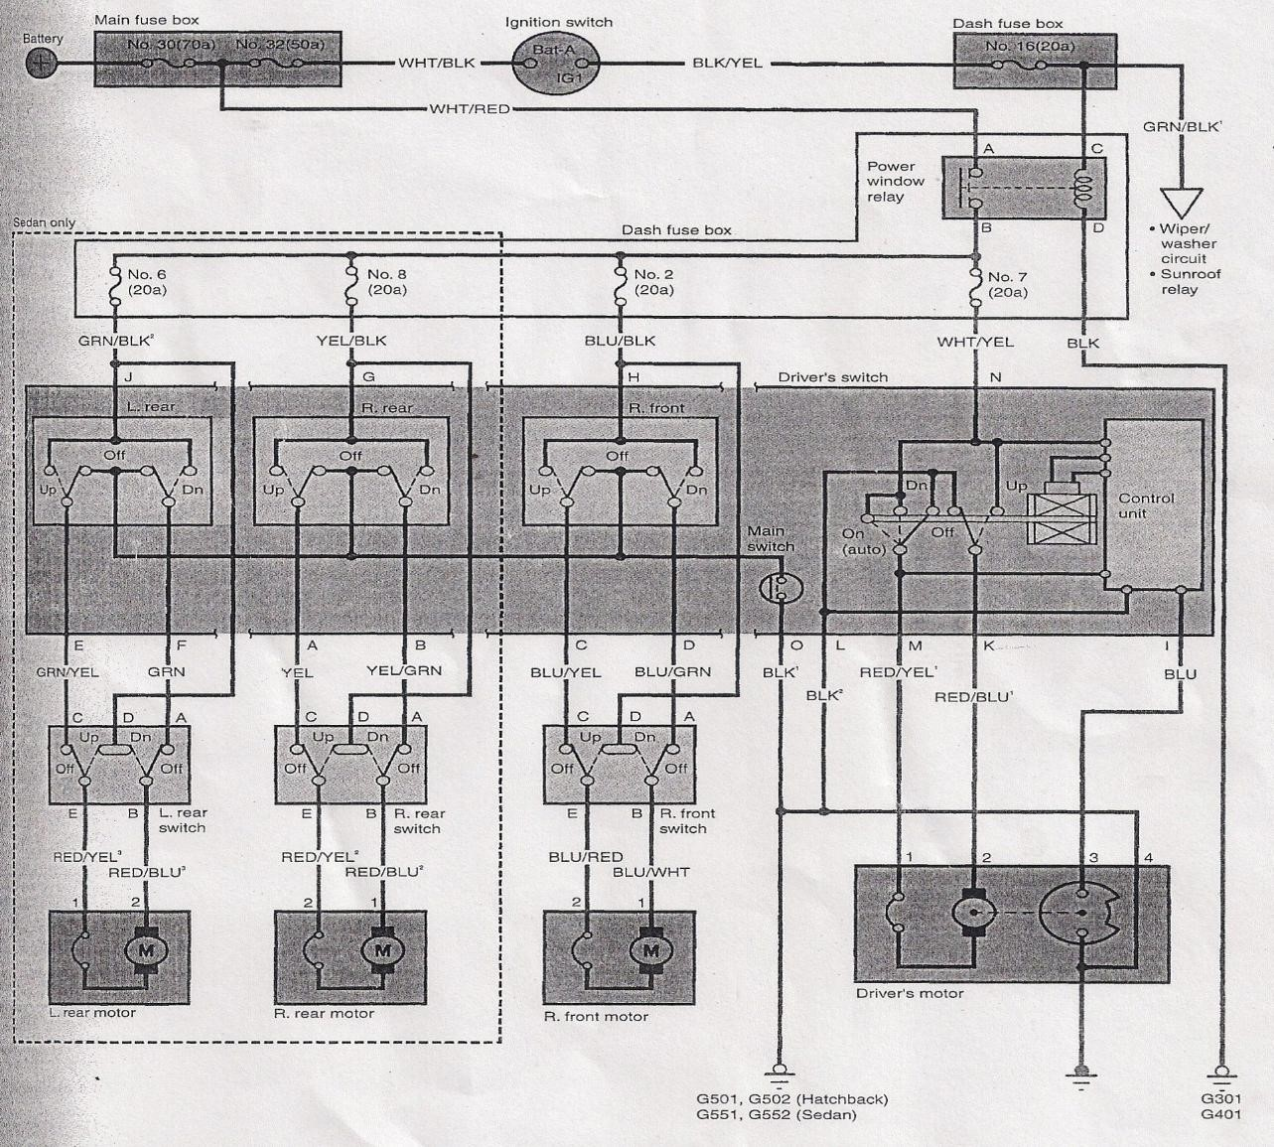
Figure 1-18 Typical Power window circuit diagram
Typically a permanent magnet motor operates each power window. Each motor raises or lowers the window glass when voltage is applied to it the direction that the motor moves the window glass is determined by the polarity of the supply voltage.
Voltage is applied to a window motor when any up switch in the master in the master switch assembly is activated the motor is grounded through the down contact. Battery voltage is applied to the motor in opposite direction when any down switch in the master switch assembly is activated. The motor is then grounded through the master switch’s up contact. The operation of individual window switched is much the same. When the up switch is activated, voltage is applied to the window’s motor. The motor is grounded through the down contact at the switch and the down contact at the master switch. When the down switch in the window is activated, voltage is applied to the motor in the opposite direction. The motor is grounded through the up contact as the window switch and the up contact in the master switch. This runs the window motor in the opposite direction each motor is protected by and internal circuit breaker. If the window switch is held too long with the window obstructed or after the window is fully up or down, the circuit breaker opens the circuit.
Some vehicles are equipped with an express window feature. This feature fully opens the window by holding the window switch down for more than 0.3 seconds then releasing it. The window may be stopped at any time by depressing the up or down switch. The express window option relies on an electric module and a relay. When signaled, the module energizes the relay, which completes the motor’s circuit. When the window is fully down, the module opens the relay control switch, which stops power to the motor. The motor will also stop 10 to 30 seconds after the down switch is depressed.

Electric side mirrors

A car’s electric mirrors are one of its most important safety features. They give the driver a clear view of the car’s blind spots, which are the areas around the car that are not visible from the driver’s seat. The mirrors are usually located on the side of the car, near the door mirrors. Electric car mirrors work by using a special type of glass that is electrically charged. This glass is called electrochromic glass. When the electric current is turned on, the glass becomes opaque, or dark. When the current is turned off, the glass becomes clear again. The mirrors are controlled by a switch inside the car. The switch is usually located on the dashboard, near the steering wheel. When the switch is turned on, the electric current flows to the mirrors, and they become opaque. When the switch is turned off, the current stops flowing and the mirrors become clear again. The electric car mirrors are an important safety feature because they help the driver see the car’s blind spots. These are the areas around the car that are not visible from the driver’s seat. The switch is usually located on the dashboard
The power mirror system consists of a joystick-type control switch and a dual motor drive assembly
located in each mirror assembly. The driver’s door switch assembly has two switches assembled as a single unit. One switch selects which side mirror, left or right, is to be adjusted. The other switch adjusts that mirror.
Rotating the power mirror switch to the left or right position selects one of the mirrors for adjustment. Moving the joystick control up and down or right and left moves the mirror to the desired position. The dual motor drive assembly is located behind the mirror glass. The position of the mirrors may be tied to the memory power seats and will automatically adjust when a seating position is selected.
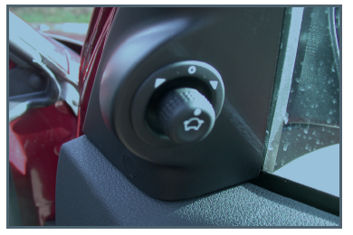
Electrochromic Mirrors Many new vehicles arebeing equipped with electrochromic outside mirrors. These mirrors automatically adjust the amount of reflection based on the intensity of the light striking the mirror’s surface. These mirrors use photo sensors to sense the light. When glare is heavy, the mirror darkens fully (down to 6 percent reflectivity). When glare is mild, the mirror provides 20 percent to 30 percent reflectivity. When glare subsides, the mirror
Figure 1-19Mirror switch
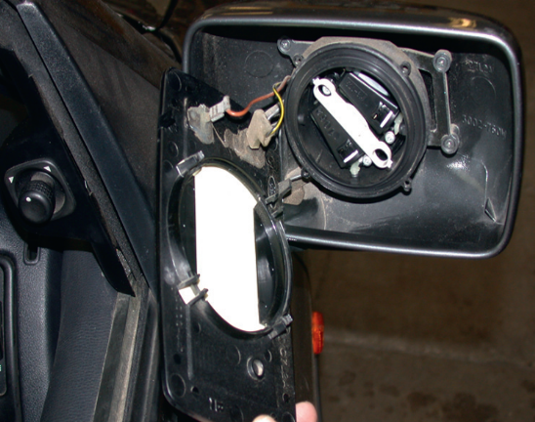
changes to its clear daytime state.
Figure 1-20MIrror motor
Many vehicles have electrical adjustment of mirrors . Two small motors are used to move the mirror vertically or horizontally .Many mirrors also contain a small heating element on the rear of the glass. This is operated for a few minutes when the ignition is fi rst switched on. The circuit mayinclude feedback resistors for position memory.

Electric adjustable exterior mirrors
These are brought in to the optimum position via a push button switch on the inside of the vehicle.
Design: If the driver presses the setting switch to adjust the mirror, the information is sent to the door control unit. This actuates two DC motors with clockwise and anticlockwise rotation. They adjust the mirror via worm gears and adjusting screws in one of the four directions of motion. Using a selector switch, the exterior mirror on the drivers or front passengers side can be selected. Normally a heating element is integrated to defrost the mirrors lens .

Operation
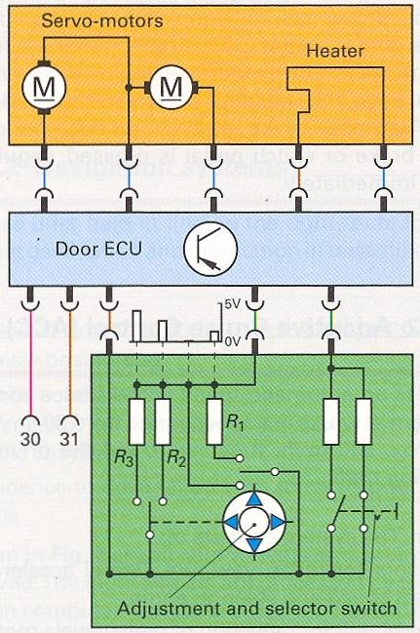
Operating principle: Actuation of the door control unit is often byway of voltage coding. Using the control switch, one of the four parallel-wired closing mechanisms is actuated. This closes the circuit to the door control unit. Each circuit has a resistor of different size (wire only, R1, R2, R3). In each circuit, they produce a different voltage drop from e.g. 0V if the wire has no resistance, 1.3 V for R1, 2.7 V for R2 and 4V for R3.The door control unit reads the desired direction of motion from the voltage that is applied and switches the working current to the correct servo-motor It runs as long as the control switch is pressed. Only one positive wire is required from the control switch to the door control unit.
Figure 1-21 Circuit diagram for control of exterior mirror

Electronic seat adjustment

Power seats allow the driver or passenger to adjust the seat to the most comfortable position. The major components of the system are the seat control and the motors. In order to allow people of all types of stature to sit in a relaxed position appropriate to the traffic situation, the seat height, tilt angle, backrest position and seat contour can be adapted to personal requirements.
Basic structure: The seat consists of a steel frame with plastic molded elements and assemblies for the various functions. Beneath the seat’s padded upholstery an air-permeable material ensures air circulation. Rubberized natural fiber mats support the bond against the backrest and the seat. Individual heater and ventilation controls provide optimal comfort. A lumbar support, with massaging system if desired, supports active seating.
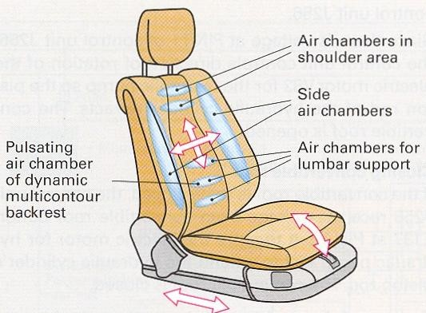
Individual seat adjustment: This is performed by electric motors and electronic control units. Occupants can move different sections of the seat in various directions to find an ideal seating posture for their individual requirements. Personal settings can be stored using the memory button. In this case, the electric motors are actuated by the control unit. Sensors and potentiometers monitor and relay positional information. Normally, this also includes adjustment of the exterior mirrors.
Active seating: During long periods when the occupant sits in a rigid position, the vertebrae are protected against muscular tension and stiffness by continual, minimal alteration of the seat position. To support this procedure, there is a variable lumbar support with pulse-controlled air chamber .
Figure 1-22 Seat for individual and active seating
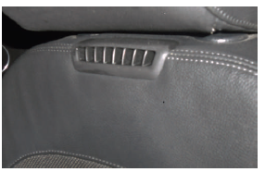
Seat heating: Central heating elements provide quick warmth for the seats centre section in winter. The edges are adjusted slowly to the right temperature afterwards.
Ventilation: The seat surfaces heated by the sun in the summer are cooled down and also ventilated by means of small fans installed below the surface.
Figure 1-23 Air vents at the top of the seats to add comfort for the driver and passengers
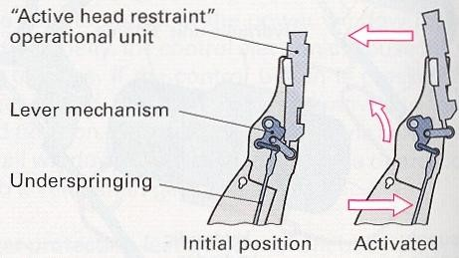
Dynamic seat adjustment: Inflatable air chambers in the seat cushions side bolsters increase lateral support during cornering.
Seat occupant detection sensor: Integrated in the seat is a sensor mat that allows occupant classification, e.g. child seat detection, based on the weight being applied to the seat’s surface. The system decides with this information whether the airbag should be triggered in the event of an accident.
Figure 1-24 Active head restraint
Active head restraint In rear collision situation, the head restraints move forward. The distance to the head is reduced. The risk of whiplash is reduced.

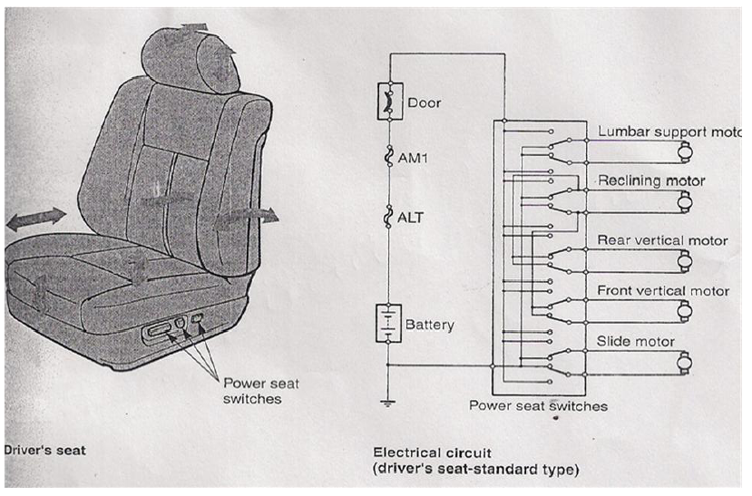
Figure 1-25 Sample power seat circuitry
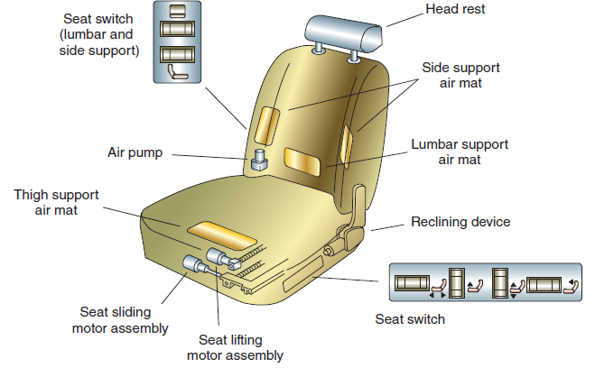
Generally, a four-way system is used on bench seats and a six-way system is used on split-bench and bucket seats. Some units also control the tilt, rear/forward movement, height, and angle of the seat back. The adjuster for the seat back may also control the height of the head rest or restraint.Two motors are typically used on four-way systems, while three are used on a six-way system. Many newer systems rely on a horizontal motor, front vertical motor, rear vertical motor, and recline motor. The names of the motors identify their function.To raise or lower the entire seat on a six-way system, both the front height and the rear height motors are operated together. The motors are generally two-directional motor assemblies that include a circuit breaker to protect against circuit overload if the control switch is held in the actuate position for long periods .
Figure 1-26Seat adjustments can improve driver and
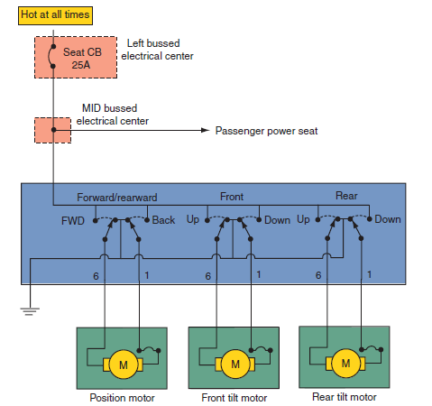
Figure 1-27 power seat circuit diagram
Operation
When the motor and the drive assemblies are activated by a switch, the reversible DC motors operate a gear mechanism. The gear mechanism changes the rotating motion of the motor armature in to a linear motion that positions the seat. Most power seats have more than one motor. There are two types of power seats i.e four way and six way. However, some vehicles allow the seats to be adjusted in up to twelve directions. In a four way system, the whole seat moves up or down, or forward and reward. A six way system has the same adjustments, plus the capability to adjust the height of the front and rear of the seat. Two motors are generally used on four-way systems while three are used on a six-way system. The motors are identified by what they do, to raise or to lower the entire seat.

Electronic Seat belt
Seat belts help reduce the risk of injury in many types of crashes by helping to properly position occupants, while the seat belt is designed to stretch at a controlled rate to absorb impact energy and reduce the severity of the occupant’s deceleration.

Seat belt component

Webbing for Seat Belts Webbing is the part of the seat belt system that is pulled around the person and is tightened to support the person upon impact. It is made from polyester and has a tensile strength to support more than 28 kNw.
Figure 1-28 Webbing for Seat Belts

Retractors for Seat BeltsThe retractor is the winding mechanism that spools the seat belt webbing, allowing the webbing to be withdrawn or pulled back into the retractor. It also locks the webbing in place upon a crash, to restrain and help protect the passenger. The retractor has two sensors: one sensor locks the webbing when it is pulled out of the retractor at a faster rate tan normal, the other sensor locks the webbing when the car brakes or accelerates quickly.
Figure 1-29Retractors for Seat Belts

Seatbelt Buckles The buckle is the piece of the seat belt system that secures and releases the tongue, which is attached to the webbing. The buckle is designed to hold the tongue firmly and allow the seat belt to be fastened and unfastened with very little force. It is also designed so that another person can easily remove the tongue from the buckle and free the passenger after a crash.
Figure 1-30 Seatbelt Buckles
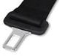
Seat Belt Tongues The tongue is the piece that is attached to the webbing and fits into the buckle to secure the seat belt.
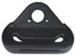
Seat Belt Pillar Loops
Figure 1-31Seat Belt Tongues
The pillar loop is used in a 3-point seat belt system. It is the piece above the shoulder of the passenger, and is used to guide the webbing over the shoulder and across the chest of the passenger.
Figure 1-32 Seat Belt Pillar Loops

The Active Buckle Lifter (ABL) makes buckling the seat belt easier and more convenient by electrically lifting the seat belt buckle. The ABL lifts the buckle past the center console between the seats, and beyond the jacket or other objects that can hide the buckle. The more “reachable,” ABL can assist elderly or other occupants with reduced mobility due to health/disability challenges. During dynamic maneuvers the ABL acts as a reversible buckle pretensioner and adjusts the seat belt slack to better position occupants in their seats. This pre-pretensioning can be activated using data from active safety systems, such as Electronic Stability Control and Brake Assist systems, as well as environmental sensor.
Active Seatbelt Systems
Active Seatbelt Systems utilize a motor that retracts seat belt webbing in critical situations before a crash occurs.
The active seat belt can be activated using data from active safety systems, such as the Electronic Stability Control or Brake Assist systems. It can also be triggered by data from environmental sensors, such as radar that provides the relative speed and distance to the vehicles ahead.
Once activated, it puts front seat occupants in a better position by keeping them more snug to the seat and lessening the forward movement of the body and is a great example of the integration of active and passive safety systems.
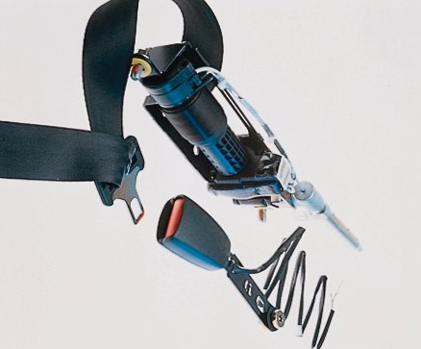
The Active Seat Belt System links active and passive safety systems. It is a reversible seat belt retractor which can be activated prior to a crash. The Active Seat Belt is designed to use braking and stability control sensor information to sense a potential accident. It reacts by securing the driver and passenger seat belts by removing seat belt slack so the occupant position on the seat is improved in advance of an impending crash.
Figure 1-33Active Seat Belt
In approximately two thirds of crashes, the actual event is preceded by hard braking, sliding, and skidding. Car occupants – even wearing seat belts – could be not in the optimal position with respect to airbags. If car occupants were placed in such optimal position, injury probability could be significantly further reduced due to improving the overall restraint system performance.
It uses a situation management algorithm to continuously process signals from the vehicle’s relevant system sensors such as ABS or electronic stability control. Unlike pyrotechnic pre-tensioning devices, if the critical situation ends without an accident, the system automatically releases the belt. It is a fully reversible feature. Data from a radar interface can be used to activate the retraction – as can other signals from environmental sensors. Once the buckle is engaged and the vehicle reaches a specified velocity, the ASB initiates a slack removal function to reduce the belt slack.
Retractor Pretensioner
Retractor pretensioner is a seat belt pretensioner technology. It pretensions seat belt webbing during certain crash events, removing excess slack and helping to begin effective occupant restraint earlier during the crash.
Passive Seat Belt Systems
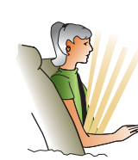
The passive seat belt system automatically puts the shoulder and/or lap belt around the driver or occupant (Figure 1-36 ). The automatic seat belt system operates by means of DC motors that move the belts by means of carrierson tracks (Figure 1-38 ). The carriers are attached to the shoulder anchor to move or carry the anchor from one end of the track to the other.
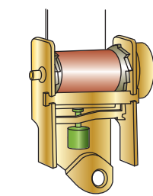
One end of the seat belt is attached to the carrier; the other end is connected to the inertia lock retractors(Figure 1-37). Inertia lock retractors use a pendulum mechanism to lock the belt tightly during sudden movement. When the door is opened, the outer end of the shoulder harness moves forward (to the A-pillar) to allow for easy entry or exit (Figure 1-39). When the door is closed and the ignition switch is placed in the RUN position, the motor moves the outer end of the harness to the locked position in the B-pillar (Figure 1-40).Th e automatic seat belt system uses a control module to monitor operation (Figure 1-41). Th e monitor receives inputs from door ajar switches, limit switches, and the emergency release switch.
Figure 1-34 Inertia lock seatbelt retractor.
Figure 1-35Passive automatic seatbelt system operation
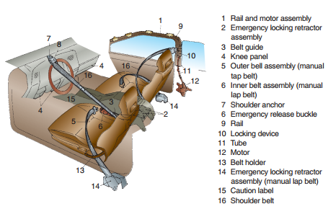

Figure 1-36 Passive seatbelt restraint system uses a motor to put the shoulder harness around the occupant.
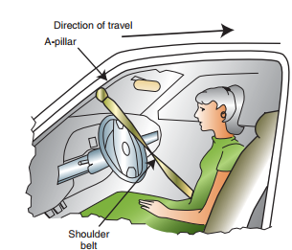
Figure 1-37 When the door is opened, the motor pulls the harness to the A pillar

. 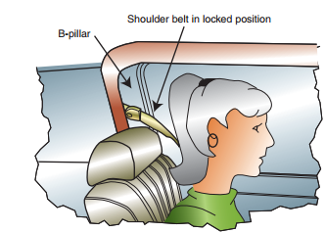
Figure 1-38 When the door is closed and the ignition switch is in the RUN position, the motor draws the harness to its lock position.

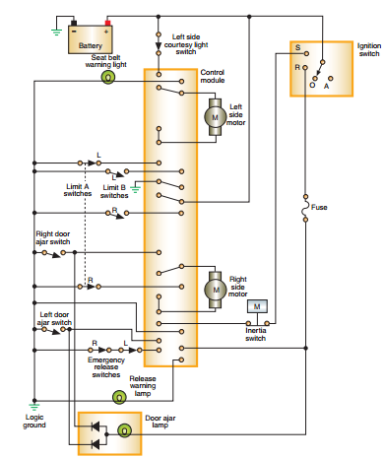
Figure 1-39Typical circuit diagram of automatic seat belt system using a control module
Operation
The door ajar switches signal the position of the door to the module. The switch is open when the door is closed. Th is signal is used by the control module to activate the motor and move the harness to the lock point behind the occupant’s shoulders. If the module receives a signal that the door is open, regardless of ignition switch position, it will activate the motor to move the harness to the FORWARD position.Th e limit switches inform the module of the position of the harness. When the harness is moved from the FORWARD position, the front limit switch (limit A) closes. When the harness is located in the LOCK position, the rear limit switch (limit B) opens and the module turns offthe power to the motor. When the door is opened, the module reverses the power feed to the motor until the A switch is opened.
An emergency release mechanism is provided in the event that the system fails to operate. Th enormally closed emergency release switch is opened whenever the release lever is pulled. The module will turn on the warning lamp in the instrument panel and sound a chime to alert the driver. The opened switch also prevents the harness retractors from locking.
Ford incorporates the fuel pump inertia switchinto the automatic seat belt system. The fuel pump inertia switch is a normally closed switch that will open if the vehicle is involved in an impact at speeds over 5 mph or if it rolls over. When the switch opens, it turns offpower to the fuel pump. Th is is a safety feature to prevent fuel from being pumped onto the ground or hot engine components if the engine dies. Th e switch has to be manually reset if it is triggered .If the seat belt module receives a signal that the switch is open, it prevents the harness from moving to the forward position if the door opens.

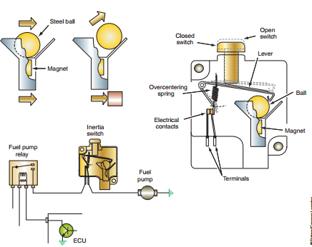
Figure 1-40 Fuel pump inertia switch.

Supplemental and restraint system/ SRS/
The Supplementary Restraint System (SRS) is an air-bag system that- works in conjunction with conventional 3-point seat belts to prevent the driver‟s chest and face from striking the steering wheel in the event of a frontal impact. SRS may additionally be fitted to the passenger‟s side of the vehicle to prevent impact with the dashboard. „Side-impact‟ air-bags have also been developed to protect the upper body and head during a sideways impact. The passengers must fasten their seat belts and adjust them for safety. The SIR/SRS is designed to protect the passengers in the event of the significant frontal as well as side impact to the vehicle.
The system consists of the following components.
Air bag system warning lamp: Lamp illuminates or flashes if malfunction occurs in air bag system and Located in instrument cluster
Air bag module:Deploys air bag when current flows to integrated igniter and Located in steering wheel hub
Clock spring connector:Ensures uninterrupted electrical connection to air bag module while allowing turning of steering wheel
Crash D-sensor: Activated (closed) when crash impact detected with Ssensor, completes circuit to inflator and Located in front part of the vehicle (left, right & center
Crash S-sensor: Activated (closed) when crash impact detected with Dsensor, completes circuit to inflator and Located on side of heater unit in passenger compartment
Diagnostic module: Monitors components and wiring harnesses in air bag system Indicates system malfunction by flashing air bag warning lamp If warning lamp is burnt, sounds warning buzzer Detects short circuit between airbag module and ground Or crash sensor malfunction and melts system down fuse to prevent unintended air bag deployment
a number of deceleration sensors (‘D-sensors’) mounted at the front of the vehicle to detect the onset of a frontal impact occurring within about 30⁰ of the vehicle centre line.
An additional deceleration sensor (called a safing sensor or ‘S-sensor’) is mounted in the passenger compartment and wired in series with the D-sensors. The S- sensor triggers at a much lower deceleration level than the D-sensor (2.5 g as against about 15 g) and is used to provide confirmation that a collision has actually occurred and prevent firing of the air-bag due to localized impacts on the wings of the car.
The sensor signals feed into the SRS ECU, often termed a ‘Diagnostic Module’ or Sensing and Diagnostic Module (SDM),, which provides constant checking and monitoring of the entire SRS. When a frontal collision is confirmed by both a D-sensor and the S-sensor, the diagnostic module sends a current pulse to fire a gas generator unit contained within the air-bag module which is located in the steering wheel centre pad. The air-bag is then inflated. If the diagnostic module detects a fault with the SRS, an instrument-panel warning lamp is illuminated and the SRS is deactivated to prevent accidental deployment. The driver should then take the vehicle for immediate repair.
Rotary coupler, air-bag and inflator
The air-bag and inflator are housed in the steering’ wheel centre pad and connected to the diagnostic module by a ‘clock-spring’ electrical rotary coupler which is fitted between the steering wheel and steering column housing.
The air-bag itself is a woven nylon bag lined with rubber and folded-up behind a polyurethane cover (Figure 1). When the bag is inflated, the cover tears along the crease and hinges open; allowing the bag to deploy. A fully inflated bag has a gas capacity of between 30 and 70 liters, depending upon the vehicle size and market.
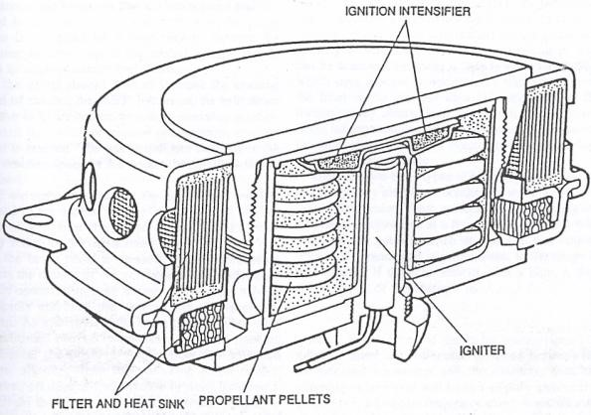
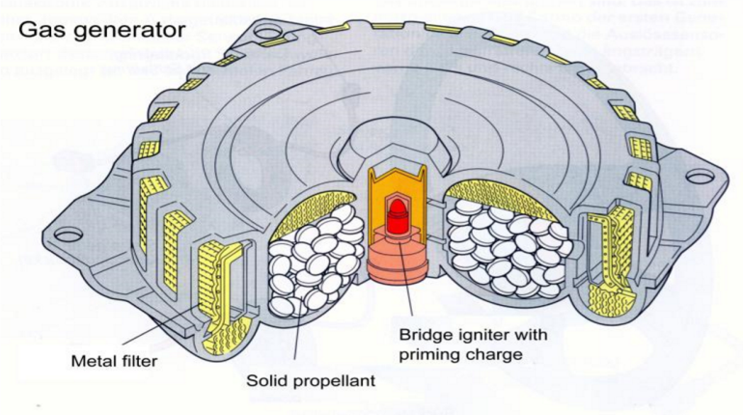

Fig 2.

-

Figure 1-41 Section through air-bag inflator uinit
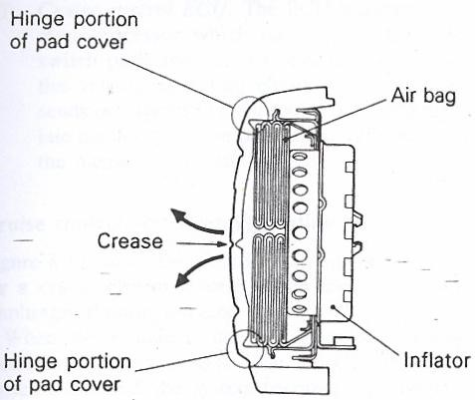
Figure 1-42 Inflation takes place

Fig 1The detailed construction of the inflator unit is illustrated in Figure 2 Inflation takes place when the diagnostic module supplies a current pulse to the ‘squib’ igniter. Both electrical connections to the igniter are floating (i.e. isolated from the vehicle ground) so that it cannot be fired by an accidental short-circuit.
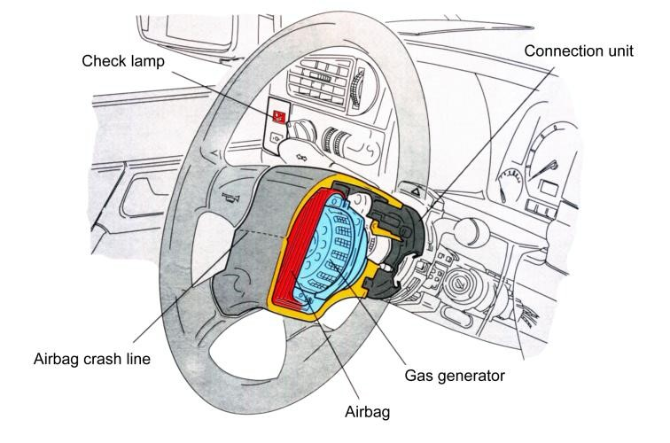
-Once the igniter rises to a temperature of over 190⁰c, self-ignition of the ignition intensifier mixture occurs. The heat which is generated causes the sodium azide propellant pellets to undergo rapid combustion, generating nitrogen gas which is filtered and cooled before passing into the air-bag. The bag’s internal pressure when fully inflated is comparatively low, about 0.1—0.3 bar (1.4—4.4 psi), but is sufficient to protect the driver as he is thrown against it. The load of the driver on the air-bag causes gas to escape through two large outlet holes in the rear of the bag and further cushions the impact.
Figure 1-43 Location of inflator

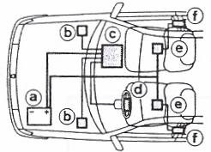
Figure 1-44Combined air-bag and pyrotechnic seatbelt crash protection system
[a] battery; [b] air-bag sensors;
[c] air-bag ECU; [e] air-bag;
[e] seatbelt sensors; [f] pyrotechnic seatbelts (Peugeot)

Pyrotechnic seatbelt tightening system
The pyrotechnic seatbelt tightening system complements an SRS installation and uses similar technology and operating principles Figure 1-46. It is designed to tighten the seatbelt around the driver and front passenger in the initial few milliseconds after an impact, holding them safely and firmly into their seats.
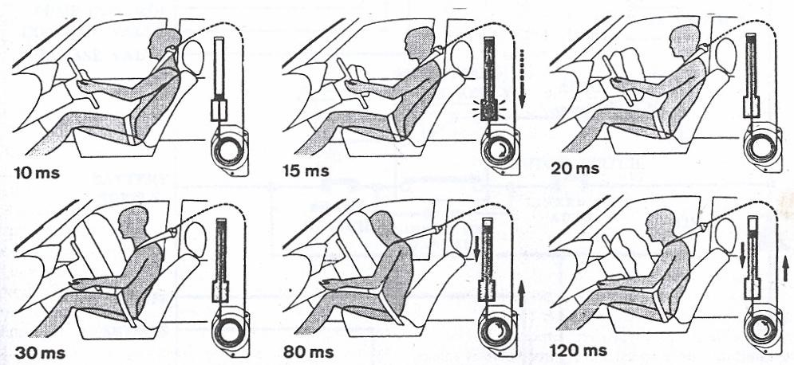
Figure 1-45Timing of air-bag and pyrotechnic seatbelt deployment (Peugeot)
Belt tightening is achieved via a cable which is wrapped around the inertia-reel seashell drum. The free end of the cable is attached to a piston that sits at the bottom of a tube mounted in the car’s B-post. Beneath the piston is an explosive capsule containing a detonator and propellant. The detonator is fired by a crash sensor that is fitted under the front seat and set to trigger on a frontal deceleration of 5 g or more. The system is designed to provide detonation within about 15 ms of impact, causing the piston to be propelled up the tube. This pulls the cable, which rotates the drum and removes about 10cm of slack from the seatbelt
SRS and pyrotechnic seatbelt deployment sequence
The timing of the SRS and pyrotechnic seat deployment sequence is illustrated in Figure 5 and is typically as follows:
      - Time = 0 ms. The vehicle collides with a solid object at an angle within-about 30⁰ of the centre line and at a speed greater than about 20 mph.
      - Time = 10 ms. The front crash sensors and the safing sensor have moved to the closed-circuit position, causing the SRS diagnostic module to transmit a firing pulse to the igniter. The pyrotechnic seatbelt unit has detonated.
      - Time = 13 ms. 3 ms after the arrival of the igniter firing signal, gas generation has started with a loud bang. The driver is still upright in his seat. The seatbelt has been partially tightened.
      - Time = 15 ms. The air-bag has partially inflated, breaking the cover crease. The seatbelt is almost fully tightened.
      - Time = 20 ms. The vehicle is starting to crumple and the driver has moved very slightly forward towards the steering wheel but is being restrained by the seatbelt which is now fully tightened.
      - Time 30 ms. The air-bag is fully inflated and the driver’s chest and face are about to come into contact with it. The seatbelt is helping to restrain the driver.
      - Time 80 ms. The load of the driver on the air-bag causes the nitrogen gas to escape through the outlet holes at the rear of the bag and so it starts to deflate. Gas pressure beneath the pyrotechnic seatbelt piston is failing and so it starts to move back down the tube, feeding some slack back into the belt.
      - Time 120 ms. The driver has moved back into his seat and the air-bag is deflating, providing unrestricted visibility and allowing an easy exit from the wrecked vehicle.
Developments in airbag technology have resulted in vehicle occupants being protected not just from head-on collisions. There are now:
- Side airbags
- Side curtain shield airbags
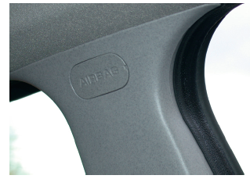
- Knee airbags
- Anti-slide airbags
- Rear curtain airbags
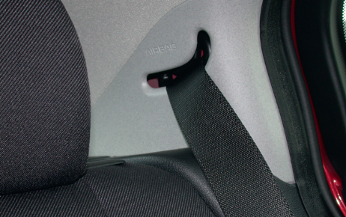
All are fitted inside or behind the interior trim, which means that pyrotechnic inflators are unsuitable due to their shape and the amount of heat they generate, so a new generation of inflators has had to be developed.
Figure 1-46 Side air bag position

Figure 1-47 Rear air bag position

Single module SRS
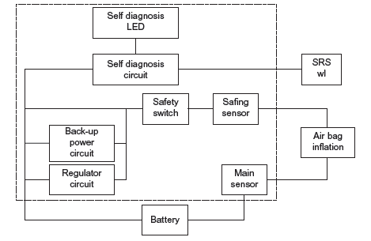
Some vehicle manufacturers have introduced air- bag systems that integrate all of the SRS elements, including the crash sensors, into a single module mounted within the steering-wheel centre cover. These systems are likely to become increasingly common since there are obvious advantages with regard to minimizing the number of connectors and the length of wiring, improving reliability and reducing cost.
Figure 1-48 Supplementary restraint system (SRS) block diagram
A block diagram of an air bag circuit is shown in Fig. 1.49 .

A digitally based system, using electronic sensors, has about 10 ms at a vehicle speed of 50 km/h, to decide whether the restraint systems should be activated. In this time, about 10 000 computing operations are necessary. The decision to take this action is the same as for the air bag.
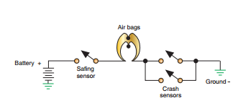
Sensors. To prevent accidental deployment of the air bag, most systems require that at least two sensor switches be closed to deploy the air bag (Figure 1-50). Th e number of sensors used depends on the system design. Some systems use only a single sensor and others use up to five. Th e name used to identify the different sensors also varies among manufacturers.
Figure 1-49 Typical sensor wiring circuit diagram.
On most three-sensor systems, the crash sensorsare usually located in the engine compartment or below the headlights. Crash sensors are normally open electrical switches designed to close when subjected to a predetermined impact. A single safing sensoris usually located inside the (Occupant Restraint Controller) ORC, which in turn is mounted on the centerline of the vehicle in the passenger compartment. Th e safing sensor determines if the collision is severe enough to infl ate the air bag. When one of the crash sensors and the safing sensor closes, the electrical circuit to the igniter is complete. Th e igniter starts the chemical chain reaction that produces heat. Th e heat causes the generant to produce nitrogen gas, which fills the air bag.
There are several different types of sensors used. Common sensors include mass-type, roller-type, and accelerometers.

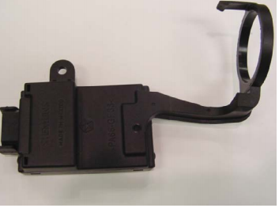
Engine immoblizer
The immobilizer systemis designed to provide protection against unauthorized vehicle use by disabling the engine if an invalid key is used to start the vehicle or an attempt to hot-wire the ignition system is made. Manufacturers have several different names for this system. The following are examples of system operation.
Figure 1-50 The immobilizer module with halo antenna
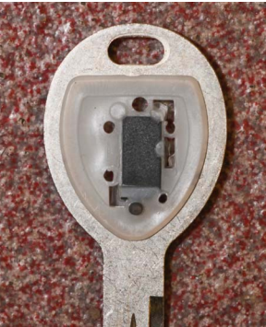
The primary components of the system include the immobilizer module, ignition key with transponder chip, the PCM, and an indicator lamp. Th e immobilizer module is either mounted to the steering column or in the instrument panel. It may include an integral antenna that surrounds the ignition switch lock cylinder (Figure 1-52 ). If the module is remote mounted in the instrument panel, then it is connected to an antenna by a cable. The system includes special keys that have a transponder chip under the covering (Figure 1-53). Most systems are capable of recognizing up to eight different keys. Any additional keys that are to be used with the vehicle require programming to the immobilizer module. Most systems provide a procedure that allows the customer to program additional keys if they have two valid immobilizer keys that are programmed to the vehicle already
Figure 1-51 The immobilizer key has an internal transponder chip.

Operation
The immobilizer module contains a radio frequency transceiver and a microprocessor. When the ignition switch is placed in the RUN position, the immobilizer module begins to transmit a radio frequency signal to the transponder in the key. Th e transponder in the key then sends its coded message to the immobilizer module. If the message properly identifi es the key as being valid, the immobilizer module sends a message over the data bus to the PCM indicating that the engine may be started. If the response received from the key transponder is missing or identifies the key as invalid, the immobilizer module sends an “invalid key” message to the PCM over the data bus.
The immobilizer module is programmed with a unique secret key code and also retains in memory the unique ID number of all keys that are programmed to the system. Th e secret key code is transmitted to the keys during the programming function and is stored in the transponder. In addition, the secret key code is programmed into the PCM. Another identification code called a PIN is used to gain secured access to the immobilizer module for service.
The immobilizer module also is programmed with the vehicle identification number (VIN). All messages transmitted by the immobilizer module are scrambled to reduce the possibility of unauthorized immobilizer module access or disabling.Th e immobilizer module also sends indicator lamp status messages. Th e indicator lamp will normally illuminate for 3 seconds for a bulb check when the ignition switch is first placed in the RUN position. After the bulb check is complete, the lamp should go out. If the lamp remains on after the bulb check, this indicates that the immobilizer module has detected a system malfunction or that the system has become inoperative. If the lamp flashes after the bulb check is completed, this indicates that an invalid key is detected or that a key-related fault is present.
Each key has a unique transponder identification code that is permanently programmed into it. When a key is programmed into the immobilizer module, the transponder identifi cation code isthen stored in the immobilizer’s memory. In addition, the key learns the secret key code from the immobilizer module and permanently programs it into its transponder memory.

For the engine to start and run, all of the following must be in place:
- Each key’s transponder ID must be programmed into the immobilizer module.
- The immobilizer’s secret key code must be programmed into each key.
- The VIN number programmed in the immobilizer module must match the VIN in the PCM.
- The data bus network must be intact to allow messages to be sent and received between the immobilizer module and the PCM.
- The immobilizer module and the PCM must have properly functioning power and
ground circuits.

OHS requirements on electronic body management systems
To prevent personal injury or damage to the vehicle, you should always take the necessary precautions before working. When possible, you should disconnect the vehicle’s battery before disconnecting any electrical wire or component. This prevents the possibility of a fire or electrical shock.
It also eliminates the possibility of an accidental short, which can ruin the car’s electrical system. Disconnect the negative or ground cable first, then disconnect the positive cable because electrical circuits require a ground to be complete, by removing the ground cable you eliminate the possibility of a circuit accidentally becoming completed.
Safe working practices in relation to electrical and electronic systems are essential, for your safety as well as that of others.
when working with Electrical body management system systems, together with suggestions for reducing them. This is known as risk assessment.
Battery acid: Sulphuric acid is corrosive so always use good personal protective equipment (PPE). In this case wear the right personal protective equipment, if necessary, rubber gloves. A rubber apron is ideal, as are goggles if working with batteries a lot
Raising or lifting vehicles: Apply brakes and/or chock the wheels when raising a vehicle on a jack or drive-on lift. Only jack under substantial chassis and suspension structures. Use axle stands in case the jack fails
Running engines: Do not wear loose clothing, good overalls are ideal. Keep the keys in your possession when working on an engine to prevent others starting it. Take extra care if working near running drive belts
Short circuits: Use a jump lead with an in-line fuse to prevent damage due to a short when testing. Disconnect the battery (earth lead off first and back on last) if any danger of a short exists. A very high current can flow from a vehicle battery; it will burn you as well as the vehicle
Fire: Do not smoke when working on a vehicle. Fuel leaks must be attended to immediately. Remember the triangle of fire – Heat/Fuel/Oxygen – don’t let the three sides come together
Skin problems: Use a good barrier cream and/or latex gloves. Wash skin and clothes regularly
Work shop Safety
- Floors and work areas should be kept clean and organized.
- Keep all tools and equipment clean, dressed, and organized.
- Memorize the location of all safety and first aid equipment
- Deactivate the high voltage system before any service is performed.
- Follow all manufacturer’s warnings and procedures.


Personal Safety
- Wear appropriate clothes, shoe ...
- Ensure the work shop hazard free
- The vehicle must park on straight surface
- The area must be clean

Precautions:-
- Ensure work area hazard free.
- Keep yourself from electric shock
- Keep yourself from danger & injury workings. may be the safety &hydraulic jack will be slept by it self
- know and implement the correct procedures
- apply wearing of protective cloths
- Safe operating of fire extinguishers
Check that the extinguisher you intend to use is suitable for the type of fire encountered eg a water extinguisher must never be used on any fire involving electrical equipment.
There are four (4) basic steps for using modern portable fire extinguishers. .
- Pull the pin. Hold the extinguisher with the nozzle pointing away from you and release the locking mechanism.
- Aim low. Point the extinguisher at the base of the fire.
- Squeeze the lever slowly and evenly.
- Sweep the nozzle from side-to-side
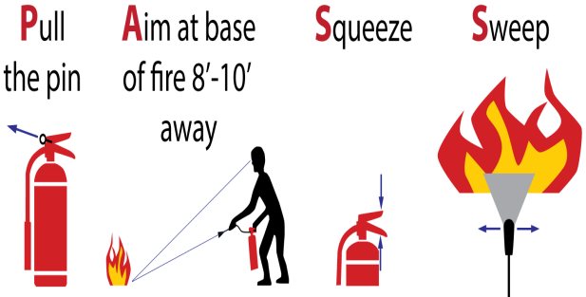

Figure 1-52 Battery Personal protective equipment (PPE)

Self-check 1.1
Directions: Answer all the questions listed below.
Part I: Fill in the blank space
- _________system acts as an engine disable system by using an ignition key that has a transponder.
- _________systems are deterrent systems designed to scare off would-be thieves by sounding alarms and/or disabling the ignition system.
- _________ a specially designed key that is programmed just for one vehicle
- _______ Lamp illuminates or flashes if malfunction occurs in air bag system and Located in instrument cluster
- _________ utilize a motor that retracts seat belt webbing in critical situations before a crash occurs.
Part-II: Choose the correct answer from the given alternatives
- Technician A says the master control switch for power windows provides the overall control of the system.
Technician B says current direction through the power seat motor determines the rotation direction of the motor.
Who is correct?
A.A only C. Both A and B
B. B only D. Neither A nor B
- __________________system automatically puts the shoulder and/or lap belt around the driver or occupant

- Retractor Pretension
- Active Seat Belt System
- Active Buckle Lifter
- passive seat belt A. system

- ______________the piece that is attached to the webbing and fits into the buckle to secure the seat belt

- Seatbelt Buckles
- Seat Belt Pillar Loops

- Seat belt Tongues
- Webbing for Seat Belts

- Which one is not correct about function of door lock system
  - Lock and unlock controlled operated by door lock control switch
  - Control the air bag system
  - Door key linked lock and unlock function
  - Key confine prevention function (keyless locking of the doors is prevented which the key is inserted in the ignition switch
- _______ is acted as door lock actuators

  - Door lock control switch
  - Door lock position switch
  - Door lock motors
  - Key unlock warning switch
Part-III: Answer the following questions accordingly.
      - List down the main central door lock sytem componet?
      - Explain the operation of the immobilizer system

: Unit Two: Installing and testing electronic body management system

This unit is developed to provide you the necessary information regarding the following content coverage and topics
  - Installing electronic body management system
  - Testing Sensors and Actuators
This guide will also assist you to attain the learning outcomes stated in the cover page. Specifically, upon completion of this learning guide, you will be able to:
  - Install electronic body management system
  - Test Sensors and Actuators

Installing electronic body management system

As with any electrical system, always use a systematic diagnostic approach to fi nding the cause.Refer to the service manual to obtain information concerning correct system operation. Th e fault is easier to locate once you understand how the system is supposed to operate.
Every electrical installation is verified initially, before being put into service, as well as periodically, during its utilization. The main reason for verification is to check whether protection against electric shock is on the satisfying level. According to standard the following
- Tests Are Recommended To Be Performed:
- Continuity Of Conductors,
- Insulation Resistance Measurement,
- Insulation Resistance Testing To Confirm The Effectiveness Of Protection Electrical Separation,
- Insulation Resistance Testing To Confirm The Effectiveness Of Floor And Wall Resistance/Impedance,
- Polarity
- Effectiveness Of Automatic Disconnection Of Supply,

Operation Sheet 2.1
Operation Title: Installing Central door Locking and alarm security
Purpose: To effectively install back removed Central door Locking and alarm security component parts on to the vehicle
Conditions for the operations:
- Safe working area
- Properly operated tools and equipment
- Appropriate working cloths fit with the body
Equipment Tools and Materials:
- Screw driver
- Multi-meter
- Vehicle
- All central door lock Accessories
- Alaram security componets
- Wire etc
Quality Criteria: Assured performing of all the activities according to the procedures
Precautions:
- Wearing proper clothes, eye glass, glove
- Make working area hazard free
- Read and interpret manual which guide you how to use tools and equipment
Steps in doing the task
- Actuator Mounting
- Remove all the handles, fittings, and arm rests from the door.
- Remove the door's interior panel by inserting a screw driver between the door, and door panel. Once inserted pry off the door panel by pushing or pulling on the screwdriver (Figure1).
- Carefully remove the clear PVC protective sheet from the door.
- Locate your factory lock and unlock rod. This rod will be connected to your unlock and lock button. When you pull or push this rod it will lock or unlock your door. This rod maybe horizontal or vertical.
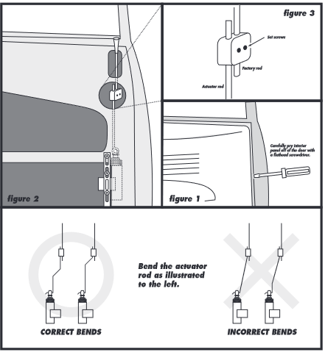
- Locate a safe position to mount the door lock actuator parallel to the factory door lock rod using the screws given (Figure 2). You can mount the actuator directly to the door, or use the bracket to cross a part of the door were there is no metal (Figure 2). In some cases, it is necessary to bend the actuator rod in order to reach the factory rod. In these cases, bend the rod so that the beginning and the end of the rod are horizontal (Figure 4). Make sure there is plenty of room for the motor to travel up and down. Check to make sure the motor will not interfere with thewindow mechanisms.
- Lock the door, then push the door actuator all the way down.
- Place the actuator rod through the eye of the door lock plunger.
- Attach the rod adapter to the actuators rod and tighten the screw (Figure 3).
- Connect the rod adapter to the factory door lock rod and secure by tightening the screw (Figure 3).
- Run the wires out of the door using the factory rubber tube to hide the wires in the door jam. Make sure the wires do not get in the way of the window mechanism.
- Wiring
      - Run all the wires to the location of the door lock module. Be sure to mount the module in a dry place (under the dash).
      - Connect the 5 wires from the actuator to the wire harness in accordance with the same color.
      - Connect the separate black wire with the "U" shaped terminal to a chassis ground (body metal).
      - Connect the separate red wire to a constant 12 volts positive power source (battery).
- Control Module
- Connect the keyless entry units negative "-" LOCK output wire (BLUE/WHITE) to the BROWN wire.
- Connect the keyless entry units negative "-" UNLOCK output wire (GREEN/WHITE) to the WHITE wire.
- Connect the keyless entry units BLACK wire to a chassis ground (body metal).
- Install the fuse and connect the keyless entry units RED wire to a constant 12 volts positive power source (battery).
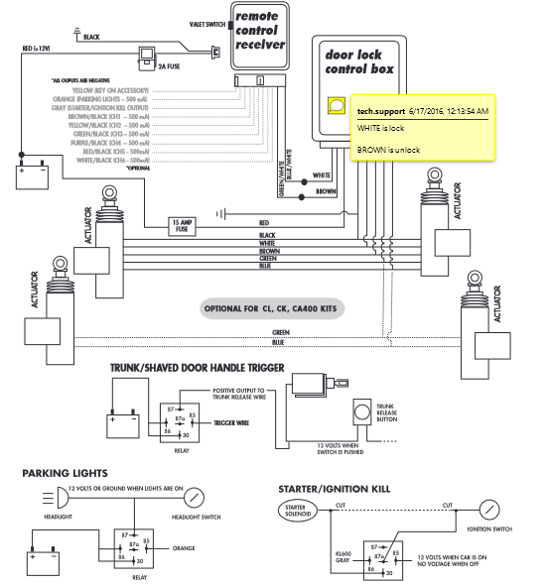

- Car Alarm
- Install the siren under the hood on a solid surface. Place the siren face down to avoid the accumulation of moisture. Make connections for power supply.
- Connect alarm powered correctly to the battery.
- Put a fuse on the power cord near the battery. Read instructions about fuse type and measure.
- Mount the vibration sensor in the place specified by handbook.
- Make a hole in the dashboard where you want to place the LED for status indication. Connect the LED to the system and put it over the hole.
- Find the wires that acts closure system of the doors.
- Connect these wires to the alarm system.
- Using manual found the wires from the hazard warning lights.
- Connect the alarm to these lights.
- Localize central locking of the doors.
- Connect the circuit for central locking to alarm.
- From the starting system, connect the wires to the alarm to be able to interrupt starting in case the alarm is triggered.
- Mount the command panel under the dashboard.
- Connect all the wires to the alarm module.
- Mount the alarm module under the dashboard on a solid surface.
- Use duct tape to insulate the wires and tying them in bunches.
- Arms the alarm and test it.

Operation Sheet 2.2

Operation Title: Installing power window
Purpose: To effectively install back removed and new power window component parts on the vehicle.
Conditions or situations for the operations:
- Safe working area
- Properly operated tools and equipment
- Appropriate working cloths fit with the body
Equipment Tools and Materials:
- Multi-meter
- vehicle
- Power window component
- Wire
Quality Criteria: Assured performing of all the activities according to the procedures
Precautions:
- Wearing proper clothes, eye glass, glove
- Make working area hazard free
- Read and interpret manual which guide you how to use tools and equipment
Steps in doing the task
- Run the wire-loom across the underside of the dash and tie down with cable ties. Note. The group of four wires runs to the driver’s side and the group of three wires runs to the passenger side.
- Connect the power wire (RED) into a switched power source, preferably the keyed ACC. Note:Using a switched power source allows the window units to only work when the key is in the ON position.
- Connect the ground wire (BLACK or YELLOW) to a clean chassis ground point.
- Run wires into the door through the existing door looms. If this is not possible then holes should be drilled in the doorjambs and additional door looms used. It is important to use door looms to prevent the wires from becoming chaffed and shorting.
- Connect the wires into the provided plugs (as shown in Diagram D), matching the wire colors with the corresponding female plug.
- Mount the switches in an appropriate place on door panel. Optional switch mounting cases may be used to provide a stock look. For moreinformation, contact your AutoLoc™ sales rep.
- Connect wires to the motor assembly. Useprovided wire extension if needed. Be sure keep the wiring away from any moving parts.
- Connect the wire-loom to the switch assembly.
- Turn ignition key to the on position and test yourpower window system

Operation sheet 2.3
Operation Title: Installing Electric side mirrors
Purpose: To change the side view mirror is broken or cracked properly
Conditions or situations for the operations:
- Safe working area
- Properly operated tools and equipment
- Appropriate working cloths fit with the body
Equipment Tools and Materials:
- Screw driver
- Multimeter
Quality Criteria: Assured performing of all the activities according to the procedures
Precautions:
- Wearing proper clothes, eye glass, glove
- Make working area hazard free
- Read and interpret manual which guide you how to use tools and equipment
Steps in doing the task
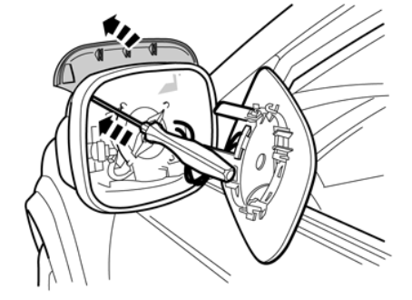
- Turn the ignition key to position 0.
- Carefully push the mirror glass out using the wedge shaped special tool .Remove the cover. New cover is included in the kit.
- Disconnect the cables
- Carefully pry off the catches and remove the cover. It will not be reused. Repeat on the car's other side.
- Install the new panel from the kit.
- Connect the cables
- Carefully press the mirror glass into place. Repeat for the other side.
- Carefully pry off the mirror glass.
- Press out the mirror's cover using a small screwdriver. Remove the cover. New cover is included in the kit.
- Make sure that the damper blades end up in their grooves. Carefully press the mirror glass into place.
- Press the new cover on the mirror. Press all the way around so that all catches engage.

Operation Sheet 2.4
Operation Title: Installing Electronic Seat Adjustment
Purpose: To checks functionality of Electronic Seat Adjustment
Conditions or situations for the operations:
- Safe working area
- Properly operated tools and equipment
- Appropriate working cloths fit with the body
Equipment Tools and Materials:
- Multi meter
- Electronic seat adjustment with vehicle
- Socket wrench and screw driver
Quality Criteria: Assured performing of all the activities according to the procedures
Precautions:
- Wearing proper clothes, safety shoes
- Make working area hazard free
- Read and interpret manual which guide you how to use tools and equipment
Steps in doing the task
- Turn the ignition switch to the ON position and check if the SRS indicator comes on for about 6 seconds, then turns off.
- If the indicator comes on, then turns off after about 6 seconds, go to step 2.
- If the indicator does not come on, or if it stays on, check the SRS DTC and record it.
- Adjust the seat to the highest position possible, then lower by about 1/2 inch.
- Disconnect the battery negative cable and wait at least 3 minutes before continuing.
- Remove the affected seat and seat cushion cover/pad. Refer to the service information for the model and model year you are working on.
- Remove the seat ventilator from seat bottom (if equipped).
- Remove any harnesses or harness clips that will prevent removal of the cushion pan.
- Remove the four 10 mm bolts from the front cushion pan.
- Lift the cushion pan, and hold it up with a bungee cord or set the seat on its back on a clean surface to keep the cushion pan out of the way.
- Disconnect the VTA unit connector.
- Remove the VTA unit nuts, then remove the VTA unit.
- Raise the seat as much as possible by pulling the seat frame as shown. This allows easier meshing of the gear.
- Wipe off any excess grease from the seat frame gear teeth with a paper towel or clean rag
teeth when installing the new VTA motor.
- Apply the provided grease to the new VTA unit motor splines.
- Mount the new VTA unit onto the seat frame.
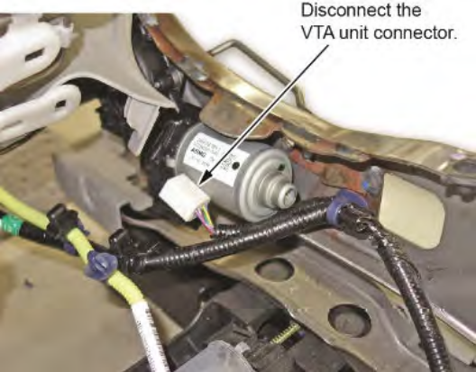
- Route and install the harnesses and the harness clips.Make sure the routing is correct by looking at the photo you took before disassembly.
- Install all other removed parts in the reverse order of removal, and install the seat.
- Reconnect the battery.
- If you are repairing a driver's seat, clear the driving position memory as outlined in the service information.
- Make sure the height and tilt functions on the seat work properly and the noise is gone.
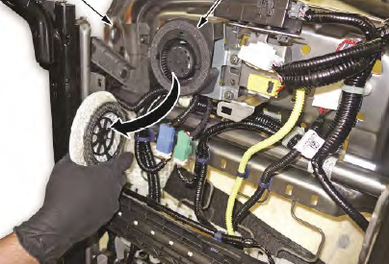
- Turn the ignition switch to the ON position and check if the SRS indicator comes on for about 6 seconds, then turns off.
- If the indicator comes on, then turns off after about 6 seconds, the procedure is complete.
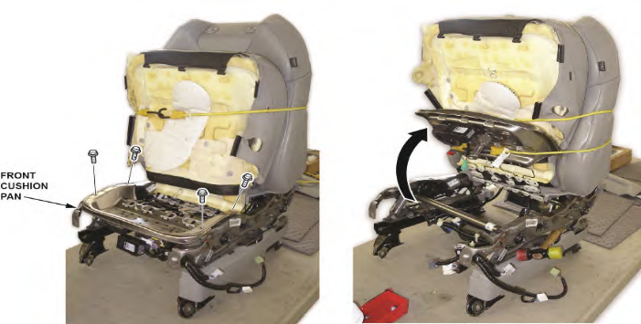
- If the SRS indicator did not perform correctly at the beginning of the procedure, check to see if the same problem exists. If there are additional problems, make sure all of the reassembly steps were completed

Operation Sheet 2.5
Operation Title: Installing Electronic Seat belt
Purpose: To check the functionality Electronic Seat belt and safe operation.
Conditions or situations for the operations:
- Safe working area
- Properly operated tools and equipment
- Appropriate working cloths fit with the body
Equipment Tools and Materials:
- Hand tools
- Electronic Seat belt With vehicle
Quality Criteria: Assured performing of all the activities according to the procedures
Precautions:
- Wearing proper clothes, glove
- Make working area hazard free
- Read and interpret manual which guide you how to use tools and equipment
Steps in doing the task
- Installing Front Seat Belt Buckle

- Position the front seat belt buckle onto the stud near the rear of the inboard seat cushion frame
- Install the retaining nut on seat cushion frame. Tighten the nut to 43 Nm (32 ft lb)
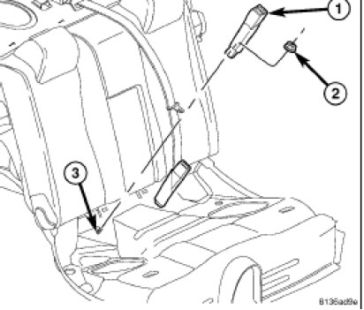
- Connect the seat belt buckle electrical connector.
- Install the seat cushion side shield.
- Install floor console
- Installing Rear Seat Belt Buckle
- Position the rear seat belt buckle onto mounting studs (3) (Figure 2).
- Install retaining nut. Torque nut to 34 Nm (25 ft lb).
- Install rear seat cushion.

Operation sheet 2.6
Operation Title: Installing Supplemental and restraint system/ SRS/
Purpose: to know if the Supplemental and restraint system defective and install the new SRS properly
Conditions or situations for the operations:
- Safe working area
- Properly operated tools and equipment
- Appropriate working cloths fit with the body
Equipment Tools and Materials:
- Melti meter
- SRS air bag equipped vehicle
- Screw driver
Quality Criteria: Assured performing of all the activities according to the procedures
Precautions:
- Wearing proper clothes, glove
- Make working area hazard free
- Read and interpret manual which guide you how to use tools and equipment
Steps in doing the task:
- Take out the negative battery cable from the terminal of the vehicle. Once this is done, give some time for capacitors to discharge, which takes about 15 minutes.
- It is essential to keep the vehicle’s wheels straight and make sure the steering wheel is positioned straight. Hold on to the middle part of the wheel where the airbag is kept. Now proceed to find the location of the screws. After locating them, you can unscrew them.
- After unscrewing the screws, bring the airbag towards you and start to remove the connectors. The connectors can be removed by using a pick to move the yellow clips out. After this, you will be able to remove the airbag. Try moving the steering wheel in different positions in order to uncover the screws that keep the steering column trim in position.
- In the next part, you have to be sure that your steering lock is fully engaged so that you do not have to move the wheel. Try using the two pieces of painter’s tape and keep them in the middle of the steering wheel and the steering column trim. This can be your reference point for when you move the steering wheel back to its initial position.
- For loosening the steering wheel nut, you can simply make use of a breaker bar of the right size socket. Make sure that you do not completely remove the steering wheel nut. It will take a few tries for you to free the wheel but make sure that the column nut is not removed.
- Once this is done, you can move to remove the nut and the wheel. This will uncover the clock spring, which is the reason why your SRS airbag warning light is turned on.
- Separate the harnesses located beneath or at the back of your clock spring and take the clock spring off. Now install the brand-new clock spring and remove the tab by bending it till it breaks.
- Now, use the initial reference point marked with the tape to install the steering wheel back to its place.
- Take a torque wrench to make sure that the steering column nuts are tightened to the specified torque. After this, you can install the harnesses and the airbag. If you are not able to find torque specks, you can always use your hands or a breaker bar to tighten them.
- Install the lower trim piece and connect the negative battery terminal back to its original place.

Operation sheet 2.7
Operation Title: Installing Engine immoblizer
Purpose: to know the functionality of Engine immoblizer after installing on vehicle
Conditions or situations for the operations:
- Safe working area
- Properly operated tools and equipment
- Appropriate working cloths fit with the body
Equipment Tools and Materials:
- Melti meter
- Immoblizer
- Screw driver
Quality Criteria: Assured performing of all the activities according to the procedures
Precautions:
- Wearing proper clothes,safety shoes
- Make working area hazard free
- Read and interpret manual which guide you how to use tools and equipment
Steps in doing the task:
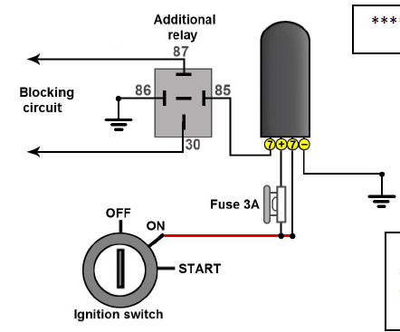
- Identify the starter line in the vehicle; this line can often be found off of the starter solenoid within the vehicle's steering column, but may be located in other areas of the vehicle as well. Samsara recommends that you install on the starter line. Using a multimeter, collect voltage readingsfrom the suspected starter line. A vehicle starter line should show 0V while the ignition is in the off, accessory, and on position. Once the key is turned to the start position, the voltage reading for the wire should show 12 or 24V, depending on your vehicle type.
- Cut the starter line wire and splice to the interrupt wires from the Engine Immobilizer using the provided butt splices to crimp and heat shrink the connections.
- Plug in the Engine Immobilizer USB plug into the USB connection on the Samsara Vehicle Gateway. If you need to install the Samsara Vehicle Gateway, please refer to that product install guide.
- Mount the Engine Immobilizer using the self tapping sheet metal screws included. Make sure to mount in a location that is hidden and secure. Mounting to a rigid surface will reduce vibration to the device

2.2. Testing Sensors and Actuators
Testing Sensors
Computer controlled systems continually monitor the operating condition of today's vehicles. Through sensors, computers receive vital information about a number of conditions, allowing minor adjustments to be made far more quickly and accurately than mechanical systems. Sensors convert temperature, pressure, speed, position and other data into either digital or analog electrical signals.
The digital signal is the easiest for the computer to understand because it reads the signal as either "on" or "off." The analog signal must be conditioned or converted to digital so the computer can understand it.
While a vehicle may have many different sensors, there are three main categories:
voltage-generating, resistive and switches.
A voltage-generating sensor generates its own voltage signal in relation to the mechanical
condition it monitors. This signal in turn relays to the computer data about the condition of the system it controls.
A resistive sensor reacts to changes in mechanical conditions through changes in its resistance.
The computer supplies a regulated voltage or reference voltage to the sensor and measures the voltage drop across the sensor to determine the data.
Switch sensors toggle a voltage from the computer high or low, or supply an "on" or "off" voltage signal to the computer. This type of sensor may be as simple as a switch on the brake pedal or as complex as a phototransistor speed sensor.
- Testing air bag sensor
Airbag sensors are devices that typically detect when a collision has occurred in a vehicle and send a signal to deploy the airbags. In order to detect the impact and determine the proper level of airbag deployment, these sensors make use of a variety of technologies, such as accelerometers and pressure sensors.When a frontal crash occurs that is severe enough to require the deployment of airbags, a sensor detects that impact. An electronic signal from the sensor triggers a chemical reaction that fills the airbag with safe nitrogen gas. To give the occupants the best possible protection in the event of a collision, they are generally fitted at strategic areas on the car, like the front and sides.

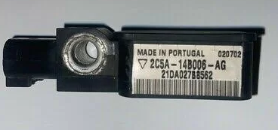
Figure 2.1 air bag snsor
Symptoms of a bad airbag sensor
The airbag control computer of the vehicle tests the airbag sensor circuit and determines if it is still in good working order each time you put on the keys and start the engine. If the airbag warning light on the dashboard illuminates each time you start the car, the sensor is obviously working.
However, if the airbag warning light remains on after the car has started, there may be an issue with the airbag sensor. An airbag light on the dashboard is the most common symptom of an airbag sensor that needs replacement.
Testing
When testing an airbag sensor, it is important :
- first check the condition of the wires and connectors.
- If the wires are frayed or the connectors are loose, the sensor may not function properly.nex check the air bag sensor sensor itself
- Most sensors have a test light or an LED that will light up when the sensor is triggered.
- If the test light does not come on, the sensor may be defective.
- Finally, check the airbag system’s computer to see if it is receiving a signal from the sensor. Using an automotive diagnostic tool to retrieve the error codes and real-time data from the airbag control unit is the only safe way to test an airbag sensor. Measure the wirings between the airbag and the airbag sensor if there is a trouble code on the sensor, and check for any measuring results inside your diagnostic tool.

Testing seat belt sensor
The seat sensor detects a passenger sitting on a seat of the vehicle based on a load exerted on the seat. The seatbelt sensor detects that a seatbelt of the seat is worn based on a fixing of a wear end of the seatbelt.
- Testing front seat inner belt assembly (For Driver Side)
Measure the resistance of the buckle switch.
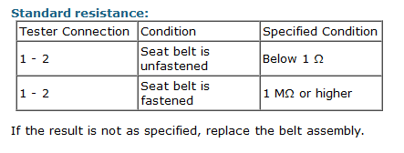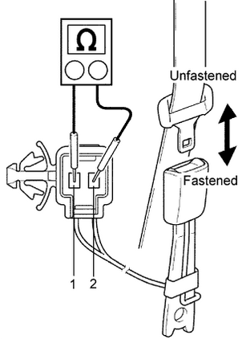
- Testing Occupant Detection Sensor
Measure the resistance of the sensor.
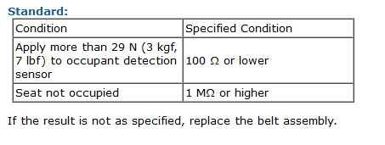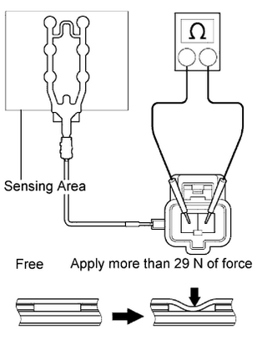

- Testing front seat inner belt assembly (Passenger Side)
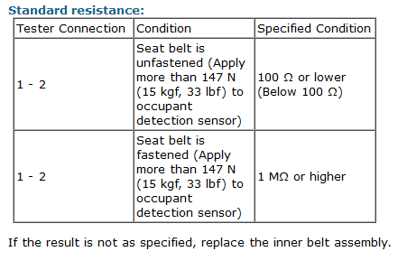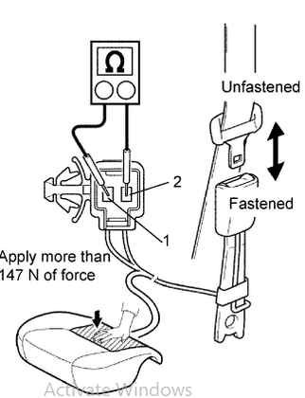

- Testing Passenger Seat Belt Warning Light Assembly
Check the illumination area of the seat belt warning light.
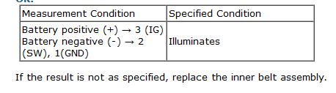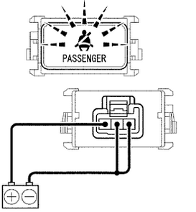

Test actuator

An actuator is an electromechanical device such as a relay, solenoid or motor. Actuators can adjust engine idle speed, change suspension height or regulate the fuel metered into the engine.
Actuators can be simple as many are operated by windings.
The resistance can be measured with an ohm-meter. A good tip is that where an actuator has more than one winding (e.g. a stepper motor), the resistance of each should be about the same. Even if the expected value is not known, it is likely that if all the windings read the same then the device is in working order.With some actuators, it is possible to power them up from the vehicle battery.. Be careful with this method as some actuators could be damaged.

Some typical examples of the use of these motors are listed as follows:•
- windscreen wipers;
- windscreen washers
- electric windows
- electric sunroof
- seat adjustment
- mirror adjustment
One disadvantage of simple motor actuators is that no direct feedback of position is possible. This is not required in many applications; however, in cases such as seat adjustment when a ‘memory’ of the position may be needed, a variable resistor–type sensor can be fitted to provide feedback
Testing power window

A window regulator converts the rotary motion of the motor into the vertical movement of the window. Th e motor operates the window regulator either through a cable or directly. On direct drive motors, the motor pinion gear meshes with gear teeth on the regulator called the sector gear .As the window is lowered, the spiral spring iswound. Th e spring unwinds as the window is raised, to assist in raising the window. Th espring reduces the amount of current that would be required to raise the window by themotor itself.
The master control switch provides the overall control of the system .Power to the individual switches is provided through the master switch. Th e master switchmay also have a safety lock switch to prevent operation of the windows by the individualswitches. When the safety switch is activated, it opens the circuit to the other switches andcontrol is only by the master switch. As an additional safety feature, some systems preventoperation of the individual switches unless the ignition switch is in the RUN or ACC position.
Testing power window switch
Pry the Power Switch Off
First, disconnect the two lugs from the main wire harness in order to pry the power window switch out of the window. After that, pry the switch off the door using a screwdriver. It will be secured in place by clips around its edge, but once these are loosened, they may be pried up.
Removing the Connectors
To test your power window switch, remove all electrical connectors on both ends and set them aside. Almost all power window switches have brittle outside insulation; if you pull too hard, it will totally snap off. Instead, carefully pull any connector without a set of needle-nose pliers. Set the connections aside after removing them.
Set Your Multimeter on Continuity Mode and Test the SwitchBy checking the continuity of their switch contacts, multimeters may be used to test power window switches. A connection between two copper contact strips within your power switch should be made when you press the power window switch. If this occurs, a strong electrical connection has been established that matches the position of the power window switch, and when you push down or draw up your power window switch, you should hear an audible click from both ends.
However, if there is no click detected throughout these tests, your power switch is broken and cannot be fixed with just replacement parts (the entire assembly must be disassembled and replaced). Before you replace your power window switch, make sure there is continuity in both switch positions with a multimeter.
Testing the Fuse
Place a multimeter or test light across the terminals of the relevant fuse on the main fuse box of your car to make sure the fuse for the power window motor is not blown. Check to see if your ground wire from the car battery has a good connection if there is no electricity flowing through this circuit (remove any corrosion and try again). Check all of the power window circuits within the door panel if the problem persists.
A good way to do this is by holding both ends of the power switch assembly—one in each hand—while lowering or raising it. This will enable you to exert pressure on every component of the mechanism at once, significantly reducing the mechanism’s cycle time and eventually leading to excessive wear (allowing more grit inside your door panels).
Put the Switch Back on or Install a New One
After determining whether or not your power window switches are damaged, you may choose what to do next. If they are still working properly, make sure the mechanism is in excellent condition and reinstall it if it is still functional (if possible). Buy a brand new switch from your auto dealership if either switch is broken or if one of them isn’t functioning correctly.

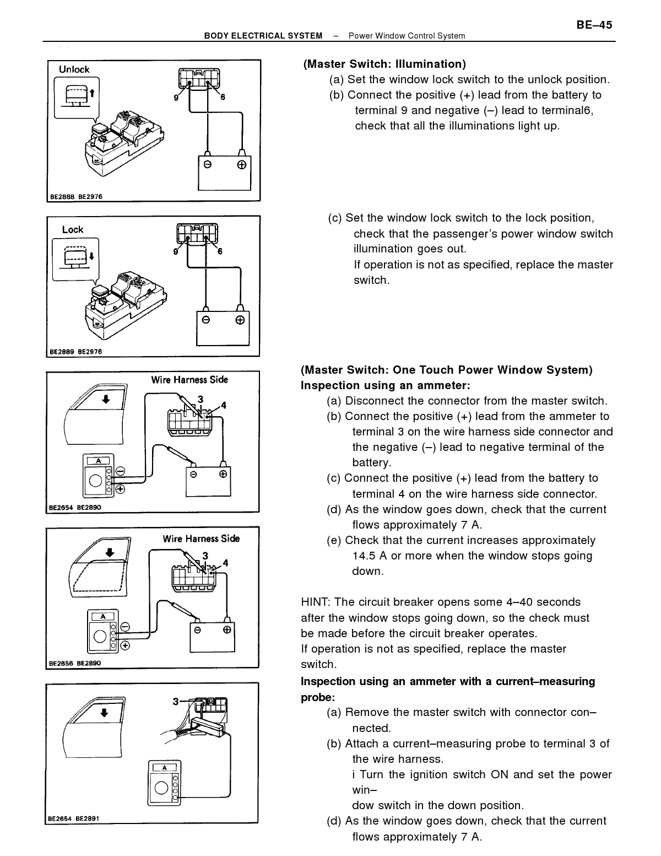

Self-check 2.1
Directions: Answer all the questions listed below.

Part I: Answer the following question accordingly
- List the three main categories of sensors
- What is the Symptoms of a bad airbag sensor?
- What is the use of window regulator?
- List down power window switch testing procedures?

LAP Test
Practical Demonstration
Name: __________________________ Date: ____________
Time started: ____________________ Time finished: _______________
Instructions: Given necessary templates, tools and materials you are required to perform the following tasks accordingly.
Task1: Perform Central door Locking and alarm security Installation on to the vehicle
Task 2: Perform power window Installation on to the vehicle
Task 3: Perform Electric side mirrors Installation on to the vehicle
Task 4: Perform Electronic Seat Adjustment Installation on to the vehicle
Task 5: Perform Electronic Seat belt Installation on to the vehicle
Task 6: Perform Supplemental and restraint system/ SRS/Installation on to the vehicle
Task 7: Perform Engine immobilizer Installation on to the vehicle

Unit Three: Service/repair body management systems
This learning guide is developed to provide you the necessary information regarding the following content coverage and topics:
  - Servicing ,repairing and retesting body management components
  - Clean up work area and maintain equipment
This guide will also assist you to attain the learning outcomes stated in the cover page. Specifically, upon completion of this learning guide, you will be able to:
  - Service ,repair and retest body management components
  - Perform Clean up work area and maintain equipment

Servicing , repairing and retesting body management components
- Servicing , repairing and retesting central doorlock and alarm system
There are three lock and alarm function variants
No central locking, no remote control and no alarm.
The passenger door can be locked from the panel on the driver's side, but the driver's door cannot be locked from thepassenger side. Externally the door has a normal lock cylinder. The driver's side has no motor or lock switch
Central locking with remote control but no alarm
The driver's side and passenger side are locked at the same time using central locking, by pressing the remote control.The doors are unlocked separately by pressing the remote control once (driver's side) or twice (passenger side).When the doors are locked and unlocked the direction indicators flash to indicate that the vehicle has beenlocked/unlocked.The lock mechanism is driven by electric motors in the driver and passenger doors
Central locking with remote control and alarm
The driver's side and passenger side are locked at the same time using central locking, by pressing the remote control.If an alarm is fitted this is activated at the same time. The doors are unlocked separately by pressing the remote controlonce (driver's side) or twice (passenger side). The alarm is deactivated when one of the doors is unlocked.The following places have alarm sensors:Driver's door Passenger door Luggage compartment hatchGrille
The alarm also has motion detectors and can detect whether someone is trying to interfere with, or disconnect thebattery. When the vehicle is locked and the alarm is activated, the direction indicators flash. When the alarm isdeactivated the direction indicators flash. It is possible to activate the alarm with reduced functionality so that thedo notmotion detectors in the cab remain deactivated. This is used to allow the driver to move about and sleep in the cab.

Common faults in the car's central locking
The common situation is that the central locking failure causes the door to lock.
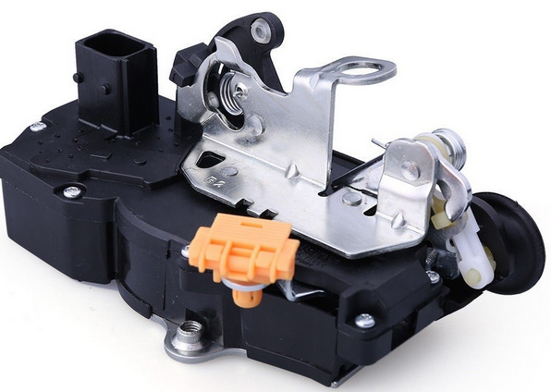
There are still many types of central locking on the car, but the basic components are mainly door lock switches, door lock actuators and door lock controllers. The failure of the central control lock causes the door to be locked, and generally the door lock actuator and the door lock controller are faulty. If there is such a situation, we recommend that the car should be repaired at the repair shop in time, and the fault information can be quickly detected by the detector.
Common faults in car central control locks generally require motor aging to be replaced; fuses in the switch circuit need to be replaced; the central control lock main unit needs to be replaced; the main motor linkage rod is loose and needs to be tightened.
Proocedures to Repairing car central locking system
To repair a broken car central locking system, there are several other ways that you can try.
- Change your car battery which needs to be replaced from time to time.
- If the key fob is not sending signals after the tests performed by your car dealer, replacing it will help.
- Before assuming the causes, try all the doors and see which ones are working and which ones are not. When any issues are found, check the wiring first and replace the broken wires. If there is no broken wire, the problems may result from a blown fuse which can be repaired easily. However, in case you need to repair a bad solenoid, contact a mechanic.
- Try spraying lubricant if one or some locks “try” to move while getting stuck. Remember to use the right lubricant for your car. After spraying the liquid, let the locks sit for a couple of minutes.
- If you leave your car in an extremely cold area which can freeze the locks and make them stuck, try defrosting them by heating methods. You can try using a hairdryer or a lighter to heat up.
To install a new car central locking system
If you wish to install a new car central locking system for your car, or replace the old one, it would be better to take your car to a garage, car dealer, or an expert mechanic. However, if you’d like to tweak your car, here’s a brief guide for you to know the basic steps to install a car central locking system.
    - Remove the trim First thing first, remove the trim by releasing the handles, winders and panel securing clips. Then carefully lift the panel away and remove the condensation sheet fixed behind the trim.
    - Position the car locking system drives unit You should mount the drive unit inside the inner door skin, and make sure that the unit doesn’t obstruct the opening mechanism nor the glass.
    - Make some holes on your car and secure the drive unit First, you should mark the position of the screw with a pen/marker, and choose a suitable-sized drill. Then affix the bracket with the screws and fit provided securing clips behind the door skin. After that, secure the drive unit.
    - Route wiring and wiring the central locking .This step is where you connect all the parts, which is written detailedly on the attached guide when you buy the kit. You can also see this tutorial video below for car central locking system installation.
Retesting
STEP 1. Check the operation of the central door locking system.
Check that the central door locking system works normally.
STEP 2. Pulse check
Check the input signal, which is related to the door key cylinder operation.
STEP 3. Retest the system.
Check that the central door locking system works normally by the door key cylinder operation.

- Servicing , repairing and retesting Power window system
Electric windows are essentially the same as a manual window-winding mechanism, except that the manual winder handle is replaced by a motor. The system usually consists of a two-way control switch wired by two circuits to a motor in each door.
Signs of a malfunctioning window regulator:
- Window does not go up or down when buttons are pressed.
- Operating the window makes an unusual or loud sound.
- Window drops to one side.
- Window closes very slowly or fails to close completely
There are 4 main reasons for a malfunctioning electric window:
- Blown Fuse
- Faulty window switch
- Faulty window motor
- Faulty window regulator
If you can hear the motor running (a humming sound) when you press the buttons to operate the window, then you can rule out a faulty window switch and a blown fuse. You should skip to checking the motor and window regulator. If you can't hear any sound when you press the buttons then it's time to check the fuse.
Checking Power to the motor
Using a digital volt meter, test the connection that is going to the motor for current. Motors with two wires are analogue systems and are safe to test.
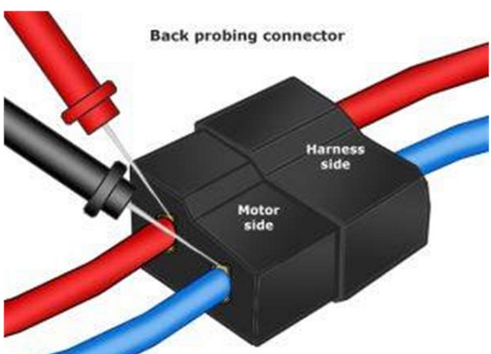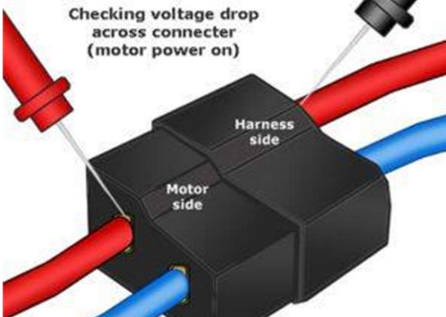
Figure 3.1 check power window

Power Window Mechanism Repair
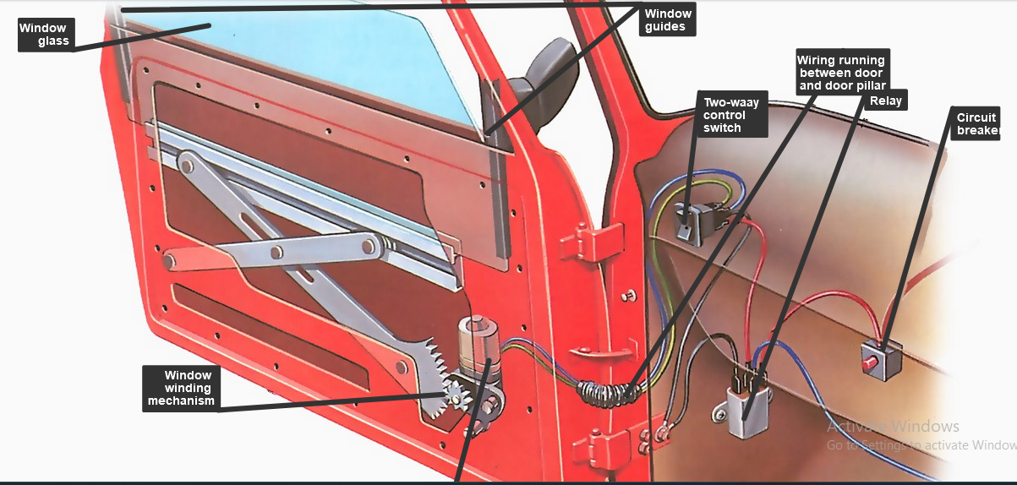
Figure 3.2 identify power window fault
Identify the fault
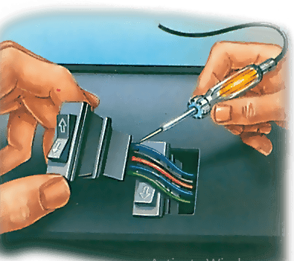
The most obvious fault with electric windows is that they fail to operate. If the problem occurs on all windows you can be pretty sure that the fault is in the main wiring circuit , and this is also the region to check first even if the problem is restricted to just one window. Try listening to see if you can hear the motor operating - if it is, but the window does not move, the problem lies in the mechanical linkage . Figure 3.3 identify power window fault
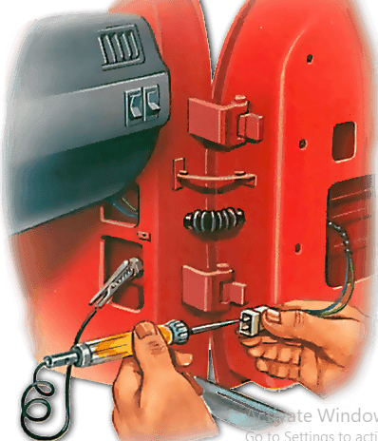
Check the fuse
Most window circuits are protected by a fuse or cutout in the supply line and this is the first place to check if the windows refuse to operate. With some arrangements a single fuse in the main supply line is used to protect the complete window system so a failure here affects all the windows. Other cars have individual fuses for each window motor so failure will only affect the one window. Figure 3.2 check power supply
Power supply
Generally the power for the window circuits (which draw a large current) is supplied direct from the battery through a relay (or relays) actuated by turning the ignition on. Find the relay position from your car handbook.
Use a test lamp to check that current is reaching the relay. With the ignition turned on check for current at the relay control terminal . If there isn't any the problem lies in the wiring from the ignition switch . Then test the output side of the relay - current means the relay is faulty and should be replaced, otherwise the problem lies in the control switches , the wiring or the motor itself.
Check the mechanism
Make sure the cable is correctly tensioned.
Sticking and jerky operation is often due to troubles with the window mechanism. To check it start by removing the door trim. Look over the mechanism to see if there is any obvious damage and make sure there is nothing that might make it jam - loose wires in the door cavity are a particular risk. Then operate the motor and watch the mechanism to see if it runs smoothly or if there is excessive play anywhere in the system.
Motor service
In most cases before you start to dismantle the regulator mechanism it is a good idea to fasten the window up in the closed position by taping it to the frame to take the weight off the mechanism. However with some cars the window has to be in the lowered position to allow you to unbolt the carrier from the window. So be prepared to undo the tape, lower the window and re-tape if necessary.
The way the motor assembly is fitted varies with the precise design of mechanism but start the removal process by disconnecting the power wires. Undo the screws that hold the motor to the door or to the winder mechanism. You may then be able to just pull the motor away from the rest of the winder mechanism. Watch out for any drive adapter pieces that may fall out when you remove the motor.
Removing the motor
Tape the window in its closed position to the frame to hold it out of the way. Then disconnect the wiring from the motor and unbolt the motor from the door.
Retesting
The window motor is tested
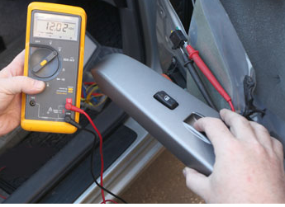
- We checked the service manual that says to remove the interior door cover and check for battery voltage at the window motor connector.
- The manual says to operate the window switch and check for the voltage at the connector. When the window switch is pressed "Down" the multimeter measures 12 Volts, so we know there is power at the window motor switch.
Figure 3.4 testing functinality
- Next, the service manual asks: does the motor operate by connecting the battery voltage directly to the motor? We did it and nothing happens, the window motor is bad and must be replaced.
- When the window switch is pressed "Up" the multimeter shows -12 Volts, because the polarity changes when the window switch is moved from "Down" to "Up" position.
- Servicing , repairing and retesting Engine immoblizer
The engine immobilizer is a state-of-the-art anti-theft system. When you insert your key into the ignition switch or bring a Smart Key fob into the vehicle, the key transmits an electronic code to the vehicle. The engine will only start if the code in the transponder chip inside the key or Smart Key fob matches the code in the vehicle's immobilizer. Because the transponder chip is embedded in the key or Smart Key fob, it can be costly to replace.
Immobilizer Problems
Ignition lights bright, everything working but engine will not turn over.
2. Engine turns over as normal but does not start.
3. Warning light flashing.
Do With Micro Chipped Keys (most modern immobilizers)
1.Try different key.
2. Turn Ignition on and off 5-6 times.
3. Turn Ignition on for 5 minutes, turn off and retry.
4. Disconnect Battery for 5 minutes.
5. Disconnect Battery for 5 minutes while disconnected join positive (+) and negative (-) leads together, this will disperse any small electrical charge stored in electronics.
6. Disconnect Battery for 5 minutes and reconnect with ignition key in switch on position.
Remote Key Fobs
1. Check batteries in remote.
2. Press button on remote with batteries removed.
3. Disconnect Battery on car for 5 minutes.
4. Hold button down for a few seconds.
5. Hold both buttons down for a few seconds.
6. If in high area of radio interference move car to new locati
  - Servicing , repairing and retestinh electric mirror
When driving, it is important to be able to see as much of the road as possible. This is why power side-view mirrors are so important.
Causes Power Mirrors Not to Work
There are several causes of power mirrors not working. They include:
A blown fuse: The fuse that controls the power mirrors may have blown. This is usually caused by a short circuit.
Bad wiring: Wiring that is damaged, frayed, or loose can cause the power mirrors to stop working.
A broken switch: The switch that controls the power mirrors may be broken.
A problem with the mirror motor: The motor that moves the mirrors may be damaged or faulty.
Fix Power Mirrors
The first thing you should do is check the fuse. If it is blown, replace it with a new one. If the fuse is not the problem, then check the wiring. If the wiring is damaged, you will need to repair or replace it.
If the wiring is not the problem, then check the switch. If the switch is broken, you will need to replace it. Finally, if the mirror motor is damaged or faulty, you will need to replace it.
Test a Power Mirror Switch
To test a power mirror switch, you will need to use a multimeter. First, locate the switch. Then, set the multimeter to the continuity setting and touch one of the probes to each of the terminals on the switch.
If there is continuity, then the switch is working properly. If there is no continuity, then the switch is not working and will need to be replaced.
Power Mirror Switch Work
A power mirror switch is a switch that controls the power mirrors. The switch is usually located on the dash or center console. When you press the switch, it sends a signal to the mirror motor. This signal powers the motor to move the mirrors.
Reset My Power Folding Mirror
If your power folding mirror is not working, you may need to reset it. To do this, you will need to locate the mirror switch. The switch is usually located on the dash or center console.
Once you have found the switch, press and hold it for about five seconds. This should reset the mirror and cause it to start working again.
Repair a Side Mirror
Yes, you can repair a side mirror. However, depending on the extent of the damage, it may be more cost-effective to replace the mirror. If the mirror is cracked or broken, it will need to be replaced.
However, if the problem is with the motor or adjustment screws, then it can be repaired.

Power Mirrors Wired
Power mirrors are usually wired to the car’s electrical system. The mirror has two wires, a positive wire, and a negative wire. The positive wire is connected to the power source, and the negative wire is connected to the ground.

Cleaning work area and Maintaining tools and equipment
Cleaning work area
A contact cleaner is a solvent cleaner designed to remove contamination from electrical contacts, the conductive surfaces of connectors, switches and other electrical and electronics.
Methods of Cleaning Electrical Apparatus. Never attempt to clean electrical power equipment while it’s energized. Remember to observe all safe work practices and lockout/tag out procedures prior to cleaning. Personnel should be properly qualified before cleaning electrical equipment.
Keeping electrical equipment clean is an important part of any electrical preventive maintenance program, but using the wrong cleaning methods could be costly. Determine the cleaning method by observing the type of contamination to be removed and the time allowed until the equipment needs to be returned to service. Sufficient dry time is required when using liquid solvents or water to clean electrical equipment. Insulation should be tested to determine whether it has been properly reconditioned before re-energizing equipment.
Methods of Cleaning Electrical System
- Rags and Brushes
- Liquid Solvents and Water
- Vacuum Cleaning
- Sweeping and Moping
Maintaining tools and equipment
Tools and equipment require proper care and maintenance, not only for longevity but also to remain useful and safe for the task at hand. Here are some care and maintenance practices for tools and equipment.

Proper storage
Proper storage entails shielding tools from harsh weather conditions, damage and theft. It is particularly crucial for metallic tools to be kept away from moisture to avoid rusting.
Having a cabinet where these tools and equipment are stored will be vital to ensuring a secure storage area. Also, greasing, lubricating or oiling metallic tools and equipment is essential to prevent rust from forming while keeping the tools in the best condition for future tasks.
Using tools and equipment for their right task
Using a tool for the task it is intended helps to keep it in its best shape. This reduces unnecessary damage and protects the user. It is also important to check whether the tools are in the right condition before using them.
Cleaning after use
Storing dirty tools without cleaning them can cause them to deteriorate. Routine cleaning reduces the chances of rust and can reduce the rate of wear and tear.
Inspect tools regularly
Regular inspection of tools is beneficial since it provides an opportunity to see if tools may need repair or replacing. Inspections can help to prevent a situation where a last minute trip to the store to purchase a new tool or spare parts delays a project.
Read and follow manuals
The manuals that come with equipment, especially power tools, have important and useful guid.

Self-check 3.1
Directions: Answer all the questions listed below.

Part I: Answer the following question accordingly
      - List the three lock and alarm function variants
      - What are the 4 main reasons for a malfunctioning electric window?
      - List the Remote Key Fobs List down window motor re testing procedures
      - List down window motor re testing procedures?
      - List down Immoblizer Problem

Operation Sheet 3.1
Operation Title: Installing a new car central locking system
Purpose: To understand how repairing central locking system by installing a new car central locking system
Conditions or situations for the operations:
- Safe working area
- Properly operated tools and equipment
- Appropriate working cloths fit with the body
Equipment Tools and Materials:
- Newcentral doorlock accessories
- Vehicle
- Tools and equipments
Quality Criteria: Assured performing of all the activities according to the procedures
Precautions:
- Wearing proper clothes, eye glass, glove
- Make working area hazard free
- Read and interpret manual which guide you how to use tools and equipment.
Steps in doing the task
    - Remove the trim First thing first, remove the trim by releasing the handles, winders and panel securing clips.
    - Then carefully lift the panel away and remove the condensation sheet fixed behind the trim.
    - Position the car locking system drives unit You should mount the drive unit inside the inner door skin, and make sure that the unit doesn’t obstruct the opening mechanism nor the glass.
    - Make some holes on your car and secure the drive unit First, you should mark the position of the screw with a pen/marker, and choose a suitable-sized drill.
    - Then fix the bracket with the screws and fit provided securing clips behind the door skin.
    - After that, secure the drive unit.
    - Route wiring and wiring the central locking .This step is where you connect all the parts, which is written detailedly on the attached guide when you buy the kit.

Operation Sheet 3.2
Operation Title: Replace/installing power window motor on vehicle.
Purpose: To give electric power to Power window accessories
Conditions or situations for the operations:
- Safe working area
- Properly operated tools and equipment
- Appropriate working cloths fit with the body
Equipment Tools and Materials:
- Open-end socket wrench,
- Screw driver
- Multi meter
Quality Criteria: Assured performing of all the activities according to the procedures
Precautions:
- Wearing proper clothes, eye glass, glove and safety shoes
- Make working area hazard free
- Read and interpret manual which guide you how to use tools and equipment’s
Steps in doing the task
- Stop the vehicle in level place
- Locate and disconnect the power window motor wire hurness terminals
- Remove the old power window motor
- Clean the power window terminal connectors
- Find the new power window motor
- Install and secure the new battery
- Close the cover and check the functionality

LAP Test
Practical Demonstration

Name: __________________________ Date: ____________
Time started: ____________________ Time finished: _______________

Instruction: Perform the following tasks
Task 1: Installing central doorlock on the vehicle
Task 2: installing power window on the given window

Reference
Books
- Tom Denton-Automobile Mechanical and Electrical Systems_ Automotive Technology_ Vehicle Maintenance and Repair (Vehicle Maintenance & Repr Nv2)-Butterworth-Heinemann (2011)
- Tom Denton - Advanced automotive fault diagnosis _ automotive technology_ vehicle maintenance and repair (2021).
- James D. Halderman - Diagnosis and Troubleshooting of Automotive Electrical, Electronic, and Computer Systems (2011, Prentice Hall).
- Automotive_Electrical_Course_-_Service_Training.pdf
- James D. Halderman - Diagnosis and Troubleshooting of Automotive Electrical, Electronic, and Computer Systems (2011, Prentice Hall).pdf

Participants of this Module (training material) preparation
No | Name | Qualification (Level) | Field of Study | Organization/ Institution | Mobile Number | E-mail
 | Fadli Aman | BSc. | Automotive Technology | General Wingate PTC | 0927283100 | Fadli.ziyad@gmail.com
 | Habtamu Deresso | PHD Candidate | Automotive Technology | ASTU | 0945853269 | habtamu.deresso@gmail.com
 | Israel Taye | MSC | Automotive Technology | General Wingate PTC | 0913424100 | isra.taye@gmail.com
 | Natnael Genene | MSC | Automotive Technology | Athlete kenenisa PTC | 0920397105 | natnealgenene143@gmail.com
 | Robsan Tesfaye | MSC | Automotive Technology | Burayu PTC | 0920117175 | robsantesfaye4@gmail.com
 | Sisay Tufa | MSC | Automotive Technology | M/G/M/Buli | 0912065407 | knbntf@gmail.com
 | Tagay Tesfaye | MSC | Automotive Technology | Bishoftu PTC | 0975971391 | tagotagotago37@gmail.com

