

Automotive Electricity and Electronics Level -III
Based on October 2023, Curriculum Version II
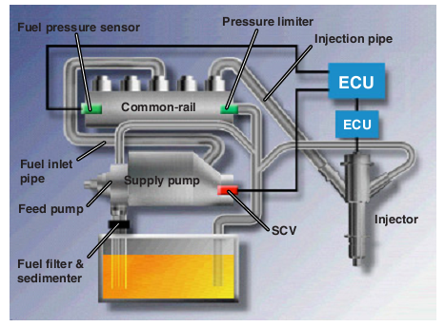
Module Title: Automotive Electricity and Electronics
Level-III
Module Code: EIS AEE 3 M01 1023
Nominal Duration: 70 Hours
Prepared by: Ministry of Labor and Skill

October, 2023
Addis Ababa, Ethiopia

Table of Contents
Acknowledgment 4
Acronym 5
Introduction to Module 6
Unit one: Introduction to EFI 7
1.1 Necessity of EFI 8
1.2 Features of EFI 8
1.3 EFI Comparison to Carburettor 10
1.4 Evolution of Electronic Fuel Injection 14
1.4.1 Hydraulic-Mechanical Fuel Injection System 14
1.4.2 Electronic fuel injection system 18
1.5 Types of EFI 21
Self-check 1.1 23
2.1 Electronic Control System 25
2.1.1 Air Induction System 25
2.2 Fuel Delivery System 27
2.3 Sensor 28
2.3 Actuator 45
2. 4. Electronic control unit 47
2.4 Electronic Ignition Systems 51
Self-check 2 63
Operation Sheet 2.1 64
Operation Sheet 2.2 67
3.1 Diesel Electronic Fuel Injection System 69
3.2 Types of Diesel EFI 71
3.3 Electronic control system 73
3.3.1 Sensor 73
3.2.2. Actuator 79
3.2.3. ECU and other 79
3.4 Fuel Deliver 81
3.5 High pressure accumulator (common rail) 82
3.9 Injector 87
Self-check 3 91
Operation Sheet 3.1 92
Operation Sheet 3.2 93
4.1 Fuel Injector Testing 95
Step 1: Safety first 100
Step 2: Fuel pressure 100
Fig 4.11 check the fuel pressure 100
Step 3: Use a flow-meter or glass measuring container 100
Fig 4.12 glass measuring container 101
Step 4: Test 101
2. Bosch Denso Delphi Simons Code Generating Common Rail Injector Tester 101
Description Bosch Denso Delphi Simons Code Generating Common Rail 101
Injector Tester Advantage: 101
Fig4.15 Economic Model Common Rail Injector Tester 104
Self-check 4 108
Operation Sheet 4.1 Precautions for Removing and Reinstalling Parts 110
Operation Title: Identify sensor mounting location 110
Inspecting sensor 110
LAP Test 111
Reference 112

Acknowledgment

The Ministry of Labor and skill wishes to thank and appreciation to MoLS leaders and experts, Regional Labor and skill/training Bureaus leader, experts, TVT College Deans, Instructors and industry experts who contribute their time and professional experience to the development of this Training Module.

Acronym
CO₂ Carbon dioxide
DEFI Manifold pressure controlled
ECU Electronic Control Unit
EDIC Electrical diesel injection control
EEC Electrical Electronic control
EECS Evaporative emission control system
EFI Electronic fuel Injection
EGR Exhaust Gas Regulator
H₂O Water
HC Hydrocarbon
IAC Idler air control
IACA Idle air control valve
L-EFI Air flow control
NO_{X} Oxide of nitrogen

Introduction to Module
In automotive Mechanics field, Overhauling Electronics Fuel Injection System is very important for the Service health of the car. It helps to know basic Overhauling Electronics Fuel Injection System concepts, methods of Overhauling Electronics Fuel Injection System and testing and also including removing and replacing procedures of Overhauling Electronics Fuel Injection System. Due to the Overhauling Electronics Fuel Injection System nature of most vehicles today, the Overhauling Electronics Fuel Injection System not only helps the car to be functional but also keeps safe when on the road.
This module is designed to meet the industry requirement under the Automotive Mechanics occupational standard, particularly for the unit of competency: Overhauling Electronics Fuel Injection System

This module covers the units:
- Overview of conventional fuel system
- Overhauling Conventional Gasoline Fuel System
- Overhauling Conventional Diesel Fuel System
Learning Objective of the Module
- Overview of conventional fuel system
- Overhauling Conventional Gasoline engine fuel system
- Overhauling Conventional Diesel Fuel System

Module Instruction
For effective use this modules trainees are expected to follow the following module instruction:
- Read the information written in each unit
- Accomplish the Self-checks at the end of each unit
- Perform Operation Sheets which were provided at the end of units
- Do the “LAP test” giver at the end of each unit and
- Read the identified reference book for Examples and exercise

Unit one: Introduction to EFI
This unit is developed to provide you the necessary information regarding the following content coverage and topics:
- Necessity of EFI
- System Layout and Operation
- Diesel EFI
- Repair of electronic Diesel fuel injector
This unit will also assist you to attain the learning outcomes stated in the cover page. Specifically, upon completion of this learning guide, you will be able to:
- Necessity of EFI
- Identify Layout and Operation
- Understand Diesel EFI
- Repair electronic Diesel fuel injector

Necessity of EFI
EFI systems are computer controlled and designed to provide the correct air-fuel ratio for all engine loads, speeds, and temperature conditions. The computer monitors the operating conditions and attempts to provide the engine with the ideal air-fuel ratio. The ideal fuel ratio is often called the stoichiometric ratio. A stoichiometric mixture is one that has the air-to-fuel ratio necessary for complete combustion of the fuel. This means all of the fuel and the oxygen in the air are completely consumed during combustion. Different fuels have a different stoichiometric ratio. The stoichiometric mixture for gasoline is 14.7:1.
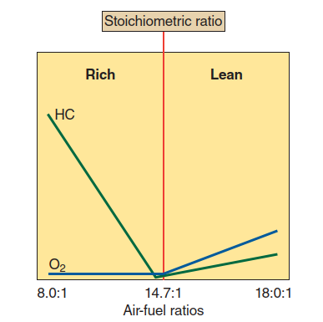
Figure 1: 1 A graph showing how the amount of raw gasoline (HC) and air (O2) released in the exhaust changes with a change in the air-fuel ratio.

A stoichiometric mixture is theoretically the best combination of fuel and air to provide for total combustion. The ratio, however, is based on an ideal environment for combustion. This environment rarely exists and the injection system’s controls vary the ratio in response to the inefficiencies. It also responds to changes in conditions that affect the combustion process. The air-fuel ratio also changes for starting, maximum power, and maximum fuel economy. The stoichiometric ratio allows the catalytic converters to work more efficiently.

Features of EFI
EFI replaces the carburettor as the mechanism responsible for mixing fuel and air, and delivering the mixture to the engine cylinders, so it can be burned, and power can be produced.
Unlike a carburettor, which relies on the vacuum created by the engine to work, a fuel-injected engine uses pressurized injectors to spray a precisely-metered amount of fuel into the air stream as it enters the engine. The system’s ability to adjust the fuel/air mixture based
on altitude and environment is a major benefit for commercial mower users on a number of levels. The following basic features of EFI:
- Uniform Air-Fuel Mixture
Because each cylinder has its own injector and because the injector volume is accurately controlled by the ECU in accordance with engine rpm and load changes, a uniform distribution of fuel to each cylinder is possible,
Further, the air-fuel mixture ratio can be controlled freely by the ECU by changing the injector operating time (fuel injection duration). For these reasons, the air-fuel mixture is distributed equally to all cylinders and an optimal air-fuel ratio is created; these are both advantageous from the aspect of exhaust emission control and power performance.
- Accurate Air-Fuel Ratio
The single nozzle of the carburettor cannot control the air-fuel ratio accurately throughout all speed ranges, so control is divided among a slow system, first high-speed system, second high-speed system, etc., and the air-fuel mixture must be made rich during the changeover from one system to another. For this reason, if the air-fuel mixture is not maintained slightly on the rich side overall, abnormalities (backfiring and hesitation) are likely to occur during changeover. Also, because there is a rather large in-equality in the distribution of the air-fuel mixture between each cylinder, the air-fuel mixture must be kept slightly rich. With EFI, however, a continual and accurate air-fuel mixture is supplied no matter what the engine speed or load. This is advantageous from the aspect of emission control and fuel economy.
- Good Throttle Angle Response
With the carburettor, there is rather a long distance from the fuel injection component to the cylinder. Also, because there is a big different between the specific gravity of gasoline and air, there occurs a slight delay in the gasoline entering the cylinder in relation to changes intake air volume. With EFI, however, the injectors are located near the cylinders, the gasoline is pressurized to 2 to 3 kg/cm2 (28.4 to 42 psi, 196.1 to 294.2 Kpa) higher than intake manifold pressure and because the gasoline is injected through a small hole, it easily forms a mist. Consequently, gasoline injection volume changes simultaneously with variations of intake air volume according to the opening and closing of the throttle valve, so the air-fuel mixture injected into the cylinder changes immediately according to the throttle vale opening. In short, there is good response in relation to changes in the position of the acceleration pedal.
- Air-Fuel Mixture Corrections
- Low temperature compensation
Stability is improved at low temperatures because a fine mist of gasoline is injected by the cold start injector during engine starting. Also, because sufficient air is drawn in by the air valve, good drivability is maintained immediately after starting.
- Deceleration Fuel Cut-off
During deceleration, the engine is running at a high rpm even though the throttle valve is closed. Consequently, the intake air volume into the cylinder is reduced and manifold vacuum becomes stronger.
With the carburettor, the gasoline adhering to the intake manifold wall will vaporize and enter the cylinder because of the sudden rise in manifold vacuum resulting in an over-rich mixture, incomplete combustion and a consequent increase in the amount of un burnt gasoline (HC) in the exhaust gas. On EFI engine, fuel injection is terminated when the throttle valve closes and the engine is running above a certain rpm so the density of the HC in the exhaust is reduced and less fuel is consumed.
- Efficient Intake of Air-fuel Mixture
With the carburettor, air flow is restricted by the venturi to increase flow speed, causing a vacuum to be formed below the venturi. With EFI, on the other hand, 2 to 3 kg/cm2 (28.4 to 42.7 psi, or 196.1 to 294.2 Kpa) of pressure is always applied to the gasoline to improve the mist of the air-fuel mixture, so there is no need for a venturi. Also, the manifold can be enlarged so the inertia of the intake air can be utilized for the intake of an abundant air-fuel mixture.

EFI Comparison to Carburettor
Automobiles use one of two devices or system for supplying the air-fuel mixture in correct ratio to the cylinders in all rpm ranges;
- A Carburettor
- An EFI (Electronic Fuel Injection)
Both of these measure the intake air volume which varies depending on the opening angle of the throttle valve and the engine rpm. Both supply a proper ratio of fuel and air to the cylinders in accordance with the volume of intake air.
Because the construction of the carburettor is relative simple, it has been used almost exclusively on gasoline in the past. However, in response to recent demands for cleaner exhaust emissions, more economical fuel consumption, improved drivability, and the likes.
In place of the carburettor, therefore, the EFI system is used, assuring the proper air- fuel ratio to the engine by electronically injecting fuel in accordance with various driving conditions.
Although the objective of the carburettors and EFI is the same methods they use to detect intake air volume and to supply fuel are different.
  - Production of Air Fuel Mixture - Carburettor
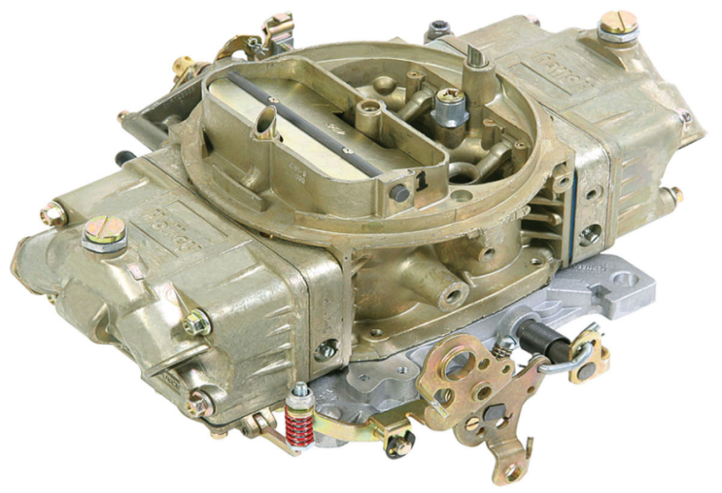
At idle rpm, intake air volume is measured in accordance with pressure (vacuum) changes around the slow and idle ports near the closed throttle valve, and a small amount of fuel is drawn into both ports.
Within normal operating range, intake air volume is measured by the vacuum in the venturi, and a proportional amount of fuel is drawn into the main nozzle of the venturi.
Figure 1: 2 Carburettor Choke System
On the other hand, EFI has several devices to measure the volume of intake air and the injection of fuel: Intake air volume is measured by a sensor (air flow meter) and a corresponding signal is sent to the ECU (Electronic Control Unit). The ECU then transmits a signal to the injectors, which inject a proper amount of fuel into the fuel intake ports of each cylinder.
Figure 1: 3 cvbf

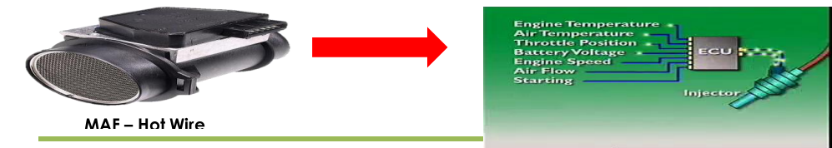
  - Driving Conditions And Air-Fuel Ratio
- During starting
When starting the engine, it is necessary to have a richer air-fuel mixture to improve starting performance, especially if the temperature is low. This is because:
(1) The air is denser, so the intake air flow velocity is lower
(2) The temperature is low, so the fuel does not vaporize easily.
- During Starting While Engine Is Cold -Carburettor
Because fuel vaporization is poor when the engine is cold, it is necessary to have a richer air-fuel mixture as when starting. The carburettors choke system performs this function. When the temperature is low, the choke valve can be operated manually or it automatically closes to provide a richer air-fuel mixture. When the temperature is low, the choke valve is fully closed to help obtain a sufficiently rich mixture. However, after the engine has started, the choke breaker operates to slightly open the choke valve for the prevention of an overly-rich mixture.
- During Starting While Engine Is Cold -EFI
Because fuel vaporization is poor when the engine is cold, it is necessary to have a richer air-fuel mixture as when starting. Cranking is detected by a signal from the starter and a richer mixture is supplied while the starter motor is cranking. There is also a cold start injector which operates only when the temperature is low to provide a greater injection volume. This valve is designed to improve the fuel mist spray for easier ignition.
Because fuel vaporization is poor when the engine is cold, it is necessary to have a richer air-fuel mixture as when starting. The coolant temperature is measured by a sensor which detects low coolant temperature. The sensor has a thermistor whose resistance changes greatly with variations in-coolant temperature. Coolant temperature transformed into electrical signal and sent to the ECU, which enriches the air-fuel mixture in accordance with this signal.
  - Driving Conditions And Air-Fuel Ratio
- During Acceleration
When the vehicle accelerates from a low speed, the volume of air immediately increase accordingly, but as the fuel is heavier than the air, there is a momentary delay in the fuel supply.

- During Acceleration - Carburettor
To prevent an overly-lean mixture during acceleration, an acceleration system is provided.
When the throttle valve is opened from the fully closed position, a certain amount of fuel is injected through a special passage to compensate for the delay in fuel supply from the main nozzle.
- During Acceleration - EFI
In contrast with the carburettors, the EFI system does not make any special correction during acceleration. This is because, in relation to the carburettor, which draws in fuel by means of a vacuum, the EFI system immediately injects high-pressure fuel in accordance with the intake air volume changes so there is no delay in the fuel supply.
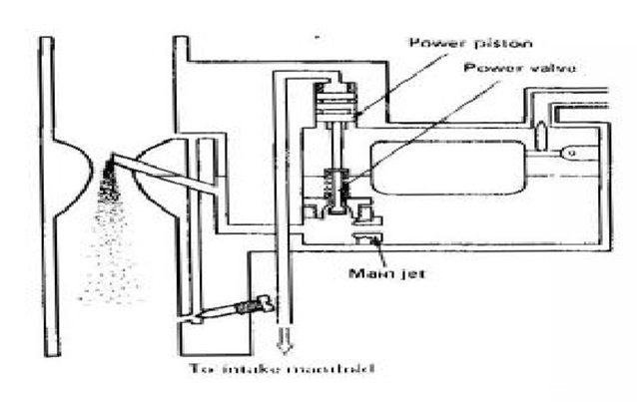
- During High Power Output-Carburettor
When driving on flat roads at a constant speed, a mixture on the lean side is supplied. However when speed is increased, as when overtake another vehicle, causing an extra load to be placed on the engine, this lean mixture will not provide sufficient output power. At such, a richer mixture (power air-fuel ratio) is required to insure sufficient power performance.
Figure 1:4 Carburettor during High Power Output
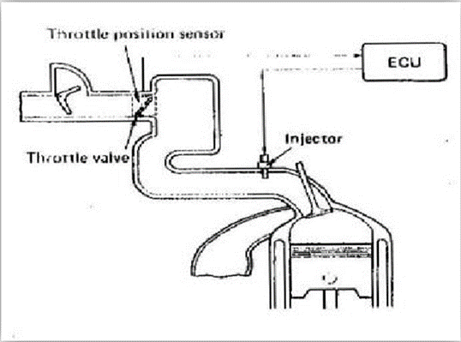
- During High Power Output - EFI
The extent of the engine load is determined by the opening angle of the throttle valve, and this is transformed into a electrical signal by the throttle position sensor. As the opening angle increases, there is a greater injection volume to provide a power air-fuel ratio.

Figure 1:5 EFI during High Power Output

Evolution of Electronic Fuel Injection
Most modern systems are controlled electronically because this form of control enables the fuel quantity and quality to be accurately set to suit the engine operating conditions. Strict emission control regulations have demanded precision in the metering of the fuel, and although petrol injection systems are more expensive, these systems are now commonly used on engines designed to output high power. The engineers first invented Hydraulic-mechanical fuel injection system and then electronic fuel injection system was built.

Hydraulic-Mechanical Fuel Injection System
K- and KE-Jetronic systems are the most common of the Bosch continuous injection systems, used on European makes at different times. K comes from the German word for continuous, "Kontinuerlich," because the fuel flows continuously from that system's injectors as long as the engine is running. When the letter "E" is added, this indicates the system is electronic, that is, controlled by a computer (KE-Jetronic).
- K-Jetronic System
The K-Jetronic is a mechanically and hydraulically controlled fuel-injection system, which needs no form of drive, and which meters the fuel as a function of the intake air quantity and injects it continuously onto the engine intake valves.
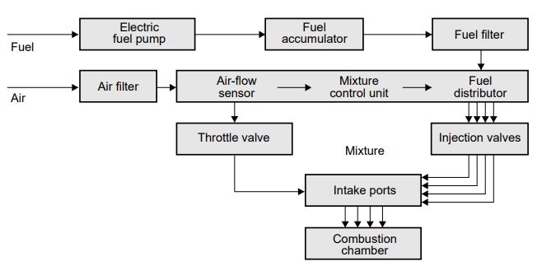
Figure 1: 6 K-Jetronic System Layout
The K-Jetronic fuel-injection system covers the following functional areas:
- Fuel Supply
An electrically driven fuel pump delivers the fuel to the fuel distributor via a fuel accumulator and a filter. The fuel distributor allocates this fuel to the injection valves of the individual cylinders.
The fuel supply system comprises
- Electric fuel pump,
- Fuel accumulator,
- Fine filter,
- Primary-pressure regulator and
- Injection valves.
An electrically driven roller-cell pump pumps the fuel from the fuel tank at a pressure of over 5 bar to a fuel accumulator and through a filter to the fuel distributor. From the fuel distributor the fuel flows to the injection valves. The injection valves inject the fuel continuously into the intake ports of the engine. The K designation taken from the German’s word which means continuous.
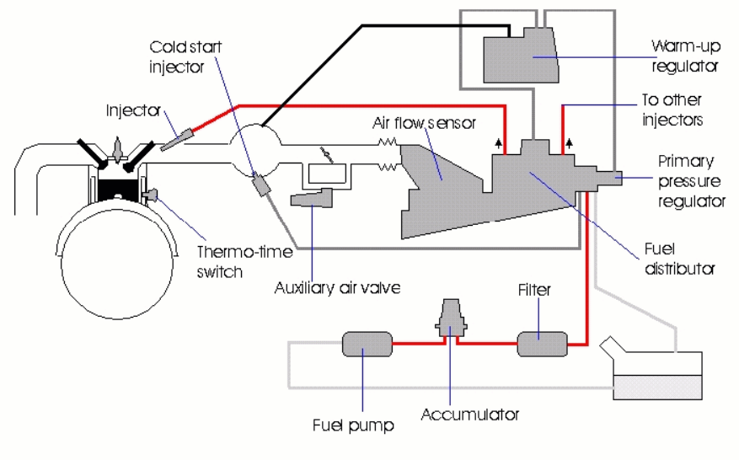
Figure 1: 7 K-Jetronic System Layout
When the intake valves open, the mixture is drawn into the cylinder. The fuel primary-pressure regulator maintains the supply pressure in the system constant and reroutes the excess fuel back to the fuel tank. Owing to continual scavenging of the fuel supply system, there is always cool fuel available. This avoids the formation of fuel-vapour bubbles and achieves good hot starting behaviour.
- Air-Flow Measurement
The amount of air drawn in by the engine is controlled by a throttle valve and measured by an air-flow sensor.
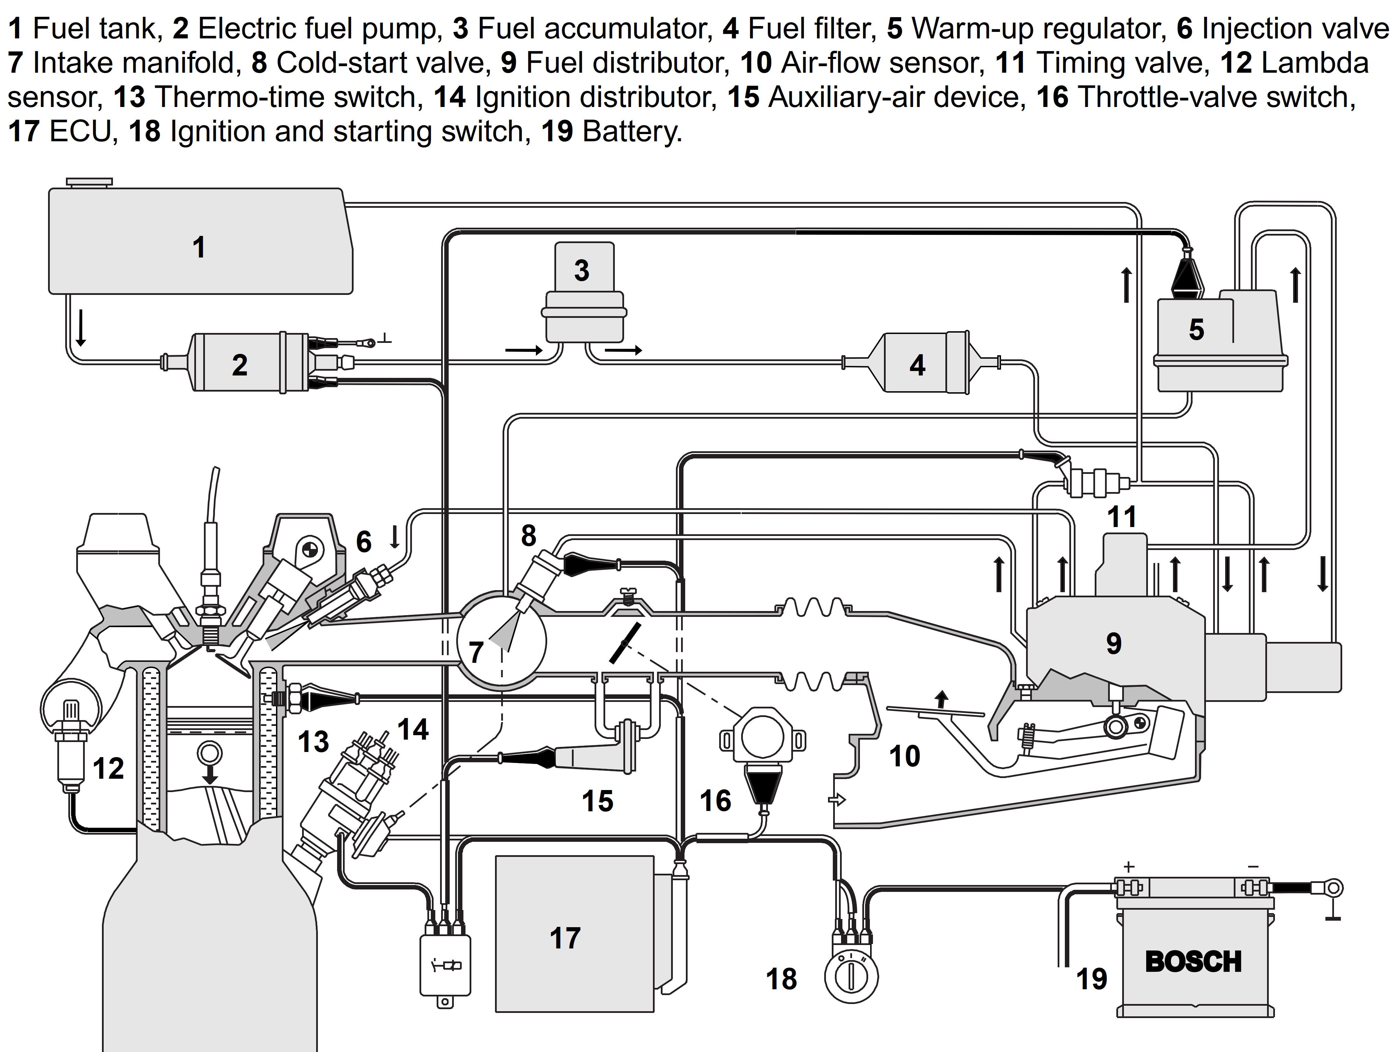
Figure 1: 8 Schematic Diagram of the K-Jetronic System

- Fuel Metering
The amount of air, corresponding to the position of the throttle plate, drawn in by the engine serves as the criterion for metering of the fuel to the individual cylinders. The amount of air drawn in by the engine is measured by the air-flow sensor which, in turn, controls the fuel distributor. The air-flow sensor and the fuel distributor are assemblies’ which form part of the mixture control unit. Injection occurs continuously, i.e. without regard to the position of the intake valve. During the intake-valve closed phase, the fuel is “stored”. Mixture enrichment is controlled in order to adapt to various operating conditions such as start, warm up, idle and full load. In addition, supplementary functions such as overrun fuel cut off, engine-speed limiting and closed loop lambda control are possible.
- KE-Jetronic System
A mechanical hydraulic injection system provides the basis for the KE-Jetronic, in the same way as on the K-Jetronic. This basic system is supplemented by an electronic control unit in order to increase flexibility and to enable further functions. Further components are:
- The sensor for the air quantity inducted by the engine,
- The pressure actuator which intervenes in the mixture composition and the pressure regulator which maintains the primary pressure constant and exerts a specific closing function when the engine is switched off.
A sensor plate deflected by the air stream controls the fuel-metering plunger and thus opens the metering slits to a greater or lesser extent. in the basic function, the KE-Jetronic meters the fuel as a function of the air quantity inducted by the engine, this being the main control variable.
However, by contrast with the K-Jetronic system, the KE-Jetronic injection system also processes other operating data of the engine via sensors whose output signals are processed by an electronic control unit. This electronic control unit controls an electro-hydraulic pressure actuator which adapts the injected-fuel quantity as required to the various operating conditions. If a malfunction occurs, the KE- Jetronic reverts to its basic function.
The fuel requirement differs greatly from the normal figures during the post- start period, during warm-up and during acceleration and full-load.
By means of commands received from its ECU (electronic control unit), the KE- Jetronic intervenes in the preparation of the air-fuel mixture and increases or decreases the injected fuel quantity accordingly.
The KE-Jetronic system incorporates additional sensors for detecting the engine temperature, the throttle-valve position (load signal) and the sensor; plate deflection (corresponds approximately to the change in engine power as a function of time). With the aid of these sensors, the ECU commands the hydraulic pressure actuator to either "lean-off" the mixture or "enrich" it as appropriate.
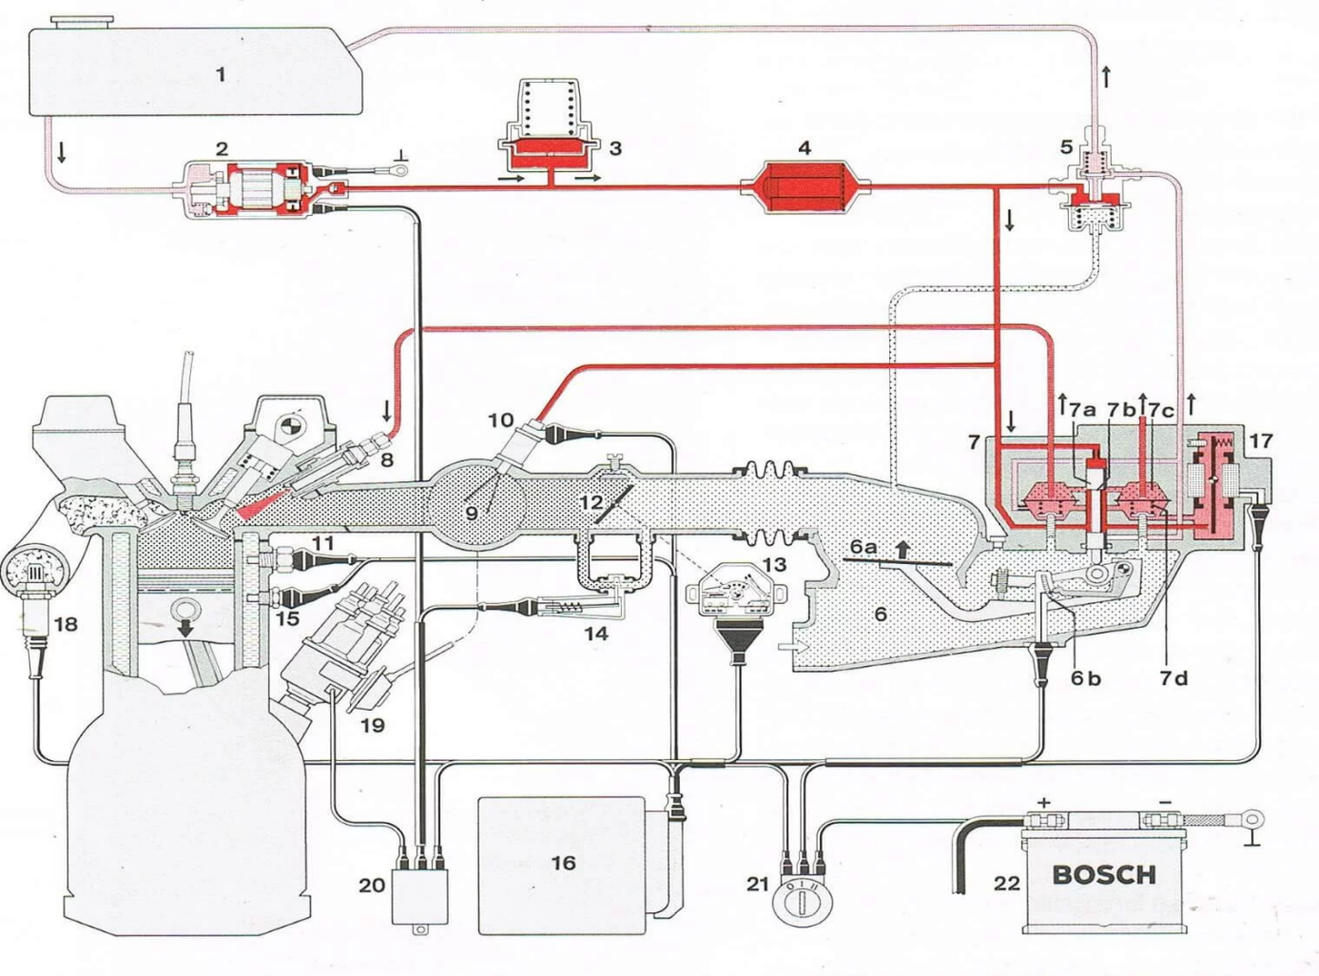
Figure 1: 9 Schematic Drawing of KE- Jetronic

Electronic fuel injection system
- L-Jetronic Fuel Injection System
The L-Jetronic is an electronically controlled fuel injection system, which injects fuel intermittently into the intake manifold ports. The L-jetronic system uses airflow sensor, air flap types, which is connected to variable resistor, to measure the amount of outside air entering the engine. The L-Jetronic system typically consists of:
- Fuel delivery system (electric fuel pump, fuel filter, fuel pressure regulator, fuel injectors, cold start injector, fuel accumulator, and connecting lines and hoses).
- Air induction system (air filter, throttle valves, idle air bypass valve, and Connecting ducts )
- Sensor system (airflow sensor, throttle position sensor, engine coolant temperature sensor, inlet air temperature sensor, lambda sensor, and distributor rpm sensor or crankshaft position sensor).
- Computer control system
- L3-Jetronic Fuel Injection System
This is a simplified and more modern variant of L-Jetronic (LE1-Jetronic, LE2-Jetronic, and LE3-Jetronic). The ECU was much cheaper to produce due to more modern components, and was more standardised than the L-Jetronic ECUs. As per L-Jetronic, a vane-type airflow sensor is used. Compared with L-Jetronic, the fuel injectors used by LE-Jetronic have a higher impedance. Three variants of LE-Jetronic exist: LE1, the initial version. LE2, featured cold start functionality integrated in the ECU, which does not require the cold start injector and thermo time switch used by older systems. LE3 (1989–), featuring miniaturised ECU with hybrid technology, integrated into the junction box of the mass airflow meter.
The L3-Jetronic fuel injection system has the same components of the L-Jetronic fuel injection system but there is some difference between them. The L3-jetronic differs from L-Jetronic in respect of the following details, the control unit, which is suitable for installation in the engine compartment, is attached to the airflow sensor and thus no longer requires space in the passenger compartment. The combined unit of control unit and airflow sensor with internal connections simplifies the cable harness and reduces installation expense. The use of digital techniques permits new function with improved adaptation capabilities to be implemented as compared with the previous analog techniques used.
- LH-Jetronic Fuel Injection System
The LH-Jetronic is closely related to the L-Jetronic. The difference lies in the hot- wire air-mass meter which measures the air mass inducted by the engine instead of air flap types. Digital fuel injection, introduced for California bound 1982. The 'LH' stands for German: "Luftmasse-Hitzdraht" - the hotwire anemometer technology used to determine the mass of air into the engine. This air mass meter is called HLM2 by Bosch. The LH-Jetronic was mostly used by Scandinavian car manufacturers, and by sports and luxury cars. The most common variants are LH 2.2, which uses an Intel 8049 (MCS-48) microcontroller, and usually a 4 kB programme memory, and LH 2.4, which uses a Siemens 80535 microcontroller (a variant of Intel's 8051/MCS-51 architecture) and 32 kB programme memory based on the 27C256 chip. LH-Jetronic 2.4 has adaptive lambda control, and support for a variety of advanced features; including fuel enrichment based on exhaust gas temperature. Some later versions contain hardware support for first generation diagnostics according to ISO 9141 (OBD-II) and immobiliser functions.
- Motronic Fuel Injection System
The Motronic fuel injection system uses an L-Jetronic system or LH-Jetronic system coupled with an electronic ignition system, with both systems being controlled by a common digital microcomputer. The same sensors can be used for both the fuel injection and ignition; thus more is achieved at a lower cost than with two separate systems.
Mono-Jetronic is different from all other known single-point systems, in that it only relies on a throttle position sensor for judging the engine load. There are no sensors for air flow, or intake manifold vacuum. Mono-Jetronic always had adaptive closed-loop lambda control, and due to the simple engine load sensing, it is heavily dependent on the lambda sensor for correct functioning.
The Motronic is an electronically controlled, multipoint injection system. The original schematic of this system claims that it is similar to the Mono Jetronic except it has added ignition control functions. I fail to see where the similarities are. This system is a multi-point, uses two lambda sensors, has EGR and uses a MAP sensor. Since there is no distributor, The ECU controls the ignition function via crank or cam angle sensors.
    - Sensor
Sensors are transducers that change physical quantity in to electrical quantity
They are of two types:
- Active (self-generating)
- Knock sensor
- O2 sensor
- Passive (modulators)
- Throttle Position Sensor
- MAF Sensor
    - Electronic Control Unit (ECU)
An ECU is an electronic device that stores and processes data. It relies on semiconductors and is a group of integrated circuit (IC).
The four basic function of an ECU are:
- Input: A signal sent from an input device. The device can be a sensor or a switch activated by the driver, technician, or a mechanical part.
- Processing: The computer uses the input information and compares it to programmed instruction. This information is processed by logic circuits in the computer.
- Storage: The program instructions are stored in the computer’s memory. Some of the input signals are also stored for processing later.
- Output: After the computer has processed the inputs and checked its programmed instructions, it will issue commands to various output devices. These output devices may be instrument panel displays or output actuators. The output of one computer may also be an input to other computers.
    - Actuator
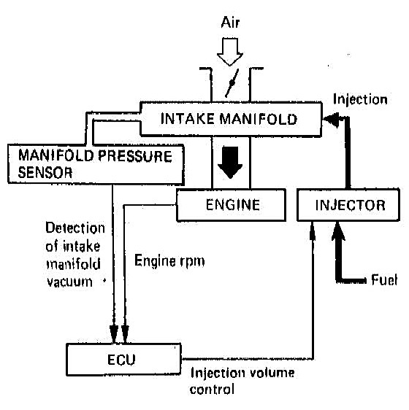
Actuator A control device that delivers mechanical action in response to an electrical signal. This mechanical action can then be used to open and close valves, control vacuum to other components, or open and close switches .These actuators, which are solenoids, switches, relays, or motors, physically act on or carry out the command sent by the computer.

Types of EFI
1. D-EFI (Manifold Pressure Control Type)
This type measures the vacuum in the intake manifold and senses the volume of air by its density.
- D-EFI is also referred to as D-Jetronic, which is a trade mark of bosch.
- Jetronic is a word created from the German word “Druck” meaning pressure and “Jetronic, a word joint by bosch meaning “injection”.
Figure 1.10 D-EFI (Manifold Pressure Control Type

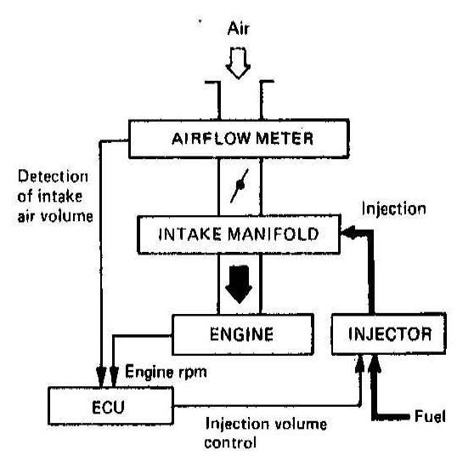
2. L-EFI (Air-flow Control Type)
This type directly senses the amount of air flowing into the intake manifold by means of air flow meter.
- L-EFI is also referred to as L- Jetronic; the “L” comes from the German “Luft” which means “Air

Figure 1.11”. L-EFI (Air-flow Control Type

Self-check 1.1
Directions: Answer all the questions listed below.
Part - 1
1. If imperfect combustion occurs, the following gases are created, EXCEPT
A.CO2 B. NoX C. Hc D. Co
2. When IACV in inoperative, which kind of valve will move to a default position?
A. Duty ratio B. ON/OFF type C. Step motor D. All
3. What type of Air flow meter measure intake air by using Air mass
A. VAF B. MAF C. MAP D. OKV
4. Technician A says that a digital signal is either on or off. Technician B says that an analog signal changes proportionally to the quantity measured. Who is correct?
A. Technician A Only C. Both technicians A and B
B. Technician B Only D. Neither technicians A nor B
5. Which type of air flow meter senses the intake air volume optically
A.VAF B. MAF C. MAP D. OKV
6.___________regulates the volume of air bypassed around the closed throttle.
A.EGR B. IAT C. ISCV D. TPS

Unit Two: System Layout and Operation

This unit is developed to provide you the necessary information regarding the following content coverage and topics:
- Air Induction system
- Fuel Delivery System
- Electronic Control System
- Electronic Ignition System
This unit will also assist you to attain the learning outcomes stated in the cover page. Specifically, upon completion of this learning guide, you will be able to:
- Identify Electronic Control System
- Function of Air Induction system components
- Demonstrate Fuel Delivery System
- Understand Electronic Ignition System

Electronic Control System

2.1.1 Air Induction System
The purpose of the air induction system is to filter, meter, and measure intake air flow into the engine. Air, filtered by the air cleaner, passes into the intake manifold in varying volumes. The amount of air entering the engine is a function of throttle valve opening angle and engine rpm. Air velocity is increased as it passes through the long, narrow intake manifold runners, resulting in improved engine volumetric efficiency.
Intake air volume is measured by movement of the air flow meter measuring plate (Vane / Flap Type or by detecting vortex frequency (Optical Karman Vortex Type) or hot wire type on engines equipped with L type EFI. Both the vane and vortex type air flow meter are used to measure the volume of air entering the cylinder, but the hot wire type is used to measure the mass of air entering the cylinder. On engines equipped with D type EFI, air volume is measured by monitoring the pressure in the intake manifold, a value which varies proportionally with the volume of air entering the engine.
The throttle valve directly controls the volume of air which enters the engine based on driver demand. Additionally, when the engine is cold, it is necessary for supplementary air to by-pass the closed throttle valve to provide cold fast idle. This is accomplished by a bimetallic or wax type air valve or by an ECU controlled Idle Speed Control Valve (ISCV).
The air induction system consists of the air cleaner, air flow meter, throttle valve, air intake chamber, intake manifold runner, and intake valve. When the throttle valve is opened, air flows through the air cleaner, through the air flow meter (on L type systems), past the throttle valve, and through a well-tuned intake manifold runner to the intake valve IC engines use two different methods to measure intake air volume. The L type EFI system measures air flow directly by using an air flow meter.
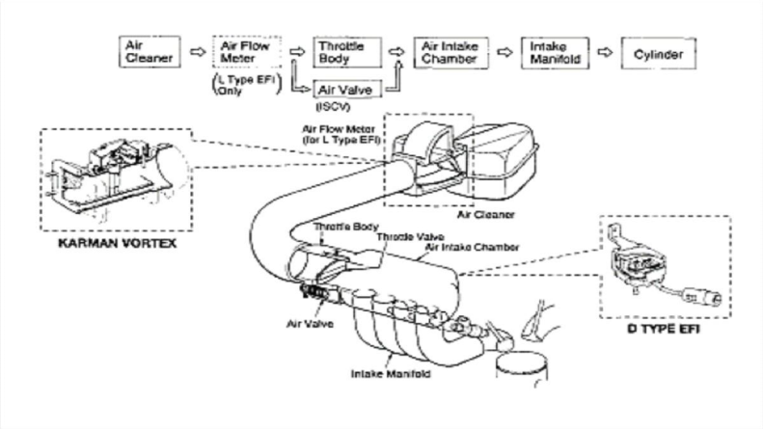
Figure 2.1 Air Induction Systems
The D type EFI system measures air flow indirectly by monitoring the pressure in the intake manifold.
- Basic System Operation
Air enters the engine through the air induction system where it is measured by the air flow meter. As the air flows into the cylinder, fuel is mixed into the air by the fuel injector.
Fuel injectors are arranged in the intake manifold behind each intake valve. The injectors are electrical solenoids which are operated by the ECU.
When the injector is turned on, it opens, spraying atomized fuel at the back side of the intake valve.
As fuel is sprayed into the intake air stream, it mixes with the incoming air and vaporizes due to the low pressures in the intake manifold. The ECU signals the injector to deliver just enough fuel to achieve an ideal air/fuel ratio of 14.7:1, often referred to as stoichiometry.
The precise amount of fuel delivered to the engine is a function of ECU control.
The ECU determines the basic injection quantity based upon measured intake air volume and engine rpm.
Depending on engine operating conditions, injection quantity will vary. The ECU monitors variables such as coolant temperature, engine speed, throttle angle, and exhaust oxygen content and makes injection corrections which determine final injection quantity.

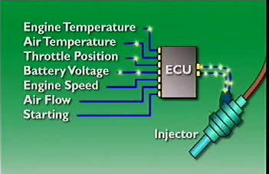

2.2 Fuel Delivery System
The fuel Delivery system consists of the fuel tank, fuel pump, fuel filter, fuel delivery pipe (fuel rail), fuel injector, fuel pressure regulator, and fuel return pipe. Actually, FDS has a charge forming device which supplies a rich fuel to a tuned injector tube. In that Induced air first metered precisely by using air flow meter and then fuel is injected in the manifold with respect to the air entered. Where fuel is delivered from the tank to the injector by using electric fuel pump. The pump is typical coated in or near the fuel tank. Contaminants are filtered out by a high capacity in line fuel filter.
Fuel is maintained at a constant pressure by means of a fuel pressure regulator. Any fuel which is not delivered to the intake manifold by the injector is returned to the tank through a fuel return pipe
The fuel delivery system consists of the fuel tank, fuel pump, fuel filter, fuel delivery pipe (fuel rail), fuel injector, fuel pressure regulator, and fuel return pipe.
Fuel is delivered from the tank to the injector by means of an electric fuel pump. The pump is typically located in or near the fuel tank. Contaminants are filtered out by a high capacity in line fuel filter.
Fuel is maintained at a constant pressure by means of a fuel pressure regulator Any fuel which is not delivered to the intake manifold by the injector is returned to the tank through a fuel return pipe.

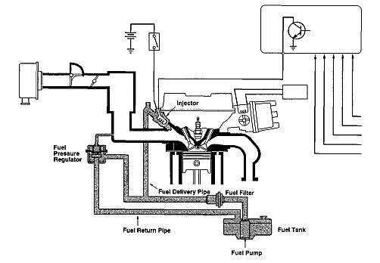

Figure 2.2 Fuel Delivery System

2.3 Sensor
In order to provide the correct amount of fuel for every operating condition, the engine control unit (ECU) has to monitor a number of input sensors.
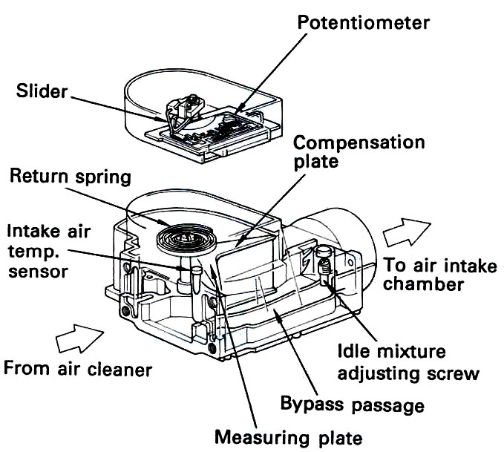
1. Air flow meter (L-type)
The air flow meter is used with L-type EFI for sensing the intake air volume.
In L-type EFI, this is one of the most important sensors. The intake air volume signal is used to calculate the basic injection duration and basic ignition advance angle.
The following two types of volume air flow meter are used:
• Vane/FLAP type Figure 2.3 Air flow meter (L-type
• Optical Karman vortex type
A. Flap/vane type air flow meter (for L-EFI):
This type of air flow meter is composed of many components, as shown in the following figure.

Operation
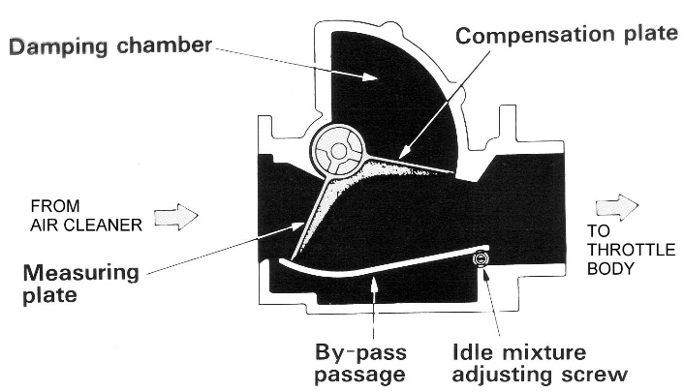
The principle used here is the measurement of force exerted in the sensor flap by the air passing through it.
When air passes through this air flow meter, the intake air pushes the flap (=measuring plate). According to the volume of the intake air, the flap-opening angle is changed.
A coil spring exerts counterforce on the flap. For each flow, the flap assumes a certain angle; with increasing angle the effective cross-sectional flow area increases. To minimize the influence on the flap of fluctuation caused by the individual cylinders' intake strokes, a compensation flap is connected rigidly with the sensor flap; these fluctuations affect the compensation flap equally but in the opposite direction, so that they cancel out and have no effect on the flow measurement.
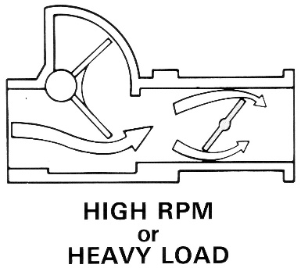
The flap is connected to the variable resistor (=potentiometer) with same axis. That means, when the intake air volume is changed, the flap-opening angle is also changed, in proportion to the flap-opening angle, the potentiometer’s resistance value is changed. The resistance value is converted to the voltage signal and that signal is sent to the ECU as the intake air volume signal.
The air-flow sensor plate moves the slider of a potentiometer, which translates the flap angle into a corresponding voltage signal Vs and transmits it to the control unit.
There are two types of vane type air flow meter. These differ in the nature of their electrical circuitry, but the components for the two types are the same.
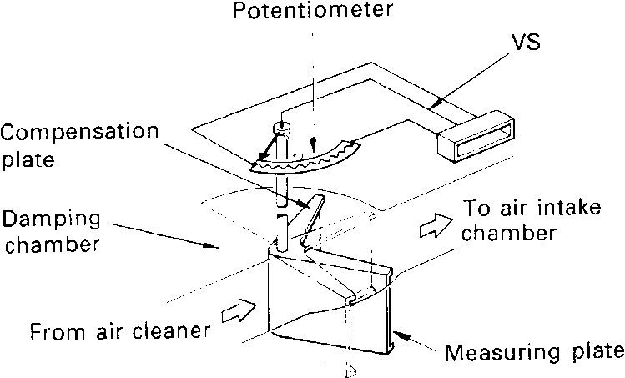
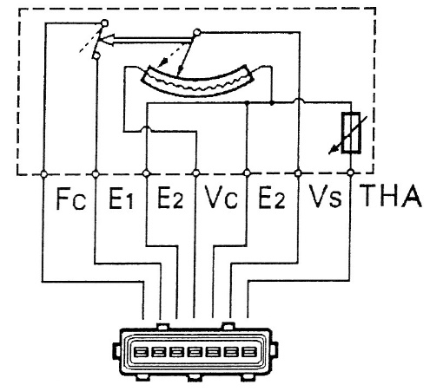
ELECTRIC CIRCUITRY
E2 = sensor ground, Fc = fuel pump control
Vs = sensor signal THA = intake air T0 sensor
Vc = power supply E1 = fuel pump ground
IDLE MIXTURE ADJUSTING SCREW
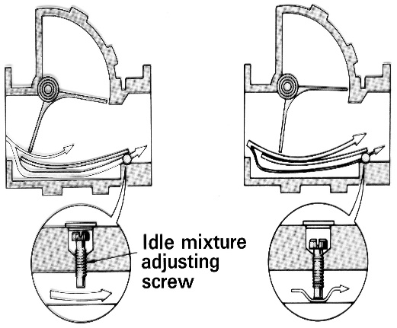
The air flow meter has two air passages; the main passage, through which intake air is drawn by means of the measuring plate, and the bypass passage. An idle mixture adjusting screw is included in the bypass passage. The volume of air through the bypass can be adjusted with the idle mixture adjusting screw.
The volume of air drawn into the engine is determined by the opening of the throttle valve. If the volume of air in the bypass is increased, there will be less air passing over the measuring plate, and the opening angle will be smaller. Conversely, if the volume of air in the bypass is decreased, the volume of air passing over the measuring plate will be increased and the opening angle will be larger.
Because the basic injection volume is decided by the opening angle of the measuring plate, the air-fuel ratio can be changed by adjusting the volume of air through the bypass.
(Some engines are equipped with air flow meters which are sealed with an aluminum plug. This means that this adjustment cannot be made.)
FUEL PUMP SWITCH
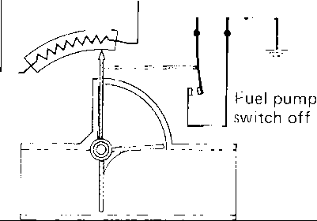
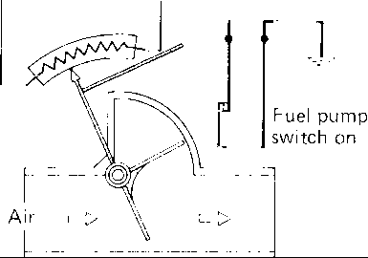
The fuel pump switch is built into the potentiometer and is closed (on) when the engine is running and air is flowing. The fuel pump switch will go off when the engine is stopped. The fuel pump will not operate when the engine is stopped even if the ignition switch is turned to ON.

Engine stopped Engine running
More on the fuel pump switch will be explained under the topic fuel pump control circuitry.
Intake air temperature sensor for engines equipped with flap type air flow meter is mounted on the air flow meter. Details of intake air temperature sensor will be described under the topic “Intake Air Temperature Sensor”
B. Optical Karman Vortex type air flow meter (for L-EFI)
This type of air flow meter directly senses the intake air volume optically. Compared to the vane type, it can be made smaller and lighter in weight. The simplified construction of the air passage also reduces inlet resistance of the intake air.
A pillar is placed in the middle of a uniform flow of air generates a vortex called a “Karman vortex” downstream of the pillar. The frequency of vortex is directly proportional to intake air velocity; therefore the number of turbulence is increased when the intake air speed is high. Utilizing this principle, the frequency of the vortexes is measured, making it possible to determine the airflow volume. The surface of a “mirror” (a piece of thin metal plate) detects the pressure of the vortexes. The ECU optically detects the vibration of the mirror by a photo coupler (The Light Emitting Diode & a phototransistor). When the intake air volume is low, the signal has a low frequency. When the intake air volume is high, this signal has a high frequency.

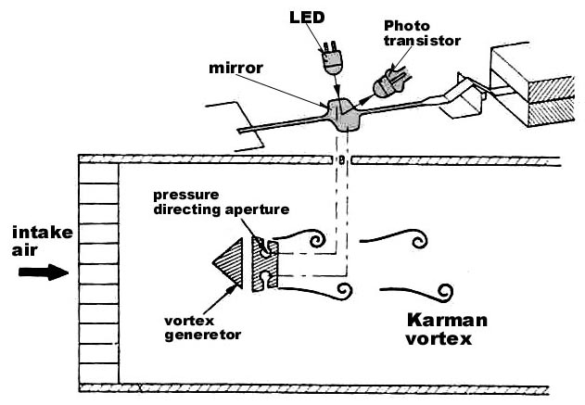
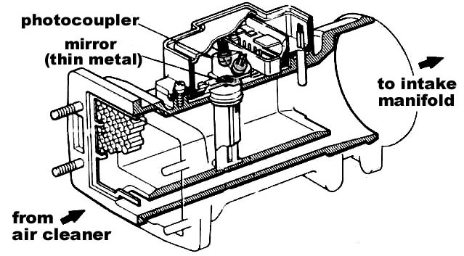

Figure 2.4 Optical Karman Vortex type air flow meter (for L-EFI)
Electrical Circuitry and Sensor Signal
The intake air volume (KS) signal is a pulse signal like that shown below. When the intake air volume is low, this signal has a low frequency. When the intake air volume is high, this signal has a high frequency.
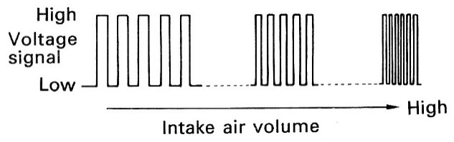
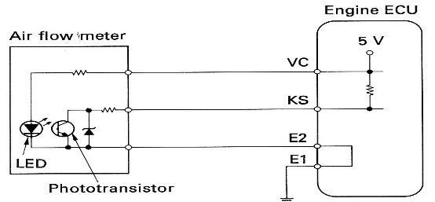

C. Hot wire type air flow meter
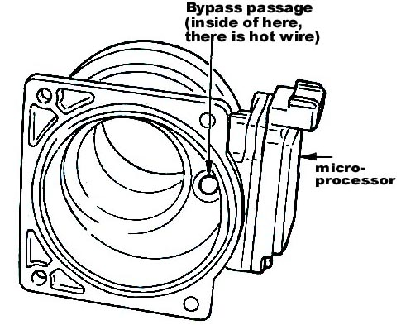
Features of Hot Wire Type:
Measurement of mass air flow
The flap type measures the volume of air. Accordingly, the air fuel mixture tends to be too rich at high altitude, and the vane type air flow meter can’t measure one factor that affects the air’s mass, this result in poor, performance, increased fuel consumption, etc. The altitude compensator was needed to correct for such error in airflow measurement.
The hot wire type measures the mass airflow, and so such compensation is not needed
Light weight Compact size No moving parts are used, and this makes the unit immune to mechanical vibration Small air flow resistance, and hence small output loss particularly in heavy load and high speed operation.
No mechanical parts used and hence good response.
OPERATING PRINCIPLE
The hot wire type air flow meter uses the following principle to measure airflow:
If a heated metal wire (hot wire) is exposed to airflow, its temperature drops as the heat is removed from the wire.
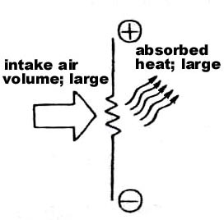
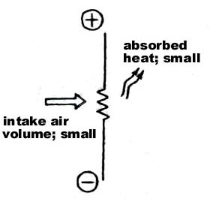

The larger the air flow, the greater the amount of removed heat.
When the temperature of the hot wire is considered to be maintained at a constant value, a certain relationship occurs between the air flow quantity and the current flow that maintains the constant temperature of the hot wire.
The air flow can be obtained by measuring the current that flows to keep the hot wire at a constant temperature. The digital microprocessor (in the control unit) measures the supply of electric current to the wire. Since the wire’s energy consumption is proportional to the mass of air entering the engine, the microprocessor can accurately measure the mass airflow. (The Microprocessor’s bridge circuit has atmospheric air temperature compensation system.)
Electrical Circuitry
The heated wire is actually one of the resistors of a balanced bridge circuit. The module supplies battery voltage to the balanced bridge .Resistors R1 and R3 form a series circuit in parallel to resistors R2 and R4. The voltage at the junction between R1 and R3 is equal to the voltage drop across R3. Because the values of R1 and R3 are fixed, the voltage at this junction is constant; it will vary but only as battery voltage varies. Resistors R1 and R2 have equal values .with no air flow across R4, its resistance is equal to R3, and the voltage at the junction between R2 and R4 is equal to the voltage at the R1/R3 junction.
As air flow across R4 increases, its temperature drops; and because it is positive temperature coefficient resistor, its resistance goes down with its temperature. As the air’s mass increases, R4`s resistance goes down even more. As the resistance of R4 goes down a smaller portion of the voltage applied to the circuit formed by R2/R4 is dropped across R4. There fore, a large portion of the voltage is dropped across R2. So, as the resistance of R4 goes down, the voltage at the R2/R4 junction goes down. The computer reads the voltage difference between the R1/R3 junction and the R2/R4 junction as the MAF sensor value. By looking at a table in the computers memory, the microprocessor converts the voltage value to a mass air flow rate.
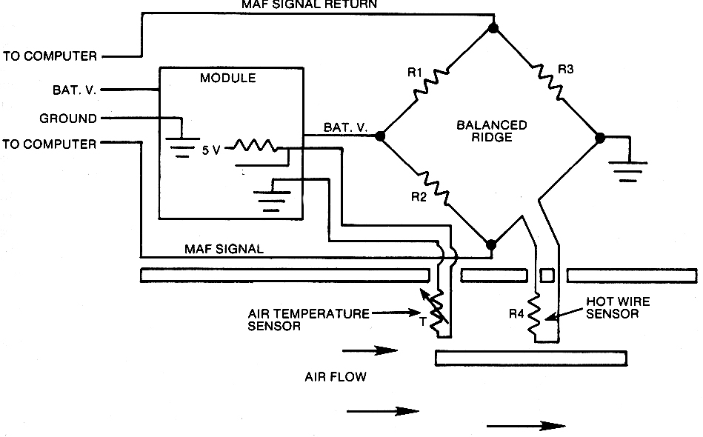

2. Intake manifold pressure sensor (for D-EFI)
This sensor detects the pressure variation of the intake manifold and converts it to the voltage signal. By means of an IC built into this sensor, the manifold pressure sensor senses the intake manifold pressure as a signal. The ECU then calculates the basic injection volume and the basic ignition advance angle on the basis of this signal.
A silicon chip combined with a vacuum chamber maintained at a predetermined vacuum is incorporated into the sensor unit. One side of the chip is exposed to intake manifold pressure and the other side is exposed to the internal vacuum chamber. Change in the intake manifold pressure causes the shape of the silicon chip to change, and the resistance value of the chip fluctuates in accordance with the degree of deformation. The IC built into the sensor converts this fluctuation in the resistance value to a voltage signal, and it is sent to the ECU as an intake manifold pressure signal. The ECU supplies a constant 5V as a power source for the IC. (VC ; constant voltage).

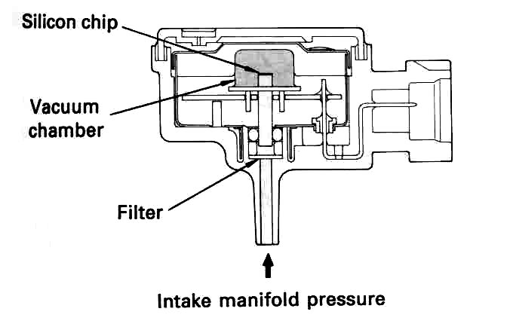
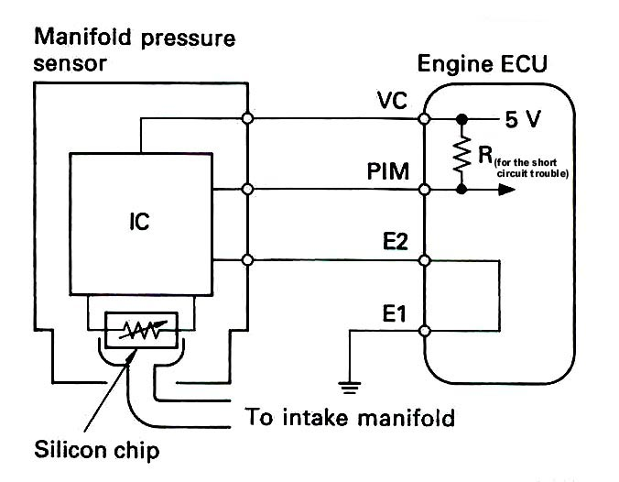

3. Throttle Position Sensor
When you step on the gas pedal, the throttle valve opens up more, letting in more air. The engine control unit (ECU) "sees" the throttle valve open and increases the fuel rate in anticipation of more air entering the engine. It is important to increase the fuel rate as soon as the throttle valve opens; otherwise, when the gas pedal is first pressed, there may be a hesitation as some air reaches the cylinders without enough fuel in it.
The throttle position sensor is mounted on the throttle body. This sensor converts the throttle-opening angle to a voltage signal. The signal is sent to the ECU. The throttle position signal is used for fuel cut off control (during deceleration or braking) and increasing the fuel volume during acceleration. (Additionally, this signal is used for automatic transmission control also.)
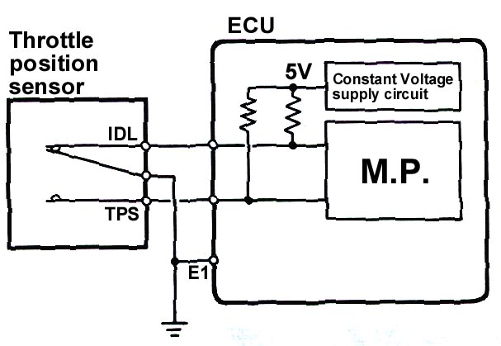
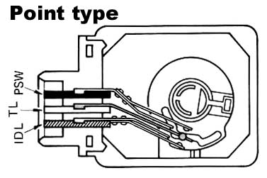

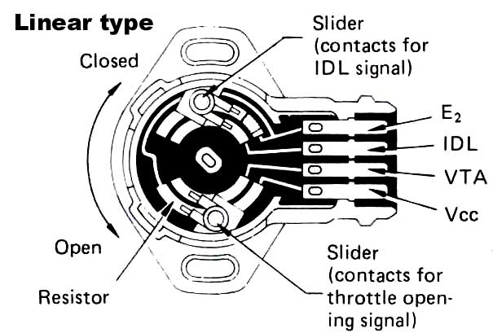
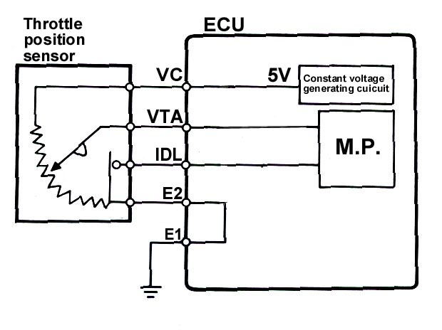

Figure 2.5 Throttle Position Sensor
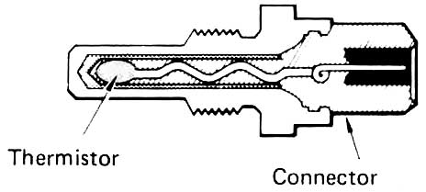
4. Water Temperature Sensor
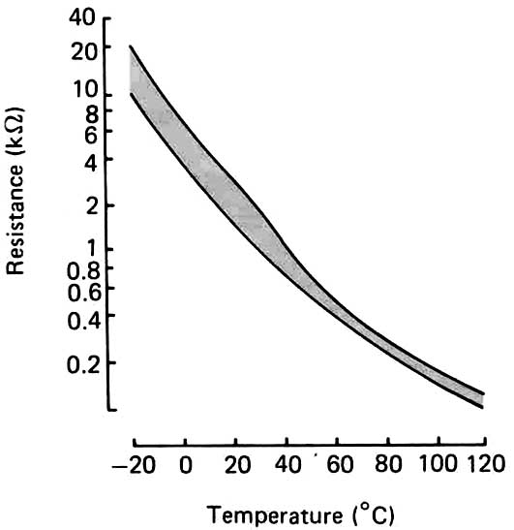
This sensor detects the engine coolant water temperature by means of a thermistor. Vaporization of the fuel is poor when the coolant temperature is low, thermistor resistance increases and a high voltage signal is sent to the ECU. Based on the signal from the sensor, the ECU increases fuel volume to improve drivability during cold engine operation. Conversely, when the coolant temperature is high, a low voltage signal is sent to the ECU, that decreases fuel injection volume. The water temperature sensor (thermistor) and a fixed resistor (in the ECU) are connected in series, therefore, the water temperature signal voltage changes when the thermistor’s resistance value changes.
5. INTAKE AIR TEMPERATURE SENSOR (THA)
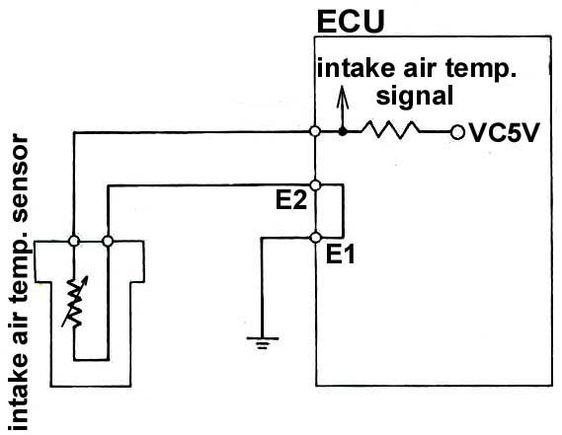
The intake air temperature sensor detects the temperature of the intake air, like the water temperature sensor. It is mounted in the intake air duct. The volume and density of the intake air changes with the air temperature. Therefore, even though the volume of air measured by the air flow meter may be the same, the fuel injection volume will vary with the air temperature. The ECU adjusts injection volume slightly, according to the intake air temperature. For example, when the intake air temperature becomes high, the ECU controls the injection volume decrease. In this method, the proper air fuel ratio is insured regardless of the ambient temperature.
6. LAMDA SENSOR (OXYGEN SENSOR)
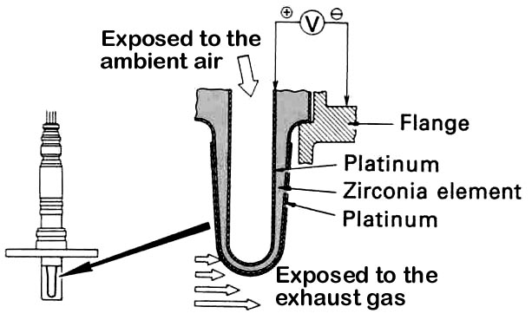
In order for engines equipped with the three-way Catalytic Converter, to achieve their best exhaust emission purification performance, it is necessary that the air fuel ratio to be kept within a narrow range near the theoretical air fuel ratio.
The O2 sensor senses whether the air fuel ratio is richer or leaner than the theoretical air fuel ratio. The O2 sensor is located in the exhaust manifold.
Types of oxygen sensors
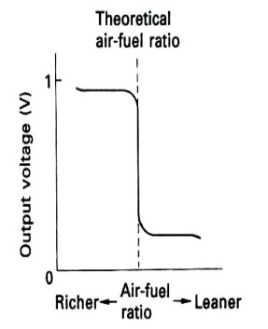
A. Zirconia element type
This O2 sensor consists of an element made of zirconium dioxide (ZrO2, a kind of ceramic material). This element is coated with a thin layer of platinum on both the inside and the outside. Ambient air is introduced into the inside of the sensor, and the outside of the sensor is exposed to the exhaust gases.

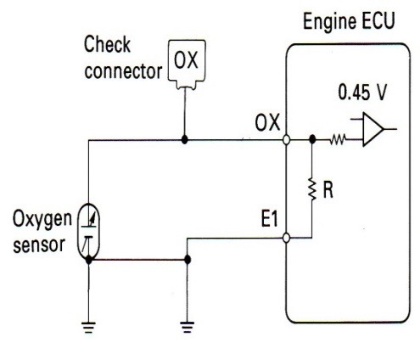
Operation: If the oxygen concentration on the inside surface of ZrO2 element differs greatly from that on the outside surface at high temperature (it works 400oC/752oF or higher), the zirconia element generates a voltage, which acts as an OX signal to the engine ECU.
When the air fuel mixture is lean, there is a lot of oxygen in the exhaust gas. Therefore, there is little difference of the oxygen concentration between the inside and the outside of the sensor element. Thus, the voltage generated by the ZrO2 element is low (close to 0V).
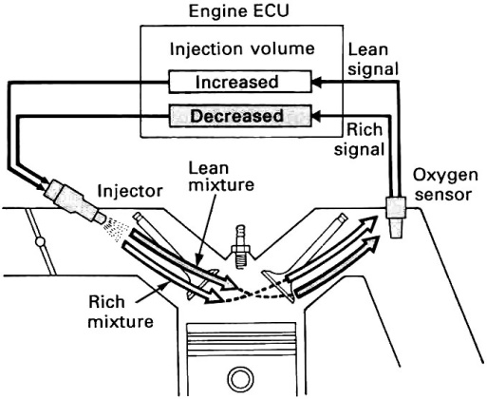
Conversely, if the air fuel mixture is rich, the oxygen in the exhaust gas almost disappears. This creates a large difference of the oxygen concentration between the inside and the outside of the sensor and the generated voltage of the ZrO2 element become large (approximately 1V).
The platinum coating acts as a catalyst, causing the oxygen in the exhaust gas to react with the CO (carbon monoxide). This decreases the oxygen volume and increases the sensitivity of the sensor.
The ECU uses this Ox signal to control the injection volume to keep the air fuel ration at an even value near the theoretical air fuel ratio.

B. Titania element type Figure 2.6 oxygen sensors
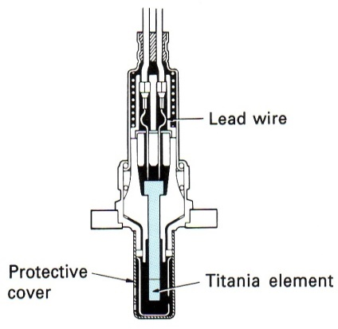
This oxygen sensor consists of a semiconductor element made of titanium dioxide (TiO2, which is, like ZrO2, a kind of ceramic). This sensor uses a thick film type titania element formed on the front end of a laminated substrate to detect the oxygen concentration in the exhaust gas.
OPERATION:
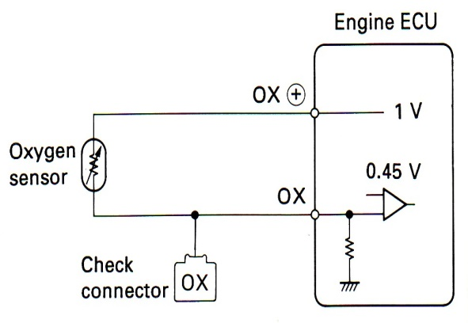
The properties of titania are such that its resistance changes in accordance with the oxygen concentration of the exhaust gas. This resistance changes abruptly at the boundary between a lean and a rich theoretical air-fuel ratio, as shown in the graph.
The resistance of titania also changes greatly in response to changes in temperature. A heater is therefore built into the laminated substrate to keep the temperature of the element constant.
This sensor is connected to the Engine ECU, as shown in the circuit diagram. A 1V potential is supplied at all times to the
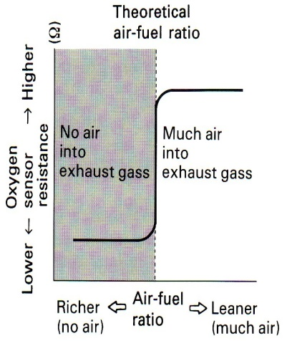
OX + terminal by the Engine ECU. The Engine ECU has a built-in comparator which compares the voltage drop at the OX terminal (due to the change in resistance of the titania) to a reference voltage (0.45 V). If the result shows that the OX voltage is greater than 0.45 V (that is, if the oxygen sensor resistance is low), the Engine ECU judges that the air-fuel ratio is rich. If the OX voltage is lower than 0.45 V (oxygen sensor resistance high), it judges that the air fuel ratio is lean.
7. Knock sensor
The charge of air-fuel mixture in the engine cylinder should burn quickly to permit optimum performance and high speed but, equally so, it should burn progressively, smoothly and not too quickly to create early detonation i.e. knocking of the engine. There are many factors which may lead to knocking combustion; different fuel qualities; advanced ignition timing; aging and environ mental effect. A knocking combustion process leads to an extremely sharp rise in cylinder pressure and produces pressure oscillation. Depending on its intensity the piston and crank components may be overloaded, or the engine may overheat and lead to serious mechanical damage. The use of knock sensors enables an engine to run on the threshold of knock’ and should knock occur the sensor feeds the information back to an electronic control unit which retards the ignition timing to reduce the knock detected.
Various technologies have been used to sense the vibrations associated with knocking pressure frequencies and convert them into electrical voltage signals. For automotive use accelerometer sensors appear to be the most suitable: where piezo-ceramic materials are used as the active elements to measure the structure-borne vibration of the engine. Their high natural frequencies and almost linear sensing of the vibration frequencies up to more than 15 kHz provide ideal information that can be analyzed for knocking.
The piezo-ceramic active element usually consists of lead, zirconia and titanium. Typical sensor construction is shown in the picture.
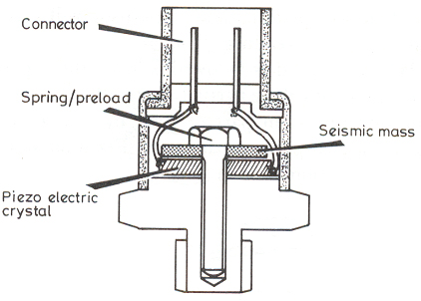
This style of construction enables the sensor to be easily attached to the most favorable point (a knock resonant site) on the engine for measuring knock. Where one sensor is used it is positioned between the centre of two cylinders. More than one sensor would be placed between two cylinder groupings.
Piezo-electric devices produce a voltage when the ceramic crystals are subjected to mechanical stress variations. This coupling between mechanical and electrical energy generates voltage across opposite faces, proportional to the cause of the stress variations. The seismic mass of the sensor is initially torqued down to pre-stress the piezo-electric sensing element. This allows the piezo-electric crystal to also act as a spring. As a knock occurs in the engine cylinder, it is transmitted via the engine block to the sensor, causing the seismic mass-piezo-electric crystal spring arrangement to vibrate in sympathy. Resultant deformation of the piezo-electric crystals generates an output voltage proportional to the original knock.
Output voltage is typically 10-25 mV/g giving a voltage sensitivity of 25 mV for every 9.81 m/s of acceleration (g). The sensor is mounted by the integral stud and to maintain sensitivity maximum torque values must not be exceeded.
Pressure vibration frequencies other than the typical knock frequency are also contained in the structure-borne vibration signal. The characteristic knocking signal must be electronically extracted from other signals, then analyzed by an evaluation circuit, the result of which is supplied to the electronic control unit, which decides whether or not to retard the ignition point of next combustion in particular cylinder.
8. START SIGNAL (STA),
STA signal is used to judge if the engine is being cranked. Its main function if to allow the ECU to increase the fuel injection volume during cranking. As can be understood from the figure, the STA signal voltage is the same voltage as that supplied to the starter motor.

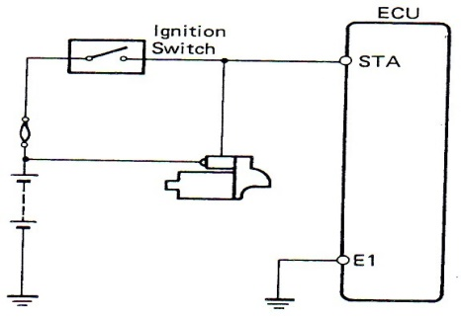
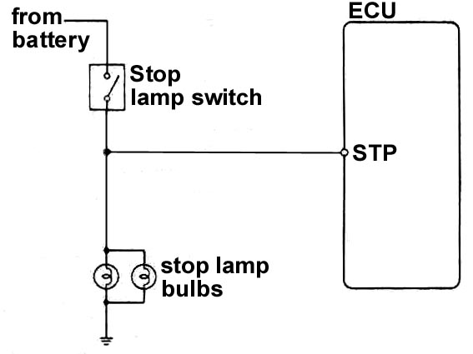

9. Crank Angle Sensor & Engine Speed Sensor (Toyota)G And Ne Signal Generators
The G and NE signals are generated by the timing rotors or signal plates and the pickup coils. These signals are used by the Engine ECU to detect the crankshaft angle and engine speed. These signals are very important not only for the EFI system but also for the ESA system.
The sensors which generate these signals can be divided into the following three types depending on their installation position, but their basic construction and operation are the same:
- In-distributor type
- Cam position sensor type
- Separate type
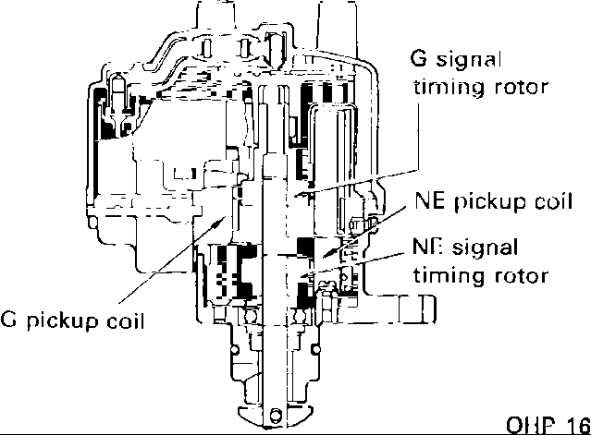
1. In-Distributor Type
The conventional governor advance and vacuum advance mechanisms have been eliminated in the distributor used with the TCCS engine control system, since spark advance is controlled electronically by the Engine ECU. The distributor in the engine control system contains the timing rotors and pickup coils for the G and NE signals.
Figure 2.7 In-Distributor Types
The number of teeth on the rotor and the number of pickup coils differ depending on the engine. Below, we will explain the construction and operation of the G and NE signal generators that use a single pickup coil and a 4-tooth rotor for the G signal, and a single pickup coil and 24tooth rotor for the NE signal.
A . NE Signal
The NE signal is used by the Engine ECU to detect the engine speed. NE signals are generated in the pickup coil by the timing rotor in the same way as with the G signal. The only difference is that the timing rotor for the NE signal has 24 teeth. It activates the NE pickup coil 24 times per each revolution of the distributor shaft, generating the waveforms shown in the chart. From these signals, the Engine ECU detects the engine speed as well as each 30° change in the engine crankshaft angle.
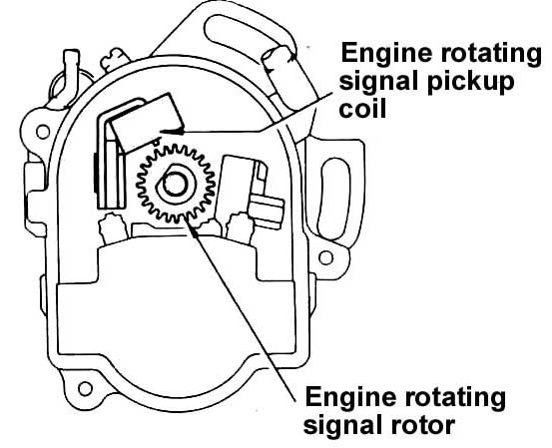
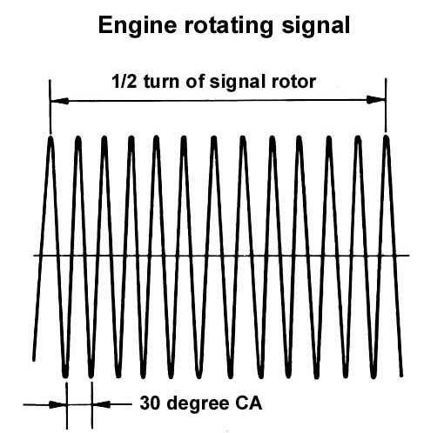

Figure 2.8 NE Signal
B. G Signal
The G signal informs the Engine ECU of the standard crankshaft angle, which is used to determine the injection timing and ignition timing in relation to the TDC (top dead center) of each cylinder.
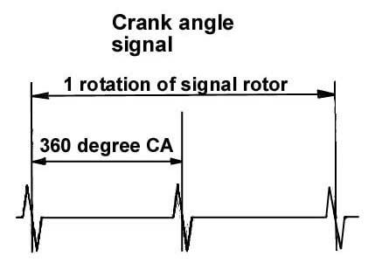
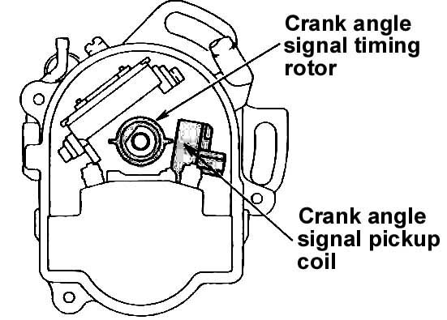
The components of the distributor used to generate these signals are as follows:

1) The G signal timing rotor, which is fixed to the distributor shaft and turns once for every two rotations of the crankshaft.
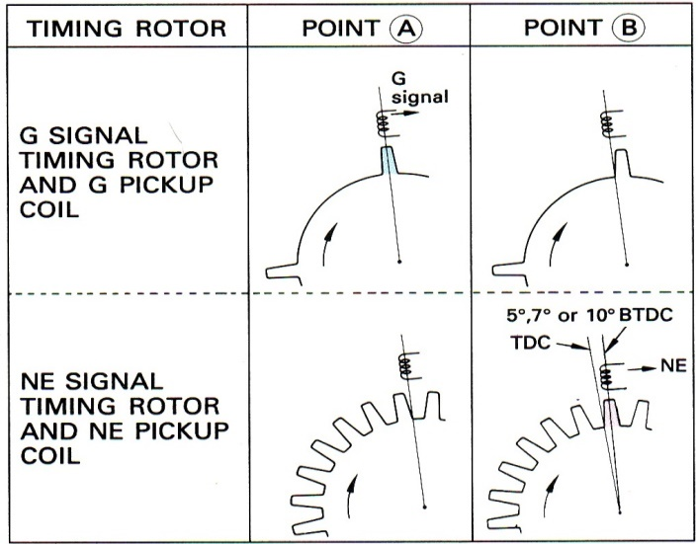
2) The G pickup coil, which is mounted on the inside of the distributor housing.
The G signal timing rotor is provided with four teeth which activate the G pickup coil four times per each revolution of the distributor shaft, generating the waveforms shown in the chart shown below. From these signals, the Engine ECU detects when each piston is near TDC (example: BTDC10°CA*).
*Depending on engine models.
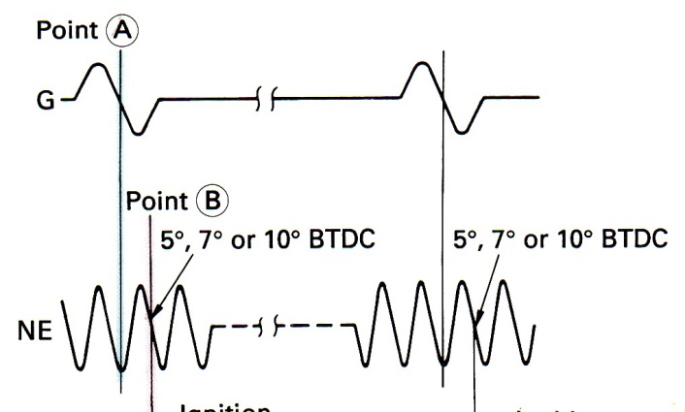

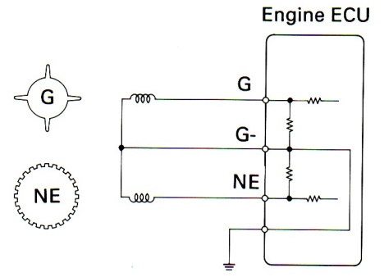
CRANK SHAFT ANGLE JUDGMENT
The ECU judges that the crankshaft has reached 50, 70, or 100 BTD (depending on the engine model) when it receives the first NE signal (point B in the illustration) following a G signal (point A).
Electrical circuitry
When the engine is running, an alternating current signal is generated by a 24-tooth Ne pickup and a four-tooth G pickup. These signals are sent to the ECU where they are conditioned and relayed to the microprocessor.
11. Stop Signal (Stp)
This signal is used to detect when the brakes have been applied. The STP signal voltage is the same as the voltage supplied to the stop lamps, as seen in the diagram. The STP signal is used mainly to control the fuel cut off engine speed. (The fuel cut off engine rotating speed is reduced slightly when the vehicle is braking.)
12. Vehicle Speed Sensor
This sensor senses the actual speed at which the vehicle is traveling. It outputs an SPD signal, which is used to control the air-fuel ratio during acceleration and deceleration.
1. Reed switch type vehicle speed sensor
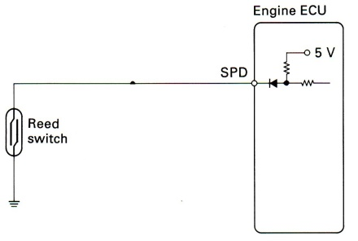
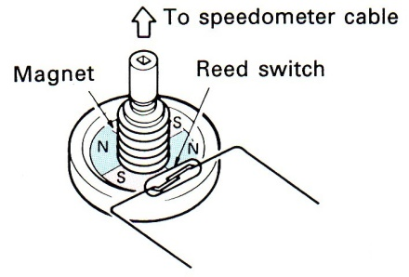
This sensor is mounted in the analog combination meter. It contains a magnet, which is rotated by the speedometer cable, turning the reed switch on and off. The reed switch goes on and off four times each time the speedometer cable rotates once.
The magnet has the polarities shown in the figure below. The magnetic force at the four areas of transition between the N and S poles of the magnet opens and closes the contacts of the reed switch as the magnet rotates.
2. Photo-coupler type vehicle speed sensor
This sensor is mounted in the combination meter. It includes a photo-coupler made from an
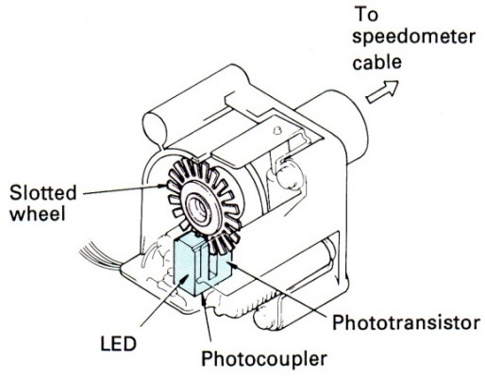
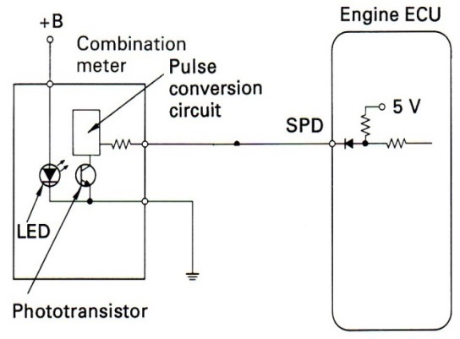

LED, which is aimed at a phototransistor. The LED and phototransistor are separated by a slotted wheel, which is driven by the speedometer cable. The slots in the slotted wheel generate light pulses as the wheel turns, with the light emitted by the LED divided into 20 pulses for each revolution of the cable. These 20 pulses are converted to four pulses by the digital meter computer, and then sent as signals to the ECU.

2.3 Actuator
Actuator A control device that delivers mechanical action in response to an electrical signal. This mechanical action can then be used to open and close valves, control vacuum to other components, or open and close switches .These actuators, which are solenoids, switches, relays, or motors, physically act on
Air induction Actuator
The Idle Air Control (IAC) system is used to stabilize idle speed during cold engine and after warm-up operations. Idle speed stabilization is needed due to the effect engine load a change has on emission output, idle quality and vehicle drivability. The IAC system uses an ECM controlled idle air control valve (IACV) that regulates the volume of air bypassed around the closed throttle. There are two different types of IACVs used on Toyota models.

- Idle Air Control Systems – Step Motor
This system uses a step-motor type IACV to control bypass airflow. The IACV consists of a step motor with four coils, magnetic rotor, valve and seat, and can vary bypass airflow by positioning its valve into one of 125 possible "steps". Basically, the higher the IACV step number, the larger the airflow opening and the greater the volume of air bypassed around the closed throttle.
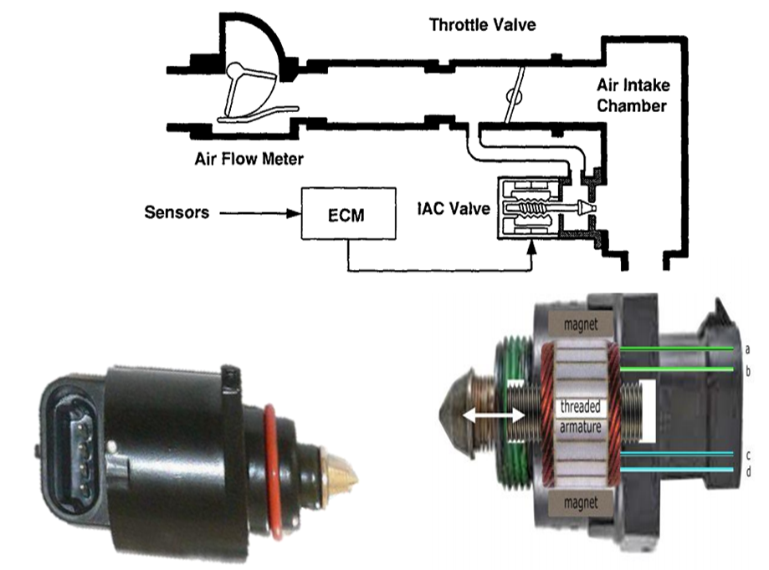
Figure 2.9 Idle Air Control Systems – Step Motor
The ECM controls IACV positioning by sequentially energizing its four motor coils. For each coil that is pulsed, the IACVs magnetic rotor moves one step, which in turn changes the valve and seat positioning slightly. The ECM commands larger IACV position changes by repeating the sequential pulses to each of the four coils, until the desired position is reached. If the IACV is disconnected or inoperative, it will remain fixed at its last position.
- Idle Air Control Systems – Duty Rotary Solenoid IAC System
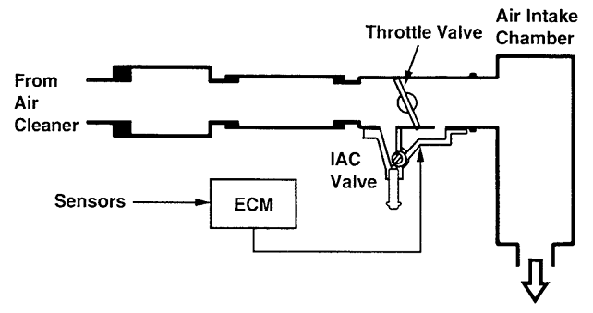
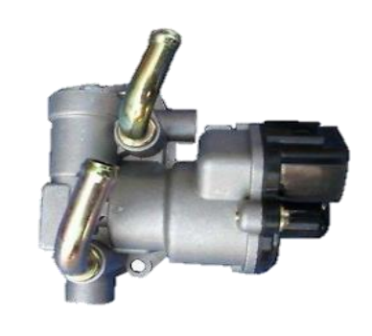
This system uses a rotary solenoid IACV to perform idle speed stabilization. Bypass air control is accomplished by means of a movable rotary valve which blocks or exposes a bypass port based on command signals from the ECM. The IACV consists of two electrical coils, permanent magnet, valve, bypass port, and bi-metallic coil.
Figure 2.10 Idle Air Control Systems – Duty Rotary Solenoid IAC System
This system uses a rotary solenoid IACV to perform idle speed stabilization. Bypass air control is accomplished by means of a movable rotary valve which blocks or exposes a bypass port based on command signals from the ECM.
The ECM controls IACV positioning by applying a duty cycled signal to the two electrical coils in the IACV. By changing the duty ratio (on time versus off time), a change in magnetic field causes the valve to rotate. Basically, as duty ratio exceeds 50%, the valve opens the bypass passage and as duty ratio drops below 50%, the valve closes the passage. If the IACV is disconnected or inoperative, the valve will move to a default position and idle rpm will be around 1000 to 1200 rpm at operating temperature.

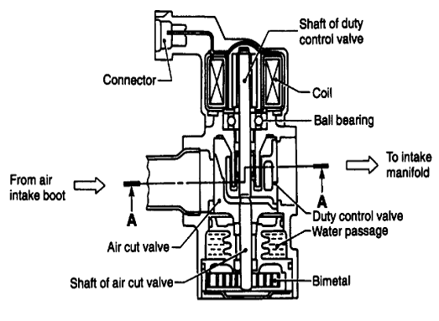
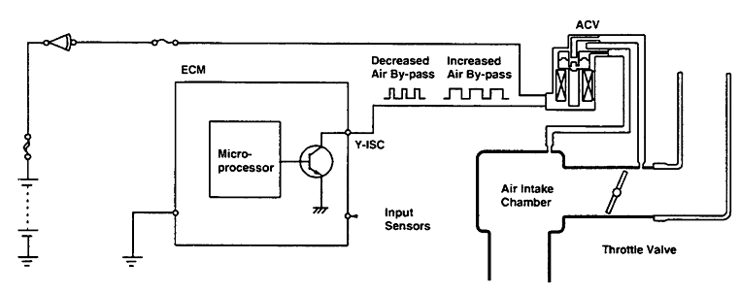

2. 4. Electronic control unit
The engine electronic control system (for EFI) can be divided into three groups: the ECU, sensors (and the signals output by them), and actuators.
Electronic Control unit (ECU/ECM) is a microprocessor, which controls all functions of the electronic fuel injection system. ECU receives signals from sensors and switches. Signals are processed by the ECU for controlling fuel injection function for various operating conditions.
ECU has constant source of battery power at BATT terminal. EFI main relay provides battery voltage to terminals +B and +B1 of ECU (TOYOTA).
How computers work?
Contrary to some "informed" options and numerous suggestions from popular movies, computers cannot think for themselves. When properly programmed, however, they can carry out explicit instructions with blinding speed and almost flawless consistency.
Communication signals
A computer uses voltage values as a communication signals, thus voltage is often referred to as signal or a voltage signal. There are two types of voltage signals:
a) Analog - an analog signal's voltage is continuously variable with in a given range and time is used for the voltage to change. An analog signal is generally used to convert information about a condition that changes gradually and continuously with in an established range. Temperature sensing devices usually give off an analog signal.
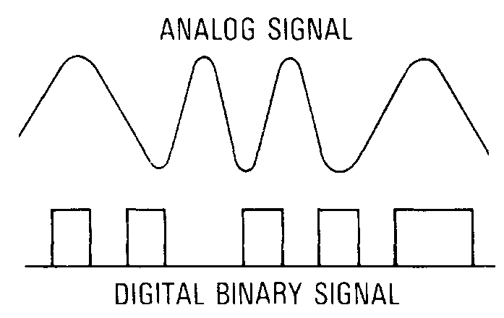
b) Digital - digital signals also vary but not continuously, and time is not needed for the change to occur. Turning a switch on and off creates a digital signal; voltage is there or it is not. Digitals are often referred to as square wave signals.
Binary code A computer converts a series of digital signal to a binary number made up of ones and zeros; voltage above a given threshold value converts to one, and voltage below that converts to zero. Each 1 or 0 represents a bit of information. Eight bits equal a bite (sometimes referred to as a word. All communications between the microprocessor, the memories, the interfaces is in binary code, which each information exchange being in the form of a bite
Interface A microprocessor is the heart of a computer, but it needs several support functions, one of which is the interface. A computer has an input and output interface circuits. The interface has two functions:
it protects the delicate electronics of the microprocessor from the higher voltages of the circuits attached to the computer, and
it translates input and output signals
The input interface translates all analog input data to binary code; most sensors produce analog signal. It is sometimes referred to as A/D, analog to digital. The output interface, D/A, translates digital signals to analog for any controlled functions that need an analog voltage.
Memories The microprocessor of a small computer does the calculating and makes all of the decisions, or data processing, but it cannot store information. The computer is therefore equipped with information storage capability called memory. The computer actually has three memories:
Read-only memory (ROM) - The ROM contains permanently stored information that instructs (programs) the microprocessor on what to do in response to input data.
Programmable read only memory (PROM) - The PROM differs from the ROM in that it plugs into the computer and is more easily removed and programmed or replaced with one containing a revised program. It contains a program information specific to different vehicle model calibrations.
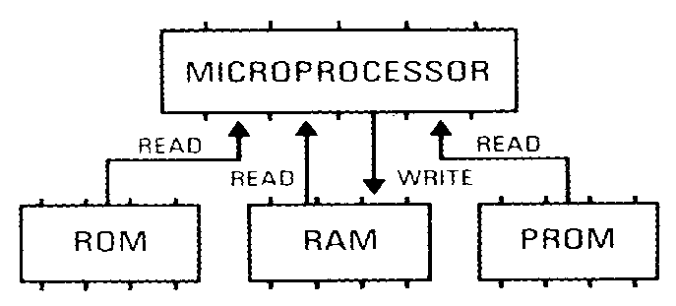
Random access memory (RAM) - The RAM is where temporary information is stored. It can be both read from and written into.
There are two kinds of RAMs: volatile and non volatile.
A volatile RAM - (sometimes called KAM, keep-alive memory) must have a constant source of voltage to continue to exist and erased when disconnected from its power source. In automotive applications volatile RAM is usually connected to the battery by way of a fuse or fusible link so that when the ignition is turned OFF the RAM is still powered.
A non volatile RAM - does no loose its stored information if its power source is disconnected. Vehicles with digital display odometers usually store information in a non volatile RAM.
Clock Pulses In order to maintain an orderly flow of information into, out of, and within the computer, a quartz crystal is used to produce a continuous, consistent, time pulse.
- ECU basic circuitries
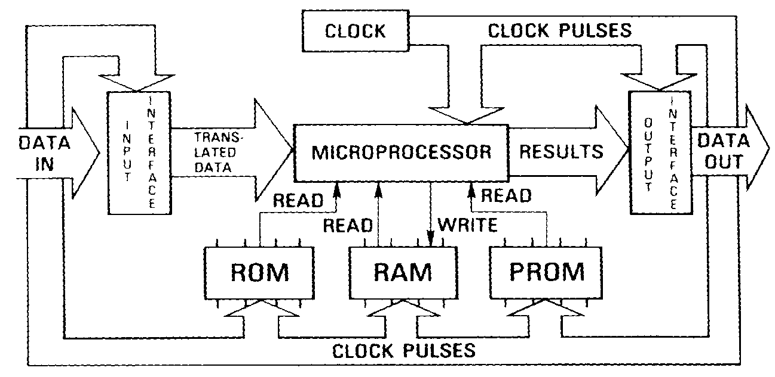
This circuitry supplies power to the Engine ECU. There are two types of this circuitry in use. In one, current flows directly from the ignition switch to the EFI main relay coil to operate the EFI main relay (the type without the stepper motor type ISC valve). In the other, the Engine ECU operates the EFI main relay directly (the type with the stepper motor type ISC valve).
A. Engine without stepper motor type ISC valve
When the ignition switch is turned on, current flows to the coil of the EFI main relay causing the contacts to close. This supplies power to the +B and +B1 terminals of the Engine ECU. Battery voltage is supplied at all times to the BATT terminal of the Engine ECU to prevent the diagnostic codes and other data in its (RAM) memory from being erased when the ignition switch is turned off.
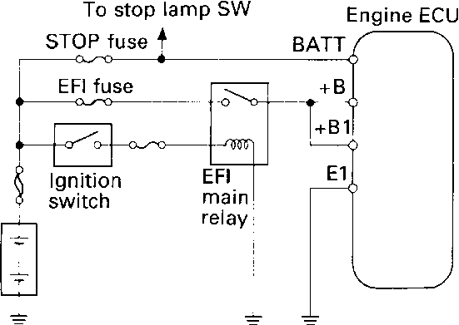
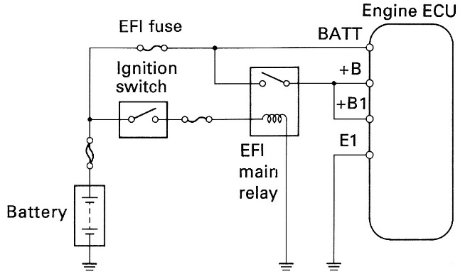
There are two types of circuitry for the type without a stepper motor, depending on the vehicle model.
B. Engine with stepper motor type ISC valve
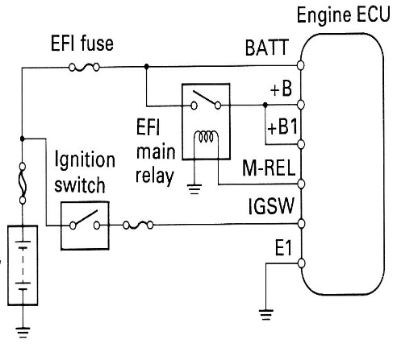
The diagram below shows the type in which the EFI main relay is operated from the Engine ECU. In engines with the stepper motor type ISC valve, since initial set control is carried out when the ignition switch is turned off, power is supplied to the Engine ECU for this purpose for approximately 2 seconds after the ignition switch is turned off. (For more information read about stepper motor type ISC valve)
When the ignition switch is turned on, battery voltage is supplied to the IGSW terminal of the
Engine ECU, and the EFI main relay control circuitry in the Engine ECU sends a signal to the M-REL terminal of the Engine ECU, turning on the EFI main relay. This signal causes current to flow to the coil, closing the contacts of the EFI main relay and supplying power to the +B and +B1 terminals of the Engine ECU. Battery voltage is supplied at all times to the BATT terminal of the Engine ECU to prevent the diagnostic codes and other data in its memory from being erased when the ignition switch is turned off.
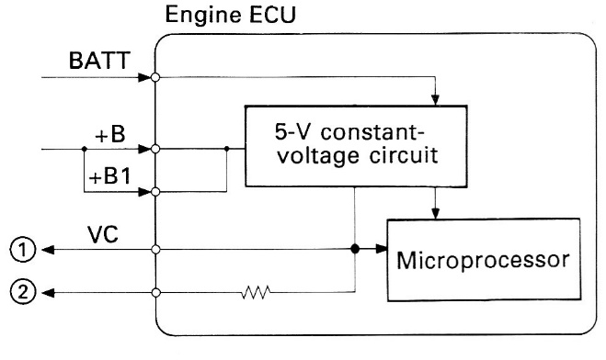
2. Constant voltage (VC) circuitry
With few exceptions all of the systems use 5 volt to operate their sensors. Within the electronics industry, 5 volt has been almost universally adopted as a standard for information transmitting circuits. This voltage value is high enough to provide reliable transmission and low enough not to damage the tiny circuits on the chips in the computer.
The Engine ECU generates a constant 5 volts to power the microprocessor from the battery voltages supplied to the +B and +B1 terminals. The Engine ECU supplies this 5 V of power to the sensors through circuitry like that shown below.
1 Outputs 5 V from the 5-volt constant-voltage circuit.
2 Outputs 5 V from the 5-volt constant-voltage circuit through a resistor.
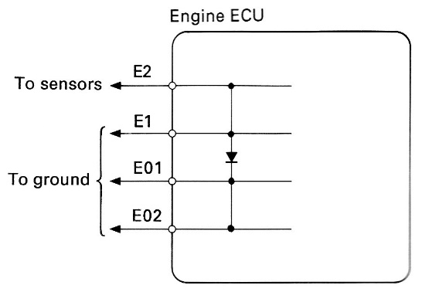
3. Ground circuitry
The Engine ECU has the following three types of basic ground circuitry:
• E1 terminal, which grounds the Engine ECU.
• E2 terminal, which grounds the sensors.
• E01 and E02 terminals, which ground the drive circuits for the injectors or ISC valve, etc. These ground circuits are connected inside the Engine ECU as shown in the left diagram.

Electronic Ignition Systems
Ignition System: The purpose of the ignition system is to ignite the air/fuel mixture in the combustion chamber. For complete combustion, the ignition system must supply properly timed, high-voltage surges across each pair of spark plug electrodes at the proper time under all engine operating conditions.

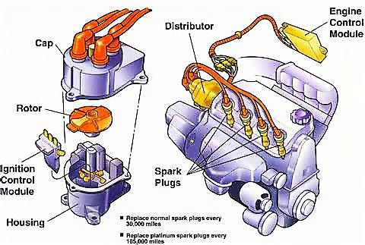
Electronic Ignition Systems have used sensors, such as a pickup coil and relict or (trigger wheel),to trigger or signal an electronic module that switches the primary ground circuit of the ignition coil. Electronic Ignition Systems based on SAE categories:

Figure 2.11 2.4 Electronic Ignition Systems
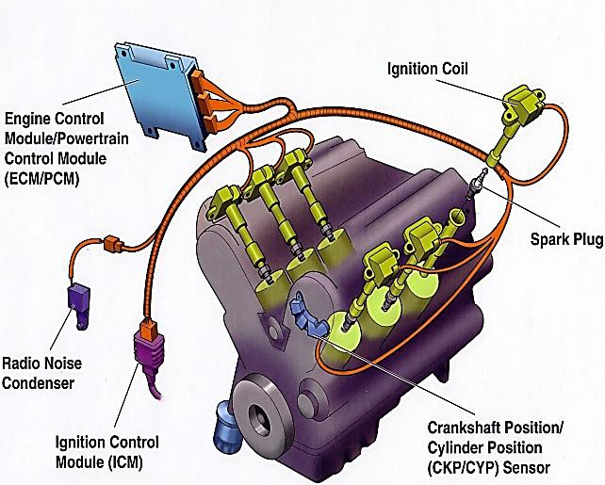
A. Distributor ignition (DI) is the term specified by the Society of Automotive Engineers(SAE) for an ignition system that uses a distributor.

Figure 2.12 Distributor ignition (DI)

B. Electronic ignition (EI) is the term specified by the SAE for an ignition system hat does not use a distributor. Types of EI systems include:
2. Coil-on-plug system. This type of system uses a single ignition coil for each cylinder with the coil placed above or near the spark plug.

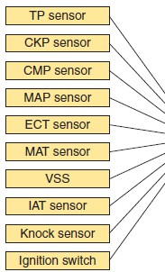
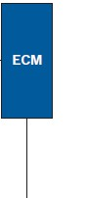
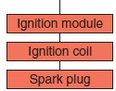
The ignition system in today’s vehicles is an integral part of the electronic engine control system. The engine control module (ECM) controls all functions of the ignition system and constantly corrects the spark timing. The desired ignition timing is calculated by the PCM according to inputs from a variety of sensors. These inputs allow the PCM to know the current operating conditions. The PCM matches those conditions to its programming and controls ignition timing accordingly.
Electronic Ignition Systems Circuit
All ignition systems consist of two interconnected electrical circuits: a primary (low-voltage) circuit anda secondary (high- voltage) circuit.

Figure 2.13 Figure 2.12 Electronic Ignition System – DI

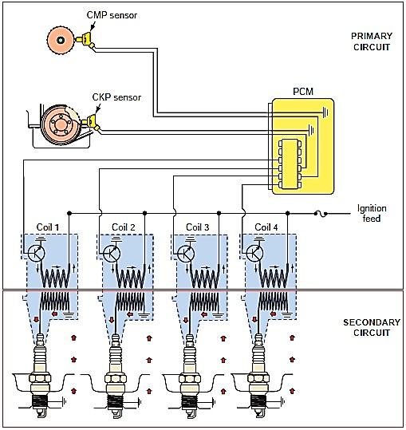
Depending on the exact type of ignition system, components in the primary circuit include the following:
■ Battery
■ Ignition switch
■ Ballast resistor or resistance wire (some systems)
■ Starting bypass (some systems)
■ Ignition coil primary winding
■ Triggering device
■ Switching device or control
module (igniter)
The secondary circuit includes these components.
■ Ignition coil secondary
winding
■ Distributor cap and rotor
(some systems)
■ High-voltage cables (some systems)
■ Spark plugs
Waste-Spark Ignition Systems
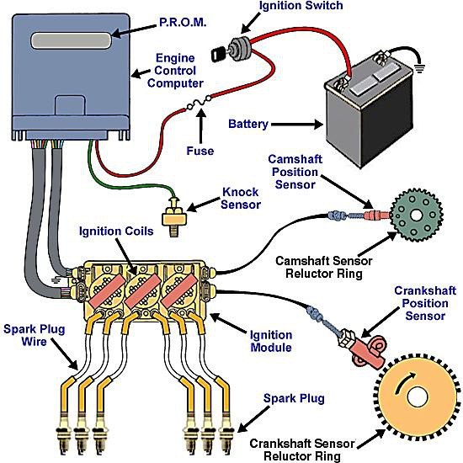
Waste-spark ignition is another name for the distributor-less ignition system (DIS) or electronic ignition (EI).Waste-spark ignition was introduced in the mid-1980s and uses the ignition control module (ICM) and/or the powertrain control module(PCM) to fire the ignition coils. A 4-cylinder engine uses two ignition coils and a 6-cylinder engine uses three ignition coils. Each coil is a true transformer because the primary winding and secondary winding are not electrically connected. A waste-spark coil has four
terminals: Figure 2.14 Waste-Spark Ignition Systems

- Two primary (Bat + and – to ICM)
- Two secondary (each connected to a spark plug)
Each end of the secondary winding is connected to the sparkplug of the cylinder exactly opposite the other in the firing order, called a companion (paired) cylinder.
Waste-Spark System Operation
- Both spark plugs fire at the same time (within nanoseconds of each other).
- When one cylinder (for example, cylinder number 6) is on the compression stroke, the other cylinder (number 3) is on the exhaust stroke.
- The spark that occurs on the exhaust stroke is called the waste spark, because it does no useful work and is only used as a ground path for the secondary winding of the ignition coil. The voltage required to jump the spark plug gap on cylinder 3 (the exhaust stroke) is only 2 to 3 kV.
- The cylinder on the compression stroke uses the remaining coil energy.
- One spark plug of each pair always fires straight polarity (from the center electrode to the ground electrode of the spark plug) and the other cylinder always fires reverse polarity (from the ground electrode to the center electrode of the spark plug). Spark plug life is not greatly affected by the reverse polarity. If there is only one defective spark plug wire or spark plug, two cylinders may be affected.
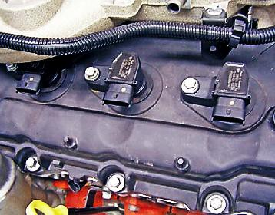
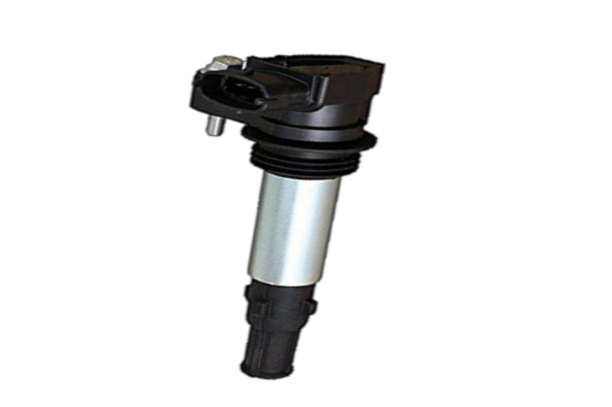
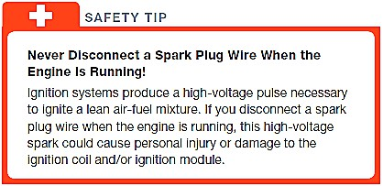
The coil-on-plug system eliminates the sparkplug wires that are often the source of electromagnetic interference (EMI) that can cause problems to some computer signals. The vehicle computer controls the timing of the spark. Ignition timing also can be changed (retarded or advanced) on a cylinder-by cylinder basis for maximum performance and to respond to knock sensor signals.

Figure 2.15 coil-on-plug system
There are two basic types of coil on-plug ignition.
- Two primary wires. This design uses the vehicle computer to control the firing of the ignition coil. The two wires include ignition voltage feed and the pulse ground wire, which is controlled by the PCM. The ignition control module (ICM) is located in the PCM, which handles all ignition timing and coil on-time control.
- Three primary wires. This design includes an ignition module at each coil. The three wires include:
- Ignition voltage
- Ground
- Pulse from the PCM to the built-in
Triggering and Switching Devices
- Triggering and switching devices are used to ensure the spark occurs at the correct time.
- A triggering device is simply (Ne sensor or CKP sensor and G sensor or CMP sensor)a device that monitors the movement of the engine’s pistons.
- A switching device(transistors) is what controls current flow through the primary winding
- When the triggering device sends a signal to the switching device that the piston of a particular cylinder is on the compression stroke, the switching device stops current flow to the primary winding. This interruption of current flow happens when the PCM decides it is best to fire the spark plug.
- The ignition module advances or retards the ignition timing in response to engine conditions with the use of a knock sensor.
Types of sensor use to monitor crankshaft and piston.
Magnetic Pulse Generator
Basically, a magnetic pulse generator or inductance sensor consists of two arts:
- A trigger wheel and a pickup coil.
- The trigger wheel may also be called are luck or, pulse ring, armature, or timing core.
- The pickup coil, which consists of a length of wire wound around permanent magnet, may also be called a stator, sensor, or pole piece.
Depending on the type of ignition system used, the timing disc may be mounted on the distributor shaft, at the rear of the crankshaft, or behind the crankshaft vibration damper.
Inductance sensors, are built with a wire wound around a permanent magnet (pole) similar to a solenoid or DC motor. They do not require external power (considered passive) and have two leads, a signal and ground.
A magnetic sensor uses a permanent magnets rounded by a coil of wire. The notches of the crankshaft (or camshaft) create a variable magnetic field strength around the coil. When a metallic section is close to the sensor, the magnetic field is stronger because metal is a better conductor of magnetic lines of force than air.
Magnetic crankshaft position sensors use the changing strength of the magnetic field surrounding a coil of wire to signal the ICM and PCM. This signal is used by the electronics in the ignition module and computer to determine piston position and engine speed (RPM). This sensor operates similarly to the distributor magnetic pickup coil. The crankshaft position sensor uses the strength of the magnetic field surrounding a coil of wire to signal the ICM. The rotating crankshaft has notches cut into it that trigger the magnetic position sensor, which change the strength of the magnetic field as the notches pass by the position sensor, creating an AC analog signal.

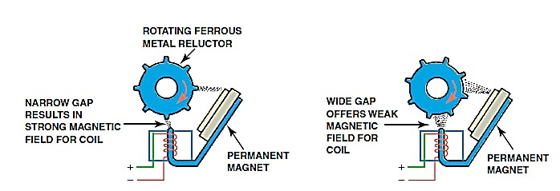
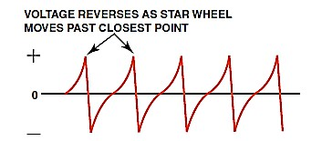

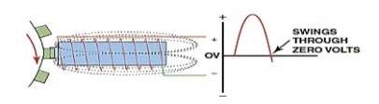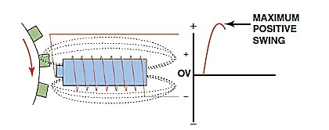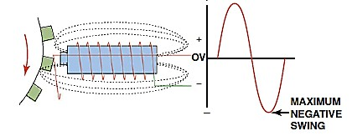

Operation of a typical pulse generator (pickup coil). At the bottom is a line drawing of a typical scope pattern of the output voltage of a pickup coil. The ICM receives this voltage from the pickup coil and opens the ground circuit to the ignition coil when the voltage starts down from its peak (just as the reluct or teeth start moving away from the pickup coil).

Hall-Effect Sensor
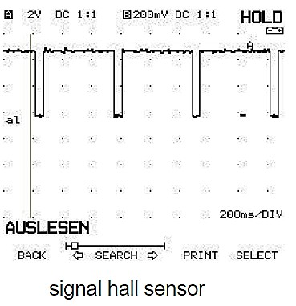
The Hall-effect sensor or switch is the most commonly used engine position (CKP) sensor. A Hall-effect sensor produces an accurate voltage signal throughout the entire speed range of an engine. It also produces a square wave signal that is more compatible with computers. In an ignition system, the shutter blades are mounted on the distributor shaft, flywheel, crankshaft pulley, or cam gear so the sensor can generate a position signal as the crankshaft rotates. A Hall-effect sensor may be normally on or off depending on the system and its circuitry. When a normally off sensor is used, there is maximum voltage output from the sensor when the magnetic field is blocked by the shutter. The opposite is true for normally on sensors. They have a voltage output when the magnetic field is not blocked.
The Hall-effect switch requires a small input voltage (4.75 to 12v) to generate an output or signal voltage. Hall-effect has the ability to generate a voltage signal in semiconductor material (gallium arsenate crystal) by passing current through it in one direction and applying a magnetic field to it at a right angle to its surface. If the input current is held steady and the magnetic field fluctuates, an output voltage is produced that changes in proportion to field strength.

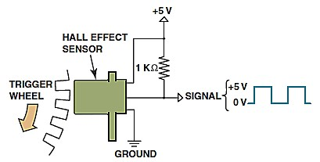
A Hall-effect sensor produces an on-off voltage signal whether it is used with a blade or a notched wheel.

A typical Hall-effect sensor has three wires connected to it. One wire is the reference voltage wire. The PCM supplies a reference voltage of 5 to 12 volts, depending on the system. The second wire delivers the output signal from the sensor to the PCM, and the third wire provides a ground for the sensor.
The signal from a Hall-effect CKP is also used to match fuel injector timing with the engine’s firing order on engines equipped with sequential fuel injection. Hall-effect switches are also used as camshaft position (CMP) sensors. When the engine is being started, the PCM receives a signal from the CKP, but the spark plugs will not fire until the PCM receives is faïence pulse from the CMP. After the engine starts, the PCM no longer relies on the CMP for ignition sequencing. However, if the CMP is bad, the engine will not restart. If the CKP goes bad, the engine will typically not start or run.

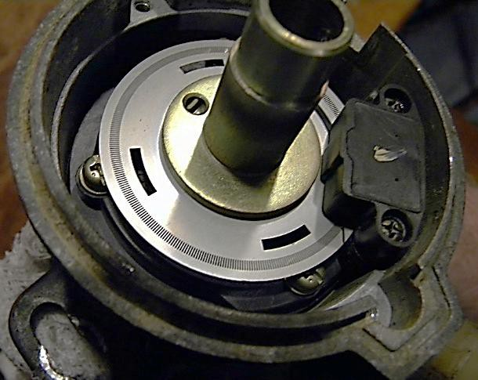

Photoelectric Sensor
This type of sensor uses light from an LED and a phototransistor to signal the computer. An interrupter disc between the LED and the phototransistor has slits that allow the light from the LED to trigger the phototransistor on the other side of the disc. Most optical sensors (usually located inside the distributor) use two rows of slits to provide individual cylinder recognition (low- resolution) and precise distributor angle recognition (high-resolution) signals that are used for cylinder misfire detection.
Ignition Spark Generation
Ne Signal and G Signal
Though there are different types of ignition systems, the use of the NE and G signals is consistent. The Ne signal (number of engine revolution) indicates crankshaft position and engine RPM. The G signal (also called Variable Valve Train or VVT signal, sometimes called Group #1) provides cylinder identification. By comparing the G signal to the NE signal, the ECM is able to identify the cylinder on compression. This is necessary to calculate crankshaft angle (initial ignition timing angle), identify which coil to trigger on Direct Ignition System (independent ignition), and which injector to energize on sequential fuel injection systems.

As ignition systems and engines evolved, there have been modifications to the Ne and G signal. Timing rotors have different numbers of teeth. For some G signal sensors, a notch is used instead of a tooth to generate a signal. Regardless, you can determine what style is used by visually examining the timing rotor or consulting the Repair Manual. Many of the different styles are represented with their respective ignition system.
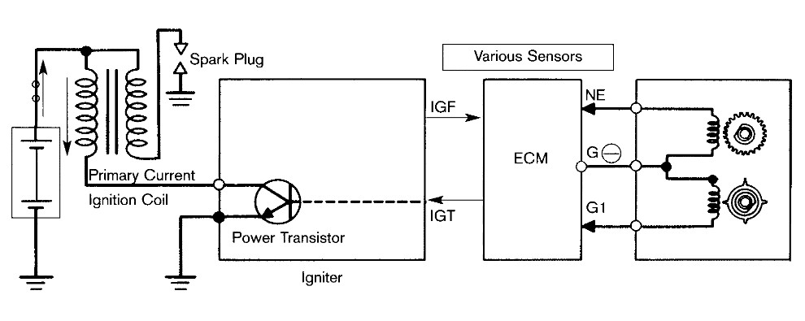

On EFI equipped engines, the Ne and G1 signals inform the ECU of engine rpm and crankshaft angle. This information, along with information from the air flow or manifold pressure sensor, allows the ECU to calculate the engine's basic operating load. Based on measure load, basic injection and spark advance angle can be accurately calculated.
- Ne Signal (Number of Engine Revolutions)
The Ne signal generator consists of a pickup coil and toothed timing rotor. The number of teeth on the signal timing rotor is determined by the system used. The Ne sensor produces an alternating current waveform signal and is of critical importance to the ECU. If this signal fails to reach the ECU, the engine will not run.
- G or G1 Signal (Group #1)
The G signal generator is very similar to the Ne signal generator. The G1 signal represents the standard crankshaft angle and is used by the ECU to determine ignition and injection timing in relation to TDC. Depending on engine, there are different variations of Ne and G1 signal generators. The following illustrations show the relationship between the Ne and G1 signals and the different variations of signal generators.

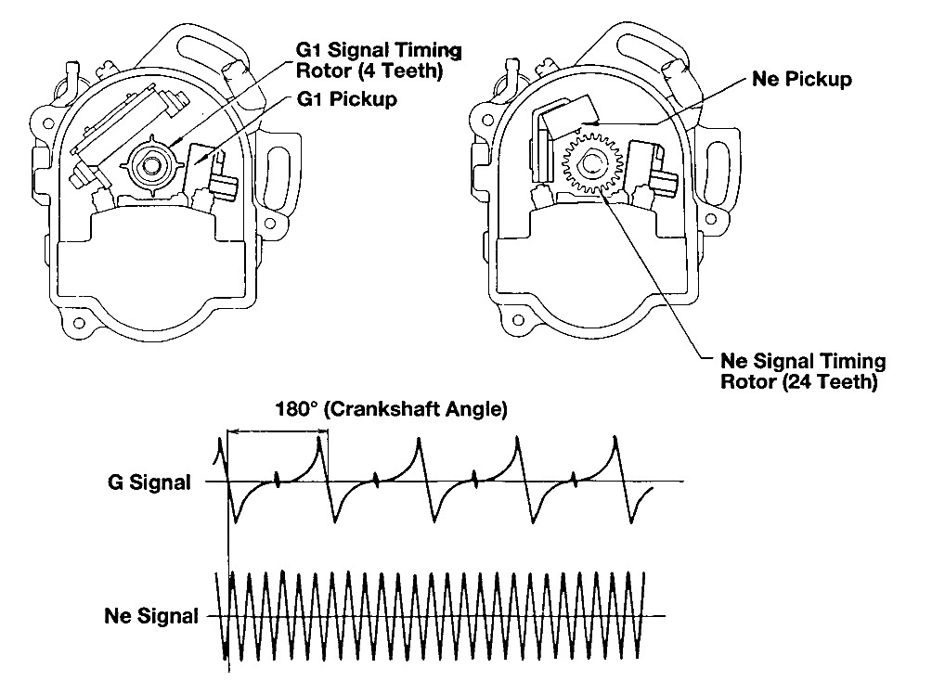
How it works - lGf Signal Confirmation
The IGf signal is generated by the igniter on EFI systems. The ECU supplies a 5 volt reference through a pull-up resistor to the lGf signal generation circuit in the igniter. When a spark plug fires, the IGf signal generation circuit pulls the five volts to ground, causing a pulse to be sensed at the ECU. One pulse is generated by the igniter for each ignition event which is carried out. The IGf signal confirms that ignition has actually occurred. In the event of a failure to trigger an ignition event, the ECU will shut down injector pulses to protect the catalyst from flooding with raw fuel. Typically this failsafe shutdown occurs within eight to eleven IGt signals after the IGf signal is lost. This condition can occur with any primary ignition system fault, an igniter failure, a problem with the IGf circuit wiring, or with a faulty ECU.
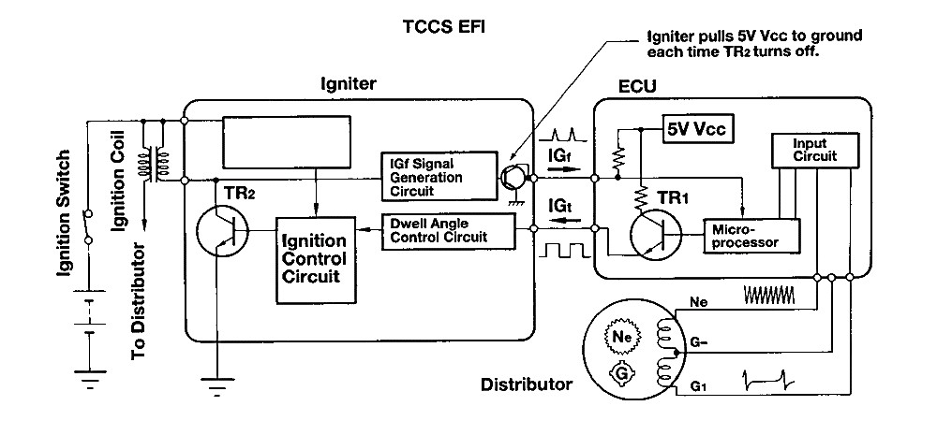

Self-check 2
Directions: Answer all the questions listed below.
Part - 1
1. Better atomization and _____________ will make the engine less knock prone.

a) ignition
b) Vaporization
c) Condensation
d) None of the mentioned

2. Formation of ice on the _____________ plate is eliminated in electronic fuel injection.

a) Throttle
3) Nozzle
c) Engine
d) None of the mentioned

4. In an electronic fuel injection, variation of air-fuel ratio is almost negligible even when the vehicle takes different positions like turning, moving on gradients, uneven roads, etc.

a) True
b) False
5. In an electronic fuel injection, position of the injection unit is critical.

a) True
b) False

6. In an electronic fuel injection, the maintenance cost is?

a) Low
b) High c) nil

d) None of the mentioned
7. In an electronic fuel injection, the servicing is very ___________

a) Difficult
b) Easy
c) nil
d) None of the mentioned

8. In an electronic fuel injection, there is a possibility of malfunctioning of some sensors.
a) True
b) False

Operation Sheet 2.1

Operation Title: Test sensor
Purpose: Test sensor is important to check Test sensor is working properly
Conditions for the operations:
- Safe working area
- Properly operated tools and equipment
- Appropriate working cloths fit with the body
Equipment Tools and Materials:
- Sensor
- Flaring nut
Quality Criteria: Assured performing of all the activities according to the procedures
Precautions:
- Wearing proper clothes, eye glass, glove
- Make working area hazard free
- Read and interpret manual which guide you how to use tools and equipment
Hoses secured by clamps are cut to length from bulk material. To remove the fuel line:
- Clean the sensor
- Disconnect the sensor at the vehicle connection using two wrenches.

Inspecting sensor
Procedure:
Instructions: Record the voltage input (source voltage) of the ECU and voltage output
(signal voltage) of the following sensors: Instruction:
Throttle Position Sensor (TPS)
1. Ignition Switch and Power Main Switch is turn to OFF position and be sure there is
NO power supplied to the sensor.

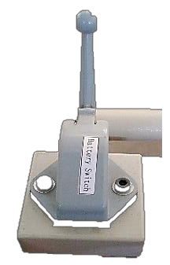
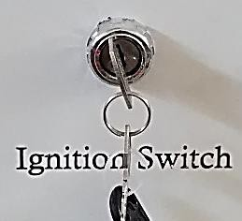

Main Switch
OFF position

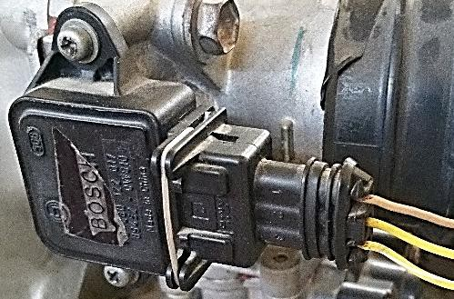
2. Disconnect the TPS connector by pressing the lock pin.

3. TPS terminal identification: Vc, VTA, E2 terminal by using DMM (Ohmmeter).

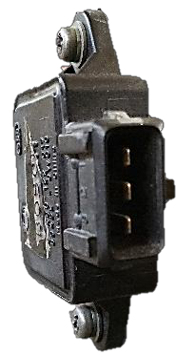
T1:

T2:

T3:

ECU / Sensors | TPS Terminal | Resistance
1. Throttle Position Sensor (TPS)  ➢ Close Throttle | Vc – E2
1. Throttle Position Sensor (TPS)  ➢ Close Throttle | Vc – VTA
1. Throttle Position Sensor (TPS)  ➢ Close Throttle | VTA – E2
2. Throttle Position Sensor (TPS)  ➢ Wide Open Throttle | Vc – E2
2. Throttle Position Sensor (TPS)  ➢ Wide Open Throttle | Vc – VTA
2. Throttle Position Sensor (TPS)  ➢ Wide Open Throttle | VTA – E2

- TPS Connector terminal identification: Vc, VTA, E2 terminal by using
- DMM (Voltmeter).

T1:

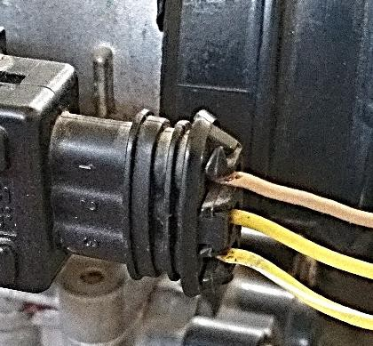
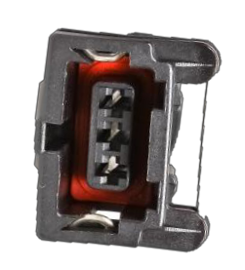
T2:

T3:

5. Re-connect the TPS connector.
6. Turn ON the main power switch.
7. Turn ON the ignition switch and start the engine.
8. Fill-up the table below with the needed information.

ECU / Sensors | TPS Terminal | Source / Signal  Voltage
1. Throttle Position Sensor (TPS) Close  throttle - Idling) | Vc – E2
1. Throttle Position Sensor (TPS) Close  throttle - Idling) | Vc – Chassis Ground
2. Throttle Position Sensor (TPS) Close  throttle - Idling) | VTA – E2
2. Throttle Position Sensor (TPS) Close  throttle - Idling) | Vc – VTA
3. Throttle Position Sensor (TPS) at 1,000  rpm) | VTA – E2
3. Throttle Position Sensor (TPS) at 1,000  rpm) | Vc – VTA
4. Throttle Position Sensor (TPS) at 2,000  rpm) | VTA – E2
4. Throttle Position Sensor (TPS) at 2,000  rpm) | Vc – VTA

9. Turn the engine OFF, ignition switch and main power switch to OFF position.
10. Locate the manifold absolute pressure sensor and disconnect the connector by pressing the lock pull it out.

Lock
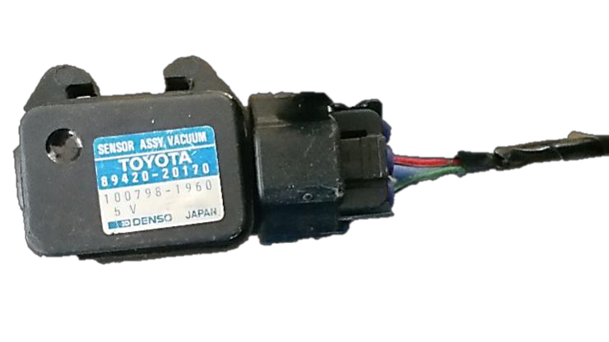

MAP Connector

Operation Sheet 2.2

Operation Title: Identify sensor mounting location
Purpose: Test sensor is important to check Test sensor is working properly
Conditions for the operations:
- Safe working area
- Properly operated tools and equipment
- Appropriate working cloths fit with the body
Equipment Tools and Materials:
- Sensor
- Flaring nut
Quality Criteria: Assured performing of all the activities according to the procedures
Precautions:
- Wearing proper clothes, eye glass, glove
- Make working area hazard free
- Read and interpret manual which guide you how to use tools and equipment
Hoses secured by clamps are cut to length from bulk material. To remove the fuel line:
- Clean the sensor
- Disconnect the sensor at the vehicle connection using two wrenches.

Inspecting sensor
Procedure:
Instructions: Record the voltage input (source voltage) of the ECU and voltage output
(signal voltage) of the following sensors: Instruction:
- Air flow meter sensor
- Crank angle sensor
- Engine speed sensor
- Water temperature sensor
- Intake air temperature sensor
- Throttle position sensor
- Ignition switch
- Vehicle speed sensor
- Oxygen sensor
- Neutral start switch
- Taillight and defogger relays
Unit Three: Diesel EFI
This unit is developed to provide you the necessary information regarding the following content coverage and topics:
- TYPES OF Diesel EFI
- Electronic Control system
- fuel delivery system
- Diesel EFI
- Common rail
- Injector
This unit will also assist you to attain the learning outcomes stated in the cover page. Specifically, upon completion of this learning guide, you will be able to:
- TYPES OF Diesel EFI
- Electronic Control system
- fuel delivery system
- Diesel EFI
- Common rail
- Injector

3.1 Diesel Electronic Fuel Injection System
Most late-model diesel injection systems are very similar to GDI systems. Actually, it is more accurate to say that the GDI systems are very similar to today’s light- and medium-duty diesel injection systems. Nearly all of today’s diesel systems have a common rail injection system in which the injectors are totally directly controlled by the PCM.
However, some diesel engines use a mechanical-type system and only the fuel pressure and emission controls are regulated by the PCM To meet OBD standards, diesel control systems use many of the same inputs as a gasoline engine (such as the MAP, IAT, MAF, TP, CKP, and CMP sensors). They also share many of the same diagnostic routines.
The only difference, and perhaps the biggest one, is the way the air-fuel mixture is ignited. With compression injection, fuel control is one of the keys to engine efficiency. Most systems control the timing and fuel pressure electronically. Diesel engines run at much higher compression ratios than gasoline engines; therefore, the injectors need to release fuel at a much higher pressure. In a typical system, the PCM calculates engine speed using inputs from the CKP. The PCM then determines the ideal fuel requirements for that speed and other operating conditions.
In response to these, the PCM, through a fuel injection module, controls the pulse width of the injectors and pressure in the fuel rail. A mechanically driven pump supplies high pressure to the fuel rail. The fuel rail is fitted with a pressure regulator that is controlled by commands from the PCM. The pressure in the fuel rail can range from 2,000 psi (138 bar) to 25,000 psi (1,724 bar).
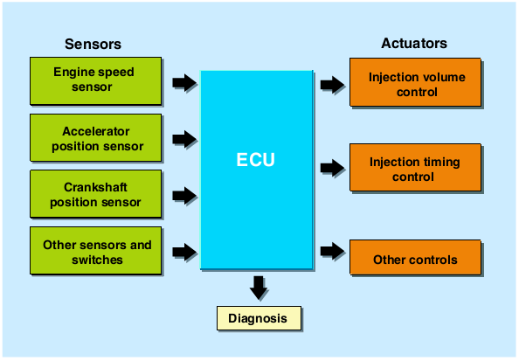
Figure 3.1 Diesel Electronic Fuel Injection System
Often, fuel is routed through the fuel injection module to cool it before it is delivered to the injectors. The design of the injectors varies with application; some are solenoid actuated and others use piezoelectric injectors. Some high-pressure common rail fuel systems are capable of injecting fuel five times during one compression stroke. This is done to keep the fuel under high pressure, reduce combustion noise, and provide lower emissions.
High voltage is required to operate most solenoid injectors, normally around 90 volts. Some, however, require only battery voltage. Diesel engines produce 20% to 30% less carbon dioxide (CO2) emissions, lower carbon monoxide (CO) emissions, better fuel economy, and more low-speed torque than a comparably sized gasoline engine. With precise control of fuel delivery through electronics, the use of exhaust-stream after treatment, and an oxidation catalytic converter; oxides of nitro-gen (NOx) and particulate matter (PM) are also drastically reduced.
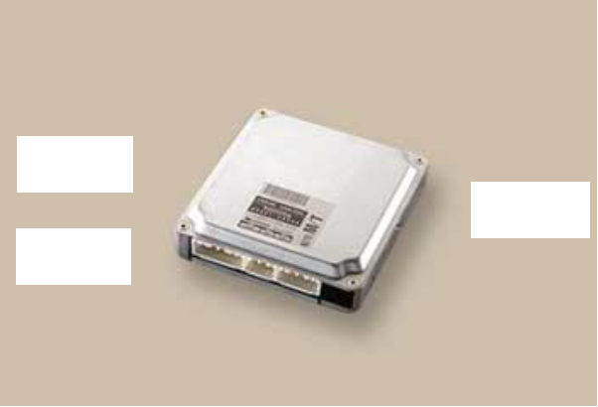



In terms of electronic control, the role of the ECU is to
Actuators

Sensors

Switches

determine the fuel injection volume, fuel injection timing,
and intake air volume suit able for the driving conditions,
based on the signals received from various sensors and
switches. In addition, the ECU outputs signals to

In terms of electronic control, the role of the ECU is to determine the fuel injection volume, fuel injection timing, and intake air volume suit able for the driving conditions, based on the signals received from various sensors and switches. In addition, the ECU outputs signals to operate actuators. The both EFI- diesel and common-rail systems.
Electronic Control System Diagram
Engine type:
• 5L-E (Axial plunger pump type)

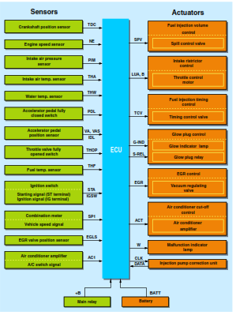

Figure 3.2 5L-E (Axial plunger pump type)

3.2 Types of Diesel EFI
1. Conventional EFI-diesel
Fuel injection volume and timing is controlled electronically. The control mechanism used for the pumping, distribution, and injection processes is based on the mechanism used in the mechanical type diesel system. As with the mechanical type pump, there are two types of pumps, named based on the shape of their pumping portion. These Axial Plunger Type Pump and Radial Plunger Type Pump.
The fuel that is drawn up by the feed pump travels from the fuel tank through the fuel filter, and is introduced into the pump where it becomes pressurized and then pumped by the plunger inside of the injection pump. This process is the same as in an ordinary diesel pump. The fuel in the pump chamber becomes pressurized by the feed pump. Further-more, in accordance with the signals from the ECU, the SPV controls the injection volume (injection duration) and the TCV controls the fuel injection timing (injection starting timing).
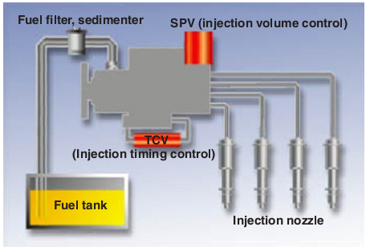
Figure3 3 Conventional EFI-diesel
Type of Pump
A conventional EFI-diesel uses one of the two types of distributor pump: an axial plunger type pump, and a radial plunger type pump with a higher injection pressure.
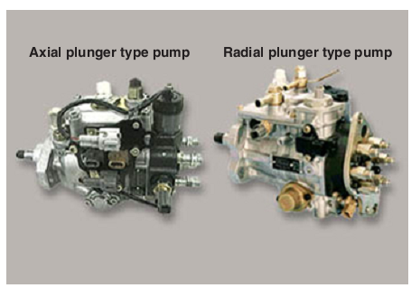
Figure 3.4 Axial plunger type pump Figure3.5 Radial plunger

Axial plunger type Radial plunger type
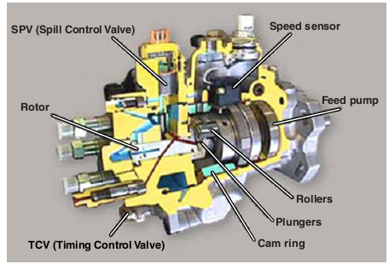
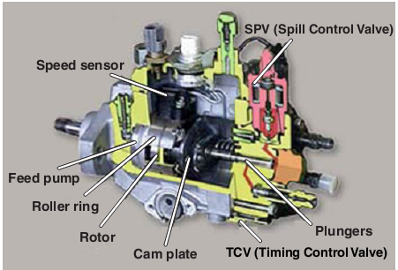

Figure 3.6 Axial plunger type Figure 3.7 Radial plunger type

3.3 Electronic control system

3.3.1 Sensor
1. Mounted Position of Sensors
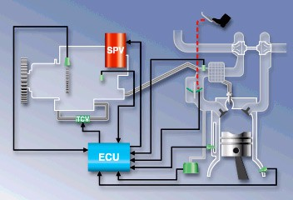
1KZ-TE Engine
• Speed sensor
• Fuel temperature sensor
• Intake air temperature sensor
• Throttle position sensor
• Water temperature sensor
• Turbo pressure sensor
Crankshaft position sensor
Figure 3.8 Mounted Positions of Sensors
2. 1HD-FTE/15B-FTB Engine
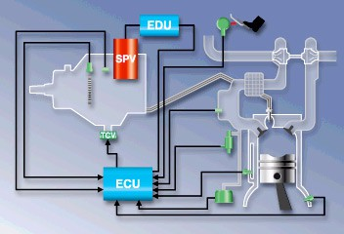
Speed sensor
• Fuel temperature sensor
• Accelerator pedal position sensor
• Intake air temperature sensor
• Water temperature sensor
• Turbo pressure sensor
• Crankshaft position sensor
Figure 3.9 1hd-Fte/15b-Ftb Engine
3. 1CD-FTV Engine
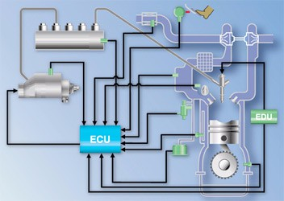
• Fuel temperature sensor
• Fuel pressure sensor
• Air flow meter/intake air temperature sensor (at air cleaner)
• Accelerator pedal position sensor
• Intake air temperature sensor (at intake manifold)
Figure 3.10 1CD-FTV Engine

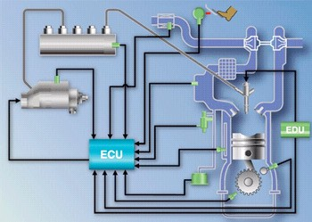
4. 1KD-FTV Engine
1KD-FTV Engine Fuel temperature sensor Fuel pressure sensor Air flow meter/intake air temperature sensor(at air cleaner) Accelerator pedal position sensor Intake air temperature sensor (at intake manifold) Water temperature sensor Turbo pressure sensor Camshaft position sensor Crankshaft position sensor (4/6)

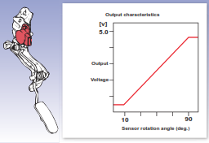
Figure 3.11 Fuel temperature sensor Fuel pressure sensor
Construction and Operation of Sensors
The sensor which sends the signal to the engine ECU is shown in the left diagram.
- Accelerator Sensor
There are two types of accelerator sen- sors. One is an accelerator pedal posi- tion sensor, which forms an assembly together with the accelerator pedal. This sensor, which is a Hall element type, detects the accelerator opening angle. A voltage that corresponds to the acceler- ator opening angle can be detected at the output terminal.
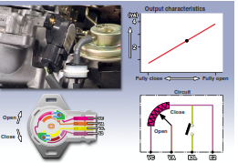
- Accelerator Sensor
The other is a throttle position sensor, which is mounted at the venturi and is a type that uses a variable resistor.

- Accelerator Sensor
The other is a throttle position sensor, which is mounted at the venturi and is type that uses a variable resistor.
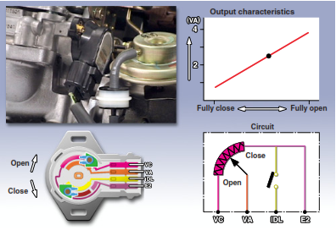
Figure 3.12 Accelerator Sensor
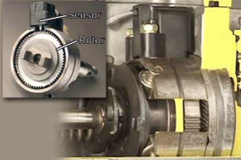
- Engine Speed Sensor
The engine speed sensor is fitted in the injection pump. It consist of a rotor that is pressed over a drive shaft, and a sensor. Electric signals are generated in the sensor (coil)in accordance with the rotation of the rotor.

Figure 3.13 Engine Speed Sensor
- Engine Speed Sensor
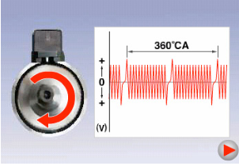
The 1CD-FTV common-rail EFI-diesel engine uses the crankshaft position sensor to detect the engine speed just as in the EFI system of a gasoline engine, in place of the engine speed sensor used in a conventional EFI-diesel engine.
The crankshaft position sensor of the common-rail EFI diesel engine outputs the same NE signal that is output By the engine speed sensor of the conventional EFI-diesel engine.
Figure 3.14 Engine Speed Sensor

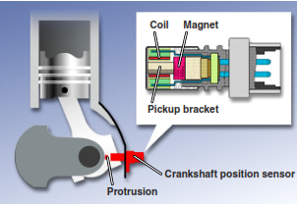
- Crankshaft Position Sensor
- The crankshaft position sensor is mounted on the engine block. It detects the crankshaft angle reference position in the form of a TDC signal.
Figure 3.13 Crankshaft Position Sensor
HINT: The crankshaft position sensor of common-rail type output the engine speed (NE) signals. It detects the crank angle based on these NE signals.
A pulse is generated when the protrusion provided on the crankshaft padded near the sensor due to the revolution of the crankshaft. A pulse is generated once for every revolution of the crankshaft, and this is detected in the form of a crankshaft angle reference position signal.
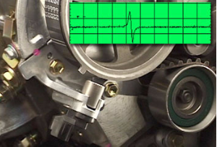
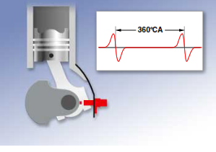
- Camshaft Position Sensor
A camshaft position sensor is used on some engines (1CD-FTV) in place of a crankshaft angle reference position is detected in the form of a G signal.

- 1ND-TV Engine
For the 1ND-TV engine a hall element type camshaft position sensor is used. The timing trigger on the timing sprocket detects the position of the camshaft by sending one signal for every two revolutions of the crankshaft.
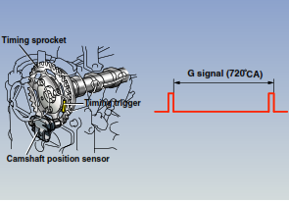
Figure 3.14 1ND-TV Engine
- Turbo Pressure Sensor
- The turbo pressure sensor is connected to the intake manifold via an air hose and a VSV, and detects the intake manifold pressure (intake air volume).
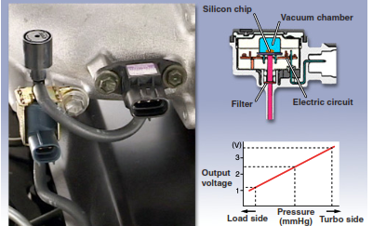
Figure 3.14 Turbo Pressure Sensor
- Turbo Pressure Sensor
The VSV operates in accordance with the signals form the ECU and switched the pressure that is applied to the actuator between atmosphere
• Vacuum
• Atmosphere
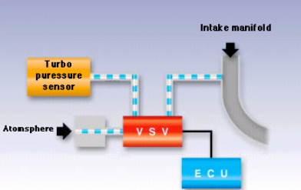
Water Temperature/Intake Air Temperature/Fuel Temperature Sensor Fuel temperature sensor There are three types of temperature sensors that are used for controlling the EFI-diesel:
The water temperature sensor is mounted on the engine block to detect the temperature of the engine coolant.
The intake air temperature sensor is mounted on the intake pipe of the engine and detects the temperature of the intake air. The fuel temperature sensor is mounted on the pump and detects the temperature of the fuel.
Water temperature sensor Fuel temperature sensor
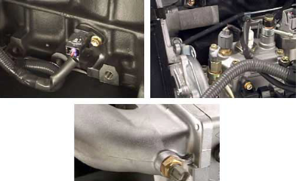
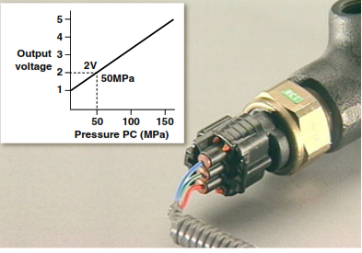
- Fuel Pressure Sensor
The fuel pressure sensor that is used in the common-rail type diesel detects the fuel pressure in the common-rail. Based on the signals from the fuel pressure sensor, the ECU controls the SCV(Suction Control Valve) to generate a prescribed fuel pressure in accordance with the drivinb conditions.
- Air Flow Meter
A hot-wire type air flow meter has been adopted in the common-rail EFI-diesel to detect the intake air volume.

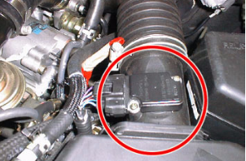

3.2.2. Actuator
(1) EGR Valve (Exhaust Gas Recirculation Valve) Control the inflow volume of the EGR gases.(2) SPV (Spill Control Valve) Controls the fuel injection volume.(3) TCV (Timing Control Valve) Controls the fuel injection timing

3.2.3. ECU and other
(1) ECU (Electronic Control Unit) Determines the operating conditions based on the signals from various sensors and sends optimal engine control signals. (2) EDU (radial plunger type pump only)
amplifies the ECU signals and actuates the SPV. (3) Pump :Pumps and distributes fuel.(4) Fuel filter and sedimentary Removes foreign particles and water from fuel.(5) Injection nozzle Injects fuel that has been pumped by the pump.
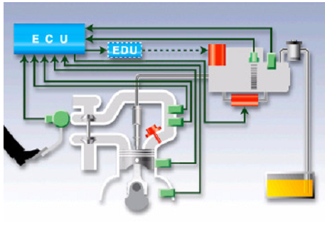
  - Fuel deliver system
- Flow of fuel
The feed pump inside the pump draws up fuel from the fuel tank into the pump. The fuel is pressurized by the pump and distributed to the injection nozzle of each cylinder. The fuel pressure causes the injection nozzle to open injecting fuel into the cylinder.
- Flow of signal
The ECU receives signals from various sensors in order to determine the operating conditions of the engine. Then, the ECU sends signals to control the SPV and TCV in the pump in order to achieve an optimal fuel injection volume and timing.
- Common-rail EFI-diesel
Instead of having the pump itself distribute fuel to the cylinders, the fuel is stored in the rail at a pressure that is necessary for injection. As with the EFI system of a gasoline engine, the injectors open and close in accordance with the injection signals from the ECU to realize optimal fuel injection. Injection volume control: injector opening duration Injection timing control: injector starting timing.
The fuel that has been drawn up from the feed pump located inside the supply pump is pressurized to the required pressure. The plunger in the pump generates the required injection pressure The ECU commands the SCV (Suction Control Valve) to adjust the fuel pressure, regulating the volume of fuel that enters the supply pump. The ECU constantly detects the fuel pressure in the common-rail by means of the fuel pressure sensor, and effects feedback control.

Generation of Fuel Pressure in the Supply Pump
The two sets of opposing plungers are driven by the inner cam via the rollers. The inner cam is driven by the engine via the timing belt. The inside of the inner cam, which is elliptic, comes in contact with the roller. As the inner cam rotates, it causes the plunger to move reciprocally, and the resulting suction and pumping of fuel generates pressure.

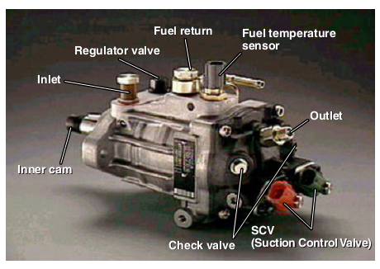

3.4 Fuel Deliver
- Flow of fuel and signal in common diesel
The feed pump in the supply pump draws up the fuel from the fuel tank. The fuel that has been pressurized by the supply pump to reach the proper injection pressure is fed into the common-rail where it is stored. The stored fuel is distributed via the injection pipes to the injectors of the cylinders, and when the injectors are operated, the fuel is injected.
(2) Flow of signal
The ECU collects information from the sensors and sends signals to the SCV in order to attain the target fuel pressure. In addition, the pressure signal from the common-rail is fed back into the ECU. The ECU sends signals to the EDU to operate the injectors, the EDU applies the raised voltage to the injectors, and the injectors inject the fuel.
Electromechanical Systems
A few diesels have mechanically actuated injectors that are fitted with a solenoid to control fuel pressure. In these units, the high-pressure pump and injector are in a single assembly and there is one these for each cylinder. The pumps are driven by a special lobe on the camshaft; this third lobe sits next to the intake and exhaust lobes for each cylinder. Because the injectors are mechanically driven, their timing is fixed. Fuel control is accomplished by regulating fuel pressure. To do this, the PCM controls the solenoids at the injectors.

Diesel Throttle
The diesel throttle is mounted on the intake manifold. The throttle valve, which operates independently from the accelerator pedal, uses the diesel throttle control motor (step motor) to regulate the throttle opening accordance with the signals received from the ECU.
Purpose:
1. Ensures an optimal amount of EGR volume throughout the operating range by increasing the intake manifold vacuum.
2. Reduces the intake noise and vibration by closing the throttle valve at idle.
3. Reduces vibrations by fully closing the throttle when stopping the engine in order to reduce the amount of air intake volume.

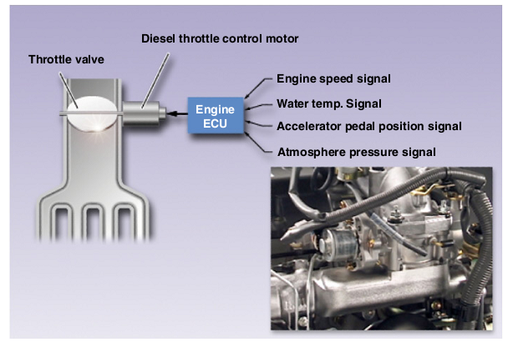

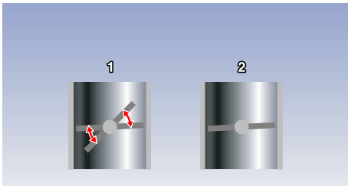
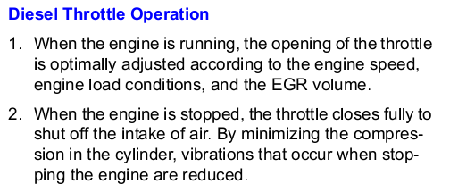

3.5 High pressure accumulator (common rail)
- Fuel is supplied to the common rail at high pressure from the high pressure pump.
- The rail stores the fuel and distributes it to the individual injectors.
- It also damps pressure vibrations caused by the high pressure pump and injection processes.
- Typical volume of fuel held in common rail: 16 –20cm³.
- Typical fuel rail pressure with engine idling and at running temperature:
Approximately between 300 –400 Bar (4410 –5880 psi)
- Typical maximum possible fuel rail pressure:
- approximately between 1600 –2000 Bar (23520 –28400 psi)

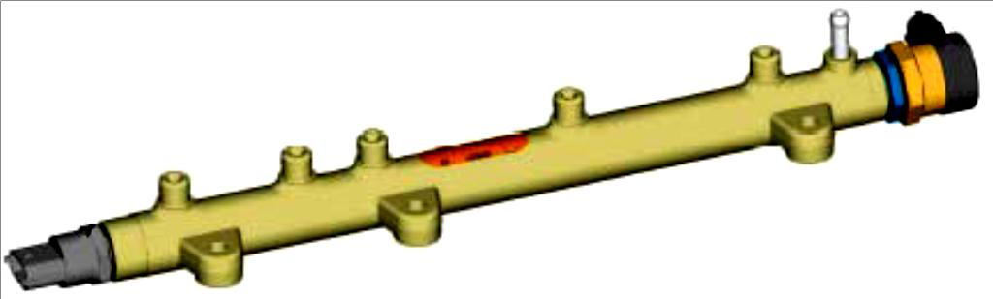
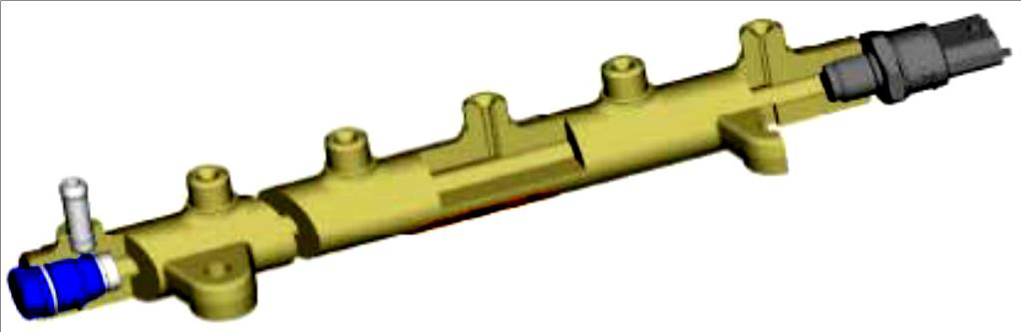

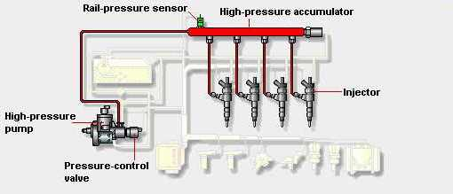

Figure 3.18 High pressure accumulator (common rail)
Low –pressure circuit comprises of:
- Fuel tank, Pre-supply pump, Fuel filter, and the respective connection lines
- Low –pressure circuit
- The low –pressure circuit is responsible for transporting the fuel to the high –pressure circuit
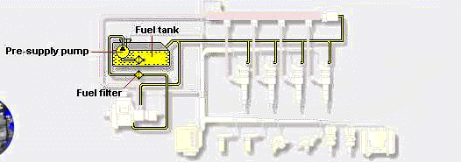

Figure 3.18 Low –pressure
- Advantages of common rail:
- Fuel pressure available on demand.
- Higher injection pressures and finer atomization of fuel.
- Injection pressure created independent of engine speed.
- Multiple injections per cylinder combustion are possible.
- Benefits of common rail:
- Reduction of overall exhaust emissions.
- Reduction of particulate emissions.
- Reduction of noise emissions.
- Improved fuel efficiency.
- Higher performance.
Health and Safety
- Due to the extremely high working fuel pressures in the common rail fuel
system, NEVER slacken fuel or injector pipes or try to disconnect components of the fuel system whilst the engine is running and high pressure is present in the system
Fuel Rail Pressure Sensor
A fuel rail pressure sensor is located on the fuel rail.
- Monitors the fuel pressure in the common rail.
- Typically, a piezo resistive type sensor has three wires:
- Volt supply from engine ECM.
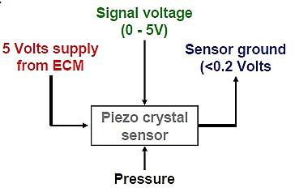
Sensor ground via engine ECM.
- Linear signal voltage output to ECM.

- Signal utilization – To enable the engine
ECM to determine the fuel rail pressure.
Used by the ECM as part of the calculation for the % duty cycle applied to the rail pressure control solenoid and fuel metering solenoid.
The engine ECM applies a stabilized 5
- Volts supply to the signal wire of the fuel pressure sensor.
- The resistive value of the sensor creates a change in the voltage on the signal wire relative to the fuel rail pressure.
- Typical signal voltages from rail pressure sensor: (Model – Bosch EDC16)
- Engine stationary: approximately 0.5 volts.
➢ Engine idling: approximately 1.32 volts.
➢ Snap acceleration: approximately 3.77 volts +

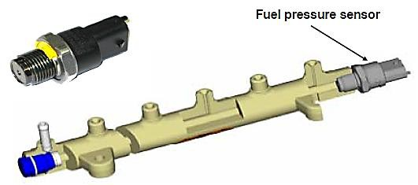
Figure3.19 Fuel pressure Sensor
Rail Pressure Limiter Valve
➢ A mechanical pressure limiter valve is fitted to some systems. It is located at the end of the fuel rail.
➢ Its function is to relieve rail pressure if abnormally high system pressure is generated.
➢ If excessive fuel pressure is generated, the valve opens a fuel return port.
➢ Excess fuel is relieved back to the fuel tank.
Rail Pressure Limiter Valve (Mechanical)
➢ Example operating pressure of rail pressure limiter valve (Denso HP3 system):
✓ valve opens at 230 MPa(2300 Bar)
✓ valve closes at 50 MPa(500 Bar)

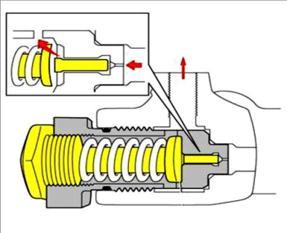
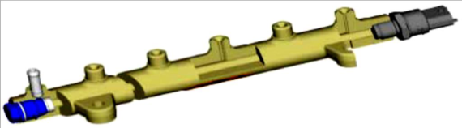

Fuel Return to tank

Figure 3.20 Fuel Return to tank
Fuel Rail Pressure Control Valve Solenoid
- A rail pressure control valve solenoid is fitted to the common rail on some systems.
- The valve controls fuel pressure by opening and closing a return port in the rail.
- Excess fuel returns to the fuel tank via the fuel return
- Receives battery voltage supply from engine ECM
- Energized by engine ECM via a negatively triggered PWM.
- Operating frequency: approximately 1000Hz
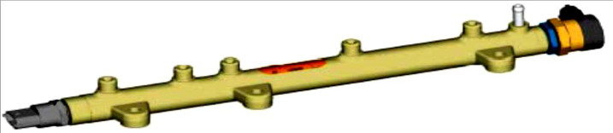
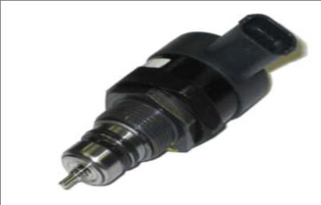
Fuel Return to tank

Fuel Rail Pressure Control Valve solenoid
- Used in conjunction with fuel metering solenoid, the rail pressure solenoid provides more accurate and faster control of pressure, particularly when reducing rail pressure during overrun.
- Rail pressure control valve de energized.
- More fuel is returned to fuel tank via return port.
- Fuel deliver decrease

3.9 Injector
The fuel injector is an electro-mechanical device which meters, atomizes and directs fuel into the intake manifold based on signals from the ECU driver circuit(s). Position the injectors, one per cylinder, directly behind the intake valve. The injectors are installed with an insulator/seal on the manifold end to isolate the injector from heat and to prevent an atmospheric pressure leak into the manifold.
Types of Injectors in Use
Different types of fuel injectors depending on engine application. These can be broken down into pintle type and hole type (cone valve and ball valve), high resistance and low resistance.
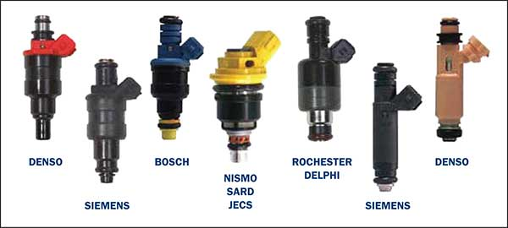
Figure 3.21 Injectors
Injector Driver Circuits
Current is supplied to the ECU driver circuits through the fuel injectors. Current flows either directly from the ignition switch or from the EFI Main Relay. When the ECU driver circuit turns on, current flows to ground through the injector solenoid coil. The magnetic field created causes the injector to
open against spring tension. When the ECU driver circuit turns off, the spring closes the injector valve. There are two common types of driver circuits currently in use on EFI engines; both of these driver circuits work on the voltage control principle. One uses an external solenoid resistor and a low resistance injector, the other using a high resistance injector without the solenoid resistor. In both cases, the high circuit resistance is required to limit current flow through the injector winding. Without this control of the current flow through the injector, the solenoid coil would overheat, causing injector failure.

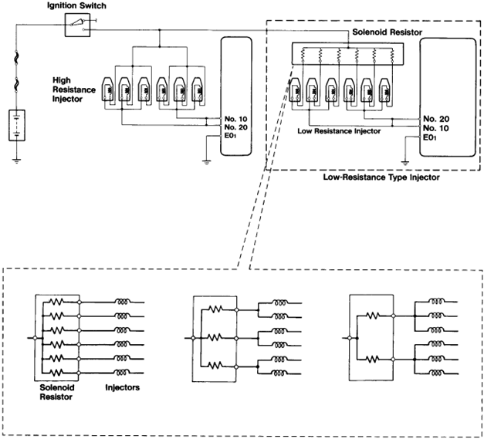

Figure 3.22 Injector Driver Circuits
Fuel Injection Pattern and Injection Timing
Fuel injectors can be pulsed in one of four patterns depending on application. These injection patterns are:
- Simultaneous
- Two groups of two injectors each (four-cylinder engines)
- Three groups of two injectors each (six-cylinder engines)
- Independent (sequential)

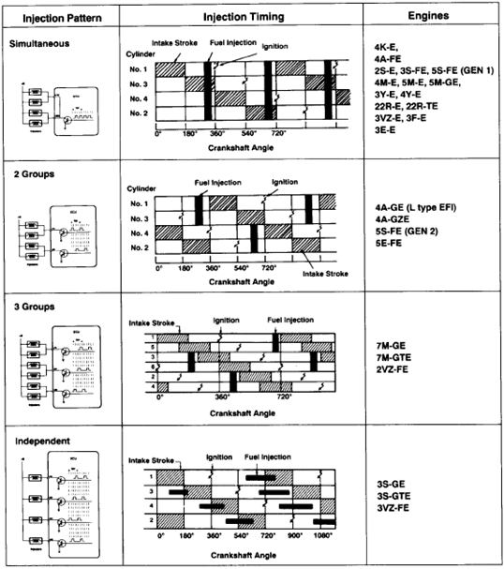
Figure:3.23 Fuel Injection Pattern and Injection Timing
- Cold Start Injection System
To improve engine starting when coolant temperatures are low a supplementary injector is installed on many EFI engines. The cold start injection system consists of the following components:
- Cold Start Injector
- Start Injector Time Switch
- ECU (most EFI/TCCS)
- Cold Start Injector
The cold start injector is located at some central location in the intake manifold. It is designed to supplement the cranking air/fuel ratio and prime the intake manifold in much the same way as a choke valve does while cranking a carbureted engine. This injector, controlled by the start injector time switch and ECU.
- Start Injector Time Switch
The function of the start injector time switch is to control the cold start injector ground circuit and to determine maximum injection duration while cranking. Its bi-metallic switch is heated by both engine coolant and an electrical heater.
- ECU Cold Start Injector Control
On most TCCS engines, an alternate ground may be supplied to the cold start injector by the ECU at the STJ terminal. Based on signals from the coolant temperature sensor, the ECU can operate the cold start injector for up to three seconds regardless of the status of the time switch. Maximum coolant temperature for ECU control is 113’F (45’C), above which the cold start injector will not operate from any source.
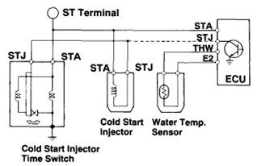
Figure:3.24 ECU Cold Start Injector Control
- Alternative Method of Cold Cranking Enrichment
Some engines have eliminated use of a cold start injector entirely. Starting with the '91 model year, cold start injectors have been eliminated on the 3E-E and 4A-FE engine. During cranking, the ECU looks at THW and lengthens injector pulse width sufficiently to start the engine.
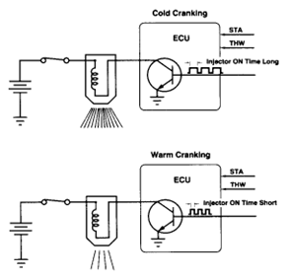
Figure: 3.25 Alternative Method of Cold Cranking Enrichme

Self-check 3
Directions: Answer all the questions listed below.
Part - 1
- ___________regulates the volume of air bypassed around the closed throttle.
- EGR B.IAT C.ISCV D. TPS
- A turbocharger is:
- a set of gears that makes the wheels turn faster
- a turbine that compresses the air traveling into the engine
- an injector that delivers fuel to the engine faster
- When you turn the key to a car, the starter motor:
- sends electricity to the spark plugs, starting ignition
- sends electricity to the fuel pump, forcing the car to start
- spins the engine a few revolutions, starting the combustion process
- Modern cars use internal combustion engines, but some early models used external combustion engines. What is one example of an external combustion engine?

- steam engine
- firecracker engine
- hydroponic engine

- What are the three common ways to arrange an engine’s cylinders?
- V-6, V-8, HEMI
- inline, V, flat
- inline, flat, rotary
- What might happen if water gets into your gas tank?
- It’ll make it hard for the engine to burn the fuel.
- It’ll help the car get better gas mileage.
- It’ll make the engine blow up.
- Name one of the causes of engine knock.

Operation Sheet 3.1
Operation Title: Step of overhaul diesel EFI (electrical fuel injection)
Purpose: overhaul diesel EFI is important to Electronic fuel injector is working properly
Conditions for the operations:
- Safe working area
- Properly operated tools and equipment
- Appropriate working cloths fit with the body
Equipment Tools and Materials:
- Injection pump
- Flaring nut
- Open wrench
- Flat screw driver
Quality Criteria: Assured performing of all the activities according to the procedures
Precautions:
- Wearing proper clothes, eye glass, glove
- Make working area hazard free
- Read and interpret manual which guide you how to use tools and equipment
Hoses secured by clamps are cut to length from bulk material. To remove the fuel line:
  - Clean the electrical fuel injection
  - Disconnect the sensor at the vehicle connection using two wrenches.

Inspecting Electronic fuel injector
Instruction:
Step 1 drain the fuel in reserve tank
Step. 2 fuel circuit remove
Step3. Dismantling the fuel supply pump
Step 4 clean the body
Step5. Disassembling fuel supply pump
Step6. Clean the part
Step 7. Inspection
Step 8. Identify the problem
Step9. Solve the problem
Step10.then assembling diesel EFI

Operation Sheet 3.2

Operation Title: EFI Fuel Injector Testing and Cleaning.
Purpose: fuel injector is important to check EFI Fuel injector is working properly
Conditions for the operations:
- Safe working area
- Properly operated tools and equipment
- Appropriate working cloths fit with the body
Equipment Tools and Materials:
- Flaring nut
- Digital multimetr
Quality Criteria: Assured performing of all the activities according to the procedures
Precautions:
- Wearing proper clothes, eye glass, glove
- Make working area hazard free
- Read and interpret manual which guide you how to use tools and equipment
Hoses secured by clamps are cut to length from bulk material. To remove the fuel line:
- Clean fuel injector he sensor
- Disconnect the sensor at the vehicle connection using two wrenches.

Inspecting
Procedure:
Instructions: Record the voltage input (source voltage) of the ECU and voltage output
(signal voltage) of the following sensors: Instruction:
Step 1. Warm up engine: Allow the engine to warm up to normal operating temperature (THW is less than 1 volt).
Step 2. While the engine is running disconnect the supply fuel line from the fuel tank, let the engine stop. This is to remove the fuel pressure in the fuel rail.
Step 3. Turn the engine switch OFF.
Step 4. Disconnect the fuel injector connector.
Step 5. Disconnect fuel line from the fuel rail.
Step 6. Disconnection pressure regulator hose.
Step 7. Loosen and remove the bolts of the fuel rail.

Unit Four:-Repairing of electronic Diesel fuel injector

This unit is developed to provide you the necessary information regarding the following content coverage and topics:
- Fuel Injector Testing
- Injector Spray Pattern Test
This unit will also assist you to attain the learning outcomes stated in the cover page. Specifically, upon completion of this learning guide, you will be able to:
- Fuel Injector Testing
- Testing Injector Spray Pattern

4.1 Fuel Injector Testing

A fuel injector is responsible for allowing fuel into the engine and is controlled by the PCM as part of the fuel injection system.
Fuel pressure supplied by the fuel pump is metered by the duty cycle of the computer which varies by engine load.
This guide will show you how to check the trigger (ground) signal from the PCM, power circuit and the operation of the injector itself.
To test the injector signal from the computer a test light works best. You will need a voltmeter to check resistance through the injector.
Fuel maybe present during testing so the usual fire precautions are necessary. Use protective gloves and eye wear for safety. Test for FI systems only.
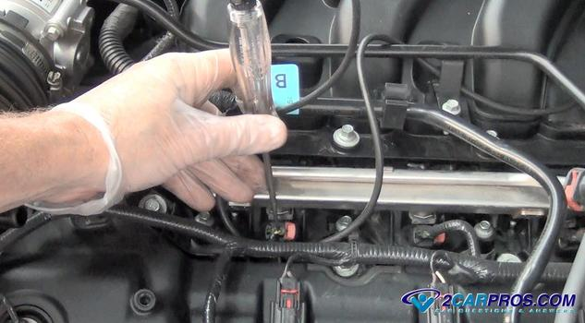

Fig: 4.1 Fuel Injector Testing
- Fuel injector Testing
- Observe audible clicking confirming injector operation
- Check trigger signal output from the PCM
- Confirm the injector has power
- Test the coil windings resistance using a volt meter
- Confirm injector valve operation
- Inspect the injector casing for leaks
- Check flow and spray pattern
- Simple Test
  - Start the engine and allow it to idle. Using a long metal rod like a screwdriver touch the end of the screwdriver to the injector. Gently lay an ear to the opposite end of the rod or handle to observe an audible clicking sound to confirm the injector is working.
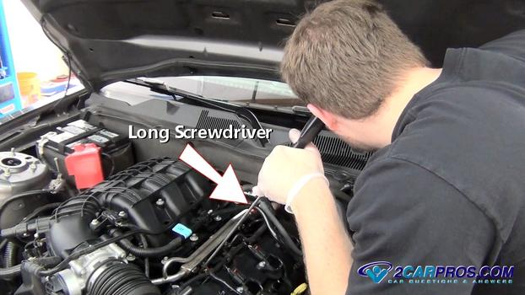
Fig 4.2 Injector Circuit Power Test
- With the key in the on position use a test light or voltmeter connected to the negative side of the battery.
Gently probe both sides of the injector wiring connector, one of the wires should react by registering around 12 volts on the meter or illuminating the test light.
If neither wire reacts test the fuel injector fuse in the PDC. If the fuse is okay a fuel injection wiring diagram is needed to help trace the wire and repair the connection.
Seal test points with a small dab of silicone rubber once testing is complete.

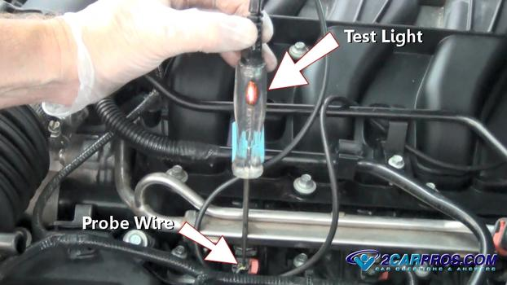
Fig 4.3 Injector Ground Trigger Test
- The PCM closes the injector circuit to trigger the injector operation. For this a test light works best to observe the pulse produced by the PCM.
Attach the test light lead to the positive side of the battery and have a helper start or crank the engine.
Probe the opposite side of the injector connector from the power circuit, you should observe the test light flicking which will respond to engine RPM/Load.
If the engine is running and no pulse is observed suspect a bad wiring connection or a failed PCM injector driver which will warrant a PCM replacement.

A shorted injector can hinder the injector driver operation for additional injectors, unplug all injectors and re-test the signal.
If pulse returns plug the injectors back in one at a time until the pulse fails then replace the shorted injector.
If the engine is not running check the crankshaft angle sensor which the computer uses to open the injectors (Note: A failed crankshaft angle sensor will not set a trouble code in most cases).

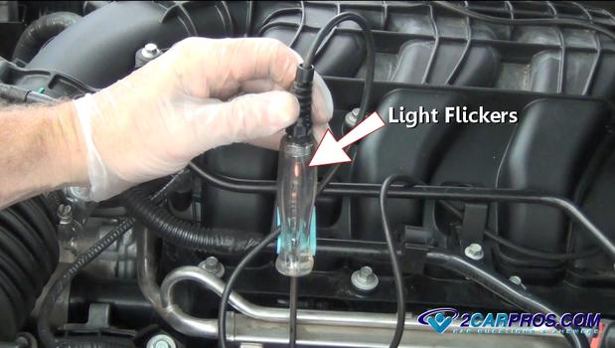
Fig 3.4 Fuel Injector Winding Test (key off)
- Using a voltmeter, adjust the setting to ohms. This test can be performed with the injector installed or uninstalled. 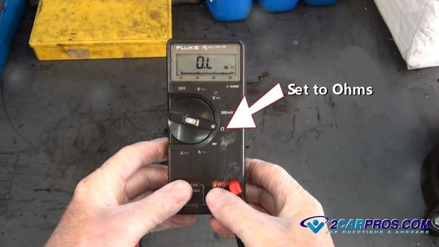
Fig 3.5 voltmeter, adjust the setting to ohms

- Remove the injector electrical connector
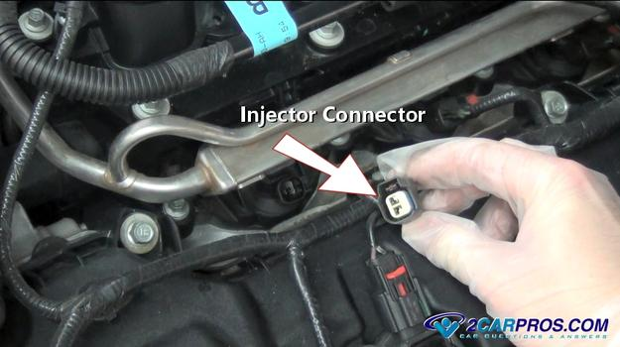
Fig 3.6 Remove the injector electrical connector
      - This will expose the injector electrical terminals.
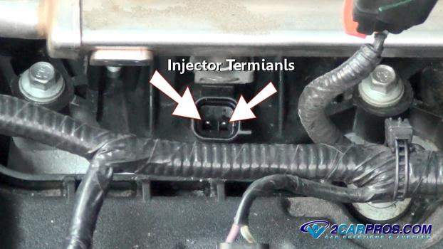
fig 3.7 injector electrical terminals
Connect the voltmeter leads to the terminals, the polarity of the leads is irrelevant. This test gives a baseline ohm reading of all injectors, a service manual also has this information. Most injector readings should range between 11 and 24 ohms. Fuel injectors should be tested cold unless otherwise specified, temperature variances will change the readings. If the test shows high resistance or an open circuit the injector needs replacement.
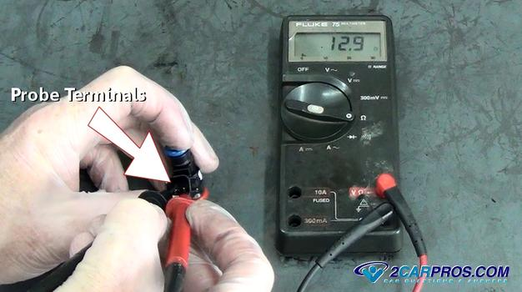
Fig 3.8Connect the voltmeter leads to the terminals

4.2 Injector Spray Pattern Test
- For this test the injector must be removed. Inspect the injector housing for leaks and electrical connectors for corrosion.
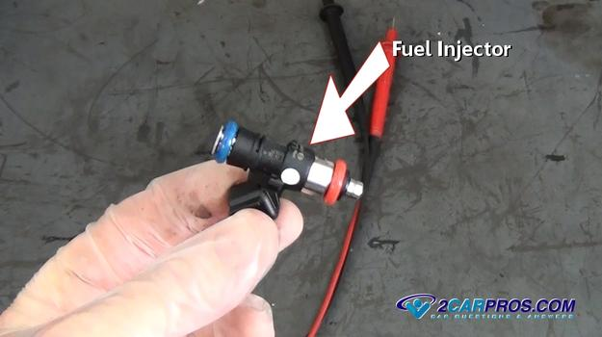
Fig 3.9 Injector
The valve and spray pattern is the most important part of testing a fuel injector. Valve testing can be done with the injector still installed using a fuel pressure gauge while hot wiring the fuel pump to stay on. Carefully attach a 12 volt power (power and ground)
- source to the injector, you should be able to see the gauge fluctuate as you connect and disconnect the circuit if the injector valve is working and not plugged.
- To check the injector spray pattern the injector must be removed. Attach pressurized air to the injector inlet. Attach a 12 volt power and ground source to energize the injector. Compressed air should be released from the outlet valve with traces of fuel still remaining from the injector (use fire precautions). Observe the pattern which should be robust, if the pattern is muted the injector should be replaced. 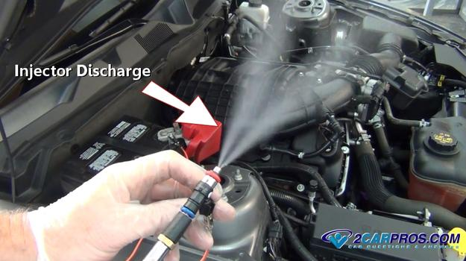
Fig 3.10 Injector Spray Pattern Test
- Steps on how to test fuel pressure and flow
Replacing a fuel pump can become a costly mistake if it is not the true cause of a fuel related problem. A fuel system should be carefully tested for pressure, volume, and electrical integrity before condemning the fuel pump.

Step 1: Safety first
Let’s take a look at fuel pressure and flow testing on a return fuel delivery system. Before you get started performing any diagnostic tests, the most important thing to remember is that releasing fuel under pressure can cause fire and injury. So put safety first. Wear safety glasses and gloves, work in a well-ventilated area, and don’t smoke or have anything around that can cause a spark.

Step 2: Fuel pressure
First, check the fuel pressure. Start the car and let it idle. Install a fuel pressure gauge, run the pump, and note the pressure reading. Then compare it to the manufacturer’s specification. If the pressure is low, you should address that problem. If the fuel pump is
supplying sufficient pressure, perform a fuel volume test to determine if the proper amount. 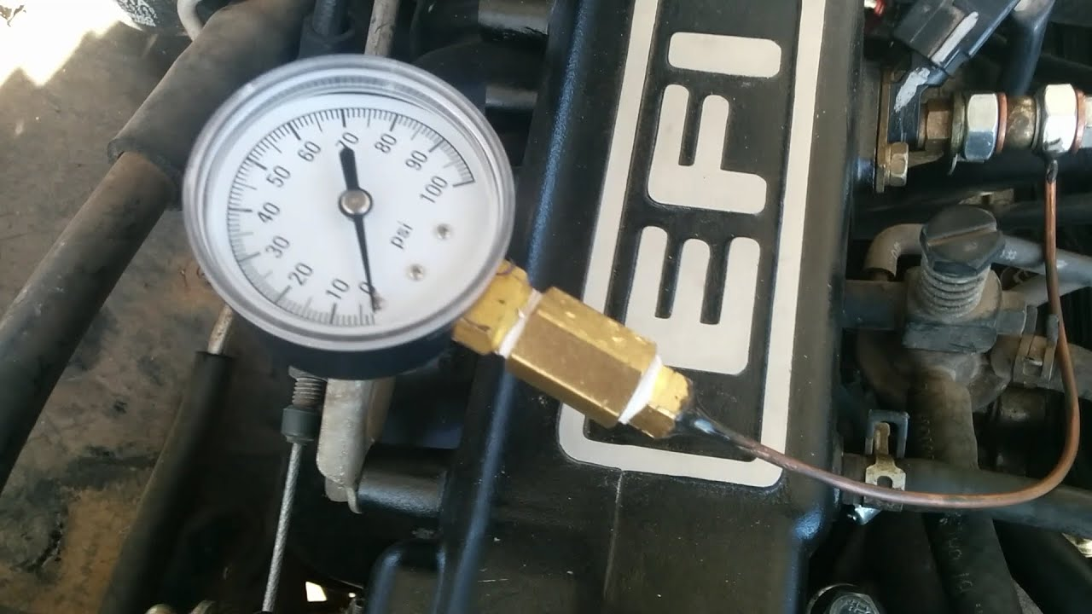

Fig 4.11 check the fuel pressure

Step 3: Use a flow-meter or glass measuring container
The most accurate way to test fuel delivery is by using a flow-meter. But while some repair facilities may have that, you may not. So here’s a pretty reliable way to perform a timed fuel delivery test. Make sure to be careful and use an appropriate measuring container. Glass is a
good choice because fuel can corrode or fog up plastic. 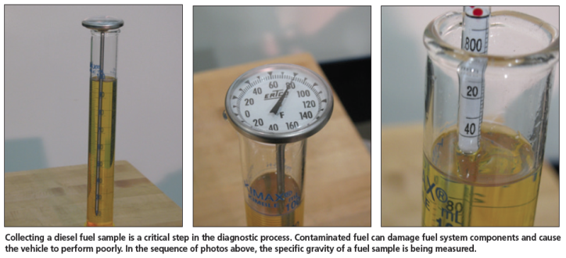

Fig 4.12 glass measuring container

Step 4: Test
Starting up the car will signal the pump to run, so start the car and let it idle. You’ll have to collect a fuel sample for five seconds with the pump running. The pump should deliver a specific amount of fuel within that time frame—check your manufacturer’s specification to see if your pump is delivering the right amount and your system is working properly. You might have to convert milliliters per second to gallons per hour in order to figure that out.
- Bosch Denso Delphi Simons Code Generating Common Rail Injector Tester
Common rail injector tester for testing common rail diesel fuel injectors, generating code for Bosch Denso Delphi common rail injector, small size, easy for transportation, remote controlling for software updating.

Description Bosch Denso Delphi Simons Code Generating Common Rail

Injector Tester Advantage:
Coding Injectors for Bosch, Denso, Delphi, Siemens common rail injectors.
- BIP function: checking the solenoid valve responding time.
- Common rail injector inductance test.
Technical parameter of the injector calibration machine:
- Output power: 2.6KW
- Rotation speed controlling: inverter
- Power supply: 220V 50/60HZ
- Fuel tank: 8 liters
- Fuel temperature controlling: 40±2℃
- Filtration: less than 5μm
- Machine size: 700×600×670 mm
- Weight: 110kg
- Flow sensor of the injector tester: imported flow sensor
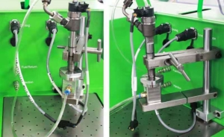
Fig.4.13 Common rail injector test bench feature

4.3. Common rail injector test bench feature:
1. Industrial computer real-time control, Windows operating system, built-in display, touch screen operation.
2. Full-automatic operation, high precision, automatically setup test plans, multiple protection of the injector tester machine.
3. Real-time display of fuel injection and back-flow curve, automatic testing the fuel quantity of all working conditions, automatic generation of report after testing.
- Diesel injector test equipment function:
1. Equipped with bosch genuine cp3 pump, which can drive various solenoid valve common rail injectors and piezoelectric crdi injectors, testing the fuel quantity under different working conditions.
2. Accurately distinguish the injectors ‘defaults, for example, missing cylinders, knock cylinders, or speed limiters when the injector working on the engine.
3. Testing diesel fuel can be heating or cooling automatic
4. Cleaning the common rail injectors by high pressure flushing.
5. The common rail injector tester has the short-circuit protection, ground protection, over pressure protection during the testing.
6. Software advantage: intelligent algorithm is used on this injector tester machine, to automatically calibrate the fuel quantity of the new injector, and generate test plan after calibration.
7. Automatic measurement of the common rail injectors under different working conditions, automatic analysis of measurement results, and generation of reports
8. User can customize parameters such as rail pressure, pulse width, and fuel injection time when using this diesel fuel injector tester.
9. Data backup, system software and function upgrade by remote control.
10. Frequency inverter equipped to achieve testing function under different speed conditions
11. Testing data same as bosch, denso, delphi original data, and accuracy can reach the original level
12 The precision filter is used before fuel comes to flow sensor, can effectively keep the
13 Sensor clean and sensor usage life.
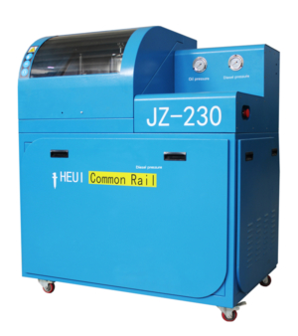
Fig 4.14 JZ230 Common Rail Diesel Injector tester And Caterpillar HEUI Injector Tester
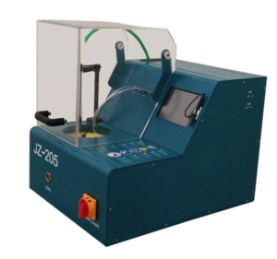

Fig4.15 Economic Model Common Rail Injector Tester
- EFI Fuel Injector Testing and Cleaning.
1. WARM UP ENGINE: Allow the engine to warm up to normal operating temperature (THW is less than 1 volt).
2. While the engine is running disconnect the supply fuel line from the fuel tank, let the engine stop. This is to remove the fuel pressure in the fuel rail.
3. Turn the engine switch OFF.
4. Disconnect the fuel injector connector.
5. Disconnect fuel line from the fuel rail.
6. Disconnection pressure regulator hose.
7. Loosen and remove the bolts of the fuel rail.
8. Full the fuel rail slowly so that the injector O-ring will not be damage. If it is hard to remove spray with penetrating oil on the mounting port of the injector against the manifold runner.
9. Remove the fuel injector from the rail by removing the clip Injectors Connector
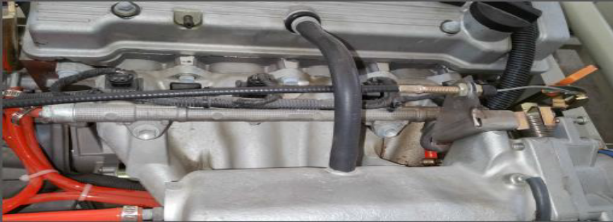
Fuel Rail Fuel Rail Bolts

Fig.4.15.1fuel hose test indication
Figure 4 .16 EFI Fuel Injector Testing and Cleaning.

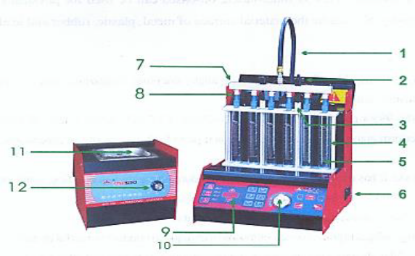
4.4 Fuel Injector Analyzer and Cleaner
1. Fuel Hose
2. Standard Nut
3. Turn Buckle
4. Tube Stand
5. Test Tube
6. Power Switch
7.Standard Feed Fuel Block
8.Injector Connector
9. Keypad
10. Gauge
11. Launder
12.Ultrasonic Timer
Keypads:
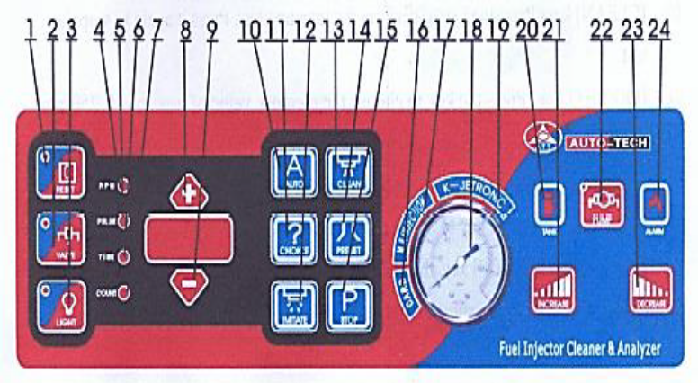
Fig.4.17 Fuel Injector Analyzer and Cleaner

Operation [reset] key: press the key, the unit will turn back to its initial setup. [Valve] key: press the key, the unit begins to back drain the liquid, and the valve indicator comes on.
Press it again, the pump stops and the indicator turns off. [Light] key: press the key, the backlight comes on.
Press it again, the backlight turns off. [Rpm] indicator: when the indicator comes on, the screen will display the frequency value.
[Pulse] indicator: when the indicator comes on, the screen will display the pulse width value. [Time] indicator:
when the indicator comes on, the screen will display the timed value. [Count] indicator: when the indicator comes on, the screen will display the injecting times.
[+] key: press the key to increase the value. [-] key: press the key to decrease the value. [Auto] key: press the key, the unit will auto conduct the test, cleaning and analysis (note: adjust the pressure to specific range before cleaning).
[Choice] key: press the key to display the in-order parameters: rpm, pulse, time and count. When the indicator comes on, the screen will display the corresponding value. for example, when the pulse indicator comes on and the screen displays 03.00, it means the pulse width is 3ms; when the rpm indicator comes on and the screen display 0750, it means the rpm is 750r/min. press [+] key to increase the value, and press [-] key to decrease the value. [Imitate] key: press the key, the unit will begin to conduct the memory program. Press [stop] key to stop during test.
And press [imitate] key again to continue the test. [Clean] key: press the key to perform the injecting test. Press it again to stop the test. [Preset] key: press the key to choose the memory value of low speed: 750rpm; medium speed value: 3200rpm; high speed: 5600rpm; the corresponding pulse width is 3ms, 12ms and 5.8ms.
The corresponding time is 320s, 37s, 32s. [Stop] key: press the key to stop the system running.
During the procedure of test, every time press [stop] key, the system will enter the next program. Carb: display the pressure of carburetor. M.p.
injection: display pressure of multi-points injection pressure gauge: display the fuel pressure of system. K-Getronics: display the pressure of single point and mechanical injection. [Tank]: it is a test fluid level indicator. When the red indicator comes on, it means the liquid level is very low and needs to charge. [increase] key: press the key to increase the value of the system pressure 22] [pump] key:
press the key, the system begins to provide test liquid, and the pump indicator comes on. Press it again, the pump stops and the indicator turns off when the pump is running but the unit System is not in work state, the pump will be protected then automatically stop running.
[Decrease] key: press the key to decrease the value of the system pressure. [Alarm] indicator: when the indicator come~ on, it means the climate and system temperature is over-heat, so stop the test at once.
Note: if keeping press [decrease] key for long time and at the same time you start the pump, pressure will be change to zero. In this case must press [increase] key and the gauge will display the current reading.
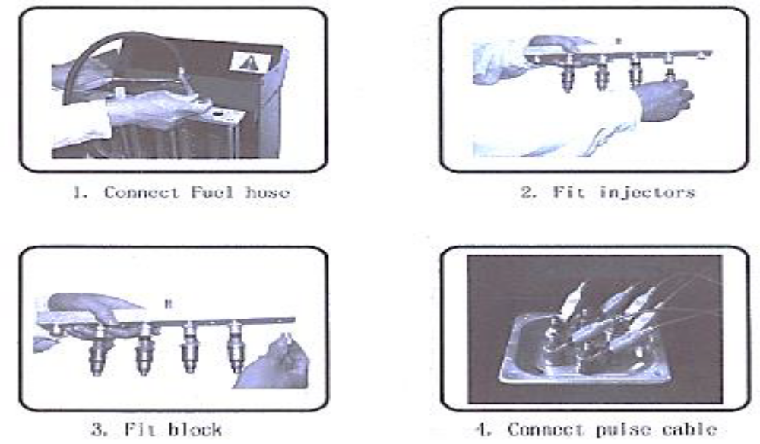
Fig.4.18 Injector Installation

Self-check 4
Directions: Answer all the questions listed below.
Part - 1
- While discussing IAC valve diagnosis: Technician A says that on some vehicles, a jumper wire maybe connected to specific DLC terminals to check the IAC valve operation. Technician B says that if the scan tester indicates zero IAC valve counts, there may be an open circuit between the PCM and the IAC valve. Who is correct?
a. Technician A
b. Technician B
c. Both A and B
d. Neither A nor B
2 While discussing a high idle speed problem: Technician A says that higher-than-normal idle speed may be caused by low electrical system voltage. Technician B says that higher-than- normal idle speed may be caused by a defective coolant temperature sensor. Who is correct?
a. Technician A
b. Technician B
c. Both A and B
d. Neither A nor B
3. While discussing IAC motor removal, service and replacement: Technician A says that throttle body cleaner may be used to clean the IAC motor internal components. Technician B says that on some vehicles, IAC motor damage occurs if the pintle is extended more than specified during installation. Who is correct?
a. Technician A
b. Technician B
c. Both A and B
d. Neither A nor B
4. While discussing the causes of a rich air-fuel ratio: Technician A says that a rich air-fuel ratio may be caused by a faulty fuel rail pressure sensor. Technician B says that a rich air-fuel ratio may be caused by a defective coolant temperature sensor. Who is correct?
a. Technician A
b. Technician B
c. Both A and B
d. Neither A nor B
4. While discussing injector testing: Technician A says that a defective injector may cause cylinder misfiring at idle speed. Technician B says that restricted injector tips may result in acceleration stumbles. Who is correct?
a. Technician A
b. Technician B
c. Both A and B
d. Neither A nor B
5. While diagnosing an idle speed problem: Technician A says that higher-than-normal TP signals at idle will cause the IAC to close, which will decrease idle speed. Technician B says that if the resistance of the ECT is too low, a lower-than- normal voltage signal is sent to the PCM, which interprets this as a hot engine and will close the IAC to decrease speed. Who is correct?
a. Technician A
b. Technician B
c. Both A and B
d. Neither A nor B
5. While discussing airflow sensors: Technician A says that with mass airflow and volume airflow
sensor systems, if any air bypasses the sensors, the engine will run lean. Technician B says that vacuum leaks in a speed density system will decrease injector pulse width. Who is correct?
a. Technician A
b. Technician B
c. Both A and B
d. Neither A nor B
6, . While looking at fuel trim values: Technician A says that restricted or dirty injectors may be
evident by a negative
LTFT .Technician B says that a faulty fuel pressure regulator may result in a negative LTFT.
Who is correct?
a. Technician A
b. Technician B
c. Both A and B
d. Neither A nor B

Operation Sheet 4.1 Precautions for Removing and Reinstalling Parts

Operation Title: Identify sensor mounting location
Purpose: Precautions for Removing and Reinstalling Parts is working properly
Conditions for the operations:
- Safe working area
- Properly operated tools and equipment
- Appropriate working cloths fit with the body
Equipment Tools and Materials:
- Sensor
- Flaring nut
Quality Criteria: Assured performing of all the activities according to the procedures
Precautions:
- Wearing proper clothes, eye glass, glove
- Make working area hazard free
- Read and interpret manual which guide you how to use tools and equipment
Hoses secured by clamps are cut to length from bulk material. To remove the fuel line:
- Clean the sensor
- Disconnect the sensor at the vehicle connection using two wrenches.

Inspecting sensor
Procedure:
Instructions: Record the voltage input (source voltage) of the ECU and voltage output
(signal voltage) of the following sensors: Instruction:
The common-rail system consists of precision parts and uses highly pressurized fuel. Therefore, extreme care must be taken to ensure that foreign matter does not enter the system.
1. Thoroughly clean and wash the work area to remove any dirt or rust before disassembling any parts in order to prevent the interior of the fuel system from becoming contaminated during disassembly.
2. Place the parts in plastic bags to prevent the entry of foreign matter and to protect the sealing surfaces from damage during storage.
3. Thoroughly clean the parts before assembly, making sure that their sealing surfaces are free of foreign matter such as dust or cutting chips.

LAP Test

Practical Demonstration
Name: __________________________ Date: ____________
Time started: _________________ Time finished: _______________
Instruction: Perform the following tasks
- EFI Fuel Injector Testing and Cleaning step
- fuel Rail, injector, and Regulator Service
- Service EFI components.
- Repairer electronic fuel injection.
- Injector Spray Pattern Test

Reference
- Automotive technology A Systems Approach 7th Edition
- Jack Erjavec, (2010) Automotive Technology: A Systems Approach, 5th Edition
- James D. Halderman, (2012) Automotive Technology Principles, Diagnosis, and Service 4th Edition Nicholas Goodnight and Kirk Van Gelder, (2010) Automotive Engine Repair
- Tim Gilles (2005) Automotive Service: Inspection, Maintenance, Repair, 5th Edition
- Tim Gilles (2011) Automotive Engines: Diagnosis, Repair and Rebuilding, 6th EditionVehicle
- Maintenance and Repair Manual

