
Automotive Electricity and Electronics Level -III
Based on October 2023, Curriculum Version- II
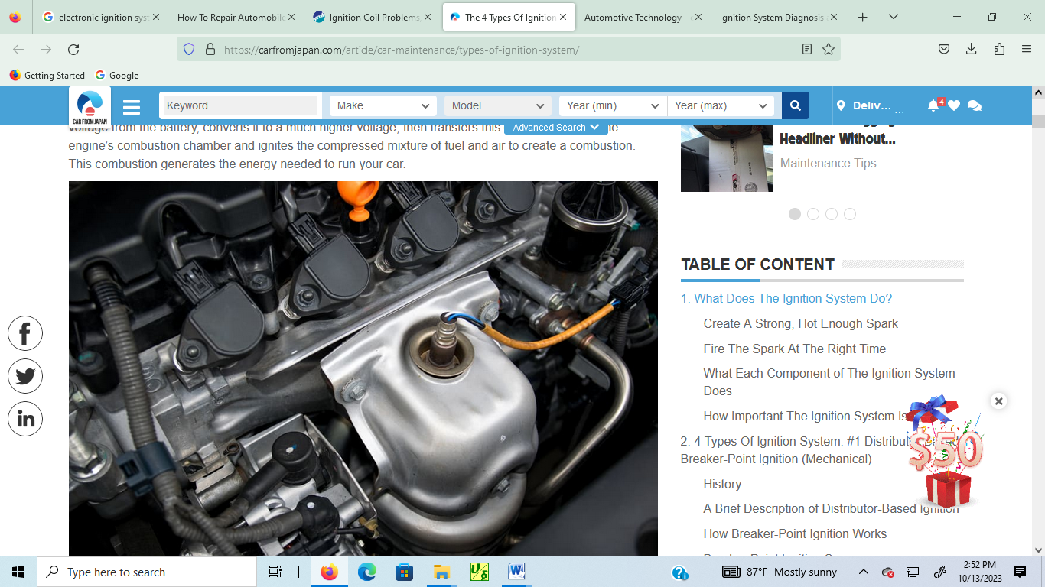
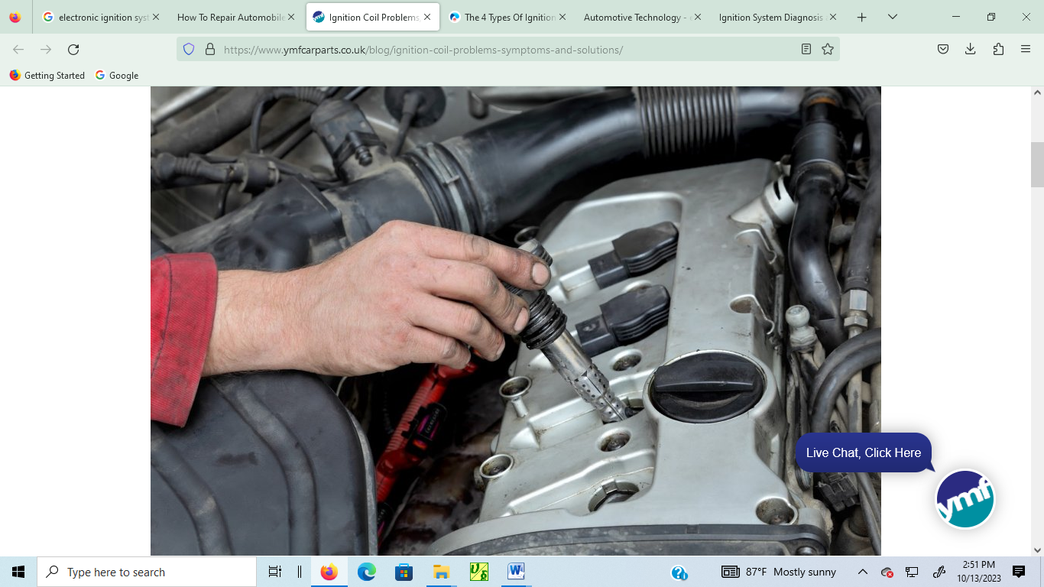

MODULE TITLE : Electronic Ignition Systems
MODULE CODE : EIS AEE3 M02 1023
NOMINAL DURATION : 40 Hours
Prepared by: Ministry of Labor and Skill

October, 2023
Addis Ababa, Ethiopia

Acknowledgment
Ministry of Labor and Skills wish to extend thanks and appreciation to the many representatives of TVT instructors and respective industry experts who donated their time and expertise to the development of this Training Module.

Acronym
CAN Control Area Network
COP Coil on Plug
DI Distributor ignition system
DIS Direct Ignition System
DIS Distributorless Ignition System
DMM Digital Multimeter
DTC Diagnostic Trouble Codes
ECM Engine Control Module
EI Electronic Ignition
ESA Electronic Spark Advance
IGF Ignition Confirmation
IGT Ignition Timing
LED Light Emitting Diode
OHS Occupational Health and Safety
OSHA Occupational Safety and Health Administration
VAST Variable Advance Spark Timing

Table of content
Unit One: Overview of Electronic Ignition Systems 6
1.1 Tools & Equipment 7
1.2 Operating principles of electronic control ignition/Transistorized/ systems 10
1.3 Type of electronic control ignition systems 17
1.4 OHS requirement on electronic ignition systems 24
Self-check 1 26
Unit Two: Inspecting and testing electronic controlled ignition systems 27
2.1 Inspecting and testing procedures 28
2.2 Testing Electronic controlled Ignition systems components 36
Self-check 2.1 Error! Bookmark not defined.
Operation Sheet 2.1 45
Operation Sheet 2.2 46
Operation Sheet 2.3 47
Operation Sheet 2.4 48
LAP Test: 2 49
Unit Three: Service/repair electronic spark ignition system component 50
3.1 Service/repair Procedures 51
3.1 Post servicing 56
3.2 Cleaning and storing equipment and work area 58
Self-check 3 63
Operation Sheet 3.1 64
Operation Sheet 3.2 65
LAP Test :3 66
Reference 67

Introduction to Module
In automotive electrical electronics field, electronic ignition system is very important system for delivering high voltage spark for modern car. As the name indicates “Electronic” the system is fully controlled electronically, so electronic ignition system is developed to improve reliability, improve mileage and decrease emission.
In this module to service/repair electronic spark ignition engine management systems and associated components. It helps to performing activities to develop the skill in testing/checking resistance, supply voltage and continuity of control module, ignition coil, Igniter and sensor; inspecting/testing and replacing spark plugs.
This module covers the units:
- Overview of electronic ignition systems
- Inspecting and testing electronic controlled ignition systems
- Service/repair electronic spark ignition system component
Learning Objective of the Module
- Understand overview of electronic ignition systems
- Inspect and test electronic controlled ignition systems
- Service/repair electronic spark ignition system component
Module Instruction
For effectively use these modules trainee are expected to follow the following module instruction:
- Read the information written in each unit
- Accomplish the Self-checks at the end of each unit
- Perform Operation Sheets which were provided at the end of units
- Do the “LAP test” giver at the end of each unit and
- Read the identified reference book for Examples and exercise

Unit One: Overview of Electronic Ignition Systems
This unit is developed to provide you the necessary information regarding the following content coverage and topics:
  - Tools & equipment
  - Operating principles of electronic controlled ignition systems
  - Classification of electronic control ignition systems
  - OHS requirement on electronic ignition systems
This unit will also assist you to attain the learning outcomes stated in the cover page. Specifically, upon completion of this learning guide, you will be able to:
  - Select Tools & equipment’s
  - Explain & discuss operating principles of electronic control ignition systems
  - Identify classification of electronic control ignition systems
  - Apply OHS requirement on electronic ignition systems

Tools & Equipment
Tool can be any item that is used to achieve a goal. Equipment usually denotes a set of tools that are used to achieve a specific objective. A tool can be non-mechanical as well. However, when one says equipment, there is a certain mechanical aspect to it that cannot be ignored. Tooling and equipment used on electronic ignition up may include:
- hand tools
- testing equipment, including multimeters, ammeters, voltmeters and tachometers
- timing light
- spark plug testers
- insulation testers
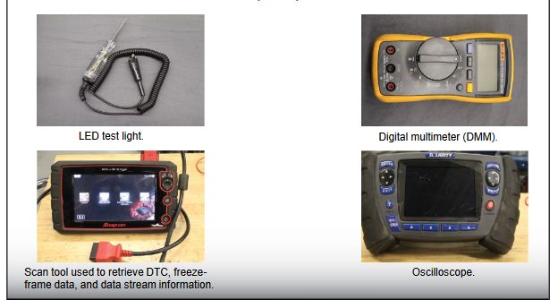
- power tools and air tools
- tune scopes
- engine analysers
- dynamometers
- distributor test bench

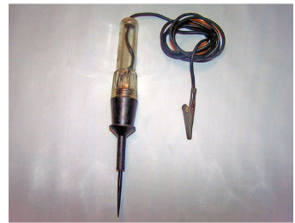
Circuit Tester/Test light: Circuit testers are used to check for voltage in an electrical circuit. A circuit tester, commonly called a test light, looks like a stubby ice pick. Its handle is transparent and contains a light bulb.
A self-powered test light is called a continuity tester. It is used on open circuits. It looks like a regular test light but has a small internal battery. When the ground clip is attached to one end of the wire or circuit and the probe touched to the other end, the lamp will light if there is continuity in the circuit. If an open circuit exists, the light will not illuminate.
Figure 1-2. Circuit Tester/Test light
Ohmmeter
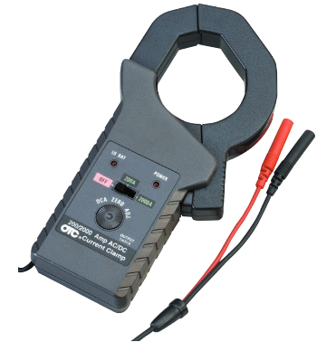
An ohmmeter measures resistance to current flow in a circuit. In contrast to the voltmeter, which operates by the voltage available in the circuit, an ohmmeter is battery powered. The circuit being tested must have no power applied. If the power is on in the circuit, the ohmmeter will be damaged. The two leads of the ohmmeter are placed across or in parallel with the circuit or component being tested. The red lead is placed on the positive side of the circuit and the black lead is placed on the negative side of the circuit. Figure 1-3. An ammeter
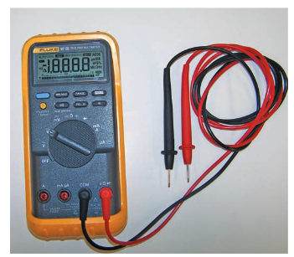
Ammeter
An ammeter measures current flow in a circuit. Current is measured in amperes. Unlike the voltmeter and ohmmeter, the ammeter must be placed into the circuit or in series with the circuit being tested. Normally, this requires disconnecting a wire or connector from a component and connecting the ammeter between the wire or connector and the component.
Figure 1-4. Digital multimeter (DMM)
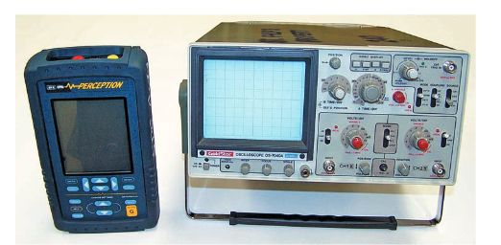
Lab Scopes/ An oscilloscope: an oscilloscope or lab scope is a visual voltmeter. A lab scope converts electrical signals to a visual image representing voltage changes over a specific period of time. This information is displayed in the form of a continuous voltage line called a wave form or trace. Figure 1-5. Lab Scopes/ An oscilloscope
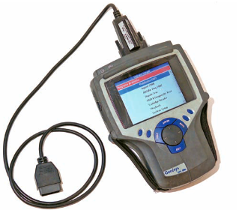
Scan Tools: A scan tool is a microprocessor designed to communicate with the vehicle’s computer. Connected to the computer through diagnostic connectors, a scan tool can access diagnostic trouble codes (DTCs), run tests to check system operations, and monitor the activity of the system. Trouble codes and test results are displayed on a screen or printed out on the scanner printer. Figure 1-6. Scan tool
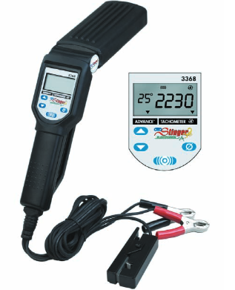
Spark Tester: A spark tester is a fake spark plug. The tester is constructed like a spark plug but does not have a ground electrode. In place of the electrode there is a grounding clamp. Using test spark plugs is an easy way to determine if the ignition problem is caused by something in the primary or secondary circuit. The spark tester is inserted in the spark plug end of an ignition cable. When the engine is cranked, a spark should be seen from the tester to a ground. Experience with these testers will also help you determine the intensity of the spark. Figure 1-7. Spark Tester

Operating principles of electronic control ignition/Transistorized/ systems
The ignition system in today’s vehicles is an integral part of the electronic engine control system. The engine control module (ECM) controls all functions of the ignition system and constantly corrects the spark timing. The desired ignition timing is calculated by the PCM according to inputs from a variety of sensors. These inputs allow the PCM to know the current operating conditions. The PCM matches those conditions to its programming and controls ignition timing accordingly. It is important to remember that there has always been a need for engine speed and load based timing adjustments.
Electronic systems are very efficient at making these adjustments. Many of the inputs used for ignition system control are also used to control other systems, such as fuel injection. These inputs are available on the CAN buses
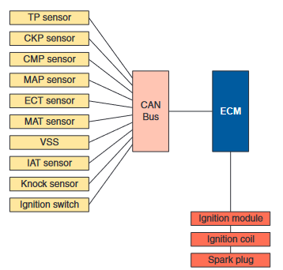
Figure 1-8. Inputs for ignition system
Many of the inputs used for ignition system control are also used to control other systems and are available on the CAN buses.
When the engine is running, timing is calculate based on signal from
- Engine load
- throttle position sensor
- Engine temperature sensor
- Knock sensor etc.
- Engine Stopped: When the ignition switch is turned on, a voltage is applied to point 'P'. This voltage is kept below the base voltage required for transistor operation through voltage division by resistor R1 and R2. As a result, the transistor remains off while the engine is stopped, so no primary current flows through the transistor from the collector (C) to the emitter (E).
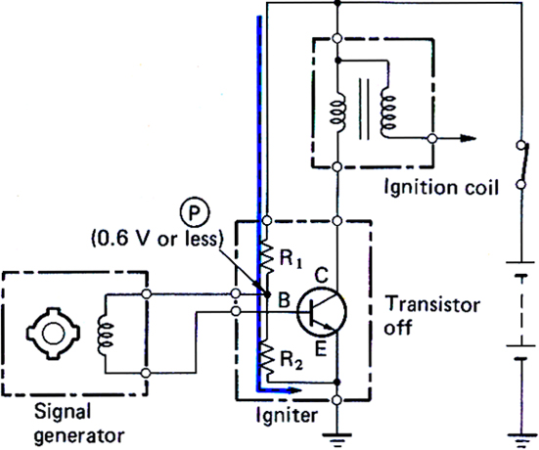
Figure 1-9. Operating principle of electronic spark ignition as engine stopped
- Engine Running (positive voltage generated in the pickup coil)
When the engine is cranked, the signal rotor of the distributor rotates, generating an alternating voltage in the pickup coil. If the generated voltage is positive, it is added to the voltage from the battery at point, 'P' raising the voltage at 'Q' base voltage above the transistor operating voltage, thus turning on the transistor as a result, the ignition coil primary current flows through the transistor from the collector (C) to the emitter (E).

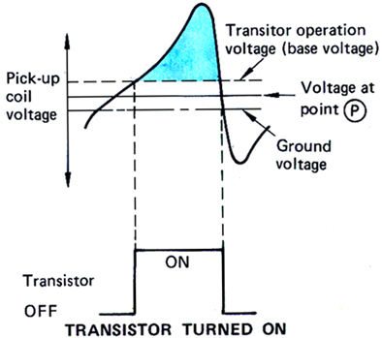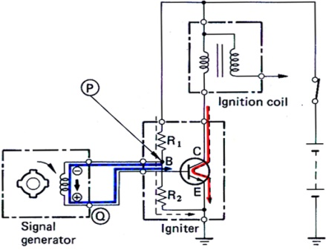
Figure 1-10. Operating principle of electronic spark ignition as engine running
- Engine Running (negative voltage generated in pick-up coil)
When the AC voltage generated in the pick-up coil is negative, this voltage is added to the voltage at point 'Q', so the voltage at point, 'P' decreases below the transistor operating voltage, turning off the transistor. As a result, the ignition primary current is turned off and a high voltage is induced in the secondary coil.
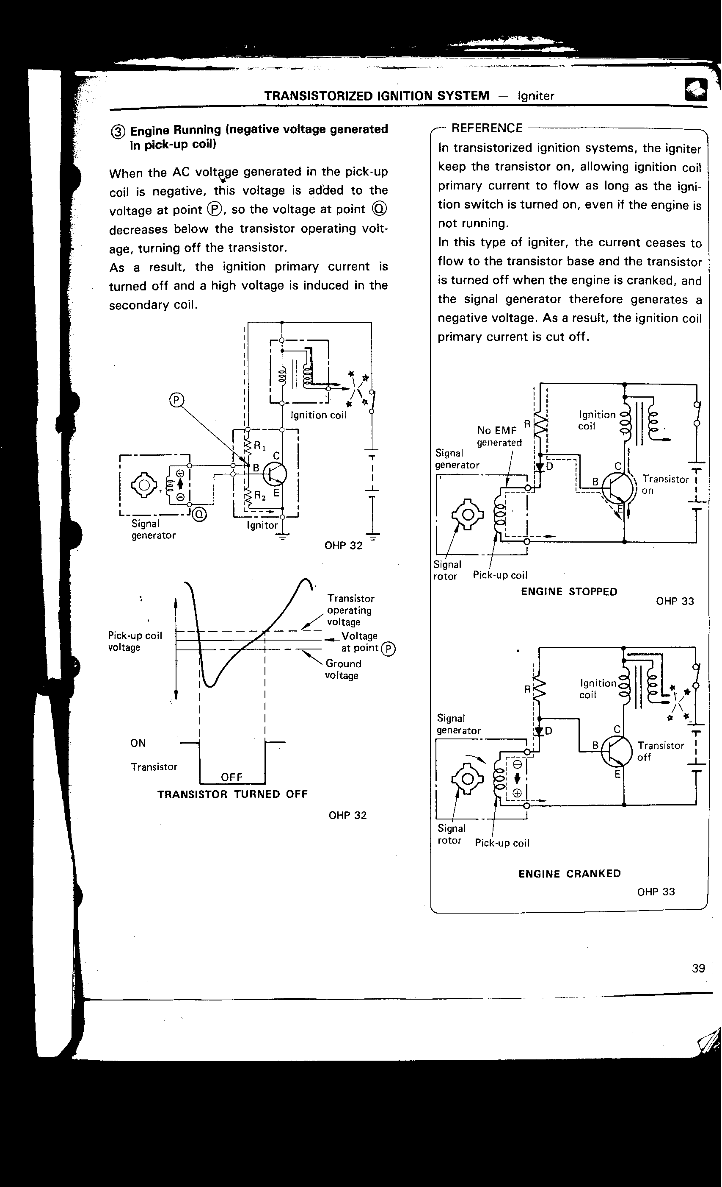
Figure 1-11. Operating principle of electronic spark ignition as engine running

An electronic ignition system in which the function performed by contact breaker points in conventional systems is carried out by an inductive pulse generator. The pulse generator signals are transmitted to a control unit, which regulates the coil charging period.
In Electronic control Ignition system, there are use two versions of electronic spark
Management:
- Electronic Spark Advance (ESA), and
- Variable Advance Spark Timing (VAST)
Electronic spark advance (ESA)
The ESA (Electronic Spark Advance) system is a system that uses the engine ECU to determine the ignition timing based on the signals from the various sensors. The engine ECU calculates the ignition timing from the optimum ignition timing stored in memory to match the engine conditions, and then sends the ignition signal to the igniter. Since the ESA always ensures optimal ignition timing, emissions are lowered and both fuel efficiency and engine power output are maintained at optimal levels
The ESA system consists of the:
- Various sensors
- Engine ECU
- Igniters
- ignition coil and
- Spark plugs.
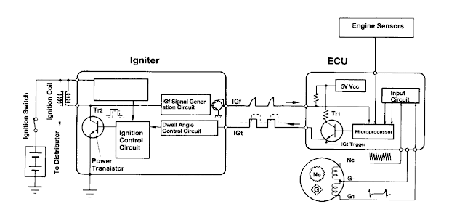
Figure 1-12. ESA ignition system circuit diagrams

Role of the sensors
- Camshaft position sensor (G signal): This detects the standard crank angle and the camshaft timing.
- Crankshaft position sensor (NE signal): This detects the crank angle and engine speed.
- Sensor (VG or PIM signal): This detects the intake air mass or manifold pressure.
- Throttle position sensor (IDL signal): This detects the idling condition.
- Water temperature sensor (THW signal): This detects the coolant temperature.
- Knock sensor (KNK signal): This detects knocking condition.
- Oxygen sensor (OX signal): This detects the oxygen concentration in the exhaust gas.
IGT Signal
The primary coil current flow is controlled by the ECM through the Ignition Timing (IGT) signal. The IGT signal is a voltage signal that turns on/off the main transistor in the igniter. When IGT signal voltage drops to “0” volts, the transistor in the igniter turns off. When the current in the primary coil is turned off, the rapidly collapsing magnetic field induces a high voltage in the secondary coil.
If the voltage is high enough to overcome the resistance in the secondary circuit, there will be a spark at the spark plug.
IGF Signal
The IGF signal is used by the ECM to determine/check if the ignition system is working. Based on IGF, the ECM will keep power supplied to the fuel pump and injectors on most ignition systems. Without IGF, the vehicle will start momentarily, and then stall. However, with some Direct Ignition Systems with the igniter in the coil, the engine will run.

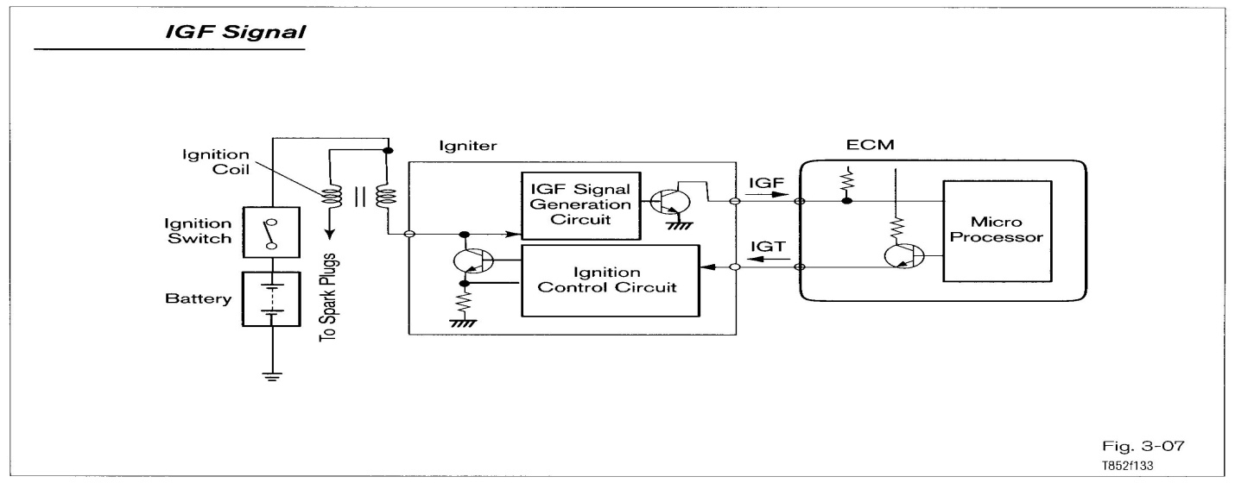
Figure 1-13. IGF signal circuit diagrams
Role of the engine ECU
The engine ECU receives the signals from the sensors, calculates the optimum ignition timing for the engine conditions, and sends the ignition signal (IGT) to the igniter.
Role of the igniter
The primary function of the igniter is to turn on and off the primary coil current based on the IGT Signal received from the ECM. The igniter or ECM may perform the following functions:
  - Ignition Confirmation (IGF) signal generation
  - Dwell angle control,
  - Lock prevention circuit
  - Over voltage prevention circuit
  - Current limiting control
  - Tachometer signal
NB: It is critical that the proper igniter is used when replacing an igniter.
The igniter responds to the IGT signal output by the engine ECU to intermittently apply the primary current to the ignition coil. It also sends the ignition confirmation signal (IGF) to the engine ECU; engine speed and intake air mass (manifold pressure).
Variable Advance Spark Timing (VAST)
When the engine is cranked, an alternating current signal is generated by a four-tooth magnetic pickup in the distributor. This alternating current signal is sent directly to the igniter where it is conditioned into a square wave by a waveform shaping circuit.
While cranking, this square wave signal is sent to the ECU on the Ne wire and to the igniter power transistor. The ignition system delivers spark at initial timing under this condition. When the engine starts and exceeds a predetermined rpm, the ECU begins sending the lGt signal to the igniter. The igniter switches to computed timing mode and uses the IGt signal to operate the power transistor. Timing of IGt is based on information from various engine sensors. Because the VAST system triggers the igniter directly from the magnetic pickup while cranking, the engine will start even if the IGt circuit to the igniter is open. If IGt signals are not received by the igniter once the engine has started, it will continue to run, defaulted at initial timing, using signals from the magnetic pickup.
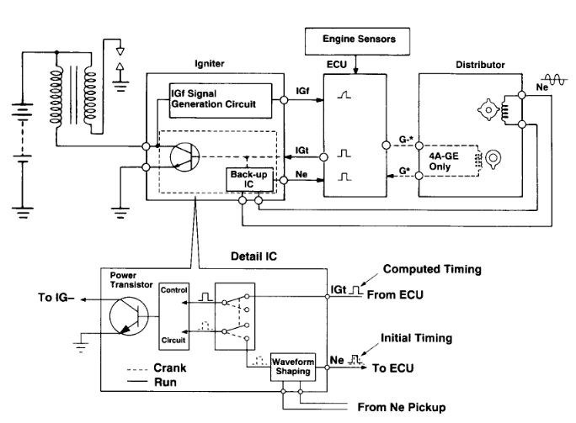
Figure 1-13 VAST ignition system circuit diagrams

Type of electronic control ignition systems
    - Distributor ignition system (DI)
In a distributor ignition system, the high voltage from the secondary winding is delivered to the distributor by an ignition cable. The cable connects the coil with a terminal in the center of the distributor cap. The distributor then distributes the high voltage to the individual spark plugs through a set of ignition cables. The cables are arranged in the distributor cap according to the firing order of the engine. A rotor driven by the distributor shaft rotates and completes the electrical path from the secondary winding of the coil to the individual spark plugs. The distributor delivers the spark to match the compression stroke of the piston. The distributor assembly may also have the capability of advancing or retarding ignition timing.
The primary circuit of a DI system is controlled by a triggering device and a switching device located inside the distributor or external to it. Although these systems are no longer used by auto makers, there are many of them still on the road and they need service. The reluctor, or trigger wheel, and distributor shaft assembly rotate on bushings in the aluminum distributor housing. A roll pin extends through a retainer and the distributor shaft to hold the shaft in place in the distributor. Another roll pin is used to fasten the drive gear to the lower end of the shaft. This drive gear typically meshes with a drive gear on the engine’s camshaft.
The gear size is designed to drive the distributor shaft at the same speed as the camshaft, which rotates at one-half the speed of the crankshaft. Through the years there have been many different designs of DI systems. All operate in the basically the same way but are configured differently. The systems described in this section represent the different designs used by manufacturers. These designs are based on the location of the electronic control module (unit) (ECU) and/or the type of triggering device used.
- DI systems with internal ignition module
- DI systems with external and remote ignition module
- DI systems with the ignition modules mounted on the distributor
Computer-Controlled DI Systems: After the manufacturers eliminated the mechanical and vacuum advance mechanisms on their distributors, the ECM or PCM controlled ignition timing. This allowed form more precise control of ignition timing and provided improved combustion. The PCM adjusted the ignition timing according to engine speed, engine load, coolant temperature, throttle position, and intake manifold pressure. These systems varied with application and used a variety of triggering devices.
The NE signal is generated by the Crankshaft Position Sensor (also called engine speed sensor). The G signal is generated by the Camshaft Position sensor that may be located in the distributor or on the engine. At the appropriate time during cylinder compression, the ECM sends a signal called IGT to the igniter. This will turn on the transistor in the igniter sending current through the primary winding of the ignition coil. At the optimum time for ignition to occur, the ECM will turn off IGT and the transistor will turn off current flow through the primary winding. The induced current will travel through the coil wire, to the distributor cap, rotor, to the distributor terminal the rotor is pointing at, high tension wire, spark plug, and ground. The rotor position determines the cylinder that receives the spark.
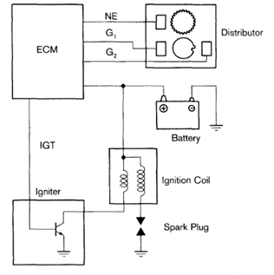
Figure 1-14 Distributor Ignition (DI) Systems circuit diagrams
    - Electronic Ignition/ Distributorless Ignition System (DIS)
Electronic ignition (EI) Systems has no distributor; spark distribution is controlled by an electronic control unit and/or the vehicle’s computer. Instead of a single ignition coil for all cylinders, each cylinder may have its own ignition coil, or two cylinders may share one coil. The coils are wired directly to the spark plug they control. An ignition control module, tied into the vehicle’s computer control system, controls the firing order and the spark timing and advance.
Distributorless ignition systems are capable of producing much higher energy than conventional ignition systems. Since DI and EI systems are firing spark plugs with approximately the same air gap across the electrodes, the voltage required to start firing the spark plugs in both systems is similar. Very few newer engines are equipped with a distributor; rather they have electronic ignitions. In the past, the term electronic ignition was designated to those ignition systems that used electronic controls. Today, electronic ignitions are those that do not use a distributor. Eliminating the distributor improved reliability by reducing the number of mechanical components.
There are many advantages of a Distributorless ignition system over one that uses a distributor. Here are some of the more important ones:
- Elimination of a rotor and its subsequent resistance.
- No moving parts and therefore requires little maintenance.
- It is possible to control the ignition of individual cylinders to meet specific needs.
- Flexibility in mounting location. This is important because of today’s smaller engine compartments.
- Reduced radio frequency interference because there is no rotor to cap gap.
- Elimination of a common cause of ignition misfire, the build-up of water and ozone/nitric acid in the distributor cap.
- Elimination of mechanical timing adjustments.
- Places no mechanical load on the engine in order to operate.
- Increased available time for coil saturation.
- Increased time between firings, which allows the coil to cool more.
All of the above reduces the chances of cylinder misfires and consequently, exhaust emissions. Distributorless Ignition systems are usually defined as having one ignition coil with two spark plug wires for two cylinders. Distributorless Ignition Systems use a method called simultaneous ignition (also called waste spark) where an ignition spark is generated from one ignition coil for two cylinders simultaneously.
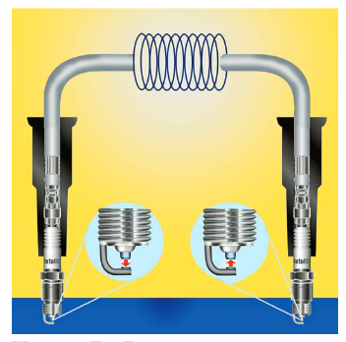
Waste Spark Double-ended coil systems are based on the waste spark method of spark distribution. Both ends of the ignition coil’s secondary winding are connected to a spark plug. Therefore, one coil is connected in series with two spark plugs. The two spark plugs belong to cylinders whose pistons rise and fall together. With this arrangement, one cylinder of each pair is on its compression stroke and the other is on its exhaust stroke when the spark plugs are fired. Figure 1-15 EI system with a double-ended coil.

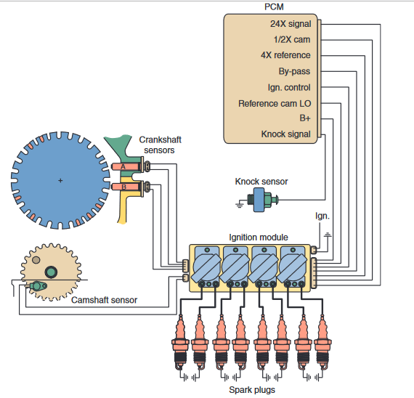
Figure 1-16. Distributorless Ignition System (DIS) circuit diagrams
    - Direct Ignition System (DIS).
Another EI system is the Direct Ignition System (DIS). This system uses a magnetic crankshaft sensor, a reluctor ring cast into the crankshaft, an ignition module, and a coil pack Notches in the reluctor ring are spaced to provide crank position information, as well as information to synchronize coil firing. Use Hall effect switches for both the crankshaft signal and the camshaft signal. A DIS (Direct Ignition System) has been adopted. The DIS improves the ignition timing accuracy, reduces high-voltage loss, and enhances the overall reliability of the ignition system by eliminating the distributor. The DIS in this engine is an independent ignition system which has one ignition coil (with igniter) for each cylinder. Iridium-tipped spark plugs have been adopted.
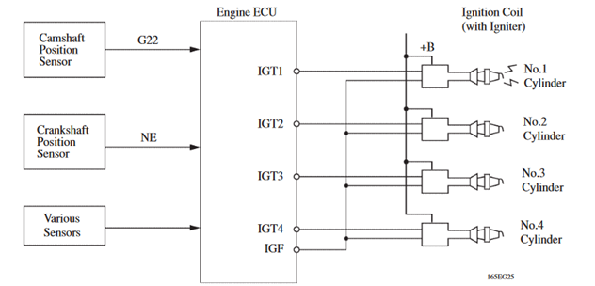
Figure 1-17. Direct Ignition System (DIS)
The DIS provides 4 ignition coils, one for each cylinder. The spark plug caps, which provide contact to the spark plugs, are integrated with an ignition coil. Also, an Igniter is enclosed to simply the system. Iridium-tipped spark plugs have been adopted to realize a 192,000 km (120,000 mile) maintenance-free operation.

Direct Ignition Systems (DIS) have the ignition coil mounted on the spark plug. DIS can come in three forms:
Single spark ignition coil (independent ignition) - one coil per cylinder.
Dual spark ignition coil (simultaneous ignition) - one coil for two cylinders. In this system an ignition coil is mounted directly to one spark plug and a high tension cord is connected to the other spark plug. A spark is generated in both cylinders simultaneously.
Independent ignition with Igniter built in to the coil
A Direct Ignition Systems coil has four terminals:
- Two primary (Bat + and - to ICM)
- Two secondary (each connected to a spark plug)
Each end of the secondary winding is connected to the spark plug of the cylinder exactly opposite the other in the firing order. Both spark plugs fire at the same time (within nanoseconds of each other).
- When one cylinder (for example, cylinder number 6) is on the compression stroke, the other cylinder (number 3) is on the exhaust stroke.
- The spark that occurs on the exhaust stroke is called the waste spark, because it does no useful work and is only used as a ground path for the secondary winding of the ignition coil. The voltage required to jump the spark plug gap on cylinder 3 (the exhaust stroke) is only 2 to 3 kV.
- The cylinder on the compression stroke uses the remaining coil energy.
- One spark plug of each pair always fires straight polarity (from the center electrode to the ground electrode of the spark plug) and the other cylinder always fires reverse polarity (from the ground electrode to the center electrode of the spark plug). Spark plug life is not greatly affected by the reverse polarity. If there is only one defective spark plug wire or spark plug, two cylinders may be affected.
The coil polarity is determined by the direction the coil is wound (left-hand rule for conventional current flow) and cannot be changed.
For example, if a V-6 engine has a firing order of 165432 when one cylinder is on compression, such as cylinder number 1, then the paired cylinder (number 4) is on the exhaust stroke.

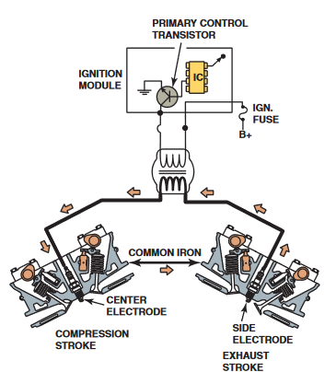
Figure 1-18. Direct Ignition Systems
During the next rotation of the crankshaft, cylinder number 4 is on the compression stroke and cylinder number 1 is on the exhaust stroke.
Cylinder1. Always fires straight polarity (from the center electrode to the ground electrode) one time requiring 10 to 12 kV, and one time requiring 3 to 4 kV.
Cylinder4. Always fires reverse polarity (from the ground electrode to the center electrode), one time requiring 10 to 12 kV, and one time requiring 3 to 4 kV.
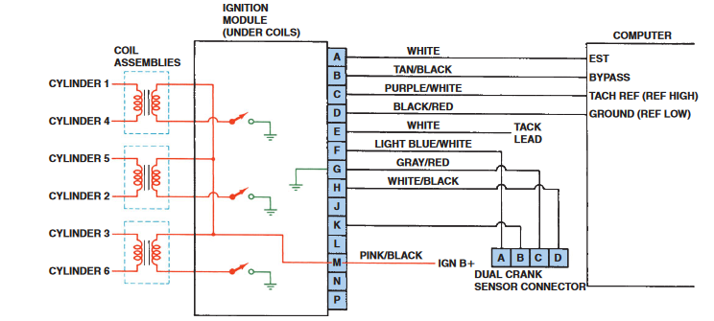
Figure 1-18. Direct Ignition System diagram

OHS requirement on electronic ignition systems
Working with electricity comes with huge risks that should never be taken lightly. If you’re a hobbyist who loves working with electronic components or electronics professional at your workplace, safety should always come first. However, much of your work on an automobile will be around or with the vehicle’s electrical/electronic system. To prevent personal injury or damage to the vehicle, you should always take the necessary precautions before working. When possible, you should disconnect the vehicle’s battery before disconnecting any electrical wire or component. This prevents the possibility of a fire or electrical shock.
It also eliminates the possibility of an accidental short, which can ruin the car’s electrical system. Disconnect the negative or ground cable first, then disconnect the positive cable, because electrical circuits require a ground to be complete, by removing the ground cable you eliminate the possibility of a circuit accidentally becoming completed. When reconnecting the battery, connect the positive cable first, then the negative.
Also, remove wristwatches and rings before servicing any part of the electrical system. This helps prevent the possibility of electrical arcing and burns.
When disconnecting electrical connector do not pull on the wires. When reconnecting the connectors, make sure they are securely connected.
An automotive electrical technician must adhere to the following safety guidelines when working around on electronic ignition system.
- Always wear OSHA-approved safety glasses when working on any electronic ignition system.
- Do not touch or remove ignition cables, the distributor cap, or the spark plug connectors when the engine is running. Use the correct spark plug wire pliers to remove a spark plug wire.
- Use rubber protection gloves while working on high voltage ignition system.
- Always use the right electronics repair and maintenance tools.
- Never assume the power circuit is off. Test and test again with a voltmeter to confirm.
- Remove fuses and replace them only after the power to the circuit is disconnected.
- Don’t connect power to a circuit until you’re done working on it and rechecked the work.
- Don’t ground yourself: Make it a practice to use only one hand when connecting equipment to an electronic circuit.
- Always ensure that all electronics equipment is properly grounded.
- If it’s damaged, replace it. For instance, replace cables instead of repairing with insulating tape.
- Always return covers after removing them to reduce the risk of electric shock.
Hand Tool Safety
Technicians using electric tools must be aware of several dangers. Among the most serious hazards are electrical burns and shocks. Electrical shocks, which can lead to injuries such as heart failure and burns, are among the major hazards associated with electric-powered tools. Under certain conditions, even a small amount of electric current can result in fibrillation of the heart and death. An electric shock also can cause the user to fall off a ladder or other elevated work surface and be injured due to the fall.
The following general practices should be followed when using electric tools:
  - Operate electric tools within their design limitations.
  - Use gloves and appropriate safety footwear when using electric tools.
  - Store electric tools in a dry place when not in use.
  - Do not use electric tools in damp or wet locations unless they are approved for that purpose.
  - Keep work areas well lighted when operating electric tools.
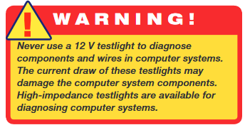

Self-check 1
Directions: Answer all the questions listed below.
Part I: Fill in the blank space
- _________is to turn on and off the primary coil current based on the IGT signal received from the ECM.
- _________Signal is a voltage signal that turns on/off the main transistor in the igniter.
- _________ have the ignition coil mounted on the spark plug
- Distributorless Ignition Systems also called _________
- _________detects the crank angle and engine speed
Part-II: Choose the correct answer from the given alternatives
  - Which one of the following is not the function of igniter?
A. Current limiting control C. Dwell angle control
B. Cold Cranking control D. Tachometer signal
  - ______ is used to allow a voltage signal that turns on/off the main transistor in the igniter.
A. IGf signal C. IDL signal
B. IGt signal D. NE signal
  - Typically in the VAST, Ne signal is sent to ECU and ECU sends IGt signal to Ignite.
      - True B. False
  - When the engine is running, timing is calculated based on signal from.
    - Engine load C. Throttle position
    - Engine temperature sensor D. Knock sensor
  - Simultaneous ignitions have one coil for two cylinders.
A. False B. True
Part-III: Answer the following questions accordingly.
      - Write and explain safety guidelines when working around on electronic ignition system.
      - What is Electronic Spark Advance?
      - Explain in the difference between Independent (Direct) and Simultaneous (Waste Spark) Ignition systems: (include the number of coils used in each)
      - Draw a basic 4 cylinder Independent (Direct) Ignition circuit below
      - Explain in detail the function and purpose of both the IGT, IGF, and IGC signals

Unit two: Inspecting and testing electronic controlled ignition systems
This unit to provide you the necessary information regarding the following content coverage and topics:
- Inspecting and testing procedures
- Testing Electronic controlled Ignition systems components
This guide will also assist you to attain the learning outcomes stated in the cover page. Specifically, upon completion of this learning guide, you will be able to:
- Follow Inspection and testing procedures
- Test electronic controlled ignition systems components

Inspecting and testing procedures
To inspecting and testing ignition systems and their individual components is must be stressed, however, that there are many variations in the ignition systems used by auto manufacturers. The tests covered in this chapter are those generally used as basic troubleshooting procedures. Exact test procedures and the ideal trou- bleshooting sequence will vary among vehicle makers and individual models. Always consult the vehicle’s service manual when performing ignition system service.
Electronic Ignition Troubleshooting Procedure
- If not using an online service, obtain the service manual for the vehicle you are servicing.
- Using the year, make, and model of the vehicle, locate the section that covers the ignition system. This section is usually located within the “Engine Performance” or “Engine Electrical” section; it may also be within the “Engine Controls” section.
- Locate and record the specifications for the pickup sensors, spark plug wires, ignition coil (primary and secondary windings), or any other related component. The specifications will be in ohms or volts, or sometimes in frequency (Hz).
- Print out or write down the specifications for use at the vehicle while you are testing.
- Remove and replace spark plugs; inspect secondary ignition components for wear and damage.
- Typical causes of a no-spark (intermittent spark) condition include the following:
- Weak ignition coil
- Low or no voltage to the primary (positive) side of the coil
- High resistance or open coil wire, or spark plug wire
- Negative side of the coil not being pulsed by the ignition module
- Defective pickup coil
- Defective module
- Periodic replacement of the spark plugs, high-tension leads or coil boots, and possibly the distributor cap and rotor is required to maintain vehicle performance and to meet emission standards. Hard starting, misfiring under load, or high tailpipe emissions may indicate a need for service.

- Inspecting Spark Plugs
Once the spark plugs have been removed, it is important to “read” them. In other words, inspect them closely, noting in particular any deposits on the plugs and the degree of electrode erosion. A normal firing spark plug will have a minimum amount of deposits on it and will be colored light tan or gray.
Two indications and their possible root causes include the following:
  - Carbon fouling. If the spark plug(s) has dry black carbon (soot), the usual causes include:
- Excessive idling
- Slow-speed driving under light loads that keeps the spark plug temperatures too low to burn off the deposits
- Overrich air-fuel mixture
- Weak ignition system output
  - Oil fouling. If the spark plug has wet, oily deposits with little electrode wear, oil may be getting into the combustion chamber from the following.
- Worn or broken piston rings
- Defective or missing valve stem seals
All spark plugs should be in the same condition, and the color of the center insulator should be light tan or gray.
As a spark plug wears, the center electrode becomes rounded. If the center electrode is rounded, higher ignition system voltage is required to fire the spark plug. When installing spark plugs, always use the correct tightening torque to ensure proper heat transfer from the spark plug shell to the cylinder head.
 | Torque with torque wrench  (in lb-ft) |  | Torque without torque  wrench (in turns)
Spark plug | Cast-iron head | Aluminum head | Cast-iron head | Aluminum head
Gasket  14 mm  18 mm | 26-30  32-38 | 18-22  28-34 | 1/4  1/4 | 1/4  1/4
Tapered seat  14 mm  18 mm | 7-15  15-20 | 7-15  15-20 | 1/16 (snug)  1/16 (snug) | 1/16 (snug)  1/16 (snug)

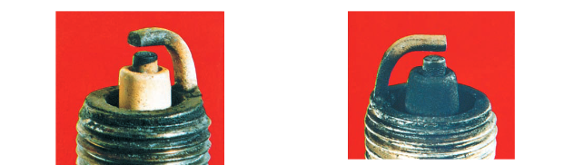
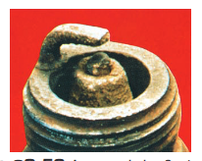
a. Normal spark plug. b. Cold- or carbon-fouled spark plug.
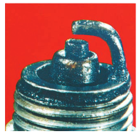
c. worn spark plug. d. wet- or oil-fouled spark plug.
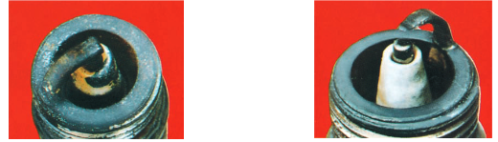
e. splash-fouled spark plug. f. This spark plug shows signs of overheating
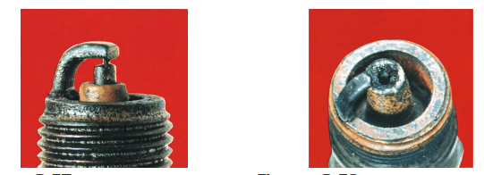
g. There is no longer a gap on this spark plug. h. spark plug with pre ignition damage.
Figure 2-1.a-h spark plug defect
- Clean out the spark plug pocket with compressed air.
- Remove the spark plug, using the correct-sized spark plug socket.
- If the new plugs are equipped with a gasket, ensure they are installed properly. Install the spark plugs by hand to avoid cross threading. Use a torque wrench to properly tighten the spark plug.
- Once the spark plug is installed, reinstall the spark plug wire by pushing it on to the terminal of the spark plug until it snaps into place.
- Replacing the Spark Plug Wires
- Remove one end of the wire (or boot) from the distributor cap, coil pack, or coil-on-plug (COP) coil. Remove the other end from the spark plug with a high-tension wire puller by twisti ng the boot on the spark plug while gently pulling it off
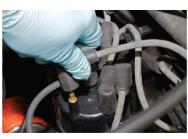
- Install the new spark plug wire by pushing one end onto the spark plug and the other onto the distributor cap, coil pack, or COP coil. The spark plug wires should be routed in their factory positions to prevent damage.

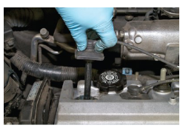
- Inspect ignition system related problems such as no starting, hard starting, engine misfire, poor drivability, spark knock, power loss, poor mileage, and emissions concerns; determine needed action.
        - Step 1
- Turn the ignition on (engine off) and, using either a voltmeter or a test light, test for battery voltage available at the positive terminal of the ignition coil.
- If the voltage is not available, check for an open circuit at the ignition switch or wiring.
        - Step 2
- Connect the voltmeter or test light to the negative side of the coil and crank the engine.
- The voltmeter should fluctuate or the test light should blink, indicating that the primary coil current is being turned on and off.
- If there is no pulsing of the negative side of the coil, then the problem is a defective pickup, electronic control module, or wiring.
- Ignition Coil Testing Using An Ohmmeter
- To test the primary coil winding resistance, take the following steps:

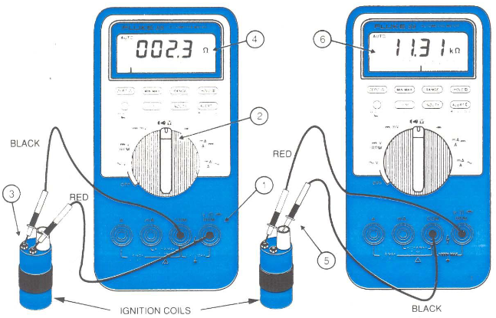

- Pickup Coil Testing
- The pickup coil, located under the distributor cap on many electronic ignition engines, can cause a no-spark condition if defective.
- The pickup coil must generate an AC voltage pulse to the ignition module so that the module can pulse the ignition coil.
- A pickup coil contains a coil of wire, and the resistance of this coil should be within the range specified by the manufacturer.
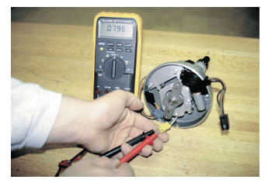
- The pickup coil can also be tested for proper voltage output.
- During cranking, most pickup coils should produce a minimum of 0.25 volt AC.
- This can be tested with the distributor out of the vehicle by rotating the distributor drive gear by hand

- Testing Hall Effect Sensors
- Using a digital voltmeter, check for the presence of charging voltage (pulsed on and off DC) when the engine is being cranked.
- The best test is to use an oscilloscope and observe the waveform.
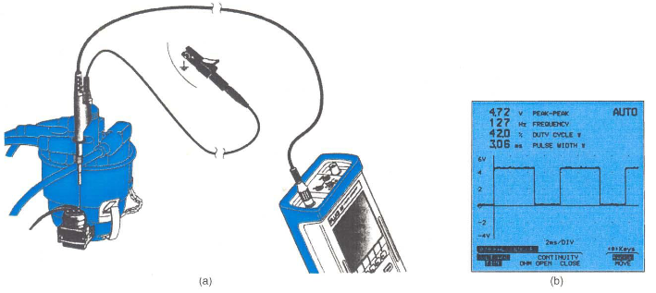
- Ignition System Visual Inspection
- Check all spark plug wires for proper routing. All plug wires should be in the factory wiring separator.
- Check that all spark plug wires are securely attached to the spark plugs and to the distributor cap or ignition coil(s).
- Remove the distributor cap and carefully check the cap and distributor rotor for faults.
- Remove the spark plugs and check for excessive wear or other visible faults. Replace if needed
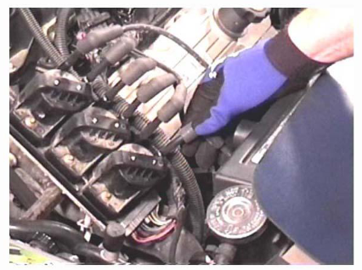
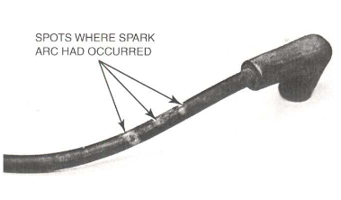
- Spark plug wires should be visually inspected for cuts or defective insulation and checked for resistance with an ohmmeter.
- Inspect a distributor cap for a worn or cracked center carbon insert, excessive side insert wear or corrosion, cracks, or carbon tracks, and check the towers for burning or corrosion by removing spark plug wires from the distributor cap one at a time.
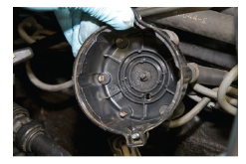

- Check the power supply to the ignition coil.
          - Disconnect the ignition coil connector.
          - Turn the ignition switch ON.
          - Measure the voltage of the wire harness side connector.
Standard voltage
Tester Connection | Specified Condition
1 (+B) - 4 (GND) | 9 to 14 V
Result
Result | Proceed to
NG | NG
OK | Check wire harness and connector

- Check the resistance of the camshaft position sensor.
Standard resistance
Temperature Condition | Specified Condition
Specified Condition | 835 to 1,400 Ω
Cold | 1,060 to 1,645 Ω
- Check the resistance of the crankshaft position sensor
Standard resistance
Temperature Condition | Specified Condition
Specified Condition | 985 to 1,600 Ω
Cold | 1,265 to 1,890 Ω
- Check the IGT signal from the ECM.
- Inspect signal generator (pickup coil) resistance.

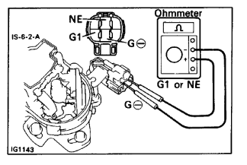

Testing Electronic controlled Ignition systems components
Two important precautions should be taken during all ignition system tests:
- Turn the ignition switch off before disconnecting any system wiring.
- Do not touch any exposed connections while the engine is cranking or running.
Preliminary checks
- Ensure battery condition prior to ignition system analysis.
- Check and confirm good connections at distributor, igniter, and coil.
- Basic secondary leakage checks at coil and coil wire.
Primary circuit checks
- Confirm power supply to igniter and coil positive (+) terminal. Confirm connections at coil positive and negative (-) terminals.
- Using a test light or logic probe, check for primary switching at the coil (-) terminal while cranking engine. Blinking light confirms primary switching is taking place; check coil wire, coil secondary winding resistance, or secondary leakage in distributor cap.
- The power transistor(s) in the igniter get their ground through the igniter case to the vehicle chassis; always confirm good ground continuity prior to trouble shooting.
- Confirm coil primary and secondary windings resistance. Confirm primary windings are not grounded.
- Confirm signal status from Ne and G pickups to ECU (ESA system) or to igniter (VAST system) using an oscilloscope or logic probe.
- If a fault is detected, check pickup(s) for proper resistance and shorts to ground. Check electrical connections.
- If signal amplitude is low, check signal generator gap(s).
- Confirm signal status from ECU IGt circuit to igniter using an oscilloscope or logic probe.
- Check pickup gaps and coil resistances against specifications. If gap and/or resistance is not within specification, replace faulty component.
Visual Inspection of Electronic Ignition Systems
Begin all troubleshoot by gathering as much information as possible from the customer. Then conduct a careful visual inspection. The system should be checked for obvious problems. Although no-start problems and incorrect ignition timing are caused by the primary circuit and the secondary circuit can be the cause of driveability problems and should be carefully checked. In addition to the ignition system, inspect all related electrical connectors or fuses, vacuum lines, air intake system, and cooling system. Also check available service information that may relate to the symptoms.
Symptoms commonly caused by ignition system problems include (keep in mind that the ignition system is not the only thing that can cause these):
- Hard starting—the engine requires an excessive amount of time to start.
- Rough idle—The engine idles poorly and may stall.
- Engine stalling—The engine quits unexpectedly. It may occur right after engine startup, while idling, or during deceleration.
- Hesitation—The engine does not immediately respond to opening of the throttle.
- Stumble—The engine temporarily loses power during acceleration.
- Poor acceleration—The vehicle accelerates slower than expected.
- Surge—The engine’s speed fluctuates with a constant throttle during idle, steady cruise, acceleration, or deceleration.
- Bucking—The vehicle jerks shortly after acceleration or deceleration.
- Knocking (pinging)—The engine makes a sharpmetallic noise during acceleration.
- Backfire and afterfire—Backfire is a loud pop coming from the intake system, usually during rapid throttle opening. Afterfire is a popping that occurs in the exhaust system, usually during quick deceleration.
        - Primary Circuit Test
Primary ignition system wiring should be checked for tight connections. Electronic circuits operate on very low voltage. Voltage drops caused by corrosion or dirt can cause running problems. Missing or broken tab locks on wire terminals are often the cause of intermittent ignition problems due to vibration or thermal related failure.
Test the integrity of a suspect connection by tapping, tugging, and wiggling the wires while the engine is running. Be gentle. The object is to recreate an ignition interruption, not to cause permanent circuit damage. With the engine off, separate the suspect connectors and check them for dirt and corrosion. Clean the connectors according to the manufacturer’s recommendations.
        - Ground Circuits Test
Ground straps are often neglected, or worse, left disconnected after routine service. With the increased use of plastics in today’s vehicles, ground straps may mistakenly be reconnected to a nonmetallic surface. The result of any of these problems is that the current that was to flow through the disconnected or improperly grounded strap is forced to find an alternate path to ground. Sometimes the current attempts to backup through another circuit. This may cause the circuit to operate erratically or fail altogether.
        - Secondary Circuit Test
Spark plug (ignition) and coil cables should be pushed tightly into the distributor cap and coil and onto spark plugs. Inspect all secondary cables for cracks and worn insulation, which cause high voltage leaks. Inspect all of the boots on the ends of the secondary wires for cracks and hard, brittle conditions. Replace the wires and boots if they show evidence of these conditions. Most manufacturers recommend sparkplug wire replacement only in complete sets.
The secondary coil cable should also be inspected. When checking this cable, check the ignition coil. The coil should be inspected for cracks or any evidence of leakage in the coil tower. Secondary cables must be connected according to the firing order. Refer to the manufacturer’s service manual to determine the correct firing order and cylinder numbering.
        - Scope-Testing The Ignition System
- Any automotive scope will show an ignition system pattern.
- With the engine running, this horizontal (zero) line is changed to a pattern that will have sections both above and below the zero line.
- Sections of this pattern that are above the zero line indicate that the ignition coil is discharging.
- Sections of the scope pattern below the zero line indicate charging of the ignition coil.
- The height of the scope pattern indicates voltage.
- The length (from left to right) of the scope pattern indicates time.

Firing Line
- The leftmost vertical (upward) line is called the firing line.
- The height of the firing line should be between 5000 and 15,000 volts (5 and 15 kV) with not more than a 3-kV difference between the highest and the lowest cylinder’s firing line.
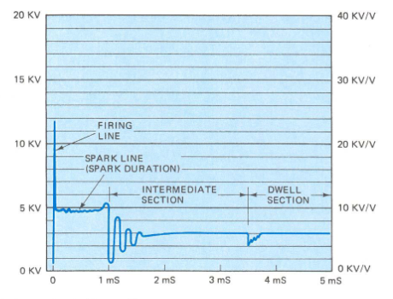
- The height of the firing line indicates the voltage required to fire the spark plug.
- It requires a high voltage to make the air inside the cylinder electrically conductive (to ionize the air).
- A higher than normal height (or height higher than that of other cylinders) can be caused by one or more of the following:
  - Spark plug gapped too wide
  - Lean fuel mixture
  - Defective spark plug wire
- If the firing lines are higher than normal for all cylinders, then possible causes include one or more of the following:
  - Worn distributor cap and/or rotor (if the vehicle is so equipped)
  - Excessive wearing of all spark plugs
  - Defective coil wire (the high voltage could still jump across the open section of the wire to fire the spark plugs).

Spark Line
- The spark line is a short horizontal line connected to the firing line.
- The height of the spark line represents the voltage required to maintain the spark across the spark plug after the spark has started.
- The height of the spark line should be one-fourth of the height of the firing line (between 1.5 and 2.5 kV).
- The length (from left to right) of the line represents the length of time for which the spark lasts (duration).
- The spark duration should be between 0.8 and 2.2 milliseconds (usually between 1.0 and 2.0 ms).
- The spark stops at the end (right side) of the spark line.
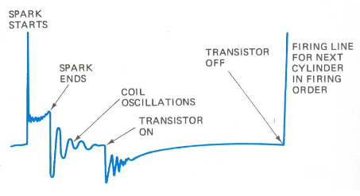
The following list will assist technicians in troubleshooting ignition system problems.
Problem | Possible Causes and/or Solution
No spark out of  the coil | - Open in the ignition switch circuit
No spark out of  the coil | - Defective ignition module (if electronic ignition coil)
No spark out of  the coil | - Defective trigger sensor
No spark out of  the coil | - Open ignition fuse or power feed circuit
Weak spark out  of the coil | - High-resistance coil wire or spark  plug wire
Weak spark out  of the coil | - Poor ground between the distributor or module and the engine block
Engine misfiring | - Defective (open) spark plug wire
Engine misfiring | - Worn, cracked, or fouled spark plugs
Engine misfiring | - Defective pickup coil
Engine misfiring | - Defective module
Engine misfiring | - Poor electrical connections at the pickup and/or module
Electronic Ignition System component test
The ignition system components should be tested whenever you know or suspect there is no spark, not enough spark, or when the spark is not being delivered at the correct time to the cylinders.
- Ignition Switch Testing
An ignition switch supplies voltage to the ignition control module and/or the ignition coil. Often an ignition system has two wires connected to the run terminal of the ignition switch. One is connected to the module. The other is connected to the primary resistor and coil. The start terminal of the switch is also wired to the module.
- Spark plug Testing
In the event of a no-start condition, the first step should be to check for secondary voltage out of the ignition coil or to the spark plugs. If the ignition system being tested does not have a separate ignition coil, disconnect any spark plug wire from a spark plug and, while cranking the engine, test for spark available at the spark plug wire, again using a spark tester.
Typical causes of a no-spark (intermittent spark) condition include the following:
  - Weak ignition coil
  - Low or no voltage to the primary (positive) side of the coil
  - High resistances or open coil wire, or spark plug wire
  - Negative side of the coil not being pulsed by the ignition module
  - Defective pickup coil or crankshaft position sensor
  - Defective ignition control module (ICM)
  - Defective main relay
The triggering sensor has to work to create a spark from the ignition coil(s). If a no-spark condition occurs, then check for triggering by using a scan tool and check for engine RPM while cranking the engine.
- If the engine speed (RPM) shows zero or almost zero while cranking, the most likely cause is a defective triggering sensor or sensor circuit fault.
- If the engine speed (RPM) is shown on the scan tool while cranking the engine, then the triggering sensor is working (in most cases).
Check service information for the exact procedure to follow for testing triggering sensors.

- Ignition Coil Testing
Ignition coils, like all parts that contain electrical windings, can be checked with an ohmmeter. In an ignition coil there are two separate windings and each has a different resistance value. Test the resistance of the primary and secondary winding inside the coil. For accurate resistance measurements, the wiring to the coil should be removed before testing.
- Testing the Crankshaft and Camshaft Position Sensors
Although ignition timing on most EI systems is not adjustable, the air gaps at the crankshaft and camshaft sensors will affect the operation of the ignition system. On some engines, this gap is adjustable and on others it is an indication that the sensor should be replaced. If there is no provision for adjusting the gap and the gap is incorrect, the sensor should be replaced. When checking the gap, make sure there are no signs of damage to the rotating vane assembly. Measure the gap with a nonmagnetic feeler gauge. Compare your findings to specifications. If the gap is not correct, the sensor should be replaced or the gap adjusted.
- Pickup Coil Testing
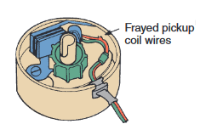
It is important that all wires and connectors between the trigger sensor and ignition module and module to the PCM be visually checked as well as checked for excessive resistance with an ohmmeter. To test magnetic pulse and metal detection pickup coils inside a distributor or used as a CKP or CMP with an ohmmeter, connect the ohmmeter from one of the pickup leads to ground to test for a short to ground. If there is a short to ground, the ohmmeter will have a reading of less than specifications. Most pickup coils have 150 to 900 ohms resistance, but always refer to the manufacturer’s specifications.
If the pickup coil is open, the ohmmeter will display an infinite reading. When the pickup coil is shorted, the ohmmeter will display a reading lower than specifications.
- Control Module Testing
Electronic ignitions use transistors as switches. These transistors are contained inside the control module that can be mounted to or in the distributor, remotely mounted to a surface inside the engine compartment, mounted below the ignition coil pack or be integral to the PCM.
Control modules should be tightly mounted to clean surfaces. A loose mount can cause intermittent misfires or no-start conditions. Often the module is grounded through its mounting. A loose mounting also can cause heat buildup that can damage and destroy the transistors and other electronic components inside the module. During the visual inspection, check all electrical connections to the module. They must be clean and tight.

Self-check 2
Directions: Answer all the questions listed below.
Part-I: Say True of False the following statements
  - On some engines, if the gap between the crankshaft sensor and its trigger wheel is outside specifications, the sensor should be replaced.
  - Defective (open) spark plug wire is the cause of engine misfiring
  - Open ignition fuse or power feed circuit can cause weak spark out of the coil
  - The pickup coil must generate an DC voltage pulse to the ignition module.
  - Defective ignition module (if electronic ignition coil) can cause no spark out of the coil.
Part II: Choose the correct answer from the given alternatives
  - While testing the coils in an EI system: Technician A says that an infinite reading means that the winding has zero resistance and is shorted. Technician B says that the primary windings in each coil should be checked for shorts to ground. Who is correct?
A.Technician A C. Both A and B
B. Technician B D. Neither A nor B
  - Typical primary coil resistance specifications usually range from _____________ohms.
A. 100 to 450 C. 0.5 to 3
B. 500 to 1,500 D. 6,000 to 30,000
  - Technician A says that a pickup coil (pulse generator) can be tested with an ohmmeter. Technician B says that ignition coils can be tested with an ohmmeter. Which technician is correct?
A. Technician A only C. Both Technicians A and B
B. Technician B only D. Neither Technician A nor B
  - Technician A says that a defective spark plug wire can cause an engine misfire. Technician B says that a defective spark plug can cause an engine misfire. Which technician is correct?
A. Technician A only C. Both Technicians A and B
B. Technician B only D. Neither Technician A nor B
  - While checking a pickup coil with an ohmmeter, a higher-than-normal reading indicates that the pickup unit is .
    - shorted C. has high resistance
B. open D. none of the above

Part-III: Answer the following questions accordingly.
- What is the typical procedure for checking the resistance of the primary winding in an ignition coil?
- How do you test a pickup coil for resistance and AC voltage output?
- What harm can occur if the engine is cranked or run with an open (defective) spark plug wire?
- List at least two methods of checking the operation of Hall-effect sensors.
- List electronic Ignition Troubleshooting Procedure

Operation Sheet 2.1
Operation title: Spark plug Testing
Purpose: To be check that sparks occur.
Instruction: Perform the test by applying the steps which is listed below
Tools and requirement:
- Spark testers
- Special spark plug socket
- Spark plug gapping tool
- High tension insulated wire puller
- Tool for removing broken-off high-thread spark plugs
- Multimeter.
Quality Criteria: Use the specified tools & service manual
Precaution: Most ignition systems can produce 40,000 volts or more, with energy levels high enough to cause personal injury. Do not disconnect a spark plug wire while the engine is running, because it may damage the ignition system or create a shock hazard.
Steps in doing the task:
- Remove the high-tension lead or coil from the end of the spark plug.
- Connect a spark tester to the boot of the coil or high tension lead, and attach the Clamp to a good ground.
- Crank the engine, and watch for a blue spark across the tester electrodes. If there is no spark present, continue on to the next skill drill.
- If the spark is weak or there is no spark, check the wiring to and from the PCM.
- If the power and ground circuits for the PCM are okay, connect a voltmeter from the input (battery) terminal on each coil pack to ground.
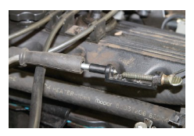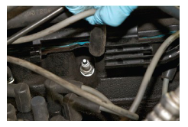

Operation Sheet 2.2
Operation title: Testing Ignition Coil
Purpose: To generate a high-voltage spark to ignite the fuel-air mixture in the combustion chamber
Conditions or situations for the operations:
- Safe working area
- Properly operated tools and equipment
- Appropriate working cloths fit with the body
Equipment Tools and Materials:
- Ohmmeter
- Battery equipped vehicle
Quality Criteria: Assured performing of all the activities according to the procedures
Precautions:
- Wearing proper clothes and glove
- Make working area hazard free
- Read and interpret manual which guide you how to use tools and equipment
Steps in doing the task
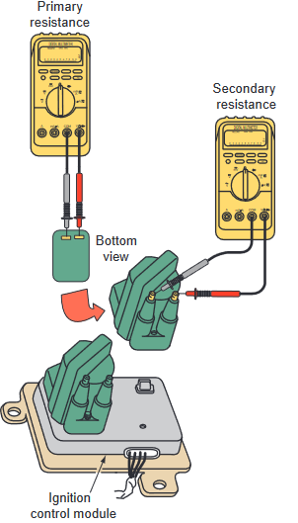
- Visually inspect the ignition coil (s) and wires. All the coil terminals should be clean, secure, and free of corrosion.
- To test the resistance of the primary windings, place the ohmmeter leads on each of the two primary winding terminals. Most coils will give a reading between 0.5 and 3 ohms. Check the manufacturer’s specifications for the exact resistance values. If the reading is not within specifications, the coil is faulty and must be replaced.
- To test the secondary windings, place one ohmmeter lead on the secondary tower terminal and the other to the negative primary terminal, or the coil secondary ground, if equipped. The normal resistance of most coils ranges between 6,000 and 30,000 ohms. If the reading is not within specifications, the coil is faulty and must be replaced.

Operation Sheet 2.3
Operation title: Testing the Crankshaft and Camshaft Position Sensors
Purpose: That it will allow the car to start and improve starting ability.
Conditions or situations for the operations:
- Safe working area
- Properly operated tools and equipment
- Appropriate working cloths fit with the body
Tools and requirement:
- Ohmmeter
Precaution:
- Wearing proper clothes and glove
- Make working area hazard free
- Read and interpret manual which guide you how to use tools and equipment
Quality Criteria: Use the specified tools & use service manual
Procedures in doing the task
- Remove the connector from the sensor by removing any lock clips that may be present, and pull the connector off Insert the spark plug gapping tool in the gap between the metal center electrode and the metal side electrode of the plug's tip.
- Check the resistance of the camshaft position sensor.
Standard resistance
Temperature Condition | Specified Condition
Specified Condition | 835 to 1,400 Ω
Cold | 1,060 to 1,645 Ω
- Check the resistance of the crankshaft position sensor
Standard resistance
Temperature Condition | Specified Condition
Specified Condition | 985 to 1,600 Ω
Cold | 1,265 to 1,890 Ω

Operation Sheet 2.4
Operation title: Pickup Coil Testing
Purpose: To generate a high-voltage spark to ignite the fuel-air mixture in the combustion chamber.
Conditions or situations for the operations:
- Safe working area
- Properly operated tools and equipment
- Appropriate working cloths fit with the body
Equipment Tools and Materials:
- Ohmmeter
- Oscilloscope
Quality Criteria: Assured performing of all the activities according to the procedures
Precautions:
- Wearing proper clothes and glove
- Make working area hazard free
- Read and interpret manual which guide you how to use tools and equipment
Steps in doing the task
  - Disconnect the electrical connector from the pickup coil.
  - Measure the resistance between the two terminals of the pickup coil with an ohmmeter.
  - If the reading is not within specifications, replace the pickup.
  - If the reading is within specifications, wiggle the pickup coil wires while watching the ohmmeter reading. It should not change.
  - Connect a lab scope to the pickup coil windings. Crank the engine over, observe the pattern, and compare it to a known good pattern.
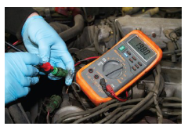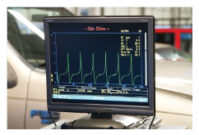

LAP Test: 2

Instruction: Perform the following tasks

Task 1: Check spark plug
Task 2: Connect a spark tester to the boot of the coil or high tension lead, and attach the
Clamp to a good ground.
Task 3: Crank the engine, and watch for a blue spark across the tester electrodes
Task 4: Visually inspect the ignition coil (s) and wires
Task 5: Test the resistance of the primary and secondary windings
Task 6: Check the resistance of the camshaft and crankshaft position sensor
Task 7: Measure the resistance between the two terminals of the pickup coil.

Unit Three: Service/repair electronic spark ignition system component
This learning guide is developed to provide you the necessary information regarding the following content coverage and topics:
- Service/repair Procedures
- Post servicing
- Cleaning and storing equipment and work area
This guide will also assist you to attain the learning outcomes stated in the cover page. Specifically, upon completion of this learning guide, you will be able to:
- Follow Service/repair Procedures
- Carryout Post servicing
- Perform Cleaning and storing equipment and work area

Service/repair Procedures
As the vehicle ages, the components of the ignition system will wear. Wear parts need to be replaced every so often. These things include the spark plugs, high tension leads (spark plug wires) or coil boots, and the distributor cap and rotor. This will maintain vehicle performance and meet emission standards. The main components to be replaced on today’s vehicles are the spark plugs and the high tension leads (if equipped). On COP systems, the coil boots may need replacement.
Hard starting, misfiring under load or high tailpipe emissions may indicate a need for service.
Spark Plug servicing
When replacing spark plugs, perform the following steps:
- Check service information. Check for the exact spark plug to use and the specified instructions and/or technical service bulletins that affect the part number of plug to be used or a revised replacement procedure.
- Allow the engine to cool before removing spark plugs. This step is especially critical on engines with aluminum cylinder heads.
- Use compressed air or a brush to remove dirt from around the spark plug before removal. This step helps prevent dirt from getting into the cylinder of an engine while removing a spark plug.
- Check the spark plug gap and correct as needed. Be careful not to damage the tip on the center electrode if adjusting a platinum or iridium type of spark plug.
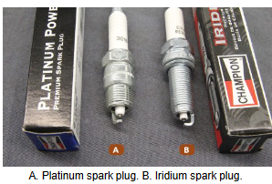
- Install the spark plugs. Be sure the threads are clean by using a thread chaser. Then install the spark plug by hand, and then using the proper spark plug socket and a torque wrench, tighten the plugs to factory specifications.
- The spark plugs should be replaced every 30,000 to 50,000 miles (50,000 to 80,000 km).
- High-performance spark plugs that are made with platinum, iridium, or gold palladium do not require replacement until the engine reaches 100,000 miles or more.
- latinum-tipped spark plugs should not be regapped!
- Using a gapping tool can break the platinum after it has been used in an engine.
- You will then have to use the proper tools and follow the correct procedures for removal of the broken plug.
- It is quicker to check the spark plug gap on all of the new spark plugs at one time.
- Most spark plugs come pre-gapped. But they should be checked to make sure they were not damaged during shipping.
- To gain access to a spark plug, first remove the spark plug wire by gripping its boot by hand. Or use a high-tension wire puller to gently pull it off the spark plug.
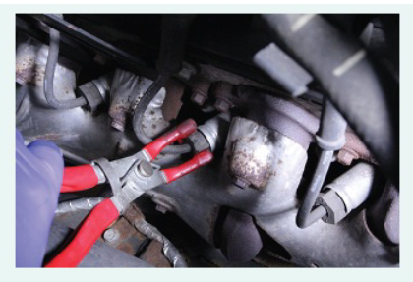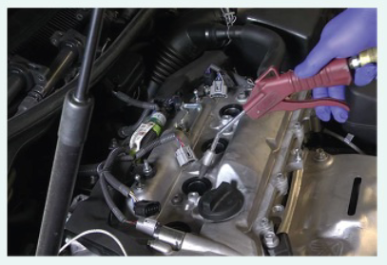
- Check the electrode gap of each spark plug by finding the correct-sized gauge on the gapping tool. Attempt to place it between the center and the side electrode.
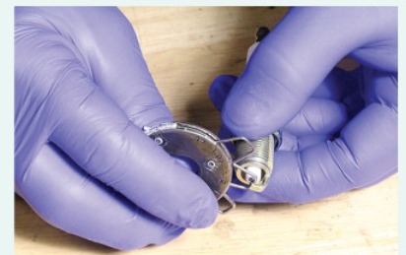
- Clean out the spark plug pocket with compressed air.
- Remove the spark plug, using the correct-sized spark plug socket.
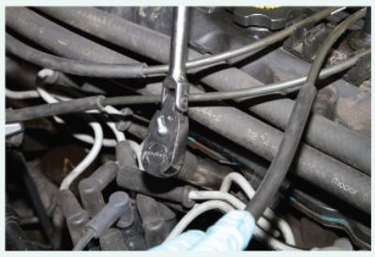
- If the new plugs are equipped with a gasket, ensure they are installed properly. Install the spark plugs by hand to avoid cross-threading. Use a torque wrench to properly tighten the spark plug.
- Once the spark plug is installed, reinstall the spark plug wire by pushing it on to the terminal of the spark plug until it snaps into place.
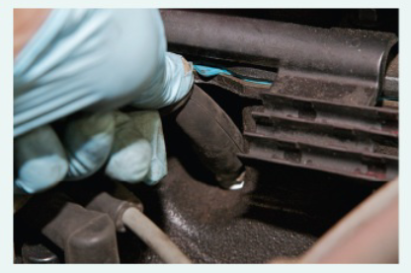

Spark Plug Wire Servicing
- Remove one end of the wire (or boot) from the distributor cap, coil pack, or COP coil. Remove the other end from the spark plug with a high-tension wire puller by twisting the boot on the spark plug while gently pulling it off.
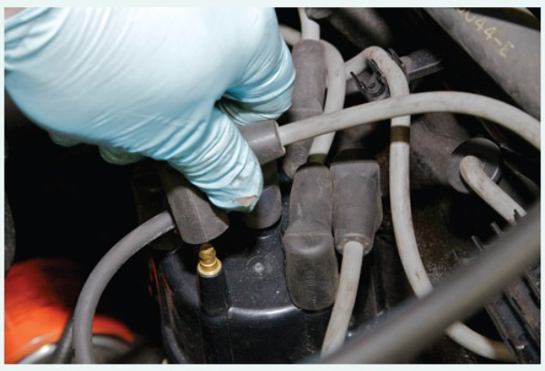
- Install the new spark plug wire by pushing one end onto the spark plug and the other onto the distributor cap, coil pack, or COP coil. The spark plug wires should be routed in their factory positions to prevent damage.
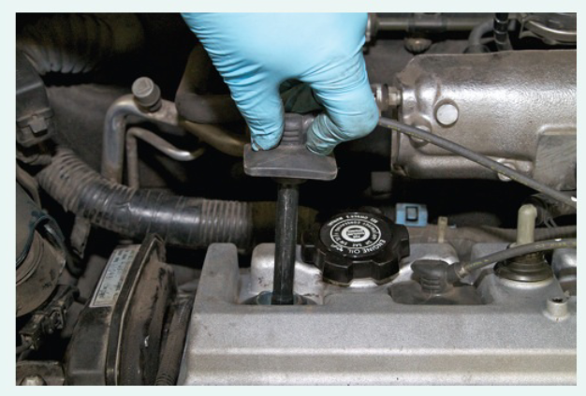
- If replacing COP boots, carefully work the boot over the secondary terminal until it is fully seated.
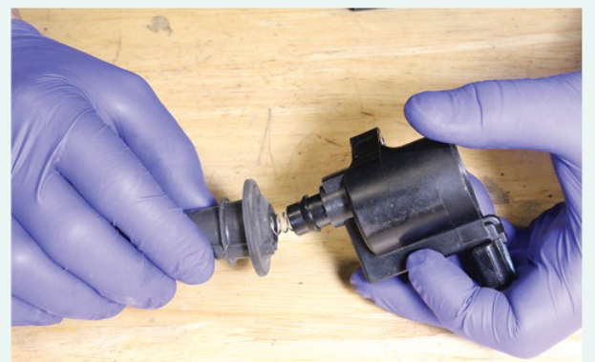
Distributor Servicing
A typical procedure for removing a distributor
- Disconnect the electrical connector and the vacuum advance hose, if the distributor has them.
- Remove the distributor cap and note the position of the rotor. On some vehicles, it may be necessary to remove the spark plug wires from the cap prior to cap removal.
- Note the position of the vacuum advance, and then remove the distributor hold down bolt and clamp.
- Pull the distributor from the engine. Most distributors will need to be twisted as they are pulled out of their bore. Note the direction of rotation.
- Once the distributor is removed, install a shop towel in the distributor opening to keep foreign material out of the engine block.
The following procedure may be followed to install the distributor and time it to the engine:
- Lubricate the O-ring on the distributor shaft.
- Position the rotor so that it is aligned with the mark made to the distributor housing prior to removal.
- Align the distributor to the mark made on the engine block during removal.
- Lower the distributor into the engine block; make sure the distributor drive is fully seated. Distributors equipped with a helical drive gear will rotate as the distributor is being installed, causing the distributor to move away from the reference marks.
- Make sure the distributor housing is fully seated against the engine block; sometimes it may be necessary to wiggle or rock the distributor to seat it fully into the drive gear.
- Rotate the distributor a small amount so the timer core teeth and pickup teeth are aligned.
- Install the distributor hold down clamp and bolt and leave the bolt slightly loose.
- Install the spark plug wires in the direction of distributor shaft rotation and in the correct cylinder firing order.
- The hold down clamp and bolt for a distributor.
- Before installing the spark plug wires to the distributor cap, identify the terminal for cylinder number 1 and then follow the engine’s firing order.
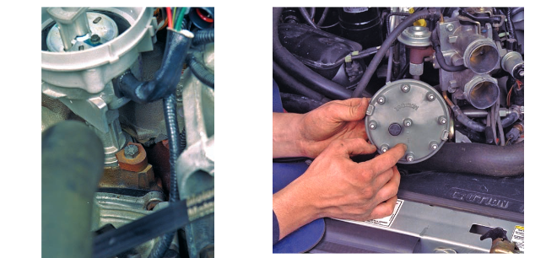
Distributorless ignition Servicing
Standard test procedures using an oscilloscope, an ohmmeter, and timing light can be used to diagnose problems in Distributorless ignition systems.
Keep in mind, however, that problems involving one cylinder may also occur in its companion cylinder that fires off the same coil. Follow the testing procedures given in the service manual. Specific DTCs are designed to help troubleshoot ignition problems in these systems. The diagnostic procedure for EI systems varies depending on the vehicle makes and model year.
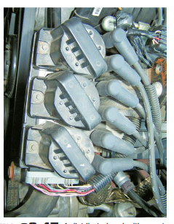
There is a separate primary circuit for each coil. If one coil does not work properly, it may be caused by something common or not common to the other coils. Regardless of the system’s design, there are common components in all electronic ignitions: an ignition module, crankshaft and/or camshaft sensors, ignition coils, a secondary circuit, and spark plugs. Most of these components are common to only the spark plug or spark plugs to which they are connected. The components that are common to all cylinders (such as the camshaft sensor) will, most often, be the cause of no start problems. The other components will cause misfire problems.
Control Module Servicing
The most effective way to test a control module is to use an ignition module tester. This tester evaluates and determines if the module is operating within a given set of parameters. It does this by simulating normal operating conditions while looking for faults in the module’s components. If a module tester is not available, check out all other system components before condemning the control module.

Post servicing
Post Repair inspection to insure that the repairs were done correctly. This evaluation is performed by a qualified technician who is tasked with examining the repairs to ensure that the proper parts were used and the proper procedures were followed. During a post repair inspection the system is assessed to ensure that no safety problems exist.
After the vehicle has been repaired and before it is released to the customer, a total module scan is performed again to not only verify the repair but also to ensure that another DTC was not set during the repair process. The results of this post service should also be documented on the repair order so it becomes a part of the documentation for the vehicle history. after checking for stored diagnostic trouble codes (DTCs), the wise technician checks service information for any technical service bulletins that may relate to the vehicle being serviced.
Procedure of Post Repair:
- The system is evaluated to determine whether a post repair inspection is needed.
- Check everything that does and does not work. This step involves turning things on and observing that every thing is working properly.
- Look for evidence of previous repairs. any time work is performed on a vehicle, there is always a risk that something will be disturbed, knocked off, or left disconnected
Regapping Spark Plugs
- Both new and used spark plugs should have their air gaps set to manufacturer’s specifications.
- Always use round wire gauges when checking and setting the gap. After the gap has been adjusted, make sure that the ground electrode is as horizontal as it can be.
- Always check the air gap of a new spark plug before installing it.
- Never assume the gap is correct just because the plug is new.
- Do not try to reduce a plug’s air gap by tapping the side electrode on a bench.
- Use a spark plug gapping tool to bend the ground electrode to its correct height. When doing this, be careful not to contact or put pressure on the center electrode.
- Make sure that the replacement spark plugs are the correct ones for the application.
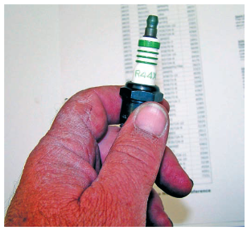

Cleaning and storing equipment and work area
Benefits of cleaning
To turn the workplace in to clean is:
- To bright place where everyone will enjoy working.
- Another key purpose is to keep everything in top condition so that when someone needs to use something, it is ready to be used.
- Companies or organizations should avoid the tradition of annual at the end of the year or on spring cleanings. Instead, cleaning should become a deeply ingrained part of daily work habits, so that tools, equipment, and work areas will be ready for use all the time.
- Cleanliness for factories and offices is a lot like bathing for human beings.
- It relieves stress and strain, removes sweat and dirt, and prepares the body and mind for the next day.
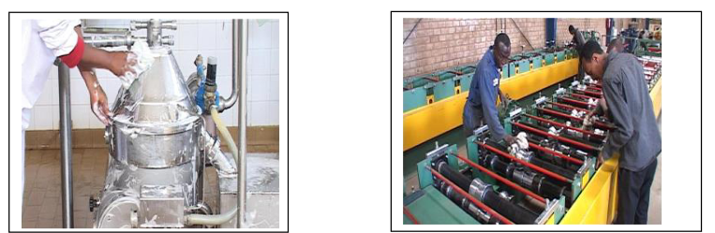
Fig. Workers cleaning machines
Cleaning activities can play an important part in bringing work efficiency and safety. Cleanliness is also linked with the morale of employees and their awareness of improvements. Factories or workshops that do not implement the shine pillar suffer the following types of problems:
- Poor morale and inefficiency at work. This could be due to dirty windows that can pass only little light.
- Unable to see or find defects in dark and messy workplaces.
- Slipping and injuries can be created due to puddles of oil and water on the floor.
- Frequent breakdown of machines due to insufficient check-ups and maintenances which in turn leads to late deliveries.
- Low and unsafe operating machines due to insufficient checkups and maintenance which in turn leads to hazard and accidents.
- Defects will result due to shaving cuts getting mixed in to production or assembly processes.
- Shaving cuts can get in to people‘s eyes and create injuries.
- Low morale due to filthy work environments.

Routine Cleaning

Fig. Routine Cleaning
The cleaning step is not meant to be a job for the maintenance or janitorial staff. Each worker should clean their own work area, and the equipment they use. This approach has several benefits:
- Workers who are familiar with the area will quickly notice any problems that arise
- Hazards or difficult situations will be understood and accounted for
- Items that are out of place or missing will be recognized
- Workers will tend to keep their own workspaces cleaner during normal operations
Clean equipment and tools
Part cleaning is a necessary step in most repair procedures.
- Cleaning automotive parts can be divided into three basic categories.
- Chemical cleaning relies primarily on some type of chemical action to remove dirt, grease, scale, paint, or rust.
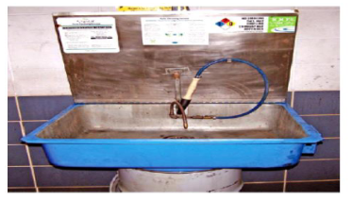
Clean up procedures
- Clean up every time whenever you leave an area, including sweeping the floor.
- Clean and return all tools to where you got them.
- Use compressed air sparingly; never aim it at another person or use it to clean hair or clothes.
- Shut off and unplug machines when cleaning, repairing, or oiling.
- Never use a rag near moving machinery.
- Use a brush, hook, or a special tool to remove chips, shavings, scraps etc. from the work area. Never use the hands.
- Keep fingers clear of the point of operation of machines by using special tools or devices, such as, push sticks, hooks, pliers, etc.
- Keep the floor around machines clean, dry, and free from trip hazards. Do not allow chips to accumulate.
- Mop up spills immediately and put a chair or cone over them if they are wet enough to cause someone to slip.
Storage of tools and equipment
- The proper care and storage of tools and equipment’s are not only the concern of the management but of the workers who use the equipment.

- Good organization of stored materials is essential for overcoming material storage problems whether on a temporary or permanent basis

Importance of proper storage of tools and equipment’s
- It is important factor for safety and health as well as good business.
- Improves appearance of general-shop and construction areas.
- Reduce overall tool cost through maintenance.
- This also ensures that tools are in good repair at hand.
- It is important factor for safety and health as well as good business.
- Teaches workers principles of tool accountability.
- Each workers principles of tool accountability.

Self-check 3
Directions: Answer all the questions listed below.
Part I: Choose the correct answer from the given alternatives
  - Storing tools and equipment’s in the follows are
A. Have a designated place for each kind of tools. C. Store them near the point of use.
B. Label the storage cabinet or place correctly. D. All
  - The most effective way to test a control module is to use ___________ tester
    - Ohmmeter C. Test light tester
    - ignition module tester D. All
  - which one of the following is not perform, when spark plug is replaced?
    - Check service information C. Install the spark plugs
    - Check the spark plug gap and correct as needed D. Remove spark plugs
  - Technician A says Post Repair inspection to insure that the repairs were done correctly. Technician B says post repair look for evidence of previous repairs. Who is correct?
A. Technician A C. Both A and B
B. Technician B D. Neither A nor B
  - Distributorless ignition systems is tested by using an oscilloscope, an ohmmeter, and timing light.
    - True B. False

Operation Sheet 3.1
Operation title: Spark Plug servicing
Purpose: To generate a high-voltage spark to ignite the fuel-air mixture in the combustion chamber.
Conditions or situations for the operations:
- Safe working area
- Properly operated tools and equipment
- Appropriate working cloths fit with the body
Equipment Tools and Materials:
- Special spark plug socket
- Spark plug gapping tool
- High-tension insulated wire puller
- Tool for removing broken-off high-thread spark plugs
Quality Criteria: Assured performing of all the activities according to the procedures
Precautions:
- Wearing proper clothes and glove
- Make working area hazard free
- Read and interpret manual which guide you how to use tools and equipment
Steps in doing the task
  - Remove the spark plug, using the correct-sized spark plug socket.
  - The spark plugs should be replaced every 30,000 to 50,000 miles (50,000 to 80,000 km).
  - Clean spark plug.
  - Check that sparks occur at the spark plug while the engine is being cranked.
  - Check the spark plug electrode gap.
  - Check the spark plug for any damage on its threads and insulator.

Operation Sheet 3.2
Operation title: Distributor Servicing
Purpose: To send high voltage electricity from the ignition coil to the spark plugs in the right sequence.
Conditions or situations for the operations:
- Safe working area
- Properly operated tools and equipment
- Appropriate working cloths fit with the body
Equipment Tools and Materials:
- Wrench
- Screw driver
- High-tension insulated wire puller
- Fleer gauge
Quality Criteria: Assured performing of all the activities according to the procedures
Precautions:
- Wearing proper clothes and glove
- Make working area hazard free
- Read and interpret manual which guide you how to use tools and equipment
Steps in doing the task
  - Disconnect the electrical connector and the vacuum advance hose, if the distributor has them.
  - Remove the distributor cap and note the position of the rotor.
  - Pull the distributor from the engine.
  - Once the distributor is removed, install a shop towel in the distributor opening to keep foreign material out of the engine block.
  - Install the distributor and time it to the engine.

LAP Test :3

Instruction: Perform the following tasks
Task 1: Observe the ignition condition visually
Task 2: Check the spark plug for any damage.
Task 3: Perform distributor servicing
Task 4: Perform Distributorless ignition servicing

Reference

- James D. Halderman Automotive Technology Principles, Diagnosis, and Service 4th Edition.
- Automotive Technology A Systems Approach.
- Automotive diagnosis/troubleshooting/
- Tom Denton Advanced automotive fault diagnosis automotive technology vehicle maintenance and repair.
- URL

No | Name | Qualification | Field of Study | Organization/ Institution | Mobile number | E-mail
 | Fadli Aman | BSc. | Automotive Technology | General Wingate PTC | 0927283100 | Fadli.ziyad@gmail.com
 | Habtamu Deresso | PHD Candidate | Automotive Technology | ASTU | 0945853269 | habtamu.deresso@gmail.com
 | Israel Taye | MSc | Automotive Technology | General Wingate PTC | 0913424100 | isra.taye@gmail.com
 | Natnael Genene | MSc | Automotive Technology | Athlete kenenisa PTC | 0920397105 | natnealgenene143@gmail.com
 | Robsan Tesfaye | MSc | Automotive Technology | Burayu PTC | 0920117175 | robsantesfaye4@gmail.com
 | Sisay Tufa | MSc | Automotive Technology | M/G/M/Buli PTC | 0912065407 | knbntf@gmail.com
 | Tagay Tesfaye | MSc | Automotive Technology | Bishoftu PTC | 0975971391 | tagotagotago37@gmail.com
Participants of this Module (training material) preparation

