

Automotive Electricity and Electronics

Level-III

Based on October, 2023 Curriculum Version II

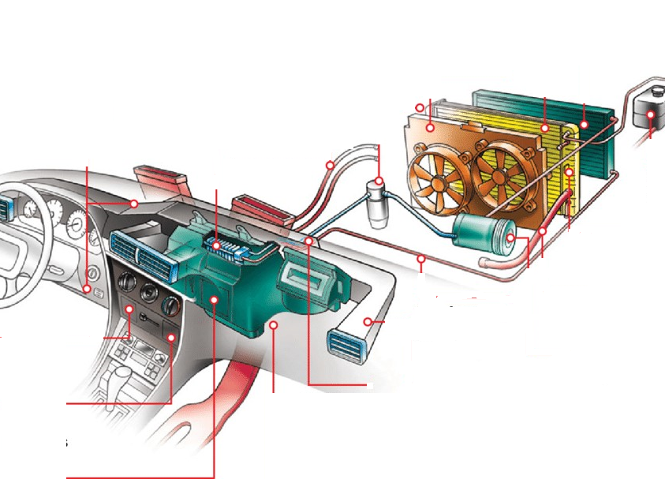

Module Title: - Vehicle Heating, Ventilation and Air Conditioning System
Module code: EIS AEE3 M08 1023
Nominal duration: 50 Hours
Prepared by: Ministry of Labor and Skill

October, 2023
Addis Ababa, Ethiopia

Table of Contents
Acknowledgment 4
Acronym 3
Unit One: Introduction To HVAC System 5
1.1 Heating System 7
1.1.1 Automotive Heating System Components and Operation 7
1.1.2 Types of heating system 10
1.2 Ventilation System 11
1.3 Air-Conditioning System 12
1.3.1 Classification air condition 12
1.3.2 Refrigeration system 13
1.3.3 Refrigerant 16
1.3.4 Basic component and their function 17
1.3.5 Refrigeration cycle and operation 28
1.4 Air Distribution and Control System 30
1.5 HVAC System Tools For System Repairs 36
1.5.1 Manifold Gauge Set 36
1.5.2 A leak detector 36
1.5.3 Vacuum Pumps 37
1.5.4 R/R/R machine 37
1.5.5 Thermometers 38
1.5.6 Refrigerant identifier/analyzer 38
1.5.7 Refrigerant system sealant detectors 38
1.5.8 An oil injector 39
1.6 OHS And Hazard Identification 39
1.6.1 PPE Requirement 39
1.6.2 OHS Requirement: 39
Self-check-1 41
Unit Two. Inspecting And Diagnosis HVAC System 43
2.1 Procedures 44
2.2 HVAC System Visual Inspection 46

2.3 Inspecting Heating And Air Conditioning (Hvac) Components 48
2.4 Air Conditioning Performance Testing And Diagnosis 50
Self-check-2 54
Operation Sheet 2.1 56
Operation Sheet 2.2 57
Operation Sheet 2.3 59
Operation Sheet 2.4 60
Operation Sheet 2.5 61
Operation Sheet 2.6 62
LAP-Test :2 63
Unit three: AC System Recovery, Evacuation, and Charging 64
3.1 Operating Procedures of Manifold Gauge 65
3.2 Methods of Evacuating an Air Conditioning System 65
3.3. Recovery and Charging of Air Conditioning System 68
Self-check-3 70
Operation Sheet 3.1 72
Operation Sheet 3.2 73
Operation Sheet 3.3 74
Operation Sheet 3.4 75
Operation Sheet 3.5 76
LAP-Test :3 77
Unit Four: Retrofitting & Post-Retrofit Testing 75
4.1 Ac System Decal Sticker Saecifications 76
4.2 Air Conditioning Retrofitting Procedures 77
4.3 Retrofit/Replace of The System and Components 78
4.4 Post-Retrofit and Performance Testing 80
4.5 Preparing Vehicle For Customer Delivery, Cleaning, and Equipment Storage 81
Self-check-4 82
Operation Sheet 4.1 84
Operation Sheet 4.2 85
LAP-Test :4 86
Reference 87

Acknowledgment
The Ministry of Labor and skill wishes to thank and appreciation to MoLS leaders and experts, Regional Labor and skill/training Bureaus leader, experts, TVT College Deans, Instructors and industry experts who contribute their time and professional experience to the development of this Training Module.

Acronym

AC  OHS  PTC  EVs  CFCs  HCFCs  HFCs  HFO  GWP  ODP  TXV  SAE  HVAC  LAP-Test | Air Conditioning  Occupational Health and Safety  Positive Temperature Coefficient  Electric Vehicles  Chlorofluorocarbons  Hydro chlorofluorocarbons  Hydrofluorocarbons  Hydro fluoro-olefin  Global Warming Potential  Ozone Depletion Potential:  Thermostatic Expansion Valve  Society of Automotive Engineers:  Heating, Ventilation, and Air Conditioning  Learning activity performance test

Introduction to module
In the Automotive Electrical and Electronics field, understanding and working on vehicle heating, ventilation, and air conditioning (HVAC) systems are crucial for auto electricians. This module provides a solid foundation in HVAC systems, trainee trainees how to diagnose, service, and repair HVAC components and systems.
Throughout this module, participants will learn fundamental HVAC concepts, identify electrical issues related to HVAC, and gain expertise in testing and repairing automotive heating, ventilation, and air conditioning systems. The module also covers essential procedures for inspecting, diagnosing, and fixing HVAC-related problems according to manufacturer specifications.
This module aligns with industry standards outlined in the Automotive Electrical and Electronics Level III occupational standard. Upon completion, trainees will be well-prepared to excel in HVAC systems, a vital aspect of the automotive industry.
This module covers the units:
- Introduction to HVAC system
- HVAC system inspection and diagnosis
- AC system recovery, evacuation, and charging
- Retrofitting & post-retrofit testing
Learning Objective of the Module
- Understand HVAC system
- Carry out HVAC system inspection and diagnosis
- Perform AC system recovery, evacuation, and charging
- Execute retrofitting & post-retrofit testing
Module Instruction
For effective use this modules trainees are expected to follow the following module instruction:
- Read the information written in each unit
- Accomplish the Self-checks at the end of each unit
- Perform Operation Sheets which were provided at the end of units
- Do the “LAP test” giver at the end of each unit and
- Read the identified reference book for Examples and exercise

Unit one: Introduction to HVAC system
This unit is developed to provide you the necessary information regarding the following content
coverage and topics:
- Heating system
- Ventilation system
- Air-conditioning System
- Air distribution and control system
- HVAC System Tools for System Repair
- OHS and Hazard identification
This unit will also assist you to attain the learning outcomes stated in the cover page. Specifically, upon completion of this learning guide, you will be able to:
- Describe heating system
- Comprehend ventilation system
- Discuss air-conditioning system
- Examine air distribution and control system
- Familiarize with HVAC system tools for system repairs
- Apply OHS and hazard identification

Introduction
The HVAC system, an acronym for Heating, Ventilation, and Air Conditioning, plays a pivotal role in ensuring passenger comfort within modern vehicles. It not only enhances comfort but also contributes significantly to safety and visibility. Whether you are an automotive enthusiast, an aspiring technician, or simply intrigued by the mechanics behind your vehicle's ability to maintain a pleasant cabin environment in varying weather conditions, this module is designed to equip you with the knowledge and insights you seek.
Our journey begins with a glance into the past when early automobiles provided minimal comfort. In winter, passengers clung to heavy coats and blankets as they faced the elements behind rudimentary windscreens. During the scorching summer months, a mere breeze from a 15 mph (25 km/h) drive was their sole relief.
The HVAC system must provide the desired vehicle passenger climate in all types of weather. In most modern vehicles, the engine’s cooling system is used to heat the vehicles interior, and an engine-driven compressor is used to circulate a refrigerant to cool the interior. A paper type filter is sometimes used to provide clean, dust-free, and odorless air to the interior of the vehicle. Today’s vehicles have ventilation, heating, and air conditioning systems to provide passenger comfort. Ventilation and heating systems are standard equipment on all passenger vehicles and air-conditioning is standard on most and available for nearly all. These systems move heat to warm or cool the passengers.
Explore the Key Components of Modern HVACS systems:
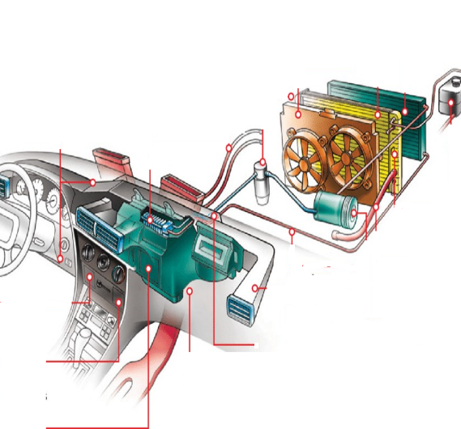
- Ventilation: Discover how ventilation systems ensure fresh air flow, enhancing air quality and maintaining comfortable cabin temperatures.
- Heating: Delve into heating systems that use engine heat for warmth, distributing it efficiently to keep passengers cozy during cold weather.
- Air Conditioning: Learn about the cooling wonders of air conditioning, where compressors and refrigerants work together to combat sweltering heat
Figure 1: 1 HVAC system

Heating system
The automotive heating system has been designed to work hand in hand with the cooling system to maintain proper temperatures inside the car. The heating system’s primary job is to provide a comfortable passenger compartment temperature and to keep car windows clear of fog or frost. to meet safety standards, all vehicles must be equipped with passenger compartment heating and windshield defrosting systems.
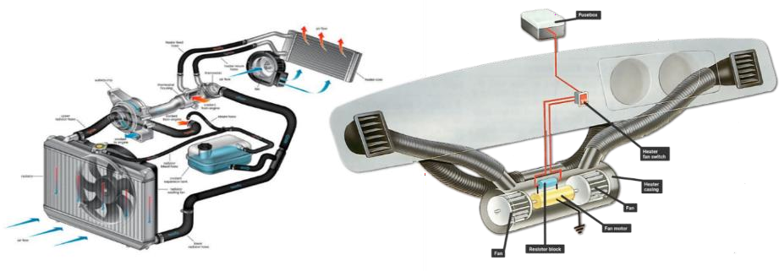

Figure 1: 2 Heating system

1.1.1 Automotive Heating System Components and Operation
The main components of an automotive heating system include the heater core, heater control valve, blower motor, fan, and heater and defroster ducts. Additionally, it shares components such as the radiator, thermostat, water pump, and hoses with the engine cooling system.

Heater Core
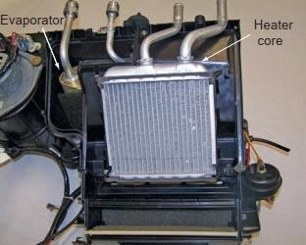
The heater core is generally designed and constructed much like a miniature radiator. It features an inlet or outlet tube and a tube and fin core to facilitate coolant flow between them Although all heater cores basically function in the same manner, several variations in design and materials are used by different automakers to achieve the same results. Although the core construction varies, this type has an aluminum core with plastic tanks
Figure 1: 3 A heater core

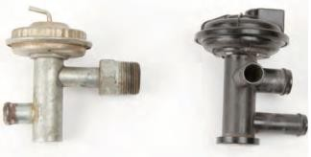
Heater Control Valve
The heater control valve (sometimes called the water flow valve) controls the flow of coolant into the heater core from the engine. In a closed position, the valve allows no flow of hot coolant to the heater core, keeping it cool. In an open position, the valve allows heated Coolant to circulate through the heater core, maximizing heater efficiency.
Figure 1:4 Two types of heater control valves: (left) a vacuum-operated plastic unit, and (right) a cable-operated valve

Heater control valves are operated in three basic ways: by cable, thermostat, or vacuum. Some vehicles do not use a heater control valve; rather, a heater door controls how much heat is released into the passenger compartment from the heater core.
Hoses and Piping
These components are responsible for transporting coolant from the engine to the heater core and back. They ensure a continuous flow of warm coolant to the heating system.
Heater and Defroster Duct Hoses
Transferring heated air from the heater core to the passenger compartment heater and defroster outlets is the job of the heater and defroster ducts. The ducts are typical parts of a large plastic shell that connects to the necessary inside and outside vents. This ductwork also has mounting points for the evaporator and heater core assemblies. Contained inside the duct are the mode doors required to direct air to the floor, dash, and/or windshield. Sometimes the duct is connected directly to the vents, whereas other times hoses are used. ducts and vents distribute the heated air to different parts of the vehicle's interior, such as the dashboard vents, floor vents, and defrost vents.
Control Cables or Electronic Actuators
connect the climate control panel to the blend door and other system controls. They ensure that the settings selected by the driver are translated into the desired temperature and airflow.
Operation
The heating system works with the engine’s cooling system and converts the heat from the cool ant circulating inside the engine to hot air, which is blown into the passenger compartment. In the liquid-cooling system, heat from the cool ant circulating inside the engine is converted to hot air, which is blown into the passenger compartment.
Hot coolant from the engine is transferred by a heater hose to the heater control valve and then to the heater core inlet. As the coolant circulates through the core, heat is transferred from the coolant to the tubes and fins of the core. Air blown through the core by the blower motor and fan then picks up the heat from the surfaces of the core and transfers it to the passenger compartment of the car. After giving up its heat, the coolant is then pumped out through the heater core outlet, where it is returned to the engine to be heated again.
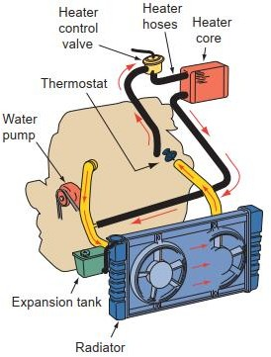
Figure 1:5 Hot coolant from the engine is sent from the upper portion of the engine to the heater core

1.1.2 Types of heating system
      - Forced Air Heating (Convection Heating)
This is the most common type of heating system in cars. It uses a blower fan to force air over a heated element, typically the heater core, which is warmed by hot coolant from the engine. The warm air is then directed into the cabin through vents to provide heat to passengers.
      - Radiant Heating
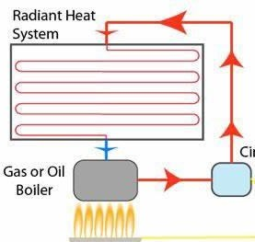
Radiant heating systems use heating elements, such as electric coils or infrared elements, to generate heat. These elements radiate heat directly into the cabin, warming surfaces they come into contact with, including seats and interior panels. Radiant heating is less common but can be found in some luxury vehicles.
Figure 1: 6 Radiant heating

      - PTC (Positive Temperature Coefficient)
Heaters PTC heaters use ceramic heating elements with a positive temperature coefficient. As the ceramic element heats up, its electrical resistance increases, limiting the amount of heat generated. PTC heaters are energy-efficient and are often used in auxiliary cabin heaters or as seat heaters.
      - Electric Heaters
Electric heaters use electrical energy to generate heat directly. While not as common in most vehicles, they may be used as supplemental cabin heaters, particularly in electric vehicles (EVs) or hybrids when the engine is not running. They can be used to preheat the cabin while the vehicle is plugged in.
Figure 1: 8 portable electrical heater

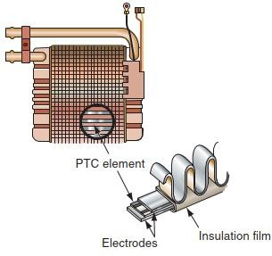

Figure 1: 7 An electronic PTC

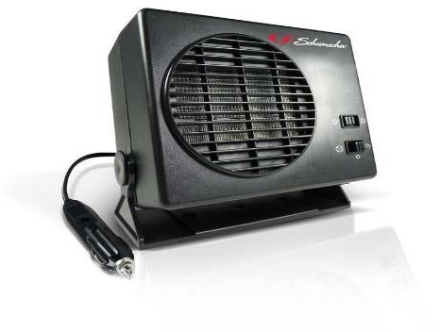

1.2 Ventilation system
Automotive ventilation systems are designed to provide a continuous flow of outside air into the passenger compartment, ensuring a comfortable and fresh cabin environment. The most prevalent system used is the flow-through system, which operates in two modes: utilizing ram air when the vehicle is in motion and relying on a heater fan when stationary. Ram air is drawn in through an inlet grille, naturally circulating throughout the cabin, and eventually exiting through an exhaust area.
In some older vehicle models, manual vent
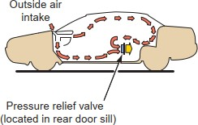
knobs enable passengers to control the airflow, directing it through left and right inlets as needed. Alternatively, ventilation fans can be employed, creating a pressure differential that effectively moves air through the system. A cabin filtration system is a common feature, serving to purify the incoming air before it reaches passengers, ensuring a clean and pollutant-free interior environment.
Figure 1: 9 A flow-through ventilation system

1.3 Air-conditioning System
The automobile air conditioning system is a crucial component that ensures the comfort and well-being of passengers during their travels. Its primary aim is to create a pleasant cabin environment by managing key factors like temperature, humidity, air quality, and air distribution. This involves a complex process of adding or removing heat and humidity, purifying the air, regulating air source and output, directing airflow, and controlling its speed through the vehicle's HVAC system. In essence, a car's AC system delivers cool, refreshing air to the cabin while reducing moisture by extracting heat from the interior and releasing it outside. All AC systems operate based on fundamental laws of nature.

1.3.1 Classification Air condition
Air conditioning systems can be classified into various categories based on different criteria.

Based on Purpose
- Comfort Air Conditioning System: designed primarily for the comfort of occupants in residential, commercial, or institutional settings. it aims to maintain a pleasant indoor temperature and humidity level.
- Industrial Air Conditioning System: Used in industrial environments to control temperature and humidity for specific processes, manufacturing, or storage requirements. Often more specialized and robust than comfort systems.
Based on Season
- Winter Air Conditioning System: These systems are designed to provide heating during the colder months. They may incorporate technologies like heat pumps, furnaces, or electric heaters.
- Summer Air Conditioning System: Designed to provide cooling during hot summer months. These systems often use refrigeration technology to remove heat from indoor spaces.
- Year-Round Air Conditioning System: Also known as "all-season" systems, they can provide both heating and cooling throughout the year. Heat pumps are a common example of year-round systems.

Based on Equipment Arrangement:
- Unitary Air Conditioning System: All components (evaporator, condenser, compressor) in a single unit, often used in homes.
- Central Air Conditioning System: Components spread throughout a building but centrally controlled, common in larger buildings and houses, with air handler, condensing unit, and ductwork.
These categories help classify air conditioning systems based on their primary purpose, season of operation, and equipment arrangement. Specific system configurations and features can vary widely within each category to meet different needs and preferences.

1.3.2 Refrigeration system
Refrigeration is the controlled transfer of heat, resulting in the reduction of temperature in a given space or material by removing heat from it, making its temperature lower than that of its surroundings.
The refrigeration system can be classified in to two:
- Vapour Compression Refrigeration (VCR): uses mechanical energy.
- Vapour Absorption Refrigeration (VAR): uses thermal energy.

Principle of Refrigeration
States of Matter
Matter is defined as anything that takes up space and has weight. In most environments, all of the substances (matter) exist in one of three different states: solid, liquid, or gas
- Solids have a definite shape, are not easily compressed, maintain a stable volume, and are below their melting point.
- Liquids, an intermediate state between gases and solids, have a definite volume but can flow and change shape. They are not easily compressible and exist between their boiling and melting points.
- Gases are characterized by high kinetic energy, allowing particles to move freely. They lack a fixed shape and volume, expanding to fill their container.
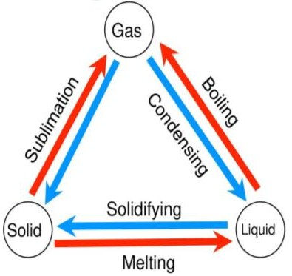
Heat and State Change
Whenever matter changes its state (e.g., from solid to liquid or from liquid to gas), heat is either absorbed or released.
Heat plays a significant role in determining the state of matter.
Heat causes increased molecular motion within a substance.
Higher temperatures result in faster molecular movement, while lower temperatures result in slower molecular movement.
Figure 1: 10 Change of states

Methods of Heat Transfer
There are three primary methods of heat transfer: conduction, convection, and radiation.
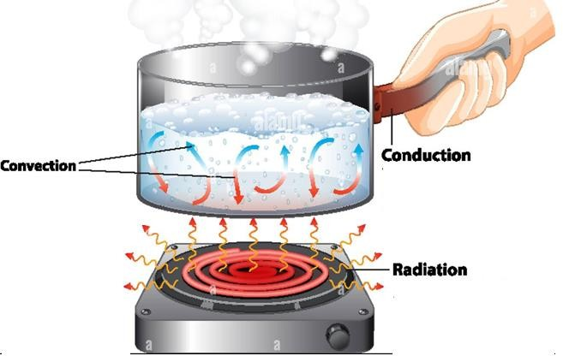
- Conduction
Heat is transferred through objects that are in direct contact with each other. The heat moves from a hotter object to a colder object through direct physical contact.
- Convection
Heat transfer occurs through a medium (e.g., air or a fluid). In convection, heat moves through the motion of the medium itself, such as warm air rising and cold air sinking.
Figure 1: 11 Heat transfer methods

- Radiation

Heat transfer occurs through electromagnetic waves, particularly infrared waves. When these waves strike a solid object, the object absorbs the energy, resulting in heat transfer.

Laws of Thermodynamics
      - Zeroth Law: If two bodies are in thermal equilibrium with a third body, they are in equilibrium with each other.
      - First Law: The total energy change in a system is the sum of thermal energy change and work done on it. Conservation of energy.
      - Second Law: Heat flows from high-temperature to low-temperature objects when they come into contact.
      - Third Law: Entropy of a pure crystal at absolute zero is zero. Entropy measures disorder, sometimes called "waste energy."
These fundamental laws of thermodynamics apply to various aspects of science and technology.
The five principles of heat transfer and pressure
To fully understand how a mobile HVAC refrigerant system works, a technician must become familiar with some basic principles of pressure, heat, and heat transfer. There are five basic principles that directly apply to mobile HVAC systems.
- Heat always travels from hot to cold.
- Materials absorb heat when changing from a liquid to a gas.
- Materials release heat when changing from a gas to a liquid.
- For a given temperature of a material, there is a corresponding pressure.
- The boiling point of a liquid varies with its pressure.
In the simplest of terms, the mobile HVAC system operation is taking heat from one area of the vehicle and releasing it to another. This is accomplished by changing both the pressure and the state of the refrigerant

1.3.3 Refrigerant
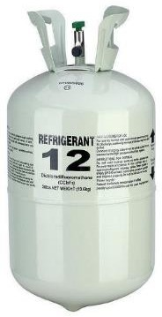
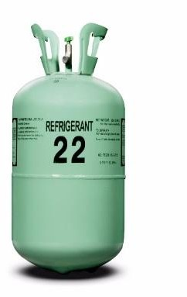
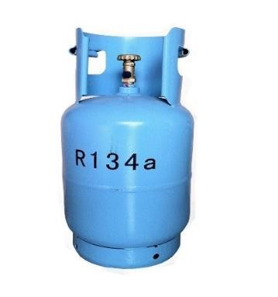
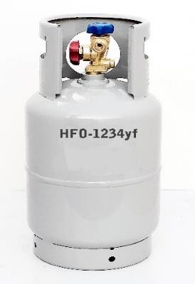
A substance with a very low boiling point that circulates through the functional parts of a refrigerating unit, absorbing heat through expansion and evaporation to produce the refrigerating effect.
A refrigerant must be:
- Non-flammable.
- Non-explosive.
- Non-poisonous.
- Non-corrosive.
- Odorless
Figure 1: 12 Different types of refrigerant

Types of refrigerants
Main types of refrigerants:
- Chlorofluorocarbons (CFCs):
- Once widely used but contain ozone-depleting chlorine.
- Contributed to ozone layer depletion.
- Examples: R11, R12, R113, and others.
- Hydro chlorofluorocarbons (HCFCs):
- Contain hydrogen, chlorine, fluorine, and carbon.
- Have lower ozone-depleting potential than CFCs.
- Examples: R22, R123, and others.
- Hydrofluorocarbons (HFCs):
- No ozone-depleting chlorine but are potent greenhouse gases.
- Developed as CFC and HCFC alternatives.
- Examples: R134A, R404A, R410A, and others.
- Hydro-fluoro-olefin (HFO):
- Environmentally friendly alternatives.
- Low Global Warming Potential (GWP) and no Ozone Depletion Potential (ODP).
- Examples: R1234yf, R1234ze (E).
Refrigerant evolution is motivated by environmental concerns, moving from ozone-depleting CFCs and HCFCs to HFCs with global warming issues. HFOs are emerging as eco-friendly options with less impact, backed by regulations promoting greener choices.

Basic component and their function
      - Compressor
Function
Compressor is the heart of the air conditioning system. It circulates the refrigerant through the system, and it also creates the pressure used to change the refrigerant from a low-pressure gas to a high-pressure gas so that the boiling point of the refrigerant is brought above ambient temperature. The increased temperature is needed to fully release the heat absorbed from the evaporator. The pressure from the compressor also keeps the refrigerant moving through the tight restriction of the metering device. Most of today’s vehicles have belt-driven compressors, with the exception of hybrid vehicles. Hybrid compressors are mostly electrically driven, but they could also be a combination of both electrical and belt driven.
General classifications compressors
There are two general classifications for mobile HVAC (heating, ventilation, and air conditioning) compressors.
- Fixed Displacement Compressors: a fixed compressor has the same displacement, where the compressor’s output depends on the turning speed of the compressor. Controlling the pressure is only accomplished by turning the compressor clutch on or off. If the pressure becomes too high, the compressor clutch is cycled off, and if the pressure is too low, the compressor clutch is cycled on.
- Variable Compressors displacement: a variable displacement compressor can internally change the displacement of its cylinders, which means no longer having to cycle the compressor on and off. These variable displacement compressors are always turning, but they may be regulated to near zero displacement, equaling no system pressure.
Common Compressor Types
There are three basic compressor types used in the mobile HVAC systems found today. They are categorized by their internal design components and how they compress the vaporized refrigerant. These common compressor designs are referred to as piston, scroll, or rotary vane. Although there may be differences in these internal components, the purpose is the same: to pressurize and circulate refrigerant. As with any compressor, the vehicle’s designers determine which type of compressor to use.

- Piston-Type Compressors
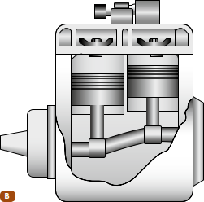
The first design of compressor is the piston type. Piston compressors are classified as either reciprocating or axial. Reciprocating compressors can have 1 to 10 cylinders. These compressors are driven by a belt through a crankshaft, a Scotch yoke, or a swash or wobble plate. Most of the piston-type compressors are considered fixed displacement compressors.

- Single or In-Line Cylinder Piston Compressors
One of the first types of reciprocating compressors is the single cylinder or in-line piston model. Weighing nearly 14 pounds, this compressor is extremely heavy and is no longer used in automotive applications.
- V-Type Piston Compressors
Figure 1: 4 In-line Piston type compressor
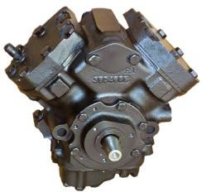
The next common type of reciprocating piston compressors is the V-type compressor. The V-type compressor, the RV-2, was used exclusively on Chrysler vehicles. It was used on R-12 refrigerant systems from the early 1960s up to the late 1970s. Chrysler stopped using this compressor, to save weight on its models, since it weighed over 40 pounds.
Figure 1: 14 V-type piston compressor

- Rotary Vane Compressor
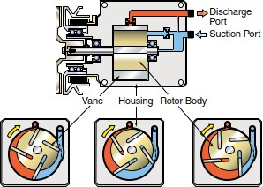
The rotary vane compressor does not have pistons. It has a rotor with several vanes and a carefully shaped housing. The sliding vanes seal against the housing at both ends. As the compressor shaft rotates, the vanes and housing form chambers. As the rotor turns, the size of the chambers changes. The refrigerant is drawn into the chambers through the suction port
Figure 1: 5 Rotary vane–type compressor.

The discharge port is located at the point where the gas is completely compressed. No sealing rings are used in a vane compressor. The vanes are sealed against the housing by centrifugal force and lubricating oil. The oil sump is located on the discharge side, so the high pressure tends to force it around the vanes into the low-pressure side. This action ensures continuous lubrication. Because this type of compressor depends on a good oil supply, it is subject to damage if the system charge is lost. A protection device is used to disengage the clutch if pressure drops too low.
- Scroll-Type Compressor
The scroll-type compressor has a movable scroll and a fixed or non-movable scroll that provide an eccentric-like motion. As the compressor’s crankshaft rotates, the movable scroll forces the refrigerant against the fixed scroll and toward the center of the compressor. This motion pressurizes the refrigerant. The action of a scroll-type compressor can be compared to that of a tornado. The pressure of air moving in a circular pattern increases as it moves toward the center of the circle. A delivery port is positioned at the center of the compressor and allows the high-pressure refrigerant to flow into the A/C system. These compressors do not have a suction valve. They are smaller and operate more smoothly than other designs.
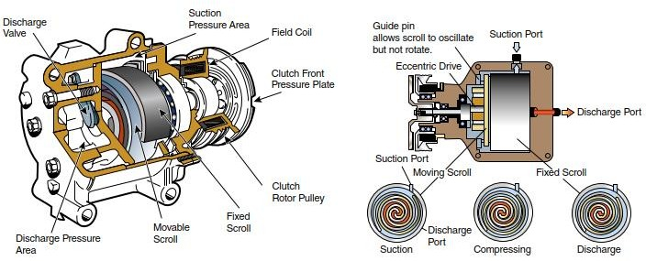
Figure 1: 6 Scroll-type compressor.

Compressor Components
Compressors are complex mechanical devices used to increase the pressure of gases or air. They consist of several key components that work together to achieve compression.
- Compressor Housing: In a car's AC system, the compressor housing contains and protects the internal components of the AC compressor.
- Compression Chamber: The space within the AC compressor where the refrigerant gas is compressed.
- Magnetic Clutch: The magnetic clutch is a specific component in the car's AC compressor system. It engages and disengages the compressor from the engine, controlling when the AC compressor operates. When the AC is turned on, an electric current activates the magnetic clutch, causing it to engage, allowing the compressor to operate and cool the cabin air. When the AC is turned off, the clutch disengages, preventing the compressor from running.
- Piston: The piston in the AC compressor helps compress the refrigerant gas by moving up and down within the compression chamber.
- Crankshaft: The crankshaft in the AC compressor is connected to the piston and converts its reciprocating motion into rotary motion.
- Connecting Rod: This component connects the piston to the crankshaft, transferring the piston's motion to the crankshaft.
- Valves: AC compressor valves regulate refrigerant gas flow into and out of the compression chamber. Reed valves are rare in car AC compressors, more common in other compressor types.
- Motor or Engine: In a car's AC system, an electric motor is commonly used to drive the AC compressor.
- Cooling System: AC compressors often have cooling systems to dissipate heat generated during compression. This may include fans or heat exchangers.
- Oil Lubrication System: Lubrication is essential for the moving parts of the AC compressor, including the piston and crankshaft.
- Pressure Relief Valve: A safety feature that releases excess pressure in the AC compressor to prevent damage.
- Control System: Modern car AC systems include electronic control systems to monitor and regulate the AC compressor's operation.

Operation
The compressor circulates refrigerant through the air conditioning system by taking low-pressure gas from the evaporator and moving the gas to the high-pressure side of the system.
When the piston begins to move away from the compressor head, the pumping chamber volume increases, and the low-side suction reed valve allows the low-pressure, low-temperature refrigerant to enter the pumping chamber. As the piston moves down to the bottom of the chamber, the cavity fills with as much vaporized refrigerant as the chamber can hold at low-side pressures. After the piston reaches the bottom of its stroke, it begins to move up toward the head of the compressor.
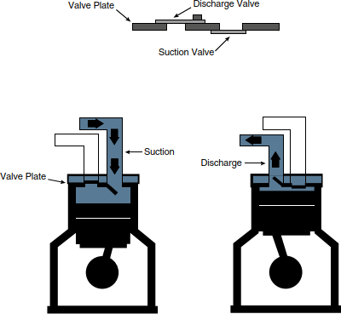
The suction side reed valve is forced shut due to the pressure increase as the piston begins to move up in the bore of the cylinder. As the chamber size becomes smaller, the pressure and temperature of the refrigerant begins to rise until the high-side discharge reed valve opens, releasing the high- pressure, high-temperature refrigerant. The discharge reed valve is pushed off its seat because the pressure of the refrigerant in the chamber becomes slightly higher than the pressure in the high side of the system
Figure 1: 7 Operating principle of compressor

      - Heat Exchangers
A heat exchanger is a component that facilitates the transfer of heat from one component to another. The heat transfers through one of two methods: from a liquid into a solid, and the solid into the air (adding heat); or from the air into the solid, and then into a liquid (removing heat). The liquid is referred to as a refrigerant or coolant. The liquid is used to either remove or add heat at a heat exchanger location. The solid (heat exchanger) is constructed of a material with excellent heat transfer characteristics usually a metal, such as copper or aluminu
Types of Heat Exchangers
HVAC systems, there are various types of heat exchangers commonly used two main heat exchangers:
- Condenser: Converts hot refrigerant vapor back into a liquid, playing a key role in air conditioning.
- Evaporator Core: Cools cabin air by transforming liquid refrigerant into vapor.
- Condenser
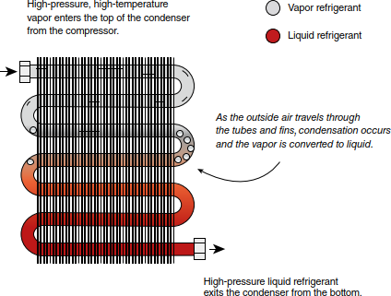
The vehicle's condenser operates by converting hot refrigerant vapor into a cooler, high-pressure liquid. It's typically made of copper or aluminum with fins for better heat transfer. Placed in front of the radiator, it maximizes airflow with fans and the vehicle's motion.
Cooling happens as cabin air cools the refrigerant, causing it to boil, while warmer ambient air makes it condense.
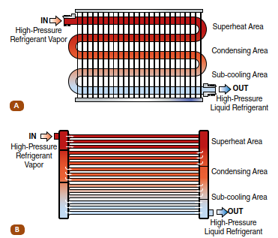
Pressure control is crucial: the compressor raises the boiling point, allowing condensation in ambient air. This process cools the refrigerant, turning it from a hot gas to a liquid in the condenser, entering as vapor at the top and exiting as a liquid at the bottom.
Figure 1: 8 Condenser operation
- Condenser design
- Serpentine: One round tube for longer heat transfer but lower efficiency due to limited refrigerant flow.
- Parallel-Flow: Multiple tubes run parallel, like a radiator, allowing more refrigerant flow for enhanced efficiency.
Figure 1: 9 Condenser flow designs:
A- Serpentine condenser. B-Parallel-flow condenser.

- Evaporator
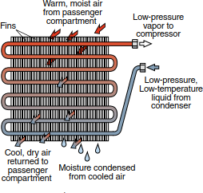
The evaporator is another essential heat exchanger in the air conditioning system. It resembles a heater core and is typically located in the passenger compartment, allowing air from the cabin to pass over its surface. It's a one-piece unit with no serviceable parts, featuring fins and small tubes for refrigerant flow. Refrigerant enters at the bottom and exits as vapor from the top.
Figure 1: 20 An evaporator

Made of copper or aluminum tubes with fins, the evaporator maximizes heat transfer. As air flows over the coils and fins, it causes the liquid refrigerant to boil, absorbing heat from the surrounding air. This heat transfer is essential for cooling.
The refrigerant's vaporization occurs just above freezing to prevent the evaporator from freezing. The heat from the cabin air is transferred to the refrigerant through convection and then into the tubes through conduction, causing the liquid refrigerant to evaporate into a gas. This process also removes moisture from the air, which exits the vehicle through an evaporator drain.
- Evaporator Design
The design of an evaporator significantly affects its efficiency. Evaporators in mobile HVAC systems can have single-pass or multiple-pass flow designs, with round or flat tubing.
- Serpentine Evaporators: Refrigerant travels in a serpentine, back-and-forth path for efficient cooling.
- Tube and Fin Evaporators: These evaporators have multiple rows of rounded tubing, allowing for effective heat exchange.
- Plate and Fin Evaporators: Refrigerant flows through a network of stacked plates between two end tanks, facilitating heat removal.
- Parallel Flow Evaporators: They utilize flat tubing between side tanks, allowing refrigerant to make multiple passes, enhancing cooling efficiency.
Choosing the right evaporator design is crucial for optimal cooling performance, and maintenance should follow guidelines similar to those for condensers, depending on the specific evaporator design used.
      - Restrictions
HVAC systems have four main components: compressor, condenser, restriction, and evaporator. The restriction transforms high-temperature, high-pressure liquid into low-temperature, low- pressure liquid. There are two common restriction types.
Restriction Operation
The restriction reduces pressure and increases refrigerant velocity. Lower pressure lowers the boiling point of the refrigerant to match cabin air temperature. It relies on the Bernoulli principle, where increased velocity leads to decreased pressure. This transformation prepares the refrigerant for the evaporator.
Types of Restrictions
- Fixed Orifice(expansion) Tube
A common system with a fixed orifice that provides a non-adjustable passage for refrigerant. It's less efficient and can flood the evaporator in certain conditions.
- Thermal Expansion Valve (TXV)
An adjustable system that responds to evaporator outlet temperature, allowing for better control and efficiency.
The choice between these two systems impacts how refrigerant flows and is controlled within the HVAC system. Fixed orifice tubes are less efficient and can't adapt to changing conditions like TXV systems.

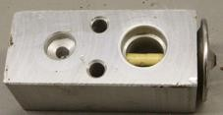

Figure 1: 21 Restrictions: A Fixed orifice tube. B Thermal expansion
      - Accumulators and receiver-driers
They are key components in refrigerant systems, serving similar purposes but located on different sides of the system. They store refrigerant and oil, filter out contaminants, and remove moisture.
        - Accumulator: Positioned on the low-pressure side between the evaporator and compressor, it ensures that only vaporized refrigerant enters the compressor, preventing liquid compression. It also allows some oil to enter the compressor for lubrication and contains a desiccant to remove moisture. When the system is serviced, it's advisable to replace the accumulator.
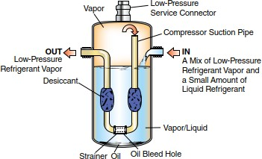
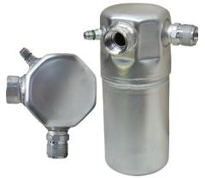

Figure 1: 10 An accumulator and operation
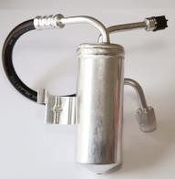
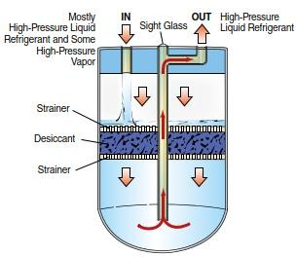
        - Receiver-Drier: Typically found on the high-pressure side before the expansion valve, it ensures pure liquid refrigerant reaches the evaporator. It collects liquid refrigerant, filters it, and uses a desiccant to remove moisture. It also acts as a surge tank when the expansion valve closes due to low temperatures and pressures in the evaporator. Like the accumulator, it should be replaced when the refrigerant system is opened for servic
Figure 1: 23 Typical receiver-drier and operation
      - Blower Motor/Fan
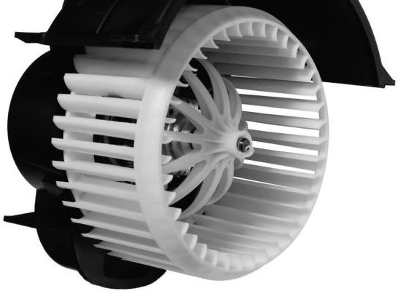
The blower motor/fan assembly is a critical component in your vehicle's climate control system. It's responsible for moving air through both the heater core and the air conditioning evaporator. This assembly consists of an electric motor and a fan, housed within the evaporator housing. Its main function is to enhance airflow within the passenger compartment.
Figure 1:24 blower motor/fan

To achieve this, it draws in warm air from inside the cabin, directs it over the coils and fins of the evaporator, and then expels the cooled, cleaned, and dehumidified air back into the passenger area.
The blower motor's speed is controlled by a fan switch, and in some systems, it can also vary with the compressor's speed to optimize cooling.
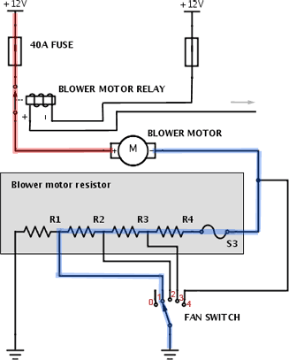
- The blower motor in a car operates on a specific voltage.
- To control its speed, a resistor is added in the circuit.
- The resistor reduces the voltage reaching the motor, slowing it down.
- By adjusting the resistor's value, you can control the motor's speed.
- Different fan speed settings on the dashboard correspond to different resistor values.
- Increasing resistance makes the motor slower, and decreasing resistance makes it faster.
Figure 1: 25 blower motor circuit
      - Hoses, Pipes, and Lines
Pipes are sturdy metal tubes used where strength is crucial, while hoses are flexible and used near moving parts like the compressor.
Hoses must meet SAE J2064 standards, be barrier-type, and prevent moisture and refrigerant leakage. Hose connections are secured with crimps, usually pre-made due to complexity. Metal pipes connect fixed parts and are less likely to leak but need proper bending and securing.
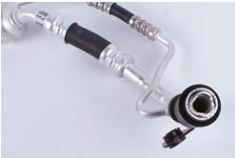
Hoses are sized by the tube they fit over; metal tubing by outer diameter. They have specific names based on function: suction, discharge, and liquid lines. Some hoses and lines have mufflers to reduce compressor noise and filter debris. Contaminated mufflers should be replaced, as flushing won't work.
Figure 1: 26 Hoses / pipes
      - Thermostatic Switch
In cycling clutch systems, the thermostatic switch is placed in series with the compressor clutch circuit so it can turn the clutch on or off. It has two purposes. It de-energizes the clutch and stops the compressor if the evaporator is at the freezing point
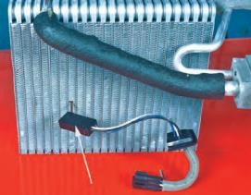
When the temperature of the evaporator approaches the freezing point (or the low setting of the switch), the thermostatic switch opens the circuit and disengages the compressor clutch. The compressor remains inoperative until the evaporator temperature rises to the preset temperature, at which time the switch closes and compressor operation resumes.
Figure 1: 27 A temperature sensor mounted onto an evaporator.
      - Pressure Cycling Switch
This switch is electrically connected in series with the compressor electromagnetic clutch. Like the thermostatic switch, the turning on and off of the pressure cycling switch controls the operation of the compressor

1.3.5 Refrigeration cycle and operation
The basic refrigeration cycle is a fundamental process that refrigeration and air conditioning systems use to transfer heat from one place to another, resulting in cooling.
Description of the refrigeration cycle in four phases:
- Compression: The refrigerant is compressed, raising its temperature and pressure.
- Condensation: Heat is released, turning the refrigerant into a high-pressure liquid. Expansion: Pressure drops, causing the refrigerant to rapidly cool and expand.
- Vaporization: Heat is absorbed from the surroundings, turning the refrigerant into a low-pressure vapor.
These phases define the basic steps of the refrigeration cycle, allowing for the transfer of heat and cooling of a space.
Refrigeration operation
In a basic A/C system, the heat is absorbed and transferred in the following steps
- When the system is off, the refrigerant occupies the system as a vapor and its pressure is the same throughout the system.
- When the A/C compressor is turned on, it increases pressure on the refrigerant and raises its temperature.
- The refrigerant is pumped out of the compressor as a high-pressure, high-temperature vapor.
- The high-pressure gas is sent to the condenser. Heat in the refrigerant is moved to the outside air by conduction and convection. The removal of the heat causes the refrigerant vapor to condense into a liquid under high pressure.
- The high-pressure, high-temperature liquid leaves the bottom of the condenser and enters a receiver/dryer or accumulator. These devices remove moisture and contaminants and store clean refrigerant until it is needed.
- The refrigerant then flows to the inlet side of the evaporator core orifice or expansion valve. These control the flow of refrigerant into the evaporator. The restriction causes the pressure and boiling point of the refrigerant to drop.
- As the liquid refrigerant leaves the restriction, it is at its lowest pressure and temperature.

- The refrigerant then passes through the evaporator where it absorbs heat, through convection, from the air inside the passenger compartment. The additional heat causes the refrigerant to boil and change back to a vapor.
- The refrigerant then returns to the compressor as a low-pressure, low-temperature vapor and the cycle continues.
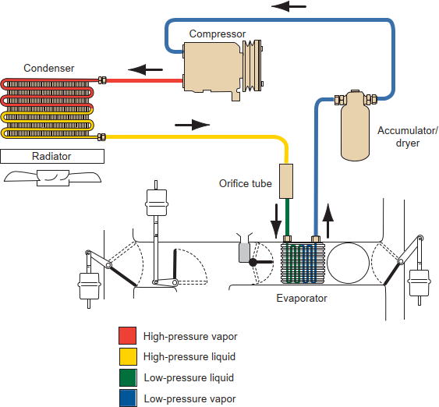
An automotive A/C system is a closed, pressurized system. It consists of a compressor, condenser, receiver/dryer or accumulator, expansion valve or orifice tube, and an evaporator. To understand the operation of these components, remember that an A/C system is divided into two sides: the high side and the low side. High side refers to the side of the system that is under high pressure and high temperature. Low side refers to the low-pressure, low-temperature side of the system

Figure 1: 11 The basic refrigerant flow cycle.

1.4 Air distribution and control system
The supply of fresh air in a vehicle is essential for comfort, reducing driver and passenger fatigue, and ultimately enhancing safety. Here's how this process works:
Fresh Air Intake: The vehicle's air conditioning and ventilation system is designed to draw in fresh air from outside. Typically, this fresh air is taken in through air ducts positioned at the base of the windshield.
Filtration: Before this fresh air enters the passenger compartment, it passes through a series of filters. These filters serve to clean and purify the incoming air. There are different types of filters used:
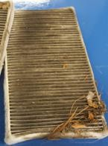
Air Filter: This filter is designed to capture larger particles like dust and debris from the outside air, similar to the air filter used for the engine. It prevents these contaminants from entering the cabin.

Cabin Air Filter: Some vehicles are equipped with cabin air filters, which are placed in the inlet side of the heating/air conditioning box, where fresh air enters. These filters are designed to catch smaller particles, allergens, and pollutants, providing cleaner and healthier air inside the cabin.
Pollen Filter: Pollen filters serve a similar purpose to cabin air filters but are specifically designed to trap pollen and allergens, making the cabin environment more suitable for individuals with allergies.
Figure 1: 29 Air Filter
Advanced cabin filters, like activated charcoal filters, enhance air quality by trapping particles, removing odors, and eliminating pollutants. Replace them annually or every 12,000-15,000 miles for best results.
HVAC Control Panels
One other input to the ECU in the HVAC system comes from the HVAC control panel. The operator can tell the ECU where to deliver air and at what temperature, by using switches that produce an on/off-type signal. The ECU receives either a 12-volt signal or 0 volts. For example, pushing the windshield defrost button sends an “on” 12-volt signal to the ECU. Pushing the floor button cancels the defrost button. The defrost button now sends an “off” 0-volt signal to the control unit. At the same time, the floor button sends an “on” 12-volt signal to the ECU for the floor vent. The ECU also receives instructions from the operator regarding the desired cabin temperature via the control panel. The desired temperature selection is used to tell the ECU what temperature the operator wishes the inside of the vehicle to be. The ECU then adjusts the position of valves and doors to achieve the desired temperature and direction of airflow.
Another control, called a mode switch or selector, controls the location of the airflow output and the temperature. Several doors, sometimes referred to as air doors, are designed to direct the air to the feet (floor ducts), head (vent ducts), windshield (defrosting ducts), or a combination of locations, such as the feet and windshield
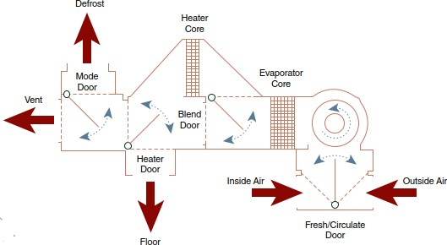
Figure 1: 12 Typical air distribution case with mode doors to control temperature and air flow direction.

Control Panel Types
The control panel buttons, knobs, and dials vary from vehicle to vehicle and from system to system, depending on whether the system is manual, semiautomatic, or fully automatic. There are also dual-zone and rear climate control panels.
- Manual Control Panel
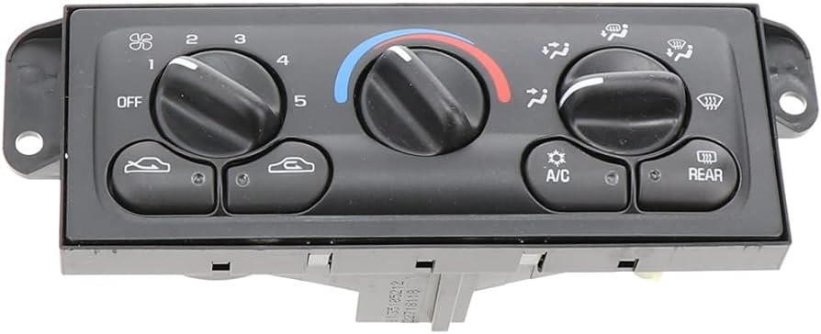
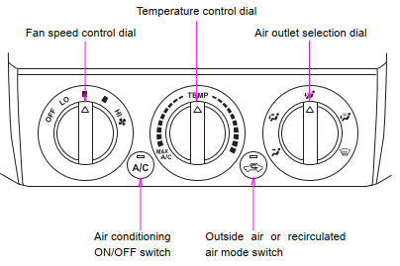
If the system is a manual control panel, there will be a rotary or linear switch for fan speed, a rotary or linear switch for modes (floor, defrost, vent, or vent and floor), and a rotary or linear switch for temperature. On some models, an air conditioning button, as well as a recirculation button, appears on the panel

Figure 1: 31 Typical manual control panel
- Temperature Control Dial:
- This dial controls the temperature in the cabin.
- Turn it clockwise for hot air and anticlockwise for cold air.
- Fan Control Dial: adjusts the fan speed.
- There are different fan speed options depending on the type of vehicle.
- Mode Selector Dial
- Turn this dial to choose the direction of the airflow (e.g., to your face, feet, or both).
- You can also set it to intermediate positions to split the airflow between modes.
- Air flow selector Turn the knob to select the vents used for air flow.
- Panel—Air flows mainly from the instrument panel vents.
- Bi−level—Air flows from both the floor vents and the instrument panel vents.
- Floor—Air flows mainly from the floor vents.
- Floor/Windshield—Air flows mainly from the floor vents and windshield vents. Use with the air intake selector positioned in FRESH
A/C Switch
- Press this switch to turn the air conditioner on.
- The indicator light on the switch illuminates when the fan control dial is on (except OFF).
- Press it again to turn the air conditioner off.
Air Intake Selector
- This switch lets you choose between drawing air from inside the cabin (recirculated air) or from the outside environment (outside air).
- It's usually recommended to use the outside air position in normal conditions to ensure fresh air circulation.
- This choice helps regulate air quality and can be especially useful for defogging windows in cold or rainy weather.
- Semiautomatic Control Panel
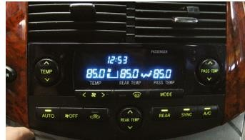
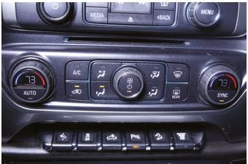
On a semiautomatic system, the control panel typically has a rotary temperature switch, a rotary fan switch, a rotary mode switch, a recirculation button, and possibly an economy button that limits the air conditioning compressor operation in an attempt to improve fuel economy. This system uses an ECU to determine when to run the compressor and the amount of heat required to match and maintain the desired temperature selected by the operator.
Figure 1: 32 Typical semiautomatic
control panel
- Fully Automatic Control Panel
The automatic control panel includes an Auto mode for system control based on chosen temperature, and it also offers manual control with all necessary buttons. A digital display shows the selected temperature.
Figure 1: 33 Typical automatic control panel with Auto mode, along with manual controls.
- Dual-Zone Temperature Control Panel
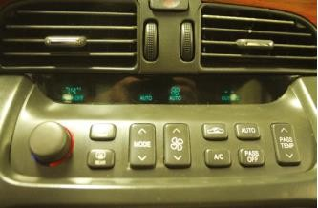
The dual-zone temperature control panel is designed to allow the driver and passenger to control temperature delivered to their side of the vehicle for a more pleasant climate for each individual. The control panel for this design contains the same buttons used in other systems but has two temperature control switches. With dual controls, the air box must have two blend doors and two blend door actuators to allow for separate temperature control.
Figure 1:34 Typical dual-control system allows separate control for the driver and passenger side of the vehicle.

- Real Climate Control Panel
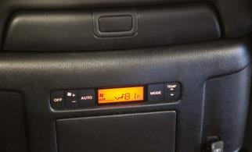
The last system available is the rear climate control panel. The control panel at the front of the vehicle has a rear button in addition to all the other buttons and switches covered here.
When the rear button is selected, the rear panel controls located at the back of the vehicle are activated. The driver can turn off control of the panel at the rear by pressing this button on the front panel. With the rear air control panel selected on the front panel, the rear passengers can typically select temperature, fan speed, and mode.
Figure 1:35 Rear climate control.
Control Panel Operating Mechanisms
The control panel assembly could be a mechanical system that operates manually via cables, vacuum valves, or electrical switches. It could also be a combination of any of the manual cables, vacuum or electrical switches. An automatic system will be completely controlled electronically, with some of the actuators operated by either a vacuum or electric power source

- Cable Control Systems
Cable systems tend to be found only on older vehicles. The cables mechanically move doors and valves. They tend to bind up over time and do not work properly, so most manufacturers have moved away from control cable systems.
- Vacuum Control System
Vacuum control systems contain vacuum switches or valves that direct source vacuum from a vacuum canister connected to engine vacuum to different vacuum servos.
The vacuum canister is installed on the vacuum system to ensure that vacuum is present for the control panel to use even when the engine is at wide-open throttle (vacuum goes away under wide-open throttle). Thus, the canister provides a reserve of vacuum so that the controls can continue to operate. The vacuum switches or valves connect vacuum hoses together at the panel.
- Electrical Control System
Electronic control panels contain electronic controls that send electrical or electronic inputs to the ECU. In many cases, the ECU is part of the control panel, so it is an all-in-one unit. The ECU sends electrical signals to actuators, which cause the doors or valves to operate.
Case and Duct Systems
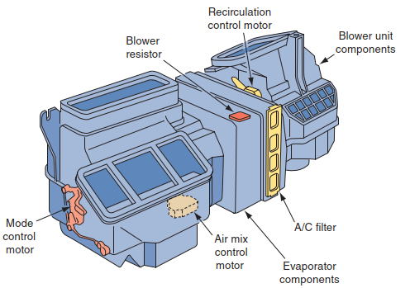
The system has two main jobs: it houses the heater and air conditioner components, and it directs either fresh or recirculated air into the car. The air can go to the floor, dash panel, or defrost outlets. In some vehicles, there are two duct systems. In one, the water valve controls the air, and in the other, an access door decides between fresh and recirculated air. Recirculated air is used for maximum cold, and the evaporator works in the max air setting. A control inside the car adjusts the hot water entering the heater core and the air temperature at the unit outlet.
Figure 1:36 Typical heater/air conditioner ducts.

1.5 HVAC System Tools for System Repairs
The proper use of specialized tools will allow the technician to begin to perform basic service and diagnostic system tests on a mobile HVAC system. When performing a diagnosis or servicing a pressurized cooling system or refrigerant system, there is always the possibility of bodily harm, so all safety precautions must be followed. Please note that the tools shown in this chapter are general in illustration. To ensure proper use and to avoid any damage or bodily injury, the technician should always follow the manufacturer’s operating manual specific to each tool.

1.5.1 Manifold Gauge Set
This essential tool allows HVAC technicians to perform various tasks, including pressure readings, refrigerant recovery, evacuation, vacuuming, and recharging of the refrigerant system. The set includes colored hoses and quick disconnect fittings for ease of use.
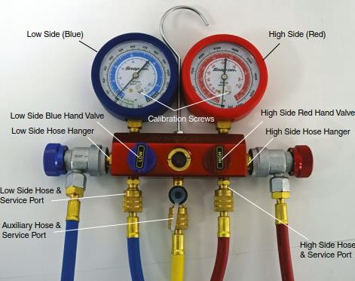
- Low Side (Blue) and High Side (Red): the manifold gauge set is dual-sided. The blue side shows low-side pressure and vacuum (30' Hg to 0-150 psi), while the red side indicates high-side pressure (0-500 psi).
- Auxiliary Port (Yellow Hose): The middle port, typically connected with a yellow hose, is for charging and vacuuming the refrigerant system.
Figure 1: 37 Manifold gauge set.

- Digital Manifold Gauge Set: In addition to the standard gauge set, a digital version is available for pressure tests and system diagnostics, providing more precise readings

1.5.2 A leak detector
A specialized tool designed to detect refrigerant leaks in the system. It can sense the presence of refrigerant gases escaping from the system, helping technicians pinpoint the location of the leak. This method is effective in identifying leaks early, allowing for timely repairs and preventing further refrigerant loss.

1.5.3 Vacuum Pumps
Essential for HVAC system maintenance.
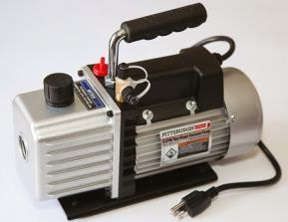
used in the final step of HVAC system repair before recharging. They serve two critical functions: ensuring system integrity and removing moisture from the system.
Vacuum Process: The vacuum pump creates a vacuum within the HVAC system. This vacuum not only verifies the system's integrity but also boils off and removes any moisture present. The boiling point of different chemicals, including water, varies with pressure.
Figure 1: 38 Electric vacuum pump
Types of vacuum pumps are essential components in HVAC maintenance and contribute significantly to the efficiency and durability of HVAC systems. There are two primary categories:
Air Pressure Pumps: Although less common than electric pumps, air pressure pumps are an alternative for creating a vacuum in HVAC applications. These pumps utilize compressed air to generate the necessary negative pressure within the system.
Electric Vacuum Pumps: These are the predominant choice in HVAC maintenance. They are frequently integrated into recovery and recycling machines, making them a common tool for HVAC professionals. Electric vacuum pumps efficiently remove air and moisture from HVAC systems.

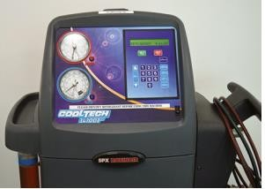
1.5.4 R/R/R machine
A tool for recovering, recycling, and recharging refrigerant systems. It includes pressure gauges and a vacuum pump. It can also remove refrigerant oil, crucial for maintaining system oil capacity during recharging.
Figure 1:39 An R/R/R machine.

1.5.5 Thermometers
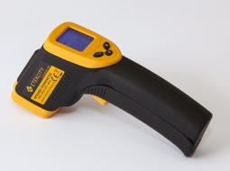
Essential tools in HVAC system diagnosis. Two main types are commonly used: Pocket-style, dial-faced thermometers: These are mechanical or electronic thermometers used to measure air temperature. They can be installed in a dash vent or placed in the open.
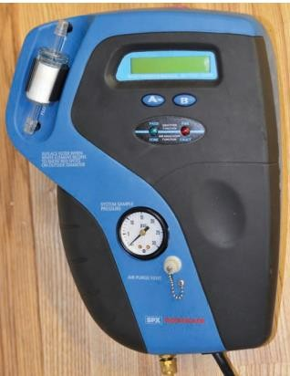
Probe thermometers: These are another type of thermometer typically used with digital multi meters. They require the probe's tip to be in contact with the air being measured or the component under inspection.
Figure 1:40 An infrared, non-contact-type thermometer.

1.5.6 Refrigerant identifier/analyzer
This tool checks refrigerant systems before servicing. It identifies the refrigerant type, tests purity, and detects air. Using a refrigerant analyzer is wise to avoid harm from wrong substances. Some have adapters for various systems.
Figure 1:41 Refrigerant identifier/analyzer

1.5.7 Refrigerant system sealant detectors
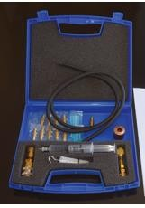
Aftermarket products often contain sealants for quick leak repairs in HVAC systems. However, some of these sealants can harm HVAC recovery/recycling equipment, necessitating costly repairs or replacements. To safeguard approved equipment, the use of a sealant detector is recommended. It helps identify the presence of sealants in the system, preventing potential damage.
Figure 1:42 Refrigerant system sealant detectors


1.5.8 An oil injector
Purpose: Oil injectors add oil or dye to HVAC systems post-evacuation, without the need to reopen the system.
Operation: Inject oil through the low-side service port using atmospheric pressure or physical force.
Use: Essential for HVAC maintenance, ensuring proper system function and efficiency. Vital for adding oils or dyes when needed.
Figure 1:43 An oil injector

1.6 OHS and Hazard Identification

1.6.1 PPE Requirement
When servicing mobile HVAC systems, it is crucial to prioritize personal safety. Proper Personal Protective Equipment (PPE) is essential to prevent potential hazards. Ensure that the following safety measures are observed:
- Always wear long-sleeve shirts and pants for added protection.
- Use proper hand and eye protection to guard against risks like burns and frostbite, which can result from the high pressures and temperatures of engine coolants and refrigerants.
- Employ splash-style goggles that meet the ANSI Z87 standard to protect your eyes. Refrigerant contact with the skin can lead to instant freezing and frostbite, and contact with the eyes can cause severe injury.

1.6.2 OHS Requirement:
Personal Safety While Servicing Mobile HVAC Systems: In the automotive repair field, there are inherent hazards to be aware of, including moving components (belts, pulleys, and cooling fans) and electrical hazards in hybrid vehicles. Servicing automotive HVAC systems involves handling chemicals such as refrigerants, refrigerant oil, solvents, and engine coolants. Always adhere to the vehicle manufacturer's service manual for the most current and proper service procedures.
Safety Data Sheets: Chemicals used in servicing HVAC systems can be hazardous. Consult the safety data sheet (SDS) manual for each chemical to understand its safe use, storage, toxicity, and emergency procedures.
Hand and Eye Protection: Wearing appropriate PPE is crucial when servicing HVAC systems due to the risk of burns and frostbite from engine coolants and refrigerants. Along with protective clothing, use hand and eye protection at all times.
Safety Procedures for Mobile HVAC Systems: Mobile HVAC systems have unique properties and operating pressures that require special precautions:
- Ensure proper ventilation in the workspace to avoid a lack of breathable air.
- Be cautious when using heating elements or open flames near the system, as heat can pose a danger.
- Maintain control and monitoring of refrigerant storage.
- Always refer to the service manual for service procedures and special warnings.
Ventilation: Mobile HVAC refrigerants, though odorless and colorless, can be irritating when inhaled. Adequate ventilation is crucial during work to prevent asphyxiation. Seek medical attention if contact occurs.
Combustion and Flammability: Avoid open flames near refrigerants, as they can turn toxic when exposed to heat. While most are noncombustible, mixing with air can make them flammable. Do not perform repairs until the system is fully recovered.
High-Temperature Cautions: Keep refrigerant components under 180°F to prevent system rupture. Store refrigerant in approved containers below 120°F to prevent explosions. Use designated warming methods. Clean heat exchangers with cold water or compressed air to avoid steam damage.
Storage Containers: Fill approved refrigerant containers to 60% capacity to allow for expansion, preventing excessive pressure and explosions. Never reuse disposable containers.
Service Procedures: When servicing a vehicle's HVAC system:
- Follow manufacturer's service procedures.
- Use the specified refrigerant and oil.
- Heed posted warnings to prevent injury and equipment damage.
- Avoid reusing O-rings and seals.
- Prevent contact with refrigerant oil, which can damage surfaces and absorb moisture.
- Seal containers of refrigerant oil when not in use

Self-check-1
- Instruction: Select the best answer
  - What is the primary function of an automotive heating system?
    - Cooling the engine c) Providing warmth to the cabin
    - Enhancing fuel efficiency d) Generating electricity
  - Which type of heating system relies on a vehicle's engine coolant to provide heat?
    - Electric heating c) Radiant heating
    - Forced air heating d) Hydronic heating
  - What is the purpose of the ventilation system in a vehicle?
    - Cooling the cabin air c) Filtering pollutants from incoming
    - Generating heat for the cabin d) Controlling the engine temperature
  - In air conditioning systems, what is the principle of refrigeration based on?
    - Conductivity of air c) Heat transfer through radiation
    - Movement of refrigerant cycles d) Conduction of electricity
  - Which component of an HVAC system is responsible for removing heat from the cabin air?
    - Compressor b) Evaporator c) Condenser d) Expansion valve

Essay Questions
II. Instruction: write short answer for the given question. You are provided 3 minute for each question and each point has 5Points.
- Explain the basic operation and components of an automotive heating system. Include details about the types of heating used in vehicles.
- Describe the principles of refrigeration in air conditioning systems.
- Discuss the types of refrigerants commonly used and their environmental impact.
- Provide an overview of the key components and their functions in an air conditioning system.
- Explain how the refrigeration cycle works to cool the cabin air.
- Discuss the classification of air conditioning systems in vehicles, including their advantages and disadvantages.
- Explain the importance of Occupational Health and Safety (OHS) requirements and Personal Protective Equipment (PPE) in the HVAC field.
- Discuss how hazard identification contributes to a safe working environment

Unit two. Inspecting and diagnosis HVAC system
This unit is developed to provide you the necessary information regarding the following content
coverage and topics:
- Procedures
- HVAC system visual inspection
- Inspecting heating and air conditioning
- Air conditioning performance test
This guide will also assist you to attain the learning outcomes stated in the cover page. Specifically, upon completion of this learning guide, you will be able to:
- Understand and follow the proper procedures related to HVAC system inspection.
- Perform a visual inspection of HVAC systems
- Inspect heating and air conditioning
- perform air conditioning performance tests

Procedures
Procedures for inspecting, testing, and diagnosing an HVAC system:
- Visual Inspection:
  - Begin with a visual inspection of the HVAC system's components.
  - Look for signs of damage, wear, or corrosion in parts such as the condenser, evaporator, compressor, hoses, and electrical connections.
  - Check for refrigerant leaks, indicated by oil stains or dye traces.
- Filter Inspection and Replacement:
  - Inspect the air filters and replace them if they are clogged or dirty.
  - Dirty filters can restrict airflow and reduce system efficiency.
- Thermostat Testing:
  - Test the thermostat settings and operation to ensure it accurately senses and maintains the desired temperature.
- Ductwork Inspection:
  - Examine the condition of the ductwork for leaks, damage, or disconnections.
  - Leaky ducts can lead to reduced system efficiency.
- Electrical Component Inspection:
  - Inspect electrical connections, switches, and wiring for signs of wear, corrosion, or damage.
  - Tighten loose connections and replace damaged components as needed.
- Refrigerant Pressure Testing:
  - Use pressure gauges to measure the refrigerant pressure.
  - Compare the readings to manufacturer specifications to ensure the system has the correct charge.
- Functional Testing:
  - Turn on the HVAC system and test its functionality.
  - Check heating and cooling functions, fan operation, and airflow direction.
  - Listen for unusual noises that may indicate problems.
- Temperature Differential Measurement:
  - Measure and record the temperature differential between the supply and return air.
  - This helps assess the system's cooling or heating efficiency.

- Refrigerant Leak Detection:
  - Use a refrigerant leak detector or UV dye to identify refrigerant leaks.
  - If leaks are detected, mark the areas for repair.
- Performance Testing:
  - Conduct air conditioning performance tests to evaluate the effectiveness of the system's cooling capacity.
  - Check for proper cooling output.
- HVAC Control Panel Testing:
  - Test the HVAC control panel, buttons, and switches to ensure they function correctly and respond to user inputs.
- Blower Motor Inspection:
  - Check the blower motor for proper operation and cleanliness.
  - Lubricate the motor if necessary.
- Cabin Air Quality Inspection:
  - Evaluate the quality of cabin air by checking for odors, unusual smells, or allergens.
  - Inspect and replace cabin air filters if needed.
- Refrigerant Oil Inspection:
  - Examine the refrigerant oil level and condition.
  - Ensure that the correct amount of oil is present for lubrication.
- Diagnosis of Specific Issues:
  - If any issues are identified during the inspection and testing, use diagnostic tools and methods to pinpoint the exact problem.
  - This may include electrical testing, refrigerant system diagnostics, or component- specific troubleshooting.
- Documentation:
  - Document all inspection findings, test results, and diagnostic outcomes.
  - Accurate records help in tracking maintenance history and planning necessary repairs.
- Recommendations:
  - Based on the inspection and diagnostic findings, provide recommendations for any required repairs or maintenance to ensure the HVAC system's optimal performance.

HVAC system visual inspection
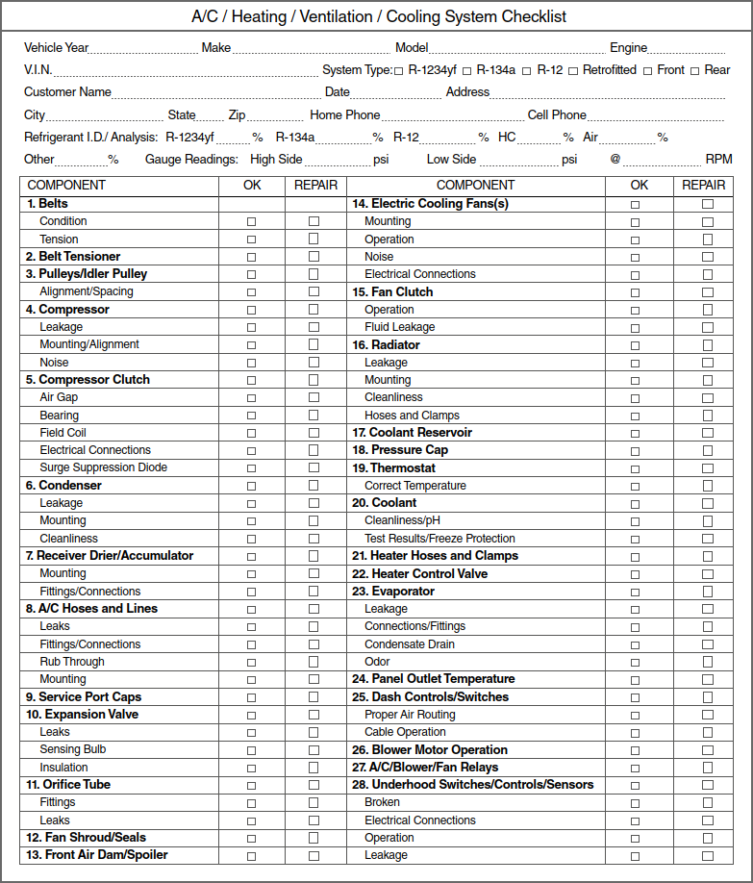
A visual inspection of an HVAC system checks for damage, wear, and corrosion in its components. This includes external units, refrigerant lines, heating and cooling elements, electrical parts, filters, ducts, ventilation, insulation, and drainage. It's crucial for identifying issues and maintenance requirements to ensure efficient operation and accurate diagnostics. Using an inspection sheet is essential to systematically check all component.
Figure 2: 1 An inspection checklist for the HVAC and air conditioning system.
Initial System Checks:

- Begin by gathering information from the customer regarding their concerns and the conditions under which the HVAC system exhibits issues.
- Perform basic checks like adjusting temperature settings, observing blower speed changes, and noting any unusual sounds or smells.
- These initial checks help narrow down potential problem areas and provide valuable information for further diagnosis.
Inspection
- Visually inspect the compressor drive belt, compressor clutch, and surrounding components for signs of damage, oil leakage, or belt slippage.
- Check refrigerant hoses and fittings for signs of leakage or damage.
- Inspect the condenser for debris buildup and damaged fins.
- Examine wiring and connectors for sensors and switches, ensuring they are secure and clean.
- Listen for unusual sounds and observe the electric engine cooling fan's operation.
Simple Checks
- Feel the air coming out of the vents to assess cooling ability.
- Adjust the temperature control to check for changes in airflow and temperature.
- Test the blower control through different speed positions.
- Inspect the discharge line, condenser, and liquid line for temperature changes or frost.
- Check the expansion valve, orifice tube (if equipped), and accumulator for temperature differences.
- Observe the suction line to the compressor for temperature and frost levels. Sight Glass (if applicable):
- Check the sight glass for signs of oil streaking, bubbles, or cloudiness, which can indicate refrigerant issues or contamination.
Accumulator Systems
- Understand that systems with accumulators may have some bubbles in the liquid line, making sight glass checks less reliable
- Pressure and performance testing may be necessary to further evaluate the system's refrigerant levels and functionality.
- Always refer to the manufacturer's service manual for specific diagnostic procedures.

Inspecting Heating and Air Conditioning (HVAC) Components
Inspecting your vehicle's HVAC system is vital to ensure its proper operation. The inspection covers various aspects:
- Heating Elements: Examine heating elements for damage or corrosion, including the heater core and heating coils.
- Obstructions: Check for obstructions that might affect heating performance.
- Air Conditioning Components: Inspect the evaporator coil, refrigeration lines for wear, leaks, or refrigerant issues.
- Blower Motor: Ensure the blower motor operates correctly and delivers adequate airflow for heating and cooling.
- Thermostat Calibration: Verify the thermostat's accuracy in controlling temperature adjustments.
- Control Systems: Test switches, buttons, and electronic controls to ensure they work correctly.
- Temperature Output: Evaluate temperature output in various modes and check indoor air quality, ventilation, and filtration.
Basic Heater Inspection and Checks
When there is a problem of insufficient heat, begin your diagnosis with a visual inspection and a check of the coolant level and condition. If the level is correct, turn the heater controls on and run the engine until it reaches normal operating temperature. If the engine does not reach operating temperature, typically around, 220 °F (104.4 °C) suspect a faulty thermostat or fan clutch. Then measure the temperature of the upper radiator hose. The temperature can be measured with a pyrometer or thermocouple and a DMM. If these are not available, carefully touch the hose. You should not be able to hold the hose long because of the heat. While doing this, make sure you stay clear of the area around the cooling fan. A spinning fan can chop off your hand. If the temperature of the hose is not within specifications, suspect a faulty thermostat.
If the hose is the correct temperature, check the temperature of the two heater hoses. They should both be hot. If only one of the hoses is hot, suspect the problem to be the heater control valve or a plugged heater core.

Leaking heater cores are often easy to diagnose because of the presence of one or more of three symptoms: coolant leaking onto the floorboards, steam coming from the vents, and a sweet smell inside the passenger compartment. Any of these conditions should prompt a complete inspection of the cooling system.
What to expect during a car HVAC inspection?
During a car HVAC inspection, anticipate the following steps:
- Thermostat Test: Check thermostat functionality.
- Air Filter Examination: Inspect air filters for clogs or dirt.
- Airflow Assessment: Evaluate airflow for heating and cooling.
- Equipment Condition: Examine HVAC equipment for wear or damage.
- Refrigerant Levels: Check refrigerant levels for efficient cooling.
- Heating Inspection: Inspect heating components for safe and efficient operation.
- Condensate Drain: Ensure the condensate drain works correctly.
- Blower Motor Examination: Examine the blower motor.
- Safety Equipment: Confirm safety equipment functionality.
- Comprehensive Component Evaluation: Assess various components for issues.
- Pest Infestation Check: Look for pest infestations.
- Diagnostic Report: Receive a detailed report outlining findings and recommendations. This inspection helps maintain, repair, or replace your car's HVAC system for comfort and safety.
Leak Testing in HVAC Systems
Detecting and addressing refrigerant leaks is essential in HVAC maintenance:
- Importance: Leaks harm efficiency and the environment.
- Detection: Use sensitive infrared leak detectors or check low-pressure gauge readings.
- Common Leak Spots: Check hose connections, fittings, and joints for oily spots.
- Using Detectors: Ensure some refrigerant is present for detectors to work.
- Thorough Check: Inspect the entire system, tighten connections, and replace parts if leaks persist.
- Safety First: Remove refrigerant with a recovery station before making repairs to prevent environmental harm.

Air Conditioning Performance Testing and Diagnosis
When evaluating the performance of an air conditioning unit, a technician must meticulously assess its components and compare its operational state to its design specifications. There are two essential tests that can be conducted without the need for refrigerant gauges.
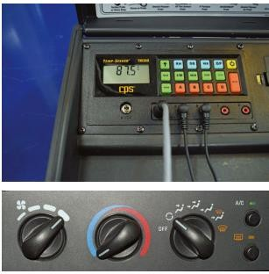
Test 1: Initial System Performance Evaluation

Before conducting this evaluation, ensure that the engine has reached its normal operating temperature. Whenever possible, position the vehicle outdoors during daylight hours with all doors, windows, the sunroof, and the hood open. To achieve an accurate assessment, the ambient air temperature should be at least 70°F. Set the air conditioning and blower speed controls to their maximum settings, directing airflow to the dash vents. Allow the air conditioning system a few minutes to stabilize.
Figure 2:2 Setting up a vehicle for performance testing.
Taking precise readings and analyzing them is crucial to obtain an accurate diagnosis and detect any concealed issues. Testing under these conditions guarantees optimal performance when the vehicle is in motion.
Function and performance test:
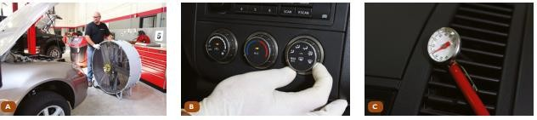
To initiate the diagnostic process and verify system operation, the function and performance test must be performed, along with a visual inspection of the air conditioning system. It is important to check the manufacturer's specific procedures (e.g., temperature fan settings, engine RPM, etc.) as outlined in the service information. Record all readings and compare them against the provided service information for conclusive results.
Figure 2: 3 function and performance test. A Turn on the vehicle. Place a fan in front of the vehicle to simulate the airflow that occurs B Close all windows. Turn the air conditioner to its maximum cold setting. C Raise the engine rpm to 1200 - 2000. Check the vent temperature recorded to the diagnostic chart in the service information.

Performance Temperature Test
If the function and performance test indicate any issues, proceed to conduct a performance temperature test to pinpoint faulty components more precisely. The recommended tool for this purpose is a four-channel temperature probe (or an equivalent instrument). The four-channel probe is ideal as it can rapidly calculate temperature differences. After identifying a faulty component or refrigerant charge issue and making necessary repairs, it is advisable to repeat the test to confirm the effectiveness of the repairs and rule out any other hidden problems.
Step 1: Condenser Sub-Cooling Efficiency Measurement
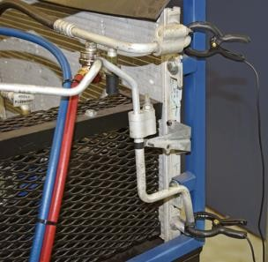
The first step involves assessing the condenser's ability to release heat, or its sub-cooling efficiency. Install clamp probe 1 on the condenser inlet and clamp probe 2 on the condenser outlet as close as possible to the condenser. Ensure that the clamps are secured on unpainted, clean metal surfaces. The sub-cooling specification for a condenser should range from a minimum of 20°F to a maximum of 50°F. Any reading outside of these specifications might indicate a restricted condenser or an issue with condenser airflow.
Figure 2: 4 Measuring condenser sub cooling
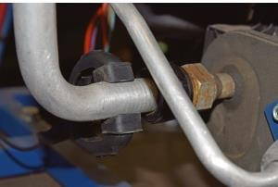
Step 2: Evaporator Super-Heat Measurement
In the second step, measure the evaporator's super-heat to assess how efficiently the system is regulating evaporator temperature. For systems equipped with a thermal expansion valve (TXV), install temperature probe 1 in the ambient air away from air currents and probe 2 on the suction line, preferably after the restriction point
Figure 2: 5 Measuring evaporator super-heat.
The difference should fall within the range of 0°Fto 10°F, given that most vehicles have expansion valves with a super-heat spring setting of 4°F to 8°F. A colder suction line compared to discharge air temperature may indicate refrigerant overcharge or a stuck open expansion valve. Conversely, a warmer reading might suggest undercharged refrigerant or a stuck closed expansion valve. For vehicles equipped with an orifice tube, measure the condenser inlet and outlet temperatures, aiming for a difference close to 0°F, with a tolerance of plus/minus 5°F.
Step 3: Heat Removed from Inside the Vehicle Assessment
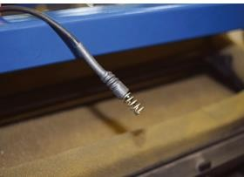
In the third step, evaluate the amount of heat removed from the ambient air. This test involves measuring the temperature of the air from the center dash vent and comparing it to the ambient air temperature. Insert one temperature probe into the center dash vent and the other into the ambient air, away from any air currents. The temperature difference between the two readings should exceed the specification of 30°F.
Figure 2: 6 Measuring heat removed
from ambient air.

By following these comprehensive testing procedures, technicians can accurately diagnose and address any issues with the vehicle's HVAC system, ensuring optimal performance and comfort for the driver and passengers.
Diagnosis
Often diagnosis of an A/C system can be done by observing the operation of the system, including listening for noises. When abnormal noises are heard, they can lead to the problem area.
- Noise
Often a customer’s concern is the noise emitted by the A/C system. The following discussion covers the common abnormal noises and their causes.
- Clutch Noises The clutch normally makes a clicking noise when it engages and disengages. This noise will become louder as the clutch wears. Once the clutch is severely worn, it will make a squealing noise when it is engaged. This noise can also result from oil on the clutch. A very loud screech or squeal can indicate a seized compressor. A bent drive pulley also can cause a growling or rubbing noise.
- Hose Noise The change in pressures in the suction/ discharge hoses can set up vibrations that cause sounds to appear from the inside of the vehicle. The noise is typically caused by a hose contacting another hose or part in the engine. Check the routing of the hoses to make sure they are not in contact. Also look for abrasions on the hoses. These can be caused by the contact.
- Compressor Noise If the mounts for the compressor are loose or damaged, there will be a rattling or groaning noise. The noise is normally random. At times, loose mounts will also cause premature wear of the drive belt.
- Hissing or Whistling This is a common and normal noise. When the A/C is turned off, a high- pitched whistle may be heard. This sound is caused by the pressures that are equalizing in the system. The high pressure moves to the low-pressure side through the metering device. This movement can result in a whistle or hiss.
- Odors
Customers sometimes notice a moldy smell from the A/C system, usually due to moisture accumulating on the evaporator or cabin filter. This moisture comes from cooling the air, but if the drain is blocked, it can cause odors. Check the evaporator drain if there's a smell complaint.
Additionally, remember to change the cabin air filter regularly to avoid unpleasant odors. You can also use products to disinfect the evaporator and ductwork, eliminating odor-causing bacteria.

Self-check-2
Instruction: Select the best answer
Multiple-Choice Questions
      - What is the purpose of the visual inspection in an HVAC system inspection?
- To check the thermostat settings
- To assess the temperature differential
- To identify signs of damage or wear in system components
- To measure refrigerant pressure
      - What is the primary function of a thermostat in an HVAC system?
- To inspect the electrical components
- To maintain the desired temperature
- To measure the refrigerant pressure
- To check for refrigerant leaks
      - Why is it important to inspect the air filters in an HVAC system?
- a) To measure the temperature differential
- To ensure proper blower motor operation
- To check for clogs or dirt that can restrict airflow
- To assess the efficiency of the compressor
      - In an HVAC system, what does the evaporator coil do?
- Releases heat
- Provides ventilation
- Cools the air
- Regulates thermostat settings
      - What is the purpose of conducting an air conditioning performance test?
- To evaluate the efficiency of the heating system
- To check the performance of the blower motor
- To assess the effectiveness of the cooling capacity
- To measure the temperature differential

Test II: Give a short Answer
Instruction: write short answer for the given question. You are provided 3 minute for each question and each point has 5Points.
- Explain the steps involved in a visual inspection of an HVAC system.
- Why is this inspection crucial, and what key component should be examined during this process?
- Describe the process of conducting a performance temperature test for an HVAC system.
- During an HVAC inspection, what initial checks should be performed before conducting a detailed examination of the system components?

Operation Sheet 2.1
Operation Title: On-Vehicle Inspection Procedure
Purpose: To perform an on-vehicle inspection of critical components related to the HVAC (Heating, Ventilation, and Air Conditioning) system.
Instructions: Follow this procedure for the on-vehicle inspection, ensuring all necessary tools and equipment are available and properly prepared.
Tools and Equipment:
Belt tension gauge, Gas leak tester
Steps:
- Condenser Fins Check: Examine the condenser fins for blockage or damage. If clogged, clean them with pressurized water, taking care not to damage the fins.
- Drive Belt Tension Inspection: Utilize a belt tension gauge to evaluate the drive belt tension, following specific criteria for new and used belts.
- Engine Start: Start the engine.

- A/C Switch Activation: Turn on the A/C switch and ensure the A/C operates at each blower switch position. If not, check the heater fuse.
- Magnetic Clutch Operation: Verify that the magnetic clutch engages.

- Idle RPM Increase: Observe if the engine RPM increases when the magnetic clutch engages.
- Refrigerant Level Check: If bubbles are visible in the sight glass, add refrigerant if needed.
- Cooling Inspection: If cooling is insufficient, inspect the refrigeration system for leaks using a gas leak tester.
This on-vehicle inspection procedure ensures the proper functioning and maintenance of the HVAC system's critical components while the vehicle is operational.

Operation Sheet 2.2

Operation Sheet: Inspecting a Heater Core
Purpose: To visually inspect the heater core for signs of damage or deterioration.
Tools and Equipment: Flashlight, inspection mirror (optional), safety gloves, safety glasses.
Procedure:

      - Safety Precautions:

- Put on safety gloves and safety glasses to protect your hands and eyes.
- Ensure the vehicle's engine is turned off and has cooled down to prevent burns.
      - Access Heater Core:

- Locate the heater core within the vehicle. It is typically located behind the dashboard in the HVAC (Heating, Ventilation, and Air Conditioning) unit.
      - Visual Inspection:

- Use a flashlight to illuminate the area around the heater core.

- If necessary, use an inspection mirror to access hard-to-reach areas.

      - Inspect for the Following:

- Corrosion or Rust: Check for any signs of corrosion or rust on the heater core's surface. These may indicate coolant leakage or exposure to moisture.
- Coolant Leaks: Look for any wet spots or traces of coolant around the heater core. A sweet smell may also be an indicator of coolant leaks.
- Blockages: Inspect the heater core's fins and tubes for blockages caused by debris or sediment buildup. Blockages can reduce heating efficiency.
- Physical Damage: Check for physical damage, such as bent fins, dents, or punctures in the heater core. These can lead to coolant leaks or reduced heating capacity.
- Airflow Obstructions: Ensure there are no obstructions blocking the airflow through the heater core. Clear any debris or foreign objects if present.
      - Document Findings:

Record your observations, including the condition of the heater core and any issues or damage detected.

      - Recommendations:

- Based on your inspection findings, make recommendations for further action. This may include:
- Repair or replacement of the heater core if damage or leaks are identified.
- Flushing the heater core to remove blockages if reduced heating efficiency is observed.

      - Safety Check:

- Ensure that the area around the heater core is free of coolant or any other hazardous materials.
- Safely dispose of any coolant or debris in accordance with environmental regulations.
      - Completion:

- Conclude the inspection and remove safety gloves and glasses.
- Provide your findings and recommendations to the appropriate personnel for further action.
- By following this operation sheet, you can systematically inspect the heater core for any issues, ensuring the proper functioning of the vehicle's heating system.

Operation Sheet 2.3
Operation Title: Testing the Heater Control Valve
Purpose: To assess the Heater Control Valve's functionality.
Conditions for the Operations:
- Safe working area
- Properly operated tools and equipment
- Appropriate work attire
- Equipped vehicle with a functioning heater system
Equipment, Tools, and Materials:
- Open circuit tester
- Multi-meter
- Vehicle with a heater system
Quality Criteria: Ensure all activities are performed as per the procedure.
Precautions:
- Wear appropriate clothing, safety glasses, and gloves.
- Ensure a hazard-free working area.
- Read and follow equipment manuals.
Steps in Performing the Task:
- Turn on the vehicle's engine and let it reach operating temperature.
- Set the vehicle's heater to the maximum temperature setting.
- Locate the Heater Control Valve in the engine compartment.
- Feel the hoses connected to the Heater Control Valve.
- Carefully touch the inlet and outlet hoses connected to the Heater Control Valve. One should be hot, and the other should be noticeably cooler.
- If the hoses behave as described, the Heater Control Valve is functioning correctly.
- If the hoses have similar temperatures, the Heater Control Valve may be faulty and require replacement.
- Ensure there are no coolant leaks around the valve or hoses.
Report your findings and recommend repair or replacement if necessary. Completion: Provide a detailed report on the Heater Control Valve's condition and any recommended actions.

Operation Sheet 2.4
Operation Title: Checking and Replacing a Coolant Hose

Purpose: To inspect and, if necessary, replace coolant hoses to ensure the proper functioning of the cooling system.
Conditions for the Operations:

  - Safe working area

  - Properly operated tools and equipment

Equipment, Tools, and Materials:

  - Inspection tools, Hose clamps, Replacement hoses, Coolant drainage equipment

  - Pressure-testing kit, Engine running equipment

Quality Criteria: Ensure all activities are performed according to the procedure.

Precautions:

  - Wear appropriate clothing and safety gear.

  - Make sure the working area is safe and clean.

  - Use equipment following safety guidelines.

  - Handle coolant properly, as it may be toxic.

Steps in Performing the Task:

- Inspect hoses for damage or wear.

- Drain coolant and remove old hoses.

- Select and install new hoses.

- Refill coolant, pressure-test, and check for leaks.

- Confirm proper hose clamp tightness.

Maintain cooling system integrity by following these steps.

Operation Sheet 2.5
Operation Sheet: Compressor Clutch Inspection
Purpose: Ensure the compressor clutch works correctly in the vehicle's air conditioning system.
Tools:
- Feeler gauges, Multi meter, Puller
- Snap ring pliers, Torque wrench

Steps:

- Inspect Air Gap:

  - Measure air gap between pulley and clutch drive plate.

  - Adjust if too small or check for wear if too large.

- Electrical Testing:

  - Measure voltage and clutch resistance.

  - Compare actual amperage to calculated value.

  - Adjust air gap if readings match, diagnose if not.

Operation Sheet 2.6
Operation tittle: Performance Test Procedure for HVAC System
Purpose: To evaluate the efficiency and functionality of the HVAC (Heating, Ventilation, and Air Conditioning) system's cooling capacity.
Instructions: Follow this procedure to conduct a performance test of the HVAC system. Ensure that the necessary tools and equipment are available and properly connected.
Tools and Equipment: Manifold gauge set, thermometer, high-volume fan, vehicle with a running engine, A/C controls, pressure gauges.
Steps:
- Preparation: Connect manifold gauge set.

  - Start engine, engage parking brake, and stabilize for 5 minutes.

- Engine Speed: Gradually increase to 1,500-2,000 rpm.

- Air Measurement: Measure front condenser air temperature and humidity.

- Enhance Airflow: Place high-volume fan in front of radiator grille.

- A/C Adjustment: Set A/C to max cooling, blower to max.

- Temperature Check: Measure dashboard air duct temperature.

- Pressure Reading: Record high and low pressures, note clutch engagement.

- Compare to Specs: Check readings against manufacturer's criteria.

- Engine Return: Return to normal idle speed.

- Service Hose Valves (if equipped): - Close valves if present

- Disconnect Service Hoses: - Carefully remove gauge lines.

- Valve Inspection: - Check valve seating and Schrader valves for leaks.

- Protective Caps: - Reinstall on service valves.

- Shutdown: - Turn off A/C and shut down the engine.

This test ensures HVAC system cooling capacity meets performance standards.

LAP-Test :2
Practical Demonstration

Instruction I: Perform the following task

Task -1 Inspect HVAC Component On-Vehicle
Task -2 Performance Test of HVAC System
Task -3 Check and replace a coolant hose
Task -4 Inspect heater core visually
Task -5 Identify and measure air gap of compressor clutch

Unit three: AC System Recovery, Evacuation, and Charging
This learning guide is developed to provide you the necessary information regarding the following content coverage and topics:
- Operating procedures of manifold gauge
- Methods of evacuation the system
- Testing pressure of system and re-charging
- Recovery and charging of air conditioning system
This guide will also assist you to attain the learning outcomes stated in the cover page. Specifically, upon completion of this learning guide, you will be able to:
- Implement operating procedures of manifold gauge
- Execute methods of evacuation the system
- Test pressure of system and re-charging
- Perform recovery and charging of air conditioning system

3.1 Operating procedures of manifold gauge
The operating procedures for a manifold gauge are essential for effectively managing refrigerant systems in HVAC (Heating, Ventilation, and Air Conditioning) systems. Here are the key action words for these procedures:
- Connect: Properly connect the manifold gauge to the HVAC system's service ports.
- Read: Read and interpret the pressure readings on the manifold gauge accurately.
- Adjust: Make necessary adjustments to regulate refrigerant pressures as needed.
- Monitor: Continuously monitor pressure and temperature readings during system operation.
- Perform: Perform leak detection tests using the manifold gauge.
- Record: Keep detailed records of pressure and temperature measurements.
- Follow: Follow manufacturer guidelines and safety protocols for manifold gauge operation.
- Calibrate: Periodically calibrate the manifold gauge for accuracy.
- Disconnect: Safely disconnect the manifold gauge from the HVAC system when finished.
- Store: Store the manifold gauge properly to prevent damage and contamination.

3.2Methods of Evacuating an Air Conditioning System
Evacuation in the context of air conditioning refers to the process of removing air and moisture from the air conditioning system. It is a critical step in the maintenance and repair of air conditioning systems. The primary objectives of evacuation are:
- Moisture Removal: Moisture can harm the system by reducing cooling efficiency, causing corrosion, and creating ice. Evacuation removes this moisture, ensuring the system's longevity and effectiveness.
- Air Removal: Air contains non-condensable gases that can disrupt the system's performance. Evacuation eliminates these gases, allowing the system to operate efficiently and maintain proper pressures.
- Leak Testing: Evacuation also acts as an initial test for leaks. If the vacuum doesn't hold, it indicates potential leaks in the system, helping to identify and fix issues early.
There are two primary methods for evacuating an air conditioning system:
- Using Gauges and a Vacuum Pump:
- This method involves connecting air conditioning gauges to the low and high- pressure service ports on the air conditioning system.
- A vacuum pump is then attached to the gauges using vacuum hoses.
- The vacuum pump is turned on, creating a vacuum within the system, which lowers the pressure and boiling point of any moisture in the system.
- This allows the moisture to boil and be evacuated out of the system through the vacuum pump.
- The system is left under vacuum for a specified duration, typically around 20 to 30 minutes.
- A preliminary leak test is conducted by observing the vacuum gauge readings. If the vacuum level remains stable, it indicates a successful preliminary leak test.
- Using an Air Conditioning R/R/R Machine (Recover, Recycle, Recharge)
- An R/R/R machine is a specialized piece of equipment designed for air conditioning system service.
- It can perform multiple functions, including the recovery of refrigerant, recycling of refrigerant, and recharging the system with the correct amount of refrigerant.
- During the recovery phase, the machine removes refrigerant from the system and stores it for later reuse.
- The machine can also create a vacuum within the system to evacuate air and moisture.
- Once the evacuation is complete, the machine can recharge the system with the appropriate amount of refrigerant, ensuring it operates at optimal performance.
Both methods achieve the same goal of evacuating the system, but the choice of method may depend on the available equipment and the technician's preference. Evacuation is a crucial step in maintaining and repairing air conditioning systems, as it ensures the system operates efficiently and effectively.
Testing pressure of system
After evacuating the air conditioning system to remove moisture and air, the next crucial step is to test and adjust the system's pressure. This process involves checking both the low and high- pressure sides of the system to ensure they are within the specified range. Additionally, if the system has lost refrigerant during maintenance or repair, it needs to be recharged to the correct level. Here's an overview of testing the pressure and recharging the air conditioning system:
Testing Pressure:
- Connect Gauges: Attach air conditioning gauges to the low and high-pressure service ports on the air conditioning system. These gauges allow you to monitor the system's pressure accurately.
- Start the Vehicle: Start the vehicle's engine and turn on the air conditioning system.
- Monitor Gauges: Observe the readings on both the low and high-pressure gauges. These readings should fall within the manufacturer's specified pressure range for the given ambient temperature.
- Low-Pressure Side: The low-pressure gauge measures the pressure on the suction side of the compressor. It typically shows lower pressure, often in the range of 20-40 psi (pounds per square inch) when the system is operating correctly.
- High-Pressure Side: The high-pressure gauge measures the pressure on the discharge side of the compressor. It usually shows higher pressure, often in the range of 150-250 psi when the system is functioning properly.
- Ambient Temperature: Keep in mind that the specified pressure ranges can vary with changes in ambient temperature. Refer to the manufacturer's guidelines or service manual for the correct pressure-temperature relationship for your specific system

3.3. Recovery and charging of air conditioning system
Recovery and charging are crucial procedures in servicing an air conditioning system. Recovery involves removing refrigerant from the system for various reasons, such as maintenance, repairs, or retrofitting to a different refrigerant type. Charging, on the other hand, is the process of adding refrigerant to the system to ensure it operates efficiently. Here's an overview of the recovery and charging process for an air conditioning system:
Recovery
- Prepare Equipment: Ensure you have the necessary equipment for refrigerant recovery, including a recovery machine or unit, recovery tank, recovery hoses, and gauges.
- Safety Precautions: Put on appropriate safety gear, such as safety glasses and gloves, and work in a well-ventilated area.
- Connect Recovery Equipment: Connect the recovery hoses to both the low and high- pressure service ports on the air conditioning system. Ensure the recovery machine is properly connected to the recovery tank.
- Start the Recovery Machine: Turn on the recovery machine and follow the manufacturer's instructions for its operation. The machine will draw the refrigerant from the system into the recovery tank.
- Monitor Pressure: Keep an eye on the pressure readings on the recovery machine's gauges. The machine will continue the recovery process until it detects that no more refrigerant can be removed from the system.
- Shut Down the Machine: Once the recovery process is complete, turn off the recovery machine and close the valves on the recovery hoses.
- Disconnect Equipment: Carefully disconnect the recovery hoses and secure the recovered refrigerant in an approved recovery tank.
- Label and Store: Properly label the recovery tank with the type of refrigerant it contains and store it in a safe, cool, and dry location.
Recharging the System
- Determine Refrigerant Type: Identify the type of refrigerant used in the air conditioning system (e.g., R-134a or R-22). Use the appropriate refrigerant for your system.
- Prepare Refrigerant Canister: Ensure the refrigerant canister is properly connected to the charging hose and the service port on the low-pressure side of the system.
- Monitor Gauges: Keep an eye on the low-pressure gauge while adding refrigerant. You want to reach the recommended pressure range for your specific system.
- Adding Refrigerant: Slowly open the valve on the refrigerant canister to allow refrigerant to flow into the system. Continue adding refrigerant until the low-pressure gauge indicates that the system pressure is within the specified range for the current ambient temperature.
- Stop Adding Refrigerant: Once the pressure is within the correct range, close the valve on the refrigerant canister.
- Check for Leaks: Perform a final leak check to ensure there are no refrigerant leaks in the system. This is critical for both safety and environmental reasons.
- Record Amount Added: Keep a record of the amount of refrigerant added to the system for future reference and documentation.

It's essential to follow manufacturer specifications and guidelines during the pressure testing and recharging process to ensure the air conditioning system operates efficiently and safely. Failure to maintain the correct pressure and refrigerant level can lead to reduced cooling performance and potential system damage.

Self-check-3
  - Instruction: Select the best answer
Multiple-Choice Questions:
1. What is the primary objective of evacuating an air conditioning system?
a. Removing refrigerant c. Removing air and moisture
b. Testing pressure. d. Adjusting temperature
2. What does a manifold gauge help monitor during air conditioning system operation?
a. Fuel consumption c. Tire wear
b. Engine oil level d. Pressure and temperature
3. Which component is crucial for removing moisture during evacuation?
a. Vacuum pump c. Refrigerant canister
b. Pressure gauge d. Air filter
4. When checking the pressure of an air conditioning system, what is the role of the high-pressure gauge?
a. Measures the pressure on the suction side c. Monitors ambient temperature
b. Measures the pressure on the discharge side d. Calibrates the gauges
5. What is the main purpose of using a recovery machine in servicing an air conditioning system?
a. Adjusting temperature settings c. Monitoring tire pressure
b. Removing and storing refrigerant d. Measuring ambient temperature

II. Instruction. Essay Questions:

  - Explain the significance of evacuating an air conditioning system. Discuss the main objectives and methods involved in this process.
  - Describe the operating procedures for a manifold gauge when working with HVAC systems. What safety measures should be taken during gauge operation?
  - Outline the steps for both the recovery and charging of an air conditioning system. Discuss the importance of proper labeling and documentation during these processes.
  - Compare and contrast passive and semi-active suspensions, highlighting their key differences in terms of control and performance.
  - Explain the purpose and operation of an R/R/R machine in the context of air conditioning system service.

II. Instruction Matching
III. Instruction: select the correct answer for the give choice. You have given 1 Minute for each question. Each question carries 2 Point.
A | B
- -1. Calibration | A preliminary test to detect potential leaks in the system.
- --2. Leak testing | B. Adjusting the manifold gauge for accuracy.
- --3. Recovery | C. The removal of refrigerant from the system for various purposes.

Operation Sheet 3.1

Operation Sheet: Installation of the Gauge
Purpose: To correctly install the manifold gauge and create a vacuum in the air conditioning system, ensuring proper operation and maintenance.
Instructions: Follow this procedure for the installation of the gauge, ensuring all necessary tools and equipment are available and properly prepared.
Tools and Equipment:
- Manifold gauge
- Vacuum pump
- Safety gear (safety glasses, gloves)
Steps:
- Close Both Hand Valves: Ensure that both the high and low-pressure hand valves on the manifold gauge are fully closed.
- Connect Low-Pressure Hose: Attach the low-pressure hose to the low-pressure service valve on the air conditioning system.
- Connect High-Pressure Hose: Connect the high-pressure hose to the high-pressure service valve.
- Tighten Hose Nuts by Hand: Secure the hose nuts by hand, avoiding the use of pliers to prevent damage.
- Connect the Center Hose: Attach the center hose of the gauge to the vacuum pump.
- Open Both Hand Valves: Open both the high and low-pressure hand valves on the manifold gauge and turn on the vacuum pump.
- Check Low-Pressure Gauge: After about ten minutes, verify that the low-pressure gauge indicates more than 80.8 kPa (600 mmHg; 23.62 in.Hg) of vacuum.
- Continue Evacuating: Keep evacuating the air from the system until the low-pressure gauge shows a vacuum of 100.0 kPa (750 mmHg; 29.53 in Hg).
- Check Gauge Indication: Close both the high and low-pressure hand valves and stop the vacuum pump. Leave the system in this condition for five minutes or longer, ensuring there is no change in the gauge indication.
This procedure correctly installs the gauge and creates the required vacuum in the air conditioning system, ensuring proper operation and maintenance.

Operation Sheet 3.2
Operation Title: AC System Recovery Process
Purpose: To safely and effectively recover refrigerant from the air conditioning system for maintenance, repair, or retrofitting.
Instructions: Follow this procedure for the AC system recovery, ensuring all necessary tools and equipment are available and properly prepared.
Tools and Equipment:
  - Recovery machine or unit
  - Recovery tank, hoses
  - Safety gear (safety glasses, gloves)
  - Manifold Gauge set
Steps:
- Prepare Equipment: Ensure all necessary equipment is set up and in good condition.
- Safety Precautions: Wear safety gear, work in a well-ventilated area.
- Connect Recovery Equipment: Attach hoses to low and high-pressure ports. Connect the recovery machine to the recovery tank.
- Start the Recovery Machine: Follow the manufacturer's instructions. The machine removes refrigerant into the recovery tank.
- Monitor Pressure: Keep an eye on gauges. Recovery continues until no more refrigerant can be removed.
- Shut Down the Machine: Turn off the recovery machine and close hose valves.
- Disconnect Equipment: Carefully disconnect hoses and store recovered refrigerant properly.
- Label and Store: Label the recovery tank and store it safely. The process ensures safe refrigerant removal, following industry standards for storage and recycling.

Operation Sheet 3.3
Operation Tittle: AC Evacuating the System
Purpose: To remove moisture and air from the air conditioning system, ensuring its proper operation and preventing issues.
Instructions: Follow this procedure for evacuating the system. Make sure all necessary equipment is available and prepared.
Tools and Equipment:
- Manifold gauge set
- Vacuum pump
- Safety gear (safety glasses, gloves)
Steps:
- Connect the Manifold Gauge Set: Attach the manifold gauge set to the air conditioning system's service ports.
- Install the Center Hose: Connect the center hose of the gauge set to the vacuum pump's inlet.
- Run the Vacuum Pump: Start the vacuum pump and let it run.
- Open Both Hand Valves: After running the vacuum pump, open both hand valves on the manifold gauge set.
- Check Low Pressure Gauge: After about ten minutes, check that the low-pressure gauge reads more than 600 mmHg (23.62 in. Hg, 80.0 kPa) of vacuum. If it's less than 600 mmHg, close both valves and stop the vacuum pump. Check for system leaks, and if found, repair them.
- Continue Evacuation: If no leaks are found and the gauge reads more than 700 mmHg (27.56 in. Hg, 93.3 kPa) of vacuum, continue evacuating for an additional 15 minutes.
- Close Both Hand Valves: After the evacuation is complete, close both hand valves, and stop the vacuum pump.
- Disconnect Hose: Carefully disconnect the hose from the vacuum pump.
The air conditioning system is now properly evacuated and ready for the next step, which is typically charging the system with refrigerant.
The AC system recovery process safely removes refrigerant, adhering to industry standards and safety protocols, and allows for proper storage for future use or recycling.

Operation Sheet 3.4
Operation Tittle: Adding AC Oil Using a Manual Oil Injector
Purpose: To replace system oil in the air conditioning system, ensuring proper lubrication and system performance.
Instructions: Follow this procedure for adding oil to the AC system using a manual oil injector. Ensure all necessary tools and equipment are available and properly prepared.
Tools and Equipment:
- Manual oil injector
- Proper type of oil
- Safety gear (safety glasses, gloves)
Steps:
- Open the Oil Injector: Ensure that the oil injector is open to the selected level of oil to be installed.
- Fill the Oil Injector: Fill the oil injector with the appropriate type of oil recommended for the specific AC system.
- Screw Cap/Hose Assembly: Screw the cap/hose assembly onto the injector body securely.
- Apply Pressure: With the injector hose facing upwards, apply pressure to the handle until resistance is felt. This pressurizes the injector.
- Purge Air: While keeping the hose pointed upward and experiencing resistance on the handle, slightly depress the valve in the center of the hose to purge any trapped air. Repeat this process until no more air exits.
- Install the Oil Injector: Attach the oil injector to the low-side fitting of the AC system.
- Operate the Injector: Operate the oil injector until all the required oil is injected into the system.
- Remove the Injector: Once the oil injection is complete, remove the injector from the low-side fitting.
- Clean the Fitting: Clean any excess oil from the fitting and the surrounding area to prevent contamination and ensure a secure connection.
This procedure ensures that the AC system receives the correct amount and type of oil for optimal lubrication and performance.

Operation Sheet 3.5
Operation Sheet: Recharging or Refilling Refrigerant in the AC System
Purpose: Safely and correctly recharge the A/C system with the appropriate refrigerant type and amount.
Instructions: Follow this procedure for recharging the AC system, ensuring all necessary tools and equipment are available and properly prepared.
Tools and Equipment:
- Container(s) of the correct type and amount of refrigerant
- Manifold gauge set, Container tap valve
- Safety gear (safety glasses, gloves)
Steps:
- Open the High-Pressure Hand Valve: Ensure the high-pressure hand valve is fully open.
- Initial Charging: Charge the system with one container of refrigerant until it is fully dispensed. Then, close the high-pressure hand valve.
- Replace with a New Container: Replace the empty container with a new container of refrigerant, following the manufacturer's specifications regarding the correct type and amount.
- Close Both Hand Valves: Close both the high and low-pressure hand valves securely.
- Remove the Container Tap Valve: Carefully remove the container tap valve from the empty container.
- Attach the Container Tap Valve to a New Container: Attach the container tap valve to a new refrigerant container, following the same procedure as in step 3.
- Never Run the Engine During High-Pressure Charging: Ensure that the engine is never running when charging the system through the high-pressure side to avoid safety hazards and damage to the system.
Additional Considerations:
- Check the tag under the bonnet or the vehicle's manual for the required type and amount of refrigerant.
- Ensure proper discharge, evacuation, and oil addition in the AC system.
- Perform a leak check before recharging.
- Only recharge if the system passes preliminary checks, ensuring efficient and effective cooling.

LAP-Test :3
Practical Demonstration
Instruction I: Perform the following task
Task-1: Install the manifold gauge
Task-2: Perform ac system recovery process
Task-3 Conduct AC Evacuating the System
Task-4 Adding AC oil using a manual oil injector
Task-5 Recharge or refill refrigerant in the Ac system

Unit four: Retrofitting & post-retrofit testing
This learning guide is developed to provide you the necessary information regarding the following content coverage and topics:
- AC System Decal Sticker Specifications
- Air conditioning retrofitting procedures
- Retrofit/Replace of the system and components
- Post-Retrofit and performance testing
- Preparing Vehicle for Customer Delivery, Cleaning, and Equipment Storage
This guide will also assist you to attain the learning outcomes stated in the cover page. Specifically, upon completion of this learning guide, you will be able to:
- Understand AC system decal sticker specifications
- Master air conditioning retrofitting procedures
- Excel in retrofitting/replacing system and components
- Execute post-retrofit and performance testing
- Prepare the vehicle for customer delivery, cleaning, and equipment storage

4.1 AC System Decal Sticker Specifications
In the realm of air conditioning retrofitting, AC system decal stickers play a pivotal role in conveying crucial information and ensuring safety compliance. Here, we outline the specifications that should be observed when creating these stickers:
- Content: The sticker must encompass vital information, including the type of refrigerant employed, the retrofit date, contact details of the responsible technician, and any pertinent safety advisories.
- Refrigerant Type: It is imperative to unequivocally state the specific refrigerant utilized, be it R134a, R1234yf, or another variant. This clarity prevents confusion and facilitates proper servicing in the future.
- Date of Retrofit: The sticker should prominently display the date when the AC system underwent retrofitting. This aids in tracking maintenance and ensuring compliance with regulatory timelines.
- Technician Contact Information: Include the name and contact particulars of the technician or service provider accountable for the retrofit. This information serves as a traceable reference and reinforces accountability.
- Safety Warnings: If relevant, integrate safety cautions or precautions related to the particular refrigerant in use. This ensures that technicians and users are well-informed about any potential hazards.
- Regulatory Compliance: Verify that the sticker aligns with any local, state, or federal regulations pertaining to AC system retrofitting. Compliance may involve adhering to specific labeling requirements.
- Adherence: Ensure that the decal sticker is affixed securely to the AC system, positioned in a conspicuous and accessible location. This facilitates ease of location and reference for future service technicians.
- Durability: The sticker material should be robust and weather-resistant, capable of withstanding diverse environmental conditions. This durability ensures that the information remains legible over time.
- Legibility: Information on the sticker must be presented clearly, in a legible format that is easily read under varying lighting conditions.
- Accessibility: The placement of the sticker should consider accessibility, ensuring it remains visible and easily retrievable during routine maintenance or servicing.

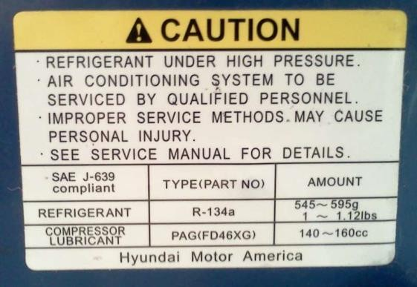
By adhering to these AC system decal sticker specifications, you enhance safety, compliance, and traceability within the context of air conditioning retrofitting. These stickers provide valuable information for future maintenance and servicing requirements, contributing to the overall efficiency and safety of the system.

4.2 Air conditioning retrofitting procedures
Air conditioning retrofitting involves the process of upgrading or modifying an existing AC system to accommodate different refrigerants or components.
Here's an overview of the key steps and procedures involved in air conditioning retrofitting:
- System Assessment: Begin by assessing the existing AC system to determine its current configuration, including the type of refrigerant in use.
- Refrigerant Selection: Choose the appropriate replacement refrigerant based on compatibility and environmental regulations. Common retrofits involve transitioning from R12 to R134a or R134a to R1234yf.
- System Evacuation: Safely evacuate the existing refrigerant from the system using a vacuum pump to remove all traces of the old refrigerant and contaminants.
- Component Replacement: Replace or retrofit system components as necessary to accommodate the new refrigerant. This may include compressor, condenser, evaporator, and expansion valve upgrades.
- System Flushing: Flush the AC system thoroughly to remove any residual old refrigerant, oils, or contaminants that could impact the performance of the new refrigerant.
- Leak Testing: Conduct a comprehensive leak test to ensure the integrity of the retrofit components and connections. Address any leaks promptly.
- Refrigerant Charge: Carefully charge the system with the selected refrigerant to the manufacturer's specifications, considering factors like system capacity and ambient conditions.
- System Testing: Test the retrofitted AC system for performance, including cooling capacity, pressure levels, and temperature control. Ensure that the system operates efficiently.

- Pressure Adjustments: Adjust system pressures and settings as needed to optimize performance with the new refrigerant. Verify that the pressure levels are within safe and operational limits.
- System Labeling: Affix proper labels and documentation to the AC system to indicate the type of refrigerant used, the retrofit date, and technician contact details.
- Documentation: Maintain detailed records of the retrofitting process, including refrigerant quantities, system pressures, and any adjustments made.
- Quality Assurance: Ensure that the retrofitting process complies with safety regulations and environmental standards. Perform final checks to confirm proper system operation.
By following these air conditioning retrofitting procedures meticulously, you can successfully transition your AC system to a new refrigerant or configuration, ensuring improved efficiency, compliance with regulations, and optimal performance.

4.3 Retrofit/Replace of the system and components
Retrofitting or replacing components within an air conditioning (AC) system is a pivotal phase in adapting the system to accommodate new refrigerants or meet specific configuration requirements. Here's a narrated overview of the procedures involved:
- Component Assessment: Evaluate the condition of AC components, like the compressor, condenser, evaporator, and others.
- Selection of Retrofit Components: Identify which parts need replacement to match the chosen refrigerant or new system specifications.
- Component Removal: Safely remove the designated components while following safety protocols and ensuring refrigerant recovery.
- Replacement or Retrofitting: Based on the assessment, replace old components with new ones that are compatible with the selected refrigerant or retrofit existing components.
- Sealing and Fastening: Ensure all connections are securely sealed and fastened to prevent potential leaks.
- Refrigerant Oil: Adjust or replace the refrigerant oil to align with the new refrigerant and system requirements.
- Flushing: Thoroughly flush the system to remove any remnants of the previous refrigerant, oil, or contaminants.
- Leak Testing: Conduct a comprehensive leak test to identify and address any potential sources of leaks.
- Reassembly: Reassemble the components, ensuring all connections are secure.
- System Integration: Integrate the retrofitted or replaced components into the AC system, making the necessary connections.
- Refrigerant Charge: Carefully introduce the chosen refrigerant according to the manufacturer's specifications, taking into consideration system capacity and environmental conditions.
- System Testing: Test the components and the entire AC system to ensure efficient operation, assessing cooling capacity, pressure, and temperature control.
- Pressure Adjustments: Optimize system performance by adjusting pressures and settings to align with the new components and refrigerant.
- Documentation: Properly document all steps and changes made during the retrofitting process for future reference and maintenance purposes.
Converting (retrofitting) R-12 systems to R-134a
The following guidelines should be followed when converting an older A/C system to R-134a. These guidelines should allow you to provide the customer with a cool vehicle and to meet current legislative mandates. The guidelines are listed in order and reflect the necessary steps for making this conversion.
- Visually inspect all A/C and heater system components.
- Use a refrigerant identifier to make sure the system only contains R-12.
- Check the system for leaks.
- Run a performance test and record the temperature and pressure readings.
- Remove all R-12 from the system with a recycling machine.
- Make sure all old refrigerant and oil are removed from the system.
- If the system uses a compressor with an oil sump, remove the compressor and drain all oil from it. Measure the amount of oil drained out.
- Remove and inspect the expansion valve or the orifice tube; replace it if necessary. If either is contaminated, flush the condenser.
- Remove the filter/dryer or accumulator; drain it and measure the amount of oil in it.
- Before converting, make all necessary system changes, such as the compressors, hoses, gaskets, and seals
- Install R-134a compatible oil into the system; put in the same amount you took out.
- Install a new filter/dryer or accumulator with the correct desiccant.
- Permanently install conversion fittings using a thread locking chemical. Unique service fittings for R-134a should be used to minimize the risk of cross-contamination.
- Install a high-pressure cutoff switch if the system does not have one.
- Install R-134a conversion labels and remove the R-12 label
- Connect R-12 system evacuation equipment and evacuate for at least 30 minutes.
- Recharge the system with R-134a to 80% of the original R-12 charge.
- Run a performance check and compare readings with those taken before the conversion.
- Leak check the system.

4.4 Post-Retrofit and performance testing
After retrofitting an AC system, it's essential to ensure that the system functions optimally in its updated configuration. This comprehensive testing phase includes the following critical steps:
- Functional Verification: Confirm that all retrofit procedures are correctly executed, adhering to manufacturer specifications and safety standards. Verify that all system components are properly assembled and securely fastened.
- Refrigerant Charge Confirmation: Double-check the refrigerant charge to ensure it aligns precisely with the manufacturer's recommendations, considering factors like system capacity and environmental conditions. A correct charge is crucial for optimal performance.
- Pressure and Temperature Monitoring: Continuously monitor system pressure and temperature levels throughout the testing process to assess performance accurately. Address any anomalies or deviations promptly.
- Cooling Capacity Assessment: Evaluate the system's cooling capacity to ensure it meets the desired or required specifications. Verify that the AC system can provide efficient cooling consistently.
- Temperature Control Testing: Assess the system's ability to maintain consistent and appropriate temperature control within the vehicle's cabin under varying conditions, ensuring passenger comfort is achieved.
- Leak Detection: Conduct a thorough leak detection test to confirm that no new leaks have developed in the retrofitted or modified system.
- Functional Testing: Operate the AC system under various real-world conditions to simulate normal usage. This testing phase ensures that the system functions as expected and delivers efficient cooling performance.
- Adjustments and Fine-Tuning: If necessary, make adjustments to system pressures, settings, or components to optimize performance and resolve any issues identified during testing.
This combined section focuses on the post-retrofit testing process, ensuring the success of the retrofit or modification, efficient system operation, and compliance with safety and performance standards.

4.5 Preparing Vehicle for Customer Delivery, Cleaning, and Equipment Storage
For a smooth HVAC-equipped vehicle delivery after service, equipment storage, and cleaning, follow these steps to ensure a positive customer experience and the integrity of your HVAC service operation:
- Service Verification: Confirm successful completion of all HVAC tasks and address any outstanding issues.
- Quality HVAC Inspection: Ensure proper HVAC system functionality with a comprehensive inspection.
- Cleaning and Sanitization: Thoroughly clean and sanitize HVAC components to eliminate dust and contaminants.
- Equipment Retrieval: Retrieve and store HVAC service equipment appropriately.
- Final HVAC Inspection: Verify a clean, sanitized, and issue-free HVAC system with proper airflow and temperature control.
- Customer Communication: Notify the customer that the HVAC-equipped vehicle is ready for pickup, providing clear instructions.
- HVAC System Check: Before delivery, ensure the HVAC system functions as expected and adjust settings to customer preferences.
- Customer Satisfaction: Engage with the customer to address concerns, encourage feedback, and confirm satisfaction with the HVAC service.
- Post-Service HVAC Follow-Up: Consider a follow-up to ensure ongoing customer satisfaction.
These streamlined steps guarantee a well-serviced, clean, and fully operational HVAC system for the customer while maintaining your HVAC service operation's professionalism.

Self-check-4

1. Which of the following information is typically included on an AC system decal sticker during retrofitting?
a. The car's model and make
b. The color of the refrigerant
c. Contact details of the responsible technician
d. The vehicle's top speed
2. What is the purpose of conducting a leak detection test in HVAC maintenance?
a. To check for clogs in the air filters
b. To ensure the refrigerant is at the correct pressure
c. To identify and address potential sources of leaks
d. To measure the indoor air quality
3. In air conditioning retrofitting, what is the primary role of the sticker affixed to the AC system?
a) To enhance the vehicle's aesthetics
b. To reduce the vehicle's weight
c. To convey vital information about the retrofit
d. To cool down the HVAC components
4. Why is it important to replace or retrofit components in an AC system during the retrofitting process?
a. To change the vehicle's color
b. To improve the vehicle's fuel efficiency
c. To meet environmental regulations and accommodate new refrigerants
d. To make the vehicle go faster
5. What does post-retrofit testing primarily aim to achieve in HVAC maintenance?
a. To assess the air quality in the cabin
b. To ensure optimal functionality in the new configuration
c. To determine the vehicle's fuel consumption
d. To check the tire pressure in the vehicle

Instruction:
Short answer
  - What key information should be included on an AC system decal sticker during retrofitting?
  - Name at least three components in an AC system that might need to be replaced or retrofitted during the retrofit process
  - Why is proper documentation crucial after retrofitting an AC system?
  - What is the purpose of post-retrofit testing, and what steps are involved in this process?
  - How can you ensure that an HVAC-equipped vehicle is ready for customer delivery, and what steps should be taken to achieve this?

Matching Questions:
Match the term on the left with its corresponding description on the right.
1. Refrigerant Type | A. Identifying potential sources of leaks in the system.
2. Component Assessment | B. Specific refrigerant used, like R134a or R1234yf.
- Leak Detection | C. Testing the retrofitted AC system for cooling capacity and temperature control.
- Safety Warnings | D. The assessment of the existing AC system's condition.
- Functional Testing | E. Ensuring that all retrofit procedures have been executed correctly.

Operation Sheet 4.1
Operation Title: Retrofitting - Change of Refrigerant Gas from R12 to R134a
Purpose: To transition an AC system from R12 to R134a safely and effectively.
Instructions: Follow this procedure for retrofitting, ensuring all necessary tools and equipment are available and properly prepared.
Tools and Equipment:
- R134a refrigerant
- Recovery machine or unit
- Manifold gauge set
- Vacuum pump
- Safety gear (safety glasses, gloves)
Steps:
- Assessment: Examine the existing R12-based AC system.
- Refrigerant Recovery: Safely remove R12 using a recovery machine.
- Component Check: Assess component compatibility with R134a.
- Component Adjustment: Retrofit or replace components as needed for R134a.
- Flushing: Remove any residual R12 from the system.
- Leak Test: Ensure no leaks in the modified system.
- Oil Adjustment: Match refrigerant oil to R134a specifications.
- Reassembly: Reassemble system components.
- Refrigerant Charge: Add R134a following manufacturer guidelines.
- Testing: Check the system's performance and cooling.
- Pressure Adjustment: Optimize pressure settings for R134a.
- Documentation: Maintain detailed records of the retrofitting process.

Operation Sheet 4.2
Operation Title: Retrofitting - Transitioning from R134a to R1234yf in an AC System
Purpose: To safely and effectively transition an AC system from R134a to R1234yf refrigerant. Instructions: Follow this procedure for the retrofitting process, ensuring all necessary tools and equipment are available and properly prepared.
Tools and Equipment:
- R1234yf refrigerant
- Recovery machine or unit
- Manifold gauge set
- Vacuum pump
- Safety gear (safety glasses, gloves)
Steps:
- Assessment: Examine the existing R134a-based AC system.
- Refrigerant Recovery: Safely remove R134a using a recovery machine.
- Component Check: Assess component compatibility with R1234yf.
- Component Adjustment: Retrofit or replace components as needed for R1234yf.
- Flushing: Remove any residual R134a from the system.
- Leak Test: Ensure no leaks in the modified system.
- Oil Adjustment: Match refrigerant oil to R1234yf specifications.
- Reassembly: Reassemble system components.
- Refrigerant Charge: Add R1234yf following manufacturer guidelines.
- Testing: Check the system's performance and cooling.
- Pressure Adjustment: Optimize pressure settings for R1234yf.
- Documentation: Maintain detailed records of the retrofitting process.
These operation sheets provide clear instructions for retrofitting AC systems with different refrigerants, ensuring safety and compliance.

LAP-Test : 4
Practical Demonstration
Instruction I: Perform the following task

Task- 1. perform retrofitting

Reference

- Joseph Wagner, Automotive Heating, Ventilation, and Air Conditioning, 2019, automotive technician series
- Jack Erjavec, Automotive Technology: a systems approach, 5 t h Edition, 2010 Delmar, Cengage Learning
- Advanced Automotive Fault Diagnosis Third Edition
- James D. Haldeman, Automotive technology Principles, Diagnosis, and Service fourth edition
- Crouse, W.H. and Anglin D.L, Auto motive mechanics 10th edition
- Nunney, M. J.Rutledge, 2007, Light and Heavy Vehicle Technology 4th ed
Participants of this Module (training material) preparation
No | Name | Qualification (Level) | Field of Study | Organization/ Institution | Mobile Number | E-mail
 | Fadli Aman | BSc. | Automotive Technology | General Wingate PTC | 0927283100 | Fadli.ziyad@gmail.com
 | Habtamu Deresso | PHD Candidate | Automotive Technology | ASTU | 0945853269 | habtamu.deresso@gmail.com
 | Israel Taye | MSC | Automotive Technology | General Wingate PTC | 0913424100 | isra.taye@gmail.com
 | Natnael Genene | MSC | Automotive Technology | Athlete kenenisa PTC | 0920397105 | natnealgenene143@gmail.com
 | Robsan Tesfaye | MSC | Automotive Technology | Burayu PTC | 0920117175 | robsantesfaye4@gmail.com
 | Sisay Tufa | MSC | Automotive Technology | M/G/M/Buli | 0912065407 | knbntf@gmail.com
 | Tagay Tesfaye | MSC | Automotive Technology | Bishoftu PTC | 0975971391 | tagotagotago37@gmail.com

