
Automotive Electrical and Electronics
Level-IV
Based on October 2023, Curriculum Version II
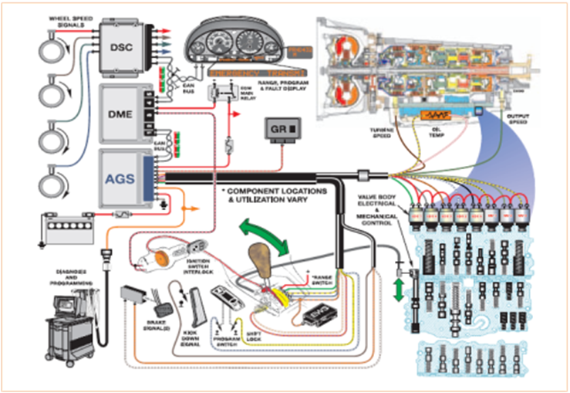
Module Title: Diagnosing Electronically Controlled Power Train Management
Module Code: EIS AEE4 M03 1023
Nominal Duration: 40 Hours
Prepared by: Ministry of Labor and Skill
October 2023
Addis Ababa, Ethiopia

Table of content
Acknowledgment 3
Acronym 4
Introduction to module 5
Unit one: Overview of Electronic Drive 6
1.1 Overview of Automatic Transmission 7
1.1.1 Conventional Automatic transmission 7
1.1.2 Introduction to Electronic Automatic Transmission 10
1.2 Drive lines 11
1.2.1 Overview of Electronic Driveline Components 11
1.2.2 Electronically Controls Automatic Transmissions 13
1.2.3 Purpose of Electronic Control Transmission 13
1.2.4. Transmission Features and Principles of Operation 26
Self-check 1 34
LAP Test: 1 35
Unit Two: Diagnostic Electronic Control System 36
2.1 Diagnosing techniques of electronic control system 37
2.2 Diagnosis procedures of electronic control system 39
2.3 Diagnosis details of electronic control system 47
Self-check 2 49
LAP Test: 2 51
Unit Three: Servicing Electronic Control System 52
Operation Sheet 3.3 55
Operation Sheet 3.4 56
LAP Test:3 58
Reference 59

Acknowledgment
The Ministry of Labor and skill wishes to thank and appreciation to MoLS leaders and experts, Regional Labor and skill/training Bureaus leader, experts, TVT College Deans, Instructors and industry experts who contribute their time and professional experience to the development of this Training Module.

Acronym
AC Alternating current
DAS Direct Adaptive Steering
DMM Digital multi meter
DTC Diagnostic trouble codes
EPS Electric controlled power steering
OBD On-Board Diagnostic
PCV Pressure control valve
PSCM Power Steering Control Module
SAS Steering angle sensors
VES Variable effort steering
DTCS Diagnostic trouble codes system
EBCM Electronic brake control module
ECS Electronic control steering
ECU Electronic control module
ESC Electronic steering control
MoLS Ministry of labor and skill
PCM pump cell control module
PID Scan tool data
TVET Technical and vocational education training
VS Vehicle steering
WDS Warehouse distributors

Introduction to module
An electronically controlled drive train, also known as diagnosing electronically controlled power train management is an advanced technology that enhances the driving train functionality and performance of vehicles. Electronic driveline management systems advanced automotive systems designed to optimize the performance and efficiency of a vehicle's drivetrain. These systems utilize electronic controls and sensors to monitor and regulate various components within the driveline, including the engine, transmission, differential, and other related systems.
Electronic driveline control incorporates various electronic components to monitor, control, and regulate the drivetrain. Due to the electrical nature of most vehicles today, the car Diagnosing Electronically Controlled Power Train Management are safe when on the operation. This module designed to meet the industry requirement under the Automotive Electrical and Electronics occupational standard, particularly for the unit of competency: Diagnosing Electronically Controlled Power Train Management.
This module covers the units:
- Overview of electronic drive management systems
- Diagnosis electronic control system
- Services electronic control system
Learning Objective of the Module
- Understand electronic drive management’s overview
- Diagnosis the electronic control system
- Apply Servicing of electronic control system
Module Instruction
For effective use these modules trainees expected to follow the following module instruction:
- Read the information written in each unit
- Accomplish the self-checks at the end of each unit
- Perform operation sheets which were provided at the end of units
- Do the “LAP test” giver at the end of each unit and
- Read the identified reference book for Examples and exercise

Unit one: Overview of Electronic Drive
This unit is developed to provide you the necessary information regarding the following content coverage and topics:
- Automatic transmission
- Drive lines control systems
- Carrying out service
This unit will also assist you to attain the learning outcomes stated in the cover page. Specifically, upon completion of this learning guide, you will be able to:
- Diagnosis Automatic transmission
- Service Drive lines control systems
- Carry out service, component replacement and adjustments

1.1 Overview of Automatic Transmission

1.1.1 Conventional Automatic transmission
Automatic transmission is a type of vehicle transmission that automatically changes gears as the vehicle accelerates and decelerates, without requiring the driver to manually shift gears. It designed to simplify the driving experience and provide smooth gear changes for the driver. Automatic transmissions have multiple gear sets consisting of planetary gears, clutches, and bands. These gear sets provide different gear ratios to match the vehicle's speed and load conditions. Automatic transmissions use a torque converter instead of a clutch to transmit power from the engine to the transmission. The torque converter allows the engine to continue running while the vehicle is stationary, and it provides smooth engagement of power when accelerating. An automatic gearbox contains special devices that automatically provide various gear ratios as they are needed. Most automatic gearboxes have three or four forward gears and one reverse gear. Instead of a gearstick, the driver moves a lever called a selector.
park, neutral, reverse, drive, 2 and 1 (or 3, 2 and 1 in some cases). Some more sophisticated types with electronic control just have driven, park and reverse positions. The fluid flywheel or torque converter is the component that makes automatic operation possible.
The engine will only start if the selector is in either the park or neutral position. In park, the drive shaft is locked so that the drive wheels cannot move. It is also now common, when the engine is running, to only be able to move the selector out of park if you are pressing the brake pedal. This is a very good safety feature as it prevents sudden, uncontrolled movement of the vehicle. Hydraulic system: Automatic transmissions employ a hydraulic system to control the shifting of gears. It uses hydraulic pressure to actuate the clutches and bands, which control the engagement and disengagement of different gear sets. The valve body is a control center within the transmission that directs the flow of hydraulic fluid to the appropriate clutches and bands. It consists of valves, solenoids, and passages that respond to various inputs such as throttle position, vehicle speed, and driver demand.
For ordinary driving, the driver moves the selector to the ‘drive’ position. The transmission starts out in the lowest gear and automatically shifts into higher gears as the car picks up speed. The driver can use the lower positions of the gearbox for going up or down steep hills or driving through mud or snow. When in position 3, 2 or 1, the gearbox will not change above the lowest gear specified.

A fluid flywheel consists of an impeller and turbine, which are immersed in oil. They transmit drive from the engine to the gearbox.
A heavy flywheel is not needed because the mass of the torque converter and flex-plate work like a flywheel to smooth out the intermittent power strokes of the engine. The ring gear for the starting motor surrounds the flex-plate or torque converter.
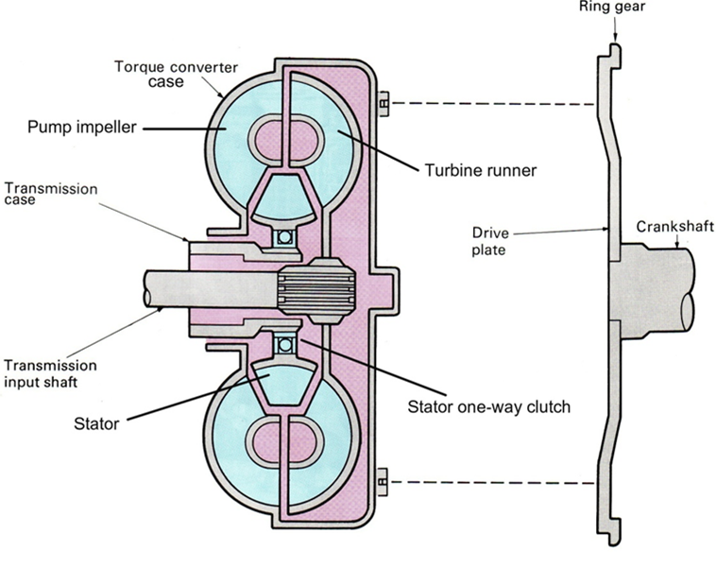
Figure 1.1 Automatic Transmission assembly with engine
Torque converter
  - Multiplying the torque generated by the engine.
  - Serving as an automatic clutch (Fluid coupling) without having mechanical coupling between drive and driven members
  - Absorbing the torsional vibration of the engine and drive train.
  - Driving the AT oil pump
  - Allows vehicle to idle at a stop sign
  - Slips during initial acceleration to prevent stalling

Components of torque converter
A standard torque converter consists of three elements
- The pump assembly, often called an impeller,
- The stator assembly, and
- The turbine.
The impeller assembly is the input (drive) member. It receives power from the engine. The turbine is the output (driven) member. It is splined to the transmission’s turbine shaft. The stator assembly is the reaction member or torque multiplier. The stator is supported on a one-way clutch, which operates as an overrunning clutch and permits the stator to rotate freely in one direction and lock up in the opposite direction.
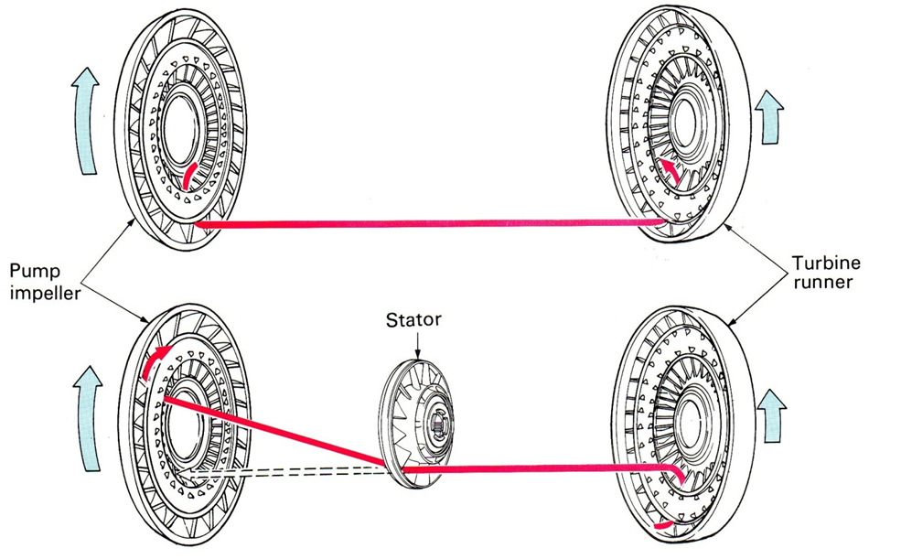
Figure 1.2 Torque multiplicación
The engine-driven impeller faces the turbine, which is connected to the gearbox. Each of the parts, idle speed oil is flung from the impeller into the turbine, but not with enough force to turn the turbine. Which are bowl-shaped, contains a number of vanes.
They are both a little like half of a hollowed-out orange facing each other. It has two sets of planetary gears, inner and outer. The inner planetary gears are in constant mesh with the smaller, rear sun gear and with the outer planetary gears. The outer planetary gears are in constant mesh with the ring gear and the larger, front sun gear.

Planetary Gears unit
  - It changes the transmission output rpm and/or the direction of the output rotation and transmits it to the final drive unit
- The planetary gears set (which changes the output rpm)
- Clutches & Brakes (which are operated by hydraulic pressure to control the operation of the PGs
- Shafts (for transmitting the engine power)
- Bearings (for facilitating the smooth rotation of each shaft
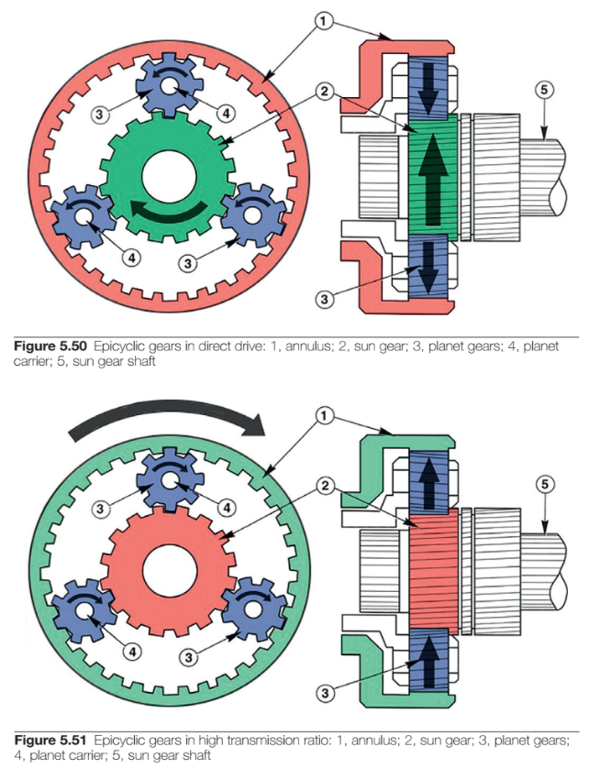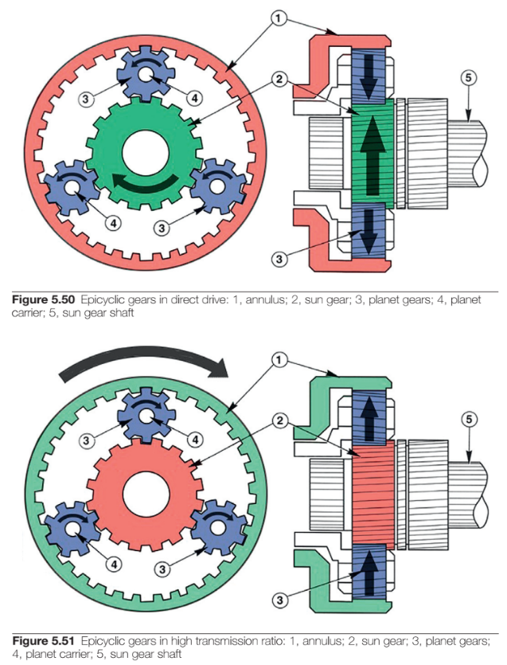
Figure 0.3 Epicyclical gears in direct and high transmission ratio respectively drive: 1, annulus; 2, sun gear; 3, planet gears; 4, planet carrier; 5, sun gear shaft
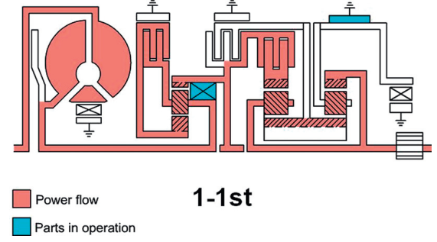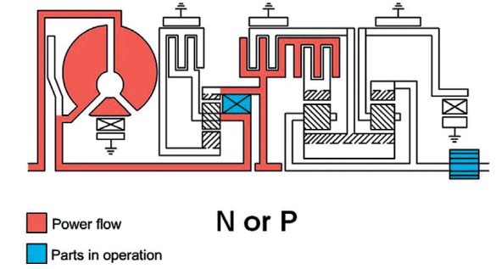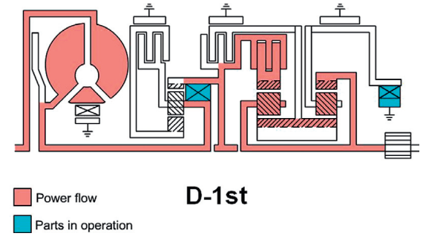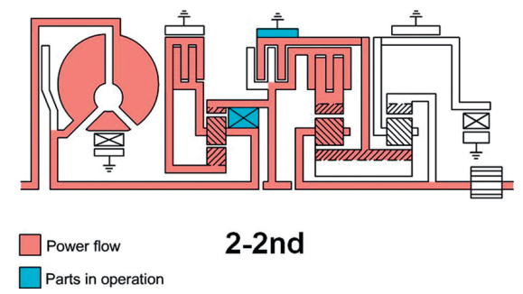
Figure 1.4: N, P,1st ,2nd sample gear with selector in position

1.1.2 Introduction to Electronic Automatic Transmission
Automatic transmissions have predetermined shift points, which are engine speeds or vehicle speeds at which the transmission upshifts or downshifts to a different gear. The shift points typically programmed based on factors such as engine power, vehicle weight, and desired performance characteristics. Modern automatic transmissions utilize electronic control units (ECUs) to monitor various parameters such as vehicle speed, throttle position, and engine load. The ECU processes this information and sends signals to the hydraulic system to initiate gear changes at the appropriate times. Electronic controls also enable additional features like adaptive shift algorithms and multiple driving modes as shown in Fig 1.5 below. Many automatic transmissions offer a manual mode or sport mode, which allows the driver to manually select gears using paddle shifters or a separate gear lever. In this mode, the driver can have more control over gear selection for a sportier driving experience.
Automatic transmissions provide several advantages over manual transmissions, including ease of use, smooth gear changes, and the ability to focus more on driving without the need for manual gear shifting. They are commonly found in a wide range of vehicles, from passenger cars to SUVs and trucks, offering convenience and comfort to drivers in various driving conditions.

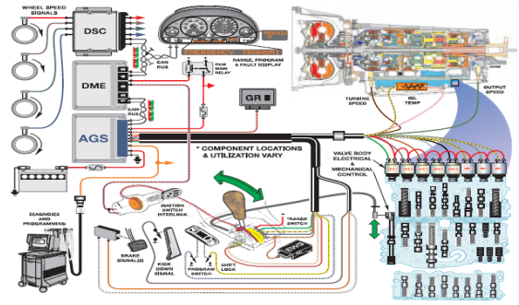
Figure 1.5 Electronic control system diagram of automatic transmission (ECT)
  - Drive lines

1.2.1 Overview of Electronic Driveline Components
Electronic driveline control systems incorporate various electronic components to monitor, control, and regulate the drivetrain. Here are some key electronic components commonly found in these systems:
- Electronic control unit (ECU): the ECU serves as the central control module of the driveline system. It receives input signals from sensors and processes data to control various components. The ECU uses software algorithms to make decisions and send commands to actuators for optimal driveline operation.
- Sensors: Sensors play a crucial role in collecting data from different drivetrain components and providing feedback to the ECU. Common sensors used in driveline control systems include:
- Throttle position sensor (TPS): Measures the position of the accelerator pedal to determine the driver's throttle demand.
- Wheel speed sensors: Monitor the rotational speed of individual wheels to detect wheel slip, enable traction control, and facilitate ABS (Anti-lock Braking System) functionality.
- Transmission speed sensor: Measures the rotational speed of the transmission output shaft to determine gear selection and detect any potential issues.
- Engine speed sensor (crankshaft position sensor): measures the rotational speed of the engine's crankshaft to determine engine RPM and timing.
- Acceleration/Inertial Sensors: Measure acceleration, deceleration, and vehicle tilt to assist in traction control, stability control, and hill-start assist systems.
- Actuators: Actuators are responsible for carrying out the commands sent by the ECU to control various components of the driveline. Common actuators used in electronic driveline control systems include:
- Solenoids: Electrically controlled valves that regulate hydraulic pressure within the transmission for gear shifting and clutch engagement.
- Electric Motors: Used in hybrid and electric vehicles to control the operation of electric drivetrain components, such as electric motors/generators and the power electronics module.
- Brake Actuators: Control the application of braking force to individual wheels in systems like ABS, TCS, and ESC.
- Clutch Actuators: In automated manual transmissions or dual-clutch transmissions, these actuators control the engagement and disengagement of clutches for gear changes.
- Communication Networks: Electronic driveline control systems often utilize communication networks to enable data exchange between various components and subsystems. Common communication protocols used include CAN (Controller Area Network), LIN (Local Interconnect Network), and Flex Ray. These networks facilitate real-time data transmission and allow different components to work together seamlessly.
- Software and algorithms: The software running on the ECU plays a critical role in the operation of the driveline control system. It consists of algorithms that interpret sensor data, make decisions based on predefined logic, and send commands to actuators. These algorithms control functions such as gear shifting, torque distribution, traction control, stability control, and hybrid vehicle management.

1.2.2 Electronically Controls Automatic Transmissions
These electronic components work in harmony to monitor, analyze, and control the various aspects of the driveline, ensuring optimal performance, efficiency, and safety in modern vehicles. Automatic transmissions utilize various electronic controls to monitor and regulate their operation.
These electronic controls play a crucial role in ensuring smooth gear shifts, optimizing performance, and enhancing overall drivability.
Shift solenoids are electronically controlled valves that regulate hydraulic pressure within the transmission. The TCU activates specific solenoids to engage or disengage clutches and bands, thereby controlling gear changes. By modulating the timing and duration of solenoid operation, the TCU ensures smooth and precise gearshifts. Many modern automatic transmissions feature adaptive shift algorithms. These algorithms continuously learn and adapt to the driver's behavior and driving conditions.
By analyzing data from various sensors, including throttle input, vehicle speed, and engine load, the TCU can adjust shift points and shift quality to provide a more personalized and responsive driving experience. These electronic controls work together to monitor and regulate the operation of automatic transmissions, ensuring smooth gear changes, optimal performance, and efficient power delivery. They enable the transmission to adapt to various driving conditions and provide a comfortable and engaging driving experience.

1.2.3 Purpose of Electronic Control Transmission
Increased driving safety by reducing fatigue. All shifts are automatic as opposed to manual transmissions that require more driver interaction.
- Increased fuel economy through use of lock up torque converter
- Increased fuel economy through optimized shift points.
- Improved shift comfort by use of “Overlap Shift” technology
- More available features with CAN bus technology.
EGS: The EGS system is also required to maintain occupant safety, safeguard drive train damage, improve vehicle emissions and operate in failsafe mode when a malfunction occurs.
How the PCM controls the transmission PCM’s
  - Command the shifts based on data received from sensors called Inputs.
  - The PCM will then use that data to calculate when to shift the transmission and how to make the shift “feel” i.e. soft or harsh.
  - The PCM will also control the shifts using critical controls called “Outputs”.
- TCM-Transmission Control Module
- The TCM receives inputs, processes information and actuates the output elements to provide optimal shift points.
- The TCM programmed for maximum shift comfort and fuel economy.
- The TCM on most BMW vehicles is located in the E-Box next to the ECM (DME).
- Always refer to the proper ETM for TCM location.
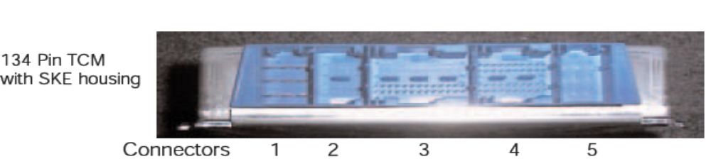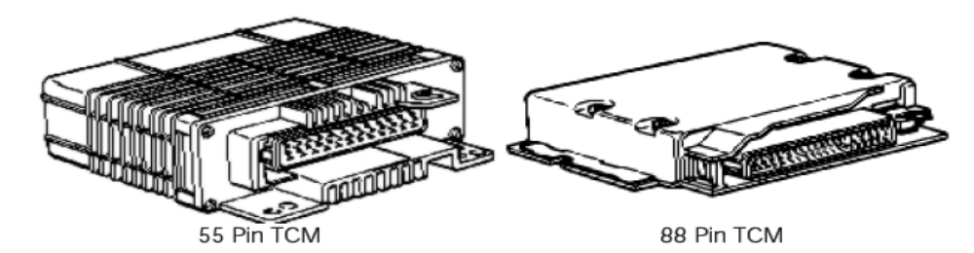
Figure 1.6 TCM-Transmission control module
There are several types of TCM housings:
- 35 Pin TCM (TCU) - used on the 4HP transmissions
- 55 Pin TCM - used on the A4S310R (THM-R1)
- 88 Pin TCM - used on all others up to 98
- 134 Pin TCM - used on all BMW transmission from the 99-model year.
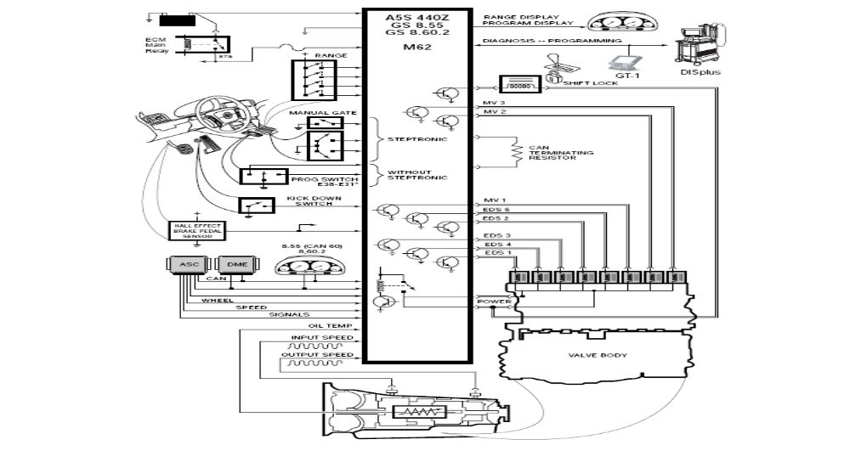
Figure 1.7 Different pin TCM (TCU)

- The 134 Pin TCM is also referred to as SKE (Standard Shell Construction).
- The SKE housing uses 5 separate connectors. On transmission applications, only three connectors 1, 3 and 4) are used.
- Connectors 2 and 5 are blank and are NOT used.
- Turbine Speed Sensor
- The turbine speed sensor used to provide input shaft speed information to the TCM (EGS).
- The input shaft speed signal is used in conjunction with the output shaft speed
- Signal to determine gear range and slip time information for processing in the TCM.
- Some TCM’s use the TD (engine speed) signal to determine input shaft speed.
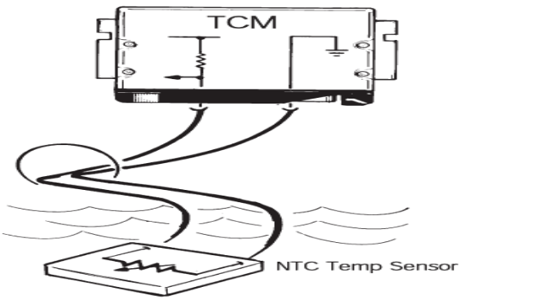
Figure 1.8 Turbine speed sensor
- All transmissions with the except a few of them use an inductive type sensor which generates an AC analog signal. Which will send a digital square wave signal to the TCM.
- Output Shaft Speed Sensor
- The output shaft speed sensor is used to provide output shaft speed information to the TCM.
- The output shaft speed signal is used in conjunction with the turbine speed signal to provide the TCM with information on gear ranges and slip times.
- The output shaft speed sensor is an inductive type which will generate an AC analog signal to the TCM.
- The frequency and amplitude of the signal will increase as output shaft speed increases.
- The exact location of the output shaft speed sensor varies by transmission model.
- Transmission Oil Temp Sensor
- The TCM is provided with transmission oil temperature information via a temperature sensor.
- On most BMW transmissions, the sensor is an NTC element which is part of the transmission internal wiring harness.
- The transmission oil temperature information is used to:
  - Initiate the Warm Up Program
  - To inhibit TCC operation until specified temperature has been reached.
  - For determining fluid level when used with diagnostic equipment.
- The transmission oil temperature sensor is connected to the TCM via a 5 Volt reference and a circuit ground.
- As transmission oil temperature increases, the circuit resistance and voltage decrease proportionately.
- The TCM receives a kick down request via one of two possible methods:
- The kick down signal is a direct ground input to the TCM.
- The kick down request is provided by the ECM (DME) via the CAN bus. The kick down request originates from the PWG.
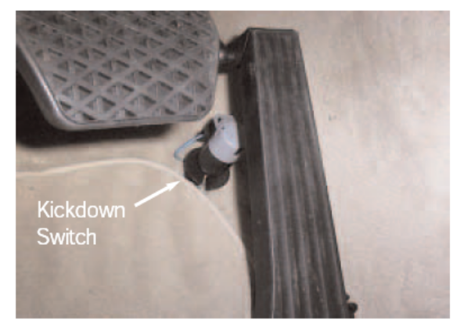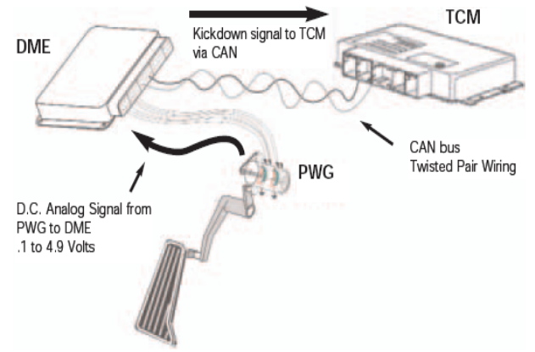
Figure1.9 The TCM receives a kick down switch
- Brake Switch
- The brake switch is located on the brake pedal linkage.
- The brake switch signal is an input to the TCM which is used for:
- De-activation of the shift lock solenoid. When the ignition key is turned to KL15 the shift lock is active.
- De-activate the Torque Converter applied. (only on Hydramatic Transmissions).
- There are two types of brake switches used on BMW vehicles:
- Double-contact mechanical switch.
- Hall Effect type switch.

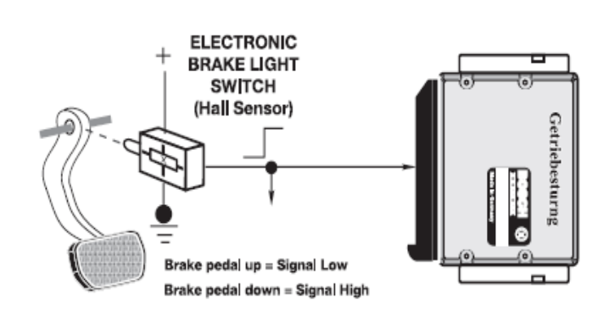
Figure 1.10 Hall Effect type switch.
- Transmission Range Selector Switch
- The range selector switch is an input to the TCM. The input is used by the TCM to determine the position of the manual valve.
- The range switch uses the familiar “coded input” signal to determine selector lever position.
- Range switch uses a 4-wire configuration to determine 7 range selector positions. And some of them uses a five-wire arrangement.
- Most range switches are located on the transmission case
- The range switch can be checked by using “Status Requests” in the displus or GT-1.
- A multimeter or an oscilloscope can also be used to check the range switch
- When diagnosing the range selector switch. Use the switch logic chart to diagnose faults in the switch.
In this Example, the range switch is in neutral.
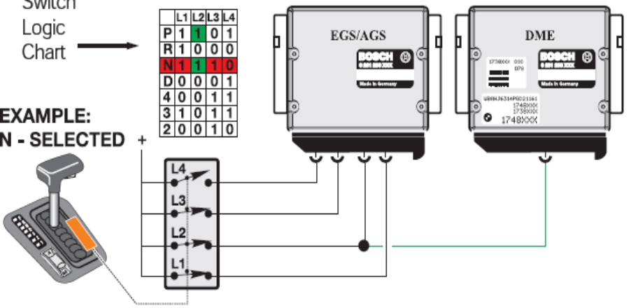
Figure 1.11 The range switch at neutral.

Where: logic chart, switches L1, L2 and L3 closed providing B+ voltage to the corresponding pins of the TCM. Switch L4 is open and no voltage is sent to the TCM.
- Transmission program switch
- The transmission program switch is used to switch between various operating modes of the transmission.
- The normal default mode of the TCM is Economy, which is indicated in the program display as “E”. Economy mode allows the transmission to operate in the most efficient mode. Shift priorities are for maximum economy and shift comfort.
- On some vehicles the program switch is designated “A” for economy mode.
- Program switches come in 2 or 3 position configurations. Early vehicles used a rotary program switch.
- The TCM can also be switched to “Manual Mode” which on some vehicles is designated “Winter Mode”.
- Manual mode is used to start the vehicle off in a higher gear when encountering slippery conditions. The program display will indicate “M” (manual) or an asterisk symbol for “Winter Mode
- Sport Mode is the third operating mode that is available which allows for a slightly delayed and more aggressive shift.
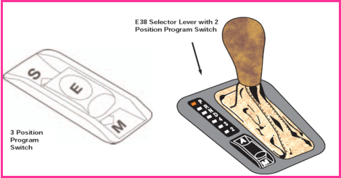
Figure 1.12 The 3postion program switch
- Steptronic Components
- The Steptronic system uses additional components not found on a conventional system.
- These components consist of a manual switch and an Up/Down micros witch. Otherwise, the Steptronic system uses the same transmission and TCM.

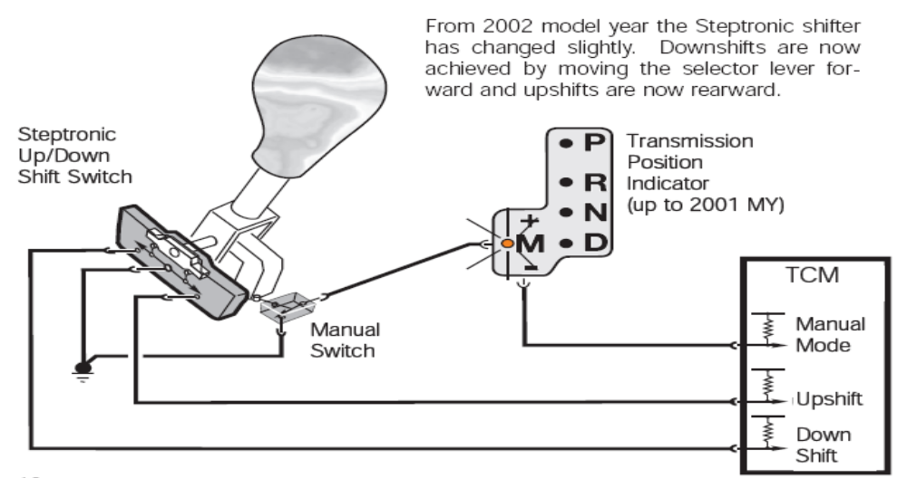
Figure 0.13 The steptronic components
- The TCM monitors the Steptronic shifter position from P through D via the conventional range selector switch located on the transmission.
- The Range Selector Switch provides positions P through D to the TCM because the automatic gate of the shifter only travels through these positions.
- When the Steptronic Shifter is moved to the left 15 degrees into the manual gate, the TCM receives a ground input from the manual gate switch.
- The ground signal is provided to the TCM through the Transmission Position Indicator.
- The transmission position indicator also provides range position signaling to the range position indicator in the shift console.

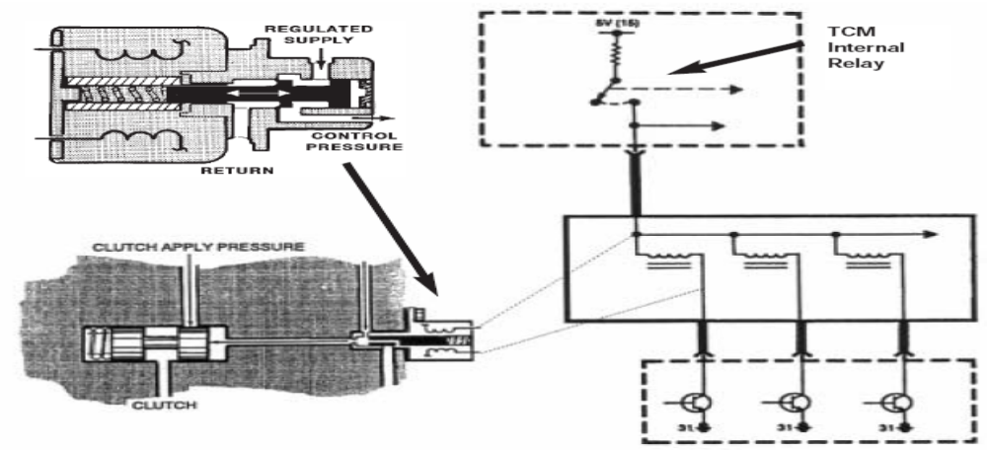
Figure 1.14 The transmission position indicator
- Magnetic Valves
- Magnetic Valves (MV) are used to electronically control hydraulic fluid flow to the various shift elements within the transmission.
- Magnetic valves are located on the valve body and replaceable as separate components.
- MV valves are designated MV1,MV2, MV3
- The magnetic valves are controlled by the TCM. They are supplied power by an internal TCM relay and are ground controlled.
- The TCM switches one or more of the MV’s on or off in various combinations to achieve various shifts.
- In addition to controlling shifts within the transmission, magnetic valves are also used for
- overlap shifting and pressure regulation on some transmission applications. When used for pressure regulation, the magnetic valves are pulse width modulated by the TCM.

- Pressure Regulating Solenoids
- Pressure Regulating Solenoids are used to modify line pressure for use in the transmission.
- There are numerous terms for these solenoids depending upon transmission type and manufacturer.
- ZF transmissions use the term EDS,
- Hydramatic Transmissions use the term DR solenoid,
- Force Motor Solenoid and Variable Bleed Solenoid (VBS)
- EDS valves are used for
- Main line pressure regulation,
    - TCC application and
    - Overlap Shift Pressure Control
- All pressure regulating solenoid are controlled by Pulse Width Modulation.
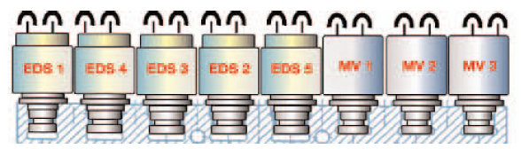
Figure1.15 Pressure regulating solenoids

The EDS valves are used for the following:
- EDS 1 is used for main line pressure regulation
- EDS 2, 3 and 5 are used Overlap Shift Pressure Control
- EDS 4 is used for TCC application. (GWK) Gradually applied TCC.
The valve body shown, the location of the main pressure regulator. Depending upon the reference text, the pressure regulator is also known as the Force Motor Solenoid Variable Bleed Solenoid or PC Solenoid.
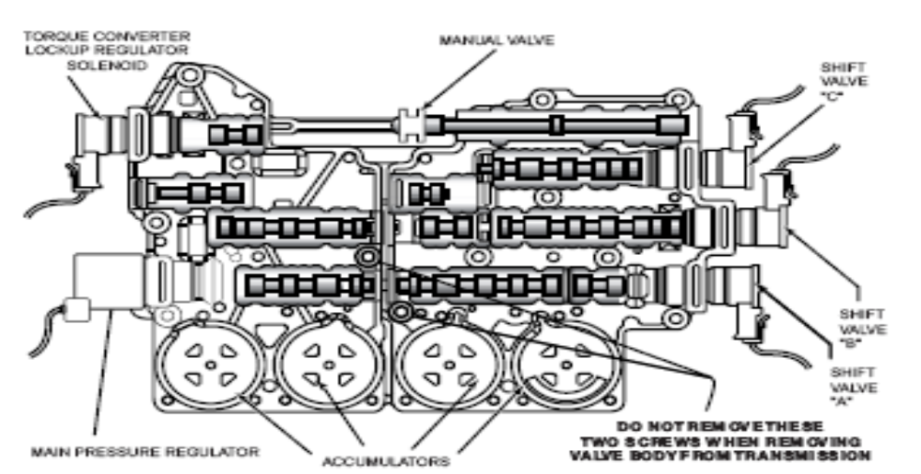
Figure 1.16 Hydromantic pressure regulator
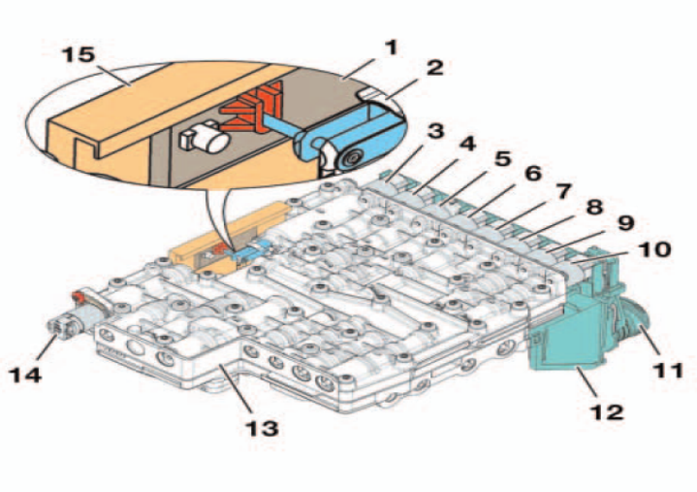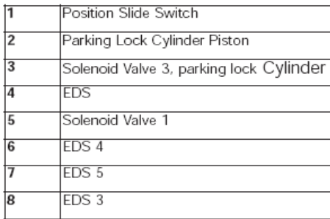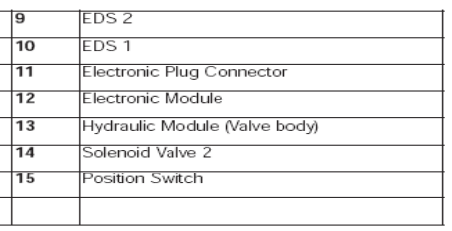
Figure 1.17 Pressure regulating solenoid
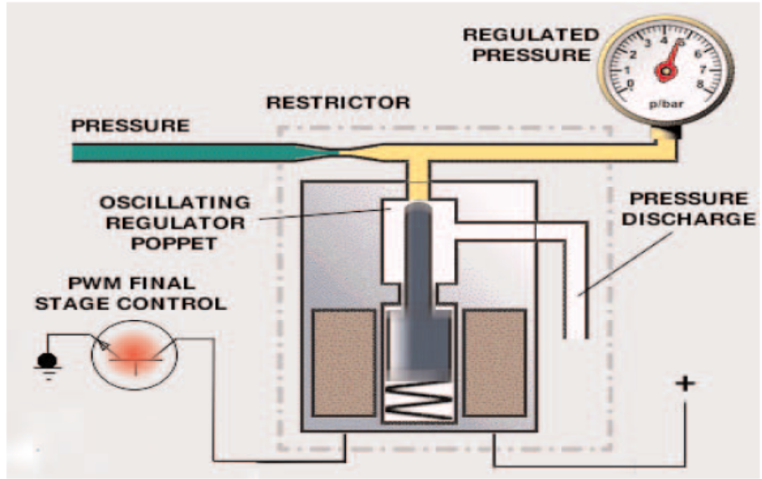
Figure 1.18 Main pressure regulating
The TCM will increase line pressure by regulating current flow to the pressure regulator. Current flow is controlled by pulse width modulation. When the duty cycle is low, the current flow to the solenoid is low. This allows spring pressure to close the valve. Therefore, maximum line pressure is achieved. As the duty cycle increases, the current flow also increases. The valve opening increases, which allows pressure to be released through the pressure discharge, which in turn decreases line pressure.
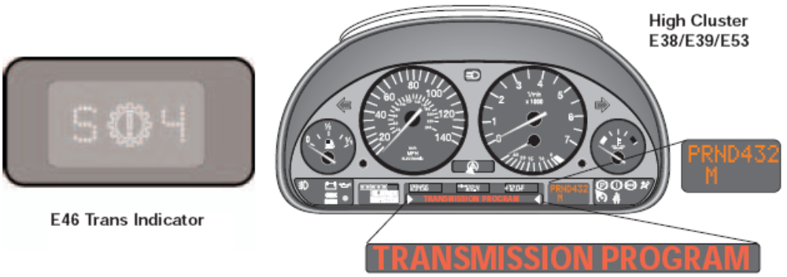
Figure 1.19 Transmission program
- Instrument Cluster
- Depending upon vehicle model and transmission, these pieces of information arrive at the cluster through different methods.
- The most current method for this information to arrive at the cluster is through the CAN bus. The cluster processes this information from the TCM via CAN.
- These is a “One Way Data Signal” from the TCM to the cluster. There is a one way serial data line that transfers this information to the cluster. On later vehicles, the cluster was introduced to the CAN bus and this method was no longer used.
- Early vehicles used a various combination of methods to transfer this data. Some clusters use
- The “Coded Input” method for the program indicator. A ground circuit through the TCM does fault indication.
Transmission range indication achieved by a direct connection between the range switch and cluster or by a coded input to cluster.

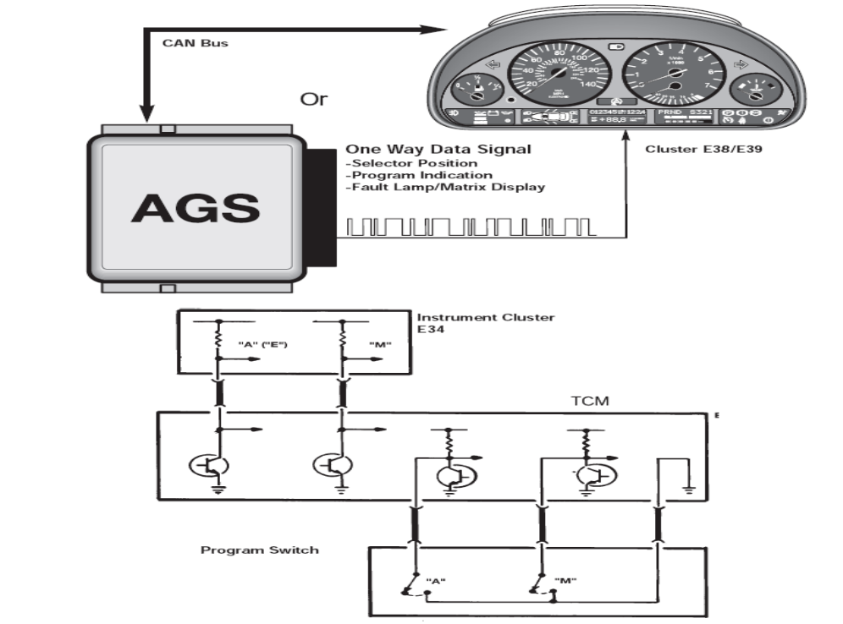

Figure 1.20 Instrument Cluster

1.2.4. Transmission Features and Principles of Operation
Adaptive Hydraulic Pressure Control
The TCM will maximize shift quality by adapting to transmission wear over time. The TCM will adjust transmission shift pressures to compensate for wear in the multi-plate clutches.
This is accomplished by monitoring the input and output speeds of the transmission. When the transmission shifts, the TCM monitors the time that it takes to accomplish the shift. The time change in gear ratios monitored and compared to an internal time value in the TCM. If the ratio change takes more time than the stored value, the TCM will compensate by adjusting the transmission shift pressures via the EDS valve solenoids.
The adaptation value is stored in the TCM. This adaptation values can only be cleared by the diagnostic tester (DIS plus or GT-1).

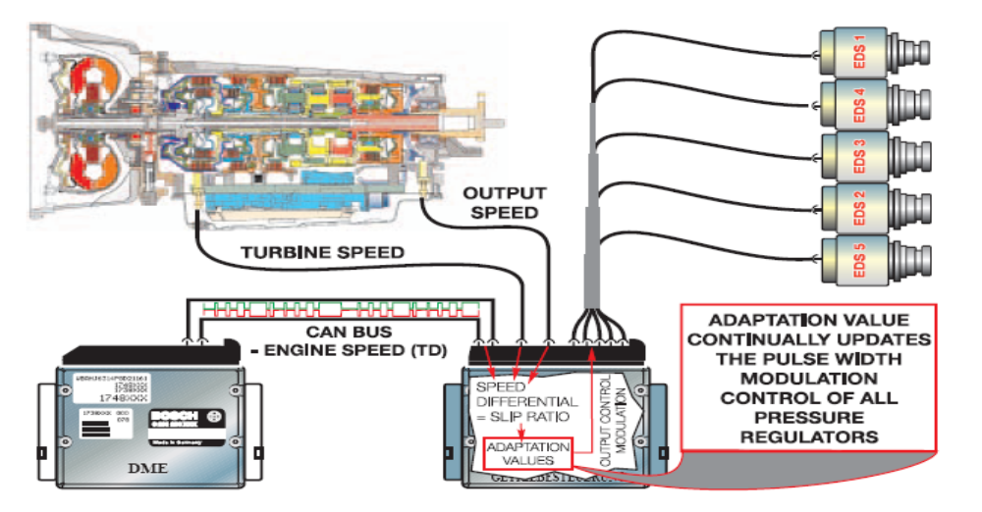
Figure 1.21 Adaptive hydraulic pressure control
- Downshift protection
- Downshift protection is a feature that prevents unwanted or improper downshifting.
- If the range selector were moved to a lower gear at a high road speed, engine damage could occur from an unintended over-rev.
- This feature will prevent engine over-rev by delaying or preventing the unwanted downshift until the proper road speed achieved.
- The result is increased safety by preventing unwanted deceleration slip.
- Reverse lockout
- The TCM will lockout reverse above 3 MPH to prevent drive train damage.
- The range selector lever will go into the reverse detent, but reverse will not engage.
- This achieved by the TCM through hydraulic intervention. The transmission will appear to be in neutral.
- Engine warm up cycle
- The transmission shift points modified after cold start to raise engine RPM during shifting.
- This allows for a faster engine warm up and reduction of catalyst warm up time.
- The TCM uses the transmission oil temperature information to determine the implementation of this function.
- The warm up phase program will be terminated if any of the following conditions exist:
- The vehicle exceeds 25 MPH or
- Transmission oil temperature exceeds 60 Degrees Celsius or
- A Maximum of three minutes exceeded.
- ASC/DSC Shift Intervention
- During ASC/DSC, regulation upshifts inhibited to enhance the effectiveness of fractional control.
- Depending upon vehicle model, this action can take place via the CAN bus or a dedicated shift intervention signal wire.
- On later model vehicles where the ASC/DSC module is connected to the CAN bus, the shift intervention signal is sent to the TCM via CAN.
- Torque Reduction
- In order to allow a smoother shift and reduce load on the transmission, engine torque reduced during shifting.
- This accomplished by a signal that sent from the TCM (EGS) to the ECM (DME) during shifting.
- The ECM will retard timing momentarily during the shift for a few milliseconds. This timing change is transparent to the driver.
- Depending upon application, the torque reduction signal is sent over a dedicated wire or a signal over the CAN bus.
- Emergency Program (Failsafe mode)
- When a malfunction occurs within the transmission, the Emergency program (failsafe mode) initiated.

- The Emergency Program will prevent unintended gear engagement and ensure driver safety.
- The following will occur during Failsafe Operation:
- All shift solenoids are de-energized via TCM internal relay.
- The pressure regulation solenoid is de-energized resulting in maximum line pressure.
- The Torque Converter Clutch is de-activated.
- The Reverse Lockout function cancelled.
- Shift lock solenoid is de-energized.
- Fault indicators are active
- The fault indicator varies depending upon model, year and cluster type etc.
- High version instrument cluster will display a message in the matrix display.
- Vehicles with low version clusters will display a fault symbol in the cluster.
- During failsafe mode the transmission will be shifted into a higher gear to allow the vehicle to be driven to a service location.
- Depending upon application, the transmission will shift into 3rd or 4th gear (on a 4spd) and 4th or 5th gear (on a 5 SPD).
Note: When diagnosing transmission related complaints, it is possible to have an erroneous fault indicator warning. Faults in the cluster can cause a false indication or “Trans Program” message. One indication of this scenario would be a transmission fault message in the cluster with no transmission faults stored in the TCM.
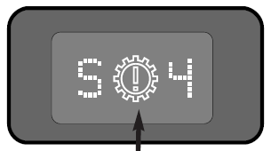
Figure 1.22 Emergency program (Failsafe mode
- Shift lock
- The shift lock solenoid mounted on the selector lever assembly and locks the selector lever in Park or Neutral when the ignition is ON.
- This prevent the selection of a gear unless the brake pedal is depressed.
- The solenoid activated by a switched ground from the TCM.
- Power supplied by the TCM internal relay. During failsafe operation, the shift lock is disabled.
- On later models, the shift lock will also be active when the TD signal is present and the shifter will remain locked above an engine speed of 2500 RPM regardless of brake application.

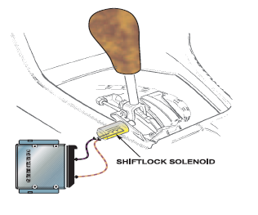
Figure 1.23 The shift lock solenoid
- Shift programs
There are 3 basic shift programs available:
- Economy Program - The economy program is the default program which is adopted every time the vehicle is started. When in economy mode, the operating priority is for maximum economy and shift comfort. Shifts will take place at low engine RPM and road speed. The economy mode is indicated by an “A” on the program switch. The cluster will display an “E” to indicate economy mode.
- Manual Mode (Winter Mode) - Manual mode is used to start out the vehicle in a higher gear on slippery surfaces when more traction is needed. A higher gear will reduce torque to the rear wheels. Manual mode can also be used to select a lower gear when needed such as when climbing a hill. Depending upon vehicle application an “M” will appear in the cluster when in Manual Mode or an asterisk (*) symbol will appear in the instrument cluster to indicate Winter Mode.
- Sport Mode - Sport Mode provides raised shift points and a more aggressive shift program for the “Enthusiastic” BMW driver. The cluster will display an “S” when in sport mode.
- Shift Programs
The program switch configurations are as follows:
- 2Position Slide Switch:
- This switch has the “A” and the “M” selection.
- Sport mode is achieved by moving the selector lever from “D” to 4, 3 or 2 when in the Economy Mode.
- The 2 Position slide switch is used on most models. These vehicles usually have a range and program display located in the instrument cluster.

- 2Position Rocker Switch:
- This switch operates the same as the slide switch,
- The rocker switch will illuminate, indicating the current program.
- 3Position Slide Switch:
- This switch has the added position for sport mode.
- The shifter does not have removed out of drive (D) to be in sport mode. This switch

- 3Position Rotary Switch –
- This switch is used only on the early EH transmissions version
- No Program Switch –
- On some vehicles with AGS features, there is no program switch.
- Shift modes obtained by moving the shift lever out of “D” range or automatically by adaptive shift functions.
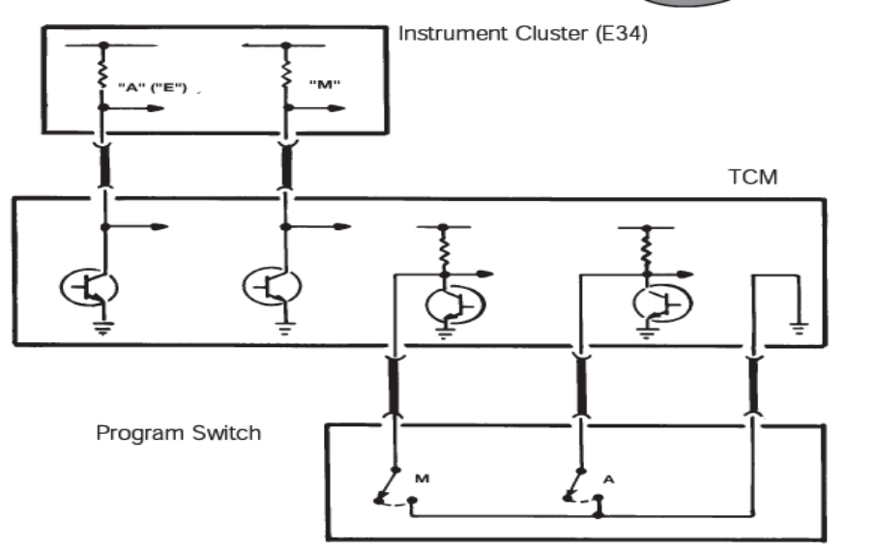
Figure1.24 Position program switch
- Steptronic Shift Modes
Regardless of version, the Steptronic system provides the driver with two modes of operation:
- To operate the transmission in fully automatic mode as with a non-Steptronic transmission.
- To operate the transmission in the manual shift mode by tilting the shift lever forward or backward when in the manual gate.
- Automatic Functions in Manual Mode: when in manual mode there are certain functions which occur automatically to prevent drive train damage and improve drivability:
Engine Over speed Prevention: To prevent engine over-rev, the TCM will upshift automatically just prior to max engine cutoff.
Kick down: If plausible, the TCM will automatically shift down to the next lower when a kick down request is received.
Decelerating: If in 5th gear and coasting to a stop, the TCM will automatically down shift to 4th gear at approximately 31 mph and then 3rd gear at approximately 19mph. The automatic downshift allows for an acceptable gear when re-accelerating. (6 cylinder models will shift to 2nd gear when stopping vehicle)
- Implausible Gear Requests:
- Certain shift requests are ignored by the TCM. For example, requesting a downshift at a high rate of speed would be ignored.
- Any shift request that would cause the engine to exceed the maximum RPM limit would not be allowed. Also starting out in a high gear is also not allowed. Only 1st, 2nd or third gear is allowed when accelerating from a stop.
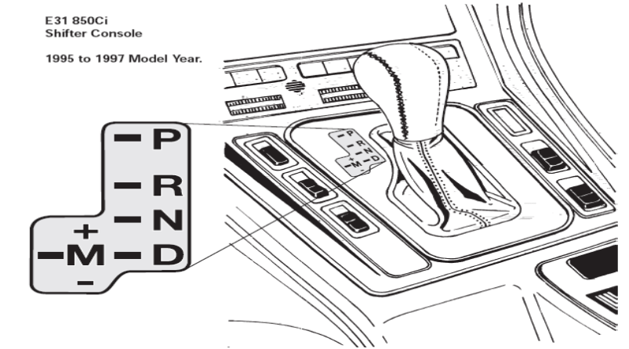
Figure 1.25 Implausible gear requests
- Steptronic shifter circuit: In order to achieve manual shifts with Steptronic, the selector lever is moved 15 degrees to the left.
A pin on the selector lever engages the “up/down” micro-switches, which are a ground input to the TCM. The selector lever also triggers the “M” gate micro-switch, which is also a ground input to the TCM.
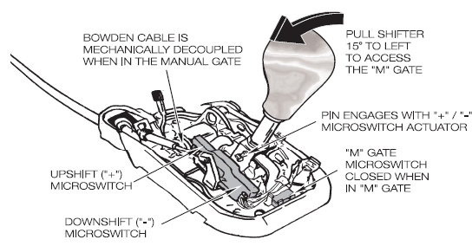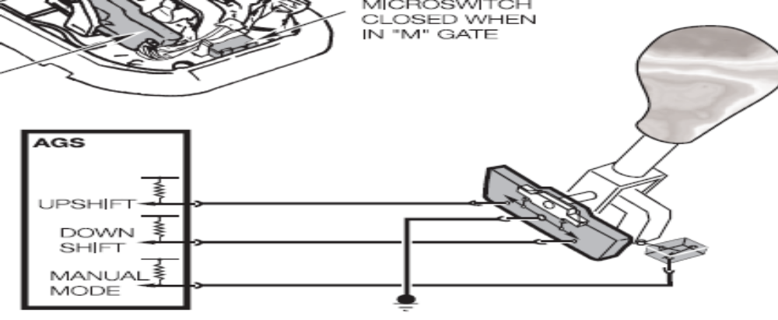
Figure 1.26 Steptronic shifter circuit
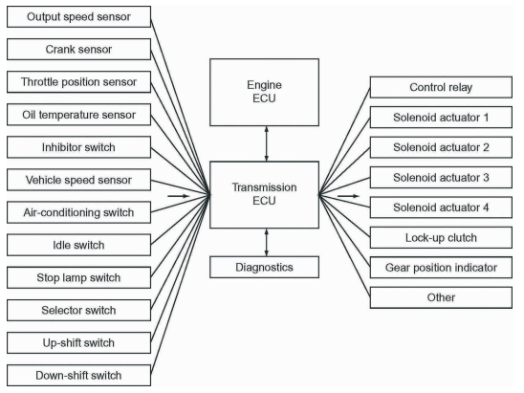
Figure1.27 Transmission Inputs and output

Self-check 1
Directions: Answer all the questions listed below.
Part-I Choose the correct answer from the given alternatives
- The purposes of torque converter
- Multiplying the torque
- Serving as an automatic clutch
- Absorbing the torsional vibration of the engine and drive train.
- all
- A standard torque converter consists of all except:
- The impeller
- The Actuators
- The stator
- The turbine
- Which one is not the input to the automatic transmission ECU?
- Throttle position sensor
- Control relay
- Speed sensor
- All
- Which one is the output of automatic transmission ECU?
- Solenoid actuator
- Control relay
- Lock up clutch
- All
- None
- The advantages of automatic as compared to manual transmissions
- Increased fuel consumption
- Improved shift comfort
- Tough to operate
- None

LAP Test: 1
Instruction: Perform the following tasks
Task 1. Visually inspect AT component
Task 2. Apply diagnosis technique
Task 3. Apply diagnosis procedurally
Task 4. Check diagnostic codes with the d diagnostic tool
Task 5. Diagnosis TCM Module

Unit Two: Diagnostic Electronic Control System
This unit is developed to provide you the necessary information regarding the following content coverage and topics:
  - Diagnosing techniques of electronic control system
  - Diagnosis procedures of electronic control system
  - Diagnosis details of electronic control system
This unit will also assist you to attain the learning outcomes stated in the cover page. Specifically, upon completion of this learning guide, you will be able to:
  - Diagnosis techniques of electronic control system
  - Diagnosis procedures of electronic control system
  - Diagnosis details of electronic control system

  - Diagnosing techniques of electronic control system
Diagnosing electronic control system issues involves a combination of techniques and tools to identify and resolve faults. Some common diagnosis techniques used for electronic control systems. In some cases, electronic control system issues may be related to software or firmware problems. Technicians may use specialized diagnostic tools or programming equipment to analyze and update the software/firmware of the ECUs. This can involve checking for software updates, re flashing or reprogramming ECUs, or troubleshooting software-related faults. Technicians rely on service manuals, technical bulletins, and manufacturer-provided resources to access system-specific diagnostic procedures, wiring diagrams, component locations, and troubleshooting guides. These resources provide in-depth information and step-by-step instructions for diagnosing and repairing electronic control system issues.
It is important to note that diagnosing complex electronic control system issues often requires expertise and experience. In challenging cases, it may be necessary to consult with manufacturer technical support or seek assistance from specialized technicians or automotive engineers. Diagnostic electronic control systems are an integral part of modern vehicles and are designed to monitor, detect, and report any malfunctions or abnormalities in the vehicle's systems. These systems utilize electronic control units (ECUs), sensors, and diagnostic protocols to identify and communicate issues to the vehicle owner or a technician. Here are the key components and features of diagnostic electronic control systems:
On-Board Diagnostics (OBD) System is a standardized diagnostic system mandated by regulations in many countries. ECUs are responsible for controlling and monitoring various vehicle systems, such as the engine, transmission, braking, and emissions systems. These ECUs continuously monitor the sensors and perform self-diagnostics to detect any faults or malfunctions in their respective systems. If a fault is detected, the ECU stores the corresponding DTC and activates warning lights on the vehicle's dashboard. Diagnostic electronic control systems rely on a wide range of sensors to collect data from different vehicle systems. These sensors measure parameters such as engine speed, coolant temperature, oxygen levels in the exhaust, wheel speed, and many more. By monitoring sensor data, the ECUs can identify deviations from normal operating conditions and trigger diagnostic processes.
Diagnostic Trouble Codes (DTCs): DTCs are alphanumeric codes generated by the ECUs to indicate specific faults or malfunctions in the vehicle. When a fault is detected, the ECU stores the corresponding DTC in its memory.
On-Board Diagnostic Codes
On board diagnostics (OBD) have been available on Toyota electronic control transmissions since the mid-eighties. The ECM monitors input and output circuits and compares them to known parameters. When a circuit operates outside these parameters, trouble codes are set, maintained in the ECM memory and the O/D OFF light is illuminated In generation two on board diagnostics (OBD II), not only does the ECM monitor input and output circuits, but it is also capable of determining slippage and shift timing. The ECM causes the overdrive OFF lamp or MIL to illuminate in the event there is a fault either in the engine or transmission. The diagnostic codes provide direction to the person diagnosing a customer’s concern; be sure to make a note of all codes and freeze data stored in memory. Diagnostic Tester: Toyota’s Diagnostic Tester can be connected to OBD II models equipped with a DLC2 or DLC3 connector located under the instrument panel. All stored trouble codes can be read directly from the tester’s screen. Some Toyota models in 1994 and 1995, such as the Previa, Land Cruiser and Supra, had diagnostic tester capability via the DLC1 connector located in the engine compartment. Common to these models is a TE2 terminal located in the DLC1 connector, which allows the scan tool to display codes.
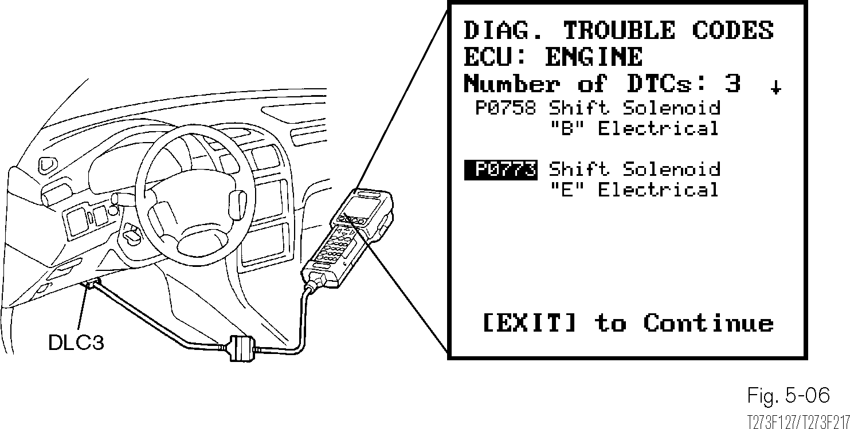
Checking Diagnostic Codes With the Diagnostic Tool
All stored trouble codes can be read directly from the tester’s screen.
Figure 2.1 Checking diagnostic codes with the diagnostic tool

These codes can be accessed using a diagnostic tool or scanner, enabling technicians to identify and diagnose the underlying issue accurately. Diagnostic electronic control systems are an integral part of modern vehicles and are designed to monitor, detect, and report any malfunctions or abnormalities in the vehicle's systems. These systems utilize electronic control units (ECUs), sensors, and diagnostic protocols to identify and communicate issues to the vehicle owner or a technician. Here are the key components and features of diagnostic electronic control systems:
- On-Board Diagnostics (OBD) System
- Communication Protocols
- Electronic Control Units (ECUs) and Sensors
- Real-Time Data Monitoring
- Diagnostic Trouble Codes (DTCs)
- Diagnostic Tools and Scanners
- Dashboard warning lights:
Diagnostic electronic control systems are essential for efficient and accurate vehicle diagnostics. They enable timely detection of faults, facilitate effective troubleshooting, and contribute to the overall reliability and safety of modern vehicles.
  - Diagnosis procedures of electronic control system
Diagnosing electronic control system issues typically involves following a systematic procedure to identify and resolve faults. It is important to note that the diagnosis procedure may require iterations and further investigation, especially for complex or intermittent issues. If necessary, consult manufacturer technical support, service bulletins, or seek assistance from qualified technicians or specialists to ensure accurate diagnosis and resolution of the electronic control system problem. While specific procedures may vary depending on the vehicle and the nature of the problem, here is a general outline of the diagnosis procedure for electronic control systems:
Gather Initial Information: begin by gathering as much information as possible about the problem. This includes noting any symptoms or abnormal behavior observed, such as warning lights on the dashboard, unusual engine noises, or performance issues. It can also be

helpful to gather information about recent repairs or maintenance work performed on the vehicle.
Visual inspection: Perform a visual inspection of the electronic control system components. Look for visible signs of damage, loose connections, or physical abnormalities.
Examine wiring harnesses, connectors, fuses, relays, and other system components for any visible issues that may contribute to the problem.
Retrieve diagnostic trouble codes (DTCs): Use a scan tool or diagnostic equipment to retrieve diagnostic trouble codes (DTCs) stored in the vehicle's electronic control units (ECUs). DTCs provide specific information about the detected faults or malfunctions in the system. Record the codes and their descriptions for further analysis.
Interpret DTCS and data analysis: Analyze the retrieved DTCs and interpret their meanings. Consult the vehicle's service manual or manufacturer-provided resources to understand the significance of each code and its potential causes. Analyze real-time data readings from sensors and system parameters to identify abnormal or out-of-spec values that may be related to the problem. Perform functional tests specific to the suspected system or component. This may involve activating actuators, checking voltage and signal outputs, or conducting system-specific tests. Functional testing helps verify the proper functioning of individual components and subsystems.
Circuit Testing: Use multi meters, oscilloscopes, or other diagnostic tools to perform circuit testing. Measure voltages, currents, and waveforms within the electronic control system circuits. Check for open circuits, short circuits, voltage drops, or other electrical issues that may affect system performance.
Component Testing and Replacement: If a specific component is suspected to be faulty, perform component testing using specialized tools or diagnostic procedures. This includes testing sensors, actuators, relays, modules, and other components to ensure they are functioning within specified parameters. Faulty components may need to be replaced to resolve the issue effectively.
Software and Firmware Analysis: If software or firmware issues are suspected, analyze the software/firmware of the ECUs. Check for software updates, reflash or reprogram ECUs, or

troubleshoot software-related faults. Follow manufacturer-provided guidelines and procedures for software analysis and updates.
Documentation and Record-Keeping: Throughout the diagnosis process, document your findings, test results, and any actions taken. Maintain a record of the steps followed, including DTCs, component testing results, and any repairs or replacements made. This documentation can be valuable for future reference and can assist in tracking the progress of the diagnosis.
Verify and Test Repairs: After performing repairs or component replacements, verify the effectiveness of the repair by conducting post-repair testing.
Ensure that the system is functioning properly and that all DTCs have been cleared. Take the vehicle for a test drive to confirm that the symptoms or issues have been resolved.
Diagnostic sequence/procedures
Diagnosis of an automatic transmission requires a logical step-by-step procedure that establishes the cause of the problem. The procedure must eliminate as many causes as possible before the transmission removed. Time spent in diagnosis will help isolate the problem to one of the following:
Many diagnostic clues are no longer available once the transmission is removed and spread out on a bench. Once diagnosis has narrowed the cause, determine whether the repair can be done with the transmission in the vehicle or if it needs to be removed. Additionally, will it be cost effective to repair the transmission or replace it with a remanufactured unit.
Diagnosis of automatic transmission complaints should follow a systematic sequence of events, which resolves the customer’s concern.
1. Verify the Customer Complaint
2. Fluid Checks
3. Time Lag Test
4. Test Drive
5. Road Test
6. Diagnostic Trouble Codes
7. Preliminary Checks and Adjustments
8. Manual Shift Test
9. Diagnostic Tester Usage: Analyzing the test drive results

Diagnostic sequence of events: Diagnosis of automatic transmission complaints should follow a systematic sequence of events, which resolves the customer’s concern as follow:
Verify the Customer Complaint: Verifying the customer complaint is the single most important step in diagnosis. The technician needs to experience the condition and be able to duplicate it to accurately diagnose it. Customer Interview Sheet: Communication between the customer and the technician is essential to verifying the complaint. The technician is frequently isolated from the customer and receives his information third−hand from the Service Writer. To bridge this gap, a customer interview sheet is strongly recommended to ensure the technician has as much information as possible to begin his diagnostic effort. The more details that are available, the more likely the condition can be found quickly.
A sample Customer Interview Sheet can be found in Appendix E. If the complaint cannot be verified, it may be necessary to speak with the customer and have him/her accompany you on the test drive to identify their concern.
Customer and Vehicle Data: The customer and vehicle data are for administrative purposes for tracking the customer or vehicle. Additionally, it’s important to determine if the person bringing the vehicle for service is the primary operator who has first−hand knowledge of the complaint. Preliminary Fluid Checks: A preliminary fluid check ensures the transmission has sufficient fluid and indicates the condition of the fluid prior to the test drive. There is no need to top off the fluid unless it is extremely low and could cause further damage. Do not attempt to make any adjustments or repairs prior to the test drive as this may mask the symptoms. Be sure to make notes of your findings on the RO for future reference.
Fluid Level: The fluid level should be inspected when the fluid has been warmed up to normal operating temperature, approximately 158F to 176F. As a rule of thumb, if the graduated end of the dipstick is too hot to hold, the fluid is hot enough. Proper fluid level is in the hot range between hot maximum and hot minimum. Check the fluid level yourself and don’t assume that someone else has done it properly.

NOTE: The cool range found on the dipstick should be used as a reference only when the transmission is cold, to ensure adequate lubrication while the fluid is brought up to temperature. The correct fluid level can only be determined when the fluid is hot.
Fluid Level: The fluid level should be inspected when the fluid has been warmed up to normal operating temperature, approximately 158F to 176F. As a rule of thumb, if the graduated end of the dipstick is too hot to hold, the fluid is hot enough. Proper fluid level is in the hot range between hot maximum and hot minimum. Check the fluid level yourself and don’t assume that someone else has done it properly.
NOTE: The cool range found on the dipstick should be used as a reference only when the transmission is cold, to ensure adequate lubrication while the fluid is brought up to temperature. The correct fluid level can only be determined when the fluid is hot.
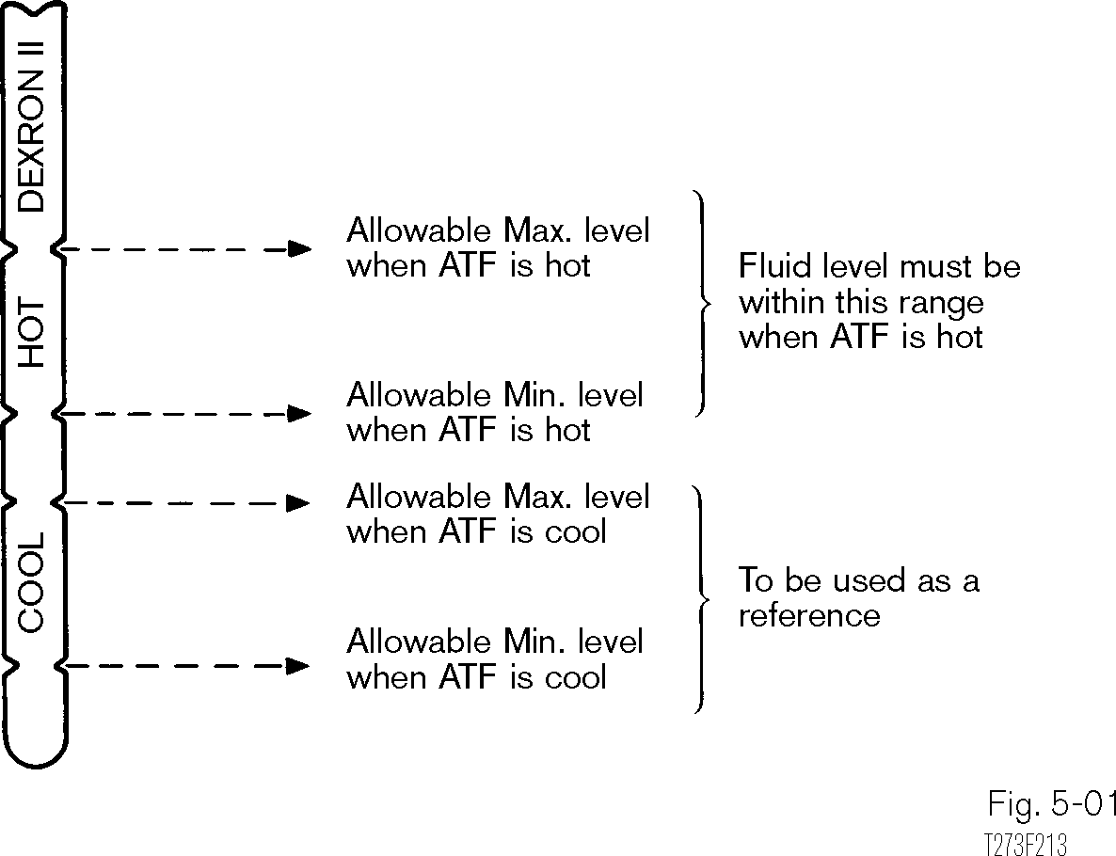
Fluid Level Check
The fluid is at the proper level if in the hot range between hot maximum and hot minimum.
Figure 2.2 Fluid Level Check
Proper fluid levels ensure proper operation of the holding devices, the torque converter and lubrication of the automatic transmission. A low fluid level causes delayed engagement in both drive and reverse and slipping when upshifting. Slipping causes overheating and rapid wear of clutches and bands. Additionally, fluid may migrate away from the oil pickup under heavy deceleration, resulting in a lack of oil volume required to disengage the lockup converter clutch.

Differential Fluid Level
In addition to the transaxle fluid level, some transaxles require a separate check of the differential fluid level. The fluid is separated from the main body of the transaxle by a pair of seals on the drive pinion. Fluid level is checked by removing the filler plug. Fluid should be level with the filler plug hole. This chamber is drained and filled separately from the transaxle. Although some transaxles are open to the differential, be sure to check the differential for proper level when refilling the transaxle.

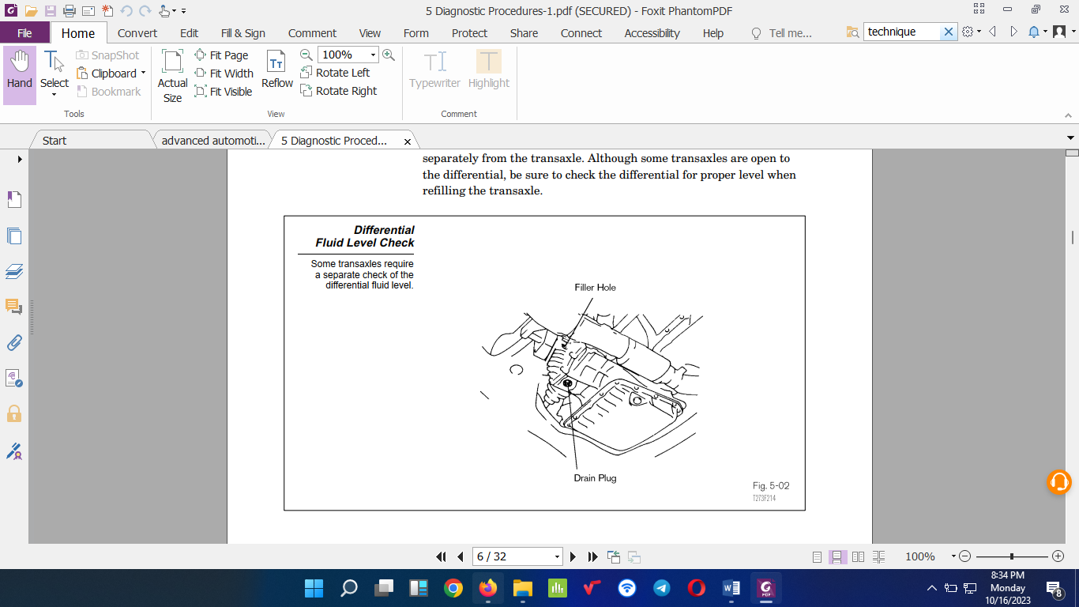
Figure 2.3 Steptronic shifter circuit
Fluid condition
Two indicators of fluid condition have been color and smell, but these can no longer be relied upon for definitive diagnosis. Since the removal of asbestos from friction material and the added resin content, the chemical formulations of new fluids and resin have contributed to the smell and color changes in current fluids. A dark clear brown or dark clear red fluid color does not by itself indicate a failed unit even if it smells burned. To get a better indication of fluid condition, place a sample of the fluid on a white paper towel.
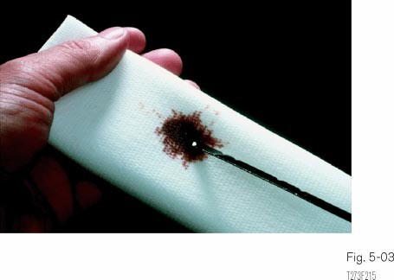
Analyzing Fluid Condition

Place a sample of the fluid on a white paper
towel for closer analysis of fluid condition.

Figure 2.4 White paper towel for closer analysis of fluid condition.

If any of the conditions listed below are found in the fluid sample, the transmission should be rebuilt or replaced with a remanufactured unit:
- Residue or flaky particles of metal or friction material.
- Heavily varnished fluid, which is tacky and no longer clear.
- Milky appearing fluid caused by engine coolant entering the transmission.
- The coolant may cause the friction facing to loosen from the clutch plates and torque converter clutch.
If you are just not sure about the fluid condition and residue on the dipstick, the transmission pan can be removed after the test drive to evaluate the residue content. Residue can be particles of steel, bronze, plastic or friction material reflecting damage to bushings, thrust washers, clutch plates or other parts. Some residue at the bottom of the pan is not uncommon. You will find two or more magnets positioned in the pan to attract metal particles, trapping them from suspension in the fluid and being transported through the transmission.

Table 1 some general diagnostic information and procedures
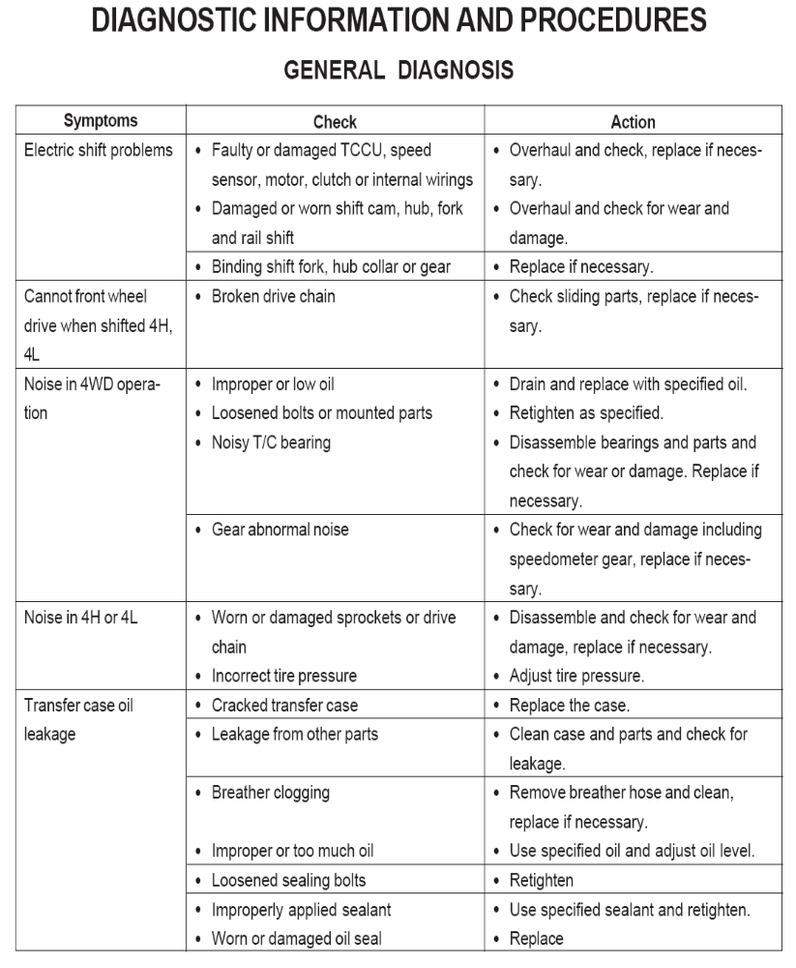
  - Diagnosis details of electronic control system
Diagnosing electronic control system issues involves a detailed and systematic approach. Here are some key aspects and steps involved in the diagnosis of electronic control systems:
Initial Assessment: begin by gathering information from the vehicle owner or operator about the symptoms or issues they are experiencing. Ask specific questions to understand the nature of the problem, such as when the issue occurs, under what conditions, and if any warning lights are illuminated on the dashboard.
Scan Tool Connection: connect a scan tool or diagnostic equipment to the vehicle's onboard diagnostic (OBD) port. This allows communication with the electronic control units (ECUs) and provides access to diagnostic trouble codes (DTCs) and real-time data.
DTC Retrieval: retrieve DTCs from the ECUs using the scan tool. DTCs are alphanumeric codes that indicate specific faults or malfunctions in the system. Pay attention to both active and stored codes, as stored codes can provide valuable history and context.
DTC Interpretation: interpret the retrieved DTCs to understand the nature of the problem. Consult the vehicle's service manual or manufacturer-provided resources to determine the meaning and potential causes of each code. DTCs are often accompanied by descriptions or freeze-frame data that can provide additional information.
Data Analysis: analyze real-time data readings from various sensors and system parameters using the scan tool. Look for values that are out of range or deviate from expected values. Pay attention to sensor voltages, temperatures, pressures, and other relevant data points. Compare the data to specifications provided by the vehicle manufacturer.
Symptom Replication: attempt to replicate the reported symptoms or issues while monitoring relevant data parameters. This can help identify patterns or triggers that contribute to the problem. For example, if the issue occurs only during cold starts or under specific driving conditions, try to recreate those conditions during the diagnosis process.
Circuit Testing: perform circuit testing using multimeters, oscilloscopes, or other diagnostic tools to measure voltages, currents, and waveforms within the electronic control system. Check for open circuits, short circuits, continuity, and proper electrical connections. This can help identify wiring harness issues, faulty connectors, or other electrical problems.

Component testing: Test individual components within the electronic control system to determine their functionality. This may involve using specialized tools or procedures to check sensors, actuators, relays, modules, and other components. Component testing can help identify faulty or malfunctioning parts that require repair or replacement.
Software and Firmware Analysis: analyze the software and firmware of the ECUs if software-related issues are suspected. Check for software updates, compatibility issues, or programming errors. Consult manufacturer-provided resources or technical support for guidelines on software analysis and updates.
Documentation and Record-Keeping: document all findings, test results, and actions taken during the diagnosis process. Keep a detailed record of DTCs, real-time data, component test results, circuit test results, and any repairs or replacements made. This documentation serves as a reference for future diagnosis or maintenance and can aid in tracking the progress of the diagnosis.
Verification and Testing: After performing repairs or component replacements, verify the effectiveness of the solution. conduct post-repair testing to ensure that the system is functioning properly and that all DTCs have been cleared. Test the vehicle under various operating conditions to confirm that the symptoms or issues have been resolved.

Self-check 2
Directions: Answer all the questions listed below.
Part-I Match B with the correct appropriate A
A B
A. Initial Assessment 1. Interpret the retrieved DTCs to get nature of the problem.
B. Scan Tool Connection 2. attempt to replicate the reported symptoms
C. DTC Retrieval 3. Analyze real-time data readings from various sensors
D. DTC Interpretation 4. Gathering information from the vehicle owner
E. Data Analysis 5. Retrieve DTCs from the ECUs
F. Symptom Replication 6. OBD-II
Part-II Choose the correct answer from the given alternatives
- _____is the documentation that recorded
- Multiplying the torque
- Component testing
- Record-Keeping
- Circuit Testing
- _____ A standard torque converter consists of all except:
- The impeller
- Actuators
- The stator
- The turbine
- _____Which one is not the input to the automatic transmission ECU?
- Throttle position sensor
- Control relay
- Speed sensor
- All
- _____ which one is the output of automatic transmission ECU?
- Solenoid actuator
- Control relay
- Lock up clutch
- All
- None
- _____The advantages of automatic as compared to manual transmissions
- Increased fuel consumption
- Improved shift comfort
- Tough to operate
- None

LAP Test: 2
Instruction: Perform the following tasks
Task 1. Visually inspect AT component
Task 2. Apply diagnosis technique
Task 3. Apply diagnosis procedurally
Task 4. Check diagnostic codes with the d diagnostic tool
Task 5. Diagnosis TCM Module

Unit Three: Servicing Electronic Control System
This unit is developed to provide you the necessary information regarding the following content coverage and topics:
  - Servicing techniques of electronic control system
  - Servicing procedures of electronic control system
  - Servicing details of electronic control system
This unit will also assist you to attain the learning outcomes stated in the cover page. Specifically, upon completion of this learning guide, you will be able to:
  - Service techniques of electronic control system
  - Follow procedures of electronic control system
  - Service details of electronic control system

Operation Sheet 3.1
Operation Title: Servicing torque convertor
Purpose: To check torque convertor
Conditions for the operations:
Safe working area
Properly operated tools and equipment
Appropriate working cloths fit with the body
Equipment Tools and Materials:
- Shift cable adjustor
- Wrenches
- Vehicles with the AT
Quality Criteria: Assured performing of all the activities according to the procedures
Precautions:
Wearing proper protective clothes
Make working area hazard free and safe
Read and interpret manual which guide you how to use tools and equipment
Steps in doing the task
To assist with the diagnosis and service of automatic transmission faults a stall test is often used. The duration of a stall test must not be more than about seven seconds.
The function of this test is to determine the correct operation of the torque converter and that there is no transmission clutch slip. Proceed the service as follows.
- Run engine up to normal operating temperature by road test if possible.
- Check transmission fluid level and adjust if necessary
- Connect a recounter to the engine.
- Apply handbrake and chock the wheels.
- Apply foot brake, select ‘D’ and fully press down the throttle for about seven seconds.
- Note the highest rev/min obtained (2500 to2750 is a typically acceptable range).
- Allow 2 minutes for cooling and then repeat the test in ‘2’ and ‘R’.

Operation Sheet 3.2
Operation Title: Servicing Techniques Electronic Control System
Purpose: To check and service throttle cable
Conditions for the operations:
Safe working area
Properly operated tools and equipment
Appropriate working cloths fit with the body
Equipment Tools and Materials:
- Shift cable adjustor
- Wrenches, Vehicles with the AT
Quality Criteria: Assured performing of all the activities according to the procedures
Precautions:
- Wearing proper protective clothes
- Make working area hazard free and safe
- Read and interpret manual which guide you how to use tools and equipment
Steps in doing the task
Check the throttle cable stopper at the boot end and ensure that there is no more than one millimeter between the end of the stopper and the end of the boot.
To adjust the throttle cable:
- Loosen the locking nuts on the cable housing.
- Verify with the repair manual whether the throttle is closed or open during the procedure.
- Reposition the cable housing and boot as needed until the specification is reached.
- Pull the inner cable lightly until a slight resistance is felt.
- Position the end of the stopper at a measurement of 0.8 to 1.5 mm from the end of the outer cable housing.
- Clamp the stopper in place on the cable.
- When the throttle cable is misadjusted, it will affect line pressure and shift quality in both ECT.

Operation Sheet 3.3
Operation Title: Servicing Procedure Electronic Control System
Purpose: To service shift cable
Conditions for the operations:
Safe working area
Properly operated tools and equipment
Appropriate working cloths fit with the body
Equipment Tools and Materials:
- Shift cable adjustor and Wrenches
- Vehicles with the AT
Quality Criteria: Assured performing of all the activities according to the procedures
Precautions:
Wearing proper protective clothes
Make working area hazard free and safe
Read and interpret manual which guide you how to use tools and equipment
Steps in doing the task
Check the throttle cable stopper at the boot end and ensure that there is no more than one millimeter between the end of the stopper and the end of the boot.
- This inspection is done from the passenger compartment with the engine off.
- Move the gear selector through each gear selection range noting the detent
- As the detent is felt, the position of the gear selector indicator should line up properly.
- Observe the gear selector indicator to ensure that only one indicator light is illuminated at one time.
- If more than one is lit, the ECM may sense a 2 or low position rather than a D position.
- Adjust the shift cable if the indicator does not line up properly.
- Loosen the swivel nut on the shift linkage.
- Push the manual lever at the transmission fully toward the torque converter end of the transmission.
- Pull the lever back two notches from Park through Reverse to the Neutral position.
- Set the selector lever to the Neutral position and tighten the swivel nut while holding the lever lightly toward the reverse position

Operation Sheet 3.4
Operation Title: Servicing Details Electronic Control System
Purpose: To apply Stall Speed Testing
Conditions for the operations:
    - Safe working area
    - Properly operated tools and equipment
    - Appropriate working cloths fit with the body
Equipment Tools and Materials:
- Tachometer
- Wrenches
- Vehicles with the AT
Quality Criteria: Assured performing of all the activities according to the procedures
Precautions:
Wearing proper protective clothes
Make working area hazard free and safe
Read and interpret manual which guide you how to use tools and equipment
Steps in doing the task
The stall test is used to determine the condition of:
- The engine state of tune.
- Specific holding devices in the transmission.
- The torque converter.
In preparing the vehicle for a stall test:
- Consider safety when staging the vehicle
- The engine and transmission should be at operating temperature and at the proper level.
- Attach a tachometer to the engine.
- The full weight of the vehicle should rest on the wheels.
- Place chocks at the front and rear wheels.
- Set the parking brake and apply the foot brakes with your left foot.
Stall testing should be checked in drive and reverse by moving the accelerator to wide open throttle and read the maximum engine rpm.

When engine rpm falls within specifications during a stall test, it verifies the following items:
- The one-way clutch in the torque converter stator is holding.
- Holding devices (clutches, brakes, and one-way clutches)
- The transmission oil pressure is adequate.
- Engine is in a proper state of tune.

LAP Test:3
Instruction: Perform the following tasks
Task 1: To check torque convertor
Task 1: To check and service throttle cable
Task 3: Service shift cable
Task 4: Apply Stall Testing

Reference
- James D. Haldeman, Automotive Technology Principles, Diagnosis and service 4th Edition (2011, Prentice Hall)
- Kirk VanGelder, Fundamentals of Automotive Maintenance and Light Repair 2nd Edition
- James D. Halderman, Diagnosis and Troubleshooting of Automotive Electrical, Electronics and computer system (2011, Prentice Hall)
Tom Denton, Automotive Electrical and Electronics system, (2004 BUTTERWORTH.), 3rd Edition

No | Name | Qualification | Field of Study | Organi/ Institution | Mobile number | E-mail
 | Fadli Aman | BSc. | Automotive Technology | General Wingate PTC | 0927283100 | Fadli.ziyad@gmail.com
 | Habtamu Deresso | PHD Candidate | Automotive Technology | ASTU | 0945853269 | habtamu.deresso@astu.edu.et
 | Israel Taye | MSc | Automotive Technology | General Wingate PTC | 0913424100 | isra.taye@gmail.com
 | Natnael Genene | MSc | Automotive Technology | Athlete kenenisa PTC | 0920397105 | natnealgenene143@gmail.com
 | Robsan Tesfaye | MSc | Automotive Technology | Burayu PTC | 0920117175 | robsantesfaye4@gmail.com
 | Sisay Tufa | MSc | Automotive Technology | M/G/M/Buli PTC | 0912065407 | knbntf@gmail.com
 | Tagay Tesfaye | MSc | Automotive Technology | Bishoftu PTC | 0975971391 | tagotagotago37@gmail.com
Participants of this Module (Training module) preparation

