
Automotive Electricity and Electronics Level IV
Based on Otober 2023, Curriculum Version II
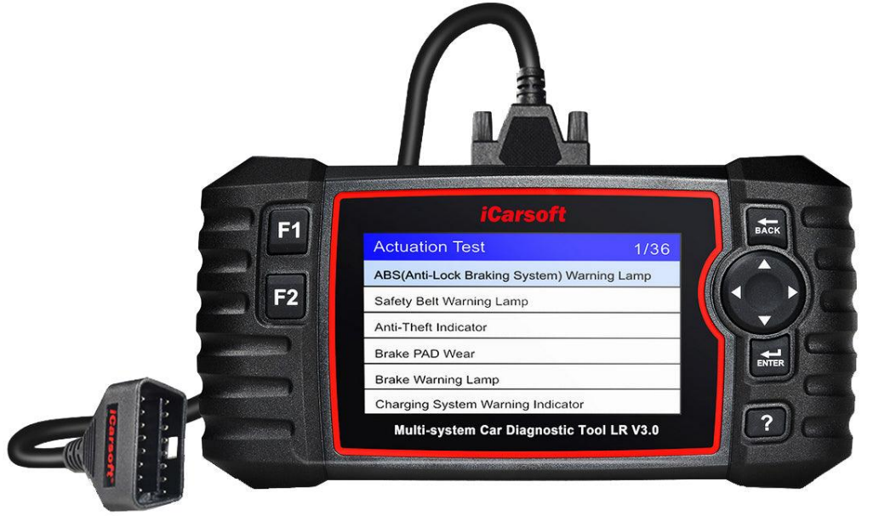
Module Title: Diagnosing Fault in Body Management System
Module Code: EIS AEE4 M06 1023
Nominal Duration: 40 Hours
Prepared by: Ministry of Labor and Skill

October , 2023
Addis Ababa, Ethiopia

Table of Contents
Acknowledgment 3
Acronym 4
Introduction to Module 5
Unit one: Overview Electronic Body Management System 6
1.1. Electronic body management system 7
1.1.1.Multimedia 8
1.1.2. Engine immoblizer 9
1.1.3. Central Door locking 11
1.1.4. Power window 13
1.1.5. Sunroof 14
1.1.6. Supplemental Restraint System(SRS)Air Bag System 16
1.7.1. Mirror positioning 20
1.2.Identifying and confirming faults 22
1.3.OHS requirements 24
Self-check 1.1 27
Unit Two: Prepare To Perform Diagnosis 28
2.1.Testing equipment and material 29
2.1. Diagnostic methods and testing process 34
Operation sheet 2.1 41
Operation sheet 2.2 43
LAP Test 45
Unit Three: Apply complex diagnostic process 46
3.1.Carrying out testing and diagnoses process 47
3.2.Analyze the diagnosis result 61
Operation sheet 3.1 65
LAP Test 67
Reference 68

Acknowledgment

The Ministry of Labor and skill wishes to thank and appreciation to MoLS leaders and experts, Regional Labor and skill/training Bureaus leader, experts, TVT College Deans, Instructors and industry experts who contribute their time and professional experience to the development of this Training Module.

Acronym
ADC | Analog Digital Converter
AMM | Analog Multi Meter
BMS | Electronic Body Management System
DLC | Data Link Connector
DMM | Digital Multi Meter
ECU | Engine Control Unit
OHS | Occupational Health And Safety
PPE | Personal Protective Equipment
SRS | Supplemental Restraint System
VIN | Vehicle Identification Number

Introduction to Module
In automotive electrical electronics field, removing and installing automotive electrical electronics system components helps to identify and remove electrical electronics components from the vehicle and install back according to manufacturer’s service manual.
This module covers the knowledge, skill and attitude required to diagnose complex faults in electronic body management system Level-III in order to initiate action to service, repair, replace or improve performance. The module involves evaluating system performance and identifying possible operational anomalies.
This module covers the units:
- Overview electronic body management system
- Prepare to perform diagnosis
- Apply complex diagnostic process
Learning Objective of the Module
- Understand electronic body management system
- Prepare to perform diagnosis
- Apply complex diagnostic process
Module Instruction
For effective use this modules trainees are expected to follow the following module instruction:
- Read the information written in each unit
- Accomplish the Self-checks at the end of each unit
- Perform Operation Sheets which were provided at the end of units
- Do the “LAP test” giver at the end of each unit and
- Read the identified reference book for Examples and exercise

Unit one: Overview Electronic Body Management System
This unit is developed to provide you the necessary information regarding the following content coverage and topics:
- Electronic body management system
- Identifying and confirming faults
- OHS requirements
This unit will also assist you to attain the learning outcomes stated in the cover page. Specifically, upon completion of this learning guide, you will be able to:
- Understand Electronic body management system
- Identify and confirming faults
- Observe OHS requirements

Electronic body management system
The Electronic Body Management System (BMS) is a comprehensive electronic control system used in modern automobiles to manage and control various functions related to the vehicle's body and interior systems. It is responsible for monitoring and controlling a wide range of electrical components and subsystems within the vehicle, including lighting, power windows, door locks, wipers, climate control, entertainment systems, and more.
The BMS utilizes multiple sensors, control modules, and actuators to receive input signals, process information, and send commands to the respective components. It acts as a central hub that communicates with different modules and subsystems, coordinating their operation and ensuring proper functionality.
common features and functions of an Electronic Body Management System include:
- Power Window and Door Lock Control: The BMS provides control over power windows and central door locking systems. It enables the driver and passengers to operate the windows and lock/unlock the doors using switches or key fobs.
- Entertainment and Infotainment Systems: The BMS interfaces with the vehicle's audio and infotainment systems, controlling functions such as radio, CD/DVD player, navigation, Bluetooth connectivity, and other multimedia features.
- Security and Anti-Theft Systems: The BMS incorporates security features, such as immobilizers and alarm systems, to deter theft and unauthorized access to the vehicle.
Some common problems with the BMS include:
- Electrical Malfunctions
- Sensor Failures
- Control Module Failures
- Software Glitches
- Component Wear and Tear

1.1.1.Multimedia
A vehicle multimedia system, also known as an infotainment system, is an integrated electronic system in a vehicle that combines various entertainment and information functionalities. It typically includes features such as audio playback, video playback, navigation, communication, connectivity, and vehicle settings. The primary purpose of a vehicle multimedia system is to provide occupants with a user-friendly interface for accessing a wide range of features and services while driving.
Here are some common components and functions found in a vehicle multimedia system:
- Display Screen: A multimedia system usually incorporates a touchscreen display or sometimes a combination of touchscreen and physical buttons
- Audio Playback: A multimedia system provides audio entertainment, including radio reception, CD/DVD playback, and digital media playback (such as from USB or Bluetooth-connected devices). It may also support streaming services or integrate with smartphone apps like Apple CarPlay or Android Auto for enhanced audio functionality.
- Video Playback: Some multimedia systems offer video playback capabilities, allowing passengers to watch movies, videos, or other visual content on the display screen. This feature is often available when the vehicle is stationary to prioritize driver safety.
- Navigation: Many multimedia systems include GPS navigation functionality, providing turn-by-turn directions, real-time traffic updates, and points of interest. The system may display maps and voice-guided instructions to help drivers reach their destinations.
- Communication and Connectivity: Multimedia systems often provide hands-free calling via Bluetooth connectivity, allowing drivers to make and receive phone calls while keeping their hands on the wheel. They may also support voice commands and text messaging features.
- Vehicle Settings and Controls: A multimedia system can provide access to various vehicle settings and controls, such as adjusting climate control, configuring driver assistance features, monitoring fuel economy, and managing vehicle diagnostics.
- Integration with Vehicle Systems: Modern multimedia systems can integrate with other vehicle systems, such as the backup camera for enhanced visibility while reversing, or displaying information from sensors like tire pressure monitoring systems or parking assist sensors.

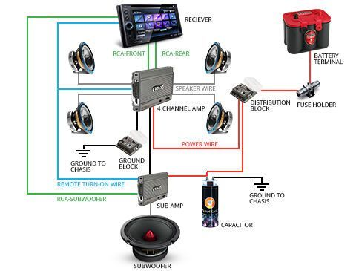

Figure 1-0-1 Multimedia system with two amplifiers

1.1.2. Engine immoblizer
An immobilizer is an anti-theft mechanism that prevents the engine from starting due to an improper ignition key. This system works by utilizing variations of radio waves as a key identity on the vehicle. By using this system, there is only one ignition key that can be used to start the vehicle engine. Engine Immobilizer is an electronic security device which the modern cars use.
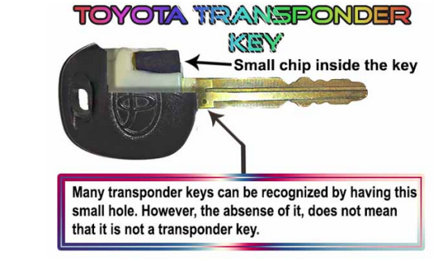
The Engine Immobilizer uses an electronic chip embedded into the ECU of the vehicle.
Figure 1-0-2 Transpoder key
It typically consists of the following components:
- Transponder Key: The transponder key is a specialized key that contains a small electronic chip. The chip emits a unique code when inserted into the ignition cylinder or brought into proximity with the ignition switch. This code is transmitted to the immobilizer system for verification.

- Antenna Coil: The antenna coil is an electromagnetic coil located near the ignition switch or ignition cylinder. It generates an electromagnetic field that interacts with the transponder chip in the key. When the key is in close proximity to the antenna coil, it energizes the chip, allowing it to transmit its unique code.
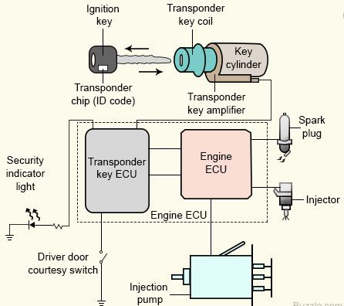
- Engine Control Unit (ECU): The ECU is the main control unit of the vehicle's engine management system. In the case of an engine immobilizer system, it also serves as the control unit for the immobilizer function. The ECU receives and processes the unique code transmitted by the transponder key and determines whether it matches the authorized code stored in its memory.
Figure 1-0-3 Engine immoblizer circuit diagram
- Immobilizer Control Module: The immobilizer control module is a separate module or integrated part of the ECU that specifically handles the immobilizer function. It receives the code from the ECU and performs the verification process. If the transmitted code matches the authorized code, the immobilizer control module allows the engine to start. If not, it prevents the engine from starting or disables the fuel supply or ignition system.
- Wiring and Connectors: The various components of the engine immobilizer system are interconnected through wiring harnesses and connectors. These electrical connections enable the communication and data exchange between the transponder key, antenna coil, ECU, and immobilizer control module.The engine immobilizer system is designed to enhance vehicle security and deter theft by preventing unauthorized starting of the engine. Its operation relies on the interaction and communication between these key components to ensure that only authorized keys with the correct code can start the vehicle

1.1.3. Central Door locking
The Central Door Locking System is a feature in vehicles that allows the driver or occupants to lock or unlock all doors simultaneously from a central control point. It provides convenience, ease of use, and improved security by enabling the locking and unlocking of all doors with a single action.
The components and functionalities of a typical Central Door Locking System:
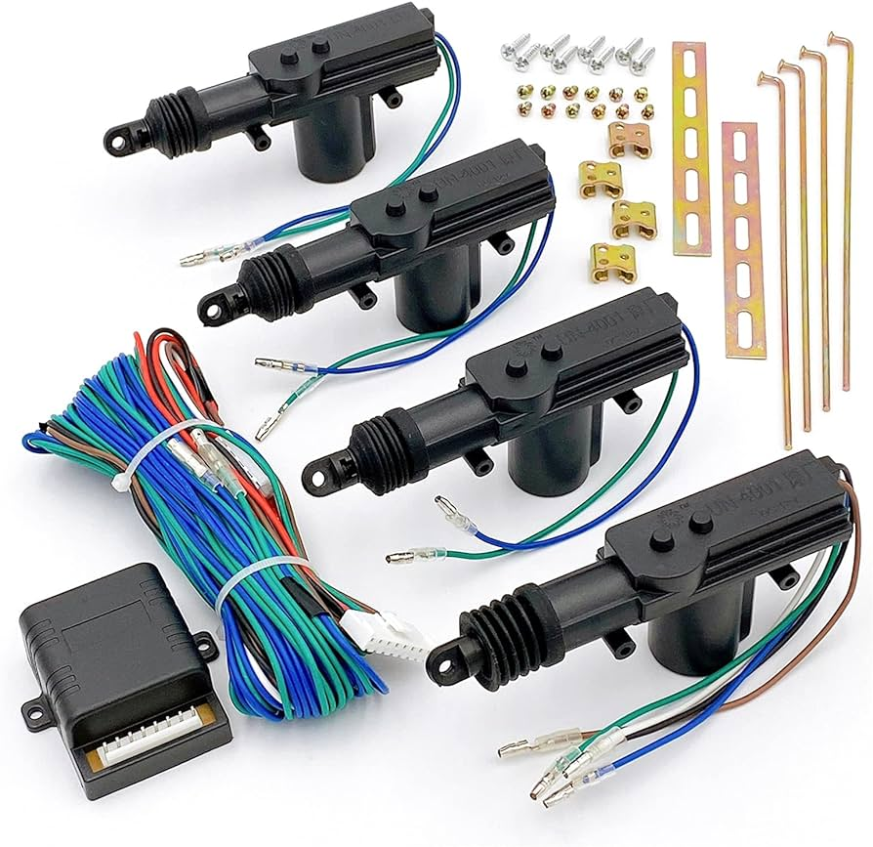
- Control Module: The central locking system is controlled by a dedicated control module. The module receives signals from the key fob, interior switches, or a central locking button located on the driver's side door panel.
- Door Lock Actuators: Each door in the vehicle is equipped with a door lock actuator. The actuator is responsible for physically locking or unlocking the door. When the control module receives a lock or unlock command, it sends a signal to the respective door lock actuator to engage or disengage the door lock mechanism.
Figure 1-0-4 central door lock actuator
- Key Fob or Interior Switches: The central locking system can be operated using a key fob with dedicated lock and unlock buttons. Pressing the lock or unlock button on the key fob sends a wireless signal to the control module, which then activates the door lock actuators accordingly. Additionally, some vehicles provide interior switches located on the driver's side door panel or other convenient locations for manual control of the central locking system.
- Anti-Theft Functionality: Central locking systems can provide anti-theft functionality by automatically locking the doors when the vehicle is in motion or when the ignition is turned on. This helps prevent unauthorized access while driving or when the vehicle is left unattended.
- Remote Keyless Entry: Many central locking systems are integrated with remote keyless entry systems. This feature allows the driver to lock or unlock the vehicle from a short distance using the key fob, eliminating the need to physically insert the key into the door lock.
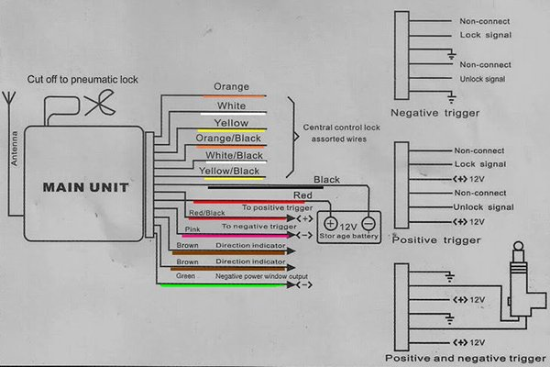
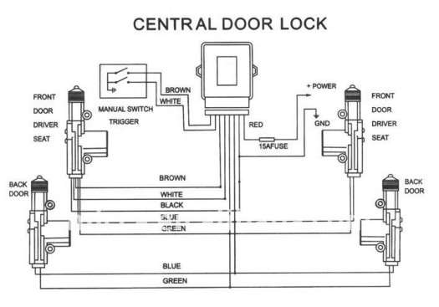
Figure 1-0-5 car central locking system's wiring diagram

1.1.4. Power window
Power window systems use an electric motor to move the glass via a regulator to which the glass is attached. The motor is a DC (direct current) design, using two brushes riding on an armature, just like a starter motor. The direction of rotation is determined by the direction of current flow applied to the motor. The system usually consists of a two-way control switch wired by two circuits to a motor in each door. One switch position and circuit drive the motor one way to wind the window up; the other switch position and circuit wind the window down. The switch is wired to the battery the vehicles electrical system.
Most vehicle manufactures have replaced the conventional window crank with electric
motors that operate the side windows. In addition, most sport utility models are equipped
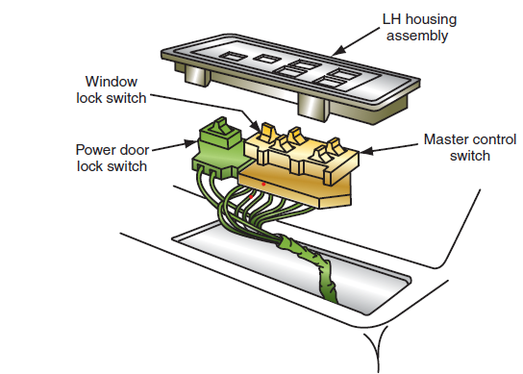
with electric rear tailgate windows. Th e motor used in the power window system is a reversible
PM or two-fi eld winding motor.
The power window system usually consists of the following components:
- Master control switch.
- Individual control switches.
- Individual window drive motors.
- Lock-out or disable switch.

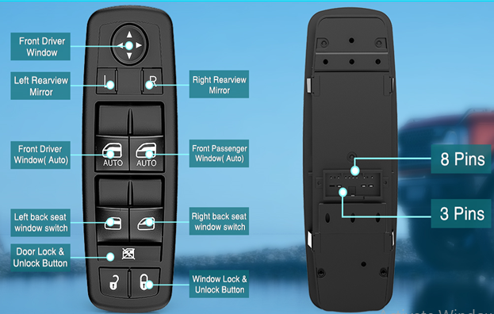
Figure 1-0-6 Master control switch
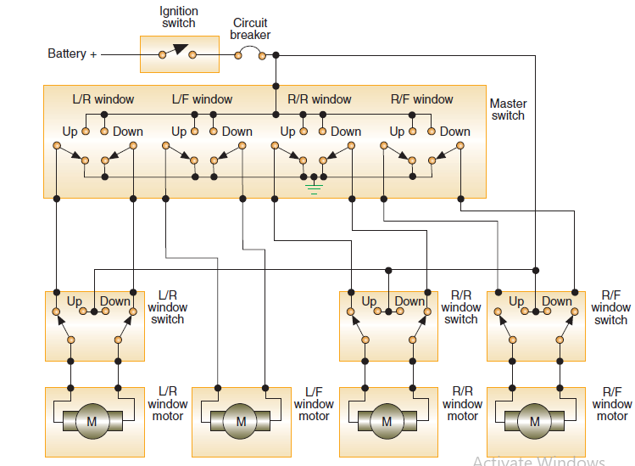
Figure 1-0-7 power window circuit using PM motors

1.1.5. Sunroof
A sunroof is a metal or, more commonly, glass panel in the roof of a car that can be opened by either sliding, venting, or both. While historically, sunroofs also included a sliding sunshade to block light when they were closed, this isn't always the case. Sunroofs are common in many late model coupes and sedans. They're usually listed as an extra feature and included at extra cost in new vehicles. Sunroofs are one such innovation. From detachable roofs to foldable roofs, we have come a long way in terms of open roofs in cars. The sunroof allows light and air to enter and is either fixed or movable, operated manually or electrically. Listed below are the variants of sunroofs found in the latest cars.
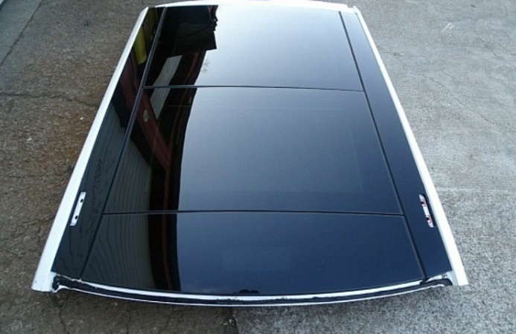
There are 7 types of Sunroof in a car, they are:
- Built in sunroof
- Spoiler Sunroof
- Pop-up Sunroof
- Panoramic Sunroof
- Folding/Ragtops Sunroof
- Removable Sunroof
- Solar Sunroof
Figure 1-0-8 sun roof

- Built-in Sunroof - This classic design is fully automotive, sliding between the car's metal roof and interior headliner. This type of sunroof is great for open space; however, it fits only for SUVs.
- Spoiler Sunroof - Also known as Tilt or Sliding Sunroof, it is similar to the Built-in sunroof version, with the main difference being the sunroof sliding on top of the car rather than in between the car's roof. The sunroof tilts and slides open on the car's roof almost 60% of the way. This sunroof version is perfect for compact cars, sliding back to provide ventilation.
- Pop-up Sunroof - The least expensive of all the sunroofs, the Pop-up Sunroof is usually a manually operated tilting panel that does not fully retract. In some models, the pop-up roof is entirely detachable.
- Panoramic Sunroof - The latest feature available in cars right now is the Panoramic sunroof. This multi-panel sunroof covers a large area front and back, allowing everybody in the car to enjoy fresh air and light.
- Folding/Ragtops Sunroof - This is similar to the older convertibles, with a fabric panel that folds as it slides back.
- Removable Sunroof - Like the convertible, cars with a removable roof feature manually removable panels, allowing air and sunlight to filter in.
- Solar Sunroof - The newest eco-friendly technology provides vehicles with additional electric power while increasing fuel efficiency and reducing CO2 emissions. This type of roof keeps the interior cool on hot days.
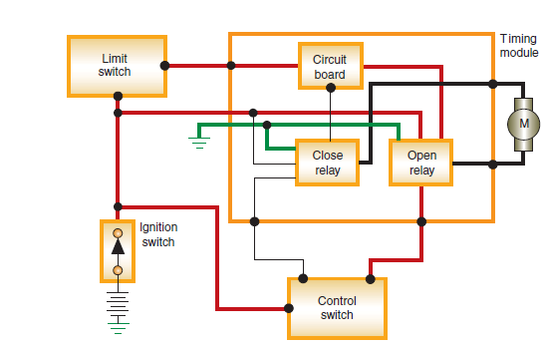
Figure 1-0-9 Block diagram of the GM sunroof.

Electronically Controlled General Motors’ Sunroof
The schematic of the sunroof system used on some GM model vehicles. Th e timing module uses inputs from the control switch and the limit switches to direct current fl ow to the motor. Depending on the inputs, the relays will be energized to rotate the motor in the proper direction. When the switch is located in the OPEN position, the openrelay is energized, sending current to the motor. Th e sunroof will continue to retract as longas the switch is held in the OPEN position. When the sunroof reaches its full open position, the limit switch will open and break the circuit to the open relay. Placing the switch in the CLOSE position will energize the close relay. Th e current sent to the motor is in the opposite direction to close the sunroof. If the close switch is held until the sunroof reaches the full closed position, the limit switch will open.

1.1.6. Supplemental Restraint System(SRS)Air Bag System

The front air bags for the driver's seat and passenger's seat deploy when a moderate or severe frontal impact is detected, mitigate impact to the head and chest. For side impact collision, Mazda offers SRS curtain air bags and SRS front side air bags.
Parts of an Airbag System (SRS)
An airbag or supplemental restraint system (SRS) is a safety device made for vehicles. It is meant to keep the driver and front passenger restrained in the event of an accident.
For instance, if a driver crashes their vehicle into the back of another vehicle at a fast speed, the airbag module inside of the steering wheel will inflate almost instantly. That way, it prevents the driver from banging their head or upper body against the steering wheel, dashboard, or windshield.

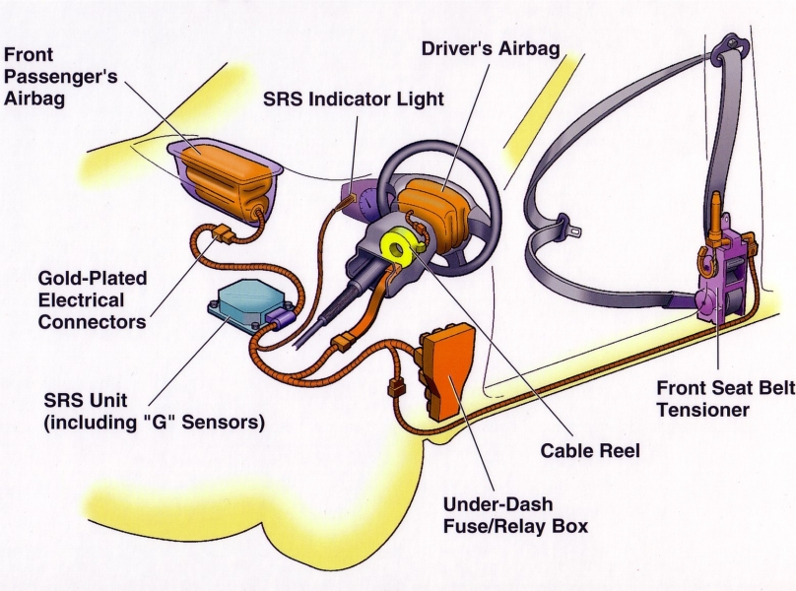
Figure 1-0-10 SRS Supplementary Restraint Systems diagram

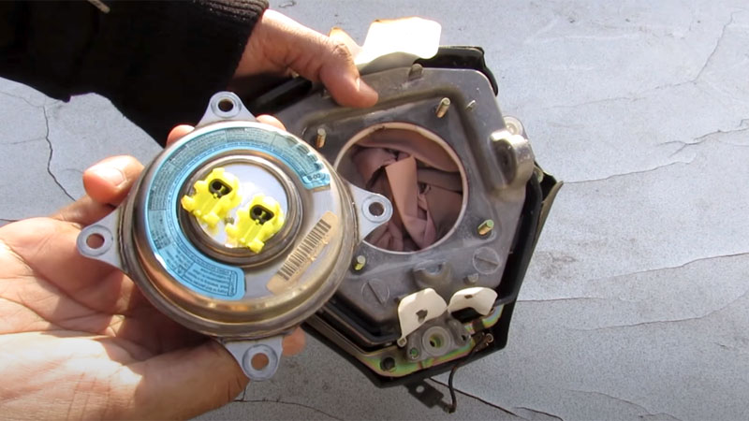
- Airbag Inflator
Figure 1-0-11 air bag inflator
The airbag inflator is part of the airbag module, which also includes the airbag as well. The job of the airbag inflator should be self-explanatory. It is to quickly inflate the airbag in the airbag module so that it comes out and shields you from flying out of the car.The inflation system is able to create this inflation effect by mixing potassium nitrate and sodium azide to create nitrogen gas. Once this gas enters the airbag, the inflation effect will happen instantaneously.
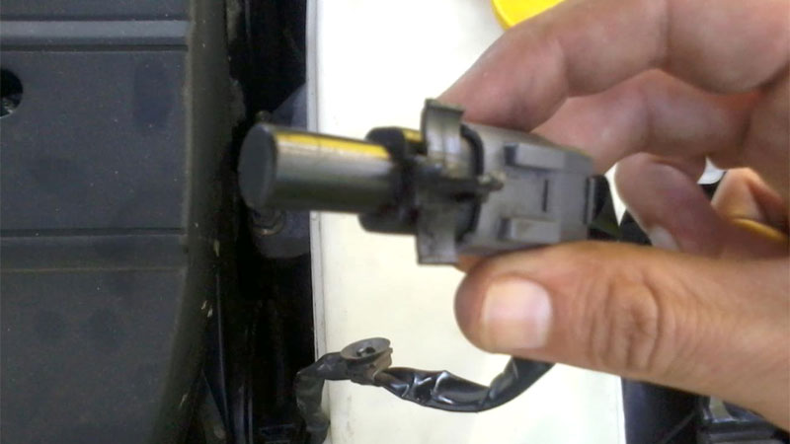
- Impact Sensors
The airbag system depends on impact or crash sensors so that the airbag module will know when to inflate the airbag. These crash sensors will detect when the car has a sudden halt in its acceleration.
Figure 0-12 Impact Sensors
Anytime the car crashes into a solid object while traveling at 15 miles per hour or higher, the crash sensors will activate the airbag inflation system.
- SRS Airbag Module
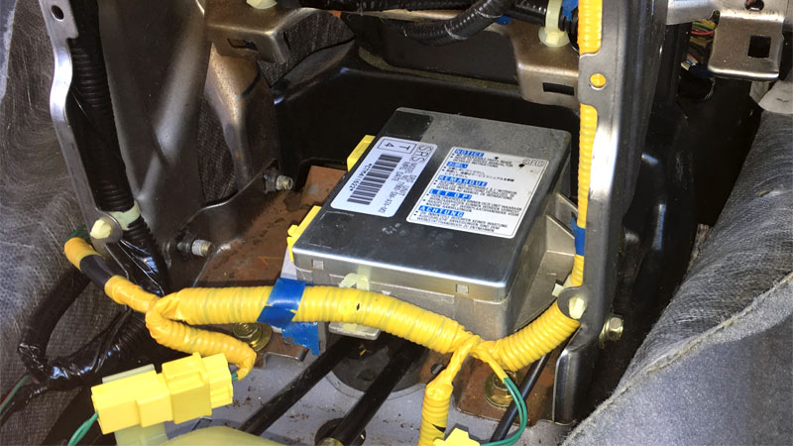
Every time that you start your vehicle, the diagnostic monitoring unit will run a test on the airbag system to make sure it is functioning properly. If you have already been in an accident and had your airbag inflate, you will need to take your vehicle to a dealership or auto repair shop that deals with airbags so that the airbag system can be reset.
Figure 1-0-13 SRS Airbag Module

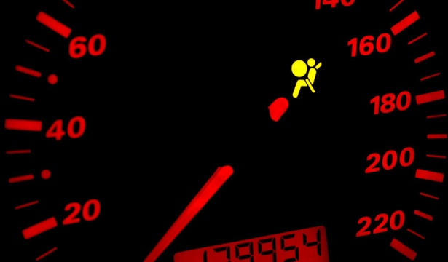
- Indicator Lamp
Figure 0-14 Indicator Lamp
The indicator lamp is basically the warning light for the airbag system. When your vehicle conducts a diagnostic check on the system, the indicator lamp will illuminate for a few seconds.
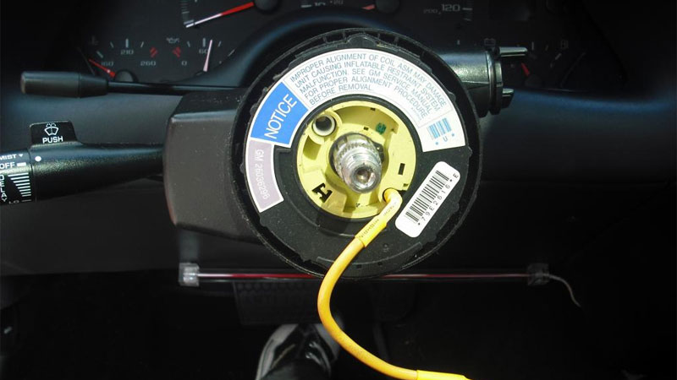
- Clock Spring
The clock coil spring is what connects the steering wheel with the airbag system. This would apply to the driver’s side airbag in a vehicle.It contains a wound-up wire which allows the car’s steering wheel to be rotated while keeping an electrical connection to the airbag, steering wheel buttons, and car horn.
Figure 1-15Clock Spring

- Airbag
The airbag itself is another part of the airbag system. This is the bag which inflates in front (and/or side) of the driver or front passenger upon collision with another vehicle or solid object.
The airbags are typically made from a nylon fabric. It is coated with a heat shield so that the fabric stays protected in case there is any scorching.
Figure 1-16 air bag
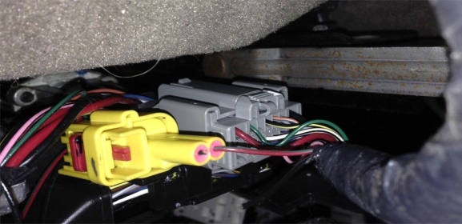
- Wiring Harness
The wiring harness represents the series of wires which connect all the components of the airbag system together. If there is just one wire that is damaged or nonfunctional in any way, then it will
Figure 1-17 Wiring Harness
throw the entire airbag system out of order.

1.1.6. Seat positioning

The safest place for your car seat is the rear middle seat due to its maximum distance from passenger-side air bags and any potential impact. Finding a seating position that is both comfortable and safe for you as a driver is crucial to optimum control of the vehicle. This position won’t be suitable for everyone, so find one that works best for you, allowing for the best visibility in your blind spots and the most comfort to reduce the risk of pain or injury.
Figure 1-18 Adjust your car seat
Depending on your vehicle, car seats can be controlled using manual, electric, or mixed controls.
- Manual controls – Cars with manual controls usually have a bar, levers or knobs which will allow you to adjust your car seat height, angle and position.
- Electric controls – If your car has electric controls, there will be a series of buttons on the side of the seat that will allow you to make adjustments.
- Mixed controls – Your car may have a combination of electric and manual controls. This is typically a bar underneath the car seat that will allow the driver to move forwards and backwards and a series of buttons at the side of the seat to adjust the angle and height.
Step by step guide
- Height – To adjust the height, you will usually find a lever at the side of your seat or a button if you have electric controls.
- Position – This is usually controlled by a lever at the bottom of your seat or a button on your door.
- Angle – You might need to adjust the angle of your seat to find a more comfortable position. This can be done using a dial at the side of your seat or a button if you have electric controls. Make sure you’re sitting right back in your seat and adjust it until you find a comfortable position.

- Headrest – You will usually find a button on the side of your headrest that will allow you to slide it up and down. Make sure you’re facing forwards in your normal driving position, then press the button to move your headrest into a safe and comfortable position.
- Seatbelt – Locate the sliding clasp on the B-pillar, and move it to a position that allows the seat belt to sit over your shoulder rather than your neck.

1.7.1. Mirror positioning

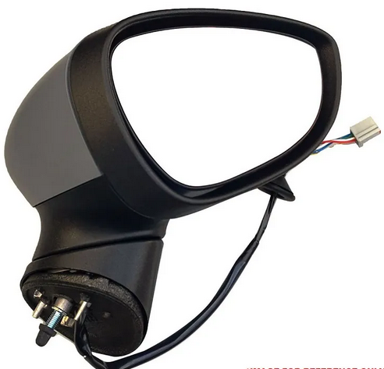
Side mirrors, also known as wing mirrors, are placed on the exterior of the vehicle. These are curved mirrors that provide a wide viewing angle of each side of your vehicle.
Figure 1-19 Electric side mirror
Depending on the make and age of your vehicle, there are two different types of controls for adjusting your side mirrors.
- Electric controls – Most modern cars have electric controls, which allow you to adjust your car’s side mirrors with simple buttons.
- Manual controls – Older vehicles often come with a joystick or lever that you manually control, or you may have to physically move the mirrors themselves.
Right side mirror
When adjusting the right side mirror, you should sit in the driver’s seat in a suitable driving position.
You want to adjust your mirror so that you can only see a small section of the car, but have a clear view of the road and traffic behind you.
For the mirror angle, the horizon should be in the centre. The horizon is the further point that you can see, where the distant road disappears.
Adjusting your right side mirror to the correct position is crucial, as you rely on this mirror particularly for moving off, overtaking and joining dual-carriageways or motorways.
Left side mirror
Make sure you’re sitting in the driver’s seat, in the correct driving position. If you have manual mirror controls, it may be trickier to adjust the left side mirror. Try moving the mirror a little at a time until you get the correct position, or you can always ask the person sitting in the passenger seat to help you.
As with the right side mirror, you want to adjust the left side mirror until you see just part of the car, and a good view of the road behind you.
The difference with the left mirror is that you want it angled slightly lower. This will give you a better view of the curbkerb when pulling over or making a manoeuvre.
Make sure your mirror is at a height that you can still see the end of the road behind you.

Use buttons to move electronically adjusted mirrors. As technologies have progressed, the physical method by which you change the angle of your mirrors has changed dramatically. In modern cars, many systems have been switched to electronic movement.
Figure 1-20 electronically adjusted mirrors
The buttons for this will normally be located just to the right of the steering wheel and will have four arrows on them indicating the direction of movement for the mirror.
There will also usually be a left/right control switch to choose which mirror to move.

If you can't seem to find the controls, head online and check as some can be hidden away in unusual places
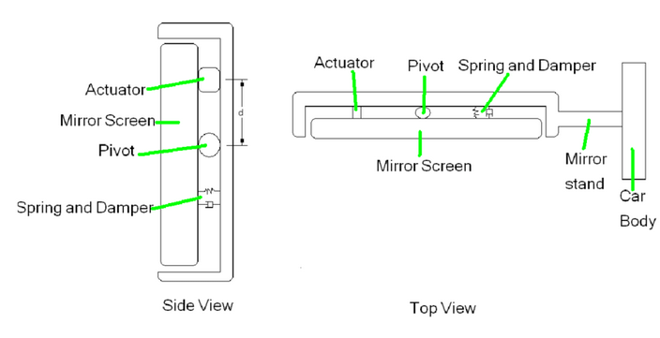
Figure 1-21 A schematic diagram of Side Car Mirror Vibration

Identifying and confirming faults
Finding the problem when complex automotive systems go wrong is easier if you have the proper knowledge. This knowledge consists of two parts:
- An understanding of the system in which the problem exists.
- The ability to apply a logical diagnostic routine.
It's also important to know about these definitions:
• Symptom – What the operator of the vehicle notices.
• Fault – The error in the system that result in the symptom.
• Root Cause – The cause of the fault.
There's direct damage that can be seen in plain sight while the indirect damage is not always visible. It's all too common for people to repair the visible car accident damage while leaving the hidden ones untouched. Here are some of the ways that your vehicle can be damaged after an accident

Faults can be
Direct faults in input sensors, output actuators, wiring Harnesses or computer systems
Indirect faults caused by the influence of external electrical and electronic systems, which may or may not be faulty in their primary operations.
The faster a maintainer acts to identify a fault the more
likely that:
- fails to find it
- disguises it
- makes it worse
Consider the problem then collect and evaluate the facts. The fundamental steps in the logical diagnostic process for all type of equipment are:
(1) Symptom analysis (2) Equipment Inspection
(3) Fault stage location (4) Circuit checks
(5) Repair or replace (6) Perform test
Fault finding procedures
Having established the symptoms of a fault it is then necessary to conduct tests to confirm the symptoms and to attempt to determine the location of the fault within the equipment. A sound knowledge of the technicalconcepts and the operation of the system may assist in locating the fault but sometimes the testing will be extensive and an overall procedure should be adopted.

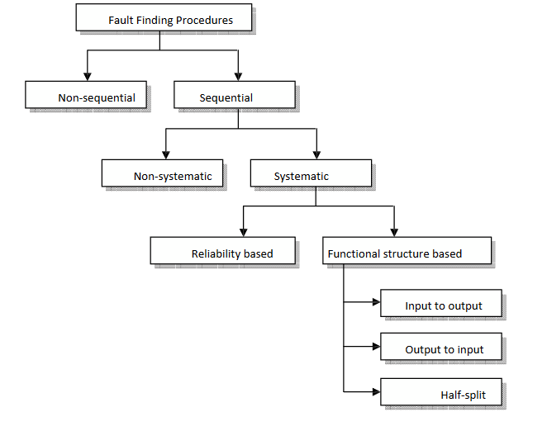
Figure 1-22Fault finding procedures

OHS requirements
OHS (Occupational Health and Safety) requirements for the Electronic Body Management System (BMS) in the automotive industry primarily focus on the safety and well-being of workers involved in the manufacturing, installation, maintenance, and repair of the system. Here are some OHS considerations related to the BMS:
- Electrical Safety: Due to the electrical nature of the BMS, workers must follow electrical safety guidelines to minimize the risk of electric shock or other electrical accidents. This includes proper handling of electrical components, use of personal protective equipment (PPE), and compliance with relevant electrical safety standards and regulations.
- Hazardous Materials: Some components within the BMS may contain hazardous materials, such as batteries or chemicals in electronic modules. Workers should be informed about the potential hazards associated with these materials and provided with appropriate training, handling procedures, and disposal methods to ensure their safety and the environment.
- Safe Work Practices: Clear procedures and safe work practices should be established and communicated to workers involved in the installation, maintenance, or repair of the BMS.

- This includes guidelines for proper tool usage, lockout/tagout procedures to isolate electrical power sources, and adherence to safety protocols when working on electrical systems.
- Risk Assessment: Employers should conduct risk assessments to identify potential hazards associated with working on the BMS and implement appropriate control measures to mitigate those risks. This may involve providing protective barriers, ensuring proper ventilation where necessary, and implementing emergency response plans in case of accidents or system failures.
- Maintenance and Inspections: Regular maintenance and inspections of the BMS should be conducted to ensure its proper functioning and identify any potential safety issues. This includes checking for loose connections, damaged wiring, or malfunctioning components that could pose safety risks
Electrical safety guidelines that should be followed when working with the Electronic Body Management System (BMS):
- Personal Protective Equipment (PPE): Wear appropriate personal protective equipment, such as insulated gloves, safety glasses, and non-conductive footwear, when working on the BMS. PPE helps protect against electric shock and other potential electrical hazards.
- Proper Tool Usage: Use insulated tools specifically designed for electrical work when handling components of the BMS. Insulated tools help prevent electrical contact and reduce the risk of electrical accidents.
- Avoid Water and Moisture: Keep the BMS and associated electrical components away from water or excessive moisture. Water can conduct electricity and increase the risk of electrical shock or damage to the system.
- Proper Wiring Practices: Follow proper wiring practices when working on the BMS. This includes ensuring that all electrical connections are secure, using appropriate wire gauges, and avoiding sharp bends or pinching of wires that can lead to insulation damage or short circuits.

- Circuit Overload and Fuse Protection: Avoid overloading circuits within the BMS by exceeding their designed electrical capacity. Use proper fuses or circuit breakers to protect against overcurrent and prevent damage to the electrical system.
- Grounding: Ensure that electrical components and equipment are properly grounded. This helps divert electrical current away from workers and reduces the risk of electric shock.
- Follow Manufacturer's Instructions: Adhere to the manufacturer's instructions, guidelines, and safety precautions specific to the BMS. Manufacturers often provide detailed information on safe installation, maintenance, and repair practices.

Self-check 1
Directions: Answer all the questions listed below.
Part I: Fill in the blank space
- _________ is the main control unit of the vehicle's engine management system.
- _________ an anti-theft mechanism that prevents the engine from starting due to an improper ignition key.
- _________ a specialized key that contains a small electronic chip.
- _______ is a metal or, more commonly, glass panel in the roof of a car that can be opened by either sliding, venting, or both
- _________ is an electromagnetic coil located near the ignition switch or ignition cylinder.

Part-III: Answer the following questions accordingly.
      - List down the main power window components?
      - List down the main 7 types of Sunroof in a car?
      - Write and explain the components of Central Door Locking System ?
      - What is the function of Engine Immobilizer?
      - List down vehicle multimedia systemcomponts ?

Unit Two: Prepare to Performing Diagnosis
This unit is developed to provide you the necessary information regarding the following content coverage and topics:
- Testing equipment and material
- Diagnostic methods and testing process
This guide will also assist you to attain the learning outcomes stated in the cover page. Specifically, upon completion of this learning guide, you will be able to:
- Test equipment and material
- Perform Diagnostic methods and testing process

Testing equipment and material
- Analogue and digital multimeters
A multimeter is a multipurpose electronic measuring instrument extensively used by professionals to determine the faults in a circuit. A typical multimeter can be used to measure various electrical quantities such as voltage, current, resistance, transistor gain, etc.

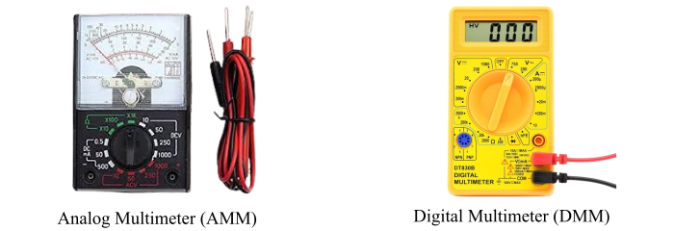
2- 1 Types of multi meter
Based on the design and method used for the measurement, multimeters are classified into two types –
- Analog Multimeter (AMM)
- Digital Multimeter (DMM)
Analog Multimeter
An analog multimeter is a type of multimeter which displays the measuring quantity by the deflection of a pointer on a scale. It is a simple measuring device which is used to measure various electrical quantities such as AC and DC voltage, AC and DC current, resistance of AC and DC circuits, etc.
An analog multimeter is also known as AVO meter, as it is primarily used to measure current in Ampere, voltage in Volts, and resistance in Ohms. An analog multimeter consists of a permanent magnet moving coil mechanism where the moving coil is free to move in the magnetic field of the permanent magnet when the current flows through it and a pointer is attached to the moving coil. The deflection of this pointer on a scale indicates the value of measuring quantity.

Digital Multimeter
Digital Multimeter is a type of multimeter that displays the measuring quantity in a digital form, i.e. by using a seven-segment or LED or LCD display to show the digits.
Basically, a digital multimeter is a combination of analog to digital converter (ADC), encoders, logic controllers, digital display, etc. One of the most significant advantages of a digital multimeter over an analog multimeter is that it can be used to measure additional electrical quantities such as capacitance, inductance, transistor gains, etc. And, digital multimeters are more accurate and easy to use than an analog multimeter.
a multimeter is a measuring device which alone can perform the operations of ammeter, voltmeter, ohmmeter, etc. Because of this advantage, analog and digital multimeters are extensively used by professionals in the industries to test the circuits and measure the electrical quantities
- Lab Oscilloscopes.
Oscilloscopes are electronic test instruments that display different signal voltages. An automotive oscilloscope differs only in the fact that it has additional functionalities used for helping to test and diagnose problems with vehicles. Since then, it has grown to become an important tool in any workshop, used for troubleshooting sensors and alternators, performing pressure tests, and more.
An automotive oscilloscope works to display different signal voltages on a graph. When electrical parts or systems in a vehicle are tested, electronic signals are generated. Different things like wavelength, frequency and amplitude are shown.
The diagnostics software converts these readings to waveforms – which show how voltage levels change over a period of time. An oscilloscope is going to capture these electrical signals in graphs to allow users to measure and see what is going on in a specific system.
A lot of automotive oscilloscopes have software or user manuals that include how to perform a range of different tests. Once the oscilloscope is connected to the specific sensor and running, it will display a waveform on the screen. This will allow the user to analyze what wascaptured.

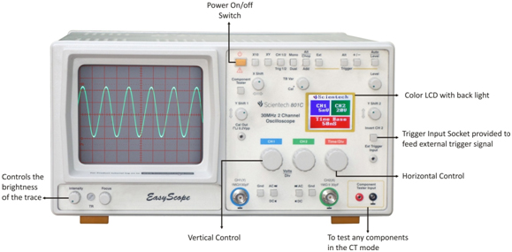
2- 2 Oscilloscope
The scope can be used to measure and test virtually all of the electrical and electronic components and circuits in any modern vehicle, including
- ignition (primary and secondary);
- injectors and fuel pumps;
- starter and charging circuits;
- batteries, alternators and starter motors;
- lambda, airf ow, knock and MAP sensors;

- scan tools
Scan tools are designed to interface with a car's onboard diagnostic system to facilitate the diagnostic process. In that way, they are similar to car code readers. They can be plugged into an OBD-I or OBD-II socket, read and clear codes, and view data readouts from various sensors
A vehicle diagnostic tool is a diagnostic scanner that can be plugged into an OBD (OBD I) or OBD2 (OBD II) socket to read and clear codes, as well as view data readouts from various sensors. This can be used to help diagnose problems with a vehicle.
OBD stands for On-Board Diagnostics. This acronym is used to identify a device that can be connected to a car or other vehicle via the OBD port or OBD2 port usually via an OBD cable

2-3 scan tool

- Test Lights And Test Leds
A test light is used to check for voltage in an electrical circuit. It is in the shape of a screwdriver with a probe and a ground wire attached. There is a light bulb on the holder itself. When the clamp is placed on the ground and the probe touches the live connector, the bulb lights up. This indicates that voltage is available. If the bulb does not light, there is no voltage on the connector. They do not use a separate power source for their work but are powered from the measuring area.
A test light can be used to check for grounds by attaching the clip of the test light to the positive terminal of the battery or any 12-volt electrical terminal. The tip of the test light can then be used to touch the ground wire. If there is a ground connection, the test light will light.
Test lights have a limitation because they do not measure the magnitude of the voltage, but are only an indicator of the existence of voltage. However, this is enough for the technician when examining the correctness of the circuit in search of an interruption.

Test light with bulb
This is an older type of test light. The housing is made of transparent material and inside there is a light bulb (12V, 2W). When there is a voltage between the two probes, the bulb lights up. However, during the test, an unwanted supply voltage may be applied to the electronic device via the test lamp and may be damaged. Therefore, it is recommended to use another type of LED test light for testing on modern vehicles.

2- 3 Test light with bulb
LED test light
A newer and safer type of test light has an LED as an indicator of the existence of voltage. The LED test light is a small consumer (0.025 A) and is safe to test in a circuit of electronic devices.
Often these test lights have two LEDs of different colors which, in addition to measuring DC voltage, also provide information on the polarity of the measuring point. For example, if the probe with LED is connected to the plus line, the red LED lights up, and if it connects to the ground (minus), the green LED lights up.
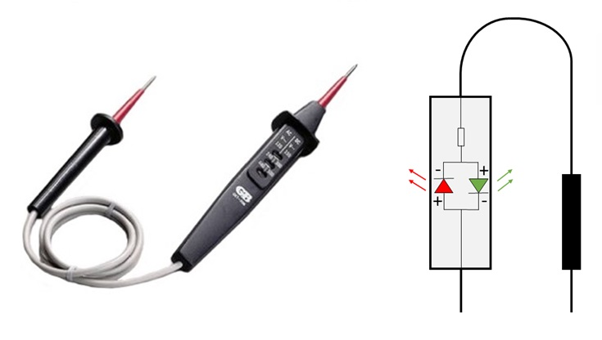
2- 4 LED test light

2.1. Diagnostic methods and testing process
A car diagnostic test is a digital analysis of your car’s various computer systems and components. Modern vehicles are much more digitized than people may be aware of. Specialized software works whenever your car’s engine is powered on to monitor various features and create data reports that can then be collected and analyzed during a car diagnostic test.
Car diagnostic tests scan your car’s components and systems to check for issues with components like the engine, transmission, oil tank, throttle, and many more.
Car diagnostic tests are typically carried out when a vehicle’s dashboard shows a “check engine” signal or other warning light illumination. They can also be performed as part of regular maintenance appointments.
Benefits of Car Diagnostic Tests
Car diagnostic tests are valuable for a variety of reasons.
- Car diagnostic tests help you detect errors before they become catastrophic, saving you money in the long run.
- Furthermore, catching errors before they become more serious could potentially save your life or the lives of others. Car diagnostic tests can, for instance, tell you when you need to replace your brakes before they fail on the freeway.
- Car diagnostic tests can also check your car’s onboard computer system for any manufacturer notifications or stored information. The data can help technicians provide the best repairs possible for your vehicle.
On-Board Diagnostics (OBD) II
The first generation of On-Board Diagnostics (called OBD I) was developed by the California Air Resources Board (ARB) and implemented in 1988 to monitor some of the emission control components on vehicles. As technology evolved and the desire to improve the On-Board Diagnostic system increased, a new generation of On-Board Diagnostic system was developed. This second generation of On-Board Diagnostic regulations is called OBD II.
The OBD II system is designed to monitor emission control systems and key engine components by performing either continuous or periodic tests of specific components and vehicle conditions.

When a problem is detected, the OBD II system turns on a warning lamp (MIL) on the vehicle instrument panel to alert the driver typically by the phrase of “Check Engine” or “Service Engine Soon”.
Diagnostic Trouble Codes (DTCs)
OBD II DTCs are codes that are stored by the vehicles' On-Board Diagnostic system in response to a problem found in the vehicle. These codes identify a particular problem area and are intended to provide you with a guide as to where a fault might be occurring within a vehicle.
OBD II DTCs consists of a five-digit alphanumeric code. The first character, a letter, identifies which control system sets the code. The other four characters, all numbers, provide additional information on where the DTC originated and the operating conditions that caused it to set. Here below is an example to illustrate the structure of the digits:
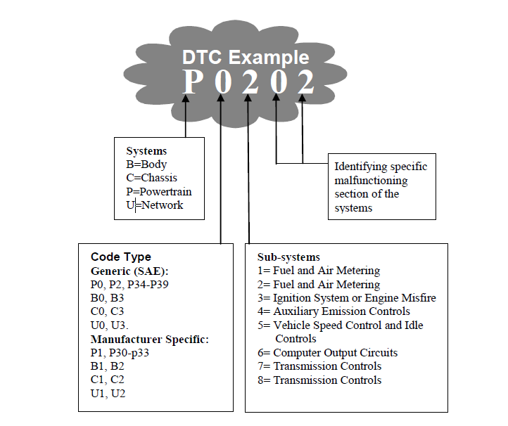
2- 5 Diagnostic Trouble Codes
Location of the Data Link Connector (DLC)
The DLC is the standardized 16-cavity connector where diagnostic Scan Tools interface with the vehicle's on-board computer. The DLC is usually located 12 inches from the center of the

instrument panel (dash), under or around the driver's side for most vehicles. If the DLC is not located under dashboard, a label should be there indicating its location.
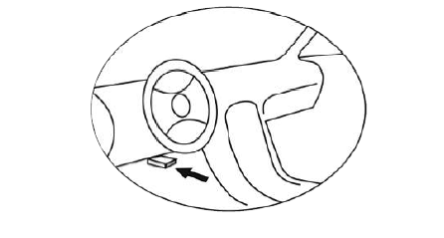

2- 6 Location of the Data Link Connector
    - Diagnostic process
A diagnostic check is a process of checking a vehicle's systems and components to help identify issues and rectify them. Modern vehicles are equipped with extensive computer networks that can provide information on the engine, brakes, and other related systems.
Six-stage diagnosis process

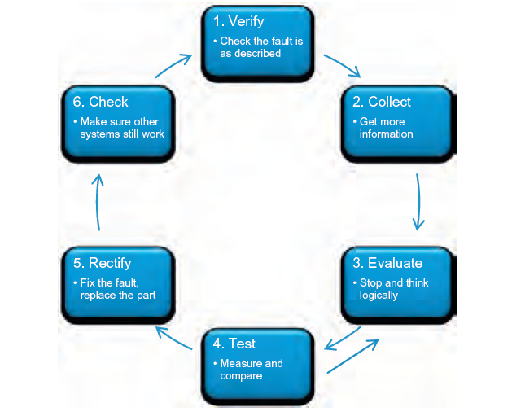
2- 7 Diagnosis process

Scantools connecting procedure
a scan tool may be able to:
- Store and play back live data
- Graph data
- Read generic and manufacturer-specific trouble codes
- Display pending codes
- Provide trouble code definitions
- Provide troubleshooting procedures or tips

      - Obtain an OBD-II scan tool.

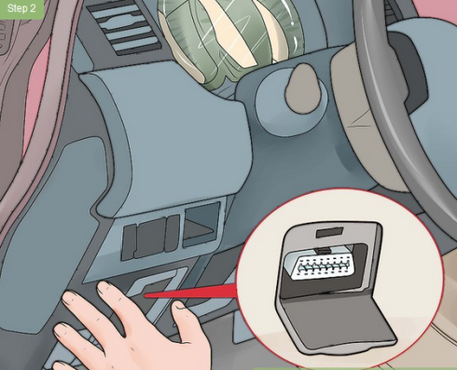
      - Locate the Diagnostic Link Connector (DLC) in your vehicle.
2- 8 DLC connector
This is a somewhat triangular shaped 16-pin connector that is commonly located underneath the left hand side of the dash near the steering column. If you have trouble locating the DLC, search for the location on the internet using your car’s model and year, or refer to the owner’s manual.

      - Insert the scan tool connector or code reader into the DLC.
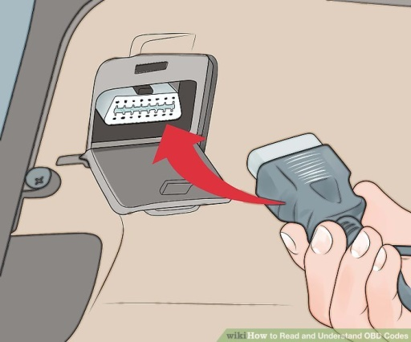
Turn your ignition on, but do not start your engine. You will see the scanner begin to communicate with the onboard computers in your vehicle.
Messages like "searching for protocol" and "establishing data transmission link" may appear on the scanner's screen.
If the screen stays blank and does not light up, jiggle the connector to achieve a better contact between the scanner and DLC connector pins. Older cars in particular may have poorer connections.If you still aren't having any luck, be sure that your cigar lighter works. This is because the OBD-II system uses the cigar lighter circuit to provide voltage to the DLC. If the cigar lighter does not work, locate and check the appropriate fuse.
2- 9 Insert the scan tool connector

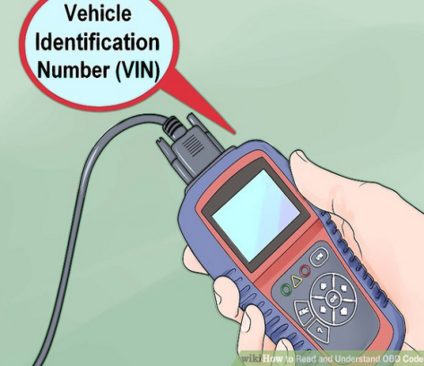
      - Enter in your vehicle information. On some scanners, you will need to input your VIN as well as the make and model of the vehicle. You may also need to specify the engine type. This process will vary depending on the scanner.
- You can usually find your VIN number on the bottom-left hand side of the windshield.
- VIN numbers are typically stamped on every single part of newer cars
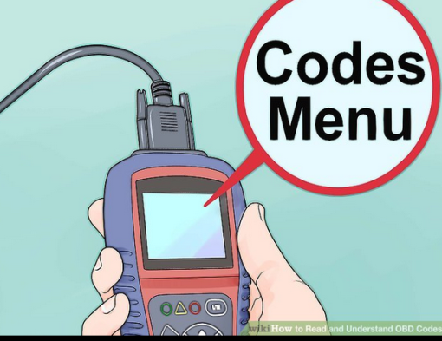
      - Find the menu. When the scanner finishes booting up, look for a menu. Select “Codes” or “Trouble Codes” to open the main Codes menu. Depending on your scanner and year of the vehicle you may be presented with a few systems such as Engine/Powertrain, Transmission, Airbag, Brakes etc. When you pick one, you will see two or more types of codes. The most common are Active codes and Pending codes.
Active codes are live codes or malfunctions that are keeping your Check Engine Light on. Just because your Check Engine Light is off doesn't mean the code or malfunction disappeared, it just means that the code setting conditions haven't occurred for two or more operations of the vehicle.
- Pending codes mean that the OBD-II monitoring system has failed the operation of an emission control system at least once and if it fails again the Check Engine Light will be turned on and the malfunction becomes an Active code.
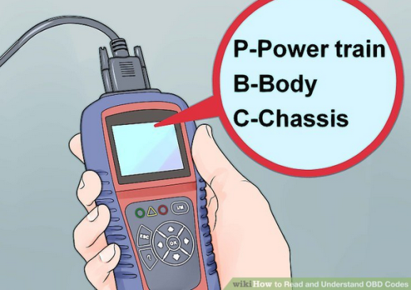
      - Learn what the letter means. Each code will start with a letter which designates what system the code is referring to. There are several letters that you may see, though you may have to move to different menus to see them:
P - Powertrain. This covers the engine, transmission, fuel system, ignition, emissions, and more. This is the largest set of codes.

B - Body. This covers airbags, seat belts, power seating, and more.
C - Chassis. These codes cover ABS, brake fluid, axles, and more.
U - Undefined. These codes cover other aspects of the car.
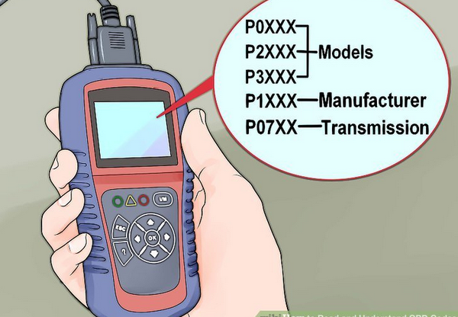
      - Learn what the numbers mean. P0xxx, P2xxx, and P3xxx are all generic codes that apply to all makes and models. P1xxx codes are manufacturer specific, such as Honda, Ford, Toyota, etc. The second number tells you what subsystem the code refers to. For example, P07xx codes refer to the transmission.
The last two digits are the specific problem that the code refers to. Check a code chart online for details on each specific code.
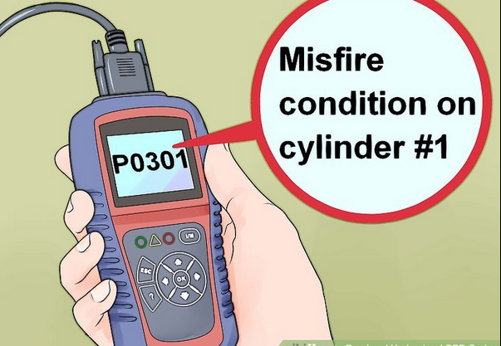
      - Read an example code. P0301 indicates a misfire condition on cylinder #1. The P indicates it's a powertrain code, the 0 indicates that it is a generic or universal code. The 3 means the area or subsystem is an Ignition System code.
- The 01 indicates it's a cylinder specific problem, in that there is a misfire condition in the number 1 cylinder. It could mean that the spark plug, plug wire or dedicated ignition coil are worn out or that there is a vacuum leak near the cylinder.
- A code does not tell you what component is defective; it only points to or indicates that a component, its circuit, or its wiring/vacuum control are malfunctioning. The code may be the symptom of a malfunction caused by a completely different system.
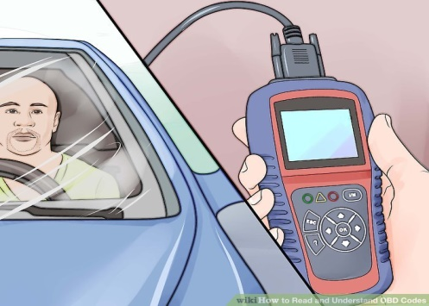
      - Diagnose your vehicle. The proper diagnosis of OBD-II codes takes years of training and practice. For example, a weak battery or worn out alternator can set five or more codes in systems that are perfectly normal. Before attempting repairs, understand that the codes alone will not tell you what parts need to be replaced or what repairs need to be made.

- If you are unsure of what you are doing, take your car to an ASE Certified Master Technician with the L1 Advanced Engine Performance Diagnostic certification, or you could end up wasting a lot of time and money.
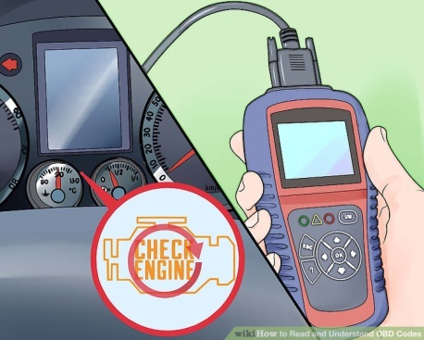
      - Reset your Check Engine Light. If you’ve made your repairs, or simply don’t want to see your Check Engine Light for a while, you can reset it using most OBD scanners. The light will turn off until the car has been driven a certain amount of time (this varies from manufacturer to manufacturer).
- You can reset the Check Engine Light from the main menu of most scanners. It is also referred to as a CEL.

Operation sheet 2.1
Operation Title: Connecting a scan tool to a vehicle
Purpose: to know scan tools connecting and diagnosis procedure
Conditions or situations for the operations:
- Safe working area
- Properly operated tools and equipment
- Appropriate working cloths fit with the body
Equipment Tools and Materials:
- Scan tools
- Vehicle
Quality Criteria: Assured performing of all the activities according to the procedures
Precautions:
- Wearing proper clothes, eye glass, glove
- Make working area hazard free
- Read and interpret manual which guide you how to use tools and equipment
Steps in doing the task:
- Locate the OBD Port: The On-Board Diagnostic (OBD) port is typically located under the dashboard on the driver's side of the vehicle. It can be at the bottom of the dashboard, above the pedals, or behind a panel. Consult the vehicle's owner's manual or look for a labeled port with a connector that matches the scan tool.
- Ensure Ignition is Off: Before connecting the scan tool, make sure the vehicle's ignition is turned off. This will prevent any potential electrical issues during the connection process.
- Connect the Scan Tool Cable: Take the cable of the scan tool and connect it to the OBD port on the vehicle. The cable connector should fit securely into the port. Ensure that it is properly aligned and inserted.
- Power On the Scan Tool: Turn on the scan tool by pressing the power button or following the manufacturer's instructions. Some scan tools may require batteries, while others can be powered directly from the vehicle's OBD port.
- Vehicle Power On (If Required): If the scan tool does not have its own power source, turn on the vehicle's ignition without starting the engine. This will provide power to the scan tool through the OBD port.
- Establish Communication: Once the scan tool is powered on and connected, it will attempt to establish communication with the vehicle's onboard computer systems. This process may take a few seconds. Follow the prompts on the scan tool's display or refer to the user manual for specific instructions.
- Retrieve Diagnostic Trouble Codes (DTCs): After the scan tool has established communication, you can retrieve diagnostic trouble codes (DTCs) from the vehicle's computer systems.
- Perform Diagnostics: With the scan tool connected and DTCs retrieved, you can now perform diagnostics by analyzing the codes, viewing live data stream parameters, conducting functional tests, or accessing specific system modules for further analysis.
- Disconnect the Scan Tool: Once you have completed the diagnostic process, turn off the vehicle's ignition. Then, disconnect the scan tool cable from the OBD port.

Operation sheet 2.2
Operation Title: Diagnosing and testing car problems
Purpose : to know how to diaganosis car problems properly
Conditions or situations for the operations:
- Safe working area
- Properly operated tools and equipment
- Appropriate working cloths fit with the body
Equipment Tools and Materials:
- Multimeter
- Scan tools
- Vehicle
Quality Criteria: Assured performing of all the activities according to the procedures
Precautions:
- Wearing proper clothes and glove
- Make working area hazard free
- Read and interpret manual which guide you how to use tools and equipment
Steps in doing the task:
- Begin by conducting a visual inspection of the vehicle to identify any obvious issues such as fluid leaks, loose connections, or physical damage. Take note of any symptoms reported by the driver or observed during the inspection.
- Connect a diagnostic scan tool to the vehicle's onboard diagnostic (OBD) port. The scan tool communicates with the vehicle's computer systems and retrieves diagnostic trouble codes (DTCs) that indicate specific issues or malfunctions. Record the retrieved codes for further analysis.
- Interpret the retrieved DTCs to understand the nature of the problem. The codes provide information about the specific system or component that is experiencing a malfunction or out-of-specification condition.
- Analyze live data stream parameters from the vehicle's onboard sensors using the diagnostic scan tool.
- Inspect the specific component related to the identified issue.
- Based on the analysis of the diagnostic results, determine the appropriate repair or replacement action.

- After making repairs or replacements, clear the DTCs from the vehicle's computer memory using the diagnostic scan tool. Retest the system or component to ensure that the issue has been resolved and that no new issues arise.
- perform a final functional test to ensure that the problem has been successfully resolved.

LAP Test :2
Practical Demonstration
Instruction: Perform the following tasks

Task 1: connect the scan tools properly on cars
Task 2: diagnosis the vehicle using the correct procedure

Unit Three: Apply complex diagnostic process
This learning guide is developed to provide you the necessary information regarding the following content coverage and topics:
- Carrying out testing and diagnoses process
- Analyze the result and concluding the finding
This guide will also assist you to attain the learning outcomes stated in the cover page. Specifically, upon completion of this learning guide, you will be able to:
- Carry out testing and diagnoses process
- Analyze the result and concluding the finding

Carrying out testing and diagnoses process
A diagnostic test determines the cause of a vehicle’s issue or cause of what has triggered the check engine light to come on.
When something isn’t operating properly, a technician will utilize an advanced computer-type tool to connect to the vehicle’s internal computer (ECM or PCM) to read any codes stored and download information to help determine what area of the car needs attention.
vehicle diagnostic scan tools have been instrumental in isolating vehicle troubles, they are unable to determine the exact cause of a breakdown or the check engine light’s illumination. While the code indicates to the technician which area of the vehicle needs attention or which component has fallen out of the acceptable range for operation, it does not provide details on what is responsible for the failure. That’s when the knowledge and expertise of a technician come in to properly diagnose and repair the problem.

Diagnosing body electrical system faults

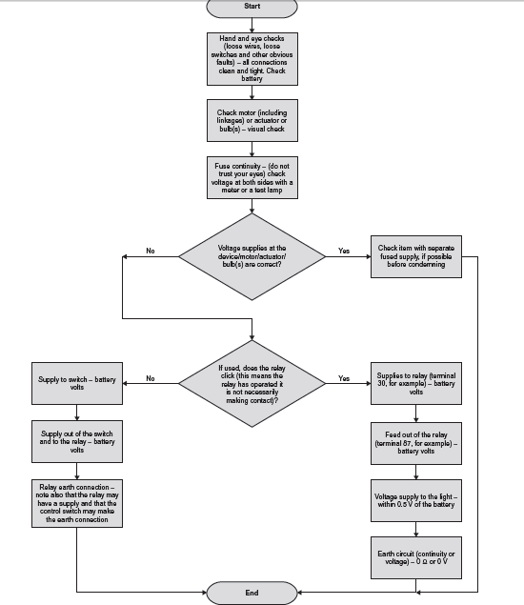

3- 1 Auxiliary and body systems diagnosis chart

Table 1 symptom and possible faults
Symptom | possible faults
Electric units not operating | If ALL units not operating  O pen circuit in main supply  M ain fuse blown
Unit _ window, door lock,  mirror, etc. | Relay coil or contacts open circuit or high resistance  If ONE unit is not operating  F use blown  C ontrol switch open circuit  M otor seized or open circuit  B ack-off safety circuit signal incorrect (windows)

Circuit systematic testing
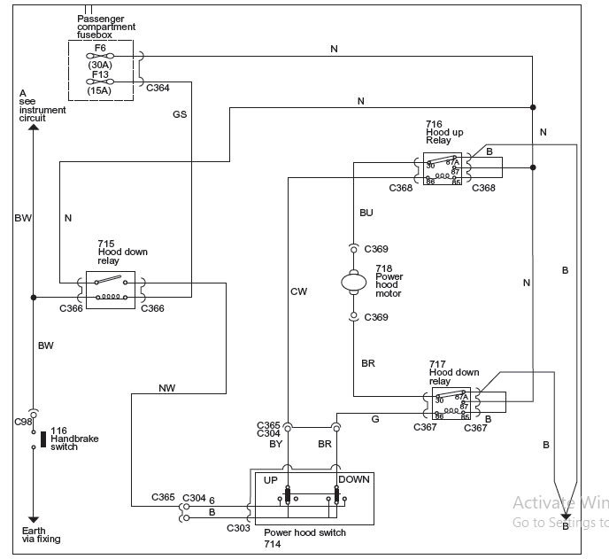
3- 2 Power hood (roof) circuit

Procedures to Carry out testing power roof
  - If the power hood will not operate with the ignition switch at the correct position
and the handbrake applied, proceed as follows:
1 Check fuses 6 and 13.
2 Check 12 V supply on N wire from fuse 6.
3 Check for 12 V on GS wire at power hood relay.
4 Check continuity from power hood relay to earth on BW wire.
5 Check power hood relay.
6 Check for 12 V on NW wire at hood switch. Check for 12 V on N wire at hood up and down relays.
7 Check continuity from hood up and down relays to earth on B wire.
8 Check switch operation.
9 Check pump motor operation.

  - If the power hood will operate in one direction only, proceed as follows:
1 Check for 12 V on N wire at hood up or down relay as appropriate.
2 Check continuity from hood up or down relay to earth on B wire.
3 Check relay.
Diagnostics – airbags and belt tensioners
Systematic testing
The only reported fault for airbags should be that the warning light is staying on. If an airbag has been deployed, then all the major components should be replaced.
Some basic tests that can be carried out are presented in carried out are as follows.

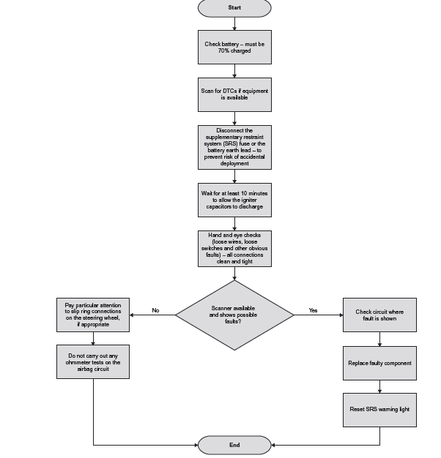

3- 3 Diagnostics – airbags and belt tensioners flow chart

Table 2 Airbags and belt tensioners fault diagnosis
Symptom | possible faults
Warning light on | Wiring fault  Fuse blown or removed  ECU fault  Crash sensor fault  Igniter fault

  - Deactivation procedure
Warning: The backup power supply must be depleted before any work is carried out on the supplementary restraint system. Wait at least one minute after disconnecting the battery ground cable. Failure to follow this instruction could cause accidental airbag deployment and may cause personal injury.
- Disconnect the battery ground cable.
- Wait one minute for the backup power supply in the Airbag Control Module to deplete its stored energy.
Warning: Place the airbag module on a ground wired bench, with the trim cover facing up toavoid accidental deployment. Failure to follow this instruction may result in personal injury.
- Remove the driver airbag module from the vehicle.
- Connect the airbag simulator to the sub-harness in place of the driver airbag
- module at the top of the steering column.
- Remove the passenger airbag module.
- Connect the airbag simulator to the harness in place of the passenger airbag module.
- Disconnect the driver f ve-way under seat connector.
- Connect the airbag simulator to driver f ve-way under seat f oor harness in place of the seat belt pre-tensioner and side airbag.
- Disconnect the passenger f ve-way under seat connector.
- Connect the airbag simulator to the passenger f ve-way under seat f oor harness in place of the seat belt pre-tensioner and side airbag.
- Reconnect the battery ground cable.

Reactivation procedure
Warning: The airbag simulators must be removed and the airbag modules
reconnected when reactivated to avoid non-deployment in a collision. Failure to
follow this instruction may result in personal injury.
    - Disconnect the battery ground cable.
    - Wait one minute for the backup power supply in the Airbag Control Module to deplete its stored energy.
    - Remove the driver airbag simulator from the sub-harness at the top of the
steering column.
    - Reconnect and install the driver airbag module.
    - Remove the passenger airbag simulator from the passenger airbag module harness.
    - Reconnect and install the passenger airbag module.
    - Remove the airbag simulator from the driver f ve-way under seat connector.
    - Reconnect the driver f ve-way under seat connector.
    - Remove the airbag simulator from the passenger f ve-way under seat connector.
    - Reconnect the passenger f ve-way under seat connector.
    - Reconnect the battery ground cable.
    - Prove out the system, repeat the self-test and clear the fault codes.
Note: This section is included as general guidance; do not assume it is relevant
to all vehicles.
  - Carry out testing on a multimedia system
To carry out testing on a multimedia system in a vehicle, you can follow these steps:
- Power On: Start by turning on the vehicle's ignition to provide power to the multimedia system.
- Visual Inspection: Perform a visual inspection of the multimedia system components. Check for any physical damage, loose connections, or abnormal signs such as burnt wires or blown fuses.
- Basic Functionality Testing:
  - Check the display: Ensure that the multimedia system's display screen is functioning properly. Look for any flickering, distortion, or blank screens.
  - Test the buttons/knobs: Press each button and turn each knob to verify that they respond correctly and perform the expected functions.
  - Audio functionality: Test the audio output by playing a radio station, CD, or audio from a connected device. Check if sound is coming from all speakers and if the volume control is working properly.
- Input Sources:
  - Test different input sources such as radio, CD player, USB, Bluetooth, auxiliary input, or any other available input options.
  - Connect your smartphone via Bluetooth or USB and test phone call functionality, music streaming, and hands-free features.
- Navigation System (if applicable):
  - If the vehicle has an integrated navigation system, test its functionality. Check if it accurately shows the vehicle's position, provides route guidance, and calculates directions.
- Connectivity Features:
  - Test connectivity features like Bluetooth pairing, phonebook synchronization, and media streaming.
  - Verify if the multimedia system can connect to external devices such as smartphones, tablets, or media players.
- Touchscreen (if applicable):
  - If the multimedia system has a touchscreen, test its responsiveness and accuracy. Ensure that it accurately registers touch inputs and performs the desired actions.
  - Carry out testing engine immobilizer system
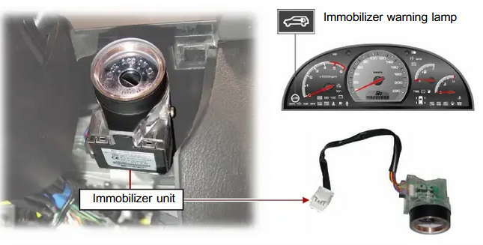
When diagnosing and testing the engine immobilizer system on a car using a scan tool, you can follow these steps:
- Prepare the Vehicle: Ensure that the vehicle is in a safe and stationary position. Make sure all accessories are turned off, and the ignition is in the "Off" position.
- Connect the Scan Tool: Locate the OBD-II port in the vehicle, usually located under the dashboard. Plug the scan tool connector into the OBD-II port until it securely clicks into place.
3- 4 immobilizer unit

- Power On the Scan Tool: Turn on the scan tool by following the manufacturer's instructions. The scan tool should power on and display a menu or prompt for vehicle information.
- Select Vehicle Information: Use the scan tool's menu or interface to select the appropriate vehicle make, model, and year. This step ensures that the scan tool communicates accurately with the vehicle's immobilizer system.
- Scan the ECU: Choose the option to scan or diagnose the engine control unit (ECU) or immobilizer control unit. The scan tool will communicate with the ECU and retrieve any stored trouble codes.
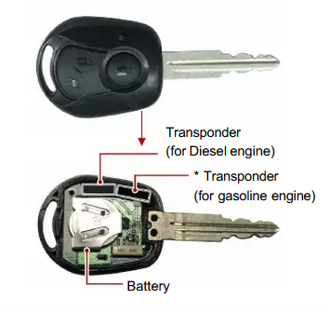
- Retrieve Trouble Codes: Once the scan tool completes the scan, review the retrieved trouble codes related to the immobilizer system. Note down the specific codes for further analysis. Additionally, pay attention to freeze frame data or any supporting information provided by the scan tool.
3- 5 Transponder key
- Interpret the Trouble Codes: Refer to the scan tool's code library or consult manufacturer documentation to interpret the retrieved trouble codes. Understand the meaning of each code and its potential causes to identify the issue affecting the immobilizer system.
- Diagnose the Problem: Use the scan tool's live data function to monitor relevant sensor values, communication signals, and other parameters related to the immobilizer system. Compare the readings to specifications or known good values to identify any abnormalities or inconsistencies.
- Clear Trouble Codes: If desired or necessary, use the scan tool to clear the trouble codes from the ECU. Note that clearing codes should be done cautiously, as it erases the codes and associated freeze frame data, which can provide valuable diagnostic information.
- Perform Functional Tests: Some advanced scan tools offer functional tests specifically designed for immobilizer systems. Follow the instructions provided by the scan tool to perform these tests, which may include activating or testing various components involved in the immobilizer system.

- Functional Tests: Some advanced scan tools offer the ability to perform functional tests on the immobilizer system.
Here are some common issues that can arise with an engine immobilizer system:
- Immobilizer Key Malfunction
- Immobilizer Control Unit Failure
- Wiring or Connection Problems
- Antenna or Transceiver Issues
- Faulty Ignition Switch
  - Carry out testing central locking and power windows system
- Visual Inspection: Start by visually inspecting the central locking and power window components. Check for any obvious signs of damage, such as broken wires, loose connections, or physical obstructions.
- Power Supply Check: Ensure that the car's battery is in good condition and fully charged. Verify that the battery terminals are clean and securely connected. Faulty power supply can affect the operation of the central locking and power windows system.
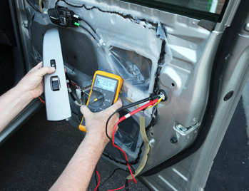
- Test Individual Door Locks: Begin by testing each door lock individually. Use the door lock switch on each door to lock and unlock the door. Check if all doors respond correctly to the switch command. Pay attention to any doors that do not lock or unlock or exhibit abnormal behavior.
- Test Central Locking System: Activate the central locking system using the key fob or the central locking switch in the vehicle. Observe if all doors lock and unlock simultaneously. Verify that the central locking system is functioning correctly and that all doors respond as expected.
3- 6 Checking the voltage at the door lock actuator
- Test Power Windows: Test each power window individually. Use the respective window switch on each door to raise and lower the window. Verify that all windows operate smoothly and without any unusual noises. Ensure that each window stops at the proper position when the switch is released.

- Test Window Auto-Down Feature: If your vehicle is equipped with an auto-down feature, test it by fully lowering each window using the respective window switch. Press and hold the switch to activate the auto-down function and ensure that the window lowers completely.
- Test Window Auto-Up Feature: Similarly, test the auto-up feature by fully raising each window using the respective window switch. Press and hold the switch to activate the auto-up function and ensure that the window closes completely.
- Check Switches and Controls: Inspect the window switches and central locking switch for any signs of damage or malfunction. Press each switch and observe if they respond properly. Faulty switches may need to be replaced.
- Check Fuse and Relay: Locate the fuse box that houses the fuses and relays for the central locking and power windows system. Inspect the relevant fuses and relays to ensure they are not blown or faulty. Replace any damaged fuses or relays as needed.
- Wiring and Connection Inspection: Inspect the wiring harnesses, connectors, and grounds associated with the central locking and power windows system. Look for any damaged or loose connections, corroded terminals, or frayed wires. Repair or replace any faulty wiring or connections.
- Test with Scan Tool: If you have access to a scan tool, perform a diagnostic scan of the central locking and power windows system. Use the scan tool to check for any trouble codes or issues that may not be evident during the visual inspection.
Several common electrical issues can occur in the central locking and power windows system. Here are a few examples:
- Blown Fuse
- Faulty Switches
- Wiring Issues
- Motor or Actuator Failure
- Control Module Malfunction
- Power Supply Problems
- Grounding Issues
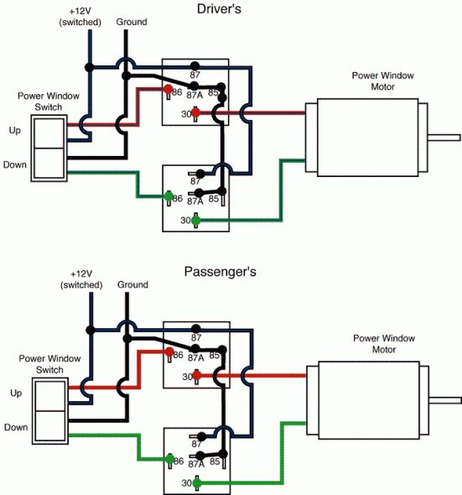
3- 7Schematic diagram of central power window
  - Carry out testing electric side mirrors of a car, you can follow these steps:
- Begin by visually inspecting the side mirrors for any visible damage, such as cracks, scratches, or loose components. Ensure that the mirrors are properly aligned and securely mounted on the vehicle.
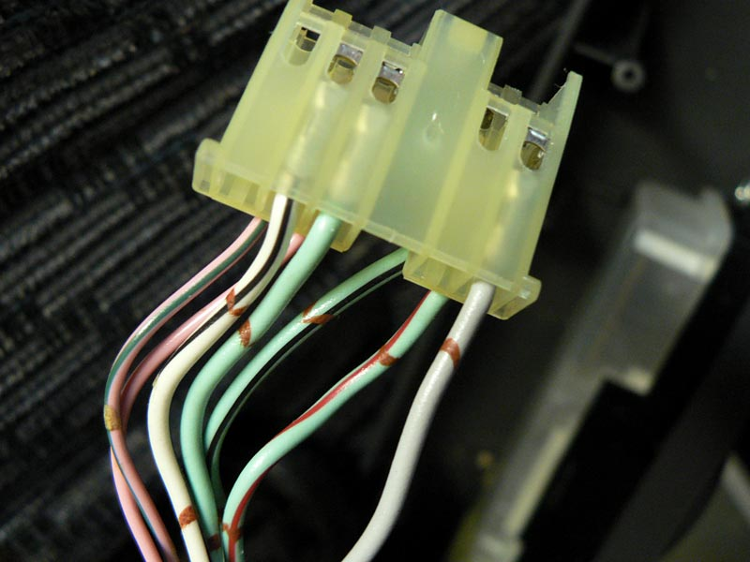
- Sit in the driver's seat and locate the mirror adjustment switch or control. It is usually located on the driver's side door panel or armrest. Test each direction of mirror adjustment (up, down, left, right) to ensure that the mirror moves smoothly and adjusts to the desired position. Verify that the mirror maintains its position once adjusted.
- Some cars have power-folding side mirrors. If your car is equipped with this feature, locate the mirror folding switch or control, usually found near the mirror adjustment switch. Test the folding function of the side mirrors by activating the switch. Observe if the mirrors fold inward and unfold back to their original position smoothly.

- If your car has heated side mirrors, locate the mirror heating switch or control. It is often integrated with the rear defogger switch or control panel. Activate the mirror heating function and allow some time for the mirrors to warm up. Check if the mirror surface becomes clear of frost, ice, or condensation.
Here are some common faults and problems that can occur with electric side mirrors:
- Mirror Motor Failure
- Broken Mirror Glass
- Wiring Issues
- Control Switch or Module Malfunction
- Mirror Housing Damage
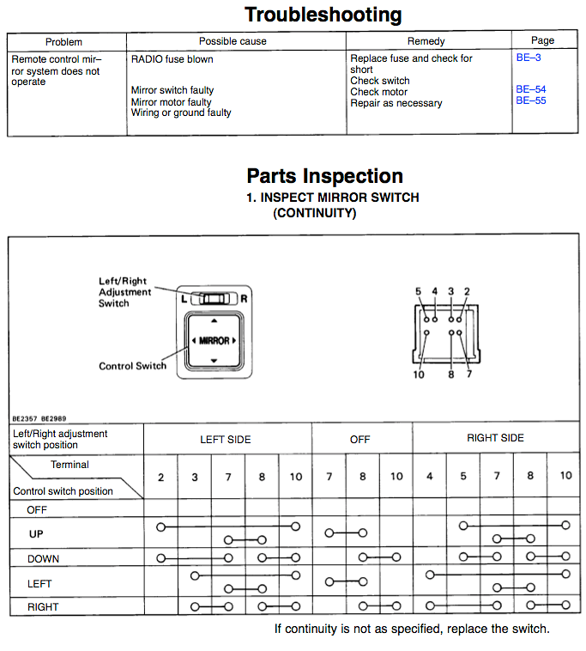
- Power Supply Problems
3- 8 Electric side mirror circuit diagram.
  - Carry out testing on the electronic seat adjustment of a car, you can follow these steps:
- inspecting the seat for any visible damage, such as tears, loose components, or broken controls. Ensure that the seat tracks and mechanisms are properly aligned and in good condition.
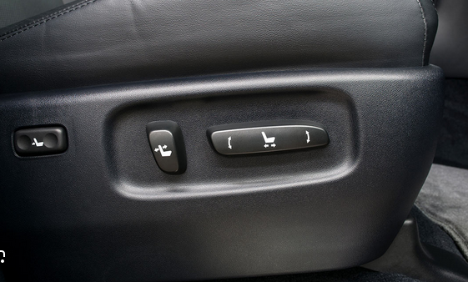
- Locate the seat adjustment controls. These controls are usually located on the side of the seat or on the door panel. Depending on the car's features, the controls may include buttons, switches, or levers for adjusting the seat position, height, backrest angle, lumbar support, and headrest position. Familiarize yourself with the controls and their functions.
3- 93.Seat Position Adjustment button
- Test each direction of seat adjustment (forward, backward, up, down) using the corresponding controls. Observe if the seat moves smoothly and adjusts to the desired position. Verify that the seat locks securely in the adjusted position without any wobbling or unexpected movement.
- Test the seat backrest adjustment controls to adjust the angle of the backrest. Check if the backrest reclines smoothly and securely locks in the desired position. Ensure that the seat backrest remains stable and does not unexpectedly spring back or move while driving.
- If your car has adjustable lumbar support, locate the lumbar support controls. These controls can be manual or electronic. Adjust the lumbar support to different positions and levels of firmness to test its functionality. Ensure that it provides adequate support and remains in the selected position.
- Test the headrest adjustment controls, if applicable. Adjust the height and angle of the headrest to find a comfortable position. Verify that the headrest stays locked in place and provides proper support for the head and neck.

Several common issues can occur with the electronic seat adjustment system in a car. Here are some examples:
- Electrical Malfunction:
- Seat Motor Failure:
- Seat Track Issues:
- Control Switch Problems: Blown Fuses
- Wiring Problems:
- Seat Position Sensor Issues:.

Analyze the diagnosis result
Analyzing the diagnosing fault in a body management system involves evaluating the diagnostic results and identifying the root cause of any issues or malfunctions.
steps to analyze the diagnosis of faults in a body management system:
- Review Diagnostic Data: If diagnostic tools were used during the diagnosis, review the data collected from the body management system. This includes error codes, sensor readings, voltage measurements, and any other relevant information. Look for patterns or abnormalities that can provide insights into the cause of the problem.
- Identify Reported Symptoms: Determine the symptoms reported by the vehicle owner or observed during the diagnosis. These may include issues such as malfunctioning lights (interior, exterior, or dashboard), non-operational features (power windows, central door locks, sunroof), abnormal sounds, or other body-related malfunctions. Document all the symptoms to help identify potential causes.
- Inspect Physical Components: Perform a visual inspection of the physical components of the body management system. This includes inspecting the wiring harnesses, connectors, modules, switches, relays, and other relevant parts. Look for signs of damage, loose connections, corrosion, or wear that may contribute to the fault.
- Check Power and Ground: Ensure that the body management system is receiving proper power and ground connections. Verify the battery voltage, check fuses and relays related to the system, and inspect the wiring for any issues. Faulty power or ground connections can cause malfunctions in the body management system.
- Test Individual Components: Test each component of the body management system individually. This includes switches, sensors, actuators, control modules, and other relevant parts. Use appropriate testing equipment, such as multimeters or oscilloscopes, to perform continuity, resistance, and voltage tests. This helps identify faulty or malfunctioning components.
  - To analysis and finding the result of diagnosing central door lock and power window issues, you can follow this simple method:
- Verify Power Supply: Check the relevant fuses and ensure they are intact. Test if there is power reaching the central door lock and power window systems. If there is no power, check the wiring connections and replace any blown fuses.
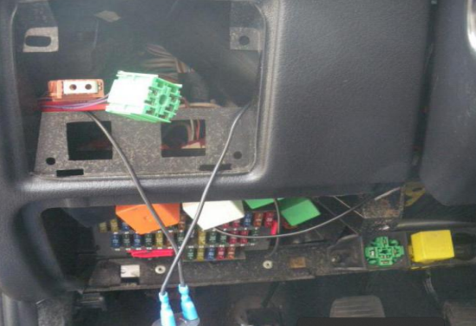
- Test Individual Switches: Press each switch for the central door lock and power window systems and observe their response. If any switch is unresponsive or behaves inconsistently, it may need to be replaced.
- Check for Common Issues: the central door lock and power window systems for your specific vehicle make and model. Look for known problems, recalls, or technical service bulletins that may provide insights into the root cause.
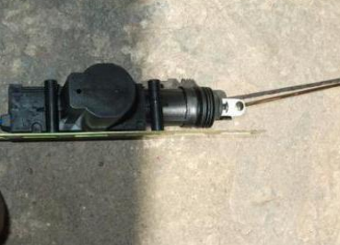
- Inspect Wiring and Connections: Visually inspect the wiring harnesses, connectors, and related components for any visible damage, loose connections, or corrosion. Repair or replace any damaged components as necessary.
- Perform Basic Component Checks: Check the window regulators and door lock actuators for smooth and unrestricted movement. If they are binding or damaged, they may need to be repaired or replaced.
- Test Non-Operational Windows: If a power window is not functioning, try operating it from both the driver's control panel and the individual window switch. If it works from one and not the other, it could indicate a faulty switch.

  - To analyzing and finding the result of diagnosing engine immobilization issues can be simplified using the following method:
- Understand the Symptoms: Gather information about the specific symptoms reported by the vehicle owner or observed during the diagnosis. These may include the engine not cranking, a flashing security light, an immobilizer warning message, or any other related issues.
- Check Key and Immobilizer System: Verify that the correct key is being used and that it is properly programmed for the vehicle. Check for any signs of damage to the key or the immobilizer system. Ensure there are no issues with the immobilizer antenna or transponder ring.
- Test Battery and Starter: Ensure that the vehicle's battery has sufficient charge and the starter is functioning properly. A weak battery or a faulty starter motor can prevent the engine from cranking. Test the battery voltage and perform a starter test if needed.
- Scan for Error Codes: Use a diagnostic scanner or scan tool to check for any error codes related to the immobilizer system. Error codes can provide important clues about the specific components or circuits that are experiencing issues.
- Inspect Wiring and Connections: Visually inspect the wiring harnesses, connectors, and related components for any visible damage, loose connections, or corrosion. Faulty wiring or poor connections can disrupt the communication between the immobilizer system and the engine management system.
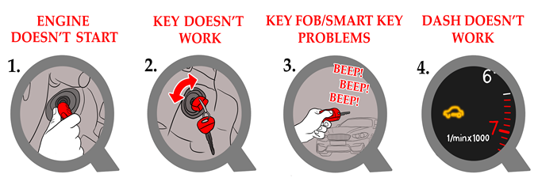
3- 10 Symptoms of a Bad Immobilizer

Repair or Replace Faulty Components: Once the issue is identified, the technician will proceed to repair or replace the faulty components. This could involve replacing a malfunctioning transponder, repairing damaged wiring or connectors, or replacing the immobilizer control module if necessary.
  - To analyze diagnose issues with the SRS (Supplemental Restraint System) airbag system, you can follow these steps:
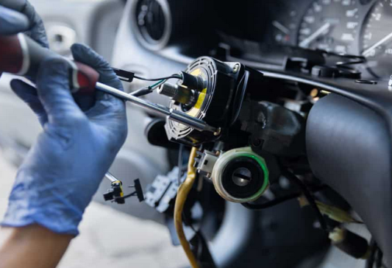
- Check for Warning Lights: If the SRS system has detected a fault, it will typically illuminate the SRS warning light on the dashboard. Check if the warning light is on. If it is, proceed with the diagnosis.
- Inspect Physical Damage: Visually inspect the vehicle for any signs of physical damage, such as collision damage or impact to the areas where the airbags are located. Look for any deployed or damaged airbags, loose connections, or disconnected wiring.
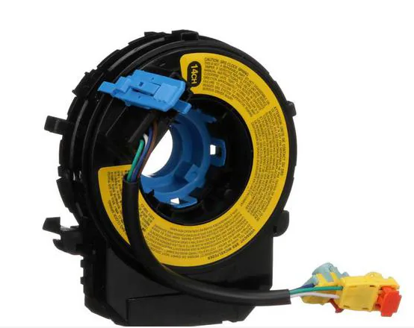
- Perform a Scan: Use a diagnostic scanner or scan tool that is compatible with your vehicle's SRS system to retrieve any error codes. These codes can provide valuable information about the specific components or circuits that are experiencing issues.
- Research Common Issues: Look for common issues related to the SRS airbag system in your specific vehicle make and model. Manufacturer recalls, technical service bulletins, or online forums can provide insights into known problems and potential solutions.
- Inspect Wiring and Connections: Visually inspect the wiring harnesses, connectors, and related components for any visible damage, loose connections, or corrosion. Repair or replace any damaged components as necessary.
- Verify Seat Belt Connections: Ensure that the seat belt connections and pretensioner systems are properly connected and functioning. Faulty seat belt connections can trigger SRS warning lights and affect the system's operation.
Here are some common SRS airbag system faults and possible remedies:
- SRS Warning Light
- Faulty Crash Sensors
- Clock Spring Failure
- Faulty Airbag Inflators
- Wiring Issues

Operation sheet 3.1
Operation Title: Diagnose the central door lock, power window, engine immobilizer, and SRS airbag systems using a scan tool.
Purpose: To identify the faults .
Conditions or situations for the operations:
- Safe working area
- Properly operated tools and equipment
- Appropriate working cloths fit with the body
Equipment Tools and Materials:
- Scan tools
- Vehicle
Quality Criteria: Assured performing of all the activities according to the procedures
Precautions:
- Wearing proper clothes, eye glass, glove
- Make working area hazard free
- Read and interpret manual which guide you how to use tools and equipment.
Steps in doing the task
- Prepare the Scan Tool: Ensure that the scan tool is compatible with the vehicle's make and model and supports the diagnostic functions required for the specific systems
- Find the OBD port in the vehicle. It is typically located under the dashboard on the driver's side. Refer to the vehicle's owner's manual or look for a labeled port with a connector that matches the scan tool.
- Turn on the scan tool by pressing the power button or following the manufacturer's instructions. Some scan tools may require batteries, while others can be powered directly from the OBD port.
- Connect the scan tool cable to the OBD port of the vehicle. Ensure that the cable connector is properly aligned and securely inserted.
- Once the scan tool is connected, it will attempt to establish communication with the vehicle's onboard computer systems.
- From the scan tool's menu or options, select the specific system you want to diagnose. For the central door lock, power window, engine immobilizer, and SRS airbag systems, select each system individually.
- Once you have selected the system, retrieve the diagnostic trouble codes (DTCs) associated with that system. The scan tool will communicate with the vehicle's computer and retrieve any stored fault codes. Record the codes for further analysis.
- Interpret the retrieved DTCs to understand the nature of the problem. Refer to the scan tool's built-in code library, the vehicle's service manual, or a reliable diagnostic database to interpret the codes accurately.
- Based on the analysis of the retrieved codes, live data, and functional tests, diagnose the root cause of the issues in each system. Inspect the components, wiring, connectors, and related systems for any visible signs of damage or malfunction. Perform further tests or inspections as required.
- Once the repairs or replacements have been made, clear the DTCs from the vehicle's computer memory using the scan tool. Retest the systems to ensure that the issues have been resolved and that no new fault codes are present.
- Final Verification: Take the vehicle for a test drive or perform a final functional test to ensure that all the diagnosed systems, such as the central door lock, power window, engine immobilizer, and SRS airbag, are functioning properly and that the reported symptoms no longer persist.

LAP Test :3
Practical Demonstration

Instruction: Perform the following tasks

Task 1: Diagnosing Fault in Body Management System using scan tools

Reference
- Tom Denton-Automobile Mechanical and Electrical Systems_ Automotive Technology_ Vehicle Maintenance and Repair (Vehicle Maintenance & Repr Nv2)-Butterworth-Heinemann (2011)
- Tom Denton - Advanced automotive fault diagnosis _ automotive technology_ vehicle maintenance and repair (2021).
- James D. Halderman - Diagnosis and Troubleshooting of Automotive Electrical, Electronic, and Computer Systems (2011, Prentice Hall).
- Automotive_Electrical_Course_-_Service_Training.pdf
- James D. Halderman - Diagnosis and Troubleshooting of Automotive Electrical, Electronic, and Computer Systems (2011, Prentice Hall).pdf

Participants in this modules training material preparation
No | Name | Qualification (Level) | Field of Study | Organization/ Institution | Mobile Number | E-mail
 | Fadli Aman | BSc. | Automotive Technology | General Wingate PTC | 0927283100 | Fadli.ziyad@gmail.com
 | Habtamu Deresso | PHD Candidate | Automotive Technology | ASTU | 0945853269 | habtamu.deresso@gmail.com
 | Israel Taye | MSC | Automotive Technology | General Wingate PTC | 0913424100 | isra.taye@gmail.com
 | Natnael Genene | MSC | Automotive Technology | Athlete kenenisa PTC | 0920397105 | natnealgenene143@gmail.com
 | Robsan Tesfaye | MSC | Automotive Technology | Burayu PTC | 0920117175 | robsantesfaye4@gmail.com
 | Sisay Tufa | MSC | Automotive Technology | M/G/M/Buli | 0912065407 | knbntf@gmail.com
 | Tagay Tesfaye | MSC | Automotive Technology | Bishoftu PTC | 0975971391 | tagotagotago37@gmail.com

