

Automotive Electricity and Electronics Level IV
Based on October 2023, Curriculum Version- II
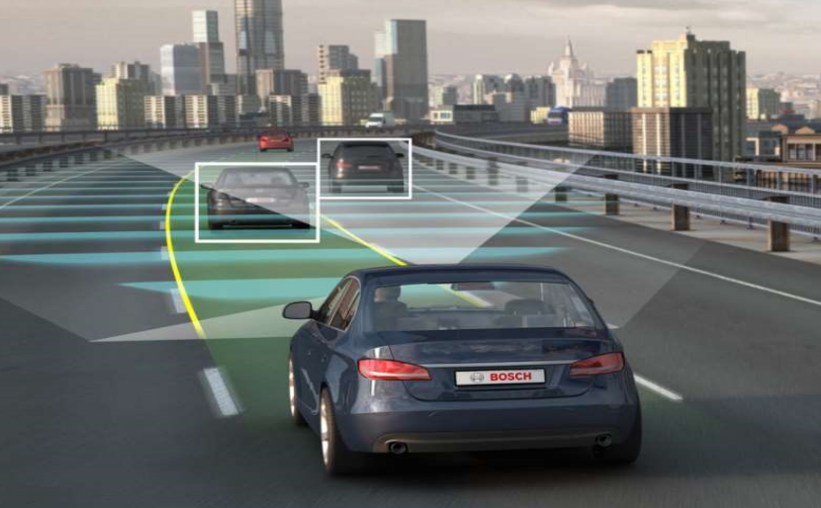
MODULE TITLE : Diagnosing Fault in Electronic Safety and Drive Assist Systems
MODULE CODE : EIS AEE4 M05 1023
NOMINAL DURATION : 40 Hours
Prepared by: Ministry of Labor and Skill
October, 2023
Addis Ababa, Ethiopia

Acknowledgment
Ministry of Labor and Skills wish to extend thanks and appreciation to the many representatives of TVT instructors and respective industry experts who donated their time and expertise to the development of this training module.

Acronym
ABS Anti-lock Brake System
ACC Adaptive Cruise Control
ADAS Advanced Driver Assistance Systems
AEB Automatic Emergency Braking
BSD Blind Spot Detection
DMS Driver Monitoring System
DTCs Diagnostic Trouble Codes
ECU Electronic Control Unit
EPB Electric Parking Brake
EPS Electric Power Steering
ESC Electronic Stability Control
FCW Forward Collision Warning
HSA Hill Start Assist
HUD Head-Up Display
IMU Inertial Measurement Unit
LDW Lane Departure Warning
LKA Lane Keeping Assist
OBD On-Board Diagnostic
OHS Occupational Health and Safety
PPE Personal Protective Equipment
RCTA Rear Cross Traffic Alert
SAE Society of Automotive Engineers
TCS Traction Control System
TPMS Tire Pressure Monitoring System
TSR Traffic Sign Recognition
WHIPS Whiplash Protection System
IPAS An Intelligent parking assist system
APGS Advanced parking guidance system

Table of Contents
Introduction to Module 5
Unit one: Introduction to Electronic Safety and drive Assist System 6
1.1 Overview of electronic safety and drive assist system 7
1.2 Automotive/vehicle safety system 8
1.3 Drive Assistance technology 12
1.4 Diagnosis tools and equipment 16
1.5 OHS requirements 22
Self-check 1 24
Unit Two: Component and sensor 26
2.1 Components and sensors used in electronic safety and drive assist system 26
2.2 Function and operation of component 28
Self-check 2 43
Unit Three: Diagnosis common faults 44
3.1 Common faults in electronic safety and drive assist system 44
3.2 Diagnosis procedures and techniques 49
3.3 Maintenance and service requirement 53
3.4 Advanced diagnostic techniques 54
Operation Sheet 3.1 56
Operation Sheet 3.2 58
Operation Sheet 3.3 59
Operation Sheet 3.4 60
LAP Test: 3 61
Reference 62

Introduction to Module
In automotive modern vehicle system, safety feature and drive assist system is very important system for increase driving safety, enhance driving comfort, and improve efficiency. As the name indicates “Electronic” the system is fully controlled electronically.
In this module to diagnosing fault in electronic safety and drive assist systems. It helps to performing activities to identify and diagnosis fire suppressing, work load detecting, tyre pressure control, speed/load limiting, seat belt pre-tensioning, roll over protection, object detection, navigation aids, intelligent SRS systems, active and passive collision avoidance, infrared vision, camera based front assist, adaptive cruise control, park assist, lane assist, Start-stop System.
This module covers the units:
- Introduction to Electronic Safety and drive Assist System
- Components and sensors
- Diagnosis common faults
Learning Objective of the Module
- Understand Electronic Safety and drive Assist System
- Identify Component and sensor
- Diagnosis common faults
Module Instruction
For effectively use these modules trainee are expected to follow the following module instruction:
- Read the information written in each unit
- Accomplish the Self-checks at the end of each unit
- Perform Operation Sheets which were provided at the end of units
- Do the “LAP test” giver at the end of each unit and
- Read the identified reference book for Examples and exercise

Unit One: Introduction to Electronic Safety and drive Assist System
This unit is developed to provide you the necessary information regarding the following content coverage and topics:
  - Overview of electronic safety and drive assist system
  - Automotive/vehicle safety system
  - Drive Assistance technology
  - Diagnosis Tools and equipment
  - OHS requirements
This unit will also assist you to attain the learning outcomes stated in the cover page. Specifically, upon completion of this learning guide, you will be able to:
  - Understanding electronic safety and drive assist system
  - Identify and confirm Automotive/vehicle safety system
  - Identify and understand Drive Assistance technology
  - Select Diagnosis tools and equipment
  - Observe OHS requirement

Overview of electronic safety and drive assist system
Electronic safety and drive assist systems are advanced technologies incorporated into modern vehicles to enhance safety, improve driving experience, and assist drivers in various aspects of their journey. These systems are designed to minimize the risk of accidents, mitigate the severity of collisions, and provide additional convenience and comfort to drivers.
Electronic modern car safety features have significantly evolved in recent years to enhance occupant protection, prevent accidents, and mitigate the severity of collisions. These electronic safety systems utilize advanced sensors, cameras, and computing power to monitor the vehicle's surroundings, detect potential hazards, and provide timely warnings or take automated actions to avoid or minimize the impact of accidents.

Driver assistance systems support the driver of motor vehicles and, in some instances, take over his tasks. The objectives of the use of driver assistance systems are to increase driving safety, enhance driving comfort, and improve efficiency.
Electronic safety and drive assist systems include:
- Anti-lock Braking System (ABS): ABS prevents wheel lock-up during braking, allowing the driver to maintain steering control and reduce stopping distance on slippery surfaces.
- Electronic Stability Control (ESC): ESC helps maintain vehicle stability by monitoring the driver's steering inputs and comparing them to the vehicle's actual response. It selectively applies brakes to individual wheels and adjusts engine power to assist in avoiding skidding or loss of control.
- Traction Control System (TCS): TCS limits wheel spin during acceleration on low-traction surfaces, such as ice or wet roads. It improves traction and prevents the drive wheels from slipping excessively.
- Adaptive Cruise Control (ACC): ACC maintains a set speed and distance from the vehicle ahead by using sensors, radar, or cameras. It automatically adjusts the vehicle's speed to match the traffic flow, reducing the need for constant speed adjustments by the driver.
- Lane Departure Warning (LDW) and Lane Keeping Assist (LKA): LDW alerts the driver if the vehicle unintentionally drifts out of its lane, while LKA applies gentle steering input to keep the vehicle within the lane.
- Forward Collision Warning (FCW) and Automatic Emergency Braking (AEB): FCW uses sensors to detect potential collisions with vehicles or pedestrians ahead and alerts the driver. AEB goes a step further by automatically applying the brakes to avoid or reduce the severity of a collision.
- Blind Spot Detection (BSD) and Rear Cross Traffic Alert (RCTA): BSD uses sensors to monitor the vehicle's blind spots and alerts the driver if a vehicle is detected. RCTA warns the driver of approaching vehicles when backing out of parking spaces or driveways.
- Parking Assistance Systems: These systems, including parking sensors and rear view cameras, help drivers manoeuvre and park their vehicles safely by providing visual and audible cues.
- Driver Attention Monitoring: This system uses cameras and sensors to monitor the driver's behaviour, such as eye movement and steering patterns, to detect signs of drowsiness or distraction. It can provide alerts to help prevent accidents caused by driver inattention.
The technology continues to evolve, with new features and advancements being introduced to improve overall safety and driving experience.

Automotive/vehicle safety system
Automotive/vehicle safety systems encompass a wide range of features and technologies designed to enhance the safety of occupants and reduce the risk of accidents. Safety features in modern cares are either active safety or passive safety features. The terms "active" and "passive" are simple but important terms in the world of automotive safety.
    - Passive Safety Systems
Passive safety systems in modern cars are designed to provide protection to vehicle occupants in the event of a collision or accident. These systems aim to minimize the risk of injuries by absorbing and dissipating crash energy and keeping occupants securely in place.
Here is some key passive safety systems commonly found in modern cars:
- Seatbelts: Seatbelts are primary safety features that restrain occupants during a collision. They work by securing passengers to their seats and preventing them from being thrown forward or out of the vehicle. Seatbelts are typically equipped with pretensions that retract the belt to remove any slack during a crash, enhancing their effectiveness.

- Airbags: Airbags are inflatable cushions that rapidly deploy during a collision. They provide an additional layer of protection by cushioning the impact and reducing the risk of injury to occupants' heads and upper bodies. Common types of airbags include frontal airbags, side airbags, curtain airbags, and knee airbags.
- Crumple Zones: Crumple zones are engineered areas in the front and rear of the vehicle designed to absorb and dissipate crash energy. They deform upon impact, helping to reduce the force transferred to the occupants' compartment. By absorbing energy, crumple zones contribute to minimizing the severity of injuries to occupants.
- Safety Cages: Safety cages, also known as passenger compartments or safety cells, are reinforced structures that provide integrity and protection to occupants. Built with high-strength materials, safety cages are designed to withstand impact forces and maintain their structural integrity, creating a protective space within the vehicle.
- Head Restraints: Head restraints, commonly found on the front and rear seats, are designed to prevent whiplash injuries in rear-end collisions. They provide support for the head and neck, minimizing excessive movement and reducing the risk of neck and spinal injuries.
- The Whiplash Protection System (WHIPS): is a safety feature designed to mitigate the risk of whiplash injuries in rear-end collisions. Whiplash is a common injury that occur when the head and neck are forcefully jerked backward and then forward, causing strain on the neck muscles and ligaments.
- Specially Designed Seats: WHIPS incorporates seats with energy-absorbing materials and a unique seatback structure. The seatback is engineered to move with the occupant's body during a rear-end collision, helping to support the head and neck and reduce the sudden backward movement.
- Integrated Head Restraints: The head restraints in WHIPS-equipped seats are designed to move with the occupant's body during a collision. They are positioned closer to the occupant's head to provide support and help limit excessive movement, reducing the risk of whiplash injuries.
- Energy-Absorbing Seatbacks: The seatbacks in WHIPS seats are designed to deform in a controlled manner during a rear-end collision. This deformation helps absorb and dissipate crash energy, reducing the sudden acceleration of the head and neck.
- Robust Seat Structure: WHIPS seats are built with a robust structure that can withstand and distribute crash forces effectively. The seat frame is designed to provide optimal support and protection, further reducing the risk of whiplash injuries.
NB: It's important to note that while WHIPS can help mitigate the risk of whiplash injuries, it does not guarantee complete prevention. Proper seatbelt usage and maintaining a safe distance from the vehicle ahead are also essential for reducing the risk of whiplash and other injuries in rear-end collisions.
- Energy Absorbing Materials: Various components within the vehicle, such as the dashboard, door panels, and interior trim, incorporate energy-absorbing materials. These materials are designed to deform or compress upon impact, absorbing crash energy and reducing the risk of injury to occupants.
- Child Restraint Systems: Child restraint systems, including infant seats, convertible seats, and booster seats, are designed to provide appropriate protection for young passengers. They help secure children and provide proper support during a collision, reducing the risk of injury.
NB: It's important to note that passive safety systems work in conjunction with active safety systems, such as seatbelt pretensions and electronic stability control, to provide comprehensive protection to vehicle occupants. These passive safety features have significantly contributed to reducing the severity of injuries and improving overall occupant safety in modern cars.
    - Active Safety Systems
Active safety systems in modern cars are designed to prevent accidents and enhance driver control and awareness by actively monitoring the vehicle's surroundings, detecting potential hazards, and providing assistance or intervention when necessary. These systems utilize sensors, cameras, and advanced computing capabilities to analyse data and take proactive measures to improve safety.
Here are some common active safety systems found in modern cars:
- Anti-lock Braking System (ABS): ABS prevents wheel lock-up during hard braking, allowing the driver to maintain steering control and reducing stopping distances. It modulates brake pressure on individual wheels to maximize braking effectiveness.
- Electronic Stability Control (ESC): ESC helps maintain vehicle stability by continuously monitoring the vehicle's movement and automatically applying brakes to individual wheels or adjusting engine power to prevent skidding or loss of control in slippery or evasive driving situations.
- Traction Control System (TCS): TCS prevents wheel spin during acceleration on slippery surfaces. It reduces engine power or applies brakes to the spinning wheels to optimize traction and maintain control.
- Adaptive Cruise Control (ACC): ACC uses radar or camera sensors to maintain a set distance from the vehicle ahead. It automatically adjusts the vehicle's speed to match the flow of traffic, providing convenience and reducing driver fatigue.
- Lane Departure Warning (LDW) and Lane Keeping Assist (LKA): LDW systems use cameras or sensors to monitor lane markings and provide visual, audible, or haptic alerts if the vehicle unintentionally drifts out of the lane. LKA systems take it a step further by actively applying steering input to keep the vehicle within the lane.
- Forward Collision Warning (FCW) and Automatic Emergency Braking (AEB): FCW systems use sensors to detect potential collisions with vehicles or pedestrians ahead and provide warnings to the driver. AEB systems can automatically apply the brakes to mitigate or avoid a collision if the driver does not respond in time.
- Blind Spot Detection (BSD): BSD systems use sensors to monitor the vehicle's blind spots and provide visual or audible alerts if there is a vehicle in the adjacent lane, helping the driver avoid lane-change collisions.
- Rear-view Cameras and Parking Sensors: Rear-view cameras provide a clear view of the area behind the vehicle, assisting with parking and manoeuvring. Parking sensors use ultrasonic or radar technology to detect objects in close proximity to the vehicle, providing audible or visual alerts to prevent collisions while parking.
- Traffic Sign Recognition (TSR): TSR systems use cameras to detect and interpret traffic signs, including speed limits, stop signs, and other relevant information. They display the detected information to the driver, helping them stay aware of road conditions and comply with traffic regulations.
- Head-Up Display (HUD): is a technology used in active safety systems that projects essential information directly onto the windshield or a dedicated transparent display panel in the driver's line of sight. It provides the driver with real-time information without requiring them to look away from the road, thus enhancing situational awareness and reducing distraction. While HUD systems can display various types of information, including navigation directions and entertainment content, their primary focus in active safety is to present critical safety-related data. Here are some key aspects of HUD in active safety.
- Driver Monitoring System (DMS): is a technology designed to monitor the driver's behaviour, actions, and attentiveness while operating a vehicle. By using sensors and cameras, a DMS tracks various parameters such as head and eye movements, facial expressions, body posture, and potentially other physiological indicators. The primary goal of a DMS is to enhance driver safety by detecting signs of drowsiness, distraction, or impairment and providing appropriate warnings or interventions.
- Tire Pressure Monitoring System (TPMS): TPMS continuously monitors the air pressure of each tire and provides a warning if the pressure drops below the recommended level. Proper tire pressure improves handling, fuel efficiency, and tire longevity.
These active safety systems works together to enhance driver control, improve situational awareness, and assist in accident prevention. Their integration and availability may vary across different vehicle models and manufacturers, but their goal is to enhance overall safety on the road.

Drive Assistance technology
Driver assistance technology in modern cars refers to a range of features and systems that are designed to enhance driver safety, convenience, and comfort. These technologies utilize sensors, cameras, and advanced computing capabilities to provide various levels of automated assistance and intervention.
    - Basic driver assistance
Basic driver assistance refers to a set of entry-level or foundational driver assistance features that are designed to provide some level of assistance and enhance safety in a vehicle. These features typically rely on sensors, cameras, or basic computing capabilities to aid the driver in specific driving tasks. While they may not offer the same level of automation or advanced capabilities as higher-level systems, they still provide valuable assistance and contribute to overall driver safety.
Some examples of basic driver assistance technologies:

- Anti-lock Braking System (ABS): ABS helps prevent wheel lock-up during braking, allowing the driver to maintain steering control and reducing stopping distances on slippery surfaces. It modulates brake pressure to each wheel individually to optimize braking performance.
- Electronic Stability Control (ESC): ESC helps maintain vehicle stability by detecting and mitigating skidding or loss of control. It applies individual brakes and adjusts engine power to help the driver maintain control during emergency manoeuvres or when encountering slippery road conditions.
- Traction Control System (TCS): TCS helps prevent wheel slippage during acceleration by reducing engine power or applying brakes to the spinning wheel. It improves traction on slippery surfaces and aids in maintaining vehicle control.
- Hill Start Assist (HSA): HSA prevents the vehicle from rolling backward when starting on an incline. It automatically holds the brakes for a short period after the driver releases the brake pedal, allowing time to smoothly transition to the accelerator pedal.
- Tire Pressure Monitoring System (TPMS): TPMS monitors tire pressure and alerts the driver if the pressure in any tire falls below the recommended level. It helps maintain proper tire inflation, which is crucial for safe handling and optimal tire performance.
- Rear-view Cameras: Rear-view cameras provide a view of the area behind the vehicle, assisting the driver during parking and reversing manoeuvres. They help improve rear visibility and reduce the risk of collisions with objects or pedestrians.
- Forward Collision Warning (FCW): FCW systems use sensors to detect potential frontal collisions with vehicles ahead. They provide visual or audible alerts to warn the driver of an impending collision, allowing them to react and apply the brakes in a timely manner.
- Lane Departure Warning (LDW): LDW systems monitor lane markings and alert the driver if the vehicle drifts out of the lane without the use of a turn signal. They help prevent unintended lane departures and promote driver attention.
These basic driver assistance features are often standard or available as optional equipment in many modern vehicles. While they provide valuable assistance, it's important for drivers to remain attentive and engaged behind the wheel, as these systems are not intended to replace the driver's responsibility for safe driving.

    - Advanced driver assistance system(ADAS)
Advanced Driver Assistance Systems (ADAS) refer to a more advanced set of technologies and features that are designed to provide higher levels of assistance, automation, and safety in vehicles. ADAS utilizes a combination of sensors, cameras, radar, lidar, and advanced computing capabilities to monitor the vehicle's surroundings, analyse data, and assist the driver in various driving tasks. ADAS technologies aim to improve safety, enhance convenience, and reduce driver workload.
Some examples of advanced driver assistance systems:
- Adaptive Cruise Control (ACC): ACC maintains a set speed and distance from the vehicle ahead. It uses sensors to detect the distance and relative speed of the preceding vehicle, allowing the vehicle to automatically adjust its speed to maintain a safe following distance.
- Lane Keeping Assist (LKA): LKA systems use cameras or sensors to detect lane markings and actively intervene to keep the vehicle within the lane. They provide steering assistance by gently guiding the vehicle back into the lane if it begins to drift unintentionally.
- Automatic Emergency Braking (AEB): AEB systems use sensors to detect potential collisions with vehicles, pedestrians, or other obstacles. They can automatically apply the brakes to mitigate or avoid a collision if the driver does not respond in time.
- Blind Spot Detection (BSD): BSD systems use sensors to monitor the vehicle's blind spots and provide warnings if there is a vehicle in the adjacent lane. They help drivers safely change lanes and reduce the risk of collisions caused by blind spot-related errors.
- Rear Cross Traffic Alert (RCTA): RCTA systems use sensors to detect approaching vehicles or pedestrians when the driver is reversing. They provide warnings to help the driver avoid collisions, particularly in parking lots or congested areas.
- Traffic Sign Recognition (TSR): TSR systems use cameras or sensors to detect and interpret traffic signs, including speed limits, stop signs, and other relevant information. They display the detected information to the driver, helping them stay aware of road conditions and comply with traffic regulations.
- Parking Assistance Systems: Advanced parking assistance systems utilize sensors and cameras to assist the driver in parking the vehicle. They can provide automated steering inputs, guidelines, and visual or audible cues to help the driver manoeuvre into parking spaces.
- Lane Centring Assist (LCA): LCA systems actively keep the vehicle centred within the lane by providing continuous steering assistance. They combine information from cameras and sensors to accurately position the vehicle within the lane boundaries.
- Driver Attention Monitoring: Some ADAS systems include technology to monitor driver behaviour and detect signs of drowsiness or inattention. They may track factors such as steering input, eye movements, or driving patterns to assess driver alertness and provide alerts or warnings if necessary.
- Advanced Head-Up Display (HUD): Advanced HUD systems project relevant information, such as speed, navigation instructions, and warnings, onto the windshield, allowing the driver to view crucial information without diverting their attention from the road.
They are designed to assist drivers, enhance safety, and improve the overall driving experience. It's important to note that while ADAS technologies can provide significant assistance, drivers should always remain attentive, follow traffic laws, and be prepared to take control of the vehicle when necessary.
    - Semi-Autonomous and Autonomous driving assist system
Semi-autonomous and autonomous driving assist systems are advanced technologies that aim to automate certain aspects of driving and reduce the need for constant driver input. While they can provide significant assistance and automation, it's important to understand the distinctions between the two:
- Semi-Autonomous Driving Assist Systems: Semi-autonomous driving systems offer a higher level of automation compared to traditional driver assistance systems but still require the driver to remain engaged and ready to take control of the vehicle when needed. These systems typically combine multiple advanced driver assistance features to provide a more integrated and automated driving experience. Some common examples of semi-autonomous driving assist systems include:
- Traffic Jam Assist: This system can take over acceleration, braking, and steering in stop-and-go traffic situations. It helps maintain a safe distance from the vehicle ahead and keeps the vehicle center within the lane.
- Highway Assist: Highway assist systems are designed to provide automated driving assistance on highways or limited-access roads. They can automatically control the vehicle's speed, maintain a safe distance from other vehicles, and keep the vehicle within the lane.
- Automated Parking: Semi-autonomous parking systems can take control of the steering, acceleration, and braking to assist the driver in parallel or perpendicular parking. They use sensors and cameras to detect parking spaces and manoeuvre the vehicle into the designated spot.
- Autonomous Driving Assist Systems: Autonomous driving, also known as self-driving or driverless technology, aims to provide full automation of the driving task without requiring human intervention. These systems are still being developed and refined, and their implementation is subject to legal and regulatory considerations. While fully autonomous vehicles are not yet widely available for public use, various companies and research institutions are actively working on developing and testing autonomous driving technologies.

Autonomous driving systems typically rely on advanced sensors, cameras, lidar, radar, and powerful computing capabilities to perceive the environment and make driving decisions. They can analyse data, recognize objects, navigate roads, and safely operate the vehicle without human input. Autonomous driving systems are categorized into different levels based on the degree of automation defined by the Society of Automotive Engineers (SAE). These levels range from Level 0 (no automation) to Level 5 (full automation). At Level 5, the vehicle is capable of performing all driving tasks without human intervention, even in complex and dynamic driving scenarios.

It's important to note that while autonomous driving technology holds great promise for improving safety, efficiency, and mobility, it is still in the development and testing phase. The deployment of fully autonomous vehicles on public roads requires comprehensive testing, regulatory approvals, and the establishment of appropriate infrastructure and legal frameworks to ensure safety and address ethical considerations.

Diagnosis tools and equipment
Diagnosis tools and equipment encompass a range of devices, software, and equipment used by technicians to diagnose, analyse, and troubleshoot issues related to vehicle safety systems and driver assistance technologies. These tools help identify problems, perform system checks, and ensure that safety features and drive assist systems are functioning correctly.
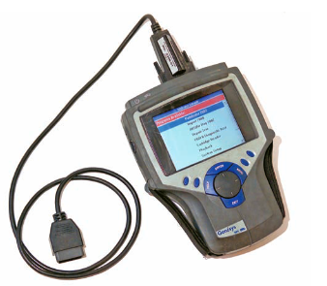
    - Use of OBD-II scanners
On-Board Diagnostic (OBD) scanners are essential tools for diagnosing issues in modern vehicles. They connect to the vehicle's OBD-II port, which is typically located under the dashboard, and retrieve diagnostic trouble codes (DTCs) related to various systems, including safety and drive assist systems. OBD-II scanners can provide valuable information about system malfunctions and help technicians pinpoint the cause of a problem. Figure 1.1OBD-II Scanner
OBD-II scanners are valuable tools that allow users to retrieve diagnostic information from a vehicle's on board computer system.
To use an OBD-II scanner, follow these general steps:
- Locate the OBD-II Port: The OBD-II port is typically located under the dashboard on the driver's side of the vehicle. It is a 16-pin connector that is standardized across most vehicles manufactured after 1996. However, the exact location may vary, so consult the vehicle's manual or look for a label indicating the OBD-II port.
- Connect the Scanner: Take the OBD-II scanner and insert its connector into the OBD-II port. Make sure it is securely connected.
- Power on the Scanner: Once the scanner is connected, turn on the power by pressing the power button or following the instructions provided by the scanner's display.
- Retrieve Vehicle Information: The scanner will establish communication with the vehicles on board computer. It may prompt you to enter or confirm the vehicle's information, such as the make, model, and engine type. Follow the scanner's instructions to input the correct information.
- Scan for Diagnostic Trouble Codes (DTCs): Select the option on the scanner to "Scan for DTCs" or "Read Codes." The scanner will communicate with the vehicle's computer and retrieve any diagnostic trouble codes stored in the system. These codes indicate specific issues or malfunctions in different vehicle systems.
- Interpret the Diagnostic Trouble Codes: Once the scan is complete, the scanner will display the retrieved diagnostic trouble codes. These codes are alphanumeric and typically consist of a letter followed by four or five digits (e.g., P0420). Consult a repair manual, online resources or the scanner's built-in code library to interpret the codes. The scanner may provide a brief description of each code, but further investigation is often necessary to determine the root cause of the issue.
- Perform Additional Functions (Optional): Depending on the capabilities of the OBD-II scanner, you may be able to perform additional functions. These can include clearing diagnostic trouble codes, viewing live sensor data, performing system tests, and accessing manufacturer-specific information.
- Troubleshoot and Repair: Once you have retrieved the diagnostic trouble codes, research the codes and their possible causes. This information will help you troubleshoot and pinpoint the specific issue. It's important to note that diagnostic trouble codes are not definitive diagnoses but rather indicators of potential problems. Further diagnosis and inspection may be required to identify and resolve the underlying issue.
OBD-II applications
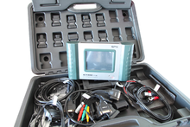
Various tools are available that plug into the OBD connector to access OBD functions. These range from simple generic consumer level tools to highly sophisticated OEM (Original Equipment Manufacturer) dealership tools to vehicle telematics devices.
- Hand-held scan tools
Multi-brand vehicle diagnostics system handheld Auto boss V-30 with adapters for connectors of several vehicle manufacturers. A range of rugged hand-held scan tools is available.
- Simple fault code readers/reset tools are mostly aimed at the consumer level. Figure 1.2 Hand-held scanner
- Professional hand-held scan tools may possess more advanced functions
- Access more advanced diagnostics
- Set manufacturer- or vehicle-specific ECU parameters
- Access and control other control units, such as air bag or ABS
- Real-time monitoring or graphing of engine parameters to facilitate diagnosis or tuning

- Mobile device-based tools and analysis
Mobile device applications allow mobile devices such as cell phones and tablets to display and manipulate the OBD-II data accessed via USB adaptor cables, Bluetooth or WiFi adapters plugged into the car's OBD II connector.
- PC-based scan tools and analysis platforms
Typical simple USB KKL Diagnostic Interface without protocol logic for signal level adjustment. A PC-based OBD analysis tool that converts the OBD-II signals to serial data (USB or serial port) standard to PCs or Macs. The software then decodes the received data to a visual display. Many popular interfaces are based on the ELM or STN1110 OBD Interpreter ICs, both of which read all five generic OBD-II protocols. Some adapters now use the J2534 API allowing them to access OBD-II Protocols for both cars and trucks.
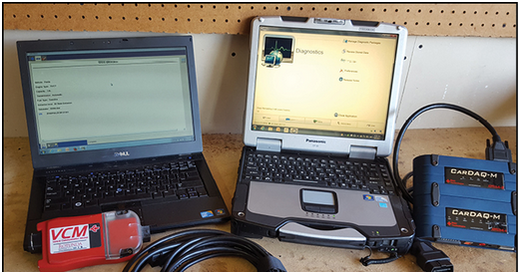
Figure 1.3 PC-based scanners
In addition to the functions of a hand-held scan tool, the PC-based tools generally offer:
- Large storage capacity for data logging and other functions
- Higher resolution screen than handheld tools
- The ability to use multiple software programs adding flexibility
The extent that a PC tool may access manufacturer or vehicle-specific ECU diagnostics varies between software products as it does between hand-held scanners.
    - Data interpretation
Data interpretation in OBD-II refers to the process of analyzing and understanding the information retrieved from a vehicle's onboard computer system using an OBD-II scanner. OBD-II systems provide various types of data that can be helpful in diagnosing issues, monitoring vehicle performance, and conducting maintenance.
Data interpretation in OBD-II:
- Diagnostic Trouble Codes (DTCs): Diagnostic Trouble Codes are alphanumeric codes stored in the vehicle's computer system that indicate specific issues or malfunctions in different vehicle systems. When retrieving DTCs using an OBD-II scanner, it is essential to interpret the codes to understand the underlying problem. Each code corresponds to a particular issue, and the interpretation involves determining the possible causes and necessary steps for repair.
- Code Descriptions: OBD-II scanners often provide brief descriptions or definitions of the retrieved diagnostic trouble codes. These descriptions can offer some insight into the nature of the problem. However, they are usually generic and may not provide precise details about the specific cause in a particular vehicle. Additional research and consultation with repair manuals or online resources may be necessary for more accurate interpretations.
- Live Sensor Data: OBD-II systems also provide real-time sensor data from various components of the vehicle. This data can include information such as engine speed, coolant temperature, fuel trim, oxygen sensor readings, and more. Interpreting live sensor data involves analyzing the values and comparing them to expected ranges or specifications. Deviations from normal ranges can provide clues about potential issues or abnormalities in the vehicle's systems.
- Freeze Frame Data: Freeze frame data captures a snapshot of sensor readings and vehicle conditions at the time a specific diagnostic trouble code was triggered. Interpreting freeze frame data helps in understanding the circumstances that led to the code being stored. It provides additional context and can aid in diagnosing intermittent or hard-to-reproduce issues.
- Manufacturer-Specific Data: OBD-II systems also support manufacturer-specific data parameters beyond the standard set of generic parameters. Manufacturer-specific data can include additional sensors, subsystems, or specific diagnostic information unique to a particular vehicle make or model. Interpreting this data requires access to manufacturer-specific documentation, service information, or specialized diagnostic software.
OBD-II Diagnostic Trouble Codes are 4-digit, preceded by a letter:
- P for engine and transmission (power train),
- B for body,
- C for chassis, and
- U for network.
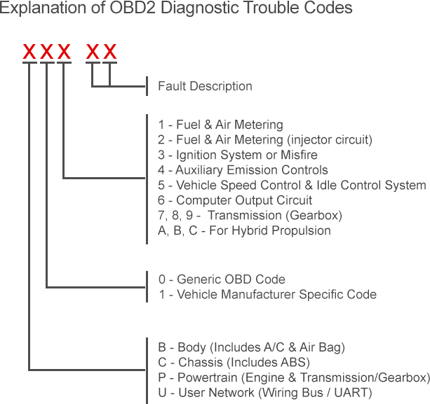
Code type | Explanation
Generic  (normally P0xxx) | The definition for the code is defined in the EOBD / OBD-II standard and will be the same for all manufacturers.
Manufacturer-specific  (normally P1xxx) | Where manufacturers feel that a code is not available within the generic list, they can add their own codes. The definitions for these are set by the manufacturer.

Interpreting data in OBD-II is a crucial step in diagnosing vehicle issues accurately. It requires a combination of technical knowledge, experience, and access to relevant resources. It's important to note that while an OBD-II scanner provides valuable information, it does not replace the expertise of a trained technician. In complex cases, further diagnosis and inspection may be necessary to identify the root cause of the problem and determine the appropriate course of action.

OHS requirements
When diagnosing safety and drive assist systems in vehicles, technicians need to adhere to Occupational Health and Safety (OHS) requirements to ensure a safe working environment. OHS considerations for diagnosing these systems:
- Personal Protective Equipment (PPE): Technicians should wear appropriate personal protective equipment to minimize the risk of injury or exposure to hazardous substances. This may include safety glasses, gloves, protective clothing, and respiratory protection if working with potentially harmful chemicals or materials.
- Electrical Safety: Safety precautions must be taken when working with electrical systems. This includes ensuring that the vehicle's electrical power is turned off before performing any diagnostic procedures. Technicians should also be trained in electrical safety practices, such as handling wires and connectors with care, avoiding contact with exposed electrical components, and using insulated tools.
- Proper Lifting and Handling Techniques: Diagnosing safety and drive assist systems may involve accessing components located in different areas of the vehicle. Technicians should use proper lifting techniques to avoid strains or injuries. They should also be aware of the weight and size of components and use appropriate lifting equipment or assistance when necessary.
- Hazardous Substances: Some diagnostic procedures may involve working with hazardous substances, such as coolant, brake fluid, or refrigerants. Technicians should be trained in the safe handling, storage, and disposal of these substances to prevent environmental contamination and minimize health risks.
- Ventilation: Adequate ventilation is crucial when working with vehicles or in enclosed spaces. Technicians should ensure that the workspace is well-ventilated to prevent the buildup of fumes, exhaust gases, or other harmful airborne particles.
- Ergonomics: Diagnosing safety and drive assist systems often requires prolonged periods of work, including reaching into tight spaces or maintaining uncomfortable positions. Technicians should be mindful of ergonomics and practice proper posture to reduce the risk of musculoskeletal strains or injuries. They may use ergonomic tools or equipment to improve comfort and minimize physical stress.
- Documentation and Recordkeeping: OHS requirements often include maintaining accurate documentation and records of diagnostic procedures, findings, and any safety incidents or near-misses. This helps track the progress of work, identify potential hazards, and ensure compliance with safety regulations.
It's important for technicians to receive proper training, follow established safety protocols, and stay updated on OHS regulations specific to their jurisdiction. Employers should provide a safe and supportive work environment, including regular safety training, access to necessary equipment, and ongoing monitoring of compliance with OHS requirements.

Self-check 1
Directions: Answer all the questions listed below.
Part I: Fill in the blank space
- _________ uses cameras and sensors to monitor the driver's behaviour, such as eye movement and steering patterns.
- _________ used in active safety systems that projects essential information directly onto the windshield.
- _________ uses radar or camera sensors to maintain a set distance from the vehicle ahead
- __________are alphanumeric codes stored in the vehicle's computer system that indicate specific issues or malfunctions in different vehicle systems.
- _________ Data captures a snapshot of sensor readings and vehicle conditions at the time a specific diagnostic trouble code was triggered.
Part-II: Choose the correct answer from the given alternatives
  - Which system supports the driver of motor vehicles and, in some instances, take over his tasks.
A. Safety system C. Driver assistance system
B. Control system D. OBD-II system
  - Which one of the following Provides automatic steering and/or breaking to keep a vehicle in its travel lane?
A. Lane Departure Warning (LDW) C. Lane Keeping Assist (LKA)
B. Road Departure Assist D. All.
  - Assists the driver to keep a safe distance from the preceding vehicle.
    - Speed limiter C. cruise control
    - Collision avoidance D. Seat belt pre-tensioning
  - __________to detect potential collisions with vehicles, pedestrians, or other obstacles.
    - Hill Start Assist C. Traffic Jam Assist
    - Forward Collision Warning D. Automatic Emergency Braking
  - Traffic Jam Assist is autonomous driving assist systems.
A. False B. True

Part-III: Answer the following questions accordingly.
      - Write and explain OBD-II application.
      - What is Electronic Spark Advance?
      - Explain the difference between passive and active safety system
      - Explain in detail Whiplash Protection System.
      - Write steps to use OBD-II scanner.

Unit two: Component and sensor
This unit to provide you the necessary information regarding the following content coverage and topics:
- Components and sensors used in electronic safety and drive assist system
- Function and operation of component
This guide will also assist you to attain the learning outcomes stated in the cover page. Specifically, upon completion of this learning guide, you will be able to:
- Identify and confirm Components and sensors used in electronic safety and drive assist system
- Understand Function and operation of component

Components and sensors used in electronic safety and drive assist system
Electronic safety and drive assist systems in vehicles utilize a range of components and sensors to enhance safety, improve driving experience, and provide assistance to drivers. Common components used in these systems:
- Electronic Control Unit (ECU): The ECU acts as the central processing unit for the safety and drive assist systems. It receives inputs from various sensors, processes the data, and sends commands to other components to perform specific functions.
- Sensors: Various sensors are employed to gather data about the vehicle's surroundings, its internal state, and the driver's inputs. These sensors include:
- Radar Sensors: Radar sensors use radio waves to detect objects and measure their speed, distance, and position. They are commonly used in systems like Adaptive Cruise Control (ACC), Forward Collision Warning (FCW), and Blind Spot Detection (BSD).
- Camera Systems: Cameras capture visual information and are utilized in systems such as Lane Departure Warning (LDW), Traffic Sign Recognition (TSR), and Pedestrian Detection.
- Ultrasonic Sensors: Ultrasonic sensors employ sound waves to detect objects and measure distances. They are often found in parking assist systems, such as Parking Sensors and Automated Parking Systems.
- LiDAR (Light Detection and Ranging): LiDAR sensors use laser beams to create detailed 3D maps of the surroundings and detect objects. They are commonly used in advanced driver assistance systems (ADAS) and autonomous vehicles.
- Inertial Measurement Unit (IMU): IMUs consist of accelerometers and gyroscopes that measure the vehicle's acceleration, angular rate, and orientation. They are utilized in systems like Electronic Stability Control (ESC) and Roll Stability Control (RSC).
- Steering Angle Sensor: This sensor detects the angle and position of the steering wheel, providing information about the driver's input, steering behavior, and stability control systems.
- Wheel Speed Sensors: Wheel speed sensors monitor the rotational speed of each wheel. They are essential for systems like Anti-lock Braking System (ABS) and Traction Control System (TCS) to maintain optimal braking and traction performance.
- Brake Pressure Sensor: The brake pressure sensor measures the hydraulic pressure in the brake system. It assists in functions like Brake Assist (BA) and Electronic Brake force Distribution (EBD).
- GPS (Global Positioning System): GPS technology provides accurate positioning and velocity information, which is utilized in systems such as Navigation Systems, Lane Keeping Assist, and Adaptive Headlights.
- Actuators: Actuators are responsible for executing commands from the ECU to perform specific actions. Some examples include:
- Electric Motors: Electric motors are used in systems like Electric Power Steering (EPS) and Electric Parking Brake (EPB) to provide steering assistance and actuate the parking brake.
- Solenoids: Solenoids are utilized in systems like Active Suspension Systems and Active Damper Systems to adjust suspension settings and improve ride comfort.
- Brake Actuators: Brake actuators are responsible for activating the brakes based on commands from the ECU. They are used in systems like Autonomous Emergency Braking (AEB) and Collision Mitigation Systems.
- Human-Machine Interface (HMI): The HMI components provide the interface between the driver and the vehicle's safety and drive assist systems. They include displays, buttons, touch screens, and audible alerts that convey information and warnings to the driver.
- Communication Networks: These networks enable communication between various components and systems within the vehicle. Examples include Controller Area Network (CAN) and Ethernet, which facilitate data exchange between the ECU, sensors, actuators, and other systems.
The specific components employed can vary depending on the vehicle's make, model, and the level of advanced driver assistance technology implemented.

Function and operation of component
Safety and drive assist components in vehicles serve various functions to enhance safety, improve driving experience, and provide assistance to drivers.
Fire suppressing system: An engine fire could prove catastrophic, not only damaging the vehicle beyond repair, but also potentially placing you and your passengers at risk. The heart of the fire detection and suppression system is our sensor tubing which acts as a linear heat and flame detector. The pressurized sensor tubing is completely flexible and can be run throughout the installation to follow the hazard risk areas.
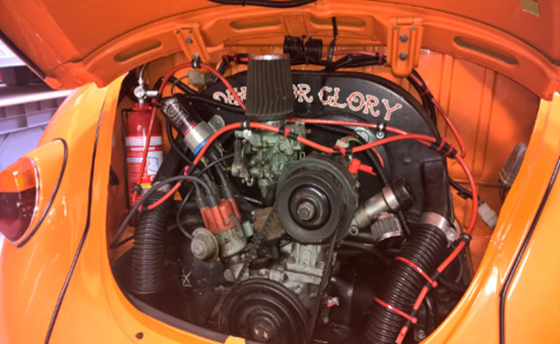
Figure 2.1 Fire suppressing system
Fire trace has a vehicle fire suppression system ideal for protecting motor engine compartments.
How it works? The Fire trace vehicle fire suppression system uses patented linear detection tubing which is fitted throughout the engine inlet and connected to the cylinder valve. After compressed air or nitrogen has been used to charge the tubing, the extinguisher is then kept within the chamber for as long as the tubing stays intact. When a high temperature or fire occurs then the pressurized tubing will burst and the extinguisher will be deployed directly from the burst hole onto the fire. This means the extinguisher is always discharged exactly in the right location.
Tire Pressure Control: purpose of the tire pressure monitoring system (TPMS) in your vehicle is to warn you that at least one or more tires are significantly under-inflated, possibly creating unsafe driving conditions. The TPMS low tire pressure indicator is a yellow symbol that illuminates on the dashboard instrument panel in the shape of a tire cross-section (that resembles a horseshoe) with an exclamation point.
That indicator light in your vehicle has a history. It’s a history rooted in years of uncertainty about proper tire pressure and many serious car accidents that might have been avoided had drivers known their air pressure was low.
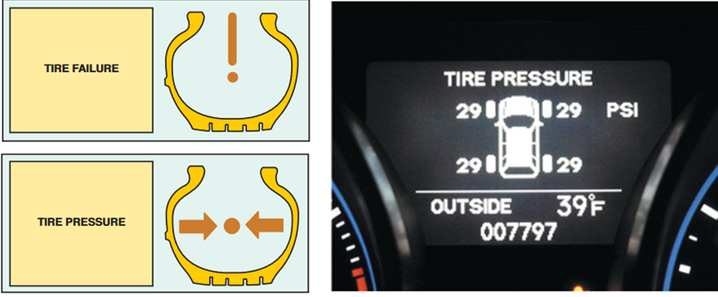
Figure 2.2 Tire Pressure Control
However, proper tire maintenance with the aid of a TPMS can and does help prevent many serious accidents. Not every TPMS works the same way. The illumination of the low tire pressure indicator represents the final step in the process of either an indirect TPMS or a direct TPMS.
Speed/load limiting: Speed limiters are devices that are fitted into vehicles to prevent them from exceeding a particular set speed, these devices could either be an OEM (original equipment manufacturer) or an after-market device. A speed limiter prevents a car from travelling over a certain speed set by the driver. Unlike cruise control; it doesn't maintain a set speed. The driver still uses the accelerator, but if the car gets to the limited speed, then pushing the pedal normally will have no effect: the limiter will prevent the vehicle going any faster.
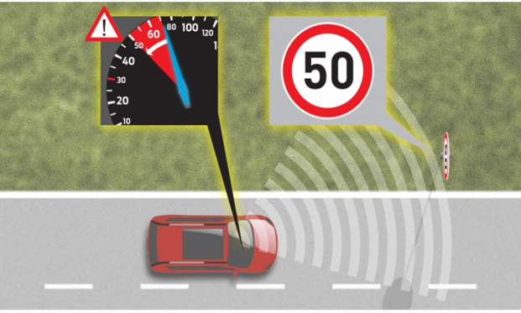
Some more modern systems can automatically change a car’s speed in response to speed limit signs. These are often referred to as intelligent speed limiters and adjustable speed limiter.
  - Intelligent speed limiters: some manufacturers, including Ford, offer the option of a more advanced system on some cars, which links the speed limiter to a camera that can spot speed limit signs. When you drive into an Figure 2.3Intelligent Speed Limiter area with a different speed limit, then the limiter is adjusted accordingly. There's no complete guarantee that the cameras will spot every sign, so you'll still need to pay attention.
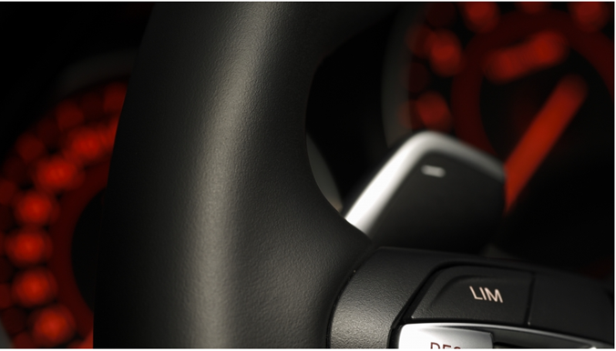
  - Adjustable Speed Limiter: The limiter is set by the driver. you select the maximum speed that you want to travel at and then drive normally. If the car reaches that speed, then it won't go any faster, even if you continue to press the accelerator gently. In traffic, the limiter will remain active as you slow down and speed up but you will need to adjust it if the speed limits changes. You can also override the limiter if you need to speed up quickly, by pressing down hard on the accelerator.
Figure2.4 Adjustable Speed Limiter
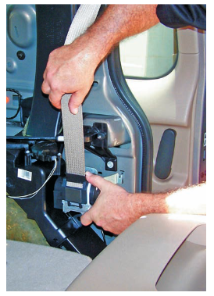
Seat belt pre-tensioning: A seat belt pretensioner simply refers to a device designed to hold passengers firmly in their position at the start of (just before) a collision/accident. It then allows the passenger to get back into comfortable position after the collision.
How does it work? A seat belt pretensioner is designed to keep passengers firm on their seats and in a position where they can receive maximum benefits of their inflated airbags. The mechanism used is quite simple yet technical. It uses an explosive charge that drives concealed pistons.
Figure2.5 Seat belt pre-tensioning
Object detection: Alerting the driver to moving objects around the vehicle by detecting moving objects around the car and alerting the driver, this technology enhances safety when pulling out of a parking space, helping give drivers better awareness of their surroundings and increased peace of mind. Cameras detect moving objects around the vehicle when it is in park or slowly maneuvering; the system then alerts the driver both visually and audibly.

There are two types of systems:
- One uses around view monitor and four cameras to the front, back and sides of the car.
- The second system uses only a single camera installed in the rear of the car.

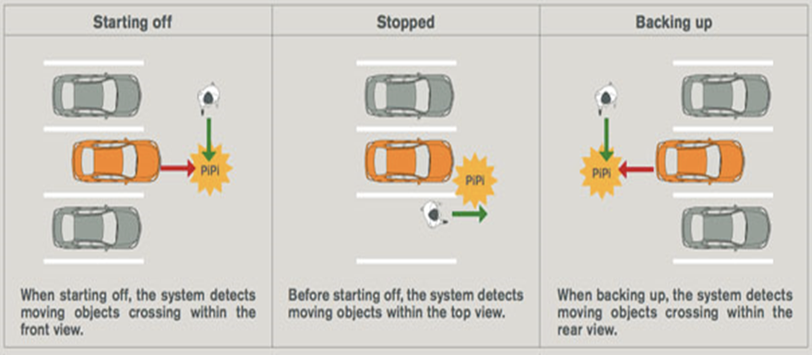
Figure2.6 Object detection
Collision avoidance: Collision avoidance assist helps the driver steer around an obstacle in a critical situation. The system uses data from the two radar sensors and the front camera for this purpose. In calculating a suitable evasive maneuver corridor, it takes into account the distance, width and offset of the vehicle driving ahead. Collision avoidance assist is available over a speed range from approx. 30 to 150 km/h (18.6 to 93.2 mph), and it assumes that the driver is actively steering throughout the maneuver. The driver is informed of the intervention by an indicator in the instrument cluster.
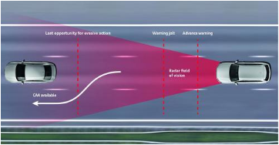
Figure2.7 Collision avoidance
First, a shock is produced to warn the driver of the hazard. If the driver then actively avoids the obstacle, the assistant applies a slight steering torque that helps by correcting the driver’s steering input or helping to make a lane change. The technology also uses radar to keep a check on the vehicles ahead, and decreases the speed automatically by autonomous braking and by reducing the throttle.
Antilock braking system: ABS (Antilock Braking System) reduces the risk of tires skidding under heavy braking and allows the driver to maintain steering control of the car. ABS only operates under heavy braking or on slippery surfaces. Active Braking Systems: Active braking systems are a new safety technology that provides drivers with braking support during emergency situations.
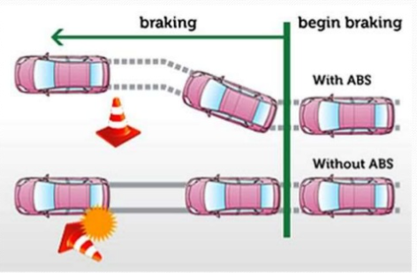
Figure2.8 Vehicle with and without Antilock braking system
Electronic Stability Control (ESC): helps drivers to avoid crashes by reducing the danger of skidding, or losing control as a result of over- steering. ESC becomes active when a driver loses control of their car. It uses computer controlled technology to apply individual brakes and help bring the car safely back on track, without the danger of fish-tailing. Electronic stability control is a fancy name for a bunch of sensors mounted throughout your vehicle that tell the computer at the heart of your vehicle what is happening.
This is way the computer can make minute adjustments to your vehicle to keep it on the road and keep you and your passengers safe. Electronic stability control is one of the least flashy safety features, but its effectiveness at preventing deaths cannot be denied.
How Electronic Stability Control works? ESC works by using a number of intelligent sensors that detect any loss of control and automatically apply the brake to the relevant wheel, putting your car back on the intended path.
ESC is of assistance to the driver in:
- Correcting impending over-steering or under-steering
- Stabilizing the car during sudden evasive maneuvers
- Enhancing handling on gravel patches, such as road shoulders
- Improving traction on slippery or icy roads.
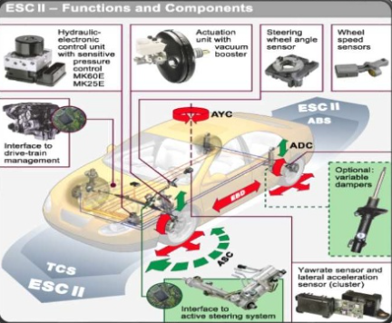
Figure2.9 ESC components
Adaptive Cruise Control (ACC): ACC maintains a set speed and distance from the vehicle ahead, providing a more relaxed driving experience on highways. Radar or LiDAR sensors detect the distance and speed of the vehicle ahead. The system adjusts the vehicle's speed by automatically controlling the throttle and, if necessary, applying the brakes. Free the driver from frequent accelerations and decelerations and also reduces the stress of the driver.
Operates in two modes:
- Cruise mode: Speed of the vehicle is controlled to maintain a set speed.
- Follow mode: Speed of the vehicle is controlled to maintain a set distance from the preceding vehicle. The driver can over-ride the system at any time. Effective in the speed between 30km/h-180km/h.

Figure2.10 Adaptive Cruise Control (ACC)
Components of an ACC System
- Adaptive cruise control Module – That major function of the adaptive cruise control module is to process the radar information and define whether a forward car is present.
- Engine Control Module – That essential function of the Engine Control Module to draw information from the adaptive cruise control.
- Brake Control Module – That is an essential function of the Brake Control Module is to define car speed through each wheel and to slow the car via stratify the brakes when requested via the adaptive cruise control Module.
- Instrument Cluster – The main function of the Instrument Cluster is to remedy the Cruise switches and send their information to the adaptive cruise control and engine control modules.
- CAN -The observer area Network or control area network (CAN) is an automotive standard network that uses two wire bus to transfer and receive the data.
- Cruise switches: The driver can set the cruise control with the cruise switches, usually ON, OFF, RESUME, SET/ACCEL and COAST, which are located in the steering wheel spokes or on the edge of the hub (HONDA vehicles) or on turn signal stalk (General Motors).
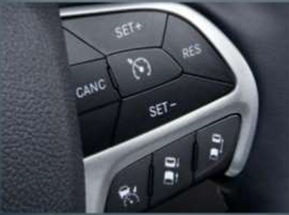
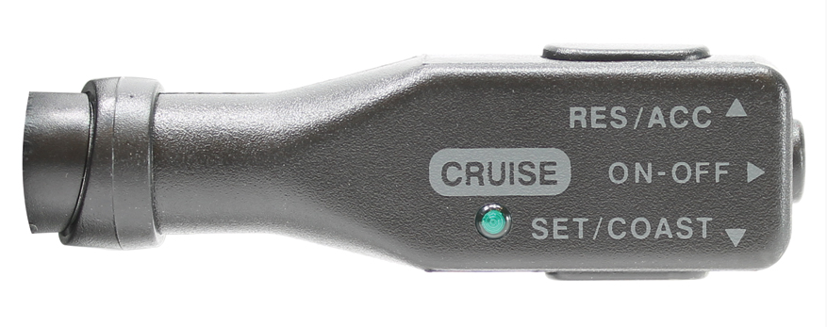

Figure2.11 Cruise switches
ON: place ACC system in stand by state
OFF: button turns the cruise control off even if it is engaged. Some cruise controls don't have these buttons; instead, they turn off when the driver hits the brakes, and turn on when the driver hits the set button.
The SET/ACCEL button tells the car to maintain the speed you are currently driving.
If you hit the set button at 45 mph, the car will maintain your speed at 45 mph. holding down the SET / ACCEL button will make the car accelerate; and on this car, tapping it once will make the car go 1 mph faster. Hit the button five times to go 5 mph faster.
ON: place system in the “ACC” stand by state
OFF: cancel ACC operation and place in the ACC OF state
Set+: activate ACC and establish set speed or accelerate.
Set-: decelerate
RES: reset to set seed
Coast: to decelerate or cancel the ACC system.
Figure2.12 Instrument Cluster switch
- Brake Switch: there are two brake switches; brake switches 1(BS1) and brake switch 2(BS2). When either of brake switch is activated, cruise control operation is deactivated and the system enters “ACC standby” state. Cruise control release switch and a stop lamp switch, mounted on the brake pedal bracket disengage the system electrically when the brake pedal is pressed.
- Brake lights: when the brake control module applies the brake in response to an ACC request, it will illuminate the brake light to warn vehicles behind the ACC vehicle that is decelerating.
- Sensors(Radars):
    - LIDAR is Light Detection and Ranging: A laser diode was used to generate the light signal.
    - RADAR is Radio Detection and Ranging: It is operated by radiating energy into space and detecting the echo signal reflected from target. While RADAR target is the car’s rear spoiler the stereo camera is constantly captures all objects in its field of view.
It includes millimeter wave radar linked to a 640x480 pixel stereo camera:
      - Vision Sensors
      - Ultrasonic Sensors
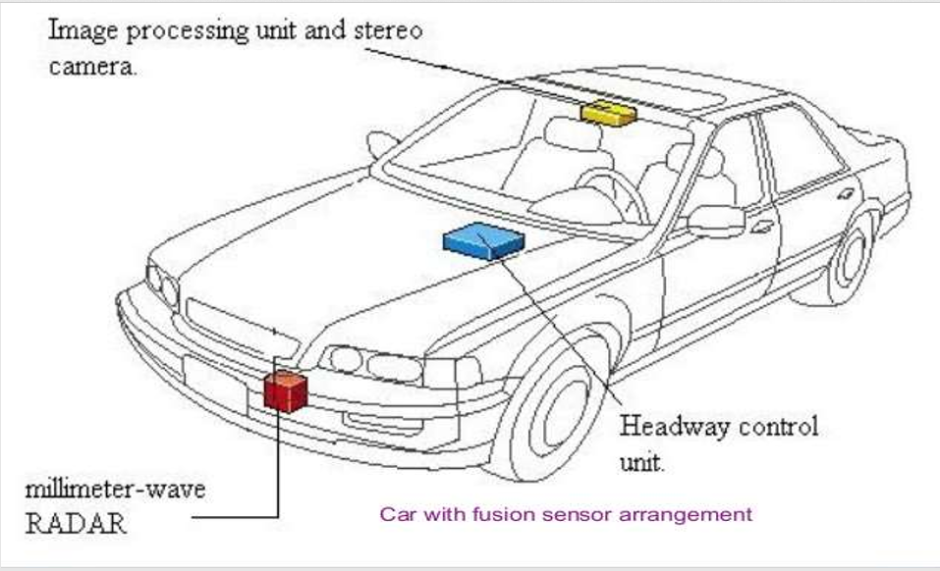
Figure1.13 Location of Components
Parking Assist: Parking aid offers greater comfort and support when parking the vehicle, Visual and/or audible warnings are issued with escalating urgency when the vehicle is within 250 cm of an obstacle. The driver has a reliable indicator of how much space remains, even if the line of sight is blocked. Even the smallest parking spaces can be used as a result.
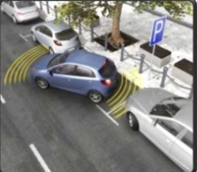
Figure1.14 Park assists
What is an intelligent parking assist system?
- An Intelligent parking assist system (IPAS) or Advanced parking guidance system (APGS) is the technology assists drivers in parking their vehicle.
- On vehicle equipped with the intelligent parking assist system(IPAS), via an in-dash screen and button controls, the car can steer itself into a parking space with little input from the user.
The parking functions are classified into two;
- Parallel parking
- Reverse parking
Parallel parking: When parallel parking with the system, drivers first pull up alongside the parking space. They move forward until the vehicle's rear bumper passes the rear wheel of the car parked in front of the open space. Then, shifting to reverse automatically activates the backup camera system, and the car's rear view appears on dash navigation/camera display. The driver's selection of the parallel park guidance button on the navigation/camera touch screen causes a grid to appear.
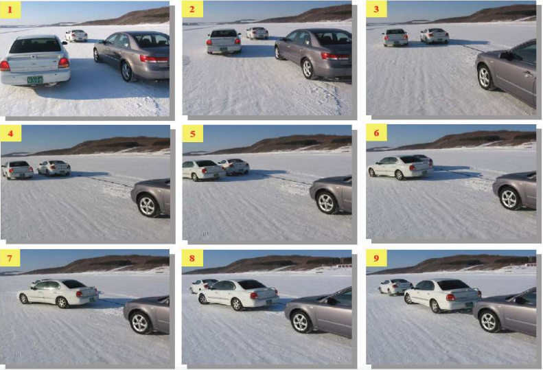
Figure1.15 Parallel Park
Reverse parking: The reverse parking procedure is virtually identical to the parallel parking procedure. The driver approaches the parking space, moving forward and turning, positioning the car in place for backing into the reverse parking spot. The vehicle rear has to be facing the reverse parking spot, allowing the backup camera to 'see' the parking area. Shifting to reverse automatically activates the backup camera system, and the driver selects the reverse park guidance button.
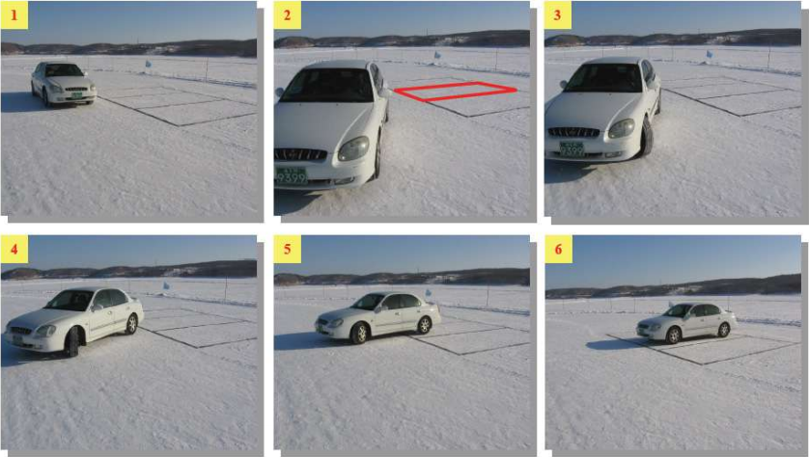
Figure1.16 Reverse parking
Lane Assisting: In the context of traffic control, a lane is part of a roadway that is designated to be used by a single line of vehicles, to control and guide drivers and reduce traffic conflicts. Most public roads (highways) have at least two lanes, one for traffic in each direction, separated by lane markings.
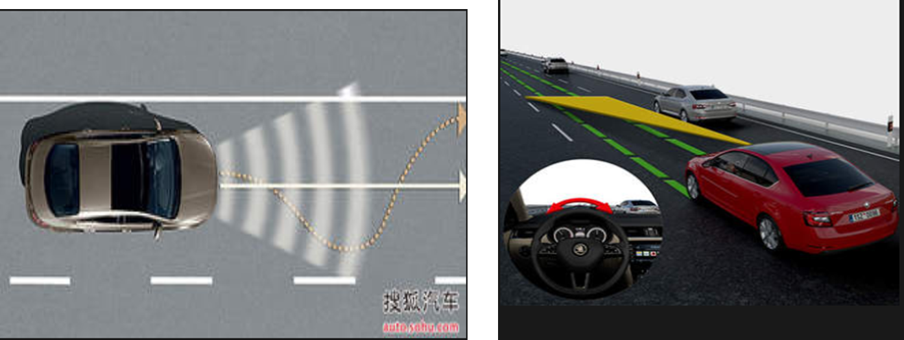
Figure1.17 Lane Assisting
Lane keeping and lane departure systems use forward-facing cameras to monitor the lane lines around your vehicle and will provide visual, audible, and/or tactile warnings such as through steering wheel or seat vibrations to alert the driver when the car approaches or crosses lane markings. These systems do not activate when you use your turn signal. If your vehicle has lane keeping assist (LKA), automatic steering or braking will try to correct the vehicle if it starts to exit the lane.
There are several common variations of lane systems:
Lane Departure Warning (LDW): Drivers get audible and/or visual warnings that their vehicle is approaching or crossing lane markings when the turn signal is not activated.
Lane Keeping Assist (LKA): Provides automatic steering and/or braking to keep a vehicle in its travel lane.
Road Departure Assist: Provides automatic steering and/or braking to try to keep the vehicle from departing the roadway.
Lane Centering Assist (LCA): Provides automatic steering and/or braking to continually center the vehicle in its lane.
How it works? Windshield camera tracks lane markings. The most common LDW system is a camera mounted high up in the windshield, often as part of the rear view mirror mounting block. It captures a moving view of the road ahead as much as 150 feet ahead.
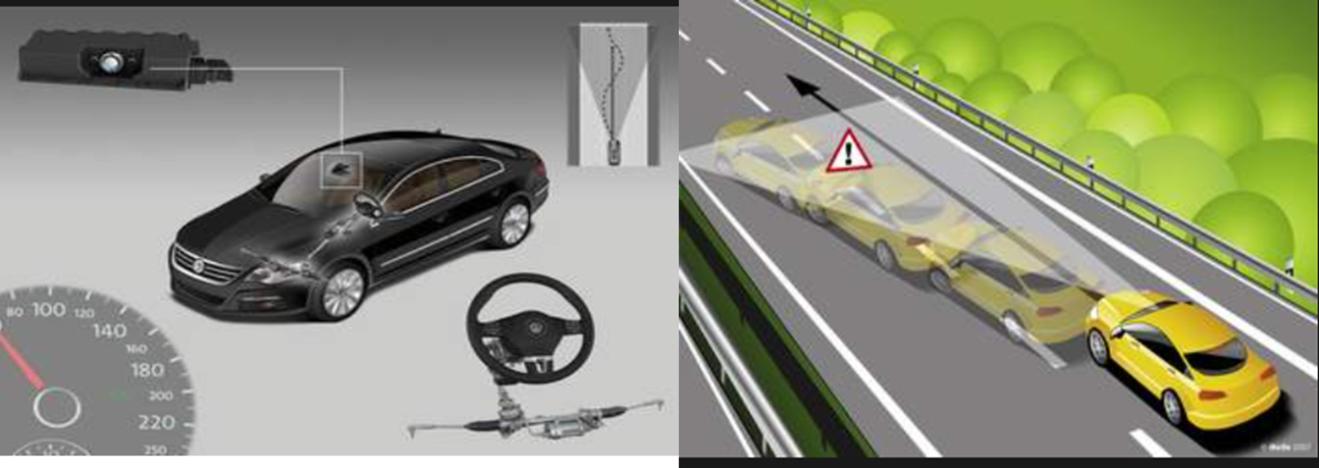
Figure1.18 Lane Departure Warning (LDW)
The digitized image is parsed for straight or dashed lines the lane markings. As the driver, you’re supposed to center the car between the two lines. As the car deviates and approaches or reaches the lane marking, the driver gets a warning: a visual alert plus either an audible tone, a vibration in the steering wheel, or a vibration in the seat. If the turn signal is on, the car assumes the driver is intentionally crossing over the lane, and there’s no alert.
Blind Spot Assist/Active Blind Spot Assist: The Blind Spot Assist system developed by Mercedes-Benz uses radar technology to monitor the area 3 m to the side and 3 m to the rear of the vehicle. The system becomes active as of 30 km/h and the yellow visual indicator in the outside mirrors then disappears. If the system detects another vehicle in the blind spot, this is indicated in the first stage by a red hazard warning triangle lighting up in the respective outside mirror. If the driver sets the turn signal despite the visual warning, an acoustic warning is issued additionally in a second stage.
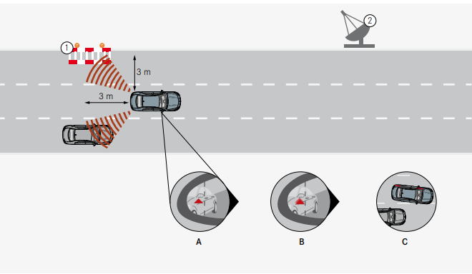
Figure1.19 the Blind Spot Assist system
The Active Blind Spot Assist system builds upon the functionality of Blind Spot Assist. This system can additionally help to avoid accidents in a third stage by performing a single sided, targeted brake application to correct the course of the vehicle in a vehicle speed range of 30 - 200 km/h. The driver is able to abort the course-correcting brake system intervention by counter steering at a steering angle of > 5° or by depressing the accelerator pedal to change its position by > 10%.

Self-check 2
Directions: Answer all the questions listed below.
Part-I: Say True of False the following statements
  - Parking assist has greater comfort and support when parking the vehicle.
  - In follow mode the speed of the vehicle is controlled to maintain a set speed.
  - Adaptive cruise control effective in the speed between 30km/h-180km/h
  - Speed limiters are devices that are fitted into vehicles to prevent them from exceeding a particular set speed.
  - Intelligent Speed Limiter The limiter is set by the driver.
Part-II: fill the blank space
- ____________Helps the driver steer around an obstacle in a critical situation
- ____________Correcting impending over-steering or under-steering
- ____________Prevents a car from travelling over a certain speed set by the driver
- ____________Assists the driver to keep a safe distance from the preceding vehicle
- ____________Automatically controls the speed of a motor vehicle
Part-III: Answer the following questions accordingly.
- How Electronic Stability Control works?
- How do you test a pickup coil for resistance and AC voltage output?
- List and explain sensors.
- List at least five components of an ACC System.
- List and explain actuator.

Unit three: Diagnosis common faults
This learning guide is developed to provide you the necessary information regarding the following content coverage and topics:
- Common faults in electronic safety and drive assist system
- Diagnosis procedures and techniques
- Maintenance and service requirement
- Advanced diagnostic techniques
Advanced diagnostic techniques This guide will also assist you to attain the learning outcomes stated in the cover page. Specifically, upon completion of this learning guide, you will be able to:
- Identify Common faults in electronic safety and drive assist system
- Follow Diagnosis procedures and techniques
- Apply Maintenance and service requirement
- Apply Advanced diagnostic techniques

Common faults in electronic safety and drive assist system
While electronic safety and drive assist systems are designed to enhance vehicle safety and performance, they can experience faults and malfunctions. Some common faults that can occur in these systems:
- Sensor Malfunction: Sensors are crucial components in safety and drive assist systems. If a sensor fails or malfunctions, it can lead to inaccurate or unreliable data, resulting in faulty system operation. For example, a malfunctioning radar or camera sensor may provide incorrect information, leading to false warnings or improper system responses.
- Wiring and Connection Issues: Faulty wiring or poor connections can disrupt the flow of data between components, leading to system failures. Loose or damaged wiring can cause intermittent faults or complete system shutdown.
- ECU Failure: The Electronic Control Unit (ECU) is responsible for processing and coordinating data from various sensors and components. If the ECU experiences a failure or software glitch, it can result in system malfunctions or complete system shutdown.
- Actuator Problems: Actuators, such as electric motors or solenoids, can develop faults. For example, an electric motor used in the power steering system may experience power loss, leading to reduced steering assistance. Similarly, a faulty solenoid in the brake actuator can result in improper brake application or release.
- Calibration Issues: Safety and drive assist systems often require periodic calibration to ensure accurate operation. If not calibrated correctly or if calibration is not performed at the recommended intervals, the system may exhibit inaccuracies or erratic behavior.
- Environmental Factors: Harsh environmental conditions, such as extreme temperatures, moisture, or exposure to contaminants, can impact the performance of electronic components. For instance, water ingress into sensors or electrical connections can cause system failures.
- Software Bugs or Updates: Safety and drive assist systems rely on sophisticated software algorithms. Software bugs or compatibility issues can lead to system malfunctions or unexpected behavior. Updates or patches to the software may be required to resolve these issues.
- Human Error: Faults can also occur due to human error, such as incorrect system operation, improper maintenance, or failure to follow recommended procedures for system calibration or updates. It's important to note that these faults are general examples, and the specific faults can vary depending on the vehicle make, model, and the complexity of the safety and drive assist systems implemented. When encountering any faults or malfunctions, it is advisable to seek professional assistance from qualified technicians or authorized service centers.
- Anti-lock brakes fault
When the anti-lock braking system (ABS) experiences a fault, it can result in various issues with the braking system.
ABS Warning Light: One of the most noticeable signs of an ABS fault is the illumination of the ABS warning light on the dashboard. This light indicates that a fault has been detected in the ABS system.
Loss of ABS Functionality: If there is a fault in the ABS system, it may cause the ABS to become non-functional. In such cases, the ABS will not engage during braking, and the wheels may lock up under hard braking, potentially leading to longer stopping distances or loss of steering control.
Erratic ABS Activation: In some cases, a faulty ABS system may activate randomly or at inappropriate times, such as during normal braking or when driving over bumps. This can result in inconsistent braking performance and may cause the vehicle to feel unstable.
ABS Pump or Motor Failure: The ABS system consists of various components, including hydraulic pumps and motors. If these components fail, it can result in a loss of hydraulic pressure, leading to a loss of ABS functionality.
Wheel Speed Sensor Issues: Wheel speed sensors are essential for the proper operation of the ABS system. If a wheel speed sensor fails or malfunctions, it can cause the ABS to inaccurately detect wheel speed, leading to improper ABS activation or non-activation when necessary.
Wiring or Connector Problems: Faulty wiring or poor connections between ABS components can disrupt the flow of data and signals, leading to ABS faults. Corroded connectors or damaged wiring can cause intermittent ABS issues or complete system failure.
ABS Control Module Failure: The ABS control module is responsible for processing data from various sensors and activating the ABS system as needed. If the control module fails or experiences a software glitch, it can result in ABS malfunctions or the inability to communicate with the ABS system.
When an ABS fault occurs, it is recommended to have the vehicle inspected and diagnosed by a qualified technician or a certified repair facility. They have the necessary equipment and expertise to identify the specific cause of the ABS fault and perform the required repairs or component replacements to restore proper ABS functionality and ensure safe braking performance.
Symptom | Possible cause
ABS not working and/or warning  light on | - Wheel sensor or associated wiring open circuit/high resistance  - Wheel sensor air gap incorrect  - Power supply/earth to ECU low or not present  - Connections to modulator open circuit  - No supply/earth connection to pump motor  - Modulator windings open circuit or high resistance
Warning light comes on intermittently | - Wheel sensor air gap incorrect  - Wheel sensor air gap  - Contaminated  - Loose wire connection

- Adaptive Cruise Control (ACC) fault
When an Adaptive Cruise Control (ACC) system experiences a fault, it can result in various issues with its functionality. Some common faults associated with ACC:
ACC Not Engaging: One of the most noticeable signs of an ACC fault is the system's failure to engage. When the driver attempts to activate the ACC, it may not respond or engage, preventing the vehicle from maintaining a set speed and distance from the vehicle ahead.
Inaccurate Speed Control: A faulty ACC system may have difficulty accurately controlling the vehicle's speed. It may struggle to maintain the desired speed, leading to fluctuations in the vehicle's velocity or an inability to maintain a consistent speed.
Unexpected Braking or Acceleration: In some cases, a faulty ACC system may exhibit unexpected braking or acceleration behavior. It may apply the brakes unnecessarily or accelerate abruptly, potentially causing discomfort to the driver or other vehicles on the road.
Sensor Issues: ACC relies on sensors, such as radar or LiDAR, to detect the distance and speed of the vehicle ahead. If the sensors malfunction or become dirty or obstructed, it can result in inaccurate or no detection of the vehicles ahead, leading to faulty ACC operation.
False Warnings or System Deactivation: A faulty ACC system may generate false warnings or deactivate unexpectedly. This can occur even when there are no obstacles or vehicles ahead, causing unnecessary disruptions in the ACC operation or rendering it temporarily unusable.
Software or Firmware Problems: ACC systems rely on software or firmware to control their operation. Software bugs, compatibility issues, or outdated firmware can result in ACC malfunctions or unexpected behavior. In some cases, a software update or reset may be required to resolve the issue.
Faulty Controls or Switches: The controls or switches used to activate and adjust the ACC settings may develop faults. This can result in difficulties in engaging or adjusting the ACC system, or the controls may not respond as intended.
When an ACC fault occurs, it is recommended to have the vehicle inspected by a qualified technician or an authorized service center. They have the necessary expertise to diagnose the specific cause of the ACC fault and perform the required repairs or replacements to restore proper ACC functionality.
Symptom | Possible cause
Cruise control will not set | - Brake switch sticking on  - Safety valve/circuit fault  - Diaphragm holed  - Actuating motor open circuit or seized  - Steering wheel slip ring open circuit  - Supply/earth/fuse open circuit  - General wiring fault
Surging or uneven speed | - Actuator cable out of adjustment  - ECU fault  - Engine/engine management fault

- Head-Up Display (HUD) fault
When a head-up display (HUD) experiences a fault, it can lead to issues with the display or its functionality. Some common faults associated with HUD:
Flickering or Dim Display: One of the most noticeable signs of a HUD fault is a flickering or dim display. The HUD may intermittently turn on and off or have a reduced brightness level. This can make it difficult to read the displayed information.
Display Alignment Issues: HUDs use mirrors or combiner glass to project information onto the windshield or a separate screen. If the alignment of these components is off, it can result in a misaligned or distorted display. The information may appear blurry, skewed, or partially cut off.
Missing or Incomplete Information: A faulty HUD may fail to display certain information or display it incorrectly. This can include missing speed readings, navigation directions, or other vital information that is supposed to be shown on the HUD.
Inaccurate Information: HUDs rely on data from various vehicle systems, such as speed sensors, navigation systems, or engine parameters. If the HUD receives incorrect or inconsistent data, it can display inaccurate information. For example, the speed reading may not match the actual vehicle speed.
Connectivity Issues: HUDs may rely on wireless or wired connections to receive data from the vehicle's systems. If there are connectivity issues, such as a loose or damaged connection, it can result in intermittent or no display at all.
Software or Firmware Problems: HUDs have software or firmware that controls their operation. Software bugs or compatibility issues can cause malfunctions in the HUD's functionality or display. In some cases, a software update or reset may be required to resolve the issue.
Power Supply Problems: HUDs require a stable power supply to function correctly. If there are issues with the power supply, such as a faulty wiring connection or a blown fuse, it can result in the HUD not turning on or experiencing intermittent power loss.
They have the necessary expertise to diagnose the specific cause of the HUD fault and perform the required repairs or replacements to restore proper HUD functionality.

Diagnosis procedures and techniques
Diagnostics or faultfinding is a fundamental part of an automotive technician’s work. The subject of diagnostics does not relate to individual areas of the vehicle. If your knowledge of a vehicle system is at a suitable level, then you will use the same logical process for diagnosing the fault, whatever the system. The increasing complexity of software in automotive systems has resulted in the recent rise of firmware-related vehicle recalls due to undetected bugs and software faults.
Finding the problem when complex automotive systems go wrong is easy, if you have the necessary knowledge. This knowledge is in two parts:
- understanding of the system in which the problem exists;
- The ability to apply a logical diagnostic routine.
It is also important to be clear about two definitions:
- symptom(s) what the user/operator/repairer of the system (vehicle or whatever) notices;
- Fault the error in the system that causes the symptom(s).
‘If it is not broken then do not go to the trouble of repairing it,’ is the translation of this main section heading. It’s a fair comment, but if a system is not operating to its optimum then it should be repaired. This is where the skills come into play. It is necessary to recognize that something is not operating correctly by applying your knowledge of the system, and then by applying this knowledge further and combining it with the skills of diagnostics, to be able to find out fault.
Diagnostic techniques
Diagnostics or faultfinding is a fundamental part of an automotive technician’s work. The subject of diagnostics does not relate to individual areas of the vehicle. If your knowledge of a vehicle system is at a suitable level, then you will use the same logical process for diagnosing the fault, whatever the system.
- Mechanical diagnostic techniques: Check the obvious first. Start all hands on diagnostic routines with ‘hand and eye checks’. In other words look over the vehicle for obvious faults. For example, if automatic transmission fluid is leaking on to the floor then put this right before carrying out complicated stall tests. Here are some further suggestions that will at some point save you a lot of time.
- Electrical diagnostic techniques: Check the obvious first. Start all hands on diagnostic routines with ‘hand and eye checks’. In other words look over the vehicle for obvious faults. For example, if the battery terminals are loose or corroded then put this right before carrying out complicated voltage readings. Here are some further suggestions that will at some point save you a lot of time.
- A misfire may be caused by a loose plug lead –it is easier to look for this than interpret the ignition waveforms on a scope.
- If the ABS warning light stays on – look to see if the wheel speed sensor(s) are covered in mud or oil.
- Diagnostics on paper: This section describes a way of changing the way you approach problems on a vehicle. The key message is that if you stop and think before taking a screwdriver to the car, a lot of time can be saved.
- On-board diagnostics: On-board diagnostics refers to the systems on the vehicle carrying out some form of self-monitoring. The more complex automobiles become, the greater the number of electronic systems and the more difficult it is to register the actual condition in case of a defect.
Many connecting cables and adapters are required to achieve this. Data about the different systems and their working together is needed to allow a system specific diagnosis. Modern electronics with self-diagnosis supports the technician by registering actual values, comparing them with the nominal values, and diagnosing faults that are stored for repair purposes. Internal to an ECU, a checksum of the program memory is calculated. Then a read and write test of the random access memory (RAM) is performed.
All problem diagnosis deals with symptoms that could be the result of many different causes. The wide range of possible solutions must be narrowed to the most likely and these must eventually be further narrowed to the actual cause. The following section describes eight steps the service technician can take to narrow the possibilities to one cause.
Steps 1 verify the problem (concern): Before a minute is spent on diagnosis, be certain that a problem exists. If the problem cannot be verified, it cannot be solved or tested to verify that the repair was complete. The driver of the vehicle knows much about the vehicle and how it is driven. Before diagnosis, always ask the following questions:
- Is the malfunction indicator light (check engine) on?
- What was the temperature outside?
- Was the engine warm or cold?
- Was the problem during starting, acceleration, cruise, or some other condition?
- How far had the vehicle been driven?
- Was any dash warning lights on? If so, which one(s)?
- Has there been any service or repair work performed on the vehicle lately?
After the nature and scope of the problem are determined, the complaint should be verified before further diagnostic tests are performed.
Step 2 performs a thorough visual inspection and basic tests: The visual inspection is the most important aspect of diagnosis. Most experts agree that between 10% and 30% of all engine performance problems can be found simply by performing a thorough visual inspection. The inspection should include the following:
- Check for obvious problems (basics, basics, basics).
- Check everything that does and does not work.
- Look for evidence of previous repairs.
- Use the paper test.
- Check the battery voltage.
Step 3 retrieve the diagnostic trouble codes (DTCS): If a diagnostic trouble code (DTC) is present in the computer memory, it may be signaled by illuminating a malfunction indicator lamp (MIL), commonly labeled “check engine” or “service engine soon.” Any code(s) that is displayed on a scan tool when the MIL is not on is called a pending code. Because the MIL is not on, this indicates that the fault has not repeated to cause the PCM to turn on the MIL. Although this pending code is helpful to the technician to know that a fault has, in the past,
been detected, further testing will be needed to find the root cause of the problem.
Step 4 checks for technical service bulletins (TSBs): Check for corrections or repair procedures in technical service bulletins (TSBs) that match the symptoms. According to studies, performed by automobile manufacturers, as many as 30% of vehicles can be repaired following the information, suggestions, or replacement parts found in a service bulletin. DTCs must be known before searching for service bulletins, because bulletins often include information on solving problems that involve a stored diagnostic trouble code.
Step 5 look carefully at scan tool data: Vehicle manufacturers have been giving the technician more and more data on a scan tool connected to the data link connector (DLC).
Step 6 narrow the problem to a system
Step7 Repairs the problem and determines the root cause: The repair or part replacement must be performed following vehicle manufacturer’s recommendations and be certain that the root cause of the problem has been found. Also follow the manufacturer’s recommended repair procedures and methods.
Step 8 verifies the repair and clear any stored (DTCs): Test drive to verify that the original problem (concern) is fixed.
- Verify that no additional problems have occurred during the repair process.
- Check for and then clear all diagnostic trouble codes. (This step ensures that the computer will not make any changes based on a stored DTC, but should not be performed if the vehicle is going to be tested for emissions because all of the monitors will need to be run and pass).
- Return the vehicle to the customer and double check the following:
- The vehicle is clean.
- The radio is turned off.
- The clock is set to the right time and the radio stations have been restored if the battery was disconnected during the repair procedure.

Maintenance and service requirement
Automotive safety and drive assist system require regular maintenance and service to ensure their proper functioning and reliability. Maintenance and service requirements for these systems:
Regular Inspections: Conduct regular visual inspections of the safety systems, including sensors, cameras, and radar units, to check for any physical damage, misalignment, or obstructions that may affect their operation. Ensure that all components are clean and free from debris.
Sensor Calibration: Many safety systems, such as adaptive cruise control, lane departure warning, and collision avoidance systems, rely on accurate sensor calibration. If the vehicle has been in a collision or had any work done that may have affected the sensor alignment, it is crucial to have the sensors recalibrated by a qualified technician.
Software Updates: Keep the vehicle's software up to date. Manufacturers often release software updates to address system bugs, improve performance, and enhance safety features. Regularly check for updates from the vehicle manufacturer and have them installed by a certified technician.
Brake System Maintenance: Proper maintenance of the vehicle's brake system is essential for the reliable operation of safety systems such as anti-lock braking systems (ABS) and electronic stability control (ESC). Regularly inspect and service the brakes, including brake pads, rotors, and fluid, as recommended by the vehicle manufacturer.
Tire Maintenance: Adequate tire maintenance is crucial for safety systems like tire pressure monitoring systems (TPMS). Regularly check tire pressure, tread wear, and overall tire condition. Ensure the tires are inflated to the recommended pressure levels as specified in the vehicle's manual.
Battery Health: Many safety systems rely on the vehicle's battery for power. Ensure that the battery is in good condition and holds a proper charge. If the battery is aging or showing signs of weakness, have it tested and replaced if Modern car safety systems and driver assist systems require regular maintenance and service to ensure their proper functioning and reliability. Here are some common maintenance and service requirements for these systems:
Scheduled Servicing: Follow the recommended service intervals outlined in the vehicle's manual. Regular servicing helps identify and address potential issues with safety systems before they become major problems. During scheduled servicing, technicians can inspect and test the various safety and driver assist systems to ensure they are functioning as intended.
Professional Diagnosis and Repair: If you encounter any issues or malfunctions with the safety or driver assist systems, it is recommended to seek professional diagnosis and repair. Qualified technicians have the necessary expertise and tools to accurately diagnose and repair any problems to ensure the systems are functioning properly.
Remember to consult the vehicle's manual for specific maintenance requirements and recommendations provided by the manufacturer. Adhering to the recommended maintenance and service requirements will help ensure the optimal performance and reliability of automotive safety systems and driver assist systems.

Advanced diagnostic techniques
Advanced diagnostic techniques are used to identify complex issues within vehicle systems that may be difficult to diagnose using traditional methods. These techniques often involve the use of specialized equipment and advanced technology. Advanced diagnostic techniques used in the automotive industry:
On-Board Diagnostics (OBD): On-Board Diagnostics systems are computer-based systems that monitor and control various aspects of a vehicle's operation. Advanced diagnostic tools can interface with the OBD system to retrieve diagnostic trouble codes (DTCs) and access real-time data from various sensors and modules. This information helps technicians pinpoint the specific area of concern and identify potential issues.
Scan Tools: Advanced scan tools go beyond basic code reading and provide enhanced capabilities. They can perform bi-directional control, allowing technicians to activate or control various vehicle components, perform system resets, and run specific tests. These tools can access manufacturer-specific data, perform advanced system calibrations, and provide detailed troubleshooting guidance.
Oscilloscopes: Oscilloscopes are electronic testing devices used to measure and analyze electrical signals. They can be used in automotive diagnostics to analyze waveforms from sensors, actuators, and other electrical components. By analyzing the patterns and characteristics of the signals, technicians can identify abnormalities, intermittent faults, and electrical issues that may not be apparent through visual inspections or basic testing.
Infrared Imaging: Infrared imaging, also known as thermal imaging, uses infrared cameras to detect and visualize temperature variations in different parts of a vehicle. By capturing and analyzing thermal patterns, technicians can identify overheating components, electrical anomalies, and potential thermal-related issues that may be causing system malfunctions.
Data Logging and Analysis: Advanced diagnostic tools can log and record data from various vehicle sensors and modules over a specific period. Technicians can analyze this data to identify patterns, correlations, and anomalies that may help in diagnosing complex issues. Data logging also allows technicians to capture intermittent faults that may not be present during real-time diagnostics.
Vehicle Network Analysis: Modern vehicles often have multiple interconnected electronic control units (ECUs) that communicate over a network. Advanced diagnostic techniques involve analyzing the network communication between these ECUs to identify faults, communication errors, or compatibility issues. This helps in diagnosing complex electrical and communication-related problems.
Component Testing and Simulation: Advanced diagnostic tools can simulate inputs and outputs to test the functionality of specific components or systems. For example, pressure testing tools can simulate different pressure values to test the responsiveness and accuracy of sensors and actuators. This helps identify faulty components and validate their performance.
Remote Diagnostics: With advances in connectivity, remote diagnostic capabilities allow technicians to access and diagnose vehicles remotely. Through secure connections, technicians can retrieve diagnostic information, run tests, and provide guidance to on-site personnel. Remote diagnostics can expedite the diagnostic process, reduce downtime, and enable faster resolution of issues.
These advanced diagnostic techniques require specialized training, knowledge, and equipment. Automotive technicians who are skilled in utilizing these advanced techniques can accurately diagnose complex problems, reduce guesswork, and provide efficient and effective repairs.

Operation Sheet 3.1
Operation title: Anti-Lock Brake System (ABS) diagnosis.
Purpose: To identify and resolve any issues or malfunctions within the ABS system of a vehicle and to prevent the wheels from locking up or skidding during braking, thereby improving the vehicle's stability and control.
Conditions or situations for the operations:
- Safe working area
- Properly operated tools and equipment
- Appropriate working cloths fit with the body
Equipment Tools and Materials:
- Diagnostic Scan Tool
- Multimeter
- Oscilloscope
- Wiring Diagrams and Technical Manuals
Quality Criteria: Assured performing of all the activities according to the procedures
Precautions:
- Wearing proper clothes and glove
- Make working area hazard free
- Read and interpret manual which guide you how to use tools and equipment
Steps in doing the task
  - Verify the customer concern
  - Perform a visual inspection
If both the red and the amber brake warning lights are on, look for a fault in the hydraulic system, including leaks or faults at the following locations:
- Master cylinder
- Electrohydraulic control unit
- Flexible brake hoses
- Brake lines and fittings
- Calipers and/or wheel cylinders
  - Check for stored diagnostic trouble codes (DTCs).
  - Check continuity of wires to modulator assembly.
  - Check wire continuity from sensors to ECU – signal should be the same at the ECU.
  - Adjust wheel speed sensor
  - Hoist the vehicle safely.
  - Turn the ignition on (engine off).
  - Spin a tire by hand as fast as possible.
  - The ABS amber warning light should come on, indicating that a speed was detected but not by all the wheel speed sensors.
  - Turn the ignition off to reset the ABS warning light.
  - Repeat the test on each of the remaining wheels.
  - Measuring the resistance of a wheel speed sensor.
  - Complete the repair.
  - Verify the repair.
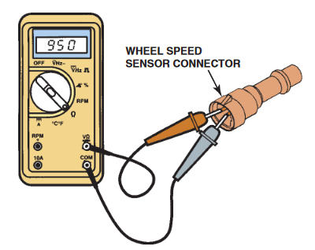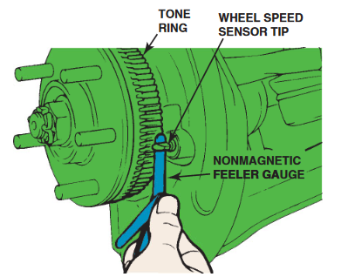

Operation Sheet 3.2
Operation title: Electronic Stability Control (ESC) diagnosis.
Purpose: To identify and resolve any issues or malfunctions within the ESC system of a vehicle. ESC, also known as Electronic Stability Program (ESP) or Vehicle Stability Control (VSC), is a safety feature designed to improve a vehicle's stability and prevent loss of control during various driving maneuvers.
Conditions or situations for the operations:
- Safe working area
- Properly operated tools and equipment
- Appropriate working cloths fit with the body
Equipment Tools and Materials:
- Diagnostic Scan Tool
- Multimeter
- Oscilloscope
- Wiring Diagrams and Technical Manuals
Quality Criteria: Assured performing of all the activities according to the procedures
Precautions:
- Wearing proper clothes and glove
- Make working area hazard free
- Read and interpret manual which guide you how to use tools and equipment
Steps in doing the task
- Verify the customer concern (complaint).
- Perform a thorough visual inspection
- Check service information
- Follow the diagnosis procedure
- Repair the fault.
- Perform road test.

Operation Sheet 3.3
Operation title: Cruise control diagnosis.
Purpose: To identify and resolve any issues or malfunctions within the cruise control system of a vehicle and maintaining the functionality, performance, and safety of the cruise control system.
Conditions or situations for the operations:
- Safe working area
- Properly operated tools and equipment
- Appropriate working cloths fit with the body
Equipment Tools and Materials:
- Diagnostic Scan Tool
- Multimeter
- Wiring Diagrams and Technical Manuals
Quality Criteria: Assured performing of all the activities according to the procedures
Precautions:
- Wearing proper clothes and glove
- Make working area hazard free
- Read and interpret manual which guide you how to use tools and equipment
Steps in doing the task
- Verify the customer concern (complaint).
- Perform a thorough visual inspection (loose wires, loose switches and other).
- Check service information
- Check the ignition supply voltage to the ECU
- Check the earth wire
- Check operation of the control and power switches (voltage same in and out).
- Check road speed sensor output – may be the same one for the speedometer is a good signal?
- Continuity of wiring to throttle actuator.
- Throttle actuator resistance or operation checks
- Perform road test on a secure wheel free ramp to check operation.

Operation Sheet 3.4
Operation title: Tire Pressure Control diagnosis.
Purpose: To identify and resolve any issues or malfunctions within the tire pressure monitoring system (TPMS) and to ensure tire safety, improve fuel efficiency, extend tire lifespan, maintain optimal vehicle performance and Enhance Safety of a vehicle.
Conditions or situations for the operations:
- Safe working area
- Properly operated tools and equipment
- Appropriate working cloths fit with the body
Equipment Tools and Materials:
- Diagnostic Scan Tool
- TPMS tester
- Digital tire-pressure gauge
- Tire valve core torque wrench
- Sensor service kit and Technical Manuals
Quality Criteria: Assured performing of all the activities according to the procedures
Precautions:
- Wearing proper clothes and glove
- Make working area hazard free
- Read and interpret manual which guide you how to use tools and equipment
Steps in doing the task
- Verify the customer concern (complaint).
- Perform a thorough visual inspection (damage, such as cuts, bulges, or punctures).
- Check service information
- Verify the fault.
- If the TPMS warning light is on but not flashing, this indicates that the system has detected a tire with low inflation pressure.
- If the TPMS warning light flashes, this indicates that the system has detected a fault. Check service information for the specified steps to follow.
- If the system has detected low tire pressure, check and adjust the tire pressure.
- Determine and correct the cause of the underinflated tire.
- Perform road test on a secure wheel free ramp to check operation.

LAP Test: 3
Practical Demonstration
Instruction: Perform the following tasks
Task 1: Perform visually inspection on vehicle safety system
Task 2: Check the operation of systems.
Task 3: Check operation of drive assist system
Task 4: Perform road test

Reference
- James D. Halderman Automotive Technology Principles, Diagnosis, and Service 4th Edition.
- Automotive Technology A Systems Approach.
- Automotive diagnosis/troubleshooting/
- Tom Denton Advanced automotive fault diagnosis automotive technology vehicle maintenance and repair.

Participants in this modules training material preparation

No | Name | Qualification | Field of Study | Organization/ Institution | Mobile number | E-mail
 | Fadli Aman | BSc. | Automotive Technology | General Wingate PTC | 0927283100 | Fadli.ziyad@gmail.com
 | Habtamu Deresso | PHD Candidate | Automotive Technology | ASTU | 0945853269 | habtamu.deresso@gmail.com
 | Israel Taye | MSc | Automotive Technology | General Wingate PTC | 0913424100 | isra.taye@gmail.com
 | Natnael Genene | MSc | Automotive Technology | Athlete kenenisa PTC | 0920397105 | natnealgenene143@gmail.com
 | Robsan Tesfaye | MSc | Automotive Technology | Burayu PTC | 0920117175 | robsantesfaye4@gmail.com
 | Sisay Tufa | MSc | Automotive Technology | M/G/M/Buli PTC | 0912065407 | knbntf@gmail.com
 | Tagay Tesfaye | MSc | Automotive Technology | Bishoftu PTC | 0975971391 | tagotagotago37@gmail.com

