
Automotive Electrical and Electronics
Level-IV


Based on October, 2023 Curriculum Version II

Module Title: Diagnosing Faults in HVAC Systems
Module code: EIS AEE4 M07 1023
Nominal duration: 40 Hours

Prepared by: Ministry of Labor and Skill

September, 2022
Addis Ababa, Ethiopia
Table of Contents
Acknowledgment 4
Acronym 5
Introduction to Module 6
Unit one: Fundamentals of Vehicle HVAC Diagnosis and Systems 7
1.1 Overview of HVAC Systems 8
1.1.1 Heating system 8
1.1.2 Ventilation system 10
1.1.3 Air conditioning system 10
1.2 Diagnosis 16
1.2.2 Diagnostic process 17
1.2.3 Diagnostic Techniques 18
1.3 Diagnostic tools and equipment for HVAC system 20
Self-check 1 23
Operation Sheet 1.1 25
Operation Sheet 1.2 26
LAP Test 1 28
Unit Two: Diagnosing HVAC system 29
2.1 HVAC Diagnosis procedure 30
2.2 Heating and ventilation fault diagnosis 32
2.3 Air conditioning fault diagnosis 33
Self-check 2 35
Operation Sheet 2 36
LAP Test 2 37
Unit Three: Servicing HVAC system component 38
3.1 Servicing Heating System 39
3.1.1 Heater Core Service 39
3.1.2 Heater Control Valve Service 41
3.1.3 Blower Motor Service 41
3.1.4 Heater and Defroster Duct Service 43
3.2 Ventilation Service 44
3.2.1 Cabin Air Filter Replacement 44
3.2.2 Duct Cleaning 44
3.2.3 Vent Mode Repair 44
3.2.4 Climate Sensor Replacement 44
3.3 Air Conditioning System Service 45
3.3.1 Refrigerant Recovery and Visual Inspection 45
3.3.2 System Preparation and Component Replacement 47
3.3.3 Refrigerant Recharge, Testing, and Final Inspection 48
Self-check 3 49
Operation Sheet 3.1 50
Operation Sheet 3.2 51
Operation Sheet 3.3 52
Operation Sheet 3.4 53
LAP Test: 3 54
Reference 55

Acknowledgment
The Ministry of Labor and skill wishes to thank and appreciation to MoLS leaders and experts, Regional Labor and skill/training Bureaus leader, experts, TVT College Deans, Instructors and industry experts who contribute their time and professional experience to the development of this Training Module.

Acronym
BCM Body Control Module
DMM Digital Multimeter
DTCs Diagnostic Trouble Codes
DVOM Digital Volt-Ohm Meter
ECU Engine Control Unit
HVAC Heating, Ventilation, and Air Conditioning
LAP Learning Activity Performance
MSDS Material Safety Data Sheets
OHS Occupational Health and Safety
PCM Powertrain Control Module
PWM Pulse Width Modulation
TSBs Technical Service Bulletins
UV Ultraviolet

Introduction to Module
This course delves into the intricate realm of diagnosing complex faults in vehicle air conditioning systems, encompassing Heating, Ventilation, Air Conditioning (HVAC) systems. The objective is to equip learners with the knowledge, skills, and the right attitude to identify and resolve a wide array of faults, which may span the mechanical, electrical, electronic, or hydraulic domains. The course not only paves the way for effective servicing, repair, replacement, or performance enhancement but also reinforces safety and best practices. Mastery of these competencies aligns with the industry's requirements, notably addressing the unit of competency: Diagnosing Faults in Air Conditioning and HVAC Systems
This module covers the units:
- Fundamentals of Vehicle HVAC Diagnosis and Systems
- Diagnosing HVAC system
- Servicing HVAC system component
Learning Objective of the Module
- Understand Vehicle HVAC Diagnosis and Systems
- Conduct Diagnosing HVAC System
- Service HVAC System Components
Module Instruction
For effective use this modules trainees are expected to follow the following module instruction:
- Read the information written in each unit
- Accomplish the Self-checks at the end of each unit
- Perform Operation Sheets which were provided at the end of units
- Do the “LAP test” giver at the end of each unit and
- Read the identified reference book for Examples and exercise

Unit one: Fundamentals of Vehicle HVAC Diagnosis and Systems
This unit is developed to provide you the necessary information regarding the following content coverage and topics:
- Overview of HVAC Systems
- Diagnosis
- Diagnostic tools and equipment for HVAC system
- OHS and Workplace Health and Safety Requirements
This unit will also assist you to attain the learning outcomes stated in the cover page. Specifically, upon completion of this learning guide, you will be able to:
- Gain an in-depth understanding of HVAC systems
- Recognize diagnosis
- Proficiently use diagnostic tools and equipment for HVAC systems
- Apply OHS and workplace health and safety

Overview of HVAC Systems
Heating, Ventilation, and Air Conditioning (HVAC) systems in vehicles are the essential components responsible for creating a comfortable and controlled environment within the cabin. These systems encompass ventilation, heating, and refrigeration, all working harmoniously to ensure passenger comfort and safety during various weather conditions.
Just as HVAC systems maintain a consistent temperature and humidity in homes and buildings throughout the year, they perform a similar role in vehicles. This consistency enables a comfortable driving experience regardless of external weather conditions. By regulating temperature and air quality, vehicle HVAC systems significantly contribute to making the journey pleasant for occupants.
In essence, vehicle HVAC systems play a pivotal role in enhancing the overall driving experience, ensuring that passengers remain comfortable and safe, regardless of the weather outside. This is achieved by efficiently controlling the temperature and air quality inside the vehicle's cabin, creating a controlled environment for passengers to enjoy their journey.

1.1.1 Heating system
Heating the vehicle interior involves harnessing heat from the engine. This is accomplished via a heat exchanger known as the heater matrix. Thanks to the thermostat in the engine cooling system, water temperature remains stable. As a result, the air passing over the heater matrix can be heated according to the outside temperature and airflow rate. Control over the amount of heat required is typically achieved using a blending technique, utilizing a control flap to determine the proportion of air directed over the heater matrix. However, it's important to note that the system's airflow can vary with vehicle speed.
Additional features include the ability to direct air of the desired temperature to specific areas of the vehicle interior. Typically, warm air can be adjusted between the windscreen, driver, and passenger foot wells. Most vehicles also offer vents for warm air to reach the driver's and front passenger's side windows. Additionally, there are outlets for fresh cool air with directional nozzles.
One valuable feature found in many vehicles is the choice between fresh or recirculated air. This is particularly useful for faster window defrosting and demisting, as well as quickly warming the car interior
Electronic Heating Control in Vehicles
Electronic heating control is a fundamental component of modern vehicle HVAC systems. While more complex air conditioning is typically integrated into these systems, a brief overview of electronic heating control provides a foundation for understanding these intricate setups.
Key Elements:
- Blower Motor Control: Electronic heating control regulates the blower motor, managing the airflow within the vehicle. This system allows for adjusting the fan speed to achieve the desired level of comfort.
- Blend Flap Control: The blend flap is essential for controlling the mixture of hot and cold air entering the cabin. Electronic systems enable precise adjustment of this flap to set the cabin temperature to the driver's and passengers' preference.
- Direction Flap Control: Direction flaps direct heated or cooled air to specific areas within the vehicle. Electronic control offers precise positioning of these flaps to ensure efficient distribution of air.
- Fresh or Recirculated Air Flap: Electronic heating control systems provide the flexibility to select between fresh outside air and recirculated cabin air. This feature serves multiple purposes, including quick defrosting of windows and maintaining cabin comfort, especially in areas with poor external air quality.
This electronic heating control system incorporates one or more temperature sensors strategically positioned inside the vehicle. These sensors collect data on the interior temperature and provide it to the Engine Control Unit (ECU). The ECU processes this information and adjusts the controls for the blower motor, blend flap, and direction flaps to achieve optimal comfort.
Essentially, this system operates as a closed-loop feedback system, with air temperature serving as the key feedback variable. The ECU continuously compares the temperature control switch's position with the data from the sensors, effectively cooling or heating the car interior as needed.
This foundational knowledge of electronic heating control is essential for understanding more intricate HVAC systems and is crucial for diagnosing and servicing these systems effectively.

Ventilation system
To ensure fresh air circulates inside the cabin, a pressure difference is essential. This is achieved using a plenum chamber, which maintains air pressure higher than the surroundings. Typically positioned beneath the windscreen, it's strategically designed to prevent water ingress. The plenum chamber acts as a reservoir, ensuring a consistent air supply, which is then directed as needed through distribution trunking, control flaps, and suitable nozzles. The efficiency of this system is further enhanced by incorporating a variable-speed blower motor.
Figure 1:1 Air ventilation grille

Air conditioning system
The air conditioning system operates in a continuous cycle, initiated by the compressor. The compressor's primary role is to draw in low-pressure vapor from the evaporator, compress it, and then release it as a superheated vapor under high pressure to the condenser. This results in a significant increase in the refrigerant's temperature, causing the release of heat through the condenser's fins. Subsequently, the refrigerant undergoes a phase change, returning to a liquid state.
The high-pressure liquid then progresses to the receiver drier, where any remaining vapor is stored, and a desiccant bag eliminates moisture or water contaminants. The refrigerant moves through the thermostatic expansion valve, transforming back into a low-pressure liquid as it passes through a valve restriction before entering the evaporator. This valve is a critical component, regulating the refrigerant flow and, consequently, the cooling capacity.
Within the evaporator, the liquid transforms into a gaseous state and absorbs heat from its surroundings. This process effectively cools the air passing over the evaporator's fins. The low-pressure vapor then returns to the compressor, completing the cycle. In cases of excessive refrigerant temperature, condenser cooling fans activate to enhance cooling, especially in warm conditions or during extended air conditioning use.
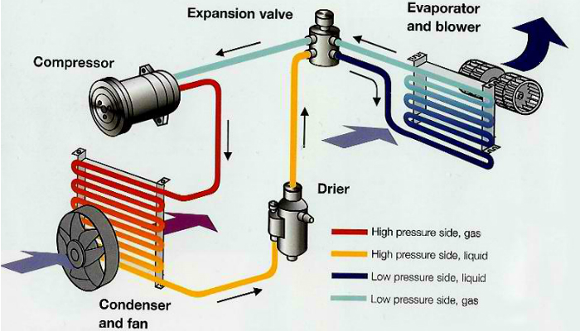
Most systems also incorporate a safety feature, the high-low pressure switch, situated on the high-pressure side. It acts as a safeguard, deactivating the compressor if pressures become too high due to a component fault or too low due to refrigerant leakage. This protective measure ensures the compressor's safety and the overall integrity of the air conditioning system.
Figure 1: 2 Air conditioning system
Typical Settings for Manual or Automatic Air-Conditioning Systems
The following are the typical settings for a manual or automatic air-conditioning system:
Heat
- Temperature set to the desired setting
- Air intake—select outside air (for faster heating, select recirculation for the first few minutes)
- Air conditioning set to off
- Set airflow to flow
- Fan speed to the desired speed
Air Conditioning
- Temperature set to the desired setting
- Air intake—set to outside air (for faster cooling, select recirculation for the first few minutes)
- Airflow—select dash vents (also called panel vents)
- Air conditioning set to on
- Fan speed set to the desired speed
Ventilation
- Temperature set to the lowest temperature
- Air intake—select outside air
- Airflow—set to dash (panel) vents
- Air conditioning set to off
- Fan speed set to the desired speed
Defogging or Defrosting the Inside of the Windshield
- Temperature set to a high temperature
- Air intake set to outside air
- Airflow set to windshield
- Fan speed set to the desired speed
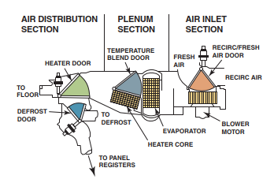

Figure 1:3 The three major portions of the A/C and heat system are air inlet, plenum, and air distribution. The shaded portions show the paths of the four control doors.

Automatic temperature control
Automatic temperature control systems offer a highly comfortable and customizable experience for maintaining the desired interior climate as per the passenger's preferences. These advanced systems grant the Electronic Control Unit (ECU) complete authority over various parameters, including fan speed, air distribution, air temperature, fresh or recirculated air, and air conditioning operation. As technology advances, these systems are on the brink of achieving automatic demisting and defrosting, pending the availability of reliable sensors. Presently, a single button press can set the system to full defrost or demist mode.
Components for Automatic Heating, Ventilation, and Air Conditioning (HVAC) Systems
All automatic heating, ventilation, and air-conditioning (HVAC) systems use a combination of the following components to control airflow into the passenger compartment:
- Vents
- Ducts
- Air doors (also called flap doors or valves)
The use of these components allows the system to provide airflow under the following conditions:
- Fresh outside air or recirculated air
- Air conditioning
- Defrost
- Heat
Sensors in Automatic Temperature Control (ATC) Systems
  - Outside Air Temperature (OAT) Sensor:
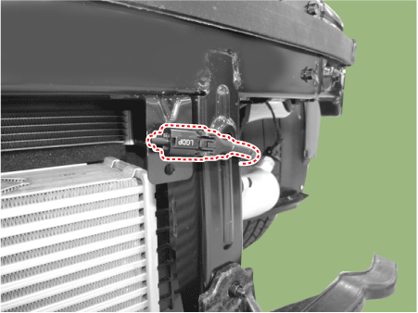
- Location: Usually located at the front of the vehicle behind the grille but in front of the radiator.
- Purpose: Detects the temperature of the outside air.
- Additional Function: Also provides temperature information for display to the driver.
Figure 1: 4 Outside Air Temperature Sensor:
- Note: Commonly referred to as the ambient air temperature sensor.
  - Inside Vehicle Temperature Sensor:
- Location: Often located behind the instrument panel.
- Function: Measures the temperature inside the vehicle.
- Airflow: Air is directed past the sensor using an aspirator tube, connected to the blower motor case.
  - Discharge Air Temperature Sensor:
- Location: Positioned at the outlet of the vents.
- Function: Informs the controller of the actual temperature at the discharge ducts.
  - Evaporator Outlet Temperature Sensor
- Purpose: Controls the AC compressor to maintain the evaporative temperature within the specified range for optimal operation.
  - Sun load Sensor:
- Location: Mounted on the top of the dashboard.
- Function: Adjusts the temperature and fan speed to compensate for increased heating through the windows caused by sunlight.
- Type: The most common type is a photo diode, which generates a voltage related to the amount of light received.
- Voltage Range: Typically varies from 0.3 volts (in shade) to 3.0 volts (in bright sunlight).
These sensors play a crucial role in the automatic control of the vehicle's interior climate, ensuring comfort and efficiency by continuously monitoring and responding to various environmental factors.
Actuators in Air-Conditioning Systems
Actuators are essential components in air-conditioning systems responsible for moving vanes or valves to control airflow. There are three main types of actuators commonly used:
- Dual-Position Actuator:
  - Function: A dual-position actuator can move a vane or valve either fully open or fully closed.
  - Example: The recirculation door in the system can be a dual-position actuator. It can be in two states: open (allowing the recirculation of air) or closed (blocking recirculation).
- Three-Position Actuator:
  - Function: A three-position actuator is designed to provide three distinct air door positions. It can control airflow to different areas of the vehicle's interior.
  - Example: The bi-level door is often controlled by a three-position actuator, enabling it to direct air for defrost only, floor only, or a mixture of both as needed.
- Variable-Position Actuator:
  - Function: Variable-position actuators are versatile and can position a valve or door at any point between fully open and fully closed. They offer precise control over airflow and temperature.
- Feedback Mechanism: These actuators utilize a feedback potentiometer that helps the system's controller detect the actual position of the door or valve. This feedback ensures accurate and continuous adjustment.
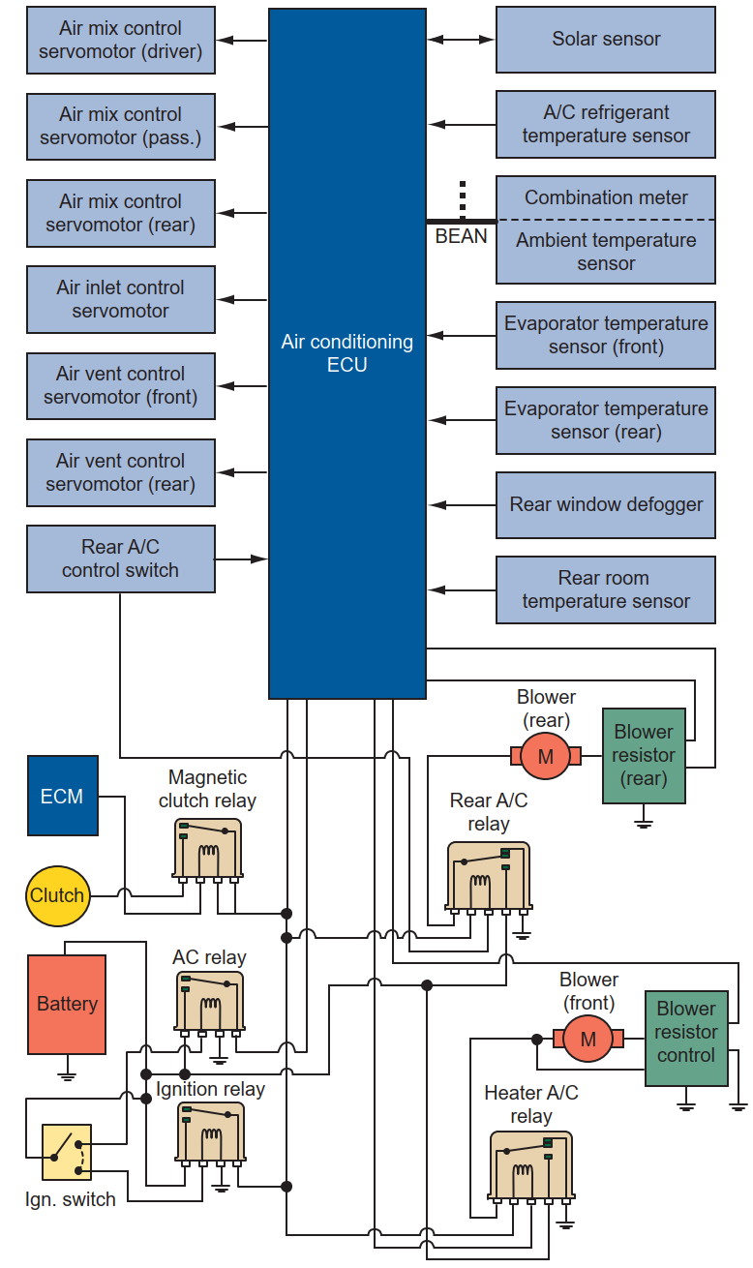
Figure 1: 5 The layout of a computer-controlled automatic climate control system.

Diagnosis
Diagnosis: Derived from the ancient Greek word 'δια′γνωσις,' meaning 'discernment,' 'diagnosis' pertains to the identification of the nature and cause of a given issue. This concept is employed across various disciplines, all of which utilize logic, analysis, and experience to establish cause-and-effect relationships. In the field of automotive, diagnosis is commonly employed to ascertain the underlying causes of a problem.
Diagnostics: The term is firmly rooted in the principle of the "four rights": measuring the correct parameters, employing the correct methods, at the correct moment, using the appropriate tools.
What is needed to find faults?
Finding the problem when complex automotive systems go wrong is easy if you have the necessary knowledge. This knowledge consists of two parts:
- An understanding of the system in which the problem exists;
- the ability to apply a logical diagnostic routine.
It is also important to be clear about these definitions:
- symptom(s) – what the user/operator/repairer of the system (vehicle or whatever) notices;
- fault(s) – the error(s) in the system that result in the symptom(s);
- root cause(s) – the cause(s) of the fault.
If a system is not operating to its optimum, then it should be repaired.
This is where diagnostic and other skills come into play. It is necessary to recognize that something is not operating correctly by applying your knowledge of the system, and then by applying this knowledge further and combining it with the skills of diagnostics to be able to find out the reason.

Diagnostic process
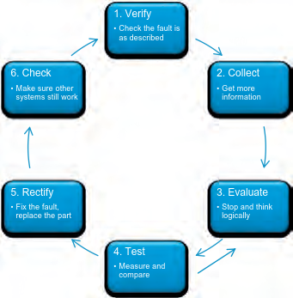
The Six-Stage Process
- Verification: Initiate the process by confirming whether there is indeed a problem, making sure to validate the observed symptoms

- Collection: Proceed by gathering further information about the issue through careful observation and research.
- Evaluation: Take a moment to consider and assess the information collected to form a clear understanding of the problem.
- Testing: Carry out a sequence of systematic tests to delve deeper into the issue and pinpoint the root cause.
Figure1:6 Six-stage diagnostic
- Rectification: Address and resolve the identified problem using appropriate techniques and tools.
- Verification: Finally, reconfirm that all systems are functioning correctly after rectifying the problem to ensure that no new issues have been introduced during the process.
This structured approach simplifies the diagnostic process and aids in achieving effective solutions.

Diagnostic Techniques
Diagnostic techniques related to vehicle HVAC (Heating, Ventilation, and Air Conditioning) systems:
- Visual Inspection: Visually inspecting HVAC components for any visible damage, such as loose hoses, broken vents, or damaged condenser fins.
- Measurement and Testing: Using gauges and thermometers to measure temperature and pressure at various points in the HVAC system to check for proper operation.
- Data Analysis: Analyzing data from onboard HVAC sensors and controls to identify anomalies or irregular system behavior.
- Fault Code Reading: Using diagnostic scan tools to retrieve diagnostic trouble codes (DTCs) from the HVAC control module, which can provide information about specific system malfunctions.
- Functional Testing: Testing the functionality of individual HVAC components, such as the blower motor, compressor, and actuators, to ensure they are working correctly.
- Cabin Air Quality Testing: Assessing the quality of the air inside the vehicle's cabin, including measuring the levels of pollutants, humidity, and temperature.
- Airflow Analysis: Checking the airflow through vents and ducts to ensure that the proper amount of air is being delivered to different areas of the vehicle.
- Thermal Imaging: Using thermal imaging cameras to identify temperature variations and potential blockages or malfunctions in the HVAC system.
- Refrigerant Pressure Testing: Measuring the pressure of the refrigerant in the air conditioning system to ensure it falls within the specified range.
- Evaporator and Condenser Inspection: Examining the evaporator and condenser coils for dirt, debris, or damage, which can impact cooling efficiency.
- Vacuum and Leak Testing: Testing for leaks in the HVAC system, particularly in the refrigerant lines, to identify and repair any leaks.
- Control Module Diagnostics: Diagnosing the HVAC control module for issues related to sensor inputs, actuators, or software-related problems.
These diagnostic techniques help identify and address problems in a vehicle's HVAC system, ensuring that it functions efficiently and provides the desired comfort and air quality for occupants.
Self-Diagnosis
Most climate control systems are computer controlled and have a self-diagnostic feature. Manufacturers’ specifications must be followed to identify the malfunction display codes, because they differ from car to car. To check the system, refer to the service manual and determine if the automatic climate control system relies on the PCM, BCM, or a separate computer for control.
If the unit is part of the PCM/BCM system, connect the scan tool and retrieve any codes that may be present. If the unit is controlled by its own computer system, use your service manual and the procedure for retrieving trouble codes. If the system is a semiautomatic system, check the service manual for the proper diagnostic procedures for checking evaporator and heating controls. Test the components or subsystems identified by the trouble codes.
The DTCs from the system can lead a technician to the following problems:
- An open or short in the air mix control motor circuit
- A problem with the air mix control linkage, door, or motor circuit
- An open or short in the mode control circuit
- A problem with the mode control linkage, doors, or motor circuit
- A problem in the blower motor circuit
- A problem with the HVAC control unit
- An open or short in the evaporator temperature sensor circuit

Diagnostic tools and equipment for HVAC system
Scan tool: This diagnostic tool is used to perform system testing; to monitor cooling sensor operation; to command air door actuators when testing low heat concerns; and to read diagnostic trouble codes (DTCs) related to cooling system operation
Figure 1: 7 Scan tool

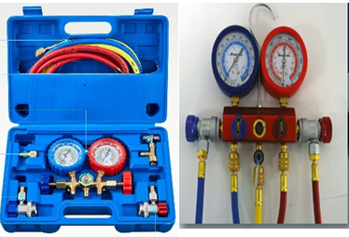
Manifold and gauge sets
Diagnostic tools used for measuring and monitoring refrigerant pressure in automotive HVAC systems. They provide real-time pressure readings on both the high and low sides of the system, helping technicians diagnose issues, ensure proper refrigerant levels, and pinpoint HVAC system problems.
Figure 1: 8 Manifold and gauge sets

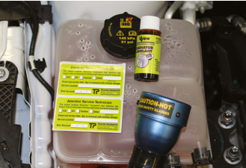
Coolant dye kit: This special dye is added to aid leak detection by adding to the coolant system and using an ultraviolet (UV) light source (black light) to trace the source of the leak; the dye glows fluorescent when an UV light is shined on it
Figure 1: 1 Manifold Gauge set
Figure 1: 9 Coolant dye kit
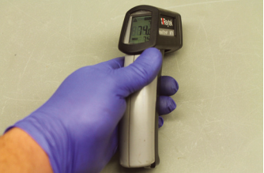
Infrared temperature sensor: A non-contact thermometer is used to check actual temperatures and variations of temperature throughout the cooling system, to help pinpoint faulty parts and system blockages
Figure 1: 10 Infrared temperature sensor:
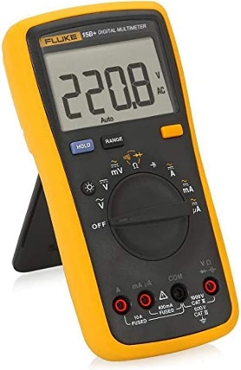
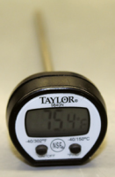
Thermometer: A tool that measures the temperature of air exiting the heating ducts

DVOM: A digital volt-ohmmeter (DVOM) is a measuring device that can be used to test for electrical problems such as cooling fan and temperature gauge issues
Figure 1: 11 Thermometer , DVOM

  - OHS and Workplace Health and Safety Requirements
Key Procedures for WHS and OHS Compliance
- Risk Assessment: Before starting any diagnostic work, conduct a thorough risk assessment of the work environment. Identify potential hazards associated with electrical systems, refrigerants, moving parts, and working at heights, among others.
- Personal Protective Equipment (PPE): Ensure that technicians wear appropriate PPE, including safety goggles, gloves, hearing protection, and, in some cases, respiratory protection when dealing with refrigerants or contaminants in the HVAC system.
- Safe Work Practices: Train technicians in safe work practices, emphasizing the importance of following established procedures and using the right tools and equipment.
- Proper Ventilation: When working on HVAC systems containing refrigerants, ensure that the workspace is adequately ventilated to prevent exposure to harmful fumes.
- Isolation Procedures: Prior to working on the system, isolate the power supply to prevent electrical hazards. Lockout/tag out procedures should be followed when servicing electrical components.
- Emergency Procedures: Technicians should be aware of emergency procedures, including the location of emergency exits, first aid kits, eyewash stations, and fire extinguishers.
- Training and Certification: Ensure that technicians are appropriately trained and certified to handle refrigerants and work on HVAC systems. Compliance with industry standards, such as EPA 608 for refrigerant handling, is crucial.
- Lifting and Handling: Use proper lifting techniques to prevent strains and musculoskeletal injuries when handling heavy equipment or components.
- Regular Maintenance: Maintain tools and equipment in good working condition to minimize the risk of accidents caused by faulty equipment.
- Documentation: Maintain detailed records of work conducted, including any identified faults, repairs, and maintenance procedures, as this can be essential for tracking safety and compliance.
- Material Safety Data Sheets (MSDS): Ensure that technicians have access to MSDS for any chemicals or refrigerants they may come into contact with during diagnostic procedures.
- Consultation: Encourage open communication among the team to address any safety concerns and promote a safety culture in the workplace.
- Reporting: Establish clear reporting procedures for any accidents, incidents, or near-misses to investigate the causes and implement corrective measures.
- Environmental Considerations: Comply with environmental regulations related to refrigerant recovery, recycling, or disposal.
- Workplace Ergonomics: Ensure workstations and equipment are ergonomically designed to minimize the risk of repetitive strain injuries.
This comprehensive approach to safety and compliance ensures that diagnostic work on HVAC systems is conducted safely, protecting the health and well-being of technicians and others in the vicinity. Staying current with industry standards is vital to maintaining a safe working environment.

Self-check 1
Directions: Answer all the questions listed below.
Part I: Fill in the blank space
- Heating the vehicle interior involves harnessing heat from the _______.
- Electronic heating control regulates the _______ to manage the airflow within the vehicle.
- To ensure fresh air circulates inside the cabin, a _______ is essential.
- The air conditioning system operates in a continuous cycle, initiated by the _______.
- The diagnostic process consists of six stages, with the first stage being _______
Part-II: Choose the correct answer from the given alternatives
  - hat is the purpose of the receiver drier in the air conditioning system?
a) To release heat b) To store remaining vapor
c) To compress refrigerant d) To control airflow
  - Which of the following components are unique to automatic HVAC systems?
a) Manual temperature control knobs b) Fan speed dials
c) Digital temperature displays d) Vent control levers
  - What do HVAC temperature sensors provide to the Engine Control Unit (ECU)?
a) Information on vehicle speed b) Interior temperature data
c) Airflow direction d) Ambient temperature readings
  - In the diagnostic process, which stage involves addressing and resolving the identified problem?
a) Verification b) Collection c) Evaluation d) Rectification
  - What is the main purpose of a manifold and gauge set in HVAC diagnosis?
a) To analyze air quality b) To check the airflow
c) To measure refrigerant pressure d) To test the blower motor

Part-III: Answer the following questions accordingly.
- Explain the operation of the air conditioning system in a vehicle
- Describe the key elements of electronic heating control in modern vehicle HVAC systems and how they contribute to a comfortable cabin environment.
- Outline the six-stage diagnostic process and the significance of each stage when diagnosing faults in automotive HVAC systems.
- Discuss the diagnostic techniques used for vehicle HVAC systems, emphasizing the importance of self-diagnosis and the role of trouble codes.
- Provide an overview of the workplace health and safety (WHS) and occupational health and safety (OHS) requirements when diagnosing HVAC systems in vehicles, and explain why these precautions are crucial for technicians' well-being.

Operation Sheet 1.1
Operation Title: Accessing DTCs Using a Scan Tool
Purpose: To retrieve diagnostic information and diagnose issues in the vehicle's Body Control Module (BCM).
Conditions for the Operation:
- Safe working area.
- Properly operated tools and equipment.
- Appropriate working attire, including safety glasses and gloves.
Equipment, Tools, and Materials:
- Scan tool.
- Vehicle equipped with BCM.
Quality Criteria: Ensure accurate retrieval and recording of all DTCs for diagnostic purposes.
Precautions:
- Wear proper clothing, safety glasses, and gloves.
- Make the working area hazard-free.
- Consult and follow the manual that provides guidance on using the scan tool.
Procedure:
- Refer to the service information to determine whether and how to retrieve diagnostic information from the Body Control Module (BCM).
- Connect the scan tool to the vehicle's diagnostic port.
- Turn the ignition switch to the "on" position, without starting the engine.
- Program the scan tool to the specific vehicle make and model.
- From the scan tool menu, select the BCM (Body Control Module) as the target system.
- Retrieve and record all Diagnostic Trouble Codes (DTCs) stored in the BCM.
- To observe the activity of inputs and outputs, select the "DATA" function on the scan tool. Pay special attention to data points that fall outside their normal operating range, such as ambient temperature, evaporator temperature, and low- and high-side pressures.
- Diagnose any abnormal operating parameters and identify potential issues in the BCM system.
- Turn the ignition switch off.
- Safely disconnect the scan tool from the diagnostic port.

Operation Sheet 1.2
Operation Title: Identifying HVAC Components and Understanding Working Principles
Purpose: To recognize and comprehend the fundamental components of Heating, Ventilation, and Air Conditioning (HVAC) systems and grasp the working principles of both automatic and manual HVAC systems in vehicles.
Conditions for the Operation:
- Safe working area.
- Properly operated tools and equipment.
- Appropriate working attire, including safety glasses and gloves.
- Access to a vehicle equipped with an HVAC system.
Equipment, Tools, and Materials:
- Vehicle with HVAC system.
- Reference material or service manual for HVAC systems.
Quality Criteria: Successful recognition and understanding of key HVAC components and their working principles.
Precautions:
- Wear proper clothing, safety glasses, and gloves.
- Make the working area hazard-free.
- Handle HVAC system components with care to avoid damage.
- Ensure the vehicle is safely parked with the engine off during the operation.
Procedure:
- Introduction to HVAC Components
  - Review reference material or service manual to understand the basic components of HVAC systems. Familiarize yourself with components like the blower motor, evaporator, condenser, compressor, refrigerant lines, thermostat, air ducts, and control panel.
- Manual HVAC System Components
  - Identify components specific to manual HVAC systems, such as manual temperature control knobs, fan speed dials, and vent control levers. Note their locations and functions.

- Automatic HVAC System Components
  - Recognize components unique to automatic HVAC systems, including digital temperature displays, climate control modules, and sensors. Understand how these components work together for automated climate control.
- Working Principle of Manual HVAC Systems
  - Learn the working principle of manual HVAC systems, where the driver adjusts settings like temperature and fan speed directly. Understand how air is directed to various vents and how the blower motor's speed affects airflow.
- Working Principle of Automatic HVAC Systems
  - Explore the operation of automatic HVAC systems, where sensors and controls manage climate settings. Understand how temperature sensors, climate control modules, and actuators work in unison to maintain desired cabin conditions.
- Hands-On Identification
  - Open the vehicle's hood and locate the main HVAC components like the compressor, condenser, and evaporator. Identify their positions within the engine compartment.
- Inside the Vehicle
  - Sit inside the vehicle and locate the control panel for the HVAC system. Identify the different controls, whether manual knobs or digital displays, and understand their functions.
- Discussion
  - Engage in a discussion or Q&A session to clarify any questions or concerns regarding HVAC components and working principles.
- Conclusion
  - Summarize the key points of component identification and working principles of both manual and automatic HVAC systems.
This operation sheet provides a structured approach to familiarizing yourself with HVAC components and the underlying principles of manual and automatic HVAC systems in vehicles.

LAP Test 1
Practical Demonstration
Instruction: Perform the following tasks
Task 1: Perform HVAC DTCs using a scan tool
Task 2: Describe HVAC components and principles.

Unit Two: Diagnosing HVAC system
This unit is developed to provide you the necessary information regarding the following content coverage and topics:
- Diagnosis procedure
- Heating and ventilation fault diagnosis
- Air conditioning fault diagnosis
This guide will also assist you to attain the learning outcomes stated in the cover page. Specifically, upon completion of this learning guide, you will be able to:
- Comprehend the diagnosis procedure
- Execute heating and ventilation fault diagnosis
- Perform air conditioning fault diagnosis

2.1 HVAC Diagnosis procedure
Diagnosing a heating and air-conditioning system problem in a vehicle, it is essential to follow a systematic approach. Here are the recommended steps:
Step 1: Verify the Customer Complaint (Concern)
- Verify the customer's reported issue. Sometimes, customers may not fully understand how the system is supposed to work or may not describe the problem clearly.
- Ensure that the problem has been corrected after the service procedure has been performed.
Step 2: Do a Thorough Visual Inspection
- Conduct a visual inspection of all system components. Look for any visible faults, damage due to accidents, or damage from road debris.
- Visual inspection may reveal obvious issues that can be addressed.
Step 3: Check for Diagnostic Trouble Codes (DTCs)
- Use diagnostic tools to check for Diagnostic Trouble Codes in the vehicle's heating and air-conditioning system.
- Many modern systems are computer-controlled and set DTCs in the event of component failure, which can provide valuable diagnostic information.
Step 4: Check for Related Technical Service Bulletins (TSBs)
- Research if there are any related Technical Service Bulletins (TSBs) released by the vehicle manufacturer to address known issues.
- TSBs can provide valuable guidance on solving specific problems, saving time and effort in diagnosis.
Step 5: Determine the Root Cause
- Identify and address the root cause of the problem. For example, if the refrigerant level is low, it indicates a system leak. Finding and repairing the source of the leak is addressing the root cause.
Step 6: Verify the Repair
- After making the necessary repairs or adjustments, test the vehicle under conditions similar to those that led to the customer's complaint.
- Confirm that the concern has been resolved and that the system is now functioning correctly.
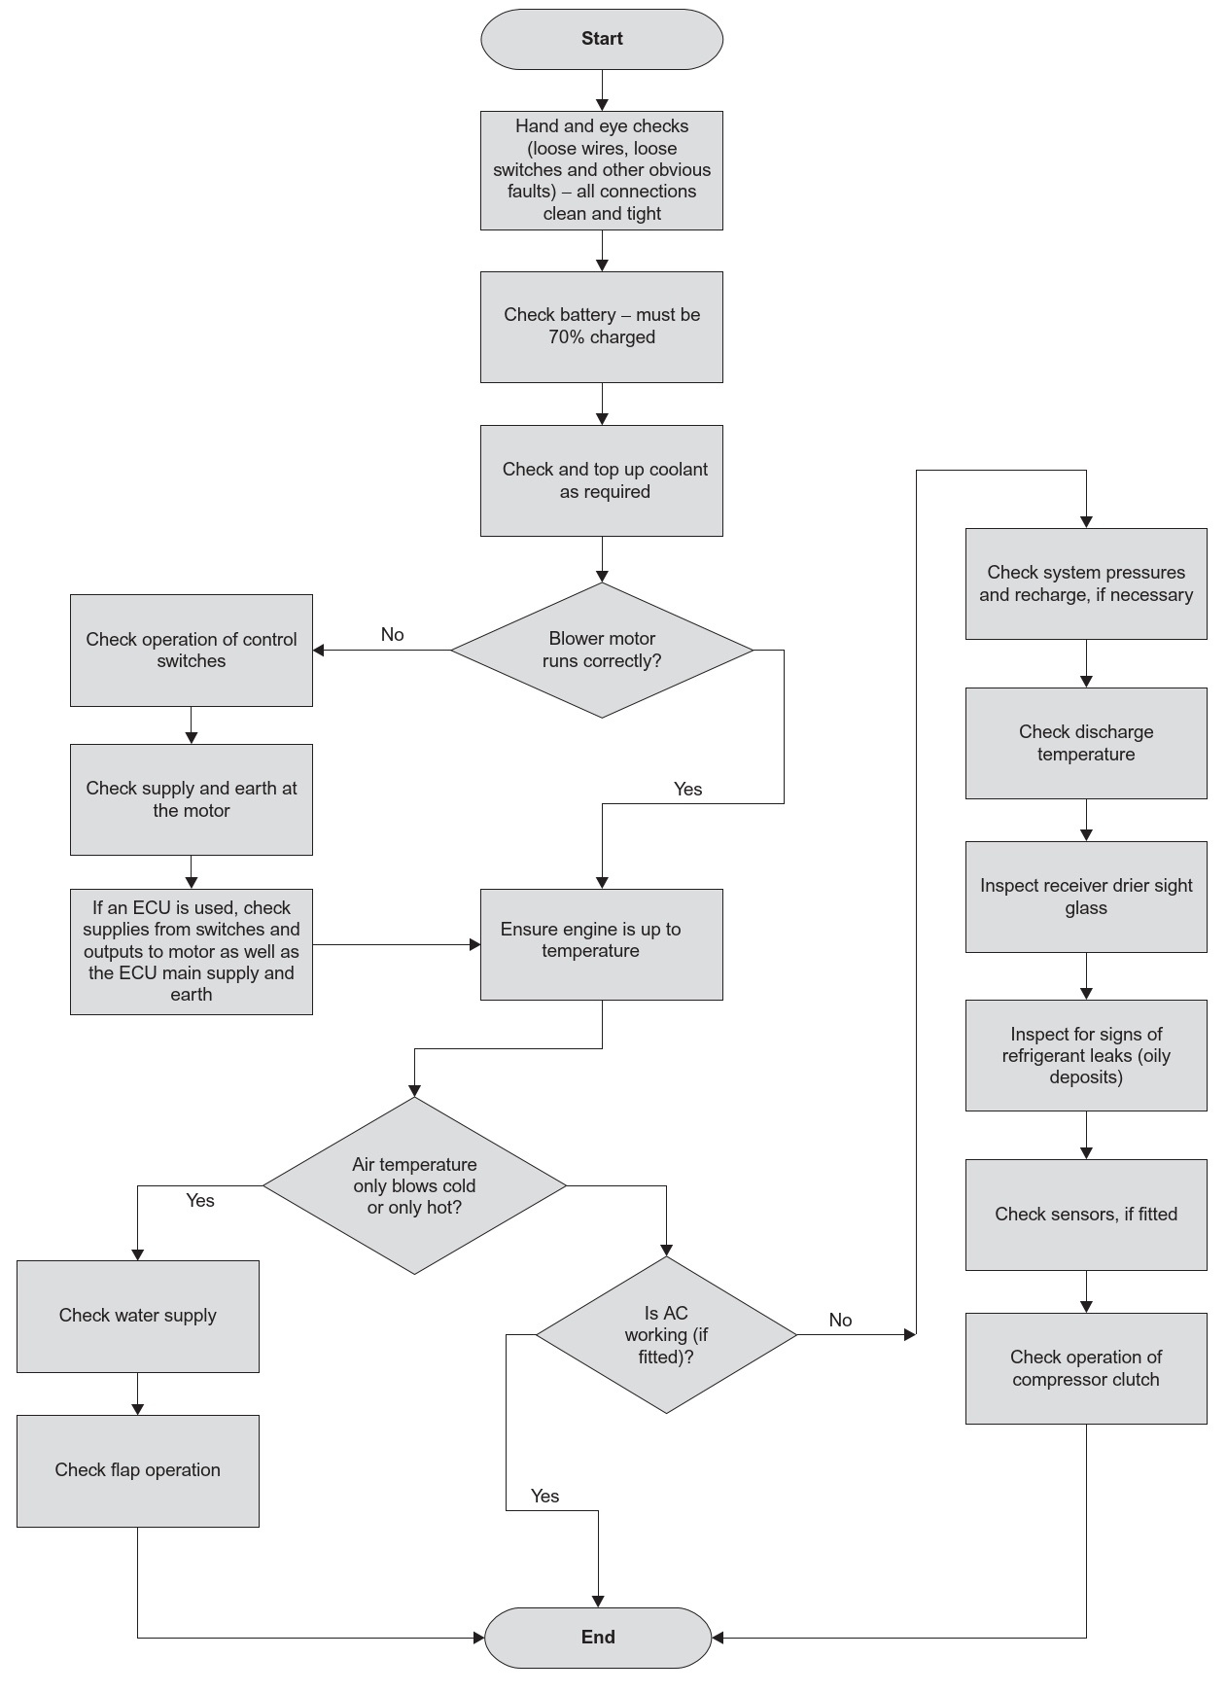

Figure 2: 1 HVAC system diagnosis chart

2.2 Heating and ventilation fault diagnosis
Heating and ventilation fault diagnosis involves identifying and resolving issues with a vehicle's HVAC system that affect heating, ventilation, and air conditioning. This process is crucial for maintaining a comfortable cabin environment and ensuring the system operates efficiently. Key steps in heating and ventilation fault diagnosis include:
- Symptom Recognition: Begin by identifying symptoms reported by the vehicle owner or driver, such as inadequate heating, poor ventilation, unusual odors, or abnormal noises.
- Visual Inspection: Inspect the HVAC system components, including the blower motor, air ducts, vents, and associated wiring, for visible damage, blockages, or loose connections.
- Temperature and Airflow Testing: Measure and test the temperature of air exiting the heating ducts and the airflow through the vents. Ensure that the system provides the desired temperature and airflow.
- HVAC Control Panel Examination: Test the controls on the HVAC panel, such as temperature knobs, fan speed settings, and vent direction, to check for proper operation.
- Diagnostic Trouble Codes (DTCs): Use a diagnostic scan tool to retrieve DTCs from the HVAC control module. These codes can provide insights into specific system malfunctions.
- Component Testing: Test individual HVAC components, such as the blower motor, heater core, evaporator, actuators, and sensors, to ensure they are functioning correctly.
- Cabin Air Quality Assessment: Check for cabin air quality issues, including measuring pollutant levels, humidity, and temperature, to identify sources of discomfort or odors.
- Check Refrigerant Levels: For air conditioning-related faults, assess the refrigerant levels in the A/C system using manifold gauge sets to verify if they fall within the specified range.
- Inspect Ducts and Vents: Examine air ducts and vents for blockages, dirt, or debris that could obstruct airflow.
- Leak Detection: If there is a suspicion of refrigerant leaks, use a coolant dye kit and an ultraviolet (UV) light source to detect and trace the source of any leaks.
- Self-Diagnosis and Control Module Testing: Utilize self-diagnostic features in some HVAC systems to identify malfunctions. Additionally, assess the HVAC control module for issues related to sensor inputs or software problems.
- Solution Implementation: Based on the diagnosis results, perform necessary repairs or component replacements to rectify identified faults.
By following these steps, technicians can systematically identify and address faults within the heating and ventilation components of a vehicle's HVAC system, ensuring a comfortable and safe cabin environment.

2.3 Air conditioning fault diagnosis
When diagnosing faults in a vehicle's air conditioning system, the process unfolds systematically to ensure optimal performance and passenger comfort. It begins with recognizing symptoms reported by the vehicle owner or driver, which might include issues like insufficient cooling, unusual noises, odors, or airflow problems. Following symptom recognition, a visual inspection of the air conditioning system components is conducted, looking for any visible damage, blockages, or leaks. This close examination covers key parts such as the compressor, condenser, evaporator, refrigerant lines, and associated wiring.
In parallel, manifold and gauge sets are employed to measure and monitor the refrigerant pressure within the A/C system. The pressure should fall within the specified range to ensure effective cooling. Additionally, a diagnostic scan tool is used to retrieve Diagnostic Trouble Codes (DTCs) from the A/C control module. These codes provide valuable insights into specific system malfunctions.
The diagnostic process extends to testing the temperature of air exiting the A/C vents and assessing the airflow. This step ensures that the system delivers the desired cooling and airflow. Individual A/C components, including the compressor, expansion valve, blower motor, and temperature sensors, are rigorously tested to verify their proper functioning.
Another aspect of diagnosis focuses on inspecting the condenser and evaporator coils. Here, technicians look for dirt, debris, or damage that might impede the system's cooling efficiency. A coolant dye kit combined with an ultraviolet (UV) light source helps in detecting and tracing potential refrigerant leaks.
In some A/C systems, self-diagnostic features can be used to identify malfunctions. The A/C control module is also examined for any issues related to sensor inputs or software problems. The electrical components of the A/C system, including relays and fuses, are tested to ensure their functionality.
Further checks are performed to detect and repair refrigerant leaks, particularly in refrigerant lines. Once the diagnosis process is complete, necessary repairs or component replacements are implemented to rectify identified A/C system faults. This methodical approach ensures that the air conditioning system operates efficiently, providing optimal cooling and creating a pleasant cabin environment for vehicle occupants, especially during warm weather.
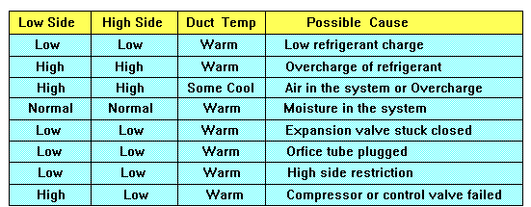
Air condition diagnosis chart
Figure 2: 2 Air condition diagnosis chart

Self-check 2
Directions: Answer all the questions listed below.

Part-I: Say True of False the following statements
- HVAC diagnosis typically begins with verifying the customer's reported issue.
- Visual inspection of system components can reveal obvious issues in a vehicle's HVAC system.
- Technical Service Bulletins (TSBs) are used to address unknown issues in HVAC systems.
- The purpose of measuring and testing the temperature of air exiting the heating ducts is to assess cabin air quality.
Part II: Choose the correct answer from the given alternatives
1. What are Technical Service Bulletins (TSBs) used for?
a) Conduct visual inspections
b) Identify root causes
c) Address known issues and provide guidance
d) Test the vehicle under conditions similar to customer complaints
2. In heating and ventilation fault diagnosis, what is the purpose of measuring and testing the temperature of air exiting the heating ducts and airflow through the vents?
a) To check for proper operation of the HVAC control panel
b) To verify that the system provides the desired temperature and airflow
c) To test individual HVAC components
d) To assess cabin air quality
3. What does a diagnostic scan tool retrieve in the air conditioning system diagnosis?
a) HVAC control module codes b) Temperature sensor data
c) Self-diagnostic features d) Refrigerant levels
4. What is the purpose of a coolant dye kit and an ultraviolet (UV) light source in air conditioning fault diagnosis?
a) To measure and monitor refrigerant pressure
b) To check for proper operation of the HVAC control panel
c) To identify and trace potential refrigerant leaks
d) To assess cabin air quality

Operation Sheet 2
Operation Title: HVAC Diagnosis
Purpose: Diagnose and address vehicle heating and air-conditioning system problems.
Conditions:
- Safe working area.
- Proper tools and equipment.
- Suitable work attire.
Tools and Materials:
- Diagnostic tools.
- Visual inspection tools.
- Diagnostic scan tool.
- TSB reference.
- Refrigerant testing equipment.
Quality Criteria: Assured performing of all the activities according to the procedures
Precautions:
- Wearing proper clothes, eye glass, glove
- Make working area hazard free
- Read and interpret manual which guide you how to use tools and equipment
Steps in doing the task
1. Verify Customer Complaint
- Confirm the issue and ensure it's fixed post-service.
2. Visual Inspection
- Examine components for visible faults or damage.
3. Check for Diagnostic Trouble Codes (DTCs)
- Use diagnostic tools to scan for DTCs.
4. Check TSBs
- Research TSBs for known issues.
5. Determine Root Cause
- Identify and fix the core problem.
6. Verify Repair
- Test the vehicle under original conditions and ensure the issue is resolved.

LAP Test 2
Practical Demonstration
Instruction: Perform the following tasks
Task 1 Diagnose heating and ventilation system fault.
Task 2 Diagnose the fault in the air conditioning system.

Unit Three: Servicing HVAC system component
This learning guide is developed to provide you the necessary information regarding the following content coverage and topics:
- Servicing Heating System
- Ventilation System Service
- Air Conditioning System Service
This guide will also assist you to attain the learning outcomes stated in the cover page. Specifically, upon completion of this learning guide, you will be able to:
- Service the Heating System
- Perform Ventilation System Service
- Conduct Air Conditioning System Service

3.1 Servicing Heating System
When doing system checks and services, always follow the procedures recommended by the manufacturer. In most cases, problems with the heating system are problems with the engine’s cooling system. Therefore, most service work and diagnosis are done to the cooling system. Problems that pertain specifically to the heater are few, these being the heater control valve and the heater core. Most often if these two items are faulty, the engine’s cooling system will be negatively affected. Both of these items are replaced rather than repaired. Some problems will pertain only to the heater controls. In some cases, it is possible to make repairs to vacuum hose and electrical connections without removing the heater assembly. If it is necessary to remove the heater assembly, the cooling system must be drained before removing the heater core.

3.1.1 Heater Core Service
Several factors can contribute to heater core failure, including age, corrosion, coolant issues, and other problems such as a faulty thermostat or a clogged radiator. These issues can lead to complete heater core failure. Like radiators, the heater core's tanks, tubes, and fins can become clogged over time due to rust, scale, and mineral deposits carried by the coolant.
Debris circulating through the system can act like a sandblaster, causing internal damage and leaks. To check for blockages, feel the heater inlet and outlet hoses while the engine is idling and the heater temperature control is set to hot. If the downstream hose of the heater valve doesn't feel hot, it likely means the valve isn't opening.
If the heater core seems blocked, the inlet hose may feel hot up to the core, but the outlet hose remains cool. While reverse flushing the core with a power flusher might clear the blockage, in most cases, the core needs to be removed for thorough cleaning or replacement. Air pockets in the heater core can also disrupt proper coolant circulation. These pockets form when the coolant level is low or when the cooling system isn't adequately refilled after draining.
Repairing or replacing a leaking heater core can be a challenging and time-consuming task, mainly due to its location deep within the car's bulkhead. Always perform a leak test on a replacement heater core before installation, and don't forget to flush the cooling system and replace the coolant.

Typically, the heater core is located beneath the dashboard. Replacing the core may necessitate evacuating the A/C system, as both the core and evaporator are housed in the same unit. Before starting the replacement process, carefully review the service information to understand the disassembly requirements.
In some vehicles, replacing the heater core is more straightforward. To remove it, take off the access panel(s), drain the coolant, and disconnect the heater hoses from the core. To prevent fluid from leaking onto the vehicle's carpet, place shop rags or towels under the core. Unbolt the core, remove it, and ensure nothing is damaged during the removal. The process of installing a new heater core follows the reverse steps of removal.
When replacing the heater core, inspect the heater hoses and replace them if necessary. Most heater hoses are molded to specific shapes and must be replaced with hoses of the same size and shape. Using bulk heater hose may cause kinking if bent to fit, which can reduce flow through the core. Since heater hoses can be challenging to access and remove from the core, many technicians prefer cutting the old hoses at the pipe connections and then replacing them.

For PTC heaters, you can check their condition by measuring the resistance of the heating element. If the resistance doesn't meet the specifications, replace the assembly.
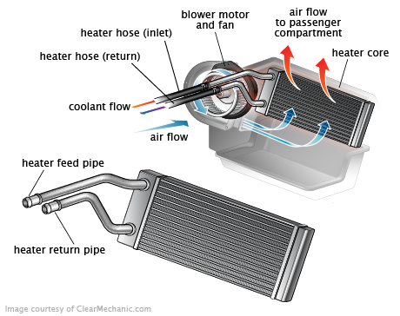
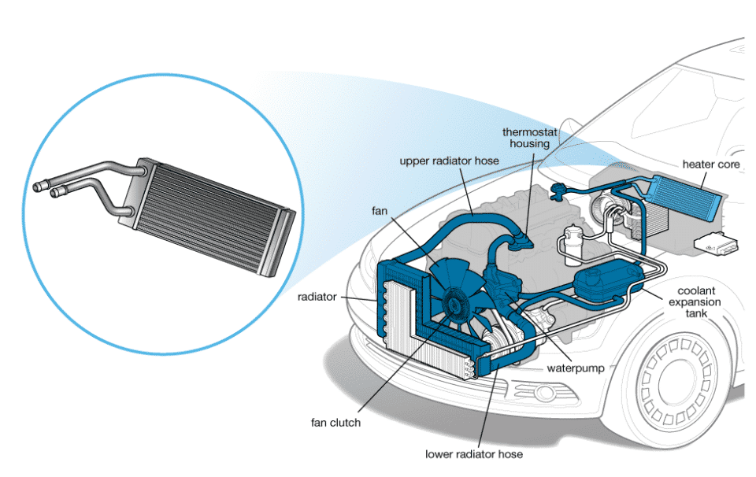
Figure 3:1 Heater Core Location

Heater Control Valve Service
When there is a problem with the control valve, it is typically caused by the controls or the valve itself. When the valve is bad, it should be replaced. If the heater control valve or its controls prevent the valve from opening all the way, heating will be reduced in the passenger compartment. If the valve does not completely close, the compartment will not cool properly when the A/C is turned on.
With cable-operated control valves, check the cable for sticking, slipping (loose mounting bracket), or mis-adjustment. With valves that are vacuum operated, there should be no vacuum to the valve when the heater is on (except for those that are normally closed and need vacuum to open.

Blower Motor Service
If the blower motor does not operate, use a DMM to make sure there is voltage on both sides of the fuse. Then check to see if there is voltage and ground at the motor. Some systems supply constant power and vary the ground while others ground the motor and vary the voltage If the system uses a PWM motor, connect a scan tool and check for DTCs and try to control the blower with the scan tool. You may need to connect a meter or scope to the fan’s wiring to determine if the fan control circuit is operating.
For non-PWM blower motors, if the blower motor is getting voltage and has a good ground, the problem is a burned-out blower motor. If voltage is present but the motor does not run, ground the motor to check if it operates. If the motor now works, the problem is likely an open resistor or switch. In situations where no voltage is available at the motor, backtrack to check for an open resistor, switch, or relay. Check for proper relay operation and for burned or corroded connections at the blower relays or in the bulkhead connectors. Carefully inspect all wiring and connectors in the fan circuit. A faulty connection can overheat, melting the plastic and damaging the connector and terminals.
As the blower motor ages and/or debris accumulates in the blower housing, blower motor speed can be reduced. This can cause the motor to increase its current draw. Excessive current draw by the motor can then cause burned resistors and damaged connections. Many technicians measure blower motor current draw whenever replacing a blower resistor and compare the reading to specs or against similar vehicles. If the motor is drawing more current than specified, it should be replaced
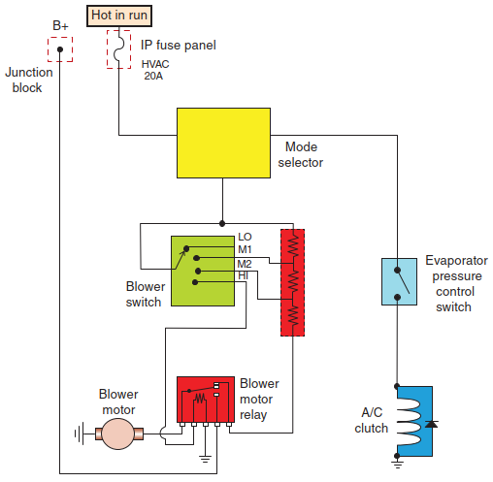
Figure 3:2 Blower motor circuit
- Blower Motor and Construction: If the blower motor is faulty, it may require replacement. If the issue is due to a defective blower motor resistor, check that the current draw of the blower motor falls within factory specifications.
- Relays and Switches: Test switches and relays for proper operation and replace them if needed, adhering to the vehicle manufacturer's recommended procedures.
- Mechanical, Electrical, and Vacuum Components: Repair electrical wiring or terminals as necessary, following recommended service information. If a component is found to be defective, adhere to the manufacturer's recommended replacement procedures.

Heater and Defroster Duct Service
If the blower motor runs but no air comes out of the ducts, the problem is either a stuck or an inoperative airflow control valve or blend door or plugged cabin filter. This can also affect the operation of the defrosters. These doors may be cable, electrically, or vacuum operated. To further diagnose the problem, change the position of the temperature selector knob, sliding it from hot to cold. If you do not hear the sound of doors opening and closing, it means the control cables have slipped loose from the dash switch or door arm, which can sometimes occur, rendering the door inoperative. If this is the case, you will feel little or no resistance when sliding the temperature control knob. A kinked or rusted cable can also prevent a door from working. If this is the case, you will feel resistance when trying to move the control knob. In either case, it is necessary to get under the dash, find the cable, and then replace, reroute, or reconnect it. Doors can also be jammed by objects that have fallen down the defroster ducts. Remove the obstruction from the plenum by fishing through the heater outlet with a coat hanger or magnet, or remove the plenum. Be careful when fishing for the obstruction; some heater cores are easily pierced.
Most current HVAC systems use electric servomotors to move the various doors. Each motor is fitted with a potentiometer that sends a signal to the A/C control unit regarding the actual position of the door. If the actual position is not the same as the commanded position, most systems will set a DTC, indicating that the door is not working properly. Before proceeding with detailed diagnostics of the electrical system, make sure there are no linkage problems or that the door is not physically stuck. Normally, if the problem is electrical, the A/C control unit, servomotor, or wiring harness is faulty.
With vacuum-controlled doors, the most common causes of failure are leaky or loose vacuum hoses or defective diaphragms in the vacuum motors that move the doors. Check the vacuum by starting the engine and disconnecting the hose that goes to one of the door’s vacuum motor. If you feel a vacuum or hear a hissing sound when trying different temperature settings, the vacuum source is good. Apply vacuum to the motor with a hand-held pump; if it moves and holds vacuum for about 1 minute then bleeds off, the problem is a bad vacuum motor. If it does not, check for leaky vacuum hose connections, a defective temperature control switch, or a leaky vacuum reservoir or check valve under the dash or in the engine compartment.

Ventilation system Service
Ventilation systems primarily focus on airflow and air quality without direct heating or cooling. Here are some ventilation system services:

Cabin Air Filter Replacement
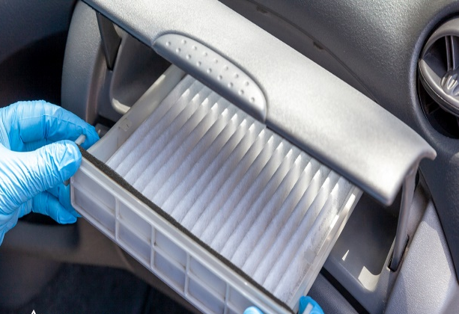
The cabin air filter is a critical component for ensuring clean air within the vehicle cabin. Over time, it can become clogged with dust, pollen, and other particles. Regular replacement, typically recommended every 12,000 to 15,000 miles, is essential for maintaining good air quality. A clean cabin air filter allows for the free flow of fresh outside air into the cabin and prevents contaminants from entering.
Figure 3:3 Cabin Air filter

Duct Cleaning
Air ducts and vents in the HVAC system can accumulate dust, debris, and even mold over time. Cleaning these components is essential for maintaining good airflow and air quality. Duct cleaning involves using specialized tools to remove contaminants, ensuring that air can flow freely through the system and into the cabin. Clean ducts also reduce the risk of unpleasant odors in the cabin.

Vent Mode Repair
Vent modes determine how and where air is directed in the cabin, such as defrosting the windshield, directing air to the floor, or distributing it through dash vents. If the vent modes are not working correctly, you may experience airflow issues. Repairing and calibrating these modes ensures that air is distributed where it's needed for optimal comfort and safety.

Climate Sensor Replacement
Climate sensors are essential for modern HVAC systems with automatic climate control. These sensors detect factors like temperature, humidity, and sunlight to adjust the HVAC settings. Replacing faulty sensors is crucial for maintaining consistent ventilation and cabin comfort. Proper ventilation prevents extreme temperatures or uncomfortable conditions inside the vehicle.
By addressing these ventilation system services, car owners can ensure that their HVAC system provides fresh, clean air and optimal airflow, contributing to a comfortable and healthy driving experience. Regular maintenance helps prevent issues with air quality, cabin comfort, and airflow distribution.

Air Conditioning System Service

3.3.1 Refrigerant Recovery and Visual Inspection
The process begins with the recovery of refrigerant from the system using an approved recovery/recycling machine. This environmentally responsible step prevents the release of refrigerant into the atmosphere, protecting our surroundings. Simultaneously, a visual inspection of the entire air conditioning system takes place. Technicians meticulously examine all components for visible damage, leaks, loose connections, and other issues. Identifying any visible problems is crucial before proceeding.
Steps Involved in Air Conditioning System Service:
- Compressor Clutch Inspection and Adjustment:
  - The compressor clutch is vital for controlling refrigerant circulation.
  - Technicians inspect it for wear, damage, and signs of slippage.
  - The gap between the clutch and pulley is checked for proper specifications.
  - Adjustments are made to ensure the clutch operates efficiently, which is crucial for the system's overall performance.
- Belt and Tensioner Inspection:
  - The drive belt powers the compressor and its clutch.
  - Technicians examine the belt for wear, cracking, and stretching.
  - The belt tensioner is inspected to ensure it maintains the right tension on the belt.
  - Proper tension is essential to prevent slippage and ensure the compressor operates correctly.
- Electrical System and Wiring Check:
  - Technicians meticulously inspect all electrical connections, wires, and switches related to the air conditioning system.
  - Any loose or damaged connections are repaired or replaced to ensure a reliable electrical supply.
  - A stable electrical system is vital for efficient air conditioning operation.
- Refrigerant Level and Performance Testing:
  - Technicians check the refrigerant level to ensure it falls within the recommended range.
  - The system's cooling performance is evaluated, including vent temperatures and air distribution.
  - Adjustments are made to achieve optimal cooling efficiency.
  - This step guarantees that the air conditioning system provides a comfortable cabin environment, especially on hot days.
Compressor Service
Compressor Drive Belt:
- Always check the compressor drive belt(s) whenever servicing the air-conditioning system and replace them as needed.
- If there are missing chunks from the belt ribs or pieces of rubber embedded in the pulleys, it can lead to noise that is often mistaken as a problem with the compressor.
Compressor Clutch Service:
- If the compressor clutch has been slipping, it may appear blue, indicating excessive heat damage. This could be a sign of wear and tear on the clutch components.
Condenser Service
- Inspect the condenser for airflow restriction and clean it as necessary.
- Sometimes, a "fin comb" may be required to straighten the fins of the condenser if they have been bent by road debris.
- If replacement is necessary, determine the quantity of oil that may be trapped in the old unit so that the correct amount can be added to the system after installing the new condenser.
Receiver/Drier or Accumulator/Drier Service
- Experts recommend replacing the receiver/drier or accumulator/drier whenever the refrigerant system is opened, and other repairs or services are being performed.
- Before replacing the receiver/drier or accumulator/drier, determine the quantity of refrigerant oil to ensure the proper amount is added to the system during recharging.
- Always adhere to the vehicle manufacturer's recommended service and repair procedures.

Orifice Tube/Expansion Valve Service
- If the orifice tube is found to be clogged or the expansion valve is determined to be malfunctioning, they will need to be replaced.
- Follow the vehicle manufacturer's recommended replacement procedures and adhere to all safety precautions when working with these components.
Evaporator Service
- If the evaporator is tested and found to be clogged or leaking, it must be replaced.
- Replacing the evaporator is a major job in most vehicles and often involves disassembling the dashboard.
- Proper maintenance and service of these components are essential for the efficient and reliable operation of the vehicle's air-conditioning system, ensuring that it functions as intended and providing a comfortable interior climate for the occupants.

3.3.2 System Preparation and Component Replacement
After refrigerant recovery and inspection, the system is meticulously prepared:
- Vacuuming eliminates any remaining refrigerant and air, ensuring a contamination-free system ready for recharging.
- The system undergoes a pressurization test using nitrogen or a suitable gas, with the aid of UV dye or electronic leak detectors. Detecting and addressing leaks is crucial for system efficiency.
- Additionally, at this stage, the oil in the compressor is drained, measured, and replaced if contaminated. Technicians also inspect the compressor for visible damage or unusual noises.
Critical Component Replacement and System Reassembly:
- Key components, such as the receiver-dryer or accumulator, which are responsible for removing moisture and contaminants, are replaced.
- All O-rings at connection points are replaced to prevent refrigerant leaks, and new O-rings are lubricated with clean refrigerant oil before installation.
- System components that were disconnected during servicing are carefully reconnected, with precise attention to fitting torques to prevent any potential leaks.
Following these steps ensures your vehicle's air conditioning system operates efficiently, maintaining a comfortable cabin environment. Regular servicing helps prevent issues like compressor clutch problems, belt wear, electrical faults, and refrigerant-related performance concerns. It is also essential to adhere to recommended guidelines and environmental regulations for refrigerant handling and disposal to protect both the system's performance and the environment.

3.3.3 Refrigerant Recharge, Testing, and Final Inspection
After reassembly, the correct type and amount of refrigerant are added to the system, as specified in the vehicle's service information. A refrigerant charging machine is employed to ensure accurate recharging. The system's performance is then tested, checking for proper cooling, vent temperature, and air distribution. Adjustments are made if necessary to achieve the desired cabin temperature. The final step involves conducting a leak test to verify that the system is free of leaks, preventing refrigerant from escaping into the environment. A comprehensive visual inspection is performed to ensure all components are securely connected, and there are no visible issues.
This four-part guide to air conditioning system service ensures that your vehicle's cooling system operates efficiently, providing a comfortable and cool cabin environment even on the hottest days. Regular maintenance and servicing help prevent issues, such as poor cooling performance, refrigerant leaks, or compressor damage. It's essential to adhere to safety and environmental regulations when handling refrigerants.

Self-check 3
Directions: Answer all the questions listed below.

Part I: Choose the appropriate answer from the given alternatives.
- What is the purpose of vacuuming the air conditioning system during servicing?
a) To cool the cabin b) To test electrical components
c) To remove remaining refrigerant and air d) To lubricate the compressor
- Why is a pressurization test using nitrogen or a suitable gas performed on the air conditioning system?
a) To create a pleasant aroma b) To recharge the refrigerant
c) To check for leaks d) To reduce system pressure
- What is the primary reason for replacing the receiver-dryer or accumulator during air conditioning system service?
a) To improve cabin air quality b) To prevent electrical faults
c) To remove moisture and contaminants d) To enhance engine performance
- Why are all O-rings at connection points replaced during servicing?
a) To make the system more colorful b) To prevent refrigerant leaks
c) To create a better scent d) To increase engine efficiency
- What is the final step in air conditioning system service?
a) Adding refrigerant to the system b) Reconnecting electrical components
c) Cleaning the cabin air filter d) Changing the engine oil
Part II: Fill in the Blank Space
- The ___________________ examination of the air conditioning system is crucial to identify any visible problems before proceeding with service.
- Proper tension in the drive belt is essential to prevent _________________ and ensure the compressor operates correctly.
- One of the key components replaced during air conditioning system service is the ___________________, responsible for removing moisture and contaminants.
- All O-rings at connection points are replaced to prevent _________________ within the system.
- Conducting a leak test after service ensures that the air conditioning system is free of leaks, preventing _________________ from escaping into the environment.

Operation Sheet 3.1
Operation Title: Replacing cabin air filter
Purpose: Replace cabin air filter in an automotive air conditioning system.
Conditions or situations for the operations:
- Safe working area.
- Properly operated tools and equipment.
- Appropriate working attire, including safety glasses and gloves.
Equipment Tools and Materials:
  - Flat and Phillips head screwdrivers
  - Spare rag for cleaning
  - Small vacuum for dust removal
Quality Criteria: Successful removal and installation of the compressor, ensuring a functioning air conditioning system.
Precautions:
- Wear proper clothing, safety glasses, and gloves.
- Ensure the working area is hazard-free.
Steps in doing the task
Step 1: Find the Correct Filter
Step 2: Gather Tools
Step 3: Locate the Filter
Step 4: Remove Dashboard Panel (if applicable)
- Using screwdrivers, remove screws and pop out the panel if the filter is located behind the dashboard.
Step 5: Remove Glove Compartment (if needed)
- For certain models (e.g., Subaru Outback, Forester, and Honda Accord), follow specific instructions to remove the glove compartment.
Step 6: Extract the Filter Housing
- Unfasten clips or screws to release the filter housing unit. Clean the area and housing to eliminate dust.
Step 7: Replace the Filter
- Remove the old filter and insert the new one, ensuring it's the correct fit. Then, reassemble the glove compartment and dash panel following the reverse of the removal steps.
Following these steps simplifies the process of changing your cabin air filter.

Operation Sheet 3.2
Operation Title: Compressor Service
Purpose: Remove and install a compressor in an automotive A/C system.
Conditions or situations for the operations:
- Safe working area.
- Properly operated tools and equipment.
- Appropriate working attire, including safety glasses and gloves.
Equipment Tools and Materials:
- Set of wrenches and sockets.
- Recovery/recycling machine.
- Replacement compressor.
Quality Criteria: Successful removal and installation of the compressor, ensuring a functioning air conditioning system.
Precautions:
- Wear proper clothing, safety glasses, and gloves.
- Ensure the working area is hazard-free.
Steps in doing the task
- Disconnect electrical connections.
- Discharge the A/C system.
- Disconnect refrigerant lines, cap the ends.
- Remove the drive belt.
- Loosen and remove compressor brackets.
- Take out the old compressor.
- Install the new compressor, tension the drive belt. Complete the operation for an efficient A/C system.
Completing this operation effectively ensures the removal and replacement of compressor in an automotive air conditioning system, contributing to the system's efficient performance and optimal cooling capabilities.

Operation Sheet 3.3
Operation Title: Evaporator Replacement
Purpose: To remove the old evaporator and install a new one in the vehicle's A/C system.
Conditions: Safe working area, proper tools, equipment, and safety gear.
Tools and Materials: • Approved recovery/recycling equipment for refrigerant.
• Wrenches and sockets. • Graduated container for oil drainage. • New evaporator unit.
• Refrigerant oil. • O-rings. • Receiver-dryer/accumulator or desiccant bag.
Quality Criteria: Successful replacement of the evaporator, restoring proper A/C function.
Precautions: Ensure safety and avoid environmental contamination. Wear appropriate safety gear.
Steps:
- Use approved equipment to recover refrigerant.
- Disconnect the negative battery cable if required.
- Drain engine coolant if the evaporator and heater core are combined.
- Label and disconnect all electrical connectors, cables, and vacuum hoses attached to the evaporator.
- Disconnect refrigerant hoses at the evaporator and cap the hose ends.
- Unbolt and remove the old evaporator.
- Drain evaporator oil into a graduated container and record the amount.
- Inspect the drained oil for contamination; replace the accumulator or receiver/dryer if necessary.
- Add the same amount of new refrigerant oil as removed, or the specified amount in service information, to the new evaporator.
- Lubricate new O-rings for the evaporator and line fittings with clean refrigerant oil.
- Install the new evaporator and tighten fittings. Also, install a new receiver-dryer/accumulator or its desiccant bag.
- Immediately evacuate the system.
- Reinstall and reconnect all parts, wires, cables, and vacuum hoses removed during disassembly. Add coolant if needed.
- Reconnect the negative battery cable.
- Evacuate and recharge the system.
- Perform a leak test and address any issues detected.
Ensure a well-functioning A/C system after completing these steps.

Operation Sheet 3.4
Operation Title: Fabrication of Replacement A/C Pressure Hose
Purpose: Create a replacement A/C pressure hose.
Conditions or situations for the operations:
- Safe working area.
- Properly operated tools and equipment.
- Appropriate working attire, including safety glasses and gloves.
Equipment Tools and Materials:
- Measuring tool
- Razor blade
- Clean refrigerant oil
- Ferrule
- Fitting
- Crimping tool
Quality Criteria: Successful removal and installation of the compressor, ensuring a functioning air conditioning system.
Precautions:
- Wear proper clothing, safety glasses, and gloves.
- Ensure the working area is hazard-free.
Steps in doing the task
- Measure and mark the required hose length.
- Cut the hose to the desired length.
- Apply refrigerant oil inside the hose.
- Install the ferrule.
- Inspect the fitting for damage.
- Coat the fitting with refrigerant oil and insert it.
- Crimp the ferrule securely.
Completion: Fabricate a functional replacement A/C pressure hose with safety precautions.

LAP Test: 3 Practical Demonstration
Instruction: Perform the following tasks
Task 1: Service the ventilation and heating system.
Task 2: Service Air conditioning system

Reference

- Joseph Wagner, Automotive Heating, Ventilation, and Air Conditioning, 2019, automotive technician series
- Jack Erjavec, Automotive Technology: a systems approach, 5 t h Edition, 2010 Delmar, Cengage Learning
- Advanced Automotive Fault Diagnosis Third Edition
- James D. Haldeman, Automotive technology Principles, Diagnosis, and Service fourth edition
- Crouse, W.H. and Anglin D.L, Auto motive mechanics 10th edition
- Nunney, M. J.Rutledge, 2007, Light and Heavy Vehicle Technology 4th ed.

Participants in this modules training material preparation
No | Name | Qualification (Level) | Field of Study | Organization/ Institution | Mobile Number | E-mail
1. | Fadli Aman | BSc. | Automotive Technology | General Wingate PTC | 0927283100 | Fadli.ziyad@gmail.com
2. | Habtamu Deresso | PHD Candidate | Automotive Technology | ASTU | 0945853269 | habtamu.deresso@astu.edu.et
3. | Israel Taye | MSC | Automotive Technology | General Wingate PTC | 0913424100 | isra.taye@gmail.com
4. | Natnael Genene | MSC | Automotive Technology | Athlete kenenisa PTC | 0920397105 | natnealgenene143@gmail.com
5. | Robsan Tesfaye | MSC | Automotive Technology | Burayu PTC | 0920117175 | robsantesfaye4@gmail.com
6. | Sisay Tufa | MSC | Automotive Technology | M/G/M/Buli | 0912065407 | knbntf@gmail.com
7. | Tagay Tesfaye | MSC | Automotive Technology | Bishoftu PTC | 0975971391 | tagotagotago37@gmail.com

