
Automotive Electricity and Electronics
Level-III
Based on October, 2023 Curriculum Version II
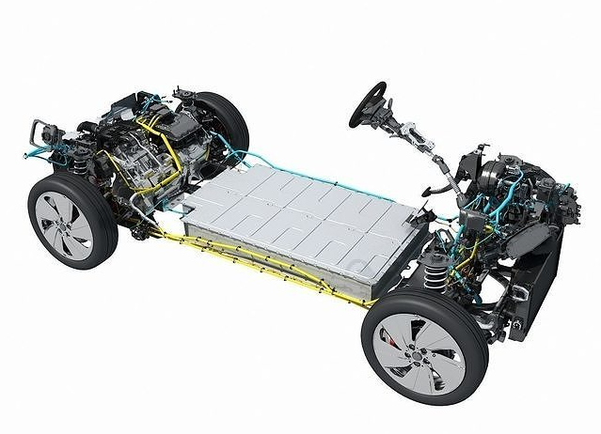
Module Title: - Diagnosing Faults in Under Chassis Management Systems
Module code: EIS AEE4 M04 1023
Nominal duration: 60 Hours
Prepared by: Ministry of Labor and Skill
October, 2023
Addis Ababa, Ethiopia

Table of Contents
Acknowledgment 4
Acronym 5
Introduction to module 6
Unit one: Overview of Electronic Under Chassis System 7
1.1 Workplace Health and Safety requirements 8
1.1.1 Hazard identification 8
1.2 Types and functions of under chassis management systems 10
1.2.1 Antilock brake system 10
ABS components 13
1.2.2 Integrated stability control system 20
1.2.3 Electronically Controlled Power Steering Systems 27
1.3 Identifying and confirming Effects of system faults 31
1.4 Testing and diagnosis equipment 34
Unit Two: Diagnosis Air Suspension System and Balance Adjustment 50
2.1 Identifying and selecting diagnostic methods and diagnostic process 51
2.2 Testing process 52
2.2.1 Electronic & Electrical system 52
2.2.2 Hydraulic systems testing 56
2.2.3 Mechanical systems testing 56
2.2.4 Axle alignment checks 57
2.2.5 On-road braking efficiency testing 58
2.3 Adjusting air suspension balance 59
2.4 Identifying causes of unbalanced air suspension 61
Unit Three: Diagnostic Under Chassis Management Systems 62
3.1 Selecting diagnostic processes 63
3.1.1 Analyzing manufacturer specifications 63
3.1.2 Six-step troubleshooting plan 63
3.1.3 Discover-investigate-fix methodology 68
3.2 Carrying out diagnostic under chassis management systems 69
3.2.1 Electronic braking systems 69
3.2.2 Electronic stability control systems 70
3.2.4 Electrical and Mechanical systems 77
Self- Check -1 84
Self-check-2 85
Lap Test 86
Reference 87

Acknowledgment
The Ministry of Labor and skill wishes to thank and appreciation to MoLS leaders and experts, Regional Labor and skill/training Bureaus leader, experts, TVT College Deans, Instructors and industry experts who contribute their time and professional experience to the development of this Training Module.

Acronym
ECM | Electronic control module
ESC | Electronic stability control
ECU | Electronic control unit
DMM | Digital multi meter
WHS | Workplace Health and Safety
EPS | Electric Power Steering
DTC | Data trouble code
OBD | On-board diagnosis
LAP | Learning Activity Performance
PPS | Personal Protective Equipment
OHS | Occupational Health Safety
TCS | Traction control system
MSDS | Material Safety Data Sheets
LED | Light Emitted Diode
TTLM | Teaching, Training and Learning Materials
ABS | Anti lock brake system

Introduction to module
Diagnosing electronic controlled under chassis systems is a complex task that requires a systematic approach and a solid understanding of the underlying technology. These systems, commonly found in modern vehicles, play a crucial role in ensuring optimal performance, safety, and comfort. They encompass various components such as electronic stability control, antilock braking systems, traction control, and suspension control, among others.
This process aims to pinpoint the root cause of the problem accurately, enabling technicians to undertake effective repairs and restore the system's functionality. This module is designed to meet the industry requirement under the Automotive Electrical and Electronics occupational standard, Level -IV particularly for the unit of competency: Diagnosing Under Chassis Management Systems
This module covers the units:
- Understanding electronic under chassis systems
- Diagnosing air suspension system
- Diagnosing under chassis management systems
Learning Objective of the Module
- Understand electronic under chassis systems
- Diagnose air suspension system
- Diagnosing under chassis management systems
Module Instruction
For effective use these modules trainees are expected to follow the following module instruction:
- Read the information written in each unit
- Accomplish the Self-checks at the end of each unit
- Perform Operation Sheets which were provided at the end of units
- Do the “LAP test” giver at the end of each unit and
- Read the identified reference book for Examples and exercise

Unit one: Overview of Electronic Under Chassis System
This unit is developed to provide you the necessary information regarding the following content coverage and topics
  - Workplace Health and Safety requirements
  - Types and functions of under chassis management systems
  - Identifying and confirming Effects of system faults
  - Testing and diagnosis equipment
This unit will also assist you to attain the learning outcomes stated in the cover page. Specifically, upon completion of this learning guide, you will be able to:
  - Perform Workplace Health and Safety requirements
  - Describe Types and functions of under chassis management systems
  - Identify and confirming Effects of system faults
  - Test and diagnosis equipment

Overview of Electronic Under Chassis system and Diagnosis
Electronic controlled vehicle under chassis systems refer to a collection of electronic systems and components that are responsible for controlling various aspects of a vehicle's chassis and suspension. These systems utilize electronic sensors, actuators, and control modules to monitor and adjust the vehicle's ride, handling, and braking characteristics in real-time, thereby enhancing safety, comfort, and performance. Under chassis system includes systems like; Anti-lock Braking System, Electronic Stability Control, Traction Control System ( TCS ), Active Suspension Systems, Adaptive Damping Control, Active Roll Control, and Electric Power Steering (EPS).

1.1 Workplace Health and Safety requirements
Workplace Health and Safety (WHS) is of utmost importance in the automotive service industry to ensure the safety and well-being of workers. As automotive service facilities can present various hazards, implementing effective WHS practices is essential. Here are some key considerations for WHS in the automotive service industry:

1.1.1 Hazard identification
Conduct a comprehensive assessment of the workplace to identify potential hazards specific to automotive service environments. This may include risks associated with heavy machinery, vehicle lifts, electrical systems, hazardous substances (e.g., oils, fuels, solvents), and ergonomic factors (e.g., repetitive tasks, awkward postures). Regular inspections should be conducted to identify new hazards or changes in existing hazards.
Safe work practices
Establish and communicate clear and safe work practices to employees. This includes procedures for vehicle maintenance, repair tasks, use of tools and equipment, and safe handling of hazardous substances. Encourage adherence to safety protocols, such as wearing appropriate personal protective equipment (PPE) like gloves, safety glasses, and hearing protection.

Equipment and machinery safety
Ensure that all equipment and machinery used in the automotive service facility are properly maintained, inspected, and in good working condition. Implement lockout/tag out procedures to control hazardous energy sources during maintenance or repair work, and provide training to employees on the safe operation of equipment and machinery.
Chemical management
Proper management of hazardous substances used in automotive service, such as oils, fuels, cleaners, and solvents, is crucial. Maintain a register of hazardous substances, provide Material Safety Data Sheets (MSDS) for each substance, and ensure their safe storage, handling, and disposal. Implement spill response procedures and provide appropriate spill kits to handle chemical spills.
Ergonomics
Address ergonomic hazards to minimize the risk of musculoskeletal disorders (MSDs) among workers. Provide ergonomic training to employees and implement measures to improve workstation design, use of lifting aids, and rotation of tasks to reduce repetitive strain and awkward postures.
Training and Education
Develop a comprehensive training program that covers WHS policies, procedures, and safe work practices. Include training on hazard identification, risk assessment, proper use of equipment, handling of hazardous substances, and emergency response. Regularly update training to reflect changes in regulations or work processes.
Incident Reporting and Investigation
Establish a system for reporting and investigating incidents, accidents, near misses, and injuries. Encourage employees to report any incidents promptly, investigate the root causes, and take corrective actions to prevent similar incidents in the future. Maintain records of incidents and use them for continuous improvement.

Consultation and Participation
Involve workers in WHS matters by establishing safety committees or regular safety meetings. Encourage workers to provide feedback, suggestions, and concerns related to WHS. This promotes a culture of safety and fosters a collaborative approach to addressing hazards and improving safety practices.
Compliance and Audits
Regularly review WHS practices, conduct internal audits, and ensure compliance with relevant WHS regulations and standards. Stay updated on industry best practices and technological advancements that can enhance safety in the automotive service industry.
Generally, by prioritizing WHS in the automotive service industry, employers can create a safer work environment, reduce workplace injuries and illnesses, improve productivity, and demonstrate their commitment to the well-being of their employees.

1.2 Types and functions of under chassis management systems
Nowadays electronic under chassis system utilizes different types of system to enhance safety comfort for the users and some of them are as discussed below.

1.2.1 Antilock brake system
The reason for the development of the antilock brake system (ABS) is very simple. Under braking conditions, if one or more of the vehicle wheels locks (begins to skid), then this has a number of consequences:
- Braking distance increases;
- Steering control is lost;
- Tire wear is abnormal.
The obvious consequence is that an accident is far more likely to occur. The maximum deceleration of a vehicle is achieved when maximum energy conversion is taking place in the brake system. This is the conversion of kinetic energy to heat energy at the discs and brake drums. The potential for this conversion process when a tire skids, even on a dry road, is far less. A good driver can pump the brakes on and off to prevent locking but electronic control can achieve even better results.
ABS is becoming more common on lower price vehicles, which should be a contribution to safety. It is important to remember, however, that for normal use, the system is not intended to allow faster driving and shorter braking distances.
It should be viewed as operating in an emergency only. Figure shows how ABS can help to maintain steering control even under very heavy braking conditions.
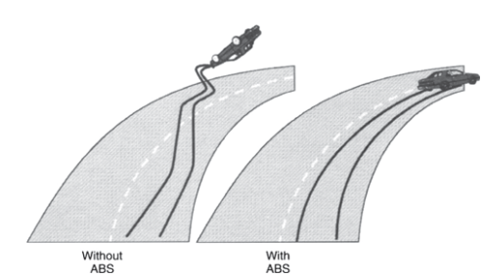
Figure 1.1 Comparison of vehicle without ABS and with ABS
Requirements of ABS
A good way of considering the operation of a complicated system is to ask, ‘What must the system be able to do?’ In other words, ‘What are the requirements?’ These can be considered for ABS under the following headings. A number of different types of antilock brake systems are in use, but all operate to achieve the requirements as set out in the following table.

Table ABS Requirements
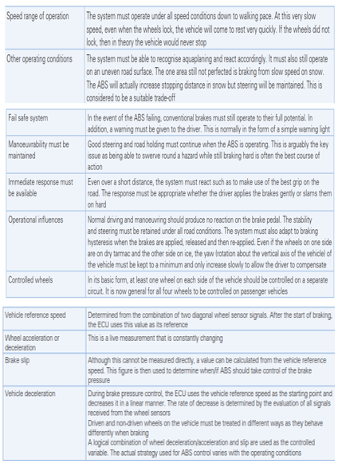

General system description
As with other systems, ABS can be considered as a central control unit with a series of inputs and outputs. The most important of the inputs are the wheel speed sensors and the main output is some form of brake system pressure control.
The task of the control unit is to compare signals from each wheel sensor to measure the acceleration or deceleration of an individual wheel. From this data and pre-programmed look-up tables, brake pressure to one or more of the wheels can be regulated. Brake pressure can be reduced, held constant or allowed to increase. The maximum pressure is determined by the driver’s pressure on the brake pedal.
ABS components
Basic components that are common to all antilock brake systems include the following.
- Wheel speed sensors
- Electronic control unit
- ABS warning lamp
- Hydraulic modulator assembly with electrically operated solenoid valves (or motor-driven valves in the case of Delphi ABS-VI)
Wheel speed sensors
Most of these devices are simple inductance sensors and work in conjunction with a toothed wheel. They consist of a permanent magnet and a soft iron rod around which is wound a coil of wire. As the toothed wheel rotates, the changes in inductance of the magnetic circuit generates a signal, the frequency and voltage of which are proportional to wheel speed. The frequency is the signal used by the ECU. The coil resistance is in the order of 800–1000 Ω. Coaxial cable is used to prevent interference affecting the signal. Some systems now use ‘Hall effect’ sensors.
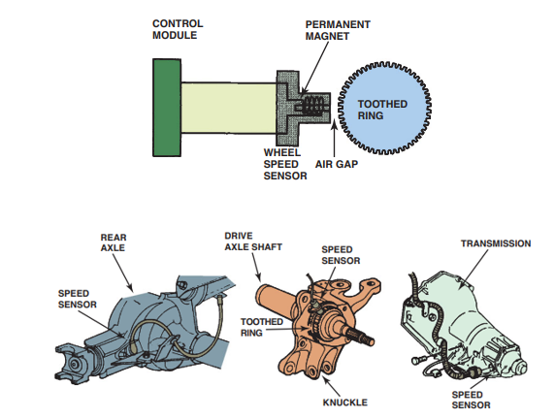
Figure 1.2 Wheel speed sensor and its optional location on vehicle
Electronic control unit
Control module terms
The ABS electronic control module, which may be referred to as an “electronic brake control module” (EBCM), “electronic brake module” (EBM), or “controller antilock brakes” (CAB) module, is a digital microprocessor that uses inputs from its various sensors to regulate hydraulic pressure during braking to prevent wheel lockup. The module may be located on the hydraulic modulator assembly (as it is on many of the newer compact ABS systems), or it may be located elsewhere in the vehicle, such as the trunk, passenger compartment, or under the hood.
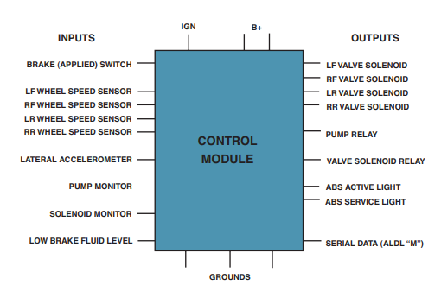
Figure 1.3 ABS control module
Module inputs
The key inputs for the ABS control module come from the wheel speed sensors and the brake pedal switch. The brake pedal switch signals the control module when the brakes are being applied, which causes it to go from a “standby” mode to an active mode. At the same time, the wheel speed sensors provide information about what is happening to the wheels while the brakes are being applied.
Note: A fault with the brake switch will not prevent ABS operation. The brake switch allows the controller to react faster to an ABS event.
Module operation
If the control module detects a difference in the deceleration rate between one or more wheels when braking, or if the overall rate of deceleration is too fast and exceeds the limits programmed into the control module, it triggers the ABS control module to momentarily take over. The control module cycles the solenoid valves in the modulator assembly to pulsate hydraulic pressure in the affected brake circuit (or circuits) until sensor information indicates that the deceleration rates have returned to normal and braking is under control. Normal braking resumes. When the brake pedal is released or when the vehicle comes to a stop, the control module returns to a standby mode until it is again needed.
ABS warning lamp
Every ABS system has an amber indicator lamp on the instrument panel that warns the driver when a problem occurs within the ABS system. The lamp comes on when the ignition is turned on for a bulb check, then goes out after the engine starts. If the warning light remains on or comes on while driving, it usually indicates a fault in the ABS system that will require further diagnosis. On most applications, the ABS system disables if the ABS warning light comes on and remains on. This should have no effect on normal braking, unless the red brake warning lamp is also on. The ABS warning light is also used for diagnostic purposes when retrieving flash codes (trouble codes) from the ABS module.

Hydraulic modulator
A high-pressure electric pump is used in some ABS systems to generate power assist for normal braking as well as the reapplication of brake pressure during ABS braking. In some systems, it is used only for the reapplication of pressure during ABS braking. The pump motor is energized by a relay, which is switched on and off by the ABS control module. The fluid pressure generated by the pump is stored in the accumulator. Some ABS systems have more than one accumulator. The accumulator on ABS systems, where the hydraulic modulator is part of the master cylinder assembly, consists of a pressure storage chamber filled with nitrogen.
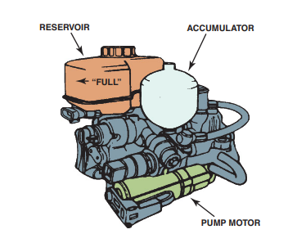
Figure 1.4 ABS Accumulator
A hydraulic modulator has three operating positions:
- Pressure build-up brake line open to the pump;
- Pressure holding brake line closed;
- Pressure release brake line open to the reservoir.
The valves are controlled by electrical solenoids, which have a low inductance so they react very quickly. The motor only runs when ABS is activated. There are 2 position solenoid valves in most cases and they are Pressure holding valve and pressure reduction valves.

Pressure holding Valve
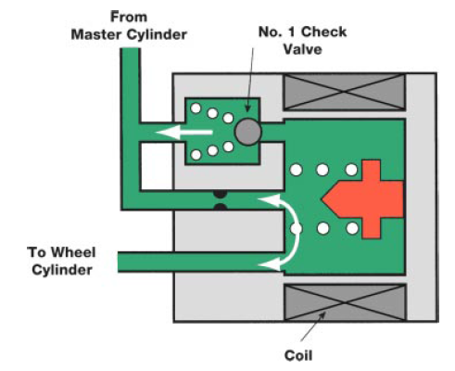
The pressure holding valve controls (open and close) the circuit between the brake master cylinder and the wheel cylinder. The valve is spring loaded to the open position (normally open). When current flows in the coil the valve closes. A spring-loaded check valve provides an additional release passage when pressure from the master cylinder drops.
Figure 1.5 Pressure holding Valve
Pressure Reduction Valve
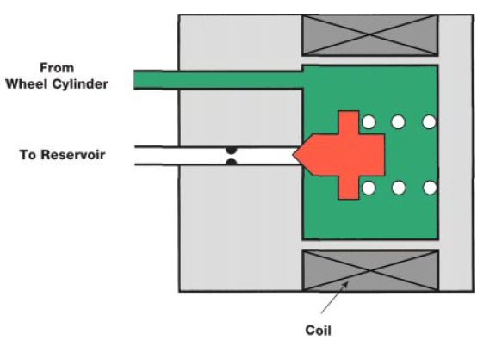
The pressure reduction valve controls (opens and closes) the circuit between the wheel cylinder and the actuator reservoir. The valve is spring loaded in the closed position (normally closed). When current flows through the coil, the valve compresses the spring and opens the valve.
Figure 1.6 Pressure Reduction Valve

Operation of ABS system
- Operation during normal Braking (ABS not activated)
During normal braking the solenoids are not energized so the pressure holding valve remains open and the pressure reduction valve remains closed. When the brake pedal is depressed, the master cylinder fluid passes through the pressure holding valve to the wheel cylinder. The pressure reduction valve prevents fluid pressure from going to the reservoir. As a result normal braking occurs.

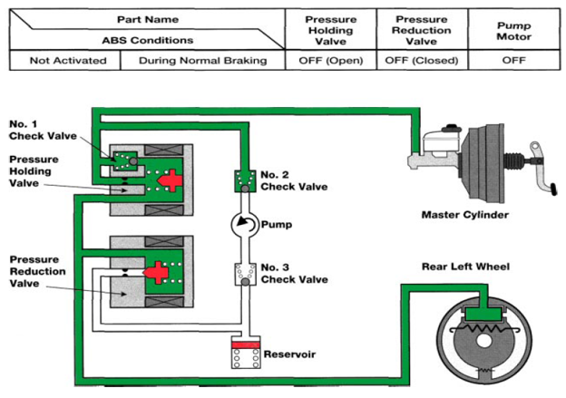
Figure 1.7 operation during normal Braking
- Operation during ABS activated
A. Pressure holding mode
When any wheel begins to lock, the ABS ECU initially goes to hold mode to prevent any additional increase in pressure. The ECU turns OFF the pressure reduction valve and turns the pressure holding valve ON. The pressure reduction valve closes, preventing hydraulic fluid from going to the reservoir. The pressure holding valve remains closed so no additional fluid pressure can reach the wheel cylinder.

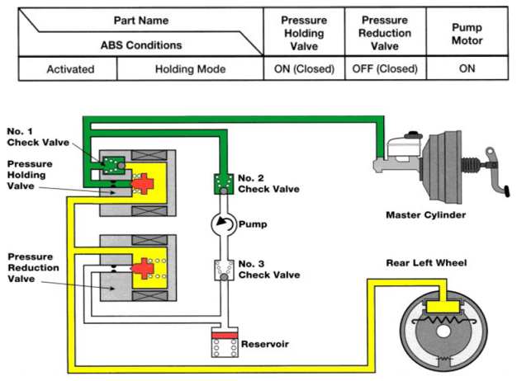
B. Pressure reduction mode
After the initial hold mode operation, the ABS ECU energizes both the holding valve and the reduction valves. The pressure holding valve closes and blocks pressure from the master cylinder. The open reduction valve allows hydraulic pressure from the wheel cylinder circuit into the reservoir, reducing brake pressure. The pump is also energized to direct hydraulic fluid back to the master cylinder. This causes brake pedal feedback and alerts the driver to ABS operation.
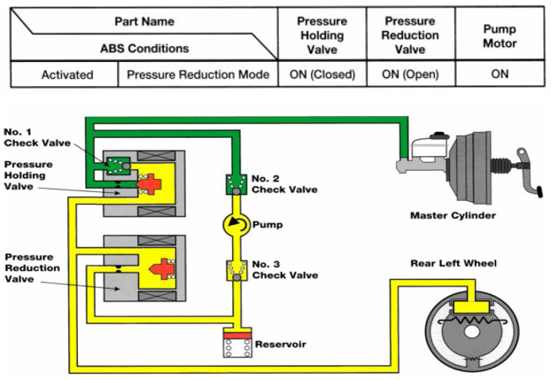
Figure 1.8 Pressure reduction mode
C. Pressure increasing mode
As pressure inside the wheel cylinder is reduced and the speed sensor sends s signal indicating that the speed is above the target level, the ECU turns OFF both the pressure reduction valve and pressure holding valve. The pressure reduction valve closes, preventing hydraulic fluid from going to the reservoir. The pressure holding valve opens so additional pressure enters to the wheel cylinder if the driver maintains pedal pressure. The operation is the same as Normal Mode except the pump is ON.
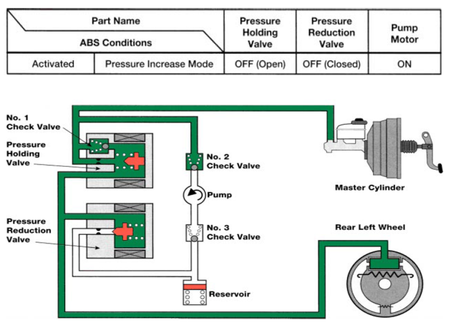
Figure 1.9 Pressure increasing mode

1.2.2 Integrated stability control system
Vehicle Electronic Stability Control (ESC), also known as Electronic Stability Program (ESP), is an advanced safety system designed to improve the stability and handling of vehicles. It helps drivers maintain control during emergency maneuvers or in situations where the vehicle is at risk of skidding or losing stability. Various stability control systems are found on today’s vehicles. Like TCSs, stability controls are based on and linked to the ABS. On some vehicles, the stability control system is also linked to the electronic suspension system. Most often, the stability control system is called an electronic stability control (ESC) system, although many other names are used.
ESC helps prevent skids, swerves, and rollover accidents. Basically, the system applies the brakes at one or more wheels to help correct the steering. In some cases, power to the drive wheels is also reduced. It is important to remember that a vehicle’s tendency to roll is influenced by its height, track width, and the stiffness of its suspension. ESC cannot override a car’s physical limits nor can it increase traction. If the vehicle is pushed beyond its traction limits, ESC may not be able to correct the vehicle’s movement. ESC simply helps the driver maintain control using the available traction.
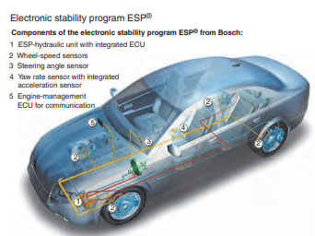
Figure 1.10 Integrated stability control
Operation of ESC
ESC systems can control the vehicle during acceleration, braking, and coasting. If the brakes are applied but oversteer or understeer is occurring, the fluid pressure to the appropriate brake is increased. Understeer is a condition where the vehicle is slow to respond to steering changes. When the system senses understeer in a turn, the brake at the inside rear wheel is applied to regain vehicle stability. Oversteer occurs when the rear wheels try to swing around or fishtail. When this occurs, the ESC system will apply the brake at the outer rear or front wheel in an attempt to neutralize the oversteering.

Figure 1.11 effects of a stability control EPS
The control unit, normally the EBCM, receives signals from the wheel-speed sensors, a steering angle sensor (typically part of the combination switch body behind the steering wheel), a lateral-acceleration sensor, a yaw sensor, roll sensors, and a brake pressure sensor. It also communicates with other control units through the CAN bus. The sensors basically let the control unit know the current status of the vehicle.
The ESC control unit compares the driver’s intended direction (by monitoring steering angle) to the vehicle’s actual direction (by measuring lateral acceleration, yaw, and individual wheel speeds). If there is a difference between the two, the control unit intervenes by modulating individual front or rear wheels and/or reducing engine power output. ESC continuously monitors key inputs such as yaw rate and wheel speed. Yaw is defined as the natural tendency of a vehicle to rotate on its vertical center axis or twist during a turn. A vehicle may also rotate naturally on its horizontal axis; this movement is called roll and pitch.
A yaw rate sensor is a gyroscopic sensor that measures the side-to-side twist of the vehicle. Two types of yaw rate sensors are used: micromechanical and piezoelectric. A micromechanical sensor relies on an oscillating element. The movement of this element is changed in response to yaw and speed.

During a turn, the vehicle tends to yaw and the output from the sensor changes. The control unit uses those signals to determine how much yaw is occurring.
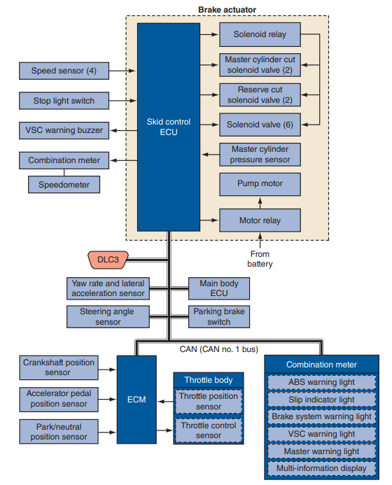
Figure 1.12 A typical system diagram for a ESC system
The control unit looks at the actual yaw rate and compares it to the calculated desired rate. It responds to the difference between the two.
This difference represents the amount of understeer or oversteer that is occurring. To correct the yaw, the system applies the brake at the appropriate wheel. Typically the yaw rate sensor and lateral accelerometer share the same housing. They are mounted in the center of the vehicle. The lateral accelerometer monitors acceleration, deceleration, and cornering forces. These sensors are commonly Hall-effect or piezoelectric units. Semiconductor materials are placed on a plate and are set 45 degrees away from the centerline of the vehicle.

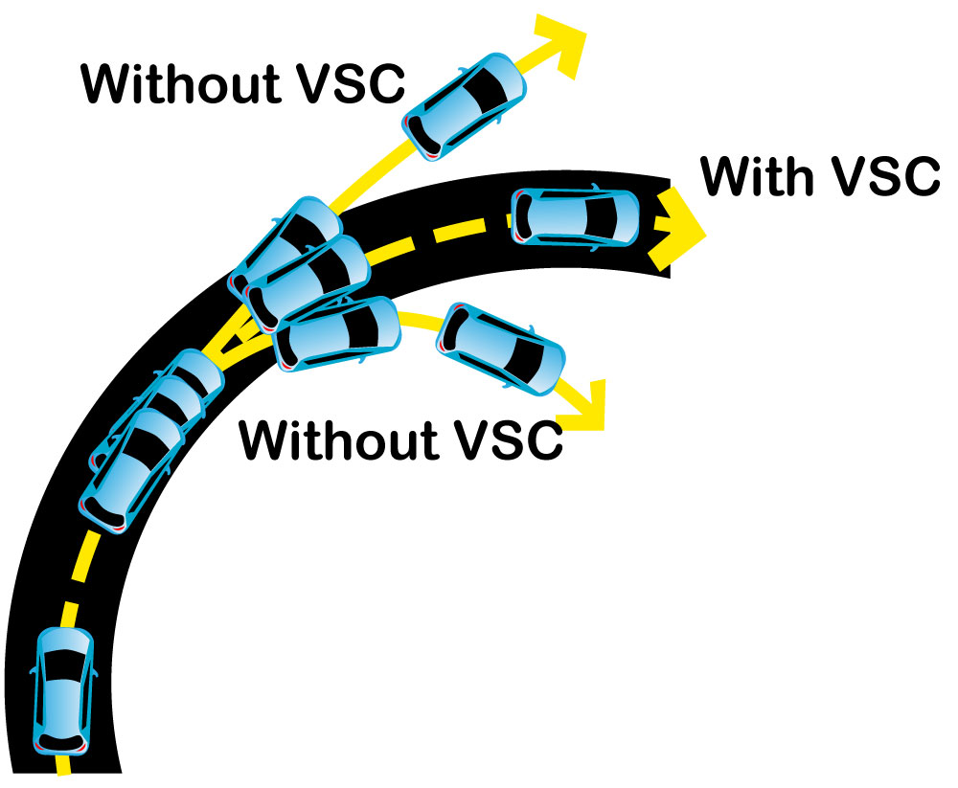
Figure 1.13 Comparison of vehicle with VSC and without VSC

Components of a typical ESC system
Sensors: ESC relies on various sensors to collect data about the vehicle's dynamics. These sensors typically include wheel speed sensors, steering angle sensors, yaw rate sensors, and lateral acceleration sensors. They provide information about the vehicle's speed, direction, and rotational motion.
Electronic Control Unit (ECU): The ECU is the brain of the ESC system. It receives data from the sensors and continuously monitors the vehicle's behavior. Based on this information, it determines if the vehicle is deviating from the driver's intended path. If a potential loss of control is detected, the ECU activates the corrective measures.
Hydraulic Control Unit (HCU): The HCU is responsible for applying precise brake pressure to individual wheels. It receives commands from the ECU and modulates the brake pressure accordingly. By selectively braking specific wheels, the HCU can counteract understeer (front-wheel skid) or oversteer (rear-wheel skid) to improve stability.
Accelerator Pedal Sensor: In some ESC systems, an accelerator pedal sensor is used to detect the driver's input. It provides information about the position and rate of change of the accelerator pedal, allowing the ECU to adjust engine torque if necessary.
Brake Assist System (BAS): ESC systems often integrate with Brake Assist, which is a feature that helps provide maximum braking force during emergency stops. When ESC detects a potential loss of control, it can activate Brake Assist to ensure rapid and effective braking.
Stability Control Off Switch: Many vehicles equipped with ESC have a stability control off switch. This allows the driver to manually deactivate the ESC system, typically for specific driving conditions such as off-road or low-grip situations. However, it's important to note that ESC is a crucial safety feature, and it's generally recommended to keep it enabled for regular on-road driving.
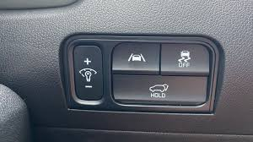
Figure 1.14 vehicle stability indicators and switch (sample)
Vehicle stability steering
Vehicle stability steering refers to a system or feature in modern vehicles that aims to enhance stability and control during various driving conditions. It is commonly associated with electronic stability control (ESC) or stability control systems. These systems use various sensors, actuators, and control algorithms to improve the vehicle's handling and stability. The primary goal of vehicle stability steering systems is to help the driver maintain control of the vehicle during challenging situations, such as sudden maneuvers, slippery road surfaces, or potential loss of traction.
They work by continuously monitoring the vehicle's behavior and intervening if it detects instability or a loss of control. Here are some key components and functions associated with vehicle stability steering systems:
Sensors
These systems utilize various sensors, such as wheel speed sensors, steering angle sensors, yaw rate sensors, and lateral acceleration sensors. These sensors provide real-time data about the vehicle's dynamics, including its speed, acceleration, steering input, and lateral movements.
Electronic Control Unit (ECU)
The ECU is the central control unit that receives input from the sensors and processes the data. It continuously evaluates the vehicle's stability and compares it to predefined thresholds or desired performance parameters.
Anti-lock Braking System (ABS)
ABS is often integrated into stability control systems. It modulates the braking force on individual wheels to prevent wheel lock-up during emergency braking or slippery conditions. By maintaining traction with the road surface, ABS contributes to overall vehicle stability.
Traction Control System (TCS)
TCS is another component commonly integrated with stability control. It monitors wheel slip and reduces engine power or applies braking to the spinning wheel to enhance traction and stability.
Active Steering Systems
Some advanced vehicle stability steering systems may incorporate active steering systems that can adjust the steering input or ratio based on the vehicle's dynamics. This helps enhance stability and control during different driving conditions.
Generally, vehicle stability steering systems work by selectively applying brakes to individual wheels, adjusting engine power, or modifying steering input to counteract understeer (when the vehicle fails to turn enough) or oversteer (when the vehicle turns more than intended).

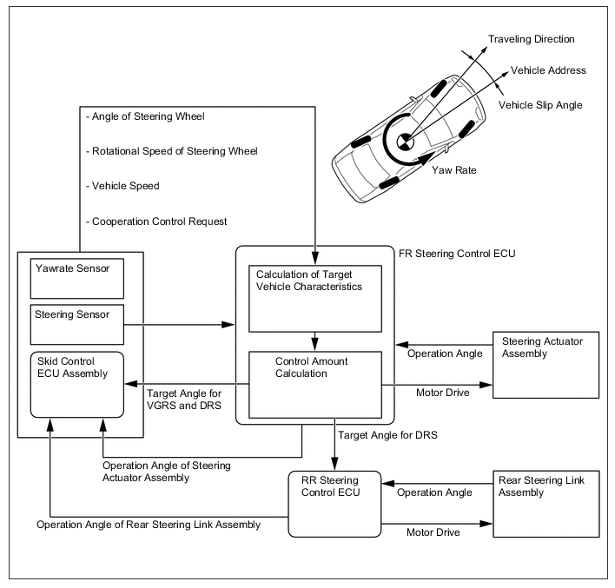
Figure 1.15 Steering stability system
The requirements of a power steering system are:
- Precise onset of power assistance
- Maintenance of driver feel
- Continued ability to steer should the power system fail.

1.2.3 Electronically Controlled Power Steering Systems
The object of power steering is to make steering easier at low speeds, especially while parking. However, higher steering efforts are desirable at higher speeds in order to provide improved down the road feel. The electronically controlled power steering (EPS) systems (as shown in the figure below) provide both of these benefits. The hydraulic boost of these systems is tapered off by electronic control as road speed increases. Thus, these systems require well under 1 pound (4.4 N) of steering effort at low road speeds and 3 pounds plus (13.2 N) of steering effort at higher road speeds to enable the driver to maintain control of the steering wheel for improved high-speed handling.

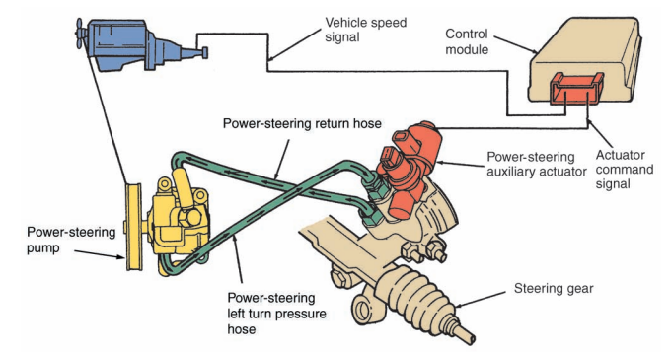
Figure 1.16 Electronic controlled power steering system
A rotary valve electronic power-steering system consists of the power-steering gearbox, power steering oil pump, pressure hose, and the return hose. The amount of hydraulic fluid flow (pressure) used to boost steering is controlled by a solenoid valve that is identified as its PCV (pressure control valve). The PCV (pressure control valve) is not to be confused with the PCV (positive crankcase ventilator) used with emission controls systems.
The electronic power-steering system’s PCV is exposed to spring tension on the top and plunger force on the bottom. The plunger slips inside an electromagnet. By varying the electrical current to the electromagnet, the upward force exerted by the plunger can be varied as it works against the opposing spring. Current flow to the electromagnet is variable with vehicle road speed and, therefore, provides steering to match the vehicle’s road speed. General Motors’ variable effort steering (VES) system relies on an input signal from the vehicle speed sensor to the VES controller to control the amount of power assist. The controller, in turn, supplies a pulse width modulated voltage to the actuator solenoid in the power-steering pump. The controller also provides a ground connection for the solenoid. When the vehicle is operating at low speeds, the controller supplies a signal to cycle the solenoid faster so it allows high pump pressure. This provides for maximum power assist during cornering and parking. As the vehicle’s speed increases, the solenoid cycles less and the pump provides a lower amount of assist. This gives the driver better road feel during high speeds.
Active Steering
Active steering improves vehicle stability by turning the wheels more or less sharply than commanded by the turn of the steering wheel during some situations. Through inputs and computer programming, this system can adjust the steering to respond quickly to the threat of skidding. The system also allows for a variable steering ratio dependent on vehicle speed. Current active steering systems are not true steer by-wire systems. There is still a mechanical connection between the steering wheel and vehicle’s wheels.
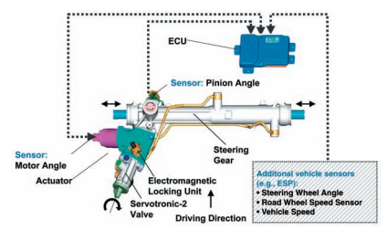
Figure 1.17 main components and circuits of an active
Steer-by-Wire System
Steer-by-wire systems are not found on any production vehicles today. They are being tested and have appeared on many concept cars. These systems do not use a steering column or shaft to connect the steering wheel to the steering gear. The system is totally electronic. The turning of the steering wheel is monitored by a sensor. The sensor sends an input signal to a controller. The controller, in turn, sends commands to an electric motor in the steering gear. The commands from the controller are also based on inputs from a variety of other inputs, such as vehicle speed. These systems also have a small motor attached to the mount for the steering wheel. This motor is controlled by a steering controller. This motor provides the correct steering feel for the current conditions. The driver needs this feel to maintain control of the vehicle.
Steer-by-wire systems allow total customization of steering performance and can provide a constantly variable steering ratio. The absence of a steering column opens up space in the vehicle’s interior and engine compartment. The systems are also lighter than conventional steering systems.

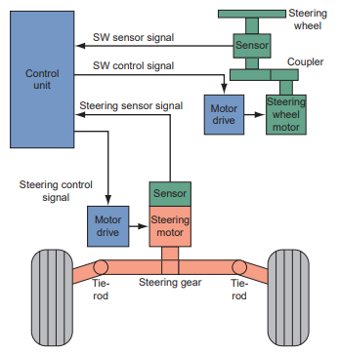
Figure 1.18 basic layout for a steer-by-wire

1.3 Identifying and confirming Effects of system faults
Electronic vehicle under chassis management systems can experience various electrical and electronics faults. Some common faults include:
Sensor Malfunctions
Sensors play a critical role in the under-chassis management system, providing inputs for various functions such as stability control, traction control, and anti-lock braking. Faulty sensors can lead to inaccurate readings or complete failure, resulting in improper system operation or fault codes being triggered.
Wiring Issues
Faulty or damaged wiring can cause intermittent connections, shorts, or open circuits, leading to system malfunctions. Wiring problems may occur due to physical damage, corrosion, poor connections, or incorrect installation.

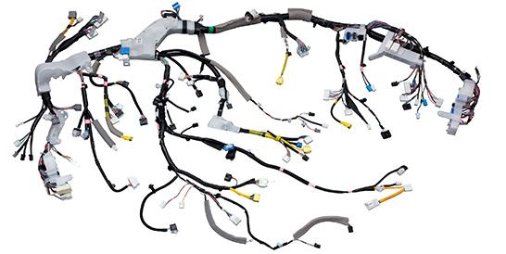
Figure 1.29 vehicle wiring harness
Control Module Failures
Control modules, such as the Electronic Control Unit (ECU) responsible for managing the under-chassis system, can experience failures due to component malfunctions, software glitches, or electrical issues. Control module failures can result in the loss of system functionality or erratic behavior.
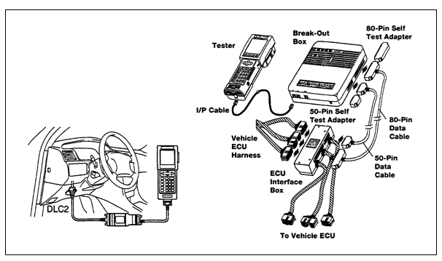
Figure 1.30 Code scanner issues
Actuator Problems
Actuators, such as solenoids or motors, control various components in the under chassis management system, such as the brake calipers, suspension dampers, or steering mechanisms. Actuator failures can lead to improper operation, uneven braking, suspension issues, or steering problems.
Communication Bus Errors:
The under-chassis management system relies on a network of communication buses (e.g., CAN bus) to exchange data between various modules. Communication bus faults, such as bus errors, loss of communication, or wiring faults, can disrupt the flow of information, leading to system malfunctions or communication errors.
Power Supply Issues
Insufficient or unstable power supply to the under-chassis management system can cause erratic behavior or system failures. This can occur due to problems with the battery, alternator, fuses, or wiring connections.
Software or Firmware Glitches
The under-chassis management system relies on complex software or firmware to control its operations. Software bugs, glitches, or outdated firmware can lead to system malfunctions, unexpected behavior, or incorrect sensor readings.
Grounding Problems
Proper grounding is crucial for the reliable operation of electronic systems. Poor or faulty grounding can result in electrical noise, voltage fluctuations, or improper functioning of electronic components.
Mechanical and hydraulic system faults
The main areas of the vehicle that produce noise, vibration and harshness are:
- tires
- engine accessories
- suspension
- driveline.
It is necessary to isolate the NVH into its specific area(s) to allow more detailed diagnosis. A road test, as outlined later, is often the best method.
Faults of a chassis electrical system malfunction
Symptom | Possible fault
ABS not working and/or warning light on | - Wheel sensor or associated wiring open circuit/high resistance.  - Wheel sensor air gap incorrect.  - Power supply/earth to ECU low or not present.  - Connections to modulator open circuit.  - No supply/earth connection to pump motor.  - Modulator windings open circuit or high resistance.
Traction control inoperative | - Wheel sensor or associated wiring open circuit/high resistance.  - Wheel sensor air gap incorrect.  - Power supply/earth to ECU low or not present.  - ABS system fault.  - Throttle actuator inoperative or open circuit connections.  - Communication link between ECUs open circuit.
ECAT system reduced performance or not working | - Communication link between engine and transmission ECUs open circuit.  - Power supply/earth to ECU low or not present.  - Transmission mechanical fault.  - Gear selector switch open/short circuit.  - Speed sensor inoperative.
Power steering assistance low or not working | - Power supply/earth to ECU low or not present. Mechanical fault.  - Power supply/earth to drive motor low or not present.  - Steering sensor inoperative

1.4 Testing and diagnosis equipment
When diagnosing electrical or electronics faults in the under-chassis management system of an electronic vehicle, specialized diagnostic scan tools, multimeters, oscilloscopes, and other mentioned tools can be used to perform tests, retrieve fault codes, analyze sensor data, and identify the root cause of the issue. It often requires a combination of technical expertise, knowledge of the specific vehicle's system, and access to service manuals or wiring diagrams to effectively diagnose and troubleshoot these faults.

Tools and Equipment
Diagnosing electronic under chassis management in vehicles often requires the use of specialized tools and equipment. Here are some common tools and equipment used in this process:
Diagnostic Scan Tool

A diagnostic scan tool is a handheld device or software interface connected to the vehicle's onboard diagnostic (OBD) port. It communicates with the vehicle's electronic control units (ECUs) to retrieve diagnostic trouble codes (DTCs), view live data, perform system tests, and access other vehicle-specific information. Modern scan tools can also perform advanced functions like programming and reprogramming ECUs.
Figure 1.31 OBD Scanner/Scan tool
Multimeter
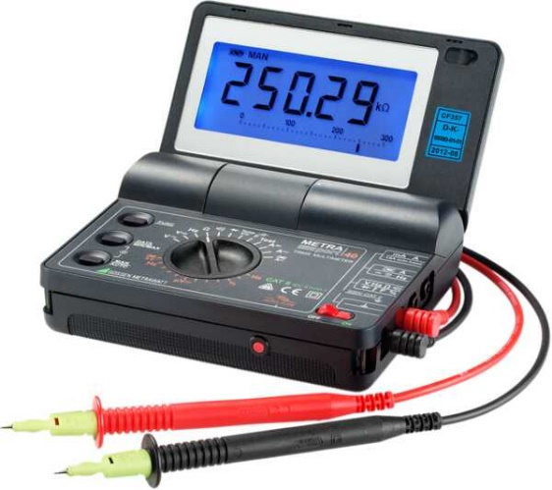
A multimeter is a versatile tool used to measure electrical voltages, currents, and resistances. It is helpful in diagnosing electrical issues, checking circuit continuity, and verifying the proper functioning of sensors, switches, relays, and other electrical components.

Figure 1.32 Digital Voltmeter

Oscilloscope
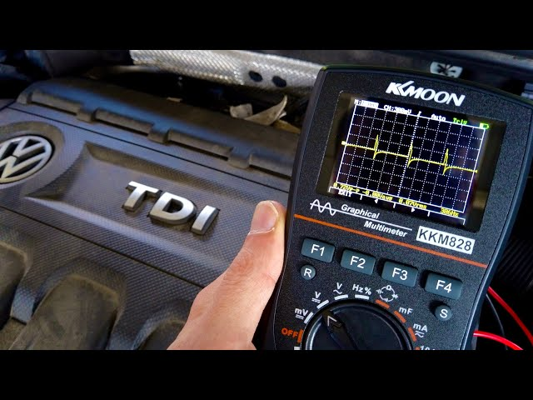
An oscilloscope is a device used to visualize and analyze electrical waveforms. It allows technicians to observe the voltage variations over time, helping in diagnosing complex electrical signals, analyzing sensor outputs, and identifying abnormalities or malfunctions in electronic circuits.

Figure 1.33 Lab scope/Oscilloscope
Circuit Tester
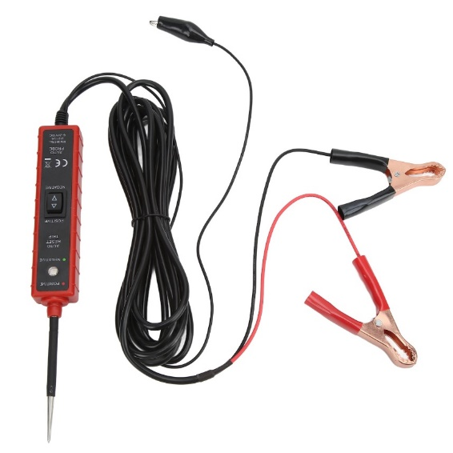
A circuit tester is a tool used to check the presence of voltage in a circuit, test for short circuits, and verify proper grounding. It typically consists of a probe with an indicator light or a digital display that illuminates or shows a reading when voltage or continuity is detected.

Figure 1.34 circuit tester

Wiring Diagrams and Service Manuals
Wiring diagrams and service manuals provide detailed information about the electrical circuits, components, and connectors in a vehicle. They help technicians understand the system's layout, identify wire colors and pinouts, and troubleshoot electrical issues effectively.
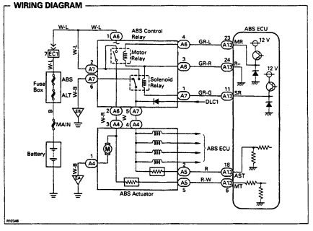
Figure 1.35 wiring diagram form RP
Logic Probe
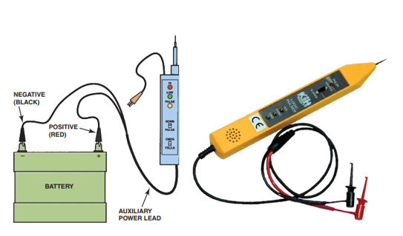
A logic probe is an electronic device that lights up a red (usually) LED if the probe is touched to battery voltage. If the probe is touched to ground, a green (usually) LED lights. A logic probe is a tool used to test digital logic circuits. It can measure voltage levels, detect pulses, and determine the logic state (high or low) of digital signals. It is useful for diagnosing issues with digital sensors, actuators, or control modules. A logic probe can “sense” the difference between high- and low-voltage levels, which explains the name logic. Figure 1.36 logic probe

- A typical logic probe can also light another light (often amber color) when a change in voltage levels occurs.
- Some logic probes will flash the red light when a pulsing voltage signal is detected.
- Some will flash the green light when a pulsing ground signal is detected.
This feature is helpful when checking for a variable voltage output from a computer or ignition sensor.
Signal Generator
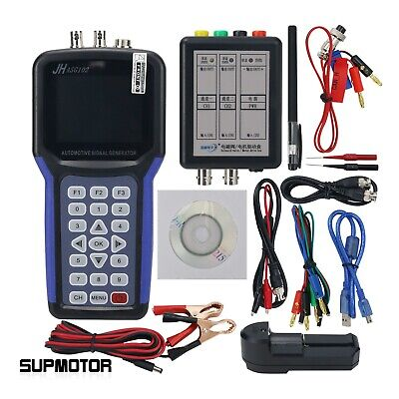
A signal generator produces specific electrical signals of known frequency, amplitude, and waveform. It is used to simulate sensor inputs or test electronic circuits by providing controlled signals for analysis or troubleshooting purposes.

Figure 1.37 Signal generator to test a sensor

Brake Tester
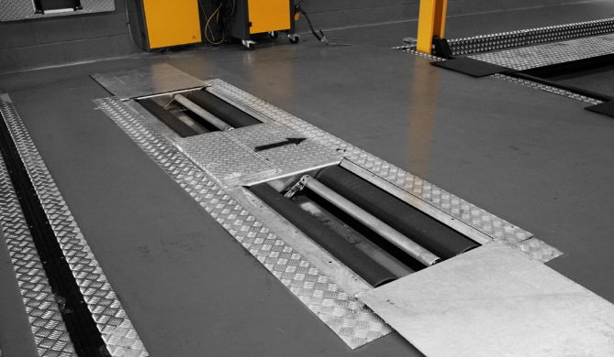
A brake tester, also known as a brake meter or brake testing equipment, is a device used to measure and evaluate the braking performance of vehicles. It is commonly used in automotive workshops, inspection centers, and regulatory agencies to ensure that vehicles meet safety standards and legal requirements.
Figure 1.38 Brake tester machine

The primary purpose of a brake tester is to assess the effectiveness and efficiency of a vehicle's braking system. By measuring various parameters, such as braking force, deceleration, and brake imbalance between wheels, the brake tester can determine if the brakes are functioning properly and if they meet the required standards.
Brake Fluid Tester
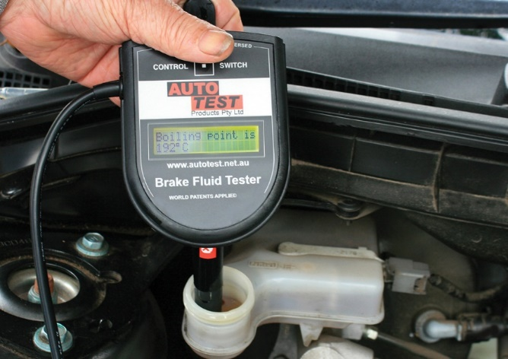
A brake fluid tester is a device used to assess the condition and quality of brake fluid in a vehicle's braking system. Brake fluid plays a critical role in transferring the pressure applied to the brake pedal to the braking components, such as the calipers and wheel cylinders, enabling efficient and reliable braking.
Figure 1.37 Brake fluid tester
Over time, brake fluid can degrade due to moisture absorption, heat, and contaminants. This degradation can lead to reduced braking performance, increased risk of brake failure, and damage to braking system components. Therefore, it is important to regularly check the condition of the brake fluid.
Traction control system
The maneuverability of a vehicle is not only lost when the wheels lock up on braking; the same effect arises if the wheels spin when driving off under severe acceleration. Electronic traction control has been developed as a supplement to ABS. This control system prevents the wheels from spinning when moving off or when accelerating sharply while on the move. In this way, an individual wheel which is spinning is braked in a controlled manner. If both or all of the wheels are spinning, the drive torque is reduced by means of an engine control function. Traction control has become known as ASR or TCR. Traction control is not normally available as an independent system, but in combination with ABS. This is because many of the components required are the same as for the ABS. Traction control only requires a change in logic control in the ECU and a few extra control elements such as control of the throttle.
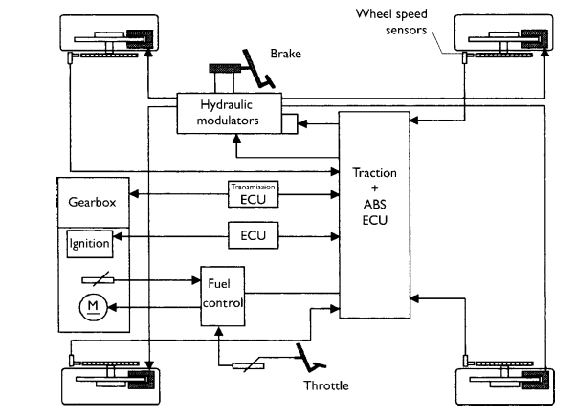
Figure 1.19 vehicle traction control system layout
Traction control will intervene to:
- Maintain stability;
- Reduction of yawing moment reactions;
- Provide optimum propulsion at all speeds;
- Reduce driver workload.
An automatic control system can intervene in many cases more quickly and precisely than the driver of the vehicle. This allows stability to be maintained at a time when the driver might not have been able to cope with the situation.
Control functions of traction control system
Control of tractive force can be by a number of methods.
Throttle control: this can be via an actuator, which can move the throttle cable or, if the vehicle employs a drive by wire accelerator, then control will be in conjunction with the engine management ECU. This throttle control will be independent of the driver’s throttle pedal position. This method alone is relatively slow to control engine torque.
Ignition control If ignition is retarded the engine torque can be reduced by up to 50% in a very short space of time. The timing is adjusted by a set ramp from the ignition map value
Braking effect: If the spinning wheel is restricted by brake pressure the reduction in torque at the affected wheel is very fast. Maximum brake pressure is not used to ensure that passenger comfort is maintained.
Traction control system operation
The description that follows is for a vehicle with an electronic accelerator (drive by wire). A simple sensor determines the position of the accelerator and, taking into account other variables such as engine temperature and speed for example, the throttle is set at the optimum position by a servo-motor. When accelerating the increase in engine torque leads to an increase in driving torque at the wheels. To achieve optimum acceleration the maximum possible driving torque must be transferred to the road. If driving torque exceeds that which can be transferred then wheel slip will occur on at least one wheel. The result of this is that the vehicle becomes unstable. When wheel spin is detected the throttle position and ignition timing are adjusted but the best results are gained when the brakes are applied to the spinning wheel.
This not only prevents the wheel from spinning but acts to provide a limited slip differential action. This is particularly good when on a road with varying braking force coefficients. When the brakes are applied a valve in the hydraulic modulator assembly moves over to allow traction control operation. This allows pressure from the pump to be applied to the brakes on the offending wheel. The valves, in the same way as with ABS, can provide pressure buildup, pressure hold and pressure reduction. This all takes place without the driver touching the brake pedal. The summary of this is that the braking force must be applied to the slipping wheel so as to equalize the combined braking coefficient for each driving wheel.
Electronic controlled suspension systems
Since the mid-1980s, many vehicle manufacturers have been introducing models with electronic suspension controls that provide a variable shock stiffness or spring rate. The main advantage of electronic controls is that the suspension can react to different conditions. The system provides a firm suspension feel for fast cornering and quick acceleration and braking, with a soft ride for cruising.
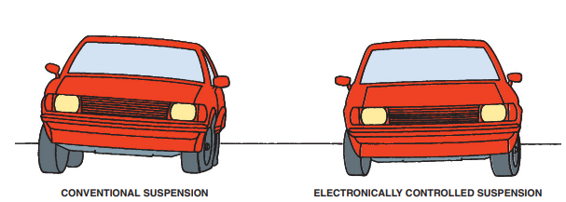
Figure 1.20 Vehicle with ECS and without ECS
Electronic suspension controls and sensors
Sensors and switches provide input to the electronic control module (ECM), or system computer. The ECM, which may also be referred to as the electronic control unit (ECU), is a small computer that receives input in the form of electrical signals from the sensors and switches and provides output electrical signals to the system actuators. The electrical signal causes an actuator to perform some type of mechanical action.
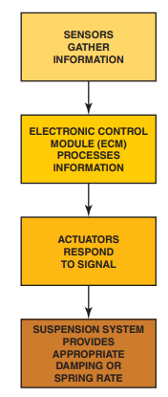
Figure 1.21 electronic suspension controls and sensors
Height sensors
Sensors, which are the input devices that transmit signals to the ECM, monitor operating conditions and component functions. A height sensor senses the vertical relationship between the suspension component and the body. Its signal indicates to the ECM how high the frame or body is, or how compressed the suspension is. A number of sensor designs are used to determine ride height, including a photocell type of sensor. Four height sensors, one at each wheel, deliver an input signal to the ECM. All four sensors are similar and use a control link, lever, slotted disc, and four photo interrupters to transmit a signal. Each photo interrupter consists of a light-emitting diode (LED) and a phototransistor, which reacts to the LED.

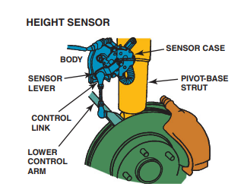
Figure 1.22 Height sensor
Inside the sensor, the LEDs and phototransistors are positioned opposite each other on each side of the slotted disc. When the system is activated, the ECM applies voltage to the LEDs, which causes them to illuminate. Light from an LED shining on the phototransistor causes the transistor to generate a voltage signal. Signals generated by the phototransistors are delivered to the ECM as an input that reflects ride height.
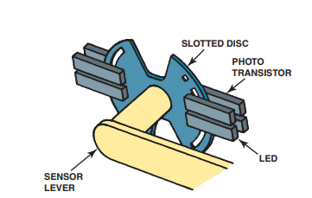
Figure 1.23 structure of height sensor

As suspension movement rotates the disc, the slots or windows on the disc either allow light from the LEDs to shine on the phototransistors or prevent it. The windows are positioned in such a manner that, in combination with the four LEDs and transistors, the sensor is capable of generating 16 different levels of voltage. This variable voltage, which is transmitted to the ECM as an input signal, directly corresponds to 1 of 16 possible positions of the suspension. This input signal tells the ECM the position of the suspension in relation to the body. Whether the input voltage signal is increasing or decreasing allows the ECM to determine if the suspension is compressing or extending.
Electronic suspension module
The ECM can also determine the relative position of the body to the suspension, or the attitude of the vehicle, from the four height sensors. Comparing front-wheel input signals to those of the rear wheels determines the amount of pitch caused by forces of acceleration or deceleration. A side-to-side comparison allows the ECM to determine the amount of body roll generated by cornering force.
Active suspension
A traditional or a conventional suspension system, consisting of springs and dampers, is passive. In other words, once it has been installed in the car, its characteristics do not change. The main advantage of a conventional suspension system is its predictability. Over time, the driver will become familiar with a car’s suspension and understand its capabilities and limitations.
Figure 1.24 electronic suspension system
The disadvantage is that the system has no way of compensating for situations beyond its original design. An active suspension system (also known as computerized ride control) has the ability to adjust itself continuously. It monitors and adjusts its characteristics to suit the current road conditions. As with all electronic control systems, sensors supply information to an ECU which in turn outputs to actuators. By changing its characteristics in response to changing road conditions, active suspension offers improved handling, comfort, responsiveness and safety.
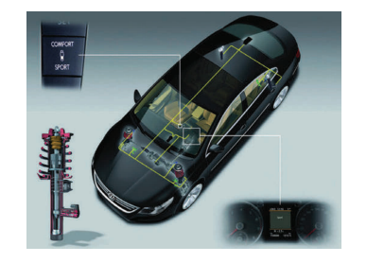
Figure 1.25 Active suspension
Active suspension systems consist of the following components
- electronic control unit;
- adjustable dampers and springs;
- sensors at each wheel and throughout the car;
- levelling compressor (some systems).
Components vary between manufacturers, but the principles are the same. Active suspension works by constantly sensing changes in the road surface and feeding that information to the ECU, which in turn controls the suspension springs and dampers. These components then act upon the system to modify the overall suspension characteristics by adjusting damper stiffness, ride height (in some cases) and spring rate.

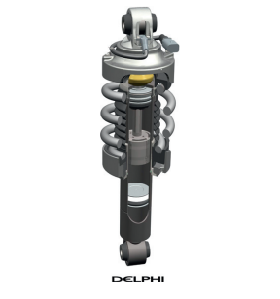
Figure 1.26 Active suspension strut
Active suspension works by constantly sensing changes in the road surface and feeding that information to the ECU, which in turn controls the suspension springs and dampers. These components then act upon the system to modify the overall suspension characteristics by adjusting damper stiffness, ride height (in some cases) and spring rate.
The suspension can be controlled in a number of ways. However, in most cases it is done by controlling the oil restriction in the damper. On some systems, ride height is controlled by opening a valve and supplying pressurized fluid from an engine-driven compressor. Later systems are starting to use special fluid in the dampers that reacts to a magnetic field, which is applied from a simple electromagnetic coil. The improvements in ride comfort are considerable, which is why active suspension technology is becoming more popular. In simple terms, sensors provide the input to a control system that in turn actuates the suspension dampers in a way that improves stability and comfort.
Active suspension operation
Assume that a car with conventional suspension is cruising down the road and then, after turning left, hits a series of potholes on the right-hand side, each one larger than the next (Figure 7.40).

This would present a serious challenge to a conventional suspension system because the increasing size of the holes could set up an oscillation loop and bottom out the system. An active system would react very differently. Sensors send information to the ECU about yaw and lateral acceleration. Other sensors measure excessive vertical travel, particularly in the right-front region of the car, and a steering angle sensor provides information on steering position. The ECU analyses this information in approximately 10 ms.
It then sends a signal to the right-front spring to stiffen up. A similar signal is sent to the right-rear spring, but this will not be stiffened as much. The rigidity of the suspension dampers on the right-hand side of the vehicle is therefore increased. Because of these actions, the vehicle will drive through the corner, with little impact on drive ability and comfort.
One of the latest types of sensors is produced by Bosch. The sensor simultaneously monitors three of a vehicle’s movement axes two acceleration or inclination axes (ax, ay) and one axis of rotation (Ωz). Previously, at least two separate sensors were required for this. The integration of the sensors for lateral acceleration and yaw rate reduces space requirements in the vehicle and the assembly work for the complete system.

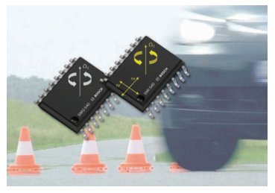
Figure 1.28 Integrated sensor
Active suspension system diagnostics
The most common complaint from customers who are experiencing active ride control issues is nose-dive during braking. Some may notice a harsh ride. But a warning message is what will bring them into the shop. The problem with most systems is that the modules do not have set monitors that can set and produce hard codes. The system will clear the code on the next key cycle, or after the vehicle has been turned off after a specific amount of time. However, the light will stay on if a sensor or actuator is open, shorted or out of range.
If you have a vehicle in your shop with active ride control you have to look not only at the dampeners, but the entire system. If there is an ABS or stability control light on, these items need to be resolved before continuing with active ride control diagnostics. Simple items like a brake pedal switch that is defective or out of range can cause a code to be set. There are aftermarket replacement options for active ride control units as well as sensors and modules. If the value of the vehicle does not warrant the cost of an expensive repair, passive units are also available.

Unit Two: Diagnosis Air Suspension System and Balance Adjustment
This unit to provide you the necessary information regarding the following content coverage and topics:
- Identifying and selecting diagnostic methods and diagnostic process
- Tests and Testing process
- Adjusting Air suspension balance
- Identifying Cause of unbalanced air suspension
This guide will also assist you to attain the learning outcomes stated in the cover page. Specifically, upon completion of this learning guide, you will be able to:
- Identify and select diagnostic methods and diagnostic process
- Test process
- Adjust Air suspension balance
- Identify Cause of unbalanced air suspension

Diagnosis air suspension system and balance adjustment

2.1 Identifying and selecting diagnostic methods and diagnostic process
The first step with any troubleshooting procedure is to check for normal operation. Some leveling systems require that the ignition key be on (run), while other systems operate all the time. Begin troubleshooting by placing approximately 300 lb (135 kg) on the rear of the vehicle. If the compressor does not operate, check to see if the sensor is connected to a rear suspension member and that the electrical connections are not corroded. Also check the condition of the compressor ground wire. It must be tight and free of rust and corrosion where it attaches to the vehicle body. If the compressor still does not run, check to see if 12 volts are available at the power lead to the compressor.
If necessary, use a fused jumper wire directly from the positive of the battery to the power lead of the compressor. If the compressor does not operate, it must be replaced. If the ride height compressor runs excessively, check the air compressor, the airlines, and the air shocks (or struts) with soapy water for air leaks. Most air shocks or air struts are not repairable and must be replaced. Most electronic leveling systems provide some adjustments of the rear ride height by adjusting the linkage between the height sensor and the rear suspension.
If necessary, use a fused jumper wire directly from the positive of the battery to the power lead of the compressor. If the compressor does not operate, it must be replaced.
If the ride height compressor runs excessively, check the air compressor, the airlines, and the air shocks (or struts) with soapy water for air leaks. Most air shocks or air struts are not repairable and must be replaced. Most electronic leveling systems provide some adjustments of the rear ride height by adjusting the linkage between the height sensor and the rear suspension.
Diagnostic method and processes
A diagnostic method refers to a systematic process or approach used to identify, analyze, and solve problems or malfunctions in a system or device. In the context of vehicles or electronics, diagnostic methods are employed to identify and troubleshoot issues or faults in the systems of a vehicle or electronic device. Diagnostic methods typically involve a series of steps or process that are followed to diagnose the source or cause of a problem accurately. These steps may include: gathering information, preliminary checks, diagnostic tools and equipment, data analysis systematic testing, problem identification, problem identification and repair or resolution. In general, a diagnostic method is a structured and systematic approach used to identify and solve problems or malfunctions in a system. It relies on the use of diagnostic tools, data analysis, and logical reasoning to diagnose and resolve issues effectively.

2.2 Testing process
Electronic component test methods
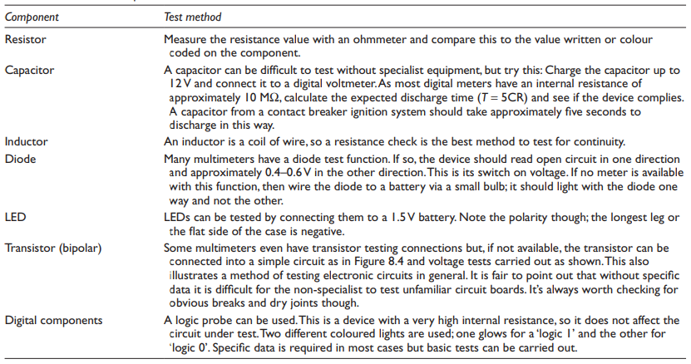

2.2.1 Electronic & Electrical system
In an electronic under chassis management system, several sensors play crucial roles in monitoring and providing inputs for various functions. Here are some common sensors used in such systems along with their explanations:
Wheel Speed Sensors
These sensors monitor the rotational speed of each wheel. They provide data that allows the system to detect wheel slip, measure vehicle speed, and enable functions like anti-lock braking systems (ABS), traction control, and stability control.
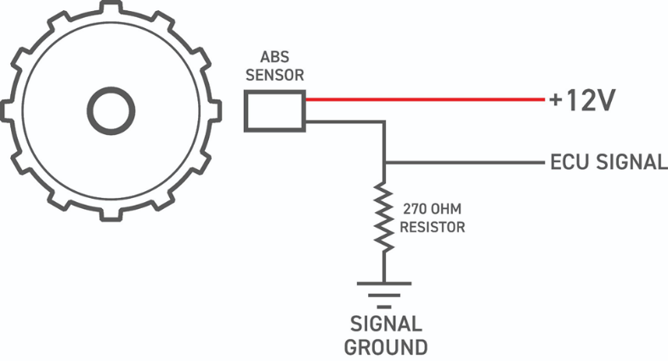
Figure 1.38 Wheel speed sensor signal
Accelerometer
Accelerometers measure changes in acceleration and deceleration. They provide information about the vehicle's dynamic movements, such as changes in pitch, roll, or lateral acceleration. This data is used for functions like electronic stability control (ESC) and active suspension systems.
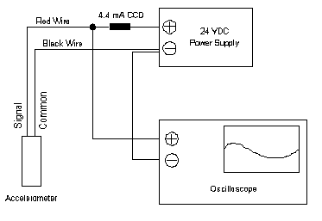
Figure 1.39 Accelerometer sensor circuit
Steering Angle Sensor
The steering angle sensor detects the position and rotation angle of the steering wheel. It provides input to the under-chassis management system, enabling features such as electronic power steering, lane-keeping assist, and stability control.
Brake Pressure Sensor
Brake pressure sensors monitor the hydraulic pressure in the braking system. They provide data that helps in controlling the brake force distribution, activating ABS, and assessing the braking performance.
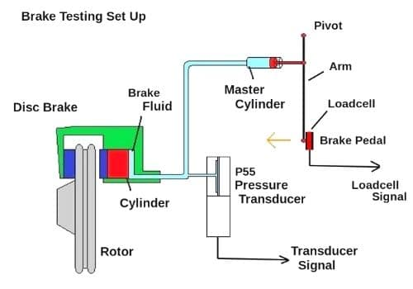
Figure 1.40 Brake pressure sensor testing
Ride Height Sensors
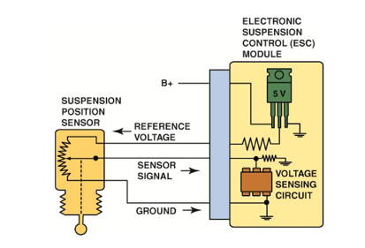
These sensors measure the vertical position of the suspension system or the distance between the chassis and the ground. They provide information for active suspension systems, self-leveling systems, and ride height adjustment.
Suspension Position Sensors: Suspension position sensors monitor the position and movement of suspension components, such as control arms or struts. They provide data for adaptive suspension systems, ensuring optimal damping and ride comfort
Figure 1.41 suspension height sensor

Yaw Rate Sensor
The yaw rate sensor measures the rotation or yaw of the vehicle around its vertical axis. It helps in detecting oversteer or understeer conditions and assists in stability control and traction control systems.
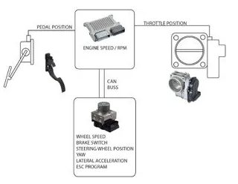
Figure 1.42 Yaw sensor schematic diagram
Lateral and Longitudinal Acceleration Sensors: These sensors measure the lateral (sideways) and longitudinal (fore-aft) acceleration of the vehicle. They provide input for functions like traction control, stability control, and rollover prevention systems.
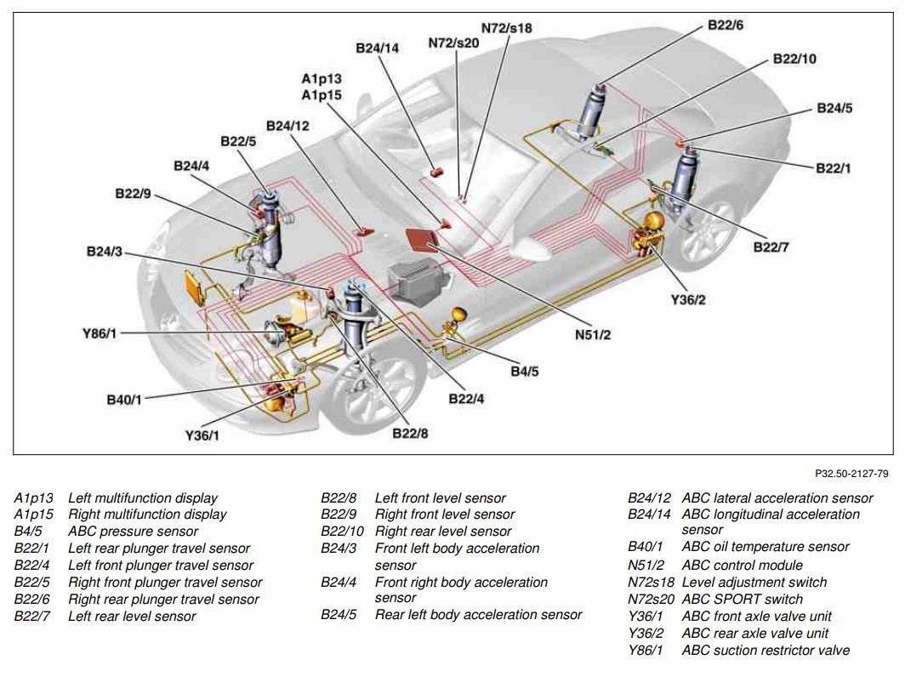
Figure 1.43 Electronic stability control system layout

2.2.2 Hydraulic systems testing
Vehicles has various systems which uses hydraulic principles to function. And to carry out a test of a vehicle's hydraulic system, you can follow these general steps:
- Gather the necessary tools and equipment.
- Inspect the hydraulic system for leaks or damage.
- Check the hydraulic fluid level and add fluid if needed.
- Start the vehicle and let the hydraulic system warm up.
- Perform a visual inspection of components during operation.
- Connect a pressure gauge to a suitable test point.
- Monitor pressure readings and ensure they stay within the recommended range.
- Optionally, test the flow rate using a flow meter.
- Perform functional tests of hydraulic functions.
Record and analyze the results, comparing them to specifications

2.2.3 Mechanical systems testing
Mechanical system tests refer to the process of evaluating and verifying the performance, functionality, and reliability of various mechanical components and systems. These tests are conducted to ensure that the mechanical systems meet the desired specifications, standards, and safety requirements. The procedures for conducting mechanical system tests may vary depending on the specific system being tested, but here are some general steps to consider:
- Define test objectives: Clearly establish the goals and objectives of the mechanical system test. Determine what aspects of the system you want to evaluate, such as performance, durability, load capacity, or efficiency.
- Develop a test plan: Create a detailed plan that outlines the specific tests to be performed, the test conditions, equipment requirements, and the acceptance criteria. Consider factors such as test duration, test environment, and any necessary safety precautions.
- Prepare the test setup: Set up the test environment and ensure that all necessary equipment and instrumentation are in place. This may involve installing sensors, connecting data acquisition systems, or configuring test rigs or fixtures.
- Conduct functional tests: Perform functional tests to assess the mechanical system's basic operations and functionality. This may involve operating various components, checking for proper movement, alignment, and function, and verifying that controls and safety mechanisms are working correctly.
- Perform performance tests: Conduct performance tests to evaluate the mechanical system's capabilities and efficiency. This could include measuring parameters such as speed, torque, force, displacement, or energy consumption. Use appropriate measuring devices and instrumentation to collect accurate data.
- Analyze and interpret test data: Collect and analyze the data acquired during the tests. Evaluate the system's performance against the defined acceptance criteria and compare the results with the desired specifications. Identify any deviations, anomalies, or areas of improvement.
- Document and report findings: Document the test procedures, observations, and results in a comprehensive test report. Include details such as test setup, test conditions, data analysis, and any recommendations or actions required based on the results.

2.2.4 Axle alignment checks
- Conducting axle alignment checks in servicing under the chassis is essential for maintaining tire health, vehicle stability, fuel efficiency, suspension component longevity, and driver comfort. It is an important aspect of vehicle maintenance that contributes to safety, performance, and cost-effectiveness. To conduct an axle alignment check in a vehicle's under-chassis system, follow these steps:
- Prepare the vehicle on a level surface, measure the wheelbase, set up alignment equipment or laser alignment system, establish reference lines, align the front axle by adjusting tie rods and other front suspension components, align the rear axle by adjusting rear suspension components, verify alignment by rechecking the wheelbase measurement, and conduct a test drive to assess vehicle handling and tire wear. Note that specific procedures and equipment may vary, so consult the vehicle's manual or seek professional assistance for accurate alignment measurements.
- Vehicle axle alignment requires the use of various tools and equipment, including a wheel alignment system (such as a laser alignment system or computerized alignment system) for measuring and adjusting alignment angles. And tools and equipment used in vehicle axle alignment include a wheel alignment system, alignment targets or sensors, wheel alignment turnplates, camber/caster gauges, toe plates or bars, wheel clamps, wrenches, socket sets, pry bars, hammers, tape measure, and safety equipment.
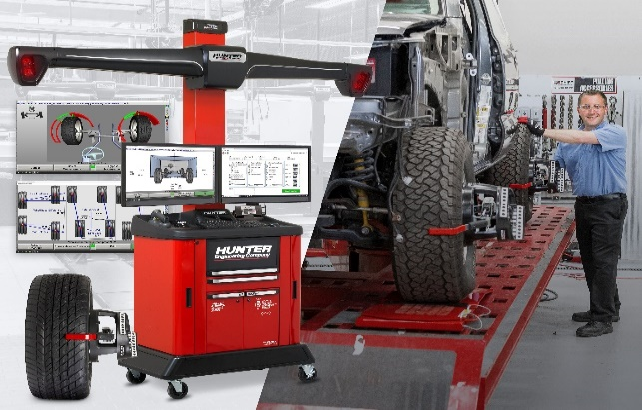
Figure 1.44 Alignment machine

2.2.5 On-road braking efficiency testing
A vehicle road test is an important part of assessing its performance, handling, and overall condition. It involves driving the vehicle on public roads to evaluate its various systems and components. Here are the key aspects to consider when conducting a vehicle road test:
- Preparing for the Road Test: Before starting the road test, ensure the vehicle is in proper working condition. Check the fluid levels, tire pressure, and overall vehicle cleanliness. Adjust the driver's seat, mirrors, and steering wheel to a comfortable position. Familiarize yourself with the vehicle's controls and features.
- Starting and Acceleration: Begin the road test by starting the vehicle's engine and smoothly accelerating. Pay attention to how the engine performs during acceleration, assessing its power delivery and responsiveness. Note any unusual vibrations or noises that may indicate engine or drivetrain issues.
- Braking and Stopping: Test the vehicle's braking system by applying the brakes at different speeds and pressures. Observe how the vehicle decelerates and comes to a stop. Check for any signs of brake noise, vibration, or excessive pedal travel, which could indicate brake system problems.
- Steering and Handling: Evaluate the vehicle's steering responsiveness and handling characteristics. Assess how well it maintains a straight line and its ability to corner and maneuver. Note any excessive play in the steering wheel, vibrations, or difficulty in maintaining control, as these could indicate suspension or steering issues.
- Transmission and Shifting: If the vehicle has a manual or automatic transmission, pay attention to how it shifts through the gears. Note if the shifting is smooth or if there are any delays, slipping, or harsh engagements that could indicate transmission problems.
- Ride Comfort and Noise: Evaluate the vehicle's ride comfort by observing how it absorbs bumps and road imperfections. Note any excessive vibrations, noises, or rattles that may indicate issues with the suspension, exhaust system, or other components.
- HVAC, Electronics, and Controls: Test the various electronic systems, including the HVAC (Heating, Ventilation, and Air Conditioning) system, audio system, lights, and other controls. Ensure that all functions are working properly and that there are no issues with electrical malfunctions or glitches.
- Overall Feel and Feedback: Throughout the road test, pay attention to the overall feel and feedback of the vehicle. Consider factors such as comfort, ergonomics, visibility, and driver confidence. Note any concerns or areas for improvement.
- Safety Considerations: Prioritize safety during the road test. Observe traffic laws, maintain appropriate speeds, and drive defensively. Be aware of your surroundings and avoid distractions that may compromise your focus on the road and the vehicle's performance.
After the road test, review your observations and notes. If you identified any concerning issues during the test, consider having the vehicle inspected and serviced by a qualified mechanic to address any necessary repairs or maintenance.

2.3 Adjusting air suspension balance
Adjusting the air suspension balance in an air suspension system typically involves modifying the air pressure in the individual air springs to achieve the desired ride height and load distribution. And the followings are a general procedure for adjusting the air suspension balance:
- Understand the System: Familiarize yourself with the specific air suspension system in your vehicle. Consult the vehicle's manual or seek guidance from a qualified technician to understand the adjustment methods and recommended air pressure ranges for your particular system.
- Determine the Desired Ride Height: Identify the desired ride height for your vehicle. This can vary depending on factors such as vehicle load, driving conditions, and personal preference. Refer to the manufacturer's specifications or guidelines to determine the appropriate ride height.
- Locate the Air Suspension Components: Identify the air suspension components, including the air springs and the air compressor. The air springs are typically located near each wheel and are responsible for supporting the vehicle's weight. The air compressor supplies and regulates the air pressure to the air springs.
- Adjust the Air Pressure: Use the appropriate method to adjust the air pressure in the air springs. Some systems may have manual valves that allow you to add or release air manually, while others may have electronic controls that enable you to adjust the air pressure electronically. Follow the instructions provided by the manufacturer to adjust the air pressure accordingly.
- Level the Vehicle: Inflate or deflate the air springs as needed to level the vehicle. Measure the ride height at each corner of the vehicle and adjust the air pressure in the corresponding air spring to achieve a consistent and balanced ride height across all corners.
- Test and Fine-tune: After adjusting the air pressure, take the vehicle for a test drive to assess the ride quality and handling. Pay attention to any signs of imbalance, such as uneven or excessive leaning, bouncing, or instability. If necessary, make further adjustments to the air pressure to achieve the desired balance and ride characteristics.
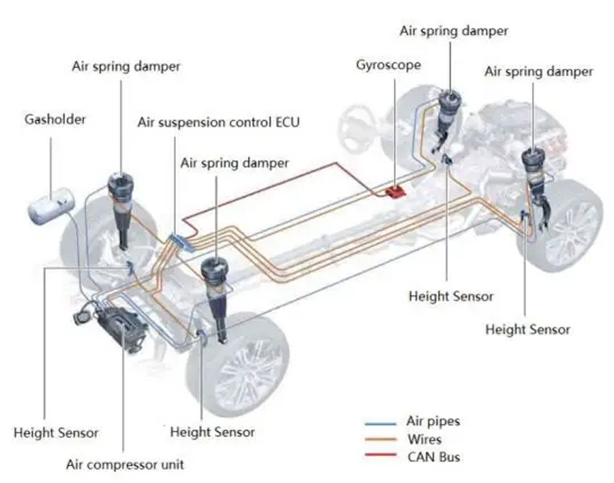
Figure 1.45 Air suspension system layout

2.4 Identifying causes of unbalanced air suspension
Unbalanced vehicle air suspension can occur due to various factors. The primary causes include air spring leaks and faulty height sensors or leveling sensors. Air spring leaks are a common cause of imbalance in an air suspension system. Over time, the air springs can develop leaks due to wear and tear, damaged seals, or faulty connections. When one or more air springs lose air pressure, it can result in an uneven distribution of weight, causing the vehicle to lean or sit lower on one side. This leads to an unbalanced suspension and can affect the vehicle's handling, ride comfort, and overall stability. Faulty height sensors or leveling sensors can also contribute to an unbalanced air suspension. These sensors monitor the ride height of the vehicle and provide feedback to the suspension system. If the sensors are malfunctioning, incorrectly calibrated, or damaged, they may provide inaccurate readings. As a result, the system may not be able to adjust the air pressure in the air springs correctly to maintain a balanced ride height. This can lead to one or more corners of the vehicle being at a different height than others, causing an imbalance in the suspension.

Unit Three: Diagnostic Under Chassis Management Systems
This unit to provide you the necessary information regarding the following content coverage and topics:
- Selecting diagnostic processes
- Carrying out Diagnostic Under Chassis Management Systems
This guide will also assist you to attain the learning outcomes stated in the cover page. Specifically, upon completion of this learning guide, you will be able to:
- Select diagnostic processes
- Carryout Diagnostic Under Chassis Management Systems

Diagnosing under chassis management systems

3.1 Selecting diagnostic processes

3.1.1 Analyzing manufacturer specifications
In automotive service operations, "component damage" refers to any kind of harm or impairment to a specific part or component of a vehicle. It could be the result of wear and tear, accidents, improper maintenance, or other factors. Component damage can affect the performance, functionality, and safety of the vehicle.
Examples of component damage in automotive service operations include:
- Suspension Damage: Suspension components, such as shocks, struts, control arms, or bushings, can suffer damage from rough driving conditions, potholes, or accidents. Suspension damage can result in poor handling, vibrations, uneven tire wear, or a harsh ride.
- Brake System Damage: Brake components, including brake pads, rotors, calipers, or brake lines, can be damaged due to excessive heat, wear, or contamination. Brake system damage can lead to reduced braking performance, longer stopping distances, or brake failure.

3.1.2 Six-step troubleshooting plan
By using this troubleshooting plan, you can minimize the amount of time spent diagnosing the circuit by performing only the checks that you need to make, with an emphasis on checks that are the easiest to make. Quickly finding and fixing an electrical problem doesn’t depend on luck, but on your skills: applying what you know about circuits, using the EWD, and devising a strategy to isolate the location of the problem. The six−step approach is a way to organize your efforts, keeping you on−track while you are troubleshooting the problem.
Step - 1: customer’s complaint
This is the first step in any diagnostic process. When you are handed a repair order with a customer’s complaint on it, there are three things that you must do:
- You must be able to identify the problem the customer noted
- You must determine if it is a problem or not
- If there is a problem, determine if it is intermittent or continuous
Step - 2: determine the related symptoms
Now that you have verified that there is a problem, you need to examine the problem symptoms more thoroughly. The related symptoms check is basically an operational check, so you won’t need any tools except for the EWD. The major goal of this check is to determine:
- How much of the circuit is affected.
- Find clues to the location of the problem by operating other circuits related or connected to the problem area.
The above step can be conducted in either way as discussed below:
- Circuits with Self-Diagnostics:
The Repair Manual (RM) are the only places to find information about how to access the Diagnostic Trouble Codes, and what each individual code means. The RM also contains specific diagnostic procedures for each circuit, including a table to direct you in diagnosing problems that do not set trouble codes. Because the method for accessing the codes varies from system to system, you’ll need to turn to the specific RM section for each of these systems. The EWD is helpful, especially with the color wiring diagrams, and location information.

Figure3.1 Repair manual
- Diagnosing with DTCs:
If the circuit has an ECU with self−diagnostic ability, the general diagnostic strategy is to:
- Always check for Diagnostic Trouble Codes (DTC) first, and write them down. Point any Freeze Frame data for reference.
- Clear the code memory and operate the system/vehicle to see if the problem is intermittent or continuous.
- If the trouble code(s) reappear, follow the diagnostic tables in the RM.
- If there are no codes, but there is a problem present, use the Problem Symptoms Table in the repair manual to direct you to the proper inspections.
- While diagnosing the circuit, use the EWD to help you locate the components, pins, connectors, or splices.
DTCs are used in many body electrical systems including Cruise Control, Anti-lock Brakes, Airbag, and Engine Control Systems
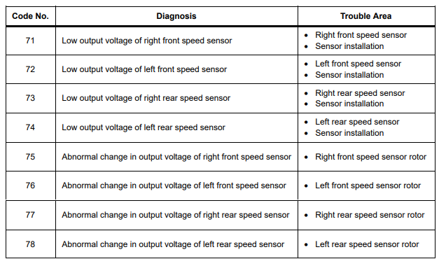
Step – 3: Analyze the Symptoms
In order to fix the problem, you need to know exactly what problem you’re dealing with. When verifying the problem, you were able to get a better understanding of the customer’s complaint. After making the related symptoms checks, you may have found other circuits that are or are not affected.
- Exactly which components/circuits are affected (both the customer’s complaint and any related symptoms)
- What kind of problem you need to look for (open, short−to−ground, high resistance, feedback)
- When it occurs (what operating conditions: key ON, driver’s door open, etc.)
After doing this, go to the System Circuit Diagram (or a photocopy of the diagram if possible), and trace the current flow paths in the parts of the circuit that are confirmed as working. By tracing the current flow paths, you will have a visual reference of areas of the circuit you don’t need to check. Areas that you have NOT traced are all places that a possible problem could exist. All of this up−front work will have a payoff: Less time spent making checks on the car!
At this point, you need to stop, and put all of this information together to specifically define:
Step – 4: Isolate the problem
To isolate the problem, there are three actions you need to make here under this step and these are:
- On the wiring diagram, find the areas that are possible problem areas
- Determine where to begin making the checks
- Make your inspections.
Step – 5: Correct the Trouble
Correcting the trouble is probably the most straight forward step in the diagnostic process. Making the repair to an electrical problem will always involve the following:
- Repair or replacement of a component
- Wiring repair
- Service to a circuit connection
- Connectors
- Terminals
- Ground point
- When disconnecting and replacing components, make sure that the circuit is off or the battery is disconnected.
Component Service Hints: It’s obvious that certain circuits require special handling. The air bag system for example requires you to disconnect the battery and wait up to 90 seconds before servicing the system. Always refer to the Repair Manual for special service precautions.
If the battery needs to be disconnected, write down the customer’s radio station “pre−sets". Reprogram the stations and reset the clock after reconnecting the battery.
Step – 6: Check for proper operation
After making the repair, it’s must always verify that the problem was actually fixed. Operate the circuit as thoroughly as you did when you first looked at the car, making sure all of the functions and features of the circuit are working properly. Sometimes, a circuit has multiple problems which are causing it to be inoperative. This re check of the circuit ensures that the customer will be satisfied. A satisfied customer means that he or she will return to your dealership for service, and tell their friends about their service experience, too.

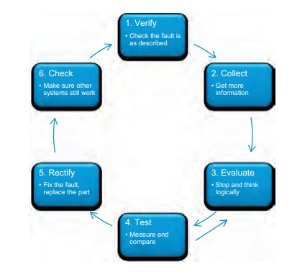
Figure 3.2 Check for proper operation

3.1.3 Discover-investigate-fix methodology
The "Discover-Investigate-Fix" methodology is an approach used in automotive diagnostics to systematically identify and resolve issues with electrical and electronic systems. It involves the following steps:
Discover
In the discovery phase, the technician gathers information from the vehicle owner or from initial observations to understand the reported symptoms or concerns. They may ask questions to gather specific details about the issue, such as when it occurs, under what conditions, or if there are any associated warning lights or abnormal behaviors.
Investigate
Once the technician has a clear understanding of the problem, they move on to the investigation phase. This involves conducting various tests and utilizing diagnostic tools to gather data and identify potential causes. The investigation may include visual inspections, multimeter testing, scan tool diagnostics, oscilloscope analysis, or other appropriate methods based on the nature of the issue.
Fix
After identifying the root cause of the issue, the technician proceeds to the fix phase. This involves implementing the necessary repairs or corrective actions. It may include replacing faulty components, repairing damaged wiring, reprogramming control modules, or addressing any other identified issues. The technician follows proper repair procedures and ensures that all necessary steps are taken to resolve the problem effectively.
Verify
Once the repairs or corrective actions are completed, the technician verifies the fix by conducting post-repair tests and checks. This ensures that the issue has been fully resolved and that all related systems are functioning properly. Verification may involve retesting the affected systems, clearing any stored fault codes, and confirming that the reported symptoms no longer persist.

3.2 Carrying out diagnostic under chassis management systems

3.2.1 Electronic braking systems
Introduction
The main braking system of a car works by hydraulics. This means that when the driver presses the brake pedal, liquid pressure forces pistons to apply brakes on each wheel. A handbrake system, usually operated by a lever and cables, is used for parking. Most handbrakes operate on the rear wheels. Two types of light vehicle brakes are used. Disc brakes were traditionally used on the front wheel of cars but now are used on all four wheels of most modern vehicles.
Braking pressure forces brake pads against both sides of a steel disc. Drum brakes are fitted on the rear wheels of some cars and on all wheels of older vehicles. Braking pressure forces brake shoes to expand outwards into contact with a drum. The important part of brake pads and shoes is a friction lining that grip well and withstands wear.
Systematic testing
If the reported fault is the handbrake not holding, proceed as follows:
- Confirm the fault by trying to pull away with the handbrake on.
- Check the foot brake operation. If correct, this suggests the brake shoes and drums (or pads and discs) are likely to be in good order.
- Consider this: Do you need to remove the wheels and drums or could it be a cable fault?
- Check cable operation by using an assistant in the car while you observe.
- Renew the cable if seized.

3.2.2 Electronic stability control systems
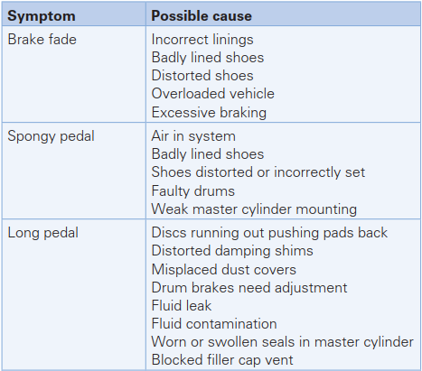
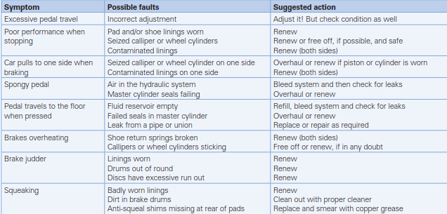
Brakes fault diagnosis
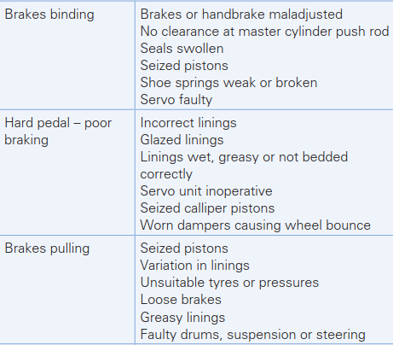

Brake hose clamps will assist in diagnosing hydraulic faults and enable a fault to be located quickly. Proceed as follows:
1 Clamp all hydraulic flexible hoses and check the pedal
2 Remove the clamps one at a time and check the pedal again (each time).
3 The location of air in the system or the faulty part of the system will now be apparent
 | Pressure increase Mode | Pressure hold Mode | Pressure reduction Mode
Function of valves | PHV= Opened | PHV= Closed | PHV= Closed
Function of valves | PRV= Closed | PRV= Closed | PRV= Opened
Pressure in wheel cylinder | Increased | Constant | Decreased
Controlled valves by the ABS ECU | No One | PHV gets Current | Both PHV and PRV gets current

Diagnostics – antilock brakes
Systematic testing procedure
If the reported fault is the ABS warning light staying on, proceed as given in Figure
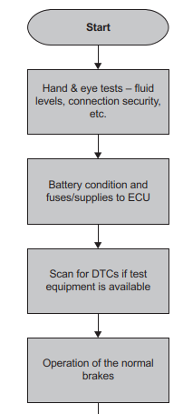
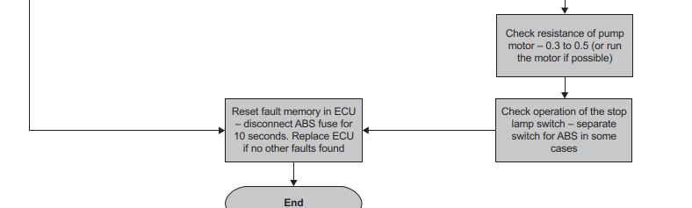
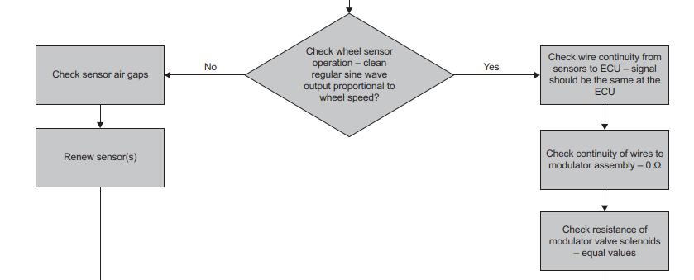

Antilock brake’s fault diagnosis table
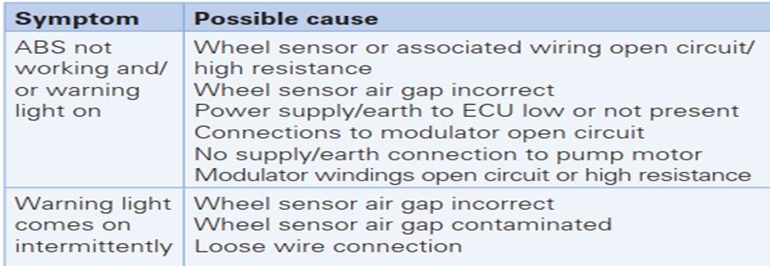
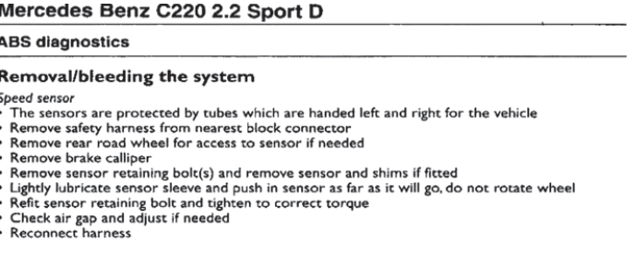
Special procedures may be required to bleed the hydraulic system when ABS is fitted. Refer to appropriate data for the particular

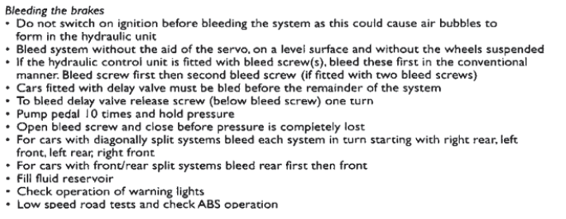
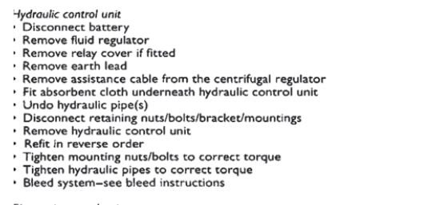
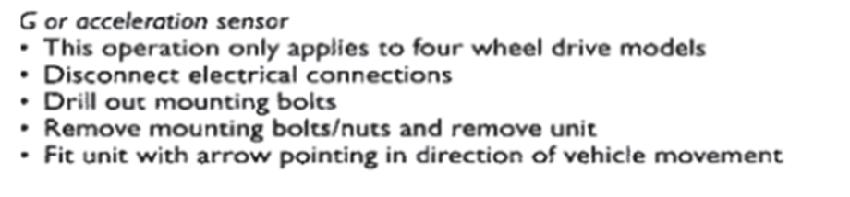

3.2.3 steering and suspension system
Active suspension, like many other innovations, was developed in the Grand Prix world. It is now slowly becoming more popular on production vehicles. It is interesting to note that just as some Formula 1 teams perfected it, the rules changed (1993–94) to prevent its use! Conventional suspension systems are always a compromise between soft springs for comfort and harder springing for better cornering ability. A suspension system has to fulfil four main functions.
● Absorb bumps.
● Manage nose dive when braking.
● Prevent roll when cornering.
● Control body movement.
This means that some functions have to be compromised in order to fulfil others to a greater extent.
Operation
Active suspension allows the best of both worlds. This is achieved by replacing the conventional springs with double-acting hydraulic units. These are controlled by an ECU, which receives signals from various sensors. Oil pressure in excess of 150 bar is supplied to the hydraulic units from a pump. A servo valve controls the oil, which is arguably the most critical component. The main benefits of active suspension are as follows.
- Improvements in ride comfort, handling and safety.
- Predictable control of the vehicle under different conditions.
- No change in handling between laden and unladen.
Sensors, actuators and system operation
To control the hydraulic units to the best advantage, the ECU needs to ‘know’ certain information. This is determined from sensor readings from various parts of the vehicle. A number of sensors are used to provide information to the suspension ECU.
Load sensor
A load cell used to determine whether actual load is positioned on each hydraulic ram.
Displacement and vertical acceleration

Lateral and longitudinal acceleration
Acceleration can be determined from a pendulum type sensor using strain gauges linked to a mass, or devices similar to an engine knock sensor.
Yaw transducer: Yaw can be determined from lateral acceleration if the sensor is mounted at the front or rear of the vehicle.
Steering position: As well as steering position, rate of change of position is determined from a rotary position sensor. This device can be a light beam and detector type or similar. If the rate of change of steering position is beyond a threshold the system will switch to a harder suspension setting.
Vehicle speed: The speed of the vehicle is taken from a standard type sensor as used for operating the speedometer.
Throttle position: Similar to the existing throttle potentiometers. This gives data on the driver’s intention to accelerate or decelerate allowing the suspension to switch to a harder setting when appropriate.
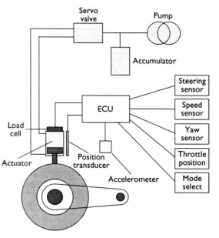
Figure 3.3 Throttle position sensor

3.2.4 Electrical and Mechanical systems
Carrying out maintenance or diagnostics on a vehicle's electronic under-chassis system typically involves inspecting and troubleshooting various components related to the vehicle's electrical and electronic systems. Here's a general guide on how to perform these tasks:
Safety Precautions: Before working on the electronic under-chassis system, ensure that the vehicle is parked on a level surface, the engine is turned off, and the ignition key is removed. Wear appropriate personal protective equipment (PPE) such as safety glasses and gloves.
Accessing the Under-Chassis Area: Depending on the vehicle, you may need to use a jack or lift to raise the vehicle and gain access to the under-chassis area. Follow proper lifting procedures and use jack stands to secure the vehicle before working underneath it.
Visual Inspection: Inspect the under-chassis area for any visible damage, loose connections, or signs of wear. Look for frayed wiring, loose connectors, or damaged components. Pay particular attention to the wiring harnesses, connectors, sensors, control modules, and any exposed electrical components.
Diagnostic Tools: To diagnose electronic under-chassis system issues, you may need specialized diagnostic tools. These can include a scan tool or code reader that can interface with the vehicle's onboard diagnostic system to retrieve trouble codes and perform system tests. Follow the manufacturer's instructions for using the diagnostic tools specific to the vehicle.
Trouble Code Retrieval: Connect the scan tool or code reader to the vehicle's OBD-II (On-Board Diagnostic) port, typically located under the dashboard. Retrieve any stored trouble codes to identify specific issues or malfunctions within the electronic under-chassis system. The trouble codes will provide a starting point for further diagnosis.
Wiring and Connector Inspection: Inspect the wiring harnesses and connectors for signs of damage, corrosion, or loose connections. Ensure that all connectors are properly seated and secured. Repair or replace any damaged wiring or connectors as necessary.
Component Testing: Depending on the specific issue, you may need to test individual components such as sensors, actuators, relays, or control modules. Follow the manufacturer's instructions or consult service manuals for the specific testing procedures and specifications. Use appropriate multimeters, oscilloscopes, or other testing equipment as needed.
Repair or Replacement: Based on the diagnostic results, repair or replace any faulty components or wiring. This may involve soldering or crimping connections, replacing sensors or control modules, or repairing damaged wiring harnesses. Ensure that all repairs are done following proper procedures and in accordance with the vehicle manufacturer's recommendations.
Functional Testing: After repairs or component replacements, perform functional tests to verify that the electronic under-chassis system is operating correctly. Use the diagnostic tools to clear any stored trouble codes and perform system tests to ensure proper functionality.
Reassembly and Final Checks: Once all repairs and testing are complete, reassemble any components that were removed for access. Double-check all connections, fasteners, and wiring routing to ensure everything is properly secured. Lower the vehicle from the jack stands or lift, and perform a final visual inspection to confirm that everything is in order.
It's important to note that the specific procedures and steps may vary depending on the vehicle make, model, and the nature of the issue. Always refer to the vehicle's service manual and follow the manufacturer's instructions and safety guidelines when performing maintenance or diagnostics on the electronic under-chassis system. If you are unsure or uncomfortable with any aspect of the process, it is recommended to seek assistance from a qualified automotive technician or repair professional.
Diagnostics of automotive sensors involves a systematic approach to identify and troubleshoot issues with various sensors in a vehicle. Here's a step-by-step procedure to perform diagnostics on automotive sensors:
Identify the Sensor: Determine which sensor you need to diagnose. Common sensors in vehicles include oxygen sensors, mass airflow sensors, throttle position sensors, coolant temperature sensors, crankshaft position sensors, and many others. Consult the vehicle's service manual or wiring diagrams to locate the sensor you need to diagnose.
Gather Information: Research the specific sensor you are working on. Understand its function, typical failure modes, and the expected voltage or resistance values it should produce under normal operating conditions. This information can be found in the vehicle's service manual or through reliable automotive resources.
Visual Inspection: Perform a visual inspection of the sensor and its wiring harness. Look for any signs of physical damage, loose connectors, corrosion, or frayed wires. Ensure that the sensor is securely mounted and that the wiring connections are clean and properly seated.
Check Power and Ground: Use a multimeter to check for power and ground connections to the sensor. Set the multimeter to the appropriate voltage or resistance range and measure the voltage across the sensor's power supply and ground terminals. Ensure that the voltage readings are within the specified range.
Test Sensor Output: Depending on the type of sensor, there are different methods to test its output. Here are a few examples:
Voltage Output Sensors: Measure the voltage output of the sensor using a multimeter. Connect the multimeter to the appropriate terminals and observe the voltage readings while the engine is running or as directed by the service manual. Compare the readings to the expected values for that sensor.
Resistance Output Sensors: Measure the resistance across the sensor terminals using a multimeter. Ensure that the sensor is disconnected from the wiring harness before performing resistance measurements. Compare the resistance readings to the specified values for the sensor.
Frequency or Digital Output Sensors: Use specialized diagnostic tools or oscilloscopes to analyze the sensor's frequency or digital output signals. These tools can provide real-time data and waveform patterns, allowing you to compare the observed signals with the expected patterns or values.
Compare Readings and Specifications: Compare the readings obtained during testing to the specifications provided in the service manual or manufacturer's guidelines. If the readings are within the specified range, the sensor is likely functioning correctly. If the readings are outside the acceptable range, further troubleshooting is required.
Verify Wiring and Connectors: Inspect the wiring harness and connectors associated with the sensor. Look for signs of damage, corrosion, or loose connections. Repair or replace any damaged wiring or connectors as necessary. Ensure that all connections are clean, secure, and properly seated.
Clear Fault Codes and Retest (if applicable): If the sensor is part of the vehicle's onboard diagnostic system and has triggered a fault code, use a scan tool to clear the fault codes after making necessary repairs or adjustments. Retest the sensor to ensure that the fault code does not reappear.
Document and Interpret Results: Keep detailed records of the diagnostic process, including the readings obtained, repairs made, or adjustments performed. If the sensor is functioning correctly, document the diagnosis and move on to other potential problem areas if necessary. If the sensor is faulty, replace it with a new one following the manufacturer's recommendations.
Verify Repair: After replacing a faulty sensor, retest the system to ensure that the new sensor resolves the issue. Perform functional tests and monitor the sensor's output to confirm that it is functioning correctly.
Remember that this is a general procedure for diagnostic purposes, and the specific steps and methods may vary depending on the vehicle make, model, and the sensor being diagnosed. Always refer to the vehicle's service manual and follow the manufacturer's instructions and safety guidelines when performing sensor diagnostics.
Air Suspension Adjustment:
Air suspension systems use air springs or airbags to provide a smooth and adjustable ride. The balance of the air suspension is adjusted using various components and controls. Here's a general overview of how air suspension balance is adjusted:
Height Sensors: Air suspension systems typically have height sensors installed at each corner of the vehicle. These sensors measure the ride height or distance between the suspension and the chassis. The sensors send signals to the suspension control module, indicating the actual height of each corner.
Suspension Control Module: The suspension control module receives input from the height sensors and other sensors in the system. It processes this information and sends commands to the air compressor and solenoids to adjust the air pressure in the air springs.
Air Compressor: The air compressor supplies compressed air to the air springs. When the suspension control module detects that a corner of the vehicle is lower than the desired ride height, it activates the air compressor to increase the air pressure in the corresponding air spring. This raises the corner of the vehicle, restoring the proper ride height.
Solenoids and Valves: Solenoids and valves control the air flow between the air compressor and the air springs. The suspension control module sends signals to these solenoids and valves to open or close, allowing air to enter or exit the air springs. By selectively adjusting the air pressure in each air spring, the system can level the vehicle and maintain a balanced ride height.
Manual Adjustments: Some air suspension systems also provide manual adjustments for ride height and balance. This can involve manual valves or switches that allow the driver or technician to manually increase or decrease the air pressure in specific air springs. Manual adjustments may be used for leveling the vehicle when carrying heavy loads or for specific driving conditions.
Electronic Controls: In more advanced air suspension systems, electronic controls such as adaptive damping or electronic stability control may also be used to further optimize the suspension's balance and performance. These systems use additional sensors and algorithms to adjust the suspension settings based on driving conditions, vehicle dynamics, and driver inputs.
It's important to note that the specific methods and components involved in adjusting air suspension balance can vary depending on the vehicle make, model, and the particular air suspension system installed. Always consult the vehicle's service manual or seek assistance from a qualified technician to ensure proper adjustment and maintenance of the air suspension system.
Component damage analysis
In automotive service operations, "component damage" refers to any kind of harm or impairment to a specific part or component of a vehicle. It could be the result of wear and tear, accidents, improper maintenance, or other factors. Component damage can affect the performance, functionality, and safety of the vehicle.
Examples of component damage in automotive service operations include:
Suspension Damage: Suspension components, such as shocks, struts, control arms, or bushings, can suffer damage from rough driving conditions, potholes, or accidents. Suspension damage can result in poor handling, vibrations, uneven tire wear, or a harsh ride.
Brake System Damage: Brake components, including brake pads, rotors, calipers, or brake lines, can be damaged due to excessive heat, wear, or contamination. Brake system damage can lead to reduced braking performance, longer stopping distances, or brake failure.
System modifications in automotive service operations refer to intentional changes or alterations made to the original design or configuration of a vehicle's systems. These modifications are typically performed to enhance performance, aesthetics, or functionality according to the owner's preferences or specific requirements.
Performance Modifications: These involve upgrades to the engine, exhaust system, intake system, suspension, or other components to increase power, torque, or overall performance. Performance modifications can include installing aftermarket parts, tuning the engine management system, or upgrading the vehicle's software.
Exterior or Interior Modifications: These modifications involve changes to the vehicle's appearance or interior features. They can include installing custom body kits, spoilers, aftermarket wheels, custom paintwork, interior trim modifications, or upgraded audio systems.
Suspension Modifications: Suspension modifications can include lowering or raising the vehicle's ride height, installing stiffer springs, upgrading shocks or struts, or adding sway bars. These modifications can affect the vehicle's handling characteristics and ride comfort.
Pressure Gauges: Pressure gauges are used to measure hydraulic pressures in systems such as the suspension, brake, or power steering.
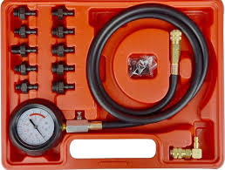
Figure 3.4 Pressure Gauges

Diagnosis
As with the diagnosis of any problem, your diagnosis should begin with trying to duplicate the customer’s complaint. For steering problems, this is done on a road test; make sure you drive carefully and cautiously, especially because the vehicle has a control problem. It is very important that during the road test the vehicle is driven under conditions similar to the owner’s normal driving. Try to duplicate the conditions on which the customer’s concern is based. Before going on the road test, do a thorough safety inspection of the vehicle, including the tires. Once the road test has been completed and it has been determined that there is an abnormal condition, use the symptom to identify the possible trouble area. Then check the parts in that area.
Steering system diagnosis
It is important to realize that many steering complaints are caused by problems in areas other than the steering system. A good diagnosis is one that finds the exact cause of the customer’s complaint. Although customers may describe the problem in different ways, the most common complaints and their typical causes are discussed next.

Self- Check -1
Directions: Answer all the questions listed below
- How Traction control will intervene?
- What are the number of methods to control of tractive force?
- Discuss briefly about TCS operation
- If Traction control fault inoperative, what will be the possible causes and remedial actions?

Self-check-2
Directions: Answer all the questions listed below
- Draw the Systematic testing procedure
- Describe about the operating positions of hydraulic modulator
- What are the requirements of ABS
- Describe how to test the operation of an ABS wheel speed sensor.
Explain why it may be necessary to check the run-out on a brake disk (rotor) and describe how this is done.

Lap Test
Task 1. Perform Systematic testing
- Antilock brake system
- Electronic Steering system
- Electronic suspension system

Reference
- Jack Erjavec, Automotive Technology: a systems approach, 5 t h Edition, 2010 Delmar, Cengage Learning
- James D. Haldeman, Automotive technology Principles, Diagnosis, and Service fourth edition
- Crouse, W.H. and Anglin D.L, Auto motive mechanics 10th edition
- R.K Rajput, Automobile Engineering
- Prof. Dr.-Ing. Konrad Reif, Brakes, Brake Control and Driver Assistance Systems
- Nunney, M. J.Rutledge, 2007, Light and Heavy Vehicle Technology 4th ed.

Participants of this Module (training material) preparation

No | Name | Qualification (Level) | Field of Study | Organization/ Institution | Mobile Number | E-mail
 | Fadli Aman | BSc. | Automotive Technology | General Wingate PTC | 0927283100 | Fadli.ziyad@gmail.com
 | Habtamu Deresso | PHD Candidate | Automotive Technology | ASTU | 0945853269 | habtamu.deresso@gmail.com
 | Israel Taye | MSC | Automotive Technology | General Wingate PTC | 0913424100 | isra.taye@gmail.com
 | Natnael Genene | MSC | Automotive Technology | Athlete kenenisa PTC | 0920397105 | natnealgenene143@gmail.com
 | Robsan Tesfaye | MSC | Automotive Technology | Burayu PTC | 0920117175 | robsantesfaye4@gmail.com
 | Sisay Tufa | MSC | Automotive Technology | M/G/M/Buli | 0912065407 | knbntf@gmail.com
 | Tagay Tesfaye | MSC | Automotive Technology | Bishoftu PTC | 0975971391 | tagotagotago37@gmail.com

