Heavy Vehicles and Earth Moving Machinery Maintenance
Based on November, 2022, Version- I

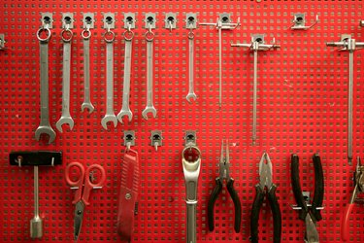

Module Title: - Carry out Workshop Practice Activities
Module code: EIS HEM1 M01 1122
Nominal duration: 70 Hours

Prepared by: Ministry of Labor and Skill
November, 2022
Addis Ababa, Ethiopia
Table of content
Acknowledgment IV
Acronyms V
Introduction to the Module 1
Unit One: Apply OHS requirement 2
1.1 OHS and environmental requirement 3
1.2 personal protective equipment 5
1.3 Hazardous materials and disposal 11
Self-check-1 17
Unit Two: Perfom Benchwork Operations 18
2.1 Use,store and calibrate tools 19
2.2 Cutting using hacksaw 28
2.3 Chiseling 30
2.4 Drilling 31
2.5 Filling 35
2.6 Grinding 37
2.7 Making External And Internal Tread 41
Self Check 2 45
Operation sheet 2.1: Grinding machine 47
Operation Sheet:2.2 Cutting procedures using hacksaw 48
Operation sheet:2.3 Check filling process 49
LAP TEST 50
Unit Three: Clean and maintain workshop 51
3.1 Cleaning tools, equipment and organizing work area 52
3.2 Managing waste material 54
Self Check 3 59
Operation sheet 3.1 Clean and maintain workshop 61
LAP TEST 62
Refferance 62

Acknowledgment
Ministry of Labor and Skills wish to extend thanks and appreciation to the many representatives of TVT instructors and respective industry experts who donated their time and expertise to the development of this Teaching, Training and Learning Materials (TTLM).

Acronyms
OHS _____________________________occupational health and safety
PPE______________________________ Personal Protective Equipment
WHS____________________________ Work place Health and Safety
TDN_____________________________Twist Drill Nomenclature
LAP_____________________________ Learning Activity performance Test
MSDS ____________________________Material Safety Data sheet

Introduction to the Module
In Heavy Vehicles and Earth Moving Machinery Maintenance Explain the basic Concept of OHS requirement Apply Methods of workshop practice Perform Cleaning and maintaining workshop.
This module covers the knowledge, skill and attitude required
This module covers the units
- Apply OHS requirement
- Preform bench work operations
- Clean and maintain workshop
Learning Objective of the Module
- Apply OHS requirement
- Preform bench work operations
- Clean and maintain workshop
Module Instruction
For effective use this modules trainees are expected to follow the following module instruction:
- Read the information written in each unit
- Accomplish the Self-checks at the end of each unit
- Perform Operation Sheets which were provided at the end of units
- Do the “LAP test” giver at the end of each unit and
- Read the identified reference book for examples and exercis

Unit One: Apply OHS requirement
This unit is developed to provide you the necessary information regarding the following content coverage and topics:
- OHS and environmental requirement
- personal protective equipment
- hazardous materials and disposal
This unit will also assist you to attain the learning outcomes stated in the cover page. Specifically, upon completion of this learning guide, you will be able to:
- OHS and environmental requirement
- personal protective equipment
- hazardous materials and disposal

Introduction
Workshop practice is a very vast one and it is very difficult for anyone to claim a mastery over it. It provides the basic working knowledge of the production and properties of different materials used in the industry.

1.1 OHS and environmental requirement
The term environment has been derived from a French word “Environia” means to surround. It refers to both abiotic (physical or non-living) and biotic (living) environment. The word environment means surroundings, in which organisms live. Environment and the organisms are two dynamic and complex component of nature. Environment regulates the life of the organisms including human beings. Human beings interact with the environment more vigorously than other living beings. Ordinarily environment refers to the materialsandforces that surrounds the living organism.
OHS Requirements means all Laws applicable to the Supply and related to occupational health or safety, and all of the City Policies that relate to occupational health or safety, and includes without limitation the WCA.


Figure 1.1 OHs Symbol
In addition to the dangerous equipment and machines, the facilities were dirty and poorly ventilated. Opening windows would reportedly disrupt the materials inside the factories, so they remained closed, leaving workers to breathe in chemical fumes and accumulated dust day in and day out.
Environmental Requirements means all applicable present and future statutes, regulations, ordinances, rules, codes, judgments, orders or other similar enactments of any Governmental Authority regulating or relating to health, safety, or environmental conditions on, under, or about the Premises or the Project, or the environment, including without limitation, the following:
- The Comprehensive Environmental Response
- Compensation and Liability Act
- the Resource Conservation and Recovery Act and
- state and local counterparts thereto, and any regulations or policies promulgated or issued thereunder.
As used herein, the term “Hazardous Materials” means and includes any substance, material, waste, pollutant, or contaminant listed or defined as hazardous or toxic, or regulated by reason of its impact or potential impact on humans, animals and/or the environment under any Environmental Requirements, asbestos and petroleum, including crude oil or any fraction thereof, natural gas liquids, liquefied natural gas, or synthetic gas usable for fuel (or mixtures of natural gas and such synthetic gas). As defined in Environmental Requirements, Tenant is and shall be deemed to be the “operator” of Tenant’s “facility” and the “owner” of all Hazardous Materials brought on the Premises by Tenant or any Tenant Party, and the wastes, by-products, or residues generated, resulting, or produced therefrom.
Environmental Requirements, Tenant is and shall be deemed to be the "operator" of Tenant's "facility" and the "owner" of all Hazardous Materials brought on the Premises by Tenant, its agents, employees, contractors or invitees, and the wastes, by-products, or residues generated, resulting, or produced therefrom.
Tenant shall indemnify, defend, and hold Landlord harmless from and against any and all losses (including, without limitation, diminution in value of the Premises or the Project and loss of rental income from the Project), claims, demands, actions, suits, damages (including, without limitation, punitive damages), expenses (including, without limitation, remediation, removal, repair, corrective action, or cleanup expenses), and costs (including, without limitation, actual attorneys' fees, consultant fees or expert fees and including, without limitation, removal or management of any asbestos brought into the Premises or disturbed in breach of the requirements which are brought or recoverable against, or suffered or incurred by Landlord as a result of any release of Hazardous Materials for which Tenant is obligated to remediate as provided above or any other breach of the requirements
(a) all requirements thereof, including, without limitation, those pertaining to reporting, licensing, permitting, investigation and remediation of emissions, discharges, releases or threatened releases of Hazardous Materials into the air, surface water, groundwater or land, or relating to the manufacture, processing, distribution, use, treatment, storage, disposal, transport or handling of Hazardous Materials; and
(b) all requirements pertaining to the protection of the health and safety of employees or the public from Hazardous Materials

1.2 personal protective equipment
All personal protective equipment should be safely designed and constructed, and should be maintained in a clean and reliable fashion. It should fit comfortably, encouraging worker use. If the personal protective equipment does not fit properly, it can make the difference between being safely covered or dangerously exposed.
PPE is equipment that will protect the user against health and safety risks at work. It can include items such as safety helmets and hard hats, gloves, eye protection, high-visibility clothing, safety footwear and safety harnesses.

PPE - key points
Consider whether there are ways other than using PPE to adequately control the risk. If not, ensure the the following points are taken into account:
- suitable PPE is provided
- PPE offers adequate protection for intended use
- those using PPE are adequately trained in its safe use
- PPE is properly maintained and any defects are reported
- PPE is returned to its proper storage after use
However, even the strictest controls will not necessarily eliminate all the risks associated with most job tasks and this is where the need for PPE must be evaluated. A hazard assessment can help identify which specialized PPE will be required. There are numerous types of workplace safety equipment available depending on the hazard exposure and work conditions. The following are basic PPE that can help protect employees:

Figure: 2.2. Personal protective equipment (PPE)

1.2.1Face and Eye Protection
PPE includes safety goggles and face shields and should be used for tasks that can cause eye damage or loss of vision, sprays of toxic liquids, splashes, and burns.
Safety Tips:
- Check if safety glasses comply with the ANSI Z87.1 eye protection standard.
- Ensure that there are no cracks or deformities on the lenses.
- Ensure the strap is in good working condition and is firmly sealed to the cheek and forehead.
- Clean and disinfect after use.
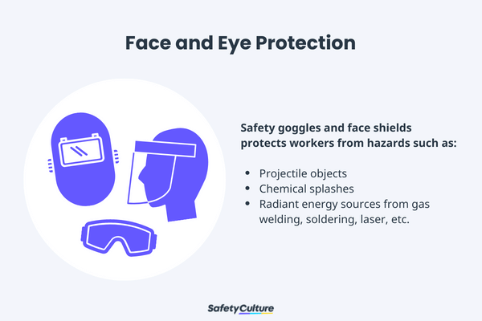
Figure 1.3.Face and Eye Protection

1.2.2 Respiratory Protection
PPE includes full-face respirators, self-contained breathing apparatus, gas masks, N95 respirators, and surgical masks are used for a task that can cause inhalation of harmful materials to enter the body. This includes harmful gas, chemicals, large-particle droplets, sprays, splashes, or splatter that may contain viruses and bacteria such as COVID-19, viral infections, and more.
Safety Tips:
- Ensure that the equipment is fit-tested and the employee has undergone proper training before wearing one.
- Carefully read the instructions to determine if it is designed to help protect against the hazards you may face.
- Change filters on half-mask or full-mask respirators frequently.
- Replace disposable respirators with every use.
- Surgical masks are not to be shared with anyone.
- Avoid touching the surgical mask after wearing it.
- Change surgical mask timely and should be disposed of after use.
- Replace the mask immediately if it is damaged or soiled.
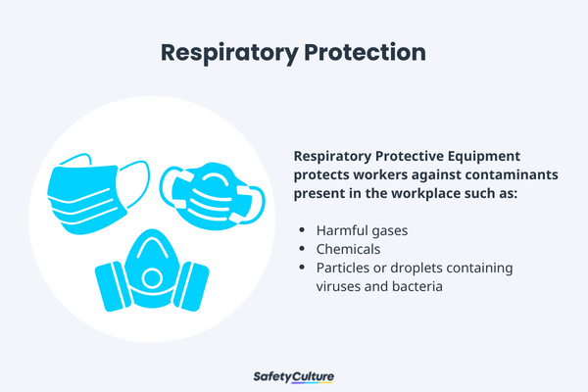
Figure 1.4 RespiratoryProtection

1.2.3 Skin and Body Protection
PPE includes the following categories to protect employees from physical hazards:

Head Protection
PPE includes hard hats and headgears and should be required for tasks that can cause any force or object falling to the head.
Safety Tips:
- Ensure that there are no dents or deformities on the shell and connections are tightened inside.
- Do not store in direct sunlight as extreme heat can cause damage.
- Choose appropriate cleaning agents as it can weaken the shells of hard hats and may eliminate electrical resistance.
- Always replace a hard hat if it was used for any kind of impact, even if the damage is unnoticeable.

Body Protection
PPE includes safety vests and suits that can be used for tasks that can cause body injuries from extreme temperatures, flames and sparks, toxic chemicals, insect bites and radiation.
Safety Tips:
- Ensure that they are clean and free from cuts and burns.
- Always get a good fit to ensure full body protection.
- Ensure bodysuit is heat-resistant clothing when working with high-temperature hazards.

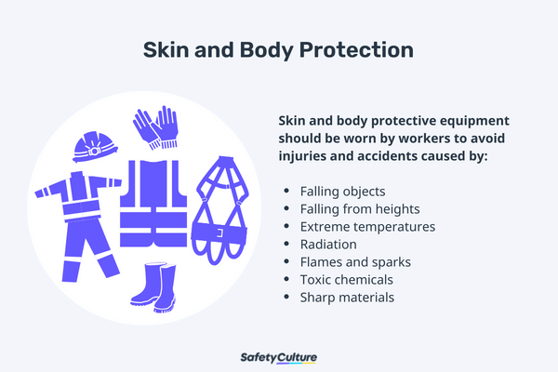
Figure 1.5 Skins and Body Protection

1.2.4 Hearing Protection
PPE includes ear muffs and plugs and should be used for tasks that can cause hearing problems and loss of hearing.
Safety Tips:
- Ensure the equipment fit the ear canal perfectly.
- It is recommended to use formable earplugs to fit on different sizes of ear canals.
- Use protectors that reduce noise to an acceptable level to have a room for communication.
- Ensure earplugs are clean and in good condition.



Figure 1.6 Hearing Protection
Protecting yourself from injury is by wearing of personal protective equipment (PPE) and clothing. These are:
- Wearing eye glasses(goggles)
- Wearing ear protection
- Wearing cap head band or hairnet.
- Wearing proper clothing, shoes, and gloves.

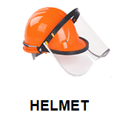
Figure 1.7 personal protective equipment (PPE)

1.3 Hazardous materials and disposal
Hazardous materials should never be disposed of down the drain or in regular trash receptacles. They should be put into proper and compatible containers that can be securely sealed. Compatible container materials ensure that wastes will not react with or corrode them. The containers should not be completely full; a “head space” allows for them.
Hazardous materials should never be disposed of down the drain or in regular trash receptacles. They should be put into proper and compatible containers that can be securely sealed. Compatible container materials ensure that wastes will not react with or corrode them.
The first three categories transform waste at the molecular level, while the fourth results in waste solidification, concentration, or volume decrease.
To destroy some organic wastes in addition to detoxifying them, you can use high-temperature incineration. Equipment used for this purpose includes:
- liquid-injection incinerators
- multiple-hearth furnaces
- fluidized-bed incinerators, and rotary kilns

Effective workshops – environment and technology
Ensure that a suitable room is selected and that the room contains the right technical equipment (flip chart, pin board, presentation materials, projector, whiteboard, markers).
Effective workshops – implementation
Good visualization is essential in a good workshop, i.e. the following steps have to be written on a flip chart or overhead projector transparency. This ensures that the team is involved.
Effective workshops follow-up
Prepare a report detailing the workshop results. Use photo reports because they have a high recognition value and are easy to distribute.
Workshop: Implementation
- Objective: Focus on the issues to be dealt with at the workshop. If a work breakdown structure is being created, the question to ask is "What do we have to do to solve the problem?" (Please refer to the specific workshop instructions).
- Procedure: Plan the workshop agenda or procedures.
- Roles: Define roles (these are generally time manager, minute taker, team leader and presenter).
- Duration: Estimate the duration of each procedure.
- Dates: Define the timeframe for each procedure.
- Implement: Implement the workshop as planned.

1.3.1 Store and dispose of hazardous materials properly.
Hazmat storage and disposal can also affect workplace safety. The first step in this process is to keep a detailed inventory of all dangerous substances on the premises. You also need to ensure proper storage in a secure but well-ventilated space. Clear signage warns employees of the dangers and notifies them about PPE requirements when they enter the storage area.
You can limit access to storage rooms so that only authorized personnel may obtain the materials. Finally, air quality monitors can sound an alarm if there is a leak or spill within the storage space.

Safe disposal
You also need to take specific steps when disposing of chemicals. Not only could improper disposal harm employees, but it could also and harm people in the nearby area.
After you understand the regulations related to toxic waste disposal, you typically need to appropriately label the material and either hire an authorized disposal service or take the material to a certified waste-management location.
You also need to log the disposal and get any necessary paperwork to prove compliance with waste disposal laws
1.3.2 Report any damage or spills immediately
The first step in a hazardous material spill is to report the incident. Companies should have a response plan in place to deal with dangerous spills, and the sooner the problem gets reported, the easier the issue is to clean up and contain. Furthermore, the plan will alert everyone to put on appropriate PPE to keep from touching or inhaling the material.
Uncontained spills can cause health and safety issues, and they could necessitate shutting down operations and evacuating employees. Emergency responders can take simple steps, such as deploying absorbents to soak up the spill, to limit the damage to people and equipment.
Land farming can be used to treat organic wastes from the petroleum industry or elsewhere. An area of land is designated, and the surface soil is conscientiously blended with the waste. Nutrients and waste-metabolizing microbes can be added to enhance treatment.
A common way to approach solidification is utilizing asphalt, plastic, or concrete to encapsulate the waste. This approach creates a leach-resistant, solid material mass.
- liquid-injection incinerators
- multiple-hearth furnaces
- fluidized-bed incinerators, and
- rotary kilns

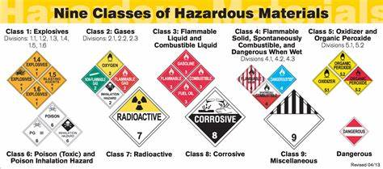

Figure 1.8 classes of hazardous materials
Methods to Dispose of Hazardous Waste
- Preventing & Reducing Waste
This method is mostly about starting to use more ecological or at least more efficient strategies to produce without creating toxic waste. Most of the time this ends up as a huge challenge for most companies and industries, but it’s always the first and most effective choice as it tackles waste from the root.
- Recycling
Many people, companies, and industries around the world are using the recycling method more and more with time. This works as a way to use waste as energy or instead make new products from it. With materials like plastic, glass, paper, and some metals this is a very common and practical choice.
If there’s a very ecological option for getting rid of waste disposal, it is recycling. It produces almost no problem eventually and instead helps to reduce overall waste for years. With the right recycling strategy, entire industries can get rid of waste disposal almost entirely.
Sadly, this tends to be highly expensive due to the problematic technological processes and a massive amount of workforce.

- Incineration & Combustion
This is another of the most effective ways to use waste disposal positively. Not only it can be used for energy creation by incinerating waste, but it also works as a way to get rid of the waste using little resources in the process.
To get rid of waste this way, most companies use incinerators, furnaces, boilers, and industrial combustion chambers or ovens. This way the disposal eventually becomes heating energy, power for turbines and machines, and even fire for cooking and much more.
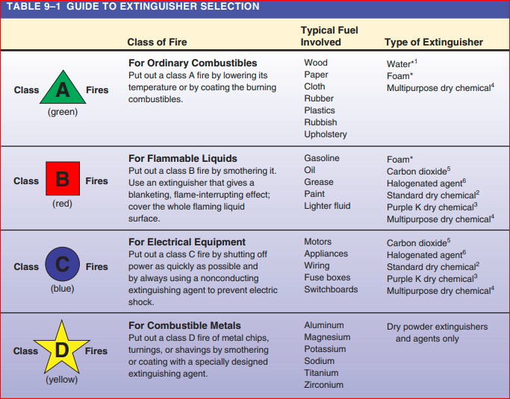
The problem with incineration and combustion processes for waste disposal can be harmful to the environment as well. Things like gasses to other harmful by-products can result from combustion process of the hazardous material. This makes incineration capable of Work intelligently around hazardous materials

Be informed; read the warnings on the product labels and in manufacturers’ literature. If more information is desired, get copies of the material safety data sheets (MSDS) for specific products from the shop’s office or from the material suppliers. Material safety data sheets (MSDS) contain information on hazardous ingredients and protective measures that the technician should use
Hazardous waste, as determined by the Environmental Protection Agency (EPA), is a solid or liquid that can harm people and the environment. If the waste is on the EPA list of known harmful materials or has one or more of the following characteristics, it is considered hazardous.
1. Ignitability means the material or waste fails the ignitability test if it is a liquid with a flash point below 140°F or a solid that can spontaneously ignite.
2. Corrosiveness means a material or waste is considered corrosive if it dissolves metals and other materials or burns the skin. It is an aqueous solution with a pH of 2 and below, or 12.5 and above. Acids have the lower value and alkalis have the higher value
3. Reactivity means a material reacts violently with water or other materials or releases cyanide gas, hydrogen sulfide gas, or similar gases when exposed to low pH solutions (acid). This also includes material that generates toxic mists, fumes, vapors, and flammable gases. 4. Toxicity means a material leaches one or more heavy metals in concentrations greater than 100 times primary drinking water standard concentrations. These heavy metals include lead, cadmium, chromium, and arsenic

Self-check-1
I. Choose the correct answer

1. ____________It consists of dumping the liquid deep in the ground close to porous rock formations for effective & complete disposal

A. Injection Wells B. Water Disposal C. Recycling D.ALL

2.____________ happens when the waste is disposed of on large landfills.

A. Injection Wells B. Water Disposal C. Recycling D.ALL

3. ___________Organic wastes have an additional method for disposal, decomposition

A. CompostingB. Water Disposal C. Recycling D.ALL

4___________Many people, companies, and industries around the world are using the recycling method more and more with time.
- Recycling B. Composting C. Water Disposal D. Recycling
- Write true if the statement is correct and false if it is incorrect.

1.__________ Hazmat storage and disposal can also affect workplace safety.
2.__________Environmental Requirements means all applicable present and future statutes, regulations, ordinances
3.__________ should never be disposed of down the drain or in regular trash receptacles

Unit Two: Perform Bench work Operations
This unit is developed to provide you the necessary information regarding the following content coverage and topics:
  - Use,store and calibrate tool
  - Cutting using hacksaw
  - Chiseling
  - Drilling
  - Filing
  - Grinding
  - External and Internal Tread
This unit will also assist you to attain the learning outcomes stated in the cover page. Specifically, upon completion of this learning guide, you will be able to:
  - Use,store and calibrate tool
  - Cutting using hacksaw
  - Chiseling
  - Drilling
  - Filing
  - Grinding
  - External and Internal Tread

2. Perform bench work operations
The bench work and fitting play an important role in every engineering workshop to complete and finish the job to the desired accuracy. The work carried out by hand at the bench is called bench work, whereas fitting is the assembling of parts together byCutting using hacksaw, Chiseling ,Drilling ,Filing ,Grinding ,External and Internal Treadetc., necessary after the machine operation

2.1 Use, store and calibrate tools
There must be a procedure defining how the tools are identified according their calibration requirements. For tools that do not need calibration at all, a sticker “No Calibration Required” can be placed on them. Other stickers can be “Calibrate before Use”,
Tool identification helps to avoid loss or theft of tools. Each tool can be carefully identified with the name of the operator to whom it belongs. Our marking systems help to reduce expenses against theft, loss and damage.
- Although no specific rules can be framed for marking yet for general marking, the following methods are adopted:
- We should draw a picture of the work that we think is proper to make and understand it.
Before marking, the two adjacent sides and the job surface must be thoroughly prepared after filling, scraping, and another machining.

2.1.1 Storing and control of tools
Importance of proper storage of tools and equipment
1. It is an important factor for safety and health as well as good business.
2. Improves appearance of general-shop and construction areas.
3. Reduces overall tool cost through maintenance.

Figure 2.1 Storing of tools

Whether you're an avid dyer or you keep a few tools around for emergency repairs, proper storage of tools and equipment is a must. Several tool storage options are safe and easy to use, allowing you to customize your tools and equipment to best fit your needs. No matter which tool storage option you choose, the important thing is providing a protected environment for the equipment.

2.2.2 Tool Storage Options
It's common to have a combination of tool storage systems, especially if you have a large collection of tools. Some of the storage solutions include:
- ​Portable toolbox:​ A handheld toolbox is ideal for your frequently used tools since you can easily take them with you. Choose one with built-in organization, such as a toolbox with a removable tray.
- ​Tool bag:​ A similar option is _{a tool bag} with soft sides. While it doesn't offer the rigid sides of a toolbox, it zips to keep your tools away from dirt and is portable.
- ​Tool chest:​ If you have a workshop, a large rolling tool chest offers lots of drawers and compartments to keep tools enclosed and protected from dirt and debris. Many models have locking drawers to reduce theft.
- ​Pegboards:​ Another popular workshop or garage option is a tool pegboard with various brackets and bins that you can rearrange. This lets you customize the storage and keeps tools easily accessible. It doesn't protect them from dirt and debris, though, so you'll need to regularly dust them off and keep them clean.
- ​Wall racks:​ For garden tools and other large equipment, a wall-mounted tool rack is an easy way to keep the items off the floor, organized, and easily accessible.
- ​Cabinets:​ Enclosed cabinetry offers a permanent storage solution in your workshop area. The doors provide some protection from dust and debris to help keep tools clean.
- ​Open shelving:​ For larger items, open shelving is a storage option. This option doesn't provide any protection from dust.
Report Unsafe Equipment
Your employer does its best to keep equipment in good condition, but maintenance personnel are only human and can’t keep up with all the problems in the field. Some defects will go unnoticed in spite of every effort made.
Those of you who work with and around machines and equipment are in a good position to notice hazardous conditions. Get in the habit of reporting things that can lead to accidents so that corrections can be made before they result in costly accidents and/or employee injuries. Keep in mind that the person who sees a situation that should be fixed and fails to report it may well end up being the victim of his/her own neglect.
Watch out for the loose or missing machine guard; the moving part with too much play; the unlubricated machine; the missing nut or bolt; the slipping belt; the loose or cracked shaft housing; or the moving part that can and should be guarded, but has never had attention.
On the electrical side of the picture, watch for the continually sparking motor, the broken switch on a tool, the damaged extension cord, the missing faceplate, loose conduit, loose conductors, the burned switch, broken plugs and receptacles.
For conveyors, watch for sharp corners; lack of crossovers, or crossovers in poor repair; unguarded parts on power-driven conveyors; or the lack of a jump-out or idler roller where two conveyors meet.
Naturally, forklift truck operators are supposed to report things that go wrong with their vehicles, just as drivers of trucks. Those who use hand trucks should be on the watch for flat or frozen wheels, broken cross members, loose toe plates and broken or slivered handles.
All workers should keep these ideas in mind. Do not hesitate to report a condition that may result in an accident or injury to yourself or one of your fellow employees. A pro-active preventive approach should be encouraged, as safety is everyone’s business.

Calibrations of tools
Calibration is a process whereby measurements produced by a tool are compared againststandardized measurements of known accuracy which meet the calibration standard that the tool must reach. If a tool is out of specification, adjustments must be made to return the tool to its original performance and accuracy.It is good practice to take another measurement after adjustment to verify that the tool is within specification.
Calibration serves two purposes:
- It checks the accuracy of the tool.
- It determines the traceability of measurements.
In addition to the above benefits, tool calibration contributes to:
- Improved product quality.
- Optimized production processes.
- Reduced scrap costs.
- Compliance with regulations.
- Early detection of process deviations.
- Customer satisfaction.
Calibration does not guarantee product quality or process performance, but it can be a contributing factor. It controls for the accuracy of tools to instill confidence in their outputs.
Vernier Caliper Mostly, the vernier caliper is more convenient than the mike. The vernier caliper can take inside, outside, and depth measurements to within hundredths or thousandths of a millimeter or thousandths of an inch.

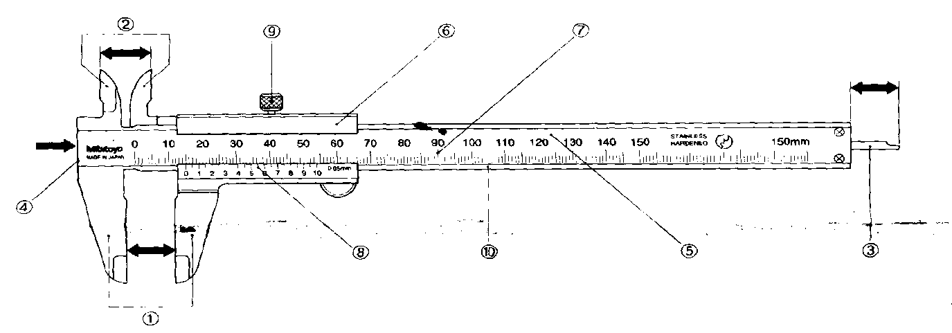

Figure 2.2 component of verniorcalliper

1.Outside Jaw
2.Inside Jaw
3.Depth Bar
4.Step Surface
7.Main Beam
8.Slider
9Main Scale
10.Vernier Scale

5.Clamp Screw
6.Reference Surface

Procedure
Grasp the vernier caliper in the right with vernier scale up
- Grasp part with left hand.
- Use the thumb of the right hand to adjust caliper so inside portion of vernier will slide in bore, then open the jaw by sliding the slide toward your right until you feel a slight amount of pressure, take reading before removing form part.
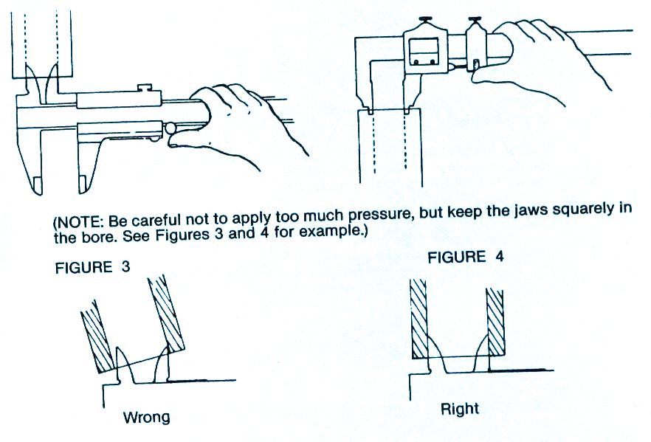

Figure 2.3Vernir Caliper Reading
- Outside Micrometer
Outside micrometers are used for measuring outside diameter of cylindrical objects, parallel surfaces or other outside dimension.
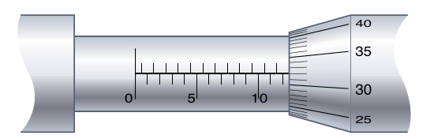
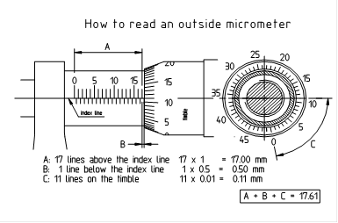
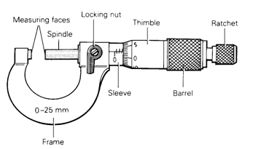
Figure: 2.4. Outside micrometer reading
- Depth Micrometer
Depth micrometers are used for measuring the depth of holes, slots, grooves and shoulders. Note that the scales are graduated in reverse as compared with external or internal micrometers.
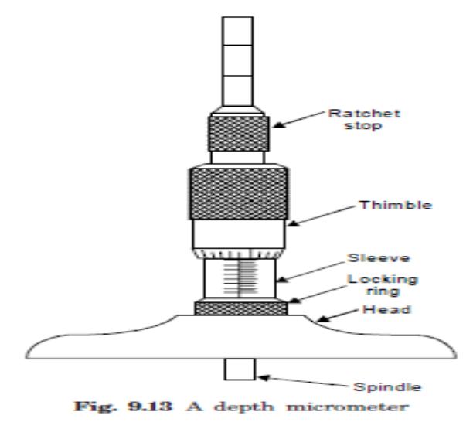
Figure: 2.5. Depth micrometer reading
- Divider
It is basically similar to the calipers except that its legs are kept straight and pointed at the
measuring edge. This is used for marking circles, arcs laying out perpendicular lines, by setting
lines. It is made of case hardened mild steel or hardened and tempered low carbon steel. Its size
is specified by the length of the leg.
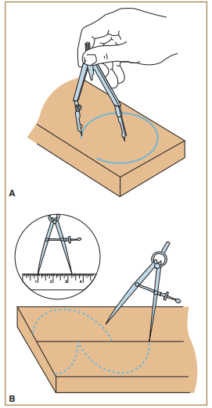
Figure: 2.6. A place and swing the compass on the center point of the circle or arc.
B-Use the Divider to Step off Measurement
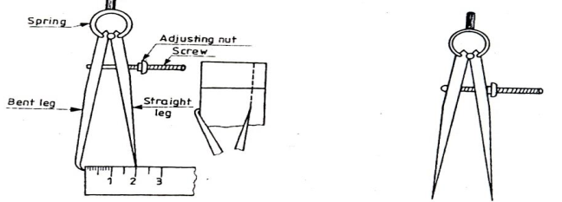
Figure: 2.7. B Odd leg caliper and divider

2.2 Cutting using hacksaw

A hacksaw is generally used for cutting a metal into pieces. (Also to produce grooves and slits.)
- The frame may be of fixed type to take only one length of blade, or adjustable to take different blade lengths. It has a wing nut to adjust the tension of the blade.

- Hand hacksaw blades are generally ½ in. wide and .025 in thick.
- The set refers to the bending of teeth outward from the blade itself.
- Two kinds of sets are found on hand hacksaw blades.
- The first is the straight or alternate set, in which one tooth is bent to the right and the next tooth to the left for the length of the blade.
- The second kind of set is the wavy set, in which a number of teeth are gradually bent to the right and then to the left.
- A wavy set is found on most fine-tooth hacksaw blades.

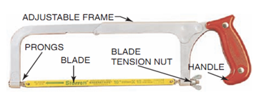
Figure 2.28 hacksaw

Component of hacksaw

- frame
- handle
- blade
- Wing nut
- Pin
- Slide suds.

Reasons for the breakage of hacksaw blades
- The cutting action may not be of uniform speed and thrust
- Improper fitting of blades (undue tightness or looseness)
- Putting into use new blades in old cuts
- Not selecting blades of suitable pitch
- Poor workmanship
Safety and Care of Hacksaw
- The cutting action is carried on the forward action only. So the blade must be mounted with its teeth pointing forward.
- Suitable tension should be applied on the blade to avoid breakage or loosen.
- Change the blade if some teeth are broken.
- Avoid rapid and erratic strokes of cut.
- Avoid too much pressure.
Starting a cut for sawing
- In order to achieve a perfect cut, To start a hacksaw cut, it is a good practice to guide the blade until the cut is well established.
- To start an accurate cut, use the file with a triangular file a small notch beside the marking line to get a good start, using the thumb can also be a guide and saw slowly with short strokes.
- Place the saw with an angle of tilt and start with sawing.
- Approximate body position when doing hand hacksaw process.

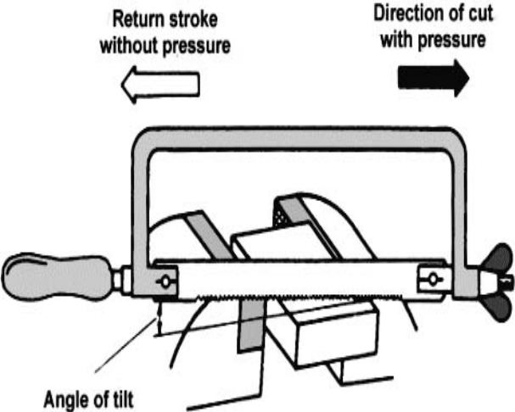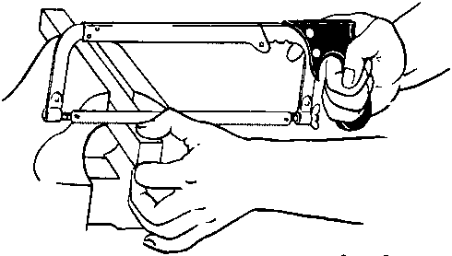

Figure 2.29 cut for sawing

2.3 Chiseling

Chiseling is a carving technique that involves using a small, sharp tool to remove pieces of material from a larger piece. The goal is to create a smooth, even surface with well-defined edges. This can be done by hand or with power tools.
ColdchiselsareusedforcuttingthinsheetsandtoremoveexcessmaterialfromlargesurfacesInthiscasethesurfacefinishandaccuracyareusually poor.
SideChisel:Thisisusedforchippingandremovingthesurplusmetalinrectangularslots.Theshankofthechiselisbentoutalittlesidewayandverticallydownagain
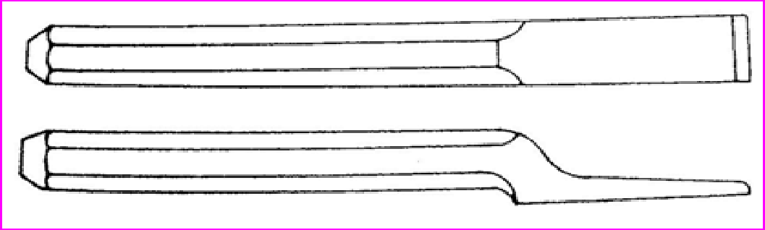

Figure 2.10SideChisel
FlatChisel:Itismostcommonchiselusedforchippinglargesurfacesandcuttingthesheets.Itisalsousedtopartoffmetalafterchaindrilling.Thelengthof a flat chiselvariesfrom100mmto400mm andthewidthfrom 16mmto32mm.
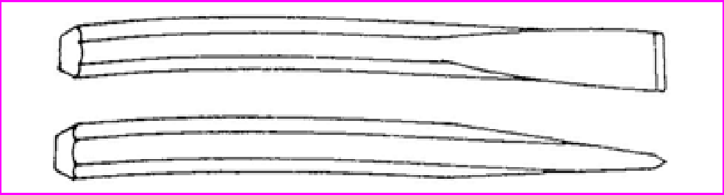

Figure 2.11 FlatChisel
CrossCutChisel:Thecrosscutchiselorcapechiselisusedforcuttinggrooves andchannelsand keysways in shafts andpulleys. Its cutting edgewiderthanthesupportingmetaltoprovideclearance.Thelengthofchiselvariesfrom100mmto400mmandwidthvariesfrom4mmto12mm.
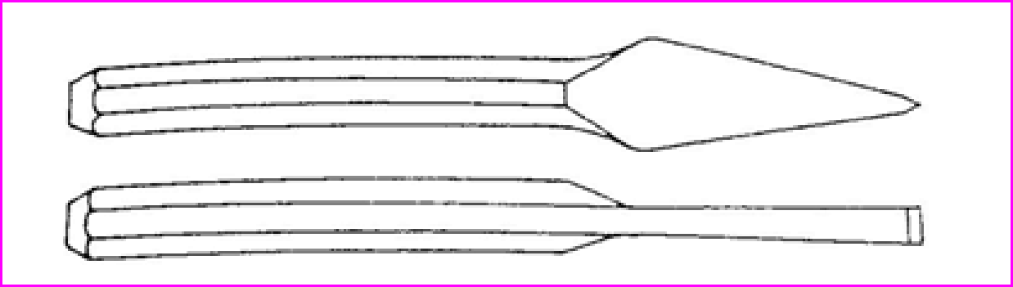

Figure2.12CrossCutChisel:
Chiseling procedure

- Wear safety glasses, and use a chisel that's 25 percent wider than what you're cutting.
- Sharpen the chisel to a 60- to 70-degree bevel.
- Apply a little 30-weight oil to the cutting edges before use.
- Position the work piece in the middle of the jaws and tighten the vise firmly.

2.4 Drilling
Drilling is a material-removing or cutting process in which the tool uses a drill bit to cut a hole of circular cross-section in solid materials. This is the most common machining process, one estimate is that 75% of all metal cutting material removed comes from the drilling operation.
Drilling is a cutting process that uses a drill bit to cut a hole of circular cross-section in solid materials. The drill bit is usually a rotary cutting tool, often multi-point.

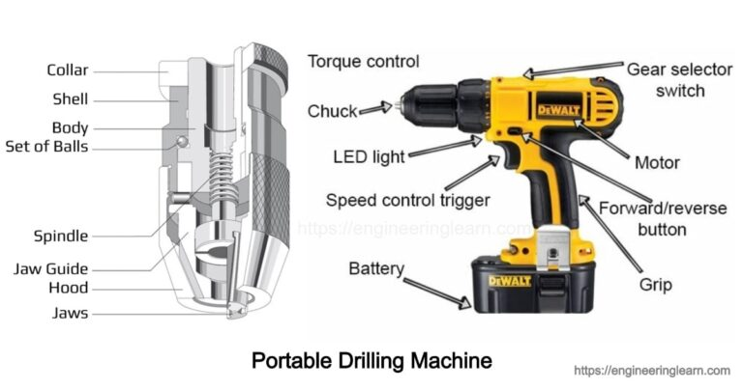

Figure 2.13 Portable Drilling Machine

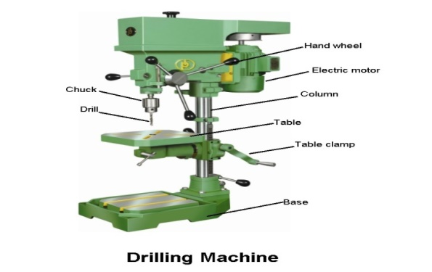
Figure 2.14 Drilling Machine

The spindle holds the drill or cutting tools and revolves in a fixed position in a sleeve.
In most drilling machines, the spindle is vertical and the work is supported on a horizontal table.
The sleeve or quill assembly does not revolve but may slide in its bearing in a direction parallel to its axis.

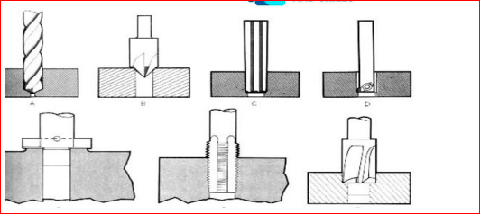

Figure 2.15 Drill bit
- When the sleeve carrying the spindle with a cutting tool is lowered, the cutting tool is fed into the work: and when it is moved upward, the cutting tool is withdrawn from the work.
- Feed pressure applied to the sleeve by hand or power causes the revolving drill to cut its way into the work a few thousandths of an inch per revolution.

Drilling procedure
1. Prior to drilling a hole, locate the hole by drawing two crossing lines. Use a center punch to make an indentation for the drill point to aid the drill in starting the hole.
2. Select the proper drill bit according to the size needed.
3. Select an appropriate size center drill.
4. Select a cutting fluid.
5. Properly secure the work piece to the table
6. Select the correct RPM for the drill bit.
7. Use an interrupted feed, called peck drilling, to break up the chips being produced.
8. Pilot holes should be used on holes larger than 10mm dia. Holes are to be enlarged in no more than 7mm increments.
9. Clean the drill press and surrounding area when finished.

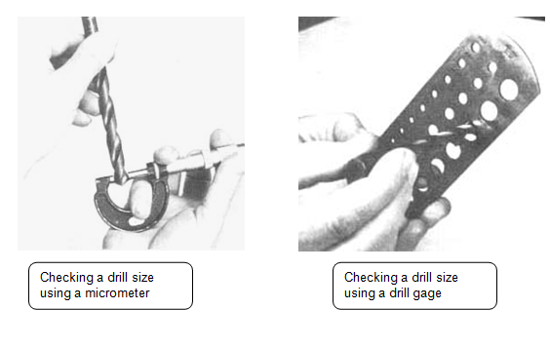
Sensitive Drill Presses
The column of most drill presses is circular and built rugged and solid. The column supports the head and the sleeve or quill assembly.
The head of the drill press is composed of the sleeve, spindle, electric motor, and feed mechanism. The head is bolted to the column. The worktable is supported on an arm mounted to the column.
The worktable can be adjusted vertically to accommodate different heights of work. or it may be swung completely out of the way. It may be tilted up to 90° in either direction, to allow for long pieces to be end or angled drilled.
The base of the drilling machine supports the entire machine and when bolted to the floor, provides for vibration-free operation and best machining accuracy. The top of the base is similar to a worktable and maybe equipped with T-slots for mounting work too large for the table.
Drill bits
Twist drills are the most common cutting tools used with drilling machines.
Twist drills are designed to make round holes quickly and accurately in all materials.
They are called twist drills mainly because of the helical flutes or grooves that wind around the body from the point to the neck of the drill and appear to be twisted (Figure 3.6).
Twist drills are simply constructed but designed very tough to withstand the high torque of turning, the downward pressure on the drill, and the high heat generated by friction.
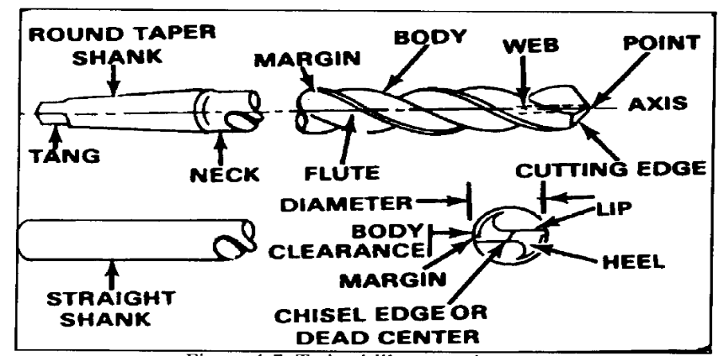
Figure. 2.16. Twist drill nomenclatures
Steps of procedure
- file permits
- Build Location
- Move rig on location and rig up
- Drill surface hole and set surface casing
- Complete drilling of the well
- Log the well and run any other test that may be needed (i.e. cores, drill stem test, etc.)
- Either plugs the well as a non-producer or set and cement the casing.

2.5 Filling
A metal filling process is provided in which micro holes formed in a work piece are filled with metal by immersing the work piece in molten metal and then removing the work piece from the molten metal.
Metal files are relatively inexpensive and effective tools for reshaping and smoothing metal and hard plastics, offering the potential for high precision and many years of trouble-free use. Be sure to select the right kind of file for the job, and keep it clean and oiled. You can straight file, cross file, or draw file, depending on whether you want to remove material, do detail work, or create a smooth surface.

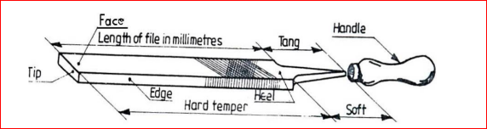
Figure 2.17 filling
1.Holding the file: For heavy work and to remove more metal, a high pressure is used.
For light and fine work, a light pressure is applied.
2. Filing internal curves: A part of half round file only makes contact as shown during filing operation. Movement of the file is indicated by arrows.
3. Cross filing: It is the most common method of filing. Cross filing is carried out across two diagonals, to produce medium surface finish. It is used when large an amount of metal is to be removed. By cross filing rounding the surface is reduced.
4. Straight filing: When a short length of work piece is required to have a flat surface, straight filing is used. File marks made during cross filing may be removed, to produce a relatively smooth surface.
5. Draw filing: It is done to get a finely finished surface. It produces a smoother surface finish than straight filing. A smooth or dead smooth flat file is used for this.
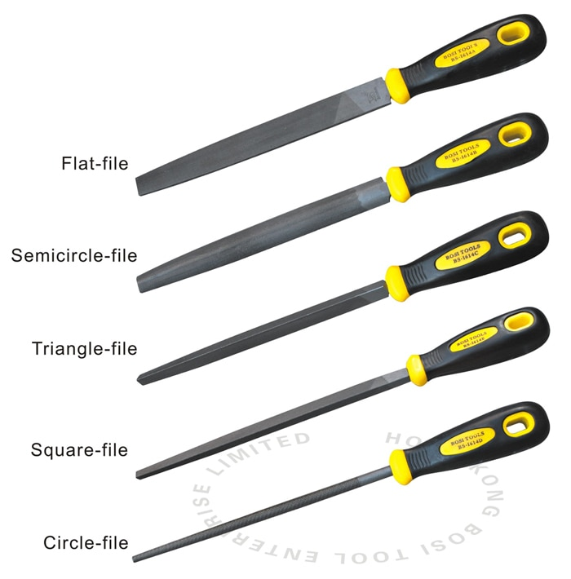
Figure. 2.29 Different file
Procedures of filling
- The first procedure is to ensure safety measures such as wearing hand gloves to prevent contact with the adhesives or bruises.
- Use a wire brush or sandpaper to clean off rusts and paints on and around the affected areas.
- Spray or rub a primer converter over the cleaned affected area.
- Select the patch type that best matches the parent metal.

2.6 Grinding
A grinding machine is a machine tool used for producing very fine finishes or making very light cuts, using an abrasive wheel as the cutting disc.
This wheel can be made up of various sizes and types of
- stones
- diamonds or
- Inorganic materials.
Removing of metal by a rotating abrasive wheel.
(Very high speed, Shallow cuts)
The wheel action similar to a milling cutter with very large number of cutting points.
Grinding was first used for making tools and arms.
- Surface Grinding: Depth of Cut: 2-5 thou, 50-125 microns
- Work Table -reciprocates beneath the wheel, Longitudinal feed
- Wheel -cross feed (Transverse feed) and
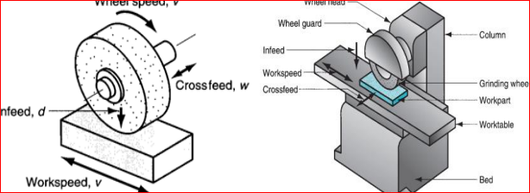
Procedure of drilling
1. Prior to drilling a hole, locate the hole by drawing two crossing lines. Use a center punch to make an indentation for the drill point to aid the drill in starting the hole.
2. Select the proper drill bit according to the size needed.
3. Select an appropriate size center drill.
4. Select a cutting fluid.
5. Properly secure the work piece to the table.
6. Select the correct RPM for the drill bit.
7. Use an interrupted feed, called peck drilling, to break up the chips being produced.
8. Pilot holes should be used on holes larger than 10mm dia. Holes are to be enlarged in no more than 7mm increments.
9. Clean the drill press and surrounding area when finished.
The grinding machine supports and rotates the grinding abrasive wheel and often supports and positions the work piece in proper relation to the wheel.
The grinding machine is used for
- roughing and finishing flat, cylindrical, and conical surfaces;
- Finishing internal cylinders or bores;
- forming and sharpening cutting tools;
- snagging or removing rough projections from castings and stampings;
- And cleaning, polishing, and buffing surfaces.
Once strictly a finishing machine, modem production grinding machines is used for complete roughing and finishing of certain classes of work. Grinding machines have some special safety precautions that must be observed.
Safety precautions
Grinding machines are used daily in a machine shop. To avoid injuries follow the safety precautions listed below.
- Wear goggles for all grinding machine operations.
- Check grinding wheels for cracks before mounting.
- Never operate grinding wheels at speeds in excess of the recommended speed.
- Never adjust the work piece or work mounting devices when the machine is operating
- Do not exceed recommended depth of cut for the grinding wheel or machine.
- Remove work piece from grinding wheel before turning machine off.
- Use proper wheel guards on all grinding machines.
- On bench grinders, adjust tool rest 1/16 to 1/8 inch from the wheel
Hand (portable) grinding
The portable grinder is
- a lightweight,
- Hand-operated machine tool.
It can be powered electrically or pneumatically, depending on the model selected. The portable grinder is used in the field or maintenance shop to grind
- excess metal from welds,
- remove rust, and
- For special finishing operations around the work area.
Since this tool is hand operated, the quality of the work depends upon the ability and experience of the operator.
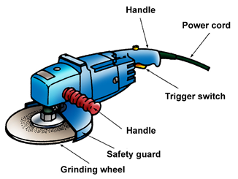
Figure 2.20 Hand (portable) grinding

Portable Hand Grinders
Bench grinding
Bench grinder which usually has two wheels of different grain sizes for roughing and finishing operations and is secured to a workbench.
It is used for shaping tool bits orvarious tools that need to be made or repaired.
Bench grinders are manually operated.

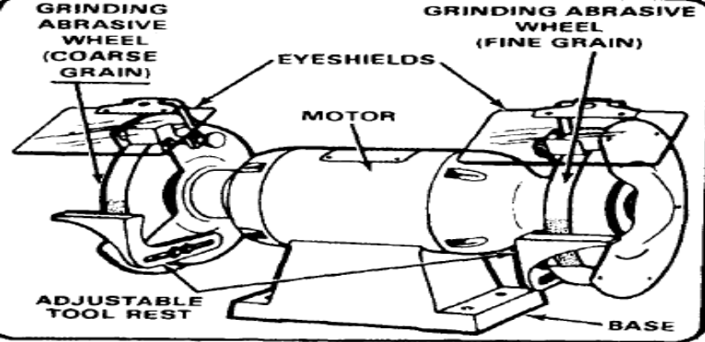
Figure 2.21 Bench grinding

2.7 Making External and Internal Tread
Purpose of thread cutting
Thread cutting is cutting of helical turns of threads out of the tapping−size hole or bolt in order to create screwed connections.
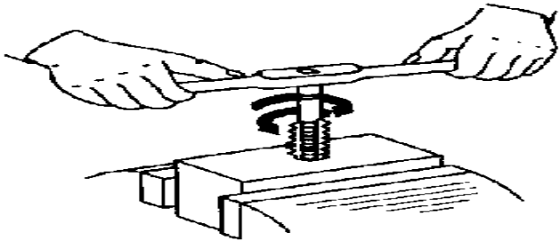
Figure:Thread cutting
A complete screwed connection requires an internal thread and a matching external thread as a counterpart.
With single−piece manufacture or with repair work, manual thread cutting is a necessary working technique, because − due to technical and economic reasons − machines cannot be used in every case.

Internal threads
Tools for internal threading (tapping)
Internal threads are cut by serial taps or by nut taps.
Serial taps: They consist of two or three tools the distinguishing feature being the design of the cutting part.
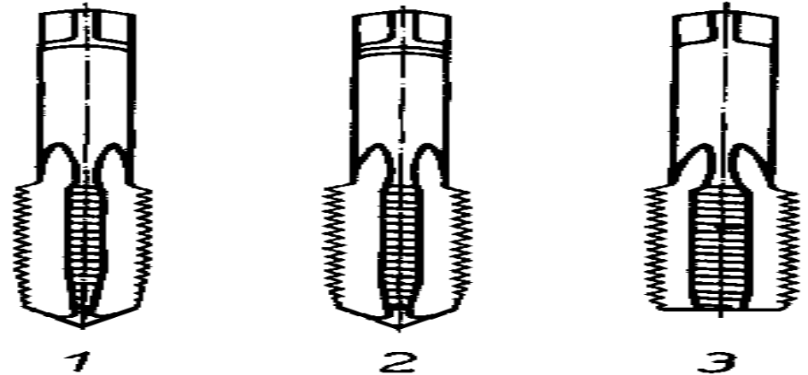
Figure 2.22Serial taps
1 − Entering tap
2 − Plug tap
3 − Third tap
The plug tap (2nd pass) has a short chamfer and trapeziform cutting edges which are deeper; it does approximately 30 % of the cutting work.
The (finishing) third tap (3rd pass) has a short chamfer and cutting edges which create the final sharp form of the thread groove; it cuts the thread to nominal size and finishes the thread flanks.
The individual tools are additionally distinguished by marks in the form of engraved rings at the shank below the square. Modern versions of serial taps consist of entering tap and finishing tap only.
- Nut taps: The nut tap (also called single−pass hand tap) in its cutting part unites the cutting parts of the three serial taps. Consequently, it has a long chamfer representing about 70 % of the total length of the cutting part; the cutting edges are initially trapeziform and become sharp only towards the end. The cutting part is not essentially longer than that of the serial tap. Yet this cutting part has to do all the cutting operation. The shank with the square is relatively long.
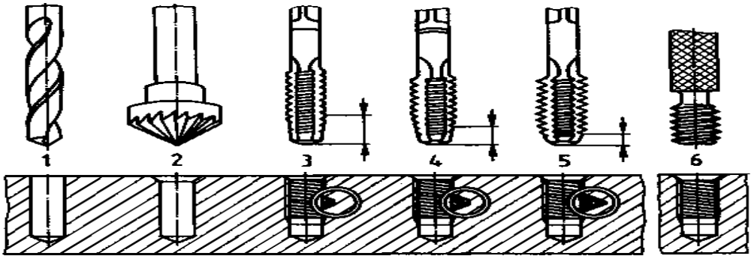
Figure: 2.23 Technology of internal thread cutting (tapping)

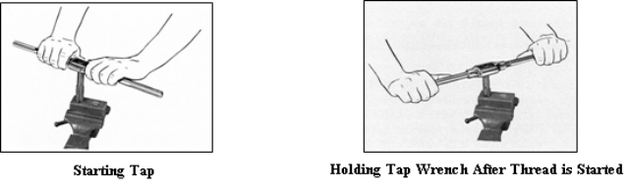
Figure 2.24 Starting Tap and holding Tap
External threads
Dies are just the opposite of taps in that they cut external threads on the outside of pipes, rods or bolts. The die is held in a Die Stock and worked in much the same manner as a tap.
Tools for external threading
External threads are made with the help of a threading die or die−stock.
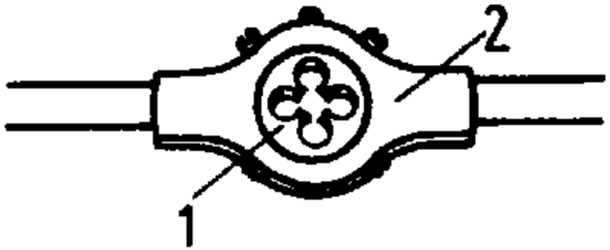
Figure2.25 − Threading die
1 − Threading die
2 − Die holder
Threading die: It consists of a cutting body (similar to a nut with milled−in chip grooves) with a chamfer on either side so that it can be applied both−way. The threading die is put into a die holder which is equipped with two handles.
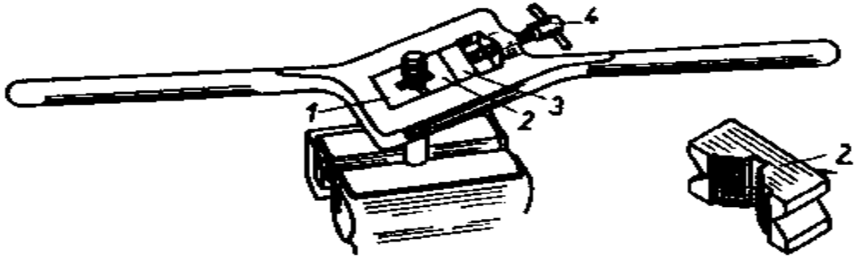
Figure2.26 Die−stock
1 − Fixed die
2 − Movable die
3 − Pressure piece
4 − Locking screw
Die−stock: It consists of a handle−equipped holder in which two threading dies are placed. One of them is fixed, the other one can be moved by means of a pressure piece via a locking screw. Three to five pairs of exchangeable threading dies for various sizes of threads belong to a die−stock
What are Dies?
Dies are made either of high-carbon steel or of high-speed steel. Unlike taps, dies are used for cutting external (male) threads.

Figure 2.27 Die
Procedures for cutting external threads
- Square the end of the work and chamfer it (using a file, grinding machine or centre lathe) for an easy start
- Grip the die, held in the stock, firmly and squarely on the work.
- Turn clockwise, about a quarter-turn, and ease back to remove chippings.
- Apply a good supply of oil (lubricant).
- Make adjustments of the screws after making a full cut until the depth required is achieved.
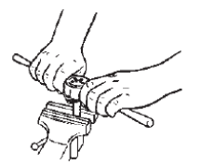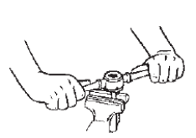
Starting Die after die is started
Figure2.28 external threads

Self Check 2
- Write the correct answers for the following questions (1point)
- A popular method is to use some type of foam product and cut out spots for each tool.
- Tool bag a similar option is with soft sides. While it doesn't offer the rigid sides of a toolbox.
- ​Tool chestIf you have a workshop, a large rolling tool chest offers lots of drawers and compartments
- ​Pegboards Another popular workshop or garage option is a tool pegboard with various brackets
- ​Wall racksFor garden tools and other large equipment, a wall-mounted tool rack .
Part-II. Choose the best alternative for the following question

1._______ Enclosed cabinetry offers a permanent storage solution in your workshop area.
A.Cabinets B.Open shelving C. Wall racks D.ALL
2.​__________For larger items, open shelving is a storage option.
A. Open shelving B. Cabinets C. Tool bag D.ALL
3.______is a material-removing or cutting process in which the tool uses a drill bit to cut a hole of circular cross-section in solid materials.
A. Drilling B. Filling C.Grinding D. Chiseling
4. ___________ is a great way to cut a wide variety of materials.
A. Hacksaw B. Drilling C. Filling D. Grinding
5.________children are given a provocation or problem to solve

A. Constructivist Workshop B. Invitational Workshop

C. Reflection Workshop D.ALL

.

Operation sheet 2.1: Grinding machine
Operation Title: Grinding machine
Purpose: To check properly grind the metal and materials
Conditions or situations for the operations:
- Safe working area
- Properly operated tools and equipment
- Appropriate working cloths fit with the body
Equipment, Tools and Materials:
- grinder
- metal
- electric
Steps in doing the task
- roughing and finishing flat, cylindrical, and conical surfaces;
- Finishing internal cylinders or bores;
- forming and sharpening cutting tools;
- snagging or removing rough projections from castings and stampings;
And cleaning, polishing, and buffing surfaces
Quality Criteria: Assured performing of all the activities according to the procedures
Precautions:
- Wear goggles for all grinding machine operations.
- Check grinding wheels for cracks before mounting.
- Never operate grinding wheels at speeds in excess of the recommended speed.
- Never adjust the work piece or work mounting devices when the machine is operating
- Do not exceed recommended depth of cut for the grinding wheel or machine.
- Remove work piece from grinding wheel before turning machine off.

Operation Sheet: 2.2. Cutting procedures using hacksaw

Operation Title; Cutting procedures using hacksaw
Purpose:perform cutting procedure to hacksaw
Conditions or situations for the operations:
- Safe working area
- Properly operated tools and equipment
- Appropriate working cloths fit with the body
Equipment Tools and Materials:
- Hacksaw
- Pipe
- Vice grip
Steps in doing the task

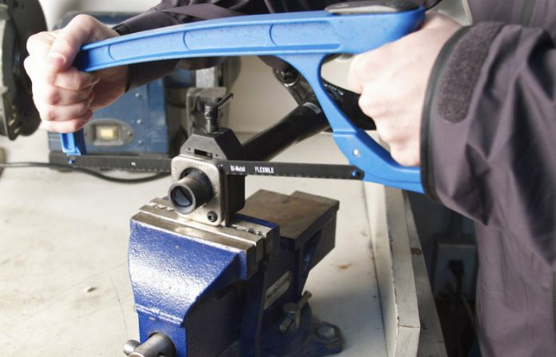
Step 1 Prep Item Measure and mark the item you plan to saw.
Step 2: Choose Blade Choose the appropriate blade for the material you're sawing.
Step 3: Install Blade To install the blade, turn the adjuster on the frame until there is enough slack to fit the blade.
Step 4: Cut Material Slowly begin to cut at the mark, using a short stroke
Quality Criteria:Assured performing of all the activities according to the procedures
Precautions:
- Wearing proper clothes, eye glass, glove
- Make working area hazard free

Operation sheet: 2.3. Check filling process
Operation Title: Check filling process
Purpose: To checks for the normal file process to the material
Conditions or situations for the operations:
- Safe working area
- Properly operated tools and equipment
- Appropriate working cloths fit with the body
Equipment Tools and Materials:
- Different file
- Vice grip
- Solid round bar
- Plate
- Sand paper
Steps in doing the task
Step 1 Prep Item Measure and mark the item you plan to fill.
Step 2: Appropriate for the material you’re fill.
Step 3: Install the fill turn the adjuster on the frame until there is enough slack to
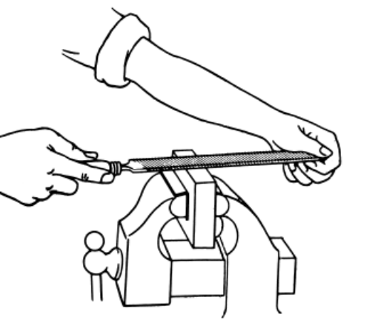
Step 4: Cut Material Slowly begin to file at the mark, using a short stroke

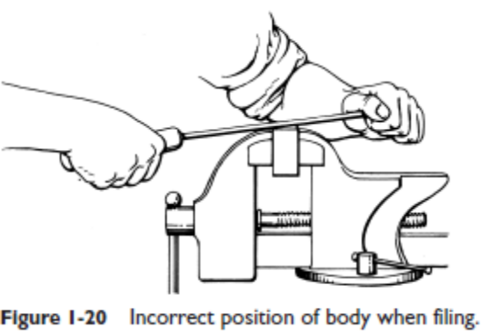
Quality Criteria: Assured performing of all the activities according to the procedures
Precautions:
- Wearing proper clothes, eye glass, glove

LAP TEST
Instructions: Given necessary templates, tools and materials you are required to perform the following tasks within 6 hour. The project is expected from each student to do it.
Task 1: perform drilling procedure
Task 2: perform filing procedure
Task 3: perform grinding procedure

Unit Three: Clean and maintain workshop
This unit is developed to provide you the necessary information regarding the following content coverage and topics:
- Cleaning tools, equipment and organizing work area
- Managing waste material
This unit will also assist you to attain the learning outcomes stated in the cover page. Specifically, upon completion of this learning guide, you will be able to:
- Clean tools, equipment and organizing work area
- Manage waste material

3.1 Cleaning tools, equipment and organizing work area
Workshops tend to be covered with grease and oil and whilst this is to be expected, it’s important to know how to properly clean your workshop in order to keep your equipment in top notch condition. Tools like hammers, screwdrivers, chisels, blades and wrenches can quickly accumulate dirt over time, which can affect their performance and worsen their condition over time. Instead of spending extra money replacing your tools, it’s better to keep them well maintained so you can always rely on your workshop equipment when you need it most.
The best way to approach tool maintenance is to choose the right cleaning agent for the job. Warm water and soap may be enough for a light touch up, but if you want to get serious about looking after your workshop tools, then you will need a much stronger and more powerful degreaser such as Multisolve.
Tools get dirty that’s a given whether they are hand tools, power tools, or especially gardening tools, your tools are bound to get some dirt, grime, soot, rust, and even oil on them. Here’s everything you need to know on how to clean your tools, so they can keep working hard for you without losing their luster.
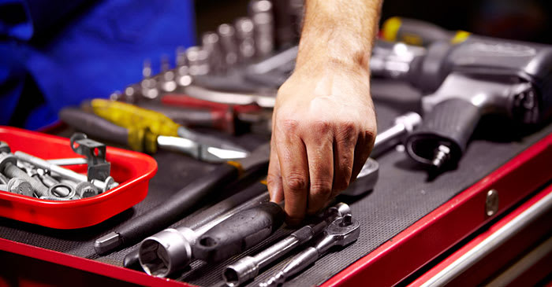
Figure 3.1 cleaning tools
Here is what you’ll need to better clean your tools:
- Dish soap to tackle oil and grease
- Large bucket for hot water and dish soap solution
- Scrubber, scrub brush, or steel wool to further clean away any dirt
- Cloth to wipe down your tools
Hand Tool Cleaning Directions
- Add a teaspoon of soap to a gallon of hot water.
- With a dishrag or sponge, scrub away the grease and oil (do not soak hand tools*).
- When clean, thoroughly rinse them under running water and dry them with a towel right away.
Cleaning Material
- Part cleaning is a necessary step in most repair procedures.
- Cleaning automotive parts can be divided into three basic categories.
- Chemical cleaning relies primarily on some type of chemical action to remove dirt, grease, scale, paint, or rust.
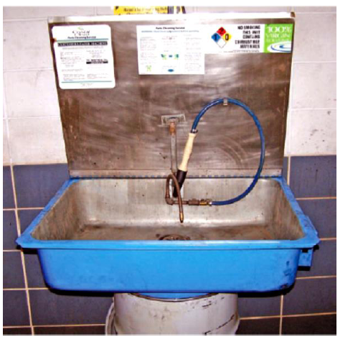
Figure 3.2 Cleaning equipmenets
Clean up procedures
- Clean up every time whenever you leave an area, including sweeping the floor.
- Clean and return all tools to where you got them.
- Use compressed air sparingly; never aim it at another person or use it to clean hair or clothes.
- Shut off and unplug machines when cleaning, repairing, or oiling.
- Never use a rag near moving machinery.
- Use a brush, hook, or a special tool to remove chips, shavings, scraps etc. from the work area. Never use the hands.
- Keep fingers clear of the point of operation of machines by using special tools or devices, such as, push sticks, hooks, pliers, etc.
- Keep the floor around machines clean, dry, and free from trip hazards. Do not allow chips to accumulate.
- Mop up spills immediately and put a chair or cone over them if they are wet enough to cause someone to slip.
Steps to a More Organized Work Area

1. Observe workers in their work areas. Look for some of the wastes of time and effort I have discussed in prior columns.
2. Determine if workstations are properly sized.
3. Determine if storage devices are properly sized.
4. Identify items needed for the job at hand.
5. Remove the unneeded items.

3.2 Managing waste material
Waste management can be defined as all the activities that are required to manage waste from the point of collecting the waste to recycling and monitoring. Waste in waste management refers to unwanted or unusable material that is produced through the activity of humans and can have different forms.
The process of managing unwanted waste items that have served their purpose but are no longer useful is referred to as Waste Management. Collecting solid waste materials, processing them, and disposing of them are all part of the solid waste management process. Human interaction with the environment has always resulted in the creation of waste.
Wastes include dead and decaying plant and animal remains, metabolic by-products (faecal remains, excreta, etc.), discarded materials from homes, workplaces, businesses, restaurants, factories, hospitals, pesticides, herbicides sprayed on fields, and many more. This article will teach students about solid waste management, including the many trash management methods and their benefits.

Industrial Wastes
All Industries generate waste materials. The wastes typically include ashes, rubbish, building material wastes, toxic wastes, metal containers, plastic containers, paints, oils, and other complex synthetic materials.
- Mining operations leave tailings (rocks of little or no value) as waste.
- Metallurgical industries release waste like slag and scrap metal.
- Paper and pulp mills release effluents containing wood chips, bits of bark, cellulose fibers, and a number of chemicals.
- Oil refineries and petrochemical units release a mixture of wastes containing hydrocarbons, organic acids, and sulphur compounds.
- Food processing units such as dairy, breweries and meatpacking units release organic wastes.

Management of Industrial Waste
Management of industrial solid waste is not the responsibility of local bodies or governments. Industries which are generating these solid wastes should manage such wastes by themselves. They need to take authorization from the pollution control board as well. Different procedures and methods are used to manage industrial waste. Although some basic steps involved in all processes are the same. Those basic steps are as follows –
- Analysis or Segregation
- Collection
- Transportation
- Recovery
- Recycling
- Disposal
Analysis or Segregation – Industrial waste is segregated or analysed, and some biodegradable wastes or recyclable material are kept separately. Industries should segregate waste materials in different categories such as biodegradable, non-biodegradable, hazardous waste etc.
Collection and Transportation – Industrial waste must be collected and transported to waste management plants.
Recovery – In waste management plants recovery should be done. It means useful materials should be recovered from industrial wastes during treatment in waste management plants.
Recycling and Disposal – If during recovery we get any useful materials then recycling should be done and disposal should be done of waste and harmful materials.
The Three M’s (Muda, Mura, Muri)
Aside from “muda” or wastes, the leaning system also attacks and avoids “mura” or overload or overburden and “muri” or unevenness.
Mura refers more specifically to overloading an equipment, facility, or human resource beyond its capacity.
This undue stress may cause downtime, defects, delays, and even disasters. Muri refers to unevenness in production volume. The wild fluctuations due to extreme highs (peaks) and lows (valleys) in production scheduling cause periods of overload and long idle time. One way to reduce muri is to implement heijunka or production leveling. In a way, mura and muri also cause wastes but in a particular way. Muda, mura, and muri cause inefficiencies and high costs in any operation.
The Three M’s
- Imbalance (inequality)(Mura)
- Excessive (too much)(Muri)
- Wasteful (Muda) Works
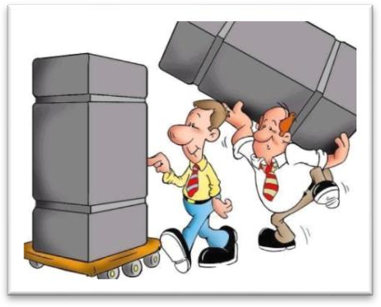

Figure 3.3 Mura
Productivity improvement does not mean hard work
Muda is: - Production factors that increase productivity and decrease cost, in other words, eliminating all unnecessary things.

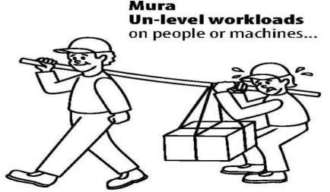
Muri:-Mental and physical overburden on operators, and overburden on production machinery we should not force hard work on Employees in the name of productivity improvement
Mura: - Variation in work distribution, production capacity of machinery, and material specifications
The Three M’s Mura (unevenness)
•It is having starts and stops, overutilization then underutilization
•Is a problem because it does not provide itself to quality, standardization of work, productivity, or continuous improvement.
Muda
This includes reducing waste and to create a process flow that can help eliminate the seven types of waste. Reducing waste also helps in eliminating waste through continuous improvement (Kaizen). The seven types of waste include; overproduction, waiting time, unnecessary transport, motion, defects, over or incorrect processing and extra inventory.
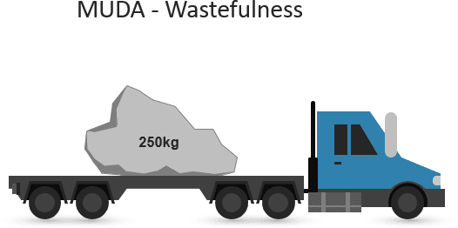
Figure 3.4 Muda
Mura
Mura implies unevenness; inconsistency, irregularity or inequality. Mura used in business/process improvement is countered through Just-In-Time systems. This enables the company to keep little or no inventory to avoid waste. In order to avoid Mura, there is a need to anticipate and cater for consumer demand, with consistent processes that can be simple enough to cater for demand and work in a regular flow.
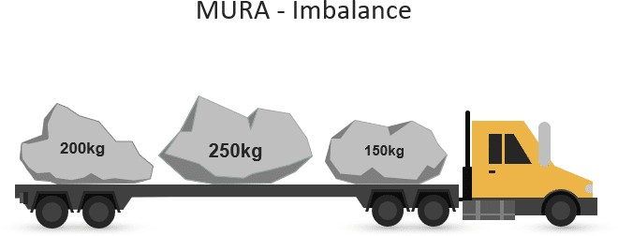

Figure 3.5 Mura

Muri
Muri means unreasonable, impossible or overburdening. By using standardized work, Muri can be avoided. Standard process allows each individual to know their work, it reduces costs and improves efficiency. A good example of this is specialization and division of labour which was introduced by Henry Ford in car manufacturing. As each assembly line worker had a specific task, the production process was improved and so was output. For production to work smoothly, each station has to perform a standard task; since the next station is only equipped to work in a standard manner to perform their part of the manufacturing task.
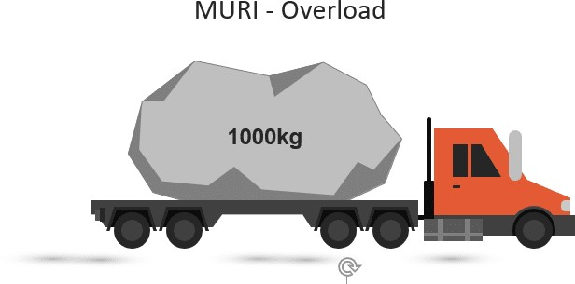

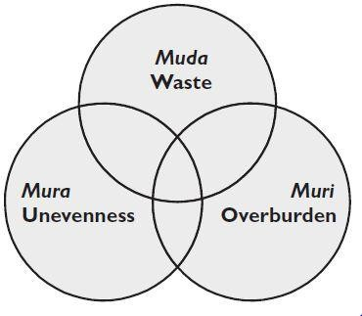
Figure 3.5 Muri

Self Check 3
PART I Choose the best alternative for the following question
1. ________ refers more specifically to overloading an equipment, facility, or human resource beyond its capacity.
A. Mura B. Muri C. Muda D.All
2. __________implies unevenness; inconsistency, irregularity or inequality
A. Mura B. Muri C. Muda D.All
3. Analysis or Segregation – Industrial waste is segregated or analysed, and some biodegradable wastes or recyclable material
A. Analysis or Segregation B. Collection and Transportation
C. Recovery D. Recycling and Disposal
4__________ Industrial waste must be collected and transported to waste management plants.
A. Analysis or Segregation B. Collection and Transportation
C. Recovery D. Recycling and Disposal
5 __________ means useful materials should be recovered from industrial wastes during treatment in waste management plants.
A. Analysis or Segregation B. Collection and Transportation
C. Recovery D. Recycling and Disposal
6 __________ any useful materials then recycling should be done and disposal should be done of waste and harmful materials.
A. Analysis or Segregation B. Collection and Transportation
C. Recovery D. Recycling and Disposal

Operation sheet 3.1 Clean and maintain workshop
Operation Title: perform cleaningworkshop
Purpose: To clean and maintain properly for the work shop
Conditions or situations for the operations:
- Safe working area
- Properly clean tools and equipment
- Appropriate working cloths fit with the body
Equipment Tools and Materials:
- Cleaning material
- equipment’s
- chemicals

Steps in doing the task
Step1.identifay workstations are properly sized.
Step2. storage devices are properly sized
Step3. Keep fingers clear of the point of operation of machines
Step4. Keep the floor around machines clean
Step5. Remove the unneeded items
Quality Criteria: Assured performing of all the activities according to the procedures
Precautions:
- Wearing proper clothes, eye glass, glove
- Make working area hazard free

LAP TEST
Instructions: Given necessary templates, tools and materials you are required to perform the following tasks within 6 hour. The project is expected from each student to do it.
Task 1: perform drilling procedure
Task 2: perform filing procedure
Task 3: perform grinding procedure

Reference
    - Introduction to Automotive Technology Third Edition 7/2010
    - Vehicle Service Manual Third Edition 7/2010
    - https://www.autoandbrakerepair.com/blog/fuel-system-common-problems.php
    - .https://www.uesystems.com/5-ways-poor-lubrication-can-cause-problems/
    - https://www.yourmechanic.com/article/how-to-diagnose-a-cooling-system-problem-by-tyler-kirkland

Participants of this Module (training material) preparation
No | Name | Qualification (Level) | Field of Study | Organization/ Institution | Mobile number | E-mail
1 | Andinet Asnake | MSc | Automotive technology | Wolkite PTC | 0913767250 | andinetasnake31@gmail.com
2 | Biratu Desalegn | MSc | Automotive Technology | Ambo PTC | 0913033783 | Biratudesalegn01@gmail.com
3 | Echu Mekonen | Msc | Automotive Technology | Burie PTC | 0912809056 | Echuhaset1@gmail.com
4 | Jemal abdu | Bsc | Automotive technology | Adadale PTC | 0922884069 | jemalabdu@75gmail.com

