Heavy Vehicles and Earth Moving Machinery
Level-I

Based on November 2022, Curriculum Version 1
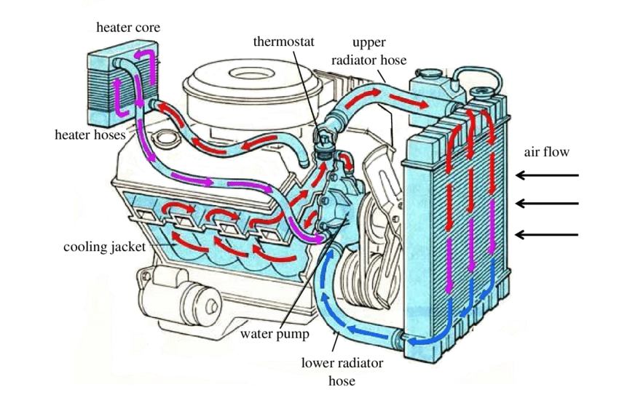

Module Title: - Removing and Replacing Engine System Components
Module code: EIS HEM1 M05 1122
Nominal duration: 90 Hour

Prepared by: Ministry of Labor and Skill
November, 2022
Addis Ababa, Ethiopia

Table of Contents
Acknowledgment 4
Acronym 5
Introduction to the module 6
Unit one: Prepare to remove Engine system related components 7
1.1. Occupational health and safety Requirements 8
1.2. Overview of engine and associated systems 9
1. Engine mechanism and exterior parts 10
2. Types and Purpose of engine system 11
1.3. Types of accessory drives related Components 17
1.4. Types and application of gaskets and sealants 19
Unit Two: Remove system assemblies 22
2.1. Service and maintenance schedules and job order 23
2.2. Overview of service techniques 24
2.2.1 Visual check 24
2.2.2. Sound checks 24
2.3. Cooling system 26
2.4. Lubrication system 32
2.5. Exhaust System 39
2.6. . Fuel system 47
2.6.2. Constructions and operation of diesel fuel system 47
Self-check 2 55
Operation sheet: 2. 1 56
Operation sheet-2.2 57
Operation sheet 2. 3 58
Operation sheet-2.4 59
Operation sheet-2.5 62
Operation sheet 2.6 64
Operation sheet- 2.7 67
LAP- Test 69
Unit Three: Replace System Components 70
3.1. Cary out minor adjustments 71
3.1.1. Coolant Condition 71
3.1.2. Inspection of drive belt Condition 72
3.2. Assembling engine system components 74
3.3. Check Post delivery 74
3.3.1. Document result with evidence 74
3.3.2. Final Inspection 75
3.3.3. Service provision 75
3.3.4. Noting and documenting observations during the service 75
3.3.5. Completing and delivering report to appropriate person 76
Self-check 3 77
Reference 78

Acknowledgment

Ministry of Labor and Skills wish to extend thanks and appreciation to the many representatives of TVT instructors and respective industry experts who donated their time and expertise to the development of this Teaching, Training and Learning Materials (TTLM).

Acronym
CO | Carbon Monoxide
EC | External Combustion (IC)
HC | Hydro Carbon
HT | High tension cable
IC | Internal Combustion (IC)
ID | Identification
KPa | Kilo Pascal
LAP TEST | Learning Activity Performance Test
N2 | Nitrogen
NOX | Oxide of Nitrogen
O | Oxygen
OHS | Occupational Health Safety
SAE | Society of Automotive Engineers
SAE20W50 | W- Milt-viscosity oil for winter Grade
SI | International Organization for Standardization
TTLM | Teaching, Training and Learning Materials
VIN | Vehicle identification number
EFE | Early Fuel Evaporation

Introduction to the module

This module covers the knowledge, skills and attitude required to Remove and Replace engine system related components
Remove and replace engine system related components in automotive engines and associated sub-system assemblies. The module involves preparing for the task, basic checking/testing to identify fault, remove, disassemble, replace worn or failed components and assemblies and reinstall. Additionally, this module covers performing post-service checks and documentation.
This module is designed to meet the industry requirement under Remove and Replace Engine System Components level I ,occupational standard, particularly for the unit of competency: Removing and Replace Engine System Components
This module covers the units:
- Prepare for work
- Overview of engine and associated systems
- Remove system related components
- Inspect and test engine system related components
- Replace engine system related components
Learning Objective of the Module
- Prepare for work
- Remove system related components
- Inspect and test engine system related components
- Adjust minor engine system
- Replace engine system related components
Module Instruction
For effective use this modules trainees are expected to follow the following module instruction:
- Read the information written in each unit
- Accomplish the Self-checks at the end of each unit
- Perform Operation Sheets which were provided at the end of units
- Do the “LAP test” giver at the end of each unit and
- Read the identified reference book for Examples and exercise

Unit one: Prepare to remove Engine system related components
This unit is developed to provide you the necessary information regarding the following content coverage and topics:
- OHS Requirements
- Overview of Engine and related associated component systems
- .Introduction to Engine and its classification
- Purpose of engine system and its type
This unit will also assist you to attain the learning outcomes stated in the cover page. Specifically, upon completion of this learning guide, you will be able to:
- Know OHS Requirements
- Identify Engine and related associated component systems
- .Demonstrate Engine and its classification
- Explain Purpose of engine system components

Occupational health and safety Requirements

Occupational health and safety (OHS) is a cross disciplinary area concerned with protecting the safety, health and welfare of people engaged in work or employment. The goal of occupational health and safety is:-
- To protect every working man against the dangerous of injury, sickness or death through safe healthful working condition.
- To protect co-workers, employers, customers, suppliers and other members of the public who are impacted by the work place environment.
The requirements of OHS are:-
- Safety
- Personal protective equipment required
- First aid
- Fire extinguisher
- Hazardous materials
Types of specifications
General Engine Specification– This specification identifies the size and style of the engine. They include cubic inch displacement, engine codes, fuel system settings, bore and stroke, horsepower, torque, compression ratio, and normal oil pressure.
Tune-Up specifications – This specification helps identify adjustments necessary for tune-up on the vehicle. This includes spark plug gap, firing order, degrees of ignition timings, fuel system settings and fuel pump pressure.
Capacity Specifications –This specification includes identifying the capacity of different fluids on the vehicle. This includes cooling capacity, number of quarts of oil, fuel tank size, transmission transaxle capacity, and rear axle capacity.
Overhaul and Maintenance Specifications – This specification used to aid technician in servicing the vehicle. This include distributor advance at different speeds, valve seat angles, valve stem clearance, piston measurements, ring end gaps, bearing clearances, shaft end play and many more. This specification help the technician determine how much wear has occurred. The mechanic is then able to decide whether or not to replace the component in question. Usually maximum or minimum clearances are given for this purpose.
Operational Specification – This specification tell how the vehicle is to operate, what type of oil to use, and so on. Some of them are found in the owner’s manual. Other specification includes tire inflation, type of gasoline to use, tire size and general information for the operator of the vehicle.
Torque Specification – It is important to torque each bolt or nut correctly when replacing or installing a component on the automobile. Torque specifications are used for this purpose. This torque specification should be used in place of any standard bolt and nut torque specification.
Owner’s manual
An owner’s manual or an operator’s manual is a booklet that comes with a new car. This manual usually explains how to operate the automobile’s control and accessories. In addition the owner’s manual provides a great deal of technical information that can be useful to the technician.
In an owner’s manual a vehicle maintenance procedure is provided so that the owner will know when to get needed service.

Overview of engine and associated systems
An Engine is a mechanical machine used to convert the chemical energy of the fuel into heat energy and then to mechanical energy. It is usually called a Heat Engine.
Basically there are two types of heat engines external and internal combustion engines.
- In an external combustion engines combustion (burning of a fuel) is taking place outside of the Engine. Example: Steam engines
- In an internal combustion (IC) engines combustion is taking place within the engine itself.
Example: Spark Ignition (SI) engines
Figure 1-1 Engine classification
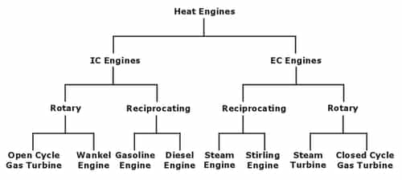
Fig 1.1.types of Engine classification

Engine mechanism and exterior parts
- Crank gear mechanism: - which includes the crank shaft, connecting rod, piston and
Cylinder.
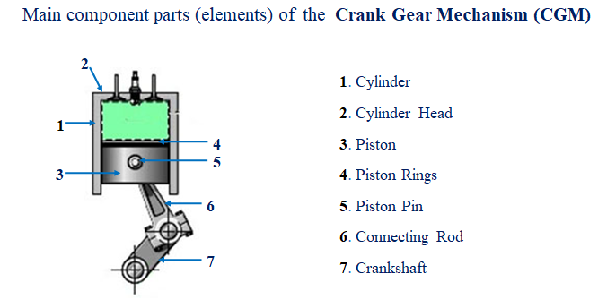
Fig.1.2. Crank gear mechanism

b) Valve gear mechanism: - which includes the camshaft, valve lifter, push rod, rocker arm and shaft, valve spring, intake and exhaust valves.
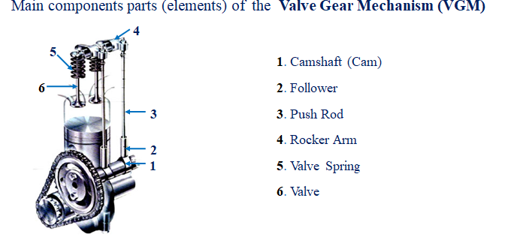
Fig.1.3. Valve gear mechanism

Types and Purpose of engine system
  - The starting system
The starting system is a combination of mechanical and electrical parts that work together to start the engine. The starting system is designed to change the electrical energy, which is being supplied by the battery, into mechanical energy, which includes the battery, start/ignition switch, starter motor
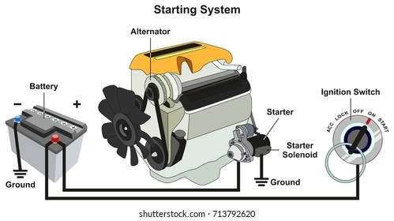
Fig.1.4. starting system
  - The intake system
The intake system is responsible for delivering oxygen, which is necessary for combustion. An intake system generally comprises an air filter, a throttle, and passageways for air to reach the cylinders themselves. There are several main types of intake systems.
Air cleaner: -Which cleans & filters the air before interring the combustion chamber of an engine
Turbocharger: -it increases the air pressure into the engine so that more fuel can be burnt & the engine output increase Turbocharger forces an additional amount of air or air-fuel mixture into the engine cylinder. With more air-fuel to burn, the engine produces more combustion pressure and hence more engine power. On many turbocharged engines, power output is boosted 30% or more (for example, a 100 horsepower engine could produce 130 horsepower with a turbocharger).
With turbocharger a smaller engine which has good fuel economy can produce high power when needed. Turbocharger is basically an air pump driven by the exhaust gas from the engine.
On a carbureted engine, the turbocharger may be installed in two different ways. It may be located between the air cleaner and the carburetor. The turbocharger compresses only air and then forces it through the carburetor. In some engines, it is installed between the carburetor and the intake manifold. All the air-fuel mixture from the carburetor is compressed by the turbocharger.

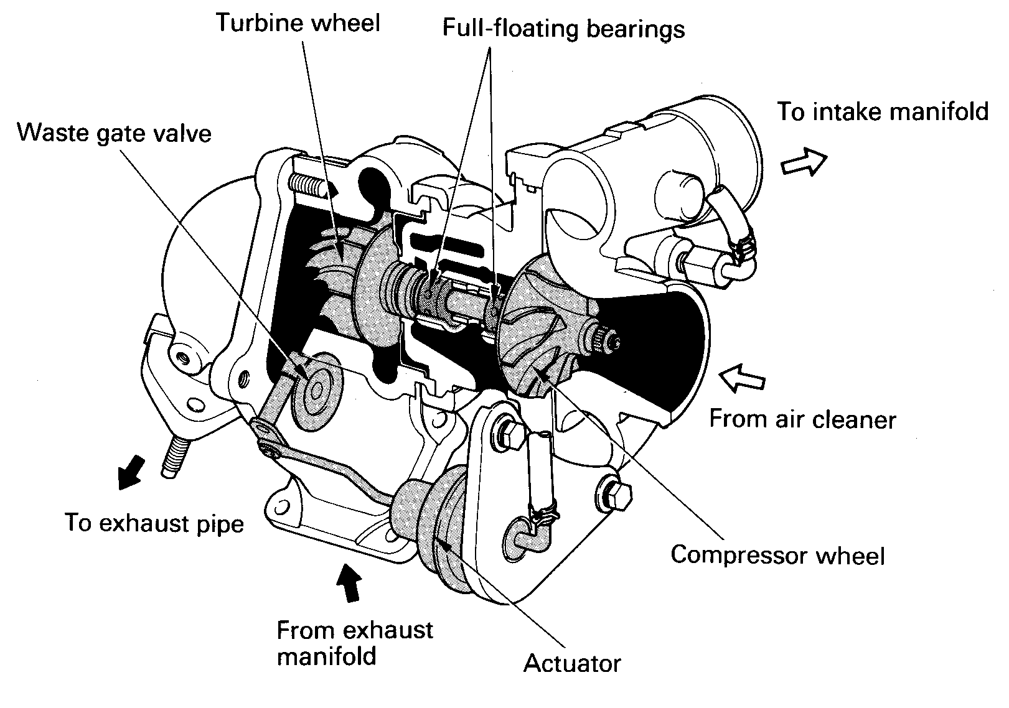
Fig.1.5 Turbocharger

Intake manifold: -is required to deliver into the cylinder either a mixture of fuel & air From the carburetor or only from the air Cleaner.

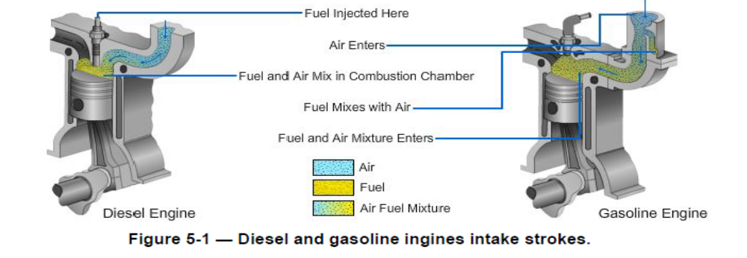

Fig.1.6. Intake system
  - The fuel system: - is one mechanical system of engine and has the function of deliver fuel to combustion chamber for combustion purpose. Fuel system has the following components
    - Fuel tank:- has function of storing fuel
    - Fuel line:- used to transport fuel
    - Fuel filter:- is the part of fuel system used to filter fuel
    - Fuel pump:- is the part which available only in gasoline engine and used to supply fuel to the chamber
    - Feed pump:- this one is available in diesel engine has the same function with fuel pump of gasoline engine
    - Injection pump:- is also available only in diesel engine and has the function to atomize the liquid fuel with high pressure
    - High pressure line:- used to transport high pressure fuel from injection pump to nozzle
    - Injection nozzle:- is used to spray fuel to combustion chamber by keeping engine firing order .

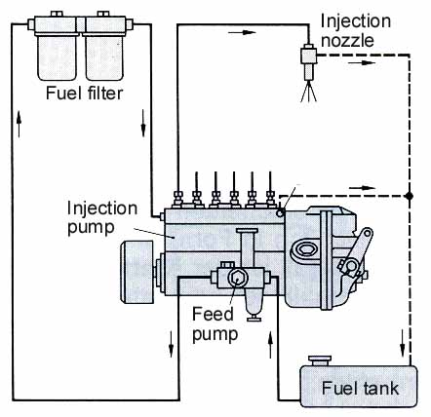
Fig. 1.7.Diesel fuel system
  - The lubricating system: - which includes the oil pan, strainer, oil pump, oil line, oil filter.
Lubricating system: - this is a system that helps the engine rotational parts and frictional surfaces to lubricate and reduce wear of parts due to over friction. The followings are parts of lubricating system
- Oil sump
- Oil strainer
- Oil pump
- Oil filter
- Oil gallery/lubricating point
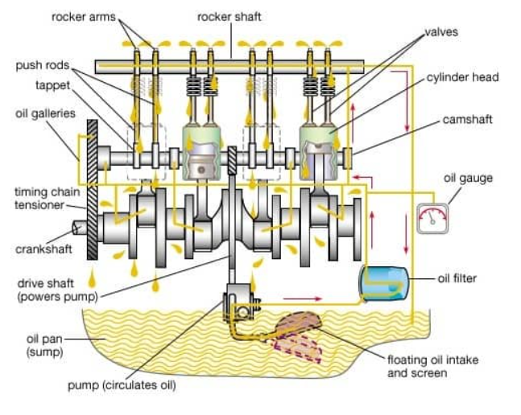
Fig. 1.8.lubrication system
  - The exhaust system: - which includes the exhaust manifold, exhaust pipe, catalytic converter, muffler, tail pipe.
Exhaust system: - is a system that used to get away the burned gas to the atmosphere by the following component parts.
- Exhaust valve
- Exhaust manifold
- Intermit pipe
- Silencer/muffler
- Catalytic converter
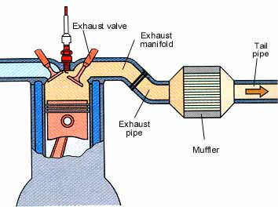
- Exhaust pipe

Fig.1.9. Exhaust system
  - The cooling system: - which include the radiator, lower hose, water pump, water jacket, thermostat, Upper hose, and cooling fan.
Cooling system: - cooling system that has the function of cooling the engine and keep the engine with its operational temperature. Components of cooling system;
- Radiator:- radiator is one part of cooling system that used to store coolant and help to cool down
- Lower hose:- to transport cooled water to engine block
- Water pump:- used to supply cooled water to water jacket inside engine block
- Water jacket:- is inside engine block which cooling process is applied
- Thermostat:- this port is temperature activated device that has the function to return the hot water to radiator by opening the valve as the coolant temperature reaches around 85-90⁰c.
- Upper hose:- is used to turn back hot water to radiator
- Fan:- is a rotary that helps to cool the coolant in the radiator

  - The charging system: - which includes the battery, start/ignition switch, regulator, alternator
The automotive storage battery is not capable of supplying the demands of the electrical systems for an extended period of time. Every vehicle must be equipped with a means of replacing the energy that is being drawn from the battery. A charging system is used to restore to the battery the electrical power that was used during engine starting. In addition, the charging system must be able to react quickly to high load demands required of the electrical system.
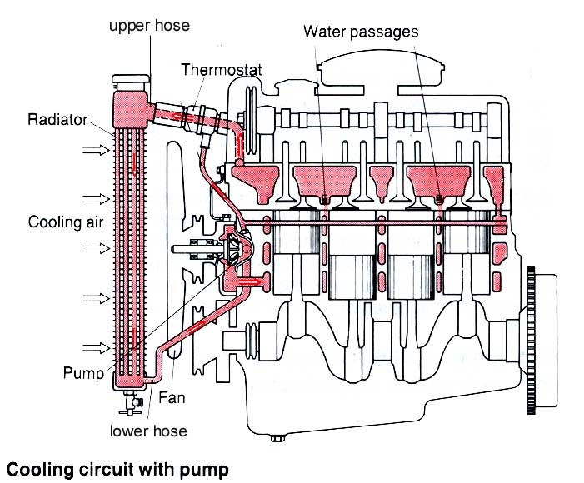

Fig.1.10.Cooling system

Types of accessory drives related Components
- Water pumps
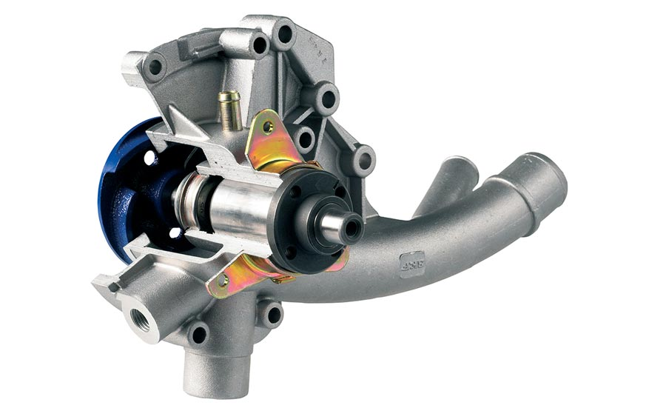
The burning of fuel in an internal combustion engine produces heat, which is sufficient to melt the metal of the cylinder. It is the function of the cooling system to prevent the engine overheating but it must also allow it to operate at a temperature high enough to assist in effective combustion.
If the engine operating temperature were allowed to go unchecked, it would burn and dry up the lubricating oil film, so that the pistons would seize in their cylinders and distortion would result from over-expansion of metals.
Figure 1-11. Water pumps
- Alternators
In the charging system electronics devices such as diodes for rectification of current in alternator zanier diode and transistor for circuit opening and closing in transistorized regulators are use. In this unit, the construction and function of diodes and transistor, the purpose of the charging system, the component parts of alternators, the generating principles of alternator, the charging system service and repair are thoroughly discussed.
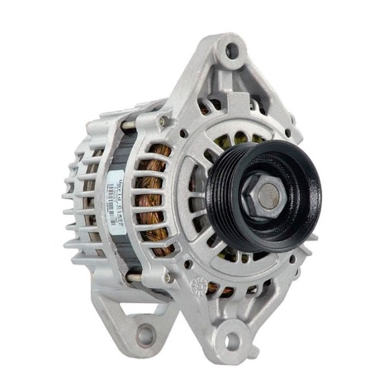

Figure 1-12.Alternator

- AC compressors
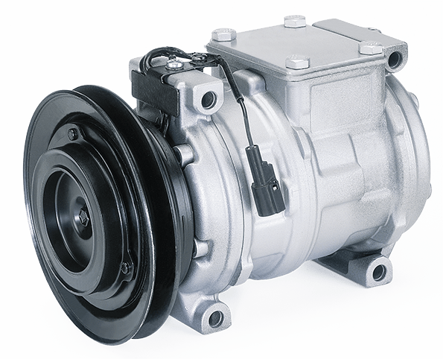
The compressor is the power unit of the air-conditioning system that puts the refrigerant under high pressure before it pumps it into the condenser, where it changes from a gas to a liquid. A fully functioning compressor is necessary for the air-conditioning system to provide peak performance.

Figure 1-13. AC compressors

- Power steering pumps
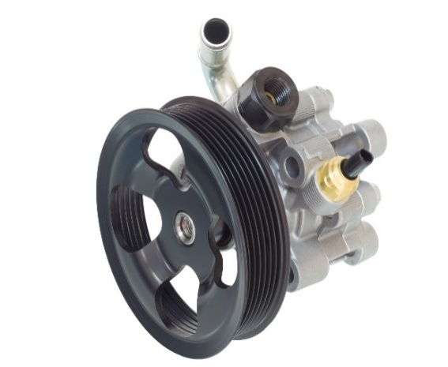
The power-steering unit is designed to reduce the amount of effort required to turn the steering wheel. It also reduces driver fatigue on long drives and makes it easier to steer the vehicle at slow road speeds, particularly during parking. Power steering can be broken down into two design arrangements: conventional and nonconventional or electronically controlled. In the conventional arrangement, hydraulic power is used to assist the driver.
Figure 1-14. Power steering pumps
In the nonconventional arrangement, an electric motor and electronic controls provide power assistance in steering. There are several power-steering systems in use on passenger cars and light-duty trucks. The most common ones are the integral-piston, and power assisted rack and pinion system.
- Supercharger
A supercharger is an air compressor that increases the pressure or density of air supplied to an internal combustion engine. This gives each intake cycle of the engine more oxygen, letting it burn more fuel and do more work, thus increasing the power output.
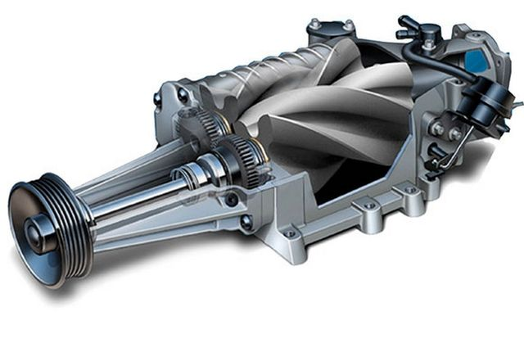

Figure 1-15. Supercharger

Types and application of gaskets and sealants
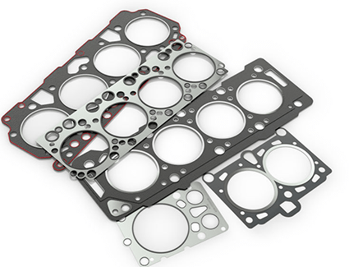
Gaskets seal a connection between two components or flanges that have flat surfaces, while seals are used between engine parts, pumps, and shafts that rotate. Gaskets are used wherever a union or flange is required to prevent leaking.
Gaskets are most commonly used as static seals. Gasket made of fiber materials, rubber, neoprene (synthetic rubber), cork, treated paper, or thin steel. When parts are fastened together, the gasket material fills small gaps, dents, or scratches in the mating surfaces.
Figure 1-16. Gaskets

Gasket Rules

    - Inspect for leaks before disassembly
    - Be careful not to damage mating surfaces while removing parts
    - Clean off old gaskets carefully
    - Wash and dry parts thoroughly
    - Use a sealer if specified
    - When assembling, start all bolts by hand

    - Tighten fasteners in steps
    - Use a crisscross tightening pattern
    - Do not over tighten fasteners
    - apply only the specified torque

Seals are used between engine parts, pumps, and shafts that rotate rather than those that are static. This type of seal is generally a molded or machined product. Seals tend to be flat and round, while gaskets are often cut into different shapes so that they fit the components. Most seals are made of an outer ring that is metal and nests over an inner surface that is often made of rubber

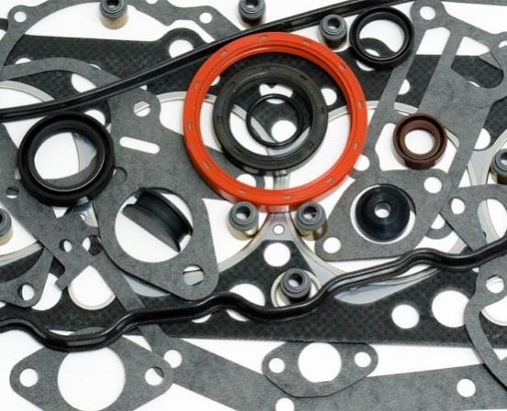

Figure 1-17. Seals

Table .1.1.types of sealant
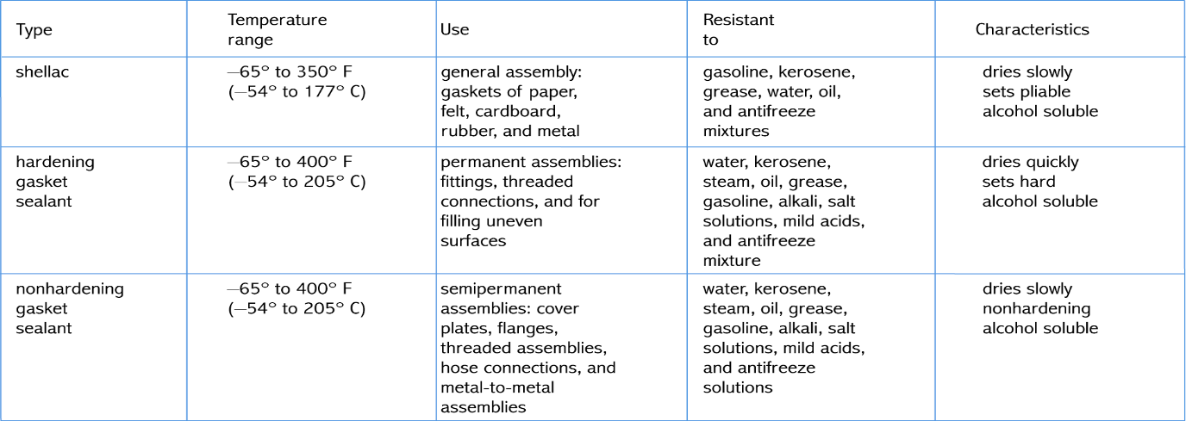

Unit Two: Remove system assemblies

This unit to provide you the necessary information regarding the following content coverage and topics:
- Service and maintenance schedules and job order
- Overview of service technique
- Engine exterior assembly
- Engine systems assembly
This guide will also assist you to attain the learning outcomes stated in the cover page. Specifically, upon completion of this learning guide, you will be able to:
- Identify Service and maintenance schedules and job order
- Over viewing of service technique
- Remove engine exterior assembly
- Remove engine systems and assembly

2.1. Service and maintenance schedules and job order
Automobiles need maintenance from time to time. Like humans are required to maintain hygiene, similarly automobiles also need to be kept clean. Automobiles have to run on dirty roads and in a polluted environment. They run on uneven roads with potholes and other obstructions, and are therefore subjected to loads which damage them. Therefore, there is a need for regular maintenance and servicing of automobiles, which is usually done in auto workshops or auto service stations. In this Unit, you will understand the concept of vehicle maintenance and servicing.
As you may be aware, there is an increase in the number of vehicles, such as motorcycle, scooter, bus, car, jeep, tempo, truck, tanker, etc., running in the cities. Every new vehicle comes with a vehicle maintenance manual. The owner of the vehicle is expected to read and use this manual, as it mentions vehicle maintenance
- Vehicle Maintenance and Servicing
Tips during driving, it has been noticed that after getting a car or vehicle, the owners do not care much about a regular car or vehicle maintenance. Even if the owners regularly service their vehicle, the vehicle maintenance tips given in the vehicle maintenance manual increases the longevity or life of the vehicle to a great extent. Vehicle maintenance and servicing is carried out when the vehicle completes certain kilometers on its normal running or when the vehicle does not give proper performance. It is suggested that the vehicle owners carry out regular and periodical checks on their vehicle, some of which are mentioned below.
- Daily Inspection (DI)
It is the responsibility of a driver or owner of a vehicle to carry out the following inspection and checks daily, before starting the engine, to avoid any type of breakdown on the road.
- Check tire pressure in all the tires visually or by hitting the tire wall with the help of a stone and judge the sound
- Check the radiator’s coolant level
- Check the fan belts for looseness
- Check the level of engine oil
- Check the windscreen, rear‑view mirror and rear window glass for their cleanliness

- Maintenance Check-up
When one plans a long distance travel, it is necessary to carry out a routine check‑up. One should read the vehicle maintenance manual for clarity. Some important check‑ups are done for better maintenance
- Topping of oil level
- Proper tension of belt
- Battery for cleanliness and level of electrolyte
- Brakes
- Air conditioning
- Topping up of coolant, if required, in the coolant reservoir
- Checking the serviceability of cooling system hoses
- Proper tire inflation pressure

2.2. Overview of service techniques

2.2.1 Visual check
A visual inspection report form is completed by quality assurance inspectors to document pass/fail decisions on visually inspected products based on set defect criteria. Use this checklist to effectively indicate product ID and location, capture photo evidence of products and/or defects, determine pass/fail decisions based on a reference image, identify visual defects based on defect criteria, and complete the visual inspection with a digital signature.

Sound checks
Checking engine noise is often one of the most difficult tasks you can deal with. Most of the noises that come from the engine can be described by such words as:
  - Piston Ring Noise
Sounds like: Clicking noise during acceleration.
Common causes: Low ring tension, broken rings, or worn cylinder walls
Try troubleshooting each cylinder by removing the spark plugs and adding a spoonful of engine oil to each cylinder. Now crank the engine quite a few revolutions to allow the oil to go down past the rings. Install the spark plugs and start the motor. If the noise is lessened then the rings are likely the source of the problem.
  - Piston Slap
Sounds like: Continuous muffled, hollow sound.
Common causes: Excessive piston-to-wall clearance, worn cylinders or inadequate oil.
A continued piston slap noise indicates that the engine needs service. Still, if the sound is only heard when the engine is cold, it is probably not a serious issue.
  - Crankshaft Knock
Sounds like: Dull, heavy, metallic knock under load.
Common causes: Worn bearings; main, rod, or thrust.
Damaged or worn main bearing noise is loudest under heavy load. Check your oil dipstick for any metal reflections. Metal shavings in the oil are one of the first indications of your main bearing material sloughing off. Replace any worn bearings with new ones.
- Valve train Noise
Sounds like: Regular clicking noise at half-speed.
Common causes: Excessive valve clearance or defective valve lifter.
You can check your clearances by inserting a thickness gauge between the lifter or rocker arm and the valve stem. If the noise is reduced, then the cause is excessive clearance and you will want to make the correct adjustments. If the noise persists, then it is most likely rough cams or worn lifter faces. You might also want to look for loosely moving lifters in their bores and weak valve springs.

- Detonation
Sounds like: High-pitched metallic pinging noise.
Common causes: Improper timing, lean air/fuel ratio, or improper octane.
You can prevent detonation by increasing the octane level of your fuel, reducing manifold pressure, enriching the air/fuel mixture, or obstructing the ignition timing. Detonation can often be a common phenomenon in forced induction applications. For some operations, you can consider an aftermarket water injection system.
- Connecting Rod Noise
Sounds like: Light knocking or pounding sound.
Common causes: Misaligned rod, inadequate oil, or worn bearing or crankpin.
A cylinder-balance test can single out the faulty connecting rod. With the engine running, this test essentially shorts out the spark plugs one cylinder at a time. Soon, you can narrow down the bad connecting rod as the sound will be lessened when its base cylinder is no longer delivering power.
- Piston Pin Noise
Sounds like: Metallic, double knock at idle.
Common causes: Worn bushing, worn or loose piston pin, or inadequate oil.

Cooling system
The cooling system keeps the engine at its most efficient temperature at all speeds and operating conditions. Burning fuel in the engine produces heat. Some of this heat must be taken away before it damages engine parts. This is one of the three jobs performed by the cooling system. It also helps bring the engine to normal operating temperature as quickly as possible. In addition, the cooling system provides a source of heat for the passenger compartment heater.

Types of cooling systems
- Air-cooled
Air-cooled: Some older cars, and very few modern cars, are air-cooled. Instead of circulating fluid through the engine, the engine block is covered in aluminum fins that conduct the heat away from the cylinder. A powerful fan forces air over these fins, which cools the engine by transferring the heat to the air
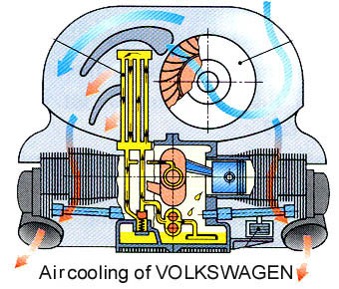

Fig.2.1.Air cooled engine
- Liquid-cooled
The cooling system on liquid-cooled cars circulates a fluid through pipes and passageways in the engine. As this liquid passes through the hot engine it absorbs heat, cooling the engine. After the fluid leaves the engine, it passes through a heat exchanger, or radiator, which transfers the heat from the fluid to the air blowing through the exchanger.

Figure 2-2. Liquid-cooled engine

Fig 2.2.Liqued cooled engine
Cooling system problem

- Engine overheating
The most common cooling system problem is overheating. There are many reasons for this. Diagnosis of this condition involves many steps, simply because many things can cause this problem. Basically, overheating can be caused by anything that decreases the cooling system’s ability to absorb, transport, and dissipate heat: The first step is to determine whether the engine is indeed overheating.
An overheating concern normally begins with high readings on the vehicle’s temperature gauge or the illumination of the temperature warning lamp. These can be caused by a cooling system problem or a faulty temperature sensor, although when the engine is greatly overheating, it is obvious by the steam emitted by the system or by smell. The best way to check the accuracy of the temperature indicators is to measure the temperature of the coolant. If the indicators seem to be wrong, troubleshoot and repair the electrical circuit. Then recheck the system’s temperature.

Condition Cause
Overheats in heavy traffic or after idling for a long time | ■ Low coolant level  ■ Faulty radiator cap  ■ Faulty thermostat  ■ Cooling fan is not turning on  ■ Restricted airflow through the radiator  ■ Leaking head gasket  ■ Restricted exhaust  ■ Water pump impeller is corroded
Overheats when  driving at speed, or  after repeated heavy  acceleration | ■ Radiator and/or block are internally clogged with rust, scale, silt, or gel  ■ Restricted airflow through the radiator  ■ Faulty radiator cap  ■ Faulty thermostat  ■ Radiator fins are corroded and falling off  ■ Water pump impeller is corroded  ■ Dragging brakes
Overheats any time or  Erratically | ■ Low coolant level  ■ Faulty radiator cap  ■ Faulty thermostat  ■ Temperature sender or related electrical problem  ■ Cooling fan is not turning on
Overheats shortly after  the engine is started | ■ Temperature sender or related electrical problem
Seems slightly too hot  all of the time; gauge  nears the red zone at  times | ■ Radiator and/or block are internally clogged with rust, scale, silt, or gel  ■ Restricted airflow through the radiator  ■ Faulty radiator cap  ■ Faulty thermostat  ■ Radiator fins are corroded and falling off  ■ Collapsed lower radiator hose  ■ Cooling fan is not turning on
Bubbles in the coolant  expansion tank | ■ Faulty radiator cap  ■ Failed head gasket
Air in the radiator but the expansion tank is full | ■ Coolant leak  ■ Faulty radiator cap  ■ Air in the system  ■ Faulty seal between the radiator cap and expansion tank  ■ Failed head gasket

- Check for external leaks
- External leaks
Usual areas of leakage are water manifolds, radiator seams, water pumps, freeze plugs and all those connections. The condition of radiator hoses should be carefully scrutinized for possible deterioration from age and/or wear from rubbing against accessory brackets, etc. Be aware that in many cases radiator hoses wear from the inside out, so outside appearance can be deceiving.

- Cracked cylinder block
- Faulty radiator cap
- Dented radiator inlet of outlet tube
- Radiator leak
- Cracked or porous water pump housing
- Water core leak
- Loose core hole plug in cylinder block
- Cracked thermostat housing

- Internal leaks
Pull the oil dipstick and check for evidence of coolant. It will show up as minute droplets or sludge and should be easy to spot. This could indicate a cracked head, block or blown head gasket.

Cooling system inspection and test
- Inspecting Cooling System for Leaks
- Fill the radiator and engine with coolant, and attach a radiator cap tester to the water outlet.
- Warm up the engine.
- Pump it to 118 kPa (1.2 kgf/cm2, 17.1 psi), and check that the pressure does not drop. If the pressure drops, check the hoses, radiator or water pump for leaks. If no external leaks are found, check the heater core, cylinder block and head.
- Temperature Test
A temperature test can be performed with an infrared temperature sensor, thermometer, or temperature probe. The latter may be a feature of digital multi-meters (DMM). A temperature test allows for monitoring temperature change through the cooling system. When a cold engine is started, the opening temperature of the thermostat can be observed as the engine warms.
- Radiator Checks
Cold spots on the radiator indicate internal restrictions. In most cases, this requires removal of the radiator so it can be deeply flushed or replaced. Normal cooling system flushing will normally not remove the restrictions. The restrictions are typically caused by internal corrosion or a build-up of scale and lime.
- Checking Hoses
Carefully check all cooling hoses for leakage, swelling, and chafing. Also replace any hose that feels mushy or extremely brittle when squeezed firmly. When a hose becomes soft, it is deteriorating and should be replaced before more serious problems result. Hard hoses will resist flexing and may crack rather than bend and should be replaced.

- Checking Fans and Fan Clutches
To confirm the diagnosis, start with this simple test: Spin the fan as hard as you can on an engine that has not been started that day. If the fan rotates more than five times, you can bet the clutch is bad. You should feel some resistance and the fan may spin up to three times, depending on the ambient temperature.
- Thermostat
If the thermostat is stuck open or closed, you may think the best option is to lose it and take it to a mechanic for diagnosis. I have good news. I will show you how to check for bad thermostats in a car without removing them. One common cause of overheating in a car is a faulty thermostat. If you suspect this component, inspect it to see if it is the culprit. Here’s how to check a car thermostat without removing it.

Lubrication system
The lubricating system supplies lubricating oil to all moving parts in the engine. It also control of friction and wear by the introduction of a friction–reducing film between moving surfaces in contact.
Lubrication as a substance lubricated material freely moving, reciprocating, back and forth movement between two hard body materials. System a way set of things working together as a mechanism

Purpose of Lubricants
- Minimize Friction – the oil must form a film between highly loaded moving parts.
- Prevent Wear – the must protect highly loaded parts which can wear out when the fluid film is very thin (boundary lubrication).
- Act as a coolant – the oil must remove heat generated both inside and outside the equipment.
- Act as a Hydraulic Medium – the oil doesn’t have this job in all applications, but it is not uncommon for the lubricating oil to be part of the hydraulic system.
- Prevent Corrosion – The oil must protect precision parts made of various metals, which are vulnerable to rust and corrosion.
- Prevent formation of deposits – lubricants are designed to resist formation of deposits (like sludge and varnish), which can accumulate in the lubricating system and interfere with the oil’s ability to lubricate.
- Carry away contaminants – the oil often wear in the process of carrying contaminants to the filter. Contamination is the major reason oils must be changed. Contaminants can come from both internal and external sources.

Properties of Lubricating Oil
- Proper Viscosity – means to measure the oil’s resistance to flow. Low-viscosity oil is thin and flows easily. High-viscosity oil is thicker. It flows more slowly.
- Viscosity Index– this is a measure of how much the viscosity of an oil changes with temperature.
- Viscosity Numbers – lubricating oils either in single or multi-viscosity oils are rated according to its numbers. SAE 30 or SAE 40 are examples of a single-viscosity oil and SAE20W50 is also an example of a multi-viscosity oil. The letter W indicated in multi-viscosity oil stands for Winter Grade and the word SAE means Society of Automotive Engineers.
- Resistance to Carbon Formation and Oil Oxidation – when oil is refine, chemicals are added to fight carbon formation and oxidation. These can occur at the high temperatures inside the engine.
- Corrosion and rust Inhibitors – these are additives that are put in the oil to help fight corrosion and rust in the engine.
- Foaming Resistance – the churning action of the crankshaft causes the oil to foam or aerate thus reduces the lubricating effectiveness of the oil. As a result, an additive is mix to prevent the oil to foam.
- Detergent-Dispersant – These additives are similar in action to soap. They loosen and detach particles of carbon and grit from engine parts.
- Extreme-pressure Resistance - this is another additives put into the oil to improve the resistance of the oil film to penetration.
- Energy-Conserving Oil – this is a property of oil which reduces fuel consumption when compared to engine operation.
- Synthetic Oil – these oils are made by chemical processes and do not necessarily come from petroleum. This is a property of oil which tolerates heat better than other oils while producing less sludge and carbon deposits.

Types of Lubricating System
- Splash Type – it refers to the system in which the oil is being splashed from the oil pan into the lower part of the crankcase. Usually, the connecting rod has a dipper that dips into the crankcase oil each time the piston reaches BDC. Likewise, usually used in a smaller like a single cylinder engine.
- Pressure Feed Type – this type of lubricating system connotes that the engine parts are lubricated by oil fed under pressure from the oil pump.

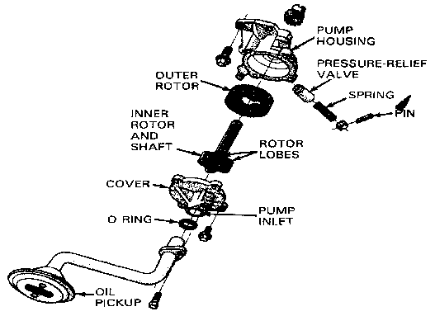
- Rotary pump: the rotary pump has an inner rotor with lobes that match similar shaped depressions in the outer rotor. The inner rotor is off center from the outer rotor. As the oil pump shaft turns, the inner rotor causes the outer rotor to spin. The eccentric action of the two rotors forms pockets that change size. A large pocket is formed on the inlet side of the pump. As the rotors turn, the oil-filled pocket becomes smaller, as it nears the outlet of the pump.
Figure 2-3.Rotary pump
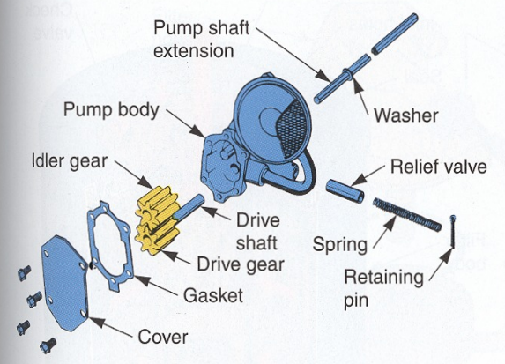
- The gear pump consists of two pump gears mounted within a close-fitting housing. A shaft, usually turned by the distributor, crankshaft, or accessory shaft, rotates one of the pump gears.
Figure 2-4. Gear type pump
The gear turns the other pump gear that is supported on a short shaft inside the pump housing.

- The crescent pump
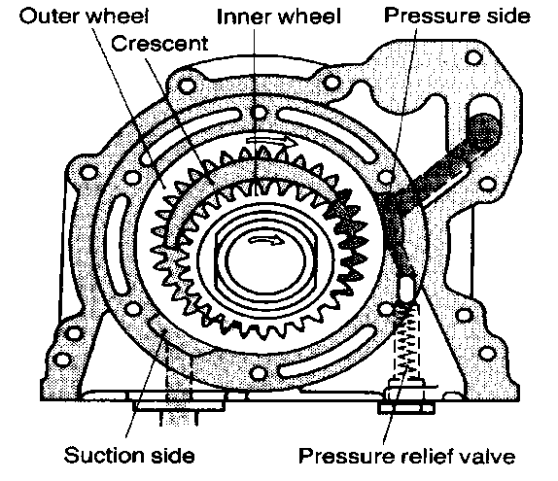
The crescent pump has external toothed gear meshed with an internal toothed gear. Some of the gears teethes are in mesh, the others are separated by a crescent shaped part of the pump housing. The suction and the discharge cavities are also separated by a crescent - shaped body. The pump is mounted on the front of the cylinder block so that the pump is driven directly from the crankshaft.

Figure 2.5 Crescent pumps

- Oil Pickup and Strainer

The oil pickup is a tube that extends from the oil pump to the bottom of the oil pan. One end of the pickup tube bolts or screws into the oil pump to the engine block.
The other end holds the strainer. The strainer has a mesh screen suitable for straining large particles from the oil and yet passes a sufficient quantity of oil to the inlet side of the oil pump.
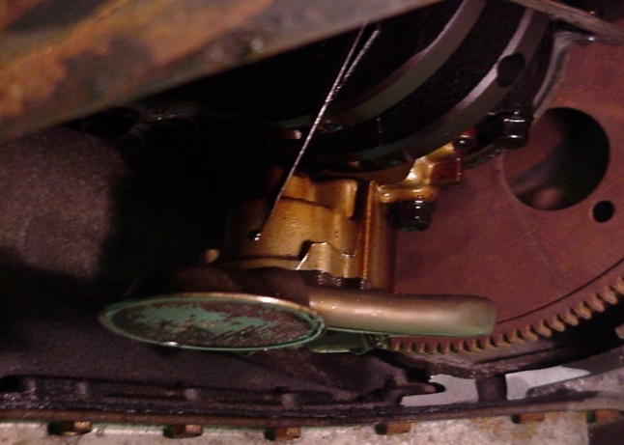

Figure 2-6. Oil Pickup and Strainer

- Oil Filter
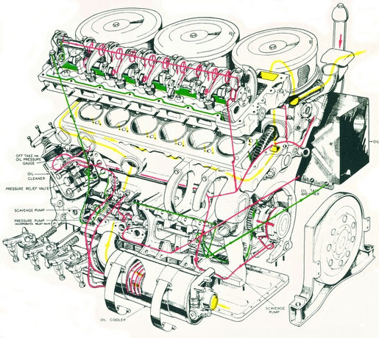
The oil filter removes most of the impurities that have been picked up by the oil, as it circulates through the engine. Designed to be replaced readily, the filter is mounted in an accessible location outside the engine.

Figure 2-7 Oil Galleries
- Oil Galleries
Oil galleries are small passages through the cylinder block and head for lubricating oil. They are cast or machined passages that allow oil to flow to the engine bearing and other moving parts.
The main oil galleries are large passages through the center of the block. They feed oil to the crankshaft bearings, camshaft bearings, and lifters. The main oil galleries also feed oil to smaller passage running up to the cylinder heads.

- Oil Pressure Warning Light
The oil pressure warning light is used in place of a gauge on many vehicles. The warning light, although not as accurate, is valuable because of its high visibility in the event of a low oil pressure condition.
Because the engine can fail or be damaged in less than a minute of operation without oil pressure, the warning light is used as a backup for a gauge to attract instant attention to a malfunction.

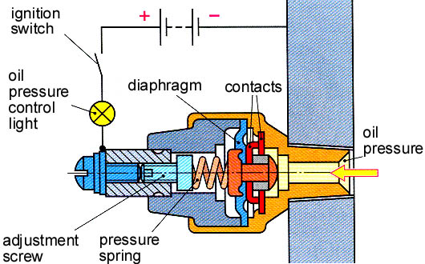

Figure 2-8. Oil Pressure Warning Light
- Oil cooler
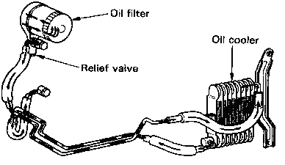
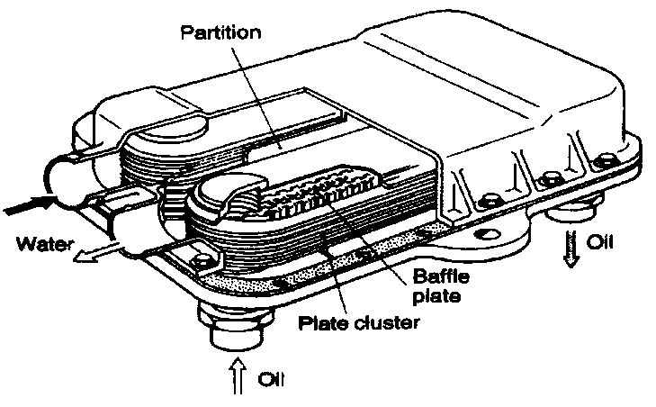
Oil cooler is a heat exchanger which is either air cooled type or liquid cooled type. In air-cooled oil cooler, oil flow through heat exchanger tubes and coolant (air) passing over the tubes where as in liquid cooled cooler, oil and coolant (water), the two being separated by tubes or baffles, flow through heat exchanger.

Figure 2-9. Oil cooler
Lubrication system problem
To troubleshoot an engine lubricating system, begin by gathering information on the problem. Ask the operator questions. Analyze the symptoms using your understanding of system operation. You should arrive at a logical deduction about the cause of the problem.
The four problems most often occur in the lubrication system are as follows:
- High oil consumption (oil must be added frequently)
- Low oil pressure (gauge reads low, indicator light glows, or abnormal engine noises)
- High oil pressure (gauge reads high, oil filter swelled)
- Defective indicator or gauge circuit (inaccurate operation or readings)
When diagnosing these troubles, make a visual inspection of the engine for obvious problems. Check for oil leakage, disconnected sending unit wire, low oil level, damaged oil pan, or other troubles that relate to the symptoms.
- High Oil Consumption
If the operator must add oil frequently to the engine, this is a symptom of high oil consumption. External oil leakage out of the engine or internal leakage of oil into the combustion chambers causes high oil consumption. A description of each of these problems is as follows:
External oil leakage—detected as darkened oil wet areas on or around the engine. Oil may also be found in small puddles under the vehicle. Leaking gaskets or seals are usually the source of external engine oil leakage.
Internal oil leakage—shows up as blue smoke exiting the exhaust system of the vehicle. For example, if the engine piston rings and cylinders are badly worn, oil can enter the combustion chambers and will be burned during combustion
- Low Oil Pressure
Low oil pressure is indicated when the oil indicator light glows, oil gauge reads low, or when the engine lifters or bearings rattle. The most common causes of low oil pressure are as follows:
- Low oil level (oil not high enough in pan to cover oil pickup)
- Worn connecting rod or main bearings (pump cannot provide enough oil volume)
- Thin or diluted oil (low viscosity or fuel in the oil)
- Weak or broken pressure relief valve spring (valve opening too easily)
- Cracked or loose pump pickup tube (air being pulled into the oil pump)
- Worn oil pump (excess clearance between rotor or gears and housing)
- Clogged oil pickup screen (reduce amount of oil entering pump)
A low oil level is a common cause of low oil pressure. Always check the oil level first when troubleshooting a low oil pressure problem.

- High Oil Pressure
High oil pressure is seldom a problem. When it occurs, the oil pressure gauge will read high. The most frequent causes of high oil pressure are as follows:
1. Pressure relief valve struck (not opening at specified pressure)
2. High relief valve spring tension (strong spring or spring has been improperly shimmed)
3. High oil viscosity (excessively thick oil or use of oil additive that increases viscosity)
4. Restricted oil gallery (defective block casting or debris in oil passage)
- Indicator or Gauge Problems
A bad oil pressure indicator or gauge may scare the operator into believing there are major problems. The indicator light may stay on or flicker, pointing to a low oil pressure problem. The gauge may read low or high, also indicating a lubrication system problem.
Inspect the indicator or gauge circuit for problems. The wire going to the sending unit may have fallen off. The sending unit wire may also be shorted to ground (light stays on or gauge always reads high).
To check the action of the indicator or gauge, remove the wire from the sending unit. Touch it on a metal part of the engine. This should make the indicator light glow or the oil pressure gauge read maximum. If it does, the sending unit may be defective. If it does not, then the circuit, indicator, or gauge may be faulty.

Exhaust System
When the combustion ends in each cylinder, the exhaust gas must be collected, cleaned, quieted, and then discharged into the air. This is the job of the exhaust system. It performs these tasks while carrying the exhaust gases from the cylinders to the atmosphere. This system includes the exhaust manifold, exhaust pipe, catalytic converter, muffler or silencer, resonator (on some cars), and tail pipe. The exhaust system has also flexible mountings that allow for engine movement and also prevent exhaust vibration from being transmitted to the body. They also allow thermal expansion of the system.

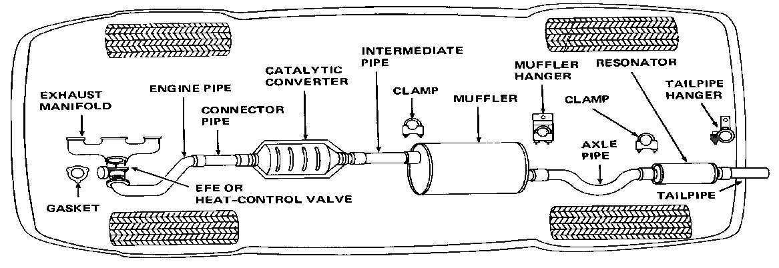
Figure 2-10 Exhaust Gas System

Exhaust system component
- Exhaust Manifold
The exhaust manifold is made of cast iron and is bolted over the exhaust ports of the engine, usually alongside the intake manifold pipe. It provides heat to the intake manifold. This heat further vaporizes the fuel in the intake manifold.
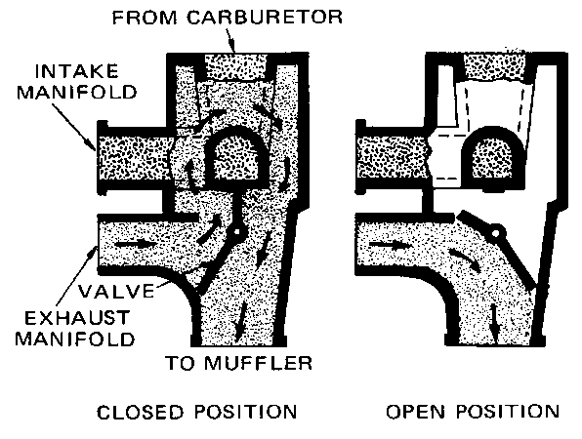
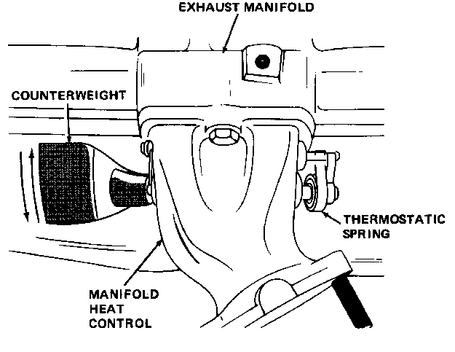
Heat Control valve (or) Heat-Riser Valve

Figure 2-11. Heat Control valve (or) Heat-Riser Valve

During cold-engine operation, the gasoline must be vaporized before entering the cylinders. If the fuel is not properly vaporized, drops of gasoline will enter the cylinders. They will wash down the cylinder walls and remove the oil. This causes the walls, pistons, and piston rings to wear quickly. The heat control valve helps to vaporize the cold gasoline when the engine is cold.
Engines with a heat control valve warm a section of the intake manifold by allowing some of the exhaust gases through it. Placing a butterfly valve between the exhaust manifold and the exhaust pipe does this. Opening and closing of the valve is controlled by a thermostatic spring or by a vacuum motor. When the valve is operated by a vacuum motor, the system is called an Early Fuel Evaporation (EFE) system.
- Exhaust Pipe
The exhaust pipe is a long pipe leading from the exhaust manifold to the muffler.
- Catalytic converter
It is discussed under exhaust gas treatment.
- Muffler
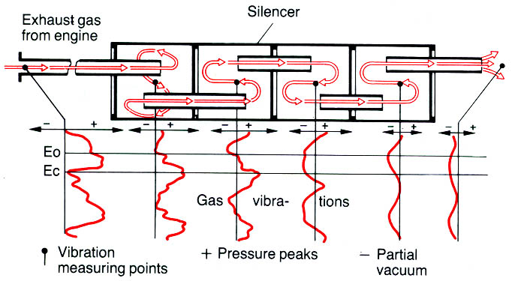
The exhaust gas emerges in a pulsating flow and therefore causes marked vibration in the exhaust pipes and mufflers (silencers). The muffler, located between the catalytic converter and the resonator or tail pipe, contains perforated pipes, baffles, and resonance chambers. Its purpose is to reduce the pressure pulses and to quiet or muffle the noise of the exhaust. Without a muffler, the exhaust gas pulsations would roar very loudly.

Figure 2-12. Muffler silencing operation

- Resonator
It is used to further muffle the noise of the exhaust gases. It is also called secondary muffler.
- Tail Pipe
The tail pipe is a pipe that carries the exhaust gases from the muffler to the rear of the vehicle. This pipe may be a separate unit or an integral part of the muffler when the muffler is located near the rear of the vehicle.
All the elements in the exhaust system are very carefully matched together and must therefore not be altered individually. There is a possibility of the vehicles official documents being rendered invalid if the exhaust system is modified.

Treating the exhaust gas
Testing the exhaust gas means that some cleaning' of the exhaust gas occurs. It takes place after the exhaust gas leaves the engine cylinders and before it exits the tail pipe and enters the atmosphere. This reduces the amount of HC, CO and NOx content in the exhaust gas. The exhaust gas is treated in two different ways. One is by injecting the fresh air into the exhaust system. The other is by sending the exhaust gas through a catalytic converter.
- Air-Injection (AI) & Air-Suction (AS) Systems
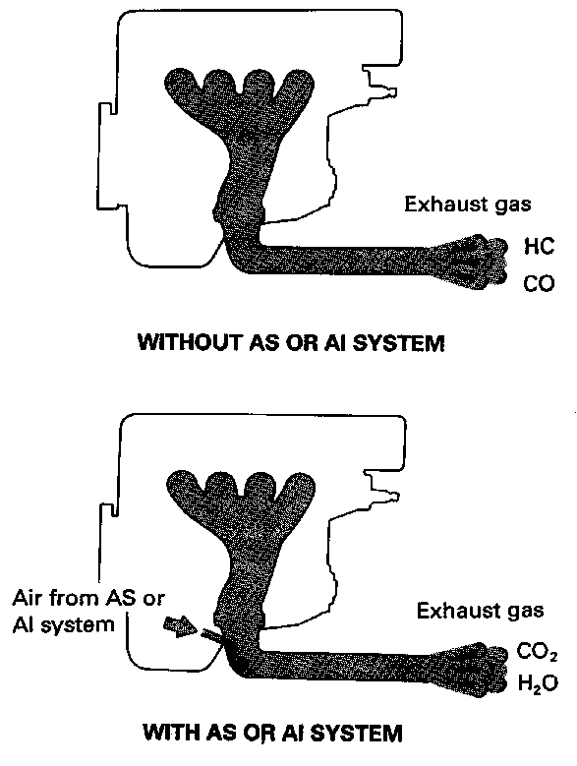
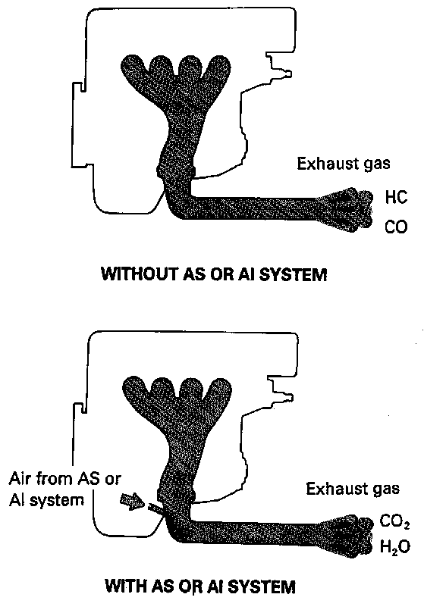
In this method, fresh air is supplied to the exhaust manifold by an air injection pump. So that it provides additional oxygen to burn HC and CO coming out of the cylinders.

Figure 2-13 Air-Injection (AI) & Air-Suction (AS) System

- Air-Aspirator (or) Air-Suction System
Some engines equipped with a catalytic converter use an air-aspirator system to deliver fresh air to the exhaust system. An air-aspirated valve is located in the tube between the air cleaner and the exhaust manifold or catalytic converter.
The aspirator valve opened and closed by the pressure in the exhaust system. The slight vacuum in the exhaust manifolds at idle and slow running causes the value to open, admitting air from the air cleaner to the exhaust system. The oxygen in the air helps to burn any HC or CO in the exhaust gas.

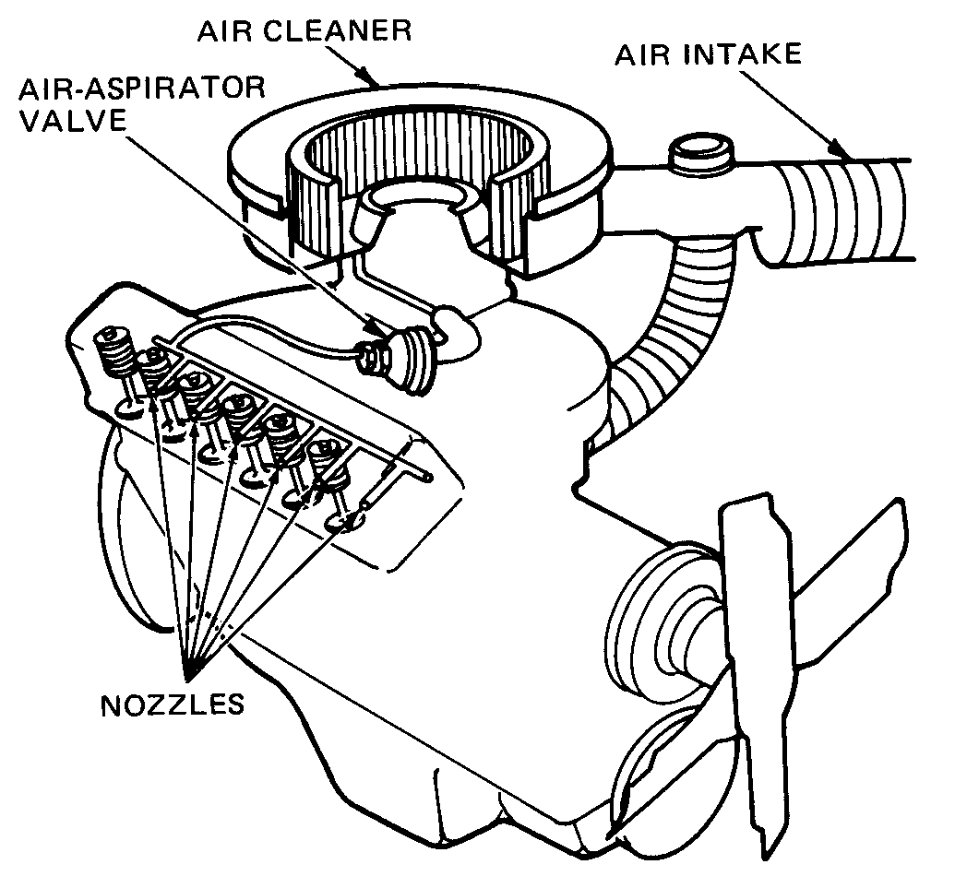

Figure 2-14. Air-Aspirator (or) Air-Suction System

- Catalytic Converter
Catalytic converters provide another way to treat the exhaust gas. These devices located in the exhaust system, convert harmful gases into harmless gases. Inside the catalytic converter, the exhaust gases Passover a catalyst. A catalyst is a material that causes a chemical reaction. In effect, the catalyst encourages chemicals to react with each other. The metals such as platinum and palladium are act as oxidizing catalysts and rhodium as reducing catalysts.
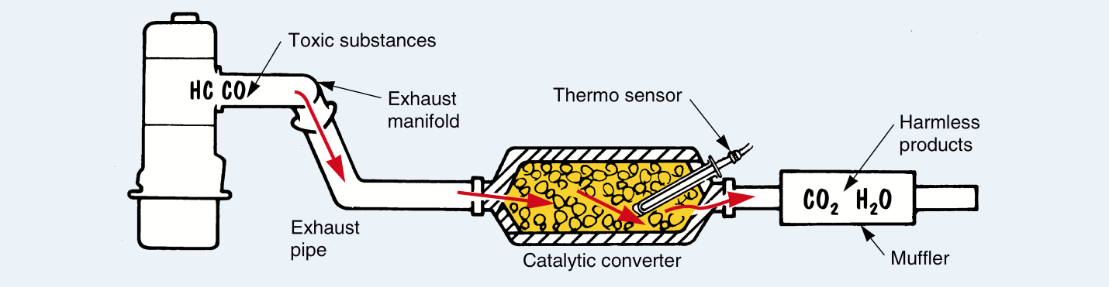
Figure 2-15 Catalytic Converter
There are three general categories of catalytic converters. These are oxidizing, reducing, and three ways. The oxidizing converter handles HC and CO, using platinum or palladium as the catalysts. The reducing converter handles NOx using metal rhodium. It splits oxygen from the nitrogen. The NOx becomes harmless nitrogen (N2) and oxygen (O).
A dual bed catalytic converter has two pellet beds, one over the other. An air chamber separates the two. The upper bed contains pellets coated with a three-way catalyst. This catalyst mainly reduces NOx to nitrogen and oxygen, but it also oxidizes HC and CO.
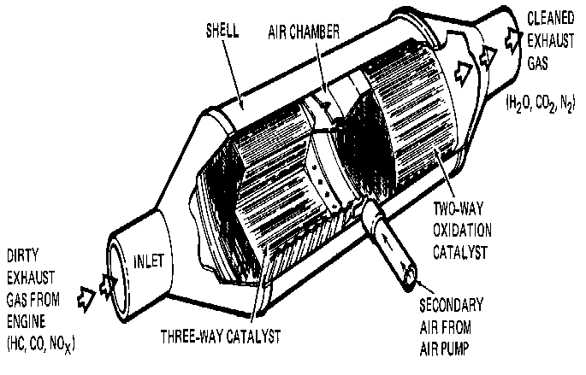
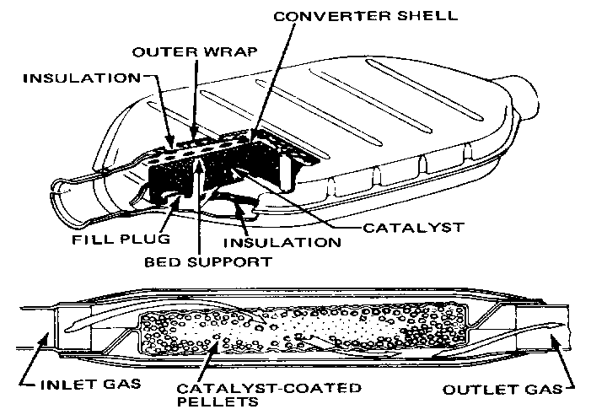
The lower bed serves as a two-way catalyst. It further oxidizes the remaining HC and CO. When the engine warms up, secondary air from the air pump feeds into the air chamber separating the beds. The air helps the oxidizing catalyst convert the HC and CO into carbon dioxide and water. A similar action takes place in the three-way honeycomb catalytic converter.
Figure. 2-17 Three way catalytic converter
Figure 2-1164 Two way catalytic convertor

Exhaust System Service
Exhaust system components are subject to physical and chemical damage. Any physical damage to an exhaust system part that causes a partially restricted or blocked exhaust system usually results in loss of power or backfire up through the throttle plate(s). In addition to improper engine operation, a blocked or restricted exhaust system causes increased noise and air pollution. Leaks in the exhaust system caused by either physical or chemical (rust) damage could result in illness, asphyxiation, or even death.
- Exhaust System Inspection
Most parts of the exhaust system, particularly the exhaust pipe, muffler, and tailpipe, are subject to rust, corrosion, and cracking. Broken or loose clamps and hangers can allow parts to separate or hit the road asthe car moves. All inspections should include listening for abnormal noises. The inspection should also include a careful look at the system while the vehicle is raised on a hoist. Before beginning work on the system, be sure that it is cool to the touch. Some technicians disconnect the battery ground to avoid short-circuiting the electrical system.
- Exhaust Restriction
Test Often leaks and rattles are the only things looked for in an exhaust system. The exhaust system should also be tested for blockage and restrictions. Collapsed pipes or clogged converters and/or mufflers can cause these blockages. There are many ways to check for a restricted exhaust. The sound of the exhaust can indicate a restriction. Although this is not the most effective way to determine if thereis a restriction, it is a good start.
Checking the pressure built up in the exhaust is the best way to determine if the system is blocked. This is done by installing a pressure gauge in the O2S bore in the exhaust pipe. At idle, the gauge should read less than 1.5 psi (10 kPa) and should be less than 2.5 psi (17 kPa) at 2,500 rpm. Some technicians check for a restricted exhaust with a vacuum gauge. With the gauge connected to the intake manifold, the engine’s speed is raised and held. The vacuum reading should rise and either hold there or increase slightly. If the vacuum decreases, there is an exhaust restriction.
- Exhaust Leaks
Exhaust leaks are often identified by sound, although very small leaks can be difficult to
locate. One of the most effective ways to identify the source of a leak in the system is the use of a smokemachine. When smoke is introduced to the exhaust system, a trace of smoke will identify the source of the leak.
- Exhaust Manifold Servicing
an exhaust manifold will warp because of excess heat. A straightedge and feeler gauge can be used tocheck the machined surface of the manifold. Another problem—also the result of high temperatures generated by the engine—is a cracked manifold. This usually occurs after the car passes through alarge puddle and cold water splashes on the manifold’s hot surface. If the manifold is warped beyondmanufacturer’s specifications or is cracked, it must be replaced.
- Replacing Leaking Gaskets and Seals
The most likely spot to find leaking gaskets and seals is between the exhaust manifold and the exhaust pipe Most often exhaust bolts are quite rusted and can be difficult to loosen. This is why it is wise to soak the bolts and nuts with penetrating fluid before attempting to disassemble the system.. To replace an exhaust manifold gasket, follow the torque sequence in reverse to loosen each bolt. Repeat the process to remove the bolts. Doing this minimizes the chance that components will warp. Inspect the manifold for irregularities that might cause leaks, such as, scratches, or cracks.
Replace it if it is cracked or badly warped. Then during Install the bolts or nuts finger-tight. Tighten themin three steps—one-half, three-quarters, and full torque. Always follow the specifications given for thatengine. Normally the nuts should be tightened in a particular sequence. This sequence typically beginsat the center and continues outward in an X pattern.
- Replacing Exhaust Pipes
In most cases, the exhaust system is replaced as a unit. Doing this ensures a proper fit and saves much time. However, there are times when only a section or component needs to bereplaced. When doing this take care not to damage any surrounding parts. To replace an exhaust pipe,support the converter to keep it from falling and remove the O2S. Remove any hangers or clamps holding the exhaust pipe to the frame. Unbolt the flange holding the exhaust pipe to the exhaust manifold.
Disconnect the pipe from the converter and pull the front exhaust pipe loose and remove it. If the pipe issealed with a gasket, replace it when installing the new pipe.

. Fuel system
Automobile engines mostly use two types of fuels gasoline and diesel fuel. These fuels must reach to the engine cylinders and be ignited. Three basic types of fuel systems are used in automobile engines
1. Gasoline fuel systems (carburetor and gasoline fuel injection)
2. Diesel fuel system

2.6.1. Diesel-Engine Fuel Systems
The automotive diesel-engine fuel system uses injection nozzles or injectors similar to the fuel injectors in gasoline fuel-injection systems. The gasoline injectors are solenoid operated. When high pressure is applied, they open and spray fuel. The diesel fuel system must:
- Deliver the right amount of fuel to meet the operating requirements.
- Time the opening of the injection nozzles so the fuel enters the engine cylinders at the proper instant. As engine speed increases, fuel injection must start earlier. This gives the fuel enough time to burn and produce pressure on the pistons. Without the advance, the pistons would be over TDC and moving down before the fuel fully ignites. This wastes fuel and power.
- Deliver the fuel to the cylinders under high pressure. Injection pressure must be high enough to overcome the high compression pressure in the diesel engine. At the end of the compression stroke, compression pressure may be 500 psi [3447 kPa] or higher.

2.6.2. Constructions and operation of diesel fuel system
The fuel delivery system has the important role of delivering fuel to the fuel injection system. The fuel must also be delivered in the right quantities and at the right pressure. The fuel must also be clean when it is delivered.
A typical fuel delivery system includes a fuel tank, fuel lines, fuel filters, and a pump. The system works by using a pump to draw fuel from the fuel tank and passing it under pressure through fuel lines and filters to the fuel injection system. The filter removes dirt and other harmful impurities from the fuel. A fuel line pressure regulator maintains a constant high fuel pressure. This pressure generates the spraying force needed to inject the fuel. Excess fuel not required by the engine returns to the fuel tank through a fuel return line.
Fuel tank: the fuel tank on commercial vehicles is often made of aluminum or plastic for reasons of weight. It must be corrosion resistant and remain tight at double its operating pressure (legally specified minimum value = 0.3 bar overpressure). Larger tanks often incorporate baffle plates to prevent the fuel from being displaced excessively when cornering, braking and moving away. The drain plug is positioned at the lowest point in the tank.

Fuel lines: Steel pipes or plastic fuel lines are used on the diesel engines of commercial vehicles.
Fuel supply pump: The fuel supply pump transfers the fuel from the tank to the injection pump. On the inline injection pumps often used on commercial vehicles, the fuel supply pump is a piston-type pump. It is flanged onto the injection pump and usually equipped with a hand-operated pump for venting the fuel system. Its task is to deliver the fuel to the injection pump at a pressure of approx. 1 - 2.5 bar. The supply pump is driven by a cam located on the injection pumps camshaft. The higher the pressure in the supply line, the less fuel is pumped. This is known as flexible delivery. Distributor pumps have integral supply pumps which take the form of vane pumps or separate diaphragm pumps.
Inline injection pumps: Inline injection pumps have a separate camshaft and one pump element per engine cylinder. The stroke of the pistons always remains the same. The pump rate is regulated via metering ramps. The fuel is pumped through a separate high-pressure line to the corresponding injector for each cylinder of the engine. The injection pumps camshaft, driven by the engine, controls the injection processes in the individual injectors.

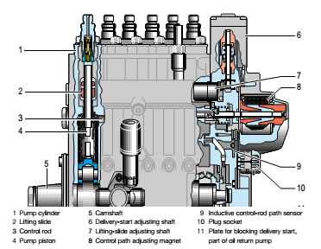

Figure 2-18. Operating principle of the lifting-slide inline injection pump & mechanical in line pump

A mechanical injection timing device adjusts the start of delivery according to engine speed, as necessary. It rotates the camshaft in relation to the engine crankshaft, thus displacing the start of delivery. The inline injection pump is connected up to the engine oil circuit for lubrication of the moving pump components.
Distributor-type pumps: Unlike the inline injection pump, the distributor-type pump has only one pump element with one piston for all cylinders. The piston operates as many strokes as there are cylinders for every revolution of the crankshaft. The simultaneous movement of the piston during the stroke distributes the fuel to the various inlets and pumps it to the corresponding injectors.
A mechanical speed governor and a hydraulic injection timing device are integrated into the distributor pumps housing. Distributor-type pumps are used on high speed passenger-car and commercial vehicle diesel engines with an output per cylinder of up to 25 kW. The injection pressure is approximately 700 bars. Distributor type pumps with electronic control are capable of injection pressures as high as 1400 bar
Fuel injectors: should be removed and taken to a qualified diesel engine repair center to be tested for leakage and spray pattern, if poor engine performance such as loss of power, rough or uneven running, sudden notice of dark exhaust, or engine becomes hard to start.
Removing injectors:
1. Clean the area around the injectors before removing.
2. Loosen nuts holding fuel lines to injector pump and injector nozzle and remove fuel lines.
3. Loosen nuts on return line adapters and remove adapters.
4. Loosen injectors and remove injectors.
Replacing injectors:
1. Check to be sure contacts surfaces and area around injectors is clean.
2. Replace injectors in the same cylinder from which they were removed.
3. Torque required to properly seat the injectors will be between 43 and 58 ft./lbs.
4. Replace fuel return lines and secure nuts.
5. Replace all fuel lines and secure all nuts.
6. After all injectors, fuel lines and hoses have been replaced and are secured; the fuel system will have to be bled.
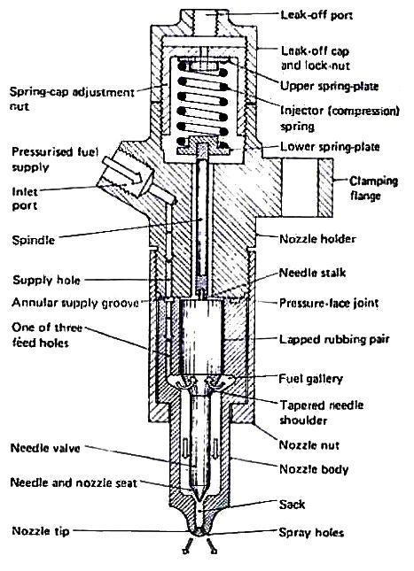
The fuel injection pump has been set at the factory and should need no adjustment. Any apparent problem with the pump should be referred to a qualified diesel mechanic or to a Universal Diesel dealer as advised

Figure: 2-19. Sectional view of injector

Bleeding Diesel fuel system

It will be necessary to bleed the fuel system to achieve a steady air free flow of fuel if any of the following have occurred.
1. Running out of fuel.
2. If fuel shut off valve is left closed and engine runs out of fuel.
3. Replacing fuel filter.
4. Fuel injector nozzle or injector pump repair.
5. After repairing or replacing any fuel line.
6. Before putting engine back into service in the spring, if fuel system has been drained.
7. Replacement of electric or mechanical fuel pump.
8. Any time air is permitted to enter the fuel system.
Bleeding procedure:
Be sure to have some means available to catch or absorb any fuel escaping during the bleeding process so that it will not accumulate in the engine compartment or bilge.
1. be sure there is a sufficient supply of fuel in the fuel tank.
2. Open the fuel shut-off valve at the tank.
3. Start the electric fuel pump by turning the ignition key to the "ON" position on models 18, 20, 25, 30, 50, all models after 1986.
4. Model 15 has a mechanical fuel pump. Therefore with decompression on, turn engine over with starter. Crank at 10 second intervals while doing steps #5 and 7.
5. Slowly loosen the air bleed plug on the fuel filter, letting air escape until an air free flow of fuel is evident. (1986 models see item 7).
6. At this time, tighten the air bleed plug on the filter.
7. Slowly loosen the air bleed plug on the injector pump, letting air escape until an air free flow of fuel is evident. Units with a self-bleed return valve open for a short period then start engine, as soon as engine runs smooth close valve. Model-12 has continuous fuel bleeding.
8. At this time, tighten the air bleed plug or knurled knob on the injector pump.
9. The fuel system should now be properly bled and ready for operation. Refer to starting instructions before attempting to start the engine after bleeding the fuel system.
CAUTION: Excessive cranking with seal cock valve open can cause water accumulation in the muffler and possibly back up into the engine. Drain muffler as needed.
Injection timing
- Timing device
- A large percentage of fuel injection pumps have timing devices incorporated in them. Varying the time when fuel injection begins will improve diesel engine performance and fuel economy, for the same reason that varying spark timing will improve the performance of a gasoline engine.
- The timing device usually consists of an aluminum casting with mounting flanges at both ends. A bore in the housing guides and supports the spider assembly. A timing opening, with a cover, is located in the top of the housing and is used to observe the position of the timing pointer in relation to the timing mark on the timing device hub during injection pump timing procedures.
- The timing device hub, with external left-hand helical splines for engaging the internal helical splines of the sliding gear, has a tapered bore and keyway. The hub is secured to the camshaft extension by a woodruff key, nut, and setscrew. The hub is usually counter bored to receive the timing device springs. The springs oppose the fly weight forces of the weight and spider assembly.
- The weight and spider assembly has external right-hand helical splines which mesh with the internal helical splines of the sliding gear. The splined end is machined to receive the end play spacer. Three flyweights are pinned to a flange adjacent to the splines. The weight and spider thrust plate, located between the flange and the timing device housing, carries the back thrust of the flyweights and prevents housing wear.
- The sliding gear has internal left-hand helical splines at one end and internal right hand helical splines at the other, and meshes with the external splines of both the weight and spider assembly and the timing device hub. Correct assembly of the spline train is ensured by a wide land on both the hub and weight and the spider assembly. The sliding gear has a missing tooth on each set of internal splines to receive the wide lands.
Operation:
- As the engine rotates the weight and spider assembly, centrifugal force opens the flyweights from their collapsed position against the force of the three timing device springs.
- As the flyweights swing out, the sliding gear is forced toward the timing device hub.
- The longitudinal movement of the sliding gear on its helical spline causes a slight change in the rotational relationship of the injection pump to the engine, causing injection to begin slightly earlier in the power stroke.
Procedure
- Remove fuel lines from injector pump fittings on injector pump (Tool).
- Pull the decompression lever so that it will remain in the decompression position.
- Open throttle fully.
- Energize the electric fuel pump and turn engine over with starter to ensure that fuel is coming out of each injector pump opening. Have clean rags around opening to soak up fuel.
- Wipe off any fuel on injector pump body and the top of each injector opening.
- Turn crankshaft over by hand, being careful not to damage spline on end of crankshaft. Engine rotation will be clockwise. STOP IMMEDIATELY at the first sign of fuel movement in the injector pump fuel fitting, for whichever injector pump is being checked. (No. 1 injector pump is the closest to the V-belt end of the engine).
- Remove the cover from flywheel timing mark inspection hold located inside of left engine mount
- Check alignment of mark on flywheel with the timing pointer on the wall of the inspection hole. The 1-Fl mark on the flywheel represents fuel injection of No. 1 cylinder. 2-Fl represents No. 2 cylinder, etc.
- If timing pointer and the flywheel marking 1-Fl is aligned then No. 1 cylinder is properly timed for fuel injection and should require no adjustment. The same will be true for No. 2, No. 3 and No. 4 cylinders if the above steps are followed.
- In order to determine if timing is off, or if the injection pump is faulty, it is necessary to recheck the timing for each cylinder two or three times. If there are variations in repeatability in the alignment of pointer and timing mark, a faulty fuel injector pump may be suspected.
- If timing marks repeat to same location but are off 3/16" or more above or below the pointer, this indicates that the engine must be retimed.
- If alignment of the timing mark is not within 3/16" above or below the pointer, the above steps must be taken to time the engine. If the timing is found to be satisfactory, then reconnect all fuel lines and fittings and tighten.

Self-check 2
  - If the cylinder head is defective, which of the following will leak into the cooling system?
A. air-fuel mixture B. fuel C. combustion gases D. exhaust
  - 2) Leakage of gases into the cooling system may form
A. oil sludge B. carbon deposits C. strong acids D. scales
  - The acids that form in the cooling system may corrode the
A. radiator B. temperature gauge C. thermostat D. water pumping
  - Combustion leaks in the valve areas can cause cracks in the
A. cylinder and piston B. valve seats and cylinder heads
C. crank shaft and camshaft D. oil pan and timing cover
5) Combustion leak in the valve area can be stopped by
A. replacing cylinder head gasket B. grinding the valve face and valve seat
C. replacing the piston ring D. none of the above
6) Which of the flowing oil contains that is located at the bottom of the engine.
A) Oil pan B) Oil c) Dip sticks D) all
7) Which of the Metal mesh located at the oil inlet to remove large dust particles.
A) Sump B) Oil c) Oil strainer D) All
8) Pumps oil that has accumulated in the oil pan to the various areas of the engine.
A) Oil filter B) Oil pressure switch c) Dip stick (Level gauge) D) Oil pump
9) ___________, located between the catalytic converter and the resonator or tail pipe, contains perforated pipes, baffles, and resonance chambers.
A) Muffler B) Exhaust manifold C) catalytic converter
10) _____________is a long pipe leading from the exhaust manifold to the muffler.
A) Muffler B) Exhaust pipe c) Tail pipe D) All

Operation sheet: 2. 1
Title: Removing and Disassemble Cooling system
Objectives: Given an engine, ultraviolet light, special dye, paper and pencil and clean rags, you will perform leak test, record, analyze results and prescribe action.
Instructions:
1. Prepare tools/equipment needed.
2. Wear protective clothing and goggles.
3. Add the specified amount of special dye to the coolant.
4. With the heater on, run the engine until the upper radiator tank hose is warm.
5. Aim the ultraviolet light at the suspected heating area. (Note: the dye in the coolant will cause any leaking coolant to glow bright green)
6. Identify and record the part of the engine where the leakage occurs.
7. Analyze if the leakage is caused by worn-out gaskets, broken parts, loose fasteners, etc.
8. Indicate preferred corrective actions. (Note: For the data in numbers 4,5 and 6, use the attached worksheet

Operation sheet-2.2
Title: Removing and Disassemble Lubrication system
Objectives: Given an engine, ultraviolet light, special dye, paper and pencil and clean rags, you will perform leak test, record, analyze results and prescribe action.
Instructions:
1. Start engine in a well-ventilated area and allow it to reach normal operating temperature. Shut off the engine.
2. Safely raise vehicle on a hoist or support vehicle on jack stands.
SAFETY CAUTION: When hot, exhaust system parts, can cause severe burns. Avoid touching exhaust system parts. In addition, drain plugs and oil are hot enough to cause pain and minor burns. Use a shop towel to hold the drain plug as it is unscrewed, and avoid getting oil on yourself during draining.
3. Loosen drain plug with a wrench. Do not unscrew plug.
4. Position an oil catch pan under oil pan drain pug.
5. Unscrew and remove drain plug by hand. Allow hot oil to drain into the catch pan for at least five minutes.
6. Clean drain plug and mounting hole with a shop towel. Thread plug in by hand, and then tighten as recommended by vehicle manufacturer.
7. Position oil catch pan under oil filter.
8. Loosen oil filter with an oil filter wrench. Unscrew filter by hand and place in catch pan to drain. Clean oil filter mounting surface with a shop towel.
10. Rub a few drops of new engine oil onto rubber gasket of oil filter.
11. Screw filter on by hand. After rubber gasket contacts mounting surface, turn filter an additional ¾ to 1 full turn by hand.
12. Lower vehicle and add correct amount of new engine oil. Start engine and watch oil pressure warning light or gauge until normal pressure is indicated. Check for leaks around filter and drain plug. Shut off engine.
13. Wait five minutes, then check engine oil dipstick for proper oil level.

Operation sheet 2. 3
Title: Bleeding the Fuel System
Objectives: Given an engine, ultraviolet light, special dye, paper and pencil and clean rags, you will perform leak test, record, analyze results and prescribe action.
Instructions
It will be necessary to bleed the fuel system to achieve a steady air free flow of fuel if any of the following have occurred.
1. Running out of fuel.
2. If fuel shut off valve is left closed and engine runs out of fuel.
3. Replacing fuel filter.
4. Fuel injector nozzle or injector pump repair.
5. After repairing or replacing any fuel line.
6. Before putting engine back into service in the spring, if fuel system has been drained.
7. Replacement of electric or mechanical fuel pump.
8. Any time air is permitted to enter the fuel system.
9. be sure there is a sufficient supply of fuel in the fuel tank.
10. Open the fuel shut-off valve at the tank.
11. Start the electric fuel pump by turning the ignition key to the "ON"
12. Model 15 has a mechanical fuel pump. Therefore with decompression on, turn engine over with starter. Crank at 10 second intervals while doing steps #5 and 7.
13. Slowly loosen the air bleed plug on the fuel filter, letting air escape until an air free flow of fuel is evident.
14. At this time, tighten the air bleed plug on the filter.
15. Slowly loosen the air bleed plug on the injector pump, letting air escape until an air free flow of fuel is evident. Units with a self-bleed return valve open for a short period then start engine, as soon as engine runs smooth close valve. Model-12 has continuous fuel bleeding.
16. At this time, tighten the air bleed plug or knurled knob on the injector pump.
17. The fuel system should now be properly bled and ready for operation.
Refer to starting instructions before attempting to start the engine after bleeding the fuel system

Operation sheet-2.4
Title: Removal of Turbocharger
Objectives: On a given Turbocharger equipped vehicle following the correct work procedure remove turbocharger.
Instructions
It will be necessary to remove turbocharger form a given vehicle following the listed bellow steps.
Tools and equipment
- Screw driver
- Open wrench
- Adjustable wrench.
    - DRAIN ENGINE COOLANT
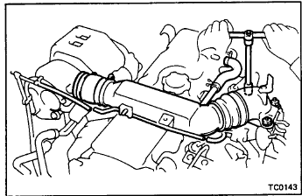
    - REMOVE INTAKE PIPE
(a) Disconnect the vacuum hoses for the boost compensator.
(b) Disconnect the air hose clamp bolt.
(c) Remove the three nuts, intake pipe and gasket.
    - DISCONNECT WATER BY-PASS HOSES
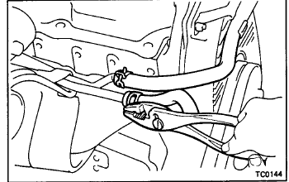

    - REMOVE TURBO HEAT INSULATORS
Remove the four bolts and three heat insulators.
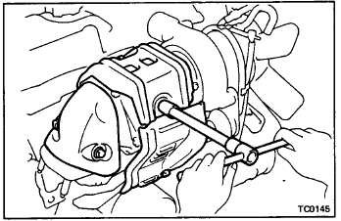
    - REMOVE EXHAUST MANIFOLD STAY
Remove the two bolts, two nuts and exhaust manifold stay.
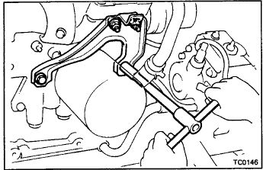
    - REMOVE TURBO OIL PlPE
(a) Remove the union bolt and two gaskets holding the turbo oil pipe to the cylinder block.
(b) Disconnect the turbo oil hose.
(c) Remove the two nuts, turbo oil pipe and gasket.
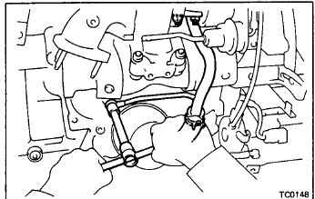
    - REMOVE TURBOCHARGER FROM EXHAUST 4 MAN l FOLD

Remove the four nuts, turbocharger and gasket.
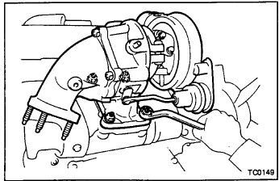
    - REMOVE TURBO WATER PIPE
Remove the bolt and two nuts, turbo water pipe and gasket.
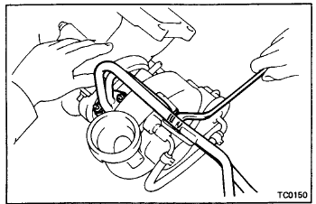
    - REMOVETURBINEOUTLETELBOW
Remove the four nuts, turbine outlet elbow and gasket
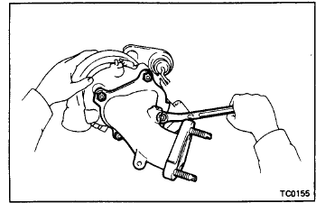

Operation sheet-2.5
Title : Remove and clean air fiter
Purpose:-Remove air cleaner correctly from a vehicle
Tools and equipment reqired
- Air comprasor
- Open wrench
Procedure
  - Paper filter type :
- remove air fiter
- inspect air filter :
- visually check that the filter element is excessively dirty,damaged or oily.
- clean air filter
- Clean the fil;ter element with compressed air.first blow from the inside thorouthly.then blow off the filter element .
- reinstall air filter
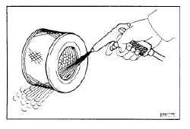

  - Washable type :
  - remove air filter
  - ispect air filter
- visualy check that the filter element is not excessively dirt,damaged or oily.
  - Clean air filter
- Blow dirt off in the filter element with compressed air
- Submerge the filter element in the water,and agitate it up and down more than 10 times.
- Repeat rinsing in clean water until rinsing water is clear.
- Remove excess water by shaking the filter element or blowing with compressed air
Notice: donot beat or drop filter element .
- Wipe off dust on air cleaner case interior.
  - Re-install Air Filter

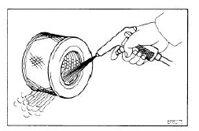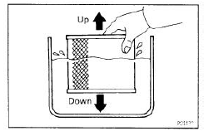

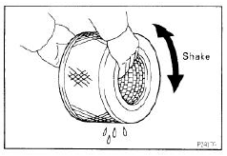

Operation sheet 2.6

Title: Replacing the radiator
Purpose:-Remove Radiator correctly from a vehicle
Materials Needed
- Radiator coolant
- Air compressor (optional)
- Cooling system vacuum fill tool (optional)
- Flare nut wrench of the appropriate size
- Free repair manuals - provides free online repair manuals for certain makes and models
- Jack and jack stands
- Pliers
- Protective gloves
- Ratchet and sockets of the appropriate size
- Ratchet extension
- Safety glasses
- Screwdriver
- Wrenches of the appropriate size
Procedure
Step 1: Raise and support the vehicle. Safely support the vehicle by jacking it up and supporting it with jack stands. Place a wheel chock behind the rear wheels and set the parking brake
Step 2: Drain the coolant from the radiator. Open the petcock valve or remove the lower radiator hose to drain the coolant from the radiator.
Step 3: Disconnect the radiator reservoir hose. Loosen the hose clamp using either pliers or a screwdriver, depending on the clamp design. Disconnect the hose by twisting and pulling it away from the radiator.

Step 4: Remove the upper radiator hose. Loosen the hose clamps using either pliers or a screwdriver, depending on the clamp design. Then remove the hose by twisting and pulling it away from the connection
Step 5: Remove the lower radiator hose. Loosen the hose clamps using either pliers or a screwdriver, depending on the clamp design. Then remove the hose by twisting and pulling it away from the connection.
Step 6: Disconnect the cooling fan electrical connector. Disconnect the cooling fan electrical connector by pushing on the tab and pulling it back.
Step 7: Remove the cooling fan mounting bolts. Remove the cooling fan mounting bolts using a ratchet, extension and socket of the appropriate size.
Step 8: Remove the cooling fan. Remove the cooling fan from the vehicle.
Step 9: Disconnect the transmission cooler lines. Disconnect the transmission cooler lines from the radiator using a flare nut wrench to prevent rounding off the fittings.
Step 10: Remove the radiator mounting bolts. Remove the radiator mounting bolts using a wrench or ratchet and socket of the appropriate size.
Step 11: Remove the condenser mounting bolts. Remove the condenser mounting bolts using a wrench or ratchet and socket of the appropriate size.
Step 12: Remove the radiator. Remove the radiator from the vehicle.
Step 13: Mount the radiator. Mount the new radiator in position.
Step 14: Install the condenser mounting bolts. Install the condenser mounting bolts and tighten them down.
Step 15: Install the radiator mounting bolts. Install the radiator mounting bolts using a wrench or ratchet and socket of the appropriate size.
Step 16: Connect the transmission cooler lines. Connect the transmission cooler lines to the radiator using a flare nut wrench to prevent rounding off the fittings.
Step 17: Mount the fan. Mount the cooling fan in position.
Step 18: Install the cooling fan mounting bolts. Install the cooling fan mounting bolts using a ratchet, extension and socket of the appropriate size.
Step 19: Reinstall the connector. Reconnect the cooling fan electrical connector.
Step 20: Install the lower radiator hose. Slide the hose onto the connection. Using either pliers or a screwdriver (depending on the clamp design), slide the hose clamps into position and tighten them down.
Step 21: Install the upper radiator hose. Slide the hose onto the connection. Then, using either pliers or a screwdriver (depending on the clamp design), slide the hose clamps into position and tighten them down.
Step 22: Connect the radiator reservoir hose. Slide the hose onto the connection. Then, using either pliers or a screwdriver (depending on the clamp design), slide the hose clamp into position and tighten it down.
Step 23: Fill the radiator with coolant. Close the drain petcock as needed. Then fill the radiator with coolant.
Step 24: Bleed the air from the cooling system. Air can be bled from the cooling system either by opening the bleeder valve if equipped, or using a cooling system vacuum fill tool attached to shop air. On some vehicles, it is possible to bleed the cooling system of air by running the engine with the radiator cap off and allowing coolant to puke out.
Step 25: Lower the vehicle. Jack up the vehicle and remove the jack stands. Then lower the vehicle and remove the wheel chock.
Radiator replacement is a big job. If this seems like a task you’d prefer to leave to a professional, Your Mechanic offers expert radiator replacement completed at your home or office.

Operation sheet- 2.7
Title: Remove Fuel Tank
Tools and equipment
- Screw driver
- Open wrench
- Adjustable wrench.
Procedure
    - Release fuel pressure from fuel line.
    - Disconnect battery ground cable.
    - Drain fuel from fuel tank.
    - Disconnect electrical connector.
    - Remove the quick connector as follows.
      - Put mating marks on tubes and connectors for correct installation.
      - Hold the sides of the connector, push in tabs, and pull out the tube inserted in the retainer.
CAUTION:
- The tube can be removed when the push in tabs are completely depressed. Do not twist it more than necessary.
- Do not use any tools to remove the quick connector.
- Keep the connecting portion of the tube and the quick connector clean.

    - Disconnect filler hose, vent hose and evaporation hose at fuel tank side.
    - Remove fuel tank mounting band bolts while supporting fuel tank.
    - Remove fuel tank.
INSTALLATION
To install, reverse the removal procedure. Connect the quick connector As follows:
- Align mating marks on tubes and connectors for correct installation.
- Align push in tabs with retainer openings.
- Be sure that the connecting portion of the tube and the quick connector is clean and smooth.
- Insert tube into the center of the connector until you hear a click.
After connecting quick connector, make sure the connection is firmly made using the following method.
- Pull on the fuel tube and connector to make sure they are firmly connected.
- Start the engine, increase engine speed and verify that there are no leaks.

Confirm means that establish the truth or correctness .state with assurance that something is true.

Generally confirm tagging procedure means as removing and tagging of the vehicle system components to check or accept based on specification or manuals the feting or assembling order in correct order and make adjust/test their operations.

LAP- Test
Instructions: Answer the following question accordingly
- Identifying the cooling system components
- Performing diesel fuel system bleeding
- Perform air cleaning
- Find the suitable oil for refilling the fresh oil
- Remove fuel tank from a vehicle

Unit Three: Replace System Components

This unit to provide you the necessary information regarding the following content coverage and topics:
- Carryout minor adjustments
- Assembling system components
- post-service/pre-delivery check
This guide will also assist you to attain the learning outcomes stated in the cover page. Specifically, upon completion of this learning guide, you will be able to:
- Carry out minor adjustments
- Assemble system components
- Conduct post-service/pre-delivery check

Cary out minor adjustments
Whenever you change an engine’s oil, you should also do a visual inspection of the different systems under the hood, including the cooling system. Inspect all cooling system hoses for signs of leakage and/or damage. Replace all hoses that are swollen, cracked, or show signs of leakage. The radiator should also be checked for signs of leaks; if any are evident the radiator should be repaired or replaced. Also, check the front of the radiator for any build-up of dirt and bugs. This can restrict airflow through the radiator and should be removed by thorough cleaning.
The level and condition of the engine’s coolant should also be checked. Check the coolant’s level at the coolant recovery tank. It should be between the “low” and “full” lines. If the level is too low, more coolant should be added through the cap of the tank, not the radiator. Bring the level up to the “full” line. Always use the correct type of coolant when topping off or replacing it. Look at the color of the coolant when checking the level. It should be green, or perhaps orange, but it should not look rusty or cloudy. If the coolant looks contaminated, the cooling system should be flushed and new coolant put into the system.

Coolant Condition
A coolant hydrometer is used to check the amount of antifreeze in the coolant. This tester contains a pickup hose, coolant reservoir, and squeeze bulb. The pickup hose is placed in the radiator coolant. When the squeeze bulb is squeezed and released, coolant is drawn into the reservoir. As coolant enters the reservoir, a pivoted float moves upward with the coolant level. A pointer on the float indicates the freezing point of the coolant on a scale located on the reservoir housing.
Hose Replacement
a. Loosen the clamps; remove the hose
b. Clean the fitting and install the new hose and clamps
c. . Check for leaks

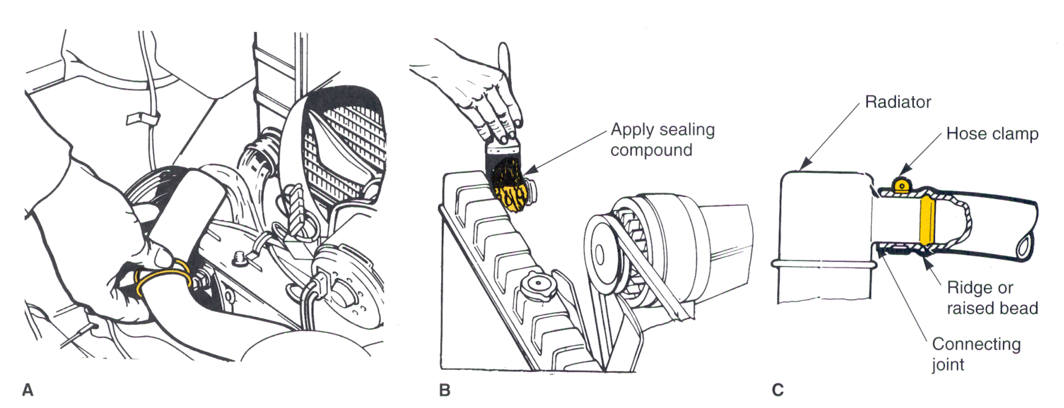
Figure: 3.1. Check hose

Inspection of drive belt Condition
Even the best drive belts last only an average of 4 years. That time can be shortened by several things; most of these can be found by inspecting the belts. Check the condition of all of the drive belts on the engine. Carefully look to see if they have worn or glazed edges, tears, splits, and signs of oil soaking. If these conditions exist, the belt should be replaced. Also inspect the grooves of the drive pulleys for rust, oil, wear, and other damage. If a pulley is damaged, it should be replaced. Rust, dirt, and oil should be cleaned off the pulley before installing a new belt.
Misalignment of the pulleys reduces the belt’s service life and brings about rapid pulley wear, which causes thrown belts and noise. Undesirable side or end thrust loads can also be imposed on pulley or pump shaft bearings. Check alignment with a straightedge. Pulleys should be in alignment within 1⁄16 inch (1.59 mm) per foot of the distance across the face of the pulley
A quick check of a belt’s tension can be made by locating the longest span of the belt between two pulleys. With the engine off, press on the belt midway through that distance. If the belt moves more than ½ inch per foot of free span, the belt should be adjusted. Keep in mind that different belts require different tensions. The belt’s tension should be checked with a belt tension gauge.
The tension should meet the manufacturer’s specifications. Many engines are now equipped with a ribbed v-belt, which has an automatic tensioning pulley; therefore, a tension adjustment is not required.
Using service information proper belt tightening procedures and specifications are given in the specification section of most service manuals.

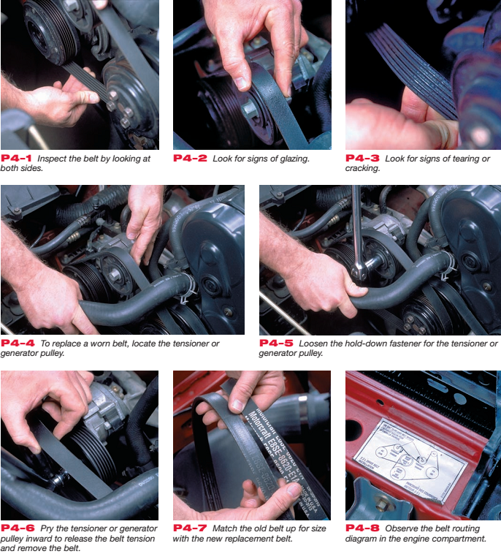
Figure 3-2 checking Belt

Assembling engine system components
- Connect the injector nozzle leak off pipe assembly
- Connect the cooling system
- Connect the exhaust pipe
- Connect the injector nozzle leak off pipe assembly
- Connect the fuel pipes from the fuel injection pump outlet and inlet to filter
- Connect fuel pipe from fuel lift pump outlet to fuel filter. Remove fuel filter
- Connect high pressure fuel pipes and nozzles
- Connect fuel pipe and electrical lead at the thermostat.
- Connect air filter and / or connecting hose
- Connect induction and exhaust manifold
- Connect the cooling system
- Connect fuel pipe and electrical lead at the thermostat.
- Remove air filter and / or connecting hose
- Remove induction and exhaust manifolds

Check Post delivery

3.3.1. Document result with evidence

Documentation provides valuable descriptions of an organization’s development, acquisition, and operating environments and significantly enhances an organization’s ability to administer, operate, and maintain technology systems. Primary advantages for technicians’ involve having access to operation manuals and on-line application help features. Documentation enhances administrators’ and technicians’ ability to maintain and update systems efficiently and to identify and correct programming defects.
Developing, maintaining current, and accurate documentation can be complicated, time consuming, and expensive. However, standardized documentation procedures and the use of automated documentation software can facilitate an organization’s ability to maintain accurate documentation.

3.3.2. Final Inspection
Consumers’ expectations are that they will receive their vehicle back in a serviceable condition and in a better operational condition than when it was delivered to the workshop. This expectation requires two (2) critical components:
- A final inspection must be completed by the service technician to ensure that all of the protective features for the braking system have been refitted is replaced to the required specifications; and
- A final inspection must be completed by the service technician to ensure that all of the work that was commenced on the system was completed to workplace, customer and manufacturers expectations.

3.3.3. Service provision
There are some tasks that a technician will not carry out frequently. It would be unrealistic for a technician to have a detailed knowledge of seldom-performed procedures. In these circumstances, job cards or checklists are very useful as they give a step-by-step guide to follow whenever the rarely-used procedure needs to be performed. The required knowledge is often kept in manuals which may not be easily accessible. However, going through a large manual, possibly in front of a customer, does nothing for time effectiveness or professional image.
A job card is also used as the basis of a recording process for the organization. In addition to refreshing the process for the technician it will be a list of the workplace expectations as well. It is suggested that the final task on a job card will be to ensure that the equipment is cleaned for use or storage.

3.3.4. Noting and documenting observations during the service
The most precise way to document instruction is to create a Running Record, or virtual transcript, noting what was observed every two minutes.
Direct observation of behaviors is important for many reasons. It is a means of generating hypotheses and new ideas or a means of answering specific questions. Observations also enable us to answer questions about what happens during repairing. For the purpose of these observations, time sampling is used to record engine parts repairing.
An observer should attend to all contextual details on the parts of engine repair. Observers do not make any assumptions at any time. They do not assume that any event is instructionally relevant or irrelevant. Observers should avoid biases based on personal preferences or practice. That is, when assigned to observe a particular instructional program, observers do not judge the engine parts or specific activities during repairing.
Observers must record what kind of an engine part is repaired without making ongoing judgments about the quality of engine part repairing or the effective use of a particular technique. The observer’s job is to capture what happened, not his or her opinion of what happened. After noting and documenting the observation during the repair every technician should complete work shop practice schedule documentation.
Follow these three general principles to develop records and documents:
- Keep it short and simple. Use bullet points and flow diagrams instead of long sentences and lengthy paragraphs.
- Clarity is important. Step-by-step instructions are easily understood.
- Use a standardized, consistent format. Although different programs may need different documents and records, using a similar approach will help staff learn quickly.

Completing and delivering report to appropriate person
Delivery is the process of transporting something/ like reports/ from a source location to a predefined destination after the work is done. The technician should be prepare a report and deliver to appropriate person. The reporting procedures are as follows
- Record the work to be done
- Inspect/test the repaired engine accordance with manufacturer procedure
- Record/ capture the problem with the necessary information
- Order the recorded problems /work done in accordance with their damaging area
- Preparing reports have no error/discrepancy
- Deliver reports to appropriate person.

Self-check 3

Instruction: Give a Short answer for the following question

- How do we check the Coolant Condition?
- During the final Inspection what requires critical components?
- What are the general principles to develop records and documents?
- List the procedures of reporting

Reference

- Automotive technology a system approach 5th edition (Jack Erjavec)
- Toyota 2L-T, 3L engine repair manual
- Auto mechanics books
- Toyota service manual (engine mechanical)
- http://www.austerclub.org/wp-content/uploads/Section-4-6.pdf
- The Good heart- Wilcox Co., Inc.
- Heavy goods vehicle (HGV)inspection manual2018 Edition
- Fundamentals of commercial vehicle technology
- Automotive Mechanics 10th edition
- Automotive Mechanics 9th edition
- http://www.e34.de/tips_tricks/haynes/02b.pdf

Participants of this Module (training material) preparation
No | Name | Qualification (Level) | Field of Study | Organization/ Institution | Mobile number | E-mail
1 | Andinet Asnake | MSc | Automotive technology | Wolkite PTC | 0913767250 | andinetasnake31@gmail.com
2 | Biratu Desalegn | MSc | Automotive Technology | Ambo PTC | 0913033783 | Biratudesalegn01@gmail.com
3 | Echu Mekonen | Msc | Automotive Technology | Burie PTC | 0912809056 | Echuhaset1@gmail.com
4 | Jemal abdu | Bsc | Automotive technology | Adadale PTC | 0922884069 | jemalabdu@75gmail.com

