Heavy Vehicles and Earth Moving Machinery Maintenance
Level-II
Based on November, 2022 Curriculum Version 1
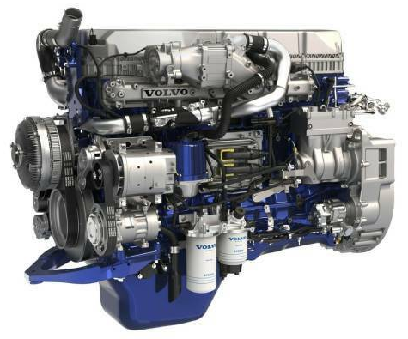
Module Title: - Servicing Engine and associated Systems
Module code: EIS HEM2 M01 1222
Nominal duration: 75 Hour
Prepared by: Ministry of Labor and Skill
November, 2022
Addis Ababa, Ethiopia

Table of Contents
Acknowledgment 5
Acronym 6
Introduction to module 7
Unit one: Introduction to engine service 9
1.1 Overview of engine and associated systems 10
1.1.1 Basic concepts of Internal Combustion (IC) engine 10
1.1.2 Main Parts of IC Engines 14
1.1.3 Engine systems 15
1.1.4 Types of accessory drives related Components 22
1.1.5 Types and application of gaskets and sealants 25
1.2 Overview of Preventive Maintenance and Basic Services 27
1.2.1 Service intervals 28
1.2.2 Repair Order 28
1.2.3 Parts registration/identification number 30
1.3 Preparing service work activity plan 32
1.4 OHS and Hazard identification 33
1.4.1 PPE Requirement 33
1.4.2 OHS Requirement 35
Self-Check 1 37
Unit Two: Inspection and basic engine services 38
2.1 Inspecting engine before removing and disassembling 39
2.1.1 Visual Check 39
2.1.2 Engine Smoke Inspection 43
2.1.3 Engine Noise Inspection 44
2.1.4 Inspecting an overheated Engine 46
2.1.5 Maintenance Check-up 47
2.2 In-vehicle engine services 48
2.2.1 Thermostat Replacement 48
2.2.2 Water pump Replacement 48
2.2.3 Inspection and replacement of Timing and fan Belt 49
2.2.4 Replacing exhaust Manifold gasket and seals 49
2.2.5 Changing Engine oil and filter 50
2.2.6 Inspecting and servicing air cleaner 51
Self-check 2 52
Operation sheet-2 53
LAP- Test 54
Unit Three: Replacing and adjusting engine System Assemblies 55
3.1 Engine removal from vehicle 56
3.2 Cleaning an engine 56
3.2.1 Mechanical cleaning 57
3.2.2 Chemical cleaning 57
3.2.3 Thermal cleaning 58
3.2.4 Ultrasonic cleaning 59
3.3 Replacing engine gaskets 60
3.3.1 Replacing Cylinder Head Gaskets 60
3.3.2 Intake Manifold Gasket Inspection and replacement 61
3.3.3 Replacing Valve Cover Gaskets 61
3.3.4 Replacing Oil Pan Gaskets 62
3.3.5 Apply Adhesives and Sealants 62
3.4 Adjustment of system/components 63
3.4.1 Valve Adjustment 63
3.4.2 Valve identification 64
3.4.3 Drive Belts adjustment 64
3.4.4 Injection timing adjustment 66
3.5 Conducting post-service/pre-delivery check 67
3.5.1 Document result with evidence 67
3.5.2 Final Inspection 67
3.5.3 Service provision 68
3.5.4 Noting and documenting observations during the service 68
3.5.5 Completing and delivering report to appropriate person 69
Self-check 3 70
Operation sheet 3 70
LAP- Test 72
Unit Four: Cleanup work area and maintain equipment 73
4.1 Kinds of Cleaning Solvents 74
4.2 Properties of Cleaning Solvents 75
4.3 Occupational Health and Safety Practices in Handling Cleaning Solvents 75
Self-check 4 77
Reference 78

Acknowledgment

Ministry of Labor and Skills wish to extend thanks and appreciation to the many representatives of TVET instructors and respective industry experts who donated their time and expertise to the development of this Teaching, Training and Learning Materials (TTLM).

Acronym
CO | Carbon Monoxide
CI | Compression Ignition
IC | Internal Combustion (IC)
HC | Hydro Carbon
HT | High tension cable
IC | Internal Combustion (IC)
ID | Identification
KPa | Kilo Pascal
LAP | Learning Activity Performance
N₂ | Nitrogen
NO_{X} | Oxide of Nitrogen
O₂ | Oxygen
OHS | Occupational Health Safety
SAE | Society of Automotive Engineers
SAE 20W50 | W- Milt-viscosity oil for winter Grade
SI | International Organization for Standardization
TTLM | Teaching, Training and Learning Materials
VIN | Vehicle identification number
EFE | Early Fuel Evaporation

Introduction to module
Heavy-duty commercial vehicles and earth moving machines play a vital in economic development of any country. Since this equipment are very expensive, providing adequate preventive as well as corrective maintenance will support in effective utilization of their potential. Accordingly, a carrier of servicing an engine of such heavy-duty commercial vehicles and earth moving machines is highly demanded in the world; which requires standard training and qualification. Hence, this module is prepared to support training of specific unit of competence, which contains knowledge, skills and attitude required to carry out minor services in automotive engines and associated sub-system assemblies. The module involves preparing for the task, basic checking/testing to identify fault, remove, disassemble, replace worn or failed components and assemblies and reinstall. Additionally, this module covers performing post-service checks and documentation.
This module is designed to meet the industry requirement under the heavy-duty vehicles and earth moving machines maintenance level II occupational standard, particularly for the unit of competency: Servicing Engine and associated System.
This module covers the units:
- Overview of engine and associated systems
- Preparing for engine service
- Inspecting engine and associated systems
- In vehicle basic engine services
- Removing and replacing engine system assembly
- Disassembling cleaning and reassembling system assembly
- Adjusting engine and associated systems
- Clean up work area and maintain equipment
Learning Objective of the Module
- Comprehend construction and operation of engine and associated systems
- Remove and replace system assembly
- Inspect engine and associated components
- Repair engine and associated system assemblies
- Clean up work area and maintain equipment
Module Instruction
For effective use this modules trainees are expected to follow the following module instruction:
- Read the information written in each unit
- Accomplish the Self-checks at the end of each unit
- Perform Operation Sheets which were provided at the end of units
- Do the “LAP test” giver at the end of each unit and
- Read the identified reference book for Examples and exercise

Unit one: Introduction to engine service

This unit is developed to provide you the necessary information regarding the following content coverage and topics:
  - Overview of engine and associated systems
  - Types of accessory drives related Components
  - Types and application of gaskets and sealants
  - Overview of preventive maintenance
  - Service work activity plan
  - OHS and Hazard identification
This unit will also assist you to attain the learning outcomes stated in the cover page. Specifically, upon completion of this learning guide, you will be able to:
  - Comprehend engine and associated systems
  - Identify different types of accessory drives related Components
  - Identify types and application of gaskets and sealants
  - Identify parts registration/identification number
  - Prepare repair order
  - Prepare service work activity plan
  - Apply OHS and identify Hazard

Overview of engine and associated systems

Basic concepts of Internal Combustion (IC) engine
The engine provides the power to drive the wheels of a vehicle or to power machine operation. All light as well as heavy duty and earth moving equipment engines, both gasoline and diesel, are classified as IC engines because the combustion or burning that provides the power to vehicle or equipment takes place inside the engine. Hence, an IC engine is a machine that converts chemical energy in a fuel in to thermal energy by means of combustion or oxidation with air inside the engine. The thermal energy raises the temperature and pressure of the gases within the engine and the high-pressure gas then expands against the mechanical mechanism of the engine. The mechanical linkages of the engine to rotating crankshaft convert this expansion, which is the output of the engine.
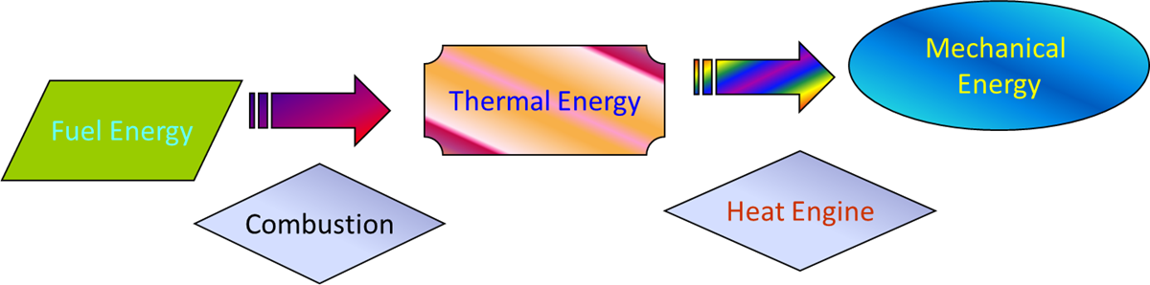
Figure 1-1 Fuel energy conversion process in IC engine
Diesel engines have been around a long time and mostly found in big heavy-duty commercial vehicles and earth moving machines. However, they used in some pickup trucks and are becoming more common in automobiles due to their fuel economy. Although the construction of gasoline and diesel engines is similar, their operation is quite different. A gasoline engine relies on a mixture of fuel and air, which ignited by a spark to produce power. A diesel engine also uses fuel and air, but it does not need a spark to cause ignition. A diesel engine is compression ignition engine, because its intake air is tightly compressed, which greatly raises its temperature. The heat of the compressed air ignites the fuel injected and combustion takes place. It constructed of mechanisms, systems and accessory attachments.
- IC Engine Terminology
- Cylinder bore (B): - The nominal inner diameter of the working cylinder.
- Piston top area (A): - the area of a circle diameter equal to the cylinder bore.
- Top Dead Center (TDC): - the extreme position of the piston at the top of the cylinder. In the case of the horizontal engine, it is known as the outer dead center (ODC).
- Bottom Dead Center (BDC): - the extreme position of the piston at the bottom of the cylinder. In horizontal engine, this is known as the Inner Dead Center (IDC).
- Stroke (L): - the distance between TDC and BDC is called the stroke length and is equal to double the crank radius (r_{c}).
- Swept volume: the volume swept through by the piston in moving between TDC and is denoted by Vs:
- 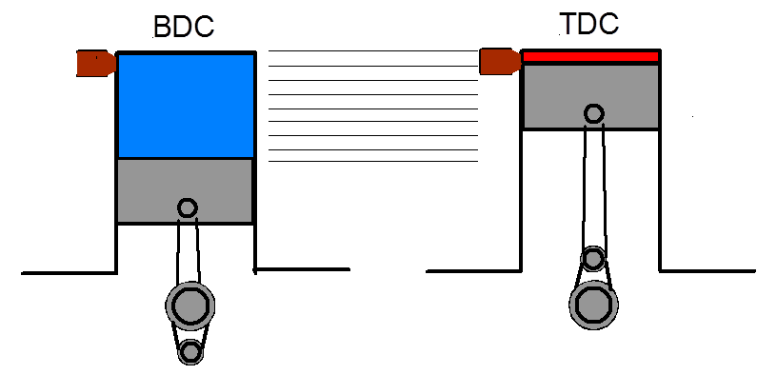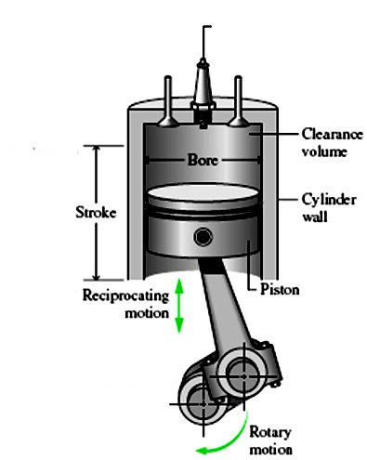
Figure 1-2 Basic engine dimensional terminologies
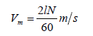
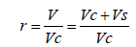
- 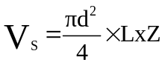

- Where d is the cylinder bore l the stroke and Z number of cylinders
- Clearance volume: the space above the piston head at the TDC, and is denoted by Vc: Volume of the cylinder: V = Vc + Vs
- Compression ratio: it is the ratio of the total volume of the cylinder to the clearance volume, and is denoted by (r)
- Mean piston speed: the distance traveled by the piston per unit of time: - where l is the stroke in (m) and N the number of crankshaft revolution per minute (rpm)

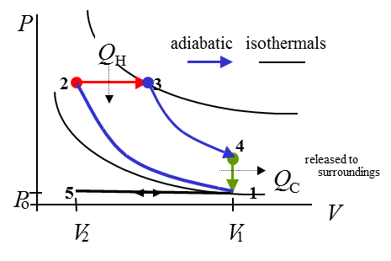
- Working cycles and valve timing diagram of Diesel engine
The working cycle of diesel engine including all strokes presented in (Figure 1-3) as described below.
- 5 to 1: intake stroke isobaric expansion
- 1 to 2: compression adiabatic
- 2 to 3: ignition isobaric heating
- 3 to 4: power adiabatic expansion
- 4 to 1: exhaust (start) isochoric cooling
Figure 1-3 Working cycles of CI engine
- 1 to 5: exhaust stroke (finish) isobaric compression
The Valve Timing Diagram shown on (Figure 1-4) is a kind of diagram that shows the ‘opening’ and ‘closing’ points of the Intake (In.) and Exhaust (Ex.) valves with respect to the position of the Crankshaft (θ) during a complete cycle of engine operation. Note: - In a Four-Stroke IC Engine, the camshaft is rotating at half the speed of the crankshaft.
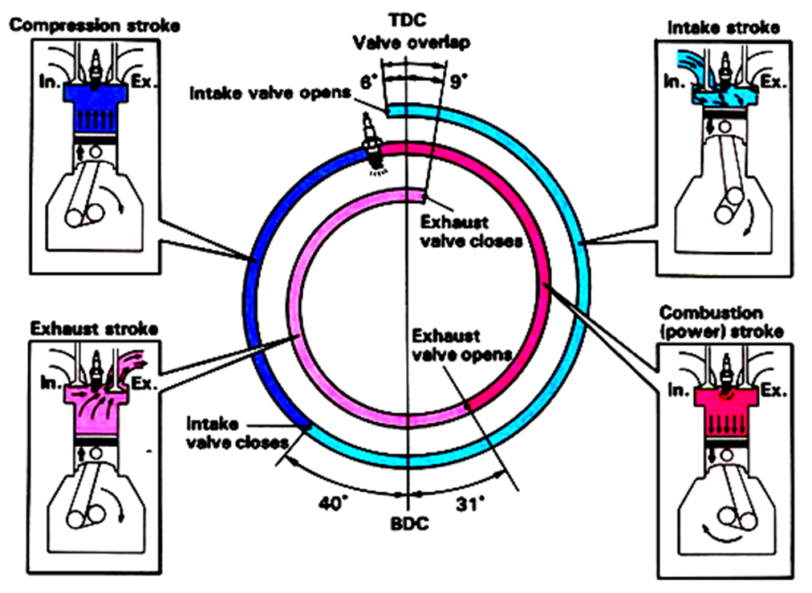
Figure 1-4 Valve timing diagram of four stroke cycle engine

Table 1-1 The relationship among piston and valve positions during different strokes
Stroke | Movement of the Piston | Position of the Valve |  | Purpose
Stroke | Movement of the Piston | Intake Valve | Exhaust Valve | Purpose
Intake | Going Down | Open | Close | Sucked air/fuel mixture into the cylinder
Compression | Going Up | Close | Close | Compresses air mixture to increase its temperature
Power | Going Down | Close | Close | Combustion takes place
Exhaust | Going Up | Close | Open | Burned gases pushed out from the engine cylinder
- Cylinder numbering firing order and direction of rotation
In-Line engines are numbered starting from the front cylinder towards the back as: 1,2, 3, “V” engines are mostly numbered starting from the front cylinder towards the back on the left banks and then starting from the front cylinder towards the back on the right banks as: 1,2,3, ....
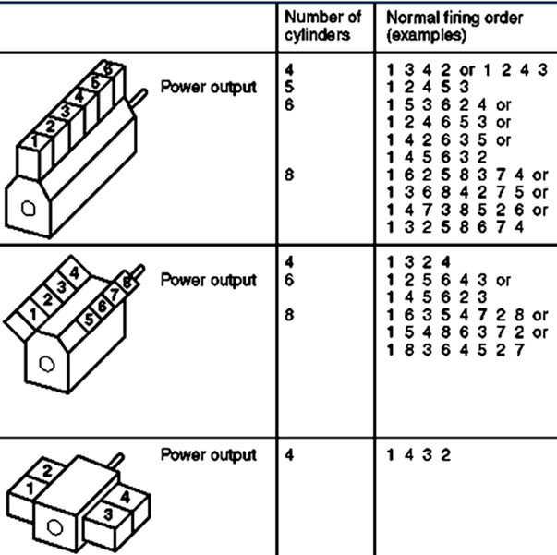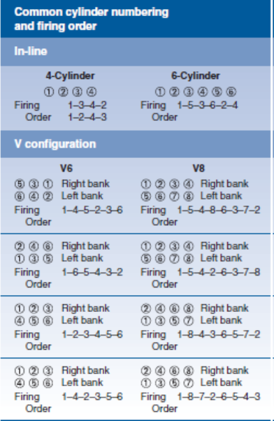
Figure 1-5 Common Numbering of cylinders and firing order of different engines

The crankshafts of IC Engines can be designed to rotate in the Clockwise (CW) or in the Counterclockwise (CCW) direction when viewed from the front of the engine. Accordingly, most of the engines (about 90%) are designed to rotate in the Clockwise (CW) direction and few engines (about 10%) are designed to rotate in the Counterclockwise (CCW) direction. Hence, the most widely used is Clockwise (CW) direction.
The firing order is the sequence or order by which the spark is distributed to the spark plug of the correct cylinder at the right time. The choice of Firing Order (FO) for a particular engine should consider the uniformity in Firing (Ignition) Intervals (FI), to obtain a proper engine balance and also to minimize vibration.
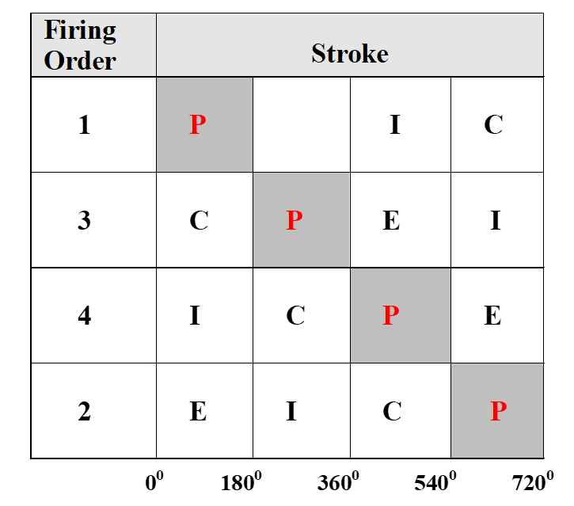
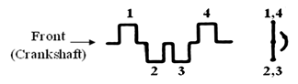
Firing Order of a Four-Stroke, Four-Cylinder, In-Line Engine

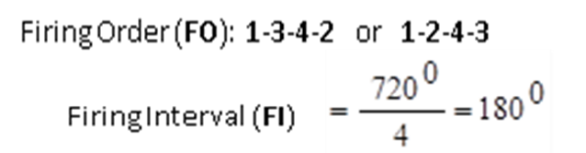

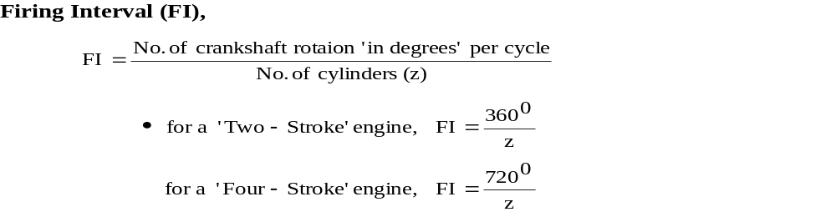

Main Parts of IC Engines
The construction of an engine varies little, regardless of size and design. The intended use of the engine determines its size and design, and the temperature at which the engine will operate determines the type of metal it will be built from. Engine is constracted of two mechisms and different systems. The two mechanisms are cranck gear and valve gear.
      - The Crank Gear Mechanism
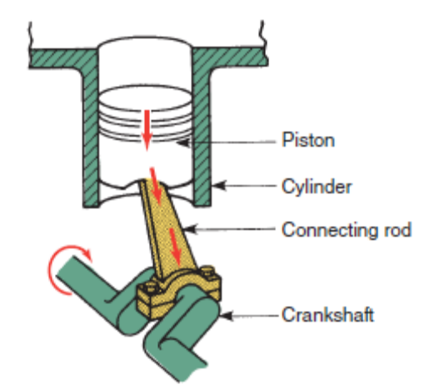
The main function of the ‘Crank Gear Mechanism’ of a reciprocating IC Engine is, to convert the Indicated Power (Pi) available on the piston head (a portion of Thermal or Heat Energy) into Brake Power (Pb) at the flywheel (Mechanical Energy).
It consists of: the Cylinder, Cylinder Head, Piston, Piston Rings (Compression and Oil Control Rings), Piston Pin, Connecting Rod, Crankshaft, Bearings (Journal and Thrust), Flywheel, and Vibration Damper
Figure 1-6 Main components of crank gear mechanism
      - The Valve Gear Mechanism
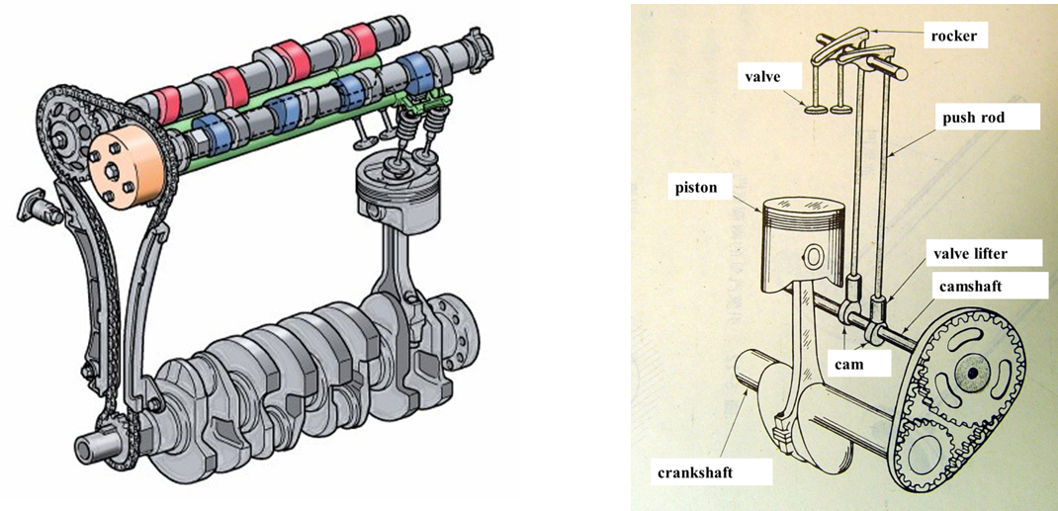
The main function of the ‘Valve Gear Mechanism’ of a reciprocating IC Engine is, to actuate (open and close) the inlet and exhaust valves at the required time with respect to the position of the crankshaft. It consists of:- the Camshaft, Cam, Follower, Push Rod, Rocker assembly, Valve assembly, …
The two mechanisms can be connected by means of a Timing Gear or a Timing Chain or a Timing Belt drive. In doing so, power is transmitted from the crankshaft to the camshaft to actuate (open and close) the valves.

Engine systems
      - Lubrication System
Figure 1-7 Main components of valve gear mechanism
The moving parts of an engine need constant lubrication. Lubrication limits the amount of wear and reduces the amount of friction in the engine. Several quarts of oil are stored in an oil pan bolted to the bottom of the engine block. The oil pan is also called the crankcase or oil sump. When the engine is running, an oil pump draws oil from the pan and forces it through oil galleries. These galleries are small passageways that direct the oil to the moving parts of the engine.
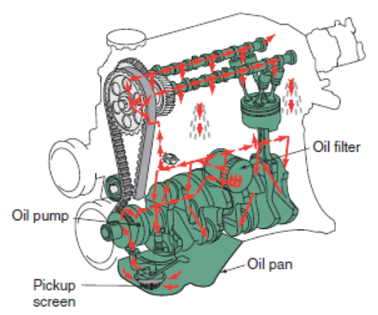
Oil from the pan passes through an oil filter before moving through the engine. The filter removes dirt and metal particles from the oil. Premature wear and damage to parts can result from dirt in the oil. Regular replacement of the oil filter and oil is an important step in a preventive maintenance program.
Figure 1-8 Typical lubrication system of an engine
      - Cooling System
The combustion of the air-fuel mixture produces large amounts of heat in the engine. This heat must not be allowed to buildup and must be reduced. The heat can damage and warp engine parts. To prevent this, engines have a cooling system.
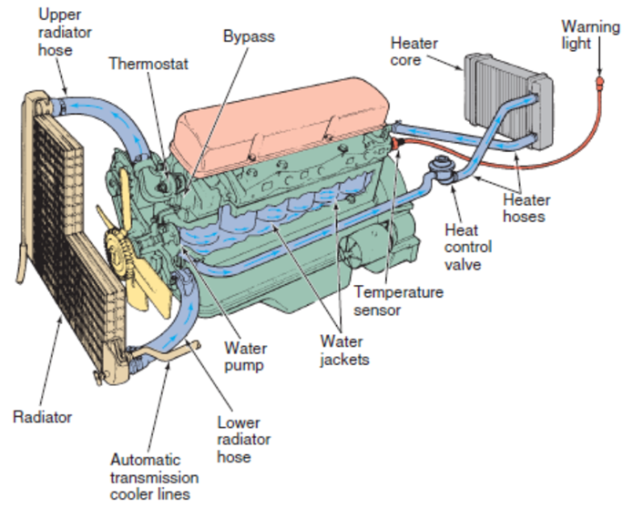
Figure 1-9 Typical cooling system of an engine
The most common way to cool an engine is to circulate a liquid coolant through passages in the engine block and cylinder head. An engine can also be cooled by passing air over and around the engine, however few air-cooled engines are found in automobiles today. A typical cooling system relies on a water pump, which circulates the coolant through the system. The engine or an electric motor drives the pump.
The coolant is a mixture of water and antifreeze, which pushed through passages, called water jackets, in the cylinder block and head to remove heat from the area around the cylinders. The heat picked up by the coolant is sent to the radiator. The radiator transfers the coolant’s heat to the outside air as the coolant flows through its tubes. To help remove the heat from the coolant, a cooling fan is used to pull cool outside air through the fins of the radiator.
To raise the boiling point of the coolant, the cooling system is pressurized. To maintain this pressure, a radiator or pressure cap is fitted to the radiator. A thermostat is used to block off circulation in the system until a preset temperature is reached. This allows the engine to warm up faster. The thermostat also keeps the engine temperature at a predetermined level. Because parts of the cooling system are located in various spots under the vehicle’s hood, hoses are used to connect these parts and keep the system sealed.
      - Diesel-Engine Fuel and air induction System
The fuel and air system is designed to supply the correct amount of fuel mixed with the correct amount of air to the cylinders of the engine. This system also:
- Stores the fuel for later use
- Delivers fuel to a device that will control the amount of fuel going to the engine
- Collects and cleans the outside air
- Delivers outside air to the individual cylinders
- Changes the fuel and air ratios to meet the needs of the engine during different operating conditions
An air filter cleans the outside air before it is delivered to the cylinders. Fuel injectors inject fuel directly in to the cylinders. An intake manifold directs the air to each of the cylinders. The basic fuel system, common to all heavy vehicle diesel engines, includes an engine driven fuel
The engine driven transfer pump delivers fuel to the injection unit via the secondary fuel filter. The unit injector, either mechanically or hydraulically actuated, combines the functions of pumping, metering and injecting into a single unit. It is located near the center of the combustion chamber in each cylinder head, between the rocker arms.
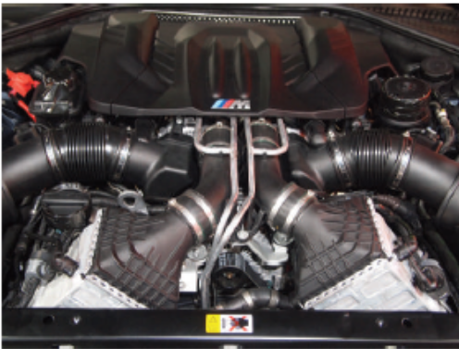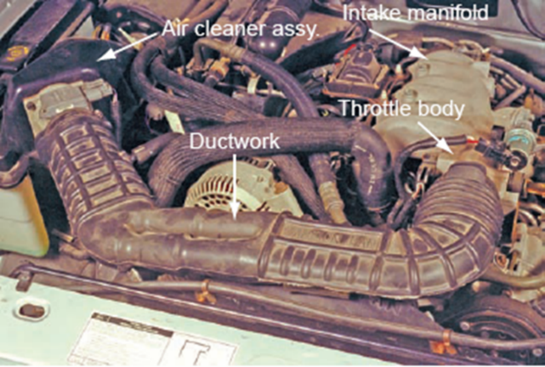
Figure 1-10 Air induction system of an engine
External manifolds supply fuel from the transfer pump to the injectors, eliminating the need for high-pressure fuel lines. Fuel continuously circulates through the injectors, and the excess fuel that is not used for combustion cools the injectors and is returned to the fuel tank via the pressure regulating. A filter removes dirt or other particles from the fuel. A fuel pressure regulator keeps the pressure below a specified level.
The automotive diesel-engine fuel system uses injection nozzles or injectors similar to the fuel injectors in gasoline fuel-injection systems. The gasoline injectors are solenoid operated. When high pressure is applied, they open and spray fuel. The diesel fuel system must:
- Deliver the right amount of fuel to meet the operating requirements.
- Time the opening of the injection nozzles so the fuel enters the engine cylinders at the proper instant. As engine speed increases, fuel injection must start earlier. This gives the fuel enough time to burn and produce pressure on the pistons. Without the advance, the pistons would be over TDC and moving down before the fuel fully ignites. This wastes fuel and power.
- Deliver the fuel to the cylinders under high pressure. Injection pressure must be high enough to overcome the high compression pressure in the diesel engine. At the end of the compression stroke, compression pressure may be 500 psi [3447 kPa] or higher.

    - Fuel filter
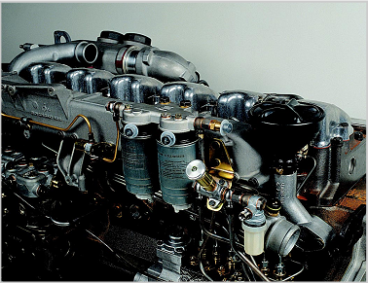
For optimum operation and service life of the diesel fuel injection system, it is essential that the diesel fuel be carefully filtered. The components of the injection pump and the injectors themselves are manufactured to a precision of a few thousandths of a millimeter. Fuel filters must filter out impurities of even this small size if the efficiency of the fuel injection system is not to be impaired. The consequences of poorer fuel quality because of contaminated filters are:
Figure 1-11 Diesel fuel filter

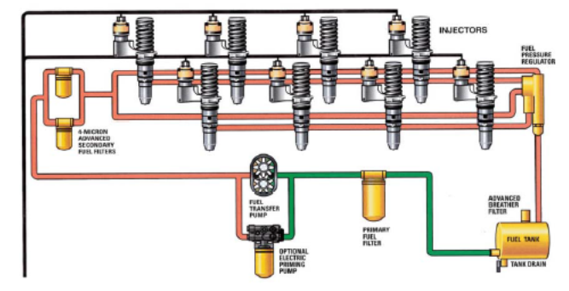
Figure 1-12 Diesel fuel system schematic
    - Inline injection pumps
Inline injection pumps have a separate camshaft and one pump element per engine cylinder. The stroke of the pistons always remains the same. The pump rate is regulated via metering ramps. The fuel is pumped through a separate high-pressure line to the corresponding injector for each cylinder of the engine. The injection pumps camshaft, driven by the engine, controls the injection processes in the individual injectors. A mechanical injection-timing device adjusts the start of delivery according to engine speed, as necessary. It rotates the camshaft in relation to the engine crankshaft, thus displacing the start of delivery. The inline injection pump is connected up to the engine oil circuit for lubrication of the moving pump components.
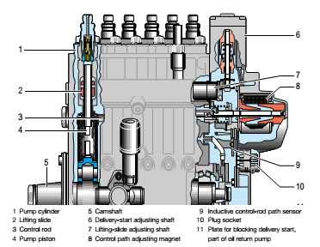
Figure 1-13 Operating principle of the lifting-slide inline injection pump & mechanical in line pump
    - Distributor-type pump
Unlike the inline injection pump, the distributor-type pump has only one pump element with one piston for all cylinders. The piston operates as many strokes as there are cylinders for every revolution of the crankshaft. The simultaneous movement of the piston during the stroke distributes the fuel to the various inlets and pumps it to the corresponding injectors.
A mechanical speed governor and a hydraulic injection-timing device are integrated into the distributor pumps housing. Distributor-type pumps are used on high-speed passenger-car and commercial vehicle diesel engines with an output per cylinder of up to 25 kW. The injection pressure is approximately 700 bars. Distributor type pumps with electronic control are capable of injection pressures as high as 1400 bar.

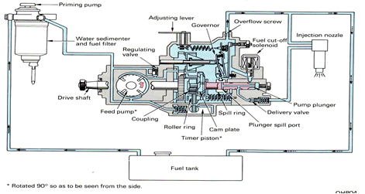
Figure 1-14 Sectional view of distributor type injection pump including all basic components
    - Common rail type
Fuel supply system, has two stages: Low pressure stage (includes tank, pre-supply pump, low pressure and return fuel lines); High pressure stage ( includes high pressure pump with element shutoff valve and pressure control valve and rail with pressure sensor, pressure limiter valve, flow limiter and injectors).
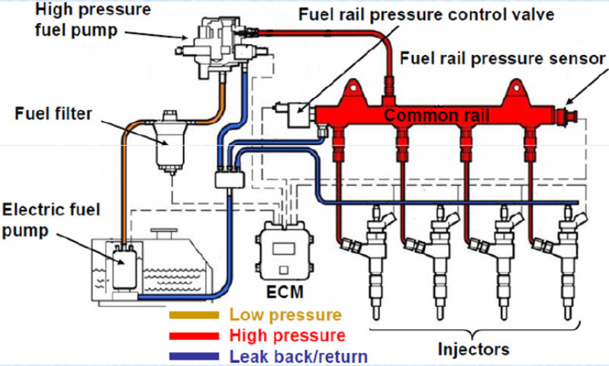
Figure 1-15 Common rail type diesel fuel injection schematic
High pressure pump: It is Radial pump with three pistons, driven by crankshaft like that of other pumps. It Supply the rail with high-pressure fuel and Comprises of; pressure control valve and element shutoff valve.
    - Unit injector system (UIS)
Pumping element and injector nozzle are integrated in a single unit. No high pressure fuel line is used. Each cylinder has its own unit injector. It is driven by overhead camshaft with rocker arm. It can produce highest pressure of up to 2,050 bar. Injection quantity and timing is controlled by solenoid valve.
    - Unit pump system (UPS)
Pumping element and injector nozzle are connected with high pressure line. Driven by camshaft in block and each cylinder has its own unit pump. Injection quantity and timing are controlled by solenoid valve. The only difference with UIS is, by having high pressure line
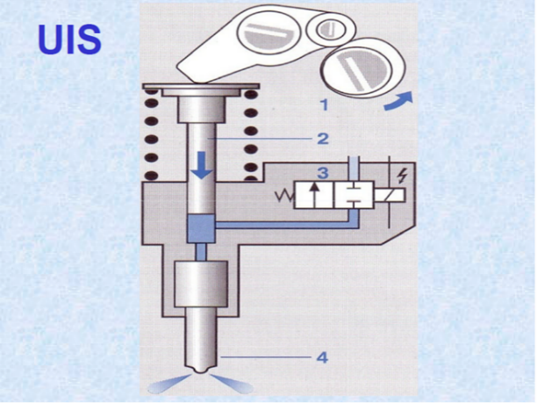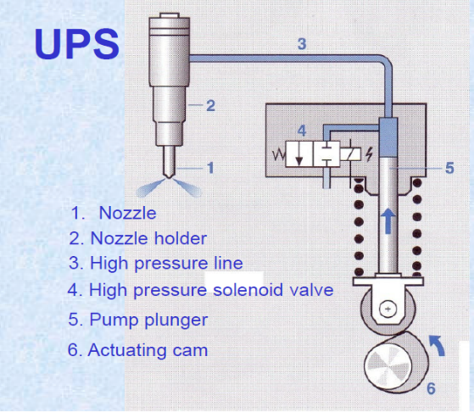
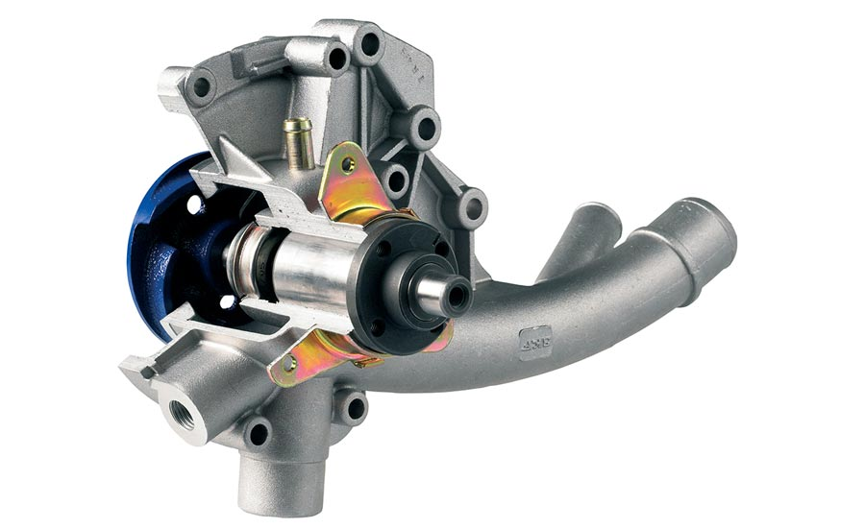
Figure 1-16 Common rail unit injection and unit pump systems

Types of accessory drives related Components
      - Water pumps
The burning of fuel in an internal combustion engine produces heat, which is sufficient to melt the metal of the cylinder. It is the function of the cooling system to prevent the engine overheating but it must also allow it to operate at a temperature high enough to assist in effective combustion. If the engine operating temperature were allowed to go unchecked, it would burn and dry up the lubricating oil film, so that the pistons would seize in their cylinders and distortion would result from over-expansion of metals.
Figure 1-17 Water pumps
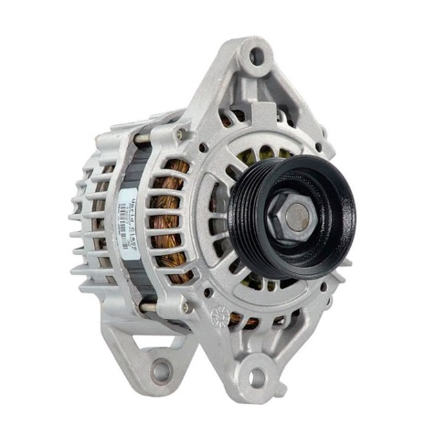
      - Alternators
In the charging system electronics devices such as diodes for rectification of current in alternator zanier diode and transistor for circuit opening and closing in transistorized regulators are use. In this unit, the construction and function of diodes and transistor, the purpose of the charging system, the component parts of alternators, the generating principles of alternator, the charging system service and repair are thoroughly discussed.
Figure 1-18 Alternators
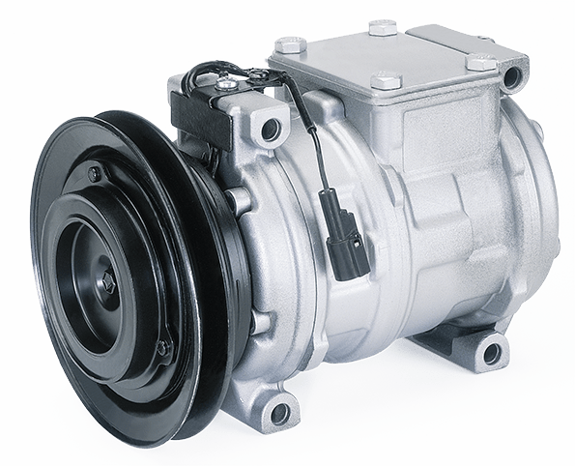
      - AC compressors
The compressor is the power unit of the air-conditioning system that puts the refrigerant under high pressure before it pumps it into the condenser, where it changes from a gas to a liquid. A fully functioning compressor is necessary for the air-conditioning system to provide peak performance.
Figure 1-19 AC compressors
      - Power steering pumps
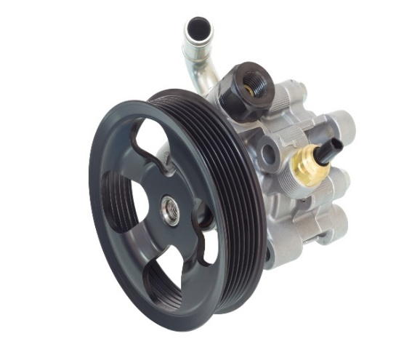
The power-steering unit is designed to reduce the amount of effort required to turn the steering wheel. It also reduces driver fatigue on long drives and makes it easier to steer the vehicle at slow road speeds, particularly during parking. Power steering can be broken down into two design arrangements: conventional and nonconventional or electronically controlled. In the conventional arrangement, hydraulic power is used to assist the driver.
Figure 1-20 Power steering pumps
In the nonconventional arrangement, an electric motor and electronic controls provide power assistance in steering. There are several power-steering systems in use on passenger cars and light-duty trucks. The most common ones are the integral-piston, and power assisted rack and pinion system.
      - Supercharger and turbocharger
A supercharger is an air compressor that increases the pressure or density of air supplied to an internal combustion engine. This gives each intake cycle of the engine more oxygen, letting it burn more fuel and do more work, thus increasing the power output.
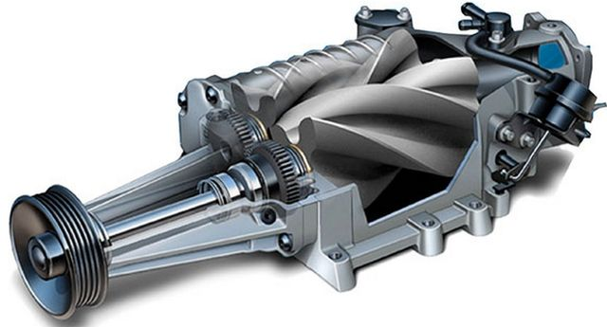
Figure 1-21 Sectional view of typical supercharger
Turbochargers are used to increase engine power by compressing intake air before it enters the engine. Turbochargers are air pumps driven by the engine’s exhaust stream. The heat and pressure of the exhaust gases spin the turbine blades (hence the name turbocharger) of the pump. The turbine wheel is connected to a compressor wheel. As the turbine spins, so does the compressor wheel.
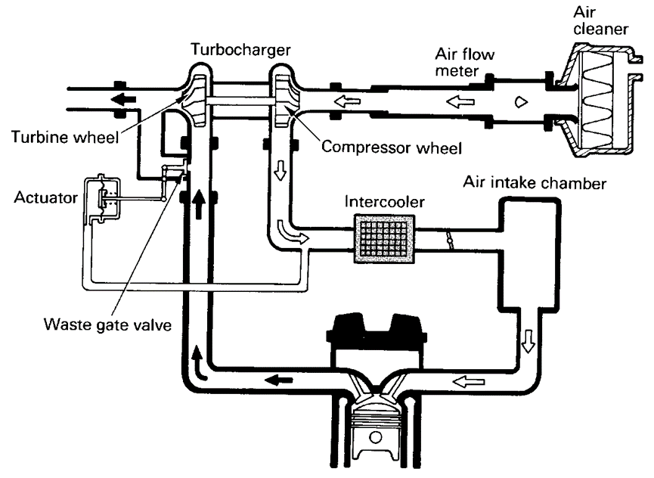
Figure 1-22 Schematic representation of turbocharger including intercooler

Types and application of gaskets and sealants
When parts are bolted together, it is nearly impossible to obtain a positive seal between the parts. Gaskets provide that seal and also serve as spacers, wear insulators, and vibration dampers. Gaskets are only used between two stationary parts. Seals are used if one of the parts moves. The material used to make a gasket depends on its application (Figure 1-23). Gaskets made of paper, fiber, and cork are normally called soft, cut gaskets (Figure 1-24). Each gasket is cut to the desired size and shape from a sheet of material.
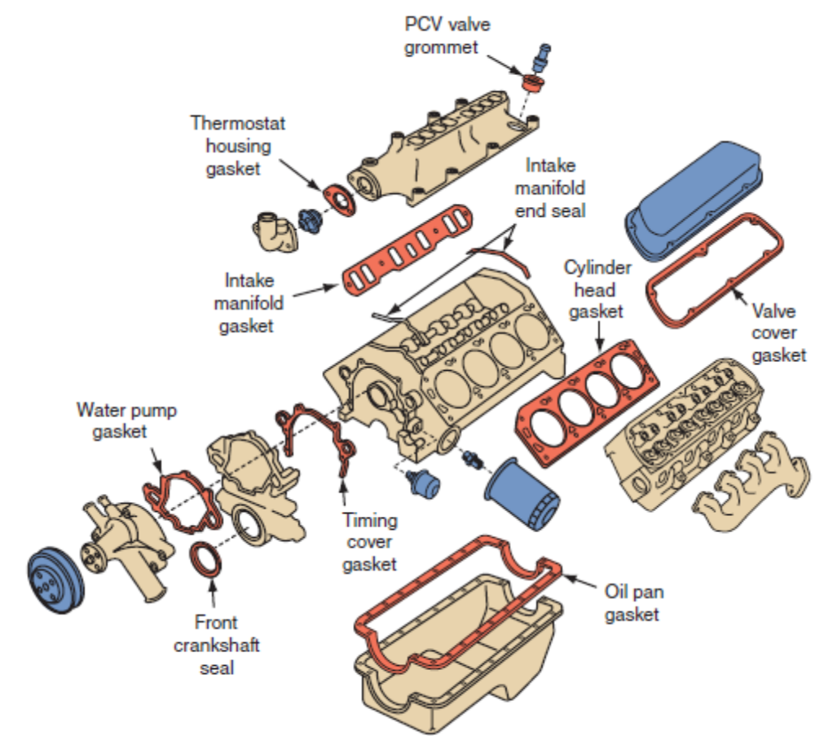
Figure 1-23 complete set of engine gaskets
1.1.5.1 Paper/Fiber gaskets
Gaskets are made of a fiber-reinforced paper-like material. They do a good job of
sealing low-pressure, low-temperature areas. For some applications, paper gaskets may be relatively thick. These gaskets seldom need an additional sealant; however, a thin coating of adhesive may be used to hold the gasket in place while it is installed. Cork gaskets are also used to seal low-pressure areas; however, they are not commonly used on today’s engines. Cork gaskets are very soft, easily distorted, and absorbent and will weep some of the fluid they are sealing. They also tend to become brittle and crack over time. Most manufacturers have replaced cork gaskets with composite gaskets, typically rubberized cork.
A connection between two components or flanges that have flat surfaces, while seals are used between engine parts, pumps, and shafts that rotate. Gaskets are used wherever a union or flange is required to prevent leaking.
Gaskets are most commonly used as static seals. Gasket made of fiber materials, rubber, neoprene (synthetic rubber), cork, treated paper, or thin steel. When parts are fastened together, the gasket material fills small gaps, dents, or scratches in the mating surfaces.
Gasket Rules

    - Inspect for leaks before disassembly
    - Be careful not to damage mating surfaces while removing parts
    - Clean off old gaskets carefully
    - Wash and dry parts thoroughly
    - Use a sealer if specified
    - When assembling, start all bolts by hand
    - Tighten fasteners in steps
    - Use a crisscross tightening pattern
    - Do not over tighten fasteners
    - apply only the specified torque

1.1.5.2 Sealants
Sealants are used between engine parts, pumps, and shafts that rotate rather than those that are static. This type of seal is generally a molded or machined product. Seals tend to be flat and round, while gaskets are often cut into different shapes so that they fit the components. Most seals are made of an outer ring that is metal and nests over an inner surface that is often made of rubber. The inner circle is tilted just a bit, which creates a lip for the seal. The lip is designed as a second barrier against any drops that manage to get past the first edge of the seal.
It is essential that seals be installed correctly because, if it’s installed backward, you could end up with a leaky mess on your hands. Common uses for seals include keeping leaks from occurring at the end of the shaft where it comes out of the cover and sealing hydraulic lines. This type of seal is generally a molded or machined product. Seals are often used in bearings, which is basically just a ball bearing surrounded by a rubber seal, which keeps it from leaking and sometimes reduces the amount of noise that occurs during operation.

Overview of Preventive Maintenance and Basic Services
Automobiles need maintenance from time to time, since they run on uneven roads with potholes and other obstructions; where subjected to loads capable of damaging them. Preventive maintenance (PM) involves performing certain services to a vehicle on a regularly scheduled basis before there is any sign of trouble. Regular inspection and routine maintenance can prevent major breakdowns and expensive repairs. It also keeps cars and trucks running efficiently and safely. Once the vehicle’s warranty or maintenance term expires, repairs will have to be made and paid for by the customer.
By carrying out periodic maintenance, the following results can be achieved, ensuring the customer's trust and peace-of-mind:
- Much larger problems with the vehicle that may occur later can be avoided.
- The vehicle can be maintained in a state which is in adherence to legal regulations.
- The life of the vehicle can be extended.
- The customer can enjoy an economic and safe driving experience.
TRIAL stand for symbols of maintenance operation.
T=Tighten to specified torque
R=Replace or change
I=Inspect and correct or replace as necessary
A=Check and/or adjust as necessary
L=Lubricate

Service intervals
Service intervals are decided according to the distance traveled and the period elapsed since the previous service. For example, if the maintenance schedule for a particular part is stated as 40,000 km or 24 months, maintenance falls due at the point at which either of these conditions is met. However, driving habits and conditions should also be used to determine the frequency of PM service intervals. In many cases, if a vehicle is driven in the severe condition, the maintenance intervals increase to twice as often as for normal service.
Many vehicles now use maintenance reminder systems. These systems often show a message, such as the engine oil life percentage, in a driver information center. Other vehicles show codes for the next required service. To determine what services are specified by the code, check the vehicle’s service manual or the service information. On the other hand several states require annual or biennial vehicle safety inspections. The intent of these inspections is to improve road safety. Research shows that states with annual safety inspection programs have 20 percent fewer accidents than states without these inspections.

Repair Order
Regardless of what type of shop, the first thing a tech needs to worry about is the repair order (RO) for any maintenance service activity. A RO/Service Order/Work Order is written legal document for every vehicle brought into the shop and used for many other purposes, such as payroll and general record keeping.
Although every shop may enter different information, most ROs contain the following information as indicated on (Figure 1-24).
- Complete customer information
- Complete vehicle identification
- Service history of the vehicle
- The customer’s concern
- Preliminary diagnosis of the problem
- Estimate of the amount of time and costs required for the service
- Time the services should be completed
- Name or other identification of the technician assigned to perform the services
- Actual services performed with their cost
- Parts replaced during the services and their cost
- Recommendations for future services
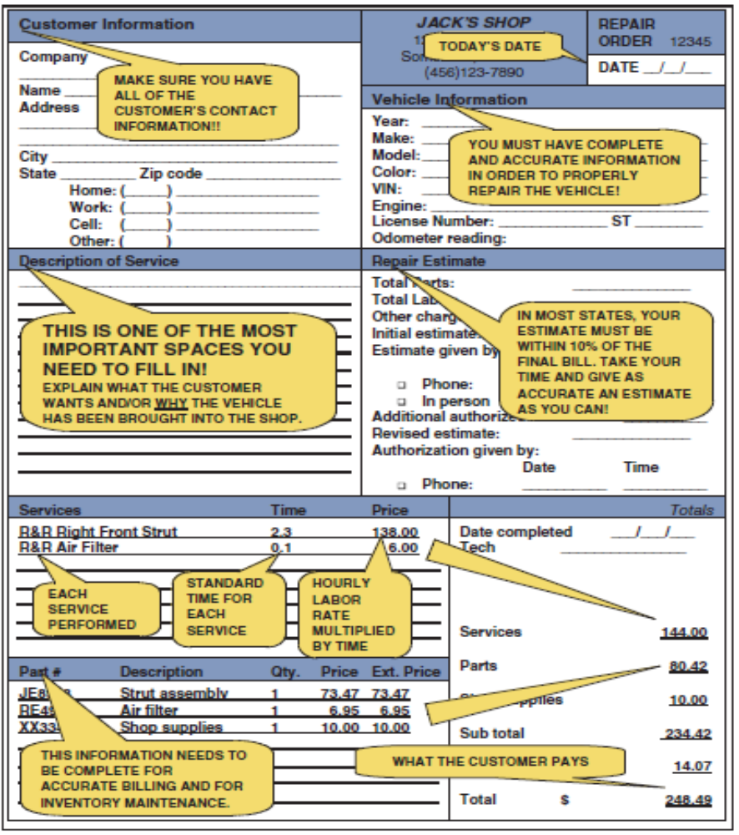
Figure 1-24 Repair order filling sample format

Parts registration/identification number
      - VIN number
Before any service is done to a vehicle, it is important for you to know exactly what type of vehicle you are working on. The best way to do this is to refer to the vehicle’s identification number (VIN). The VIN is given on a plate behind the lower corner of the driver’s side of the windshield as well as other locations on the vehicle.
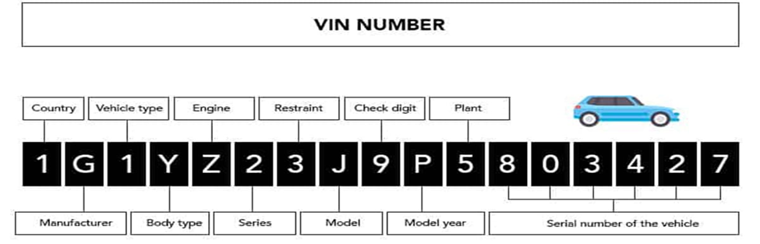
Figure 1-25 VIN representation
The VIN is made up of seventeen characters and contains all pertinent information about the vehicle. The use of the seventeen numbers and letter code became mandatory beginning with 1981 vehicles and is used by all manufacturers of vehicles both domestic and foreign. Most new vehicles have a scan code below the VIN.
Each VIN number represents different data. The following information can be determined be reading the VIN number.
      - Engine Identification
By referring to the VIN, much information about the vehicle can be determined. Identification numbers are also found on the engine. Some manufacturers use tags or stickers attached at various places, such as the valve cover or oil pan. Blocks often have a serial number stamped into them. Service manuals typically give the location of the code for a particular engine. The engine code is generally found beside the serial number. The engine code will help you determine the correct specifications for that particular engine.
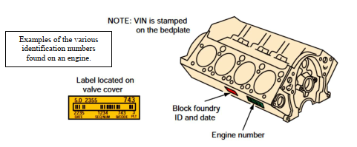
Engine ID Tags Many engines have ID tags or stickers attached to various places on the engine, such as the valve cover or oil pan. The tags include the displacement, assembly plant, model year, change level, engine code, and date of production. Service manuals normally note the location of these stickers or tags on a particular engine.
Figure 1-26 Engine ID number

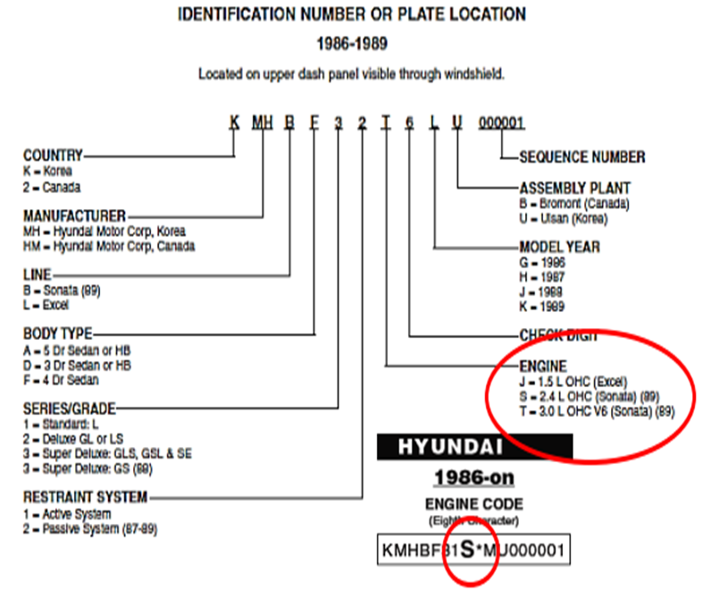
Figure 1-27 Engine Identification explained

Preparing service work activity plan
Specifications are included as part of the service manual. Specifications are technical data, numbers, clearances and measurements used to diagnose and adjust automobile components. Specifications can be referred to as specs. They are usually considered precise measurements under standard conditions. Examples of specifications include valve clearances, spark plug gaps, and tire pressure, number of quarts of oil, ignition timing and size of engine.
There are different Types specifications
- General Engine Specification– This specification identify the size and style of the engine. They include cubic inch displacement, engine codes, fuel system settings, bore and stroke, horsepower, torque, compression ratio, and normal oil pressure.
- Tune-Up specifications – This specification helps identify adjustments necessary for tune-up on the vehicle. This includes spark plug gap, firing order, degrees of ignition timings, fuel system settings and fuel pump pressure.
- Capacity Specifications –This specification includes identifying the capacity of different fluids on the vehicle. This includes cooling capacity, number of quarts of oil, fuel tank size, transmission transaxle capacity, and rear axle capacity.
- Overhaul and Maintenance Specifications – This specification used to aid technician in servicing the vehicle. This include distributor advance at different speeds, valve seat angles, valve stem clearance, piston measurements, ring end gaps, bearing clearances, shaft end play and many more. This specification help the technician determine how much wear has occurred. The mechanic is then able to decide whether to replace the component in question. Usually maximum or minimum clearances are given for this purpose.
- Operational Specification – This specification tell how the vehicle is to operate, what type of oil to use, and so on. Some of them are found in the owner’s manual. Other specification includes tire inflation, type of gasoline to use, tire size and general information for the operator of the vehicle.
- Torque Specification – It is important to torque each bolt or nut correctly when replacing or installing a component on the automobile. Torque specifications are used for this purpose. This torque specification should be used in place of any standard bolt and nut torque specification.
- Owner’s manual or an operator’s manual is a booklet that comes with a new car. This manual usually explains how to operate the automobile’s control and accessories. In addition the owner’s manual provides a great deal of technical information that can be useful to the technician. In an owner’s manual a vehicle maintenance procedure is provided so that the owner will know when to get needed service.
- Aftermarket repair manual:-is most often used by the technician at independent repair shops. This manual is called an aftermarket because it is published by independent publisher and not by the car manufacturer. Like the shop manual. This contains information on troubleshooting, specifications and step-by-step repair procedures. The main difference is that they cover many different car models and years instead of just one. Because they are covering more models and years, they typically cover topics in less detail.

OHS and Hazard identification
OHS (occupational health and safety) is a cross-disciplinary area concerned with protecting the safety, health and welfare of people engaged in work or employment. The goal of occupational health and safety (OHS) is-
- To protect every worker against the dangerous of injury, sickness or death through safe healthful working condition.
- To protect co-workers, employers, customers, suppliers and other members of the public whom does the work place environment impact.
To protect yourself from injuries, you must take precautions including Personal Protective Equipment (PPE) and OHS

PPE Requirement
To protect your Safety glasses, Protective goggles or face shields can give used where protection more suited to activities encounter; splashing liquid, fume, vapor, dust or powder and working with hydraulic system. Different types of goggles are available which cover the whole eye.
Ear protection on exposure to high noise levels can result in permanent hearing loss. Hence Ear protection is recommended when:
- Work area is constantly noisy
- Grinding
- Hammering
Skin protection is recommended when: working with chemicals & corrosives and handling heavy materials like wheel bearing service Rubberized Gloves: when working with chemicals, when using the parts washer. Leather gloves: when grinding or welding When lifting heavy engine parts or transmissions.
Your clothing should be well fitted and comfortable but made with strong material. Wear appropriate clothing while performing tasks
- No sleeveless shirts
- No shorts
- No holes
- No hats
Safety Shoes: protect your feet from injury. There are many designs of safety shoes and boots that also have steel plates built into the toe and shank to protect your feet. Many also have soles that are designed to resist slipping on wet surfaces.
N.B Keep your clothing clean. If you spill gasoline or oil on yourself, change that item of clothing immediately. Oil against your skin for a prolonged period can produce rashes or other allergic reactions. Gasoline can irritate cuts and sores.
Respiratory protection is recommended: When working with chemicals that give. Toxic fumes, extended time around gasoline, when working on brakes or clutches that may contain asbestos. When using power sanding, using the parts washer for extended periods.

OHS Requirement
When doing heavy lifting, always get assistance and lift with your knees, not your back.
When lifting any object follow these steps:
Clean equipment and tools
- Part cleaning is a necessary step in most repair procedures. Cleaning automotive parts can be divided into three basic categories.
- Chemical cleaning relies primarily on some type of chemical action to remove dirt, grease, scale, paint, or rust.
- Abrasive cleaning relies on physical abrasion to clean the surface. This includes everything from a wire brush to glass bead blasting, airless steel shot blasting, abrasive tumbling, and vibratory cleaning. Chemical in-tank solution sonic cleaning might also be included here because it relies on the scrubbing action of ultrasonic sound waves to loosen surface contaminants.
Clean up procedures
- Clean up every time whenever you leave an area, including sweeping the floor.
- Clean and return all tools to where you got them.
- Use compressed air sparingly; never aim it at another person or use it to clean hair or clothes.
- Shut off and unplug machines when cleaning, repairing, or oiling.
- Never use a rag near moving machinery.
- Use a brush, hook, or a special tool to remove chips, shavings, scraps etc. from the work area. Never use the hands.
- Keep fingers clear of the point of operation of machines by using special tools or devices, such as, push sticks, hooks, pliers, etc.
- Keep the floor around machines clean, dry, and free from trip hazards. Do not allow chips to accumulate.
Hazards in the work shop
- Faulty work habits
- Misuse of equipment
- Misuse of hand tools
Select the work place depending on: -
- Environmental condition
- Free from flammable things
- Events around the work campus is closer together
- Climatic condition
- Working area events

Self-Check 1
- What are the Advantages of supercharger?
- A belt drives the supercharger
- The supercharger turns, compressing the air inside the housing and forcing it into the intake manifold
- An electromagnetic clutch is sometimes used to disengage the drive belt from the blower
- No “turbo lag”
- ___________ is called an aftermarket because it is published by independent publisher and not by the car manufacturer.
A) Part Catalog B. specification C. repair manual D. service manual
- _______ called a shop manuals, are written by the automotive manufacturer for the technicians in their dealership.
A. Manufacturer’s service manual B. specification C. repair manual D. structural manual
- ______ Which one the purpose of to provide all the information necessary to describe all item accurately both physically and intellectually in order to distinguish it from every other items.
A. Part catalog B. specification C. repair manual D. structural manual
5) One of the following is used to prevent coolant circulation until engine operating temperature is reached
A. Water pump B. Thermostat C. Radiator D. Expansion tank

Unit Two: Inspection and basic engine services
This unit to provide you the necessary information regarding the following content coverage and topics:
- Inspecting engine before removal
- Inspection techniques
- In vehicle engine services
- Disassembling engine exterior assembly
- Reassembling engine systems assembly
Overview
This guide will also assist you to attain the learning outcomes stated in the cover page. Specifically, upon completion of this learning guide, you will be able to:
- Apply inspection techniques
- Conduct different visual inspections
- Service engine in vehicle
- Disassemble engine exterior assembly
- Remove engine systems and assembly

Inspecting engine before removing and disassembling
It is the responsibility of a driver or owner of a vehicle to carry out the following inspection and checks daily, before starting the engine, to avoid any type of breakdown on the road. Engine drivability problems are caused by either mechanical or system associated fault.
Hence most essential systems like fuel and air induction systems should also be inspected and tested along with mechanical engine problems. These may include visual check, engine compression loss tests, smoke test, vacuum test and noise test. Typical engine mechanical-related complaints include the following:
- Excessive oil consumption
- Coolant consumption and Engine overheating
- Loss of power
- Engine noise
- Engine backfire
- High Engine emission

Visual Check
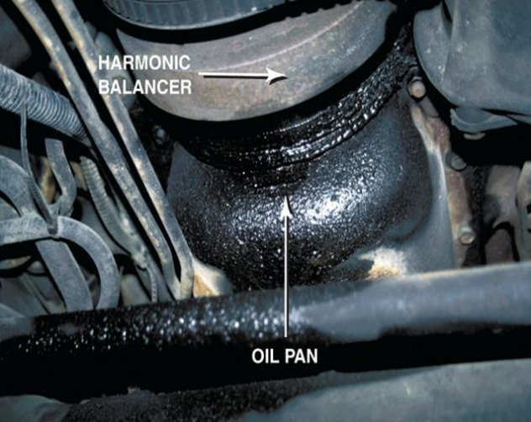
The first and most important “test” that can be performed is a careful visual inspection of
Figure 2-1 Typical location of oil leack
- Oil level and condition
- Coolant level and condition
- Drive belt tension
- Loose connections
- Leakages including oil, coolant and fuel
- Abnormal noise around engine
A visual inspection report form is completed by quality assurance inspectors to document pass/fail decisions on visually inspected products based on set defect criteria. Use this checklist to effectively indicate product ID and location, capture photo evidence of products and/or defects, determine pass/fail decisions based on a reference image, identify visual defects based on defect criteria, and complete the visual inspection with a digital signature. What looks like an oil pan gasket leak can be a rocker cover gasket leak. Always look up and look for the highest place you see oil leaking; that should be repaired first
      - Checking internal and external coolant leaks
Usual areas of external leakage are water manifolds, radiator seams, water pumps, freeze plugs and all those connections. The condition of radiator hoses should be carefully scrutinized for possible deterioration from age and/or wear from rubbing against accessory brackets, etc. Be aware that in many cases radiator hoses wear from the inside out, so outside appearance can be deceiving.

- Cracked cylinder block
- Faulty radiator cap
- Dented radiator inlet of outlet tube
- Radiator leak
- Cracked or porous water pump housing
- Water core leak
- Loose core hole plug in cylinder block
- Cracked thermostat housing

To check internal leaks, Pull the oil dipstick and check for evidence of coolant. It will show up as minute droplets or sludge and should be easy to spot. This could indicate a cracked head, block or blown head gasket.

        - Inspecting Cooling System for Leaks
- Fill the radiator and engine with coolant, and attach a radiator cap tester to the water outlet.
- Warm up the engine.
- Pump it to 118 kPa (1.2 kgf/cm2, 17.1 psi), and check that the pressure does not drop. If the pressure drops, check the hoses, radiator or water pump for leaks. If no external leaks are found, check the heater core, cylinder block and head.
        - Temperature Test
A temperature test can be performed with an infrared temperature sensor, thermometer, or temperature probe. The latter may be a feature of a digital multi-meters (DMM). A temperature test allows for monitoring temperature change through the cooling system. When a cold engine is started, the opening temperature of the thermostat can be observed as the engine warms.
        - Checking Fans and Fan Clutches
To confirm the diagnosis, start with this simple test: Spin the fan as hard as you can on an engine that has not been started that day. If the fan rotates more than five times, you can bet the clutch is bad. You should feel some resistance and the fan may spin up to three times, depending on the ambient temperature.
      - Engine Lubricant inspection
To troubleshoot an engine lubricating system, begin by gathering information on the problem. Ask the operator questions. Analyze the symptoms using your understanding of system operation. You should arrive at a logical deduction about the cause of the problem.
The four problems most often occur in the lubrication system are as follows:
- High oil consumption (oil must be added frequently)
- Low oil pressure (gauge reads low, indicator light glows, or abnormal engine noises)
- High oil pressure (gauge reads high, oil filter swelled)
- Defective indicator or gauge circuit (inaccurate operation or readings)
When diagnosing these troubles, make a visual inspection of the engine for obvious problems. Check for oil leakage, disconnected sending unit wire, low oil level, damaged oil pan, or other troubles that relate to the symptoms. External oil leakage out of the engine or internal leakage of oil into the combustion chambers causes high oil consumption. A description of each of these problems is as follows:
Low oil pressure is indicated when the oil indicator light glows, oil gauge reads low, or when the engine lifters or bearings rattle. The most common causes of low oil pressure are as follows:
- Low oil level (oil not high enough in pan to cover oil pickup)
- Worn connecting rod or main bearings (pump cannot provide enough oil volume)
- Thin or diluted oil (low viscosity or fuel in the oil)
- Weak or broken pressure relief valve spring (valve opening too easily)
- Cracked or loose pump pickup tube (air being pulled into the oil pump)
- Worn oil pump (excess clearance between rotor or gears and housing)
- Clogged oil pickup screen (reduce amount of oil entering pump)
A low oil level is a common cause of low oil pressure. Always check the oil level first when troubleshooting a low oil pressure problem.
High oil pressure is seldom a problem. When it occurs, the oil pressure gauge will read high. The most frequent causes of high oil pressure are as follows:
1. Pressure relief valve struck (not opening at specified pressure)
2. High relief valve spring tension (strong spring or spring has been improperly shimmed)
3. High oil viscosity (excessively thick oil or use of oil additive that increases viscosity)
4. Restricted oil gallery (defective block casting or debris in oil passage)
A bad oil pressure indicator or gauge may scare the operator into believing there are major problems. The indicator light may stay on or flicker, pointing to a low oil pressure problem. The gauge may read low or high, also indicating a lubrication system problem.
Inspect the indicator or gauge circuit for problems. The wire going to the sending unit may have fallen off. The sending unit wire may also be shorted to ground (light stays on or gauge always reads high).
To check the action of the indicator or gauge, remove the wire from the sending unit. Touch it on a metal part of the engine. This should make the indicator light glow or the oil pressure gauge read maximum. If it does, the sending unit may be defective. If it does not, then the circuit, indicator, or gauge may be faulty.
      - Exhaust System Inspection
Most parts of the exhaust system, particularly the exhaust pipe, muffler, and tailpipe, are subject to rust, corrosion, and cracking. Broken or loose clamps and hangers can allow parts to separate or hit the road asthe car moves. All inspections should include listening for abnormal noises. The inspection should also include a careful look at the system while the vehicle is raised on a hoist. Before beginning work on the system, be sure that it is cool to the touch. Some technicians disconnect the battery ground to avoid short-circuiting the electrical system.
- Exhaust Restriction
Test Often leaks and rattles are the only things looked for in an exhaust system. The exhaust system should also be tested for blockage and restrictions. Collapsed pipes or clogged converters and/or mufflers can cause these blockages. There are many ways to check for a restricted exhaust. The sound of the exhaust can indicate a restriction. Although this is not the most effective way to determine if thereis a restriction, it is a good start.
Checking the pressure built up in the exhaust is the best way to determine if the system is blocked. This is done by installing a pressure gauge in the O2S bore in the exhaust pipe. At idle, the gauge should read less than 1.5 psi (10 kPa) and should be less than 2.5 psi (17 kPa) at 2,500 rpm. Some technicians check for a restricted exhaust with a vacuum gauge. With the gauge connected to the intake manifold, the engine’s speed is raised and held. The vacuum reading should rise and either hold there or increase slightly. If the vacuum decreases, there is an exhaust restriction.
- Exhaust Leaks
Exhaust leaks are often identified by sound, although very small leaks can be difficult to
locate. One of the most effective ways to identify the source of a leak in the system is the use of a smokemachine. When smoke is introduced to the exhaust system, a trace of smoke will identify the source of the leak.

Engine Smoke Inspection
Examining and interpreting the vehicle’s exhaust can give clues of potential engine problems.
The color of engine exhaust smoke can indicate what engine problem might exist.
      - Black Smoke exhaust
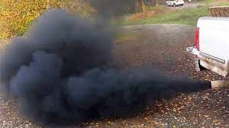
Caused by incomplete combustion due to a lack of air or fault in injection system that could cause excessive amounts of fuel in the cylinders.
The most common causes of black smoke:
- Clogged air filter
- Faulty injection system
- Ignition problem
Figure 2-2 Black smoke leaving tail pipe of a vehicle
- Restricted intake manifold

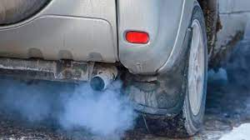
      - Gray or Blue Smoke exhaust
Usually due to oil consumption caused by worn piston rings, scored cylinder walls, or defective valve stem seals.
      - White Smoke exhaust
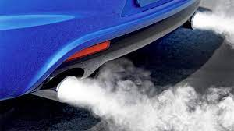
Occurs most often during cold engine starts because the smoke is usually condensed fuel droplets. White exhaust smoke is also an indication of cylinder misfire on a warm engine. The most common causes of white exhaust smoke:
Figure 2-3 Blue smoke leaving tail pipe of a vehicle
- Inoperative glow plugs
- Low engine compression
- Incorrect injector spray pattern
- A coolant leak into the combustion chamber
Figure 2-4 White smoke leaving tail pipe of a vehicle
White steam is usually an indication of a blown (defective) cylinder head gasket that allows engine coolant to flow into the combustion chamber where it is turned to steam

Engine Noise Inspection
A stethoscope is very helpful in locating engine noise by amplifying the sound waves. An engine knocking noise is often difficult to diagnose. Several items that can cause a deep engine knock include:
- Piston Ring Noise
Sounds like: Clicking noise during acceleration.
Common causes: Low ring tension, broken rings, or worn cylinder walls
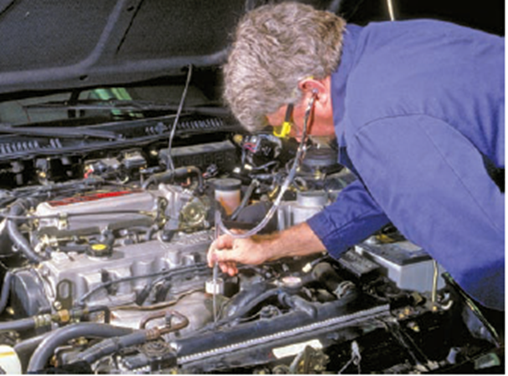
Try troubleshooting each cylinder by removing the spark plugs and adding a spoonful of engine oil to each cylinder. Now crank the engine quite a few revolutions to allow the oil to go down past the rings. Install the spark plugs and start the motor. If the noise is lessened then the rings are likely the source of the problem.
Figure 2-5 Inspecting an engine noise by using stethoscope
- Piston Slap
Sounds like: Continuous muffled, hollow sound.
Common causes: Excessive piston-to-wall clearance, worn cylinders or inadequate oil.
A continued piston slap noise indicates that the engine needs service. Still, if the sound is only heard when the engine is cold, it is probably not a serious issue.
- Crankshaft Knock
Sounds like: Dull, heavy, metallic knock under load.
Common causes: Worn bearings; main, rod, or thrust.
Damaged or worn main bearing noise is loudest under heavy load. Check your oil dipstick for any metal reflections. Metal shavings in the oil is one of the first indications of your main bearing material sloughing off. Replace any worn bearings with new ones.
- Valve train Noise
Sounds like: Regular clicking noise at half-speed.
Common causes: Excessive valve clearance or defective valve lifter.
You can check your clearances by inserting a thickness gauge between the lifter or rocker arm and the valve stem. If the noise is reduced, then the cause is excessive clearance and you will want to make the correct adjustments. If the noise persists, then it is most likely rough cams or worn lifter faces. You might also want to look for loosley moving lifters in their bores and weak valve springs.
- Detonation
Sounds like: High-pitched metallic pinging noise.
Common causes: Improper timing, lean air/fuel ratio, or improper octane.
You can prevent detonation by increasing the octane level of your fuel, reducing manifold pressure, enriching the air/fuel mixture, or obstructing the ignition timing. Detonation can often be a common phenomenon in forced induction applications. For some operations, you can consider an aftermarket water injection system.
- Connecting Rod Noise
Sounds like: Light knocking or pounding sound.
Common causes: Misaligned rod, inadequate oil, or worn bearing or crankpin.
A cylinder-balance test can single out the faulty connecting rod. With the engine running, this test essentially shorts out the spark plugs one cylinder at a time. Soon, you can narrow down the bad connecting rod as the sound will be lessened when its base cylinder is no longer delivering power.
- Piston Pin Noise
Sounds like: Metallic, double knock at idle.
Common causes: Worn bushing, worn or loose piston pin, or inadequate oil.
Conduct a cylinder-balance test like described above to discover the distressed components.

Inspecting an overheated Engine
The most common cooling system problem is overheating. There are many reasons for this. Diagnosis of this condition involves many steps, simply because many things can cause this problem. Basically, overheating can be caused by anything that decreases the cooling system’s ability to absorb, transport, and dissipate heat: The first step is to determine whether the engine is indeed overheating.
An overheating concern normally begins with high readings on the vehicle’s temperature gauge or the illumination of the temperature warning lamp. These can be caused by a cooling system problem or a faulty temperature sensor, although when the engine is greatly overheating, it is obvious by the steam emitted by the system or by smell. The best way to check the accuracy of the temperature indicators is to measure the temperature of the coolant. If the indicators seem to be wrong, troubleshoot and repair the electrical circuit. Then recheck the system’s temperature.

Table 2-1 Probable causes and conditions indicated for typical overheated engine
Cause | Condition
Overheats in heavy traffic or after idling for a long time | Low coolant level, Faulty radiator cap, Faulty thermostat, Cooling fan is not turning on, Restricted airflow through the radiator, Leaking head gasket, Restricted exhaust and Water pump impeller is corroded
Overheats when driving at speed, or after repeated heavy acceleration | Radiator and/or block are internally clogged with rust, scale, silt, or gel; Restricted airflow through the radiator, Faulty radiator cap, Faulty thermostat, Radiator fins are corroded and falling off Water pump impeller is corroded and Dragging brakes
Overheats any time or Erratically | Low coolant level, Faulty radiator cap, Faulty thermostat Temperature sender or related electrical problem and Cooling fan is not turning on
Overheats shortly after the engine is started | Temperature sender or related electrical problem
Seems slightly too hot all of the time; gauge nears the red zone at times | Radiator and/or block are internally clogged with rust, scale, silt, or gel, Restricted airflow through the radiator, Faulty radiator cap, Faulty thermostat, Radiator fins are corroded and falling off Collapsed lower radiator hose and Cooling fan is not turning on
Bubbles in the coolant expansion tank | Faulty radiator cap, Failed head gasket
Air in the radiator but the expansion tank is full | Coolant leak, Faulty radiator cap, Air in the system, Faulty seal between the radiator cap and expansion tank and Failed head gasket

Maintenance Check-up
When one plans a long distance travel, it is necessary to carry out a routine check‑up. One should read the vehicle maintenance manual for clarity. Some important check‑ups are done for better maintenance
- Topping of oil level
- Proper tension of belt
- Battery for cleanliness and level of electrolyte
- Brakes
- Air conditioning
- Topping up of coolant, if required, in the coolant reservoir
- Checking the serviceability of cooling system hoses
- Proper tire inflation pressure

In-vehicle engine services

Thermostat Replacement
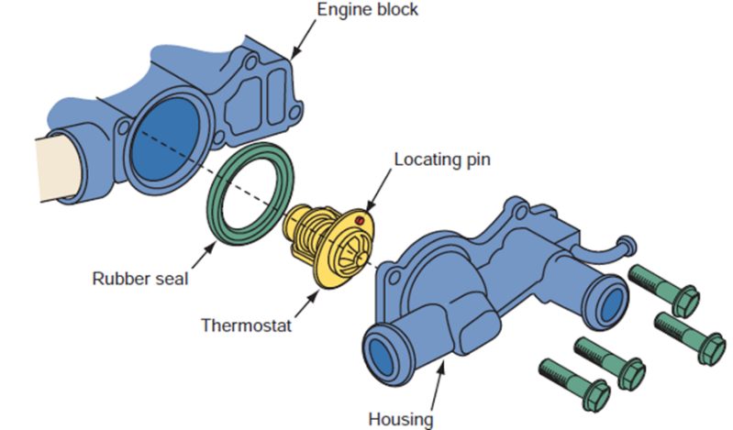
All thermostat valves move during operation to maintain the desired coolant temperature.
Figure 2-6 Thermostat replacement
Thermostats can fail in the following ways.
- Stuck open
- Stuck closed
- Stuck partially open
- Skewed

Water pump Replacement
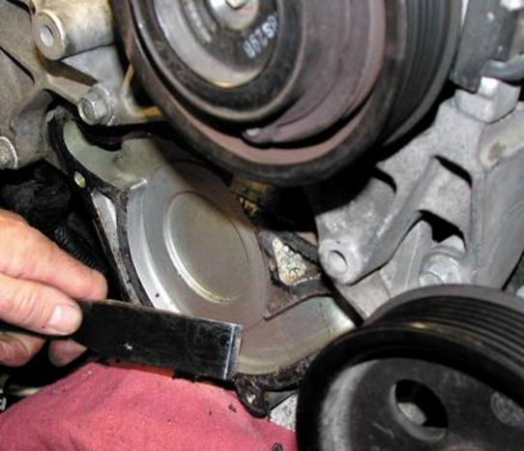
A water pump will require replacement if any of the following conditions are present.
- Leaking coolant from the weep hole
- Bearing noisy or loose
- Lack of proper coolant flow caused by worn or slipping impeller blades
Caution do not use a steel scraper to remove a gasket from aluminum parts. It is best to use a wood or plastic scraper
Figure 2-7 Water pump replacement

Inspection and replacement of Timing and fan Belt
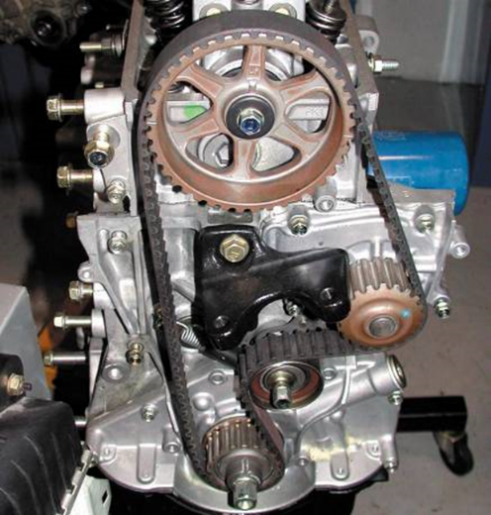
Timing belts have a limited service and a specified replacement interval ranging from 60,000 miles (97,000 km) to about 100,000 miles (161,000 km). Timing belts are required to be replaced if any of the following conditions occur.
- Meets or exceeds the vehicle manufacturer’s recommended timing belt replacement interval.
- The timing belt has been contaminated with coolant or engine oil.
- The timing belt has failed (missing belt teeth or broken).
Figure 2-8 Replacement and adjustment of timing belt
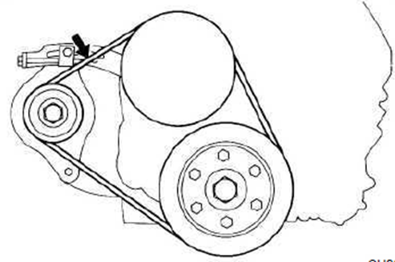
Even the best drive belts last only an average of 4 years. Belt life time can be shortened by several things; most of these can be found by inspecting the belts. Check the condition of fan belts on the engine, carefully look to see if they have worn or glazed edges, tears, splits, and signs of oil soaking.
If these conditions exist, the belt should be replaced. Also inspect the grooves of the drive pulleys for rust, oil, wear, and other damage. If a pulley is damaged, it should be replaced. Check a belt Tension:
Check the drive belt deflection by pressing on the belt at the center points indicated in the illustration with 10 kg of pressure. If the deflection is not as specified, adjust it.
Figure 2-9 Replacement and adjustment of drive belt

Replacing exhaust Manifold gasket and seals
An exhaust manifold will warp because of excess heat. A straightedge and feeler gauge can be used tocheck the machined surface of the manifold. Another problem also the result of high temperatures generated by the engine—is a cracked manifold. This usually occurs after the car passes through alarge puddle and cold water splashes on the manifold’s hot surface. If the manifold is warped beyondmanufacturer’s specifications or is cracked, it must be replaced.
The most likely spot to find leaking gaskets and seals is between the exhaust manifold and the exhaust pipe Most often exhaust bolts are quite rusted and can be difficult to loosen. This is why it is wise to soak the bolts and nuts with penetrating fluid before attempting to disassemble the system.. To replace an exhaust manifold gasket, follow the torque sequence in reverse to loosen each bolt. Repeat the process to remove the bolts. Doing this minimizes the chance that components will warp. Inspect the manifold for irregularities that might cause leaks, such as, scratches, or cracks.
Replace it if it is cracked or badly warped. Then during Install the bolts or nuts finger-tight. Tighten themin three steps—one-half, three-quarters, and full torque. Always follow the specifications given for thatengine. Normally the nuts should be tightened in a particular sequence. This sequence typically beginsat the center and continues outward in an X pattern.

Changing Engine oil and filter
Oil is the life-blood of an engine, it is critical that the oil and filter are changed on a regular basis. To replace engine oil and filter follow the following procedure:
- Prepare A Vehicle:-Park a vehicle in level place. Allow the engine to run awhile. After it is warmed, turn off the engine.
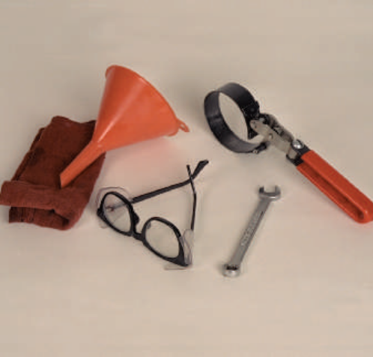
- Drain Engine Oil: Remove the oil filler cap. Remove the oil drain plug, and drain the oil into a container.
- Replace Oil Filter and Fill With Engine Oil
- Clean and install the oil drain plug with a new gasket.
- Fill engine with new engine oil of a recommended viscosity number and API.
- Reinstall the oil filler cap.
- Start Engine And Check For Leaks
- Recheck Engine Oil Level
- Stop the engine and wait until it cool down
Figure 2-10 SST required for engine oil changing demonstration
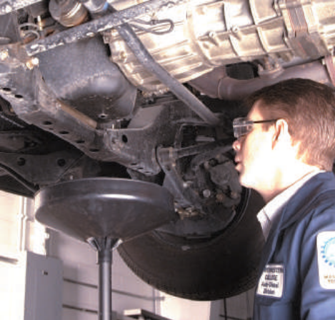
- Check engine oil level using a dipstick
In order to preserve the environment, used oil and used oil filters must be disposed of only at designated disposal sites. When engine oil has been replaced oil filter should be replaced.
Procedure:
Using SST, remove the oil filter (Figure 2-11).
Clean and check the oil filter installation surface
Figure 2-11 Engine oil changing demonstration
Apply clean engine oil to the gasket of a new oil filter
Lightly screw the oil filter into place, and tighten it until the gasket contacts the seat
Fill oil filter with clean engine oil (Optional)
Using SST, tighten it additional 3/4 turn
After running the engine, check for oil leaks

Inspecting and servicing air cleaner
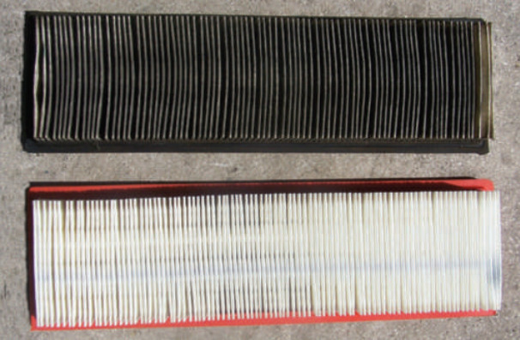
The air taken in by the engine contains dust and other particles which clog the carburetor passage, cause rapid engine cylinder wear and oil deterioration. The air cleaner traps the dust and dirt particles in the air with its filter, preventing them from entering the carburetor and engine cylinders.
If the filter becomes clogged with dirt, it has the effect of reducing the cross-section and increasing resistance to the airflow. This in turn makes the fuel-air mixture richer, so that the total supply volume to the engine drops and engine power output is reduced. For these reasons, the air cleaner must be inspected periodically.
Figure 2-12 Air cleaner before and after cleaning

Self-check 2
  - If the cylinder head is defective, which of the following will leak into the cooling system?
A. air-fuel mixture B. fuel C. combustion gases D. exhaust
  - Leakage of gases into the cooling system may be form
A. oil sludge B. carbon deposits C. strong acids D. scales
  - The acids that form in the cooling system may corrode the
A. radiator B. temperature gauge C. thermostat D. water pumping
  - Combustion leaks in the valve areas can cause cracks in the
A. cylinder and piston B. valve seats and cylinder heads
C. crank shaft and camshaft D. oil pan and timing cover
5) Combustion leak in the valve area can be stopped by
A. replacing cylinder head gasket B. grinding the valve face and valve seat
C. replacing the piston ring D. none of the above
6) Which of the flowing oil contains that is located at the bottom of the engine.
A) Oil pan B) Oil c) Dip stick D) all
7) Which of the Metal mesh located at the oil inlet to remove large dust particles.
A) Sump B) Oil c) Oil strainer D) All
8) Pumps oil that has accumulated in the oil pan to the various areas of the engine.
A) Oil filter B) Oil pressure switch c) Dip stick (Level gauge) D) Oil pump
9) ___________, located between the catalytic converter and the resonator or tail pipe, contains perforated pipes, baffles, and resonance chambers.
A) Muffler B) Exhaust manifold C) catalytic converter
10)______________is a long pipe leading from the exhaust manifold to the muffler.
A) Muffler B) Exhaust pipe c) Tail pipe D) All

Operation sheet-2
Operation sheet 2-1
Title: Replace/ change engine oil and filter
Objectives: Given an engine, ultraviolet light, special tools, paper and pencil and clean rags, you will identify engine oil and filter, sealant, replace both oil and filter and check engine for proper operation
Instructions:
1. Start engine in a well-ventilated area and allow it to reach normal operating temperature. Shut off the engine.
2. Safely raise vehicle on a hoist or support vehicle on jack stands.
SAFETY CAUTION: When hot, exhaust system parts, can cause severe burns. Avoid touching exhaust system parts. In addition, drain plugs and oil are hot enough to cause pain and minor burns. Use a shop towel to hold the drain plug as it is unscrewed, and avoid getting oil on yourself during draining.
3. Loosen drain plug with a wrench. Do not unscrew plug.
4. Position an oil catch pan under oil pan drain pug.
5. Unscrew and remove drain plug by hand. Allow hot oil to drain into the catch pan for at least five minutes.
6. Clean drain plug and mounting hole with a shop towel. Thread plug in by hand, and then tighten as recommended by vehicle manufacturer.
7. Position oil catch pan under oil filter.
8. Loosen oil filter with an oil filter wrench. Unscrew filter by hand and place in catch pan to drain. Clean oil filter mounting surface with a shop towel.
10. Rub a few drops of new engine oil onto rubber gasket of oil filter.
11. Screw filter on by hand. After rubber gasket contacts mounting surface, turn filter an additional ¾ to 1 full turn by hand.
12. Lower vehicle and add correct amount of new engine oil. Start engine and watch oil pressure warning light or gauge until normal pressure is indicated. Check for leaks around filter and drain plug. Shut off engine.
13. Wait five minutes, then check engine oil dipstick for proper oil level.

LAP- Test
Instructions:
You are required to perform at least three of the following tasks:
Task-1: Remove and replace air compressor
Task-2: Detaching and replacing injection pump and high-pressure lines.
Task-3: Replace turbo charger and oil cooler.
Task-4: Replace the alternators and its driving belts.
Task-5: Replace steering gear fluid pump.

Unit Three: Replacing and adjusting engine System Assemblies
This unit to provide you the necessary information regarding the following content coverage and topics:
- Carryout minor adjustments
- Cleaning techniques of an engine
- Assembling system components
- Replacing engine system assemblies
- Conducting post-service/pre-delivery check
This guide will also assist you to attain the learning outcomes stated in the cover page. Specifically, upon completion of this learning guide, you will be able to:
- Carry out minor adjustments
- Assemble system components
- Replace engine system assemblies
- Conduct post-service/pre-delivery check

Engine removal from vehicle
It is wise to clean the engine and engine compartment before beginning to remove the engine.
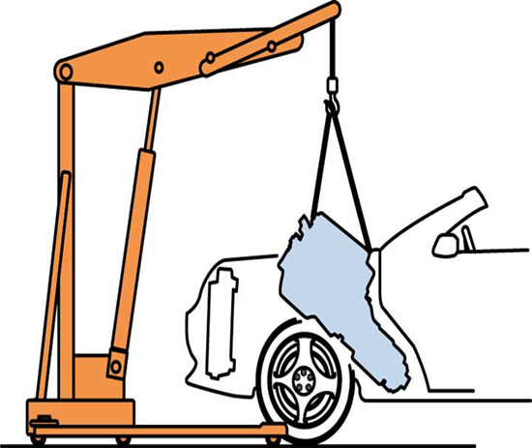
Using pressure washing will remove the majority of engine and under-hood grime prior to engine removal. Protect the Alternator, fuel injection and ignition system while cleaning by covering these components with a plastic bag and by not spraying directly on them. Make sure you have all the tools and equipment before you begin. Always follow the manufacturer’s removal procedures. Adhere to all safety guidelines and procedures. The basic procedures for engine removal vary, depending on whether the engine is removed from the bottom of the vehicle or through the hood opening. Many FFWD vehicles require removal of the engine from the bottom, whereas most FRWD vehicles require the engine to come out from the hood opening. To lift an engine out of its compartment, most technicians use a mobile crane, frequently called a cherry picker, which uses a hydraulic power to do lifting. To lift an engine, attach a pulling sling or chain to the engine. Some engines have eye plates for use in lifting. It is a good practice to mount the engine securely to an approved engine stand.
Figure 3-1 Removing engine from RWD vehicle

Cleaning an engine
When the engine is removed from the vehicle or disassembled, all parts including fasteners as well as the engine itself been must be thoroughly cleaned. The cleaning method depends on the component to be cleaned and the type of equipment available. An incorrect cleaning method or agent can often be more harmful than no cleaning at all. Only after all components have been thoroughly and properly cleaned can an effective inspection be made or proper machining be done.
Being able to recognize the type of dirt you are to clean will save your time and effort. Basically there are four distinict sources of dirt. These are:-
- Water-Soluble Soil: it is the easiest dirt to clean, which includes dust and mud.
- Organic Soils: Organic soils contain carbon and cannot be effectively removed with plain water. These are petroleum by-products derived from crude oil including road oil, engine oil, gasoline, diesel fuel, grease, and engine oil additives; by-products of combustion like carbon deposit; coatings including such items as rustproofing materials, gasket sealers and cements, paints and waxes.
- Rust: the result of a chemical reaction that takes place when iron and steel are exposed to oxygen and moisture.
- Scale: the buildup of minerals and deposits inside the cooling system is known as scale.
The methods employed to clean different dirts also varies

Mechanical cleaning
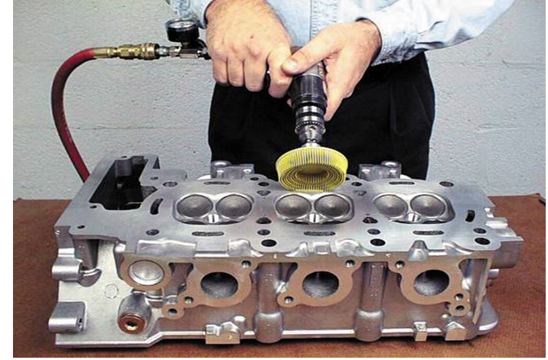
Heavy deposits should be removed by mechanical cleaning before using other cleaning methods.
Mechanical cleaning involves:
- Scraping
- Abrasive brushing
- Abrasive blasting
Mechanical cleaning should be done very carefully by soft metals. The scraper most frequently used is a putty knife or a plastic card. The broad blade of the putty knife helps avoid scratching the surface as it is used to clean the parts. A rotary disc can be used on disassembled parts that will be thoroughly cleaned to remove the fine abrasive that is part of the plastic bristle
Figure 3-2 Power assisted mechanical cleaning of cylinder head

Chemical cleaning
This method of cleaning uses chemical action to remove dirt, grease, scale, paint, and/or rust. Cleaning chemicals applied to engine parts will mix with and dissolve deposits, so that they can be brushed or rinsed from the surface. Most chemical cleaners used for cleaning carbon-type deposits are strong soaps called caustic materials.
The basic chemical cleaning processes are:
- Solvent-based cleaning:
- Chlorinated hydrocarbons and mineral spirits may have some health risks associated with their use through skin exposure and inhalation of vapors.
- Hydrocarbon cleaning solvents are also flammable, toxic and require special handling and disposal procedures
- Water-based non-toxic chemical cleaning: most aqueous- chemicals are silicate based and mixed with water.
Chemical cleaning can involve a spray washer or a soak in a cold or hot tank.
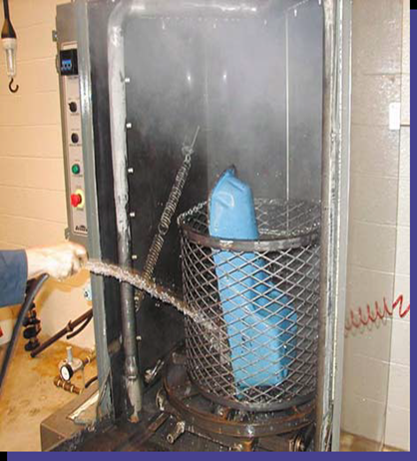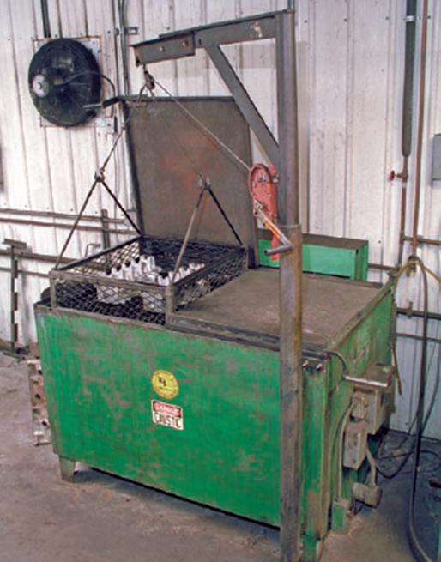
Figure 3-3 Spray and hot tank soaked chemical cleaning

Thermal cleaning
Thermal cleaning uses heat to vaporize and char dirt into a dry powdery ash. Thermal cleaning is best suited for cast iron, where temperatures as high as 425°C are used. Aluminum should not be heated to over 315°C. Advantages include:
- This process cleans the inside as well as the outside of the casting or part.
- The waste generated is non hazardous and is easy to dispose of.
- This method of engine part cleaning is popular because there is no hazardous waste associated with it.
- Labor costs reduced because the operator does not need to be present during the cleaning operation.
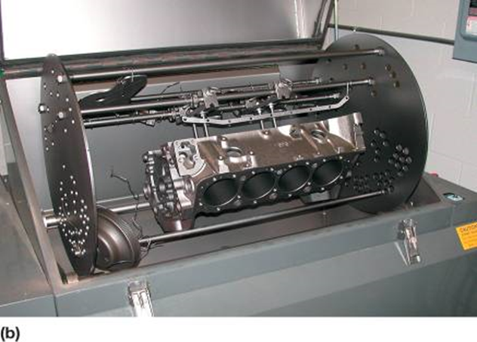
Figure 3-4 Thermal cleaning of cylinder block

Ultrasonic cleaning
It utilizes high-frequency sound waves to create microscopic bubbles that burst into energy to loosen soil from parts. It is used to clean small parts that must be absolutely clean like diesel injectors.
The disassembled parts are placed in a tank of cleaning solution which is then vibrated at ultrasonic speeds to loosen all the soil from the parts. The soil goes into the solution or falls to the bottom of the tank.
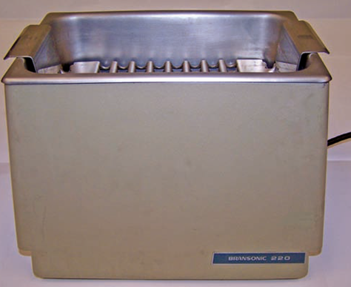
Figure 3-5 Ultrasonic cleaning

Replacing engine gaskets
Gaskets can be purchased individually or in sets. Sets are often available for the service performed on the engine. The most common are timing cover, head, manifold, oil pan, and full sets.
General Gasket Installation Procedures
The following instructions will serve as a helpful guide for installing gaskets. Because there are many different gasket materials and designs, it is impossible to list directions for every type of installation. Always follow any special directions provided in the instructions packed with the gasket sets.
- Never reuse old gaskets.
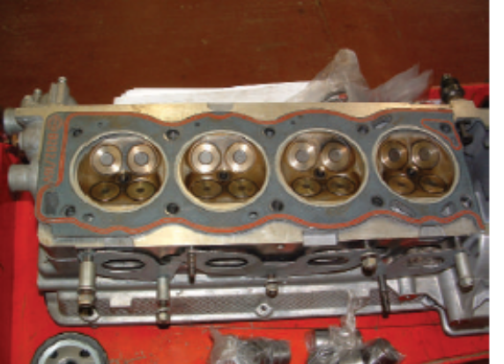
- Make sure you are installing the latest gasket part number. Sometimes gasket designs are revised and improved to correct pattern failures
- Handle new gaskets carefully.
- Cleanliness is essential. New gaskets seal best when used on clean surfaces.
- Use the right gasket in the right position. Always compare the new gasket to the mating surfaces to make sure it is the right gasket. Check that all bolt holes, dowel holes, coolant, and lubrication passages line up perfectly with the gasket. Some gaskets have directions such as “top,” “front,” or “this side up” stamped on one surface
Figure 3-6 Replacing cylinder head gasket
- Use sealants and adhesives only when the engine or gasket manufacturer recommends their use. Some chemicals will react negatively with the gasket’s coating.
- Always start each bolt into its hole before you begin to tighten any of the bolts.

Replacing Cylinder Head Gaskets
Cylinder head gaskets seal the cylinder head to the block (Figure 3-6). The head gasket has a very demanding job. It must seal the combustion chambers and the coolant and oil passages between the head and the block.

- Always follow the manufacturers recommended service procedures for torqueing cylinder head bolts.
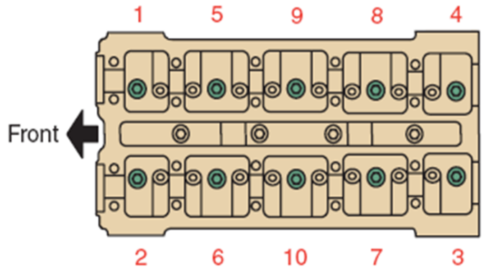
Figure 3-7 Typical de-torqueing pattern of cylinder head bolt; torqueing is simply reverse trace

Intake Manifold Gasket Inspection and replacement
Many V-type engines leak oil, coolant, or experience an air (vacuum) leak caused by a leaking intake manifold gasket. Expansion or contraction rate difference between the cast-iron head and the aluminum intake manifold can cause the intake manifold gasket to be damaged by the relative motion of the head and intake manifold. This type of failure is called fretting.
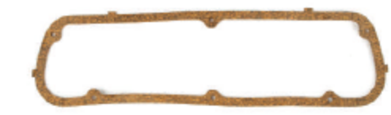
To diagnose a possible leaking intake manifold gasket, perform the following tests.
- Visual inspection
- Coolant level
Figure 3-8 Replacing valve cover gasket
- Air (vacuum) leak

Replacing Valve Cover Gaskets
Valve cover gaskets must make a seal between a steel, aluminum, magnesium, or molded plastic cover and the cylinder head surface. On OHC engines, cam covers are normally made of die-cast aluminum. Some cylinder cover gaskets have spark plug gaskets integrated into the gasket. When installing these, make sure the gasket is perfectly aligned. Valve cover bolts are usually widely spaced so the gasket material is able to seal without being tightly clamped. Valve cover gaskets must be able to withstand high temperatures and the caustic action of acids in the oil.

Replacing Oil Pan Gaskets
An oil pan gasket seals the joint between the oil pan and the bottom of the block (Figure 3-9).
The gasket might also seal the bottom of the timing cover and the lower section of the rear main bearing cap. Like valve cover gaskets, the oil pan gasket must resist hot, thin engine oil. Oil pans are usually made of stamped steel, cast iron, or cast aluminum. Because of the added weight and splash of crankcase oil, the pan has many retaining bolts closely spaced. As a result, the clamping force on the oil pan gasket is great.
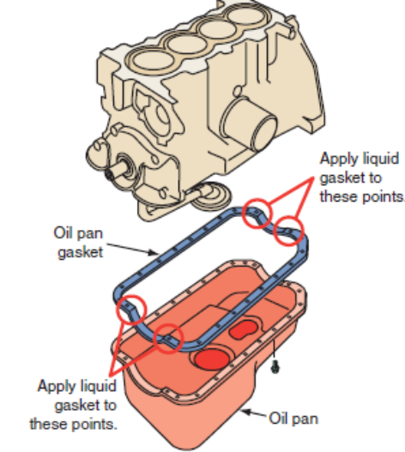
Oil pan gaskets may be made with several types of material. A commonly used material is synthetic rubber, known for its long-term sealing ability. It is tough, durable, and resists hot engine oil. Synthetic rubber gaskets are easy to remove, so the sealing surfaces need less cleanup. Carefully follow the recommendations of the OEM and gasket manufacturer. Before installing a stamped steel oil pan, make sure its flange is flat.
Figure 3-9 Replacing oil pan gasket
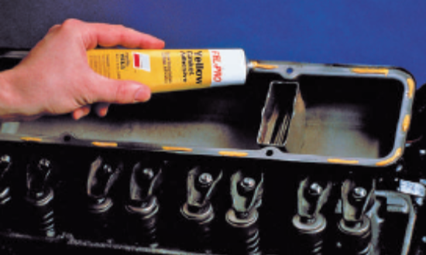
Tighten the oil pan bolts according to specifications and in the sequence given in the service manual. Many late-model engines use a hard gasket with a bead of sealant around the inside dimensions of the gasket. The bead increases clamping pressures and provides a positive seal.
Figure 3-10 Applying gasket adhesives

Apply Adhesives and Sealants
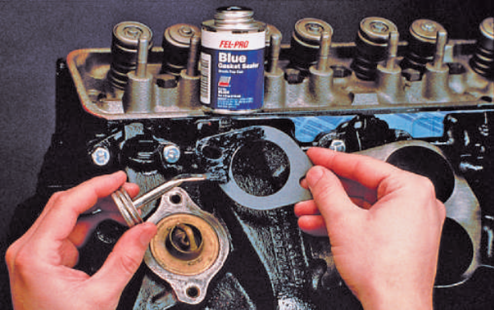
Many gasket sets include a label with the recommended chemical to use with that gasket set. Some even include sealers when the OEM used a sealer to replace a gasket and a gasket cannot be manufactured for that application. They also include sealers when gasket unions need a sealant to ensure a good seal. Gasket adhesives form a tough bond when used on clean, dry surfaces. Adhesives do not aid the sealing ability of the gasket. They are meant only to hold gaskets in place during assembly. Use small dabs. Do not assemble components until the adhesive is completely dry (Figure 3-10). Manufacturers sometimes specify the use of sealants to assist a gasket or seal or to form a new gasket. These sealants should only be used when specified by the manufacturer. Also make sure to use the specific sealant recommended by the manufacturer
Figure 3-11 Applying gasket sealant

Adjustment of system/components

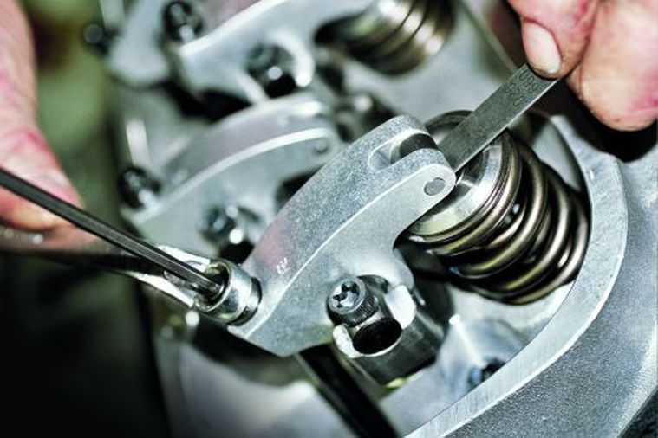
Valve Adjustment
Excessive valve clearance would result in:
- Presence of a regular taking sound: the noise can become more of a general clatter emanating from the top of the engine, if more than one valve clearance is excessive.
- The valve is not fully open: The valve opens too late & closes too early.
Figure 3-12 Valve Adjustment
- The valve is returned to its seat much faster than it would normally do. In severe cases this can result in the head of the valve breaking off causing extensive engine damage.
- With some arrangements, an indentation may being created in the rocker (tinge pad).
- When the valve clearance increases it might cause engine noise, increased emission, or decreased engine performance.
To check the clearance of any valve accurately, hot or cold, you must rotate the engine so that the valve is fully closed and the heel, or base circle, of the came lobe is on the tappet. This provides maximum clearance. Insert a flat feeler gauge of the specified thickness between the valve stem and the rocker arm or cam follower.
Obviously the clearances should be checked when they are at their widest which ,with most overhead camshaft arrangements is no problem for once the cover has been removed the actual cams can be seen the gap is at its widest the lobe of the cam is pointing directly away from the valve or rocker. In overhead valve layouts it’s rather more difficult because the camshaft cannot be seen with these or any or similar layout there is some method of setting the gap at its widest.

Valve identification
Usually the specified clearance at the exhaust valve will be greater than that of the inlet, which means that it is important to be able to differentiate one the other.
One way of doing this is to note the location of the valve in relationship to the manifold braches at the cylinder head. Example if the exhaust manifold branches terminate at the end of the cylinder head, then the first & the last valves are both exhaust.
The valve layout of a typical four cylinder engine would be E,I,I E,E,I,I,E. Where E =Exhaust &I= Intake. A further method of identifying which valve is which is to turn the engine over in its normal direction of rotation and watch the valves (or rockers), at each cylinder, the exhaust valve will open &close, will be immediately followed by the inlet. The engine can then be turned through nearly a complete revolution before the exhaust will open.

Drive Belts adjustment
Drive belts have been used for many years. V-belts and V-ribbed (serpentine) belts are used to drive water pumps, power steering pumps, air-conditioning compressors, generators, and emission control pumps. Heat has adverse effects on drive belts and they tend to over cure due to excessive heat. This causes the rubber to harden and crack. Excessive heat normally comes from slippage. Slippage can be caused by improper belt tension or oily conditions. When there is slippage, heat also travels through the drive pulley and down the shaft to the support bearing of the component it is driving. These bearings may be damaged if the slippage is allowed to continue.
V-belts ride in a matching groove in the engine’s pulleys. The angled sides of the belt contact the inside of the pulleys’ grooves. This point of contact is where motion is transferred. As a V-belt wears, it begins to ride deeper in the groove. This reduces its tension and promotes slippage. Because this is a normal occurrence, periodic adjustment of belt tension is necessary.
Drive belts can be used to drive a single part or a combination of parts. An engine can have three or more V-belts. In some cases, two matched belts are used on the same pulley set. This increases the strength of the belt and pulley connection and provides redundancy in case a belt breaks.
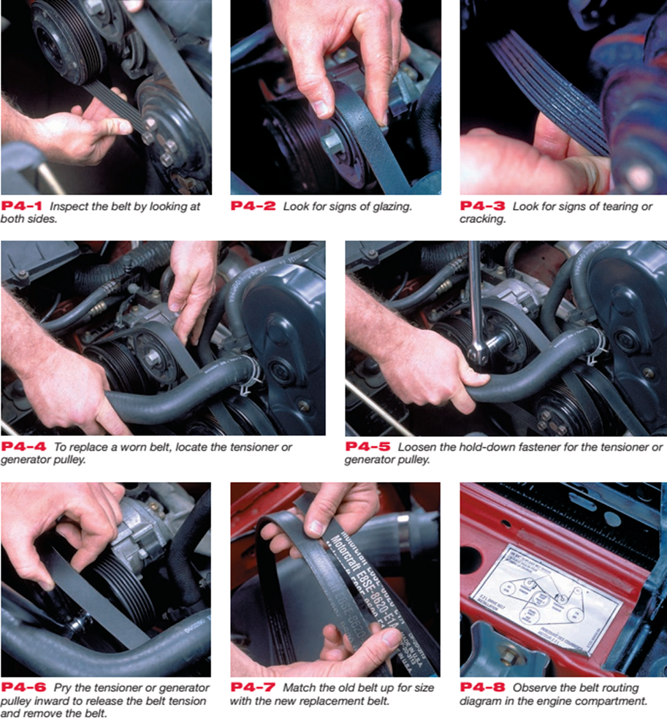
Figure 3-13 Inspection and replacement of drive belt
Inspection:- Even the best drive belts last only an average of 4 years. That time can be shortened by several things; most of these can be found by inspecting the belts. Check the condition of all of the drive belts on the engine. Carefully look to see if they have worn or glazed edges, tears, splits, and signs of oil soaking. If these conditions exist, the belt should be replaced. Also inspect the grooves of the drive pulleys for rust, oil, wear, and other damage. If a pulley is damaged, it should be replaced. Rust, dirt, and oil should be cleaned off the pulley before installing a new belt.
Misalignment of the pulleys reduces the belt’s service life and brings about rapid pulley wear, which causes thrown belts and noise. Undesirable side or end thrust loads can also be imposed on pulley or pump shaft bearings. Check alignment with a straightedge. Pulleys should be in alignment within 1⁄16 inch (1.59 mm) per foot of the distance across the face of the pulleys.
Belt Tension:- A quick check of a belt’s tension can be made by locating the longest span of the belt between two pulleys. With the engine off, press on the belt midway through that distance. If the belt moves more than ½ inch per foot of free span, the belt should be adjusted. Keep in mind that different belts require different tensions. The belt’s tension should be checked with a belt tension gauge.
The tension should meet the manufacturer’s specifications. Many engines are now equipped with a ribbed v-belt, which has an automatic tensioning pulley; therefore, a tension adjustment is not required.
Using service information:- proper belt tightening procedures and specifications are given in the specification section of most service manuals.

Injection timing adjustment
A large percentage of fuel injection pumps have timing devices incorporated in them. Varying the time when fuel injection begins will improve diesel engine performance and fuel economy, for the same reason that varying spark timing will improve the performance of a gasoline engine. The timing device usually consists of an aluminum casting with mounting flanges at both ends. A bore in the housing guides and supports the spider assembly. A timing opening, with a cover, is located in the top of the housing and is used to observe the position of the timing pointer in relation to the timing mark on the timing device hub during injection pump timing procedures.
The timing device hub, with external left-hand helical splines for engaging the internal helical splines of the sliding gear, has a tapered bore and keyway. The hub is secured to the camshaft extension by a woodruff key, nut, and setscrew. The hub is usually counter bored to receive the timing device springs. The springs oppose the fly weight forces of the weight and spider assembly. The weight and spider assembly has external right-hand helical splines which mesh with the internal helical splines of the sliding gear. The splined end is machined to receive the end play spacer. Three flyweights are pinned to a flange adjacent to the splines. The weight and spider thrust plate, located between the flange and the timing device housing, carries the back thrust of the flyweights and prevents housing wear.
The sliding gear has internal left-hand helical splines at one end and internal right hand helical splines at the other, and meshes with the external splines of both the weight and spider assembly and the timing device hub. Correct assembly of the spline train is ensured by a wide land on both the hub and weight and the spider assembly. The sliding gear has a missing tooth on each set of internal splines to receive the wide lands.

Conducting post-service/pre-delivery check

Document result with evidence
Documentation provides valuable descriptions of an organization’s development, acquisition, and operating environments and significantly enhances an organization’s ability to administer, operate, and maintain technology systems. Primary advantages for technicians’ involve having access to operation manuals and on-line application help features. Documentation enhances administrators’ and technicians’ ability to maintain and update systems efficiently and to identify and correct programming defects.
Developing and maintaining current, accurate documentation can be complicated, time consuming, and expensive. However, standardized documentation procedures and the use of automated documentation software can facilitate an organization’s ability to maintain accurate documentation.

Final Inspection
Consumers’ expectations are that they will receive their vehicle back in a serviceable condition and in a better operational condition than when it was delivered to the workshop. This expectation requires two (2) critical components:
- A final inspection must be completed by the service technician to ensure that all of the protective features for the braking system have been refitted is replaced to the required specifications; and
- The service technician to ensure that all of the work that was commenced on the system was completed to workplace, customer and manufacturers expectations must complete a final inspection.

Service provision
A technician will not carry out frequently some tasks. It would be unrealistic for a technician to have a detailed knowledge of seldom-performed procedures. In these circumstances, job cards or checklists are very useful as they give a systematic guide to follow whenever the rarely used procedure needs to be performed. The required knowledge is often kept in manuals, which may not be easily accessible. However, going through a large manual, possibly in front of a customer, does nothing for time effectiveness or professional image.
A job card is also used as the basis of a recording process for the organization. In addition to refreshing the process for the technician it will be a list of the workplace expectations as well. It is suggested that the final task on a job card will be to ensure that the equipment is cleaned for use or storage.

Noting and documenting observations during the service
The most precise way to document instruction is to create a Running Record, or virtual transcript, noting what was observed every two minutes.
Direct observation of behaviors is important for many reasons. It is a means of generating hypotheses and new ideas or a means of answering specific questions. Observations also enable us to answer questions about what happens during repairing. For the purpose of these observations, time sampling is used to record engine parts repairing.
An observer should attend to all contextual details on the parts of engine repair. Observers do not make any assumptions at any time. They do not assume that any event is instructionally relevant or irrelevant. Observers should avoid biases based on personal preferences or practice. That is, when assigned to observe a particular instructional program, observers do not judge the engine parts or specific activities during repairing.
Observers must record what kind of an engine part is repaired without making ongoing judgments about the quality of engine part repairing or the effective use of a particular technique. The observer’s job is to capture what happened, not his or her opinion of what happened. After noting and documenting the observation during the repair every technician should complete work shop practice schedule documentation.
Follow these three general principles to develop records and documents:
- Keep it short and simple. Use bullet points and flow diagrams instead of long sentences and lengthy paragraphs.
- Clarity is important. Step-by-step instructions are easily understood.
- Use a standardized, consistent format. Although different programs may need different documents and records, using a similar approach will help staff learn quickly.

Completing and delivering report to appropriate person
Delivery is the process of transporting something/ like reports/ from a source location to a predefined destination after the work is done. The technician should be prepare a report and deliver to appropriate person. The reporting procedures are as follows
- Record the work to be done
- Inspect/test the repaired engine accordance with manufacturer procedure
- Record/ capture the problem with the necessary information
- Order the recorded problems /work done in accordance with their damaging area
- Preparing reports have no error/discrepancy
- Deliver reports to appropriate person.

Self-check 3
Short answer questions
- How do we check the Coolant Condition?
- During the final Inspection what requires critical components?
- What are the general principles to develop records and documents?
- List the procedures of reporting

Operation sheet 3
Operation sheet-3-1
Title: Replacing intake manifold gasket
Objectives: Given an engine, ultraviolet light, special tools, paper and pencil and clean rags, you will identify gasket, sealant, replace analyze engine operation
Instructions and procedures:
1. Prepare tools/equipment needed.
2. Wear protective clothing and goggles.
3. be sure the engine has been off for about an hour
4. Remove covers and other specified parts needed to get access to the retaining bolts.
5. To help ensure that the manifold does not warp when removed, loosen all fasteners in the reverse order of the tightening sequence.
6. Remove the upper intake manifold, if equipped, and inspect for faults.
7. Remove the lower intake manifold, using the same bolt removal procedure of starting at the ends and working toward the center.
8. Thoroughly clean the area and replace the intake manifold if needed. Check that the correct replacement manifold is being used, and even the current part could look different from the original.
9. Install the intake manifold using new gaskets as specified.
10. Torque all fasteners to factory specifications and in the proper sequences. The tightening sequences usually start at the center and work outward to the ends.
11. Reinstall all parts needed to allow the engine to start.
12. Start the engine and check for leaks and proper engine operation.
13. Reset the idle speed if necessary.
14. Install all of the remaining parts and perform a test drive to verify proper operation and no leaks.
15. Check and replace the air filter if needed
Operation sheet-3-2
Title: Replacing intake manifold gasket
Objectives: Given an engine, ultraviolet light, special tools, paper and pencil and clean rags, you will identify gasket, sealant, replace analyze engine operation
Instructions and procedures:
1. Remove fuel lines from injector pump fittings on injector pump (Tool).
- Pull the decompression lever so that it will remain in the decompression position.
- Open throttle fully.
- Energize the electric fuel pump and turn engine over with starter to ensure that fuel is coming out of each injector pump opening. Have clean rags around opening to soak up fuel.
- Wipe off any fuel on injector pump body and the top of each injector opening.
- Turn crankshaft over by hand, being careful not to damage spline on end of crankshaft. Engine rotation will be clockwise. STOP IMMEDIATELY at the first sign of fuel movement in the injector pump fuel fitting, for whichever injector pump is being checked. (No. 1 injector pump is the closest to the V-belt end of the engine).
- Remove the cover from flywheel timing mark inspection hold located inside of left engine mount
- Check alignment of mark on flywheel with the timing pointer on the wall of the inspection hole. The 1-Fl mark on the flywheel represents fuel injection of No. 1 cylinder. 2-Fl represents No. 2 cylinder, etc.
- If timing pointer and the flywheel marking 1-Fl is aligned then No. 1 cylinder is properly timed for fuel injection and should require no adjustment. The same will be true for No. 2, No. 3 and No. 4 cylinders if the above steps are followed.
- In order to determine if timing is off, or if the injection pump is faulty, it is necessary to recheck the timing for each cylinder two or three times. If there are variations in repeatability in the alignment of pointer and timing mark, a faulty fuel injector pump may be suspected.
- If timing marks repeat to same location but are off 3/16" or more above or below the pointer, this indicates that the engine must be retimed.
- If alignment of the timing mark is not within 3/16" above or below the pointer, the above steps must be taken to time the engine. If the timing is found to be satisfactory, then reconnect all fuel lines and fittings and tighten.

LAP- Test
Instructions:
You are required to perform at least three of the following tasks:
Task-1: Replacing engine gasket
Task-2: Adjusting injection timing and timing belt
Task-3: Adjusting injection timing and timing belt
Task-4: Adjusting valve lash/clearance
Task-5: Replacing turbocharger including intake and exhaust manifold gasket
Task-6: Inspecting leakages abnormal noise and exhaust smoke
Task-7: Removing and replacing an engine from/on to the vehicle

This unit is developed to provide you the necessary information regarding the following content coverage and topics:
- Waste and scrap materials
- Hazardous goods and substances
- Tools equipment
- Workplace documentation and reporting
This unit will also assist you to attain the learning outcomes stated in the cover page. Specifically, upon completion of this learning guide, you will be able to:
- Reusing waste and scrap materials
- Safe handling and storage of hazardous goods and substances
- Inspecting and maintain tools equipment
- Workplace documentation and reporting

Unit Four: Cleanup work area and maintain equipment

Cleaning and making ready workplace for next work is not just a measure of respect for the workspace, it also removes hazards. Plan to easily and regularly remove trash and debris. Enforce a strict clean up policy throughout the workspace. Keep work areas tidy as well by minimizing the number of wires running around. Extension cords quickly become tripping hazards, and power strips also cause trouble on the ground or as they tumble erratically on a desktop. We suggest you provide access to grounded outlets all along the perimeter of the room and/or dropped from the ceiling for each workbench.

Kinds of Cleaning Solvents
Solutions are homogeneous mixture of two or more components. They can be gaseous, liquid or solid. When we speak of a solution, we usually think of a solid dissolved in water. While water is the most common solvent, other liquids are frequently employed as solvents for certain substances for example wax maybe dissolved in gasoline. The dissolved material in a solution is termed as solute (e.g. Wax) while the dissolving medium is called solvent (e.g. Gasoline). However, the term can be interchanged depending on which substance is of greater amount. Solvent is a component of a solution that dissolves solute and is usually present in large proportion or amount.
Table 4-1-1 Different kind cleaning solvents based on their solubility in water.
Cleaning Solvents | Solubility in Water | Polar | Nonpolar
Water | Soluble | X
Gasoline | Insoluble |  | X
Kerosene | Insoluble |  | X
Thinner | Insoluble |  | X
Detergent soap | Soluble | X
Table 4-1 shows the kinds of cleaning solvents based on their solubility in water. It can be classified as polar or non-polar. Polar solvents are solvents, which dissolve/are soluble in water; while non-polar solvents are solvents, which do not dissolve/are insoluble in water. Solvents usually used for cleaning in automotive shops are: water, gasoline, kerosene, thinner and detergent soap.

Properties of Cleaning Solvents
A useful generalization much quoted is that “Like dissolves like”. More specifically, high solubility occurs when the molecules of the solute are similar in structure and electrical properties to the molecules of the solvent.
When there is a similarity of electrical properties; e.g. High dipole element between solute and solvent, the solute-solvent attractions are particularly strong. When there is dissimilarity, solute-solvent attractions are weak. For this reason, as shown on (Table 4-2) a polar substance such as H₂O usually is a good solvent for a polar substance such as detergent soap but a poor solvent for a non-polar substance such as gasoline.
Table 4-2Uses of Cleaning Solvents
Cleaning Solvents | Uses
1. Gasoline | To wash oil/greasy tools/equipment.
2. Diesel | To wash oil engine, transmission and other parts of the vehicle.
3. Kerosene | To remove dust, grease oil, paint, etc.
4. Thinner | To remove spilled paint on the floor, walls and tools.
5. Soap and water | To wash/clean upholstered furniture such as seats, tables, cabinets, etc.

Occupational Health and Safety Practices in Handling Cleaning Solvents
A great percentage of eye injury and cuts results from a disregard for the simplest of rules in handling cleaning solvents. You should never use compressed air to clean your clothes, hands or body. The pressure could cause the cleaning solvents and dirt particles to penetrate your skin, resulting in infection and /or blood poisoning. Do not use compressed air to clean an object immediately after it has been removed from a hot cleaning tank. First, rinse the cleaning solvents away with water. Do not use carbon tetrachloride as a cleaning solution. The fumes, when inhaled can cause serious internal injury and possibly result in death. When steam-cleaning, place the object to be cleaned on a pallet and wear a face shield and rubber gloves for protection against loose debris.
If a job or cleaning task requires the use of gloves, use the appropriate gloves. Do not for instance use welding gloves when removing an object from a hot tank, or rubber gloves when welding. If you have cut, nicked, or burned yourself, or something has got into your eyes, report immediately to the first-aid person.
Keep all inflammable cleaning solvents in closed tin containers and whenever possible, store them in a separate area.
Cleaning procedures are:-
- Clean up every time whenever you leave an area, including sweeping the floor.
- Clean and return all tools to where you got them.
- Use compressed air sparingly; never aim it at another person or use it to clean hair or clothes.
- Shut off and unplug machines when cleaning, repairing, or oiling.
- Never use a rag near moving machinery.
- Use a brush, hook, or a special tool to remove chips, shavings, etc. From the work area. Never use the hands.
- Keep fingers clear of the point of operation of machines by using special tools or devices, such as, push sticks, hooks, pliers, etc.
- Keep the floor around machines clean, dry, and free from trip hazards. Do not allow chips to accumulate.
- Mop up spills immediately and put a chair or cone over them if they are wet enough to cause someone to slip.

Self-check 4
Direction: Discuss the following questions briefly
- What are the kinds of Cleaning Solvents?
- When are the similarity of electrical properties?
- How do we Uses of Cleaning Solvents?
- What are the OHS practices in Cleaning Solvents
- What are the cleaning procedures?

Reference
- Robert H. et al…, Modern diesel technology: heavy equipment systems, 2nd edition 2014 Delmar, Cengage learning
- Jack Erjavec, Automotive Technology: a systems approach, 5 t h Edition, 2010 Delmar, Cengage Learning
- James D. Haldeman, Automotive technology Principles, Diagnosis, and Service fourth edition
- Crouse, W.H. and Anglin D.L, Auto motive mechanics 10th edition
- R.K Rajput, Automobile Engineering
- Prof. Dr.-Ing. Konrad Reif, Brakes, Brake Control and Driver Assistance Systems
- David A. Crolla , Automotive Engineering
- Nunney, M. J.Rutledge, 2007, Light and Heavy Vehicle Technology 4th ed.

Participants of this Module (training material) preparation

No | Name | Qualification (Level) | Field of Study | Organization/ Institution | Mobile number | E-mail
 | ADINET ASNAKE | MSc | Automotive Technology Mgt | Wolkite PTC | 0913767250 | andinetasnake31@gmail.com
 | BIRUK TILAHUN | BSc | Automotive Technology | General Wingaste PTC | 0913789176 | biruktilahun1@gmail.com
 | FADLI AMAN | BSc | Automotive Technology | General Wingate PTC | 0927283100 | Fadli.ziyad@gmail.com
 | HANA NIGUSISE | BSc | Automotive Technology | Selam TVET college | 0988751516 | Hana.nigussie25@gmail.com
 | ISREAL TAYE | BSc | Automotive Technology | General Wingate PTC | 0913424100 | Isra.taye@gmail.com
 | TATEK MAMO | PhD scholar | Automotive Technology | DEC | 0911841121 | mimibaba928@gmail.com
 | ZELALEM YITBAREK | BSc | Automotive Technology | Selam TVET college | 0972030621 | Zolosmart12@gmail.com

