

Heavy Vehicle and Earth Moving Machinery Maintenance
Level-II
Based on May 2022, Curriculum Version- I
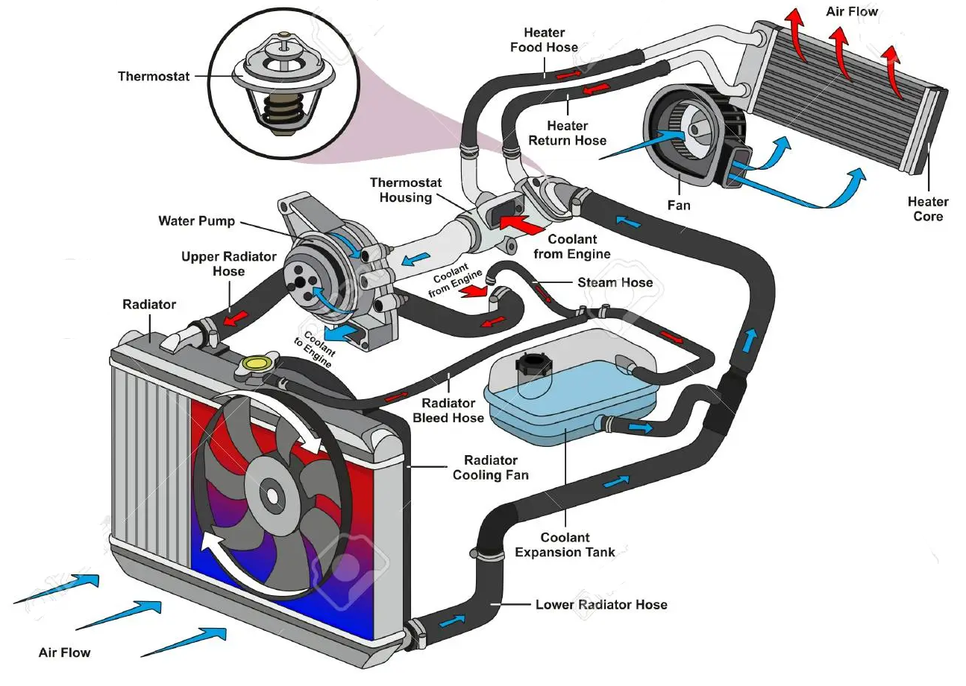
Module Title: - Servicing Cooling System
Module code: EIS HEM2 M02 1122
Nominal duration: 40 Hour
Prepared by: Ministry of Labor and Skill
December, 2022
Addis Ababa, Ethiopia

Table of Contents
Acknowledgment 4
Acronym 5
Introduction to module 6
Unit one: Over view of cooling system service 7
1.1 Introduction to cooling system 8
1.1.1 Purpose of cooling system 8
1.1.2 Types of cooling system 8
1.2 Cooling system component and their function 13
1.3 Operation of cooling system 25
1.4 OHS requirements 26
1.5 Identified tools and Equipment 26
1.5.1 Hand tools 26
1.5.2 Measuring tools 27
1.5.3 Consumable Materials 28
1.5.4 Workshop equipment 29
Self-check-1 30
Unit Two: Inspect, test and interprets result of cooling system and its component 31
2.1 Basic inspection and testing procedures 32
2.2 Inspect and test cooling system components 35
2.3 Record findings and interpreting results 43
Operation sheet 2.1 45
Operation sheet 2.2 47
Operation sheet 2.3 50
LAP Test: 2 51
Unit Three: Service cooling system components 52
3.1 Select methods and techniques servicing cooling system 53
3.2 Adjust, repair and replace system/components 54
Operation sheet 3.1 63
Operation sheet 3.2 64
Operation sheet 3.3 66
Operation sheet 3.4 68
Operation sheet 3.5 70
LAP Test: 3 74
Unit Four: Prepare vehicles for use and documentation 75
4.1 Inspecting and maintain tools equipment 76
4.2 Safe handling and storage of hazardous goods and substances 77
4.3 Workplace documentation and reporting 79
Self-check-4 80
Reference 81

Acknowledgment

Ministry of Labor and Skills wish to extend thanks and appreciation to the many representatives of TVT instructors and respective industry experts who donated their time and expertise to the development of this Teaching, Training and Learning Materials (TTLM).

Acronym

DMM  OEM  OHC  PPE  SAE  SDSs  TTLM  TVT | Digital Multi Meter  Original Equipment Manufacturer  Overhead Camshaft  Personal Protective Equipment  Society of Automotive Engineers  Safety Data Sheets  Teaching, Training and Learning Materials  Technical and vocational Training

Introduction to module
In Automotive field of study; Servicing Cooling System is one of important task the mechanic undertaking during servicing. This module covers the fundamentals of the cooling system, including inspection, testing, and interpreting the results, as well as performing cooling system services, preparing vehicles for use, and creating documentation.
This module is designed to meet the industry requirement under the Heavy Vehicle and Earth Moving Machinery Maintenance level II occupational standard, particularly for the unit of competency: Servicing Cooling System
This module covers the units:
- Overview cooling system service
- Test and inspect cooling system and its components
- Remove and repair cooling system
- Preparing vehicles and equipment for use or storage
Learning Objective of the Module
- Comprehend cooling system
- Perform inspection and test cooling system and its components
- Perform remove and repair cooling system
- Prepare vehicles and equipment for use or storage
Module Instruction
For effective use this modules trainees are expected to follow the following module instruction:
- Read the information written in each unit
- Accomplish the Self-checks at the end of each unit
- Perform Operation Sheets which were provided at the end of units
- Do the “LAP test” giver at the end of each unit and
- Read the identified reference book for Examples and exercise

Unit one: Over view of cooling system service
This unit is developed to provide you the necessary information regarding the following content coverage and topics:
- Introduction to cooling system
- Cooling system component and their function
- Operating principle of cooling system
- OHS requirements
- Identifying tools and equipment
This guide will also assist you to attain the learning outcomes stated in the cover page. Specifically, upon completion of this learning guide, you will be able to:
- Explain cooling system
- Comprehend cooling system component and their function
- Clarify operation of cooling system
- Apply OHS requirements
- Identify tools and equipment

Introduction to cooling system

Purpose of cooling system
The cooling system keeps the engine at its most efficient temperature at all speeds and operating conditions. Burning fuel in the engine produces heat. Some of this heat must be taken away before it damages engine parts. This is one of the three jobs performed by the cooling system. It also helps bring the engine to normal operating temperature as quickly as possible. In addition, the cooling system provides a source of heat for the passenger compartment heater.

1.1.2 Types of cooling system
Engines use either of two types of cooling systems: air cooling and liquid cooling.
- Air Cooling
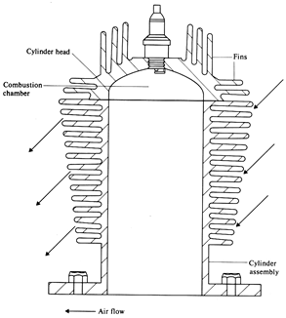
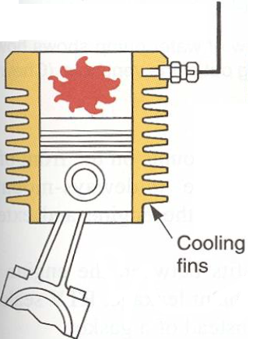
If the engine is air-cooled, excess heat is radiated from the cylinder bores and head directly into the surrounding air. In order to increase the surface area exposed to the cooling effect of the air, fins are formed on the external surfaces of the engine. The fins are cast integrally with the cylinder and cylinder head and act as a means of increasing the amount of radiation surface presented to the cooling air stream. Heat produced by the combustion process passes through the walls of the cylinder and cylinder head to the fins, where it is dissipated into the passing air.
- Direct Cooling
It is the most straightforward method and normally used on motorcycles which have an engine exposed to the air stream on its forward motion and no surrounding bodywork. To improve the thermal conductivity of cylinders and cylinder heads, they are usually alloy castings with cooling fins (in some cases the crankcase also) to maximize the cooling effect.
Drawback: cooling effect depends on vehicle speed & outside temperature
Figure 1-1 Direct air cooled system

- Fan (or) Blower Cooling
Fan cooling enables engines enclosed within bodywork, for instance in cars, trucks and motor scooters, to be adequately cooled. The fan can be mounted directly on the crankshaft or driven by a V-belt.
The cowling (enclosed bodywork) often encloses the engine to control the flow of air over the hotter sections of the engine.
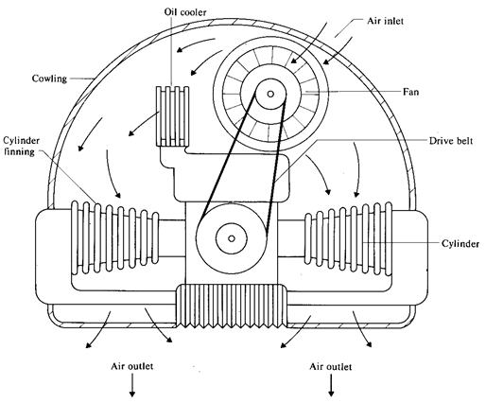
In many arrangements, baffles or deflector plates are located near or between the cylinders to deflect the air through the finning and around the rear of the engine cylinders. A thermostat may be fitted on an air-cooled engine to prevent the fan from forcing air past the engine cylinders until they have reached their normal working temperature. This will take the form of a flap or shutter assembly which is controlled by a thermostatically operated valve.
Figure 1-2 Forced air cooling
Advantages of Air-Cooling system
- simplicity, with no problems associated with water leaks, radiators, water pumps, etc. so that Maintenance is minimum.
- aluminum alloys are generally used for the construction of engine components as they are better heat conductors than cast iron or steel; this ensures that the air-cooled engine is lighter than water-cooled engines.
- reach its normal working temperature in a shorter period than a water-cooled engine
- able to operate at a higher temperature than a water-cooled engine.

Disadvantages of Air-Cooling system
- absence of a sound-muffling water jacket results in noisy engine operation.
- Variations in engine operating temperatures are very difficult to control and lead to temperature variations between different parts of the engine which may result in distortion of major components.
- Since it operates at higher temperatures than other types of engine, greater clearances must be provided between moving parts to allow for expansion.
- A large fan must be provided. Fans of this type absorb engine power when driven by the engine and therefore reduce its effective output.
- The disadvantages of air-cooled engines can be overcome or minimized by careful design. That is why, there are still very few vehicle and all the motorcycles preferred to employ this type of cooling medium. Air-cooling is not generally used for the larger and more highly rated, high-speed engines.
- Liquid-Cooled System
Liquid cooling (indirect air cooling) most popular and efficient method of engine cooling. In this system, heat is removed from around the combustion chambers by a heat-absorbing liquid (Coolant) circulating inside the engine. This liquid is pumped through the engine and, after absorbing the heat of combustion, flows into the radiator where the heat is transferred to the atmosphere. The cooled-liquid is then returned to the engine to repeat the cycle. Excessive cooling capacity can decrease engine efficiency. Therefore, systems are designed to keep engine temperatures within a range where they provide peak performance.
Methods of Circulation
For the efficient and successful operation of a liquid cooling system it is necessary to maintain constant circulation of the coolant under all operating conditions. The simplest method of coolant circulation is the ‘thermo-syphon’ system which depends upon the natural circulation of heated water. An improvement on this basic method of circulation can be found in the modern ‘forced circulation (or) pump assisted’ cooling system which ensures a more positive circulation of the coolant.

- Thermo-Syphon Cooling System
It this simple cooling system, which is rarely used in modern vehicle engines, movement of the coolant depends upon the natural circulation. The water surrounds each of the cylinders,
combustion chambers, valves, etc. As the water in these areas absorbs heat it expands, becomes less dense, and so rises to the top of the radiator, thus making room for cold water from the bottom of the radiator to take its place and so maintain circulation by natural means.
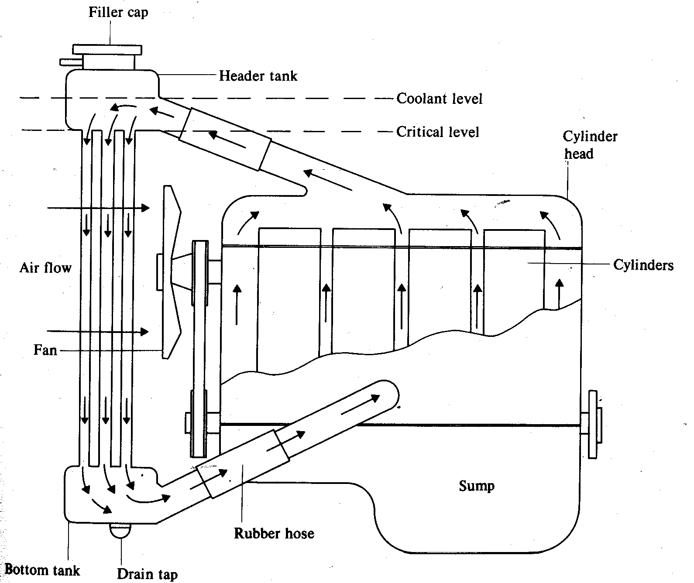
The cooling efficiency of this system can be improved by increasing the speed of air passing through the radiator. This is achieved by a fan located between the engine and radiator, and usually driven by a belt from the engine crankshaft. The cooling fan is essential when the vehicle is moving at low speeds or is stationary (engine idling).
Figure 1-3 Thermo-Syphon water Cooling System
Disadvantages of a Thermo-Syphon cooling system
- To ensure the successful operation of this type of cooling system all coolant passages must be free from obstruction and the connecting pipes and hoses between engine and radiator should be of a large diameter.
- engine cylinder block should be located well below the header tank of the radiator to assist the convection action.
- coolant level is not allowed to fall below the level of the delivery pipe to the radiator header tank. If the water level should fall, circulation will cease.
- speed of circulation is dependent upon coolant temperature, i.e., the hotter the coolant the faster it circulates.
- overall circulation efficiency is relatively low and consequently this method of cooling is unsuitable for modern high-speed engines.
- Although the thermo-syphon system of coolant circulation has the advantage of being simple and relatively efficient in small, low-speed engines, it is unable to provide the circulation rate required for adequate cooling of modern high-powered engines. For these reasons, thermo-syphon cooling is seldom used in modern vehicle design.

- Forced Circulation (or) Pump Assisted Pressurized Cooling System
As a result of the disadvantages associated with the thermo-syphon system, it has been replaced by a pump assisted cooling system. The pump provides for more positive circulation of the coolant and is essential for powerful engines and complex cooling systems
The modern water-cooled engine can be divided into a number of separate elements or components that function together to maintain the engine at its normal operating temperature.
The heat generated by an engine is passed to the coolant contained in the water jacket and can be dissipated by radiation to the surrounding atmosphere. With the advent of more complex cylinder head designs there is danger of local steam pockets being formed around the combustion chamber
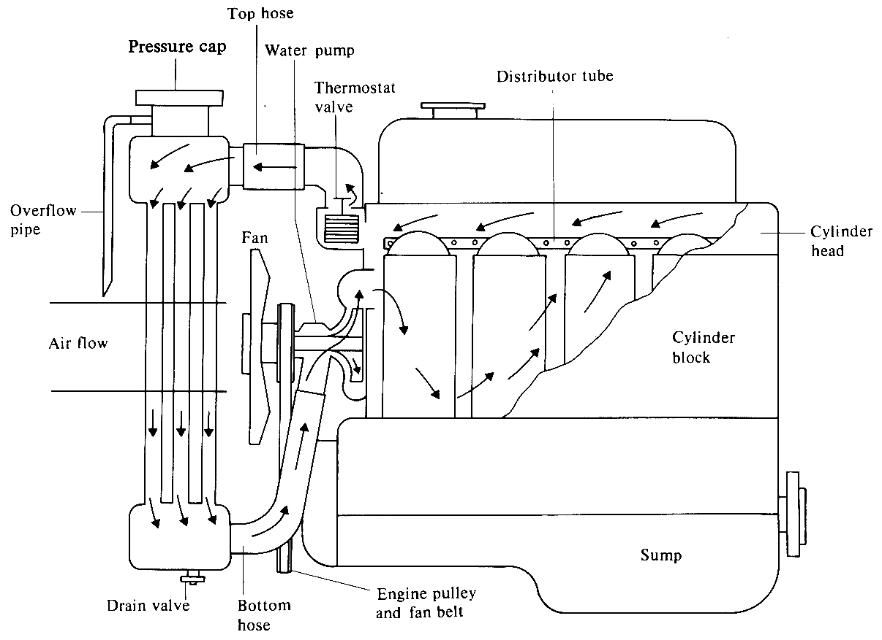
and the valve seats.
Figure 1-4 Forced Circulation (or) Pump Assisted Pressurized Cooling System
If heat is generated faster than it can be radiated, the temperature of the coolant will rise until eventually boiling point is reached. From this point the temperature will no longer increase, but any further heat will be dissipated by converting the coolant into steam. Steam is a poor conductor of heat and should therefore be removed from the engine cooling system as efficiently as possible.
Advantages of a Pressurized Cooling System
- The engine is able to operate at a higher, more efficient temperature without the coolant boiling and producing dangerous steam pockets.
- The actual cooling efficiency of the system is increased by 2.5 per cent for each 6.9kPa increase in pressure since heat dissipation is proportional to the difference between the coolant temperature and the external air temperature.
- By pressurizing the cooling system, water pump efficiency is maintained irrespective of coolant temperature.
- By using the radiator pressure cap to seal the cooling system, losses of coolant by evaporation and surging are prevented. This in turn improves cooling system operation and eliminates the need for frequent topping-up of the radiator.
- As coolant losses are minimized and cooling efficiency is increased, a smaller size of radiator may be used. Alternatively, a smaller cooling fan requiring less engine power may be fitted, therefore improving the effective horsepower of the engine.
- Scale deposits within the cooling system are slow in forming.

1.2 Cooling system component and their function
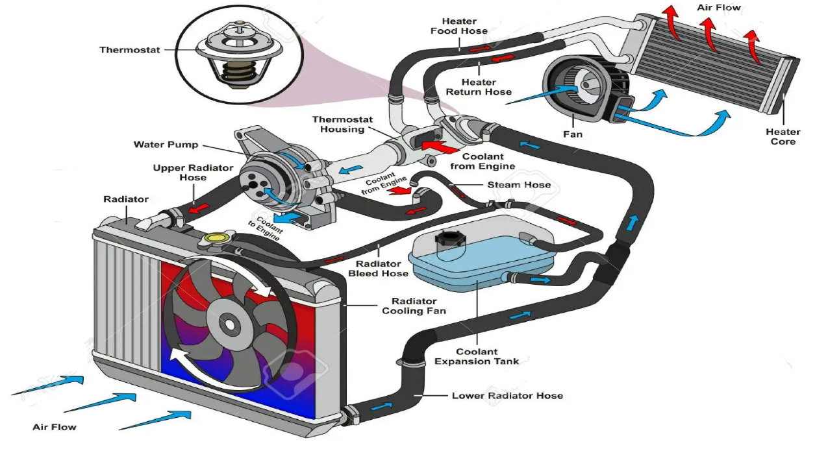

Figure 1-5 component of Cooling system
- Coolant
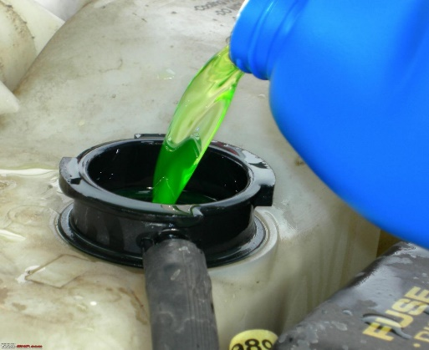
Engine coolant is a mixture of water and anti-freeze/coolant. Engine coolant has a higher boiling temperature and a lower freezing point than water. The exact boiling or freezing temperatures depend on the mixture.
The typical recommended mixture is a 50/50 solution of water and antifreeze/coolant. temperature is controlled by the amount of heat produced by the engine and the cooling system’s ability to dissipate the heat.
Figure 1-6 coolant

Types of Coolant Additives and their Uses
There are three types of coolant additives commonly used in automotive vehicle
- Antifreeze solution – a chemical, usually ethylene glycol, added to the engine coolant to raise its boiling temperature and lower its freezing temperature. Mixing the proper amount of antifreeze with water produces a coolant mixture that is not likely to freeze.
- Anti-rust/corrosion solution – removes and prevents rust and corrosion in the engine cooling system particularly in the water jackets and radiator.
Corrosion and rust can shorten the life of metal parts. It also forms an insulating layer which reduces heat transfer from the metal to the coolant.
- Antifoam solution – helps prevent the coolant from foaming as it passes through the water pump. Foam contains air bubbles which do not conduct heat as well as the liquid coolant. If the coolant foams excessively, the cooling system becomes less effective. The engine could overheat.
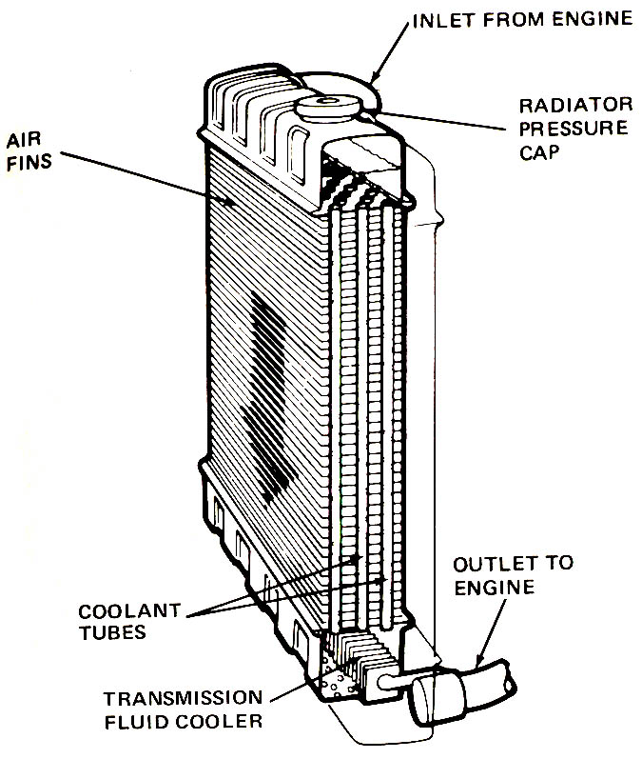
- Radiator
The radiator is basically a heat exchanger, transferring heat from the engine to the air passing through it. The radiator itself is a series of tubes and fins (collectively called the core) that expose the coolant’s heat to as much surface area as possible Attached to the sides or top and bottom of the core are plastic or aluminum tanks One tank holds hot coolant and the other holds the cooled coolant.
Cores are normally comprised of flattened aluminum tubes surrounded by thin aluminum fins. The fins conduct the heat from the tubes to the air flowing through the radiator. Most radiators have drain petcocks or plugs near the bottom. Coolant is added at the radiator cap or the recovery tank.
Figure 1-7 A radiator core is made of a series of tubes and fins that expose the coolant’s heat to as much surface area as possible.
The efficiency of a radiator depends on its basic design, the area and thickness of the core, the amount of coolant going through the radiator, and the temperature of the cooling air.
Today’s radiators are designed to limit the amount of heat dissipated; this keeps the coolant somewhat hot at all times. Keeping engines operating at a high temperature is necessary to maintain low emission levels.
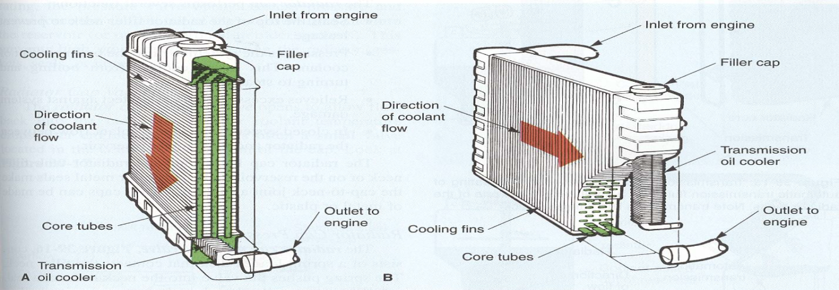
Radiators are normally based on one of two designs: cross flow or down flow. In a cross-flow radiator, coolant enters on one side, travels through tubes, and collects on the opposite side. In a down-flow radiator, coolant enters the top of the radiator and is drawn downward by gravity. Cross-flow radiators are seen most often on late-model cars because all the coolant flows through the fan’s airstream, and the design allows for body designs with lower hood profiles.
Figure 1-8 Down flow Cross flow
- Radiator Pressure Cap
The radiator pressure cap is a removable pressure relief valve and is Located on the radiator header tank. As coolant temperature rises, evaporation and expansion take place and since the system is sealed by the radiator cap, internal pressure builds up within the system. The pressure developed within the cooling system fluctuates between zero and the stated pressure of the cap, according to operating conditions.
The radiator cap performs several functions:
- Seals the top of the radiator filler neck to prevent leakage.
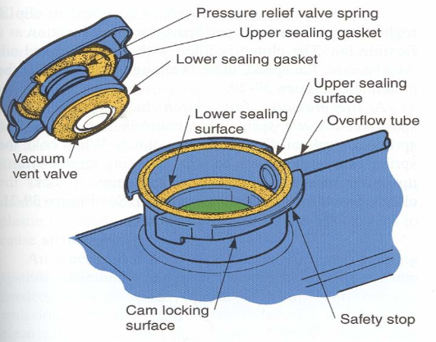
- Pressurizes the system to raise the boiling point of coolant. This keeps coolant from boiling and turning to steam.
- Relieves excess pressure to protect against system damage.
- When cold it prevents the radiator from collapsing by allowing coolant flow to the radiator.
- In closed systems, it allows coolant flow between the radiator and the coolant reservoir (expansion tank).
Figure 1-9 radiator cap

Radiator Cap Pressure Valve
- The radiator cap pressure valve, consists of a spring-loaded disk that contacts the filler neck. The spring pushes the valve into the neck to form a seal and increase the pressure.
- When water is placed under pressure, its boiling point increases.
- But If the engine overheats and pressure exceeds the cap rating, the pressure valve opens. Excess pressure and steam force the coolant out of the overflow tube and into the reservoir (or onto the ground in older systems). This prevents high pressure from rupturing the radiator, gaskets, seals, or hoses.
Radiator Cap Vacuum Valve
- The radiator cap vacuum valve opens to allow flow back into the radiator when the coolant temperature drops after engine is stopped. It is often a small valve located in the center of the bottom of the cap.
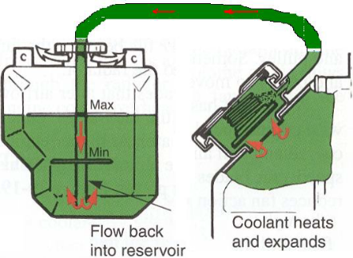
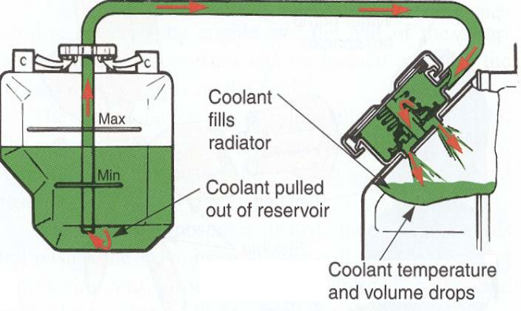
- The cooling and contraction of the coolant and air in the system decrease the coolant volume and pressure. Without a cap vacuum valve, the radiator hoses and radiator tanks could collapse from outside pressure.
Figure 1-10 Pressure Valve Opened vacuum valve opens
- Coolant Hoses
Flows from the engine to the radiator and from the radiator to the engine through radiator hoses. The hoses are usually made of butyl or neoprene rubber hoses to cushion engine vibrations and prevent damage to the radiator.
A hose is typically made up of three parts: an inner rubber tube, some reinforcement material, and an outer rubber cover. Different covers and reinforcements are used depending on the application of the hose. All three parts are bonded together. Basically the difference in hose construction lies in what the hose will carry, where it is located, and the temperature and pressure it will face. Cooling system hoses must be able to endure heavy vibrations and be resistant to oil, heat, abrasion, weathering, and pressure.
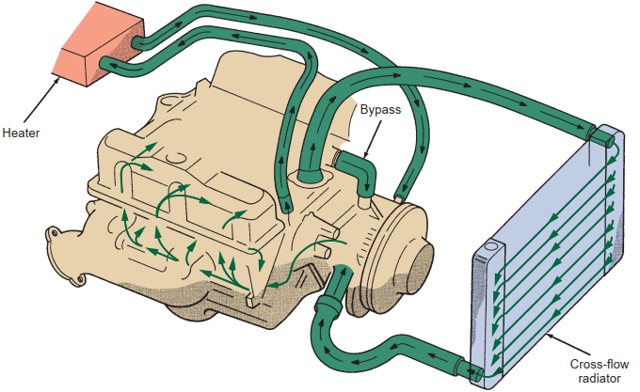
Most vehicles have at least four hoses in the cooling system; some have five or more (Figure 1–11). Two small diameter hoses send hot coolant from the water pump to the heater core and back. Two larger diameter hoses move the coolant from the water pump to the radiator and back into the engine block. The fifth hose is a small diameter bypass hose that allows coolant to circulate within the engine when the thermostat is closed.
Figure 1-11 Routing of coolant through the cooling system hoses
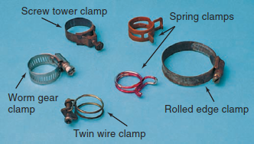
- Hose Clamps
Hoses are attached to the engine and radiator with clamps (Figure 1–12). Hose clamps are designed to apply clamping pressure around the outside of the hose at the point where it connects to the inlet and outlet connections at the radiator, engine block, water pump, or heater core. The pressure exerted on this connection is important to making and maintaining a seal at that point.
Figure 1-12 Common types of hose clamps.
- Belt Drives
Belt drives are used to power the water pump and/or cooling fan on many engines. The belts must be in good condition and properly tensioned in order to drive this at the correct speed.
- Water Pump
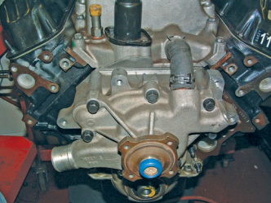
The heart of the cooling system is the water pump. Its job is to move the coolant through the system. Typically, the water pump is driven by the crankshaft through pulleys and a drive belt (Figure 1–13) On some engines the pump is driven by the camshaft, timing belt or chain, or an electric motor. No matter how these units are driven, they all basically work the same way.
Figure 1-13 A water pump bolted to the front of an engine.
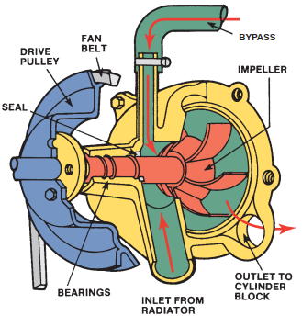
The pumps are centrifugal-type pumps (Figure 1–14) with a rotating impeller to move the coolant. The shaft is mounted in the water pump housing and rotates on bearings. The pump has a seal to keep the coolant from passing through it. The inlet of the pump connects to the lower radiator hose, and its outlet connects to the engine block
Figure 1-14 An impeller-type water pump.
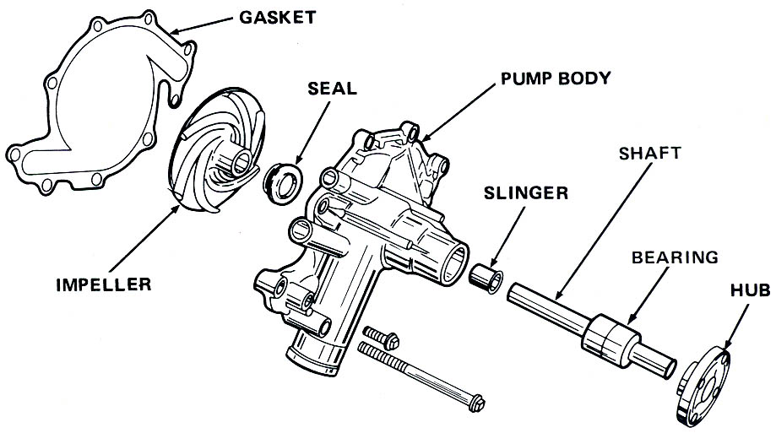
Construction
The pump consists of a number of blades which project from one side of a disc. This disc is called an impeller and is a press fit onto a spindle. The other end of the spindle carries a fan pulley which is driven by a vee belt from the crankshaft. Both spindle and impeller are mounted in a cast-iron or aluminium-alloy casing.
Figure 1-15 construction of water pump

The major parts of a typical water pump include the following:
- Water pump impeller: a disc with fanlike blades that spins and produces pressure and flow.
- Water pump shaft (spindle): steel shaft that transfers turning force from the hub to impeller.
- Water pump seal: prevents coolant leakage between pump shaft and pump housing.
- Water pump bearing: plain or ball bearing that allows the pump shaft to spin freely in the housing.
- Water pump hub: provides mounting place for the belt and fan.
- Water pump housing (body): iron or aluminum casting that forms the main body of the pump
- Fan and Shroud
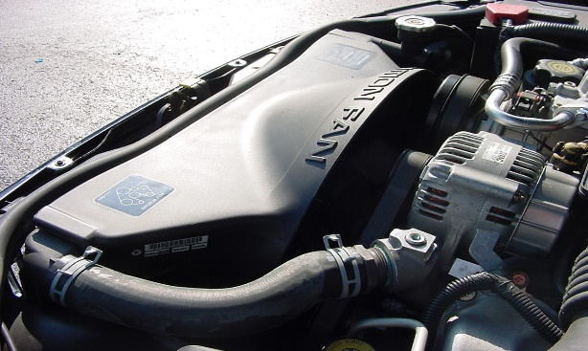
The cooling system fan pulls a large volume of air through the radiator core that cools the hot water circulating through the radiator. The efficiency of the cooling system depends on the amount of heat that can be removed from the system and transferred to the air. At highway speeds, the ram air through the radiator should be sufficient to maintain proper cooling. At low speeds and idle, the system needs additional air. This air is delivered by a fan (Figure 1–16). The fan may be driven by the engine, via a belt, or driven by an electric motor. A belt-driven fan is bolted to a pulley on the water pump and turns constantly with the engine.
Figure 1-16 Fan and shroud

A fan that is placed more than 3 inches from the radiator is ineffective. It merely recirculates hot
air around the fan blades. This is why most radiators are equipped with shrouds.
A shroud is a large, circular piece of plastic, metal, or card board like material that extends outward from the radiator to enclose the fan and increase its effectiveness. These shrouds should always be kept intact and not be modified.
Types cooling fans
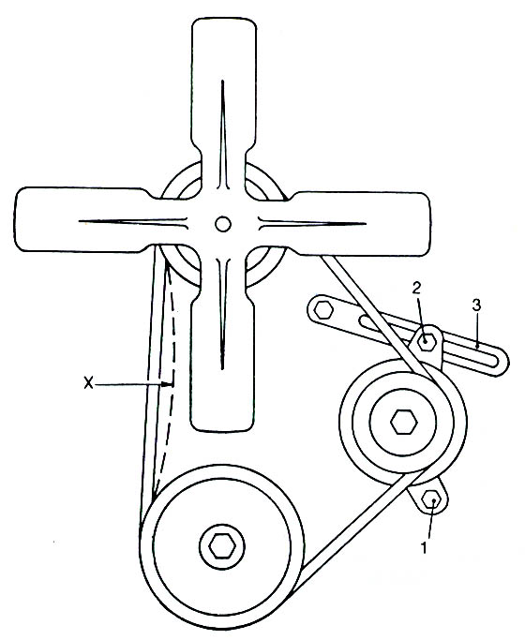
- Mechanical cooling fan
Clutch Fans : have fixed blades. They require a coupler to engage and disengage the fan. This coupler is called the Fan Clutch.
Flex Fans: do not need a clutch. At high rpm, the blades “flatten out.” This achieves the same function as disengaging the fan.
Figure 1-17 Mechanical Belt Driven Fan
However, flex fans require a Fan Spacer. The spacer Properly Locates the Fan in the Shroud to optimize airflow. Some engines have flexible blades or flex-blades that bend or change pitch based on engine speed. That s, at slower speeds the blade pitch is at the maximum. As engine speed increases, the blade pitch decreases as does the horsepower losses and noise levels.
ii) Fluid coupling fan
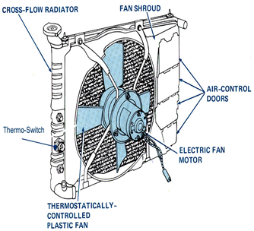
The fluid coupling fan clutch is designed to slip at high speeds, performing the same function as a flexible fan. The clutch is filled with silicone-based oil. Fan speed is controlled by the torque-carrying capacity of the oil. The more oil in the coupling, the greater the fan speed; the less oil in the coupling, the slower the fan speed.
iii) Electric cooling fans
in most late-model applications, to save power and reduce the noise level, the conventional belt-driven, water pump mounted engine cooling fan has been replaced with an electrically driven fan. This fan and motor are mounted to a shroud. The 12-volt, motor-driven fan is electrically controlled by an engine coolant temperature switch and/or the air conditioner switch.
Figure 1-18 Electric Fan
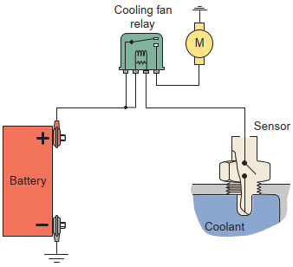
As the schematic in (Figure 1–19) shows, the cooling fan motor is connected to the battery through a normally open (NO) set of contacts in the cooling fan relay During normal operation, with the air conditioner off and the engine coolant below a predetermined temperature of approximately 215°F (101.6°C), the relay contacts are open and the fan motor does not operate.
Figure 1-19 A simple schematic for an electric
When coolant temperatures exceed approximately 230°F (110°C), the coolant temperature switch closes This energizes the fan relay coil, which in turn closes the relay contacts. The contacts provide 12 volts to the fan motor. When the air conditioner select switch is set to any cool position, regardless of engine temperature, a circuit is completed through the relay coil to ground.
This closes the relay contacts to provide 12 volts to the fan motor. The fan then operates as long as the air conditioner and ignition switches are on.
There are many types of electric cooling fans. Some provide a cool-down period, which means the fan continues to run after the engine has been stopped and the ignition switch is turned off. These systems have a second temperature sensor. The fan stops only when the engine coolant falls to a predetermined temperature, usually about 210°F (98.8°C).

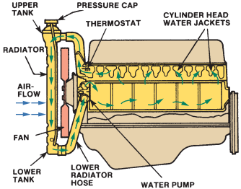
- Water Jackets
Hollow passages in the block and cylinder heads surround the areas closest to the cylinders and combustion chambers (Figure 1–20). Included in the water jackets are soft (core) plugs and a block drain plug. Some engines are equipped with plastic liners that direct coolant flow around critical areas. The soft plugs and drain plugs are usually removed during engine teardown.
Figure 1-20 The cooling system circulates coolant through the engine’s water jackets.

- Thermostat
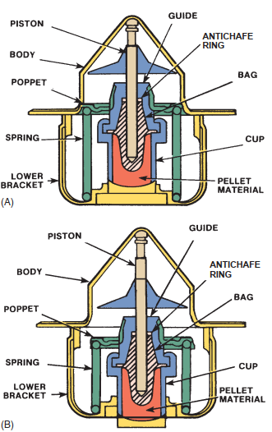
A temperature-responsive coolant flow control valve. It controls the temperature and amount of coolant entering the radiator. While the engine is cold, the thermostat remains closed (Figure 1–21A), allowing coolant to only circulate in the engine. This allows the engine to uniformly warm up. When the coolant reaches a specified temperature, the thermostat begins to open and allows coolant to flow to the radiator.
The hotter the coolant gets, the more the thermostat opens (Figure 1–21B), sending more coolant. Once the coolant moves through the radiator, it reenters the water pump. From there it is pushed through the passages in the engine and the cycle starts again.

The thermostat permits fast engine warmup. Slow warmup causes condensation in the crankcase, which can cause the formation of sludge. The thermostat also keeps the coolant above a specific minimum temperature to ensure efficient engine performance. Thermostats must start to open at a specified temperature—normally 3°F (1.6°C) above or below its temperature rating.
Figure 1-21 (A) Thermostat closed; (B) thermostat open
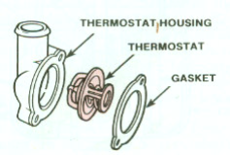
Today’s thermostats have a specially formulated wax and powdered metal pellet contained in a heat conducting copper cup that has a piston inside a rubber boot. Heat causes the wax to expand, forcing the piston outward, which opens the thermostat’s valve. The pellet responds to temperature changes and opens and closes the valve to control coolant temperature and flow.
Today’s thermostats are also designed to slow the flow of coolant when they are open. This prevents the coolant from moving too quickly through the engine. Fast-moving coolant may not have enough time to absorb heat and, therefore, overheating can result.
Figure 1-22 thermostat parts
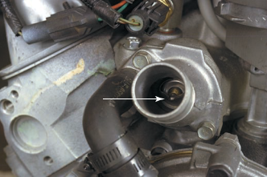
Most thermostats are located on the top and front of an engine (Figure 1–23). The heat element fits into a recess in the block where it is exposed to hot coolant. The top of the thermostat is then covered by the water outlet housing, which holds it in place and provides a connection to the upper radiator hose.

Types of Thermostats
Figure 1-23 A typical thermostat located in the water outlet.
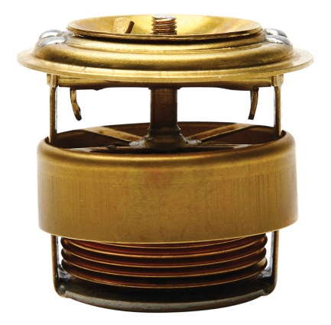
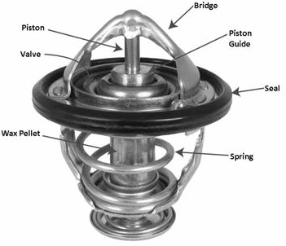
1.Bellows Type Thermostat
Figure 1-24 Bellows type thermostat
The unit comprises a disc valve and seat with the valve attached to a brass bellows. These bellows contain a volatile liquid, which is usually a mixture of methyl alcohol and water, in a partial vacuum. The bellows are supported by a frame assembly which is suspended from the valve seat, the complete unit being held in position by the flange lip, which is clamped between the cylinder head and thermostat top housing.

2.Wax Type Thermostat
In most engines the wax thermostat has almost completely superseded the bellows type. The wax type thermostat has a stronger action and is more reliable in service. It is not affected by normal coolant pressures and is particularly suitable for cooling systems where the operating pressures are in excess of 48 kPa.
The thermostat consists of a temperature sensitive wax compound within a copper capsule. This wax compound also contains a copper powder which improves thermal conductivity. As the coolant temperature increases the wax melts and expands rapidly and uniformly, conversely as the temperature of the coolant is reduced, the wax contracts and solidifies again.
Figure 1-25 Wax type
A bridge section, which is integral with the thermostat flange, provides a strong mounting for the fixed thrust rod, the lower section of the rod being separated from the wax by a moulded synthetic rubber sleeve, which is constructed to withstand high pressures and temperatures. The capsule assembly and spring are located and supported by a frame section.
- Expansion Tank:
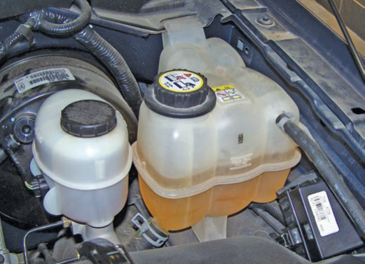
All late-model cooling systems have an expansion or recovery tank (Figure 1–26). Cooling systems with expansion tanks are called closed-cooling systems. They are designed to catch and hold any coolant that passes through the pressure cap. As the engine warms up, the coolant expands. This eventually causes the pressure cap to release. The coolant passes to an expansion tank.
When the engine is shut down, the coolant begins to shrink. Eventually, the vacuum spring inside the pressure cap opens and the coolant in the expansion tank is drawn back into the cooling system.
Figure 1-26 A coolant expansion tank
- Temperature Indicators
Coolant temperature indicators alert the driver of an overheating condition. These indicators are a temperature gauge and/or a warning light. installed in the instrument panel of the vehicle. An abnormal heat rise is a warning of abnormal conditions in the engine. The warning lights alert the operator to stop the vehicle before serious engine damage can occur.
A temperature sensor is threaded into a bore in a water jacket Besides displaying coolant temperatures, temperature sensors supply some important information to the computers in engine control systems.
- Transmission Cooler
Radiators used in vehicles with automatic transmissions have a sealed heat exchanger, or a form of radiator, located in the coolant outlet tank of the engine’s radiator. Metal or rubber hoses carry hot automatic transmission fluid to the oil cooler. The coolant passing over the sealed oil cooler cools the fluid, which is then returned to the transmission. Cooling the transmission fluid is essential to the efficiency and durability of an automatic transmission
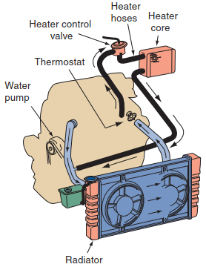
- Heater System
hot liquid passenger compartment heater is part of the engine’s cooling system. Heated coolant flows from the engine through heater hoses and a heater control valve to a heater core located on either side of the fire wall (Figure 1–27). Air is directed or blown over the heater core, and the heated air flows into the passenger compartment. Movable doors can be controlled to blend cool air with heated air for more or less heat.
Figure 1-27 The coolant for the heater core is sent from the upper part of the engine through the heater core and back to the inlet side of the water pump.

Operation of cooling system
Heat is removed from around the combustion chambers by a heat-absorbing liquid (coolant) circulating inside the engine. Coolant then flows to the radiator where the coolant’s heat is transferred to the outside air. A pump moves the coolant through the engine block and then through the cylinder head. A thermostat is used to control operating temperature. When the coolant temperature is below the desired operating temperature, the thermostat is closed, which allows the coolant to recycle through the engine.
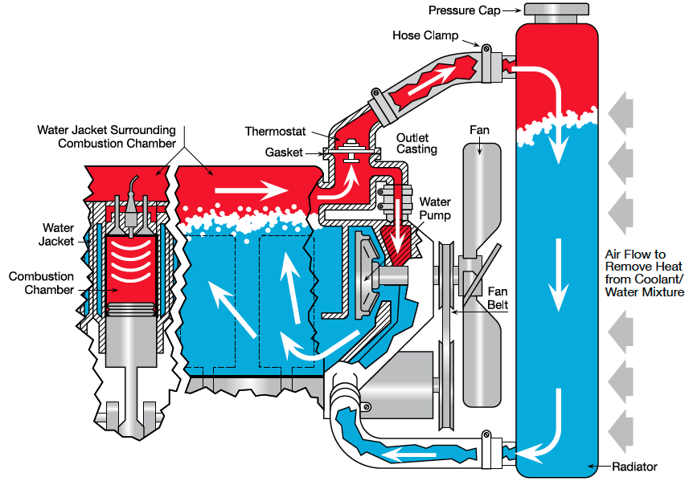
When normal operating temperatures are reached, the thermostat opens to allow the coolant to flow to the radiator. The coolant flows to the top of the radiator and loses heat as it flows down through the radiator. Ram air and the airflow from the cooling fan move through the radiator and cool the coolant. The cooled coolant leaves the radiator and enters the water pump and then is sent back through the engine.
Figure 1-28 cooling system circulation

OHS requirements
- Anyone working on cooling system should become familiar with some basic component and working principles and safety handling before attempting any service.
- Whenever working near running engine keep your hands and clothing away from the stethoscope or rubber tubing to be caught by the moving parts
- The radiator cap should never be removed when the radiator is hot to the touch. When the pressure in the radiator is suddenly released, the coolant’s boiling temperature is reduced. This causes the coolant to immediately boil. Because coolant is a thick liquid, it will stick to your skin and can cause severe burns.
- The radiator should be allowed to cool, or you can force cool it by lightly spraying water on the radiator. When the cap is cool and the engine is shut off, use a cloth over the cap and turn it counterclockwise one-quarter turn to its safety stop and release the pressure. Let the cap remain in this position until all pressure subsides. When all discharge ends, use a cloth over the cap, press it down, and turn it counterclockwise to remove the cap.

Identified tools and Equipment

Hand tools
The following hand tools uses for servicing cooling system
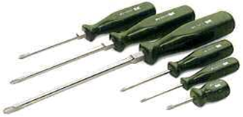
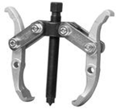
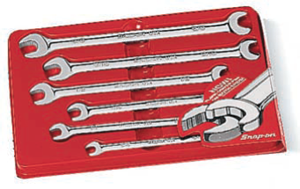
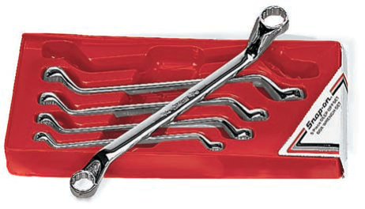
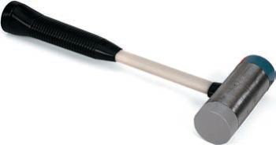
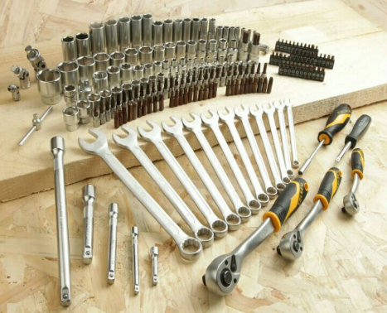

Figure 1-29 Hand tools uses for servicing cooling system

Measuring tools
- Multi meter
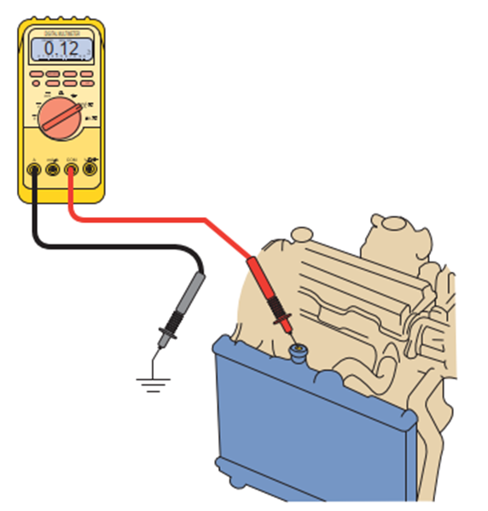
Testing for electrolysis in cooling systems Electrolysis is a process in which an electrical current is passed through water, causing the separation of hydrogen and oxygen molecules. In a cooling system, electrolysis removes the protective layer on the inside of the radiator tubes. It also can cause serious engine failures. Electrolysis occurs when there is improper grounding of electrical accessories and equipment or static electricity buildup somewhere in the vehicle. Checking for these should be a part of all checks of the coolant.
Figure 1-30: Using a square to check dual tire
- Radiator cap pressure test
A radiator pressure tester is the most common tool used to test a cooling system. It is extremely handy for finding the source of any leak in the cooling system. The tester applies pressure to the entire cooling system. A good cooling system should be able to hold about 14 psi (93 kPa) for 15 minutes or more without losing pressure
- Thermometer
The easiest way to check thermostat operation is to measure engine temperature with an infrared thermometer. However, you can use your hand to feel the temperature. Touch the upper and lower radiator hoses when the engine is first started. If the hoses do not become hot within several minutes, the thermostat is not opening.
- Heating plate
A thermostat can be tested by sub merging it in water, heating the water, and observing the temperature at which the thermostat begins to open.
- dye penetrant and a black light
A common way to identify the source of an external leak is to use dye penetrant and a black light. Where the dyed coolant leaks, a bright or fluorescent green color will be seen.
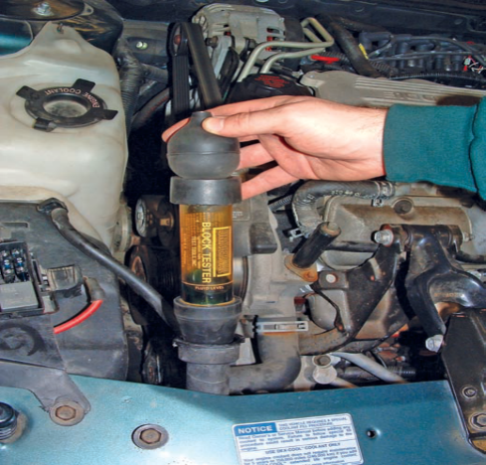
- combustion leak tester
A combustion leak tester is used to determine whether combustion gases are entering the cooling system. This tester is basically a glass tube with a rubber bulb. The tube is fit with a one-way valve at the bottom. To check for combustion gas leaks,
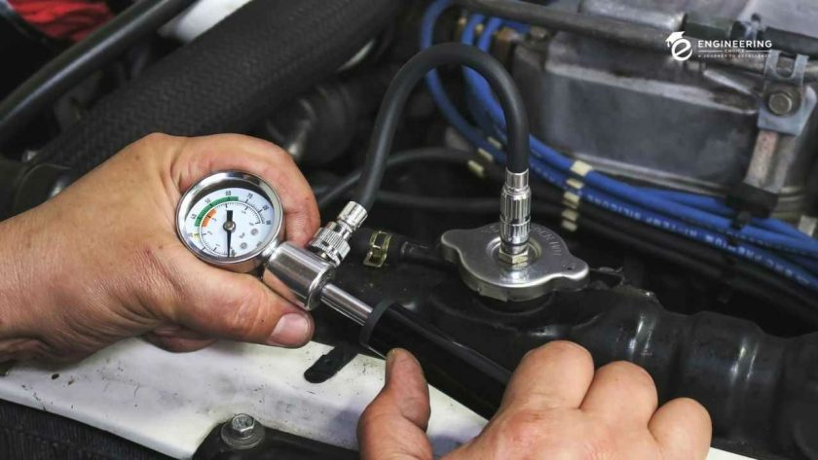
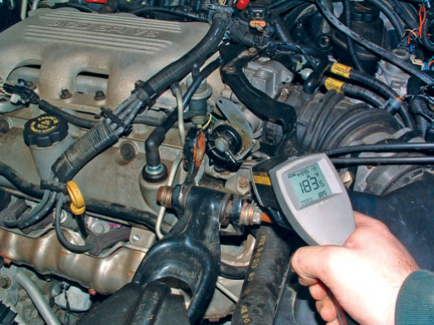
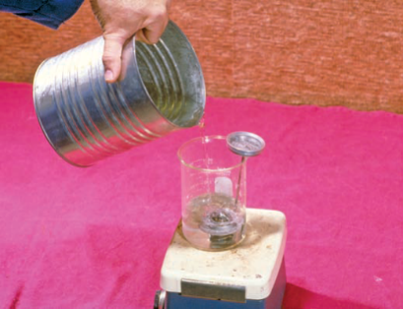
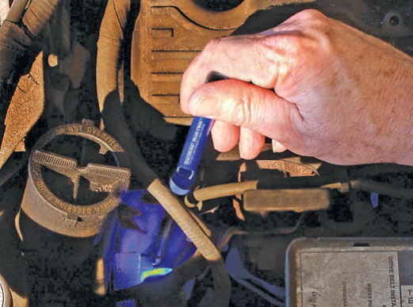
Figure 1-32 Radiator cap pressure tester
Figure 1-33 The operation of a thermostat can be observed with an infrared thermometer.
Figure 1-34 Heating plate
Figure 1-35 dye penetrant and black light
Figure 1-31 combustion leak tester
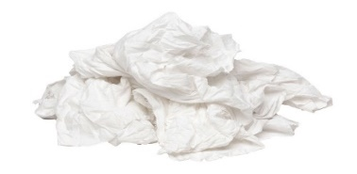
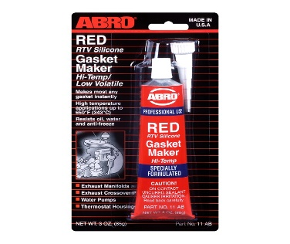

1.5.3 Consumable Materials
A) Rag
a piece of old cloth, especially one torn from a larger piece, used typically for cleaning things.
B) Gasket maker
A thin line of the liquid gasket should be applied around the water passages, and the housing installed before the liquid dries.
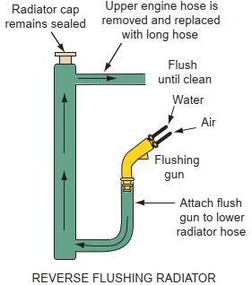

Workshop equipment
- Flushing guns
Flushing guns use compressed air to back flush the system and to break loose layers of dirt and other debris). This method of flushing the system is not recommended on systems that use plastic and aluminum radiators

Figure 1-36 The typical setup for back flushing a cooling system.
- Coolant Exchangers
A coolant exchanger is used to remove old coolant from the system and to put in new cool-ant at the correct mixture. Some coolant exchangers will also leak test the system and flush it. Coolant exchangers are normally powered by shop air, although a few are powered by the vehicle’s battery. Most exchangers move through their cycles with the engine off.
- hydraulic press
A machine press using a hydraulic cylinder to generate a compressive force. to remove and assemble impeller shaft and bearing
- Wheel chocks
Wheel chocks are effective safety devices when used properly.
To ensure maximum safety for both workers and equipment, it is the responsibility of the end user to make the ﬁnal determination about proper chocking of a vehicle under the circumstances presented.
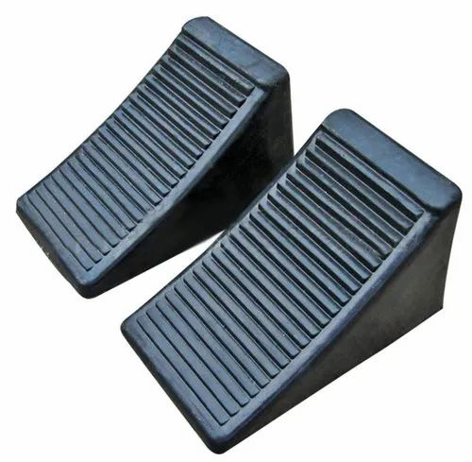
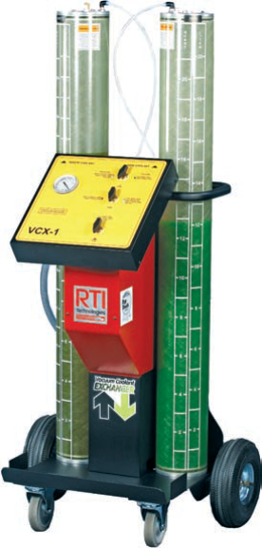
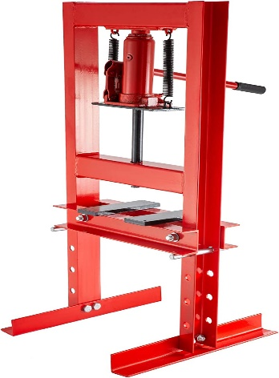

Figure 1-37 A coolant exchanger
Figure 1-39 choke
Figure 1-38 Hydraulic press
Figure 1-39 Wheel chocks

Self-check-1
Part I Instruction: A. True or False. Write true if the statement is true; if false, write false. Get your answer sheet from your trainer.
- From the water pump, the coolant goes into the engine block.
- Coolant returns from the left radiator tank and lower hose to the cylinder head
- When the coolant is cold, the thermostat closes and the coolant continues to flow
- When the engine reaches normal operating temperature, the thermostat closes and the coolant stops to flow.
Part II: select best answer
1. What leak testing instrument is used to locate external leakage of coolant?
a) Exhaust gas analyzer c) Cooling system pressure tester
b) Combustion leakage tester d) Ultraviolet light
2. What makes the coolant circulate in the engine
a) thermostat c) radiator
b) water pump d) radiator hoses
3. Expansion causes coolant to go
a) To the reservoir tank c) To the thermostat
b) On the ground d) In the engine
4. Proper coolant mix Water/Coolant is
a) 60% to 40% c) 50% to 50%
b) 25 % to 25% d) 100% Coolant
5. What is the purpose of the radiator?
a) Help the heater work c) Maintain excessive engine temperature
b) Cause overheat d) Remove heat from the coolant
Part III: short answer
    - What are the two types of cooling system?
    - Discuss working principle of cooling system?
    - Enumerate at least 5 components/parts of the cooling system with their function
    - State difference between two methods of coolant circulation
    - List out tools and equipment needs for cooling system service

Unit Two: Inspect, test and interprets result of cooling system and its component

This unit is developed to provide you the necessary information regarding the following content coverage and topics:
- Basic inspection of cooling systems
- Inspecting and testing cooling systems component
- Interpreting results and report the findings
This guide will also assist you to attain the learning outcomes stated in the cover page. Specifically, upon completion of this learning guide, you will be able to:
- Identify basic inspection of cooling systems
- Perform Inspection and test cooling systems components
- Interpret results and report the findings

2.1 Basic inspection and testing procedures
The cooling system as a whole must be inspected. Visual inspection is one of the methods used to inspect all cooling system components, including belts and hoses.
Listening engine noise is frequently one of the most difficult tasks you can face. The type of sound does not indicate where it came from. sounds can be produced by a variety of engine components. using your ear and a few simple tools, use some simple techniques to find the potential source related to cooling system and make Simple checks, tests, and leak testing. Some engine problems can be detected by fluid leaks.
Inspection of the cooling system should begin with perform visual inspection
- coolant leaks
- loose or missing fan belts
- low coolant level
- water pump noises
- plugged radiator fins,
- coolant in the oil (oil looks milky)
- combustion leakage into the coolant
Cooling System Problems
- Coolant leaks
- Over heating
- Over cooling

- Coolant leaks:
External leaks: most common show up as wet, discolored areas on parts

- Radiator leak
- Loose hose clamp
- Hose leak
- Faulty radiator cap
- Dented radiator inlet of outlet tube
- Cracked or porous water pump housing
- Water core leak
- Loose core hole plug in cylinder block
- Cracked thermostat housing
- Leak at water temperature sending unit
- Cylinder head bolts loosened or tightened unevenly
- Warped or cracked cylinder head
- Cracked cylinder block
- Damaged gasket or dry gasket if engine has been stored
- Coolant reservoir or hose le

Internal leaks: caused by cracked block, cracked head, or blown head gasket Transmission fluid cooler leak
- A blown head gasket can allow combustion gases to enter the coolant
- Mineral deposits in the water jackets can prevent proper heat transfer
- A cracked part or blown gasket can allow coolant to leak into the engine oil
Testing for Leaks
The most common cause of overheating is low cool-ant levels due to a leak. Leaks can occur anywhere in the system. The most common leak points include the hoses, radiator, heater core, water pump, thermostat housing, engine freeze plugs, transmission oil cooler, cylinder head(s), head gasket, and engine block. Often only a visual inspection of the cooling system and engine is necessary to find the source of a leak. The point of the leak may be wet or have a light gray color, the result of the coolant evaporating at that point.
Leak Detection with Dye
Another common way to identify the source of an external leak is to use dye penetrant and a black light. The dye is poured into the cooling system and the engine run until it reaches operating temperature. With the engine off, the engine and cooling system are inspected with the black light. Where the dyed coolant leaks, a bright or fluorescent green color will be seen (Figure 1–35).
Combustion Leak Check
Internal leaks are suspected when there are no visible external leaks but the engine is losing coolant or could not hold pressure during the pressure test.
These leaks are typically caused by a cracked cylinder head or block or a bad head gasket that is allowing coolant to leak into the cylinders or combustion gases leak into the cooling system. Sometimes steam, white smoke, or water in the exhaust, or coolant in the oil or oil in the coolant, will give a hint that there is a bad head gasket.
A combustion leak tester (Figure 1–31) is used to determine whether combustion gases are entering the cooling system. This tester is basically a glass tube with a rubber bulb. The tube is fit with a one-way valve at the bottom. To check for combustion gas leaks, follow this procedure:
A bad head gasket normally results from another problem. Make sure that problem is corrected before replacing the gasket. Bad head gaskets should be replaced as soon as possible. The excessive heat and pressures resulting from this problem are far greater than what a cooling system can handle and can lead to serious engine problems.
- Overheating
The most common cooling system problem is overheating. There are many reasons for this. Diagnosis of this condition involves many steps, simply because many things can cause this problem. Basically, overheating can be caused by anything that decreases the cooling system’s ability to absorb, transport, and dissipate heat: The first step is to determine whether the engine is indeed overheating.
An overheating concern normally begins with high readings on the vehicle’s temperature gauge or the illumination of the temperature warning lamp. These can be caused by a cooling system problem or a faulty temperature sensor, although when the engine is greatly overheating, it is obvious by the steam emitted by the system or by smell. The best way to check the accuracy of the temperature indicators is to measure the temperature of the coolant. If the indicators seem to be wrong, troubleshoot and repair the electrical circuit. Then recheck the system’s temperature.
Normal operating temperature for most engines is 195 to 220°F (91 to 104°C). To maintain this temperature, the coolant must circulate through the engine and radiator. Anything that will interfere with the movement of coolant, such as a faulty water pump or thermostat, or a loss of coolant, will cause overheating. Likewise, anything that interferes with the passing of air through the radiator will also cause the engine to overheat.
Effects of Overheating: Engine overheating can cause the following problems:
- Low coolant level
- Rust or scale accumulation in water jacket
- Stuck thermostat
- Retarded ignition
- Loose fan belt
- Bad water pump or collapsed lower hose
- Missing fan shroud or fan problems

- Over cooling
Engine overcooling is the lowering of the temperature of the engine below the optimum temperature required for the proper combustion. As like overheating, overcooling is also harmful to the engine life and performance.
Causes of engine overcooling:
Here are some reasons because of which the engine may experience the effects of engine overcooling.
1) Improper working of heater during the cold season: - During the winter season, if the heater is not working properly then the engine runs with the effects of overcooling.
2) Thermostat is not working properly: - If the thermostat starts the cooling too earlier or if the thermostat is continuously kept cooling on then the engine becomes overcooled.
3) If the bypass valve remains open: - If the bypass valve of the radiator is open then the coolant will continuously circulate through the circuit and that causes the overcooling of the engine.
4) Locked fan clutch and Shorted fan switch
Temperature Test
A temperature test can be performed with an infrared temperature sensor, thermometer, or temperature probe. The latter may be a feature of a digital multi-meter (DMM). A temperature test allows for monitoring temperature change through the cooling system.
When a cold engine is started, the opening temperature of the thermostat can be observed as the engine warms. This can be compared to specifications to determine if the thermostat is bad. Once the engine has warmed up, the probe can be used to scan for cool
spots in the radiator. These indicate an area where coolant is not flowing freely through the radiator. The cooling fan temperature switch can also be check

Inspect and test cooling system components
- Checking Coolant
One of the first checks of the cooling system is the checking of coolant level and condition. These checks should be done during normal preventive maintenance and when there is a problem.
There are marks on most expansion tanks that show where coolant levels should be when the car is hot and when it is cold. To check coolant levels on a car without a recovery tank, remove the radiator cap (when the engine is cold) and see if the coolant is up to where it should be.
If there are no markings, make sure the coolant is covering the radiator core. If the coolant level is low after repeated filling, there is probably a leak in the cooling system. The condition or effectiveness of the coolant should be checked with a hydrometer, a refractometer, or alkaline test strips.
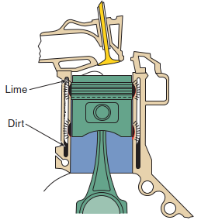
The proper mixture of water and antifreeze also reduces the amount of rust and lime deposits that can form in the system. These deposits tend to insulate the walls of the water jackets. As a result, the coolant is less able to absorb the engine’s heat at the points where there is scale. This causes engine hot spots that result in increased component wear and make overheating more likely (Figure 2– 1). Regardless of the mixture of the coolant or the type of antifreeze used, some lime, rust, and scale will always build in a cooling system.
Figure 1-1 Lime and dirt buildup in the coolant passages tend to insulate the walls of the water jackets and can cause hot spots that result in increased wear and make overheating more likely.
- Radiator Checks
Cold spots on the radiator indicate internal restrictions. In most cases, this requires removal of the radiator so it can be deeply flushed or replaced. Normal cooling system flushing will normally not remove the restrictions. The restrictions are typically caused by internal corrosion or a buildup of scale and lime.
The radiator should also be inspected for external restrictions and for evidence of leaks. Dirt, bugs, and other debris on the surface of the radiator will block airflow. These should be removed by careful cleaning. Also, check for loose cooling fins. Salt and other road debris can corrode the solder used to attach the fins around the radiator’s tubes. When the fins are not attached to the tubes, heat is not as easily transferred to the outside air.
- Inspect Radiator Pressure Cap
Remove the cap from the tester and visually inspect the condition of the cap’s pressure valve and upper and lower sealing gaskets. If the gaskets are hard, brittle, or deteriorated, the cap may leak when exposed to hot, pressurized cool-ant. It should be replaced with a new cap in the same pressure range.
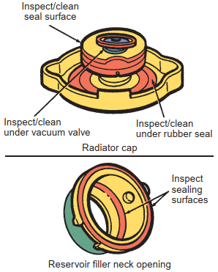
The opening pressure of the radiator cap should be measured and the cap checked for gasket cracking, brittleness, or deterioration (Figure 2–2).
Testing the Radiator Pressure Cap
A radiator pressure tester is the most common tool used to test a cooling system. It is extremely handy for finding the source of any leak in the cooling system. The tester applies pressure to the entire cooling system. A good cooling system should be able to hold about 14 psi (93 kPa) for 15 minutes or more without losing pressure. The procedure for using a pressure tester is given in (operation sheet 2.2)
Figure 1-2 Radiator cap inspection
Over time the spring in the cap can weaken and will lower the coolant’s boiling point. This will cause the engine to lose coolant through the overflow tube whenever it gets hot. Also check the sealing surfaces in the radiator filler neck.
An internal leak caused by a bad head gasket can be verified with the pressure tester. Relieve all pressure in the cooling system. Install the pressure tester onto the radiator filler neck and start the engine. Allow the engine to idle and watch the gauge on the tester. If the pressure begins to build, it is more than likely that the head gasket is blown and combustion gases are entering the coolant.
- Checking Hoses
Carefully check all cooling hoses for leakage, swelling, and chafing. Also replace any hose that feels mushy or extremely brittle when squeezed firmly (Figure 2–3). When a hose becomes soft, it is deteriorating and should be replaced before more serious problems result. Hard hoses will resist flexing and may crack rather than bend and should be replaced.
Normally, hoses begin to deteriorate from the inside. Pieces of deteriorated hose will circulate through the system until they find a place to rest. This place is usually the radiator core, causing clogging. Deterioration can also cause leaks. Any external bulging or cracking of hoses is a definite sign of failure. When one hose fails, all of the others should be carefully inspected.

The upper radiator hose has the roughest service life of any hose in the cooling system. It must absorb more engine motion than any of the other hoses. It is exposed to the coolant at its hottest stage, and it is insulated by the hood during hot soak periods. These conditions make the upper hose the most likely to fail.
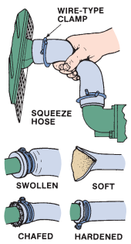
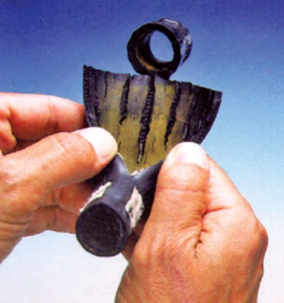
Check the firmness of the lower radiator hose to make sure that the internal reinforcement spring is in place and not damaged. Without this reinforcement, the hose can collapse under vacuum at high engine speeds and restrict coolant flow from the radiator to the engine. Squeeze each hose and look for splits. These splits can burst wide open under pressure. Also look for rust stains around the clamps. Rust stains indicate a leak, possibly because the clamp has eaten into the hose. Loosen the clamp, slide it back, and check the hose for cuts.
Figure 1-3 Defects in cooling hoses.
A major cause of hose failure is an electrochemical attack on the rubber hose. This is known as electrochemical degradation (ECD). It occurs because the hose, engine coolant, and the engine/radiator fittings form a galvanic (battery) cell. This chemical reaction causes very small cracks in the hose, allowing the coolant to attack and weaken the reinforcement in the hose (Figure 2-3). ECD can cause pinhole leaks or hose rupture under normal operating pressures. The effects of ECD are accelerated by high temperatures and vibrations.
- Belt Drives
Figure 1-4 An ECD-damaged hose
Belts tend to over cure due to excessive heat. This causes the rubber to harden and crack. Excessive heat usually comes from slippage. Slippage can normally be attributed to lack of proper belt tension or oily conditions. When slippage occurs heat not only over cures the belt, it also travels through the drive pulley and down the shaft to the support bearings. These bearings might be damaged if the slippage is allowed to continue. As a V-belt wears, it begins to ride deeper in the pulley groove. This reduces its tension and promotes slippage. Carefully inspect all drive belts and replace them as necessary. Common signs include cracks or frayed nylon cords in the belt, squealing noises, and a burning rubber smell from the engine
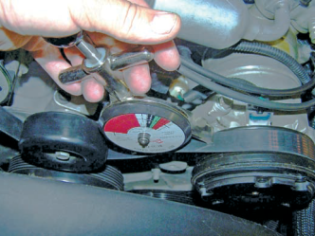
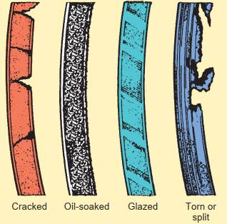
Figure 1-6 Check the tension of a drive belt with a belt tension gauge.
Figure 1-5 Drive belts should be inspected
- Water Pump Checks
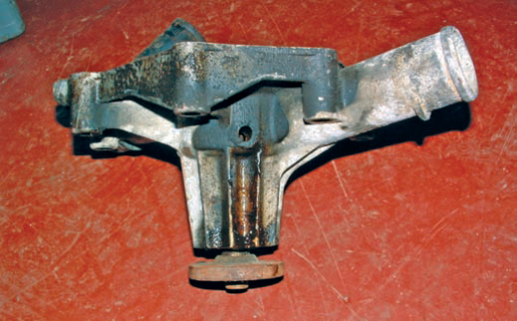
Water pumps are driven by a belt, the crankshaft or camshaft, or by an electrical motor. A water pump pulls coolant from the radiator and pushes it through the engine. If the water pump is not working properly, the engine will quickly overheat. Seldom does a pump merely stop working. Problems with a pump are normally noise or leakage. An exception to this is electrically operated pumps. Electric problems can cause the pump to totally stop. The cause of these problems is identified by troubleshooting the circuit.
The majority of water pump failures are attributed to leaks. When the pump bearings and seals begin to fail, coolant will seep out of the weep hole in the casting or through the outer seal (Figure 2–7). The seals may be worn out due to age or abrasives in the system, or they may have cracked because of thermal shock, such as adding cold water to an overheated engine
Figure 1-7 This pump shows signs of bad leaks.
Other failures can be attributed to bearing and shaft problems and an occasional cracked casting. Water pump bearing or seal failure can be caused by surprisingly small out-of-balance conditions that are difficult to spot. Look for the following: a bent fan, a piece of the fan missing, a cracked fan blade, a dirty fan-mounting surface, and a worn fan clutch. Any wobble of the pump shaft or fan means the pump and/or fan should be replaced.
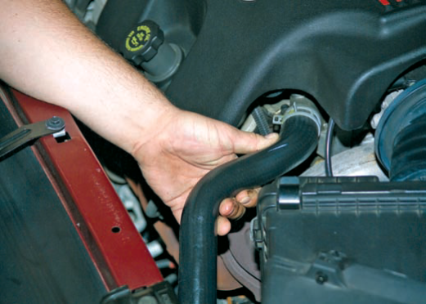
Through time, the impeller blades may corrode or come loose from the shaft. Both of these situations will cause the pump not to work and it must be replaced. In less extreme cases, corrosion may cause the impeller to be loose on the shaft and not rotate all of the time. This can cause an intermittent cooling problem. Unfortunately, the only sure way of knowing the condition of the impeller is to remove the pump and inspect it. To check the operation of the water pump, start the engine and allow it to warm up. Squeeze the upper radiator hose (Figure 2–8) and accelerate the engine. If a surge is felt in the hose, the pump is working.
Figure 1-8 accelerating the engine. If a surge is felt in the hose, the pump is working.

Air in the cooling system can prevent the pump from working properly. To check for the presence of air, attach one end of a small hose to the radiator overflow outlet and put the other end into a jar of water.
Then make sure all those connections are tight, and the coolant level is correct. Run the engine and bring it to its normal operating temperature. Then run the engine at a fast idle. If a steady stream of bubbles appears in the jar, air is getting into the system.
- Checking Fans and Fan Clutches
The cooling fan is a very important part of the cooling system. Most engine-driven fans have a clutch, and most overheating problems are caused by a defective clutch. However, the fan itself as well as the fan shroud must be thoroughly checked. The fan shroud should be securely fastened to the radiator bracket. The shroud should also be checked for cracks and other damage. A damaged shroud should be replaced.
Any damage or distortion to the fan will cause it to be out of balance. This can cause major problems, including rapid and excessive water pump bearing and seal wear or damage to the radiator if the fan blades hit the radiator. A noticeable wobble as the fan spins means that the fan should be replaced.
Fan clutches are filled with silicone oil. The oil responds to speed and temperature. As the engine increases speed, the oil allows the fan to slip on its hub. This reduces the drag on the engine. If the clutch allows the fan to slip during low engine speeds
overheating can occur. A loss or deterioration of the oil will cause fan slippage. Over time, the oil begins to break down and offers less of a coupling between the fan and hub. It is said that the life of a fan clutch is about the same as that of a water pump and when one needs replacing, the other should also be replaced.
The clutch assembly should be carefully checked for leakage. Oily streaks radiating outward from the hub shaft mean that fluid has leaked out past the bearing seal. A leaking clutch should be replaced. The clutch should also be replaced if the fan can be spun with little or no resistance with the engine off, if the clutch wobbles when the fan is moved in or out, or if there are damaged or missing fins on the assembly.
Electric Cooling Fans
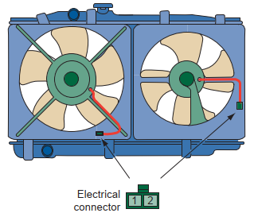
The action of the electric cooling fan should be observed. However, before doing so, check the mounting of the fan assembly and the condition of the fan blades. The fan should be energized when the A/C is turned on and when the cool-ant reaches a specified temperature. If the fan does not turn on when it should, check the motor. Do this by connecting the motor directly to the battery. If the motor runs, the problem is in the motor’s control circuit. Diagnosis of this problem should follow the prescribed sequence given by the manufacturer. If the jumped motor does not run, the problem is the fan motor (Figure 2–9).
Figure 1-9 Test each fan motor by connecting battery power to terminal 1 and a ground to terminal 2. If
- Testing the Thermostat
Thermostats are often the cause of overheating or poor heater performance. They can also cause an increase in fuel consume Electronic engine control systems are programmed to deliver the ideal air-fuel mixture and ignition timing according to the engine’s operating conditions.
A properly working thermostat is closed when the engine is cold and the coolant’s temperature is lower than the thermostat’s rating. Once the coolant reaches the opening temperature of the thermostat, the thermostat opens and allows coolant to flow to the radiator. The hotter the coolant gets, the more the thermostat opens, allowing more coolant to flow through the radiator. If the thermostat is stuck open, the coolant may not reach the desired temperature because it is cooled before it gets hot. If a thermostat is stuck closed because it failed or because there is a steam pocket below the thermostat, coolant will not flow between the engine and the radiator; the engine will, therefore, quickly overheat. The presence of steam results from low coolant levels or air in the system.
The easiest way to check thermostat operation is to measure engine temperature with an infrared thermometer (Figure 1–33). However, you can use your hand to feel the temperature. Touch the upper and lower radiator hoses when the engine is first started. If the hoses do not become hot within several minutes, the thermostat is not opening.
Another way to test a thermostat is to remove it and totally submerge it in a small container of water so that it does not touch the bottom (Figure 1–35). Place a thermometer in the water so that it does not touch the container and only measures water temperature. Heat the water. When the thermostat begins to open, read the thermometer. This is opening temperature of the thermostat. Then remove the thermostat from the water and allow it to cool. If the valve stays open after the thermostat is removed from the water, the thermostat is defective and must be replaced.
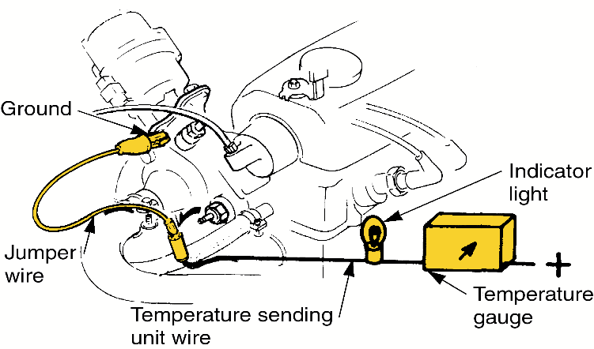
- Gauge or Indicator Light Test
- Disconnect the wire from temperature sending unit
- Turn the key on, ground the wire
- If the gauge sweeps or the light glows as the wire is grounded, the sender may require replacement
Figure 1-6 temperature indicator light testing

record findings and interpreting results
Cooling system inspection report
Name: _______________________ VIN: __________________ millage: ________________
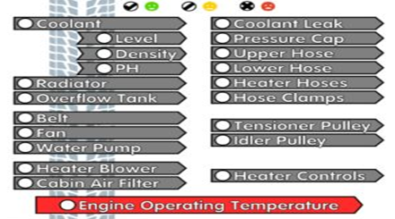
Make: _______________________model: __________________ year: _________________

Comment ______________________________________________________________________________________________________________________________________________________________________________________________________________________________________________________________________________________________________.
Inspected by: ________________________ Date: ______________

Interpretation result
No | Task | Cause | Interpret | Preferred Corrective Actions
1 | Found leaks
2 | cooling system pressure tests; check coolant condition; inspect and test radiator, pressure cap, coolant recovery tank, and hoses
3 | Verify engine operating temperature
4 | Inspect and test mechanical/electrical fans, fan clutch, fan shroud/ducting, air dams, and fan control devices

Operation sheet 2.1
Operation Title: cooling system inspection
Instruction:
- Safe working area
- Properly operated tools and equipment
- Appropriate working cloths fit with the body
Purpose: Properly testing cooling system pressure
Required tools and equipment: vehicle
Consumable Materials: rag, coolant
Precautions:
- Wearing proper clothes and eye glass
- to avoid the danger of being burned, do not remove the reservoir the cap while the engine and radiator are still hot, as fluid and steam can be blown out under pressure.
Quality criteria: - The servicing procedure meet the OEM standards
Procedures:
Perform all activities to check the condition of in accordance with the given procedures
    - coolant level and quality
- check the coolant level when the engine is cold.
- check engine coolant level at reservoir
  - the engine coolant level should be between the” low” and” full” line.
  - if low, check for leaks and add” coolant” or equivalent up to the” full” line.
- check engine coolant quality
(a) remove the reservoir cap.
(b) there should not be any excessive deposits of rust or scale around the reservoir cap or reservoir filler hole, and the coolant should be free from oil. if excessively dirty, replace the coolant.
(c) reinstall the reservoir cap.
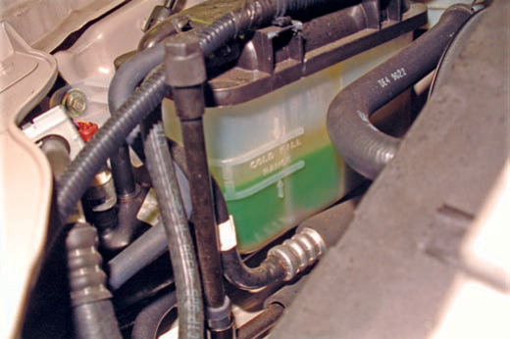

The level of coolant in the cooling system should be checked at the coolant recovery tank.

- Inspect drive belts for:
- Proper tension. They should not be too loose or too tight. Adjust belts required.
- Fraying, glazing, oil, grease, cuts, breaks, and other damage. Replace defective belts.

3. Inspect radiator hoses, heater hoses, and coolant bypass hoses for:
a. Loose or broken clamps. Tighten screw type clamps if needed; replace defective clamps.
b. Cracks or brittleness. Head and ozone in the air cause hoses to harden. Replace cracked or brittle hoses.
c. Swelling and softness. Grease, oil, and hot coolant can soften hoses. Squeeze them with your hand and replace any that are spongy.

Operation sheet 2.2
Operation Title: cooling system pressure test
Instruction:
- Safe working area
- Properly operated tools and equipment
- Appropriate working cloths fit with the body
Purpose: Properly testing cooling system pressure
Required tools and equipment: Radiator cap pressure test, vehicle
Consumable Materials: rag
Precautions:
- Wearing proper clothes and eye glass
- Make working area hazard free
Quality criteria: - The servicing procedure meet the OEM standards
Procedures:
Perform all activities to check the condition of in accordance with the given procedures
1. cooling system pressure test
- Remove the radiator cap.
- Top off the coolant level.
- Connect the tester to the radiator’s filler tube and apply pressure to the system by pumping the handle of the tester.
- Once the pressure is equal to the rating of the pressure cap, watch for a pressure decrease and look for leaks.
- Using the appropriate adapter, mount the pressure cap to the tester.
- Apply pressure to the cap that is equal to the cap’s rating. If the cap does not hold that pressure, replace it. Then apply more pressure. If the cap is good, the excess pressure will vent through the cap.
- Correct any leaks and top off the fluid level.
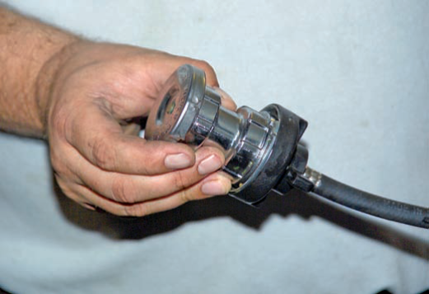
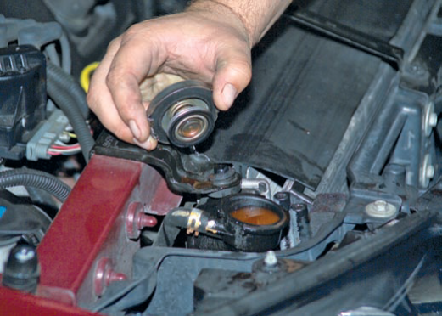
1.
5.

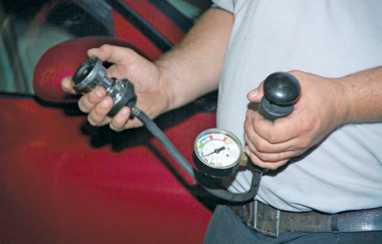
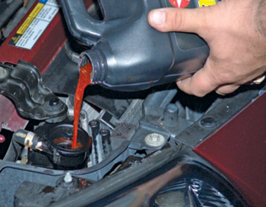
6.

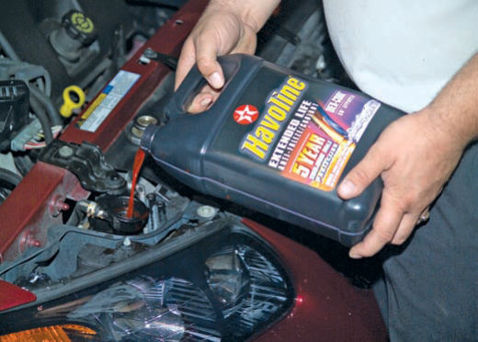
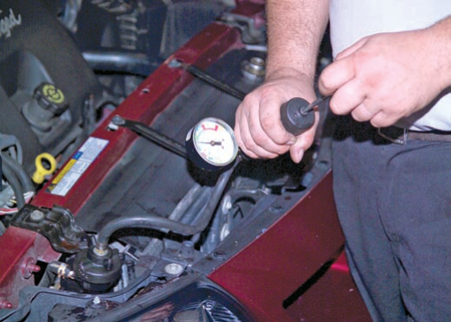
- 7.

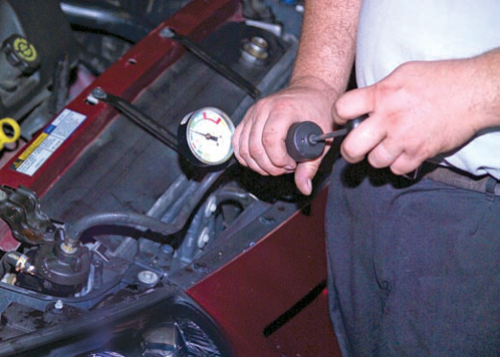

- Combustion Leak Test
Instruction: test for exhaust leakage into the cooling system with the same pressure tester you used to check system pressure
Perform activities to check the condition of in accordance with the given procedures
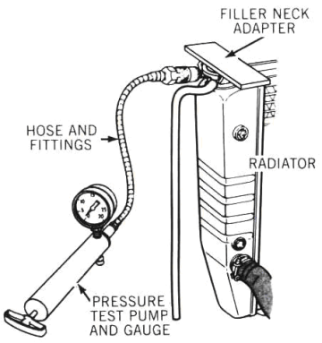
1. Run the engine to normal operating temperature. Do not turn it off.
2. Observing necessary precautions, carefully remove the radiator cap.
3. Install the sealing ring in the filler neck and attach the tester to the radiator with the relief valve open, Figure.
4. Close the tester relief valve and watch the gauge.
5. If the gauge reading rises quickly, there is a large exhaust leak into the system. If the gauge reading does not increase rise, operate the pump until the gauge reads within the pressure range of the cap but below the maximum specification. If the needle vibrates, there is a small exhaust leak. If the needle is steady, there is no leak.
6. Isolate the source of a leak by shorting each spark plug. Gauge needle vibration will decrease when you short the leaking cylinder.

Operation sheet 2.3
Operation Title: inspect thermostat
Instruction:
Conditions or situations for the operations:
- Safe working area
- Properly operated tools and equipment
- Appropriate working cloths fit with the body
Purpose: Checks for the presence of combustion gases in the coolant
Required tools and equipment: thermometer, vehicle
Consumable Materials: rag
Precautions:
- Wearing proper clothes and eye glass
- Make working area hazard free
Quality criteria: - The servicing procedure meet the OEM standards
Steps in doing the task
Perform all activities to check the condition of in accordance with the given procedures
Testing a thermostat on the vehicle
The fastest basic check is with thermostat installed. You can measure system temperature with a thermometer.
1. With the engine cold, remove the radiator cap and add coolant if necessary to bring it to the proper level.
2. Place a thermometer in the filler neck.
3. Start the engine and watch the thermometer and coolant circulation in the radiator tank as the engine warms up. You can speed the warm up by blocking the front of the radiator or the grille with a fender cover until the engine reaches normal working temperature.
4. You will see coolant start to circulate in the top of the tank when the thermostat opens.

LAP Test: 2
Task 1: visual inspect cooling system
Task 2: perform cooling system pressure test and combustion leak test
Task 3: inspect thermostat

Unit Three: Service cooling system components
This learning guide is developed to provide you the necessary information regarding the following content coverage and topics:
- Select methods and techniques servicing cooling system
- Adjust and replace system/components
This guide will also assist you to attain the learning outcomes stated in the cover page. Specifically, upon completion of this learning guide, you will be able to:
- Apply different methods and techniques to servicing cooling system
- Carry out system/component adjustments and replacements

3.1 Select methods and techniques servicing cooling system
Cooling system is very vital in an engine, service must be ensured to save the life of the engine as well as the cooling system.
Choosing tools and equipment and the kinds of repairs they will allow you to complete.
There are three main types of activities to perform on your customers’ vehicles: Service, diagnosis and repair.
Cooling system service is generally made up of the activities that are performed on a functional car or truck as part of preventive maintenance or based on the OEM’s recommendations for service at specific time or mileage intervals. This service should include at the very least, a visual inspection of the cooling system, an analysis of the coolant, a pressure and performance test, and replacement of the vehicle’s coolant.
The visual inspection can take a couple of different paths depending on whether the customer mentioned any unusual conditions
The most common service that can be performed is draining, flushing and refilling engine with fresh antifreeze coolant periodically. Doing so, there are numbers of additives in the antifreeze that help to prevent corrosion in the cooling system.
As manufacturers will always indicate, using ordinary coolant will cause corrosion which tends to increase when several types of metal interact with each other. This will cause a scale that eventually develops and begins to clog the thin flat tubes in the heater core and radiator. The engine will eventually overheat when such happens.
Antifreeze is very important as vehicle users must take note of their functions in their cooling system. Since it will increase the lifespan of the engine and also save them some money. The antifreeze formulation can serve for five years or 150,000 miles before replacement. It’s usually reddish and greenish in color.
As reverse-flush cooling system required professional and special equipment, ensure the operation is carried in the right mechanic workshop. During the service process, some important components like a thermostat, radiator pressure cap, water pump, etc. should be tested, if weak ensure change them
A pressure test should be performed to identify any external leaks in the cooling system parts. Parts like the radiator, coolant passage, heater hoses, and heater core. The engine fan should also be in good working operation.

3.2 Adjust, repair and replace system/components
Service to the cooling system entails replacing leaking or broken parts as well as emptying, flushing, and refilling the system. One of the common services is replacing the drive belt. Belts are a common wear item and should be installed at the correct tension. A loose belt will slip and prevent the water pump from moving coolant fast enough through the engine and/or turn the fan fast enough to cool the coolant.
The water pump on many late-model engines is driven by the engine’s timing belt or chain. When replacing the water pump on these engines, always replace the timing belt. Make sure all pulleys and gears are aligned according to specifications when installing the belt.
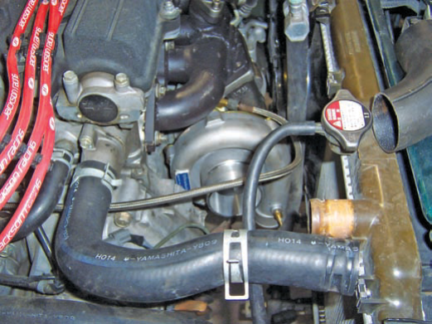
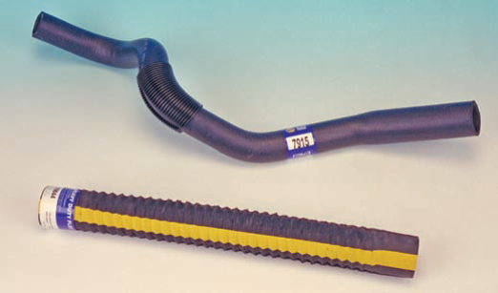
Replacement hoses must be made of the right material and have the correct diameter, length, and shape. The hose’s part number is often printed on the outside of the hose and replacement hoses should match or correspond to those numbers
Figure 3-1 Nearly all radiator hoses have a part number painted on the outside of the hose. These should be used when replacing a hose.
Nearly all OEM hoses are of the molded, curved design. Lower radiator hoses are normally wire reinforced to prevent collapse due to the suction of the water pump. Molded hoses designed to fit many applications are often sold. The hose is cut to fit a specific application. Some have printed cutoff marks on them to show where they should be cut. Others should be compared to the old hose for a cut reference.
Aftermarket hoses are either molded or flex types (Figure 3–2). A flex-type hose allows greater vehicle coverage per part number. Flex hoses are available in different lengths and diameters. They can flex or bend into most required shapes without causing a restriction.
Figure 3-2 Aftermarket replacement hoses are either molded (top) or flex types (bottom).
Flex hoses may not be desirable for some systems that require radical bends and shapes. rather than replacing heater hoses with the molded type, formable heater hoses are available. This hose design has a wire spine. The wire spine allows the hose to bend into a curve without collapsing at the bend. Once the desired shape is obtained, the hose is cut to length and then installed.
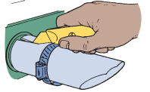
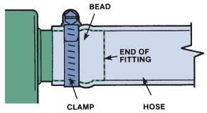
All cooling system hoses are basically installed the same way. The hose is clamped onto inlet-outlet nipples on the radiator, water pump, and heater.
Figure 3-3 Cutting off an old hose.
Figure 3-4 New clamps should be placed immediately after the bead of the fitting.
When replacing a hose, drain the coolant system below the level that is being worked on. Loosen or carefully cut the old clamp. With a knife, carefully cut the end of the old hose (Figure 3–3) so it can slide off its fitting. If the hose is stuck, do not pry it off. You could possibly damage the inlet/outlet nipple or the attachment between the end of the hose and the bead. Simply make more cuts into the hose.
Always clean the neck of the hose fitting or nipple with a wire brush or emery cloth after the old hose has been removed. Burrs or sharp edges can cut the hose and lead to premature failure. Dirty connections will prevent a good seal. Do not reuse spring-type clamps, even if they look good. Slip the hose over its fittings, engine end first. In cold weather, the hose may be stiff; it can be soaked in warm water to make it more flexible. If the hose does not fit properly, remove it and reverse the ends.
Hose Clamps Original equipment clamps are usually spring steel wires that are removed and replaced with special pliers. A worm drive hose clamp is often used as a replacement for many reasons. It provides even pressure around the outside of the hose. It is also easy to install and requires no special tools. It is a good idea to readjust the clamp of a newly installed hose after a brief run-in period. The hose does not contract and expand at the same rate as the metal of the inlet/outlet nipple. Rubber hoses, warmed by the hot coolant and hot engine, will expand. When the engine cools, the fitting contracts more than the rubber, and the hose will not be as secure. This can result in cold coolant leaks at the inlet/outlet nipple. Retightening the clamp eliminates the problem.
Thermostat
When replacing the thermostat, the replacement should always have the same temperature rating as the original. Since 1971, nearly all engines require a thermostat with 192° or 195° ratings. Using a thermostat with a different opening temperature than was originally installed on a computerized engine will affect the operation of the fuel, ignition, and emissions control systems. This is due to the fact that the wrong thermostat can prevent the system from going into closed loop.
Replacement Markings on the thermostat normally indicate which end should face toward the radiator. Regardless of the markings, the sensor end must always be installed toward the engine.
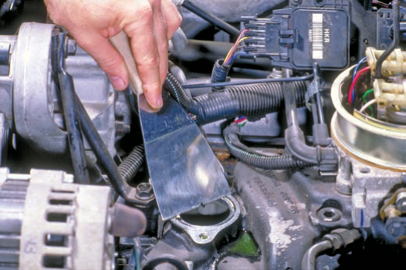
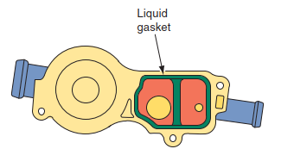
When replacing the thermostat, also replace the gasket that seals the thermostat in place and is positioned between the thermostat housing and the block. Make sure the mating surfaces on the housing and block are clean and free of old gasket material (Figure 3–5). Some housings are sealed with a liquid gasket (Figure 3–6).
Figure 3-5 Make sure all old gasket material is removed before installing a new thermostat gasket and housing
Figure 3-6 Some thermostat housings are sealed with a liquid gasket.
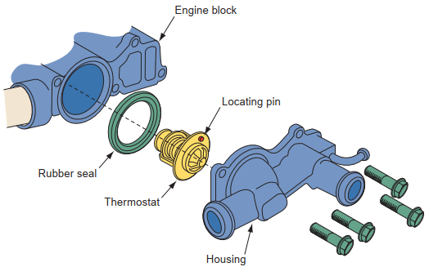

A thin line of the liquid gasket should be applied around the water passages, and the housing installed before the liquid dries. Normally there are locating pins on the thermostat that are used to position the thermostat in the block and housing (Figure 3–7).
Figure 3-7 Normally there are locating pins on the thermostat that are used to position the thermostat in the block and housing.
Most thermostats and housings are sealed with gaskets or rubber seals. the gaskets are normally composition fiber material cut to match the thermostat opening and mounting bolt configuration of the housing. Thermostat gaskets generally come with an adhesive backing the backing holds the thermostat securely centered in the mounting flange. This makes it easier to properly align the housing to the block.
Repairing Radiators
Most radiator leak repairs require the removal of the radiator. Coolant must be drained and all hoses and oil cooler lines disconnected. Bolts holding the cooling fans and radiator are then loosened and removed.
The actual radiator repair procedures depend on its construction and the type of damage. Most repairs are made by radiator specialty shops whose technicians have knowledge of such work. Many of today’s radiators have plastic tanks, which are not repaired. If these tanks leak, they are replaced. If the radiator is badly damaged, it should be replaced.
Replacing the Water Pump
When replacing a water pump, make sure that the replacement is the correct one. Using the wrong pump can cause engine overheating. The water pump on some engines with a serpentine belt turns in the opposite direction to that used on the same engine with a V-belt
Before replacing a water pump, the cooling system should be drained. Remove all parts that will interfere with the removal of the pump this includes the drive belts, fan, fan clutch, fan shroud, and pump pulley. Most pumps are bolted to the block as shown in (Figure 3–8).
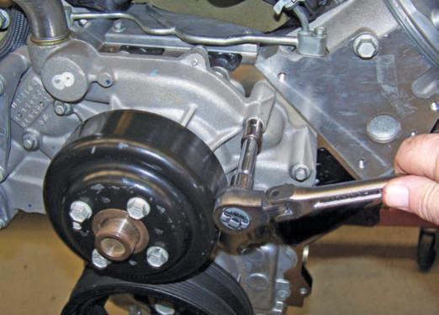
Loosen and remove the bolts in a crisscross pattern from the center outward. Insert a rag into the block opening and scrape off any remains of the old gasket. When replacing a water pump, always follow the procedures given by the manufacturer. Most often a coating of adhesive should be applied to a new gasket before it is placed into position on the water pump.
Figure 3-8 Installing a water pump.
Some pumps are sealed to the block with an O-ring. Make sure that the O-ring groove in the block is clean. when installing the O-ring, make sure it is totally inserted in the groove.
Lubricate the O-ring to ensure it will not tear during installation. Position the pump against the block until it is properly seated. Install the mounting bolts and tighten them evenly in a staggered sequence to the torque specifications. Careless tightening can cause the pump housing to crack. Check the pump to make sure it rotates freely.
The water pumps on many late-model OHC engines are driven by the engine’s timing belt. When replacing the water pump on these engines, always replace the timing belt. make sure all pulleys and gears are aligned according to specifications when installing the belt.
Draining the Coolant
An important part of a preventive maintenance program is changing the engine’s coolant. This is done to prevent the coolant from breaking down chemically. When this happens, the coolant becomes too acidic.
This should be done every 2 to 4 years. Obviously, draining the coolant is the first step in doing this. The coolant should also be drained when replacing cooling system parts.
Before draining the coolant, find the capacity of the system in the vehicle’s specifications. This allows you to know what percentage of the coolant has been drained. normally, 30% to 50% of the coolant will remain in the system.
Most radiators have a drain plug located in the lower part of a tank. Some have a petcock valve. Make sure the engine is cool before draining the coolant. Set the heater controls to the hot position. Remove the radiator pressure cap. remove the overflow reservoir and empty it into a catch can. Now, place the catch can under the drain plug and remove the plug. If the radiator has a petcock, open it fully. If the radiator does not have a drain plug, remove the lower radiator hose. Be careful not to force the hose away from the radiator. The tube on the radiator can be easily broken by excessive force. Twist the hose back and forth while pulling it off. If the hose is stuck, slip a thin screwdriver between the hose and the radiator tube to loosen it. After the coolant stops flowing out, install the drain plug or close the petcock.
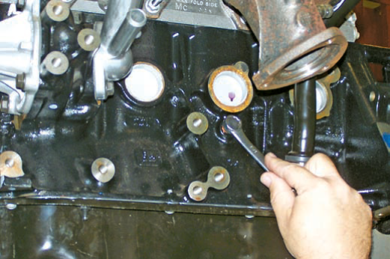
Additional coolant can be drained through drain plugs in the engine block (Figure 3–9). Place the catch can below the drain plug and remove the plug. Once the coolant has drained, replace the plug. Make sure to apply sealer on the threads of the plug. Clean up any spilled coolant.

Figure 3-9 Most engines have drain plugs that allow for draining coolant out of the block.
Coolant Recovery and Recycle System
Whenever coolant is drained to service the cooling system, the used coolant should be drained and recycled by a coolant recovery and recycle machine. Typically, additives are mixed into the used coolant during recycling. These additives either bind to contaminants in the coolant so they can be easily removed, or they restore some of the chemical properties in the coolant.
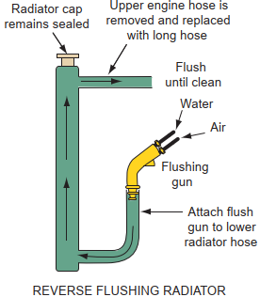
Flushing Cooling Systems
Whenever coolant is changed and especially before a water pump is replaced a thorough flushing should be performed. The bottom of the radiator will trap rust, dirt, and metal shavings. Draining the system will only remove the contaminants that are suspended in the drained fluid. Rust and scale will inevitably form in any cooling system. Buildups of these will affect the efficiency of the cooling system and can cause blockages inside the radiator.
Figure 3-10 The typical setup for back flushing a cooling system.
Flushing may not remove all debris. In fact, if the radiator is plugged, the radiator should be removed and rebuilt or it should be replaced.
The system can be flushed in many ways. Power flushing equipment is often used to force the old cool-ant and contaminants out of the system. This function is often part of the operating cycle of a coolant exchanger. Back flushing forces clean water backward through the cooling system. The discharge of fluid carries away rust, scale, corrosion, and other contaminants.
Flushing guns use compressed air to back flush the system and to break loose layers of dirt and other debris (Figure 3–10). this method of flushing the system is not recommended on systems that use plastic and aluminum radiators. Check the service manual for the proper way of cleaning out the cooling system in the vehicle being serviced.
A simple way to flush the system is to drain it and fill it with water. The engine is then run and brought to its operating temperature. At this point the engine is shut down and allowed to cool. The coolant is then drained. These steps are repeated until the discharged fluid is clear. The clear fluid indicates that all of the old coolant has been removed. Once this occurs, the system is drained again and refilled with coolant.
- Flushing Chemicals
Many different flush chemicals are available. Before using any chemical, make sure it is safe for the type of radiator. Coolant exchangers often use chemicals as part of their flushing function. The typical procedure for using flushing chemicals is to drain the system. Then pour the chemical into the radiator and top off the radiator with water. Install and tighten the radiator cap. Now start the car and set the heater control to its hottest position. Allow the engine to run until it reaches normal operating temperature. Then turn the engine off and allow it to cool. Once the engine has cooled, completely drain the radiator. If the flushing chemical requires a neutralizer, add it to the water remaining in the system and then refill the system with fresh coolant.

Refilling and Bleeding
After the cooling system has been drained and all services performed, the system needs to be refilled with the proper type and mixture of coolant. It is important that the correct type is put into the system. The color of the coolant normally indicates its purpose: Most cool-ants are green, extended-service coolants are orange, and special Toyota coolants are red. The additives in orange coolant are not chemically compatible with those in green or red coolant; therefore, the system must be completely drained and flushed before switching from orange to red or green, or vice versa.
When refilling a system, determine the total capacity of the system. Half of the capacity is the amount of undiluted coolant that should be put into the system. Then top off the system with water. Loosely install the radiator cap. Run the engine until it reaches operating temperature. Then turn it off and correct the level of the coolant. Tighten the radiator cap and run the engine again and check for leaks.
When refilling the cooling system, be sure you get it completely full. Some systems are difficult to fill without trapping air. Air pockets in the head(s), heater core, and below the thermostat can prevent proper coolant flow and cooling. If air is trapped in the engine block or cylinder head(s), it can also cause “hot spots.” This can ruin the head gaskets, the cylinder walls, and the entire cooling system.
This is more of a problem on newer vehicles than older ones. In older cars, the top of the radiator sat higher than the rest of the cooling system. This positioning allowed air in the system to escape through the radiator cap. The radiator cap on many newer cars is much lower than the rest of the cooling system. This results from the lower hood lines. Because all liquids seek a natural level, that level may be above the cap and air gets trapped easily in other high places such as the block or head(s).
These new vehicles must be purged of the air after refilling. This can be done in many ways. Sometimes jacking up the front of the car will raise the radiator cap higher than the rest of the cooling system. With the radiator cap in its first lock position, start the engine. Allow it to run until the thermostat opens and the coolant circulates. trapped air bubbles will naturally blow out the cap.
When no more air escapes, shut off the engine and correct the coolant level. Then reinstall the radiator cap and tighten it to its fully locked position.
When refilling a system on a late-model vehicle, always check the service information for the correct coolant fill procedure. Each vehicle may have its own specific bleeding procedure. Some engines have air bleed valves located at the high point in the system (Figure 3–11).
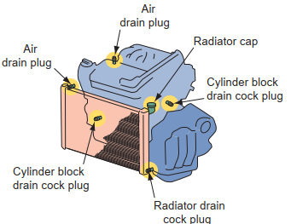
Check the service manual for their location. These valves allow air to escape while the system is being filled.
To use the air bleeds, make sure the engine is warm and the heater is fully on. Connect a hose to the end of the valves and place the open end in a catch can. Open all bleed valves. Slowly put the required amount of coolant into the radiator until the coolant begins to leak out of the valves. Then close the valves and top off the system.
If the system does not have a bleeder valve, disconnect a heater hose at the highest point in the system. Once fluid flows steadily out of the hose, reconnect the hose. If the system was previously fit with a flushing Tee, remove its cap to purge the system. Always recheck the fluid level and make sure that all air is purged before putting the car back into service
Figure 3-11 Some cooling systems are equipped with air bleed screws.

Operation sheet 3.1
Operation Title: coolant replacement
Instruction:
- Safe working area
- Properly operated tools and equipment
- Appropriate working cloths fit with the body
Purpose: Properly coolant replacement
Required tools and equipment: drain pan, screw driver, wrenches, vehicle
Consumable Materials:
Precautions:
- Wearing proper clothes, eye glass, glove
- Make working area hazard free
Quality criteria: - The servicing procedure meet the OEM standards
Procedures:
Perform all activities to check the condition of in accordance with the given procedures
- Operate the vehicle with the heater fully on, and leave it on. Park the vehicle in a well-lit service area, and allow the engine to completely cool (minimum 4 hours).
- Remove all radiator caps to help allow coolant to drain.
- Drain the radiator into a drain pan, either through a petcock in the bottom of the radiator, or by removing the lower radiator hose. On some vehicles, there may be additional drains in the engine block.
- Bottle and correctly dispose of the used coolant.
- If the vehicle age and/or visual inspection require it, replace both upper and lower radiator hoses, heater hoses, hose clamps, thermostat, and thermostat gasket while the system is empty.
- Refill the cooling system with 50/50 mixture of the correct antifreeze for your vehicle combined with distilled water.
- Start and run the engine with radiator cap off, which helps bleed any trapped air from the system (note that some engines have separate coolant bleeder valves; check the service literature for your vehicle).
- Run the engine until the upper radiator hose is warm, which means the thermostat has opened. Shut off the engine and allow it to cool down.
- Add additional coolant as needed until the system is full. Reinstall the radiator/overflow bottle caps, and test drive the car. Watch the temperature gauge, and check for leaks.
- Clean and put away your tools. Be sure to record the date and mileage you performed this service, and be proud of completing a job well done.

Operation sheet 3.2
Operation Title: service water pump
Instruction:
- Safe working area
- Properly operated tools and equipment
- Appropriate working cloths fit with the body
Purpose: Properly
Required tools and equipment: wrench, screwdriver, vehicle
Consumable Materials:
Precautions:
- Wearing proper clothes, eye glass, glove
- Make working area hazard free
Quality criteria: - The servicing procedure meet the OEM standards
Procedures:
Perform all activities to check the condition of in accordance with the given procedures
- water pump removal
- Prepare tools and materials needed
- Wear protective clothing and goggles.
- Drain coolant in the radiator and engine using the following steps:
  - Place a container under the radiator to avoid spillage.
  - Open the radiator drain plug
- Remove the radiator hose when coolant is completely drained.
- Remove the radiator.
- Dismount fan belt, cooling fan and pulley
- Remove the water pump cover.
- Unbolt all brackets and components
- air-conditioning compressor
- power steering pump
- alternator
- Drive out the water pump assembly by threading a removed screw into the female screw.
- Remove the pump
- Scrape off the old gasket or sealer material
- Inspection and Disassembly
- Check Water Pump Bearing Turn the impeller and check the bearing play. If abnormal noise occurs or any sign of stickiness is noted, replace the bearing with a new one.
- Remove the E-ring.
- Pull out the impeller shaft.
- Remove the impeller from the impeller shaft.
- Remove the water pump bearing by using the special tools.
- Gouge out the oil seal.
- Repair
- Check the impeller. In normal operation, impeller blades may wear due to the abrasive action of sand in the coolant.
- Check the water pump shaft bearing for lack of lubricant or wear.
- Check water pump seal for leakage due to cracks
- Check water pump gasket.
- Reassembly
Reassemble the water pump components in precisely the reverse order in which they were disassembled. When pressing the bearings and seals into place, use the correct adapters and sleeves. Note: Any worn-out, cracked or loose parts should be replaced.by
- Installing Water Pump
To install a new pump:
- Coat a new gasket with sealer, and install the pump and gasket to the engine.
- Tighten all bolts to manufacturer’s specification.
- After the pump has been installed, rotate the shaft by hand to make sure it turns freely.
- Install the pulley.
- Install the belt, and tighten to the correct specified tension.
- Install the hoses to the pump
- Checking Water Pump
    - Install the cooling system hoses and fill the system with proper coolant solution.
    - Check for leaks at the water pump shaft seal and water pump housing attachment points.
using the special tools

Operation sheet 3.3
Operation Title: service radiator
Instruction:
- Safe working area
- Properly operated tools and equipment
- Appropriate working cloths fit with the body
Purpose: Properly
Required tools and equipment: wrenches, screwdriver, vehicle
Consumable Materials:
Precautions:
- Wearing proper clothes, eye glass, glove
- Make working area hazard free
Quality criteria: - The servicing procedure meet the OEM standards
Procedures:
Perform all activities to check the condition of in accordance with the given procedures
- Removing Radiator
Removing a radiator is a simple job although it takes a considerable amount of work. The procedure varies somewhat from car to car but, in general, is as follows:
1. Drain the engine and radiator by opening the drain cocks in the radiator and engine block.
2. Detach the upper and lower radiator hoses.
3. Remove any support bolts, horns, wiring harnesses, and so forth that might interfere with radiator removed.
4. With these parts out of the way and the radiator loose, lift it straight up and off the car.

- Repair radiator
  - Identify the source of the radiator leak
  - Determine the gravity of the issue
  - Using a commercial radiator leak stop product
- Installing radiator assembly
Read the instructions in the workshop manual on how to install a radiator. But in general follow this procedure to install a radiator on a vehicle.
- Put the shroud in position.
- Install the radiator in the correct position.
- Put on the washers and nuts and tighten the mountings and brackets on the body well, by hand.
- Fit and tighten the bolts and nuts, with washers, to the sides of the shroud, left and right.
- Check, and correct if necessary, that the fan blades do not touch the shroud tunnel.
- When all the bolts and nuts are fastened tightly and the radiator is in the correct position, put on the lower and upper hoses.
- Tighten the clamps
- Connect the hose to the expansion tank if fitted.
- Close all the drain plugs and check them for tightness.
- engine repairs caused by a badly contaminated cooling system.
- Replace a Radiator
- Safety First.
- Inspect
- Drain the Radiator.
- Disconnect the Radiator.
- Remove the Old Radiator.
- Mount the New Radiator.
- Add Coolant.
- Bleed the air from the Cooling System.

Operation sheet 3.4
Operation Title: service thermostat
Instruction:
- Safe working area
- Properly operated tools and equipment
- Appropriate working cloths fit with the body
Purpose: Properly
Required tools and equipment: vehicle, pressure tester, thermometer, screwdriver, wrenches, snap ring remover
Precautions:
- Wearing proper clothes, eye glass, glove
- Make working area hazard free
Quality criteria: - The servicing procedure meet the OEM standards
Procedures:
Perform all activities to check the condition of in accordance with the given procedures

- Thermostat removal
    - drain the coolant.
    - remove the secondary case cover.
    - remove the gearshift lever by removing the snap ring.
    - disconnect the radiator hose and remove the water pump cover assembly.
    - disassemble the cover assembly. the thermostat will then be free.

- Testing a thermostat out of the system
you can test the exact opening and closing temperatures of a thermostat when it is out of the system. place the thermostat in a heat proof container with a thermometer or in a special thermostat tester, do not let the thermostat touch the sides or bottom of the container. hang it on a wire if necessary.
- fill the container with a 50 – 50 mixture of water and ethylene glycol coolant. heat the container on a stove and watch the thermometer.
- not the temperature at which the thermostat starts to open and the temperature at which it is fully open.
- turn off the heat, allow the thermostat to cool, and not the temperature at which it closes.
- for a more accurate temperature measurement, insert a mm feeler gauge in the thermostat valve. when you can pull the gauge easily from the thermostat, the valve has just opened.
- replace the thermostat if any of the following temperatures are out of limits.
  - the temperature at which the thermostat is fully open should match its rated temperature.
  - the temperature at which it starts to open should be 5 to 10 degrees lower than its rated temperature.
  - install the correct thermostat in the housing with the sensing bulb toward the engine.
- clean the housing surface and install a new gasket or seal the housing with try sealant.
- reconnect the radiator hose and refill the system with coolant.
- Installing the thermostat
- before installing the thermostat check that both sealing surfaces are absolutely clean. if not clean them properly.
- make sure that the thermostat is in the correct position and not upside down, then put it into the housing.
- if you are re-using the old gasket make sure it is in good condition, if not, use a new one. replace the cover.
- replace the thermostat cover and tighten the screws properly.
- connect the upper hose at the water outlet stub.
- tighten the hose clamp.

Operation sheet 3.5
Operation Title: Flushing coolant
Instruction:
- Safe working area
- Properly operated tools and equipment
- Appropriate working cloths fit with the body
Purpose: Properly
Required tools and equipment: vehicle, pressure tester, thermometer, screwdriver, wrenches, snap ring remover
Precautions:
- Wearing proper clothes, eye glass, glove
- Do not allow the cleaning solution to boil when running the engine.
- Do not splash hot cleaning solution onto yourself. It may burn or irritate your skin.
Quality criteria: - The servicing procedure meet the OEM standards
Procedures:
Perform all activities to check the condition of in accordance with the given procedures

A. Flushing the cooling system with water
1. Following the manufacturer’s lifting instructions and appropriate safety procedures, raise the vehicle to a convenient working height.
2. Open the radiator drain and open or remove the block drain plugs to drain old coolant into a suitable container.
3. Remove the thermostat the reinstall the thermostat housing and hose on the engine.
4. With all drains open or the lower hose disconnected, put a water hose in the radiator. Turn on the water and adjust the flow to keep the radiator full as water flows from the drain.
5. Flush the engine and radiator with running water for about 10 minutes. Run the engine at idle and turn on the heater (if the vehicle is equipped with) to the maximum heat position to improve circulation. Do not accelerate the engine or you will splash water all over the engine compartment.
6. After 10 minutes, stop the engine. Turn off the water and close all drains after water has drained from the system.
7. Remove the coolant recovery reservoir from the vehicle, clean it thoroughly with fresh water, and reinstall it.
8. Reinstall the thermostat and refill the system with the kind and amount of coolant specified by the manufacturer. Run the engine to operating temperature until the thermostat opens.
9. With the engine off, check the coolant level, and add if necessary.

B. Reverse Flushing the Cooling System
In reverse flushing, water is forced through the system in direction opposite to normal flow. This gets behind the scale and rust to loosen it so it will be flushed away.
1. To reverse flush the radiator, remove the radiator upper and lower hoses, and replace the radiator cap.
2. Connect a lead way hose to the top of the radiator. Connect a new hose to the radiator outlet at the bottom of the radiator
3. Connect the water hose of the flushing gun to a water outlet, and the air hose to an airline, as shown in Figure Connect the flushing gun to the new hose at the bottom of the radiator

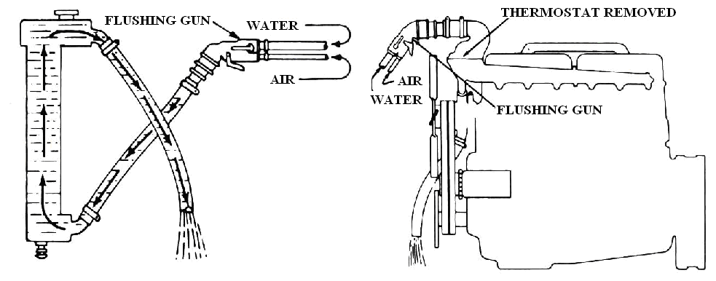

4. Turn on the water. When the radiator is full, turn on the air in short blasts, allowing the radiator to fill between blasts of air.
5. Continue until the water from the lead way hose runs clear.
6. To reverse flush the cylinder block and head, first disconnect the heater hose. Cap the connections at the engine. Then, with the radiator hose removed, attach a lead away hose to the water – pump inlet. Connect a length of new hose to the coolant outlet at the top of the engine. Connect the flushing gun to the new hose at the top of the engine.
7. Turn on the water. When the engine water jacket is full, turn on the air in short blasts.
8. Continue flushing until the water from the lead away hose runs clear.
9. The heater radiator core should also be reverse – flushed, but care must be taken to avoid too much air pressure. The core can be damaged by excessive air pressure.

3. Cleaning the cooling system using chemicals
If the cooling system is badly contaminated, you may want to use a chemical cleaner on the system. The following is a general procedure to clean the system.
1. Drain the old coolant and remove the thermostat as described in the preceding section.
2. Close the drains and reinstall the thermostat housing.
3. Be sure the chemical cleaner is safe for use on the vehicle. Some cleaners are not compatible with aluminum engine and radiator parts.
4. Fill the radiator with the specified amount of cleaner and fresh water.
5. Run the engine for about 30 minutes at a fast idle. Turn on the heater (if the engine equipped so) to the maximum heat position for complete circulation. Cover the car grille or lower part of the radiator to raise the temperature if necessary.
6. Stop the engine and drain the cleaning solution from the system while it is still warm.
7. If the cleaner requires a neutralizer, close the drains and add it to the system along with fresh water. This is important because acids in some cleaners will attack metal parts if left in the system.
8. Run the engine for 10 to 15 minutes at fast idle. Then drain the neutralizer.
9. If desired, flush the system with fresh water as directed in the preceding section.
10. Remove the coolant recovery reservoir from the vehicle, clean it thoroughly with fresh water, and reinstall it.
- If the system was badly contaminated, deposits may continue to break loose from water jackets and the radiator after they are refilled. You may want to inspect the cooling system again in a week or two and drain it, flush it, and refill it with fresh coolant. This extra effort is cheaper and simpler than expensive engine repairs caused by a badly contaminated cooling system.

LAP Test: 3
Task 1: perform coolant replacement
Task 2: service water pump
Task 3: service radiator
Task 4: service thermostat

Unit Four: Prepare vehicles for use and documentation
This learning guide is developed to provide you the necessary information regarding the following content coverage and topics:
  - Inspecting and maintain tools equipment
  - Safe handling and storage of hazardous goods and substances
  - Workplace documentation and reporting
This guide will also assist you to attain the learning outcomes stated in the cover page. Specifically, upon completion of this learning guide, you will be able to:
  - Inspect and maintain tools equipment
  - Safe handling and storage of hazardous goods and substances
  - Workplace documentation and reporting

Inspecting and maintain tools equipment
If you are in the habit of using a power tool every day, it can be easy to fail to notice when that tool’s performance gradually drops over time. That’s why it is important to at least semi-regularly take a moment and inspect your most-used tools, paying close attention to signs of wear and performance issues. Run a few basic operations with a tool, paying close attention to warning signs like weaker than normal power levels, any sort of burning smell, and strange buzzes and noises coming from inside the tool. Any of these is a pretty strong indicator that there’s something off with your tool and it may require some extra attention.
- Keeping the workplace clean is the principle that determines the order and continuity of the workshop. You should not only pay attention to cleaning surfaces (floors and equipment), but also, most importantly, cleaning tools to optimize their operation and increase their service life. Both operations must be performed daily to avoid the accumulation of dirt, dust, grease or chips.
- To organize the workflow, it is important to choose a location for each tool. The organization mode should be reasonable, functional and should adapt to the daily work in the workshop.
- Storage locations should be optimized and convenient, but should not carry the risk of running out of space, as this can lead to confusion. In addition, storage areas in passage areas should be avoided to avoid collisions among workers.
- After each operation in the workshop, it is necessary to clean and collect all the tools and materials. If they cannot be moved, it is important to have space for storing these elements (cages or boxes) in order to avoid alterations or damage, and thus contribute to order in the workshop.
- Keeping tools and equipment in working order prevents errors in work and confusion that lead to a halt in the production process.
- For this reason, it is very important to carry out maintenance, preventive and corrective measures with equipment in accordance with the recommendations of the manufacturer and do not forget that, if necessary, such operations should be carried out by specialized, certified personnel.
- In connection with the previous paragraph, a technical inspection and a report to the manager on malfunction or damage to tools.
- For safety reasons, it is important to keep the staircases and passageways always clean, free of obstructions and properly marked. In addition, it is impossible to block or impede access to fire extinguishers, emergency exits, hydrants and other elements related to worker safety.
- The use of a tool trolley is very useful for the technical workshop, as it makes it easy to carry hand tools, its use prevents tools from being scattered around the workshop and being lost. Likewise, carts must have a permanent place.
- It is very important that workshops have fireproof containers that are closed and sealed, where it is possible to dispose of hazardous waste, toxic, flammable and inert, as well as rags, paper or containers contaminated with oils, greases or any other chemical substances, always separating debris depending on it. Containers should never be left open to avoid the risk of leakage and also to avoid unpleasant odors.
- Sometimes manufacturers of workshop tools and equipment advise storage regimes and rules. Everyone must follow the instructions of the experts to ensure the long life of each tool. For this reason, it is necessary to have the operating instructions or safety data sheets of machines and tools in an accessible place.
- As a final recommendation, it is very important to educate shop workers on the rules and the need to maintain the cleanliness and order of their workplace and rest area, as well as personal hygiene with regard to work clothes and safety elements.

Safe handling and storage of hazardous goods and substances
Handle hazardous materials safely there are 12 basic rules all employees who handle or work around hazardous materials should know and follow:
- Follow all established procedures and perform job duties as you have been trained.
- Be cautious and plan ahead. Think about what could go wrong and pay close attention to what you are doing while working with or around hazardous materials.
- Always use required PPE; inspect it carefully before each use to make sure it’s safe to use. Replace worn PPE; it won’t provide adequate protection.
- Make sure all containers are properly labeled and that materials are contained in an appropriate container. Don’t use any chemical not contained or labeled properly. Report damaged containers or illegible labels to your supervisor immediately.
- Read labels and the Safety Data Sheets (SDSs) before using any material to make sure you understand hazards and precautions.
- Use all materials solely for their intended purpose. Don’t, for example, use solvents to wash your hands, or gasoline to clean equipment.
- Never eat or drink while handling hazardous material. If your hands are contaminated, don’t use cosmetics or handle contact lenses.
- Employees handling hazardous materials need to read labels on chemicals they use or handle and have Safety Data Sheets (SDSs) available to refer to that explain how to properly deal with handling, storing, and cleaning up spills, and that explain relevant first-aid procedures.
- Store all hazardous materials properly, separate incompatibles, and store in ventilated, dry, cool areas.
- Employees must keep themselves and the work area clean. After handling any hazardous material, wash thoroughly with soap and water. Clean work surfaces at least once per shift, so contamination risks are minimized.
- Learn about emergency procedures and equipment. Understanding emergency procedures means knowing evacuation procedures, emergency reporting procedures, and how to deal with fires or spills/leaks. It also means knowing what to do in a medical emergency if a co-worker is injured or overcome by chemicals.
- Keep emergency eyewash and shower stations clean. Test them at least monthly to make sure they are working properly and keep them accessible; don’t let clutter build up around the stations.
May have other safety rules and concerns recycle all used antifreeze/coolant or take it to an authorized collection point. do not dump old coolant into a sewage drain, the ground, or any body of water. never leave ethylene glycol or propylene glycol coolant out and lying around. Both children and animals will drink it because of its sweet taste. The coolant is poisonous and can cause death.

Workplace documentation and reporting
Documentation plays a crucial role in any treatment setting. documentation helps assure continuity of care. Performing documentation like this indeed can take additional time but, in the end, it’s well worth it. The documentation is the story that illustrates exactly what happened as a vehicle entered the service center, what was done, what wasn’t done, and what was recommended. Some shop management systems make it very easy to integrate their inspection items and subsequently include additional rich assets alongside descriptive text.
The rules of good documentation
Rule #1: make it complete
Rule # 2: keep it consistent
Rule #3: keep it legible
Rule #4: make it accurate
Rule #5: finish on time
A Service/maintenance report is a document that contains specific information about your past maintenance actions and their effect on cost, assets, and business performance. For any report to be useful, it has to be:
- Concise: the report should be brief but comprehensive; presented in a way that makes complex data easy to digest.
- Fact-based: accurate; up-to-date; objective, based on hard data rather than opinions and speculations.
Reviewed in the proper context: was downtime prolonged because a supplier delayed the shipment of an important spare part or because we didn’t order it in time – context is crucial for decision making

Self-check-4
Instruction: Short answer
- How to inspect tools and equipment?
- What are the rules of good documentation?
- What are the basic rules that employees should know and follow when working with hazardous materials?

Reference

- Jack Erjavec, Automotive Technology: a systems approach, 5 t h Edition, 2010 Delmar, Cengage Learning
- M.J. Nunney, Light and Heavy Vehicle Technology Fourth edition
- Sean Bennett and Ian Andrew Normann. Heavy Duty Truck Systems , Fifth Edition
- Robert Huzij, Angelo Spano, and Sean Bennett, Modern Diesel Technology: Heavy Equipment Systems2nd Edition
- Sean Bennett, Medium/Heavy Duty Truck Engines, Fuel & Computerized Management Systems 4th Edition
- James D. Haldeman, Automotive technology Principles, Diagnosis, and Service fourth edition
- Ben Watson, Modern Diesel Technology: Mobile Equipment Hydraulics: A Systems And Troubleshooting Approach
- M.J. Nunney, Light and Heavy Vehicle Technology, Fourth edition
- John Dixon, Modern Diesel Technology: Preventive Maintenance And Inspection

Participants of this Module (training material) preparation

No | Name | Qualification | Field of Study | Organization/ Institution | Mobile number | E-mail
 | Adinet Asnake | MSc | Automotive Technology Mgt | Wolkite PTC | 0913767250 | andinetasnake31@gmail.com
 | Biruk Tilahun | BSc | Automotive Technology | General Wingate PTC | 0913789176 | biruktilahun1@gmail.com
 | Fadli Aman | BSc | Automotive Technology | General Wingate PTC | 0927283100 | Fadli.ziyad@gmail.com
 | Hana Nigusise | BSc | Automotive Technology | Selam TVET college | 0988751516 | Hana.nigussie25@gmail.com
 | Israel Taye | BSc | Automotive Technology | General Wingate PTC | 0913424100 | Isra.taye@gmail.com
 | Tatek Mamo | PhD scholar | Automotive Technology | DEC | 0911841121 | mimibaba928@gmail.com
 | Zelalem Yitbarek | BSc | Automotive Technology | Selam TVET college | 0972030621 | Zolosmart12@gmail.com

