Heavy Vehicles and Earth Moving Machinery Maintenance.
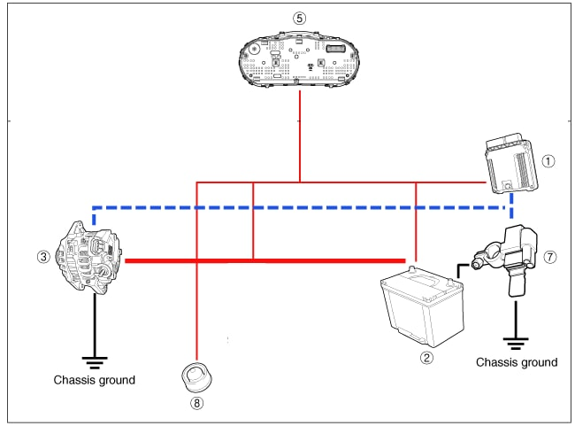
Level-II
Based on Nov, 2022, Curriculum Version I

Module Title: Charging system
Module code: EIS HEM2 M04 1122
Nominal duration: 40 Hour
Prepared by: Ministry of Labor and Skill
December, 2022
Addis Ababa, Ethiopia

Table of Contents
Acknowledgment 4
Acronym 5
Introduction to module 6
Unit one: Overview of charging system 7
1.1 Purpose of charging system 8
1.1.1. Functions of Charging System 9
1.1.2. Components of Charging System 9
1.1.3. Components of the alternator and their functions 11
1.2 Operating principle of charging system 15
1.2.1. Alternator operation 15
1.2.2. Types of alternators 18
1.3 Voltage regulator 20
1.3.1. Types of voltage Regulator 20
1.4 OHS Requirement 30
1.5 Identify tools and Equipment 30
Self-check: 1 32
Unit Two: Service charging system 33
2.1. Inspect and test charging system 34
2.1.1 Inspect charging system 34
Operation sheet: 2.1 34
2.1.2 Test charging system 36
Operation sheet: 2.2 36
2.2 Repair and replace charging system component 39
Operation sheet: 2.3 40
Operation sheet: 2.4 42
Operation sheet:2. 5 43
2.3 Charging system troubleshooting 44
LAP Test 47
Unit Three: Overhaul Alternator 48
3.1 Disassembling alternator 49
Operation sheet: 2.7 50
3.2 Testing alternator components 52
Operation sheet: 2.8 53
3.3 Repairing and replacing the component 61
LAP Test 62
3.4 Reporting 63
Unit four: Clean-up work area and maintain equipment 64
4.2 Removing waste and scrap 68
Self-check: 1 71
Reference 72

\

Acknowledgment

Ministry of Labor and Skills wish to extend thanks and appreciation to the many representatives of TVT instructors and respective industry experts who donated their time and expertise to the development of this Teaching, Training and Learning Materials (TTLM).

Acronym

AC | Alternative Current
DC | Direct Current
DMM | Digital Multimeter
LAP test | Learning Activity performance Test
OHS | Occupational Health and Safety
ZD | Zener Diode
IC | Integrated Circuit

Introduction to module
This module covers the knowledge, skills and attitude required to carry out services in charging system and associated components. The module involves preparing for the task, basic checking/testing to identify fault, remove, disassemble, replace worn or failed components and assemblies and reinstall. This module is designed to meet the industry requirement under the Performing charging Systems Service occupational standard, particularly for the unit of competency: Maintain charging system and its components.
This module covers the units:
- Introduction to Charging system
- Test systems/ components and identify faults
- Repair charging systems and/or associated components
- Clean-up work area and maintain equipment
Learning Objective of the Module
- Prepare for work
- Test systems/ components and identify faults
- Repair charging systems and/or associated components
- Clean-up work area and maintain equipment
Module Instruction
For effective use these modules trainees are expected to follow the following module instruction:
- Read the information written in each unit
- Accomplish the Self-checks at the end of each unit
- Perform Operation Sheets which were provided at the end of units
- Do the “LAP test” giver at the end of each unit and
- Read the identified reference book for Examples and exercise

Unit one: Overview of charging system
The unit covers the competence to maintain automotive starting motor, systems and direct current motors:
  - Purpose and types of charging system
  - Operating principle of charging system
  - Types of voltage regulator
  - OHS Requirements
  - Tools and equipment
This unit will also assist you to attain the learning outcomes stated in the cover page. Specifically, upon completion of this learning guide, you will be able to:
- Understand the Purpose and types of charging system
- Discuss Operating principle of charging system
- Identify Types of voltage regulator
- Perform OHS Requirements
- Identify Tools and equipment

1.1 Purpose of charging system
A truck charging system consists of the batteries, alternator, voltage regulator, associated wiring, and the electrical loads of the truck. The purpose of the system is to recharge the batteries whenever necessary and to provide the current required to power the electrical components of the truck. It does this by converting a portion of the mechanical energy of the engine into electricity. A charging system can be compared to a compressed air system on a truck. The compressor forces air into a reservoir or tank. When a pneumatic component needs air, air is drawn from the reservoir. Eventually, the air pressure in the tank will drop below a certain level and a pressure-sensitive switch will activate the compressor. Air will be pumped into the reservoir again until cut-out pressure is reached. Then the switch (governor) will unload the compressor.
In a charging system, the battery acts as a reservoir of electrical energy. Electrical energy is drawn from it to crank the engine and to power electrical systems. The electrical “pressure” in a battery is called voltage. You can also call this “potential.” When fully charged, a heavy-duty 12-volt battery has 12.6 volts potential available across its terminals. As the battery is discharged, the voltage level drops, just as the pressure of compressed air in a tank as it is used. When battery potential reaches a preset voltage level, an electrical switch, called a voltage regulator, activates the alternator.
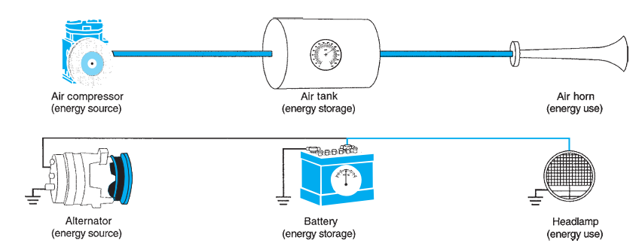
Figure1.1 charging system can be compared to a compressed air system.

To generate electricity, the alternator uses this basic law of physics: When magnetic lines of force move across a conductor (such as a wire or bundle of wires), an electrical current is produced in the conductor.

Electricity can be induced in an electrical circuit either by moving the circuit wiring through the magnetic field of a magnet or by moving the magnetic field past the wiring. In both situations, the direction of electrical current flow is determined by the polarity of the magnetic field. The magnetic forces of the north pole of a magnet will force electrons to flow in one direction and the south pole of a magnet will force electrons to flow in the opposite direction. If the wiring is exposed alternately to both north and south poles, an alternating current will be produced. Actual current flow induced depends on several factors: the strength of the magnetic field, the speed of the wire passing through the field, and the size and number of wires. In an alternator, the rotor provides the magnetic fields necessary to induce a current flow. The rotor spins inside a stationary coil of wires called a stator. The moving magnetic fields induce a flow of electrons through the stator wiring that is pumped to the batteries when they are in need of recharging. The following paragraphs explain how the rotor and stator and other alternator components work together to provide charging current to the battery.

1.1.1. Functions of Charging System
Below are functions of the charging system in automobile engines:
- The primary purpose of the charging system is to provide power to all electrical components in a vehicle.
- It comprises alternator that maintains and keep the vehicle’s battery charged.
- Charging system supplies electrical current to fire the spark plugs, which ignite the air/fuel mixture in the combustion chamber,
- Alternators help to charge dead batteries, while the engine is running.
- Charging system help to send the engine mechanical issue to the engines ECU using a sensing device.
- Vehicles electrical components are powered when the engine is not running.

1.1.2. Components of Charging System
- Battery: The battery is another essential of the automobile charging system, as it serves as a reservoir of electrical power. the engines starter motor is directly connected to the positive terminal. It helps to crank the component making the engine to start. As the engine is running, alternator directly charges the battery. The battery can also supply power to the electrical components when the engine isn’t running.
- Fuse and Fusible links Fuse and fusible links have different functions even though have the same shape. Fusible link can be called as main fuse which is placed near the battery positive terminal. The function of this fuse is to protect the entire electrical system of the car from excessive currents. Generally, the fusible link has a capacity of up to more than 60 Ampere. While the function of the fuse is as a safety of a series of specific electrical wiring, in conventional charging system there are two fuses with same capacity (it’s about 10-15 Ampere). A fuse is used as a voltage regulator fuse and another fuse is used to secure the CHG and Voltage relay.
- CHG Lights CHG lamp or commonly also called “charging warning light” is an indicator light to indicate the presence failure of charging system. When the ignition key ON then this light will light up normally, as well as when the engine life of this lamp should turn on, if it is dead then it could mean the charging system failure.
- Ignition key The ignition key works as a switch. The charging system will be activated automatically when the engine is running, but to generate a magnetic field on the rotor coil must be done by a switch. Ignition switch is used as a switch to connect and disconnect power (positive battery currents) from battery to rotor coil. When the ignition key is ON, then the electricity from the battery to the coil rotor will be connected. However, when the ignition key is turned OFF then the power supply will be cut off. So, it is not possible the alternator generates electricity when the ignition key is OFF even the engine crankshaft is rotate.
- Regulator The function of the regulator is to regulate the voltage generated by the alternator. Why should it be there? because the voltage generated by the alternator depends the engine’s RPM. This means that if the engine RPM is low, the alternator voltage is also low, but if the engine RPM is high then the alternator voltage is also high. The regulator will be used to keep the voltage generated by the alternator not exceeding 14 volts even if the engine run in high RPM. This voltage setting aims to protect the electrical components of the vehicle to prevents over-voltage.
- Alternator The function of the alternator is to convert a partial engine’s rotating energy into electricity. The alternator input comes from the engine pulley connected through a V belt, the rotation of the rotor will cause the intersection of the magnetic force line with the stator coil so that the electrons flow on the stator coil. The electricity in the stator coil is not directly connected to the battery, but it must pass through the diode bridge to rectify the current. This is done because the current in the stator coil is AC (Alternate Current).
- Charging Wires The function of charging wires are to connect every component of the charging system, there are at least two types of wires: standard wire and B + wire. The standard wire has a small diameter like the car’s electrical wiring in general, the function of this wire is connecting each terminal on the entire charging system. While the B + wire has a larger diameter than the standard wire and almost matches the stator wire. The function of this wire is to connect the terminal B alternator with Battery.

1.1.3. Components of the alternator and their functions
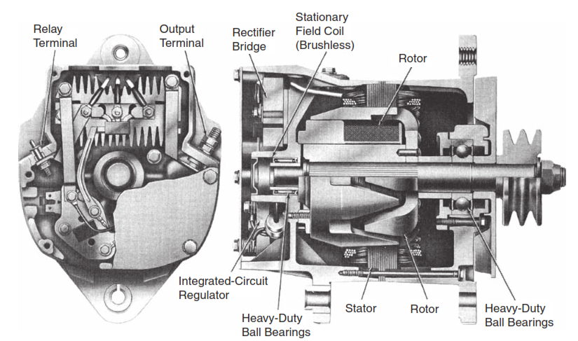

Figure 1.2 Cutaway view of an alternator.

Rotor
The rotor is the only moving component within the alternator. It is responsible for producing the rotating magnetic field. The rotor consists of a coil, two pole pieces, and a shaft. The magnetic field is produced when current flows through the coil; this coil is simply a series of windings wrapped around an iron core. Increasing or decreasing the current flow through the coil varies the strength of the magnetic field, which in turn defines alternator output. The current passing through the coil is called the field current. It is usually 3 amperes or less. The coil is located between the interlocking pole pieces. As current flows through the coil, the core essentially becomes a magnet. The pole pieces assume the magnetic polarity of the end of the core that they touch. Thus, one pole piece has a north polarity and the other has a south polarity. The extension on the pole pieces, known as the fingers, form interlacing magnetic poles. A typical rotor has fourteen poles, seven norths and seven souths, with the magnetic field between the pole pieces moving from the north poles to the adjacent south poles. The more poles a rotor has, the higher the alternator output will be.
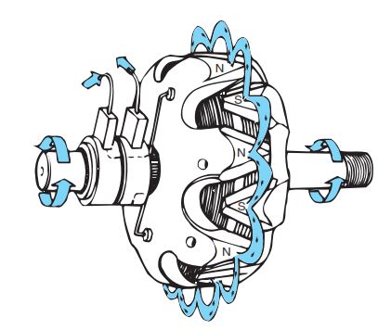
Figure 1.3 rotor

Slip rings and brushes
The wiring of the rotor coil is connected to slip rings. The slip rings and brushes conduct current to the rotor. Most alternators have two slip rings mounted directly on the rotor shaft; they are insulated from the shaft and from each other. A spring-loaded carbon brush is located on each slip ring to carry the current to and from the rotor windings. Because the brushes carry only 1.5 to 3.0 amperes of current, they do not require frequent maintenance. This is in direct contrast to generator brushes, which conduct all of the generator’s output current and consequently wear rapidly.
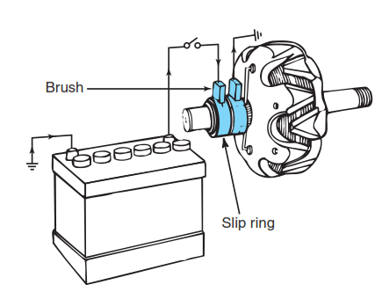

Figure 1.4 slip ring and brushes

Stator
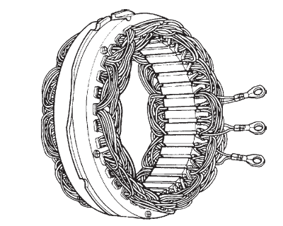
The stator is made up of many conductors, or wires, into which the spinning rotor induces voltage. The wires are wound into slots in the alternator frame, with each wire forming several coils spaced evenly around the frame. There are as many coils in each wire as there are pairs of north and south rotor poles.

Figure 1.5 stator
Windings
The wires are grouped into three separate bundles, or windings. The coils of the three windings are staggered in the alternator frame so that the electrical pulses created in each coil will also be staggered. This produces an even flow of current out of the alternator. In an alternator rated at 120 amps output, each winding or phase pumps out 40 amps. The ends of each winding are attached to separate pairs of diodes, one positive and the other negative. They are also wired together in one of two configurations: a wye shape or a delta shape
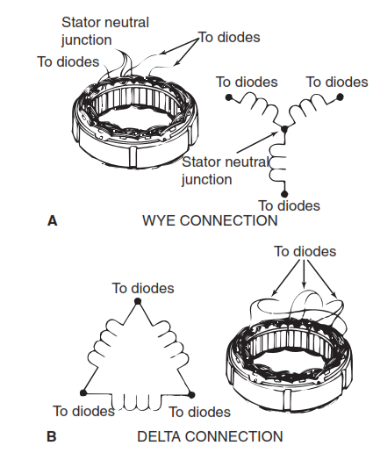
Figure 1.6 (A) wye configuration; or (B) a delta configuration.

End frame assembly
The end frame assembly, or housing, is made of two pieces of cast aluminum and contains the bearings for the end of the rotor shaft. The drive pulley and fan are mounted to the rotor shaft outside the drive end frames. Each end frame also has built-in air ducts so the air from the rotor shaft fan can pass through the alternator. A heat sink—called a rectifier bridge, or diode holder—containing the diodes is attached to the rear end frame; heat can pass easily from these diodes to the moving air. Because the end frames are bolted together and then bolted directly to the engine, the end frame assembly provides the electrical ground path for many alternators. This means that anything connected to the housing that is not insulated from the housing is grounded.
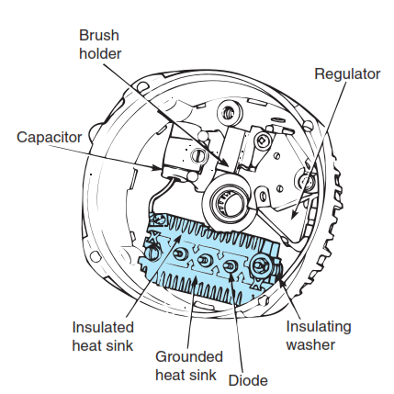
Figure 1.7 End frame assembly

Diodes
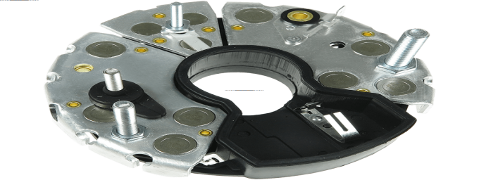

A diode allows current to flow in one direction but not in the opposite direction. Therefore, it can function as a switch, acting as either conductor or insulator, depending on the direction of current flow. In an AC generator, current is rectified (changed from AC to DC) through the use of diodes. The diodes are arranged so that current can leave the generator in one direction only (as DC).

Figure 1.8 Diodes

1.2 Operating principle of charging system
A vehicle charging system has been represented in Fig. 1.9 as three blocks, i.e. the alternator, battery and vehicle loads. When engine is not running, the alternator voltage is less than the battery voltage so current flows from the battery to the vehicle loads and the alternator diodes prevent current flowing into the alternator. When engine is running, the alternator output is greater than the battery voltage, so current flows from the alternator to the vehicle loads as well as the battery. This implies that alternator output voltage must always be above the battery voltage during operation of the engine. However, the actual voltage used is critical and depends on a number of factors.
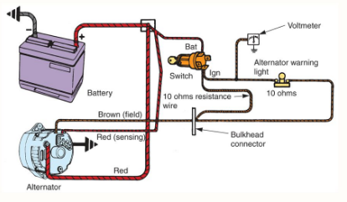
Figure 1.9 Operating principle of charging system

1.2.1. Alternator operation
As the rotor, driven by a belt and pulley arrangement, rotates inside the alternator, the north and south poles of the rotor alternately pass by the coiled windings in the stator. Only a very small air gap separates the rotor from the stator so that the windings are subjected to a maximum intensity of the magnetic force fields. As each pole alternately passes by the coils, magnetic lines of force cause electrons to flow in the wires. As a north pole passes by a coil in the winding, electrons first flow in one direction. As the next pole, having a south polarity, passes by the coil, the flow of electrons changes direction. In this way, an alternating current (AC) is produced. The positive side of the wave is produced by a north pole and the negative side of the wave is produced by a south pole. Because a truck alternator has three windings staggered around the rotor, a three-phase sine wave is produced.
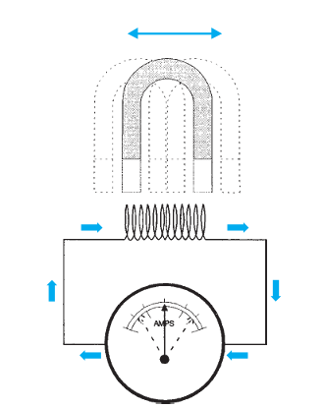
Figure 1.10 magnetic field

AC TO DC
A battery can only be charged using direct current (DC). Truck accessories also are powered by DC. In order for the alternator to provide the electricity required, the AC it produces must be converted, or rectified, to DC. While generators accomplish this using a mechanical commutator and brushes, alternators achieve this electronically with diodes. A diode can be thought of as an electrical check valve. It permits current to flow in only one direction—positive or negative. When a diode is placed in a simple AC circuit, one-half of the current is blocked. In other words, the current can flow from X to Y as shown in Figure 1.10, but it cannot flow from Y to X. When the voltage reverses at the start of the next rotor revolution, the current again can pass from X to Y, but not back. This type of output is not efficient because current would be available only half of the time. Because only 50 percent of the AC voltage produced by the alternator is being converted to DC, this is known as half-wave rectification.

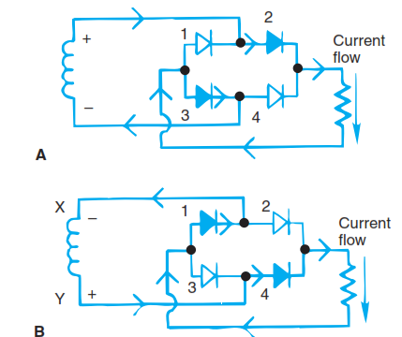
Figure 1.11 AC to DC

DC Rectification When AC passes through a diode, the negative pulses are blocked off to produce the scope pattern shown. If the diode is reversed, it blocks off current during the positive pulse and allows the negative pulse to flow.
- Half-wave rectification only half of the AC current pulses (either the positive or the negative) is able to pass.
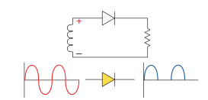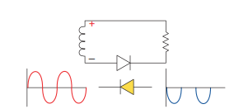
Figure 1.13 Half-wave rectifications, diode negatively biased.
Figure 1.12 Half-wave rectifications, diode positively biased.

- Full-wave rectification By adding more diodes to the circuit, more of the AC is rectified. When all of the AC is rectified, full wave rectification occurs and requires another circuit with similar characteristics.
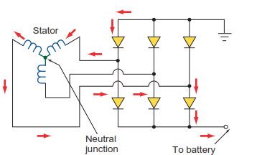
Figure 1.14 Full-wave rectification

- WYE stator with two diodes attached to each winding. One diode is insulated, or positive, and the other is grounded, or negative. The center of the Y contains a common point for all windings. It can have a connection attached to it. It is called the stator neutral junction. At any time during the rotor movement, two windings are in series and the third coil is neutral and inactive. As the rotor revolves, it energizes the different sets of windings in different directions.
- The diode action does not change when the stator and diodes are wired in a delta pattern. the major difference. Instead of having two windings in series, the windings are in parallel. Thus, more current is available because the parallel paths allow more current to flow through the diodes. Nevertheless, the action of the diodes remains the same.

1.2.2. Types of alternators
- Three phase alternator
In a heavy-duty three-phase alternator, there are three coils and six diodes (Figure 8–13). At any time, two of the windings will be in series and the third winding will be neutral, doing nothing. Depending on the combination of coils and the direction of current flow, one positive diode will rectify current flowing in one direction and a negative diode will rectify the current flowing in the opposite direction. This is true for both wye and delta configurations. Many heavy-duty truck alternators use a delta arrangement. The windings in a delta stator are arranged in parallel rather than in series circuits. The parallel paths permit more current to flow through the diodes, thereby increasing the output of the alternator.
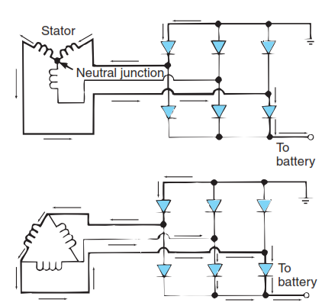
Figure 1.15 three-phase alternator

- Brushless alternator
Many alternators do not use brushes to deliver voltage to the field windings of the rotor. In this type of alternator, the field windings do not rotate with the rotor. They are held stationary while the rotor turns around them. The rotor itself retains sufficient residual magnetism to energize the stator when the truck engine is first started. Part of the voltage induced in the stator windings is then diverted to the field windings, which energizes the electromagnetic field. As the strength of the stationary field windings increases, the magnetic field of the rotor also increases and stator output reaches its specified potential. Many current alternators use a brushless design because they produce better longevity. The output ratings in current trucks are necessarily higher because of the more complex electrical and electronic circuits.
Advantages of a Brushless Generator
- Brushless generators make less noise than brushed generators and present a smooth operation. Without electric brushes, there is much less friction when the generator is running.
- Brushless generator motors are easier to maintain than brushed generators with less moving parts to clean, repair or replace. Fewer moving parts also means less wear and tear on the alternator. The absence of brushes eliminates overheating issues and breakdowns as well.
- While brushless generators may pose a higher cost upfront, they have an extended lifecycle of as much as three to five times longer than traditional brush models.
- A brushless motor is more compact and two to three times lighter than brushed units. This makes for smooth and easy portability.
Disadvantages of a Brushless Generator
- The initial cost of a brushless generator is higher than a brushed generator since brushing requires much less copper. An electronic controller is also required to keep the brushless engine running, increasing the cost.
- In the case that a brushless generator breaks, it may require a higher skill level to repair than a brushed generator due to its robust composition.

1.3 Voltage regulator
For more than 50 years prior to the introduction of solid-state voltage regulators in the early 1970s, mechanical regulators were used to control alternator(or generator) output. Like so many other mechanical components that have been replaced with electronic parts, the mechanical voltage regulator is slow and imprecise when compared to today’s transistorized regulators. A voltage regulator defines the amount of current produced by the alternator and the voltage level in the charging circuit. It does this by turning the field circuit off and on. Without a voltage regulator, the batteries would be overcharged and the voltage level in the electrical system would rise to a point where lights would burn out and fuses and fusible links would blow. Controlling the voltage level is particularly important as electronic components are added to heavy-duty trucks. Microprocessors and electronic sensors and switches are easily damaged by voltage spikes and high-voltage levels.

1.3.1. Types of voltage Regulator
There are two types of regulators according to purpose
1, Conventional type: - the point type/ conventional uses two coils to adjust the alternator output voltage.
- One point type regulator
In this regulator a resistor (R) is connected in series with the field coil (F) of the rotor. This resistance is by passed by the points while the engine is running at low speed . Since the magnetic field in the coil is weak, the points remain closed. When the voltage of the alternator is increased the magnetic field will be strong and the points open. So, current passes through the resistor and the field coil. This decreases the magnetic field strength and the voltage of the alternator reduces and the points close again. In this manner the voltage is stabilized by this type of regulator. However, one point type regulator is not used very often in present day automobiles because of the following disadvantage.

- There is great fluctuation of voltage at low speed when the points are opened and closed
- A large resistance will cause more sparking when the points are open, resulting in shorter life of the points.
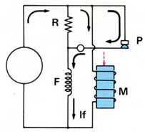
Figure 1.16 One-point type regulator

B. Two-point type regulator
The characteristic of the two-point type regulator is that it has both low speed and high-speed operating ranges. At low speed, the moving point opens and closes the low-speed point (P1) in the same manner as one point type regulator make and break the contact. At high speed the moving point contacts P2 and field current ceases to flow. The voltage output of the alternator decreases. This decreases the field strength of the regulator and the moving point closes again with P1 and the cycle is repeated.
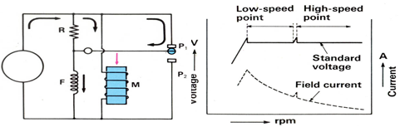
Figure 1.17 Two-point type regulator

But the disadvantage of this type of regulator is the voltage drop due to the hysteresis effect when changing from the high-speed side to low-speed side. Nevertheless. compared to the one-point type, the resistance can be made smaller so there is less sparking so there is a longer life of the points.
Voltage Relay (Charge lamp relay)
A Charging system employs a two-element combination accurate voltage regulation. This is because, the voltage regulator operates in accordance with the voltage generated by the alternator. If there were no voltage relay, there would occur a drop in voltage in the magnetic coil because the voltage is applied to a long circuit via the ignition switch. A reduction of voltage would cause a proportionate decrease in magnetic force of magnetic coil so the moving points would not pulled sufficiently. As a result, alternator voltage would rise to high.
Operation of a regulator with voltage relay
A. When the ignition switch is on engine stepped.
- When the ignition switch is turned on field current from the battery flows to the rotor and excites the rotor coil. At the same time, battery current also flows to the charge warning lamp and the lamp comes on.
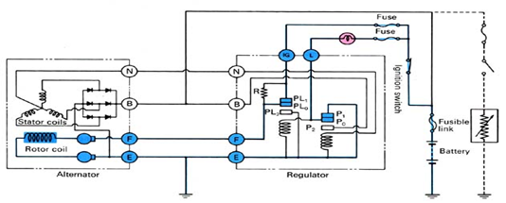
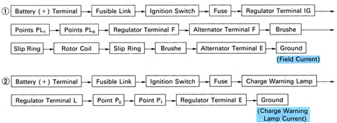

Figure 1.18 Ignition switch on engine stepped

B, Engine operation- (low speed to middle)
- After the engine is started and the rotor is turning. Voltage is generated in the stator coil, and neutral voltage is applied to the voltage relay so the charge warning lamp goes out. At the same time; output voltage is acting on the voltage regulator. Field current to the rotor is controlled in accordance with the output voltage acting on the voltage regulator. Thus depending on the condition of point PL₀, the field current either passes through or does not pass through the resistor (R)
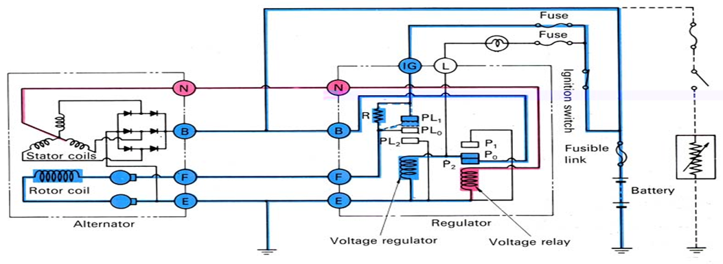
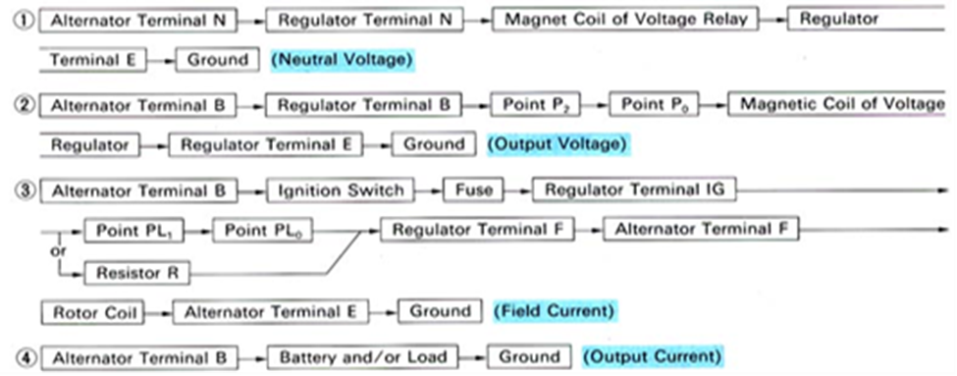
Figure 1.19 Engine operation- (low speed to middle)

C, Engine operating (Middle speed to high speed)
- As engine RPM increases, the voltage generated by the stator coil rises and the pulling force of the magnetic coil becomes stronger with a stronger pulling force, field current to the rotor will flow intermittently. In other words moving point PL0 of the voltage regulator intermittently make contact with point PL2
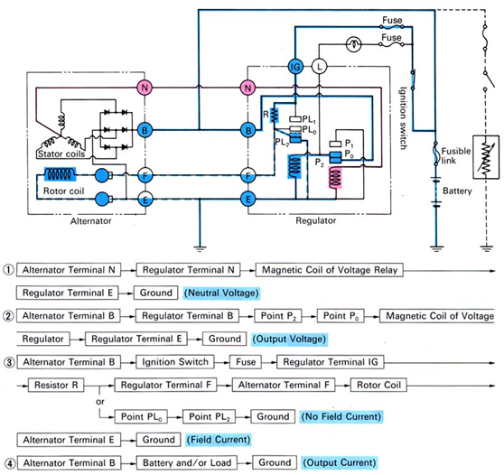
Figure 1.18 Engine operating (Middle speed to high speed)

2. IC-Regulator: - The solid state regulator allows battery current to excite alternator field coils, and also controls charging voltage at safe values. It may be separately mounted or inbuilt type.
Advantages over mechanical regulator:

- It is almost fool proof i.e., incapable of error or failure
- It is smaller in size i.e., compact and light
- It can control higher field current with improved durability and reliability (this is due to lack of mechanical points).
- A narrower output voltage range and little or no variation with alternator speed and input voltage i.e., no hysteresis characteristics.
- Voltage variation at the rated load, or at maximum output current of the alternator is between 0.5-1v
- Good resistance to vibration , climatic effects and high durability due to lack of moving parts
- Voltage output becomes lower as its temperature rises, hence proper charging of the battery can be performed. This is because the Zener diode become more conductive as temperature rises
- Spark free switching prevents radio interference

Disadvantage

- Susceptible to unusually high voltage and temperatures.
N.B.
If a load exceeds the alternators capacity is applied, the output voltage will suddenly drop, as in the case of point type regulator. Therefore, never apply an excessive load when checking the output voltage.
Operating principles of IC regulator
The solid-state regulator controls the field current using transistors, diodes, and resisters. As in the illustration shown below, when the output voltage at terminal B is low, the battery voltage is applied to the base of Tr1 through resistor R and Tr1 turns on. At the same time, field current flows from B to rotor coil. When the output voltage at terminal B is high a higher voltage is applied to the Zener diode (ZD) and when this voltage reaches the Zener voltages, the Zener diode becomes conductive. Accordingly,
As Tr2 turns on Tr1 turns off. This interrupts the field current. Regulating the output voltage.
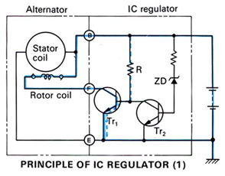
Figure 1.20 Engine operating (Middle speed to high speed)

Regulators can also be categorized by the way circuit connections supply current to the rotor used to induce “field excitation”. Knowing the type of filed excitation circuit used is helpful to quickly test whether an alternator or voltage regulator is defective. Type of alternator field excitation includes:
- “A” type regulator controls the strength of the rotor’s magnetic field by changing the resistance to current flow through the rotor on the ground side of the circuit. This means one rotor brush is connected to the ignition switch or the alternator’s B+ output and the other brush is connected to ground through the regulator.
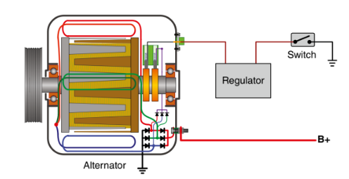
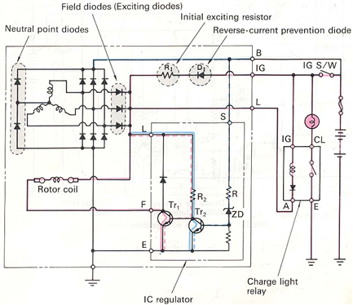

Figure 1.21 “A” type regulator

- “B” type regulators control the battery positive current supply to the rotor field. One brush is connected directly to negative ground and the regulator varies battery positive voltage supplied to the other brush. B-type circuits are used only by external regulators. Unfortunately, if the electronic regulator fails or develops a resistive ground due to corrosion, it senses low battery voltage, which causes the alternator voltage to increase and overcharge. Overcharging batteries completely gas all electrolyte dry them out and chassis light bulbs often burn out.

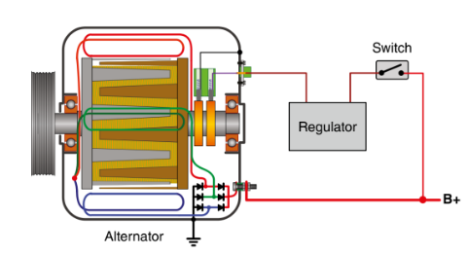

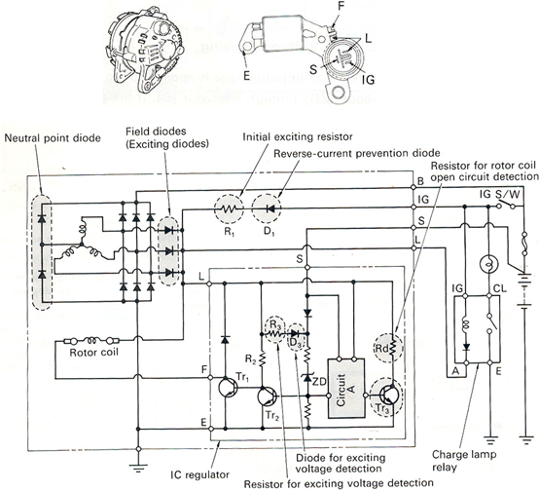
Figure 1.22 “B” type regulator

- An isolated field-type voltage regulator varies current flow through both the negative ground and battery positive current supplied to the rotor field.
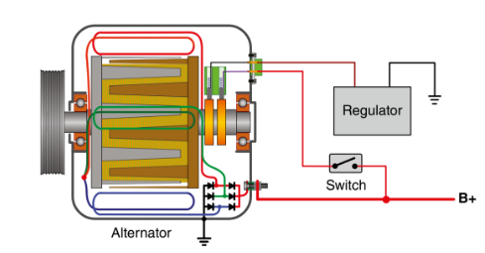
Figure 1.23 isolated field-type

1.4 OHS Requirement
If incorrectly handled, there is the danger that electrical equipment and machinery will short-circuit and cause a fire, so the following point must be carefully observed:
- When any irregularities are detected in electrical equipment and machinery, turn off the switch at once and contact your supervisor.
- In cases of short circuit or accidental fire, turn off the switch first before taking fire extinguisher measures.
- Do not go near broken electrical wires.
- Report any inadequately installed wiring or electrical equipment to your supervisor.
- Do not touch electrical equipment and machinery with wet hands, as there is the danger of electrical shock.
- Do not let an electric cord pass through wet or soaked areas.
- As fire starts easily near power switches, motors, and switchboards, do not place anything, which is likely to burn or explode in these areas.
- Never touch switches with labels out of order.
- A blown fuse indicates some sort of electrical trouble, and the instructor should be informed immediately.
- When removing a plug, do not pull on the plug itself.
- Do not attempt to operate the alternators set with a known unsafe condition.
- Read and understand all safety precautions and warnings before operating charging system components

1.5 Identify tools and Equipment
A variety of tools and measuring instruments are used to service vehicles. To perform work efficiently and safely, it is important that you fully understand how they are used and, furthermore you keep the following in mind.
- Choose the most suitable tools for carrying out the work safely and sufficiently.
- Reduce the time spent selecting tools for use and facilities itemized checking, by always keeping them in a fixed place in the toolbox or tool lack and putting them away in the correct order.
- Protect the vehicle from dirt, and prevent tools from slipping, by always wiping off any oil and keeping tools clean.
- When handling a tool to another person, hold the handle away from you to prevent the other person from injuring himself by taking a hold of the tool's blade etc.
- If a tool becomes blunt, loose or damaged, or its movement stiff, repair or replace the tools as necessary.
No | Materials | Equipment’s
1 | lamps | Different types of alternator
2 | Fuse | Glower Test
3 | Different size wires | Multi meter
4 | Soldering leads | Test lamp
5 | Insulating tape | Different types of wrenches
6 | Storage battery | alternator testing machine
7 | Terminals | regulators
8 | Wiring brushes

Self-check: 1
Directions: I Choose the correct answer
1. What part of an alternator produces the magnetic field?
A. stator B. rotor
C. brushes D. poles
2. A typical rotor contains:
A. Fourteen north poles and fourteen south poles
B. Fourteen north poles or fourteen south poles
C. Seven north poles and seven south poles
D. a pair of poles, one north and one south
3. What is used in an alternator to rectify AC to DC?
A. a stator B. a regulator
C. diodes D. a rotor
4. What is the function of slip rings in an alternator?
A. to conduct current to the rotor
B. to conduct current to the stator
C. to conduct current to the armature
D. to act as bearings to support the rotor
5. What is the moving component in an alternator?
A. the stator B. slip rings
C. the rotor D. the diode
6. How many windings are in a typical alternator stator?
A. One B. Two
C. Three D. Six
7. What is used to control the current output of an alternator?
A. a voltage regulator B. a storage battery
C. a resistor D. a two-pole switch
Directions: II Give short answer
- What is the purpose of charging system?
- Wright types of alternators?
- What is the difference of conventional and IC regulator?

Unit Two: Service charging system
This unit to provide you the necessary information regarding the following content coverage and topics:
  - Inspect and test charging system
  - Repair and replace charging system
  - Charging system troubleshooting
This guide will also assist you to attain the learning outcomes stated in the cover page. Specifically, upon completion of this learning guide, you will be able to:
- Inspect and test charging system
- Repair and replace charging system
- Apply charging system troubleshooting

2.1. Inspect and test charging system

2.1.1 Inspect charging system
Inspecting and testing the battery charging system periodically is necessary to make sure you do not any unexpected breakdowns, this is especially true when the heat of summer fades into the cold of winter. During the summer, the excessive heat takes a toll on a battery that is not often noticed until the battery goes dead on a cold day.

Operation sheet: 2.1
Operation Title: Inspect charging system
Instruction:
- Safe working area
- Properly operated tools and equipment
- Appropriate working cloths fit with the body
Purpose: To perform inspecting charging system
Required tools and equipment: Wrench, belt tension gauge
Consumable Materials: Rag, electrolyte, insulation tap
Precautions:
- Wearing proper clothes, eye glass, glove
- Make working area hazard free
- Read and interpret manual which guide you how to use tools and equipment
- Battery
- Inspect the battery for external damage to the case or the cables, corroded terminals and loos connection.
- Check the specific gravity of each cells
- Check the amount of the electrolyte in each cell. If necessary, refill with distilled water
- System cables & wires
- Make sure all connections are clean and tight
- Check wires for fraying, insulation damage, and other physical damage
- Alternator drive belt
- Belt condition
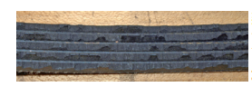
- Alignment
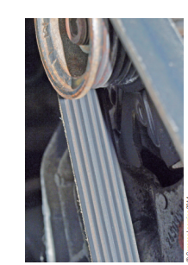
- Check the drive belt tension.
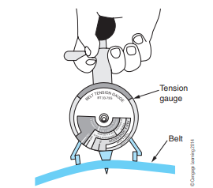

- Visually check alternator wiring and listen for abnormal noises
- Check that the wiring is in good condition.
- Check that there are no abnormal noises from the alternator while the engine is running
- Inspect charge warning lamp circuit
- Warm up the engine and then turn it off
- Turn off all accessories
- Turn the ignition switch to the ON. Check that the charge warning lamp is on
- Start the engine. Check that the light goes out.
If the light does not operate as specified, troubleshoot the charge warning 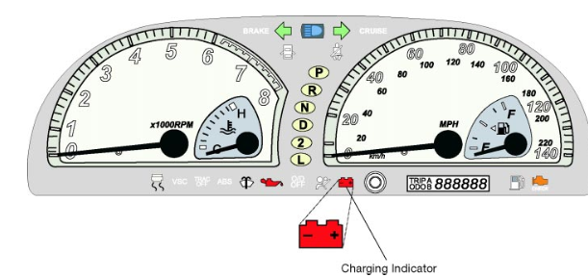

2.1.2 Test charging system
The alternator converts mechanical energy into electrical energy. Other than very small parasitic horsepower losses that slightly heat the bearings, the diodes, and the windings, it only draws enough power from the crankshaft to supply the output power necessary to run the electrical system and charge the battery

Operation sheet: 2.2
Operation Title: Test charging system
Instruction:
- Safe working area
- Properly operated tools and equipment
- Appropriate working cloths fit with the body
Purpose: To perform inspecting charging system
Required tools and equipment: Multimeter
Consumable Materials: Rag, electrolyte, insulation tap
Precautions:
- Wearing proper clothes, eye glass, glove
- Make working area hazard free
- Read and interpret manual which guide you how to use tools and equipment
1. Test the Alternator with the Engine Off
Now you're ready to begin the actual testing of the alternator. First, test it with the engine turned off.
- Turn the engine off.
- Turn on your voltage meter and set it to DC volts.
- Connect the positive lead to the positive terminal (+) on the battery, then connect the negative lead to the negative terminal (-) on the battery.
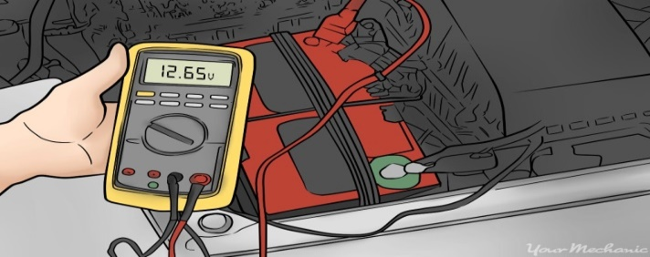

2. Test the Alternator with the engine on
Next, test the alternator with the engine and electrical systems turned on.
- Turn the engine on.
- Check the voltage meter again. It should read between 13.5 and 14.5 volts.
- Stress test the alternator by turning on the car's radio, headlights, and air conditioner.
- Check the voltage meter to make sure there is not a reduction in voltage with the electrical systems turned on.
3. Voltage drop test
The next series of tests help you find excessive resistance in the charging system circuit.
For these tests, you'll need a digital Multimeter and, possibly, the vehicle repair manual for your particular vehicle make and model. The manual will help you locate and identify wires and components, and look up test results’ specifications, if necessary.
Also, during the next two tests, maintain engine conditions as described in the following steps:
- Apply the parking brake.
- Set your transmission to Park (automatic) or neutral (manual).
- Start the engine and let it idle.
- Have an assistant increase and maintain engine speed at 2000 rpm.
- Turn on the headlights on high-beam.
- Turn on the wipers on high speed.
- Turn on the AC and set it to high.
- Turn on other electrical accessories.
A. Ground Circuit Voltage Drop Test
Excessive voltage drop on the ground side of the charging system may lead to an overcharging condition and other electrical system issues. So let’s start by checking the ground path for the charging circuit first.
- Set your voltmeter to 2 volts on the DC Volts scale.
- Connect your voltmeter black lead to the alternator housing.
- Connect the red meter lead to the battery negative (-) post.
- Double check that your voltmeter leads are away of moving engine components.
- Check your voltmeter readout.
Your drop voltage should be between 0.3 volts and 0.5 volts:
- If your reading is below 0.3 volts, have the alternator checked to make sure it is charging. Consult your repair manual for the correct specifications for your application. Some manufacturers suggest a maximum voltage drop of 0.2 volts.
- If your reading is over 0.5 volts, check each connection in the ground circuit (tighten alternator mounting bolts, mounting bracket free of corrosion, good engine grounds).
- Follow the steps in the next section Checking engine grounds.
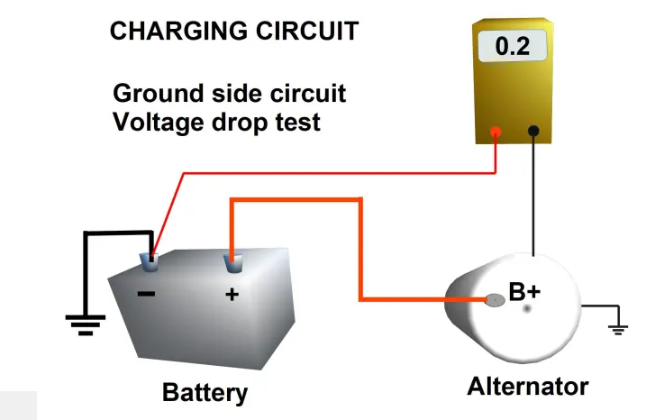
B. Power Circuit Voltage Drop Test
Excessive voltage drop on the power side of the charging circuit may lead to an undercharged condition and other engine electrical system issues. So now, let’s check the power side of the charging circuit.
- Set your voltmeter to 2 volts on the DC Volts scale.
- Connect the voltmeter red lead to the output battery post (B+) on the back of the alternator.
- Connect the voltmeter black lead to the positive (+) battery post.
- Make sure your voltmeter leads are away of moving engine components.
Then check your voltmeter readout.
Your drop voltage should be between 0.3 volts and 0.5 volts:

- If your reading is below 0.3 volts, have the alternator checked to make sure it is charging. Consult your repair manual for this specification, if necessary.
- If your reading is over 0.5 volts, check each connection in the power side of the circuit. Follow the next steps.
Usually you should expect 0.1 volts or less of voltage drop per connection. Consult your vehicle repair manual for the correct specifications for your particular model, if necessary. Keep in mind that some manufacturers may recommend a maximum voltage drop of 0.2 volts or less.
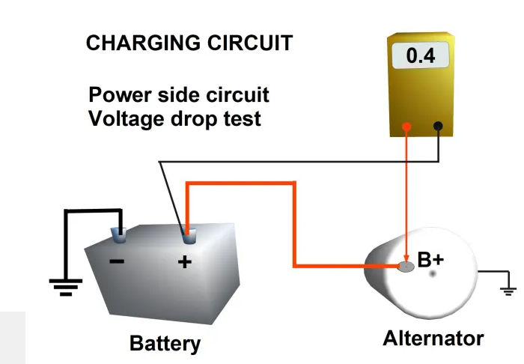
If Voltage Drop Is Too High:
- Move your meter red lead to the terminal on the B+ post.
- Then check the next connection in the circuit (perhaps a fusible link) until you reach the battery terminal that connects to the positive (+) battery post.
- Notice at which point your voltage drops to an acceptable level.
- Your trouble point will be the previous one to this point

2.2 Repair and replace charging system component
Regulator repairing and replacing Once it has been determined that the problem is with the regulator and not the alternator, you can find out if the source is the regulator itself or its wiring or ground.

Operation sheet: 2.3
Operation Title: Regulator repair and replace
Instruction:
- Safe working area
- Properly operated tools and equipment
- Appropriate working cloths fit with the body
Purpose: To perform inspecting charging system
Required tools and equipment: wrench
Consumable Materials: Rag, insulation tap
Precautions:
- Wearing proper clothes, eye glass, glove
- Make working area hazard free
- Read and interpret manual which guide you how to use tools and equipment
Steps
- Check the wiring between the regulator and alternator for heat damage or wear. The regulator is usually mounted on the firewall or on the finder under the hood.
- Remove the bolts from the voltage regulator.
- Use sandpaper to clean off the area around the bolts and the spot where the voltage regulator mounts on the car. This will assure a good ground.
- Clean, reinstall, and tighten the bolts.
- Perform all of the troubleshooting procedures again to see if the problem still exists.
- If so, the problem is either in the wiring or the regulator itself. If you have already inspected the wiring, try replacing the regulator.
- Most voltage regulators are housed inside the alternator and should be replaced by a professional. The externally mounted type can be replaced easily enough – just be sure to label any wires that have to be disconnected.
Caution: The battery ground cable should be disconnected before replacing the voltage regulator.
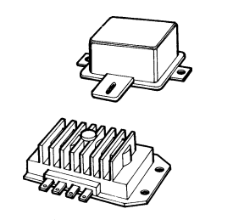
Alternator repairing and replacing
If the alternator is found to be malfunctioning, you can either replace it or have it repaired.

Operation sheet: 2.4
Operation Title: Alternator repair and replace
Instruction:
- Safe working area
- Properly operated tools and equipment
- Appropriate working cloths fit with the body
Purpose: To perform inspecting charging system
Required tools and equipment: wrench
Consumable Materials: Rag, insulation tap
Precautions:
- Wearing proper clothes, eye glass, glove
- Make working area hazard free
- Read and interpret manual which guide you how to use tools and equipment
To replace an alternator, proceed as follows:
- Disconnect the battery ground cable, using a battery terminal puller if necessary.
- Loosen the alternator bolts. There are usually two: one adjustment bolt at the top and one connecting the alternator to the engine block.
- Push the alternator toward the fan and slip the drive belt of the pulley.
- Label and disconnect the wires attached to the alternator.
- Remove the mounting bolts and alternator.
- Reinstall the new or repaired alternator and the mounting bolts.
- Reconnect the wires in their proper locations.
- Slip the drive belt over the pulley. Use a pry bar to pull the alternator away from the fan until the belt is tight.
- Tighten the mounting bolts.
- Check the drive belt for proper tension and make any necessary adjustments.

Operation sheet:2. 5 Alternator drive belt replacement
Operation Title: Drive belt repair and replace
Instruction:
- Safe working area
- Properly operated tools and equipment
- Appropriate working cloths fit with the body
Purpose: To perform inspecting charging system
Required tools and equipment: wrench, cutter
Consumable Materials: Rag
Precautions:
- Wearing proper clothes, eye glass, glove
- Make working area hazard free
- Read and interpret manual which guide you how to use tools and equipment
- Loosen the two alternator bolts and push the alternator toward the fan.
- In some cases, additional belts must be removed to gain access to the drive belt. Take note of which belts ride in which grooves before removing them.
- Remove the drive belt.
- Install the new drive belt, being careful not to stretch it. Reinstall any other belts.
- Use a pry bar to tighten the belt, then tighten the bolts. Do not over tighten the belt; it should be firm but flexible.
- Check and adjust the belt tension.
- Run the engine to make sure all belts are working properly. Check the belt tension again after a few weeks.
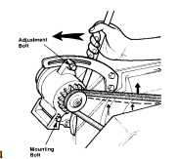

2.3 Charging system troubleshooting

Factors that are affecting the alternator output are:
- The speed of the rotor,
- Strength of the magnetic field, i.e., number of turns of wire in the rotor winding, amount of electricity applied to the rotor coil, the air gap between the rotor poles and the stator
- The number of turns of wire in the stator coils, and
- Inductive reactance

Operation sheet:2. 6
Operation Title: Charging system troubleshooting
Instruction:
- Safe working area
- Properly operated tools and equipment
- Appropriate working cloths fit with the body
Purpose: To perform inspecting charging system
Required tools and equipment: wrench
Consumable Materials: Rag, insulation tap
Precautions:
- Wearing proper clothes, eye glass, glove
- Make working area hazard free
- Read and interpret manual which guide you how to use tools and equipment
System Diagnosis
Proper vehicle diagnosis requires a plan before you start
Following a set procedure to base your troubleshooting on will help you find the root cause of a problem and prevent unnecessary repeat repairs .
step 1: Understand the Customer’s
- Concern Information collection beyond the basics
- .Questions asked MUST be related To the system you will be working on and the customer complaint
step 2: Check for Technical Service Bulletins
- Every vehicle that comes into the shop for a repair (not necessary for routine maintenance) should be checked for TSB’s , This can save you hours of troubleshooting.
step 3: Conduct a Systematic Diagnosis
- This step will be different for every system
- Follow the troubleshooting steps for the system you are working on.
- Make sure to check EVERY component of the system and that they are in proper working order.
- Document your diagnosis including tests and results.
step 4: Complete and Confirm the Repair
- Make sure you have taken care of the customer’s concerns.
- Try to duplicate the conditions that were present when the vehicle failed.
Charging System Troubleshooting Chart
Symptom | Possible Cause | Corrective Action
Batteries not charging | Insufficient belt tension, worn belt | Tighten or replace
Batteries not charging | Defective battery(s) or battery connections | Check battery and battery terminal connections
Batteries not charging | Blown fuse or fusible link | Check fuse and fusible link; replace as needed
Batteries not charging | Defective wiring | Check voltage drop
Batteries not charging | Faulty alternator | Replace alternator
Batteries not charging | Excessive electrical load | Reduce load by turning off all unnecessary accessories
Constantly overcharging (battery electrolyte is depleted in a short time) | Battery | Faulty battery; replace
 | Poor contact at voltage detection point of alternator | Clean contact area
 | Faulty voltage regulator | Replace alternator
Abnormal Noise | Insufficient belt tension | Tighten or replace
Abnormal Noise | Faulty bearing | Replace alternator

LAP Test: 2

Task 1 Inspect and test charging system
Task 2 Repair and replace regulator
Task 3 Repair and replace alternator
Task 3 Repair and replace drive belt
Task 3 Apply troubleshooting

Unit Three: Overhaul Alternator
This unit to provide you the necessary information regarding the following content coverage and topics:
- Disassembly alternator
- Test alternator component
- Repair and replace alternator component
- Reporting
This guide will also assist you to attain the learning outcomes stated in the cover page. Specifically, upon completion of this learning guide, you will be able to:

- Perform disassembly alternator
- Test alternator component
- Repair and replace alternator component
- Perform assemble alternator component

Disassembling alternator

To disassemble the alternator follows this procedure
- Take out the four through-bolts, and separate the drive end frame and rotor assembly from the stator assembly by prying apart with a screwdriver at the stator slot.
- A scribe mark will help locate the parts in the same position during assembly.
- After disassembly, place a piece of tape over the slip ring end frame bearing to prevent the entry of dirt and other foreign material, and also place a piece of tape over the shaft on the slip ring end.
- If brushes are to be reused, clean with a soft dry cloth. Caution: Use pressure sensitive tape and not friction tape which would leave a gummy deposit on the shaft.
- To remove the drive end frame from the rotor, place the rotor in a vise and tighten only enough to permit the removal of the shaft nut.
Caution: Avoid excessive tightening as this may cause distortion of the rotor. Remove the shaft nut, washer, pulley, fan, and the collar, and then separate the drive end frame from the rotor shaft.

Operation sheet: 2.7
Operation Title: Disassemble the alternator
Instruction:
- Safe working area
- Properly operated tools and equipment
- Appropriate working cloths fit with the body
Purpose: To perform inspecting charging system
Required tools and equipment: socket wrench, wire brush, screw driver, hammer, soldering gun, vise
Consumable Materials: Rag, insulation tap, soldering wire
Precautions:
- Wearing proper clothes, eye glass, glove
- Make working area hazard free
- Read and interpret manual which guide you how to use tools and equipment

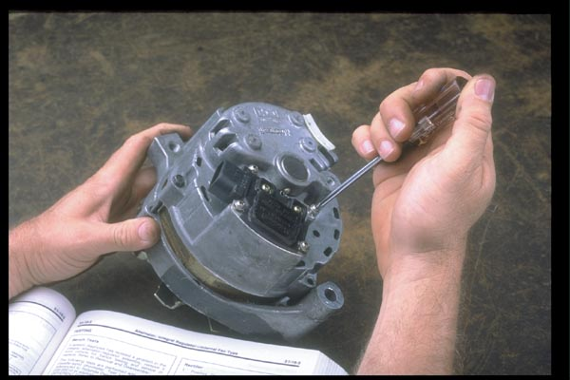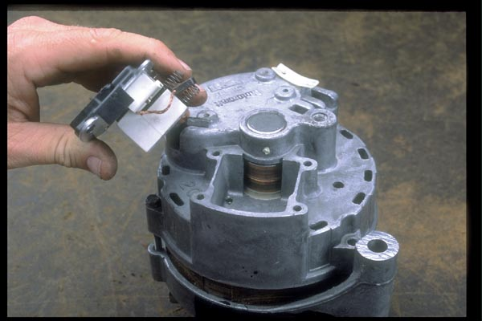
remove the four attaching screws that hold Remove the regulator and brush assembly
the regulator to the AC generator housing
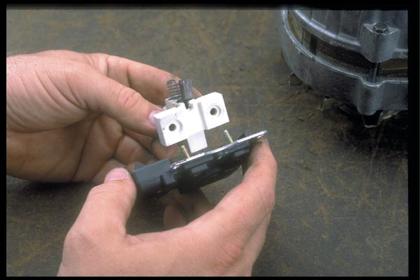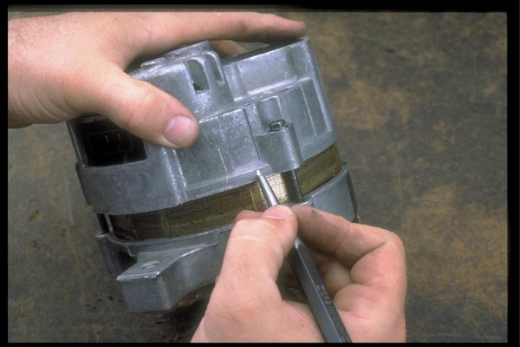
Separate the regulator from the brush Scribe or mark the two end housing and the
holder stator core for reference during reassembly. .
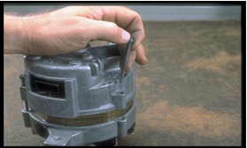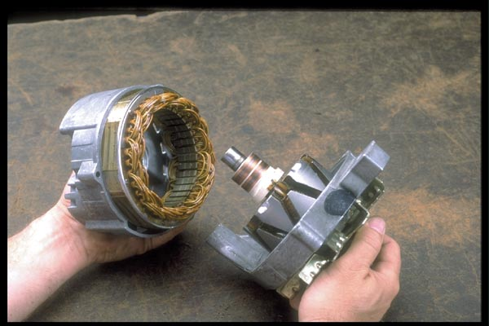
Remove the three through bolts that secure Separate the front housing from the rear
the two housings

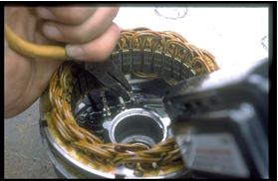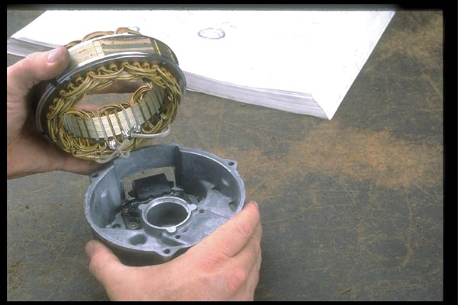
Separate the three stator lead terminals Remove the stator coil from the housing
from the rectifier bridge.

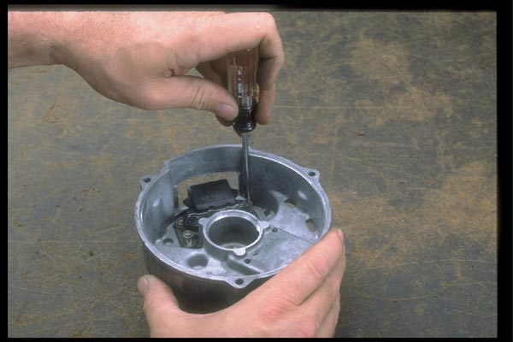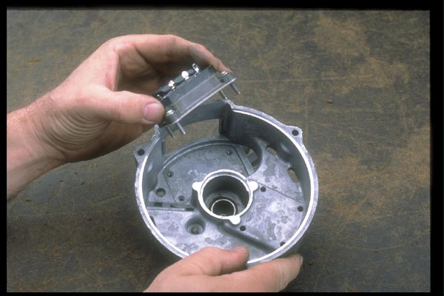
Using the torx wrench, remove the four Remove the rectifier bridge from the housing
attaching bolts that hold the rectifier bridge
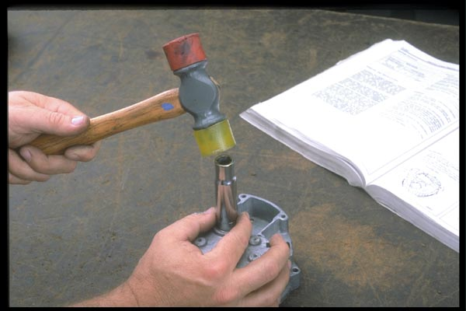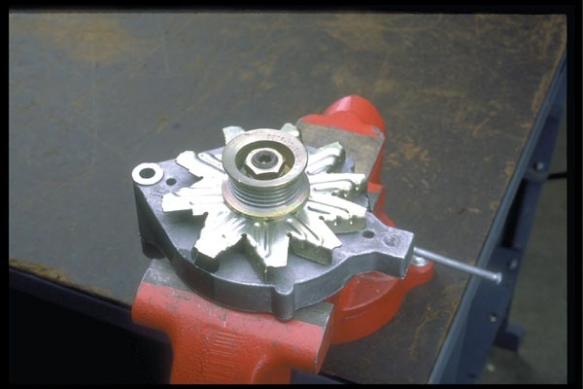
Use a socket to tap out he bearing from the Clamp the rotor in the vise.
housing

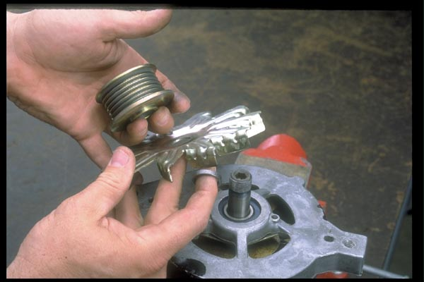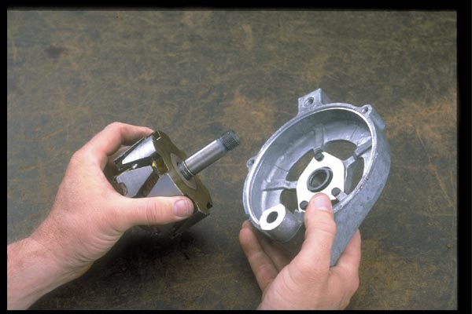
Remove the pulley-attaching nut, flat Separate the front housing from the rotor
washer, drive pulley, fan, and fan spacer
from the rotor shaft
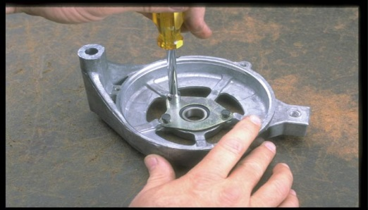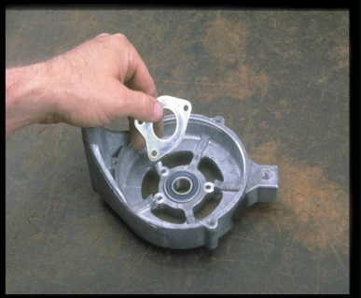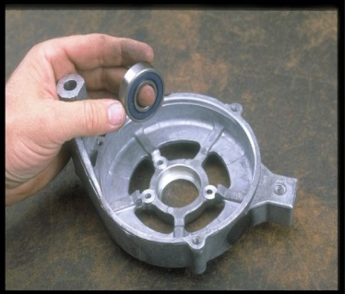
Remove the three screws that hold the Remove the bearing retainer and
bearing retainer to the front housing Remove the front bearing from the housing

3.2 Testing alternator components

To test the components of an AC generator it must be removed and disassembled.
A faulty AC generator can be the result of many different types of internal problems.
- Diodes
- Stator windings
- Field circuits (may be open, shorted or improperly grounded).
- The brushes or slip rings can become worn.
- The rotor shaft can become bent and the pulley can work loose or bend out of proper alignment.

Operation sheet: 2.8
Operation Title: Test the alternator component
Instruction:
- Safe working area
- Properly operated tools and equipment
- Appropriate working cloths fit with the body
Purpose: To perform inspecting charging system
Required tools and equipment: Multimeter, Verner caliper
Consumable Materials:
Precautions:
- Wearing proper clothes, eye glass, glove
- Make working area hazard free
- Read and interpret manual which guide you how to use tools and equipment

Alternator bench tests

If the on-vehicle checks have indicated that the alternator is defective, it should be removed for bench testing and replacement.
- Specific procedures for testing are noted in the appropriate repair manuals.
- Rotor
- Check the rotor for an open circuit by measuring for resistance between the slip rings. If there is no continuity, replace the rotor.
- Check the rotor for grounded circuits by measuring for resistance between the rotor and slip ring. If there is continuity, replace the rotor.

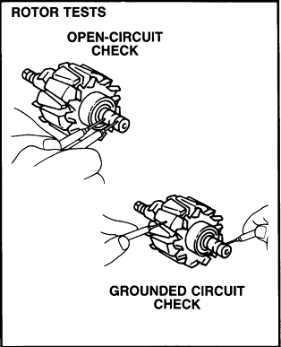

- Stator
- Check the stator for an open circuit by measuring for resistance between the winding. If there is no continuity, replace the stator.
- Check the stator for grounded circuits by measuring for resistance between the stator and stator body. If there is continuity, replace the stator.

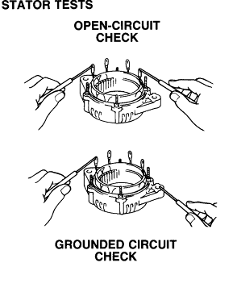

- Diode and rectifier
- Inspect positive side
- Inspect negative side
- If no resistance is seen in both directions, the diode is shorted.
- If infinite resistance is seen in both directions, the diode is open.

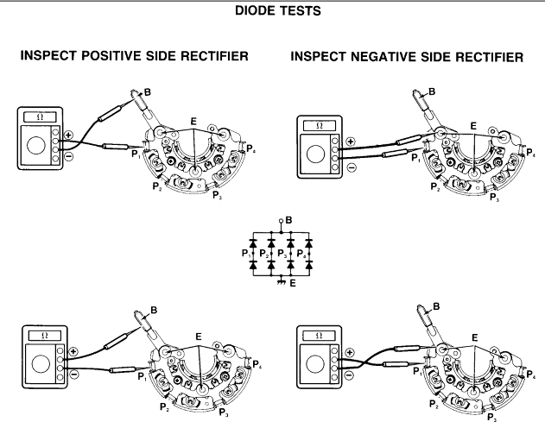

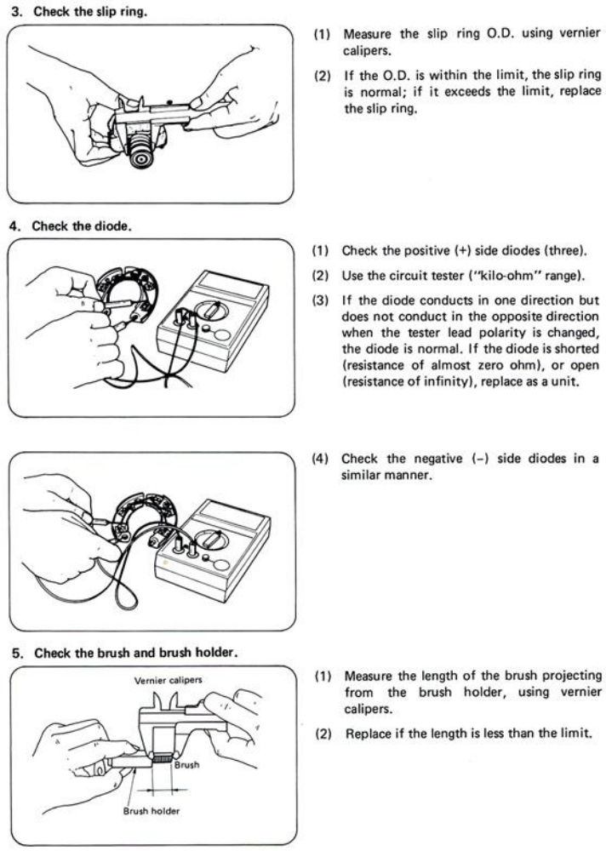

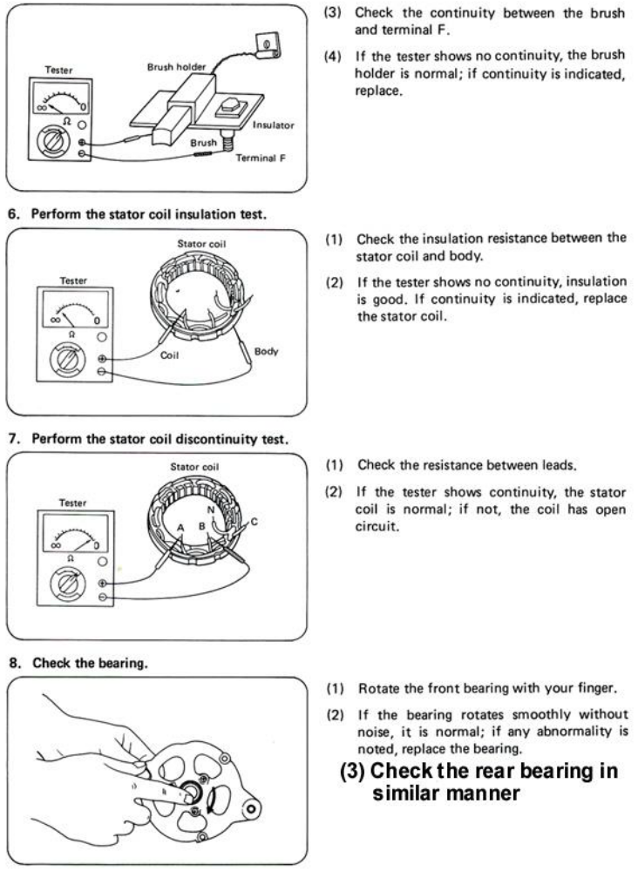

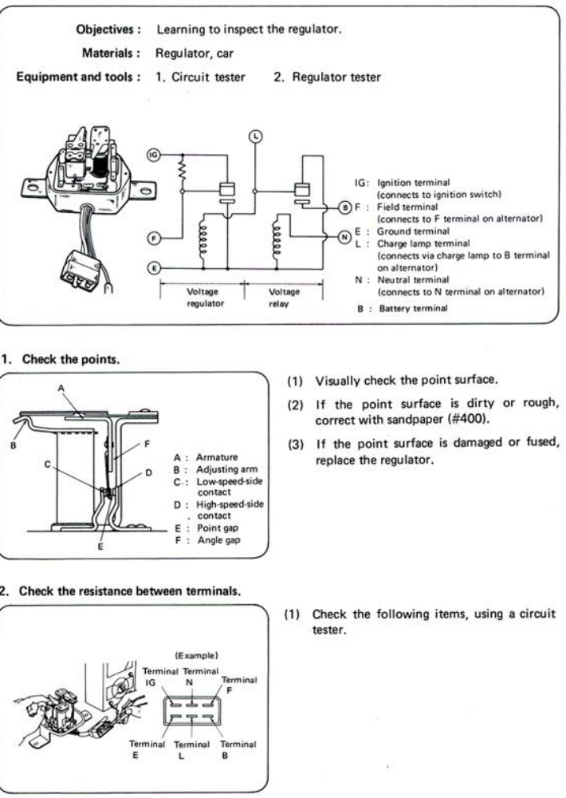

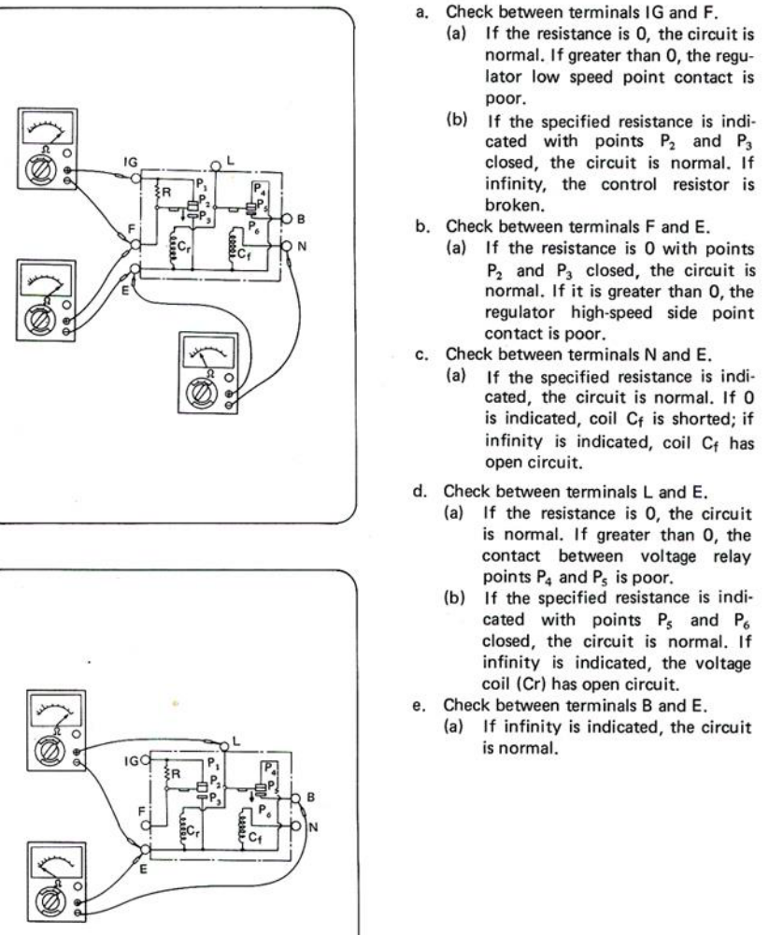

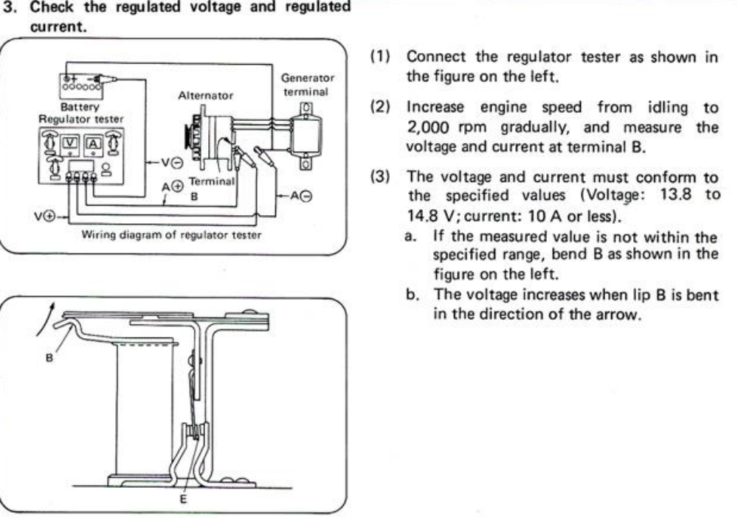

Repairing and replacing the component

Procedure
- Wipe the stator, rotor, and front bearing with a clean cloth. Do not clean these parts with solvent.
- Rotate the front bearing on the drive end of the rotor shaft. Check for any scraping noise, looseness, or roughness. Look for excessive lubricant leakage. If any of these conditions exist, replace the bearing. Pack the bearings with high-temperature grease where required. Record your results on the accompanying “Report Sheet for Inspecting and Cleaning Generator Components.”
- Inspect the rotor shaft rear bearing surface for roughness or severe chatter marks. Replace the rotor assembly if the shaft is not smooth. Record your results on the report sheet.
- Place the rear bearing on the slip ring end of the rotor shaft and rotate the bearing. Make the same check for noise, looseness, and roughness as was made for the front bearing. Inspect the rollers and cage for damage. Replace the rear bearing if these conditions exist or if lubricant is lost or contaminated. Record your results on the report sheet.
- Inspect the slip rings for nicks and scratches. These may be removed by turning the slip rings while holding 400 grain polishing cloth against them. (Never use emery cloth). If the rings are badly damaged, replace the rotor assembly. Record your result on the report sheet.
- Inspect all wire leads on both the rotor and stator assemblies for loose or broken connections. Check the windings for burned insulation. Replace all parts that show signs of burned insulation. Record your result on the report sheet.
- Inspect the pulley and fan for excessive looseness on the rotor shaft and for cracks or other damage. Replace any pulley or fan that is loose, cracked, or bent out of shape. Record your results on the report sheet.
- Inspect both the front and rear housing for cracks, particularly in webbed areas at the mounting ear. Replace a damaged or cracked housing. Record your results on the report sheet.
- Wipe all grease from the rectifier assembly base and rectifier mounting areas of the rear housing with a clean shop towel.
- Brushes must be free of any oil or grease. Replace the brushes if they are worn shorter than one-fourth inch.

LAP Test
Practical Demonstration

Instruction I: Given necessary templates, tools and materials you are required to perform the following tasks within 5 hours.
Task 1 Disassembly alternator
Task 2 Alternator component
Task 3 Repair and replace alternator component
Task 4 prepare report

3.4 Reporting

REPORT SHEET FOR INSPECTING AND CLEANING GENERATOR COMPONENTS
 | Serviceable | Corrective Action
Visual inspection
Front bearing
Rotor shaft
Rear bearing
Slip rings
Wire leads
Windings
Pulley
Front housing
Rear housing
Brushes
Conclusion and Recommendations ____________________________________________________________________________________________________________________________________________________________

Unit four: Clean-up work area and maintain equipment
This unit to provide you the necessary information regarding the following content coverage and topics:
- Collecting and storing reused materials
- Removing waste and scrap.
This guide will also assist you to attain the learning outcomes stated in the cover page. Specifically, upon completion of this learning guide, you will be able to:

- Collect and store reused materials
- Remove waste and scrap.

1.1 Collecting and storing reused materials
Cleaning of tools and equipment’s
Layer of oil, grease and dirt gets coated to the tools and equipment with time and usage. Before performing in a maintenance work on the tools and equipment’s the unwanted layer should be removed. This can be done by hand or by means of certain cleaning methods (using cleaning solvent compressed air etc.).
Maintaining the tools and equipment’s
Maintenance is controlling the condition of tools, machines and equipment’s against deterioration. there are different failure modes and their behavior in time is met with different maintenance strategies.
Maintaining Equipment’s/Machines
The following are some of machines / equipment maintenance strategies.
- Preventive maintenance
- Predictive maintenance
- Break down maintenance
Preventive maintenance
Understood as periodic or schedule activates in which the main objective is the direct prevention of modes or defects. It includes
- Inspection
- Cleaning
- Testing
- Overhauling
- Repairing
- Adjusting
- Replacement

predictive maintenance
Is a periodic inspection followed by replacement or overhaul if incipient defects are detested. This methods does not directly reduce the deterioration rate but indirectly control the consequences of accidents, breakdowns, malfunctions, and general troubles .It involves the observers sense of seeing, hearing, feeling and smell.
This strategy dictates a continues search for defects i.e. continues monitoring of machinery /equipment conditions and performance coupled with continues feedback.
Break down maintenance
Is the maintenance activities necessary to restore machines and equipment’s back to service after failure modes developed which were:-
- Preventable but not prevented
- Preventable but not predicted
- Predicted but not acted upon
- Not preventable or predictable
In order to carry out successful maintenance work every machine or equipment’s should have a history card on which all testes and repairs are recorded.
Note: -in technical institution the development of this attitudes is no less important. After the installation of the required equipment, it becomes the trainer’s responsibility to keep the machines, instruments in condition for effective use. This involves constant checking as well as minor repairs. The following suggestions will prove to be most helpful in maintaining equipment in excellent working condition and there by demand a minimum of repairs
1. Lubrication
The lubrication system of all machines should be checked before each period of use .to do it effectively, trainee should be assigned the specific responsibility and should be closely supervised by the instructor(trainer)

2. Machine/Equipment cleaning
All machines and equipment should be cleaned at the end of each period of use. Electrical and electronics related instruments should not be exposed to dust and moisture.
3. Machine/Equipment Testing
All machines and equipment should be tested and adjusted periodically as much of the actual work as possible.
4. Repairs
Minor repair should be done promptly by the trainee if possible or under the trainees’ supervision.
5. Safety
Safe working conditions should be maintained through the trainees’ safety committee.
Maintenance of Tools
To guard against accident and provide effective means for work, tools must be kept on good working condition .Good work cannot be produced with dull or in appropriate tools. Proper tools maintenance maybe accomplished by:-
1. Regular Sharpening
- . tools to be issued from tools room only when sharp
- tools in individual kits kept sharp by the one to whom they are assigned.
2. Re-conditioning before tools are in use again
A. handles broken or loose
B. defective parts replaced or repaired
Work area
A safe shop is the clean shop. You can make the shop safe by keeping the floor clean. Cleaning up spilled liquids before starting work will make final clean up easier and quicker.

4.2 Removing waste and scrap
Trainers are concerned how to handle the disposal of the following three types of materials or tools or equipment’s.
  - Scrap: -it is an item or equipment which becomes salvaged after giving service for ample period of time
  - Surplus: -this refers to the existence of items or equipment’s in excess of the requirements. Materials or equipment’s become obsolete as a result of change in technology.
  - Obsolete materials/equipment’s: - .materials or equipment’s become obsolete as a result of change in technology.
Methods of disposing unwanted/wasted material
There are three ways of disposing materials they are:-
- Transferring to another equivalent organization
- Selling
- Discarding the material/equipment’s
Proper storage
One of the responsibilities of a shop instructor/trainer is to organize and handle storage in order to protect tools equipment’s and materials against loose and deterioration. These, the following factors should be given due consideration.
- Accessibility: - classification and making
- Ease of handling: - based on the weight and bulk of the piece
- Inventorying: - protect against un authorized withdrawals of materials
- Safety Procedure: - un authorized usage and un necessary damage or deterioration.

However general storage should be
  - Convenient storage
  - Safe storage
  - Visible storage
I. Convenient storage
The material must be stored correctly to minimize the labor required for:-
- Putting the material in storage
- Maintaining the material in good order
- Issuing materials quickly and orderly
- Accounting for material
- Inspecting the quality and quantity
II. Safe storage
Materials must be stored safely to prevent
- Loose
- Breakage
- Spoilage by
- Sun light
- Heat
- Cold
- Dampness
- Insects
- Spontaneous combustion
III. Visible Storage
Materials when stored should as far as possible be visible:-
- To reduce duplication
- To help maintaining adequate supplies
- To permit quick check and inspection
Note:-A problem of major importance in training center shop is the storage of tools, machines, equipment’s and accessories. in solving this the shop trainer apply the practices commonly found in industry.
- Machine storage
- Central tools room
- Separate facilities convenient to particular machine
- Tools storage
- Tray
- Tools box/kit
- Hooks (against inclined tool board, in cup board and on wall)
- Compartment to fit in drawer and in rack
- Hole to fit part of the tool as drill bits, chisels and welding machine accessories
The place where each tools belong should be identified. This may be done by
- A symbol letter or number
- A painted outline
- Name of the tool painted over or under the position

Self-check: 1
Directions: Give short answer
1, list and explain some of machines / equipment maintenance strategies?
2, there are three ways of disposing materials describe them?
3, one of the responsibilities of a shop instructor/trainer is to organize and handle storage in
Order to protect tools equipment and materials against loose and deterioration. T/f
4, list three general storage?

Reference

- Fifth edition Heavy Duty Truck System ( Sean Bennett)
- Automotive Technology system approach 5th edition(Jack Erjavec)
- Modern automotive technology
Participants of this Module (Training Material) preparation

No | Name | Qualification | Field of Study | Organization/ Institution | Mobile number | E-mail
 | Adinet Asnake | MSc. | Automotive Technology Mgt | Wolkite PTC | 0913-767250 | andinetasnake31@gmail.com
 | Biruk Tilahun | BSc. | Automotive Technology | General Wingate PTC | 0913-789176 | biruktilahun1@gmail.com
 | Fadli Aman | BSc. | Automotive Technology | General Wingate PTC | 0927-283100 | Fadli.ziyad@gmail.com
 | Hana Nigusise | BSc. | Automotive Technology | Selam TVET college | 0988-751516 | Hana.nigussie25@gmail.com
 | Israel Taye | BSc. | Automotive Technology | General Wingate PTC | 0913-424100 | Isra.taye@gmail.com
 | Tatek Mamo | PhD scholar | Automotive Technology | DEC | 0911-841121 | mimibaba928@gmail.com
 | Zelalem Yitbarek | BSc. | Automotive Technology | Selam TVET college | 0972-030621 | Zolosmart12@gmail.com

