

Heavy Vehicles and Earth Moving Machinery Maintenance.
Level-II
Based on Nov, 2022, Curriculum Version I
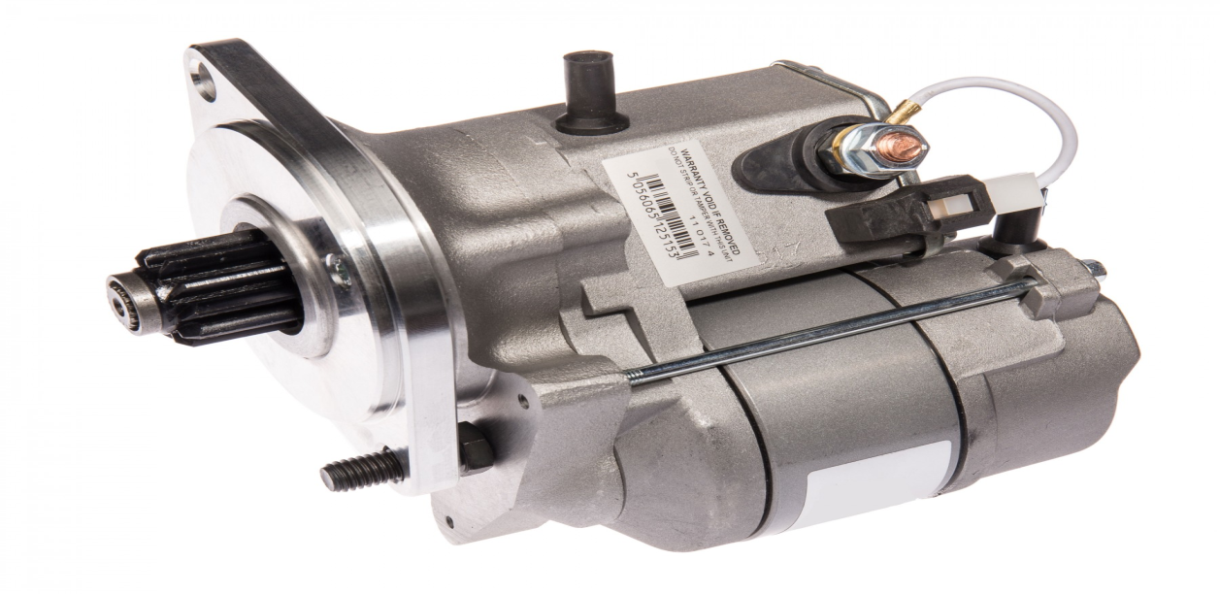
Module Title: - Starting System
Module code: EIS HEM2 M05 1122
Nominal duration: 60 Hour

Prepared by: Ministry of Labor and Skill
December, 2022
Addis Ababa, Ethiopia

Table of Contents
Acknowledgment 4
Acronym 5
Introduction to module 6
Unit one: Introduction to starting system 8
1.1 Purpose of Starting System and Type of starter motor 9
1.1.1 Purpose starting System 9
1.1.2 Type of starter motor 9
1.2 Components of Starting system and its function 11
1.2.1 Starter motor construction 13
1.3 Principles of operations of starting system 17
1.3.1 Principles of starting system 17
1.3.2 Operation of gear reduction type starter motor 20
Current path 22
23
1.4 OHS requirement 23
1.5 Identify tools and Equipment 24
Self-check: 1 25
Unit Two: Dismantle starting motors and clean individual components/ parts 26
2.1 Disassemble starter motor components parts 27
Operation sheet: 2.1 27
2.2 Cleaning starter motor and components 32
Operation sheet: 2.2 32
Unit Three: Inspect and test starting systems /components 35
3.1 Inspect and test starting system circuit and components 36
Operation sheet: 3.1 36
Operation sheet: 3.2 38
3.3. Inspect and test starter motor and associated components 43
Operation sheet: 3.3 44
Unit four: Disassemble and Repair starter motor associated components 49
4.1 Overhaul starter motor components 50
Operation sheet: 4.1 50
4.2 Repair starter motor 56
Operation sheet: 4.2 56
4.3 Assemble starter motor components 63
Operation sheet: 4.3 63
4.4 Retests starter motor 67
Operation sheet: 4.4 67
LAP Test 69
Unit five: Clean-up work area and maintain equipment 70
5.1 Remove waste and scrap 71
5.1.1 Waste disposal 71
5.2 Cleaning and inspecting equipment and work area 72
5.2.1 Methods of Cleaning Electrical System 72
5.2.2 Maintaining tools and equipment 72
5.2.2 Proper storage 73
Reference 75

Acknowledgment

Ministry of Labor and Skills wish to extend thanks and appreciation to the many representatives of TVET instructors and respective industry experts who donated their time and expertise to the development of this Teaching, Training and Learning Materials (TTLM).

Acronym

OHS Occupational Health and safety
V Voltage
Amp Ampere

Introduction to module
The function of the starter motor is to start up the combustion engine. An electric motor forms the basis of the starter motor. When the starter switch is turned on, the starter relay turns on the electric motor. This motor drives the starter gear ring via the pinion gear. The rotating movement of the starter motor is created through the interaction of two magnetic fields. Starter motors come with permanent magnets or with electromagnets. Each of these configurations has its own specific characteristics. The energy required by the starter motor is provided by the battery. The starter motor requires a lot of start-up power. The battery must therefore have sufficient capacity and any losses must be kept to a minimum. As the starter motor begins to turn faster, start-up power is reduced. This is caused by the inverse voltage generated..
This module is designed to meet the industry requirement under the Performing starting Systems Service occupational standard, particularly for the unit of competency: Maintain starting system and its components.
This module covers the units:
- Introduction to Starting system
- Dismantle starting motors and clean individual components/ parts
- Inspect and test starting systems /components
- Repair starting systems and overhaul associated components
- Clean-up work area and maintain equipment
Learning Objective of the Module
- Prepare for work
- Perform Dismantling starting motors and clean individual components/ parts
- Inspect and test starting motor and systems component/ parts
- Repair starting systems and overhaul associated components
- Clean up work area and maintain equipment

Module Instruction
For effective use this modules trainees are expected to follow the following module instruction:
- Read the information written in each unit
- Accomplish the Self-checks at the end of each unit
- Perform Operation Sheets which were provided at the end of units
- Do the “LAP test” giver at the end of each unit and
- Read the identified reference book for Examples and exercise

Unit one: Introduction to starting system
The unit covers the competence to maintain automotive starting motor, systems and direct current motors:
  - Purpose and type of Starting System
  - Components of Starting system and its function
  - Principles of operations of starting system
  - OHS requirement
  - Identify tools and Equipment
This unit will also assist you to attain the learning outcomes stated in the cover page. Specifically, upon completion of this learning guide, you will be able to:
- Understand the Purpose and type of Starting System
- Identify Components of Starting system and its function
- Discuss Principles of operations of starting system
- Apply OHS requirement
- Identify tools and Equipment

1.1 Purpose of Starting System and Type of starter motor

1.1.1 Purpose starting System
The automotive cranking motor circuit includes the storage battery, the starter switch, the cables to connect the motors and switch, to the battery, and the ground return circuit. The starter motor is a low voltage direct current motor, which converts electrical energy from the storage battery in to mechanical energy. When circuit between the starting motor and the battery is completed by the cranking switch it cranks the engine at speed sufficient to cause the starting of the engine at speeds sufficient to cause starting of the engine. The starter motor used in automobiles is incorporates a magnetic switch that shifts a rotating gear in to and out of mesh with the ring gear around the circumference of the flywheel.
A cranking system can be divided into two sub circuits known as the control circuit and the starter circuit. The objective of the cranking system is to energize a starter motor using energy from the vehicle batteries. The control circuit is activated either directly from the vehicle ignition key or by a dedicated starter button. The control circuit uses low current to switch the starter circuit. The switch used to bridge the control circuit and the starter circuit is a magnetic switch. The magnetic switch receives a low-current command signal that switches the high-current starter circuit. Once energized, the starter circuit uses full battery power to energize the starter motor.

1.1.2 Type of starter motor
a) Conventional Starter Motor
The conventional starter motor contains the components shown, The pinion gear is on the same shaft as the motor armature and rotates at the same speed. A plunger in the magnetic switch (solenoid) is connected to a shift lever. When activated by the plunger, the shift lever pushes the pinion gear and causes it to mesh with the flywheel ring gear. When the engine starts, an over-running clutch disengages the pinion gear to prevent engine torque from ruining the starting motor. This type of starter was used on most 1975 and older Toyota vehicles.
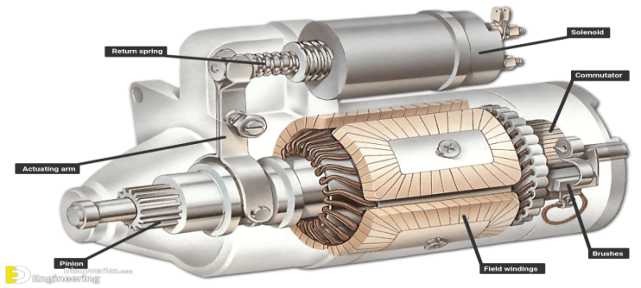
Fig1.1 conventional starter motor

- Gear-Reduction Starter Motor
A welcome innovation in truck engine starter technology has been the introduction of reduction gearing starters capable of cranking diesel engines up to 16 liters displacement. This new generation of heavy-duty starters. This type of starter has a compact, high-speed motor end a set of reduction gears. While the motor is smaller and weighs less than conventional starting motors, it operates at higher speed. The reduction gears transfer this torque to the pinion gear at 1/4 to 1/3 the motor speed. The pinion gear still rotates faster than the gear on a conventional starter and with much greater torque (cranking power).
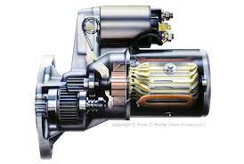
Fig 1.2 Gear reduction starter motor

- Planetary-type starter motor
The key to enabling a lightweight starter motor such as the 39MT to crank large-bore, high-compression engines is a planetary gear set. The armature assembly, where the drive pinion on the armature shaft engages with the four planetary gears. This means that the role of the armature pinion is that of the sun gear in the planetary set. In this type starter planetary set, the sun gear is the input, the planetary carrier is the output, and the ring gear that surrounds the four planetary gears is held stationary. This arrangement provides for a reduction ratio of about 3½:1. This means that for every output rotation of the output carrier, the sun gear has to turn over three revolutions. A planetary gear set arrangement such as this provides for maximum rpm reduction and maximum output torque. The output from the planetary gear set is the starter pinion. The starter pinion is solenoid/shift lever engaged to the ring gear on the flywheel for cranking. This uses a nose less drive snout and soft start engagement technology.
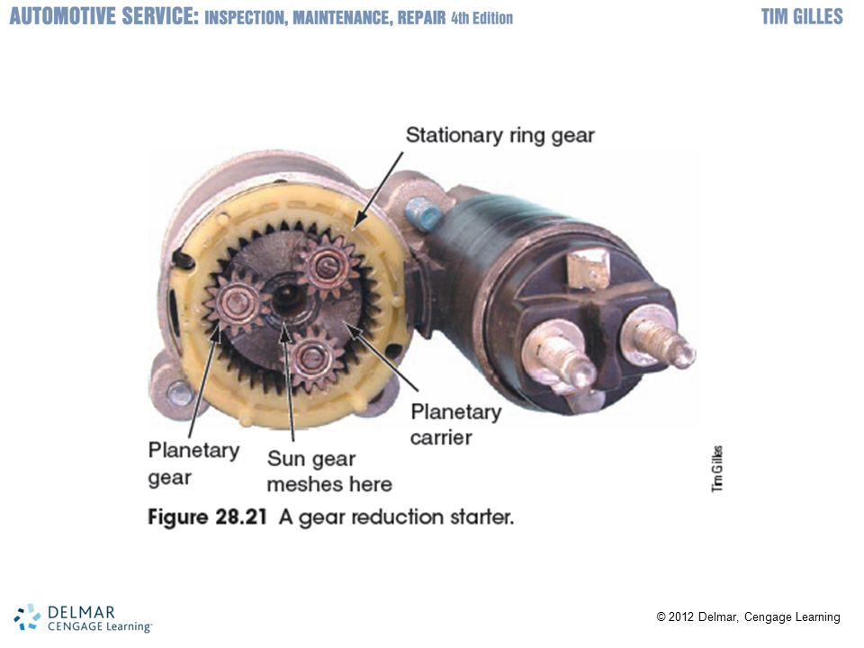
Fig 1.3 Planetary-type starter motor

1.2 Components of Starting system and its function
There are five basic components and two distinct electrical circuits in a typical cranking system. The components are:
- Battery
- Key switch (or starter button)
- Battery cables
- Starter relay
- Magnetic switch
- Starter motor
- Neutral Safety
- Battery:- The automotive battery, also known as a lead-acid storage battery, is an electrochemical device that produces voltage and delivers current. In an automotive battery we can reverse the electrochemical action, thereby recharging the battery, which will then give us many years of service. The purpose of the battery is to supply current to the starter motor, provide current to the ignition system while cranking, to supply additional current when the demand is higher than the alternator can supply and to act as an electrical reservoir.
- Key switch (or starter button):- The ignition switch allows the driver to distribute electrical current to where it is needed. The term ignition switch is commonly used to describe the switch that energizes the control circuit in the cranking system. There are two types. The first type is integral with the ignition key: To close the control circuit to initiate cranking, the key is turned. The second type is a push-button and requires that the ignition key circuit be closed before the push-button starter is powered. In both cases, the switch is spring-loaded to the open position. This means that it must be either turned (by key) or pushed (by thumb) against the spring pressure to close the starter control circuit and initiate cranking.
- Battery cables:- are large diameter, multistranded wire which carry the high current (250+ amps) necessary to operate the starter motor. Some have a smaller wire soldered to the terminal which is used to either operate a smaller device or to provide an additional ground. When the smaller cable burns, this indicates a high resistance in the heavy cable. Care must be taken to keep the battery cable ends (terminals) clean and tight. Battery cables can be replaced with ones that are slightly larger but never smaller.
- Starter relay is a small, electrical device found in the starting circuit of high-current motors. The relay is essentially a remote switch that controls a high-current circuit. In motor vehicles, a starter relay uses the small ignition switch current to close the much heavy-duty starter circuit.
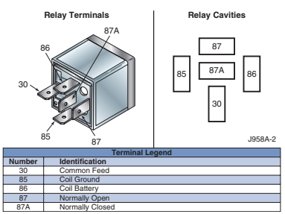
Fig 1.4 Starter relay

- Magenetic switch The starter relay is a magnetic switch that enables the control circuit to open and close the high-current cranking circuit. It is either mounted at a remote location from the starter or built into the front end of the starter solenoid assembly. Remote-mounted starter relays are located close to the battery or starter to keep the cables as short as possible. a starter relay mounted on the firewall of a conventional truck near the windshield wiper motor on the driver’s side. On cab-over-engine models, the starter relay is often mounted on the front frame cross member. The starter relay consists of an electromagnet plunger, contact disc, and two springs. The electromagnet has a hollow core in which the plunger moves.

- Starter motor:- The starter motor converts electrical energy from the battery into mechanical energy for cranking the engine. The starter is an electric motor designed to operate under great electrical loads and produce high torque.
- Neutral Safety Switch The neutral safety switch prevents vehicles with automated and automatic transmissions from being started in gear. Neutral safety switches are located in either of two places in the control circuit. One position is between the ignition switch and the starter relay. Placing the transmission in park or neutral will close the switch so current can flow to the starter relay. The neutral safety switch can also be connected between the starter relay and ground so that the switch must close before current can flow from the starter relay to ground.
A starter motor draws high current from the batteries, typically 300 to 400 amperes. This current flows through the heavy-gauge cables that directly connect the battery to the starter. The driver switches the current flow using the ignition key. However, if the high-current cables were to be routed from the battery to the ignition key and then on to the starter motor, the voltage drop caused by resistance in the cables would be too great. The starter motor is energized directly by the vehicle batteries. The function of the starter motor is to convert electrical energy into sufficient mechanical torque to turn a high-compression diesel engine. The output torque from the starter motor pinion is imparted to ring gear teeth on the engine flywheel. A cranking circuit must be capable of starting an engine even under the most demanding conditions such as cold weather extremes.

1.2.1 Starter motor construction
Starter motors do not differ much in design and operation. A starter motor consists of a housing, field coils, an armature, a commutator, brushes, end frames, and a solenoid-operated shift mechanism.
- starter housing or frame encloses the internal starter components and protects them from damage, moisture, and foreign materials. The housing supports the field coils and forms a conducting path for the magnetism produced by the current passing through the coils.
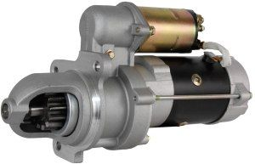
Fig 1.5 starter housing

- Field Coils The field coils and their pole shoes are securely attached to the inside of the iron housing. They are insulated from the housing but are connected to a terminal that protrudes through the outer surface of the housing. The field coils and pole shoes are designed to produce strong stationary electromagnetic fields within the starter body as current is passed through the starter. These magnetic fields are concentrated at the pole shoes. Field coils will have an N or S magnetic polarity depending on the direction the current flows. The coils are wound around respective pole shoes in opposite directions to generate opposing magnetic fields. The field coils connect in series with the armature winding through the starter brushes. This design permits all current passing through the field coil circuit to also pass through the armature windings.
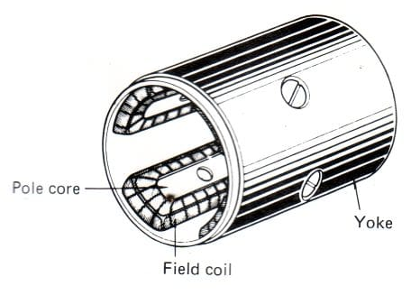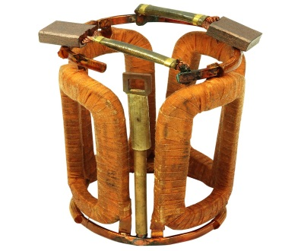
Fig 1.6 Field Coils housing
Fig 1.7 Field Coils

- Armature The armature is the rotating component of the starter. It is located between the drive and commutator end frames and the field windings. When the starter motor operates, the current passing through the armature produces a magnetic field in each of its conductors. The reaction between the armature’s magnetic field and that of the field coils causes the armature to rotate. This creates the torque required to crank the engine.
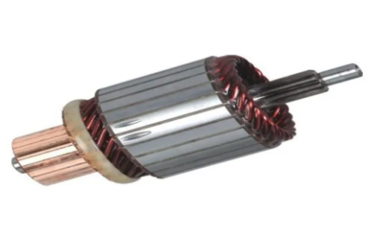
Fig 1.8 Armature

- Armature Windings The armature has two main components: the armature windings and the commutator.Both mount to the armature shaft. The armature windings are not made of wire. Instead, heavy flat copper strips that can handle heavy current flow are used. The windings are constructed of several coils of a single loop each. The sides of these loops fit into slots in the armature core or shaft but are insulated from it. Each slot contains the side of two of the coils. The coils connect to each other and to the commutator so that current from the field coils flows through all of the armature windings at the same time. This action generates a magnetic field around each armature winding, resulting in a repulsion force all around the conductor. This repulsion force causes the armature to turn.
- Commutator The commutator assembly presses onto the armature shaft. It is made up of heavy copper segments separated from each other and the armature shaft by insulation. The commutator segments connect to the ends of the armature windings. Starter motors have four to twelve brushes that ride on the commutator segments and carry the heavy current flow from the stationary field coils to the rotating armature windings via the commutator segments. The brushes are held in position by a brush holder.
- Armature Segments In a starter motor, many armature segments must be used. As one segment rotates past the stationary magnetic field pole, another segment immediately takes its place. The turning motion is made uniform and the torque needed to turn the flywheel is constant rather than fluctuating, as it would be if only a few armature coils were used. Starter motors are usually series-wound motors. Current is flowed through the motor circuit in a single series path. It is first routed to the field coils and from there routed through the armature. This is one factor that enables cranking motors to produce maximum torque at zero rpm. All series wound motors produce maximum torque at low rpm close to stall.
- Brushes are parts that run on a section of the commutator at the rear of the housing. it rubs the commutator and conducts electricity.
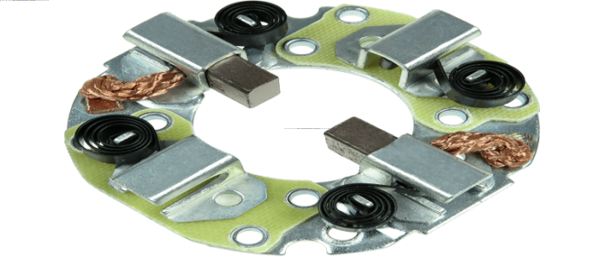
Fig 1.9 Brushes

- Starter solenoid The solenoid-operated shift mechanism (Figure 9–12) is mounted in a solenoid housing that is sealed to keep out oil and road splash. The case is flange mounted to the starter motor housing. It contains an electromagnet with a hollow core. A plunger is installed in the hollow core, much like the starter relay described earlier. The solenoid performs two functions.
- When energized, plunger movement acts on a shift lever that shifts the starter motor drive pinion into mesh with the engine flywheel teeth so that the engine can be cranked.
- The solenoid also closes a set of contacts that allows battery current to flow to the starter motor; this ensures that the pinion and flywheel are engaged before the starter armature begins to rotate.
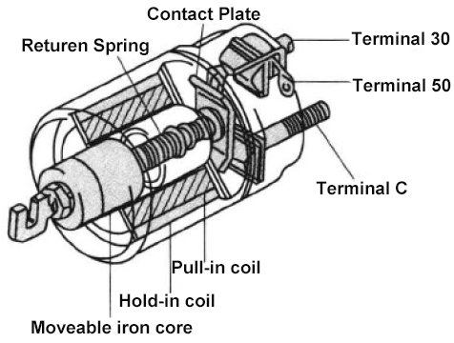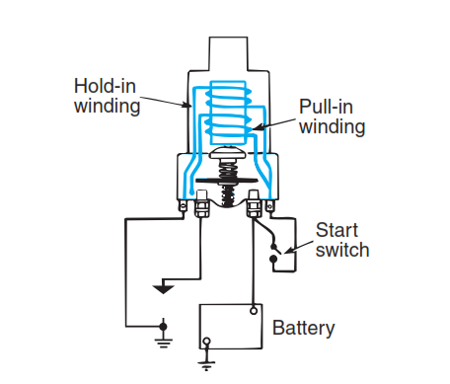
Fig 1.10 Starter solenoid

- Overrunning Clutches The overrunning clutch performs an important job in protecting the starter motor. When the engine starts and runs, its speed increases. If the starter motor remained connected to the engine through the flywheel, the starter motor would spin at very high speeds, destroying the armature windings. To prevent this, the starter must be disengaged from the engine as soon as the engine turns more rapidly than the starter. But with a solenoid-actuated drive mechanism, the pinion remains engaged with the flywheel until current stops flowing to the starter.In these cases, an overunning clutch is used to disengage the starter. The clutch housing is internally splined to the starting motor armature shaft. The drive pinion turns freely on the armature shaft within the clutch housing. When the clutch housing is driven by the armature, thespring-loaded rollers are forced into the small ends of their tapered slots and wedged tightly against the pinion barrel. This locks the pinion and clutch housing solidly together, permitting the pinion to turn the flywheel and, thus, crank the engine. When the engine starts, the flywheel spins the pinion faster than the armature. This action releases the rollers, unlocking the pinion gear from the armature shaft. The pinion then “overruns” the armature shaft freely until being pulled out of the mesh without stressing the starter motor. Note that the overrunning clutc is moved in and out of mesh with the flywheel by linkage operated by the solenoid.

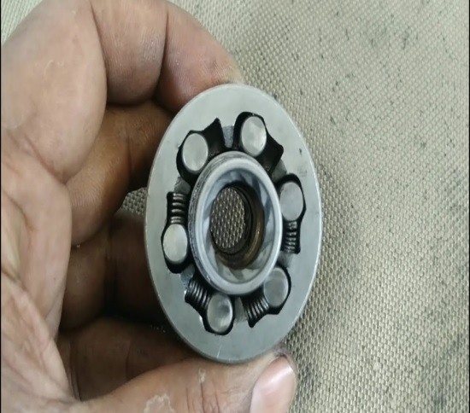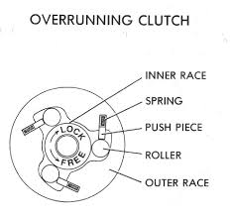
Fig 1.11 Overrunning Clutches

- Pinion gear A pinion is a small mechanism containing gear and springs. It engages immediately the engine started, by extending the gear to the flywheel teeth. The flywheel is the source of engine rotation.

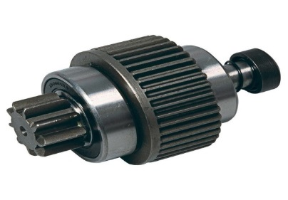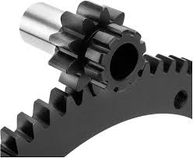
Fig 1.12 Pinion gear

1.3 Principles of operations of starting system

1.3.1 Principles of starting system
DC starter motors work on the principle of magnetic repulsion. This principle states that magnetic repulsion occurs when a straight rod conductor composed of the armature, commutator, and brushes is located in a magnetic field (field windings) and current is flowing through the rod. This situation creates two separate magnetic fields: one produced by the magnet (pole shoes of the magnetic field winding) and another produced by the current flowing through the conductor (armature/commutator/brushes). Magnetic field moving from the N pole to the S pole and the conductor’s magnetic field flowing around the conductor. The magnetic lines of force have a rubber-band characteristic. That is, they stretch and also try to shorten to minimum length. a stronger magnetic field on one side of the rod conductor (armature/commutator/brushes) and a weak magnetic field on the other side. Under these conditions, the conductor (armature) will tend to be repulsed by the strong magnetic field (pole shoes and field winding) and move toward the weak magnetic field. As current in the conductor (armature) and the strength of the magnet (field windings) increases, the following happens:
- More lines of magnetism are created on the strong side.
- More repulsive force is applied to the conductor (armature).
- The conductor tries harder to move toward the weak side in an attempt to reach a balanced neutral state.
- A greater amount of electrical heat is generated.
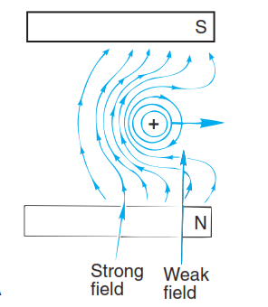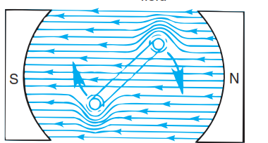
Fig 1.13 Magnetic force

- Motor Internal Circuit Because field current and armature current flow to the motor through one terminal on the housing, the field and armature windings must be connected in a single complete circuit. The internal circuitry of the motor (the way in which the field and armature windings are connected) gives the motor some general operating characteristics the three general types of motor internal circuit, as follows:
- Series
- Shunt (parallel)
- Compound (series-parallel)
- Series all automotive starter motors in use today are the series type or the compound type. The series motor has only one path for current. As the armature rotates, its conductors cut magnetic flux lines. A counter-voltage is induced in the armature windings, opposing the original current through them. The counter voltage decreases the total current through both the field and the armature windings, because they are connected in series. This reduction of current also reduces the magnetic field strength and motor torque. Series motors produce a great amount of torque when they first begin to operate, but torque decreases as the engine begins to. Series motors work well as automotive starters because cranking an engine requires a great amount of torque at first, and less torque as cranking continues.
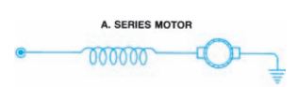
Fig 1.14 Series wound

- Shunt motor does not follow the increasing-speed/decreasing-torque relationship just described. The counter-voltage within the armature does not affect field current, because field current travels through a separate circuit path. A shunt motor, in effect, adjusts its torque output to the imposed load and operates at a constant speed. Shunt motors are not used as automotive starters because of their low initial torque, but are used to power other automotive accessories.
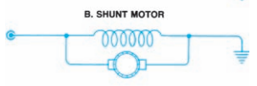
Fig 1.15 Shunt wound

- Compound motor has both series and shunt field windings. It combines both the good starting torque of the series type and the relatively constant operating speed of the shunt-type motor. A compound motor is often used as an automotive starter. The actual relationships of field and armature windings in different types of motors.
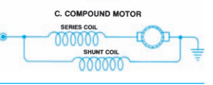
Fig 1.16 compound wound

1.3.2 Operation of gear reduction type starter motor
- Ignition switch in start position
When the ignition switch this is turned to start terminal 50 passes electrical current to the hold in and pull in coil, from the pull in coil the current flows to the field coils and armature coils via terminal 'C'. The motor rotates at lower speed at this point, since the energised pull in coil causes a voltage drop which limits the supply of current to the field coil and the armature coil the hold in & pull in coils at the same time set up a magnetic field which pushes the plunger against the return spring. The pinion gear there fore shifts to engage with the ring gear. The low speed at this stage helps the gear to mesh smoothly.
Current path
Ground
Hold in coil

Terminal 50
Ignition switch
Battery

Terminal C
Pull in coil
Ground
Armature
Field coil

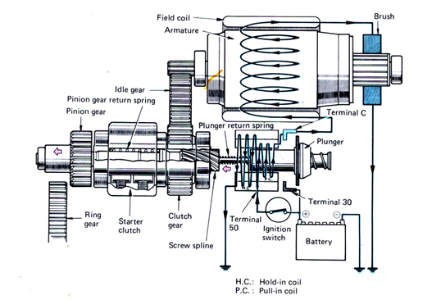
Fig 1.17 Ignition switch in start position

- Pinion and ring gear engaged
When the magnetic switch and screw splines have pushed the pinion gear to mesh with the ring gear, the contact plate attached to the plunger turns the main switch on by short circuiting the connection between terminal 30 and terminal 'C'. As a result a larger electrical current passes through the starter motor to rotate with a greater torque the screw splines helps the pinion gear mesh more securely with the ring gear. At the same time, the voltage levels at both ends of the pull in coil becomes equal so that no current flows through this coil the plunger is therefore held in position only by the magnetic force exerted by the hold in coil.
Current path
Ground
Hold in
Terminal 50
Ignition
Switch

Battery
BBB
Field
Terminal C
Contact
Plate
Terminal 30

Ground
Armature

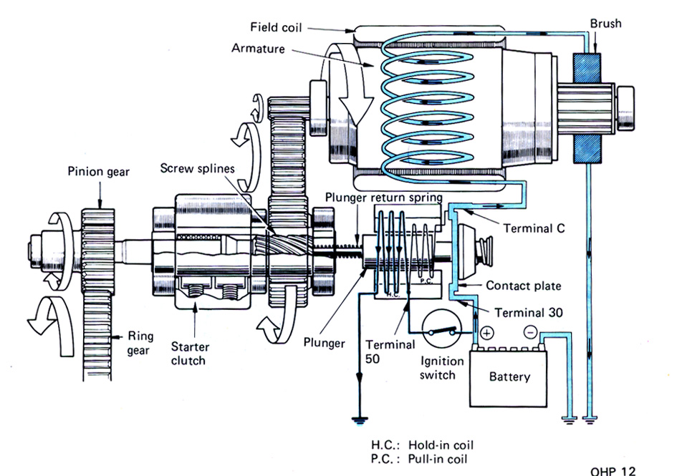

Fig 1.18 Pinion and ring gear engaged

- Ignition switch in on position
Turning the ignition switch back to "on" from the START cuts off the voltage to terminal 50 the main switch remains closed, however some current flows from terminal 'C' to the hold in coil via the pull in coil. Since current flows through the hold in coil in the same direction as when the ignition switch is in the start position. It generates a magnetic force which pulls the plunger in the pull in coil, on the other hand, current flows in the opposite direction generating a magnetic force which attempts to return the plunger to its original position. The magnetic fields set up by these coils cancel each other so that the plunger back to its original position by the return springs which in turn disengages the pinion gear from the ring gear therefore the heavy current which has been supplied to the motor is cut off. The armature used in the reduction type starter motor has less inertia because of the friction of the gears. Hence this type of starter motor does not need brake mechanism

Current path
Pull in
Ground
Hold in
Terminal "C"
Terminal 30
Battery
Ground
Armature
Field coil

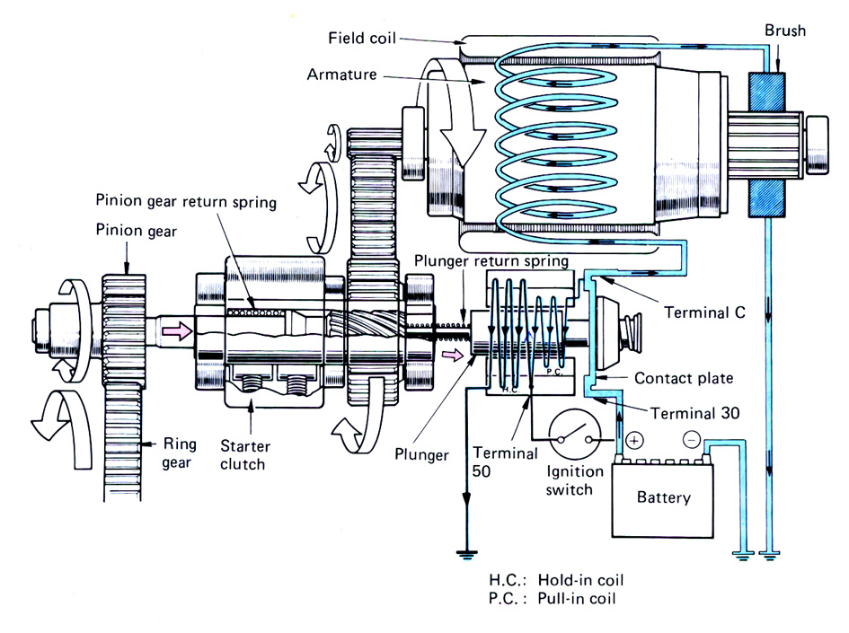
Fig 1.19 Ignition switch in on position

1.4 OHS requirement
If incorrectly handled, there is the danger that electrical equipment and machinery will short-circuit and cause a fire, so the following point must be carefully observed:
- When any irregularities are detected in electrical equipment and machinery, turn off the switch at once and contact your supervisor.
- In cases of short circuit or accidental fire, turn off the switch first before taking fire extinguisher measures.
- Do not go near broken electrical wires.
- Report any inadequately installed wiring or electrical equipment to your supervisor.
- Do not touch electrical equipment and machinery with wet hands, as there is the danger of electrical shock.
- Do not let an electric cord pass through wet or soaked areas.
- As fire starts easily near power switches, motors, and switchboards, do not place any thing, which is likely to burn or explode in these areas.
- Never touch switches with labels out of order.
- A blown fuse indicates some sort of electrical trouble, and the instructor should be informed immediately.
- When removing a plug, do not pull on the plug itself.

1.5 Identify tools and Equipment
A variety of tools and measuring instruments are used to service vehicles. To perform work efficiently and safely, it is important that you fully understand how they are used and, furthermore you keep the following in mind.
- Choose the most suitable tools for carrying out the work safely and sufficiently.
- Reduce the time spent selecting tools for use and facilities itemized checking, by always keeping them in a fixed place in the toolbox or tool lack and putting them away in the correct order.
- Protect the vehicle from dirt, and prevent tools from slipping, by always wiping off any oil and keeping tools clean.
- When handling a tool to another person, hold the handle away from you to prevent the other person from injuring himself by taking a hold of the tool's blade etc.
- If a tool becomes blunt, loose or damaged, or its movement stiff, repair or replace the tools as necessary.
No | Consumable Materials | Equipment’s
1 | Starter motor relay | Different types of Starter motor
2 | Fuse | Glower Test
3 | Different size wires | Multi meter
4 | Soldering leads | Test lamp
5 | Insulating tape | Different types of wrenches
6 | Storage battery | Starter motor testing machine
7 | Terminals
8 | Wiring brushes

Self-check: 1
Directions: choose the correct answer
1. What is the function of the control circuit in a truck cranking circuit?
- To regulate current flow through the charging circuit
- to limit overcharging of the batteries
- to switch the starter motor to crank the engine
- to manage the cranking motor voltage
2. What component prevents a starter motor from being turned by the engine at speeds that could damage the motor?
- Rotor
- Overrunning clutch
- Pinion gear
- Solenoid gear
3, Which of the following produces the stationary magnetic fields in a typical truck starter motor?
- Brushes
- Armature
- Commutator
- Field coils and pole shoes
4, What is the function of a neutral safety switch in the cranking circuit?
- To prevent accidental engine startup in neutral gear
- to prevent engine startup when an automatic transmission is in gear
- to prevent the engine from being over-revved in neutral
- to prevent the starter motor from over speeding after engine start
Directions: Give short answer
- List all consistent component of starting system?
- List and explain starter motor components?
- What is the function of overrunning clutch?
- What are the three starter motor internal circuit?

Unit Two: Dismantle starting motors and clean individual components/ parts

This unit to provide you the necessary information regarding the following content coverage and topics:
- Disassemble starter motor components parts
- Cleaning starter motor and components

This guide will also assist you to attain the learning outcomes stated in the cover page. Specifically, upon completion of this learning guide, you will be able to:

- Perform Disassemble starter motor components parts
- Clean starter motor and components

2.1 Disassemble starter motor components parts

Operation sheet: 2.1
Operation Title: Disassemble starter motor
Instruction:
- Safe working area
- Properly operated tools and equipment
- Appropriate working cloths fit with the body
Purpose: Perform to disassemble starter motor
Required tools and equipment: assorted wrenches, snap ring pliers, flat blade screwdriver, ball-peen hammer, plastic head hammer, punch, scribe, safety glasses, and small press.
Consumable Materials: Safety poster, first aid kit, waste bin, grease, rag
Precautions:
- Wearing proper clothes, eye glass, glove
- Make working area hazard free
- Read and interpret manual which guide you how to use tools and equipment

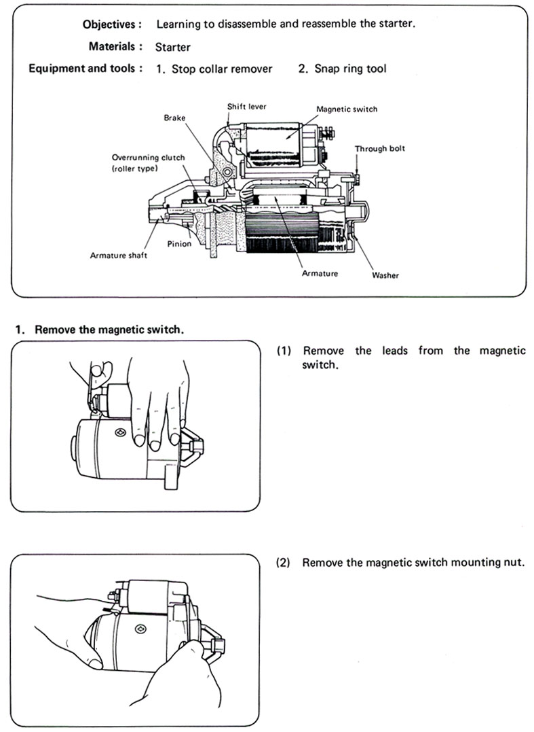

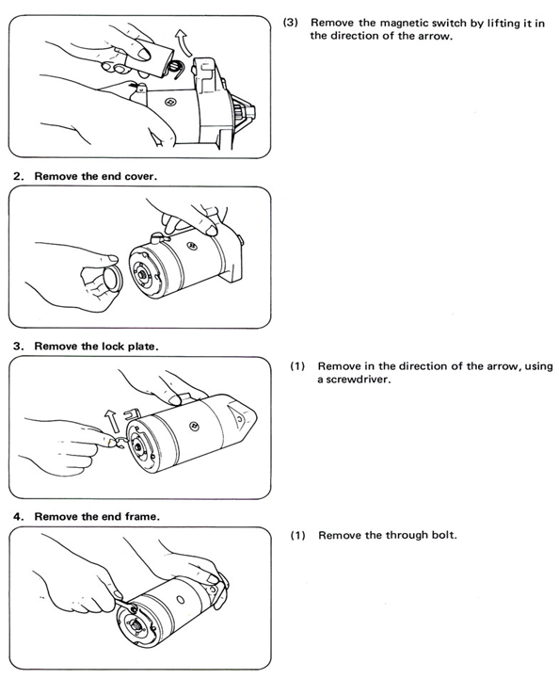
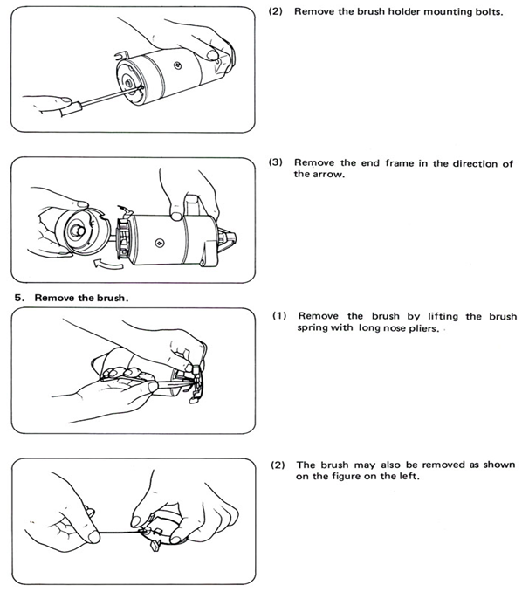
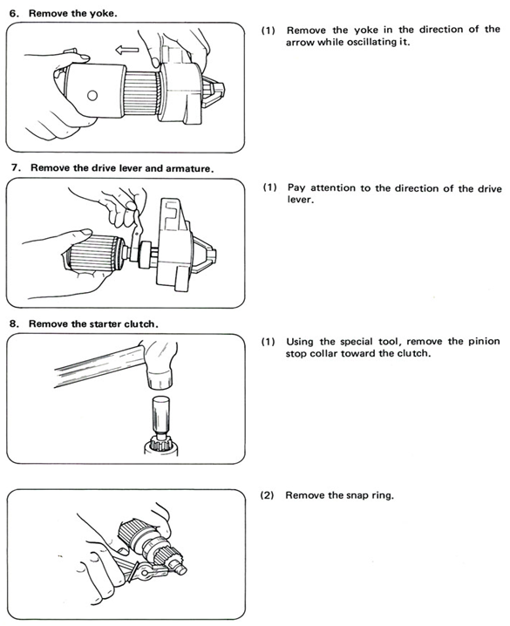

2.2 Cleaning starter motor and components

Operation sheet: 2.2
Operation Title: Cleaning starter motor and components
Instruction:
- Safe working area
- Properly operated tools and equipment
- Appropriate working cloths fit with the body
Purpose: Learning to clean starter motor and components
Required tools and equipment: Nylon brush, drill with larger chuck, plastic scriber, file, razor knife, cutting blade.
Consumable Materials: electrical contact cleaner, first aid kit, waste bin, grease, 600 grit aluminum oxide sandpaper, rag
Precautions:
- Wearing proper clothes, eye glass, glove
- Make working area hazard free
- Read and interpret manual which guide you how to use tools and equipment

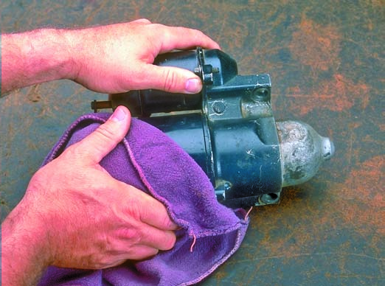

If you play in mud holes a bit, you will end up with the starter motor playing up. But unless it is a very high mileage one, most just need to be pulled apart and given a clean and they are as good as new again. Not much too them and way more cost effective than getting a replacement one. This is only and strip and clean for if your starter has been effected by mud and water and not worn out needing replacement parts. But I would look at pulling it apart and have a look anyway because in most cases this is all that is needed for those with less than 200,000 kms on the clock.

- Using a small flathead screwdriver, remove all of the old grease. Using a Q-tip, get in all the cervices. Super clean helps. So does hot water. Hot water breaks up grease one, and two, it evaporates faster than cold water.
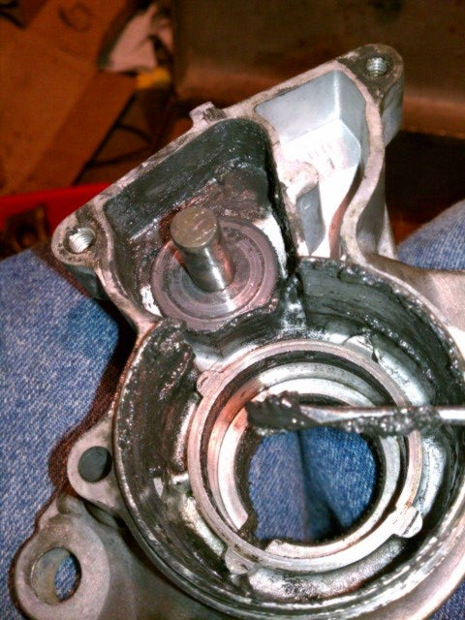

- Using the same soft abrasive bit in your Dermal, polish the contact points in the solenoid assembly. These contact points act like a heavy duty "Switch", bridging the connection between the battery positive and the starter motor itself, which needs a ton of current to turn the engine over. Over time, these contacts become burned, pitted, and dirty, increasing resistance and giving the motor less current to work with.
- Using only aluminum oxide sandpaper, 600 grit, rip off a piece roughly about the wide of the commutator. Holding the armature in one hand, wrap the sandpaper around the commutator, light pressure, turn the commutator in a full rotational motion and not just back and forth.
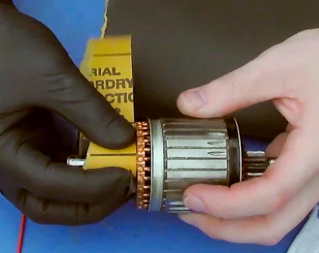
- After that, give the commutator a final clean up with contact cleaner.
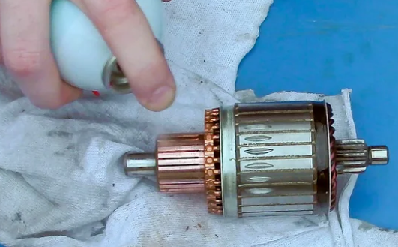
- Clean each component carefully with the lubricant cleaner and an abrasive pad, light brush or rag. If there is dirt or grime stuck in an area, the abrasive pad or brush will help break it loose with the cleaner. Otherwise, the soft rag should work well with the cleaner.

Unit Three: Inspect and test starting systems /components
This unit to provide you the necessary information regarding the following content coverage and topics:
- Inspect starting system circuit
- Inspect and test starting system components
- inspect and test starter motor and associated components

This guide will also assist you to attain the learning outcomes stated in the cover page. Specifically, upon completion of this learning guide, you will be able to:

- Inspect starting system circuit
- Inspect and test starting system components
- inspect and test starter motor and associated components

3.1 Inspect and test starting system circuit and components

Operation sheet: 3.1
Operation Title: Inspect starting system circuit component
Instruction:
- Safe working area
- Properly operated tools and equipment
- Appropriate working cloths fit with the body
Purpose: Learning to inspect starting system circuit
Required tools and equipment: vehicle equipped with starting system circuit
Consumable Materials: Insulating tap, wire, terminal connector
Precautions:
- Wearing proper clothes, eye glass, glove
- Make working area hazard free
- Read and interpret manual which guide you how to use tools and equipment

For complete starter wiring circuit diagrams, refer to Wiring Diagrams. Before removing any unit from starting system for repair or diagnosis, perform the following inspections:
- Battery - Visually inspect battery for indications of physical damage and loose or corroded cable connections. Determine state-of-charge and cranking capacity of battery. Charge or replace battery if required.
- Ignition Switch - Visually inspect ignition switch for indications of physical damage and loose or corroded wire harness connections. Refer to Ignition Switch and Key Lock Cylinder.
- Park/Neutral Position Switch - Visually inspect park/neutral position switch for indications of physical damage and loose or corroded wire harness connections. Refer to Park/Neutral Position Switch.
- Starter Relay - Visually inspect starter relay for indications of physical damage and loose or corroded wire harness connections.
- Starter Motor - Visually inspect starter motor for indications of physical damage and loose or corroded wire harness connections.
- Starter Solenoid - Visually inspect starter solenoid for indications of physical damage and loose or corroded wire harness connections.
- Wiring - Visually inspect wire harnesses for damage or corrosion. Repair or replace any wiring problems as required.
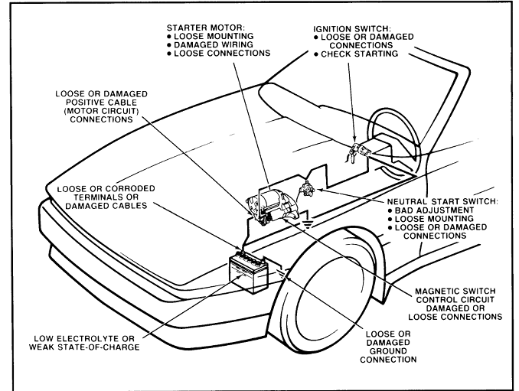

Operation sheet: 3.2
Operation Title: starting system circuit test
Instruction:
- Safe working area
- Properly operated tools and equipment
- Appropriate working cloths fit with the body
Purpose: Learning to inspect starting system circuit
Required tools and equipment: meltimeter, ammeter
Consumable Materials: Insulating tap, wire, terminal connector
Precautions:
- Wearing proper clothes, eye glass, glove
- Make working area hazard free
- Read and interpret manual which guide you how to use tools and equipment

- Current Draw Test the starter current draw test provides a quick check of the entire starting system it also checks battery cranking voltage. If another type of tester is used, follow the manufacturer’s recommendation procedure. The following steps outline a typical procedure for performing a current draw test on a starting system;
- This test should be made only with a serviceable battery.
- prepare the tester;
- Connect the clamp on Amps pickup around the battery ground cable or cables.
- Make sure all lights and accessories are off and vehicle door are closed.
- Set the test selector switch to #1 starting.
- Disable the ignition so the engine dose not start during testing.
- Cranking the engine, while observing the tester ammeter and voltmeter.
- Cranking speed should be normal (200-250)
- Current draw should not exceed the maximum specified.
- Cranking voltage should be at or above the minimum specified.
8, Restore the engine to starting condition and remove tester leads.
Testing Results: -
- High current draw and low cranking speed usually indicate a faulty starter.
- High current draw may also be caused by engine problems.
- Low cranking speed with low current draw, but high cranking voltage, usually indicates excessive resistance in the starter circuit.
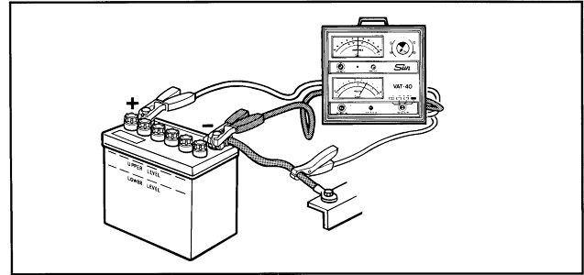

- Voltage Drop Tests
Voltage drop testing can detect excessive resistance in the starting system. High resistance in the starter motor circuit (power side or ground side) will reduce current to the starting motor. This can cause slow cranking speed and hard starting. High resistance in the starter control circuit will reduce current to the magnetic switch. This can cause improper operation or no operation at all.
Insulated Circuit Resistance Test
- Connect the voltmeter between the battery positive and the starting motor terminal
- Crank the engine and observe the voltmeter.
- Maximum should be 0.5 volts
- Excessive voltage indicates dirty or loose connections, or burned or pitted solenoid contacts
- If excessive resistance is indicated, locate the cause. Acceptable voltage drops are 0.3 volt across the magnetic switch, 0.2 volts for the cable, and zero volts for the cable connection. Repair or replace components, as needed.
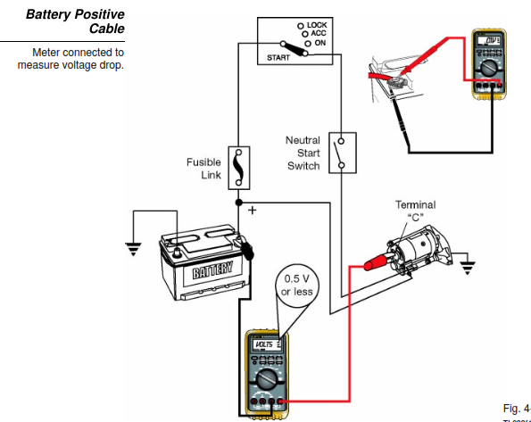

Starter Ground Circuit Test
- Connect the voltmeter between the starting motor ground and battery negative
- Crank the engine, noting voltage
- Maximum should be 0.5 volts
- Excess voltage indicates dirty or loose connections

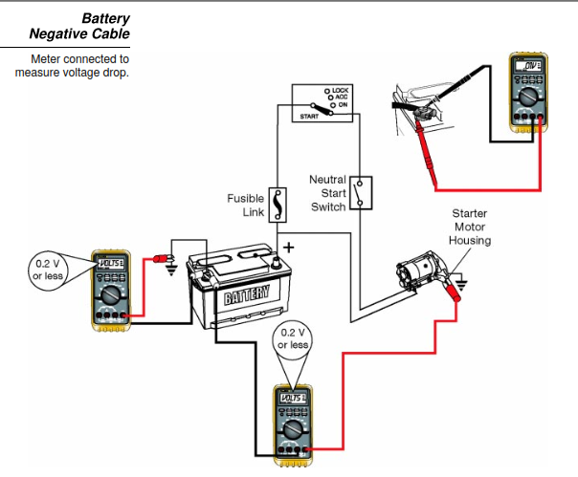

- Testing the starter relay
Testing the starter relay involves two steps
- Check for continuity with the relay de energized
- Check for continuity with the relay energized.
Relay de –energized
- No continuity between pin 3 and 5( through the open contacts)
- Continuity between pins 1 and 2 ( through the relay coil)
Note; To energize the relay, contact two jumper wires:
- Battery positive to pin 1
- Battery negative to pins 2
Relay energized
- Continuity between pins 3 and 5( through the closed contact)
If any of these check do not produce the specified result, replace the relay

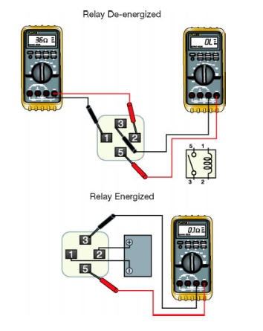

3.3. Inspect and test starter motor and associated components
Electrical Faults
- Positive conductor is going direct to ground
- Two conductors are contacting creating a shorter path
- Broken conductor or switch turned OFF
- Restriction to current flow
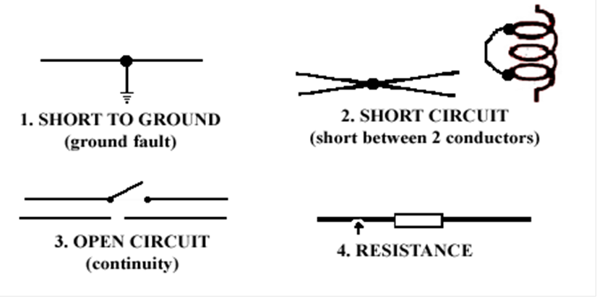

Operation sheet: 3.3
Operation Title: 3.3 Inspect and test starter motor and associated components
Instruction:
- Safe working area
- Properly operated tools and equipment
- Appropriate working cloths fit with the body
Purpose: Learning to inspect and test starter motor and associated components
Required tools and equipment: Meltimeter, ammeter, growler tester, dial gauge, Verner caliper, mica depth, spring balancer, v- block
Consumable Materials:
Precautions:
- Wearing proper clothes, glove
- Make working area hazard free
- Read and interpret manual which guide you how to use tools and equipment

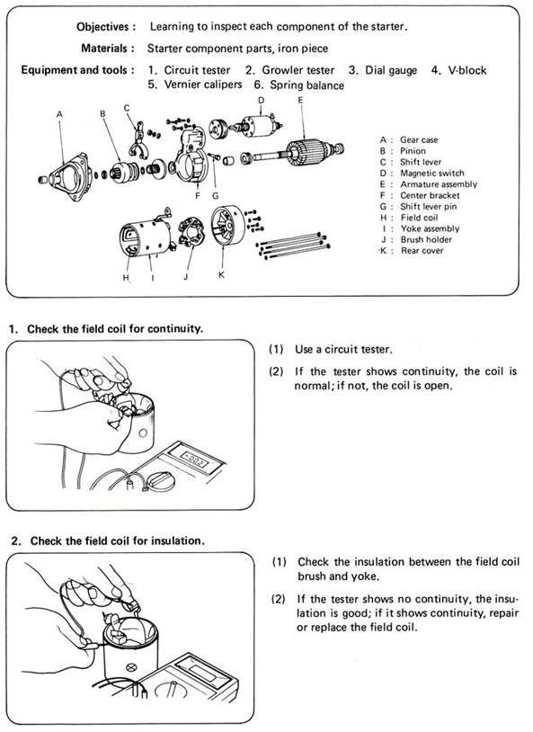

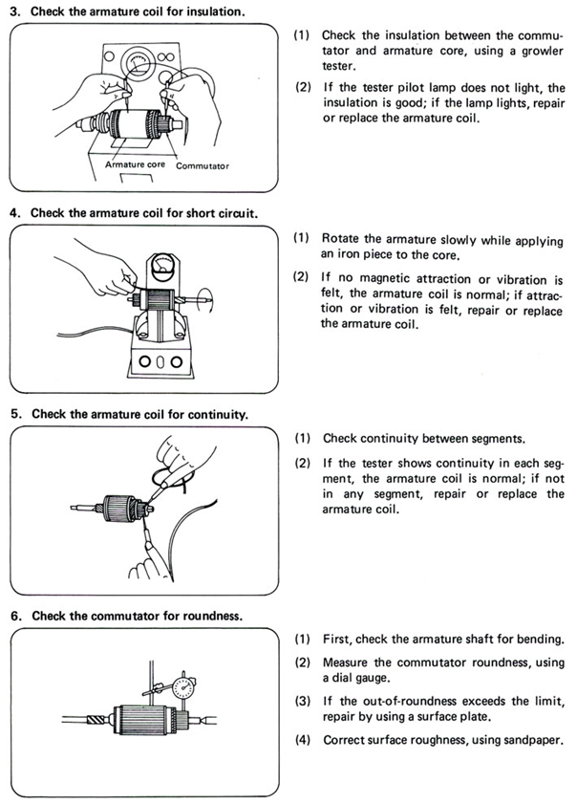

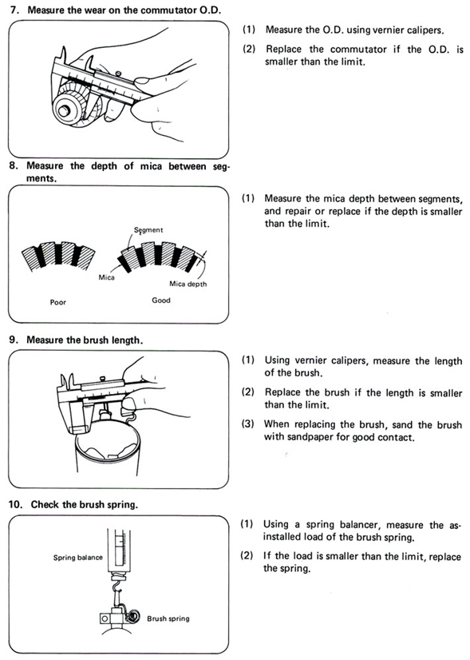
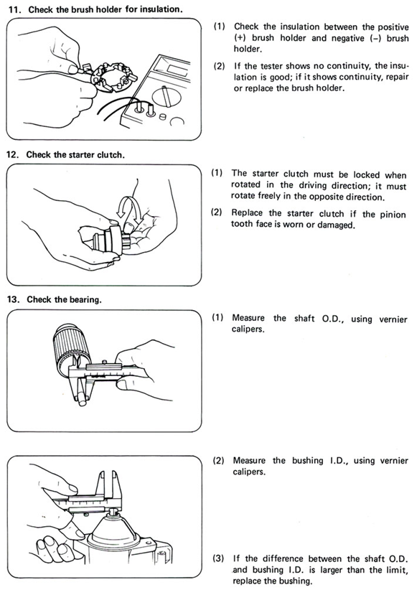

Unit four: Disassemble and Repair starter motor associated components
This unit to provide you the necessary information regarding the following content coverage and topics:
- Repair procedure for Starter motor components
- Repair starting system
- Repairs and retests starter motor
- Overhaul starter motor components
- Assemble starter motor components

This guide will also assist you to attain the learning outcomes stated in the cover page. Specifically, upon completion of this learning guide, you will be able to:

- perform Repairing procedure for Starter motor components
- perform Repairing starting system
- Repair and retests starter motor
- Overhaul the starter motor components
- Assemble the starter motor components

4.1 Overhaul starter motor components

Operation sheet: 4.1
Operation Title: Overhauling starter motor components
Instruction:
- Safe working area
- Properly operated tools and equipment
- Appropriate working cloths fit with the body
Purpose: Learning to overhaul starter motor components
Required tools and equipment: Meltimeter, ammeter, growler tester, dial gauge, Verner caliper, mica depth, spring balancer, v- block
Consumable Materials:
Precautions:
- Wearing proper clothes, glove
- Make working area hazard free
- Read and interpret manual which guide you how to use tools and equipment

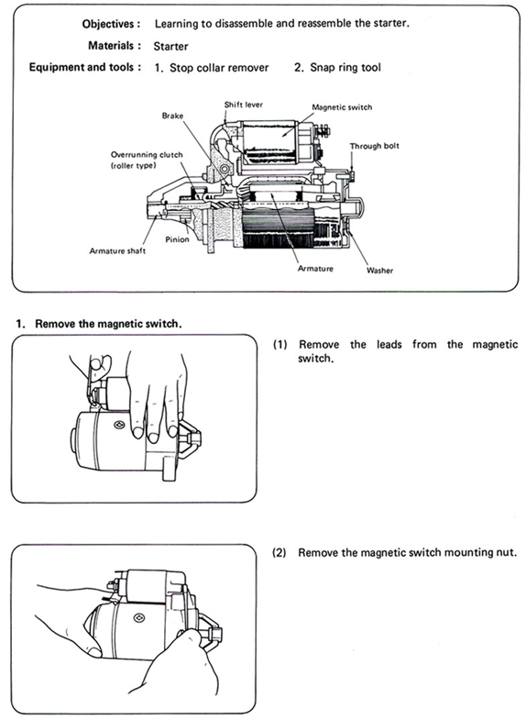

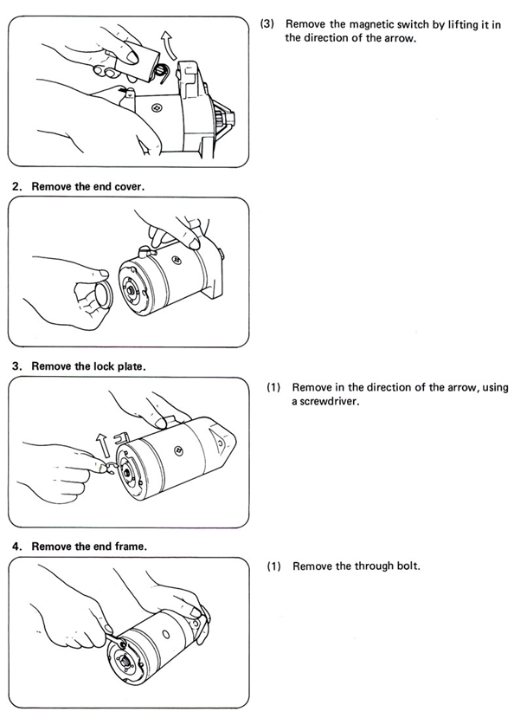

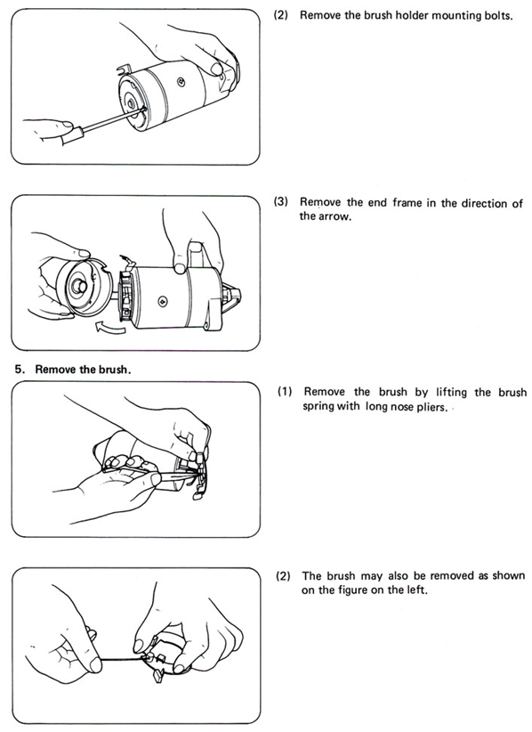

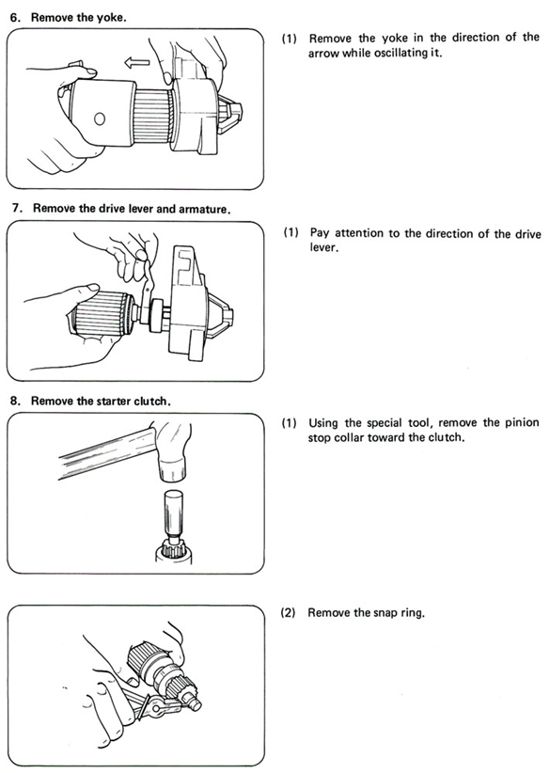

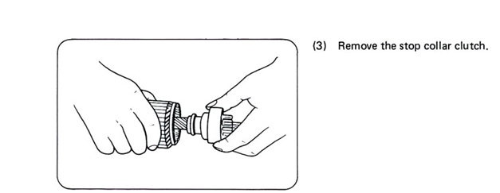

4.2 Repair starter motor

Operation sheet: 4.2
Operation Title: 4.2 Repairing starter motor
Instruction:
- Safe working area
- Properly operated tools and equipment
- Appropriate working cloths fit with the body
Purpose: Learning to repair starter motor
Required tools and equipment: socket wrench, hammer, cutter, soldering gun,knife
Consumable Materials: Rag, sand paper, oil, soldering wire
Precautions:
- Wearing proper clothes, glove
- Make working area hazard free
- Read and interpret manual which guide you how to use tools and equipment

Step 1: Assess the Damage
- Thoroughly do a visual inspection of the field windings, and armature for any burnt or broken insulation, broken wires corrosion or other damage. Also check the commutator on the armature for broken or missing segments If these parts are damaged it may be cheaper to replace the whole starter motor. The pinion gear and solenoid can also be checked for wear or damage.
- This starter was quite corroded in places due to the recent flood we have had here, the brushes and bushes are worn, but the rest appears to be in reasonable condition
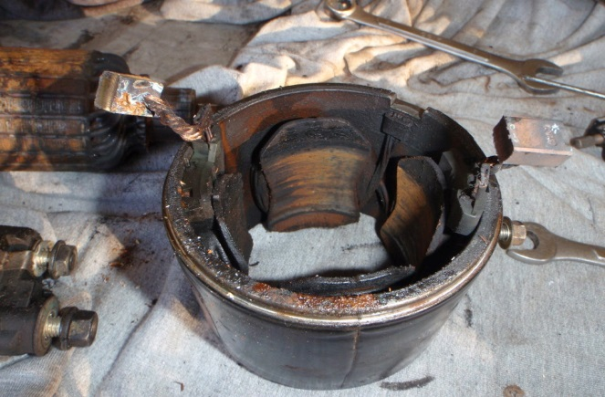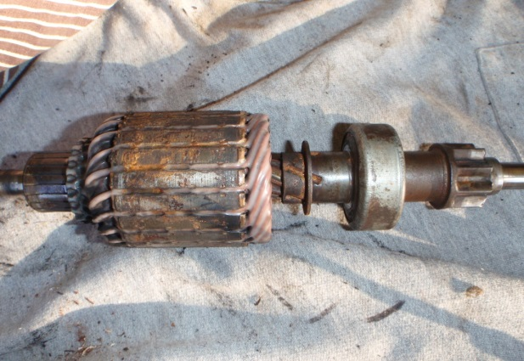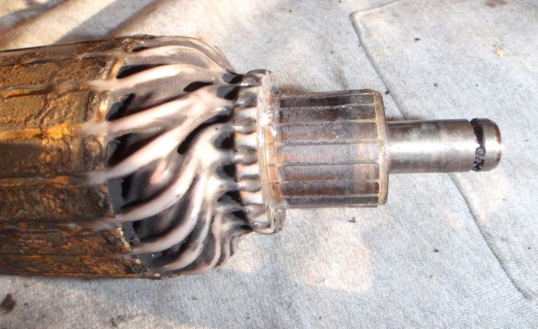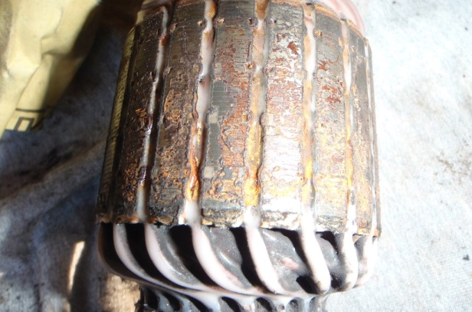
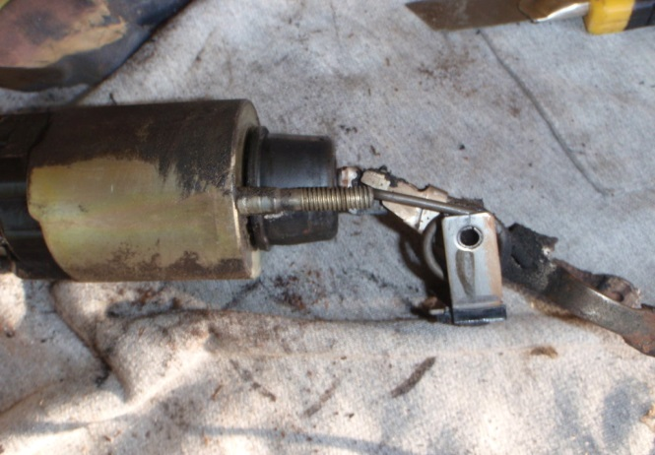

Step 2 Repairing the Armature and Field Windings
Remove any corrosion with wet and dry sand paper, and the commutator can be sanded and the back of a box cutter knife can be used to clean out between the segments. The insulation between the segments should be undercut to work correctly. Than an oily rag is used to wipe everything to help prevent any future corrosion

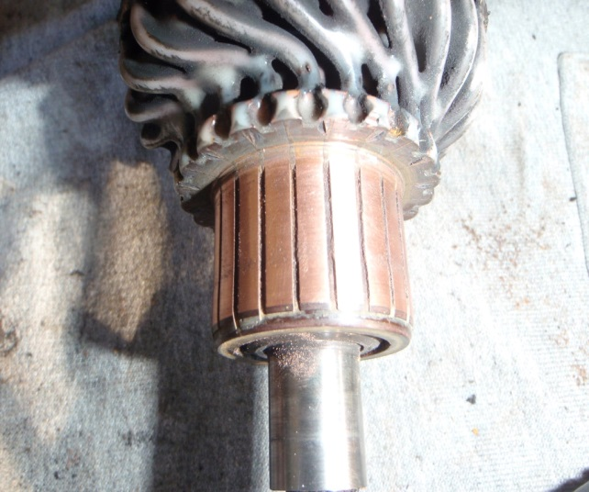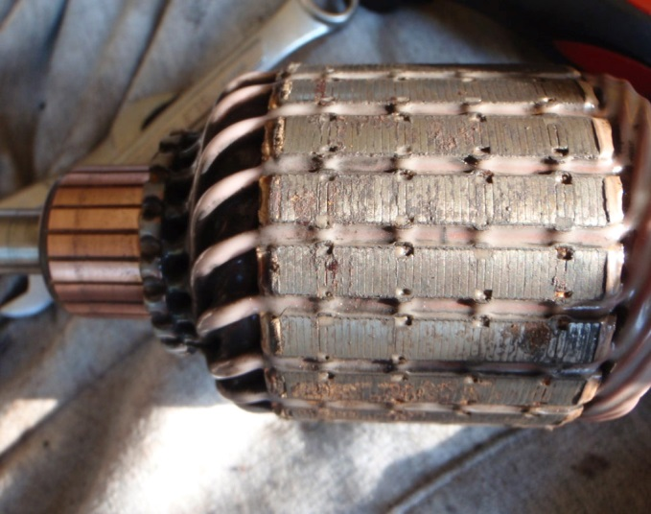
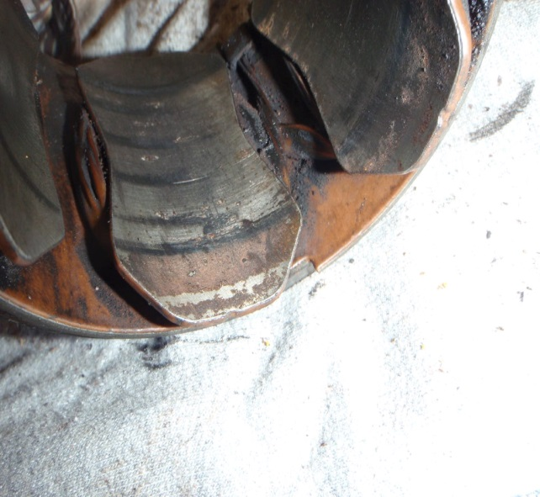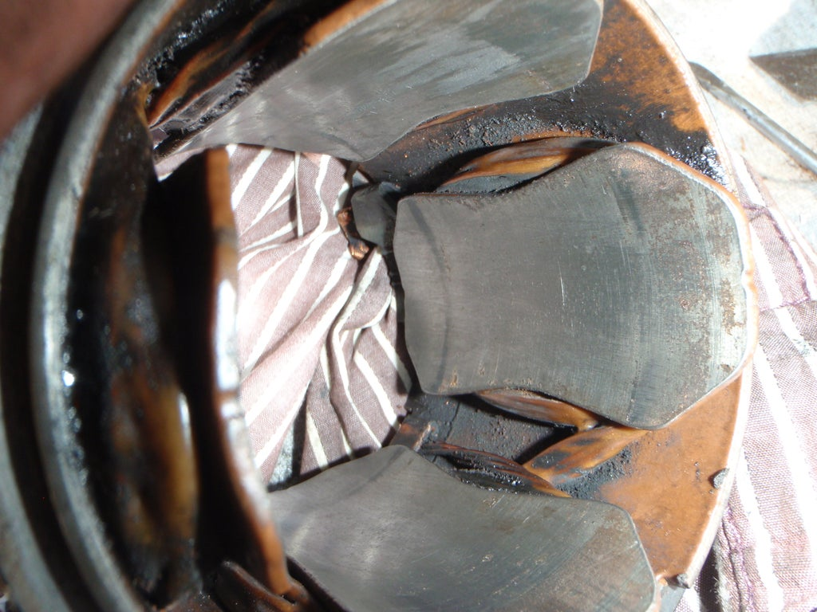

Step 3 Purchase the Parts
- After inspecting and cleaning up everything it was decided to only replace the brushes and bushes. The bushes can be removed with socket and a hammer. The bush in the nose of the starter has a cap which can be carefully knocked out with a 1/4" drive extension. A little heat on the alloy nose will help remove the bush. 2 of the bushes are crimped on and can be carefully un crimped and the brush removed. Take the parts and the identification plate on the field winding and the vehicles chassis number to an auto electrical shop and they should be able to match the pars up.
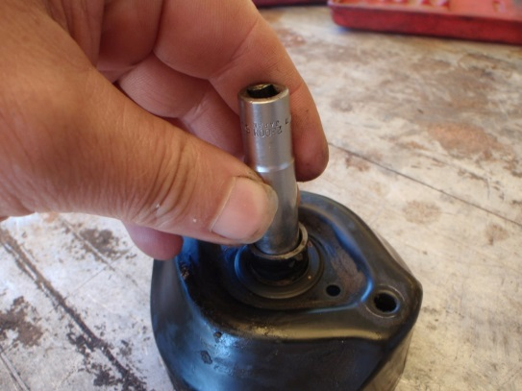 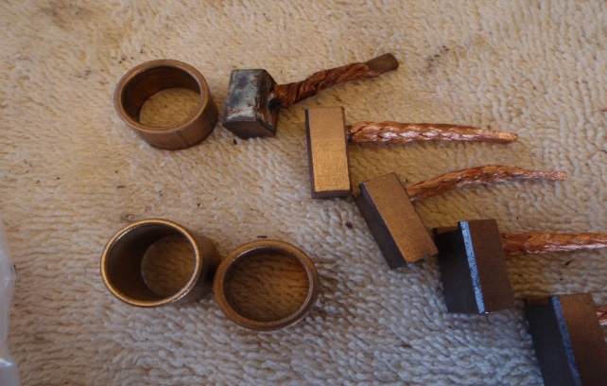Bushes can be tapped out with a socket New parts
and hammer
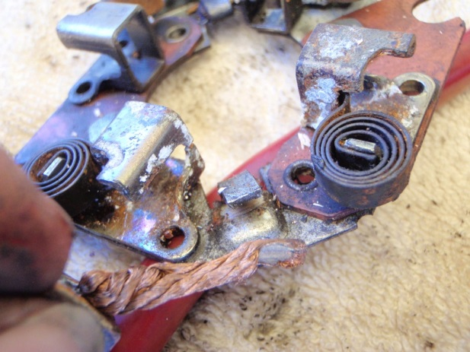
2 of the bushes are crimped on and can be
carefully un crimped and the brush removed

Step 4 Lubricating the New Bushes
The bushes are made from phosphor bronze which is porous and has to be pre-oiled or they will not last very long. This is not to difficult just put it on your finger and fill with engine oil then place your thumb on top and squeeze. Do this 2 or 3 times until you can see the oil coming out the sides of the bush.
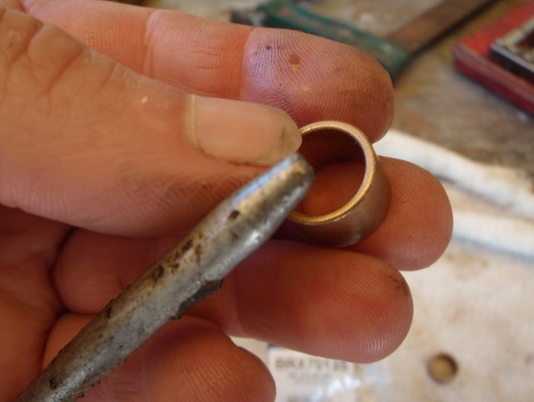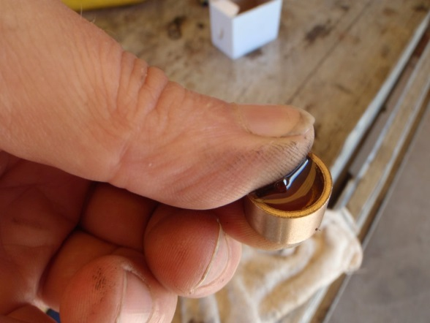
Engine oil fill it up and squeeze
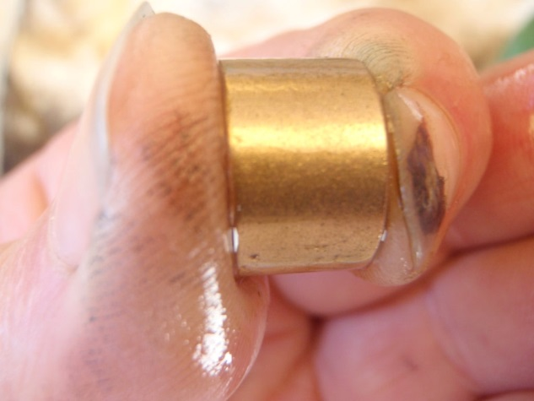
you should be able to see oil oozing out the metal

Step 5 Fitting the New Bushes
- This step can be tricky, and if you have access to a press then use it, as you a much less likely to damage the bushes.
- First make sure that the housing where the bushes fit into is clean, then fit the bush to the end of the armature and gently tap it in to the housing with hammer. Make sure that the armature is straight and you tap the end of the armature flat with the hammer or it could be damaged. Again a little heat on the alloy end will help fit the bush. Once you have got the bush in about 1/2 way you can use a drift or large punch to drive it into its final position. Again if you use a hammer to do this step, be gentle and get everything straight and flat.
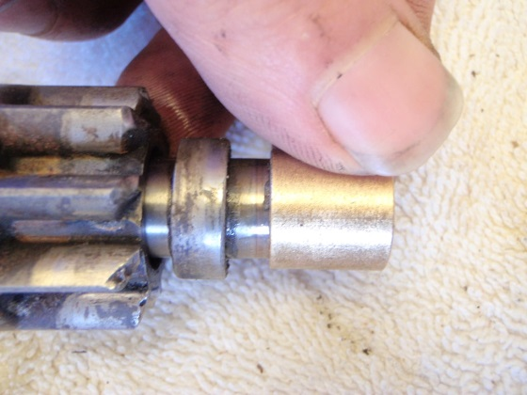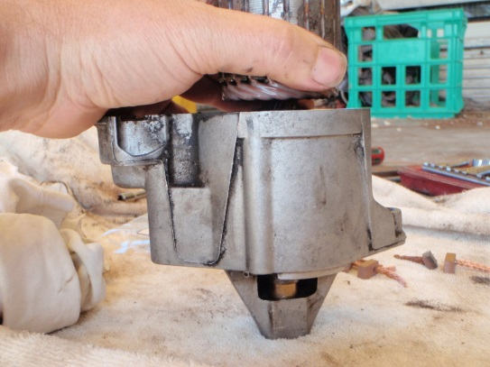
make sure the armature is straight press or tap the bush into the housing
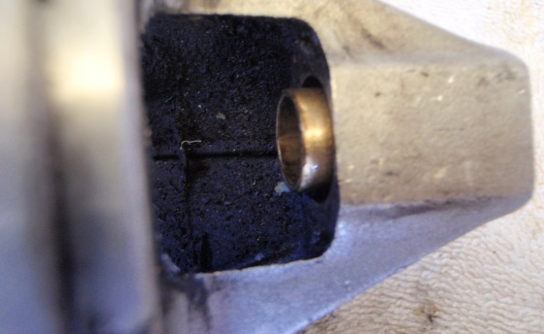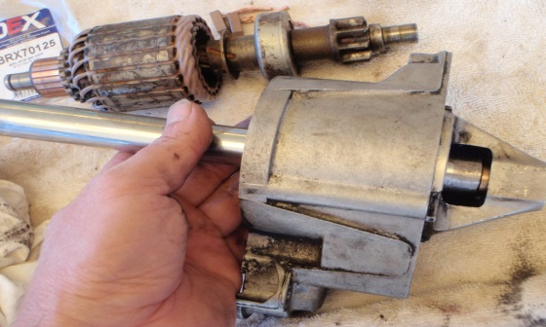
large drift can be use to push the bush home

Step 6 Fitting the Brushes
- Look carefully at the brushes how they are fitted and there orientation. 2 brushes are crimped on, they could be carefully un crimped with side cutters and new brushes crimped back on. 2 brushes are spot welded on. these 2 were carefully pulled off and a little solder melted on the braid on the end of the brush and on the copper where it was spot welded. The brush is then sweated into position.
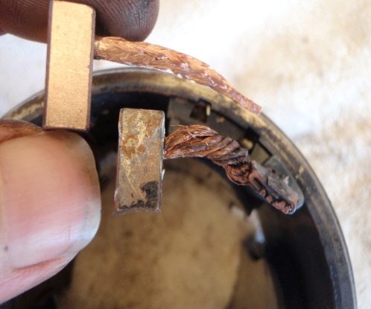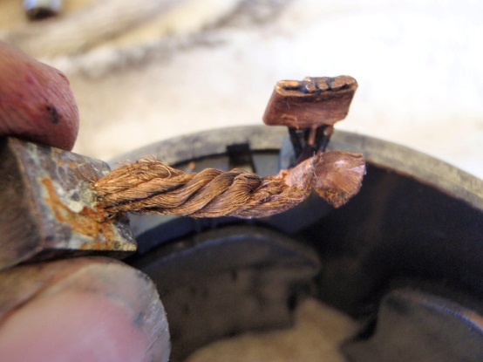
Look carefully at the brushes how carefully removed
they are fitted and there orientation
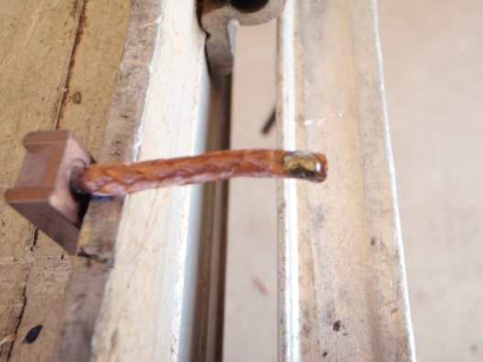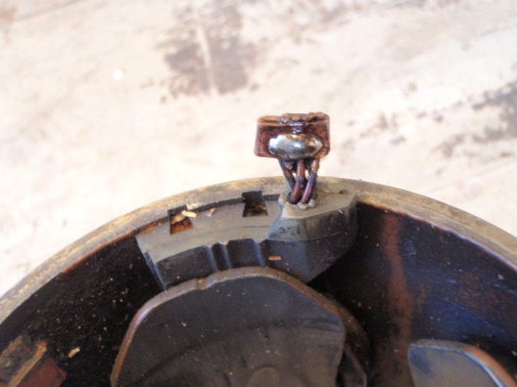
soldered on end of braid solder the copper joiner
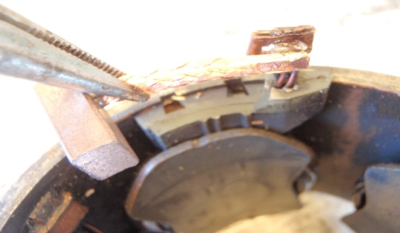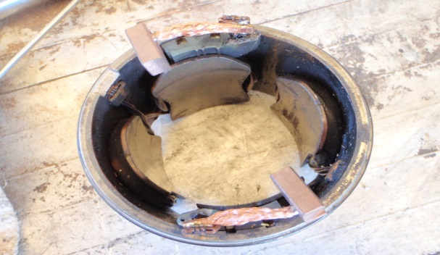
The brush is then sweated into position new brushes fitted

4.3 Assemble starter motor components

Operation sheet: 4.3
Operation Title: Assemble starter motor components
Instruction:
- Safe working area
- Properly operated tools and equipment
- Appropriate working cloths fit with the body
Purpose: Learning to assemble starter motor components
Required tools and equipment: Screw driver, wrench, socket wernch
Consumable Materials:
Precautions:
- Wearing proper clothes, glove
- Make working area hazard free
- Read and interpret manual which guide you how to use tools and equipment

- The brush plate can now be fitted, and the bushes on the field windings are inserted into the brush holders. Make sure the bolts all line up and then the brushes can be pushed in properly so the springs are pushing down on them.
- The back plate or brush cover can go on next and the long bolts inserted and done up finger tight. Put one screw into the brush holder to make sure everything is lined up and tighten it all up. Make sure the armature turns freely.
- The spring and clip can go on next and a little oil on the shaft before screwing the end cap on. The nose of the starter can also have a little oil on the shaft before refitting the cap which is carefully put into position and punched on.
- The motor cable can be connected to the solenoid and all the bolts and screws re-tightened and re checked
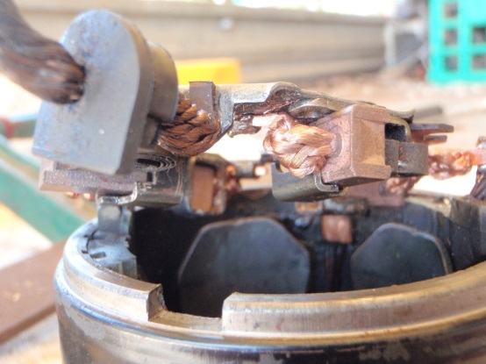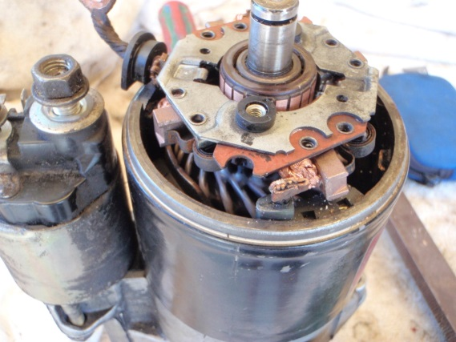
the field windings are inserted into the brush holders
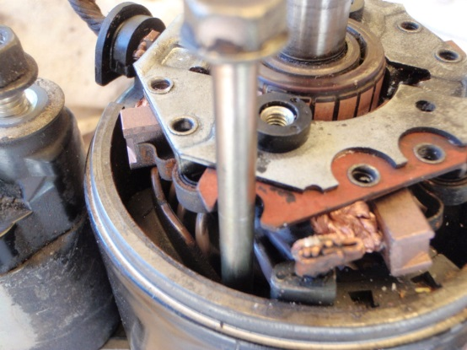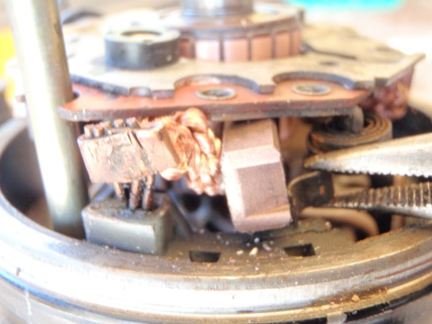
brushes can be pushed in properly so the springs are pushing down on them
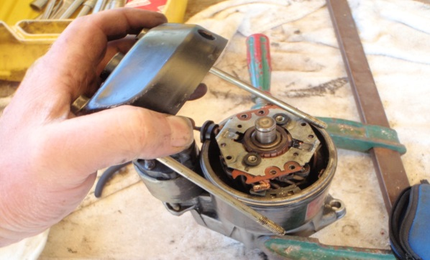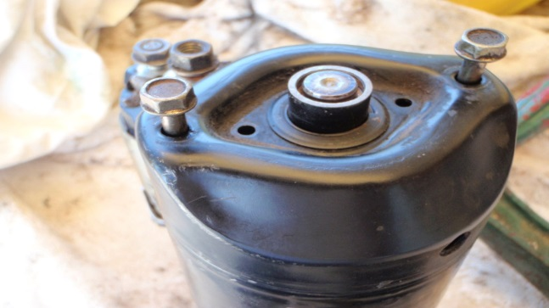
the long bolts inserted and done up finger tight

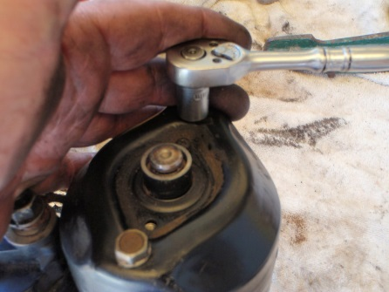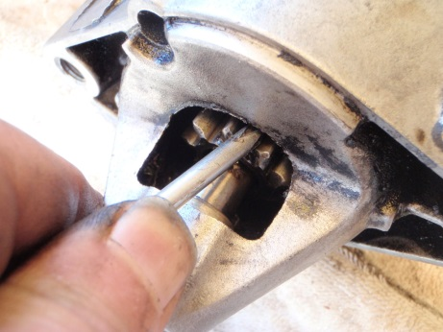
Put one screw into the brush holder to make Make sure the armature turns freely
sure everything is lined up and tighten it all up
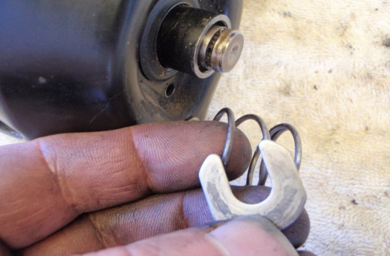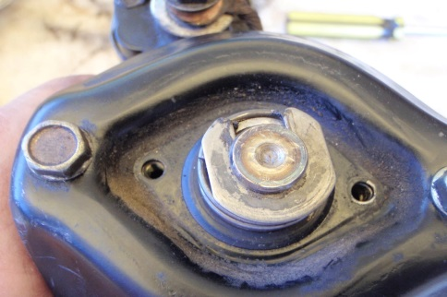
The spring and clip can go on next and a little
oil on the shaft before screwing the end cap on
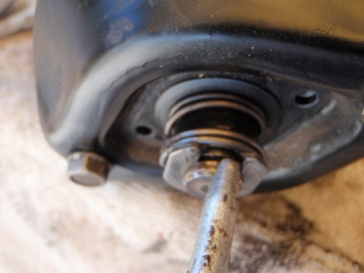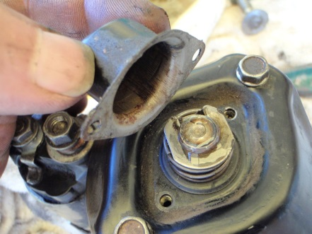
a little oil on the shaft before screwing the end cap on
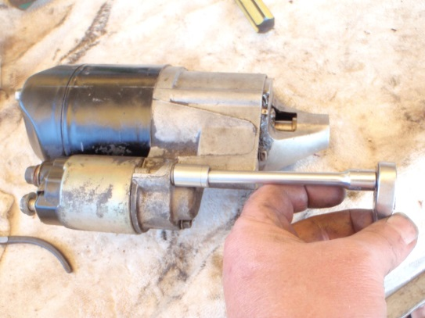
all the bolts and screws re-tightened and re checked

4.4 Retests starter motor

Operation sheet: 4.4
Operation Title: Retests starter motor
Instruction:
- Safe working area
- Properly operated tools and equipment
- Appropriate working cloths fit with the body
Purpose: Learning to retests starter motor
Required tools and equipment: Ammeter, Jumper cable, Battery, wrench
Consumable Materials: wire, connectors
Precautions:
- Wearing proper clothes, glove
- Make working area hazard free
- Read and interpret manual which guide you how to use tools and equipment

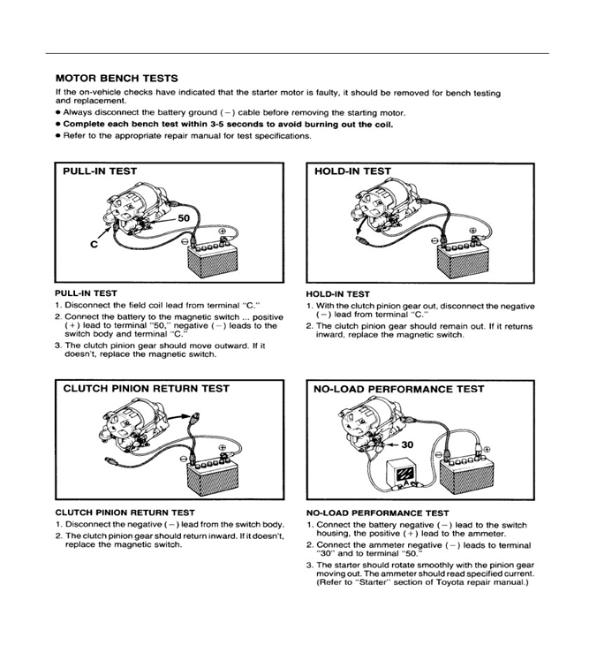

LAP Test
Practical Demonstration
Instruction I: Given necessary templates, tools and materials you are required to perform the following tasks within 7 hours.
- Perform Disassemble starter motor components parts
- Clean starter motor and components
- Inspect starting system circuit
- Inspect and test starting system components
- Inspect and test starter motor and associated components
- Overhaul the starter motor components
- Assemble the starter motor components
- Repair and retests starter motor

Unit five: Clean-up work area and maintain equipment
This unit to provide you the necessary information regarding the following content coverage and topics:
- Remove waste and scrap
- Cleaning and inspecting equipment and work area
This guide will also assist you to attain the learning outcomes stated in the cover page. Specifically, upon completion of this learning guide, you will be able to:

- Remove waste and scrap
- Clean and inspect equipment and work area

5.1 Remove waste and scrap

5.1.1 Waste disposal
Trainers are concerned how to handle the disposal of the following three types of materials or tools or equipment’s.
  - Scrap: -it is an item or equipment which becomes salvaged after giving service for ample period of time
  - Surplus: -this refers to the existence of items or equipment’s in excess of the requirements. materials or equipment’s become obsolete as a result of change in technology.
  - Obsolete materials/equipment’s: - .materials or equipment’s become obsolete as a result of change in technology.
5.1.2 Methods of disposing unwanted/wasted material
There are three ways of disposing materials. they are:-
- Transferring to another equivalent organization
- Selling
- Discarding the material/equipment’s

5.2 Cleaning and inspecting equipment and work area

5.2.1 Methods of Cleaning Electrical System
1. Rags and Brushes
Wiping off dirt with a clean, dry, lint-free cloth or soft brush is usually satisfactory if the apparatus is small, the surfaces to be cleaned are accessible, and only dry dirt is to be removed. Don't use waste rags when cleaning electrical equipment because lint will adhere to the insulation, acting as a further dirt-collecting agent, which can cause tracking. Cloth rags should be clean and free of oil, grease, and metallic deposits.
Use care to avoid damage to delicate parts. Rags can easily catch on edges other and sharp objects, which could damage small plastic or moving parts.
2. Liquid Solvents and Water
Accumulated dirt, oil, or grease might require a solvent to be removed. A rag barely moistened (not wet) with a nonflammable solvent can be used for wiping. Solvents used for cleaning of electrical equipment should be selected carefully to ensure compatibility with materials being cleaned. Accumulated dirt, oil, or grease might require a solvent to remove it.
3. Vacuum Cleaning
Loose dust, dirt, and particles can be removed using a vacuum-type cleaner with non-metallic attachments and hoses. Blowing equipment out with compressed air is likely to spread contamination and damage insulation.
4. Sweeping and Moping
If the sweeping of a substation room is required, use a sweeping compound to limit the amount of dirt and dust becoming airborne. When mopping, keep the mop bucket as far as practical from the switchgear to prevent damage from spillage.

5.2.2 Maintaining tools and equipment
Tools and equipment require proper care and maintenance, not only for longevity but also to remain useful and safe for the task at hand. Here are some care and maintenance practices for tools and equipment.

A. Proper storage
Proper storage entails shielding tools from harsh weather conditions, damage and theft. It is particularly crucial for metallic tools to be kept away from moisture to avoid rusting. Having a cabinet where these tools and equipment are stored will be vital to ensuring a secure storage area. Also, greasing, lubricating or oiling metallic tools and equipment is essential to prevent rust from forming while keeping the tools in the best condition for future tasks.
B. Using tools and equipment for their right task
Using a tool for the task it is intended helps to keep it in its best shape. This reduces unnecessary damage and protects the user. It is also important to check whether the tools are in the right condition before using them.
C. Cleaning after use
Storing dirty tools without cleaning them can cause them to deteriorate. Routine cleaning reduces the chances of rust and can reduce the rate of wear and tear.
D. Inspect tools regularly
Regular inspection of tools is beneficial since it provides an opportunity to see if tools may need repair or replacing. Inspections can help to prevent a situation where a last minute trip to the store to purchase a new tool or spare parts delays a project.
E. Read and follow manuals
The manuals that come with equipment, especially power tools, have important and useful guidelines. They instruct and advise on the best way to keep equipment in optimal condition.

5.2.2 Proper storage
One of the responsibilities of a shop instructor/trainer is to organize and handle storage in order to protect tools equipment’s and materials against loose and deterioration. These, the following factors should be given due consideration.
- Accessibility: - classification and making
- Ease of handling: - based on the weight and bulk of the piece
- Inventorying: - protect against un authorized withdrawals of materials
Self-check: 2
Directions: choose the correct answer
1………….it is an item or equipment which becomes salvaged after giving service for ample period of time
A, Surplus B, Obsolete materials/equipment’s
C, Scrap D, all of the above
2……………. materials or equipment’s become obsolete as a result of change in technology
A, Obsolete materials/equipment’s B, Surplus
C, Scrap D, all of the above
Directions:
Column A column B
1, Accessibility A, classification and making
2, Ease of handling B, protect against un authorized withdrawals of materials
3, Inventorying C, based on the weight and bulk of the piece
Directions: Give short answer
- What are three ways of disposing materials?
- List and explain methods of cleaning electrical system?
- Explain all cares and maintenance practices for tools and equipment?

Reference

- Fifth edition Heavy Duty Truck System ( Sean Bennett)
- Automotive Technology system approach 5th edition(Jack Erjavec)
- Modern automotive technology

Participants of this Module (Training Material) preparation

No | Name | Qualification | Field of Study | Organization/ Institution | Mobile number | E-mail
 | Adinet Asnake | MSc. | Automotive Technology Mgt | Wolkite PTC | 0913-767250 | andinetasnake31@gmail.com
 | Biruk Tilahun | BSc. | Automotive Technology | General Wingate PTC | 0913-789176 | biruktilahun1@gmail.com
 | Fadli Aman | BSc. | Automotive Technology | General Wingate PTC | 0927-283100 | Fadli.ziyad@gmail.com
 | Hana Nigusise | BSc. | Automotive Technology | Selam TVET college | 0988-751516 | hana.nigussie25@gmail.com
 | Israel Taye | BSc. | Automotive Technology | General Wingate PTC | 0913-424100 | Isra.taye@gmail.com
 | Tatek Mamo | PhD scholar | Automotive Technology | DEC | 0911-841121 | mimibaba928@gmail.com
 | Zelalem Yitbarek | BSc. | Automotive Technology | Selam TVET college | 0972-030621 | Zolosmart12@gmail.com

