

Heavy Vehicles and Earth Moving Machinery Maintenance
Level – II
Based on Nov, 2022, Curriculum Version-I
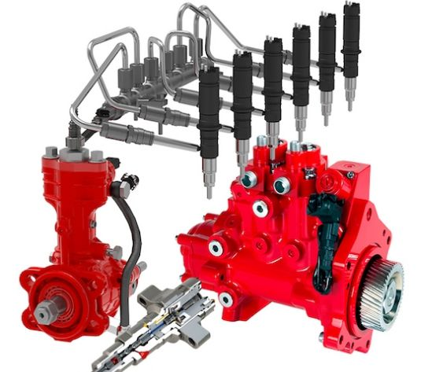

Module Title: Service diesel fuel injection systems
Module code: EIS HEM2 M06 1122
Nominal duration: 50 Hour
Prepared by: Ministry of Labor and Skill
December,2022
Addis Ababa, Ethiopia

Acknowledgment

Ministry of Labor and Skills wish to extend thanks and appreciation to the many representatives of TVT instructors and respective industry experts who donated their time and expertise to the development of this Teaching, Training and Learning Materials (TTLM).

Table of Contents

Acknowledgment 2
Acronym 6
Introduction to module 7
Unit one: Overview to diesel fuel system and its components 8
1.1 Introduction to diesel fuel injection system 9
1.1.1 Diesel fuel 9
1.2 Function and types of diesel fuel injection system 13
1.3 Part of diesel fuel injection system 18
1.3.1 Fuel tank, 18
1.3.2 Transfer pump or lift pump 19
1.3.3 Injection pump 19
1.3.4 Fuel lines 20
1.3.5 Injection nozzle 20
1.3.6 Fuel filter 21
1.4 operating principle of diesel fuel injection system 22
1.5 OHS Requirements 22
1.5.1 Nature and Scope of the Work Requirements 23
1.6 Tools, Equipment, workshop manual and Specification 24
1.6.1 Preparing Required Tools and Equipment 24
1.6.2 Sourcing Workshop Manuals 24
1.6.3 Analyzing Method Options Requirements 24
Self-check: 1.1 24
Unit Two: Inspect diesel fuel system and its components, analyses results 27
2.1 Inspect diesel fuel injection system components 28
2.1.1 Inspection of fuel tank 28
2.1.2 Inspection of fuel filter 28
2.1.3 Inspection of injector nozzle 29
2.1.4 Inspection of fuel line 30
2.1.5 Inspection of fuel injection pump 31
2.1.6 Inspection of Transfer pump Housing 32
2.1.7 Inspecting Fuel Filter and Fuel Pipe Connections 32
2.2 Analyzing result 33
2.2.1 Analyzing Faults and Forward Recommendation 33
Self-check: 2.1 34
Unit Three: Service diesel fuel injection system components 35
3.1 Service diesel fuel injection system components 36
3.1.1 Servicing fuel tank 36
3.1.2 Servicing injector nozzles 37
3.1.3 Servicing transfer pump 42
3.2 Perform bleeding procedure 46
3.2.1 Bleeding the In-Line Pump Diesel Fuel System 46
3.2.2 Bleeding the Distributor (VE) Pump: 47
3.3 Injection timing 48
Operation sheet: 3.1 Adjusting injection timing 48
Operation sheet: 3.2 Servicing of fuel tank 50
LAP: Test 52
Unit 4: Prepare vehicles/Equipment/ for use or storage 53
4.1 Completing Work Schedule Documentation 54
4.2 Performing Final Inspection and Cleaning 55
Self-check: 4.1 56
Operation sheet: 4.1 Prepare vehicles/Equipment/ for use or storage 57
Reference 58

List of Figures

Figure 1-1 Diesel fuel 9
Figure 1-2 Ignitability of diesel fuel 10
Figure 1-3 Ignitable liquid 10
Figure 1-4 Viscosity of liquid 11
Figure 1-5 property of diesel and gasoline 11
Figure 1-6 Common rail 13
Figure 1-7 Common rail 15
Figure 1-8-unit injector 16
Figure 1-9-Inline injection pump 18
Figure 1-10-VE pump 18
Figure 1-11 Fuel tank 18
Figure 1-12- Transfer pump 19
Figure 1-13- Fuel line 20
Figure 1-14- Injector nozzle 20
Figure 1-15- fuel filter 21
Figure 1-16- Two stages fuel filter 22
Figure 2-1- diesel fuel tank 28
Figure 2-2- diesel fuel filter 28
Figure 2-3- diesel fuel injector 30
Figure 2-4- diesel fuel pipe 31
Figure 2-5- Injector nozzle tester 37
Figure2-6- Opening pressure testing 38
Figure 2-7- Leakage or Valve-Seat 39
Figuren2-8- injection nozzle Spray Pattern 40
Figure 2-9- Transfer pump 42
Figure 2-11- Measuring delivery pressure 43
Figure 2-10- Measuring suction pressure 43
Figure 2-12- Performance test 45
Figure 2-13- Leakage (air tightness test) 45
Figure 2-14- work schedule 54
Figure 2-15- Final inspection 55

List of Table
Table 1-1 Distributor/In-line type 17

Acronym

TDC | Top Dead Center
TTLM | Teaching, Training and Learning Materials
VE | Verteiler
LAP test” | Learning Activity Performance Test”
Km | Kilo Meter
EDU | Electronic driving unit
ECU  OHS  HC  CO  NOx  H2so4  So2  So3  EGR  EFI  SCV | Electronic control unit  Occupation Health safety  Hydrocarbon  Carbon monoxide  Nitrogen oxide  Sulfuric acid  Sulfur dioxide  Sulfur trioxide  Exhaust gas recirculation  Electronic fuel injection  Suction control valve

Introduction to module
The information, abilities, and attitude needed to service a diesel fuel injection system are covered in this session. The module entails getting ready for the task, doing some basic checks and tests to find any faults, removing, disassembling, replacing worn-out or defective components and assemblies, and reinstalling. This module also includes documentation and conducting post-service checks.
This module is designed to meet the industry requirement under the heavy duty and earth moving machinery level II occupational standard, particularly for the unit of competency: Service diesel fuel injection system.
This module covers the units:
- Overview to diesel fuel system and its components
- Inspect diesel fuel system and its components and analyses results
- service diesel fuel injection system components
- Prepare vehicles/Equipment/ for use or storage
Module Instruction
For effectively use these modules trainees are expected to follow the following module instruction:
- Read the information written in each unit
- Accomplish the Self-checks at the end of each unit
- Perform Operation Sheets which were provided at the end of units
- Do the “LAP test” giver at the end of each unit and
- Read the identified reference book for Examples and exercise

Unit one: Overview to diesel fuel system and its components
This unit is developed to provide you the necessary information regarding the following content coverage and topics:
- Introduction to diesel fuel injection system
- Types of diesel fuel injection system
- Components of diesel fuel injection system
- Operating principle of diesel fuel injection system
- OHS requirements
- Selection and using tools, equipment workshop manuals and specifications
This unit will also assist you to attain the learning outcomes stated in the cover page. Specifically, upon completion of this learning guide, you will be able to:
- Understand diesel fuel injection system
- Describe types of diesel fuel injection system
- Identify components of diesel fuel injection system
- Explain the operating principle of diesel fuel injection system
- Perform OHS requirements
- Select tools, equipment workshop manuals and specifications

1.1 Introduction to diesel fuel injection system
The fuel-injection system injects fuel into the combustion chamber at high pressure, at the right time, and in the right quantity. The main components of the fuel-injection system are the injection pump that generates high pressure, and the injection nozzles that are linked to the injection pump via high-pressure delivery lines except with the Unit Injector System. The injection nozzles project into the combustion chamber of each cylinder. In most systems, the nozzle opens when the fuel pressure reaches a specific opening pressure, and closes when it drops below this pressure. The nozzle is only controlled externally by an electronic controller in the common-rail system.
Diesel injection technology has gone through two development stages: traditional purely mechanically controlled fuel injection and modern electronically controlled fuel injection. At present, the electronic control fuel injection technology has developed from the initial position control type to the time control type. The means to realize modern electronically controlled fuel injection technology mainly include electronically controlled pump nozzles, electronically controlled unit pumps, and electronically controlled common rail systems.

1.1.1 Diesel fuel
Diesel fuel is a mixture of hydrocarbons obtained by distillation of crude oil. The important properties which are used to characterize diesel fuel include cetane number (or cetane index), fuel volatility, density, viscosity, cold behavior, and sulfur content. Diesel fuel specifications differ for various fuel grades and in different countries. Diesel fuel also called diesel oil combustible liquid used as fuel for diesel engines, ordinarily obtained from fractions of crude oil that are less volatile than the fractions used in gasoline. In diesel engines the fuel is ignited not by a spark, as in gasoline engines, but by the heat of air compressed in the cylinder, with the fuel injected in a spray into the hot compressed air. Diesel fuel releases more energy on combustion than equal volumes of gasoline, so diesel engines generally produce better fuel economy than gasoline engines.
Figure 1-1 Diesel fuel

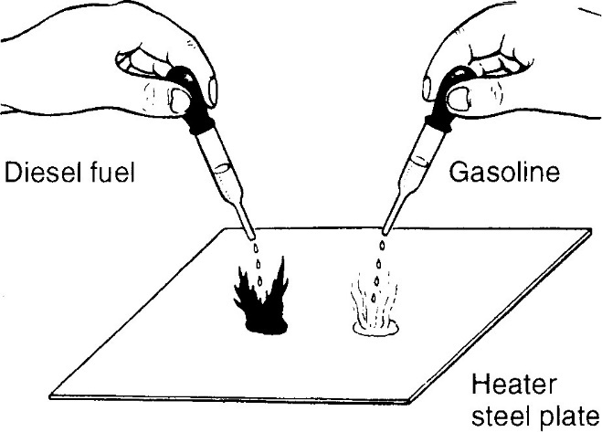
Ignitability of diesel fuel
fuel's property to self-ignite when its temperature is increased, even if an externally sourced fire is not placed next to it. When drops of diesel fuel and gasoline are placed on a heated steel plate, the diesel fuel burns into a flame after a while, but gasoline immediately evaporates without burning. This indicates that the diesel fuel has better ignitability
Figure 1-2 Ignitability of diesel fuel

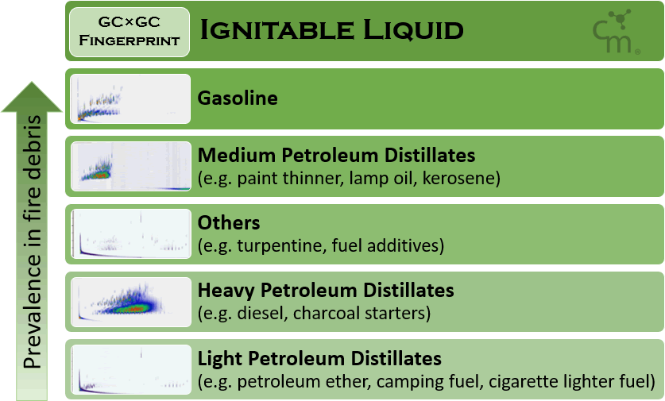
The temperature at which the fuel ignites is called its flash point. The lower the flash point, the better is the fuel's ignitability. Because the diesel engine relies on the combustion of fuel prompted by the compression heat of air, the ignitability of fuel is an important property in the operation of the diesel engine. Ignitability thus greatly influences the ignition delay time, which is the time between when fuel is introduced into the combustion chamber and when it starts to burn. The cetane number indicates the ignitability of a diesel fuel.
The numerical value of the cetane number indicates the ignitability of a fuel by the ratio of the mixture of reference fuels (cetane (C₁₆H₃₄) and alpha-methyl naphthalene (C₁₁H₁₀). Cetane's ignitability is assigned the cetane number 100, and alpha-methyl naphthalene, with poorer ignitability, is assigned the number 0.
Figure 1-3 Ignitable liquid


Viscosity of diesel fuel
Viscosity is an important property of the fuel that is used in a diesel engine. If the viscosity is too high, the fuel becomes injected into the combustion chamber in large particles, with poorer dissipation qualities, thus resulting in poorer combustion. Because diesel fuel has an additional function to lubricate the fuel system, including injection pump and nozzles, those parts will not receive enough lubrication if the viscosity of the fuel is too low, and they might even seize as a result.
Figure 1-4 Viscosity of liquid

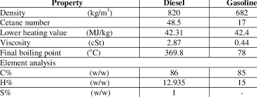
Viscosity resistance of a fluid (liquid or gas) to a change in shape, or movement of neighboring portions relative to one another. Viscosity denotes opposition to flow. The reciprocal of the viscosity is called the fluidity, a measure of the ease of flow. Molasses, for example, has a greater viscosity than water. Because part of a fluid that is forced to move carries along to some extent adjacent parts, viscosity may be thought of as internal friction between the molecules; such friction opposes the development of velocity differences within a fluid. Viscosity is a major factor in determining the forces that must be overcome when fluids are used in lubrication and transported in pipelines. It controls the liquid flow in such processes as spraying, injection molding, and surface coating.
Figure 1-5 property of diesel and gasoline

Sulphur contained in diesel fuel
Diesel fuel contains sulfur which derives from the original crude oil source and can still be present after refining. After combustion in the engine, the sulfur in fuel forms particulates that are a primary contributor to air pollution and the cause of harmful corrosion in the engine. During combustion, the sulphur that is contained in fuel converts into sulfuric dioxide and sulfuric anhydride. These gases combine with the water that is created during combustion and converts into sulfuric acid, which has highly corrosive properties. In addition, because sulphur compounds have poor ignitability creates black smoke and contaminates the engine oil.
Diesel sulfur content has little impact on engine-out HC, CO, and NOX emissions. On the other hand, higher diesel sulfur does have an effect on engine-out PM emissions. The sulfur in the fuel can be oxidized to sulfur dioxide (SO2) and sulfur trioxide (SO3) in the exhaust. SO3 readily hydrolyzes to form sulfuric acid (H2SO4) with available and abundant water molecules in the exhaust gas mix. Sulfuric acid acts as a nucleation site for particle formation and growth once the exhaust gases have cooled down, and eventually increases the PM mass emissions from the engine. The sulfuric acid present in the engine-out exhaust may also condense into sulfuric acid in the EGR system during normal operations, because exhaust gas cooling is required for EGR to be effective at reducing NOX emissions. To minimize the risk of sulfuric acid corrosion of EGR, sulfur diesel content is preferred at less than 15 ppm. However, there are a number of materials for the EGR cooling pipes that would be appropriate for vehicles designed to operate at higher ppm sulfur

1.2 Function and types of diesel fuel injection system

1.2.1 Functions of Diesel fuel injection systems
Diesel fuel injection systems must accomplish five particular functions: meter, inject, time, atomize, and create pressure. A description of these functions follows:
- METER: Accurately measure the amount of fuel to be injected.
- INJECT: Force and distribute the fuel into the combustion chamber.
- TIME: Injection of the fuel must start and stop at the proper time.
- ATOMIZE: Break the fuel up into a fine mist.
- CREATE PRESSURE: Create the necessary high pressure for injection.
Figure 1-6 Common rail
- Metering
Accurate metering or measuring of the fuel means that, for the same fuel control setting, the same quantity of fuel must be delivered to each cylinder for each power stroke of the engine. Only in this way can the engine operate at uniform speed with uniform power output. Smooth engine operation and an even distribution of the load between the cylinders depend upon the same volume of fuel being admitted to a particular cylinder each time it fires and upon equal volumes of fuel being engine.

Injection control
A fuel system must also control the rate of injection. The rate at which fuel is injected determines the rate of combustion. The rate of injection at the start should be low enough that excessive fuel does not accumulate in the cylinder during the initial ignition delay (before combustion begins). Injection should proceed at such a rate that the rise in combustion pressure is not great, yet the rate of injection must be such that fuel is introduced as rapidly as possible to obtain complete combustion. An incorrect rate of injection affects engine operation in the same way as improper timing. When the rate of injection is too high, the results are similar to those caused by an injection that is too early; when the rate is too low, the results are similar to those caused by an injection that is too late.
- Timing
In addition to measuring the amount of fuel injected, the system must properly time injection to ensure efficient combustion so that maximum energy can be obtained from the fuel. When the fuel is injected too early in the cycle, ignition may be delayed because the temperature of the air, at this point, is not high enough. An excessive delay, on the other hand, gives rough and noisy operation of the engine. It also permits some fuel to be lost due to the wetting of the cylinder walls and piston head. This, in turn, results in poor fuel economy, high exhaust gas temperature, and smoke in the exhaust. When fuel is injected too late in the cycle, all the fuel will not be burned until the piston has traveled well past top center. When this happens, the engine does not develop enough power, the exhaust is smoky, and fuel consumption is high.

Atomization of Fuel
As used in connection with fuel injection, atomization means the breaking up of the fuel, as it enters the cylinder into small particles, which form a mist like spray. Atomization of the fuel must meet the requirements of the type of combustion chamber in use. Some chambers require very fine atomization; while others function with coarser atomization. Properly atomization makes it easier to start the burning process and ensures that each minute particle of fuel is surrounded by particles of oxygen with which it can combine.

Creating Pressure
A fuel injection system must increase the pressure of the fuel to overcome compression pressure and to ensure proper dispersion of the fuel injected into the combustion space. Proper dispersion is essential if the fuel is to mix thoroughly with the air and burn efficiently. While pressure is a chief contributing factor, the dispersion of the fuel is influenced, in part, by atomization and penetration of the fuel. (Penetration is the distance through which the fuel particles are carried by the motion given them, as they leave the injector or nozzle.)

1.2.2 Types of diesel fuel injection system
There are three basic types of diesel injection systems:
- Common rail
- Unit injector
- Pump controlled

Common rail
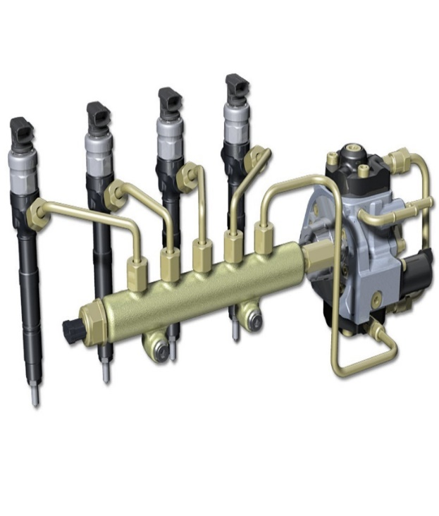
The fuel that has been pressurized by the supply pump is stored in the common- rail before it is distributed to the injectors. The ECU (Electronic Control Unit) and EDU (Electronic Driving Unit) control the fuel injection volume and timing to an optimum level by operating and closing the injectors in accordance with the signals from the sensors. This process is similar to that of the EFI system used on gasoline engines. The fuel that has been drawn up from the feed pump located inside the supply pump is pressurized to the required pressure. The plunger in the pump generates the required injection pressure. The pressure varies by engine speed and load conditions from 20 MPa at idle, to 135 Mpa under high-load, high-speed operating conditions. The ECU commands the SCV (Suction Control Valve) to adjust the fuel pressure, regulating the volume of fuel that enters the supply pump. The ECU constantly detects the fuel pressure in the common-rail by means of the fuel pressure sensor, and effects feedback control
Figure 1-7 Common rail

Unit injector
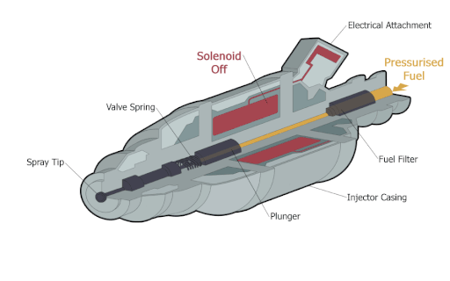
The unit injector system is one in which the pump & injector are combined in one housing. Each cylinder is provided with one of these unit injectors. Fuel is brought up to the injector by a low-pressure pump at proper time, a rocker arm actuates the plunger & thus injects the fuel into the cylinder.
Figure 1-8-unit injector

Pump controlled
A device that pumps fuel into gasoline or diesel engine cylinders is known as a fuel injection pump. The pump is usually driven by a chain or toothed timing belt that is motivated by the gears in a crankshaft. This system is also linked to the camshaft, causing them to be intertwined. In traditional four-stroke engines, it rotates at half the speed of the crankshaft in order to enable the correct timing of the injection process. This occurs as the cylinder's compression stroke is about to begin.
These devices are distinctly different from a fuel pump itself, which is primarily responsible for the flow of the fuel from its container or fuel tank. This is the part of the system in which fuel is brought out of the tank and pumped along a system of tubes to the engine block. The fuel injection pump then pushes the fuel inside the cylinders
Fuel injection pumps need to operate in high-pressure environments in order to keep the system in full containment. In modern systems this is at the level of 15,000 psi or higher. For this reason, mechanics or engineers who work on these systems, especially diesel, take great care for personal safety. The fuel injection pump itself can possibly push fuel into the human body, causing serious harm to an individual.

Automobiles/ construction machinery engine fuel injection system, inject fuel with regard of load and road condition. There are deferent types of injection pump used in light and heavy-duty vehicles.
The most common wildly used type of these pump are classified as follows.
- Inline type pump: The same number of plungers as engine cylinders is aligned in series in the pump.it is the most widely used in heavy trucks and construction machinery engine.
- Distributor type pump: One plunger distributes fuel into each cylinder. This type of injection pump used in small and medium vehicles.
Major concerns and distinguishing characteristics of Distributor type and In-line type injection pumps are summarized in the following table.
Major concerns | Distributor type | In-line type
Weight | Distributor type is smaller and lighter and provides higher rpm than In-line type
No of plungers | Single | Several (same as the number of engine cylinders)
Governor | Mechanical | Combined (pneumatic and
 |  | mechanical) or mechanical
Timer | Built-in (controlled by fuel pressure) | Separated (controlled by centrifugal force)
Fuel cut-off | Using solenoid valve | A device to drive control rack is Provides
 |  | (e.g., electrical diesel injection control (EDIC), etc.)
Lubrication | Self-lubrication by fuel only | Self-lubrication by fuel and engine oil
Feed pump | Built-in | Fitted to side of injection pump
Table 1-1 Distributor/In-line type

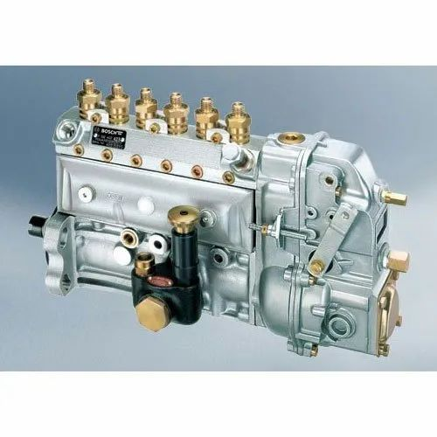
Inline Fuel Injection Pump
This consists of pump main body, governor, feed pump and timer. It has the same number of plungers as cylinders of the engine and supplies fuel to all cylinders with one rotation of the camshaft.
Now a day used on Heavy duty vehicles/ construction machineries inline fuel injection pumps are of different types. The common types of these, Such as Inline500 type, Inline 620type, Euro1type, HINO type fuel injection pumps. The working principle of all the Inline fuel injections pumps is the same, but they are different in the construction.
Figure 1-9-Inline injection pump

Distributor type pump
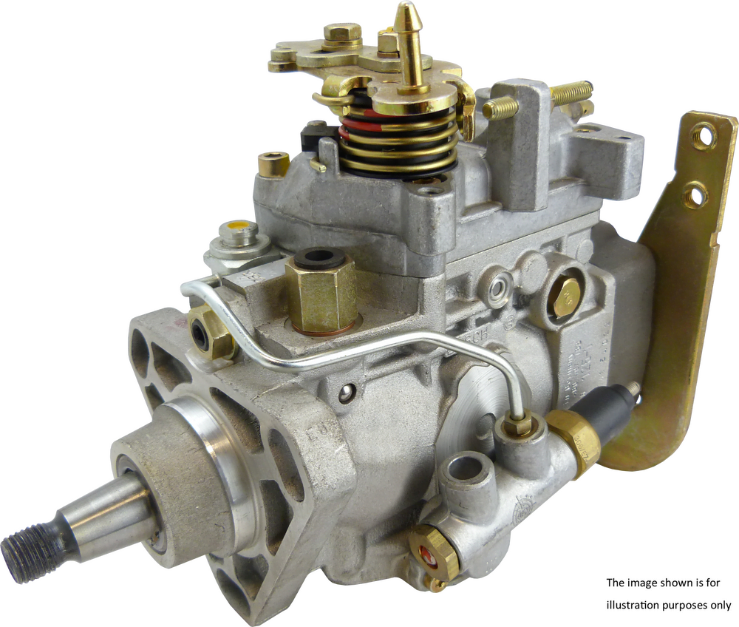
VE in the name of the Bosch pump used in many diesel engines stands for "Verteiler", which is German for distributor or divider. The other common kind of injection pump is the inline pump. The difference between them is that the VE pump has one fuel-metering plunger, and a mechanism (distributor) to send the fuel to the right cylinder. The inline pump has one plunger for each cylinder. The Bosch VE has comparatively few moving parts, but what does move does so in a complex way Today's high speed-diesel engines have been making great progress towards higher fuel economy while maintaining drivability and performance. In addition to meeting these demands, it has been necessary to reduce the size and the weight of the fuel injection pump as well as increase it's reliability. The VE-type/distributor pump differs from the conventional/In-line pump in several ways. The main difference is that the VE pump uses only one pumping plunger for all engine cylinders while the In-line type pump has one pumping element for each cylinder. This feature alone allows for fewer parts as well as reduced size.
Figure 1-10-VE pump

1.3 Part of diesel fuel injection system
All diesel fuel injection systems have these parts,

1.3.1 Fuel tank,
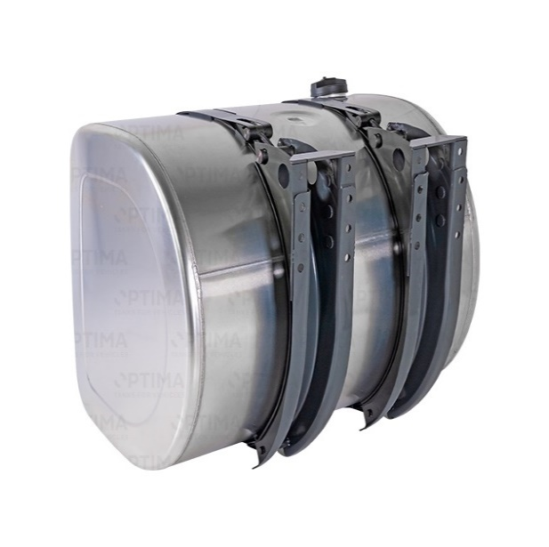
The fuel tank is the main storage for the fuel that runs the vehicle. Generally speaking, the gas tank is generally found at, or under, the rear of the vehicle. There are many different types and shapes of fuel tanks. Each size and shape is designed for a specific purpose. The fuel tank must be capable of storing enough fuel to operate the engine for a reasonable length of time. The tank must be closed to prevent contamination by foreign objects. It must also be vented to allow air to enter, replacing any fuel demanded by the engine. Three other tank openings are required one to fill, one to discharge, and one to drain.
Figure 1-11 Fuel tank

1.3.2 Transfer pump or lift pump
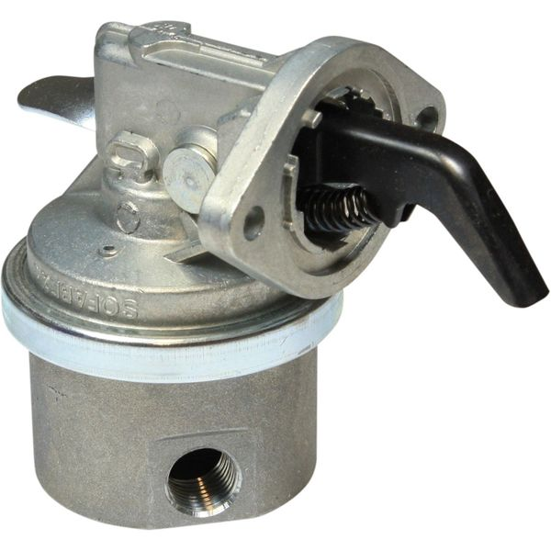
To draw fuel from the tank and supply to the high-pressure injection pump. Simple fuel systems use gravity or air pressure to get fuel from the tank to the injection pump. On modern high-speed diesel engines, a fuel transfer pump is normally used. This pump, driven by the engine, supplies fuel automatically to the diesel injection system. The pump often has a hand primer lever for bleeding air from the system. Modern injection pumps are almost all jerk pumps that use the plunger and cam method of fuel injection.
Figure 1-12- Transfer pump

1.3.3 Injection pump
The fuel injection pump is the heart of the diesel engine. Precisely delivered fuel maintains a timing that keeps the engine running smooth. Simultaneously, the pump also controls the amount of fuel needed to gain the desired power. The injection pump does the job of both the throttle and the ignition system needed in gasoline engines. When troubleshooting a gasoline engine, you check compression, fuel, and spark. A diesel doesn't have an ignition system, so there is one less thing to go wrong with it. Major advances in the development of the diesel engine are a direct result of better fuel injection. that raises fuel pressure to more than 1,000psi (6890 kps) and that times and meters fuel delivery to each cylinder in firing order sequence

1.3.4 Fuel lines
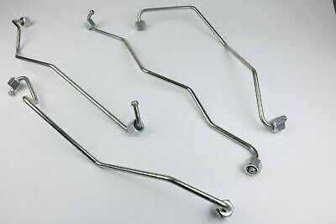
Fuel injection systems use seamless steel tubing for injection lines because of injection pressures of 1,500 psi (10,335 kPa) or more. All lines from the pump to the injectors must be the same length, because line length determines the time that it takes fuel to travel from the pump to the injector. Therefore, injection line length affects ignition timing. Because of these critical pressure and line length requirements, replacement injection lines should always be factory made items. Injection pumps and injectors rely on diesel fuel to lubricate and cool close tolerance moving parts. Excess fuel circulates through pumps and injectors, and return lines carry this fuel back to the tank or to the filter.
Figure 1-13- Fuel line
- Low Pressure Line from tank to high pressure pump through feed pump and filters. Pressure about 28 to 98 kPa (4 to 14 psi).
- High Pressure Line from the high-pressure pump to the injector. Must short, straight, and stiff as practicable to avoid excessive vibration. The pressure over 98100 kPa (14228 psi).

1.3.5 Injection nozzle
The main functions of the injector are:
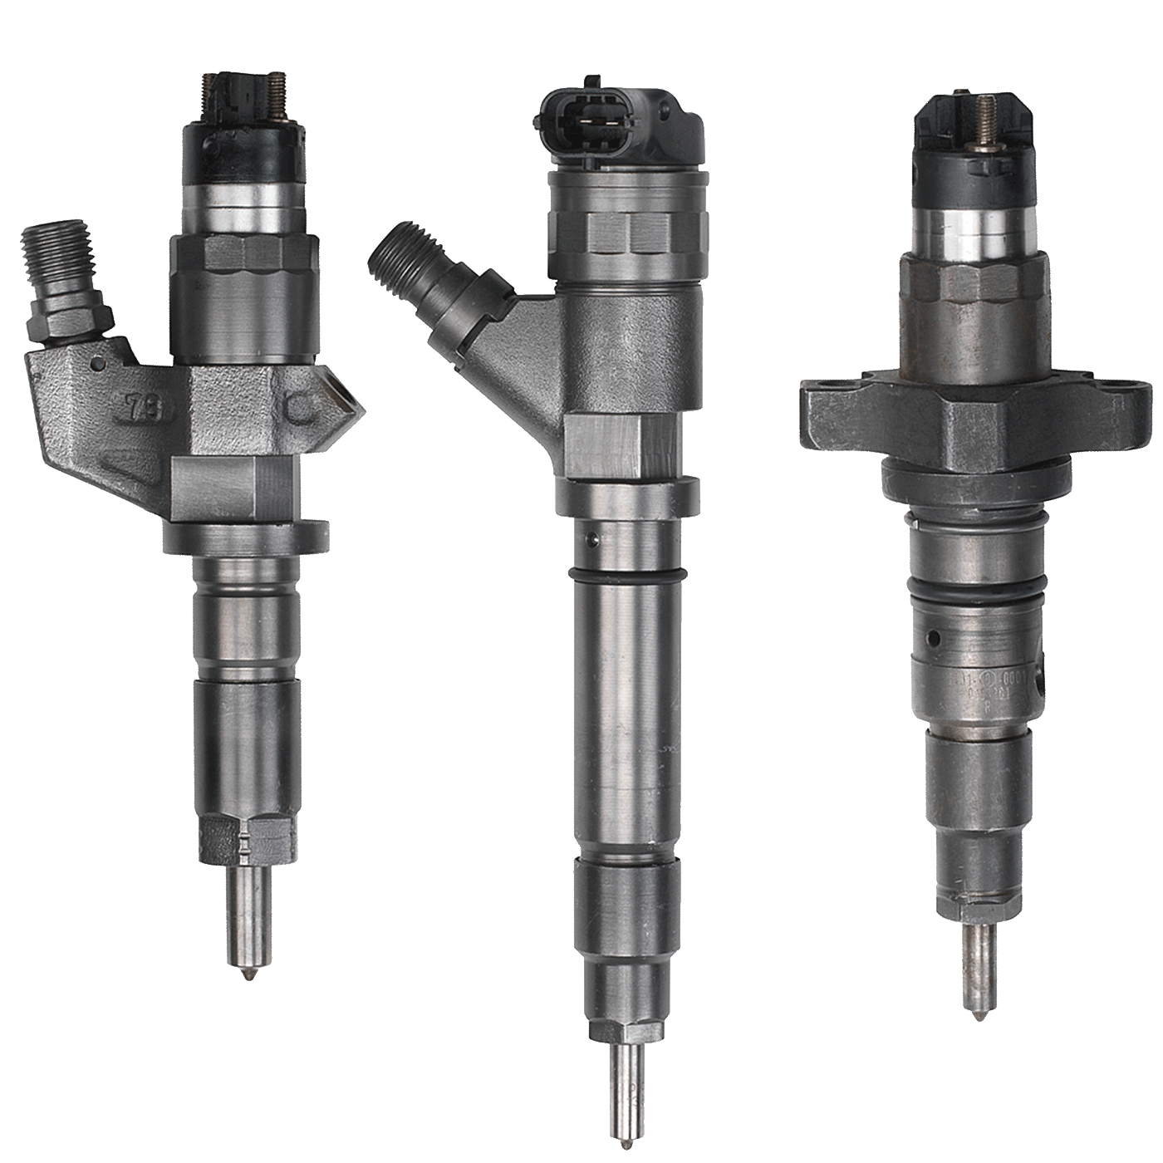
- To develop the pressure at which injection begins.
- To control the rate of injection for achieving the required rate of increase in pressure and a combustion process that is compete without generating harmful emission.
- To inject the fuel into the combustion chamber in a manner such that all of it atomizes, and mixes with and evaporates into the air as completely and uniformly as possible within the available time.
Figure 1-14- Injector nozzle
- To terminate injection instantaneously at the appropriate time, without any dribble or after injection, leaving the combustion chamber completely sealed off from the fuel system.
There are three basic types of nozzles in common use. These include:
- The pintle type conical seating face which at its end has a pintle projecting into the hole. Opening pressure normally about 10 to 13 MPa (1450 to 1885 psi). Used for indirect injection engine.
- The hole type has one, two or more holes at nozzle tips. Location of holes depend on location of injection nozzle. Opening pressure is higher than pintle type, 15 to 25 MPa (2175 to 3625 psi). Suitable for direct injection engine.
- Two stage injection (Pintaux) type this nozzle incorporate provision for cold starting.

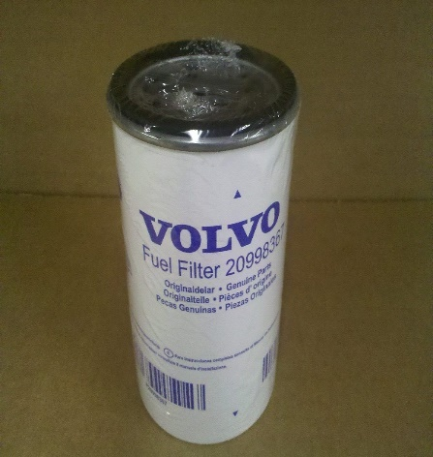
1.3.6 Fuel filter
The fuel filter is included in the fuel supply line to keep impurities away from the injection pump and the injectors. Trouble-free operation of a diesel injection system is possible only with filtered fuel. Fuel filters help reduce damage and premature wear from contaminants by retaining very fine particles and water to prevent them from entering the fuel injection system. In addition to filters with replaceable elements, box type filters are being used increasingly today. A sheet-metal box containing the paper element is screwed to the filter cover. The filter box has inlet holes for the unfiltered fuel, and 1 outlet hole for the filtered fuel. The outlet hole is tapped, and is also used to screw the filter box to the cover. The complete box is renewed when the filter element becomes unserviceable. It is unscrewed from the cover and discarded, after which a new box is screwed on hand tight until the sealing ring makes firm contact. It is then given another quarter-turn to tighten it finally. The old filter elements must be scrapped, as they cannot be cleaned. This also eliminates the risk of damage to the fuel injection system if replaceable filter elements were to be installed again after incorrect or careless cleaning.
Figure 1-15- fuel filter
Figure 0-14- fuel filter
Fuel systems can contain one or more stages of filtration. In many cases, a course screen is also located at the fuel intake located in the fuel tank.
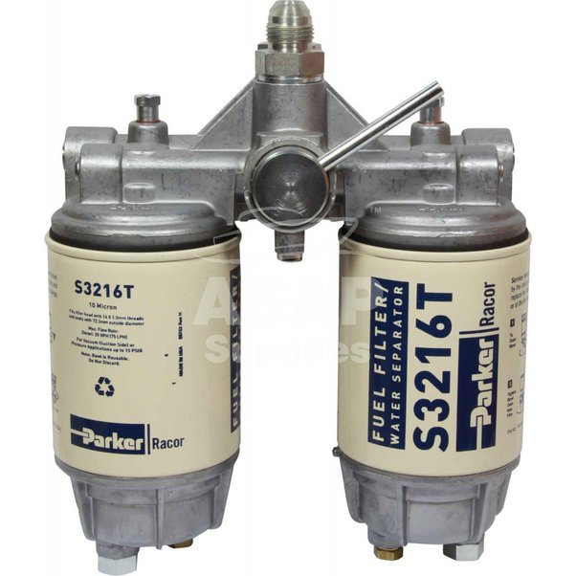
Two stage filter system typically uses a primary filter on the inlet side of the fuel transfer pump and a secondary filter on the outlet side. The primary filter is required to remove larger particles. The secondary filter is required to withstand higher pressures and remove smaller particles that can damage the engine components. One-stage systems remove larger and smaller particles in a single filter.
Figure 1-16- Two stages fuel filter

1.4 operating principle of diesel fuel injection system
The diesel engine fuel system works using the principle of pressure, in this case there are two chambers, namely cylinder space and fuel lines. The cylinder chamber is filled by high pressure air, while the fuel lines is filled by diesel fuels that ready to be sent to the cylinder. In order for the diesel fuel to come out into the cylinder, the pressure in the fuel lines must be made higher. So that when the nozzle is open, diesel fuel can come out towards the cylinder. To be understand easily, we divide the diesel fuel injection system into several components. Fuel pumps is used to deliver fuel from tanks to fuel injection lines. Fuel pump works using an electric motor.
While a high-pressure pump is a special pump that has high pressure. Its function is to increase the fuel pressure inside the injector up to 1,500 bars. Increased fuel pressure means that the fuel can get out into the cylinder during the combustion step, as you read above that the air pressure inside the cylinder when the combustion step is high. So that require higher fuel pressure.

1.5 OHS Requirements
For every task in diesel injection system, the following safety task must be strictly enforced:
Fulfill with personal and environmental safety practices associated with clothing; eye protection; hand protection; proper lifting practices; hand tools; power equipment; proper ventilation; and the handling, storage, and disposal of fuels/chemicals/materials in accordance with federal, state, and local regulations.

1.5.1 Nature and Scope of the Work Requirements
To determine nature and scope of the work requirements, the first task in diesel engines fuel injection system is to listen abnormal noise, visually observe exhaust smoke and verify the operator’s concern, review past maintenance and repair documents, and determine necessary action. Therefore, to limit work scope of overhauling activities follow these steps: -
- check fuel, oil, and coolant levels, and engine condition;
- Check engine no cranking, cranks but fails to start, hard starting,
- Check engine starts but does not continue to run, cranks normally but will not start,
- Check rough idle, Rough idle with abnormal noise and smoke,
- Check no abnormal noise or smoke Idle okay but misfires as throttle opens,
- Check loss of power, Combustion noise with excessive black smoke
- Check isolate engine rough operation, miss firing, low power, and slow deceleration and shut down problems…etc.
Based on these procedures, identify the real problems and analyze the following troubleshooting information.

Troubleshooting means solving a problem by considering each possible cause of a problem in turn and eliminating those that are found to be not applicable. The remaining possible causes can then be considered to be possible causes. This method is much faster and more accurate than simple guessing or making random adjustments or repairs. Possible causes are explained below.
- Incorrect or dirty fuel, restricted fuel return
- No fuel to nozzle or injection pump Limited fuel to nozzles or injection pump,
- Plugged fuel return, Pump timing off
- Inoperative glow plugs, incorrect starting procedure,
- Idle incorrectly set, Pump timing off
- Injection-pump trouble, Internal engine problems…etc.
After completing the check, determine the scope of the work. And then decide the real activity to solve the problem.

1.6 Tools, Equipment, workshop manual and Specification

1.6.1 Preparing Required Tools and Equipment
In well-organized automotive repairing workshop, there are deferent Hand tools equipment, Special Service tools (SST), Testers, Gauges, Jacks, lifters, measuring tools, power tools, etc. Among these materials, the trainees should be able to select the material that can used to the work he/she perform.

1.6.2 Sourcing Workshop Manuals
Work shop manuals/manufacturers repair manuals or specifications are the most valuable materials that used the technicians during repairing activities. As the result of technology variation, any type of technical product has its repair and service manual. Hence, the trainee should identify and make ready the right manual for the type and model of the injection pump to be maintained.

1.6.3 Analyzing Method Options Requirements
During technical work activity, test, measurement and calibration results are compared with manufactures specification to isolate the trouble from functional Components.
To analyze system troubles, there are deferent option based on the work
Performed. See on the above how to determine the nature of the work scope.

Self-check -1

Self-check: 1.1
Instruction I: Give answer for the following questions
      - What are the main components of diesel fuel injection system?
      - Describing all functions of diesel fuel injection system?
      - Identifying components parts of diesel fuel injection system?
      - Describe the three types of injector nozzle?
      - What is octane and cetane number?
Instruction II. Choose the best answer
1. In which of the following fuel injector is used?
A. Compression-ignition engine
B. Spark-ignition engines
C. Steam engines
D. Sterling engines
2. Which of the following is not the function of the fuel injection system?
A. Time the fuel injection
B. Filter the fuel
C. Atomize the fuel to fine particles
D. Control the engine speed.
3. which of the following is the correct flow of fuel in an individual pump fuel injection system?
A. Fuel tank – filter - feed pump - injector
B. Fuel tank – filter – injector – feed pump
C. Fuel tank – feed pump – filter – injector
D. Filter – feed pump – fuel tank – injector
4. what is the main function of good fuel filter concerning the injector?
A. faulty spraying
B. leakage
C. increased fuel consumption
D. filter moisture present
5. which of the following is used from the engine to drive gear – driven injection pump?
A. crank shaft B. cam shaft C. motor D. none
6. Which fuel related with cetane number?
A. petrol
B. diesel
C. A and B
D. Neither A nor B
7. Where the diesel fuel is obtained?
A. Crude oil
B. vegetable oil
C. animal oil
D. none
8. Which part is atomizing the fuel into engine cylinder?
A. injector
B. transfer pump
C. fuel line
D. fuel tank
9. why fuel filter is essential in diesel engine?
A. Increase the power
B. prevent dirty smoke
C. easy starting
D. All
10. Diesel fuel injection systems must accomplish five particular functions
A. Metering
B. Inject
C. Time.
D. Atomizes
E. All

Unit Two: Inspect diesel fuel system and its components, analyses results
This unit to provide you the necessary information regarding the following content coverage and topics:
- Inspect diesel fuel injection system components
- Analyzing Results of each inspection of diesel fuel injection system
This guide will also assist you to attain the learning outcomes stated in the cover page. Specifically, upon completion of this learning guide, you will be able to:
- Inspect diesel fuel injection system components
- Analyze the results

2.1 Inspect diesel fuel injection system components

2.1.1 Inspection of fuel tank
fuel tanks should be inspected for leaks; road damage; corrosion and rust on metal tanks; loose, damaged, or defective seams; loose mounting bolts; and damaged mounting straps. Leaks in the fuel tank, lines, or filter may cause a gasoline and diesel odor in and around the vehicle, especially during low-speed driving and idling. A weak seam, rust, or road damage can cause leaks in the metal fuel tank. The best method of permanently solving this problem is to replace the tank. Another method is to remove the tank and steam clean or boil it in a caustic solution to remove the gasoline and diesel residue. After this has been done, the leak can be soldered or brazed by an appropriately equipped specialty shop. Holes in a plastic tank can sometimes be repaired by using a special tank repair kit. Be sure to follow manufacturer’s instructions when doing the repair. When a fuel tank is leaking dirty water or has water in it, the tank must be cleaned, repaired, or replaced.
Service Tip
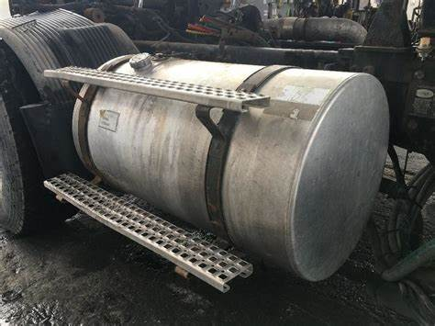
When a fuel tank must be removed, if possible, ask the customer to bring the vehicle to the shop with a minimal amount of fuel in the tank
Figure 2-1- diesel fuel tank

2.1.2 Inspection of fuel filter
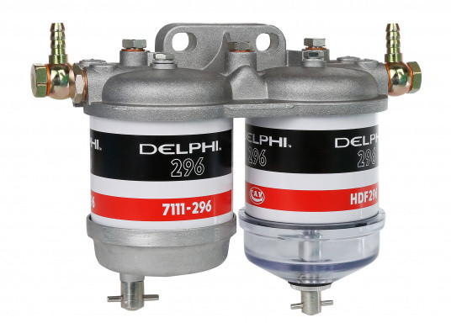
A diesel fuel filter ensures that fuel is clean before it reaches the injectors that feed the engine. If a filter is dirty or clogged, you may find it difficult to start your vehicle, or you may notice it idling roughly, perhaps sounding ready to stall. Most diesel engines have two fuel filters: The primary one is found somewhere on the fuel line between the fuel tank and the engine, while the secondary filter is typically located near the engine. Before colder weather settles in, it’s advisable to change both filters.
Figure 2-2- diesel fuel filter

2.1.3 Inspection of injector nozzle
The fuel injector is one of the most important devices in the fuel supply system of the diesel engine, which can spray the diesel oil into the cylinder uniformly, finely and evenly to make it mix with the compressed air in the cylinder evenly and form a good combustible mixture. Its working quality directly affects the power, economy and service life of diesel engines. inspection of fuel injection pressure. If the injection pressure does not meet the standard, it will seriously affect the power and economy of the diesel engine. If the injection pressure is too low, the oil beam velocity, range and spray cone angle will be reduced, which will make the diesel atomization not good and produce the phenomenon of dropping oil. At the same time, it will cause the injection time to advance and the injection quantity to increase after the end of the injection. This will result in incomplete combustion, black smoke from the exhaust gas, carbon deposition, and fuel injector seizure.
The injector injection pressure check can be performed on the diesel engine. Connect a tee joint to the outlet pipe of the high-pressure oil pump, and connect the other two ends with the standard injector (the same model as the injector to be tested, and the injection pressure is the standard value) and the injector to be tested
Check the injection advance angle. The injection advance angle is different from the supply advance angle. The fuel supply advance angle refers to the crankshaft angle from the piston position of the first cylinder to the top dead center when the first cylinder plunger pair of the fuel injection pump starts to supply oil. The fuel injection advance angle refers to the crankshaft angle from the piston position of the first cylinder to the TDC when the fuel injector of the first cylinder starts to inject fuel into the cylinder. Obviously, the injection advance angle is smaller than the oil supply advance angle, generally less than about 8 °C. This is related to the structure of the injection pump and the length of the high-pressure oil pipe.
spray quality inspection. It is mainly to check whether the fuel injector can inject the diesel oil into a fine and uniform spray under the specified pressure. The inspection shall be carried out on the fuel injector calibrator, and the pump oil handle shall be pressed at the speed of 80-100 times per minute to observe whether the injected oil beam is normal, and the atomization quality shall meet the requirements.

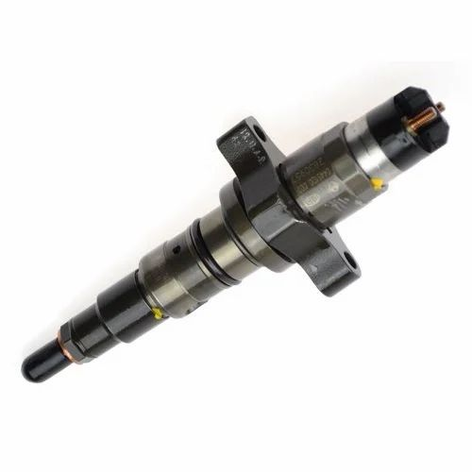
When the starter drives the engine to rotate, use a long-handled screwdriver or a stethoscope to listen to whether the fuel injector has a "click, click, click" working sound. If it is difficult to judge due to the influence of other noises, you can use a long-handled screwdriver or a stethoscope to listen to the sound of the fuel injector. Use the method of unplugging and plugging in the injector harness connector to identify whether the injector is working.
Figure 2-3- diesel fuel injector
If the fuel injector does not work, you can connect a test lamp to the wiring harness connector of the fuel injector and then start the engine. If the test light flashes, it indicates that the injector control system is working normally and the fault lies in the injector. For fuel injector inspection, use a multimeter to measure the resistance value of its solenoid coil. The resistance value is normal, indicating that the injector is blocked (affected by the carbon deposits and the gum in the fuel during combustion. This phenomenon is the most common), the needle valve card, etc., the injector should be repaired, cleaned or replaced; the resistance value is abnormal, the injector must be replaced.
If the test light does not light up, it means that the control system or circuit of the injector is faulty. In this regard, you should first check whether the relevant circuit of the injector is intact, and only if the external circuit is in good condition can it be judged that the computer is faulty.

2.1.4 Inspection of fuel line
All fuel lines should occasionally be inspected for holes, cracks, leaks, kinks, or dents. Since the fuel is under pressure, leaks in the line between the pump and injection assembly are relatively easy to recognize. Rubber fuel hose should be inspected for leaks, cracks, cuts, kinks, oil soaking, and soft spots or deterioration. If any of these conditions is found, the fuel hose should be replaced. When rubber fuel hose is installed, the hose should be installed to the proper depth on the metal fitting or line Steel tubing should be inspected for leaks, kinks, and deformation Tubing should also be checked for loose connections and proper clamping to the chassis. If the tubing’s threaded connections are loose, they must be tightened to the specified torque. Some threaded fuel line fittings contain an O ring. If the fitting is removed, the O-ring should be replaced. Nylon fuel pipes should be inspected for leaks, nicks, scratches and cuts, kinks, melting, and loose fittings. If these fuel pipes are damaged in any way, they must be replaced. Nylon fuel pipes must be secured to the chassis at regular intervals to prevent fuel pipe wear and vibration.
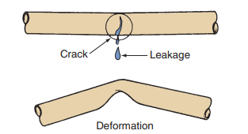
Service Tip

If a vehicle has nylon fuel pipes, do not expose the vehicle to temperatures above 194°F (90°C) for any extended period to avoid damage to the pipes

Figure 2-4- diesel fuel pipe

2.1.5 Inspection of fuel injection pump
Clean fuel pump housing, check valves, pulse chamber, and pump base in solvent, and dry all but check valves with compressed air. Inspect each check valve, for cracks and/or holes. Check each black rubber disc to see that the black coating is not coming off. Unless damaged while disassembled, replacement is seldom necessary. Inspect the Check Valve Assembly on Chamber Plate (check by both pressure and suction to hose barb), to see that check ball is moving and functioning (1-3 psi required). Inspect fittings on fuel pump housing for looseness or any signs of fuel or air leaks. Replace or tighten fitting if leak is found, or replace chamber Plate Assembly
- Look at fuel line hoses and connections: Your connections from your tank to the fuel pump could have kinks or leaks that show signs of a bad diesel fuel pump. Loosen your in-line fuel filter hose clamps using a screwdriver, then check the filter to make sure there aren’t any obstructions.
- Use a fuel pressure gauge: Attaching a fuel pressure gauge to the pulse hose coming out of your fuel pump will help you show if your fuel pump is putting out the right pressure. Any reading below your manufacturer’s specifications means you probably have a defective fuel pump diaphragm or check valve.
Here are a few signs you might have a failing diesel fuel pump
- Squeaks, squeals and other high-pitched sounds: If your vehicle starts squealing or making unusual, high-pitched noises, this could be a sign that your diesel fuel pump is going bad. Different pumps naturally make different sounds, but over time you should be able to adjust to these noises while you drive. If anything sounds out of the ordinary, it’s a good time to call a mechanic to check out the vehicle.
- Difficulty accelerating: Are you having trouble getting your vehicle up to speed quickly enough? This could be a sign that your diesel fuel pump is having some troubles. The primary cause is the pump not giving the engine an adequate supply of fuel, which makes it difficult to accelerate.
- Bad fuel pressure: A vehicle that is unable to maintain a good fuel pressure likely has a fuel pump that is not functioning correctly. When the vehicle is dealing with low pressure, the car could have problems starting, even when the rest of the parts of the vehicle are functioning exactly as they should.
- Power issues: Does your vehicle ever lose power, or start to slow down? This probably is a sign that you need to replace your diesel fuel pump.
- Filter issues: If the filter of your vehicle seems like it is malfunctioning in any way, this could indicate diesel fuel pump problems. While it’s important for you to change your filter regularly, you shouldn’t have to do so very frequently. Some people who have diesel fuel pump problems see those problems manifest themselves in the filter, and end up having to change the filter almost daily just to keep up.
- Engine stoppages: The engine could bring itself to a halt if it’s not getting enough fuel fed to it. This means you need to replace your diesel fuel pump as soon as possible.

Inspection of Transfer pump Housing
- Check the condition of the inlet and the outlet valve seats. If these are worn beyond specifications or damaged, replace housing with new
- Inspect the push rod bore. If bore is worn beyond specification or badly scored or scratched, replace valve with new

Inspecting Fuel Filter and Fuel Pipe Connections
- Check filter if dirty or damaged, clean with dry air or replace if required.
- Check pipe connections and threads for damage
- Replace pipe joint bolts or connections if required
- Recondition threads if possible.

2.2 Analyzing result

2.2.1 Analyzing Faults and Forward Recommendation
While conducting diesel injection fuel system, results are noted based on work place format and procedure and compared to the specifications. At this step, the trainee should analyze the evaluation and make the necessary decision as work place forwarding recommendation format. After investigating the trouble cause, he/she proceed to solve the problem.
Test activity results, result comparison and result evaluation should be properly registered and documented according to work place procedures and format because this document will used as back history information for the next task.

Self-check -2

Self-check: 2.1

INSTRUCTION: Answer the question stated below based on information sheet.
Write your answer on a paper and submit for your trainer.
If your progress is unsatisfactory discuss with your trainer.
1. What are the symptoms of black exhaust gas?
2. What are the symptoms of white Exhaust gas during acceleration?
3. What symptoms indicates loud diesel knocking?

Unit Three: Service diesel fuel injection system components

This unit to provide you the necessary information regarding the following content coverage and topics:
  - Service diesel fuel injection system components
  - Bleeding procedure
  - Adjust injection timing
This guide will also assist you to attain the learning outcomes stated in the cover page. Specifically, upon completion of this learning guide, you will be able to:
  - service diesel fuel injection system components
  - Perform bleeding procedure
  - adjust injection timing

3.1 service diesel fuel injection system components

3.1.1 Servicing fuel tank

Removing Fuel tank
Fuel tank removal may not seem at first necessary, but it can be. Within tank electric fuel pumps, common on many late model cars, it is often necessary to remove a tank to cure a fuel pump problem. Also, dirt, water and other contamination in the fuel tank can cause filtration and delivery problems. Such problems can be particularly critical for diesel and gasoline injection systems. Often the only way to cure chronic fuel contamination is to remove and clean the tank.
Fuel tank installations vary from car to car, but the methods for removing and replacing a tank share the common points outlined below. If you can obtain the carmaker’s drawing of the tank installation, study it before you start the job to determine the locations of lines, vent hoses, electrical connectors, and mounting straps.
Warning

Explosive vapors are present in an empty fuel tank. Because of the air and fuel vapor mixture, an empty tank can be more explosive than a full one. Observe all fuel and electrical safety precautions to keep heat, spark, and flame away from a fuel tank.
Cleaning fuel tank
After removing the tank, you can clean it, or replace it as required. Remove the fuel gauge sending unit, any electrical pumps or water separators, and other reusable parts from the old tank (if you replace the tank). You can clean some tanks by steam cleaning or with special cleaning solutions.
Warning

Do not try to repair a tank by welding. Fuel vapors trapped in the tank may explode. A leaking tank can sometimes be repaired by soldering. Because passenger car fuel tanks are usually inexpensive, it is advisable to replace a defective tank rather than repair it.
Caution
Soldering a fuel tank is a dangerous job. Exercise caution to avoid an explosion. An empty fuel tank will explode as readily as a tank containing fuel.
- Drain all the fuel from the tank and flush it with water until every trace of gasoline fumes is removed.
- Fill the tank with water and position it so water will not seep out of the section to be repaired.
- Use a wire brush to clean around the spot to be repaired.
- Scrap the surface to be soldered until it is clean and bright.
- Solder the damaged section following the proper procedure.
Caution
Do not use a soldering iron when it is red hot. Make sure there is no glowing carbon or oxidation on the tip. Do not hold the iron in any one spot for more than a few seconds at a time.
- Drain the water from the tank.
- Blow compressed air into the tank to remove all traces of moisture.
- To test the tank for leakage, close all tank openings. Then put soap suds on the repaired area and blow a small amount of air into the tank. If soap bubbles appear, the tank still leaks.
Installing fuel tank
To install a new or cleaned tank, first install al reusable parts removed from the original tank. Use new gaskets and install new rubber hoses where required. Use a jack to raise the tank into position under the car and reinstall the mounting straps, filler tube, lines, and other parts.

3.1.2 Servicing injector nozzles
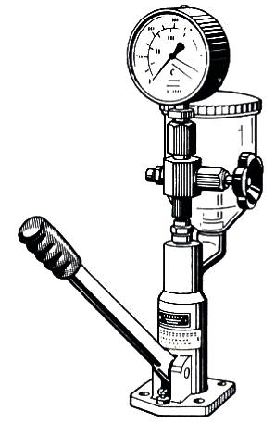
The following section describes the general procedure to service injector nozzles: removing, cleaning, disassembling, inspecting parts of injection nozzle, assembling injector nozzle, testing, and installing injector nozzle on the engine
If the clamp-type injector holders are difficult to remove by hand, a special injector extractor must be used to pull them out. Cover the injector bore in the cylinder head with a piece of cloth to protect the cylinder from dust and dirt. Perform the testes in the Following order: -
Figure 3-1- Injector nozzle tester
- Opening pressure test
- Back leakage test
- Leakage or valve-seat test
- Spray pattern test
- Adjusting injection nozzle Opening Pressure
Testing Procedure:
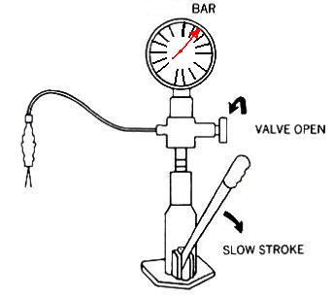
- Open the pressure gauge isolator after bleeding the system, figure 3-2
- Operate the lever of the tester slowly until injection occurs.
- Observe the pressure gauge and note highest reading just before injection pressure begins to drop.
- Compare the recorded opening pressure reading with manufacturer's specification. If the actual pressure varies from the standard, the pre-tension of the pressure spring has to be adjusted. This is done by the adjustment screw provided, or by adjusting shims of various sizes. Adjusting Shims are usually available in sizes from 1.0 - 3.0mm thickness and in steps of 0.05mm.
Figure 3-2 Opening pressure testing
Note
If New Injection Nozzles has to be installed, adjust the opening pressure 5.0 to 10.0 bar above the specified pressure in order to compensate a pressure drop caused by the short break-in period of the needle valve.
- Checking injection nozzle back Leakage Test
after the leakage or valve-seat test, some manufacturers recommend to perform a back leakage test.
Testing Procedure:
- Open the pressure gauge isolator on the tester.
- Slowly depress the operating lever until stated pressure is shown on gauge.
- Release the operating lever and note the time taken for pressure to fall.
The time for the pressure drop can be influenced by: -
- The fuel temperature
- The viscosity of the test fluid used
- The length of the pressure line used.

Results
Generally, a pressure drops from 150 to 100 bar (ΔP ≈ 50 bar) within a time not less than 6 seconds (T≥6 second), using shelf fluid “C” and maintaining a test temperature approximately 10⁰ up to 20⁰c indicates a satisfactory injector.
A higher pressure drops than specified can be caused by: -
- Loose fuel pipe connections
- High temperatures, causing thinning of the test oil
- Loose nozzle cap or nozzle holder retaining nut.
- Dirty or damaged sealing surfaces of nozzle and/or nozzle holder, which allows fuel to escape.
- Checking injection nozzle Leakage or Valve-Seat
Testing Procedure:
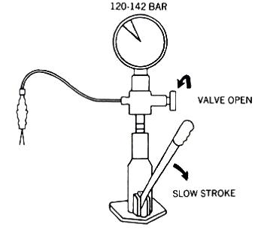
            - Open the pressure gauge isolator and wipe injector tip dry, figure 3-3
            - Depress the operating level of the tester slowly until the gauge indicates a pressure of about 10 to 20 bar below the before- measured opening pressure.
            - Maintain this pressure for 10 seconds and observe the injector tip.

Figure 3-3 Leakage or Valve-Seat

Results
If no fuel drop occurs during this time, the needle-valve seat is in good condition. If there is any evidence of fuel at the tip, the needle-valve seat is defective. The nozzle assembly should be replaced or overhauled.

- Checking injection nozzle Spray Pattern
Testing Procedure:
- Close the pressure gauge isolator on the tester.
- Move the opening lever at about 1 strokes/second and observe the spray jet. A nozzle in good condition shows a thin and even cone-shaped jet of spray without distortion and fine atomized fuel.
- After this, gradually increase the lever movement to about 2 strokes per second.

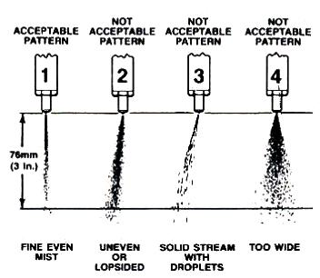
Figure 3-4 injection nozzle Spray Pattern

Results
Now a characteristic "chattering or humming" sound should be noticed indicating a properly working injector. This depends also very much on the test fluid used. If the injector does not atomize the fuel completely, incomplete combustion, causing black smoke, a loss in engine power and poor fuel economy, will result, figure 3.4. Increased diesel knock, due to the longer delay period that follows poor atomization, will also be evident.

Installing injector nozzle on the engine
- Before installing the injectors, replace the sealing washers and heat protection washers in the injector bores. Check that all old washers are removed from the bore and that the position of the new ones is correct. Be sure to check this in the manufacturer’s manual.
- Install the injectors in the bore and press down by hand.
- Remove the protection caps or cape and connect the fuel pipe. Screw the connection nut by hand. If necessary, move the injector a little to fit the nut properly.
- Tighten the nuts or bolts for the injector fixing with a torque wrench. Tighten alternate nuts in equal amounts to ensure that the injector is seated squarely.
Note
It is very important that the retaining nuts are tightened with the correct torque. Excessive tightening can cause cracks in the cylinder head.
- Tighten the pipe flange nut and, at the same time, check that the flange nut at the injector is also tightened properly.
- Connect the leak-off pipe
- Be careful when tightening the screw because some are hollow and rather weak in construction. Use the recommended torque.
- Start the engine and check that no leakage occurs from the transfer pump connections.
Note
Keep the injectors protected by placing them in a bag or box. Also make sure that the injectors are kept in order so that they can be re-fitted in the same cylinder.
Be careful not to damage the needle, which protrudes from the injector.

Servicing transfer pump

Removing transfer pump
To remove the pump:
  - Disconnect both fuel pipes.
  - Place a container under the end of the tube, to catch any fuel, which might run out.
  - Remove the nut, which fit the pump to the injection pump.
  - Remove the transfer pump
Disassembling transfer pump
When dismantling and reassembling the fuel transfer pump manufacturer's specifications and procedures should always be taken into considerations and strictly followed in order to provide maximum of service life and to guarantee a proper and failure less operation of the component. The working area should be clean from dirt and spilled liquids and in particular free from dust. As an example, disassemble the following transfer pump in the given numerical order.
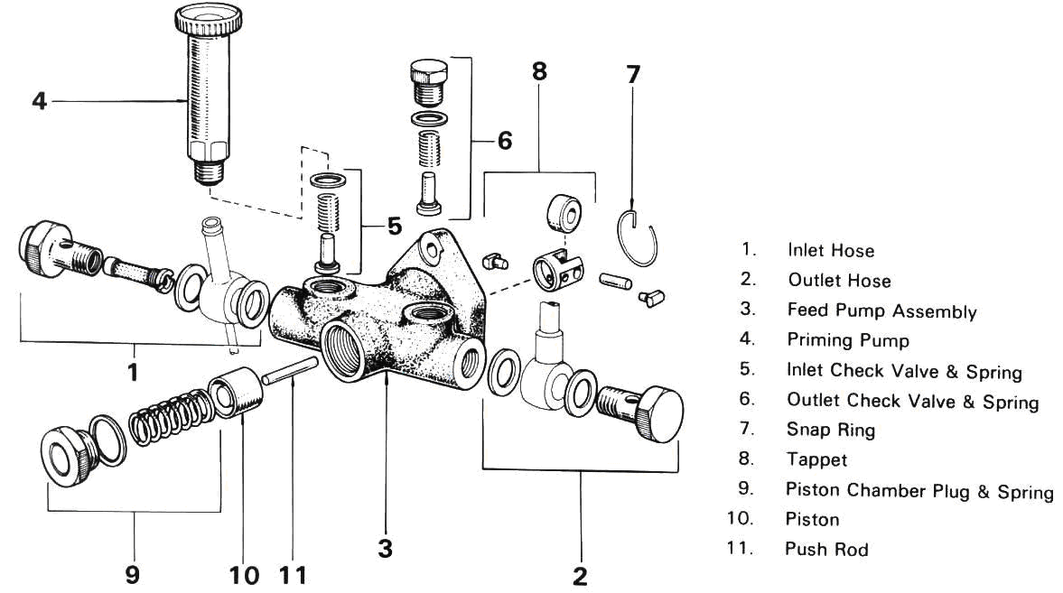

Figure 3-5 Transfer pump

Assembling transfer pump
The procedure to assemble the transfer pump is the reverse of disassembling. Follow the reverse order of the example above in figure 3-6/7.
Testing the transfer pump
- Testing transfer Pump Intake (Suction) Pressure
The pressure gauge is positioned into the suction side of the fuel transfer pump, figure 3-6.
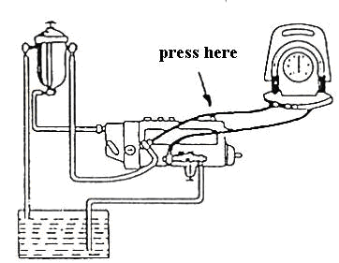
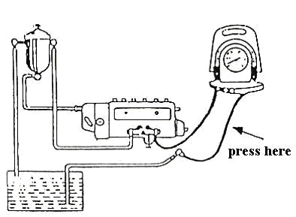

Figure 3-7 Measuring delivery pressure
Figure 3-6 Measuring suction pressure
Testing Procedure:
- Bleed system after pressure gauge installation.
- Start engine and run with idle speed until normal operation temperature is attained.
- Measure the reduced fuel pressure in the suction line at idle speed and compare with specifications.
Under this condition, the actual reading should be very low and correspond to the suction height between fuel tank and transfer pump. The suction height of 1m ≅ 0.1bar of reduced pressure
B. Maximum Suction Pressure of transfer Pump
- Clamp the suction line in front of the manometer in order to attain maximum reduced pressure reading.
- Write down and compare with manufacturers specification.
Results
- If Transfer pump is new or in good condition, a reading of 0.5 to 0.6 bar of reduced pressure should be attained.
- Transfer pump is still in acceptable condition if a reading of at least 0.2 bar is attained.
- If Manometer reading is below 0.2 bar, the Transfer pump is defective and the possible cause are:
- Worm transfer pump piston (plunger).
- Worn or defective transfer pump valves
C. Delivery Pressure Test
The pressure gauge is attached to the outlet side of the fuel transfer pump.
Testing Procedure
- Bleed system after pressure gauge is installed using the priming pump.
- Operate the engine until normal operation temperature is attained.
- Take the pressure gauge reading at engine idling speed.
Result
If a check valve is installed in the system a reading of about 1.5 bar should be attained
D. Maximum Delivery Pressure Test:
- Press together the supply line after the gauge.
- Take the reading and compare with manufacturers specification.
Results:
- If Transfer pump is new or in good condition a reading taken should be between 3.5 to 4.5 bar.
- Reading below 2.8 bar indicates a defective transfer pump.
E. Testing the Condition of Fuel Filter Unit
- Fit the pressure gauge to the outlet side of the filter unit.
- Bleed system and run the engine until normal operation temperature is attained.
- Take gauge reading at idle and medium speeds and compare the result with specifications.
Result
Too low-pressure reading could be caused by: -
- A dirty or blocked fuel filter element.
- Defective check valve was fitted
- Defective transfer pump

F. Testing the Transfer pump When Dismounted
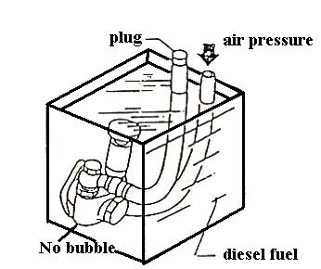
This is a simple transfer pump performance test and can be executed with the transfer pump dismounted, figure 3-8.
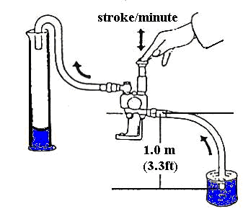

Figure 3-8 Performance test
Figure 3-9 Leakage (air tightness test)
Testing Procedure
- Connect a fuel pipe to the inlet and outlet of the transfer pump.
- Put a fuel container underneath the transfer pump so that a suction height of 1m is maintained between fuel level and pump inlet side.
- Operate priming pump at certain strokes per minute according to service recommendations.
- Count the number or strokes required to suck fuel from the tank or measure the amount of fuel delivered by a defined number of strokes. Also, see manufacturer’s recommendations.
- Compare test results with manufacturer’s specifications.
G. Air-Tightness Test of Fuel Transfer pump (figure 3-9)
Testing Procedure
- Close the transfer pump outlet and fit a suitable pipe to the intake side.
- Apply low air pressure (1.5 to 2.0 bar) to the intake side of the transfer pump.
- Immerse the pump in clean kerosene or diesel fuel and observe if air bubbles appear.

Result
- If continuously air bubbles show up, replace the concerning gasket or seal, or overhaul pump- assembly if necessary
Note:
The tests and procedures described above are general methods of testing the low-pressure fuel circuit. Since the testing procedures and pressure data might slightly vary depending on the manufacturers, their specifications and recommendations should always be followed!

Installing the transfer pump on the injection pump
  - Fit the transfer pump back onto its position.
  - You may have to press a little bit.
  - Fit back the nuts.
  - With one hand, press the pump firmly onto the housing of the pump and, with the other hand, tighten the nuts. This will avoid twisting the pump and/or destroying the threads.
  - Tighten the nuts to the correct torque. Finally connect the fuel lines to the transfer pump.

3.2 Perform bleeding procedure

3.2.1 Bleeding the In-Line Pump Diesel Fuel System

In general, bleeding is executed with the help of a priming pump, and follows certain steps of procedure.
- Loosen the priming pump by turning it counterclockwise.
- Loosen the air vent screw positioned nearest to the priming pump in the system (usually found on the fuel filter unit)
- Operate the priming pump by hand until pure diesel fuel, free from air bubbles, comes out of the air vent screw.
- Tighten the air vent screw
- Now, open the air vent plug on the fuel injection pump
- Close the air vent screw when air bubbles disappear from fuel coming out of the plug.
- Tighten the priming pump by pushing it downwards and turning it clockwise at the same time.

With fuel systems provided with suction-side scavenging of the injection pump, the fuel manifold can be bled without opening the air vent plug on the injection pump, by cranking the engine at starter motor speed. The air escapes via the check and the fuel return line into the fuel tank. Pull the stop lever back completely to ensure that the engine will not run.

Bleeding the Distributor (VE) Pump:
- Usually, the bleeding procedure is the same as mentioned above.
- The priming pump is usually positioned on the filter unit or fit to a pre-delivery pump, which is placed between filter unit and tank.
- Often the distributor pump does not require venting. In this case, no priming pump and pre-delivery transfer pump is found in these fuel systems. The injection pump is "self-venting" when the engine operates.
Note
If high-pressure injection lines where loosened or dismounted, execute the following procedure:
- Loosen injection lines at nozzle side and crank engine with pressed down accelerator pedal.
- Crank engine until fuel escapes from the loosen pressure pipes.
- After this, tighten injection pipe flare nuts and run the engine.

3.3 Injection timing

Operation sheet: 3.1 Adjusting injection timing
Operation Title: Adjust injection timing
Operation purpose: perform injection timing
Condition and situation for the operation:
- Safe working area
- Properly operated tools and equipment
- Appropriate working cloths fit with the body
Equipment, tools and material:
- Service manual
- Flat screwdriver
- Set of wrenches (socket, box and open wrenches)
- Torque wrench
Steps in doing the task: Adjust injection timing
- Remove fuel lines from injector pump fittings on injector pump (Tool C).
- Pull the decompression lever so that it will remain in the decompression position. No decompression lever on Model-12
- Open throttle fully.
- Energize the electric fuel pump and turn engine over with starter to ensure that fuel is coming out of each injector pump opening. Have clean rags around opening to soak up fuel.
- Wipe off any fuel on injector pump body and the top of each injector opening.
- Turn crankshaft over by hand, being careful not to damage spline on end of crankshaft. Engine rotation will be clockwise. STOP IMMEDIATELY at the first sign of fuel movement in the injector pump fuel fitting, for whichever injector pump is being checked. (No. 1 injector pump is the closest to the V-belt end of the engine).
- Remove the cover from flywheel timing mark inspection hold located inside of left engine mount (Tool B).
- Check alignment of mark on flywheel with the timing pointer on the wall of the inspection hole. The 1-Fl mark on the flywheel represents fuel injection of No. 1 cylinder. 2-Fl represents No. 2 cylinder, etc.
- If timing pointer and the flywheel marking 1-Fl is aligned then No. 1 cylinder is properly timed for fuel injection and should require no adjustment. The same will be true for No. 2, No. 3 and No. 4 cylinders if the above steps are followed.
- In order to determine if timing is off, or if the injection pump is faulty, it is necessary to recheck the timing for each cylinder two or three times.
- If there are variations in repeatability in the alignment of pointer and timing mark, a faulty fuel injector pump may be suspected.
- If timing marks repeat to same location but are off 3/16" or more above or below the pointer, this indicates that the engine must be retimed. If alignment of the timing mark is not within 3/16" above or below the pointer, the above steps must be taken to time the engine. If the timing is found to be satisfactory, then reconnect all fuel lines and fittings and tighten. The fuel system must be bled before the engine will operate properly.
Quality criteria: Assured performing of all the activities according to the procedures
Precaution:
- Wearing proper clothes, eye glass, glove
- Make working area hazard free
- Read and interpret manual which guide you how to use tools and equipment

Operation sheet: 3.2 Servicing of fuel tank
Operation Title: Service fuel tank
Operation purpose: Service fuel tank
Condition and situation for the operation:
- Safe working area
- Properly operated tools and equipment
- Appropriate working cloths fit with the body
Equipment, tools and material:
- Service manual
- Flat screwdriver
- Set of wrenches (socket, box and open wrenches)
- Torque wrench
Steps in doing the task:
- Remove the filler cap to equalize air pressure in the tank and disconnect the battery ground cable. Depressurize a fuel injection system according to the carmaker’s procedures.
- Most tanks are under the rear of the vehicle. Following the carmaker’s lifting instructions; raise the vehicle on a hoist or with a jack and stands to a convenient working height.
- Drain remaining fuel in the tank into a metal or plastic container by:
  - Removing a drain plug from the tank
  - Disconnecting the fuel line at the inlet of the fuel pump and using a hand operated siphon pump to siphon fuel from the tank.
- If electrical connectors for the fuel gauge sending unit and an in -tank electric pump are accessible, disconnect them. You may have to wait until the tank is partly lowered form the car to reach some connectors.
- Disconnect fuel supply and return lines and EEC vapor hoses from the tank. You may have to remove a vapor separator from the tank.
- Separate the tank from the filler tube or separate the filler tube from the car body
  - If the filler tube is connected to the tank with a hose and clamps, disconnect it at this point.
  - If the tube is soldered to th4 tank and fastened to the body by a clamping flange, remove the flange screws.
  - If the tube is fastened to the tank by a clamping flange, disconnect it at this point.
Some filler tubes do not have to be removed from the car once they are separated from the tank. This is good point to check the carmaker’s installation drawing.
- Many station wagon tanks are located in rear fender wells. Remove the wheel and tire for access to such a tank.
- Remove any shields, shock absorbers, or other chassis parts that may block tank removal.
- Place a jock or suitable support under the tank to hold its weight as you remove the mounting straps.
- Loosen the mounting straps and lower the tank far enough to remove any other lines or wires.
- After removing all connections and clearing obstructions, remove the mounting straps and lower the tank to the tank to the ground.
Quality criteria: Assured performing of all the activities according to the procedures
Precaution:
- Wearing proper clothes, eye glass, glove
- Make working area hazard free
- Read and interpret manual which guide you how to use tools and equipment

LAP: Test

Instructions:
1. You are required to perform any of the following:
- Performing diesel fuel system bleeding
- Check timing of diesel engine
- Adjust injection timing
- Test Injector Nozzle

Unit 4: Prepare vehicles/Equipment/ for use or storage
This unit to provide you the necessary information regarding the following content coverage and topics:
- Schedule documentation
- Final inspection
This guide will also assist you to attain the learning outcomes stated in the cover page. Specifically, upon completion of this learning guide, you will be able to:
- Prepare service schedule documentation
- Perform final inspection

Completing Work Schedule Documentation

Documentation provides valuable descriptions of an organization’s development, acquisition, and operating environments and significantly enhances an organization’s ability to administer, operate, and maintain technology systems. Primary advantages for technicians involve having access to operation manuals and on-line application help features. Documentation enhances administrators’ and technicians’ ability to maintain and update systems efficiently and to identify and correct programming defects.
Figure 4-1 work schedule
Developing and maintaining current, accurate documentation can be complicated, time consuming, and expensive. However, standardized documentation procedures and the use of automated documentation software can facilitate an organization’s ability to maintain accurate documentation.
To conduct Preparation of vehicle/system for customer and/or storage based on workplace procedures, it is required to follow setups and procedure.
- complete work documentation that performs during the practical repairing work.
- performing final road test and over all condition finalizing checkup.
Follow these three general principles to develop records and documents:
- Keep it short and simple. Use bullet points and flow diagrams instead of long sentences and lengthy paragraphs.
- Clarity is important. Step-by-step instructions are easily understood.
- Use a standardized, consistent format. Although different programs may need different documents and records, using a similar approach will help staff learn quickly.

4.2 Performing Final Inspection and Cleaning

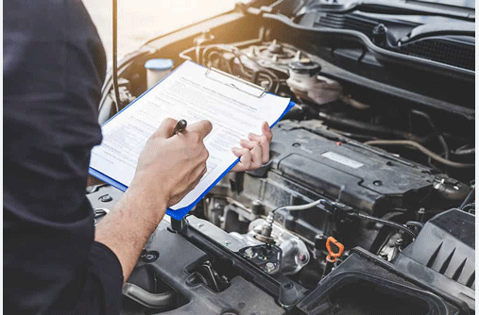
- cleaning vehicle
- processing Job card based on workplace procedures.
- Forwarding report to the customer.

Figure 4-2 Final inspection
Consumers’ expectations are that they will receive their vehicle back in a serviceable condition and in a better operational condition than when it was delivered to the workshop. This expectation requires two (2) critical components:
- A final inspection must be completed by the service technician to ensure that all of the protective features for the braking system have been refitted is replaced to the required specifications; and
- A final inspection must be completed by the service technician to ensure that all of the work that was commenced on the system was completed to workplace, customer and manufacturers expectations.
Delivery is the process of transporting something/ like reports/ from a source location to a predefined destination after the work is done. The technician should be preparing a report and deliver to appropriate person. The reporting procedures are as follows
- Record the work to be done
- Inspect/test the repaired engine accordance with manufacturer procedure
- Record/ capture the problem with the necessary information
- Order the recorded problems /work done in accordance with their damaging area
- Preparing reports have no error/discrepancy
- Deliver reports to appropriate person.

Self-check -3

Self-check: 4.1

INSTRUCTION: - Answer the question stated below based on information sheet.
- If your progress is unsatisfactory discuss with your trainer and do this work again.
- Explain briefly on the blank space.
Time given 15 min
            - How can you prepare the vehicle to the customer/storage?

Operation sheet: 4.1 Prepare vehicles/Equipment/ for use or storage
Operation Title: Preparing vehicles/Equipment/ for use or storage
Operation purpose: To conduct Preparation of vehicle/system for customer and/or storage based on workplace procedures, it is required to follow setups and procedure.
Condition and situation for the operation:
- Safe working area
- Properly operated tools and equipment
- Appropriate working cloths fit with the body
Equipment, tools and material:
- Live Vehicle/Engine with injection pump
- complete tool box and Equipment
Steps in doing the task:
      - Conduct the activity based on information sheet
Quality criteria: Assured performing of all the activities according to the procedures
Precaution:
- Wearing proper clothes, eye glass, glove
- Make working area hazard free
- Read and interpret manual which guide you how to use tools and equipment

Reference
- Automotive technology a systems approach 5th edition jack erjavec
- Auto motive mechanics William H.Crouse 10th edition
- Light & heavy vehicle technology Fourth Edition
- Automotive technology A Systems Approach 7th ed. Jack Erjavec Rob Thompson
- Heavy duty truck systems fifth edition sean bennett ian andrew norman

Participants of this Module (training material) preparation

No | Name | Qualification | Field of Study | Organization/ Institution | Mobile number | E-mail
 | Adinet Asnake | MSc. | Automotive Technology Mgt | Wolkite PTC | 0913-767250 | andinetasnake31@gmail.com
 | Biruk Tilahun | BSc. | Automotive Technology | General Wingate PTC | 0913-789176 | biruktilahun1@gmail.com
 | Fadli Aman | BSc. | Automotive Technology | General Wingate PTC | 0927-283100 | Fadli.ziyad@gmail.com
 | Hana Nigusise | BSc. | Automotive Technology | Selam TVET college | 0988-751516 | Hana.nigussie25@gmail.com
 | Israel Taye | BSc. | Automotive Technology | General Wingate PTC | 0913-424100 | Isra.taye@gmail.com
 | Tatek Mamo | PhD scholar | Automotive Technology | DEC | 0911-841121 | mimibaba928@gmail.com
 | Zelalem Yitbarek | BSc. | Automotive Technology | Selam TVET college | 0972-030621 | Zolosmart12@gmail.com

