

Heavy Vehicles and Earth Moving Machinery Maintenance
Level – II
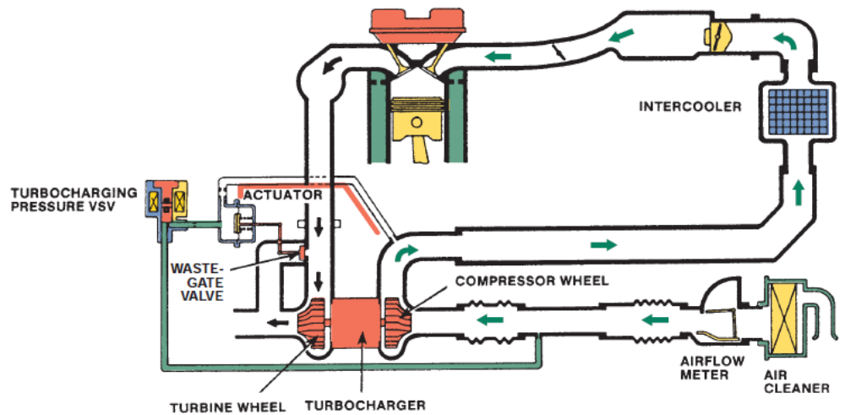
Based on Nov, 2022, Curriculum Version-I

Module Title: Maintaining Air induction, Exhaust and emission control system and their Components
Module code: EIS HEM2 M07 1122
Nominal duration: 70 Hour
Prepared by: Ministry of Labor and Skill
December, 2022
Addis Ababa, Ethiopia

Table of Contents

Acknowledgment 6
Acronym 7
Introduction to module 8
Unit one: Overview to air induction, exhaust and emission control systems and their components 9
1.1 Introduction to air induction system 10
1.1.1 Purpose of air induction system 10
1.1.2 Components and function of air induction system 11
1.1.3 Types of air induction engine system 14
1.1.4 Function and Construction Turbocharger 17
1.1.5 Types of Turbochargers 21
1.1.6 Working principle 24
1.1.7 Turbo Lubrication and Cooling 27
1.1.8 Function and types of superchargers 28
1.1.9 Type of supercharger 29
1.1.10 Supercharger + Turbocharger 37
1.2 Introduction to exhaust system 38
1.2.1 Purpose of exhaust system 38
1.2.2 Types of exhaust system 38
1.2.3 Components and function of Exhaust system components 40
1.2.4 Summary of exhaust system 50
1.3 Introduction to emission control system 51
1.3.1 Harmful Exhaust Emissions 51
1.3.2 Exhaust emission 52
1.3.3 Causes of Excessive Exhaust Emissions 55
1.3.4 Emission control device 56
1.4 OHS requirement 70
1.5 Tools, Equipment, workshop manual and Specification 71
1.5.1 Preparing Required Tools and Equipment 71
1.5.2 Sourcing Workshop Manuals 71
1.5.3 Analyzing Method Options Requirements 71
Self-check: 1 72
Unit Two: Servicing to air induction, exhaust and emission control systems 74
2.1 Servicing to air induction 75
2.1.1 Inspection to air induction 75
Operation sheet: 2.1 Pressure testing to turbocharger 79
2.1.2 Remove to air induction 81
2.1.3 Repair and replace to air induction 83
Operation sheet: 2.2 Replace the air filter 85
2.2 Servicing to exhaust system 87
2.2.1 Inspection to exhaust system 87
Operation sheet: 2.3 Examining the exhaust system 89
2.2.2 Remove to exhaust system 91
Operation sheet: 2.4 Exhaust Manifold Removal 92
2.2.3 Repair and replace to exhaust system 94
2.3 Service to emission control system 96
Operation sheet: 2.5 Analyzer Test Procedures the exhaust emission system 99
Operation sheet: 2.6 Emissions Testing Programs 100
LAP TEST 102
Unit Three: Prepare vehicles/Equipment/ for use or storage 103
3.1 Prepare to Schedule documentation 104
3.2 Performing Final Inspection 104
Operation sheet: 3.1 Prepare vehicles/Equipment/ for use or storage 105
Self-check 3 106
Reference 107

List of figures
Figure 1-1 A typical late-model air induction system 11
Figure 1-2 Dry type filter 12
Figure 1-3 Oil wet type air cleaner 12
Figure 1-5 A die-cast aluminum intake manifold 13
Figure 1-6 An IMT control valve 13
Figure 1-4 A plastic intake manifold for an inline five-cylinder engine 13
Figure 1-7 Naturally aspirated 14
Figure 1-8 Naturally aspirated 14
Figure 1-9 Forced induction 15
Figure 1-10 Turbocharger 17
Figure 1-11 Turbocharger construction 18
Figure 1-12 Compressor wheel (Cold side) 18
Figure 1-13 Turbine wheel (Hot side) 18
Figure 1-14 Center housing and rotating assembly (CHRA) 19
Figure 1-15 Seals 19
Figure 1-16Vacuum type waste gate valve 19
Figure 1-17 Electrical type waste gate valve 20
Figure 1-18 Intercooler 20
Figure 1-19 Single turbo 21
Figure 1-20 Twin-turbo 22
Figure 1-21 Twin-scroll turbo 22
Figure 1-22 Variable geometry turbocharger 23
Figure 1-23 Variable twin-scroll geometry turbocharger 23
Figure 1-24 Electric motor in a turbocharger 24
Figure 1-25 Working principle of turbocharger 24
Figure 1-26 Working principle of turbocharger 25
Figure 1-27 A schematic Working principle of turbocharger 25
Figure 1-28 Turbo Lubrication and Cooling 27
Figure 1-30 supercharger 28
Figure 1-31 Turbo Lubrication and Cooling 29
Figure 1-32 Main parts of centrifugal supercharger 30
Figure 1-33 Root type supercharger 31
Figure 1-34 Main parts of root supercharger 32
Figure 1-35 Working Principle of Roots Supercharger 33
Figure 1-36 Twin Screw Supercharger 34
Figure 1-37 Main parts of root supercharger 35
Figure 1-38 Working Of Twin Screw Supercharger 36
Figure 1-39 Single exit type 38
Figure 1-40 Dual exit exhaust 39
Figure 1-41 Opposite dual exhaust 39
Figure 1-42 Dual side exhaust 39
Figure 1-43 High performance exhaust 40
Figure 1-44 Exhaust manifold has two separate mini- or warm-up catalytic converters. 40
Figure 1-45 A tuned exhaust manifold, called a header 41
Figure 1-46 The front exhaust pipe assembly for a V6 engine 42
Figure 1-47 A catalytic converter 42
Figure 1-48 A catalytic converter 43
Figure 1-49 A muffler 43
Figure 1-50 sectional flow muffler 44
Figure 1-51 Resonator or silencer 44
Figure 1-52 Reflection-Pattern Silencers 45
Figure 1-53 Combined Interference and Reflection Silencer 45
Figure 1-54 Absorption-Pattern Silencers 46
Figure 1-55 Combined Absorption and Reflection Silencer 46
Figure 1-56 Silencers with Branch Resonators 47
Figure 1-57 Tailpipe 48
Figure 1-58 Heat shields 48
Figure 1-60 Hangers 49
Figure 1-59 Clamps 49
Figure 1-61 Brackets 49
Figure 1-62 Exhaust system 50
Figure 1-63 Exhaust emission gas 51
Figure 1-64 Quench zones 53
Figure 1-65 Oxygen starved combustion 54
Figure 1-66 High temperature combustion 54
Figure 1-67 Operation of PCV 56
Figure 1-68 PCV valve 57
Figure 1-69 Heated PCV 57
Figure 1-70 Electrically PCV 58
Figure 1-71 EGR control valve 58
Figure 1-72 EGR control valve 59
Figure 1-73 EGR Vacuum modulator assembly 60
Figure 1-74 Operation of EVAP 62
Figure 1-75 Components of EVAP 63
Figure 1-76 Operation of air injection 64
Figure 1-77 Belt-driven and electric pump 65
Figure 1-78 Components of thermostatic air cleaner 66
Figure 1-79 Catalytic converter 67
Figure 1-80 Operation of Catalytic converter 68
Figure1-81 Pellet-Type Converter 69
Figure 2-1 Heavy-duty single air cleaner 76
Figure2-2 Replace the air filter 86
Figure 2-3 Leaking gaskets and seals 94
Figure 2-4 Replacing Exhaust Pipes 95
Figure 2-5 Exhaust Gas Analyzer 97

Acknowledgment

Ministry of Labor and Skills wish to extend thanks and appreciation to the many representatives of TVT instructors and respective industry experts who donated their time and expertise to the development of this Teaching, Training and Learning Materials (TTLM).

Acronym

TTLM | Teaching, Training and Learning Materials
DTC | Data trouble code
LAP test” | Learning Activity Performance Test”
NA | Naturally aspirated
IC | Internal combustion
CHRA  OHS  HC  CO  NOx  VGT  TWC  FWD  EGR  EFI  PCV  VSV  TVS  PVS  EVAP  TVV  TAC  SST  IMRC  TSB  Co2 | Central housing rotating assembly  Occupation Health safety  Hydrocarbon  Carbon monoxide  Nitrogen oxide  Variable geometry turbo  Three-way converter  Front wheel drive  Exhaust gas recirculation  Electronic fuel injection  Positive crankcase ventilation  Vacuum switching valve  Thermal vacuum switch  Ported vacuum switch  Evaporative emission control  Themo vacuum valve  Thermostatic air cleaner  Special service tools  Intake manifold runner control  Technical service bulletins  Carbon dioxide

Introduction to module
This module covers the competence required to inspect, repair or replace engine turbocharger or supercharging forced induction systems, exhaust system and emission control system The unit includes identification and confirmation of work requirement, preparation for work, inspection of systems and analysis of results, repair and replacement of systems and components and completion of work finalization processes, including clean-up and documentation.
This module is designed to meet the industry requirement under the heavy duty and earth moving machinery level II occupational standard, particularly for the unit of competency: Maintaining Air induction, Exhaust and emission control system and their Components
This module covers the units:
- Overview to air induction exhaust and emission control systems and their components
- Remove, repair and replace faulty air induction exhaust and emission control systems and their components
- Prepare vehicle/ Equipment for use or storage
Learning Objective of the Module
- Understand air induction exhaust and emission control systems and their components
- Perform Remove, repair and replace faulty air induction exhaust and emission control systems and their components
- Prepare vehicle/ Equipment for use or storage
Module Instruction
For effectively use these modules trainees are expected to follow the following module instruction:
- Read the information written in each unit
- Accomplish the Self-checks at the end of each unit
- Perform Operation Sheets which were provided at the end of units
- Do the “LAP test” giver at the end of each unit and
- Read the identified reference book for Examples and exercise

This unit is developed to provide you the necessary information regarding the following content coverage and topics:
- Introduction to air induction, exhaust and emission control system
- OHS requirements
- Tools, equipment workshop manuals and specifications
This unit will also assist you to attain the learning outcomes stated in the cover page. Specifically, upon completion of this learning guide, you will be able to:
- Understand to air induction, exhaust and emission control system
- Perform OHS requirements
- Select tools, equipment workshop manuals and specifications

Unit one: Overview to air induction, exhaust and emission control systems and their components

1.1 Introduction to air induction system
An internal combustion engine needs air for combustion. It also needs to allow spent gases to leave the cylinder after combustion. The focus of this learning outcome is on the intake and exhaust systems. Both of these are often overlooked but are very important.
The reason air enters a cylinder is simply a basic law of physics high pressure always moves toward an area of low pressure. Therefore, outside air moves into the cylinders because of the vacuum formed on the intake stroke.
For the internal combustion engine that drives trucks, cars and motorcycles, the exhaust system carries waste gases away from the engine and through a system of manifolds and pipes. The exhaust system is an essential part of a vehicle engine and must be kept in good working order, otherwise engine performance and mileage will suffer.

1.1.1 Purpose of air induction system
The function of an air intake system is to supply the correct amount of air needed to increase the combustion and the efficiency of an engine. On a diesel engine, the air intake system cleans the intake air, silences the intake noise, furnishes air for supercharging, and supplies scavenged air in two-stroke engines.
The air induction system directs outside air to the engine’s cylinders. The induction system is comprised of ductwork that channels outside air to an air cleaner that removes dirt from the air, ductwork that connects the filter to the throttle body, and an intake manifold that distributes the air to the engine’s cylinders Within the induction system are sensors that measure intake air temperature and airflow. An inspection of the air induction system should be part of diagnosing a drivability problem. Make sure that the intake ductwork is properly installed and that all connections are air tight especially those between an airflow sensor or remote air cleaner and the throttle body.

1.1.2 Components and function of air induction system
The air induction system directs outside air to the engine’s cylinders. The induction system is comprised of ductwork that channels outside air to an air cleaner that removes dirt from the air, ductwork that connects the filter to the throttle body, and an intake manifold that distributes the air to the engine’s cylinders

Air filter
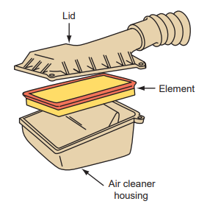
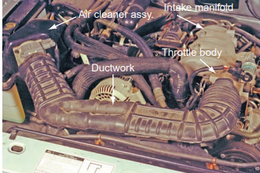
The primary purpose of the air filter is to prevent airborne contaminants and abrasives from entering the cylinders. These contaminants can cause serious damage and appreciably shorten engine life. Therefore, all intake air should pass through the filter before entering the engine. The air filter is inside a sealed air cleaner assembly. This assembly is also used to direct the airflow and reduce the noise caused by the movement of intake air (figure 1-1). The air cleaner also provides filtered air to the PCV system and provides engine compartment fire protection in the event of backfire. If the air filter becomes very dirty, the dirt can block the flow of air into the engine. Restricted airflow to the engine can cause poor fuel economy, poor performance, and high emissions

Figure 1-1 A typical late-model air induction system

- Types of Air Cleaner
The fuel system mixes air and fuel to produce a combustible mixture. A large volume of air passes through the carburetor or fuel injection system and engine. Air always contains a lot of floating dust and grit. The dust and grit could cause serious damage if they entered the engine. To prevent this, an air cleaner is mounted at the air entrance of the carburetor or fuel injection system. The two types of cleaners currently used are the wet and dry types.
- Dry type filters
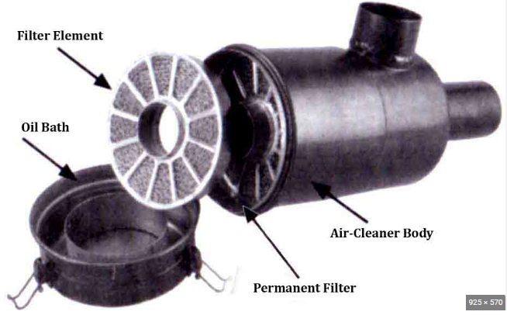
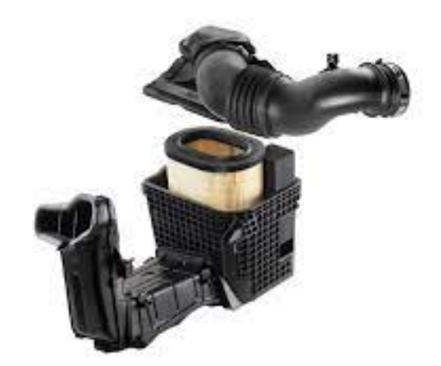
Dry type filters are non-metal media, non-oiled filters primarily used in applications requiring a slightly higher level of filtration than an all-metal filter, a less harsh environment, or for customers looking for a more economically priced option. Washable dry type filters have media made from various layers of nonwoven polyester or heavy polyester felt, and reinforced with metal wire support. Dry type filters have some overlapping applications with all-metal filters, again based on airflow requirements, the particulate needing to be filtered, and the environment the filter will be in
Figure 1-2 Dry type filter
- Oil wet type air cleaner
Oil wet type air cleaner consist of a clean element usually wire mesh covered by an oil layer. Air passes during this element and the dust particle of the air stick to the oil layer. This kind of air cleaner must be cleaned at times, on all 10,000Km, by wash the wire mesh in petrol or paraffin. once drying it correctly, coat it by engine oil, let it to use up and over fit it used for work.
Figure 1-3 Oil wet type air cleaner

Intake manifolds
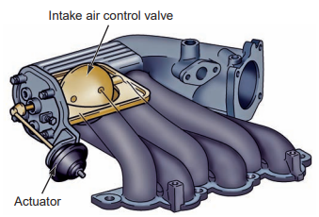
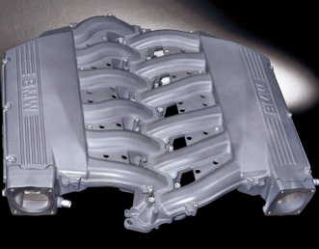
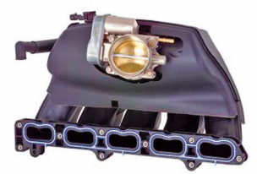
An intake manifold distributes the clean air or air-fuel ratio as evenly as possible to each cylinder of the engine. Older engines had cast-iron intake manifolds. The manifold delivered air and fuel to the cylinders and had short runners. These manifolds were either wet or dry. Wet manifolds had coolant passages cast directly in them. Dry manifolds did not have coolant passages but had exhaust passages through the manifold to heat the floor of the manifold. This helped to vaporize the fuel before it arrived in the cylinders. Other dry manifold designs used some sort of electric heater unit or grid to warm the bottom of the manifold. Heating the floor of the manifold stopped fuel from condensing in the plenum area. Good fuel vaporization and the prevention of condensation allowed for delivery of a more uniform air-fuel mixture to the individual cylinders. Intake manifolds also serve as the mounting point for many intake-related accessories (such as the fuel injectors, fuel rail, and throttle body) and sensors. Some include a provision for mounting the thermostat and thermostat housing. In addition, connections to the intake manifold provide a vacuum source for the exhaust gas recirculation (EGR) system, power brakes, and/or heater and air conditioning airflow control doors. Intake manifolds for today’s engines are typically made of die-cast aluminum or plastic. These materials are used to reduce weight. Because these intake manifolds only deliver air to the cylinders, fuel vaporization and condensation are not of any concern. The primary goal of their design is the capability to deliver equal amounts of air to each cylinder.
Figure 1-5 A die-cast aluminum intake manifold
Figure 1-6 An IMT control valve
Figure 1-4 A plastic intake manifold for an inline five-cylinder engine

1.1.3 Types of air induction engine system

Naturally aspirated
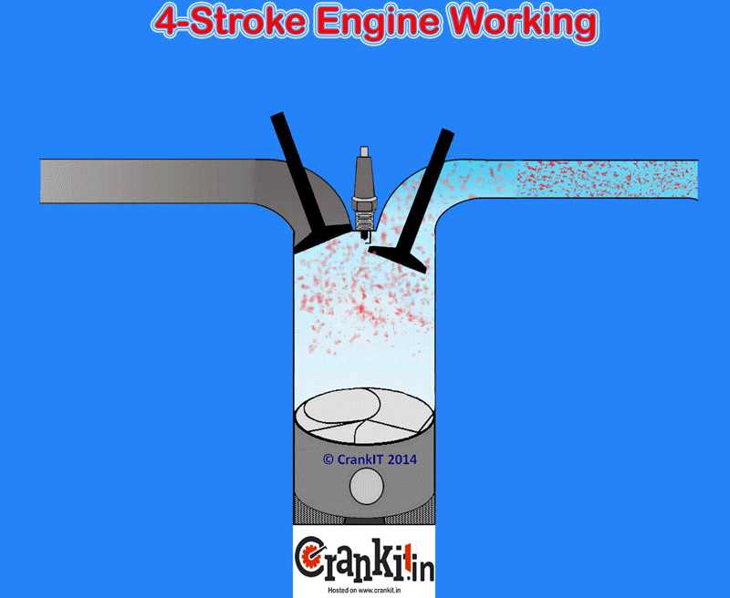
In natural aspiration, air intake occurs similarly to respiration in your lungs. It begins when you start your car and the pistons are drawn downward. This creates a partial vacuum. The surrounding air then rushes in to fill that vacuum at which point it can be used for combustion. An engine that is naturally aspirated uses the dynamic forces involved it’s in own operation to move air into its cylinders. Naturally aspirated engines are called such because they draw air into the engine cylinders through an air intake by creating a partial vacuum. The atmospheric pressure acts against this partial vacuum that occurs as the piston travels downward toward the bottom dead center during the intake stroke.
Figure 1-7 Naturally aspirated
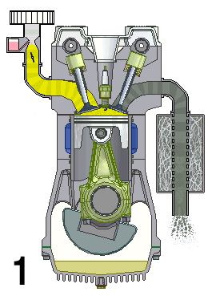
The term NA stands for the Naturally Aspirated engine. This term applies only to an internal combustion (IC) engine. In an IC engine, the intake of the air completely depends upon the atmospheric pressure. So, manufacturers term it as naturally aspirated or naturally breathing. When the engine inlet valves open, they fill the cylinder with a fresh air or air-fuel mixture charge. The engine cylinder sucks the charge (or just the air in case of diesel and gasoline direct injection engines) because of the atmospheric pressure and the vacuum created by the descending piston. It DOES NOT use an external mechanism to force the air into the cylinders. Hence, the manufacturers term this type of engine as naturally aspirated.
Figure 1-8 Naturally aspirated

- Advantages of NA air induction Engine:
- Less number of parts
- Low cost of manufacturing
- Simple and easy to produce
- Low cost of ownership
- Low cost of maintenance
- Great throttle response (No lag)
- Disadvantages of NA air induction Engine:
- Lower power-to-weight ratio
- Lower efficiency
- Incomplete combustion resulting in the higher emission

Forced induction
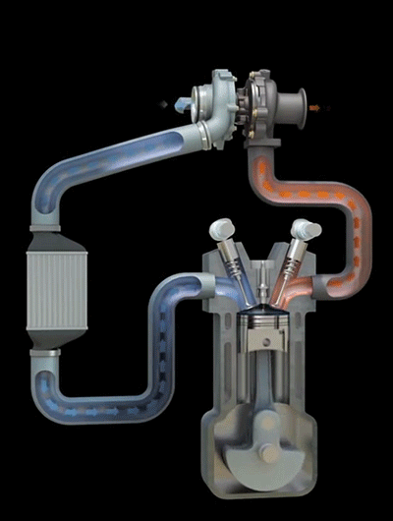
Forced induction is often used to increase the power output of an engine. This is achieved by compressing the intake air, to increase the mass of the air-fuel mixture present within the combustion chamber. Engines cannot produce the amount of power they are capable of at high speeds because they do not receive enough air. This is the reason why many “race cars” have hood scoops. Hood scoops deliver cool air under pressure to the intake manifold and provide an open source for the air. With today’s body styles, hood scoops are not particularly desired because they increase air drag. Therefore, other methods are used to increase the volume of intake air and compression.
Figure 1-9 Forced induction

Variable intake manifolds and valve timing certainly help with this. Keep in mind that the power generated by the internal combustion engine is directly related to the amount of air that is compressed in the cylinders. In other words, the greater the compression (within reason), the greater the output of the engine. Two approaches can be used to increase an engine’s effective compression. One is to modify the engine to increase its compression ratio. This can be done in many ways, including the use of domes or high-top pistons, altered crankshaft strokes, or changes in the shape and structure of the combustion chamber.
Another, less expensive way to increase compression (and engine power) without physically changing the shape of the combustion chamber is to simply increase the intake charge. By pressurizing the intake mixture before it enters the cylinder, more air and fuel molecules can be packed into the combustion chamber.
- The two ways to artificially increase the amount of airflow into the engine are known as turbo charging and supercharging. Both of these systems force more air into the intake manifold by compressing the air before it reaches the manifold.
- Turbo charging uses exhaust gases, the heat of which is normally wasted
- supercharging relies on the rotation of the engine to compress the air.
The biggest disadvantage of using either system is related to the compression of air. When air is compressed, its heat increases. High-temperature air is less dense, meaning there is less air or oxygen in the air. Most turbocharged or supercharged systems use an intercooler to increase the density of the air

1.1.4 Function and Construction Turbocharger
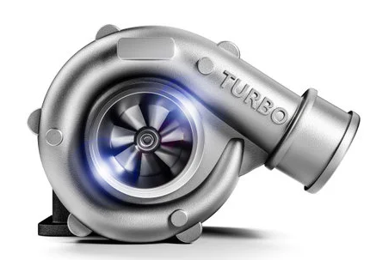
A turbocharger is a turbine driven, force induction device that increases the efficiency and power output of internal combustion engines by forcing extra compressed air into the combustion chamber. This hot air induction seems to work because the compressor can force more air and proportionately more fuel into the combustion chamber than normal atmospheric pressure.
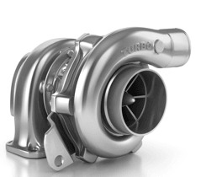
Turbochargers are used to increase engine power by compressing intake air before it enters the engine. Turbochargers are air pumps driven by the engine’s exhaust stream. The heat and pressure of the exhaust gases spin the turbine blades (hence the name turbocharger) of the pump. The turbine wheel is connected to a compressor wheel. As the turbine spins, so does the compressor wheel. The compressor wheel spins at very high speeds and compresses the intake air.
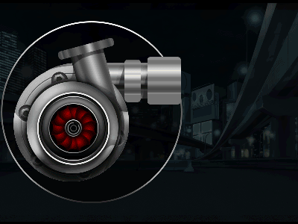
The compressed air is then sent to the cylinders. Because exhaust gas is a waste product, the energy developed by the turbine is said to be free because it theoretically does not use any of the engine’s power it helps to produce. Turbochargers are used on both diesel and gasoline engines. The main advantage of their use is that they allow for an increase of power without a substantial decrease in fuel economy. This is because they boost the engine’s power output only when extra power is needed. A small engine, in most cases, can be used to provide low fuel consumption and emissions levels. When increased power is needed, the turbocharger is activated.
Figure 1-10 Turbocharger

Construction
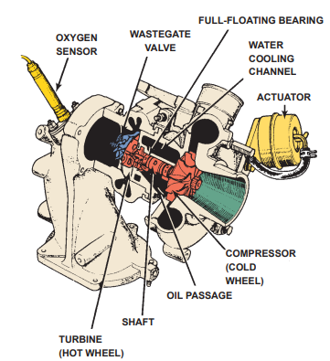
A turbocharger is normally located close to the exhaust manifold. An exhaust pipe runs between the exhaust manifold and the turbine housing to carry the exhaust flow to the turbine wheel. Another pipe connects the compressor housing intake to the throttle plate assembly or intake manifold.
A typical turbocharger, usually called a turbo, has the following components
- Turbine or hot wheel Compressor or cold wheel
- Center housing and rotating assembly (CHRA)
- Seals
- Westgate Valve
- Intercooler

  - Turbine (Hot wheel) and Compressor wheel (Cold wheel)
Figure 1-11 Turbocharger construction
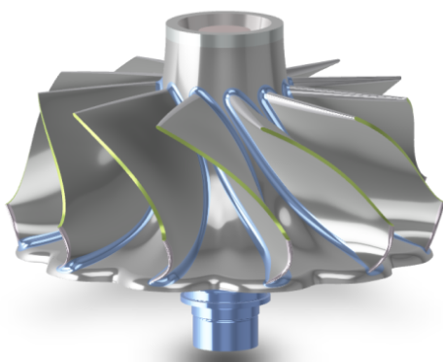
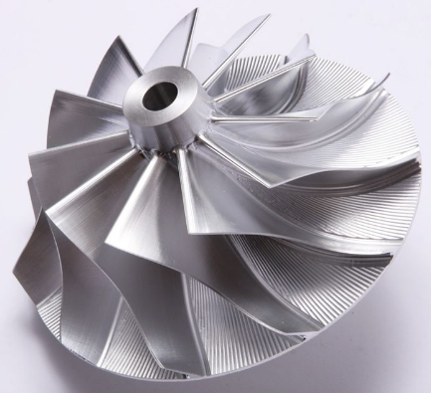
The turbine wheel and the compressor wheel are mounted on the same shaft. When the engine is running, the exhaust gases flow from the exhaust manifold to the turbine wheel. They strike the blades of the turbine, spinning it up to 100,000 rpm or higher. Since the compressor is on the same shaft, it also spins at high speed. As the compressor spins, it forces the intake air into the engine cylinders. Since the turbine wheel is exposed directly to the exhaust gases, it becomes extremely hot and since it rotates at high speeds and must be heat resistant and durable, it is made of an ultra-heat resistant alloy
Figure 1-12 Compressor wheel (Cold side)

Figure 1-13 Turbine wheel (Hot side)

  - Center housing and rotating assembly (CHRA)
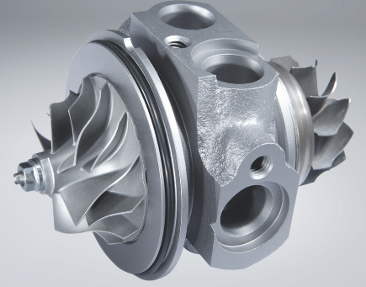
The center housing supports the turbine and compressor wheels via the shaft. Inside the housing, engine oil is circulated through channels that are provided for this purpose. Also, engine coolant is circulated through coolant channels that are built into the housing.
Figure 1-14 Center housing and rotating assembly (CHRA)

  - Seals
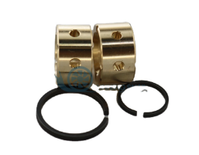
Seals are located at both ends of the bearing housing. These seals represent a difficult design problem due to the need to keep frictional losses low, the relatively large movements of the shaft due to bearing clearance and adverse pressure gradients under some conditions.
Figure 1-15 Seals
  - Westgate Valve
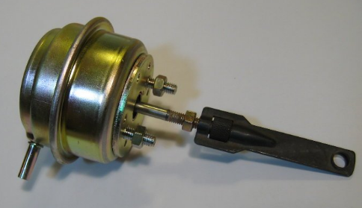
The waste gate valve is built into the turbine housing. Its purpose is to reduce the boost pressure when this begins to rise too high. When this valve opens, part of the exhaust gas bypasses the turbine wheel and flow to the exhaust pipe. If the pressure of the air from a turbocharger becomes too high, knocking occurs, engine output decreases, and the pressure created by the combustion of the air fuel mixture can become so great that the engine may self-destruct. To prevent this, turbochargers have a waste gate valve. The waste gate valve is part of the turbine housing. It allows a certain amount of exhaust gas to bypass the turbine when the boost pressure exceeds a certain value.
Figure 1-16Vacuum type waste gate valve
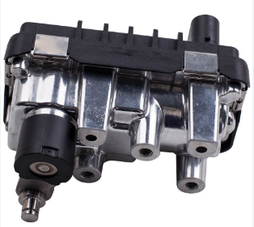
The action of the waste gate can be controlled directly by manifold pressure or by the PCM according to manifold pressure. Most late-model systems have PCM-controlled waste gates. In non-PCM systems, an actuator that senses the air pressure in the induction system opens the waste gate when the pressure becomes too high. This action decreases the amount of exhaust that reaches the turbine. This, in turn, reduces turbine and compressor wheel speed and decreases the output pressure from the turbocharger.
Figure 1-17 Electrical type waste gate valve
- When the pressure in the intake manifold is not great enough to override the spring in the actuator, the waste gate is closed and all of the exhaust flows past the turbine; therefore, the turbine spins accordingly.
- When the boost pressure overcomes the tension of the actuator’s spring, the actuator opens the wastegate valve and some exhaust gas is diverted around the turbine wheel. As a result, turbine speed is controlled, as is boost pressure.
  - Intercooler
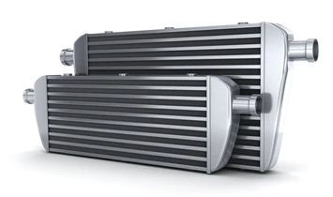
The intercooler cools the turbocharged or supercharged air before it reaches the combustion chamber. When intake air is compressed, its temperature increases greatly. As a result, air density is reduced and the cylinders receive less fresh air than what could be from the boosted intake air. Also, the increased temperature of the air increases the chances of engine knock. To offset these consequences, many turbocharger and supercharger systems are fitted with an intercooler or charge air cooler. The removal of heat from the pressurized air going into the intercooler increases the density of the air, which improves efficiency, engine horsepower, and torque. Intercoolers are really radiators for the intake air.
Figure 1-18 Intercooler

The heat from the compressed air that passes though it is removed and dissipated to the atmosphere. An intercooler system typically consists of an added radiator in the grille area or above the engine, a coolant reservoir (separate from the reservoir of the engine’s cooling system), a pump, and hoses and tubes to connect the components. An intercooler is always located after the turbocharger or supercharger and before the intake manifold. As the heated air flows through the intercooler, heat is transferred to the coolant circulating through the intercooler. The coolant is cooled by the air passing through the intercooler.

1.1.5 Types of Turbochargers
Below are the various types of turbochargers that exist:
  - Single turbo
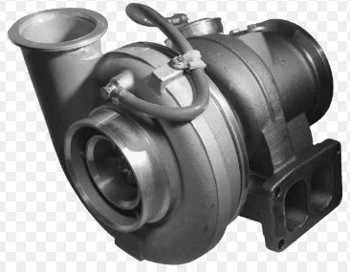
The single turbo is the simplest, most common and cheapest type of turbocharger that exist. It has limitless variability and being a smaller turbo, it provides better low-end grunt as they spool faster. The single turbo has a ball bearing and journal bearing which provide less friction for the compressor and turbine to spin on. The benefits of the single turbochargers are that smaller engines are also allowed to feature a turbo, cost-effectiveness is also considered, simplicity and easier to install. It also increases engine efficiency. Some limitations still occur despite its advantages which includes; having a fair narrow effective rpm range. Single turbos make sizing an issue since one has to choose between better high-end power or good low-end torque. Finally, the response may be slow compare to other turbo types.
Figure 1-19 Single turbo

  - Twin Turbos
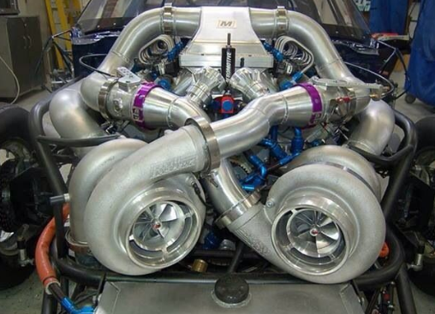
The twin-turbo is another option that allows single turbocharger for each cylinder bank (v8, v12 etc.). Alternatively, a single turbocharger could be used for low rpm and bypass to a larger turbocharger for high rpm. Two similar-sized turbos where one is used at low rpm and both are used at higher rpm (14, 16). BMW x5 M and x6 M uses twin-scroll turbos, one on each side of the v8. The benefit of twin-turbo when it’s sequential or on the turbo at low rpm and both at high rpm. It allows wider, flatter torque curve, better low-end torque, but the power won’t taper at high rpm like a single turbo. Limitations with these turbochargers include cost and complexity,
Figure 1-20 Twin-turbo
  - Twin-Scroll Turbo
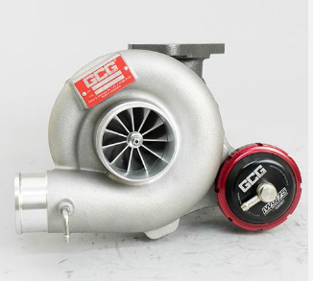
In almost every way, twin-scroll turbochargers are better than single-scroll turbos because while using two scrolls, the exhaust pulses are divided. For instance, in four-cylinder engines having firing order of 1 3 4 2, cylinders 1 and 4 may be feed to one scroll of a turbo. Whereas cylinders 2 and 3 are feed to separate scroll. The purpose of these types of a turbocharger is that there is overlap in the cylinder. Let say cylinder is ending its power stroke as the piston reaches the bottom dead center, and exhaust valve will open. During this time, cylinder two ends its exhaust stroke by closing the valve and opening the intake valve.
Figure 1-21 Twin-scroll turbo

D. Variable Geometry Turbocharger (VGT)
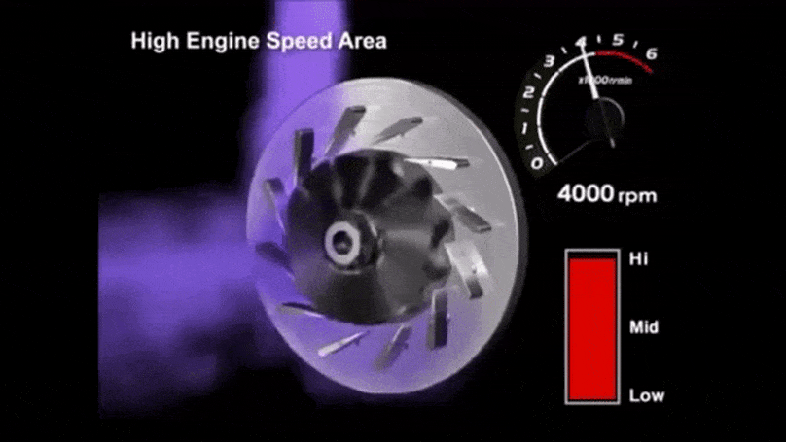
The variable geometry types of a turbocharger are common on diesel engines and they are limited in production. This is because of its cost and exotic material requirements. Internal vanes within the turbocharger alter the area-to-radius A/R ratio to correspond with the rpm. That is, at a low rpm, a low A/R ratio is used to increase exhaust gas velocity and quickly spool up the turbocharger. If the revs climb, the A/R ratio increases in order to increase the airflow which result in low turbo lag. It also leads to low boost threshold and a wide and smooth torque band. The benefits of this type of turbo are that wide, flat torque curve is produced. Which is effective at a very wide rpm range. It requires a single turbo, simplifying a sequential turbo setup into something more compact. Its limitations are that it is only used in diesel applications where exhaust gases are lower so the vanes will not be destroyed by the head. Using the turbo on a gasoline engine, high-cost exotic metals will be used in order to maintain reliability.
Figure 1-22 Variable geometry turbocharger
E. Variable Twin-Scroll Turbocharger:
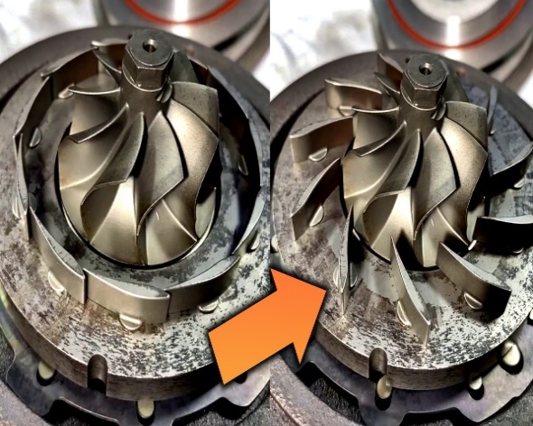
The variable twin-scroll turbo is significantly cheaper than VGTs, making it a preferable choice for gasoline turbocharging. It combines a VGT with a twin-scroll setup, thus, at a low revolution, one of the scrolls is completely closed forcing all the air into the other. As the engine speed up, a valve opens to allow air into the other scroll and good high-end performance is obtained. Advantages of the turbocharger are that it allows a wide, flat torque curve and it’s more robust in design than the VGT. Cost and complexity are also its limitations and technology have been unwanted before.
Figure 1-23 Variable twin-scroll geometry turbocharger
  - Electric Turbochargers:
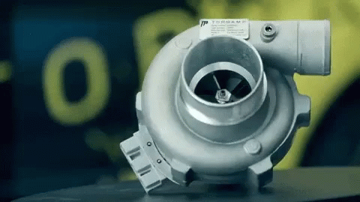
With the application of electric motor in a turbocharger, it enhances its features and provides an instant boost to the engine. Low-end torque is easily produced, lag is eliminated. This turbocharger is just the best of all, perhaps a new version might bring it down. its benefits are that wider effective rpm range with even torque throughout is produced. Wasted energy is recovered as an electric motor is connected directly to the exhaust turbine. And as mentioned earlier turbo lag and insufficient exhaust gases can be virtually eliminated by rotating the compressor with electric power when needed. Complexity and cost are one of the disadvantages of the turbocharger as account for the electric motor is now included. Packaging and weight are also an issue, especially with the addition off a battery onboard, which supply sufficient power to the turbo when needed. Similar benefits can be obtained from other types like the VGTs or twin-scrolls.
Figure 1-24 Electric motor in a turbocharger

1.1.6 Working principle
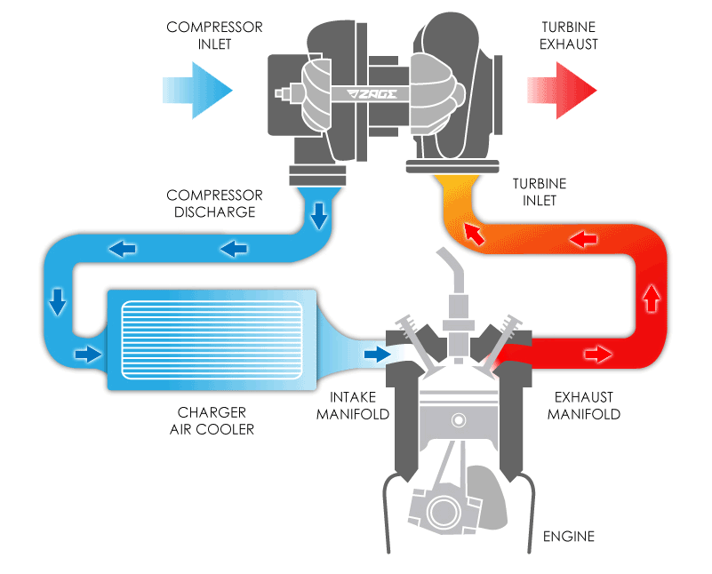
Turbocharger is a device that is used to increase the power of the engine or one can say the efficiency of an engine by increasing the amount of air entering into the combustion chamber. More air into the combustion chamber means more amount of fuel will be admitted into the cylinder and as a result, one will get more power from the same engine if the turbocharger is installed in it. Inside the turbocharger, the turbine wheel (hot wheel) and the compressor wheel (cold wheel) are mounted on the same shaft. The CHRA houses the shaft, shaft bearings, turbine seal assembly, and compressor seal assembly. Each wheel is encased in its own spiral-shaped enclosure in the housing that serves to control and direct the flow of exhaust and intake air. Because the turbine wheel is in the exhaust path, it gets very hot. It also spins at very high speeds; therefore, it is normally made of a heat-resistant cast iron. A turbocharger is equipped with a waste gate valve to control the pressure of the air delivered to the cylinders.
Figure 1-25 Working principle of turbocharger
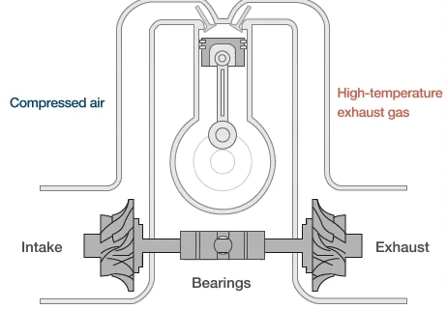
The turbocharger typically begins to compress the intake air when the engine’s speed is above 2,000 rpm. The force of the exhaust flow is directed against the side of the turbine wheel. As the hot gases hit the turbine wheel, causing it to spin, the specially curved turbine fins direct the exhaust gases toward the center of the housing where they exit. This action creates a flow called a vortex. Once the turbine starts to spin, the compressor wheel (shaped like a turbine wheel in reverse) also starts to spin. Intake air is drawn into the housing and is caught by the whirling blades of the compressor and thrown outward by centrifugal force. From there the air exits under pressure to the intake manifold and the individual cylinders. Air is typically drawn into the cylinders by the difference in pressure between the atmosphere and engine vacuum. A turbocharger, however, is capable of pressurizing the intake charge above normal atmospheric pressure.
Figure 1-26 Working principle of turbocharger
Turbo boost is the term used to describe the positive pressure increase created by a turbocharger.
Figure 1-27 A schematic Working principle of turbocharger

- Advantages and Disadvantages of Turbochargers
- Advantages:
Below are the benefits of turbochargers:
- Extra power is offered to the engine.
- Free power is given to the engine using waste exhaust gases. it does not require any engine’s power to drive it.
- It’s used in both diesel and gasoline engines.
- Improve fuel efficiency of engines
- Disadvantages:
- One of the big issues with a turbocharger is known as turbo lag. This happened when the throttle is press down, it takes time for the engine to speed up. That’s, turbochargers take time to reflect the engine speed. When the engine’s speed is low, there are not enough exhaust gasses to spin the compressor to offer the power needed. The required exhaust will be created after the throttle is pressed. This effect is reduced by downshifting to a lower gear but expert drivers sometimes notice the split delay in response.
- The second limitation of turbochargers does not occur in everyday driving conditions. It happens only when the engine is pushed to its limits. The heat produced from the exhaust gasses, it gets very hot and causes the turbocharger to start glowing red.
- Turbo Lag Increases in horsepower are normally evidenced by an engine’s response to a quick opening of the throttle. The lack of immediate throttle response is felt with some turbocharged engines. This delay or turbo lag occurs because exhaust gas requires a little time to build enough energy to spin the wheels fast enough to respond to the engine’s speed. This causes the power from the engine to temporarily lag behind what is needed for the conditions.

1.1.7 Turbo Lubrication and Cooling
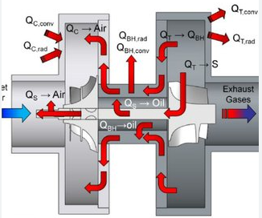
Keeping a turbocharger cool and well lubricated is essential to the unit’s durability. The turbine wheel faces very high temperatures. The temperature of the exhaust from a gasoline engine can surpass 1,800°F (982°C). The exhaust from a diesel engine is cooler and ranges from 1,400° to 1,500°F (768° to 816°C). This heat can destroy the turbocharger if it is not controlled.
Figure 1-28 Turbo Lubrication and Cooling
The turbine and compressor wheels rotate at very high speeds (up to 100,000 rpm). Their shaft is mounted on full-floating bearings designed to keep the shaft secure while it is rotating. The bearings are lubricated by engine oil and rotate freely on the shaft and in the housing. Engine oil is delivered to the turbocharger through an oil inlet pipe and then circulated to the bearings. The bearings have outer seals to prevent oil leakage. The oil passes over the bearings and returns to the engine’s oil pan through an oil outlet pipe. The circulation of the oil cools the turbocharger.
A turbocharger may be cooled by engine coolant that circulates through coolant channels built into the housing. Coolant is sent from the engine’s thermostat housing through a coolant inlet pipe to the turbo housing. After the coolant has circulated through the housing, it is returned to the water pump through the coolant outlet pipe.

1.1.8 Function and types of superchargers
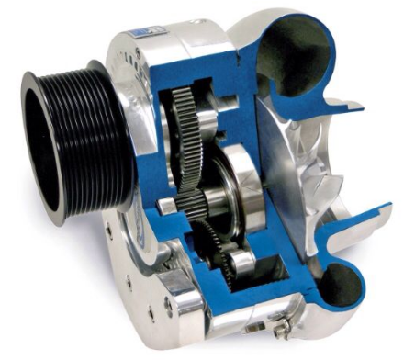
A supercharger is a mechanical driven component which is used in piston engines to pump pressurized air into the intake manifold using air compressor or blower. The high pressure increases the level of air enters the cylinder during the intake stroke. Superchargers let the engine burn more fuel and do more work as each intake circle of the engine gets more oxygen. These power components are mechanically driven by the means of a gear, belt, shaft, or chain connected to the engine’s crankshaft.
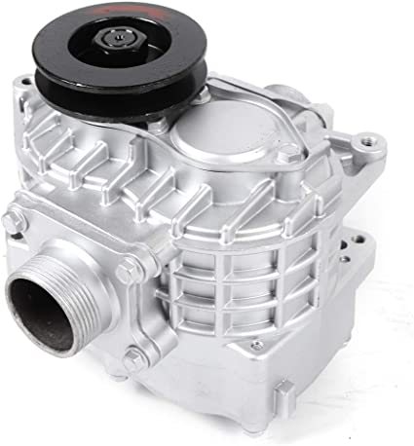
Supercharger are positive displacement air pumps driven directly by the engine’s crankshaft via a V-ribbed belt. They improve horsepower and torque by increasing air pressure and density in the intake manifold. The pressure boost is proportional to engine speed. A typical supercharger is normally made up of a magnetic clutch, two rotors, two shafts, two rotor gears, housing, and a rear plate and cover. Some superchargers have four rotor assemblies. The drive belt connects the engine to the magnetic clutch connected to one rotor shaft. Gears connect the two aluminum rotor shafts and drive them in opposite directions. The rotors have three helical lobes. The rotors are press-fit onto the rotor shafts and then held in position by pins and serrations. The rotors turn within a sealed housing and pressurize the air as they rotate. The rotors’ shafts are supported by ball or needle bearings in the rear plate and are lubricated by oil in the supercharger unit.
Figure 1-30 supercharger

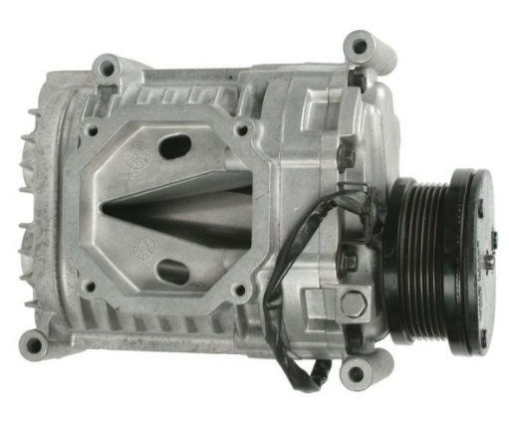
The magnetic clutch allows the PCM to engage and disengage the drive power to the supercharger.
The PCM also can control the amount of fuel injected and the ignition timing during boost. When the clutch is energized, the engine drives the supercharger. The PCM de-energizes the clutch when the engine is running under a light load. The clutch is comprised of a stator, pulley, pressure plate, and hub. The clutch pulley rotates with the drive belt and drives the stator. When the stator is energized, the pressure plate is pressed against the clutch pulley, locking them together. The clutch hub is splined to the rotor’s shaft and the rotors rotate as a unit. To reduce the shock caused by the quick engagement of the clutch, most clutch assemblies have a rubber damper between the boss of the clutch hub and the pressure plate. Normally, there is a 0.02 in. (0.5 mm) clearance between the clutch hub and clutch pulley. If this clearance increases because of wear, noise will result. The clearance can be corrected by changing the thickness of the adjusting shim. To handle the higher operating temperatures imposed by supercharging, the engine is typically fitted with an engine oil cooler. This water-to-oil cooler is generally mounted between the engine front cover and oil filter.
Figure 1-31 supercharger

1.1.9 Type of supercharger
  - Centrifugal superchargers
Centrifugal superchargers is a specialized type of supercharger that uses natural centrifugal energy to force additional oxygen into an engine. Increased airflow into the engine allows the engine to burn more fuel which results in increased engine power output. At its most basic, a centrifugal supercharger is driven off the engine’s crankshaft and feeds compressed air into the engine. The centrifugal supercharger is generally attached to the front of the engine with a rigid bracket and driven via a belt-drive or gear-drive from the engine’s crankshaft.
The centrifugal supercharger contains an impeller which spins at high speed to draw air into a small compressor housing (volute). When air leaves the impeller, it is traveling at high speed while having a low pressure. This low-pressure, high-speed air is sent through a diffuser which converts the airflow so that it is high-pressure, and low-speed. The air is then fed into the engine, where the additional airflow (caused by increased pressure) gives the engine the ability to burn more fuel and have a higher level of combustion. This results in a faster, more responsive vehicle due to greater engine efficiency.
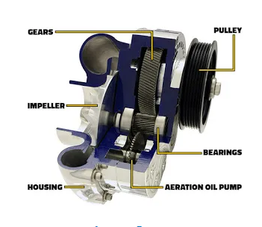
- Main Parts
- Impeller: It is a rotating wheel which must be spin at high rpm.
- Diffuser: It is a stationary wheel having the larger vane compare to an impeller. The impeller sucks the air at high-speed and less pressure. A diffuser converts it to low speed and high-pressure air. This air goes throughout the housing outlet.
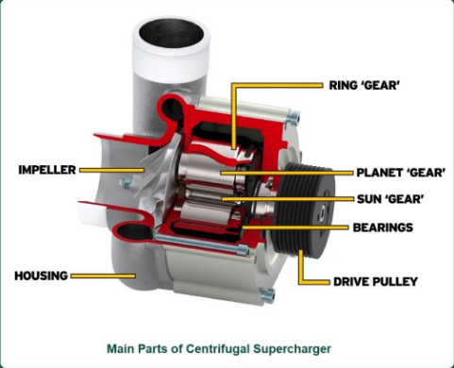
- Driven Pulley: Drive pulley is getting the rotational moment from engine crankshaft which has connected via belt or chain with drive pulley of an engine.
- Aeration Pump: Aeration pump placed at below the transmission. It provides self-contained oiling with good bearing lubrication.
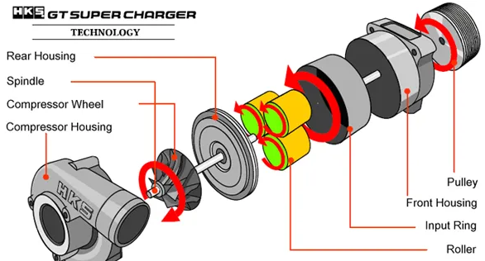
- Housing: The outer body of the device is called housing. It is made up of aluminum and material has high in strength, weigh less, also corrosion resistance.
- Gears: Gearing section is large in the centrifugal supercharger. The sun gear is smaller which is surrounded by the mid-size three gears are closed with a ring gear.

Figure 1-32 Main parts of centrifugal supercharger

Working of Centrifugal Supercharger
- As the engine starts, the supercharger connected to the crankshaft through the belt also starts rotating.
- the impeller of the centrifugal supercharger starts rotating and sucks the high speed and low-pressure air from the atmosphere axially. It compresses the air, reduces the speed of the air and gives high density air at its outlet. The pressure increases and velocity decreases as the air moves from impeller blades to the diffuser blade and then finally from the casing.
- The high density and high pressure compressed air is passed to the inlet manifold of the engine.
- This high dense air burnt the fuel in the engine cylinder more efficiently and increases the power of the internal combustion engine to a greater extent.
- The impeller rotates at a speed of up to 100,000 rpm.
  - Root type supercharger
Roots type supercharger is the oldest type of supercharger and still has its place in the automotive world on dragsters, smaller engines, and trucks all of which are need power in the bottom half of the rpm range. roots type supercharger is two counter-rotating meshed lobed rotors. The two rotors trap air in the gaps between rotors and push it against the compressor housing as they rotate towards the outlet/discharge port. During each rotation, a specific fixed amount of air is trapped and moved to the outlet port where it is compressed, which is why the roots type supercharger falls under the broader category of fixed-displacement superchargers
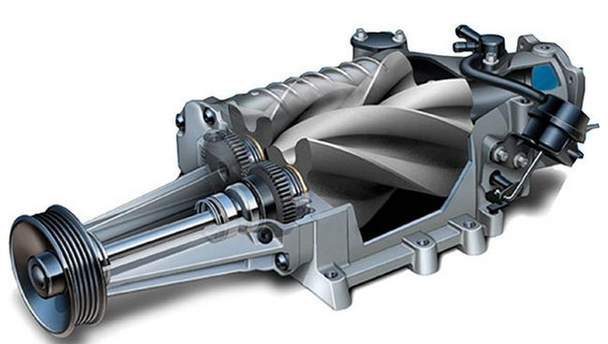
Figure 1-33 Root type supercharger

- Main part
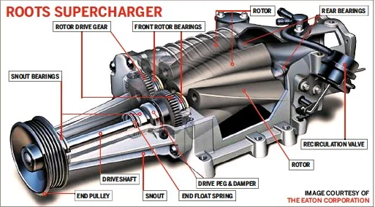
- Drive pulley: From the drive pulley, this device gets the rotational power from engine belt. As pulley rotate two rotors and lobes can try to move in a different direction as per mechanism
- Lobes: The most important part of the root supercharger is the lobe also known as an impeller.
- Bearings: Which supports the lobes and anti-friction type; it may be ball or roller.
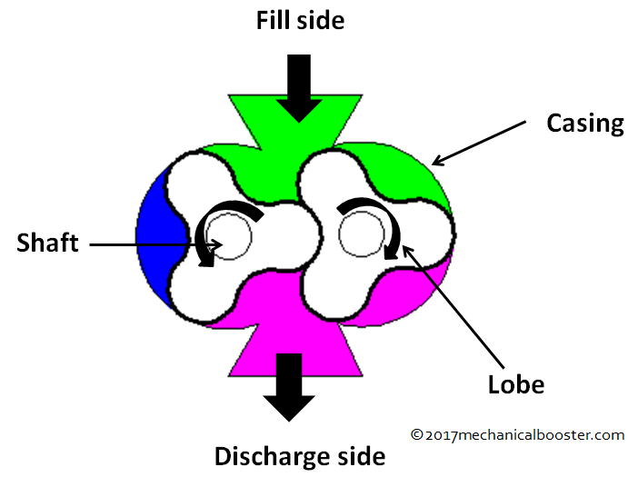
- Gears: It has helical types of gears. And it must be of high quality with good tolerance to maintain clearance between two lobes of the rotor.
- Shafts: Both shafts support the lobes. It has restricted design and diameter in order to support the rotor and lobe.
- Casing: The casing is outer body of root supercharger, it looks like the box, in that all parts lobes, rotors, inlet and discharge ports are fixed and casing made up of cast grey iron
Figure 1-34 Main parts of root supercharger

Working Principle of Roots Supercharger
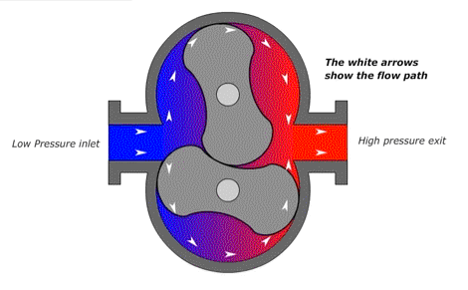
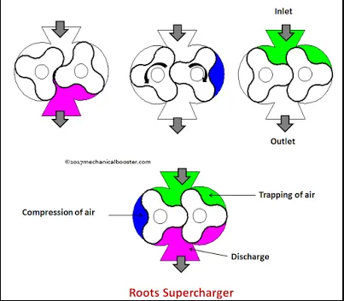
It can be powered mechanically by engine belt. The roots supercharger is a positive displacement supercharger, works on a very simple principle. As the drive shaft is rotated by engine belt, the lobes turn in opposite directions with very tiny clearances between each other and between the rotors and the casing. As each lobe passes air at the inlet fill side, a measured quantity of air is trapped between the lobes and the casing. As the shafts continue to rotate, this amount of air is transported around the casing to the discharge port side and created high-pressure air directly send to inlet manifold through the intercooler and then cylinder of an engine. With this more quantity of air is used to burn more fuel and produce more power and torque in result.

Figure 1-35 Working Principle of Roots Supercharger

  - Twin Screw Supercharger
The twin-screw supercharger makes use of two rotors of different shapes which mesh the air between the rotors. Hence, the air is actually compressed within the supercharger itself. Then, the air goes through the intercooler and pushed into the cylinder. Also works same as other superchargers and driven from the engine’s crankshaft via a belt or gear drive. Twin screw name has given because, it uses a pair of spiral rotors which is identical and both are in the shape of screw. It comes under the positive displacement device and more efficient than the roots type. It is used for increasing air quantity in the engine cylinder for more combustion which actually leads to more horsepower and torque from the engine. Air suction and compression process is done in a very unique way whereas in other devices, just air gets sucked at the inlet side and pushed at the discharge side. It looks similar to roots supercharger
The difference from the root’s supercharger is that the air is compressed with the supercharger. The by-pass valve is extremely important in the twin-screw superchargers because there is constant compression of air taking place at all times. This is not required while normal cruising or city driving conditions and therefore is inefficient. Like the roots superchargers, the main issue with the twin-screw supercharger is also packaging and location. They must be mounted on top of the engines directly to be effective and driven by the pulley which is connected to the crankshaft of the vehicle.
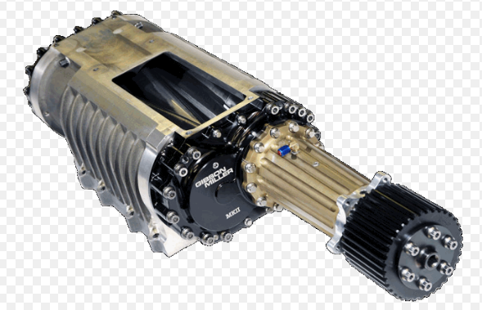
Figure 1-36 Twin Screw Supercharger

- Main parts
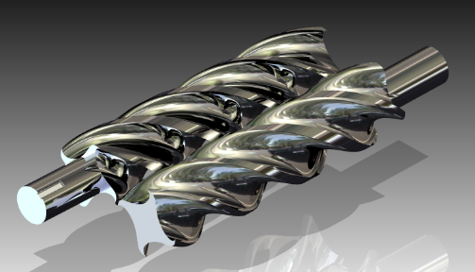
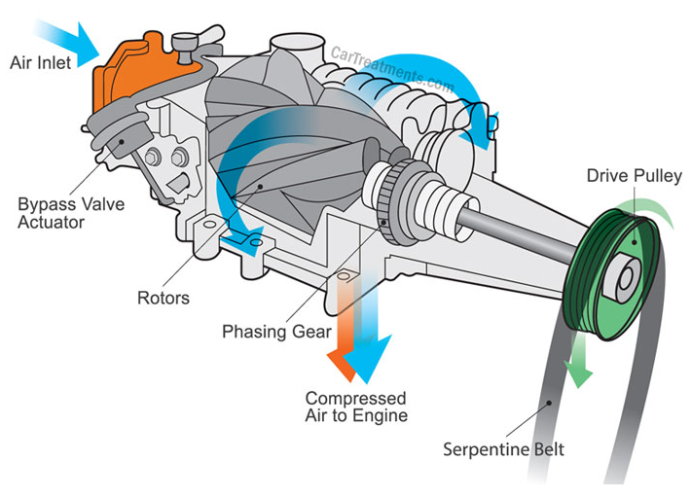
- Bypass Actuator: This is can controls the bypass valve opening and closing action for intake manifold to provide required boost level. It is control by ECU and it has boost control shaft and boost control solenoid. At low speed no boost is required, at that time by pass valve stay opened and there is no pressure in intake manifold. But when high speed high boost is required, the by-pass valve get closed, which causes the increase of pressure in the intake manifold
- Front Cover: Front portion where input shaft is placed Inside of it and driven pulley fixed at outside. It is in conical shape
- Drive Pulley: From drive pulley, this device gets the rotational power from engine belt. As pulley rotate two rotors can try to move in different direction as per mechanism.
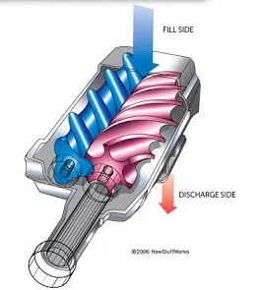
- Bearings: Anti-friction ball bearings actually support the backside of both rollers which absorbs the drive loads.
- Time Gears: It has the helical gears and must be of high quality with good tolerance to maintain the gap between the rotors.
- Rotors: Rotors are spiral in shape and designed in such a way that they never touch each other or housing. Each rotor will get rotational motion in opposite direction.
Figure 1-37 Main parts of root supercharger

Working of Twin Screw Supercharger
- This device starts its function from driving pulley and power transmitted to input shaft that makes the rotors to move in the opposite direction. One of its rotors has taper teeth section and second rotor has warm gear teeth section.
- When both side of rotor pocket meshes together, air gets squeezed between them. When air get start to compress by both side of rotor’s pockets the air flow in auxiliary motion at inlet and transported horizontally all the way to discharge side in radial motion.
- From the discharge side, the compressed air goes to intercooler, here it decreases the high temperature to a desired low temperature and pressurized air goes into the inlet manifold of the engine. At less temperature of the air the density of air will be greater so, more air molecules mean more oxygen to burn more fuel to achieve more power and torque from the engine.
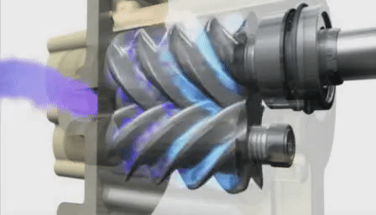
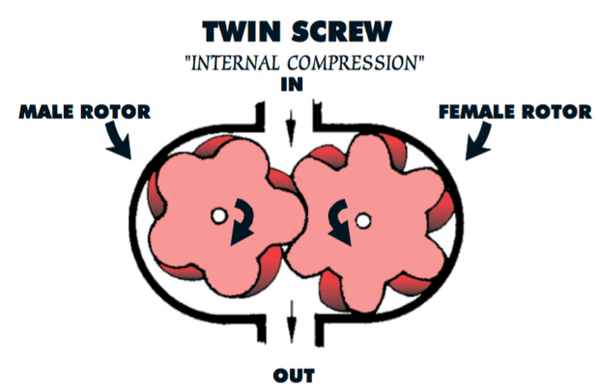

Figure 1-38 Working of Twin Screw Supercharger

1.1.10 Supercharger + Turbocharger
A few European vehicles are equipped with a gasoline engine that has a supercharger and a turbocharger. These systems are called “twin charger” systems. The supercharger is used to boost power at low speeds and the turbocharger boosts power at high speeds. These engines have direct injection and can provide as much power as larger engines with low fuel consumption and emissions. The supercharger is belt driven and spins at five times the speed of the crankshaft. A magnetic clutch engages the supercharger when it is needed. The supercharger is connected in series with the turbocharger. A control flap facilitates intake air to both the turbocharger and supercharger. The maximum boost of the twin charger system is about 36 psi (2.5 bar) at 1,500 rpm. This provides for an increase in torque at low speeds and a substantial increase in horsepower at high speeds. This also results in a decrease in fuel consumption and emissions. The supercharger provides boost from just over 2,400 rpm and then the turbo kicks in and provides all of the boost. With this system there is no turbo lag

1.2 Introduction to exhaust system
The exhaust system collects the exhaust gases from the cylinders, removes harmful substances, reduces the level of noise and discharges the purified exhaust gases at a suitable point of the vehicle away from its occupants. The exhaust system can consist of one or two channels depending on the engine. The flow resistance must be selected so that the exhaust backpressure affects engine performance as little as possible. To ensure that the exhaust system functions perfectly, it must be viewed as a whole and developed accordingly. This means that its components must be coordinated by the design engineers in line with the specific vehicle and engine.

1.2.1 Purpose of exhaust system
When the combustion ends in each cylinder, the exhaust gas must be collected, cleaned, quieted, and then discharged into the air. This is the job of the exhaust system. It performs these tasks while carrying the exhaust gases from the cylinders to the atmosphere. This system includes the exhaust manifold, exhaust pipe, catalytic converter, muffler or silencer, resonator (on some cars), and tail pipe. The exhaust system has also flexible mountings that allow for engine movement and also prevent exhaust vibration from being transmitted to the body. They also allow thermal expansion of the system

1.2.2 Types of exhaust system
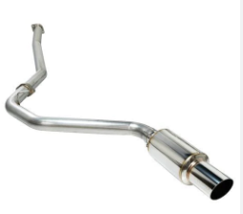
  - Single exit type
The most common type of exhaust systems is the single exit type. You’ll usually find them on cars and trucks you buy from the dealer. They aren’t the most efficient pipes, but they are the cheapest to manufacture and install. The pipe’s exit will always be on the car’s passenger side.

Figure 1-39 Single exit type

Dual Exit Exhaust
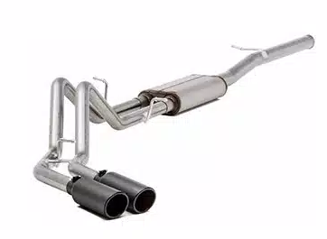
The dual rear exit exhaust system refers to as that system which is generally installed in the sportier cars or is added to make a vehicle seem sporty in look. It gives a really deeper note to the exhaust and thus makes the sound of the engine even more powerful. This system comprises of two exhaust pipes on the opposite sides of the car. It is important to know that pipes are not bent around the wheels unlike the other ones.
Figure 1-40 Dual exit exhaust

Opposite Dual Exhaust
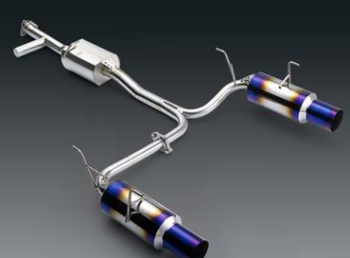
These types of exhausts are used there where the dual rear exhaust systems cannot bend. Opposite dual exhaust systems are installed as they work a bit differently as compared to the other exhausts. These are wrapped around the wheel with the bend to add a filtering process. These types of exhausts will be seen more on vehicles which are used for towing large loads.

Figure 1-41 Opposite dual exhaust

Dual Side Exhaust
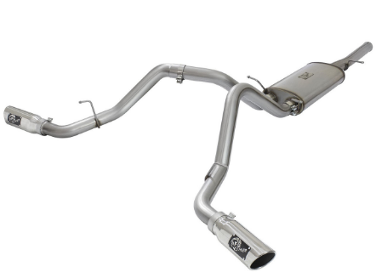
A dual side exhaust system refers to as that system which has two pipes next to each other on one side. These two pipes are used to expel gasses more efficiently as compared to the single exit pipes. The look and sound of these exhausts is similar to that of a high-performance system which offers some enhancement in the performance.
Figure 1-42 Dual side exhaust

High Performance Exhaust
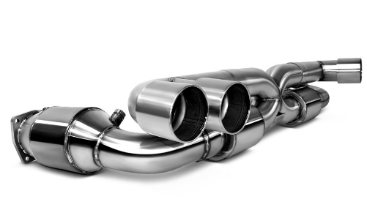
High-performance exhaust systems are comparatively more expensive which is found doing a highly efficient job of filtering out the gasses. Whereas, these are not the standard and should not be fitted to the vehicle aftermarket but in some cases the high-performance exhaust system is found increasing the efficiency of a car and also the performance of the engine
Figure 1-43 High performance exhaust

1.2.3 Components and function of Exhaust system components
Exhaust system components
The various components of the typical exhaust system include the following:
- Exhaust manifold
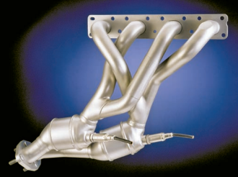
The exhaust manifold collects the burnt gases as they are expelled from the cylinders and directs them to the exhaust pipe. Exhaust manifolds for most vehicles are made of cast or nodular iron. Many newer vehicles have stamped, heavy gauge sheet metal or stainless-steel units. Inline engines have one exhaust manifold. V-type engines have an exhaust manifold on each side of the engine. An exhaust manifold will have either three, four, or six passages, depending on the type of engine. These passages blend into a single passage at the other end, which connects to an exhaust pipe. From that point, the flow of exhaust gases continues to the catalytic converter, muffler, and tail pipe, then exits at the rear of the car.
Figure 1-44 Exhaust manifold has two separate mini- or warm-up catalytic converters.

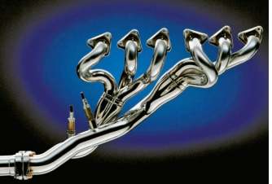
V-type engines may be equipped with a dual exhaust system that consists of two almost identical, but individual systems in the same vehicle. Exhaust systems are designed for particular engine-chassis combinations. Exhaust system length, pipe size, and silencer size are used to tune the flow of gases within the exhaust system. Proper tuning of the exhaust manifold tubes can actually create a partial vacuum that helps draw exhaust gases out of the cylinder, improving volumetric efficiency. Separate, tuned exhaust headers can also improve efficiency by preventing the exhaust flow of one cylinder from interfering with the exhaust flow of another cylinder. Cylinders next to one another may release exhaust gas at about the same time. When this happens, the pressure of the exhaust gas from one cylinder can interfere with the flow from the other cylinder. With separate headers, the cylinders are isolated from one another, interference is eliminated, and the engine breathes better. Perhaps the largest performance gain from using an exhaust header is that it increases the engine’s volumetric efficiency. A low pressure is present in the exhaust each time a pulse of exhaust ends. A header uses this low pressure to pull exhaust gases out of the cylinder when the exhaust valve opens. The low pressure also helps draw more air into the cylinder during valve overlap. Enhancing exhaust flow and increasing intake flow increases the efficiency of the engine.
Figure 1-45 A tuned exhaust manifold, called a header

- Exhaust pipe and seal
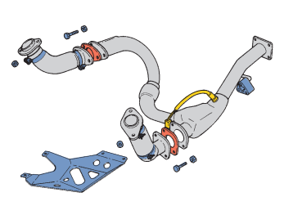
The exhaust pipe is metal pipe either aluminized steel, stainless steel, or zinc-plated heavy-gauge steel that runs under the vehicle between the exhaust manifold and the catalytic converter
Shop Talk
Figure 1-46 The front exhaust pipe assembly for a V6 engine
The exhaust manifold gasket seals the joint between the head and exhaust manifold. Many new engines are assembled without exhaust manifold gaskets. This is possible because new manifolds are flat and fit tightly against the head without leaks. Exhaust manifolds go through many heating/cooling cycles. This causes stress and some corrosion in the exhaust manifold. Removing the manifold usually distorts the manifold slightly so that it is no longer flat enough to seal without a gasket. Exhaust manifold gaskets are normally used to eliminate leaks when exhaust manifolds are reinstalled

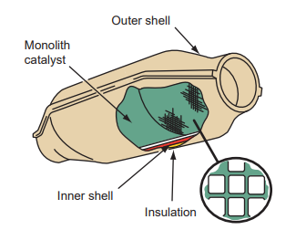
- Catalytic converter
A catalytic converter is part of the exhaust system and a very important part of the emission control system. The catalytic converter is ahead of the muffler in the exhaust system. The extreme heat in the converter oxidizes the exhaust that flows out of the engine. Because it is part of both systems, it has a role in both. As an emission control device, it is responsible for converting undesirable exhaust gases into harmless gases. As part of the exhaust system, it helps reduce the noise level of the exhaust. A catalytic converter contains a ceramic element coated with a catalyst.
Figure 1-47 A catalytic converter
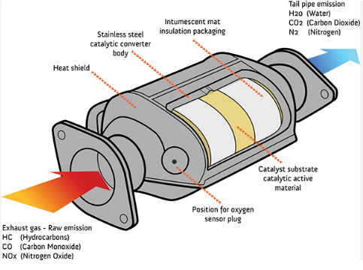
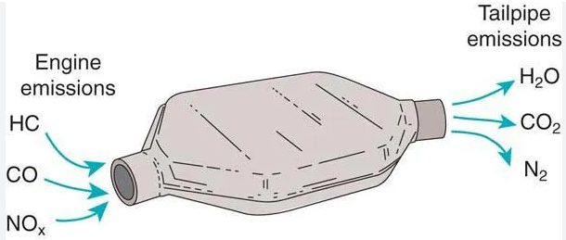
Catalytic converters may be pellet type (used in older systems) or monolithic type. Exhaust gases pass over this bed of catalyst material. In a monolithic-type converter, the exhaust gases pass through a honeycomb ceramic block. The converter beads or ceramic block are coated with a thin coating of cerium, platinum, palladium, and/or rhodium and are held in a stainless-steel container. These elements are used alone or in combination with each other to change the undesirable emissions into harmless compounds. Since the late 1980s, vehicles have had a three-way converter (TWC) that treats all three controlled emission gases. It oxidizes HC and CO by adding oxygen and reduces NOx by removing oxygen from the nitrogen oxides. Diesel engines have a particulate oxidizer catalytic converter that collects and cleans the particulates from diesel fuel that would normally be emitted from a diesel engine as black smoke.
Figure 1-48 A catalytic converter
- Muffler
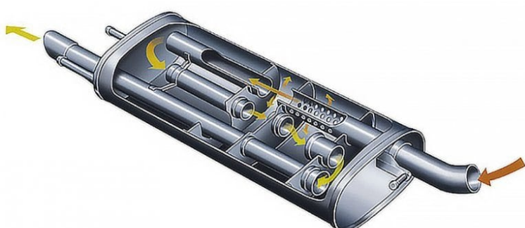
The muffler is a cylindrical or oval-shaped component, generally about 2 feet (0.6 meter) long, mounted in the exhaust system about midway or toward the rear of the car. Inside the muffler is a series of baffles, chambers, tubes, and holes to break up, cancel out, or silence the pressure pulsations that occur each time an exhaust valve opens. Two types of mufflers are frequently used on passenger vehicles. Reverse-flow mufflers change the direction of the exhaust gas flow through the inside of the unit. This is the most common type of automotive muffler. Straight-through mufflers permit exhaust gases to pass through a single tube.
Figure 1-49 A muffler
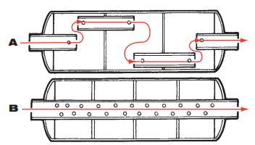
The tube has perforations that tend to break up pressure pulsations. They are not as quiet as the reverse-flow type. In recent years there have been several important changes in the design of mufflers. Most of these changes have been centered at reducing weight and emissions, improving fuel economy, and simplifying assembly.
These changes include the following
Figure 1-50 sectional flow muffler
- New Materials More and more mufflers are being made of aluminized and stainless steel. Using these materials reduces the weight of the units and extends their lives.
- Double-Wall Design Retarded engine ignition timing that is used on many small cars tends to make the exhaust pulses sharper. Many cars use a double-wall exhaust pipe to better contain the sound and reduce pipe ring.
- Rear-Mounted Muffler More and more often, the only space left under the car for the muffler is at the very rear. This means the muffler runs cooler than before and is more easily damaged by condensation in the exhaust system. This moisture, combined with nitrogen and sulfur oxides in the exhaust gas, forms acids that rot the muffler from the inside out. Many mufflers are being produced with drain holes drilled into them.
- Backpressure Even a well-designed muffler produces some backpressure in the system. Backpressure reduces an engine’s volumetric efficiency, or ability to “breathe.” Excessive backpressure caused by defects in a muffler or other exhaust system part can slow or stop the engine. However, a small amount of backpressure can be used intentionally to allow a slower passage of exhaust gases through the catalytic converter. This slower passage results in more complete conversion to less harmful gases. Also, no backpressure may allow intake gases to enter the exhaust.
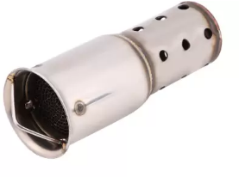
- Resonator
On some older vehicles, there is an additional muffler, known as a resonator or silencer. This unit is designed to further reduce or change the sound level of the exhaust. It is located toward the end of the system and generally looks like a smaller, rounder version of a muffler.
Figure 1-51 Resonator or silencer
Types
- Reflection-Pattern Silencers
They contain several chambers arranged in series and connected by tubes of carefully calculated dimensions.
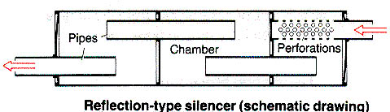

Figure 1-52 Reflection-Pattern Silencers
The pulsating flow of exhaust gas is interrupted several times. Noise damping is by the principle of pulse reflection (sound waves rebounding from surfaces) at the points between the pipes and chambers where the cross-section changes, and also by containing the noise in the chambers and allowing it to decay.
- Interference Silencers
In interference pattern silencers, the exhaust flow is divided into a great many smaller branches before being brought together again. The purpose of this is to break down violent exhaust explosions into less marked sound peaks. However, the large number of subsidiary passages and the extent of the complete system tend to make such system uneconomical.
- Combined Interference and Reflection Silencer
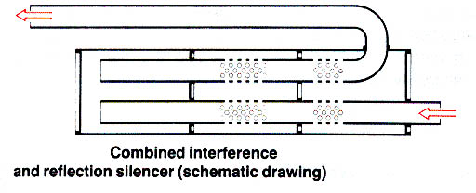

Figure 1-53 Combined Interference and Reflection Silencer

In the combined interference and reflection silencer, the various sub-pipes are also coupled together with the chambers. In addition to the reflective noise reduction principle, this silences unpleasant pulsating noise.
- Absorption-Pattern Silencers
Absorption-pattern silencers have lower flow resistance and are used when the exhaust system must not produce too much backpressure.
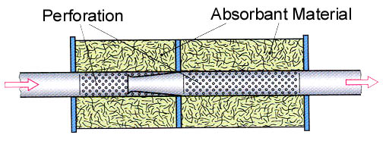
Figure 1-54 Absorption-Pattern Silencers
Silencer

They consist of a number of separate compartments, a partially perforated exhaust pipe and a filling of porous, heat resistant absorbent material based on silicon. The exhaust gas enters in pulses and, as result, penetrates through the perforations into the spaces containing the absorbent material. Friction against this causes it to lose its vibration energy and emerge as a continuous flow from the silencer, almost free from pulsation.
- Combined Absorption and Reflection Silencer
In the combined absorption and reflection silencer, the effect of the absorption-pattern silencer is improved in certain frequency ranges by adopting the reflection principle as well.
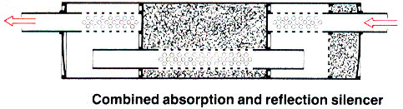
Figure 1-55 Combined Absorption and Reflection Silencer

Silencer

- Silencers with Branch Resonators
Silencers with branch resonators can be used to attenuate particularly loud sounds without greatly affecting the overall flow resistance, if these sounds have the effect of raising the overall noise level.
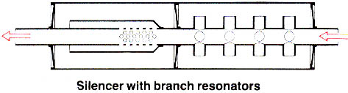
Figure 1-56 Silencers with Branch Resonators

Silencer

- Tailpipe
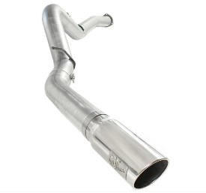
The tailpipe is the last pipe in the exhaust system. It releases the exhaust fumes into the atmosphere beyond the back end of the car.

Figure 1-57 Tailpipe
- Heat Shields
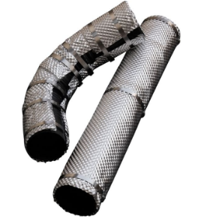
Heat shields are used to protect other parts from the heat of the exhaust system and the catalytic converter. They are usually made of pressed or perforated sheet metal. Heat shields trap the heat in the exhaust system, which has a direct effect on maintaining exhaust gas velocity. Heat shields on a catalytic converter also prevent the heat from a catalytic converter connected to a misfiring engine from setting grass or other materials on fire while it is parked. There is enough heat from an overheated converter to melt asphalt. Flex Joints The exhaust systems on FWD vehicles have a flex joint somewhere in the front exhaust pipe. This joint allows the engine to move or roll without moving the exhaust system with it. The joint prevents the exhaust from hitting the vehicle’s underbody as well as prevents the pipe from cracking due to the stress put on it.
Figure 1-58 Heat shields

- Clamps, Brackets, and Hangers
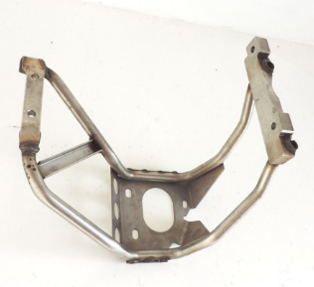
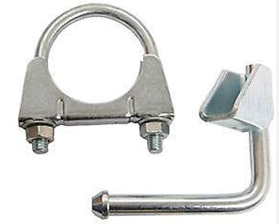
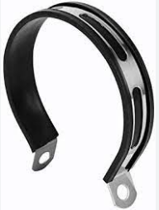
Clamps, brackets, and hangers are used to properly join and support the various parts of the exhaust system. These parts also help to isolate exhaust noise by preventing its transfer through the frame or body to the passenger compartment. Clamps help to secure exhaust system parts to one another. The pipes are formed in such a way that one slips inside the other. This design makes a close fit. A U-type clamp usually holds this connection tight. Another important job of clamps and brackets is to hold pipes to the bottom of the vehicle. Clamps and brackets must be designed to allow the exhaust system to vibrate without transferring the vibrations through the car. There are many different types of flexible hangers available, each designed for a particular application. Some exhaust systems are supported by doughnut shaped rubber rings between hooks on the exhaust component and on the frame or car body. Others are supported at the exhaust pipe and tailpipe connections by a combination of metal and reinforced fabric hanger. Both the doughnuts and the reinforced fabric allow the exhaust system to vibrate without breakage that could be caused by direct physical connection to the vehicle’s frame. Some exhaust systems are a single unit in which the pieces are welded together by the factory. By welding instead of clamping the assembly together, car makers save the weight of overlapping joints as well as that of clamp
Figure 1-60 Hangers
Figure 1-59 Clamps

Figure 1-61 Brackets

1.2.4 Summary of exhaust system
All the elements in the exhaust system are very carefully matched together and must therefore not be altered individually. There is a possibility of the vehicles official documents being rendered invalid if the exhaust system is modified. In the case of two-stroke engines in particular, any attempt to modify the exhaust system adversely affects cylinder filling and therefore reduces power output and increases fuel consumption, quite apart from raising the noise level from the exhaust beyond the permissible limit. Deposits of soot from the engine oil can also affect silencer and lead to a drop in power output.
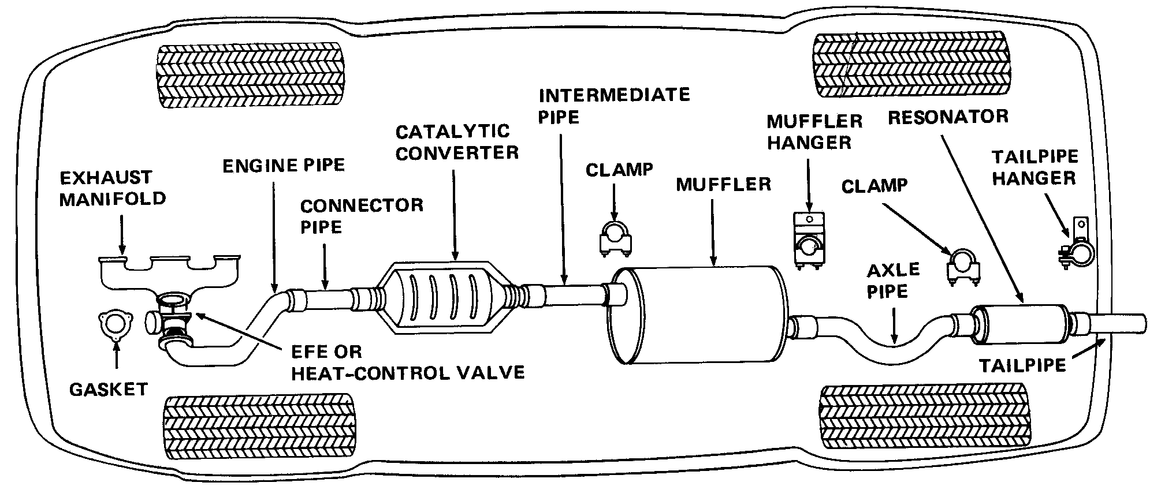
Figure 1-62 Exhaust system

Silencer

When the combustion ends in each cylinder, the exhaust gas must be collected, cleaned, quieted, and then discharged into the air. This is the job of the exhaust system. It performs these tasks while carrying the exhaust gases from the cylinders to the atmosphere. This system includes the exhaust manifold, exhaust pipe, catalytic converter, muffler or silencer, resonator (on some cars), and tail pipe.
The exhaust system has also flexible mountings that allow for engine movement and also prevent exhaust vibration from being transmitted to the body. They also allow thermal expansion of the system

1.3 Introduction to emission control system
The emission controls on today’s cars and trucks are an integral part of the engine and electronic engine control system. Perhaps it is better to say that the electronic control systems are really emission control systems. The drive to have cleaner and more fuel-efficient vehicles has led to many of the control systems now in place. These systems have also contributed to significant increases in power and reliability and improved drivability
The emission control system includes a series of functions that the vehicle performs to keep the emissions as low as possible. Harmful emissions like carbon monoxide (CO), hydrocarbons (HC) and nitrogen oxide (NOx) are minimized with the help of an emission control system. We can generally classify the emission control methods into two categories, prevention/active and destruction/passive. Automotive engines have become a lot more advanced and the new technologies have reduced the emission output. Some small improvements like using the correct air/fuel ratio, enhanced combustion techniques, and variable fuel ratio are some of the advancements. However, we explain more impactful and necessary emission control methods that are needed to comply with new stringent emission norms.

1.3.1 Harmful Exhaust Emissions
As previously mentioned, even the most modern, technologically advanced automobile engines are not "perfect"; they still inherently produce some level of harmful emission output. There are several conditions in the combustion chamber which prevent perfect combustion and cause unwanted chemical reactions to occur. The following are examples of harmful exhaust emissions and their causes.
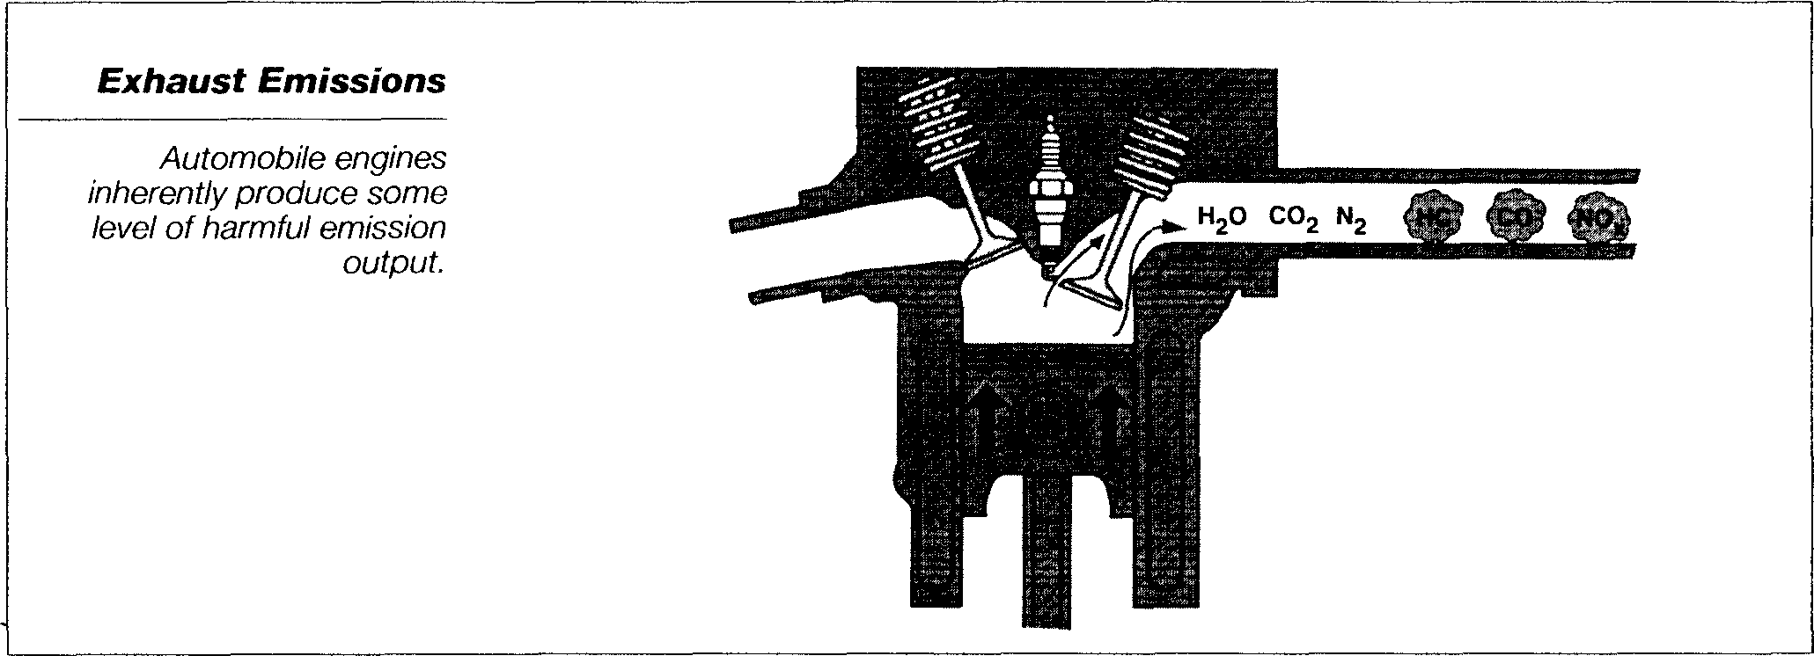

Figure 1-63 Exhaust emission gas

Silencer

Sources of air pollution
Caused by an excess amount of harmful chemical in the atmospheres.
- Manmade
- Factories
- Home furnaces
- Fire places
- Internal combustion engine
- Natural
- Volcanoes
- Forest fires
- Dust
- Decay of vegetation
- Smog
- Visible cloud of air pollutants
- Derived from the word smoke fog
- Formed when pollutants combine with oxygen and nitrogen in the presence of sunlight.

1.3.2 Exhaust emission
Pollutants produced by internal combustion engine
- Hydrocarbon (HC)
- Carbon monoxide (CO)
- Oxides of nitrogen (No) and carbon dioxide (Co2)
- Hydrocarbon (HC)
Hydrocarbons are, quite simply, raw unburned fuel. When combustion does not take place at all, as with a misfire, large amounts of hydrocarbons are emitted from the combustion chamber.
A small amount of hydrocarbon is created by a gasoline engine due to its design. A normal process called wall quenching occurs as the combustion flame front burns to the relatively cool walls of the combustion chamber. This cooling extinguishes the flame before all of the fuel is fully burned, leaving a small amount of hydrocarbon to be pushed out the exhaust valve.
Another cause of excessive hydrocarbon emissions is related to combustion chamber deposits. Because these carbon deposits are porous, hydrocarbon is forced into these pores as the air/fuel mixture is compressed. When combustion takes place, this fuel does not burn, however, as the piston begins its exhaust stroke, these hydrocarbons are released into the exhaust stream. The most common cause of excessive hydrocarbon emissions is misfire which occurs due to ignition, fuel delivery, or air induction problems. Depending on how severe the misfire, inadequate spark or a noncombustible mixture (either too rich or too lean) will cause hydrocarbons to increase to varying degrees. For example, a total misfire due to a shorted spark plug wire will cause hydrocarbons to increase dramatically. Conversely, a slight lean misfire due to a false air entering the engine, may cause hydrocarbons to increase only slightly. Excess hydrocarbon can also be influenced by the temperature of the air/ fuel mixture as it enters the combustion chamber. Excessively low intake air temperatures can cause poor mixing of fuel and air, resulting in partial misfire.
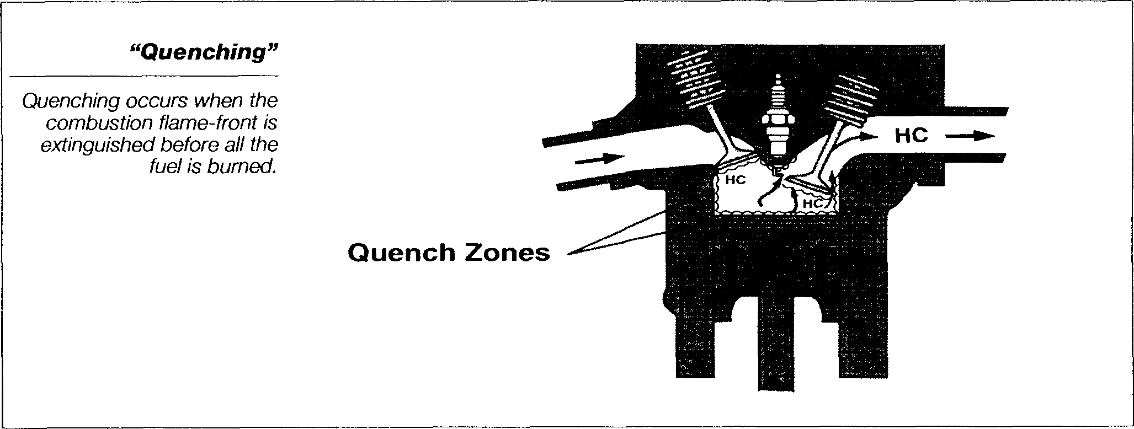
Figure 1-64 Quench zones

Silencer

- Carbon monoxide (CO)
Carbon monoxide (CO) is a byproduct of incomplete combustion and is essentially partially burned fuel. If the air/fuel mixture does not have enough oxygen present during combustion, it will not bum completely. When combustion takes place in an oxygen starved environment, there is insufficient oxygen present to fully oxidize the carbon atoms into carbon dioxide (CO2). When carbon atoms bond with only one oxygen atom carbon monoxide (CO) forms.
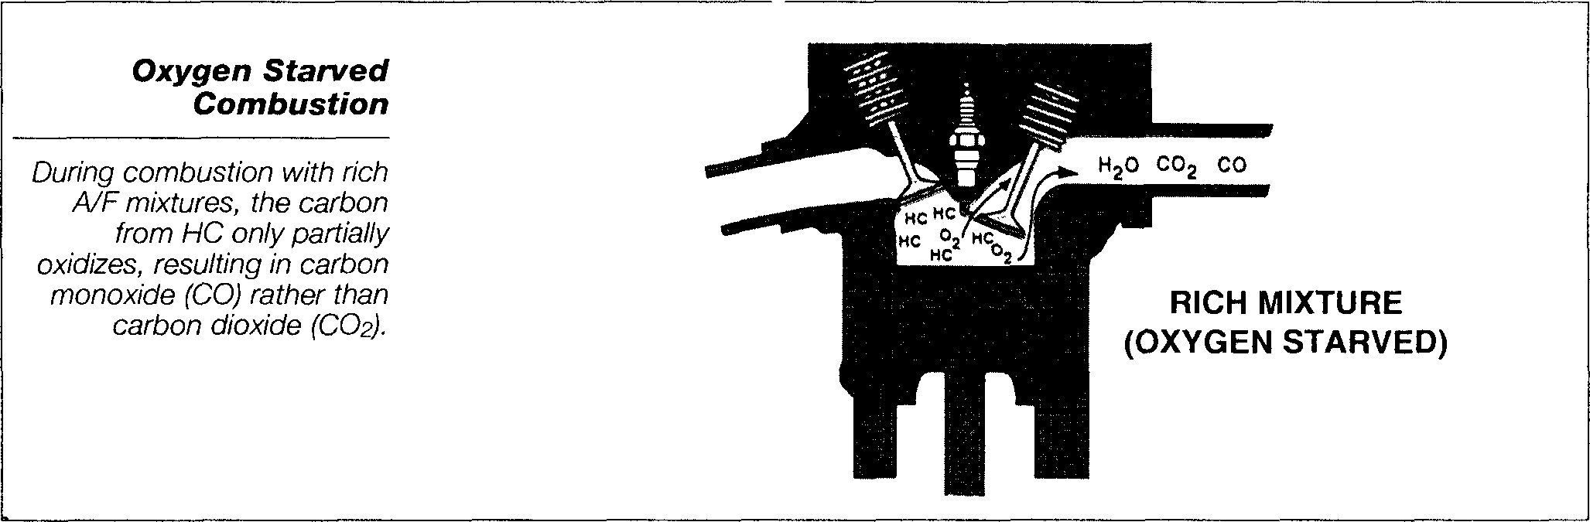
An oxygen starved combustion environment occurs as a result of air/fuel ratios which are richer than stoichiometry (14.7 to 1). There are several engine operating conditions when this occurs normally. For example, during cold operation, warm-up, and power enrichment. It is, therefore, normal for higher concentrations of carbon monoxide to be produced under these operating conditions. Causes of excessive carbon monoxide includes leaky injectors, high fuel pressure, improper closed loop control, etc
Figure 1-65 Oxygen starved combustion

Silencer

- Oxides of nitrogen (No)
High cylinder temperature and pressure which occur during the combustion process can cause nitrogen to react with oxygen to form Oxides of Nitrogen (NOx). Although there are various forms of nitrogen-based emissions that comprise Oxides of Nitrogen (NOx), nitric oxide (NO) makes up the majority, about 98% of all NOx emissions produced by the engine
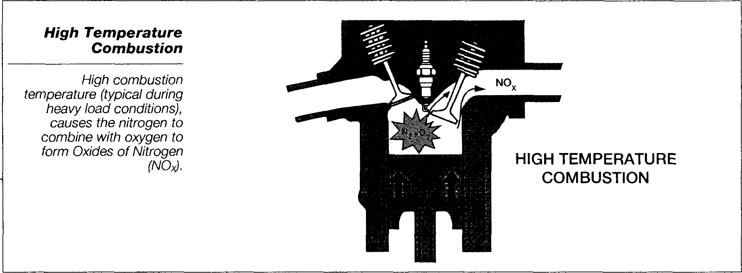
Generally speaking, the largest amount of NOx is produced during moderate to heavy load conditions when combustion pressures and temperatures are their highest. However, small amounts of NOx can also be produced during cruise and light load, light throttle operation. Common causes of excessive NOx include faulty EGR system operation, lean air/fuel mixture, high temperature intake air, overheated engine, excessive spark advance, etc.
Figure 1-66 High temperature combustion

Silencer

- Carbon Dioxide (CO2)
Carbon dioxide, or CO2, is a desirable byproduct that is produced when the carbon from the fuel is fully oxidized during the combustion process. As a general rule, the higher the carbon dioxide reading, the more efficient the engine is operating. Therefore, air/fuel imbalances, misfires, or engine mechanical problems will cause CO2 to decrease. Remember, "ideal" combustion produces large amounts Of CO2 and H2O (water vapor).

1.3.3 Causes of Excessive Exhaust Emissions
As a general rule, excessive HC, CO, and NOx levels are most often caused by the following conditions:
- Excessive HC results from ignition misfire or misfire due to excessively lean or rich air/fuel mixtures
- Excessive CO results from rich air/fuel mixtures
- Excessive NOx results from excessive combustion temperatures
There are lesser-known causes to each of these emissions that will be discussed later. When troubleshooting these types of emissions failures, you will be focusing on identifying the cause of the conditions described above. For example, to troubleshoot the cause of excessive CO emissions, you need to check all possible causes of too much fuel or too little air (rich air fuel/ratio). The following lists of causes will help familiarize you with the sub-systems most often related to excessive CO, HC and NOx production.

1.3.4 Emission control device
Emission control devices means those components of a vehicle that were designed and are used to control vehicle exhaust emission:
- Positive crankcase ventilation (PCV)
During combustion some unburned fuel and other products of combustion leak past the piston rings and move into the crankcase. This leakage is called blowby. Blowby gases are largely HC gases which are PCV systems route the gases, which are mixed with outside air, into the engine’s intake. From there the gases are drawn into the cylinders and burned.
Blowby must be removed from the engine before it condenses in the crankcase and reacts with the oil to form sludge. Sludge, if allowed to circulate with engine oil, corrodes and accelerates the wear of pistons, piston rings, valves, bearings, and other internal parts of the engine. Blowby also carries some unburned fuel into the crankcase. If not removed, the unburned fuel dilutes the engine’s oil. When oil is diluted, it does not lubricate the engine properly, which causes excessive wear.
Blowby gases must also be removed from the crankcase to prevent premature oil leaks. Because these gases enter the crankcase by the pressure created during combustion, they pressurize the crankcase. The gases exert pressure on the oil pan gasket and crankshaft seals. If the pressure is not relieved, oil is eventually forced out of these seals.
- Operation of PCV
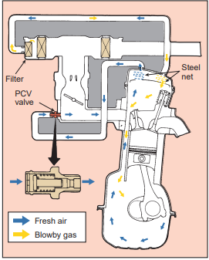
The PCV system uses engine vacuum to draw fresh air through the crankcase. This fresh air enters through the air filter or through a separate PCV breather filter. When the engine is running, intake manifold vacuum is supplied to the PCV valve. These vacuum moves air through the clean air hose into the rocker arm or camshaft cover. From there, the air flows through openings in the cylinder head into the crankcase where it mixes with blowby gases. The mixture of blowby gases and fresh air flows up through cylinder head to the PCV valve. Vacuum draws the blowby gases through the PCV valve into the intake manifold (Figure 1-67). The blowby gases mix with the intake air and enter the combustion chambers where they are burned.
Figure 1-67 Operation of PCV

Silencer

- Components of PCV
- PCV Valve
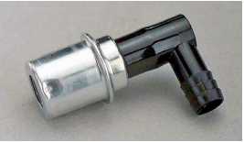
PCV Valve the PCV valve (Figure 1–68) is usually mounted in a rubber grommet. A hose connects the valve to the intake manifold. A clean air hose is connected from the air filter to the opposite rocker arm cover. A filter is positioned at end of the clean air hose. On some systems, the PCV valve is mounted in a vent module, and the clean air filter is located in this module.
Figure 1-68 PCV valve

Silencer

- PCV Monitor
PCV Monitor Vehicles that have OBD-II PCV monitoring capabilities use special PCV valves. These valves are designed so they create a total seal when installed. Most use a cam-lock thread design that requires one-quarter to one-half turn to lock them in place. The locking mechanism is designed to eliminate the chance of the valve accidentally becoming loose in its grommet
- Heated PCV Systems
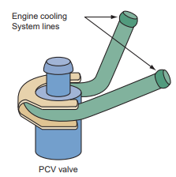
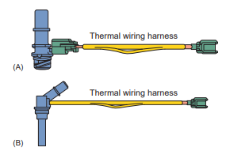
Crankcase vapors contain some moisture, which means the water in the vapors can freeze when the engine has sat in cold weather. This can cause the PCV system not to work until the ice melts, which may be a while. When the PCV system is not working, excess pressures can build up in the crankcase and force blowby gases out. To prevent this from occurring, some engines are equipped with heated PCV systems. Heated systems have a heated PCV valve or heated PCV tube. The valves can be coolant heated (Figure 1–69/70) or electrically heated. Coolant heated valves have passages that allows the coolant to flow around the valve. Some electrically heated valves are controlled by the PCM, whereas others use a thermistor in the heater’s wiring harness. Heated tubes rely on electrical heaters that are either PCM controlled or use a thermistor to control the heat.
Figure 1-69 Heated PCV

Silencer

Figure 1-70 Electrically PCV

Silencer

- Air-Oil Separator
May be used instead of a PCV valve and Makes oil vapors condense and flow back into the oil pan.
- EGR system
The Exhaust Gas Recirculation (EGR) system is designed to reduce the amount of Oxides of Nitrogen (NOx) created by the engine during operating periods that usually result in high combustion temperatures. NOx is formed in high concentrations whenever combustion temperatures exceed about 2500’F.
The EGR system reduces NOx production by recirculating small amounts of exhaust gases into the intake manifold where it mixes with the incoming air/fuel charge. By diluting the air/fuel mixture under these conditions, peak combustion temperatures and pressures are reduced, resulting in an overall reduction of NOx output. Generally speaking, EGR flow should match the following operating conditions:
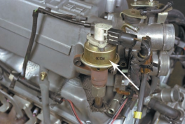
High EGR flow is necessary during cruising and mid-range acceleration, when combustion temperatures are typically very high
Low EGR flow is needed during low speed and light load conditions
No EGR flow should occur during conditions when EGR operation could adversely affect engine operating efficiency or vehicle drivability (engine warm up, idle, wide open throttle, etc.)
Figure 1-71 EGR control valve

Silencer

- Operation of EGR
The purpose of the EGR system is to precisely regulate EGR flow under different operating conditions, and to override flow under conditions which would compromise good engine performance. The precise amount of exhaust gas which must be metered into the intake manifold varies significantly as engine load changes. This results in the EGR system operating on a very fine line between good NOx control and good engine performance.
If too much exhaust gas is metered, engine performance will suffer. If too little EGR flows, the engine may knock and will not meet strict emissions standards. The theoretical volume of recirculated exhaust gas is referred to as EGR ratio. As the accompanying graph shows, the EGR ratio increases as engine load increases.
- EGR System Components
To achieve this designed control of exhaust gas recirculation, the system uses the following components:
- Vacuum Actuated EGR Control Valve
- EGR Vacuum Modulator Assembly
- ECM Controlled Vacuum Switching Valve (VSV)

- Vacuum Actuated EGR Control Valve
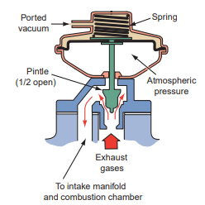
The EGR control valve is used to regulate exhaust gas flow to the intake system by means of a pintle valve attached to the valve diaphragm. A ported vacuum signal and calibrated spring on one side of the diaphragm are balanced against atmospheric pressure acting on the other side of the diaphragm. As the vacuum signal applied to the valve increases, the valve is pulled further from ifs seat. The key to accurate EGR metering is the EGR vacuum modulator assembly which precisely controls the strength of the applied vacuum signal.
Figure 1-72 EGR control valve

Silencer

- EGR Vacuum modulator assembly
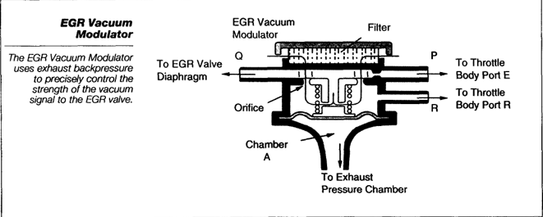
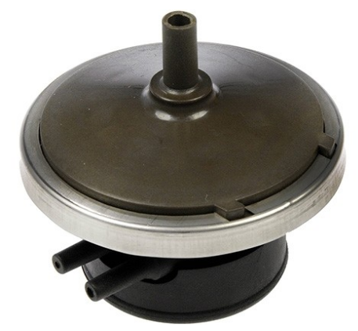
EGR vacuum modulator uses this principle to precisely control the strength of the vacuum signal to the EGR valve. The typical EGR control system uses two ported vacuum signals from the throttle body. Port E is the first stage ported vacuum signal and Port R is the second stage ported vacuum signal uncovered by the opening throttle valve.

Figure 1-73 EGR Vacuum modulator assembly

Silencer

- ECM Controlled Vacuum Switching Valve (VSV)
Used to inhibit EGR operation during conditions where it could adversely affect engine performance and vehicle drivability. The EGR VSV can be either normally open or closed and installed in series between the vacuum modulator and EGR valve or installed on a second port on the EGR valve. This VSV controls an atmospheric bleed which inhibits EGR operation any time a given set of ECM parameters are met. The following are various controls that relate directly to vacuum-controlled EGR systems.
The thermal vacuum switch (TVS) senses the air temperature. When the engine reaches operating temperature, the TVS opens to supply vacuum to the EGR valve.
The ported vacuum switch (PVS) senses coolant temperature. The PVS cuts off vacuum when the engine is cold and allows vacuum to the EGR valve when the engine is warm.
Some engines have an EGR delay timer control system, which prevents EGR operation for a predetermined amount of time after warm engine startup.
Some applications have a WOT valve to cut off EGR flow at WOT.

- Evaporative emissions control
Approximately 20% of all hydrocarbon (HC) emissions from the automobile originate from evaporative sources. The Evaporative Emission Control (EVAP) system is designed to store and dispose of fuel vapors normally created in the fuel system; thereby, preventing its escape to the atmosphere. The EVAP system delivers these vapors to the intake manifold to be burned with the normal air/fuel mixture. This fuel charge is added during periods of closed loop operation when the additional enrichment can be managed by the closed loop fuel control system. Improper operation of the EVAP system may cause rich drivability problems, as well as failure of the Two Speed Idle test or Enhanced I/M evaporative pressure or purge test.
The EVAP system is a fully closed system designed to maintain stable fuel tank pressures without allowing fuel vapors to escape to the atmosphere. Fuel vapor is normally created in the fuel tank as a result of evaporation. It is then transferred to the EVAP system charcoal canister when tank vapor pressures become excessive. When operating conditions can tolerate additional enrichment, these stored fuel vapors are purged into the intake manifold and added to the incoming air/fuel mixture.
- Operation of EVAP
Under some conditions, the fuel tank operates under a slight pressure to reduce the possibility of pump cavitation due to fuel vaporization. Pressure is created by unused fuel returning to the tank and is maintained by check valve #2 in the charcoal canister and the check valve in the fuel tank cap. Under other conditions, as fuel is drawn from the tank, a vacuum can be created in the tank causing it to collapse. This is prevented by allowing atmospheric pressure to enter the tank through check valve #3 in the charcoal canister or the fuel tank cap check valve. The EVAP system is designed to limit maximum vacuum and pressure in the fuel tank in this manner.
When the engine is running, stored fuel vapors are purged from the canister whenever the throttle has opened past the purge port (port P) and coolant temperature is above a certain point (usually around 129' F). Fuel vapors flow from the high-pressure area in the canister, past check valve #1 in the canister, through the Themo Vacuum Valve (TVV), to the low-pressure area in the throttle body. Atmospheric pressure is allowed into the canister through a filter located on the bottom of the canister. This ensures that purge flow is constantly maintained whenever purge vacuum is applied to the canister.

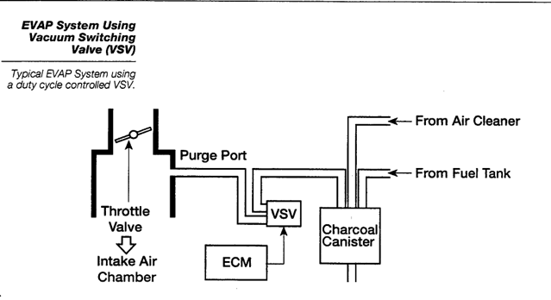
When coolant temperature falls below a certain point (usually around 95’F), the TVV prevents purge from taking place by blocking the vacuum signal to check valve #1.
Figure 1-74 Operation of EVAP

Silencer

- EVAP System Components

- Non-vented fuel cap
- Air dome or liquid-vapor separator
- Rollover valve
- Charcoal canister
- Purge valve

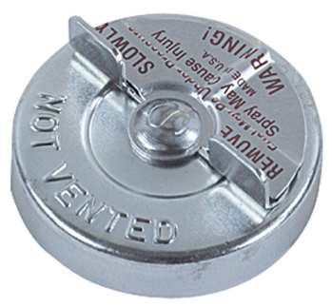
- Non-Vented Fuel Cap
Prevents fuel vapors from entering the atmosphere The pressure and vacuum relief valve will vent if tank pressure or vacuum levels get excessively high

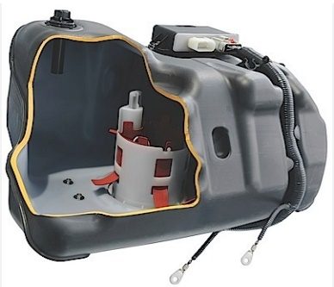
- Air Dome
A hump formed in the top of the fuel tank Allows for fuel expansion without spillage Provides about 10% air space to allow for fuel heating and expansion

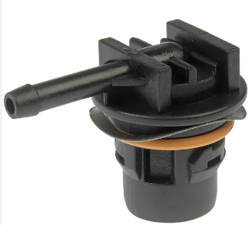
- Rollover Valve
Keeps liquid fuel from entering the vent line if the vehicle rolls over A metal ball or plunger valve blocks the vent line when the valve is turned over
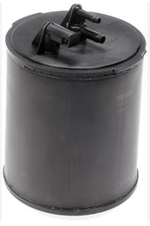
- Charcoal Canister
Stores fuel vapors when the engine is not running

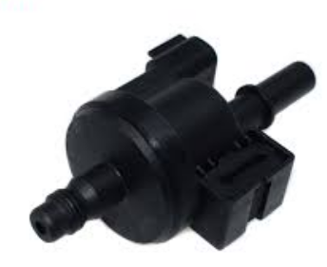
- Purge Valve
Controls the flow of vapors Operated electrically or by vacuum Located on top of the canister or in the purge line Generally allows flow when the engine is operating above idle and at operating temperature
Figure 1-75 Components of EVAP

Silencer

- Air injection
The air caused combustion of the gases in the exhaust manifolds and pipes, thereby reducing the amount of the gases emitted from the tailpipe. O2 in the air combines with the HC and CO to oxidize them and produce harmless water vapor and CO2. The air was delivered by an air pump or through a pulse-air system that relied on exhaust pulses that created a vacuum and drew in outside air as manufacturers gained more control over emissions through engine design and advanced emission control systems, the purpose of the air system changed. It became known as the secondary air injection system and was modified to allow catalytic converters to operate more efficiently. The system injected air into the catalytic converter. This helped the converter oxidize and reduce the gases entering into it. air systems are not commonly used today. Improved combustion and better catalytic converters have eliminated their need
- Operation of air injection
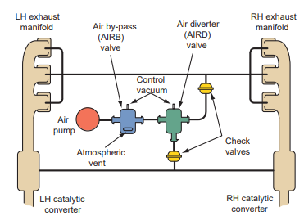
The air pump forces air through the diverter valve, through the check valve, into the exhaust manifold Late-model vehicles may force air into the catalytic converter to help oxidize (burn) HC and CO.

Figure 1-76 Operation of air injection

Silencer

Figure 1-77 Belt-driven and electric pump

Silencer

- Components of air injection
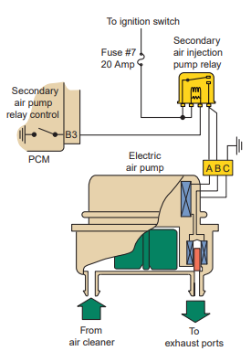
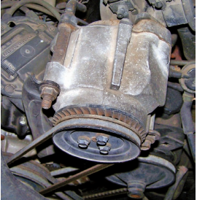
- Belt-driven or electric pump forces air into the system
- Air distribution manifold directs air toward each exhaust valve
- Air check valve keeps exhaust gases from entering the air injection system
- Diverter valve keeps air from entering the system during deceleration high manifold vacuum during deceleration acts on the diaphragm in the valve switches the airflow to atmosphere limits the maximum air pressure in system

- Thermostatic air cleaner
A device on carbureted engines to control emissions, which contains a thermostat-controlled diverter that ducts air warmed by the exhaust manifold to the carburetor during cold conditions, and then ambient air to it once a certain temperature has been attained. This enables the engine to reach a normal operating temperature and end its fuel-rich/inefficient cold-temperature mode as quickly as possible.
- Operation of thermostatic air cleaner
The typical TAC system uses a vacuum motor to actuate an air flow door, located in the air cleaner inlet. The vacuum motor is operated by a signal from a thermostatic switch located in the air cleaner assembly. Warm air is supplied to the air cleaner via a hose that connects from a shroud mounted on the exhaust manifold, to a port on the underside of the air cleaner inlet. During cold engine operation, the actuator closes the air flow door and warm air is drawn into the engine from around the exhaust manifold (take special note of this during a diagnosis of the TAC system). As the engine warms up, the vacuum signal is removed from the actuator and the door slowly opens to allow cooler air to enter through the air cleaner inlet, while at the same time, blocking warm air from the exhaust manifold.
- Components of thermostatic air cleaner

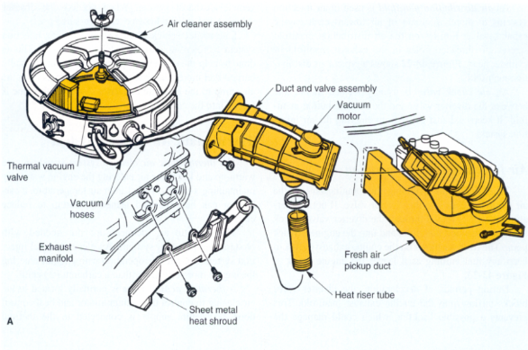
- Thermal vacuum valve located in the air cleaner controls the vacuum motor in relation to air temperature

- Vacuum motor operates the heat control door
- Heat control door routes cool or heated air into the air cleaner
Figure 1-78 Components of thermostatic air cleaner

Silencer

- Catalytic converter
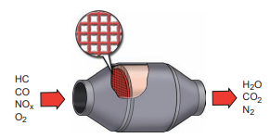
A catalytic converter is basically a housing shaped like a muffler that contains two or more ceramic elements coated with a catalyst. The catalysts are responsible for the chemical changes that occur in the converter. A catalyst is something that causes a chemical reaction without being part of the reaction. As the exhaust gases pass over the catalyst, most of the harmful gases are changed to harmless gases. Internally, the ceramic elements are designed to expose the exhaust gases to as much surface area as possible. Ceramic materials are coated with the catalyst material to minimize the amount of catalyst material necessary. Most catalyst materials are precious metals that are quite expensive.
Figure 1-79 Catalytic converter

Silencer

- Operation of Catalytic converter
As engine exhaust gases flow through the converter passageways, they contact the coated surface which initiate the catalytic process. As exhaust and catalyst temperatures rise, the following reaction occurs:

- Oxides of nitrogen (NOx) are reduced into simple nitrogen (N2) and carbon dioxide (CO2)

- Hydrocarbons (HC) and carbon monoxide (CO) are oxidized to create water (H2O) and carbon dioxide (CO2)
Catalyst operating efficiency is greatly affected by two factors; operating temperature and feed gas composition. The catalyst begins to operate at around 550' F.; however, efficient purification does not take place until the catalyst reaches at least 750' F. Also, the converter feed gasses (engine-out exhaust gases) must alternate rapidly between high CO content, to reduce NOx emissions, and high O2 content, to oxidize HC and CO emissions.

- Effects of Closed Loop Control on TWC Operation
To ensure that the catalytic converter has the feed gas composition it needs, the closed loop control system is designed to rapidly alternate the air/fuel ratio slightly rich, then slightly lean of stoichiometry. By doing this, the carbon monoxide and oxygen content of the exhaust gas also alternates with the air/fuel ratio. In short, the converter works as follows:

- When the A/F ratio is leaner than stoichiometry, the oxygen content of the exhaust stream rises and the carbon monoxide content falls. This provides a high efficiency operating environment for the oxidizing catalysts (platinum and palladium). During this lean cycle, the catalyst (by using cerium) also stores excess oxygen which will be released to promote better oxidation during the rich cycle.

- When the A/F ratio is richer than stoichiometry, the carbon monoxide content of the exhaust rises and the oxygen content falls. This provides a high efficiency operating environment for the reducing catalyst (rhodium). The oxidizing catalyst maintains its efficiency as stored oxygen is released.
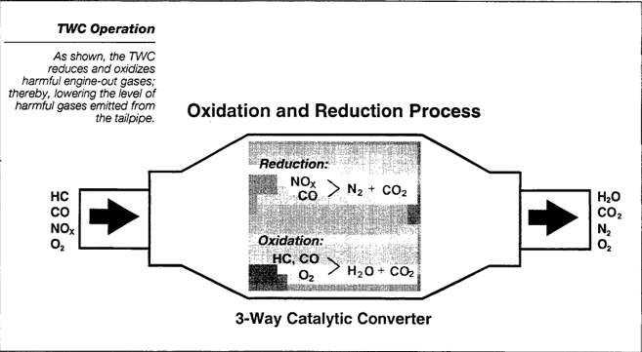
Figure 1-80 Operation of Catalytic converter

Silencer

Closed loop fuel control effectively satisfies the three-way catalyst's requirement for ample supplies of both carbon monoxide and oxygen. Generally speaking, if the closed loop control system is functioning normally, and fuel trim is relatively neutral, you can be assured that the air induction and fuel delivery sub-systems are also operating normally. If the closed loop control system is not working properly, the impact on catalytic converter efficiency, and ultimately emissions, can be significant.
- Pellet-Type Converter
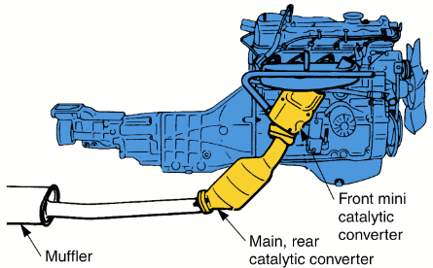
Uses beads coated with active elements
Mini Catalytic Converter Mounted close to exhaust manifold to heat up quickly on startup
Two-Way Converter
- Known as an oxidation converter
- Uses a single bed
- Reduces HC and CO
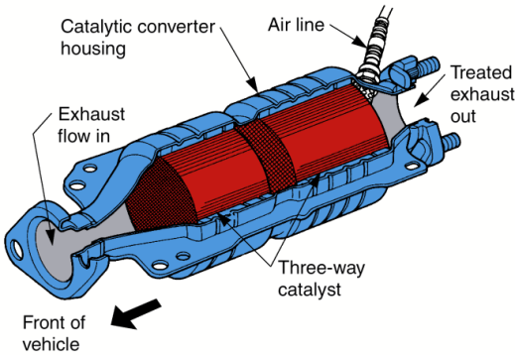
- Contains platinum
Three-Way Converter
- Known as a reduction converter
- Single bed
- Reduces HC, CO, and NO_{x}
- Contains platinum and rhodium
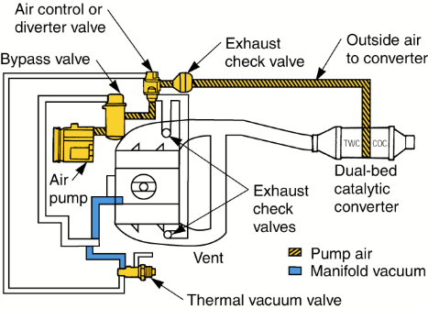
Dual Bed Converter
- Two separate catalyst units (beds) in a single converter
- Front bed is a three-way unit
- Rear bed is a two-way unit
- When the engine is hot, air is forced into a mixing chamber between the two beds, increasing oxidation efficiency
Figure1-81 Pellet-Type Converter

Silencer

1.4 OHS requirement

For every task in maintaining air induction, exhaust and emission control system the following safety task must be strictly enforced:
Fulfill with personal and environmental safety practices associated with clothing; eye protection; hand protection; proper lifting practices; hand tools; power equipment; proper ventilation; and the handling, storage, and disposal of fuels/chemicals/materials in accordance with federal, state, and local regulations.
Personal protective equipment includes those prescribed under legislation/ regulations/codes of practice and workplace policies and practices. Safe operating procedures include the conduct of operational risk assessment and treatments associated with workplace organization. Emergency procedures include emergency shutdown and stopping of equipment, extinguishing fires, enterprise first aid requirements.
OHS (occupational health and safety) is a cross disciplinary area concerned with protecting the safety, health and welfare of people engaged in work or employment. The goal of occupational health and safety (OHS) is:
- To protect every working man against the dangerous of injury, sickness or death through safe healthful working condition.
- To protect co-workers, employers, customers, suppliers and other members of the public who are impacted by the work place environment.

1.5 Tools, Equipment, workshop manual and Specification

1.5.1 Preparing Required Tools and Equipment
In well-organized automotive repairing workshop, there are deferent Hand tools equipment, Special Service tools (SST), Testers, Gauges, Jacks, lifters, measuring tools, power tools, etc. Among these materials, the trainees should be able to select the material that can used to the work he/she perform.

1.5.2 Sourcing Workshop Manuals
Work shop manuals/manufacturers repair manuals or specifications are the most valuable materials that used the technicians during repairing activities. As the result of technology variation, any type of technical product has its repair and service manual. Hence, the trainee should identify and make ready the right manual for the type.

1.5.3 Analyzing Method Options Requirements
During technical work activity, test, measurement and calibration results are compared with manufactures specification to isolate the trouble from functional Components.
To analyze system troubles, there are deferent option based on the work
Performed. See on the above how to determine the nature of the work scope.

Self-check -1

Self-check: 1
Instruction I. Choose the best answer
1. A restricted exhaust system can cause.
A. Stalling B. Loss of power C. Backfiring D. All of the above
2. Which of the following is not characteristic of a turbocharger?
A. It is used to increase engine power by compressing the air that goes into the combustion chambers.
B. It usually is located close to the exhaust manifold.
C. It utilizes an exhaust-driven turbine wheel.
D. It requires a mechanical connection between the engine and the pressurizing pump to compress the intake gases
3. What manages turbo output by controlling the amount of exhaust gas entering the turbine housing?
A. Wastegate
B. Turbine seal assembly
C. Hot wheel
D. Cold wheel
4. Which of the following statements concerning superchargers is incorrect?
A. Superchargers must overcome inertia and spin up to speed as the flow of exhaust gas increases.
B. Superchargers do not require a wastegate to limit boost.
C. A bypass is designed into the system to allow the supercharger to idle along when extra power is not needed.
D. Superchargers improve horsepower and torque
5. Which of the following systems is designed to reduce NOx and has little or no effect on overall engine performance?
A. PCV B. EGR C. AIR D. EVAP

Instruction II. Give answer for the following questions
- What is acoustic supercharging?
- Describe the basic operation of an intake manifold runner control (IMRC) system?
- What is the purpose of an intercooler?
- True or False? The wastegate on variable turbochargers is controlled by the PCM?
- Why is a wastegate not needed on a supercharge?
- What are the consistent components of exhaust system?
- What is the purpose of exhaust system?
- Write the purpose of all components of exhaust system?
- What is the basic difference between resonator and muffler?
- What is emission system?
- Write Man made sources?
- Write about Hydro carbons (HC)?
- Write all Pollutants produced by internal combustion engine?
- Write Carbon monoxide (CO) elements?
- Write Natural sources?
Instruction III. Matching
A B
- Turbocharger of turbine wheel is rotated A. Supercharger
- When air transmitted in to engine by turbo, what will happen B. Exhaust gas
- Reduce the amount of Oxides of Nitrogen ( NOx ) C. HC, NOx, Co
- Pollutants produced by internal combustion engine D. air pressure increased
- Mechanical driven component pressurized air E. EGR
F. EVAP

Unit Two: Servicing to air induction, exhaust and emission control systems
This unit to provide you the necessary information regarding the following content coverage and topics:
- Servicing to air induction
- Inspect to air induction
- Remove to air induction
- Repair and replace to air induction
- Servicing to exhaust system
- Inspect to exhaust system
- Remove to exhaust system
- Repair and replace to exhaust system
- Servicing to emission system
- Inspect to emission system
- Remove to emission system
- Repair and replace emission system
This guide will also assist you to attain the learning outcomes stated in the cover page. Specifically, upon completion of this learning guide, you will be able to:
- Service to air induction
- Service to exhaust system
- Service to emission system

2.1 Servicing to air induction
An air induction service, or intake cleaning, is a method of cleaning the air intake system without disassembling it. Using special chemical cleaning agents, deposits are dissolved for safe combustion in the cylinders. The air induction service could take up to an hour, depending on the severity of the deposits and how complex the air intake system is on your particular vehicle.
An air induction service is preferred to a full rebuild and individual parts cleaning, because it takes far less time and is far less expensive. Otherwise, intake cleaning could take several hours, if not days. Air induction service is often recommended for vehicles every 30,000 miles or if you are experiencing rough idle, poor performance, reduced fuel economy, or other intake system problem

2.1.1 Inspection to air induction
Inspect the intake piping for cracked hoses, loose clamps, or punctures which can allow dirt and debris to enter the engine. Tighten or replace parts as necessary to make sure the air intake system does not leak.
Inspection the Air Cleaner
- Squeeze the evacuator to allow the debris to fall out.
- Loosen the wing nut in the center of the air cleaner end cap and remove the end cap.
- Remove the outer, primary air filter and clean the inside of the air cleaner housing thoroughly.
- Remove the evacuator tube and clean it and the evacuator.
- Examine the primary filter element. If dust is present on the inside surface, or if it shows signs of damage, it MUST be replaced.
- Blow compressed air through the element, from inside outward, to remove any particles from the element.
- Wash the primary element in non-foaming detergent for approximately fifteen minutes then rinse with warm tap water from inside outward until the water that passes through the element is clear.
- Allow the primary element to air dry then examine the condition using a bright Iight shining through the element from inside outward.

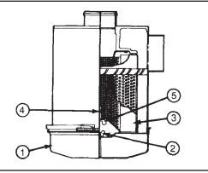
- Heavy-duty air cleaners (single and dual types) combine centrifugal cleaning with element filtering before air enters the engines. Before disassembly, wipe dirt from the cover and the upper portion of the air cleaner. To clean the single types:
Figure 2-1 Heavy-duty single air cleaner

Silencer

- Loosen the wing bolt, and remove the band securing the dust pan
- Loosen the wing nu
- Remove the dust shield (3) from the dust pan (1). Clean the dustpan and shield
- Remove the wing nut (5) and secure the air cleaner primary element in the air cleaner housing. Inspect the rubber-sealing washer on the wing nut
- Clean the element from the clean air side with compressed air not exceeding 207 kPa [30 psi]. Inspect the element after cleaning. Install the cleaned primary element or a new element
- Make sure the gasket washer is in place under the wing nut before tightening
- Assemble the dust shield and dustpan again. Position them to the air cleaner housing and secure with the band.
- Heavy duty air cleaners (single and dual types) combine centrifugal cleaning with element filtering before air enters the engines. Before disassembly, wipe dirt from the cover and the upper portion of the air cleaner. To clean the dual types:
- Loosen the wing bolt (1), and remove the band securing the dust pan (2)
- Loosen the wing nut (3). Remove the dust shield (4) from the dust pan (2). Clean the dustpan and shield.
- Remove the wing nut (5) and secure the air cleaner primary element (6) in the air cleaner housing. Inspect the rubber-sealing washer on the wing nut (9).
- Clean the element from the clean air side with compressed air not exceeding 207 kPa [30 psi]. Inspect the element after cleaning. Install the cleaned primary element or a new element.
- Make sure the gasket washer is in place under the wing nut before tightening
- Assemble the dust shield and dustpan again. Position them to the air cleaner housing and secure with the band

- Visually inspect the core assembly for debris and clogging of external fins with the engine off. Before engine operation, remove any debris blocking the core.
- Turbocharger-to-charge air cooler.
- Charge air cooler-to-intake manifold pipe.
- Mounting bracket.
- Chassis-mounted charge air cooler core
- Inspect air intake piping:
- Check for accumulation of salt deposits (where applicable). If present, disassemble and clean the complete air intake piping system. If pitting is evident on the intake piping, use Motorcraft Silicone Gasket and Sealant TA-30 to seal joints against leakage.
- Check for loose hoses and clamps.
- Check for ruptured or collapsed hoses.
- Check air cleaner housing for cracks.
Turbocharger Inspection
- To inspect a turbocharger, start the engine and listen to the sound that the turbo system makes. As you become more familiar with this characteristic sound, it will be easier to identify an air leak between the compressor outlet and engine or an exhaust leak between engine and turbo by the presence of a higher pitched sound. If the turbo sound cycles or changes in intensity, the likely causes are a plugged air cleaner or loose material in the compressor inlet ducts or dirt buildup on the compressor wheel and housing.
- After listening, check the air cleaner and remove the ducting from the air cleaner to turbo and look for dirt buildup or damage from foreign objects. Check for loose clamps on the compressor outlet connections and check the engine intake system for loose bolts or leaking gaskets. Then disconnect the exhaust pipe and look for restrictions or loose material. Examine the exhaust system for cracks, loose nuts, or blown gaskets. Rotate the turbo shaft assembly. Does it rotate freely? Are there signs of rubbing or wheel impact damage?
- Visually inspect all hoses, gaskets, and tubing for proper fit, damage, and wear. Check the low-pressure, or air cleaner, side of the intake system for vacuum leaks.
- Inspect all turbocharger parts carefully before you rinse them. All parts within manufacturer's recommended specifications can be used safely for another service period. Damage to the floating bearing may require replacement of the turbocharger main casing with a new part or an exchange main casing.
- Inspect the turbine casing. If you find cracks which are too wide for welding, replace the casing.
- Do not use the exhaust casing if it is warped or heavily damaged on the inside surface caused by contact with the turbine wheel or a foreign object, or if it is cracked in any way.
- Usually, oil seal plates do not wear excessively during service and can be reused if they have not been scored by a seizure of the piston ring.
- As you inspect the diffuser plates, look for contact scoring by the rotor assembly on the back of the diffuser plate or broken vanes. This scoring will make the plate unacceptable for reuse.
- Inspect the inner heat shield. If it is distorted, replace it.
- Dents found on the outer heat shield can usually be removed, allowing its reuse. However, if this shield is cut or split in the bolt circle area, replace it.

Operation sheet: 2.1 Pressure testing to turbocharger
Operation Title: Inspect to turbocharger
Operation purpose: Inspect the pressure testing of a turbocharger
Condition and situation for the operation:
- Safe working area
- Properly operated tools and equipment
- Appropriate working cloths fit with the body
Equipment, tools and material:
- Service manual
- Flat screwdriver
- Set of wrenches (socket, box and open wrenches)
- Torque wrench
- Pressure gauge
Steps in doing the task
Pressure Testing The performance of a turbocharger can be checked with a pressure gauge.
- Wear suitable personal protection equirements.
- The gauge is connected to the intake manifold and the amount of boost observed. This is best done on a road test. This check can also verify the action of the waste gate and its controls. Manifold pressure can be monitored with a scan tool as well.
- When oil leakage is noted at the turbine end of the turbocharger, check the turbocharger oil drain tube and the engine crankcase breathers for restrictions. When sludge engine oil is found, the engine’s oil and oil filter must be changed.
- On the pressure side of the system, you can check for leaks by using soapy water. After applying the soap mixture, look for bubbles to pinpoint the source of the leak.
- Exhaust leaks upstream to the turbocharger housing will also affect turbo operation. If exhaust Gases escape prior to entering the housing, the reduced temperature and pressure will cause a proportionate reduction in boost and a loss of power. If the waste gate does not appear to be operating properly (too much or too little boost), check to make sure that the connecting linkage is operating smoothly and not binding. Also make sure that the pressure sensing hose is clear and properly connected.
- Westgate problems can usually be traced to carbon buildup, which keeps the unit from closing or causes it to bind. A defective diaphragm or leaking vacuum hose can result in an inoperative waste gate. Before condemning the waste gate, check the ignition timing, the spark-retard system, vacuum hoses, knock sensor, oxygen sensor, and computer. When removing carbon deposits from turbine and waste gate parts, never use a hard metal tool or sandpaper. Remember that any gouges or scratches on these parts can cause severe vibration or damage to the turbocharger. To clean these parts, use a soft brush and a solvent.
Quality Criteria: Assured performing of all the activities according to the procedures
Precautions:
- Wearing proper clothes, eye glass, glove
- Make working area hazard free
- Read and interpret manual which guide you how to use tools and equipment.

2.1.2 Remove to air induction
Supercharger Removal
Refer to the appropriate service manual for detailed instructions on the removal and installation of the supercharger.
  - Remove the supercharger and intake components.
  - Remove the O-rings from the oil feed side and oil return side and discard.
  - Carefully clean all sealing surfaces including the O-ring grooves with an appropriate cleaner. Ensure there is no residual Three Bond 1217F sealant left on any sealing surfaces of the crankcase cover or supercharger.
  - Apply an adequate amount of Three Bond 1217F sealant into the O-ring groove on the oil feed side only
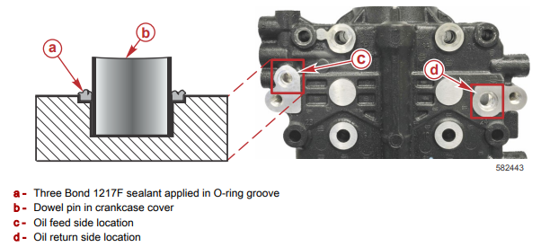

  - Evenly distribute the Three Bond 1217F sealant around the O-ring groove and remove excess sealant as needed. Ensure the sealant is flush with the machined surface.
  - Install the new O-rings on the oil feed side and oil return side
  - Align the supercharger on the dowel pins.
  - Apply Loctite 242 Thread locker to the supercharger mounting screws.
  - Tighten the supercharger mounting screws to the specified torque.
  - Install the remaining intake components on the engine.
  - Run the engine for approximately five minutes or until normal operating temperature is achieved and check for leaks.

Turbocharger removal
- Open the hood.
- Remove the engine cover.
- Disconnect the charge air cooler inlet and outlet pipes.
- Label and disconnect the intake air heater element electrical leads, intake air temperature (IAT) sensor electrical connector, manifold absolute temperature (MAP) sensor electrical connector and the pressure hoses.
- Loosen the clamps. Remove the compressor manifold.
- Remove and discard the compressor manifold O-ring seal.
- Disconnect the exhaust outlet pipe.
- Loosen the Marmon clamp.
- Disconnect the exhaust outlet pipe.
- Disconnect the exhaust back pressure valve. Vehicle with exhaust back pressure system only)
- Slide the retaining clip away from the exhaust back pressure Valve actuator lever.
- Detach the exhaust back pressure valve actuator rod.
- Label and disconnect the waste gate solenoid vacuum hose and the pressure hose. Loosen the clamps. Remove the air inlet tube.
- NOTE: The Marmon clamp cannot be removed with the turbocharger installed. Loosen the Marmon clamp.
- Remove the turbocharger.
- Remove the bolts.
- Remove the turbocharge
- Remove and discard the O-ring seals.

2.1.3 Repair and replace to air induction
Replacing a Turbocharger
If the turbocharger is faulty, it should be replaced with a new or rebuilt unit. Always follow the procedure given in the service information. Before removing the turbocharger, plug the intake and exhaust ports and the oil inlet to prevent the entry of dirt or other foreign material. While replacing it, check for an accumulation of sludge in the oil pipes and, if necessary, clean or replace the oil pipes. Do not drop or bang the new unit against anything or grasp it by easily deformed parts.
When installing a new turbocharger, put 20 cc (0.68 oz.) of oil into the turbocharger oil inlet and turn the compressor wheel by hand several times to spread oil to the bearings. After installing the new turbocharger, or after starting an engine that has been unused, there can be a considerable lag after engine startup before the oil pressure is sufficient to deliver oil to the turbo’s bearings. To prevent this problem, follow these simple steps:
Make certain that the oil inlet and drain lines are clean before connecting them.
- Be sure the engine oil is clean and at the proper level.
- Fill the oil filter with clean oil.
- Leave the oil drain line disconnected at the turbo and crank the engine without starting it until oil flows out of the turbo drain port.
- Disconnect the fuel supply lines and crank the engine for 30 seconds to distribute oil throughout the engine.
- Allow the engine to idle for 60 seconds.
- Connect the drain line, start the engine, and operate it at low idle for a few minutes before running it at higher speeds.

Replacing a air cleaner
The engine in your vehicle requires fresh, clean air to run at its best, and a major component of this system is the air filter.
This filter removes dirt and debris from the air to stop it entering into the engine and causing damage.
- The first step is to locate the air box.
- Open the bonnet of the vehicle and the air box will be located to one side of the engine. It may be held together will clamps, or screwed together.
- Undo the fasteners and lift the top of the box away, to allow access to the filter.
- Remove the filter from the box, and inspect it. A good way of checking how blocked it is, is to hold it up to a light source and if the light is difficult to see through the filter, it is time to replace it.
- With the filter removed from the air box, inspect inside the box for any leaves or debris and clean out if required.
- Slide the new air filter into the box, tighten the fasteners, and you’re done!

Operation sheet: 2.2 Replace the air filter
Operation Title: Changing the air filter
Operation purpose: To perform right steps to change the air filter
Condition and situation for the operation:
- Safe working area
- Properly operated tools and equipment
- Appropriate working cloths fit with the body
Equipment, tools and material:
- Service manual
- Flat screwdriver
- Set of wrenches (socket, box and open wrenches)
- Torque wrench
- 6-inch extension
- Air filter (new)
- Gloves
- Ratchet
- Safety glasses
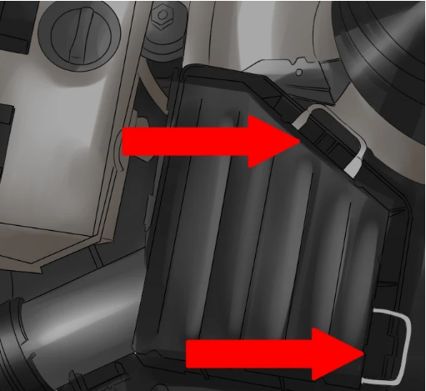
Steps in doing the task
  - Find the air cleaner box. Open the hood and locate the air cleaner box. The air cleaner box can vary in size and shape depending on the make of the vehicle.
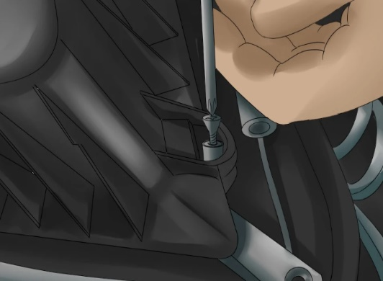
  - Open the air cleaner box. Once located, take note of the type of fasteners that are being used to keep the box closed

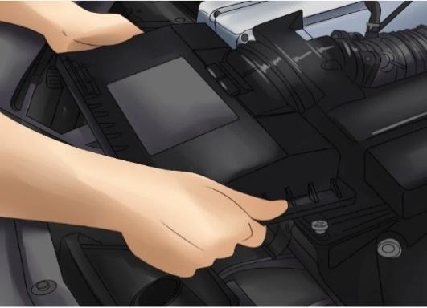
  - Access the air cleaner box. For air cleaner boxes that are fastened with screws or bolts, locate the appropriate socket and ratchet or locate a screwdriver and loosen the fasteners.

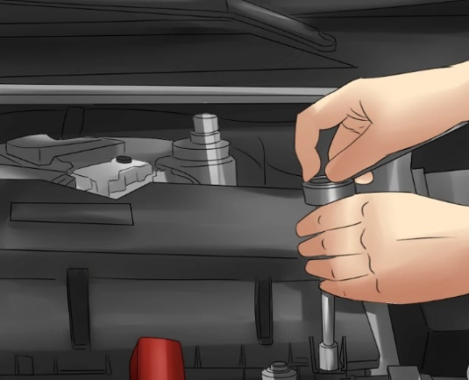
  - Remove the engine beautification panels. Some Mercedes, Audi, and Volkswagen air cleaner boxes also double as engine beautification panels. Firmly yet gently lift off the locking panel from the posts. Once it has been removed, flip it over and use the appropriate size torx bit and ratchet to loosen the fasteners there.
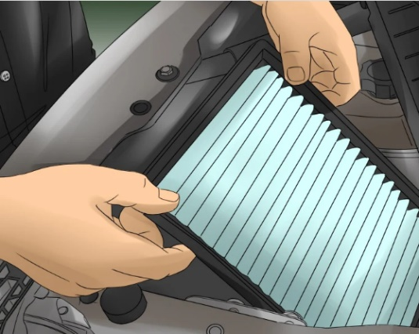
  - Discard the dirty air filter. Remove the dirty air filter from the air cleaner box and toss it in the trash. Take a peek inside the air cleaner box. If there is any debris present be sure to take the time to remove it. Use of a vacuum may be helpful to remove any dirt or other particles that should not be there.

  - Secure the fasteners. Depending on the type of fasteners being used, either secure the clamps that were loosened earlier or use the appropriate tool to tighten down the fasteners securely.
Figure2-2 Replace the air filter

Silencer

Quality Criteria: Assured performing of all the activities according to the procedures
Precautions:
- Wearing proper clothes, eye glass, glove
- Make working area hazard free
- Read and interpret manual which guide you how to use tools and equipment.

2.2 Servicing to exhaust system
Exhaust system components are subject to physical and chemical damage. Any physical damage to an exhaust system part that causes a partially restricted or blocked exhaust system usually results in loss of power or backfire up through the throttle plate. In addition to improper engine operation, a blocked or restricted exhaust system causes increased noise and air pollution. Leaks in the exhaust system caused by either physical or chemical rust damage could result in illness, asphyxiation, or even death.

2.2.1 Inspection to exhaust system
Most parts of the exhaust system, particularly the exhaust pipe, muffler, and tailpipe, are subject to rust, corrosion, and cracking. Broken or loose clamps and hangers can allow parts to separate or hit the road as the car moves.
All inspections should include listening for abnormal noises. The inspection should also include a careful look at the system while the vehicle is raised on a hoist. lists some of the common exhaust systems problems and their likely causes. Before beginning work on the system, be sure that it is cool to the touch. Some technicians disconnect the battery ground to avoid short-circuiting the electrical system. Finally, check the system for critical clearance points so the system does not contact the chassis while the vehicle is driven
Exhaust Restriction Test
Often leaks and rattles are the only things looked for in an exhaust system. The exhaust system should also be tested for blockage and restrictions. Collapsed pipes or clogged converters and/or mufflers can cause these blockages. There are many ways to check for a restricted exhaust. The sound of the exhaust can indicate a restriction. With a restriction, the exhaust will wheeze as it struggles to exit the exhaust system. Although this is not the most effective way to determine if there is a restriction, it is a good start. Checking the pressure built up in the exhaust is the best way to determine if the system is blocked. This is done by installing a pressure gauge in the O2S bore in the exhaust pipe. At idle, the gauge should read less than 1.5 psi (10 kPa) and should be less than 2.5 psi (17 kPa) at 2,500 rpm. Some technicians check for a restricted exhaust with a vacuum gauge. With the gauge connected to the intake manifold, the engine’s speed is raised and held. The vacuum reading should rise and either hold there or increase slightly. If the vacuum decreases, there is an exhaust restriction

Exhaust Leaks Exhaust leaks
often identified by sound, although very small leaks can be difficult to locate. One of the most effective ways to identify the source of a leak in the system is the use of a smoke machine. When smoke is introduced to the exhaust system, a trace of smoke will identify the source of the leak

Operation sheet: 2.3 Examining the exhaust system
Operation Title: Inspect to exhaust system
Operation purpose: Examining the exhaust system
Condition and situation for the operation:
- Safe working area
- Properly operated tools and equipment
- Appropriate working cloths fit with the body
Equipment, tools and material:
- Service manual
- Flat screwdriver
- Set of wrenches (socket, box and open wrenches)
- Torque wrench
- Pressure gauge
Steps in doing the task
- Look for exhaust leaks
Leaks can be visible or audible. Look under the vehicle for leaks that you can see. Pay attention to the following areas:
- Welds look for breaks, cracks or corrosion.
- Pipe connections check for improper alignment or burned gaskets.
- Clamp connections ensure there are no leaks.
- Flex pipes a common area for failure, make sure there are no leaks.
To check for audible leaks, take the vehicle for a test drive and listen for any unusual sounds coming from the exhaust system. While you’re in the car, it’s a good time to check for the smell of exhaust gases in the cabin of the vehicle.
Correct and repair any leaks in the exhaust system.

- Replace damaged parts
Check the hangers and isolators for wear, and look for any loose, damaged or missing parts. Replace any parts that have failed.
- Check for blockages
Check for blockages in the exhaust system by performing an engine vacuum or backpressure test.
- Inspect the catalytic converter
Examine the catalytic converter. Before replacing the catalytic converter, be sure to:
- Retrieve and repair all PCM trouble codes.
- Check for any technical service bulletins (TSB) or any updates on the PCM.
- Check fuel control
Make sure the vehicle is in proper fuel control and is at operating temperature and that it is in closed loop. Next, check oxygen sensors. Under normal operating conditions, the front oxygen sensor should be around 450mv and the rear sensor should be between 650mv and 850mv.
- Test for contamination
Make sure there are no fluids or coolant that is getting in the exhaust causing premature wear or failure.
- Select the right catalytic converter
Quality Criteria: Assured performing of all the activities according to the procedures
Precautions:
- Wearing proper clothes, eye glass, glove
- Make working area hazard free
- Read and interpret manual which guide you how to use tools and equipment.

2.2.2 Remove to exhaust system
Exhaust Manifold Back Removal (Normally Aspirated)
- Disconnect the O₂ sensor near the back of the firewall and drop the sensor connector down to the exhaust pipe.
- Remove the CO sample tube from the exhaust pipe. This pipe has been removed and capped off on many cars as it is not used and it has a tendency to rust out and cause exhaust leaks. If your car is still equipped with the sample tube, you'll find the top end of it at the back of the camshaft housing at the engine lifting ring.
- Remove the six nuts and bolts that attach the exhaust pipe to the exhaust manifolds.
- Support the exhaust with blocks or jack stands.
- Remove the nuts and bolts on the hanger in front of the catalytic converter, the rear of the catalytic converter, and at the rear of the muffler.
- Lower the exhaust system from the car.
Cross-Over Pipe Back Removal (Turbo)
- Disconnect the O₂ sensor near the back of the firewall and drop the sensor connector down to the exhaust pipe.
- Remove the CO sample tube from the exhaust pipe. This pipe has been removed and capped off on many cars as it is not used and it has a tendency to rust out and cause exhaust leaks. If your car is still equipped with the sample tube, you'll find the top end of it at the back of the camshaft housing at the engine lifting ring.
- Remove the nuts on the turbocharger discharge pipe flange (near O₂ sensor).
- Remove the nuts and bolts on the triangle shaped flange on the discharge of the wastegate.
- Support the exhaust with blocks or jack stands.
- Remove the nuts and bolts on the hanger in front of the catalytic converter, the rear of the catalytic converter, and at the rear of the muffler.
- Lower the exhaust system from the car.

Operation sheet: 2.4 Exhaust Manifold Removal
Operation Title: Removing to exhaust system
Operation purpose: perform to remove exhaust system
Condition and situation for the operation:
- Safe working area
- Properly operated tools and equipment
- Appropriate working cloths fit with the body
Equipment, tools and material:
- Service manual
- Screwdriver
- Set of wrenches (socket, box and open wrenches)
- Torque wrench
Steps in doing the task
- Remove the six nuts and bolts on the flanges between the exhaust manifolds and the exhaust pipe (crossover pipe on Turbo models).
- Remove the two Allen head bolts that attach the coolant return pipe to the cam housing.
- It may be necessary to remove the coolant return pipe completely to get the exhaust headers out. This will require partially draining the coolant system.
- To remove the exhaust manifolds, it is necessary to remove the exhaust manifold studs. To do this, loosen the exhaust nut several turns and then install a second nut onto the stud. Tighten the outside nut against the inside nut while holding the inside nut with a wrench to prevent it from turning. Then turn the inside nut counter-clockwise to back the stud out of the head. If the nuts turn on the stud, the outside nut needs to be tightened.
- Remove the exhaust manifolds from the car

Quality Criteria: Assured performing of all the activities according to the procedures
Precautions:
- Wearing proper clothes, eye glass, glove
- Make working area hazard free
- Read and interpret manual which guide you how to use tools and equipment.

2.2.3 Repair and replace to exhaust system
Replacing Exhaust System Components Before beginning work on an exhaust system, make sure it is cool to the touch. Some technicians disconnect the battery’s negative cable before starting to work to avoid short-circuiting the electrical system. Soak all rusted bolts, nuts, and other removable parts with a good penetrating oil. Finally, check the system for critical clearance points so they can be maintained when new components are installed. Most exhaust work involves the replacement of parts. When replacing exhaust parts, make sure the new parts are exact replacements for the original parts. Doing this will ensure proper fit and alignment as well as ensure acceptable noise levels. Exhaust system component replacement might require the use of special tools and welding equipment
- Replacing Leaking Gaskets and Seals
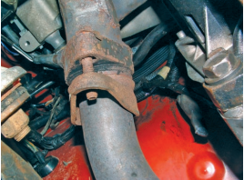
The most likely spot to find leaking gaskets and seals is between the exhaust manifold and the exhaust pipe
Most often exhaust bolts are quite rusted and can be difficult to loosen. This is why it is wise to soak the bolts and nuts with penetrating fluid before attempting to disassemble the system. When installing exhaust gaskets, carefully follow the recommendations on the gasket package label and instruction forms. Read through all installation steps before beginning. Take note of any of the original equipment manufacturer’s recommendations in service manuals that could affect engine sealing. Manifolds warp more easily if an attempt is made to remove them while they are still hot. Remember, heat expands metal, making assembly bolts more difficult to remove and easier to break.
Figure 2-3 Leaking gaskets and seals

Silencer

- To replace an exhaust manifold gasket, follow the torque sequence in reverse to loosen each bolt. Repeat the process to remove the bolts. Doing this minimizes the chance that components will warp.
- Any debris left on the sealing surfaces increases the chance of leaks. A good gasket remover will quickly soften the old gasket debris and adhesive for quick removal. Carefully remove the softened pieces with a scraper and a wire brush. Be sure to use a nonmetallic scraper when attempting to remove gasket material from aluminum surfaces.
- Inspect the manifold for irregularities that might cause leaks, such as gouges, scratches, or cracks. Replace it if it is cracked or badly warped. File down any imperfections to ensure proper sealing of the manifold.
- Retap and redie all threaded bores. This ensures tight, balanced clamping forces on the gasket. The most common cause of manifold warpage is incorrectly torqued manifold studs and nuts. Often when an exhaust manifold is removed, the studs for the manifold unthread with the nuts. Before reinstalling the manifold, separate the nuts from the studs and thoroughly clean both. In many cases it is best to replace the studs and nuts. Make sure that the studs and nuts are exact replacements for the original parts. Lubricate all threads with a high-temperature anti seize lubricant.
- Apply a small amount of contact adhesive onto the mounting surface to hold the gasket in place. Align the gasket before the adhesive dries. Allow the adhesive to completely dry before installing the manifold.
- Install the bolts or nuts finger-tight. Tighten them in three steps one-half, three-quarters, and full torque. Always follow the specifications given for that engine. Normally the nuts should be tightened in a particular sequence. This sequence typically begins at the center and continues outward in an X pattern.
- Replacing Exhaust Pipes
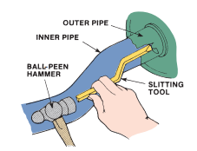
In most cases, the exhaust system is replaced as a unit. Doing this ensures a proper fit and saves much time. However, there are times when only a section or component needs to be replaced. When doing this take care not to damage any surrounding parts. To replace an exhaust pipe, support the converter to keep it from falling and remove the O2S. Remove any hangers or clamps holding the exhaust pipe to the frame. Unbolt the flange holding the exhaust pipe to the exhaust manifold. Disconnect the pipe from the converter and pull the front exhaust pipe loose and remove it. If the pipe is sealed with a gasket, replace it when installing the new pipe
Figure 2-4 Replacing Exhaust Pipes

Silencer

2.3 Service to emission control system
The quality of an engine’s exhaust depends on two things: One is the effectiveness of the emission control devices; the other is the efficiency of the engine. A totally efficient engine changes all of the energy in the fuel into heat energy. This heat energy is the power produced by the engine. To run, an engine must receive fuel, air, and heat.
OBD II Emission System Monitoring
- Monitors for:
- catalytic converter efficiency
- engine misfire
- O₂ sensor output
- EGR valve action
- fuel injection
- air injection
- Evaporative System Monitor
- Checks components for leakage and restrictions that could increase emissions
- If the system does not pressurize and depressurize normally, a DTC is set
- EGR Monitor
- The computer turns the EGR off while checking the O₂ sensor readings
- Changes in the EGR opening affect the air-fuel mixture
- If changes do not affect the O₂ sensor readings, a DTC is set
- Catalyst Monitor
- Uses at least two O₂ sensors
- one before the converter and one
behind it
- If the signal from the rear O₂ sensor becomes too similar to the engine-mounted sensor signal, the converter is not working properly
- a DTC is set, and the MIL is illuminated

- Scanning Emission Systems
- Connect the scan tool to the data link connector
- Check for diagnostic trouble codes (DTC’s)
- Retrieve data
- Emission Maintenance Reminder
- The circuit turns on a dash light to indicate the need for emission control system service
- After repairs, the light must be turned off
- Refer to the service manual for numerous procedures
- Inspecting Emission Control Systems
- Inspect vacuum hoses and wires,
- Use a stethoscope to listen for
vacuum leaks
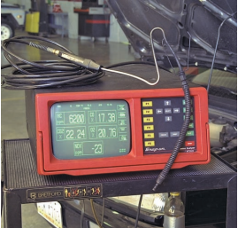
- Exhaust Gas Analyzer
Measures the chemical content of exhaust gas
- Two-Gas Analyzer

- Measures two gases:
- hydrocarbons (HC)
- carbon monoxide (CO)
Figure 2-5 Exhaust Gas Analyzer

Silencer
2
- Four-Gas Analyzer
- Measures four gases:
- hydrocarbons (HC)
- carbon monoxide (CO)
- carbon dioxide (CO2)
- oxygen (O2)

- Five-Gas Analyzer
- Measures five gases:
- hydrocarbons (HC)
- carbon monoxide (CO)
- carbon dioxide (CO2)
- oxygen (O2)
- oxides of nitrogen (NOx)
- Analyzer with a calibration gas
Using a Gas Analyzer
- Warm-up the analyzer
- about 10 minutes
- Zero and calibrate the analyzer
- zero the meter while sampling shop air or calibration gas
- Warm the vehicle to operating temperature
- Insert a probe into the tail pipe through a hole in the shop’s vent hose

Operation sheet: 2.5 Analyzer Test Procedures the exhaust emission system
Operation Title: Inspecting to exhaust emission system
Operation purpose: Examining the exhaust emission control system
Condition and situation for the operation:
- Safe working area
- Properly operated tools and equipment
- Appropriate working cloths fit with the body
Equipment, tools and material:
- Service manual
- Exhaust Gas Analyzer
Steps in doing the task
- Analyzer Test Procedures
- Two speed idle test
- idle and 2500 rpm
- Dynamometer test
- loads the engine to simulate actual driving conditions
- Compare the readings to specifications
Quality Criteria: Assured performing of all the activities according to the procedures
Precautions:
- Wearing proper clothes, eye glass, glove
- Make working area hazard free
- Read and interpret manual which guide you how to use tools and equipment.

Operation sheet: 2.6 Emissions Testing Programs
Operation Title: Emissions Testing Programs
Operation purpose: perform Emissions Testing Programs
Condition and situation for the operation:
- Safe working area
- Properly operated tools and equipment
- Appropriate working cloths fit with the body
Equipment, tools and material:
- Service manual
- Exhaust Gas Analyzer
Steps in doing the task
- Emissions Testing Programs
- Exhaust gas readings are taken
- idle and a set rpm (e.g., 2500 rpm)
- The vehicle may be checked for a catalytic converter, fuel inlet restrictor, and other emission control systems
- IM 240
- The vehicle is operated on a dynamometer at speeds up to 55 mph (89 kmh) for 240 seconds while exhaust gases are measured
- The evaporative emissions system may be tested:
- Purge test
- Pressure test
Purge test
- Measures the flow of fuel vapors into the engine while performing the IM 240 test
- A flow meter is installed into the purge line between the canister and the intake manifold
- A computer compares the purge rate to specifications
Pressure test
- Checks the system for leaks into the atmosphere
- Pressure test equipment is connected to the evaporative emission system
- A computer meters low pressure nitrogen into the system (0.5 psi, 3.4 kPa)
- If the pressure drops too much, the computer will fail the system
Quality Criteria: Assured performing of all the activities according to the procedures
Precautions:
- Wearing proper clothes, eye glass, glove
- Make working area hazard free
- Read and interpret manual which guide you how to use tools and equipment.

LAP TEST
Instructions:
1.You are required to perform any of the following:
Request your teacher to arrange for you all necessary tools, materials and equipment. Submit your outputs to your teacher for evaluation.
Request a set of tools, materials, and equipment for the tasks then perform the following tasks in front of your teacher:
  - How to Inspect the Emission System
  - Emission System Testing
  - Perform to inspect air induction

Unit Three: Prepare vehicles/Equipment/ for use or storage

This unit to provide you the necessary information regarding the following content coverage and topics:
- Prepare to Schedule documentation
- Final inspection
- Clean, store and organize tools and equipment
This guide will also assist you to attain the learning outcomes stated in the cover page. Specifically, upon completion of this learning guide, you will be able to:
- Prepare to Schedule documentation
- Perform Final inspection
- Prepare job card
- Perform Clean, store and organize tools and equipment

3.1 Prepare to Schedule documentation
To conduct Preparation of vehicle/system for customer and/or storage based on workplace procedures, it is required to follow setups and procedure.
- complete work documentation that performs during the practical repairing work.
- performing final road test and over all condition finalizing checkup.

3.2 Performing Final Inspection
- cleaning vehicle
- processing Job card based on workplace procedures.
- Forwarding report to the customer.

Operation sheet: 3.1 Prepare vehicles/Equipment/ for use or storage
Operation Title: Preparing vehicles/Equipment/ for use or storage
Operation purpose: To conduct Preparation of vehicle/system for customer and/or storage based on workplace procedures, it is required to follow setups and procedure.
Condition and situation for the operation:
- Safe working area
- Properly operated tools and equipment
- Appropriate working cloths fit with the body
Equipment, tools and material:
- Live Vehicle/Engine with injection pump
- complete tool box and Equipment
Steps in doing the task:
      - Conduct the activity based on information sheet
Quality criteria: Assured performing of all the activities according to the procedures
Precaution:
- Wearing proper clothes, eye glass, glove
- Make working area hazard free
- Read and interpret manual which guide you how to use tools and equipment

Self-check -3

Self-check 3

INSTRUCTION: - Answer the question stated below based on information sheet.
- If your progress is unsatisfactory discuss with your trainer and do this work again.
- Explain briefly on the blank space.
Time given 15 min
            - How can you prepare the vehicle to the customer/storage?

Reference
- Automotive technology a systems approach 5th edition jack erjavec
- Auto motive mechanics William H.Crouse 10th edition
- Light & heavy vehicle technology Fourth Edition
- Automotive technology A Systems Approach 7th ed. Jack Erjavec Rob Thompson
- Heavy duty truck systems fifth edition sean bennett ian andrew norman

Participants of this Module (training material) preparation

No | Name | Qualification | Field of Study | Organization/ Institution | Mobile number | E-mail
 | Adinet Asnake | MSc. | Automotive Technology Mgt | Wolkite PTC | 0913-767250 | andinetasnake31@gmail.com
 | Biruk Tilahun | BSc. | Automotive Technology | General Wingate PTC | 0913-789176 | biruktilahun1@gmail.com
 | Fadli Aman | BSc. | Automotive Technology | General Wingate PTC | 0927-283100 | Fadli.ziyad@gmail.com
 | Hana Nigusise | BSc. | Automotive Technology | Selam TVET college | 0988-751516 | Hana.nigussie25@gmail.com
 | Israel Taye | BSc. | Automotive Technology | General Wingate PTC | 0913-424100 | Isra.taye@gmail.com
 | Tatek Mamo | PhD scholar | Automotive Technology | DEC | 0911-841121 | mimibaba928@gmail.com
 | Zelalem Yitbarek | BSc. | Automotive Technology | Selam TVET college | 0972-030621 | Zolosmart12@gmail.com

