

Heavy Vehicles and Earth Moving Machinery Maintenance
Level II
Based on May, 2022, Curriculum Version-I
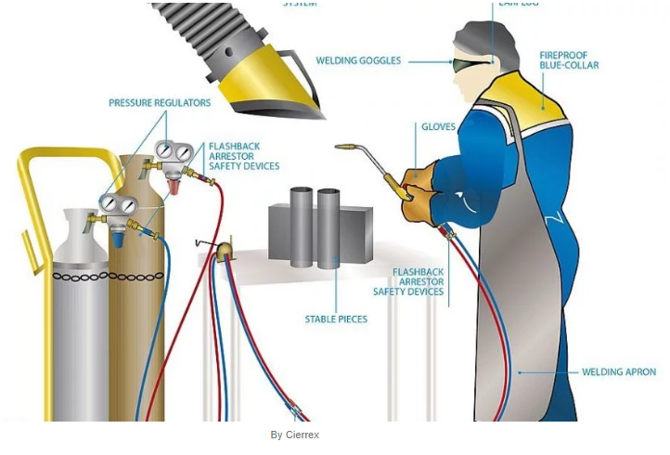
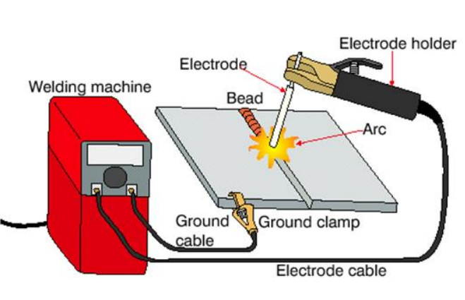

Module Title: Performing Manual Arc and Oxy Acetylene Welding
Module Code: EIS HEM2 M08 1122
Nominal Duration: 60 hours

Prepared By: Ministry of Labor and Skill
December, 2022
Addis Ababa, Ethiopia

Acknowledgement
Ministry of Labor and Skill swish to extend thanks and appreciation to the many representatives of TVT instructors who donated their time and expertise to the development of this Teaching, Training and Learning Materials (TTLM).

Acronyms

SMAW -----------------------------------Shielded Metal Arc Welding)
GMAW-----------------------------------.Gas Metal Arc Welding)
GTAW -----------------------------------Gas Tungsten Arc Welding)
SMAW ……………………………...Shielded Metal Arc Welding
MMAW…………………………… Manual metal arc welding

Table of contents
Acknowledgement 2
Acronyms 3
Table Of Contents 3
Introduction To The Module 6
Unit One: Introduction Of Welding 7
1.1 Overview Of Arc And Gas Welding 8
1.2 Prepare For Ohs, Ppe And Environmental Requirement 9
1.2. Tools And Equipment, Workshop Manuals And Specifications 12
Self-Check-1 16
Unit Two: Welding Requirements 17
2.1. Types Of Metals, Electrodes And Their Application 18
2.2. Equipment Maintenance Procedures 24
2.3. Fuel Gas Properties And Application 25
2.4. Identifying Welding Treatments 27
Self-Check-2 29
Unit Three: Perform Manual Metal Arc Welding 30
3.1 Preparing Materials, Methods And Techniques For Arc Welding 31
3.2 Manual Metal Arc Working Procedures 33
3.3 Reporting 35
Self-Check-3 36
Unit Four: Perform Oxy Acetylene Welding 37
4.1 Methods And Techniques For Oxy Acetylene Welding 38
4.2 Oxy Acetylene Working Procedures 38
4.3 Reporting 40
Operation Sheet 4.1 42
Operation Sheet 4.2 45
Operation Sheet 4.3 47
Lap Test 1 50
Unit Five: Clean And Maintain Workshop 51
5.1 Waste And Scrap Removing 52
5.2 Reused, Collect And Store Materials 52
5.3 Maintain Tools And Equipment 52
Self-Check-5 53
Annex 54
Reference 58

Introduction to the Module
Welding is the process of joining together two pieces of metal so that bonding takes place at their original boundary surfaces‖. When two parts to be joined are melted together, heat or pressure or both is applied and with or without added metal for formation of metallic bond. Oxygen/Acetylene welding, or “Gas Welding”, is a process which relies on combustion of oxygen and acetylene. Oxy-acetylene welding is a method of joining metals by heating them to the melting point using a mixture of oxygen and acetylene gases. When mixed together in correct proportions within a hand-held torch or blowpipe, a hot flame is produced with a temperature of about 3,200°C. The chemical action of the oxy/acetylene flame can be adjusted by changing the ratio of the volume of oxygen to acetylene, using the valves on the torch or blowpipe.
This unit of competency covers the skills and knowledge required to carry out manual metal arc and routine oxy acetylene welding procedures.
This module covers the units:
- Introduction to welding
- Welding requirements
- Perform manual metal arc welding
- Perform oxy acetylene welding
- Clean and maintain workshop
Learning Objective of the Module
- Introduction to welding
- Welding requirements
- Perform manual metal arc welding
- Perform oxy acetylene welding
- Clean and maintain workshop
Module Instruction
For effective use this modules trainees are expected to follow the following module instruction:
- Read the information written in each unit
- Accomplish the Self-checks at the end of each unit
- Perform Operation Sheets which were provided at the end of units
- Do the “LAP test” giver at the end of each unit and
- Read the identified reference book for Examples and exercise

Unit One: Introduction of Welding
This unit is developed to provide you the necessary information regarding the following content coverage and topics:
- Overview of arc and gas welding
- Prepare for OHS, PPE and environmental requirement
- Tools and equipment, workshop manuals and specifications
This unit will also assist you to attain the learning outcomes stated in the cover page. Specifically, upon completion of this learning guide, you will be able to:
- Understand arc and gas welding
- Apply OHS, PPE and environmental requirement
- Use Tools and equipment, workshop manuals and specifications

Overview of arc and gas welding

Arc welding
Welding is the process of joining together two pieces of metal so that bonding takes place at their original boundary surfaces‖. When two parts to be joined are melted together, heat or pressure or both is applied and with or without added metal for formation of metallic bond. The arc is struck between the electrode and the metal. It then heats the metal to a melting point. The electrode is then removed, breaking the arc between the electrode and the metal. This allows the molten metal to freeze or solidify. The arc is like a flame of intense heat that is generated as the electrical current passes through a highly resistant air gap. There are various welding processes but commonly used types include the following:
  - SMAW (Shielded Metal Arc Welding)
  - GMAW (Gas Metal Arc Welding)
  - GTAW (Gas Tungsten Arc Welding) in this level, SMAW/MMAW welding is to be discussed
- Manual metal arc welding (MMAW)
MMAW is a welding process that creates an electric arc between a hand held, flux-coated, consumable filler wire and the work piece. Welding commences when an electric arc is struck by making contact between the tip of the electrode and the work. The intense heat of the arc melts the tip of the electrode and the surface of the work close to the arc. Tiny globules of molten metal rapidly form on the tip of the electrode, then transfer through the arc stream into the molten weld pool.
Figure 1:1 Manual metal arc welding
In this manner, filler metal is deposited as the electrode is progressively consumed. The arc is moved over the work at an appropriate arc length and travel speed, melting and fusing a portion of the base metal and continuously adding filler metal.
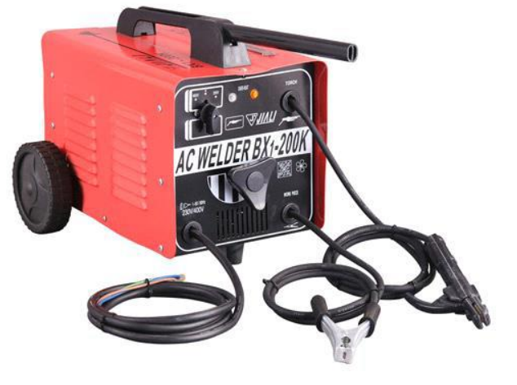
Since the arc is one of the hottest of the commercial sources of heat [temperatures above 9000° F (5000° C) have been measured at its center], melting of the base metal takes place almost instantaneously upon arc initiation.
Figure 1:2 Arc welding machine
If welds are made in either the flat or the horizontal position, metal transfer is induced by the force of gravity, gas expansion, electric and electromagnetic forces, and surface tension. For welds in other positions, gravity works against the other forces. The flux coating breaks down in the arc to produce a gaseous shield.
- Gas welding
Oxygen/Acetylene welding, or “Gas Welding”, is a process which relies on combustion of oxygen and acetylene. Oxy-acetylene welding is a method of joining metals by heating them to the melting point using a mixture of oxygen and acetylene gases. When mixed together in correct proportions within a hand-held torch or blowpipe, a hot flame is produced with a temperature of about 3,200°C. The chemical action of the oxy/acetylene flame can be adjusted by changing the ratio of the volume of oxygen to acetylene, using the valves on the torch or blowpipe.
Figure 1:3 Oxy-Acytelyne welding equipment’s

Prepare for OHS, PPE and environmental requirement
To achieve safe working conditions in the metal fabrication and welding industry, all personnel should be able to recognize the hazards which apply to their particular occupation. Welding operators must also know the correct operating procedures for the equipment. An operator can be subjected to many safety hazards associated with the industry. As with any other industrial worker, they may be injured through incorrect lifting practices, falling or tripping, or incorrect use of hand tools and machines. The operator will also encounter particular hazards associated with welding. A clean, tidy workplace, free from combustible materials, is an essential requirement for the safety of welding personnel. Additionally, others working in the vicinity of welding operations are at risk from hazards such as electrocution, fumes, radiation, burns or flying slag and noise. They too must be protected if their health and safety is not to be put at risk.

Safety Recommendations for Arc Welding
The beginner in the field of arc welding must go through and become familiar with these general safety recommendations which are given as under.
- The body or the frame of the welding machine shall be efficiently earthed. Pipe lines containing gases or inflammable liquids or conduits carrying electrical conductors shall not be used for a ground return circuit All earth connections shall be mechanically strong and electrically adequate for the required current.
- Welding arc in addition to being very is a source of infra-red and ultra-violet light also; consequently the operator must use either helmet or a hand-shield fitted with a special filter glass to protect eyes.
- Excess ultra-violet light can cause an effect similar to sunburn on the skin of the welder..
- The welder‘s body and clothing are protected from radiation and burns caused by sparks and flying globules of molten metal with the help of the following:
- Gloves protect the hands of a welder.
- Leather or asbestos apron is very useful to protect welder‘s clothes and his trunk and thighs while seated he is doing welding.
- For overhead welding, some form of protection for the head is required
- Leather skull cap or peaked cap will do the needful.
- Leather jackets and 1ather leggings are also available as clothes for body protection.
- Welding equipment shall be inspected periodically and maintained in safe working order at all times.
- Arc welding machines should be of suitable quality.
- 12. All parts of welding set shall be suitably enclosed and protected to meet the usual service conditions

Personal protective equipment (PPE)
Arc welding, like most welding processes, requires operators to protect themselves from the radiated heat and rays associated with the process. Perhaps the most efficient way of doing this is by the wearing of protective clothing. The use of all protective clothing is dictated by the nature of the work and the comfort of the operator.

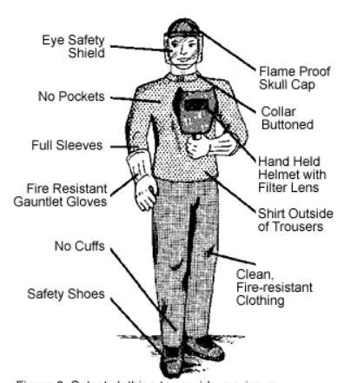
Figure 1:4 Welding equipment’s

Welding hazards and risks
The hazards in manual electric arc welding operation can be broadly grouped into the following major categories:
A. Fire and explosion hazards;
B. Electrical hazards;
C. Physical hazards;
D. Respiratory hazards; and
E. Other related hazards.
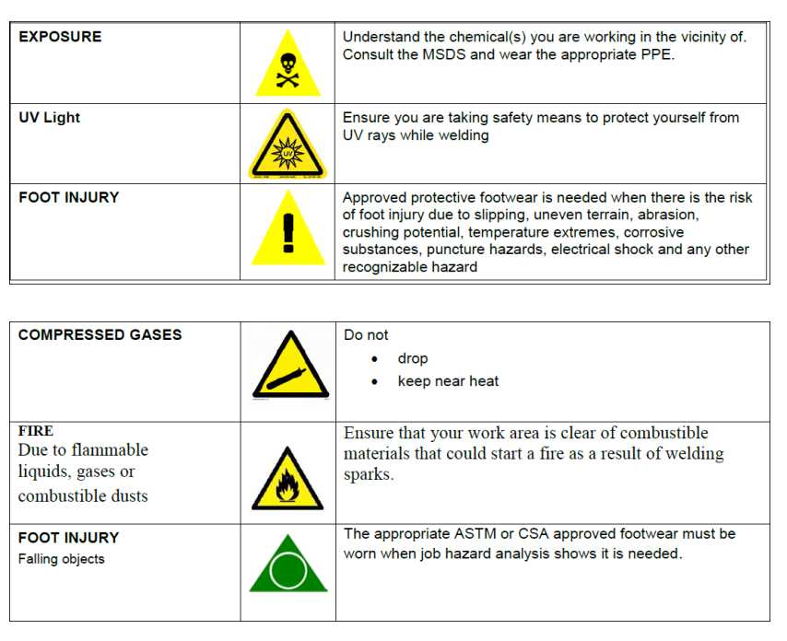
Figure 1:5 Welding hazards and risks

Tools and equipment, workshop manuals and specifications

Arc Welding Tools and Equipment List
The tools need to start arc welding are-
- An arc welding machine
- A power source
- Electrode holder and cables
- Electrodes

An Arc Welding Machine
A welding machine, also sometimes called a welder, works to create the electric current you’ll need while you weld. Most welding machines come in two categories:
- CC, or constant current welding machines
- CV, or continuous voltage welding machines
So, what’s the difference between these choices? A CV machine alternates how much output current it creates to keep a constant voltage. On the other hand, a CC machine will vary its output voltage and keep a steady flow. When selecting a welding machine, you’ll need to consider the following features of the machine carefully:
- The duty cycle
- Voltage power
- The AC/DC settings

Power Source
The next item you’ll need to purchase is a welding power source. Welding power sources help to give enough power to the welding machine or welding stick so that you can melt your metal pieces together. That power source also needs to be able to create a current for melting your electrode when you weld metal pieces together. So that means your power source also has to have a high voltage capability so that it can keep the arc going.
If you are using an MMA electrode (and we’ll talk more about electrodes later), then you’ll need to use that electrode with a combination of an alternating current (AC) and direct current (DC) power sources. You can utilize AC electrodes on a DC power source. However, you cannot use all DC electrodes on an AC power source. So, regardless, you’ll need to have both sources of power to conduct proper welding.
There are four different types of power sources you’ll need to use when you weld:
- DC Generator
- DC rectifier
- AC transformer
- AC/DC transformer

Electrodes and High Currents
MMA electrodes need strong currents but low voltages to operate. So, if you wind up using a higher voltage supply, you’ll need to take down that supply through the help of a transformer. If you’re also going to create a DC power supply, you’ll have to ensure you have that output and that it can also be used with the transformer. Most power supplies are designed to reduce the risk of receiving an electrical shock while you are working. Because of that, most power sources have to work well using a maximum no-load voltage. That means no arc can be created when you have the external circuit open, and the power leads connected to the power source. So, your power source needs to have a hazard reducing device on it that’s either internal or external. That device will help bring down the no-load voltage and prevent you from experiencing any electrical shock. You’ll need to create the primary welding current once your electrode starts touching the piece of metal. If you weld in smaller spaces, using DC or AC with a low voltage safety device will keep you very safe while you work on your welds.

Electrode holder and cables
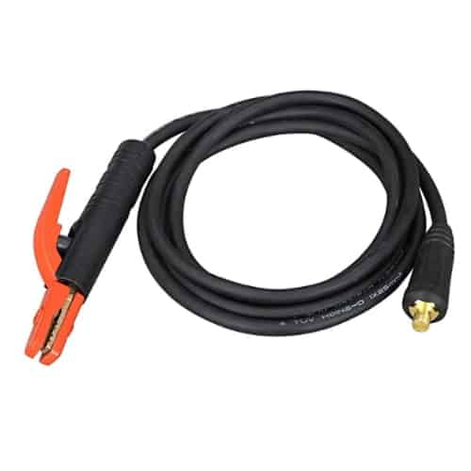
Since you’ll be working with electrodes, you’ll also need electrode holders and cables. An electrode holder will help clamp your electrode’s end with copper that’s built into the head of the holder. The shoes that are found in the head area are then held together using a spring-loaded system or a twist grip. The clamping tool that holds the electrode will then quickly let go of the stub end. The electrode must stay clamped into the holder to make the entire process efficient. If you don’t clamp the electrode into your holder, you’ll wind up with low-quality electrical current, and that can make your arc unstable and undergo arc fluctuations. Both of these issues would result in a poor quality weld
Figure 1:6 welding handle &cable

You’ll also need to take welding cables and connect those to your electrode holder as well as your power source. These cables are usually crimped mechanical or soldered to withstand the currents running through them. For proper welding to take place, you’ll need to keep consistent connections between the following:
- Your holder
- The electrode
- Your cable
If you don’t pay attention to the connections, then you’ll wind up with poor connections. Poor connections create problems with resistance heating. Furthermore, poor connections can also result in a slight arcing within the torch itself, and that can make the holder itself malfunction and overheat. To avoid all of these issues, simply make sure your connections are both reliable and secure. We’ll describe how to do this to help you out.
- Connect two cables to your power source output.
- Next, place your welding lead into the electrode holder.
- After that, clamp the current return into the work piece.

Gas Welding Tools and Equipment List
These are the equipment which needed to perform gas welding:
- Cylinders
- Oxygen cylinders
- Acetylene cylinders
- Pressure regulator
- Torches

Self-check-1
Instruction One: Give short answer
  - Write the two categories welding machines

- ------------------------------------------------------------------------
- -------------------------------------------------------------------------
- -------------------------------------------------------------------------
- -------------------------------------------------------------------------
- -------------------------------------------------------------------------

  - Write the different types of power sources

- ------------------------------------------------------------------------
- -------------------------------------------------------------------------
- -------------------------------------------------------------------------
- -------------------------------------------------------------------------
- -------------------------------------------------------------------------

  - Write the four different types of power sources

- ------------------------------------------------------------------------
- -------------------------------------------------------------------------
- -------------------------------------------------------------------------
- -------------------------------------------------------------------------
- --------------------------------------------------------------------------

Unit Two: Welding Requirements
This unit is developed to provide you the necessary information regarding the following content coverage and topics:
- Types of metals, electrodes and their application
- Equipment maintenance procedures
- Fuel gas properties and application
- Identifying welding treatments
This unit will also assist you to attain the learning outcomes stated in the cover page. Specifically, upon completion of this learning guide, you will be able to:
- Select the types of metals, electrodes and their application
- Apply Equipment maintenance procedures
- Identify Fuel gas properties and application
- Identify welding treatments

Types of metals, electrodes and their application

Types of Metals
There are millions of different types and grades of metals, each designed for specific uses. You come into contact with dozens of metals regularly every day. Here’s an interesting director that will walk you through some of the types of metals and where to find them.
- Steel
It is without a doubt the most common metal in the contemporary world. Steel, by meaning, is simply iron (the element) diverse with carbon. This proportion is generally 99% iron and 1% carbon, although this proportion can vary somewhat. In 2017, more than 1.8 billion tons of steel were produced worldwide (half in China). The average African elephant weighs around 5 tons. If you were to stack elephants on top of each other to form a really weird bridge to the moon (not really possible), it still wouldn’t be as heavy as the weight of the steel that is made every year. In fact, there are many types of steel. Here is an overview of the main types:
- Carbon steel
While talking about the types of metals, This is the base steel and ‘carbon and iron, although other very small amounts of other elements could be added. The three general groups are low, medium, and high carbon steels. More carbon means harder and stronger. Less carbon means cheaper, smoother, and easier to make. Carbon steel is most commonly used as a structural building material, in simple mechanical components, and in various tools.
- Alloy steel
Think of it like genetically modified steel. Alloy steel is made by adding other elements to the mix. This changes the properties and makes the metal essentially customizable. It is a tremendously common type of metal because, in general, it is still very cheap to manufacture. Common alloying elements for steel are manganese, vanadium, chromium, nickel, and tungsten. Each of these elements changes the properties of the metal in different ways. For example, alloy steel can strengthen the strength of high-performance gears, make medical implants more resistant to corrosion and wear, and increase the pressure that the pipes can withstand. He is widely regarded as the workhorse of the metal world.

- Stainless steel
Technically, it is a type of alloy steel, but there are so many types in such a large quantity that it is usually assigned its own category. It is steel specially designed to resist corrosion. While talking about the types of metals, it is basically steel with a noticeable amount of chromium. Chromium forms an ultra-fine barrier when it corrodes, slowing oxidation. Scratching the barrier will instantly form a new one. You will see a lot of this in kitchens; tables, Knives, utensils, anything that originates into contact with food. Not-so-fun fact: Just While speaking about the types of metals, since something is stainless steel doesn’t mean it can’t rust. Different compositions prevent oxidation to different degrees. The stainless steel used near saltwater must be particularly corrosion-resistant so as not to rot. However, all types of stainless steel will rust if not properly cleaned and maintained.

- Iron (wrought or cast)
Although it is a very old-fashioned metal (especially common in the “Iron Age”), it still has many modern uses. On the one hand, it is the main component of steel. In addition, here are some other uses and an explanation of why iron is used:
- Cooking Utensils (such as Pans) – Porous surface allows cooking oils to burn and create a natural non-stick surface
- Wood-burning stoves: Cast iron has an extremely high melting point, so the stove can withstand high temperatures.
- Heavy Machine Bases and Frames – This heavy metal reduces vibration and provides rigidity
- Aluminum
As for metals, this one is really modern. Aluminum was first produced in 1825 and has been the basis of some massive achievements since then. For example, due to its incredible strength-to-weight ratio, it is the primary metal responsible for the flight and transport of humans to the moon. It is easy to mold (malleable) and will not rust, making it ideal for beverage cans. And (maybe) more importantly, it can be made into a very fine foil that can be used to grill freshly caught fish to wet perfection. Although the manufacturing process for aluminum is a bit more complicated than some of the other metals, it is actually an extremely common metal. It is the most abundant non-ferrous metal (excluding iron) on the planet. Although it does not rust, it does rust. Iron is, in fact, the only metal that “rusts” by definition. Aluminum corrodes in contact with salt. However, it will corrode not in contact with water. This varieties aluminum categorically useful for making things like freshwater boats.
- Magnesium
Magnesium is actually a cool metal. It weighs about 2/3 the weight of aluminum and has comparable strength. For this reason, it is pretty more and more common. Whereas talking about the types of metals, Most of the time, you will see this as an alloy. This means that it mixes with other metals and elements to create a hybrid material with certain properties. It can also facilitate the use of manufacturing processes.
One of the most popular uses of magnesium is in the automotive industry. Magnesium is considered a breakthrough over aluminum in weight reduction and is not astronomically more expensive. Some places you see magnesium on a performance car are the tires, engine blocks, and gearboxes. However, magnesium has drawbacks. Compared to aluminum, it corrodes more easily. For example, it corrodes in contact with water, unlike aluminum.
In general, it is about twice as expensive as aluminum, but it is generally faster to manufacture.
- The copper
Copper is another old-fashioned metal. Today you often see it as an alloy (more on this later) or in a reasonably pure state. Common uses include electronics, water pipes, and giant statues representing freedom. Copper forms a patina or an oxide layer which prevents, in fact, corrosion further. In essence, it turns green and stops corroding. It can take ages. The Statue of Liberty is completed of copper and is covered with a patina or an oxide layer that gives it a blue-green appearance.
- Brass
Brass is really an alloy of copper and zinc. The resultant yellow metal is really useful for a number of reasons. Though speaking about the types of metals, Its golden color makes it very popular for decoration. It is common to see this metal used in antique furniture, such as handles and knobs. It is also extremely malleable, which means it can be removed and shaped. This is why it is used for brass instruments such as tubas, trumpets, and trombones. They are easy to hammer (relatively speaking) and are durable. Brass is also a great rolling material because it slides well against other metals. Another really cool quality of brass is that it will never spark off. For example, a steel hammer can create a spark if it is stuck in a certain way. A brass hammer does not do this. This means that brass tools are ideal for areas where flammable gases, liquids, or powders may be present.
- Bronze
It is made mostly of copper, but it also contains around 12% tin. The result is a harder and stronger metal than normal copper. Bronze can also be an alloy with other elements. For example, Nickel, aluminum, zinc, and manganese are common alloying elements. Each of these can change the metal in very remarkable ways. Bronze has enormous historical significance (as in the Bronze Age) and is easy to spot. A commonplace to see it is in the huge church bells. Bronze is hard and strong, so when it grows, it won’t crack or bend like other metals. It sounds better too. Modern uses include sculpture and art, springs and bearings, and guitar strings.
- Zinc
While talking about the different types of metal, It is an interesting metal because it is very useful. While talking about the types of metals, On its own, it has a fairly low melting point, which makes it very easy to pour. The material flows easily when it melts, and the resulting parts are relatively strong. It is also very easy to melt it for recycling. Zinc is a very common metal used in coatings to defend other metals. For example, it’s usual to see galvanized steel, which is basically zinc-plated steel. This will help prevent rust from forming.
- Titanium
It is a truly amazing modern metal. It was first discovered in 1791, made in its pure form in 1910, and first made outside a laboratory in 1932.
While talking about the kinds of metal, Titanium is actually very common (the seventh most common metal on earth), but it is complicated to refine. This is the reason that this metal is so expensive. This also applies:
- Titanium is biocompatible, which means your body won’t fight or reject it. Medical implants are usually made of Titanium.
- The strength to weight ratio is greater than that of any other metal. This produces it tremendously valuable for anything that flies.
- It is really corrosion resistant
- Titanium Nitride (Titanium which reacts with nitrogen in a high energy vacuum) is an incredibly hard, low friction coating applied to metal cutting tools.
Fun fact: Titanium is corrosion-resistant because it reacts instantly with oxygen and forms a very thin and strong barrier that protects the metal. Scratching the barrier will instantly form a new one. It is as if he is healing himself.
- Tungsten
Tungsten has the uppermost melting point and the highest tensile strength of all pure metals. This makes it extremely useful.
About half of all tungsten is utilized to create tungsten carbide. It is an incredibly strong material used for cutting tools (for mining and metallurgy), abrasives, and heavy equipment. It can easily cut Titanium and super alloys at high temperatures.
It takes its name from the Swedish words” Tungsten,” which means “heavy stone.” This is about 1.7 times the density of lead.
Tungsten is also a popular alloying element. Because its melting point is so high, it is often alloyed with other elements to make things like rocket nozzles that must withstand extreme temperatures.
- Nickel
Nickel is a very common element that is used everywhere. The most common application is in the manufacture of stainless steel, where the strength and corrosion resistance of the metal is increased. In fact, almost 70% of the world’s Nickel is used to make stainless steel.
Interestingly, Nickel makes up only 25% of the composition of the American five-cent coin.
Nickel is also a common metal for electroplating and alloying. It can be utilized to coat lab and chemical equipment, as well as anything that needs a really smooth and polished surface.
Fun fact: Nickel got its name from medieval German folklore. Nickel ore appearances a lot like copper ore, but when the old drillers couldn’t get copper from it, they blamed a mischievous goblin named Nickel.
- Cobalt
It is a metal that has long been used to make blue pigments in paints and stains. Today, it is mainly used to make high-strength and wear-resistant steel alloys.
Cobalt is rarely mined by itself; it is actually a by-product of the production of copper and Nickel.

- Tin
Pewter is very soft and malleable. It is used as an alloying element to make things like bronze (1/8 tin and 7/8 copper). It is also the main component of tin (85-99%).
Fun Fact: When you bend a pewter bar, you can hear something called a “pewter cry.” It is a changing sound of the crystal structure rearranging itself (called twinning).
- Lead
Lead is very soft and malleable, and it is also very dense and heavy. It also has a very low melting point.
In the 19th century, lead was found to be quite toxic. That’s why it’s not that common at this time; even though it wasn’t that long ago, it was still found in things like colors and spheres.
Lead is a neurotoxin that can origin brain injury and behavior problems, among other things.
That said, it still has modern uses. For example, it is ideal for protection against radiation. Copper alloys are also sometimes added to facilitate cutting. The mixture of copper and lead is widely used to improve the performance of bearings.
- Silicon
Silicon is technically a metalloid. This defines that it has both metallic and non-metallic properties.
For example, it looks like metal. It is strong, shiny, flexible, and has a high melting point. However, it does a terrible job conducting electricity. This is partly why it is not considered complete metal.
Even so, it is a common element in metals. The use of the alloy can dramatically change the properties of the metal. For example, adding silicon to aluminum makes welding easier.

Types of electrode and their application
An electrode in welding is a stick piece of metal attached to your welding machine that creates a current. In turn, this current forms the arc that melts the work piece.
Electrode Materials some of the most prominent alloys and materials used as electrode materials are copper, graphite, titanium, brass, silver, and platinum. Copper is second only to silver in terms of bulk electrical conductivity. Copper has better strength than silver, but offers inferior oxidation resistance.

  - Types of electrode
The two main types of welding electrodes are
- consumable and
- Non-consumable electrodes.
When welding two pieces of metal, the electrode helps conduct electricity from the work piece to fuse two metal pieces. Consumable electrodes are melted and reduced in size during the welding process. Meanwhile, non-consumable electrodes are more durable and don’t melt off into the parent metals.
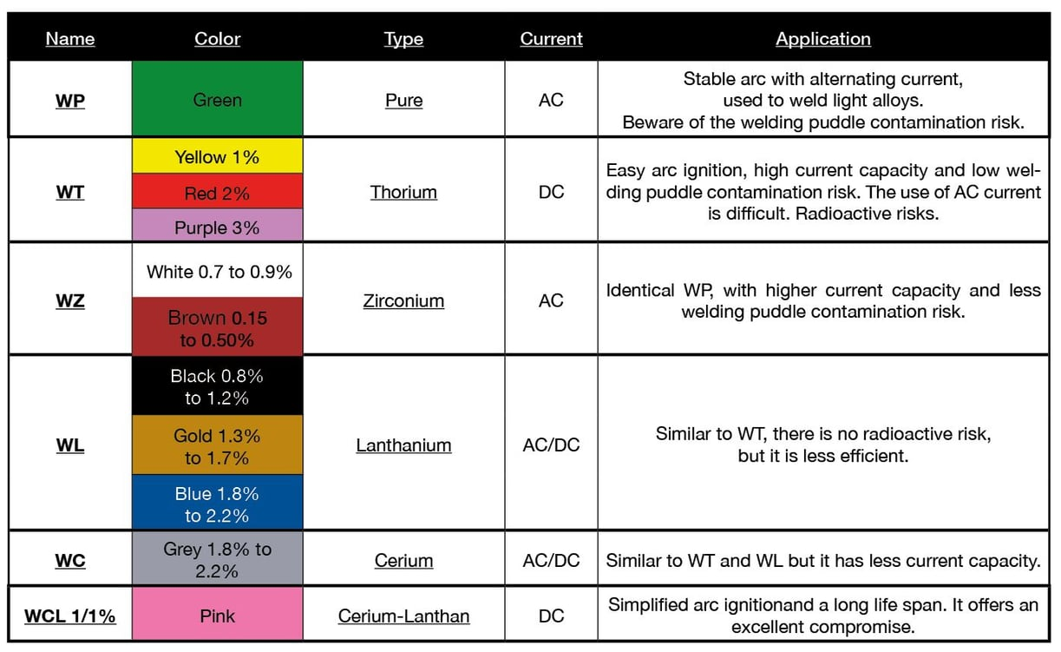
Figure 2:1 Types of electrode

Equipment maintenance procedures
The following items require routine inspection:
- Power sources: Approximately every six months, disconnect the power to the unit and blow out or vacuum the inside of the machine. ...
- Wire feeders: Periodically inspect the electrode wire drive rolls. ...
- Gun and liner assembly: Guns and torches should be kept in good working order and serviced at regular intervals by qualified technicians. ...
- Electrode holders: Fully insulated electrode holders should be used.

Fuel gas properties and application
Acetylene is a fuel gas which produces a very high temperature flame with the help of oxygen because it has more amount of carbon (92.3%) than any other fuel gas. Its chemical symbol is C2 H2 and composed of: -
- Carbon 92.3% (24 parts)
- Hydrogen 7.7% ( 2 parts)
It is a colorless gas, lighter than air and highly inflammable and burns with a brilliant flame. Commercial acetylene has pungent odor because of certain impurities. It forms a long range of explosive mixture with air any percentage between 3 x 80 becoming explosive on ignition. It may also explode when under unduly high pressure even in absence of air, when mixed with oxygen it explodes more violently. Acetylene absorbs heat during producing and liberates heat when decomposed.
There are two type of acetylene generators:
- Water – to – Carbide generators.
- Carbide – to – Water generators.
Dissolved acetylene means compressed acetylene pumped into steel cylinder filled with porous filling material soaked in acetylene.
Oxygen gas
Oxygen is a supporter of combustion. Its chemical symbol is O2. It is a clear, colorless, odorless and tasteless gas. It is slightly soluble in water. It does not burn itself, but supports combustion of fuels. It is industrially produced by two methods: -
- By air liquefaction.
- By electrolysis of water.
Oxyacetylene
Oxyacetylene gas welding is commonly used to permanently join mild steel. A mixture of oxygen and acetylene, burns as an intense / focused flame, at approximately 3,500 degrees centigrade. When the flame comes in contact with steel, it melts the surface forming a molten pool, allowing welding to take place. Oxyacetylene can also be used for brazing, bronze welding, forging / shaping metal and cutting.

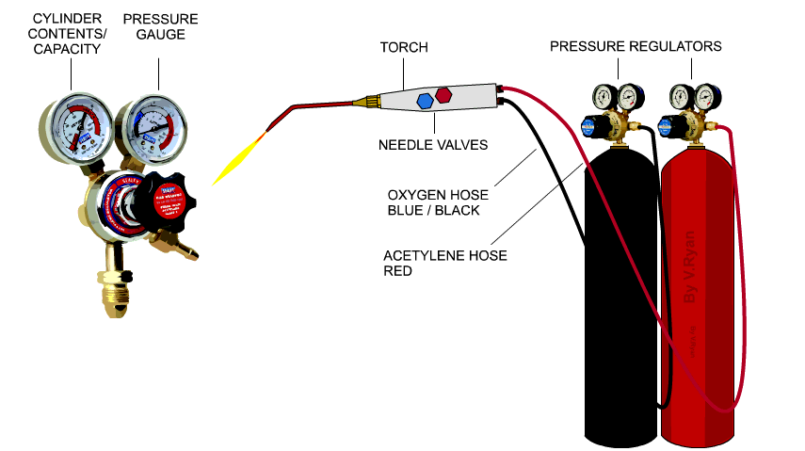
Figure 2:2 Oxyacetylene component
Hydrogen
Hydrogen produces low-temperature flame and is best for aluminum. Hydrogen flame isnon-luminous, commonly used for underwater welding (can be used at higher pressure than acetylene).
Gasses suitable for cutting but NOT welding:
- Propane
- Methane
- LPG
Hydrocarbon gases, such as propane, butane, city gas, and natural gas, are NOT suitable for welding ferrous materials due to their oxidizing characteristics. Although propane has a very high number of BTUs per cubic feet in its outer cone, it does not burn as hot as acetylene in its inner cone and therefore not very useful for welding operations. However with a right torch (injector style), propane can make a faster and cleaner cutting and is much more useful for heating and bending applications than acetylene. In some instances, many nonferrous and
Ferrous metals can be braze welded with care taken in the adjustment of flare and the use of flux.

Identifying welding treatments

Welding Defects
The lack of training to the operator or careless application of welding technologies may cause discontinuities in welding. In joints obtained by fusion welding, the defects such as porosity, slag inclusion, solidification cracks etc., are observed and these defects deteriorates the weld quality and joint properties.
Common weld defects found in welded joints
hese defects may result in sudden failures which are unexpected as they give rise to stress intensities. The common weld defects include
1. Porosity
Occurs, when the solidifying weld metal has gases trapped in it. The presence of porosity in most of the welded joints is due to dirt on the surface of the metal to be welded or damp consumables. It is found in the shape of sphere or as elongated pockets. The region of distribution of the porosity is random and sometimes it is more concentrated in a certain region. By storing all the consumables in dry conditions and degreasing and cleaning the surface before welding, porosity can be avoided.
- Lack of Fusion
Due to too little input or too slow traverse of the welding torch, lack of fusion arises. By increasing the temperature, by properly cleaning the weld surface before welding and by selecting the appropriate joint design and electrodes, a better weld can be obtained. On extending the fusion zone to the thickness of the joints fully, a good quality joint can be obtained.
- Inclusions
Due to the trapping of the oxides, fluxes and electrode coating materials in the weld zone the inclusions are occurred. Inclusions occur while joining thick plates in several runs using flux cored or flux coated rods and the slag covering a run is not totally removed after every run and before the next run starts. By maintaining a clean surface before the run is started, providing sufficient space for the molten weld metal between the pieces to be joined, the inclusions can be prevented.

  - Cracking
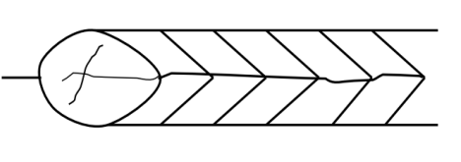
Due to thermal shrinkage, strain at the time of phase change, cracks may occur in various directions and in various locations in the weld area. Due to poor design and inappropriate procedure of joining high residual stresses, cracking is observed. This can greatly increase the cost of welded joints. Cracks are classified as hot cracking and hydrogen induced cracking. A schematic diagram of centerline crack is shown below fig. 3.1

The cracking can be minimized by preferring fillers with low carbon and low impurity levels. The solidification cracking can be avoided by reducing the gaps and cleaning the surface before welding.
Figure 2:3Schematic diagram of centerline crack
  - Undercutting
The undercut is caused due to incorrect settings or using improper procedure. Undercutting can be detected by a naked eye and the excess
  - Lamellar Tearing
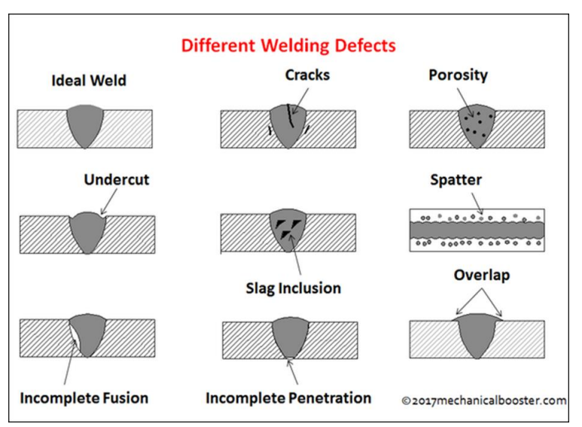
Due to nonmetallic inclusions, the lamellar tearing occurs through the thickness direction. This is more evidently found in rolled plates. As the fusion boundary is parallel to the rolling plane in T and corner joints, the lamellar tearing occur. By redesigning the joint and by buttering the weld area with ductile material, the lamellar tearing can be minimized.

Figure 2:4 Welding defects

Self-Check-2
INSTRUCTION ONE: -MULTIPLE CHOICES
Read each item carefully and choose the correct answer from the available four choices.

1.______are used on drawings to indicate the type and specifications of the weld.
A.Welding symbols
B. Joining
C.joining materials
D.all
2.The angle between the torch flame and the steel
A.Torch
B. Rod Angle
C.joining materials
D.a&b

Instruction Two: - Short Answer (2pts each)
Write the short answer on the space provided
- --------------It is an oxy-acetylene gas welding technique, in which the welding is begun at the left hand edge of the welding job and it proceeds towards the right.
- ------------ is produced by the combustion of a mixture of oxygen and acetylene in various proportions.
- ------------It receives an excess of acetylene over oxygen from the blowpipe.
- -------------It contains an excess of oxygen over acetylene as the gases come out of the nozzle.
- ------------Oxygen and acetylene are mixed in equal proportion in the blowpipe and complete combustion takes place in this flame.

Unit Three: Perform Manual Metal Arc Welding
This unit is developed to provide you the necessary information regarding the following content coverage and topics:
- Selecting materials, methods and techniques for arc welding
- Manual metal arc working procedures
- Reporting
This unit will also assist you to attain the learning outcomes stated in the cover page. Specifically, upon completion of this learning guide, you will be able to:
- Select materials, methods and techniques for arc welding
- Apply Manual metal arc working procedures
- Write welding Report

Preparing materials, methods and techniques for arc welding

Preparing materials for arc welding
Preparation the edges or surfaces of parts selected and to be joined by welding shall be prepared by shear, hack saw, power cutter or plasma arc cutting. Where hand cutting is involved the edge will be ground to a smooth surface. All surfaces and edges shall be free from fins, tears, cracks or any other defects which would adversely affect the quality of the weld. Before welding, the work pieces must be thoroughly cleaned of rust, scale and other foreign material. The piece for metal generally welded without beveling the edges, however, thick work pieces should be beveled or veed out to ensure adequate penetration and fusion of all parts of the weld. But, in either case, the parts to be welded must be separated slightly to allow better penetration of the weld.
All moisture, grease or other foreign material that would prevent proper welding or produce objectionable fumes, shall be removed. Contact with lead, zinc, or lead or zinc compound shall be avoided due to the potential for hot cracking. All surfaces to be welded shall be wire brushed prior to welding. In multi-pass welds the weld bead shall be wire brushed between passes.
The brushes shall be of stainless steel and be kept exclusively for use on stainless steel and be kept clean and free of contaminants. All other equipment such as grinding discs shall be kept exclusively for use on stainless steels

Methods and techniques for arc welding
- Setting the work piece
Once the selected work piece is prepared and cleaned, the next step is to tap the pieces to be joined after slightly striking electric arc on the way to checking whether the right amperage is set. Moreover, the tapped pieces should be positioned and clamped to a system of fixture. Generally the following should be considered while setting the work piece.
- Set the job in a flat position on the welding table
- Ensure there is good electrical contact between the job and the welding table.
- Striking and maintaining an Arc
Material: stick welding electrodes come in cast iron, high carbon steel, mild steel, iron-free (nonferrous), and special alloys.) Strength: referred to as tensile strength. Each weld needs to be stronger than the metal being welded. This means that the materials in the electrode need to be stronger as well.
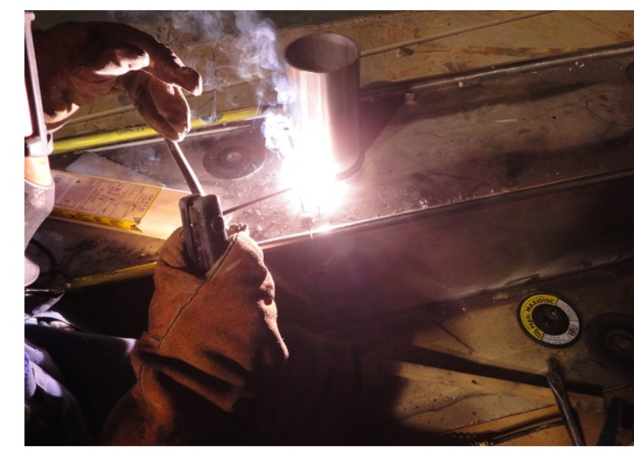
Figure 3:1 Stick welding electrodes
Scratching method:
- Hold the electrode about 25 mm above the job piece at one end perpendicular to surface
- Bring the welding screen in front of your eyes.
- Ensure safety apparatus is worn
- Strike the arc by dragging the electrode quickly and softly across the welding job,using wrist movement only.
- Withdraw the electrode approximately 6 mm from the surface for a few seconds
- And then lower it to (approximately) 4mm distance.
- If the arc has been properly struck, a burst of light with a steady sharp crackling
- Sound will be produced.
Tapping method:
- Strike the arc by moving the electrode down to touch the job surface lightly.
- Move the electrode slowly up approximately 6mm for a few seconds and thenϖ lower it to approximately 4 mm from the surface.
- The tapping method is generally recommended as it does not produce pit marksϖ on the job surface

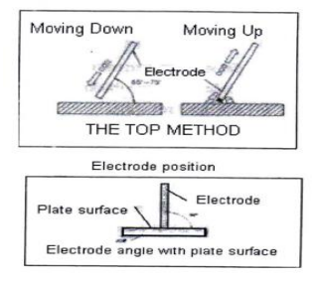
Figure 3:2 Stick welding electrodes (tapping method)

Manual metal arc working procedures
To weld materials by manual arc welding, the following common procedures should be followed. Safety and other issues should be considered as described in the previous information sheets of this learning guide.
- Set the arc welding plant by one cable connection to electrode with electrode holder another connection for work piece with earthling clamp.
- Set the current range• & electrode according to plate thickness.
Ex: 6mm plate i) Current range 120Amps
ii) Electrode size 3.2mm Diameter
- Set the work piece for tack weld by fixing with C Clamp using suitable tack welding fixture.
- Tack the pieces at both ends by scratching or tapping method.
- Place the tack weld unit to full bead welding fixture as provided in working table.
- Deposits full bead weld with correct i) Arc lengths 3 to 5mm ii) Electrode angle 700 to 80o iii) Travel speed 150mm/min iv) uniform Movement v) Direction towards your end , usually from left to right for right handed welders.
- Reverse the joint to perform full bead on other end.
- Chip off all slag, remove spatters with using white spectacles
- Clean the bead by wire brush with using white spectacles
- Inspect the weld bead
This process employs coatings or fluxes to prevent the weld pool from the surrounding atmosphere.

- Switch box.
- Secondary terminals
- .Welding machine.
- Current reading scale.
- Current regulating hand wheel.
- 6Leather apron.
- Asbestos hand gloves.
- Protective glasses strap
- Electrode holder.
- Hand shield
- Channel for cable protection
- Welding cable. \
- Chipping hammer.
- Wire brush.
- Earth clamp.
- Welding table (metallic).
- Job

Reporting

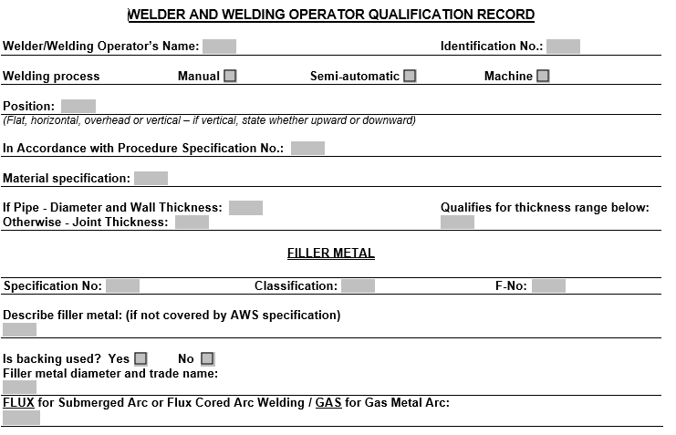

Self-Check-3

Instruction one: -Multiple Choices
Read each item carefully and choose the correct answer from the available four choices.

1.______are used on drawings to indicate the type and specifications of the weld.
A. Welding symbols
B. Joining
C. Joining materials
D. All
2.The angle between the torch flame and the steel
A. Torch
B. Rod Angle
C. Joining materials
D. A&B

Instruction Two: - Short Answer (2pts Each)
Write the short answer on the space provided
- --------------It is an oxy-acetylene gas welding technique, in which the welding is begun at the left hand edge of the welding job and it proceeds towards the right.
- ------------ is produced by the combustion of a mixture of oxygen and acetylene in various proportions.
- ------------It receives an excess of acetylene over oxygen from the blowpipe.
- -------------It contains an excess of oxygen over acetylene as the gases come out of the nozzle.
- ------------Oxygen and acetylene are mixed in equal proportion in the blowpipe and complete combustion takes place in this flame.

Unit Four: Perform Oxy Acetylene Welding
This unit is developed to provide you the necessary information regarding the following content coverage and topics:
- methods and techniques for oxy acetylene welding
- Oxy acetylene working procedures
- Reporting
This unit will also assist you to attain the learning outcomes stated in the cover page. Specifically, upon completion of this learning guide, you will be able to:
- Apply methods and techniques for oxy acetylene welding
- Understand and Apply Oxy acetylene working procedures
- Write Report for oxy acetylene welding

Methods and techniques for oxy acetylene welding
    - Welding Techniques

The welder guides the welding torch in a straight line and moves the welding rod in a dabbing action (the welding torch follows the welding rod). To weld using the leftward technique, hold the welding rod in your left hand and use your right hand to guide the welding torch. The welding is started from the right side towards the left side.

Leftward Technique The leftward technique of Oxy-Acetylene welding is employed to weld steel plates that are up to 5mm thick. Rightward Technique For metal plates that are more than 4mm in thickness, the rightward technique is recommended. All-Position Rightward Weld The all-position rightward weld is a modification of the rightward technique.

Oxy acetylene working procedures
- Oxy-Acetylene welding/cutting safety procedure should not be carried out in a crowded area; job area should be segregated.
- All the combustible materials must be removed, be it liquid solid or gaseous. As far as it is not needed for the activity at hand.
- The combustible materials which unable to be removed from their place, they must be covered with any kind of insulate materials.
- Flame-resistant sheets may be used.
- Fire extinguishers must be available and workable, and placed in a strategic position.
- Always use an approved friction striker, never use matches or a cigarette lighter.
- All gas cylinders must be properly labeled.
- Never point the flame towards the regulators and another person.
- If the gauge doesn’t return to zero when pressure is released, have it repaired.
- Keep tight connections between the regulator and the cylinder.
- Extinguish the torch flame by closing the acetylene valve first and then the oxygen.
- When finished welding shut off the main valves, bleed the lines and loosen the regulator adjusting screws.
- Wind up the hoses when finished shutting everything off.
- Do not turn acetylene valve more than 1 ½ turns.
- Make sure the lines are purged before and after use.
- Only a qualified technician should repair a regulator.
- Store the cylinders in a well-ventilated area, preferably in the open air.
- Never allow hoses to become coated with oil, grease or dirt, since such coatings could conceal damaged areas.
- The storage area for cylinders should be well away from sources of heat, sparks and fire risk.
- If cuts, burns or damaged fittings are found, replace the hose.
- Hoses should be examined before attaching to torch handle.
- Cylinders should be stored upright and well secured
- Oxygen cylinders should be stored at least 3m away from fuel gas cylinders (Acetylene gas cylinder) or separated by a 30 minute fire resisting barrier.
- Cylinder valves or valve guards should never be loosened
- Ensure that the regulator is rated for the pressure in the cylinder.
- When attaching the regulator to the cylinder the joints must be clean and sealant must not be used.
- Always make sure your equipment is rated for the size tip you have selected.
- A tip with too much capacity for the equipment can starve or choke the tip. This causes overheating of the head and a flashback may result.
- Should a flashback occur (flame disappears and/or a hissing sound is heard, the flame is burning inside the nozzle), immediately turn off the oxygen valve on the torch handle. Then, turn off the fuel valve, allow the nozzle to cool before using.
- When cleaning the cylinder threads, connecting the regulator and purging the hoses, protect face and eyes by wearing the appropriate head shield
- Ensure the cylinder is not heated by the flame or by stray arcs from adjacent electrical equipment.
- Joints and hoses should be checked for leaks before any welding is attempted.
- Ensure that flashback arrestors are in place. The flash back arrestor is an automatic flame trap device designed not only to quench the flame but also to prevent the flame from reaching the regulator.
- Do not attempt to interchanges oxygen and acetylene regulators.
- Always use proper PPE (shield, goggles, gloves, clothing, etc.)

Reporting

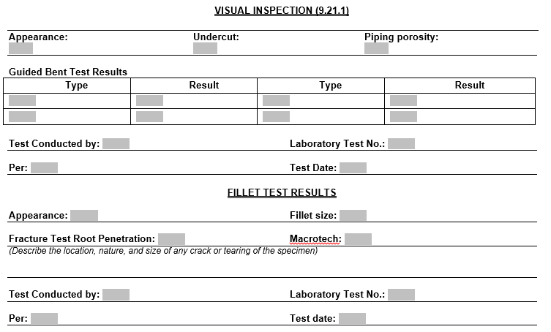

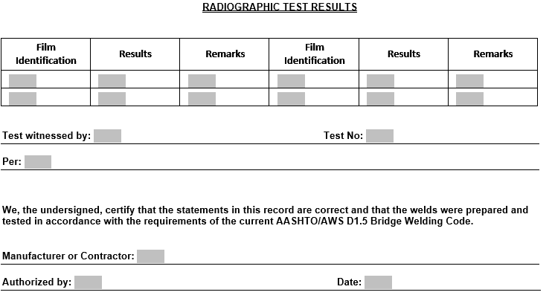

Operation Sheet 4.1
Operation Title: Butt Joint:
Instruction: Choose the Right Filler Material & critical step in butt joint preparation
Purpose: the purpose of this Operation Sheet is how to join metals by applying Butt Joint: Methods
Required tools and equipment:
Oxy-acutely welding machine
Plates
Precautions:
- Be sure the welder is properly installed and grounded.
- Never weld without adequate ventilation.
- Take proper precautions to prevent fires.
- Protect your entire body with fire retardant clothing, shoes, and gloves.
- Wear eye protection at all times.
- Weld only in a fire safe area.
Procedure
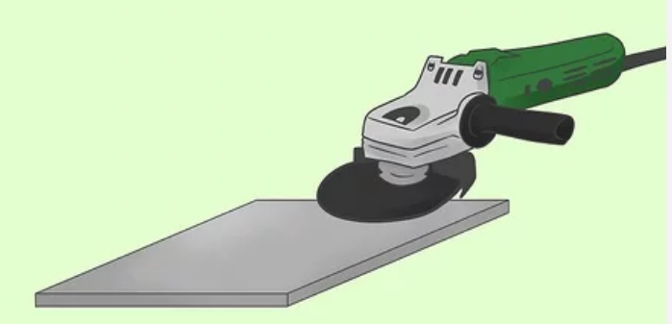
Step 1. Obtain all necessary equipment. This should be a welding machine, electrode and work piece clamps (and their leads), a welding helmet darker than shade 10, welding gloves, and appropriate safety clothing.

Step 2. Prepare the metal to be welded. This includes grinding down rough edges and cleaning the areas to be welded.

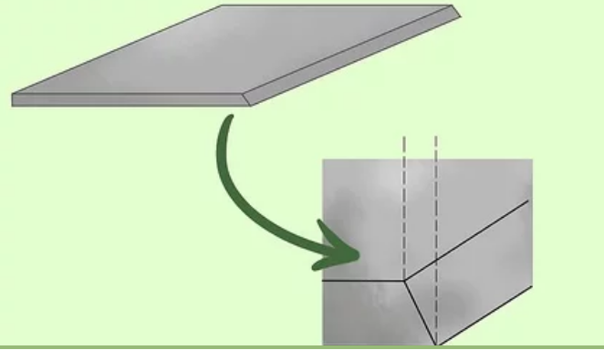

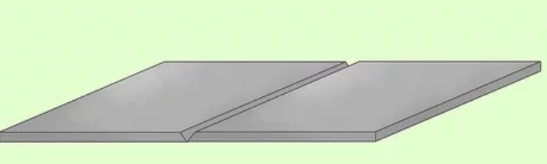
Step 3. Bevel the edge of the metal if it is thicker than 1⁄4 inch (0.6 cm). Beveling allows for better penetration of the root pass and subsequent passes. Beveling can be done with an oxy-fuel torch or a plasma arc cutter, but isn't necessary on thinner metal.

Step 4. Align your metal to make sure the edges line up well. They should be smooth and align cleanly.
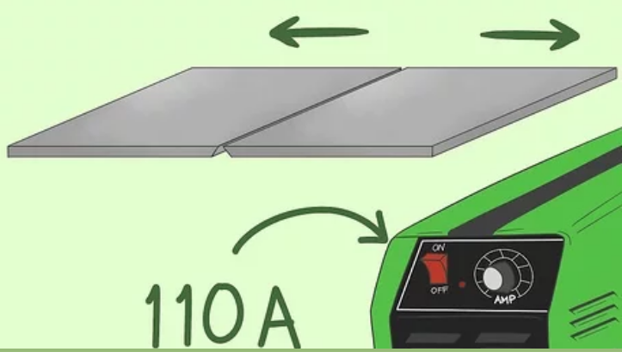
Step 5. Turn your pieces over. This should be the flat side if on or more pieces are beveled, or the side you don't want to start welding.

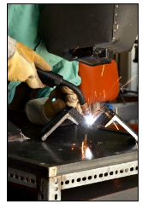
Step 6. Separate the pieces a little bit and set the amperage on your machine about 10 percent higher than the level you intend to use welding the metal. So, if you are going to use 100 amps to make your weld(s), set your amperage at 110 amps.
Step 7. Make tack welds. These will hold the metal together and prevent it from warping or bending inward when the weld is finished. To make a tack weld, strike an arc and let it sit for a few seconds. A few tack welds are usually needed and you should be able to break them with a hammer or wrench.
Step 8. Flip your metal over to be welded.
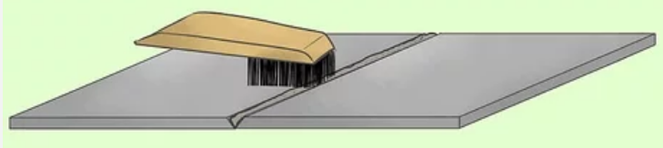
Step 9. Strike an arc and create your root pass. This is going to be the first and deepest pass on your weld, and if the metal is thick enough, the only pass you'll need. If you beveled the steel start at the bottom for your root pass. You need to ensure the root pass penetrates deeply enough, and for this reason 6010 electrodes are frequently used for this purpose.

Step 10. Clean the weld with a hammer and wire brush and make subsequent passes if needed. These passes should strengthen the weld and fill it in. Make sure to clean each pass before you start a new one.
Quality criteria:
The basic conditions of welding quality to achieve products of such high quality includes the following:
No cracks or holes found in the bead.
The bead has uniform waves, width and height.
The finished product satisfies the design dimensions and has almost no distortion.

Operation Sheet 4.2
Operation Title: How to Prepare Lap Joint:
Instruction: Choose the Right Filler Material & critical step in Lap joint preparation
Purpose: the purpose of this Operation Sheet is how to join metals by applying Butt Joint: Methods
Required tools and equipment:

- Welding power supply
- Flat file
- Welding rod
- Chipping hammer
- Electrode holder
- Wire brush
- Gloves and apron
- Earthling clamps
- Shield and goggles

Precautions:
- Be sure the welder is properly installed and grounded.
- Never weld without adequate ventilation.
- Take proper precautions to prevent fires.
- Protect your entire body with fire retardant clothing, shoes, and gloves.
- Wear eye protection at all times.
- Weld only in a fire safe area.
Procedure
Step 1. The given work pieces are thoroughly cleaned, i.e. rust, scales are removed and the edges are filed.
Step 2. The electrode is held in an electrode holder and ground clamp is clamped to the welding plates and the power is supplied.
Step 3. The work pieces are positioned on the table to form a “Lab joint”.
Step 4. The tag weld is done on the both the ends of joining plates to avoid the movement of work pieces during welding.
Step 5. The welding is carried throughout the length of the work pieces on both sides by maintaining 3mm gap between plates and the welding rod.
Step 6. The welded plates are allowed for air cooling after the slags are removed.
Step 7. The weld joint portions are cleaned by wire brush.
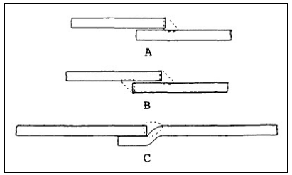
As the name implies, your joint will be your base metal overlapping one another:
Image A is an example of a one sided weld (fillet weld) of a single lap joint.
Image B shows you a weld on both sides which will make it much stronger.
Image C is what is called an offset lap joint. Your weld will be done in the natural seem made by the offset. It is usually a stronger weld than a single lap joint, but it can be more a more challenging joint preparation.
Quality criteria:
The basic conditions of welding quality to achieve products of such high quality includes the following:
No cracks or holes found in the bead.
The bead has uniform waves, width and height.
The finished product satisfies the design dimensions and has almost no distortion.

Operation Sheet 4.3
Operation Title: How to Prepare Tee joint:
Instruction: Choose the Right Filler Material & critical step in Tee joint preparation
Purpose: the purpose of this Operation Sheet is how to join metals by applying Tee joint: Required tools and equipment:
1. Welding power supply
2. Flat file
3. Welding rod
4. Chipping hammer
5. Electrode holder
6. Wire brush
7. Gloves and apron
8. Earthling clamps
9. Shield and goggles
Precautions:
- Be sure the welder is properly installed and grounded.
- Never weld without adequate ventilation.
- Take proper precautions to prevent fires.
- Protect your entire body with fire retardant clothing, shoes, and gloves.
- Wear eye protection at all times.
- Weld only in a fire safe area.
Procedure
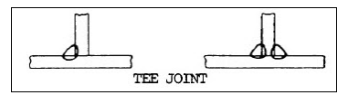
A Tee joint is another joint that looks the way it sounds. If you look at it from a cross sectional view it looks like the letter 'T'.
So it basically where two pieces of flat bar, plate, or whatever are at a right angle but not on the edge. If it was on the edge you would be making more of a corner joint.
As you can see in right hand side image above there is weld on either side of it. To prepare this Tee Joint you will bevel the edges, tack weld it on both sides, and then lay a bead on either side. But there are occasions where you will only weld one side as you can see in the left hand image.
Note that the beveled edges on either a single side or double side weld will be at an angle that is about 50% of what you would do on a Butt joint.
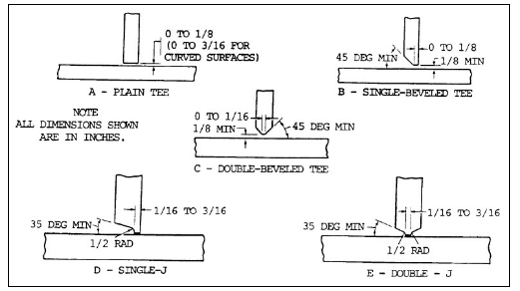
Joint Preparation for Tee Joints Part 2:

Step1 A regular Tee joint is seen in Image A above. This is a Tee joint that does not require any prep. Of course, you will clean the base metal (both pieces).
Step 2 Image B shows a single joint bevel. This will be used on heavier sections and you will be welding both sides.
Step 3 Image C is a joint that has been beveled on both sides, and both sides are welded as well. This type of preparation is for thick plates.
Step 4 Image D is what is called a sing J joint. You will weld both sides of this material but only bevel one side of the joint.
Step 5 Image E is to be used on even heavier or thicker material and it is called a double j joint.
It is very important that you get good penetration. You want penetration to the root of your weld.
Quality criteria:
The basic conditions of welding quality to achieve products of such high quality includes the following:
- No cracks or holes found in the bead.
- The bead has uniform waves, width and height.
- The finished product satisfies the design dimensions and has almost no distortion.

LAP Test 4
Task 1. Select the tools and equipment to Butt Joint
Task 2. perform the Butt Joint

Unit Five: Clean and Maintain Workshop
This unit is developed to provide you the necessary information regarding the following content coverage and topics:
- Procedures of Waste and scrap removing
- Reused, collect and store materials
- Maintain tools and equipment
This unit will also assist you to attain the learning outcomes stated in the cover page. Specifically, upon completion of this learning guide, you will be able to:
- Apply Procedures for the removal of Waste and scrap
- Reuse, collect and store materials
- Maintain tools and equipment

Waste and scrap removing

Waste: This is a loss connected with raw material or inputs to the production process and usually means to refer that input has been lost due to any reason either because of its nature of the material itself, nature of the process or some other conditions. Sometimes such output that does not have any sales or use is also referred as waste.
For example in paint industry many chemical are used that are volatile i.e. can evaporate at room temperature. Another example can be of break-oil which is wasted in the process named “bleeding” in which air bubbles are removed from the pressure pipes so that hydraulics can work effectively.
Scrap: This is a loss connected with the output. Most of the time at the end of production/conversion process such outputs is generated that were not intended but cannot be eliminated due the nature of material or process itself. Usually they are of no to insignificant value as compared to the main product that was intended. We usually know them with the term by-products. This is considered as loss as not all of the raw material is converted into intended product. For example, in furniture manufacturing chippings of wood and sawdust is a common example. Another very known example is of gold dust in jewellery and gold industry.

Reused, Collect and Store Materials
- Store all welding wire and base metal in a dry location with a minimum temperature fluctuation.
- Welding wire should preferably be stored in a dry heated room or cabinet.
- Store metal vertically to minimize moisture condensation and absorption of water contamination between layers.
- Bring all filler and base metal materials into the welding area 24 hours prior to welding to allow them

Maintain tools and equipment
- Welding equipment maintenance tips Here are some important tips to remember to ensure that your welding equipment is in smooth-running condition all year round.
- Schedule maintenance per parts.
- Follow specification instructions, use a cover and keep a distance from the machine. ...
- Replace damaged parts when needed.

Self-Check-5

INSTRUCTION ONE: - SHORT ANSWER (2pts each)
Write the short answer on the space provided
  - Write the tips of maintenance
- ----------------------------------------------------------------------------
- -------------------------------------------------------------------------
- -------------------------------------------------------------------------
- ----------------------------------------------------------------------------
- ---------------------------------------------------------------------------
  - Write material storage procedure
- ----------------------------------------------------------------------------
- -------------------------------------------------------------------------
- -------------------------------------------------------------------------
- -------------------------------------------------------------------------------------------------------------------------------------------------------
  - Write material re-usage procedure
- ----------------------------------------------------------------------------
- -------------------------------------------------------------------------
- -------------------------------------------------------------------------
- ----------------------------------------------------------------------------
- ---------------------------------------------------------------------------

Annex
Terminology
- Acetone: A flammable liquid used in acetylene cylinders to dissolve and store acetylene.
- Acetylene: A colorless, flammable gas that is used in ox fuel welding. Acetylene is the most commonly used gas for mixing with oxygen to fuel ox fuel torches.
- Airtight: Not allowing any gases or air to penetrate. An airtight joint will not leak any gas.
- Aluminum: A silvery white metal that is soft, light, and has a high strength-to weight ratio. Aluminum is one of the most difficult metals to weld.
- Arc welding: A joining process that uses electricity to generate the heat needed to melt the base metals.
- Braze pool: The pool formed by the melted filler metal during braze welding. The temperature to melt the filler metal is low enough that the pieces being joined do not melt.
- Braze welding: A process in which a filler metal is melted at a temperature above 840° F (450° C), but below the melting point of the base metals to fill in a gap between two base metals. Braze welding differs from brazing because the filler metal is used to fill a gap.
- Brazing: A joining process that is used to combine dissimilar metals at temperatures lower than welding.
- Butt joint: A joint formed by joining two pieces of metal edge to edge.
- Capillary action: The ability of a substance to draw a liquid upwards against the force of gravity. In brazing, capillary action causes a filler metal to be drawn into the space between work pieces.
- Copper: A reddish metal that is very ductile, thermally and electrically conductive, and corrosion resistant. Copper can be welded using limited methods.
- Cutting: The use of an ox fuel torch to separate metal from a work piece. Oxy-fuel cutting uses an additional high-pressure stream of oxygen to cut metal.
- Cylinder: A container for compressed gases. Each gas is stored in a unique type of cylinder.
- Die: A reusable mold that holds heated liquid metal and imparts its shape as the metal cools. Oxygen cylinders are shaped in dies.
- Distillation: The process by which oxygen is extracted from the air to be stored in a cylinder.
- Ductility: The ability of a metal to be drawn, stretched, or formed without breaking.
- Edge joint: A joint formed by joining the edges of two pieces of metal that are parallel to each other.
- Ferrous metal: A metal that contains iron. Ferrous metals are the most common type of welded metal.
- Filler metal: A type of metal sometimes added to the joint in fusion welding. Filler metal adds to the strength and mass of the welded joint.
- Flashback: A torch malfunction in which the flame briefly or continually moves up into the torch and hoses. If a flame reaches the hoses, an explosion can occur.
- Flashback arrestor: A part of an oxy fuel outfit that is installed between the hoses and the torch. A flashback arrestor reduces the chances of flashback occurring while a torch is used.
- Flux: A non-metallic material used to protect the weld puddle and solid metal from atmospheric contamination.
- Hose connector: The part of an oxy fuel torch where the flashback arrestor is attached to the torch.
- Impurities: Any elements contained in an oxy fuel weld that are not the metal being joined or the filler metal.
- Injector: The part of an injector torch that pulls low-pressure acetylene into the torch and mixes it with oxygen.
- Injector torch: A type of torch that uses lower-pressure acetylene and features an internal injector that pulls the acetylene into the torch.
- In-tip mixer: A welding tip that contains a mixing chamber as part of the tip.
- Joining: Bringing two separate materials together through some type of forming. Joining is one of the main ways metals can be formed.
- Lap joint: A joint formed by two overlapping pieces of metal.
- Low-carbon steel: Carbon steels that contain less than 0.3% carbon. Also referred to as mild steel, low-carbon steel is the most commonly welded metal.
- MAPP gas: Also called methylacetylene-propadiene gas. A liquefied petroleum gas that can be used in ox fuel processes. The main disadvantage of MAPP gas is that it costs much more than acetylene.
- Metal: A hard, crystalline solid that conducts electricity and heat. It is shiny when polished, and it can be hammered, bent, formed, and machined.
- Mixing chamber: A part of an ox fuel outfit that is connected to the tip of the torch, or is part of the tip. The mixing chamber is where the two gases are combined before being burned by the flame.
- Non-ferrous metal: A metal that does not contain iron. Nonferrous metals are more difficult to weld than ferrous metals.
- Orifice: The hole or holes at the end of a torch tip. The shape and number of holes determine the use of the tip.
- Outside corner joint: A joint formed by the edges of two metal pieces being welded together at an angle of around 90 degrees. The weld is done on the outside of the corner.
- Oxide: A chemical compound containing oxygen and one other element. Oxides form during oxyfuel welding is harmful to the weld.
- Oxy-fuel welding: A joining process that uses a mix of gases to fuel a torch to join two metal parts.
- Oxygen: A nonmetallic element that is colorless, odorless, and tasteless. Oxygen is one of the two gases used in ox fuel welding.
- Porous: Full of holes that allow the material to absorb liquids. The material inside an acetylene cylinder is porous, enabling it to hold acetone.
- Positive pressure torch: A torch that uses equal pressures of oxygen and acetylene and does not have an injector.
- Propylene: Also known as propane. A flammable gas that can be used in ox fuel welding instead of acetylene.
- Soldering: A joining process in which a filler metal is melted at temperatures below 840° (450° C) to form a joint between two base metals. Soldering is often used for delicate projects such as jewelry and electronics.
- Stainless steel: A type of steel that contains more than 15% chromium and exhibits excellent corrosion resistance. Stainless steel can be welded using many methods.
- T-joint: A joint formed when the edge of one piece is welded to the surface of another piece at a 90° angle.
- Torch: A tool used to generate the flame for ox fuel welding by mixing oxygen and a fuel gas, usually acetylene.
- Torch body: Also called the handle. The part of the torch held by the welder. Inside the torch body are hoses which direct the flow of gases to the mixing chamber.
- Unstable: Highly reactive and dangerous, possibly explosive. Unstable chemicals require careful handling to ensure safety.
- Valve: The part of the torch used to regulate the amount of oxygen and fuel gas flowing into the torch.
- Watertight: Not allowing any liquids to penetrate. A watertight joint will not leak any liquids at all.
- Welding rod: Also known as a filler metal. Filler metals come in rods that are used during the welding process.
- Welding tip: The end of the torch where the flame is ignited. Tips are usually interchangeable, and are made of solid copper.

Reference
- Literature provided by EWAC Alloys Limited Mumbai (a subsidiary of L&T Limited).
- . Book on Welding Engineering Technology by Dr.R.S.Parmar.
- Book on Welder Trade Theory published by National Instructional Media Institute, Chennai (under Directorate General of Employment and Training, Ministry of Labour and Employment, Govt. of India).
- Book “Welding notes for Artisans” issued by Basic Training Centre (C&W), Nagpur Division, Central Railway.
- Suggestions received during seminar held on 14th November, 2011 at CAMTECH Gwalior on “Welding process for good quality weld”
- https://www.mbaskool.com/business-concepts/marketing-and-strategy-terms/11884-customer-requirements.html
- https://www.bizmanualz.com/increase-customer-satisfaction/what-are-the-customers-requirements.html
- https://axenics.com/blog/contract-manufacturing-vs-component-manufacturing-whats-the-difference
- http://www.technologystudent.com/despro_flsh/manspec1.html
- https://lawpath.com.au/blog/what-is-an-industry-code-of-practice
- https://www.worksafe.qld.gov.au/laws-and-compliance/codes-of-practice
- https://www.codea.com.au/publication/workplace-policies-and-procedures/
- https://www.thoughtco.com/using-material-safety-data-sheets-602279
- https://www.uregina.ca/hr/hsw/assets/docs/pdf/Laboratory-Safety/Material-Safety-Data-Sheet.pdf
- https://www.ccohs.ca/oshanswers/legisl/msdss.html
- http://www.acastronovo.com/ClassHtms/Weld01.htm
- https://www.sciencedirect.com/topics/engineering/gas-welding
- http://ignou.ac.in/upload/Unit-5.pdf
- https://en.wikipedia.org/wiki/Standard_operating_procedure
- https://www.lawinsider.com/dictionary/manufacturers-specifications

Participants of this Module (training material) preparation
No | Name | Qualification | Field of Study | Organization/ Institution | Mobile number | E-mail
 | Adinet Asnake | MSc | Automotive Technology Mgt | Wolkite PTC | 0913767250 | andinetasnake31@gmail.com
 | Biruk Tilahun | BSc | Automotive Technology | General Wingaste PTC | 0913789176 | biruktilahun1@gmail.com
 | Fadli Aman | BSc | Automotive Technology | General Wingate PTC | 0927283100 | Fadli.ziyad@gmail.com
 | Hana Nigusise | BSc | Automotive Technology | Selam TVET college | 0988751516 | Hana.nigussie25@gmail.com
 | Israel Taye | BSc | Automotive Technology | General Wingate PTC | 0913424100 | Isra.taye@gmail.com
 | Tatek Mamo | PhD scholar | Automotive Technology | DEC | 0911841121 | mimibaba928@gmail.com
 | Zelalem Yitbarek | BSc | Automotive Technology | Selam TVET college | 0972030621 | Zolosmart12@gmail.com

