
Heavy Vehicles and Earth Moving Machinery Maintenance
Level-II
Based on November, 2022 Curriculum Version 1
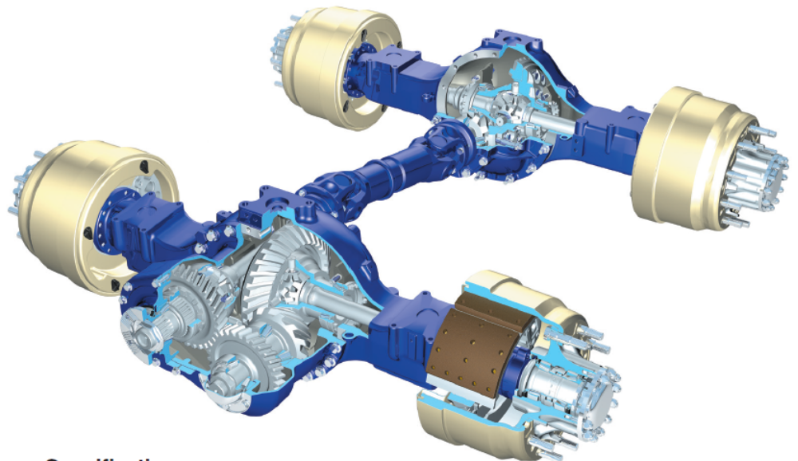

Module Title: - Service driveline components
Module code: EIS HEM2 M10 1122
Nominal duration: 70 Hour

Prepared by: Ministry of Labor and Skill
November 2022
Addis Ababa, Ethiopia

Table of Contents
Acknowledgment 5
Acronym 6
Introduction to module 7
Unit one: Introduction to Heavy Vehicle and Equipment Driveline maintenance 9
1.1 Overview of Heavy Vehicle and Equipment Driveline 10
1.2 Types of driveline layout 11
1.2.1 Transaxle layout 11
1.2.2 Front Engine Rear Wheel Drive (FRWD) 12
1.2.3 Four Wheel Drive layout (4WD) 13
1.3 Major components of driveline 15
1.3.1 Drive shaft line assembly 15
1.3.2 Final drive and drive axles 21
1.3.3 Wheel Bearing and Hub Assembly 27
1.4 OHS and PPE requirements 30
1.4.1 PPE Requirement 30
1.4.2 OHS Requirement 32
1.5 Hand Tools and equipment requirement 36
Self-check-1 39
Unit Two: Maintaining drive shaft line assemblies 40
2.1 Road test 40
2.2 Propeller shaft maintenance 41
2.3 Universal joint service and maintenance 42
2.3.1 Universal Joint Inspection 42
2.3.2 Universal Joint Disassembly 43
2.4 CV Joint service and maintenance 43
2.4.1 CV-joint inspection 43
2.4.2 CV-joint service 44
2.5 Inspecting mounting points and fittings 45
2.5.1 Inspecting Yoke End Fittings 45
2.5.2 Inspecting Centers Bearing (Carrier Bearing) 46
2.5.3 Inspecting the Driveshaft Tube 46
2.5.4 Inspecting drive line Mounts 46
Self-check-2 48
Operation sheet-2 49
Unit Three: Maintain Differential and drive Axle 52
3.1 Differential Inspection before Disassembly 52
3.2 Differential Overhaul 53
3.2.1 Differential/Crown Gear Disassembly 54
3.2.2 Inspection after Disassembly of Carrier 56
3.2.3 Differential Carrier Assembly 57
3.2.4 Installing the Differential Carrier into the Axle Housing 60
3.2.5 Axle Assembly Adjustments and Checks 60
3.2.6 Checking/Adjusting Pinion Cage Shim Pack 62
3.2.7 Differential Bearing Preload Adjustment 63
3.2.8 Ring Gear Runout Check 64
3.2.9 Ring Gear Backlash Adjustment 64
3.2.10 Ring Gear Tooth-Contact Adjustment 65
3.3 Drive axle inspection and repair 67
3.3.1 Planetary Wheel End Removal 68
3.3.2 Planetary Wheel Ends Installation 69
3.3.3 Wheel Bearing Adjustment Procedures 69
Self-check-3 72
Operation sheet-3 74
Unit Four: Prepare equipment and vehicle for use or storage 79
4.1 Inspect Tools and equipment 79
4.2 Clean Tools and equipment 79
4.3 Lubricate Tools and equipment 80
4.4 Store Tools and equipment 80
Self-check-4 80
LAP-TEST 81
Reference 82

Acknowledgment
Ministry of Labor and Skills wish to extend thanks and appreciation to the many representatives of TVT instructors and respective industry experts who donated their time and expertise to the development of this Teaching, Training and Learning Materials (TTLM).

Acronym

2WD | Two wheel drive
4WD- | Four Wheel drive
AWD | All wheel drive
6WD | Six wheel drive
CAN | Computer area network
CV | Continues Variable
FWD | Front wheel drive
Lap-Test | Learning activity performance
LSD | Limited Slip Differentials
MP | Multi-purpose
RWD | Rear wheel drive
SST | Special service tools
SUV | Sport utility vehicle
TTLM | Teaching, Training and Learning Materials
U-joint | Universal joint

Introduction to module
Heavy-duty commercial vehicles and earth moving machines play a vital in economic development of any country. Since this equipment are very expensive, providing adequate preventive as well as corrective maintenance will support in effective utilization their potential. Accordingly, a carrier of maintaining driveline of such heavy-duty commercial vehicles and earth moving machines is highly demanded in the world; which requires standard training and qualification. Hence, this module is prepared to support training of specific unit of competence, which contains how to maintain heavy-duty vehicles and earth-moving machines drive line assemblies. In addition, it involves minor inspections to identify deviations from correct operation, removal, disassembly and fitting procedures for main and interrelated components following manufacturer specification.
This module is designed to meet the industry requirement under the heavy duty vehicles and earth moving machines maintenance level II occupational standard, particularly for the unit of competency: Maintain drive line assemblies.
This module covers the units:
- Overview of heavy duty vehicles and earth moving machines maintenance
- Servicing drive shaft line assemblies
- Servicing differential and drive axles
- Clean-up work area and finalize work processes
Learning Objective of the Module
- Comprehend drive line assemblies
- Inspect drive line assemblies
- Service drive line assemblies
- Repair drive line assemblies
- Clean-up work area and finalize work processes
Module Instruction
For effective use this modules trainees are expected to follow the following module instruction:
- Read the information written in each unit
- Accomplish the Self-checks at the end of each unit
- Perform Operation Sheets which were provided at the end of units
- Do the “LAP test” giver at the end of each unit and
- Read the identified reference book for Examples and exercise

Unit one: Introduction to Heavy Vehicle and Equipment Driveline maintenance
This unit is developed to provide you the necessary information regarding the following content coverage and topics:
- Overview of automotive powertrain
  - Introduction to Heavy Vehicle and Equipment Driveline
  - Fundamentals of drive shafts differentials and hydrostatic transmission
  - Types of drive line layout
  - Major components of drive line
  - OHS and PPE requirement
  - Tools and equipment requirement
This unit will also assist you to attain the learning outcomes stated in the cover page. Specifically, upon completion of this learning guide, you will be able to:
- Identify heavy vehicle drive line assemblies
- Explain basic concepts of drive shaft and hydrostatic transmission
- Describe operation and function of drive shaft line assembly
- Demonstrate operation of Final drive and axle shafts
- Identify types of drive axles and wheel bearing

Overview of Heavy Vehicle and Equipment Driveline
Heavy vehicles and equipment found at commercial transportation, construction sites, open pit mines, and quarries these days is capable of hauling hundreds of tons at a time. The torque generated by the use of large gear reductions (up to 100:1) found in heavy equipment powertrain components (often as high as 135580Nm/100,000 lb-ft) are generated at the wheel ends. This high torque must be handled by a series of drivelines on its way to the final drives. Hence, it transmits torque from the engine and transmission to drive the vehicle’s wheels.
The driveline changes the direction of the power flow, multiplies torque, and allows different speeds between the two drive wheels. Driveline technology has evolved considerably, since the development of the modern driveshaft U-joint arrangement as shown in (Figure 1-1) has evolved to what could be considered as an engineering marvel. Whereas overall mechanical driveline includes propeller shaft, universal joint, slip joint, center bearing and support; which transmits power to differential and/ or final drive and drive axles,
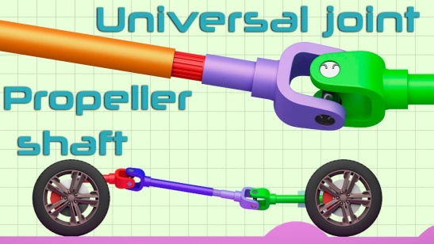
Figure 1-1 Front engine with front and rear wheel drive
On the other hand, hydrostatic drive systems, as shown in (Figure 1-2) can be found on most tracked earth moving machines, where it is capable of using hydraulic fluid under pressure to convert diesel engine power to fluid power, and then convert it back to mechanical power at the wheels or tracks. In a hydrostatic drive system used on heavy equipment, the hydraulic pump, which is turned by a diesel engine, supplies the movement of oil, while the motor converts the hydraulic energy back to mechanical energy to provide drive.
The main advantages of hydrostatic drive system are: -
- Ability to provide infinite speed and torque range in both directions of travel
- Capability of generating a dynamic braking effect to slowing or stopping or even to coast
- Capability to deliver 90% full torque at start-up along with providing maximum flexibility when it comes to engine placement on a machine.
- Lower overall weight of the powertrain than equivalent conventional drive systems
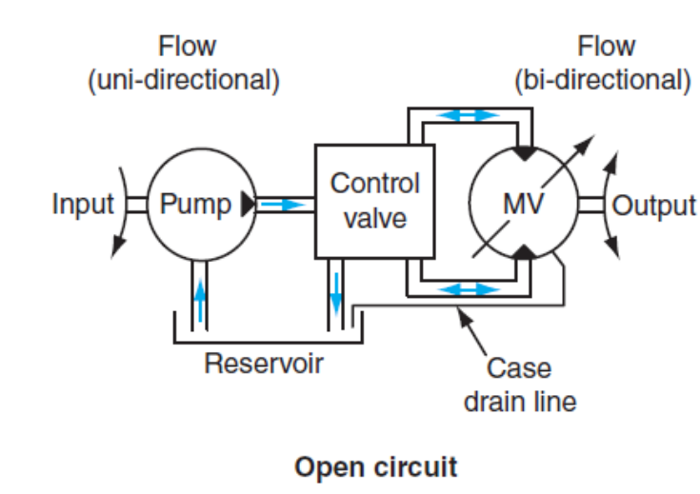
Figure 1-2 Operating principle of Hydrostatic drive system

Types of driveline layout
Location as well as arrangement of engine and transmission assemblies in a vehicle will vary with different makes and models. This makes it essential to vary the layout of driveline, which transmits power from transmission to traction wheels or tracks. Identifying each type along with the instruction manuals help to ascertain a correct and safe method in repair and service activity of the system assemblies. Base up on the engine and transmission position the driveline arrangement of typical vehicle may be; two wheels Drive (2WD), four-wheel drive (4WD) or six-wheel drive (6WD)

Transaxle layout
The front wheels propel front - wheel drive (FWD) vehicles. For this reason, they must use a drive design different from that of a RWD vehicle called transaxle. The transaxle is the special power transfer unit commonly used on FWD vehicles. A transaxle combines the transmission gearing, differential, and drive axle connections into a single case housing located in front of the vehicle as shown on (Figure 1-3). This layout can be designed either in cross mounted engine and transmission, engine behind transmission or engine in front of transmission arrangements as shown in (Figures 1.4a-c). In addition, cars with a mid or rear-mounted engine send power to the rear wheels through a transaxle.
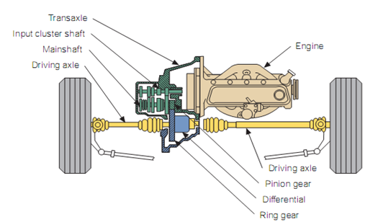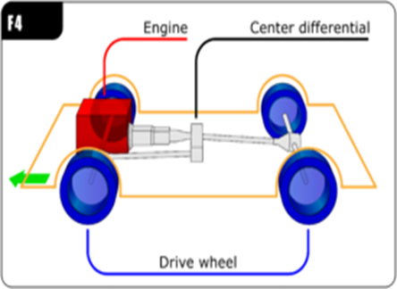
Figure 1-3 Transaxle arrangement front engine (left) and rear engine (right)
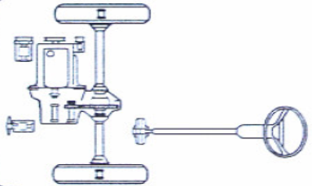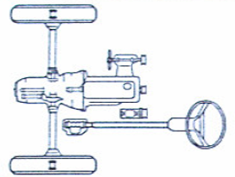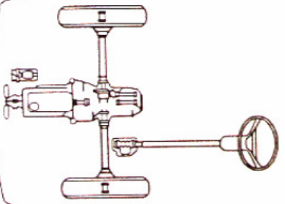
c
b
a
Figure 1-4 different designs of front engine transaxle (a) cross mounted engine and transmission,(b) engine behind transmission and (c) engine in front of transmission
Transaxle design especially of front engine offers many advantages.
- Good traction on slippery roads due to the weight of the drivetrain components being directly over the driving axles of the vehicle.
- It is also more compact and lighter than the transmission of a RWD vehicle.
- Transverse engine and transaxle configurations also allow for lower hood lines, thereby improving the vehicle’s aerodynamics.

Front Engine Rear Wheel Drive (FRWD)
Today, most cars and mini-vans are front-wheel drive (FWD), whereas some larger luxury and performance cars are rear-wheel drive (RWD). Most pickup trucks and large SUVs are also RWD vehicles. Power flow in a RWD vehicle passes through the clutch or torque converter, manual or automatic transmission, and the driveline (drive shaft assembly). Then it goes through the rear differential, the rear-driving axles, and onto the rear wheels.
a
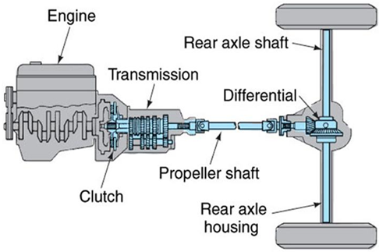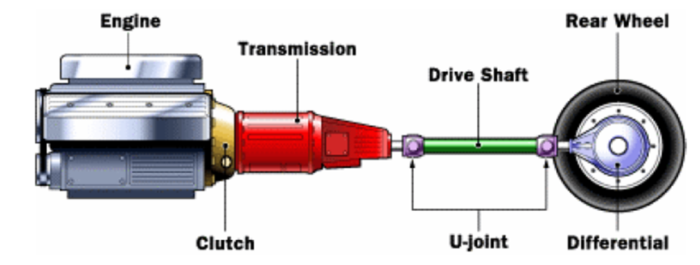
b
Figure 1-5 Front engine rear wheel drive (RWD) arrangement (a) sectioned and (b) block diagram

Four Wheel Drive layout (4WD)
Today most SUVs, pickup trucks, and crossover vehicles are equipped with four-wheel drive systems. Figure 1-6 and 1-7 show four/All-wheel drive (4WD/AWD) systems can dramatically increase a vehicle’s traction and handling ability in rain, snow, and off-road driving. In such situations, the workload is evenly spread out to four tires rather than two.
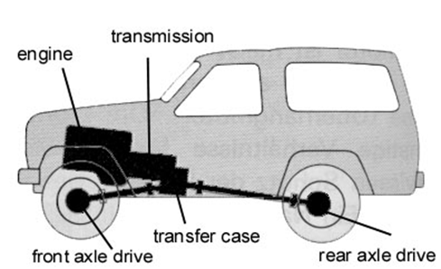
Figure 1-6 Four wheel drive (4WD) arrangement
However, it is important to note that most of these systems do not allow actual 4WD under most driving conditions. Driving all four wheels when traction is very low, such as on ice, requires the ability to lock the differentials or wheel hubs. What most systems do is allow torque to be routed to the both the front and rear axles, which improves traction.
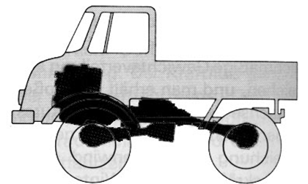
Figure 1-7 Four wheel drive (4WD) arrangement of Medium truck vehicles
Although there is constructional and operational variation among names assigned by manufacturer’s as 4WD and AWD systems, both have the ability to send torque to all four wheels with the help of transfer case and a differential unit located at the front and rear axles. A transfer case splits the power from the transmission between the front and rear axles. For clarity, the primary difference between the two is that the transfer case in a 4WD vehicle offers two speed ratios in four-wheel drive: high and low.
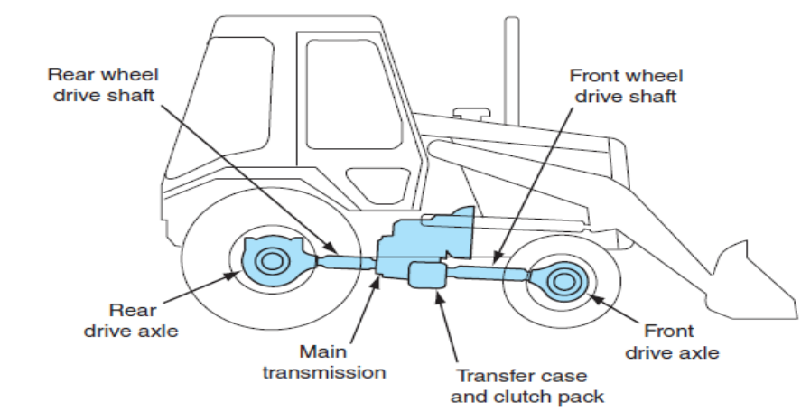
Figure 1-8 Typical layout of four wheel backhoe
Many loader/backhoe machines are equipped with four-wheel-drive, whereas some commercial vehicles are six wheel drive as shown in Figure 1.8 (a and b). This gives the machines more traction for loading or for working in very muddy or slippery conditions. These machines are equipped with a front drive axle as well as the regular rear drive axle.
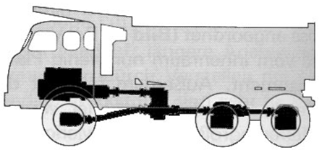
Figure 1-9 Typical layout of six wheel drive heavy truck
Four-wheel-drive is not always necessary, so the option to engage four-wheel-drive is made available by implementing a clutch pack within the transfer case to split the drive between front and rear drive axles.

Major components of driveline
The driveline in the rear-wheel drive vehicles must be able to transfer driving torques from the transmission output shaft to the differential under all operating conditions. It should do this smoothly and without any appreciable loss of torque. The driveline on the front-wheel drive vehicles must be able to transfer driving torque from the transaxle output shot to the front wheels. These major components can be grouped under drive shaft line assembly and final drive.
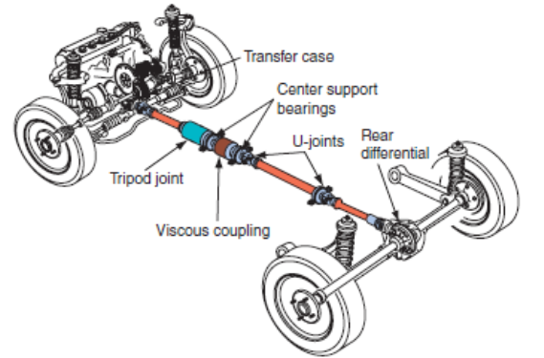
Figure 1-10 Major components of driveline

Drive shaft line assembly
The drive shaft line assembly must operate at varying angles and provide a means for shaft length changes to allow for vertical suspension (wheel) and engine movement. In general, it must:
- Send turning power from the transmission to the rear axle assembly.
- Flex and allow up-and-down movement of the rear axle assembly.
- Provide a sliding action to adjust for changes in driveline length.
- Provide a smooth power transfer.
- Be lightweight and strong enough.
The components of driveline assembly are-
- Slip Yoke-connects the transmission output shaft to the front universal joint
- Front Universal Joint- the swivel connection that fastens the slip yoke to the drive shaft.
- Drive Shaft- a hollow metal tube that transfers turning power from the front universal joint to the rear universal joint.
- Rear Universal Joint- a flex joint that connects the drive shaft to the differential yoke.
- Rear Yoke-holds the rear universal joint and transfers torque to the gears in the rear axle assembly.
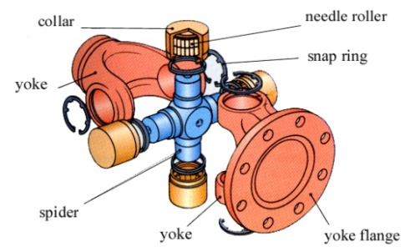
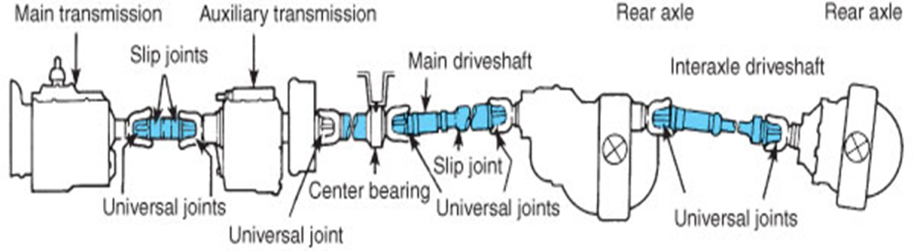

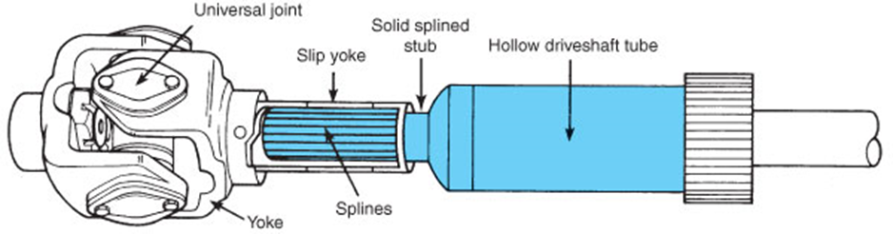
Figure 1-11 Essential components of drive shaft line assembly

Propeller shaft
In general, propeller shafts is a components fitted to vehicles that have a conventional in-line layout. In this layout, the engine and gearbox are in line with the longitudinal axis of the vehicle and generally at the front, with the final drive located at the rear. The propeller shaft presented on (Figure 1-12) is commonly of tubular steel construction; hence, it has a number of advantages
- A tubular propellers shaft weights less than a slid shaft this helps to improve fuel economy.
- A tubular shaft is less likely than a slide shaft to go out of balance when subjected to centrifugal forces because it has a smaller mass
- A tubular shaft is considerable stronger than the equivalent solid propeller shaft of similar mass, and is much less likely to bend or snip when spinning at speed.
- Constant velocity joint
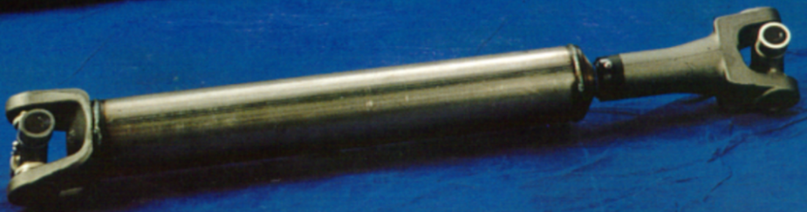
Figure 1-12 Propeller shaft U-joint and slip joint
Another importance of using hollow Shaft is to improve strength to weight ratio. A typical tubular shaft has 5.2 times higher torque transmission capability of solid shaft having equal weight. The weight of solid shaft must be as high as three times of tubular to handle equal torque as shown in (Figure 1-13).
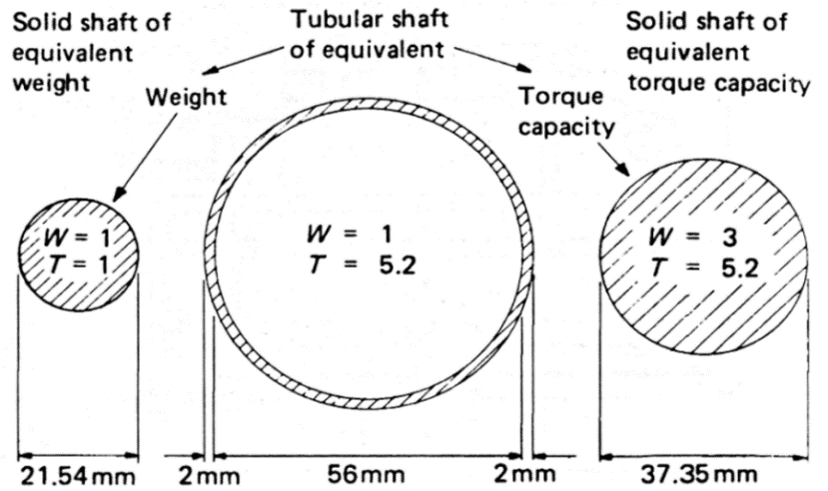
Figure 1-13 Cross-section of tubular and solid shafts to compare weight and torque transmission
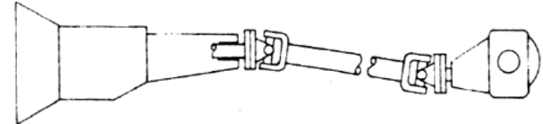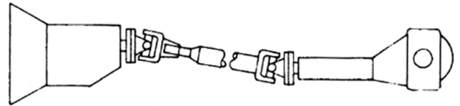
One piece with extended gearbox housing one piece with extended differential housing
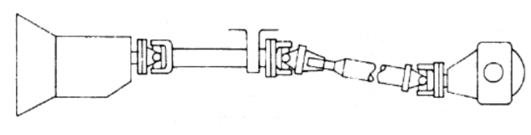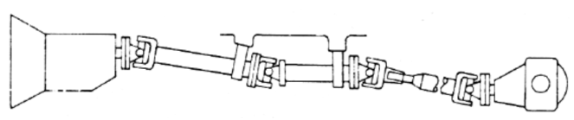
Two pieces with single intermediate support three pieces with two intermediate supports
Figure 1-14 Different type configurations of Propeller Shaft

Universal joint
Universal joints called U-joints are located at both ends of the drive shaft to link two independent units, such as the gearbox and final drive. They transmit power at an angle. When the axle moves up or down, the universal joint allows the changes in angle at the ends of the drive shaft to take place. The universal joints enable the propeller shaft to rotate smoothly and to transmit the engines torque, even though the axis of the engine and gearbox, proper shaft and final drive des not form a straight line.
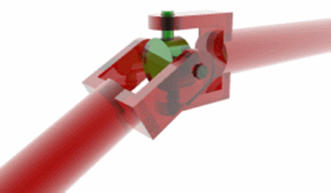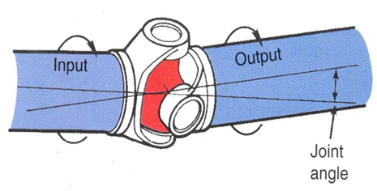
Figure 1-15 U-joint connects input and output shafts at different phase angles
Drive shaft U-joint can be designed as cross and roller, ball and trunnion, and double-cardan (constant velocity). Parts of the cross and roller design, the most common type of drive shaft U-joint consists of four bearing caps, four needle roller bearings, cross trunnion (spider), driven and driving yokes, snap rings inside or outside and U-bolts or straps.
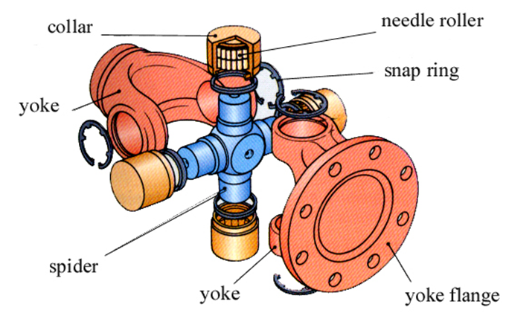
Figure 1-16 Internal parts of U-joint

Slip joint
Propeller shaft must be capable of extension to account for suspension travel and change in propeller shaft length due to bumps and re-bounds acceleration-torque reaction and brake-torque reaction
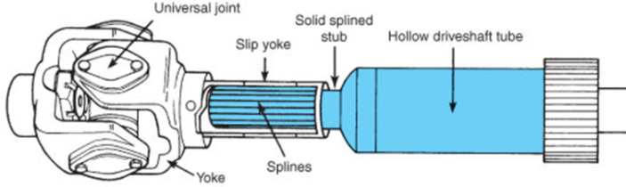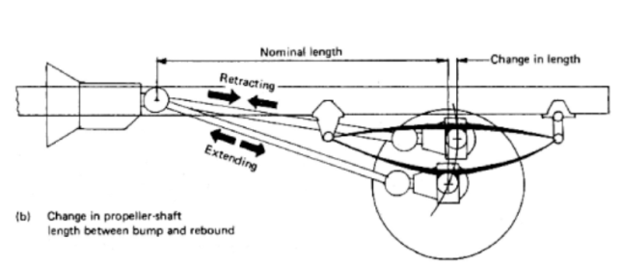
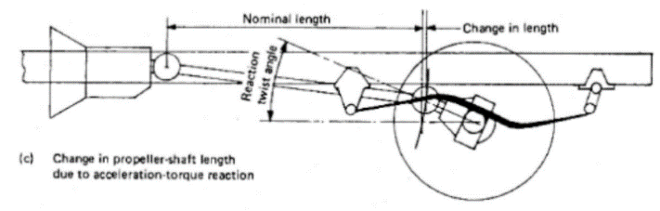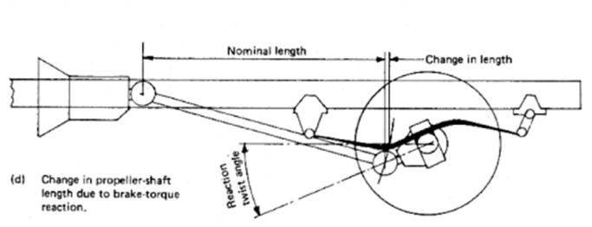
Figure 1-17 Operation of slip joint to change the length of drive shaft due to (a) bump and rebound (b) acceleration torque reaction (c) braking torque reaction

Constant velocity (CV) joint
The speed fluctuations caused by the conventional universal joints do not cause much difficulty in the rear-wheel drive shaft where they have to drive through small angles only. In front-wheel drives, the wheels are cramped up to 30 degrees in steering. For this reason, velocity fluctuations present a serious problem. Conventional universal joints would cause hard steering slippage, and tire wear each time the vehicle turns a corner.
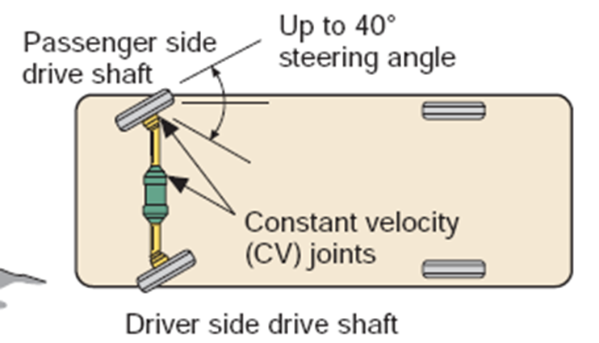
Figure 1-18 Constant velocity (CV) joint of typical front wheel drive axle including outboard and inboard CV joints
Constant velocity joints eliminate pulsations, since they are designed to be used exclusively to connect front axle shaft to the driving wheels. The outboard CV joint is a fixed joint that transfers rotating power from the axle shaft to the hub assembly whereas the inboard CV joint is a sliding joint that functions as a slip joint in a drive shaft for rear-wheel drive vehicles. The different types of constant velocity joints commercially available are Rzeppa and Tripod
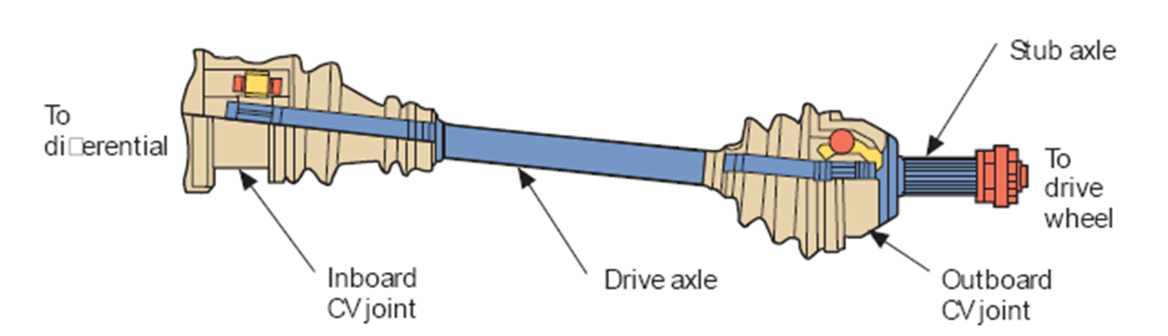
Figure 1-19 Constant velocity (CV) joint including drive axle outboard and inboard CV joints
    - The Rzeppa joint
Six spherical balls are held in precise geometrical position midway between two shafts
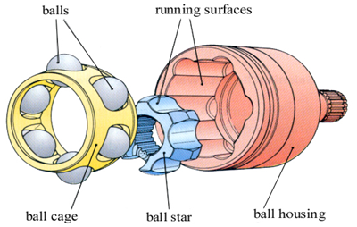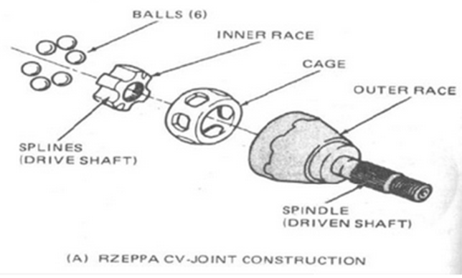
Figure 1-20 Internal components of Rzeppa type CV-joint
    - Tripod types
It uses three roller bearings attached to arms at the end of the driving shaft, which further modified with plugging. This permits driving and driven shafts move towards away each other
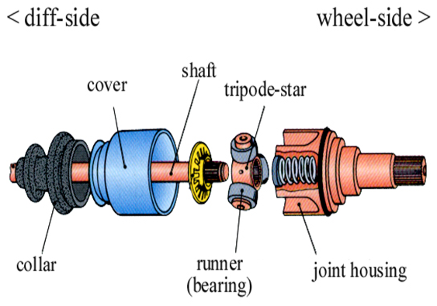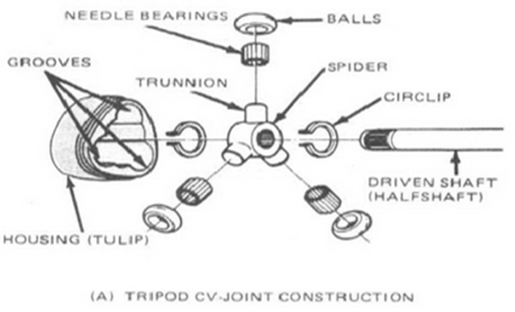
Figure 1-21 Internal components of Tripod type CV-joint
Front wheel service vehicles of either transverse or inline layout use similar shafts but with constant velocity (VC) joints. A CV-joint can transmit the available torque through varying angles without any noticeable difference in the speeds of the two shafts. This results in the vehicles having an acceptable steering lock, but without the vibration associated with other designs of coupling.

Final drive and drive axles
The final drive is a geared mechanism located between the driving axles of a vehicle. The differential, a critical part of the final drive unit, rotates the driving axles at different speeds when the vehicle is turning a corner (Figure 1-22). It also allows both axles to turn at the same speed when the vehicle is moving in a straight line.
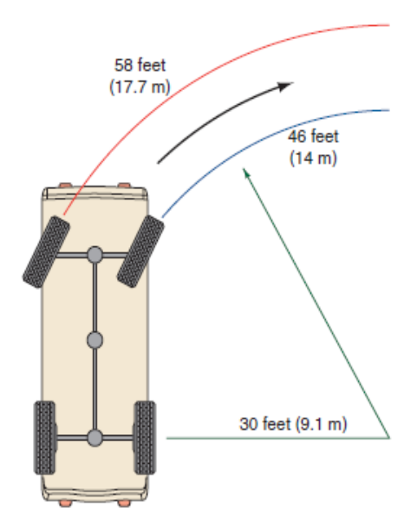
Figure 1-22 Travel of wheels when a vehicle is turning a corner (left) and sectional view of differential
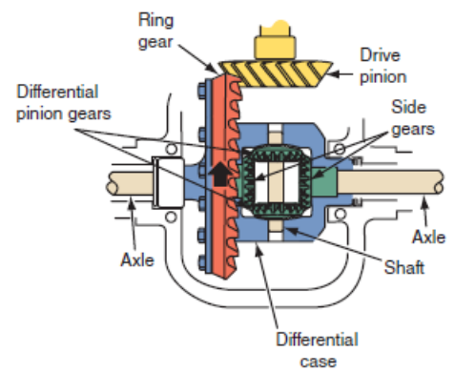
The drive axle assembly directs driveline torque to the vehicle’s drive wheels at a 90-degree angle and split it between the two wheels. The gear ratio of the drive axle’s ring and pinion gears is used to increase torque. The differential serves to establish a state of balance between the forces between the drive wheels and allows the drive wheels to turn at different speeds when the vehicle changes direction.

Figure 1-23 The components of a typical final drive and differential unit
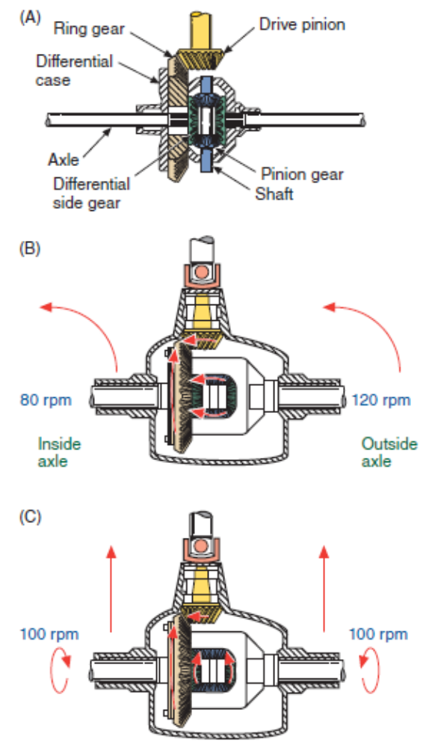
Additionally, the housing is used to support chassis, drive axles, and differentials; while providing the means to attach the suspension system brake assemblies, and drive wheels. The components of commonly used final drive units are shown in (Figure 1-23). There are several other basic design arrangements. However, the one most commonly used design has pinion/ring gears and a pinion shaft. In RWD vehicles the gear set is comprised of hypoid gears, whereas FWD units use a planetary gear set or spiral bevel gears.
Figure 1-24 Basic differential components

Types of differential
The differential is a device or gear assembly between two shafts that permits the shafts to turn at different speeds while continuing to transmit torque. It is used in drive axles to allow different rates of wheels’ rotation on curves. In a rear-wheel drive (RWD) vehicle, the rear wheels receive power from the engine, and the differential is located in the rear axle.
Figure 1-25 Differential action while the vehicle is moving straight.

- Open Differentials
Figure 1-26 differential action while the vehicle is turning left

This type of diff is the most basic and only allows for variations of individual wheel speed or slip. The amount of power delivered to each driving wheel by the differential is expressed as a percentage. When the vehicle moves straight ahead, each driving wheel rotates at 100 percent of the differential case speed. When the vehicle is turning, the inside wheel gets less than 100 percent of the differential case speed.
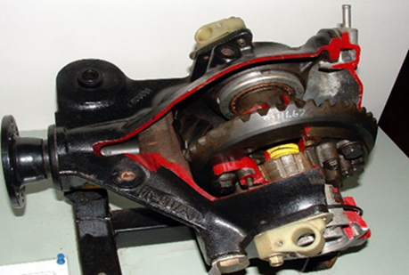
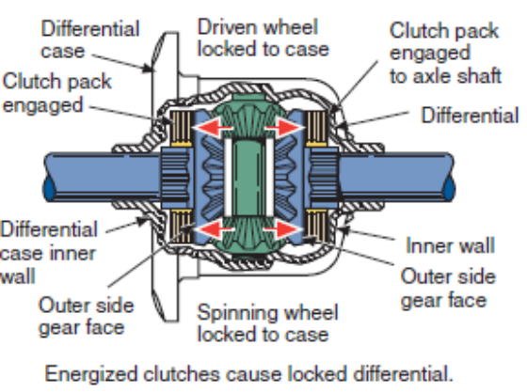
Power flow through the axle begins at the drive pinion yoke, or companion flange (Figure 1-27). The companion flange accepts torque from the rear U-joint. The companion flange is attached to the drive pinion gear, which transfers torque to the ring gear. As the ring gear turns, it turns the differential case and the pinion shaft. The differential pinion gears transfer torque to the side gears to turn the driving axle shafts. The differential pinion gears determine how much torque goes to each driving axle, depending on the resistance an axle shaft or wheel has while turning. The pinion gears can move with the carrier, and they can rotate on the pinion shaft.
Figure 1-27 Internal parts of limited-slip differential

- Limited Slip Differentials
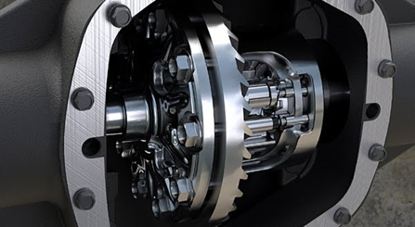
A Limited Slip Differential (also known as a LSD) attempts to address the problems of an Open differential. A Limited Slip Differential is very similar to an Open Differential, but it adds a spring pack and a set of clutches. Some of these have a cone clutch that is similar to the synchronizers in a manual transmission.
Figure 1-28 Action of the clutches in a limited-slip differential
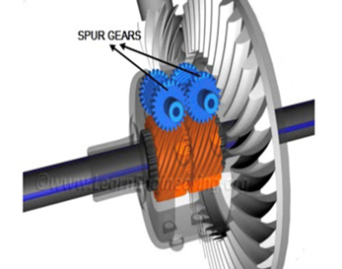
The spring pack pushes the side gears against the clutches, which are attached to the cage. Both side gears spin with the cage when both wheels are moving at the same speed, and the clutches aren't really needed - the only time the clutches step in is when something happens to make one wheel spin faster than the other, as in a turn. The clutches fight this behavior, wanting both wheels to go the same speed. If one wheel wants to spin faster than the other, it must first overpower the clutch. The stiffness of the springs combined with the friction of the clutch determines how much torque it takes to overpower it.
Figure 1-29 typical locking differential
- Locking Differentials
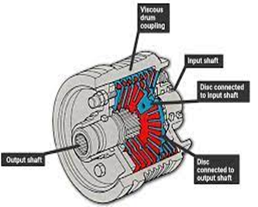
The locking differential is useful for serious off-road vehicles and for drag racing. This type of differential has the same parts as an open differential, but adds an electric, pneumatic or hydraulic mechanism to lock the two output pinions together. This mechanism is usually activated manually by switch, and when activated, both wheels will spin at the same speed. If one wheel ends up off the ground, the other wheel won't know or care. Both wheels will continue to spin at the same speed as if nothing had changed. This maximizes the amount of forward motion, regardless of wheel slippage - perfect for drag racing.
Figure 1-30 Torsen locking differential
There are several types of locking differentials. An ARB Air Locker is a unique differential because it acts like an open differential until a switch activates an on-board air compressor. The air pressure is used to lock the differential. This allows a very high breakaway torque for racing but no compromises for daily driving. A Detroit Locker, popular on muscle cars and some off-road trucks, is a ratcheting type of locking differential. A Detroit Locker is very strong and will usually provide equal torque application to each axle, but it is noticeable when cornering.
Figure 1-31 Viscous coupling type locking differentials
Finally there is the spool, which solidly connects the left and right axles with no slipping allowed. It is used for drag-racing applications only, since it maximizes forward acceleration, but makes the vehicle very difficult to turn and is very hard on the axles.
- Torsen viscous and Postreaction Differentials
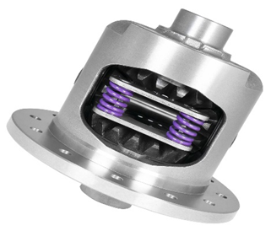
The Torsen differential is a purely mechanical device; it has no electronics, clutches or viscous fluids. It works as an open differential when the amount of torque going to each wheel is equal. As soon as one wheel starts to lose traction, the difference in torque causes the gears in the Torsen differential to bind together.
The viscous coupling is used to link the back wheels to the front wheels when one set of wheels starts to slip, torque will be transferred to the other set. The viscous coupling has two sets of plates inside a sealed housing, where one set of plates is connected to each output shaft. Under normal conditions, both sets of plates and the viscous fluid spin at the same speed. When one set of wheels tries to spin faster, perhaps because it is slipping, the set of plates corresponding to those wheels spins faster than the other. A postreaction differential improves the way your differential performs under adverse conditions. When one wheel starts to slip, these differentials transfer the torque to the wheel that is not slipping. The car can then continue to go forward.
Figure 1-32 Postreaction type locking differentials

Drive Axles
The purpose of an axle shaft is to transfer driving torque from the differential assembly to the vehicle’s driving wheels. There are two types of axles: dead and live or drive. A dead axle does not drive a vehicle. It merely supports the vehicle load and provides a mounting place for the wheels. The rear axle of a FWD vehicle is a dead axle, as are the axles used on trailers. A live axle is one that drives the vehicle. Drive axles transfer torque from the differential to each driving wheel. Depending on the design, rear axles can also help carry the weight of the vehicle or even act as part of the suspension. Details of final drive and drive axles shown on Figure 1-33.
Three types of driving axles are commonly used: semi floating, three-quarter floating, and full-floating.
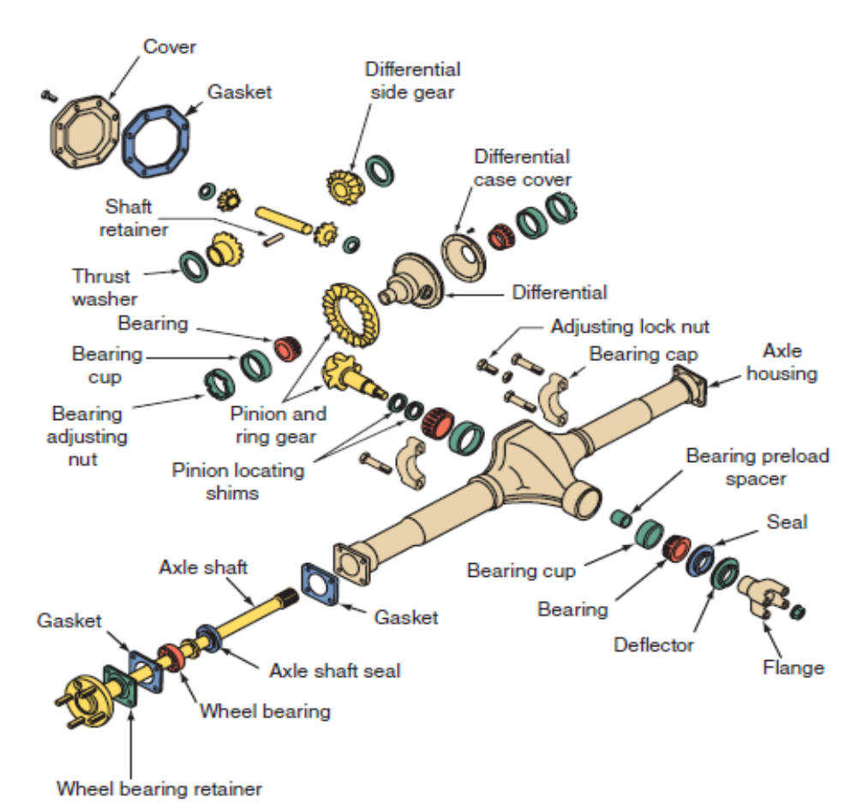
Figure 1-33 An exploded view of an integral-carrier axle housing with a hypoid final drive assembly and semi-floating axles
All three use axle shafts that are splined to the differential side gears. At the wheel ends, the axles can be attached in any one of a number of ways. This attachment defines the type of axle it is and the manner in which the shafts are supported by bearings.
    - Semi floating Axle Shafts
Semi floating axles help to support the weight of the vehicle. Most RWD vehicles have semi floating axles. The axles are supported by bearings located in the axle housing. An axle shaft bearing supports the vehicle’s weight and reduces rotational friction. The inner ends of the axle shafts are splined to the axle side gears. The driving wheels are bolted to the outer ends of the axle shafts. The outer axle bearings are located between the axle shaft and axle housing.
    - Three-Quarter Floating Axle
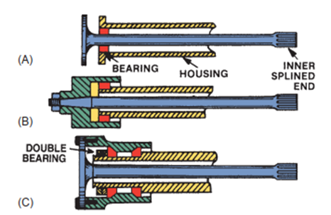
The wheel bearing on a three-quarter floating axle is on the outside of the axle housing instead of inside the housing as in the semi floating axle. The wheel hubs are bolted to the end of the axle shaft and are supported by the bearing. In this arrangement, the axle shaft only supports 25% of the vehicle’s weight. The weight is transferred through the wheel hub and bearing to the axle housing. Three-quarter floating axles are found on older vehicles and some trucks.
Figure 1-34 Different type rear wheel drive axle (A)semi-floating, (B) three quarter floating and (C) full floating

    - Full-Floating Axle Shafts
Most medium- and heavy-duty vehicles use a full-floating axle shaft. This design is similar to the three-quarter floating axle except that two bearings rather than one are used to support the wheel hub. These are slid over the outside of the axle housing and carry all of the stresses caused by torque loading and turning. The wheel hubs are bolted to flanges on the outer end of each axle shaft. In operation, the axle shaft transmits only the driving torque. The driving torque from the axle shaft rotates the axle flange, wheel hub, and rear driving wheel. The wheel hub forces its bearings against the axle housing to move the vehicle. The stresses caused by turning, skidding, and bent or wobbling wheels are taken by the axle housing through the wheel bearings.

Wheel Bearing and Hub Assembly
Wheel bearings allow the wheel and tire assembly to turn freely around the spindle, in the steering knuckle, or in the bearing support. Wheel bearings are lubricated with heavy, high-temperature grease. This allows the bearing to operate with very little friction and wear.
The two basic wheel-bearing configurations are tapered roller or ball bearing types. The basic parts of a wheel bearing are as follows:
- Outer race (cup or cone pressed into the hub, steering knuckle, or bearing support).
- Balls or rollers (anti-friction elements that fit between the inner and outer races).
- Inner race (cup or cone that rests on the spindle or drive axle shaft).
There are two types of wheel bearing and hub assemblies: non-driving and driving. For example, the front wheels on a rear-wheel drive vehicle are non-driving.

Non-driving Wheel Assembly
The components of a non-driving wheel bearing and hub assembly include the following:
- Spindle
A stationary shaft extending outward from the steering knuckle or suspension system to which the following components are attached. Wheel bearings (normally tapered roller bearings mounted on the spindle and in the wheel hub). Hub (outer housing that holds the brake disc, or drum, wheel, grease, and wheel bearing)
- Grease wheel
A seal that prevents loss of lubricant from the inner end of the spindle and hub). Safety washer is a flat washer that keeps the outer wheel bearing from rubbing on and possibly turning the adjusting nut. Spindle adjusting nut (a nut threaded on the end of the spindle for adjusting the wheel bearing). Nut locks (a thin, slotted nut that fits over the main spindle nut).
- Dust cap
A metal cap that fits over the outer end of the hub to keep grease in and dirt out of the bearings. Since a non-driving wheel bearing and hub assembly does NOT transfer driving power, the spindle is stationary. The spindle simply extends outward and provides a mounting surface for the wheel bearings, hub, and wheel. With the vehicle moving, the wheel and hub spin on the wheel bearings and spindle. The hub simply freewheels.

Driving Wheel Assembly
The components of a driving wheel bearing and hub assembly as shown in Figure 1-36 includes the following: Outer drive axle (a stub axle shaft that extends through the wheel bearings and is splined to the hub). Wheel bearings are either ball or roller type bearings that allow the drive axle to turn in the steering knuckle or bearing support.
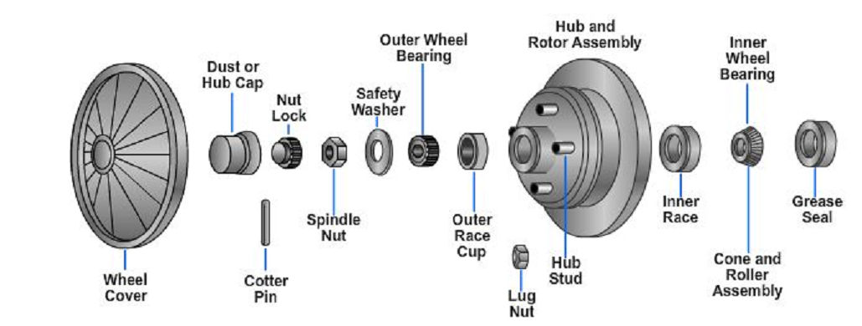
Figure 1-35 Rear wheel bearing assembly
Steering knuckle or bearing support (a suspension or steering component that holds the wheel bearings, axle stub, and hub). Drive hub (a mounting place for the wheel which transfers driving power from the stub axle to the wheel). Axle washer is a special washer that fits between the hub and locknut. Hub or axle locknut is a special nut that screws onto the end of the drive axle stub shaft to secure the hub and other parts of the assembly. Grease seal prevents lubricant loss between the inside of the axle and the steering knuckle and bearing support.
The driving wheel bearing and hub assembly has bearings mounted in a stationary steering knuckle or bearing support. The drive axle fits through the centers of the Bearings. The hub is splined to the axle shaft. Instead of a stationary spindle, the axle Shaft spins inside the stationary support. With the hub splined to the axle shaft, power is transferred to the wheels.
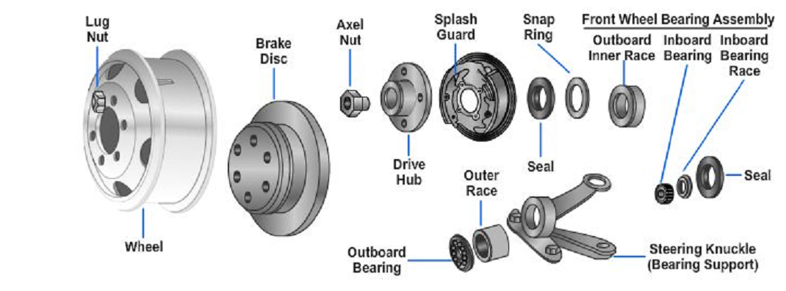

Figure1-36 Front wheel bearing assembly

Bearing Lubrication - Grease
Grease should be replaced every 12,000 miles or 12 months. Prior to repacking bearings, all old grease should be removed from the wheel hub cavity and bearings. Bearings should be packed by machine if possible. If a machine is unavailable, packing by hand method is acceptable. The method to pack bearing cones is as follows:
1. Place a quantity of grease onto the palm of your hand.
2. Press a section of the widest end of bearing into the outer edge of the grease pile closest to the thumb forcing grease into the interior of the bearing between two adjacent rollers.
3. Repeat this while rotating the bearing from roller to roller.
4. Continue this process until you have the entire bearing completely filled with grease.
5. Before reinstalling, apply a light coat of grease onto the bearing cup mating surface

OHS and PPE requirements
To protect yourself from injuries, you must take precautions including Personal Protective Equipment (PPE) and OHS

PPE Requirement
      - Eye protection
Safety glasses, Protective goggles or face shields can give used where protection more suited to activities encounter; splashing liquid, fume, vapor, dust or powder and working with hydraulic system. Different types of goggles are available which cover the whole eye.
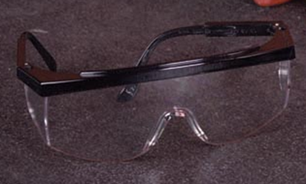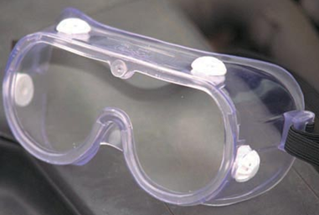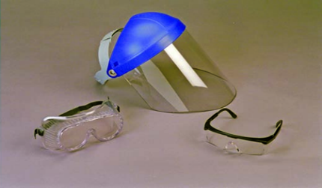
Figure 1-37 Different type eye protection devices including safety glasses ,protective goggles and face shield
      - Ear protection
Long exposure to high noise levels can result in permanent hearing loss. Hence Ear protection is recommended when:
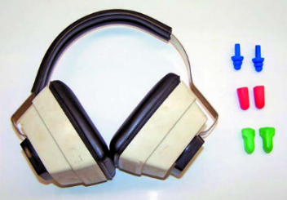
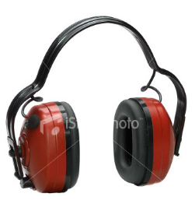
- Work area is constantly noisy
- Grinding
- Hammering

Figure 1-38 Ear plug and set used for ear protection
      - Skin protection
Skin protection is recommended when: working with chemicals & corrosives and handling heavy materials like wheel bearing service Rubberized Gloves: when working with chemicals, when using the parts washer. Leather gloves: when grinding or welding When lifting heavy engine parts or transmissions.
Figure 1-39 Safety glove leather (left) and rubber (right)
      - Safety clothing


A. Safety overalls
Your clothing should be well fitted and comfortable but made with strong material.
Wear appropriate clothing while performing tasks
- No sleeveless shirts
- No shorts
- No holes
- No hats
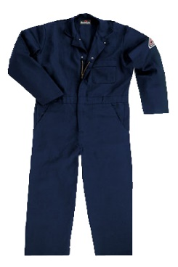
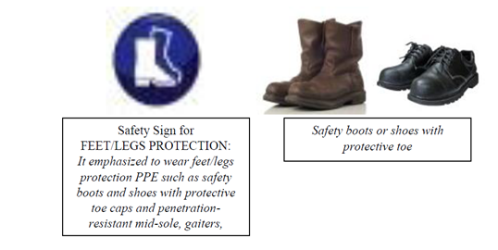
B. Safety Shoes: protect your feet from injury.
There are many designs of safety shoes and boots that also have steel plates built into the toe and shank to protect your feet. Many also have soles that are designed to resist slipping on wet surfaces.
N.B Keep your clothing clean. If you spill gasoline or oil on yourself, change that item of clothing immediately. Oil against your skin for a prolonged period can produce rashes or other allergic reactions. Gasoline can irritate cuts and sores.
      - Respiratory protection
Respiratory protection is recommended: When working with chemicals that give. Toxic fumes, extended time around gasoline, when working on brakes or clutches that may contain asbestos. When using power sanding, using the parts washer for extended periods.
Figure 1-40 Safety clothing including overalls and shoes

OHS Requirement
      - Lifting and Carrying
When doing heavy lifting, always get assistance and lift with your knees, not your back.
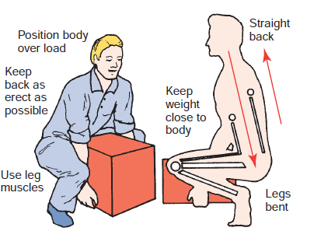
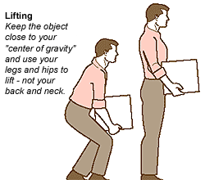
When lifting any object follow these steps:

Figure 1-41 Lifting and carrying objects safely
      - Clean equipment and tools
- Part cleaning is a necessary step in most repair procedures. Cleaning automotive parts can be divided into three basic categories.
- Chemical cleaning relies primarily on some type of chemical action to remove dirt, grease, scale, paint, or rust.
- Abrasive cleaning relies on physical abrasion to clean the surface. This includes everything from a wire brush to glass bead blasting, airless steel shot blasting, abrasive tumbling, and vibratory cleaning. Chemical in-tank solution sonic cleaning might also be included here because it relies on the scrubbing action of ultrasonic sound waves to loosen surface contaminants.
Clean up procedures
- Clean up every time whenever you leave an area, including sweeping the floor.
- Clean and return all tools to where you got them.
- Use compressed air sparingly; never aim it at another person or use it to clean hair or clothes.
- Shut off and unplug machines when cleaning, repairing, or oiling.
- Never use a rag near moving machinery.
- Use a brush, hook, or a special tool to remove chips, shavings, scraps etc. from the work area. Never use the hands.
- Keep fingers clear of the point of operation of machines by using special tools or devices, such as, push sticks, hooks, pliers, etc.
- Keep the floor around machines clean, dry, and free from trip hazards. Do not allow chips to accumulate.
      - Hazards in the work shop
- Faulty work habits
- Misuse of equipment
- Misuse of hand tools
Select the work place depending on: -
- Environmental condition
- Free from flammable things
- Events around the work campus is closer together
- Climatic condition
- Working area events
      - Professional Behavior and work area safety
Accidents can be prevented simply by the way you behave.
The following list does not include everything you should or should not do; it merely gives some things to think about:
- When working with a hydraulic press, sure the pressure is applied in a safe manner.
- Properly store all parts and tools by putting them away in a place where people will not trip over them.
- Keep your work area clean and uncluttered. Make sure you clean up all spills before continuing to work.
- Any oil, coolant, or grease on the floor can make it slippery. Slips can result in serious injuries.
- Make sure the work areas around machines are large enough to safely operate the machine.
- Keep an up dated list of emergency telephone numbers clearly posted next to the telephone. These numbers should include a doctor, hospital, and fire and police departments.
- The work area should have a first-aid kit for treating minor injuries and eye flushing kits readily available. You should know where these items are kept.
- Keep tools in good condition by using them properly and storing them properly.
- Always keep the place where you work clean. When a job is finished, everything should be replaced neatly in order and wastes should be disposed.
- Do not leave things, even temporarily, in passage ways or entrances and exits where they may obstruct people or cars going in and out.
- Do not leave tools and parts on the floor where you, or any one else, might trip over them. Make a habit of putting them on a workbench
- Clean up any spilled fuel, oil or grease immediately to prevent yourself or others from slipping on the floor.
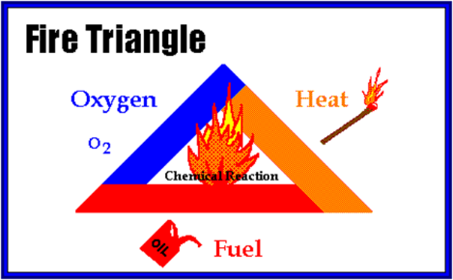
      - Possible causes of fire and Fire Extinguishers
Three things must be present at the same time to produce fire:- Enough OXYGEN to sustain combustion, Enough HEAT to reach ignition temperature and Some FUEL or combustible materials. Together, they produce the chemical reaction that is fire.
Figure 1-42 Illustration of fire triangle
Type of fire extinguishers: - are classified by the type fires on which they may be used.
- Water Fire Extinguishers: - The cheapest and most widely used fire extinguishers. It is used for Class A fires. Not suitable for Class B (Liquid) fires, or where electricity is involved.
- Foam Fire Extinguishers: - More expensive than water, but more versatile. It is used for Classes A & B fires. Foam spray extinguishers are not recommended for fires involving electricity.
- Dry Powder Fire Extinguishers: Often termed the ‘multi-purpose’ extinguisher. It can be used on classes A, B & C fires. Best for running liquid fires (Class B). Special powders are available for class D metal fires.
- CO2 Fire Extinguishers: fires involving for electrical apparatus. It will also extinguish class B liquid fires.
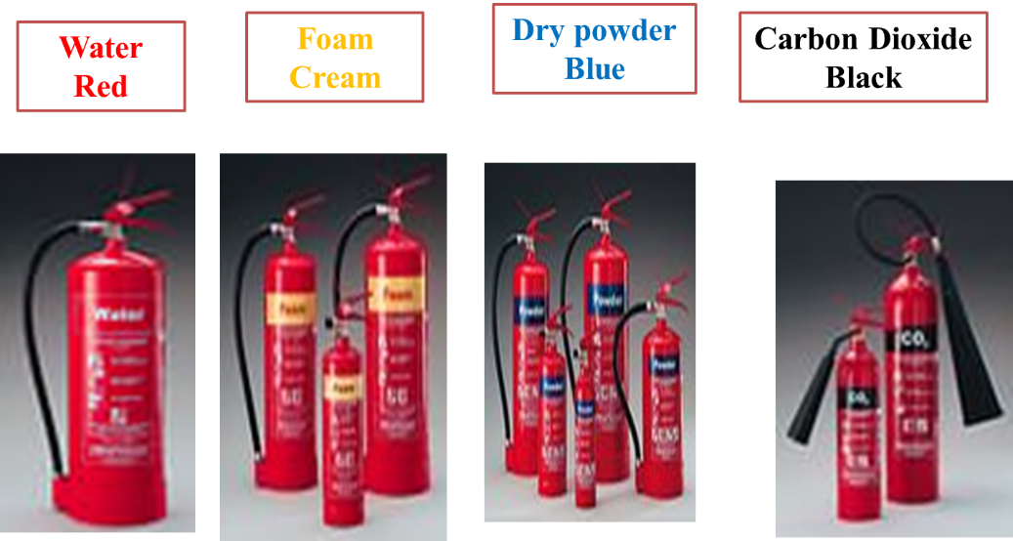
Figure 1-43 Different type fire extinguishers
Note: The use of wrong fire extinguisher will not pull out the fire and under some conditions may cause to increase the fire.
To use a fire extinguisher, simply remember the word PASS
P = Pull the safety pin
A = Aim the nozzle of the extinguisher at the base of the fire
S = Squeeze the lever to actuate the extinguisher
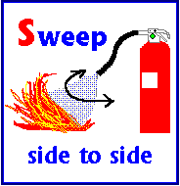
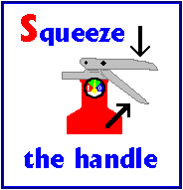
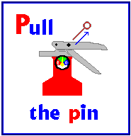
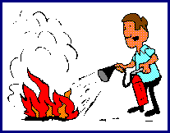
S = Sweep the nozzle from side to side

Figure 1-44 Typical sequence to use fire extinguisher
- Fire rules
Pull the Fire Alarm, Call emergency number and Assist anyone in danger
- Never Fight a Fire if you don't know what is burning.
If you don't know what is burning, you don't know what type of extinguisher to use. Even if you have an ABC extinguisher, there may be something in the fire which is going to explode or produce highly toxic smoke.
- Never fight a fire if your instincts tell you not to.
If you are uncomfortable with the situation for any reason, just let the fire department do their job.
- Never Fight a fire if you don't have adequate or appropriate equipment
If you don't have the correct type or large enough extinguisher, it is best not to try to fight the fire.
- Never fight a fire if you might inhale toxic smoke
If the fire is producing large amounts of smoke that you would have to breathe in order to fight it, it is best not to try.
- The final rule is always position yourself with an exit or means of escape at your back before you attempt to use an extinguisher to put out a fire. In case the extinguisher malfunctions, or something unexpected happens, you need to be able to get out quickly, and you don't want to become trapped. Just remember, always keep an exit at your back.

Hand Tools and equipment requirement
Automotive service work requires a great variety of tools. It is said that using the right tools for the right job enables to do work with safety, speed, and efficiency.
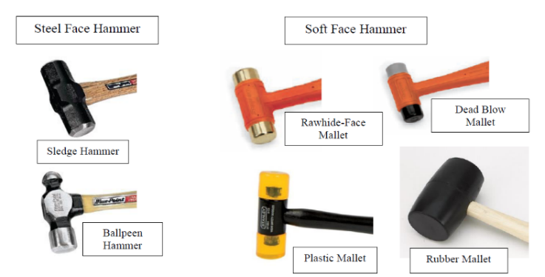
- Striking Tools
- Turning Tools
- Gripping Tools
Figure 1-45 Different type hammers
- Cutting Tools
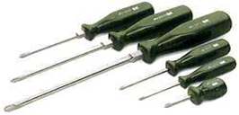
A hammer is a hand tool used for striking and the ball-peen hammer is the most common hand tool used in the shop. Other types of hammer are as follows: Plastic, Rubber and Rawhide-Faced
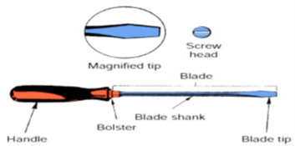
Turning tools includes the various types of screwdrivers and wrenches. Screwdrivers. Are used to drive or turn screws. They are made in a variety of sizes, shapes and special purpose design. They are two kinds such as:
Wrenches. Refers a long handled tool with fixed or adjustable jaws. It maybe classified as follows: Open-end Wrench it has the jaw opening at a 15 degree angle to the handle and has different sizes on each end. Box end wrench is the most widely used tools in the shop and they are like box wrench except that the head or socket is the detachable from the handle. Combination Wrench has a box one end and an open end on the other. Both ends are usually of the same size
Figure 1-46 Screw drivers
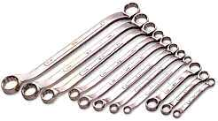
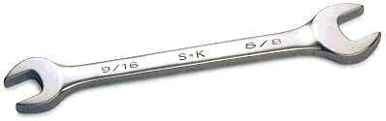
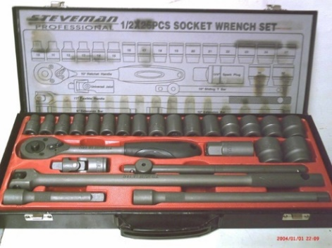
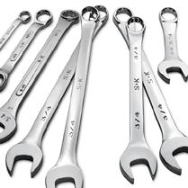

Figure 1-47 common wrench types

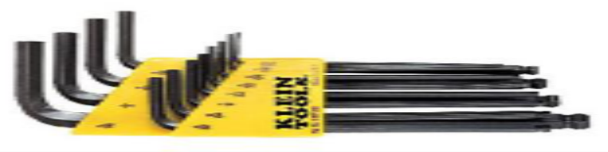
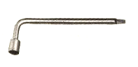

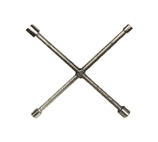
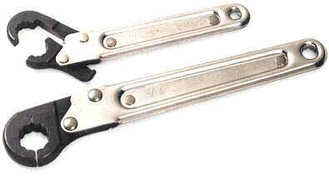
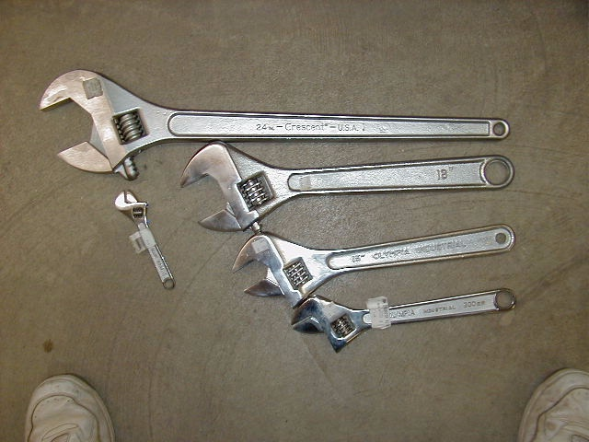

Figure 1-48 Special type wrenches
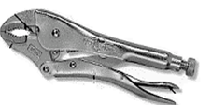
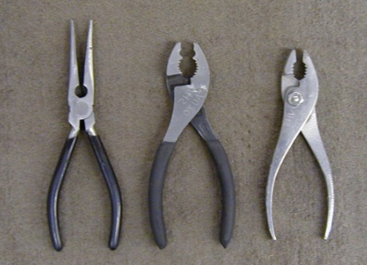
Gripping Tools: Pliers are the most common example of gripping tools. It has a pair of adjustable pivoted jaws for cutting or gripping. There are six (6) common types of pliers:
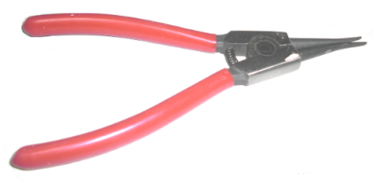
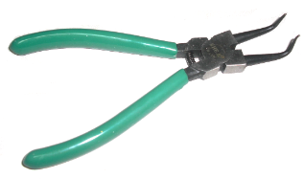

Figure 1-49 Typical examples of gripping tools

Self-check-1
- Multiple choose questions
Instruction: Choose the best answer and circle the letter corresponds to best answer
- Technician A says, in a gear set, speed reduction means torque. Technician B says speed increase means torque reduction. Who is right?
- A only
- B only
- Both A and B
- Neither A nor B
- In front-wheel drivetrains, the CV joint nearer the transaxle is the ___.
- Inner joint
- Inboard joint
    - Outboard joint
    - Both a and b
- Which type of driving axle supports the weight of the vehicle?
- Semi-floating
- Three-quarter floating
- Full-floating
- None of the above
- Technician A says that when a car is moving straight ahead, all differential gears rotate as a unit. Technician B says when a car is turning a corner, the inside differential side gear rotates slowly on the pinion, causing the outside side gear to rotate faster. Who is correct?
- Technician A only
- Technician B only
- Both A and B
- Neither A nor B
- Which one of the following is a transaxle drive line layout?
- Front engine rear wheel drive
- Front engine front wheel drive
- Four-wheel drive (4WD)
- Six-wheel Drive (6WD)

II. Short answer questions
      - List the steps that should be followed to precisely tighten a bolt to specifications.
      - Describe three sources of service information available to technicians.
      - Explain different layouts of drive line
      - What is the difference between hydrostatic and mechanical power transmission?
      - What are the purposes of U-joint?

Unit Two: Maintaining drive shaft line assemblies
This unit to provide you the necessary information regarding the following content coverage and topics:
- Road test
- Inspection of drive shaft line assemblies
- Inspection of mounting points and fittings
- CV Joint service and maintenance
- U- Joint service and maintenance
- Report inspection findings
This guide will also assist you to attain the learning outcomes stated in the cover page. Specifically, upon completion of this learning guide, you will be able to:
  - Inspect drive shaft line assemblies
  - Inspect mounting points and fittings
  - Service drive shaft line assemblies
  - Repair drive shaft line assemblies
  - Report inspection findings

Road test
The key to diagnose a drive axle or differential problem is to note what happens during different vehicle speeds and speed changes. Most manufacturers recommend that the vehicle should be operated in four distinct modes during the road test.
- Drive mode: The vehicle is accelerated; the throttle must be depressed enough to apply sufficient engine torque.
- Cruise mode: Vehicle speed is held constant. This means that the throttle must be applied at all times. The speed must be held at a predetermined rpm on a level road.
- Coast mode: The throttle is released and the vehicle is allowed to coast down from a specific speed.
- Float mode: This is controlled deceleration. The throttle is slowly released. It is important that the brakes be applied during this test mode.
During each of these modes, the stress on the various driveline parts changes. The cause of a problem is identified by thinking about what is under and not under stress during each mode. Drive shaft problems can result in noise or vibration from worn or rusted U-joints (universal joints), a worn slip yoke, or a bad centers support bearing. Worn U-joints can cause squeaking or grinding sounds. Sometimes a car will have a clunking sound when changing from acceleration to deceleration. This can be due to worn slip yoke splines or a bad extension housing bushing. It can also be because of problems in the differential or a much worn U-joint. Sometimes leaf springs can be loose at the differential allowing the housing to wind up.
A ringing sound is sometimes a complaint. This often results from a bad clutch disc damper. Replacing the clutch disc usually solves the problem. If the car has an automatic transmission, the problem can be due to a bad lock-up converter. A worn centers support bearing can cause a whining sound that varies with vehicle speed. The noise is constant in pitch, rather than changing or intermittent like U-joint noise. Unbalanced drive shafts are a possible source of vibration. In high gear, the drive shaft spins at engine rpm. If the shaft is bent or a universal joint is worn, a vibration can occur. Some drive shafts are built in two pieces with rubber dampening rings inside of them. Another drive shaft style has a damper like a crankshaft vibration damper mounted on its outside. This absorbs torsional vibration.

Propeller shaft maintenance
The drive shafts must be perfectly straight and the joints must be unworn to function properly. If any component allows the drive shafts to wobble, severe vibration, abnormal noises, or even major damage can result. Driveshaft problems result in noise or vibration and its possible causes are as follows:
Grinding and squeaking of shaft caused by worn universal joints. The joints become dry, causing the rollers to wear. A clunking sound, when going from acceleration to deceleration or deceleration to acceleration, may be caused by slip yoke problems. The splines may be worn or the yoke transmission extension housing bushing may wear. An excessively worn U-joint or differential can cause a similar noise. A whining sound from the drive shaft is sometimes caused by a dry, worn center support bearing.
The driveshaft should be inspected for the following:
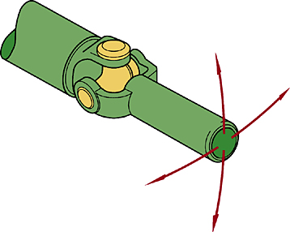
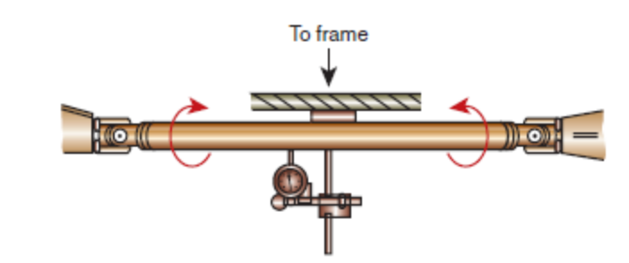
Physical damage and loose joints, excess slip yoke movement, missing balance weights and cracked welds, any dents caused by incorrect hoisting of the vehicle or by road debris, dirt buildup on the driveshaft can cause a vibration and measured for bend at center by using dial gauge as shown in (figure2-1)
Figure 2-1 Drive shaft runout

Universal joint service and maintenance

Universal Joint Inspection
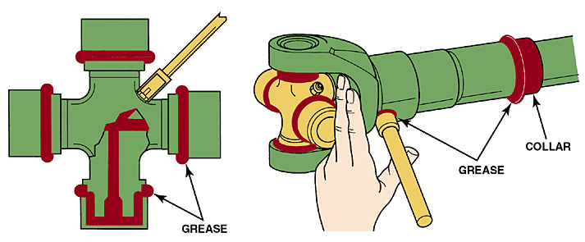
When a universal joint begins to fail, a squeaking sound is often noticed just when the car begins to go forward. The most common cause of U-joint failure is when its grease dries out. This often happens because the seal on the U-joint has failed allowing moisture in.
Figure 2-2 Check the condition by rocking
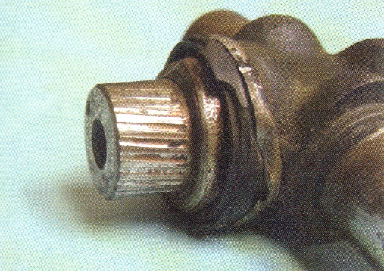
A vibration can also occur when a U-joint starts to fail. With a worn U-joint, a sharp, one-time click sound often occurs when the vehicle direction is changed from forward to reverse or when the vehicle first takes off. The U-joints should be inspected every time the vehicle chassis is lubricated, or four times a year.
Figure 2-3 Grease nipple and lubrication area of U-joint
- Original equipment (OE) U-joints are permanently lubricated and have no provision for greasing.
- If there is a grease fitting, the U-joint should be lubricated by applying grease with a grease gun. See figure below.
Figure 2-4 Brine ling of the trunnion
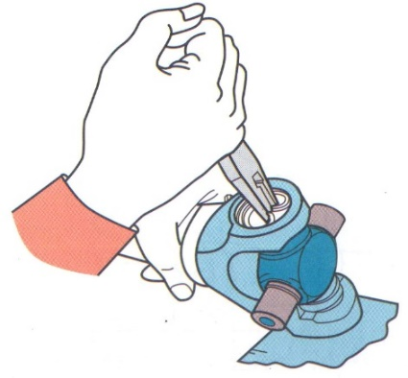
One problem caused during installation in a vise is that drive shaft yoke ears commonly become sprung inward. This results in brine ling. Brine ling is when small indentations wear into the bearing surface. Brine ling is often the result of a faulty U-joint installation. The joint should always fell loose and relaxed (not binding up) after a correct installation.

Universal Joint Disassembly
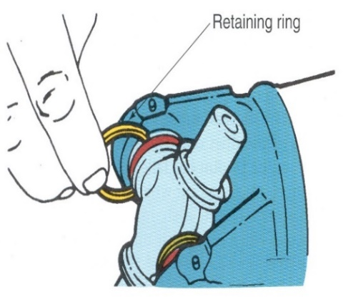
The procedure described here is for single cross and yoke (cardan) universal joints. If the U-joint has any snap rings, remove them. Some snap rings are on the inside of the yoke. Other are on the outside. When the snap ring is on the outside, a sturdy pair of pliers can be used.
Figure 2-5 Removing snap ring
Note: Smaller needle nose pliers can become damaged because they are not sturdy enough.
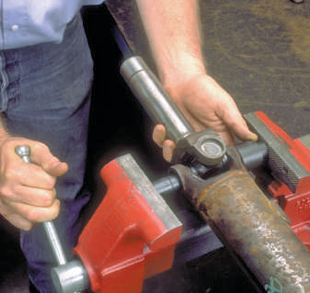
Sometimes snap rings are on the inside. A punch or a special tool can be used to remove them. If the U-joint is retained by plastic resin, follow the manufacturer’s service manual instructions. A small tube of resin is usually used
Figure 2-6 Sometimes snap rings go on the inside of the yoke.

CV Joint service and maintenance

CV-joint inspection
A popping or clicking noise when turning indicates a possible worn or damaged outer joint. To help identify the exact cause, put the vehicle in reverse and back up in a circle. If the noise gets louder, the outer joints should be replaced. A clunk during accelerating, decelerating can be caused by excessive play in the inner joint on FWD vehicles. A humming or growling noise is sometimes due to
Figure 2-7 Removing U-joint by using vise
- Inadequate lubrication of either the inner or outer CV joint.
- more often due to worn or damaged wheel bearings,
- A bad intermediate shaft bearing on equal-length half-shaft transaxles
- worn shaft bearings within the transmission.
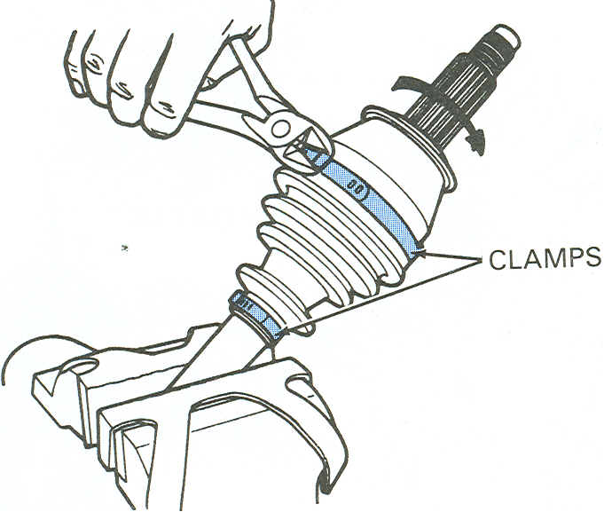
A shudder or vibration when accelerating is often caused by excessive play in either the inboard or outboard joint but more likely it is the inboard plunge joint. A cyclic vibration that comes and goes between 45 and 60 mph (72 and 100 kmph) However, as a rule, an out-of-balance wheel produces a continuous vibration. A more likely cause is a bad inner tripod CV joint. If a noise is heard while driving straight ahead but it ceases while turning, the problem is usually not a defective outer CV joint but a bad front wheel bearing. A vibration that increases with speed is rarely due to CV joint problems or FWD half-shaft imbalance. More likely due to
- An out-of-balance tire or wheel,
- an out-off round tire or wheel, or
- a bent rim
- a bent half shaft, as the result of collision or towing damage, could cause the vibration.
Figure 2-8 Cutting boot clamp
- A missing damper weight could also be the culprit.

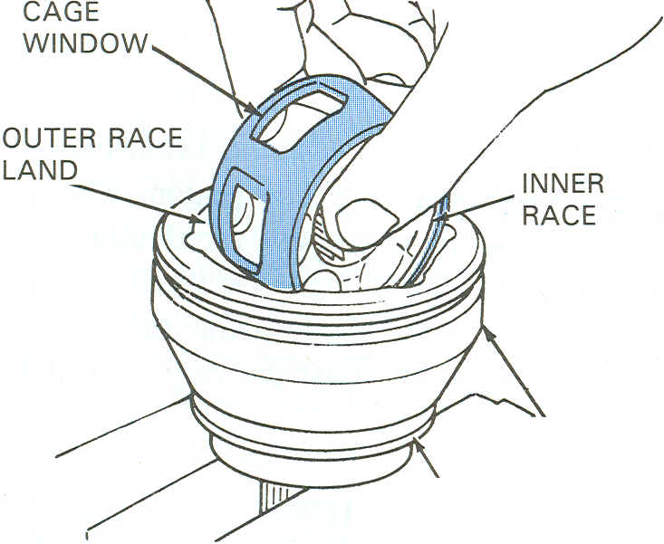
CV-joint service
CV joints Once packed with grease and installed, they require no further maintenance. A loose or missing boot clamp, or a slit, tear, or a small puncture in the boot itself allows grease to leak out and water or dirt to enter, consequently, the joint is destroyed.
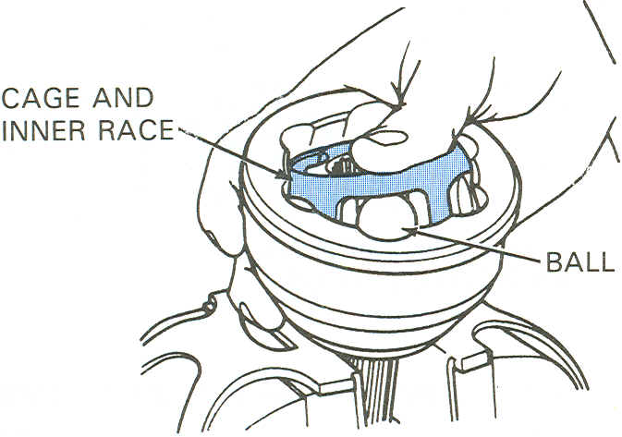
Outboard joints tend to wear faster than the inboard ones, if the vehicle has low miles and joint failure is the result of a defective boot, there is no reason to replace both joints. On a high-mileage vehicle where the bad joint has actually just worn itself out, it might be wise to save the expense and inconvenience of having the half shaft removed twice for CV joint replacement.
Figure 2-9 Checking grease for grit
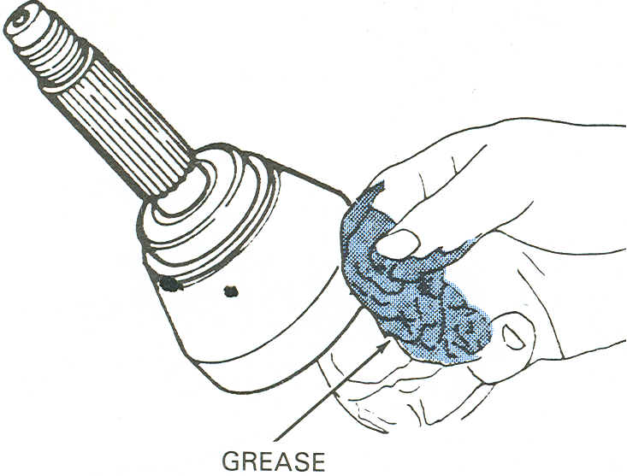
To service the outer CV joint, cut off the boot clamps (Figure. 2-9) and remove the boot. Rub some of the grease from the CV joint between your fingers (Figure. 2-10). If the grease feels gritty, the joint probably may damage.
Figure 2-10 Tilting cage and inner race
Wipe away the grease and remove the CV joint from the half shaft. Most are retained by a snap ring or circlip. Force up one side of the cage and inner race, and remove each ball. Then pivot the cage and inner race so the cage windows align with the lands of the outer race. Lift out the cage and inner race. The Rzeppa outer CV joint completely disassembled.
Figure 2-11 Lifting out cage and inner race
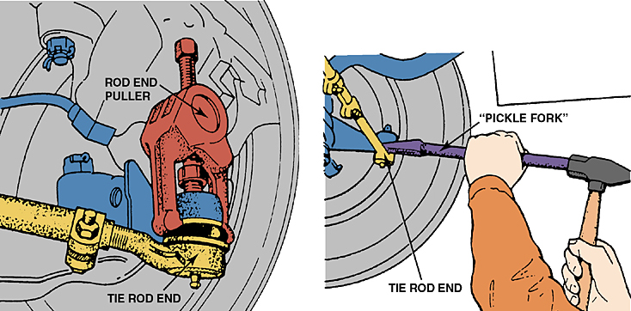
Inspect the cage for cracks and pitting. This allows excess ball movement and causes a clicking sound during turns. Check the inner and outer races for excess wear in the grooves caused by the balls moving back and forth. Shiny areas in the grooves and cage windows are normal. Replace the CV joint only if a part is broken, cracked, severely pitted, or damaged.
Figure 2-12 How to use pickle fork
The preferred method for separating the tie rod end from the steering knuckle is to use a puller such as the one shown. A “pickle-fork” type tool should be used only if the tie rod is going to be replaced. A pickle-fork-type tool can damage or tear the rubber grease boot

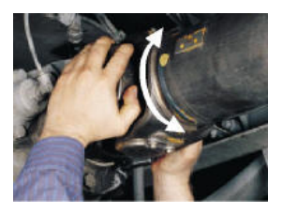
Inspecting mounting points and fittings

Inspecting Yoke End Fittings
Inspecting Yoke End Fittings (Includes Slip Yoke, Yoke Shaft, Tube Yoke and End Fitting Yoke). Take hold of the end fitting with both hands. Try to move it vertically and horizontally to feel any looseness. NOTE: If oil is evident coming from the transmission, it may be hot and officers should exercise caution.
Figure 2-13 Rock the joint in clock and anti-clock wise
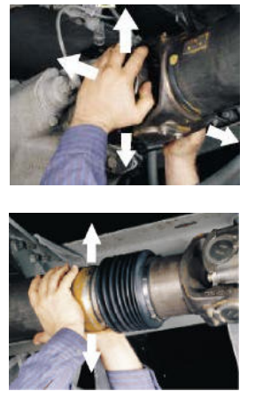
Check all input and output end fittings (yokes at each end of driveshaft) for looseness or play. Ensure that all the mounting hardware (nuts bolts, etc.) are not loosen by hand pressure, broken or missing. Inspect the yoke end for cracks. Attempt to move the slip joint yoke shaft by hand. Check to see if there is any movement.
Figure 2-14 Rock joint along four directions
Movement indicates wear in the splines of the slip joint. Attempt to rotate the universal joint ends in opposing directions. With hand pressure only, determine if there is any independent rotational movement between the opposing yoke ends. Verify all bearing cup assembly caps are in place. With hand pressure, ensure the universal joint bolts are fit
Figure 2-15 Inspection of Yoke End Fittings

Inspecting Centers Bearing (Carrier Bearing)
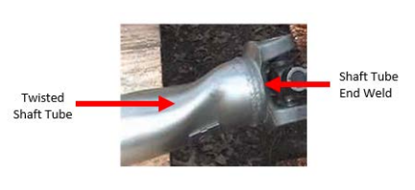
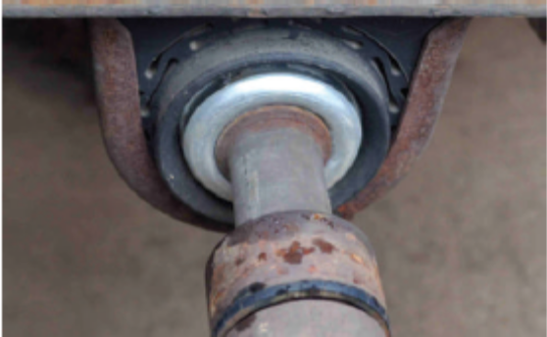
With hand pressure only, push up and pull down on the driveshaft to check for movement in the centers bearing carrier. Movement of shaft in the centers bearing carrier is not a violation until the out-of-service criteria is met. Inspect the centers bearing bracket, bracket bolts and mounting hardware and ensure they are not loosen or broken. Inspect the centers bearing bracket for cracks.
Figure 2-16 Inspection of center bearing assembly

Inspecting the Driveshaft Tube
Inspect the driveshaft tube for cracks, for any obvious cracked welds at the driveshaft tube end. Ensure the driveshaft tube has no obvious twists.
Figure 2-17 Inspection of Driveshaft Tube

Inspecting drive line Mounts
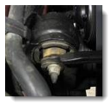
Engines and transmissions are suspended on rubber isolating mounts that absorb vibration and powertrain noise. Most vehicles have three different mounts: two engine mounts and one transmission mount. The engine mounts can be tested by brake torqueing the engine forward and backward. If a mount is broken, the engine will lift and visibly separate from the mount. To test the transmission mount, use proper lifting equipment to raise the vehicle and attempt to lift the extension housing. If the mount is separated, the extension housing will lift from the mount.
Some drivelines have adjustable mounts to compensate for variations in drivelines. An angle gauge can be used to measure the angle of the drive shaft. Consult proper service information for the correct procedure. Front-wheel-drive mounts not only suspend the engine and transaxle but also locate the assembly left to right and absorb the torque wrap-up of the engine from front to back.
Figure 2-18 Powertrain Mounts

The front-to-back engine mount is sometimes called a torque strut because it absorbs the forward and backward movement of the engine and transaxle during acceleration and deceleration. This forward and backward movement of the engine is called torque wrap-up.
Front-wheel-drive transaxle and engine mounts can be inspected in much the same way as rear-wheel drive transmission mounts. When the weight of the assembly is lifted from the mount, look for looseness or separation of the rubber from the metal. If the rubber bushing is loose on the mount bolt of the torque strut, the strut is defective.
An additional check can be made by brake torqueing the engine forward and backward. This will force the engine back and forth against the strut. If the bushing is bad, there will be a noticeable cling or thumping in the mount.
Procedures for centering front-wheel-drive mounts vary, depending on the manufacturer. On some vehicles, the drive shaft hub nuts must be loosened and the CV-joints bottomed. Then the amount of shaft thread that extends from the hub is measured, and the mounts are adjusted until they are equal. Other vehicles require different centering procedures. All centering procedures are designed to achieve sufficient length clearance to allow for changes in suspension geometry. Consult proper service information for the correct procedure.

Self-check-2
      - Which operating application would be correct when determining more frequent driveline lubrication intervals?
    - Off-road operation
    - Pick-up and delivery
    - Line haul trucking
    - Short-haul trucking
      - Which failure would likely occur from an incorrectly installed U-joint?
      - Damage from galling
      - Damage from spalling
      - Damage from pitting
      - Damage from brine ling
      - Which statement would not be considered a cause of driveline vibration?
- Driveshaft out-of-balance
- Equal operating angles
- Improper phasing
- Unequal U-joint working angles
      - Which is the correct procedure when lubricating U-joints?
- Grease until you see grease come out of a trunnion seal.
- Pump grease until it exits from all four trunnion seals.
- Apply only two shots of grease per trunnion.
- Hand pack each bearing cap when first installing a U-joint.
      - What must have occurred if a driveshaft is out of phase?
- U-joint has been assembled incorrectly.
- Transmission yoke has been damaged.
- Differential carrier yoke has been damaged.
- Driveshaft has been separated at the slip splines.
      - What tool must be used to remove a universal joint from a driveline yoke?
- Two-jaw U-joint puller
- 12-pound sledge hammer
- 25-pound slide hammer on yoke
- Hydraulic jack on yoke hub
      - When inspecting a U-joint failure you see metal flakes separating from the bearing surfaces on the cross. What has occurred to cause this?
- Brine ling
- Spalling
- Galling
- False brine ling

Operation sheet-2
Propeller Shaft and U-joint Service
PROCEDURE:
- Inspect propeller shaft & intermediate shafts runout. If runout is greater than maximum, replace the shaft. Refer specific manual
Maximum runout: 0.8 mm (0.031 in.) Actual Reading: ______________
- Disassembly, separate propeller shaft and intermediate shaft. Place a match mark on both flanges.
Remove four bolts, washers and nuts.
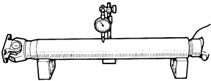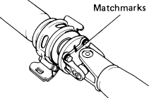
- Replace spider bearing, place match mark on shaft and flange or yoke, remove snap rings, slightly tap in the bearing outer races, use two screwdrivers remove the four snap rings from the grooves.
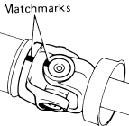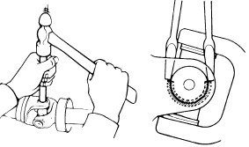
- Remove spider bearing, using SST push out the bearing from the propeller shaft, clamp the bearing outer race in a vise and tap off the propeller shaft with a hammer, remove the bearing on opposite side in the same procedure.
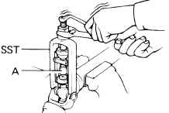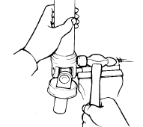
- Install spider bearing, apply MP grease to the spider and bearings, align the match mark on the yoke and shaft, fit a new spider into the yoke, using SST install new bearings on the spider.
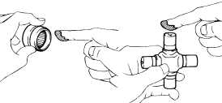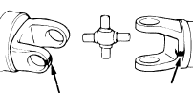

- Using SST, adjust both bearings so that the snap ring grooves are at maximum and equal widths, install two snap rings of equal thickness which will allow 0 – 0.05 mm (0 – 0.0020 in.) axial play.
Do not re use snap rings.
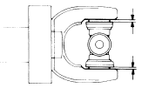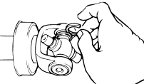

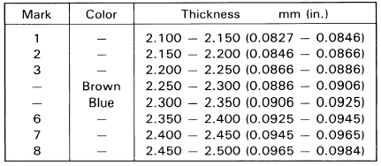

Propeller shaft components

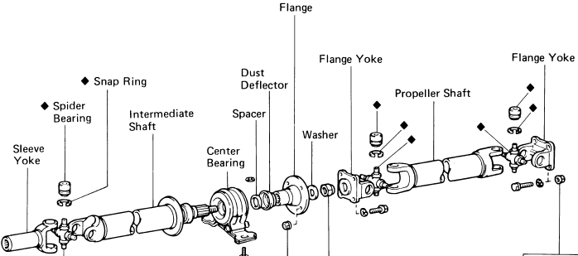

Unit Three: Maintain Differential and drive Axle
This unit to provide you the necessary information regarding the following content coverage and topics:
- Differential inspection before disassembly
- Drive axle inspection
- Differential overhauling
- Differential inspection and adjustment after assembly
- Wheel bearing service
- Report inspection findings
This guide will also assist you to attain the learning outcomes stated in the cover page. Specifically, upon completion of this learning guide, you will be able to:
  - Inspect differential
  - Overhaul differential
  - Service wheel bearing
  - Repair drive axle
  - Report inspection findings

Before removing a final drive unit for service, make sure it needs to be serviced. Typically, problems with the differential and drive axles are first noticed as a leak or noise. As the problem worsens, vibrations or a clunking noise might be felt during certain operating conditions. Diagnosis of the problem should begin with a road test in which the vehicle is taken through the different modes of operation. Most manufacturers recommend that the vehicle should be operated in four distinct modes during the road test such as drive, cruise, coast and float modes.
During each of these modes, the stress on the various driveline parts changes. The cause of a problem is identified by thinking about what is under and not under stress during each mode. Typically, problems with the differential and drive axles are first noticed as a leak or noise. As the problem worsens, vibrations or a clunking noise might be felt during certain operating conditions.

Differential Inspection before Disassembly
Diagnosis of the problem should begin with a road test at different condition
- If the noise changes with the road surfaces, it means the tires are the cause of the noise.
- Another way to isolate tire noises is to coast at speeds less than 30 MPH or 48 km/h. If the noise is still heard, the tires are probably the cause. Drive axle and differential noises are less noticeable at these speeds.
- Accelerate and compare the sounds made while coasting. Drive axle and differential noises change. Tire noise remains constant.
- Differential noises often change with the driving mode, whereas axle-bearing noises are usually constant. The sound of the bearing noise usually increases in speed and loudness as vehicle speed increases.
Worn, loose or damaged bearings or gears generally cause operational noises. Bearing noises might be a whine, which is a high-pitched, continuous “whee” sound. Gears can also whine or emit a howl a very loud, continuous sound. Howling is often caused by low lubricant in the drive axle housing. The meshing teeth scrape metal from each other and can be heard in all gear ranges. If topping up the lubrication level does not alleviate the howling noise, then the drive pinion and ring gear must be replaced. The differential case assembly and drive pinion should be inspected before they are removed from the carrier casting. These inspections help to find the cause of the trouble and to determine the correction needed.
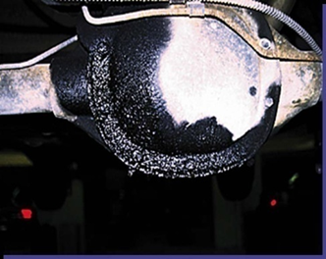
Lubrication levels on off-road equipment are generally checked every 250 hours of operation. Oil levels in drive axles/differentials must be checked properly; the oil level must be even with the bottom of the oil filler plughole. A good rule is to replace the oil every 2,500 hours of operation or after 1 year, whichever comes first. Remove the plug in the axle banjo housing; the oil should be even with the bottom of the oil level plug hole.

Differential Overhaul
The differential carrier should be secured to an overhaul stand before attempting to disassemble it. Inspect the crown and pinion for physical damage before attempting to remove it. If there are broken teeth or indication of excessive wear measuring the backlash is not necessary. If the gear set is determined to be usable, then the backlash and runout must be measured and recorded.
Figure 3-1 Differential ready for removal and overhauling
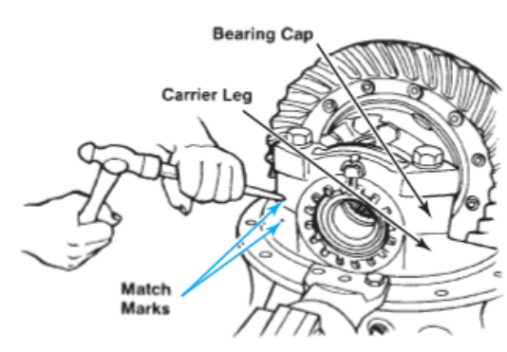
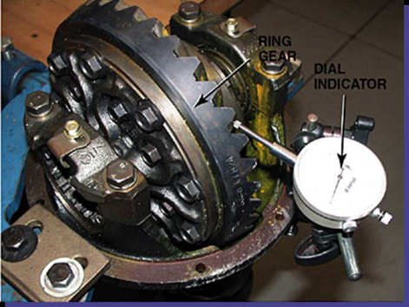
The crown and pinion must be reinstalled with the same backlash to maintain the correct tooth-con tact pattern. If the gear set is damaged and must be replaced, this last step is not required. Drain lubricant and remove cover, then proceed as follows: - Carefully inspect the ring gear, side, and pinion gears for obvious damage or wear. The backlash is the amount of clearance between the drive pinion and the ring gear; excessive backlash could indicate excessive wear. Use a dial indicator as shown in Figure 3-2 to check and compare the results with specifications. Adjust the side bearing preload or repair if the backlash is not within the specifications of 0.15 – 0.20 mm. NOTE: Measure the backlash at 3-4 places and confirm that it is the same value.
Figure 3-2 Crown and pinion gear backlash inspection

Differential/Crown Gear Disassembly
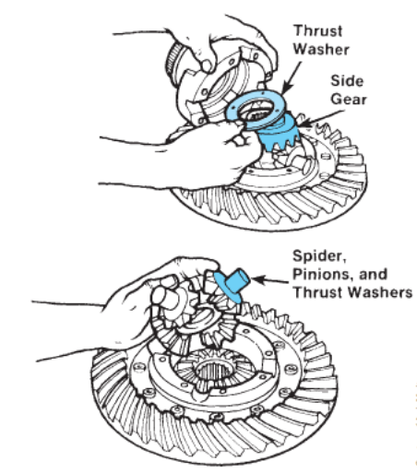
If match marks are not present on the carrier case, use a centre punch to identify correct orientation. The carrier halves must be installed in the same location when reassembled. Separate the case halves and remove the spider, four pinion gears, two side gears, and the thrust washer. If the crown gear needs to be replaced, unbolt it from the differential casing. In some cases, it may need to be pressed out of the flange case.
Figure 3-3 How to correctly match mark the caps
before removal.

Figure 3-4 Removing the input (A) flange or (B) yoke.

      - Removing the Pinion Drive
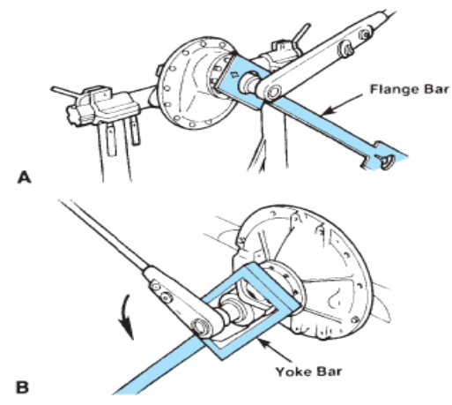
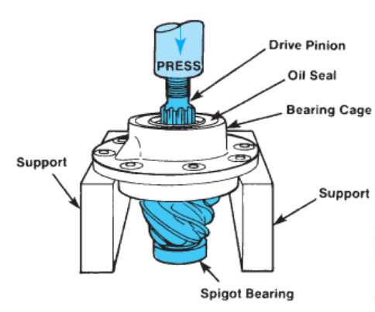
The pinion drive on heavy duty differentials is mounted to a pinion carrier, which houses two tapered roller bearings and the drive pinion and yoke. First remove the pinion nut with an impact. Sometimes a pinion nut will have a cotter pin locking it to the shaft; remove it first. In some cases, such as on some larger differentials, the pinion nut is torqued as high as 1,000 lb-ft and must first be loosened with a large 3 /4-inch drive power bar.3. Refer to Figure 14-43 to view the procedure for this type of pinion nut removal. Once the pinion yoke is removed, remove the cover and seal assembly along with the gasket from the bearing cage.
Figure 3-5 Removal of the spider and pinion gears
If the seal needs to be replaced, it must be installed with a press or sleeve driver or seal damage will occur. Carefully remove the drive pinion assembly from the housing; do not damage or loosen the shims, as shown in Figure 3-5 Measure the shim pack and record the measurement. It will be needed to calculate the pinion depth when reassembling.
Figure 3-6 Pressing the drive pinion from the bearing cage
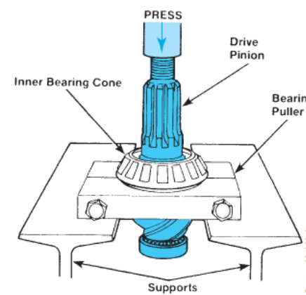
      - Drive Pinion Bearing Cage Disassembly.
On large differentials a press will usually be required to remove the pinion from the bearing carrier, as shown in Figure 3-6. As with any type of disassembly, first review the specific repair literature for the type of differential that is being disassembled. Use a suitable press to remove the pinion from the bearing carrier, as shown in Figure 3-7. Be careful not to drop the pinion to the ground once it has cleared the bearing; this could damage the pinion gear faces. If you are replacing the pinion bearings, use a press to remove the inner bearing from the pinion shaft. If the spigot bearing is to be replaced, remove the snap ring and use a suitable bearing puller to remove the bearing.
Figure 3-7 Pinion bearing removal

Inspection after Disassembly of Carrier
Replace all parts that do not pass inspection. Thoroughly clean all parts. Synthetic seals must not be cleaned, soaked, or washed in cleaning solvents. Always use clean solvent when cleaning bearings. Oil the bearings immediately after cleaning to prevent rusting. Inspect the parts for defects. Clean the inside of the carrier before rebuilding it. When a scored gear set is replaced, the axle housing should be washed thoroughly and steam cleaned. This can only be done effectively if the axle shafts and shaft seals are removed from the housing. Inspect individual parts as outlined below.
      - Gears
Examine the pinion and ring gear teeth for scoring or excessive wear. Extreme care must be taken not to damage the pilot bearing surface of the pinion. Worn gears cannot be rebuilt to correct a noisy condition. Gear scoring is the result of excessive shock loading or the use of an incorrect lubricant. Noise that resembles a howl or whine can be due to adjustment of the ring and pinion or due to bearings that are worn. Incorrect differential gear adjustment can result in a howl that occurs only under drive or only under coast conditions. Worn bearings will make a constant sound that changes in relation to road speed. Clunking noises can be due to damaged gears or bearings. When a gear is badly damaged, a shudder can sometimes be felt along with the noise.
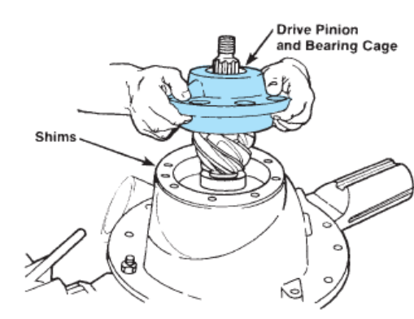
Noise that happens only during a turn is probably due to a problem with the spider gears. They can become damaged when a wheel is allowed to spin in a puddle and then gets traction. The differential pinions are very small gears. They cannot withstand the punishment of a heavy load that the large ring and pinion can. Remember that the pinion gears (spiders) are only turning during a turn. When they come to an abrupt halt, they can easily lose teeth. Damaged side gears are usually on the side that received the stress.
Figure 3-8 Removing the drive pinion and bearing cage
Other problems related to the spider gears include:
- Pinion gears too tight on the shaft
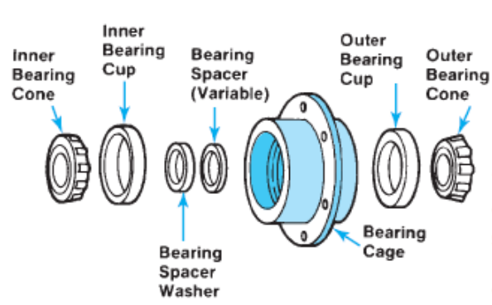
- Side gears too tight or too loose in the differential case
- Excessive backlash between the spider gears. The two parts of the case are smooth and free from nicks or burrs.
      - Differential case
Figure 3-9 Correct orientation of parts in a pinion
cage assembly
Make sure that the differential bearing bores are smooth and the threads are not damaged. Remove any nicks or burrs from the mounting surfaces of the carrier housing. Make sure that the hubs where the bearings mound are smooth. Carefully examine the differential case bearing shoulders, which may have been damaged when the bearings were removed. The bearing assemblies will fail if they do not seat firmly against the shoulders. Check the fit (free rotation) of the differential side gears in their counter bores. Be sure that the mating surfaces of

Differential Carrier Assembly
The steps outlined below are basically the reverse steps that are required to disassemble a differential carrier. This procedure is intended to be an example showing the general steps required to assemble a differential. The procedures that are used may vary extensively from differential to differential and should be attempted only after you have consulted the manufacturer’s repair literature for a specific product. If the pinion bearings have been replaced, the new bearing cups must be pressed into place in the bearing cage on a press. Installing the cups with a metal hammer is not recommended; the cups are made from hardened, high-quality steel and may splinter from impact blows. Press the inner bearing cone onto the drive pinion using a press. Be sure to apply pressure only on the inner race of the cone, not on the roller cage, or damage to the bearing will occur. Some bearings have a radius on one shoulder of the inner race. This radius faces toward the drive pinion teeth. Lubricate all the bearings and cups with axle lube before installing the drive pinion in the cage. Set the correct preload to the drive pinion assembly.
      - Installing the Drive Pinion Assembly
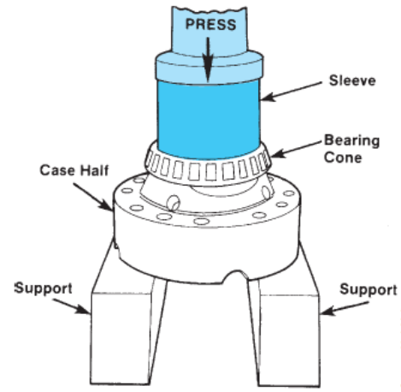
After completing the preload adjustments to the drive pinion assembly, install the assembly into the differential housing as indicated below: If a new crown and pinion is to be installed, follow the calculation procedure to determine the shim pack thickness. If the same crown and pinion is reinstalled, then install the shim pack that was removed during disassembly.
Be sure to line up the oil holes in the shim pack with the oil holes in the housing using the guide studs as shown in Figure 3-9. To install the drive pinion assembly in the housing, it may be necessary to use a soft-blow hammer to force the parts together. Install the seal cover and gasket to the assembly.
Figure 3-10 Installation of the shim pack before the drive pinion assembly is installed

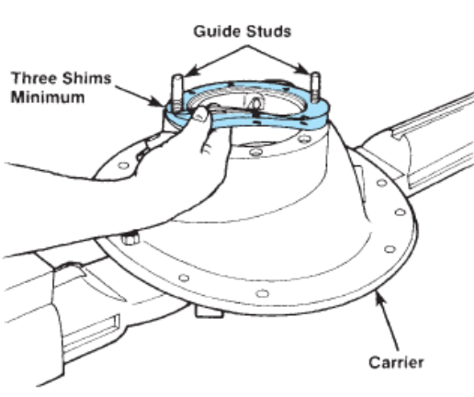
Refer to Figure 3-11 for the correct orientation. Install and torque all the cap screws to the correct torque values recommended by the manufacturer’s specifications. Install the input yoke and torque up to the manufacturer’s recommendations; use the yoke or flange bar during the torque procedure.
      - Installing the Crown Gear
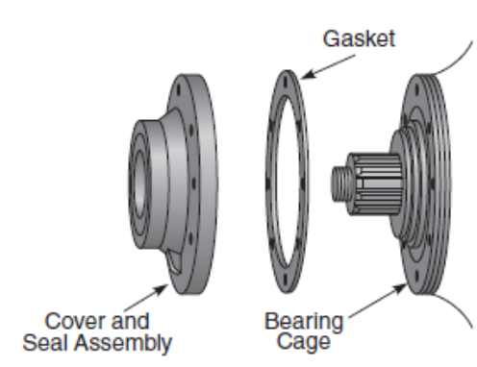
The steps outlined here are shown as examples only. Crown gears, or ring gears as they are sometimes called, may have different installation procedures that are dependent on brand name. Always refer to the manufacturer’s technical documentation for the actual procedures and specifications to perform this type of work. To facilitate ease of installation, the ring gear should be heated for a few minutes, using water to a temperature of 718C to 828C).
Figure 3-11 Correct orientation of the seal cover and gasket.
Figure 3-12 Correct orientation of the crown gear
Never expose the gear to any type of flame, such as a torch, to heat the gear; damage to the hardened surface could result. Pressing a cold ring gear into place can damage the case halves from the interference fit.
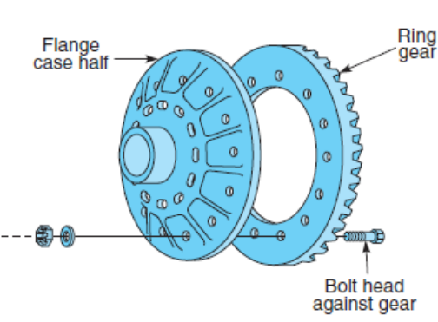
The displaced metal could be trapped between the parts and cause excessive ring gear runout. If new side bearings are to be used, install the bearings to both sides of the case halves by using a press Lubricate both sides of the case halves along with all the internal parts before assembly.
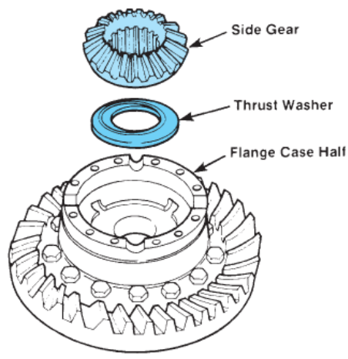
Place the case half with the crown gear facing up on a suitable bench to begin assembly. Install one thrust washer and one side gear into the case. Install the spider, differential pinions, thrust washers, and side gear. Refer to Figure for correct orientation. Install the other case half into position, being careful of alignment. Tighten the fasteners in a cross pattern to the manufacturer’s torque specifications. Check to see that the differential spiders rotate freely when assembled.
Figure 3-13 Bearing cone installation in case half
      - Crown Gear Assembly Installation
The following steps are general examples of installation procedures. The actual procedures for this type of installation require that you follow the manufacturer’s service literature on installing the crown gear assembly into the differential housing. Be sure that the cups and bearing bores of the differential carrier is clean and dry. Apply lube to the inside surface of the cups, and be sure to lube the roller bearings in the process. Install the bearing cups onto the side bearing before installing the crown assembly into the housing.
Figure 3-14 Correct orientation of the thrust washer and side gear. Lubricate all internal parts with axle lube before installing into place.
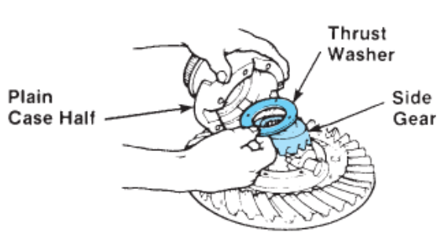
Lower the assembly carefully into the housing, being careful that the cups stay in place on the side bearings.
Install the bearing cups following the orientation marks that were made during disassembly, and torque up to specifications. To perform all the necessary adjustments in the right sequence, refer to the testing and adjusting section later in this chapter.
Figure 3-15 Correct orientation of the spider, differential pinions, thrust washer, and side gear

Installing the Differential Carrier into the Axle Housing
After completing the differential carrier assembly, it is now ready to install into the axle housing. The steps outlined here are only examples. Always consult the manufacturer’s technical documentation before attempting to install the carrier into the axle housing; not all installations are exactly the same.
The installation procedure is the reverse of the disassembly procedure and is outlined in operation sheet. Thoroughly cleaning all mating surfaces and inspecting for burrs or any other abnormality that may interfere with the fitment is crucial.
Apply a thread locking compound, such as Loctite1 to the studs and torque up to specification. In some cases, the manufacturer does not require a gasket to be installed between the differential
carrier and the mounting flange of the banjo housing. Apply a small bead of silicone to the banjo housing surface to form a seal. Install the differential carrier carefully, making sure the mating surfaces are in contact all the way around. Use only one fastener at each corner (at this time) to ensure that the assembly is drawn in evenly. Note: Clean the mating surfaces of the wheel hub and planetary carrier and apply a bead of silicone to the wheel hub contact area before assembling.

Axle Assembly Adjustments and Checks
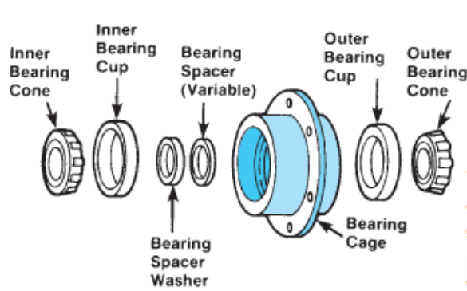
Due to the large number of differential designs, this section covers the adjustments made to a conventional single reduction differential assembly. The adjustment procedures will require the use of the manufacturer’s shop literature for the differential that is being overhauled. Pinion Bearing Preload Adjustment. Newer differential carriers use a press-fit outer bearing on the drive pinion. Although not as common, some older units use a slip-fit outer bearing that slips over the drive pinion.
Figure 3-16 Correct orientation of parts in a pinion cage assembly before adjusting the preload
      - Press-Fit Method of Adjustment.
Assemble all the parts that are required to perform this procedure. Refer to Figure 3-16 to view the correct order of assembly. Be sure to centre the spacers between the bearing cones. If a new gear set or new bearings are used, choose a nominal spacer based on the manufacturer’s specifications. If the original parts are used, use the original spacers that were removed when it was disassembled. Place the cage assembly in a suitable press and apply and hold a load onto the bearings. As pressure is applied, rotate the cage back and forth; this ensures seating the bearings. Hold pressure on the bearing assembly. The scale should be read while the cage is actually turning; this will avoid getting the start-up torque reading, which would be higher. When using this method of preload calculation, the radius (half the diameter of the cage) must be used to perform these calculations. When using this method, it is important to select a spacer that is 0.001" larger than specified to compensate for bearing expansion when it is pressed onto the pinion shaft. This method will result in preload that will be correct most of the time.
The following is an example of formulas used to calculate preload in Standard Measurement:
Pull (lb) × radius (inches) =preload (lb-in)
To convert to Newton meters use:
Preload (lb-in) × 0.113 ; (conversion value) = preload (Nm)
The following is an example of formulas used to calculate preload in Metric Measurement:
Pull (kg) × radius (cm) = preload (kg-cm)
To convert to Newton meters use:
Preload (kg-cm) × 0.098 (conversion value) = preload (Nm)
The following is an example in Standard Measurement: 10 lb × 5 in = 50 lb-in (preload)
To convert to Newton meters use: 50 lb-in × 0.113 =5.65 Nm
The following is an example in Metric Measurement: 4.6 kg × 2.7 cm = 58.42 kg-cm (preload)
To convert to Newton meters use:
58.42 kg-cm × 0.098 =5.73 Nm (preload)
      - Yoke Method of Preload Adjustment
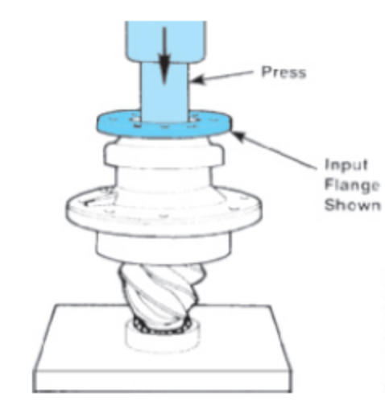
This method uses the pinion bearing assembly, fully assembled. The prior adjustment procedure did not use the drive pinion in the equation. Completely assemble the drive pinion cage including the input flange, as shown in Figure 3-17, by using a press. Assemble the yoke, flange washer, and nut and torque to specification. Note the position of the yoke on the splines of the drive pinion; it must rest against the outer bearing before it is torqued. Two methods can be used to perform this.
If you are working on a small differential assembly (12-inch ring gear or smaller) and have a large vice available, you can place the lip of the pinion carrier in a vice equipped with soft jaws to keep it from turning while you torque the pinion nut to specification. If you are working on a larger differential assembly, you will temporarily install it in the banjo housing and secure it with two hand-tightened bolts to hold it in place during the torqueing procedure. Do not install the shims at this time since it is only a temporary installation
Figure 3-17 Procedure for installing the input flange with a press

Checking/Adjusting Pinion Cage Shim Pack
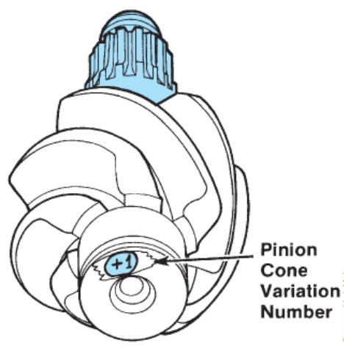
If the crown and pinion is being reused, start with the shim pack that was removed when the unit was disassembled. If a new gear set is used, then use this procedure to determine the shim pack thickness. Measure the old shim pack with a micrometre and record that number along with the number on the new drive pinion. Refer to Figure. If the number on the old pinion was a plus number, subtract it from the shim pack thickness. If the number was a minus, add it to the shim pack thickness. Check the number on the new pinion and record it for reference later. If the new pinion number is a plus, add the number to the shim pack thickness that was calculated previously. If the number on the new pinion is a minus, subtract it from the previously calculated shim pack. The answer to the previous two steps now yields the new shim pack thickness to be installed with the new gear set.
Figure 3-18 Location of the pinion cone variation number
Table 3-1 Calculations of shim pack thickness
 | Inches | mm
Old Shim Pack Thickness | 0.030 | 0.76
Old PC Number PC 2 | –0.002 | –0.05
Standard Shim Pack Thickness | 0.028 | 0.71
New PC Number PC+5 | +0.005 | +0.13
New Shim Pack Thickness | 0.033 | 0.84
Old Shim Pack Thickness | 0.030 | 0.76
Old PC Number PC – 2 | +0.002 | +0.05
Standard Shim Pack Thickness | 0.032 | 0.81
New PC Number PC + 5 | +0.005 | +0.13
New Shim Pack Thickness | 0.037 | 0.9

Differential Bearing Preload Adjustment
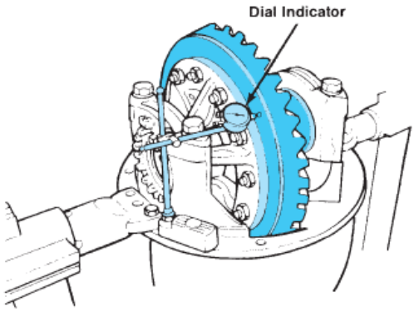
Although there is more than one method for making this adjustment, only the most common one will be shown in this example. As with all adjustments, this example is to be used only as a general guide; always consult the manufacturer’s service literature to get the exact procedures and specifications for each individual design application. It is important to start with a small amount of endplay in the carrier assembly.
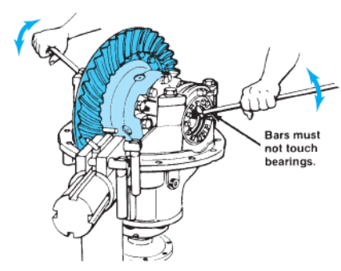
Place a dial indicator onto a flat surface, such as the mounting flange of the carrier, and place the plunger of the dial indicator so that it sits 90 degrees to the back of the ring gear, as shown in Figure 3-19. To begin this procedure, loosen the adjusting ring opposite the dial indicator until a small amount of endplay is registered on the indicator. Use an appropriate T-bar wrench for this adjustment. To adjust the ring gear to the left or right, use a pry bar, as shown in Figure 14-58 as you read the dial indicator. Use the differential case as a pinch point when performing this adjustment.
Figure 3-19 Location of the dial indicator used to measure carrier endplay
Figure 3-20 Adjustment procedure used to achieve preload to the differential assembly bearings
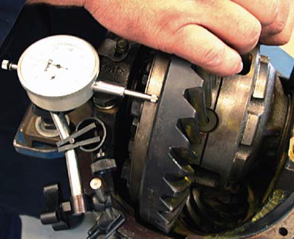
Tighten the same adjusting ring until no endplay shows on the dial indicator, moving the ring gear to the right or left as required to achieve no endplay. Keep repeating until zero endplay is reached. To complete this adjustment procedure, tighten each adjusting ring one notch farther in from zero-lash to preload the bearings.

Ring Gear Runout Check
Figure 3-21Ring gear runout should be less than 0.10 mm as measured by a dial indicator
To check the runout on the ring gear assembly, the following steps must be followed carefully or an inaccurate reading will result. Follow the steps below in sequence to measure the ring gear runout. Place a magnetic dial indicator on the flange mount of the differential housing and position the pointer 90 degrees to the back face of the ring gear with a slight preload on the pointer. Adjust the dial indicator to zero and slowly rotate the ring gear. Record the total runout during one complete revolution of the ring gear. A nominal value will typically be around 0.008". Always consult the manufacturer’s service literature for the specific differential that is
being adjusted. If excessive runout is recorded, then the differential must be disassembled and checked carefully for any burrs that might have been missed during assembly. The root cause of excessive runout must be corrected as this will lead to a short crown and pinion life.

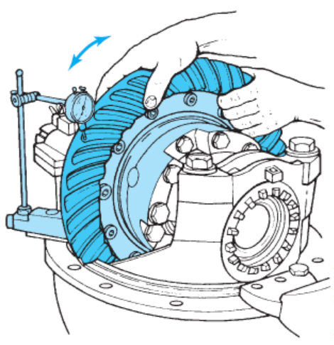
Ring Gear Backlash Adjustment
If the old ring gear set is being reused, adjust the backlash to the values that were measured before disassembly. If a new ring gear set is used, adjust the backlash according to the manufacturer’s specifications.
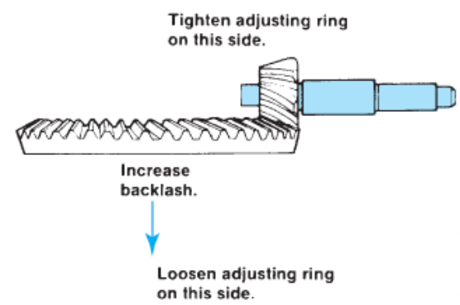
Note: Backlash readings should be taken in at least three different places on the ring gear to get an average reading. Place a magnetic dial indicator on the flange mount of the differential housing and position the pointer 90 degrees to the face of a ring gear tooth with at least one revolution of preload on the pointer and set it to zero, as shown in Figure 3-22. Move the ring gear back and forth slightly and read the dial indicator movement; repeat this in three places spread out evenly around the ring gear. If the reading is not within specifications, adjust the backlash as outlined in the following step. Depending on which way the backlash must go, move the adjusting ring one turn at a time by loosening one bearing and tightening the opposite one. This will maintain bearing preload. Backlash will increase when the ring gear is moved away from the pinion and decrease when moved toward the pinion. Refer to Figure 3-23.
Figure 3-22 What happens when the ring gear is moved away from the pinion
Figure 3-23 How to correctly measure backlash of the ring gear

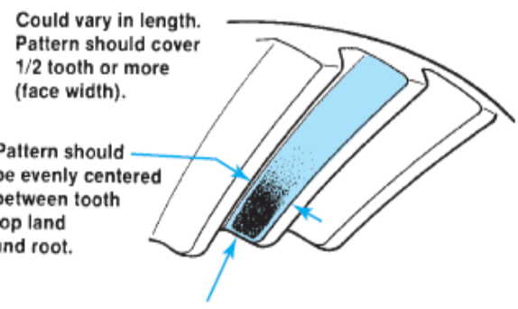
Ring Gear Tooth-Contact Adjustment
As with any adjustments on a differential, this one is critical to the life of the gear set and, if not done correctly, can lead to a catastrophic failure. The tooth-contact pattern consists of a contact patch that runs lengthwise along the tooth of the ring gear as well as the profile of the tooth. Paint at least 8 to 12 teeth on the ring gear before rolling the gear teeth together to check the pattern.
Figure 3-24 Contact pattern on a new gear set
A good pattern, as shown in Figure 3-24, will have the contact mark cantered on the ring gear teeth lengthwise. This test is in an unloaded condition and does not represent what takes place under load. The contact pattern in this case will be about one-half to two-thirds of the tooth. The contact pattern will have a pocket at the toe of the gear that forms a tail at the root of the tooth. This pattern would look better if a load could be placed on the gear set.
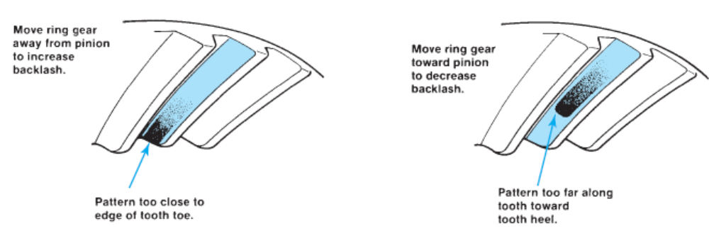
Figure 3-25 Contact pattern too far toward the heel and too close to the toe
Table 3-2 Tooth contact pattern for different scenario
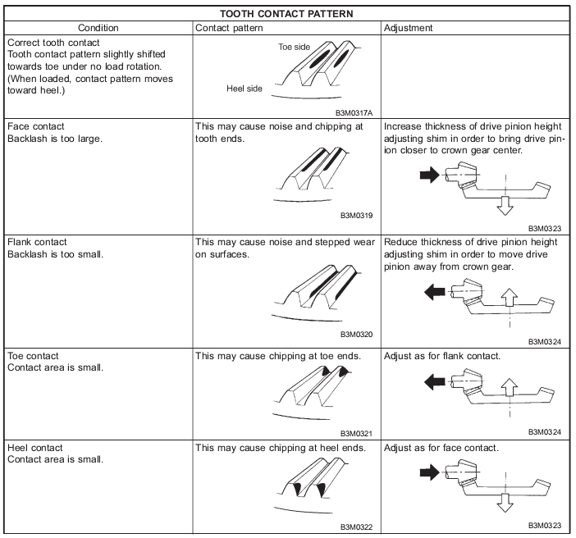
The more wear there is on the gear set, the more pronounced the tail will be. Before you disassemble the gear set, perform a tooth contact check and sketch the pattern for future reference. A good pattern will not extend to the toe, and it will be cantered evenly along the tooth face between the top land and the root. At no time should the pattern run off the tooth. If required, adjust the contact pattern by moving the ring gear and pinion gear either away from each other or toward each other. Pinion position in relation to ring gear position is determined by the thickness of the shim pack between the pinion cage and the differential housing. This adjustment controls the tooth depth.
These adjustments are interrelated because one will affect the other; they must be considered together even though they are two distinct adjustments. Whenever these adjustments must be made, adjust the pinion first, and then adjust the backlash.

Drive axle inspection and repair
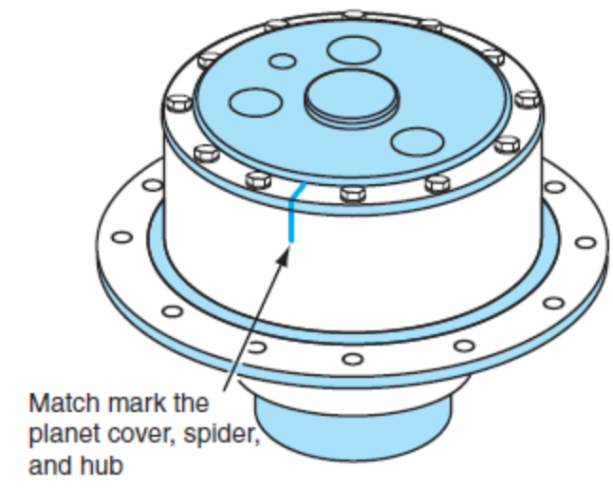
Extensive dirt build-up on the outside of the axle housing can contribute to high lubricating oil temperatures and should be cleaned off regularly. Power washing the axle assembly when dirt is noticeable makes good sense. If the axle is to be repaired, it is mandatory to power wash the area that will be dismantled for servicing. During the inspection procedure, certain off-road equipment axles may require a technician to pressurize the axle centre housing and wheel ends to check for leaks before disassembly.
An axle housing that has seals that isolate the wheel ends (some wheel ends with internal wet disc brakes) need to be air pressure- tested at each wheel end separately in addition to testing the banjo housing. This air-pressure testing procedure requires the use of a 30-psi (206 kPa) air pressure gauge, an air shutoff valve, and an air regulator. Regulated air pressure of 12 psi (82 kPa) is applied to the planetary wheel end fill hole. The pressure should be maintained for 15 seconds. If the pressure does not hold, the wheel hub oil seal is leaking and must be replaced.
Figure 3-26 Match mark the spider, hub, and planet cover before removing
Pressure check the banjo housing the same way but use the air vent hole in the banjo housing to perform this test. If 12-psi (82 kPa) pressure does not hold, find the source of the leak and make the necessary repairs.
Extreme care should be exercised when working on axle assemblies because the subassemblies are, in some cases, very heavy and may require the use of a lifting device. Before beginning work on an axle assembly, the technician should review the manufacturer’s recommended repair procedures carefully to avoid any possibility of damaging the subcomponents through improper disassembly and assembly and to prevent any possibility of injury. Before beginning any repairs, ensure that the vehicle is properly blocked up and the tires and wheels have been removed and stored in a safe location to facilitate the safe removal of the subassemblies. Drain all lubricants from the subassembly that is to be removed.

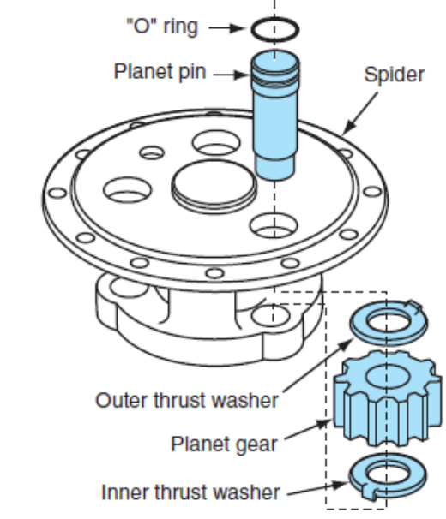
Planetary Wheel End Removal
Once the oil has been drained, match mark the planet cover, spider, and hub, as shown in Figure 3-26. Remove the bolts and planet cover. Separate and remove the planetary spider assembly from the wheel hub. The use of puller screws may be necessary to complete this task. The adhesive that seals the spider to the hub may make it necessary to use a pry bar to loosen the spider assembly.
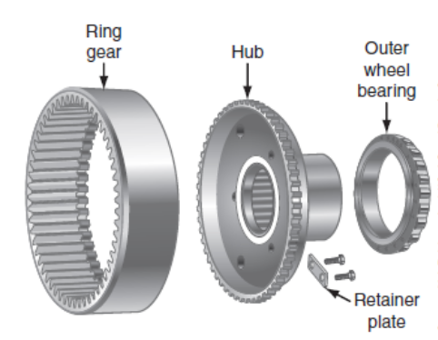
Depending on the model of the axle assembly, removing a set screw (if present) may be required before removing the planet pins. In some cases, a press may be required to remove the pins, as shown in Figure 3-27; in other cases, they may be drifted out with a block of hardwood or brass drift. CAUTION Do not strike the planet pins with a metal hammer; they are hardened steel and may splinter and cause personal injury. Remove the planet pins, thrust washers, and needle bearing if present.
Figure 3-27 The ring gear assembly.
Figure 3-28 Breakdown of the planetary pinion
Note: Depending on the model, some units may use a double nut with lock and may be locked to the hub in a different manner. Before removing the wheel bearing adjusting nut, use a sling to support the wheel hub, and then remove the adjusting nut. On some models, the ring gear to ring gear hub may be bolted together with cap screws and lock plates on the back of the assembly. Remove the outer wheel bearing from the hub. Remove the inner seal and inner bearing from
the hub.

Planetary Wheel Ends Installation
Install new bearing cups with a suitable driver if the inner wheel bearings are to be replaced. Install a new oil seal in the rear of the hub and lubricate the lip. Depending on the axle model, a suitable lifting device may be required to reinstall the hub assembly on the axle. Damage to the inner lip seal may occur if alignment is not maintained during the assembly process.
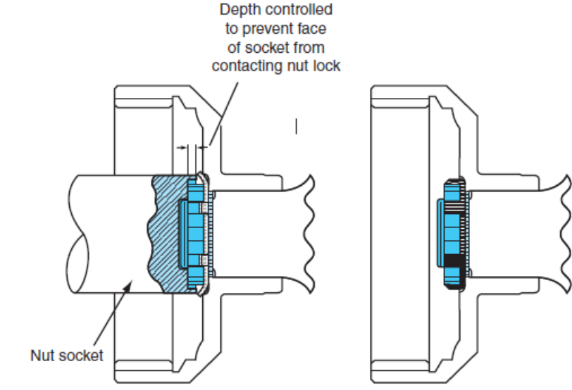
Figure 3-29 Illustration shows the position the wrench must be in to avoid shearing the inner tang on the lock plate

Reinstall the ring gear assembly (see Figure 3-28) into the hub and install the adjustment nut as shown in Figure 3-29 to prevent the hub from slipping off the spindle.

Wheel Bearing Adjustment Procedures
Because a large number of adjustment methods are used on different types of wheel ends, it is important to understand that the following adjustment procedures are examples of typical adjustment procedures and should not be used to actually adjust all wheel bearing preloads. Always refer to the manufacturer’s recommended procedures for a particular type of preload wheel end adjustment. Figure 3-30 shows how to check the rolling resistance of the wheel end assembly.
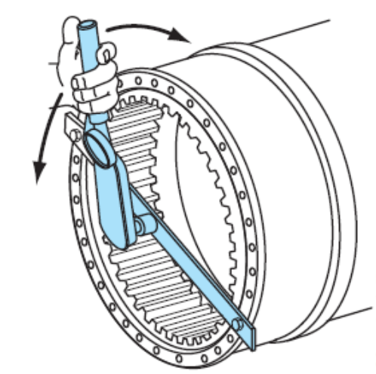
Two basic bearing adjustment procedures that are used by most manufacturers will be outlined in this section the nut and lock plate design and the retainer plate and shim pack design. Before any wheel bearing assembly can be adjusted, the tapered bearing and cups must be seated properly in the hub assembly.
Figure 3-30 Rolling resistance of the wheel end measurement
To bottom out the bearing cups in the hub assembly, the adjusting nut must be torqued up to approximately 500 lb-ft (677 Nm) repeatedly until the torque does not advance the adjusting nut any further.
      - Nut and Lock Plate Adjustment.
The nut and lock plate design has many variations. Always refer to the manufacturer’s installation procedure for the particular type that is being worked on. Loosen the nut a quarter turn until a slight bearing endplay is felt and the hub rotates freely. Measure the no-load rolling resistance of the wheel hub assembly. Refer to Table 3-3 for the correct values. Now refer to Figure 14-38. Note: The rolling resistance is the force being shown on the dial torque wrench while the wheel is turning and is not to be confused with the start-up torque of the wheel, which is always higher.
Table 3-3Ttorque chart for wheel bearing adjustment
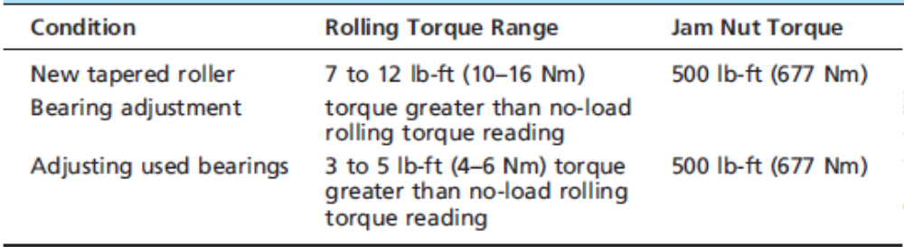
      - Plate and Shim Pack Adjustment
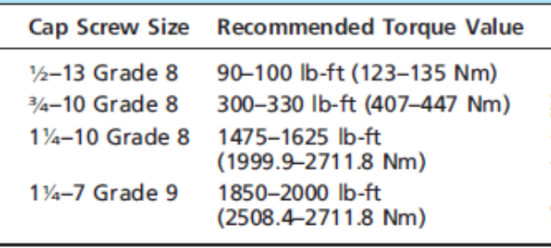
Always refer to the manufacturer’s specifications for the recommended adjustment procedures and specifications for a particular type of wheel end bearing. Before beginning, measure the retaining plate thickness and record the value as shown in Figure 14-39. Install the retainer plate without the shims. Tighten the cap screws to the recommended torque values as outlined in Table 3-4.
Table 3-4 recommended torque value
Table 3-5 Example of calculations to determine shim pack thickness
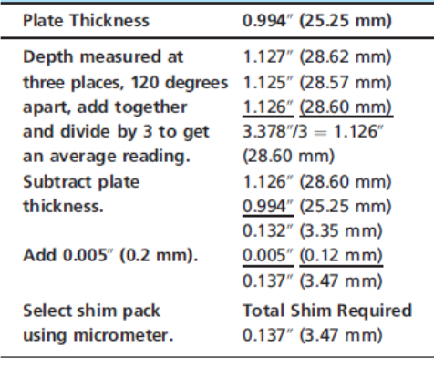
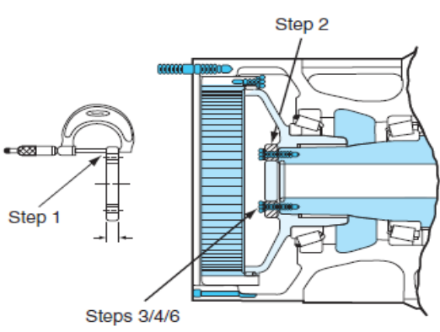
Strike the retainer with a soft-blow hammer to ensure bearings are seated properly, then loosen the cap screws two turns, and rotate the wheel end four or five times. Measure the rolling resistance using the correct dial indicator torque wrench and adapter. Use a depth micrometre to measure the distance from the face of the retainer plate to the end of the spindle.
Figure 3-31 The steps required to calculate correct shim pack installation

Self-check-3
      - What is the final drive section of an articulating haulage truck drive axle usually known as?
- Rear transaxle
- Dead axle
- Differential axle
- Articulating axle
      - What takes place in a conventional differential during cornering?
      - Outside wheel rotates faster than the inside wheel.
      - Outside wheel rotates slower than the inside wheel.
      - Inside wheel is accelerated to the speed of the outside wheel.
      - Outside wheel is braked to the speed of the inside wheel.
      - Which drive configuration uses a drive axle configuration that uses two gear sets to provide additional gear reduction and has greater torque at the drive wheels?
- ingle reduction axle
- Power splitter axle
- Tandem drive axles
- Double reduction axle
      - Which one of the following statements is accurate?
- All two-speed axles use double reduction.
- Double reduction axles are always two-speed axles.
- All tandem drive axles are double reduction.
- Single reduction axles are seldom used in haulage trucks.
      - Which statement describes an amboid gear arrangement?
- Axis of the drive pinion is at the centreline of the ring gear.
- Axis of the drive pinion is below the centreline of the ring gear.
- Axis of the drive pinion does not identify the amboid gear design.
- Axis of the drive pinion is above the centerline of the ring gear.
      - Which axle type would use a kingpin?
- Tandem drive axles
- Steering axles
- Trailer lift axles
- Articulating axles
      - What components change the direction of power flow in a drive axle carrier?
- Differential gearing
- Crown and pinion
- Planetary reduction gearing
- Axle shafts and side gears
      - Which term is used to identify a differential carrier housing?
- Dead axle
- Pusher axle
- Banjo housing
- Trailing housing
      - Where does the gear reduction actually take place on a single reduction differential carrier?
- Differential gearing
- Planetary carrier
- Propeller shaft and pinion
- Pinion and crown gear set
      - What component does the differential pinion drive in an inter-axle differential?
- Sider
- Ring gear
- Pinions
- Propeller shaft
      - What connects the steering knuckles on a drive steer axle?
- steering differential arm
- Pitman arm
- Tie rod
- Drag link

Operation sheet-3
Differential Inspection & Service
Disassembly
- Disassembly, using hammer & chisel loosen the stake part of nut, using SST hold the flange and remove the nut, remove the companion flange.
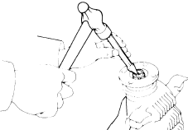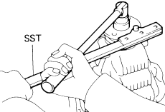
- Using SST, pull out the side gear shaft from the differential, remove differential case, place match marks on the bearing cap and differential carrier, remove the two bearing caps.
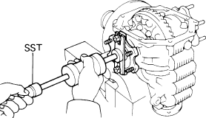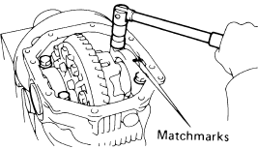
- Remove the two side bearing preload adjusting plate, remove the differential case and bearing outer race from the carrier, tag the bearing outer races to show the location for reassembly.
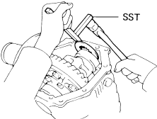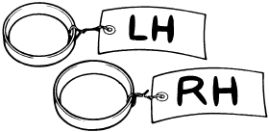
- Remove the ring gear set bolts and lock plate, place match mark on the ring gear and differential case, using hammer tap on the ring gear to separate from differential case, disassemble the differential case.
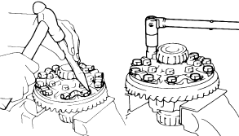

Reassembly & Inspection
- Assemble the differential case, install the ring gear, align the match marks, coat set blots with gear oil and tighten uniformly.
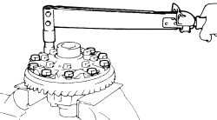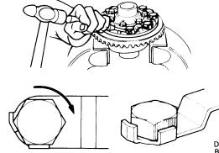

- Inspect ring gear runout, maximum runout: 0.1 mm (0.004 in.), adjust the drive pinion preload by tightening the companion flange, using torque wrench, measure the preload.
New bearing: 10 – 16 kg-cm (8.7 – 13.9 in.-lb, 1.0 – 1.6 N.m)
Reused bearing: 5 – 8 kg-cm (4.3 – 6.9 in.-lb, 0.5 – 0.8 N.m)
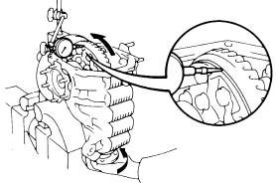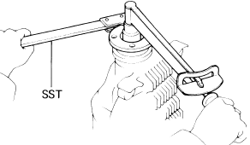
- Adjust ring gear backlash, install only the plate washer on the ring gear back side, select a ring gear back plate washer using back lash as reference.
Back lash (reference): 0.10 mm (0.0039 in).
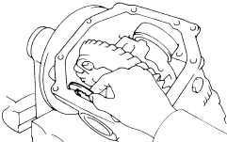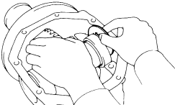
- Using hammer snug down the washer and bearing by tapping the ring gear, using dial indicator measure the ring gear backlash.
Backlash: 0.13 – 0.18 mm (0.0051 – 0.0071 in).
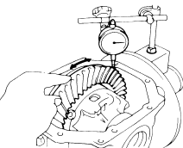
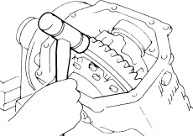

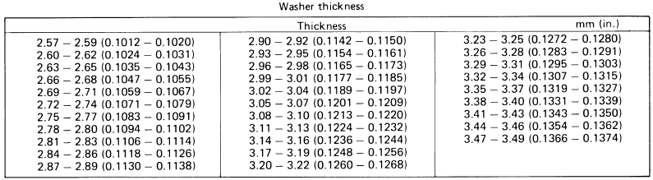

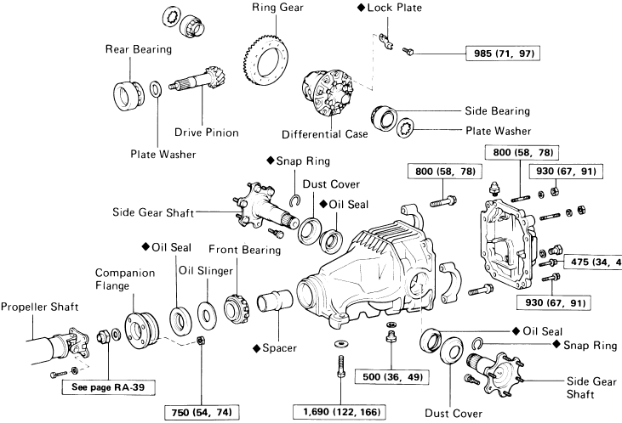

Differential case (conventional 2 pinion type)
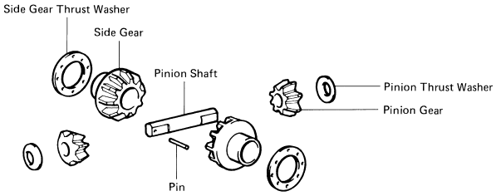
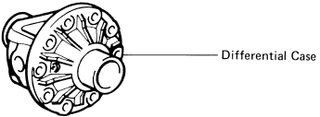
Differential case (conventional 4 pinion type)
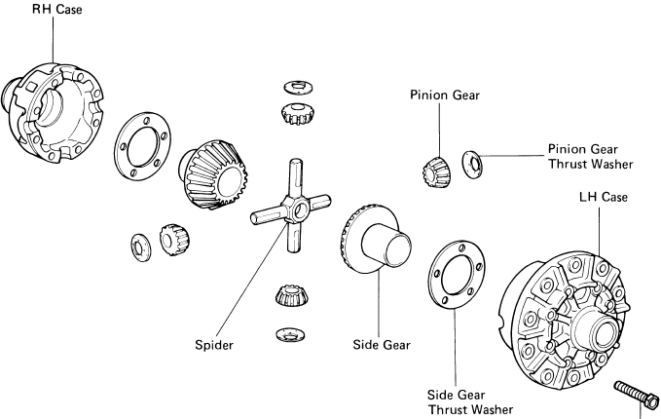

Unit Four: Prepare equipment and vehicle for use or storage
This learning guide is developed to provide you the necessary information regarding the following content coverage and topics:
  - Inspecting tools and equipment
  - Cleaning tools and equipment
  - Lubricating tools and equipment
  - Storing tools and equipment
This guide will also assist you to attain the learning outcomes stated in the cover page. Specifically, upon completion of this learning guide, you will be able to:
  - Inspect tools and equipment
  - Clean tools and equipment
  - Lubricate tools and equipment
  - Store tools and equipment

Inspect Tools and equipment
If you are in the habit of using a power tool every day, it can be easy to fail to notice when that tool’s performance gradually drops over time. That’s why it is important to at least semi-regularly take a moment and inspect your most-used tools, paying close attention to signs of wear and performance issues. Run a few basic operations with a tool, paying close attention to warning signs like weaker than normal power levels, any sort of burning smell, and strange buzzes and noises coming from inside the tool. Any of these is a pretty strong indicator that there’s something off with your tool and it may require some extra attention.

Clean Tools and equipment
It might seem like overkill at first, but be sure that each of your power tools gets cleaned every time you finish using it. Cleaning methods will vary from tool to tool, but most of the time everyday cleaning can be as simple as wiping dirt and dust from the casing. Something as simple as a good wipe down will keep particles from building up and getting into your tool’s internal mechanisms. Tighter areas like filters can be kept dust free with a few blasts from a can of compressed air.

Lubricate Tools and equipment
Lubrication is an often neglected maintenance step that can really drag down tool performance, causing issues like chafing that can cause parts to quickly deteriorate. Most likely, each of your tools will have a section in their owner’s manual explaining proper lubrication practices. Follow the recommended steps to ensure that your power tools remain the well-oiled machines they are meant to be.

Store Tools and equipment
Always store tools in a dry, climate-controlled environment. Moist and dirty environments can cause hand tools to rust and dull, and storing power tools in damp areas can degrade electrical components and cause parts to corrode over time. While fitting power tools back into their cases can be a pain, the case will go a long way towards protecting its tool from the environment. If you need the extra space, consider gutting your tool cases.

Self-check-4
Instruction: Short answer
- How do we Inspect tools and equipment?
- How can cultivate the habit of cleaning?
- What the best practices for lubricate tools and equipment?
- What are the storing tools and equipment?

LAP-TEST
Service drive line joints, differential and axle
  - Task-1: Service drive shaft assembly
  - Task-2: Repair U-joint
  - Task-3: Service CV-joint
  - Task-4: Service differential
  - Task-5: Service rear drive axle
  - Task-6: Service wheel bearing

Reference

- Robert H. et al…, Modern diesel technology: heavy equipment systems, 2nd edition 2014 Delmar, Cengage learning
- Jack Erjavec, Automotive Technology: a systems approach, 5 t h Edition, 2010 Delmar, Cengage Learning
- James D. Haldeman, Automotive technology Principles, Diagnosis, and Service fourth edition
- Crouse, W.H. and Anglin D.L, Auto motive mechanics 10th edition
- R.K Rajput, Automobile Engineering
- Prof. Dr.-Ing. Konrad Reif, Brakes, Brake Control and Driver Assistance Systems
- David A. Crolla , Automotive Engineering
- Nunney, M. J.Rutledge, 2007, Light and Heavy Vehicle Technology 4th ed.

Participants of this Module (training material) preparation
No | Name | Qualification (Level) | Field of Study | Organization/ Institution | Mobile number | E-mail
 | ADINET ASNAKE | MSc | Automotive Technology Mgt | Wolkite PTC | 0913767250 | andinetasnake31@gmail.com
 | BIRUK TILAHUN | BSc | Automotive Technology | General Wingaste PTC | 0913789176 | biruktilahun1@gmail.com
 | FADLI AMAN | BSc | Automotive Technology | General Wingate PTC | 0927283100 | Fadli.ziyad@gmail.com
 | HANA NIGUSISE | BSc | Automotive Technology | Selam TVET college | 0988751516 | Hana.nigussie25@gmail.com
 | ISREAL TAYE | BSc | Automotive Technology | General Wingate PTC | 0913424100 | Isra.taye@gmail.com
 | TATEK MAMO | PhD scholar | Automotive Technology | DEC | 0911841121 | mimibaba928@gmail.com
 | ZELALEM YITBAREK | BSc | Automotive Technology | Selam TVET college | 0972030621 | Zolosmart12@gmail.com

