
Heavy Vehicles and Earth Moving Machinery Maintenance
Level-II
Based on November, 2022 Curriculum Version 1

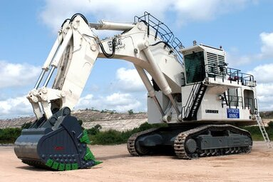

Module Title: - Servicing Basic hydraulic systems
Module code: EIS HEM2 M11 1222
Nominal duration: 70 Hour

Prepared by: Ministry of Labor and Skill
December 2022
Addis Ababa, Ethiopia

Table of Contents
Acknowledgment 4
Acronym 5
Introduction to module 6
Unit one: Overview of Hydraulic Systems. 7
1.1 Introduction to hydraulic systems 8
1.1.1 Fluid Mechanics and principles of Hydraulic system 8
1.1.2 Pascal’s law 9
1.1.3 Pressure 10
1.1.4 Hydraulic Levers 12
1.1.5 Flow 13
1.1.6 Work and energy 14
1.1.7 Types of Hydraulic System 15
1.2 Hydraulic system components and their purpose 16
1.2.1 A hydraulic tank (reservoir) 16
1.2.2 Hydraulic pump 16
1.2.3 Hydraulic Valves 21
1.2.4 Accumulators 26
1.2.5 Actuators 27
1.2.6 Conductors and Connectors 29
1.2.7 Hydraulic Fluids 30
1.3 Symbols, schematic diagrams, graphs, and drawing 30
1.3.1 Symbols and Schematics 30
1.3.2 Hydraulic circuit diagrams 37
1.4 OHS and PPE requirements 37
1.4.1 PPE Requirement 37
1.4.2 OHS Requirement 39
Self-check-1 41
Unit Two: Inspecting and testing basic hydraulic system 42
2.1 Maintenance schedule 43
2.2 Hydraulics system measuring tools 43
2.3 Inspecting hydraulic system 44
2.3.1 Check Reservoir 45
2.3.2 Check Oil Lines and Connections 45
2.3.3 Check Circuit Components 46
2.3.4 Leakage Inspection 46
2.4 Testing Hydraulic system 48
2.4.1 Flow and Pressure Testing 48
2.4.2 Diagnosing Test Results 51
2.4.3. Load Sensing/Pressure Compensated and Torque Limiting System Test 51
Self-check-2 54
Operation sheet-2.1 55
Operation sheet 2.2 56
Unit Three: Servicing hydraulic system 58
3.1 Servicing procedures of hydraulic system 59
3.1.1 Safe Practice 59
Operation sheet 3.1 61
LAP Test 62
Unit Four: Prepare vehicle for use or storage 63
4.1 Inspect Tools and equipment 64
4.1.1 Clean Tools and equipment 64
4.2 Lubricate Tools and equipment 64
4.3 Store Tools and equipment 64
Self-check-4 65
Reference 66

Acknowledgment
Ministry of Labor and Skills wish to extend thanks and appreciation to the many representatives of TVT instructors and respective industry experts who donated their time and expertise to the development of this Teaching, Training and Learning Materials (TTLM).

Acronym

LAP-Test | Learning activity performance
TTLM | Teaching, Training and Learning Materials
TVT | Technical vocational training

Introduction to module
Heavy-duty commercial vehicles and earth moving machines are critical to any country's economic development. Given the high cost of this equipment, providing adequate preventive and corrective maintenance will aid in its effective utilization. As a result, a carrier capable of service hydraulics system of such heavy-duty commercial vehicles and earth moving machines is in high demand around the world, necessitating standard training and qualification. As a result, this module is designed to supplement training for a specific unit of competence that teaches how to service basic hydraulic systems used on heavy-duty vehicles and earth-moving machines. This module is intended to fulfill the industry requirement under the heavy duty vehicles and earth moving machines maintenance level II occupational standard, specifically for the unit of competency: Basic hydraulic system maintenance
This module covers the units:
- Overview of Hydraulic Systems.
- Inspecting and testing Hydraulic Systems.
- Service hydraulic system
- Prepare vehicle for use
Learning Objective of the Module
- Understand of Hydraulic Systems.
- Inspect and test Hydraulic Systems.
- Perform Service hydraulic system
- Prepare vehicle for use
Module Instruction
For effective use this modules trainees are expected to follow the following module instruction:
- Read the information written in each unit
- Accomplish the Self-checks at the end of each unit
- Perform Operation Sheets which were provided at the end of units
- Do the “LAP test” giver at the end of each unit and
- Read the identified reference book for Examples and exercise

Unit one: Overview of Hydraulic Systems.
This unit is developed to provide you the necessary information regarding the following content coverage and topics:
  - Introduction to hydraulic systems
  - Identify major components of hydraulic system
  - Symbols, schematic diagrams, graphs, and drawing
  - OHS requirements
This unit will also assist you to attain the learning outcomes stated in the cover page. Specifically, upon completion of this learning guide, you will be able to:
  - Understand hydraulic systems
  - Identify major components of hydraulic system
  - Identify Symbols, schematic diagrams, graphs, and drawing
  - Apply OHS requirements

Introduction to hydraulic systems

Fluid Mechanics and principles of Hydraulic system
Mechanics is the oldest physical science that deals with both stationary and moving bodies under the influence of forces. The branch of mechanics that deals with bodies at rest called statics, while the branch that deals with bodies in motion called dynamics. The subcategory of fluid mechanics defined as the science that deals with the behavior of fluids at rest (fluid statics) or in motion (fluid dynamics), and the interaction of fluids with solids or other fluids at the boundaries. Fluid mechanics is also referred to as fluid dynamics by considering fluids at rest as a special case of motion with zero velocity.
Fluid mechanics itself also divided into several categories. The study of the motion of fluids that are practically incompressible (such as liquids, especially water, and gases at low speeds) usually referred to as hydrodynamics. A subcategory of hydrodynamics is hydraulics, which deals with liquid flows in pipes and open channels. Gas dynamics deals with the flow of fluids that undergo significant density changes, such as the flow of gases through nozzles at high speeds. The category aerodynamics deals with the flow of gases (especially air) over bodies such as aircraft, rockets, and automobiles at high or low speeds.
Heavy vehicles and equipment found at commercial transportation, construction sites, open pit mines, and quarries these days is capable of hauling hundreds of tons at a time. Most of them used hydraulic fluid under pressure to convert diesel engine power to fluid power, and then convert it back to mechanical power at the wheels or tracks. The term hydraulics used to describe fluid power circuits that use liquids, usually specially formulated oils in confined circuits to transmit force or motion. A heavy equipment technician is required to have a good knowledge of hydraulics to understand steering and brake systems, hydraulic auxiliary equipment, engine operation, fuel systems, and many types of transmissions.
Although we do not often differentiate between them, hydraulics can be divided into two branches, which we know as hydrostatics and hydrodynamics. Hydrostatics is the science of transmitting force by pushing on a confined liquid. In a hydrostatic system, transfer of energy takes place because a confined liquid is subject to pressure.
- Hydrostatic principal is defined as ‘‘high-pressure fluid moving at a slow rate of speed.’’ A good example of a hydrostatic circuit is that used to actuate a boom cylinder.
Hydrostatics: low fluid movement with high system pressures.
Hydrodynamics is the science of moving liquids to transmit energy. Hydrodynamic principal defined as ‘‘low-pressure fluid moving at a high rate of speed. ’The best example on mobile equipment chassis is the torque converter used to impart drive to a power-shift transmission.
Hydrodynamics: high fluid velocity with lower system pressures.
Hydraulic systems have many desirable features and many advantages that make it the most economical means of power transmission. However, one disadvantage is the original high cost of the various components
- Efficiency: -Minimum energy loss or all the energy transmitted through a hydraulic system received at the output end, where the work performed.
- Control Sensitivity: -The confined liquid of a hydraulic system operates like a bar of steel in transmitting force
- Flexibility of Installation: - Hydraulic lines can be run almost anywhere. Unlike mechanical systems that must follow straight paths, the lines of a hydraulic system can be led around obstructions.
- Low Space Requirements: -The functional parts of a hydraulic system are small in comparison to those of other systems; therefore, the total space requirement is comparatively low.
- Low Weight: -The hydraulic system weighs remarkably little in comparison to the amount of work it does.
- Self-Lubricating-The majority of the parts of a hydraulic system operate in a bath of oil. Thus, hydraulic systems are practically self-lubricating.
- Low Maintenance Requirements: -records consistently show that adjustments and emergency repairs to the parts of hydraulic systems are seldom necessary.

Pascal’s law
Pressure in an enclosed fluid can be considered uniform throughout a practical system. This equality of pressure is known as Pascal’s law, and is illustrated in (Figure 1-1) below where a small force F₁ is applied to a piston of small area at A₁.
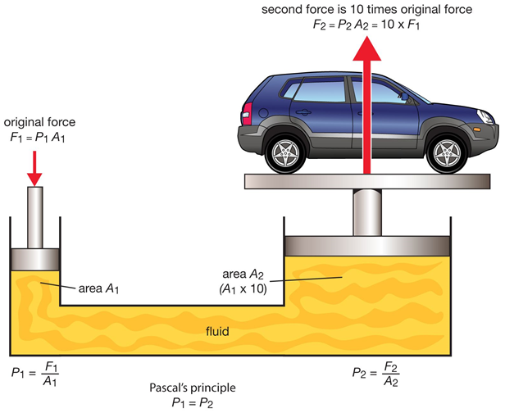
Figure 1-1 Typical application of Pascal’s principle
This produces a uniform pressure at every point within the fluid, which acts with equal force per unit area on the walls of the system. Liquid properties enable large objects (rudder, planes, etc) to be moved smoothly. According to Pascal's principle Magnitude of force transferred is indirectly proportional to the surface area (F α A) , hence proportionality coefficient (pressure is constant).
$$P=\frac{F}{A}$$
Where, P = Pressure
F = Force
A = Area

Pressure
Pressure is force applied to a specific area. When a confined fluid is subject to pressure, the force applied to the area of confinement will be uniform throughout (Pascal’s law). When a liquid confined in a vessel is pushed on, the pressure that results acts evenly on all of the walls of the vessel. This characteristic makes it possible to transmit force or ‘‘push’’ through pipes. In hydraulics, we use liquids rather than gases as hydraulic fluids, because liquids are not easily compressed. Because of this incompressibility, we can relay action almost instantaneously, so long as the circuit is full of liquid and contains no air.
Pressure measurement
The actual pressure at a given position is the absolute pressure, and it is measured relative to absolute vacuum (i.e., absolute zero pressure). However, most pressure measuring devices calibrated to read zero in the atmosphere, and so they indicate the difference between the absolute pressure and the local atmospheric pressure. This difference is the gage pressure.
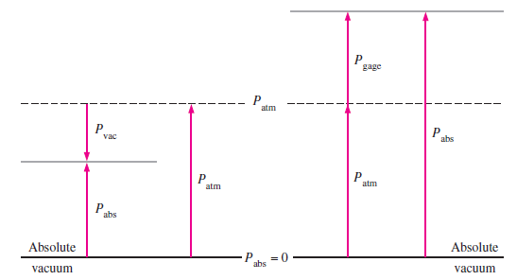
Figure 1-2 Relationship among absolute (P_{abs}), atmospheric (P_{atm}) and gauge pressures (P_{gage})
Pressures below atmospheric pressure are vacuum pressures and measured by vacuum gages that indicate the difference between the atmospheric pressure and the absolute pressure. Absolute, gage, and vacuum pressures are all positive quantities and related to each other by equations given below.
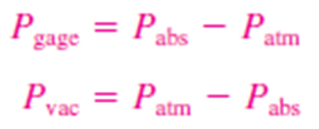
Force is push or pull effort. The weight of one object placed upon another exerts force on it proportional to its weight. The formula for force (F) is calculated by multiplying pressure (P) by the area (A) it acts on.
$$F=P A$$
Pressure is usually expressed in pounds per square inch or kilopascals. Additionally, there are a number of different pressure scales whereas all based on atmospheric pressure. One unit of atmosphere is the equivalent of atmospheric pressure and it can be expressed in all these ways:
- 1atm = 1 bar (European) =14.7psia = 29.92’’ Hg (inches of mercury) = 101.3kPa (metric)
However, each of the above values is not precisely equivalent to the others:
- 1atm = 1.0192 bar
- 1bar = 29.53’’ Hg = 14.503psia
- 1’’ Hg = 13.6’’ H₂O @ 60° F

Hydraulic Levers
Hydraulic levers can be used to demonstrate Pascal’s Law. Pressure equals force divided by the sectional area it acts on. Similarly, force equals pressure multiplied by area. So if we want to calculate the force exerted by a cylindrical ram we would use the following formula:
- Force exerted = hydraulic pressure (psi) × cylindrical area (diameter² × 0.7854)
If we build a simple hydraulic circuit such as that shown in (Figure 1-3), we have the building blocks of a hydraulic jack.
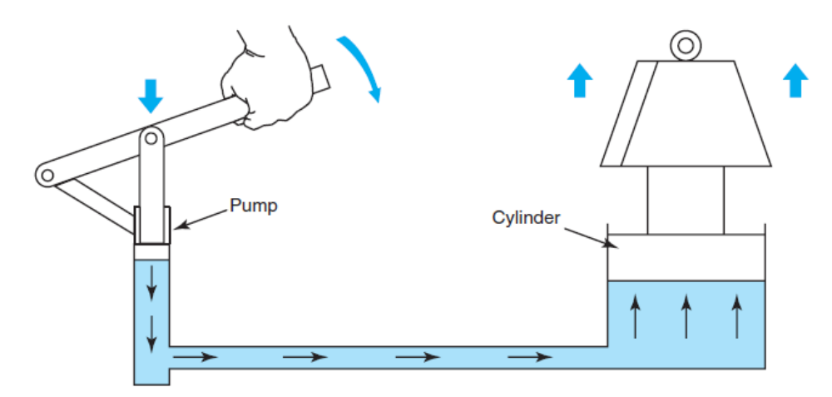
Figure 1-3 Simple hydraulic lever: Pressure multiplies force. (Reproduced with permission from Deere & Company)
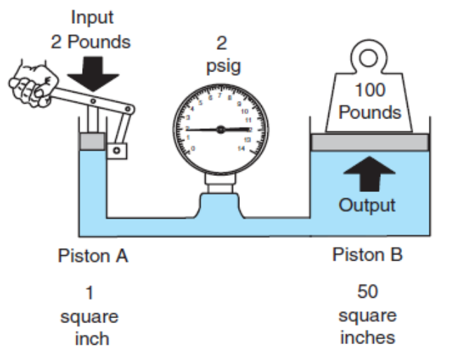
A variation on the hydraulic jack principle can be seen in the type of hydraulic circuit shown in (Figure 1-4), the basis of a hydraulic ram. This consists of a pair of unequally sized cylinders connected by a pipe. In the figure, one of the cylinders has a sectional area of 1 sq. in. and the other 50 sq.in. Therefore, the following would be true:
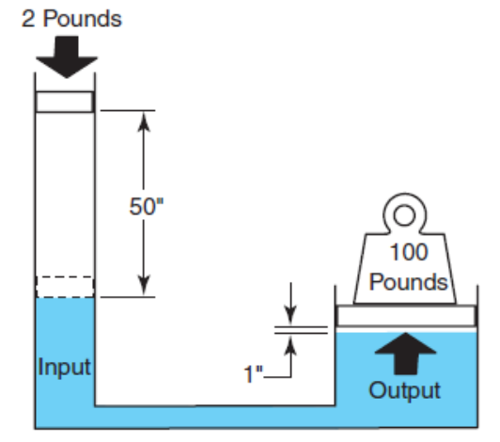
Applying a force of 2lb on the piston in the smaller cylinder produces a circuit pressure (potential) of 2psi because the force is applied to a sectional area of 1sq. in and it would lift a weight of 100lb supported on a piston in the larger cylinder with sectional area of 50 sq.in. Accordingly, if a force of 10lb was to be applied to the smaller piston, the resulting circuit pressure would be 10 psi and the circuit would have the potential to raise a weight of 500 lb.

This principle is applied every time we use a hydraulic jack. A hydraulic jack is a simple hydraulic lever as is a cab lift ram or dump ram. However, when 2lb of force is applied to the smaller cylinder to raise a 100lb weight 1in. in the larger cylinder, the piston in the smaller piston must move through 50in. as shown in (Figure 1-5). This movement is accomplished using multiple strokes and a check valve in typical hydraulic circuits.

Flow
Flow is the term we use to describe the movement of a hydraulic medium through a circuit. Flow occurs when there is a difference in pressure between two points. In a hydraulic circuit, a device such as a pump creates flow. A pump exerts push effort on a fluid.
Flow can be measured in two ways: velocity and flow rate. The velocity of a fluid in a confined circuit is the speed at which the fluid moves through it. It is measured in feet per second (fps). Flow rate is the volume of fluid that passes a point in a hydraulic circuit in a given time. It is measured in gallons per minute (gpm).
Flow rate determines the speed at which a load moves. Fluid velocity and flow rate have to be considered when sizing the hydraulic hoses and lines that connect hydraulic circuit components.
- If a small-diameter pipe opens into a larger-diameter one, then we can conclude:
- A constant flow rate will result in lower velocity when the diameter increases.
- A constant flow rate will result in higher velocity when the diameter decreases.
- The velocity of oil in a hydraulic line is inversely proportional to its cross-sectional area.
We should also add that lower fluid velocities are generally desirable to reduce friction and turbulence in the fluid. The same will work for hydraulic cylinders. Given an equal flow rate, a small cylinder will move faster than a larger cylinder.
If the objective is to increase the speed, at which a load moves, then:
- Decrease the size (sectional area) of the cylinder.
- Increase the flow to the cylinder (gpm).
The opposite would also be true, so if the objective were to slow the speed at which a load moves, then:
- Increase the size (sectional area) of the cylinder.
- Decrease the flow to the cylinder (gpm).
Therefore, the speed of a cylinder is proportional to the flow it is subject to and inversely proportional to the piston area.

Work and energy
Work occurs when effort or force produces an observable result. In a hydraulic circuit, this means moving a load. To produce work in a hydraulic circuit, we must have flow. Work is measured in units of force multiplied by distance, for example, in pound-feet.
- Work = Force × Distance
Energy simply means the capacity to perform work. In a hydraulic circuit, the objective is to transfer energy. We transfer energy from one form to another and from one point to another. The idea is to accomplish this as efficiently as possible and not waste too much by transforming it to heat. In a typical hydraulic circuit, mechanical energy is required to drive a hydraulic pump to create flow and kinetic energy potential in the fluid. Fluid under pressure is the potential energy of a hydraulic circuit. This energy can then be reconverted to mechanical energy to move a load-that is, kinetic energy or the energy of motion. The prime source of the energy used in a hydraulic system may be the heat value of the fuel used in an engine, or the electrical energy in a battery. The term prime mover is used to describe the machine that creates the mechanical energy required to power a hydraulic pump, though it is also sometimes used to describe the pump itself.

Types of Hydraulic System
Hydraulic systems can be grouped into two main categories:
- Open-center systems
- Closed-center systems
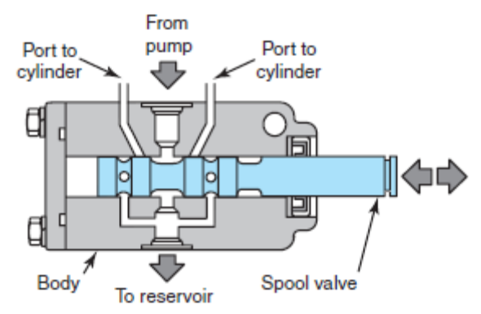
The primary difference between open-center and closed-center systems has to do with what you do with the hydraulic oil in the circuit after it leaves the pump.

In an open-center system, the pump runs constantly, which means that oil flows through the circuit continuously. A valve is used to manage the circuit and when this valve is in its “open” or neutral position, fluid is allowed to return to the reservoir. An example of an open-center hydraulic system on a truck is power assisted steering. Figure 1-6 shows an example of an open-center spool valve.
In a closed-center system, the pump can be “rested” during operation whenever flow is not required to operate an actuator. This means that the control valve blocks flow from the pump when it is in its “closed” or neutral position. A closed-center system requires the use of either a variable displacement pump or proportioning control valves. Closed-center systems have many uses on agricultural and industrial equipment, but on trucks, they would be used on garbage packers and front bucket forks.

Hydraulic system components and their purpose
Most of the components in a hydraulic circuit are interrelated in much the same way as components in an electrical circuit.

A hydraulic tank (reservoir)
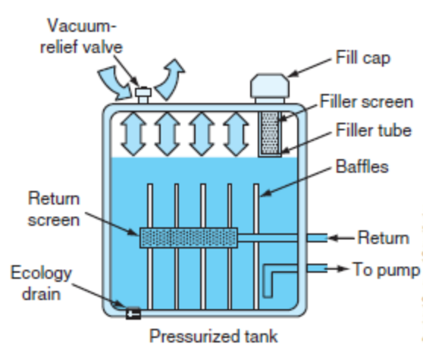
If you keep on operating the pump to raise the weight, a supply of extra oil is needed.
Figure 1-4 Parts of pressurized oil reservoir
- Stores hydraulic oil.
- Helps keep oil clean and free of air.
- Acts as a heat exchanger to help cool the oil.
The reservoir has an air vent, which allows oil to be forced into the pump by gravity and atmospheric pressure when the pump piston is retracted.
- Filler Cap. This is the means of replenishing oil in the hydraulic circuit.
- Oil Level Gauge or Dipstick. To verifying that there is sufficient oil in the reservoir.
- Outlet and Return Lines. To conduct the oil out of and back into the reservoir.
- Baffle(s). The function of a baffle or baffles in a reservoir is to separate the return oil from that being drawn out by the pump.
- Inlet Filter/Screen. The inlet filter is often just a screen or strainer located in series with the system hydraulic pump.
- Inspection Cover. Used to gain access to the internal side of the reservoir for scheduled inspections and clean-out maintenance.
- Hydraulic Filter
- Drain plug

Hydraulic pump
The pump is the heart of the hydraulic system. It creates the flow of fluid which supplies the whole circuit. They operate on a principle called displacement. The fluid is taken in and displaced to another point. Displacement can be done in two ways:
- Non-Positive Displacement
- Positive Displacement
Positive displacement pump
The positive displacement pump, used in hydraulics today, not only creates flow, it also backs it up. Notice the sealed case around the gear. This traps the fluid and holds it while it moves.
As the fluid flows out the other side, it is sealed against back up. This sealing is the “positive” part of displacement. Without it, the fluid could never overcome the resistance of the other parts in the system. When high pressure is needed in a circuit, a positive displacement pump is a must. This is true for all modern hydraulic systems which provide fluid power. Gear, Vane, Piston are the examples of Positive Displacement Pump .In low-pressure systems, such as water cooling or crop spraying types, the old non-positive displacement pump still works.
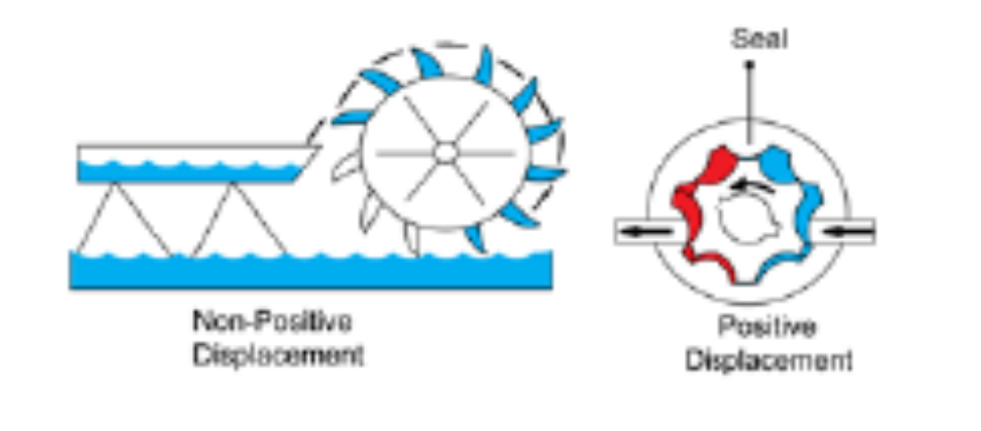
Figure 1-5 Positive and non-positive displacement hydraulic pumps
Displacement is the volume of oil moved or displaced during each cycle of a pump. In this sense, hydraulic pumps fall into two broad types:
- Fixed Displacement Pumps
- Variable Displacement Pumps
Fixed Displacement-Pumps move the same volume of oil with every cycle. This volume is only changed when the speed of the pump is changed. The pressure can affect volume in the system, but this is due to an increase in leakage back to the pump inlet. Usually this occurs when pressure rises. This leakage means that fixed displacement pumps are usually found in lower pressure systems or as aids to another pump in a higher-pressure system.
Variable displacement pumps can vary the volume of oil they move with each cycle-even at the same speed. These pumps have an internal mechanism which varies the output of oil, usually to maintain a constant pressure in the system. When system pressure drops, volume increases and as pressure rises, volume decreases. Remember: A hydraulic pump does not create pressure: it creates flow. Pressure is caused by resistance to flow.
Types of hydraulic pumps
- Gear pumps
Gear pumps are of the fixed displacement type. They are widely used because they are simple and economical. While not capable of variable displacement, they can produce the volume needed by most systems using fixed displacement. Often they are used as charging pumps for larger system pumps of other types. Servo systems also make use of gear pumps. Basic types of gear pumps are used: External Gear Pumps and Internal Gear Pumps
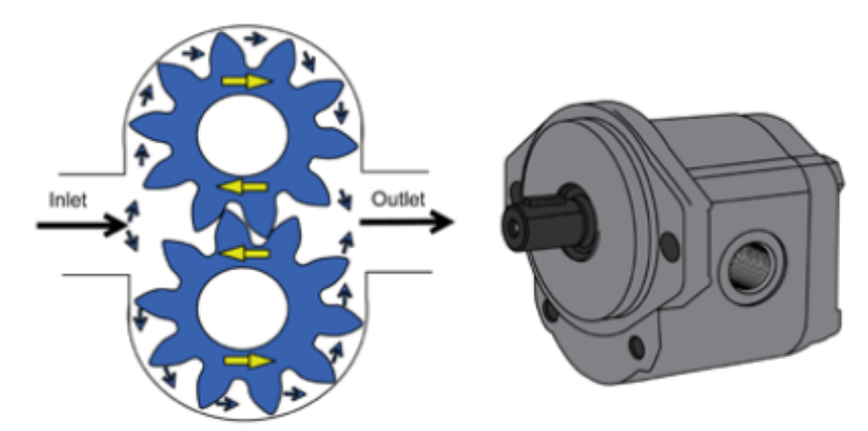
Figure 1-6 External gear pump
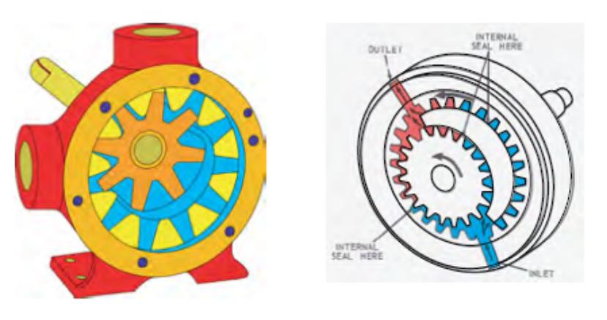
Figure 1-7 Internal gear pump

- Vane pumps
Vane pumps are fairly versatile pumps and can be designed as single, double, or even triple units.
All vane pumps move oil using a rotating slotted rotor with vanes fitted into the slots. Two types of vane pumps are most often used: Balanced Vane Pumps and Unbalanced Vane Pumps
The balanced vane pump is strictly a fixed displacement type. The unbalanced vane can have a fixed or a variable displacement.
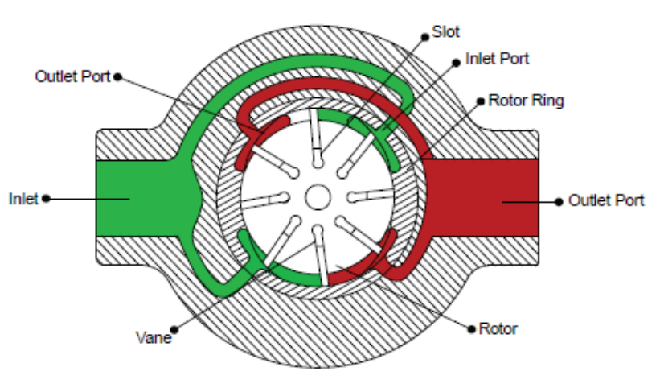
Figure 1-8 Balanced vane pump
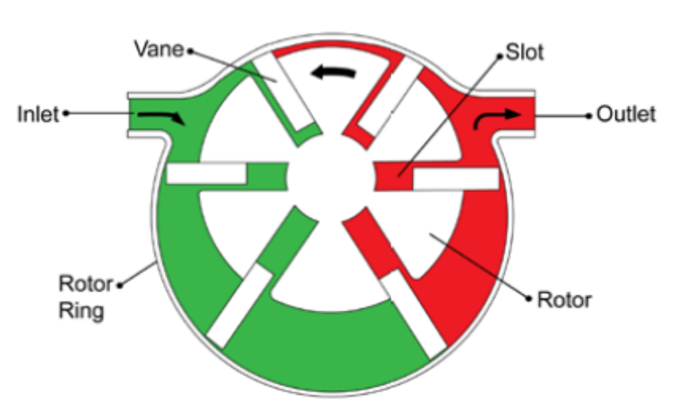
Figure 1-9 Unbalanced vane pump
- Piston pumps
Piston pumps are often favored on modern hydraulic systems which use high speeds and high pressures. However, piston pumps are more complex and more expensive than the other two types. Piston pumps can be designed for either fixed or variable displacement.
- Axial Piston Pumps
- Radial Piston Pumps
In-line Axial Piston Pumps the cylinder block is mounted on a drive shaft and rotates with the shaft. The pistons work in bores in the cylinder block which are parallel to the axis of the block. The heads of the pistons are in contact with a tilted plate called a swashplate. The swashplate does not turn but it can be tilted back and forth. It mounts on a pivot and is controlled either manually or by an automatic “servo” device. When the swashplate is tilted as shown. As the cylinder block rotates, piston bores align with this port and oil is forced into the bores by the small charging pump. This oil pushes the pistons against the swashplate. Then as they revolve, these pistons follow the tilt of the swashplate and force the oil out of their bores into the outlet port. If the angle of the swashplate was fixed, the pump would operate as a fixed displacement type, putting out the same amount of oil with each revolution.
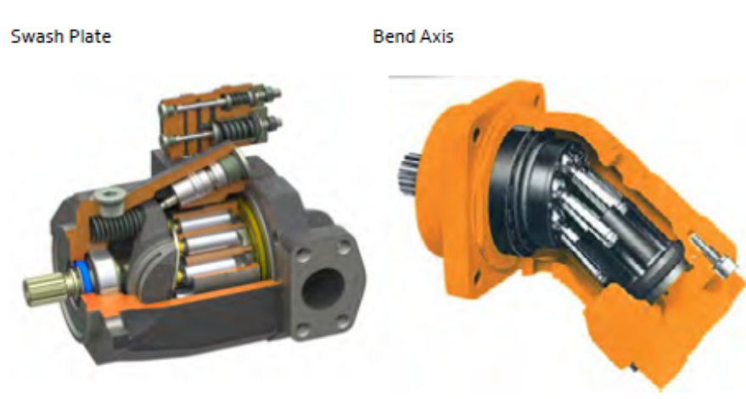
Figure 1-10 In-line swashplate and bend Axial piston pumps
Hydrostatic driven wheel loaders used to be equipped with bent axis hydraulic motors. Since more difference in speed and torque is needed, the latest type of wheel loaders are equipped with a axial piston pump, variable displacement, two directions of flow. The hydraulic motors are no longer of fixed displacement type but are variable and some Wheel loader have two of them fixed onto the transfer box (high and low speed).
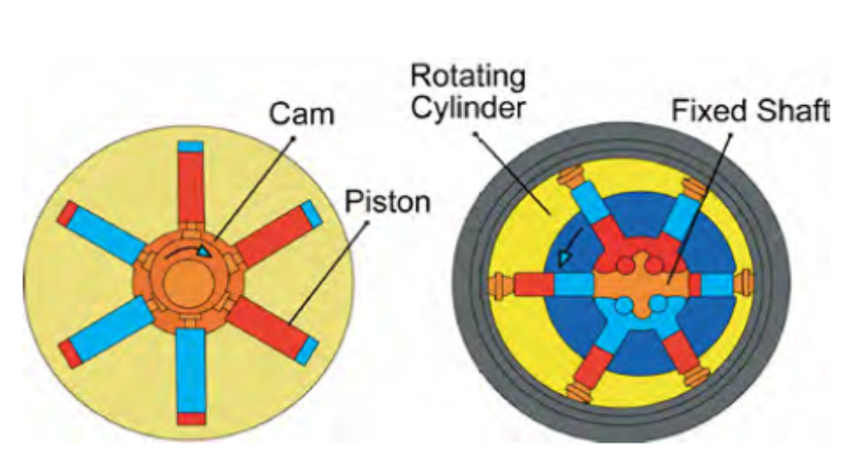
Figure 1-11 Radial piston pumps
Radial piston pumps are among the most sophisticated of all pumps. They are capable of high pressures, high volumes, high speeds, and variable displacement. The basic operation is simple, but by using extra valves and other devices, this pump can be adapted to many systems and needs. This pump is closely fitted, so wear can be a problem unless clean oil is used. And the oil must contain properties which lubricate the closely fitted parts.

Hydraulic Valves
Valves are the controls of the hydraulic system. They regulate the pressure, direction, and volume of oil flow in the hydraulic circuit. Valves can be divided into three major types:
- Pressure Control Valves
- Directional Control Valves
- Volume Control Valves
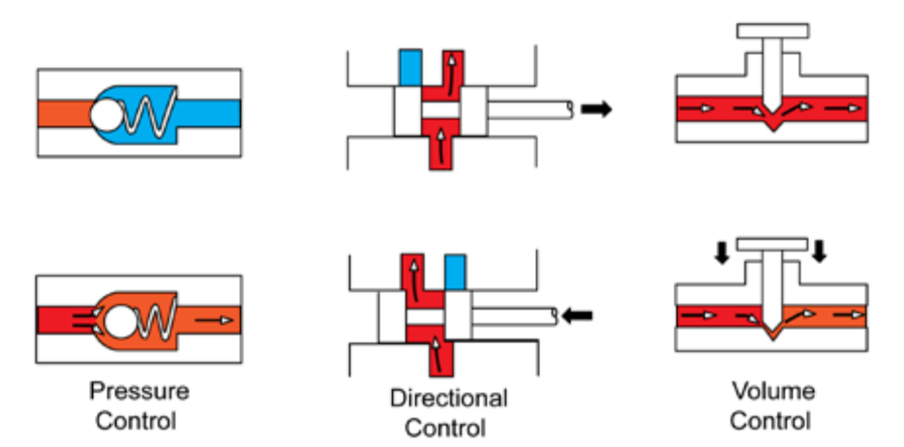
Figure 1-12 Different type hydraulic valves
- Pressure control valves are used to limit or reduce system pressure, unload a pump, or set the pressure at which oil enters a circuit. Pressure control valves include relief valves, pressure reducing valves, pressure sequence valves, and unloading valves.
- Directional control valves control the direction of oil flow within a hydraulic system. They include check valves, spool valves, rotary valves, pilot controlled poppet valves, and electrohydraulic valves.
- Volume control valves regulate the volume of oil flow, usually by throttling or diverting it. They include compensated and non-compensated flow control valves and flow divider valves
- Relief valves
Each hydraulic system is designed to operate in a certain pressure range. Higher pressures can damage the components or develop too great a force for the work to be done. Relief valves remedy this danger. They are safety valves which release the excess oil when pressures get too high. Types of relief valves are used:
- Direct acting relief valves are simple open-closed valves.
- Pilot operated relief valves have a “trigger” which controls the main relief valve.
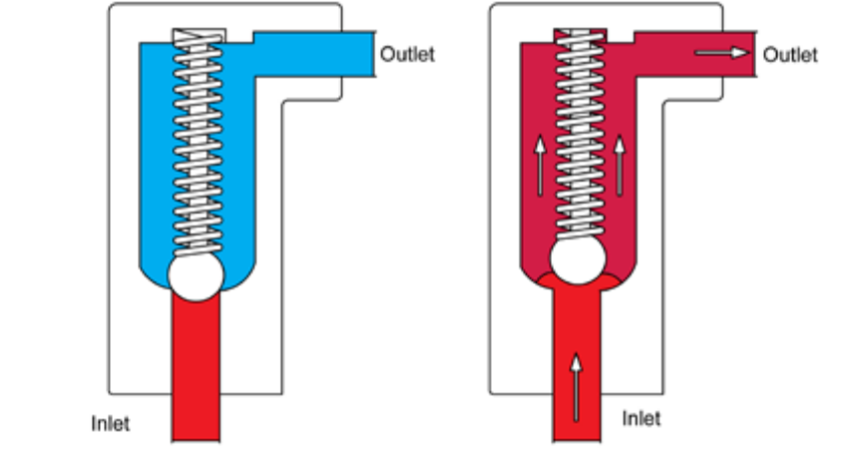
Figure 1-13 Direct acting relief valves
When a relief valve is needed for large volumes with little pressure differential, a pilot operated relief valve is often used. The pilot valve is a “trigger” which controls the main relief valve. It is usually a small, spring loaded relief valve built into the main relief valve. The main relief valve is closed when inlet oil pressure is below the valve setting. In (Figure 1-16) Passage (1) in the main valve (6) keeps it in hydraulic balance, while spring (5) holds it closed. The pilot valve (3) is also closed at this time. Inlet pressure through sensing passage (2) is less than the pilot valve setting.
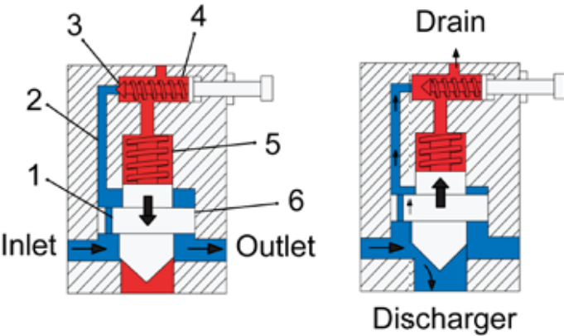
Figure 1-14 Pilot operated relief valves
- Pressure reducing valves
A pressure-reducing valve is used to keep the pressure in one branch of a circuit below that in the main circuit. When not operating, a pressure-reducing valve is open. When it operates, it tends to close as shown.
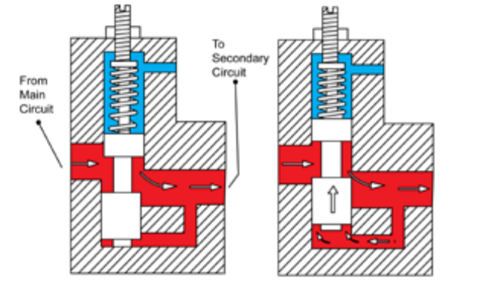
Figure 1-15 Pressure reducing valve
When pressure starts to rise in the secondary circuit, force is exerted on the bottom of the valve spool, partly closing it. Spring tension holds the valve against the oil pressure so that only enough oil gets past the valve to serve the secondary circuit at the desired pressure (The spring tension can be adjusted using the screw shown at the top) The pressure sensing for the valve comes from the outlet side, Or the secondary circuit. This valve operates the reverse of a relief valve, which senses pressure from the inlet and is closed when not operating. A pressure-reducing valve will limit maximum pressures in the secondary circuit, regardless of pressure changes in the main circuit, as long as the system workload does not create backpressure into the reducing valve port. Backpressure would close the valve completely

- Pressure Sequence Valves
Pressure sequence valves are used to control the sequence of flow to various branches of a circuit. Usually the valves allow flow to a second function only after a first has been fully satisfied. When closed, the valve directs oil freely to the primary circuit. When opened, the valve diverts oil to a secondary circuit. The valve opens when pressure oil to the primary reaches a preset point (adjustable at the valve spring). The valve is then lifted off its seat as shown and oil can flow through the lower port to the secondary.
One use of the sequence valve is to regulate the operating sequence of two separate cylinders. The second cylinder begins its stroke when the first completes its stroke. Here the sequence valve keeps pressure on the first cylinder during the operation of the second. Sequence valves sometimes have check valves which allow a reverse free flow from the secondary to the primary, but sequencing action is provided only when the flow is from primary to secondary.
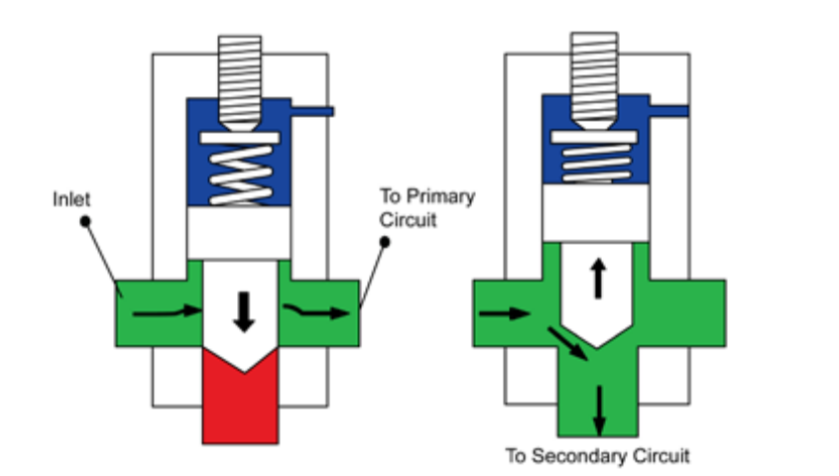
Figure 1-16 Pressure Sequence Valves
- Unloading valves
The unloading valve directs pump output oil back to reservoir at low pressure after system pressure has been reached. They may be installed in the pump outlet line with a tee connection. In some hydraulic systems pump flow may not be needed during part of the cycle. If pump output has to flow through a relief valve at system pressure, much hydraulic energy is wasted as heat. This is where an unloading valve works best. When closed, spring pressure holds the valve on its seat. Sensing pressure at the other end of the valve is less than spring pressure. The reservoir outlet is closed and no unloading occurs. The valve opens when the sensing pressure rises and overcomes the spring thrust
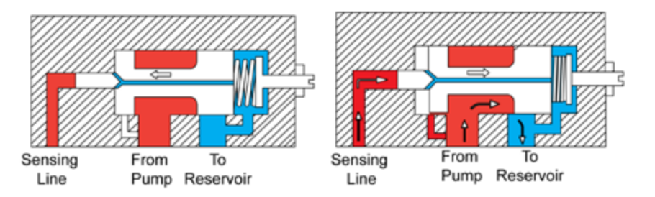
Figure 1-17 Unloading valve
The valve moves back, opening the outlet to the reservoir. Pump output oil is now diverted to the reservoir at low pressure.

- Unloading Valves for Accumulator Circuits
An unloading valve is often used in an accumulator circuit to unload the pump after the accumulator is charged. The valve is closed while the pump charges the accumulator with oil. As the pressure rises it forces the small sensing piston against the large valve and compresses the spring. When accumulator pressure reaches that determined by the spring setting, the valve opens by passing oil and relieving the pump. At this time the low neutral pressure oil is directed to the large end of the large piston.
When the accumulator discharges and the system pressure drops, the spring moved the valve against the reduced system pressure in the small piston and the neutral pressure against the large end of the valve. This means the valve will close at a slightly lower pressure than it opens. This gives the valve an operating range and prevents chattering.
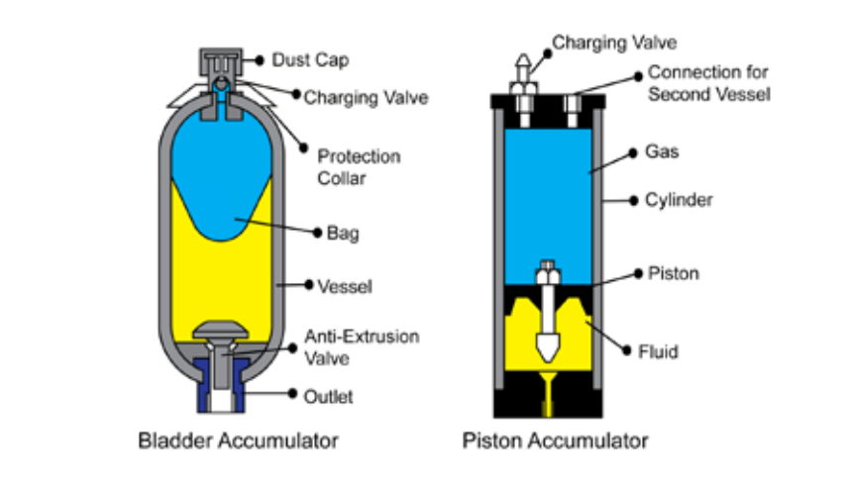
Figure 1-18 Unloading Valves for Accumulator Circuits

Accumulators
Accumulators used in hydraulic circuits perform the following roles:
- Store potential energy.
- Dampen shocks and pressure surges.
- Maintain a consistent pressure.
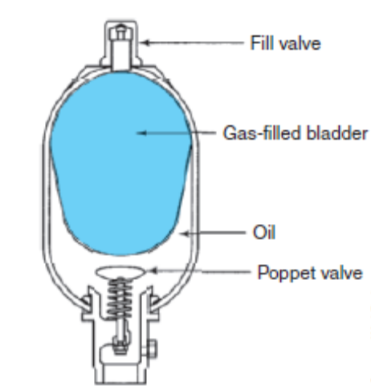
In an actual hydraulic circuit, an accumulator is usually used for a specific function in one of the foregoing roles. An accumulator that stores potential energy is often used to back up a hydraulic pump in the event of pump failure or at system start-up. For instance, in large off-highway dump trucks using hydraulically assisted brakes, in the event of oil supply failure, an accumulator is used to feed several charges of oil into the circuit to effect an emergency stop. Accumulators can also be used to dampen shock loads, control pressure surges, and ensure smooth operation of a hydraulic circuit. Although it uses a self-contained circuit, any vehicle shock absorber is a type of accumulator. In terms of operating principles, accumulators generally fall into one of three categories:
Figure 1-19 Gas filled accumulator
- Gas-loaded
- Weight-loaded
- Spring-loaded

Actuators
Hydraulic actuators convert the fluid power from the pump into mechanical work. In mobile hydraulic systems, actuators can be grouped as hydraulic cylinders and hydraulic motors. A hydraulic cylinder is a linear actuator. A hydraulic motor is a rotary actuator. Three types of hydraulic cylinders are used:
- Piston
- Vane
- Telescopic
- Piston-Type Cylinders
In hydraulics, both single acting and double-acting cylinders are used. In both types, a piston is moved linearly within the cylinder bore when it is subjected to pressurized oil. A single acting cylinder is hydraulically actuated in one direction only.
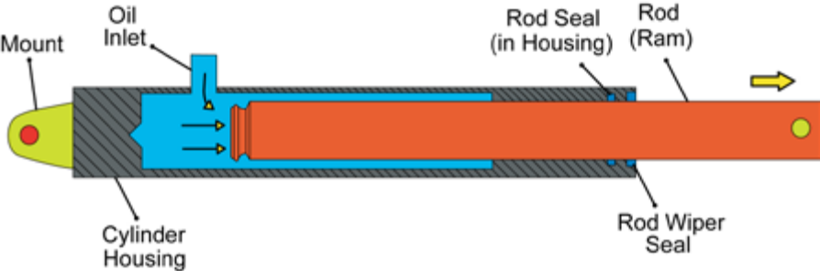
Figure 1-20 single acting cylinder
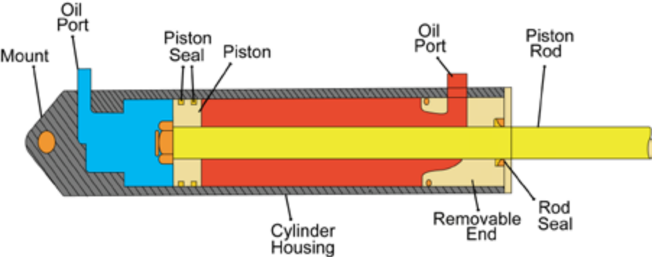
A double-acting cylinder is hydraulically actuated in both directions. In application, a dump box ram requires only a single-acting cylinder while the boom on an excavator requires a double acting cylinder.

Figure 1-21 Double acting cylinder
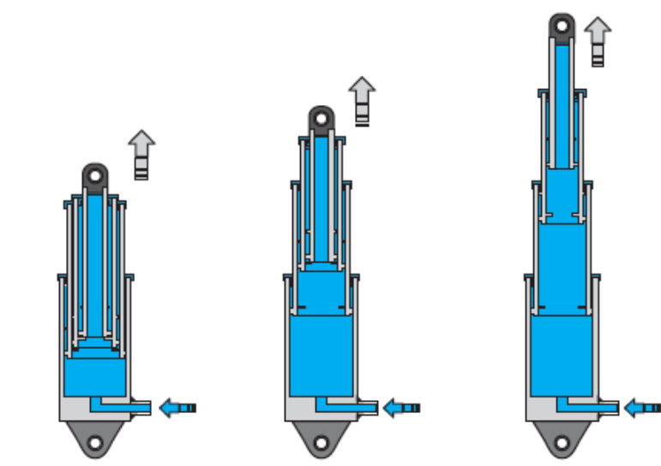
Figure 1-22 single acting telescopic cylinder
- Hydraulic Motors
The function of hydraulic motors is opposite that of hydraulic pumps: Pump: draws in oil and displaces it, converting mechanical energy into fluid force. Motor: oil under pressure is forced in and spilled out, converting hydraulic energy into mechanical energy. A pump drives its fluid, while a motor is driven by fluid. Figure 1-25 shows this principle.
The work output of a motor is in the form of twisting force that we describe as torque. Like pumps, motors can be either fixed displacement or variable displacement. In a fixed-displacement motor, the speed is varied by managing the input flow of oil: this type of motor usually has a fixed torque rating. Variable displacement motors can have both variable speeds and output torque.
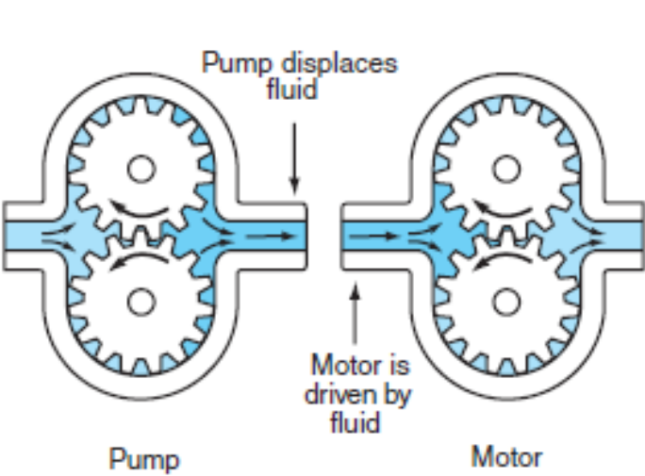
Figure 1-23 Hydraulic pump verses motor
There are three categories of hydraulic motors:
- Gear motors
- Vane motors
- Piston motors
All hydraulic motors rotate; they are driven by incoming hydraulic oil under pressure.

Conductors and Connectors
In any hydraulic circuit, the hydraulic medium has to conduct from the various components plumbed into the circuit. In mobile hydraulic equipment, hoses tend to function best as hydraulic conductors because they:
- Allow for movement and flexing
- Absorb vibrations
- Sustain pressure spikes
- Enable easy routing and connection on the chassis
- Hydraulic Hoses
The selection of hoses in a hydraulic circuit is important because the hoses play a major role in determining how the system performs. The flow requirements of a conductor determine what the internal diameter of a hose should be. For instance, a hose that can withstand the pressure specification but has too small internal diameter will restrict circuit flow, causing overheating and pressure losses. The size of any hydraulic hose is determined by its inside diameter.
- Couplers (Connectors)
Hydraulic hose couplers (also known as connectors and fittings) are made of steel, stainless steel, brass, or fiber composites. Hose couplers or fittings can either be reusable or permanent. Hose fittings are installed at the hose ends and the mating end consists of either a nipple (male fit) or a socket (female fit).
- Pipes and Tubes
Pipes used in hydraulic circuits are generally made from cold drawn, seamless, mild steel. The pipe should never be galvanized because the zinc can flake off and plug up hydraulic circuits. Tubing can also be used, and it has the advantage of being able to sustain some flex, hence its use in vehicle brake systems. Tubing should be manufactured from cold drawn steel if used in moderate- to high-pressure circuits. For low-pressure circuits, copper or aluminum tubing may be used.

Hydraulic Fluids
Hydraulic fluid is the medium used to transmit force through a hydraulic circuit. Most hydraulic fluids are refined from petroleum-base stocks and are seldom compatible with vehicle brake fluids. Hydraulic fluids used in hydraulic systems are usually specialty hydraulic oils, but engine and transmission oils can also be used. Always check when adding or replacing hydraulic oil. Synthetic hydraulic oils are commonly used in today’s hydraulic circuits because they have wider temperature operating ranges and offer greater longevity. Hydraulic oils must perform the following:
- Act as hydraulic media to transmit force.
- Lubricate the moving components in a hydraulic circuit.
- Resist breakdown over long periods of time.
- Protect circuit components against rust and corrosion.
- Resist foaming.
- Maintain a relatively constant viscosity over a wide temperature range.
- Resist combining with contaminants such as air, water, and particulates.
- Conduct heat.

Symbols, schematic diagrams, graphs, and drawing

Symbols and Schematics
When working with vehicle hydraulic schematics, it is important to be able to interpret standard symbols. Symbols are two-dimensional figures that roughly approximate the components they represent in a hydraulic schematic. The symbols used in hydraulic schematics are standardized by the American National Standards Institute (ANSI) and by the International Standards Organization (ISO). This helps make life easier because most manufacturers today use either ANSI or ISO symbols in their schematics. The graphics used in hydraulic schematics consist of shapes and marks.

The basic shapes used in hydraulic schematics are:
- Circle/semicircle-indicates a pump or motor symbol.
- Square (or envelope)-represents one position or path through a valve. Two squares together indicate a two-position valve.
- Diamond-indicates a component that conditions fluid in the circuit, such as a filter or heat exchanger.
- Rectangle-indicates a hydraulic cylinder or reservoir.
A symbol is drawn by using one of the four basic shapes above and adding the appropriate marks. Typical marks include:
- Solid lines-indicate the flow route for hydraulic fluid.
- Dashed lines-indicate a pilot line that connects control circuit to a slave circuit.
- Dotted lines-indicate a return or exhaust circuit.
- Center lines-enclose assemblies.
- Arrows-show the direction of fluid flow or rotational direction of pumps and motors. Arrows at 45-degree angle indicate an adjustment point. A vertical arrow in a component indicates pressure.
- Arcs-show points of adjustment in the circuit such as the flow-control valve.
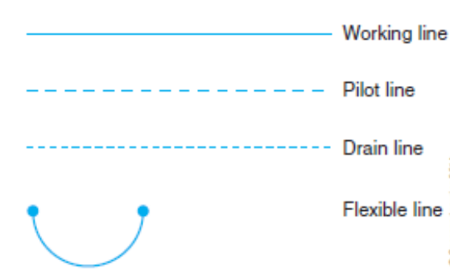
Lines on a schematic represent conductors. Solid lines indicate inlet, pressure, or return circuits. Broken lines with long dashes usually indicate pilot or control lines, while lines of short dashes indicate leakage oil. An arced line (that is not semicircular) between two dots indicates a flexible hose. Figure 1-26 shows how conductors are typically represented on a hydraulic schematic.
Figure 1-24 Conductor symbols
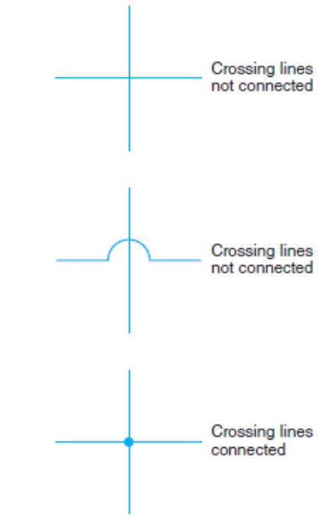
A semicircular loop on one line crossing another indicates that the two lines are not hydraulically connected. However, sometimes crossing (but not hydraulically connected) lines simply cross each other. In the event that a pair of intersecting lines are hydraulically connected, a dot is shown at the intersection point. These three arrangements are shown in Figure 1-27.
- Reservoir Symbols.
Figure 1-25 Intersecting lines
A horizontal rectangle is used in schematics to represent a reservoir. A pressurized reservoir is indicated when the rectangle is drawn fully enclosed as indicated in Figure 1-28. A vented-to atmosphere reservoir is indicated when the rectangle is open at the top as indicated in Figure 1-28.
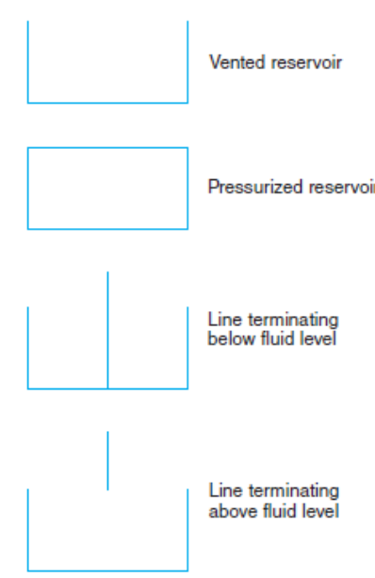
The way in which lines are shown entering a rectangle symbol is also of significance. Either a line terminating above the rectangle or before its base indicates that return flow is above the fluid, whereas one that is drawn contacting the base of the rectangle indicates a line that terminates below the fluid level.
All these symbols are shown in Figure 1-28. Lines connected to a reservoir are usually drawn from the top, regardless of where the connection is made on the actual component. Every reservoir has at least two hydraulic lines connected to it and can have many more. Because numerous components in a hydraulic circuit may depend on a single reservoir, the reservoir symbol is often repeated rather than creating a scramble of return lines all over the schematic. In most cases, the reservoir symbol is the only one to be repeated on a schematic; you can regard it in the same way a ground symbol is regarded on an electrical schematic.
- Pump and Motor Symbols.
Pump and motor symbols are similar in appearance. Both use a circle. A hydraulic pump is indicated when the small triangle at the output line (within the circle) is shown pointing outward (see Figure 1-29). A hydraulic motor is indicated when the small triangle at the inlet line (within the circle) is shown pointing inward (see right end in Figure 1-29).
Figure 1-26 Reservoir symbols
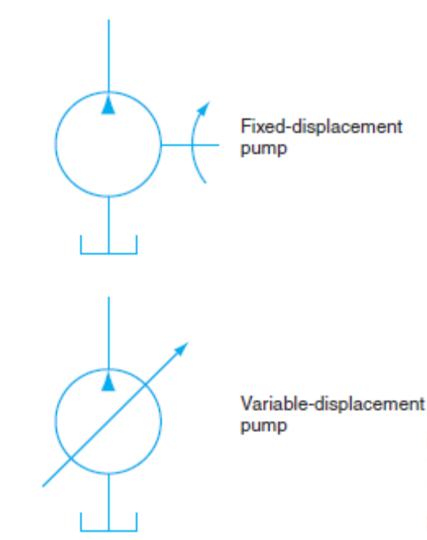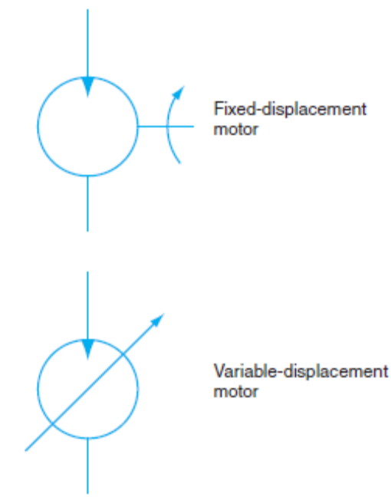
Figure 1-27 Fixed- and variable-displacement hydraulic pump (left) and motor (right)
- Valve Symbols
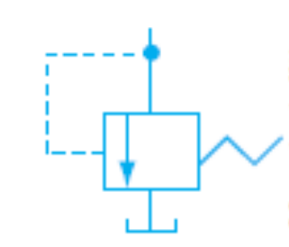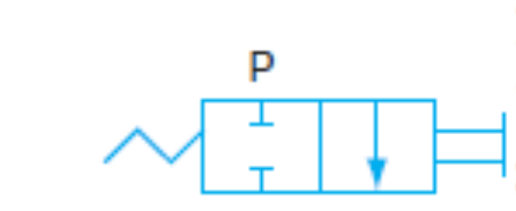
Figure 1-28 Pressure relief valve (left) and Two-position, two-way valve (right) symbol

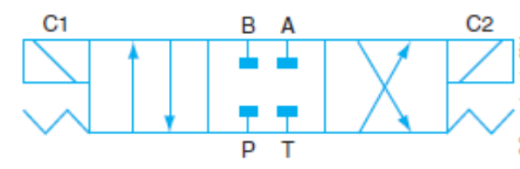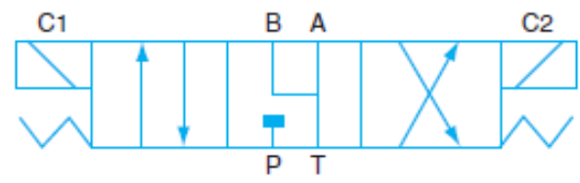
Figure 1-29 Three-position, four-way valve (left) and Alternate three-position, four-way valve (right) symbol
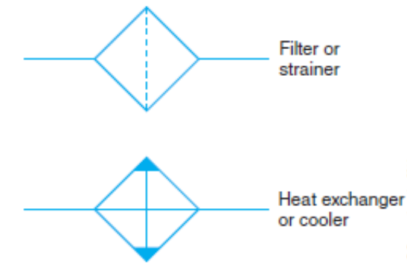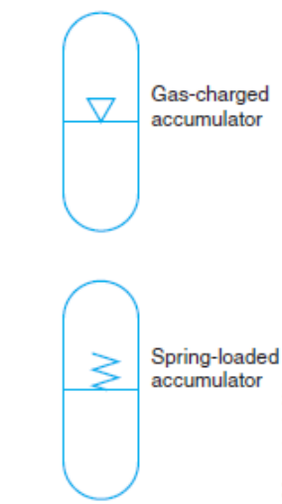
Figure 1-30 Symbols for filters and strainers (left) and accumulator symbols (right)
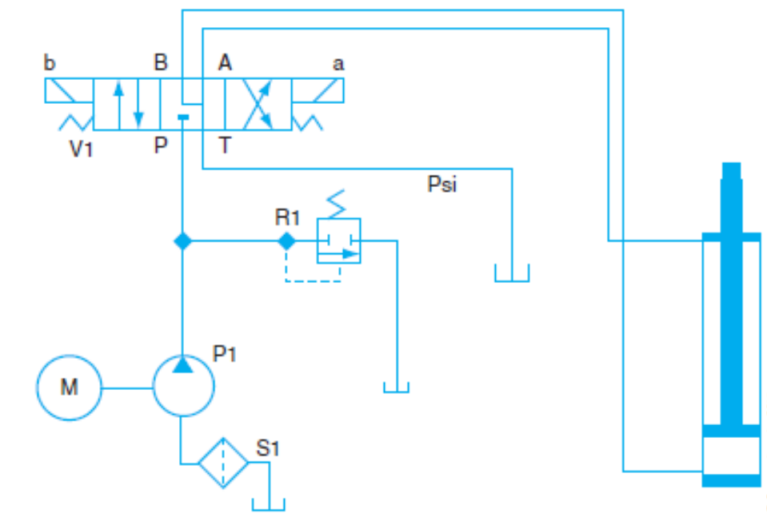
Figure 1-31 Simple hydraulic circuit used to actuate a cylinder

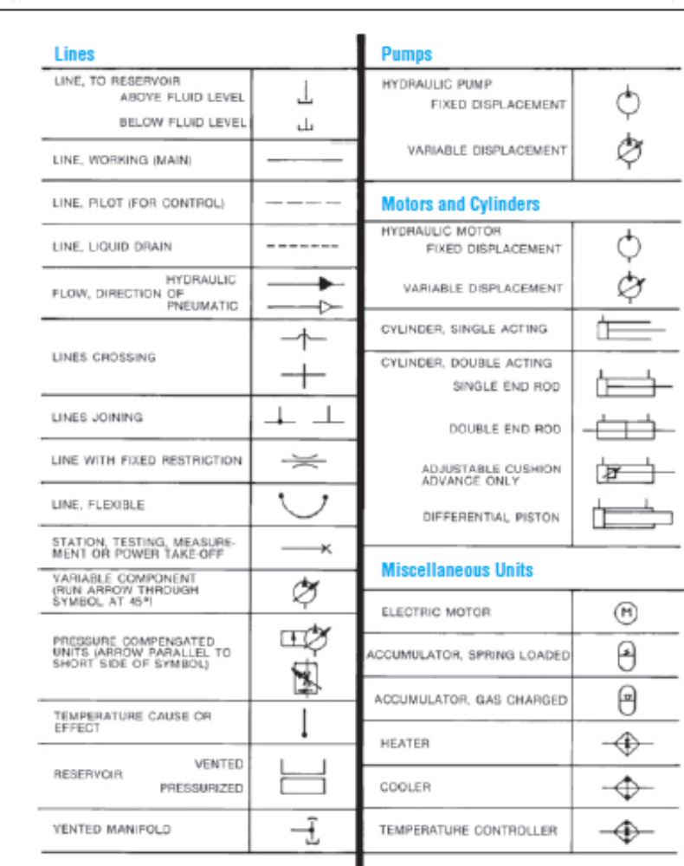
Figure 1-32 ISO/ANSI schematic symbols

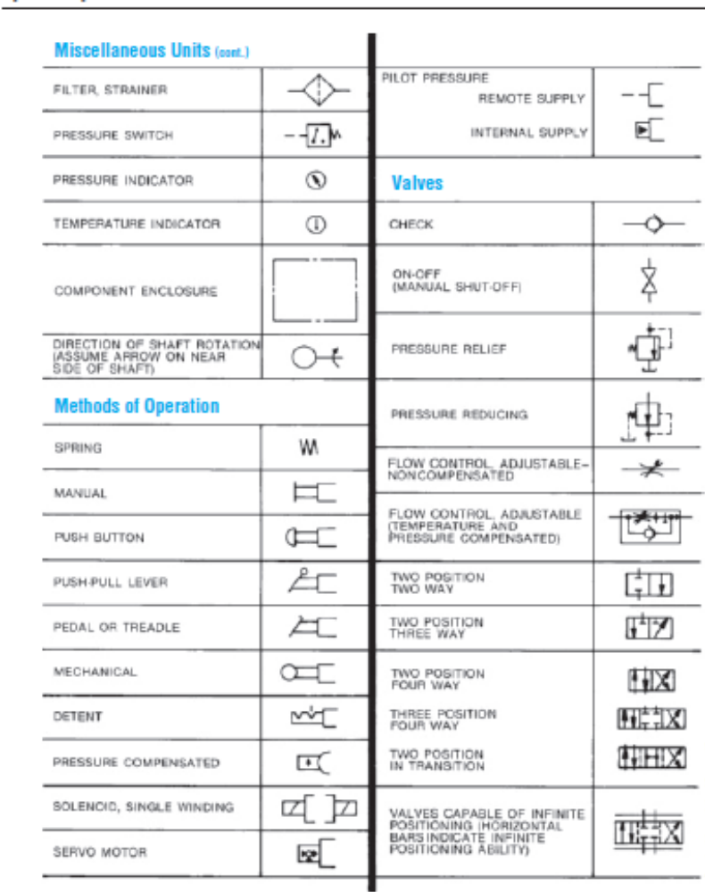

Hydraulic circuit diagrams
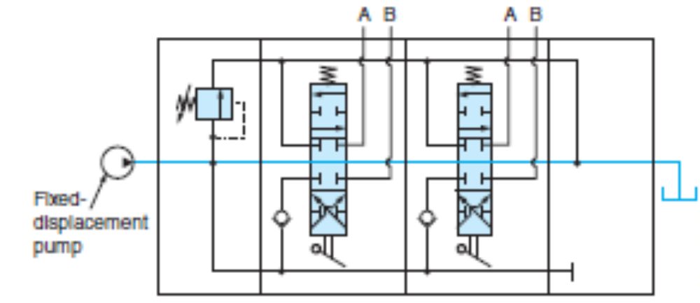
Figure 1-33 Open-center schematic.
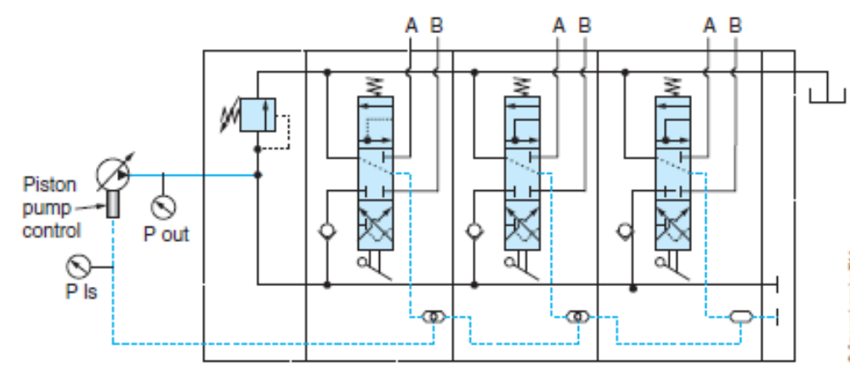
Figure 1-34 Closed-center schematic load sensing

OHS and PPE requirements
To protect yourself from injuries, you must take precautions including Personal Protective Equipment (PPE) and OHS

PPE Requirement
Safety glasses, Protective goggles or face shields can give used where protection more suited to activities encounter; splashing liquid, fume, vapor, dust or powder and working with hydraulic system. Different types of goggles are available which cover the whole eye. Long exposure to high noise levels can result in permanent hearing loss. Hence Ear protection is recommended when:
- Work area is constantly noisy
- Grinding
- Hammering

Skin protection is recommended when: working with chemicals & corrosives and handling heavy materials like wheel bearing service Rubberized Gloves: when working with chemicals, when using the parts washer. Leather gloves: when grinding or welding When lifting heavy engine parts or transmissions.
Your clothing should be well fitted and comfortable but made with strong material.
Wear appropriate clothing while performing tasks
- No sleeveless shirts
- No shorts
- No holes
- No hats
Safety Shoes: protect your feet from injury. There are many designs of safety shoes and boots that also have steel plates built into the toe and shank to protect your feet. Many also have soles that are designed to resist slipping on wet surfaces.
N.B Keep your clothing clean. If you spill gasoline or oil on yourself, change that item of clothing immediately. Oil against your skin for a prolonged period can produce rashes or other allergic reactions. Gasoline can irritate cuts and sores.
Respiratory protection is recommended: When working with chemicals that give. Toxic fumes, extended time around gasoline, when working on brakes or clutches that may contain asbestos. When using power sanding, using the parts washer for extended periods.

OHS Requirement
- Lifting and Carrying
When doing heavy lifting, always get assistance and lift with your knees, not your back.
When lifting any object follow these steps:
- Clean equipment and tools
- Part cleaning is a necessary step in most repair procedures. Cleaning automotive parts can be divided into three basic categories.
- Chemical cleaning relies primarily on some type of chemical action to remove dirt, grease, scale, paint, or rust.
- Abrasive cleaning relies on physical abrasion to clean the surface. This includes everything from a wire brush to glass bead blasting, airless steel shot blasting, abrasive tumbling, and vibratory cleaning. Chemical in-tank solution sonic cleaning might also be included here because it relies on the scrubbing action of ultrasonic sound waves to loosen surface contaminants.
Clean up procedures
- Clean up every time whenever you leave an area, including sweeping the floor.
- Clean and return all tools to where you got them.
- Use compressed air sparingly; never aim it at another person or use it to clean hair or clothes.
- Shut off and unplug machines when cleaning, repairing, or oiling.
- Never use a rag near moving machinery.
- Use a brush, hook, or a special tool to remove chips, shavings, scraps etc. from the work area. Never use the hands.
- Keep fingers clear of the point of operation of machines by using special tools or devices, such as, push sticks, hooks, pliers, etc.
- Keep the floor around machines clean, dry, and free from trip hazards. Do not allow chips to accumulate.
- Hazards in the work shop
- Faulty work habits
- Misuse of equipment
- Misuse of hand tools
Select the work place depending on: -
- Environmental condition
- Free from flammable things
- Events around the work campus is closer together
- Climatic condition
- Working area events
- Professional Behavior and work area safety
Accidents can be prevented simply by the way you behave. The following list does not include everything you should or should not do; it merely gives some things to think about:
- When working with a hydraulic press, sure the pressure is applied in a safe manner.
- Properly store all parts and tools by putting them away in a place where people will not trip over them.
- Keep your work area clean and uncluttered. Make sure you clean up all spills before continuing to work.
- Any oil, coolant, or grease on the floor can make it slippery. Slips can result in serious injuries.
- Make sure the work areas around machines are large enough to safely operate the machine.
- Keep an up dated list of emergency telephone numbers clearly posted next to the telephone. These numbers should include a doctor, hospital, and fire and police departments.
- The work area should have a first-aid kit for treating minor injuries and eye flushing kits readily available. You should know where these items are kept.
- Keep tools in good condition by using them properly and storing them properly.
- Always keep the place where you work clean. When a job is finished, everything should be replaced neatly in order and wastes should be disposed.
- Do not leave things, even temporarily, in passage ways or entrances and exits where they may obstruct people or cars going in and out.
- Do not leave tools and parts on the floor where you, or any one else, might trip over them. Make a habit of putting them on a workbench
- Clean up any spilled fuel, oil or grease immediately to prevent yourself or others from slipping on the floor.

Self-check-1
Instruction: Choose the best answer and circle the letter corresponds to best answer
- What force moves the fluid through the circuit upstream to the hydraulic pump when a vented reservoir is used in a hydraulic system?
A. vacuum
B. atmospheric pressure
C. hydraulic pressure
D. return pressure
- How much linear force is generated when a hydraulic force of 1000 psi acts on a sectional area of 50 sq. in?
A. 50 pounds
B. 5,000 pounds
C. 50,000 pounds
D. 500,000 pounds
- Which of the following is a measure of flow rate?
A. psi
B. gpm
C. BHP
D. lb/ft
- When a hydraulic pump discharges the same slug volume it picks up per cycle, it should be described as:
A. variable-displacement
B. constant cycle
C. positive displacement
D. non-positive cycle
- Which of the following is not a function of a hydraulic accumulator?
A. dampens pressure surges
B. stores potential energy
C. maintains consistent circuit pressure
D. charges hydraulic actuators
- Which valve is classified as a pressure-control valve?
A. check valve
B. relief valve
C. priority valve
D. directional control valve

Unit Two: Inspecting and testing basic hydraulic system
This unit to provide you the necessary information regarding the following content coverage and topics:
- Maintenance schedule
- Hydraulics system measuring tools
- Inspecting hydraulic system
- Testing Hydraulic system
This guide will also assist you to attain the learning outcomes stated in the cover page. Specifically, upon completion of this learning guide, you will be able to:
- Prepare Maintenance schedule
- Identify Hydraulics system measuring tools
- Inspect hydraulic system
- Test Hydraulic system

Maintenance schedule
Proper maintenance is key to having a hydraulic system perform properly and to minimize repair downtime. Properly planned and scheduled maintenance is known as preventative maintenance (PM). A key factor of preventative maintenance is the scheduling of preventative maintenance inspections (PMIs). The type of preventative maintenance schedule that suits a particular operation varies depending on the equipment and the kind of environment in which it operates. Typical maintenance problems result from:
- Low reservoir oil level
- Clogged oil filters
- Contaminated or improper oil in the system
- Dirt in the hydraulic circuit
Preventative maintenance schedules should be observed. Most routine maintenance on hydraulic circuits takes little time and can eliminate expensive component repair and replacement

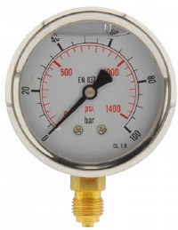
Hydraulics system measuring tools
- pressure gauge is a device used to measure and visualize fluid intensity in a system. Pressure gauges are indispensable devices during the setup of a system and its operation. They ensure the system is within the correct operating conditions and that there are no leaks.
Therefore, a hydraulic pressure gauge can be defined as a measurement device that shows the hydraulic system’s pressure. Hydraulic systems are usually high-pressure systems compared to water or air systems that typically have a lower maximum operating pressure limit.
Figure 2-1 A pressure gauge
Principle of operation
The most common operating principle used in hydraulic pressure gauges is the Bourdon tube. It is a simple method of indicating the hydraulic pressure in a system with high accuracy. The tube is usually created by flattening a circular cross-section tube and forming a C-shape or a helix. One end of the “C is fixed to a block and connected to an inlet pipe for the pressurized fluid, while the other end is closed and free to move.
- 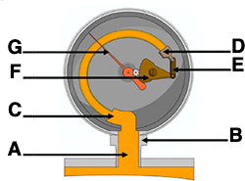
Figure 2-2 The Bourdon tube: inlet pipe (A), socket block (B), stationary end of the Bourdon tube (C), moving end of the Bourdon tube (D), pivot and pivot pin (E), sector gear (F), indicator needle (G)
- flow meter is a device that measures how much liquid or gas moves through a pipeline in a given period of time. By measuring flow rates, flow meters provide crucial visibility into what’s flowing where, within pipes, drainage systems, and other types of infrastructure.
- A thermometer is an instrument that measures temperature. It can measure the temperature of a solid such as food, a liquid such as water, or a gas such as air.
- A tape measure is a flexible instrument used for measuring lengths and distances; an essential for many industries and applications. From clothes making to carpentry, DIY and masonry, there is no doubt tape measures are an exceptionally popular tool, available in different types and sizes to suit every need and profession.
- A stopwatch is a watch with buttons which you press at the beginning and end of an event, so that you can measure exactly how long it takes.

2.3 Inspecting hydraulic system
Most hydraulic circuit failures follow a pattern, producing either a sudden or a gradual loss of system performance. To identify the fault and after repairs, and as part of preventative maintenance, hydraulic systems should be checked. Some OEMs have system-specific checklists and these should be used when available. Maintenance checks should be performed in the following fields.

2.3.1 Check Reservoir
This check should be undertaken regularly because it can be performed in seconds and can identify small problems before they become major problems. Before opening the system filler cap, clean it and the surrounding area with a clean rag. When dipsticks are used, clean the dipstick with a lint-free cloth before checking the level. Look for:
- Oil aeration-foaming oil or bubbles can indicate an air leak in the system, usually on the suction side of the circuit.
- Change in oil level-reservoir oil level that requires constant topping up usually indicates an external leak in the system.
- Milky oil. -this usually indicates the presence of water in the system. Often system flushing will be required because hydraulic oil and water emulsify under pressure.
Many reservoirs incorporate the filter and filter lines within the reservoir. Proper inspection of these reservoirs and filter housing requires removal of the reservoir from the machine and disassembling it. Large clean-out and inspection covers are typically implemented with these types of reservoirs and must be removed to gain access to the filter connections and all internal components.

2.3.2 Check Oil Lines and Connections
Both low- and high-pressure sides should be checked for leaks and physical damage.
- Low-pressure side leaks can result in air being pulled into the system, while high pressure side leaks will produce external leakage.
- Pinched lines can create restrictions that result in foaming, overheating, and reduction in hydraulic efficiency. A pinched inlet line can also cause cavitation.
In equipment with high working hours (20,000 to 30,000), a common practice during a major overhaul is to replace all flexible oil lines due to increased risk of deterioration of the inner tube. The rubber liner can become brittle and fragments can break away and contaminate the entire system. It is almost impossible to find the specific defective hose, and when age and service hours are high, it is a good PM practice to replace all lines.

2.3.3 Check Circuit Components
A thorough visual inspection should be made of all of the hydraulic circuit components including the oil cooler, valves, cylinders, pumps and motors.
- The circuit should be run through its working cycle to check for leaks and whether the flow is sufficient to run the system.
- Check the oil cooler fins for plugging and test system valve operation, remembering that wear can cause internal leakage.
- Motors should not be allowed to run hot. If this happens, check that the oil supply is adequate and that the oil cooler is functioning properly.
- Also check for leaks around the motor hose fittings, shaft, seals, and body mating surfaces.

2.3.4 Leakage Inspection
Theoretically, a hydraulic pump should be able to turn a hydraulic motor at the same speed, providing both of equal displacement. To achieve this would require 100% volumetric efficiency. However, this is not achievable due to circuit leakage factors. Circuit leakage in hydraulic circuits classified as:
- Internal leakage
- External leakage
- Intended Internal Leakage
Any leakage that is designed into a hydraulic circuit can be classified as internal leakage. Intended internal leakage is used to lubricate plungers and pistons, valve spools, pumps, motor components, and pretty much anything that moves in the circuit. Intended internal leakage can also help ‘‘guide’’ a close-fitting component, such as a plunger, in the bore it reciprocates within.
Leak paths are built into certain hydraulic components, such as motors, to provide balanced operation. These leak paths are referred to as case drain and typically are routed back to the reservoir via the hydraulic filter.
Many OEMs have a case drain leakage test to determine if internal leakage is greater than the acceptable level. This is measured by using a flow meter on the pump case drain outlet line and following the manufacturer’s test procedure of load testing the pump and measuring the outcome from the flow meter.
- If the flow is greater than the acceptable level, the pump may be deemed defective.
On many hydraulic systems a pressure tap is connected to the case drain circuit, and instead of a flow measurement, a pressure test of the case drain is measured. Always refer to proper OEM test procedures and guidelines prior to condemning components.
- Unintended Internal Leakage
Unintended internal leakage can occur when normal wear opens up flow paths in intended internal leakage circuits, or it can result from internal seal failure. Excessive internal leakage slows down actuators and, in the case of failed seals, can create a leakage path that diverts all of the pump flow around the actuator.
- Effect of internal Leakage
- Pressure and Leakage
Whether internal leakage is intended or not, it increases with pressure. In addition, heat is generated at the leakage flow path.
- Operating a circuit at higher than specified pressures produces both increased leakage and adds heat to the circuit fluid.
- While excess internal leakage can result in loss of control or function in a hydraulic circuit, the good news is that the oil is not lost. One way or another, it will be routed back to the reservoir, either by means of the return circuit or by drain passages.
- Viscosity and Leakage
The viscosity of hydraulic oil influences internal leakage flow rate. A low viscosity oil flows more readily and therefore increases internal leakage. The viscosity and viscosity index of the hydraulic oil used are key considerations, both in providing the appropriate intended internal leakage and in preventing excessive internal leakage.
- Internal Seal Failure
When an internal seal fails, the result can be a complete failure of the hydraulic circuit. Oil continues to flow through the circuit and heat is generated at the location of the seal failure. A sudden rupture of an internal seal can be dangerous in many types of hydraulic circuit
- External Leakage
All hydraulic circuit external leakage is unintended. External leakage presents less of a challenge in troubleshooting because of the mess it makes. Apparently minor external hydraulic leaks should always be promptly repaired because what begins as seal leakage can progress to a rupture. External leakage can usually be sourced to one of the following:
- Improper assembly
- Poor maintenance
- Shock load on an actuator
- Lines subjected to excessive vibration

Caution
Pinholes in hydraulic lines result in high-pressure oil escaping from the system in minute droplets. These oil droplets can penetrate the skin, often with little external evidence, and the result can be blood poisoning. Use a piece of cardboard to search for leaks in hydraulic lines; never use a bare hand.

2.4 Testing Hydraulic system

2.4.1 Flow and Pressure Testing
Various types of hydraulic analyzers are available for testing hydraulic circuits. A hydraulic analyzer typically consists of a pressure gauge(s), flow meter, manual gate (choke) valve, and thermometer. Figure 2-1(left) shows one type of hydraulic analyzer. Figure 2-1 (right) shows how the analyzer is plumbed into a circuit to perform a simple pump output test.
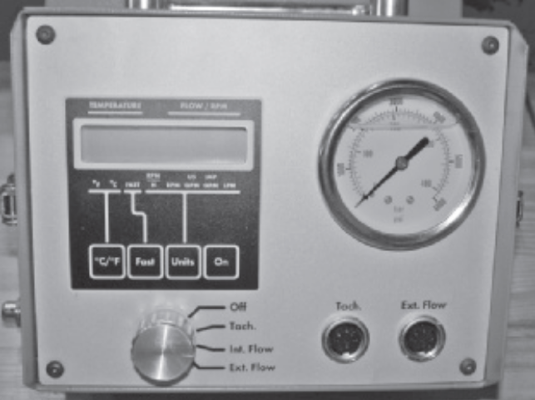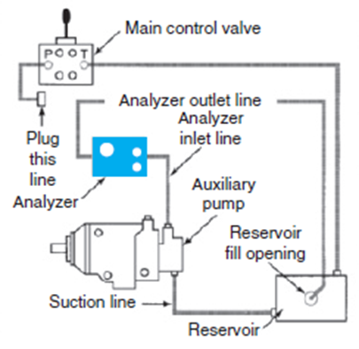
Figure 2-3 Hydraulic analyzer (left) and plumbing of analyzer into a circuit to perform a simple pump output test (right)
Typically, a hydraulic analyzer checks:
- Flow-Flow testing determines whether the pump is producing its specified output.
- Pressure-Pressure testing verifies the operation of the relief valve and, in closed-center systems, pump performance.
- Cycle Times-Cycle times are a measurement of independent implement speeds. Because cycle times are calculated from specific flow and pressure rates, most OEMs will list a specific time chart for each implement of every machine they manufacture. Cycle times can allow the technician to perform a quick evaluation of the machine performance without installing pressure gauges and flow meters.
- Note: It is common practice to test engine performance prior to testing cycle times. Poor engine performance in many cases causes poor hydraulic performance.
- Temperature-Hydraulic oil temperature should be measured because system pressure and flow specifications are calculated with the system at operating temperature. An infrared temperature gun is a non-invasive method of quickly checking internal leakage of components as well as testing temperature differentials within a circuit.
- Leakage-Leakage testing identifies leakage in a specific circuit component.
When you are required to test a vehicle hydraulic circuit, observe the OEM test cycle. It is recommended that you record the results of each test step using a procedure such as that shown in Table 6-1 for a pump performance test and Table 6-2 for a hydraulic circuit performance test. In this example here, typical excavator system used. Most manufacturers use system-specific tables for recording performance test data in their service literature.
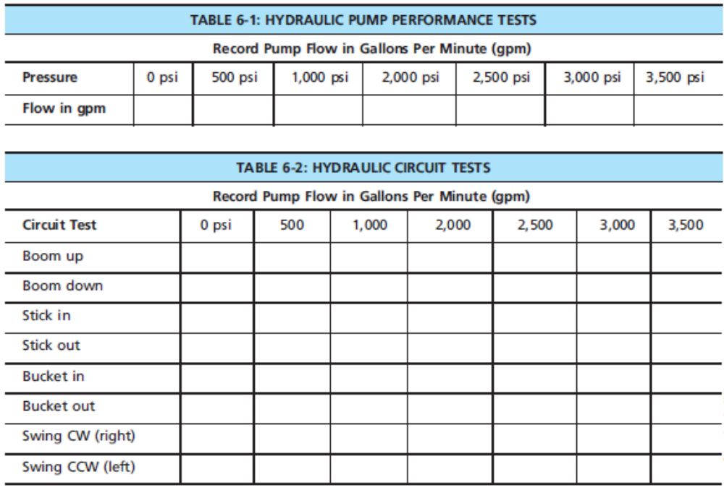
OEMs identify the test points along with specifications in their service literature. The test points used to diagnose the hydraulic circuits in an excavator are shown in Figure 2-2. In this test profile, a tachometer connected to monitor engine speed. Note the test locations for both the pumps and control valve.
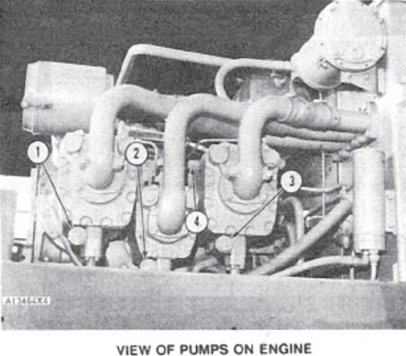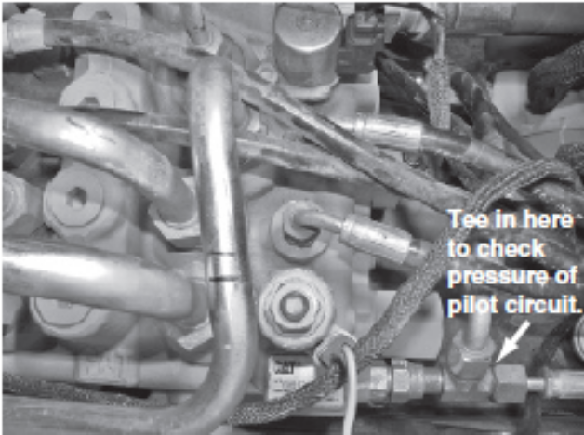
Figure 2-4 Test points for hydraulic system checks (left) and Control valve pressure test location (right)

2.4.2 Diagnosing Test Results
You should make sure that you consult the OEM literature when diagnosing hydraulic circuit test results, but here are some typical guidelines used to test a simple hydraulic cylinder type circuit:
- Pump flow at maximum pressure should be at least 75% of the pump flow measured at zero pressure; OEM specifications can require higher percentage values. A pump that fails to meet 75% of this value is probably worn.
- When flow at each pressure value throughout testing is within 75% of pump flow at zero pressure, the hydraulic circuit components are probably functioning properly.
- When pressure drops off before full load, a leaking circuit is indicated. To determine whether the leakage is occurring in the control valve or in the cylinder, disconnect the cylinder return hose and move the control valve to a power position. If oil leaks at the cylinder return, it is probably leaking internally and is defective. If no oil exits the cylinder return line, the control valve may be at fault.
- A relief valve should open within a window of its specified pressure, so check the OEM specifications. A defective relief valve can be identified when the valve opens before system maximum pressure is achieved. If circuit flow suddenly drops off before system pressure is achieved, a defective relief valve is indicated.

2.4.3. Load Sensing/Pressure Compensated and Torque Limiting System Test
In a load sensing/pressure compensated (LS/PC), torque limiting system, there are four basic tests to check compensator performance:
- Low-pressure standby test
- High-pressure stall test
- Margin pressure test
- Torque limiter test
These tests are critical because they affect the variable pump performance between zero and maximum flow. The following tests are performed with oil at operating temperature, engine at high idle, and all implements in their rest position on the ground. Before performing each test, check for leaks on all connections made to the system.
- Low-Pressure Standby Test
A typical standby pressure can be from 200 to 500 psi. Therefore, a pressure gauge from 0 to 1,000 psi would be most accurate to install on the pump outlet line. It is recommended to use an auto-ranging gauge that is made up of multiple gauges that will automatically switch to the appropriate gauge as the pressures rise beyond the limits of each gauge.
- Start and run the engine at high idle. Be sure not to touch any of the controls including the steering circuit. By doing so, pressure may spike and damage the pressure gauge.
- Allow the engine speed to stabilize and record your reading.
- Pressure should be within the limits of the OEM specification. If the pressure is not within specification, do not adjust until all other pressure tests are performed.
- High-Pressure Stall Test
This test checks the setting of the pressure compensator that will de-stroke the pump when pressure in the system reaches the specification setting. High-pressure compensator settings may range from 2,500 to 4,000 psi. A 0 to 6,000 psi gauge is recommended for this test installed at the pump outlet line. Always refer to OEM specifications and recommendations.
- Start and run the engine at high idle.
- Slowly move each control valve lever independently to fully retract each cylinder. Do not hold the control valve open with the cylinder fully retracted for more than 10 seconds. This should be substantial time to record your readings for each implement. Wait 30 seconds between each implement to allow oil to cool.
- If pressure settings are too high or too low, the pressure compensator spring must be adjusted. A counterclockwise turn will lower the spring setting thus lowering the pressure. A clockwise turn will increase spring setting, raising the compensator pressure setting.
- Margin Pressure Test
Margin pressure is the differential pressure between pump outlet working pressure and signal pressure to the flow compensator. Therefore, two pressure gauges are required for this test. Two 0 to 4,000 psi gauges would be sufficient, one connected at the pump outlet line and one connected to the flow compensator signal line.
- Start and run the engine at high idle.
- Move one implement at a steady rate of speed and record the pressures. The pressure differential should always be as close to standby pressure as possible. This is because the pressure required to move the actuator is sent to the flow compensator via the check-valve network as signal pressure.
- This pressure plus the spring pressure pushing on the flow compensator spool is additive.
- Pump outlet pressure routed to the opposite end of the spool must equal this pressure to maintain a balanced position for the swashplate.
- Torque Limiter Test
The torque limiter is responsible for not allowing the hydraulic circuit to work above the horsepower limits of the engine. It is not necessary to be working in high flow and high-pressure conditions simultaneously. Therefore, the torque limiter is set to inversely control pump displacement to pump outlet pressure. Prior to this test, an engine performance evaluation must be done. If engine performance is within specification and hydraulic performance is low, then proceed with this test.
- Pick one implement with a port relief valve and set to 500 psi below the pressure compensator setting. Example:
- If the pressure compensator is set for 3,000 psi, adjust port relief valve to 2,500 psi. By doing this, the pressure compensator will not be able to control pump displacement when this circuit is placed under load.
- With an accurate rpm gauge installed, set engine to 1,000 rpm.
- Operate the implement against its stop or farthest extension point. Note engine rpm drop. If engine rpm drops more than 150 rpm, torque limiter adjustment is necessary.
- Adjust torque limiter spring outward to relieve spring tension and retest. The proper setting should allow engine to lug between 100 and 150 rpm. If engine lug is less than 100 rpm, torque limiter spring tension should be increased.
- Reset the port relief valve to its original setting.
Note: This is one example and should not be used as standard practice for all machines. Always refer to OEM testing and adjusting procedures for machine-specific testing.

Self-check-2
      - What would cause a hydraulic pump to produce 0 psi and only 60% of the OEM-specified flow?
A. defective pressure-relief valve
B. worn pump
C. defective reservoir vent cap
D. worn unloading valve
      - What would cause the boom to not raise or lower on a piece of equipment, but all other implements appear to operate correctly?
A. aerated hydraulic oil
B. out-of-adjustment control
C. low pump relief valve setting
D. Oil leakage from track brake linkage between the lever and pilot valve
      - Technician A says that aerated hydraulic oil can cause a circuit to operate erratically. Technician B says that excessively cold hydraulic oil can cause a system to operate erratically. Who is correct?
A. Technician A only
B. Technician B only
C. Both A and B
D. Neither A nor B
      - Which two pressure values denote margin pressure?
A. pump outlet and pump inlet
B. pump outlet and standby pressure
C. pump outlet and system pressure
D. pump outlet and case drain
      - What would cause pressure to drop off in a hydraulic implement circuit significantly before full load is achieved?
A. defective relief valve
B. internal leak in the circuit
C. seized control valve spool
D. cold hydraulic fluid

Operation sheet-2.1
Inspection and replacement of Hydraulic cylinder seals
To prevent possible injury, do not use compressed air for removing the piston and piston rod form the cylinder barrel.
- High oil pressures are dangerous.
- Hot components can cause burns.
Given a hydraulic cylinder (double acting), you are to carry out the following:
Inspection of piston rod, piston and cylinder barrel
Inspection and replacement of seals:
- Select the correct tools and accessories
- Use the correct workshop manual
- Use a torque wrench, if necessary
- Measure the piston rod for straightness
- Install new oil seals, using the right procedure
Excavator cylinder is given as an example
The cylinder that is used to operate the excavator boom or bucket is equipped with a rod stopper, which acts as a cushion only when the cylinder rod is fully retracted (and the bucket is pulled close to the arm).This type of cylinder is shown in the lower drawing
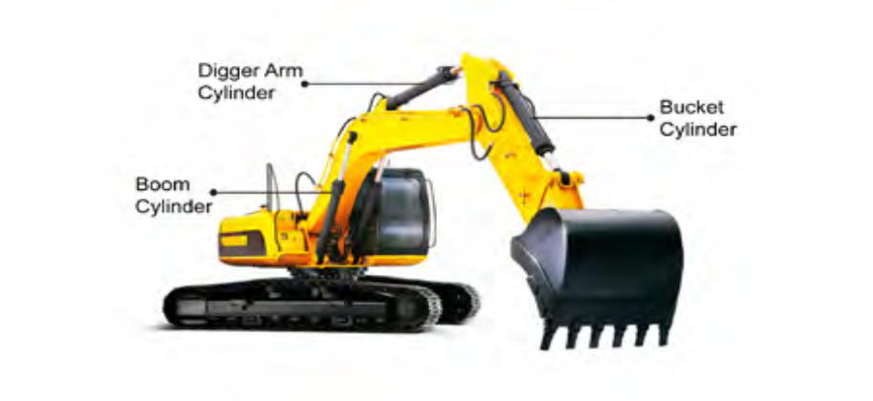

Operation sheet 2.2
Operation Title: Hydraulic pump test
Purpose: To identify the hydraulic pump condition
Conditions or situations for the operations:
- Safe working area
- Properly operated hydraulic bench with hydraulic components
- Appropriate working cloths fit with the body
Equipment Tools and Materials:
- Hydraulic system analyzer, hydraulic bench and hydraulic components, OEM manual
Steps in doing the task
- Install the hydraulic tester into the circuit to be tested between the pump and the control valve. The pressure line should be connected to the inlet port of the tester.
- Connect the hydraulic tester outlet (return) to the system reservoir.
- After installation, check the system oil level.
- Start the electric motor and gradually close the hydraulic tester gate valve to load the circuit and bring the temperature up to normal operating value.
- Make a full brake application with the foot valve and hold. Observe the reservoir air pressure gauge.
- Next, open the gate valve and record system flow at zero pressure.
- Move the system control valve into one of its power positions and gradually close the tester gate valve, recording flow in 250 or 500 psi increments from zero up to full system pressure.
- Repeat the above test in each of the system control valve power positions.
Quality Criteria: Assured performing of all the activities according to the procedures

Precautions:
- Wearing proper clothes, make working area hazard free
- Read and interpret manual which guide you how to perform the test.

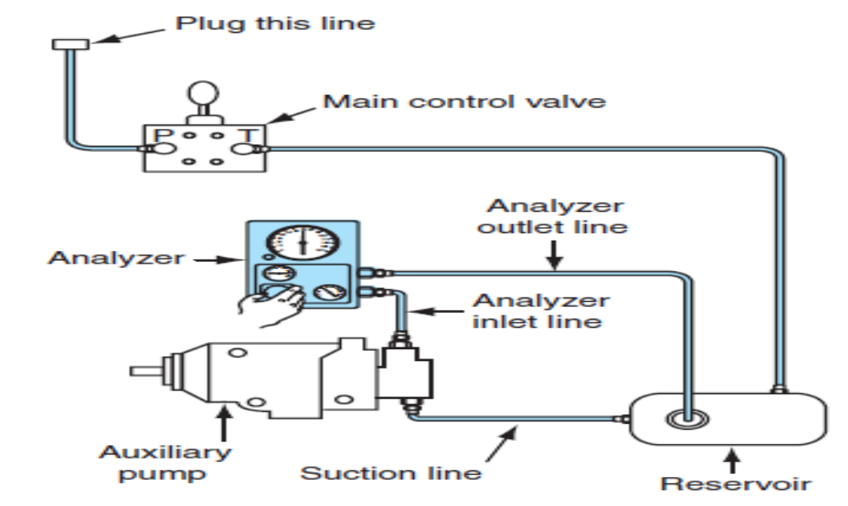

Unit Three: Servicing hydraulic system
This unit to provide you the necessary information regarding the following content coverage and topics:
- Servicing procedures of hydraulic system
This guide will also assist you to attain the learning outcomes stated in the cover page. Specifically, upon completion of this learning guide, you will be able to:
- Service of hydraulic system

3.1 Servicing procedures of hydraulic system

3.1.1 Safe Practice
Truck hydraulic circuits are designed to run at high pressures and support high loads. It is essential that you work safely around chassis hydraulic equipment. Some basic rules are:
- Never work under any device that is only supported by hydraulics. It must be mechanically support before you work under it. Just as when using a floor jack, you must use some means of mechanically supporting any raised equipment or components.
- Hydraulic circuit components can retain high residual pressures. The system does not have to be active for this to be a potential. Try to ensure that pressures are relieved throughout the circuit before opening it up. Crack hydraulic line nuts slowly and be sure to wear both safety glasses and gloves.
- Pinholes in hydraulic lines result in high-pressure oil escaping from the system in minute droplets. High-pressure oil droplets can penetrate the skin, often with little external evidence, and the result can be blood poisoning. Use a piece of cardboard to search for leaks in hydraulic lines never a bare hand.
3.1.2 Drain, Flush, and Fill
A draining, flushing, and refilling procedure is the only way to remove contaminants and degenerated hydraulic fluid from a hydraulic circuit. The frequency with which this is performed will depend on the severity of the working conditions, and in many cases simply draining and replacing the hydraulic oil will be sufficient. Sludging oil, solid deposits, and the appearance of varnishing on components are indicators that draining the system should be followed by system flushing before refilling with new hydraulic oil.
Drain System
Gravity-drain the system, cleans any sediment from the reservoir, and replace the filter elements. Inspect the old oil. If it shows signs of severe degeneration, flushing the system should be considered. Indicators of severe degeneration of hydraulic oil are burned odor, excessive stickiness, discoloration, and lacquer flakes in oil.

Flush System
Most hydraulic system flushing should be performed with the specified service hydraulic oil. After draining, fill the system reservoir with the specified oil, bleed the hydraulic pump, and then operate the equipment to circulate it through the entire system.
All the valves should be actuated to ensure that the flushing oil reaches every part of the circuit. Then drain and dispose of the flushing oil.
Fill the System
Remembering that the intrusion of dirt into hydraulic systems probably causes more problems than any other single problem, ensure that everything used in the refill procedure is clean. A new filter should be used. Fill the reservoir to the prescribed level with new hydraulic oil. Then run the equipment through its entire working cycle several times to ensure that any air is purged from the circuit. The equipment should run smoothly. Finally, recheck the oil level in the reservoir

Operation sheet 3.1
Operation Title: Drain, Flush, and Fill hydraulic system
Purpose: To drain, flush, and fill hydraulic system properly
Conditions or situations for the operations:
- Safe working area
- Properly operated hydraulic bench with hydraulic components
- Appropriate working cloths fit with the body
Equipment Tools and Materials: OEM manual
Steps in doing the task
- Install the hydraulic tester into the circuit to be tested between the pump and the control valve. The pressure line should be connected to the inlet port of the tester.
- Connect the hydraulic tester outlet (return) to the system reservoir.
- After installation, check the system oil level.
- Start the electric motor and gradually close the hydraulic tester gate valve to load the circuit and bring the temperature up to normal operating value.
- Make a full brake application with the foot valve and hold. Observe the reservoir air pressure gauge.
- Next, open the gate valve and record system flow at zero pressure.
Quality Criteria: Assured performing of all the activities according to the procedures
Precautions:
- Wearing proper clothes, make working area hazard free
- Read and interpret manual which guide you how to perform the test.

LAP Test
Task 1: perform drain, flush, and fill hydraulic system

Unit Four: Prepare vehicle for use or storage
This learning guide is developed to provide you the necessary information regarding the following content coverage and topics:
  - Inspecting tools and equipment
  - Cleaning tools and equipment
  - Lubricating tools and equipment
  - Storing tools and equipment
This guide will also assist you to attain the learning outcomes stated in the cover page. Specifically, upon completion of this learning guide, you will be able to:
  - Inspect tools and equipment
  - Clean tools and equipment
  - Lubricate tools and equipment
  - Store tools and equipment

Inspect Tools and equipment
If you are in the habit of using a power tool every day, it can be easy to fail to notice when that tool’s performance gradually drops over time. That’s why it is important to at least semi-regularly take a moment and inspect your most-used tools, paying close attention to signs of wear and performance issues. Run a few basic operations with a tool, paying close attention to warning signs like weaker than normal power levels, any sort of burning smell, and strange buzzes and noises coming from inside the tool. Any of these is a pretty strong indicator that there’s something off with your tool and it may require some extra attention.

Clean Tools and equipment
It might seem like overkill at first, but be sure that each of your power tools gets cleaned every time you finish using it. Cleaning methods will vary from tool to tool, but most of the time everyday cleaning can be as simple as wiping dirt and dust from the casing. Something as simple as a good wipe down will keep particles from building up and getting into your tool’s internal mechanisms. Tighter areas like filters can be kept dust free with a few blasts from a can of compressed air.

Lubricate Tools and equipment
Lubrication is an often neglected maintenance step that can really drag down tool performance, causing issues like chafing that can cause parts to quickly deteriorate. Most likely, each of your tools will have a section in their owner’s manual explaining proper lubrication practices. Follow the recommended steps to ensure that your power tools remain the well-oiled machines they are meant to be.

Store Tools and equipment
Always store tools in a dry, climate-controlled environment. Moist and dirty environments can cause hand tools to rust and dull, and storing power tools in damp areas can degrade electrical components and cause parts to corrode over time. While fitting power tools back into their cases can be a pain, the case will go a long way towards protecting its tool from the environment. If you need the extra space, consider gutting your tool cases.

Self-check-4
Instruction: Short answer
- How do we Inspect tools and equipment?
- How can cultivate the habit of cleaning?
- What the best practices for lubricate tools and equipment?
- What are the storing tools and equipment?

Reference

- Robert H. et al…, Modern diesel technology: heavy equipment systems, 2nd edition 2014 Delmar, Cengage learning
- Crouse, W.H. and Anglin D.L, Auto motive mechanics 10th edition
- R.K Rajput, Automobile Engineering
- Prof. Dr.-Ing. Konrad Reif, Brakes, Brake Control and Driver Assistance Systems
- David A. Crolla , Automotive Engineering
- Nunney, M. J.Rutledge, 2007, Light and Heavy Vehicle Technology 4th ed.

Participants of this Module (training material) preparation
No | Name | Qualification (Level) | Field of Study | Organization/ Institution | Mobile number | E-mail
 | ADINET ASNAKE | MSc | Automotive Technology Mgt | Wolkite PTC | 0913767250 | andinetasnake31@gmail.com
 | BIRUK TILAHUN | BSc | Automotive Technology | General Wingate PTC | 0913789176 | biruktilahun1@gmail.com
 | FADLI AMAN | BSc | Automotive Technology | General Wingate PTC | 0927283100 | Fadli.ziyad@gmail.com
 | HANA NIGUSISE | BSc | Automotive Technology | Selam TVET college | 0988751516 | Hana.nigussie25@gmail.com
 | ISREAL TAYE | BSc | Automotive Technology | General Wingate PTC | 0913424100 | Isra.taye@gmail.com
 | TATEK MAMO | PhD scholar | Automotive Technology | DEC | 0911841121 | mimibaba928@gmail.com
 | ZELALEM YITBAREK | BSc | Automotive Technology | Selam TVET college | 0972030621 | Zolosmart12@gmail.com

