

Heavy Vehicle and Earth Moving Machinery Maintenance
Level-II
Based on May 2022, Curriculum Version- I
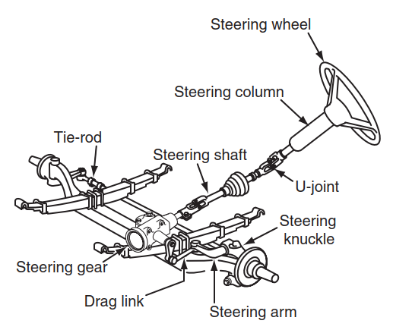

Module Title: - Servicing Steering System
Module code: EIS HEM2 M13 1122
Nominal duration: 60 Hour
Prepared by: Ministry of Labor and Skill
December, 2022
Addis Ababa, Ethiopia
Table of Contents
Acknowledgment 3
Acronym 4
Introduction to module 5
Unit one: Overview of Steering System 6
1.1 Purpose of steering system 7
1.2 Steering System Components 7
1.3 Types of Steering Systems 10
1.4 OHS requirements 12
1.5 Selection and using tools, equipment workshop manuals and specification 12
Self-check-1 14
Unit Two: Inspection of steering Systems 15
2.1 Basic inspection procedures 16
2.2 Inspection of steering system 17
2.2.1 Steering Axle Inspection 17
2.2.2 Steering Knuckle Inspections 18
2.2.3 Kingpin inspection 18
2.2.4 Tie-Rod Inspection 21
LAP Test 22
Unit Three: Servicing Steering System 23
3.1 Servicing steering system Components 24
3.2 Diagnosis steering system problem 36
3.3 Power steering system Service 38
3.4 Grease Fitting 44
LAP Test 45
Unit Four: Wheel Alignment 46
4.1 Introduction to Steering geometry 47
4.2 Toe Angle 47
4.3 Caster 49
4.4 Twisted Axles 54
4.5 Camber 56
4.6 Ackerman Geometry 58
4.7 Axle Alignment 60
LAP Test 63
Reference 64

Acknowledgment

Ministry of Labor and Skills wish to extend thanks and appreciation to the many representatives of TVT instructors and respective industry experts who donated their time and expertise to the development of this Teaching, Training and Learning Materials (TTLM).

Acronym

EPS | Electric power hydraulic steering
GPM | Global Precipitation Measurement
HPS | Hydraulic power steering
KM | Kilo Meter
KPA | Kilo Pascal
KPA | Kilo pascal
LAP | Learning Activity Performance
mm | Millimeter
OEM | Original equipment manufacturer
OHS | Occupational Health Safety
PDI | Pre-Delivery Inspections
PM | Preventive maintenance
PSI | Per square inch
TTLM | Teaching, Training and Learning Materials

Introduction to module
In Automotive field of study; Service Steering System is one of important task the mechanic undertaking during servicing. This module contain to carry out the service of steering systems and associated components.
This module is designed to meet the industry requirement under the Heavy Vehicle and Earth Moving Machinery Maintenance level II occupational standard, particularly for the unit of competency: Service Steering System
This module covers the units:
- Overview of Steering System
- Inspection of Steering Systems
- Servicing Steering System
- Wheel Alignment
Learning Objective of the Module
- Overview of Steering System
- Inspection of Steering Systems
- Servicing Steering System
- Wheel Alignment

Module Instruction
For effective use this modules trainees are expected to follow the following module instruction:
- Read the information written in each unit
- Accomplish the Self-checks at the end of each unit
- Perform Operation Sheets which were provided at the end of units
- Do the “LAP test” giver at the end of each unit and
- Read the identified reference book for Examples and exercise

Unit one: Overview of Steering System
This unit is developed to provide you the necessary information regarding the following content coverage and topics:
- Purpose of steering system
- Steering System Components
- Types of Steering Systems
- OHS requirements
- Selection and using tools, equipment workshop manuals and specification

This unit will also assist you to attain the learning outcomes stated in the cover page. Specifically, upon completion of this learning guide, you will be able to:
- Understand the purpose of steering system
- Identify Steering System Components
- Types of Steering Systems
- OHS requirements
- Selection and using tools, equipment workshop manuals and specification

Purpose of steering system
The steering system in a heavy-duty truck is expected to deliver precise directional control of the chassis at both gross and unloaded vehicle weight. It has to be able to minimize driver effort while retaining some road feel. Truck steering systems can be either manual or power-assisted. Most truck steering gear found on trucks today is power-assisted. Power-assisted steering on highway vehicles is required to function with full mechanical redundancy in the event of a loss of the power-assist system. Do not confuse power-assisted steering with the full power steering systems found on some off-highway equipment. This equipment often uses hydrostatic steering; in the event of a loss of hydraulic power, this will result in no steering capability.

Steering System Components
The steering system of the truck is made up of the steering wheel, steering column, steering gear, and steering linkages that actually move the steering tires.
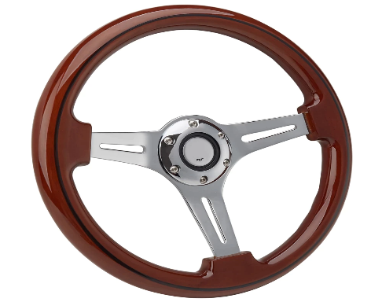
    - Steering Wheel
The steering wheel is the driver’s means to control the direction that the vehicle travels. It is therefore the primary input to the steering system. The steering wheel is formed from a strong steel rod that is formed into the shape of a wheel and supported by spokes.
Figure 1:1: Steering wheel
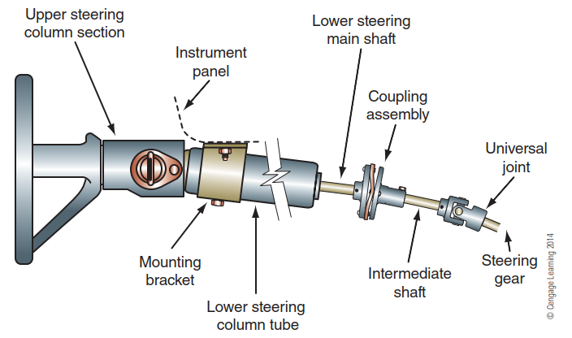
    - Steering Column
The steering column connects the steering wheel to the steering gear. The major components of the steering column assembly are a jacket, bearing assemblies, a steering column shaft, and wiring and contact assemblies for the electric horn.
    - Steering Gear
Figure 1:2: Steering Column
The steering gear, sometimes referred to as the steering box, is used to multiply the driver’s efforts at the steering wheel as well as change its direction. There are three general categories of heavy-duty steering gears: worm and sector shaft, recirculating ball and rack and pinion.
    - Pitman Arm
A Pitman arm is a steel lever, spline-attached to the sector (output) shaft of the steering gear. The end of the Pitman arm moves through an arc with the sector shaft center, forming its center. The Pitman arm functions to change the rotary motion of the steering gear sector shaft to linear motion.
    - Drag Link
The drag link is a forged rod that connects the Pitman arm to the steering control arm. The drag link can be a one-piece or two-piece component. The two- piece design allows the technician to adjust its length, which makes it easy to center the steering gear with the wheels straight ahead.
    - Steering Control Arm
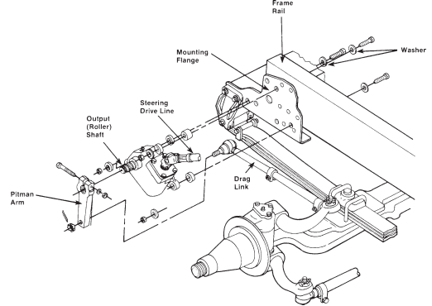
The steering control arm (steering arm or lever) connects the steering knuckle to the drag link on the driver’s side of the vehicle. It is usually a drop-forged tempered steel component. When the drag link is moved, the steering arm will cause the steering knuckle to move, changing the direction of the frontier.

Figure 1:3: Typical manual steering gear installation.
    - Steering Knuckle
The steering knuckle mounted by kingpins (knuckle pins) to the solidly mounted front axle. Kingpins allow for the pivoting action of the steering knuckle required to control the direction of the vehicle. The steering knuckles incorporate the spindle onto which wheel bearings and wheel hubs are mounted, plus a flange to which the brake spider is mounted.

    - Kingpins
Kingpins can be either tapered or straight. Tapered pins are drawn into the axle center and secured by tightening a nut at the upper pin end. Straight kingpins are secured to the axle with tapered draw keys that bear against flats on the pins.
    - Ball Joints
A ball joint is a ball-and-socket assembly made up of a forged steel ball with a threaded stud attached to it. A socket shell grips the ball. This assembly will allow movement in any direction from the fixed ball.
    - Ackerman Arm
The Ackerman arm or tie-rod arm is used to transfer and synchronize steering action on both steer wheels on a steering axle. Ackerman arms are drop- forged, tempered steel levers that are angled to allow the outer wheel to turn at less of an angle that the inner wheel (toe-out on turn).
    - Tie-Rod Assembly
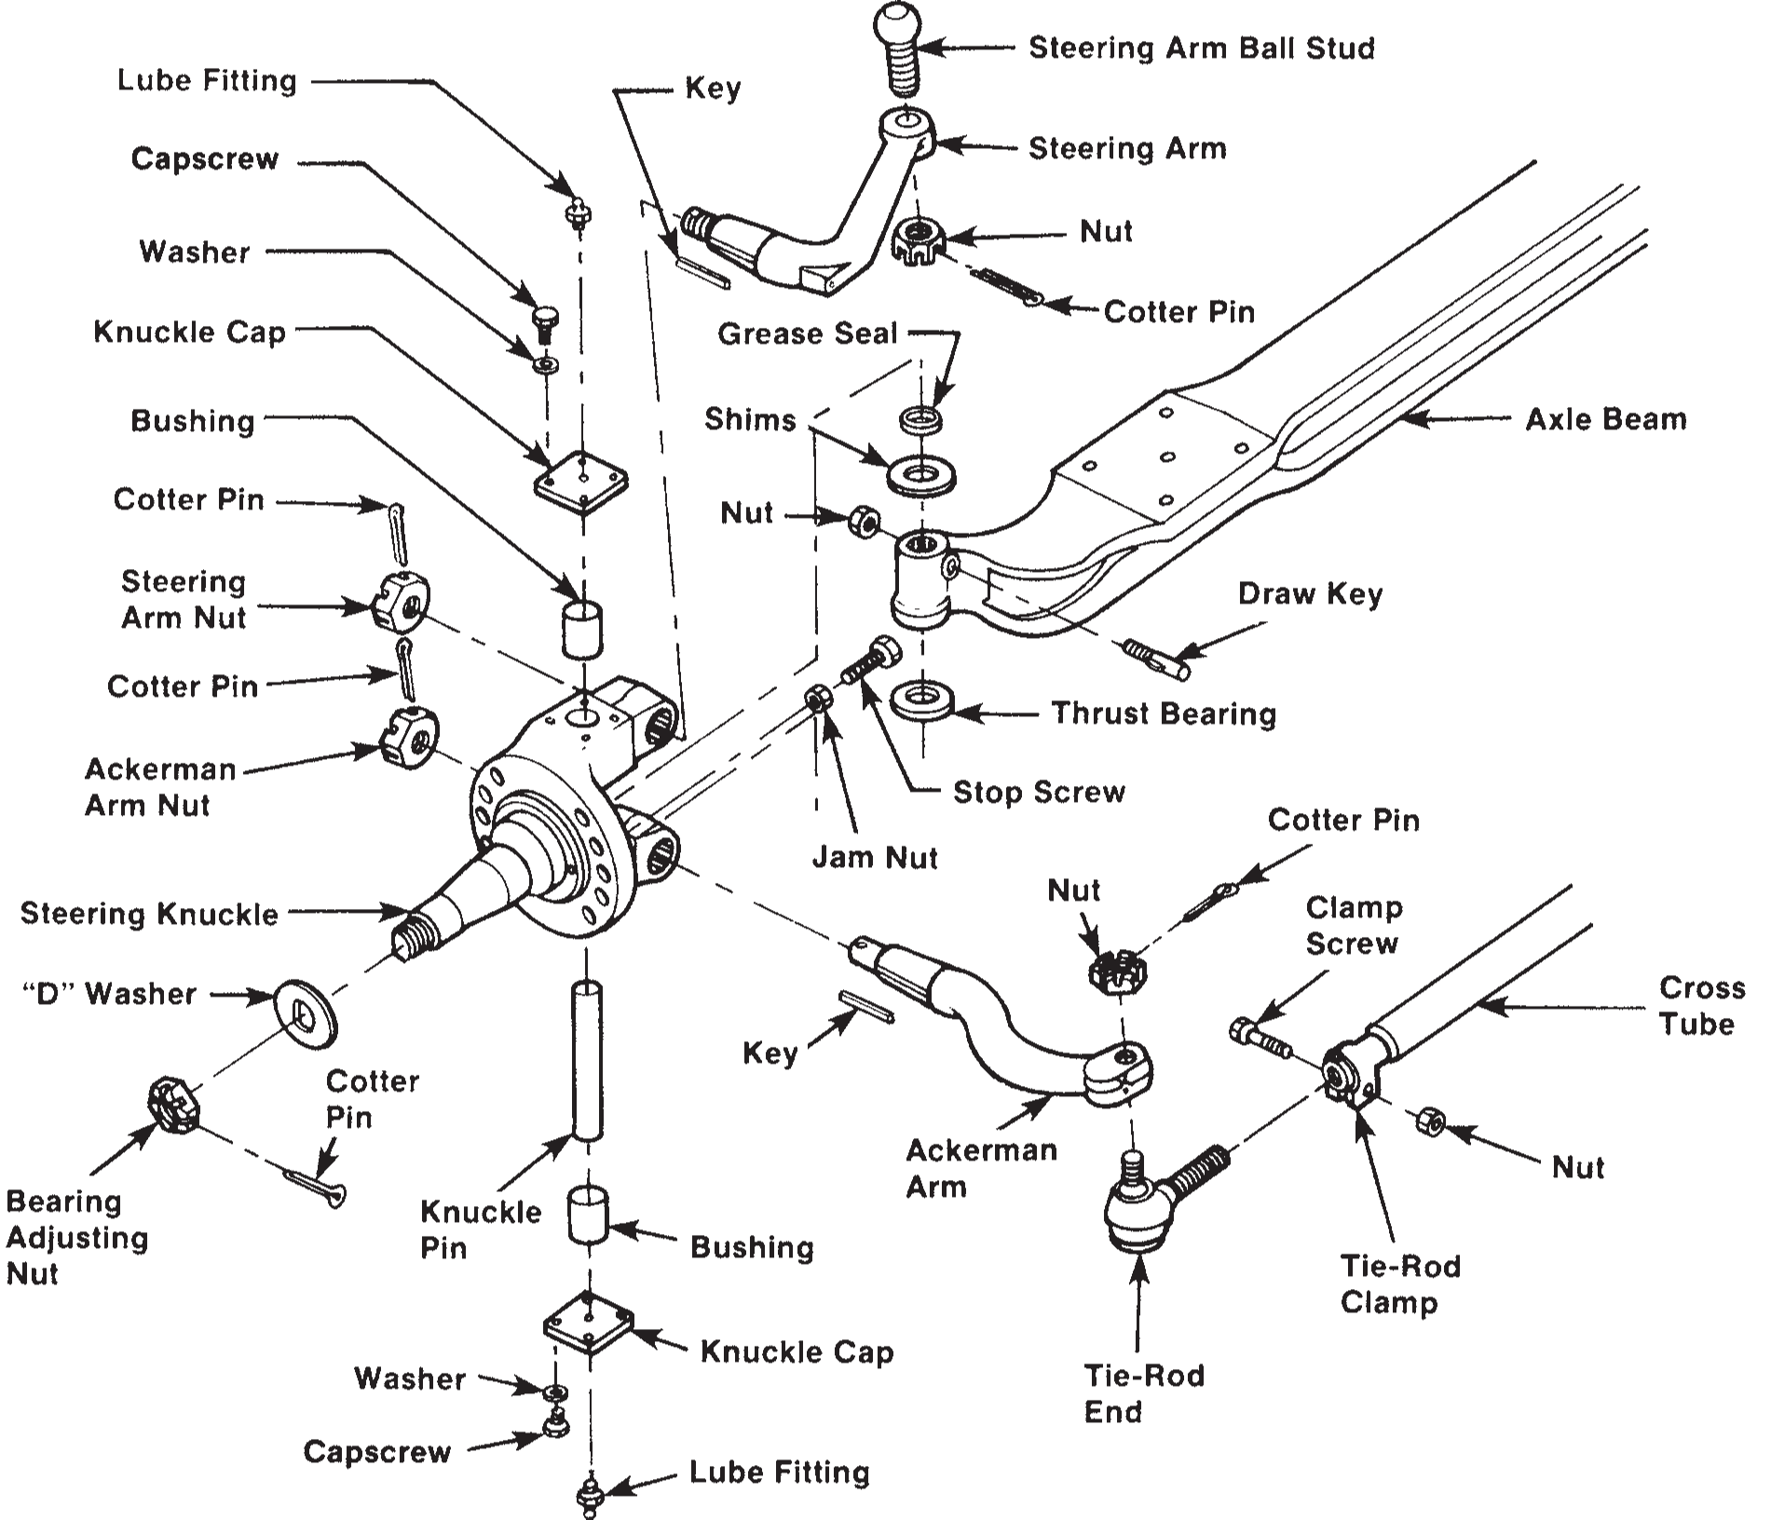
The tie-rod assembly consists of two tie-rod ends fastened to a cross tube. The assembly transfers any movement from the right side steering knuckle to the right side Ackerman arm to the left side Ackerman arm and on to the left side steering knuckles. The tie-rod ends are ball joints that connect to the Ackerman arms on each steering knuckle.

Figure 1:4: Components of a steering axle.

Types of Steering Systems
    - Manual-Steering Systems
The steering system is composed of three major subsystems: the steering linkage, steering gear, and steering column and wheel. As the steering wheel is turned by the driver, the steering gear transfers this motion to the steering linkage. The steering linkage turns the wheels to control the vehicle’s direction. Although there are many variations to this system, these three major assemblies are in all steering systems.
Figure 1:5: Manual steering gear components.
    - Power-Steering Systems
Truck power-assisted steering systems are not so different from manual steering systems. As we said in the introduction to this chapter, any power steering system used in a highway vehicle must default to manual operation in the event of power-assist circuit failure. There are three basic types of power steering systems found in vehicles:
- Hydraulic power steering (HPS) uses hydraulic pressure supplied by an engine-driven pump, known as the power steering pump, to assist the motion of turning the steering wheel. The power steering pump is turned by the accessory drive or serpentine belt and provides pressurized power steering fluid to the high side power steering hose which delivers it to the input side of the power steering control valve at the steering gear.
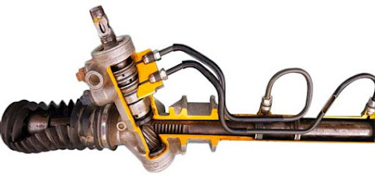
Power steering fluid is drawn from the power steering fluid reservoir which is maintained at the appropriate level by a low side power steering hose that returns the fluid from the gear at a much lower pressure.
Figure 1:6: Hydraulic power steering (HPS)

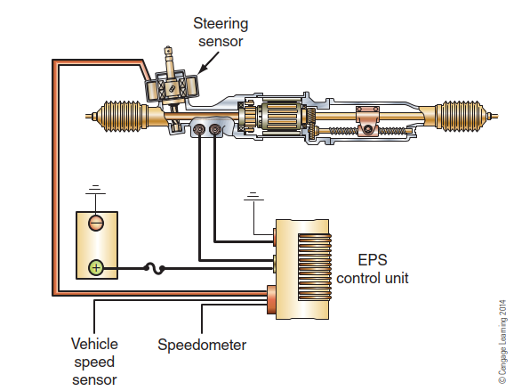
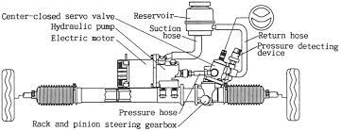
- Electric power hydraulic steering (EPHS) is a hybrid of hydraulic and electric. In this system, a hydraulic pump gets its energy from an electric motor instead of a belt driven by the engine. In EPHS the customary drive belts and pulleys that drive a power steering pump are replaced by a brushless motor. The power steering is driven by this electric motor, which reduces the amount of power that needs to be taken from the engine.
Figure 1:7: Electric power hydraulic steering

- Electric power steering (EPS) system, an electric motor replaces the hydraulic pump and a fully electric power steering system is established. The electric motor is either attached to the steering rack or to the steering column.
Figure 1:8: Electric power steering
- "Steer-by-wire" or "drive-by-wire"
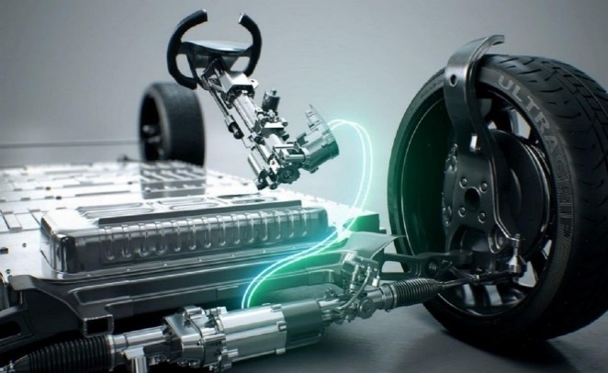
This systems are also being designed and implemented. These systems eliminate the mechanical connection between the steering wheel and the steering system, replacing it with a purely electronic control system. This system frees up a lot of space in the dashboard that can be used for other things.
Figure 1:9: Steer-by-wire
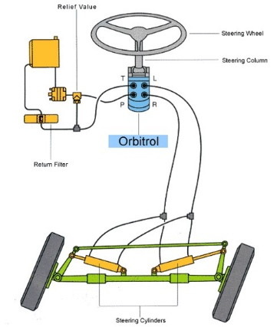
- Hydrostatic Steering
Figure 1:10: Hydrostatic Steering
Fluid power systems are used in mobile applications to perform several operations, from load handling and hydraulic equipment control, to the translation and steering control of the vehicle. Hydrostatic steering is a hydraulic steering system that does not require mechanical steering linkage.

OHS requirements
Heavy-duty truck repair work involves use of many materials classified as hazardous by both state and federal governments. These materials include such items as solvent and cleaners, paint and body repair products, adhesives, acids, coolants, and refrigerant products.
- Hazardous materials are those that could cause harm to a person’s well-being. Hazardous materials can also damage and pollute land, air, or water. There are four types of hazardous waste:
- Flammable—Flammable materials easily catch fire or explode.
- Corrosive—Corrosive materials are so caustic that they can dissolve metals and burn the skin and eyes.
- Reactive—Reactive materials will become unstable (burn, explode, or give off toxic vapors) if mixed with air, water, heat, or other materials.
- Toxic—Toxic materials can cause illness or death after being inhaled or upon contacting the skin.

Selection and using tools, equipment workshop manuals and specification
Steering system tools are necessary if you want to repair the steering system without damaging other parts or getting injured in the process. To the technician, they help save precious time, and to the vehicle owner, they help save money. Here is a list of the most important types of conventional and power steering repair tools that you can use to get started.
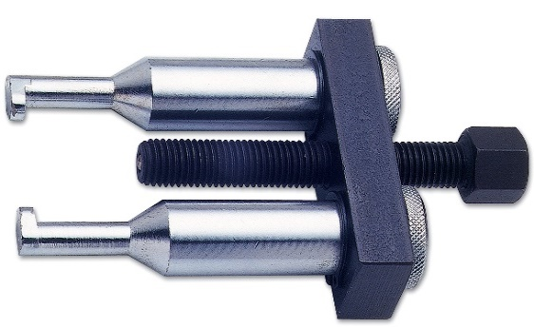
  - Steering Wheel Puller
The steering wheel is mounted to the steering column with a nut or bolt. To remove the steering wheel, this nut needs to be loosened or removed. But because the steering is usually firmly held on the shaft, it can be difficult to remove without special steering wheel tools.
Figure 1:11: Steering Wheel Puller
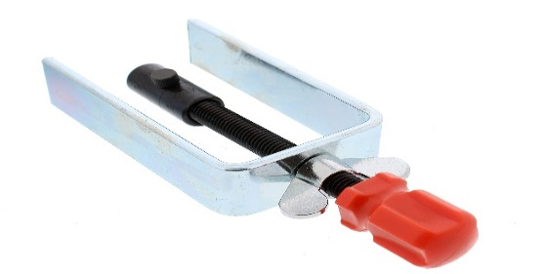
  - Steering wheel Lock Plate Tool
The steering lock plate is a metal plate located just behind the steering wheel. In order to access the steering column, this plate needs to be removed first. But the plate is installed with snap rings, and removing it can be quite a task without the proper tool.
Figure 1:12: Steering wheel Lock Plate Tool
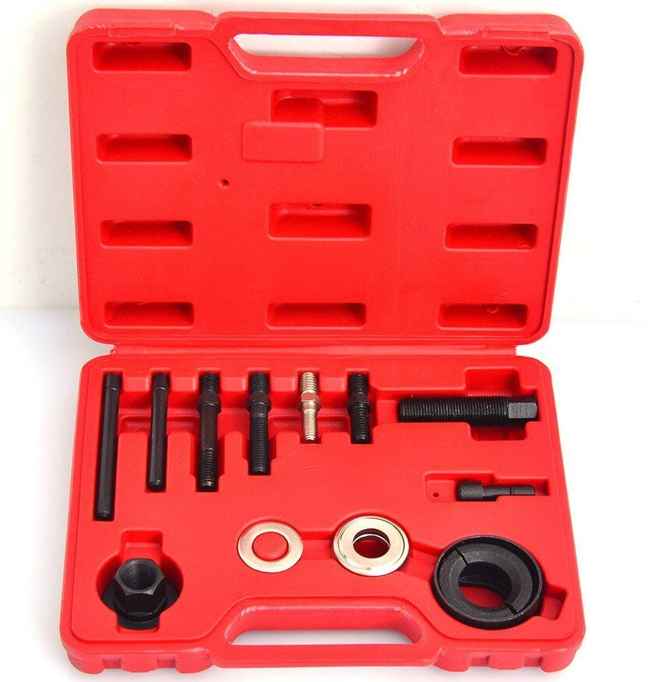
  - Steering Pump Puller Kit
The steering pump is a hydraulic component that helps the movements of a power a steering system. It’s usually mounted to the engine with bolts and it has a pulley that’s connected to the engine crankshaft via a belt.
To remove the steering pump, the technician needs to first disconnect the electrical connector, then remove the pulley and finally unscrew the bolts holding the pump in place.
Figure 1:13: Steering Pump Puller Kit
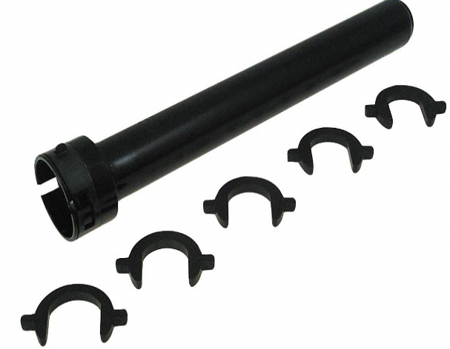
  - Inner Tie Rod End Tool
Figure 1:14: Inner Tie Rod End Tool
The inner tie rod ends are the ends of the tie rods that connect to the steering gear. They act as a link between the steering wheel and the wheels, allowing you to turn them. The inner tie rod ends are usually held in place with a ball joint and boot. The inner tie end rod is one of the most difficult steering system parts to service. The inner tie rod end tool is supposed to make the job easier, making it one of the most crucial steering tools.
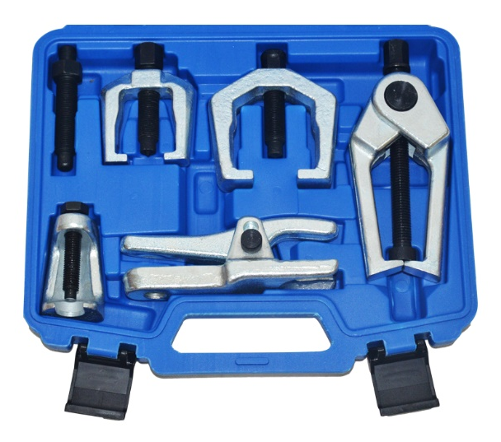
  - Front End Service Kit
Figure 1:15: Front End Service Kit
The car’s front end makes part of the steering system and includes various components such as the Pitman arm, idler arm, drag link, and a series of ball joints.
These parts are connected to the steering gear or parts via a series of rods and joints. With all these moving parts, it’s not surprising that front end wear and tear is inevitable.

Self-check-1
Instruction 1: Select the best answer
1. Which of the following assemblies uses U-joints?
A. the steering wheel B. the steering column C. the tie-rod D. the drag link
2. Which of the following components contains ball joints?
A. the steering gear B. the Pitman arm C. the steering knuckle D. the tie-rod end
3. Which of the following components connects the Pitman arm to the steering control arm?
A. the drag link b. the tie-rod c. the cross tube d. the steering column
4. What is the likely result of an out-of-alignment front end on a truck?
A. directional instability B. steer tire wear C. hard steering D. all of the above
5. Which of the following alignment angles has the potential to cause the most tire wear?
A. toe B. camber C. caster D. Ackerman angle

Instruction 2: Give Short answer
- What are purpose of Steering system?
- Discuss about the classification of Steering system?
- Discuss about Steering System Components
- What are steering system tools are necessary if you want to repair the steering system?

Unit Two: Inspection of steering Systems

This unit is developed to provide you the necessary information regarding the following content coverage and topics:
- Identifying basic inspection procedures
- Inspecting steering system
This guide will also assist you to attain the learning outcomes stated in the cover page. Specifically, upon completion of this learning guide, you will be able to:
- Basic inspection procedures
- Inspection of steering system

Basic inspection procedures
When a steering problem is reported, systematically inspect the vehicle steering system, front and rear suspensions, and trailer suspensions. In most cases, a road test will be required, but never take a truck out onto a road until you are sure it is roadworthy. If a reported problem occurs only when the vehicle is loaded, you should test drive the vehicle loaded, and when you check out steering systems, remember that other chassis systems can cause steering problems. Perform the following sequence of checks when symptoms such as rapid tire wear, hard steering, or erratic steering indicate a problem in the steering system:
- Check that the front tires are the same size and model. Ensure they are equally and adequately inflated. Underinflated tires cause hard steering. Overinflated tires reduce the road contact foot- print, reducing control.
- If the steering problem occurs only when the vehicle is loaded, make sure that the fifth wheel is adequately lubricated.
- Inspect the steering linkages for loose, dam aged, or worn parts. Steering linkage components include the tie-rod assembly, steering arms, bushings, and other components that carry movement of the Pitman arm to the steering knuckles. The wheels should turn smoothly from stop to stop through a full turn cycle.
- Inspect the drag link, steering driveshaft(s), and upper steering column for worn or damaged parts.
- Ensure that the steering column components, especially the U-joints, are adequately lubricated.
- Check front axle wheel alignment, including wheel bearing adjustment, caster, camber angles, and toe-in.
- Check the rear axle alignment. Rear axle misalignment can cause hard or erratic steering. If needed, align the rear axle(s).
- Inspect the front axle suspension for worn or damaged parts.
- With the front wheels straight ahead, turn the steering wheel until motion is seen at the wheels. Align a reference mark on the steering wheel with a mark on a ruler and then slowly turn the steering wheel in the opposite direction until motion is again observed at the wheels. Measure the lash (free play) at the steering wheel. Too much lash exists if the steering wheel movement exceeds:
2-3/4 inches (70 mm) for a 22-inch (0.56 m) steering wheel
2-1/4 inches (57 mm) for 20-inch (0.51 m) steering wheel
- Turn the steering wheel through a full right and full left turn. If the front wheels cannot be turned to the right and left axle steering stops without binding or noticeable interference, the problem s likely in the steering gear.
- Secure the steering wheel in the straight ahead driving position. Move the front wheels from side to side. Any play in the steering gear bearings will be felt in the drag link ball joint at the Pitman arm. If any bearing play exists, adjustments to the steering gear may be in order
- Check the tractor fifth wheel. Lack of lubrication between the fifth wheel plate and trailer upper coupler can cause serious steering problems. This is most common in tractor-trailer combinations that seldom uncouple. With most fifth wheels, the tractor and trailer must be split to apply grease directly to the fifth wheel top plate.

Inspection of steering system

Steering Axle Inspection
Specific service procedures and maintenance intervals can be found in OEM service literature. The following procedures are general guidelines for periodic steering axle inspection:
- A thorough visual inspection for proper assembly, broken parts, and looseness should be performed each time the vehicle is lubricated. In addition, ensure that the spring-to-axle mounting nuts and the steering connection fasteners are secure.
- Wheel Alignment. Front steering wheel alignment should be checked periodically according to OEM-recommended service intervals (typically 3 months or 25,000 miles). If excessive steering effort, vehicle wander, or uneven and excessive tire wear is evident, the wheel alignment should be checked immediately.
- Steering Axle Stops. Although steering axle stops should be checked periodically, they seldom need adjustment. However, if the steering turning radius is insufficient or excessive (resulting in tire or wheel contact with the frame), the stops should be adjusted.
- Tie-Rod Ends. Tie-rod ends should be inspected each time the axle is lubricated. Check for torn or cracked seals and boots, worn ball sockets, or loose fasteners.
- Steering Knuckle Thrust Bearings. The knuckle thrust bearings should be checked each time the hub/drum is removed. Knuckle vertical play should be adjusted each time the knuckle pin is removed for service, at each axle overhaul, or whenever excessive knuckle vertical movement is noted.
- Kingpins. The kingpin and its bushings should be inspected whenever the pin is removed for service, at axle overhaul, or looseness is noted.
- Wheel Bearings. The wheel bearings should be inspected for damage or wear each time the hub or drum is removed. Check for signs of wear and distress.
- Lubrication. Steering axle components should be lubricated at least every 25,000 miles. Good quality chassis grease should be used. Kingpins, thrust bearings, and tie-rod ends should be lubricated at each preventive maintenance (PM) service interval. Those without grease fittings are usually permanently lubricated. Consult the OEM service literature for the recommended steering gear lubricant. This may be gear lube, engine oil, or hydraulic transmission fluids. Because most steering gear have a number of lubricant options, you should try to top up with the same lubricant that is already in the gear or reservoir.

Steering Knuckle Inspections
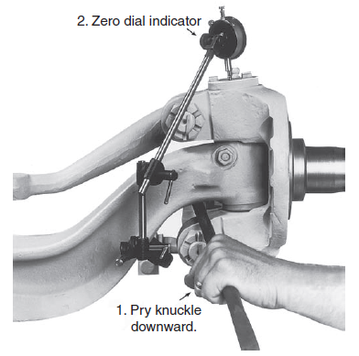
Steering knuckles account for a number of steering problems and many of these problems originate from lack of lubrication. The following tests should be performed to check out steering knuckles and kingpins.
Steering Knuckle Vertical Play
1. Mount a dial indicator on the axle beam.
2. Position the indicator plunger on the knuckle cap
3. Pry the steering knuckle downward.
4. Zero the dial indicator.
Figure 2:1: Steering Knuckle Vertical Play
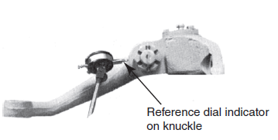
5. Lower the front axle to obtain the dial indicator reading. If the reading exceeds the OEM specification (typically 0.04 inch [1 mm]), inspect the thrust bearings. Replace them if necessary.

Kingpin inspection
  - Upper Bushing Free Play
1. Mount a dial indicator on the axle. Place the indicator plunger on the upper part of the knuckle, as shown.
Figure 2:2: Inspecting free play in the upper bushing.
2. Move the top of the wheel in and out with a push/pull motion. Have someone monitor the dial indicator readings. Readings that exceed the OEM specifications (typically 0.015 inch [0.38 mm]) indicate the need for bushing replacement.

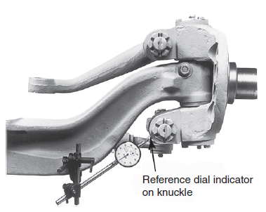
  - Kingpin Lower Bushing Free Play
1. Mount the dial indicator on the axle. Reference the plunger on the lower tie-rod end socket of the steering knuckle, as shown in Figure 2.3.
2. Move the bottom of the wheel in and out with a push/pull motion. Have an assistant read the dial indicator.
Figure 2:3: Measuring free play in the lower bushing.
3. A dial indicator reading that exceeds the OEM specifications (typically 0.015 inch [0.38 mm]) indicates that the lower bushing should be replaced.
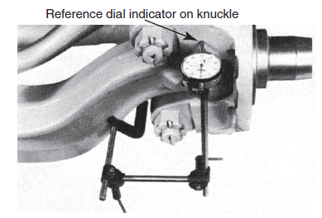
  - Kingpin Upper Bushing Torque Deflection
1. Mount the dial indicator to the axle, referencing the upper knuckle steering arm socket area
2. Have someone apply the foot brake. Try to roll the wheel forward and backward and note the deflection.
3. Readings in excess of the manufacturer’s specifications (typically 0.015 inch indicate that the top bushing should be replaced.
Figure 2:4. Measuring upper bushing torque deflection.
  - Lower Bushing Torque Deflection Test
1. Mount the dial indicator on the axle and the plunger on the lower bushing area.
2. Have someone apply the foot brake. Try to roll the wheel forward and backward and note the deflection.
3. Readings that exceed the OEM specifications (typically 0.015 inch [0.38 mm]) indicate that the lower bushing should be replaced.

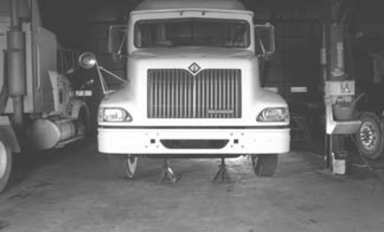
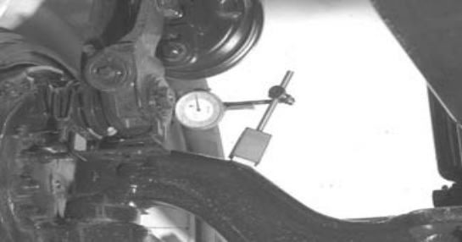
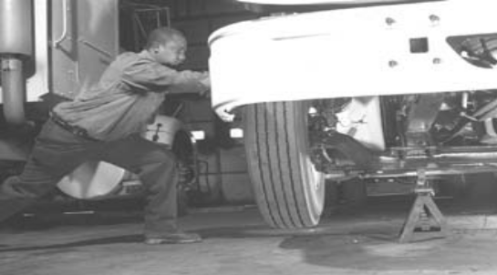
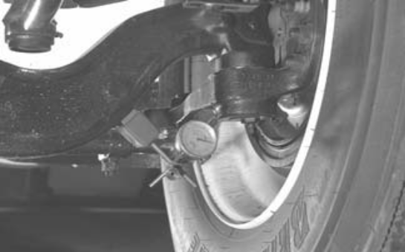
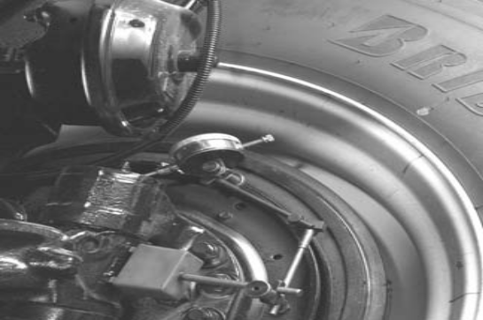
  - Measuring steering kingpin wear and vertical end
- Apply the parking brakes, block the rear wheels, and use a floor jack to raise the front axle until the tires are off the shop floor.

- Lower the vehicle so that it is supported securely on safety stands with the front tires still off the shop floor.

- Mount a dial indicator on the front axle I-beam and position the dial indicator plunger on the inner side of the upper end of the steering knuckle. Zero the dial indicator.

- While a helper moves the top of the wheel and tire inward and outward, observe the dial indicator reading. If the total movement on the dial indicator exceeds the specified kingpin bushing movement, the kingpin bushing must be replaced.

- Mount the dial indicator on the front axle I-beam with the dial indicator plunger touching the inner side of the lower end of the knuckle. Zero the dial indicator.
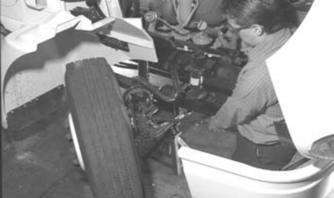
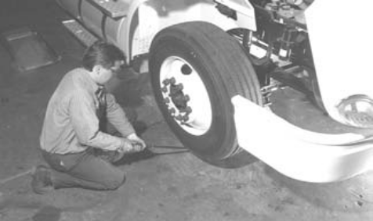
- Mount the dial indicator on the axle I-beam and position the dial indicator plunger on top of the upper knuckle joint cap.
- Use a pry bar to force the steering knuckle downward. Check the reading on the dial indicator.
- Next, observe the dial indicator reading while a helper uses a large pry bar to lift upward on the tire and wheel. If the dial indicator reading exceeds the truck manufacturer’s specifications, remove the steering knuckle and inspect the thrust bearing. Replace this bearing if necessary and install the required shim thickness.
Figure 2:5 Photo Sequence for Measuring steering kingpin wear and vertical end

Tie-Rod Inspection
1. Shake the tie-rod or cross tube. Movement, or looseness, between the tapered shaft of the ball and the cross-tube socket members indicates that the tie-rod end assembly should be replaced.
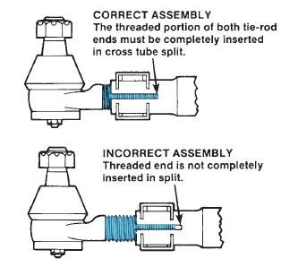
2. The threaded portion of both tie-rod ends must be inserted completely beyond the tie rod split recess, as shown in Figure 2.5. This is essential for adequate clamping. If this is not so, components will have to be replaced. Check to see if the cross-tube or tie-rod ends are at fault.
3. Ball and socket torque (exclusive of boot resistance) should be 5 lb.in. or more on disconnected tie-rod end assemblies. Replace assemblies that test less than 5 lb.in. loose assemblies will adversely affect the steering system performance and might prevent adjustment of the steering assembly to the vehicle OEM alignment specifications.
Figure 2:6: Correct and incorrect tie-rod installation
4. If the tapered shank-to-tie-rod arm connection is loose or the cotter pin is missing, disconnect and inspect these components for worn contact surfaces. If either one is worn, replace it.

LAP Test

Practical Demonstration

Name: __________________________ Date: ____________
Time started: ____________________ Time finished: _______________

Instruction I: Perform the following tasks
Task 1: Inspecting Steering Axle
Task 2: Inspecting Steering Knuckle
Task 3: Inspecting Kingpin
Task 4: Inspecting Tie-Rod

Unit Three: Servicing Steering System

This learning guide is developed to provide you the necessary information regarding the following content coverage and topics:
  - Servicing steering system Components
  - Diagnosis steering system problem
  - Power steering system Service
  - Grease Fitting

This guide will also assist you to attain the learning outcomes stated in the cover page. Specifically, upon completion of this learning guide, you will be able to:
  - Service steering system Components
  - Diagnosis steering system problem
  - Power steering system Service
  - Grease Fitting

Servicing steering system Components
Steering system service normally involves the adjusting or replacement of worn parts. Service is required when the worm shaft rotates back and forth without normal pitman arm shaft movement. This would indicate that there is play inside the gearbox. If general troubleshooting and inspecting of a steering system suggest a problem in the steering axle, you can use the following procedure to identify worn or out-of-adjustment components
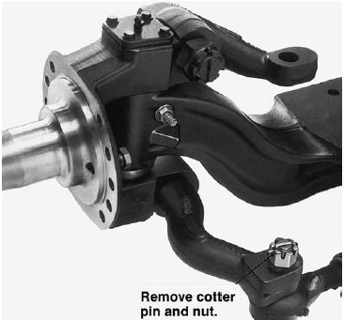
    - Steering Knuckle Disassembly
1. Back off the slack adjuster to ensure that the brake shoes are in the released position and well clear of the drum.
2. Remove the hubcap from the wheel assembly, followed by the cotter pin, nut, washer, and outer bearing cone assembly on traditional wheel ends.
Figure 3:19: To remove a tie-rod, first remove the cotter pin and nut.
3. Remove the wheel and hub assembly.
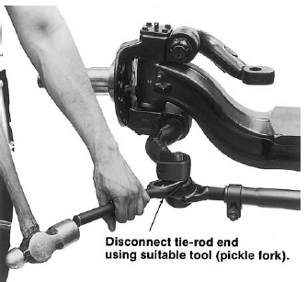
4. Disconnect the air line from the brake assembly.
5. Remove the foundation brake assembly from the axle spider.
6. To disconnect the tie-rod end from the Ackerman arm, remove the cotter pin and slotted nut
7. Disconnect the tie-rod end using a suitable tool, such as a pickle fork
8. Disconnect the drag link from the steering arm by removing the cotter pin and slotted nut.
Figure 3:2: Use a pickle fork to separate the tie-rod end from the tie-rod arm.
    - Kingpin Removal
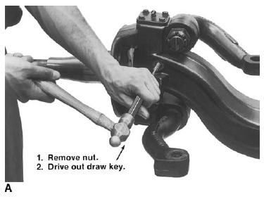
      - Remove the cap screws and lock washers to remove the knuckle caps.
      - Remove the nut from the draw key; then, drive the key out using a hammer and brass drift
      - Drive the kingpin out with a hammer and brass drift.
      - Remove the steering knuckle from the axle beams and discard the thrust bearing.
Figure 3:3: To remove the kingpin drive out the draw key
    - Adjusting Knuckle Vertical Play
- If the vertical play in the knuckle exceeds the OEM specifications, adjustments can be made by removing or installing shims between the axle beam and the upper part of the knuckle. To do so, follow these steps:
- Remove the cap screws, lock washers, and grease caps from the steering knuckle.
- Remove the nut and draw key.
- Partially drive out the kingpin, using a hammer and brass drift. Drive from the top down.
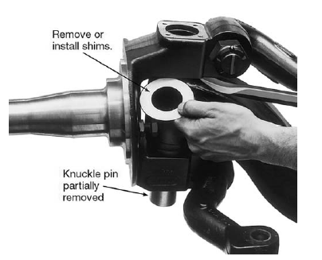
- Remove the kingpin far enough to facilitate removal and replacement of the shims.
- Adjust the shim pack to obtain the manufacturer’s specified vertical play (typically 0.005 to 0.025 inch [0.127 mm to0.635 mm]).
- With the correct shims installed, drive the kingpin back into the knuckle assembly.
- Recheck the vertical play and readjust if necessary.
- With the adjustment complete, ensure that the kingpin flat is aligned with the draw key so it can be secured.
Figure 3:4: With the knuckle pin partially removed
- Install the draw key and nut. Torque the nut to the OEM specification.
- Install the knuckle grease cap gasket (if applicable) or use a silicone compound on the grease cap mounting surface. Install the grease caps.
- Install the cap screws and the lock washers. Torque the cap screws to the OEM specification.
Assembling Steering Knuckle
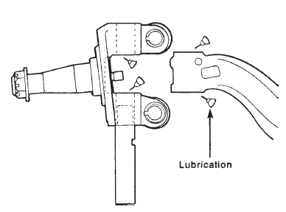
Use the following procedure to assemble a steering knuckle assembly:
- Lightly lubricate the thrust bearing areas of the steering knuckle, axle end, and kingpin bore of the axle beam

- Position the thrust bearing on the knuckle with the seal facing up.
Figure 3:5 Lubricate the steering knuckle and axle before assembling the two

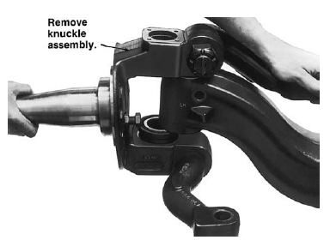
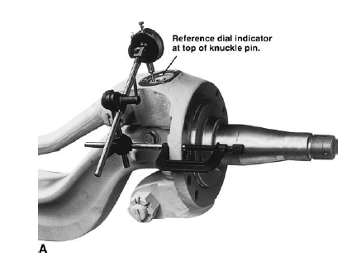
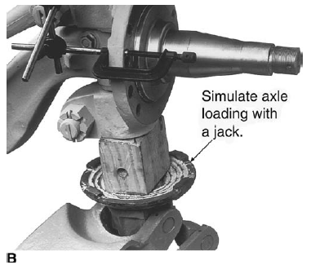
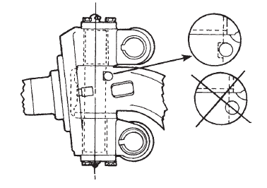
- Mount the steering knuckle onto the axle beam.
- Wedge the steering knuckle upward and fit shims to fill the gap at the knuckle upper end.
- This step is a pre adjustment of knuckle vertical play.
- Position the kingpin flat, aligned with the draw key hole, and start installing it by pushing it in by hand.
- Install the kingpin into the knuckle and axle beam from the top. If necessary, tap the pin home using a hammer and brass drift.
- To check knuckle vertical play, center the steering.
- Mount the dial indicator to the flange and set the plunger to reference the top of the kingpin, Zero the dial indicator.
- Simulate axle loading with a jack and note the dial indicator reading.

- If the vertical play is outside of OEM specifications, either add or remove shims to set the specified endplay.
- When the adjustment is complete, check the draw key opening and kingpin flat alignment.
- Install a new draw key, using a soft face hammer.
- Install the draw key nut and tighten it to the correct torque.
- Apply silicone compound to the kingpin grease cap mounting surface, or install a gasket if applicable.
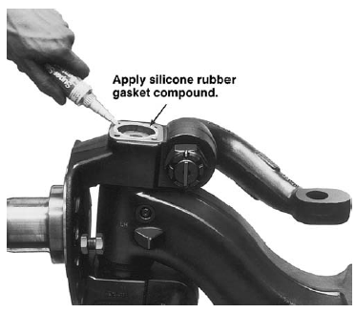
- Install cap screws and lock washers to secure the grease cap.
- Tighten the cap screws to the OEM specification.
- Attach the drag link to the steering arm. Install and torque the nut to the OEM specification. Install the cotter pin.
- Attach the tie-rod end to the Ackerman arm. Install and torque. Install the cotter pin.
- Reinstall the brake and wheel assemblies, following the OEM service literature procedure.
Figure 3:6 Procedure to assemble a steering knuckle assembly
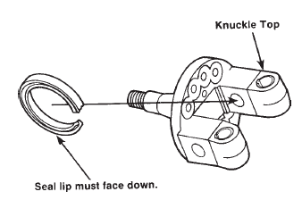
    - Kingpin Seal Replacement
1. Remove the grease seal from the knuckle upper arm.
2. Install a new seal, using a suitable pilot drift or mandrel that will not damage the seal as it is installed.
    - Ackerman Arm Replacement
Figure 3:7: The seal lips must face the axle when installed in the knuckle.
1. Disconnect the tie-rod end from the Ackerman arm (or drag link from the steering arm).
2. Remove the cotter pin and nut from the arm at the knuckle end.
3. Drive the arm out of the knuckle using a suitable brass drift and hammer.
4. Install a new key in the slot provided in the Ackerman arm.
5. Install the nut and tighten it to the correct torque. Install the cotter pin.
    - Tie-Rod End Replacement
1. Disconnect the tie-rod end using a pickle fork.
2. Loosen the clamp nut, apply penetrating the threads, and unscrew the tie-rod end.
3. Install the new tie-rod end. Thread the end into the cross tube past the tube split.

4. Attach the tie-rod end stud to the tapered bore in the Ackerman arm. Tighten to the correct torque. Install the cotter pin.
5. Adjust toe-in using the procedure described earlier. Tighten the cross-tube clamp screw to correct the torque.
    - Kingpin Bushing Replacement
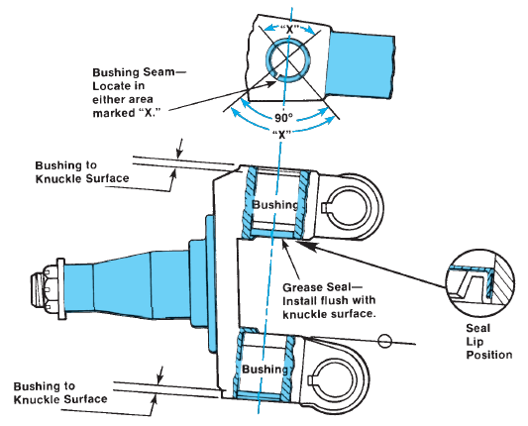
1. After removing the kingpin, drive the upper bushing out of the steering knuckle using a suitable piloted drift or mandrel.
2. Drive the lower bushing out in the same manner.
3. Remove all foreign material from the steering knuckle and axle beam.
4. Lightly lubricate the outside diameter of the bushing to assist installation.
5. Align the bushing seam
6. To install the bushings, first hand-start the bushing in the bore. Then, using a suitable piloted drift or bushing mandrel, drive the bushings home,
Figure 3:8: Bushing and seal installation.

    - Service steering gearbox
Manual steering gears tend to be reliable, usually requiring only routine maintenance through their service life. The housing is filled with lubricant but has few moving parts. Depending on service application, some adjustments will be required throughout the service life of a steering gear, but when these are specified to trucks today, it is almost always in highway applications.
Because of the increased physical effort required to steer a manual steering gear it makes little sense ever to spec them to non-line haul applications. Some typical adjustments required in manual steering gear are described here.
- Worm and Sector Gear Set
When the vehicle is driving in straight-ahead direction, the steering gear should be in the center of its travel. This means that the sector gear (or roller) should be positioned at the center of the worm gear. Mesh between the worm and sector is at maximum in this over center position. The minimum clearance in the over center position produces tight response to steering inputs and good road feel at highway speeds.
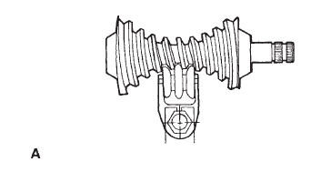
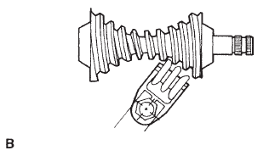
When the steering wheel is turned, the worm gear rotates, moving the sector gear to one side away from the center. It also reduces the extent of mesh. This results in more clearance between the sector shaft gear and worm gear teeth. The increased clearance that results is known as backlash. The backlash travel area of a manual steering gear begins to be felt around a half-turn each way off the over center position. Steering gear backlash can be felt by wiggling the Pitman arm.
- Worm Shaft Preloads
Steering gear worm shafts are assembled with a specified amount of resistance to input turning effort by preloading the bearings that support the shaft. This preload is required to prevent random unwanted movements within the system.
Figure 3:9: (A) Over center position; and (B) backlash area
Two types of preloads are used: worm bearing preload and total mesh preload. The worm bearing preload is end-to-end pressure on the worm shaft and its bearings. The total mesh preload is the result of the combined pressure of the sector shaft gear acting on the worm gear and the worm bearing preload. Both types of preloads are originally set to factory specifications and usually expressed in inch pounds of torque. Preloads can be reset by the user as required.
When preloads are out of adjustment, steering can be significantly affected. From a driver’s perspective, this will mean constant corrections are required to drive a straight line. Insufficient preload permits lost motion within the gear set, meaning that the driver must turn the steering wheel farther than normal to get a response from the front wheels. On the other hand, excessive preloads result in hard steering, darting, and over steer.
- Measuring and Adjusting Preloads
Although incorrect preloads can cause the steering problems we have described, they are not the only cause of these conditions. Before checking steering gear preload, check the steering linkages for worn or binding areas first. If the steering linkage components check out okay, then proceed with the preload check.
- Worm Shaft Preload Check
This test is performed with the sector shaft gear located in the backlash area.
  - Position the front wheels straight ahead. If possible, drive the vehicle in a straight line for a short distance, stopping at the location where service operations will be performed.
  - Disconnect the drag link from the Pitman arm and the steering column shaft from the steering gear input shaft.
  - Slowly turn the input shaft until the sector gear is close to the end of the worm gear.
  - Reverse the rotation of the input shaft a quarter turn. In this position, there should be no contact between the sector shaft gear and worm gear teeth.
  - Place an inch-pound torque wrench on the end of the input shaft. Turn the torque wrench back and forth within about a quarter-turn arc to record the torque in the area where the gear teeth are not touching. The output shaft should not turn.
  - If the preload reading of the moving shaft is within OEM-specified limits, proceed to the total mesh preload check. If the preload is above or below these limits, it will need to be adjusted.
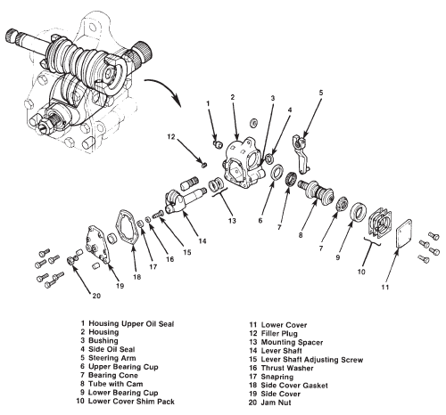
  - Preload is adjusted by adding or removing shims between the gear housing and the cover plate, as shown in Figure 3–9, or by turning the worm bearing adjuster plug on the recirculating ball steering gear, as shown in Figure 3–10.

Figure 3:10: Exploded view of a typical manual steering gear.

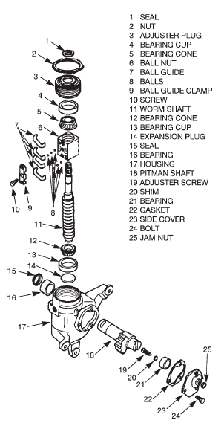

Figure 3:11: Exploded view of a typical re circulating ball-type manual steering gear.
- Adjusting Worm Shaft Preload
If you have already tested worm shaft preload and it is out of specification, you should use the following procedure to correct it:
  - Clean the outside of the steering gear.
  - Remove the fill plug and the drain plug from the steering gear. Drain the lubricant and dispose of it in an environmentally safe manner.
  - Remove the worm shaft cover screws and the worm shaft cover.
  - If worm shaft preload tested lower than specified (requires less torque to turn) shims will have to be removed. Removal of shims increases preload; adding shims decreases preload. Shims are available in a variety of sizes. Typical sizes include 0.002, 0.003, 0.005, 0.0075, and 0.010 inch. Remove only one shim at a time, as necessary, using a knife blade. The size of the shim to be removed or added will depend on the amount of lash. Use a micrometer to identify the thickness of the shims.
  - Assemble the worm shaft cover and shims.
  - Install the worm shaft cover screws. Make sure you have a light preload before final torqueing the fasteners.
  - Using a crisscross pattern or sequence, incrementally tighten the worm shaft cover screws to the OEM torque specification.
  - Recheck the worm bearing preload. If necessary, repeat the adjustment procedure modifying shim pack thickness as appropriate.
- Full Mesh Preload Check.
Do not check the sector shaft full mesh preload unless the worm shaft bearing preload has been previously checked to be within the specifications. Checking sector shaft full mesh preload when the worm shaft bearing preload is out of adjustment will produce inaccurate measurements.
  - After checking the worm shaft bearing preload to be within specs, center the steering gear by turning the worm shaft from stop to stop, counting the number of turns required. Starting at the end of travel, turn back exactly half that number of full turns. This will place the sector shaft gear teeth in the approximate center of the worm gear.
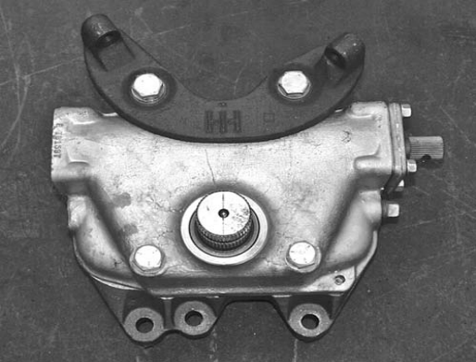
  - Check the alignment mark on the sector shaft output stub. If the alignment mark is at a right angle to the worm shaft, the gear is centered, as shown in Figure 3–12. If not, turn the worm shaft using the input shaft until the sector shaft alignment mark is at a right angle to the worm shaft

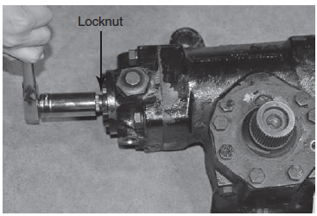
  - Rotate the worm shaft with a torque wrench approximately 180 degrees through the center Position. Compare the torque reading with the manufacturer’s specification. If the sector shaft total mesh preload measurement is not within specifications, adjust the preload.
Figure 3:12: When the gear is centered, the sector shaft alignment mark is at a right angle to the input

- Full Mesh Preload Adjustment
  - If an adjustment is necessary, loosen the adjustment screw locknut
  - Center the steering gear.
  - Turn the slotted adjustment screw clockwise to increase the preload or counterclockwise to decrease the preload and then check the adjustment. Repeat until the preload is within specifications.
Figure 3:13: loosen the adjustment screw locknut.
  - Hold the adjustment screw in place with a screwdriver while tightening the adjustment screw locknut to specifications.
  - Recheck the preload.
  - Fill the steering gear with lubricant, as follows:
a. If not already done, remove the filler plug (and pressure relief fitting) from the steering gear housing. Thoroughly clean the plug.
b. Add the recommended lubricant until it is within 1/2 inch of the filler hole.
c. Install the filler plug (and pressure relief fitting) and tighten it to OEM specifications.
  - Center the steering wheel and reconnect the steering driveline and linkage.
- Adjust bearing preload
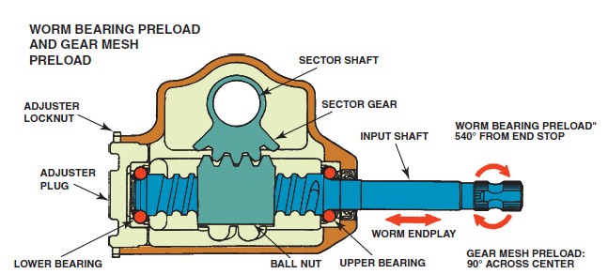
Worm bearing preload, also referred to as worm endplay, and is a measurement of how much force is required to turn the steering gear input shaft against the force, or preload, that the thrust bearings apply to the worm gear and shaft. Worm endplay, which is the distance the worm gear can move end-to-end between the thrust bearings, is directly related to preload. The higher the force the bearings push against the worm gear, the less endplay there is, and the more force it takes to turn the input shaft and worm gear. Worm bearing preload is adjusted by one of two methods: turning an adjustment nut or screw or installing selectively sized shims. Either adjustment method increases or decreases the worm endplay
Figure 3:14: Worm Bearing Preload

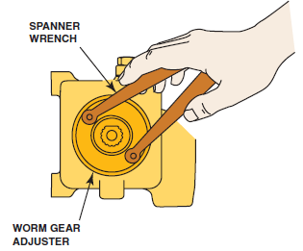
Worm endplay is a linear measurement, made in fractions of inches or millimeters, of how far the worm gear and shaft can slide axially. Worm bearing preload is a measurement of how much force it takes to overcome bearing pressure in order to turn the input shaft. Preload is a torque, or turning force, measurement made in inch-pounds or Newton-meters. Because endplay and preload are related, one measurement affects the other.
Figure 3:15: Adjust worm gear free play
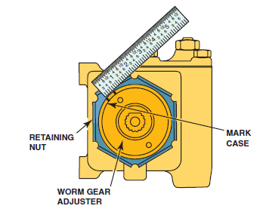
When measuring and adjusting the worm bearing preload, a technician measures preload and adjusts endplay. The endplay is correct when the preload measurement is correct.
Gear mesh preload is a measurement of how closely the teeth of the ball-nut gear and sector gear, or the worm gear and roller, fit together. Gear mesh preload is related to another measurement, called sector lash or gear lash.
Figure 3:16: Rotate the worm gear nut counterclockwise 1/2 inch, align the marks
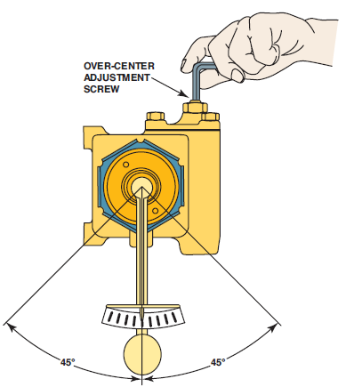
Gear mesh preload is a measurement of how much turning force must be applied to the input shaft to overcome the resistance of the sector gear and move it. Gear mesh preload is usually measured in a 90-degree turn across the center of the input shaft movement.
General Motors calls this adjustment the over center adjustment. Gear mesh preload (over center adjustment) determines how sensitive the steering gear is to small steering wheel movements during straight-ahead driving. Insufficient preload contributes to steering wander.
Figure 3:17: Performing an over center adjustment
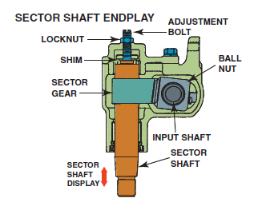
Sector shaft endplay is a measurement of how much room the sector shaft has to slide axially. If provision is made to measure sector shaft endplay, the measurement is taken in fractions of inches or millimeters. Some steering gears provide an external adjusting method, but it is more common for sector shaft endplay to be adjusted by internal shims, if it is adjustable.
Figure 3:18: Sector shaft endplay
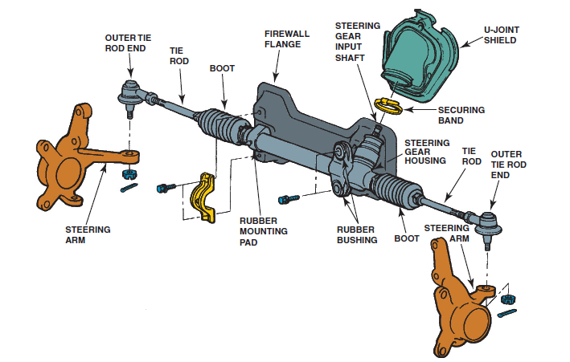
C. Rack-And-Pinion Steering Gears Adjustment
Some rack-and-pinion steering gears can be adjusted. Pinion torque is a measurement of how much turning force is needed at the input shaft for the pinion to overcome the resistance of the rack and move it.
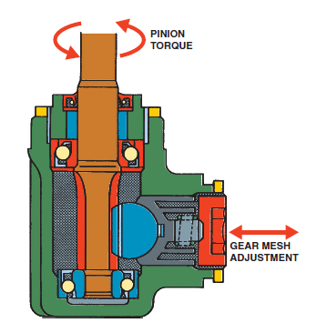
The measurement gives an indication of how closely meshed the pinion teeth and the rack teeth are. Like gear mesh preload in a standard steering gear, pinion torque indicates steering system responsiveness.
Figure 3:19: Manual rack-and-pinion steering gear mounts
The adjustment method is to thread the rack support cover farther into the steering gear housing to reduce gear lash, or thread it out to increase gear lash.
Manufacturers specify an acceptable range of pinion torque in inch pounds or Newton-meters. Because the middle teeth on the rack wear before the teeth at either end, pinion torque should be checked across the whole stroke of the rack.
Figure 3:20: Tightening the rack support against the rack increases the pinion torque.

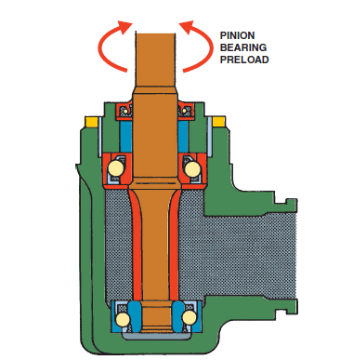
- Bearing Preload Procedure
Pinion bearing preload in a rack-and-pinion steering gear is the same concept as worm bearing preload in a standard steering gear.
That is, it is a measurement of how much force is required to turn the steering gear input shaft against the force, or preload, that the bearings apply to the pinion gear and shaft.
Figure 3:21: Pinion bearing preload

Diagnosis steering system problem
It is important to realize that many steering complaints are caused by problems in areas other than the steering system. A good diagnosis is one that finds the exact cause of the customer’s complaint. Although customers may describe the problem in different ways, the most common complaints and their typical causes are discussed next.
    - Excessive Steering-Wheel Play
Excessive play in the steering wheel is apparent when there is too much steering-wheel movement before the wheels begin to turn. A small amount of play is normal. This problem can be caused by the following:
- Loose, worn, or damaged steering linkages or tie rod ends
- Worn ball joints
- Loose, worn, or damaged steering column U-joints
- Loose, worn, or damaged steering column bearings
- Damaged or worn steering gear
- Aerated fluid
- Loose steering gear bolts
- Faulty strut bearing or plate
    - Feedback
When the driver feels the surface of the road through the steering wheel it is called feedback.
This problem can be caused by the following:
- Loose, worn, or damaged steering linkages or tie rod ends
- Loose, worn, or damaged steering column U-joints
- Loose or damaged steering gear mounting bolts
- Damaged or worn steering column bearings
- Loose suspension bushings, fasteners, or ball joints
    - Hard Steering
Obviously, a complaint of hard steering results when extra effort is needed to turn the steering wheel. This problem may be simply an absence of power assist. Hard steering problems can occur whenever the steering wheel is turned or just when it has been turned close to its limit. This problem can be caused by the following:
- A faulty power-steering pump
- Damaged or faulty steering column bearings
- Seized steering column U-joints
- Steering gear set too tight or is binding
- Faulty suspension components
- Stuck flow control valve
- Inadequately inflated tires
- Restricted power-steering lines or hoses
    - Pulling or Drifting
A pull is a tugging sensation felt at the steering wheel. The driver must push the steering wheel in the opposite direction of the pull to keep the vehicle going straight. Drifting is a condition in which the vehicle slowly moves to one side of the road when the driver’s hands are taken off the steering wheel. These problems can be caused by the following:
- Improper frame alignment
- Brake system problem
- Worn or binding suspension components, especially springs
- Poor wheel alignment
- Unevenly loaded or overloaded vehicle
- Loose, worn, or damaged steering linkages or tie-rod ends
- Out of balance steering gear valve
- Torque steer
- Tire problems
- Binding strut bearing
    - Wandering
When a vehicle wanders, the driver must constantly turn the steering wheel to the left and right to keep the vehicle going straight on a level road. This problem can be caused by the following
- Loose or worn suspension components
- Poor wheel alignment
- Unevenly loaded or overloaded vehicle
- Loose or damaged steering gear bolts
- Loose steering column U-joint bolts
- Loose, worn, or binding steering linkages or tie-rod ends
- Improper steering gear preload adjustment
- Leaking rack pistons

Power steering system Service

Belt Tension Adjustment
The power steering belt should be checked for glazing (hard, shiny inner surface), cracking, fraying and proper alignment. The tension should be checked with a belt tension gauge and compared to specifications. Many serpentine belts use an automatic belt tensioner and do not require adjustment. V-belts and applications that do require adjustment may use either a screw-type adjustment or prying to set the proper tension.
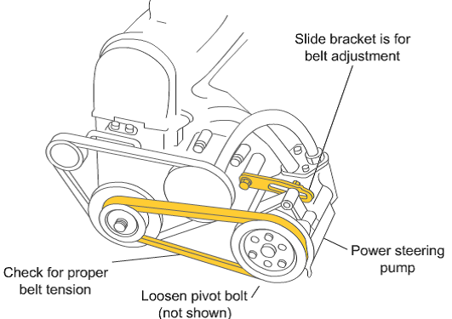
On applications with a screw-type adjustment, make sure you have loosened all the required pivot and bracket fasteners to avoid stripping or bending the adjuster mechanism. If the tension is set by prying, loosen the fasteners, pry to the proper tension, and then tighten the slide bracket bolt. Use care when prying; do not pry against the reservoir or the side of the pump. Look for a 3/8ths or 1/2 inch square hole on the housing or a bracket. This hole is designed for a pull handle to be inserted for safe and easier prying.
Figure 3:22: Belt Tension Adjustment

Steering fluid changing procedure
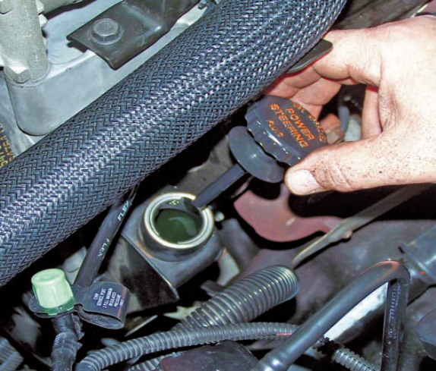
The power-steering fluid can be checked either hot or cold. Fluid level will vary with temperature, however, and a more accurate check is done when the engine is warm. The reservoir cap has a dipstick typically marked HOT and COLD on opposite sides of the dipstick.
Make sure to check the level on the right side of the dipstick. If necessary, add fluid to correct the level. Some manufacturers recommend a specific fluid for use in a power-steering system. However, most recommend a specific type of ATF. Always check the service information before installing fluid to the system.
Figure 3:23: Check the fluid level with the dipstick attached to the cap.

Hydraulic Tests
If a visual inspection of the vehicle suggests that the power steering system is at fault, check the hydraulic supply circuit first. Power steering gear performance is dependent on an adequate supply of oil pressure and oil flow through the circuit.
When diagnosing power steering problems, oil pressure and oil flow must meet the OEM specifications. Pressure and flow specifications vary considerably, so follow the vehicle manufacturer recommendations.

High system oil temperatures reduce the efficiency of the power steering pump and the steering gear. High temperatures are caused by restriction to flow or inadequate system oil capacity to allow for heat dissipation during normal operation. A supply pump that constantly operates at maximum pressure relief will also generate more heat than can be dissipated.

Various types of pressure gauges and flow meters are available and can be used to diagnose power steering problems. You can purchase a specialty power steering analyzer or use more crude, shop-made test components built into a manifold gauge set. The advantage of specialized power steering analysis equipment is speed and accuracy.

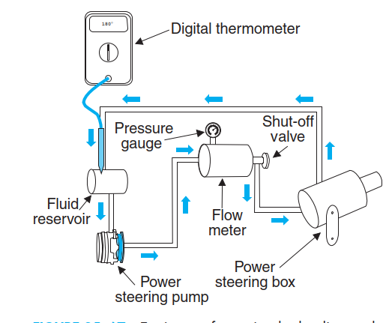
A pressure gauge that reads at least 3,000 psi and a flow meter with a capacity up to 10 gpm. should be used to check pressures and oil flow. A shutoff valve downstream from the pressure gauge makes it possible to isolate the steering pump from the steering gear and by closing the valve, maximum pump relief pressure can be read. A simple thermometer in the reservoir will indicate system oil temperatures.
The following procedure is general in nature, so make sure you consult the vehicle OEM service literature before actually performing it.
Figure 3:24 Equipment for testing hydraulic supply

- Make necessary gauge/meter connections.
- Start the engine and check the system oil level, ensuring that oil flow is in the proper direction through the flow meter.
- Place the thermometer in the reservoir.
- Run the engine at the correct idle speed and steer from lock to lock several times to allow the system to warm up (60–70°C).
- With the engine running at a specified idle speed, slowly turn the shutoff valve until closed and read the pressure at which the pressure relief valve opens. (Open the shutoff valve as quickly as possible to avoid heat buildup or possible damage to the steering pump.) This pressure reading should equal the maximum pump pressure specified by the chassis OEM. Check your specifications.
- With the engine running at a specified idle speed, the vehicle stationary on the shop floor, and with a normal load on the front axle, steer the wheels from a full right to a full left turn and observe the flow meter. The flow should not fall below the minimum gpm flow specification.
- Increase engine speed to approximately 1,500 rpm and note the flow rate with the steering wheel stationary. Check this reading against the maximum flow rate specifications. Excessive oil flow can cause high operating temperatures and sluggish or heavy steering response.
- If the supply pump is performing to specification, install a 1/2-inch (12.5 mm) spacer between the axle stops on one side and turn the steering wheel to full lock in the direction necessary to pinch the spacer block. Record the maximum pressure reading. The maximum pressure reading should be within 100 psi of that recorded in step 5 for pump relief pressure when the shutoff valve was closed.
- Remove the spacer and repeat the test in the opposite direction. Record the pressure. If the pressure does not meet the recorded maximum pressure reading, the steering gear is worn internally and should be repaired or replaced.
- Normal system back-pressure should be 50 to 75 psi (345 to 482 kPa.) with the engine idling and the steering wheel stationary. Back-pressure is checked with the system at a nor-mal operating temperature.
- Steering system oil temperature is best checked after 2 hours of normal operation. The ideal operating temperature should range between 140°F and 160°F (60°C and 70°C). Normal operation in this range will al-low for intermittently higher temperatures that will be encountered during periods of heavy steering usage.
- Visually check for the presence of air mixed with the oil in the steering system. The oil should be clear. Any signs of frothing indicate air entry, and steering performance will be affected. Carefully check for leakage on the suction side of the steering pump. Drain and refill the system and bleed for air.

Flushing the System
The reason for flushing the system should be obvious. Hydraulic fluid is easily contaminated by moisture and dirt. Flushing removes the old fluid with its contaminants and new fluid is added to the system. It is also wise to flush the system after you have replaced or repaired a part in the system. Before beginning to flush the system, you should disable the engine’s ignition. Then disconnect the power steering return hose and plug the reservoir. Attach an extension hose between the power-steering return hose and an empty container. Raise the vehicle’s front wheels off the ground. Fill the reservoir with the correct type of fluid.
Fluid is clear, fill the reservoir to its full mark and lower the vehicle. Disconnect the extension hose from the power steering return hose and reconnect the return hose to the reservoir. Check the fluid level again and add fluid as necessary. Now enable the ignition system. Start the engine and turn the steering wheel from stop to stop. If the power-steering system is noisy and bubbles are forming in the fluid, the system must be purged of air.

Flow and Pressure Test
We will test flow and pressure test in hydraulic assist steering gear system
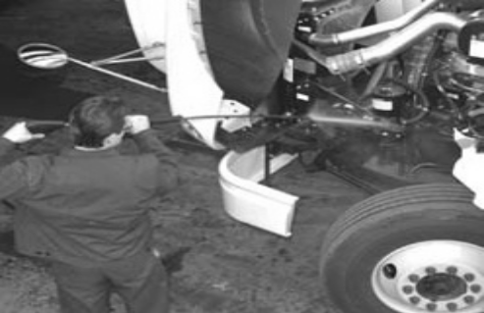
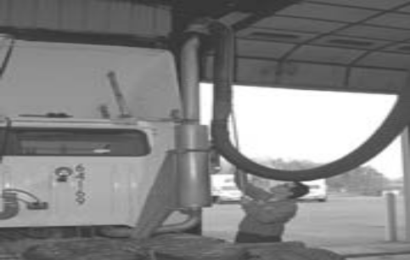
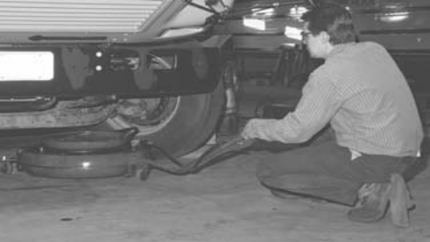
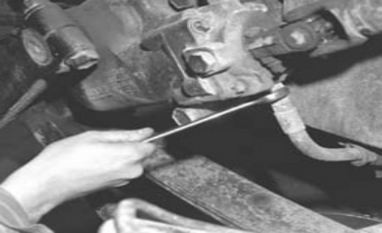
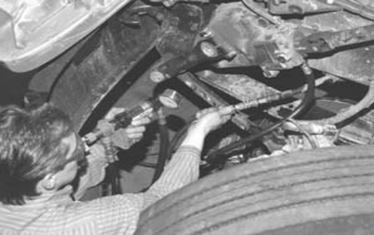
- Use a high-pressure washer or steam cleaner to thoroughly clean the area around the steering gear.

- Park the vehicle in a stall and ensure that the front wheels are tracking in the straight-ahead position. Fit a shop exhaust pipe to the truck exhaust stack.

- Place a drain pan under the steering gear to catch power steering fluid spilled during this procedure.

- Separate the high-pressure supply hose from the steering gear. Be aware that the fluid in this line may have some residual high pressure. Some fluid will drain from the system, so the drain pan should be placed directly under the steering gear.

- Connect the power steering analyzer in series with the high pressure supply hose and the nipple on the inlet side of the steering gear. Now the system will function as normal except that the hydraulic fluid will be routed through the power steering analyzer.

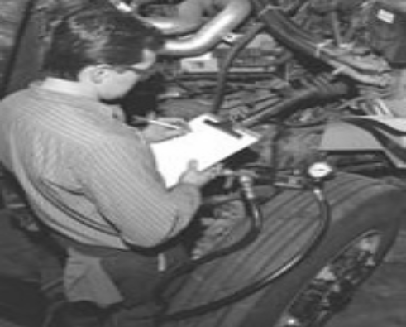
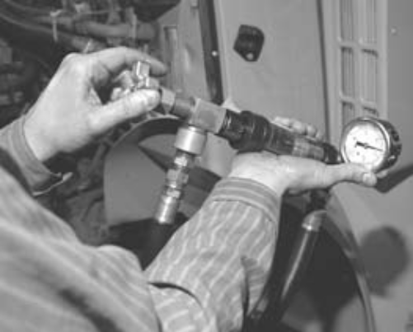
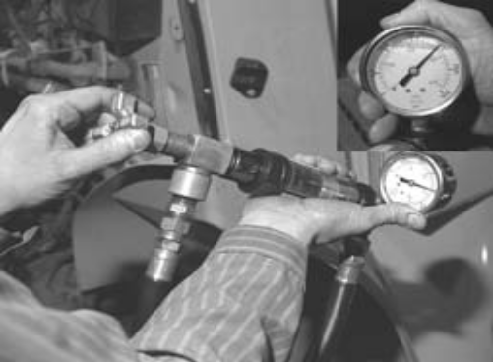
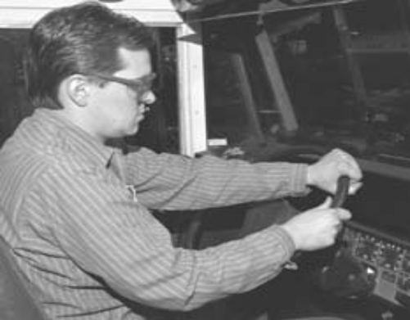
Figure 3:25 Flow and Pressure Test photo sequence
- Start the engine. Run it at idle speed and record the pressure and flow readings on the power steering analyzer. Check to specifications.

- Next close down the flow valve until the pressure increases to the test value specified in the OEM service literature. This may be between 500 and over 1,000 psi, depending on the system. Record the flowing pm at this pressure value. If the flow is lower than specified, the power steering pump may be defective and require replacement.

- Test the pump relief valve and flow control pressures by closing down the flow valve until the flow gauge reads zero. Record the peak pressure reading on the gauge. Perform this two or three times but for no longer than 5 seconds separated by a 30 second interval. Check the gauge pressure.

- Compare all test results to OEM specifications and perform repairs as required. Ensure that after the power steering analyzer is removed, the engine is run, and the steering turned from lock to lock and back to center before attempting to remove the truck. This will ensure that no air remains in the high-pressure circuit.

Grease Fitting
Grease fittings are permanently installed by either a (taper) thread or straight push-fit ('hammer in') arrangement, leaving a nipple connection that a grease gun attaches to. The pressure supplied by the grease gun forces a small captive bearing ball in the fitting to move back against the force of its retaining spring. The arrangement is thus essentially a valve that opens under pressure to allow lubricant to pass through a channel and be forced into the voids of the bearing.

When the pressure ceases, the ball returns to its closed position. The ball excludes dirt and functions as a check valve to prevent grease escaping back out of the fitting. The ball is almost flush with the surface of the fitting so that it can be wiped clean to reduce the amount of debris carried with the grease into the bearing
The common convex shape of the fitting allows the simple concave tip of the grease gun to seal against the fitting easily from many angles, yet with a sufficiently tight seal to force the pressured grease to move the ball and enter the fitting, rather than simply oozing past this temporary annular (ring-shaped) seal. For higher pressure greasing, the grease gun end latches onto the nipple and sealing is affected as a butt joint.
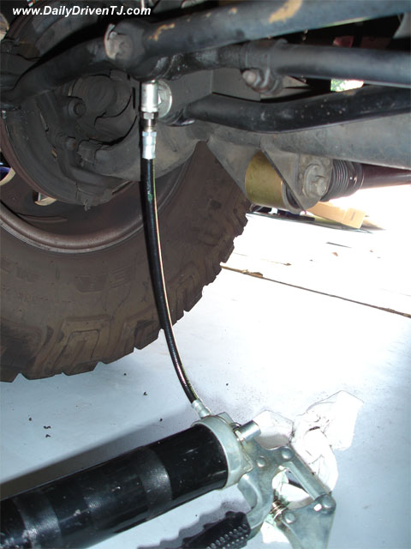
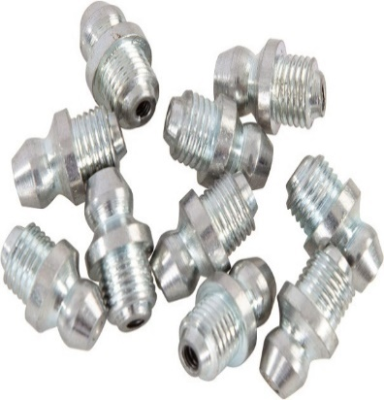

Figure 3:26 Grease fittings

LAP Test

Practical Demonstration

Name: __________________________ Date: ____________
Time started: ____________________ Time finished: _______________
Instruction I: Perform the following tasks
Task 1: Disassembling Steering Knuckle
Task 2: Changing
Task 3: Flushing steering fluid
Task 4: Diagnosis steering system problem

Unit Four: Wheel Alignment
This learning guide is developed to provide you the necessary information regarding the following content coverage and topics:
  - Introduction to Steering geometry
  - Toe Angle
  - Caster
  - Twisted Axles
  - Camber
  - Ackerman Geometry
  - Axle Alignment
  - Electronic Alignment Systems
This guide will also assist you to attain the learning outcomes stated in the cover page. Specifically, upon completion of this learning guide, you will be able to:
  - Introduction to Steering geometry
  - Toe Angle
  - Caster
  - Twisted Axles
  - Camber
  - Ackerman Geometry
  - Axle Alignment
  - Electronic Alignment Systems

Introduction to Steering geometry
The components of a truck front axle, steering system, and suspension must be precisely aligned to ensure the vehicle steers and tracks true. When properly aligned, the wheels of both a loaded and unloaded vehicle should contact the road properly, allowing each wheel to rotate without scuffing, dragging, or slipping on the road. A front end that is properly aligned will result in:

- Easier steering
- Longer tire life
- Directional stability
- Less wear on front-end components
- Better fuel economy
- Increased safety

The primary alignment angles are toe, caster, and camber. Kingpin inclination, turning angle, Ackerman geometry, and axle alignment will also have some effect on tire wear and steering characteristics. Front-end alignment should be checked at regular intervals, particularly after the front suspension has been subjected to severe impact loads. Before checking and adjusting alignment, components such as wheel bearings, tie rods, steering gear, shock absorbers, and tire inflation should be inspected and corrected when necessary.

Toe Angle
Toe is defined as the difference in distance that the front if the tire is compared to the back of the tire on the steering axle as viewed from above. Toe-in exists when the tires are closer together at the front than at the rear. If toe-in is excessive, the tire will scrub (wear) in a direction from the outside toward the inside of the tire, resulting in feather edge wear on the inner edge.
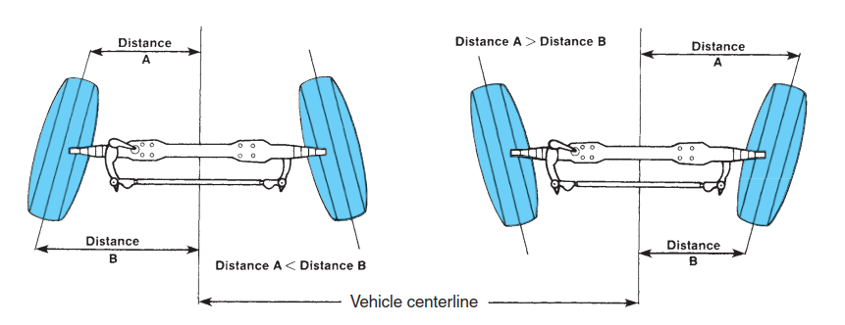
Toe-out is when the tires are closer together at the rear when viewed from above. Excessive toe-out wear can be indicated by tire scrub from the inside toward the outside of the tire, resulting in feather edge wear on the outer edge.
Figure 4:1 Toe-in (left) and toe-out (right).

- Measuring Toe
Toe is specified in either degrees or fractions of inches depending on the type of alignment instruments you are using. When a toe-in setting is required, settings of 1/16 inch 6 1/32 inch are usually specified. The toe specification usually depends on whether radial or bias-ply tires are used. Adjustment of toe angle or dimension requires lengthening or shortening the tie-rod dimension. This is achieved by loosening the tie-rod end clamp bolts and then rotating the cross tube. To determine the causes of excessive tire wear that you suspect to be related to toe angle, you should first check kingpin inclination, camber, and caster. Correct, if necessary, in this order. These are covered later in this chapter. You should not make an adjustment to toe angle until the other factors of front-wheel alignment are known to be within specifications.
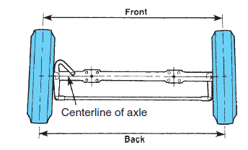
When measuring toe angle, the front suspension should be neutralized. To neutralize the suspension, roll the vehicle back and forth about a half vehicle length. This relaxes the front suspension and steering linkages. Neutralizing the front suspension is important before making front-end adjustments, especially if the vehicle has been jacked up on either side to scribe the tires. This operation causes the front wheels to angle as each is returned to the floor. When possible, use a scissor jack that cradles both sides of the front axle when working on front ends. If you began by neutralizing the front end, both front wheels should at this point be in the exact straight-ahead position. Toe-in measurements should be taken across the hub centerline, front, and rear on each tire (Figure 4–2). Make sure that the wheels are on the ground and fully supporting the vehicle weight. Measure and record the measurements. The difference between the front and rear measurements is the toe specification.
Figure 4:2: To determine toe, measure between the centerlines of the tires, both front and back positions. The difference between the two measurements is the toe.

- Adjusting Toe Angle
After measuring toe, you can use the following procedure to adjust toe angle:
- Use the steering wheel to turn the steering gear to the exact mid position (over center).
- Loosen the clamping bolts on both tie-rod ends. Raise the weight off the axle.
- Turn the tie-rod cross tube in the direction necessary to bring toe to the specified setting; turning the cross tube either lengthens or shortens it. After making the adjustment, lower the vehicle to the floor. Measure the toe setting again.
- When the toe angle is set to specification, torque the tie-rod end clamp bolts to specification.
- Deep Drop Tie-Rod Ends
Toe-in tends to increase slightly on some steer axles when loaded and stationary. It is, therefore, important that vehicles with setback axles and deep drop tie-rod ends be given some special attention. A deep drop tie-rod end can be identified by a downward curve, as shown in Figure 4-2.
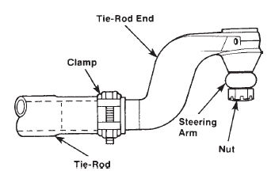
Because of the turning geometry that results from setback and deep drop tie-rod end axles, the tie-rod end clamps if facing forward can interfere with the axle I-beam on a full lock turn. This interference will not necessarily impede steering control, but it can reduce the effective turn angle of the vehicle. Refer to the appropriate service literature for diagnosis and repair procedures.
Figure 4:3: A typical deep drop tie-rod end. Note the top-mounted curve.

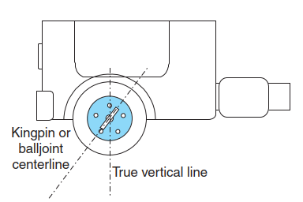
Caster
Caster is the forward or rearward tilt of the kingpin centerline when viewed from the side of the vehicle. Zero caster occurs when the centerline of the kingpin is exactly vertical. Positive caster indicates the kingpin is tilted rearward. Negative caster indicates that the kingpin is tilted forward
Figure 4:4: Caster is the forward or rearward (shown) tilt of the kingpin when viewed from the side of the vehicle.
Caster is a directional stability angle only. Incorrect caster by itself will not affect tire wear. Most heavy-duty trucks are designed with some degree of positive caster. Positive caster creates a trailing force in the front wheels, which tends to keep them tracking straight ahead. Positive caster tends to make the steering axle wheels want to return to a straight-ahead position after a turn has been made. The principle is exactly the same as that used in tilting the front fork of a bicycle, which makes it possible to ride the bicycle without holding the handlebars. It is the opposite of the wobble-wheel effect of a supermarket pushcart when mobile.
Positive caster also means that when the front wheels of the truck are turned, one side of the vehicle raises slightly when the other side is lowered. When the steering wheel is released, the weight of the vehicle forces the lifted side downward, resulting in the wheels returning to a straight-ahead steering track. In other words, positive caster produces a condition in which the right wheel resists a right turn and the left wheel resists a left turn. The further into a turn, the more this resistance increases. Caster settings generally affect steering performance in the following ways:
• Too little caster can cause wheel instability, wandering, and poor wheel recovery.
• Too much caster can result in hard steering, darting, over steer, and low-speed shimmy.
- Recommended Caster Settings
Vehicle manufacturers specify varying caster settings, depending on the truck model, what type of load it is to carry, whether it is a tandem or single drive axle, and whether it has manual or power steering. The objective is to provide just enough positive casters to ensure wheel stability and good wheel recovery. The following settings are some examples used for vehicles with manual steering gear, measured weight down on a level floor:
• Tandem drive axle: 1/2–11/2 degrees positive
• Single drive: 11/2– 21/2 degrees positive
• No more than 1/2 degree difference between the left and right wheels
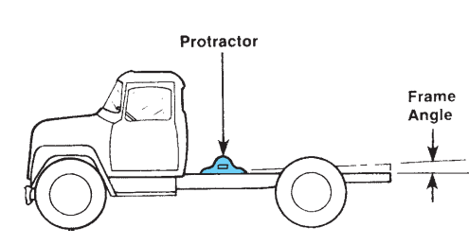
• Positive caster on the left wheel should not be greater than on the right.
Caster specifications are based on vehicle design load (no payload), which will usually result in a level frame. If the frame is not level when alignment checks are made, this must be factored in the caster measurement. With the vehicle on a smooth, level surface, measure the frame angle with a protractor or inclinometer placed on a frame rail, as shown in Figure 4–5.
Figure 4:5: Measuring frame angle.
Positive frame angle is defined as forward tilt (front end down) and negative angle as tilt to rear (front end high). The frame tilt angle should be added or subtracted, as required, from the caster specification in the service literature, noting the following:
1. Positive frame angle should be subtracted from the caster specification.
2. Negative frame angle should be added to the caster specification.
For instance, if the specified caster setting is a positive 1 degree and you measure the vehicle frame angle to be positive 1 degree, the measured caster is 6 1/2 degree. This calculates to the desired 1 degree 6 1/2 degree caster angle when the chassis settles to level the frame under load.

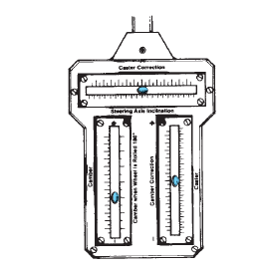
Caster should be measured with the vehicle on a level floor. If the vehicle is equipped with a manually controlled air-lift axle, adjust it so that the frame is at normal operating height. Replacement of worn suspension, frame, and axle components should be done before caster is measured.
Camber/Caster Gauges
The following steps must be performed before making both camber (explained later in this chapter) and caster measurements. Wheel runout should be checked using a tram bar or dial indicator to make an accurate camber/caster reading.
- Drive the truck onto a level surface.
- Raise the front end and position a radius gauge with the lock pins installed, under each front wheel. The degree scale should be pointing outward.
Figure 4:6: Camber/caster gauge.
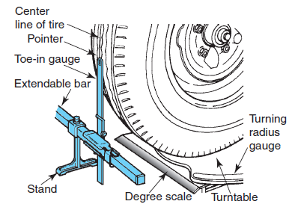
- Turn the steering wheel so that the front wheels face straight ahead.
- Lower the tires onto the radius gauges. Be sure that the tires contact the center of the turntables, as shown in Figure 4–6.
- Remove the lock pins that hold the turntables in a fixed position.
- Zero both radius scales.
Figure 4:7 Simple wheel alignment equipment, including a turning radius gauge and toe-in gauge.
- Apply the brakes when using a full-floating turning gauge, but if a semi floating type is used, leave them released.
- Install the wheel clamp to the wheel rim and the camber/caster gauge to the wheel clamp. On smaller wheels the camber/caster gauge is usually fitted directly to the wheel hub instead of the wheel rim. Follow the equipment OEM’s instructions.
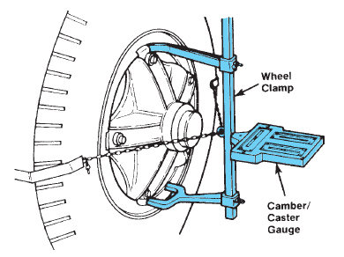
- To check and adjust wheel run out, first make sure that the wheel clamp fingers rest firmly against the rim and that the gauge rests firmly against its seat.
- Raise the front wheel off the turning radius gauge.
- Note the reading on the camber scale.
- When turning the wheel, note the point of the greatest wheel run out and mark the tire in that location. Next, position this location in the forward or rearward direction.
Figure 4:8: The camber/caster gauge attached to clamp
- Lower the front end so that the tires sit again on the turning radius gauges.
- Measuring Caster
Caster can be measured in a number of ways. One way is to use a protractor. Another is to use a radius gauge and caster gauge. Modern computerized alignment equipment is the fastest, most accurate method of measuring caster and, increasingly, shops are using this.
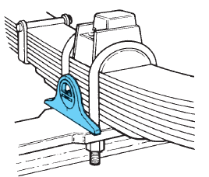
- Protractor:
A protractor measures the angle between its base and true horizontal, as determined by a bubble cylinder on one side of the dial. To measure caster angle:
- Place the protractor on the machined surface of the front axle pad as shown in Figure4-8. The axle pad must be free of dirt and debris. Make sure that the protractor contacts both U-bolts so that it is parallel with the truck frame.
Figure 4:9: To measure caster, place the protractor on a clean, flat surface of the axle pad. Be sure that the axle pad is clean and the protractor touches the U-bolts.
- Center the bubble in the cylinder by rotating the dial of the protractor. Lock the dial and remove the protractor to record the angle.
- Make sure you determine whether the caster angle you measured is positive or negative.
The original orientation of the protractor must be remembered when determining the direction of the caster angle
- Repeat the preceding procedure on the opposite side of the vehicle. If the caster difference on each side exceeds 1/2 degree, the axle is probably twisted.
- Radius gauges:
To measure caster using radius gauges, use the following procedure:
- Set both turning radius scales at zero.
- Make a right-hand turn with the steering wheel so that the left front wheel is turned to 20
Degrees.
- Turn the adjusting screw to center the left wheel caster gauge bubble.
- Now turn the steering wheel to the left until the left front wheel is at the 20-degree left-hand turn position.
- Rotate the gauge to level it.
- Visually align the center of the bubble with the left- or right-hand caster graduation and read the degree of caster. The caster is positive if the bubble is toward the positive sign and negative if the bubble is toward the negative sign.
- Repeat this procedure on the opposite side of the truck.
- If the caster difference from side to side exceeds ½ degree, the axle is probably twisted. Also remember that the right side should not have less positive caster than the left. If the right side has less, it will tend to lead the vehicle to the right, particularly on crowned roads.
- Caster Shims.
Caster angle is changed by using caster shims, which are angled metal wedges inserted between the spring seat and the axle pad, as shown in Figure 4–10. Shims are typically manufactured in half-degree increments, from 1/2 degree to about 4 degrees, and in a choice of 3-, 31/2-, or 4-inch widths to accommodate typical spring pack widths. When inserting caster shims under spring seats, you should observe the following:
- Use only one shim on each side. Do not stack them.
- The width of the shim should equal that of the spring.
- Do not use shims of more than 1 degree difference from side to side.
- Changing Caster.
After determining the caster desired on each side of the axle, use the following procedure to install the caster shims.
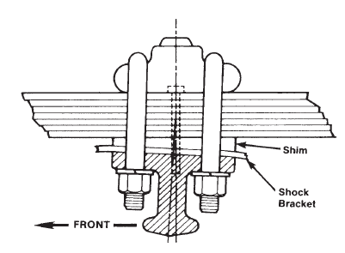
- Loosen all spring U-bolts on each side just enough to relieve clamping tension.
- On one side, fully back off the U-bolt nuts without completely removing them from the U-bolt threads.
- With a frame jack, raise the springs from the axle seat. Do not lift the wheel from the floor.
- If a caster shim has been previously installed, remove it and make sure that the angle is factored in the calculation of desired caster angle. In the interest of safety, use a tool to remove the shim. Never insert your fingers between the axle and the springs.
Figure 4:10: Caster angle is changed by inserting metal shims between the spring and axle pad.
- Remove dirt and debris from the exposed axle pad.
- Ensure that the spring center bolt cap protrudes sufficiently to pass through the caster shim and locate to the axle alignment recess.
- Insert the shim, aligning the hole with the center bolt, and slowly lower the spring onto the axle, making sure that the center bolt seats the axle alignment recess. The caster shim must be installed with the thick part of the wedge positioned to produce the correct caster reading.
- Apply initial torque to the U-bolt nuts.
- Repeat steps 2 through 8 on the other side of the axle.
- Torque the U-bolt nuts to the OEM specifications in a crisscross pattern.
- Measure the caster again. Changing shims does not always produce the exact caster change desired.
- In most cases, caster angle should not change significantly when a load is added to the vehicle.
- If steering difficulties persist, caster should be rechecked with the vehicle loaded.

Twisted Axles
In a few cases, steering problems can be traced to a twist in the front axle. A twisted steer axle can be caused by an actual structural twist or one induced by improper use of caster shims. A twisted axle should be suspected whenever:
- The difference in caster angle exceeds 1/2degree from side to side
- The caster shims in place differ by 1 degree or more
- A low-speed shimmy exists, and there is no evidence of looseness
- A leading or darting condition persists

- Checking Steer Axle Twist
To detect a twisted axle, you can use the following procedure:
  - Roll the vehicle onto a level floor, leaving the steering wheel free for at least the last 10 feet to permit the tires to seek a true straight ahead position.
  - Remove the cap screws that hold the kingpin cap in place.
  - Lift the cap from the knuckle assembly and wipe away any excess grease.
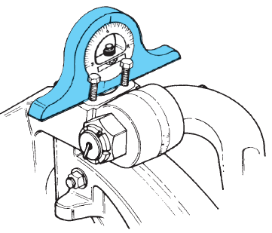
  - Partially insert two cap screws about 1/4 inch deep. Place a protractor on the knuckle contacting the two cap screws to ensure that it is parallel to the frame, as shown in Figure4–11.
  - Center the bubble, lift carefully, and record the angle. If this measurement is more than
- 1/2 degree different than the angle measured at the axle pad, it can indicate a twisted condition between the pad and the kingpin.
  - Repeat steps 2 through 5 on the other end of the axle.
Figure 4:11: Checking for a twisted axle using a machinist’s protractor on the steering knuckle.

It sometimes happens that the previous check will not indicate a twisted axle at either end, but there remains a side-to-side caster difference exceeding ½ degree or the steering problems previously mentioned still exist. This can be because of a twist in the axle that can be detected only in its natural or unloaded state. This can be determined by the following check:
  - Loosen all U-bolts on the front axle enough to relieve tension when keeping center bolts in position in the axle recesses.
  - Using a frame jack, lift the vehicle weight from the axle.
  - Measure the angle at both kingpins and axle pads. Any differences in these readings should identify a twist in the axle.

Camber
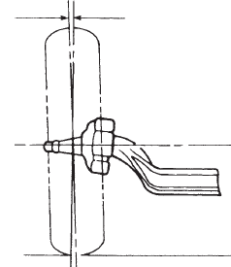
Camber is the tilt of the tires as viewed from the front of the vehicle, Positive camber exists when the tire are tire are closer together at the bottom. Negative camber exists when the tires are closer together at the top.
If the centerline of the tire is exactly vertical, the tire has a camber setting of zero degrees. If the top of the tire tilts outward, it has positive camber, and if the top of the tire tilts inward, it has negative camber. Positive and negative camber is illustrated in Figure 4–12. Camber settings of 11/4 degree for the curb side and 13/4 degree for the driver side wheels are typical. The amount of camber used depends on the kingpin inclination (KPI) setting.
Figure 4:12: Camber is the inward or outward tilt when viewed from the front of the vehicle.
Kingpin inclination is the inclination of the steering axis to a vertical plane that is the equivalent of steering axis inclination (SAI) in automotive front ends. Incorrect camber angle results in abnormal wear on the side of a tire tread. Excessive positive camber causes the tire to wear on its outside shoulder. Likewise, excessive negative camber causes the tire to wear on its inside shoulder. Unequal camber in the front wheels also can cause the steering to lead to the right or left. The truck will lead to the side that has the most positive camber.
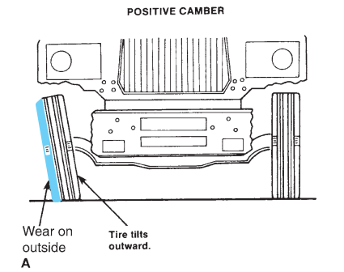
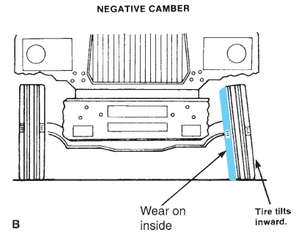
Camber adjustments are not often made on heavy-duty truck axles. Some service facilities with
(A) Positive camber results in wear on the outer edge of the tire; (B) negative camber results in tire wear on the inner edge.
Specialized equipment adjusts camber by cold bending axle beams, but, generally, axle manufacturers do not approve of this practice. Bending an axle can damage the structural integrity of the beam, increase the risk of metal fatigue, and lead to the axle breaking. Heating and bending the axle should never be attempted because it removes the heat tempering.
    - Measuring Camber
The preparatory procedure that has to be performed before measuring camber is detailed earlier in the section on caster. Perform those steps first. Then stabilize the front end. Next, visually align the center of the bubble with the left- or right-hand camber graduation in order to read the camber from the camber scale. Camber is positive if the bubble gravitates toward the positive sign, and it is negative if it gravitates toward the negative sign. It should be emphasized that camber should be checked but seldom has to be adjusted in truck front ends.
    - Kingpin Inclination
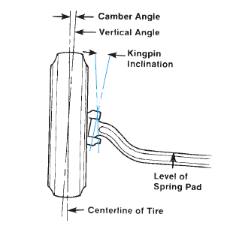
KPI is the amount in degrees that the top of the kingpin inclines away from the vertical, viewed from the front of the truck, as shown in Figure 4–9. KPI, in conjunction with camber angle, places the approximate center of the tire tread footprint in contact with the road. KPI reduces steering effort and improves the directional stability. KPI cannot be adjusted in trucks. Once set,
KPI should not change unless the front axle has been bent. Corrections or changes to this angle are accomplished by replacement of broken, bent, or worn parts.
Figure 4:13: Kingpin inclination and camber angle as viewed from the front of the truck.
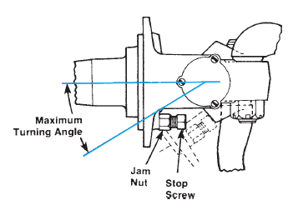
    - Turning Angle or Radius
Turning angle or radius is the degree of movement from a straight-ahead position of the front wheels to either an extreme right or left position. Two factors limit the turning angle: tire interference with the chassis and steering gear travel. To avoid tire interference or bottoming of the steering gear, adjustable stop screws are located on the steering knuckles (Figure 4–14).
Figure 4:14: The maximum turning angle of a wheel is determined by a stop screw
Turning radius or angle should be checked using the radius gauge described earlier. If turning angle does not meet specifications, it should be corrected.
To make an adjustment to the turning radius, use the following procedure:
  - Block the rear wheels and raise the truck off the ground. Position support stands under the front axle.
  - Turn the wheels to the extreme right turn until the steering gear bottoms or tire-to-chassis contact is made.
  - Back off the steering wheel one-quarter turn or until 1/2- to 1-inch clearance is obtained between the tire and chassis.
  - Next check both front tires for clearance at full steering lock. When the specified clearance is set, back the wheel stop screw out until the screw contacts the axle stop and tighten the jam nut.
  - Repeat the same procedure on the left extreme turn and set the left steering knuckle stop screw.

Ackerman Geometry
Ackerman geometry is the means used to steer a vehicle so that the tires track freely during a turn. During a turn, the inboard wheel on a steer axle has to track a tighter circle than the outer wheel. In other words, the outer tire has to travel just a little further because of the wider arc it has to follow. Ackerman geometry is also known as toe-out during turns. It allows the inner and outer wheel to turn at different angles so that both wheels can negotiate the turn without scrubbing. This is shown in Figure 4-15.
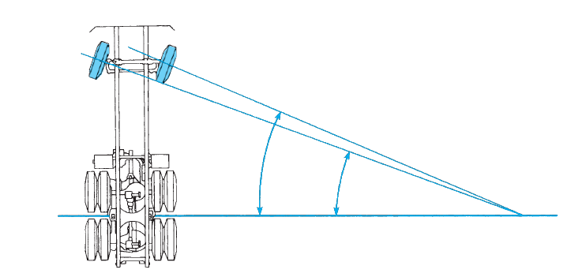
Figure 4:15 Ackerman geometry requires that an ideal turning radius is one where the turning angles of the front wheels intersect the centerline of the drive axles at the same point.
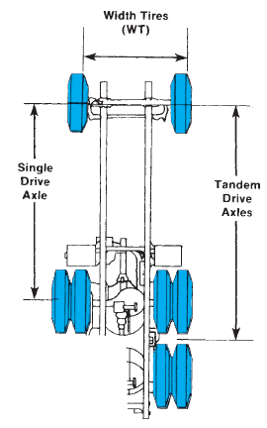
To achieve the required Ackerman angle, the steering linkage must be arranged so the axes of the steering wheels intersect on the axis of the rear axle. On single drive axles, the centerline of the drive axle is the rear axis. On tandem drive axles, the intersecting axis is centered between the two drive axles.
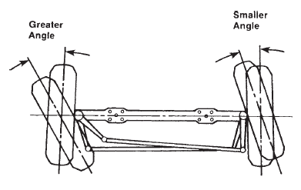
The Ackerman angle built into the steering geometry actually provides perfect rolling angles for both front wheels at only one turning angle. Anything other than this turning angle introduces an error, the size of which depends on the length and inclination of the tie-rod arms. As a result, the lengths of the cross tube and tie-rod arms have to be selected so as to minimize the error throughout the full range of steering angles possible on a particular front end. In trucks, the Ackerman steering error has to be smallest at low turning angles where the most steering corrections are made and at the highest road speeds. Toe-out on turns is accomplished by having the ends of lower steering arms closer together than the kingpins, as shown in Figure 4–11. Actual toe-out during a turn depends on the length and angle of the steering control arms and the length of the cross tube. Even if the toe-in setting with the wheels in a straight-ahead position is correctly adjusted, a bent steering arm can cause the toe-out on a turn to be incorrect, causing tire scuffing.
Figure 4:16: On single drive axles, wheelbase is measured from the centerline of the front axle to the centerline of the rear axle. On tandem drive axles, the wheelbase is measured from the centerline of the front axle to the center point between the two drive axles.

Figure 4:17: In a toe-out condition on turns, the inside wheel turns at a greater angle than the outside wheel
Turning radius angle should be checked using turning radius plates. To check the turning radius angle, you can use the following procedure:
1. Position the front wheels on the radius plates and in the straight-ahead position.
2. Remove the locking pins from each plate and adjust the scale on the edge of the plates so that the pointers indicate zero.
3. Next, turn the wheels to the right until the indicator gauge at the left wheel reads 20 degrees. Then read and record the angle of the right wheel.
4. The right wheel should then be turned to an angle of 20 degrees. The left wheel should read the same turn angle as the right wheel did in the previous step. If the angle is different, check the steering arms for damage and replace any that are bent. Do not attempt to straighten them.

Axle Alignment
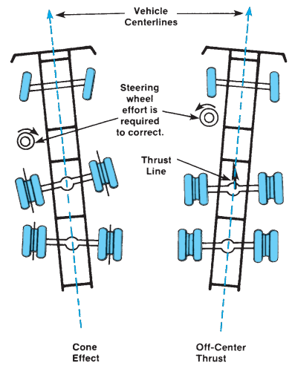
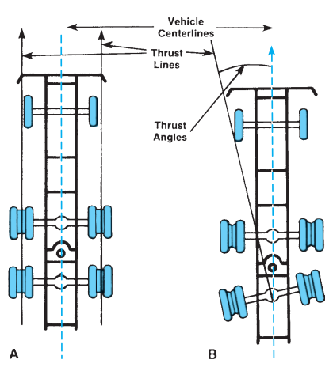
When a vehicle is running on the highway, all of the axles should track perpendicular to the vehicle centerline; that is, the rear wheels should track directly behind the front wheels when the vehicle is moving straight ahead. When this happens, the thrust line created by the rear wheels is parallel to the vehicle centerline, as shown in Figure 4–19A.
Figure 4:18 typical tracking problems of tandem-axle vehicles
Figure 4:19 (A) Correct thrust line; and (B) incorrect thrust line
However, if the axles are not running perpendicular to the vehicle centerline, the rear wheels will not track directly behind the front wheels, and the thrust line of the rear wheels deviates from the centerline of the vehicle, as shown in Figure 4–19B. The steering controls fight the vehicle thrust line, resulting in an un-centered steering wheel and accelerated front tire wear, and which causes the vehicle to oversteer when turning in one direction and understeer when turning in the other direction. Oversteer is an overresponse to steering input, which results in vehicle yaw or lateral tracking off the intended turning radius. Understeer is an under response to steering input, most often causing steering tire slip at high speeds. Incorrect directional tracking can occur on single-axle vehicles, tandem-axle vehicles, and trailers. On a single-axle vehicle, the rear-axle thrust line can be off if the entire axle is offset or if only one wheel has an improper toe angle. On a tandem axle, there are a number of different combinations that can cause incorrect tracking.
One method of checking a single axle for misalignment is to clamp a straightedge across the frame so that it is square with the frame rails on each side. Then measure from the straightedge to the center of the hub. The distances on each side should be within 1/8 inch of each other. If not, the axle must be aligned.
  - Electronic Alignment Systems
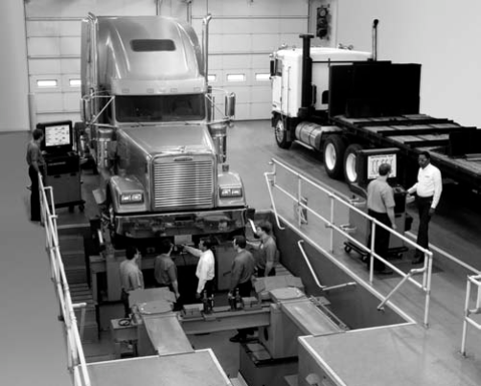
As mentioned earlier in this chapter, wheel and axle alignment measurements can be taken in a number of ways. A number of electronic alignment systems exist. Any electronic alignment system uses computers to analyze and display alignment conditions. The electronic methods include:
Light beam or laser alignment systems use wheel-mounted instruments to project light beams onto charts, scales, and sensors to measure toe, caster, and camber and to note the results of alignment adjustments. The wheel-mounted light projectors can be focused to handle any length wheelbase. The system checks all alignment angles. Two- and four-wheel models are available.
Figure 4:20: Hunter 811 T Alignment system. Class 8 truck fitted to alignment pit for alignment analysis using Win Align software.

Four-wheel models reference all measurements to the rear wheel thrust line to ensure precise alignment. They can check rear camber and toe without moving the vehicle or switching the instruments. This is done by redirecting the light beam through the use of mirrors and precisely positioned scales built into the projectors and the rear wheel instruments. The light projectors are mounted on the front steering axle, and the rear wheel instruments are mounted on the rear axle of the tandem drive axle.
The function of the projectors is to project light in two directions: forward onto the wheel alignment chart positioned in front of the vehicle and rearward onto scales built into the rear wheel instruments. This setup enables you to measure and record the camber of the rear axle of the tandem drive axle. To set the thrust angle of the rearward tandem axle, the front steering wheels are positioned straight ahead so that the light beam is equal on the rear scales of the rear wheel instruments. The steering wheel is then locked in place with a special tool, and the toe of the front wheel is adjusted to specification. Front wheel toe readings are taken off the chart positioned in front of the vehicle.
To adjust the rear axle of the tandem drive axle, the rear scales of the rear wheel instruments are lifted to expose mirrors. These mirrors redirect the light beam from the projector back onto scales mounted in the rear toe boxes of the projectors. The rearward tandem axle can then be aligned, based on the readings shown on the rear toe box scales. To align the front steering axle, the front wheels are set straight ahead and camber and caster measurements are taken off the chart positioned in front of the vehicle.
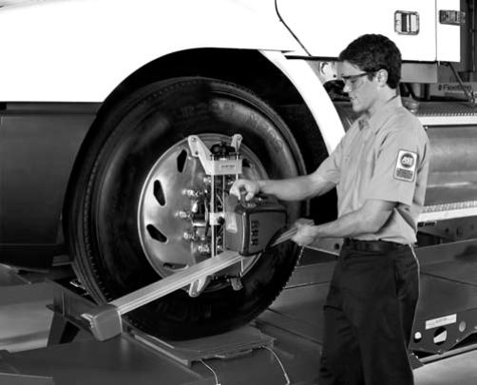
Adjustments are made as needed. With the wheels still in the straight-ahead position, toe can be measured and adjusted as needed. To align the forward drive axle of a tandem drive truck, the rear scales of the rear wheel instruments are lifted to expose the mirrors.
Figure 4:21: Technician fitting a self-centering wheel adaptor to a highway tractor front wheel. The wheel adaptor uses a digital signal processor and wireless technology to interface with Win Align software.
The beams from the projectors are now directed back into the rear toe boxes of the projectors. Adjustments are then made based on the reading on the rear toe box scales.

LAP Test

Practical Demonstration

Name: __________________________ Date: ____________
Time started: ____________________ Time finished: _______________
Instruction I: Perform the following tasks
Task 1: Performing steering geometries

Reference

- M.J. Nunney, Light and Heavy Vehicle Technology Fourth edition
- Sean Bennett and Ian Andrew Normann. Heavy Duty Truck Systems , Fifth Edition
- Robert Huzij, Angelo Spano, and Sean Bennett, Modern Diesel Technology: Heavy Equipment Systems2nd Edition
- Sean Bennett, Medium/Heavy Duty Truck Engines, Fuel & Computerized Management Systems 4th Edition
- James D. Haldeman, Automotive technology Principles, Diagnosis, and Service fourth edition
- Ben Watson, Modern Diesel Technology: Mobile Equipment Hydraulics: A Systems And Troubleshooting Approach
- M.J. Nunney, Light and Heavy Vehicle Technology, Fourth edition
- John Dixon, Modern Diesel Technology: Preventive Maintenance And Inspection
- Joseph A. Bell, Modern Diesel Technology Electricity & Electronics, 2nd Edition

Participants of this Module (Training Material) preparation

No | Name | Qualification | Field of Study | Organization/ Institution | Mobile number | E-mail
 | Adinet Asnake | MSc. | Automotive Technology Mgt | Wolkite PTC | 0913-767250 | andinetasnake31@gmail.com
 | Biruk Tilahun | BSc. | Automotive Technology | General Wingaste PTC | 0913-789176 | biruktilahun1@gmail.com
 | Fadli Aman | BSc. | Automotive Technology | General Wingate PTC | 0927-283100 | Fadli.ziyad@gmail.com
 | Hana Nigusise | BSc. | Automotive Technology | Selam TVET college | 0988-751516 | Hana.nigussie25@gmail.com
 | Israel Taye | BSc. | Automotive Technology | General Wingate PTC | 0913-424100 | Isra.taye@gmail.com
 | Tatek Mamo | PhD scholar | Automotive Technology | DEC | 0911-841121 | mimibaba928@gmail.com
 | Zelalem Yitbarek | BSc. | Automotive Technology | Selam TVET college | 0972-030621 | Zolosmart12@gmail.com

