

Heavy Vehicle and Earth Moving Machinery Maintenance
Level-II
Based on May 2022, Curriculum Version- I
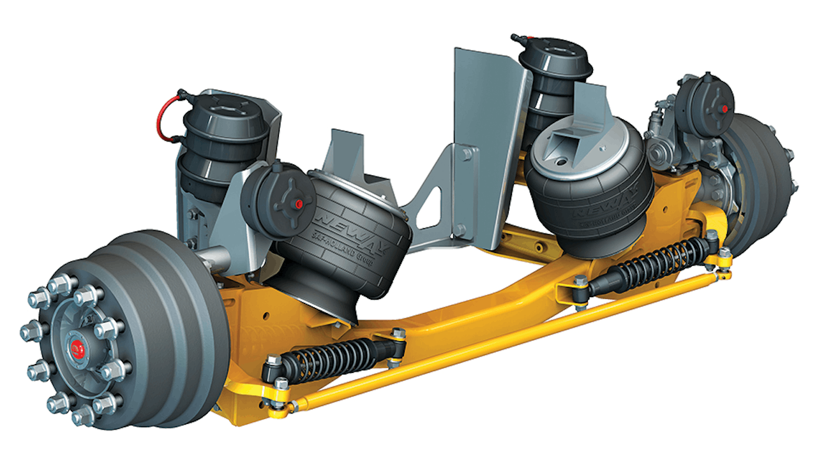

Module Title: - Servicing Suspension System
Module code: EIS HEM2 M14 1122
Nominal duration: 60 Hour

Prepared by: Ministry of Labor and Skill
December, 2022
Addis Ababa, Ethiopia

Table of Contents
Acknowledgment 3
Acronym 4
Introduction to module 5
Unit one: Overview of Suspension System 6
1.1 Purpose of suspension system 7
1.2 Classification of suspension system 8
1.3 Types of suspension system in heavy duty application 8
1.1.1 Leaf Spring Suspensions 8
1.1.2 Equalizing Beam Suspensions 10
1.1.3 Rubber Block and Torsion bar Suspensions 11
1.1.4 Air Spring Suspensions 12
1.4 Applications of suspension system 15
1.5 OHS requirements 17
1.6 Selection and using tools equipment 18
1.7 Sourcing workshop manuals and specifications 20
Self-check-1 25
Unit Two: Conduct inspection and analysis suspension systems 26
2.1 Basic inspection procedures 27
2.2 Inspection of suspension system 29
LAP Test 1 34
Unit Three: Servicing Suspension System Components 35
3.1 Leaf Spring Servicing 36
3.2 Shock Absorber Servicing 37
3.3 Equalizing Beams Servicing 38
3.4 Air Suspensions Servicing 40
LAP Test 44
Unit Four: Preparing vehicle to use and Documentation 45
4.1 Post repair inspection and functionality check 46
4.2 Processing Job card 47
4.3 Maintaining Order in the Workshop 48
4.4 Service Schedule Documentation 49
4.5 Service report 50
Self-check-2 52
Reference 53

Acknowledgment

Ministry of Labor and Skills wish to extend thanks and appreciation to the many representatives of TVT instructors and respective industry experts who donated their time and expertise to the development of this Teaching, Training and Learning Materials (TTLM).

Acronym

OEM | Original equipment manufacturer
BPW | Buffered Peptone Water
CM | Centimeter
KM | Kilo Meter
KPA | Kilo Pascal
LAP | Learning Activity Performance
N M | Newton meter
OHS | Occupational Health Safety
PDI | Pre-Delivery Inspections
PM | Preventive maintenance
SPEC’D | Specked
TSB | Technical service bulletins
TTLM | Teaching, Training and Learning Materials
WO | Work order

Introduction to module
In Automotive field of study; Service Suspension System is one of important task the mechanic undertaking during servicing. This module contain to carry out the service of suspension systems and associated components.
This module is designed to meet the industry requirement under the Heavy Vehicle and Earth Moving Machinery Maintenance level II occupational standard, particularly for the unit of competency: Service Suspension System
This module covers the units:
- Overview of Suspension System
- Inspection and Analysis of Suspension Systems
- Servicing Suspension System Components
- Preparing vehicle to use and Documentation
Learning Objective of the Module
- Overview of Suspension System
- Inspection and Analysis of Suspension Systems
- Servicing Suspension System Components
- Preparing vehicle to use and Documentation

Module Instruction
For effective use this modules trainees are expected to follow the following module instruction:
- Read the information written in each unit
- Accomplish the Self-checks at the end of each unit
- Perform Operation Sheets which were provided at the end of units
- Do the “LAP test” giver at the end of each unit and
- Read the identified reference book for Examples and exercise

Unit one: Overview of Suspension System
This unit is developed to provide you the necessary information regarding the following content coverage and topics:
- Purpose of suspension system
- Classification of suspension system
- Types of suspension system in heavy duty application
- Applications of suspension system
- OHS requirements
- Selecting and using tools suspension system service
- Sourcing workshop manuals and specifications
This unit will also assist you to attain the learning outcomes stated in the cover page. Specifically, upon completion of this learning guide, you will be able to:
- Understand purpose of suspension system
- Classify suspension system
- Types of suspension system in heavy duty application
- Applications of suspension system
- OHS requirements
- Select and using tools for suspension system
- Source workshop manuals and specifications

Purpose of suspension system
A suspension system supports the frame on a vehicle. It acts as an intermediary between the axles and the frame. The axles are subject to whatever forces they encounter when running down the highway. With no suspension, these forces would be transferred directly to the truck frame. Think of how rough it was to ride in one of those wagons you had as a kid. Given this kind of pounding and punishment, without the forgiveness of a suspension, the truck frame, its load, and the driver would not last too long. A suspension system plays a number of roles:
- It stabilizes the truck when traveling over smooth highway as well as over rough terrain.
- It cushions the chassis from road shock and enables the driver to steer the truck.
- It maintains the proper axle spacing and alignment.
- It provides a smooth ride both when loaded and unloaded.
Since trucks are specified by the heaviest load they are expected to haul, the suspension must be able to support that maximum load. However, heavy-duty suspensions that perform comfortably when fully loaded can be harsh and unforgiving when not loaded down. A really good suspension should perform well under loaded, unloaded, highway, and off-road conditions. The heavy duty suspension systems into four general categories:
- Leaf spring
- Equalizer beam: leaf spring and solid rubber spring
- Rubber block and torsion bar
- Air spring: pneumatic-only and combination air/leaf spring
Before we begin looking as the different suspension categories used on heavy vehicles, here are some suspension terms that we will be using:
- Jounce literally means “bump”: In suspension terminology, it is the most compressed condition of a spring. For instance, many suspensions use jounce blocks to prevent frame-to-axle contact known as suspension slam.
- Rebound is the reactive response of a spring after being jounced: It kicks back.
- Unsprung weight, an important factor in a suspension, refers to the weight of any chassis components not supported by the suspension, for instance, the axles.
- Ideally it is kept as low as possible because of the reaction effect, which is one of the reasons for spacing aluminum wheels.
- Oscillation is either rhythmic or irregular vibrations or movements in a suspension. For instance, a good suspension will minimize jounce/rebound oscillations by using dampening devices such as shock absorbers and multi leaf spring packs.

Classification of suspension system
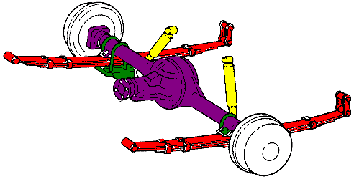
      - Rigid Axle Suspension
In vehicles having a rigid axle suspension system, the right and left wheels are connected by a single axle which itself is fitted to the body and the frame via springs (leaf springs or coil springs).
Due to its great strength and simple construction, the rigid axle suspension system is widely used on the front and rear wheels of buses and trucks, and on the rear wheels of passenger cars.
Figure 1:1 Rigid Axle Suspension
      - Independent Suspension
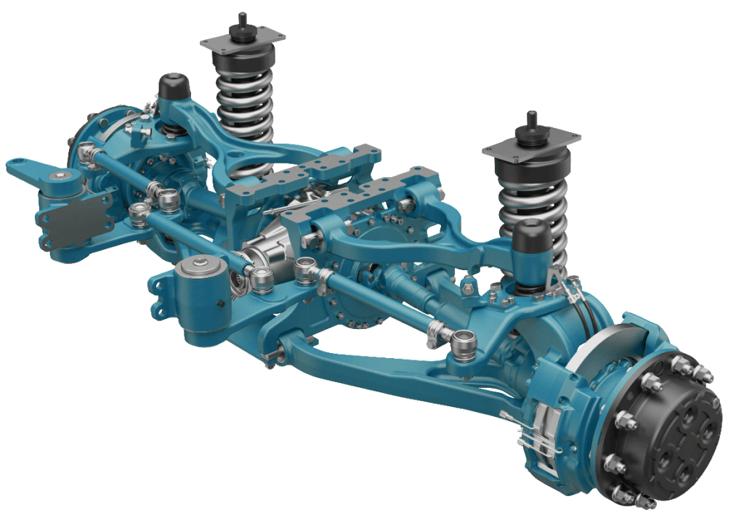
In vehicles having an independent suspension system, the right and left wheels are not connected directly by an axle. The suspension is fitted to the body and the frame in such a way that both wheels can move independently without affecting each other. The independent suspension system is commonly used with the front wheels of passenger cars and small trucks and, more recently, with the rear wheels of passenger cars as well.
Figure 1:2: Independent Suspension

Types of suspension system in heavy duty application

Leaf Spring Suspensions
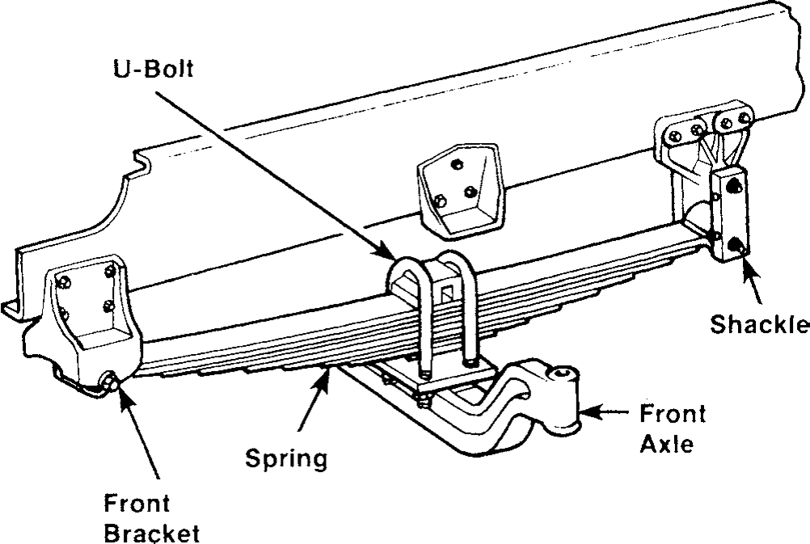
A leaf spring is a steel plate or stack of clamped steel plates. They have been used since the first vehicles hit our roads; for instance, they were key comfort components in horse-drawn buggies. Most leaf springs used in trucks today are manufactured from spring steel. Spring steel is middle-alloy steel that has been tempered; that is, heat treated. The result is to provide a leaf spring plate with considerable ability to flex without permanently deforming.
Principle of spring: A spring pack consists of a stack of tempered steel leaves clamped together by a center bolt. In theory, a multi-leaf spring pack is based on a diamond-shaped plate supported at either end. If such a shape were to be loaded in the center between the supports at either end, then the bending (deflection) that takes place would be proportional to the load applied.
Figure 1:3: Semi-elliptical spring pack—constant
If you take a look at the spring pack shown in Figure 1:3, you can see that the shape is as if a diamond had been cut in half. This half-diamond shape has the same load stress characteristics as a full-diamond-shaped spring, so it is commonly used in springs. The half-diamond shape we just described is also known as a semi-ellipse. A term used to describe the shape of a typical multi leaf spring pack is semi-elliptical. Most multi leaf spring packs used in trucks and trailers are semielliptical.
- Types of Leaf Spring Assemblies
Until relatively recently, leaf spring assemblies were used on a majority of truck and trailer suspensions. Although heavy-duty air suspensions have been around for over 50 years, recently they have become more common in transport applications. Many current truck suspensions use combination air/leaf spring suspensions. A combination suspension exploits the advantages of each type of spring to provide good unloaded and fully loaded suspension performance. For our purposes, we have divided leaf springs into two general types: Constant rate and Progressive or variable rate auxiliary.
- Constant Rate
Constant rate springs are leaf-type spring assemblies that have a constant rate of deflection. For example, if 500 pounds deflect the spring assembly 1 inch, 1,000 pounds deflect the same spring assembly 2 inches. A typical constant rate spring is mounted to an axle saddle with U-bolts. The front end of the spring is pinned to a stationary bracket.
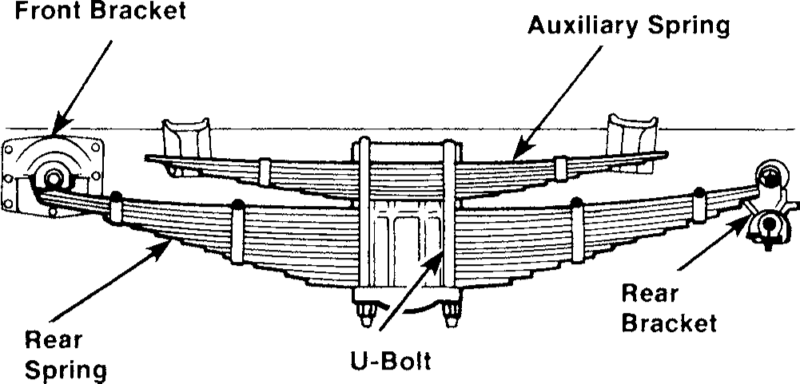
The rear end of the spring is pin mounted to a flex bracket known as a spring shackle. The shackle allows for variations in spring length between jounce and rebound. In the constant rate multi-leaf spring pack, individual spring leaves are clamped by a center bolt and the spring pack is secured to the axle housing by U-bolts. Some spring packs use spring clips to ensure that the alignment between the leaves in the stack is maintained.
Figure 1:4: Constant Rate
- Variable Rate
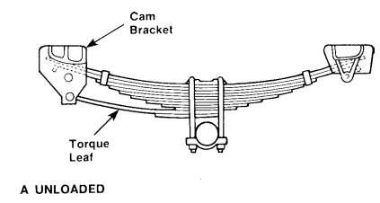
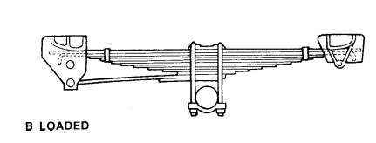
Variable rate springs are leaf-type spring assemblies with a variable deflection rate obtained by varying the effective length of the spring assembly. This is accomplished by using a cam bracket. As the spring assembly deflects, the point of contact on the bracket moves toward the center of the spring assembly, shortening the effective length. Variable rate spring assemblies also incorporate a progressive feature in that the lower spring leaves are separated at the ends. As the spring assembly deflects under load, these leaves come in contact, providing increased capacity and stiffness.
Figure 1:5: Progressive spring operation.

Equalizing Beam Suspensions
Equalizing beam suspensions are commonly used in rough service tandem drive applications. Equalizing beams flex on pivots, allowing a pair of axles to balance the forces that they are subjected to while still maintaining good tire-to-road contact. Two types of equalizing beam suspensions are used on heavy-duty trucks:
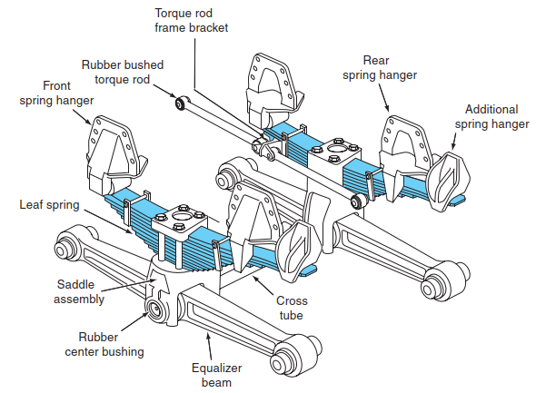
- Leaf Spring Equalizing Beam
The leaf spring-type suspension uses a leaf spring pack on each equalizer beam. The springs are mounted on saddle assemblies above the equalizing beams and pivot at the front on spring pins and brackets. The rear of each spring pack has no rigid attachment to the spring brackets but is free to move forward and backward to compensate for spring deflection.
Figure 1:6: Leaf Spring Equalizing Beam
- Solid Rubber Equalizing Beam
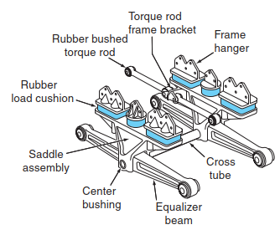
This type of suspension system uses solid rubber springs and is known as a solid rubber suspension. Solid rubber springs are sometimes known as rubber cushions. They fulfill the same role as leaf springs in supporting load and absorbing road shock. On these units, rubber load cushions are mounted on a saddle assembly at each side. Mounted between frame brackets and the suspension, each rubber block unit is secured by four rubber-bushed drive pins, each of which passes through the rubber cushion.
Figure 1:7: Equalizing beam suspension

Rubber Block and Torsion bar Suspensions
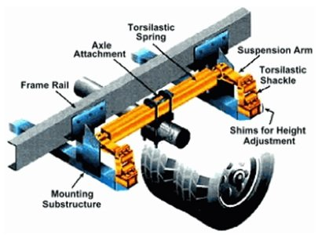
A rubber block and torsion bar suspension system uses a combination of both types of springs to maximize the advantages of each. They are known as combination rubber/torsion spring suspensions and have had a recent resurgence of popularity in both truck and trailer applications because of their versatility. This category of suspensions has some special advantages for vehicles required to negotiate rough, off-highway terrain along with normal highway operation.
Figure 1:8: Rubber Block and Torsion bar Suspensions

Air Spring Suspensions
An increasing number of heavy-duty trucks and trailers are equipped with air spring suspension systems. These suspensions may be fully pneumatic (all air springs) or combination air/leaf spring suspension, The air bag or air spring suspension system provides a smooth shock- and vibration-free ride with a preset constant frame height. Using it in combination with steel leaf springs helps it to over-come some of its disadvantages.
Figure 1:9: Air Spring Suspensions
Air suspensions have been used as the rear suspension on highway tractors and on trailers for many years, but more recently they have gained acceptance on the front steer axle of trucks. The key to making air springs possible on front axles is to dampen the spring oscillations effectively so that steering control is not compromised. This is achieved on current systems by combining the air spring with steel or composite leaf springs and shock absorbers.
- Air Suspension Components
An advantage of air spring suspensions is their simplicity combined with the ability to adapt to load and road conditions. The key to the adaptive capability of an air suspension is the height control valve. The major components of an air suspension system are:
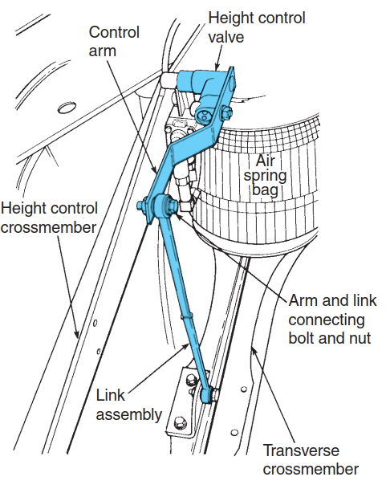
- Height Control Valve
An air spring suspension system is managed by a simple lever-actuated valve known as a height control valve (also known as a leveling valve).The height control valve automatically maintains chassis ride height. The height control valve is usually mounted at the rear of the truck frame, but other arrangements also are used. The valve has a lever rigidly connected to the rear axle assembly by means of a linkage rod. This height control lever controls air into and out of the air springs.
Figure 1:10: Height Control Valve
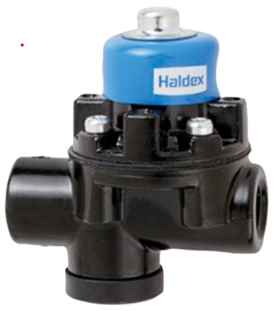
When the axle moves upward, as when passing over a road bump, the lever is forced upward. The reverse would occur if the axle dropped into a pothole. Moving the height control lever charges and discharges air to the air springs. To prevent rapid cycling, a delay mechanism is built into most height control valves.
- Regulator
The air used in most air suspensions on trucks and trailers is regulated to a value lower than chassis system pressure. This means that the first device in a suspension circuit is a pressure regulator. Different values are used that vary according to OEM and application, but 90 psi (620 kPa.) is typical. Most regulators are combined with a pressure protection check valve used to prevent the suspension system from siphoning chassis air in the event of a serious leak.
Figure 1:11 Air suspension regulator
- Air Lines
The air suspension uses air lines to connect all of the components of the system together. Air lines connect the air reservoir to the height control valve and from the height control valve. Also, air lines located.
- Air Springs
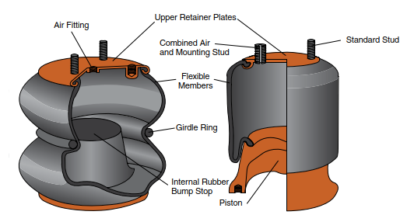
The air springs or air bags used in air suspension systems are of either the reversible sleeve type or the convoluted type. The most common type of air spring in use today on trucks and trailers is the reversible sleeve type. The convoluted air spring is also available in three styles: single, double, and triple convolutions.

Figure 1:12: Components of reversible sleeve and convoluted air springs

- Shock Absorbers
Shock absorbers are necessary on many types’ of suspensions to reduce potentially damaging shock and vibration on heavy-duty trucks. There are three advantages of reducing or eliminating shock and vibration:
- Reduced wear to high-maintenance areas such as electrical systems, suspension parts, and cooling systems as well as premature wear to other components on the vehicle, with resulting downtime
- Reduced driver fatigue
- Reduced cargo damage
All of this is accomplished by stopping the vibration at its source: road shock transferred through the axle.
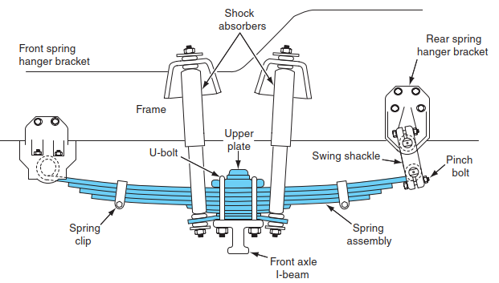
As a wheel passes over an imperfection in the road surface, the vehicles springs deflect (jounce) and respond by over returning (rebound). This causes the suspension to oscillate and will continue, slightly reduced, each time the spring deflects. These oscillations, coupled with road-induced shock, can cause severe damage to truck components. The jounce and rebound force dampening (resistance to movement) built into shock absorbers reduces component failures.
Figure 1:13 Semi-elliptical, steel spring suspension with shock absorbers

Applications of suspension system
Suspensions are used as both front and rear suspensions on tractor and trucks and on trailer suspension systems. They are spec’d to handle the load requirements for which the vehicle is rated and, if these are exceeded, the life of the suspension components will be reduced.
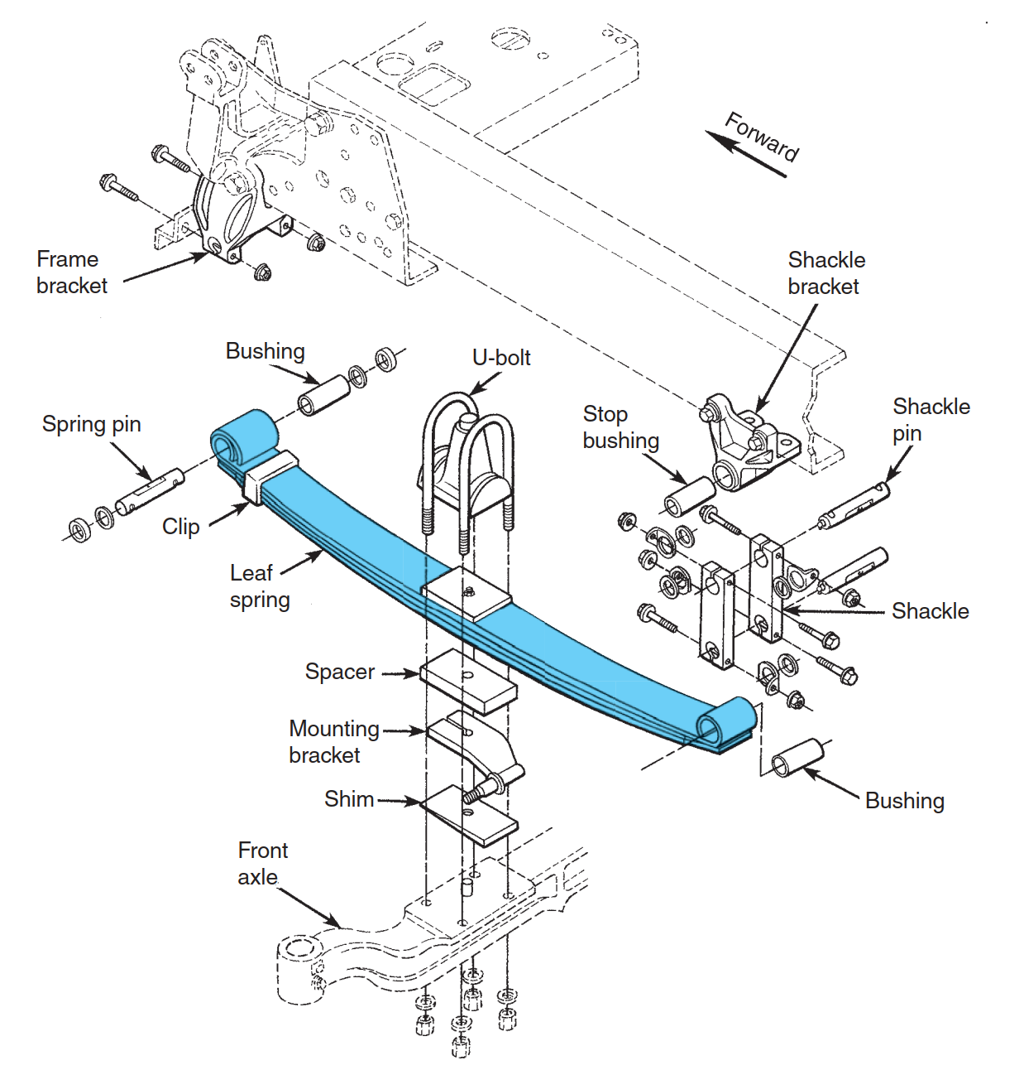
    - Front Suspension
The front suspension plays a special role in the suspension because it directly impacts on driver comfort. Until recently, steel spring suspensions were used exclusively on the front of trucks, but air springs have now become an option. Many types of front steel spring assemblies are used. Some common types include taper-leaf eye and slipper, multi-leaf eye and slipper, taper-leaf shackle, and multi-leaf shackle. An exploded view of a commonly used front suspension, multi-leaf shackle spring.
Figure 1:14 Exploded view of front suspension
    - Rear Suspension
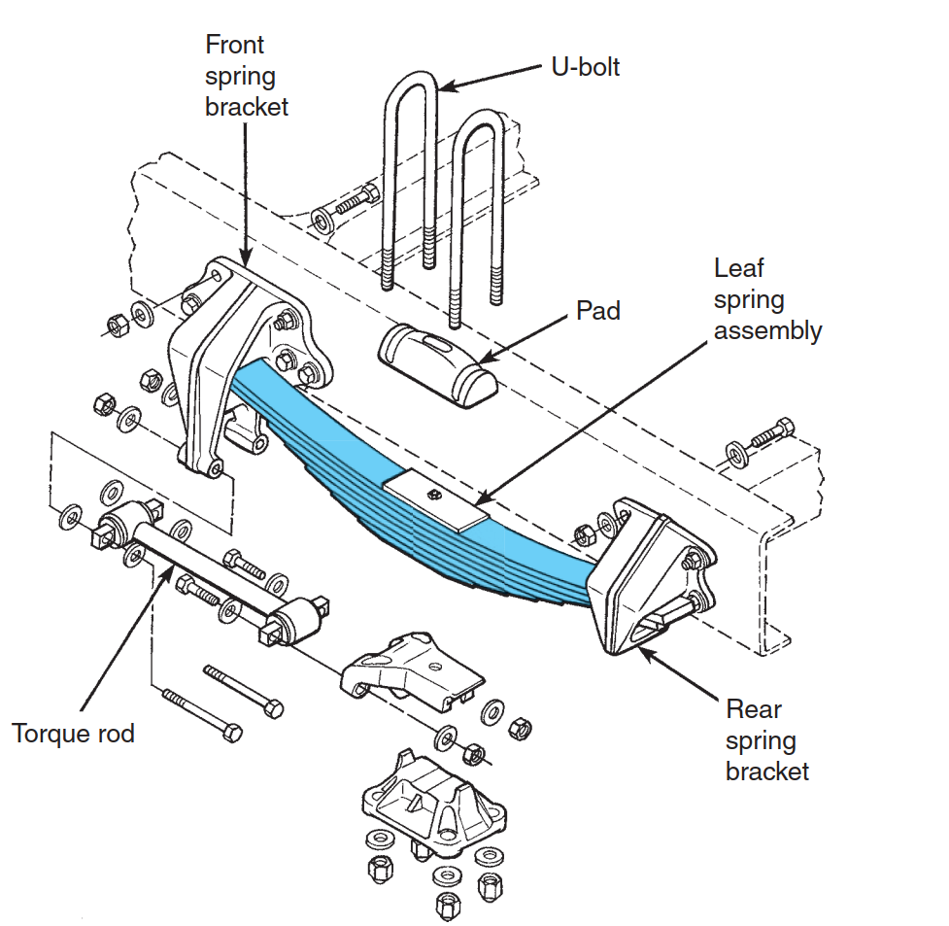
- Single Axle
Single rear axle spring assemblies generally are one of two types: eye and slipper spring or semielliptical radius rod. This spring is clamped to the axle with U-bolts, with the ends riding in slipper brackets mounted to the frame rails.
Slipper brackets do not control longitudinal forces because they do not hold the spring. A radius or torque rod attached to the axle seat forward spring bracket holds the axle in alignment and controls longitudinal forces applied to the suspension.
Figure 1:15 Exploded view of single axle rear suspension
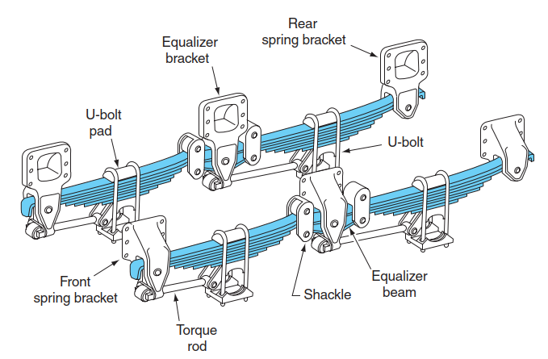
- Tandem Axle
The tandem axle rear spring suspension uses a six-point equalizing leaf spring de-sign to compensate for axle articulation, both side to side and front to rear. Four spring packs are attached to the axles with U-bolts.
On both sides of the vehicle, the forward end of the forward spring and the rear end of the rear spring ride in brackets mounted on the frame rails. Steel wear shoes are cast into each bracket. At the center, between the forward and rear springs, the springs ride on an equalizer, which pivots on a sleeve in the equalizer bracket.
Figure 1:16: Exploded view of Tandem Axle rear suspension
U-Bolts
U-bolts perform three very important functions:
1. Provide a positive clamping force between top plates, spring seats, and axles.
2. Provide a flex point away from the spring center bolt area (weakest point of the spring).
3. Keep spring pack together, eliminating shearing of spring center bolts.
From the functions listed above, you can see that maintaining proper torque is the key to preventing U-bolt and suspension problems. OEMs recommend that U-bolts be torqued at time of delivery, after the first 1,000 miles, after 3,000 miles, and thereafter at 5,000-mile intervals. This same procedure should be followed when springs are replaced or new U-bolts have been installed. Consult the manufacturer for recommended torque specification.
If the vehicle is operated in an environment with a lot of corrosion, re-torqueing cannot be accurately preformed. In this case, tap the U-bolt with a hammer and look for any signs of movement. This should give you a good indication if it has lost its tension.

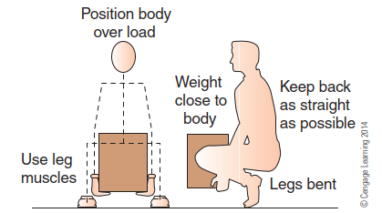
OHS requirements
Working on the suspension system often requires lifting heavy objects, working with springs that are compressed, using air-powered tools, and working with rusted components. All of these conditions require extra attention to safety to prevent injury and damage to the vehicle.
Figure 1:17: Proper lifting requires using your leg muscles
Wheel and tire assemblies can range from around 30 pounds to over 50 pounds. Always use your leg muscles when lifting. Ask for help when it is needed to lift a wheel and tire. Back injuries are common among service technicians and can cause long-term pain and disability.
When you are working with suspension springs, always follow the proper service procedures for safely compressing and handling the springs. Check spring compressors for wear, damage, and proper operation before use. Coil springs can, if released suddenly, bounce around and cause serious injury and damage to vehicles.
Replacing suspension components often requires fighting with rusted components and fasteners. Try to clean as much rust from the area as possible with a wire brush before attempting service. This is especially important when you are using air tools, such as air impacts, because rust tends to break off and fly through the air. Apply a penetrant to rusted nuts and bolts before attempting to remove them.
Safe Work Practices. When you are performing work on the suspension system, you will often be working with springs and other components that require special handling procedures. The following are some general safe work practices for working on the suspension system.
Make sure that the vehicle is properly raised and supported before beginning any work.
- Use the proper tool for the job and ensure that the tool is undamaged and in proper working condition before use.
- Use the appropriate spring compressors when servicing springs and struts. Suspension springs can contain a lot of stored energy that, if released accidentally, can cause serious injury to people and damage to the vehicle.
- Before using a strut spring compressor, make sure you are fully trained in its use and understand how to safely operate the equipment.
- Shock absorbers contain oil, and some pressurize the oil with nitrogen gas. Heat should never be applied to a shock absorber body since the heat will cause pressure to build in the shock, which could cause it to rupture, sending hot oil and metal flying.
- Gas-charged shocks should be relieved of the gas pressure before disposal. This often is done by drilling a small hole in the shock body and allowing the nitrogen to escape. Refer to the manufacturer’s service procedures before depressurizing a shock or throwing it away.
- Do not use steel hammers, punches, or chisels on other steel components.

Selection and using tools equipment
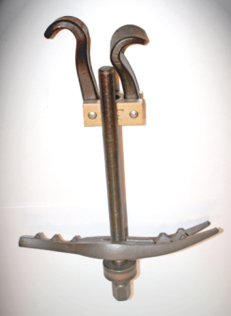
Without the correct tools, many of the common repairs made to the automobile would not be possible. When you are servicing the suspension system, common hand tools as well as some specialty tools, described below, are used.
Tools for Suspension Service. Figure 1-18 through Figure 1-21 show and explain the uses of many of the tools you will use when you are working on the suspension system.
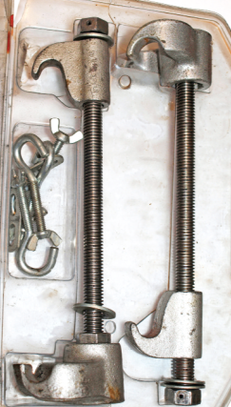
Working with coil springs often requires using a spring compressor. Figure 1-19 shows a spring compressor that attaches to the spring from the inside. This type of compressor is commonly used with front coil springs.
Figure 1:18 the spring and compresses it between the hooks at the top and the fork at the bottom.
Figure 1-19 is of a coil spring compressor that attaches to the outside of the coils. This type of compressor can be used on struts and other coil springs. When you are replacing MacPherson strut shock absorbers, often a spring compressor similar to that shown in Figure 1-21 is used. The strut is removed from the vehicle and mounted in the compressor, where it can safely be disassembled for service.
Figure 1:19: This is a type of external spring compressor.
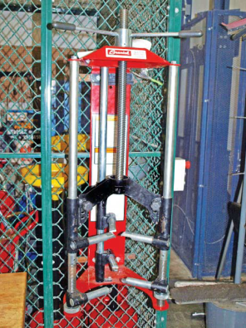
Installing press fit ball joints and certain types of suspension bushings requires a special press, shown in Figure 1-21. The press is needed to install new pressed-in ball joints without damaging the joint or the control arm. Adapters for the press may be used to remove and install control arm bushings. Some control arm bushings will require a specific tool for service, shown in Figure 1-22. This tool is used to remove and reinstall the bushings without damaging the bushing or the control arm.
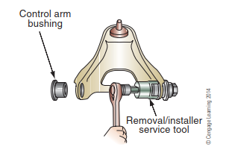
Separating tie rods, ball joints, and other components is often easier using a separator tool like the one shown in Figure 1-23. This tool is used so that the studs, threads, and grease boots of ball joints are not damaged when removing them without replacing them.
Figure 1:20: A strut compressor holds a strut assembly and allows the spring to be compressed and the strut disassembled for replacement.
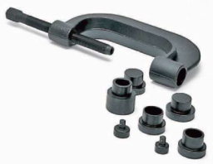

Figure 1:21: Ball joint presses are used to install press-fit ball joints and may have adapters to press in control arm bushings.
Figure 1:22 : A special tool is used to remove and install some types of control arm bushings. Some bushings can be driven out with a hammer and the new bushings pressed back in.
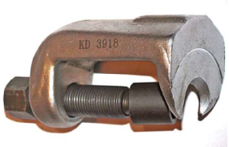

Figure 1:23: This tool is used to separate ball joint studs from components without damaging the studs or grease boots.

Sourcing workshop manuals and specifications
Under the service manual the following elements are incorporated. These are the safety regulations, safety informations and care and maintenance of repair work.

Safety regulations
All work must be performed by trained mechanics at competent repair facilities or authorised specialist companies who have access to all relevant tools and have acquired the knowledge required for this work.Anyone who performs maintenance and repair work must be trained in automotive mechanics and already have experience in repairing trailers and semi-trailers.
- Comply with local safety regulations.
- The relevant operation and service regulations as well as safety regulations of the vehicle manufacturer and of the manufacturers of other vehicle parts must be adhered to.
- The vehicle must be prevented from moving during repair work. Please observe the relevant safety regulations for repair work on commercial vehicles, in particular the safety regulations for jacking up and securing the vehicle.
- For all welding operations, the hangers, U-bolts, air bags and plastic lines must be protected against ﬂ ying sparks and weld spatter.
- The earth terminal should under no circumstances be attached to the trailing arm, U-bolt or wheel hub.
- Do not carry out any welding on the trailing arm.
- Do not machine the trailing arms with cutters or grinders. The spring seat guides should always be widened if replacement trailing arms do not ﬁ t exactly into the bed of the axle spring seats.
- It is not permitted for the hanger brackets to be heated for straightening work!
- During repair work, make sure that the brake is not operated inadvertently. The brake must be released.
- Do not perform repair work unless wearing protective clothing and using the recommended tools.
- Only use recommended tools.
- A second technician must provide assistance when carrying out work with heavy components
- All air lines and components must be depressurised before being removed.
- Following each repair, perform a function check or a test drive in order to make sure that the brakes and suspensions are functioning correctly.
- All exchanged components must be reused or disposed in accordance with the applicable environmental regulations, laws and directives.
- The remaining thickness of the brake lining and the condition of the brake disc or brake drum must be visually inspected at regular intervals with respect to the way in which the vehicle is used
- Tighten all ﬁ xings to the recommended tightening torque.

Safety informations
This workshop manual contains different types of safety instructions, each of which is designated an icon and a key word. The key word describes the severity of the potential danger.



Warning! Possible potential danger of serious or fatal injury
Caution! Possible dangerous situation

Repair Guide! Risk of damage to property or consequential damage if this information is not observed.

Note! Application hints and especially useful information.

It is essential that all maintenance work is carried out in accordance with the prescribed intervals in order to maintain the safe operation and roadworthiness of the trailer. The relevant operation and service regulations of the vehicle manufacturer and of the manufacturers of other vehicle parts must also be adhered to.

Guidelinre for Maintenance Work

- Lubrication Points
There are few areas requiring lubrication for suspensions and axles. These areas include tie rod ends,kingpins (steer axle), brake adjusters, S-cam spider bushes and support bearing journal or cam tube. Apply grease when components are unloaded; brakes mustbe released, and steer axles must be off the ground. Alwaysapply grease until fresh lubricant appears at purge point.
- Inspection
Recommended inspections should be conducted atperiodic intervals and should also be carried out any time the suspension is damaged or otherwise functioning improperly. This schedule is based on normal on-highway average annual trailer distance of 180,000 km. Inspection intervals will need to be adapted to suit trailer distance and operating conditions. Inspections should be carried out at the time or mileage intervals specified, whichever occurs first.
- Areas to Inspect
A general inspection should include any point on thesuspension where suspected wear or damage may occur.
- Inspection/Lubrication Intervals
Periodic intervals listed in this bulletin for inspection andlubrication should be modified according to trailer use.
Inspection and lubrication may be required more often if:
- Required by OEM
- Required by component vendor
- Trailer type and application demands are high
- Impact or other evidence of suspension damage
Pre-Delivery
Pre-Delivery Inspections (PDI) are typically required by the trailer OE to be conducted prior to new trailer delivery to the customer. It includes testing suspension and vehicle for proper operation. This should also be performed by a repair facility after replacing a suspension or axle/beam weldment.
Daily
This pre-operation inspection can detect worn, broken or loose parts before any serious problems occur. During a walk-around, check for any obvious problems or abnormalities.
First Service (before 15,000km)
This inspection is to be carried out after the trailer has been in service, but no later than 15,000km.
15,000km (Monthly)
This inspection is more comprehensive than the dailyinspection and covers more areas. Seals, hubcap and hubcap gaskets should be checked for condition and potential leaks. This is to be carried out at 15,000km or monthly intervals, whichever occurs first.
45,000km (Quarterly)
Perform quarterly inspections listed. This is to be conducted at 45,000km or quarterly intervals, whichever occurs first. Along with other checks, hubs must be inspected for smooth rotation. If the bearings feel rough, sound noisy or do not rotate freely, do not place the suspension back into service.
180,000km (Yearly)
Perform yearly inspection as listed. This is to be carried out at 180,000km or yearly intervals, whichever occurs first. The yearly service is similar to the 45,000km, but increases depth of service. It includes service of conventional bearings, brake and suspension systems inspection.

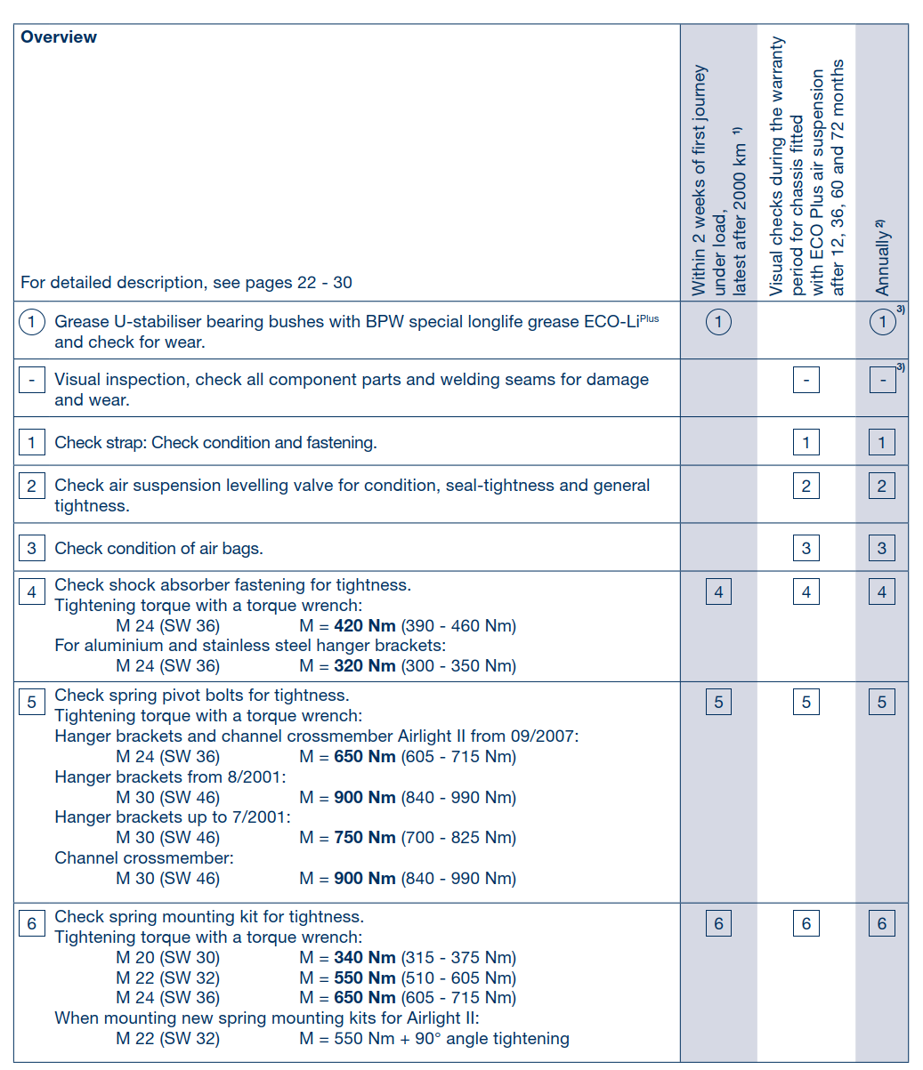
Sample taken from BPW Air suspension, series EA

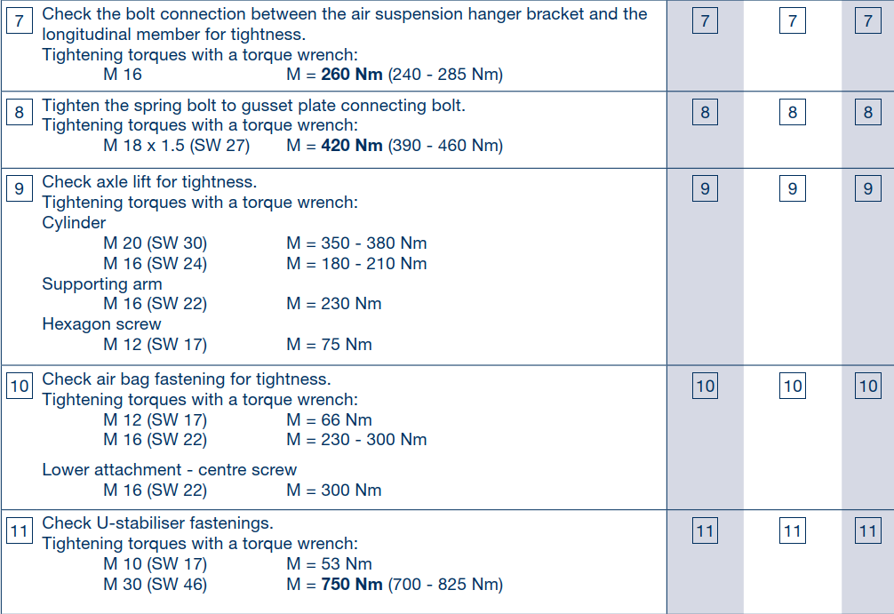

Self-check-1
Instruction 1: Select the best answer
- Technician A says if a vehicle’s ride height is below specifications, a wheel alignment can still be performed. Technician B says if ride height is too low, the shocks and springs are weak and need to be replaced. Who is correct?
a. Technician A b. Technician B c. Both A and B d. Neither A nor B
- All of the following statements about front suspensions are correct except:
  - Most strut suspensions eliminate the upper control arm and ball joint.
  - The load-carrying ball joint is in the control arm on which the spring sits.
  - The load-carrying ball joint on a MacPherson strut suspension is the lower joint.
  - The no-load-carrying ball joint is called a following ball joint.
- The suspension system performs all of the following functions EXCEPT:
  - Supporting the weight of the chassis and drivetrain,
  - Monitoring the tread wear of each tire.
  - Holding the wheels and tires in the proper orientation.
  - Absorbing the large road forces generated while driving on non-perfect roads.
- What is used to load the leaves in a spring pack under tension to provide its self-dampening properties?
a. spring clips b. U-bolts c. center bolt d. spring pins
- In an air suspension, what happens to the air in the air bags when a height control valve lever is raised upward off horizontal?
a. The air is exhausted. b. The bag is further inflated.
c. The suspension air circuit is dumped. d. The chassis system pressure is reduced.

Instruction 2: Give Short answer
- What are purpose of suspension system?
- Discuss about the classification of suspension system?
- Safety rules in mind when operating impact wrenches:
- What are the general categories of suspension systems?
- Discuss the following terms: Jounce, Rebound, Unsprung weight and Oscillation

Unit Two: Conduct inspection and analysis of suspension systems

This unit is developed to provide you the necessary information regarding the following content coverage and topics:
- Basic inspection procedures
- Inspection of suspension system
This guide will also assist you to attain the learning outcomes stated in the cover page. Specifically, upon completion of this learning guide, you will be able to:
- Identify basic inspection procedures
- Inspect suspension system

Basic inspection procedures
Inspection of the suspension system includes looking at the tires and the steering system. This is because problems with the suspension system may show up as tire-wear issues and because there is some sharing of parts between the steering and suspension systems.
In every aspect of automotive service and repair, you first should verify the customer’s complaint. Once you have done that, your next step is determining the cause of a concern. The best way to begin your diagnosis is to perform a thorough inspection. Before any repairs are made to the suspension system, a complete inspection of the system must be performed. One of the best ways to locate possible concerns is by performing a visual inspection.
- Visual Inspection. A technician who performs a good visual inspection can often discover many items that need attention. Use a logical and systematic approach to visual inspections rather than randomly looking at components that may or may not have anything to do with the situation at hand. Begin your inspection by looking over the entire vehicle, and consider the following:
      - Does the vehicle appear to lean?
      - How do the tires look? Do you see any wear pattern that may be caused by the suspension system?
      - Based on your knowledge of tires and the suspension system, what type of problem or component may relate to the concern?
- Ride Height. As springs age and weaken, vehicle ride height decreases. Broken springs, will cause a very quick and very noticeable drop in height, but the owner may not notice the gradual drop over years of service. Once the vehicle ride height falls below a certain spot, it may be impossible to bring the wheel alignment back into specification. Additionally, as the springs weaken and sag, their ability to handle the vehicle’s weight and the constant jounce and rebound actions that occur while driving are reduced.
A weak spring will be more likely to allow bottoming out of the suspension, resulting in a much harsher ride. Vehicle ride height can be checked in several different places depending on what the manufacturer specifies. One common way to check ride height, measures the height from the ground to the bottom edge of the body. Another common method is to measure from the top of the wheel opening to the ground. Ride height measurements should usually be close to equal from front to rear and side-to-side. Always refer to the manufacturer’s measurements, procedures, and specifications as some vehicles specify different ride heights at the front and rear.
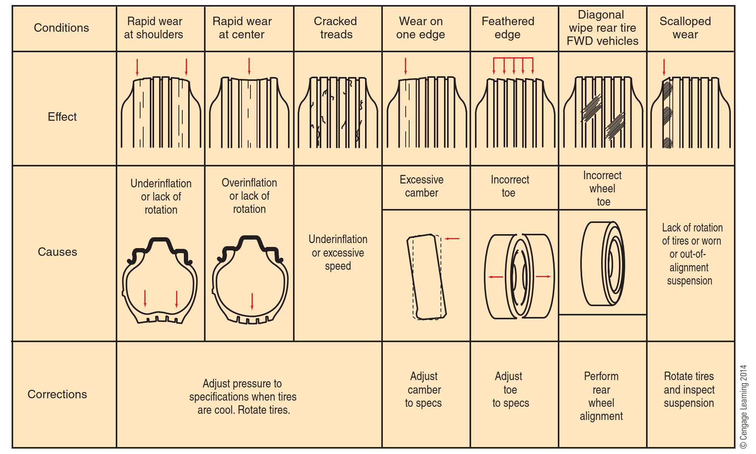
- Reading Tire Wear. A very important skill for any-one who is doing suspension, steering, and alignment repairs is the ability to read tire tread wear. The wear on a tire can provide a lot of information about the vehicle’s condition and how well it is maintained. Figure 2-1 shows common tire wear conditions and their causes. Being able to determine what factors are causing tire wear will help you to accurately diagnose suspension and steering problems.
Figure 2:1: This chart shows examples of tire wear and the common causes.
- Noises. Noises can be a challenge for even the most experienced technician, but if you have a thorough under-standing of the vehicle, its systems, and its components, you will be much more likely to be able to quickly determine the causes of most noises.
Noises can be caused by worn suspension components, such as loose ball joints and strut bearing plates. A test drive is usually needed to pinpoint a noise. Try to determine under what conditions the noise occurs, such as over bumps, when turning, or when accelerating or decelerating. You may need to perform the test drive with the customer so that you know exactly what the customer’s complaint is. If the customer is not available, perform a test drive with another technician so both of you can listen and discuss what could be the cause.
- Test Driving. A test drive is often necessary when a technician is trying to determine the cause of a noise or vibration. Even though as a student you are not likely to perform test drives, it is an expected and necessary part of being a professional technician. As a student, you may be able to drive the vehicle around the lab or parking lot enough to confirm the customer’s complaint. Test drives can be extremely important to diagnosing many concerns, especially noises and vehicle handling com-plaints. Once the problem is diagnosed and repaired, the test drive confirms that the repair is complete, and the vehicle is ready to be returned to the customer.
- Body Lean or Sway. While you are test driving the vehicle, pay attention to how the car body reacts while cornering. Excessive lean or sway is caused by broken sway bar links. If the sway bar links are broken, the body will pitch or roll much more than normal when turning a corner.
- Service History and TSBs. You should also per-form a search of the vehicle’s service history and for any relevant technical service bulletins (TSBs). If the vehicle is regularly serviced by your shop, there should be a service history available. Look through previous repair orders to check for prior repairs to the suspension or steering systems. This is called checking the vehicle’s service history, which is often an important source of information about the vehicle. Also, check the service information for any TSBs related to the suspension or steering systems, especially if you are attempting to diagnose a noise complaint. The few minutes it takes to check these items could save you hours of work by identifying a known problem for you.

Inspection of suspension system

Leaf spring suspensions inspection

The troubleshooting chart in Table 2–2 covers many of the most frequent causes of problems that might occur in a leaf spring suspension system. However, different symptoms can produce similar complaints relating to axle and wheel alignment problems, so be careful about jumping to conclusions.

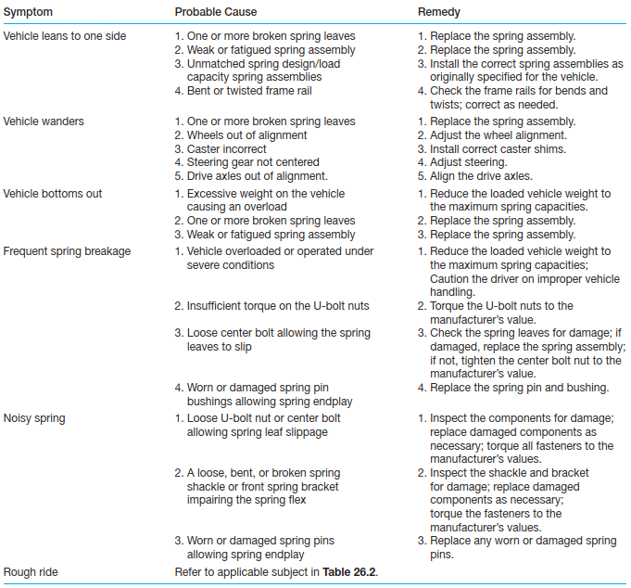
Equalizing Beam Inspection
Figure 2:2: Leaf Spring Suspension Troubleshooting Guide
Inspect rubber bushing for damage or deterioration and plan to replace them if they show any indication of fatigue.
Equalizing beam bushings can be replaced using special service tools, and it is recommended that you use them. There are also many service facilities that specialize in the replacement of suspension system components. The bushings can be removed with standard shop tools, but it can be a tough job. If a portable press is available, this can be used in conjunction with steel pipe sections with diameters equivalent to the bushing sleeves as drivers for both removal and installation.

Air Suspension Inspection
Air ride suspensions should be checked daily and incorporated into the driver pre-trip inspection and PM schedules. The truck or trailer should be observed to be level and riding at the correct height in both a loaded and unloaded condition. Any broken or loose components should be noted and repaired immediately.
Monthly or B schedule service should include inspections of clearance around the air springs, tire shock absorbers, and other moving parts in the suspension system. When air spring bellows make contact with other chassis components, the problem almost never originates in the air spring assembly. Quarterly or on C schedule service, all welds should be visually inspected, and the frame attachment joints and fasteners, cross-members, and pivot connections inspected for wear, cracks, and corrosion. U-bolt lock nuts should be re-torqued every 100,000 miles. Air springs should last a very long time, as long as they are not rubbed, scuffed, or twisted (improper installation or suspension misalignment), and they are easily punctured by contact with sharp objects.
Even a plastic airline or plastic tie will eventually puncture the air spring if left unchecked. If an air spring does fail, the chassis weight settles onto the pedestal’s jounce blocks (if equipped), which have almost no ability to buffer road forces when used in this way. In this situation, the driver should be instructed to proceed with caution to the closest service facility.

Shock Absorber Inspection
OEMs suggest checking shock absorbers at intervals of 12,000 miles (20,000 km). To check shock absorbers on a truck, you can use the following sequence:
      - To check for noise, make sure that it is not coming from some other part of the vehicle. Then check shock absorber brackets and mounting stud nuts to ensure that they are tight and that the shock absorber is not striking or rubbing on the frame or some other part of the chassis.
      - If a truck has just been operated on the high-way (a short test drive is sufficient), shock absorbers can be checked using an infrared temperature gun or by manual contact. The shock absorber cylinder should feel warmer than the frame to which it is attached.
      - Check the rubber mounting bushings and replace if worn.
      - Disconnect the bottom mount and work the shock absorber by hand to check that the outer tube is not contacting or rubbing against the fluid reservoir tube.
      - When the shock absorber is disconnected, check the piston movement by pulling and pushing the absorber down and up slowly. Through its travel stroke, making sure that the piston does not bind in the pressure tube. Typically, there should be considerable resistance when extending the absorber but only slight resistance when collapsing it. Also note the rate of effort for distance of travel. This rate should not vary.
      - If it is determined that the shock absorber is defective, replace it. Shock absorbers should also be inspected when vehicle is experiencing:
- Frequent lightbulb replacements
- Excessive kingpin wear
- Premature tire wear
- Air spring damage

Spring and Bracket Bushings Inspection
Replace the spring bushings if gouged, cracked, or otherwise damaged. If the bushings are not damaged, inspect them for wear. Using a telescoping gauge and micrometer, check the inside diameter of each bushing. As a rule, the inside diameter of any bushing should not exceed the diameter of its pin by more than 0.020 inch. Replace any bushing that exceeds this limit.

Rough Ride inspection
There are two ways of describing rough ride conditions: harmonic and erratic.
Harmonic ride problems are those that occur rhythmically, for instance, a once-per-revolution energy input from such things as bent or imbalanced wheels. The rhythmic vibration that results continues as long as the critical road speed is maintained. Harmonic ride problems are more likely to be noticed on smooth roads. The sources of harmonic ride problems are typically wheels, rims, and brake drums or hubs.
Erratic ride problems are those in which the suspension transfers, rather than absorbs, momentary energy inputs produced when the tires hit bumps or holes in the road. Wavy asphalt, or a series of bumps, might cause repetition of the harsh, jarring motion in the cab, but the motion ceases after the tires pass over the bumps. Harsh ride problems tend to occur on rough roads. This section contains general information on correcting rough ride problems and is not intended to replace OEM service literature.

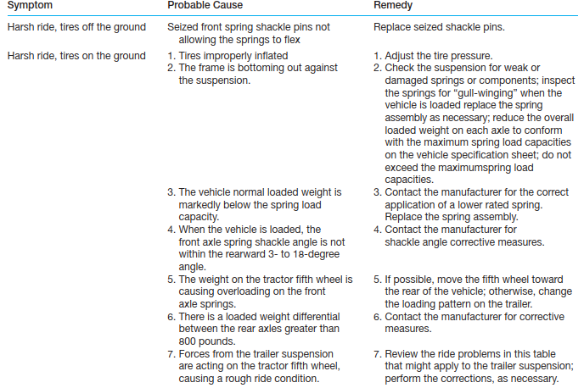
Figure 2:3 Rough Ride Inspection

LAP Test

Practical Demonstration

Name: __________________________ Date: ____________
Time started: ____________________ Time finished: _______________

Instruction I: Perform the following tasks
Task 1: Inspecting Leaf spring suspensions
Task 2: Inspecting Equalizing Beam
Task 3: Inspecting Air suspension
Task 4: Inspecting Shock Absorber
Task 5: Inspecting Spring and Bracket Bushings Shock Absorber

Unit Three: Servicing Suspension System Components

This learning guide is developed to provide you the necessary information regarding the following content coverage and topics:
  - Servicing Leaf Spring
  - Servicing Shock Absorber
  - Servicing Equalizing Beams
  - Servicing Air Suspensions
This guide will also assist you to attain the learning outcomes stated in the cover page. Specifically, upon completion of this learning guide, you will be able to:
  - Service Leaf Spring
  - Service Shock Absorber
  - Service Equalizing Beams
  - Service Air Suspensions

Leaf Spring Servicing
Leaf spring suspensions tend to be low maintenance over the lifetime of the vehicle. The U-bolts should be tightened on a PM Service along with lubricating pin bushings and visually inspecting the spring clearance. On new trucks and trailers, it is good practice to re-torque U-bolt nuts after the first month or 1,000 miles of operation.
Thereafter, tightening of U-bolts should be built into a PM schedule C type service occurring typically between 35,000 and 50,000 line haul miles, or every 6 months, depending on the application. If the vehicle is operated in an environment with a lot of corrosion re-torqueing cannot be accurately per-formed. In this case, tap the U-bolt with a hammer and look for any signs of movement. This should give you a good indication if it has lost its tension.
If spring pins fail to take grease, the first thing you should do is jack up the frame removing the weight from the spring and try again. If this does not work, try using a hand grease gun with the weight off the spring. A hand grease gun develops more pressure than an air-actuated grease gun. If this fails, you can try heat using a rosebud (make sure the bracket/shackle is not made out of aluminum alloy). But when you spend extra time properly lubing a spring pin, remind yourself that without grease, the pin/bushing will fail if not lubricated. It is only a question of when the failure will occur.
Inspect spring ends to ensure that they have not shifted and come into contact with the sides of equalizer or hanger brackets. Inspect spring hangers for cracks. Spring end contact indicates that the spring assemblies are not seated on the axle housing or there is a need for suspension alignment. Check U-bolt seats, U-bolts, and spring assembled for integrity.

Leaf Spring Replacement
The exact replacement procedures will differ somewhat for each type of leaf spring assembly, but the basics remain similar. The following is a general outline of spring pack replacement.
  - Remove the Spring Pack
      - Chock the tires, place a floor jack under the truck frame, and raise the truck sufficiently to relieve the weight from the spring to be removed. Then place safety stands under the frame.
      - Remove shock absorbers where used.
- Remove U-bolts, spring bumper, and retainer or U-bolt seat.
- Remove the lubricators or zerk fittings (not used on springs equipped with rubber bushings).
- Remove the nuts from the spring shackle pins or bracket pins.
- Slide the spring off the bracket pin and shackle pin and remove from chassis.
  - Install a Spring Pack
Although the actual installation procedures will vary with each spring type, the pivot end of the spring is usually fastened to the frame bracket first. The shackle or slipper end then can be fastened by aligning it to the other frame bracket. When installing the U-bolts or spring clips to secure the axles, do not final torque until the springs have been placed under normal load. This requires lowering the chassis weight onto the spring.
  - Maintenance
U-bolts that loosen in service place undue strain on the spring center bolt. OEMs state that center bolts should be re-torqued at specified intervals but this is seldom done. If you are torqueing center bolts on a spring not clamped by U-bolts, remember that they are under considerable tension should the center bolt fail.
Loose spring clips or U-bolts can result in axle misalignment, which adversely affects tire wear. When torqueing U-bolt nuts, follow the recommended tightening sequence after lubricating the U-bolt threads with a little lubricant. The lubricant helps ensure the specified clamping pressure of the spring pack.
To correctly torque U-bolt nuts, first tighten all the nuts until they are snug. Next, tighten the nuts until approximately one-third of the recommended torque is achieved. Repeat tightening of the nuts, using the same sequence and gradually increasing the torque through a second, third, and fourth stage, until the recommended final torque is attained.

Shock Absorber Servicing

Replacing a shock absorber
The task of replacing a shock absorber is straight-forward and one that a new technician should be able to accomplish as follows:
- Remove the nuts from the top and bottom bolts/studs from the eyes of the shock absorber.
- Remove the shock absorber from the vehicle.
- Insert new rubber bushing into the eyes of the new shock absorber.
- Install the top bolt/stud through the top mounting bracket on the frame rail.
- Place a flat washer over the bolt and thread the bolt into the upper rubber bushings of the new shock absorber.
- Place a second flat washer over the bolt and then turn the nut finger tight.
- Extend the lower part of the shock absorber until the mounting holes line up in the lower brackets and shock absorber eye.
- Install the bottom bolt/stud through the lower mounting bracket on the axle.
- Place a flat washer over the bolt and thread the bolt into the lower rubber bushing of the new shock absorber.
- Place a second flat washer over the bolt and turn the nut finger tight.
- Check to make sure that the rubber bushings are seated properly and tighten the nuts to the specified torque.

Equalizing Beams Servicing
Power wash the suspension and inspect the components for cracks or damage. Inspect rubber bushings for damage or deterioration and plan to replace them if they show any indications of fatigue.

Equalizing Beam Bushings
Special service tools facilitate replacement of equalizing beam bushings. It is recommended that you use them if available. The bushings can be removed with standard shop tools but it can be a tough job. If a portable press is available, this can be used in conjunction with steel pipe sections with diameters equivalent to the bushing sleeves as drivers for both removal and installation.

Equalizing Beam Overhaul
Make a thorough inspection before you start disassembling the suspension to ensure that you have replacement parts in place before undertaking the work.
The following procedure describes a general approach to reconditioning an equalizing beam suspension.
- Preparation for Overhaul
- Block the wheels on both axles of the truck.
- Remove the drive axle shafts from both rear axles.
- Remove the four saddle caps that lock the center bushing of the equalizer beams to the saddle assemblies.
- Disconnect the torque rods from the axle housing by loosening the locknuts and driving the shaft from the bushing and axle housing bracket.
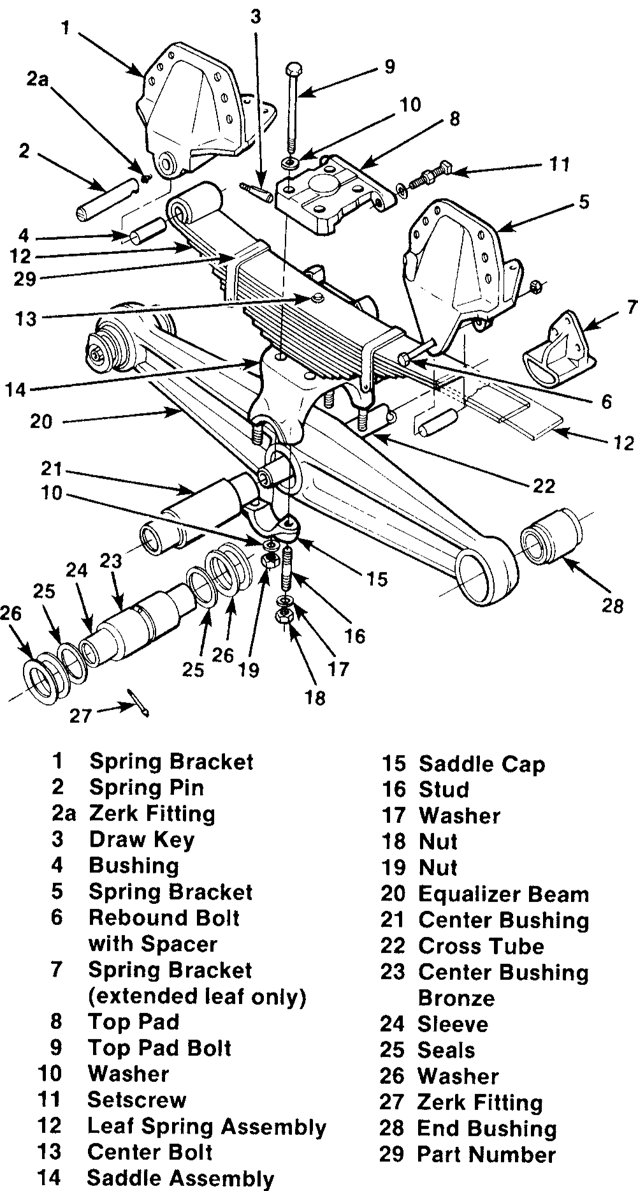
- Using an overhead hoist (A-frame works best), raise the truck frame sufficiently so that the lower part of the saddle clears the top of the axle housings. Support the frame securely. Block the axles to prevent them from pivoting on the wheels.
- Roll axles, with the beams attached, out from under the truck.
- Overhaul Procedure
The replacement procedure outlined here primarily references bolt-type beam ends.
- Disconnect the equalizer beam from the axle housing
- Separate the equalizer beams from the cross tube.
- After both equalizer beams have been separated from the axles, separate the beams from the cross tube by pulling them apart by hand.
- Remove the saddle assemblies, springs, or cushions. Reference the leaf spring-type equalizer beam.
Figure 3:1: Leaf spring-type, equalizer beam suspension
- Support the spring and saddle assembly on a floor jack and safety stand. Loosen the spring-aligning setscrew. Remove the spring top pad saddle bolts and nuts. Remove the top pad. Lower the floor jack and remove the saddle.
- Remove the spring assembly by repositioning the floor jack under the spring. Loosen the locknut on the spring pin draw key
- Back off the nut sufficiently to protect the draw key threads and then strike the nut with a soft hammer to loosen the draw key. Remove the draw key and drive the spring pin out of the spring and spring bracket. Lower the spring assembly from the frame and remove it from the jack.

Air Suspensions Servicing
Air suspension systems tend to require a little more attention in inspection and preventive maintenance schedules than mechanical suspensions. Some of the commonly required service procedures are outlined in this section, including repairs and height control valve adjustment.

Ride Height Control Servicing
- Checking a Ride Height Control Valve
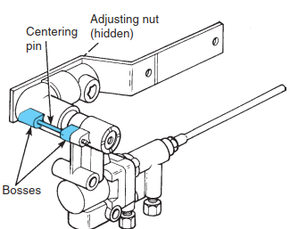
Ride height control valves (also known as leveling valves) are too often improperly diagnosed as defective and unnecessarily replaced. A simple diagnostic routine can determine whether the valve is defective or whether proper adjustment has not been performed.
- Ride Height Adjustment
Some versions of height control valves have a centering pin and bosses. The pin is positioned in the bosses after setting the height.
To adjust the height control valve, do the following:
- Remove the plastic center pin from the bosses
- Ensure that at least 100 psi (690 kPa) air pressure is indicated on the dash air pressure gauges of the truck.
Figure 3:2: Ride Height control valve Adjustment
- Disconnect the vertical link from the height control valve lever.
- The height adjustment is checked at the rearmost axle. Place a straightedge on the centerline of the top metal plate on the air springs, do not position the straightedge on the frame rails.
- Measure the distance from the bottom edge of the straightedge to the top edge of the transverse cross-member. Reference the OEM service literature for the correct specification distance.
- If the distance is less than specified, raise the valve control lever and hold it up until the distance is correct. Release the lever. Loosen the lever adjusting nut, which is located 17/8 inch (4.75 cm) from the lever pivot point, so that the steel portion of the lever moves but the plastic portion does not. Position the lever so that the link-to-lever bolt can be inserted through the lever and link.
- If the distance is more than specified, lower the valve lever and hold it down until the distance is correct. Release the lever. Loosen the lever adjusting nut. Position the lever and link so that the lever bolt can be inserted through the lever and link.
- Install the lever link bolt nut. Tighten the nut 115 to 130 inch-pounds (13 to 15 Nm).
- Center the plastic portion of the valve lever and insert the alignment pin through the boss on the valve body and plastic arm.
- Tighten the lever adjusting nut to lock the steel and plastic portions of the lever together; then tighten to specification.
- Remove the centering pin (if equipped) and discard.

Replacing a Height Control Valve
Make sure that you use the procedure outlined previously in this chapter to performance check the height control valve before replacing it. One OEM reports that 50 percent of height control valves submitted for warranty function to specification. The following procedure to replace a defective leveling valve:
        - Exhaust air pressure from the truck chassis air system. Then disconnect the air lines from the height control valve.
        - Remove the height control valve threaded extension link from the valve and axle by removing the fasteners.
        - Remove the mounting fasteners that connect the height control valve to the truck frame.
        - Disconnect the brass air fittings from the height control leveling valve and install them in the replacement valve.
        - Secure the new height control valve to the truck frame, torqueing the fasteners to specification. Reattach the airlines to the valve, making sure that each connects to the correct port.
        - Install the threaded extension rod to the height control valve using the appropriate fasteners.
        - Build up chassis system air pressure to cut out and then adjust the height control valve for ride height using the method described earlier.

Air Spring Replacement
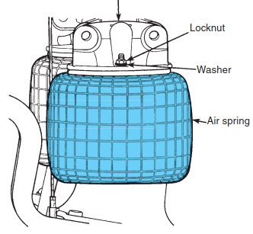
The procedure for replacing air springs differs slightly depending on whether the bag is of the convoluted type or reversible bellows type. The description provided here references the more common reversible bellows-type air spring,
  - Chock the wheels and exhaust the air pressure from the air spring
  - Raise the truck frame to remove the load from the suspension. Support the frame with safety stands.
  - Remove the locknuts and washers that connect the air spring to the air spring mounting bracket
  - Remove the airlines connected to the air spring.
  - Remove the brass air fittings from the air spring.
Figure 3:3: Reversible sleeve air spring upper
  - Remove the locknuts and washers that connect the air spring to the frame hanger and then those that attach the pedestal to the saddle. Remove the air spring from its upper and lower mountings.
  - Install the replacement air spring to the frame hanger by inserting the studs on the air spring into the appropriate holes on the hanger bracket.
  - Slide the air spring pedestal onto the spring mounting saddle. You can inflate the bag using shop air to extend the spring if required.
  - Install the locknuts and washers to secure the air spring to the bracket. If the pedestal is aluminum and uses bolt fasteners, lightly paste some Aluminastic™ compound or equivalent on the threads to prevent reaction. Tighten and torque the locknuts.
  - Install the washers and locknuts to secure the air spring to the frame hanger. Tighten and torque the locknuts
  - Install the brass air fitting to the air spring using a thread sealant.
  - Install the airlines to the brass fitting.
  - Supply air pressure to the air spring. Adjust the height of the truck or trailer to specification

Air Circuit Maintenance
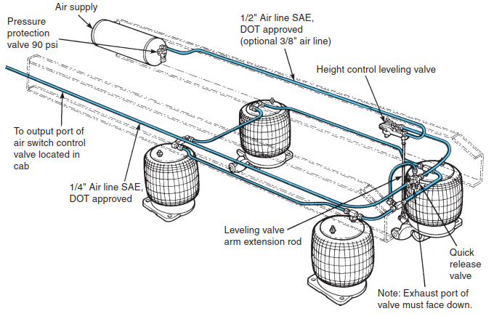
Air lines route air pressure to and from the air springs, height control valve, and pressure protection/regulator valve. They should be routinely inspected and repaired when chaffed or leaking.
Figure 3:4: Air plumbing installation for an air suspension system

LAP Test

Practical Demonstration

Name: __________________________ Date: ____________
Time started: ____________________ Time finished: _______________
Instruction I: Perform the following tasks
Task 1: Servicing Leaf spring
Task 2: Servicing Equalizing beam
Task 3: Servicing Air suspension
Task 4: Servicing Shock Absorber

Unit Four: Preparing vehicle to use and Documentation
This learning guide is developed to provide you the necessary information regarding the following content coverage and topics:
  - Performing Post repair inspection and functionality check
  - Completing Service Schedule Documentation
  - Processing Job card
  - Maintaining Order in the Workshop
  - Utilizing Service report
This guide will also assist you to attain the learning outcomes stated in the cover page. Specifically, upon completion of this learning guide, you will be able to:
  - Post repair inspection and functionality check
  - Service Schedule Documentation
  - Process Job card
  - Maintain Order in the Workshop
  - Utilize Service report

Post repair inspection and functionality check
A post-repair inspection is an evaluation of a vehicle by a qualified engineer after servicing, this is to make sure the vehicle has been restored to an acceptable condition and that the manufacturer guidelines were followed by the repairer.
Post-repair inspections are carried out either because the vehicle owner wants to seek financial compensation for diminished value, the owner wants to make sure their vehicle has been repaired properly and is safe to drive or an insurance company wants to confirm the vehicle is in an adequate state to reinsure it.
Customers may have concerns or complaints regarding the repair work that has been carried out to their vehicle. Our post repair inspections are designed to make sure that the garage, company or engineer that repaired your vehicle has completed the repair properly and to the correct standards.
Inspection of the garage, company and engineers handling the vehicle, this can be post repair or whilst the repair is ongoing. By visiting the site, experts are able to gather as much information as possible and come to a professional conclusion on the quality of repair. A post repair inspection / audit can be designed to meet the needs of the auditing party.
A standard audit package would include:-
- Initial checks - car park/reception/customer facilities;
- Workshop check - organization/safety/cleanliness/facilities;
- Equipment check - use of equipment and sight of maintenance/calibration certificates for equipment etc.
- Cold case reviews - checks of invoices for any recently completed cases and parts purchases invoices;
- Review of ongoing repair cases for auditing customer at that repairer to ensure authority provided by the engineer is accurate/correct and agreed works are being completed properly with correct repair methods;
- Highlight and deal with any issues that can be dealt with whilst on site.

Processing Job card
When a vehicle owner enters the service center, he or she is attended by the supervising engineer. The customer informs about the vehicle defect. After getting feedback from the vehicle owner or driver regarding defects of the vehicle, the supervising engineer in a service station or workshop inspects it.
The defects pointed out or listed are noted down in a standard format, which is called the job card or work order. In order to indicate his satisfaction with the diagnosis made by the supervising engineer, the customer of the vehicle signs the job card before the repairs on the vehicle are started. Work is then assigned to the concerned person to carry out repairs and the supervisor signs the job card too. The work order or job card is prepared in duplicate.
    - Contents of a Standard Job Card
- Job card number
- Name, address and phone number of the service center
- Name, address and phone number of the customer
- Details of vehicle, such as make, model, registration number, chassis number, engine number, date of sale, kilometers’ reading, receiving date and time, delivery date and time by the service center
- Checklist before trial
- Customer’s observation
- Job to be done
- Estimated cost in rupees for the customer and insurance company
- Labor required
- Name of the mechanic
- Name and signature of the supervisor
- Customer’s authorization for repair and their signature
- Acknowledgement
    - Filling the Job Card
Almost all the information must be properly filled in the job card by the supervisor with their signature and the customer also needs to sign on the authorization for work column. Then the repairing or servicing job on the vehicle is taken over.

Maintaining Order in the Workshop
- Keeping the workplace clean is the principle that determines the order and continuity of the workshop. You should not only pay attention to cleaning surfaces (floors and equipment), but also, most importantly, cleaning tools to optimize their operation and increase their service life. Both operations must be performed daily to avoid the accumulation of dirt, dust, grease or chips.
- To organize the workflow, it is important to choose a location for each tool. The organization mode should be reasonable, functional and should adapt to the daily work in the workshop.
- Storage locations should be optimized and convenient, but should not carry the risk of running out of space, as this can lead to confusion. In addition, storage areas in passage areas should be avoided to avoid collisions among workers.
- After each operation in the workshop, it is necessary to clean and collect all the tools and materials. If they cannot be moved, it is important to have space for storing these elements (cages or boxes) in order to avoid alterations or damage, and thus contribute to order in the workshop.
- Keeping tools and equipment in working order prevents errors in work and confusion that lead to a halt in the production process.
- For this reason, it is very important to carry out maintenance, preventive and corrective measures with equipment in accordance with the recommendations of the manufacturer and do not forget that, if necessary, such operations should be carried out by specialized, certified personnel.
- In connection with the previous paragraph, a technical inspection and a report to the manager on malfunction or damage to tools.
- For safety reasons, it is important to keep the staircases and passageways always clean, free of obstructions and properly marked. In addition, it is impossible to block or impede access to fire extinguishers, emergency exits, hydrants and other elements related to worker safety.
- The use of a tool trolley is very useful for the technical workshop, as it makes it easy to carry hand tools, its use prevents tools from being scattered around the workshop and being lost. Likewise, carts must have a permanent place.
- It is very important that workshops have fireproof containers that are closed and sealed, where it is possible to dispose of hazardous waste, toxic, flammable and inert, as well as rags, paper or containers contaminated with oils, greases or any other chemical substances, always separating debris depending on it. Containers should never be left open to avoid the risk of leakage and also to avoid unpleasant odors.
- Sometimes manufacturers of workshop tools and equipment advise storage regimes and rules. Everyone must follow the instructions of the experts to ensure the long life of each tool. For this reason, it is necessary to have the operating instructions or safety data sheets of machines and tools in an accessible place.
- As a final recommendation, it is very important to educate shop workers on the rules and the need to maintain the cleanliness and order of their workplace and rest area, as well as personal hygiene with regard to work clothes and safety elements.

Service Schedule Documentation
Scheduled maintenance is any task that is given a deadline and assigned to a technician. It can either be a recurring task done at regular intervals or a one-time task. Scheduled maintenance includes inspections, adjustments, regular service, and planned shutdowns.
An example of scheduled maintenance occurring at repeating intervals is changing a bearing on a conveyor belt every 30 days or inspecting the condition of a motor every 90 days. Scheduled maintenance can also take the form of a one-time work order. If a problem with an asset or part is identified, a time is scheduled to check and repair the asset.
The primary goals of scheduled maintenance are to reduce reactive maintenance, equipment failure, and maintenance backlog. Standard checks help increase the lifetime of assets and reduce the number of equipment repairs and replacements. Scheduling tasks also allows you to better allocate resources in a cost-effective and efficient manner.
Scheduled maintenance is the act of deciding when planned maintenance tasks should be completed and who should complete them. While planned maintenance establishes a process, scheduled maintenance is part of that process. When an issue or task is identified, it can be given a deadline for completion and assigned to a technician. This is when it becomes scheduled maintenance. There are six basic steps to creating a maintenance schedule:
- Identify and prioritize the assets that need maintenance
- Collect historical work order data for each repair work
- Use that data, along with recommendations from the original manufacturer, to make projections about asset maintenance needs
- Create a preventive maintenance plan for each repair work
- Evaluate the progress of your scheduled maintenance plan and adjust where needed
- Expand your scheduled maintenance program to other maintenance areas
Here, you have all the documents that explain how to look after your repair work, including:
- Original equipment manufacturer (OEM) manuals
- Checklists for inspections
- Step-by-step instructions
- Standard operating procedures (SOPs)
- General policies and procedures
- Preventive maintenance schedules
- Because safety is so important, it can be its own subcategory, and include:
- Safety-specific policies and procedures
- Lock out/tag out policies
- Workplace Hazardous Materials Information System
- OHS documents

Service report
A Service/maintenance report is a document that contains specific information about your past maintenance actions and their effect on cost, assets, and business performance. For any report to be useful, it has to be:
- Concise: the report should be brief but comprehensive; presented in a way that makes complex data easy to digest.
- Fact-based: accurate; up-to-date; objective, based on hard data rather than opinions and speculations.
- Reviewed in the proper context: was downtime prolonged because a supplier delayed the shipment of an important spare part or because we didn’t order it in time – context is crucial for decision making.

Points include in a servicing report
This depends entirely on what you are making the report for. It is impossible to give a unified template. In general, an official maintenance report might include:
- Information about the organization (name, logo, address, contact information)
- Name/type of the report
- Timeframe for which the report was generated
- Report details (the main part of the report that outlines all of the data)
- Any additional information that might be useful (considered on a case-to-case basis)

The most common types of servicing reports
With the right data, maintenance and facility managers can generate dozens of useful maintenance reports. Here’s a list of the most common ones:
- Breakdown of total maintenance costs: can include parts cost, labor cost, vendor cost, and more.
- Preventive maintenance report: includes an overview of preventive maintenance activities and maintenance schedules. It can be broken down by location, equipment type, vendor, etc.
- Work order report: an overview of work order management activities – received maintenance tickets and created, open, closed, and deferred WOs.
- Asset history report: it can include the list of purchase orders, PMs, WOs, spare parts, and other resources spent on a specific asset or group of assets.
- Purchase order report: list of created, sent, scheduled, received, and closed purchase orders; can be broken down by vendor, facility, priority, order type, order status, and more.
- Vendor history report: an overview of the work performed by a maintenance vendor and associated costs.
- Labor summary report: it can include things like total hours spent, overtime hours, hours spent on reactive vs proactive work, individual performances, and more.
- Performance report: numerous reports can be number of planned vs unplanned tasks, number of breakdowns, downtime duration.

Self-check-2
Instruction 1: Answer the following questions
- List the standard audit package
- What the steps of creating a maintenance schedule?
- What the documents that explain how to look after your repair work?
- Describe about the contents of a Standard Job Card?

Reference

- M.J. Nunney, Light and Heavy Vehicle Technology Fourth edition
- Sean Bennett and Ian Andrew Normann. Heavy Duty Truck Systems , Fifth Edition
- Robert Huzij, Angelo Spano, and Sean Bennett, Modern Diesel Technology: Heavy Equipment Systems2nd Edition
- Sean Bennett, Medium/Heavy Duty Truck Engines, Fuel & Computerized Management Systems 4th Edition
- James D. Haldeman, Automotive technology Principles, Diagnosis, and Service fourth edition
- Ben Watson, Modern Diesel Technology: Mobile Equipment Hydraulics: A Systems And Troubleshooting Approach
- M.J. Nunney, Light and Heavy Vehicle Technology, Fourth edition
- John Dixon, Modern Diesel Technology: Preventive Maintenance And Inspection
- Joseph A. Bell, Modern Diesel Technology Electricity & Electronics, 2nd Edition

Participants of this Module (Training Material) preparation

No | Name | Qualification | Field of Study | Organization/ Institution | Mobile number | E-mail
 | Adinet Asnake | MSc. | Automotive Technology Mgt | Wolkite PTC | 0913-767250 | andinetasnake31@gmail.com
 | Biruk Tilahun | BSc. | Automotive Technology | General Wingate PTC | 0913-789176 | biruktilahun1@gmail.com
 | Fadli Aman | BSc. | Automotive Technology | General Wingate PTC | 0927-283100 | Fadli.ziyad@gmail.com
 | Hana Nigusise | BSc. | Automotive Technology | Selam TVET college | 0988-751516 | Hana.nigussie25@gmail.com
 | Israel Taye | BSc. | Automotive Technology | General Wingate PTC | 0913-424100 | Isra.taye@gmail.com
 | Tatek Mamo | PhD scholar | Automotive Technology | DEC | 0911-841121 | mimibaba928@gmail.com
 | Zelalem Yitbarek | BSc. | Automotive Technology | Selam TVET college | 0972-030621 | Zolosmart12@gmail.com

