ACCOUNTING AND FINANCE
LEVEL - III
Based on March, 2022curriculum V - I

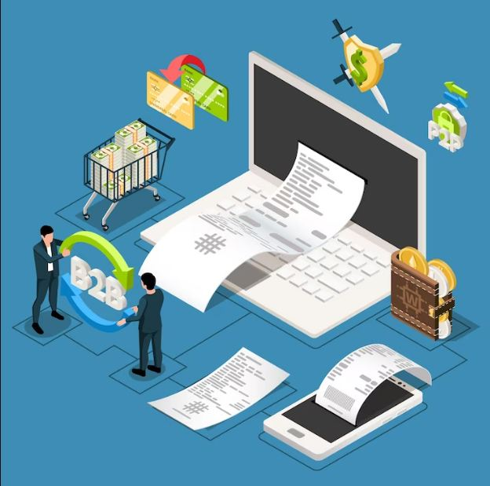
Module Title: - Processing Payment documentation
Module code: LSA ACF3 M080322
Nominal duration: 70 Hours
PREPARED BY: A.A TVT BUREAU

September, 2023
Addis Ababa, ETHIOPIA
Table of Contents
Acknowledgment 4
Introduction to the Module 5
Acronyms 7
Unit One. Entering data into systems 8
1.1.Enterig data in to system without error 9
1.1.1.Characteristics of Data Quality 9
1.1.2.Benefit of data 11
1.2 Allocating and updating data 12
1.2.1 Types Data Allocation 12
1.2.2 Data duplication 13
1.2.3 Data updating 14
1.3 Maintaining system control 14
1.3.1 Benefit of system development 16
Self-check 19
Unit Two. Creat payment facility 20
2.1.Processing payment facility 21
2.1.1Characteristics of payment 22
2.1.2Way of payment 22
2.2 Maintaining documentation 24
2.2.1 Type of dcumentation 25
Self-check 29
Unit three. Verify payment against documentation 30
3.1.Confirming authorization for payment 31
3.1.1Importance of payment authorization 31
3.1.2 Steps of payment or Credit Card Authorization 33
3.2. Identify and followup descripancies 37
3.2.1 Evoluation of invoice 38
3.2.2 Function of invoice 39
3.2.3 Type of invoice 40
Operation sheet 42
Self-check 43
Unit Four Effect payment 44
4.1. Making payment within agreed credit 45
4.1.1.Discussing different type of credit 45
4.2. Signing and updating payment instrument 47
4.2.1 Classification of payment instrument 47
4.3. cancelling and noting payment documentation 49
Self-check 51
Unit Five File documentation 52
5.1. Understanding File documenttion 53
5.1.1 Discussing methods and type of filing 53
5.1.2 Process documentation 55
5.2 Accessing and tracing filed documents 56
Self-check 57
Unit six Authorize payment 58
6.1. Authorizing payment 59
6.2. Understandng releasing funds prior to authorization 61
6.3. Payment authorization 62
Self-check 64

Acknowledgment
Addis Ababa TVT bureau wish to extend thanks and appreciation to the many representatives of TVT instructors and respective industry experts who donated their time and expertise to the development of this Teaching, Training and Learning Materials (TTLM).

Introduction of the module
This module covers the knowledge, skills and attitudes required to understand basic knowledge and awareness of process business documentation as they to apply payments for processing and accurately process financial payment documents.
This module covers
- Enter data to system
- Create payment facility
- Verify payments against documentation
- Effect payments
- File documentation
- Authorized payment
Learning objectives of the Module:
At the end of this session, the students will able to:
- Allocate and enter data to system
- Make payment facility
- Establish payments against documentation
- Assess effect of payments
- file documentation
- Authorize Payment
Module Instruction
For effective use this modules trainees are expected to follow the following module

Instructions:
1. Read the information written in each unit
2. Accomplish the Self-checks at the end of each unit
3 .Perform Operation Sheets which were provided at the end of units
4. Read the identified references book for Examples and exercise

Acronym
POS point of sale
CNP Card not present
SaaS Software as a Service
PA Payment authorization
TX Transformation Extender
ATM Automatic Teller machine

UNIT ONE: ENTER DATA TO SYSTEM

This Unit is developed to provide you the necessary information regarding the following content coverage and topics:
  - Entering data into systems without error
  - Allocating and updating data
  - Maintaining System controls
This Unit will also assist you to attain the learning outcomes stated in the cover page. The completion of this learning guide, you will be able to:
  - Enter data into systems without error
  - To allocate and updating data
  - Maintain System controls

  - Entering data into systems without error
Introduction
Data is information that has been translated into a form that is efficient for movement or processing. Relative to today's computers and transmission media, data is information converted into binary digital form. It is acceptable for data to be used as a singular subject or a plural subject.
An organised, machine-readable collection of symbols, to be interpreted as a true account of some enterprise
Data is defined as a collection of individual facts or statistics. (While “datum” is technically the singular form of “data,” it's not commonly used in everyday language.) Data can come in the form of text, observations, figures, images, numbers, graphs, or symbols.
Information is a stimulus that has meaning in some context for its receiver. When information is entered into and stored in a computer, it is generally referred to as data.
- Data is a related group of files
- file is a related group of records
- record is a related group of fields
- field is a specific attribute of interest for the entity (record)
1.1.1 Characteristics of Data Quality
Correctness
Data should be sufficiently accurate for the intended use and should be captured only once, although it may have multiple uses. Data should be captured at the point of activity.
• Data is always captured at the point of activity. Performance data is directly input into Performance Plus (P+) by the service manager or nominated data entry staff.
• Access to P+ for the purpose of data entry is restricted through secure password controls and limited access to appropriate data entry pages. Individual passwords can be changed by the user and which under no circumstances should be used by anyone other than that user.
• Where appropriate, base data, i.e. denominators and numerators, will be input into the system which will then calculate the result. These have been determined in accordance with published guidance or agreed locally. This will eliminate calculation errors at this stage of the process, as well as provide contextual information for the reader.
• Data used for multiple purposes, such as population and number of households, is input once by the system administrator.
Validity
Data should be recorded and used in compliance with relevant requirements, including the correct application of any rules or definitions. This will ensure consistency between periods and with similar organisations, measuring what is intended to be measured.
•Relevant guidance and definitions are provided for all statutory performance indicators. Service Heads are informed of any revisions and amendments within 24 hours of receipt from the relevant government department. Local performance indicators comply with locally agreed guidance and definitions.
Reliability
Data should reflect stable and consistent data collection processes across collection points and over time. Progress toward performance targets should reflect real changes rather than variations in data collection approaches or methods.
•Source data is clearly identified and readily available from manual, automated or other systems and records. Protocols exist where data is provided from a third party, such as Hertfordshire Constabulary and Hertfordshire County Council
Timeliness
Data should be captured as quickly as possible after the event or activity and must be available for the intended use within a reasonable time period. Data must be available quickly and frequently enough to support information needs and to influence service or management decisions.
•Performance data is requested to be available within one calendar month from the end of the previous quarter and is subsequently reported to the respective Policy and Scrutiny Panel on a quarterly basis. As a part of the on-going development of Performance Plus it is intended that performance information will be exported through custom reporting. This will improve access to information and eliminate delays in publishing information through traditional methods.
Relevance
Data captured should be relevant to the purposes for which it is to be used. This will require a periodic review of requirements to reflect changing needs.
We have a duty to collect and report performance information against a wide range of statutory indicators. These are set out in the context of the Government’s White Paper – Strong and Prosperous Communities. Where appropriate each service will identify reliable local performance indicators to manage performance and drive improvement. These are reviewed on an annual basis to ensure relevance.
Completeness
Data requirements should be clearly specified based on the information needs of the organisation and data collection processes matched to these requirements.
•Checks will be made to ensure for completeness of data. An annual assessment of this is undertaken by Internal Audit.
1.1.2 Benefit of data
- Improve operational efficiency
- Customer Acquisition and Retention
- Focused and Targeted Promotions
- Potential Risks Identification
- Improve Supplier Networks
- make informed decisions that can lead
- enhanced business performance
- strong customer relationships
1.2Allocating and updating data
Introduction
Allocation is the process of requesting access to a data established. If you allocate a data set that exists, the system allows you to open the data set. If you allocate a data set that does not exist, the system creates space for it on an available device and allows you to open that space
Data Allocation is an intelligent distribution of your data pieces, (called data fragments) to improve database performance and Data Availability for end-users. It aims to reduce overall costs of transaction processing while also providing accurate data rapidly in your DDBMS systems.
1.2.1 Types Data Allocation
1, Data Fragmentation
2, Data Duplication
Data Fragmentation
Fragmentation is a process of disintegrating relations or tables into several partitions in multiple locations. It divides a database into various sub tables and sub relations so that data can be distributed and stored efficiently. Database Fragmentation can be of two types: horizontal or vertical. In a horizontal fragmentation, each tuple of a relation r is assigned to one or more fragments. In vertical fragmentation, the schema for a relation r is split into numerous smaller schemas with a common candidate key and a special attribute. More details on horizontal and vertical fragmentation will be discussed in the next section.
Methods of Data Fragmentation
In this section of our fragmentation and replication in distributed database guide, we discuss the two fundamental fragmentation strategies: horizontal and vertical. In addition to these, Distributed Database Management Systems also allow the nesting of fragments in a hybrid fashion, called Hybrid Fragmentation. This will be discussed separately in our third fragmentation strategy.
- Horizontal Fragmentation
- Vertical Fragmentation
Horizontal fragmentation
Horizontal fragmentation refers to the process of dividing a table horizontally by assigning each row or (a group of rows) of relation to one or more fragments. These fragments are then be assigned to different sides in the distributed system.
Vertical Fragmentation
Vertical fragmentation refers to the process of decomposing a table vertically by attributes are columns. In this fragmentation, some of the attributes are stored in one system and the rest are stored in other systems. This is because each site may not need all columns of a table.
1.2.2 Data Duplication
Distributed Database Duplication is the process of creating and maintaining multiple copies (redundancy) of data in different sites. The main benefit it brings to the table is that duplication of data ensures faster retrieval. This eliminates single points of failure and data loss issues if one site fails to deliver user requests, and hence provides you and your teams with a fault-tolerant system.
However, Distributed Database Replication also has some disadvantages. To ensure accurate and correct responses to user queries, data must be constantly updated and synchronized at all times. Failure to do so will create inconsistencies in data, which can hamper business goals and decisions for other teams
Problems created by duplicate data.
- Lost Income and Wasted Costs
- Lack of a Single Customer View
- Lack of Personalization
- Ineffective Customer Service
- Inaccurate Reporting
- Lost Productivity
- Harms Brand Perception
- Storage Costs
- Confusion among Customers
- Missed Sales Opportunities
1.2.3 Data updating
Data updating means the functional process of updating information already contained in a data base within the System that results in the creation of a new record and may result in storage of existing data as history. The modification of data that is already in the database is referred to as updating. You can update individual rows, all the rows in a table, or a subset of all rows. Each column can be updated separately; the other columns are not affected.
1.3 Maintaining System controls
Introduction
Any organized assembly of resources and procedures united and regulated by interaction or interdependence to accomplish a set of specific functions. System can be defined as a collection of interrelated components that work together towards a collective goal. A system is a group of interacting or interrelated elements that act according to a set of rules to form a unified whole. A system, surrounded and influenced by its environment, is described by its boundaries, structure and purpose and expressed in its functioning. Systems are the subjects of study of systems theory and other systems sciences.
Benefits of Systems Integration
- Accessibility, Accuracy, and Coordination
- Efficiency and Productivity
- Cost Effectiveness
- Availability of New Performance Insights
- Security
Systems Development
Systems development is the process of defining, designing, testing, and implementing a new software application or program.
The process of creating and maintain systems is called systems development or systems analysis and design.

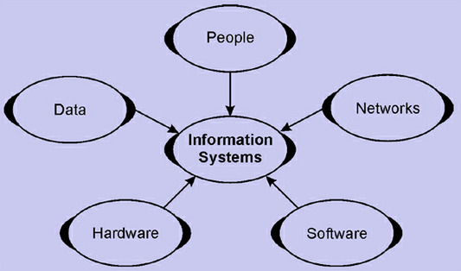
Figure 1 component of information system
1.3.1Benefit of Systems Development
- Reduce the time it takes to run the business
- Increase the consistently of customer expectations
- Determination reliable results and quality all the time
- Increase productivity and performance
- Reduce costs
- Create Organization structure within the business
- Establish procedures for resolving issues
- Increase Profitability

- Reduce the time it takes to run the business
When you develop systems in your business, you are creating leverage. You are doing the hard work (thinking) up front, (as it is hard to develop good systems), and you are preparing a platform so others don’t need to deal with this issue again. You are creating a path for others to follow. This removes the opportunity for people to waste time, reduces the risk of mistakes and enables you to specify efficient and effective ways of achieving your desired outcome. People can be trained and they can follow the specified steps. All these processes reduce the issues that can go wrong and reduce the need for the owner to oversee every step to ensure people are doing the right thing.
2. Increase the consistently of customer expectations
Effective systems promote measurement. They require you to quantify the less tangible things in your business so you can measure things like quality, customer satisfaction, employee satisfaction and success. Once you have been able to define and place a measurement on customer satisfaction, you can then set goals within your business that exceed these measurements.
3. Determination reliable results and quality all the time
Systems identify the steps and procedures to produce a result. If the same series of steps are followed each time, with the same resources, you will get the same result. Systems include robust training programs that instill your company’s way in your team, so they can simply follow the steps to produce the same results that would be attained if you were to do them. They include a series of check points to ensure consistency and reliability and these are what drive the results that you receive in your business daily.
4. Increase productivity and performance
As mentioned above, individual goals are derived from your organizational goals, and consequently create accountability. When individuals meet their goals, the business will be hitting its goals creating a win-win-win scenario as your customer will also be happy. Clear goals for your team members mean that they know clearly what they are to do. I have seen it many times when individuals have been “doing the wrong thing to the best of their ability” simply because they thought that was what they were mean to be doing. This is obviously a terrible result for the individual’s moral and the businesses results. Clear systems ensure clear goals and targets which produce higher levels of productivity and performance.
5. Reduce costs
Systems allow continuous improvement which removes waste from the business. Time is saved through increasing focus and clarity of responsibilities, resources are saved due to people adhering to efficient pathways consistently and minimal rework as the quality of output is higher. Effective systems will significantly reduce costs throughout your business.
6. Create Organization structure within the business
Good systems provide structure, and a way to complete each task to maximize organization. We’ve all heard the saying “everything having a place and everything in its place”… this is the result of effective systems that are understood and implemented by all those involved.
7. Establish procedures for resolving issues
Issues within your business impact quality, process time, delivery and reliability, how your team works together… potentially, issues can impact any part of your business. It is the process of efficiently and effectively resolving this issue that removes waste from your business and allows your business to run by it. If however your team don’t have a clear process for the resolution of issues, they will get “stuck” on issues and not know what to do next (unless they have as much initiative as you! But we can’t guarantee they will have this!) 8. Increase Profitability
Increased performance and productivity with a reduction in costs and resources equals an increase in profitability. Measurable objectives within systems will include establishing goals of increasing profitability and identifying pathways to achieve these goals. An increase in profitability is often the byproduct of effective systems.

Self check - one
Part I: Fill in the blank space
1. ------------------- is the process of creating and maintaining multiple copies (redundancy) of data in different sites
2. ---------------- is defined as a collection of individual facts or statistics.
3. ---------------------- is a related group of records
4, ---------------- method of data fragmentation dividing a table horizontally by assigning each row or (a group of rows) of relation to one or more fragments

Part II: Write short answer for the following question
- Define Data
____________________________________________________________________________________________________________________________________
- Write the types of data allocation
____________________________________________________________________________________________________________________________________
- Identify methods of data fragmentation
____________________________________________________________________________________________________________________________________
- Identify possible problem that can be made Data duplication
__________________________________________________________________________________________________________________________________________
- Write five components of an information system

UNIT TWO: CREATE PAYMENT FACILITY
This Unit is developed to provide you the necessary information regarding the following content coverage and topics:
  - Processing payment facility
  - Maintaining documentation
This Unit will also assist you to attain the learning outcomes stated in the cover page. The completion of this learning guide, you will be able to:
- Understand payment facility
- Maintain documentation

2.1 Processing payment facility
Introduction
Payment is the voluntary transfer of money, equivalent, or other valuable items from one person to another in exchange for goods or services received or to meet a legal obligation. The person who gives the money is often called the payer, while the person who gets the money is called the payee. Payment is the exchange of money, goods, or services for goods and services in an acceptable amount to both parties and has been agreed upon in advance. You can pay with cash, a check, a wire transfer, a credit card, a debit card, or even crypto currency.
Understanding Payment
The way money works now, you can pay for things with cash. Money is a convenient way to pay for things and easy to store. It has made economic transactions easier. Before, many people used money and other ways to make payments; people would trade one good or service for another. For example, if an egg farmer had a lot of extra eggs and wanted milk, he would have to find a dairy farmer who would trade eggs for milk.
If a good dairy farmer couldn't be found in time, the egg farmer wouldn't get the milk, and the eggs would go bad, making them useless. On the other hand, the money stays worth what it is worth over time. But bartering is still used by businesses that want to trade services.
Payment can be the exchange of something of value or use to both parties. Most of the time, an invoice or bill comes before a payment. Payees can usually choose how they want to be paid most of the time. However, several rules say that the payer must take up to a certain amount of the country's legal cash. When a payment is made in a foreign currency, there are often fees for the foreign exchange transaction. These fees are usually between 2 and 3 present of the total payment amount, but they can be much higher depending on the bank, card issuer, and place of purchase.

2.1.1Characteristics of payment
Privacy: It refers to whether the payment model is anonymous or not. It is concerned with whether a third party can trace back who was involved in payment transaction.
Security: This is concerned with whether the payment method is secured, in particular whether it is easy to perpetrate different kinds of fraud such as forged payment.
Transferability: This refers to whether a payment can be carried out without the involvement of a third party such as bank.
Divisibility: This refers to whether a payment can be divided into arbitrary small payments whose sum is equal to original payment.
Acceptability: This refers to whether the payment method is supported globally, i.e. not by a closed group only.
2.1.2 Ways of payment
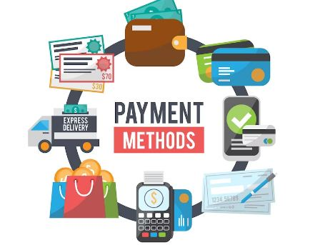
Figure 2, way of payment

Credit
Most people use credit and debit cards to buy things and pay for them. But many businesses that accept credit cards are charged a fee by both the merchant who provides the machine and payments infrastructure and their bank. Most of the time, this fee is a fixed rate or a percentage of the transaction amount.
Cash
Cash is still used in a lot of businesses, including retail. For example, you can still pay cash at coffee shops and convenience stores. Due to the fees with debit and credit cards, many small stores would rather have customers pay in cash. Cash can be lost, stolen, or destroyed, which is bad. Businesses that do a lot of large transactions often have to pay more for security measures.
Mobile Phones
Contactless payment technology has made it easier to pay than ever in the past few years. The customer's banking information can be accessed by the credit or debit card machine, also called a point of sale terminal (POS). This is done through the software application on the customer's mobile device. Once the phone has read the information from the POS terminal, a signal is sent to let the customer know that payment has been received.
Checks
A bank cashier's check or a certified check is two types of checks that banks offer to help sellers get the money that the buyer owes them. Over time, people have used checks less and less because technology has made it possible to send payments electronically. There are, however, times when checks can be useful, such as when the vendor needs a guarantee of payment.

2.2 Maintaining documentation
Introduction
Documentation is any communicable material that is used to describe, explain or instruct regarding some attributes of an object, system or procedure, such as its parts, assembly, installation, maintenance and use. Documentation encourages knowledge sharing, which empowers your team to understand how processes work and what finished projects typically look like. Documentation is any communicable material that is used to describe, explain or instruct regarding some attributes of an object, system or procedure, such as its parts, assembly, installation, maintenance and use. As a form of knowledge management and knowledge organization, documentation can be provided on paper, online, or on digital or analogue media, such as audio tape or CDs. Examples are user guides, white papers, online help, and quick-reference guides. Paper or hard-copy documentation has become less common. Documentation is often distributed via websites, software products, and other online applications.
Documentation as a set of instructional materials shouldn't be confused with documentation science, the study of the recording and retrieval of information.
2.2.1 Types of documentation
- Product Documentation
- Process Documentation
- Sales and Marketing Documentation
a )Product Documentation
Product documentation describes the information related to a product and includes the method to use this product. The information includes the product specifications, manuals, logic, disclaimers, and information on all the features of the product.

Types of Product Documentation
Although there are many types and sub-types, product documentation can be divided into two major categories.
- System Documentation
- User Documentation
System Documentation
System documentation contains information such as architecture, design, and source code that is used by product designers and manufacturers. The technical part of system documentation is aimed at a highly technical audience such as researchers and engineers. The business part of system documentation is aimed at business developers and marketers. System documentation is not generally released to the public.
User Documentation
Use documentation is the content you provide end-users with to help them be more successful with your product or service. Depending on the product, the information is aimed at either a technical or a non-technical audience. Examples are user manuals, quick start guides, and troubleshooting manuals.
b)Process documentation
A process guide is a step-by-step document that explains how to do something in your business. For example, it might explain exactly how to transition an aspect of your data from legacy servers to the cloud. It might take the form of a policy, a tutorial or a flow chart. It could live in your business plan, your company handbook, your new-hire training manual or your cloud-based standard operating procedures.
Process documentation is the act of capturing or documenting all of the steps in a particular task. Ideally, it should happen in real time. As employees perform a task, they document each step they take. On-going process documentation, followed by regular process review, helps staff and managers learn what works and what doesn’t, helping everyone adapt the process guides as the business evolves. Examples of process documentation include:
- Step-by-step guides: Detailed, sequential instructions for completing a specific task or operation
- Checklists: A list of items to verify, inspect, or complete, ensuring consistency and thorough
- Tutorials: Educational resources that guide users through a process, often including tips and best practices
- Process maps, diagrams, or flowcharts: Visual representations of a process that display the sequence of steps, decision points, and possible outcomes
- SOPs (Standard Operating Procedures): Formal, written instructions that outline how a specific task should be performed within an organization
- Workflow documentation: Formal documentation that specifically focuses on operational aspects of a process, such as task sequences, interactions between roles or teams, and dependencies.
- Company policies: Official rules, guidelines, or principles that define how employees should perform tasks, make decisions, or interact with stakeholders
Checklist Template
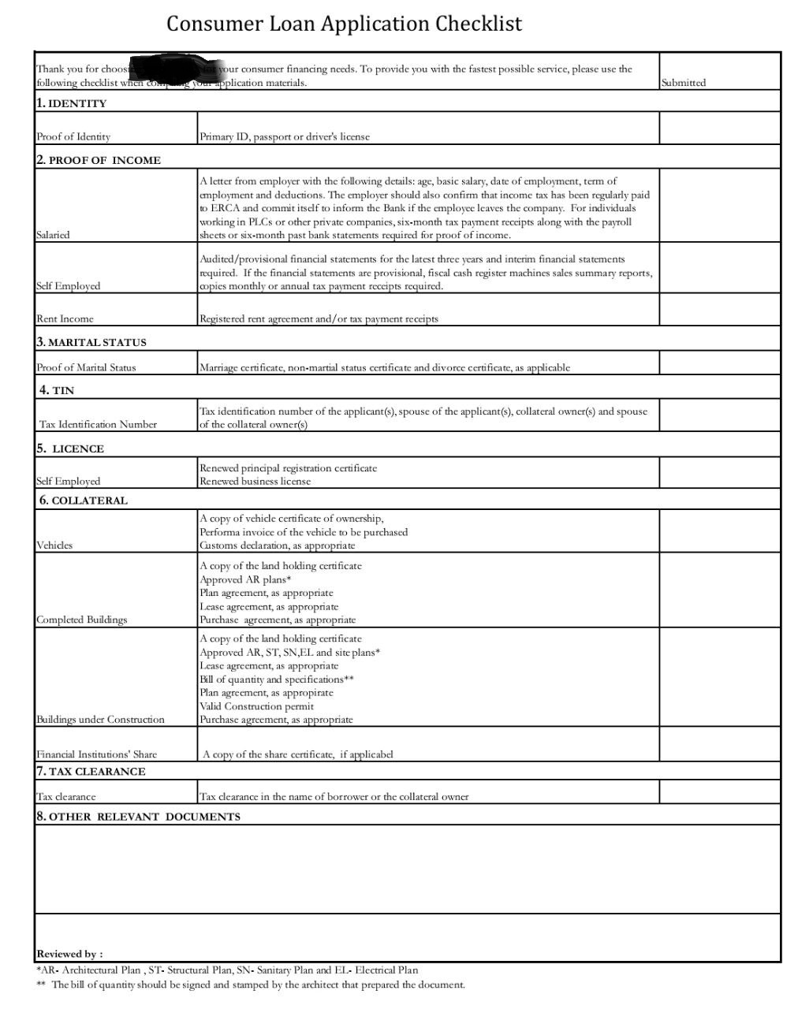
Figure 3, Checklist
c)Sales and Marketing Documentation
Sales documentation is writing down anything that helps your sales team close deals. It can range from: Sales processes, such as your sales methodology and methods of collaboration with other departments, too. Sales collateral, such as slide decks and case studies
A marketing requirements document is one that tells you exactly how you are supposed to market a particular product or service. This document is supposed to be created by the product creators or service providers, but the truth is many of them don't know they need this.
Payment documentation means all documents which are either
(i) specified in the Purchase Order which must be sent to and approved by Schneider Electric as the condition for payment of the Price or Purchase Order Price, or
(ii) if the relevant Purchase Order fails to specify any documents,
(a) a commercial invoice correctly stating the Price or Purchase Order Price and, if any, all requested details as per applicable law,
(b) an original copy of the Final Acceptance Certificate bearing Schneider Electric’s company stamp and its authorised representative’s signature; and
(c) if any third party Intellectual Property Right is involved in the manufacture, use, or delivery of the Products, Works and/or Services, all necessary documents or certificates which prove that Schneider Electric has the license or right to use, sell or otherwise dispose of the Products and/or Services supplied by the Supplier.

Self check Two
Part I Say true for correct statement and false for incorrect statements (one point each)
- Payment is the exchange of money, goods, or services for goods and services in an acceptable amount to both parties and has been agreed upon in advance.
- System documentation is the act of capturing or documenting all of the steps in a particular task.
- Security is only the characteristics of payment.
- Sales documentation is writing down anything that helps your sales team close deals.
- Mobile phone is a method of payment good and service.
Part II Write short answer for the following question
- Discuss Characteristics of payment
____________________________________________________________________________________________________________________________________

- Define ways of payment
____________________________________________________________________________________________________________________________________
- Identify type of documentation
____________________________________________________________________________________________________________________________________
- Identify Sales and Marketing Documentation

UNIT THREE: VERIFY PAYMENTS AGAINST DOCUMENTATION
This Unit is developed to provide you the necessary information regarding the following content coverage and topics:
- Confirming authorization for payment
- Identifying and following up discrepancies

This Unit will also assist you to attain the learning outcomes stated in the cover page. The completion of this learning guide, you will be able to:
- To confirm authorization for payment
- To identify and follow up discrepancies

  - Confirming authorization for payment
Introduction
Payment Authorization is a process through which the amount to be paid on a payment method is verified. In case of credit cards, authorization specifically involves contacting the payment system and blocking the required amount of funds against the credit card.Payment authorization, also called credit card authorization, is a process that verifies a customer has enough funds to cover the amount to be paid on a sale. This process also applies to debit card transactions and PayPal transactions.
Payment Authorization is a kind of an approach which guarantees evidence that the certain account is valid and adequately provisioned inquiry can be approved. If the client conducts a payment by his/her card, the data must be transmitted to the cardholder’s financial establishment for handling. The PA is a type of operation which ensures the security of clients’ payments. It is a kind of pending charge or hold of the payment in order to guarantee that the client’s account has a sufficient sum of funds which can cover the price of the product/service. The PA commonly occurs in the pending transactions of the cardholder’s account.
3.1.1 Importance of payment authorization
- Minimize fraud and chargebacks
We’ve learned a payment authorization form confirms the authenticity of the purchase and serves as verification of the transaction in the event of a customer dispute. Unfortunately, some customers have second thoughts on purchases of goods or services and don’t want to pay for them. As a result, a customer requests their financial institution to mark a payment as fraud or unauthorized, and a chargeback initiates against your business. This debits the funds for your bank account without prior warning or your authorization. The health of your merchant account, in turn, suffers, and it is a frustrating scenario to deal with when your company is not in the wrong.
In cases where a dispute arises, the burden of proving payment was authorized falls to you as the merchant. Providing the authorization form to the bank confirms serves as proof payment was submitted with the customer’s consent. This, in turn, assists the process of reversing the chargeback, so it doesn’t count negatively towards your business.
- Minimize errors
Human error is inevitable – mistakes happen all the time. It is not uncommon in a CNP payment environment to key in the payment digits incorrectly or transposes a number. Certainly, with your trusty payment authorization form on file, you can easily confirm the details without creating a frustrating experience for the customer should you receive a payment error.
- Establish positive merchant reputation
If operating in a high-risk industry, you most likely are subject to many restrictions and must adhere to specific guidelines. This encompasses the requirements you need to maintain with your merchant bank. Falling outside of the rules established can leave you without the ability to process an electronic payment. This can quickly create a negative situation for your business…fast. Establishing a payment authorization form process proves to your processor you take the responsibility to accept a payment seriously and are doing your part to reduce the risk of fraudulent transactions occurring. Having a good reputation with your payment processor can, in turn, lead to lower processing rates or a higher monthly volume when requested.
To conclude, accepting CNP payments comes with risk – no matter how you look at the scenario. The payment authorization is one tool available to your business to ensure you are receiving valid payments. But it is just one tool – there are many options available to reduce your merchant risk. Looking to learn more? Reach out to Payment Savvy today to discuss how we provide secure, reliable, and innovative payment solutions to a wide array of high-risk merchants

3.1.2 Steps of payment or Credit Card Authorization
Now that we’ve covered the fundamentals of credit card authorization, let’s look into how the process actually works.
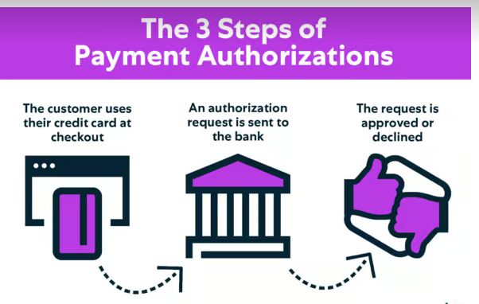
Figure 4 authorization process
Step 1: The customer uses their credit card at checkout
Payment authorization starts when your customer offers a credit card for payment at checkout and inserts, swipes, or taps their card into your payment terminal. It might also begin when your client orders from your website and enters a credit card number in an online form. In some instances, credit card authorizations take place when a customer gives their number to one of your sales agents over the phone.
Step 2: An authorization request is sent to the bank
Once this information is received, your client’s credit card information is sent through an authorization switch. This authorization switch is established and managed by the organization or system hosting your POS device, sales support, or online ordering.
By analysing the transaction information, the authorization switch determines which financial institution is servicing the credit or debit card. It then sends an authorization request for the transaction to the issuing bank or acquirer for verification.
Step 3: The request is approved or declined
After the bank verifies that your client’s credit is in good standing and has not exceeded the credit limit, your payment terminal receives an authorization message. At this time, merchants have the option to place an authorization hold on the cardholder’s account for the authorized amount of the sale. You can then complete the sale, often instantaneously.

Authorization Letter to Collect Payment on Behalf of Me Sample
It may not always be feasible to collect the payment money from a party personally by the person, who is supposed to receive it. Hence, he can authorize someone in writing to collect the money on his behalf.
You may be wondering, in this day and age, why a person will have to write a letter and why he cannot just call over the phone and inform the payer that someone is coming to collect the payment.
Payment authorization form
In any scenario where (CNP) payment transaction initiates, an agreement between the cardholder and your business for the product or service provided is paramount. Typical CNP payments occur over the phone, online, or still via snail mail in some instances. Having a payment authorization form process for these transactions helps confirm and verify the payment details agreed upon with your customer. It certainly establishes validity when assessing debits against a particular card or bank account.
In short, it is a financial agreement between your business and your consumer. It is signed by the authorized account holder and grants merchant permission to charge a specific dollar amount to the payment method for concrete for a period of time. It can be used in both one-time and recurring payment transactions.
The details confirmed within the document vary among businesses as needs differ, but standard items generally include:
- Agreement Date
- Merchant’s Address and Contact Information (Customer Service Phone Numbers and Email Addresses)
- Customer’s Billing Address on File with the Payment Method
- Language Authorizing Your Business to Charge the Payment Method on File
- Instructions on how a Customer can Alter a Payment
- The Account Holder’s Payment Information
- Name on Card or Checking/Saving Account
- If Credit/Debit – Card Type, Card Number, Expiration Date, and CVV Code (if One-Time Payment)
- If Checking/Savings Account – Account and Routing Numbers, Check Numbers (if Applicable)
- Signature and Name of Account Holder
It is because a signed authorization letter serves as evidence in case the matter is disputed between the parties in the future and the case ends up in the court of law.
An organization can authorize any of its officials to collect money on its behalf.
Here are examples of authorization letters for collecting money on behalf of someone.
TEMPLATE #1
(Official Authorization)
Ref: ...................
Date: .................
To
(Name of the Party)
(Address)
(Phone Number)
Sub.: Authorization for collecting payment
Dear .............,
We are hereby authorizing the following official of our company to collect a payment of a sum of Rs.................... (Rupees ...................... only) in respect of the amount outstanding towards invoice number................. Dated.............. For the supply of the.............. Goods
Name of the employee: .........................
Designation: .......................
Employee code: .................
Signature: ................
You may pay him the said amount in cash or by cheque or demand draft as suitable to you.
Thank you for your cooperation!
Yours faithfully,
For.................... Limited,
(Signature)
(Name of the Officer)
(Designation)
TEMPLATE #2
(Email Authorization)
Dear ...............,
Greetings of the day! I hope you are doing well.
You are hereby authorized and directed to pay to Mr ................... an amount of Rs. ............... owing in respect of the loan, which I gave you last year. He will be visiting your house tomorrow morning to collect the money.
You may verify his identity through his government identity card before handing over the money.
This shall be your good and sufficient authority for so doing.
In case of any query, please contact me at (Phone Number).
Thanks & Regards,
(Name of the Person)
TEMPLATE #3
(Personal Authorization Letter)
Date: .................
From
(Name of the Sender)
(Address)
(Phone Number)
(Email Id)
To
(Name of the Person)
(Designation)
(Name of the Organization)
(Address)
(Phone Number)
Sub.: Authorization to collect payment
Dear Sir/Madam,
I, the undersigned, hereby authorize Mr / Ms’ (Name of the Person) for collecting money from you for an amount of Rs. .............../- towards the services rendered by my firm last week vide invoice number ............. dated ...........
For the purposes of identification, Mr / Ms’ (Name of the Person) is the holder of Passport/ Aadhar card bearing number ................., which you may verify as well.
This authorization letter will be valid until (Date).
In case of any questions, feel free to contact me at (phone number).
Thanking you,
Yours sincerely,
(Signature)
(Name of the Sender)
3.2 Identifying and following up discrepancies.
Introduction
Invoice Discrepancy means discrepancies in invoices, discrepancies between the invoices and the accounts of the Paying Party and/or any dispute related to the invoices.After you identify a discrepancy, you might have to contact the vendor if you think that the information on the invoice is incorrect. Depending on the resulting agreement with the vendor, you can then take one of these actions: Accept the price difference, and post the invoice that has matching discrepancies.
Invoice
Invoice is a document given to the buyer by the seller to collect payment. It includes the cost of the products purchased or services rendered to the buyer. Invoices can also serve as legal records, if they contain the names of the seller and client, description and price of goods or services, and the terms of payment. An invoice is a document submitted to a customer, identifying a transaction for which the customer owes payment to the issuer. This document represents an asset of the issuer and a liability of the customer. An invoice typically identifies the following information.
An invoice is an important source document for a company’s auditors. An auditor will likely want to review a sampling of all invoices issued as part of the procedures associated with an audit. The auditor will also send requests for confirmation to a seller’s customers, asking them to confirm the amounts stated on the invoices.
3.2.1 Evolution of invoices for payment
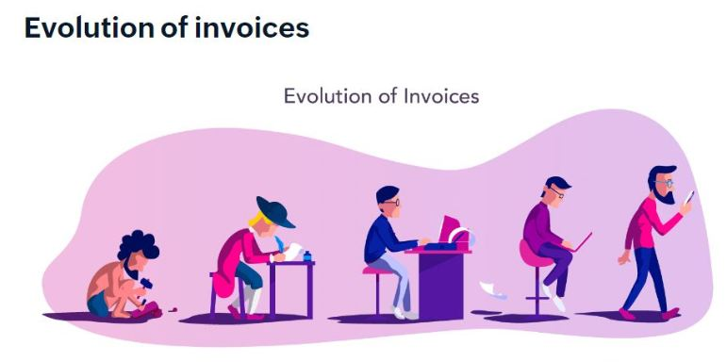
Electronic invoices

Hand-written invoices

Online invoice

Stone invoices

Mobile invoice
Figure 5 Evolution of invoice
Stone invoices
Invoices and records of transactions were made as early as 5000 BC in Mesopotamia. The merchants used to carve details of transactions on clay or stone tablets using the earliest form of math.
Hand-written invoices
Invoicing later evolved to hand-written invoices on animal skin, parchment, or paper. These invoices contained most of the elements of a modern invoice and used signatures or seals.

Electronic invoices
The invention of computers brought about the next big change in invoicing. This revolution was triggered by the desire to reduce traditional costs and labor. Invoicing became cheaper, easier, and faster with electronic invoices.
Online invoices
The advent of the internet led to better, more secure, greener ways to communicate with clients. Online invoices are paperless as the invoices are sent through email, and payments are made online.
Mobile invoices
Invoicing in the modern world has gone mobile. Specialized SaaS (Software as a Service) companies ensure that invoicing is now automated, secure, and instant, so you can invoice on the move.
3.2.2 Functions of invoices
Companies need to deliver invoices in order to demand payments. An invoice is a legally binding agreement showing both parties' consent to the quoted price and payment conditions. However, there are other benefits to using invoices.
- Maintaining records
The most important benefit of an invoice is the ability to keep a legal record of the sale. This makes it possible to find out when a good was sold, who bought it, and who sold it.
- Payment tracking
An invoice is an invaluable tool for accounting. It helps both the seller and the buyer to keep track of their payments and amounts owed.
- Legal protection
A proper invoice is legal proof of an agreement between the buyer and seller on a set price. It protects the merchant from fraudulent lawsuits.
- Easy tax filing
Recording and maintaining all sale invoices helps the company report its income and ensure that it's paid the proper amount of taxes.
- Business analytics
Analyzing invoices can help businesses gather information from their customers' buying patterns and identify trends, popular products, peak buying times, and more. This helps to develop effective marketing strategies.
3.2.3 Types of Invoices
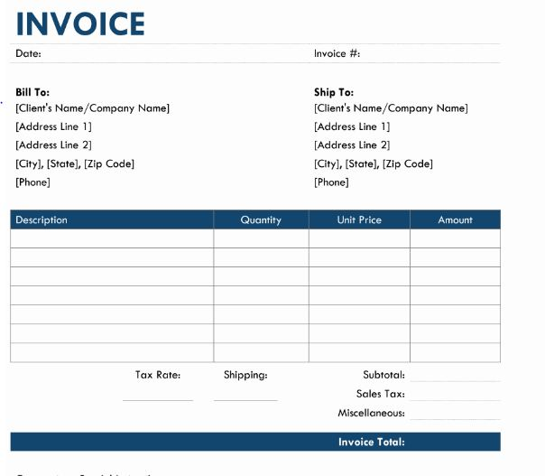

Figure 6 invoice

Pro forma invoice
Sent before any work is carried out, these documents list out the goods and services being provided along with the price they aren’t usually a request for payment but more a notice of when your client will need to pay the invoice.
- Interim invoice
When working on very large projects, instead of waiting until the end of the work and issuing one big invoice, interim invoices allow you to send them intermittently throughout the project.
- Recurring invoice
These invoices tend to be scheduled to go out indefinitely or for projects set to last for a set period of time, for example 12 months.
- Final invoice
This is the last invoice sent to a client outlining all the work that has been carried out as well as any outstanding balance due.
- Collective invoice
If a business is doing lots of small projects for a client, instead of issuing multiple small invoices, they can instead provide one collective invoice grouping together the smaller invoices. These tend to be beneficial as you don’t need to keep track of multiple invoices and keep transaction fees to a minimum.
- Credit invoice
Credit invoices are issued by businesses to clients to provide a refund or discount as a result of a previous invoicing error. They usually include a negative amount that needs to be paid.
- Debit invoice
Much like a credit invoice, your client may issue a debit memo if you have under billed them. Debit invoices are useful to small businesses and freelancers when they need to make slight adjustments to an existing bill.
Operation sheet. 1 Payment Authorization letter
Instructions:-Prepare tools for authorization letters.
Computer, A4 papers, pen, pencils, company manuals and guide lines, Customer information
Task1:- list the necessary steps to prepare authorization letter
- Agreement Date
- Merchant’s Address and Contact Information (Customer Service Phone Numbers and Email Addresses)
- Customer’s Billing Address on File with the Payment Method
- Language Authorizing Your Business to Charge the Payment Method on File
- Instructions on how a Customer can Alter a Payment
- The Account Holder’s Payment Information
- Name on Card or Checking/Saving Account
- If Credit/Debit – Card Type, Card Number, Expiration Date, and CVV Code (if One-Time Payment)
- If Checking/Savings Account – Account and Routing Numbers, Check Numbers (if Applicable)
- Signature and Name of Account Holder

Self cheeck question
- what do you mean Payment Authorization

____________________________________________________________________________________________________________________________________

- what are the importance of payment authorization
____________________________________________________________________________________________________________________________________
- What are the steps to authorization Payment or Credit Card Authorization
____________________________________________________________________________________________________________________________________
- Identify the types of Invoices
____________________________________________________________________________________________________________________________________
- List Function of invoice

UNIT FOUR: EFFECT PAYMENTS
This Unit is developed to provide you the necessary information regarding the following content coverage and topics:
  - Make payments within agreed credit arrangements
  - Signing and update payment instruments
  - Cancelling and noting primary documentation

This Unit will also assist you to attain the learning outcomes stated in the cover page. The completion of this learning guide, you will be able to:
  - To make payment within agreed credit arrangements
  - To update payment instruments
  - To Cancel primary documentation

  - Making payments within agreed credit arrangements
Introduction
Credit is a contractual agreement in which a borrower receives something of value immediately and agrees to pay for it later, usually with interest.
The ability of a customer to obtain goods or services before payment, based on the trust that payment will be made in the future. In general Credit A contractual agreement in which a borrower receives something of value now and agrees to repay the lender at some later date. When a consumer purchases something using a credit card, they are buying on credit receiving the item at time, and paying back the credit card to the company according to the agreement between the creditor and debtor. Any time when an individual finances something with a loan (such as an automobile or a house), they are using credit in that situation as well.
    - Types of credit
- Trade Credit
Trade Credit refers to credit in business dealings like selling goods on credit where the customer promises to pay money later, buying goods on credit where we, the customer of the supplier, promise to pay to the supplier on a later date. It is given based on the borrower’s financial capability, i.e., credit taker. In some cases, it is given based on a relationship with the person asking for credit, or it depends upon business rules. In a large organization, the credit rules are the same for all the customers.

2. Bank Credit
Bank Credit is an extension of consumer credit. In bank credit, the bank gives loans and credit facilitates to clients. Consumer credits are given based on creditworthiness, analysis of financial statements, and value of the asset given by consumers as security. Examples of consumer credit are mortgage loans, cash credit facility, housing loans, etc., letter of credits, bank guarantee, discounting of bills of exchange also falls under the bank credit facility.

3. Revolving Credit
Revolving credit involves the continuous credit in which the lender gives the extension of credit to the borrower so long as the account is regular and open by regular payments like in case of credit card the credit is given regularly and limit of credit is given and payment to be made on monthly or quarterly basis. And the account will continue till it is closed, i.e., credit is extended every month.

4 .Installment Credit
Installment credit is the extension of bank credit. When we obtain credit from banks by way of loan, the bank sets the fixed monthly Installment as repayment type of loan along with interest up to a certain period till the loan gets re-paid along with interest. The bank or finance company charges a penalty if the borrower cannot pay the instalment

5 .Mutual Credits
In mutual credit, money is not used as in this case. If one person owes another person for something that another person also owes to the first one, the credit becomes mutual credit. So credit gets cancelled with each other, and in case a balance remains after that, then the same is settled by the mode of cash or equivalent. Like in business, one person is a creditor and a debtor. Hence, they mutually settle the payments.

6 Service Credit
In-service credit, the credit is given for services availed earlier. Like lawyers ask for final fees once the case is over, the accountants charge after filing the returns. Electricity bills, telephone bills, gas bills, and post-paid bills are examples of service credit. Service credit borrowers can pay after availing of the service at fixed intervals. But if the service receiver fails to pay at fixed intervals, it may cancel services or charge a penalty for late payments.

  - Signing and updating payment instruments
Introduction
A payment instrument means any electronic or written instrument, it is a designation for how a payment was or will be made. For example a check, draft, warrant, money order, traveller’s check, electronic instrument, or other instrument, payment of funds, or monetary value (other than currency), The term does not include any credit card voucher, letter of credit, or tangible object redeemable by the issuer in goods or services.
Understanding license payment instrument in Ethiopia
According to the directive a person other than the licensed financial institutions, shall submit a complete application to NBE to get a license to issue a payment instrument.
As part of the application process, the National Bank, may request for a preliminary meeting and demonstration of the intended payment instrument to be issued, its related services, products as well as operation.
Based on requests made and written approval of the National Bank, a payment instrument issuer may be allowed to provide cash-in and cash-out; local money transfers including domestic remittances, load to card or bank account, transfer to card or bank account; domestic payments including purchase from physical merchants, bill payments; over-the-counter transactions; and inward international remittances services.
Besides, based on written approval of the National Bank, a licensed payment instrument issuer under full responsibility of and written outsourcing agreement with a regulated financial institutions and pension funds may be allowed to provide
4.2.1 Classification of Payment instruments
Cash payments
Cash payment is money in the physical form of currency, such as banknotes and coin. It I used in small-value transactions relating to everyday purchases.
Non-cash payments
Non-cash payments are mostly made by means of (1) credit transfers, (2) checks, (3) payment cards, and (4) direct debits.
1, Credit transfers
A credit transfer is a payment transaction by which a payment service provider transfers funds to a payee's account against a payer's order, and the payer and the payee can be the same person.
2, Checks
A check payment is a negotiable instrument drawn against deposited funds, to pay the recipient a specific amount of funds on demand. A check has traditionally been physically routed from the payer to the payee, then to the payee's bank, which issues funds to the payee, and then by the payee's bank to the payer's bank.
(3) - Payment cards
(3.1) - Credit cards
A credit card is a type of credit facility, provided by banks that allow customers to borrow funds within a pre-approved credit limit. It enables customers to make purchase transactions on goods and services.
(3.2) - Debit cards
A debit card is a payment instrument which allows the cardholder to acquire goods and services in authorized establishments, using financial resources from a bank account, as well as to make withdrawals in ATM’s. The operation’s approval and corresponding debit in the cardholder’s account happen the moment the payment is made.
(3.3) - Retailer cards
Retailer cards, which are mainly issued by major stores, can only be used only at the shops of the same group, i.e., they are “in-store” cards. The use of this instrument implies, in fact, payment deferment (sometimes the issuer admits payment by installments, without explicit financial fees).
On the due date, the payer normally uses either cash or another payment instrument (check or debit card) to settle the obligation, having to return to the commercial establishment to do so.
(3.4) - Pre-paid cards
Prepaid cards are technically a type of debit card. Issued by a financial institution or credit card company—Visa, MasterCard, and Discover all offer them—they are deposited or "loaded" with a certain amount of money. They then can be used in person or online to purchase items or pay bills.
(4) - Direct debits
Direct debits are normally used for recurrent payments, that is, those that are made on a periodic basis, mostly related to utility services (water, electricity, and telephone, for example). For such payments, the payer should pre-authorize the bank to accept funds transfers initiated by the payee, which should previously send to the payer, for his control, the correspondent invoice. The authorization is usually for an indefinite period of time, therefore valid until not cancelled.
Updating payment instruments
Updates a payment instrument. Once a payment instrument is already active, you can only update its status. you can update the balance account associated with the card.
Keeping customers' payment card information up to date is very important. Updating payment card information is simple, safe, and secure. Use a separated field’s form to update the expiration date, or billing address.

Update Credit card
You can visit the card issuer’s branch for changing the address on credit card, email ID, or registered phone number. You will have to fill out a Customer Request Form (CRF) with new details. For address change, you will have to submit a self-attested copy of the proof of the new address. The bank will notify you once your request is processed through the updated details.
  - Cancelling and noting primary documentation
Cancellation is the act of destroying a document by making lines through it, tearing it up, or defacing it with the intention of rendering it void.
Cancelling Payment
If Payee went to cancel the payment, Call the company and tell them you are taking away your permission for the company to take automatic payments out of your bank account. The company’s customer service should be able to help you, and there might be an online form you can use. Then, follow up by writing a letter or an e-mail. When you contact the company, you can explain whether you are cancelling your ongoing contract or subscription, or only changing the way you are paying them. For example, you might cancel automatic payments and decide to pay invoices when they arrive.
Cancellation payment form
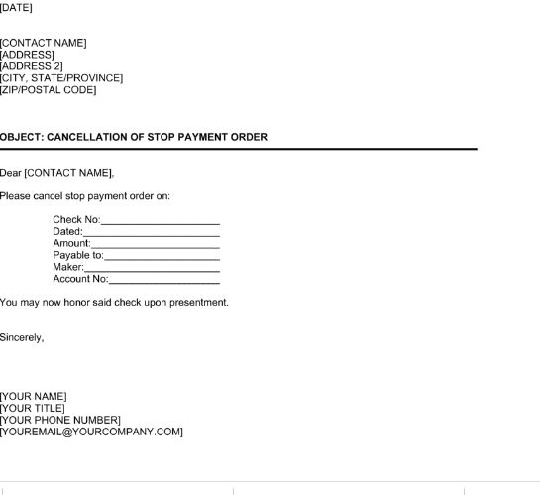
Figure 7 Cancellation payment form

Self check Four
Part I. Answer the following questions
- Identify the term Credit
- How to update Credit card
- List the type of Credit
- What are the difference between Installment and revolving credit
Part II. Matching
1. Retailer card A, VISA
2. Debit card B, negotiable instrument
3. Direct debit C, ATM
4. Prepaid card D, store card
5. Check E, for utility service

UNIT FIVE: FILE DOCUMENTATION
This Unit is developed to provide you the necessary information regarding the following content coverage and topics:
  - Filling Documentation
  - Accessing and tracing filed documents
This Unit will also assist you to attain the learning outcomes stated in the cover page. The completion of this learning guide, you will be able to:
  - Fill Documentation
  - Location of file documents Access and trace

  - Filing Documentation
Introduction
Filing means keeping documents in a safe place and being able to find them easily and quickly. Documents that are cared for will not easily tear, get lost or dirty. A filing system is the central record-keeping system for an organisation. It helps you to be organised, systematic, efficient and transparent. Filing means keeping documents in a safe place and being able to find them easily and quickly. Documents that are cared for will not easily tear, get lost or dirty. A filing system is the central record-keeping system for an organisation. It helps you to be organised, systematic, efficient and transparent. It also helps all people who should be able to access information to do so easily.
It is always a pleasure when someone looks for something and is able to find it without difficulties. In our organisations we work in groups. We receive and send out documents on different subjects. We need to keep these documents for future reference. If these documents are not cared for, we cannot account for all our organisational activities. Everyone who needs to use documents should know where to get them.
5.1.1 Methods of filing
- Filing by Subject/Category
- Filing in Alphabetical order
- Filing by Numbers/Numerical order
- Filing by Places/Geographical order
- Filing by Dates/Chronological order
Types of filing systems
There are three commonly utilized types of filing arrangements which are designed to file and reference records in different ways: alphabetical, numeric, and alpha-numeric. Each has advantages for certain types of records and reference needs and possesses distinct patterns of arrangement and indexing.
- alphabetic filing
Alphabetic filing is the most common filing system for less than 5,000 records. Filing by alphabetic order is a system where you arrange files by names of individuals, businesses, institutions, agencies, subjects, topics or geographic locations according to dictionary order. This system is effective for client or customer name files. If filing subjects, use a relative index. The index is a list in alphabetical order of the topic names chosen to represent each subject. Reference the relative index to find out what topic name to file the record under.
- numeric filing
In setting up a numeric filing system, arrange files in sequential order using the numbers directly from the record or an assigned number. Most systems use an index to retrieve the files. A numerical filing system increases productivity due to increased speed of filing and locating a file. It also provides accurate identification and allows for greater confidentiality. It is capable of infinite expansions and you can use it for more than 5,000 records, unlike alphabetic filing systems.
- alpha -numeric filing
Alpha-numeric filing uses a combination of names and numbers. You commonly use this type of filing system with subject names and numbers. Arrange files according to alphabetic divisions or subject heading, then by number category. It is necessary to use a relative index for alpha-numeric files. The index will list the number codes assigned to each alphabetic division.
- paperless filing systems
Paperless filing systems are becoming common for many businesses and homes. It solves the need for physical storage space and the problem of lost or misplaced information. A paperless filing system allows for shared access across multiple departments. Although shared access provides on-demand access to records, you can set user rights to either view, edit, create or delete files to control access. Types of paperless filing systems include simple software programs, document servers and document management systems.

5.1.2 Process Of documentation

1. Identify the process
First, identify the process you are documenting. Give it a clear name and objective.
2. Place boundaries
Document the start and end points of the process. What triggers it to begin, and how do you know when it’s over? For example, the process might start when you realize your app’s home screen looks dated and end when you send the updated version to all customers.
3. List the expected result
What should happen at the end of the process? This might be something like, “The finished app rolls out to end users,” or “The software update pushes to all registered users without hiccups.”
4. Detail the inputs
Note what materials and equipment are necessary to complete the process. This could be as simple as your assembly line and robotic assistants, or as complex as your legacy servers, private cloud and multiple platforms.
5. Walk through the process
You can brainstorm how it might work, but it’s better to perform the entire process from beginning to end. For example, you might want to walk through the sales funnel to see if any elements were left out during the mock-up phase. Remember, if a button isn’t on the wireframe, engineering won’t build it!
6. Determine who is involved
List the people who play a role in completing the process. This typically encompasses only those who perform the task, but you can also note who the decision makers are for that process.
7. Utilize your process documentation system
Carefully copy all of your notes into your process documentation system. Review all the details to make sure you didn’t miss anything.
5.2 Accessing and tracing filed documents
Introduction
File tracing can be especially helpful in assessing the cause of a problem. File tracing provides valuable information about file opens, reads, and writes. File status codes for unsuccessful I/O operations are also shown, and configuration variable settings can be examined. Trace files generated by the Kaspersky Password Manager downloader and Installer are stored on your device starting when the product is installed and are deleted permanently when the operating system shuts down.
Trace files
The trace file is a text or XML file that records the steps of map execution. You can use the information in the trace file to diagnose invalid data or incorrect type definitions.
- Trace for general data
the trace file records map execution progress. You can enable the trace option from the map settings or from the adapter command line. You can trace the input data, the output data, or both.
- Static file validation and tracing
Transformation Extender (TX) validates a static input file in a compiled map only once, when the map loads, and produces a trace file only if the static file fails validation. TX validates other map inputs each time the map runs, and logs them in the map trace file as specified by the map settings.

Self check Five
- How to keep documents in safe place
____________________________________________________________________________________________________________________________________
- What are the type of filing system
____________________________________________________________________________________________________________________________________
- What is the purpose of trace file
____________________________________________________________________________________________________________________________________
- What are the process of file documentation
____________________________________________________________________________________________________________________________________

UNIT SIX: AUTHORIZED PAYMENT
This Unit is developed to provide you the necessary information regarding the following content coverage and topics:
  - Authorizing payments
  - Not releasing funds prior to authorization
  - Using payment authorizations

This Unit will also assist you to attain the learning outcomes stated in the cover page. The completion of this learning guide, you will be able to:
  - Method of Authorize payments
  - Not release funds prior to authorization
  - To use payment authorizations

6.1 Authorizing payments
Introduction
Payment authorization, also called credit card authorization, is a process that verifies a customer has enough funds to cover the amount to be paid on a sale. This process also applies to debit card transactions and PayPal transactions. Payment authorization starts when your customer offers a credit card for payment at checkout and inserts, swipes, or taps their card into your payment terminal. It might also begin when your client orders from your website and enters a credit card number in an online form. In some instances, credit card authorizations take place when a customer gives their number to one of your sales agents over the phone.

6.1.1 Steps of Payment or Credit Card Authorization
Now that we’ve covered the fundamentals of credit card authorization, let’s look into how the process actually works.

Step 1: The customer uses their credit card at checkout
Payment authorization starts when your customer offers a credit card for payment at checkout and inserts, swipes, or taps their card into your payment terminal. It might also begin when your client orders from your website and enters a credit card number in an online form. In some instances, credit card authorizations take place when a customer gives their number to one of your sales agents over the phone.

Step 2: An authorization request is sent to the bank
Once this information is received, your client’s credit card information is sent through an authorization switch. This authorization switch is established and managed by the organization or system hosting your POS device, sales support, or online ordering.
By analysing the transaction information, the authorization switch determines which financial institution is servicing the credit or debit card. It then sends an authorization request for the transaction to the issuing bank or acquirer for verification.

Step 3: The request is approved or declined
After the bank verifies that your client’s credit is in good standing and has not exceeded the credit limit, your payment terminal receives an authorization message. At this time, merchants have the option to place an authorization hold on the cardholder’s account for the authorized amount of the sale. You can then complete the sale, often instantaneously.

A note about transaction fees
Every time a transaction is authorized, your business will pay a transaction fee. The amount of this fee varies and you’ll want to factor it into your overall sales.
A transaction that’s been authorized but not posted to a customer’s account appears as a pending transaction. This just means the money spent is no longer available in the customer’s credit line but has not been added to the current balance. In general, pending transactions clear after a few business days. In many cases, the authorization amount and final transaction amount are identical. Sometimes, however, the authorization amount may temporarily differ from the amount of the actual purchase. Likewise, hotels and rental car agencies can submit a credit card for payment authorization with just the nightly room rate.

What Happens If Payment Authorizations Fail?
During the payment authorization process, the bank or credit issuer may recognize the credit card as lost, stolen, frozen, or past its expiration date. In other cases, the transaction itself may be deemed suspicious and potentially fraudulent. When this happens, the transaction gets rejected and there may be a check for suspicious charge activity.
Payment authorizations may also fail for technical reasons. This usually happens when issues with configuration or online submission cause problems with the information being supplied to the processor. In these cases, an error code gets generated and the sale can’t be completed.
When payment authorizations fail, the seller should not complete the transaction until they receive proper authorization. Online businesses should also not ship any products until the issue gets fixed. In most cases, the seller will need to fix technical problems that arise from payment authorization failure. Occasionally, however, the buyer may be having issues with their credit cards, debit cards, or device, and will need to resolve the problems from their end.
  - Not releasing funds prior to authorization

Introduction
Authorization only is a type of payment card transaction that holds funds from a cardholder’s account for settlement at a later date. When an individual makes a purchase with a credit or debit card, the institution from which the purchase is made has to seek authorization to process the transaction from the issuer of the credit or debit card. In an authorization only transaction, the selling institution only seeks permission to process a transaction; they do not actually complete it. This results in a “pending” or “processing” charge on the customer's statement. Authorization only, or author only, transactions may have an expiration date; for example, an authorization only transaction may expire seven days after the transaction is authorized.

Release of funds authorization form
Seller’s attorney, _______________________________whose office is located at_____________________________ , is presently holding the sum of $__________________________ in escrow pursuant to the terms of the Contract of Sale between party of the first part (Seller) ______________________________________________ and parry of the second part (Purchaser)_________________________________ hereto, dated this day of , _______, regarding Premises known as (the “Escrow Fund”).
The undersigned hereby authorize to release the sum of $ from the Escrow Fund to and agree to hold (him) (her) (them) harmless for the release of the escrow funds authorized hereby. Dated this day of_______
PURCHASER: SELLER:
Printed Name: Printed Name:
  - Using payment authorizations
Introduction
Payment Authorization is a process through which the amount to be paid on a payment method is verified. In case of credit cards, authorization specifically involves contacting the payment system and blocking the required amount of funds against the credit card. Payment authorization is when the merchant submits a transaction request to the issuing bank (cardholder’s bank), who will determine if the transaction should be approved or denied. The issuing bank will decide after verifying that the cardholder has the appropriate funds or credit in their account. After an authorization request has been sent, the merchant will receive a response code from the card association.

Authorization process
Payment Authorization is a process through which the amount to be paid on a payment method is verified. In case of credit cards, authorization specifically involves contacting the payment system and blocking the required amount of funds against the credit card. Payment types may or may not require this authorization step. This is configurable in Sterling Order Management in the seller’s payment rule. If an order requires payment processing, the order is not picked up for scheduling or other processing until it is authorized.
The Payment Collection time-triggered transaction analyses an order to create authorization requests. The Payment Execution time-triggered transaction monitors requests created for authorization and provides user exits to carry out the authorization.

Self check Six
1. When to start Payment authorization
____________________________________________________________________________________________________________________________________

- Why payment authorization fail
____________________________________________________________________________________________________________________________________
- Discuss the steps of credit card authorization
____________________________________________________________________________________________________________________________________
_______________________________________________________________

Reference
Invoice and payment process (the researcher foundation for the state university of New work)
Payment Processing service Written by Nadia Benaissa/ Mar 11, 2021
Process documentation Knowledge management, Published: October 5, 2022 Updated: October 6, 2023
Training.gov.au FNSACM303A Process payment documentation
www.coursehero.com Prepare payment documentation

No | Name | Qualification | Educational background | Region | College | Mobile number | E-mail
1 | Kassa Terefe | BA, degree | Accounting & finance | A.A | KMC | +251993298301 | kssterefe@gmail.com
2 | Sewumehon Anteneh | BA degree | Accounting & finance | A.A | KMC | +251948032126 | Sewumehonanteneh@gmail.com
3 | Remedan Abdurehman | MBA | Accounting & finance | A.A | GWPTC | +25133233939 | rame.abdu10@gmail.com
4 | Meskerem Getachew | MBA | Accounting & finance | A.A | ARADA | +251925918465 | meskigetach@gmail.com
5 | Mahmud Oumer | BA | Accounting | A.A | GWPTC | 0913099303 | Mahmudoumer@gmail.com
6 | Mekuanint Abeje Melese | MSc degree | Accounting & finance | A.A | LMC | +251913969620 | Mekuanitabeje21@gmail.com
7 | Hussien Ebrahim | MBA | Accounting & finance | A.A | GWPTC | +251920188426 | Hussienebrahim701@ gmail.com
8 | Alemayehu | MBA | Accounting & finance | A.A | MPTC | +251920188426

