ACCOUNTING AND FINANCE

LEVEL – III
BASED ON JUNE 2022, CURRICULUM VERSION -2

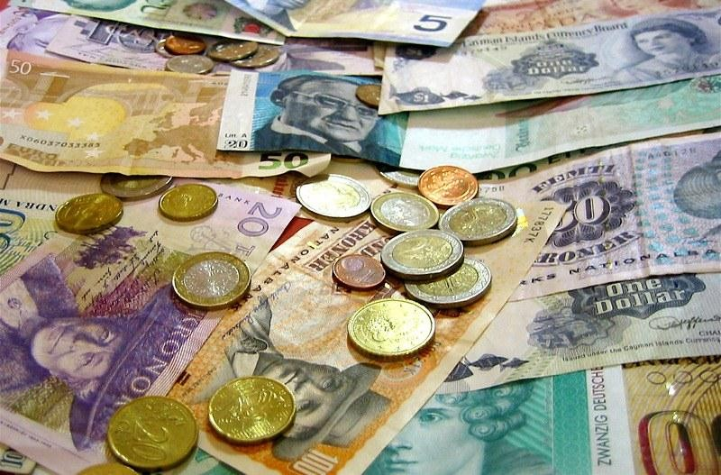

Module Title: Handling Foreign Currency Transactions Module Code: LSA ACF3 11 0322
Nominal duration: 70 Hours

September 2023
ADDIS ABABA, ETHIOPIA

TABLE OF CONTENTS

  - Clarifying the nature of foreign currency transaction 3
Introduction 3
    - NATURE OF FOREIGN EXCHANGE MARKET 3
    - Types of forex transactions: 5
  - Obtaining information from the customer 7
    - Import goods into Ethiopia –steps 7
    - Export Requirement of goods from Ethiopia 8
  - Handling customer requests for foreign currency dealings 9
Introduction 9
    - Foreign Currency and Coin 9
    - Currency exchange 10
    - Currency exchange 11
    - Arranging payment issues 11
    - Collecting documents for foreign exchange 12
Self-Check -1 14
UNIT 2 15
Instruction sheet 15
  - Identifying cleared funds 16
Introduction 16
    - International clearing system 17
    - important of international clearing system 17
    - Foreign currency transactions includes: 18
  - Assessing requests for foreign currency 20
  - Verifying foreign currency notes presented for sale 21
Introduction 21
    - Handling Foreign Currency Transactions 22
Self-Check -2 23
UNIT 3 25
Instruction sheet 25
  - Calculating conversion of foreign currency amounts 26
Introduction 26
    - Currency Arbitrage 27
    - Foreign currency transaction recorded in a Company’s books and records 28
  - Providing the customer with a copy of the rates 32
    - Rate Of Exchange 32
  - PURCHASING or Selling Travelers Cheque 32
Introduction 32
    - Benefit of issuing traveller's cheques for financial institutions 33
  - Entering details of the transaction into the database 34
Self-check 3 35
Operational sheet 1 35
LAP test 1 37
UNIT 4 Maintain accurate records of transaction 38
Instruction sheet 38
Introduction 39
4.1 Completing vouchers and receipts 40
Foreign Currency Receipts 40
  - Completing and filing reports in the event of significant cash transactions 41
    - Reporting Currency 41
  - Updating and maintaining internal records of foreign currency transactions 43
    - Re-Measurement process currency transactions 43
Self-check 4 44

- Reference 43

Acknowledgement
Addis Ababa TVET and Tech Bureau wish to extend thanks and appreciation to the many representatives of TVT instructors and respective industry experts who donated their time and expertise to the development of this Teaching, Training and Learning Materials (TTLM)

Introduction of the module

This module covers the performance outcomes, skills and knowledge required to provide customer service and handle foreign currency transactions including buying and selling foreign currency travelers cheques, notes and coins within a retail banking environment.

This module covers

  - Identify nature of customer's foreign currency needs
  - Verify that the proposed transaction can be conducted
  - Conduct the transaction
  - Maintain accurate records of transaction

Learning objectives of the Module:
  - Identify nature of customer's foreign currency needs
  - Verify that the proposed transaction can be conducted
  - Conduct the transaction
  - Maintain accurate records of transaction

Module Instruction
For effective use this modules trainees are expected to follow the following module
- Read the information written in each unit
- Accomplish the Self-checks at the end of each unit
- Perform Operation Sheets which were provided at the end of units
- Read the identified references book for Examples and exercise.

UNIT ONE: Identify nature of customer's foreign currency needs

This unit is developed to provide you the necessary information regarding the following content coverage and topics
- Clarifying the nature of foreign currency transaction.
- Obtaining information from the customer.
- Handling customer requests for foreign currency dealings.

This unit will also assist you to customer attain the stated objective. Specifically, upon completion of this learning guide line, you will be able to:
- Clarify the nature of foreign currency transaction.
- Obtain information from the customer
- Handle customer requests for foreign currency dealings

1.1 Clarifying the nature of foreign currency transaction
Foreign exchange market is a floor provided for buying, selling, exchanging, and speculation of currencies. The forex market also undertakes currency conversion for investments and international trade. The Forex markets, also termed, Forex markets, consist of investment management firms, central banks, commercial companies, retail forex brokers, and investors

Foreign exchange transactions: refers to the sale and purchase of foreign currencies. Simply, the foreign exchange transaction is an agreement of exchange of currencies of one country for another at an agreed exchange rate on a definite date

Foreign exchange, also termed Forex, refers to converting one country’s currency into another country’s currency. A single country’s currency is valued against another’s currency or against a basket of currencies.

    - NATURE OF FOREIGN EXCHANGE MARKET
The foreign exchange market is the place where money denominated in one currency is bought and sold with money denominated in another currency. It is the largest financial market in the world with prices moving and currencies trading somewhere every hour of every business day.
      - Market Transparency
      - Dollar is extensively traded currency
      - Most Dynamic Market

      - International Network of Dealers
      - High Liquidity
      - Twenty -Four Hour Market
      - Lower Trading Cost

Dollar is extensively traded currency
The dollar is the most dominant currency in the foreign exchange market. This currency is paired with every country’s currency being traded in the forex market. In
a major proportion of transactions every day, the dollar is one of the two currencies being traded.

Most Dynamic Market
The foreign exchange market is a dynamic market. In these markets, currency values change every second and hour. These values change in accordance with changing forces of demand and supply which also helps in determining the exchange rates.
Due to its fast-changing character, this market is termed as the perfect market to trade.

International Network of Dealers
The market is made up of an international network of dealers. The market consists of a limited number of major dealer institutions that are particularly active in foreign exchange, trading with customers and (more often) with each other. Most, but not all, are commercial banks and investment banks. These dealer institutions are geographically dispersed, located in numerous financial centres around the world.
Wherever located, these institutions are linked to, and in close communication with, each other through telephones, computers, and other electronic means.

High Liquidity
The foreign exchange market is the most liquid financial market in the world. It involves the trading of various currencies across the globe. All traders in this market are free to buy or sell

Currencies anytime as per their choice. They are free to exchange currencies without prices of currencies being traded getting affected.
Currencies prices remain the same both at the time of order placed and executed thereby enabling to earn the expected prices.

Operates 24 Hours
Foreign exchange markets function 24 hours a day. It provides a platform where currencies can be traded anytime by traders. It provides a convenient time to all necessary adjustments when and wherever needed.

Lower Trading Cost
The forex market has a very low trading cost. In these markets, there are no commissions like in case of any other investments. Any difference between buying and selling prices of currencies is the only cost of trading in the forex market. As there are low costs then the possibility of incurring losses is also minimum thereby making it possible for small investors to make good profit from trading.
    - Types of forex transactions:
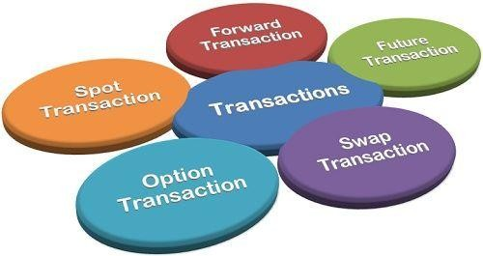
    - Diagram .1 Types of forex transactions:

Spot Transactions
This method of transaction is the fastest way to exchange currencies. Spot transaction refers to the exchange or settlement of the currencies by the buyer and seller within two days of the deal without a signed contract. The Spot Exchange Rate is the prevailing exchange rate in the market.

A spot rate is associated with the immediate need for a good, as the contract's delivery date typically occurs within two business days of the trade date. Regardless of price fluctuations between the settlement and delivery dates, the contract will be completed at the agreed-upon spot rate. Buyers and sellers mitigate price fluctuation risk when contracting with a spot rate by sacrificing potentially favorable future market conditions.

Forward Transactions
Forward transactions are future transactions when the buyer and seller enter into an agreement of purchase and sale of currency after 90 days. The agreement is framed on the basis of a fixed exchange rate for a definite date in the future. The rate at which the deal is fixed is termed as Forward Exchange Rate.

Swap Transactions
Simultaneous lending and borrowing of two different currencies between two investors are called swap transactions. One investor borrows a currency and repays it in the form of a second currency to the second investor. Swap transactions are done to pay off obligations without suffering a foreign exchange risk.

Option Transactions
The exchange of currency from one denomination to another at an agreed rate on a specific date is an option for an investor. Every investor owns the right to convert the currency but is not obligated to do so.

1.2. Obtaining information from the customer
Each foreign exchange transaction in which customers enter into will be subject to the Terms and Conditions for doing business with foreign currency.
It may be required to sign these before entering in to foreign exchange transaction for the first time. In addition to Terms and Conditions it may also need to provide the signed documentation. Together with such other “Know your Customer “information that banks may require in its standard application. Upon completion of these documents banks will conduct a accreditation process.
    - Import goods into Ethiopia –steps

Obtain an import license / investment license
The first step to import a good is to obtain an import license.Licenses are issued by the concerned government offices against the submission of a completed application form5 along with the following documents:
- A copy of the Tax Identification Number (TIN);
- A copy of the Memorandum of Association and Articles of Association foprivate limited and share companies;
- A contractual agreement of office rent or office building plan;
- A document evidencing the capital allocated for the commercial activity;
  - Two passport size photographs taken within the last six months;
  - If the applicant is a foreign investor, the investment and residence
  - Permits; and
  - A valid business registration certificate.
- Obtain a pre-import permit (for certain restricted goods only)
- Arrange payment issues
- Foreign currency approval
- Obtain bank permit/arrange mode of payment
- Collect commercial documents required for customs declaration
- Prepare the customs declaration
- Submit the customs declaration
- Obtain import customs clearance and goods release note
- Pay service charges, exit goods from customs warehouse, and receive final import customs declaration
- Submit clearance declaration to NBE
    - Export Requirement of goods from Ethiopia

      - Obtain an export license

      - Arrange payment issues

      - Collect documents

      - Obtain export permit (for goods restricted for export only)

      - Prepare customs declaration

      - Submit customs declaration

      - Obtain export customs clearance and ship goods

      - Pay service charges and receive final export customs declaration

      - Submit clearance declaration

Handling customer requests for foreign currency dealings
The management and operation function of foreign exchange transaction have been transferred from National Bank of Ethiopia to Commercial Banks. No persons can be engaging in any transactions of foreign exchange except with banks or authorized dealers or with the special permissions of the National bank.
The term, conditions limitations and circumstances for transfer of foreign exchange to and from Ethiopia, and the export and import of valuable goods or the transfer of other valuable goods across the customs boundaries or frontiers of Ethiopia in any manner , the return of such goods and settlement of any foreign exchange that results from export or import of or transfer under which residents of Ethiopia ,and non-residents visiting Ethiopia or any other person may possess or utilize foreign currency or instruments of payment in foreign exchange shall be determined by directive issued by the National Bank of Ethiopia.

    - Foreign Currency and Coin
Foreign currency and coin itself (as opposed to bank deposits) is an important instrument for payment in foreign exchange markets.
  - This is especially true for tourists who require pocket money to pay for lodging, meals, transportation and so on.
  - Usually this money winds up in the hands of merchants accepting it in payment for purchases & is deposited in domestic banks.
  - These funds normally are routed through the banking system back to banks in the country of issue. In this regard,

- The bank in the issuing nation credits the account of the foreign bank.
- The deposit may then be loaned to a customer or to another bank that needs foreign currency

    - Currency exchange
A currency exchange is licensed business that allows customers to exchange one currency for another currency exchange of physical money (coins and paper bills) is usually done over the counter at a teller station, which can be found in various places such as airport, banks, hotels and resort .currency exchange make money by charging a nominal fee and through the bid-ask spread in a currency
      - Currency exchange are business that allow customers to swap one currency for another
      - Currency exchange can be found in physical locations such as in banks or airport, but are increasingly common on line
      - Currency exchange fees vary so much that credit card fees may be less than the fees paid
      - Through adjusted exchange rate.

Currency exchange
- Currency exchange business can be found in a variety of forms and venues:
  - It may be stand-alone
  - Small business operating out of a single office
  - At airport or a large international bank
Airport are common place for currency exchanges, enabling travelers to purchase currency of their travel destination immodestly before their departure on exchange any excess money back to their local currency upon their return.
Currency exchange service can also be found through business that offer these service on line. This may be offered as part of the service provided by a bank, forex brokers or other financial institutions.
    - Arranging payment issues
An important step early in the process – after the pre-import permit is secured, if required – is to prepare for the payment of imported goods, which might be through a bank or franco-valuta. Payment through a bank requires two tasks.
First, a foreign currency approval must be obtained. This approval is necessary due to the foreign exchange controls in place and will allow the importer to pay for the imported goods in foreign currency.
Second, the payment arrangements have to be agreed with the importer’s bank.
Foreign currency approvals must be requested through the bank at which the importer has the account which is to be used for the import
As part of the request, the importer must present his/her valid business license9 and a pro-forma invoice from the supplier.
The pro-forma invoice should describe the imported goods, state the unit price, quantity and total price, as well as list additional charges that may be applied on the transaction. Currently, foreign currency approvals are issued by Commercial banks and are processed manually; the time required for the approval depends on the availability of foreign currency requested.
The second task within the payment issues is to arrange with the bank for the method of payment and obtain a bank permit. In this regard, the methods of payment for imports used in Ethiopia are the following:

Letter of credit (L/C), in which the bank undertakes to pay the supplier a stated sum of money within a prescribed time limit and against the hand-over of the documents needed for the release of goods from customs;

- Cash against document (CAD), where the importer’s bank hands over to the importer the documents needed for the release of goods from customs against full payment;

- Advance payment, i.e. the importer orders the bank to pay the seller via SWIFT transfer prior to shipment or rendering the service

    - Collecting documents for foreign exchange
Once the payment issues have been completed and the supplier has been informed, the goods will be shipped to Ethiopia. Upon arrival of the goods at the port of entry in Ethiopia,
They will be placed in a customs warehouse, and the importer must accomplish the necessary customs formalities. For this, the first step is to collect the necessary commercial documents from his/her bank (in case of L/C or CAD) or directly from the supplier (in case of advance payment).

The delinquent list is a register held by the NBE of account holders whose cheques have been dishonored repeatedly and whose accounts are closed by banks.These will normally include the documents required for the foreign currency application as well as the foreign currency approval, an insurance certificate, the regulatory permit (for products requiring pre-import permit), and ownership certificate from country of purchase (for used vehicles), an original price confirmation (for used commodities), a written waiver (in case of shipment by a foreign vessel), and an undertaking letter for the entry of goods (in case of advance payment).

The following documents are necessary for the preparation of a customs declaration:

      - Transportation document such as bill of lading, air way bill or truck way bill;

      - Invoice which describes the value of imported goods;

      - Bank document, i.e. L/C, CAD, confirmation of advance payment/TT;

      - Packing list which describes how the goods are packed during transport;

      - Certificate of origin which describes where the goods were originally produced;

      - Other documents as required, such as pre-import permits issued by regulatory

Self-Check -1 | Written Test

Name id date
Directions: Answer all the questions listed below. Examples may be necessary to aid some explanations/answers.

1. What are the foreign currency transactions?

2. Identify foreign currency transactions (at list 3) ------------------------------------------------------------

--

3. What is the relevant information for customer? ------------------------------------------------------------

- Identify relevant document for exporters need to export aboard? ----------------------------------------

- What are the institutions facilitating currency trading in forex markets? -------------------------------

Direction 1. Mach column “A” with column “B”

“A” “B”

- Foreign exchange market A. Import goods
- Inflation B. volume of currency

- Telegraphic transfers C. The major international economic & political developments
D. trading currencies and making foreign exchange

E. Foreign currency transactio

UNIT 2 | Verify that the proposed transaction can be conducted
Instruction sheet
This learning guide is developed to provide you the necessary information regarding the following content coverage and topics:
- Identifying cleared funds
- Assessing requests for foreign currency
- Verifying foreign currency notes presented for sale
This guide will also assist you to attain the learning outcomes stated in the cover page. Specifically, upon completion of this learning guide, you will be able to:
- Cleared funds are identified as available for requests to purchase foreign currency
- Requests for foreign currency notes are assessed against current stock
- Foreign currency notes presented for sale are verified for authenticity

Identifying cleared funds
Cleared funds are the cash balances in an account that are able to be immediately withdrawn or used in financial transactions. Until funds are considered to be cleared funds they are considered to be pending, and investors or customers will be unable to conduct transactions with them.
When cash or checks are deposited into an account, either as an account funding transaction or as the result of the sale of a security, it may take several business days until the financial institution is able to make all of the funds available for withdrawal or trading. A check clears when funds are moved from the check writer's bank to the bank of the person depositing the check that was written. If the check writer and depositor use the same bank, this can potentially happen on the same day.
When a person receives a check and deposits it, the bank receiving the deposit makes a request to the bank that houses the account the check was written from. Intermediary banks, clearinghouses, or the Federal Reserve may assist in the transaction. This can take varying amounts of time. Often, larger deposits may require a longer period of time to clear than smaller ones, especially if the size of the deposit requires a financial institution to comply with government regulations.
    - Cleared funds are money that has been fully transferred from one account to another, for example
After depositing a check
    - Cleared fund are available for immediate withdrawals or use
    - Payments and money transfer take time to clear especially if the originator use a different bank than the receiver of the fund.
    - International clearing system
International clearing system is a trading system used in futures contract or other eligible transactions occur on an international or an-inter- country level. It is design to promote world trade and market efficiency.
Most international clearing transactions are administrated by international clearing houses. International clearing system is used to clear trades when the parties involved in different countries
Clearing is necessary to facilitate efficient trade and gives participating parties peace of mind that their transaction will be settled in an orderly fashion.

    - important of international clearing system
      - It essentially converts the promise to pay money.
      - deliver the contract in to actual transfer of each from one account to the other
      - matching of all buy and sell orders in the market,
      - It confirms the specific type and quantity of the traded instrument:
        - Transaction price.
        - date and
        - Identity of the buyer and seller.
        - It creates more efficient market between buyer and seller.
For example a company wanted to purchase a future contract for wheat from a foreign party, they will need to contact a clearing house, which will use the international clearing system to much a trade to another party.
The other party, who will assume the opposite position (selling the wheat contract) in the future contract, will have also contracted a clearing house in their respective country who will also use international clearing system. , individual countries have their own clearing mechanisms and requirements.
Therefore, in a global world with parties trading futures outside of their home markets, a system to coordinate internationally is a must, future delivery typically means one, three, or six months from today.
    - Foreign currency transactions includes:
      - conversion of Ethiopian birr to another currency
      - foreign notes and coins
      - international drafts
      - overseas bank cheques
      - telegraphic transfers
      - Traveler’s cheques.

        - Foreign Draft
A foreign draft is an alternative to foreign currency when dealing with international trade or finance. A foreign draft is essentially a bank draft that is drawn on a financial institution in the non-home country of the currency needed. These can be purchased at commercial banks and usually come with a fee depending on the institution and the type of account you hold.
If it is too expensive or cumbersome to obtain the foreign currency needed for an international transaction, a foreign draft can be used to establish a credit account in that country, denominated in the local currency, which can then be used as payment.

Foreign cheques
Also known as foreign currency drafts and bank drafts, foreign cheques are a way to physically receive money from overseas.
- telegraphic transfer
Is a way to send money electronically between banks, where the start and the end of a transfer are in different countries? Average fees for sending an overseas transfer with SWIFT can range from $10 to $30 USD. For domestic rates, it can range by financial provider starting from $0 upwards.J

Traveler’s Check
A traveler’s check refers to a kind of check used instead of hard currency by travelers. They use it to pay for purchases and obtain local currency. It is issued by institutions functioning in the banking and financial services industry.

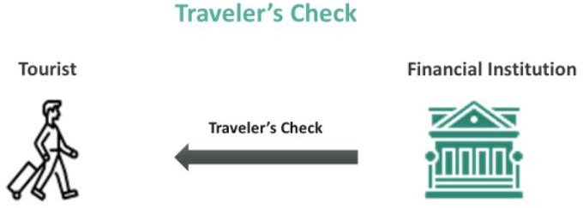

FIG. Traveler’s Check
    - Traveler’s Check Explained
Traveler’s checks are pre-filled checks with a specific amount of money. They work similarly to cash. It is like prepaid money is stored in these checks that can be used to purchase goods or services in the local currency. In addition, they protect against loss or theft because the check holder shows identification and signature proof to cash the check. As a result, traveler’s checks are regarded as a secure form of taking money abroad.

Assessing requests for foreign currency
Individual investors who are considering participating in the foreign currency exchange (or “forex”) market need to understand fully the market and its unique characteristics. Forextrading can be very risky and is not appropriate for all investors.
It is common in most forex trading strategies to employ leverage. Leverage entails using a relatively small amount of capital to buy currency worth many times the value of that capital. Leverage magnifies minor fluctuations in currency markets in order to increase potential gains and losses.
By using leverage to trade forex, you risk losing all of your initial capital and may lose even more money than the amount of your initial capital. You should carefully consider your own financial situation, consult a financial adviser knowledgeable in forex trading, and investigate any firms offering to trade forex for you before making any investment decisions.

Verifying foreign currency notes presented for sale
Foreign Currency Note or "Foreign Currency Notes" means, as the context may require:
(a) any of the Foreign Currency Notes executed by the Borrower payable to the order of any Lender, substantially in the form of Exhibit B hereto, originally in the principal amounts each such Lender's Pro Rata Share bears to the Maximum Total Amount of the Foreign Currency Loan, evidencing the aggregate indebtedness of the Borrower to such Lender resulting from the outstanding Foreign Currency Loan, as each such Foreign Currency Note may from time to time be amended, increased, decreased, extended, renewed, restated and/or changed in any way.
A foreign currency exchange rate is a price that represents how much it costs to buy the currency of one country using the currency of another country. Currency traders buy and sell Currencies through forex transactions based on how they expect currency exchange rates will fluctuate.
When the value of one currency rises relative to another, traders will earn profits if they purchased the appreciating currency, or suffer losses if they sold the appreciating currency. As discussed below, there are also other factors that can reduce a trader’s profits even if that trader “picked” the right currency.
2.3.1 Handling Foreign Currency Transactions
Currencies are identified by three-letter abbreviations. For example, USD is the designation for the U.S. dollar, EUR is the designation for the Euro, GBP is the designation for the British pound, and JPY is the designation for the Japanese yen.
Forex transactions are quoted in pairs of currencies (e.g., GBP/USD) because you are purchasing one currency with another currency. Sometimes purchases and sales are done relative to the U.S. dollar, similar to the way that many stocks and bonds are priced in U.S. dollars. For example, you might buy Euros using U.S. dollars. In other types of forex transactions, one foreign currency might be purchased using another foreign currency. An example of this would be to buy
Euros using British pounds - that is, trading both the Euro and the pound in a single transaction.
For investors whose local currency is the U.S. dollar (i.e., investors who mostly hold assets denominated in U.S. dollars), the first example generally represents a single, positive bet on the Euro (an expectation that the Euro will rise in value), whereas the second example represents a positive bet on the Euro and a negative bet on the British pound (an expectation that the Euro will rise in value relative to the British pound).There are different quoting conventions for exchange rates depending on the currency, the market, and sometimes even the system that is displaying the quote. For some investors, these differences can be a source of confusion and might even lead to placing unintended trades.
For example, it is often the case that the Euro exchange rates are quoted in terms of U.S. dollars.
A quote for EUR of 1.4123 then means that 1,000 Euros can be bought for approximately 1,412
U.S. dollars. In contrast, Japanese yen are often quoted in terms of the number of yen that can be purchased with a single U.S. dollar. A quote for JPY of 79.1515 then means that 1,000 U.S. dollars can be bought for approximately 79,152 yen. In these examples, if you bought the Euro and the EUR quote increases from 1.4123 to 1.5123, you would be making money. But if you bought the yen and the JPY quote increases from 79.1515 to 89.1515, you would actually be losing money because, in this example, the yen would be depreciating relative to the U.S. dollar
(i.e., it would take more yen to buy a single U.S. dollar).

Self-Check -2 | Written Test

Direction 2: choose the correct answer
- Currencies are identified by

A. two letters B. three letters C. four letters D. five letters

Directions: Answer all the questions listed below. Use the Answer sheet provided in the next page:

- What are cleared funds?

- What does cleared funds mean in banking

- What is international clearing system?

- Describe foreign exchange rate

5. Identify special risks of foreign exchange ( at list 4) -------------------------------------------------------

UNIT 3 | Conduct the transaction
Instruction sheet
This learning guide is developed to provide you the necessary information regarding the following content coverage and topics:
- Calculating conversion of foreign currency amounts
- Providing the customer with a copy of the rates
- Purchasing or selling travelers cheques
- Entering details of the transaction into the database

This guide will also assist you to attain the learning outcomes stated in the cover page. Specifically, upon completion of this learning guide, you will be able to:
- Calculate conversion of foreign currency amounts
- Provide customer with a copy of the rates
- Purchase or selling travelers cheques
- Enter details of the transaction into the database

Calculating conversion of foreign currency amounts
A foreign currency transaction is a sales or purchase transaction denominated in a currency other than the company’s functional currency. A foreign currency transaction involving foreign currencies commonly goes through several stages.
    - Forecast. A forecast is an anticipated transaction that is not yet legally committed.
In IFRS terms, a transaction is ‘expected to occur’ if its estimated probability ranges between 20% and 75%.
    - SO/PO. Also known as a ‘firm commitment’, a SO/PO (sales order/purchase order) is a legally binding agreement that establishes the exchange of a specified quantity of resources at a specified price on a specified future date or dates.
(c) AR/AP. A foreign currency denominated trade receivable or payable is a legally enforceable claim that certifies the sale/purchase to be settled at a later date.
(D) Settlement. The transaction is settled when payment in cash, in a foreign currency, finally takes place.
Currency pair: Every Forex transaction is an exchange of one currency for another. A currency pair quote looks like this: USD/GBP = $1.15. In this example, the U.S. dollar is the base currency, and the British pound is the quote currency. A trader who wishes to buy British
pounds will pay $1.15 for each.

    - Currency Arbitrage
Currency arbitrage is a forex strategy in which a currency trader takes advantage of different spreads offered by brokers for a particular currency pair by making trades. Different spreads for a currency pair imply disparities between the bids and ask prices. Currency arbitrage involves the simultaneous buying and selling of currency pairs from different brokers to take advantage of the mispriced rates.
      - Currency arbitrage is the exploitation of differences in quotes offered by brokers
      - The strategy involves simultaneously buying and selling the same security on two different markets.
      - Strategies can include two-currency arbitrage and three-currency arbitrage

Two types of arbitrage
- Financial Centre Arbitrage: is act of buying a currency from financial center they offer it at lower rate. And selling it higher rate in other financial center
e.g:55.4 birr/USA in Addis. 55 birr/USA in NEYORK. Profit 0.4 /each dollar.
- Cross-Currency Arbitrage: is the act of arbitraging by using middle currency
e.g 1 dollar=18birr
1 pound =1.5 dollar

1pound=? 1.5x18=27 birr.
Assume 1 pound =28 birr then it is advantageous to use dollar as a middle currency rather than direct trading of pound with birr(profit 1 birr per pound)

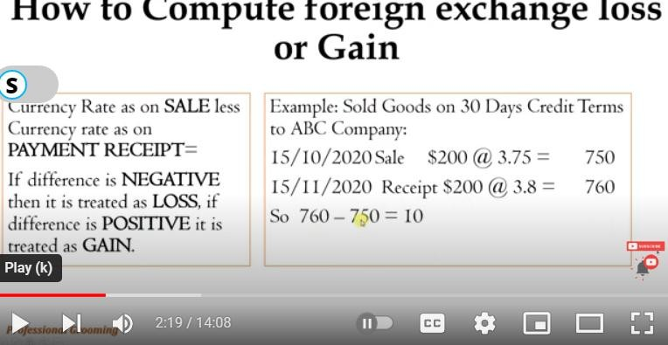
Video.1. foreign currency exchange loss/gain https://www.youtube.com/watch?v=9bLQPxT8-tA&t=17s
    - Foreign currency transaction recorded in a Company’s books and records
At the date a foreign currency transaction occurs, each asset, liability, revenue, expense, gain, or loss arising from the transaction is recorded in the functional currency of the recording entity using the exchange rate in effect at that date. Using the exchange rate at that date may not be practical therefore a weighted average rate may be used.
Transaction gains or losses arise due to changes in the exchange rate among:
      - the transaction date and the settlement date;
      - the transaction date and a subsequent balance-sheet date; or
      - A subsequent balance-sheet date and the settlement date.
We will show some example entries to record a foreign exchange transaction, and for those examples here are some facts:

- Company A is a US operating entity whose functional currency is the US dollar (USD),
- Company B is a Spanish operating entity whose functional currency is the euro (EUR)
- Company A purchased product from Company B on November 16, 2020
- The transaction was denominated in EUR
- The cost of the product is 50,000 EUR at the date of transaction
- The exchange rate on November 16, 2020 was 1 EUR: 1.18326 USD.
- Company A recorded a payable and related expense for 59,163 USD using the exchange rate on the date of the transaction
- The exchange rates were as follows: o 1.8326 on November 16, 2020 o 2.2389 on December 18, 2020 o 2.2824 on December 31, 2020 o 2.0748 on January 18, 2021

Example Entry #1
If settled before year end, for example on December 18, 2020 Company A would owe Company B 61,194 USD based on the exchange rate as of that date. Company A would make the following entry:
Accounts Payable 59,163
Foreign Exchange Loss – Realized 2,031 Cash 61,194

Example Entry #2

If settled after year end, Company A would adjust the payable at year end based on the exchange rate as of December 31, 2020, which amounts to 61,412 USD. When recording this adjustment, it is common for companies to have a contra account instead of adjusting the accounts payable balance. A common name would be Accounts Payable – Revaluation. Company A would make the following entry:
Foreign Exchange Loss – Unrealized 2,249
Accounts Payable – Revaluation 2,249

Example Entry #3
Once the payable is settled after year end on January 18, 2021, the amount owed based on the exchange rate at that time would be 60,374 USD. Company A would then make the following entry:
Accounts Payable 59,163
Accounts Payable – Revaluation 2,249 Foreign Exchange Loss – Realized 1,211 Cash 60,374
Foreign Exchange Gain – Unrealized 2,249

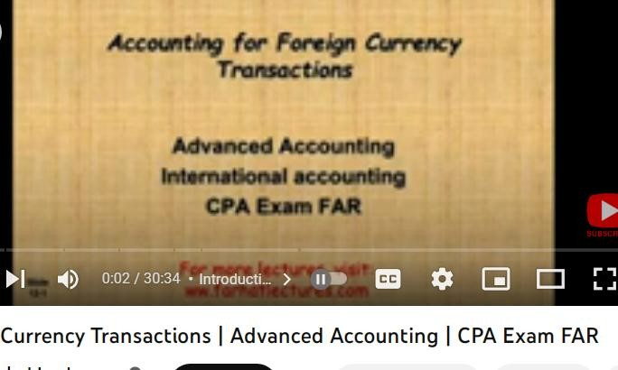

Providing the customer with a copy of the rates
    - Rate Of Exchange
This is the rate at which one currency is bought or sold in exchange for another. The exchange rates are available in the banking halls of banks and they are published in newspapers. They are also available on the internet from different sources
The rates fluctuate almost on day to day basis and this poses a special risk to international business. Some of the factors that influence exchange rates are:
      - Confidence and Speculation: confidence is a function of demand and supply for the currency. But this often times fuelled by speculation which may arise from multiple factors such as general elections, change in government, disturbances in the national economy such as strikes, coups, natural disasters etc. Speculation can be in favor or against a currency.
Exports more goods and services than it imports, then the country will be earning more currency than it spends.

PURCHASING or Selling Travelers Cheque
Travelers Cheque: is a medium of exchange that can be used in place of hard currency.
They can be denominated in one of a number of major world currencies and are preprinted, fixed-amount cheques designed to allow the person signing it to make an unconditional
payment to someone else as a result of having paid the issuer for that privilege.
32| P a g e Addis Ababa TVT bureau Module title: : Handling Foreign Currency Ver
 |  |  |  | sion-1
 |  | Transactions  Accounting & finance level – IV | September 2023

They were generally used by people on vacation in foreign countries instead of cash, as many businesses used to accept traveller's cheques as currency.
The incentive for merchants and other parties to accept them lies in the fact that as long as the original signature (which the buyer is supposed to place on the cheque in ink as soon as they receive the cheque) and the signature made at the time the cheque is used are the same, the cheque's issuer will unconditionally guarantee payment of the face amount even if the cheque was fraudulently issued, stolen, or lost.
This means that a traveller's cheque can never 'bounce' unless the issuer goes bankrupt or out of business. If a traveller's cheque were lost or stolen, it could be replaced by the issuing financial institution.
    - Benefit of issuing traveller's cheques for financial institutions
      - They earn income in a number of ways:
Firstly, they charge a fee on sale of such cheques.
In addition, they can earn interest for the period that the cheques are uncashed, while not paying any interest to the cheque holder, making them effectively interest-free loans.
Also, the foreign exchange rate commonly used on traveler’s cheques (generally based on rates applicable at the time of purchase) is less favourable compared to other forms of obtaining foreign currency, especially those on credit card transactions (which use a rate applicable at the transaction date).

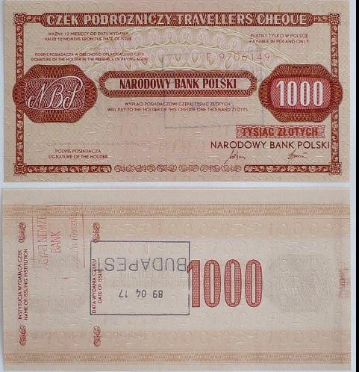

Figure. traveller's cheque of National Bank of Poland (nominal value: 1000 Polish złoty); sold in April 1989 in Budapest (Hungary), for use during travel to Poland only, never used.

Entering details of the transaction into the database
It is possible use various storage methods to keep records - such as a computer, hard disc drive or CD - as long as they:
- Show all information contained within a document
- allow information to be presented in a readable format You should try to keep all original documents, and must keep any which show that tax has been deducted - eg your end of year certificate for PAYE (form P60). Detailed and up-to-date records will help you comply with tax legislation, deal with mistakes and avoid penalties. You can be penalized for:
- Not keeping adequate records
- Failing to keep records for required periods of time
- Inaccurate tax returns Analytical accounting tools Analyzing your financial accounts enables you to compare your performance against previous years and with its competitors. Ratios enable you to quickly compare relative values - eg two items on the balance sheet. Ratio analysis can also be applied to non-financial data. For ease of reference, ratios are often split into the following areas of common control:

- Liquidity ratios - these are used to measure solvency and short-term survival prospects

- Capital structure ratios - these measure the adequacy of owners' funding in relation to long- term debt
- Activity and efficiency ratios - these measure the operating efficiency of the business in non- financial terms
- Profitability ratios - these measure overall profitability and how well the business is using its assets and covering overhead costs

Self-check 3 | Written test

Name………………………ID………………………… Date……. Directions: Answer all the questions listed below
Operational sheet 1

Method of Recording Foreign currency transaction

- Use the following information for the next six questions:

On November 29, 2001, ABC Co. placed a non-cancellable purchase order for the importation of a machine with a purchase price of €40, from a company based in France. The contract term is FOB shipping point.
The machine was shipped on December 1, 2001 and was received by ABC on December 15, 2001. The purchase price was settled on January 3, 2002.

The following are the exchange rates:
November 29, 2001. ₱55:€
December 1, 2001. ₱58:€
December 15, 2001. ₱57:€
December 31, 2001. ₱60:€
January 3, 2002. ₱61:€
- Procedures of Recording foreign currency transaction Step 1. The entry on November 29, 2001
Step 2.The entry on December 1, 2001
Step 3.The total FOREX gain (loss) recognized in 2001
Step 4.The adjustment to the machinery account on December 31, 2001 is – increase (decrease)
Step 5.The total FOREX gain (loss) recognized in 2002
Step 6.The net adjustment to the machinery account on January 3, 2002 is – increase (decrease)

LAP test 1 | Practical demonstration

Name: Date:
Time started: Time finished:
Instructions: Giving the necessary equipment’s and stationary materials you are required to perform the following tasks within 40min.

Task 1: record of necessary entry.

Task 2.calculate gain and loss of forex exchange buying and selling.

UNIT 4 | Maintain accurate records of transaction
Instruction sheet
This learning guide is developed to provide you the necessary information regarding the following content coverage and topics:
- Completing vouchers and receipts
- Completing and filing reports in the event of significant cash transactions
- Updating and maintaining internal records of foreign currency transactions
This guide will also assist you to attain the learning outcomes stated in the cover page. Specifically, upon completion of this learning guide, you will be able to:
- Complete vouchers and receipts
- Complete and filing reports in the event of significant cash transactions
- Update and maintain internal records of foreign currency transactions

Introduction
The importance of maintaining accurate accounts: It’s important that your accounts are accurate and up to date so you can draw up 'true and fair' annual accounts. Your accounts should be backed up with full and detailed records of all business income and expenditure, such as receipts, invoices and purchase orders, payments in and out, etc. Why you should keep records and documents following careful record keeping procedures can also help you with tax returns and prevent fraud or theft. Using a good record keeping system will keep you up to date and help you to:
- Track Expenses, Debts and Creditors
- Apply For Additional Funding –
Eg A Bank Loan or Overdraft Facility
- Save Time and Accountancy Costs
- Pay Tax, Accurately and On Time, Avoiding Penalties
- Apply For And Receive The Correct Amount Of Benefits Or Credits If You Are Starting A New Business It Is Essential That You Get A Proper Record Keeping System In Place Immediately.

Completing vouchers and receipts
Foreign Currency Receipts
A foreign currency receipt is a receipt that is in the foreign (transaction) currency of the invoice. You specify the foreign currency of the receipt at the time you enter the receipt. When you enter a foreign currency receipt, these criteria must be met for the system to process the receipt:
    - The foreign currency of a receipt must be the same as the transaction currency of the invoice.
    - The base currency of the receipt must be the same as the domestic (base) currency of the invoice.
    - If the bank account is a monetary account, the currency of the company to which the bank account is assigned must be the same as the base currency of the receipt and invoice; otherwise, the system issues an error message and you cannot continue entering the receipt.
When you enter a receipt in a foreign currency, the system converts the foreign currency amount to the domestic currency amount based on the exchange rate in the F0015 table or, if applicable, a spot rate entered on the receipt record.

Completing and filing reports in the event of significant cash transactions
    - Reporting Currency
Reporting currency is the currency in which an entity's financial statements or other financial documents are reported. Choosing one currency for reporting makes it easier to understand the financial documents across the board.
Most often the currency used is the currency of the country in which the parent company is legally registered.

Understanding a Reporting Currency
Many large companies have operations in different countries, which often requires doing business in a variety of currencies. When this is the case, the currency of the company's home office or parent company where the financial statements are prepared is considered the reporting currency.
Other satellite locations or subsidiaries that use different currencies, referred to as the local currency, in their day-to-day functioning must convert their financial statements into the reporting currency so that the statements can be consolidated. This is accomplished using either the temporal or current rate method of conversion and is often referred to as foreign currency translation.
To compile financial reports for multicurrency firms, accountants must convert foreign currencies into a single reporting currency at the current exchange rate. To standardize this process, there are a variety of accounting regulations that prescribe a uniform methodology for carrying out this conversion. This helps to maximize the transparency with which these financial reports are presented.
- Example of a Reporting Currency
Exxon Mobil is a large oil company that conducts business across the world.
It is headquartered in the United States but has many subsidiaries spread out globally, such as Esso Australia and Mobil Producing Nigeria. Esso Australia would conduct its business in Aussie dollars and Mobil Producing Nigeria would conduct its business in Nigerian naira.
When ExxonMobil is preparing its financial statements, it will require that both Esso Australia and Mobil Producing Nigeria convert their financial figures into U.S. dollars, because it is the currency of the United States, where ExxonMobil is headquartered.

The U.S. dollar is the reporting currency. If Esso Australia reported AUD 1 million, it would convert that AUD 1 million into USD, which is approximately $750,000. ExxonMobil would then use the $750,000 figure in its consolidated financial reporting.
Because the United States adheres to the generally accepted accounting principles (GAAP), ExxonMobil would have to follow GAAP guidelines on foreign currency translation, which would require the use of the spot exchange rate or an average rate for the period in question that is a close approximation. This would be for monetary items, whereas non-monetary items would be done at a historic exchange rate.

Updating and maintaining internal records of foreign currency transactions
Before they can be recorded, foreign currency transactions need to be adjusted to today’s value in your company’s functional currency in a process known as re-measurement. Your functional currency is the currency in which you keep your books.
For example, a U.S.-based company’s functional currency would be the U.S. dollar. All other transaction currencies would represent foreign currency transactions. So, if a U.S. functional entity sells goods into the U.K. in the Pound sterling (GBP), the company would need to record and re- measure that foreign currency transaction.
    - Re-Measurement process currency transactions

INITIAL RECORDING
When a foreign currency transaction is recorded, it needs to use the exchange rate in effect on the date of the transaction.
For example, a U.S. company sells a widget for 100K GBP. To record the sale, the company needs to first record the transaction in GBP. This represents the currency of denomination (the underlying transaction currency).
To record it, there needs to be an exchange rate so that the accounting results can be presented in USD terms.
So, assuming a 1.17 USD/GBP exchange rate, the company records the transaction as $117,000. There is no foreign currency gain/loss at the time of recording the transaction

Subsequent measurement
All foreign monetary account balances need to reflect changes in exchange rates between the initial recording rate and the month-end accounting rate.

Transaction settlement
At some point, the accounts receivable will be collected and converted into U.S. dollars. It’s important to note that collecting GBP is not a conversion of currency. The transaction is considered settled only after GBP is converted into USD.

Self-check 4 | Written test

Name………………………ID………………………… Date……. Directions: Answer all the questions listed below
- What is Vouchers?

- Describe the contribution of Cumulative transaction adjustments? ---------------------------

- What are the reasons of re-measurment foreign currency? ------------------------------------

- Write important of recording internal foreign currency transactions? -------------------------------

5. What is Reporting Currency? --------------------------------------------------------------------------
-----------------------------------------------------------------------------------

REFERENCES
BOOKS:
  - Samson Tsedeke (2018) import and export regulations in ethiopia.
  - Ethiopian Revenues and Customs Authority (2001.
  - Adam Hayes (2023). Cleared Funds: How They Work, Importance.
  - Saranthip Saetang. (2023) Telegraphic Transfer (TT).
  - JAMES CHEN (2023) Currency Arbitrage.
  - WILL KENTON, (2021) Reporting Currency:

WEB PAGE:
  - https://en.wikipedia.org/wiki/Foreign_exchange_market/nature

  - https://efinancemanagement.com/international-financial-management/foreign-exchange

  - https://www.kantox.com/en/glossary/foreign-currency-transaction/

  - https://en.wikipedia.org/wiki/Traveller%27s_cheque

  - https://docs.oracle.com/en/applications/jd-

  - https://gtreasury.com/blog/how-to-record-foreign-currency-transactions-identify-fx- exposure/
YOUTUBE:

  - https://www.youtube.com/watch?v=9bLQPxT8-tA&t=17s

  - https://www.youtube.com/watch?v=rhq-dd6pjBY

No | Name | Qualification | Educational background | Region | College | Mobile number | E-mail
1 | Kassa Terefe | BA, degree | Accounting & finance | A.A | KMC | +251993298301 | kssterefe@gmail.com
2 | Sewumehon Anteneh | BA degree | Accounting & finance | A.A | KMC | +251948032126 | Sewumehonanteneh@gmail.com
3 | Remedan Abdurehman | MBA | Accounting & finance | A.A | GWPTC | +25133233939 | rame.abdu10@gmail.com
4 | Meskerem Getachew | MBA | Accounting & finance | A.A | ARADA | +251925918465 | meskigetach@gmail.com
5 | Mahmud Oumer | BA | Accounting | A.A | GWPTC | 0913099303 | Mahmudoumer@gmail.com
6 | Mekuanint Abeje Melese | MSc degree | Accounting & finance | A.A | LMC | +251913969620 | Mekuanitabeje21@gmail.com
7 | Hussien Ebrahim | MBA | Accounting & finance | A.A | GWPTC | +251920188426 | Hussienebrahim701@ gmail.com
8 | Alemayehu | MBA | Accounting & finance | A.A | MPTC | +251920188426

