ACCOUNTING AND FINANCE
LEVEL - IV
BASED ON March 2022, CURRICULUM VERSION I


Module Title: Managing overdue customer accounts
Module code: LSA ACF4 10 1221
Nominal duration: 60Hour
PREPARED BY: A.A TVT BUREAU
September, 2023
Addis Ababa, Ethiopia

Table of Contents
INTRODUCTION 6
Unit One: Identify customers requiring collection activity 9
1 Monitoring overdue account reporting system 10
1.1 Overdue customer account 10
1.2 Accessed and Records Customer Information 10
1.3 Reviewing overdue debtors 11
1.3.1 Organization policy and procedures 11
1.3.2 Legislation 12
Self – check I 14
Unit Two: Establish contact with customer 15
2.1 Determining and confirming propose communication 16
2.2 Establishing and communicating rapport 17
2.3 Advising purpose of contact 19
Self – check II 21
Unit Three: Negotiate resolution of outstanding payments 22
3.1 Advising debtors the possibility of legal action 23
3.1.1 Legal action 23
3.2 Using appropriate techniques 25
3.2.1 Appropriate techniques 25
Self – check III 27
Unit four: Agreement is monitored to ensure adherence 28
4.1 Reviewing account 29
4.2 Addressing breaches of agreement 29
4.3 Referring outstanding payment matters 30
Self – check IV 34
REFERENCE 34

Figure No, | Figure Name
Figure1-1 | Content Of Policy And Procedure
Figure 2-1 | Model Of Communication
Figure 2-2 | Build Rapport
Figure 4-1 | Day Payable Outstanding

Acknowledgment
A.A TVT BUREAU wishes to extend thanks and appreciation to the many representatives of TVT instructors and respective kirkos manufacturing college Dean who donated their time and expertise to the development of this Teaching, Training and Learning Materials (TTLM).

INTRODUCTION
Welcome to the module Manage Overdue Customer Accounts”. This learner’s guide was prepared to help you achieve the required competence in Accounting and finance Level IV. This will be the source of information for you to acquire knowledge attitude and skills in this particular occupation with minimum supervision or help from your trainer.
One of the least enjoyable, and arguably most dreaded, tasks in business is following up on unpaid customer accounts; but with the right processes in place it doesn’t need to be stressful. In Manage Overdue Customer Accounts you will gain the skills and knowledge required to correctly initiate and complete the debt collection process. In this online debt collection course, you will also learn how to identify customers requiring collection activity, establish contact with customers and attempt to resolve outstanding payment matters, negotiate resolution and monitor agreements to ensure adherence. On completion of this course, you will feel empowered to professionally manage overdue customer accounts with ease.
This module covers the units:
- Identify customers requiring collection activity
- Establish contact with customer and attempt to resolve outstanding payment matters
- Negotiate resolution of outstanding payments
- Agreement is monitored to ensure adherence
Learning Objective of the Module
- To identify customers requiring collection activity
- To established contact with customer and attempt to resolve outstanding payment matters
- Determine negotiate resolution of outstanding payments
- Agreement is monitored to ensure adherence

Module instruction
For effective use these modules trainees are expected to follow the following module instruction:
- Read the information written in each unit
- Accomplish the self-checks at the end of each unit
- Red the identified reference book for examples and exercise

ACRONYMS

QMS Quality management system
DPO Days payable outstanding
EPA Enforceable Payment Agreement

Unit One: Identify customers requiring collection activity
This unit is to provide you the necessary information regarding the following content coverage and topics:
- Monitoring overdue account reporting system
- Accessing and recording relevant customer information
- Reviewing overdue debtors
This unit will also assist you to attain the learning outcomes stated in the cover page. Specifically, upon completion of this learning guide, you will be able to:
- Monitor overdue account in reporting system
- Access and record relevant customer information
- Review overdue debtors

Monitoring overdue account reporting system

Overdue customer account
As soon as you miss a payment, the account is considered past due or overdue. Even if you’re only a few days late, this is technically considered an overdue payment. However, if your account is only a little bit past due, you’re unlikely to face any intimidating collection efforts.
However, if you don’t pay the past due balance, you could experience any of the following:
- Phone calls from your creditor or service provider
- Past due letter in the mail
- Discontinued service (in the case of utilities)
- Negative impact on your credit score
- Legal action

Accessed and Records Customer Information
Information is a fact, thought or data conveyed or described through various types of communication, like written, oral, visual and audio communications.
Knowledge communicated or received concerning a particular fact or circumstance; news: information concerning a crime. Knowledge gained through study, communication, research, instruction, etc.; factual data: His wealth of general information is amazing.
Types of information
The information you collect from your customers might include:
- Personal contact details
- Personal residential details
- Government-issued identification
- Medical history
- Emergency contact and next of kin
- Buying habits and preferences
- Product or service preferences
- Financial statements and credit history.
Customer information is the behavioral, demographic and personal information about customers collected by businesses and marketing companies to understand communicate and engage with customers.

Reviewing overdue debtors
A debt is overdue as soon as payment is late. A debt is overdue as soon as payment is late. It must be remembered that once payment is late, even by as little as a single day, the law considers the debt to be overdue. The debtor is in breach, because he failed to fulfil his obligation by the deadline.
A debt is a creditor’s right to be paid by a debtor. A debt becomes an overdue debt once it is due and outstanding, provided that it is certain, liquidated, due and payable. Once a debt is overdue, the creditor can collect it, either personally or through an agent.
To ensure timely payment to vendors, accounts payable departments often set up a schedule. An overdue invoice is an invoice a company has yet to pay and is past the invoice due date. Failure to pay the invoice by a due date makes an invoice overdue.

Organization policy and procedures
Organizational policies and procedures provide guidelines for decision-making processes and the way that works in an organization should be carried out. The result of having clear, well-written policies and procedures are increased transparency, accountability, uniformity and stability.

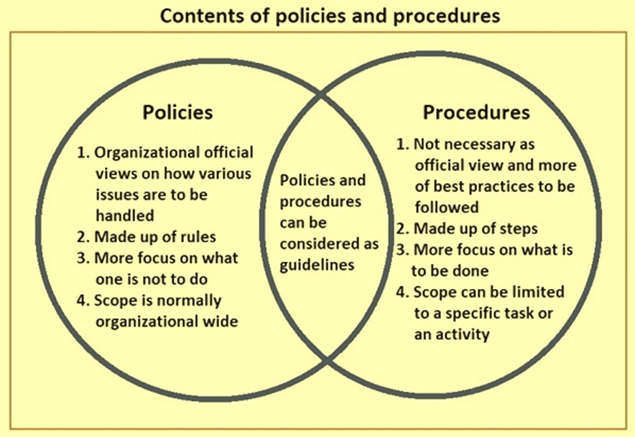
Figure1-1: content of policy and procedure
Organization policy and procedures
May include but not limited to;-
  - Consideration of customer circumstances
  - Ongoing support and negotiation with customers
  - Referral to external organizations for advice
  - Settlement schedules recovery costs suspension of credit facilicilite

Legislation
Legislation, the preparing and enacting of laws by local, state, or national legislatures. In other contexts it is sometimes used to apply to municipal ordinances and to the rules and regulations of administrative agencies passed in the exercise of delegated legislative functions.
Legislation is the process or result of enrolling, enacting, or promulgating laws by a legislature, parliament, or analogous governing body.[1] Before an item of legislation becomes law it may be known as a bill, and may be broadly referred to as "legislation" while it remains under consideration to distinguish it from other business. Legislation can have many purposes: to regulate, to authorize, to outlaw, to provide (funds), to sanction, to grant, to declare, or to restrict. It may be contrasted with a non-legislative act by an executive or administrative body under the authority of a legislative act.
Examples of legislation
- Bankruptcy law
- Bills of Sale and Other Instruments law
- Cheques and Payment Orders manuals
- Consumer credit directives
- Corporations law
- Criminal code
- Door to Door Sales Act or equivalent
- Evidence Reproduction procedures
- Fair Trading laws

Self – check
      - How to collect from your customer information’s
_______________________________________________________________________________________________________________________________________________________________________________________________
      - What is legal action and their examples
______________________________________________________________________________________________________________________________________________________________________________________________________________________________________________________________________
      - Define the difference between policy and procedures
_____________________________________________________________________________________________________________________________________________________________________________________________________________
- Explain the difference between debtor and creditor

Unit Two: Establish contact with customer
This unit is to provide you the necessary information regarding the following content coverage and topics:
- Determining and confirming proposed communication.
- Establishing and communicating rapport.
- Advising purpose of contact.
This unit will also assist you to attain the learning outcomes stated in the cover page. Specifically, upon completion of this learning guide, you will be able to:
- Determine and confirm proposed communication.
- Establish and communicate rapport.
- Advise purpose of contact.

Determining and confirming propose communication
Communication is neither transmission of message nor message itself. It is the mutual Exchange of understanding, originating with the receiver. Communication needs to be effective in business. Communication is essence of management. The basic functions of management (Planning, Organizing, Staffing, Directing and Controlling) cannot be performed well without effective communication. Business communication involves constant flow of information. Feedback is integral part of business communication. Organizations these days are very large. It involves number of people. There are various levels of hierarchy in an organization. Greater the number of levels, the more difficult is the job of managing the organization. Confirming messages convey that parties in the relationship are valued. There are three main categories of confirming communication: showing recognition, acknowledging the other person's thoughts and feelings, and expressing agreement.
For example, if a friend enters your home and you smile, hug them, and say, “I'm so glad to see you” you are confirming their existence. If you say “good morning” to a colleague and they ignore you by walking out of the room without saying anything, then they are creating a disconfirming climate by not recognizing you.
The purpose of communication is to inquire, inform, persuade, entertain, request and investigate. A single message can have one or more of the following purposes: To convey information/opinion, for example, “I have headache” or “I am here to give you medication”.
Confirmation- Messages sent to another that communicate they are valued by the sender. Disconfirmation- Messages sent to another that communicate they are not valued by the sender.

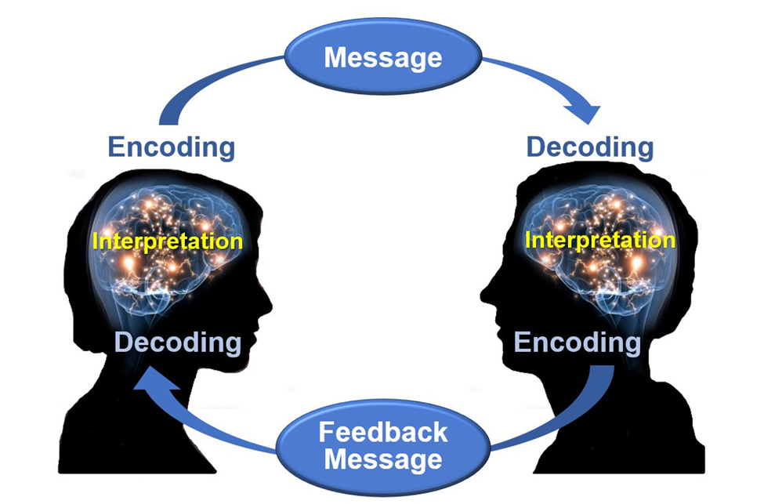
Figure 2-1:Model of communication

Establishing and communicating rapport

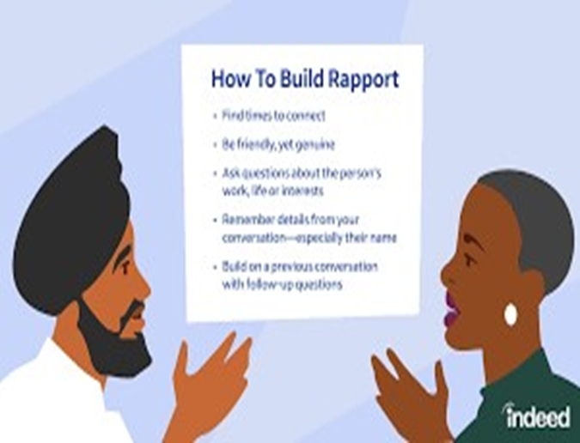

Figure 2-2: build rapport
Building rapport with colleagues, managers and customers is a critical stage of creating trust and building relationships. Without trust you limit what you can achieve at work, whatever your position. Everything becomes a lot harder and takes a lot longer.
Establishing rapport
It's the sense of connection that you get when you meet someone you like and trust, and whose point of view you understand. It's the bond that forms when you discover that you share one another's values and priorities in life.
One of the most important communication skills for building rapport and trust is listening actively. This means paying attention to what the other person is saying, showing interest and empathy, and asking relevant questions.

Five ways of Building Rapport and Connecting with Work Colleagues
  - Be the Real You
  - Turn Up Prepared
  - Practice Positive Body Language
  - Make the Conversation About Them
  - The Power of Notes

Advising purpose of contact
Advising
It means plays a key role in your education—whether you’re an undergraduate or a graduate student. Advisors not only know program requirements, but they also get to know you. They take time to learn about your interests and goals.
The advisor/advisee relationship is essentially educational in nature, and is thus broad and multi-faceted. For the student new to an academic community, advisors can help the student engage with and learn to thrive in their new environment. Advisors who take the time to introduce themselves to their new advisees with something as simple as an introductory exchange of emails, office visit, or telephone conversation do the following:
- Demonstrate an interest in the student’s well-being
- Communicate to the student that he/she, as an individual, matters
- Provide a friendly and supportive connection to university life
- Can serve as a campus expert by referring them to campus and community resources
- Confirm that faculty on campus are approachable and helpful
Advisor and advisee responsibility
Advisor Responsibilities:
- Communicate university policies and procedures
- Help students define and develop realistic goals
- Match student needs with available resources; make appropriate referrals
- Assist students with planning programs consistent with their abilities and interests
- Discuss linkage between academic preparation and careers

Advisee Responsibilities:
- Gather all relevant decision-making information
- Clarify personal values and goals
- Become knowledgeable about college programs, policies, and procedures
- Be an active learner by participating fully in the advising experience
- Ask questions if you do not understand an issue or have a concern
- Accept responsibility for decisions
Purpose of advising
The advisor's role is to help the student evaluate and realize educational and career options. This requires the advisor to: approve the student's academic program of study. Provide accurate and consistent information.

Self – check
      - Explain communicating rapport
________________________________________________________________________________________________________________________________________________________________________________________________________________________________________________________________________
      - Discus the purpose of relevant customer information
____________________________________________________________________________________________________________________________________________________________________________________________________
      - Write the difference between advisee and advisor
___________________________________________________________________________________________________________________________________________________________________________________________________________________________________________________________________________________
      - What is rapport?
________________________________________________________________________________________________________________________________________________________________________________________________________________________________________________
- List and explain model of communication
_____________________________________________________________________________________________________________________________________________________________________________________________________________________________________________

Unit Three: Negotiate resolution of outstanding payments
This unit is developed to provide you the necessary information regarding the following content coverage
and topics:
- Advising debtors the possibility of legal action
- Using appropriate techniques
- Undertaking further action
This unit will also assist you to attain the learning outcomes stated in the cover page. Specifically, upon completion of this learning guide, you will be able to:
- Advising debtors the possibility of legal action
- Using appropriate techniques
- Undertaking further action

Advising debtors the possibility of legal action

Legal action
The act of using a lawyer or a court to help settle a disagreement, etc. that you have with a person or an organization. Legal Action means, with respect to any Person, any and all litigation or legal or other actions, arbitrations, counterclaims, investigations, proceedings, requests for material information by or pursuant to the order of any Authority or suits, at law or in arbitration, equity or admiralty, whether or not purported to be brought on behalf of such Person, affecting such Person or any of such Person's business, property or assets.
Examples of legal action
May include but not limited to;-
Court action:
  - Statement of claim (summons)
  - Statement of liquidated claim letter of demand
If the debtor does not pay the debt, there are five options:
  - Offering the debtor an Enforceable Payment Agreement
  - Further negotiation
  - Mediation
  - Commencing legal action
  - Writing the debt off
- Offering the debtor an Enforceable Payment Agreement (EPA)
Instead of taking legal action, or at any stage after you have started legal action, you can offer an Enforceable Payment Agreement to the debtor. An EPA is an agreement for the debtor to pay the debt in installments, and that the creditor will not commence a legal action or report the debt to credit referencing agencies.
If the debtor defaults on the EPA, the creditor can rely on the EPA to issue proceedings (if that has not happened already) and obtain summary judgment.
- Further negotiation
Further negotiation may be an attractive option, especially if the debtor indicates they may be able to pay the debt in the future. Use the same techniques described in ‘Negotiation with the debtor’ above. Consider suggesting an EPA as part of your negotiations.
- Mediation
Mediation is a process where both parties agree to sit down in the same room with a mediator to resolve their dispute. A mediator is a neutral third party who may help with discussions, but it is up to the parties themselves to arrive at a solution. Mediation has a number of benefits:

  - It is informal compared to court proceedings, with less stress on the parties
  - The mediator will not decide on how to settle the matter – this is for the parties to decide
  - The parties have more control over the process and outcome
  - Free mediation services are available, whereas legal action involves court fees
  - Mediation generally gives a quicker resolution than going to court
  - The privacy and confidentiality of the mediation process is assured (parties sign a confidentiality agreement before the first mediation session and, if both parties are in agreement, the outcome can remain confidential)
  - The Magistrates Court offers a mediation service.
- Commencing legal action
There are several factors to consider before taking legal action.
Proof
Can you prove that you are owed money by the debtor? Do you have documentation of the debt such as an invoice, or witnesses who will confirm your version of events? Do you have text messages, letters or emails from the debtor that confirms the debt?
Time
A Minor Civil Claim in the Magistrates Court can be settled at any time. However, it will be some months before a trial occurs if the debtor does not agree to pay the debt. Enforcing the judgment will take some time after this and the debt may not be paid in full straight away but in installments.
If you are representing yourself, you would need to be available in court at the time set for your directions hearing and trial.
Costs
Fees need to be paid when:
  - You give notice of intention to sue using the prescribed Final Notice
  - You file a Minor Civil Claim
  - If you need to enforce the judgment
- Writing the debt off
If negotiation and mediation are not successful or possible, and if any of the above factors mean that you do not wish to take legal action, then you can choose not to recover the debt, that is, you can ‘write the debt off’. In some cases, a business debt may be tax deductible.

Using appropriate techniques

Appropriate techniques
The increased sensitivity gained from this drill helps a practitioner attack and counter an opponent's movements precisely, quickly, and with appropriate techniques.
A technique is a method of doing some task or performing something. Your technique for opening drinks might be to twist the top off with your teeth. If so, your dentist better have a good tooth-repair technique. The noun technique can also refer to someone's skillfulness with the fundamentals of a particular task.
To help visitors develop an understanding of the relevance and significance of resources, interpretation involves linking a tangible resource at your site to the intangible meanings it represents. Appropriate interpretive techniques create those links. Simply declaring that a resource is relevant doesn't provide an opportunity for visitors to form their own connection to what the resource means or why it is significant. Using techniques like storytelling or comparisons can provide opportunities for connections to the resource. This may motivate visitors to care about, and perhaps even care for, the resource

Self – check
      - Define and explain legal action
_________________________________________________________________________________________________________________________________________________________________________________________________________________________________
      - List examples of legal action
___________________________________________________________________________________________________________________________________________________________________________________
      - What is an appropriate technique?
______________________________________________________________________________________________________________________________________________________________________________________________________________________________________________________________

Unit four: Agreement is monitored to ensure adherence
This unit is developed to provide you the necessary information regarding the following content coverage and topics:
- Reviewing account.
- Addressing breaches of agreement.
- Referring outstanding payment matters.
This unit will also assist you to attain the learning outcomes stated in the cover page. Specifically, upon completion of this learning guide, you will be able to:
- Review account.
- Adders breaches of agreement.
- Referrer’s outstanding payment matters.

Reviewing account
An account review is a regularly scheduled meeting between a supplier and client to review performance and further develop the relationship. On the client side, participants include the decision maker, the purchaser and the user of the product or service. On the supplier side, the sales rep attends and may bring the sales manager, president and/or technical expert. Frequency is less important than consistency. For some industries, annual reviews are enough, while for others, quarterly works best.
Increasing revenue is among the top three goals of company owners, and while converting new prospects is an easy way to measure the return on investment for a sales implementation, there is also often a larger untapped pocket of potential in the clients the company already serves. The first step to accessing this potential is an account review.
The accounting review consists of control processes and clearance of the balance sheet accounts before the closing of a financial year or period. It enables the financial statements of a company to be analyzed with a view to verifying their sincerity, regularity and conformity.

Addressing breaches of agreement
One way companies can ensure compliance with Contracts of Adherence is by implementing a quality management system (QMS). A QMS can help companies to track and improve their performance against the standards set out in the contract. It can also help companies to identify and address any areas of non-compliance.
A contract of adherence is an agreement between two parties that outlines the rules and regulations each must abide by. In a business context, it's used to ensure compliance with any laws or regulations that may be imposed on the business or its customers.
A contract of adherence is an agreement between two parties in which one party agrees to adhere to the terms and conditions of the other party. The terms and conditions may include, but are not limited to, the payment of a fee or the performance of a service.
In order for a company to ensure compliance with a Contract of Adherence, they must first understand what the contract entails. A Contract of Adherence is an agreement between two or more parties that outlines the terms and conditions under which they will do business with one another. This type of contract is often used in situations where one party is providing a service to another party, and both parties want to ensure that the quality of the service meets their expectations.
The key elements of a Contract of Adherence include:
  - A description of the services to be provided
  - The expectations of both parties regarding the quality of those services
  - The consequences that will occur if either party fails to meet their obligations under the contract
One way companies can ensure compliance with Contracts of Adherence is by implementing a quality management system (QMS). A QMS can help companies to track and improve their performance against the standards set out in the contract. It can also help companies to identify and address any areas of non-compliance.
Another way companies can ensure compliance with Contracts of Adherence is by appointing a compliance officer. The compliance officer is responsible for ensuring that the company complies with all aspects of the contract. They will liaise with different departments within the company to ensure that everyone is aware of their obligations under the contract.

Referring outstanding payment matters
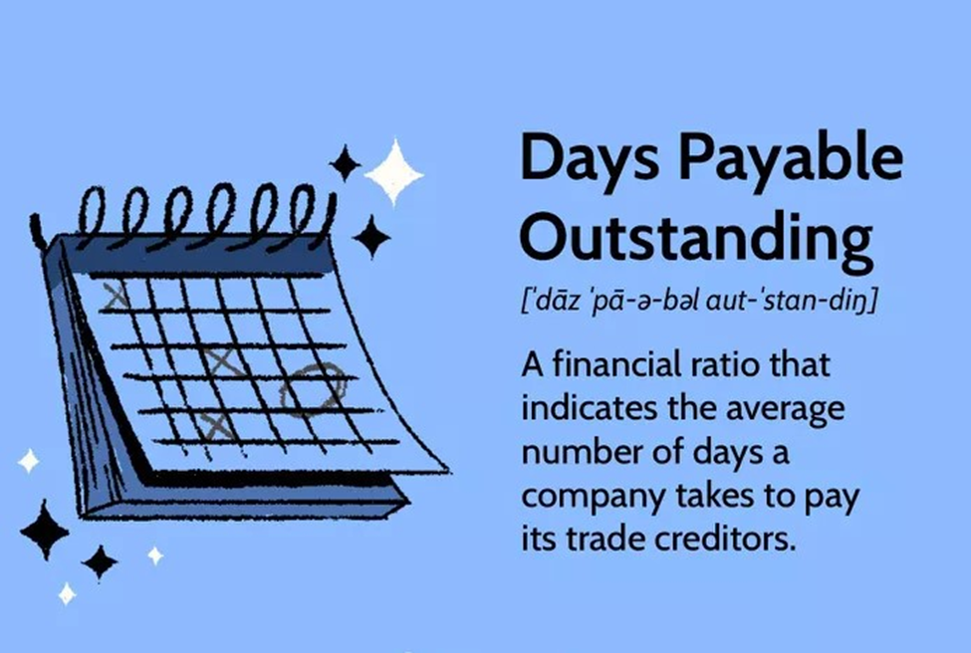

Figure 4-1: Day payable outstanding
Outstanding payment refers to a payment that has not yet been made or received. It may refer to a bill or invoice that has not been paid, or to money that is owed to someone but has not yet been received. This term is commonly used in financial contexts, such as in businesses or personal finance.
It means the payment has been billed ‘out’ but not received. That distinguishes it from accumulated but unbilled accounts receivable. These are distinctions that make up the discipline of accounting.
Days payable outstanding (DPO) is a financial ratio that indicates the average time (in days) that a company takes to pay its bills and invoices to its trade creditors, which may include suppliers, vendors, or financiers. The ratio is typically calculated on a quarterly or annual basis, and it indicates how well the company’s cash outflows are being managed.
A company with a higher value of DPO takes longer to pay its bills, which means that it can retain available funds for a longer duration, allowing the company an opportunity to use those funds in a better way to maximize the benefits. A high DPO, however, may also be a red flag indicating an inability to pay its bills on time.
Formula for Days Payable Outstanding (DPO)
DPO = (Accounts Payable × Number of Days)/COGS
Where: COGS = Cost of Goods Sold
= Beginning Inventory + P − Ending Inventory
P = Purchases
Example of Days Payable Outstanding
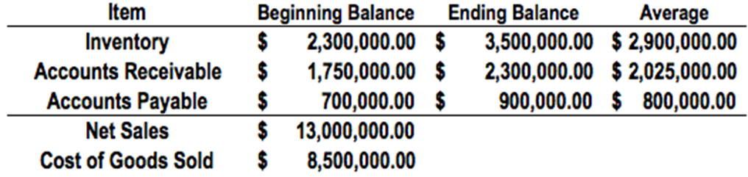

Calculating the DPO with the beginning and end of year balances provided above:
Average accounts payable: $800,000
Cost of goods sold: $8,500,000
Number of days: 365
Solution
DPO: ($800,000 / $8,500,000) x 365 = 34.35.
Therefore, this company takes an average of 34 days to pay back its accounts payable.

Self – check
- What is review account?
_______________________________________________________________________________________________________________________
- Define and explain quality management system
________________________________________________________________________________________________________________________________________________________________________________________________________________________
- List the elements of a Contract of Adherence
______________________________________________________________________________________________________________________________________________________________________________
- Explain outstanding payment
____________________________________________________________________________________________________________________________________________________________________________

REFERENCE

- Www.training.gov.au. Retrieved 9 May 2009. ^ LMF20202:
- https://training.gov.au/TrainingComponentFiles/FNS10/FNSCRD405A_R1.pdf
- https://www.studocu.com/row/document/dillauniversity/education/managing-overdue-customer-accounts/69300124
- https://business-central.to-increase.com/md/en-US/receivables-collect-outstanding-balances.md
- https://encartalabs.com/accounts/manage-overdue-customer-accounts-training-course.php
- https://www.collinsdictionary.com/dictionary/english/appropriate-technique

The trainers who developed the curriculum
No | Name | Qualification | Educational background | Region | College | Mobile number | E-mail
1 | Kassa Terefe Gelaw | BA, degree | Accounting & finance | A.A | KMC | +251993298301 | kssterefe@gmail.com
2 | Sewumehon Anteneh | BA degree | Accounting & finance | A.A | KMC | +251948032126 | Sewumehonanteneh@gmail.com
3 | Remedan Abdurehman | MBA | Accounting & finance | A.A | GWPTC | +25133233939 | rame.abdu10@gmail.com
4 | Meskerem Getachew | MBA | Accounting & finance | A.A | ARADA | +251925918465 | meskigetach@gmail.com
5 | Mahmud Oumer | BA | Accounting | A.A | GWPTC | 0913099303 | Mahmudoumer@gmail.com
6 | Mekuanint Abeje Melese | MSc degree | Accounting & finance | A.A | LMC | +251913969620 | Mekuanitabeje21@gmail.com
7 | Hussien Ebrahim | MBA | Accounting & finance | A.A | GWPTC | +251920188426 | Hussienebrahim701@ gmail.com
8 | Alemayehu | MBA | Accounting & finance | A.A | MPTC | +251920188426

