Accounting and Finance Level IV
Based on March 22, 2022 (V- I) Occupational standard (OS) 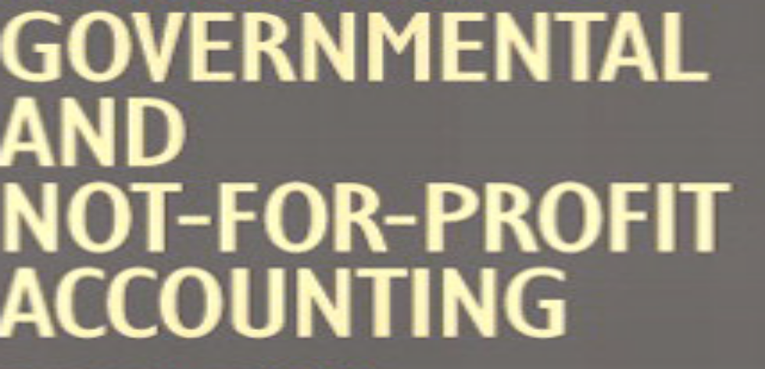
PREPARE FINANCIAL STATEMENTS FOR GOVERNMENTAL AND NOT FOR PROFIT ENTITIES (NFP)
MODULE CODE’S ACF4 01 1221
NOMINAL DURATION: 80 HOURS
Sep, 2023
Addis Ababa, Ethiopia

Table of Contents
Acknowledgment .3
Acronyms ………………………………………………………………………………………………4
Introduction to the Module……………………………………………………………………………………………………………….5
Unit One. Nature of Governmental and not-for profit organizations 6
1.1. Identifying characteristics of government and not for profit organizations (NFP). 7
1.2. Identifying and discussing growth and importance of NFPs sectors 16
1.3. Identifying accounting principles of governmental entities 18
Self-check questions 32
Unit Two: accounting for governmental entities 33
2.1. Governmental funds 33
2.2. Proprietary funds 37
2.3 . Fiduciary funds 40
2.4. Reports are prepared following a clear and appropriate structure and format 41
2.5.Reports are prepared following a clear and appropriate structure and format 43
2.6.Self -check 45
Unit Three: Accounting for governmental entities for Ethiopian 46
3.1. source of revenue and expenditure for government organizations 46
3.2.Transactions are identified ,analyzed and recorded 52
3.3.Reports are prepared following a clear and appropriate structure and format 53
Self-Chech………………………………………………………………………………………………………………………….70
Referene…………………………………………………………………………………………………………………………………71

Acknowledgment
A.A TVT BUREAU wishes to extend thanks and appreciation to the many representatives of TVT instructors and respective kirkos manufacturing college Dean who donated their time and expertise to the development of this Teaching, Training and Learning Materials (TTLM)

Acronyms
- AICPA- American Institute of Certified Public Accountants
- BFSs - Basic Financial Statements
- CAFR - Comprehensive Annual Financial Report
- CPF- Capital project fund
- DSF - Debt service funds
- GAAP- Generally accepted accounting principles
- GDP - Gross Domestic Product
- GF - General Fund
- NFP - Not-for-Profit Entities
- NGOs - Not-Governmental Organizations
- SRF - Special Revenue fund
12. SL&G- State and Local Government
13. FASB– Financial Accounting Standard Board
14. GASB- Governmental Accounting Standard Board
15. YMCA - Young Men’s Christian Association

Introduction to the Module
This module covers the competence required to develop a range of commonly required financial reports for entities that has a statutory duty to file financial reports with government agencies and Regulatory.
This module covers the units:
- Nature of Governmental and not-for profit organizations
- accounting for governmental entities
- Accounting for governmental entities for Ethiopian method
Learning Objective of the Module
- Identify Nature of Governmental and not-for profit organizations
- Understand accounting for governmental entities
- Describe accounting for governmental entities
Module Instruction
For effective use this modules trainees are expected to follow the following module instruction:
1. Read the information written in each unit
2. Accomplish the Self-checks at the end of each unit
3. Read and use the recommended reference book and materials

Unit One: Nature of Governmental and not-for profit organizations
This unit is developed to provide you the necessary information regarding the following content coverage and topics:
- Identifying characteristics of government and not for profit organizations (NFP)
- Identifying and discussing growth and importance of NFPs sectors
- Identifying accounting principles of governmental entities
This unit will also assist you to attain the learning outcomes stated in the cover page. Specifically, upon completion of this learning guide, you will be able to:
- Identify characteristics of government and not for profit organizations (NFP)
- Identify and discussing growth and importance of NFPs sectors
- Identify accounting principles of governmental entities

Introduction
Governmental and not for profit organizations are vast in number and diversity. States, countries municipalities (for example cities and villages) and townships are general purpose governments that provide many categories to their residents (such as police and fire protection; sanitation; construction, and maintenance of streets, roads, and bridges; and health and welfare). Independent school districts, a public colleges and universities, and special districts are limited or special purpose governments that provide only a single function, or limited number of functions (such as education, drainage and flood control, irrigation, soil and water conservation, fire protection, and water supply).
Not-for-profit organizations also exist in many forms and serve many different functions. These include private colleges and universities, various kinds of health care organizations, certain libraries and museums, professional and trade associations, fraternal and social organizations, and religious organizations
1.1. Identifying characteristics of government and not for profit organizations (NFP)
Governmental and not-for-profit organizations differ in important ways from business organizations. Not surprisingly then, accounting and financial reporting for governmental and not-for-profit organizations is markedly different from accounting and financial reporting for businesses.
An understanding of how these organizations differ from business organizations is essential to understanding the unique accounting and financial reporting principles that have evolved for governmental and not-for-profit organizations.
Broad generalizations about such a diversified group as G&NP organizations are difficult. Nonetheless, the major differences arise from differing:
General purpose governments provide a broad array of services. Special purpose governments usually provide only a single or just a few services. Not-for-profit organizations are legally separate organizations which are usually exempt from federal, state, and local taxation
Non Profit making organizations are formed for social welfare or charity.
- It is a type of organization which does not gain profits for its owners, instead all the amount of money they earn as donation is utilized in pursuing objectives of it and in keeping it running. Typically these non-profit seeking organizations are under the non-profit sector and are tax-exempt charities or other types of public service organizations.
In its Statement of Financial Accounting Concepts No. 4,the Financial Accounting Standards Board (FASB) emphasized and noted the following characteristics that it felt distinguished governmental and not-for-profit entities from business organizations:
- A. Receipts of significant amounts of resources from resource providers who do not expect to receive either repayment or economic benefits proportionate to the resources provided.
B. Operating purposes that are other than to provide goods or services at a profit or profit equivalent.
C. Absence of defined ownership interests that can be sold, transferred, or redeemed, or that convey entitlement to a share of a residual distribution of resources in the event of liquidation of the organization

Differences between For-Profit and Nonprofit Organizations
Purpose
- All organizations have a purpose, but one of the biggest differences profit versus nonprofit organizations have lies in the fact that for-profit organizations’ primary mission is to generate profits for personal fulfillment. They do this by creating and selling products and/or services.
- On the other hand, the main goal of a nonprofit organization is to make profits for serving society. They promote a social cause by offering assistance with basic human needs. Nonprofits aim to tackle challenges and solve important issues such as alleviating poverty, providing education, food and water, assisting with housing, protecting endangered species and/or the environment, etc.
Funding
- Providing funds is the basis of all successful operations and projects. The seed capital of for-profit organizations is provided by the founders or business owners, by bank loans, investors and revenues generated from sales of their products and services.
- Nonprofit organizations use a different approach. They seek both private and corporate donations of time, material, products, and money. Government grants are also used for funding the operations of nonprofits, together with crowd funding
Target Audience
- When looking at for-profit vs. nonprofit organizations, the diversity of the audience is another key difference. While for-profit businesses have a more precisely defined target audience that is usually not the case with nonprofits. While for-profit organizations try to establish a relationship with clients who buy their products and services in order to generate revenue, the nonprofit ones seek to reach a more diverse audience including volunteers, corporate sponsors, donors, and the general public. Therefore, nonprofits need to take into account the different interests of each segment of their audience.
Management
- A for-profit organization can be a privately held business or a large corporation with boards and stakeholders. Responsibilities are distributed among individuals or a group that takes part in the financial success of the business. Since for-profits are primarily focused on increasing revenue, not only do these for-profit leaders share responsibilities, but they often share financial incentives.
- Nonprofits, on the other hand, are mostly led by trustees, a board of directors or committee members that do not have direct financial ownership. Their main concern is not about financial success, but about social and/or environmental issues.
Organizational Culture
- For-profit vs. nonprofit organizations differentiate in their organizational cultures. Since for-profits tend to focus on the financial gain, they value employees who contribute to the creation of new products and services, as this can help increase revenue.
- Nonprofit organizations, on the other hand, are community-oriented. Their employees are often seen supporting the cause outside their regular schedule attending events or handing out informative and educational resources to local businesses in the evenings or on weekends.
Taxation
- Since for-profit companies make profits for their own benefits, they have to pay taxes as required by the law. However, nonprofit organizations are exempted from paying taxes as they make profits to help society. In addition, individuals and businesses that donate to nonprofits can claim tax deductions.
- If an organization is a non-profitable entity that does not mean it cannot be profitable. Just like for-profit organizations, the nonprofit ones very often have the same approach to generating revenues and increasing profits with the aim of creating more programs or improving the existing one(s). However, the difference between a for-profit and nonprofit organization is that the latter is required to reinvest any profit in pursuit of its purpose.
In the Governmental Accounting Standards Board (GASB) view, accounting and financial reporting standards for governments must be separate and distinct from those for business organizations because the needs of users of financial reports are unique and different
The Governmental Accounting Standards Board (GASB) further distinguishes governmental entities from not-for-profit entities and from businesses by stressing that governments exist in an environment in which the power ultimately rests in the hands of the people. Voters delegate that power to public officials through the election process. The power is divided among the executive, legislative, and judicial branches of the government so that the actions, financial and otherwise, of governmental executives are constrained by legislative actions, and executive and legislative actions are subject to judicial review. Further constraints are imposed on state and local governments by the existence of the federal system in which higher levels of government encourage or dictate activities by lower levels and finance the activities (partially, at least) by an extensive system of intergovernmental grants and subsidies that require the lower levels to be accountable to the entity providing the resources, as well as to the citizenry. Revenues raised by each level of government come, ultimately, from taxpayers. Taxpayers are required to serve as providers of resources to governments even though they often have very little choice about which governmental services they receive and the extent to which they receive them.
Since governments may have a monopoly on the services they provide to the public, the lack of a competitive marketplace makes it difficult to measure efficiency in the provision of the services. It is also extremely difficult to measure optimal quantity or quality for many of the services rendered by government - for example, how many police are “enough”? The Governmental Accounting Standards Board notes the determination of optimal quantity or quality of government services is complicated by the involuntary nature of the resources provided. “A consumer purchasing a commercial product can determine how much to purchase and may choose among ‘good,’ better,’ or best’ quality and pay accordingly. A group of individuals paying for governmental services (and paying in different proportions for services that some of them may or may not use or desire) presents a far more complex situation.” For example, two homeowners may pay the same amount of property taxes but consume different amounts of government services if one does not drive and use the roads or has no children in public schools.

Characteristics of Not for Profit Organizations
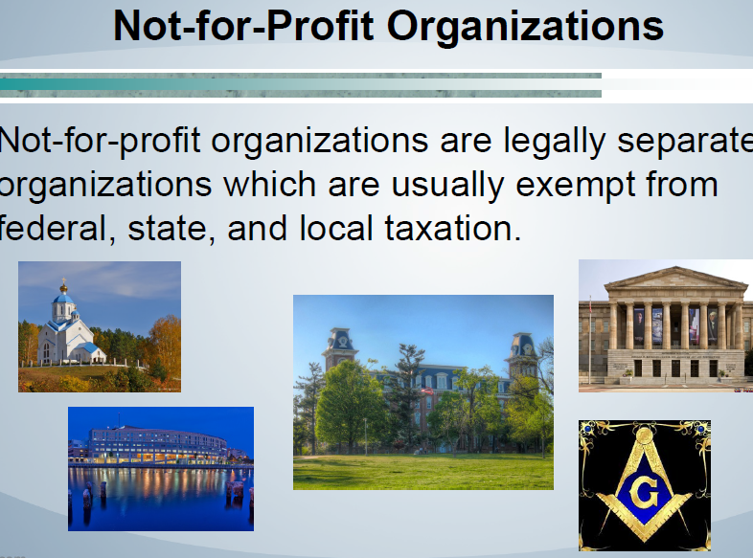
Fig 1.1. Not for Profit Organizations.
Characteristics of Not for Profit Organizations
There are a few distinct features which make them different from regular organizations.
The Motive for Service – Non-profit organization meaning they are set up mainly to provide service to a specific group of people or public, without discriminating for their caste, creed and gender. They extend help free of cost or at a nominal price as profit making is not their motive. For example, they provide services like health care, education, food, recreation, shelter, clothing, sports facilities, etc.
Management – Usually, a managing committee or executive committee looks after these organizations, and its members elect them.
Members – Since these organizations are formed as charitable societies or trusts, the people who give subscriptions to these are its members.
Income Sources – The primary source of these trusts are donations, subscriptions, government grants, incomes from investments, legacies and several others.
Surplus – If a financial year surplus is generated, that will be credited to the capital fund.
Reputation – These organizations generally earn a reputation for the contribution it makes through the services and not for any of its member’s personal goodwill.
Accounting Information – Generally, any present or potential contributors and its members can have access to its accounting information
Five common characteristics of effective nonprofits:
- Clear mission and purpose.
- Ability to perform key functions.
- Strong practices, procedures, and policies.
- Good people.
- Ability to mobilize others.
Five common characteristics of effective nonprofits:
1. Clear mission and purpose
- The most fundamental quality of an effective nonprofit is clarity about its mission—both what it seeks to accomplish and why this purpose is important.
- The nonprofit should communicate its mission clearly to all its stakeholders—board, staff, donors, volunteers, partners, and the general public—so that everyone understands its goals and works toward a common purpose. All the nonprofit’s programs and operations should be aligned to advance its mission.
2. Ability to perform key functions
Effective nonprofits can perform essential functions necessary to fulfill their missions. The authors of How Effective Nonprofits Work cite six essential functions:
- Communicate vision and mission
- Engage and seek stakeholders’ input in designing programs, including people who use its services, and serve its target community appropriately
- Achieve results and track impact against a few key measures, at least through basic means
- Manage an active and informed governance structure
- Secure resources appropriate to its needs
- Plan for the future
A seventh function is key to effectiveness: making it part of the organization’s culture to evolve its programs and operations as it learns from stakeholders, from its assessment of impact, and from new knowledge in its field. In short, the nonprofit should be a learning organization
3. Strong practices, procedures, and policies
- Effective nonprofits also follow good practices in three functional areas: finance, governance, and organizational and program development. (Thanks to How Effective Nonprofits Work for this framework.) As a donor, look for the following factors:
Financial
- Yearly audits are conducted and made available to you on request. (If a small nonprofit, it should provide you with a copy of its Internal Revenue Service Form 990, or you can look up 990s for any nonprofit at Guide Star)
- Financial statements are prepared quarterly, following a consistent format
- Solid fiscal management processes are in place. Good practices include a board finance committee, careful cash monitoring, and regular budgets monitored with monthly cash flow statements
- A diverse range of supports exists, such as individual donors at varying levels, foundations, and government or other institutional contributors
- Efforts are in place to establish and maintain a reserve fund, ideally equal to 3–6 months of operating expenses
Governance
- Strong leadership runs the organization
- An active process exists to properly handle governance issues
- A board nominations process and board term limits are in place
- Regular and ongoing evaluation of programs and fundraising plans takes place
- Board meetings are scheduled for the year
- Written policies set expectations, increase efficiency, and promote transparency and accountability in operations. Examples include policies for board term limits, personnel hiring and management, conflicts of interest, and investments
- The organization demonstrates flexibility to adjust to environmental shifts
Organizational and program development
- A strategic plan is in place and is used. The organization reviews that plan annually and adjusts it, as necessary. Key staff members refer to it when talking to you
- Regular client input is welcomed and used for continual program improvement. The organization can demonstrate involvement of constituents in planning and evaluation
- Other organizations doing similar work speak highly of the organization
- Staff can articulate key accomplishments, lessons learned, and future directions
- The organization is recognized as an institution; it is not identified solely with one or two individuals who work there
- The organization is able to demonstrate measurable outcomes
4. Good people
- Above all, nonprofits depend on one key resource to fulfill their missions: qualified, skilled, and talented board members, staff, and volunteers. Boards should be diverse, talent rich, informed, responsible about stewardship, dedicated to the nonprofit and not their self-interest, and, above all, engaged. When nonprofits lack the resources and know-how to recruit and train effective board members, their governance, oversight, and leadership suffer accordingly. In addition, the effectiveness of a nonprofit largely depends on employing an appropriate number of staff members who are talented, adequately trained, and properly supported and compensated.
5. Ability to mobilize others
- The ability to mobilize and engage volunteers, other nonprofits, businesses, and government agencies is an essential skill for nonprofits seeking to address the root causes of problems and bring about long-term change. Building awareness and support among key audiences, and bringing more people and resources to the table are essential to change. If change is part of your goals, look for nonprofits that have the following characteristics or develop them in your favorite organizations:
- Staff skilled in working with government or advocating for policy change
- A willingness to partner with businesses to stretch their influence
- The capacity to inspire and engage volunteers and constituents or members as passionate partners and spokespersons
- A willingness to partner with other nonprofits working to address the same issues and to regard those groups as allies not competitors
- A commitment to sharing leadership with staff, volunteers, and constituents or members to empower more people to make impact
Following are more governmental characteristics:
(1) Their officers are popularly elected, or a controlling majority of their governing body is appointed or approved by governmental officials;
(2) They possess the power to enact and enforce a tax levy;
(3) They hold the power to directly issue debt whose interest is exempt from federal taxation; or
(4) They face the Potential that a government might dissolve them unilaterally and assume their assets and liabilities.
On the Other hand Not-for-profit organizations exhibit certain basic characteristics that distinguish them from business enterprises. Not-for-profit entities
(1) Receive contributions of significant amounts of resources from resource providers who do not expect equivalent value in return;
(2) Operate for purposes other than to provide goods and services at a profit; and
(3) Lack ownership interests like those of a business enterprise. As a result, not-for-profit organizations may obtain contributions and grants not normally received by business enterprises. On the other hand, not-for-profit organizations do not engage in ownership-type transactions, such as issuing stock and paying dividends. Four broad categories of not-for-profit organizations are discussed in this text: voluntary health and welfare organizations, health care organizations, colleges and universities, and other not-for-profit organizations.

1.2. Identifying and discussing growth and importance of NFPs sectors
The major types of government and nonprofit organizations may be classified as:
1. Governmental: federal, state, county, municipal, township, village, and other local governmental authorities and special districts.
2. Educational: kindergarten, elementary and secondary schools, vocational and technical schools, and colleges and universities.
3. Health and welfare: hospitals, nursing homes, child protection agencies, the American red Cross, and United Service Organizations (USO)
4. Religious: Young Men’s Christian Association (YMCA), Young Women’s Christian Association (YWCA), Salvation Army, and other church-related organizations.
5. Charitable: United Way, Community Chest, and similar fund-raising agencies; related charitable agencies; and other charitable organizations.
6. Foundations: private trusts and corporations organized for educational, religious, or charitable purposes.
They have created, defined and promoted a self-image, forming a group and also having a place and a role in the Romanian civil society. Thus, NGOs have recently taken over, amid a crisis of state resources, functions and roles which in the past were the exclusive power of government, becoming a very important factor in promoting the values of democracy and the new relationships established between state and society.
NGOs are characterized by functional dynamics of methods because their running is directly influenced by the community needs and the specific ways of interacting with the civil society.
"non-profit organizations", "NGOs", "associative commercial sector, "civil society", "the third sector", "non-profit association", "organizations without lucrative purpose" etc. – all have a single definition. They are willing parties, in their own right, established by the free will of the citizens who are associated on common career interests and/or other interests aiming to achieve shared civil, economic, social and cultural rights and not obtaining profits.
The mobility of non-governmental organizations mirrors the community capacity to respond rapidly to its needs. NGOs direct to the community the resources that the government does not have or cannot collect.
Also, the lines of actions analysis of nongovernmental organizations may be relevant for the problems solving by the public administration. The NGOs play an important role in highlighting issues that might pass unnoticed by the public authorities and in helping them to solve problems by using their human resources, local data and their v organizational capacity, even monitoring their activities.
NGOs can offer tangible solutions to the community problems more efficiently and involving less costs than the public administrations in areas such as social work or management of social welfare institutions.
The main ways of influencing the NGO sector are:
1. Encouraging the officials and the government agencies to accept some variants of solving the problems, which are successfully used in the sector.
2. Educating and informing the public of the rights provided by law and the increase of their awareness of these aspects.
3. Active participation in adjusting the official programs to the needs of the community, expressing the public opinion and taking into account the specific conditions of the area
4. Co-operation with official agencies.
5. Influencing the local development policies of national and international institutions.
6. Supporting the governments and donors to develop more effective development strategy through strengthening the institutions, increasing the level of professional qualification of their personnel, training their staff in order to acquire a good management capacity.
NGOs are sometimes perceived as "alternatives" to the solutions proposed by the public administration. The population of a community cannot choose the development policy developed by the government or by the NGOs because NGOs cannot launch such an offer. It is unlikely that the NGOs can solve the problems of the local communities by their own efforts, the lack of resources being the main cause.
The NGOs may find optimal ways and solutions for solving social problems but these ones can be completed only if they have an impact on the development of the whole community. The public administrations and NGOs cannot provide competitive solutions but complementary solutions which can lead to the co-operation between the two bodies.
1.3. Identifying accounting principles of governmental entities
Government may involve in three types of activities:
1. Governmental Activities: Governmental organizations differ from those of for-profit business organizations in that governments are not profit seeking but exist to meet citizens’ demand for services, consistent with the availability of resources to provide those services.
Although the types and levels of service vary from government to government, most general purpose governments provide certain core services: those related to protection of life and property (e.g., police and fire protection), public works (e.g., streets and highways, bridges, and public buildings), parks and recreation facilities and programs, and cultural and social services. Governments must also incur costs for general administrative support such as data processing, finance, and personnel. Core governmental services, together with general administrative support, comprise the major part of what GASB Concepts Statement No. 1 refers to as governmental-type activities. In its more recent pronouncements, GASB refers to these activities as simply governmental activities.
2. Business-Type Activities: Governments also engage in business-type activities. These activities include, among others, public utilities (e.g., electric, water, gas, and sewer utilities), transportation systems, toll roads, toll bridges, hospitals, parking garages and lots, liquor stores, golf courses, and swimming pools. Many of these activities are intended to be self-supporting by charging users for the service they receive. Operating subsidies from general tax revenues are not uncommon, however, particularly for transportation systems.
3. Fiduciary Activities: Governments often act in a fiduciary capacity, either as an agent or trustee, for parties outside the government. For example, a government may serve as agent for other governments in administering and collecting taxes. Governments may also serve as trustee for investments of other governments in the government`s investment pool, for escheat properties that revert to the government when there are no legal claimants or hears to a deceased individuals estate, and for assets being held for employee pension plans, among other trustee roles.
GAAP Vs Legal Compliance (Accounting/Reporting Capacity) (prn-1)
Prn-1 A governmental accounting system must make it possible both: (a) to present fairly and with full disclosure the financial position and results of financial operation of the funds and account groups of the governmental unit in conformity with generally accepted accounting principles; b) to determine and demonstrate compliance with finance related legal and contractual provisions.
In summary, the accounting system must make possible both financial statements based on GAAP, and adhere to whatever the legal requirements for book keeping and reporting are. This does not mean that two sets of books are needed, but that whichever system (GAAP or legally mandated) is used, statement for the other should be able to be produced.
Sometimes legal requirements are contrary to good management.
For example, a purchase for $3 might require the same amount of paperwork as a purchase of $10,000. In that case, the cost of the forms, the labor to complete them, and the storage space to keep them, might actually exceed the $3. It is the law, but is it good management of resources?
Sometimes legal requirements are contrary to GAAP
An example of this could be a government entity which is required to keep books with a single entry ledger, or one that is required to keep all account on a strictly cash basis. Both of these are contrary to GAAP, but sometimes they are what is required by the law, perhaps because the system is old and has not been updated.
Fund And Fund Accounting (Prn # 2,3,4)
“Fund Defined And Illustrated
Prn 2. Governmental accounting systems should be organized and operated on a fund basis. A fund is defined as a fiscal and accounting entity with a self balancing set of accounts recording cash and other financial resources, together with all related liabilities and residual equities or balances, and changes therein, which are segregated for the purpose of carrying on specific activities or attaining certain objectives in accordance with special regulations, restrictions or limitations.
Definition Of Fund And Discussion Of Fund Accounting
The word fund is given a special definition as it relates to fund accounting. The narrow definition of fund, as used in ordinary conversation is “a resource of money”. However, in this course it is given the special definition above. Understanding the word fund as it is used here is absolutely essential to this course. It is the key concept in the entire course. (module)
To distinction fund (NFP) accounting from FP accounting, it will be noted that on FP is accounted for as one entity. However, a single NFP unit may be treated as several different entities. Each of these entities is a fund.
Example of funds
Two examples follow to illustrate the concept of “fund” first, the ministry of education operates several colleges. Although all are part of the ministry of education as a whole, each one is treated as a fund. Each college will be given money that is specifically for its operations, and is not be mixed up with other institutions. Therefore, each college will keep its own set of books, and issue its own financial reports, irrespective of the performance of the other individual institutions or the ministry as a whole.
Or, consider an NGO with several projects. For example, a single NGO could have a school in Tigray, a water development project in Amhara, and cattle project in Oromia. Each of those projects will probably be supported by a different donor. The donor for each project will not be necessarily concerned with the financial statements of the NGO as a whole. The donor for a particular project will want financial statements for that project. Therefore, each project will have its own set of books, and produce its own financial statements. Each project will be a separate, distinct fund.
The Rational For Fund Accounting
Why is fund accounting needed? The main reason for fund accounting is to focus accountability, and secondarily to enhance reporting ability. For government branches, budget amounts are legally given for specific purpose e.g provision of police protection, repayment of debt, construction of new offices. The money for the different purposes can not be mixed with that of other purposes, so a fund (separate ledger, set of books) is established for each purpose. The separate fund then makes it very clear who is responsible for those resources, and that person can then report on his performance. Similarly, the donations, NGOs receive, are often designated for a specific purpose, and should not be used for anything else. The donors of these designated funds often request a financial report for the specific project they have given to, and are there by able to held NGO responsible for the money given.
The Justification For Opening A New Fund
Setting up, journalizing entries, and reporting for each separate fund is time consuming, so why would an NFP set up a new fund? The primary reason would be a legal requirement, a secondary reason would be if the management felt a fund was necessary for good management. That is, if it felt that some particular type of expenditure needed special attention, it could set up a fund to divide its activity for the other organization.
Two Kinds Of Funds- Expendable And Non Expendable
Expendable funds are meant to be expended (entirely used up), usually with in one year. As a particular matter, any money that remains in an expendable fund at the end of the year typically must be returned to its source. Therefore, managers of expendable fund normally try to ensure that all that their funds are used up with in the time period. If they are not all used up, the manager is often perceived as being a poor budget planner. This course will deal primarily with accounting for expendable funds.
The accounting equation for an expendable fund is slightly different from an FP. Recall the accounting equation for An FP: A-L = C. The accounting equation for an expendable fund (from the definition of fund above) is cash plus other financial Resources minus liabilities.
= Fund balance (C+OR-L=FB). There are no ownership interests in an NFP, so there is no capital or owner’s equity. There is only a balance remaining to be used for the specific purpose.
The key statement for an expendable fund is the statement of changes in financial positions. (Revenue), uses of money (expenditures), the corresponding terms in FP accounting are, of course, income, expenses, and net income, and the corresponding statement is the income statement.
Non expendable funds are used when maintenance of capital is desired, and the unexpended funds are not meant to be returned. The employees’ cafeteria of a governmental unit is an example of this. The accounting for non expendable fund very closely resembles that of a profit making entity, and the accounting equation will be nearly the same (A-L=C). One expendable funds are sometimes could proprietary funds.
Types Of Funds
There are seven types of funds, which are divided into three categories:
Prn-3 The following types of funds should be used by state and local governments.
- Government Funds
- General fund –GF
- Special Revenue fund – SRF
- Capital project fund – CPF
- Debt service funds - DSF
- Proprietary Funds
- Enterprise funds
- Internal service funds
- Fiduciary Funds
- Trust and Agency funds
Governmental Funds
All governmental funds are expendable. They are meant to be entirely used up, usually in one accounting period. Expendable assets are assigned based on the purpose for which they may (must) be spent.
- The General Fund - used to account for all financial resources except those required to be accounted for in another funds.
All governments should have a general fund, and there will be only one general fund. Some governmental units will have only a general fund. If any of the other types of funds are needed. The governmental unit may have several of those, as needed. The general fund is used for general government services. It is basically used for everything that does not require a separate fund.
- Special Revenue Fund - used to account for the process of specific revenue sources (other than expendable trusts, or for major capital projects) that are legally restricted to expenditure for specified purposes.
An example of a special revenue fund might be the unity and safety of the mother land tax that was collected during the Derg regime. This tax was not for the general fund of the government, but was raised specifically for the armed forces. It would have needed to be accounted for and reported on separately.
- Capital project funds - to account for financial resources to be used for the acquisition or construction of major capital facilities (other than those financed by proprietary funds or trust funds).
An example of capital projects fund could be the new Wukiro Agricultural college campus. The costs incurred in the construction of the buildings are quite different from operating costs of the college, and would need to be accounted for and reported on as an entity in itself.
- Debt Service Funds – used to account for the accumulation of resources for, and the payment of, general long-term debt principal and interest.
If money has been borrowed for the construction of the new campus, that would give rise to a debt service fund. Assume that 10 million Birr was borrowed, at 10% simple interest, and it to be repaid in full in 10 years. Each year, 2 million birr would need to put into a debt service fund 1 million for repayment of principal, plus 1 million for each years interest.
Proprietary Funds
Proprietary funds are non expendable. They are for a part of the government that is run like a private business, where the income and fees for services of the fund is expected to cover at least a part of the expenses. The accounting for proprietary funds is very much like the accounting for a profit making business.
Enterprise funds – to account for operations
That are financed and operated in a manner similar to private business enterprises where the intention of the governing body is that the costs (expenses, including depreciation) of providing goods or services to the general public on a continuing basis be financed or recovered primarily through user charges; or
Where the governing body has decoded that periodic determination of revenues earned, expenses incurred, and / or net income is appropriate for capital maintenance, public policy, management control, accountability, or other purposes.
A public park could be an example of an enterprise fund. The park would charge a user fee from which it would pay the expenses (e.g. salaries) of operating the park. As a non expendable fund, it would not have to return unused money to its source at the end of the year. Therefore, it might also accumulate money from year to year for the purchase of equipment, furnishings, and the like from its income from the user charges.
- Internal service fund - to account for the financing of goods or services provided by one department or agency to other departments or agencies of the governmental unit, or to other governmental units, on a cost reimbursement basis.
A shared garage is a common example of an internal service fund, particularly in NGOs. That garage would repair all the NGO’s vehicles, regardless of which project or fund uses them. Charges are made to the various funds for the repair costs. As a non expendable fund, part of the charge made to the various funds could be intended to be accumulated for future years for the purchase of tools and equipment.
Fiduciary Funds
Fiduciary funds are used to account for money which one branch of government has on behalf of another fund, organization, or individuals. A common example of a fiduciary fund is a central tax collection agency, such as the Inland Revenue Department. The taxes it collects are not for its own benefits, but are rather passed on to other ministries or departments.
Trust and Agency funds: - to account for assets held by a governmental unit in a trustee capacity or as an agency for individuals, private organizations, other governmental units, and/or funds. These include expendable trust funds, non expandable trust funds, pension trust funds, and agency funds.
Number Of Funds
Prn 4. Governmental units should establish and maintain those funds required by law and sound financial administration. Only the minimum number of funds consistent with legal and operation requirements should be established, however, since unnecessary funds result in inflexibility, undue complexity, and inefficient financial administration.
This principle is especially important in NGOs NGOs tend to do a number of limited life projects, each of which is accounted for a separate fund. When the project is finished the fund should be closed. As long as the fund remains open, financial statements will continue to be produced for it, wasting paper, ink, and time. On the other hand, if not enough funds are opened, it will difficult to account for the sources allocated to each specific purpose.
Basis Of Accounting (Principle 5)
Modified Accrual Basis
Prn.5. The modified accrual basis or accrual basis of accounting, as appropriate, should be used in measuring financial position and operating results.
- Governmental fund revenues and expenditures should be recognized on the modified accrual basis. Revenues should be recognized in the accounting period in which they become available and measurable. Expenditures should be recognized in the accounting period in which the fund liability is incurred, if measurable, except for unmatured interest on general long term debt, which should be recognized when due.
Discussion of modified accrual basis of accounting.
Revenues - recognize as “available and measurable” measurable means when the amount to be collected is known with some certainty. Available means the taxes are available to cover spending in the year of recording (usually interpreted to mean during the fiscal year, or with in 60 days of the end of the fiscal year).
Example:
Taxes: Assume a January to December fiscal year. In October 1999, property tax rates for 2000 are set. Formal notice (levy) is sent to property owners on December 31,1999. Taxes must be paid by June 30,2000. On what date do the revenue become measurable? October 1999, Available? Assuming that each taxpayer wait until the last day to pay, they become available on June 30,2000. There is probably no need to accrue in this case.
Still assuming a January to December fiscal year, in October 1999, property tax rates for 1999 are set. The levy is sent on December 31,1999, to be paid by February 29,2000. On what date have these revenues become measurable? October 1999. When do they become available? December 31,1999 why?
Note that in an FP, the revenue would most likely have been recognized (accrued) on December 31,1999 the day they become officially due.
Donation (NGO): In 1998, an NGO solicits money from private individuals to operate a clinic. Ten thousand individual donars pledge to contribute $25 per month in 1999 and 2000. The NGO’s giving history shows that 50% of its pledge are actually received in cash, and half of the donors fulfill their pledge by giving a lump sum for the entire year in December.
On what date do the revenues becomes measurable? In 1998 available? Sometimes in 1999 and 2000. When should they be recorded pledges is a subject of debate among accountants. Most NGOs would probably record the funds as they were received in cash. They likely would not be accrued, unless required by law.
Expenditures- It is assumed throughout the module that governments operate on an account basis. That is, as transactions are entered into, the entity charges its account for later payment, rather than paying cash when the goods are recorded or delivered. That is why this principle says that expenditures are recognized when the fund liability is incurred (except general long-term debt). At that point, a sum is owed on account, and it is an expenditure regardless of when the cash actually changes hands. These liabilities are then paid from the expendable assets which have been assigned for that specific purpose.
The difference between expense and expenditure must be understood to properly understand the distinction between NFP and FPC (for profit accounting). In the dictionary these worlds have almost exactly the same meaning. However, almost exactly the same meaning. However, in Fund Accounting they have been given specialized meanings. An expense is current period consumption of resources. An expenditure is a decrease in fund financial resources.
For example, in profit making accounting, a car would be considered an asset, depreciation would be recorded as an expense as the car is “used up”, or wears out. In a fund, the car would be considered an expenditure at the time of purchase.
Interest on General Long Term Debt - For example, a government issues 10 years, 8% simple interest bond of $1,000,000 on July 1,1999. The interest and principal are both payable at maturity. When is the liability incurred for the principal? July 1,1999 for the interest? As it occurs. What is the amount of accrued interest after one year? $80,000. When should it be recorded as an expenditure? In the period it must actually be paid out each year, Accordingly, the principal is recorded as an expenditure in the period when it must actually be paid, in this case on June 30,2009.
Proprietary Fund Basis Of Accounting
- Proprietary fund revenues and expenses should be recognized on the accrual basis. Revenues should be recognized in the accounting period in which they are earned and become measurable; expenses should be recognized in the period incurred, if measurable.
Discussion of Proprietary Fund Basis of Accounting
Proprietary fund accounting is virtually the same as for profit accounting. Note the difference in wording for recognizing revenues-“period in which they are earned,” as opposed to “become available.”
Fiduciary Fund Basis Of Accounting
- Fiduciary fund revenues and expenses or expenditures (as appropriate) should be recognized on the basis consistent with the funds accounting measurement objective. Non expendable Trust funds should be accounted for on the accrual basis; expendable trust funds should be accounted for on the modified accrual basis. Agency fund assets and liabilities should be accounted for on the modified accrual basis.
Discussion of Fiduciary Fund Basis of Accounting
The basis of accounting for fiduciary funds depends on whether or not the nature of the fund is expendable or non expendable. Both kinds are possible in fiduciary funds.
Inter Fund Transfer Basis Of Accounting
- Transfers should recognized in the accounting period in which the inter fund receivable and payable arise.
Discussion of Inter Fund Transfer Basis of Accounting
Sometimes there are transfers between funds. Because each fund is separate accounting and reporting entity, these transfers must be reported. This principle is saying that the transfer should be recorded when the receivable and payable arise, rather than when the cash is actually shifted from one fund to another. This is accrual basis. For example, consider that on December 31,1999, the General fund of a governmental entity is required to transfer money to the capital projects fund to help pay for construction of a new office building. The transfer would be recorded at that time, even if the cash did not actually change hands until July 31,2000.
Fixed Assets And Long Term Liabilities (Principle 6,7,8)
Distinguishing Fund Fixed Assets /L.T Debt From General Fixed Assets/L.T Debt
Prn. 6. A clear distinction should be made between a) fund fixed assets and general fixed assets and b) Fund long term liabilities and general long-term debt.
- Fixed assets related to specific proprietary funds or trust funds should be accounted for through those funds. All other fixed assets of a governmental unit should be accounted for through the general fixed assets account group.
- Long-term liabilities of proprietary funds and trust funds should be accounted for through those funds. All other unmatured general long term liabilities of the governmental unit should accounted for through the general long-term debt account group.
Discussion of Fixed Assets
Some fixed assets belongs to a particular fund, while others belongs to the governmental entity as a whole. For example, consider the assets of a cafeteria for used by government employees. The cafeteria would have a stove, tables, chairs, etc, which belongs to it those assets are not available to be used for another purpose. On the other hand, a governmental unit, e.g. The City of Mekelle, may have an office building which belongs to the city as a whole. It may be used for the administration of all the different funds. In order to account for these fixed assets that belongs to the unit as a whole, a governmental unit should have a General Fixed Asset Account Group in addition to the funds mentioned in principle # 3. Another example of a general fixed asset might include a fleet of cars that is shared among the different funds.
The rational for not including general Fixed Assets in the General Fund accounts is that available for current expenditures. Rather, they are items for which resources have been used. Neither do these assets constitute a fiscal entity. However, these assets do require accountability, and an account group is though to be the best way to maintain this accountability.
Discussion of Long-term Debt
Similarly an enterprise fund, such as a city park, might borrow money for improvements on a long-term basis. This debt would probably by backed by the assets of the park, and therefore, would be accounted for in the books of that enterprise fund. Conversely, General long-term debt would be borrowings of the entire governmental entity, rather than by a specific fund. The money would be backed by the “Full faith and credit of the governmental entity,” i.e., its taxing authority, rather than by specific assets.
The rational for not including General long-term debt in the General Fund Accounts is like that of General Fixed Assets. The General long-term Debt is not something which will require current period resources for repayment. These liabilities do not constitute a fiscal entity, either. But they do need accountability, so the General long-term Debt account group is used to provide this.
Valuation Of Fixed Assets
Prn 7. Fixed assets should be accounted for at cost or, if the cost is not practicably determinable, at estimated cost. Donated fixed assets should be recorded at their estimated fair value at the time received.
Discussion of Valuation of Fixed assets
As with FP accounting, fixed assets should be recorded at their historical costs. NFP accounting allows for two exceptions, because there are not typically encountered by NFPs. That are not typically encountered by FPs. One is unknown cost, the other is donated fixed assets.
Unknown costs sometimes happen because of the nature of expendable fund accounting. Fixed assets are debited to expenditure, and then like expense accounts, expenditures are closed at the end of the fiscal year. After that first year, the financial statements - balance sheet and operating statements for the do not show the fixed asset. Since the amounts are not on the statements, and therefore, not examined by the auditors, many NFPs have not kept good fixed asset records, and the documents supporting the costs of the fixed asset get “lost”. If a new accountant comes along, who feels the need to open a General Fixed Asset Account Group, the historical costs of those assets may need to be estimated in order for the entity to have a complete record of assets. GAAP (Generally Accepted Accounting Principle) for NFP, allows estimated costs to be used in cases like this, and others in which the cost of fixed assets is unknown.
The other difference that NFPs have is the inclusion of donated fixed assets in this principle. Fixed assets are not usually donated to profit making entities, so they are not concerned with accounting for them. If the cost of the asset is known (i.e a new asset), then the cost should be used. If the asset is second hand, as frequently happens with NGOs, the fair market value will need to be estimated.
Depreciation Of Fixed Assets
Prn 8. a) Depreciation of general fixed assets should not be recorded in the accounts of governmental funds. Depreciation of general fixed assets may be recorded in cost accounting system or calculated for cost finding analyses; an accumulated depreciation may be recorded in the general fixed assets account group.
b) Depreciation of fixed assets accounting for in a proprietary fund should be recorded in the accounts of that fund. Depreciation is also recognized in those trust funds where expenses, net income and/or capital maintenance are measured.
Discussion of Depreciation of Fixed Assets.
General Fixed Assets – Depreciation is not recognized as an expenditure in governmental funds because it is not a decrease in fund financial resources. However, it should be calculated in the general fixed assets account group. Why? Because knowing depreciation is helpful for good financial management, and helps in planning for the replacement of assets in the future.
Proprietary fixed Assets - Because a proprietary fund needs to know that it is covering all its costs, it includes depreciation as an expense in its accounts. Remember that accounting in proprietary fund is almost identical to FP accounting.
Budgetary Accounting (Principle 9)
- An annual budget (6) should be adopted by every governmental unit.
- The accounting system should provide the basis for appropriate budgeting.
- Budgetary comparisons should be included in the appropriate financial statements and schedules for governmental funds for which an annual budget has been adopted.
Financial Reporting (Principle 10)
Interim (Time Between Fiscal Years) Financial Reporting
- Appropriate interim financial statements and reports of financial position, operating results, and other pertinent information should be prepared to facilitate management control of financial operations, legislative oversight, and where necessary or desired for external reporting purposes.
Discussion of Interim Financial Reporting
In NFP accounting, interim reporting is used if it fulfills one of these three purposes:
- For good management
- For the legislature (legal compliance)
- For external reporting (perhaps for those who have loaned money to it)
Comprehensive Annual Report
- A comprehensive annual financial report covering all funds and account groups of the governmental unit included in the compressive financial report.
Classification & Terminology (Principle 11, 12)
Classification Of Transfers And Long Term Debt Proceeds.
Prn 11 a) Interfund transfers and proceeds of general long term debt issues should be classified separately from fund revenues and expenditures.
Definition and Discussion
Interfund transfers – a transfer from one fund with in the unit to another fund with in the same unit. For example, suppose an NGO operates clinics, and these clinics charge to cover wages and medicines. During the year one clinic had a surplus, and another had a loss. The head of the organization decides to transfer funds from the one with a surplus to the one with a loss.
Proceeds of General long-term Debt issues – Money that is received from borrowing by the entity as a whole, backed by the full faith and credit of the governmental unit. These two sources of resources should appear distinct from revenues and expenditures on the entity’s financial statements.
State and Local Government Accounting Principles
Fundamentals of SLG Accounting & Financial Reporting
1. GAAP & legal compliance
2. Fund accounting
3. Fund categories
4. Types of funds
5. Comparative financial statement formats
6. Annual financial reporting
Rules guiding accounting and financial reporting are referred to as generally accepted accounting principles (GAAP). The American Institute of Certified Public Accountants (AICPA) defines this term as follows: The consensus at a particular time as to which economic resources and obligations should be recorded as assets and liabilities by financial accounting, which changes in assets and liabilities should be recorded, when these changes should be recorded, how the assets and liabilities and changes in them should be measured, what information should be disclosed and how it should be disclosed, and which financial statements should be prepared. Generally accepted accounting principles encompass the conventions, rules, and procedures necessary to define accepted accounting practice at a particular time. The standard of “generally accepted accounting principles” includes not only broad guidelines of general application, but also detailed practices and procedures.
The origins of GAAP can be traced back to the period just after the 1929 stock market crash, when attempts were made to formulate accounting principles. Many criticized the earliest statement of principles as being little more than a codification of the then-current accounting practices. Continued concerns with the way in which accounting principles were being established led to the formulation of the FASB in 1973 and then to the GASB in 1984. Seven members are appointed to each of these bodies by the Financial Accounting Foundation (FAF), an entity whose members are appointed by certain professional accounting and financial organizations. Advisory councils to both the FASB and the GASB are composed of individuals representing organizations concerned with the activities of the standards-setting bodies. The FASB–GASB structure is shown in Exhibit 1-1.
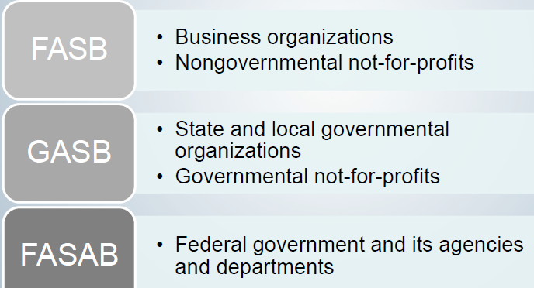

The FASB and the GASB are charged with establishing and improving standards of accounting and financial reporting within their respective areas of jurisdiction. The GASB’s jurisdiction includes all state and local governmental entities, including government-sponsored colleges and universities, health care providers, and utilities. The FASB establishes standards for all nongovernmental entities, including not-for-profit colleges and universities and health care providers. Under this arrangement, it is possible for the two boards to establish different accounting and reporting standards for similar transactions of similar entities, such as hospitals. Although this situation occurs sometimes, the two boards cooperate with each other to keep differences to a minimum.
GAAP & Legal Compliance
GAAP Reporting
- Ensures that the financial reports of all SLGs contain the same types of financial and disclosures for the same types of funds and activities
- Requires “full” disclosure
Reconciling GAAP & legal requirements
- Maintain budgetary accounting control during the year
- Clearly distinguish between budgetary basis from GAAP basis
- Prepare statements and schedules using both bases and reconcile differences

Self- Check -1
1. Describe the characteristics that distinguish not-for-profit organizations from business enterprises.
2. Who are the users of governmental and not-for-profit entity accounting information, and for what? Purposes might they use that information?
3. Explain Characteristics of Governmental and Not-for-Profit Entities NFP
4. What are the jurisdictions of the accounting standards-setting bodies: GASB, FASAB, and FASB?

Unit Two: Accounting for governmental entities
This unit is developed to provide you the necessary information regarding the following content coverage and topics:
- Identifying governmental funds
- Identifying Proprietary funds
- Identifying Fiduciary funds
- Identifying, analyzing, and recording transactions
- Preparing reports
This unit will also assist you to attain the learning outcomes stated in the cover page. Specifically, upon completion of this learning guide, you will be able to:
    - Identify governmental funds
    - Identify Proprietary funds
    - Identify Fiduciary funds
    - Identify analyzing, and recording transactions
    - Prepare reports

2.1. Identifying governmental funds
Governmental funds
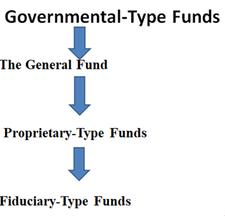
Fig 1.2.Governmental type funds
Governmental Funds: Accounting Equation Terms
- Financial Assets –refers primarily to cash, investments, and receivables
- Related Liabilities –related to the current year and normally paid for available current financial resources
- Fund Balance –net financial assets of fund –the difference in financial assets and related liabilities
Used to account for sources, uses, and balances of general government financial resources
Funds represent segregations of general government net financial assets
Accounting equation
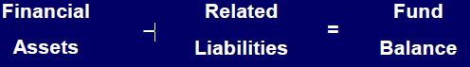
State and Local Government Financial Reporting
The GASB statement of reporting objectives for state and local governments calls for financial reporting to assist in fulfilling government’s duty to be publicly accountable and to help users assess that accountability.
Federal Government Financial Reporting
FASAB objectives for federal financial reporting cover budgetary integrity, operating performance, stewardship, and systems and controls. The objectives state that financial reporting should assist in fulfilling the government’s duty to be publicly accountable for money raised through taxes and other means and for their expenditure in accordance with the government’s budget. Financial reporting also should assist report users in
(1) Evaluating the entity’s service efforts, costs, and accomplishments and its management of assets and liabilities;
(2) Assessing the impact on the nation of the government’s operations and investments and how, as a result, the nation’s financial condition has changed and may change in the future; and
(3) Understanding whether financial management systems and internal accounting and administrative controls are adequate.
Fund Accounting
Funds as Subdivisions of an Entity
Why Governments Use Fund Accounting
Fund Categories
Financial Reporting with the Use of Funds
Measurement Focus and Basis of Accounting
Application to Proprietary-Type and Fiduciary-Type Funds
Application to Governmental-Type Funds
Governmental Accounting in Practice: Form versus Substance in Budgeting
Governmental Accounting in Practice: Current Financial Resources versus Economic Resources
Governmental Type Fund
The General Fund
Comparison with Business Enterprise Reporting—Operating Statement
Comparison with Business Enterprise Reporting—Balance Sheet
Special Revenue Funds
Capital Projects Funds
Debt Service Funds
Permanent Funds
Proprietary-Type Funds
Enterprise Funds
Internal Service Funds
Reporting on Proprietary-Type Funds
Fiduciary-Type Funds
Pension (and Other Employee Benefit) Trust Funds
Investment Trust Funds
Private-Purpose Trust Funds
Agency Fund
Governmental-type: General-purpose governments (such as states, counties, and cities) provide a range of basic, day-to-day services, including police and fire protection, sanitation, parks and recreation, and transportation. The operating costs of these services are financed mostly by tax revenues, intergovernmental grants, and general fees. Capital assets (such as buildings and roads) used in providing these services are financed primarily by long-term borrowing, which is ultimately paid off primarily from tax revenues.
Governmental-type activities are controlled by a legally adopted budget—perhaps the single most important financial document prepared by governments. The revenue side of the budget
Governmental-type funds are used to account for most of the day-to-day public services provided by state and local governments. Shows estimates of how much will be raised from each revenue source. On the spending side, the budget both authorizes and limits how much may be spent for each activity or purpose.
Business-type: General-purpose and, often, special-purpose governments provide other specific services—such as mass transit and water and electric utility services—financed not by taxes, but instead by user fees or charges that cover both operating and capital costs.
Because of how they are financed and administered, these activities are often referred to as business-type or proprietary-type activities.
Fiduciary-type: Many governmental entities also perform certain fiduciary-type services, holding segregated resources on behalf of others. For example, a government may perform investing or tax collection services on behalf of other governments. Also, governments may hold and invest resources on behalf of their employees and those of other governments to pay pensions when the employees retire
Categories and Types of Funds
GOVERNMENTAL FUNDS
- General Fund
- Special Revenue Funds
- Capital Projects Funds
- Debt Service Funds
- Permanent Funds
PROPRIETARY FUNDS
- Enterprise Funds
- Internal Service Funds
FIDUCIARY FUNDS
- Pension Trust Funds
- Investment Trust Funds
- Agency Funds
- Private Purpose Trust Funds
- (1) The General Fund - to account for all financial resources except those required to be accounted for in another fund.
- (2) Special Revenue Funds - to account for the proceeds of specific revenue sources (other than private-purpose trusts or for major capital projects) that are legally restricted to use for specified purposes.
- (3) Capital Projects Funds - to account for financial resources to be used for the acquisition or construction of major capital facilities (other than those financed by proprietary funds and trust funds).
- (4) Debt Service Funds - to account for the accumulation of resources for, and the payment of, general long-term debt principal and interest.
(5) Permanent Funds - to account for legally restricted resources provided by trust in which the earnings but not the principal may be used for purposes that support the primary government’s programs (those that benefit the government or its citizenry). [Note: Similar permanent trusts that benefit private individuals, organizations, or other governments—that is, private- purpose trust funds—are classified as fiduciary funds, as shown below.]
2.2. Identifying Proprietary funds
- Measurement focus (MF)
- Economic resources
- Financial statement recognition of all assets and all liabilities
- Basis of Accounting (BA)
- Accrual
- Recognize revenues when earned and expenses when incurred
Similar to accounting for businesses
- Accounting measures net assets, changes in net assets, and cash flows
- Accounting equation:
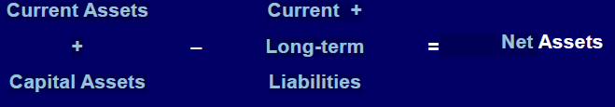
(6) Enterprise Funds - to account for operations
(a) that are financed and operated in a manner similar to private business enterprises—where the intent of the governing body is that the costs (expenses, including depreciation) of providing goods or services to the general public on a continuing basis be financed or recovered primarily through user charges; or (b) where the governing body has decided that periodic determination of revenues earned, expenses incurred, and/or net income is appropriate for capital maintenance, public policy, management control, accountability, or other purposes.
(7) Internal Service Funds - to account for the financing of goods or services provided by one department or agency to other departments or agencies of the governmental unit, or to other governmental units, on a cost- reimbursement basis.
2.3. Identifying Fiduciary Funds (and similar component units).
These are trust and agency funds that are used to account for assets held by a governmental unit in a trustee capacity or as an agent for individuals, private organizations, and other governmental units. These include:
- (8) Agency funds.
- (9) Pension (and other employee benefit) trust funds.
- (10) Investment trust funds.
- (11) Private-purpose trust funds
Accounts for assets held by government in trustee or agency capacity for others
Not used to report assets held for governments own us
Summary of Fund Characteristics’ 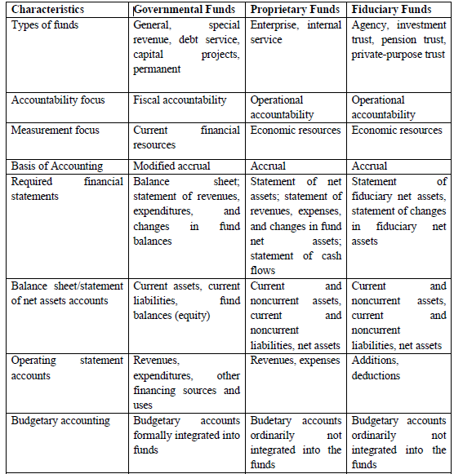
Table -1.1. Summary of Fund Characteristics

2.4. Transactions are identified, analyzed and recorded
Comparative Operating Statements
Proprietary Funds
- Accrual-based
- Must distinguish between operating and non-operating revenues and expenses
- Separate reporting for capital contributions, special & extraordinary items, and transfers
- Change in Net Assets
Governmental Funds
- Modified accrual-based
- Report revenues by source and expenditures by character
- Other Financing Sources and Uses for other resource flows, including transfers
- Special & extraordinary items reported separately
- Change in Fund Balance
- Comparative Balance Sheets
Proprietary Funds
- Current and Noncurrent Assets
- Current and Noncurrent Liabilities
- Net Assets
Governmental Funds
- Financial Assets
- Related Liabilities
- Fund Balance

2.5. Preparing Reports following a clear and appropriate structure and format and to conform to organization requirements
Comprehensive Annual Financial Report (CAFR)
- Should be prepared for all governmental entities
- Sections include:
- Introductory –little GAAP for this section
- Financial –most GASB standards apply to this section
- Statistical –see recently issued GASBS 44
Annual Financial Reporting Minimum reporting requirements
- Management’s Discussion & Analysis
- Basic Financial Statements
- Government-wide financial statements
- Fund financial statements
- Notes to the financial statements
- Required supplementary information other than MD&A
Financial Reporting Entity consists of
Primary government (PG)
Organizations for which the PG is financially accountable
Other organizations whose omission would cause financial statements to be misleading or incomplete
Preparation Process:
Preparation Process: Step 1.Transaction Data Start with the transaction data –the basic building blocks for everything in the Comprehensive Annual Financial Report (CAFR),
Preparation Process: Step 2.TransactionDataSchedulesIndividual FundStatements1From the transaction data, prepare the individual fund financial statements and schedules. Also, some of the transaction data will be used later in the CAFR preparation process.
Preparation Process: Step 3.TransactionDataSchedules Statements Major Fund Determination Determine the major funds (this process will be discussed later). Also, information from the individual fund statements and schedules will be used later in the process.
Preparation Process: Step 4.TransactionDataSchedulesIndividual. Once the major funds have been determined, the non-major fund combining statements can be prepared. The total column from these statements becomes a single column in the major fund statements along with a separate column for each major fund.
Preparation Process: Step 5.TransactionDataThe major funds statements undergo a conversion process and are combined with the component units financial statements to complete the government-wide statements
Preparation Process: Step 6.TransactionData Statements Information from all the financial statements and the schedules are used to prepare the notes to the financial statements. This process completes the Basic Financial Statements (BFS
Preparation Process: Step 7.Transaction Data Schedules Individual Statements Information from the transaction data, individual fund statements, and schedules are used to complete the Other RSI. Then information from all sources combines to provide data for the MD&A.
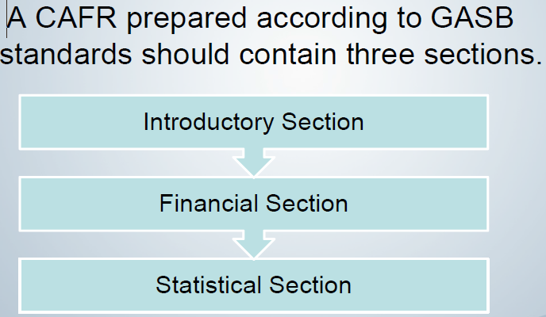
CAFR - Introductory Section
CAFR - Financial 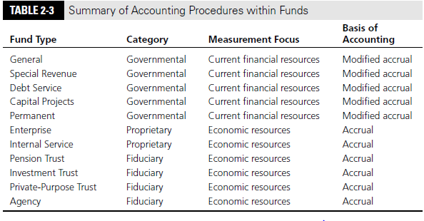 Summary of Accounting with Fund
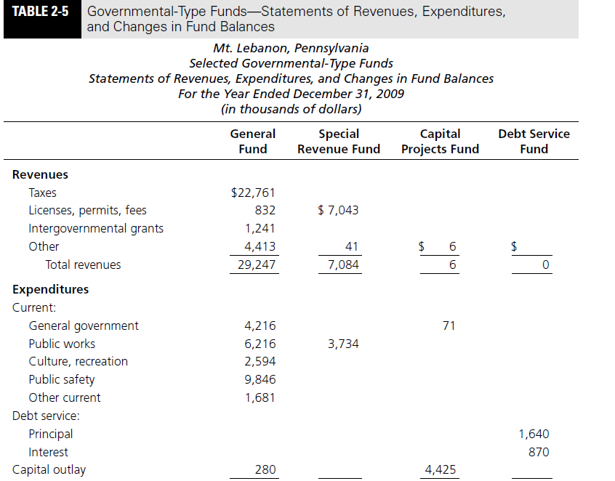 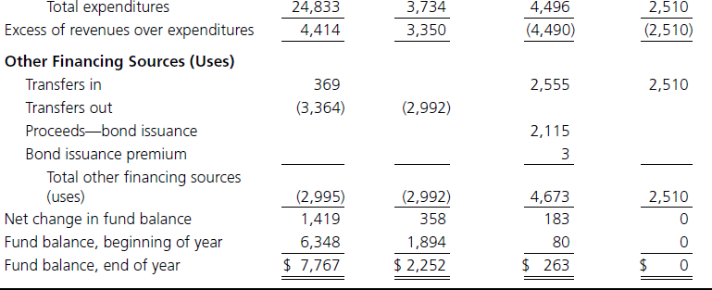
Self- Check- 2
1. Differentiate
Fiduciary-type________________________________________________________________
Governmental Fund type__________________________________________________________
Business type Fund______________________________________________________________
2. What are Steps of Financial Preparation Process? List

Unit Three: Accounting for governmental entities of Ethiopia
This unit is developed to provide you the necessary information regarding the following content coverage and topics:
- Identifying and recording source of revenue and expenditure
- Identifying, analyzing, and recording transactions
- Preparing reports
This unit will also assist you to attain the learning outcomes stated in the cover page. Specifically, upon completion of this learning guide, you will be able to:
  - Identify and recording source of revenue and expenditure
  - Identify, analyzing, and recording transactions
  - Prepare reports

3.1. Identifying and recording source of revenue and expenditure
Governments generate revenue by collecting income taxes, payroll taxes, sales taxes, property taxes, and social insurance taxes. Revenue is also generated from income on assets and transfer receipts from businesses and individuals.
Tax is the main source of revenue for the government. The government levies taxes on incomes, goods and services.
Sources of income:
Subscriptions
- Life membership fees
- Donations
- Income generating activities such as: dinner dances and raffles
- Income statements for income generating activities
- Income and expenditure accounts
- Accumulated funds
- Statements of financial position


Fig: show revenue generate
What is Revenue?
Government revenue refers to all the income of the government from taxes and non-tax sources. These funds are used for government expenditure. Government revenues and spending are an important part of fiscal policy of the government.
Revenue refers to all the receipts of the government from taxes, custom duties, and revenue from state-owned enterprises, capital revenues and foreign aid.
Revenue is generated from mainly two types of sources:
Sources of Government Revenue
The government account consists of both inflows and outflows. Fund inflows come from taxes and borrowing. Taxes, which are required payments to the government, come from several sources. At the national level, the government collects personal income taxes, corporate profit taxes, and social insurance taxes.
Tax revenue: Taxes on incomes of individuals and corporations and also on the goods and services produced.
Non-tax revenue: Dividends from state-run companies, central bank revenue and capital receipts in the form of external loans and debts from international financial institutions
Meaning of Government Revenue
Government revenue is the money the government raises from taxes, asset income, and transfer receipts at the federal, state, and local levels. Although the government can also raise funds by borrowing (selling bonds), the funds raised are not considered revenue.
Federal government revenue sources
Refer to Figure 1 below which shows the Federal government revenue sources. Personal income taxes and corporate profit taxes account for about half of all tax revenue. In 2020, they accounted for approximately 53% of all tax revenue. Payroll taxes or social insurance taxes - taxes for programs to protect families in case of hardship (e.g. Social Security) accounted for 38% of tax revenue. There are also taxes at the state and local levels on sales, property, and income, in addition to various types of fees collected
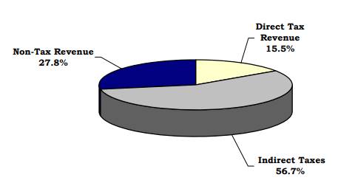
Diagram show the % revenue generate from different taxes

CLASIFICATION OF REVENUES
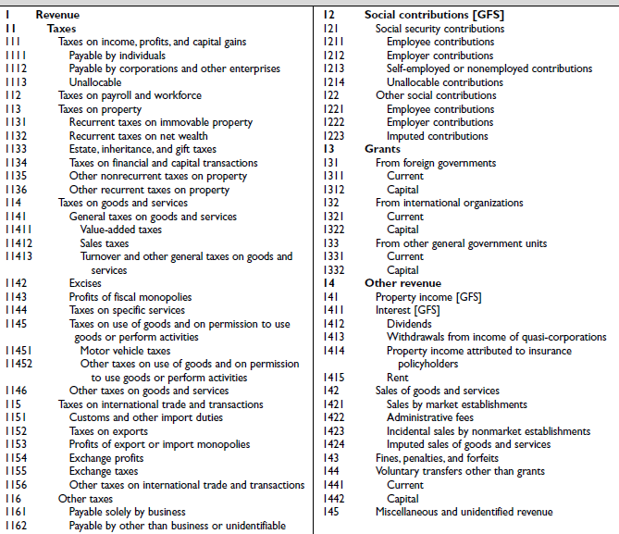Table show classification of D/T Types revenues

What is Government Expenditure?
What is Government Spending? Government spending refers to money spent by the public sector on the acquisition of goods and provision of services such as education, healthcare, social protection, and defense.
- In national income accounting, when the government acquires goods and services for current use to directly satisfy the individual or collective needs and requirements of the community, it is classified as government final consumption spending.
- When the government acquires goods and services for future use, it is classified as government investment. This includes public consumption and public investment, and transfer payments consisting of income transfers.

Fig show government expenditures

Sources of Government Spending
Government spending is financed primarily through two sources:

1. Tax collections by the government
- Direct taxes
- Indirect taxes

2. Government borrowing
- Borrowing money from its own citizens
- Borrowing money from foreigners
Public spending enables governments to produce goods and services or purchase goods and services that are needed to fulfill the government’s social and economic objectives. Over the years, we’ve seen significant changes in the role and size of governments around the world.
Public spending increased remarkably in the 20th century, when governments all over the world started spending more funds on education, healthcare, and social protection. At present, the governments of developed countries spend more as a percentage of Gross Domestic Product (GDP) than the governments of developing countries.
Also, governments around the world rely upon the private sector to produce and manage a country’s goods and services and utilize public-private partnerships to finance, design, build, and operate infrastructure projects.
In the 2005-10 period alone, the total value of public-private partnerships, designed to increase the spending on public infrastructure projects in low and middle-income countries, more than doubled.

Purposes of Government Spending
- To supply goods and services that are not supplied by the private sector, such as defense, roads, and bridges; merit goods such as hospitals and schools, and welfare payments and benefits including unemployment and disability benefits.
- To achieve improvements in the supply-side of the macro-economy, such as spending on education and training to improve labor productivity.
- To provide subsidies to industries that may need financial support for either their operation or expansion. The private sector is not able to meet such financial requirements and, hence, the public sector plays a crucial part in lending necessary support. For example, transport infrastructure projects do not attract private finance unless the government provides expenditures for the industry.
- To help redistribute income and promote social welfare.

Types of Spending

1. Current spending
They are for the short term and include expenditure on wages and raw materials.

2. Capital spending
They are for the long term and do not need to be renewed each year. Also called “social capital,” they include spending on physical assets like roads, bridges, hospital buildings, and equipment.

Government Borrowings
The government primarily funds its spending on the economy through tax revenues it earns. However, when revenue is insufficient to pay for expenditures, it resorts to borrowing. Borrowing can be short-term/long-term and involves selling government bonds/bills. Treasury bills are also issued into the money markets to help raise short-term cash.

Additional Resources
Thank you for reading CFI’s guide to Government Spending. To keep learning and developing your knowledge of financial analysis, we highly recommend the additional CFI resources below:
- Balance of Payments
- Capital Account
- Fiscal Policy
- Market Economy
3.2. Identifying, analyzing, and recording transactions
What is the definition of a transaction?
A transaction is an agreement between two parties: a buyer and a seller. In a transaction, the seller supplies goods, services or other financial assets in exchange for cash funds.
Examples of transactions are as follows: Paying a supplier for services rendered or goods delivered. Paying a seller with cash and a note in order to obtain ownership of a property formerly owned by the seller. Paying an employee for hours worked
A financial transaction is a communication or an agreement between buyers and sellers to exchange assets, services, or goods in return for money. It involves at least one asset, for example, money or any valuable item like silver or gold.
- Financial transaction definition refers to a completed agreement between a buyer and a seller to exchange financial assets, goods, or services for payment. Such a transaction changes the finances of two organizations or individuals.
- The four types of financial transactions are purchases, sales, payments, and receipts. Businesses use the accrual or cash method of accounting to record such transactions.
- Financial transactions in accounting are always bidirectional, unlike non-financial transactions.
- Countries like Belgium, Finland, and Colombia levy a financial transaction tax to achieve specific objectives, such as more equitable and fair tax collection and suppressing the volatility in financial markets.

  - Reports are prepared following a clear and appropriate structure and format and to conform to organization requirements
FINANCIAL STATEMENTS
The financial statements presented are intended to meet the needs of users who are not in a position to demand reports tailored to meet their specific requirements. These users include stakeholders such as members of the legislature, donors, lenders, tax payers and employees.

The objective of the financial statements is to provide information about the financial position, performance and cash flows that is useful in making and evaluating decisions about the sources, allocation and uses of financial resources and about how the activities were financed. In addition, the financial reporting also provides users with information about whether resources were used in accordance with the approved budget.

Transparency in government begins with full and fair disclosure of financial information. The FGE uses the International Public Sector Accounting Standards (IPSAS) issued by the Public Sector Section of the International Federation of Accountants as a basis for establishing the financial statements.

The FGE accounting system can produce the following set of financial statements:

A set of federal-level financial statements that includes:
- Statement of Financial Position
- Statement of Financial Performance
- Statement of Changes in Net Assets/Equity
- Cash Flow Statement
- Accounting Policies and Notes to Financial Statements
- Statement of Comparison of Budget and Actual Amounts – Domestic Revenue
- Statement of Comparison of Budget and Actual Amounts – External Assistance
- Statement of Comparison of Budget and Actual Amounts – Expenditure
- Comparison of Original and Adjusted Budget and Actual Amounts
- Statement of Expenditure by Functional Classification

A set of countrywide financial statements that includes:
- Summary Statement of Domestic and External Revenues
- Summary Statement of Expenditure
- Summary Statement of Expenditure and its Statement.

In addition to the above financial statements, the accounting system also produces detailed revenue and expenditure schedules that provide detailed information and analysis of the summary countrywide financial statements.

The remainder of this chapter describes the format of each financial statement.
GOVERNMENT OF ETHIOPIA
Statement of Financial Position
As at 7 July 20X2
Ethiopian Birr '000
 |  |  |  |  | Notes | 20X2 |  |  |  | 20X1
ASSETS (CURRENT)
Cash and cash equivalents |  |  |  |  | 1 | 0 |  |  |  | 0
Receivables |  |  |  |  | 2 | 0 |  |  |  | 0
Total Assets |  |  |  |  |  | 0 |  |  |  | 0
LIABILITIES(CURRENT)
Current Liabilities - Payables |  |  |  |  | 3 | 0 |  |  |  | 0
Total liabilities |  |  |  |  |  | 0 |  |  |  | 0
Net Current Assets/(Liabilities) |  |  |  |  |  | 0 |  |  |  | 0
NET ASSETS/EQUITY
Accumulated surpluses/deficits |  |  |  |  |  | 0 |  |  |  | 0

GOVERNMENT OF ETHIOPIA
Statement of Financial Performance
For the year ended 7 July 20X2
Ethiopian Birr '000
 |  |  | Notes |  | 20X2 |  | 20X1
OPERATING ACTIVITIES
Operating Revenue
Tax revenues |  |  | 4 |  | 0 |  | 0
Non-tax revenues |  |  | 5 |  | 0 |  | 0
Subsidies |  |  | 6 |  | 0 |  | 0
Municipality revenues |  |  | 7 |  | 0 |  | 0
Other revenue |  |  | 8 |  | 0 |  | 0
Total operating revenue |  |  |  |  | 0 |  | 0
Operating Expenses
Subsidies |  |  |  |  | 0 |  | 0
Personnel services |  |  | 9 |  | 0 |  | 0
Goods and services |  |  | 10 |  | 0 |  | 0
Fixed assets and construction |  |  | 11 |  | 0 |  | 0
Other expenses |  |  | 12 |  | 0 |  | 0
Total operating expenses |  |  |  |  | 0 |  | 0
Surplus/(deficit) from operating activities |  |  |  |  | 0 |  | 0
NON OPERATING ACTIVITIES
External assistance |  |  | 13 |  | 0 |  | 0
External loans |  |  | 14 |  | 0 |  | 0
Capital revenue |  |  | 15 |  | 0 |  | 0
Debt repayments – principal |  |  | 16 |  | (0) |  | (0)
Finance costs |  |  | 17 |  | (0) |  | (0)
Surplus/(deficit) from non-operating activities |  |  |  |  | 0 |  | 0
Surplus/(deficit) for the year |  |  |  |  | 0 |  | 0

GOVERNMENT OF ETHIOPIA
Statement of Changes in Net Assets/Equity
For the year ended 7 July 20X2
Ethiopian Birr '000
Balance at 7 July 20X1 |  | 0
Changes in accounting policy/Fundamental errors |  | 0
Restated balance |  | 0
Net surplus/(deficit) for the year |  | 0
Balance as at 7 July 20X2 |  | 0

GOVERNMENT OF ETHIOPIA
Cash Flow Statement
For the year ended 7 July 20X2
Ethiopian Birr '000 |  |  |  |  |  | 20X2 |  | 20X1
1 | CASH FLOW FROM OPERATING ACTIVITIES
 |  | Tax revenues |  |  |  | 0 |  | 0
 |  | Non tax revenues |  |  |  | 0 |  | 0
 |  | Other income |  |  |  | 0 |  | 0
 |  | Miscellaneous income |  |  |  | 0 |  | 0
 |  | Municipality revenues |  |  |  | 0 |  | 0
 |  | Regional subsidy |  |  |  | 0 |  | 0
 |  | Total Receipts - A |  |  |  | 0 |  | 0
 |  | Personnel services |  |  |  | 0 |  | 0
 |  | Goods and services |  |  |  | 0 |  | 0
 |  | Finance charges |  |  |  | 0 |  | 0
 |  | Subsidies |  |  |  | 0 |  | 0
 |  | Other expenses |  |  |  | 0 |  | 0
 |  | Total Payments - B |  |  |  | 0 |  | 0
 |  | Non Cash Movements
 |  | Increase/(Decrease) in payables |  |  |  | 0 |  | 0
 |  | Increase/(Decrease) in receivables |  |  |  | 0 |  | 0
 |  |  | Total Non Cash Movements - C |  |  | 0 |  | 0
 |  | Net Cash Flow from Operating Activities |  |  |  | 0 |  | 0
2 | CASH FLOW FROM INVESTING ACTIVITIES
 |  | Sale of assets |  |  |  | 0 |  | 0
 |  | Sale of equity |  |  |  | 0 |  | 0
 |  | Repayment of borrowings to government |  |  |  | 0 |  | 0
 |  | Privatization proceeds |  |  |  | 0 |  | 0
 |  | Capital receipts from non-government |  |  |  | 0 |  | 0
 |  | Total Receipts (A) |  |  |  | 0 |  | 0
 |  | Fixed Assets and Construction |  |  |  | 0 |  | 0
 |  | Govt. lending or equity investments |  |  |  | 0 |  | 0
 |  | Total Payments (B) |  |  |  | 0 |  | 0
 |  | Net Cash Flow from Investing Activities |  |  |  | 0 |  | 0

GOVERNMENT OF ETHIOPIA
Cash Flow Statement
For the year ended 7 July 20X2
Ethiopian Birr '000
 |  |  |  |  |  |  | 20X2 |  | 20X1
3 | CASH FLOW FROM FINANCING ACTIVITIES
 |  | Proceeds from external assistance |  |  |  |  | 0 |  | 0
 |  | Proceeds from external loans |  |  |  |  | 0 |  | 0
 |  | Total Receipts (A) |  |  |  |  | 0 |  | 0
 |  | Debt repayments – external Total Payments (B) |  |  |  |  | 0 |  | 0
 |  | Net Cash Flow from Financing Activities |  |  |  |  | 0 |  | 0
4 | NET INCREASE/(DECREASE) IN CASH &CASH EQUIVALENTS |  |  |  |  |  | 0 |  | 0
5 |  | Cash and Cash Equivalents at Beginning of Year |  |  |  |  | 0 |  | 0
6 |  | Net Increase/(Decrease) in Cash Equivalents During the Year |  |  |  |  | 0 |  | 0
7 |  | Cash and Cash Equivalents at End of Year |  |  |  |  | 0 |  | 0

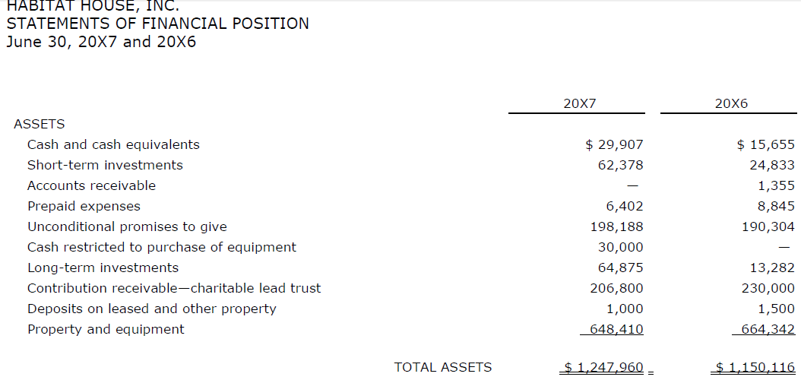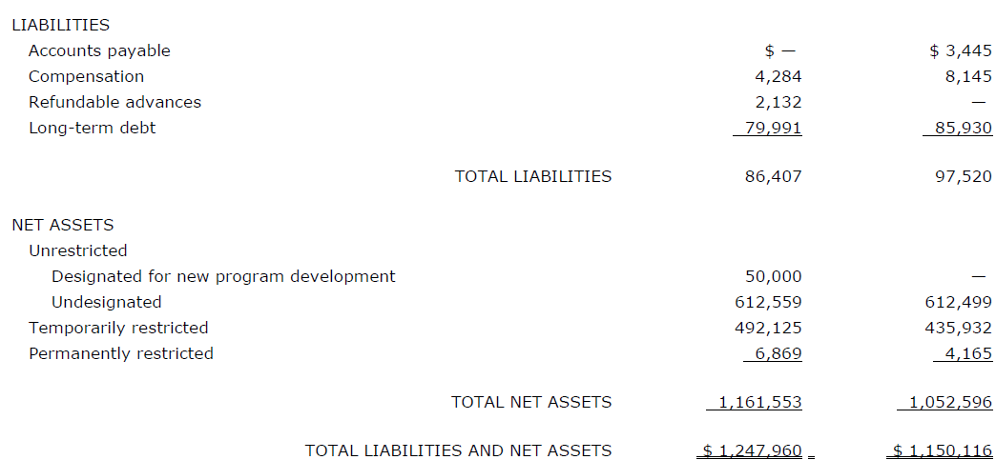
Assume the estate of John Cash makes a bequest to Tech City of $5,000,000. The bequest provides that the corpus of the gift is to remain intact permanently, that all realized and unrealized investment gains and losses shall become part of the corpus, and that all other investment income (net of operating expenses) shall be transferred to the city’s Museum Special Revenue Fund. Because only the net investment income can be expended and these expenditures must support programs that benefit the city, a Permanent Fund, the Cash Bequest Fund, is used to account for the bequest and its activities. Shortly after the bequest is received, the entire are as amount is invested in securities. The entries to record the bequest and the purchase of securities follow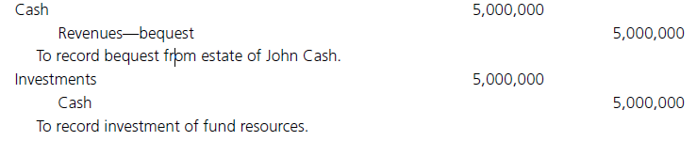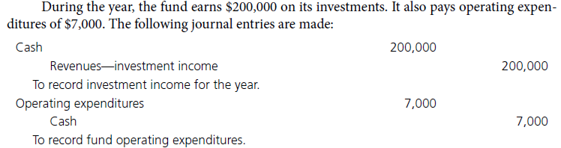Illustrative Transactions—Voluntary Health and Welfare Organizations Preceding sections of this chapter point out the fact that NPOs vary greatly regarding the kinds of program services provided and the sources of support and revenue utilized. Accordingly, the transactions and accounting entries presented in this section should be taken as illustrative of those considered appropriate for an organization that offers counseling, adoption, and foster home care; they are not necessarily typical of other NPOs. The transactions illustrated in this section are assumed to pertain to the year 2011 of a hypothetical organization called the Community Family Service Agency, Inc. The trial balance of the Community Family Service Agency, Inc., as of December 31, 2010, is shown on the next page.
The trial balance as of December 31, 2010, indicates that the capital assets (land, building, and equipment) are temporarily restricted, either explicitly by the donor or by an organization policy implying that donated capital assets will be restricted for the term of their useful life, or, in the case of land, for some specified period of time. An amount equal to depreciation expense is reclassified from temporarily restricted to unrestricted net assets each year. Donors of temporarily restricted gifts for programs, plant, or future periods have also restricted the specific asset or investments, in addition to net assets.
1. Contributions received in 2010 but specified by donors for unrestricted use in 2011 were transferred from the temporarily restricted to the unrestricted net asset class, as shown.
a. Net Assets Released—Expiration of Time Restrictions—Temporarily
Restricted . . . . ……………………………………………………… .5,125
Net Assets Released—Expiration of Time Restrictions—Unrestricted . . . 5,125
2. Pledges receivable resulting from the 2011 fund drive were recorded. Pledges of $69,500 were unrestricted; in addition, pledges of $16,500 were donor restricted for a special outreach project to be undertaken in 2011.
a. Contributions Receivable—Unrestricted ... 69,500
Contributions—Unrestricted . . . . . . . . . . . . . . . . . . . . . . . . . . 69,500
- b. Contributions Receivable—Temporarily Restricted. .. . . . 16,500

Contributions—Temporarily Restricted—Program . . . . . . . . . . . 16,500
3. Cash collected for unrestricted pledges totaled $68,500; collection of accounts receivable amounted to $2,200. Cash collected for restricted pledges made this year totaled $16,500. Cash in the amount of $9,200 was collected for pledges given during a building fund drive in the preceding year.
a. Cash . . . . . . . . . . . . . . . . . . . . . . . . . . . . . . . . . . . . . . . . . . . . . . 70,700
Contributions Receivable—Unrestricted . . . . . . . . . . . . . . . . . . 68,500
Accounts Receivable . . . . . ….. . . . . . . . . . . . . . . . . . . . . . . . . . . 2,200
- b. Cash . . . . . . . . . . . . . . . . . . . . . . . . . . . . . . . . . . . . . . . . . .. . . 16,500
Contributions Receivable—Temporarily Restricted . . . . . . . .. . 16,500
- c. Cash . . . . . . . . . . . . . . . . . . . . . . . . . . . . . . . . . . . . . . . . . . . . . . 9,200
Contributions Receivable—Temporarily Restricted . . . . . . . . . . 9,200
4. The organization sponsored a bazaar to raise funds for the Special Outreach Project. Direct costs of $3,000, not considered peripheral or incidental in nature, incurred for this event were paid in cash; the event yielded cash contributions of $10,000.
a. Cash . . . . . . . . . . . . . . . . . . . . . . . . . . . . . . . . . . . . . . . . . . . . . 10,000
Contributions—Temporarily Restricted—Program . . . . . . . . . . 10,000
- b. Direct Costs—Special Outreach Project—Program . . . . ..... 3,000
Cash . . . . . . . . . . . . . . . . . . . . . . . . . . . . . . . . . . . . . . . . . . . . 3,000
5. The FY 2011 allocation from the United Way of Fair share Bay amounted, in gross, to $317,000. Related fund-raising expenses to be borne by the Community Family Service Agency totaled $13,200; the net allocation was received in cash.
a. Cash . . . . . . . . . . . . . . . . . . . . . . . . . . . . . . . . . . . . . . . . . . . . . . 303,800
Fund-Raising Support Expenses . . . . . . . . . . . . . . . . . . . . . . . . . . 13,200
Contributions—Unrestricted . . . . . . . . . . …. . . . . … . . . . . . . . . . . . 317,000
6. Salaries expense for the year totaled $265,000, employee benefits expense totaled $51,000, and payroll taxes expense was $20,300. As of year-end, $15,100 of these expenses were unpaid; the balance had been paid in cash.
a. Salaries Expense . . . . . . . . . . . . . . . . . . . . . . . . . . . . . . . . . . . . . . 265,000
Employee Benefits Expense . . . . . . . . . . . . . . . . . . . . . . . . . . . . . . 51,000
Payroll Taxes Expense . . . . . . . . . . . . . . . . . . . . . . . . . . . . . . . . . . .. 20,300
Cash . . . . . . . . . . . . . . . . . . . . . . . . . ….. . . . . . . . . . . . . . . . . . . . . .321,200
Accounts Payable and Accrued Expenses . . . … . . . . . . . . . . . . . . 15,100
7. Expenses incurred for the Special Outreach Project were professional fees, $17,000; supplies, $4,500; and printing and publications, $1,600. All amounts were paid in cash.
a. Professional Fees Expense . . . . . . . . . . . . . . . . . . . . . . . . . . . . . . . 17,000
Supplies Expense . . . . . . . . . . . . . . . . . . . . . . . . . . . . . . . ….. . . . . . 4,500
Printing and Publications Expense . . . . . . . . . . . . . . . . . . . . . . ..... . 1,600
Cash . . . . . . . . . . . . . . . . . . . . . . . . . . . . . . . . . . . . . . . ….. . . . . . 23,100
8. Expenses for program services and supporting services were professional fees, $43,000; supplies, $7,800; telephone, $9,800; postage and shipping, $7,800; occupancy, $23,900; rental and maintenance of equipment, $8,700; printing and publications, $7,900; travel, $22,000; conferences, conventions, and meetings, $13,800; specific assistance to individuals, $30,000; membership dues, $700; awards and grants to national headquarters, $5,500; costs of sales to the public, $900; and miscellaneous, $4,200. All expenses were credited to accounts payable and accrued expenses.
a. Professional Fees Expense . . . . . . . . . . . . . . . . . . . . . . . . . . . . .. 43,000
Supplies Expense . . . . . . . . . . . . . . . . . . . . . . . . . . . . . . . . . . . . . 7,800
Telephone Expense . . . . . . . . . . . . . . . . . . . . . . . . . . . . . . . . . . . . 9,800
Postage and Shipping Expense . . . . . . . . . . . . . . . . . . . . . . . . . . . 7,800
Occupancy Expense . . . . . . . . . . . . . . . . . . . . . . . . . . . . . . . . .. . 23,900
Rental and Maintenance of Equipment Expense . . . . . . . . . . . . . 8,700
Printing and Publications Expense . . . . . . . . . . . . . . . . . . . . . . . . 7,900
Travel Expense . . . . . . . . . . . . . . . . . . . . . . . . . . . . . . . . . . . . . . . 22,000
Conferences, Conventions, and Meetings . . . . . . . . . . . . . . . .... . 13,800
Specific Assistance to Individuals . . . . . . . . . . . . . . . . . . . . . . . .. 30,000
Membership Dues . . . . . . . . . . . . . . . . . . . . . . . . . . . . . . . . . . …….. 700
Awards and Grants to National Headquarters . . . . . . . . . . . . .... . .. 5,500
Cost of Sales to the Public . . . . . . . . . . . . . . . . . . . . . . . . . . . …… . . 900
Miscellaneous Expense . . . . . . . . . . . . . . . . . . . . . . . . . . . . . . …….. 4,200
Accounts Payable and Accrued Expenses . . . . . . . . . . . ……. . . . . . 186,000
9. Unrestricted support and revenue were received in cash during 2011 from the following sources: legacies and bequests, $15,000; membership dues from individuals, $1,000; program service fees, $55,000; investment income, $2,900; and miscellaneous, $1,500. In addition, $250 of net incidental revenue was collected in cash from advertisers for the Special Outreach Project.
Cash . . . . . . . . . . . . . . . . . . . . . . . . . . . . . . . . . . . . . . . . . .. 75,650
Contributions—Unrestricted . . . . . . . . . . . . . . . . . . . . . . . . . . . 15,000
Membership Dues . . . . . . . . . . . . . . . . . . . . . . . . . . . . . . . . . …. 1,000
Program Service Fees . . . . . . . . . . . . . . . . . . . . . . . . . . . . . . . . 55,000
Investment Income—Unrestricted . . . . . . . . . . . . . . . . . . . . . . . 2,900
Miscellaneous Revenue . . . . . . . . . . . . . . . . . . . . . . . . . . . . . . . 1,500
Contributions—Temporarily Restricted—Program . . . . . . . . . . . 250
10. Sales to the public amounted to $1,000 gross for the year. None of this amount was collected by year-end.
11. Accounts payable and accrued expenses paid in cash during 2011 totaled $182,864.
Accounts Payable and Accrued Expenses . . . . . . . . . . . . . . 182,864
Cash . . . . . . . . . . . . . . . . . …… . . . . . . . . . . . . . . . . . . . . . . . 182,864
12. Contributions received in cash in 2011 amounted to $20,000, of which $10,000 was specified by donors for use in 2012, $6,000 was temporarily restricted for a program, and $4,000 was temporarily restricted for plant.
Cash . . . . . . . . . . . . . . . . . . . . . . . . . . . . . . . . . . . . . . . . . . . . . 20,000
Contributions—Temporarily Restricted—Time . . . . . . . . . . . . …. 10,000
Contributions—Temporarily Restricted—Program . . . . . . . …..…. . 6,000
Contributions—Temporarily Restricted—Plant . . . . . . . . . . . …...... 4,000
13. Interest of $4,540 and $6,500 on the principal of the mortgage were paid. Short term investments that were restricted for plant were sold at par, $5,000; the proceeds were used to purchase equipment. The organization’s policy is that there is an implied restriction on plant assets and that this restriction is satisfied as the assets are used (measured by depreciation expense).
a. Miscellaneous Expense . . . . . . . . . . . . . . . . . . . . . . . . . . ... 4,540

Mortgage Payable . . . . . . . . . . . . . . . . . . . . . . . . . . . . . . . . . 6,500
Cash . . . . . . . . . . . . . . . . . . . . . . . . . . . . . . . . . . . . . . ... . . . . 11,040
- b. Cash . . . . . . . . . . . . . . . . . . . . . . . . . . . . . . . . . . . . . . . . . . . . . 5,000

Short-Term Investments—Temporarily Restricted—Plant . . . . 5,000
- c. Equipment—Temporarily Restricted . . . . . . . . . . . . . . . . . . . 5,000

Cash . . . . . . . . . . . . . . . . . . . . . . . . . . . . . . . . . . . . . . . . . . . 5,000
14. Interest received in cash on short-term investments restricted for the plant amounted to $1,390. Interest received in cash on investments of endowment funds amounted to $12,780. This income was not restricted by the donor.
a. Cash . . . . . . . . . . . . . . . . . . . . . . . . . . . . . . . . . . . . . . . . . . . . . 1,390

Investment Income—Temporarily Restricted—Plant . . . . . . . . 1,390
- b. Cash . . . . . . . . . . . . . . . . . . . . . . . . . . . . . . . . . . . . . . . . . . . . . 12,780

Investment Income—Unrestricted . . . . . . . . . . . . . . . . . . . . . 12,780
15. The Community Family Service Agency paid its national affiliates in accord with the affiliation agreements; the amount of the payment in 2011 was $8,574.

Payments to Affiliated Organizations . . . . . . . . . . . . . . . . . . . 8,574
Cash . . . . . . . . . . . . . . . . . . . . . . . . . . . . . . . . . . . . . . . . . . . . 8,574
16. At the end of the year, a local family donated $100,000 in cash to be held in perpetuity with any investment income or gains and losses (realized or unrealized) to be used at the discretion of management.

Cash . . . . . . . . . . . . . . . . . . . . . . . . . . . . . . . . . . . . . . . . . . . . . 100,000
Contributions—Permanently Restricted . . . . . . . . . . . . . . . . . . 100,000
End-of-the-Year Adjusting Journal Entries
17. A physical count of supplies, valued at the lower of cost or market, indicated the proper balance sheet value should be $19,100, a decrease of $3,995 during the year. Prepaid expenses at year-end were $3,600; the decrease of $317 is chargeable to postage and shipping expense.
a. Supplies Expense . . . . . . . . . . . . . . . . . . . . . . . . . . . . . . . . . . 3,995
Supplies . . . . . . . . . . . . . . . . . . . . . . . . . . . . . . . . . . . . . . . . . 3,995
- b. Postage and Shipping Expense . . . . . . . . . . . . . . . . . . . . . . . . . . 317
Prepaid Expense . . . . . . . . . . . . . . . . . . . . . . . . . . . . . . . . . …. 317

Self- Check

1. Demonstrate the Purposes of Government Spending
2. List and briefly explain the Summary of Fund Characteristics’

Reference
Accounting for Governmental and Non-Profit Entities, 15th edition, by Wilson, Kattelus, Hay. McGraw-Hill/Irwin Inc., USA, 2010 or recent edition
Introduction to Governmental and Not-for-Profit Accounting Martin Ives Terry K. Patton & Se v e n t h E d i t i o n
From web site and internet

No | Name | Qualification | Educational background | Region | College | Mobile number | E-mail
1 | Kassa Terefe Gelaw | BA, degree | Accounting & finance | A.A | KMC | +251993298301 | kssterefe@gmail.com
2 | Sewumehon Anteneh | BA degree | Accounting & finance | A.A | KMC | +251948032126 | Sewumehonanteneh@gmail.com
3 | Remedan Abdurehman | MBA | Accounting & finance | A.A | GWPTC | +25133233939 | rame.abdu10@gmail.com
4 | Meskerem Getachew | MBA | Accounting & finance | A.A | ARADA | +251925918465 | meskigetach@gmail.com
5 | Mahmud Oumer | BA | Accounting | A.A | GWPTC | 0913099303 | Mahmudoumer@gmail.com
6 | Mekuanint Abeje Melese | MSc degree | Accounting & finance | A.A | LMC | +251913969620 | Mekuanitabeje21@gmail.com
7 | Hussien Ebrahim | MBA | Accounting & finance | A.A | GWPTC | +251920188426 | Hussienebrahim701@ gmail.com
8 | Alemayehu | MBA | Accounting & finance | A.A | MPTC | +251920188426

