ACCOUNTING AND FINANCE
LEVEL-IV
Based on March, 2022, Curriculum Version I
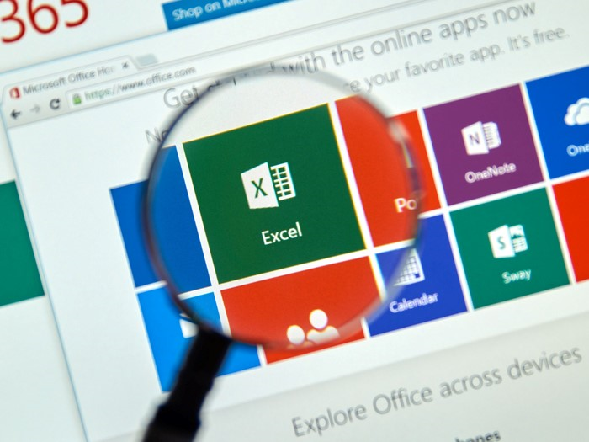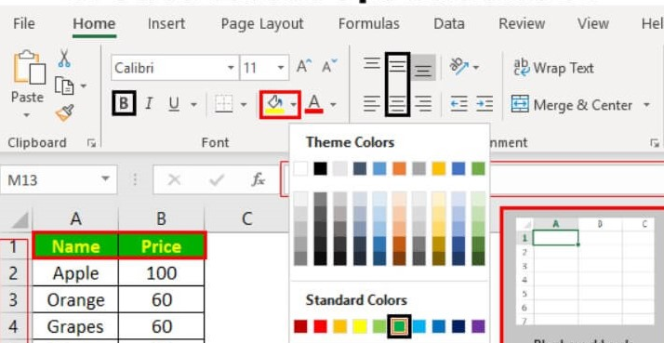
Module Title: Develop and Use Complex Spreadsheet
Module code: LSA ACF4 M06 0322
Nominal duration: 60Hour
PREPARED BY: A.A TVT BUREAU

September, 2023
Addis Ababa, Ethiopia

Table of Contents
INTRODUCTION 6
UNIT ONE : Prepare and develop spreadsheet 9
1.1 Organizing personal work environment based on ergonomic requirements 10
1.1.1 Ergonomic requirements 11
1.2 Analyzing and specifying task 15
1.3 Identifying organizational and task requirements 19
1.4 Applying organization strategies, energy and resource conservation techniques 22
1.4.1 Work organization strategies 22
1.4.2 Energy and resource conservation techniques 22
Self-check 24
Unit Two: Develop a linked spreadsheet solution 26
2.1 Utilizing spreadsheet design software functions and formula 26
2.1.1 Spreadsheet design 26
2.1.2 Function 28
2.1.3 Formula 30
2.2 Linking Spreadsheets 32
2.3 Formatting cell and assigning data attributes 34
2.3.1 Formatting cell 34
2.4 Testing formula 37
Self-check 39
Operation sheet 2.1 40
Unit Three Automate and standardize spreadsheet operation 41
3.1 Evaluating tasks 42
3.2 Creating using and editing macros 43
3.2.1 Macros 43
3.3 Developing editing and using templates 54
3.3.1 Templates 54
Self-check 56
Unit Four: Use Spreadsheets 57
4.1 Entering checking and amending data 58
4.1.1 Entering data 58
4.2 Import and export data 61
4.2.1 Export Data 61
4.2.2 Import Data 63
4.3 Using manuals, user documentation and online help 66
4.4 Previewing, adjusting and printing spreadsheets 68
Self- check 70
Operation Sheet 70
Lap Test 71
Operation Sheet -II 72
Lap Test -II 73
Unit Five: Represent Numerical Data In Graphic Form 75
5.1 Determining style of graph 75
5.2 Creating graphs with labels and titles 77
5.3 Saving, viewing and printing graph 82
Self- Check 86
Reference 87

Figure No, | Figure Name
Figure 1 -1 | Correct Setting Posture
Figure1-2 | Starting Excel
Figure1-3 | The Excel Windows
Figure 1-4 | Data Entry
Figure 1-5 | Output Device
Figure 2-1 | Spreadsheet
Figure 2-2 | Excel
Figure 2-3 | Excel Formula
Figure 2-4 | Link Data And Spreadsheet
Figure 2-5 | Formatting Toolbar
Figure 2-6 | Format Cell
Figure 3-1 | Automation Process
Figure 3-2 | Recording Macro
Figure 3-3 | Record Macro
Figure 3-4 | Template Screen
Figure 4-1 | Entering Column Headings Into A Worksheet
Figure 4-2 | Using The Formula Bar To Edit And Enter Data
Figure 4-3 | User Documentation And Help
Figure 5-1 | Graph Style
Figure 5-2 | Adding Title
Figure 5-3 | Chart Title
Figure 5-4 | Chart In Excel
Figure 5-5 | Saving Graph

Acknowledgment
A.A TVT BUREAU wishes to extend thanks and appreciation to the many representatives of TVT instructors and respective kirkos manufacturing college Dean who donated their time and expertise to the development of this Teaching, Training and Learning Materials (TTLM).

INTRODUCTION
Welcome to the module “Develop and Use Complex Spreadsheets”. This learner’s guide was prepared to help you achieve the required competence in “Accounting and finance Level IV”. This will be the source of information for you to acquire knowledge attitude and skills in this particular occupation with minimum supervision or help from your trainer.
A spreadsheet is like an electronic ledger sheet and it is one element/component of the Microsoft office applications. Spreadsheet is a software program that allows users to enter and manipulate data. It can be used to automate calculations or analyze numeric information. Spreadsheets are often used to automate accounting tasks, budgeting, or any application that requires many calculations. In order to use the spreadsheet or excel program you should follow the following activities. A spreadsheet is a computer program that can capture, display and manipulate data arranged in rows and columns. Spreadsheets are one of the most popular tools available with personal computers. A spreadsheet is generally designed to hold numerical data and short text strings. A spreadsheet is a file that exists of cells in rows and columns and can help arrange, calculate and sort data. Data in a spreadsheet can be numeric values, as well as text, formulas, references and functions. The most common reason to use spreadsheets is to store and organize data, like revenue, payroll and accounting information. Spreadsheets allow the user to make calculations with this data and to produce graphs and charts. It's a grid made up of rows and columns where you enter and organize your data. For example, in our small business scenario, the January worksheet would contain all the expense data for that month. Cell: A cell is an individual box within the worksheet where rows and columns intersect.

This module covers the units:
- Prepare to develop spreadsheet
- Develop a linked spreadsheet solution
- Automate and standardize spreadsheet operation
- Use spreadsheets
- Represent numerical data in graphic form
Learning Objective of the Module
      - To prepare and develop spreadsheet
      - To develop a linked spreadsheet solutions
      - Determine automate and standardize operations
      - To use spreadsheet
      - To represent numerical data in graphics form
Module Instruction
For effective use this modules trainees are expected to follow the following module instruction:
- Read the information written in each unit
- Accomplish the Self-checks at the end of each unit
- Perform Operation Sheets which were provided at the end of units
- Do the “LAP test” giver at the end of each unit and
- Read the identified reference book for Examples and exercise

ACRONYMS

SNMP Simple Network Management Protocol
VBA Visual Basic for Applications
CSV Comma separated value
CFL Compact Fluorescent Lights
LED Light-Emitting Diodes
GPS Global Posting System

UNIT ONE : Prepare and develop spreadsheet
This unit is to provide you the necessary information regarding the following content coverage and topics:
- Organizing personal work environment based on ergonomic requirements
- Analyzing and specifying task
- Identifying organizational and task requirements
- Applying organization strategies, energy and resource conservation techniques
This unit will also assist you to attain the learning outcomes stated in the cover page. Specifically, upon completion of this learning guide, you will be able to:
- Organizing personal work environment based on ergonomic requirements
- Analyzing and specifying task
- Identifying organizational and task requirements
- Applying organization strategies, energy and resource conservation techniques

Organizing personal work environment based on ergonomic requirements
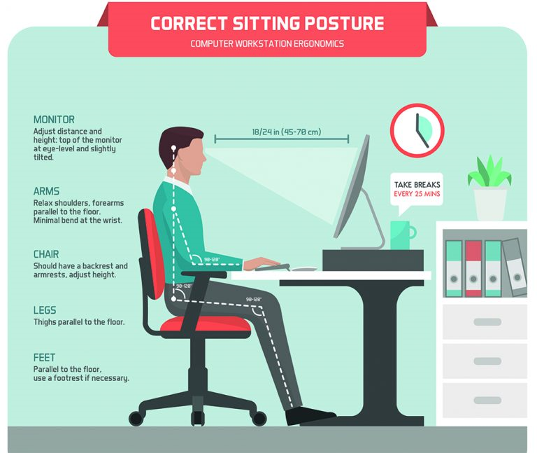
Figure 1 -1 correct setting posture

Ergonomic requirements
Ergonomics, from the Greek ergon (work) and nόmos (law), is a discipline that studies the interactions between human activity and the components of this activity (tasks, tools, methods, work environment, etc.) to develop systems that allow people to work in conditions of optimal efficiency, safety and comfort.
Ergonomics is the process of designing and/or modifying tools, materials, equipment, plant, work spaces, tasks, jobs, products, systems and environments to match the physical and mental capabilities and limitations of users, including those with special needs and those returning to work following injury or illness.
There are five aspects of ergonomics:
    - Safety
    - Comfort,
    - Ease of use
    - Productivity/performance
    - Aesthetics.
Requirements
- Prevention
The person(s) that design the work environment and/or design tasks is/are responsible for ensuring that ergonomic hazards relating to work environments, tools, equipment, workstations or work practices are identified and the associated risks are identified, assessed and controlled.
The manager/supervisor is responsible for:
- Ensuring staff and students are provided with appropriate equipment to enable them to undertake their tasks safely;
- Ensuring staff and students have completed relevant training;
- Ensuring, where staff have a working from home agreement, that the working from home requirements are followed;
- promoting early reporting of hazards, work-related incidents and musculoskeletal concerns and injuries; and
- Consulting with staff, where reasonably practicable, when planning:
- Introduction of new work that may have an impact on health and safety;
- Changes to existing work that may have an impact on health and safety;
- Selection and purchase of new plant and equipment that may have an impact on health and safety; and
- Refurbishment, renovation or redesign of existing workplaces that may have an impact on health and safety.
Ergonomic requirement may includes
- avoiding radiation from computer screens
- chair height, seat and back adjustment
- document holder
- footrest
- keyboard and mouse position
- lighting
- noise minimization
- posture
- screen position
The 5 Requirements for Sustainable Ergonomics in the Workplace
- Purpose and Goals
- Training
- Metrics and Continuous Improvement
- Documentation and Proof
- Teamwork and Accountability

- Workplace Ergonomics Purpose, Goals
There are many reasons to establish or revitalize an ergonomics process. One common purpose is to address ergonomics-related injuries, but good ergonomics brings many more economic and intangible benefits, and some of those benefits will expand the influence, value and success of ergonomics and continuous improvement throughout your company.
Ergoweb promotes and works to achieve at least the following benefits in a workplace ergonomics process. We might add or subtract from this list, depending on the maturity of your current process.
- Prevent injuries, fatigue and discomfort
- Reduce the severity of injuries, disabilities, and all associated costs
- Improve production quality and workmanship
- Improve efficiency and productivity
- Improve moral, accountability, teamwork and cross-functional cooperation
- Improve absenteeism and turnover rates
Ergonomics can benefit other corporate functions, including product and service design, but this article focuses only on workplace ergonomics.

- Training
Training is an important part of any process, especially so for ergonomics, because even though it seems like common sense, there’s much more to it, and it’s not as intuitive as it may seem at first glance.
It’s also common that an incomplete version of ergonomics has previously been promoted within a company. For example, there’s much work to do if ergonomics has been promoted as stretching routines, or as lifting technique training, or any variety of employee behavioral modification. There’s a time and place to improve behavior within your ergonomics strategy, but the greatest value and best outcomes in ergonomics come from a focus on human-centered design and engineering, first and foremost. With good ergonomics design, safe and effective employee interactions become natural and intuitive.
Who Needs Ergonomics Training? The short answer is that everyone in a company has some level of ergonomics ownership and responsibility, and therefore will benefit from training tailored to their needs and responsibilities. In a mature ergonomics process, everyone knows their roles and responsibilities. Some team members will need minimal introduction and exposure to the ergonomics process, while those responsible for carrying out the day-to-day ergonomics process will need deeper training. Part of the ergonomics process strategy should be a strategic, timed approach to training.

- Metrics and Continuous Improvement
Metrics are a requirement in today’s business environment, with good reason. Metrics, meaning the method in which we measure the state of our process, are key to understanding whether we’re succeeding, failing, or having little or no effect at all with our strategies.
Metrics are what transforms well-intentioned, heartfelt beliefs and expectations into documented reality for all to see. And as the saying goes, seeing believes, and decision makers in particular need to see it to believe it. If they don’t believe it, they won’t put their neck on the line to support, participate and promote it, and neither would you or I.
On the other hand, metrics can be dangerous if they aren’t an accurate measure of what they purport to be measuring, or if perceived as busy-work. For integrity, a measure, and the method in which we do the measuring, must to be consistent and repeatable. If it’s too variable and easily disputable, our methods or measures won’t be credible or accepted.

- Documentation and Proof
Ergonomics is an essential tool for organizations that are built to last. Maintaining an ergonomics process that encompasses the five requirements described above is an important ingredient in the recipe for sustainability.
- Teamwork and Accountability
Ergonomics is no different than any other improvement management strategy. The process can only succeed if people understand and execute their respective roles and responsibilities. Without individual accountability and the ability to effectively cooperate, no improvement process is successful in the long term.

Analyzing and specifying task
A Specification is a statement of how the spreadsheet is to meet the user requirements. A specification can be as simple as explanatory text in a worksheet, or as complex as separate legal documentation.
Excel is a spreadsheet program from Microsoft and a component of its Office product group for business applications. Microsoft Excel enables users to format, organize and calculate data in a spreadsheet. By organizing data using software like Excel, data analysts and other users can make information easier to view as data is added or changed. Excel contains a large number of boxes called cells that are ordered in rows and columns. Data is placed in these cells.
Spreadsheet application (sometimes referred to simply as spreadsheet) is a computer program that allows us to add (i.e. enter) and process data. We shall understand spreadsheet with the help of MS-Excel (or simply, Excel), which is one of the Microsoft Office Suite of software.
Starting Excel
You are encouraged to start using MS Excel as you read through the following materials to familiarize yourself with the topics and procedures.
1. Click the Start button on the Windows taskbar.
a. The Start menu opens
2. Point to Programs
a. The Programs menu opens
3. Click Microsoft Excel
a. Excel opens a new workbook
Note: an icon for MS Excel may be located either on the desktop or on the Office toolbar.
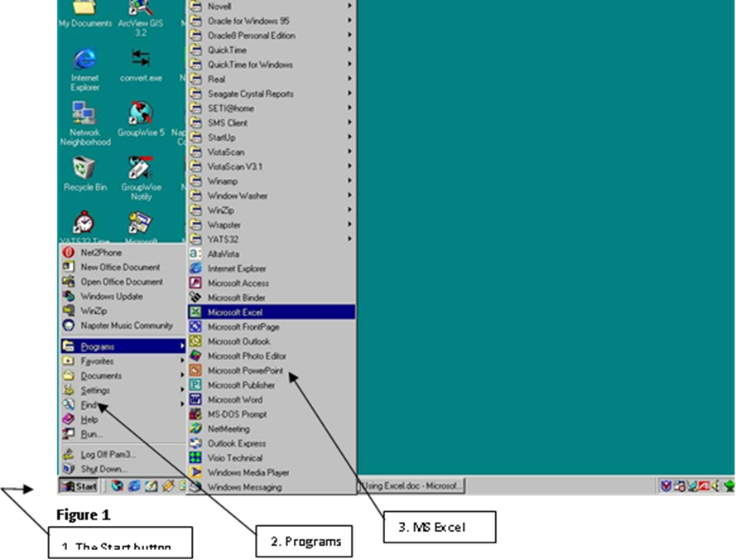
Figure1-2 starting excel
Parts of an Excel spreadsheet or windows
Example:
- Menu bar displays/lists the names of the application menus.
- Formula bar as you type text or number into the active cell, it appears in the formula bar or it shows your action on the work sheet active cell.
- Title bar shows the title of the opened sheet or active sheet/window and found at the top of the window.
- Toolbars (such as standard and formatting toolbars) allow you to execute commands with a single click.

Office button menu bar tool bars title bar help button

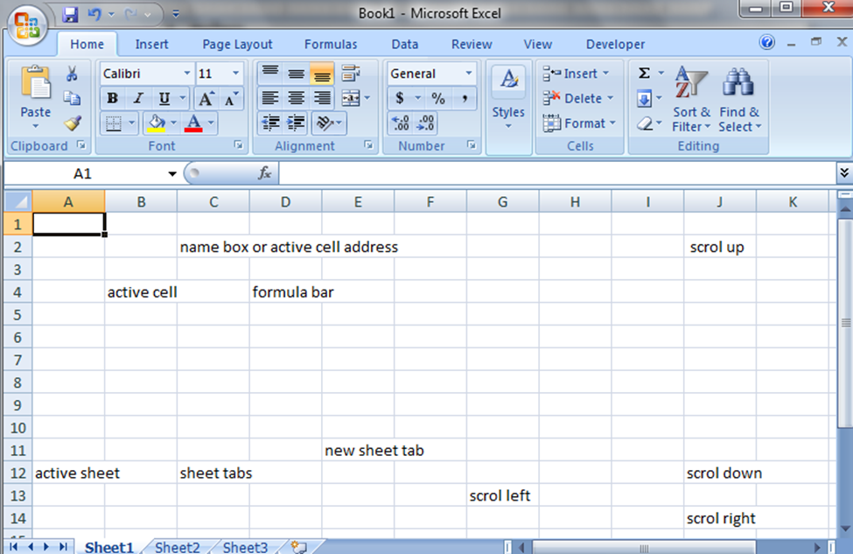

Row heading Worksheet area column heading
Figure1-3 the Excel windows
Define a column, row, worksheet and cell
A spreadsheet is comprised of rows, columns, and cells. A column is a vertical line on the spreadsheet and they are defined by letters. A row is a horizontal line on the spreadsheet and they are defined by numbers. A cell is represented as a rectangular box on the worksheet. Cells are defined by the column and row at which they intersect. The current cell is displayed in the Name Box. Worksheet is a working area that you can store or enter, manipulate, calculate, and analyze data such as numbers, texts and formulas on it.
Detail steps to create worksheet on spreadsheet
- Choose New from the file menu in 2003 or on office button on 2007 Microsoft office
- Select blank workbook
- MS-Excel displays the new worksheet in a new window
- Now we can enter, check and amend data on the work sheet
The data that can be entered in the work sheet, checked, and amended may be number or text. Entering data is simple. Hence, in order to enter data:
- Locate the cell in which the data is to be placed (a box should be highlighted or selected) that is the active cell.
- Type the data
- Press enter or click out of the cell when you finished your work or action.
- Check the accuracy of the data
- If necessary amend it or correct it or change their font size, style color and so on.

Identifying organizational and task requirements

Organization allows you to add more structure to your work life so that you can better control your workload and break it into manageable tasks. Being organized ensures you know what tasks to complete and the expected deadlines for them and have a schedule in place to meet those deadlines.
Organizational requirements formulate rules about how users are to perform their tasks, e.g. “The radiological assistant must keep an eye on the patient while adjusting the patient table.” In practice, the term “business requirement” is sometimes used.
Task Requirements is a collection of physical, functional, mental and administrative needs that should be covered by the assigned resources: they serve as quality criteria to approve suitability of resources.
Task Requirements is a collection of physical, functional, mental and administrative needs that should be covered by the assigned resources: they serve as quality criteria to approve suitability of resources: they serve as quality criteria to approve suitability of resources. In other words, task requirements motivate the managers to select appropriate resources (manpower, equipment, materials, etc) and assign them to a task to fully supply it with everything suitable to this work (resources, in order to be assigned, should match the task requirements).
Task requirement includes
- Data entry
- Output
- Data presentation
- Storages
- Formats etc

Data entry
Data entry is the process of entering information or updating records in a database or computer system. What does a data entry clerk do? Data entry professionals use computers and data processing programs to input information.
Data entry is the process of digitizing data by entering it into a computer system for organization and management purposes. It is a person-based process and is one of the important basic tasks needed when no machine-readable version of the information is readily available for planned computer-based analysis or processing.
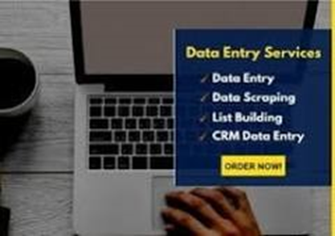
Figure 1-4 data entry
Output
The output of a computer or word processor is the information that it displays on a screen or prints on paper as a result of a particular program. Computer's output devices obtain information from the computer and send data that has been processed by the computer to the user. Output devices transfer data in human readable forms, like audio, visual, and hard copy media. Examples include monitors, printers, speakers, headphones, projectors, GPS devices, optical mark readers, and braille readers. An output device is any piece of computer hardware that converts information/DATA into a human-perceptible form or, historically, into a physical machine-readable form for use with other non-computerized equipment. It can be text, graphics, tactile, audio, or video. Examples include monitors, printers, speakers, headphones, projectors, GPS devices, optical mark readers, and braille readers.
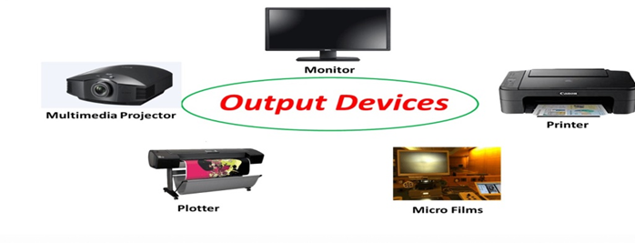
Figure 1-5 output device
Data presentation
The purpose of putting results of experiments into graphs, charts and tables is two-fold. First, it is a visual way to look at the data and see what happened and make interpretations. Second, it is usually the best way to show the data to others. Reading lots of numbers in the text puts people to sleep and does little to convey information. From an educational standpoint, students at most levels are required to learn various data presentation methods, and learning to graph data one has collected oneself from one �s own experiments is considerably more engaging and motivatthan learning to graph using data that is given by the teacher. Presentation of data refers to an exhibition or putting up data in an attractive and useful manner such that it can be easily interpreted. The three main forms of presentation of data are:
- Textual presentation.
- Data tables.
- Diagrammatic presentation.
Storages
Storage is a mechanism that enables a computer to retain data, either temporarily or permanently. Storage devices such as flash drives and hard disks are a fundamental component of most digital devices since they allow users to preserve all kinds of information such as videos, documents, pictures and raw data.
Formats
Formatting refers to a set of standards for academic writing that dictate how a paper should look, including typeface settings, margins, headers and footers, cover pages and page headings, and citations. Uniformity in writing is important for maintaining integrity, especially when it comes to citations and including the correct information in both in-text and in full citations. Citation refers to the identification of each source of information that was used in the paper and is required for academic integrity and to avoid plagiarism. Following the style guidelines help ensure that a paper includes all of the necessary citation information and that it is presented in an appropriate way for the academic audience.

Applying organization strategies, energy and resource conservation techniques

Work organization strategies
An organizational strategy is a strategic plan generally developed by the leadership team detailing how your business will allocate resources (like inventory, time, and funding) to support all its business activities. General business activities might include: Creating or purchasing inventory to meet market demand. The core benefits of being organized and operating in a generally clutter-free environment are increased productivity and improved performance. And with those comes a greater sense of control, which is a vital part of stress management , resilience, and overall wellbeing.
Work organization strategies may includes
- Exercise breaks
- Mix of repetitive and other activities
- Rest periods

Energy and resource conservation techniques

Energy conservation is the effort to reduce wasteful energy consumption by using fewer energy services. This can be done by using energy more effectively (using less energy for continuous service) or changing one's behavior to use less service (for example, by driving less). Energy conservation can be achieved through efficient energy use, which has some advantages, including a reduction in greenhouse gas emissions and a smaller carbon footprint, as well as cost, water, and energy savings. Replace incandescent lights with compact fluorescent lights (CFLs) or light-emitting diodes (LEDs) for desk lamps and overhead lighting. Use dimmers, motion sensors, or occupancy sensors to automatically turn off lighting when not in use to reduce energy use and costs. Turn off lights when you leave at night. Turning off the light when you leave the room, unplugging appliances when they're not in use and walking instead of driving are all examples of energy conservation.
Energy and resource conservation techniques include:
- double-sided paper use
- recycling used and shredded paper
- re-using paper for rough drafts (observing confidentiality requirements)
- using power-save options for equipment

Self-check
  - List at least three requirements of task
________________________________________________________________________________________________________________________________________________________________________________________________________________________________________________________________
  - Explain teamwork and accountability
__________________________________________________________________________________________________________________________________________________________________________________________________________________________________
  - List and explain ergonomic requirements
_______________________________________________________________________________________________________________________________________________________________________________________________
  - Explain the difference and similarities of energy and resource
_______________________________________________________________________________________________________________________________________________________________________________________________________________
- Explain spreadsheet
___________________________________________________________________________________________________________________________________________________________________________________________________________________________

Unit Two: Develop a linked spreadsheet solution
This unit is to provide you the necessary information regarding the following content coverage and topics:
- Utilizing spreadsheet design software functions and formula
- Linking Spreadsheets
- Formatting cell and assigning data attributes
- Testing formula

This unit will also assist you to attain the learning outcomes stated in the cover page. Specifically, upon completion of this learning guide, you will be able to:

- Utilize spreadsheet design software functions and formula
- Link Spreadsheets
- Format cell and assign data attributes
- To test formula

Utilizing spreadsheet design software functions and formula

Spreadsheet design

Spreadsheets should be as simple, clear, and consistent as possible. Remove unnecessary data and formatting to reduce clutter. Think about using cell styles to make it clear which cells are input cells, which are calculation cells, and which contain headings and warning messages. A spreadsheet is generally designed to hold numerical data and short text strings. In a spreadsheet program, spaces that hold items of data are called spreadsheet cells. These can be renamed to better reflect the data they hold and can be cross-referenced through row numbers and column letters.
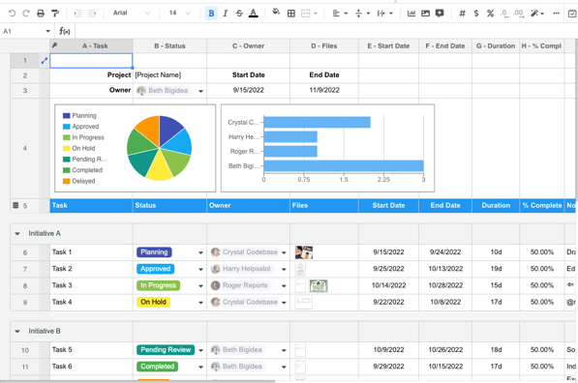
Figure 2-1 spreadsheet

Spreadsheet design includes:
- Analysis
- Appropriateness
- Avoidance of blank rows and columns
- Embedding cell references in formula
- Formula
- Formatting and reformatting
- Functions
- Headers and footers
- Headings

Function
Functions are "self-contained" modules of code that accomplish a specific task. Functions usually "take in" data, process it, and "return" a result. Once a function is written, it can be used over and over and over again. Spreadsheets usually contain a number of supplied functions, such as arithmetic operations (for example, sum, averages, maximum, minimum and so forth), statistical functions, and so forth. In addition there is often a provision for user-defined functions.
Example, =average (A1:A6), =sum (A2:D6) and so on

Practice table below excel
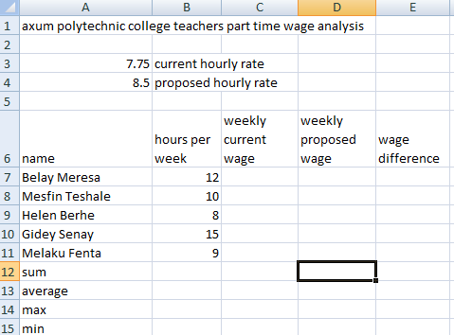
Figure 2-2 excel
Instruction
- Calculate the current, proposed an wage difference of each employees
- Calculate the sum, average, maximum and minimum hours and wages horizontally
The Excel IF function checks to see if a certain condition is true or false. If the condition is true, the function will do one thing, if the condition is false, the function will do something else.
The IF function we are using in this tutorial asks if the value in column A is greater than the value in column B. If it is, the IF function will place the statement "A is larger" in column D. If it is not, the IF function will place the statement "B is larger" in column D.
Our IF function will be entered into cell D1 on excel worksheet and it looks like this:
=IF(A3 > B3,"A is larger","B is larger"). Hence, to see the if function, compare the columns on the table below as instructed under column D on excel worksheet.

Column A | Column B | Column C | Column D | Column E
250 | 500 | 350 | Compare column A1 and B1
300 | 600 | 400 | Compare column A1 and C2
200 | 150 | 360 | Compare column A3 and B2
Function may include but not limited to:
- basic financial functions (if available)
- date functions
- logical functions (lookup, if, choose, true, false, conditions)
- mathematical functions (square root, integer, absolute value, round)
- simple nested functions
- statistical functions (standard deviation, count, maximum, minimum)

Formula
Formulas are one of the most commonly used features of Excel. They can be used to carry out simple addition and subtraction or far more complex mathematical calculations. Formulas begin with an equal sign.
- Click on the cell where you want the formula's result to be displayed or select the cell in which you want to type a formula
- Type an equal sign (= ) to let Excel know you are creating a formula.
- Type cell references in either uppercase or lower case or use the mouse or the arrow keys to select cells as you type the formula
- Press the enter key to complete the formula

Using Cell References in Formulas
Rather than enter the data directly into a formula, it is better to enter the cell references where the data is located into the formula.
The advantages of this are that:
If you later change your data the formula automatically updates to show the new result in certain instances, using cell references makes it possible to copy formulas from one location to another in a worksheet. The easiest and best way to add cell references to a formula is to use pointing, which means to click with the mouse pointer on the cell containing the data you want added to the formula.
Arithmetic operator | Operator’s Name | Example Formula
( ) | parentheses | =(1+B4)/B20
^ | Exponentiation | =E4^6 or power (4,6)
* | multiplication | =B4*D4
/ | Division | =A10/B10
+ | sum or addition | =A5+A9
- | subtraction | =A6-A7
N² | power | =power (number, power)
$\sqrt{}x$ | square root | = sqrt(number)
Table 1 formula
All formulas in Excel, no matter how complex, always begin with the same steps as follows:
Formula is an expression that calculates values in a cell or in a range of cells.
For example, =A2+A2+A3+A4 is a formula that adds up the values in cells A2 through A4.
Function is a predefined formula already available in Excel. Functions perform specific calculations in a particular order based on the specified values, called arguments, or parameters. For example, instead of specifying each value to be summed like in the above formula, you can use the SUM function to add up a range of cells: =SUM (A2:A4)

You can find all available Excel functions in the Function Library on the Formulas tab:
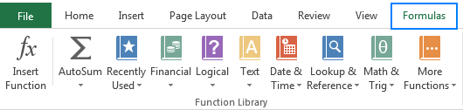
Figure 2-3. excel formula
There exist 400+ functions in Excel, and the number is growing by version to version. Of course, it's next to impossible to memorize all of them, and you actually don't need to. The Function Wizard will help you find the function best suited for a particular task, while the Excel Formula Intellisense will prompt the function's syntax and arguments as soon as you type the function's name preceded by an equal sign in a cell:
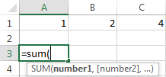

Linking Spreadsheets

Figure 2-4. Link data and spreadsheet
The process of displaying or using data that resides in another cell, perhaps even in another workbook, is known as data linking. Excel enables you to link the data in your worksheet with data in other sheets, other workbooks and even other applications. Linking Data allows you to input data from one worksheet into another worksheet in such a way that it will change if the original data is changed. This can be used to prevent your spreadsheet from needing to hold multiple copies of the same data.
Then link them together with an exclamation mark.
- From Excel (or any spreadsheet app), open or create a new sheet.
- Select the cell you want to pull data into.
- Type = immediately followed by the name of your source sheet, an exclamation mark, and the name of the cell being copied. For example, =Roster! A2 .
Linking spreadsheets, or workbooks, in Excel can be beneficial because it allows you to reference data from a variety of sources within one main sheet. It also keeps all your information accurate across your documents because changes you make to one sheet automatically update across all documents with which it's linked. You can link sheets in the same workbook or sheets from two workbooks on your computer. Linking spreadsheets can reduce errors by keeping all forms consistent and it can save time because you don't update each sheet manually for one change.

Formatting cell and assigning data attributes

Formatting cell

The icons on the Home ribbon provide you with a variety of formatting options. To apply any of these, just select the cell or cells that you want to format, and then click the desired icon. Commonly used formatting attributes include:
- Font and size
- Bold, Italic, Underline
- Cell borders
- Background and Font color
- Alignment: Left, Centre or Right
- Merge text across multiple cells
- Wrap text within a cell
- Rotate angle of text
- Format number as Currency, Percentage or Decimal
- Increase or Decrease number of decimal places
- The Format Painter allows you to copy formatting attributes from one cell to a range of cells.
Formatting the worksheet is the process of altering or changing the appearance of data in one or more worksheet cells. Formatting is purely cosmetic-changing only the appearance, not the contents of the formula, values or texts stored in the cells. This only changes the font size, color, style of text or values.
Background color
Border
Font style box left right merge and font color
Or font face font style alignment alignment center
font size
Figure 2-5 formatting toolbar
Cell formats allow you to only change the way cell data appears in the spreadsheet. It is important to keep in mind that it only alters the way the data is presented, and does not change the value of the data. The formatting options allow for monetary units, scientific options, dates, times, fractions, and more. Positive and negative values can have different colors and formats for aiding in keeping track of values. There are also a large variety of date and time formats for virtually any time and date format one can think of. Formatting also allows you to set font, background color, and borders for selected cells. Finally, advanced formatting options allow you to lock some of the cells so that their values cannot be changed, or restrict the range of values that can be entered in the selected cells.
To change the formatting of a cell or a selection, you can either use the Format Cells dialog which holds all of the formatting options or use specific formatting elements available as buttons on the Format Toolbar.
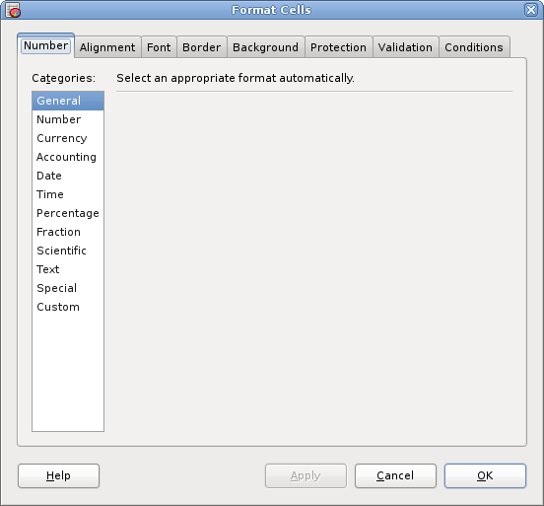

Figure 2-6 format cell
Select the cell or range of cells you want to format (see Section 2.6 ― Selecting Cells and Cell Ranges for details on selecting cells) and then use one of the following methods:
- Use keyboard shortcut Ctrl+1 (this is number one, not letter l).
- Choose Format ▸ Cells... in the menu bar.
- Click with the right mouse button on the cell grid area and choose Format Cells... from the context menu.
The Format Cells dialog contains tabs Number, Alignment, Font, Border, Background, Protection, and Validation. These tabs are described in detail in the subsequent sections. To set one of formatting options, select the corresponding tab, choose the options you need, and click OK. This will apply the options you selected (in all tabs) and close Format Cells dialog. You can also click on Apply to apply the and keep the dialog open, or on Close to close the dialog without applying changes.

Testing formula

Go to Formulas > Formula Auditing > Evaluate Formula. Select Evaluate to examine the value of the underlined reference. The result of the evaluation is shown in italics. If the underlined part of the formula is a reference to another formula, select Step In to display the other formula in the Evaluation box. To make matters worse, your spreadsheet will not always tell you if a formula is wrong. It will usually just go ahead and run the calculations and give you the wrong answer. It's up to you to double-check your formulas whenever you create them.
To test a formula, follow these steps:
Procedure
- Ensure that the default collector is started.
- Click the Test tab.
- Specify an element, sub elements, or group of sub elements for which to test the formula from the Target list box. You must specify an appropriate target to test against. For example, an Ethernet formula requires a target with an Ethernet interface. A token ring formula requires a target with a token ring interface.
- Click the refresh button to update this list box with available resources.
- Specify an instance from the Instance box. For example, a single instance such as 1, or multiple instances such as 1,3,5-4.1.2,7.*,8.1.*,9-10.You can override the default instances specified in the formula by using the Instance field.
Dim I1 AS Integer Default * NAME Interface
You can use the Instance field to specify only instances 2 through 5:
Interface<2-5>
If you do not specify any instances, Tivoli Netcool Performance Manager DataMart uses the default instances specified in the formula, and inserts them into the Instance field when testing the formula.
- Enter a community name in the Community box.
- Optional: You can select an SNMP Collector for the formula test from the SNMP Collector listbox. When you selected resources in step 3, the associated collector appears by default.
- Click Test to test the validity of the formula. The selected target and community name are also tested.
In a few moments, the results are displayed in the Trace box. If the test passed, the formula is correct and the element or sub element is active. The numerical results of the test are displayed. If the test failed, an error message is displayed. For example, the message might tell you that no data was found.
- Right-click the Trace > Reset to clear the Trace box or select Save to print the results or save them to a file.

Self-check
  - Explain linkage spreadsheet ___________________________________________________________________________________________________________________________________________________________________________________________________

  - Discus cell formula ________________________________________________________________________________________________________________________________________________________________________________________

  - What is the difference between function and formula ______________________________________________________________________________________________________________________________________________________________________________________________________________________________________________________________________________________

  - List at least four commonly used formatting cell __________________________________________________________________________________________________________________________________________________________________________________________________________________________________________________________
- How to test formula explain and discus? ______________________________________________________________________________________________________________________________________________________________________________________________________________________________

Operation sheet 2.1: using spreadsheet

PURPOSE: the purpose of the operation sheet is to show all necessary conditions and steps in using spread sheet.

Conditions or Situations For The Operations: before starting using spread sheet first identify the task and organization requirements on layout of the data and data presentations and other all things to be completed.
Equipment Tools and Materials: Computer, excel Microsoft office
Procedure: Choose New from the file menu in 2003 or on office button on 2007 Microsoft office
- Select blank workbook
- MS-Excel displays the new worksheet in a new window
- Now we can enter, check and amend data on the work sheet
The data that can be entered in the work sheet, checked, and amended may be number or text. Entering data is simple. Hence, in order to enter data:
- Locate the cell in which the data is to be placed (a box should be highlighted or selected) that is the active cell.
- Type the data
- Press enter or click out of the cell when you finished your work or action.
- Check the accuracy of the data
- If necessary amend it or correct it or change their font size, style color and so on.
PRECAUTIONS: Be careful from touching any electric power and save your documents properly before you close your program.

QUALITY CRITERIA: layout, format and presentation of data should be acceptable.

Unit Three: Automate and standardize spreadsheet operation
This unit is to provide you the necessary information regarding the following content coverage and topics:
- Evaluating tasks
- Creating using and editing macros
- Developing editing and using templates

This unit will also assist you to attain the learning outcomes stated in the cover page. Specifically, upon completion of this learning guide, you will be able to:

- To evaluate tasks
- To Create use and edit macros
- To develop edit and use templates

Evaluating tasks

Automation reduces the repetitive and monotonous tasks humans have to do by relegating those tasks to software, which usually means a better experience for customers, reduced error rates, improved compliance, and lower stress for teams.
One useful way to think about the quality of a spreadsheet is to assess it along three dimensions. Specifically, a spreadsheet model should be correct, flexible, and documented. A spreadsheet model should produce the correct answer for the information given. A spreadsheet model must be flexible in producing accurate results even if the user changes any of the inputs (controllable or uncontrollable). To provide this flexibility, users should enter each input only once in the model. In Excel on the web, for Windows, or for Mac, open an Excel workbook. Select Automate > Automate a Task. Select the template you want to use. Sign in, provide the required information, and then select the Create button.
Daily & weekly task automation examples:
Scheduling social media posts using a platform like Hootsuite, or blog posts using a content management system like Wordpress. Sending payroll for processing. Backing up files. Sending reminder emails.
Figure 3-1 automation process

Creating using and editing macros

Macros

An Excel macro is an action or a set of actions that can be recorded, named, saved and executed as many times as required and whenever desired. To record a macro in excel, either the View tab or the Developer tab can be used, as shown in the following images.
Macros and VBA tools can be found on the Developer tab, which is hidden by default, so the first step is to enable it. For more information, see Show the Developer tab.
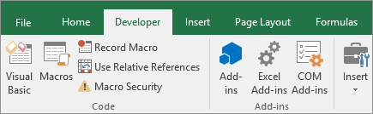
Figure 3-2 recording macro
Record a macro
There are a few helpful things you should know about macros:
- When you record a macro for performing a set of tasks in a range in Excel, the macro will only run on the cells within the range. So if you added an extra row to the range, the macro will not run the process on the new row, but only the cells within the range.
- If you have planned a long process of tasks to record, plan to have smaller relevant macros instead of having one long macro.
- It is not necessary that only tasks in Excel can be recorded in a macro. Your macro process can extend to other Office applications, and any other applications that support Visual Basic Application (VBA). For example, you can record a macro where you first update a table in Excel and then open Outlook to email the table to an email address.
Follow these steps to record a macro.
1. On the Developer tab, in the Code group, click Record Macro.
-OR-
Press Alt+T+M+R .
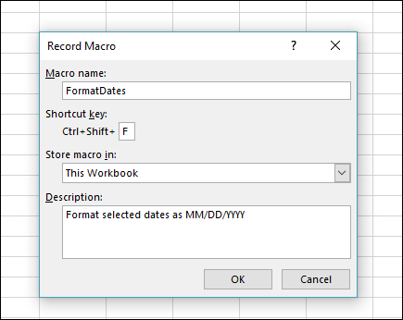
Figure 3-3 record macro
- In the Macro name box, enter a name for the macro. Make the name as descriptive as possible so you can quickly find it if you create more than one macro.
Note: The first character of the macro name must be a letter. Subsequent characters can be letters, numbers, or underscore characters. Spaces cannot be used in a macro name; an underscore character works well as a word separator. If you use a macro name that is also a cell reference, you may get an error message that the macro name is not valid.
- To assign a keyboard shortcut to run the macro, in the Shortcut key box, type any letter (both uppercase or lowercase will work) that you want to use. It is best to use Ctrl + Shift (uppercase) key combinations, because the macro shortcut key will override any equivalent default Excel shortcut key while the workbook that contains the macro is open. For instance, if you use Ctrl+Z (Undo), you will lose the ability to Undo in that Excel instance.
- In the Store macro in list, select where you want to store the macro.
In general, you’ll save your macro in the This Workbook location, but if you want a macro to be available whenever you use Excel, select Personal Macro Workbook . When you select Personal Macro Workbook, Excel creates a hidden personal macro workbook (Personal.xlsb) if it does not already exist, and saves the macro in this workbook.
- In the Description box, optionally type a brief description of what the macro does.
Although the description field is optional, it is recommended you enter one. Also, try to enter a meaningful description with any information that may be useful to you or other users who will be running the macro. If you create a lot of macros, the description can help you quickly identify which macro does what, otherwise you might have to guess.
- Click OK to start recording.
- Perform the actions that you want to record.
- On the Developer tab, in the Code group, click Stop Recording Button image.
- OR-
Press Alt+T+M+R.

Creating Microsoft excel
Microsoft Office Excel supports to use or create numerous types of charts to help you display data in ways that are meaningful to your audience or users of your data. Chart enables you to compare your data easily by graphs. When you want to create a chart or change an existing chart, you can choose from a wide range of chart subtypes available on excel. In addition, you can also modify the chart type and its layout using formatting features. In order to create a chart first you should create a table and use the steps below.
On excel 2007 follow the steps are to create a column bar chart
- Enter the data below
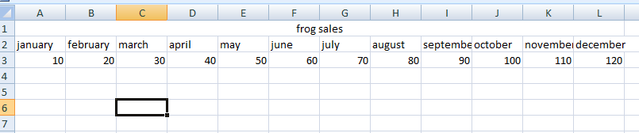
- Select the data or range of cells that you want to use for creating chart
- Click on insert menu and click on column in chart control group
- From 2-D Select the first one
- From the layout tab you can edit the title of the chart, horizontal axis, vertical axis and legend as you want.
Create a table using the figure below to create a chart on excel 2003 using the steps below
  - In the Sales worksheet, highlight cells A3 through L4.
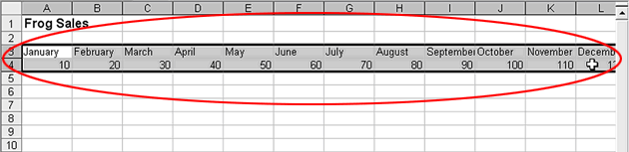

  - On the Toolbar, click the icon.
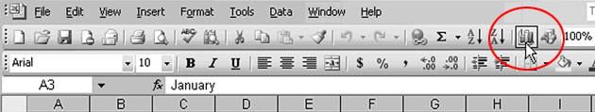
  - When the Chart Wizard window appears, click Column in the Chart Type list.
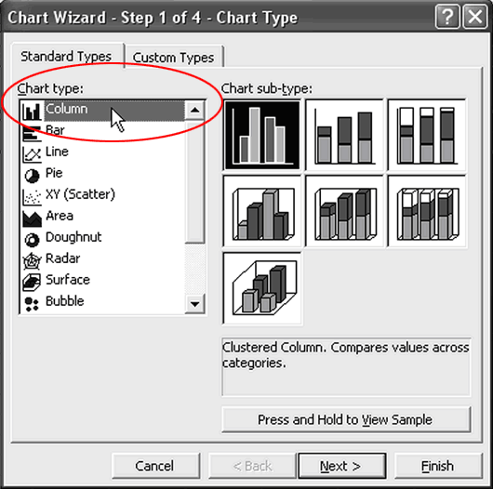
  - Click the button.
  - In the next step, make sure the Rows button is clicked which is the data source or values.

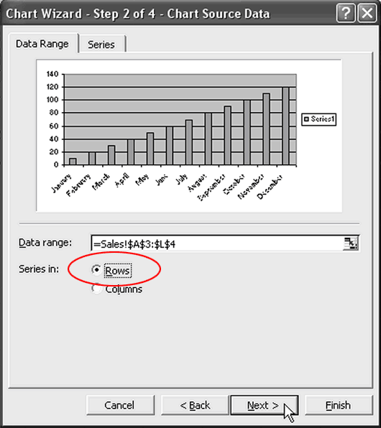
Then click the button.
  - In the next step or chart option dialog box, click the Titles tab, then type: Frog Sales in the Chart title box. You can also add category axis, vertical axis and data label on this dialog box.
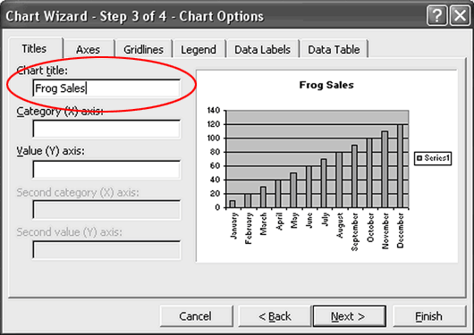
- Click the button
- In the next step, click the As new sheet button to move the chart into a new sheet with out the data but if you check the As object in option box the chart can be embedded chart. We can see the chart and its data on a single worksheet or page.
- In the box beside it, type: Frog Sales Chart
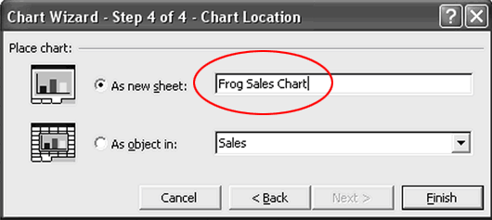
This dialog box comes in the fourth step on Microsoft excel 2003 but on 2007 you can move the chart into new sheet by clicking the design tab and move chart button at the right corner of the windows.
- Click the button.
The chart should appear as:
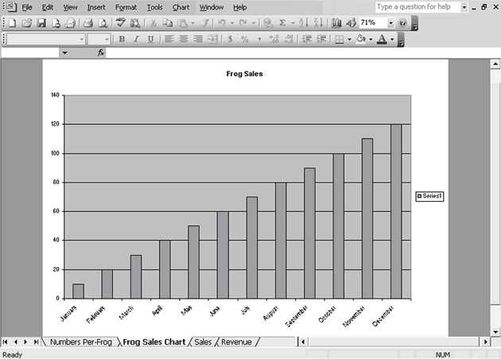
- This is a new sheet chart
- Click the Frog Sales Chart tab and drag it to the end of the tabs.
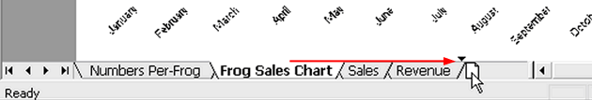
- Release the mouse button.
It should be last in the list of tabs:
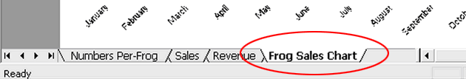

- To remove the legend, click the legend.
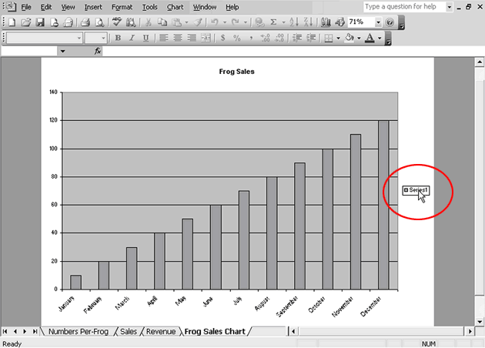
- Press DELETE.
The chart should look like this:
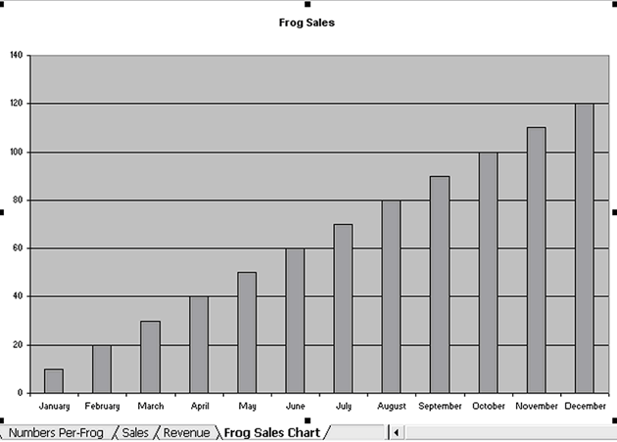

Example
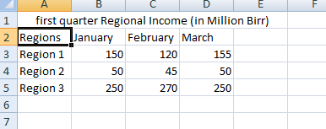
Instruction
      - Create 2-D columnar chart using the above data
      - Add data labels at a center
      - Move the chart into new sheet
      - Make chart title first quarter regional income
      - Make vertical axis in million birr and horizontal axis first Quarter
Answer
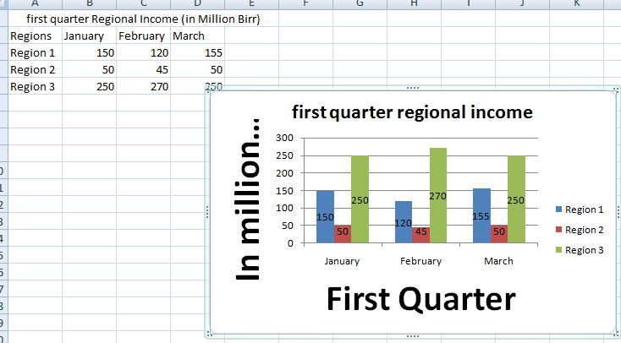

Developing editing and using templates

Templates
A template is a predefined pattern for a spreadsheet that has already been created for you. Hundreds of templates, already created by Microsoft, are available for you to use in Excel. These templates are very helpful if you have limited time to get a new task done in Excel, and you don’t know where to start. Templates do a lot of the work for you! Templates include all the formulas, formatting, etc. needed in a professional Excel spreadsheet. All that’s left to do is enter the data. Predefined Microsoft templates include everything from billing statements to blood pressure trackers to business cards. Depending on your version of Excel or Office 365, template categories may include: Business, Personal, Planners and Trackers, Lists, Budgets, Charts, and Calendars. In this chapter we will explore using existing Microsoft templates.
To access the templates in Excel, do the following:
- Click the File tab in the ribbon.
- Click New in Backstage View. Excel for Mac icon Mac Users: Click the File menu option and choose New from Template
- The top of your screen should look similar to Figure 3.4. If you have opened templates previously, these may show in this screen as well.
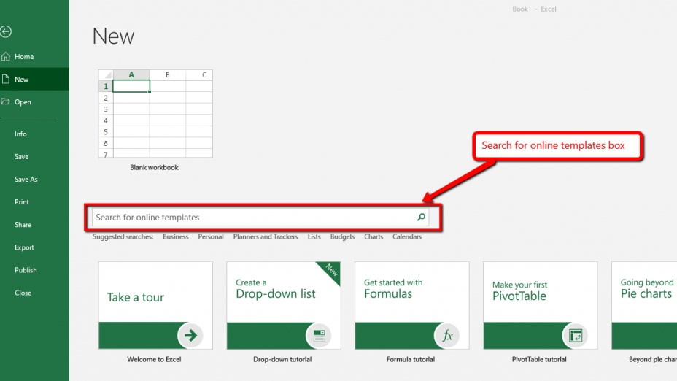
Figure 3-4 Template screen
Edit templates
- Click File > Open.
- Double-click This PC. (In Word 2013, double-click Computer).
- Browse to the Custom Office Templates folder that's under My Documents.
- Click your template, and click Open.
- Make the changes you want, then save and close the template.

Self-check

        - What is macro in spreadsheet?
________________________________________________________________________________________________________________________________________________________________________________________
        - How to create and edit in macros?
_______________________________________________________________________________________________________________________________________________________________________________________________________________________________________
        - How to evaluate task?
_______________________________________________________________________________________________________________________________________________________________________________________________________________________________________________________________________

Unit Four: Use Spreadsheets
This unit is to provide you the necessary information regarding the following content coverage and topics:
- Entering checking and amending data
- Importing and exporting data between compatible spreadsheets
- Using manuals, user documentation and online help
- Previewing, adjusting and printing spreadsheets
This unit will also assist you to attain the learning outcomes stated in the cover page. Specifically, upon completion of this learning guide, you will be able to:

- To enter check and amend data
- Import and export data between compatible spreadsheets
- Use manuals, user documentation and online help
- Preview, adjust and print spreadsheets

Entering checking and amending data

Entering data
On the active worksheet, select the cell or range in which you want to edit existing or enter new data. In the active cell, type new data or edit the existing data, and then press Enter or Tab to move the selection to the next cell. The changes are applied to all the worksheets that you selected. The following steps explain how the column headings in Row 2 are typed into the worksheet:
- Click cell location A2 on the worksheet.
- Type the word Month.
- Press the RIGHT ARROW key. This will enter the word into cell A2 and activate the next cell to the right.
- Type Unit Sales and press the RIGHT ARROW key.
- Repeat step 4 for the words Average Price and then again for Sales Dollars.
Figure 4-1 shows how your worksheet should appear after you have typed the column headings into Row 2. Notice that the word Price in cell location C2 is not visible. This is because the column is too narrow to fit the entry you typed. We will examine formatting techniques to correct this problem in the next section.
Figure 4-1 Entering Column Headings into a Worksheet

Editing Data
Data that has been entered in a cell can be changed by double clicking the cell location or using the Formula Bar. You may have noticed that as you were typing data into a cell location, the data you typed appeared in the Formula Bar. The Formula Bar can be used for entering data into cells as well as for editing data that already exists in a cell. The following steps provide an example of entering and then editing data that has been entered into a cell location:
- Click cell A15 in the Sheet1 worksheet.
- Type the abbreviation Tot and press the ENTER key.
- Click cell A15.
- Move the mouse pointer up to the Formula Bar. You will see the pointer turn into a cursor. Move the cursor to the end of the abbreviation Tot and left click.
- Type the letters al to complete the word Total.
- Click the checkmark to the left of the Formula Bar (see Figure 4-2). This will enter the change into the cell.
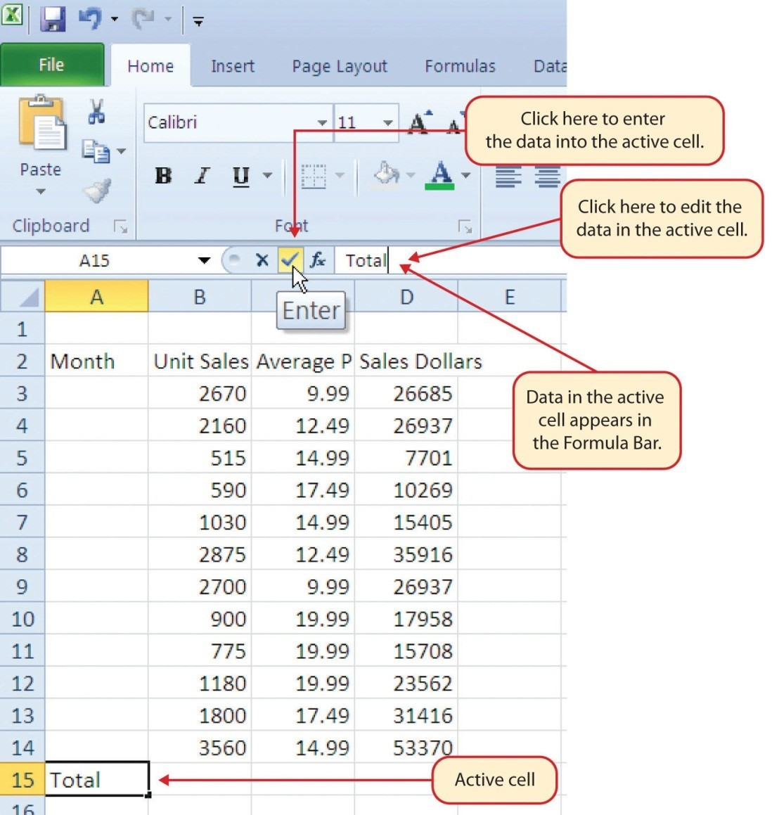
Figure 4-2 Using the Formula Bar to Edit and Enter Data

Import and export data

There are two ways to import data from a text file with Excel: you can open it in Excel, or you can import it as an external data range. To export data from Excel to a text file, use the Save As command and change the file type from the drop-down menu. Excel can import and export many different file types aside from the standard .xslx format. If your data is shared between other programs, like a database, you may need to save data as a different file type or bring in files of a different file type.

Export Data
When you have data that needs to be transferred to another system, export it from Excel in a format that can be interpreted by other programs, such as a text or CSV file.
- Click the File tab
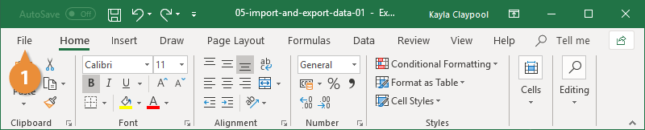
- At the left, click Export.
- Click the Change File Type.
- Under Other File Types, select a file type.
- Text (Tab delimited): The cell data will be separated by a tab.
- CSV (Comma delimited): The cell data will be separated by a comma.
- Formatted Text (space delimited): The cell data will be separated by a space.
- Save as Another File Type: Select a different file type when the Save As dialog box appears.
The file type you select will depend on what type of file is required by the program that will consume the exported data.

- Click Save As.

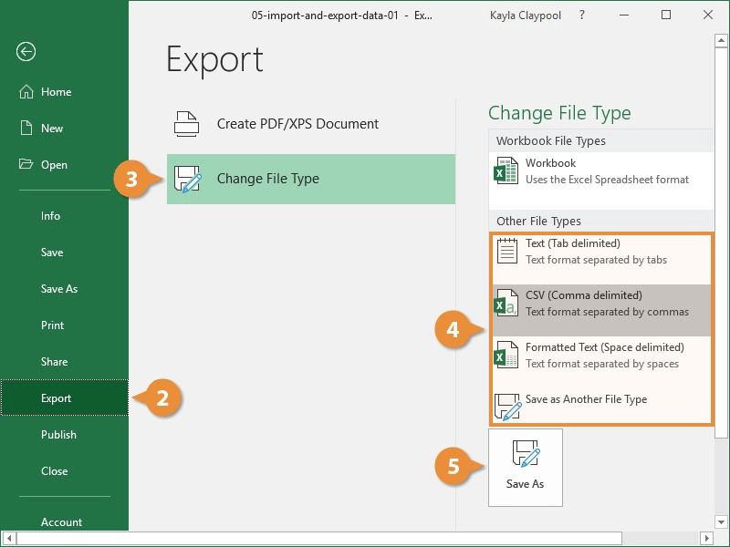
- Specify where you want to save the file.
- Click Save.

- Click Yes.

Import Data
Excel can import data from external data sources including other files, databases, or web pages.
- Click the Data tab on the Ribbon..
- Click the Get Data button.
Some data sources may require special security access, and the connection process can often be very complex. Enlist the help of your organization’s technical support staff for assistance.
- Select From File.
- Select From Text/CSV.

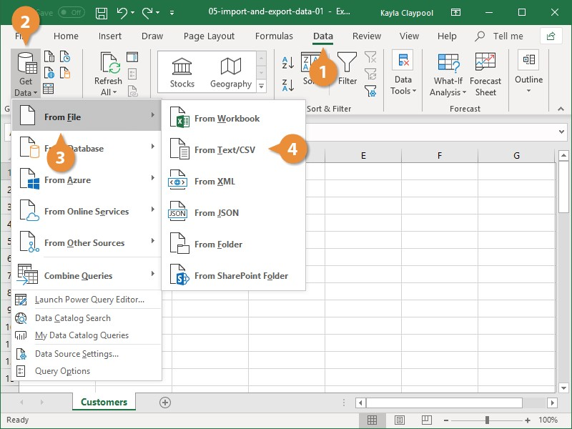
If you have data to import from Access, the web, or another source, select one of those options in the Get External Data group instead.
- Select the file you want to import.
- Click Import.
If, while importing external data, a security notice appears saying that it is connecting to an external source that may not be safe, click OK.
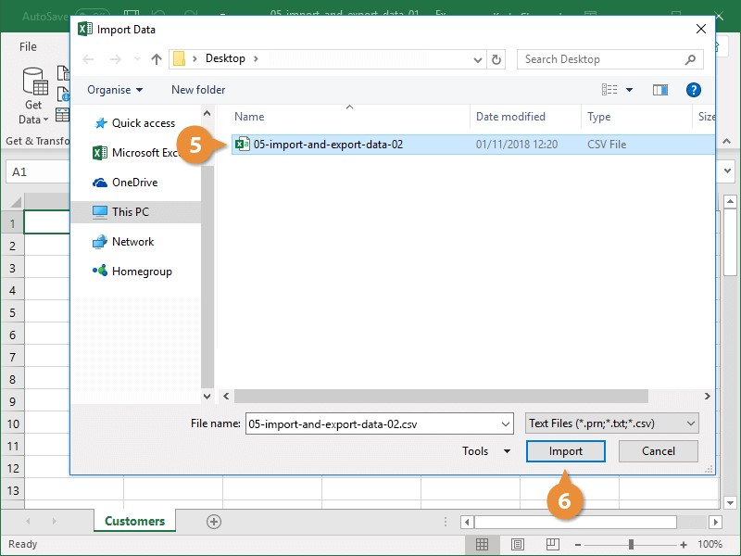
- Verify the preview looks correct.
Because we've specified the data is separated by commas, the delimiter is already set. If you need to change it, it can be done from this menu.
- Click Load.

Using manuals, user documentation and online help

A Manual spreadsheet is ledger book with many sheets of papers divided into rows and columns for entering/writing data. The data is entered manually using a pen or pencil.
User documentation is the content that you provide the end user in order for them to be more successful with your product or service. Also known as user guides, instruction manuals, or user manuals, user documentation is there to hold your customer's hand as they learn about your product.

Figure 4-3 : user documentation and help
A Spreadsheet is a ledger sheet that lets the user enter, edit, and manipulate numerical data. A Spreadsheet usually consists of a series of rows & columns in which data entries can be made. Types of Spreadsheets:
There are 2 types of spreadsheets:
- Manual spreadsheet: A Manual spreadsheet is ledger book with many sheets of papers divided into rows and columns for entering/writing data.The data is entered manually using a pen or pencil.
- Electronic Spreadsheet: A computer program that looks like the manual ledger sheet with rows & columns for entering data that can be manipulated mathematically using of formulae.

Previewing, adjusting and printing spreadsheets

When you select one or more sheets and then click File > Print, you'll see a preview of how the data will appear on the printout.
  - Select the worksheet(s) you want to preview.
  - Click File, and then click Print to display the Preview window and printing options.
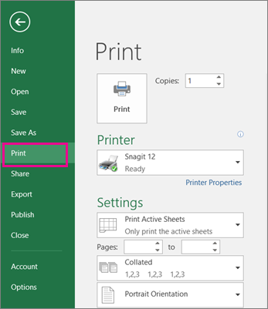
Keyboard shortcut you can also press Ctrl+F2.

Notes:
- Unless you're using a color printer, the preview will appear in black-and-white, even if there is color in your sheet(s).
- Next Page and Previous Page are available only when you select more than one sheet, or when a sheet contains more than one page of data. To view multiple worksheets, under Settings, click Entire workbook.

Self- check
    - Explain the difference between import and export data
______________________________________________________________________________________________________________________________________________________________________________________________________________________________________
    - List and explain type of spreadsheet
____________________________________________________________________________________________________________________________________________________________________________________________________________________________________________________________________
    - How to adjust and print in spreadsheet
_______________________________________________________________________________________________________________________________________________________________________________________________________________________________________
    - Explain entering data
__________________________________________________________________________________________________________________________________

Operation Sheet
Necessary steps to prepare payroll
Step 1: Establish your employer identification number
Step 2: Collect relevant employee tax information
Step 3: Choose a payroll schedule
Step 4: Calculate gross pay
Step 5: Determine each employee's deductions
Step 6: Calculate net pay, and pay your employees

Lap Test
Hani super market is paying its employees a certain amount of basic salary plus a commission that is based on their performance. The following table shows the monthly basic salary of workers and the total sales by each person in a month. The commission is paid to each worker based on the following rules.
- If the total sales in a month is less than or equal to 10,000 birr then no commission.
- If it is more than 10,000 birr and less than or equal to 25,000 birr then a commission of 3% is paid on the amount above 10,000.
- And finally the commission is increased to 4.5% for the additional amount more than 25,000 birr.
Sewi supermarket year 20013
Employee | Sex | Basic salary (in birr) | Total sales (in birr) | Gross salary (in birr)
AbebaMeles | F | 1500 | 5000
DawitNigus | M | 600 | 16000
Helen Senay | F | 1400 | 35000
BerheHagos | M | 1200 | 60000
ShewitMeles | F | 1400 | 24000
SisayTesfay | M | 2000 | 8000
BeleteLema | M | 1800 | 15000
AngesomHiluf | M | 1300 | 21000
TemesgenNigus | M | 1600 | 28000
SelamSenay | F | 500 | 17000
Average
INSTRUCTION
    - Insert one column between total sales and gross earning and name it as commission
    - Calculate commission based on the above rules.
    - Calculate gross earning ( basic salary + commission)
    - Calculate average value of each column
    - Sort the data in descending order of employee
    - Save the file with your name
    - Create a 3-D pie chart that shows gross salary of employees and add data labels

Operation Sheet -II
Necessary steps to prepare payroll
Step 1: Establish your employer identification number
Step 2: Collect relevant employee tax information
Step 3: Choose a payroll schedule
Step 4: Calculate gross pay
Step 5: Determine each employee's deductions
Step 6: Calculate net pay, and pay your employees

Lap Test -II
- preparation of payroll

No | Name | Basic S. | allowance | Over Time | Gross Earning | pension | Tax | Other deduction | Total deduction | Net pay
1 | Abeba | 1500 | 250 | 1500
2 | Dawit | 1200 | 500 | 500
3 | Helen | 1550
4 | Berhe | 900 | 300 | 800
5 | Shewit | 1400
6 | Senay | 2500 |  | 300
 | Total
 | Average

Instruction

    - calculate Gross earning, pension 6%, tax in the Ethiopian system, other deduction 4%, total deduction and net pay
    - calculate total and average
N.B Helen is contract worker

Unit Five: Represent Numerical Data In Graphic Form
This unit is to provide you the necessary information regarding the following content coverage and topics:
- Determining style of graph
- Creating graphs with labels and titles
- Saving, viewing and printing graph
This unit will also assist you to attain the learning outcomes stated in the cover page. Specifically, upon completion of this learning guide, you will be able to:

- Determine style of graph
- To create graphs with labels and titles
- To Save, view and print graph

Determining style of graph

Graphs are a graphical representation of various points of a domain. Graphs help you view and analyze your data in a more realistic and simplified way. Graphs, Plots, and Charts can all be used interchangeably since they all mean more or less the same. Graph is a visual element that represents data in a worksheet. You will be able to analyze the data more efficiently by looking at a graph in Excel rather than numbers in a dataset. Excel covers a wide range of graphs that you can use to represent your data.
A graph can tell you a lot about your data and makes it easy to understand much like A picture is worth a thousand words!
Types of Graphs
There are many different kinds of graphs, but to name a few:
- Line Graph: Used to visualize the information that is connected over time.
- Pie Chart: A circular statistical graph, which is divided into slices to illustrate numerical proportion.
- Bar Graph: It uses bars to compare data among categories. It can be both horizontal and vertical.
- Cartesian Graph: It is just two number lines that cross at 0. These number lines are called the horizontal axis (the x-axis) and the vertical axis (the y-axis).
- Scatter Plot: Values of two variables are plotted along x-axis and y-axis as dots.
- Heatmap: Represents the data where the individual values contained in a matrix are represented as colors.
- Parallel Coordinate Graph: Used for plotting multivariate numerical data and a common way of visualizing high-dimensional geometry.
- Histogram: A bar graph creates a view of the data's distribution. The vertical bars represent the frequency of occurrence by classes of data.
- Box Plot: It displays the five-number summary of a set of data. The five-number summary is the minimum, first quartile, median, third quartile, and maximum.
Graph style examples
You may want to display your grid report data in a pie graph format, as shown in the image below.
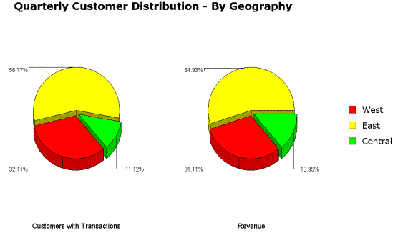
Figure 5-1 graph style

Creating graphs with labels and titles

Creating titles and labels
All graphs can include a title, subtitle, and footnote. Most graphs can also include a Category Axis title and a Numeric Y1-Axis title. Other axis titles may be available depending on the graph type.
You can specify the title and axis labels for a graph report, as well as their location within the report. You can also select whether you want title and labels information to be displayed. Titles help to clearly identify the graph.
The Graph Preferences dialog box can be used to add, change, or delete a title, subtitle, footnote, Category title, X-Axis title, Value title (Y1 and Y2), and Series Axis title in the graph. Note that not all title or label options are available for every graph type.
You can also change the location, font, and color of titles by using formatting options.
To create titles and labels
- Run a report. (How?)
- If the report is not already in Graph view, from the View menu, choose Graph View.
- From the Graph menu, select Titles and Labels. The Preferences dialog box opens.
- With the Titles category selected, select a check box for a component for which to create a title or label and enter a title name in the space provided. For more information, refer to Titles.
- Type text to display for the title or label. For the following components, you can also enter variables so the titles are generated automatically every time the report is run. Variables can be used to display the report name, current date and time, report description, name of the project, name of the user executing the report, and so on:
      - Title
      - Subtitle
      - Footnote
      - X Axis (for Scatter and Bubble charts only)
      - Y Axis (for Scatter and Bubble charts only)
- After you finish with a title, click OK to save any changes and return to the graph.
Add Title to Excel Chart
This section demonstrates how to insert the chart title in different Excel versions so that you know where the main chart features reside. And for the rest of the tutorial, we will focus on the most recent versions of Excel.
Add title to chart in Excel
In Excel 2013 - 365, a chart is already inserted with the default "Chart Title". To change the title text, simply select that box and type your title:
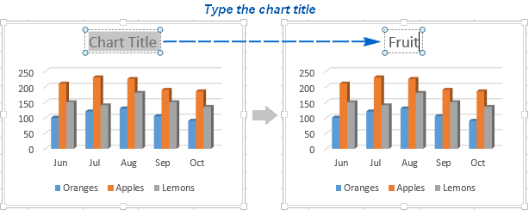
Figure 5-2 adding title
If for some reason the title was not added automatically, then click anywhere within the graph for the Chart Tools tabs to appear. Switch to the Design tab, and click Add Chart Element > Chart Title > Above Chart I (or Centered Overlay).
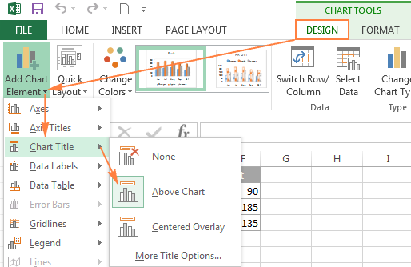
Or, you can click the Chart Elements button in the upper-right corner of the graph, and put a tick in the Chart Title checkbox.
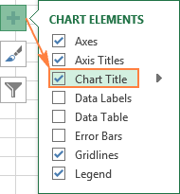
Figure 5-3 chart title

Add title to chart in Excel 2010 and Excel 2007
To add a chart title in Excel 2010 and earlier versions, execute the following steps.
- Click anywhere within your Excel graph to activate the Chart Tools tabs on the ribbon.
- On the Layout tab, click Chart Title > Above Chart or Centered Overlay.
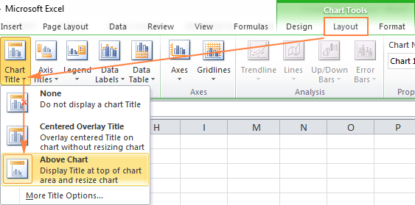
Figure 5-4 chart in excel

Saving, viewing and printing graph

Saving graphs
To save a graph, click the “Account Tools” button below the graph. Click “Save graph” to store your graph for future use. If you have not already signed into your account, you will be prompted to do so. To save the graph in the repository, choose File > Store Output from the menus.
.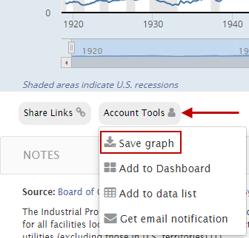
Figure 5-5 saving graph
Printing graphs
If you need to print a chart in Excel 2013 or Excel 2016, you can use the Print option from the File tab. You can use the Settings menu to specify precisely the item you want to print from your workbook.

- Click the chart within your workbook.
- Click File > Print.
- Click the Printer drop-down menu, and select the printer you want to use.

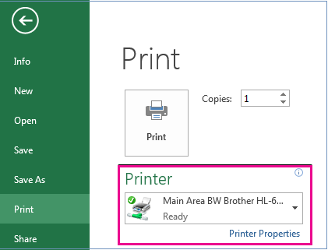
- Click Print.
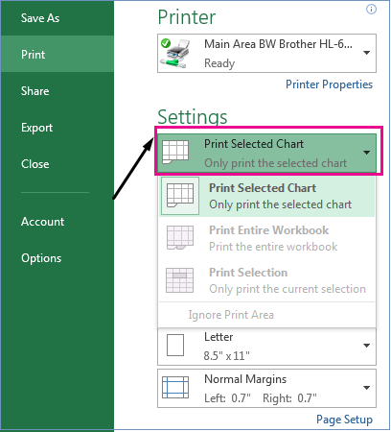
OR
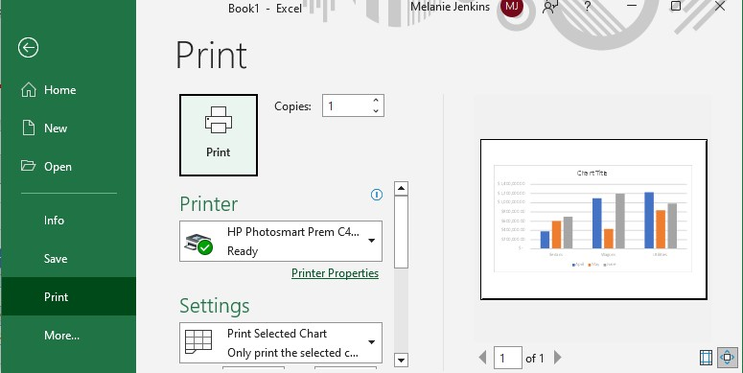

Self- Check
      - List at least four types of graph
____________________________________________________________________________________________________________________________________________________________________________________________________________________________________________________________________________
      - How to add title in chart of excel
______________________________________________________________________________________________________________________________________________________________________________________________________________________________________________________________________
      - How to save excel in graph
_______________________________________________________________________________________________________________________________________________________________________________________________
      - How to print the graph
_____________________________________________________________________________________________________________________________________________________________________________________

Reference

- Occupational Health and Safety Act 2004 (Vic)
- Occupational Health and Safety Regulations 2017 (Vic)
- The National Construction Code
- HB 59-1994 Ergonomics - The human factor - A practical approach to work systems design
- The OHS body of knowledge. Biomechanical hazards (2013)
- Work Safe Victoria publications: Office Wise – A guide to health and Safety in the Office
- W. Edwards Deming, http://www.azquotes.com/quote/873755
- Taiichi Ohno, http://www.azquotes.com/quote/1411460

The trainers who developed the curriculum
No | Name | Qualification | Educational background | Region | College | Mobile number | E-mail
1 | Kassa Terefe Gelaw | BA, degree | Accounting & finance | A.A | KMC | +251993298301 | kssterefe@gmail.com
2 | Sewumehon Anteneh | BA degree | Accounting & finance | A.A | KMC | +251948032126 | Sewumehonanteneh@gmail.com
3 | Remedan Abdurehman | MBA | Accounting & finance | A.A | GWPTC | +25133233939 | rame.abdu10@gmail.com
4 | Meskerem Getachew | MBA | Accounting & finance | A.A | ARADA | +251925918465 | meskigetach@gmail.com
5 | Mahmud Oumer | BA | Accounting | A.A | GWPTC | 0913099303 | Mahmudoumer@gmail.com
6 | Mekuanint Abeje Melese | MSc degree | Accounting & finance | A.A | LMC | +251913969620 | Mekuanitabeje21@gmail.com
7 | Hussien Ebrahim | MBA | Accounting & finance | A.A | GWPTC | +251920188426 | Hussienebrahim701@ gmail.com
8 | Alemayehu | MBA | Accounting & finance | A.A | MPTC | +251920188426

