Accounting and Finance Level IV
Based on March, 2022 (V- I) Occupational standard (OS)

Module Title:-Establishing and Maintaining a Cash and Accrual Accounting System
Module code: LSA ACF4 M08 0322
Nominal duration: 150Hr
Sep, 2023

Addis Ababa, Ethiopia
Table of Contents
Acknowledgmen 5
Acronyms………………………………………………………………………………………….6
Introduction to the Module 7
Unit One. Identify relevant information and establish a chart of accounts 8
1.1.. Consulting nature and type of business to undertake business activities 9
1.2.dentifying and examining existing materials 10
1.3.Examining business operations 11
1.4. Establishing Chart of accounts and opening balances 21
1.5. Validating and authorizing chart of accounts and balances…………………………………………………………….28
Self-Check…………………………………………………………………………………………………………………………………………….29
Unit Two. Analyse and verify source documents 30
2.1.Verifying invoices and other source documents 30
2.2. Identifying and investigating discrepancies 37
Self-Check 40
Unit three. Process receipts and payments 41
3.1. Receiving and banking money and making payment 41
3.2. Recording and coding receipts and payments on cash basis 51
3.3.Filing receipts and payments……………………………………………………………………........ 52
3.4 Balancing cash register against purchases and takings 55
Self-Check……………………………………………………………………………………………………………………………………………58
Unit Four Establish and replenish a petty cash system 59
4.1.Preparing expenditure authorization record 59
4.2. Reconciling and reimbursing expenditure 65
Self -Check 66
Unit Five Process and reconcile credit 67
5.1.Processing credit card transactions 67
5.2.Processing credit card payments 70
5.2.Self-Check 71
Unit six : Manage bank reconciliations and prepare and produce reports 72
6.1.Verifying receipts of statement and processed transactions 72
6.2.Processing and verifying bank entries 79
6.3. Reconciling bank statement 80
6.4 Producing and validating report……………………………………………………………………….82
Self-Check…………………………………………………………………………………………………83
Seven Unit Seven: Process invoices, adjustment notes and other general ledger transactions……………84 7.1. Issuing invoices to debtors and allocating invoices to creditor………………………………………84 7.2. Receiving, processing and banking payments from debtors…………………………………………87 7.3. Processing and Making payments to creditors………………………………………………………88. 7.4. Raising and allocating adjustment……………………………………………………………………88 7.5. Raising credit notes and entering other transactions…………………………………………………89.
Self-Check…………………………………………………………………………………………………90
Unit Eight. Manage contra entries………………………………………………………………………...90 8.1. Concept of contacting relevant persons on contra deals……………………………………………...90 8.2. Completing reporting procedures and documentation……………………………………………….,92 Self -Check………………………………………………………………………………………………...92
Unit Nine: Identify and process bad debts………………………………………………………………...95
9.1. Verifying bad debt status……………………………………………………………………………………………………………….95
9.2. Completing reporting procedures and documentation………………………………………………..98
Self-Check………………………………………………………………………………………………..102
Unit Ten: Manage debt recovery…………………………………………………………………………………………………………103
10.1. Reviewing activities and communication with debtors……………………………………………103
10.2. Undertaking measures to collect monies……………………………………………………………………………………107
Self-Check……………………………………………………………………………………………………………………………………………109
Unit Eleven: Prepare trial balance and Financial reports……………………………………………………………………11
11.1. Producing and validating transactions reports…………………………………………………………………………….120
11.2. Producing reports and reconciling debtors and creditors……………………………………………………………121
11.3. Producing and reporting trial balance…………………………………………………………………………………………122
Self-Check……………………………………………………………………………………………………………………………………………122
References………………………………………………………………………………………………………………………………………….123

Acknowledgment
A.A TVT BUREAU wishes to extend thanks and appreciation to the many representatives of TVT instructors and respective kirkos manufacturing college Dean who donated their time and expertise to the development of this Teaching, Training and Learning Materials (TTLM).

Acronyms
AR Account Receivable
GAAP General Accepted Accounting Principle
IRS Internal Revenue Service
EHR Electronic health record
CR Credit
DR Debit

Introduction of the module
This unit describes the performance outcomes, skills and knowledge required to establish and manage organizational procedures in arranging for and administering receipts and payments to establish and maintain a manual and computerized bookkeeping system on a cash and accrual basis.
This module covers
- Identify relevant information and establish a chart of accounts
- Analyze and verify source documents
- Process receipts and payments
- Set up and maintain a petty cash system
- Process and reconcile credit
- Manage bank reconciliations and prepare and produce reports
- Process invoices, adjustment notes and other general ledger transactions
- Manage contra entries
- Identify and process bad debts
- Manage debt recovery
- Prepare trial balance and Financial reports
Learning objectives of the Module:
At the end of the module the trainee will be able to:
- Identify relevant information and establish a chart of accounts
- Analyse and verify source documents
- Process receipts and payments
- Set up and maintain a petty cash system
- Process and reconcile credit cards
- Manage bank reconciliations and prepare and produce reports
- Process invoices, adjustment notes and other general ledger transactions
- Manage contra entries
- Identify and process bad debts
- Manage debt recovery
- Prepare trial balance and financial reports

Module Instruction
For effective use this modules trainees are expected to follow the following module instruction:
1. Read the information written in each unit
2. Accomplish the Self-checks at the end of each unit
3. Read and use the recommended reference book and materials

Unit One: Identify relevant information and establish a chart of accounts
This Unit is developed to provide you the necessary information regarding the following content coverage and topics:
- Consulting nature and type of business to undertake business activities
- Identifying and examining existing materials
- Examining business operations
- Establishing Chart of accounts and opening balances
- Validating and authorising chart of accounts and balances
This unit will also assist you to attain the learning outcomes stated in the cover page. Specifically, upon completion of this learning guide, you will be able to:
- Consult nature and type of business to undertake business activities
- Identifying and examine existing materials
- Examine business operations
- Establish Chart of accounts and opening balances
- Validate and authorising chart of accounts and balances

1.1. Consulting nature and type of business to undertake business activities
Introduction
What is consulting? Consultants are people who specialize in helping clients resolve their company's most urgent problems, issues, or projects. They work across a huge range of roles and industries and share their gift of analyzing information and identifying the best path for each company to take.
The nature of the business should address the following elements of the business.
- Regular Process. Regular processes separate functioning businesses from mere hobbies
- Economic Activity
- Utility Creation
- Capital Requirement
- Goods And Services
- Anticipated Risk
- Profit-earning Motive
- Satisfaction Of Consumers' Needs
Organizations in many industries use business consulting services to help them solve problems, improve efficiencies, and grow their ventures.
Business consultants partner with companies and small businesses to identify obstacles a company faces in reaching its goals. These consultants are responsible for determining out-of-the-box strategies to help companies overcome their challenges
Business consulting involves providing expert advice and guidance to organizations to help them improve their operations, achieve their goals, and solve complex business problems,
Business consulting services include anything from strategic planning, financial management, and marketing to operations management, IT, and organizational development.

Business Consulting Industries
Business consultants can work in a wide variety of industries. Business consultants work in every industry, as the need for real world expertise and perspective is universal,” Anywhere where an organization wants to realize a specific set of outcomes, who is struggling to achieve these goals, would benefit from engaging a consultant to help them.”
- Some typical industries that seek business consulting services include:
- Health care
- Finance
- Technology
- Retail
- Manufacturing
- Energy and environment
- Public sector

Skills for Business Consulting
To succeed in business consulting, it helps to have the right combination of hard and soft skills. Essential hard skills include:
- Knowledge of business processes
- Data analysis
- Project management
- Technical expertise
- Business writing
- Public speaking
Some key soft skills include:
- Communication
- Problem-solving
- Critical thinking
- Interpersonal
- Organizational
- Executive presence
Nature of the entity
May include but not limited to :
- association
- limited company
- not-for-profit groups
- partnership
- private company
- public company
- sole trader
- trust
1.2. Identifying and examining existing materials
The other main grouping of resources we need includes facilities, software, equipment, raw material, information and stock and supplies. Human resource is the most vital resource in an organization because it derives or moves all resources in the organization. This resource can increase the efficiency, economy and effectiveness of other resource. It is this resource that is most difficult to control because human beings are most unpredictable. However, if you are able to manage it properly, it can give wonderful results which no other resource can give. The heart of the issue with human resource is the skills-base of the business
Existing material
- May include but not limited to :
- computer data file
- existing chart of account
- financial statements and other material available from accountant
- source documents such as:
- asset and inventory records
- cash receipts journals
- cash payments journals
- sales and purchases distribution journals
- general ledger
1.3.Examining business operations
The first transaction of the new business was opening a checking account in the name of Wells’ Consulting Services. The separate bank account helps Wells keep her financial interest in the business separate from her personal funds.
When a business transaction occurs, it is analyzed to identify how it affects the equation property equals financial interest. This equation reflects the fact that in a free enterprise system, all property is owned by someone. In this case, Wells owns the business because she supplied the property (cash).
Use these steps to analyze the effect of a business transaction:
Business process analysis involves the following steps:
- Identify a Process to Analyze.
- Collect Data About the Process.
- Map Out the Process.
- Analyze the Process.
- Develop a “To-Be” Plan.
- Implement and Reevaluate.
1. Describe the financial event.
• Identify the property.
• Identify who owns the property.
• Determine the amount of increase or decrease
2. Make sure the equation is in balance.

Cash basis accounting
The cash basis of accounting recognizes revenues when cash is received, and expenses when they are paid. This method does not recognize accounts receivable or accounts payable.
Many small businesses opt to use the cash basis of accounting because it is simple to maintain. It’s easy to determine when a transaction has occurred (the money is in the bank or out of the bank) and there is no need to track receivables or payables.
The cash method is also beneficial in terms of tracking how much cash the business actually has at any given time; you can look at your bank balance and understand the exact resources at your disposal.
Also, since transactions aren’t recorded until the cash is received or paid, the business’s income isn’t taxed until it’s in the bank.

Accrual basis accounting
Accrual accounting provides the mechanisms essential for implementing the matching principle: Report revenues and the expenses that brought them in the same period.
Accrual accounting is standard, normal practice for the overwhelming majority of businesses, large and small, across industries, worldwide. Accrual accounting contrasts with cash accounting (cash-basis accounting), which records only cash receipts and cash payments.
Accrual accounting is a method of accounting where revenues and expenses are recorded when they are earned, regardless of when the money is actually received or paid. For example, you would record revenue when a project is complete, rather than when you get paid. This method is more commonly used than the cash method.
The upside is that the accrual basis gives a more realistic idea of income and expenses during a period of time, therefore providing a long-term picture of the business that cash accounting can’t provide.
The downside is that accrual accounting doesn’t provide any awareness of cash flow; a business can appear to be very profitable while in reality it has empty bank accounts. Accrual basis accounting without careful monitoring of cash flow can have potentially devastating consequences.
Note that many businesses do their bookkeeping on a cash basis but file taxes on an accrual basis. They take the steps

What it means to “record transactions”
We’ve talked a lot so far about recording transactions in your books, and how cash and accrual dictates “when” you do that.
But what does it mean to record a transaction?
Every business has to record all its financial transactions in a ledger—otherwise known as bookkeeping. You’ll need to do this if you want to claim tax deductions at the end of the year. And you’ll need one central place to add up all your income and expenses (you’ll need this info to file your taxes).
There are some good DIY bookkeeping options out there. Or if you’d rather have someone else do your bookkeeping for you, check out Bench.

Diagram comparing accrual and cash accounting
Cash accounting | Accrual accounting
Recognizes revenue when cash has been received | Recognizes revenue when it’s earned (eg. when the project is complete)
Recognizes expenses when cash has been spent | Recognizes expenses when they’re billed (eg. when you’ve received an invoice)
Taxes are not paid on money that hasn’t been received yet | Taxes paid on money that you’re still owed
Mostly used by small businesses and sole proprietors with no inventory | Required for businesses with revenue over $25 million
What is cash and accrual system?
Cash basis accounting records revenue and expenses when actual payments are received or disbursed. It doesn't account for either when the transactions that create them occur. On the other hand, accrual accounting records revenue and expenses when those transactions occur and before any money is received or paid out.
What accounting method do you use accrual or cash?
Using the cash method, revenue is recorded when money comes in and expenses are recorded when they are paid. This is often considered the simplest method. Using the accrual method, revenue is recorded when a sale is made—whether or not cash is received at the time.
To better understand the nature of accrual accounting, understand first that each company's accounting system starts with a chart of accounts. This chart is simply as a list—the complete list—of the company's accounts. The chart of accounts for even a small business may very well include a hundred.

Five Account Categories

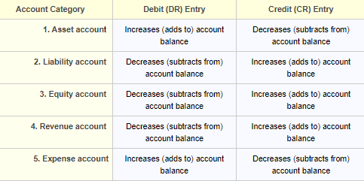
Exhibit 1. The accrual-base accounting system includes five categories of accounts. A debit transaction increases the balance in Asset accounts and Expense accounts. A credit transaction increases the balance in Liability accounts, Equity accounts, and Revenue accounts.
Note also that only two kinds of impact are possible on any account—a debit or a credit. Note also that debits and credits have different impacts in different account categories.
The example transactions in sections below represent the mainstay actions in accrual accounting. Note especially, that most of these are completely "off the books"—non-existent— in cash accounting. Examples below show how transactions enter the accounting system as journal entries. The same transactions will post later to the firm's general ledger. And, account balances will ultimately appear in the firm's end-of-period financial reports.

Advantages to Accrual Accounting:
Accrual accounting:
- Describes accurately sales transactions that are only partially completed, e.g.. where customers have received goods and services but not yet paid for them. Such situations are invisible to cash accounting.
- Makes possible the application of the matching concept, the idea that firms report revenues in the same period as the expenses that brought them.
- Has the advantage of immediacy. Because the firm records sales revenues then they earn them and expenses when they incur them, the company knows immediately what it can expect in both categories.
- Has one form of built-in error-checking. Accrual accounting is implemented with double-entry bookkeeping and accounting, in which the sum of total debits must equal the sum of total credits. This relationship is tested every reporting quarter and year during a trial balance period.
- Conforms to GAAP in most countries, as well as IFRS / IASB standards.

Disadvantages to Accrual Accounting:
- Accrual accounting is not well suited to managing cash flow for budgeting and planning purposes. The benefit of "immediacy" is also a disadvantage concerning cash flow management. Cash flow management is not "immediate" under accrual accounting.
- The understanding and using accrual accounting requires an understanding of double-entry accounting and bookkeeping. Many business people lack this understanding. For most companies, the use of accrual accounting requires professional accountants.

Advantages to Cash Basis Accounting:
- Immediacy: Whereas cash accounting does not readily give immediate information on earnings and expenses, cash accounting does give immediacy to cash inflows and outflows.
- Cash basis accounting is simpler than accrual accounting. Those without a background in accounting or bookkeeping can readily learn and apply cash basis accounting. And, this approach is understandable to a much wider audience than accrual accounting.
- Many small companies can use the cash basis approach without involving a professional bookkeeper or accountant.
- The cash basis approach does not require complex accounting software. Firms can easily create and maintain a cash basis single entry system in a written notebook or a very simple spreadsheet.

Disadvantages to Cash Basis Accounting:
- Cash basis accounting does not conform to GAAP in almost all countries. That means that public companies cannot use cash basis account for reporting to shareholders or tax authorities.
- Cash basis accounting does not allow for tracking actual dates of sales and purchases. This limitation is not a problem for businesses that always receive payment immediately when they make a sale, and always pay immediately when they incur an expense. This limitation does create a problem for companies that sell on credit, or invoice customers after a sale for payment some period later.
- Under cash basis accounting, firms do not record partial payments by customers as such, and therefore the cash accounting Balance sheet may not reflect all payments due.

What Is an Accounting Method?
An accounting method refers to the rules a company follows in reporting revenues and expenses. The two primary methods of accounting are accrual accounting (generally used by companies) and cash accounting (generally used by individuals).
Cash accounting reports revenues and expenses as they are received and paid through cash inflows and outflows; accrual accounting reports them as they are earned and incurred through sales and purchases on credit and by using accounts receivable & accounts payable. Generally accepted accounting principles (GAAP) requires accrual accounting.

Types of Accounting Methods

Cash Accounting
Cash accounting is an accounting method that is relatively simple and is commonly used by small businesses. In cash accounting, transactions are only recorded when cash is spent or received.
In cash accounting, a sale is recorded when the payment is received and an expense is recorded only when a bill is paid. The cash accounting method is, of course, the method most people use in managing their personal finances and it is appropriate for businesses up to a certain size.
If a business generates more than $25 million in average annual gross receipts for the preceding three years, however, it must use the accrual method, according to Internal Revenue Service rules.

Accrual Accounting
Accrual accounting is based on the matching principle, which is intended to match the timing of revenue and expense recognition. By matching revenues with expenses, the accrual method gives a more accurate picture of a company's true financial condition.
Under the accrual method, transactions are recorded when they are incurred rather than awaiting payment. This means a purchase order is recorded as revenue even though the funds are not received immediately. The same goes for expenses in that they are recorded even though no payment has been made.

Example of an Accounting Method The value of accrual accounting becomes more evident for large, complex businesses. A construction company, for example, may undertake a long-term project and may not receive complete cash payments until the project is complete.
Under cash accounting rules, the company would incur many expenses but would not recognize revenue until cash was received from the customer. So, the accounting book of the company would look weak until the revenue actually came in. If this company was looking for debt financing from a bank, for example, the cash accounting method makes it look like a poor bet because it is incurring expenses but no revenue.
Under accrual accounting, the construction company would recognize a percentage of revenue and expenses corresponding to the portion of the project that was complete. This is known as the percentage of completion method. How much actual cash coming into the company, however, would be evident in the cash flow statement. This method would show a prospective lender a much more complete and accurate picture of the company's revenue pipeline.

KEY TAKEAWAYS
- An accounting method consists of the rules and procedures a company follows in reporting its revenues and expenses.
- The two main accounting methods are cash accounting and accrual accounting.
- Cash accounting records revenues and expenses when they are received and paid.
- Accrual accounting records revenues and expenses when they occur. Generally accepted accounting principles (GAAP) requires accrual accounting.
- The Internal Revenue Services (IRS) requires accrual accounting for businesses making an average of $25 million or more in sales for the preceding three years.
- Once a company chooses an accounting method, it has to stick to that method per rules set by the IRS and requires approval if it wants to

Cash Accounting Definition, Example & Limitations

What Is Cash Accounting?
Cash accounting is an accounting method where payment receipts are recorded during the period in which they are received, and expenses are recorded in the period in which they are actually paid. In other words, revenues and expenses are recorded when cash is received and paid, respectively.
Cash accounting is also called cash-basis accounting; and may be contrasted with accrual accounting, which recognizes income at the time the revenue is earned and records expenses when liabilities are incurred regardless of when cash is actually received or paid.

KEY TAKEAWAYS
- Cash accounting is simple and straightforward. Transactions are recorded only when money goes in or out of an account.
- Cash accounting doesn't work as well for larger companies or companies with a large inventory because it can obscure the true financial position.
- The alternative to cash accounting is accrual accounting, where transactions are recorded as revenues are earned and expenses are incurred, regardless of the exchange of cash.

Understanding Cash Accounting
Cash accounting is one of two forms of accounting. The other is accrual accounting, where revenue and expenses are recorded when they are incurred. Small businesses often use cash accounting because it is simpler and more straightforward and it provides a clear picture of how much money the business actually has on hand. Corporations, however, are required to use accrual accounting under Generally Accepted Accounting Principles (GAAP).
When transactions are recorded on a cash basis, they affect a company's books with a delay from when a transaction is consummated. As a result, cash accounting is often less accurate than accrual accounting in the short term.
Most small businesses are permitted to choose between either the cash and accrual method of accounting, but the IRS requires businesses with over $25 million in annual gross receipts to use the accrual method.1﻿ In addition, the Tax Reform Act of 1986 prohibits the cash accounting method from being used for C corporations, tax shelters, certain types of trusts, and partnerships that have C Corporation partners.2﻿ Note that companies must use the same accounting method for tax reporting as they do for their own internal bookkeeping.

Example of Cash Accounting
Under the cash accounting method, say Company A receives $10,000 from the sale of 10 computers sold to Company B on November 2, and records the sale as having occurred on November 2. The fact that Company B in fact placed the order for the computers back on October 5 is deemed irrelevant, because it did not pay for them until they were physically delivered on November 2.
Under accrual accounting, by contrast, Company A would have recorded the $10,000 sale on October 5, even though no cash had yet changed hands.
Similarly, under cash accounting companies record expenses when they actually pay them, not when they incur them. If Company C hires Company D for pest control on January 15, but does not pay the invoice for the service completed until February 15, the expense would not be recognized until February 15 under cash accounting. Under accrual accounting, however, the expense would be recorded in the books on January 15 when it was initiated.

Limitations of Cash Accounting
A main drawback of cash accounting is that it may not provide an accurate picture of the liabilities that have been incurred (i.e. accrued) but not yet paid for, so that the business might appear to be better off than it really is. On the other hand, cash accounting also means that a business that has just completed a large job for which it is awaiting payment may appear to be less successful than it really is because it has expended the materials and labor for the job but not yet collected payment. Therefore, cash accounting can both overstate and understate the condition of the business if collections or payments happen to be particularly high or low in one period versus another.
There are also some potentially negative tax consequences for businesses that adopt the cash accounting method. In general, businesses can only deduct expenses that are recognized within the current tax year.3﻿if a company incurs expenses in December 2019, but does not make payments against the expenses until January 2020, it would not be able to claim a deduction for the fiscal year ended 2019, which could significantly affect the business' bottom line. Likewise, a company that receives payment from a client in 2020 for services rendered in 2019 will only be allowed to include the revenue in its financial statements for 2020.

What Is Accrual Accounting?
Accrual accounting is a financial accounting method that allows a company to record revenue before receiving payment for goods or services sold and record expenses as they are incurred.
In other words, the revenue earned and expenses incurred are entered into the company's journal regardless of when money exchanges hands. Accrual accounting is usually compared to cash basis of accounting, which records revenue when the goods and services are actually paid for.
Learn more about accrual accounting and how it differs from the other popular accounting method, cash accounting.

KEY TAKEAWAYS:
- Accrual accounting is an accounting method where revenue or expenses are recorded when a transaction occurs vs. when payment is received or made.
- The method follows the matching principle, which says that revenues and expenses should be recognized in the same period.
- Accrual accounting uses the double-entry accounting method.
- Accrual accounting is required for companies with average revenues of $25 million or more over three years.
- Cash accounting is the other accounting method, which recognizes transactions only when payment is exchanged.

1.4. Establishing Chart of accounts and opening balances
Chart of Accounts is a list of all Asset, Liability, Equity, Revenue, and Expense
Accounts included in the company’s General Ledger. The number of accounts included in the chart of accounts varies depending on the size of the company. A small family run business may only have twenty total accounts whereas a worldwide company like General Electric will likely have hundreds of accounts.
A numbering system is used in a chart of accounts to make organization and recordkeeping easier.
To set up a chart of accounts, one first needs to define the various accounts to be used by the business. Each account should have a number to identify it. For very small businesses, three digits may suffice for the account number, though more digits are highly desirable in order to allow for new accounts to be added as the business grows. With more digits, new accounts can be added while maintaining the logical order. Complex businesses may have thousands of accounts and require longer account reference numbers. It is worthwhile to put thought into assigning the account numbers in a logical way, and to follow any specific industry standards.
The following numbering system would be similar to that of a midsized business.
101-199 Asset Accounts
201-299 Liability Accounts
301-399 Equity Accounts
401-499 Revenue Accounts
501-599 Expense Accounts
The following are examples of Asset accounts:
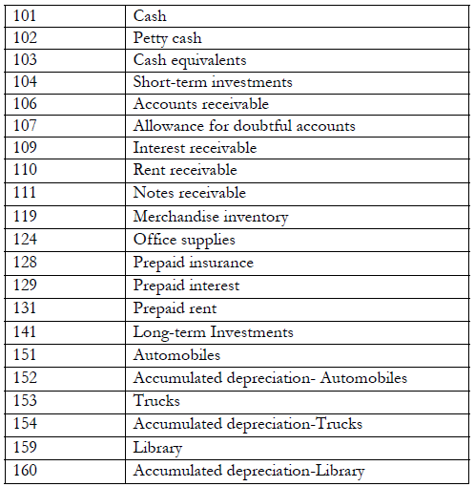
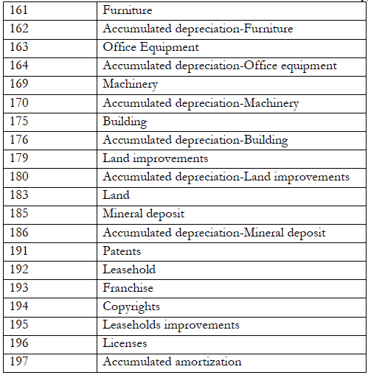
The following are examples of Liability accounts:
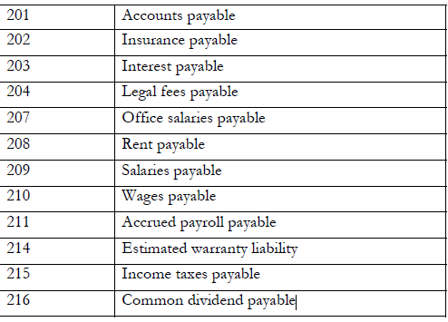
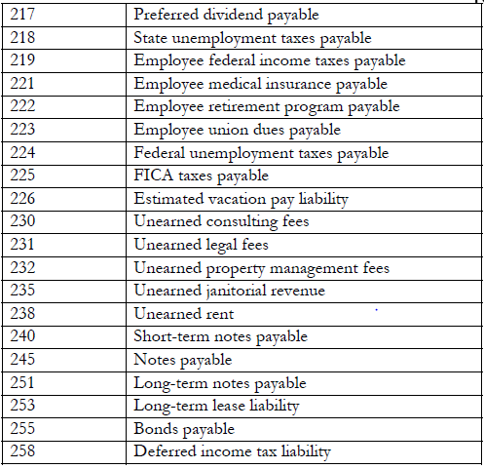
The following are examples of Equity accounts:
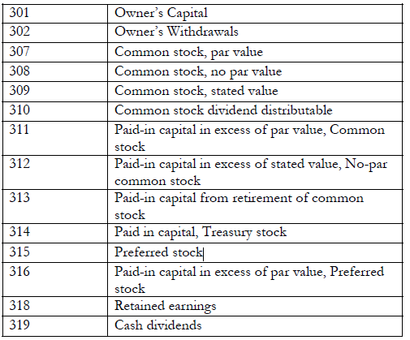
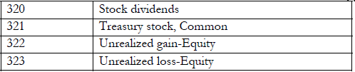
*A firm will have a varying number of these accounts depending on the number of products or services the firm manufactures or offers.

The following are examples of Expense accounts:
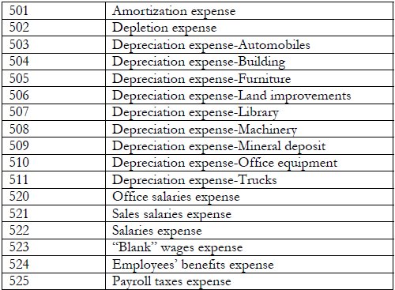
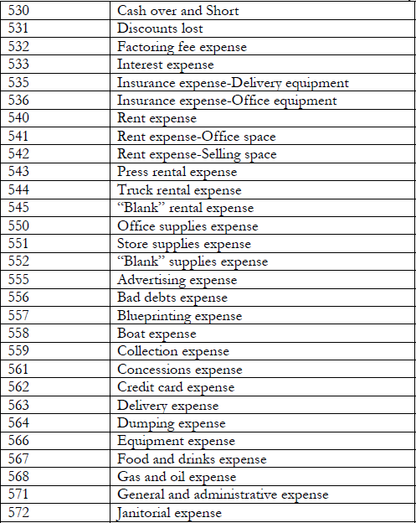
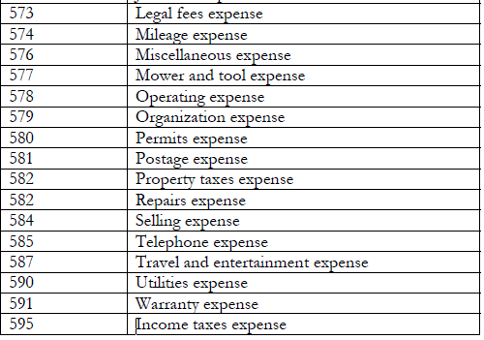
The journal entry rules for the accounts are as follows:
For Asset accounts you debit increases and credit decreases.
For Liability accounts you credit increases and debit decreases
For Revenue accounts you credit increases and debit decreases
For Expense accounts you debit increases and credit decreases
1.5. Validating and authorizing chart of accounts and balances
May include but not limited to:
- accountants
- debtors
- directors
- managers
- owners
- Staff members Relevant persons includes,
The true test of the chart of accounts is that it produces correct accounting information. The only way to run this test is by posting several transactional documents (invoices, shipments, payments, etc.) into a new client and checking the accounting entries and reports are as you expect.

Self- Check
1. Define what Chart of Accounts is_________________________________________________________________________________________________________________________________________________________________________________________________________________________________________________________________________________
2. Briefly Explain Accrual &Cash Accounting System_______________________________________________________________________________________________________________________________________________________________________________________________________________________________________________________________________________________________________________________________________________________________________________________________________________________________________________________________________________________________________
3. List some typical industries that seek business consulting services
1. 6.
2. 7.
3.
4.
5.

Unit Two: Analyse and verify source documents
This Unit is developed to provide you the necessary information regarding the following content coverage and topics:
- Verifying invoices and other source documents
- Identifying and investigating discrepancies
This unit will also assist you to attain the learning outcomes stated in the cover page. Specifically, upon completion of this learning guide, you will be able to:
- Verify invoices and other source documents
- Identify and investigate discrepancies

  - Verifying invoices and other source documents
1. Cheque
A Payment Requisition confirms that the purchase has been supplied by the vendor according to the agreed upon terms and conditions, and that the authorized signing authority has approved the vendor charges
2. Invoice:
An invoice is an itemized list of products sold or services provided, along with the amount of money owed for each line item, and the total amount of money owed. An invoice is sent from the biller to the client; in hopes of being paid within a certain amount of time.itAn invoice is a request for payment. It lists the goods or services you've supplied to your customer, and what they owe you in return.
Invoices – An invoice relates to a sales order or a purchase order. When a business buys goods or services on a credit customer it sends out an invoice. The details on the invoice should match up with the details on the sales order. When a business sells buys goods or services on credit it receives an invoice from the suppliers. The details on the invoice should match up with the details on the purchase order.
An invoice is a document which is sent by a business to its customers for goods or services supplied. It states the amount to be paid and the due date. An invoice is not the same as a receipt, which is an acknowledgement of payment. An invoice indicates what must be paid by the buyer
Purpose of invoice
Record Keeping
The most basic purpose for a sales invoice is to keep a record of the sale. It provides a way to track the date a good was sold, how much money was paid and any outstanding debt.
Parts of an invoice
What does an invoice contain? Clearly label an invoice so a customer knows what it is. All invoices should include the same basic information:
Invoice date: This shows the customer the date the invoice was created.
Customer information: Clearly state the customer’s name, business (if applicable), address, and phone number on the invoice.
Seller information: Include your business’s name, address, email address, and
Telephone number. That way, a customer can contact you if they have any questions.
Goods and/or services purchased: List out the exact products or services, quantities, and prices the invoice is for. A good description will alleviate potential confusion.
Total amount due: After adding up the total and sales tax (if applicable), include the total amount the customer owes you. If they paid part of the total at the time of purchase, make sure to account for that according to the payment terms of the seller.
Receipts: A receipt is different from an invoice in that an invoice is requesting payment for products or services received, whereas a receipt is proof that the services or products have already been paid for. An invoice comes before the payment has been made, while a receipt comes after the payment has been made.
Invoice is sent → Customer receives it as a bill → Payment is made → Receipt

Understanding the Invoice Verification Process
Invoice verification is making sure whether the vendor is charging customers for what the customers availed. It is done by cross-checking the invoices received against the purchase order and delivery receipt. An invoice is paid only if the invoice details match the supporting documents.
And if the invoice has any discrepancies, it is rejected and the vendor is requested for the correct invoice.
Generally, companies have dedicated accounts payable managers who are authorized to verify and approve an invoice payment.
The main reason for invoice verification is to avoid any fraudulent payments. The invoice approval process varies from company to company, depending on their size, type, and workflow.
So, if you are wondering about which type of invoice verification you should practice, and then let’s talk about all the significant types of invoice verification.
Send Accurate Invoices to Win More Jobs
Invoice Owl, all-in-one invoicing software, allows you to approve or reject invoices, so you can build your reputation as a reliable businessman.

Different Types of Invoice Verification

The invoice-checking process depends on the nature of the trade. However, most businesses practice the following three common invoice-checking methods.
Let’s have a look at the three of them.
- Invoices based on purchase orders:
In the purchase order (PO) based invoice verification, the invoice is matched with the PO placed. It is generally done by the authority who placed the order to avoid communication gaps. This method does not count the number of partial deliveries. It counts only the total quantity and the invoice amount.
- Invoices based on goods receipt:
Invoice verification based on goods receipt is considered an apt option when the goods delivery is done in parts. Therefore, individual goods are invoiced separately.
- Invoices without an order reference:
Sometimes, when PO is not available to refer to, companies verify the invoice directly to the accounts payable manager, marital accountant, or G/L accountant.
Now that you know the benefits of invoice approval, you must be eager to see the process. Aren’t you?
Alright then, let’s jump right in.

The Invoice Processing Procedure
The first step in invoice processing is to check the invoice number as soon as you receive the invoice. The invoice number has to be matched with the Purchase Order number or goods receipt number.
Now that the invoice number is correct let’s begin the invoice verification process.
- Check invoice accuracy
Checking invoice accuracy is the most vital step of invoice verification. Here is what you need to do to make sure that the invoice is accurate:
    - Check if the invoice you received is meant for your company or not. Sometimes a vendor may mistakenly send an invoice to the wrong client.
    - Verify the rates of services/products to see whether they match the agreement.
    - Check whether the applied tax, discount, and final amount are correct.
- Confirm the invoice date
Checking the invoice dates has a massive significance in invoicing because it has many benefits, such as:
    - It can make you lose or win legal battles about the transactions.
    - It helps you avoid double payments.
    - You can find invoices much easier if you want them later for auditing.
    - You can calculate taxes more accurately with correctly dated invoices.
- Confirm the delivery with the project manager
Confirming the delivery with the project manager keeps you away from fraudulent payments. Ensuring that you have received the services/products you are paying for is one of the best invoicing practices.
Before green lighting the delivery, the manager has to check the described quantity and quality of the line items in the invoice with those of the actual delivery.
Sometimes, if the delivery is not made on time, the customer can pay less to the vendor and save the company money. And this could only be possible by confirming the delivery with authority.
- Check the vendor information
Checking vendor information is another easiest method to avoid fraudulent payments. You should cross-check the vendor details on the invoice with the past invoices in your accounts payable process. Check:
    - Business name
    - Logo
    - Contact number
    - Mailing address
    - Email ID
This cross-checking not only warns you about fraud but also helps you keep your system data updated. And if it is a new vendor, you must verify the contact details before proceeding.
Moreover, if you want to save time and avoid payment failures, you should also check invoice payment terms like:
    - Account number
    - Tax ID number
    - Preferred payment method mentioned on the invoice
- Mark invoice due date
Making a note of the invoice due date helps you sort out the invoice payment priority and improve cash flow. Other than that, noting the payment deadline has economic benefits for your organization too.
It saves you from paying late payment fees and helps you avail of the early bird discounts as mentioned in the payment terms.
- Schedule the payment
Once all the above checks are done, the payment must be approved and scheduled by the accounts payable manager at least a couple of days prior. This gives you a window to stop the payment if there are any issues with the payment.
As discussed, invoice verification is a crucial process, and it demands all of your attention. However, every step of the process has almost zero tolerance limits as it can cause financial accounting disasters.
Thus, a wise thing would be to run the approved invoices through a final checklist before submitting invoices to make the transaction.
So, here is a quick but essential invoice verification checklist for invoice reconciliation.

Invoice Verification Checklist
- Make sure the invoice is unpaid
Before you submit invoices making the payment, you should confirm that the invoice is unpaid. The most accurate way to find that out is to run an invoice number check in your “paid invoices” logs.
- Clarify discrepancies
Invoicing mistakes are not a rare phenomenon. And suppose you find any discrepancies in the invoice is verified. In that case, you should never neglect it and clarify it with the accounts payable & accounts receivable clerk, project manager, or the appropriate authority. Still, if you are facing any issues, you should contact the vendor to resolve them.
- Verify the invoice with documentation
Once you know the invoice is yet unpaid. You should cross-verify it with all the supporting documents available relevant to the purchase. For example, it includes the PO, quotation, and delivery receipts.
Talking of documentation, do you know what documents you need to verify an invoice?
Don’t worry; we have listed all the documents here. Just have a look.

Essential Documents You Need to Verify an Invoice
- Valid trade license number mentioned on the invoice
- Quoted estimate for the same service/product
- Purchase Order Issued
- Duly signature delivery note with specifications
- Payment receipt for all the reimbursable expenses claimed
. Source document
- The business documents (or source documents) relating to the transactions are used in the accounting system as initial input information for the recording process.
Ex – sales invoices, checks, freight bills etc.
The source documents normally contain information as to
-The monitory amount to be recorded
- The parties involved
- The terms of the transactions & other relevant information.
3. Journal
- A journal is a permanent documents used for initial (first) or original recording of the day to day business transactions. Knowing for each transaction the date, debit, credit and explanation (if necessary).
- It is often called book of original entry or document of original entry. it classified as general journal and special journal
- General journal – general purpose of journal listing transactions expressed in terms of debits and credits to particular accounts. The simplest type of journal
* Special journal:-are special purposes of journal designed accumulating a single type of transaction.
Ex – cash payment journal,
Sales journal,
Purchase journal cash receive journal
In general a journal consists of
- A date column
- A description a column to record the accounts
- A column to list the account numbers
- A debit & credit column for listing the amounts to be recorded as a debit or credit to each account.
- The process of recording the transaction in the journal is called Journalizing Procedures in recording transactions in a two column journal.
- Recording the date:- your, month & day of the first transaction
- Recording the debit account & amount. The debit account is written in the left margin
- Recording the credit account & amount. The credit account is written in the right margin
- Writing explanation about the Nature of the transaction.
Note: - efficient use of a general journal requires two things:
- ability to analyze the effect of a transaction upon assets, liability and owner’s equity , and
- Familiarly with the standard form & arrangement of journal entries

2.2. Identifying and investigating discrepancies

What is the meaning of discrepancies?
1. The quality or state of being different: disagreement. a great discrepancy between the two reports.
2. Something that is different or that disagrees.
What are discrepancies examples?
An unexpected difference, esp. in two amounts or two sets of facts or conditions, which suggests that something is wrong and has to be explained: There were troubling discrepancies between his public and private opinions on how to balance the budget.
Identifying and solving data discrepancies
Struggling to make your numbers match up? Can't wrap your head around a discrepancy? Let us help you get to the bottom of it.
Discrepancies between monies owed and monies paid may occur as a result of:
- Deduction of brokers' or agents' commissions
- Incorrect account allocation
- Keystroke errors
- Overpayments
- Part payments
- System errors
- Termination of policies
- Underpayment

Generally speaking, a data discrepancy is when 2 or more sets of comparable data don’t match up. And, despite sounding kind of technical, it isn’t something that is unique to big data or adtech.
Ever done your shopping while keeping a running total in the calculator on your phone, and ended up handing over a different amount to the cashier?
Then, my friend, you’ve experienced a data discrepancy.
In this case, the discrepancy may have arisen because you didn’t notice a discount or your kid decided to smuggle something into the basket or you accidentally added the same item twice. Now, in this case, other than some potential embarrassment this discrepancy is unlikely to be particularly harmful.
But in the case of attach and big data, a data discrepancy can be genuinely damaging. It’s really important to take data reliability and consistency really seriously, particularly in an industry like ad tech where data is the foundation upon which the whole thing sits.

Most common causes of a data discrepancy
So, we’ve established that you can end up with a discrepancy between data sets for a variety of reasons, but let’s keep the focus on ad tech. Here’s a rundown of the most common causes if you do experience a data discrepancy.

1) Compatibility
In our post-GDPR world, you need to double and triple check that any third-party tracking you want to add to a creative is approved by the ad serving platform you want to use to traffic those ads. If your third-party tracker isn’t approved, you’ll likely end up with no impressions or interactions being detected by your tracking platform.
If your third-party trackers are added to your NEXD ad tag correctly - i.e. added directly to the NEXD tag - you’ll still be able to track at least partial data.

2) Tag setup
Double-check your ad tag for any errors. It’s quite common to end up with issues arising from incorrect syntax in the tracker, missing URLs or even characters “breaking” when copy-pasting. There are tools to automatically check your ad tag for syntax errors and it’s always a good idea to double-check all the URLs before your campaign goes live.

3) Date ranges in reports
It’s always important to make sure the reports or data sets you are comparing reflect the exact same date range. On the surface, this seems pretty obvious, but when you start to factor in time zones that can have an impact on dates as well.
Take some time to make sure the date ranges in both analytics platforms match up and that the time zones are also the same (and if they are not, you’ve adjusted your date range if needed).

4) Filtering
Virtually all reporting systems in the adtech ecosystem allow you to apply some level of filtering. So, it’s important to ensure that, if filters are enabled for your report, both of the reports have the same filters applied.
If you have a data discrepancy and you have filters applied to both datasets, sometimes it’s worth removing all filters to both sets and just looking at the raw data. The most common issue we see is around viewable and served impressions. Mismatching these two different impression types can lead to wildly different values.

5) Metric definitions and terminology
Many metrics are clearly defined and universally understood - like, CTR. But not every metric is so black and white. Even some pretty fundamental ones differ because there have been attempts at standardization, but there’s no single body that outlines how things should be measured and defined, leading to many companies defining them slightly differently.
At the other end of the spectrum, defining engagement metrics between platforms can sometimes be tricky because it means so many different things to different people. It’s always a good idea to dig a little deeper with engagement metrics because you need to make sure the data you have represents the same type of engagement.

6) Network connection and server reliability
If a third-party server goes down or experiences some kind of network interruption, even very briefly, it’s likely some data will not be tracked correctly, if at all. In this event, check status pages and your email to see if your provider has experienced some kind of issue that may have impacted your campaign.

7) Latency
If there’s a time delay between the systems responsible for tracking when a creative is requested, loaded, viewed and interacted with then you can end up with a discrepancy. Plus, if the user navigates away part way through after clicking but before the tracker on the landing page has loaded, you’ll see a click but no landing page visit.
Another case is when you introduce extra “layers” that can potentially slow things down. For example, NEXD is an ad server - we’ve spent a lot of time making sure it’s super-snappy and rich media optimized. If you then add a NEXD tag to another ad server you’ll end up with a big spike in latency - we’re talking seconds rather than milliseconds.

When and how NEXD investigates a data discrepancy
We take the reliability and veracity of our data very seriously and we have policies and procedures in place to help our customers investigate a data discrepancy if they experience one.
As a general rule, a data discrepancy of 10% or less falls within acceptable tolerances and, in most cases, wouldn’t warrant deeper investigation. A discrepancy in the 11-20% range would be investigated by our support team. Once we’ve received all the information we need to carry out our investigation, we will perform a comparative test for around 48-72 hours to better understand the cause of the issue.
If you see a discrepancy rate higher than 20% then it is likely there is an issue with the ad inventory and you should reach out to your provider and ensure there are no issues with compatibility. We also encourage you to send us a screenshot of your tag setup and a preview link.
Please note that at the start of the campaign when your creative has less than 10k impressions the discrepancy may be a bit higher than 10% and that is acceptable. It’s due to the fact that we may count and report more audit clicks than your DSP. There’s nothing to worry about - the difference will even out once there’s a more considerable amount of data.

Self-Check.

1.What are most common causes of a data discrepancy?____________________________________________________________________________________________________________________________________________________________________________________________________________________________________________________________________________________________________________________________________________________________________________________________________________________________________________________________________________________________________________________________________________________
2. Discrepancies between monies owed and monies paid may occur as a result of?
A.__________________________________________________
B. ________________________________________________
C.__________________________________________________
D._________________________________________________
E.__________________________________________________
3. What is discrepancy?
____________________________________________________________________________________________________________________________________________________________________________________________________________

Unit Three: Process receipts and payments
This Unit is developed to provide you the necessary information regarding the following content coverage and topics:
- Receiving and banking money and making payment
- Recording and coding receipts and payments on cash basis
- Filing receipts and payments
- Balancing cash register against purchases and takings
This unit will also assist you to attain the learning outcomes stated in the cover page. Specifically, upon completion of this learning guide, you will be able to:
- Receive and banking money and making payment
- Record and coding receipts and payments on cash basis
- File receipts and payments
- Balance cash register against purchases and takings

3.1. Receiving and banking money and making payment
What are banking payments?
Bank payments are payments made from one bank account directly to another. This means of digitally moving money in an integrated and automated fashion is faster and more secure, but there's more to it than that.
What are the five method of making payment?
The methods commonly used for making payments are:
- Cash.
- Bank transfer.
- Cheque.
- Bank draft.
- E-payment.

What is the payment?
Payment is the exchange of money, goods, or services for goods and services in an acceptable amount to both parties and has been agreed upon in advance. You can pay with cash, a check, a wire transfer, a credit card, a debit card, or even crypt currency.

What Is a Receipt?
A receipt is a written acknowledgment that something of value has been transferred from one party to another. In addition to the receipts consumers typically receive from vendors and service providers, receipts are also issued in business-to-business dealings as well as stock market transactions.

KEY TAKEAWAYS
- Receipts are an official record that represents proof of a financial transaction or purchase.
- Receipts are issued in business-to-business dealings as well as stock market transactions.
- Receipts are also necessary for tax purposes as proof of certain expenses.
- In accounting, receipts can also refer to the total cash inflows over a specific period of time.
- A typical receipt states the time and value of a transaction, and may also include information on the type of service or product being provided, the method of payment, and any additional taxes or fees.
For example, the holder of a futures contract is generally given a delivery instrument, which acts as a receipt in that it can be exchanged for the underlying asset when the futures contract expires.

How a Receipt Works
Receipts are used to document payments and business transactions. Companies and other entities use receipts to track their cash flows, reimburse eligible payments, or claim certain benefits on their taxes. In some countries, businesses are required to provide a receipt for each transaction.
Each receipt should include the date of the transaction. In most cases, they include other details such as the nature of the transaction, details of the vendor, method of payment, and any additional taxes or costs. In some cases, they may require a signature.
While receipts were once written out by hand, today they are automatically generated at the point-of-sale.
What is the difference between receipt and payment?

Receipt accounts records incoming funds, such as customer payments, donations, or grants.
Payment accounts record outgoing funds, such as expenses, salaries, and other bills. Receipt accounts follow the principle of credit. Payment accounts follow the principle of
A receipts and payments account is a summary of actual cash receipts and payments extracted from the cash book over a certain period.
All cash received and paid during the period, whether capital or revenue, is included in this account.
Receipts are entered on the debit side of the receipts and payments account. This is the same as how receipts appear in the cash book.

Explanation
All receipts are grouped under headings such as entrance fees, annual subscriptions, lifetime subscriptions, donations, interest, and sundry receipts.
All payments are entered on the credit side under headings such as salaries and wages, printing and stationery, office expenses, and rent, rates, and taxes.
The receipts and payments account starts with the opening cash balance. It closes with the cash balance at the end of the period.
Given that the receipts and payments account is simply a summary of cash transactions, it does not cover outstanding income or expenditure.
It also naturally fails to show the actual income or expenditure of the period it covers.

Format/Specimen
In a receipts and payments account, there is a receipts column on the debit side. This is used to record all receipts.
There is also a payment column on the credit side, which is used to record all payments made by non-trading concerns or non-profit-making organizations during a specific accounting period (usually one year).
The table below shows the format/specimen of a receipts and payments account.
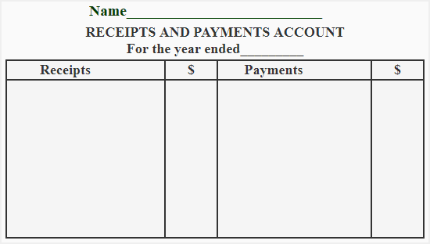

Main Features
There are several important features associated with a receipts and payments account.
First, a receipts and payments account is a summarized form of a cash book. It starts with an opening cash and bank balance (sometimes the two are merged) and ends with their closing balances.
In a receipts and payments account, all receipts are recorded on the left-hand (debit) side and all payments are recorded on the right-hand (credit) side.
The account contains a record of receipts and payments for both capital and revenue. It also includes all cash and bank receipts and payments for the current year, whether they are related to current, past, or future accounting periods.
A receipts and payments account only contains records of transactions related to cash and bank. All non-cash items are excluded.
Receipts and payments accounts are not part of the double entry system.
These accounts show cash positions only, not surpluses or deficits for the period. They generally show debit balance, and in case of a bank overdraft, the bank balance will be credit.
It is rare, but a receipts and payments account may also show nil balance.
The last noteworthy feature of receipts and payments accounts is that they are always prepared at the end of an accounting period.

Advantages
The following are the advantages of a receipts and payments account:
- At a glance, a receipts and payments account shows total receipts and total payments under different headings.
- A receipts and payments account can be used to verify the cash book.
- The account provides classified records of different heads of receipts and payments.
- It provides readily available data for preparing an income and expenditure account.

Preparation of Accounts
A receipts and payments account is prepared by extracting receipts and payments from the cash book for the entire year.
In a cash book, each item is recorded separately in chronological order. However, the items in a receipts and payments account are recorded in classified form under different headings.
To prepare a receipts and payments account, follow these steps:
Step 1: Write the title of the account and use the format shown in the specimen.
Step 2: Write the opening cash and bank balances at the top on the left-hand side.
Step 3: Add up all the receipts with different dates under the same head.
Step 4: Add up all the payments made on different dates under the same head. You can also use a separate sheet for this.
Step 5: Write the sums of each head of receipts on the left-hand side and the total of each head of payments on the right-hand side.
Step 6: Deduct all payments from all receipts and find the closing balance.

Example 1
A library and debating society was formed on 1st January 2017. The receipts and payments for the year ended 31 December 2017 are as follows:
Receipts:
- Subscription: $1350.00
- Donations: $2600.00
- Entrance fees: $480.00
- Locker rent: $785.00
Payments:
- Library books: $1210.00
- Rent for library hall: $240.00
- Office expenses: $35.00
- Postage and stationery: $72.00
- Furniture purchased: $934.00
- Investment: $1100.00
Required: Show the receipts and payments account for the year ended 31 December 2017.

Solution
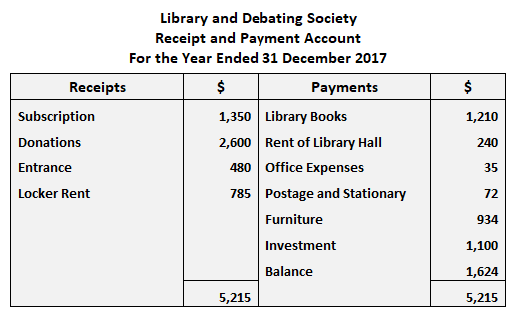

Example 2
Cash transactions for a beach club are shown below:
- Cash at commencement of year: $4,500.00
- Entrance fees received: $18,300.00
- Life membership subscription received: $2,605.00
- Locker rent received: $465.00
Subscription:
- Received during the year: $3,500.00
- Arrears for the last year: $2,360.00
- This year's advance: $346.00
Printing and Stationery:
- Paid during the year: $2,160.00
- Payable this year: $94.00
- Payable last year: $312.00
Rent and Rates:
- Paid during the year: $370.00
- Payable this year: $230.00
- Sports material purchased: $348.00
Required: Prepare a receipts and payments account for the year ended 30 June 2017.
How to Process Cash Receipts
- Apply Cash to Invoices. Access the accounting software, call up the unpaid invoices for the relevant customer, and apply the cash to the invoices indicated on the remittance advice that accompanies each payment from the customer. ...
- Record Other Cash (Optional) ...
- Deposit Cash. ...
- Match to Bank Receipt.
What Is a Receipt of Payment? A payment receipt is a document issued by a business (seller) to another business (buyer) or personal customer after payment has been made for either goods or services. Receipts can also be issued when deposits or partial payments are made toward goods or services

Solution
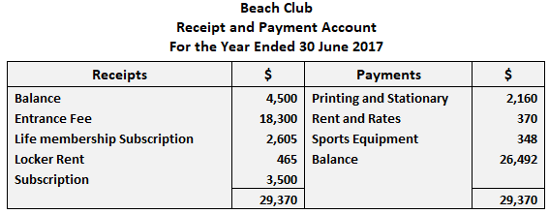
Explanatory Note
Adjustments regarding subscription, arrears for the last year, this year's advance, printing and stationery payable this year, payable last year, and rent and rates payable this year have not been recorded in the receipts and payments account.
The reason for this is because these items do not affect the receipt or payment of cash.
How to Process Cash Receipts
Apply Cash to Invoices. Access the accounting software, call up the unpaid invoices for the relevant customer, and apply the cash to the invoices indicated on the remittance advice that accompanies each payment from the customer. ...
- Record Other Cash (Optional)
- Deposit Cash
- Match to Bank Receipt
What Is a Receipt of Payment? A payment receipt is a document issued by a business (seller) to another business (buyer) or personal customer after payment has been made for either goods or services. Receipts can also be issued when deposits or partial payments are made toward goods or services.

Payment is the voluntary transfer of money, equivalent, or other valuable items from one person to another in exchange for goods or services received or to meet a legal obligation. The person who gives the money is often called the payer, while the person who gets the money is called the payee.
Types of Receipts
In addition to showing ownership, receipts are important for other reasons. For instance, many retailers insist that a customer must show a receipt to exchange or return items while others demand that a receipt—generally issued within a certain timeframe—be produced for product warranty purposes. Receipts can also be important for taxes because the IRS requires documentation of certain expenses. The Internal Revenue Service (IRS) suggests that the following types of receipts if generated, be retained by small businesses:
- Gross receipts such as cash register tapes, deposit information (cash and credit sales), receipt books, invoices, forms 1099-MISC
- Receipts from purchases and raw materials (These should show the amount paid and confirm that they were necessary business purchases; documents could include canceled checks or other documents that identify the payee, amount, and proof of payment/electronic fund transfers.)
- Cash register tape receipts
- Credit card receipts and statements
- Invoices
- Petty cash slips for small cash payments

Origin of Receipts
The practice of retaining receipts for tax purposes is thought to originate from ancient Egypt. Farmers and merchants sought ways to document transactions to avoid tax exploitation. Papyrus was used instead of paper. In more modern times, London banks used the printing presses of the industrial revolution to print receipts with their own brands.

Fast Fact
Thermal printing is the most commonly used form of physical receipt printing because it is low cost and easy to use. Today, however, paper receipts are increasingly giving way to electronic receipts in the form of emails or other digital record.

IRS Requirements for Digital Receipts
Digital receipts are becoming the norm. Since 1997, the IRS has accepted scanned and digital receipts as valid records for tax purposes. Revenue Procedure 97-22 states that digital receipts must be accurate, easily stored, preserved, retrieved, and reproduced. The business owner must be able to supply a copy to the IRS.
Digital records are not subject to wear and tear as are physical receipts, but they can be lost if a hard drive fails. It's thus wise to store them on the cloud or somewhere where they can always be accessed.
Paper receipts can be stored digitally using desktop scanners and mobile phone apps. This type of technology can organize, create expense reports, and integrate data with bookkeeping software.

3.2. Recording and coding receipts and payments on cash basis

What is Receipt and Payment Account?
Receipt and payment account functions as a summary of cash payments and receipts of an organization during an accounting period. It provides a picture of the cash position of a Not-for-Profit organization. It does not differentiate between the receipts and payments, whether they are of capital or revenue in nature and records all cash and bank transactions of both capital and revenue nature.
Receipt and payment account does not include any non-cash transactions such as depreciation. The Receipt and payment account is prepared at the end of an accounting period.
Receipt and Payment Account format
Receipt and Payment Account format is presented below:
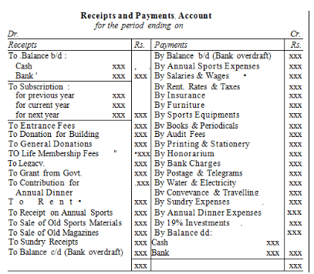

Accrual Basis Accounting
Accrual accounting records all economic transactions, regardless of whether they involve cash, in the books of accounts. This accounting method is used to give more detailed information about business transactions and allows companies to make better financial decisions.
Cash Basis Accounting
Cash basis accounting records only cash-related receipts and payments in books of accounts. Although this method is less popular than accrual-based accounting, many businesses still use it because of its simplicity. This system makes transactions easier to track and manage.
Now that you know everything about receipt payment accounts, you should learn accounting basics.
3.3. Filing receipts and payments
How do I file receipts and invoices?
When placing your receipts in folders, place each receipt in chronological order. Putting receipts in chronological order is beneficial when you need to look for a specific receipt. Keep the most recent receipts in the front of the folder and older receipts in the back
. When it comes to organizing your small business receipts, you can either store them physically (e.g., filing cabinets) or electronically (e.g., online accounting software). Find out how to store receipts for business using the two methods below.

Paper receipts
Storing paper receipts can be challenging. To remain organized with a paper filing system, you must be disciplined and create a routine for receipt storage. You can use files and folders to stay organized.
Overcome clutter by utilizing the following paper storage strategies in your small business.

Sort by type
After receiving a receipt, separate receipts by the type of business expense. For example, place office supplies receipts in one pile and meal and entertainment receipts in another.
Consider adding codes to each receipt to categorize expenses (e.g., Code 125 for meals). That way, if you decide to expand your organizational efforts to an electronic system, you can easily break receipts up by category.

Invest in supplies
Invest in supplies to help organize your receipts. Folders, files, and storage cabinets are great ways to keep receipts safe and accessible.
Include the types of receipts on the label of the folder. For example, you may dedicate a folder to company vehicle-related receipts.
Consider organizing the files in your cabinet in alphabetical order so they are easy to find.
If your business does not need to store many receipts, use envelopes instead. Label each envelope and place them in a smaller filing system or folder

Electronic storage
More than ever, it’s easy to automate the organization of your receipts. If you want to ditch the old school filing cabinets, consider switching to a digital system.
To electronically store your receipts, you can use software or store scanned receipts on your computer.
Keep in mind that you must back up your digital receipts to prevent losing important financial information. Review the different ways to store receipts electronically below.

Software
Accounting or receipt management software allows you to upload, record, and track your receipts.
Most systems allow you to extensively organize your receipts and access features that paper storage does not offer. For example, you may be able to add reminders in your software to upload and organize receipts.
Although you may need to invest more money to use a digital system, software does allow you to go paperless. And, it makes it easier to store and organize receipts for longer periods.
Business owners can also opt to store receipts in digital folders. You can use scanners to transfer receipts from paper to other devices, such as a computer, smartphone, or tablet

Preparation of Receipt and Payment Account Format
The account records cash like any other and is prepared in this format:

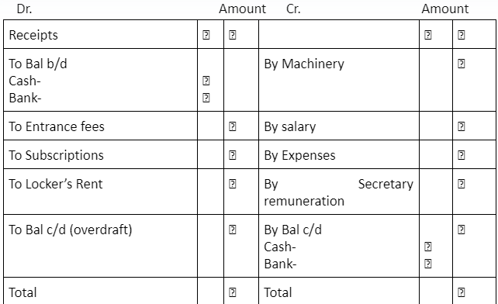
Receipts
When receipts are available, no other proofs of payment are required. A receipt is any document that contains the following five IRS-required elements:
1. Name of vendor (person or company you paid)
2. Transaction date (when you paid)
3. Detailed description of goods or services purchased (what you bought)
4. Amount paid
5. Form of payment (how you paid – cash, check, or last four digits of credit card)
For guidance on restrictions specific to the event type or funding source, contact inquiries@law.berkeley.edu

Proofs of payment
Provide a proof of payment only if no receipt is available. Proof is needed only when a receipt has been lost or was not provided by the merchant and there is no other way to demonstrate that you incurred a business-related expense. Please provide the below information along with a CLLAW Certificate of Lost or Missing Receipt.
- Cleared check – obliterate the bank routing and account numbers printed on the bottom of the check, leaving any numbers in the lower right corner visible. Check the endorsement side of the check and obliterate any legible numbers. Most cleared checks are available as scanned images from your online bank account.
- Credit card or Bank statement – obliterate cardholder address, account number, summary of account information (payment due, balance, etc.) and all other details not relevant to the particular transaction for which reimbursement is requested. Information must be fully redacted; Business Services recommends using Adobe Acrobat’s redaction tool to completely hide your personal information.

How to Prepare Documentation/Receipts
Obscure or remove any sensitive or confidential information, including:
  - Social Security Numbers
  - Credit card numbers (except the last four digits)
  - Debit card numbers (except the last four digits)
  - Credit or debit card security codes
  - Bank account numbers, including numbers encoded on the bottom of checks
  - Passwords, including access codes for financial institutions
  - Home addresses (UCB employees only)
  - Passport numbers
  - Driver’s license numbers or other state identification card numbers
  - Date of birth information
If the receipt is in foreign currency, convert to U.S. dollars and notate the U.S. dollar amount on all receipts
Refer to your credit card statement or look up rates effective on the purchase date at https://www.oanda.com/currency/converter(opens in a new tab). Attach a copy of the currency conversion page from the website when submitting for reimbursement
3.4. Balancing cash register against purchases and takings
Balancing a cash register is the method used to accurately account for all daily monetary transactions in a business. Good accounting and bookkeeping procedures begin with a balanced register. Typically, trustworthy employees who prove capable of exchanging cash in an efficient manner will operate the cash registers. When their shift is complete, it’s time to prepare the drawer for the next employee to use or for earnings to leave your location in the form of a bank deposit. The best process for how to balance a cash register is simple to introduce with just a few easy steps.
A.Determine the Best “Starting” Amount
The cash register should contain a consistent number of bills and coins so you can make change for your customers. However, too much cash in a drawer at one time can lead to theft, which could leave your wait staff in a potentially dangerous situation. Stuffing the drawer can also result in bills falling to the ground or slipping into the back of the register. Regardless of intent, both situations take away from your business’s bottom line. You can't accurately create a profit and loss statement for your business if shrinkage is affecting your sales.
Select a base amount of cash to keep in the register to easily handle routine transactions throughout the first half of the shift. It also helps to pick a round number, and one that is easy to count by hand prior to loading and after removing the drawer. Generally, this number will be between $50 and $150

B.Assign One Employee per Register
Prior to the start of a shift or meal, ensure that a single individual will be responsible for the register for the entirety of the allotted time. If multiple registers are required, take time to carefully assign one employee to each register. When work areas and specific responsibilities are noted ahead of time, it will improve the efficiency of your dining operation. By allowing several employees to access one drawer in a short period of time, there can be room for mistakes and increased opportunities for bills to go missing.
C. Require the Same Employee to Count Their Drawer
When making your restaurant staffing schedule, create drawer counting assignments. While it may not always be possible, try to have the same staff member count his or her drawer at the end of a shift with a supervisor nearby. This leaves little room for discrepancies in the final amount. Any small overages or shortages (up to $1) are usually the result of human error. If the difference is routinely any larger, the supervisor or owner will need to decide if disciplinary action is required.
D. Schedule Times for Cash Drops
A cash drop is when a manager or supervisor manually removes and deposits cash into the drawer in order to keep up with customer transactions. Depending on the traffic and frequency with which your customers pay with cash, these drops will typically take place towards the end of a meal rush.
Make a point to always note the individual who has deposited the cash and maintain a standard amount for each cash drop. If time allows, have the cashier sign off on the transaction, since they will be the ones held responsible for working with the new balance

E. Separate Earnings from Starting Amount, and Promptly Store in a Safe
Earnings intended for a bank deposit should remain in a sealed envelope, then placed into a safe along with other restaurant cash register drawers. It’s important that the safe is located in a secure, isolated area, with owners and supervisors the only ones capable of unlocking it. Incorporating a combination of door alarms or security cameras is beneficial as well.
F. Utilize Up-to-Date Cash Register Software
Today, restaurants and bars rely heavily on a cash register system, especially those that operate in a fast-paced environment or with multiple registers in use at one time. Equipping your establishment with software that is out-of-date will only cause problems. To prevent this, ensure that your business is reaching its full potential with the right cash register software. There are many software options available, several of which can be custom designed for the operation you wish to run.

How do you balance a cash register?

The 5-step process for balancing cash registers
- Determine your ideal starting amount.
- Keep one employee per register.
- Run an X read.
- Conduct the physical count.
- Don't forget the cash drop
Self- Check
1. How to Prepare Documentation?
____________________________________________________________________________________________________________________________________________________________________________________________________________________________________________________________________________________________________
2. What are methods commonly used for making payments? List at least 5.

Unit Four: Establish and replenish a petty cash system
This Unit is developed to provide you the necessary information regarding the following content coverage and topics:
- Preparing expenditure authorization record
- Reconciling and reimbursing expenditure
This unit will also assist you to attain the learning outcomes stated in the cover page. Specifically, upon completion of this learning guide, you will be able to:
- Prepare expenditure authorisation record
- .Reconcile and reimbursing expenditure
4.1. Preparing expenditure authorization record
What Is Petty Cash?
A petty cash fund is a small amount of company cash, often kept on hand (e.g., in a locked drawer or box), to pay for minor or incidental expenses, such as office supplies or employee reimbursements.
A petty cash fund will undergo periodic reconciliations, with transactions also recorded on the financial statements. In larger corporations, each department might have its own petty cash fund.
KEY TAKEAWAYS
- Petty cash is a nominal amount of money readily accessible for paying expenses too small to merit writing a check or using a credit card.
- In larger corporations, each department might have its own petty cash fund.
- A petty cash fund can be used for office supplies, cards for customers, flowers, paying for a catered lunch for employees, or reimbursing employees for expenses.
- Petty cash's main advantages are that it's quick, convenient, and easy to understand and use.
- Disadvantages of petty cash funds include their vulnerability to theft and misuse, and the need to monitor and balance them periodically.
Understanding Petty Cash
Petty cash provides convenience for small transactions for which issuing a check or a corporate credit card is unreasonable or unacceptable. The small amount of cash that a company considers petty will vary, with many companies keeping between $100 and $500 as a petty cash fund. Examples of transactions that a petty cash fund is used for include:
- Office supplies
- Cards for customers
- Flowers
- Paying for a catered lunch for a small group of employees
- Reimbursing an employee for small work-related expenses
Petty cash fund custodians are appointed to oversee the fund. The custodial duties generally include enforcing petty cash rules and regulations, requesting replenishments, and dispensing funds.
Requirements for Petty Cash
The use of a petty cash fund can circumvent certain internal controls. However, the availability of petty cash doesn't mean that it can be accessed for any purpose by any person. Many companies employ strict internal controls to manage the fund. Often, a few individuals are authorized to approve disbursements and can only do so for expenses related to legitimate Company activities or operations.

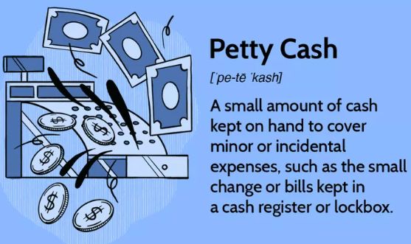

What is the authority to incur expenditure?
Authority to incur expenditure means a delegated responsibility by the Clerk to the constituency office Manager to enable the manager authorize expenditure; Sample 1Sample 2.
Ideally, all government expenditure transactions should be classified in four ways:
- by administrative responsibility--the ministry, department, or spending agency that undertakes the expenditure;
- by economic category--defined by Government Financial Statistics standards;
- by function (e.g., health, education)--defined by the United Nations; and
- by program (e.g., by policy goals and objectives)
Previous | Guidelines for Public Expenditure Management
Cash Planning
As an integral element of public expenditure management, governments need to develop cash planning and management to keep within budgeted expenditure in cash terms; to prevent unanticipated borrowing that might disrupt monetary policies; and to help identify the need for in-year remedial fiscal action. Variations in in-year actual versus planned patterns of expenditure are not without cost. Even if the total limit on borrowing were not exceeded over a fiscal year, higher-than-planned expenditures within a short period may lead to a surge in borrowing and can disrupt the achievement of monetary policy objectives.
The ability to adjust central government spending, both in the timing as well as the amount, is of strategic importance in any budget system. Careful financial planning and efficient in-year management of budget delivery are essential, but both planning and management will work well only if the budget information systems are comprehensive, timely, accurate, and reliable--and if all the departments involved, both inside and outside the ministry of finance, cooperate closely. These conditions are rarely fulfilled in developing countries, thus making monitoring of the fiscal program difficult and cash management more challenging. This section will outline the main cash planning requirements for ensuring that expenditures are smoothly financed throughout the year and that overall fiscal targets are met.
The main questions are:
- What are the essential features of cash planning?
- Who is responsible for preparing and monitoring the cash plan?
- What are the main constraints that disrupt smooth financing of expenditure plans and how can these be overcome?
What are the essential features of cash planning?
Cash planning has three main objectives: (1) to ensure that expenditures are smoothly financed during the year, so as to minimize borrowing costs; (2) to enable the initial budget policy targets, especially the surplus or deficit, to be met; and (3) to contribute to the smooth implementation of both fiscal and monetary policy. An effective cash planning and management system should:
- recognize the time value and the opportunity cost of cash;
- enable line ministries to plan expenditure effectively;
- be forward-looking--anticipating macroeconomic developments while accommodating significant economic changes and minimizing the adverse effects on budget execution;
- be responsive to the cash needs of line ministries;
- be comprehensive, covering all inflows of cash resources; and plan for the liquidation of both short- and long-term cash liabilities.
Even if a budget is realistic in the sense of having well-prepared and objective aggregate revenue and expenditure estimates, this does not mean that budget execution will be smooth. Timing problems can be expected between payments coming due and the availability of the cash necessary to discharge them.
Ideally, a cash plan for central government expenditures should include, for the month ahead, a daily forecast of cash outflows (i.e., mainly expenditures) and cash inflows (receipts from tax and nontax revenues and also from borrowing, including issues of government securities as well as other external and domestic borrowing).³⁵
But some such daily systems found in developing countries are essentially misdirected and represent "emergency" cash budget regimes that pay out tomorrow what flowed in today. Where such cash planning systems do exist, they are rudimentary, dirigiste, and unresponsive in practice, to unanticipated shortfalls in revenues or borrowings. They have many drawbacks. While they can be broadly effective in limiting cash payments to available cash inflows, they often do so at considerable cost to the effective allocation of resources (sudden cuts in cash provision relative to budget appropriation) and to the timely delivery of services (because there is insufficient information on the likely flow of cash available to enable managers in line ministries to plan their delivery of services). Moreover, such systems are often associated with a buildup of payment arrears. Governments need to pursue a more sophisticated approach to cash management.
Developing countries should aim to deliver their budget by adopting a monthly cash plan, based on projected aggregate cash inflows and limits on cash outflows. The principal components should be as follows:
- The starting point should be an annual cash plan, prepared in advance of the fiscal year, setting out projected cash inflows and cash outflows month by month.
- Past patterns can help establish likely month-to-month inflows of tax and nontax revenue receipts. The likely timing of external borrowing is also often partly known in advance, so that total inflows can be projected. Past patterns of expenditures can usually be a guide to the cash outflows each month.
- However, factors such as irregular capital expenditure patterns, variations in the timing of donor grant receipts (whether for specific capital projects or general budgetary support), and the precise timing of new borrowing (which may have to await a conjunction of beneficial market conditions) are likely to mean variation from year to year in monthly patterns of cash inflows and outflows.
- When it appears from the initial projections that there might not be enough cash available within a given month to cover expenditures falling due, a government can delay the planned commitment of the expenditure; speed up the collection of revenue; or borrow. The choice among the three options will depend on feasibility and costs.
Once the annual plan is established, it should become the basis for rolling three-month projections, and within that projection an operational cash management plans for the month ahead. These should operate as follows:
- The three-month projections and monthly plans need to be revised each month on a rolling basis in the light of actual revenues and expenditures (and often experience in borrowing domestically and externally).
- When the three-month rolling projections indicate there may not be enough cash available within one or more of the three forward months to cover expenditures, action can be taken to delay expenditure commitments, accelerate revenue collection, or borrow, with the choice depending on feasibility, costs, and borrowing constraints.
- The operational cash management plan for central government expenditure for the month ahead should, ideally, include a daily (or at least weekly) forecast of cash outflows and inflows. This cash management plan should be prepared and updated at least every week.
The operational monthly cash management plan is often translated into a monthly cash limit set on some, or all, expenditures of individual ministries or spending agencies. In some instances--and not just in post-chaos situations or as a temporary means of re imposing control--there can be cash limits on economic categories of spending or even individual line items. Some industrial countries have put limits on certain sub aggregates like "running costs"--wages, utilities, and residence costs for individual spending agencies. These cash limits are often seen as being the way in which a "hard" budget constraint operates. But, as noted, as a means of expenditure rather than cash control, cash plans on their own are ineffective when there is no separate control over commitments, and often lead to a buildup of (unpaid) liabilities.

Who is responsible for preparing and monitoring
the cash plan?
As noted, in principle, within the monthly cash management plan for the central government budget, the figures should be prepared and updated at least every week by the treasury or cash management department of the ministry of finance, as the government's financial manager. This often does not occur in developing countries--although sometimes the central bank may undertake all or part of such an exercise. The budget advisor should encourage the creation of some kind of cash management unit within the ministry of finance (typically as one of the components of the treasury department) to prepare and maintain cash plans and monitor outcomes.
To monitor delivery of the cash budget, the treasury department must get all the necessary information as quickly as possible from all the departments involved--not only from the ministry of finance departments, (e.g., the tax and customs administration and budget department) but also from the planning ministry, the line ministries, the spending agencies, and the central bank. This task is often not adequately carried out because, among other reasons, the reporting system is not fully networked. As a first step, before more lasting comprehensive reforms are put in place, a provisional monitoring system may have to be introduced.
For this purpose, one approach is to set up a small team, headed by someone with enough authority to obtain information from the various departments. For example, in some francophone African countries, the Direction de la Prevision or Cabinet du Minister des Finances are already operational in coordinating budget execution and cash planning. In Latin American countries, the unit in charge of monitoring is either in the central bank or within the ministry of finance under the supervision of its minister. The functions of this unit should be to:
- prepare a monthly cash plan;
- keep an inventory of the existing in-year fiscal reports, on the revenue side of the budget as well as on the expenditure side, and propose the preparation of new reports if those existing do not fulfill their requirements;
- centralize the outturn revenue and expenditure information in "flash reports," summarizing main developments with minimum lags;
- analyze the reports, and update cash forecasts on the basis of these flash reports;
- make proposals for adjusting cash flows if the need arises; and
- Keep the central bank fully informed (because government operations can have important consequences for bank liquidity).

4.2. Reconciling and reimbursing expenditure
What is reconciliation in finance? Financial reconciliation involves checking and verifying that two sets of records match. The goal is to make sure that your records are accurate, that income and spending in your accounts are the same as in your books, and to spot any mistakes, fraud, or wrongdoing.
How do you reconcile expenditures?
Steps to Reconcile
- Review expenditures that you don't recognize or appear unusual.
- Compare transactions to source documents as needed.
- Review infrequent transactions.
- Investigate and resolve differences.
What is Reconciliation?
Records of these purchases are imported from IU’s US Bank credit card statement and applied to the Chrome River user (AKA expense owner) responsible for incurring those expenses. These records are housed in the expense owner’s e Wallet and must be added to expense reports. This process, known as reconciliation, ties the expense to the expense owner, allows approvers to review and approve expenses, and moves these credit card charges to your department’s account.

What is a reimbursement?

Reimbursement is money paid to an employee or customer, or another party, as repayment for a business expense, insurance, taxes, or other costs
A reimbursement can be almost anything perceived as allowable by the IU Travel Policy and your approver. On most reimbursements, except certain small dollar amounts as defined by Travel Management, receipts must be attached to these expenses in Chrome River. Furthermore, approvers can approve or deny specific reimbursements or adjust amounts at their Reimbursement
is when a business pays back an employee, client, or other people for money they spent out of their pocket or for overpaid money. Some examples are getting money back for business costs, insurance premiums, and overpaid taxes. In contrast to regular pay, however, reimbursement is not taxed.
Many businesses have rules about when to pay back employees for costs they paid for themselves. Most of the time, these costs are related to travel and include lodging, food, transportation on the ground, and airline fees (travel reimbursement). Most of the time, reimbursement has something to do with business costs.
In addition to paying for college courses or classes for continuing education, employers may also pay for other expenses, such as fees for college courses or classes for continuing education.
Types of Reimbursement
Insurance
Insurance companies also use reimbursement for things besides business costs. When someone with health insurance needs medical care right away, they probably won't have time to call their insurance company to find out what's covered. The person with the policy may have to pay out of pocket for medicines, medical services, or other costs.
But when he/she goes for reimbursements, the insurance policy might not cover all the expenses. Many dental procedures and cosmetic surgeries are not covered by insurance policies. Thus when you will apply for reimbursement, you might face a denial of the claim. Thus it is better to check the policy in detail before going for a medical procedure.
Taxes
Taxes paid to the Central governments are also eligible for reimbursement. Your taxes are deducted from your salary. If you had not applied for any exemptions, you might have deposited higher taxes. You can claim for reimbursement of taxes that you paid in excess. Tax refunds are a type of reimbursement because the money going back to the taxpayer is money that was overpaid in the past.
Legal
Reimbursement alimony is a type of reimbursement in the world of law.
A judge orders reimbursement alimony, which is a payment made to an ex-spouse for the time and money spent on the ex-financial spouse's prospects and development. In a divorce settlement, alimony may be paid back to a person who worked full-time to put his or her spouse through college and who is now working and making money. Creation.
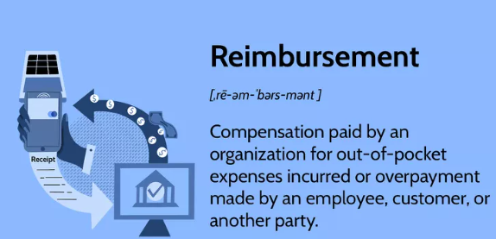
Self-Check
1. What is a reimbursement?
2. What are Types of Reimbursement? List
3. What Is Petty Cash?

Unit Five: Process and reconcile credit
This Unit is developed to provide you the necessary information regarding the following content coverage and topics:
- Processing credit card transactions
- Processing credit card payments
This unit will also assist you to attain the learning outcomes stated in the cover page. Specifically, upon completion of this learning guide, you will be able to:
- Process credit card transactions
- Process credit card payments
5.1. Processing credit card transactions
What is the process of credit card transaction?
Merchants send batches of authorized transactions to their payment processor.
The payment processor passes transaction details to the card associations that communicate the appropriate debits with the issuing banks in their network.
The issuing bank charges the cardholder's account for the amount of the transactions.
What Are the Different Credit Card Transaction Types?
- Purchase. Also referred to simply as a charge or sale, a purchase is the basic credit card transaction type that everyone is familiar with. ...
- Pre-Authorization.
- Capture.
- Refund.
- Void.
- Verification.

What Are the Different Credit Card Transaction Types?
Let’s get right to the list, starting with the most common type:

Purchase
Also referred to simply as a charge or sale, a purchase is the basic credit card transaction type that everyone is familiar with. When a cardholder wants to buy something, they give their card information to the merchant—either by scanning it at a terminal in card-present environments or by furnishing their payment credentials over the phone or internet—and the merchant transmits the card and sale information to the payment processor. The processor then communicates with the card network to finalize the transaction and will send an approval message back to the merchant to confirm it.
Despite their complexity and the number of parties involved, most credit card transactions are completed in a matter of seconds, regardless of their type. However, the settlement process that actually moves money from the issuing bank to the merchant account can take some time.

Pre-Authorization
Every purchase transaction should begin with the authorization step, in which the issuing bank confirms that the card is valid and the account is in good standing before the charge goes through. However, sometimes you want to authorize an expected charge without completing it right away.
This is how self-service fuel pumps work. If customers were allowed to gas up first and then pay once the final purchase price was established, lots of them would just drive off without paying.
Instead, they’re required to run their credit card first, which unlocks the pump for use. Hotels and motels use a similar process, running a guest’s card at the start of their stay instead of when they check out.
Pre-authorization is a transaction type that puts a certain amount of funds “on hold” for the merchant until the final purchase price is established. At that point, the merchant can run a capture transaction (see below) to actually charge the cardholder’s account. These holds are temporary, and if the merchant doesn’t capture the charge within a short time frame—usually about seven days—the hold expires.

Capture
A capture transaction is used to complete a purchase that was initiated with a pre-authorization. You can capture an amount less than or equal to the hold amount, but you cannot exceed it. Captures can be processed up to thirty days after pre-authorization, but the hold does not last that long and there’s no guarantee the funds will be available after that point.
In order to establish the relationship between the two transactions, captures should always include the approval code generated by the pre-authorization.

Refund
Every cardholder’s favorite transaction type—a refund transaction—is when a credit is processed to return funds to the cardholder’s account. Refunds should be utilized when the original transaction has already settled and the funds are in the merchant account. If the charge has not yet been settled, it’s better to use a void transaction instead.

Void
Sometimes transactions get processed in error, or the cardholder changes their mind right away, and the charge needs to be reversed. You can accomplish this with a refund, but refunds can take several days to settle and both the debit and the credit will show up on the cardholder’s billing statement. If the charge hasn’t been settled yet, a void transaction is a neat and clean way to make it go away. Another benefit of void transactions is that they cancel out the interchange fees you would otherwise be required to pay.

Verification
In certain situations, particularly in e-commerce, it can be useful to verify that a card is valid and tokenize its information for future use, but you don’t actually want any funds to change hands just yet. This is what verification transactions are for. It’s basically just a $0 charge that confirms that the card has a valid account number, expiration date, and security code. It cannot tell you how much funds are left available on the card, though.

How Are Chargebacks Affected by Different Transaction Types?
Chargebacks that result from processing the wrong transaction type are almost always categorized as merchant error chargebacks. When you get a valid chargeback as a result of your own mistake, there’s nothing you can do to fight it—your best move is to accept it, figure out why it happened, and adjust your business operations to ensure it doesn’t happen again in the future.

5.2. Processing credit card payments
What is the process of credit card payment?
Credit card processing in 8 simple steps
- Making the purchase.
- Entering the transaction.
- Transmitting the data.
- Authorizing the transaction.
- Responding to processor and merchant.
- Completing the transaction.
- Sub mitting batch closure.
- Depositing the funds.
Credit card processing in 8 simple steps

Read below to learn how the processing of credit cards works for merchants in eight simple steps.
1. Making the purchase
The customer finds a product that he or she likes and decides to make the purchase. The customer can use a credit card to pay for the item in the store, through an online payment gateway, by phone, or by mail.
2. Entering the transaction
The credit card is swiped or dipped using a secure credit card reader, or the card and transaction information is manually entered using a virtual terminal. For e-Commerce transactions, the cardholder keys in the payment details on a hosted payment form on the website.
3. Transmitting the data
The credit card data is encrypted and transmitted for approval as the terminal, POS system, or secure payment gateway is connected to the processing network. Point-to-point encryption (P2PE) can help protect the sensitive payment information from the moment the card is swiped or dipped all the way through to authorization and approval. This security method can help maintain compliance with PCI security standards. E Book
4. Authorizing the transaction
Once the data is transmitted, the credit card issuer can approve or decline the transaction. This is based on the validity of the card, the amount of the transaction, as well as the cardholder’s available funds.
5. Responding to processor and merchant
If the transaction is approved, the processor and the merchant receive an authorization response.
6. Completing the transaction
The merchant completes the transaction by issuing a receipt to the customer. For e Commerce orders, the merchant then prepares to ship the items to the customer.
7. Submitting a batch closure
The merchant completes the credit card payment process with a batch closure. This closes out the transactions that have been processed on that day. The processor’s acquiring bank then collects the funds from the credit card issuers.
8. Depositing the funds
The processor’s acquiring bank then deposits the funds into the merchant’s business account. This typically takes up to 48 hours.
Self-Check
1. What is the process of credit card transaction?
2. What is the process of credit card payment? List the step.
3. Demonstrate the steps involved in verifying receipts:

Unit Six: Manage bank reconciliations and prepare and produce reports
This Unit is developed to provide you the necessary information regarding the following content coverage and topics:
- Verifying receipts of statement and processed transactions
- Processing and verifying bank entries
- Reconciling bank statement
- Producing and validating reports
This unit will also assist you to attain the learning outcomes stated in the cover page. Specifically, upon completion of this learning guide, you will be able to:
- Verifying receipts of statement and processed transactions
- Process and verifying bank entries
- Reconcile bank statement
- Produce and validating reports
6.1. Verifying receipts of statement and processed transactions
A lot of transactions take place in the day-to-day operations of a business. Therefore, an acknowledgment to confirm the receipt of the message becomes imperative for the vendors and the business owners alike.
However, the usage of the expression “please confirm receipt” requires a more nuanced understanding before its application. If you’re looking for enhancing your business correspondence, this article will undoubtedly come in handy.

Confirm Payment Receipts in your email
Payment receipts piling up in your email can turn into a big issue for a small business.
As the owner of a small business, you will end up spending a lot of hours searching through these receipts for your accountant, and let’s be honest: You will probably miss a few that have been lost.
Welly Box solves that problem for you. It automatically collects and stores all of your digital receipts in an easily accessible format.
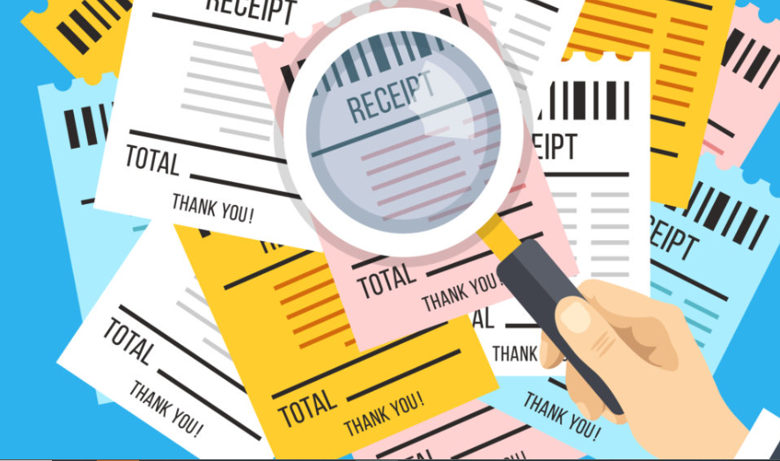
A lot of transactions take place in the day-to-day operations of a business. Therefore, an acknowledgment to confirm the receipt of the message becomes imperative for the vendors and the business owners alike.
However, the usage of the expression “please confirm receipt” requires a more nuanced understanding before its application. If you’re looking for enhancing your business correspondence, this article will undoubtedly come in handy.

What’s in this article?
- “Please confirm receipt”: what does it mean?
- Please confirm receipt: samples of usage
- Variation options for “please confirm receipt”
- Conclusion

“Please confirm receipt”: what does it mean?
“Please confirm receipt” is an expression commonly used in business correspondence. In addition, it is used for acknowledgment of the receipt of a message or a payment by the sender.

Confirm Payment Receipts in your email
Payment receipts piling up in your email can turn into a big issue for a small business.
As the owner of a small business, you will end up spending a lot of hours searching through these receipts for your accountant, and let’s be honest: You will probably miss a few that have been lost.
Welly Box solves that problem for you. It automatically collects and stores all of your digital receipts in an easily accessible format.
Try for Free
As a result, the term means to prompt the receiver to respond. It also means to confirm whether a piece of information, document or payment has been received successfully. Like a freelancer or a corporate firm, an individual usually uses this phrase to establish contact or note receipt.
Generally, formal messages or emails use “please confirm receipt” compared to casual writing or letters. The response from the recipient is significant in maintaining the books, essential record-keeping, and tracking of transactions. The acknowledgment becomes pivotal in claiming that the transaction is successful and valid.
“Please confirm receipt” is a common tenet of formal business correspondence. It is inappropriate to use the same expression in a casual setting, for example, with friends and family. In the case of an informal setting, phrases like “let me know when you receive it” are more appropriate.
The English dictionary has two kinds of meanings for the word “receipt”.
On the one hand, “receipt” links to a document or an invoice that usually indicates a transaction.
The second meaning in the English dictionary refers to receiving payment or services from a sender.
The meaning of the word depends on the context of its usage.

Please confirm receipt: Examples of usage
“Please confirm receipt” could be used as below:
Dear “XYZ”,
Please confirm receipt of payment.
Thanks.



Please confirm receipt of this email
Many times, business operations involve the common task of acknowledging the receipt of various kinds of email. It plays a significant role in professional communication and record-keeping in businesses. It also prompts an affirmative response from the recipient to validate the transaction. Alternatively, it indicates that it is successfully complete. Writing an email to confirm receipt often gets daunting due to the change in digitized formats and interfaces.

How to reply to “please confirm receipt of this email?”
The expression “please confirm receipt of this email” is limited to transactions incurred or intimated via emailing tools. Therefore, the recipient must acknowledge affirming the request by the sender.
A typical example of “please confirm receipt of this email” looks like this:
Dear “ABC”,
I am writing to inform you that we would like to initiate business franchise operations with you.
We will discuss the propositions furthermore later this week.
Please confirm receipt of this email.
Best.
The recipient commonly answers the email by replying in two manners:
- Formal
Dear “XYZ”,
I have received the email/document/payment successfully.
Thank you.
2. Informal
Dear “XYZ”
Thank you/Acknowledged.
Please confirm due upon receipt.
Running a business comes with its fair share of invoice workload. While you may meet the job deadlines, the client can take a while to process the payment for the task. In such situations, it is advisable to set the terms of payment before the commencement of the work. The best method to implement this is through the use of the phrase “due upon receipt”.
“Please confirm due upon receipt” implies that the client must try to compensate as soon as the work meets completion. This is when the payment invoice is sent. This straightforward phrase requesting the pay due manages steady cash flow. It also indicates the client to make necessary payment arrangements in time to avoid any delays.
“Please confirm due upon receipt” is commonly used to establish a strengthened professional relationship with new clients. The phrase proves pivotal in record-keeping and tracking business transactions. Sometimes forgetfulness to charge or request due leads to delays in payments and inaccuracy in the business books.

How to reply to “please confirm due upon receipt?” (how to actually confirm the receipt)
The vendor or a business firm answers to confirm the receipt of the document or work. It is essential to keep in mind that the kind of conditions are agreed upon or requested for revision. It is essential to promptly notify the vendor that their communication has been received. After receiving the acknowledgment, the vendor can commence or continue the necessary job. Lastly, you must inform the client in case of any expected delays in payment or disagreements. This is done in the payment conditions as soon as prompted with “please confirm due upon receipt.”
The most significant advantage of using this phrase is that a speedy payment via bank transfer or credit card. It is expected that improves business correspondence and relations.
The recipient must acknowledge and communicate the same as early as possible. The receipt must be after receiving an email or an invoice carrying the message “please confirm due upon receipt”.
One of the correct examples of acknowledging the message is to write:
Dear XYZ
I agree and acknowledge the terms of the task.
Thank you.
The above email body will prompt the related person to commence or continue the work. They are expected to send it over as soon as it finishes. Once the document or task allotted is received, the client expects prompt payment and confirmation via email or letter. A payment initiation email or letter must include a few components like:
- Sender’s name
- Sender’s account
- Recipient’s name
- Recipient’s account
- Payment amount, in numbers and/or words
- Date of payment
- Method of payment – bank transfer, credit card payment, wire transfer
- Transaction number
It is also advisable to attach a copy of the invoice or refer to the dated invoice number. This enhances further transparency and clarity.
The following are the steps involved in verifying receipts:
- Gathering and Examining Documents
- Obtaining Statements and Conducting Interviews
- Seeking assistance from computers
- Making a Personal Information Request
- Gathering information from third parties

6.2. Processing and verifying bank entries
Banking practices in some countries rely heavily on magnetic media processing, electronic fund transfers, and direct bank involvement in settling outstanding debts. For these countries, the bank statement serves as the source document for all banking activity.
Bank statement processing consists of:
- Understanding transaction codes
- Working with bank statements
- Updating the reconciliation table
- Reconciling bank statements
- Posting bank statement transactions
- Reconciling bank statements manually
- Printing bank statement reports
The system accepts and clears transactions in the following tables:
- Accounts Receivable Ledger (F0311)
- Account Ledger (F0911)
- Account Ledger for Reconciliation worktable (F0911R)
The system also uses the following tables for bank statement information:
- Bank Statement Header (F0916)
- Bank Statement Detail (F0917)
The following illustrates how to process your bank statements.
Figure 58-1 How to Process Your Bank Statements

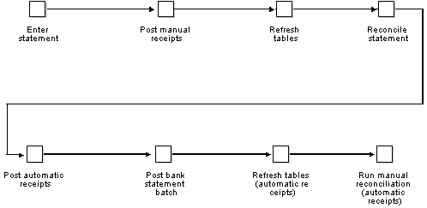
6.3. Reconciling bank statement
- The cash balance on a company’s books almost never matches the bank statement balances at the end of the month.
- Bank reconciliation is used to identify, justify and align these mismatches and provide the most accurate possible picture of cash flow.
- The reconciliation process requires business owners to understand some key accounting concepts, such as NSF checks and deposits in transit.
- Bank reconciliations should be done on a regular basis so that conflicting items don’t pile up, becoming more confusing and harder to fix.
- Software can help companies automate certain parts of the reconciliation process
Step-by-step guide to reconcile your bank statement
- Compare balances. Gather your accounting records for the time period covered by the bank statement.
- Identify differences.
- Resolve any issues.
- Adjust balances.
- Compare balances.
- Book adjusting journal entries.
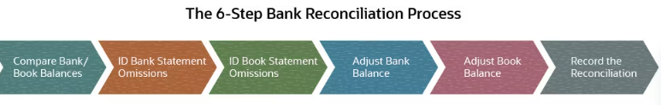
- Compare the bank account balance to the cash balance on your books. The first step in bank reconciliation is to look at the bank account statement and bookkeeping record side by side. For most businesses, the cash balances are not going to be the same. The difference could be a few hundred dollars, a few thousand dollars, or more depending on the size of the business and the type and magnitude of any un reconciled transactions.
- Scrutinize your bank statement. In this step, you are looking for the line items on the bank statement that aren’t reflected in the bookkeeping of the company’s cash accounts. Bank fees are an example of an item on the bank statement that may not be in the accounting records.
- Scrutinize your cash book. Next you want to figure out the cash-in or cash-out transactions that are on the company’s books but not listed on the bank statement. This may include deposits or payments recorded or made on the first or last day of the period that have not yet cleared. It may also include checks written that haven’t reached their recipients, or that the recipients haven’t deposited.
- Adjust the balance of your bank account. After identifying transactions in the general ledger that haven’t yet been processed by the bank, you can figure out how the balance in your bank account is expected to change in the next few days or as those transactions are recorded by the bank. Outstanding deposits will increase the amount of cash. Outstanding withdrawals decrease the cash in your bank account.
- Adjust the balance of your books. This is similar to step four, but here you manually adjust the company’s book balance for any unmatched transactions listed on the bank statement. Some of the transactions listed in the bank account, such as interest payments, will increase the balance on your books. Other transactions, like bank fees, will decrease the cash shown on your books.
- Record the reconciliation. There are two ways to record reconciliation, both of which apply only to the company’s books, not its bank account. The first is to put a simple note at the bottom of the cash book categorizing each discrepancy and showing the aggregate discrepancy in each category. The second is to compile a bank reconciliation statement. This is a more detailed document that shows the reason for each discrepancy from the bank balance. Where a cash book note might only show there was $100 worth of NSF checks in a given month, the bank reconciliation statement would break down the bounced checks by date, amount and payer.
Example of Bank Reconciliation
A hypothetical San Francisco home contractor, By the Bay Contracting, is doing reconciliation at the end of January. By the Bay’s bank account shows $106,800 but there is $120,000 in cash on the company’s books. The company’s accountant sets about reconciling the discrepancy. She notices $200 worth of bank fees that aren’t reflected on the company’s books and $13,000 worth of deposits in transit — checks from three separate home renovation clients that were received earlier in the week but that have not been deposited at the bank.
The accountant calculates that the bank account balance is going to end up at $119,800 once it includes the $13,000 of deposits in transit. At the same time, the cash balance of $120,000 on the company’s books will go down by the $200 in bank fees. She creates a bank reconciliation statement that itemizes both the $200 in unrecorded bank fees and the $13,000 in outstanding deposits. Bank Reconciliation Statement
Here’s an example of how By the Bay Contracting’s bank reconciliation would look.
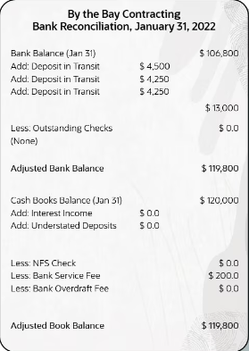
6.4. Producing and validating reports
What is process validation report?
What Is a Process Validation Report? A process validation report is a document that describes process validations performed in the manufacturing process of a product. This document shows evidence that a manufacturing process can deliver quality products consistently

Self-Check
1. What does Reconciling bank statement mean? Write the steps.
____________________________________________________________________________________________________________________________________________________________________________________________________________________________________________________________________________________________________________________________________________________________________________________________________________________________________________________________________________________
2. What are the steps involved in verifying receipts:
____________________________________________________________________________________________________________________________________________________________________________________________________________________________________________________________________________________________________________________________________________________________________________________________________________________________________________________________________________
3. A payment initiation email or letter must include a few components. What these components?
______________________________________________________________________________________________________________________________________________________________________________________________________________________________________________________________________________________________________________________________________________________________________________________________________________________________________________________________

Unit Seven: Process invoices, adjustment notes and other general ledger transactions
This Unit is developed to provide you the necessary information regarding the following content coverage and topics:
- .Issuing invoices to debtors and allocating invoices to creditors
- Receiving, processing and banking payments from debtors
- Processing and Making payments to creditors
- Raising and allocating adjustments
- Raising credit notes and entering other transactions
This unit will also assist you to attain the learning outcomes stated in the cover page. Specifically, upon completion of this learning guide, you will be able to:
- Issue invoices to debtors and allocating invoices to creditors
- Receive, processing and banking payments from debtors
- Process and Making payments to creditors
- Raise and allocating adjustments
- Raise credit notes and entering other transactions

7.1. Issuing invoices to debtors and allocating invoices to creditors
What are the 3 main steps involved in invoice processing?

Here are the steps for invoice processing:
- Capture, general ledger (GL) code, and match supporting documents such as a purchase order and/or delivery receipt.
- Send invoices to authorized approvers to approve or reject invoices.
- Authorize and submit invoices for payment in a financial system.
Invoice Processing Definition

Step 1. Receiving the Invoice
You made an order to your supplier and they delivered the goods and the accompanying invoice. The invoice processing starts the moment when you receive the invoice, even if the goods or services that you bought are delivered on some other occasion.
You can get a supplier invoice via mail or fax, but most frequently they arrive by email.
First, you should check it to make sure that all the necessary information is included: the date, the amount owed, the account number, and the billing period. If any of this information is missing, the invoice should be sent back to the sender for clarification.
If everything is verified, the invoice can be entered into the accounting system.

Step 2. Entering Data into System
Now here’s the tricky part. If you still manage invoices manually, you need to enter all of the relevant data into the system by hand, and you have to be very careful not to make a mistake. This part of the process is the most sensitive, as it can cause many errors and further disturbances across the general ledger. Manual data entry is time-consuming and very prone to errors.
That is why automated solutions use scanning and optical character recognition (OCR) technology to accurately capture data. OCR scans different formats of invoices like PDF or even image JPG formats.
Some AP processing solutions, like DOKKA, develop AI that learns how to read scans and secure fast transaction data entry with high accuracy.
Once the data is entered into the system, the original invoice is checked against other sources, like the purchase order that you made to the supplier before the invoice.

Step 3. Three-Way Matching
The 3-way matching process is a quality control measure to ensure that the three documents in an invoice paying process correspond:
- Purchase Order (PO) – the order or request for goods/services
- Delivery Receipt – the confirmation of delivery/receipt
- Invoice – the supplier’s invoice at the end of a transaction
Manually, you would take these three papers, put them in front of you and compare the details. Quantities and prices on a purchase order need to match those delivered and the ones that are listed on the invoice.
If the invoice data doesn’t correctly match the purchase order or delivery receipt, then the process stops and cannot continue until the supplier corrects the issue.

Step 4. Payment Approval
After you enter the invoice into the system and the 3-way matching is correct, the invoice is ready to be paid, so your next step is to get payment approval. Accounts Payable departments usually have authorized individual who formally approves payments.
Approval may involve the permission to release the company’s funds, write a check or initiate an electronic funds transfer, or authorize a supplier to charge the company’s credit card.
With AP processing solution like DOKKA, the approval process is fast and effective, and it happens in just a few clicks.

Step 5. Payment Processing
After all the approvals, the invoice is paid on the terms that are agreed upon with the supplier. It could be a wire transfer, credit card charge, or any other method that was determined before the conditions and terms took place.
In a manual process, you would send payment details to the adequate person who is in charge to do the transaction. Depending on the internal company structure, payments are usually the responsibility of AP departments, or in some cases of the purchasing department that issued the purchase order.
In automated solutions, workflows are predefined and the payment process happens when the system gets all the approvals.

Step 6. Storing the Invoice
The only thing left is to record the transaction into the general ledger and store the invoice properly to keep it organized and accessible for audits.
There are a few different ways to store invoices, but the most important thing is to ensure that they are stored in a way that makes them easy to find and retrieve. One option is to create a dedicated folder for each supplier, which can help to keep invoices organized and easy to find. Another option is to have an automated solution that takes care of that for you.
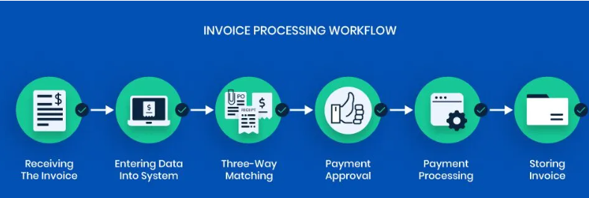
7.2. Receiving, processing and banking payments from debtors
What is the entry for payment received from debtors?
The entry will be: Cash A/c Dr. Debtor is personal account as per the traditional accounting concept. And the golden rule for personal account is, 'debit the receiver and credit the giver'.
7.3. Processing and Making payments to creditors
Payment is the performance of an obligation to pay money. A person under such an obligation is called a debtor, and a person to whom the obligation is owed is called a creditor. The obligation may arise in various ways, but it is most commonly the result of a commercial transaction or contract between the parties

What is a creditor?
The term creditor can mean different things depending on the situation, but it typically means a financial institution or person who is owed money.
If you’re the person who owes the money to a creditor, you may be referred to as a debtor or borrower.
Once a borrower and lender agree on terms for financing and sign a loan agreement, they’re entering into a contract. That contract often specifies the repayment agreement terms of the loan and the expected payment amounts.
You may hear the terms lender and creditor used interchangeably. The same goes for borrower and debtor. But you’ll more likely hear creditor and debtor used during legal proceedings where a creditor is trying to collect on an outstanding balance, such as during a bankruptcy case.
Ultimately, if a debtor can’t repay the funds borrowed, the creditor typically has the right to attempt recovery of what is owed, which is when repossession, foreclosure and debt collectors can come into play.

Examples of common creditors
There are several types of creditors, such as real creditors, personal creditors, secured creditors and unsecured creditors.
Real creditors: A real creditor is a financial institution, such as a bank or credit card issuer, that has a right to be repaid.
Personal creditors: These are friends or family you owe money.
Secured creditors: These lenders have a legal right — often through a lien — to property you used as collateral to secure the loan.
Unsecured creditors: A credit card issuer is a good example of this type of creditor. You may owe money, but it’s unsecured debt, meaning you haven’t agreed to give the creditor any property — such as a car or home — as collateral to secure your debt.

Examples of common debts
- Mortgage: A mortgage is a loan you take out from a financial institution to purchase a house. In this case, the creditor would be the financial institution that provides the borrower with the mortgage loan.
- Auto loans: Similar to a mortgage, an auto loan is a loan that someone takes out in order to purchase a vehicle.
- Student loans: Students who cannot afford the cost of tuition on their own can apply for financial aid, including student loans to cover expenses such as tuition, housing and books. When the time comes to repay the student loan, payments are made to the creditor.
- Credit cards: Credit cards offer a revolving credit line with a specified credit limit. The credit card issuer that extended the credit line could be the creditor if you have an outstanding balance.
- Personal loans: A personal loan is a loan — often unsecured — that can help you pay for a big project like home improvements or to consolidate debt. If you have an outstanding balance on the personal loan, the creditor is likely the lender that issued the loan.
7.4. Raising and allocating adjustments

Each year organizations determine budgets for pay adjustments. The process used to determine the size of the budget involves several considerations:

1. How much the organization can afford,

2. What competitors for talent are budgeting,

3. What the current position of pay structures and pay rates are compared to the prevailing market rates,

4. What the organization’s desired competitive posture is (pay above, at or below market and by how much) and

5. What the relationship is between current individual pay rates and what individuals should be paid relative to their pay range.
7.5. Raising credit notes and entering other transactions
A credit note can be raised for the full amount of an incorrect invoice (meaning it is now written off), and then another invoice issued to correct any mistakes

Key takeaways
A credit note is a financial document issued by supplier companies to reduce the amount owed to them by the buyers. It helps firms maintain a proper paper trail and is issued when the goods are returned, the price is under dispute, or when there are invoicing errors.
A credit note is a financial document issued by supplier companies to reduce the amount owed to them by the buyers. It helps firms maintain a proper paper trail and is issued when the goods are returned, the price is under dispute, or when there are invoicing errors.
The journal entry passed when a credit note is issued: Creditors' Account – Dr. To Goods Returned Account – Cr. A debit note is issued to the seller of goods by the purchaser while returning goods purchased while a credit note is issued to the purchaser of goods or the customer by the seller of goods.
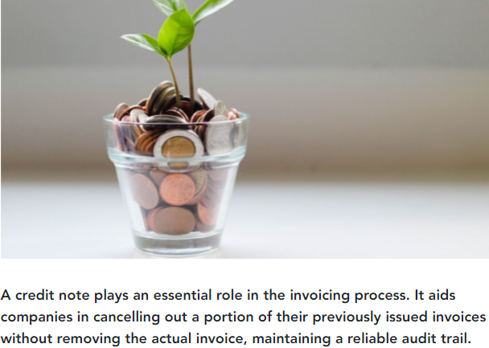

Self-Check
1._________________ can mean different things depending on the situation, but it typically means a financial institution or person who is owed money.
2._________________ is a financial document issued by supplier companies to reduce the amount owed to them by the buyers.
3. What are the common creditors?
___________________________________________________________________________________________________________________________________________________________________________________________________________________________________________________________________________________________________________________________________________________________________________________________________________________________________________________________________________________
4. What are the common Debtors?
______________________________________________________________________________________________________________________________________________________________________________________________________________________________________________________________________________________________________________________________________________________________________________________________________

Unit Eight: Manage contra entries
This Unit is developed to provide you the necessary information regarding the following content coverage and topics:
- Concept of Contacting relevant persons on contra deals
- Completing reporting procedures and documentation

This unit will also assist you to attain the learning outcomes stated in the cover page. Specifically, upon completion of this learning guide, you will be able to:
- .Concept of Contact relevant persons on contra deals
- .Complete report procedures and documentation

8.1. Concept of contacting relevant persons on contra deals
What is the meaning of contra deal?
What is a contra deal? Contra deals are a tried and tested marketing method that businesses have been using for years. Similar to bartering, contra deals, also known as contra partnerships, occur when two parties exchange goods or services, usually without handing over a payment.
Contra Deals means the provision of goods or services other than programme material in return for advertising airtime or sponsorship credits in on-air programmer features but what is a contra partner?
A Contra-Partnership is essentially a give and take relationship. They are business deals which do not include monetary interactions.including prizes.
The contra meaning is closely related to the traditional concept of bartering or trading. This means that a customer and supplier might be the one and the same, with both parties trading goods or services of equal value.
What does Contra mean in payment?
The contra account is a holding account designed for situations where money comes into your bank account and then goes straight back out, or vice versa. For example, a bounced cheque or money paid to the business in error and then refunded.
What are the types of contra transactions?
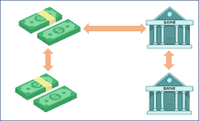
As illustrated in the above image, the following is the list of contra transactions:
- Cash account to Bank account.
- Bank account to Cash account.
- Bank account to Bank account.
- Cash account to Cash account
What are the two examples of contra entry?
Some transactions that can lead to contra entry are provided below.
- Opening of a bank account.
- Depositing cash into bank.
- Withdrawal from bank.
8.2. Completing reporting procedures and documentation
What is reporting and documentation?
Reporting is oral communication between care providers that follows a structured format and typically occurs at the start and end of every shift or whenever there is a significant change in the resident. Documentation is a legal record of patient care completed in a paper chart or electronic health record (EHR).
What are Financial Reporting procedures?
Financial reporting aims to track analyses and report your business income. This helps you and any investors make informed decisions about how to manage the business. These reports examine resource usage and cash flow to assess the financial health of the business
A simple reporting procedure will help you obtain important information about health and safety issues in the workplace identify problems when they arise, and address them. Safety reporting procedures make it simpler for you and your workers to manage safety
What are the 5 steps of Financial Reporting?
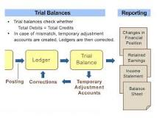
Defining the accounting cycle with steps: (1) Financial transactions, (2) Journal entries, (3) Posting to the Ledger, (4) Trial Balance Period, and (5) Reporting Period with Financial Reporting and Auditing.
What is process documentation?
Process documentation involves outlining each step needed when completing tasks or processes. It's an internal document of the lifecycle of your processes. Documenting processes is more about how each task is implemented rather than what the task impacts.
May include but not limited to :
1.accountants
2. Debtors 3. Directors 4. managers 5.owners 6.staff members

Your firm essentially is a conglomeration of intertwined processes—if the exact "how" aren't written down in a document staff members can reference, steps can get lost. Your processes are repeatable and fundamental to your success, so documenting processes serves as a guide for you and your staff to reference as needed.
Relevant person

Self-Check
1.__________________ account is a holding account designed for situations where money comes into your bank account and then goes straight back out, or vice versa
2. What are the 5 steps of Financial Reporting?

____________________________________________________________________________________________________________________________________________________________
3.__________________ oral communication between care a provider that follows a structured format and typically occurs at the start and end of every shift or whenever there is a significant change in the resident.
4.______________________ Documentation is a legal record of patient care completed in a paper chart or electronic health record (EHR).

Unit Nine: Identify and process bad debts
This Unit is developed to provide you the necessary information regarding the following content coverage and topics:
- Verifying bad debt status
- Completing reporting procedures and documentation
This unit will also assist you to attain the learning outcomes stated in the cover page. Specifically, upon completion of this learning guide, you will be able to:
- Verify bad debt status
- Complete report procedures and documentation

9.1. Verifying bad debt status

What Is Bad Debt?
Bad debt is an amount of money that a creditor must write off if a borrower defaults on the loans. If a creditor has a bad debt on the books, it becomes uncollectible and is recorded as a charge-off. Bad debt is a contingency that must be accounted for by all businesses that extend credit to customers, as there is always a risk that payment won't be collected. These entities can estimate how much of their receivables may become uncollectible by using either the accounts receivable (AR) aging method or the percentage of sales method.

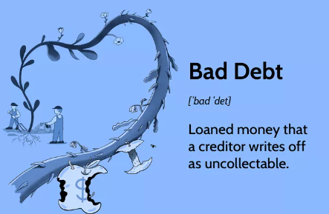
Simply put, a bad debt is a type of expense that occurs after repayment by a customer (when credit has been extended) is no longer considered to be collectable. In other words, bad debt is an irrecoverable receivable. Any businesses that extend credit to their customers must account for the possibility of bad debt, as there’s always a chance that your customer’s circumstances will change and they won’t be able to complete payment as agreed.
Why do bad debts happen?
There are a broad range of reasons why you may end up dealing with a bad debt. In some cases, you may have simply extended credit to an unsuitable customer. If this is the case, you should look to tighten up your credit policy to stop it from happening in the future. It could also be the result of fraud wherein your business has been deliberately targeted by criminals. In most cases, however, the reason is simple: the customer simply cannot pay your bill due to insolvency or bankruptcy.
How to record a bad debt
There are two main ways that you can record a bad debt in accounting. These methods are as follows:
- Bad debt write-off
- Bad debt provision
It’s important to note that the bad debt write off method doesn’t adhere to the matching principle associated with generally accepted accounting principles (GAAP). Therefore, if you’re using GAAP for accounting, you’ll need to use the bad debt provision method instead. Most businesses based in the UK use international financial reporting standards (IFRS) instead of GAAP, but it’s important to remember that the way you record bad debt expenses may differ depending on the country you’re based in.
Here’s a little more information about these accounting methods of recording bad debt expenses:
Bad debt write-off method explained
Bad debt write-offs are used when you have a specific and recognizable bad debt on your accounts, i.e. you know that the debt is irrecoverable. In the bad debt write-off method, you’ll debit the bad debt expense for the amount of the write off and credit the accounts receivable asset account for the same amount.
Bad debt provision method explained
A bad debt provision or allowance, also known as a provision for doubtful debts, is an accounting method that requires you to estimate the amount of bad debt that you’ll need to write off in any given period. In essence, you’ll charge an estimated amount of accounts receivable to bad debt expense, before debiting the bad debt expense for the estimated amount of the write-off. Finally, you’ll credit the same amount to the bad debt provision contra account.
Why is it important to understand bad debts?
Thriving businesses can run into difficulty at the drop of a hat, and reliable customers who always pay their debts can become problematic non-payers within a relatively short space of time. As a result, it’s always important to be prepared to deal with bad debt expenses. Furthermore, businesses are judged by potential investors on their financial statements, which means that a bad debt could make your business look like it isn’t doing as well as it is in reality. Consequently, it’s important to classify bad debts as bad debts so that investors can see that all your accounts are in good order.
How to Record Bad Debts
Recording bad debt involves a debit and a credit entry. Here's how it's done:
- A debit entry is made to a bad debt expense
- An offsetting credit entry is made to a contra asset account, which is also referred to as the allowance for doubtful accounts
The allowance for doubtful accounts nets against the total AR presented on the balance sheet to reflect only the amount estimated to be collectible. This allowance accumulates across accounting periods and may be adjusted based on the balance in the account.
Payments received later for bad debts that have already been written off are booked as bad debt recovery.
Methods of Estimating Bad Debt
We've established that bad debts must be recorded. But what amounts are listed on corporate financial statements? This involves estimating uncollectible balances using one of two methods. This can be done through statistical modeling using an AR aging method or through a percentage of net sales. We've highlighted the basics of each below.
Accounts Receivable Aging Method
The AR aging method groups all outstanding accounts receivable by age, and specific percentages are applied to each group. The aggregate of all groups' results is the estimated uncollectible amount. This method determines the expected losses to delinquent and bad debt by using a company's historical data and data from the industry as a whole. The specific percentage typically increases as the age of the receivable increases to reflect rising default risk and decreasing collectability.
Let's say a company has $70,000 of accounts receivable less than 30 days outstanding and $30,000 of accounts receivable more than 30 days outstanding. Based on previous experience, 1% of AR less than 30 days old will not be collectible, and 4% of AR at least 30 days old will be uncollectible.
This means the company must report an allowance and bad debt expense of $1,900. This is calculated as:
($70,000 x 1%) + ($30,000 x 4%)
If the next accounting period results in an estimated allowance of $2,500 based on outstanding accounts receivable, only $600 ($2,500 - $1,900) will be the bad debt expense in the second period.
Percentage of Sales Method
A bad debt expense can be estimated by taking a percentage of net sales based on the company’s historical experience with bad debt. This method applies a flat percentage to the total dollar amount of sales for the period. Companies regularly make changes to the allowance for doubtful accounts so that they correspond with the current statistical modeling allowances.
Using the example above, let's say a company expects that 3% of net sales are not collectible. If the total net sales for the period are $100,000, the company establishes an allowance for doubtful accounts for $3,000 while simultaneously reporting $3,000 in bad debt expense.
If the following accounting period results in net sales of $80,000, an additional $2,400 is reported in the allowance for doubtful accounts, and $2,400 is recorded in the second period in bad debt expense. The aggregate balance in the allowance for doubtful accounts after these two periods is $5,400.
What Is Bad Debt in Accounting?
Bad debt is debt that creditor companies and individuals can write off as uncollectible.
9.2. Completing reporting procedures and documentation
What is reporting and documentation?
Reporting is oral communication between care providers that follows a structured format and typically occurs at the start and end of every shift or whenever there is a significant change in the resident.
Documentation is a legal record of patient care completed in a paper chart or electronic health record (EHR).
Documentation is essential to quality and process control there needs to be some level of cohesion so that you don't look sloppy or uninformed. Documentation encourages knowledge sharing, which empowers your team to understand how processes work and what finished projects typically look like.

Documentation
- Serves as a permanent record of client information and care.

Reporting
- Takes place when two or more people share information about client care, either face to face or by telephone

Guidelines for Good Documentation and Reporting
- Fact – information about clients and their care must be factual. A record should contain descriptive, objective information about what a nurse sees, hears, feels and smells
- Accuracy – information must be accurate so that health team members have confidence in it
- Completeness – the information within a record or a report should be complete, containing concise and thorough information about a client’s care. Concise data are easy to understand
- Correctness’ – ongoing decisions about care must be based on currently reported information.
  - At the time of occurrence include the following:
    - Vital signs
    - Administration of medications and treatments
    - Preparation of diagnostic tests or surgery
    - Change in status
    - Admission, transfer, discharge or death of a client
    - Treatment for a sudden change in status
- Organization – the nurse communicate in a logical format or order
- Confidentiality – a confidential communication is information given by one person to another with trust and confidence that such information will not be disclosed

Documentation
- Anything written or printed that is relied on as a record of proof fro authorized persons.

Purposes of Records
- Communication
- Planning Client Care
- Auditing Health Agencies
- Research
- Education
- Reimbursement
- Legal Documentation
- Health Care Analysis

Documentation Systems
- Source – Oriented Record
  - The traditional client record
  - Each person or department makes notations in a separate section or sections of the client’s chart
  - It is convenient because care providers from each discipline can easily locate the forms on which to record data and it is easy to trace the information
  - Example: the admissions department has an admission sheet; the physician has a physician’s order sheet, a physician’s history sheet & progress notes
  - NARRATIVE CHARTING is a traditional part of the source-oriented record
- Problem – Oriented Medical Record (POMR)
  - Established by Lawrence Weed
  - The data are arranged according to the problems the client has rather than the source of the information.
    - The four (4) basic components:
      - Database – consists of all information known about the client when the client first enters the health care agency. It includes the nursing assessment, the physician’s history, social & family data
      - Problem List – derived from the database. Usually kept at the front of the chart & serves as an index to the numbered entries in the progress notes. Problems are listed in the order in which they are identified & the list is continually updated as new problems are identified & others resolved
      - Plan of Care – care plans are generated by the person who lists the problems. Physician’s write physician’s orders or medical care plans; nurses write nursing orders or nursing care plans
      - Progress Notes – chart entry made by all health professionals involved in a client’s care; they all use the same type of sheet fro notes. Numbered to correspond to the problems on the problem list and may be lettered for the type of data
    - Example: SOAP Format or SOAPIE and SOAPIER
      - S – Subjective data
      - O – Objective data
      - A – Assessment
      - P – Plan
      - I – Intervention
      - E – Evaluation
      - R- Revision
  - Advantages of POMR:
    - It encourages collaboration
    - Problem list in the front of the chart alerts caregivers to the client’s needs & makes it easier to track the status of each problem.
  - Disadvantages of POMR:
    - Caregivers differ in their ability to use the required charting format
    - Takes constant vigilance to maintain an up-to-date problem list
    - Somewhat inefficient because assessments & interventions that apply to more than one problem must be repeated.
- PIE (Problems, Interventions, and Evaluation)
  - Groups information in to three (3) categories
  - This system consists of a client care assessment floe sheet & progress notes
  - FLOW SHEET – uses specific assessment criteria in a particular format, such as human needs or functional health patterns
  - Eliminate the traditional care plan & incorporate an ongoing care plan into the progress notes
- Focus Charting
  - Intended to make the client & client concerns & strengths the focus of care
  - Three (3) columns for recording are usually used: date & time, focus & progress notes
- Charting by Exception
  - Documentation system in which only abnormal or significant findings or exceptions to norms are recorded
  - Incorporates three (3) key elements:
    - Flow sheets
    - Standards of business care
    - Bedside access to chart forms
- Computerized Documentation
  - Developed as a way to manage the huge volume of information required in contemporary health care
  - Business use computers to store the client’s database, add new data, create & revise care plans & document client progress.
- Case Management
  - Emphasizes quality, cost-effective care delivered within an established length of stay
  - Uses a multidisciplinary approach to planning & documenting client care, using critical pathways.

Self-Check
Explain the Guidelines for Good Documentation and Reporting
1._______________________________________________________________________________________________________________________________________________________________________________________________________________________________________________________________________________________________________________________________________________________________________________________________________________________________________________________________________________________________________________________________________________________________________________________________________________________________________________________________________________________________________________________
2. Let's say a company has $60,000 of accounts receivable less than 30 days outstanding and $20,000 of accounts receivable more than 30 days outstanding. Based on previous experience, 1% of AR less than 30 days old will not be collectible, and 3% of AR at least 30 days old will be uncollectible.
This means the company must report an allowance and bad debt expense of $1,900.
A. Find the Accounts Receivable Aging Method &
B. If the next accounting period results in an estimated allowance of $2,500 based on outstanding accounts receivable, what is bad expense second period?

Unit Ten: Manage debt recovery
This Unit is developed to provide you the necessary information regarding the following content coverage and topics:
- Reviewing activities and communication with debtors
- Undertaking measures to collect monies
This unit will also assist you to attain the learning outcomes stated in the cover page. Specifically, upon completion of this learning guide, you will be able to:
- Review activities and communication with debtors
- Undertake measures to collect monies

10.1. Reviewing activities and communication with debtors
Debt recovery and debt collection are similar terms with one small, but very important distinction. The difference is who is trying to retrieve a debt.
Debt collection is when a creditor attempts to recover consumer credit and loans that have not been paid back by a customer.
Debt recovery is when a loan – such as a credit card balance – continues to go unpaid, and the creditor hires a third party, known as a collection service, to focus on collecting the money.
Debt recovery is sometimes called loan recovery, but the purpose of both is exactly the same: find a way to make you pay back the money you borrowed
Debt (or loan) recovery is important because it is directly correlated to your credit score. If a debt recovery service is contacting you, it means there is a record that you have defaulted on a loan and currently have delinquencies. These delinquencies get reported to the credit bureaus, damaging your credit score, which can potentially hurt any future loan opportunities.
There are several steps in the debt recovery process, and it is important to know what to expect when a debt recovery agent contacts you. In fact, because financial debt can be a sticky situation, legislation has been established to guide the debt recovery process and ensure that consumers are protected from harassing debt recovery practices.
Debt Recovery Terminology:
- Debtor: Person obligated to pay back money that was borrowed.
- Creditor: Person who extends credit with an agreement that the money loaned will be paid back.
- Third party collector: Person or service that is contracted to collect debts for a creditor.
The Debt Collection Process
The debt collection process starts when there is a missed payment on a credit card or loan. The debtor has 30 days from the bill due date (not the billing date) to make the payment before it is reported to the credit bureaus. During this time, the creditor will try to contact the debtor by phone, email, or letter to get their payment and any late fees. It’s best to take care of the debt during this 30-day window. The debtor can explain his/her situation and set up a repayment plan.
After 30 days, the debt is handed off to another department at the same company that specializes in retrieving delinquent debt. This isn’t a collection agency, just a department within the lending company. They could report your delinquency to a credit bureau and shut down your credit card account.
After 180 days, the creditor usually will contract the debt or write it off their books and sell it to a debt collection agency. Be aware that the creditor might contract or sell the debt at any time before the 180 days, so it’s best to act sooner rather than later.
Debt Recovery Process
Once the debt belongs to a collection agency, the creditor will send the claim information and supporting documentation to the debt collector noting your failure to pay according to the terms of the agreement. After the claim is reviewed and accepted by the debt collection service, the recovery process begins with a demand letter being sent to the debtor and an acknowledgement letter being sent to the client (creditor who enlisted the collection service).
What steps should be used for debt recovery?
- Letter of demand. A letter of demand is the first debt recovery step to take. ...
- Summons. Step two ramps things up a few notches with a summons. ...
- Default judgment. If the debtor fails to appear in court or respond to the summons, you move things along to step three.
- Warrant of execution.
- Garnishee order.
- Business rescue.
The account is now active, and the debt recovery efforts swing into high gear through several methods.
The first is usually via telephone in an attempt to arrange payment for the outstanding balance and ensure that the payments are realized.
If the debtor does not cooperate with resolving the debt, the debt collection service updates the client with details on forwarding the claim to the affiliated attorneys. The forwarded claim is signed by the client and sent to the affiliated attorneys, and if attorneys recommend legal action, suit requirements are provided.
If the client authorizes legal action and agrees upon suit requirements, the lawsuit is prepared and filed. If the client doesn’t want to pursue legal action, the claim is worked on for an additional 60 days by the debt collection service and then closed.
If debtor files a response, the discovery process begins, and a trial date is set. If debtor does not respond, a default judgment is filed by the attorneys.
If a judgment is awarded in the client’s favor, attorneys will file a Writ of Attachment, attempt to locate debtor’s assets, and initiate steps to satisfy the judgment, which most often comes in the form of bank levies, garnishments, liens, etc.
How do you communicate with debtors?
A hard copy letter sent by post remains the most authoritative form of communication for debt collection. It's also the most likely to be read, particularly if it's sent by some form of registered or signed-for mail service.
The following steps can help facilitate effective communication during debt collection:
- Preparation.
- Active Listening.
- Empathy and Understanding.
- Negotiation and Persuasion.
- Follow-up.
- The evasive debtor.
- The angry or aggressive debtor.
- The emotional debtor.
Debt collection is an essential process that helps businesses recover outstanding payments from their clients. The process of debt collection is made up of many key elements, one of which is the way in which you communicate.
Effective communication plays a critical role in the debt collection process, as it can determine the success or failure of debt recovery efforts.
The Communication Process in Debt Collection
Effective communication during debt collection can make all the difference and often involves understanding the debtor’s perspective, building a rapport, and negotiating a payment plan that suits both parties.
The following steps can help facilitate effective communication during debt collection:
Preparation
Before contacting the debtor, it’s crucial to prepare by reviewing the debtor’s payment history, outstanding invoices, and any correspondence related to the debt. This information can help you understand the debtor’s financial situation and devise an appropriate payment plan.
Active Listening
During communication, it’s essential to actively listen to the debtor’s concerns and acknowledge their situation. This can help build trust and increase the likelihood of successful debt recovery. Every situation is unique and while they may have an outstanding payment that is causing you frustration, it’s best to understand as much about their situation as possible.
Empathy and Understanding
Empathy and understanding can help create a more positive and cooperative environment during communication. It’s crucial to acknowledge the debtor’s situation and offer support and guidance towards resolving the debt. Building up the trust and learning about them can make them also feel empathetic towards you too.
Negotiation and Persuasion
Negotiation and persuasion are essential skills in debt collection. It’s important to be firm but respectful when negotiating payment plans and persuading debtors to fulfill their financial obligations.
Follow-up
Following up regularly and promptly can help ensure that debt recovery efforts remain on track. It’s important to keep the debtor informed about any progress made and follow up on any promises made during communication.
10.2. Undertaking measures to collect monies
The typical collections process includes the following steps:
- Overdue invoice is assigned. When an invoice becomes overdue for payment, it is typically assigned to an employee for collection activities.
- Verify past due amount. There may need to be some homework, and some adjustment, to the past due invoice if there are deductions to account for, product returns, or marketing promotions or special incentives that were offered.
- Issue dunning letters. Dunning letters, notifications to a customer that an account is past due, are usually sent at fixed intervals. Dunning letters are generally printed and sent through the postal service.
- Call the customer. In conjunction with the dunning letters, phone calls are placed to customers to discuss the reasons for lack of payment.
- Settle payment arrangements. This may take the format of instant payment over the phone, or an extension of payment deadline, or new terms for the payment arrangement.
- Adjust credit limit. Depending on the customer’s payment situation and history with the business, a review of their current credit limit may take place, and adjustments made per the credit team’s discretion and policy.
- Monitor payments under settlement arrangements. If there are special payment plans, businesses want to stay on top of the new arrangements and contact customers as soon as it appears that they will miss a scheduled payment date. This level of monitoring is required to keep customers from delaying their payments.
- Refer to a collection agency. Once all other in-house collection techniques have been attempted, many businesses shift invoices to a collection agency. At this point, the customer is often placed on a credit hold list.
- Sue the customer. If all other alternatives have failed, a business may authorize the legal staff to proceed with a lawsuit against the customer in an attempt to reclaim the debt.
- Write off remaining balance. If all collections techniques have failed, businesses may write off the overdue amount as bad debt.
What is the Cost of Collections?
The cost of collections
Collections are an expensive and labor intensive process. It’s a needed investment because the business’ cash flow is at stake, and the sooner overdue debt is collected, the healthier the business. A structured and diligent collections process can be the difference between a thriving and a dying business when you consider the data:
- An account that is 90 days past due has a 69.6% chance of being paid
- An account that is 180 days past due has a 52.1% chance of being paid
- After one year of delinquency, the chance of collecting payment falls to 22.8%
Although typically a last resort, businesses will turn to collections agencies to reclaim their debt. Debt collectors only get paid when they recover an outstanding debt, and when they do, it comes at a cost of anywhere from 25%-45% of the total amount owed.
One of the best ways to manage your collections comes before you even extend credit. Having a thorough and clear credit assessment process can minimize the risk in your collections process. Assessing credit risk takes into account the payment performance history of customers, allowing the business to be selective about whom they extend credit to. If there is an intelligent credit risk management process, then collection of accounts receivable should be less demanding.
The key to successful collections is clarity in the process and frequent, open communications with customers. The collections process can be a sensitive time for customer communications, and the more you offer consistency and professionalism in the process, the more your customers will want to work with you and take care of their debts. At the end of the day, the success of business is all about how it takes care of its customers.

Self-Check
1. What is Communication Process in Debt Collection?
_________________________________________________________________________________________________________________________________________________________________________________________________________________________________________________________________________________________________________________________________________________________________________________________________________________________________________________________________________________________________________________________________________________________________
2. Write correct order of the typical collections process includes the following steps
A._____________________________________________
B._____________________________________________
C.____________________________________________
D.___________________________________________
F.____________________________________________
G.___________________________________________
H.___________________________________________
I.____________________________________________
J.____________________________________________
K.___________________________________________

Unit Eleven: Prepare trial balance and Financial reports
This Unit is developed to provide you the necessary information regarding the following content coverage and topics:
- Producing and validating transactions reports
- Producing reports and reconciling debtors and creditors
- Producing and reporting trial balance
This unit will also assist you to attain the learning outcomes stated in the cover page. Specifically, upon completion of this learning guide, you will be able to:
- Produce and validating transactions reports
- Produce reports and reconciling debtors and creditors
- Produce and reporting trial balance

11.1. Producing and validating transactions reports
What is the process of validating transactions?
Transaction validation is the process of determining if a transaction conforms to specific rules to deem it as valid. Validators check if transactions meet protocol requirements before adding the transactions to the distributed ledger as part of the validating process.
Transaction reporting requires reports to be generated, following certain transactions, containing complete and accurate information on the types of instruments traded, when and how the instruments are traded and by whom.
Transaction validation is the process of determining if a transaction conforms to specific rules to deem it as valid. Validators check if transactions meet protocol requirements before adding the transactions to the distributed ledger as part of the validating process.
This validation process is carried out by nodes who store full copies of the block chain. When nodes validate a transaction, it is added to the mempool (short for memory pool). In a proof of work network, miners are incentivized by transaction fees to confirm these transactions by including them in a block in the block chain, establishing a clear chronological record of when the transaction occurred so that a later transaction cannot spend the same coins as in the original.
A transaction is considered valid if the sender in the transaction has an initial balance in their wallet equal to or greater than the amount is being sent in the transaction (including the transaction fee). Other rules can exist depending on the specific protocol in question, but this rule is generally applicable to all protocols.
11.2. Producing reports and reconciling debtors and creditors
The balance in the prepaid insurance account, before adjustment at the end of the year is $ 7225. Journalize the adjusting entry required under each of the following alternatives for determining the amount of the adjustment.
A. the amount of insurance expired during the year is $4900
B. the amount of unexpired insurance applicable to future periods is $2325.
2. A business enterprise pays weekly salaries of $ 12000 on Friday for a five-day week ending on that day. Journalize the necessary adjusting entry at the end of the fiscal period, assuming that the fiscal period ends on
A. Monday
B. Wednesday
3. The balance of the supplies account, before adjustment at the end of the year, is $ 2750. The inventory of supplies at the end of the year was determined to be $600. Journalize the adjusting entry required at the end of the year to recognize supplies used during the year.
Solution
1. A. Insurance Expense----------------------------------4900
Prepaid insurance --------------------------------4900
B. Insurance expense (7225-2325) -----------------4900
Prepaid insurance --------------------------------4900
2. Daily salary=12000 ÷5=2400
A. Since Monday is the first day of the week, the amount of salary is $ 2400. If we assume Monday is the last day of the fiscal period, the following adjusting entry is need:
Salary Expense-----------------------------2400
Salary payable--------------------2400
B. Wednesday is the third day of the week. So the amount of salary to be paid as of this day is 2400x3= 7200. If we assume Wednesday is the last day of the fiscal period, the following adjusting entry is needed.
Salary expense----------------------------7200
Salary payable-------------------7200

3. Supplies expense (2750-600) -------------- 2150
Supplies --------------------------------2150
- What term is used to describe a delay of the recognition of an expense already paid or of revenue already received?
- What term is used to describe an expense that has not been paid or revenue that has not been received?
- Where would (a) accrued expenses and (b) accrued revenues, both due with in a year, appear on the balance sheet?
- Classify the following items as (a) prepaid expenses, (b) unearned revenue, (c) accrued expense, or (d) accrued revenue
- Utilities owed but not yet paid
- Fees received but not yet earned
- Salary owed but not yet due
- Storage fees earned but not yet received
- Fees earned but not yet received
- Taxes owed but payable in the following period
- Life insurance premiums received by an insurance company
8. Property taxes paid in advance
9. A two-year premium paid on a fire insurance policy
- Tuition collected in advance by a university.

Solution
- Deferral
- Accrual
- Current asset section
- 1. Accrued expense
2. Unearned revenue
3. Accrued expense
4. Accrued revenue
5. Accrued revenue
6. Accrued expense
7. Unearned revenue
8. Prepaid expenses
9. Prepaid expenses
10. Unearned revenue
11.3. Producing and reporting trial balance
The Trial Balance report is the sum of debits and credits for every account of your business on an accrual basis. It allows you to identify discrepancies in your account totals, produce financial statements and ensure that your accounts balance for a given period of time.
How do you produce accounts to a trial balance?
Here's how you can complete a trial balance of your own.
- Calculate the account balances for your ledger accounts.
- Record credit and debit balances on your trial balance.
- Calculate the total in your credit column.
- Calculate the total in your debit column.
- Compare your debit and credit totals.
- Look for errors.
What is a trial balance?
A trial balance is an internal report that includes all of the account balances in your general ledger. The word "trial" implies that this report is not actually a part of your official financial statements; instead, it is frequently done at the end of each reporting period to ensure that there are no mathematical errors in the ledger. It can also serve as a test to ensure accuracy before an audit.
Your trial balance shows you errors in your financial reports and helps you correct them before you face an official audit.
How does a trial balance work?
In a double-entry accounting system, you record your debits and credits in separate columns on your general ledger. For instance, you register a transaction when it occurs, then record the same transaction once you receive payment. All the ledger accounts must balance to zero.
The trial balance simply records all of the transactions listed in your general ledger accounts on a separate spreadsheet so you can ensure that your journal entries are balanced and accurate.
If they are not, your trial balance will serve as a red flag to indicate that something is wrong with your books, allowing you the chance to fix them.
What does a trial balance include?
A trial balance includes all your business accounts that have credits or debits during a given reporting period. It includes the amounts credited or debited to each account, the dates of the reporting period, the account numbers, and the totals for all credits and debits entered during that time.
Trial balances vary depending on your business, but may include:
- Income
- Assets
- Liabilities and expenses
- Accounts receivable
- Accounts payable
- Gains
- Losses
What is the difference between a trial balance and a balance sheet?
A trial balance should not be confused with an actual balance sheet. While a trial balance is used for internal management purposes, a balance sheet is an essential component of your company's financial statements.
A balance sheet should be prepared annually and distributed to investors or relevant financial institutions. And while a trial balance is prepared purely for your internal controls, a balance sheet is required to manage your company's finances.
How often should businesses create trial balances?
You should try to create a trial balance at least once every reporting period. This ensures that your books are correct and that you can withstand a financial audit.
In addition, any time you suspect an error in your books, you should quickly put together a trial balance to check that your debits and credits are correctly balanced.
Who uses a trial balance?
Accounting and bookkeeping professionals might use a trial balance to perform an internal audit of the company's finances. While modern accounting software can minimize data entry errors and similar mistakes, trial balances still have their uses among internal company leadership.
For example, senior management may appreciate regular trial balance reports, as they put the company's most important information in one place. Similarly, accounting teams might use trial balances when performing periodic reviews or when an error is suspected.
Trial balance format
While there are no formal requirements for a trial balance, it typically consists of at least three columns. The first column on the far left will include the names of each account listed on your general ledger. The next two columns will include your credit and debit balances.
You'll record your credit balances in the center column (the credit column), while your debit balances are recorded in the far right column (the debit column). The total credit balance will appear at the bottom of the columns.
When you prepare your trial balance, include as much detail as possible, such as the date of the accounting period. This information will help you stay organized if you need to refer to your previous trial balances.
Trial balance example
Here is what a trial balance might look like for Company X. The far left column will include the account names used in the company's accounting system:
- Cash Account
- Accounts Receivable
- Loans
- Revenue
- Employee Expenses
- Cost of Inventory
The credit column will include the credit balances for each of these accounts:
- Cash Account: $5,000
- Accounts Receivable: $15,000
- Accounts Payable: N/A
- Revenue: $100,000
- Employee Expenses: N/A
- Cost of Inventory: N/A
- Total: $120,000
The debit column will include the debit balances for these accounts:
- Cash Account: N/A
- Accounts Receivable: N/A
- Accounts Payable: $20,000
- Revenue: N/A
- Employee Expenses: $40,000
- Cost of Inventory: $60,000
- Total: $120,000
In this example, the debits equal credits ($120,000 and $120,000), which suggests that the debit and credit entries are accurate.
Types of trial balances
Trial balances come in three different types:
- Unadjusted trial balance
- Adjusted trial balance
- Post-closing trial balance
Each trial balance will follow the same format as above, but they are used in slightly different circumstances.
What is an unadjusted trial balance?
An unadjusted trial balance is done before adjusting journal entries are completed. This is a quick spot-check that records transactions. You can use this trial balance as a starting point to analyze your accounts before adjusting your journal entries.
What is an adjusted trial balance?
You can perform an adjusted trial balance once your book is balanced. This type of trial balance contains the final balances in all company accounts, and you can use it to prepare your official financial statements.
What is a post-closing trial balance?
A post-closing trial balance contains data on your total entries for the year. The post-closing trial balance thus becomes your starting trial balance for the next fiscal year.
Limits of a trial balance
While a trial balance can provide a helpful snapshot of your financial position, it's not a foolproof method of preventing all possible mistakes. Even if your debit and credit entries add up to zero, that doesn't mean they are correct.
These are some common examples of errors that can creep into your records without being detected by your trial balance:
- Duplication error: Transactions are recorded more than once
- Omissions: Transactions haven't been recorded in the books
- Errors of reversal: Transactions are recorded backward (credit and debit entries are flipped)
- Compensating error: Transactions contain two errors that happen to match
- Data entry errors: Transactions are recorded in the wrong account or as the wrong amount
Limitations aside, a trial balance can still be a valuable tool for evaluating your company's finances, and it can be helpful when you examine your company's financial statements.
How to prepare a trial balance
Preparing a trial balance is simple once you know the steps. Here's how you can complete a trial balance of your own.
1. Calculate the account balances for your ledger accounts
Your business transactions are initially recorded in your general ledger. Each transaction will receive its own journal entry connected to the corresponding account name.
Depending on your accounting system, you may need to combine multiple expenses and sources of income. For example, your accounts payable account may contain multiple smaller entries, which you'll need to total before transferring this data to your trial balance.
You'll also need to close each balance to ensure that you focus on a specific time — usually, the duration of your accounting cycle, whether monthly or quarterly. It's also possible to look at your balance for a shorter period.
2. Record credit and debit balances on your trial balance
Next, you'll transfer the closing balances from your ledger to your trial balance. Make sure that the accounts listed on your trial balance are the same as on your general ledger.
You'll record the total credit amounts in the left column (i.e., the column immediately to the right of your account names) and your total debit balance in the column on the far right.
Be careful! This is where you can make the mistake of recording items in the wrong column or even the wrong account. This will significantly alter the accuracy of your completed trial balance and cost you valuable time chasing down your mistake.
3. Calculate the total in your credit column
Calculate your total credits. If you've followed the above method, you can simply and quickly calculate all of the credit balances in your credit entry column. If you're preparing your trial balance with a spreadsheet software program like Microsoft Excel, you can insert a formula that will perform the calculation for you.
4. Calculate the total in your debit column
Perform the same calculation for your debit column. Again, this is simply a sum of all the debits of your accounts for that period.
5. Compare your debit and credit totals
Look at your completed totals. Ideally, your credit and debit balances should be identical. This indicates your books are correctly balanced. If you get two different numbers, don't panic. Finding discrepancies like this is why you created a trial balance, and discovering the error now can save you time and headaches later on.
6. Look for errors
You'll need to discover why when your numbers don't add up. First, check the trial balance for the most common errors. This check might reveal a basic manual data entry mistake or entries made in the wrong column or account.
Once you discover your error, repeat steps three through five to see whether your numbers now match. Repeat this process as necessary until you get matching totals.
7. Close your trial balance
Once you complete the process, you can close your trial balance. Save the document itself, this can be helpful if you need to perform the process again for a longer period.
Again, if you create your trial balances using spreadsheet software, you can save time by keeping a template that includes the basic mathematical formulas.

Prepare adjusting entries on January 31 for each item below
A. office supplies used $64,290. Acquisitions of office supplies were recorded in the inventory of office supplies ledger account.
B. Rent Revenue received in advance, $ 16200. Advance rent received is credited to the Rent Revenue ledger account.
C. Royalty revenue accrued from licensing a patent, $4,500.
- On June 30, the end of its fiscal year, an enterprise owed salaries of $ 12,500 for an incomplete payroll period. On the first payday on July, salaries of $ 20,900 are paid; (a) is the $ 12,500 a deferral or an accrual as of June 30?
(b) Which of the following types of accounts will be affected by the related adjusting entry: (1) assets (2) liability, (3) revenue, (4) expense?
- On January 2, an enterprise receives $ 24,000 from a tenant as rent for the current calendar year. The fiscal year of the enterprise is from April 1 to March 31.
(a) Which of the following types of accounts will be affected by the adjusting entry as of March 31: (1) assets (2) Liabilities, (3) revenue, (4) expense?
(b) How much of the $ 24,000 rent should be allocated to the current fiscal year ending March 31?
Solution
- A. Office Supplies Expense……………………………….64,290
Office Supplies…………………………………… 64,290
B. Unearned Rent…………………………………………16,200
Rent Revenue…………………………………….. 16,200
C. Royalty receivable……………………………………..4,500
Royalty revenue………………………………….. 4,500
- A. Accrual
B. Liabilities and Expense
- A. Liabilities and Revenue
B. $6,000

Self-Check
1.___________ the sum of debits and credits for every account of your business on an accrual basis. It allows you to identify discrepancies in your account totals, produce financial statements and ensure that your accounts balance for a given period of time
2. How you can complete a trial balance of your own. Mention the steps
1._________________________________________________________________2._________________________________________________________________3._________________________________________________________________4._________________________________________________________________5._________________________________________________________________6._________________________________________________________________7.________________________________________________________________

References
From d/t website
Web page
Mastering Bitcoin. O'Reilly | Safari. https://www.oreilly.com/library/view/mastering-bitcoin/9781491902639/ch02.html
https://jmacreditcontrol.com.au/blog/the-role-of-communication-in-debt-collection/
https://debitoor.com › dictionary

