ACCOUNTING AND FINANCE
LEVEL - IV
Based on 2022 curriculum V – I

Module title: Performing auditing and reporting
Module code: LSA ACF4 M09 0322
Nominal duration: 70hrs

Prepared by: Addis Ababa TVET bureau

September 2023
Addis Ababa Ethiopia

Table of Contents
Acknowledgment 3
INTRODUCTION 4
Introduction to the Module 5
Acronym 6
UNIT ONE PARTICIPATE IN PLANNING AN AUDIT 7
1.1 Identifying roles and responsibilities 8
1.2. Purpose and scope of audit 16
1.3 Identifying and locating resources of audit 17
Self-cheek 22
UNIT TWO PARTICIPATE IN CONDUCTING AN AUDIT 23
2.1 Collecting information for audit plan 24
2.2 Analysing information of audit 26
2.3 Reviewing Records 29
3.4 Observing compliance with the program 32
2.4 Identifying areas requiring corrective action 38
Self-cheek 39
UNIT THREE REPORT AND FOLLOW UP AUDIT OUTCOMES 40
3.1 Identifying and reporting Situations 41
Benefits of internal and external audits 41
3.2 Preparing audit reports 41
3.3 Communicating results of audit 63
Techniques used in the Communication Audit 64
3.4 Developing corrective action plan 66
Self-cheek 69
Reference 70

Acknowledgment
The Addis Ababa TVET bureau wishes to thank and appreciation for the trainers who donated their effort and time to develop this outcome based curriculum for the TVET Program Accounting and Finance Level IV. We also thank all Addis Ababa TVET College, Addis Ababa TVET bureau coordinators, all instructors who donated their time and expertise to the development of this Teaching, Training and Learning Materials (TTLM).

INTRODUCTION
Welcome to the module “Perform auditing and reporting”. This learner’s guide was prepared to help you achieve the required competence in “Accounting and finance Level IV”. This will be the source of information for you to acquire knowledge attitude and skills in this particular occupation with minimum supervision or help from your trainer.
A Perform auditing and reporting is assures the financial statements as it is issued by the professional having an unbiased opinion as he is not a part of the company's management. This report helps the users of the financial statements to get assured of the truth and fairness of the financial statement. Audit Report Contents are the basic structure of the audit report which needs to be clear, providing sufficient evidence providing the justification about the opinion of the auditors.

Introduction to the Module
This module describe Produce Job order and Process Costing System training course provide the skills and knowledge required to Participate in planning an audit, Participate in conducting an audit and Report and follow up audit outcomes
This module covers the units:
- Participate in planning an audit
- Participate in conducting an audit
- Report and follow up audit outcomes
Learning Objective of the Module
- To conduct audit activity
- To Participate audit planning
- To Identify audit outcomes and audit Report
Module Instruction
- For effective use this modules trainees are expected to follow the following module instruction:
- Read the information written in each unit
- Accomplish the Self-checks at the end of each unit
- Perform Operation Sheets which were provided at the end of units
- Red the identified reference book for examples and exercise

Acronym
CPA public accounting profession
GAAS generally accept auditing standards
GAAP generally accept accounting principle
IIA Institute of Internal Auditors
OAG office of the auditor general
NGO non-governmental organization

UNIT ONE PARTICIPATE IN PLANNING AN AUDIT
This unit is developed to provide you the necessary information regarding the following content coverage and topics:
- Identifying roles and responsibilities
- Purposing and scope of audit
- Identifying and locating resources
This unit will also assist you attain the learning outcomes stated in the cover page the completing of the learning guide you will able to:-
- Identify roles and responsibilities
- Analysis Purpose and scope of audit
- Identify and locating resources

  - Identifying roles and responsibilities
Introduction
This unit deals with the definition of Auditing, why there is a demand for Auditing by stock holders, managers, employees, and debt holders, what is the role of Internal Auditing in an organization; and deals with description of types of Audits commonly used by the professional Auditors. The public accounting profession (CPA), as we knew it today grew mainly out of the demand for financial statement Audits. Very specific auditing standards, referred to as generally accept auditing standards (GAAS), are provided for conducting financial statement audits. However, in recent years, the profession has been asked to provide services beyond the traditional financial Statement Audit. These include compliance and operational Audits.
Definition of Auditing
The American Accounting Association, committee on Basic Auditing concepts - Defined Auditing as:
Auditing is systematic process of objectively obtaining and evaluating evidence regarding assertions about economic actions and events to ascertain the degree of correspondence between assertions and established criteria and communicating the results to interested users.
The phrases in this definition require additional explanation. The phrase systematic process implies there should be a well-planned approach for conducting an audit. This plan involves objectively obtaining and evaluating evidence. The evidence gathered by the auditor must relate to assertions about economic actions and events. For example financial statements prepared by management contain numerous assertions.
If the Balance sheet contains amount of Br. 10million for property, plant and equipment, management is asserting (declaring) that the company owns the assets, uses them in the production of goods and services, and that this amount represents their un depreciated historical costs. The Auditor compares the evidence gathered to assertions about economic activity in order to assess the degree of correspondence between those assertions and established criteria. Generally Accepted Accounting Principles (GAAP) is normally used for measuring the degree of correspondence, for financial Audits. The last Phrase, communicating the results to interested Users, is concerned with the type of report the auditor provides to the intended users. (Banker, investors, stockholders, Creditors, etc
Audit objectives
The objective of the ordinary examination of financial statements by the auditor is expression of an opinion on the fairness of the financial statements. It is customary in the audit to identify audit objectives for the audit in general and for each account reported in the financial statements. These objectives are derived from management’s assertions. The auditor’s objectives are closely related to management assertions. Audit objectives are intended to provide a framework to help the auditor accumulate sufficient and competent evidence required by the third standard of fieldwork and decide the proper evidence to accumulate given the circumstances of the engagement.
Management Assertion | General Objective | Specific Audit Objective
Existence or Occurrence | Validity | All recorded inventory exist at the balance sheet date
Completeness | Completeness | All existing inventory has been included in the account
Rights and Obligations | Ownership | The company has title to all inventory items listed
Valuation or Allocation | Valuation | Inventory quantity agrees with items physical on hand
Valuation or Allocation | Valuation | Price used to value inventory are correct
Valuation or Allocation | classification | Inventory items are properly classified to raw material, work in process and finished goods
Valuation or Allocation | cutoff | Purchase and sales cut off at the end is proper
Valuation or Allocation | Mechanical accuracy | Total of inventory items agree with general ledger
Presentation and Disclosure | Disclosure | The pledge and consignment of inventory is disclosed
Completeness: - there are no unrecorded assets or liabilities, transaction or events.
Occurrence: - a transaction or event occurred during the relevant accounting period (i.e. has correct cut-off been applied?).
Measurement: - a transaction or event is recorded at the proper amount and in the correct period.
Ownership: - an asset pertains (i.e. belongs) to the entity.
Valuation: - the asset or liability is recorded at an appropriate carrying value.
Presentation and disclosure: - must be in accordance with the relevant legislation and accounting standards (i.e. the applicable financial reporting framework).
Demand for Audit
The essence of demand for audit refers to the question “why do organizations request an audit?” the answer to this question can be described as follows:
Control mechanism – audits whether important control mechanisms for accountability The auditors role is determining whether the reports prepared by management are in conformity with the responsibility and duties provided in the organization policies. The overall need for monitoring activities, need demands (requests) auditing to provide credible or Audited financial information, Audited performance reports, Audited implementation of rules, & regulations.
To resolve conflict of interest between management and the owners The Agency relationship that exists between the owner and manager produces a natural conflict of interest. Because, the manager has more information about the “True financial position and results of operations of the entity than the owner who is absentee It both parties seek to maximize their own self-interest, It is likely that the manager will not act in the best interest of the owner. Example The manager may spend organizational funds to provide excessive personal benefits or manipulate the reported earnings in order to earn a larger bonus. Thus, the need for Independent (non-partisan) opinions or view is necessary to resolve such conflicts.
To reduce damaging Consequences – Even though, the function of accounting is to provide information for economic decision making; this information must be verified by auditors, before they are used for decisions that have serious and subsequent factual economic consequences.
To simplify complexity – In our age, financial information & translation has been come complex in preparation, content, and format. Therefore it demands drippy specialized body of knowledge to prepare (compilation), verify and interpret them.
Regulatory requirements – many business laws, memo random of association and government regulation, make requirements’ annual audits For Example –For renewal of license, or permit, (commercial code to Ethiopia), financial Administration regulation proclamation tax, requires audited financial statements.
Internal Auditing
Internal auditing is a managerial control activity performed with an organization as service to management by an employee of the organization. It reviews operations through the measurement and evaluation of other control mechanisms. Their primary activities are to conduct compliance and operational audits within the organization. However, they assist the external auditor with the annual financial statement audit. Internal auditors are employed by Individual companies, partnerships, government agencies. The Institute of Internal Auditors (IIA) has developed set of standards that should be followed by internal auditors and Established certification program – which Includes passing of uniform writer examination. Like external auditors they must be Independent and objective.
Types of audit
While there are many types of audit based on the definitions previously provided, generally they are discussed under three types: financial statement audits, compliance audits and operational audits
Financial Statement Audits
The purpose of a financial statement audit is to determine whether the overall financial statements present fairly in accordance with specified criteria. This type of audit usually covers the basic set of financial statements (Balance sheet, Income statement, statement of stockholders equity, and statement of cash flows); and Generally Accepted Accounting principles (GAAP) serve as the criteria. However, certain financial statements audits may use of other criteria, such as cash basis or Income tax basis.
Types of audited financial statements:
1. Income Statement
An income statement shows the performance of the company during a fiscal year. The statement reports the revenue earned and expenses incurred during the period. On the last line, the report reveals the net profit or loss for the period. (This fact is actually the origin of the term, “bottom line”, as the bottom line on an income statement shows a company’s profit/loss for the year.) The earnings per share (EPS) figure may be included when the financial statements are issued by a publicly traded company. The auditor verifies the accuracy of transactions by cross-checking the cash book and individual books of accounts.
2. Balance Sheet
The balance sheet reports the financial position of the company at the end of the fiscal year (or at any other point in time a balance sheet is prepared; for example, companies are usually required to submit a balance sheet when applying for a loan).
It reveals the value of assets, liabilities, and equity of a company. The items in the assets and liabilities columns are typically presented in order of liquidity, with the most liquid items reported first. The auditor may verify the existence of assets and liabilities, and the accuracy of the figures presented
3. Cash Flow Statement
The cash flow statement may also be included in the audited financial statements. The cash flow statement reveals the cash inflows and outflows during the fiscal year. It provides an insight into the company’s ability to meet its short-term obligations and continue operating in the foreseeable future. The auditor may verify the entries in the cash flow statement against the bank statement and also check the accuracy of the footnotes.
Compliance Audits
The purpose of a compliance audit is to determine the extent to which rules, policies, Laws covenants, or governmental regulation are followed by the entity being audited for example, accompany may use auditors to determine whether the corporate rules, and policies are being followed by departments within the organization. The corporate rules and policies serve as the criteria for measuring the departments Compliance. Another example is examination of tax returns (payment) of individuals and companies by the Internal Revenue Service for compliance with Tax Laws.
Operational Audits
Operational Audit involves a systemic review of organizational activities, or apart of them, in relation to the efficient and effective use of resources. The purpose of operational audit is to assess performance, Identity areas of Improvement, and develop recommendations. Sometimes this type of audit is referred to as a performance audit or management audit. Operational audits are generally more difficult to conduct than financial and compliance audits. Since the purpose of an operational audit is to assess effectiveness and efficiency, it can be very difficult to identify objective, measurable criteria that can be used for that purpose.
Examples of such audit include – audit of government programs, Efficiency of the food and Drug administration’s procedures for Introduction of new Drugs, to market. Assessment of the efficiency and effectiveness of organizations use of computer resources etc
Types of Auditors
The most known types of auditors are
- Independent auditors
- Internal auditors
- Government auditors
Independent (external auditors): - Independent auditors have no connection to the firm as an owner or employee/manager. The basic task of independent auditor is to confirm to the owners that the employees are correctly reporting on their financial position and performance.
Internal auditor: - An internal auditor is paid salary as employee on the organization that is being audits. He/she is responsible to appraise and investigation the performance of unit and/or units within the organization and give recommendation to top management.
Government audit: - The government auditor is paid a salary by the government. He/she is responsible to the legislature or executive.
Auditing principle
Auditing principles are generally, guidelines that help direct or chart goals and aims. Principles are based on concepts or assumptions, and/or developed from particular observations. The following are the basic principles:
Integrity, objectivity and independence the auditor should be straightforward, honest, and sincere in his approach to his professional work.
Confidentiality: - the audit should respect the confidentiality of information acquired in the course of his work and should not disclose any such information to a third party without specific authority unless there is legal or professional duty to disclose.
Skills and competence: - the audit should be performed and the reports prepared with due professional care by persons who have adequate training, experience and competence in auditing.
Documentation: - the auditor should document matters which are important in providing evidence that the auditor was carried out with the basic principles.
Planning: - the auditor should plan his work to enable him to conduct an effective audit in efficient and timely manner
Audit evidence: - the auditor should obtain sufficient appropriate audit evidence through the performance of compliance and substantive procedures to enable him to draw conclusion there from and give opinion on the financial statements.
Accounting system and internal control: The auditor should gain or understanding of the accounting system and related internal controls to determine the nature, extent, and timing of audit procedures.
Audit standards
Standards are authoritative rules for measuring the quality of performance. The existence of generally accepted auditing standards is evidence that auditors are very concerned with the maintenance of a uniformly high quality of audit work by all independent public accountants.
The 10 GAAS are stated in their entirety as follows:
General standards
1. The examination is to be performed by a person or persons having adequate technical training and proficiency as auditor.
2. In all matters relating to the assignment, independence in mental attitude is to be maintained by the auditor or auditors.
3. Due professional care is to be exercised in the performance of the examination and the preparation of the report.
Standards of fieldwork
1. The work is to be adequately planned and assistants, if any, are to be properly supervised.
2. The auditor should obtain a sufficient understanding of the internal control structure to plan the audit and to determine the nature, extent and timing of tests to be performed.
3. Sufficient competent evidential matter is to be obtained through inspection, observation, inquiries, and confirmation to afford a reasonable basis for an opinion regarding the financial statements under examination.
Standards of reporting
1. The report shall state whether the financial statements are presented in accordance with generally accepted accounting principles.
2. The report shall identify those circumstances in which such principles have not been consistently observed in the current period in relation to the preceding period.
3. Informative disclosures in the financial statements are to be regarded as reasonably adequate unless otherwise stated in the report.
4. The report shall either contain an expression of opinion regarding the financial statements, taken as a whole, or an assertion to the effect than an opinion cannot be expressed.
Keep in mind, however, that these standards represent the minimum requirements for all audit engagements.
Nature of external auditing in Ethiopia
In Ethiopia audits seem to be done primary on account of government regulation. For example, NGOS are audited because the assets of the NGOS are deemed a “national asset,” the use of which is ultimately accountable to the government of Ethiopia.
Auditing in Ethiopia could be viewed in five main areas.
The office of the auditor general (OAG)
The powers and functions of the office of the OG are circumscribed through the proclamations that established it, its sphere of activity lies in government audit.
The audit service corporation the duty and functions of this entity involve mostly commercial audits of commercial and productive enterprises wholly or partially owned by government.
Private audit firms
Ministry of finance audit and inspection
Auditing activity in this area includes audit of ministries and government departments by MF auditors and inspectors, including tax audit by Inland Revenue authorities.
State corporations’ and enterprises’ auditors
These are audits performed by internal auditors within enterprise.
Roles and responsibilities of audit participants
An audit client is an organization or person requesting an audit. Typical roles of an audit client include:
- Initiates audit
- Determines audit purpose and scope
- Provide resources
- Receives the audit report
- Determine the report distribution
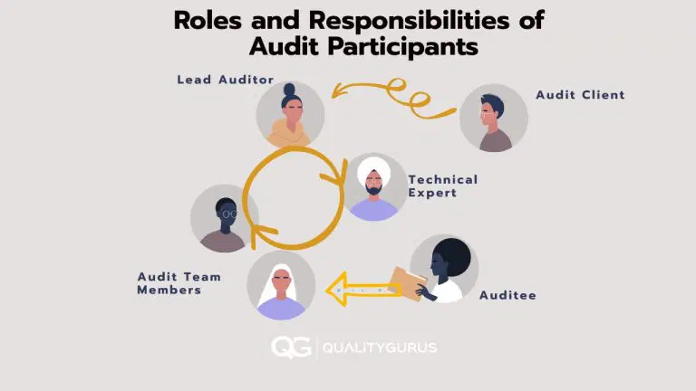
Auditor's Role
Auditors are responsible for verifying the implementation and effectiveness of the processes and procedures used by employees and contractors to meet the requirements of the QMS.
- Plans the audit
- Perform the audit
- Collect audit evidences
- Analyze audit evidences
- Follows up the action on audit findings


Auditees Roles
Auditees are an organization as a whole or parts thereof being audited. A typical role of an auditees includes the following:
- Inform the staff in the organization about the audit so that they are available for the audit.
- Provide resources to the audit team (interview room, communications and clerical support)
- Provide guides to the audit team (if needed)
- Show objective evidence when an auditor requests these
- Cooperate with the audit team
- Determine and initiate corrective actions (in case a non-conformity is identified)

1.2. Purpose and scope of audit
Introduction
An audit is an examination by one or more auditors of the records, documents, processes, procedures, etc., to determine whether those things comply with certain specified requirements. The requirements may be outlined in the internal work process, rule, regulation, contract, or other documents.
Audit Purpose
The purpose of an audit is to form a view on whether the information presented in the financial report, taken as a whole, reflects the financial position of the organisation at a given date, There are two main purposes of conducting an audit: Compliance and Improvement.
1. Compliance
The purpose of an audit is to determine if the entity being reviewed is complying with the requirements. If the entity is not in compliance, then corrective action must be taken to bring it into compliance. This is called remediation. Remediation is taking steps to correct problems found during an audit. It includes actions such as correcting errors, changing policies, training employees, and making changes in systems.
2. Improvement
An audit is conducted for the purpose of improvement when the auditor has determined that there are areas where the entity being examined could improve. These improvements may relate to any aspect of the operation of the entity. For example, they may involve improving customer service, increasing efficiency, reducing costs, or increasing profitability.
Audit Scope
Audit scope includes the time period of the audit, documents that are involved, physical location, organizational unit, and all the activities and the processes that will be conducted. It is the idea that deals with the depth of the audit process and how deep the auditor will dig in to get the relevant information.
Audit scope defines the extent and boundaries of an audit. Audit scopes vary depending on the type of audit being performed. An audit scope can also include additional information about the audit. The audit scope generally consists of a description of the following:
- plants, office locations to be audited
- functions to be audited
- organizational units to be audited
- activities and processes to be audited
- the period of activities covered by the audit
The scope of the review should be defined based on the following factors:
- The nature of the business activity being audited
- The complexity of the business activity being analysed
- The risk associated with the business activity being audited
- The potential impact of non-compliance on the organization’s ability to perform its mission
  - Identifying and locating resources of audit
Introduction
The audit should obtain sufficient appropriate audit evidence to be able to draw reasonable conclusions on which to base the audit opinion. Audit evidence is all the information used by the auditor in arriving at the conclusions on which the audit opinion is based and includes the information contained in the accounting records underlying the financial statements and other information. Auditors are not expected to examine all information that may exist. Audit evidence, which is cumulative in nature, includes audit evidence obtained from audit procedures performed during the course of the audit and may include audit evidence obtained from other sources, such as previous audits and a firm's quality control procedures for client acceptance and continuance. Sufficiency is the measure of the quantity of audit evidence. Appropriateness is the measure of the quality of audit evidence, that is, its relevance audits reliability in providing support for, or detecting misstatements in, the classes of transactions, account balances, and disclosures and related assertions. The auditor should consider the sufficiency and appropriateness of audit evidence to be obtained when assessing risks and designing further audit procedures.
Audit Evidence
Audit evidence is the data or the information collected by auditors to review a company's financial reports and transactions. The reports may need to be verified to prove their authenticity, which can be conducted by the Auditor or the Certified Public Accountant (CPA). Hence, evidence is required to ensure the authenticity of these reports. Audit evidence is usually considered sufficient when the company's claims, which they make in the financial statements and their adherence to the accounting laws of their country's legal framework, are at par. Without any proper audit evidence, the entire audit process cannot be completed. Hence, such proof is required to complete the task Audit evidence alludes to data or information used or gathered by inspectors as a feature of their review works so they could close their perspective on whether or not fiscal summaries are ready in all material regard and understanding with the pertinent monetary revealing systems.

Factors that Influence the Reliability of Audit Evidence
All the factors that influence the reliability of audit evidence are listed below:
- Audit evidence, when obtained from outside the corporation or the firm through independent sources, is considered more reliable.
- One of the most critical factors influencing the reliability of Audit evidence is the form in which it is recorded. If it is recorded in documentary form through the medium of paper or electronics in a legal format, it is considered more reliable.
- If the related controls that are imposed by the corporation or the firm are thoroughly effective, the Audit evidence is the most reliable.
- If the Audit Evidence is obtained through CPA or the Auditor directly, it will be considered more reliable when compared to obtaining Audit evidence documents from an indirect source or through any other inference.
- Original Audit evidence documents are more reliable than photocopies.
Characteristics of Audit Evidence
Features of Audit Evidence may depend on the following factors:
Relevancy: The relevancy of the Audit evidence is largely influenced by the type of audit evidence being conducted and how to the point the information is received, in comparison to the overall analysis.
Source: It is one of the major factors that influence the reliability of the audit evidence. External source information will always be preferred over any internal information because it is generally considered void of any bias.
Nature: Audit evidence is usually considered sufficient when the information is provided through presentations, physical confirmation, or legal documents.
Sufficiency: Audit evidence also takes into account the material provided, such as bank statements, which further help determine the financial position of the company.
Sources of Audit evidence
Physical Observations: Auditors verify the tangible and intangible assets through inspections and on-spot observations. This is typically conducted during inventory audit procedures.
Original Source Document: This means vouching of the claim made by the financial statements of the company to the original documents. The Auditor conducts this through verifying the claim against any asset by comparing its sale invoice.
External Data: Certain company assets may be actively traded in the financial markets. In these cases, it should be noted if these assets are reported at a lower cost or the market value in the given financial statements. The characteristics of audit evidence become important in these situations.
Recalculations: All the recorded documents and transactions are submitted to the Auditor based on which they make the financial statements, which then get compared to the company’s financial statement. The stated process is called recalculation.
Types of Audit Evidence
There are various types of Audit evidence that can be in any form, physical as well as non-physical. They can be in the form of sensory visuals like videos and other non-physical ways such as email and audio versions. Some of the types of audit evidence are listed below:
- Financial Documents
- Invoices and Receipts
- Fixed assets registrations
- Management accounts
- Payroll system
- Bank documents
- Balance sheets, Profit and loss account, Cash flow statements, and other financial documents
- Accounting information
- Other financial documents of the company
- Confirmation and inspection of the document
- Recalculation and client inquiry
Characteristics of Audit Evidence
Nature refers to the type of information received. It can be received in many forms – presentations, orally, or through physical records.
Relevance refers to the pertinence of the information to provide an opinion.
Reliability refers to determining whether the material can be trusted or relied upon to form an opinion. The source of the information needs to be considered.
Source refers to whether the accounting evidence was obtained directly from the audited company or an external source. External source information is preferable since it is less subject to manipulation than internally sourced information.
Sufficiency refers to whether the information provided is enough to provide an opinion or make an accurate judgment.
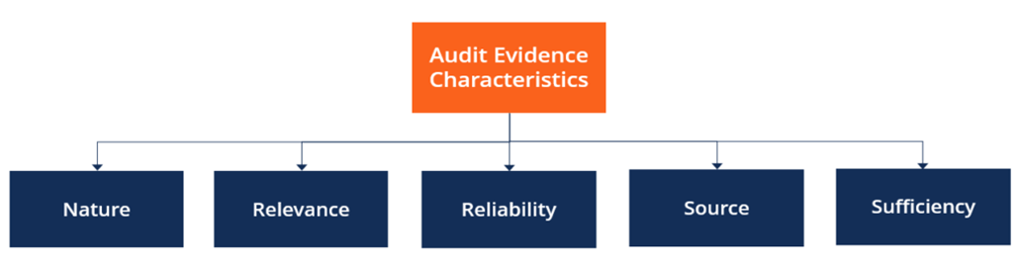
Sorts of Audit Evidence
Inspectors use Audit evidence in various structures and sources. Those Audit evidence could be information or data, physical or nonphysical. For an illustration of Audit evidence:
- Budget reports
- Bookkeeping data
- Financial balances
- The board Accounts
- Fixed Assets Register
- Payrolls Listing
- Banks Statements
- Bank affirmation
- Solicitations
- Receipts
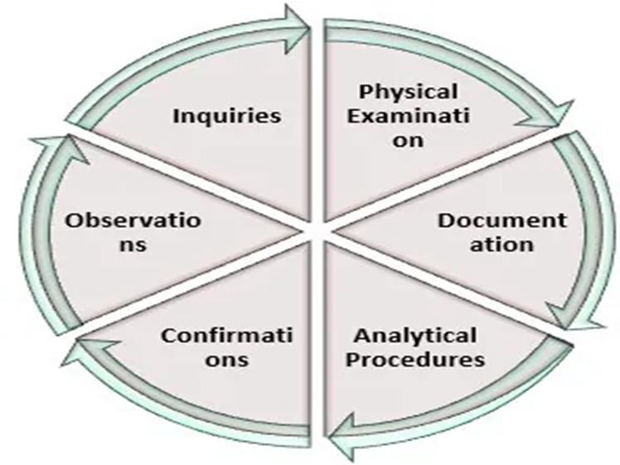

Self-cheek
1, Define the three general types of audits.
--------------------------------------------------------------------------------------------------------------------------------------------------------------------------------------------------------------------------------------------------------2, What important consideration is to be considered in establishing Internal Control?
--------------------------------------------------------------------------------------------------------------------------------------------------------------------------------------------------------------------------------------------------------
3, Define the Types of audited financial statements
--------------------------------------------------------------------------------------------------------------------------------------------------------------------------------------------------------------------------------------------------------
4, Define the Characteristics of Audit Evidence
--------------------------------------------------------------------------------------------------------------------------------------------------------------------------------------------------------------------------------------------------------
5, discuss the Roles and responsibilities of audit participants
--------------------------------------------------------------------------------------------------------------------------------------------------------------------------------------------------------------------------------------------------------
6, discuss the Factors that Influence the Reliability of Audit Evidence
--------------------------------------------------------------------------------------------------------------------------------------------------------------------------------------------------------------------------------------------------------

UNIT TWO PARTICIPATE IN CONDUCTING AN AUDIT
This unit is developed to provide you the necessary information regarding the following content coverage and topics:
- Collecting information for audit plan
- Analysing information
- Reviewing Records
- Observing compliance with the program
- Identifying areas requiring corrective action
This unit will also assist you attain the learning outcomes stated in the cover page the completing of the learning guide you will able to:-
- Collect information for audit plan
- Analysis information
- Review Records
- Observe compliance with the program
- Identify areas requiring corrective action

2.1 Collecting information for audit plan
Introduction
An audit program, also called an audit plan, is an action plan that documents what procedures an auditor will follow to validate that an organization is in conformance with compliance regulations. The goal of an audit program is to create a framework detailed enough for any outside auditor to understand.
Audit Plan
The Case Western Reserve’s Board of Trustees and management place assets at risk to achieve established priorities and goals. A key function of the Office of Internal Audit Services is to understand, audit, and report to management and the Board of Trustees how that risk is being managed. Knowing what areas to audit and where to commit resources is an integral part of managing the internal audit function.
To identify areas of potential risk, each year the Office of Internal Audit Services performs a thorough risk assessment of all university management centres, operating units, and significant departments. From this assessment, an Audit Plan is developed and presented to the Audit Committee for approval.
The plan addresses high-risk areas as well as allocates time for special ad-hoc projects. In intervening years, the risk assessment is updated through data analysis and interviews with senior executives across the university. If necessary, the audit plan is adjusted for any changes to the university's risk assessment.
We believe that the university is best served if the Audit Plan is a dynamic document that continually adjusts to changes in the environment. Therefore, if your management centre or department has a need for our services, please contact us.
Depending on the relative risk associated to your need and the amount of time necessary to fulfil your request, the Office of Internal Audit Services will communicate what level of assistance we will be able to provide. At a minimum, we will be available to offer guidance and advice throughout any project you perform on your own.
In most cases, expect to receive notification when you or your department is to be audited.
- Expect to understand the audit's purpose and objective
- Expect to provide your ideas or concerns regarding the audit
- Expect to be treated with respect and courtesy
- Expect to be asked for various financial and department documentation; some may be confidential
- Expect confidential information to remain confidential
- Expect to answer all questions honestly
- Expect to receive a draft copy of the Final Audit Report prior to its release
Preparing for an Audit
- Have all requested materials/records ready when requested
- Organize files so we minimize disruption of your day
- Provide complete files
- Please make yourself available during the time of the audit and communicate any planned absences
- Provide work space for auditors if requested
Audit Process
Step 1: Planning
The auditor will review prior audits in your area and professional literature. The auditor will also research applicable policies and statutes and prepare a basic audit program to follow.
Step 2: Notification
The Office of Internal Audit Services will notify the appropriate department or department personnel regarding the upcoming audit and its purpose, at which time an opening meeting will be scheduled.
Step 3: Opening Meeting
This meeting will include management and any administrative personnel involved in the audit. The audit's purpose and objective will be discussed as well as the audit program. The audit program may be adjusted based on information obtained during this meeting.
Step 4: Fieldwork
This step includes the testing to be performed as well as interviews with appropriate department personnel.
Step 5: Report Drafting
After the fieldwork is completed, a report is drafted. The report includes such areas as the objective and scope of the audit, relevant background, and the findings and recommendations for correction or improvement.
Step 6: Management Response
A draft audit report will be submitted to the management of the audited area for their review and responses to the recommendations. Management responses should include their action plan for correction.
Step 7: Closing Meeting
This meeting is held with department management. The audit report and management responses will be reviewed and discussed. This is the time for questions and clarifications. Results of other audit procedures not discussed in the final report will be communicated at this meeting.
Step 8: Final Audit Report Distribution
After the closing meeting, the final audit report with management responses is distributed to department personnel involved in the audit, the President, Provost, and Chief Financial Officer, and CWRU’s external accounting firm.
Step 9: Follow-up
Approximately six months after the audit report is issued, the Office of Internal Audit Services will perform a follow-up review. The purpose of this review is to conclude whether or not the corrective actions were implemented.

2.2 Analysing information of audit
Introduction
Auditing is the process of checking the financial statements along with other accounting information of a business entity. It is a systematic procedure where the economic condition of the entity is analysed. The person taking up the responsibility of the process is called an “Auditor”. The main goal of auditing is to make sure that a company's financial statements are accurate and are following regulatory guidelines. Auditing also gives investors, creditors, and other stakeholder’s reasonable assurance that they can rely on a company and its integrity. Audit evidence is a fundamental concept in auditing. Audit evidence consists of underlying accounting data and all corroborative information available to the auditor. Both categories of evidential matter are required in making an audit in accordance with GAAS.
Audit Information areas
Analytical evidence
Analytical evidence involves comparison of current period client data, such as total revenues or return on assets, with expected values for the data based on (1) historical or budgeted amounts for the client or (2) industry data.
Documentary Evidence
Documentary evidence includes a wide variety source documents as well as such items as minutes of board of director or executive committee meetings, lease agreements various other contracts, and bank statements.
Confirmations
Confirmations constitute a special class of documentary evidence involving direct written responses by knowledgeable third parties to specific requests for factual information.
Written representations
Written representations are signed statements by responsible and knowledgeable individuals that bear on one or more of management’s assertions.
Mathematical evidence
Mathematical evidence results from recompilations by the auditor and comparison of those results the client’s computations.
Oral evidence
During the audit, an auditor receives oral responses to numerous inquiries directed to officers and employees of the client and others.
Physical evidence
Physical evidence is obtained from the physical examination or inspection of tangible assets.

Documents and record examination
In the early stages of an audit, the external auditors must become familiar with many aspects of the client’s business. For example, the auditors must obtain knowledge of the client’s organization plan, financial structure, physical facilities, products, accounting policies, and the control procedures. However, information about the internal activities of the client is not in itself sufficient.
If this information is to be interpreted and evaluated in a proper perspective, the auditor must also understand the business environment in which the client operates. The auditors can gain considerable information about both the client’s business environment and internal operations by examining the client’s general records. The term general records is used to include the following categories:
1. Non-financial records
- Articles and certificates of corporations and bylaws
- Partnership contract
- Minutes of directors and shareholders meetings
- Contracts with customers and suppliers
- Contracts with officers and employees
- Government regulations directly affecting the enterprise
- Correspondence files
2. Financial records
- Income tax returns of prior years.
- Financial statements and annual reports of prior years
3. Accounting records
- General ledger
- General journal
  - Reviewing Records
Introduction
A records audit formally reviews how your organization controls who recovers, changes, or owns a particular record. During this process, the auditor examines your files in light of both legal and practical terms and delivers a report detailing record retention or possible destruction an audit record consists of a sequence of audit tokens, each of which describes an attribute of the event being audited. Each auditable event in the system generates a particular type of audit record. The audit record for each event has certain tokens within the record that describe the event.
Audit Record Format
Audit files consist of self-contained audit records of user-level and kernel-level events that have been preselected for auditing by the security administrator. An audit record consists of a sequence of audit tokens, each of which describes an attribute of the event being audited. Each auditable event in the system generates a particular type of audit record. The audit record for each event has certain tokens within the record that describe the event. An audit record does not describe the audit event class to which the event belongs; that mapping is determined by an external table, the /etc./security/audit event file.
Each audit token starts with a one-byte token type, followed by one or more data elements in an order determined by the type. The different audit records are distinguished by event type and different sets of tokens within the record. Some tokens, such as the text token, contain only a single data element, while others, such as the process token, contain several (including the audit user ID, real user ID, and effective user ID
Reasons why records audits are conducted
Even if you’ve established a viable records management system, you still need a way to track the strengths and weaknesses of your record keeping. By utilizing records management audits, you can guarantee compliance, confirm overall consistency, and fine-tune your files thanks to a deeper understanding of which documents aren’t needed any longer.
Ensure compliance
While the goal of a records audit varies, they’re often focused on making sure your organization follows the procedures for records management as defined by your operational controls. In other words, conducting an audit ensures your office complies with all legal and regulatory requirements. Not only do federal agencies have their own record keeping specifications, there are state and local statutes to consider, too. With repeat audits, your office can stay up-to-date on a range of regulations, and operate more freely as a result.
Confirm consistency of records management
Records management is centred on preserving an accurate archive of the happenings and transactions within your organization. At its core, records management is accountable for the systematic control over the creation, maintenance, use, and disposal of agency records — and consistency is key when it comes to keeping each of these responsibilities in check. Taking part in periodic records audits supports consistency in how records are initially created, how they’re stored, how they’re used, and eventually, how they’re discarded
Understand which records are no longer needed
Proper management of agency records is essential for maintaining control of confidential employee data and other pertinent (but private) information. While the preservation of records can extend for years after an employee has left your office, there does come a point when certain files are no longer needed. A records audit can reveal which documents are ready for disposal, and which paperwork still requires retention. The timely and steady destruction of inactive files keeps your agency organized, streamlined, and performing at its fullest potential.
How records audits are conducted in 4 steps (and our tips for being prepared)
It’s been said there’s always room for improvement, and records management doesn’t seem to be the exception to this rule. While a records management system can be strengthened through data backups and a shift toward digitizing your files, having a professional audit records can build on these aforementioned assets and boost your records management even further.
1. The auditor requests a list of records to review
Before beginning a records audit, you will need to decide what and how much you want to assess; an audit can either include all of your record management procedures, or just a small sampling. Once you have clarity around the files to focus on, the auditor will request a list of your agency’s records to review, including both physical and digital documents.
This list provides a sense of the volume and type of records your organization manages, and helps dictate the direction of the audit as well as the results you receive. Keep in mind, if the audit is abrupt, digitized files will make light work of creating your list and proceeding with the audit process (versus sorting through piles of paperwork to find what you need).
2. The auditor reviews your records in detail
With your approved list in tow, the auditor can then review your records in-depth and in detail. In addition to looking at the way your organization creates its records (to evaluate reliability), they’ll also examine how you decide what’s worth keeping. From there, the auditor is likely to consider your records’ ages — that is, if your agency archives or destroys its documents.
If you store your records, the auditor will look into your method for storage, whether that’s in a database, warehouse, or off-site facility. If you destroy your records, the auditor will instead analyse your procedures for destroying them, including how security is enforced during the destruction process. To prepare for this line of questioning, make sure you know how record storage is handled, and/or the safety measures employed when documents are disposed of.
3. The auditor produces an audit report
After the necessary details and insights have been collected, the auditor will produce an audit report to determine the relative importance of your records. For example, this report will highlight which files need to be retained and for how long, and thus affirm what can be destroyed. Using this report, your agency can implement record revisions, retention, or disposal as needed, and clear up some much needed space within your database or storage facility.
If elimination is in order for some of your records, the audit report will outline destruction procedures to guarantee the confidentiality of employee information at all times.
4. The auditor may recommend additional audits
Most organizations enjoy the best outcomes when they agree to be audited on a regular basis. The auditor may recommend additional audits to keep tabs on whether the correct processes are being followed, and to diagnose where improvements can be made for increased efficiency.
If the auditor doesn’t mention anything about your next audit, you can take the lead and address a follow up appointment for yourself. This way, you can better ensure your agency is routinely reviewed and up to par with all of its policies, procedures, and compliance.
  - Observing compliance with the program
Introduction
In defining what Compliance Auditing is, we need to consider the definition of public sector auditing as the definition of Compliance auditing builds on from it. Public-sector auditing can be described as a systematic process of objectively obtaining and evaluating evidence to determine whether information or actual conditions conform to established criteria [1]. The definition of compliance audit builds on this definition with a specific focus on assessing compliance with criteria derived from authorities. Compliance audit is an independent assessment of whether a given subject matter is in compliance with applicable authorities identified as criteria. As auditors, we assess whether activities, financial transactions, and information are, in all material respect, in compliance with the authorities which govern the audited entity [2]. Auditors in compliance audit look for material deviations or departure from established criteria which could be based on laws and regulations, principles of sound financial management, or propriety.
Compliance audit
A compliance audit is a comprehensive review of an organization's adherence to regulatory guidelines. Audit reports evaluate the strength and thoroughness of compliance preparations, security policies, user access controls and risk management procedures over the course of a compliance audit. A compliance audit is an evaluation of whether a company is following these set standards. Compliance auditing involves the review of an organization's policies, procedures, processes, files, and documentation to determine whether they are in alignment with existing regulations in that industry.
Internal compliance audits vs. external compliance audits
Internal compliance audits are conducted by employees of a company to gauge overall risks to compliance and security as well as to determine whether the company is following internal guidelines. Internal audits occur throughout the fiscal year, and management teams use reports to identify areas that require improvement. Internal audits measure company objectives against output and strategic risks.
External compliance audits are formal audits conducted by independent third parties. They follow a specific format determined by the compliance regulation being assessed. External audit reports measure if an organization is complying with state, federal or corporate regulations, rules and standards.
An auditor's report is used by regulators to assess possible fines for noncompliance or by the C-suite to prove regulatory compliance. An external compliance auditor might use internal audits to further evaluate compliance and regulatory risk management efforts.
Overview of an external compliance audit
External compliance audits begin with a meeting between company representatives and compliance auditors to outline compliance checklists, guidelines and the scope of the audit. The auditor conducts reviews of employee performance, studies internal controls, assesses documents and checks for compliance in individual departments.
Compliance auditors will generally ask members of the C-suite and IT administrators a series of specific questions that might include what users were added and when, who has left the company, whether user IDs have been revoked, and which IT administrators have access to critical systems. IT administrators can prepare for compliance audits using event log managers and robust change management software to track and document authentication and controls in their IT systems. The growing category of governance, risk and compliance software can help CIOs quickly show auditors that an organization is compliant as well as avoid costly fines or sanctions.
Auditors then review business compliance processes as a whole and create a final audit report. Compliance auditors provide details to company leaders about the organization's level of compliance adherence, any violations and suggestions for improvement. They eventually make the audit report public.
Importance of compliance auditing
Compliance auditing, whether internal or external, can help a company identify weaknesses in regulatory compliance processes and create paths for improvement. In some cases, guidance provided by a compliance audit can reduce risk and mitigate potential legal trouble or federal fines for noncompliance. Much like the laws that drive them, compliance programs are in a constant state of flux as existing regulations evolve and new ones are implemented. Compliance auditing provides an outline of internal business processes that can be changed or improved as regulations and requirements change.

Compliance audits important
Compliance audits are important because they ensure organizations follow government policies and regulations. The main purpose of conducting a compliance audit is to determine whether a company is conducting business in an appropriate manner. If an auditor notices ineffective policies or processes, they may report their findings to the company's leadership team or notify the appropriate government agency. Completing a compliance audit can also benefit organizations and their employees by:
Identifying opportunities for improvement: Compliance audits may uncover outdated systems or processes. When this happens, auditors may offer suggestions to help the organization implement more effective ones.
Increasing safety measures: Many regulations exist to protect employees, consumers and the environment. Compliance audits are a great tool to assess whether organizations meet these requirements and provide them with guidelines to develop safer working environments.
Reducing legal risks: Participating in routine compliance audits can help companies ensure they're following all of the necessary government regulations. This can help them reduce the risk of being fined or penalized and ensure they remain complicit in the future.
Compliance audit work
1. Review documents
A compliance auditor begins their work by reviewing important records and documents. They typically use a compliance audit checklist to ensure they examine all of the necessary materials. Compliance auditors may review paper documents or electronic files during this step.
2. Conduct interviews
Next, the compliance auditor conducts formal interviews to learn more about how the organization conducts business. They may interview managers, board members, company leaders and employees to collect evidence during this phase of the audit. Depending on the size of the organization they're auditing, they may work alone or with a team of other compliance auditors.
3. Assess processes
In addition to conducting interviews, the compliance auditor may visit each of the organization's physical locations and check individual departments for requisite compliance. This allows them to inspect the infrastructure and workspaces, which is important if the auditor is reviewing safety procedures and assessing environmental impact. During this stage of the compliance audit, the auditor may shadow several employees to ensure they're following all of the proper processes and protocols in their daily work.
4. Compile a compliance report
Finally, the compliance auditor uses all of the information they've gathered to develop a compliance report, which often includes areas of improvement, areas that are well-within regulations and any other factors that affect compliance. They use this report to share their findings and make recommendations to help the organization improve in the future. This can help the organization minimize risks and develop more efficient processes. The auditor may also share their compliance report with relevant government agencies if the organization requires significant corrective actions.
Types of compliance audits
There are many types of federal and local compliance audits that vary by industry. These audits may address technical, operational, financial or safety processes and protocols. Here are 10 types of compliance audits you may encounter
Healthcare Insurance Portability and Accountability
Healthcare organizations undergo routine HIPPA compliance audits to ensure they protect the privacy of the people they serve. This involves assessing the security of their electronic records, physical documents and procedures.
Social compliance
There are several social compliance and sustainability audits that assess whether an organization meets regulations regarding health and safety, employees' rights and environmental impact. These types of audits often review an organization's supply chain and facilities.
Payment Card Industry Data Security Standard
This type of compliance audit enforces a set of standards for companies that process, store or transmit electronic payments. Businesses that complete more than 6 million credit card transactions each year may complete an annual PCI DSS compliance audit to assess the security of their processes, systems and networks.
Internal Revenue Service
The IRS conducts routine audits to ensure organizations pay the appropriate amount of taxes on time. They may also audit individuals to ensure they're following the required tax codes and processes.
Human resources
There are several types of HR compliance audits that assess whether an organization adheres to important employment laws and regulations at the local, state and federal level. These compliance audits may focus on personnel files and payroll.
Financial Industry Regulatory Authority
FINRA collaborates with the Securities and Exchange Commission (SEC) to audit financial, securities, and brokerage and investment firms every year. They assess advertisements, licenses and daily operations to ensure these organizations follow the appropriate trading regulations.
Occupational Health and Safety Act
OSHA audits assess whether an organization meets the necessary health and safety standards for its employees. Auditors may use OSHA guidelines to make sure workplaces are hygienic and free of hazards.
The Centres for Medicare and Medicaid Services
The CMS conducts compliance audits alongside the Department of Health and Human Services. Together, they review Medicare funding to ensure fair distribution.
Environmental Protection Agency
The EPA is responsible for conducting audits to ensure organizations comply with environmental laws established by tribal, state and federal authorities. They inspect business processes such as waste management, manufacturing and distribution.
How to prepare for a compliance audit
If an organization has an upcoming compliance audit, you may be wondering what you can do to ensure your team is prepared. While compliance audits vary by industry and geographic region, there are still some basic steps you can take to improve your audit results. Here are some instructions you can follow to get started:
1. Organize the necessary documents
Start by documenting the organization's processes. Highlight what types of practices your employees follow to comply with government regulations. You can also reach out to the third-party auditor to ask if there are any specific documents they review, such as financial statements or personnel files. This can help you ensure you have the necessary documents available. Once you identify which documents you share with the auditor, organize them so you're prepared for the day of the organization's compliance audit.
2. Conduct an internal review
Conducting an internal review of the organization's processes and systems can help you identify areas for improvement before your official compliance audit. Research what key areas compliance auditors in your industry typically focus on to get started. For example, if you work in cyber security, an auditor may review your IT systems to ensure they meet the basic industry standards. Understanding what compliance auditors search for when conducting reviews can help you focus your attention on the most important areas of the business.
3. Create an audit trail
Developing a clear audit trail can help you maintain important documents that prove the organization is compliant with government regulations. Maintain organized manual or electronic records of the company's primary processes. This may include tracking your security policies, hiring protocols and tax information.
4. Train team members
Before the organization's upcoming compliance audit, take the time to review important procedures and policies with your team members. This can help you ensure your team understands what steps they take to follow important government regulations. In addition to offering a review course for your employees to reinforce important processes and protocols, make sure to update your on boarding materials to reflect changes in local and federal regulations.
5. Review updated regulations
Stay informed about new and updated regulations by subscribing to industry newsletters. You can also attend networking events and conferences to learn about changes that may affect your industry. This can help you conduct routine reviews of the organization's policies and processes to ensure you remain compliant in the future.
  - Identifying areas requiring corrective action
Introduction
A correction is “action to eliminate a detected non-conformity.” Corrective action is an action to eliminate the cause of a detected nonconformity. The key difference between a correction and a corrective action is that one focuses on non-conformity itself, whereas the other focuses on the cause of the non-conformity. An example of correction might be a site identifying that there is peeling paint at their site and removing the peeling paint. They have made a correction. Corrective action would eliminate peeling paint in that area in the future through a change in the type of paint used or eliminating paint in that area altogether. A correction fixes the immediate problem. A corrective action focuses on preventing it from reoccurring by addressing the root cause.
Corrective Action Plan
A corrective action plan is a documentation used in quality management that outlines a set of steps for addressing issues and gaps in business operations and processes that could negatively impact the business. It describes the approach for resolving an issue that interferes with reaching company goals. The corrective action plan should be S.M.A.R.T. (Specific, Measurable, Attainable, Relevant, Time bound) and includes timeframes, costs, and signatories.
Corrective actions in an audit
An audit is all about improving. With this in mind, it’s reasonable to think that some things need to change after the evaluation. Some businesses may consider it an obstacle, but it couldn’t be further from the truth. By taking corrective actions, a company can make tweaks (some more complex than others) in its system to perfect its processes and, in turn, obtain a certification. Corrective action is taken by a business to fix a failure in its system to ensure that it won’t happen again, addressing a non-conformity raised during an audit.
To take corrective action, you must be clear about who, what, when, where, and why. Doing this will let you know all the specifications about the problem so that you can solve it most quickly and effectively.
It may be utopian to think about correcting a failure forever, but what you must be looking for is to minimize the probability of it happening again. These are some aspects you must consider when taking corrective actions:

Self-cheek
1, Define the three general types of audits.
--------------------------------------------------------------------------------------------------------------------------------------------------------------------------------------------------------------------------------------------------------2, What important consideration is to be considered in establishing Internal Control?
--------------------------------------------------------------------------------------------------------------------------------------------------------------------------------------------------------------------------------------------------
3, Define the Types of audited financial statements
--------------------------------------------------------------------------------------------------------------------------------------------------------------------------------------------------------------------------------------------------
4, Define the Characteristics of Audit Evidence
--------------------------------------------------------------------------------------------------------------------------------------------------------------------------------------------------------------------------------------------------
5, discuss the Roles and responsibilities of audit participants
-------------------------------------------------------------------------------------------------------------------------------------------------------------------------------------------------------------------------------------------------

UNIT THREE REPORT AND FOLLOW UP AUDIT OUTCOMES
This unit is developed to provide you the necessary information regarding the following content coverage and topics:
- Identifying and reporting Situations
- Preparing audit reports
- Communicating results of audit
This unit will also assist you attain the learning outcomes stated in the cover page the completing of the learning guide you will able to:-Developing corrective action plan
- Identify and reporting Situations
- Prepare audit reports
- Communicate results of audit

3.1 Identifying and reporting Situations
Introduction
The audit report is usually the only channel of communication between the shareholders of the company whose financial statements have been subject to audit and the auditors. As such the report acts as a bridge taking the large volume of information possessed by auditors and conveying it to the shareholders in a much abbreviated form. In order to convey information in a succinct form the audit report has become an extremely formalized group of phrases, each of which has special significance.
Audit reporting Situations
The condition is what was discovered during testing. It is a statement that describes the results of the audit. The audit report template includes 7 parts of elements these are: report title, introductory Paragraph, scope paragraph, executive summary, opinion paragraph, auditor's name, and auditor's signature.

Benefits of internal and external audits
- It provides a holistic view of the organization.
- It helps identify potential issues early.
- It helps identify areas (or risks) where improvements need to be made.
- It helps improve the overall effectiveness of the organization.
- It helps identify if the final product is fit for use and meets customer requirements.
- It helps ensure that the required work processes are in place and are effective.
- It helps avoid lawsuits by ensuring that the organization meets all legal/regulatory needs.
- It ensures that the Corrective Actions (Remedial actions) are taken that are effective.

3.2 Preparing audit reports
Introduction
Audit Report Contents are the basic structure of the audit report which needs to be clear, providing sufficient evidence providing the justification about the opinion of the auditors and includes Title of Report, Addressee details, Opening Paragraph, scope Paragraph, Opinion Paragraph, Signature, Place of Signature, and Date of the Report.
Basic Content of an Audit Report
An audit report is an opinion on the financial statements of the Company given by the Auditors after conducting the financial audit of the Company. The Auditor’s report is published with the Annual report of the Company. Auditors report is read by investors, analysts, Company’s management, lenders while analysing the Companies performance and ascertaining that the financial reports are as per the generally accepted accounting standards.
The most common type of the audit report is an unqualified audit report. The form of an auditor’s reports will generally be the form an unqualified consisting of the following basic elements:
- Title: - the auditor’s report should have an appropriate title which helps the readers to identify the auditor’s report and easily distinguish it from other reports, such as that of management. The recommended title is “Auditor’s Report”.
- Addressee: - The report should be appropriately addressed as required by the circumstances of the engagement and the local regulations. The report is usually addressed either to the shareholders or supervisory board of the entity whose financial statements have been audited.
- Introductory Paragraph: - The report should identify financial statements that have been audited. The preparation of these statements requires management to make significant accounting estimates and judgments, as well as to determine the appropriate accounting principles and methods used when preparing these statements. The auditor responsibility is to audit these statements and express an opinion on them.
- Scope paragraph
Scope refers the auditor’s ability to perform audit procedures deemed necessary in the circumstances. It is the factual statements of what the auditor did in the audit. The report should include a statement that the auditor was planned and performed to obtain reasonable assurance about whether the financial statements are free of material misstatement.
- Opinion paragraph
The auditor’s report should clearly state the auditor’s opinion as to whether the financial statements give a true and fair view, and the financial statements comply with laws.
- Date of report
The report must be dated. The auditor should date the report as the completion date of the audit (usually the last date of the fieldwork).
- Auditor’s address
The report should name a specific location, which is usually the city in which the auditor maintains an office.
- Signature
The report should be signed in the name of the audit firm or by the personnel name of the auditor or both as appropriate.
Audit Opinion Letter
An auditor issues an audit opinion letter after completing the audit process, and it is included with the audited financial statements. In this letter, the auditor reveals the financial statements reviewed and the audit method used. If there were no material errors in the financial statements, then the auditor will give an audit opinion that the financial statements represent a true and fair view of the company’s performance and position.
Learn more about audit standards from AICPA.
Contents of Audit Opinion Letter
Below is an example of an audition opinion letter, to be used for educational purposes only.
Dear Board of Directors
XYZ Company
We, the auditors, have audited the income statement, balance sheet, and cash flow statement of XYZ Company as of December 31, 2022.
We completed our audit according to the auditing standards set out by Generally Accepted Accounting Principles (GAAP) in the United States. Based on this audit, we have obtained reasonable assurance that the above noted financial statements are free of material misstatement.
As part of our audit, we examined and tested evidence supporting the figures contained in the financial statements. We also assessed the accounting principles and estimates used by the company in preparing their financial statements. This audit formed the basis of our opinion, stated below.
In our opinion, the financial statements of XYZ Company are represented in accordance with Generally Accepted Accounting Principles (GAAP) in the United States.
[Signature]
Auditor’s name
Types of Audit Opinion
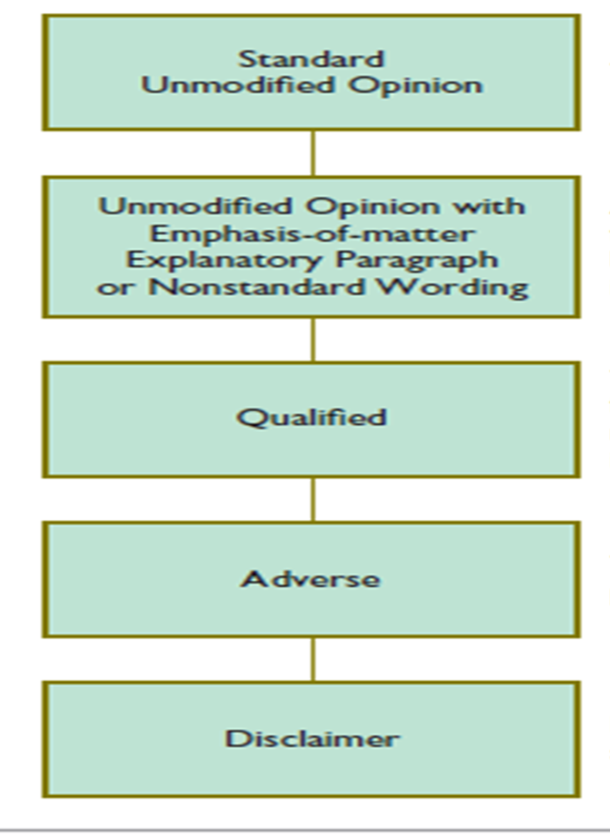
(I) Unqualified (Clear) Opinion: - In an auditor’s report on financial statements an unqualified opinion expressed in a clear and affirmative manner when the auditor is satisfied in all material respects that:
- The financial statements have been prepared using acceptable accounting policies, which is consistently applied,
- The financial statements comply with relevant laws and regulations,
- The view presented by the financial statements as a whole is consistent with the auditor’s knowledge of the business of the entity, and
- There are adequate disclosures of all material matters relevant to the proper presentation of the financial statements.
Sample Wording-Auditor’s Unqualified Opinion: An example of an audit report given in ISA 700.The auditor’s report on financial statements, illustrates the high level of assurance given by an audit:
Auditor’s Report to the Shareholders of ABC Company
We have audited the accompanying balance sheet of ABC Company as at 31 December 20X1, and the related statements of income and cash flows for the year then ended. These financial statements are the responsibility of the company’s management. Our responsibility is to express an opinion on these financial statements based on our audit
We conducted our audit in accordance with International Standards on Auditing (or to relevant national standards). Those Standards require that we plan and perform the audit to obtain reasonable assurance about whether the financial statements are free of material misstatement. An audit includes examining, on a test basis, evidence supporting the amounts and disclosures in the financial statements. An audit also includes assessing the accounting principles used and significant estimates made by management, as well as evaluating the overall financial statement presentation. We believe that our audit provides a reasonable basis for our opinion.
In our opinion, the financial statements give a true and fair view of (or present fairly, in all material respects) the financial position of the company as at 31 December 20X1, and of the results of its operations and its cash flows for the year then ended in accordance with International Accounting Standards (or title of national standards used) and comply with ( title of relevant statute or law)
Auditor Address_____________________
Date______________________________
- The final paragraph in the standard unqualified report states the auditor’s conclusions based on the results of the audit examination. This paragraph is also important that the entire audit report is frequently referred to “the auditor’s opinion”.
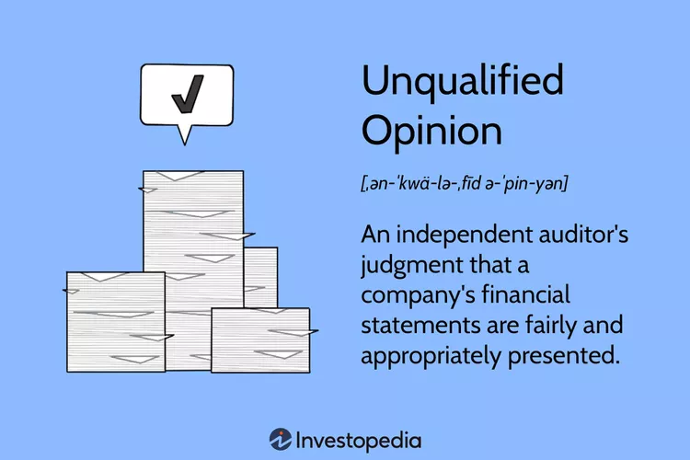
(II) Qualified Opinion
A qualified auditor’s opinion is expressed when the auditor concludes that an unqualified opinion cannot be expressed. There at least two circumstances where the auditor may not be able to express an unqualified opinion limitation in scope, and a disagreement with management. Limitations on Scope
- Limitation on scope arises when the auditors are unable for any reason to obtain the information and explanations considered necessary for the audit.
- Scope may be limited by the inability to carry out a procedure the auditor considers necessary and the absence of proper accounting records.
- A limitation on the scope of the auditor’s work may sometimes be imposed by the client, for example, when the terms of the engagement specify that the auditor will not carry out an audit procedure that the auditor believes is necessary.
Disagreement with Management:-The auditor may disagree with management regarding:
- The acceptability of accounting policies selected,
- The method of policy application, or
- Compliance of the financial statements with relevant regulations and statutory requirements. If any of the disagreements are material, the auditor should express a qualified opinion. Auditor reports that are not unqualified are referred to as “other than unqualified report”.
Sample Wording-Limitation on Scope Qualified of Opinion
Auditor’s Report
Report of the Independent Auditors to Members of KAKA Cooperative.
We have audited the accompanying balance sheet of KAKA Cooperative society as of 30 June 2006, and the related statements of income and cash flows for the year then ended. These financial statements are the responsibility of the cooperative society’s management. Our responsibility is to express an opinion on these financial statements based on our audit.
Except as discussed in the following paragraph, we conducted our audit in accordance with the International Auditing Standards. These Standards require that we plan and perform the audit to obtain reasonable assurance about whether the financial statements are free of material misstatement. An audit includes examining, on test basis, evidence to supporting the amounts and disclosures in the financial statements. An audit also includes assessing the accounting principles used, and significant estimates made by management as well as evaluation of the overall financial statements preparation. We believe that our audit provides a reasonable basis for our opinion.
We did not observe the counting of the physical inventories as of 30 June 2006, since that date was prior to the time we were initially engaged as auditors for cooperative society. Owing to the nature of the cooperative’s records, we were unable to satisfy ourselves as to the inventory quantity by other audit procedures.
In our opinion, except for the effects of such adjustments, if any, as might have been determined to be necessary had we been able to satisfy ourselves as to the physical inventory quantities, the financial statements give a true and fair view of (present fairly, in all material respects) the financial position of the Company as of 30 June 2006, and its results operations and its cash flows for the year then ended in accordance with… (And comply with …).
Auditor Address
Date

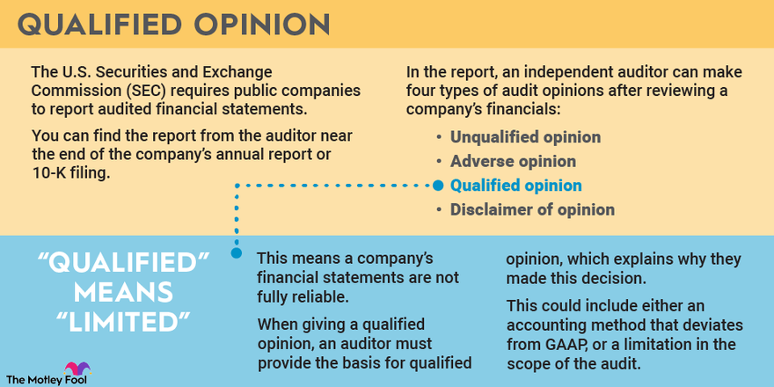
(III) Adverse (Except For) Opinion
An adverse opinion is expressed when the effects of a disagreement so material to the financial statements that the auditor concludes that a qualification of his report is not adequate to disclose the misleading or incomplete nature of the financial statements.
An adverse opinion is a professional opinion made by an auditor indicating that a company's financial statements are misrepresented, misstated, and do not accurately reflect its financial performance and health. Adverse opinions are usually given after an auditor's report, which can be internal or independent of the company.
Consequences of Adverse Opinions
An adverse opinion can in some cases cause de-listing of a company's stock from an exchange. Toshiba Corp. of Japan narrowly escaped this fate when the Japanese affiliate of Price Water house Coopers gave the company a qualified opinion instead of an adverse opinion on its financial statements in 2017. However, the auditing firm issued an adverse opinion on the company's internal auditing controls, a less serious offense, but one that the company must address to earn back some trust with the investment community.
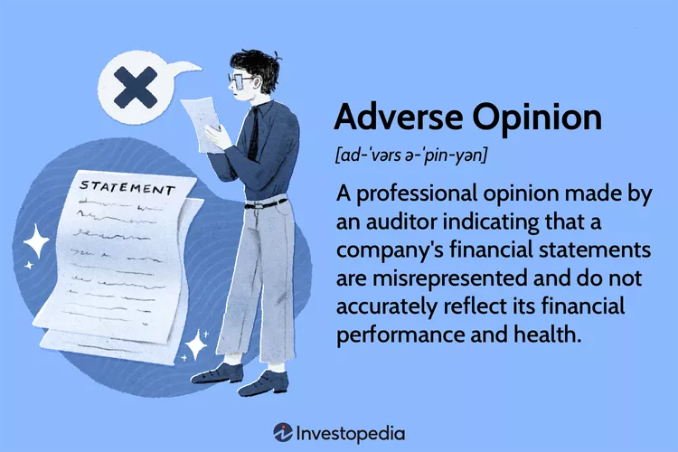
Declaimer Opinion
A disclaimer of opinion audit report is a statement issued by an auditor indicating that they were unable to form an opinion on the financial statements due to insufficient or unreliable information.
Disclaimer of Opinion
A Disclaimer of Opinion is a statement made by an auditor declaring that they were unable to complete an accurate audit report on a company’s finances. This typically occurs when the company being audited does not provide sufficient evidence or data to support their financial statements, or when there’s a significant limitation on the scope of the auditor’s work that prevents the auditor from collecting enough evidence.
In such cases, the auditor can’t form an opinion on the financial statements and issues a disclaimer of opinion, stating that they cannot confirm whether the financial statements are a fair and accurate representation of the company’s financial position.
It’s important to note that a disclaimer of opinion is not an adverse opinion. An adverse opinion is issued when an auditor believes the financial statements materially misrepresent the company’s financial position, while a disclaimer of opinion is issued when the auditor simply cannot form an opinion due to lack of information or restrictions on their work.
When a company receives a disclaimer of opinion, it can raise red flags for investors, creditors, and other stakeholders because it suggests there may be underlying issues preventing a clear audit, such as potential mismanagement or lack of transparency.
Example of a Disclaimer of Opinion
Here’s a simplified example of a Disclaimer of Opinion:
ABC Auditing Firm
Independent Auditor’s Report
To the Shareholders of XYZ Company,
We have been engaged to audit the accompanying financial statements of XYZ Company, which comprise the balance sheet as at December 31, 2023, and the income statement, statement of changes in equity, and cash flow statement for the year then ended, and a summary of significant accounting policies and other explanatory information.
Disclaimer of Opinion
We were not able to obtain sufficient appropriate audit evidence to provide a basis for an audit opinion on these financial statements due to significant limitations on the scope of our audit. Specifically, XYZ Company was unable to provide us with complete records pertaining to their inventory and accounts receivable balances as of December 31, 2023.
Because of the significance of the matters described in the Basis for Disclaimer of Opinion paragraph, we have not been able to obtain sufficient appropriate audit evidence to provide a basis for an audit opinion. Accordingly, we do not express an opinion on the financial statements.
Basis for Disclaimer of Opinion
XYZ Company did not maintain proper records of inventory and there were significant discrepancies and omissions in the accounts receivable ledger. These conditions prevented us from conducting a complete and satisfactory audit of the Company’s financial statements.
Emphasis of Matter
We draw attention to Note 2 to the financial statements, which describe the issue mentioned above. Our opinion is not modified in respect of this matter.
Other Matters
The comparative financial information of XYZ Company for the year ended December 31, 2022, was audited by another auditor who expressed an unmodified opinion on those statements on March 1, 2023.
ABC Auditing Firm
(signature)
(Date)
Please note, this is a simplified example and real audit reports would be significantly more detailed. In the event of a disclaimer of opinion, the company should work to address the issues that led to the disclaimer and ideally resolve them by the time of the next audit.
Disclaimer of Opinion Audit Report

Advantages of the Audit Report
The management is different from the auditor, so the auditor is independent of his decision. So the auditor’s report can provide knowledge about the integrity and honesty of the management, i.e., whether the company’s management is true toward the company’s shareholders. It assures the financial statements as it is issued by the professional having an unbiased opinion as he is not a part of the company’s management. This report helps the users of the financial statements to get assured of the truth and fairness of the financial statement. It helps the stakeholders to get knowledge about the operational and financial position of the company. It helps the stakeholders to know the prospects of the company as an auditor is required to report in its audit report if there are some issues with the company which can affect its going concern. The problem affecting going concern can be the financial or non-financial problems that the company faces.
Disadvantages/Limitation of Audit Reports
Sometimes management does not provide the auditor full access to the audit evidence. As per the auditing standards, management should provide all the information that the auditor demands, but in real life, the management may prevent the auditor from getting access to sensitive information as they may have doubts about the confidentiality of the auditor. These kinds of problems may affect the quality of the opinion. It is required that the auditor should be independent of their client. But sometimes, the client may influence the auditor, resulting in the auditor’s issuance of an incorrect report. It is required that the auditor should be independent of their client. But sometimes, the client may influence the auditor, resulting in the auditor’s issuance of an incorrect report.
Important Points
The auditor’s opinion mostly covers the financial statements prepared for 12 months or one financial year. This report is then used by the stakeholders, management, investors, board of directors the government body, lenders, and other parties interested in the business. The investors use it to assess the entity’s financial performance on the basis that only they will decide whether to invest in that company or not. It is used by the Government agency to assess the accuracy and completeness of tax declarations and to check that there is no tax evasion. It is used by the Shareholders and the board of directors to assess the transparency of the financial statement and the integrity of the management.
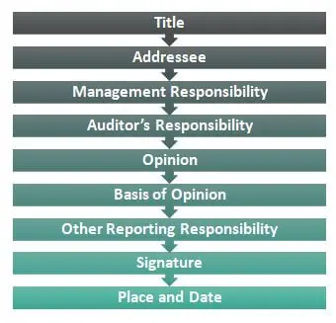
Internal Audit
Internal audits evaluate a company’s internal controls, including its corporate governance and accounting processes. These types of audits ensure compliance with laws and regulations and help to maintain accurate and timely financial reporting and data collection. Internal auditors are hired by companies who work on behalf of their management teams. These audits also provide management with the tools necessary to attain operational efficiency by identifying problems and correcting lapses before they are discovered in an external audit.
Understanding Internal Audits
Internal audits play a critical role in a company’s operations and corporate governance, especially now that the Sarbanes-Oxley Act of 2002 holds managers legally responsible for the accuracy of their company's financial statements. SOX also required that a company's internal controls be documented and reviewed as part of its external audit.
In addition to ensuring that a company complies with laws and regulations, internal audits also provide a degree of risk management and safeguard against potential fraud, waste, or abuse. The results of internal audits provide management with suggestions for improvements to current processes not functioning as intended, who may include information technology systems as well as supply-chain management.
Internal audits may take place on a daily, weekly, monthly, or annual basis. Some departments may be audited more frequently than others. For example, a manufacturing process may be audited on a daily basis for quality control, while the human resources department might only be audited once a year.
Types of Internal Audits
Compliance Audit
A company may be required to adhere to local laws, compliance needs, government regulations, external policies, or other restrictions. To demonstrate compliance with these rules, a company may task an internal audit committee to review, compile appropriate information, and provide an overall opinion on the status of the compliance requirement.
Internal Financial Audit
Public companies are required to perform certain levels of external financial auditing where a completely independent third party provides an opinion on the company's financial records. Companies may want to dive further into audit findings or perform an internal financial audit in preparation for an external audit. Many of the tests between an internal or external auditor may be similar; the nature of independence separates the two types of audits for financial audits.
Environmental Audit
As companies become continually more environmentally conscious, some take the steps of reviewing the business' impact on the planet. This results in an internal audit covering how a company safely sources raw materials, minimizes greenhouse gases during production, utilizes eco-friendly distribution methods, and reduces energy consumption. Companies leveraging triple bottom line reporting may perform internal environmental audits as part of annual reporting.
Technology/IT Audit
An IT audit may have different objectives. The internal audit may be the result of an external lawsuit, a company complaint, or a target to become more efficient. An internal audit focused on technology reviews the controls, hardware, software, security, documentation, and backup/recovery of systems. The goal is likely to assess general IT accuracy and processing capabilities.
Performance Audit
An internal audit focused on performance pays less attention to the processes and more on the final result. The company will have likely have set performance objectives or metrics that may be tied to performance bonuses or other incentives. As a result, an internal auditor assesses the outcome of an objective that may not be easily quantifiable.
For example, a company may wish to have expanded its use of diverse suppliers; the internal auditor, independent of any purchasing process, will be tasked with analysing how the company's spending patterns have changed since this goal was set.
Operational Audit
An operational audit is most likely to occur when key personnel leave or when new management takes over an entity. The company may want to assess how things are done and whether resources are being used more efficiently. During an operational internal audit, the auditor will review whether current staff and processes fulfil the mission statement, value, and objectives of a company.
Construction Audit
Development, operating, real estate, or construction companies may perform construction audits to ensure not only appropriate physical development of a building but appropriate project billing along the life of the project. This mostly includes adherence to contract terms with the general contractor, sub-contractors, or standalone vendors as necessary.
This may also include ensuring the company has remit the appropriate payments, collected the appropriate payments, and internal project reports regarding project completion are correct.
Special Investigations
Many of the audits above may be recurring and performed each year. In some cases, it might make sense for an internal audit committee to evaluate a special circumstance that will occur only once. This may entail gathering a report on the efficiency on a recent merger, the hiring of a key employee, or a complaint from staff. When selecting the individuals for the special investigation audit, a company must be especially mindful to select members with appropriate expertise and independence.
Internal Audit vs. External Audit
Internal and external audits have the same objective. Both types of audits analyse an aspect of a company to determine a specific opinion. However, there are many differences between the two types of audits.
In an internal audit, the company is often able to select its own audit team. As such, the team represents the interests of the company's management team. This may be advantageous to specifically place certain employees with very niche experience on the team. In an external audit, the company can often select the external audit firm; however, the company often does not have a say in the specific employees put on their external audit.
There may be some requirements regarding the external audit staff depending on the audit. For example, in an external financial audit, a Certified Public Accountant (CPA) must certify the financial statements. In an internal audit, there is no requirement that any member of the audit team must be a CPA.
The end goal of either audit is an audit report; however, audit reports are used for very different reasons. An internal audit report is usually used by internal management to improve the operations, processes, or policies of the company. An external audit report is often required for an outside reason and is more often used heavier by members outside of the company.
Finally, the nature of the engagement will be very different. During an internal audit, the employees of a company may often freely give advice, discuss unrelated matters with the company, or may have a very fluid consulting agreement. During an external audit, a very defined scope is often set, and the external auditor will often take great care to ensure they do not exceed their audit boundaries.
Internal Audits
- A company is usually able to select its own internal audit lead and team members
- Members of the audit team often do not need to have specific titles or licenses
- Audit reports are primarily used by internal management to improve company operations
- Internal audits may be less formal with blurred structure as the auditor provides casual guidance
External Audits
- A company or board can usually pick the audit firm but not audit team members
- Members of the audit team may be required to hold specific titles or license as part of the audit agreement
- Audit reports are primarily used by external parties to satisfy a reporting requirement
- External audits are often more formal with defined boundaries and disallowed services
Internal Audit Process
Internal auditors generally identify a department, gather an understanding of the current internal control process, conduct fieldwork testing, follow up with department staff about identified issues, prepare an official audit report, review the audit report with management, and follow up with management and the board of directors as needed to ensure recommendations have been implemented.
Step 1: Planning
Before any audit procedures are performed, the internal auditors often start by developing the audit plan. This sets the audit requirements, objectives, timeline, schedule, and responsibilities across audit team members. The audits may review prior audits to understand management expectations for presentation and data collection.
The audit plan often has a checklist to ensure members of the team adhere to broad expectations. The internal audit team may also pre-emptively plan to meet with management throughout the audit to communicate the status and any struggles of the audit. The planning stage often ends with a kick-off meeting that launches the audit and communicates the initial information needed.
Sample Audit Plan
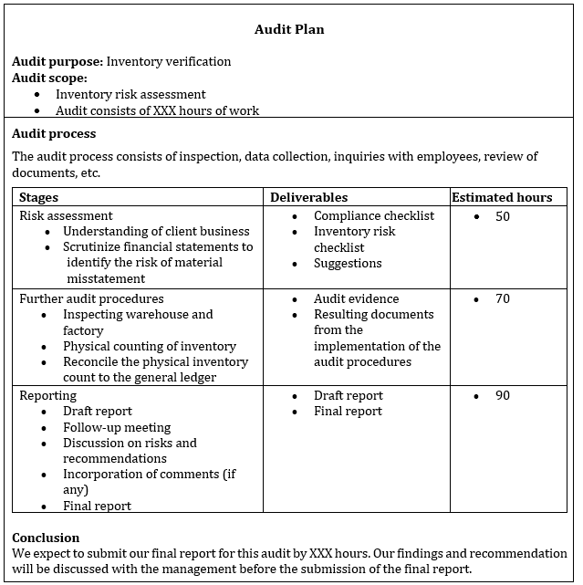
Step 2: Auditing
Many of the auditing procedures used by internal audits are the same as external auditors. Some companies might use continuous audits to ensure on-going oversight of company practices. Assessment techniques ensure an internal auditor gathers a full understanding of the internal control procedures and whether employees are complying with internal control directives.
To avoid disrupting the daily workflow, auditors begin with indirect assessment techniques, such as reviewing flowcharts, manuals, departmental control policies, or other existing documentation.
Auditing fieldwork procedures can include transaction matching, physical inventory count, audit trail calculations, and account reconciliation as is required by law. Analysis techniques may test random data or target specific data if an auditor believes an internal control process needs to be improved.
The internal audit may have started with a defined scope; but as the internal audit team gathers and analyses information, it may become necessary to redefine the purpose and extent of the audit. This includes re-evaluating the original timeline or resources allocated to the audit.
Step 3: Reporting
Internal audit reporting includes a formal report and may include a preliminary or memo-style interim report. An interim report typically includes sensitive or significant results the auditor thinks the board of directors needs to know right away. Similar to an interim financial statement, an interim audit communicates a partial set of information useful for laying the road for the remaining portion.
Often, a company may deliver a draft copy of the final audit report and host a pre-close internal audit meeting with management. This may allow management to provide rebuttals, additional information that may change findings, or provide commentary on their feedback regarding the audit findings.
The final report includes a summary of the procedures and techniques used for completing the audit, a description of audit findings, and suggestions for improvements to internal controls and control procedures. The final report may also communicate next steps in terms of changes to be implemented, future monitoring processes, and what future reviews will entail.
Step 4: Monitoring
After a designated amount of time, an internal audit may call for follow-up steps to make sure the appropriate post-close audit changes were implemented. The details and process for these monitoring and review steps is often agreed to at the delivery of the final audit.
For example, an internal financial audit may find severe internal control deficiencies that an internal auditor believes will not pass an external financial audit. Management agreed to implement changes within the next six weeks. After six weeks, the internal auditor may be tasked with implementing a small-scope or limited review of the deficiency to see if the issue still persists.
Internal Audit Reports: The 5 C's
Internal audit reports are often known for adhering to the 5 C's reporting requirement. A complete, sufficient internal audit often ends with a summary report that communicates answers to the following questions:
Criteria: What particular issue was identified, and why was the internal audit necessary? Is the internal audit in preparation for a future external audit? Who requested the audit, and why did this party request the audit?
Condition: How as the issue in relation to a company target or expectation? Does the company have a policy that was broken, a benchmark that was not met, or other condition that was not satisfied? Is the company confident no issue exists, or do they believe an issue is at hand?
Cause: Why did the issue arise? Who was involved, what processes were broken, and how could the issue have been avoided?
Consequence: What is the outcome of the problem? Are issues limited to internal matters, or are there risks of external consequences? What are the financial implications of the issue?
Corrective Action: What can the company do fix the problem? What specific steps will management take to resolve the issue, and what type of monitoring or review will occur after solutions have been put in place to ensure a fix has been implemented?
Importance of Internal Audits
Some may think internal audits are not as valuable as external audits. After all, a company may hand-pick its own internal audits that do not have full independence from the company. However, there are many ways internal audits provide value to the company and external parties:
Management can be more efficient about what to explore. For example, while external financial audits must test an entire financial system, a company may be concerned about whether the cash management process is being fraudulently managed; therefore, management can elect to have all audit procedures analyse cash processes.
Internal audits may save companies money. If a company's processes are very strong, the external audit process may not be as long as intensive, thereby reducing the external audit fee and time spent supporting external auditors.
The company enhances its control environment. Even if the internal audit yields no findings, employees may be aware that their work gets analysed and reported on, thereby motivating adherence to company policy.
Internal audits may make companies more efficient. External audits often are not intended to make processes better; they are meant to review whether processes are accurate. This distinction is important because a company may be "just getting by" with inefficient processes that meet very minimum requirements.
Internal audit reports give management a head start to make corrections. Instead of having to scramble when an external audit finds a deficiency, management can take longer to think through solutions, implement the solution with care, and review whether the solution worked.
Certain departments may need enhanced oversight. Whether it is lack of expertise, staffing shortages, or problem with current personnel, a company may benefit from targeting a specific area and formally reviewing its workflow and processes.
External Audits
External auditors report primarily to the shareholders of the company which could range from its owners to the general public. The main report is in a format required by the Auditing Standards and focuses on whether the financials give a true and fair view and comply. with legal requirements An external audit is an examination that is conducted by an independent accountant. This type of audit is most commonly intended to result in a certification of the financial statements of an entity. This certification is required by certain investors and lenders, and for all publicly-held businesses.
External Auditor Duties
External auditors afford businesses and organizations greater confidence regarding financial accuracy and compliance with generally accepted accounting principles (GAAP) and other accounting standards. Specialized audit engagements cover employee benefits, non-profits, government agencies, and publicly traded companies.
After assessing a firm's financial statements, external auditors prepare an independent opinion of their findings. Income statements, balance sheets, and cash flow statements should not include material misstatements. External auditors report any discrepancies resulting from fraud or error, along with recommendations for improvements. Five key job duties for external auditors include:
Planning the Audit: Qualified external auditors have a thorough understanding of clients' businesses and industries when assessing associated risks when planning, they consider their own expertise and only accept engagements they are qualified to perform
Performing Audit Procedures: Auditors learn clients' accounting policies to assess the risk of material misstatement by doing so, they minimize the risk of relying on inaccurate or incomplete information these professionals assess operations and apply their findings when designing audit procedures.
Evaluating Audit Results: External auditors test controls to determine whether they are effective at mitigating risks they perform testing to determine the state of organizations' financial statements. External auditors must determine which tests to run, what the results mean, and their own judgements about material misstatements.
Communicating Audit Results: External auditors ensure stakeholders understand audit results by providing a detailed report explaining findings. The report must be clear and concise, providing information for stakeholders to make informed decisions about their organizations' financial health.
Documenting the Audit: External auditors document audits by including information about their processes, findings, and recommendations these documentations are used as reference for subsequent audits
The objectives of an external audit are to determine
- The accuracy and completeness of the client's accounting records;
- Whether the client's accounting records have been prepared in accordance with the applicable accounting framework; and
- Whether the client's financial statements present fairly its results and financial position.
Elements of external audit
- Ethical Conduct
- Systematic
- Independent
- Evidence-Based
- Objectively Evaluated
In exploring these principles, we can further outline the dynamic relationship between internal and external audits.
Ethical Conduct
The first principle from the ISO audit definition speaks to integrity more than anything else. Ethical conduct refers to reporting findings from your audit in an open and honest manner. When documenting findings from your internal audits, be sure to reflect any audit non-conformances that you may come across. Try to view your facility and processes as if it were from an outside perspective, removing as much bias as possible. By recording non-conformances and the corrective actions you take when you do find them, you provide external auditors with a more accurate baseline to compare against and demonstrate that you have made attempts to improve based on your findings. While performing an SQF audit or GMP audit, for example, a food auditor will review your documentation in addition to asking verbally. Maintaining ethical conduct and accurately representing your facility gives validation to what you say and reinforces trust with your food auditor and furthermore your consumers.
Systemic
The word systematic can be used to imply “due professional care.” Your internal audit should be performed methodically, with a scope established beforehand. Complete each step of your audit thoroughly, respecting employees who are present while the audit is in process. Be intentional with how you record your findings and use template documents to add to the consistency. If you do find any non-conformances, review the evidence to support it with employees who are present, making sure that everyone recognizes the reasoning. The “systematic” principle ties in with external audits in that professional auditors who evaluate BRC (or BRCGS), SQF, GMP, or GFSI audit standards are very practiced in how they audit facilities. In this instance, the internal audit function serves to mimic the external audit process and streamline audit completion.
Independent
The success of internal audits is dependent on the audit being facilitated by employees who work outside of the area being audited. Independence ensures that there is no conflict of interest, whether intentional or unintentional. Employees who work in the area regularly may not notice subtle deviations from established procedures or see visible evidence of non-conformances. GFSI standards dictate that internal audits must be done by employees outside of the audited department.
Evidence-Based Approach
Circling back to Ethical Conduct is the principle “Objectively Evaluated.” External food auditors may come to the same facility repeatedly but still must maintain that their audits are performed impartially and in a fair manner. Removing personal bias when inspecting conditions safeguards consumers, who essentially depend on this. Assessing conditions, and documenting them as they truly are, reflects a high standard and helps ensure food quality and safety. Use detailed templates and guidelines to perform your internal audits. Observe processes as they occur on a regular basis to have an accurate depiction of adherence to policies and standards. Stage internal audits to simulate external audits so employees are adequately prepared and can be more comfortable when external auditors do come in. Objectively assessing the state of your facility, documentation, and processes show integrity and reinforce the trust that backs your brand.
Conclusion
Following these principles helps you achieve “Excellent” marks on your external audits and minimize any incidents that could occur. BRC audits differ from SQF audits, but knowledge of the audit standards helps you adequately form your procedures and prepare for audit success. Learn more about internal audit best practices in our fully online courses Internal Auditing—Basics and Internal Auditing—Advanced. Gain valuable knowledge and resources to start your journey to audit success.

3.3 Communicating results of audit
Introduction
Before adopting the audit report, the auditees should be given an opportunity to comment on the audit findings, conclusions and recommendations. Audit results should be communicated to the audited entity in such a way that the audited entity can understand them and make such comments as it considers necessary. The communications audit may be defined as “the process whereby the communications within an organisation are analysed by an internal or external consultant, with a view to increasing organisational efficiency”
Communication audit
The Communication Audit is a process of exploring, examining, monitoring, and evaluating the communication process in organizations. In organizational settings, discourse serves either to maintain established policies, procedures, and operations or to facilitate change. Communication Audit, as the name itself suggests is a systematic and dynamic process that the business undergoes to examine, observe and evaluate the quality and effectiveness of the information flow, as well as to give recommendations and improvements, which are important for the organizational communication, as a whole.
Objectives of Communication Audit
The objectives of the communication audit are:
- To diagnose the current communication practices
- To test the consistency in communication.
- To acknowledge the communication barriers and gaps.
- To check the effectiveness of vertical (upward and downward), horizontal and diagonal communication.
- To measure the satisfaction of employees with internal communication.
- To identify the employee’s role in the process of communication.
In finer terms, it is a comprehensive analysis of the internal and external communication that takes place in an organization to ascertain the communication needs, policies, methods and practice
Quality and effectiveness of communication rely on the following:
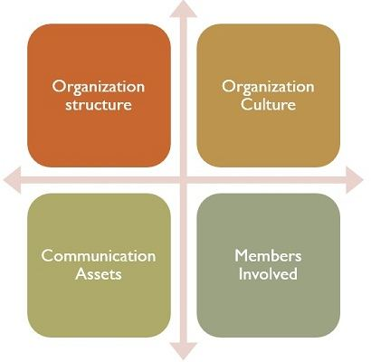
Organization Structure: It includes channels and means of communication in terms of the length of the transmission path.
Organizational Culture: It encompasses the procedure followed, standard behaviour and language or tone used during communication.
Communication Assets: It entails the quality and quantity of the transferred message in terms of validity, suitability, completeness and relevance.
Members involved: It covers the stakeholders involved in the process of communication, be it employees, managers, or other outside parties such as suppliers, creditors, etc., to know their communication skills.

Techniques used in the Communication Audit

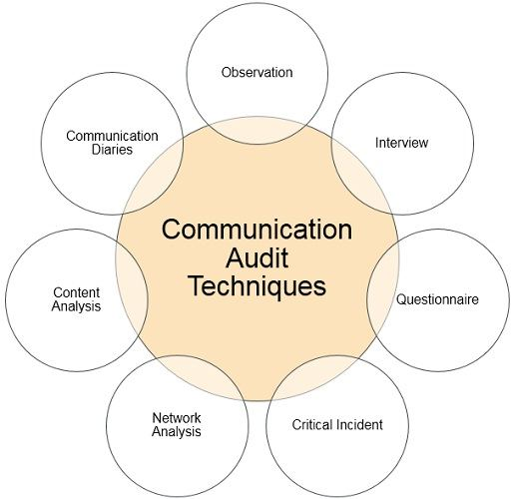
Observations: In this method, the auditor monitors the communication flow and process in an organization by sitting on the team meetings, interviews, and discussions, along with informal gatherings such as tea breaks, lunches, etc., so as to analyse the communication climate deeply.
Interviews: In this method, in-depth one-to-one interviews with random employees are conducted, which provides accurate and valuable data. However, this method is a bit expensive and consumes a lot of time.
Questionnaires: One of the most efficient methods of conducting a communication audit with respect to time. It covers all the employees of the concern. A questionnaire contains a number of questions written or printed with various alternative answers, provided to the respondents who need to mark the answers and submit the same to the audit team.
Critical Incidents: Its aim is to concentrate on the real behaviour of the employees while handling a particular situation or event, often a non-recurring one. The auditor can also use critical incident questions in interviews and questionnaires to make it more effective.
Network Analysis: Network analysis determines when, how, where, from whom, and to whom information flows in the organization. It also checks if there is any distortion in the information while on the way. By doing so, disclosure of disparities in the process takes place.
Content Analysis: A comprehensive and thorough analysis of the content will help in ascertaining the categories of satisfactory and unsatisfactory communication in the organization.
Communication Diaries: First of all, if the auditor chooses this method, there is a need for commitment from all the participants prior to the audit. The participants need to note down every message sent or received, after which the messages are identified as per pre-determined characteristics, which provides rich and valuable data.

3.4 Developing corrective action plan
Introduction
Corrective action plan, or CAP, is a set of actions designed to correct an issue, problem, non-compliance, or underperformance. In direct relation to compliance, CAP is a series of proposed actions to implement or address reported recommendations and audit comments. However, you can deploy a CAP anytime you identify an issue in your organization that you desire to change.
Purpose of a Corrective Action Plan
In the context of a compliance audit, a corrective action plan is usually developed to address audit findings and provide a roadmap to the desired future state. It can also be implemented to streamline workflow, improve processes or methods, and increase effectiveness and efficiency. For example, during the course of the SOC audit, management might discover that while user system access authorization occurs consistently, the authorization is documented in multiple places and in an unstructured format (e.g. instant messages or emails).
This makes it a nightmare when it comes time to collect audit evidence. That challenge in itself might not result in an audit finding, but it might cause an excessive amount of time spent in evidence gathering each year. That is time spent away from revenue-generating activities, and justifies the need for process improvement.
Steps to the Corrective Action Process
The National Institute of Standards and Technology (NIST) provide a logical methodology to identify and implement a corrective action plan. According to NIST special publication 800-100: Information Security Handbook, a Guide for Managers, the process involves the steps outlined below.
Collect Data and Analyse Results
In the context of compliance audits, this should be collaboration with your auditors. At the conclusion of each audit, your auditor should hold a closing meeting with you to present you with findings and recommendations (if any) and collect your feedback on potential improvements for the next audit. This also serves as a great opportunity for you to ask for their observation on how your organization measures up to other organizations of similar size in the same industry.
Once the information is collected, it’s necessary to perform a root because analysis before jumping into developing CAP. After all, you can fix something if you don’t know what caused it. Common causation factors that contribute to poor security control implementation and effectiveness include resources (human, monetary, time), training, policies and procedures, and awareness and commitment.
Identify Corrective Actions
This phase involves developing a plan that will provide a roadmap to reach your desired future state. This includes determining the range of corrective actions based on the causation factors, prioritizing corrective actions based on overall risk mitigation goals, and selecting the most appropriate corrective actions. There might be several corrective actions that could achieve the same goal but some may be inappropriate if they are inconsistent with the magnitude of the problem or too costly.
For example, one of the gaps identified from SOC 2 readiness might be to track the movement of removable media. The principle behind this requirement is to prevent data loss. There are many ways to help mitigate the risk. An entity could opt to implement data loss prevention (DLP) platform or prohibits the use of removable media and data exfiltration in general by the policy. The entity should make the decision based on the budget, the type of data they possess and process, laws and regulations, and technology compatibility.
Develop Business Case and Obtain Resources
This phase is a continuation of the previous in that the sound factors that played into the decision of corrective action plan should help plead the case with management and/or the board of directors for adequate resources to implement the plan.
Apply Corrective Actions
This “final” phase involves implementing corrective actions as determined through data analysis and as defined in an applicable business case as described above. Per the NIST guide referenced above, “After corrective actions are applied, the cycle completes itself and restarts with subsequent data collection and analysis”. The key here is that the process should be iterative in nature to ensure the progress is monitored and the corrective actions are implemented and yield results as planned.
Also, as an entity’s internal controls and processes evolve, so should its policies and procedures. In general, most compliance frameworks require the policies and procedures to be reviewed and updated at least annually. However, the policies and procedures should be re-examined at the time of CAP implementation.
How Do You Write a Corrective Action Plan?
Most compliance frameworks require the development of a corrective action plan post-assessment: Plan of Actions and Milestones and they serve as excellent examples for a proper corrective action plan. Common elements between the two include:
Point of Contact: the person/role that is held responsible for resolving the weakness.
Resource Requirements: resources required for resolving the weakness and when applicable, provide an estimated staff time in hours.
Planned Milestones: specific actions to correct the weakness with an associated completion date for each milestone
Scheduled Completion Date: the target completion date for the CAP as a whole
Status Date: the latest date an action was taken to remediate the weakness or some change was made to the CAP.

Self-cheek
1, Define the Objectives of Communication Audit
--------------------------------------------------------------------------------------------------------------------------------------------------------------------------------------------------------------------------------------------------------2, discuss the Types of Audit Opinion--------------------------------------------------------------------------------------------------------------------------------------------------------------------------------------------------------------------------------------------------------
3, Define the Elements of external audit
--------------------------------------------------------------------------------------------------------------------------------------------------------------------------------------------------------------------------------------------------------
4, Define the Characteristics of Audit Evidence
--------------------------------------------------------------------------------------------------------------------------------------------------------------------------------------------------------------------------------------------------------
5, discuss the Purpose of a Corrective Action Plan
--------------------------------------------------------------------------------------------------------------------------------------------------------------------------------------------------------------------------------------------------------
6, discuss the Steps to the Corrective Action Process

Reference
Boulescu, M., (2001) and collaborators, Audit Fundamentals, Didactic and
Pedagogical Publishing, Bucureşti
Boulescu, M., (2003) Financial audit. Highlights of national legislation, Economical Publishing, Bucureşti
Jinga, C. G., (2009) financial audit, ASE Publishing, Bucureşti
Ghiţă, M., Popescu, M., (2006) Internal audit of public institutions: theory and practice, CECCAR Publishing, Bucureşti Ghiţă, M., Sas, F., Tamas, A. S., Briciu, S
Ghiţă, R. and Dobra, I. B., (2009) Governing corporate and internal audit, AETERNITAS Publishing, Alba Iulia Giurgiu, A. I., Ungureanu, P. V., Duma, F. S., (2009) Mic Lexicon Financiar – Banking and Stock Exchange, Didactic and Pedagogical Publishing, Bucureşti
Oprean, I., Popa, I. E., Lenghel, R. D., (2007) Audit and financial control procedures, Misprint Publishing, Cluj Napoca Stârcea, D., (2008) Internal audit, Brâncuşi Academic Publishing, Târgu – Jiu Toma, M., (2007) Initiation in an entity financial statement audit, CECCAR Publishig, Bucureşti
Emergency Ordinance 75/1999 on financial audit amended and republished IFAC CAFR, Financial audit 2006, IRECSON Publishing, 2007. Professional auditing standards published by the IIA and commented by the IFACI, (2002), Bucureşti.

The trainers who developed the curriculum
No | Name | Qualification | Educational background | Region | College | Mobile number | E-mail
1 | Kassa Terefe Gelaw | BA, degree | Accounting & finance | A.A | KMC | +251993298301 | kssterefe@gmail.com
2 | Sewumehon Anteneh | BA degree | Accounting & finance | A.A | KMC | +251948032126 | Sewumehonanteneh@gmail.com
3 | Remedan Abdurehman | MBA | Accounting & finance | A.A | GWPTC | +25133233939 | rame.abdu10@gmail.com
4 | Meskerem Getachew | MBA | Accounting & finance | A.A | ARADA | +251925918465 | meskigetach@gmail.com
5 | Mahmud Oumer | BA | Accounting | A.A | GWPTC | 0913099303 | Mahmudoumer@gmail.com
6 | Mekuanint Abeje Melese | MSc degree | Accounting & finance | A.A | LMC | +251913969620 | Mekuanitabeje21@gmail.com
7 | Hussien Ebrahim | MBA | Accounting & finance | A.A | GWPTC | +251920188426 | Hussienebrahim701@ gmail.com
8 | Alemayehu | MBA | Accounting & finance | A.A | MPTC | +251920188426

