Marketing and Sales Management
Module II
Based on June 2021, Curriculum Version 1

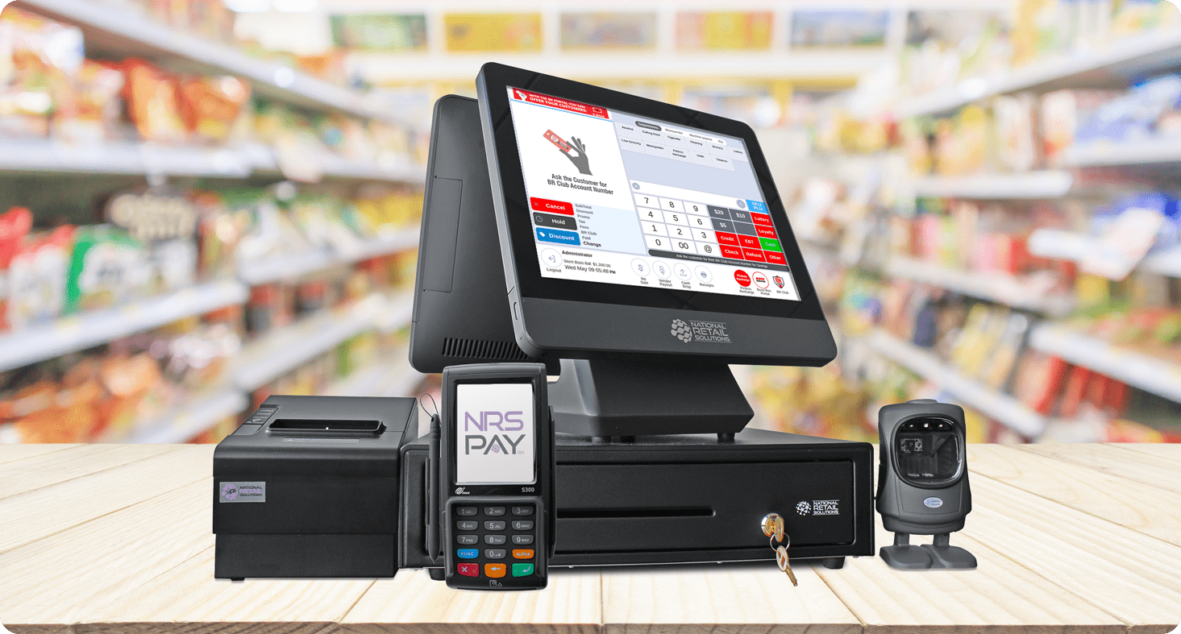

Module Title: - Applying Point of Sales Procedures
Module code: -LSA MSM3 05 1221
Nominal duration:46 Hour
Prepared by:Lideta Manufacturing College
August 18, 2023
Addis Ababa Ethiopia

Table of Contents
Introduction to module 6
Unit One: Operating point-of-sale equipment 8
1.1 Opening and closing point-of-sale. 9
1.2 Clearing Point-of-sale terminal 18
1.3 Handling cash 18
1.4 Maintaining supply of change in point-of-sale 19
1.5 Attending active point-of-sale 20
1.6 Completing records transaction error 22
1.7 Maintaining adequate dockets and vouchers 23
1.8 Informing customer point-of-sales 25
Self- check of unit One 26
Unit Two: Ensuring accuracy of transactions 28
2.1 Identifying Numerical calculations 28
2.2 Collecting and calculating numerical information 31
Self-Check of Unit Two 33
Unit Three: Perform point-of-sale transactions 34
3.1 Completing point-of-sale transactions 34
3.2 IDENTIFYING CASH AND NON-CASH TRANSACTION 49
3.3 Applying exchanges and returns 51
3.4 Moving goods efficiently 52
3.5 Entering Information into point-of-sale equipment 53
3.6 Receiving and stating price verbally to customer. 55
3.7 Tendering correct change. 56
Self-Check of Unit Three 58
OPERATION SHEET- 59
Unit Four: Perform point-of-sale transactions 60
4.1 Completing and processing customer order. 60
4.2 Processing customer delivery requirements 62
4.3 Directing g sales transactions 63
4.4 Acknowledging and thanking customer 65
Self-Check of Unit Four 66
Unit Five: Wrapping and packing goods 67
5.1 Maintaining and requesting adequate supplies. 67
5.2 Selecting wrapping and packaging material 68
5.3 Wrapping and requiring merchandise 74
5.4 Packing items safely 75
5.5 Arranging and transfer delivery merchandise 76
Self-Check of Unit Five 78

Acknowledgment
Ministry of Labor and Skills wish to extend thanks and appreciation to the many representatives of TVET instructors and respective industry experts who donated their time and expertise to the development of this Teaching, Training and Learning Materials (TTLM).

Introduction to module
This module describes the performance outcomes, skills and knowledge required to apply POS procedures, including, Operate point-of-sale equipment, Ensure accuracy of transactions, Perform point-of-sale transactions, complete sales, Wrap and pack goods. By the end of this module, you will have the knowledge and skills necessary to confidently operate a POS system and contribute to efficient and accurate sales processes.
This module is designed to meet the industry requirement under the Applying Point of sale occupational standard, particularly for the marketing and sales management.
This module covers the units:
- Operating point-of-sale equipment
- Ensuring accuracy of transactions
- Performing point-of-sale transactions
- Completing sales
- Wrapping and pack goods
Learning Objective of the Module
- Operate point-of-sale equipment.
- Ensure accuracy of transactions
- Perform point-of-sale transactions.
- Complete sales.
- Wrap and pack goods
Learning Instructions
For effective use this modules trainees are expected to follow the following module instruction:
- Read the specific objectives of this Learning outcome.
- Follow the instructions described below 3 to 5.
- Read the information written in the ―Information Sheets Try to understand what are
being discussed. Ask you teacher for assistance if you have hard time understanding
them.
- Accomplish the ―Self-check‖ given at the end of each information sheet
- If you earned a satisfactory evaluation, proceed to next information sheet. However,if your rating is unsatisfactory, contact your teacher for further instructions
- Perform Operation Sheets which were provided at the end of units
- Do the “LAP test” giver at the end of each unit and
- Read the identified reference book for Examples and exercise

Unit One:Operating point-of-sale equipment
This unit is developed to provide you with the necessary information regarding the following content coverage and topics:
- Opening and closing point-of-sale.
- Clearing Point-of-sale terminal
- Handling cash.
- Maintaining supply of change in point-of-sale
- Attending active point-of-sale
- Completing records transaction error.
- Maintaining adequate dockets and vouchers.
- Informing customer point-of-sales
This unit will also assist you to attain the learning outcomes stated on the cover page. Specifically, upon completion of this learning guide, you will be able to:
- Operate point of sales equipment.
- Clear point of –sale
- Apply Handling cash
- Maintain supply of change in point-of-sale
- Attend active point-of-sale
- Complete records transaction error.
- Maintain adequate dockets and vouchers.
- Inform customer point-of-sales

Opening and closing point-of-sale.
Point of Sale (POS) software, also known as electronic Point of Sale (EPOS), is an essential application for retail or hospitality businesses because it manages checkout operations and is what the customer sees when they make a transaction.
Point of sale systems process and track sales in an easy way, but they also track inventory. This means you run out of stock less often and don't order too much of one product. Choose from brands such as HP, Motorola, and ELO.
POS systems range in price and functionality, so you will find one to suit your needs. Several of the systems are designed to work with iPad, so you simply connect your iPad to process sales and then take it with you when you leave. These types of systems are perfect for smaller businesses. For an alternative mobile option, choose a hand-held terminal to improve inventory monitoring. To make them an all-in-one option, POS computers are touch screen, so handling sales and tracking inventory is just a touch away
POS printers connect to your POS system and print out receipts and orders for your customers or staff. Printer types include direct thermal, dot matrix, impact, and label printers. Print methods include dot matrix, inkjet matrix, and thermal among others. Choose print speeds from 3 lines per second to 8.9 lines per second to suit your business's needs.
To complete your POS system, POS accessories are a must. Signature pads and card readers allow your customers to pay via credit or debit card. Paper, roll mounts, and ribbon allow you to accurately print receipts for customers, and cash drawers allow you to keep money safe before you take it to the bank. These POS accessories are everything you need to keep yourPoint-of-sale equipment include:-
- Cash register
- Cash drawer
- Scanner
- EFTPOS terminal
- Electronic scales
- Security tagging
- Numerical display board

- Cash register
A cash register, sometimes called a till or automated money handling system, is a mechanical or electronic device for registering and calculating transactions at a point of sale. It is usually attached to a drawer for storing cash and other valuables. A modern cash register is usually attached to a printer
Point of sale registers come in a range of shapes and sizes. Improved technology provides many stores with sophisticated equipment for processing transactions.
A scanning cash register is one that combines a traditional cash register with a bar code scanner. This not only removes the need for a checkout operator to manually type in a price (for example, from a price label), but can make it easier to track stock levels. A scanning cash register may also be described as a complete point of sale system.
Scanning cash registers allow the operator to automatically retrieve the price and details of an item, adding it to the running total of a customer's shopping and in many cases feeding into a stock control system. The register can have either a handheld scanner (which the operator runs over the bar code) or a fixed scanner (over which the operator swipes the item). The scanner works by beaming light onto the item and measuring the reflection from different points of the bar code. Most bar codes use black and white to increase the contrast between the different points and reduce the possibility of a misreading
Entering information accurately into a register
Whatever the type of point of sale equipment used, information from a sales transaction needs to be entered into a point of sale register accurately.
The general process for entering this information into most cash registers requires you to:
- Enter the cost of the item into the register,
- press the department button for the item, then
- enter the amount tendered into the box provided, and
- Press TOTAL to find out if you've entered the information correctly.

- Setting Up Your Cash Register
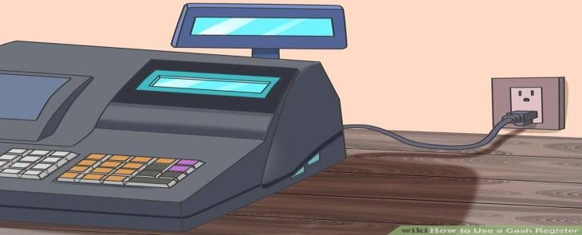
- Set up your cash register and plug it in. Find a hard, flat surface to set your register on. Ideally, this will be on a countertop with room for customers to place their merchandise. Plug the register directly into an outlet (do not use an extension cord)

- Install batteries. Batteries provide backup memory for the cash register in case of power failure and should be installed before you program any functions in the cash register.[1] Take off the receipt paper cover and locate the battery compartment. You may need to use a small screwdriver to unscrew the lid to this area. Install the batteries according to the directions on the machine. Put the lid back on the battery compartment.
- Some battery compartments are located underneath the receipt paper area.
- Change batteries once per year to ensure that they will work properly.

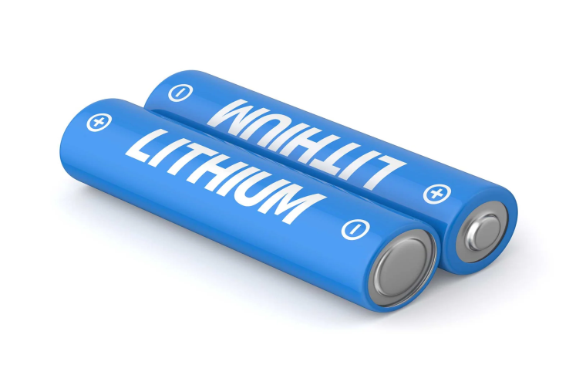

- Install the receipt paper. Take off the cover to the receipt paper compartment. Make sure the end of your paper roll has a straight edge so it will be fed easily into the paper feeder. Feed the paper roll through so that it will run up through the front of the register where you will be able to tear off receipts for customers. Press the FEED button so that the register will catch the receipt and feed it through
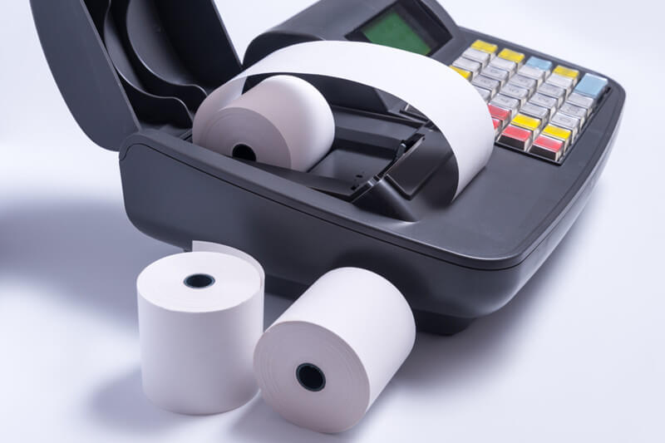

- Unlock the till drawer. The till drawer usually has a key that locks it up for safety. Do not lose this key. You can just leave the key in the drawer when it is unlocked so that it is easily found when you need to lock it up

- Turn the cash register on. Some cash registers have an ON/OFF switch on the back or side of the machine. Others may have a key on the front top of the machine. Turn on the machine, or turn the key to the REG (register) position.
Newer registers may have a MODE button instead of a physical key. Press the MODE button to scroll into a REG or operational mode
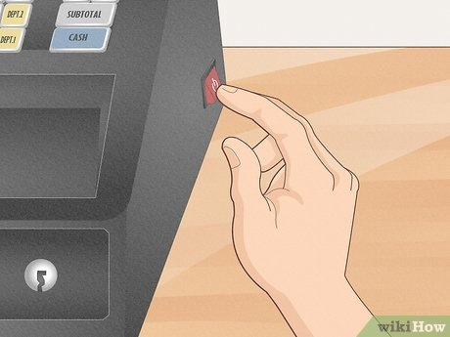
- Program your register. Most registers have buttons that can be programmed to categorize similar items. These categories, or departments, can also be associated with taxable or non-taxable items. You can also set the date and time
- The program function is usually accessed by either turning the key to PRG or P, or pressing the mode button to PROGRAM. Other registers may have a manual lever underneath the receipt tape cover that needs to be switched to a Program option.
- Many cash registers have at least 4 tax buttons. These can be programmed at different tax rates, depending on if you have a flat sales tax as some states in the U.S. do, or if you have other types of taxes, such as GST, PST, or VAT rates (depending on your location).
- Follow the specific instructions in your register’s manual to program these functions
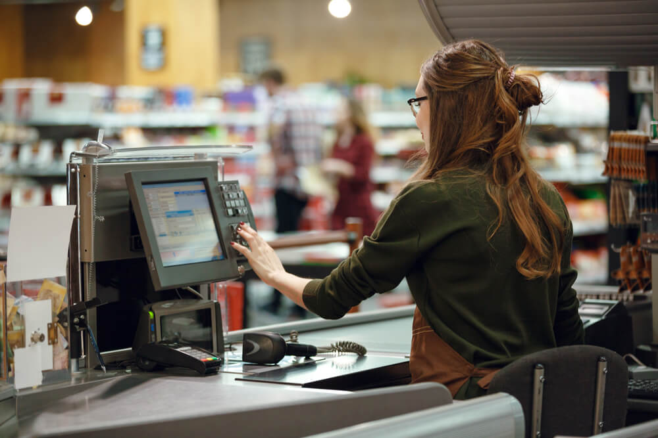

- Cash drawers
A cash drawer is a container or part of a cash register in which money is kept in a store, bank, or other business.
They may be the simplest part of your POS but making sure you have the right cash drawer is key. Most cash drawers are printer driven and will need the right cabling to connect to your receipt printer. Manual, USB, and Serial cash drawer models are also available to ensure compatibility with any POS system. We offer cash drawers that are designed for the most rugged environments, as well as cash drawers that are compatible with an iPod
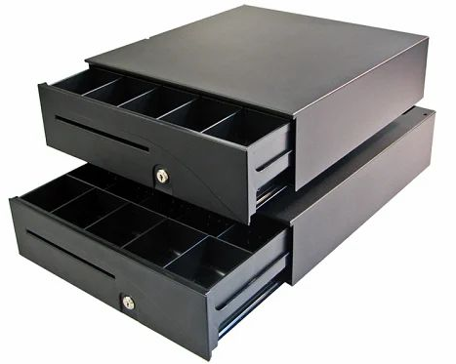
- EFTPOS terminal
A point-of-sale (POS) terminal is a computerized replacement for a cash register. Much more complex than the cash registers of even just a few years ago, the POS system can include the ability to record and track customer orders, process credit and debit cards, connect to other systems in a network, and manage inventory. Generally, a POS terminal has as its core a personal computer, which is provided with application-specific programs and I/O devices for the particular environment in which it will serve. A POS system for a restaurant, for example, is likely to have all menu items stored in a database that can be queried for information in a number of ways. POS terminals are used in most industries that have a point of sale such as a service desk, including restaurants, lodging, entertainment, and museums.
Integrated EFTPOS is suitable for businesses of any size looking to reduce the complexity of their EFTPOS payments. It allows merchants to directly connect an EFTPOS terminal to their Point of Sale (POS) system or Electronic Cash Register (ECR) – removing the need to re- enter the purchase amount into the EFTPOS terminal
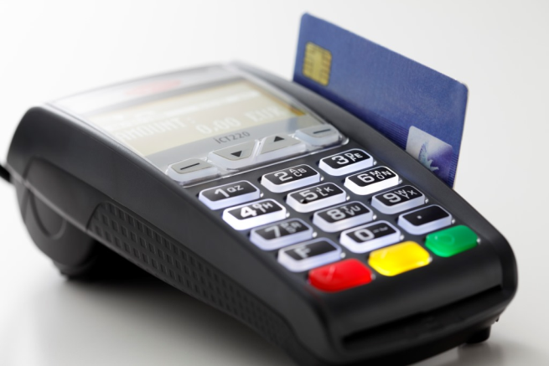
- Store policy and procedures
Store policies and procedures related to point of sale (POS) procedures govern the specific processes and guidelines for operating the POS system and conducting sales transactions. Here are some common policies and procedures within the context of POS procedures:
- POS System Usage: Outlines guidelines for properly using the POS system, including logging in and out, navigating the system interface, accessing different functions, and following specific steps for processing transactions.
- Product Pricing and Discounts: Defines policies for assigning prices to products, applying discounts or promotions, and ensuring accurate pricing information is reflected in the POS system.
- Sales Transaction Process: Describes the step-by-step process for conducting sales transactions, including scanning or manually entering products, adding quantities, applying discounts or coupons, and calculating the total amount.
- Payment Methods: Specifies the accepted payment methods, such as cash, credit/debit cards, mobile payments, and gift cards. It may provide instructions on how to process each payment type and any additional steps, like obtaining signatures or checking identification.
- Returns and Exchanges: Establishes procedures for handling returns or exchanges, including verifying proof of purchase, assessing the condition of the returned item, issuing refunds or store credits, and updating inventory records.
- Voided or Canceled Transactions: Defines guidelines for voiding or canceling transactions in the POS system, including when it is appropriate to void a transaction, the required approvals, and any documentation or record-keeping requirements.
- Cash Handling and Reconciliation: Outlines procedures for managing cash transactions, including opening and closing the cash register, counting the cash float, reconciling cash amounts with sales records, and depositing cash into the appropriate secure location.
- Reporting and Record-Keeping: Specifies the frequency and requirements for generating sales reports, tracking transaction data, and maintaining accurate records within the POS system. It may also outline any regulatory or compliance requirements related to reporting.
- System Security: Addresses security measures to protect the POS system and customer data from unauthorized access or breaches. This may include guidelines for password protection, user access levels, data encryption, and regular system updates.
- Training and Troubleshooting: Provides guidance on training employees to use the POS system effectively, troubleshooting common issues, and escalating technical problems to the appropriate support channels.
- Scanner
Scanner is used to read barcode .These barcodes are scanned with the help of a barcode scanner or barcode reader to check the details regarding the price, item no, batch code, etc.This barcode reader or barcode scanner is attached to the computer system.After scanning, the complete details of the item can be fetched on the computer for quick access with database administration.
The barcode is scanned with the help and assistance of an optical barcode reader.
The Optical barcode reader or barcode scanners are an input device of a computer system used for standardized identifications.
Uses of Scanner Devices
- The scanners are used to scan documents to the computer for further modifications and use.
- The documents are converted into a digital format which can later be shared via Google drives, emails or uploaded online on other websites.
- The OMR [Optical Mark Reader] is an input device of a computer that is primarily utilized in the examination for solving multiple-choice questions.
- The OMR converts these solved questions into machine-readable form.
- They are extensively used in libraries where scanners scan all important information related.
- They are used in malls, all the product-sensitive information can be captured using them like product cost, manufacturing date, expiry date, batch number, etc.
- One scanner is available in the markets which is capable of scanning, and printing.
- Modern scanners can be connected to the computer system using Wi-Fi, Bluetooth, Infrared, LAN, USB cables, TWAIN, parallel port, SCSI, etc.
- They are widely used as the qualities of scan documents are never compromised.
Benefits and Advantages of Scanners in Points
- The speed of modern scanners is pretty impressive, they can carry out multiple operations simultaneously, without affecting another important working process.
- They are capable of storing and handling huge files and documents as they possess enough memory to execute any operation and tasks given to them.
- As they work with tremendous speed they do not compromise the quality of scanned documents they present therefore it is considered the major advantage of scanners.
- They are compact in size and hence can be installed in small spaces.
- They are highly portable and can be transferred from one location to another.
- They are extremely easy to use and handle.
- For further modification and viewing additional editing software is used on computers and laptops.
- They can be easily connected to other devices like laptops, desktops, and notepads using USB cables or parallel ports, or Wifi.
- The qualities produced by scanners are never compromised and hence widely used and accepted.

1.2 Clearing Point-of-sale terminal
Clearing a point-of-sale (POS) terminal refers to the process of removing all transaction data and resetting the terminal to its default state. This is typically done at the end of each business day or when transitioning between shifts. Clearing the terminal helps maintain system performance, protect sensitive information, and ensure a fresh start for the next day's transactions. Here are the general steps to clear a POS terminal:
- Log Out of the System:
- Close Any Open Applications:
- Clear Transaction Data
- Access the Terminal Settings
- Confirm Clearing Operation
- Print or Save Reports (Optional)

1.3 Handling cash
Cash handling materials are ideal for ensuring your cash is always safe. Some feature electronic counting and sorting to make handling large amounts of money easy. Use these counters along with currency straps and coin wrappers to sort and transport cash at the end of the day
Maintain supplies of change in point-of-sale terminal according to store policy.
Attend active point-of-sale terminals according to store policy.
Complete records for transaction errors according to store policy.
Point-of-sale documents
Point-of-sale documents include:

- Order forms
- Lay-by slips
- Credit slips
- Product return slips
- Message pads
- Promotional materials

Customers include:
- New or repeat contacts
- Internal and external contacts
- Customers with routine or special requests
- People from a range of social, cultural and ethnic backgrounds and with varying physical and mental abilities

1.4 Maintaining supply of change in point-of-sale
Maintaining an adequate supply of change at the point-of-sale (POS) is crucial to ensure smooth cash transactions and excellent customer service. Here are some tips for effectively managing the supply of change:
- Determine Optimal Change Amounts: Analyze historical transaction data to identify the most frequently used denominations and quantities of change. This analysis will help you determine the optimal amounts of coins and bills needed to meet customer demands.
- Set a Starting Cash Float: Establish a predetermined starting cash float for each cash register or drawer. The starting cash float should include an appropriate amount of change to handle initial transactions and provide flexibility during the business day.
- Regular Cash Replenishment: Monitor the cash levels throughout the day and replenish the change as needed. Assign a responsible staff member or cashier to periodically check the cash supply and request additional change from the cash office or designated change fund.
- Cash Ordering Schedule: Develop a schedule for ordering change from your bank or cash provider to ensure timely replenishment. Consider factors such as business volume, peak periods, and any special events that may impact cash flow. Ordering change in advance helps prevent running out of specific denominations.
- Coin and Bill Storage: Organize the storage of coins and bills in the cash register or drawer for easy access and efficient change handling. Use coin trays or compartments to separate different denominations and ensure quick and accurate dispensing.
- Float Adjustment: Regularly assess the cash float to determine if adjustments are necessary. If there is consistently excess change or shortages, consider adjusting the starting cash float to better align with transaction patterns and minimize the need for additional change requests.
- Cash Handling Policies: Implement clear cash handling policies and procedures for all employees. Ensure that staff members understand the importance of maintaining an adequate change supply, counting change accurately, and documenting any discrepancies.
- Communication with Cashiers: Foster open communication with cashiers and front-line staff to gather feedback on change needs. Encourage employees to report any issues or concerns related to change availability promptly so that appropriate actions can be taken.
- Consider Alternative Payment Methods: Encourage customers to use alternative payment methods, such as card payments or mobile wallets, to reduce the reliance on cash transactions and minimize the need for change.
- Training and Education: Provide training to cashiers on efficient change handling techniques, including counting change quickly and accurately, providing proper denominations, and addressing customer inquiries or concerns related to change.
By implementing these strategies, you can maintain an adequate supply of change at the POS, reduce transaction delays, and deliver excellent customer service. Regular monitoring, effective communication, and adherence to cash handling policies are key to successful change management.

1.5 Attending active point-of-sale

Attending an active point-of-sale (POS) refers to actively managing and serving customers at the checkout counter or POS terminal. Here are some tips for effectively attending to an active POS:
- Greet Customers: Welcome each customer with a friendly and warm greeting. Make eye contact, smile, and acknowledge their presence. A positive first impression sets the tone for a pleasant transaction.
- Multi-Tasking: Develop the ability to multitask efficiently. While attending to one customer's transaction, be aware of other customers waiting in line. Balance speed and accuracy without making customers feel rushed or neglected.
- Efficient Transaction Processing: Familiarize yourself with the POS system and its functionalities to process transactions swiftly. Scan or input items accurately, apply discounts or promotions, and handle various payment methods efficiently. Practice using shortcut keys or commands to expedite the process.
- Clear Communication: Communicate clearly and effectively with customers. Confirm the total amount, inform them of any discounts or promotions applied, and provide necessary information about the transaction. Use simple and jargon-free language to avoid confusion.
- Handling Cash: If handling cash, count and provide change accurately. Double-check the amounts to avoid mistakes. Maintain a secure and organized cash drawer, and follow cash handling procedures to ensure the safety of both customers and employees.
- Problem Resolution: Be prepared to handle any issues or concerns that may arise during a transaction. Remain calm and professional when addressing customer complaints, product inquiries, or technical difficulties with the POS system. Seek assistance from a supervisor or manager for complex issues if needed.
- Bagging Items: Offer assistance with bagging items, particularly for customers with numerous or heavy purchases. Be mindful of fragile or perishable items and pack them appropriately. Ensure bags are properly sealed and labeled if required.
- Customer Engagement: Engage in friendly conversation with customers, but be mindful of their preferences for interaction. Some customers may prefer a quick and efficient transaction, while others may appreciate small talk or personalized recommendations.
- Up-selling and Cross-selling: Pay attention to opportunities for up-selling or cross-selling relevant products or services. Offer additional items that complement the customer's purchase, but avoid being pushy or overselling.
- Closing the Transaction: Thank customers for their purchase and invite them to return. Provide them with a receipt or proof of purchase, and offer assistance with any additional needs or inquiries they may have.
Remember, attending to an active POS requires a balance between efficiency and excellent customer service. The goal is to provide a positive and seamless checkout experience while ensuring accuracy and meeting customer expectations.

1.6 Completing records transaction error

Completing records for a transaction error involves documenting the details of the error, investigating its cause, and taking appropriate corrective actions. Here's a step-by-step process to complete records for a transaction error:
Identify the Error: Recognize and understand the nature of the transaction error. It could include overcharging, undercharging, incorrect item entry, incorrect discounts, or any other mistake that affects the accuracy of the transaction.
Document the Error: Record the details of the error in a designated error log or incident report. Include the date and time of the transaction, the nature of the error, the customer's name or identifier, and any other relevant information that helps identify the specific transaction.
Investigate the Cause: Determine the root cause of the error. This may involve reviewing the original transaction receipt, consulting the POS system's transaction logs, or interviewing the staff members involved in the transaction. Understanding the cause is crucial to prevent similar errors in the future.

Correct the Error: Depending on the nature of the error, take appropriate corrective actions. This could involve refunding the customer, adjusting the transaction amount, issuing a store credit, or any other necessary steps to rectify the mistake. Follow your organization's policies and procedures for error correction.

Update Records: Make the necessary updates to the transaction records. This may involve voiding or canceling the original transaction and creating a new, corrected record. Ensure that all relevant information, including the correction details, is accurately documented in the POS system or any other record-keeping system used by your organization.
Notify Relevant Parties: If necessary, inform the customer about the error and the corrective actions taken. Apologize for any inconvenience caused and provide any necessary explanations or assurances. Notify any other relevant parties, such as supervisors or managers, about the error, its resolution, and any follow-up actions required.
Learn from the Error: Use the transaction error as an opportunity to learn and improve. Analyze the error and identify any underlying issues in processes, staff training, or system limitations that contributed to the mistake. Implement necessary changes, such as additional training, process improvements, or system updates, to prevent similar errors in the future.
Follow-up and Monitoring: Keep track of the corrected transaction and monitor it to ensure that the error has been resolved satisfactorily. Maintain regular communication with the customer, if applicable, to address any ongoing concerns or provide updates on the resolution.

1.7 Maintaining adequate dockets and vouchers
Maintaining adequate dockets and vouchers is essential for efficient record-keeping and financial management within an organization. Dockets and vouchers serve as evidence of transactions, expenses, and other financial activities. Here are some key points to consider for maintaining adequate dockets and vouchers:
Document Organization: Establish a systematic approach to organizing dockets and vouchers. Create a filing system that allows for easy retrieval and categorization of documents. This can be done physically using folders or electronically using file management software.
Standardized Format: Develop a standardized format for dockets and vouchers to ensure consistency and clarity. Include essential information such as date, description of the transaction, amount, relevant account codes, and any other necessary details.
Numbering System: Implement a unique numbering system for dockets and vouchers. Assigning a sequential number to each document helps track and reference them accurately. Use a preprinted numbering system or utilize digital solutions that can automatically generate and assign document numbers.
Supporting documentation: Ensure that all dockets and vouchers have appropriate supporting documentation. This may include invoices, receipts, purchase orders, contracts, or any other relevant paperwork. Attach these documents to the respective dockets or vouchers to provide a comprehensive record.
Accuracy and Completeness: Double-check the accuracy and completeness of the information on each docket or voucher. Verify that all necessary fields are filled out correctly, and review calculations to avoid errors. Accuracy is crucial for maintaining reliable financial records.
Approval and Signatures: Establish a clear process for approving and signing off on dockets and vouchers. Ensure that authorized personnel review and authorize each document before it is considered valid. This helps maintain accountability and control over financial transactions.
Storage and Retention: Determine appropriate storage methods for dockets and vouchers. Physical documents should be stored in a secure and organized manner, protecting them from damage or loss. If using electronic storage, implement secure backup systems and access controls. Adhere to any legal or regulatory requirements regarding document retention periods.
Regular Audits: Conduct periodic audits of dockets and vouchers to ensure compliance, accuracy, and adherence to internal controls. Regular reviews help identify any discrepancies or irregularities and allow for corrective actions to be taken promptly.
Training and Documentation: Provide training to employees involved in the document management process. Educate them on the importance of maintaining adequate dockets and vouchers, as well as the procedures and best practices to follow. Develop documentation outlining the guidelines and instructions for reference.

1.8 Informing customer point-of-sales
Informing customers at the point of sale is crucial for providing them with relevant information about products, services, promotions, and policies. It helps enhance their shopping experience and enables them to make informed purchasing decisions. Point of sale systemsenable a business to accept payments from customers and track sales. It keeps track of different data related to a business. Think of a payment checkout counter at a store. The counter displays a point of sale system and terminal

Self- check of unit One
- Choose the best answer for the following question
- Which one of the following is an automated money handling system
- Cash register B. Scanner C. Cash drawer D. all
- The part of a cash register in which money is kept is—
- Cash drawer B. Scanner C. Cash register D. EFTPOS terminal
- Which one of the following the specific processes and guidelines for operating the POS system and conducting sales transactions?
- Cash drawer B. Scanner C. Cash register D. EFTPOS terminal
- Which one of point –of –sale equipment use to read barcode ?
- Cash register B. Scanner C. Cash drawer D. None
- The process of removing all transaction data and resetting the terminal to its default state
- POS system B. Clearing POS Terminal C. Handle Cash D. None
- Which one of the following is point of sale document?
- Order forms B. Lay-by slips C. Credit slips D. Product return slips E. None

- Give short for the following questions
- Write Point-of-sale equipment accessories

OPERATION SHEET-1
OPERATION TITLE:- Setting Up Cash Register machine PURPOSE:- trainees will attain the required skill to install cash register
CONDITIONS OR SITUATIONS FOR THE OPERATIONS:- the counter will be
Comfortable to seat, electric installation and enough ventilation
EQUIPMENT TOOLS AND MATERIALS: - cash register machine, divider, stabilizer, screw driver, batteries
PROCEDURE:-
- Plug the register directly into an outlet (do not use an extensioncord)
- use a small screwdriver to unscrew the batterycompartment
- Install the batteries according to the directions on themachine
- Put the lid back on the batterycompartment.
- Take off the cover to the receipt papercompartment
- Feed the paper rollthrough
- Press the FEED button so that the register will catch the receipt and feed itthrough
- Unlock the tilldrawer
- Turn the cash registeron
- Program yourregister

PRECAUTIONS:-
• Take care of electric shortages and contacts
• Some battery compartments are located underneath the receipt paper area.
• Change batteries once per year to ensure that they will work properly
• Make sure the end of your paper roll has a straight edge
• Do not lose this key
QUALITY CRITERIA:-
• The cash register can start when put on the light
• The cash register can work and have back up while put off light

Unit Two: Ensuring accuracy of transactions
This unit is developed to provide you with the necessary information regarding the following content coverage and topics:
- Identifying Numerical calculations
- Collecting and calculating numerical information
This unit will also assist you to attain the learning outcomes stated on the cover page. Specifically, upon completion of this learning guide, you will be able to:
- Identify Numerical calculations
- Collect and calculate numerical information

2.1 Identifying Numerical calculations

In any transactioncustomers buy/purchase goods and services this means the merchandiser in turn sales this goods and services. And also the merchandiser or producer purchase raw materials and other services. This transaction takes place at point of sale (POS).
When it comes to identifying numerical calculations at the point of sale (POS), it usually refers to the calculations involved in processing a transaction and determining the final amount to be paid by the customer.
To perform these transactions mainly focusing money exchanges personnel’s in charge of this should have to use numerical. Some of the numerical performed are:
- Calculations of cash amounts received and paid
- Addition, multiplication, division and subtraction amounts
- Changing of different types of money with the current currency value
- Calculations of percentages
- Measurements
- Estimation of quantities
Here are some common numerical calculations that take place at the point of sale:
- Subtotal Calculation: is the sum of all the individual prices of the items or services being purchased. It involves adding up the prices of each item or service selected by the customer.
- Discounts and Coupons: If any discounts or coupons are applicable to the transaction, the POS system needs to calculate the discounted amount. This calculation may involve subtracting a fixed amount or a percentage from the subtotal.
- Taxes: Depending on the jurisdiction and the type of goods or services being sold, taxes may need to be calculated and added to the subtotal. This calculation typically involves applying a tax rate to the subtotal.
- Total Calculation: The total amount payable by the customer is the sum of the subtotal, any applicable taxes, and any discounts or coupons. The POS system calculates the total by adding or subtracting the relevant amounts.
- Payment Calculations: If the customer pays with cash and requires change, the POS system may need to calculate the amount of change due. This calculation involves subtracting the total payment amount from the total amount payable.
Let's consider an example to illustrate numerical calculations at a point of sale.
Example:
A customer purchases three items from a store: Item A priced at Br.20, Item B priced at Br.15, and Item C priced at Br.10. The store offers a 10% discount on the total purchase, and a sales tax of 8% applies to the subtotal.
- Subtotal Calculation:
Subtotal = Item A price + Item B price + Item C price
= 20 + 15 + 10 = 45
- Discount Calculation:
Discount = Subtotal X Discount percentage
= 45 X 0.10 = 4.50
- Subtotal after Discount:
Subtotal after Discount = Subtotal - Discount
= 45 - 4.50 = 40.50
- Tax Calculation:
Tax = Subtotal after Discount X Tax rate
= 40.50 X 0.08= 3.24
- Total Calculation:
Total = Subtotal after Discount + Tax
= 40.50 + 3.24= 43.74
In this example, the numerical calculations at the point of sale involved calculating the subtotal, applying a discount, calculating the tax, and determining the total amount payable by the customer.
    - Numerical problems
Here are a few numerical problems that can arise at a point of sale (POS) and require calculations:
- Calculating Change:
Given a customer's payment amount and the total amount due for a purchase, calculate the correct change to be given back to the customer.
Example:
Total amount due: Br.42.50
Customer payment: Br.50.00
Change = Customer payment - Total amount due
Change = Br. 50.00 – Br. 42.50
Change = Br. 7.50

2.2 Collecting and calculating numerical information
Collecting and calculating numerical information involves gathering data and performing calculations on that data to derive meaningful results. Here's a general process for collecting and calculating numerical information:
- Data Collection: Begin by collecting the relevant numerical data. This can involve various methods, such as surveys, measurements, observations, or accessing existing data sources. Ensure that the data collected is accurate, complete, and relevant to the problem or analysis at hand.
- Data Organization: Organize the collected data in a structured manner that is easy to work with. This may involve creating tables, spreadsheets, or databases to store and manage the data effectively. Ensure that the data is appropriately labeled and categorized for further analysis.
- Data Cleaning: Review the collected data for any errors, inconsistencies, or outliers. Clean the data by removing or correcting any inaccuracies or anomalies that may affect the validity of the analysis. This step is crucial to ensure reliable and accurate calculations.
- Calculation and Analysis: Perform the necessary calculations and analyses on the collected data. This can involve a wide range of mathematical operations, such as addition, subtraction, multiplication, division, averages, percentages, ratios, or morecomplex statistical analyses depending on the nature of the problem.
- Interpretation and Presentation: Once the calculations are complete, interpret the numerical results in the context of the problem or question being addressed. Clearly communicate the findings, whether through written reports, visualizations, or presentations, to make the information easily understandable to others.
Example 1:
Suppose you are working at a retail store and need to collect and calculate numerical information for a sales transaction. Consider the following scenario:
An item is being sold for Br. 50, and the customer purchases three of these items. The store applies a 10% discount on the total purchase. The applicable sales tax rate is 8%.
- Data Collection: Collect the relevant numerical information for the transaction:
- Item price: $50
- Quantity purchased: 3
- Discount percentage: 10%
- Sales tax rate: 8%
- Calculation and Analysis: (use the previous example 1)
- Subtotal
- Discount Calculation
- Subtotal after Discount
- Tax Calculation
- Total Calculation
- Interpretation and Presentation: The calculations reveal that the subtotal before discount is Br.150. After applying a 10% discount, the subtotal reduces to Br.135. The sales tax on the discounted subtotal amounts to $10.80, resulting in a total amount payable by the customer of Br.145.80.
In this example, we collected numerical information such as item price, quantity, discount percentage, and sales tax rate at the point of sale. We performed calculations to determine the subtotal, discount amount, subtotal after discount, tax amount, and the final total payable by the customer.

Self-Check of Unit Two
I. Give short for the following questions
- Discuss how you can identify numerical calculation
- Explain Collecting and calculating numerical information
- A customer purchases three items from a store: Item A priced at Br.200, Item B priced at Br.105, and Item C priced at Br.110. The store offers a 8% discount on the total purchase, and a sales tax of 10% applies to the subtotal.
Then Calculate
- Subtotal
- Discount Calculation
- Subtotal after Discount
- Tax Calculation
- Total Calculation

Unit Three: Perform point-of-sale transactions
This unit is developed to provide you with the necessary information regarding the following content coverage and topics:
- Completing point-of-sale transactions.
- Identifying cash and non-cash transaction
- Applying exchanges and returns.
- Moving goods efficiently
- Entering Information is into point-of-sale equipment
- Entering Information is into point-of-sale equipment.
- Receiving and stating price verbally to customer.
- Tendering correct change.
This unit will also assist you to attain the learning outcomes stated on the cover page. Specifically, upon completion of this learning guide, you will be able to:
- Complete-of-sale transactions.
- Identify cash and non-cash transaction
- Apply exchanges and returns.
- Move goods efficiently
- Enter Information is into point-of-sale equipment
- Enter Information is into point-of-sale equipment.
- Receive and stat price verbally to customer.
- Tender correct change.

3.1 Completing point-of-sale transactions
Point-of-sale transactions
A point-of-sale (POS) transaction is a payment made by the customer for products or services purchased, either at a physical cash counter or through an online store. These transactions involve two user roles: the buyer and the seller .
To complete a POS transaction, businesses deploy a comprehensive system encompassing both software and hardware components, commonly referred to as POS or Point of Sale systems. POS hardware typically includes elements such as a credit card reader, a cash register, or even a tablet. Simultaneously, the accompanying software diligently records transaction data and effectively integrates these sales into a company’s financial records.
There are different types of POS transactions such as online, offline, and returns. Understanding these different types of POS transactions helps businesses adapt to customer preferences and optimize their payment processes.
Regular POS reconciliation ensures accuracy, stability, and security in financial transactions, reducing errors and identifying unauthorized activities promptly

Point-of-sale transactions include:

- EFTPOS
- Cheques
- travelers cheques
- credit cards and store cards
- smart cards

- exchanges
- gift vouchers

  - EFTPOS
EFTPOS stands for Electronic Funds Transfer at Point of Sale. It is an electronic payment system that allows customers to make payments for goods or services using debit or credit cards at the point of sale (POS) terminal. EFTPOS systems are widely used in retail stores, restaurants, and other businesses to process card-based transactions securely and efficiently.

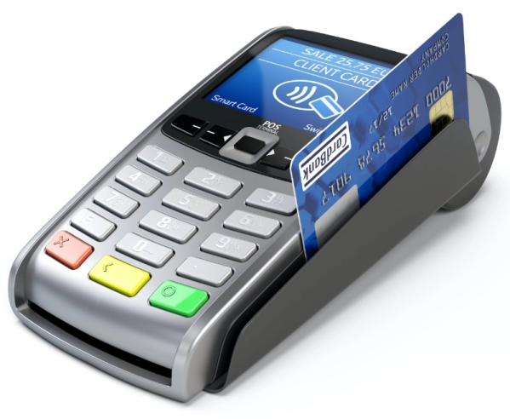
Here's how EFTPOS typically works:
- Card Swipe or Insert: The customer presents their debit or credit card to the EFTPOS terminal. The card can be swiped or inserted into the terminal, depending on the type of card and the terminal's capabilities.
- Card Verification: The EFTPOS terminal reads the card information and verifies its validity. This involves checking the card's magnetic stripe or the chip for authentication and security purposes. The terminal may also prompt the customer to enter a PIN (Personal Identification Number) for further verification.
- Transaction Authorization: Once the card is verified, the EFTPOS terminal establishes a connection with the payment network (such as Visa, Mastercard, or a local payment network) to request authorization for the transaction. The terminal sends the transaction details, including the purchase amount and merchant information, to the payment network.
- Authorization Response: The payment network receives the transaction request and communicates with the issuing bank that issued the customer's card. The issuing bank checks the customer's account for sufficient funds or credit availability. Based on this verification, the issuing bank sends an authorization response back to the payment network, confirming whether the transaction is approved or declined.
- Transaction Completion: Upon receiving the authorization response, the EFTPOS terminal displays the transaction status to the customer. If the transaction is approved, the terminal prints a receipt for the customer to sign (in the case of credit transactions) or enter their PIN (in the case of debit transactions). The transaction amount is deducted from the customer's account or credit line.
- Settlement: At the end of the business day or a specific settlement period, the merchant initiates a settlement process to transfer the funds from the approved transactions to their designated bank account. This involves reconciling all the authorized transactions and submitting them for payment processing.
EFTPOS systems offer convenience, speed, and security for both customers and merchants. They eliminate the need for handling cash and provide a seamless payment experience at the point of sale.
  - Cheques

Cheques, also known as checks in some regions, are a widely used form of payment that allows individuals or businesses to make payments or transfer funds from one bank account to another. A cheque is a written, unconditional order issued by an account holder (the drawer) to their bank, instructing the bank to pay a specified amount of money to the person or entity named on the cheque (the payee).
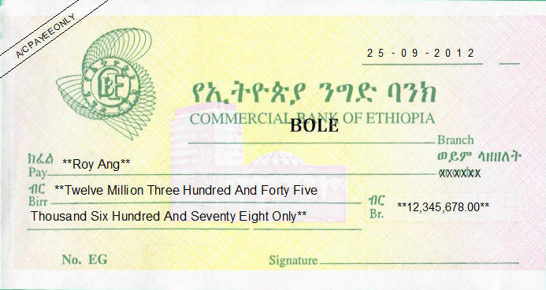
Here's an overview of how cheques typically work:
- Issuing a Cheque:
The account holder (drawer) writes a cheque, providing the following information:
- Payee: The name of the individual or business to whom the payment is being made.
- Amount: The specific amount of money to be paid, written both numerically and in words.
- Date: The date on which the cheque is issued.
- Signature: The drawer's signature, which is necessary for authorization.
- Presenting the Cheque:
The payee receives the cheque and presents it to their bank for deposit or cashing. This can be done by depositing the cheque at a bank branch, through an ATM, or by mobile deposit if available.
- Verification and Processing:
The bank where the cheque is presented (the payee's bank) verifies the cheque's authenticity, examines the signature, and checks for any irregularities. The bank may also verify that the drawer has sufficient funds in their account to cover the cheque amount.
- Clearing Process:
The payee's bank sends the cheque to the bank where the drawer holds their account (the drawer's bank) through a clearing process. This process involves the exchange of cheque information and settlement of funds between banks. The drawer's bank verifies the details of the cheque and processes the payment.
- Fund Deduction and Payment:
If the drawer has sufficient funds to cover the cheque amount, the funds are deducted from the drawer's account, and the payee's bank credits the payment to the payee's account. The payee can then access the funds as per their bank's policies.
It's important to note that the processing time for cheques can vary, with some banks taking a few business days to clear a cheque. Additionally, banks may charge fees for processing cheques, and there may be restrictions or holds on fund availability, especially for large or out-of-town cheques.
What are the advantages of using cheques compared to other payment methods?
What are some common drawbacks and limitations of using cheques?
What are some examples of electronic payment methods that are commonly used?
- Traveler’s cheques
Traveler's cheques are a type of prepaid instrument used by travelers as a secure and convenient form of payment when abroad. Traveler's cheques are issued by financial institutions and can be exchanged for local currency or used for purchases at participating businesses.
Here are some key points about traveler's cheques:
- Security: Traveler's cheques are designed to provide enhanced security for travelers. They typically have built-in security features, such as a unique serial number, a signature line, and a counterfoil. In case of loss or theft, the cheques can be replaced by the issuing institution.
- Universal Acceptance: Traveler's cheques are widely accepted around the world. They can be exchanged for local currency at banks, currency exchange offices, and some hotels. Many businesses, including restaurants and retail stores, also accept traveler's cheques as a form of payment.
- Signature Verification: When using a traveler's cheque, the holder is required to sign the cheque in the presence of the recipient, who can compare the signature with the one on the cheque. This provides an additional layer of authentication and helps prevent unauthorized use.
- Ease of Use: Traveler's cheques are available in various denominations and currencies. They can be used for both small and large transactions, making them suitable for different travel expenses. Traveler's cheques also offer the convenience of being easily convertible into local currency when needed.
- Replacement and Refunds: If traveler's cheques are lost or stolen, they can be replaced by the issuing institution, usually with a quick turnaround time. Some institutions may also provide emergency assistance, such as providing emergency cash or arranging for a card replacement.
However, it's worth noting that with the advent of electronic payment methods and the widespread availability of ATMs and credit cards, the usage of traveler's cheques has declined in recent years. Many travelers now rely on debit or credit cards, prepaid travel cards, or mobile payment apps for their travel expenses. These electronic payment methods offer convenience, ease of use, and wider acceptance in various locations.
Before traveling, it's advisable to research the payment methods accepted at your destination and consider a combination of payment options to ensure you have a secure and accessible means of payment during your trip.
- Credit cards and store cards
Credit cards and store cards are two common types of electronic payment methods that are widely used for making purchases.
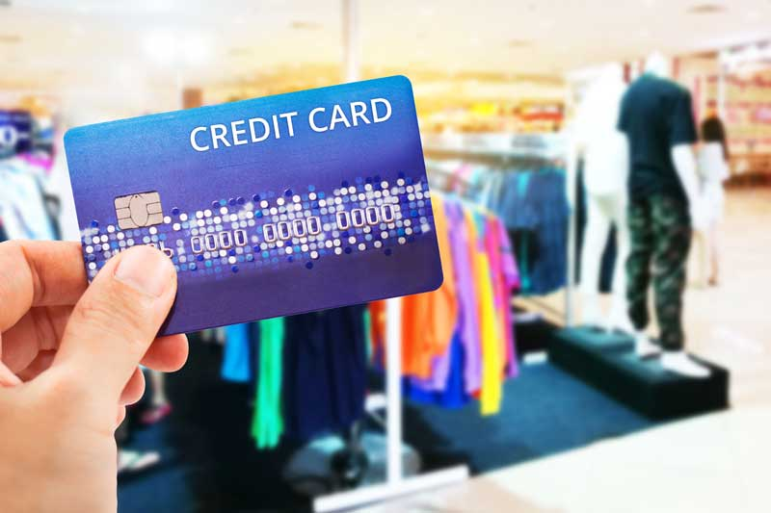
Here's an overview of each:
- Credit Cards:
Credit cards are payment cards that allow users to borrow money from a financial institution, typically a bank, to make purchases. Here are some key features and benefits of credit cards:
- Convenience: Credit cards offer a convenient and widely accepted method of payment. They can be used for in-person transactions at various merchants, as well as for online and over-the-phone purchases.
- Borrowing Capacity: Credit cards provide a revolving line of credit, allowing users to make purchases up to a predetermined credit limit. The cardholder can choose to pay the full balance by the due date or make minimum payments and carry a balance, subject to interest charges.
- Rewards and Perks: Many credit cards offer rewards programs, such as cashback, travel points, or discounts on specific purchases. Cardholders can earn rewards based on their spending patterns, and these rewards can be redeemed for various benefits like statement credits, travel expenses, or merchandise.
- Purchase Protection: Credit cards often come with purchase protection features, such as extended warranty coverage, price protection, and dispute resolution services. These benefits can provide added security and peace of mind when making purchases.
- Building Credit History: Responsible credit card usage can help individuals build a positive credit history and improve their credit scores. Timely payments, low credit utilization, and maintaining a good credit profile can open doors to better borrowing options in the future.
- Store Cards:
Store cards, also known as retail credit cards, are credit cards issued by specific retailers or store chains. These cards are designed to be used primarily at the issuing retailer's locations.
Here are some key points about store cards:
- Store-Specific Benefits: Store cards often come with benefits tailored to the specific retailer. These benefits can include discounts on purchases, rewards points, exclusive promotions, or special financing options for large purchases.
- Limited Usage: Store cards typically have limited acceptance and can only be used at the issuing retailer or affiliated stores. They may not be widely accepted outside of the specific retail network.
- Higher Interest Rates: Store cards may have higher interest rates compared to general-purpose credit cards. It's important to carefully consider the interest rates and terms associated with store cards before applying.
- Building Store Loyalty: Store cards can help foster customer loyalty by providing incentives and rewards for frequent purchases at a specific retailer. Cardholders may receive personalized offers and discounts based on their shopping habits.
When using credit cards or store cards, it's important to manage them responsibly by making timely payments, keeping track of expenses, and staying within your budget. Failure to make payments on time can result in interest charges, late fees, and potentially impact your credit score.
It's advisable to compare different credit card options, understand their terms and conditions, and choose the cards that align with your spending habits, financial goals, and lifestyle.
- Smart cards
Smart cards, also known as chip cards or integrated circuit cards (IC cards), are payment cards that contain an embedded microchip. These cards are designed to store and process data securely, offering enhanced functionality and security compared to traditional magnetic stripe cards. Here are some key points about smart cards:
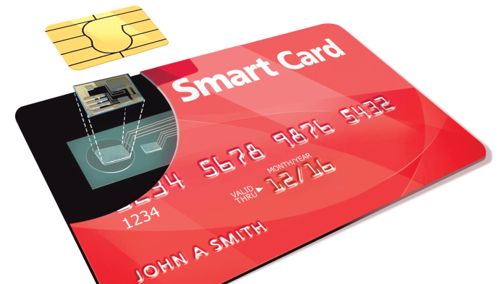
- Exchanges
Exchanges, in the context of finance and investments, refer to platforms or marketplaces where various financial instruments, such as stocks, bonds, commodities, crypto currencies, and derivatives, are bought and sold. These exchanges provide a regulated and organized environment for trading and facilitate the efficient functioning of financial markets.
- Gift vouchers
Gift vouchers, also known as gift cards or gift certificates, are prepaid cards or certificates that can be used as a form of payment at specific retailers or service providers. They are typically purchased by individuals as gifts for others, allowing the recipients to choose their desired items or experiences within the designated store or business.
- Identifying cash and non-cash transaction
Cash and non-cash transactions are differentiated based on the form of payment used to complete a financial transaction. Here's how you can identify cash and non-cash transactions:
- Cash Transactions:
Cash transactions involve the use of physical currency (such as banknotes and coins) as the medium of exchange. Here are some characteristics of cash transactions:
- Physical Currency: Cash transactions involve the direct exchange of physical currency from one party to another.
- Immediate Settlement: Cash payments are typically settled immediately at the time of the transaction.
- Tangible and Portable: Cash is tangible and can be held in hand, making it easily transferable.
- No third-Party Involvement: Cash transactions do not require involvement from intermediaries, such as banks or electronic payment processors
Examples of cash transactions include paying for groceries with banknotes at a supermarket, giving cash to a friend, or receiving cash as payment for services rendered.
- Non-Cash Transactions:
Non-cash transactions involve the use of alternative payment methods instead of physical currency. These transactions are typically electronic or digital in nature. Here are some characteristics of non-cash transactions:
- Electronic Payments: Non-cash transactions involve the use of electronic payment methods, such as credit cards, debit cards, online banking, mobile wallets, and electronic fund transfers (EFT).
- Delayed Settlement: Non-cash payments may take some time to settle, depending on the specific payment method and processing procedures.
- Digital Representation: Non-cash transactions rely on digital records or representations of value instead of physical currency.
- Involvement of Third Parties: Non-cash transactions often require the participation of intermediaries, such as financial institutions or payment service providers, to facilitate the transfer of funds.
Examples of non-cash transactions include using a credit card to pay for a restaurant meal, transferring money from one bank account to another electronically, or making an online purchase using a digital payment platform.

- Applying exchanges and returns
Exchanges and returns are processes that allow customers to address issues with products or services they have purchased. While the specific policies and procedures may vary between retailers, here is a general overview of how exchanges and returns are typically applied:
- Exchanges:
An exchange occurs when a customer wants to replace a product they have purchased with another product of the same or similar value. Exchanges are often sought for reasons such as incorrect sizing, a defective item, or a change of preference. Here's how exchanges are generally applied:
Eligibility: The customer must meet the eligibility criteria set by the retailer, such as returning the item within a specified time frame, providing proof of purchase, and ensuring the item is in its original condition with all accompanying accessories and packaging.
Product Availability: The customer checks if the desired replacement product is available in stock. If it is available, they can proceed with the exchange process.
Exchange Process: The customer visits the retailer's physical store or contacts their customer service department to initiate the exchange. They present the original item, along with any required documentation, and specify the reason for the exchange. The retailer verifies the eligibility and condition of the item before processing the exchange.
Exchange Options: Depending on the retailer's policy, the customer may have the option to choose a different size, color, or model of the same product, or they may be allowed to exchange it for a different product altogether. Any price differences between the original and replacement items may be adjusted, either by refunding the difference or requesting additional payment.
Completion: Once the exchange is processed, the customer receives the replacement product, and any necessary adjustments to payment or refunds are made.
- Returns:
Returns are made when a customer wishes to receive a refund for a product they have purchased. Returns are commonly requested for reasons such as dissatisfaction, receiving a damaged item, or a change of mind. The following steps generally apply to return processes:
Eligibility: The customer must meet the retailer's eligibility requirements, such as returning the item within a specified timeframe, providing proof of purchase, and ensuring the item is in its original condition with all accompanying accessories and packaging.
Return Initiation: The customer typically contacts the retailer's customer service department or uses an online return portal to initiate the return process. They provide the necessary details, including the reason for the return.
Return Authorization: The retailer assesses the return request and authorizes the return if it meets their criteria. They may issue a return merchandise authorization (RMA) number or provide specific instructions on how to proceed.
Return Shipment: The customer prepares the item for return shipment, following the retailer's instructions. This may involve packaging the item securely, affixing the RMA number or return label, and arranging for shipping.
Inspection and Refund: Once the retailer receives the returned item, they inspect its condition to ensure it meets their return policy. If the item is approved, the retailer processes the refund. The refund may be issued in the original form of payment or as store credit, depending on the retailer's policy.
Completion: The customer receives the refund, and the return process is considered complete.
It's important to note that the specific exchange and return policies, including timeframes, conditions, and refund methods, can vary between retailers. It is advisable for customers to familiarize themselves with the retailer's policies before making a purchase to understand their rights and responsibilities regarding exchanges and returns.
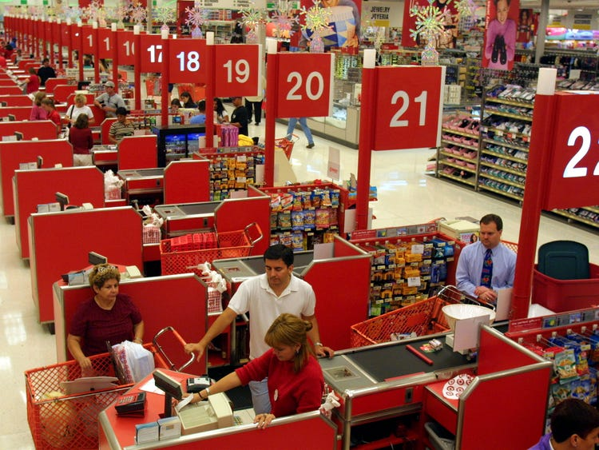
  - Moving goods efficiently
Moving goods efficiently involves optimizing the processes and logistics associated with the transportation, storage, and distribution of products. Here are some key considerations to enhance the efficiency of moving goods:
Supply Chain Planning: Effective supply chain planning is crucial for efficient goods movement. This involves forecasting demand, aligning production schedules, and coordinating procurement to ensure the timely availability of goods. By accurately predicting demand and synchronizing the supply chain, unnecessary delays and bottlenecks can be minimized.
Inventory Management: Efficiently managing inventory levels is essential to avoid overstocking or stockouts. Maintaining an optimal inventory level helps ensure the availability of goods when needed, minimizes storage costs, and reduces the risk of product obsolescence. Utilizing inventory management systems and adopting just-in-time (JIT) or lean inventory practices can help streamline the movement of goods.
Transportation Optimization: Choosing the most suitable transportation modes, routes, and carriers is vital for efficient goods movement. Factors such as cost, transit time, reliability, and sustainability should be considered. Leveraging technology and logistics software can assist in route optimization, load consolidation, and real-time tracking to enhance transportation efficiency.
Warehousing and Storage: Efficient warehousing and storage practices play a significant role in goods movement. Designing warehouses for optimal space utilization, implementing efficient layout and picking strategies, and adopting inventory management systems can minimize handling time, reduce errors, and facilitate faster order fulfillment.
Packaging and Handling: Appropriate packaging and handling techniques contribute to efficient goods movement. Using standardized packaging that minimizes wasted space, ensures product protection, and facilitates easy handling can enhance efficiency. Additionally, employing proper material handling equipment and training personnel in safe and efficient handling techniques can reduce the risk of damage and improve overall efficiency.
Collaboration and Partnerships: Collaborating with suppliers, logistics providers, and other stakeholders in the supply chain can lead to improved efficiency. Establishing strong partnerships, sharing information, and coordinating activities can help optimize processes, reduce lead times, and enhance overall supply chain performance.
  - Entering Information is into point-of-sale equipment.

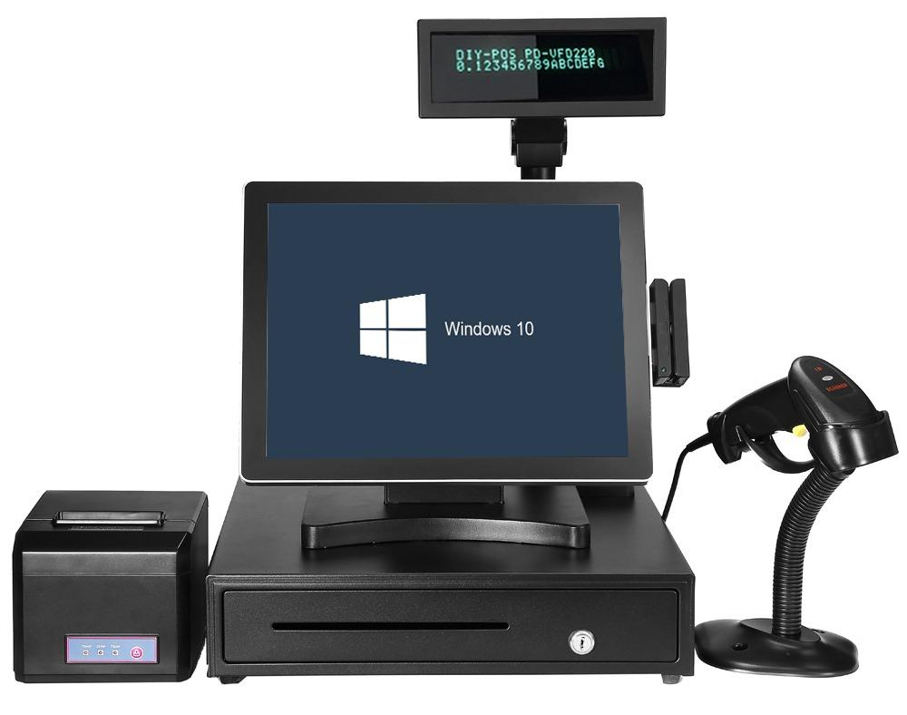

- Enter a security code or password to use the register. Many registers will require that you enter a clerk number or other security code to use the register. Clerk numbers are useful so that each sale is attributed to a particular person. This is helpful in tracking sales and clearing up errors.
- If you work in at Supper Market, you may need to enter your employee code along with the table number and number of customers.
- Newer cash registers (such as the Square cash register) may require that you log in with an email address and password.
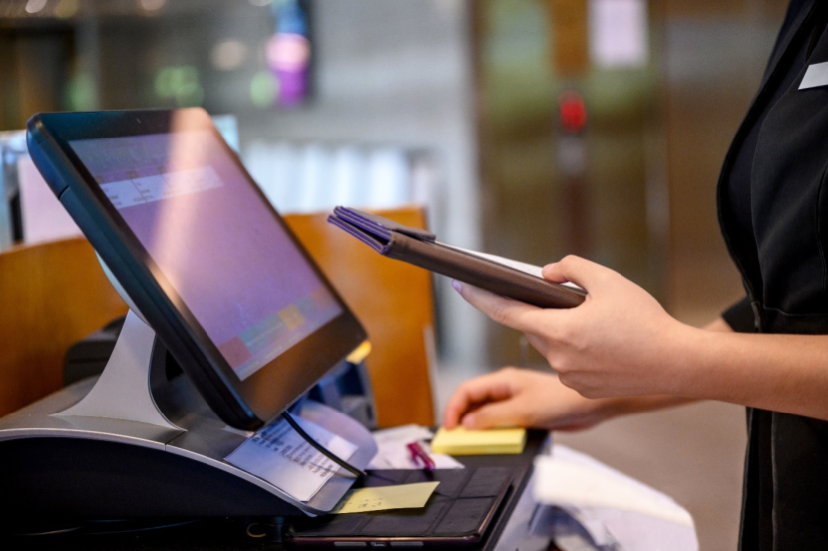
1. Enter a security code or password
- Product Selection
The cashier or salesperson uses the POS system to select the products or services being purchased by the customer. This can be done by scanning barcodes or using search functions within the POS software. The system typically displays a list of available products or a search field to find the desired items.
- Quantity and Variations:
Once the product is selected, the cashier enters the quantity of each item being purchased. If there are variations or options for the product (e.g., size, color), the cashier may need to select the appropriate options from the system.
- Discounts and Promotions:
If there are any discounts or promotions applicable to the sale, the cashier enters the relevant information into the POS system. This could include entering coupon codes, applying percentage or fixed amount discounts, or selecting promotional offers from the system.
- Customer Information:
If the sale requires capturing customer information, the cashier may enter customer details into the POS system. This could include information such as name, contact information, loyalty program membership, or any other relevant data that the business collects for customer records or marketing purposes.
- Payment Method:
The cashier selects the payment method chosen by the customer, such as cash, credit/debit card, mobile payment, or gift card. Depending on the payment method, the cashier may need to enter additional information, such as the card number, expiry date, or authorization code.
- Confirmation and Receipt:
Once all the necessary information is entered, the cashier confirms the transaction in the system. The POS equipment calculates the total amount due, including any applicable taxes or fees, and generates a receipt for the customer. The receipt can be printed or sent electronically, depending on the setup of the POS system.
It's important for cashiers to accurately enter the information into the POS equipment to ensure proper recording of the transaction, accurate inventory management, and efficient payment processing. Training on the specific POS system used by the business can help cashiers become familiar with the entry process and ensure accurate and efficient data input.

3.2 IDENTIFYING CASH AND NON-CASH TRANSACTION
In banking and accounting, a non-cash item refers to an expense listed on an income statement, such as capital depreciation, investment gains, or losses, that does not involve a cash payment .On the other hand, a cash transaction is a business transaction that is settled with immediate exchange of cash.
A cash transfer is a transaction where money is moved from one account to another account in real-time. This can be done through various means such as wire transfer, electronic funds transfer (EFT), or cash withdrawal and deposit .
A non-cash transaction is a transaction that does not involve the use of cash or a cash equivalent. Examples of non-cash transactions include investing and financing-related transactions.

To identify cash and non-cash transactions, you can refer to the Statement of Cash Flows. This statement is one of the three key financial statements that reports the cash generated and spent during a specific period of time (i.e., a month, quarter, or year).
The statement of cash flows acts as a bridge between the income statement and balance sheet by showing how money moved in and out of the business. It is divided into three sections: Operating Activities, Investing Activities, and Financing Activities.
Operating Activities include the principal revenue-generating activities of an organization and other activities that are not investing or financing; any cash flows from current assets and current liability.
Investing Activities include any cash flows from the acquisition and disposal of long-term assets and other investments not included in cash equivalents.
Financing Activities include any cash flows that result in changes in the size and composition of the contributed equity capital or borrowings of the entity (i.e., bonds, stock, dividends) .
Cash transactions are those that involve immediate payment of cash for the purchase of an asset. Examples include buying clothes at a store and paying using a debit card . Non-cash transactions are investing and financing-related transactions that do not involve the use of cash or a cash equivalent. Examples include depreciation, amortization, unrealized gain/loss, impairment expenses, stock-based compensation, provision for discount expenses, deferred income taxes.
To distinguish between cash and non-cash transactions:
- Cash transactions are immediate payments and involve cash.
- Non-cash transactions do not involve cash. Examples include depreciation, exchange of property from other property, or issuing stocks for purchasing an item.
- Some market stock transactions are considered cash transactions although the trade may not settle for a few days.
- A futures contract is not considered a cash transaction.
- While cash transactions work purely on a cash basis, credit transactions use a credit facility to make payments

3.3 Applying exchanges and returns

Exchange and return are two distinct processes¹.Exchange is when you trade one item for another, typically because the original item didn’t meet your needs.Return is when you give back an item for a refund, usually because you no longer want or need it.
Here are some tips on how to apply exchanges and returns:
- Write a clear and concise return policy: A well-written return policy can help customers understand the process of returning or exchanging items. It should include information on how to initiate a return, the time frame for returns, and any conditions that must be met for a return or exchange to be accepted.
- Make the process easy for customers: Customers are more likely to shop with you again if they have a positive experience with returns and exchanges. Consider offering free returns or exchanges, providing a prepaid shipping label, or allowing customers to return items in-store.
- Turn returns into exchanges: When a customer returns a product for a refund, your business usually loses money on customer acquisition and return shipping costs. Plus, you’ll need to refund the customer any profit made on the original order. By offering an exchange instead of a refund, you can retain the customer and potentially make another sale.
- Use returns as an opportunity to learn: Returns and exchanges can give you valuable information about your products and customer preferences. Consider tracking the reasons for returns and exchanges so you can identify patterns and make improvements

3.4 Moving goods efficiently

Efficient movement of goods is critical to the satisfaction of the customer, the success of individual businesses and the urban and global economies. Logistics is the process of efficiently moving goods from Point A to Point B. Poor logistics can dent a company’s bottom line. The goods movement industry is the backbone of society and cannot disappear.
In logistics, the movement of goods refers to the transportation of goods from one location to another in an efficient and cost-effective manner. This process involves managing the transportation of goods, tracking the progress of shipments, and ensuring that goods are delivered on time and in good condition. Companies need to be able to move their goods quickly and efficiently to meet the demands of their customers. To ensure the efficient movement of goods, businesses must use the right solutions. Automation is one of the most effective solutions companies can use to improve their logistics processes. Automation can simplify many tasks involved in moving goods, such as route mapping and shipment tracking, allowing businesses to streamline operations and reduce costs . Another solution that businesses can use is the implementation of tracking systems. Tracking systems such as GPS can help companies track their shipments in real time, allowing them to monitor their progress and ensure they are delivered on time and in good condition. Tracking systems can also provide valuable insights into the logistics process, allowing businesses to identify potential issues and take corrective action before they become a problem.
Efficiently moving goods is a critical aspect of logistics and supply chain management. Here are some tips that can help you move goods efficiently:
- Plan ahead: Create a detailed plan for the move, including the timeline, budget, and resources required. This will help you stay organized and avoid last-minute surprises.
- Use the right packaging: Choose the right packaging materials based on the type, size, and weight of the goods. This will help protect the goods during transit and reduce the risk of damage.
- Label everything: Label each package with a unique identifier, such as a serial number or barcode. This will help you keep track of the goods during transit and ensure that they are delivered to the right location.
- Optimize your routes: Use route optimization software to plan the most efficient routes for your shipments. This will help you save time, reduce fuel costs, and minimize your carbon footprint.
- Track your shipments: Use shipment tracking software to monitor your shipments in real-time. This will help you identify any issues or delays and take corrective action as needed.
- Partner with a reliable carrier: Choose a carrier that has a proven track record of delivering goods on time and in good condition. This will help you build trust with your customers and ensure that your goods are delivered safely and efficiently.
- Continuously improve: Regularly review your logistics processes and look for ways to improve efficiency. This could include optimizing routes, reducing packaging waste, or using more eco-friendly transportation options.

3.5 Entering Information into point-of-sale equipment

A Point-of-sale (POS) equipment is a device that is used to process transactions by retail customers. It can be a physical device in a brick-and-mortar store or a checkout point in a web-based store. The software for POS devices is growing increasingly elaborate, with features that allow retailers to monitor inventory and buying trends, track pricing accuracy, and collect marketing data .
When you enter information into a POS equipment, it means you are providing the device with the necessary data to complete a transaction. This data can include the item name, price, quantity, and any applicable discounts or promotions. Once the information is entered into the system, the POS equipment will calculate the total cost of the transaction and process the payment
To enter information into point-of-sale equipment, you need to follow the instructions provided by the manufacturer of the equipment. The process may vary depending on the type of equipment you are using. However, generally, you will need to:
- Install and launch your software: If your point-of-sale solution is cloud-based, download the app onto your device, connect it to the internet, and enter your account credentials. If you’re setting up a traditional point-of-sale system, the software will already be installed into your server. In both cases, the point of sale will then ask you to create an account or enter your credentials.
- Connect your hardware: Connect your point-of-sale hardware to your device. If you’re only opting for a smartphone or tablet-based point-of-sale system, connecting the hardware should be pretty straightforward.
- Set up your inventory: Input all the information about your inventory items into your point-of-sale system.
- Enter user accounts and permissions: Create user accounts and set up permissions for each user.
- Set up payment methods: Set up payment methods that you will accept from customers.
- Integrate your point of sale with other software if needed: If you need to integrate your point of sale with other software, follow the instructions provided by the manufacturer.
If you need further assistance with entering information into point-of-sale equipment, please refer to the manufacturer’s documentation or contact their customer support.
  - Receiving and stating price verbally to customer.
When it comes to receiving and stating price verbally to customers, it is important to communicate the price in a clear and concise manner. This can be done by talking to the customer in person or over the phone, rather than sending an email .
It is also important to explain the reason for the change in price, whether it is an increase or decrease. This helps customers understand why the price has changed and reassures them that the quality of the product or service remains unchanged .
Adding more value to your product or service can also make customers feel better about paying a higher price. This can take the form of additional features, an add-on service, follow-up support, or an extended guarantee.
To state the price verbally to a customer, it’s important to have strong negotiation skills that help you and the customer agree on reasonable product prices that benefit both parties. Here are some tips to help you negotiate price with a customer:
Ask questions and listen to the customer’s needs: While explaining why the product is worth the sales price, it’s important to take a moment to listen to the customer’s reasoning for needing a lower price. This can help you understand what features they’re looking for in a product and if they’re considering other products. Use this information to compare the product’s features with others and offer rates that are competitive but still provide you with a profit. Asking questions and listening to customers’ needs also shows that you care about offering a valuable product that helps them overcome challenges or benefits to their business.
Present the product’s value to the customer: Once you gain a stronger understanding of the client’s needs and preferences, you can present the product’s value to them. Focus more closely on the features and benefits the product offers rather than speaking solely about money. This may help customers understand that you care about providing them with a valuable solution rather than just earning a profit from them. Making a customer feel valuable as a person instead of just another customer can help establish a trusting relationship that results in more sales.
Remain transparent about your own needs and priorities: It’s important to remain honest and transparent with customers throughout the entire negotiation process. You may find the conversation is more productive when both sides are honest and open with each other. If they ask for a significantly low price, explain why it’s too low. You can mention the company budget or compare the asking price with the money or effort that goes into building, preparing, and delivering the product.
Use facts when stating opinions or stances: Consider researching competitors to more effectively demonstrate what your product or service offers that others don’t.
Remember, negotiating properly allows you to listen to the customer’s needs and communicate the product’s value to them. Understanding how to negotiate effectively can be a transferrable skill for a variety of skills disciplines, and may help you close more sales and establish better relationships with customers
Ways to Communicate Price to Customers
1. Talk to customers, don’t send an email ...
2. Explain clearly the reason for the change in price ...
3. Increase the value of your product or service ...
4. Provide a lower-priced option ...
5. Give customers enough time ...
6. Reward longtime customers for their past business ...
7. Make room for big customers to negotiate ...
8. Encourage customers to contact you if they have any questions
  - Tendering correct change.
Tendering refers to the process of offering something, usually in writing, or to make an offer in writing to do something. It can also refer to the act of making a formal offer or estimate for a job or contract.Correct change refers to the exact amount of money that is due back to a customer after they have made a payment. Tendering correct change means that the cashier has given the customer the exact amount of change that they are owed .
A tender change can be considered material if it:
- Introduces conditions which would have allowed for the admission or acceptance of a different tender.
- Extends the scope of the contract considerably.
- Changes the economic balance of the contract in favor of the contractor.
However, there are some changes that can be made to awarded public contracts without triggering a requirement to conduct a fresh tender process.

Self-Check of Unit Three
  - Choose the best answer for the following question
- Which one of the following is Point-of-sale transactions
- Cash register B. Scanner C. Cash drawer D. smart cards
- Which one of the following is an electronic payment system that allows customers to make payments for goods or services
- EFTPOSB. Scanner C. Cash drawer D. smart cards
- The payment cards that allow users to borrow money from a financial institution, typically a bank, to make purchases
- Gift vouchers B. Credit Cards C. Smart cards D. Cash Transactions
- chip cards or integrated circuit cards that contain an embedded microchip use for payment
- Smart cards B. Gift vouchers C.Exchanges D.Cash Transactions
- The transaction where money is moved from one account to another account in real-time is
- Cash transaction B. Non cash transaction C. Credit Cards D. Smart cards

  - Give short for the following questions
- Discuss how EFTPOS typically works:
- Explainhow cheques typically work
- Explain Cash and non-cash transaction

...

OPERATION SHEET-
OPERATION TITLE: - Perform sales in the cash register machine
PURPOSE: - the trainee will easily conduct sales by using cash register machine in the work place
CONDITIONS OR SITUATIONS FOR THE OPERATIONS:-
There has to be installed cash register machine and a customer who conducts purchase the products and services
EQUIPMENT TOOLS AND MATERIALS: installed cash register machine, variety currencies
PROCEDURE:-
- Open the cash register by entering a security code or password to use the register
- Key the amount of the item and hit the corresponding department button
- press arrow or FEED key to have the register feed the receipt upwards
- Add any necessary discounts to the price
- key in the discount percentage number and then press the % key
- Enter in the exact dollar amount for each remaining items and hit the subtotal button
- Determine how the customer is going to pay
- Close the till drawer
PRECAUTIONS:-
- You do not need to key any decimal, as cash registers do this for you.
- Be sure to press the corresponding department key after each item is entered.
QUALITY CRITERIA:
- The total sale at last will sum up individual sales information collected from various sources

Unit Four: Perform point-of-sale transactions
This unit is developed to provide you with the necessary information regarding the following content coverage and topics:
- Completing and processing customer order.
- Processing customer delivery requirements.
- Directing sales transactions.
- Acknowledging and thanking customer.
This unit will also assist you to attain the learning outcomes stated on the cover page. Specifically, upon completion of this learning guide, you will be able to:
- Complete and process customer order.
- Process customer delivery requirements.
- Directsales transactions.
- Acknowledge and thank customer.

4.1 Completing and processing customer order.

Completing and processing a customer order involves a series of steps to ensure that the order is fulfilled accurately, the payment is processed, and the customer receives their desired products or services. Here's a general overview of the process:
- Order Placement:
The customer places an order, either in person, over the phone, or through an online platform. They provide the necessary information, such as the products or services they want to purchase, quantity, variations, delivery preferences, and any other relevant details.
- Order Confirmation:
Once the order is received, the business typically sends an order confirmation to the customer. This confirmation verifies the details of the order, including the items, quantities, prices, delivery information, and any special instructions or terms.
- Inventory Check and Fulfillment:
The business checks the availability of the ordered items in their inventory. If the items are in stock, they are prepared for fulfillment. If any items are out of stock or unavailable, the customer is notified and provided with alternatives or given the option to cancel or modify the order.
- Order Preparation:
The business prepares the order for shipment or pickup. This involves gathering the items, packaging them securely, and including any necessary documentation, such as invoices or packing slips. The order may also undergo quality checks or additional processing, depending on the nature of the products or services.
- Payment Processing:
If the customer has not already made payment during the order placement process, the business processes the payment at this stage. This can involve various payment methods, such as cash, credit/debit cards, mobile payments, or invoicing for corporate clients. The payment is verified and recorded in the business's financial system.
- Shipment or Pickup:
For orders that require shipping, the business arranges for the delivery through a shipping carrier or logistics partner. The order is assigned a tracking number, and the customer is notified of the shipment details. Alternatively, if the customer has opted for in-store pickup, they are informed when the order is ready for collection.
- Delivery and Receipt:
The order is delivered to the customer's specified address or made available for pickup at the designated location. The customer receives the order and checks its contents to ensure that everything is as expected. Any discrepancies or issues are addressed promptly by the business's customer service.
- Order Completion and Follow-Up:
Once the customer has received the order and is satisfied, the order is considered complete. The business may follow up with the customer to ensure their satisfaction, request feedback, or provide post-purchase support.
It's important for businesses to have efficient order processing systems in place, including inventory management, payment processing, and logistics coordination, to ensure smooth and timely order fulfillment. Regular monitoring and continuous improvement of the order processing workflow can help optimize efficiency and customer satisfaction.

4.2 Processing customer delivery requirements

Processing customer delivery requirements involves understanding and fulfilling the specific delivery preferences and instructions provided by customers. Here's an overview of the process:
- Customer Communication:
The business initiates communication with the customer to gather their delivery requirements. This can be done at the time of order placement or through follow-up communication. The customer may provide instructions regarding delivery date and time, preferred delivery method, special handling requirements, or any other specific delivery preferences.
- Delivery Date and Time:
The business confirms the desired delivery date and time with the customer. If the customer has a specific deadline or urgency, the business works to accommodate their request. It's important to manage customer expectations regarding delivery timeframes, considering factors such as product availability, processing time, and logistics capabilities.
- Delivery Method:
The customer may have a preference for the delivery method, such as courier service, postal service, local delivery, or self-pickup. The business ensures that the chosen delivery method aligns with the customer's preference and is feasible based on the business's capabilities and resources.
- Packaging and Handling:
Based on the customer's instructions, the business prepares the order for delivery. This includes appropriate packaging to protect the items during transit and adherence to any specific handling requirements, such as fragile or perishable goods. The packaging should also comply with any regulations or guidelines related to the transportation of certain products.
- Logistics Coordination:
If the business handles its own deliveries, it coordinates the logistics internally to ensure the order reaches the customer on time. This involves assigning delivery personnel, optimizing delivery routes, and managing the necessary transportation resources. Alternatively, if the business relies on third-party logistics providers or shipping carriers, it arranges for pickup or shipment according to the customer's chosen delivery method.
- Tracking and Communication:
Throughout the delivery process, the business keeps the customer informed about the progress of their order. This can include providing tracking numbers, estimated delivery times, and any updates or changes to the delivery schedule. Open and transparent communication helps manage customer expectations and build trust.
- Delivery Confirmation:
Once the order is successfully delivered to the customer, the business seeks confirmation to ensure the delivery was completed to the customer's satisfaction. This can be done through various means, such as email confirmation, digital signatures, or feedback collection. Any issues or concerns raised by the customer are addressed promptly and resolved appropriately.
Efficiently processing customer delivery requirements requires effective communication, coordination with logistics partners (if applicable), and attention to detail in packaging and handling. By understanding and meeting customer expectations, businesses can provide a positive delivery experience and enhance customer satisfaction.

4.3 Directing g sales transactions
Directing sales transactions involves guiding customers through the process of completing a purchase and ensuring a smooth and efficient transaction.
Greeting and Engagement:
When a customer enters the sales area or approaches a salesperson, it's important to greet them warmly and engage in a friendly and professional manner. This creates a positive first impression and sets the stage for a productive interaction.
Needs Assessment:
The salesperson should actively listen to the customer's needs and preferences. By asking open-ended questions and actively engaging in conversation, the salesperson can understand the customer's requirements and tailor their recommendations accordingly.
Product or Service Presentation:
Based on the customer's needs, the salesperson presents relevant products or services. This involves highlighting the features, benefits, and value proposition of each offering. The salesperson should be knowledgeable about the products or services and be able to address any questions or concerns the customer may have.
Providing Recommendations:
The salesperson provides personalized recommendations based on the customer's needs and preferences. This may involve suggesting additional products or services that complement the customer's intended purchase or offering alternatives if the desired item is unavailable.
Demonstrations and Trials:
If appropriate, the salesperson may offer product demonstrations or trials to allow the customer to experience or test the product firsthand. This helps build confidence and aids in the decision-making process.
Addressing Objections:
Customers may have concerns, objections, or questions that need to be addressed before making a purchase. The salesperson should listen attentively, empathize with the customer's concerns, and provide accurate and persuasive responses to alleviate any doubts or objections.
Closing the Sale:
Once the customer has made a decision to purchase, the salesperson guides them through the transaction process. This may involve directing the customer to a checkout counter, initiating an online purchase, or assisting with any paperwork or documentation required for the transaction.
Payment Processing:
The salesperson ensures that the customer's payment is processed accurately and securely. This may involve handling cash, processing credit card payments, or facilitating other payment methods such as mobile payments or electronic transfers.
Post-Sale Engagement:
After the transaction is completed, the salesperson expresses gratitude to the customer for their purchase and offers any additional assistance or support. This can include providing information about warranties, return policies, or after-sales services.
Throughout the sales transaction, it's important for the salesperson to be attentive, knowledgeable, and responsive to the customer's needs. Building rapport, providing exceptional customer service, and ensuring a seamless buying experience can help maximize customer satisfaction and foster long-term customer relationships.
  - Acknowledging and thanking customer
Acknowledging and thanking customers is a crucial part of customer appreciation. It refers to the phrasing used to recognize and validate a situation and how the other person feels. It helps demonstrate that the agent has not only heard but also understood the customer.
In a business context, acknowledging and thanking customers can be done through various means such as sending thank-you notes, offering discounts, providing personalized services, or simply expressing gratitude verbally.
Acknowledging and thanking customers is an essential part of customer service. It is a way of showing appreciation for their business and building a positive relationship with them. Acknowledging a customer means recognizing their presence, listening to their concerns, and responding appropriately. Thanking a customer means expressing gratitude for their business and loyalty.
There are several ways to acknowledge and thank customers. Here are some examples:
Say “Thank you”: A simple “thank you” can go a long way in making a customer feel appreciated. It can be said in person, over the phone, or in an email.
Send a thank-you note: A handwritten note can be a more personal way of thanking a customer. It shows that you took the time to write something specifically for them.
Offer discounts or promotions: Offering discounts or promotions to loyal customers is another way of thanking them for their business.
Ask for feedback: Asking customers for feedback shows that you value their opinion and are committed to improving your service.
Remember, acknowledging and thanking customers is not just about making them feel good. It can also help build customer loyalty and increase the likelihood of repeat business.

Self-Check of Unit Four

  - Choose the best answer for the following question
- Which one of the following is processing a customer order
    - Order placement B. order confirmation C. Order Preparation D. All
- The requirements involves understanding and fulfilling the specific delivery preferences and instructions is
    - Delivery method C. Processing customer delivery
    - Delivery day D. Customer communication
- Directing sales transactions involves
  - Guiding customers C. completing a purchase
  - Ensuring a smooth and efficient transaction D. All
- Which one of the following involved in Post-Sale Engagement
- Warranties B. return policies C. after-sales services.D.All
- Which one of the following used to recognize and validate a situation and how the other person feels
- Acknowledging B. Presentation C. Delivery customer D. Respecting

II Give short for the following questions
- Discuss ways to acknowledge and thank customers.

Unit Five: Wrapping and packing goods
This unit is developed to provide you with the necessary information regarding the following content coverage and topics:
- Maintaining and requesting adequate supplies.
- Selecting wrapping and packaging material.
- Wrapping and requiring merchandise
- Packing items safely.
- Arranging and transfer delivery merchandise
This unit will also assist you to attain the learning outcomes stated on the cover page. Specifically, upon completion of this learning guide, you will be able to:
- Maintain and request adequate supplies.
- Select, wrap and pack material.
- Wrap and require merchandise
- Apply Packing items safely.
- Arrange and transfer delivery merchandise

5.1 Maintaining and requesting adequate supplies.
Maintaining and requesting adequate supplies is crucial for ensuring smooth business operations.
- Inventory Management:
Implement a robust inventory management system to track your supplies accurately. Regularly monitor inventory levels to determine when supplies need replenishment. This can be done through manual tracking or by using inventory management software that provides real-time updates.
- Forecasting and Planning:
Analyze historical data, sales trends, and upcoming demand to forecast future supply needs. Consider factors such as seasonality, promotions, and anticipated growth to estimate the quantities of supplies required. This helps prevent stockouts or overstocking situations.
- Supplier Relationships:
Maintain strong relationships with your suppliers. Communicate your requirements clearly and provide them with accurate forecasts. Regularly review supplier performance to ensure they meet your quality and delivery expectations. Negotiate favorable terms, such as flexible lead times and competitive pricing, to optimize your supply chain.
- Reorder Points and Lead Times:
Establish reorder points for each supply item. Reorder points indicate the minimum quantity at which you should initiate the replenishment process. Consider lead times, which are the time it takes for a supplier to deliver goods after an order is placed, to ensure you reorder in advance.
- Automated Systems:
Consider using automated systems or software to streamline and simplify the supply request process. This can include implementing electronic ordering systems, barcode scanners, or integrated inventory management software that generates automatic supply requests when stock levels reach predetermined thresholds.
- Regular Monitoring and Auditing:
Regularly review and audit your inventory to identify any discrepancies, such as shrinkage or excess stock. Conduct physical counts and reconcile them with your recorded inventory levels. Identify any issues or inefficiencies in your supply chain and take corrective actions.
- Communication and Collaboration:
Maintain open lines of communication within your organization. Ensure that your purchasing department, inventory management team, and other relevant stakeholders are aware of supply needs and requirements. Foster collaboration and information sharing to optimize supply chain efficiency.

5.2 Selecting wrapping and packaging material

The first step in choosing the right packaging materials is to consider the features of your product, such as its size, shape, weight, fragility, and shelf life. These factors will determine the type and amount of protection your product needs, as well as the dimensions and design of your packaging.
Selecting the appropriate wrapping and packaging materials is essential to ensure the safe and presentable delivery of products to customers. Here are some factors to consider when choosing wrapping and packaging materials:
- Product Requirements:
Understand the characteristics and requirements of the products being packaged. Consider factors such as size, shape, weight, fragility, perishability, and any specific handling considerations. Different products may require different types of packaging to ensure proper protection during transit and storage.
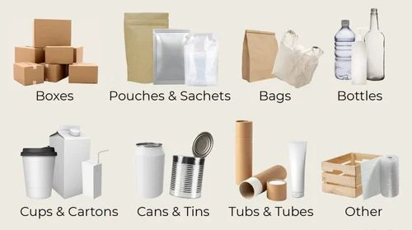
- Protection and Safety:
Choose materials that provide adequate protection for the products. This may include cushioning materials to prevent damage from impacts, moisture-resistant materials to protect against water damage, or insulation materials for temperature-sensitive items. Consider the fragility of the products and select materials that offer appropriate shock absorption and stability.
- Cost-effectiveness:
Balance the cost of packaging materials with the value and nature of the products being packaged. Opt for materials that offer a good balance between cost and functionality. Explore options to source materials at competitive prices without compromising on quality and protection.

- Sustainability:
Consider environmentally friendly packaging options to align with sustainability goals. Look for materials that are recyclable, biodegradable, or made from renewable resources. Reduce excessive packaging wherever possible to minimize waste. Communicate your commitment to sustainable packaging to customers, as it can resonate positively with eco-conscious consumers.

- Branding and Presentation:
Packaging materials can also serve as a branding and marketing tool. Consider materials that align with your brand image and convey a sense of quality and professionalism. Choose colors, patterns, and designs that enhance the visual appeal of the packaging and create a positive unboxing experience for customers.

- Compliance and Regulations:
Be aware of any packaging regulations or requirements specific to your industry or the regions in which you operate. Ensure that the selected materials meet relevant standards and guidelines. This can include considerations such as food-grade packaging for food products or child-safe packaging for products intended for children.
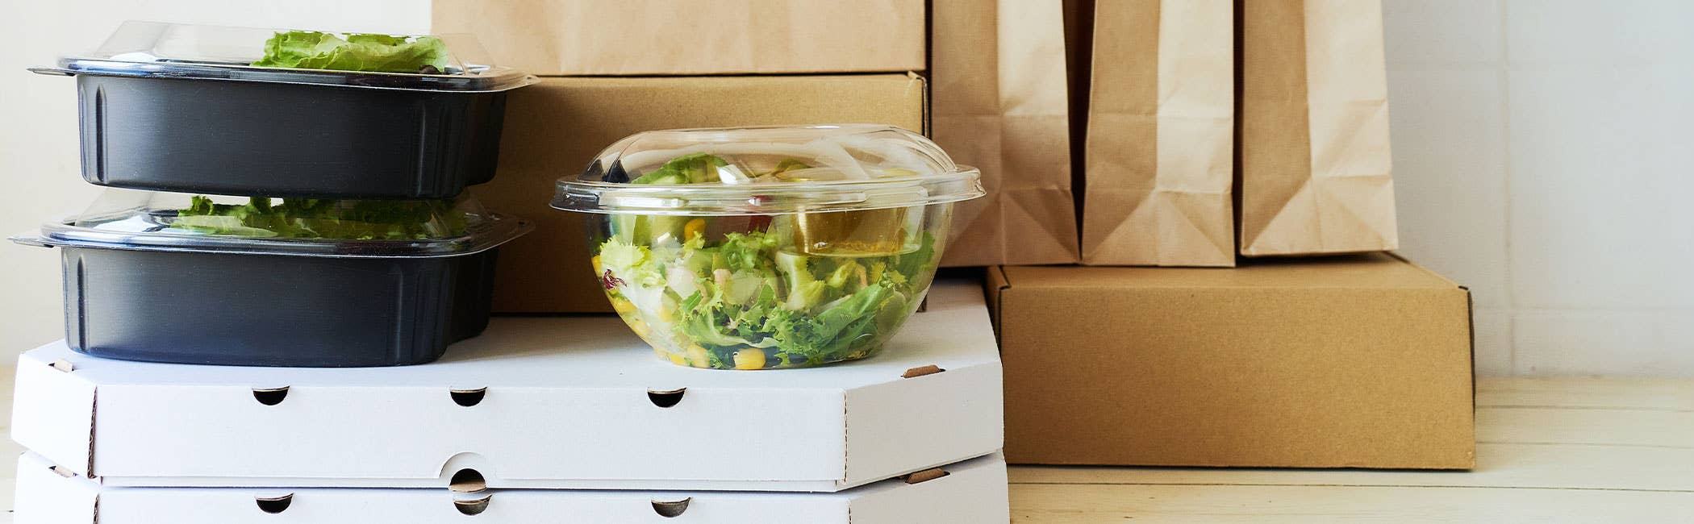
Types of Packing Materials

The type of packaging a manufacturer chooses depends on what they need. For something lightweight, paper and plastic fit the bill. Materials like metal or glass are heavier but more durable. Ultimately, choosing a packaging type comes down to stylistic choices, shipping conditions, shelf stability, and the product’s end user.
The main role of packaging is to protect the product from Point A (usually the manufacturing plant) to Point B (the ultimate user!).
But that’s not its only task. Packaging designs also serve as an advertising medium, letting manufacturers describe and promote their products with eye-catching words, colors, and fonts.
Packaging can even extend shelf life. It also allows oddly shaped items to stack neatly in a display and makes possible the use of machines to move pallets loaded with goods.
Additionally, packaging is a reflection of the manufacturer’s budget, advertising technique, and environmental awareness.
Choosing a packaging material
The type of packaging a manufacturer chooses depends on what they need. For something lightweight, paper and plastic fit the bill. Materials like metal or glass are heavier but more durable. Ultimately, choosing a packaging type comes down to stylistic choices, shipping conditions, shelf stability, and the product’s end user.
What are your choices? Here are five common packaging materials to choose from:
- Glass.

A nonporous, nontoxic material made from sand, glass is infinitely recyclable. One of its downsides is breakability — glass products may shatter in transit, costing the manufacturer money in the form of lost products and time spent cleaning up. It’s also heavier than plastic and requires substantial heat (energy) to produce.
But glass is an excellent barrier material, preserving the flavor of foods and drinks without leaching particles into them.
Manufacturers may design colored or textured glass containers with aesthetic appeal, encouraging people to buy the product inside. This is often the case with alcohol, soda, or candles.
Glass packaging is also reusable.
- Plastic
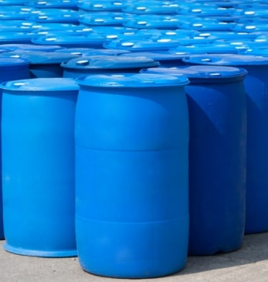
Polymers are the main ingredient of this synthetic material. When it comes to packaging, plastic may be flexible — as is the case with bags, wrappers, and stickers — or rigid — such as bottles, jars, and tubs, holding foods, drinks, detergents, pharmaceuticals, and more.
Plastic is also used inside other types of packaging in the form of packing peanuts or bubble wrap.
Plastic is lightweight, inexpensive, and strong enough to protect items during shipping. As a tape, it can bind packages together. Manufacturers can make it in a variety of colors and opacities.
However, it’s could be difficult to recycle plastic, so most of it ends up in landfills or the environment. It could break down into tiny pieces called micro plastics that often contaminate
- Paper

Pulp from wood or other sources, such as hemp or bamboo, makes up this type of packaging. Manufacturers often use it as a wrapper, paper box, shredded packing material, or in the form of paperboard. Corrugated boxes are made of two or more layers of paper stuck together by adhesive.
Paper is 100% recyclable, which can make it a sustainable choice of packaging material. Making it out of wood is less eco-friendly, but there are numerous up-and-coming alternatives that have a smaller carbon footprint. Bamboo, for example, grows quickly and comes back repeatedly after being cut down.
- Metal

Aluminum, steel, and other types of metal packaging are made by mining raw materials from the earth, then refining them. Metal can be more durable than glass or plastic, although thin metal is usually pliable and subject to bending out of shape.
Manufacturers use metal cans to package products as diverse as soda, green beans, paint, and shoe polish. Metal cans prevent food from spoiling, allowing it to be stored longer. Steel drums also transport large quantities of liquids, such as oil, for commercial use.
Metal can be dropped or subjected to high heat without breaking. Obtaining metal by mining is often an ecologically destructive process, but it’s easier to recycle than plastic. Metal packaging ranges from light to heavy depending on its thickness.

5.3 Wrapping and requiring merchandise

Wrapping materials means materials used to enclose, surround, or contain a packaged completed product or products during shipping to any buyer providing such materials are not customarily returned by the buyer to the seller for reuse by the seller.
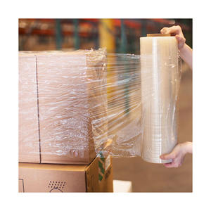

5.4 Packing items safely
Packing items safely is essential to protect them from damage during transit. Here are some tips to pack items securely:
- Use Sturdy Boxes or Containers:
Select boxes or containers that are strong and durable enough to withstand the rigors of shipping. Consider using new boxes whenever possible, as they provide better structural integrity. Ensure that the box is an appropriate size for the item being packed, leaving minimal empty space.
- Wrap Individual Items:
Wrap each item individually using appropriate protective materials such as bubble wrap, foam sheets, or packing paper. This helps cushion the item and protect it from scratches, impacts, and shifting during transportation. Secure the wrapping in place with tape or adhesive if necessary.
- Provide Inner Padding:
Add cushioning materials inside the box to provide extra protection. Use materials such as packing peanuts, air pillows, crumpled paper, or foam inserts to fill any empty spaces. The goal is to prevent the items from moving or shifting within the box.
- Separate and Protect Fragile Items:
For fragile items, create a buffer zone by placing them in the center of the box and surrounding them with additional padding. Use dividers, cardboard inserts, or specialized packaging materials designed for fragile items to keep them separate and minimize the risk of breakage.
- Securely Seal the Box:
Close the box securely using high-quality packing tape. Apply tape along the seams of the box to reinforce its strength. Consider using a tape dispenser for easier and more efficient application. Ensure all edges and corners are well-sealed to prevent the box from opening or collapsing during transit.
- Label Fragile Items:
Clearly mark boxes containing fragile items with "Fragile" or "Handle with Care" labels. This alerts handlers to exercise caution when handling the package. Place the labels on multiple sides of the box to increase visibility.
- Consider Waterproofing:
If there's a risk of exposure to moisture during transit, consider using waterproof materials or placing items in sealed plastic bags before packing them in the box. This helps protect against water damage.
- Reinforce Heavy Items:
If packing heavy items, reinforce the bottom of the box with extra tape or double-layered cardboard. This provides additional strength and prevents the box from breaking or collapsing under the weight.
- Test Package Durability:
Before shipping the package, gently shake it to ensure the items are secure and well-protected. If there is movement or shifting, add more padding or adjust the packaging to eliminate any potential risks.
- Choose a Reliable Shipping Service:
Select a reputable shipping service known for handling packages with care. Consider purchasing shipping insurance for valuable or fragile items to provide extra protection in case of loss or damage.

5.5 Arranging and transfer delivery merchandise
Arranging and transferring delivery merchandise involves coordinating the logistics and transportation of goods from one location to another. Here are some steps to consider:
Inventory Management:
Ensure that you have accurate and up-to-date inventory records. This helps you track available stock, plan for delivery, and avoid any discrepancies or delays.
Packaging and Labeling:
Properly package the merchandise to protect it during transportation. Use suitable packaging materials and follow any specific packaging guidelines for fragile or sensitive items. Label the packages clearly with necessary information such as shipping addresses, tracking numbers, and handling instructions.
Choose a Delivery Method:
Select an appropriate delivery method based on factors like distance, urgency, and cost. Options may include using a courier service, shipping via a logistics provider, or arranging for in-house transportation if available. Consider factors such as delivery timeframes, tracking capabilities, and the reliability of the chosen method.
Coordinate with Delivery Service Providers:
If you are working with external delivery service providers, establish clear communication channels with them. Provide accurate information about pick-up locations, delivery addresses, and any specific requirements. Confirm delivery schedules, rates, and any additional services needed, such as insurance or signature confirmation.
Arrange Transportation and Logistics:
Organize the transportation logistics based on the chosen delivery method. This may involve scheduling pick-up times, coordinating with warehouses or distribution centers, and arranging any necessary documentation or permits for cross-border shipments. Consider factors such as transportation costs, transit times, and customs requirements for international shipments.
Ensure Compliance and Documentation:
Adhere to any legal and regulatory requirements related to the transportation of merchandise. This includes obtaining necessary permits, licenses, or certifications for specific types of products or shipments. Prepare and maintain accurate documentation such as shipping labels, invoices, customs paperwork, and proof of delivery records.
Customer Support and Feedback:
Provide excellent customer support throughout the delivery process. Address any inquiries or concerns promptly and professionally. Encourage customers to provide feedback on their delivery experience, which can help identify areas for improvement and enhance future delivery processes.
Evaluate and Improve:
Regularly review and evaluate your delivery processes to identify areas for improvement, cost optimization, and customer satisfaction enhancement. Analyze delivery performance metrics such as delivery times, accuracy, and customer feedback to drive operational efficiency.

Self-Check of Unit Five

- Choose the best answer for the following question
- Forecasting and Planning is
- Analyze historical data B. sales trends C. upcoming demand D. All
- Which one of the following initiates the replenishment process?
- Automated Systems C. Regular Monitoring
- Reorder Points and Lead Times: D. Communication and Collaboration
- When choosing the right packaging materials is to consider the features product
- Size B. shape C. Weight D. All
- Which one of the following wrapping and packaging materials use to prevent damage from impacts, moisture-resistant materials to protect against water damage?
- Product Requirements C. Safety
- Protection D. All except A
- Packaging materials can serve as
- Protection B Safety C Promotion of brands D. All
- Give short for the following questions
- Discuss common packaging materials of the products

Prepared By
Adisalem Minwuyelet MBA 0920522464
Bikila Zelalem MBA 0941338597
Taddese Tesfaye MBA 0922934005

