MARKETING AND SALES MANAGEMENT
MODULE III
BASED ON JUNE 2021, CURRICULUM VERSION 1

MODULE TITLE: - OPTIMIZE CUSTOMER AND TERRITORY COVERAGE

MODULE CODE: - LSA MSM3 11 1223
NOMINAL DURATION: 90 HOUR
SEPTEMBER 2023
ADDISKETEMA, ETHIOPIA

Table of Contents
UNIT ONE Establish coverage plan for a territory 5
1.1 Optimizing Customer and Territory Coverage 5
1.1.2 Ensuring coverage objectives 7
1.2 Setting customer territory coverage plans 10
SELF CHECK 13
UNIT TWO REPORTING ON BUSINESS VISITS 15
2.1. Completing territory plan 15
2.2 Establishing feedback 19
2.3 Analyze and acting feedback 21
2.4 Preparing documentation 23
2.4.1 Formatting Titles 25
2.4.2: Creating Headings and Subheadings 27
2.4.3: Choosing Fonts 27
2.4.4: Line Spacing Considerations 30
2.4.5: Using Lists 35
2.4.6: Choosing Visual Aids 36
2.4.7: Using Interactive Elements 39
2.4.8: Balancing Text and Whitespace 39
2.4.9: Making Accessible, AODA-compliant Documents 39
2.5 keeping documentation in a secure location 44
2.6 submitting documentation 45
SELF CHECK UNIT TWO 47
UNIT THREE Improving customer or territory coverage 48
3.1 Determining customer needs and expectations 48
3.2 Determining Current satisfaction. 52
3.3 Improving customer satisfaction. 53
3.4 Optimizing coverage of territory and customer 56
3.5 Confirming and reporting for merchandizing improvement 57
SELF CHECK UNIT THREE 60
Reference 63

Introduction to module
This module is designed to meet the industry requirement under the optimize customer and territory coverage Market occupational standard, particularly for the marketing and sales management.
This module covers the units:
- Establish coverage plan for a territory
- Report on business visits.
- Improve customer or territory coverage.
Learning Objective of the Module
- Establishing coverage plan for a territory
- Reporting on business visits.
- Improving customer or territory coverage
Learning Instructions
For effective use this modules trainees are expected to follow the following module instruction:

Read the specific objectives of this Learning outcome.

Follow the instructions described below 3 to 5.

Read the information written in the “Information Sheets Try to understand what are being discussed. Ask you teacher for assistance if you have hard time understanding them.

Accomplish the “Self-check” given at the end of each information sheet

If you earned a satisfactory evaluation, proceed to next information sheet. However, if your rating is unsatisfactory, contact your teacher for further instructions
Preface
The reformed TVET-System is an outcome-based system. It utilizes the needs of the labor market and occupational requirements from the world of work as the benchmark and standard for TVET delivery. The requirements from the world of work are analyzed and documented taking into account international benchmarking as occupational standards (OS).
In the reformed TVET-System, curricula and curriculum development play an important role with regard to quality driven TVET-Delivery. Curricula help to facilitate the learning process in a way, that trainees acquire the set of occupational competences (skills, knowledge and attitude) required at the working place and defined in the occupational standards (OS). Responsibility for Curriculum Development will be given to the Regional TVET-Authorities and TVET-Providers.
This curriculum has been developed by a group of professional experts from different Regional TVET Bureaus, colleges, Industries, Institutes and universities based on the occupational standard for Marketing and Sales Management level III
It has the character of a model curriculum and is an example on how to transform the occupational requirements as defined in the respective Occupational Standard into an adequate curriculum.
The curriculum development process has been actively supported and facilitated by Ministry of Labor and Skills.

UNIT ONE Establish coverage plan for a territory

The learning guide Advice on resource requirements is developed to provide you the necessary information regarding the following content coverage and topics are:
- Ensuring coverage objectives
- Setting customer territory coverage plans
Appling new segmentation The above Learning guide will also assist you to attain the following specific objectives. Specifically, upon completion of this Learning outcome you will be able to:
- Ensuring coverage objectives
- Setting customer territory coverage plans.

1.1 Optimizing Customer and Territory Coverage
Introduction
Territory optimization is the alignment of workload, opportunity and sales resources to provide the best possible outcomes. This can be done manually or with the help of an automated territory optimizer tool.

Types of Territories
In addition to geographical area, territories can be based on other sales data such as:
- Account type
- Industry segment
- Market Potential
- Number of customer accounts

Why Is Territory Management Important For Outside Sales Teams?
Territory management helps sales managers more effectively allocate resources and improve opportunities for their team. These are some of the key advantages of territory management:

Cover Territories More Strategically
Territory management helps your reps be more productive and ensures you’ve got your best reps working the top territories and accounts.

Boost Rep Selling Time
When reps have assigned territories and routes, as well as clear objectives, they can spend less time planning their day and more time selling.

Assign Balanced Workloads
Reassessing your territories can help you distribute work evenly across your sales team. You can use data to improve sales territory alignment.

Build Stronger Customer Relationships
You can plan your territories to match reps with prospects and customers based on specific characteristics, such as personality or customer lifecycle.

The Effect of Bad Territory Planning on Sales Performance
your sales strategy success relies heavily on well-planned sales territories. When your sales territories are poorly planned, it can result in:
- Drops in revenue earnings and failed quota achievement
- Lower sales rep morale and decreased motivation
- Higher frequencies of sales burnout
- Unsatisfied prospects and customers
Poorly planned territories decrease sales rep motivation and morale, which hurts overall company success. When reps feel their territories are unfairly planned, they are less motivated to close deals and over-perform. The perception of favoritism and seniority in territory design damages team morale even if it’s not true.

1.1.2 Ensuring coverage objectives
It is the process of meeting specific targets or goals related to the extent and scope of coverage in a particular context. Coverage objectives can vary depending on the domain or industry involved. Here are a few examples:
Media Coverage: In the field of journalism or public relations, coverage objectives may involve ensuring that news stories or press releases receive adequate coverage in various media outlets. This could include securing mentions, interviews, or feature articles in newspapers, magazines, television, radio, or online platforms.
Healthcare Coverage: In the healthcare industry, coverage objectives may focus on ensuring that a certain population or group has access to specific healthcare services or treatments. This could involve measures such as expanding insurance coverage, improving access to healthcare facilities, or increasing awareness of available healthcare programs.
Test Coverage: In software development, coverage objectives often refer to the extent to which software testing has covered different components, functions, or scenarios. Test coverage aims to ensure that a significant portion of the code or system has been tested to identify potential issues or bugs.
Market Coverage: In marketing, coverage objectives may involve reaching a specific target market or audience through various channels. This could include advertising campaigns, social media outreach, partnerships with influencers, or expanding distribution channels to maximize market reach.
To ensure coverage objectives, organizations typically develop strategies, allocate resources, and implement tactics tailored to the specific objective. Regular monitoring, evaluation, and adjustment of these efforts are essential to track progress and make improvements as needed.
Ensuring coverage objectives involves implementing strategies and actions to achieve specific targets or goals related to coverage in a particular context. Here's a general framework for ensuring coverage objectives:
- Define Clear Objectives: Clearly articulate the specific coverage objectives you want to achieve. Make sure they are measurable, attainable, relevant, and time-bound. For example, increasing media coverage by 20% in the next six months or expanding insurance coverage to 90% of the target population within a year.
- Assess the Current Situation: Evaluate the existing coverage landscape to understand the starting point and identify gaps or areas of improvement. This may involve analyzing data, conducting surveys, or gathering feedback from stakeholders.
- Develop a Strategic Plan: Create a comprehensive plan that outlines the steps and initiatives needed to achieve the coverage objectives. Identify the key strategies, activities, and resources required. Consider factors such as target audience, geographical coverage, channels of communication, and partnership opportunities.
- Allocate Resources: Ensure that sufficient resources, including budget, personnel, technology, and infrastructure, are allocated to support the implementation of the coverage plan. Adequate resources are essential to execute the planned activities effectively.
- Implement Actionable Tactics: Execute the planned strategies and tactics to drive coverage. This may involve activities such as media outreach, advertising campaigns, community engagement, partnerships with relevant organizations, or policy advocacy efforts. Tailor the tactics to the specific context and objectives.
- Monitor and Measure Progress: Regularly monitor the progress towards the coverage objectives. Use appropriate metrics and indicators to track and evaluate the impact of the implemented tactics. This allows you to identify areas of success and areas that require adjustment or additional interventions.
- Make Adjustments and Iterate: Based on the monitoring and evaluation results, make necessary adjustments to tactics, strategies, or resource allocation. Iterate the implementation process to optimize effectiveness and address any challenges or barriers encountered.
- Communicate and Engage: Maintain transparent and open communication with stakeholders, including the target audience, partners, and internal teams. Regularly update them on progress and engage them in the process to build support and collaboration.
- Continuously Improve: Emphasize a culture of continuous improvement. Learn from successes and failures, gather feedback, and incorporate lessons learned into future initiatives. Adapt strategies as needed to ensure the coverage objectives are met and sustained over time.

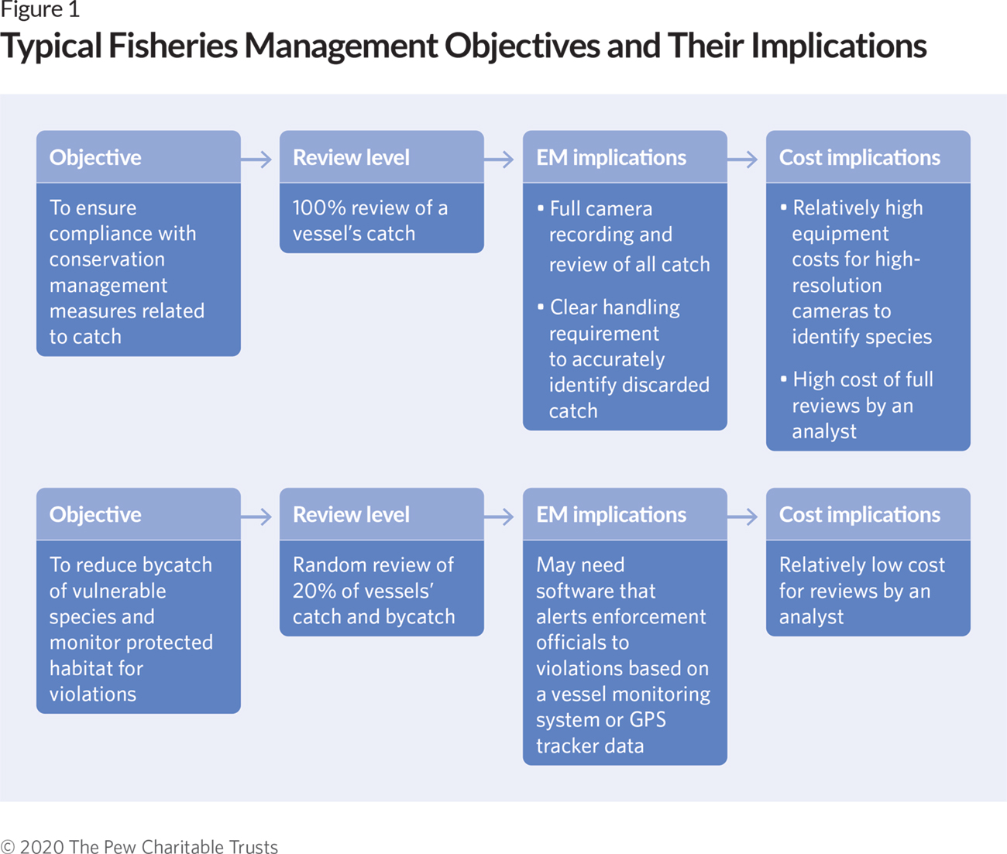

1.2 Setting customer territory coverage plans

Optimized Territory Planning
With optimized territory plans, companies have greater intelligence into account density and location. This allows them to lower travel time, reduce costs, and increase time spent selling for higher revenue attainment. Optimized sales territories create fair opportunities for sales reps to meet quota and close deals, which ultimately, boosts morale and motivates performance.
Setting customer territory coverage plans involves defining strategies and plans to effectively cover and serve specific territories or regions where customers are located. Here are some steps to consider when setting customer territory coverage plans:
Identify Target Territories: Determine the territories or regions that you want to cover based on factors such as customer density, market potential, geographical considerations, or specific business goals. Consider factors like demographics, customer preferences, competition, and market opportunities.
Segment the Territories: Divide the target territories into manageable segments based on relevant criteria. This can include factors such as customer profiles, purchasing behavior, industry sectors, or geographic boundaries. Segmenting territories helps in allocating resources and tailoring coverage strategies based on specific customer needs.
Assess Customer Needs: Understand the needs, preferences, and requirements of customers within each territory segment. Conduct market research, surveys, or engage in direct conversations with customers to gain insights into their expectations, pain points, and desired products or services.
Define Coverage Objectives: Clearly define the coverage objectives for each territory segment. These objectives could include metrics like market share, customer acquisition targets, revenue goals, or customer satisfaction levels. Ensure that the objectives are specific, measurable, achievable, relevant, and time-bound (SMART).
Allocate Resources: Assess the resources required to effectively cover each territory segment. This includes sales teams, marketing budgets, distribution channels, customer support infrastructure, and any necessary training or technology. Allocate resources based on the potential and importance of each territory.

Develop Territory-specific Strategies: Tailor strategies and action plans for each territory segment based on customer needs and objectives. This may involve designing marketing campaigns, sales approaches, customer engagement initiatives, or service delivery models that best suit each territory's characteristics.
Assign and Train Sales Teams: Assign sales teams or representatives to specific territories, ensuring that they have the necessary skills, knowledge, and tools to effectively cover their assigned areas. Provide training and support to ensure they understand the territory-specific strategies and customer requirements.
Implement Monitoring and Evaluation: Establish mechanisms to monitor and evaluate the performance of the coverage plans in each territory segment. Use metrics such as sales performance, customer satisfaction, market penetration, or lead generation to assess progress and make data-driven decisions.
Review and Adapt: Regularly review the effectiveness of the coverage plans and adjust strategies as needed. Analyze results, gather feedback from customers and sales teams, and identify areas of improvement or untapped opportunities. Continuously refine and adapt the coverage plans to optimize results.
Foster Collaboration and Knowledge Sharing: Encourage collaboration and knowledge sharing among sales teams operating in different territories. Facilitate the exchange of best practices, success stories, and customer insights to enhance overall coverage effectiveness and drive continuous improvement.

By following these steps, organizations can develop comprehensive and tailored coverage plans for customer territories, enabling them to effectively serve their customers and achieve their business objectives.

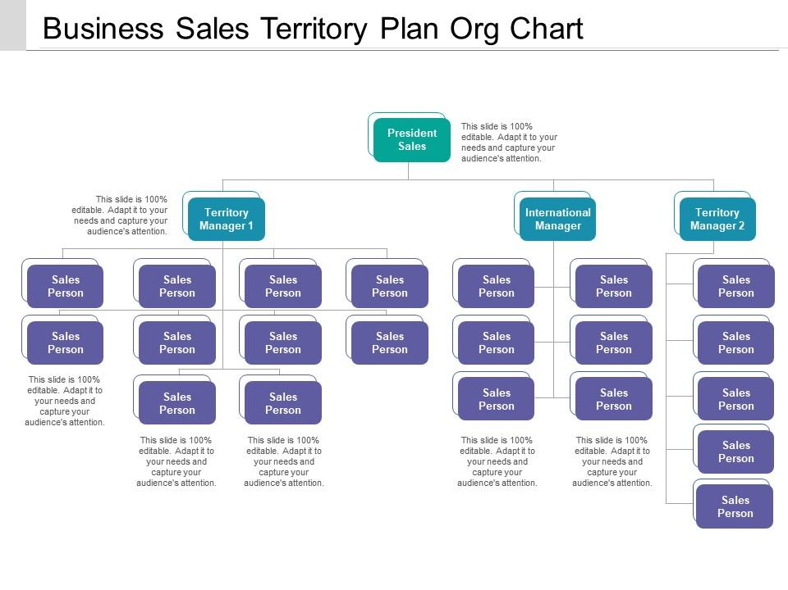

SELF CHECK UNIT ONE CHOOSE THE BEST ANSWER FROM THE GIVEN ALTERNATIVES

1: Territory optimization is the alignment of workload, opportunity, and sales resources to provide the best possible outcomes. This can be done manually or with the help of:
A) Automated territory optimizer tool
B) Spreadsheet software
C) Customer relationship management (CRM) software
2: In addition to geographical area, territories can be based on other sales data such as:
A) Account type
B) Industry segment
C) Market Potential
D) All of the above
3: Territory management helps sales managers more effectively allocate resources and improve opportunities for their team. Which of the following is NOT an advantage of territory management?
A) Cover Territories More Strategically
B) Boost Rep Selling Time
C) Assign Balanced Workloads
D) Reduce Customer Relationships
4: When sales territories are poorly planned, it can result in:
A) Drops in revenue earnings and failed quota achievement
B) Lower sales rep morale and decreased motivation
C) Higher frequencies of sales burnout
D) All of the above
5: Optimized territory planning allows companies to:
A) Lower travel time and reduce costs
B) Increase time spent selling for higher revenue attainment
C) Create fair opportunities for sales reps to meet quota and close deals
D) All of the above
6: When setting customer territory coverage plans, it is important to:
A) Define the market, analyze, and segment existing customers
B) Conduct a SWOT analysis
C) Set goals and create targets
D) All of the above

UNIT TWO REPORTING ON BUSINESS VISITS

The learning guide Advice on resource requirements is developed to provide you the necessary information regarding the following content coverage and topics are:
- Completing territory plan.
- Establishing feedback
- Analyzing and acting feedback
- Preparing documentation.
- keeping documentation in a secure location
- submitting documentation
Appling new segmentation The above Learning guide will also assist you to attain the following specific objectives. Specifically, upon completion of this Learning outcome you will be able to:
- Complete territory plan.
- Establish feedback
- Analyze and acting feedback
- Prepare documentation.
- keep documentation in a secure location
- submit documentation

2.1. Completing territory plan.
Completing a territory plan involves finalizing and documenting the specific details and actions required to implement your coverage strategy effectively. Here are the steps to complete a territory plan:
Review and Refine: Review the draft territory plan and ensure it aligns with your overall business goals and objectives. Refine the plan based on any new insights, feedback, or changes in the market landscape.
Territory Mapping: Create a visual representation of the territories you have identified, clearly defining the boundaries and segments. Use maps or software tools to create visual territory maps that can be easily understood by your team.
Territory Assignments: Assign sales teams or representatives to each territory based on their skills, experience, and workload capacity. Consider factors such as customer relationships, product knowledge, and language proficiency to ensure effective coverage.
Set Territory Objectives: Define specific objectives for each territory, aligning them with your overall coverage goals. These objectives can include targets for revenue, market share, customer acquisition, or customer satisfaction metrics.
Action Plans: Develop detailed action plans for each territory, outlining the specific tasks, strategies, and activities required to achieve the defined objectives. Include timelines, responsibilities, and key performance indicators (KPIs) to track progress.
Resource Allocation: Determine the resources needed to support the execution of the territory plan. This includes budget allocation, personnel, technology, marketing materials, and any other necessary resources to enable effective coverage.
Sales Enablement: Provide the necessary training, tools, and resources to empower your sales teams to effectively cover their territories. This can include product training, sales techniques, competitive insights, and access to relevant marketing collateral.
Communication and Collaboration: Establish clear channels of communication and collaboration among the sales teams and other stakeholders involved in executing the territory plan. Regularly share updates, insights, and best practices to foster a coordinated approach.
Performance Measurement: Identify the key performance indicators (KPIs) that will gauge the success of the territory plan. These metrics can include sales revenue, customer acquisition rates, customer satisfaction scores, or market share growth. Set up a system to regularly track and analyze these metrics.
Review and Adjust: Schedule periodic reviews of the territory plan to assess its effectiveness and make any necessary adjustments. Gather feedback from the sales teams, customers, and other stakeholders to identify areas of improvement and refine the plan as needed.
Documentation: Document the completed territory plan, including all the details, assignments, objectives, action plans, and resources. This documentation will serve as a reference and guide for your sales teams and other stakeholders involved in executing the plan.

Process of sales territory
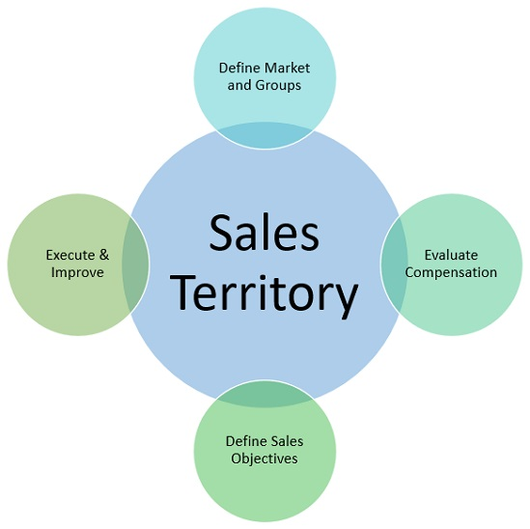

Fig 3 Process of sales territory

Executing a territory plan can come with various challenges. Here are some common challenges that organizations may face:

Territory Alignment: Ensuring proper alignment between territories and the target market can be challenging. It requires a thorough understanding of customer demographics, preferences, and behaviors. Misalignments may result in inefficient coverage, missed opportunities, or overlapping efforts.

Resource Allocation: Allocating resources, such as sales teams, budgets, and support staff, can be a challenge. Balancing resource distribution across territories based on their potential and requirements is crucial. Limited resources or uneven resource distribution can hinder effective execution.

Sales Team Performance: The performance and capability of sales teams can significantly impact territory plan execution. Challenges may arise if sales teams lack the necessary skills, product knowledge, or motivation to effectively cover their assigned territories. Ongoing training and performance management are essential to address these challenges.

Competitor Pressure: Competitors operating within the same territories can pose challenges. They may have established customer relationships, brand recognition, or competitive advantages. Developing strategies to differentiate your offerings and effectively compete within the territories is important.

Market Dynamics: Market dynamics, including changes in customer preferences, industry trends, or economic conditions, can impact territory plan execution. Adapting to these dynamics and adjusting strategies accordingly is vital to remain competitive and meet customer demands.

Communication and Collaboration: Effective communication and collaboration across sales teams and other stakeholders can be a challenge, particularly when teams are dispersed across different territories. Ensuring smooth information flow, sharing best practices, and fostering collaboration can help overcome these challenges.

Data Availability and Analysis: Access to accurate and timely data is critical for effective territory planning and execution. Challenges may arise in gathering, analyzing, and utilizing relevant data, such as customer data, market insights, or performance metrics. Implementing robust data management and analysis systems can help address these challenges.

Customer Variability: Customers within a territory may vary significantly in terms of their needs, preferences, and buying behaviors. Tailoring sales and marketing approaches to cater to diverse customer segments within a territory can be challenging but crucial for success.

Territory Expansion or Restructuring: As business needs evolve, organizations may need to expand or restructure territories. Managing the transition, realigning resources, and ensuring a smooth handover of accounts or territories can present challenges.

Performance Measurement and Evaluation: Establishing effective performance measurement systems and evaluating the success of the territory plan can be challenging. Selecting appropriate metrics, collecting accurate data, and analyzing performance against objectives require careful planning and implementation.

Addressing these challenges requires proactive management, continuous monitoring, and adaptability. Regular evaluation, feedback collection, and adjustment of strategies based on lessons learned are essential for successful territory plan execution.

2.2 Establishing feedback

Establishing a feedback mechanism is crucial for evaluating the effectiveness of a territory plan and making necessary improvements. Here are some steps to establish a feedback process:
Define Feedback Objectives: Determine the specific objectives of gathering feedback. It could be to assess the performance of the territory plan, identify areas for improvement, gauge customer satisfaction, or gather insights from the sales teams operating in the territories.
Identify Feedback Sources: Identify the key stakeholders from whom you want to gather feedback. This may include sales teams, customers, managers, support staff, or other relevant parties involved in the territory plan execution.
Select Feedback Methods: Choose appropriate methods for collecting feedback. These can include surveys, interviews, focus groups, performance reviews, suggestion boxes, or online feedback forms. Consider the preferences and convenience of the feedback providers when selecting the methods.

Develop Feedback Questions: Craft clear and specific questions that address the objectives of gathering feedback. Ensure that the questions are relevant, unbiased, and allow for open-ended responses to encourage detailed insights. Include a mix of quantitative and qualitative questions to gather both numerical data and subjective feedback.
Implement Feedback Collection: Execute the feedback collection process by distributing surveys, conducting interviews, or organizing feedback sessions. Provide clear instructions and ensure confidentiality and anonymity if necessary to encourage honest and candid responses.
Analyze Feedback: Thoroughly analyze the collected feedback to identify trends, common themes, strengths, weaknesses, and areas for improvement. Utilize both qualitative and quantitative analysis techniques, such as coding responses, categorizing feedback, or calculating satisfaction scores.
Share Feedback Results: Communicate the feedback results to the relevant stakeholders involved in the territory plan execution. Share the key findings, insights, and recommendations derived from the feedback analysis. Present the results in a clear and understandable format, such as a report or presentation.
Take Action and Make Improvements: Based on the feedback results, develop an action plan to address the identified areas for improvement. Assign responsibilities, set timelines, and implement necessary changes to enhance the territory plan's effectiveness. Keep the stakeholders informed about the actions taken based on their feedback.
Continuous Feedback Loop: Establish a continuous feedback loop by regularly collecting feedback at defined intervals or milestones. This allows for ongoing evaluation, adjustment, and improvement of the territory plan. Encourage stakeholders to provide feedback and suggestions throughout the execution process.
Monitor and Measure Progress: Continuously monitor the impact of the feedback-driven improvements on the territory plan's performance. Track relevant metrics, compare results over time, and measure the effectiveness of the implemented changes. Use this information to further refine the territory plan and feedback process.
By establishing a robust feedback mechanism, you can gather valuable insights, address challenges, and optimize your territory plan based on real-time information from stakeholders. This iterative feedback loop ensures continuous improvement and enhances the effectiveness of your territory coverage strategy.

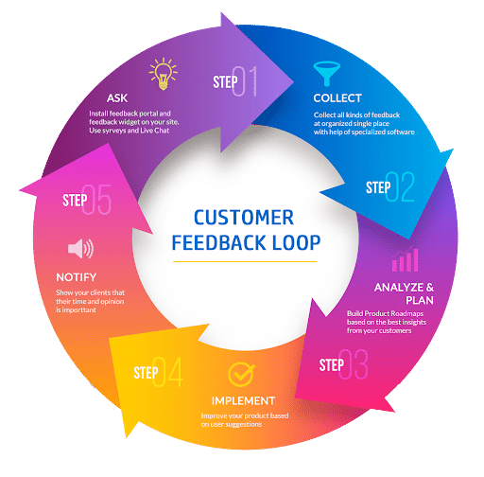

2.3 Analyze and acting feedback
Analyzing and acting on feedback is a critical step in the feedback process. Here's how you can effectively analyze and take action based on the feedback received:
Consolidate Feedback: Gather all the feedback received from various sources, such as surveys, interviews, or feedback forms. Organize the feedback systematically, ensuring that you have a comprehensive view of the feedback data.
Categorize Feedback: Group similar feedback together based on themes, topics, or issues. This categorization helps in identifying common patterns and areas that require attention. It provides a structured approach to analyzing the feedback data.
Identify Key Insights: Analyze the feedback data to extract key insights and observations. Look for recurring themes, trends, or significant points that emerge from the feedback. Identify both positive feedback that highlights strengths and areas for improvement that require attention.
Prioritize Areas for Action: Prioritize the areas for action based on the significance and impact of the feedback. Focus on the areas that have the most potential to improve the territory plan's effectiveness or address critical issues identified in the feedback.
Develop Actionable Plans: For each identified area for improvement, develop actionable plans. Define specific steps, strategies, or initiatives that will address the feedback and lead to positive changes. Set clear objectives, assign responsibilities, and establish timelines for implementing the action plans.
Communicate Action Plans: Communicate the action plans to the relevant stakeholders, including sales teams, managers, or other individuals involved in the territory plan execution. Ensure that everyone understands their roles and responsibilities in implementing the action plans.
Implement Changes: Execute the action plans according to the defined timelines. Monitor the progress of the implemented changes and ensure that they align with the feedback received. Provide necessary support, resources, or training to enable the successful implementation of the action plans.
Evaluate Impact: Regularly evaluate the impact of the implemented changes on the territory plan's effectiveness. Monitor relevant metrics, such as sales performance, customer satisfaction, or market share, to assess the outcomes of the changes. Compare the performance before and after the implementation to measure the impact.
Iterate and Refine: Based on the evaluation results, iterate and refine the territory plan as needed. Continuously gather feedback and make adjustments to further improve the plan. This iterative process ensures that the territory plan remains responsive to changing needs and continues to deliver desired results.
Close the Feedback Loop: Close the feedback loop by sharing the outcomes and improvements resulting from the feedback with the stakeholders who provided the feedback. Show appreciation for their input and demonstrate how their feedback has influenced positive changes.
Analyzing and acting on feedback is an ongoing process that requires continuous monitoring, evaluation, and adjustment. By taking prompt action based on feedback, you can optimize your territory plan, enhance its effectiveness, and meet the evolving needs of your customers and stakeholders.
2.4 Preparing documentation.
Preparing documentation is an essential step in the territory planning process. Documentation helps ensure clarity, consistency, and easy reference for the territory plan. Here's how you can effectively prepare documentation for your territory plan:
Territory Plan Overview: Start by creating an overview document that provides a high-level summary of the territory plan. This document should include the purpose of the plan, key objectives, and an outline of the key components covered in the plan.
Territory Descriptions: Create documents or sections that describe each territory in detail. Include information such as territory boundaries, target market segments, customer profiles, competitor analysis, and any specific considerations or challenges for each territory.
Territory Objectives: Document the specific objectives for each territory. Clearly state the desired outcomes, such as revenue targets, market share goals, customer acquisition metrics, or any other relevant performance indicators. Align the objectives with the overall business goals.
Action Plans: Prepare detailed action plans for each territory. Break down the tasks, strategies, and activities required to achieve the territory objectives. Include timelines, responsible parties, and any necessary resources or support required for the successful execution of the action plans.
Resource Allocation: Document the allocation of resources across territories. Specify the sales teams or representatives assigned to each territory, along with their roles and responsibilities. Include information on budget allocation, technology requirements, marketing materials, and any other resources necessary for effective territory coverage.
Communication and Collaboration Guidelines: Define guidelines for communication and collaboration among the sales teams and other stakeholders involved in the territory plan execution. Document preferred communication channels, meeting schedules, reporting structures, and any other protocols that promote coordination and information sharing.
Performance Measurement Metrics: Document the key performance indicators (KPIs) that will be used to measure the success of the territory plan. Specify how these metrics will be tracked, evaluated, and reported. Include any benchmarks or targets that will be used for comparison.
Feedback Mechanism: Outline the process for gathering feedback on the territory plan and how it will be incorporated into the plan's ongoing improvement. Document the methods, timelines, and responsibilities for collecting and analyzing feedback, as well as the actions that will be taken based on the feedback received.
Training and Development: If there are specific training or development programs associated with the territory plan, document them in detail. Include information on the topics covered, training methods, schedules, and responsible parties for delivering the training.
Review and Update Process: Establish a process for regularly reviewing and updating the territory plan documentation. Specify the frequency of reviews, the stakeholders involved, and the criteria for determining when updates are necessary. Document any change management processes that will be followed when making updates to the plan.
Version Control: Maintain proper version control for the territory plan documentation. Use clear naming conventions or version numbers to differentiate between different iterations or updates of the plan. This ensures that everyone is working with the most current and accurate information.
Accessibility and Distribution: Ensure that the territory plan documentation is easily accessible to the relevant stakeholders. Store the documentation in a centralized location, such as a shared drive or project management tool, and provide appropriate access permissions. Distribute the documentation to all involved parties and communicate any updates or changes effectively.
By preparing comprehensive and well-structured documentation, you provide a reference point for all stakeholders involved in the territory plan execution. It promotes clarity, alignment, and effective implementation of the plan, ultimately leading to improved territory coverage and business outcomes.
Document design techniques:
- 2.4.1: Formatting Titles
- 2.4.2: Creating Headings and Subheadings
- 2.4.3: Choosing Fonts
- 2.4.4: Line Spacing Considerations
- 2.4.5: Using Lists
- 2.4.6: Choosing Visual Aids
- 2.4.7: Using Interactive Elements
- 2.4.8: Balancing Text Whitespace
- 2.4.9: Making Accessible, compliant Documents

2.4.1 Formatting Titles
Almost every document that exists as a standalone unit must have a title that accurately represents its contents in a nutshell. It’s the first thing a reader looks for to understand what a document is all about and should thus be easily found centred at the top of the first page of any small document, and prominently placed on the cover of larger documents. Though some documents represent exceptions to this rule (e.g., business letters lack titles, and many lack subject lines), any document that brings with it the expectation of a title but omits it is incomplete, and readers might not know what to make of it (or would waste time figuring that out). Even emails and memos have titles in the form of subject lines.

Spotlight: “Crafting Titles”

In whatever document you find it, a title should have the following characteristics so that it can serve your reader’s understanding of the whole:
- Topic summary: A title is the most concise summary possible of a topic while still making sense. If you glance at a news website or newspaper, for instance, you can get a reasonably good sense of what’s going on in the world just by reading the headlines because they are titles that, in as few words as possible, summarize the narratives told in the articles that follow.
- Conciseness: Aim for a length in the 2- to 7-word range—something that can be said repeatedly in one short breath. One-word titles are appropriate only for art (e.g., for books, films, songs, albums, etc.), but most other professional documents use a reasonable number of words to give a sense of the topic, albeit streamlined to the point of having no words that don’t absolutely need to be there. In scientific papers, titles can be quite long and carry plenty of detail, though you can expect that their audiences will rarely pronounce the full title.
- Capitalization: Capitalize the first word no matter what, as well as all major words (nouns, verbs, adjectives, adverbs, pronouns, etc.) thereafter.
  - Don’t capitalize prepositions (e.g., on, to, from, in, out, of), conjunctions (and, but, or, for, nor, so, yet), nor articles (the, a, an) unless they’re the first word of the main title or subtitle (Darling, 2014a, 2014b, 2014c).
  - When including a hyphenated word (i.e., with a compound-modifier hyphen), leave the second word, the one immediately following the hyphen, lowercase (see the first two examples in the titles listed at the end of this subsection).
- Structure: Use a noun, verb, or adjective phrase rather than a complete sentence.
  - Main title: If your title comes in two parts with a main title and subtitle, the main title establishes the general context of the topic, perhaps with catchy or clever phrasing, and ends with a colon ( : ) with a single space after it but none before.
  - Subtitle: The subtitle follows the main title with a more specific and detailed summary of the document topic.
- Position: Centre the title at the top of the page and include 1-2 empty lines below it to separate it from the opening text.
- Typeface: Use bold typeface to help draw the eye towards the title, as well as colour if appropriate.

2.4.2: Creating Headings and Subheadings
After the main title of a document, using headings and subheadings as titles for sections and subsections helps guide the reader around a document’s breakdown of topics. Especially in reports, headings and subheadings that stand out in bold typeface flush (or close) to the left margin and follow a consistent numbering system, exactly as you see in this textbook, help a busy reader quickly locate any specific content they seek. Even a routine email that covers a topic in so much detail that it could be internally divided—without being so big that its content should just go into a document attachment—would benefit from bolded headings. Just like titles, headings and subheadings must be properly phrased and capitalized like main titles (see 2.4.1 above).
When using a word processor such as Microsoft Word, you can achieve additional functionality by using “true headings.” From the Home menu tool ribbon, heading styles are available as options in the Styles section. If you prefer to design your own styles of headings, you can click on the downward triangle at the bottom right of the style examples field and select “Create a Style.” Doing this allows you to see your entire document at a glance on the left and quickly jump to any section you wish by clicking on the Navigation Pane checkbox in the Show section of the View menu tool ribbon (or Alt + w, k), then clicking on the heading for the section you want. This is especially useful in larger documents like reports. Additionally, using such headings makes your document accessible to audiences with assistive technologies such as screen readers (see §2.4.9 below on AODA compliance).

2.4.3: Choosing Fonts
Font selection is an important consideration because it determines how the audience will receive a document. Font involves decisions concerning the style of type, size, and even colour. Consider the following:

Font Type

A list of font styles including: Arial, Garamond, Times New Roman, Verdana and Comic Sans
Writers considering typeface must choose between two major style categories depending on how they would like to accommodate their reader. Serif fonts like Times New Roman and Garamond have little perpendicular cross line “feet” or “hands” at the ends of letter strokes, as well as variable thickness in the strokes themselves depending on their horizontal/vertical or curving position, which altogether help readers distinguish between similar letters or combinations of letters, such as m and rn, which almost look like the same letter in a non-serif font. Serif fonts are ideal for printed documents, especially those with smallish font sizes such as newspapers. Without serifs, sans-serif fonts like Arial (the one used in this textbook) or Verdana achieve a cleaner and modern look, especially on computer screens where serif fonts appear to wither away at the thin part of the stroke and are thus harder to read. In the appropriate format, all the fonts mentioned above make a document look respectable. Comic Sans, on the other hand, is appropriate for documents aimed at children, but undermines the credibility of any professional document, such as when the unfortunate choice to use it when reporting CERN particle physics discoveries became more newsworthy than the discoveries themselves (CBC, 2012).
Anticipate that audiences might care about font choices, especially if the font clashes with the content like the example above. To anyone who considers the effects that fonts have on an audience, even going with the Microsoft Word default font of Calibri has its dangers because it comes off looking lazy, being the non-choice of those who never consider the importance of font. At the other extreme, digging around for and using exotic fonts for a document is risky because they can look flakey, such as Papyrus or Copperplate (Butterick, 2013). Even if they look nice, however, the receiver opening the document on the other end may not have that font in their word processor program, requiring that program to substitute it with another font, which may look worse or mangle layouts arranged around that font. The safe bet, then, is always to go with familiar, respectable-looking serif or sans serif fonts like those identified at the top of this subsection.

Font Size
Size is another important consideration because readers depend on text being an ideal size for readability and are frustrated by font sizes that are bigger or smaller than that. In a standard written document, for instance, a 12-point Arial or Times New Roman is ideal. If the MS Word default size when you open a blank document is 11-point, it’s worth increasing it for the sake of those who have slight visual impairment. Increasing the size much past 12-point has a similar effect as using the Comic Sans font type: it makes your document appear to be targeting an audience of children. Of course, situations where you want to increase the font size abound, such as for titles on title pages so that the eye is drawn immediately to them, and any time readers are required to read at a distance, such as posters on a notice board or presentation slides. The ideal font size for bullet points in a PowerPoint is in the 30- to 35-point range, whereas a 12-point font will appear microscopic on a projector screen, if not invisible, from across the room.
Occasions for going smaller with your font size include footnotes in a report or source credits under images in a document or PowerPoint presentation. Decreasing font size to 8-point merely to get all your text to fit into a one-page résumé, however, would undermine the document’s purpose because, by frustrating the hiring manager trying to read it, it runs the risk of prompting them to just dump it in the shredder and move on to the next (hopefully reader-friendly) résumé. In such cases, choosing the right font size becomes a major life decision. Whatever the situation, strike a balance between meeting the needs of the reader to see the text and design considerations.

Font Color
A choice of color may also enter into document design considerations, in which case, again, the needs of the reader must be accommodated. Used appropriately, a touch of color can draw the eye to important text. Coloring your name red at the top of your résumé is effective if few or no other elements in the document are so colored because your name is essentially the title of your document. Likewise, coloring the title of other documents is effective if there are no expectations of doing otherwise (some style guidelines forbid color).

Boldface, Italics, and Underlining
Boldface, italics, and underlining serve various purposes in focusing audience attention on certain words. Boldface type is especially helpful in directing audience eyes towards titles, headings, and keywords as you can see at the beginning of this paragraph and throughout this textbook.

2.4.4: Line Spacing Considerations
Single-spaced lines are common to most documents because they accommodate the reader’s need to dart quickly to the next line to continue reading a sentence. The gap between 1.0-spaced lines is just enough to clearly separate one line from another so the hanging elements at the bottom of letters like j and g don’t interfere with the tops of uppercase letters on the line below. Some documents such as academic manuscripts are double-spaced to give readers, who are usually the instructors or teaching assistants grading them, enough space to write comments and editorial marks between the lines.
Frustratingly, some word processors such as Microsoft Word open blank pages with line spacing values other than single (1.0) spacing as their default setting, such as 1.08 or 1.15. In such cases, a couple of adjustments are necessary if you want to single-space a document you’re writing from scratch. Make these adjustments as soon as you open a blank page or by highlighting all (ctrl. + a) if you’ve already started. In MS Word’s Home menu:
- Click on the Line and Paragraph Spacing icon that has four lines representing text with two blue arrows on its left side, one pointing up and one down, in the Paragraph section of the Home menu ribbon (or just type the Alt + h, k keys).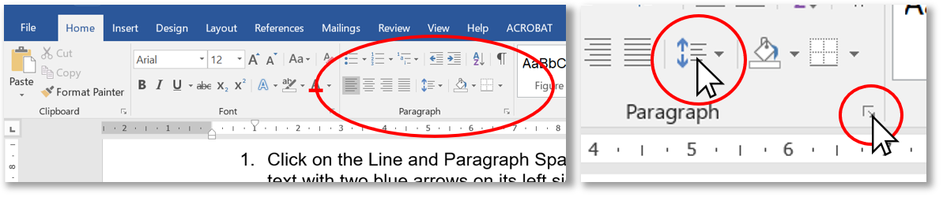
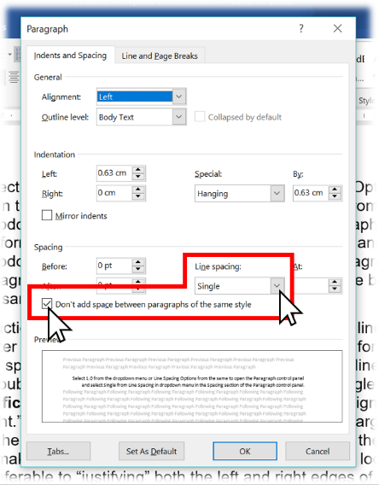Figure 2.2.4.a: In Microsoft Word,, you can locate a dropdown menu where line spacing can be changed.
- Select 1.0 from the dropdown menu or Line Spacing Options from the same to open the Paragraph control panel and select Single from the Line Spacing dropdown menu in the Spacing section.
- Perform the same two steps as above to get the Line and Paragraph Spacing dropdown menu and select Remove Space After Paragraph or, from the Paragraph control panel, click on the “Don’t add space between paragraphs of the same style” checkbox and the Okay button at the bottom to apply the style.
The third action above prevents MS Word from adding a full line of space every time you hit Enter at the end of a line. When typing address lines for a letter without the “Don’t add space” checkbox ticked, for instance, the default line spacing will continue to look like double spacing even if you set the line spacing to single.
Need More Help with Microsoft Word?
For the most up-to-date options within Microsoft Word, please refer to the Microsoft Office website for help and support on the most recent version of the company’s software.
Justification should ideally be left as the default left-aligned or “Left-justified / ragged right.” This means that all lines are flush to the left margin and the lines end wherever the last full word fits before the right margin sends (or “wraps”) the next word down to the next line, making each line vary in length so the right margin looks “ragged,” as you can see throughout this textbook. This is usually preferable to “justifying” both the left and right edges of the text so that they align perfectly along both the left and right margins, as in the example below. While this may look clean, like the columns in newspapers, this look is achieved by adding space between the words within each line, and since every line varies in length without justification, every line with it will vary in the amount of space added between words. Some lines that would be short without justification look awkward with it because the space between some words is greater than the span of small words.
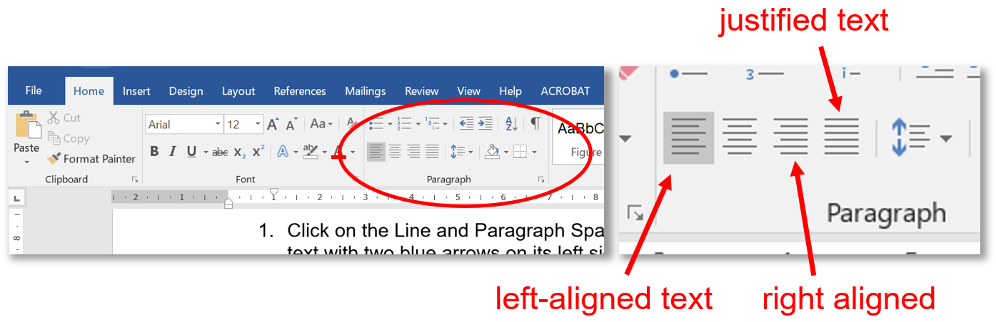Figure 2.2.4.b: Where to click to select text justification or left-aligned (“ragged right”) text in the MS Word Home menu tool ribbon.
To fix the “hockey teeth” gaps that can result from justification such as what you see in the example above, turn on hyphenation in MS Word via the Layout tool ribbon: select Automatic in the Hyphenation dropdown menu in the Page Setup section. This automatically adds hyphens between syllables of long words whose size and position at the end of a line would otherwise send them entirely to the beginning of the next line, decreasing the number of words in the line above and increasing the gap between each. If working in a company document template with justification, keep the justification throughout to be stylistically consistent with other documents produced in that template and ensure that the hyphenation is turned on (unlike this paragraph). Otherwise, left-aligned text is perfectly fine and may even help readers find their place if they lose it momentarily compared with the uniform brick-wall effect of justified text seen here.

2.4.5: Using Lists
Another technique that helps the reader skim and easily find sought-after content is numbered or bulleted lists for a series of discreet but related items. Whether you use numbered or bulleted lists depends on your organizing principle:
Use Bulleted Lists for : | Use Numbered Lists for:
- an un prioritized collection of related points  - points under a heading in an email or note-form points on a presentation slide (e.g., PowerPoint) for easier readability | - a step-by-step procedure such as a set of instructions  - description of a chronological sequence — a series of events unfolding in time  - rankings that arrange items in priority order
You’ve seen numbered and bulleted lists used throughout this textbook (e.g., the two bulleted lists immediately above). Whichever list type you use, ensure each has the following:
- A sentence or phrase introducing and explaining the list and ending with a colon before delivering the list immediately below it, as you can see in the sentence that introduces this list;
- Capitalization of the first letter in each point OR no capitalization for any of the items (except if they are proper names);
- Periods ending each point only if it is a complete sentence on its own, whether it be in the declarative, imperative, or any other mood; a list of nouns or noun phrases, on the other hand, doesn’t end in periods (semicolons can be used in this case — as in the list you are reading right now — for all list items except the last one, which should end in a period);
- Parallelism in the sense that each point in a list follows the same grammatical pattern, such as only full sentences, only noun phrases, or only verb phrases (or imperative sentences); for instance, each point in the three bulleted lists in this section (including the present one) is a noun phrase (i.e., it begins with a noun) and the numbered list in §2.4.5 above, as a step-by-step procedure, is a sequence of imperative sentences (i.e., each begins with a verb: “Click,” “Select,” “Perform”). The need for parallelism extends also to lists within a sentence.

2.4.6: Choosing Visual Aids
The cliché that a picture is worth a thousand words holds true because images are excellent aids to understanding when placed near the messages they illustrate. Just as the visual elements in this textbook support and reinforce the content, such as those in §2.2.4 above, so photos, graphics, charts, and graphs provide readers something that can be understood and remembered at a glance—as long as those visuals are used appropriately. Of course, the main criterion for usability is if the image helps the reader understand the text better. If the image is complementary, it can only help. If it is unnecessary, confusing, or contradicts the text, however, the image isn’t worth the time and effort it takes to add it to your document.
When considering using an image, ask yourself:
- Aesthetic considerations:
  - Does the image look good?
  - Are the colors complementary?
- Technical considerations:
  - Is the image resolution of sufficiently high quality or is it too pixilated to use?
- Legal considerations:
  - Does the image’s copyright license permit or forbid use by others?
  - Am I using the image for educational or commercial purposes?
- Design considerations:
  - Is it big enough to see?
  - Is it placed appropriately?
The ideal size depends on the resolution, detail of the content, relative importance, and the use to which the document will be put. The following guidelines help ensure that the images you use will meet aesthetic, design, technical, and legal expectations:
- Aesthetic guidelines:
  - Choose images that look like they were produced by professional photographers, illustrators, or graphic designers—the sort you would see in a magazine or professional industry website.
  - Professionals usually produce images with a limited palette of colors that work well together.
  - Use images that are in focus and well-framed with the central image clearly visible rather than too far in the background or so close that important aspects are cropped out.
- Design guidelines:
  - An image or graphic that is crucial to the reader’s understanding and is highly detailed really deserves to stretch across the text block from margin to margin.
  - An image that is more ornamental and relatively simple can be inset within the text either on the left or right margin, or centered on the page without text on either side.
  - Important images, especially those labeled as figures, must be placed as near as possible to the text they support and even referred to in the text (“See Figure 2 for an illustration of . . .”)
  - Ensure that the text and corresponding image aren’t separated by a page break if the text is close to the top or bottom of the page. The reader’s eye must be able to move between the image and corresponding text in the same field of view to seal their understanding.
- Technical guidelines:
  - Screen resolution must be at least 72dpi (dots per inch), the internet standard; anything less than 72 may appear pixilated even on the screen, especially if maximized in size across the page.
  - Images in documents that will be printed should be 300dpi to avoid appearing pixilated on paper.
  - Preferred image file types include JPEG (.jpg) and PNG (.png). The latter includes the possibility of contouring so that the image doesn’t necessarily have to be a square or rectangle. You can make a PNG image file of your handwritten and scanned signature, for instance, by erasing the white background around the pen strokes in Photoshop and saving the image as a PNG. That way, you can drag and drop your signature onto a signature line in an electronic document and it won’t block out the line underneath if your signature typically sprawls out over lines.
- Legal guidelines:
  - To stay on the right side of copyright legislation, searching online for images that are free to use is easy by including licensing status in an advanced Google Image search. From the Google Images search screen:
    - Click on the Settings spring-up menu at the bottom right.
    - Select Advanced Search.
    - Scroll down and click on the “usage rights” dropdown menu at the bottom.
    - Select “free to use or share” or whatever licensing status suits your purposes.
  - Otherwise, you can acquire the right to use images for commercial purposes by purchasing them from stock photo vendors such as Getty Images, Adobe Stock, or Shutter stock.
With modern word processors, placing an image is as easy as dragging and dropping the image file from a folder into a document (or copying and pasting). Sometimes you will need to be a little craftier with capturing images, however. For instance, if you need to capture a still from a YouTube video to use as an image, you can pause the video at the moment you want to capture and use your computer’s screen-capturing program to get the image.
- On a Windows-based computer:
  - Open the included Snipping Tool (Microsoft Support, 2021) to turn the cursor into crosshairs.
    - Note: in Windows 10 , the Snipping Tool may be replaced with the Snip & Sketch app. Please see Microsoft’s help and support site for how to take and annotate additional screenshots on Windows 10.
  - Click and drag the crosshairs to select the desired portion of the screen for capturing; when you release the cursor, the captured image will open immediately in the clipboard. Ensure that you’ve included only the elements necessary, rather than the whole screen, plus a short span of margin on each side.
  - Save the image in a folder from the clipboard or add it directly to the document by switching immediately to the document window (Alt + tab) and pasting it (ctrl. + v) wherever you’ve placed your cursor.
- On a Mac, use Shift + Command + 4 and use the crosshairs to select the desired portion of the screen (Apple Support, 2020).
Once your image is in your document, use the layout options to place it where appropriate. Clicking on it may produce a layout icon near the top right that you can click on to open the dropdown menu (alternatively, you can right-click on the image and select the Wrap Text option from the dropdown menu). The default setting left-justifies the image and displaces the text around where you put it, but other layout options allow you to place it elsewhere on the page so that your text wraps around it (“Square,” “Tight,” or “Through”) or so that text doesn’t move around it at all (“Behind” or “In front of text”), which gives you the freedom to move the image anywhere.

2.4.7: Using Interactive Elements
Another aid to understanding that can benefit readers of an online or electronic document is a web link that provides them with the option of accessing other online media.

2.4.8: Balancing Text and Whitespace
Another consideration that helps readers find their way around a page is the balance of text and whitespace, which is simply a gap unoccupied by text or graphic elements.

2.4.9: Making Accessible, AODA-compliant Documents
The Accessibility for Ontarians with Disabilities Act (2005) sets out guidelines for how workplaces can help people with disabilities, including accommodations that extend to document design.
Document security protects data, making sure you're legally compliant, and prevents data loss through fraud and identity theft. Whether you're sending information via print or online, your document management system should protect your recipients' personal information
Document security is the protection of information contained in documents from unauthorized access or theft. It can also refer to measures taken to prevent the alteration or counterfeiting of documents. Physical and digital documents should be treated with caution.

Scope
This guidance covers all types of initial applications for marketing authorization made in the Centralized (CP), Mutual Recognition (MRP), Decentralized (DCP) and National procedures including updates provided during the assessment phase (validation updates and responses to questions).
It applies also to active substance master files (ASMF), MRL applications, and post-authorization

Procedures for sending electronic information
There are different ways of submitting electronic dossiers to competent authorities, including portals, Eudralink or hard media (CD/DVD), if accepted by authorities. Normally, only one way should be used, to avoid sending multiple copies of the same submission to the authority.
Authorities may require provision of a paper cover letter for electronic submissions via hard media, portals or Eudralink. An electronic version of a cover letter should always be included in the folder “add-info” of the Vines submission (PDF preferably generated from text source without a requirement to scan a wet signature).
See CMDv website for further details on NCA requirements. For submissions to the EMA, please refer to the submission section of the Agency website.

Portals
It is strongly recommended to use secure portals for the submission of applications. For submissions to national competent authorities (CP or MRP/DCP), the Common European Submission Platform (CESP) can be used for many types of veterinary submissions and is accepted by many authorities, please refer to the CESP website for further details. The EMA submission Gateway/Web Client may be used only for submissions to the EMA in the Centralized Procedure. For further details see the submission website.

Hard media (CD/DVD)
Where electronic files are provided on finalized optical media such as CD or DVD, each hard medium on which the submission is presented should include at a minimum the following label information:
- Name of the product,
- type of application,
- procedure number (if known in advance by the applicant),
- name of company,
- target species (if necessary to avoid confusion of products),
- version (including date),
- indication as to whether multiple media components are used (and if so, these should be numbered, e.g. 1/2, 2/2),
The information provided, specifically procedure number and version (including date), should allow at any procedural step a unique identification of the submission, that can be referred to by involved competent authorities.
This information should preferably be printed directly onto the hard media as hand-written or self-adhesive labels may compromise the disc or peel-off in time.
Zipped files should not be used when sending CDs or DVDs.
Applicants should provide the electronic submission on the smallest number of media components possible, e.g. if the Vines submission spans several CDs, the provision of a DVD is recommended.
If more than one media component is needed, the dossier should be split at a logical point within the granularity such that the integrity of the granularity is maintained. Where possible, individual dossier parts (Part 1, Part 2 etc.) should be kept together and not be split over multiple media components.
Several Vines submissions for the same medicinal product may be provided on a single media component.
Grouped variations or variations submitted in a work sharing procedure should preferably be submitted on the same media component.

Language
In order to facilitate the processing of the application and make the assessment more efficient, the scientific and technical documentation should be submitted in English. Both applicants and authorities should refrain from translations to languages other than English as this makes quality control and validation difficult and less reliable

File Format & Source
All documentation should be submitted using file formats that facilitate both reviews on screen and paper while retaining a similar format.
The portable document format (PDF) is a format which supports the described features. PDF provides an ISO-standardized format (ISO 32000-1:2008), including a long-term archiving format also known as PDF/A (ISO-19005-1:2005, ISO-19005-2:2011 and ISO-19005-3:2012). PDF/A has been accepted as a standard for providing documents in electronic format by the International Conference on Harmonization (ICH) and is recommended as default file format by the veterinary equivalent (VICH).
The PDF format used for a Vines-compliant submission should follow the specifications defined in VICH Guideline 53: Electronic exchange of documents: electronic file format.
With implementation of a web-based interface for creation of Marketing Authorization Application forms, electronic application forms (eAF) are replaced by a CESP Dataset Module. The output of the Dataset Module is a PDF form to which the application data are also attached in form of an XML file. Thus the content of the XML attachment does not contain additional data but is visually mirrored in the PDF rendition. When switching from the previous eAF technology to the new application forms with attached XML files, Vines validation rules are not impacted. It is noted that VICH Guideline 53 discourages the use of file attachments for any dossier-related content as they can be easily overlooked during compilation / review of documents and may complicate technical validation. As the XML attachment to the CESP form however follows closely defined rules and neither introduces new content nor needs to be subject to Vines validation criteria, the approach is fully compatible with the VICH concept.
Product information (SPC, label, leaflet) should be submitted in addition to a PDF file in an editable format like Microsoft Word.

Requirements for creating PDF files for electronic submission

Electronic source documents
To allow functionality such as text searching, copying and pasting into editable formats, PDF documents should be created (rendered) directly from their electronic source documents, except where the applicant has no access to the electronic source document. Such exempted documents are for example
- copies of documents provided by regulatory authorities such as manufacturer’s licenses, certificates of suitability, manufacturing authorizations,
- copies of documents from other external sources like certificates of analysis,
- Any literature references sourced from journals, periodicals and books.
If documents are sourced from a scanned original the only way to create searchable text is using an Optical Character Recognition (OCR) routine. The use of OCR should be considered when preparing key documents of the submission, in particular the main body of text of the detailed and critical summaries, or written summaries of the applicant. Applicants do not have to quality assure the underlying OCR; however, good quality scanned copies should be used for OCR wherever possible, as more accurate text will allow for increased utility by reviewers.
Where only signature pages may need to be scanned, applicants should consider providing signatures on separate pages not containing other information key to the understanding of the submission.

Signatures
The applicant has the obligation to ensure a proper certification of the submitted documents. Valid signatures should be available from the applicant and be presented at the request of the authorities. National Competent Authorities should, wherever necessary, accept a signed paper cover letter confirming the correctness of the submitted file(s).

Structure of the electronic submission

General considerations
The folder structure (granularity) for an electronic submission is based on the Notice to Applicants Volume 6B as amended by Directive 2009/9/EC (Annex I to Directive 2001/82/EC as amended). This hierarchical structure of folders within a root folder gives, depending on the type of submission, up to three levels of granularity. The complete VNeeS folder structure is shown in Table 1 for pharmaceutical products and Table 2 for immunological products and should be used where applicable to prepare any electronic submission.

Root folder
The name of the top level folder ("root folder") of each Vanes folder structure should allow appropriate identification of the submission, especially in cases where more than one Vanes structure is located on a single hard medium.
For reasons of automated identification and technical validation of e-submissions with tools like the Vanes checker each root folder name must start with the letters "root", followed by a specific identification of the submission which can be defined by the applicant. A hyphen ("-" character) should be used as separator.
It is recommended to use as specific identification
- the product (invented) name and/or
- the procedure number (if known), especially if more than one procedure is included on the same CD, and /or
- the submission date or day of procedure, to allow tracking of updates during the procedure

2.5 keeping documentation in a secure location

Keeping documentation in a secure location is crucial to protect sensitive and confidential information related to your territory plan. Here are some key considerations for securely storing your documentation:
Choose a Secure Storage Solution: Select a storage solution that provides appropriate security measures. This can include password protection, encryption, access controls, and other security features. Options may include cloud-based storage services with strong security protocols or an on-premises server with robust access controls.
Implement User Access Controls: Limit access to the documentation to authorized individuals only. Assign access permissions based on job roles, responsibilities, and the need-to-know principle. Regularly review and update access privileges as personnel changes occur within the organization.
Use Strong Passwords and Encryption: Ensure that your storage solution utilizes strong passwords and encryption mechanisms to safeguard the information. Encourage the use of unique and complex passwords and consider implementing two-factor authentication for an added layer of security.
Regularly Backup Documentation: Regularly back up your documentation to prevent data loss in case of system failure, data corruption, or other unforeseen events. Implement an automated backup schedule and verify the integrity of the backup data periodically.
Train Employees on Security Practices: Educate employees on the importance of data security and provide training on best practices for handling and storing sensitive information. Train them on password management, phishing awareness, and the proper use of the storage solution to minimize the risk of data breaches.
Secure Physical Documentation: If you have physical copies of the documentation, store them in a secure location with restricted access. Implement measures such as locked cabinets, access logs, or surveillance systems to protect physical documents from unauthorized access or theft.
Regularly Monitor and Audit Access: Monitor access logs and regularly review them to identify any suspicious activities or unauthorized access attempts. Conduct periodic audits to ensure compliance with security protocols and identify any potential vulnerabilities or gaps in the security system.
Secure Document Transmission: When sharing or transmitting sensitive documentation, use secure communication channels such as encrypted email or secure file transfer protocols (SFTP). Avoid transmitting sensitive information through unsecured or public networks.
Establish Document Retention Policies: Develop and enforce document retention policies to determine the appropriate length of time to retain documents. Properly dispose of outdated or unnecessary documentation to minimize the risk of unauthorized access or data breaches.
Continuously Update Security Measures: Stay informed about the latest security practices and updates for your chosen storage solution. Regularly update software, apply security patches, and stay vigilant against emerging threats to maintain the integrity and security of your documentation.

By implementing these security measures, you can protect the confidentiality, integrity, and availability of your territory plan documentation. Safeguarding sensitive information ensures that your territory plan remains secure and minimizes the risk of unauthorized access or data breaches.

2.6 submitting documentation
Submitting documentation involves sharing the relevant materials with the appropriate stakeholders or entities. The process of submitting documentation may vary depending on the context and requirements. Here are some general guidelines to follow when submitting documentation:
Understand Submission Requirements: Familiarize yourself with the specific submission requirements or guidelines. Determine if there are any specific formats, templates, or platforms specified for submitting the documentation. This could include online forms, email attachments, file-sharing platforms, or physical submission methods.

Review and Organize Documentation: Before submitting, review the documentation to ensure accuracy, completeness, and compliance with any formatting or content guidelines. Organize the documents in a logical order, using clear file names or labels to make it easy for recipients to identify and navigate through the materials.
Compile Supporting Materials: If there are any additional supporting materials or attachments required, gather them together and ensure they are properly formatted and labeled. These may include charts, graphs, presentations, or other relevant data that complement the documentation.
Follow Submission Instructions: Adhere to the specified submission instructions provided by the recipient. Pay attention to details such as submission deadlines, preferred communication channels, and any specific instructions for naming or labeling files. This ensures that your submission is received and processed correctly.
Securely Transmit Documentation: If submitting electronically, take appropriate measures to ensure the security of your submission. Use secure file transfer methods or encryption when transmitting sensitive or confidential information. If submitting physical copies, consider using certified mail or other secure delivery methods.
Provide Clear Communication: Include a cover letter or email that clearly communicates the purpose of the submission and any additional context or instructions. Use a professional tone and ensure that the communication is concise, well-written, and free of errors.
Confirm Receipt: If possible, request a confirmation of receipt from the recipient to ensure that your submission has been successfully received. This provides assurance that your documentation has reached the intended destination.
Maintain Copies: Keep copies of the submitted documentation for your records. This helps ensure that you have a backup in case of any issues or disputes regarding the submission. Store digital copies securely and maintain physical copies in a safe and organized manner.
Follow Up if Needed: If you do not receive a confirmation of receipt or if there are any concerns or inquiries regarding your submission, consider following up with the recipient. Politely inquire about the status or request any necessary clarification or feedback.
Track Submission Progress: Keep track of the progress of your submission, especially if it involves multiple stages or approvals. Maintain a record of the submission date, any communication exchanges, and any subsequent actions or outcomes related to the submission.

By following these guidelines, you can ensure that your documentation is submitted in a professional, organized, and secure manner. Effective submission of documentation contributes to efficient communication, compliance with requirements, and successful collaboration with stakeholders or entities.

SELF CHECK UNIT TWO CHOOSE THE BEST ANSWER

1: Which of the following is an example of effective feedback?
A) Criticizing someone without providing specific suggestions for improvement.
B) Acknowledging a specific action or behavior and explaining its impact.
C) Ignoring the person's actions and focusing on unrelated topics.
D) Setting unrealistic expectations for future actions.
2: What is the purpose of formatting titles in a document?
A) To make the document visually appealing.
B) To summarize the entire document in a concise manner.
C) To demonstrate the author's creativity.
D) To highlight important sections within the document.
3: When creating headings and subheadings in a document, it is important to:
A) Use a consistent numbering system for all headings.
B) Avoid using bold typeface to differentiate the headings.
C) Capitalize only the first word of each heading.
D) Place the headings in the center of the page.
4: When choosing a font for a document, which factor should be considered?
A) The reader's favorite font style.
B) The availability of different font sizes.
C) The document's topic or purpose.
D) The font's popularity on social media.
5: What is an important characteristic of effective feedback?
A) being vague and general in providing suggestions.
B) Focusing on the person's intentions rather than actions.
C) Guiding the person towards improvement.
D) Discouraging the person from future actions.

UNIT THREE Improving customer or territory coverage
The learning guide Advice on resource requirements is developed to provide you the necessary information regarding the following content coverage and topics are:
- Determining customer needs and expectations.
- Determining Current satisfaction.
- Improving customer satisfaction.
- Optimizing coverage of territory and customer
- Confirming and reporting for merchandizing improvement
The above Learning guide will also assist you to attain the following specific objectives. Specifically, upon completion of this Learning outcome you will be able to:
- Determining customer needs and expectations.
- Determining Current satisfaction.
- Improving customer satisfaction.
- Optimizing coverage of territory and customer
- Confirming and reporting for merchandizing improvement

3.1 Determining customer needs and expectations

Conduct preliminary research to determine achievable but challenging objectives for each territory your organization establishes. Having realistic goals to work towards will keep employee engagement levels high and lead to a boost in productivity. High-performing sales reps should be assigned to high-priority clients.
Determining customer needs and expectations is a critical step in delivering products or services that meet or exceed customer satisfaction. Understanding what customers want and expect enables businesses to tailor their offerings, improve customer experiences, and build strong relationships. Here's a guide on how to determine customer needs and expectations effectively:

Conduct Market Research: Start by conducting thorough market research to gain insights into your target market. Use a combination of qualitative and quantitative methods such as surveys, focus groups, interviews, and data analysis to understand customer preferences, pain points, and expectations. This research helps identify common trends, customer demographics, and buying behaviors.
Analyze Customer Feedback: Regularly collect and analyze customer feedback from various sources, including surveys, social media, customer support interactions, and online reviews. Look for patterns, recurring themes, and specific suggestions or complaints that highlight customer needs and expectations. Pay attention to both positive and negative feedback to identify areas for improvement.
Engage in Direct Communication: Engage in direct communication with customers to gather firsthand insights. This can involve conducting one-on-one interviews, holding customer feedback sessions, or organizing customer advisory boards. Direct interactions provide opportunities to ask specific questions, delve deeper into customer needs, and gain a better understanding of their expectations.
Monitor Industry Trends: Stay abreast of industry trends, emerging technologies, and market dynamics to anticipate evolving customer needs and expectations. Engage in industry forums, attend conferences, follow relevant publications, and monitor competitor activities to identify emerging trends and market shifts that may impact customer preferences.
Analyze Customer Behavior and Data: Utilize customer data and analytics to gain insights into customer behavior and preferences. Analyze purchase history, browsing patterns, website analytics, and customer segmentation data to identify common characteristics and preferences among different customer segments. This information helps in tailoring your offerings to specific customer needs.
Foster Customer Relationships: Build strong relationships with customers through ongoing engagement and feedback loops. Encourage customers to provide feedback, participate in surveys, or join loyalty programs. Regularly communicate with customers via newsletters, email updates, or personalized messages to understand their evolving needs and expectations.
Leverage Customer Service Interactions: Customer service interactions provide valuable opportunities to gather insights into customer needs and expectations. Train customer service representatives to actively listen, ask probing questions, and document customer feedback. Monitor customer service interactions to identify recurring issues or areas where customers express specific needs or expectations.
Stay Agile and Responsive: Customer needs and expectations can change over time, so it's crucial to stay agile and responsive. Continuously monitor the market, gather feedback, and adapt your products, services, and processes accordingly. Regularly review and update customer personas, journey maps, and customer experience strategies to align with evolving preferences.
Collaborate with Sales and Marketing Teams: Foster collaboration between sales, marketing, and customer service teams to share customer insights and align strategies. Sales teams interact directly with customers and can provide valuable feedback on their needs and expectations. Marketing teams can conduct surveys, run campaigns, and analyze data to gain insights into customer preferences.
Seek Continuous Improvement: Establish a culture of continuous improvement by regularly reviewing and acting upon customer feedback. Use customer satisfaction metrics, such as Net Promoter Score (NPS) or customer satisfaction surveys, to measure performance and identify areas for improvement. Actively involve stakeholders in the decision-making process to ensure customer needs and expectations are central to business strategies.
By diligently determining customer needs and expectations, businesses can align their offerings and strategies to meet customer demands effectively. This customer-centric approach fosters loyalty, improves customer satisfaction, and drives long-term business success.
Determining customer needs and expectations
Some examples of how businesses can adapt their products and services based on changing customer needs.
Product Innovation: Based on customer feedback and market research, businesses can innovate and develop new products or features that address emerging customer needs. For example, a technology company may introduce a mobile app version of their software to cater to customers' increasing preference for on-the-go access.
Customization and Personalization: Businesses can offer customization or personalization options to meet individual customer preferences. This can involve allowing customers to tailor product features, choose from different configurations, or even personalize packaging. For instance, a clothing retailer may offer customization options for garments, such as choosing fabric, color, or adding personalized embroidery.
Enhanced Customer Support: Understanding customer needs can help businesses improve their customer support services. This may involve expanding support channels, such as introducing live chat or 24/7 customer service, to cater to customers' needs for real-time assistance. Additionally, businesses can invest in training support staff to provide personalized and efficient solutions.
Agile Pricing Models: Changing customer needs may require businesses to adapt their pricing models. For example, a software-as-a-service (SaaS) company may introduce flexible pricing tiers to accommodate the varying needs and budgets of different customer segments. This allows customers to choose a pricing plan that aligns with their specific requirements.
Streamlined User Experience: By analyzing customer behavior and feedback, businesses can identify pain points in their user experience and make necessary improvements. This can involve simplifying the user interface, reducing steps in the checkout process, or optimizing website performance for faster loading times. Such enhancements contribute to a smoother and more satisfying customer experience.
Expansion of Delivery Channels: As customer preferences and behaviors shift, businesses can adapt by expanding their delivery channels. This may involve offering online ordering and delivery services, partnering with third-party delivery platforms, or establishing brick-and-mortar stores in new locations to cater to customers' convenience and accessibility needs.
Sustainability and Ethical Considerations: As environmental and social consciousness grows among customers, businesses can adapt by integrating sustainability and ethical practices into their products and services. This may include using eco-friendly materials, supporting fair trade initiatives, or implementing recycling programs. By aligning with customers' values, businesses can attract and retain a more socially conscious customer base.
Continuous Improvement and Adaptation: Businesses should foster a culture of continuous improvement and adaptation based on evolving customer needs. By regularly soliciting and incorporating customer feedback, conducting market research, and monitoring industry trends, businesses can proactively adapt their products and services to stay relevant and maintain a competitive edge.
These examples demonstrate how businesses can be responsive to changing customer needs by continuously evaluating, innovating, and evolving their offerings. By staying customer-centric and adaptable, businesses can effectively meet customer expectations and drive long-term success.
How do you determine customer’s needs and expectations?

3.2 Determining Current satisfaction.
Determining current satisfaction levels is essential for businesses to gauge how well they are meeting customer expectations and identify areas for improvement. Here are some approaches to determining current satisfaction:
Customer Surveys: Conducting customer satisfaction surveys is a common method to assess customer satisfaction levels. Surveys can be administered through various channels, such as email, online forms, or in-person interviews. Use a combination of quantitative rating scales (e.g., Likert scale) and open-ended questions to gather both numerical ratings and qualitative feedback.
Net Promoter Score (NPS): NPS is a widely used metric that measures customer loyalty and satisfaction. It involves asking customers a single question: "On a scale of 0-10, how likely are you to recommend our product/service to others?" Based on their responses, customers are categorized as Promoters (score 9-10), Passives (score 7-8), or Detractors (score 0-6). Calculating the NPS provides an overall measure of satisfaction and loyalty.
Online Reviews and Ratings: Monitor online review platforms, social media, and industry-specific websites to assess customer satisfaction. Analyze customer reviews and ratings to understand their experiences, identify trends, and spot areas of improvement. Pay attention to both positive and negative reviews to gain a comprehensive view of customer satisfaction.
Customer Feedback and Complaints: Actively encourage and collect customer feedback and complaints through various channels, such as customer service interactions, feedback forms on websites, or dedicated feedback mechanisms. Analyze these interactions to identify common issues, recurring concerns, and opportunities for
Improvement. Customer Interviews and Focus Groups: Conduct one-on-one interviews or focus groups with selected customers to gather in-depth insights into their satisfaction levels. These qualitative research methods allow businesses to delve deeper into customer experiences, understand their motivations and expectations, and identify specific pain points or areas of delight.
Customer Success Metrics: For businesses offering subscription-based or recurring services, customer success metrics can provide insights into satisfaction levels. These metrics may include customer retention rates, up sell or cross-sell rates, usage patterns, or customer lifetime value. Analyzing these metrics helps determine how satisfied customers are with the ongoing value they receive.
Comparative Analysis: Compare your satisfaction levels with industry benchmarks or competitor performance if available. This analysis provides context and helps identify areas where your business may be falling behind or excelling in comparison to others. Industry reports, market research, and customer satisfaction indices can be useful sources for benchmarking.
Employee Feedback: Engage with frontline employees who have direct interactions with customers. They can provide valuable insights on customer satisfaction based on their observations, feedback received, and personal interactions. Regularly gather and analyze employee feedback to identify patterns and better understand customer satisfaction levels.
Customer Effort Score (CES): CES measures the ease of customer interactions with your business by asking a question like, "How easy was it for you to resolve your issue?" on a scale of agreement. This metric focuses on minimizing customer effort and can provide insights into how satisfied customers are with their overall experience.
Continuous Feedback Mechanisms: Establish ongoing feedback mechanisms such as customer feedback portals, suggestion boxes, or feedback forms on your website to capture real-time customer insights. This allows customers to provide feedback at their convenience, ensuring a continuous pulse on satisfaction levels.
By employing a combination of these methods, businesses can gain a comprehensive understanding of current customer satisfaction levels. The insights gathered from these approaches can guide decision-making, help prioritize improvement initiatives, and ultimately drive enhanced customer satisfaction and loyalty.

3.3 Improving customer satisfaction.
Improving customer satisfaction is a crucial goal for businesses as it leads to increased customer loyalty, positive word-of-mouth, and overall business growth. Here are some strategies to improve customer satisfaction:
Understand Customer Needs: Gain a deep understanding of your customers' needs, preferences, and pain points. Conduct market research, analyze customer feedback, and engage in direct communication to gather insights. Use this information to tailor your products, services, and experiences to better meet customer expectations.
Provide Excellent Customer Service: Deliver exceptional customer service at every touchpoint. Train your customer service team to be knowledgeable, empathetic, and responsive. Ensure prompt and effective resolution of customer issues and inquiries. Invest in technology and tools that enable efficient customer service, such as live chat, self-service portals, and chat bots.
Personalize the Customer Experience: Tailor the customer experience to individual preferences whenever possible. Leverage customer data and insights to provide personalized recommendations, offers, and communications. Use personalization techniques to make customers feel valued and understood.
Streamline Processes: Simplify and streamline processes to minimize customer effort. Remove unnecessary steps, automate repetitive tasks, and ensure a seamless and efficient customer journey. For example, optimize your website navigation, checkout process, and order fulfillment procedures.
Act on Customer Feedback: Actively listen to customer feedback and take action based on their suggestions and concerns. Regularly review customer feedback and make improvements accordingly. Communicate with customers about the changes implemented based on their feedback, showing them that their opinions are valued.
Set Realistic Expectations: Be transparent and set realistic expectations about your products, services, and delivery. Avoid overpromising and under delivering, as this can lead to dissatisfaction. Clearly communicate product features, pricing, and timelines to manage customer expectations effectively.

Continuous Improvement: Foster a culture of continuous improvement within your organization. Regularly evaluate your processes, products, and services to identify areas for enhancement. Encourage employees to contribute ideas for improvement and implement changes that positively impact customer satisfaction.
Build Strong Relationships: Focus on building strong relationships with your customers. Engage with them through personalized communication, loyalty programs, and exclusive offers. Show appreciation for their business and loyalty by providing rewards, discounts, or special perks.
Anticipate Customer Needs: Stay ahead of customer needs by monitoring industry trends, technological advancements, and changes in customer behavior. Anticipate their future requirements and proactively offer solutions that address those needs. This demonstrates your commitment to staying relevant and meeting evolving customer expectations.
Measure and Monitor: Continuously measure and monitor customer satisfaction metrics to track improvements and identify areas that need further attention. Utilize metrics such as Net Promoter Score (NPS), Customer Satisfaction Score (CSAT), or Customer Effort Score (CES) to gauge satisfaction levels and track progress over time.
Remember, improving customer satisfaction is an ongoing process that requires commitment and dedication. By consistently prioritizing the needs of your customers and actively working to enhance their experience, you can create a loyal customer base and achieve sustainable business growth.
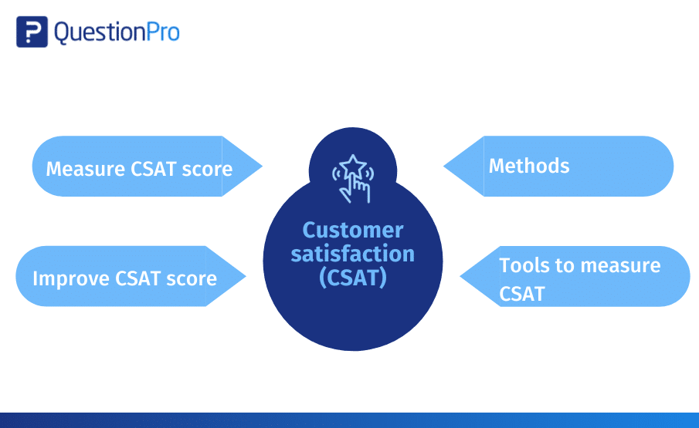

3.4 Optimizing coverage of territory and customer
To optimize the coverage of territory and customers, businesses can employ several strategies:
Market Segmentation: Divide your target market into distinct segments based on characteristics such as demographics, location, industry, or behavior. This allows you to focus your resources on specific segments that are most likely to generate the highest value and tailor your offerings to their unique needs.

Customer Profiling: Develop detailed profiles of your ideal customers within each segment. Understand their preferences, pain points, buying behaviors, and communication preferences. This knowledge will help you craft targeted marketing messages and determine the most effective channels to reach and engage with them.
Geographic Analysis: Analyze geographical data to identify areas with high customer density, growth potential or untapped markets. Utilize mapping tools and demographic information to determine the optimal locations for targeting your sales and marketing efforts.
Sales Territory Mapping: Divide your sales territories in a way that ensures efficient coverage and balanced workloads for your sales team. Consider factors such as customer density, revenue potential, travel distances, and accessibility. Regularly review and adjust territories to align with changes in customer distribution and market dynamics.
Customer Relationship Management (CRM) Systems: Implement a CRM system to manage customer data, track interactions, and gain insights. Use CRM analytics to identify patterns, trends, and opportunities for cross-selling or upselling. Leverage CRM capabilities to prioritize leads, manage sales pipelines, and improve customer communication and follow-ups.
Multi-Channel Approach: Deploy a multi-channel marketing and sales strategy to reach customers through various touchpoints. This includes online channels (website, social media, email marketing), offline channels (print media, events, direct mail), and emerging channels (mobile apps, chatbots). Tailor your messaging and offerings to each channel to maximize customer engagement and response rates.

Strategic Partnerships: Collaborate with complementary businesses or strategic partners to expand your reach and access new customer segments. Identify partners whose products or services align with yours to leverage cross-promotion and shared customer bases. This can help you tap into new markets and extend your coverage without the need for significant investment.

Sales Force Automation: Implement sales force automation tools to streamline sales processes, improve efficiency, and optimize customer interactions. These tools enable sales representatives to manage leads, track activities, automate follow-ups, and access real-time data. By automating routine tasks, your sales team can focus more on building relationships and closing deals.
Customer Retention Strategies: While acquiring new customers is important, retaining existing ones is equally crucial. Implement customer retention strategies such as loyalty programs, personalized communication, proactive customer support, and regular check-ins. Satisfied and loyal customers not only contribute to ongoing revenue but also serve as advocates for your brand, attracting new customers through referrals.
Continuous Analysis and Optimization: Regularly analyze sales data, customer feedback, and market trends to identify areas for improvement and adjustment. Monitor key performance metrics, such as customer acquisition costs, customer lifetime value, and territory coverage ratios. Use this data-driven approach to optimize your strategies, make informed decisions, and allocate resources effectively.
By employing these strategies, businesses can optimize their coverage of territories and customers, ensuring efficient resource allocation, customer engagement, and revenue growth.

3.5 Confirming and reporting for merchandizing improvement
Confirming and reporting on merchandising improvement involves assessing the effectiveness of merchandising strategies and communicating the findings to relevant stakeholders. Here's a step-by-step approach to confirming and reporting on merchandising improvement:
Establish Key Performance Indicators (KPIs): Determine the KPIs that align with your merchandising objectives. These may include metrics such as sales revenue, conversion rate, average transaction value, product performance, customer feedback, or inventory turnover. Clearly define the metrics and set specific targets for improvement.
Collect Data: Gather relevant data to evaluate the impact of your merchandising efforts. This may include sales data, customer feedback, website analytics, point-of-sale data, inventory reports, or any other relevant information sources. Ensure the data is accurate, complete, and representative of the time period being assessed.
Analyze Performance: Analyze the collected data to assess the effectiveness of your merchandising strategies. Compare the current performance against historical data or benchmarks to identify trends, patterns, and areas of improvement. Use statistical techniques or data visualization tools to uncover insights and derive meaningful conclusions.
Identify Improvement Opportunities: Based on the analysis, identify specific areas where merchandising can be improved. This could involve product assortment, pricing strategies, product placement, visual merchandising, promotional activities, or any other aspect of your merchandising efforts. Consider both quantitative data and qualitative feedback to gain a comprehensive understanding of improvement opportunities.
Develop Actionable Recommendations: Formulate actionable recommendations to address the identified improvement opportunities. Provide clear and specific guidance on what changes or initiatives should be implemented to enhance merchandising effectiveness. Consider the feasibility, cost implications, and potential impact of each recommendation.
Prepare a Comprehensive Report: Compile the findings, analysis, improvement opportunities, and recommendations into a comprehensive report. Structure the report in a clear and logical manner, ensuring it is easy to understand for non-technical stakeholders. Include relevant visuals, charts, or graphs to support the analysis and highlight key points.
Communicate the Report: Present the report to relevant stakeholders such as merchandising managers, executives, or cross-functional teams. Use a combination of written documentation, presentations, or meetings to effectively communicate the findings and recommendations. Emphasize the benefits and potential impact of implementing the suggested improvements.
Implement and Monitor Progress: Collaborate with relevant teams to implement the recommended merchandising improvements. Develop an implementation plan, allocate resources, and set timelines. Regularly monitor and track the progress of the implemented changes against the established KPIs. Continuously assess the impact of the improvements and make adjustments as necessary.
Provide Ongoing Updates: Keep stakeholders informed of the progress and outcomes of the merchandising improvement initiatives. Regularly report on the performance against the KPIs and provide updates on the effectiveness of the implemented changes. Share success stories, lessons learned, and any adjustments made along the way.
Iterate and Improve: Merchandising is an ongoing process, and continuous improvement is key. Encourage feedback, learn from the results, and iterate on your strategies. Regularly revisit the analysis, identify new improvement opportunities, and update your reporting to reflect the evolving merchandising landscape.
By following these steps, you can confirm the effectiveness of your merchandising efforts and provide valuable insights and recommendations for improvement to drive better business outcomes.
Common Key Performance Indicators (KPIs) used to measure the effectiveness of merchandising strategies. The specific KPIs you choose will depend on your business objectives, industry, and the nature of your merchandising efforts. Here are some examples of commonly used KPIs for measuring merchandising effectiveness:
Sales Revenue: This is a fundamental KPI that measures the total amount of revenue generated from merchandise sales. It provides an overall view of the effectiveness of your merchandising strategies in driving sales.
Conversion Rate: Conversion rate measures the percentage of visitors or prospective customers who complete a desired action, such as making a purchase. It helps evaluate the effectiveness of your merchandising efforts in converting visitors into buyers.
Average Transaction Value: This KPI calculates the average value of each transaction or order. It helps assess whether your merchandising strategies are encouraging customers to spend more per transaction.
Gross Margin: Gross margin measures the profitability of your merchandise sales by calculating the difference between the revenue generated and the cost of goods sold. It helps evaluate the efficiency of your pricing and inventory management strategies.
Sell-Through Rate: Sell-through rate measures the percentage of inventory that is sold within a specified period. It indicates how well your merchandising strategies are moving inventory and avoiding excess stock.
Customer Lifetime Value (CLV): CLV measures the total value a customer brings to your business over their entire relationship with your brand. It helps assess the long-term impact of your merchandising efforts in terms of customer loyalty and repeat business.
Return on Investment (ROI): ROI calculates the return on the investment made in your merchandising activities. It helps evaluate the financial impact of your strategies and assess whether the returns justify the resources allocated.
Customer Satisfaction: Customer satisfaction metrics, such as Net Promoter Score (NPS) or Customer Satisfaction Score (CSAT), assess the level of satisfaction and loyalty among your customers. It helps gauge the effectiveness of your merchandising efforts in meeting customer expectations and generating positive experiences.
Foot Traffic or Store Traffic: For brick-and-mortar retailers, foot traffic measures the number of people visiting the physical store. It helps evaluate the effectiveness of visual merchandising, store layout, and promotional activities in attracting customers.
Online Engagement Metrics: For e-commerce businesses, online engagement metrics such as website traffic, bounce rate, time on site, or click-through rate can provide insights into the effectiveness of your online merchandising strategies.
the selection of KPIs should align with your specific goals and objectives. It's essential to define measurable KPIs that reflect the desired outcomes of your merchandising strategies and track them regularly to assess performance and make informed decisions for improvement.

SELF CHECK UNIT THREE CHOOSE THE BEST ANSWER FROM THE GIVEN ALTERNATIVE
1 Which of the following methods can be used to determine current customer satisfaction levels?
a) Customer Surveys
b) Net Promoter Score (NPS)
c) Online Reviews and Ratings
d) All of the above
2 The Net Promoter Score (NPS) categorizes customers into three groups based on their responses. Which are these groups?
a) Promoters, Passives, Detractors
b) Satisfied, Neutral, Dissatisfied
c) Advocates, Supporters, Critics
d) High, Medium, Low
3 Which of the following is NOT a strategy to improve customer satisfaction?
a) Personalize the Customer Experience
b) Streamline Processes
c) Ignore Customer Feedback
d) Provide Excellent Customer Service
4 What does CES stand for in the context of determining customer satisfaction?
a) Customer Effort Score
b) Customer Engagement Strategy
c) Customer Experience Survey
d) Customer Expectation Standard
5 Which strategy involves dividing the target market into distinct segments based on characteristics?
a) Market Segmentation
b) Customer Profiling
c) Geographical Analysis
d) Strategic Partnerships

6 Which tool can businesses use to manage customer data, track interactions, and gain insights?
a) Customer Relationship Management (CRM) System
b) Sales Territory Mapping
c) Sales Force Automation
d) Geographic Analysis
7 Which metric measures the ease of customer interactions with a business?
a) Net Promoter Score (NPS)
b) Customer Satisfaction Score (CSAT)
c) Customer Effort Score (CES)
d) Customer Retention Rate
8 Which strategy focuses on tapping into new markets and extending coverage through collaboration?
a) Strategic Partnerships
b) Continuous Improvement
c) Multi-Channel Approach
d) Customer Retention Strategies
9 What is the purpose of continuously analyzing sales data, customer feedback, and market trends?
a) To optimize customer satisfaction
b) To allocate resources effectively
c) To identify areas for improvement
d) All of the above
10 Which metric can be used to track improvements in customer satisfaction over time?
a) Customer Acquisition Cost (CAC)
b) Customer Lifetime Value (CLV)
c) Net Promoter Score (NPS)
d) Market Segmentation

Reference
- Chandraseker, K. (2010). Marketing Management: Text & Cases. New Delhi, USA: Tata McGraw Hill Education Private Limted.
- Dickson, Peter R. and James L. Ginter (1987), “Market Segmentation, Product Differentiation, and Marketing Strategy.
- Kotler, P. (2006). Principle of marketing. 11th edition. Hall of India PLC.
- Kotler, P. and G. Armstrong (2006). Principle of Marketing. New Delhi: MC Graw hill publishing company)
- Andris A. Zoltners, Prabhakant Sinha, "Sales Force Territory Design: A Review and Research Agenda" by
- Sally E. Lorimer: This research paper delves into the strategies and challenges associated with sales force territory design.,
- Optimizingterrithttps://pubsonline.informs.org/doi/pdf/10.1287/mnsc.38.9.1257)
- "Sales Management. Analysis and Decision Making" by Thomas N. Ingram, Raymond W. LaForge, and Ramon A. Avila:
- “John J. Burnett: This book provides a comprehensive overview of sales territory planning and optimization.

Prepared By
Adisalem Minwuyelet MBA 0920522464
Bikila Zelalem MBA 0941338597
Taddese Tesfaye MBA 0922934005

