Secretarial and Office Administration

Level – II
Based on March 2022, Curriculum Version I,

Module Title: Use Office equipment & Resources

Module Code: LSA SOA2 M02 0322
Nominal duration: 39 hours

Prepared By: Ministry of Labor and Skills

December, 2022
Adama, Ethiopia

Acknowledgement
Ministry of Labor and Skills and _____________ wish to extend thanks and appreciation to the many Representatives of TVET instructors and respective industry experts who donated their time and expertise to the development of this Teaching, Training and Learning Materials (TTLM).

Table of Contents
Acknowledgement 2
Table of Contents Error! Bookmark not defined.
Introduction to Module 4
Unit One: Select Office Equipment and Resources 6
1.1 identify & access business equipment and resources 6
1.2 Estimate quantities of resources 10
1.3 Check equipment for serviceability 11
Unit Two: Operate Office Equipment 15
2.1 Operate Equipment 15
2.2 Identify Equipment Faults 22
2.3 Take Action on Equipment Maintenance 23
Unit Three: Maintain equipment or resources 24
3.1 Maintain Equipment and/or Resources 24
3.2 Maintain Equipment Maintenance Records 25
3.3 Store Equipment and Resources 29
Unit Four: Monitor and report on resource usage 30
4.1 Identify and implement resource planning 30
4.2 Measure effectiveness of Resource Planning 32
4.3 Develop and implement methods of monitoring resource 32
4.4 Report usage and difficulties encountered 33

Introduction to Module
A business resource is anything of value to you as you successfully operate your company. For example, an employee is an extremely valuable business resource, as is a computer, software program or a book that contains information that helps you generate income. Business resources also include financial assets, including checking accounts and credit cards. Do what you can to make optimum use of your business resources.
Learn everything you can about a business resource so that you can utilize that resource fully. Gaining a full understanding of the product, service or person at your disposal helps you gain more value from your investment. For instance, if you purchase business equipment and don't read the manual to learn that a few features can cut your production time in half, you're wasting time and money.
Treat your human business resources, your employees, with respect, admiration and recognition. When an employer shows respect, compassion and gratefulness for the work of the employees, it helps increase worker morale and productivity. Host an occasional party to remind employees that you value them.
Handle your tangible business resources with care to ensure that you have them for as long as possible and get maximum use out of each item before having to get a replacement. Take care of your computers and perform regular maintenance activities to keep them running at top capacity. Do the same with business vehicles and heavy equipment.

Module units
- Selection Resources
- Office Equipment operations
- Maintain equipment
- Report equipment faults

Learning objectives of the Module
At the end of this session, the students will able to:
- Select Resources
- Operate equipment
- Maintain Equipment
- Report equipment faults

Module Learning Instructions:
- Read the specific objectives of this Learning Guide.
- Follow the instructions described below.
- Read the information written in the information Sheets
- Accomplish the Self-checks
- Perform Operation Sheets
- Do the “LAP test”

Unit One: Select Office Equipment and Resources
This learning unit is developed to provide the trainees the necessary information regarding the following content coverage and topics:
  - Business resources
  - Estimate quantities
  - Check equipment

This unit will also assist you to attain the learning outcomes stated in the cover page. Specifically, upon completion of this learning guide, you will be able to:
  - Identify and access business resources
  - Estimate quantities
  - Check equipment

Introduction
Equipment and resources are materials that can be used in any business organization in order to carry out the day to day activities. Knowledge is required to choose the right equipment and resources appropriate and required for the right task. They are variety of types ranging from smallest tools to the largest ones. These equipment and resources can be learned and practiced to operate at a work place. Some of them are demonstrated below.

1.1 identify & access business equipment and resources
All modern organizations use a wide variety of business equipment. During a typical business day at the office, you may be asked to use telephones, printers, computers, binders, shredders and photocopiers. Each of these pieces of equipment is designed to enable you to complete your work quickly and professionally. As you begin a new job, it is important that you are able to use the various pieces of equipment that are in use within your organization. This knowledge will enable you to ascertain which pieces of equipment will be of most help in completing your jobs.
We will be looking at the types of equipment that you will possibly be asked to use. what they are used for, how to use them, and how to be safe when using them. This information is crucial to your efficiency in the workplace.
A vital part of your job will be to be able to determine the right machine to use in a given circumstance. All machines have different functions, which enable them to be used for different tasks. Being able to select the right equipment for the right task is of vital importance. Over the page we will discuss the various functions of different types of machinery. Be sure to practice using various types as much as possible. After you have practiced using the equipment, you will get to know the various tasks each type of machine can do. This will make it easy for you to decide what equipment to choose and how to use it for the job.
Learning to use the right equipment for the task is crucial. For example making 100 copies of a document using a photocopier is much quicker the printing out 100 copies. This improves your efficiency.
Types of business resource:
Business resources as mentioned above include many varieties that can be used in the office. These may refer to tangible and non-tangible resources. Tangible resources are materials which can be physical seen or touched whereas non-tangible resources are resources that cannot be seen or touched. For our purpose we will focus on tangible ones especially on equipment. Some of the equipment used in the office may include:
Types of Equipment to be used in the Office
While each organisation has a core set of equipment that it requires to get the job one, the type of equipment in your organisation is likely to depend greatly on the type of work that it undertakes. The typical office will have a wide range of equipment, but an organisation specialising in designing advertising is likely to have more computers and printing equipment. A copy shop will have many photocopiers available; an outbound call centre will require specialised computer and telephone equipment to operate efficiently.
However, the typical office has a core set of equipment that is used on a day-to-day basis. This equipment generally includes:
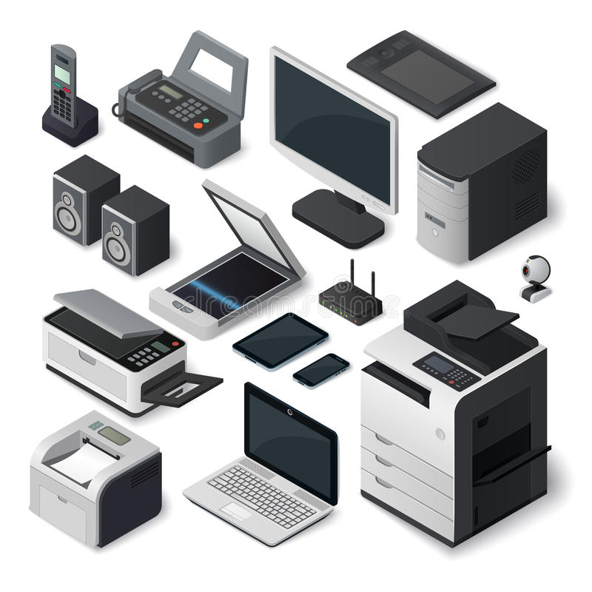
Figure 1: Office equipment
- Photocopiers – These are machines which will copy documents, maps, drawings or plans onto paper.
- Fax machine – These machines are used for sending and receiving hand written, typed or graphic messages over telephone lines.
- Printers – There are various types of printer available on the market. Their main purpose is to produce hard copies (that is copies on paper) of information stored in a computer. This may include words or pictures.
- Telephones - This type of business equipment is used for internal, external or international voice communication. Mobile telephones are increasingly common within organisations. They may or may not be connected to exchange systems which essentially link all the telephones in an organisation together.
- Answering machines – This equipment is designed to answer the telephones when the subscriber is unavailable. The caller generally will hear a recorded message requesting that a message be left. Most machines are able to be accessed from a remote telephone in order to receive the message.
- Shredders – This machinery is used for the destruction of records in paper format and are of particular value in organisations where confidential information is collected, Some of the more expensive models are also able to shred magnetic tape (such as microfiche and castes) as well as carbon ribbons.
- Binding equipment – These types of machines are used to produce bound volumes of documents.
Brief descriptions of the most common office equipment:
    - Calculators – Perform basic or advanced calculations.
    - Collators – Often linked to photocopiers, these machines assemble multi-page documents ready for binding.
    - Dictating machines – These systems use magnetic media (such as cassettes to collect a verbal record of what has been said for later playback.
    - Electronic whiteboards – The used can place written or drawn information on the white background, and if required copies of this information can be made.
    - Folding machines – These machines are pre-set to fold documents in various ways to suit the size of envelopes into which the document is to be placed.
    - Franking machines – These are machines used to imprint the postage amount directly onto envelopes or labels.
    - Guillotines – These are manual or mechanical machines for cutting paper to a particular size or for trimming rough edges before binding.
    - Laminators – These are document presentation aids and provide a plastic covering to booklets, reports or catalogues.
- Overhead projector – This type of equipment is used in conjunction with overhead transparencies to throw an enlarged reflection of material on to a white screen.
    - Punches – This is a manual device used for making holes in paper which are to be filed or bound.

1.2 Estimate quantities of resources
Knowing what is needed
When you are given a task to perform, it is important that you attempt to establish the resources that you will require to undertake the job. This will enable you to ensure that you can gather the right resources and that these resources are on hand and available at the time when you will need them.
Estimating required resources involves looking carefully at your job and trying to determine exactly what resources are required to undertake that job. The resources that you may need for a job include:

- Paper;
- Ink;
- Toner;
- Binders;
- Staples; and
- Card stock.

Other specialised resources may be required depending on the type of task that you have been asked to complete.
Think carefully about all the resources you will require. Often there are some that you simply may forget about, or which may seem insignificant, until you run out!
Let’s look at an example of how you can go about estimating the required resources for a given task. Let’s assume that you have been asked to print 50 copies of a catalogue, along with accompanying cover letter and then mail these. You have been supplied the data files, so all you will need to do is print and mail them. The catalogues consist of 8 A5 sized pages, which are printed on A4 paper which is then folded in half.
The first thing we need to do is to establish the required resources. In this case we will require paper, envelopes, a printer or photocopier to copy the catalogue, a printer to print the labels, stamps and staples.
The major quantity that we will need to establish is for the paper. The catalogue consists of 8 A5 sized pages; each page will be double sided. Because we will be folding this in half, and because each page is half the size of A4 paper, the 8 pages will be printed onto 2 single A4 sheets of paper. This results in 100 sheets for the catalogue. There are also 50 cover letters to be printed. As these are single sided and single pages this will only require 50 extra sheets. We need 50 copies of each document, so all up 150 sheets of paper will be required.
In terms of binding, we are using staples, and we will place two staples in each catalogue along the middle of the left spine of each page, so 50 catalogues will require 100 staples. We will also need 50 envelopes, and 50 labels to complete the task. So our schedule of resources is:

- 150 sheets of paper,
- 100 staples,
- 50 envelopes,
- 50 labels.

1.3 Check equipment for serviceability
The Instruction Booklet
All the equipment in your workplace will come with its own Instruction Manual. This booklet should have step-by-step instructions on how to use it. These instructions should also allow you to check whether or not a piece of machinery is working correctly.
This is known as serviceability.
An instruction booklet will show how to use the equipment, such as where to put the paper and how to select the different print or copy options. These diagrams can be difficult to follow, so watch carefully when your supervisor demonstrates how to use the equipment. When you are being trained, ask questions if you don’t understand anything. It’s a good idea to have a notebook and write in it the steps you have to take, or any suggestions the trainer gives you.
Draw a diagram to help you remember. Keep your notebook handy so you can easily refer to it. Many organisations display a ‘How to Use’ sign near the equipment. This tells you the steps you take to operate it and what to do if it breaks down. Often there are pictures that show how to use the equipment. Practise using the equipment. You will get better as you gain more experience.
An important aspect of serviceability is keeping a machine clean. Every piece of machinery will have its own cleaning instructions that are specific to the equipment, however there are some general rules that you should follow.
Remember that it is everyone’s responsibility to keep the office equipment clean. You might wipe a soft brush or cloth over the equipment when you have finished using it.
Use recommended cleaning materials only – these are usually found in the Instruction Manual. Cleaning instructions are generally found near the front of the manual. Make sure you know where they are kept – often with equipment that is portable, a special place is reserved for storage. You may find this is used to keep the equipment clean, free of dust or in a place where it will not be damaged. A very important rule is never to eat or drink near equipment – this can damage and dirty it.
Testing
Serviceability also means that you should be sure that the equipment is working the way it should be. Some equipment (such as printers, photocopiers and fax machines) has a self-test option where a test page can be printed out. If you are unsure whether a piece of machinery is working correctly, print a test page.
Self-testing options for printer, for example, are often found within your printers control panel.
The manner in which the printing of a test page is accomplished will vary from equipment to equipment, however in the main your instruction book or online help (for printers) will tell you how to perform this task.
Another important aspect of serviceability is ensuring that the equipment has enough resources available to complete your task. Take another look at the picture above. Just above the help button are the ink monitors. They are currently empty, thus the printer will need its ink cartridges replaced before a job can be done. Some photocopiers also have monitors showing how much toner is contained in the photocopier (or laser printer).
If no monitor is available, making a test page, or printing out a document should tell you whether there is toner or ink available, if the page is not bright and clear, replacement may be required.

Self-check questions
Part One: Matching - Select the most appropriate equipment to use for a given task
 | Task | Suitable equipment
 | Making a hard copy of a page from this manual. | Dictating machine
 | Trimming the edges of paper. | Facsimile
 | Sending a hand drawn sketch to an international contact immediately. | Guillotines
 | Making a paper copy of a plan drawn using CAD software. | Answering machine
 | Recording a verbal note for oneself. | Photocopier
 |  | printer
Part Two: Identify the resource requirement
You have been asked to produce 5 employee induction kits for new employees.
These are printed out using supplied data files and consist of:
    - 1 Welcome letter (single A4 sheet)
    - 1 Employee Manual (40 A4 pages, double sided, printed on A3 paper & folded – spiral bound)
    - 1 Employment Agreement (5 single sided A4 pages – stapled in the corner)
What resources are required to complete this task?
Part Three: True or False Questions - Say ‘True’ or ‘False’
T F - Offices generally use a wide range of equipment.
T F - Printing a large print job on a photocopier is less efficient than using a printer.
T F - Fax machines send only text over telephone lines.
T F - A binder and a stapler serve the same basic purpose.
T F - Printers and copiers serve the same purpose.
T F - Shredders are useful in businesses when confidentiality is required.
T F - Determining the resources you require to complete a task, allows you to be sure that you have the resources on hand.
T F - A 4 page, A5, double sided booklet printed on A4 paper will only require a single sheet of paper.
T F - An instruction booklet will show how to use the equipment, such as where to put the paper and how to select the different print or copy options.
T F - Printing a test page will not assist you in determining the serviceability of a piece of equipment.

Part Four: Choice: choose the best answer.
1. Which of the following is/are Business resources?
a. human power b. raw materials c. production process d. a and b
2. Which of the following is office equipment?
a. Dictating machines b. calculator c. a and b d. supplies
3. Why we estimate quantities of resources?
a. to gather appropriate resources b. To verify the what resources
c. To determine what resources are not required d. a and b
4. The fist step in using equipment and resource is:
a. reporting b. selection c. maintenance d. operate
5. _ is ensuring the equipment is working the way it should be:
a. Testing b. checking c. operating d. except a all are correct

Unit Two: Operate Office Equipment
This learning unit is developed to provide the trainees the necessary information regarding the following content coverage and topics:
- Operate equipment
- Identify equipment faults
- Take action on equipment maintenance
This unit will also assist you to attain the learning outcomes stated in the cover page. Specifically, upon completion of this learning guide, you will be able to:
  - Operate equipment
  - Identify equipment faults
  - Take action to ensure equipment is repaired

2.1 Operate Equipment
When you are given a task to perform, it is important that you attempt to establish the resources that you will require to undertake the job. All the equipment in your workplace will come with its own Instruction Manual. This booklet should have step-by-step instructions on how to use it. These instructions should also allow you to check whether or not a piece of machinery is working correctly. Operate equipment in accordance with manufacturer's specifications and under direct instructions.
Manufacturer’s Specifications means:
(a) the written specifications, instructions or recommendations provided by the manufacturer of equipment or supplies that describe how the equipment or supplies are to be constructed, erected, installed, assembled, examined, inspected, started, operated, used, handled, stored, stopped, calibrated, adjusted, maintained, repaired or dismantled; and
(b) an instruction, maintenance and operating manual, including any diagrams, for the equipment or supplies
Standard operating procedure (SOP) is an easy to understand, step-by-step document for office work flows and routine operations. It consists of systematizing all of your company process and putting them in one file. SOPs provide employees with a clear set of guidelines they can follow to do their best at their job.
To operate any telephone system effectively in the workplace, you should learn how to:
- Answer the telephone
- Put incoming calls on hold
- Recall incoming calls from the hold position to retrieve the caller or transfer the call
- Transfer calls to another phone extension
- Pick up calls in a group from any extension
- Make outgoing calls
Some telephone systems enable you to use a loud speaker or headset and microphone so you can make calls without the need to hold the handset. This is extremely useful for operators that need to use their hands to enter data into the computer whilst they are on the telephone.

Answering Machines and Voicemail

Answering machines are small devices that can be separate to the telephone system or built into the telephone system. The answering machine is connected to the main telephone handset or the night switch. The answering machine is used for two main reasons:
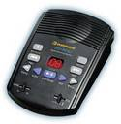
- To advise callers that the telephone is unattended and to leave a message
- To enable callers to leave a message when the telephone is unattended.

The owner of the answering machine can record an outgoing message that advises callers that the phone is currently unattended. This practice is used today by many businesses and homes. Callers to unattended telephones have accepted the practice of listening to a recorded message and then leaving a message for the receiver to return their call.
Answering machines enable clients to call your business after hours and leave a message that can be attended to the next business day. Messages may also be left by staff if they are running late for work or if a manager needs a task to be performed before they arrive to work.
Voicemail is similar to an answering machine except that callers are able to leave a recorded message on individual staff member’s telephones or direct lines. Each member of staff is able to record an outgoing message on their own handset for their callers to hear. This is a useful device to use in a large organisation as the receptionist is free to attend to other incoming calls and personal callers and telephone callers can call or be put through to the direct line for the receiver and leave a message.
Computer with its accessories
A computer is an electronic device that manipulates information, or data. It has the ability to store, retrieve, and process data. You may already know that you can use a computer to type documents, send email, play games, and browse the Web. The other details are to be given in the other competencies.
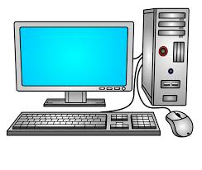

Printers
Printers are used to reproduce documents created, retrieved or received via a computer. A printer can be used to print a word-processed document, a worksheet in a spread sheet program, database report, presentation slide, email, or information from the Internet. Where a computer has facsimile software installed, the computer can be used as a fax machine and the printer can print a copy of all fax messages sent and received. Printers can be:

Impact printers, such as dot matrix, where letters or characters are produced through a series of dots printed onto the paper. Impact printers tend to be noisy but are inexpensive to operate and maintain.

Non-impact printers, such as a laser printer, where powder is discharged from a cartridge inside the printer to make up the characters or letters to be printed; an ink-jet printer (or bubble jet), where ink is discharged onto the paper to create the letters or characters. Non-impact printers are more expensive to maintain and operate than an impact printer and they provide a good result.
Printers can print black images or full colour images. Printing in colour can be expensive so you should be very careful when printing in colour to ensure you are not wasting the ink or toner.

Photocopier
Photocopiers are used to make copies of:
- Documents that may need to be read by more than one person
- Pages from books or journals
- Articles from newspapers
- Fax messages received on thermal paper.

Photocopiers can be basic – providing an option to produce a copy of the document in its original form. Photocopiers can also offer a range of other options. You can use a photocopier to:
- Enlarge an image
- Reduce an image
- Sort a document of many pages into sets or separate duplicates of each page
- Staple documents
- Produce a document printed on both sides of the page
- Produce a document in colour.
To operate any telephone system effectively in the workplace, you should learn how to:
- Answer the telephone
- Put incoming calls on hold
- Recall incoming calls from the hold position to retrieve the caller or transfer the call
- Transfer calls to another phone extension
- Pick up calls in a group from any extension
- Make outgoing calls
Some telephone systems enable you to use a loud speaker or headset and microphone so you can make calls without the need to hold the handset. This is extremely useful for operators that need to use their hands to enter data into the computer whilst they are on the telephone.
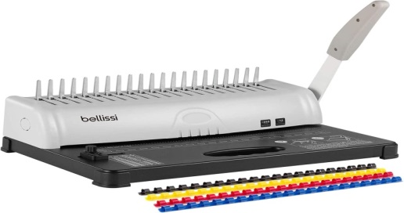
Binding Machine
There are lots of different ways you can join paper to make a book. A quick and easy method is to use staples, paper clips or fold-away clips.
However, you may be asked to present the material in a file or put covers on it to make it more secure and give the document a more professional look. When material is bound, it becomes stronger, which is important if a lot of people are handling the material. You can bind pages with special binding machines.
Organisations will have a range of binding equipment depending on the number of documents that need to be presented in this way.
Using a Fax Machine
All fax machines and fax transmissions revolve around the same basic concept – they scan a document, transfer the image of that document over to a signal, then send that signal to another fax machine that decodes the signal and prints the document back out. It can perform the following duties:
- Communication - Fax machines make sending and receiving documents a quick alternative to sending and receiving them via postal mail or other delivery services
- Copying.- A fax machine can also function as a photocopier and
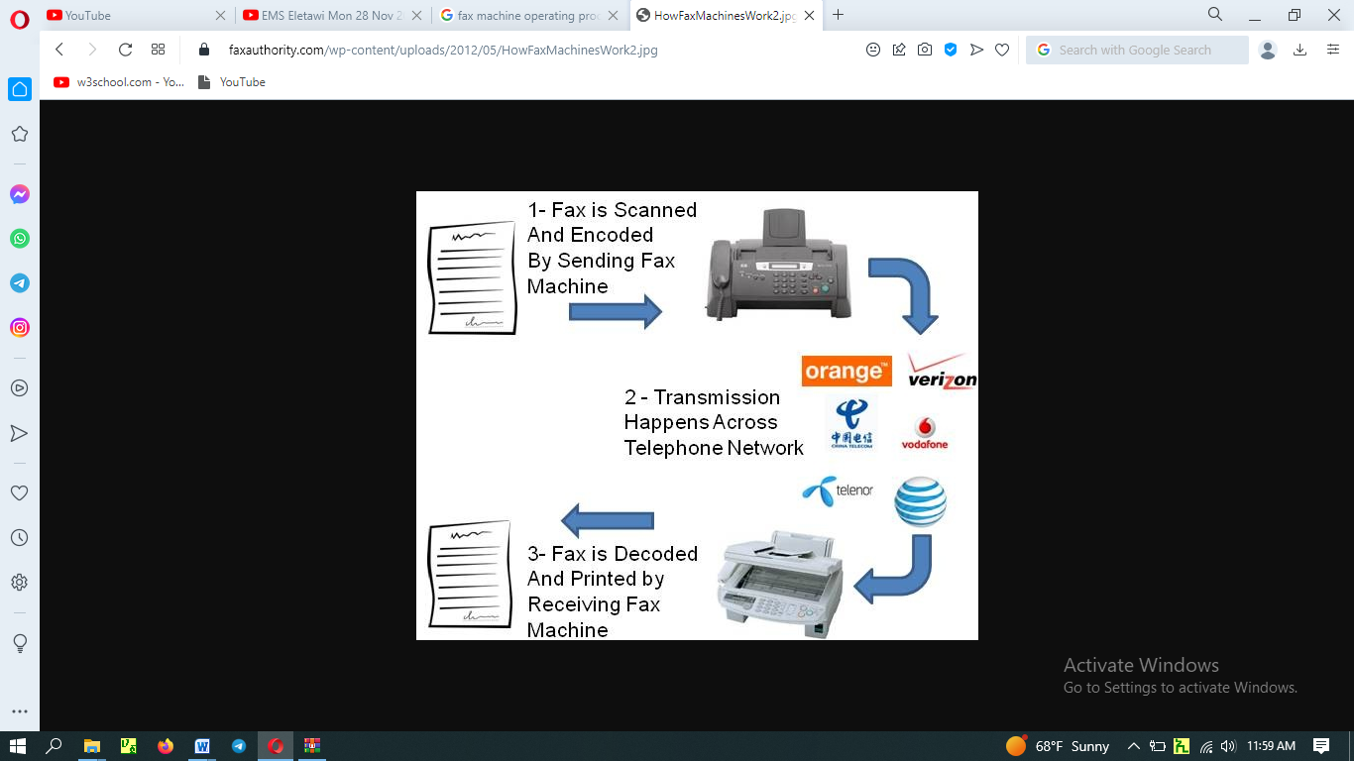
- Printing – it also serves as a printer.

- The sender feeds the original document into the fax machine at their end.
- The sender keys in the fax number for the receiver (this may be the same as the receiver’s telephone number; however, you need to check with the receiver).
- The sender presses ‘Start’ on the fax machine and the paper is automatically fed through the fax machine as its image is scanned.
- The original page remains at the sender’s end.
- The receiver’s fax machine starts to print an exact image of the original document.
- A report can be printed by the sender to confirm the document has been received by the receiver and the receiver can print a report to confirm the message.
Paper Scanner
A document scanner is a machine that can copy a physical item and transfer an image of it to a computer. In most cases, a document scanner is designed specifically to copy images or text on paper.
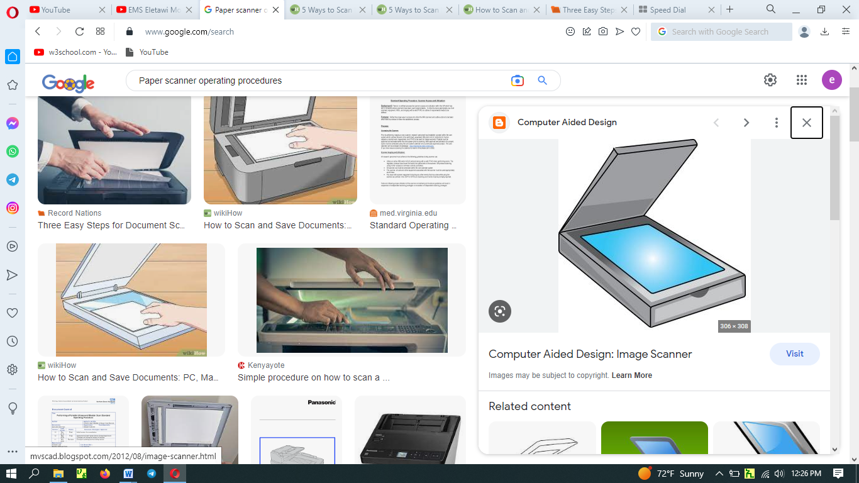
How to scan a document into a computer
There are many reasons people need to scan documents or photos into their computer. A couple common reasons include sending paperwork to someone across the country immediately, and the use of mail or other shipping methods are not fast enough. A person might be going paperless, but still want to keep important documents handy. They also may have printed photos that they want to transfer digitally to their phone or other devices.
While the methods vary slightly for different models of scanners, the following steps walk you through how to scan a document or photo into your computer.
Shredder
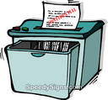
There are often many confidential documents printed in an office. When the organisation wants to get rid of these, they use a shredder, rather than placing them in the rubbish bin or the recycled paper bin. The shredder cuts these documents into very thin strips that are hard to read.

Follow safety procedures when operating a shredder. Be very careful. Keep your hair and clothes away from the shredder as they may get caught. Don’t put your hands anywhere near the slot where you place the paper.

To shred paper, take a few pages at a time and feed them slowly into the machine. Generally, only five pages are the most you should put in at a time. The machine will cut them into narrow strips.

When the bin is full of shredded paper, turn the shredder off and lift its top off. Do this very carefully because the top is very heavy. Empty the bin.

Guillotine
A paper cutter, also known as a paper guillotine or simply a guillotine, is a tool often found in offices and classrooms, designed to administer straight cuts to single sheets or large stacks of paper at once. It is easy to use.
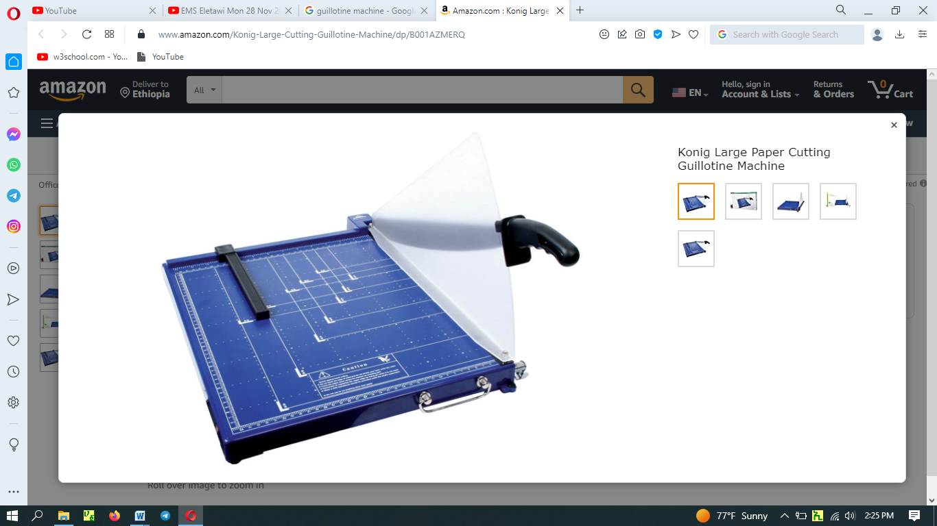

2.2 Identify Equipment Faults
Troubleshooting minor equipment faults
Fault | Possible Solution
Photocopier:
Spots or marks on the copy | Check the glass to see that it is clean. If not, clean with a special cleaner and use a soft cloth.
Jammed paper | Look at the display screen to locate the jammed paper.  Open that section and remove the paper.
Paper tearing | Remove the paper and if necessary, reset the paper feed guides on the tray.
Toner low | Fill up the toner with correct powder or replace the toner cartridge.
Facsimile machine:
Incorrect number for the receiver | Check you have the correct fax number and try again. You may need to telephone the organization to check the number.
Document not transmitting | Try again. If it is still not transmitting, call the receiver and ask them to check their machine for paper out, paper jam etc.
Blank paper received | Paper could have been inserted the wrong side up at the sender’s end or If your fax machine uses thermal paper, the roll may be feeding in the wrong way up (it only prints on one side).
Telephone:
Voicemail message has disappeared | System my have been shut down and you therefore need to record your message again.
Printer:
Paper jammed | Check the display for the error message and search for the paper. Remove all parts of the paper as any stray pieces could block the pathway for paper feeding through.
Error message | This could be due to low toner or someone has set their paper source tray for Manual Feed and not automatic. Press continue button if available.
Toner is dropping on the page during printing | Replace the toner cartridge as it is getting low or it is a recycled toner cartridge with a poor seal.
Printer not printing | Check the online button as it should be on.
Stapler:
Jammed staples | Remove staples from the stapler – a staple remover is good for that – reload the staples and try again.
Staples not inserted correctly or completely into the paper | Remove staples from page using a staple remover – reload stapler with staples – place document on the table and try again.

2.3 Take Action on Equipment Maintenance
Equipment maintenance is defined as any preventive or corrective process, cleaning, or update applied to a business’s assets to keep them running smoothly. It may be applied to any essential machinery that a business relies upon for standard operation.
When you encountered problems take proper action to solve the problem. This would be an effective equipment maintenance program. These maintenance program may include:
- Create an inventory of equipment
- Select which maintenance strategy will be applied to which piece of equipment
- Create the equipment maintenance schedule
- Define maintenance checklists and procedures
- Train your maintenance team
- Analyze and improve

Unit Three: Maintain equipment or resources
This learning unit is developed to provide the trainees the necessary information regarding the following content coverage and topics:
- Maintain Equipment and Resources
- Maintain Maintenance Records
- Store Equipment and Resources
This unit will also assist you to attain the learning outcomes stated in the cover page. Specifically, upon completion of this learning guide, you will be able to:
  - Maintain equipment and resources
  - Maintain maintenance records
  - Store equipment and resources

Introduction
When working with office equipment, you may experience minor problems. The problems that occur may be due to lack of a routine maintenance procedure for the equipment, such as cleaning the equipment, overuse of the equipment, faulty feeding of paper into a copier or printer, mishandling or improper use of the equipment.

Not all equipment faults require you to call in the service technician – most faults can be rectified by referring to the manufacturer’s operating manual or asking other more experienced staff to assist you.

Identifying Minor Equipment Faults
Minor equipment faults are the faults that can be rectified by general office staff through reference to the operation’s manual. When you have been using equipment for some time, you will learn to quickly identify the fault and take the most appropriate action immediately.

3.1 Maintain Equipment and/or Resources
The most important thing in any workplace is safety. With that in mind, all equipment should be safe to use at any time. If not properly maintained, your equipment could break, wires could split and parts could fall off and go missing. This could ultimately mean that your equipment is too dangerous to use.
Equipment maintenance is a process that involves several steps, including inspection, testing, measurement, replacement, and adjustment. Treating the process seriously is one way to reduce the risk of workplace accidents or injury. There are two types of maintenance – routine and reactive.
Objectives of Equipment Maintenance
- Cut maintenance costs.
- Protect equipment and lengthen lifespans
- Reduce unplanned downtime
- Increase safety
By having your equipment regularly maintained it will ensure that things keep running smoothly. When routine maintenance needs go unnoticed or unattended, larger issues with equipment can result. If equipment starts to wear over time, without being maintained the quality of the product being produced may be affected.
Timely maintenance of the equipment ensures improved performance, productivity, and safety. And the hassle-free production would result in a better quality product. It is likely to reduce the repair requirements as well.

3.2 Maintain Equipment Maintenance Records
Maintenance record, as name suggests, is a document that includes information regarding each repair and maintenance work that is done on asset or equipment. In simple words, it keeps tracks of assets failures and repairs. It is one of best way to maintain health and safety management.
Maintenance record, as name suggests, is a document that includes information regarding each repair and maintenance work that is done on asset or equipment. In simple words, it keeps tracks of assets failures and repairs. It is one of best way to maintain health and safety management. It also improves asset management as such record includes information such as :
- Time and date when maintenance is required to be done.
- Type of maintenance required to be done.
- Asset details such as number, parts required, working condition, etc.
- Risk associated with it.
- Environment condition and its affect.
Advantages of keeping Maintenance Record:
There are several benefits of keeping maintenance record. Some of them are given below :
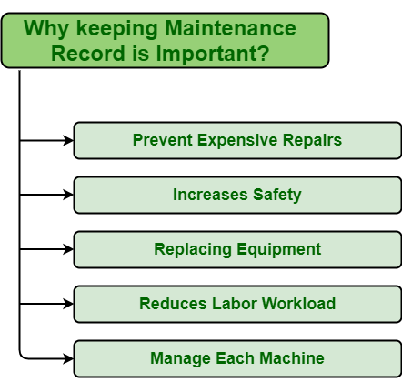
- Prevent Expensive Repairs - sset Maintenance is something that leads to increase in overall cost of organizations. Some assets maintenance is less costly and some of them are very high. Repair cost is simply amount required to bring back asset back to its normal working condition. Maintenance record keeps information regarding reach maintenance and repair done on equipment. With help of maintenance record, one can easily determine when and which maintenance strategy is required to be performed on particular asset. These helps to prevent assets from failure and reduces cost required to repair.
- Increases Safety - Maintenance record also includes information regarding effect of each assets failure on system, employees, and environment. It also includes information regarding how workers or operators are performing their tasks. With help of maintenance record, one can easily determine how severe asset is, when its going to fail, how it can be prevented from failure so that one can take measure steps to prevent it from occurrence. This is turn reduces risk regarding safety and environmental health. It also helps one to ensure that which equipment’s are safe to work with. Even operators or workers also perform their task in well manner.
- Replacing Equipment - Maintenance record includes information regarding asset failure about number of times particular asset is getting failed, asset condition. One can easily determine about working condition of asset, when asset is required to repair, cost associated with each repair of particular asset. One of main advantage is that, one can easily determine when asset is required to be replaced. If repair cost of asset is more than cost required to replace with new one, then its much better to replace asset with new one as it can reduce cost, reduces failure occurrences, includes warranty, minimizes effort required to repair, etc.
- Reduce Labor Workload - As we know that with help of maintenance record, one can prevent failure from occurrence. It helps to reduces unnecessary maintenance work required, schedule maintenance work that is required, help management to ensure employees, workers or labors that are performing well, labors that are required to perform tasks. This simply reduces efforts required to repair assets. In turn, it reduces number of labors required to perform task and as well as reduce labor workload.
- Manage Each Machine - Maintenance record keeps each information about assets. It includes working details, maintenance details, repair details, working environment, its processing, risk associated with it, etc. With help of all this information, one can perform maintenance task whenever required so that assets condition is maintained well, prevent it from failures, and increases its life span.
Benefits of using equipment maintenance logs
Companies use equipment maintenance logs to monitor the conditions of their equipment. Their business operations depend on the functionality of their assets, so it is important to have high-quality equipment maintenance logs. The benefits of keeping good logs include creating more cost-effective decisions, increasing the resale value of equipment, and developing specialized equipment maintenance programs.

Creates more cost-effective decisions - Having clear records of completed tasks can enable maintenance planners to more easily plan out future activities and more efficiently delegate resources. More cost-effective decisions can be made given a clear picture of the status of equipment maintenance activities.

Increase equipment resale value - Keeping maintenance logs updated is proof that assets are being taken care of. In the event that facilities need to be upgraded and existing assets need to be sold, detailed maintenance logs can help increase the resale value of the equipment.

Develop specialized equipment maintenance programs - Equipment maintenance logs provide rich historical data that can be analyzed to provide insights on an asset’s performance compared to similar devices. Different equipment makes or models, for example, can be compared by analyzing differences in maintenance costs incurred, frequencies of unplanned maintenance activities, etc.
With available technologies, the benefits of having a well-documented equipment maintenance log are more easily achieved than ever.
Equipment maintenance log template - An equipment maintenance log may vary for each company. The general idea is that each piece of equipment has its own maintenance log and each maintenance log has spaces to be filled in with details each time a maintenance activity is performed.
A sample template, if printed out on paper, might resemble the following
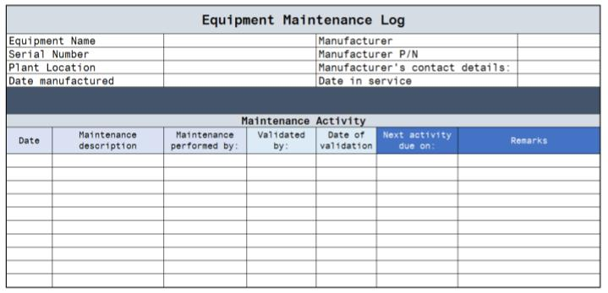
Notice that the header provides information about the equipment: equipment name, serial number, plant location, manufacturer, manufacturer part number, manufacturer contact details, date manufactured, and date in service.
Each log will be kept separate even for similar types of equipment. For example, two same-sized centrifugal pumps from the same manufacturer will differ in the serial number and/or plant location. Keeping separate logs for each pump ensures that there is no confusion about which maintenance log refers to which piece of equipment.
The second part allows entries of maintenance activities. Details about the maintenance activity are listed: the date when it was performed, and a description of the activity and the person who performed the activity. The person is responsible for validating that the maintenance procedures were performed correctly is also included. The next scheduled date for any required action and other remarks can also be added for reference.

3.3 Store Equipment and Resources
Safe storage of materials and equipment is essential for many businesses, such as construction job sites, laboratories, and other locations that handle chemicals, flammable gases and other hazardous materials. Storage methods and procedures are regulated for many such items; when in doubt it is always best to be cautious to prevent accidents. Locking storage cabinets and restricting access to storage areas will prevent unauthorized handling of stored items and minimize the possibility of theft.
general plan - Create a plan for storing all equipment and materials at your site. Assign a specific location to each item or type of item and label the space accordingly. Make certain that work areas and walkways are kept clear of all stored items. Use tape or paint to identify such areas on the floor of a large area, such as a manufacturing facility. In an office, laboratory or similar smaller setting, use cabinets with doors that close securely. Always leave at least 1.5 feet between the top of stored items and fire sprinklers, if present. Make sure that all stacks are solid and secure them whenever possible.
A clean and organized storage not only ensures optimal utilization of space and easy stock access, but also creates a safe place for employees working in the storage. Cleaning a storage place can be a monumental task as there are several areas to handle. Setting up a professional housekeeping checklist helps keep things in order.

Unit Four: Monitor and report on resource usage
This learning unit is developed to provide the trainees the necessary information regarding the following content coverage and topics:
  - Identify and implement resource planning
  - Measure effectiveness of resource planning
  - Develop and implement methods of monitoring resource
  - Report usage and difficulties encountered
This unit will also assist you to attain the learning outcomes stated in the cover page. Specifically, upon completion of this learning guide, you will be able to:
  - Identify and implement resource planning
  - Measure effectiveness of resource planning
  - Develop and implement methods of monitoring resource
  - Report usage and difficulties encountered in resource

4.1 Identify and implement resource planning
Resource planning refers to the strategy for planned and judicious utilization of resources. Resource planning is essential for the sustainable existence of all forms of life. This shows that resource planning is needed at the national, regional, state, local and organization levels for the balanced development of a country.
Identifying resources is the process of evaluating which funding streams and resources are accessible to support the goals and objectives of the organization, system, project, or initiative. A fiscal analysis study can help find and evaluate the usefulness of current and potential resources. A resource plan identifies, organizes, and lists the resources required to complete a task. Because most organizational expenses are resource related, it's essential that they're used as efficiently as possible.

Resource Planning
The process of distributing tasks to team members based on their capacity, skill sets, and best fit for the work is known as resource planning.
In other words, resource planning is about assigning the right people to the right projects at the right time. Sounds simple but - in reality - surprisingly difficult. Even if you think you’re managing it - unless you’re measuring your resource performance - you might not be.
Overall, resource planning may include human labor, technology, equipment...anything that’s involved in getting you through to that finished product or result.
Resource planning is a strategic approach that ensures the most effective use of resources within a single project or portfolio of tasks. Organizations can achieve maximum efficiency when resources are implemented properly and with the better optimization of resources, without over or under utilization of any one resource.
Professional services businesses don’t always recognize the bottom-line benefits that effective resource planning delivers - like improved efficiency, reduced costs, and fewer expensive bottlenecks.
Important to Plan Resources
The importance of effective resource planning cannot be overstated. It’s essential that project managers can strategically shift resource to where it has the most impact for the business. And this can only happen with resource planning processes in place. Otherwise, you are operating in the dark, with no way of knowing when or where to reallocate employees to have the biggest impact.
When it comes to the ‘talent’ part of the equation, business growth is realized in a number of ways. Leveraging resource planning can help your business prosper by:
- Increasing efficiency and reducing ‘idle’ or underutilized resources.
- Optimizing your use of available resources to maximize project outcomes.
- Approaching tasks with an organized, strategic approach (rather than ad hoc).
- Knowing your resource availability for future projects.
- Promoting job satisfaction and staff retention.
- Improving your relationships with clients and other stakeholders.
An effective resource planning process can determine the right mix of resources needed to complete a task based on the task's demands, which are influenced by three factors: its requirements, its constraints, and its opportunities.

4.2 Measure effectiveness of Resource Planning
While there are multiple ways to measure resource utilization, the simplest and most common method is by taking the actual number of hours worked by a resource, and dividing it by the total number of hours that the resource could have worked. So, effective planning is a key ingredient for success. The dreams and goals that each of us has cannot be achieved if not for proper planning.
Resource utilization rates show how much of your team's time is being spent on billable tasks, as well as how productive each team member is. Ultimately, these figures enable team leaders to measure billing efficiency and determine if you are pricing your projects correctly to cover your costs and make a profit.
First we have to understand the two terms that can be used in resource measurement are efficiency and effectiveness: 'Efficiency' is a measure of the work-rate of a process by which system inputs are turned into system outputs. 'Effectiveness' on the other hand is considered to be a measure of the 'quality' of the outcomes being achieved by the system
Efficient utilization of resources refers to getting things done in the right manner, in minimum time with the minimum cost incurred and with no wastage of resources. Effectiveness refers to achieving targets and setting goals in the right direction

4.3 Develop and implement methods of monitoring resource
Monitoring and evaluation (M&E) are classified into different types based on the purpose, focus, timing and audience of the assessment. Knowing each of the tools is essential for selecting and implementing the tools.
Monitoring tools
- Process Monitoring - This is often referred to as ‘activity monitoring.’
- Compliance Monitoring - Just as the name suggests, the purpose of compliance monitoring is to ensure compliance with the expected results of the project.
- Corrective Monitoring - is often called ‘situation monitoring.’
- Beneficiary Monitoring – it tracks stakeholder complaints and feedback mechanism
- Financial Monitoring - measures financial efficiency
- Organizational Monitoring - tracks institutional development, communication, collaboration, sustainability and capacity building within an organization and with its partners and stakeholders in relation to project implementation.
- Results Monitoring - to determine if the project is on the right track towards its intended results.

4.4 Report usage and difficulties encountered
Difficulties will face when we use equipment. These difficulties may cause for the interrupt of the work to be done. If difficulties can be corrected easily by the employees assigned the task properly, the problem is solved and no need for reporting the incident. The problem beyond our capacity and ability should be timely reported to appropriate person in the organization for correction.
Some of the common causes of difficulties encountered during the operation of equipment failure may include:
- Improper operation.
- Failure to perform preventive maintenance.
- Too much preventive maintenance.
- Failure to continuously monitor equipment.
- Bad (or no) reliability culture.

Self-check questions
- Demonstrate how to operate fax machine and scanner.
- What are the Minor Equipment Faults?
- Describe the difference between photocopier, fax machine and scanner
- List some of business equipment used in the office.
- What do you do when you find major faults outside of your scope?

Instruction: Choose the best answer
1. Why equipment and resources are identified?
a. To determine crucial materials required c. a & b
b. To determine the reliability d. To arrange for own personal use
___ 2. What is the purpose of estimating quantities?
a. To give the client a complete lists of quantity required
___3. The first step in using business equipment and resources are:
a. reporting b. selection c operating d. maintenance
___ 4. Which of the following is a business resources?
a. Time b. computer c. a & b d. producing
-----5 In selection the importance of estimating quantities is:
b To purchase too much quantities c. To estimate for each quantities D. a & b
___6. ____is an electric device that manipulate information or data.
a. binder machine b Fax machine c. computer d. ;photo copier

Instruction: Match the following
A B
____1 photo copier A is used to make copies
____2 shredder B. is used to transmit a copy of document to some
___ 3 printers located to another location
___ 4 Faxes mile C. used to red of confidential documents
___ 5 Telephone D. is used to pass calls
E. is used to red of confidential documents

Operation sheet-1
Operation Title: How to operate bind machine
Instruction: please write the steps used to operate bind machine
Purpose: to bind documents
Required tools and equipment: binding machine, binding rings, front transparent paper and hard back paper.
Precautions: please during punching each paper keep the margin of each paper
Procedures:
Step 1. Put the paper orderly(numeric order)
Step 2. Select the right number of papers to be punched at once.
Step 3. Put the punched papers orderly
Step 4. Insert the ring in its appropriate place after completion of punching.
Step 5. Insert the hard back cover first and then all punched papers orderly
Step 6. Insert the front cover transparency paper
Step 7. Remove slowly bind document slowly.

Quality criteria:
- Alignment paper should be kept consistently.
- Choice the right ring
- Choose the right transparency paper
- Keep page order strictly.

Operation Sheet -2: Procedures to operate photocopier
- Turn on the Photocopier
- Let the Photocopier Warm Up
- Place Your Document on the Photocopier
- Choose the Number of Copies
- Choose the Color Preferences
- Choose the Paper Size
- Hit the Copy Button.

Operation Sheet – 3: Step-by-step instructions on how to use a comb binding machine appropriately:
- Make sure the comb binding machine is placed stably on a safe work bench before use. Make adjustments to the comb binding machine, such as adjusting the comb opener size, the margin depth and disengaging punching dies.
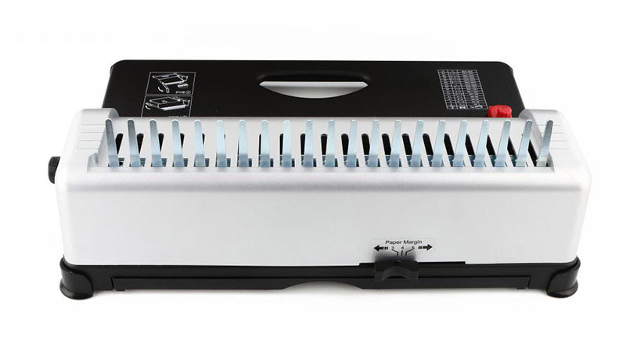
- Collect together all the documents that need to be punched. This includes the papers, the front cover and the back cover.

- Insert some sheets of paper to be punched. Insert approximately 80% of the maximum amount the machine is capable of punching. Then pull the handle and punch the sheets to make holes.
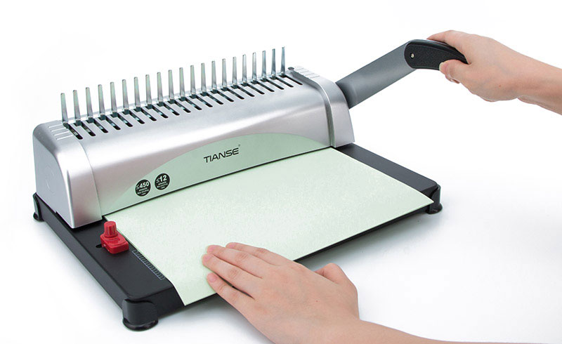
4. Place the comb on the machine’s comb opener.
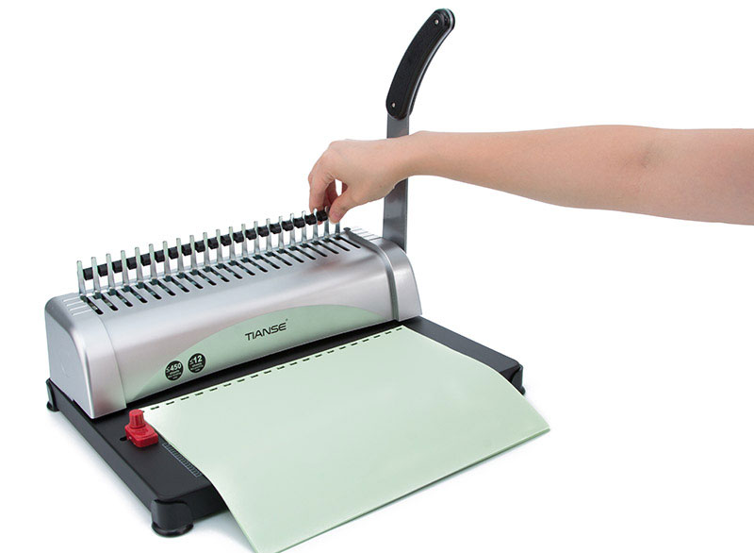
5. Push the handle lever to open the comb.
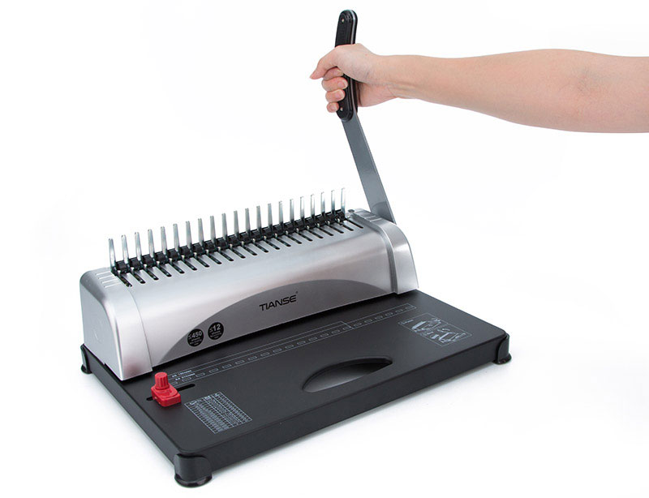
6. Insert the opened combs spines through the holes in the sheets.
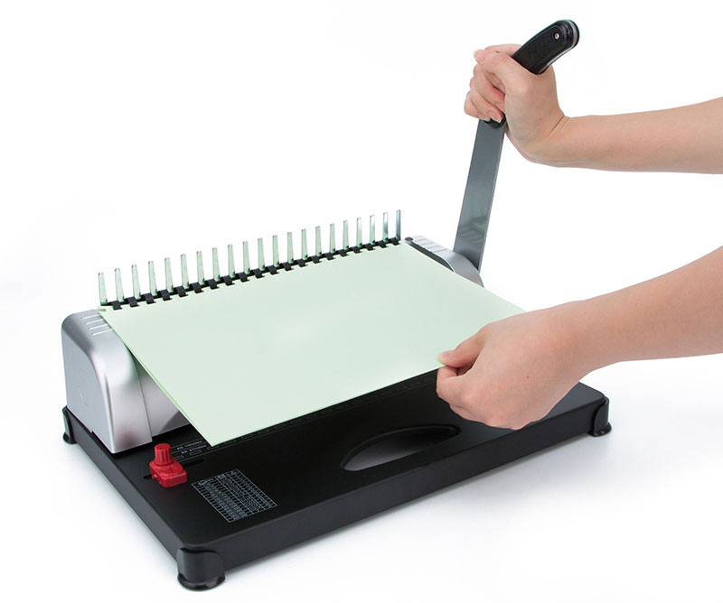
7. Release the comb opener and close the comb.
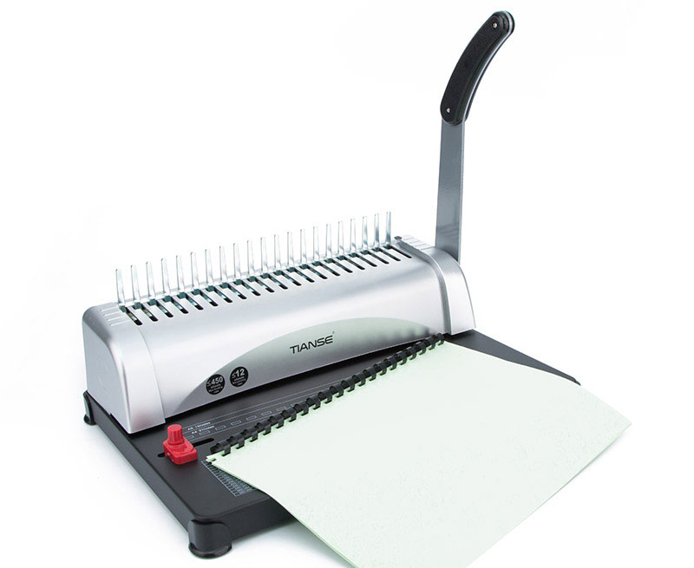
8. The book binding is completed and you’re now ready to move on to your next document project!

Operation Sheet – 4: How to scan a document
  - Turn on the scanner.

  - Locate the software for the scanner on your computer. If you don't have the software that came with the scanner, most versions of Windows have a Windows Fax and Scan program installed, which works with most scanners.

  - Count the number of pages you want to scan. If you are working with only one side of the page, we recommend using the flatbed, shown in the first picture below. If you are using either multiple pages or one page needing both sides scanned, you need a scanner with a feeder port, shown in the second picture below.
Example of a flatbed on a scanner
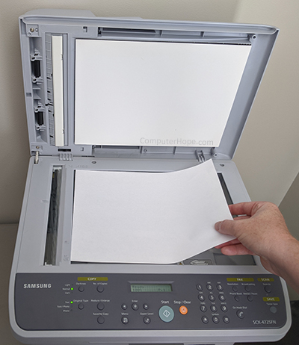
Example of a feeder on a scanner
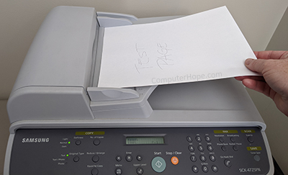
  - When using the Windows Fax and Scan software, you need to verify at the bottom left of the computer screen that Scanner is selected, not Fax.
  - Put the page(s) that needs to be scanned on the flatbed or in the feeder. Most scanners have directions on how to insert the paper, either face up or face down. Especially when using the feeder, make sure the paper is seated correctly so it is grabbed correctly.
  - In the scanner software, click the New Scan or similar option.
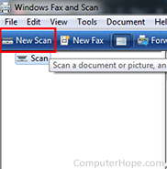
  - In the New Scan window, you'll need to change any settings that might apply from the available options. For example, options may include Profile, Source, Paper size (if not letter size), Color format, File type, Resolution (DPI), Brightness, and Contrast. Change each of these depending on the type of document you are scanning.
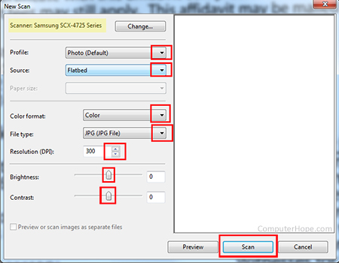
  - Once those options are changed, click Scan.

Saving the document
- After all the pages are scanned, a screen pops up showing the scanned pages. Make sure all pages are showing on the screen. If not, you need to re-scan the document.
- If using the Windows Fax and Scan program, at the top middle of the screen, click Save as, or you can click File, then click Save as.
- In the pop-up window, choose the Save in location, then type in the desired file name. Then, change the Save as type to .jpg, .bmp, .gif, .tiff, or .png, depending on your preference. We recommend saving any photos as .jpg, and any documents as .tiff. Saving documents as a .tiff reduces their size, making it easier to send by e-mail and similar programs.
- Once you've made the selections, click Save.
Operation Sheet – 5:
How to Shred Paper in a Shredding Machine
- Check the shredder blades - Unplug then open the shredder. If the blades are too chipped, then you may need a new shredder.
Know the limitations of your shredder - Your shredder might not be able to shred certain materials. For example, your shredder may not be able to shred banking cards or may get jammed if you try to shred paper clips or staples. Knowing the limitations of your shredder can help you avoid breaking your shredder.

Insert the documents or cards into the shredder - This fragments the documents into hundreds of pieces. You will not be able to piece the documents back together after doing this.

Turn the shredder on - Press and hold the shredder button or turn the switch. This will allow the shredding of the documents.

Recycle the fragments - The resulting paper/plastic can be recycled. Save trees and the environment by recycling the fragments! Open the shredder and dispose of the contents in the recycling bin.

LAP Test | Practical Demonstration

Name: __________________________ Date: ____________
Time started: ____________________ Time finished: _______________
Instruction I: Given necessary templates, tools and materials you are required to perform the following tasks within 10 hours.
Task 1:
Task 2:
Task 3:

Reference

Developers Profile
No | Name | Qualification (Level) | Field of Study | Organization/ Institution | Mobile number | E-mail
1 | Engida Eshete Wolde | BA, MA | BA AOST & MA in Marketing | Hawassa Tegbareid | 0916136741 | engdaeshete@gmail.com
2 | Birhanu Hailu Becho | BED | BA OAOT | Nekemte TVET college | 0917854441 | Obsa2013@gmail.com/  berihanuhailu41@gmail.com
3 | Estifanos Worku Tegegn | BSc, MBA | Business Admin | Harer Polytechnic C | 0920457778 | Worku.estifanos220@gmail.com
4 | Ephrem Haile | OAOT | BA OAOT | Tulu Bolo TVETC | 0965554581 | Ephremhaile1081@gmail.com
