SECRETARIAL AND OFFICE ADMINISTRATION

Level – II
Based on March 2022, Curriculum Version I,

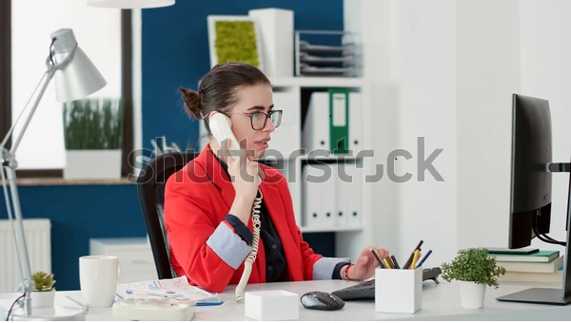

Module Title: Produce Word Processed Documents

Module Code: LSA SOA2 M07 0322
Nominal duration: 120 hours

Prepared By: Ministry of Labor and Skills

December, 2022
Addis Abeba, Ethiopia

Acknowledgement
Ministry of Labor and Skills wish to extend thanks and appreciation to the many Representatives of TVET instructors and industry experts who donated their time and expertise to the development of this Teaching, Training and Learning Materials (TTLM).

Table of Contents
Acknowledgement 2
Table of Contents Error! Bookmark not defined.
Acronyms 4
Introduction 5
Unit one: Prepare to produce documents 7
1.1 Addressing use of safe work practices 8
1.1.1 Work organization and energy requirements 9
1.1.2. Resource conservation requirements 10
1.2 Identifying and clarifying document requirements 12
1.3 Identifying organizational and task requirements 41
Operation sheet-1 44
Unit Two: Produce documents 45
Introduction 46
2.1 Formatting document 46
2.2 Using System features 48
2.2.1 Identifying and manipulating screen display options and controls 49
2.3 Using Manuals, user documentation and online help 50
Operation sheet-1 54
Unit Three: Finalize documents 55
Introduction 57
3.1 Ensuring final document preview, check, adjust and print 57
3.2 Preparing documents within designated time lines 58
3.3 Naming and storing document. 58
Operation sheet-1 60
Reference 66
Developers Profile 67

Acronyms

SS Single Space

DS Double Space

TS Triple Space

CC Carbon Copy

PC Photo Copier

PS Post Script

P.O.B Post Office Box

BCC Blind Carbon Copy

TVET Technical & Vocational Education Training

TTLM Teaching, Training & Learning Materials

Introduction
Produce Word Processed Documents requires keyboard skills acquired during the training duration in other competencies especially, Amharic and English Keyboard Skills. The trainees always required to develop accuracy and speed in order to produce promptly any documents, without delay, pertaining to business activities effectively and efficiently.
This competency has three units. Namely: Prepare to produce documents, Finalize documents and Produce documents. Preparation of document require prerequisite of taking keyboard training. After extensive training the trainees are required to product a business document effectively.
A business document is a tool for conveying messages between business organizations. So, this tool requires skill which is obtained from the trainings given in the institution. In the training area trainers are expected to help the trainees to be competent to produce finalized business documents.

Module units
- Prepare to produce documents
- Produce documents
- Finalize documents

Learning objectives of the Module
At the end of this session, the students will able to:
- Prepare to produce documents
- Produce documents
- Finalize documents

Module Learning Instructions:
- Read the specific objectives of this Learning Guide.
- Follow the instructions described below.
- Read the information written in the information Sheets
- Accomplish the Self-checks
- Perform Operation Sheets
- Do the “LAP test”

Unit one: Prepare to produce documents
This learning unit is developed to provide the trainees the necessary information regarding the following content coverage and topics:
  - Use safe work practices
  - Document requirements
  - Identifying Organizational and task requirements
This unit will also assist you to attain the learning outcomes stated in the cover page. Specifically, upon completion of this learning guide, you will be able to:
- Address use of safe work practices
- Identify and clarify document requirements
- Identify organizational and task requirements

Introduction
Document preparation requires technology. The technology required in the office includes computers, printers, photocopiers, scanners, etc. In order to produce documents knowledge and skill of how to manipulate these technologies are required. When manipulating them effectively and efficiently safe work practices should be learned and developed.
In the office, works are processed using resources. Such resources include employees, machines, supplies, time, spaces, water, electricity, and so on. Work duties are organized in such a way that they can be carried out smoothly in a systematic manner. Resources are used keeping in mind the fulfillment of resource conservation requirements to reduce unnecessary wastages.
When documents are produced, the organizational and document requirement should coincide. There are many types of documents that can be processed in the workplace as per requirements. These documents may include letter writing, memos, reports, minutes, notices, etc. They all have their own writing styles and organization. Knowing all the styles and organization of the documents we are going to prepare helps to produce the right documents effectively and efficiently.

1.1 Use safe work practices
Safe work practices:
Workplace organization facilitates the smooth flow of activities. Companies should establish Safe Work Practices/Safe Job Procedures for addressing significant hazards or for dealing with circumstances that may present other significant risks/liabilities for the company. They should reflect your company's approach to controlling hazards.
Some regulations require employers to have written procedures/instructions for specific activities/conditions. The number of practices/procedures and the degree of detail will depend on the range of work activities your company performs. It is important that management and supervision are involved in the development of safe work practices and that they provide adequate training for workers likely to follow these practices.
Safe work practices are generally written methods outlining how to perform a task with minimum risk to people, equipment, materials, environment, and processes.
Safe job procedures are a series of specific steps that guide a worker through a task from start to finish in a chronological order. Safe job procedures are designed to reduce the risk by minimizing potential exposure.
All safe work practices should be kept in a location central to the work being performed and readily available to the workforce. Some safe work practices will require specific job procedures, which clearly set out in a chronological order each step in a process.
Safe work procedures should be included in the company's "Worker Orientation" program. All workers should be aware of the fact that safe job procedures have been established, are in effect, are written down and must be followed.

1.1.1 Work organization and energy requirements
Work organization, energy and resource conservation requirements
Ergonomics – The root of the term “ergonomics” stems from the Greek “nomos” meaning rule, and “ergo” meaning work. Therefore, Ergonomics means work rules. In other words, Ergonomics is the study of efficiency, comfort and safety of people in their working environment. It will be clear already that the benefits of ergonomics can appear in many different forms, in productivity and quality, in safety and health, in reliability, in job satisfaction and in personal development.

The reason for this breadth of scope is that its basic aim is efficiency in purposeful activity—efficiency in the widest sense of achieving the desired result without wasteful input, without error and without damage to the person involved or to others in the workplace area. In general, The aim of ergonomics is to ensure that the working situation is in harmony with the activities of the worker.
Ergonomic requirements may include:
  - avoiding radiation from computer screens
  - chair height, seat and back adjustment
  - document holder
  - footrest
  - keyboard and mouse position
  - lighting
  - noise minimization
  - posture
  - screen position
  - workstation height and layout
Work organization requirements
Work organization should be made in such a way that it can easily facilitate the requirements of performance of a task effectively and efficiently. Work organization requirements may include: exercise breaks, mix of repetitive and other activities, rest periods. Exercise breaks helps to divide huge task into small tasks that can be easily manageable. Mix of repetitive tasks also helps to bring similar tasks together for easy performance. Rest periods refer to the relaxation break to refresh you. This may take fifteen minutes tea break.

1.1.2. Resource conservation requirements
Energy and Resource conservation requirements

Energy conservation is one of the words you are hearing more and more. Energy conservation is not about making limited resources last as long as they can, that would mean that you are doing nothing more than prolong a crisis until you finally run out of energy resources all together. Conservation is the process of reducing demand on a limited supply and enabling that supply to begin to rebuild itself. Many times the best way of doing this is to replace the energy used with an alternate.
Figure 1: Energy Conservation Method

Energy Conservation Techniques
There are some techniques which help to make energy conservation:
- Education: Education is probably the most powerful of the energy conservation techniques that can be used. Education is about more than teaching people the importance of conservation, it is about showing the alternative choices that can be used in construction, manufacturing and other processes.

- Zero Energy Balance: Zero Energy Balance is more than techniques of conserving energy in green construction. It is a process of re-evaluating and retrofitting manufacturing and commercial operations so that they can harvest and store energy, as well as take and replace it onto the grid to relieve brown out stresses.
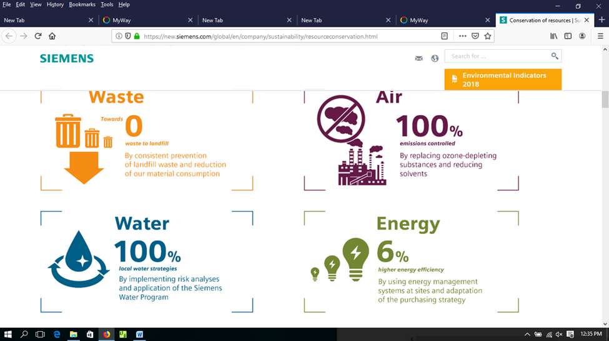

Figure 2: Energy conservation result

- Alternative Power: The use of alternative power is one of the most key energy conservation techniques because almost all of the transition models require that the existing processes be upgraded or replaced to more energy efficient models too.

- Reduced Demand: There are numerous initiatives that are working to reduce the overall demand on the energy resources of the world. This can range everywhere from education programs to changing the type of energy requirements.

- Research & Development: Continued funding of research and development projects in the energy conservation field is how we discover the changes that can be made to reduce consumption and discover renewable methods to provide us with the energy that modern life requires. It should be one of the energy conservation techniques that are most valued as it is what holds the promise for leading to a solution to the world’s energy crisis.

Benefits of energy conservation:
- Saves the cost and lowers your utility bills
- Prolongs the existence of fossil fuels.
- Protects the environment.
- Reduces pollution
Resource conservation
Water, electricity, office supplies, manufacturing and production materials, building materials etc. form resources that a company uses. Conservation of such resources is an important environmental measure taken by companies. These include restrictions and reductions in the use of resources, recovery of (re)usable resources from waste products, recycling of resources after adequate processing. Thus company purchasing decisions are increasingly including environmental concerns in their choice of supplies, materials and refills.
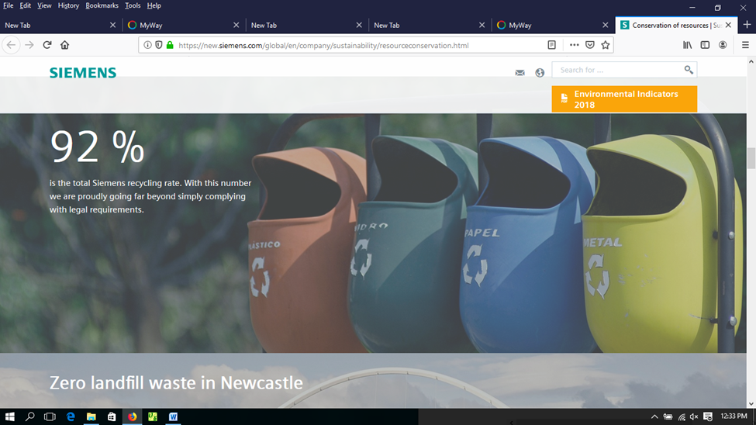
Resource conservation measures have also covered maintaining regulatory compliance, chemical source reduction, emissions control, equipment review and construction support, and product stewardship. Increased 'returnable' content in a product or its packaging has also been used in conservation efforts to ensure working safely requirements. Protecting the environment is the right social and business policy to business success and prevention of pollution.

Figure 1: Zero landfill waste

1.2 Document requirements
When writing a document, think about its purpose, audience, and design or presentations requirements. Good technical writing has to focus on its audience's needs. For all of us, an audience is a group of people with similar needs and similar levels of technical and subject matter expertise and who will be using the document. Once I am asked to write a document, I start by identifying my audience's needs and ask myself the following questions before I begin writing:

- Who will use this document?
- How will each audience use this document?
- What information does each audience need in this document for them to use it?
First, identify your audience, design of presentation and the type of information embodied in it. The document must provide sufficient information for the audience to use it with appropriate design. Therefore, you must determine what knowledge each audience has and what additional information each audience needs in the document.
During the writing process, it is helpful to position yourself as a reader. Ask yourself whether you can focus easily on each point you make. One technique that effective writers use is to begin a fresh paragraph for each new idea they introduce.
Paragraphs separate ideas into logical, manageable chunks. One paragraph focuses on only one main idea and presents coherent sentences to support that one point. Because all the sentences in one paragraph support the same point, a paragraph may stand on its own. To create longer assignments and to discuss more than one point, writers group together paragraphs.
Three elements shape the content of each paragraph:
- Purpose. The reason the writer composes the paragraph.
- Tone. The attitude the writer conveys about the paragraph’s subject.
- Audience. The individual or group to whom the writer intends to address.
Figure 2: Purpose, Audience, Tone, and Content Triangle
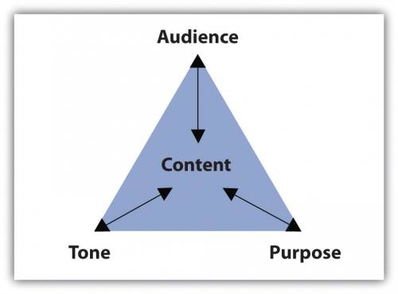
The assignment’s purpose, audience, and tone dictate what the paragraph covers and how it will support one main point.
Documents may include:

  - agendas
  - briefing papers
  - envelopes
  - faxes
  - labels
  - letters
  - memos
  - minutes
  - Reports
  - simple one-page flyers
  - standard form letters

Each document presented above has our peculiar design and purpose of writing. For example, to write a business letter, a business letter has its own designs and styles. It also used to communicate with internal and external customers concerning business activities. On the contrary, Memorandum (short form is Memos) is used to communicate only with internal audience and also has own writing style and design, etc. Agendas are matters to be discussed during the committee meetings. Minutes, on the other hand, the document which emerges from the committee meetings and it is the resolution/outcome of the agenda. We will take thorough training of Agenda and Minutes documents in Level III. Now, we shall start training on the design and style of some main documents such as: Letters, Memos, Report writing and how to merge Mail.

Main Business Documents:

Letter Writing
When we talk about letter we are talking about a business letter (Amharic or English). Business letter has main parts and writing style. It has, in general, eight main and eight supplementary parts.
Parts of a business letter
Business Letter has as little as eight parts and as much as 16 parts. Eight parts are called main parts of a business letter and another eight parts are supplementary parts. Any Business Letter must display the main 8 parts while writing a letter, because they are essential parts. No business letter can have all 16 parts at one instance but use them when you find appropriate to use among them.

Main Business Letter Parts | Supplementary Parts
- Letterhead or Sender’s Name and address  - Date /current date/  - Inside / Receiver’s address  - Salutation  - Body of the letter/ Message Parts  - Complimentary close  - Signer’s Name & Title  - Typist initials | - Reference No  - Attention line  - Subject  - COMPANY NAME  - Enclosure  - Carbon Copy /CC/  - Post Script /PS/  - Blind Carbon Copy /BCC/

These two business letter parts are displayed below:

The eight basic parts of a letter:

- Letterhead or Return address or Sender’s address – this gives, in print, the name and address of the company. Contents:
- Name of the organization
- Emblem/Logo for header* and Motto for footer*/
- Telephone number/Office telephone/
- Fax number
- P.O.B number
- e-mail
- Name of Town / City
*Logo is the symbol that represents the organization pictorially or symbolically or in word that brands the business organization whereas Motto is the value/slogan that the organization assumes to achieve in its existence. Motto’s can be expressed in words, phrases and in a sentence.
The design may depend on the need of the organization
Coverage – The heading/header may cover up to the first 12 lines. If the organization has many telephone addresses, please insert some addresses in the footer part with motto of the organization. This reduces the sophistication of the heading with addresses.
- The Date Line – It shows current month, day and the year. Type today’s date after header, entering/leaving two blank spaces, starting at the center or more to the right edge. Then advance/leave 4 or 5 lines after the date line.

Writing Options: October 30, 20___ or 30th October 20____

- The Inside Address / Receiver’s Address – which includes both the full name and the mailing address of the addressee. Enter/advance twice

Options:
1. Name of the organization 2. Individual’s name, title 3. Individual’s Title
P.O.B. number Department Department
Town/City Organization Organization
P.O.B. number P.O.B. number
Town/City Town/City
- Salutation – is an opening greeting and always begins with Dear. It should match with the options mentioned above. It is always typed at the left margin and always proceeded and followed by a blank line. It is almost followed by a colon.

Options: 1. Ladies and Gentlemen: or Ladies or Gentlemen:
2. Dear Ato ___/W/ro___/W/rt___ or Dear Mr.__/Mrs.___/Miss___:
3. Dear Sir/Madam/Miss:

- The Body of the letter – it contains message of a letter. It is the main part of a letter which initiates the writer of a letter to write this letter.

Content of the body: 1. always typed in single spaced line.
2. A blank line is always there between paragraphs
3. Before and after the body there is always one blank line.

- The Complimentary Closing: - Closing is the sign-off phase. Proceeded by one blank line from the body and followed by 2-6 lines depending on the size of the letter. If the letter is too short on a paper may allow 6 lines to stretch in order to balance the top and bottom space of your letter. If your letter is long enough allow minimum of 2 lines for pen signing signature to balance the space available.
- Most often, it begins at, or near, the center.
- It usually ends with a comma./for standard & closed punctuation styles/
- Only the first letter is capitalized.

Samples: 1. The truly family 2. The sincerely family 3. The cordially family
Yours truly, Sincerely yours, Cordially yours,
Truly yours, Sincerely, Cordially,
Very truly yours, Very sincerely yours, Very cordially yours,
Yours very truly, Yours very sincerely,

Other options: Best regards, Best wishes, Regards, Respectfully, Respectfully yours, Thank you, Thanks, Love, Take care, etc.

- The Signer’s Identification – which is typed under the space left blank for him to write his name, may be the name or the title (or dept.) or both of the signer. Ordinarily three blank lines are left for the penned signature; but this can be changed depending on the blank space left below. This space may be as few as two or as many as six blank lines for the penned signature.

- The Reference Initials/Symbols – this is usually typist/secretary’s initial who writes the letter. This may include:
- Signer’s initials - if his/her name is not properly written in its appropriate place.
- Composer’s initials – sometimes the composer differs from the secretary, at this time initials of the person is included to indicate this person.
- Secretary’s/typist’s initials - Initials are normally typed at the left margin without periods in either lowercase letters or all-caps., preceded by one blank line from the signer’s identification.

Options:
- /ab - when the secretary’s/typist’s name is written. This includes first letter of her and father’s names. e.g. Alemitu Birru is typed as /ab - hyphen and with lowercase letters.
- XY/ab – only when the signer’s and secretary’s initials are included.
- XY/DE/ab - only when signer’s, composer’s and secretary’s names are included.

II. SUPPLEMENTAL or ADDITIONAL BUSINESS LETTER PARTS
In the course of many years of business communication, the business letter has picked up a number of extra parts to serve particular purposes. While none of these are essential for getting the message across to addressee, they do serve as aids to him/her to the writer, and to both their secretaries. The supplemental parts are also eight(8) in type like the basic parts.
These Additional Business Letter Parts are:

- The Reference Line – is used in business where records are kept in numerical files or where transactions are handled by a very large staff as references.it is a line (when replying, refer to:) printed in the letterhead.
e.g Refer to: File 187/985/16
file No/ letter No/year

- An Attention Line – an extension of the inside address, it is typed between the inside address and salutation, preceded and followed by one blank line. It can be basic when the letter is addressed to the organization. It shortens its way.
Options for writing:
      - Attention Sales Department
      - Attention: Credit Manager
      - Attention of the President
      - ATTENTION Legal Department s
      - ATTENTION OF THE PRESIDENT
      - Attention of Mr. John Hall

- THE SUBJECT LINE – is a preview of the message & so is typed b/n the salutation and the body. It may be arranged in many styles. A subject line is usually introduced by the word “Subject”(by the Latin term “In Re or Re”) in all-caps followed by a colon. Type the subject line between the salutation and the body of the letter. Leave one blank line before and after the subject line. Follow the word Subject with a colon and two spaces. Samples:
SUBJECT: Your Application RE: The State Vs Government
SUBJECT: Special New Sales In Re Park Forest Vs Wood yard
SUBJECT: Invoice No. 123A Subject: Agreement of Salary
Subject: Our Special Sale In Re: Salary
RE: Salary

- THE COMPANY NAME: is typed in all-caps. Double-space below the complimentary closing. The name of the organization is typed
- If the letter needs stretching
- If the employer simply wants it there, and
- Whenever the letter involves a contractual matter

- Enclosure Notations – are signals to remind both the sender and receiver of a letter that something is enclosed (attached) in the same envelope. Enclosure notes can be left out properly only when a letter is formal. Whenever an item is sent with a letter, the word Enclosure is typed on the line below the reference initials.
Examples: Encl.,
2 Enclosures;
3 Encl. and so on
.
- A Carbon Copy (CC) or Photocopy (PC) Notations – it is typed under the enclosure notation to indicate the addresses that carbon/photo copies (hence “CC”/”PC”) are being sent to the persons indicated. On the name and address of individuals/organizations to whom a copy of the letter/memo is/is going to be/sent.
Samples
With different addresses | When the address is the same
CC/PC::  - Ministry of Education  Addis Abeba  - Ato Taye Lema  Hawassa University  Hawassa | CC/PC:  - Office of the Ministers  - Office of Minister of State  - Finance Minister  - Ministry of Education  Addis Abeba | CC/PC:  - Ato Lema Yifru  Ministry of Finance  - Dr. Solomon Zerga  Ministry of of Education  Addis Abeba

- A Post Script – is an extra/extension of paragraph added at the very bottom of the letter and is treated as such. It is indented or blocked as the other paragraphs. The initials PS., PS:, P.S., or PS- are typed at the start of the paragraph. Or short message in a sentence form which is not included in the message part or an idea which you need to get special attention. Samples:
Indented & Blocked  paragraph | Blocked paragraph style | Indented style

PS:__________________  _____________________  _____________________ | PS:_______________  _______________  _______________ | PS:________________  ______________________  ______________________

- A Blind Carbon Copy (BCC:) notation – indicates to whom copies of the letter are being sent without the addressee’s/receiver’s knowledge. It is not typed on the original copy. To type a “BCC” notes, a typist prints the original letter and top sheet of carbon copy/print copy types the “BCC” note an inch/on the 7th line/ from the top of the paper at the left margin.

e.g.
BCC:
- Dr. Ketema Dori
Ministry of Finance
- Ato Taye Bori
Ministry of Education
Addis Abeba

Letter Margins Setting Table:
Letter Style | Inch | Body of letter | Page Layout Margins | Margins
Short Letter | 4' | Up to 100 words | Wide | Top 1' Bottom 1'  Left 2' Right 2'
Average Letter | 5' | 101 - 200 words | Moderate | Top 1' Bottom 1'  Left 0 .75'  Right 0.75'
Long Letter | 6' | Above 200 words | Narrow | Top 0.5' Bottom 0.5'  Left 0.5 Right 0.5'

Note: Only when it is necessary to use the supplemental parts, the secretary must know the exact insertion place of each supplemental part in her/his letter while typing a letter. Certainly, no doubt! Nevertheless, this does not mean that s/he uses all supplemental parts at one instance at the same time. Never! This is merely to indicate the exact insertion place of each part.

Principal letter styles:
      - Full Blocked/Extremely Blocked – has no indentions; all lines begin at the margin. It is the easiest style of all styles.
      - Blocked/Modified blocked – has date, complimentary closing and signer’s name and title indented to center or near it. It is widely used style among others.
      - Semi blocked – also has paragraphs uniformly indented together with date, complimentary closing and signer’s name & title. Less widely used style.
      - Indented – also has indented steps in its address and closing parts. Oldest style of all styles.
- See below the practical four principal letter samples carefully.

Important tips: make adjustments when writing letters
            - Font type – Times New Roman/as general rule/
            - Adjust space and paragraph spacing at 1.0
            - Adjust style at No Spacing position
            - Adjust font size at 12
            - Always Justify the body of the letter /alignment Justify or /Ctrl + j/
            - Depending on the letter size, adjust margins at for
- Short letter (4 inch) – wide / Page Layout Margins Wide
- Medium letter (5 inch) – Moderate /Page Layout Margins Moderate
- Long letter (6 inch) – narrow / Page Layout Margins Narrow
            - Advice! To develop speed, increase your short cut key practices.
e.g.

- Ctrl + S = to save
- Ctrl + j = to justify
- Ctrl + c = to copy
- Ctrl + x = to cut
- Ctrl + v = to paste
- Ctrl + a = to select all
- Ctrl + p = to print
- Ctrl + B = to make Bold
- Ctrl + U = to underline
- Ctrl + I = to make Italic

            - When you want to indent a paragraph – please use TAB key which forwards the first line of a paragraph 5 spaces from the margin.
            - Logo and Motto are used when we are preparing to write letter previously not having Logo and Motto.

Punctuation Styles:
No variation in punctuation is permitted in the body of any letter; the demands of correct English style must be fulfilled. There are, however, three different styles of punctuation that are used for treating the displayed heading and closing lines.
- Standard punctuation, the form used in the great majority of business letters, requires a colon after the salutation and a comma after the complimentary closing. No other punctuation (except the period that follows any abbreviation) is used to end or “close” any of the displayed heading and closing lines.
- Open punctuation, eliminates all-end line punctuation marks (except the period that follows any abbreviation, for the displayed heading and closing lines. Not even the colon and comma found in the “standard” style are used.

- Closed punctuation, rarely used in America (but popular in British) correspondence, requires that every display heading and closing line end with a punctuation mark. Periods required after the date, after the last line of the inside address, after the signer’s identification, and after each of the final notations (reference symbols, enclosures, etc.). A colon is used after the salutation. All other lines must end with a comma. No line ends without a punctuation mark.

- Full blocked Letter with eight basic parts

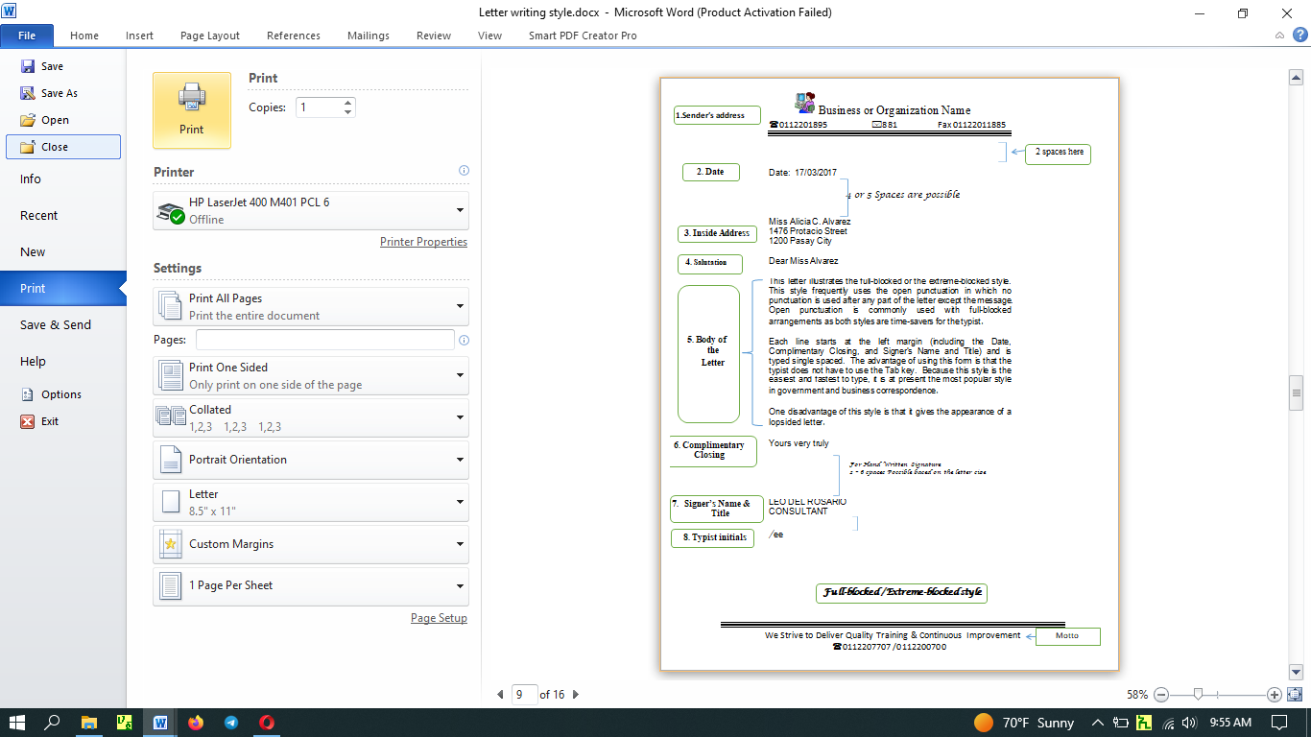
Note: Between each letter part one space is necessary except the lines left between Date and Inside address (3 or 4), and complimentary closing and signer’s name and title (2-6 depending on the size of the letter).

Ii) Blocked Letter
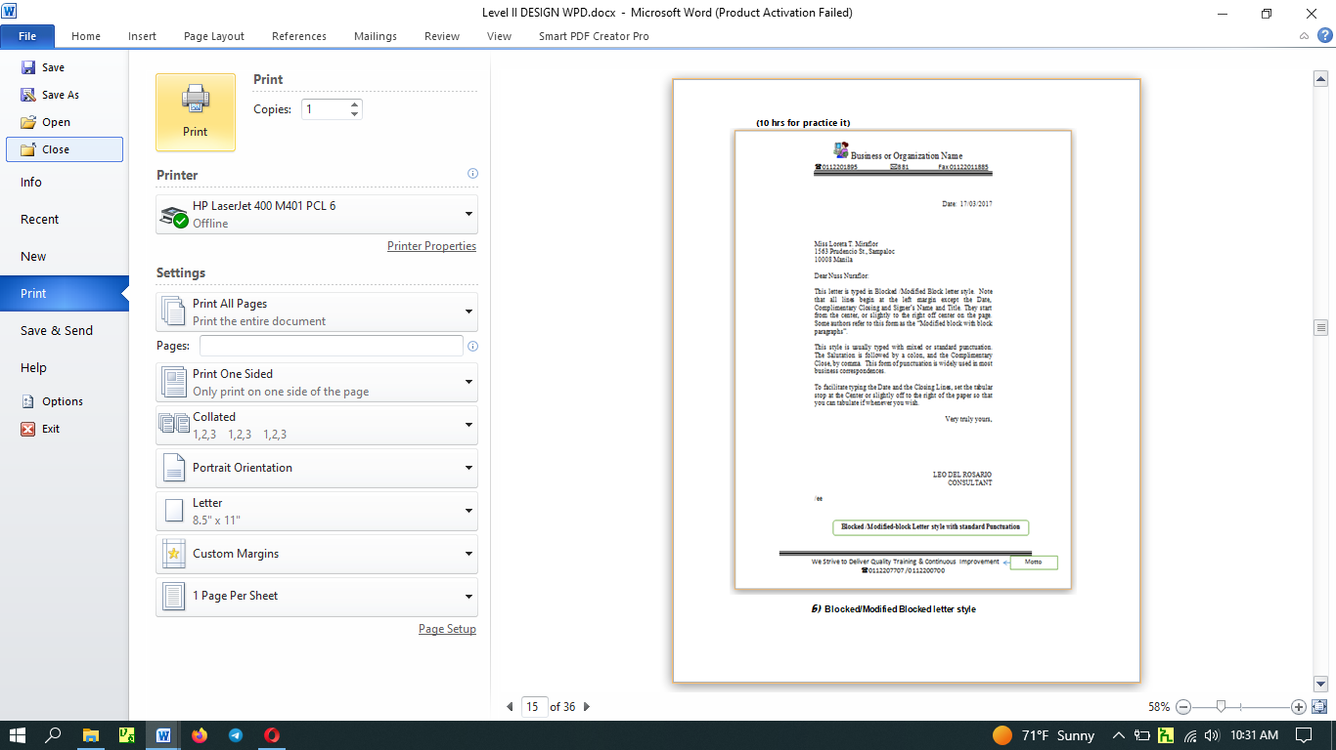
Note: The difference is only on three parts, namely: date, complimentary closing and signer’s name & tittle. They are written at right-edge of the letter.

Iii) Letter with Semi-Blocked Style
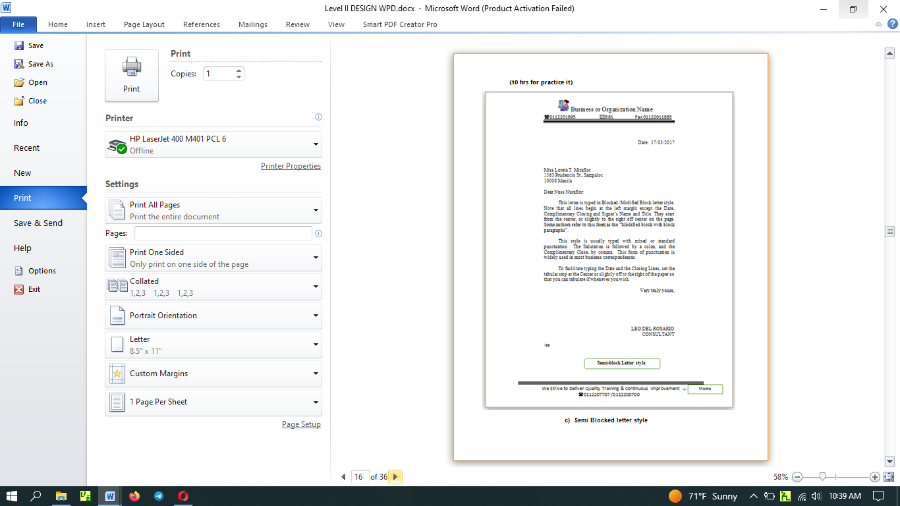
Note: Being on blocked letter style, indent paragraphs only 3-5 spaces using Tab key.

Iv) Indented Letter Style
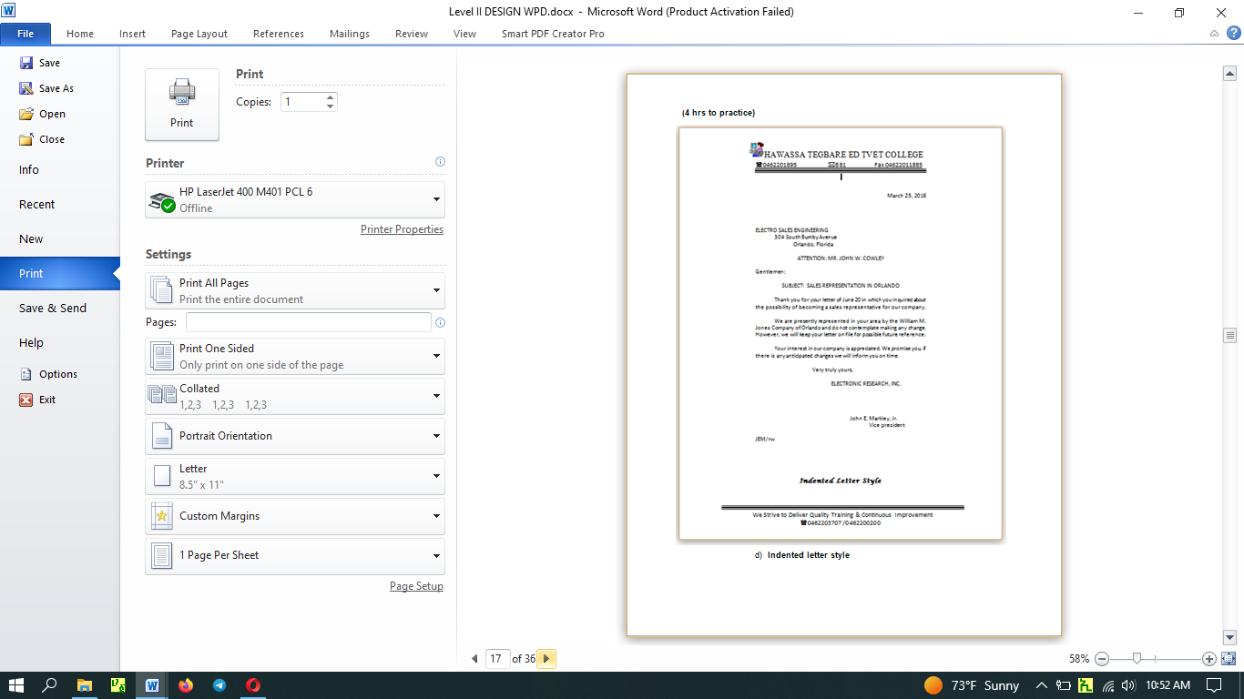
Note: Being on semi-blocked letter, indent each part of the inside address and closing parts of the letter five space each.

የአማርኛ የሥራ ደብዳቤ የአፃፃፍ ስልት
የአማርኛ የሥራ ደብዳቤ - የመንግስትም ሆነ የግል ድርጅት ከማንኛውም መስሪያ ቤትም ሆነ ግለሰቦች ጋር የስራ ግንኙነት ማድረግ ሲፈልጉ ግንኙነቱ ለመመስረት የሚጠቀምባቸውን የሥራ ደብዳቤዎችን የሚመለከት ነው፡፡ የአማርኛ የስራ ደብዳቤ ለመጻፍ የአማርውን ግዕዝ ፊደላትን በመጠቀም መጻፍ ይቻላል፡፡ ስለዚህ የአማርኛው ግዕዝ ሶፍት ዌር በኮምፕተራችን ላይ መጫኑን ማረጋገጥና ከእንግሊዝኛው ወደ አማርኛው ግዕዝ መቀየርን ይፈልጋል፡፡ ስለዚህ በኮምፕተራችን ዴስክ ቶፕ ግርጌ ላይ ስታተስ ባሩን ኢ የሚለውን ወደ ፎ (2ኛዋን ፎ) መቀየር ያስፈልጋል፡፡ ኢ - ኢንግሊዝኛ ፊደላትን የሚመለከት ሲሆን ፎ - አማርኛ ፎነቲኩን የሚመለከት ነው፡፡ ይህን ካደረግን በኋላ ደብዳቤያችን መጻፍ እንጀምራለን፡፡
የአማርኛ ደብዳቤ አጻጻፍ ከኢንግሊዝኛየደብዳቤ አጻጻፍ ስልት የሚቀራረብ ሲሆን ልዩነቱ የፊደላቱ መለየት እና የመልዕክቱ ክፍልን የቁም ቦታን /Vertical Line Spacing/ የሚመለከት ነው፡፡ የቁም ቦታን /Line Spacing/ 1.0 ላይ አድረገን የምንተይብ ከሆነ ደብዳቤያችን ውበት አይኖረውም፡፡ ፈታ ብሎ እንደልብ ለማንበብም ያስቸግራል፡፡ ስለዚህ የአማርኛ ደብዳቤ ለመተየብ የቁም ቦታውን /Line Spacing/ ወደ 1.5 መቀየር ያስፈልጋል፡፡ ከዚያ ውጭ ሌላው በአብዛኛው ተመሳሳይ በመሆኑ ዓይነታቸውን መመልከት እንጀምራለን፡፡
የአማርኛ የስራ ደብዳቤ ሦስት ዓይነት ሲሆን እነዚህም፣
- ሙሉ ግጥም /Full blocked/
- ግጥም /Blocked/
- ከፊል ግጥም/Semi-Blocked/ ናቸው፡፡
- ገባ ብሎ /indented style/ በአማርኛው የማንጠቀምበት ሲሆን በእንግሊዝኛው እንደ አራተኛ የደብዳቤ አይነት የሚወሰድ መኖሩ ማስታወስ ያስፈልጋል፡፡

ሁሉም የስራ ደብዳቤዎች ከኢንግሊዝኛው የደብዳቤ አጻጻፍ ስልት ጋር ተመሳሳይ ሲሆኑ ከላይ ከተጠቀሱት ልዩነቶች በተጨማሪ በደብዳቤ ክፍሎች ላይ የመግቢያ ሠላምታን የሚመለከት ብቻ ነው፡፡ ማለትም የአማርኛ የስራ ደብዳቤ አጻጻፍ ላይ አብዛኛው መስሪያ ቤቶች የመግቢያ ሠላምታ ሲጠቀሙ አይታይም፡፡ አንዳንድ መስሪያ ቤቶች ግን የስልጣን ደረጃን መሠረት በማድረግ ሊጠቀሙ ስለሚችሉ ሙሉ በሙሉ አያስፈልግም ለማለት አያስደፍርም፡፡
የአማርኛ ደብዳቤ ክፍሎችም መሠረታዊ /ዋና የደብዳቤ ክፍሎች እና ተጨማሪ የደብዳቤ ክፍሎች ተብለው በሁለት ይከፈላሉ፡፡ እነዚህም ፣

ሀ) ዋና/መሠረታዊ የሥራ ደብዳቤ ክፍሎች
- የላኪ ስምና አድራሻ /እንደ ኢንግሊዝኛ የመ/ቤቱ ስምና አድራሻ በሄደር ይዘጋጃል፡፡/
- ቀን - ደብዳቤው የተጻፈበት ቀን
- የተቀባይ ስምና አድራሻ .
- የመግቢያ ሠላምታ
- መልዕክቱ ክፍል - ለደብዳቤ መጻፍ ያነሳሳው ጉዳይ ሆኖ በሶስት አንቀጽ ቢቀመጥ መልካም ነው፡፡
- የመዝግያ ሀረግ - ብዙውን ጊዜ ከሠላምታ ጋር ወይም ወቅታዊ መፈክር ሊሆን ይችላል፡፡
- የፈራሚ ስምና ማዕረግ - ለብዕር ፊርማ በቂ ቦታ በማስቀረት ይጻፋል፡፡
- የተያቢ/የአርቃቂ/ መለያ ናቸው፡፡ በምህፃር የተያቢ ስም የመጀመሪያ ፊደልና የአባት የመጀመሪያ ፊደልን በማስቀመጥ ሲተየብ የተተየበው በማን እንደሆነ ለማመልከት የምንጠቀመው ክፍል ሲሆን በደብዳቤው አጻጻፍ ላይ ችግር ቢፈጠር ኋላፊነት ለመውሰድ ያገለግላል፡፡
ለ) ተጨማሪ የሥራ ደብዳቤ ክፍሎች የሚባሉት ደግሞ /አስፈላጊ ሆኖ ስናገኝ የምንጠቀምባቸው/
- የደብዳቤ ቁጥር - ደብዳቤ በአሁኑ ወቅት ያለ ቁጥር ወጪ ተደርጎ አይላክም፡፡ ይህም በደብዳቤ ውጪ እና ገቢ መዝገብ ላይ ስመዘገብ ከመዝገቡ ላይ የሚሰጥ ቁጥር ነው፡፡
- በተለይ ለ________ - ደብዳቤው በመ/ቤቱ አድራሻ ተጽፎ ደብዳቤው ግን በመ/ቤቱ ውስጥ ላሉት ክፍሎች ላኪው እንዲሰጥ በሚፈልግበት ጊዜ ለይቶ ለማመልከት የሚረዳ ሲሆን ለምሳሌ፣ በተለይ ለሰው ሀብት ተብሎ ሊጠቀስ ይችላል፡፡ ከተቀባይ መ/ቤቱ ስም በመቀጠል በመሐሉ አንድ ባዶ ቦታ በመተው፡፡
- ጉዳዩ፣ - የመልዕክቱን በአጭሩ ለመግለጽ ሲፈለግ የምንጠቀምበት ነው፡፡ ለፈራሚው መልዕክቱን በማንበብ ጊዜውን እንዳያባክን የጠቅመዋል፡፡
- የመ/ቤቱ ስም - ይህ ደግሞ ከመግቢያ ሀረጉ ቀጥሎ የመ/ቤቱን ስም የሚፃፍ ሲሆን ዓላማው 1ኛ ደብዳቤ የኮንትራት ውል ከሆነ 2ኛ ደብዳቤ አጭር ሆኖ በወረቀቱ ላይ ወደ ላይ ከተንጠለጠለ ፀሐፊዋ/ው ደብዳቤውን ለመዘርጋት 3ኛ አንዳንድ ጊዜ የድርጅቱ ኃላፊዎች የመ/ቤቱ ስም እዚያ ቦታ ላይ እንዲጻፍላቸው ሲፈልጉ ሊገባ ይችላል፡፡
- አባሪ - ከደብዳቤው ጋር ተጨማሪ ሰነድ ወይም ዕቃ ካለ ለተቀባዩ ለማስታወስ ሊጻፍ ይችላል፡፡
- ግልባጥ፣ - ከተቀባዩ በተጨማሪ የተጻፈው ደብዳቤ ሌሎች የሚመለከታቸው ክፍሎች እንዲያውቁት ለማድረግ ሲፈለግ የሚጻፍ ነው፡፡
- ድህረ ጹሁፍ - ትኩረት መስጠት የተፈለገ ጉዳይን ለአፅንኦት ሲባል ሊገባ ይችላል፡፡

- ስውር ግልባጭ - ከተቀባዩ እውቅና ውጭ ደብዳቤውን ሌሎች አካላት እንዲያውቁት ሲፈለግ ዋናውን ኮፒ ፕሪንት በማድረግ በሌሎች ኮፒዎች ላይ እንዲያውቀው/ቁት የተፈለገውን መ/ቤት/ቶች/ ስም/ሞች እና አድራሻ በመጻፍ መላክ ሲፈለግ የሚዘጋጅ ነው፡፡
ለማጠቃለል ፣ ከተጨማሪ ክፍሎች በአማርኛ ደብዳቤ አጻጻፍ ላይ በተለይ
- የደብዳቤ ቁጥር
- ጉዳዩ ፣ እና
- ግልባጭ
የደብዳቤው ዋና ክፍል እስከሚመስሉ ድረስ በደብዳቤ አጻጻፍ ላይ ኣዘውትሮ መጠቀም እየተለመደ መጥቷል፡፡ በአረፍተ ነገር መሀል ሁለት ነጥብ ከመጠቀም አንድ ባዶ ቦታ መተው በአብዛኛ ተመራጭ እየሆነ ስለመጣ ይህንን ማስተዋል ያስፈልጋል፡፡
የደብዳቤ ናሙናዎቹን ከታች ይመልከቱ

- የሙሉ ግጥም ደብዳቤ አጻጻፍ ስልት
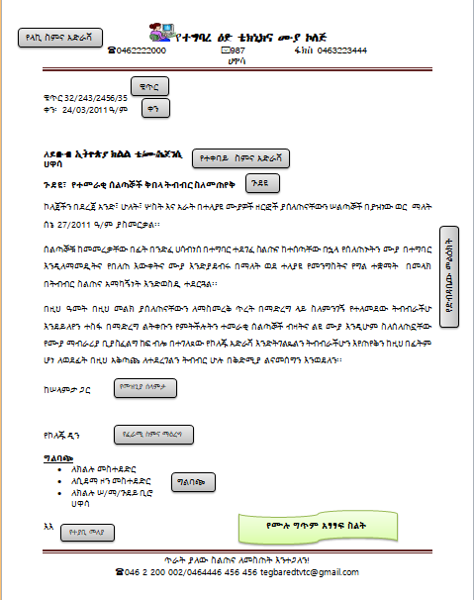

- የግጥም ደብዳቤ አጻጻፍ ስልት
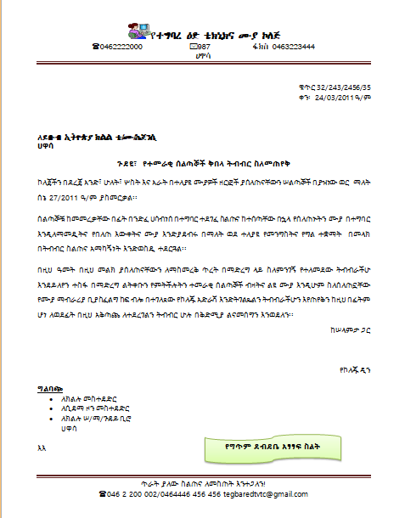

- የከፊል ግጥም ደብዳቤ አጻጻፍ ስልት
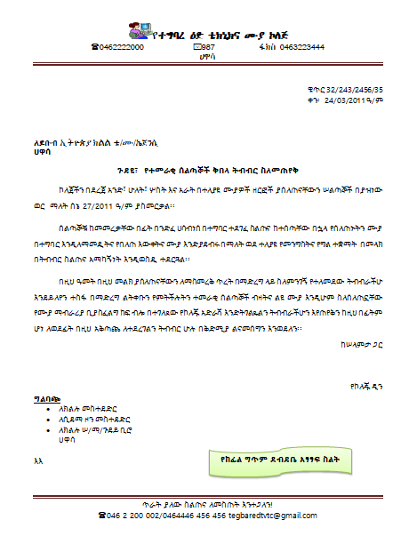

INTER-OFFICE MEMORANDIUM (In short Memo/s)
Inter-office memorandum is a form used to convey messages between persons/departments in the same organization/company. It can be prepared on a half-page paper or a full-page paper depending on the size of massage to be conveyed. Inter-office memorandum has four guide words. They are:
- TO:
- FROM:
- DATE:
- SUBJECT:
- TO: Name of the receiver of the message
- FROM: Name of the sender of the message
- DATE: The date on which the memo is written.
- SUBJECT: The message to be transmitted.
Attention:
After guide words use colon (:) and again after a colon leave two spaces. And then, leave single space between parts and guide words; except below guide words (next to the last guide word, Subject and the body or message of the memo). There leave triple spaces (3 spaces) between the last guide word and the message. Guide words with two lines should be typed with single line spacing.
- Memos are different from business letters in that it doesn’t include :
- Full addresses
- The Salutation
- The Complimentary closing (end of letter closing)
- The Signature, etc.

- Memos may include:
- Reference initials
- Enclosure notations, and
- Carbon copy notations.
- Personal Titles are usually omitted from the memo heading. They are included on the envelope, however.

ከላይ እንደተገለጸው የቢሮ ውስጥ ማስታወሻ /Inter-Office Memorandum / ዋና መሪ ቃላት ያሉት በመሆኑ ከስራ ደብዳቤ አጻጻፍ ስልት ይለያል፡፡ መሪ ቃላት ያሰናቸውም በፊት ለፊታቸው መጻፍ የሚገባንን ነገር ስለሚያመለክቱ የተሰጠ ስያሜ ነው፡፡ እነዚህ መሪ ቃላት
- ለ፣ _________________________________
- ከ፣ _________________________________
- ቀን፣ __________________________________
- ጉዳዩ፣ __________________________________________________
ለ መልዕክቱን ተቀባይ ያመለክታል፡፡ ከ የመልዕክቱን ላኪው ያመለክታል፡፡ ቀን መልዕክቱ የተጻፈበትን ቀን ያመለክታል፡፡ ጉዳዩ ደግሞ ዋናውን መልዕክት ይመለከታል፡፡ ያጻጻፍ ስልታቸውም፡
- 4 በ 0፣
- 3 በ 1፣ እና
- 2 በ 2 በማለት ይለያሉ፡፡
- Styles of Inter-Office Memorandums
- There are three styles of Inter-Office Memorandums. These are:
- four by Zero (4 X 0);
- Three by One (3 X 1); and
- Two by Two (2 X 2) Styles.

- Four by Zero /4 x 0/ Style

INTER-OFFICE MEMORANDUM
DS
TO: All Communication Processors
SS
FROM: Mr. John, Director
SS See the arrangements carefully
DATE: March 17, 2017
SS
SUBJECT: Company Correspondence
TS

Correspondence within a company/organization is frequently typed on interoffice forms, either half or full sheets, depending on the length of the message. The following points describe the features of an Interoffice Memo:
SS
- Spacing twice after printed headings to set the left margin stop for typing the heading items and the body. Set the right margin stop an equal distance from the right edge. These margin adjustments will usually give you side margins of one inch.

- Full addresses, the Salutation, the Complimentary Close, and the Signature are omitted.

- Personal titles are usually omitted from the memo heading. They are included on the envelope, however.

- TS between the Headings and Message. Single Space and Block the Paragraphs, but Double Space between them.

- Reference initials, Enclosure notation, and Carbon Copy notation are included.

Special colored envelopes are usually used for interoffice memos. Type the addressee’s name, personal title, and business title or name of department for the address. COMPANY MAIL is typed (in all Capitals) in the postage.
SS
Xx
SS
CC: Elena Bolen, Assistant to the President

- Three by One /3 X 1/ Style
INTEROFFICE MEMORANDUM

TO: SOA Training Dept. DATE: MARCH 23, 2017

FROM: Training Vice Dean

SUBJECT: Night School Refreshment Program

The dates for our Night School Trainees have been set. Level I program will begin on April 1, 2017 and ends on April 30. All those who attend level I training will receive 20 hours of instruction during the training.

Level II training will be available to those trainees who successfully completed Level I training last year. We expect approximately 27 trainees to attend the Level II training session. It will begin on May 1, 2017.

ee

- Two by Two /2 X 2/ Style

INTEROFFICE MEMORANDUM

TO: Registrar Office of the College FROM: SOA Training Dept.

SUBJECT: Night School Refreshment Program DATE: MARCH 23, 2017

The dates for our Night School Trainees have been set. Level I program will begin on April 1, 2017 and ends on April 30. All those who attend level I training will receive 20 hours of instruction during the training.

Level II training will be available to those trainees who successfully completed Level I training last year. We expect approximately 27 trainees to attend the Level II training session. It will begin on May 1, 2017.

ee

Enclosure

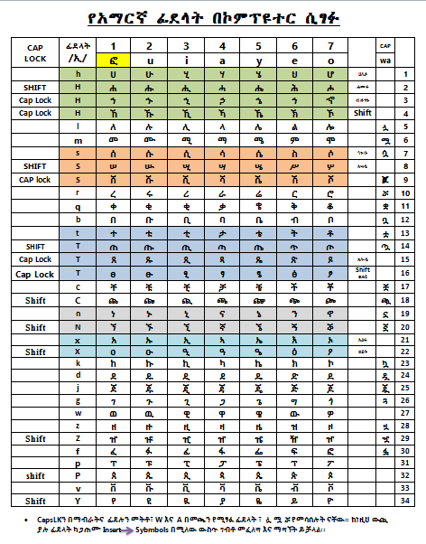

C . Report writing Mechanism

- Name and placement of parts and Opening page

- Main heading – centered and lines are double-spaced.
- Title – in all capitals, is the main line
- Subtitle – (if used) – tells more about the purpose of content of the report.
- By-Line – name of the author – tells who prepared the report.
- Text (Body) – a triple space below the main heading. The text is usually typed in double-spacing (i.e. to provide room for making corrections).

The basic assumption in spacing reports is if the report is to be read critically, as by an author or teacher, it should be typed with double-spacing. Therefore, room for making corrections is provided; but if it is final and only for reading, the report may be 1.5 line-spaced.

- Minor Headings

- Major subheading, centered, in capital and small letter combinations, underscored, proceeded by 2 blank lines and followed by one.
- Minor subheadings (side headings), at left margin all caps, preceded by 2 blank lines and followed by one blank line.
- Balance line, used only on 1-page reports that seem too high on the page. This may be date, report number, reference source, course name, etc. at the left margin to balance the placement of the report.
- Top Margin: leave a 2-inch (12-line) top margin by starting on line 13.
- Side Margin: for every short reports (200 or fewer words in the body), use a 6-inch line.
- Bottom Margin: seek a bottom margin of 2 inches for both very short and short reports. Short ones can have bottom margins as narrow as 1 ½ inches.

- Multipage Reports
The first page of a multi-page report is just formatted like a one-page report. Do not type a page number on the first page. To format continuation pages:
- Insert page number using a footer
- Quotations: quotations that fit within 3 lines should be run into the text and enclosed in quotation marks.
- Longer Quotations are displayed in single spacing with/without quotation marks(permissible but not required) and are indented 5 spaces from both margins (left and right margins). Double-space before and after the long quotation.

- Paragraph Heading: are indented and underscored. Do not underscore a period after a paragraph.
- Separation Line: is a line that separates the text from the footnote and it is 1- or 2-inches long, a single-spaced below the text.
- Foot Notes: some writers use footnotes instead of endnotes. As you type the last word of the footnote click References and click AB insert footnote and you will get short line that separate the report from footnote and the number at end of your current page that indicate footnote number and then write footnote to show your reference. After completion of your footnote return to your report and proceed your job.

When writing a report, the report may be unbound, top bound or left-bound report. See the table below, the margins setting of each report.

Report margins setting
Margins | Unbound Report | Bound Report
Top
Front | 2”* | 2 ½ “
Other Pages | 1” | 1 ½ “ | Begin on the 7th line
Left | 1 ¼ “ | 1 ½ “
Right | 1 ¼ “ | 1”
Bottom | 1” – 1 ½ “ | 1” – 1 ½”
2”* - 2 inches

- See the sample Report writing mechanism below in the next page.

STRETCHING A SHORT MANUSCRIPT

A Report for Typing I

By Richard Hall

There are three ways to stretch short reports. You may use double-spacing, use side headings, and use a balance line near the bottom of the paper.

DOUBLE-SPACING

Reports may be single-spaced, but they stretch twice as far when they are double-spaced.

SIDEHEADINGS

Side Headings, which are preceded by two blank lines and followed by one, take four lines.

BALANCE LINE

A balance line is a date, a report number, or some other some other point of information that is typed below a report. Such a line is intended to help balance a report that looks too high on the page.

November 19, 2017

MAILINGS
Mail Merges – it is a mechanism of duplicating a document in many copies for dispatching same document to different recipients only with changing/inserting the names and addresses of the individuals/organizations.
There are many ways of making mail merges. Here only one built-in with step will be discussed.
Open your document or type your document and then Mailings start Mail Merge and select Step by Step Mail Merge Wizard... at this time you will get a panel at the right corner and then follow the steps shown below carefully following the instructions of each step by clicking Next step 1 of 6 up to the completion of all steps. Finally you will get your document duplicated. Even you will return back to make some adjustments by clicking Previous.
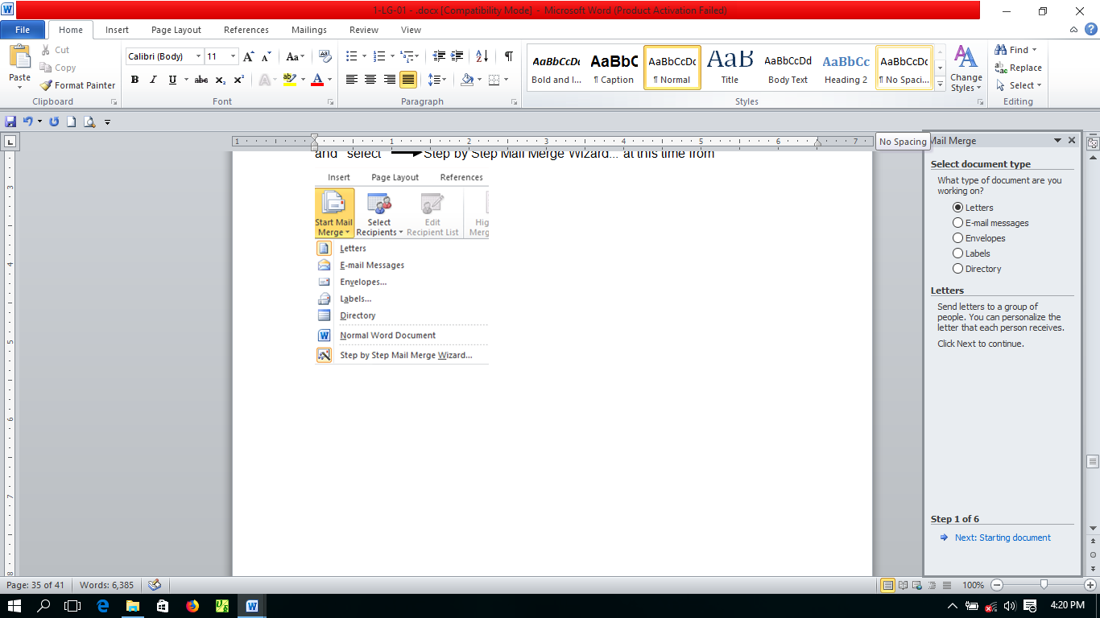
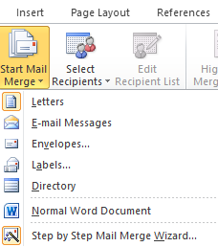
Step 1 – selecting type of document from the given alternatives letters (e-mail message, etc.)
Step 2 – click Next and then select starting document. Here there are three alternatives. Among them select the default Use the current document if your document is the current one. Otherwise click start from existing document and open it from the place you saved it.
Step 3 – select recipients – (Use an existing list or Type a new list) when you select the last one Type a new document. At this time, from coming option click Create … in the coming dialog box(New Address List) insert recipients names and addresses of each recipient using New Entry for each new recipient. When you completed inserting all names and addresses of recipients, click OK. And then Save Address List comes in the File Name box write File Name for your address list. And then click. Ok and Next. Step 4 will come.
Step 4 – insert Address Block and click OK, and then Greeting Line and click OK by selecting from the options in their appropriate letter placement area.
Step 5 – gives you see how the name and address of the recipients appear on your letter. You can see all recipients one by one.
Step 6 – click Finish and Merge. From coming options select the one that satisfy your requirement.

1.3 Identifying organizational and task requirements
Organizational and Task Requirements
When preparing documents for a particular purpose, document layout and design should align with organizational and task requirements. Organization requires the document to contain the necessary features, organization’s identification logo/emblem/, its name, date, document title, file name, etc. based on the task requirements. These Organizational requirements may include:
- organization’s colour scheme
- organization’s logo
- consistent corporate image
- content restrictions
- established guidelines and procedures for document production
- house styles
- observing copyright legislation
- organisation name, time, date, document title, filename etc. in header/footer
- templates
- A logo (abbreviation of logotype) is a graphic mark, emblem, or symbol used to aid and promote public identification and recognition. It may be of an abstract or figurative design or include the text of the name it represents as in a word mark.
Figure 1: Log of Ministry of Labor and Skills and Red Cross and Red Crescent
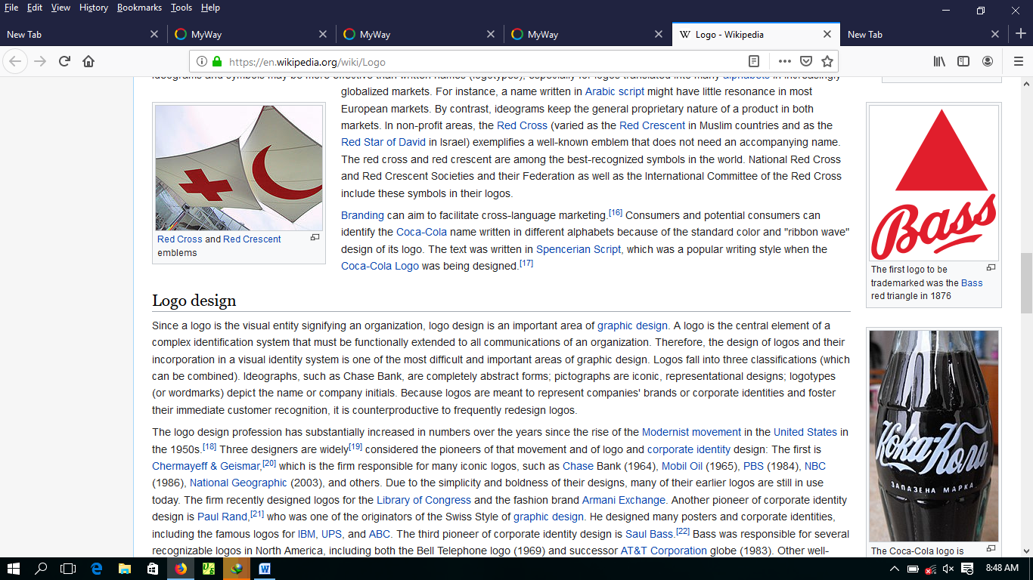


- User manuals and user guides are book-like documents with contents which describe the features and operation of the machine.
e.g Computer software manuals and guides
Note: Observing organization requirements while preparing business document layout and design is essential.

Part One: Self-Check Questions:
- Explain safe work practices and safe work procedures.
- Elaborate these words listed below
- ergonomic,
- work organization requirements,
- energy conservation and
- resource conservation
- What are the techniques which help to make energy conservation?
- What is a business letter? What are its main and supplementary parts?
- What are the styles of business letter?
- Explain memorandum and its styles
- መሰረታዊ እና ተጨማሪ የስራ ደብዳቤ ክፍሎችን እና የደብዳቤ ዓይነቶችን አብራሩ
- Practically show the steps of preparing Mail Merging
- Explain organizational and task requirements
- Demonstrate the use of Logo, Motto and Manuals & User Guides

Advice to the trainees
Dear Trainees! First please make extensive practice on the keyboard using keyboard manuals and Mavis keyboard software. Then make daily proper practice. Because practice makes you perfect and boosts your speed and accuracy. And then:
- Exercises on business letters, memos, report writings and its techniques.
- የአማርኛ ደብዳቤ ክፍሎችና ዓይነቶች ላይ በቂ ልምምድ አድርጉ

Part Two: Multiple choices
      - Safe work practices in the business organization refers to:
        - People b. equipment c. process d. all
      - ______ are a series of outlining specific steps that guide a worker through tasks.
        - Safe work practices b. safe work procedures c. work place organization d. a & b
      - _____ is the study of efficiency comfort and safety of people in the work environment.
        - Ergonomy b. safe job procedures c. safe work practice d. a & b
      - Which of the following includes under ergonomic requirement?
        - Avoiding radiation b. keyboard and mouth position c. a & b d. customer profile
      - Which of the following benefits of energy conservation?
        - Reduces pollution b. destroying environment c. saves the cost d. a & b

Part Three: Matching
A B
      - Safe work practice a. reference
      - Alternative Power b. written methods
      - Maintaining regulatory c. energy conservation
      - Supplementary parts of a letter d. compliance
      - Minutes, report & memos e. document
f. letter

Operation sheet-1

Operation Title: types of business letter
Instruction: prepare the three popular types of business letter in English & Amharic
Purpose: to make familiar with the types of business letter
Required tools and equipment: computer, unarranged business letter
Precautions: start from full blacked, blocked, semi blocked letter keep the sequence of parts order.
Procedures:
Step 1. Prepare header and footer
Step 2. Write the date and end with writer’s initials
Step 3. Check correct arrangements of each letter
Step 4. Save your letter with you full name on the desk top

Quality criteria:
      - Make the necessary formatting
      - Use current date
      - Font style for English letter New Roman, for Amharic Visual Geez
      - Use appropriate line spacing for English and Amharic letters

Unit Two: Produce Business Documents
This learning unit is developed to provide the trainees the necessary information regarding the following content coverage and topics:
  - Format document
  - System features
  - Manuals, user documentation and online help
This unit will also assist you to attain the learning outcomes stated in the cover page. Specifically, upon completion of this learning guide, you will be able to:
- Format document
- Use System features
- Use Manuals, user documentation and online help

Introduction
After completion of typing the document the next step is doing formatting the required parts for more decorating the document and to make the document to be appeared attractive. When you are making formative activities, you may use formatting tools such as font size adjustment, font type changing, justifying the bodies of the document, making bold, underlining texts found necessary, indenting the paragraph, etc.

2.1 Format document
Formatting
Business readers expect documents to be set up in a certain way. Standard formatting is a generally accepted way to set up a document so its appearance follows a convention. Writers use standard formatting so their business documents are consistent in appearance with what the reader expects. Letters, reports, graphics, headings, and other elements are visual cues that make it easy for the reader to locate and understand information.
A visual cue is an element the reader sees and interprets to have a particular meaning. For example, a red octagonal sign is a visual cue to a driver to stop at the intersection.
The appearance of a document is the first impression your writing makes on the reader. That first glance at your message should be an open invitation to the receiver. Format refers to how written information is presented on the printed page or screen. Another term for format is layout. The arrangement of text and graphics in relation to the white space on the page determines the visual appeal to the reader.
White space includes margins, space between paragraphs, and any other blank space on the page. Without properly formatted elements, the reader can easily become lost or distracted. If your message lacks visual appeal, it may be discarded even before it is read.
Readability is a measure of how easy it is for the reader to understand your writing and locate information within a document. Readability is achieved through a combination of clear writing and effective formatting. Together, these elements help obtain the response you need from the reader.
Writing is most readable when it is presented in small segments with adequate white space. Information presented in long paragraphs is uncomfortable for the reader and physically tiring to read, since the eyes are given few breaks. Putting all of these points together, you can use the following techniques to enhance readability.

  - Introduce the message with a short paragraph.
  - Use headings.
  - Use standard fonts and sizes.
  - Vary font style.
  - Use parallel structure.
  - Use formatting and organizational symbols.
  - Use high quality paper.

A well-formatted document appears open and inviting. The Formatting may include:
- alignment on page – /paragraph/
- columns - /Page Layout – Columns - as per your requirement/
- company logo/letterhead - /Insert – Header /Footer/ - copy logo & paste and adjust the size/
- enhancements to format - borders, patterns and colours - /Page Layout /
- enhancements to text - colour, size, orientation - /Page Layout /
- headers/footers - /insert/
- margins - /Page Layout/
- page orientation - /Page Layout/

Software functions may include:

- Default settings - settings which appear when opening an application.
- document protection – password – Home/File – Save As – Tools – General
Options – write your password.
- grammar check
- headers/footers - insert – Header/Footer
- indent - Page Layout – indent
- line spacing
- page numbers – insert – page number – select the options and click.
- page set up - Page Layout – margins/orientation/size.
- paragraph formatting
- spell check
- tabs
- text formatting

Formatting and Organizational Symbols
Formatting makes information more accessible to the reader by creating and labeling sections (headings), highlighting key words or ideas (bold, italics, or lists), and making a good impression (professional look and feel, appropriate font choice for the document type). Highlight important information or set off related items by using bulleted lists, numbered lists, asterisks, underlining, or boldface type. Numbered lists should be used only when the order of the items is important, such as sequential steps. If the order of the items is not important, use a bulleted list. Always treat lists consistently throughout a document.
You can use the formatting options to format documents available on the Home tab to format text.
For example, to change the font: Select some text and then tap the font name box. Choose a font from the drop-down list. Change the font size: Select some text, tap the font size box, and then choose a size from the drop-down list.
Organizational Symbols serve two distinct social-cognitive functions: communication and representation

2.2 System features
Features are the “tools” you use within a system to complete a set of tasks or actions. Knowing all the features and their functions of application software that we are using in general is very essential for effective completion of the given task. Functionality is how those features actually work to provide you with a desired outcome.
If you want to see your document view in different ways, click view and click the options found at the left side on top of your document, or click the options found at the right side on the bottom of your document. These options refer to the screen display options and control. Some of the Screen display options and controls may include:
- Minimise/Maximise/Restore Down/Close
- layout view
- normal view Menu bar - View or click at right hand side on the bottom
- Page view of your document.
- print preview
- Ruler - View – click in the box if there is not thick mark in the box /√/.
- Toolbars (Address, Links, Desktop)
- Zoom percentage - you can determine your document size view on the screen using zoo dialogue box shown below. View Zoom
- Setting Time/date

2.2.1 Screen display options and controls
Most of the advanced display settings from previous versions of Windows are now available on the Display settings page.
- Select Start > Settings > System > Display.
- If you want to change the size of your text and apps, choose an option from the drop-down menu under Scale and layout.
- To change your screen resolution, use the drop-down menu under Display resolution. Note: You should use the Recommended resolution. If you change the resolution, content might appear blurry or pixelated.
- To adjust your color calibration, search "calibrate display color" in the Settings search box and follow the directions.
- If you don't see a setting you're looking for, try searching for it in the search box on the taskbar.
The Control Panel is a component of Microsoft Windows that provides the ability to view and change system settings. It consists of a set of applets that include adding or removing hardware and software, controlling user accounts, changing accessibility options, and accessing networking settings

On-screen displays usually comprise a menu that is accessible by pressing a button on the monitor, mobile device, TV remote control or another type of input device. Once the menu is open, users can use the up and down arrows or other navigation keys to scroll through the options and make their selection.

2.3 Manuals, user documentation and online help
You may encounter problems while you are preparing your documents. To solve this type of problem you can refer to the manuals pertaining to your document or search for user documentations or online help using internet for more information access.
A user manual or user guide is the most well-known type of user documentation. It contains the fullest information on the product. It typically includes:
- a title page (often with copyright information),
- a preface that describes how to navigate the guide,
- table of contents,
- a purpose overview,
- an audience section that defines the probable users of the product (and, essentially, readers of the manual),
- a scope section (often serves as a disclaimer),
- an overview of the main features and a guide on how to use them,
- a troubleshooting section,
- a FAQ (Frequently Asked Questions) section,
- contact details and where to look for more information or assistance, and
- a glossary and/or index.
A user manual is a single source of truth about your software so make sure it’s as complete and detailed as possible. Note that it’s created not only for new users but also for those who want to know more about the features.
So why is documentation so important for users? After reading the product’s user manual, they can learn

- the features of your software,
- how to use your product,
- what NOT to do to avoid problems,
- how to address issues that arise in spite of all precautions, as well as
- the useful tricks, shortcuts, and tips.
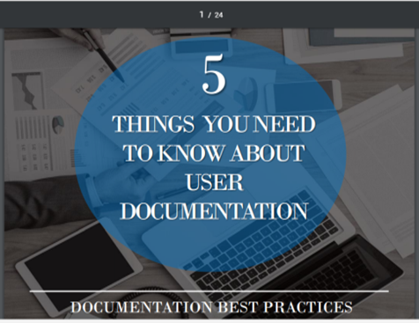
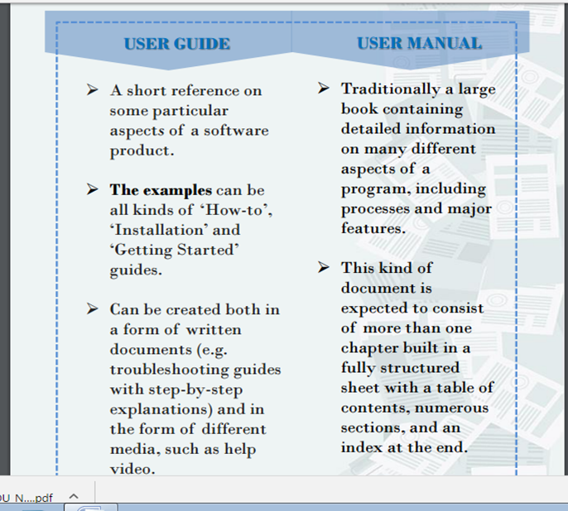

Documentation Best Practices - With this in mind, technical writers prefer guides to manuals. Indeed, such big companies as Microsoft, Apple, IBM tend to name their pieces of documentation “user guides”, or sometimes “user’s guides” regardless of the fact that these documents have all the characteristics of manuals.

Online Help
Online help is the help file accessible for software applications or operating systems. It provides information relating to general operation of the program as well as troubleshooting. Online help can help customers resolve their issues without having to contact a customer service representative, saving time and effort. In other words, it is a topic-oriented, procedural or reference information delivered through computer software. It is a form of user assistance. The purpose of most online help is to assist in using a software application, web application or operating system.
The ways computer programs deliver online help includes: Web Help, Context Sensitive Help, Microsoft WinHelp (HLP), HTML Help (CHM), Microsoft Help 2 (HXS), Microsoft Help Viewer 1.0 (MSHC), and many others.
Online help can be a wealth of information and is provided for free with the concerned product. Online help is usually provided in a table form with easy navigation and search options. It is created mostly with the help of authoring tools and is delivered in different formats based on the product, like hypertext markup language or Adobe PDF.
Common deficiencies reported for online help are the absence of an index or glossary, unorganized topics, inconsistency in formatting, grammatical errors, difficult navigation and lack of complementary information in addition to the instructions or data.
Characteristics of good online help include:
- Providing good, solid navigation
- Providing user assistance with easy and understandable examples
- Engaging users by providing supplementary information
- Providing and highlighting tips and tricks related to the information
- Ensuring consistency in information provided to users
- Making searches related to information user friendly
With online help, the need for live customer support has decreased, which has led to decreasing the cost and manpower involved in issue resolution. Unlike other forms of customer troubleshooting like live chat and calls, online help can provide additional information to the customer. This can in turn educate them more on the product and its services, making users less likely to need support in the future.

Self-check - Questions
Part One: Directions - Answer all the questions listed below.
- List the advantages of Formatting documents.
- Explain screen and control features
- Describe user manuals and guides
- What Does Online Help Mean?

Part Two: choose the best answer
      - Which of the following is a software function?
        - Header/footer b. text formatting c. a & b d. handwritten
      - Which of the following categorized under formatting?
        - Page orientation b. alignment c. a & b d. default setting
      - Which of the following is characteristic of a good online help?
        - Making searches relating to the information c. ensure consistency of information
        - Taking hand related information d. a & b
      - _____ is a component of Microsoft windows that provide the ability to view and system.
        - My computer b. document c. control panel d. cycle bin
      - Document are prepared considering the following:
        - Audience b. the purpose c. design d. all

Part Three: Matching
A B
1. Set up the document a. education
2. ____ is the measure of how easy to the reader b. zoom
3. Determining the document view c. proof read
4. Energy conservation technique d. standard formatting
5. Checking spelling & grammar e. readability
f. outlook

Operation sheet-1

Operation Title:
Instruction:
Purpose:
Required tools and equipment:
Precautions:
Procedures:
Step 1.
Step 2.
Step 3.

Quality criteria:

Unit Three: Finalize documents
This learning unit is developed to provide the trainees the necessary information regarding the following content coverage and topics:
  - Document preview, check, adjust and print
  - Prepare documents within designated time lines
  - Save document.

This unit will also assist you to attain the learning outcomes stated in the cover page. Specifically, upon completion of this learning guide, you will be able to:
  - Document preview, check, adjust and print
  - Prepare documents within designated time lines
  - Save document.

Introduction
In order to finalize document process run a critical eye over the page elements, such as margins, justification, text and illustrations. If the document includes graphs or charts, make sure they don't overwhelm the text and are formatted properly. Including enough white space in a document is important for readability.
While you are making proofreading, you are required to check grammar and spelling errors before printing the document carefully. Finally, you are required to save your documents. All these activities are properly done in this portion of the training.

3.1 Document preview, check, adjust and print
Before printing a document, edit or proofread carefully. This may refer to previewing, checking and adjusting the documents properly. Checking may include::
- accuracy of information
- consistency of layout
- ensuring instructions with regard to content and format have been followed
- grammar
- proofreading
- spelling, electronically and manually
Use High-Quality Paper for print
When publishing letters for hardcopy distribution, make sure you use high-quality paper. This will help the presentation of your information look professional. Photocopier paper may not be the best quality for a business letter. It is a good idea to keep a supply of higher-grade paper to use for important correspondence. After completing the necessary checking and corrections, print the document and submit for appropriate person to be signed and sealed. Printing may include:
- basic print settings
- multiple copies
- odd or even pages
- print preview
- printer setup
- specified pages
- whole document

These tasks can be performed by using print dialog box:
Home/File print and then make adjustments as per your requirement.

3.2 Prepare documents within designated time lines
Document preparation is completed within the designated time line. This time line may be the established time line by relevant person or the time line agreed with customers based on the requirements, or the time line agreed with person requiring the documents, etc. Designated time lines may include:
- organizational time line e.g. deadline requirements
- time line agreed with internal/external client
- time line agreed with supervisor/person requiring document/s/

3.3 Save document
Documents prepared may need to be saved for further reference or later use. Naming and storing documents may include:
- appropriate file type
- authorised access – restrict access of your document for an unauthorized person by using password
- file names according to organizational procedure e.g. numbers rather than names
- file names which are easily identifiable in relation to the content
- File/directory names which identify the operator, author, section, date, etc.
- filing locations
- organizational policy for backing up files
- organizational policy for filing hard copies of documents
- security
- storage in folders/sub-folders
- storage on hard/floppy disk drives, CD-ROM, tape back-up

Save a document may be accomplished through using the following steps: - for new document -
Home/File Save /Save As select the File/Directory Name from the coming Save As dialog box /Desktop or My Documents or other option/ and then click New Folder Write appropriate folder name in File name below write your document name finally click Save.

Part One: Self-check questions:
      - What is the advantage of name and saving a document?
      - Write the steps used to save a document on Desktop.
      - Demonstrate how to print document.
      - When finalizing your document what things do you check before printing?

Part Two: Choose the best answer
            - Which of the following is used to make copy multiple?
              - Report b. memo c. mail merge d. flyer
            - Which of the following is written within the organization from one department to another?
              - Letter b. report c. memo
            - The reference Subject in a memo indicates:
              - Shows that the number of document enclosed c. summarizes the idea of paragraph
              - Indicate the person who act on the document d. all
            - The difference between blocked and semi blocked letter lies on :
              - Only on the indention of the paragraph c. indicates the margin difference
              - a & c d. no difference

Part Three: Matching
A B
1. Checking document a. encl. 2
2. Printing b. accuracy of information
3. File Save As select c. save a document
4. 2 by 2 form d. odd or even pages
5. Enclosure e. types of memo

LAP Test | Practical Demonstration

Name: __________________________ Date: ____________
Time Started: ___________________ Time Started: ________________
Date started: ____________________ Dated finished: _______________
Instruction I: Trainees are required to complete the given practical project tasks 1- 4.

Project Work
- PROJECT EXERCISES

General Directions of the Project work: These projects contain Four parts:
- project one contains three letter writing tasks
- project two contains the Memorandum task
- Project three about Word Processing task
- The last Project four contains Amharic letter writing task

You are requested to perform correctly as you are instructed by your instructor. Complete and submit the projects within the given time line by your instructor.
Project One

It contains practical drills of Letter Writing, Memorandum and Report writing activities. For all letters use your college address as a header and footer.

Task I: Letter writing

Direction: Write in Block Letter Style, use the current date. Body approximately 135 words.

Mrs. Morgan McDonald/Adwa Victory Street/ Arat Kilo Kifle Ketema/Abay Kebel House No. 75134/ Dear McDonald:
It has been several years since we have had an opportunity to serve you at the Ethiopia Hotel, one of Addis ABeba’s best-known Hotels; but we have not forgotten you. Nothing would please us more than to have you spend your vacation with us. (P) The Ethiopia Hotel has for many years enjoyed a world-wide famous reputation for providing the best in facilities, food, and service. The same experienced staff that took care of your needs when you were last with us is ready to serve you again. (P) Won’t you plan to visit us this summer? A form is enclosed for your convenience in making your reservation. Cordially yours, Gizachew Meseret, General Manager.

Task II – Letter Writing

Direction: Prepare semi-block letter style and use the Current Date.
Body approximately 65 words.

Mr. James L. Parker, 6322 Sunset, Las Vegas, Nevada

Dear Jim: I would like to apologize for the late reply to your last letter. I inadvertently misplaced the letter and caused this unnecessary delay.
We appreciate your writing to us, but we do not write that type of insurance; and, therefore, we cannot be of assistance to your agency.
I assume all is well with you and hope our paths will cross again in the near future. Sincerely, Robert J. Newberg

Task III: Letter Writing

Direction: Produce Extreme Block/Full Block/ letter style. 160 Words.

Today’s date/Mr. Rob Mowrey, Director/ Southern Region Inc. / 7333 West 14 Avenue/ Atlanta, Georgia 20303/ Dear Mr. Mowrey:
Before Mr. Alison left on his trip to the West Coast, we had a long talk about Look magazine; so I can tell you what his decision has been. ¶ The recent increases in rates in the magazines have caught us with our budget down, and so we have had to adjust our plans. Mr. Alison felt that we had to eliminate Look or Sunset or else to divide the space between them. He made the latter choice. ¶so, when you receive your next list from us, the one for the final April issues in the schedule, you will find Look listed and Sunset not listed. We are dividing the space. ¶Our staff can clear the decks for a meeting at two o’clock on the afternoon of either June 28 and 29. Which afternoon do you and your staff prefer?
Very sincerely yours, / Dennis Graham McHugh / Assistant Sales Manager/ Enclosure

Project Two: Interoffice Memorandum
Direction: Write the given interoffice memorandum in the:
a) 4 by 0 b) 3 by 1 c) 2 by 2 styles

TO: All Communication Processor FROM: Bilen Derese, Director DATE: March 17, 2017 SUBJECT: Company Correspondence
Correspondence within a company/organization is frequently typed on interoffice forms, either half or full sheets, depending on the length of the message. The following points describe the features of an Interoffice Memo:
- Spacing twice after printed headings to set the left margin stop for typing the heading items and the body. Set the right margin stop an equal distance from the right edge. These margin adjustments will usually give you side margins one inch.
- Full addresses, the Salutation, the Complimentary Close, and the Signature are omitted.
- Personal titles are usually omitted from the memo heading. They are included on the envelope, however.
- TS between the Headings and Message. SS and Block the Paragraphs, but DS between them.
- Reference initials, Enclosure notation, and Carbon Copy notation are included.

Special colored envelopes are usually used for interoffice memos. Type the addressee’s name, personal title, and business title or name of department for the address. Type COMPANY MAIL (in all Capitals) in the postage location.
ee
CC: Addis Mulugeta, Assistant to the President

Project Three: Produce Word Processing Document
Functions of Managers
There are four main functions that fall under the purview of managers. The first is the planning function. This function includes defining an organization’s goals, developing a strategy for achieving those goals, and coordinating a comprehensive set of plans to implement the strategy. The next function is organizing. This function sets forth what tasks are to be done, who is to do them, how the tasks are to be grouped, who reports to whom, and where decisions are made. The third function is leading. This function looks at the manager’s job to direct and coordinate the people within their area of influence. The final function is controlling. The controlling process ensures that things are going as they should by monitoring performance.
Instructions: write the given paragraph and do the activities based on the instructions that follow it.
- Copy the paragraph and paste twice below the original one.
- Insert a picture at the center behind the text and indent both sides by .5 for paragraph two
- Underline paragraph three
- Font 12 and title 16, font type Times New Roman
- Drop Cap three Lines and insert line between for the first paragraph.

Project Four: Amharic Letter writing
- Amharic Letter writing /የአማርኛ ደብዳቤ አፃፃፍ ተግባር
የተሰጠውን ደብዳቤ በከፊል ግጥም የአጻጻፍ ስልት ለፊርማ ዝግጁ በሆነ መልክ ይጻፍ
የደብዳቤው ፀሐፊ የኢትዮጵያ ልማት ባንክ ነው፡፡ አድራሻው የኢትዮጵያ ልማት ባንክ አዋሳ ቅርንጫፍ ስልክ 046 2 209 877 046 2200456 046 2 202 233 ፖስታ ሣ. ቁ 786 ፋክስ 046 2 209 897 ነው፡፡
ደብዳቤው የተፃፈው ለሀዋሳ ሴራሚክ እና ፕላስቲክ ማምረቻ ድርጅት፣ ሀዋሳ ነው፡፡
አ/መ ጥር 14/2010 ዓ/ም በቁጥር መ/25/89 በቅድሚያ በብድር ስለወሰዳችሁት ሁለት ሚሊዮን የኢት/ብር የፃፉትን ደብዳቤው ደርሶን ተመልክተነዋል፡፡ አ/መ በመሠረቱ የተወሰደው ገንዘብ ለምን እንደሆነ ቢታወቅም በትክክል ለምን ለምን እንዳዋላችሁት የሚገልጽ መረጃ እስከ ዛሬ ድረስ ባለመላካችሁ ለሂሳብ መዝገብ አያያዛችን ከማስቸገሩም በላይ ሂሳባችንን በወቅቱ እንዳናወራርድ አድርጎናል፡፡ አ/መ ስለዚህ ይህ ደብዳቤ እንደደረሳችሁ የገዛችሁት ዕቃ ካለ የገዛችሁበትን ደረሰኝ ዋናውን ኮፒ ምን ምን እንደገዛችሁ እና ለምን ስራ እንዳዋላችሁት በዕቃ ግምጃ ቤት ዕቃው ካለም ምን ያህል እንደሆነ በዓይነትና በቁጥር ዝርዝሩን በጥሬ ያለ ገንዘብ ምን ያህል እንደሆነ በመግለጽ በአስቸኳይ እንትጽፉልን እናሳስባለን፡፡ ከሠላምታ ጋር
የብድር ክፍል ዋና ኃላፊ የሆኑት አቶ ገቢሳ ቶሎሳ ፈርመውበታል፡፡

ግልባጭ፣ ለመሃል ክፍለ ከተማ ማህበራት ማደራጃ እና ለሀዋሳ ከተማ ማዘጋጃ ቤት ለማህበራት ዘርፍ አድራሻው ሀዋሳ በሚል ይኑረው፡፡
- ለደብዳቤው ሄደርና ፉተር (Header & Footer)ይኑረው

Reference

      - The definitive Personal Assistant & Secretarial Handbook, A best-practice guide for all secretaries, PAs, office managers and executive assistants, Sue France, 2009. London.

      - Use pdf drive: Business School: Secretarial Studies, The Secretarial Profession(pdf)

      - Gregg Book I & II

      - Amharic type writing practice book prepared by Mehari Haile.

Developers Profile
No | Name | Qualification (Level) | Field of Study | Organization/ Institution | Mobile number | E-mail
1 | Engida Eshete Wolde | MA | BA in AOST & MA in Marketing | Hawassa Tegbareid | 0916136741 | engdaeshete@gmail.com
2 | Birhanu Hailu Becho | BED | OAOT | Nekemte TVET college | 0917854441 | Obsa2013@gmail.com/  berihanuhailu41@gmail.com
3 | Estifanos Worku Tegegn | MBA | Business Admin | Harer Polytechnic C | 0920457778 | Worku.estifanos220@gmail.com
4 | Ephrem Haile | OAOT | OAOT | Tulu Bolo TVETC | 0965554581 | Ephremhaile1081@gmail.com

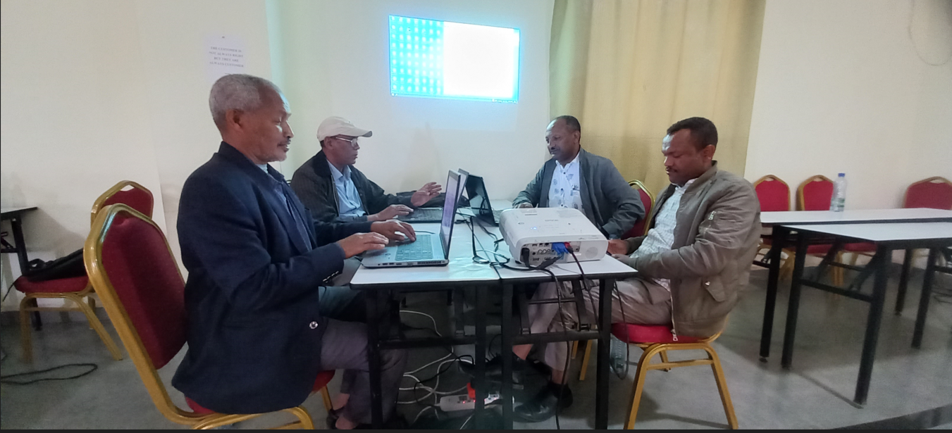

Footnotes

