Secretarial and Office Administration

Level II
Based on March 2022, Curriculum Version I

Module Title: Apply 5S Procedures
Module code: LSA SOA2 09 1222
Nominal duration: 40Hour
Prepared by: Ministry of Labor and Skills

December, 2022
Addis Ababa, Ethiopia

Acknowledgment
Ministry of Labor and Skills wish to extend thanks and appreciation to the many representatives of TVET instructors and respective industry experts who donated their time and expertise to the development of this Teaching, Training and Learning Materials (TTLM).

Table of Content
Contents
Acknowledgment 2
Table of Content 3
Module Instruction 7
Unit One: Prepare for work 8
1.1 Work instructions 9
1.2 Job Specification/or Job description/ 11
1.3 OHS Requirements 11
1.4 Tools and Equipment to implement 5S 12
1.5 Safety equipment and tools 13
1.6 Prepare Kaizen Board (Visual Management Board) 13
Unit Two: Sort Items. 17
2.1 Plan Sorting Activities 19
2.2 Perform Cleaning activities 20
2.3 Identify all items in the workplace 20
2.4 List Necessary and unnecessary items 21
2.5 Use Red tag strategy for unnecessary items 23
2.6. Evaluate unnecessary items 28
2.7. Quantify Necessary items 29
2.8. Report Performance results 29
2.9 Check workplace necessary items regularly 29
Unit Three: Set all items in order. 34
3.1 Plan to Implement Set in order 35
3.2 Perform general cleaning 38
3.3 Decide Location/Layout, storage and indication methods 38
3.4 Use Necessary tools and equipment 39
Unit Four: Perform shine activities. 46
4.1 Plan to Implement shine activities 47
4.2 Necessary tools and equipment 48
4.3 Use appropriate procedures 50
4.4 Conduct Regular Shine activities 51
Unit Five: Standardize 5S 56
5.1 Plan to standardize 5S activities 58
5.2 Tools and techniques to standardize 5S 59
5. 3 Follow Standardize activities Checklists 60
5.4 Standardize workplace 72
5.5 Avoid problems by standardize activities 72
Unit Six: Sustain 5S 77
6.1.Plan to sustain 5S activities. 81
6.2 Implement tools and techniques 83
6.3 Inspect Workplace regularly 88
6.4 Clean up Workplace after completion of job 89
6.5 Follow Checklists 92
6.6 Avoid Problems by sustaining activities. 93

Introduction
The 5S system is a lean manufacturing tool that improves workplace efficiency and eliminates waste. 5S is a system for organizing spaces so work can be performed efficiently, effectively, and safely. This system focuses on putting everything where it belongs and keeping the workplace clean, which makes it easier for people to do their jobs without wasting time or risking injury. There are five steps in the system, each starting with the letter S:
1. Sort | 2. Set In Order | 3. Shine | 4. Standardize | 5. Sustain
 |  |  |  | 
By providing a systematic framework for organization and cleanliness, 5S helps facilities avoid lost productivity from delayed work or unplanned downtime.
As a company holistic approach, 5s implementation in the office activities must fully support shop-floor manufacturing operations to eliminate waste as a means to improve productivity.
When developing a culture of continuous improvement, 5S improvement steps mirrors our attitudes and behavioral patterns during the transformation process.
Although not manufacturing, you can consider the office as a paperwork factory. Like manufacturing, adopting the 5S principles throughout the office and administrative functions increases efficiency.

The Steps of 5S
5S was created in Japan, and the original “S” terms were in Japanese, so English translations for each of the five steps may vary. The basic ideas and the connections between them are easy to understand, though.

Step Name | Japanese term | Explanation
1. Sort | Seiri (tidiness) | Remove unnecessary items from each area
2. Set In Order | Seiton (orderliness) | Organize and identify storage for efficient use
3. Shine | Seiso (cleanliness) | Clean and inspect each area regularly
4. Standardize | Seiketsu (standardization) | Incorporate 5S into standard operating procedures
5. Sustain | Shitsuke (discipline) | Assign responsibility, track progress, and continue the cycle

The Origins of 5S – 5S & Lean Manufacturing
5S began as part of the Toyota Production System (TPS), the manufacturing method begun by leaders at the Toyota Motor Company in the early and mid-20th century. This system, often referred to as Lean manufacturing in the West, aims to increase the value of products or services for customers. This is often accomplished by finding and eliminating waste from production processes. Lean manufacturing involves the use of many tools. By having a systematically organized facility, a business organization increases the likelihood that production will occur exactly as it should.
Benefits of 5S
Over time, the 5S methodology leads to many benefits, including:
- Reduced costs
- Higher quality
- Increased productivity
- Greater employee satisfaction
- A safer work environment
5S involves assessing everything present in a space, removing what's unnecessary, organizing things logically, performing housekeeping tasks, and keeping this cycle going. Organize, clean, repeat.
The above introduction is all about we will discuss topics of 5S. Only the first phase discusses about the work or implementation preparation for 5S procedures in the work area. But the whole discussion revolves around 5S.

Apply 5S
This module covers the units:
- Prepare for work.
- Sort items.
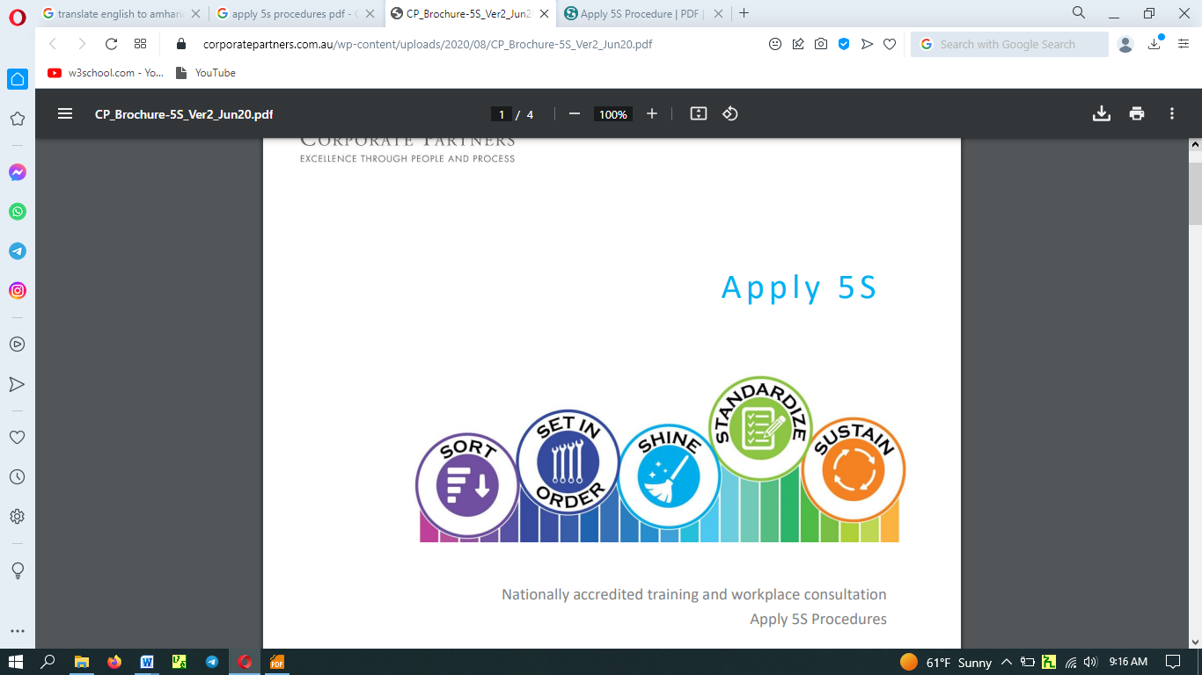
- Set all items in order.
- Shine activities.
- Standardize 5S.
- Sustain 5S.

Learning Objective of the Module
- Determine Prepare for work.
- Identify Sort items.
- Set all items in order.
- Perform shine activities.
- Implements of Standardize 5S.
- Determine Sustain 5S.

Module Instruction
For effective use this modules trainees are expected to follow the following module instruction:
- Read the information written in each unit
- Accomplish the Self-checks at the end of each unit
- Perform Operation Sheets which were provided at the end of units
- Do the “LAP test” giver at the end of each unit and
- Read the identified reference book for Examples and exercise

Unit One: Prepare for work
This unit is to provide you the necessary information regarding the following content coverage and topics:
- Work instructions
- Job Specifications
- OHS requirements
- Tools and equipment to implement 5S.
- Safety equipment and tools
  - Prepare Kaizen Board (Visual Management Board)
This unit will also assist you to attain the learning outcomes stated in the cover page. Specifically, upon completion of this learning guide, you will be able to:
  - Use Work instructions
  - Read and interpret Job Specifications
  - Observe OHS requirements
  - Prepare and use Tools and equipment to implement 5S.
  - Check Safety equipment and tools
  - Prepare and use Kaizen Board (Visual Management Board)
You can start implementing 5S by providing training to your staff to understand the system. This may be followed up with one-day sessions with each employee or team to ensure they are on the same page as far as implementation is concerned.

Work instructions
In preparing for implementing the 5S clarity about the system and procedures are essential.
Information about the work
- Describe what workers need to be able to do on the job
- Work functions
- Key activities of each work function
- Performance indicators
- Describe what task to be done or work roles in a certain occupation
Work instruction is a description of the specific tasks and activities within an organization. A work instruction in a business will generally outline all of the different jobs needed for the operation of the firm in great detail and is a key element to running a business smoothly.
In other words it is a document containing detailed instructions that specify exactly what steps to follow to carry out an activity. It contains much more detail than a procedure and is only created if very detailed instructions are needed. For example, describing precisely how a Request for Change record is created in the Change Management software support tool
Procedures vs. Work Instructions
Many people confuse “procedures” with “work instructions”. In fact, most people write work instructions and call them procedures. Knowing the differences of procedures vs work instructions can help you understand the documentation process much better and, therefore, procedure documentation.
Procedures describe a process, while a work instruction describes how to perform the conversion itself. Process descriptions include details about the inputs, what conversion takes place (of inputs into outputs), the outputs, and the feedback necessary to ensure consistent results. The PDCA process approach (Plan, Do, Check, Act) is used to capture the relevant information.
- Questions that need to be answered in a procedure include:
- Where do the inputs come from (suppliers)?
- Where do the outputs go (customers)?
- Who performs what action when (responsibilities)?
- How do you know when you have done it right (effectiveness criteria)?
- What feedback should be captured (metrics)?
- How do we communicate results (charts, graphs and reports)?
Job Requirements
A Job can be defined as:
  - A piece of work, especially a specific task done as part of the routine of one's occupation or for an agreed price.
  - A post of employment; full-time or part-time position
  - Anything a person is expected or obliged to do; duty; responsibility
  - An affair, matter, occurrence, or state of affairs.
  - The material, project, assignment, etc., being worked upon.
  - The process or requirements, details, etc., of working.
  - The execution or performance of a task.
The requirements for a job vary according to the nature of the job itself. However, a certain work ethic must be cultivated to succeed in any job and this is fundamental to an individual’s sense of himself as a worker, as part of production relations and a fundamental economic being. The basic requirements for a job remain the same no matter what the job is, where it is located or what professional and educational qualifications are required for it. These are as follows:
Discipline: Nothing is possible without discipline. Any job requires a fundamental core of discipline from the worker or the employee and this is a quality which is independent of age, post, stature, job and so on. Discipline is absolutely indispensable and provides the impetus for work that can be strenuous, repetitive, boring and even unsatisfactory at times.
Enthusiasm: Enthusiasm for work is also a pre-requisite for any job. An innate love for the job, which in modern parlance is known as job satisfaction, is a core requirement for any job. The drive to succeed, to innovate, to do well and to make one’s profession into one’s livelihood is a critical drive which needs to be present in the employee or cultivated as soon as possible. No job, however perfectly carried out, can evoke the feeling of satisfaction of a job well done without the instinct for success.
Qualifications: This is a more material, tactile need for a job which can be conveyed through degrees and certificates. However education is not limited to what is taught in colleges or vocational training courses. It is the burning desire to learn more, to reach the depths of knowledge about a particular field of interest, to complete the job and learn from it that marks the true enthusiast and the truly learned.
Soft Skills: Soft skills include those skills which ensure that a job is executed well, and the employee can carry himself in the proper manner too. For example, good and smooth communication, computer skills, proficiency in language if needed, presentable appearance, the ability to manage crises are all soft skills which are fundamentally important in any job and which must be cultivated consciously.
Thus, the requirements of a job, though specific to it, cover also a general spectrum. These make for better employees and better individuals.

1.2 Job Specification/or Job description/
A statement of employee/workers characteristics and qualifications required for satisfactory performance of defined duties and tasks comprising a specific job or function. In other words, a job specification is an official document which describes the duties, required knowledge, skills and abilities, and minimum qualifications of stated jobs. Components of job specification are: Educational qualification, experience, skills and knowledge, characteristics, and personality traits.

1.3 OHS Requirements
OHS requirements are legislation/regulations/codes of practice and enterprise safety policies and procedures. This may include protective clothing and equipment, use of tooling and equipment, workplace environment and safety, handling of material, use of firefighting equipment, enterprise first aid, hazard control and hazardous materials and substances.
Personal protective equipment include those prescribed under legislation/regulations/codes of practice and workplace policies and practices. Safe operating procedures include the conduct of operational risk assessment and treatments associated with workplace organization. Emergency procedures include emergency shutdown and stopping of equipment, extinguishing fires, enterprise first aid requirements and site evacuation.
Occupational safety and health (OSH) also commonly referred to as occupational health and safety (OHS) or workplace health and safety (WHS) is an area concerned with the safety, health and welfare of people engaged in work or employment.
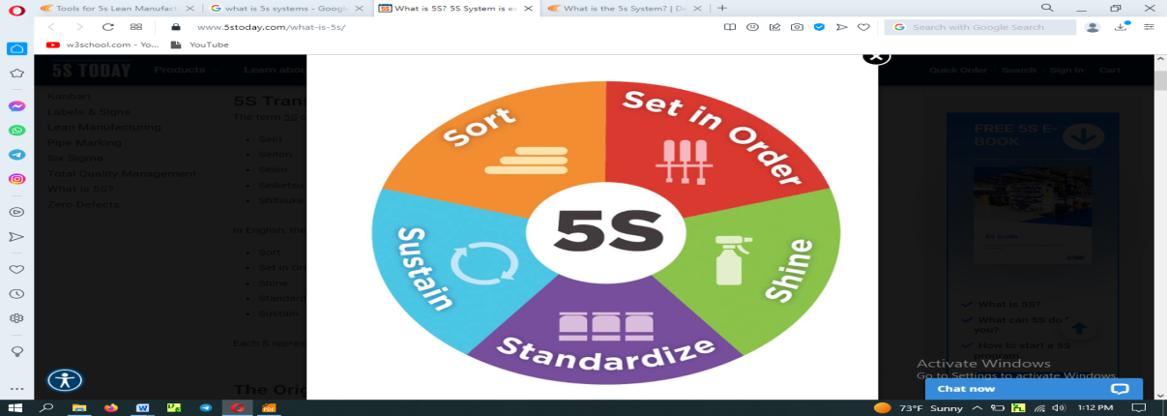
1.4 Tools and Equipment to implement 5S
The 5S System is a lean manufacturing tool that helps to clean and organize the workplace, as well as improve how things are done through the system. This can be accomplished with the five following steps:
- Sort: Differentiating the necessary and the unnecessary items in the workplace and taking action on unnecessary items.
- Set in Order: Organize each area in the workplace based on how work is done.
- Shine: Clean your workplace, tools, and equipment to restore them to their original condition.
- Standardize: Improve how work is done by creating procedures that ensure work is done consistently and efficiently.
- Sustain: Make 5S part of your daily routine by repeating each step on a daily basis.
Tools and materials used to implement Sort activity
Tools and materials are required to implement sort, set in order and shine activities in work stations. The following are some tools and materials used to implement the first pillar of 5S-Sort.

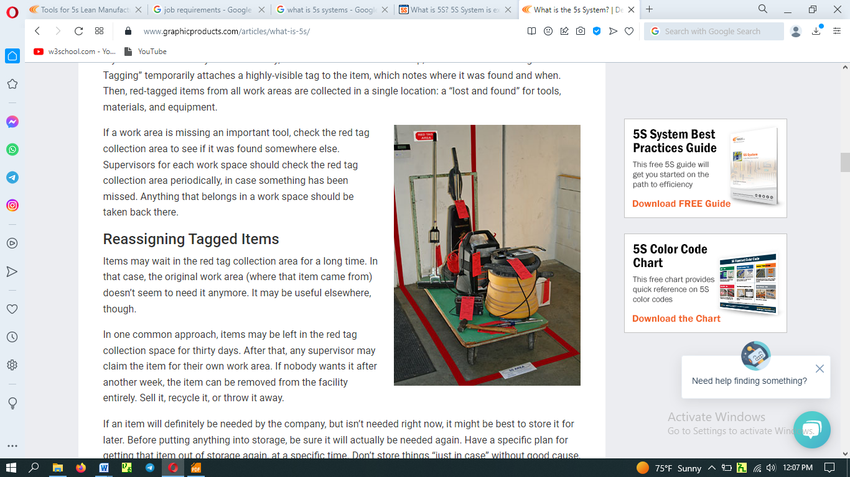
- red tags
- hook
- shelves
- sponge
- sticker
- nails
- chip wood
- broom
- pencil
- shadow board/ tools board

- formats (for recording necessary and unnecessary items, plans etc…)

1.5 Safety equipment and tools
Safety equipment and tools differ from occupation to occupation. It is advisable to choose appropriate safety equipment and tools that are necessary for our job assigned. In general to mention some Personal Protective Equipment (PPE) that should be on your essential list for a safe industrial workplace [checklist] are as follow:
- Leggings, Foot Guards, and Safety Shoes

- Hard Hats
- Earplugs and Earmuffs
- Gloves
- Eye Protection
- Surgical Face Masks
- Respirators
- Face Shields

1.6 Prepare Kaizen Board (Visual Management Board)
General Rules
- The goal of the Kaizen board is to give every employee opportunity to have an impact on the company’s performance now and in the future. Each employee’s responsibility is to look at how to make the work easier, better, faster and cheaper.
- Each Team has its own Kaizen board to track the implementation of Kaizen ideas and define the colour of the Kaizen Card. The target is 3 Kaizens submitted per month per team – 3 Kaizen cards submitted every month on the Kaizen board.
- All Kaizen implemented in each month will be collected on the last day of the month and the Kaizen of the month will be selected by management. The winning team will be recognized.
- All Kaizen implemented will be moved to the Kaizen Wall of Fame and allocated to each value of the company.
- Kaizen Cards should be used for problems/ideas/wastes to be reduced that are easy to implement and in the control of the team. Even small improvements like 2 minutes time savings can have a big impact on the company’s performance.
- Kaizen Cards are not dedicated to solving problems related to many departments involved, this type of problem should be marked on the whiteboard in the problem-solving section.
- All completed Kaizens will be moved to Kaizen Wall of fame and allocated to the company Value that the improvement is connected the most.
- Kaizen is not about spending more money: we have the current resource and we find a way how to use them more efficiently

A Kaizen board is a visual tool that helps teams and organizations manage their continuous improvement efforts. The Kaizen board uses four distinct principles known as the “four corners” to achieve this goal. They are as follows:

- Visualize Your Ideas.
- Create a “To Do” List.
- Make the Improvements.
- Analyze the Results.

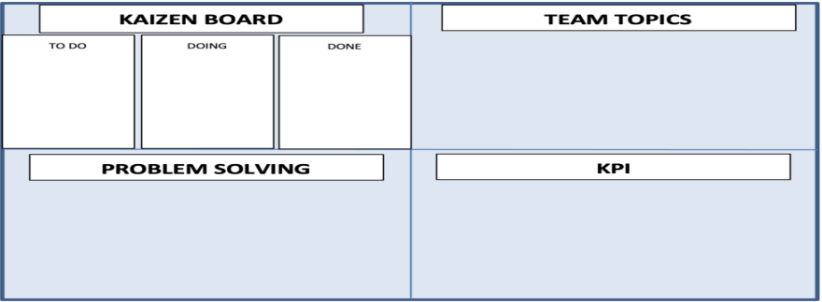

Kaizen board is part of the visual management

Each principle serves a particular purpose in improving a company’s daily tasks/operations.

Visualize Your Ideas - The first principle is to brainstorm and visualise ideas for continuous improvement. Write down all the problems and issues facing your organisation on the first corner of the Kaizen board, such as old equipment, high absenteeism, poor time efficiency, etc. Then you will have a clear illustration of what needs to be improved.

Create a “To Do” List - Use the second corner of the Kaizen board to create a list of tasks for remedying the problems outlined in the first corner. These could include replacing old equipment and offering wellness incentives to employees.

Make the Improvements - The third corner outlines the improvements which are actively being made in real-time. Then workers can see the current progress toward the efforts to improve the organization.

Analyze the Results - The fourth corner lists all the improvements made. You can use this list to analyze the results of the improvements and how they have changed the organization for the better.
Self-Check 1

Instructions: I
Directions: Answer all the questions listed below.
- List the requirements of job.
- Describe work instruction in your own words. (5 points)
- Explain the difference between procedure and work instruction? (5 points)
- Define job specification? (3 points)
Part I: Multiple choice
Instruction: choose the best answer
1. How can job define?
a. a piece of work b. full time or part time position
c. a and b c. not the requirement details2
2. ____ is a more material, tactile need for a job which can be conveyed through and certificates
a. soft skills b. qualifications c enthusiasm D hard skill
3. What is the job specification?
a. Official document b. describes duties c a and b c. not required for knowledge
4. ___requirements are legislation of practice for enterprise safety procedures. a. job specification b. OHS c. job description C. a and c. d. job
5. What is the system used to clean the workplace?
a. sort b. standardize c. shine d. 5S

Part III: Marching
Instruction: Match column B with A
A B
1. Remove unneeded item from workplace a. Standardize
2. Organize workplace b. Sort
3. Repeating each step c. set in order
4.clean your workplace d. shine
5.Ensure the work is done e. sustain

Unit Two: Sort Items.
This unit is developed to provide you the necessary information regarding the following content coverage and topics:
  - Plan sorting activities
  - Perform Cleaning activities
  - Identify all items in the workplace.
  - List Necessary and unnecessary items.
  - Use Red tag strategy for unnecessary items.
  - Evaluate unnecessary items
  - Quantify Necessary items.
  - Report Performance results
  - Check workplace necessary items regularly
This unit will also assist you to attain the learning outcomes stated in the cover page. Specifically, upon completion of this learning guide, you will be able to:
- Prepare to Plan implement sorting activities
- Perform Cleaning activities
- Identify all items in the workplace following the appropriate procedures
- List Necessary and unnecessary items using appropriate format
- Use Red tag strategy for unnecessary items.
- Evaluate unnecessary items to place appropriate place
- Quantify Necessary items using appropriate format
- Report Performance results
- Check workplace necessary items regularly
Sort, the first pillar of 5S, means classifying items in the workplace in to two categories – necessary and unnecessary - and removing all the unnecessary items that are not needed for current operations. It corresponds to the just in time (JIT) principle of “only what is needed, only in the amount needed, and only when it is needed.” The workplace is full of unused machines, jigs, dies, rejects, work-in-process, raw materials, supplies, parts, shelves, containers, desks, workbenches, files, carts, racks, pallets and other items.
People tend to hang onto parts, thinking that they may be needed for the next time. They see an inappropriate machine or equipment and think that they will use it somehow. In this way, inventory and equipment tend to accumulate and get in the way of everyday activities. This leads to a massive build of waste in companywide or in the whole workshop. An easy rule is to remove anything that will not be used within the next 30 days. A ceiling on the number of necessary items should be established.
Red-tag holding area can also help to evaluate the need of an item instead of simply getting rid of it. This greatly reduces the risk of disposing of an item that is needed later that will be explained in detail in the next contents.
Benefits of sort activity
Implementing this first pillar creates a work environment in which space, time, money, energy, and other resources can be managed and used most effectively. Sorting can lead to a much safer workplace. By clearing out the items you no longer need, people will have more room to work and things like trip hazards and items falling off shelves will be greatly reduced. Sorting also improves work flow since there is less clutter to deal with and will most definitely increase productivity in both production and office environments.
Problems and annoyances in the work flow are reduced, communication between workers is improved, and product quality is increased, and productivity is enhanced. If the first pillar is not well implemented, the following types of problems occur:
      - The factory or a workshop becomes increasingly crowded and hard to work in.
      - Unnecessary lockers, shelves, cabinets and items make communication between employees difficult.
      - Time is wasted in searching for parts and tools.
      - Increase unnecessary maintenance cost of unneeded inventory and machinery.
      - Excess stock-on-hand hides other types of problems in production.
      - Unneeded items and equipment make it harder to improve the process flow

2.1 Plan Sorting Activities
Implementing sort activity is not always easy to identify unneeded items in a factory or workplace. Workers seldom know how to separate items needed for current production from unnecessary items. The following procedures will help in implementing sort activity based on the Plan Sort activity and plan sheet.
Table 2-1 Sort activity plan sheet (sample)
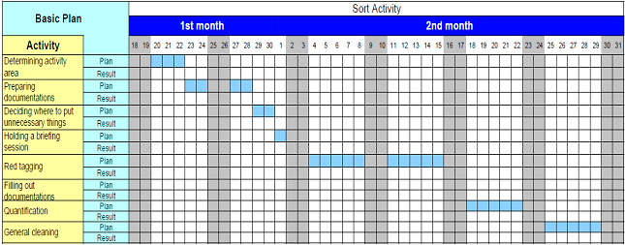
- Procedure for Sort activity
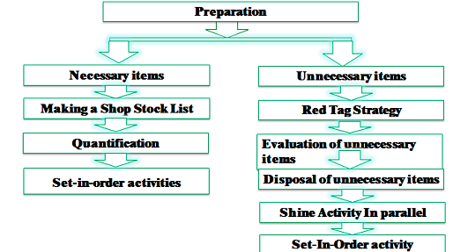
- Steps of implementing sorting
- Evaluate and take pictures of the work area. It’s extremely important to take pictures during this evaluation step since referencing them after improvements have been made can be very enlightening. To help you get started use also a 5S evaluation form.
- Identify and red tag the items you no longer need.
- Decide what to do with the tagged items.

2.2 Perform Cleaning activities
Sort - The first step in the 5S process is Sort, or “seiri,” which translates to “tidiness.” The goal of the Sort step is to eliminate clutter and clear up space by removing things that don’t belong in the area.

Clearing the Work Area - For this step, take a close look at the items, tools, and materials in a work area. Items that is necessary or useful for the work being done in that space should be kept there. Everything else should be removed or placed at appropriate place other than the work place.
Some of those removed items will need to be thrown away or recycled. Other items might belong to another work process or location; they should be returned to their “homes.” However, you might find some items that you aren’t sure about. Keep these items away from current work area.

Cleaning activities helps to remove foreign objects or materials which are not necessary at the work area. The work area cleaning activities steps may include:
- Pre-Clean. The first stage prepare cleaning materials

- Main Clean
- Rinse
- Final Rinse
- Drying

2.3 Identify all items in the workplace

The steps used to identify what is and is not needed in a work area and then to clear the work area of the unnecessary items are:
- Define what is needed.
- Define what is NOT needed.
- Disposition the items.
- Take action: Sort out (move out) what is not needed and move in what is needed (and is not there now).

Define what is needed
- When considering what is needed in a work area, don’t just look at the core equipment and tools used. Consider the materials, supplies, and even the paperwork.
- This is also a good time to evaluate the proper quantities of items to keep in the work area.
- Defining what is needed in a work area is not something that can be done effectively by one person working alone; use a team representing all that work in the area.

Define what is NOT needed
- After the team has identified what needs to be in the area, focus on all the other items currently in the work area.
- If an item is not needed to make the product, support the operation of the equipment, or for safety reasons, then it probably should not be kept in the direct work area.
Table 2-2 list of all the items at the work shop
No. | Name of items | Unit | QYT | Category
 |  |  |  | Equipment’s | Tools/device | materials
1
2
3
4
5
6

List Necessary and unnecessary items
Unnecessary and necessary items found in our office first should be properly differentiated and listed respectively. Some of the unnecessary items are:
- defective or excess quantities of small parts and inventory
- outdated or broken jigs and dies
- old rags and other cleaning supplies
- electrical equipment with broken
- Old, broken and outdated Office furniture
- Outdated posters, signs, notices, and memos, papers, etc.
- All unnecessary items that are not helpful for our work

Places of where unnecessary items accumulate
Some locations where unneeded items tend to accumulate are:
- in rooms or areas not designated for any particular purpose
- in corners next to entrances or exists
- Along interior and exterior walls, next to partitions, and behind pillars.
- Under the eaves of warehouses.
- under desks and shelves and in desk and cabinet drawers
- near the bottom of tall stacks of items
- on unused management and production schedule boards
- in tools boxes that are not clearly sorted or
- areas found to be appropriate to accumulate
Sample of format for records necessary items at the workplace
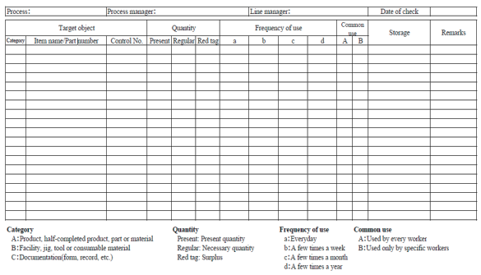
A sample format for recording unnecessary items in the workplace
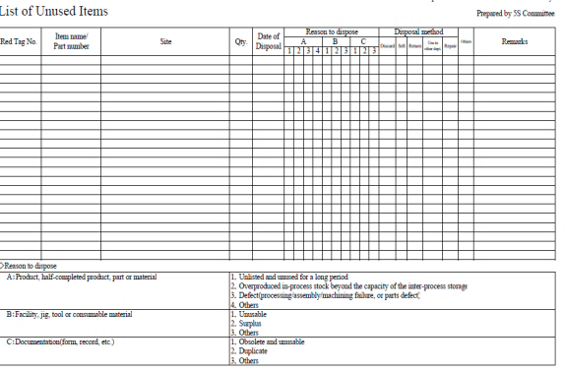

Use Red tag strategy for unnecessary items
The Red-Tag Strategy is a simple method for identifying potentially unneeded items in the factory or workshop, evaluating their usefulness and dealing with them appropriately. Red-tagging means putting red tags on items in the factory or workshop that need to be evaluated as being necessary or unnecessary. A Red tag is a red colored tag used to identify items no longer needed in a particular work area. The red tags catch people’s attention because red is a color that stands out. An item with a red tag is asking three questions:
- Is this item needed?
- If it is needed, is it needed in this quantity?
- If it is needed, does it need to be located here?
Once these items are identified, they can be held in a “Red Tag Holding Area” for a period of time to see whether they are needed, disposed of, relocated, or left exactly where they are.

Red-tag Holding areas
In order to implement the red-tag strategy effectively, a red-tag holding area must be created. A red-tag holding area is an area set aside for use in storing red-tagged items that need further evaluation. Red-tagging is helpful when the need or frequency of need for that item is unknown. When an item is set aside in a red-tag holding area and watched for an agreed-upon period of time people tend to be more ready to let it go when that time is over.
There are two red-tag holding areas: local and central holding areas. Local red-tag holding area is used to manage the flow of red-tagged items with in a local department orproduction area. Central red-tag holding area is used to manage the flow of items that cannot or should not be disposed of by individual departments or production area. Usually central red-tag holding area is used by an organization that is launching a companywide red-tagging effort
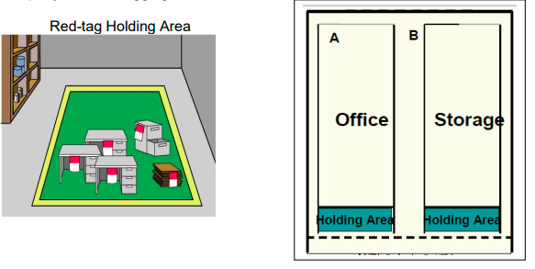
Figure 2.3 two red-tag holding areas

Steps/procedures in Red tagging
The red-tagging process in a department or work area can be broken down into seven steps

Step 1: Launch the red-tag project.
Step 2: Identify the red-tag targets.
Step 3: Set red-tag criteria.
Step 4: Make red tags.
Step 5: Attach red tags.
Step 6: Evaluate red-tagged items.
Step 7: Document the results of red-tagging

Step 1: Launch the red-tag project
Red-tag campaigns are started and coordinated by the upper-level management of a company. Even when a red-tag campaign is companywide, local campaigns need to be organized in each department or production area. This involves
- Organizing a team
- Organizing supplies
- Organizing a time or schedule to perform red-tagging
- Deciding a local-tag holding area
- Planning for disposal of red-tagged items
People from outside a department can be valuable members on a red-tagging team since they tend to see the area with a fresh eye. Hence, it is helpful to partner with other departments or production areas items:
Step 2: Identify red-tag targets
There are two red-tag targets
- In the manufacturing area items like inventory (warehouse and in process inventory), equipment, and space are targets for red tags. Warehouse inventory include material, parts, products etc.
- Areas: It is better to define a smaller area and evaluate it well than to define a larger area and not be able to evaluate it fully in available time.in creating red-tagging teams.
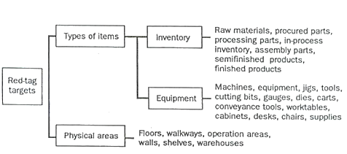
Figure 2.4 creating red-tagging teams.
Step 3: Set red-tag criteria
As already mentioned, the most difficult thing about red-tagging is differentiating what is needed from what is not. This issue can be managed by establishing clear-cut criteria for what is needed in particular area and what is not. The most common criterion is the next Month’s production schedule
- Items needed for that schedule are kept in that location.
- Items not needed for the schedule can be disposed of or stored in a separate location.
Three main factors determine whether an item is necessary or not. These factors are:
- The usefulness of the item to perform the work at hand. If the item isn’t needed it should be disposed of.
- The frequency with which the item is needed. If it is needed infrequently it can be stored away from the work area.
- The quantity of the item needed to perform this work. If it is needed in limited quantity the excess can be disposed or stored away from the work area.
Note: Each company must establish its own red-tagging criteria and each department may customize this standard to meet its local needs.
Step 4: Make red-tags
Each company has specific needs for documenting and reporting the movement, use, and value of materials, equipment, tools, inventory and products. The company’s red Tags should be designed to support this documentation process.
Various types of information on a red tag may include:
- Category: provides a general idea of the type of item (e.g., a warehouse item or
- Machine). Categories include raw materials, in-process inventory, products,
- Equipment, jigs, tools and dies.
- Item name and manufacturing number.
- Quantity: indicates the number of items included under this red tag.
- Reason: describes why a red tag has been attached to this item.
- Division: includes the name of the division responsible for managing the red-tagged item.
- Value: includes the value of the red-tagged item.
- Date: includes the red-tagging date
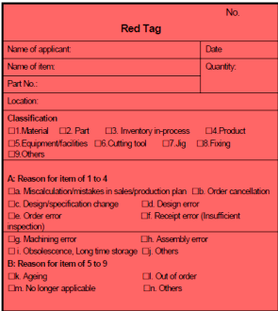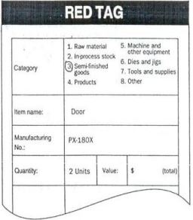
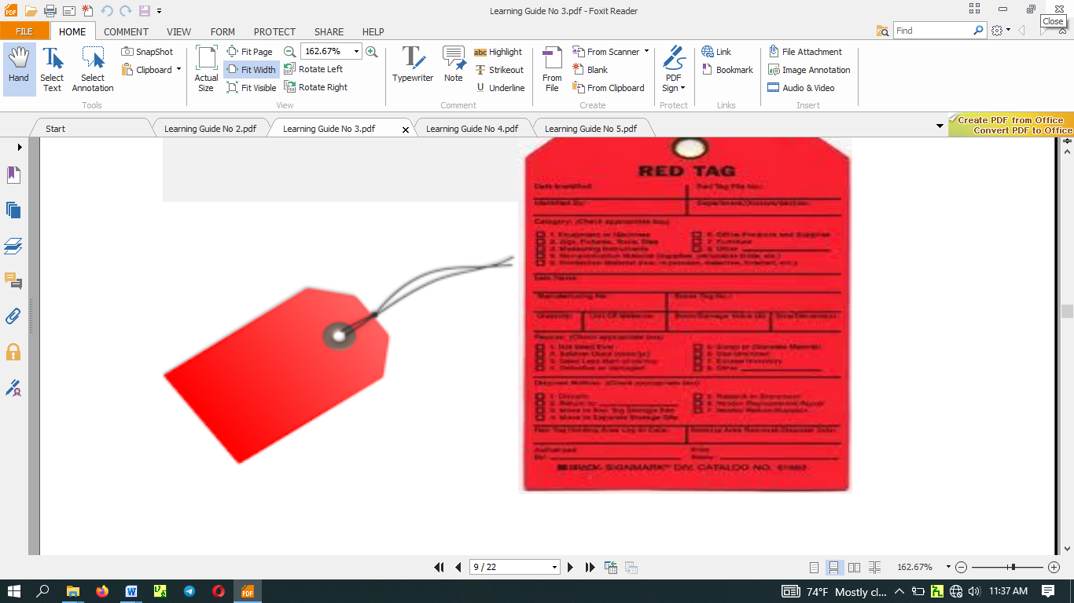
Figure 2.5 Make red-tags
The material used for red tags can be red paper, thick red tape, or others. Red tags can be laminated with plastic or another material to protect them during repeated use.
Step 5: Attach the red tags
The best way to carry out red-tagging is to do the whole target area quickly, if possible, in one or two days. In fact, many companies choose to red-tag their entire factory during a one or two day period. Red-tagging should be a short and powerful event. You should red-tag all items you question, without evaluating what to do with them
Step 6: Evaluate the red-tagged items
In this step, the red-tag criteria established in step 3 are used to evaluate what to do with red-tagged items. Options include:
- Keep the item where it is.
- Move the item to a new location in the work area.
- Store the item away from the work area.
- Hold the item in the local red-tag holding area for evaluation.
- Dispose of the item.
Disposal methods include: The next table shows disposal methods.
Table 2.3 disposal methods
Treatment | Description
Throw it away | Dispose of as scrap or incinerate items that are useless or unneeded for any purpose.
Sell | Sell off to other companies items that are useless or unneeded for any purpose
Return it to the vender | Return items to the supply company
Lend it out | Lend items to other sections of the company that can use them on a temporary basis
Distribute | Distribute items to another part of the company on a permanent basis.
Central red-tag area | Send items to the central red-tag holding area for redistribution, storage, or disposal.

Step 7: Document the results of red-tagging
Each company or organization needs to create its own system for logging and tracking necessary information as red-tagging takes place. The documentation system may involve a written logbook in each department and in the central red tag holding area. Or it may involve entering data from the red-tags into a computer system. Whatever the system, documenting results is an important part of the red-tagging process. It allows the company to measure the improvement and savings produced as a result of the restaging effort. As it is indicated in step 4, the red-tags should be designed to support the documentation process.

2.6. Evaluate unnecessary items
Prevent accumulation of unnecessary items. Reduce chances of being disturbed with unnecessary items. Evaluate necessary items with regard to cost or other important factors. Remove all items or parts or tools that are not in use. Segregate unwanted material from the workplace. Define Red-Tag area to place unnecessary items that cannot immediately be disposed of. Dispose of these items when possible.

Disposition of the items
- Once items that are not needed in the work area are identified, it’s time to disposition them and determine where they should be stored.
- Tag items to be removed; use a standardized set of usage-based guidelines to disposition items to be removed.
- Whenever possible, use data to determine the frequency of use, do not guess. The less frequently an item is used, the farther from the work area it should be stored.

Take action
- Once items are dispositioned, it’s time to take action to clear the work area and move tagged items to a temporary holding area.
- The holding area should be an accessible place where others not on the team can examine the items, confirm that they do not need to be kept in the work area, or discuss why they think an item is needed in the work area.

Recap
- The goal of the first of the 5S’s, Sort, is to have only what is needed for the job in the work area.
- The Sort phase applies to all work areas, manufacturing departments, service processes, and offices.

2.7. Quantify Necessary items
After necessary and unnecessary items are identified and separated. Unnecessary items that found to be unnecessary are disposed of from work area and the other items which have less importance for the time removed from work area and placed at the appropriate area.
Items found necessary are quantified and listed according to similarity. And then, keep necessary items in such manner that they can be easily accessible. Listing can be done in alphabetic order and number of quantities of each item.

2.8. Report Performance results
Activities carried out or worked during the process needs to be reported to the person authorized for the system at the right time. Comments given on the performance are very essential and put in to practice while performing duties.

2.9 Check workplace necessary items regularly
Put every item at its assigned place orderly. And then, regularly check the items that kept in its place are kept as we put them. This helps to find an item easily when needed. After completion of work items should be returned to their appropriate place. This should be maintained at every time.
Self-Check-2
Instructions I:
Answer all the questions listed below. Illustrations may be necessary to aid some explanations/answers. Write your answers in the sheet provided in the next page.
- Define the first pillar of 5S – Sort. (2 points)
- write the benefits of implementing sort of activity (4 points)
- What problems occur in a workshop if sort activity is not implemented?(6 points)
- What are the reasons for the accumulation of unnecessary items in a workshop? (3 points)
- write the procedures of sort activity (5 points)
- define the red-tagging strategy(3 points)
- What are red-tag holding areas and explain the types? (4 points)
- List the steps of red-tagging strategy. (7 points)
- List at least seven items that are considered as unnecessary. (2 points
- Name places where unnecessary items are accumulated? (3 points)
Part II: Choose the best answer
1. Which of the following is the procedure for sort activity?
a. Necessary items b. red tag strategy c. a and b d. no procedure is needed
2 Which step is the first in 5S? a. sustain b. shine c. sort d. standardized
3. The work area cleaning activities include:
a. rinse b. drying c. pre-clean d. all
4. Which of the following step is used to identify what is not needed in a work area?
a. define what is needed b. b. define what is NOT needed
c. a and b. d. position the items
5. Which of the following is unnecessary items?
a. outdated jigs b. excess quantities c. new rags d. a and b

Part I Matching
Instruction: Matching column B with column A
A B.
1. Locations where unneeded items a. report performance
2. Use Red tag strategy b. rooms
3 Launch the red tag project c unnecessary items
4. Evaluate unnecessary items d. procedures in red tagging
5. activities carried out e to prevent accumulation

Operation sheet 2
- Operation title: Sort
- Purpose: To implement sort in the work place
- Instruction: By following steps in implementing sort, apply them at your work place.
- Tools and requirement:
- PPE
- Camera
Steps in doing the task
1. Use the straight edge of the line a
2. Record the result on the line a
3. Repeat the step for line b, c and d
4. Check for the second time for the second round
5. Complete your work by confirming the recorded measurement

•Quality Criteria: Taking photos before and after to inspect thorough implementation of sort.

•Precautions: Utilizing PPEs carefully..

LAP Test 2
Instructions: Given necessary templates, workshop, tools and materials you are required to perform the following tasks.
Task 1: Perform a sorting stage in 5S of materials, tools and equipment at your work place.
Task 2: Using the given templates, list necessary and unnecessary items.
Task 3: Make red-tags appropriate for your workshop.
Task 4: Following the procedures of sort activity, perform sort activity in the assigned workshop

Unit Three: Set all items in order.
This unit is developed to provide you the necessary information regarding the following content coverage and topics:
- Plan to implement set in order activities.
- Perform general cleaning
- Decide Location/Layout, storage and indication methods
- Use Necessary tools and equipment
This unit will also assist you to attain the learning outcomes stated in the cover page. Specifically, upon completion of this learning guide, you will be able to:
- Prepare plan for implementing set in order activities.
- Perform general cleaning activities, in parallel with set in order activity.
- Decide location/layout, storage and indication methods for items.
- Prepare and use necessary tools and equipment for setting in order activities.
- Place items in their assigned location.
- Return immediately the items to their assigned location after use.
- Report performance results using appropriate formats.
- Regularly check each item in its assigned location and order
Set in order means arranging necessary items so that they are easy to use and labeling them so that anyone can find them and put them away. The key word in this definition is “anyone”. Set in order can be implemented only when the first pillar- sort is done first. No matter how well you arrange items, set in order can have little impact if many of the items are unnecessary and not sorted. Similarly, if sorting is implemented without setting in order, it is much less effective. Where necessary items should be placed should be made clear for anyone to immediately find them and return them easily. Hence, Sort and Set in order work best, when they are implemented together.
Benefits - Setting in order is important because it eliminates many kinds of waste from operations in a workplace. These include searching time waste, waste due to difficulty in using items, and waste due to difficulty in returning items. In general, the following problems and wastes are avoided when set in order is well implemented.

- Motion wastes
- Searching time wastes
- The waste of human energy
- The waste of excess inventory
- The waste of defective products

Figure 3.2Set in order is the core of standardization.

3.1 Plan to Implement Set in order
Once you have what you need to work on the office tables, it's time to put things in order, which can be confused with the previous step, but here we are looking to cut a fine line by ordering the elements that were already selected in the office. In this sense, make sure that the computers are in their corresponding place, according to the location in the physical space of each collaborator.
It would be pertinent for each computer to have support to facilitate viewing the screen and writing since there are office chairs that are usually lower than others and it can be uncomfortable for the spine to work bent over the computer. Also, pay attention to the cables and outlets so that you don't get saturated with voltage in the same box.
The set in order step is actually at the core of so many important business principles such as safety, ergonomics, quality, inventory control, productivity, standard work, the visual workplace and employee morale. Also it is the core of standardization. This is because the workplace must be organized before any type of standardization can be implemented effectively.
The second step, Set in Order, was originally called “seiton,” which translates to “orderliness.” A variety of names have been used in English: “Systematic Organization,” “Straightening Out,” and “Simplify,” for example. No matter what it’s called, the goal of this step is to organize the work area. Each item should be easy to find, use, and return: a place for everything, and everything in its place.

Building a 5S Map
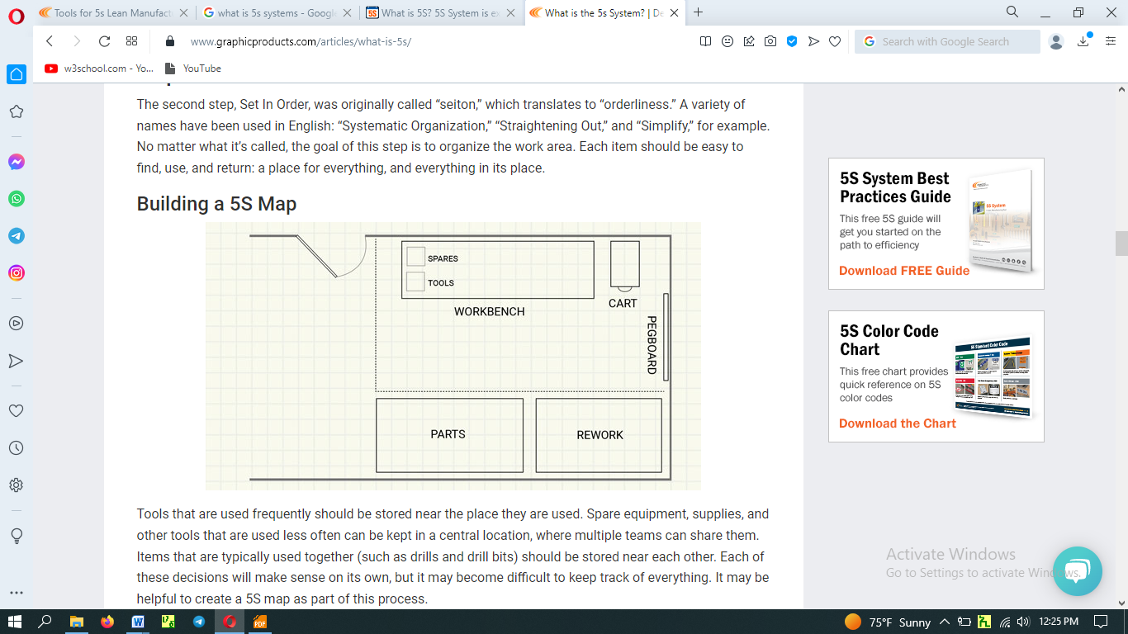
A 5S map is a diagram or floor plan that provides an overview of a work area, process, or station. It provides a visual reference to show where the tools, supplies, workers, and travel paths are, and how they relate to each other. A good map may also include a description of the work that happens in the area. Set in order - keep work areas clean, efficient and safe by setting in order
Depending on your facility’s needs, you may find one approach easier than another:
- Draw up a map, and then implement it
- Physically arrange the workplace first, and then map it out
- Map as you go, testing ideas and writing down what works well
No matter which approach is used to create it, the resulting 5S map should be kept as a training tool, used for reference in later steps of 5S, and updated over time as the work area changes. In implementing set in order pillar, we use visual controls so that communications became easy and smooth. For example, we can visually know where items are placed and where to return them and so on. A visual control is any communication device used in the workplace that tells us at a glance how work should be done. Through visual controls, information such as where items belong, how many items should be placed there, what the standard procedure is for doing something, the status of work in process etc. can be communicated.
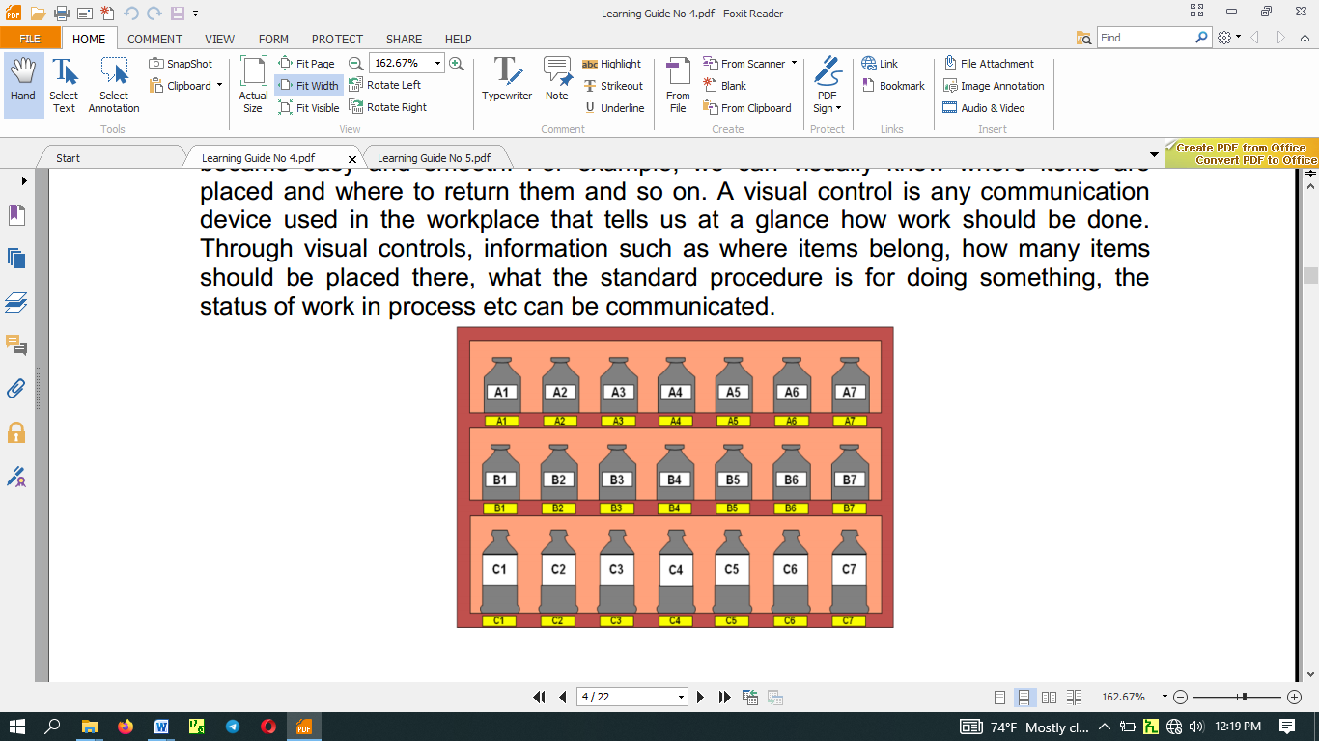
Communicating the Plan - Once storage locations are assigned, each storage area should be labelled. Label the outside of cabinet doors to help workers quickly identify what’s inside each one. Then, label any interior shelves to show where different supplies belong. The same ideas extend to rack labels, bins, and other storage systems.
Many facilities use a “shadow board” for tool storage, to ensure that each tool is easy to put back in its correct storage place. With this approach, a label matching the shape and size of the tool is placed where that tool belongs. Workers can immediately spot where each item belongs, and know at a glance if the item is there or not. No more time wasted looking through drawers and bins.
Organization can extend to the floor, too. Work areas, movement lanes, and storage for supplies and finished products can all be marked with floor marking tape.

Plan and procedures for set in order: Set in order activity plan sheet (sample)
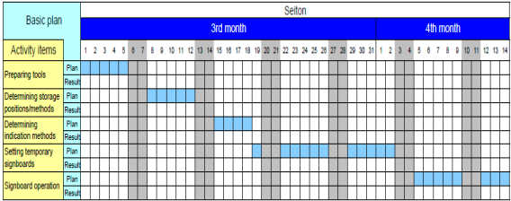
The Procedures for Set in order is implements follow as
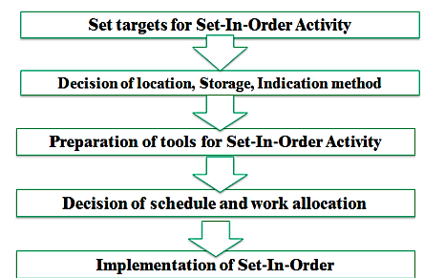

3.2 Perform general cleaning

Scheduled cleaning is very important. Based on your established schedule, perform general cleaning activities at regular pattern. Cleaning activities helps to shine work area and remove foreign objects or materials which are not necessary at the work area. The work area cleaning activities steps may include:
- Pre-Clean. The first stage prepare cleaning materials

- Main Clean
- Rinse
- Final Rinse
- Drying

3.3 Decide Location/Layout, storage and indication methods
Set In Order during the 5s implementation in the office articles means to arrange essential items in order for easy access. Here you focus on functional storage and eliminating the need to look for things.
All items should be arranged for easy access. For a good system, one can find any item in less than 5 seconds. There must be a place for everything, and everything should be in its place after use.

Evaluating current locations and deciding best locations

The 5S Map is a tool that can be used to evaluate current locations of parts, jigs, tools, dies, equipment, and machinery, and to decide best locations. 5S Map involves creating two maps ‘before map’ and ‘after map’. The ‘before map’ shows the layout of the workplace before implementing set in order. The ‘after map’ shows the workplace after implementing set in order. The 5S Map can be used to evaluate the locations in a small or large workplaces, like in a single workstations, on a production line, or in a department.
The steps of using the 5S Map:
      - Make a floor plan or area diagram of the workplace you wish to study. Show the location of specific parts, inventory, tools, jigs, dies, equipment and machinery.
      - Draw arrows on the plan showing the work flow between items in the workplace. There should be at least one arrow for every operation performed. Draw the arrows in the order that the operations are performed, and number them as you go.
      - Look carefully at the resulting “spaghetti diagram”. Can you see places where there is congestion in the work flow? Can you see ways to eliminate waste?
      - Make a new 5S Map to experiment with a better layout for this work place. Again, draw and number arrows to show the flow of operations performed.
      - Analyze the efficiency of the new layout (the after map), based on the principles explained in the above.
      - Continue to experiment with possible layouts (after maps) using the 5S Map until you find one which you think will work well.
      - Implement this new layout in the work place by moving parts, tools, jigs, dies, equipment, and machinery to their new locations.
      - Continue to evaluate and improve the layout in the workplace.

3.4 Use Necessary tools and equipment
The purpose of the Set in Order stage is to find a place for everything and put everything in its place. At the end of this stage, there will be a set place for everything in the workplace.
Key takeaways from the Set in Order stage:
- Arrange items for convenience when using.
- Eliminate wasting time looking for certain tools and items.
- Simplify the work process by making it easier to find necessary tools.
- Create a plan to help the workplace stay in this new organization.
- Organize items based on their frequency of use and proximity to where they are used.
In the Set in Order step, companies should match the place of an item with its amount of use. Items used more frequently should be designated first and should be placed near where they will be used. By moving items not frequently used out of the way, the workplace will become more efficient.
Things you can Set in Order:

- Offices
- Books
- Papers
- Blueprints/Plans
- Invoices
- Desk Drawers
- Tools
- Storage areas
- Income and outgoing letter
In conclusion, it is important to remember that once everything has been assigned a proper place, also create a system that will help everything easily be returned to its proper place so as to maintain your Set in Order step.
To make sure you carry out the first 3 pillars of 5S correctly, you need to provide a consistent approach that employees can follow. An important prerequisite here is giving employees standardized guides and checklists, as well as supporting documentation so that they can integrate these best practices into their work routine.
Maintain these Activities Regularly:
- Place items in their assigned location.
- Return immediately the items to their assigned location after use.
- Report performance results using appropriate formats.
- Regularly check each item in its assigned location and order
Set in order strategies
Once best locations have been decided, it is necessary to mark these locations so that everyone knows what goes where, and how many of each item belongs in each location. There are several strategies for marking or showing what, where and how many.
Motion Economy strategy
Following the principles explained in the above, we can remove motion waste from existing operation. By using human body appropriately, by organizing the workplace and by redesigning of tools and equipment, we can minimize motion waste.
Visual control Strategy
A visual control is any communication device used in the work environment that tells us at a glance how work should be done. There are several strategies for setting in order items so that to easily identify what, where and how many (visual control).
Signboard strategy: uses signboards to identify what, where, and how many. The three main types of signboards are:
- Location indicators that show where items go.
- Item indicators that show what specific items go in those places.
- Amount indicators that show how many of these items belong there.

Signboards are often used to identify:

Names of work areas

Inventory locations

Equipment storage locations

Standard procedures

Machine layout

For example, in order to identify inventory stored on shelves in a warehouse, a whole system of signboards may be used. Every section of shelving may have a signboard identifying the section. Within that section, vertical and horizontal addresses on shelves can be identified with additional signboard. Each item stored on the shelvemay also have a signboard showing the “return address” for that item. The “return address” allows the item to be put back in the proper location once it has been removed.
The ‘after 5S Map’ discussed before is a kind of signboard. It shows the location of parts, tools, jigs, dies, equipment, and machinery in a given work area after set in order is implemented. When posted in the work place, it is useful in communicating the standard for where items are located.
Painting strategy: is a method for identifying locations on floors and walkways. It is called the Painting strategy because paint is the material generally used. But also plastic tape, cut in to any length, can be used. Plastic tape, although more expensive, shows up just as clearly as paint and can be removed if the layout is changed.
The painting strategy is used to divide the factory’s or workshop’s walking areas (walkways) from the working areas (operation areas). When putting lines to divide walkways from operation areas, the following factors should be considered:
- U-shaped cell designs are generally efficient that straight production lines.
- In-process inventory should be positioned carefully for best production flow.
- Floors should be levelled or repaired before we put lines.
- Walkways should be wide enough to avoid twists and turns and for safety and a smooth flow of goods.
- The dividing lines should be between 2 and 4 inches in width.
- Paint colors should be standardized. For example
- operation areas are painted by green;
- walkways are fluorescent orange or red;
- Lines that divide the walkways from operation areas are yellow in color.
Dividing lines can be used to show:
- Cart storage locations,
- aisle directions,
- door range, to show which way a door swings open,
- for worktables,
- tiger marks, to show areas where inventory and equipment should not be placed, or to show hazardous areas.

Color-code strategy: is used to show clearly which parts, tools, jigs a nd dies are to be used for which purpose. For example, if certain parts are to be used to make a particular product, they can all be color-coded with the same color and even stored in a location that is painted with that color. Similarly, as shown the picture in below, if different types of lubricants are to be used on different parts of a machine, the supply containers, oil cans, and machine parts can be color-coded to show what is used where

Outlining strategy: is used to show which jigs and tools are stored where. Outlining simply. means drawing outlines of jigs and tools in their proper storage positions. When you want to return a tool, the outline provides an additional indication of where it belongs.

Self-Check
Instructions 1: Answer all the questions listed below. Illustrations may be necessary to aid some explanations/answers.
- Write the three main types Signboard strategy
- Define the principles of helpful to eliminate or reduce motions.
- Write the Procedures of Set in order implementation.
- Define the Implementation of the Second Pillar of 5S – Set in order

Part II: choice
Instruction: choose the best answer
1. The second step in set in order Is:
a. shine b. sort c. standardize c. set in order c. sustain
2. Which step needs mind analysis:
a. sustain b. set in order c. a and b d. self-discipline
3. Which of the following items need to be set in order in an office?
a. offices b. papers c. desk d . all
4. What are the stages categorized under set in order stage?
a arrange items b. create a plan c. don't eliminate wasting time d. a and b
5. Which of the following avoided when set in order is well implemented?
a. waste of excess inventory b. searching time wastes c. a and b
d. human energy conservation

Operation sheet
• Operation title: Set-in order
• Purpose: To implement Set-in order in the work place
• Instruction: By following steps in implementing Set-in order, apply them at your work place.
• Tools and requirement:
1. PPE
2. Cart
3. Ladder
Steps in doing the task
- Locate items in the workplace according to their frequency of use.
- Place frequently used items near the place of use.
- Store infrequently used items away from the place of use.
- Store items together if they are used together, and store them in sequence in which they are used.
- Device a just let go arrangement for tools. This approach involves suspending tools from a retractable cord just within reach so that they will automatically go back in to their correct storage position when released.
- Make storage places larger than the items stored there so that they are physically easy to remove and put back
- Eliminate the variety of jigs, tools and dies needed by creating a few jigs, tools and dies that serve multiple functions.
- Store tools according to function or product. Function-based storage means storing tools together when they have similar functions. This works best for job-shop production. Product-based storage means storing tools together when they are used on the same product. This means works best for repetitive production.

• Quality Criteria: Taking photos before and after to inspect thorough implementation of se-in order.
• Precautions: Utilizing PPEs carefully and taking care for tools and equipments.

LAP Test
Instructions: Given necessary templates, workshop, tools and materials you are required to perform the following tasks.
Task 1: Perform Set in Order of materials, tools and equipment at your work place.

Unit Four: Perform shine activities.
This unit is developed to provide you the necessary information regarding the following content coverage and topics:
4.1 Plan to Implement shine activities.
4.2 Necessary tools and equipment
4.3 Use appropriate procedures.
4. 4 Conduct Regular Shine activities
This unit will also assist you to attain the learning outcomes stated in the cover page. Specifically, upon completion of this learning guide, you will be able to:
- Plan to Implement shine activities.
- Prepare and use Necessary tools and equipment for shinning activities
- Use appropriate procedures
- Conduct Regular Shine activities

The third pillar of 5S is shine. Shine means sweeping floors, wiping off machinery and generally making sure that everything in the factory stays clean. In a manufacturing company, shine is closely related to the ability to produce quality products. Shine also includes saving labor by finding ways to prevent dirt, dust, and debris from piling up in the workshop. Shine should be integrated in to daily maintenance tasks to combine cleaning checkpoints with maintenance checkpoints.
One of the more obvious purposes of shine is to turn the workplace in to clean, bright place where everyone will enjoy working. Another key purpose is to keep everything in top condition so that when someone needs to use something, it is ready to be used. Companies or organizations should avoid the tradition of annual or on spring cleanings. Instead, cleaning should become a deeply ingrained part of daily work habits, so that tools, equipment, and work areas will be ready for use all the time.

4.1 Plan to Implement Shine Activities
The third step of 5S is Shine, or “seiso,” which means “cleanliness.” While the first and second steps cleared up space and arranged the area for efficiency, this step attacks the dirt and grime that inevitably builds up underneath the clutter, and works to keep it from coming back.

Routine Cleaning - Shine moves far beyond just pushing a broom around every now and then. It involves regular cleaning of every part of the work area — often a daily wipe-down, and a more thorough cleaning each week.
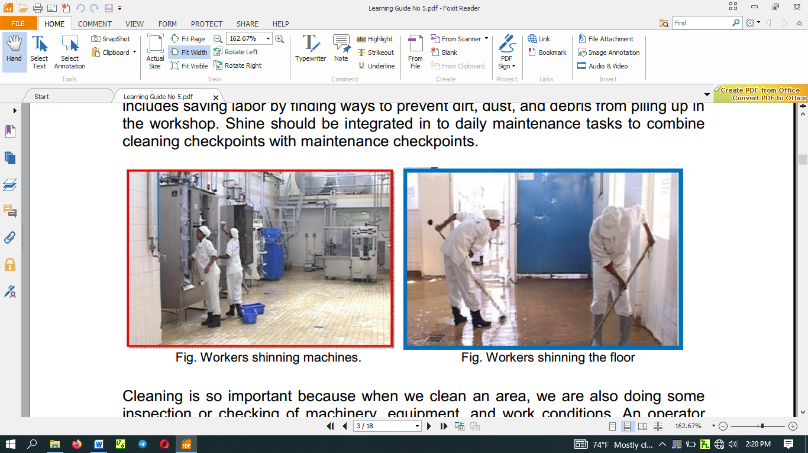
Cleaning is so important because when we clean an area, we are also doing some inspection or checking of machinery, equipment, and work areas. Shine means cleaning the workplace’s floors, equipment and facilities, provide inspection, at the same time and ensure that equipment are in good operating condition
Cleanliness for factories and offices is a lot like bathing for human beings. It relieves stress and strain, removes sweat and dirt, and prepares the body and mind for the next day. Cleanliness is important for physical and mental health. Cleaning should be done on daily basis.
Benefits of shine - One of the more obvious purposes of shine is to turn the workplace in to clean, bright place where everyone will enjoy working. Another key purpose is to keep everything in top condition so that when someone needs to use something, it is ready to be used. Companies or organizations should avoid the tradition of annual at the end of the year or on spring cleanings. Instead, cleaning should become a deeply ingrained part of daily work habits, so that tools, equipment, and work areas will be ready for use all the time.
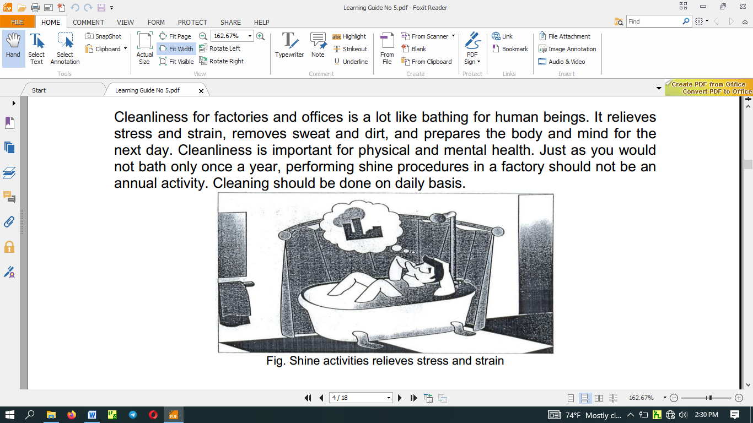
Shine activities can play an important part in bringing work efficiency and safety. Cleanliness is also linked with the morale of employees and their awareness of improvements. Factories or workshops that do not implement the shine pillar suffer the following types of problems:
      - Poor morale and inefficiency at work. This could be due to dirty windows that can pass only little light.
      - Unable to see or find defects in dark and messy workplaces.
      - Slipping and injuries can be created due to puddles of oil and water on the floor.
      - Frequent breakdown of machines due to insufficient check-ups and maintenances which in turn leads to late deliveries.
      - Low and unsafe operating machines due to insufficient checkups and maintenance which in turn leads to hazard and accidents
      - Defects will result due to shaving cuts getting mixed in to production or assembly processes.
      - Shaving cuts can get in to people’s eyes and create injuries.
      - Low morale due to filthy work environments.
Figure 4.1: Shine activity plan sheet (sample) Prepared by: 5S Committee
Area: _______ Preparation Date: Year, Month, Date
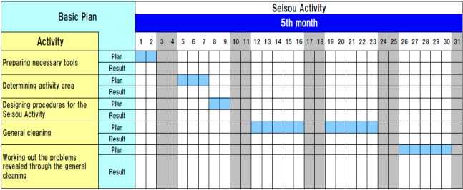

4.2 Necessary tools and equipment
Tools and equipment necessary for the particular task/job area depend on the type of the job/task assigned. So, when we prepare and use the tools and equipment we should select the right/appropriate items that fit for our purpose. For sample, the followings are some tools and materials used to implement the Shining activities.

- Sponge oil
- Broom detergents
- Brush spade
- vacuum cleaner bolts
- garbage containers
- floor scrubber
- cleaning Pads
- Screws etc.


Figure 4.5: Tools and materials
Shine activities can play an important part in bringing work efficiency and safety. Cleanliness is also linked with the morale of employees and their awareness of improvements. Factories or workshops that do not implement the shine pillar suffer the following types of problems:
- Poor morale and inefficiency at work. This could be due to dirty windows that can pass only little light.
- Unable to see or find defects in dark and messy workplaces.
- Slipping and injuries can be created due to puddles of oil and water on the floor.
- Frequent breakdown of machines due to insufficient check-ups and maintenances which in turn leads to late deliveries.
- Low and unsafe operating machines due to insufficient checkups and maintenance which in turn leads to hazard and accidents.
- Defects will result due to shaving cuts getting mixed in to production or assembly processes.
- Shaving cuts can get in to people’s eyes and create injuries.
- Low morale due to filthy work environments.

4.3 Use appropriate procedures
Shine activities should be taught as a set of steps and rules that employees learn to maintain with discipline. The following sample format can be used to prepare a plan for implementing shine activities.
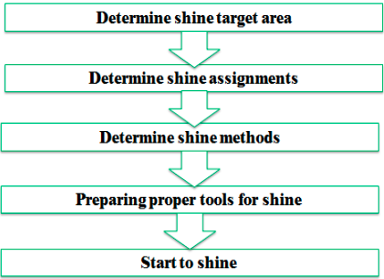
Figure 4.8: Procedures for shine activities
Step 1: Determine shine target areas
Step 2: Determine Shine Assignments – to keep work area clean and tidy (if there is no person responsible for cleaning) is the responsibility of everyone who works there. Each employee should be assigned specific area to clean. To do these two methods can be used:
A 5S Assignment Map – shows all the target areas for shine activity and who is responsible for cleaning them. By marking on 5S Map, the shine assignments can be shown.
- A 5S schedule – shows in detail that is responsible for cleaning which areas on which days and times of the day. Then this schedule should be posted in the work area.
- A 5S schedule – shows in detail that is responsible for cleaning which areas on which days and times of the day. Then this schedule should be posted in the work area.
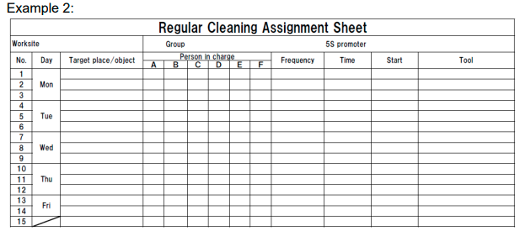
Step 3: Determine shine methods - Shine activities should be a natural part of the daily work. Shine activities and inspection should be done before a shift starts, during work time and at the end of the shift.
Shine methods include:
- Choosing targets -. Define what will be cleaned in each area and what supplies and equipment will be used.
- Performing the five-minute shine. Cleaning should be practiced daily and should not require a lot of time.
- Creating standards for shine procedures. People need to know what procedures to follow in order to use their time efficiently. Otherwise, they are likely to spend most of their time getting ready to clean.
Step 4: prepare tools - the cleaning tools should be placed properly or set in order where they are easy to find, use and return.
Step 5: Start to shine - When implementing the shine procedures, consider the following suggestions:
- Be sure to sweep dirt from floor cracks, wall corners, and around pillars.
- Wipe off dust and dirt from walls, windows, and doors.
- Be thorough about cleaning
- Use cleaning detergents when sweeping is not enough to remove dirt.

4.4 Conduct Regular Shine activities
A regular and thorough cleaning helps prevent tool and machinery degradation. Not only does this help with safety as described above, it can also ensure these items last longer. A longer natural lifespan means less costly replacement and maintenance in the future.
Be proactive, not reactive. Cleaning should always be carried out on a schedule, not in response to a workspace that has grown too cluttered to navigate efficiently. Reactive cleaning indicates a lack of cleaning already in progress and also suggests that workers are unable or unwilling to stick with the schedule. Shine is not about cleaning up messes as they arise; instead, it is more about implementing the proper cleanliness strategies to avoid making messes in the first place.

Shine as Preventative Maintenance - Keeping work areas clean will have many advantages. One important advantage is that it’s easy to spot leaks, cracks, or misalignments. If the people keeping the area clean are the same people who work there regularly, they will be quick to recognize any of these problems.
Leaving those problems unnoticed and unresolved could result in equipment failure, safety hazards, and loss of productivity. With the constant cleaning and inspections used in the Shine step of 5S, the system can feed into a preventative maintenance program. This way, 5S can extend the working life of equipment and help reduce emergency downtime.
Importantly, the Shine step is not meant to be a job for the maintenance or janitorial staff. Each worker should clean their own work area, and the equipment they use regularly. This approach has several benefits:
- Workers who are familiar with the area will quickly notice any problems that arise
- Hazards or difficult situations will be understood and accounted for
- Items that are out of place or missing will be recognized
- Workers will tend to keep their own workspaces cleaner during normal operations
Everyone should pay attention to the overall cleanliness of the workplace, being willing to pick up trash and so on. But for 5S to give the best results, each worker should take personal responsibility for their own working space.

Self-Check 4
Instructions 1: Answer all the questions listed below. Illustrations may be necessary to aid some explanations/answers. Write your answers on the sheet provide.
- Write the definition of the third pillar shine. (2 points)
- What problems occur in a workshop if shine is not implemented? (8 points)
- What are the steps/procedures for implementing shine? (5 points)
- Described the methods of used to assign shine activities to employees? (2 points)
- What are the most frequent problems of equipment’s/machines? (4 points)
- List the steps of inspection. (5 points)
- How do you detect abnormalities in a workplace or machine? (4 points)

Operation sheet
• Operation title: Shine
• Purpose: To implement shine in the work place
• Instruction: By following steps in implementing shine, apply them at your work place.
• Tools and requirement:
1. PPE
2. Cart
3. Ladder
4. Cleaning tools, equipment and agents
5. Paints and brush

- Steps in doing the task
- Determine shine target areas; Shine target areas are grouped in to three categories: warehouse item, equipment’s and space.
- Determine Shine Assignments; Workplace cleanliness is the responsibility of everyone who works there. Each employee should be assigned specific area to clean.
- Determine shine methods; Shine activities should be a natural part of the daily work. Shine activities and inspection should be done before a shift starts, during work time and at the end of the shift.
- Prepare tools the cleaning; tools should be placed properly or set in order where they are easy to find, use and return.
- Start to shine
- Quality Criteria: Taking photos before and after to inspect thorough implementation of shine.
• Precautions: Utilizing PPEs carefully and taking care for tools and equipment.

LAP Test4
Instructions: Given necessary templates, workshop, tools and materials you are required to perform the following tasks.
Task 1: Identify and prepare tools and materials for implementing shine activity.
Task 2: Prepare plan for shine and Sample plan
Task 3: Implement shines activity.

Unit Five: Standardize 5S
This unit is developed to provide you the necessary information regarding the following content coverage and topics:
5.1 Plan to standardize 5S activities.
5.2 Tools and techniques to standardize 5S
5. 3 Follow Standardize activities Checklists
5.4 Standardize workplace
5.5 Avoid problems by standardize activities
This unit will also assist you to attain the learning outcomes stated in the cover page. Specifically, upon completion of this learning guide, you will be able to:
- Plan to standardize 5S activities.
- Prepare and implement Tools and Techniques to standardize 5S
- Follow Checklists for Standardize activities
- Keep the workplace to the specified standard
- Avoid problems by standardize activities

Standardize is the fourth step in the 5S process. This stage directly connects with some of the closing tips from the "Shine" section, and that's because it builds on the idea of auditing and checking in on 5S efforts regularly. Standardization is essentially "the bridge" between Shine and the final step of 5S, Sustain. By standardizing the approach to 5S, it can ensure organizational efforts are sustained in the long run. Failing to standardize procedures can lead to work becoming sloppy over time and a loss of efficiency.
Begin to standardize 5S operations by making the process more than a word-of-mouth agreement. This is the time to implement a clear, universally understood system so that employees are certain about what they are expected to do. One excellent way to do this is to design and print out 5S audit sheets that can be used by whoever is checking an area on a given day. A checklist that asks specific questions about the work area can help ensure that processes are carried out as intended.

Benefits from Standardize
1. Lead to workplace standardization
- prevent setbacks in the first three pillars
- Make implementing them a daily habit
- Ensure that all the three pillars are maintained in their fully implemented state.
2. Lead to work standardization

- Muda elimination
- Quality improvements
- Cost improvements
- Delivery time improvements
- Process improvements

Here are some problems that result in when we do not implement Standardization well:
- Conditions go back to their previous and undesirable levels even after a companywide 5S implementation campaign.
- At the end of the day, piles of unneeded items are left from the day's production and lie scattered around the production equipment.
- Tool storage sites become disorganized and must be put back in order at the end of the day.
- Cutting shavings constantly fall on the floor and must be swept up
- Even after implementing Sort and Set in order, it does not take long for office workers to start accumulating more stationery supplies than they need.
These problems and others reveal backsliding in gains made from implementing Sort, Set in Order, and Shine Activities. The basic purpose of the Standardize pillar is to prevent setbacks in the first three pillars, to make implementing them a daily habit, and to make sure that all three pillars are maintained in their fully implemented state.
How to Implement Standardize
The three steps to making Sort, Set in Order and Shine activities (the three pillars or 3S) a habit are:
Step 1: Decide who is responsible for which activities with regard to maintaining 3S conditions.
Step 2: To prevent backsliding, integrate 3S maintenance duties in to regular work activities.
Step 3: Check on how well 3S conditions are being maintained.
As you read this section, you will discuss some of the tools for implementing Standardize of the Sort, Set in Order, and Shine activities. This is because in order to standardize we must use these same tools in a more systematic way to make sure that the first three pillars are maintained.

Plan to standardize 5S activities
Standardize is the fourth step in the 5S process. This stage directly connects with some of the closing tips from the "Shine" section, and that's because it builds on the idea of auditing and checking in on 5S efforts regularly.
The last step of 5S workplace organization which concentrates on covering every former step of 5S, with the standardized processes, and converting them into continuing practices to guarantee continuous improvement. It addresses describing a new outlook and a standard in place of work.
Standardize is an essential bridge between Shine and the last step of 5S is to standardize. By systematizing the method to 5S through standardization, it can be confirmed that organizational efforts are continued in due course through a sustainable approach. If an organization fails to standardize work processes then it can cause disordered and inefficient work over time. It is helpful to give employees opportunities to play a dynamic role in the standards development. An outstanding technique to accomplish this is to plan and print out 5S sheets of audit that can be used by anyone who is examining an area on a particular day. Lock at the following picture.
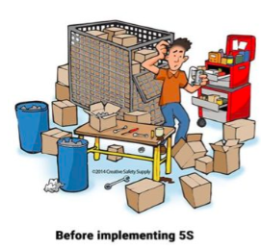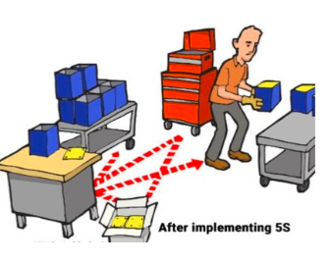

The first three steps of 5S cover the basics of clearing, organizing, and cleaning a work space; on their own, those steps will provide short-term benefits. The fourth step is Standardize, or “seiketsu,” which simply means standardization. By writing down what is being done, where, and by whom, you can incorporate the new practices into normal work procedure. This paves the way for long-term change.

The Power of Writing Things Down

It’s been said that “If it isn’t written down, it didn’t happen.” Writing down the decisions that you make in your 5S program will help ensure that your work doesn’t just disappear. If you made a 5S map in the Set In Order step, that map can be part of your new standard for the area. In the same way, the process that you use for red-tagging items can be written down and included in the standards.
Writing out your decisions doesn’t mean you can’t change your mind, though. The purpose of 5S is to make your workplace better, not to make it unchangeable. You are writing the standards for your facility, and you can change them to fit new information or new business needs.

5.2 Tools and techniques to standardize 5S

Tools for Standardizing - Once you’ve made decisions on how to change your work practices, those decisions need to be communicated to workers. This communication is a key part of the Standardize step. Common tools for this process include:
- 5S checklists – Listing the individual steps of a process makes it easy for workers to follow that process completely. It also provides a simple auditing tool to check progress later on.
- Job cycle charts – Identify each task to be performed in a work area, and decide on a schedule or frequency for each of those tasks. Then, assign responsibility to a particular worker (or job duty). The resulting chart can be posted visibly to resolve questions and promote accountability.
- Procedure labels and signs – Provide operating instructions, cleaning steps, and preventative maintenance procedures right where that information will be needed.
Common Tools and Techniques to standardize 3S are:

- 5S Job Cycle Charts
- Visual 5S
- The Five Minute 5S
- Standardization level checklist
- 5S checklist
- The five Whys and one How approach(5W1H)
- Suspension
- Incorporation
- Use Elimination

The Three Steps to Make the 3S Activities a Habit/Standardize using the Tools and Techniques of 3S Standardization

Assign 3S Responsibilities - When it comes to maintaining three pillar conditions, everyone must know exactly what they are responsible for doing and exactly when, where and how to do it. If people are not given clear 3S job assignments based on their own workplaces, the Sort, Set in Order, and Shine activities will not have much meaning. Similarly, clear 3S instructions must be given to the people who deliver goods from outside suppliers. The delivery sites should be clearly marked and a 5S Map posted to show where each supplier’s goods are to be unloaded. At each unloading site, signboards should make it clear whose things go where and in what amount. The suppliers should be made responsible for maintaining 3S conditions at their own unloading sites and encouraged to join in full 5S implementation.
Tools for assigning 3S responsibilities include:
- 5S Maps
- 5S schedules
- 5S job cycle charts, which list the 5S jobs to be done in each area, and set frequency cycle for each job (see the figure below). In the example shown in the figure below, 5S duties are sorted out according to the first three pillars and the scheduling cycle. In the figure, code letters are used for the various cycle periods:
A is for 'continuously," B for "daily (mornings)," C for "daily (evenings), " D for "weekly," E for "monthly" and F for "occasionally." Each 5S job assignee can then use these charts as 5S Checklists. This particular example shows clearly who is responsible for each job, which area, what to do, and when to do it.
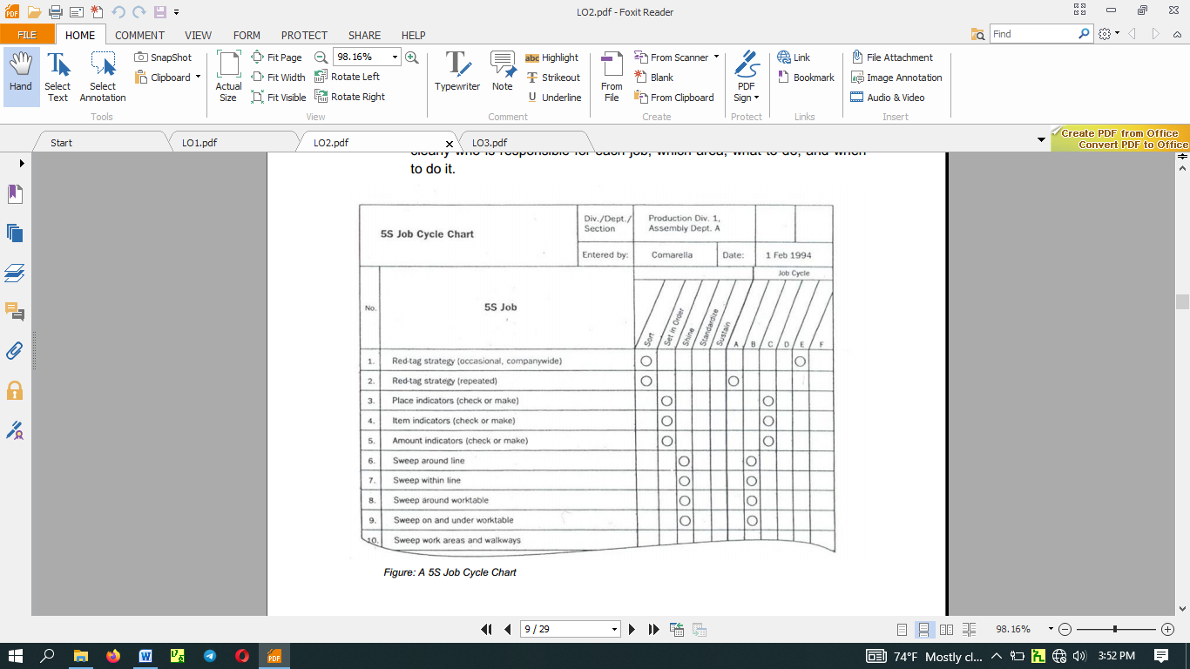

Integrate 3S Duties into Regular Work Duties - If people carry out three pillar maintenance duties only when they see three pillar conditions slipping, then the five pillar implementation has not yet taken root. Maintenance must become a natural part of everyone’s regular work duties. In other words, the five pillars -centered on maintaining 3S conditions-must be part of the normal work flow. We sometimes refer to this as "5S line integration" or establishing a five pillars flow. Visual 5S and Five-Minute 5S are two approaches that help make maintenance work part of the everyday work routine. .

Visual 5S - The Visual 55 approach makes the level of five pillar conditions obvious at a glance. This is particularly helpful in factories that handle a great variety and number of materials.

The main point of Visual 5S is that anyone should be able to distinguish between abnormal and normal conditions at a glance.

As a factory example, consider a drill-press process where Set in order has been applied so that the position and amount of each finished work piece is clearly indicated. As an additional visual aid, the place where the last batch item goes can be marked with a thick red line to indicate that it is time to stop and send the batch to the next process.
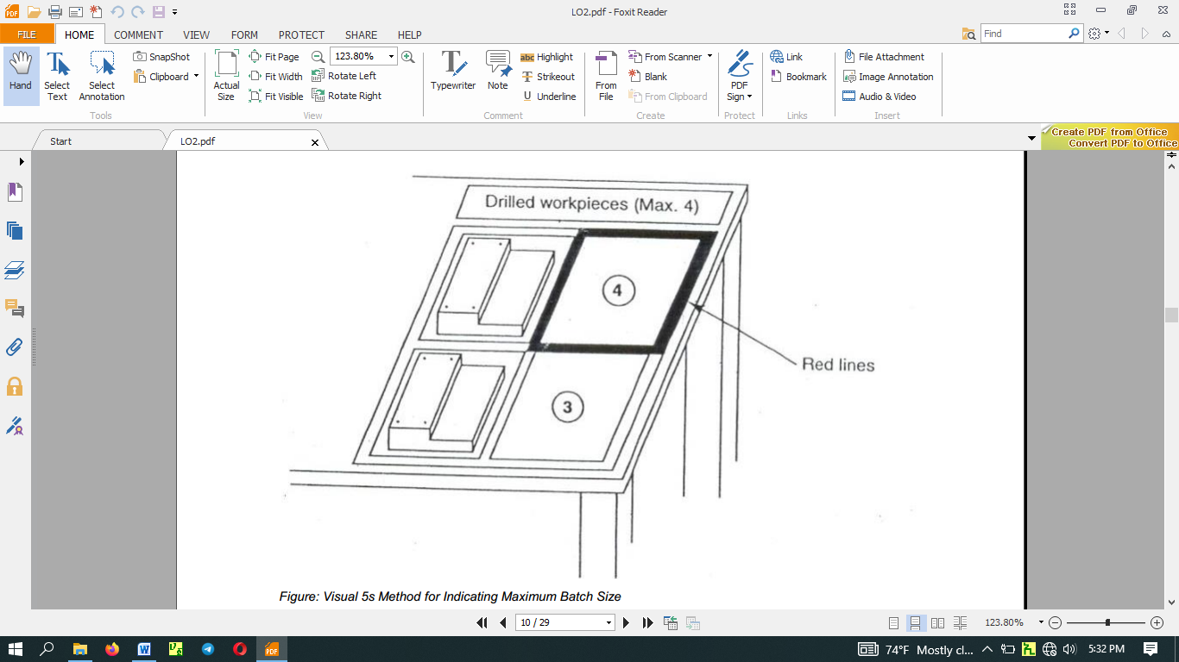
Five-Minute 5S - When using the Visual 5S approach, instant visibility can act as a trigger for taking immediate three pillar action(Sort, Set in Order, and Shine activities) against the discovered abnormalities (i.e., overproduction, disorder, and contamination). We must also deal with the question of how skillfully and efficiently these actions are carried out. Instead of following two hours for removing all of the cutting shavings from the floor, we can set up a half -hour or a one-hour Shine procedure that accomplishes the same task. The term "Five-Minute 5S" is a loose one-the actual time can be three minutes, six minutes, or whatever is appropriate. The point is to make the five pillar work brief, efficient, and habitual. In figure below shows a signboard that was made as part of a Five-Minute 5 campaign.
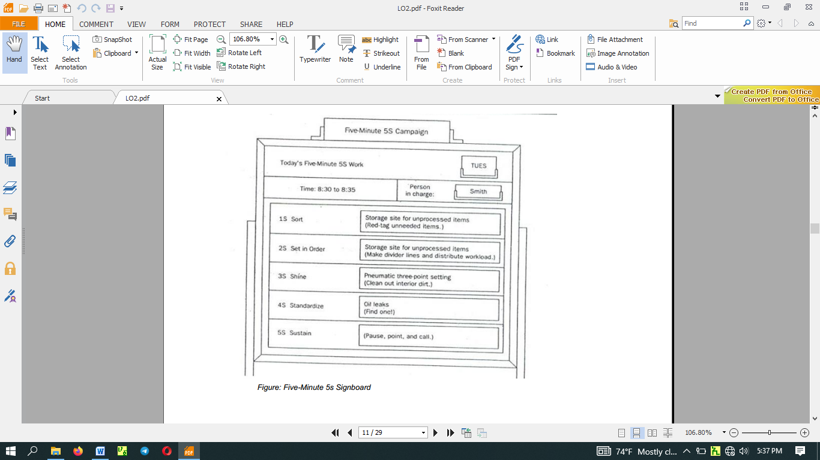
- Check on 3S Maintenance Level - After we have assigned the three pillar jobs and have incorporated the three pillar maintenance into the everyday work routine, we need to evaluate how well the three pillars are being maintained. For this, we can use a Standardization-level Checklist as shown in the figure below.
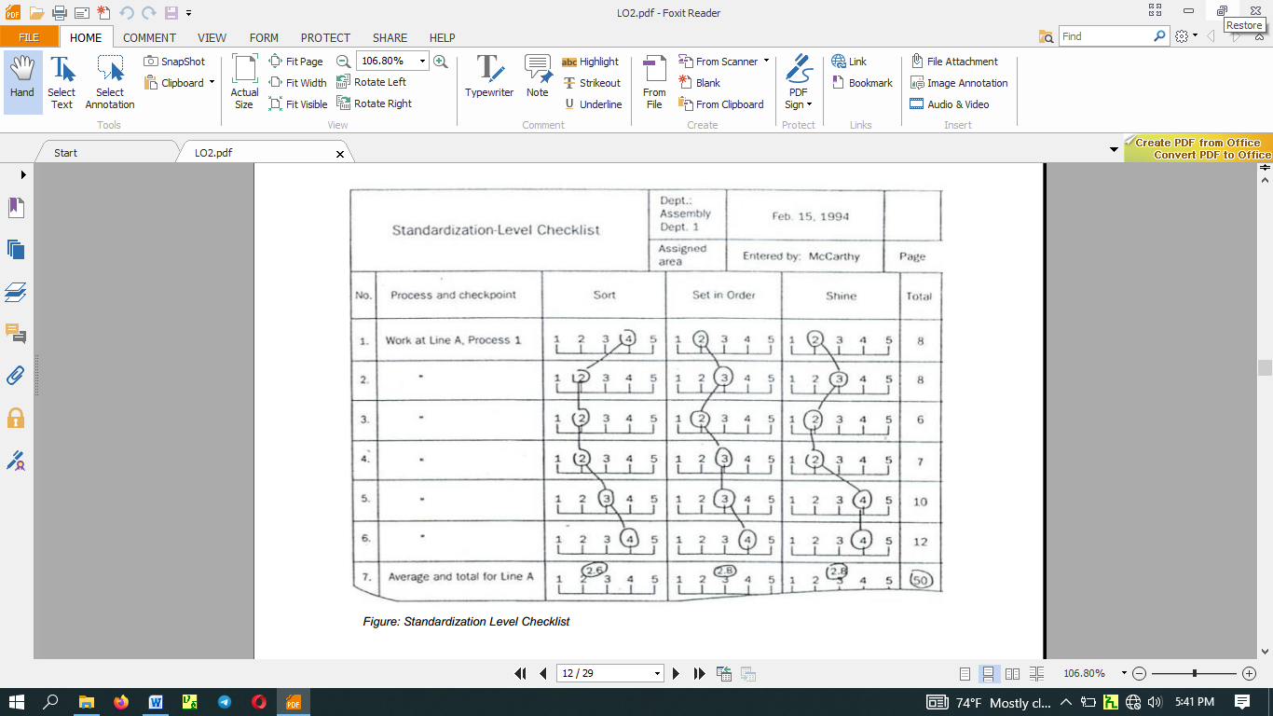
To evaluate the effectiveness of the maintenance activities, the evaluator ranks the Sort, Set in order, and Shine levels on a scale of 1 to 5. Such checklists can be made for specific workshop and/or production processes. One example is shown in the Figure below. 5S Checklists like the one in the figure are used to check five pillar levels in the factory as a whole. When a company implements 5S Month of intensive activities, 5S Checklists should be used to make weekly evaluation of five pillar conditions.
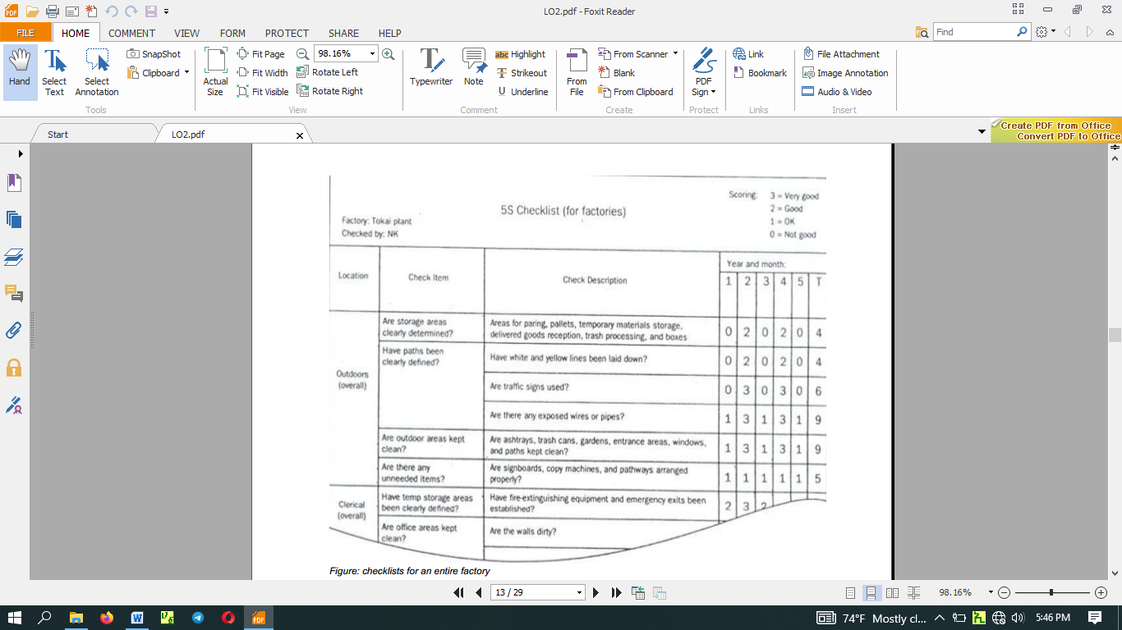
The Concept of Prevention - When we find that tools have not been put back correctly, we immediately take care of them. When we find an oil puddle on the floor, we immediately mop it up. Making these actions habit is the foundation of Standardize. However, when the same problems keep on happening over and over again, it is time to take the concept of Standardize to the next level: prevention.
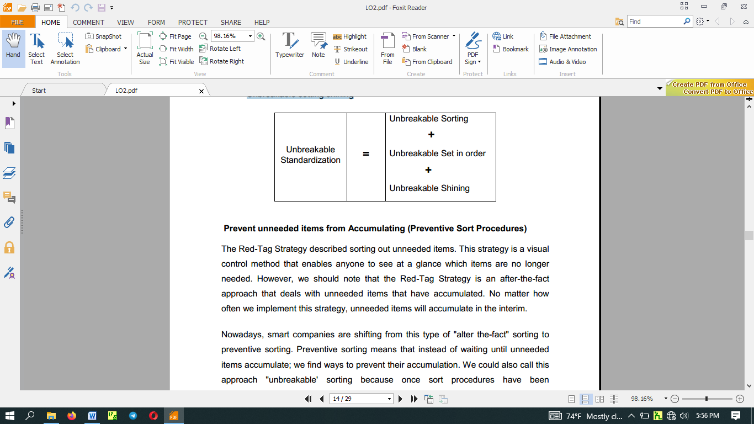
To take this pillar to a higher level, we must ask "why?" Why do unneeded items accumulate (despite Sort procedures)? Why do tools get put back incorrectly (despite Set in order procedure? Why do floors get dirty (despite Shine procedures)? When we ask "why" repeatedly, we eventually find the source of the problem and can address that source with a fundamental improvement. Such improvements can help us develop Unbreakable standardization, which means:
- Unbreakable sorting
- Unbreakable setting in order
- Unbreakable setting shining

Prevent unneeded items from Accumulating (Preventive Sort Procedures)
The Red-Tag Strategy described sorting out unneeded items. This strategy is a visual control method that enables anyone to see at a glance which items are no longer needed. However, we should note that the Red-Tag Strategy is an after-the-fact approach that deals with unneeded items that have accumulated. No matter how often we implement this strategy, unneeded items will accumulate in the interim.
Nowadays, smart companies are shifting from this type of "alter the-fact" sorting to preventive sorting. Preventive sorting means that instead of waiting until unneeded items accumulate; we find ways to prevent their accumulation. We could also call this approach "unbreakable' sorting because once sort procedures have been implemented, having only needed items in the workplace becomes an "unbreakable" condition.
To achieve unbreakable sorting we must prevent unneeded items from even entering the workplace. These words- «only what is needed" -have a familiar ring to anyone acquainted with the just-in- time (JIT) philosophy and program. To prevent the accumulation of unneeded inventory, we must find a way to procure and produce only those materials that are needed, only when they are needed, and only in the amount needed.
For example, suppose your company is scheduled to produce a certain number of units of a product during a particular month. Ideally, at the beginning of this month, only the parts needed to produce the scheduled number of units would be delivered to you from your suppliers. For any given part, your company might even receive the part in several deliveries, depending on the type of part and the delivery considerations.
Receiving parts just-in-time for production rather than storing large quantities of parts in advance eliminates many of the potential costs associated with maintaining inventory. As well, receiving parts just-in- time is a preventive measure that avoids the accumulation of parts that needed to be sorted.
Prevent Things from Having to Be Put Back (Preventive Set in Order Procedures)
Preventive setting in order means keeping set in order procedure from breaking down. To achieve preventive setting in order, we must somehow prevent the inefficiency that results from the lack of orderly control of any specific item. There are two ways to do this: (1) make it difficult to put things in the wrong place and (2) make it impossible to put things in the wrong place.
The first method relies heavily on discipline and visual controls. Clearly marked storage sites show at a glance what goes where and in what amount. When it is obvious what goes where and in what amount. When it is also obvious that things are not put back properly. As people practice returning things, such visual setting in order becomes habitual. This condition supports setting in order that is difficult to break.
However, there is still a big difference between setting in order that is difficult to break and setting in order that is unbreakable. 'Why settle for the first when the second is possible? But how we achieve unbreakable setting in order?
The 5 Whys and 1How (5W1H) Approach
We begin by asking "why?" until we identify the underlying causes- for every answer we gel we must ask "why" again. Usually we ask "why" at least five times to get to the root of the problem. When we do find the underlying cause, we ask "how" we call fix it. Accordingly, this method is called the "5W1H' approach.
When we ask "why" setting in order is breakable, we find that one answer is because people make mistakes putting things back. At this point, we need to identify what types of items are not being returned correctly. Once we identify this, the question is how to achieve unbreakable setting in order by making it impossible to return them to the wrong place. If we can somehow eliminate the need to return items at all, we can achieve unbreakable setting in order.
Three techniques for doing this are:
- Suspension
- Incorporation
- Use elimination.
Suspension
In the Suspension technique, tools are literally suspended from above, just within reach of the user. Figure above shows this method in practice. Here a weighted pulley device is used to suspend tools from an overhead rack. When the operator finishes using the tool, he merely releases it and it automatically returns to its proper storage place.
While this technique does not eliminate the need to return items to a specific place, it does effectively eliminate the need for people to return them. People may make mistakes in returning things, but suspension devices do not. This technique achieves unbreakable setting in Order.
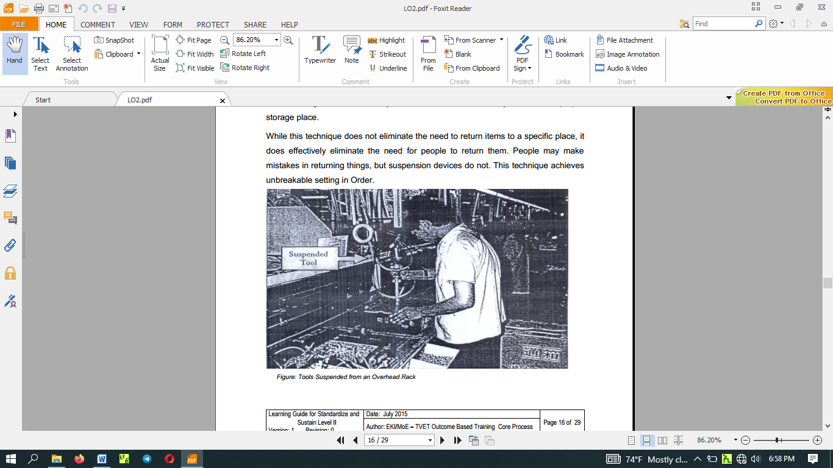
Incorporation
Incorporation means creating a flow of goods or operations in a factory process in which (1) jigs, tools, and measuring instruments are smoothly integrated into the process and (2) such devices are stored where they are used and therefore do not have to be returned after use. The figure below shows an example where a measuring gate has been incorporated into a cutting process for an automobile part. The measuring gate catches any pieces that have not been machined to the correct height. This measuring procedure is an example of "mistake-proofing’' (or pokayoke). The incorporation of the measuring gate into the cutting process means that its storage place is also its place of use. It is therefore used (for full-lot inspection) without having to be put back anywhere.
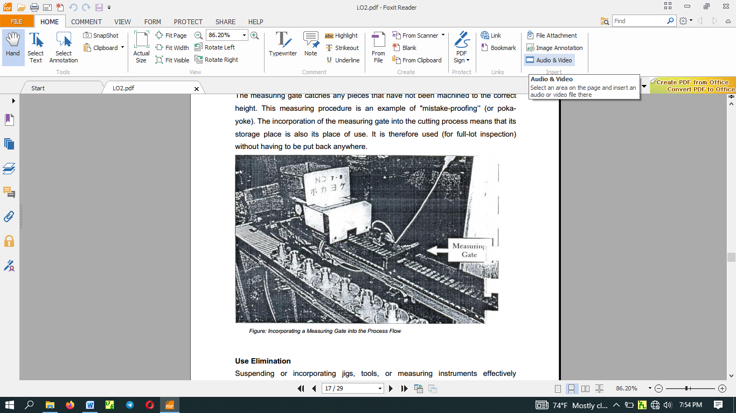
Use Elimination
Suspending or incorporating jigs, tools, or measuring instruments effectively eliminates the need to return them after each use. However, these items are still being used. The question is whether there is some way to serve the function of the tool without using the jig, tool or measuring instrument. A set in order approach that eliminates the use of a particular jig, tool or measuring instrument is in fact unbreakable setting in order.
There are three techniques for eliminating the use of certain tools:
- Tool unification
- Tool substitution
- Method substitution
Tool unification
Tool unification means combining the functions of two or more tools into a single tool. It is an approach that usually reaches back to the design stage. For example, we can reduce the variety of die designs to unify dies or make all fasteners that require a screw-driver conform to the same kind of screw-driver, flat-tip or Phillips.
Tool substitution
Tool substitution means using something other than a tool to serve the tool's function, thereby eliminating the tool. For example, it is sometimes possible to replace wrench turned bolt with hand-turned butterfly-grip bolts, thereby eliminating the need for a wrench.
Method substitution
If we substitute ordinary wrench-turned bolts with hand-turned butterfly-grip bolts, we have eliminated the wrench, but we have not eliminated the method (bolt fastening). Bolt fastening is just one way to fasten things. Fastening pins, clamps and cylinders can also be used for this purpose. We may find we can improve efficiency even more by replacing one method with another. This is "method substitution."
Standards for location indicators: Standards for indication of fixed positions
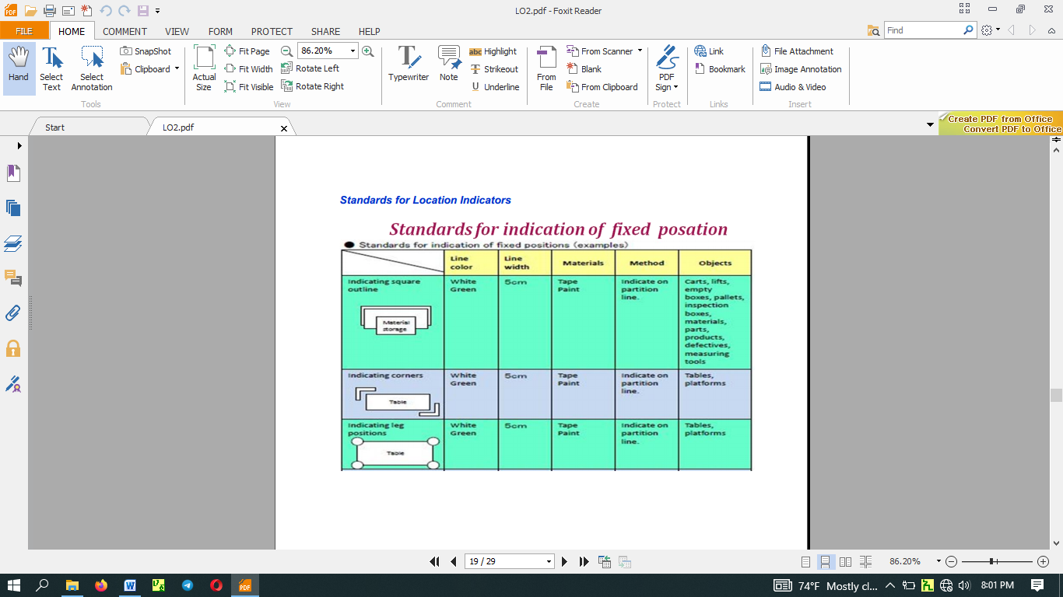
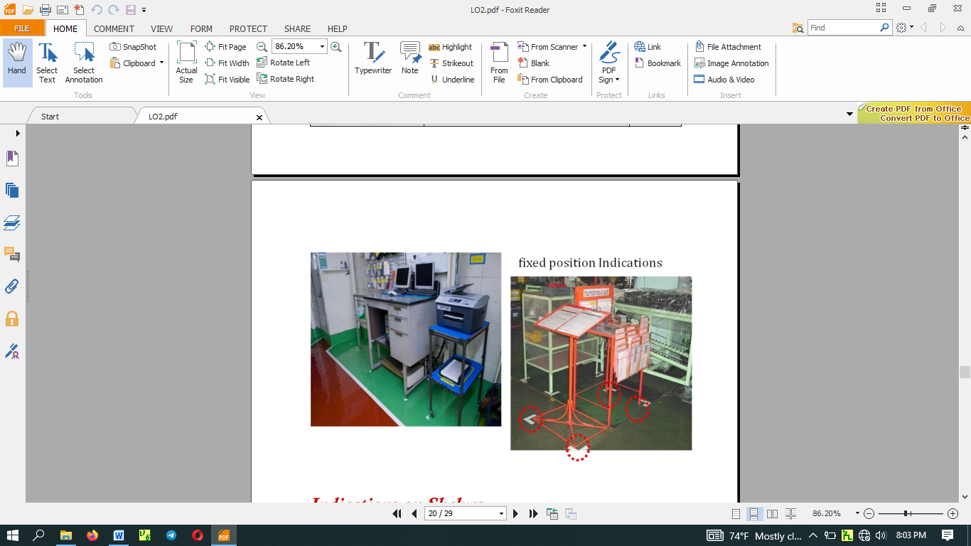
Fixed position indications
Indications on Shelves
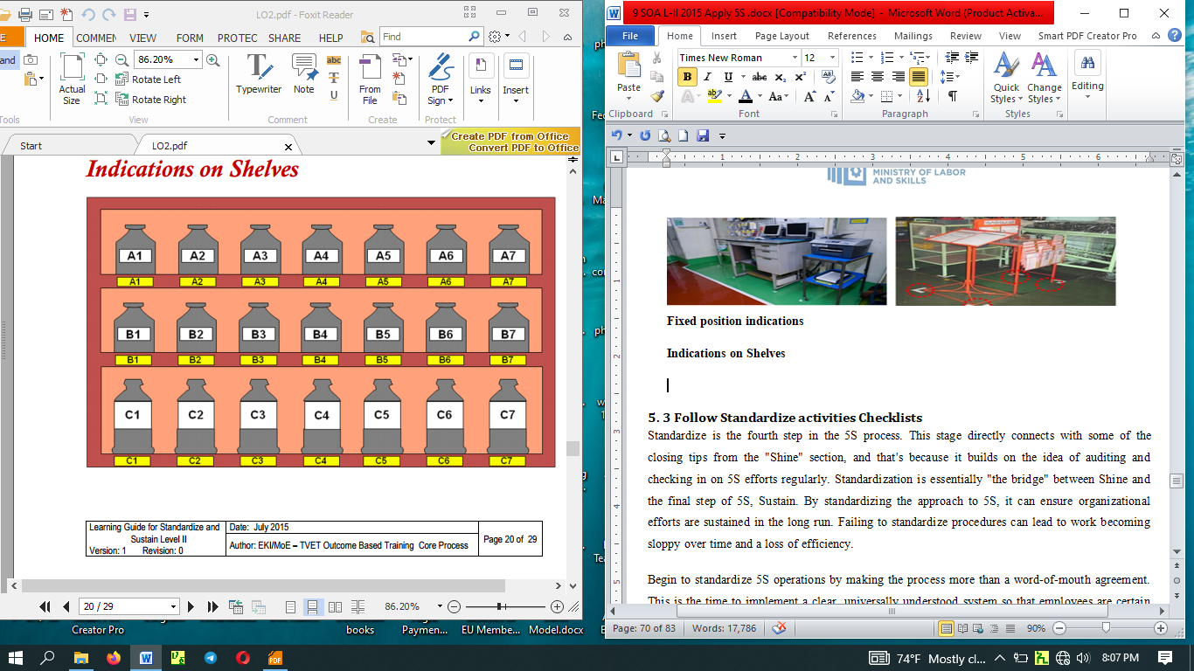
Indication of pathways
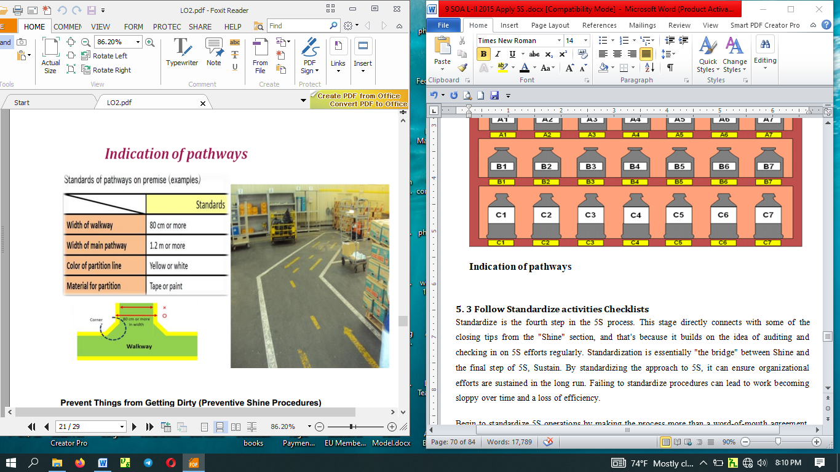

Prevent Things from Getting Dirty (Preventive Shine Procedures)

Preventives shine Procedures will prevent things from getting dirty to begin with. Anyone has participated in 5S implementation can tell you that the initial cleanup is very hard work. To minimize the drudgery of cleaning up, the key is to treat contamination problems at their source. The 5Why approach can be applied In figure out why dirt is being generated, and how this problem can be fixed. For example, instead of mopping up oil puddles, figure out where the oil is leaking from and repair the leak.

Question: Why mop the floor every day?

Answer: Because oil collects on the floor.

Question: does oil collect on the floor every day?

Answer: Because there's a leak from the drill press machine

Question: Why is there a leak from the drill press machine?

Answer: Because oil is leaking from a valve.

Question: Why is oil leaking from a valve?

Answer: Because it's broken.

Question: Why hasn’t the valve been replaced?

Answer: because we didn’t notice it was broken

Question: How can we coordinate getting the valve fixed?

Answer: The maintenance team will order the part and the operator will replace it.

5. 3 Follow Standardize activities Checklists
Standardize is the fourth step in the 5S process. This stage directly connects with some of the closing tips from the "Shine" section, and that's because it builds on the idea of auditing and checking in on 5S efforts regularly. Standardization is essentially "the bridge" between Shine and the final step of 5S, Sustain. By standardizing the approach to 5S, it can ensure organizational efforts are sustained in the long run. Failing to standardize procedures can lead to work becoming sloppy over time and a loss of efficiency.
Begin to standardize 5S operations by making the process more than a word-of-mouth agreement. This is the time to implement a clear, universally understood system so that employees are certain about what they are expected to do. One excellent way to do this is to design and print out 5S audit sheets that can be used by whoever is checking an area on a given day. A checklist that asks specific questions about the work area can help ensure that processes are carried out as intended

Some questions on the checklist may include:
- "Are all tools in their correct place on the shadow boards?"
- "Have power tools been unplugged with their cords properly stored?"
- "Are the necessary supplies in place for the next worker who will begin a shift at that station?

5.4 Standardize workplace
Standardized work is the name given in lean manufacturing for documenting the steps of a job task and the sequence in which those should be performed. You can think of standardized work as defining who does the task, when they do it, and how they do it. Standardize work can improve quality and reduce variability in products or services, keep quality consistent, make it easier to train new staff, allow for a respectful workplace for everyone involved, create a safer working environment, and are a basis for continuous improvement.
Make sure that you clearly communicate a consistent written message. Train your team to deliver on standards. Make sure everyone is told what is required and demonstrates the ability to deliver on expectations. Provide them with tools to maintain standards, such as check lists, photos and posters.

5.5 Avoid problems by standardize activities
Standardization is for continuous improving processes. Without standards, there can be no improvement as the old saying goes.
Activity of establishing, with regard to actual or potential problems, provisions for common and repeated use, aimed at the achievement of the optimum degree of order in a given context. In particular, the activity consists of the processes of formulating, issuing and implementing standards
The goal of standardization is to enforce a level of consistency or uniformity to certain practices or operations within the selected environment.
Standardization promotes productivity by eliminating inefficiency. This is the result of eliminating ambiguity and providing quality control: tasks are completed in a more efficient manner, and there are fewer quality control issues from tasks that were not completed correctly the first time around.
By assigning standard of performance for the things to be done problems related to inefficiency can be resolved easily. Standardizing the activities also helps to improve quality of products and services.
Standardize during 5s implementation in the office means to establish standards and guidelines to maintain an organized office. Here you focus on standardization and the application of visual management tools such as colored labels and sign boards.
Practical essentials for Standardize include:
- Set in place rules and policies that support the first three S's, e.g. designated areas, proper labeling of storage areas, a log of what goes where, etc.
- Define a schedule for 5S activities and make it a part of the work routine.
- Put in place an emergency plan for fires, medical emergencies and natural disasters.
- Install automated external defibrillators (AED).
- Train new employees on the 5S system.
- Put up a bulletin board to keep employees informed and aware of the 5S system and activities.
- Reward and recognize participation and achievement in the 5S program.

Self-Check -5
Directions: choose the best answer for the following question (1 point each):
- ___________ is Arrangement / organization of necessary items in good order for use.
- What is the use of arranging necessary items in good order in implementing the 5S?
- _______________________
- _______________________
- _______________________
- _______________________
- What is the result of implementing 3S without standardization? (4 points)
- List at least five tools and techniques used to standardize the 3S.
- What are the tools used to assign 3S responsibilities? (3 points)
- How the 5 whys and 1 how (5W1H) approach are used to sustain the 3S? (7 points)
- What is suspension in terms of sustaining of the 3S? (3 points)
- Define incorporation. (3 points)
- Describe Use Elimination in sustenance of the 3S. (3 points)
- What will result implementing 3S without standardization? (4 points)

Operation Sheet 1: Procedures in Implementing Standardize
Sequence of Standardize
  - Planning for Standardization
  - Assign 3S Responsibilities for everyone in the work place by using the tools by using the tools such as 5S Maps, 5S schedules, 5S job cycle charts
  - Integrate 3S Duties into Regular Work Duties by using the two approaches: visual 5S and five- minute 5S
  - Check on 3S Maintenance Level by using Standardization-level Checklist and 5S checklist and make maintenance/correction on back sliding the 3S.
  - Prevention of back sliding of the first three pillars by using 5W1H approach, suspension, incorporation and use elimination.

LAP Test: Practical Demonstration
Instructions: Given necessary templates, workshop, tools and materials you are required to perform the following tasks within -------- hours.
Task 1: Prepare standard to the sort activities in your workplace.
Task 2: Prepare standard to the set in order activities in your workplace.
Task 3: Prepare standard to the shine activities in your workplace.
- consider the OHS procedures

Unit Six: Sustain 5S
This unit is developed to provide you the necessary information regarding the following content coverage and topics:
  - Plan to sustain 5S activities.
  - Implement tools and techniques
  - Inspect Workplace regularly
  - Clean up Workplace after completion of job
  - Follow Checklists
  - Avoid Problems by sustaining activities.
This unit will also assist you to attain the learning outcomes stated in the cover page. Specifically, upon completion of this learning guide, you will be able to:
- Prepare and follow Plan to sustain 5S activities.
- Prepare and Implement tools and techniques to sustain 5S
- Inspect Workplace regularly for compliance to specified standard and sustainability of 5S
- Clean up Workplace after completion of job
- Follow Checklists
- Avoid Problems by sustaining activities.
The final step, which is known as Sustain or Shitsuke, focuses on taking all of the previous steps of 5S, including the standardized procedures, and transforming them into ongoing habits to ensure 5S continuous improvement. Just having a basic system in place is not enough, and the existence of the Sustain step is a testament to this. When workers are required to do something new in the workspace, it will not become an automatic habit right away; it takes people time to actually form longstanding habits.
In the context of the five pillars, to sustain means to make a habit of properly maintaining correct procedures. In your life, in general, what do you mean when you talk about sustaining something? Usually, you think of it as drawing on something from inside yourself in order to maintain a course of action-even when forces in your life challenge in this effort.
- Means making a habit of properly maintaining correct procedures

Problems Avoided by Implementing Sustain
Here are some of the things that happen in a company when Commitment to the five pillars is not sustained.
- Unneeded items begin piling up as soon as sorting is completed
- No matter how well Set in Order is planned and implemented, tools and jigs do not get returned to their designated place after use.
- No matter how dirty equipment becomes, little or nothing is done to clean it.
- Terms are left protruding into walkways, causing people to trip and get injured.
- Dirty machines start to malfunction and produce defective goods.
- Dark, dirty, disorganized workplaces lower workers' morale.
These 5S related problems and others are likely to occur in any factory or office that lacks a commitment to sustain the five pillar gains over time.
Why Sustain Is Important
Usually you commit yourself to sustain a particular course of action because the rewards for keeping to the course of action are greater than the rewards for departing from it (see figure above). Viewed another way, the consequences of not keeping to the course of action may be greater than the consequences of keeping to it. For example, suppose you want to start an exercise program – say you decide you want to work out at a gym three times a week. You probably have difficulty sustaining this course of action. This is because forces in your life, such as limits on your time and energy as well as the power of inertia, challenge this plan. However, if the rewards of sticking to your exercise program (for example, feeling and looking better) are greater than the rewards of not sticking to it (for example, having more time for other things that you need to do), your commitment will increase and you will probably sustain this program over lime.
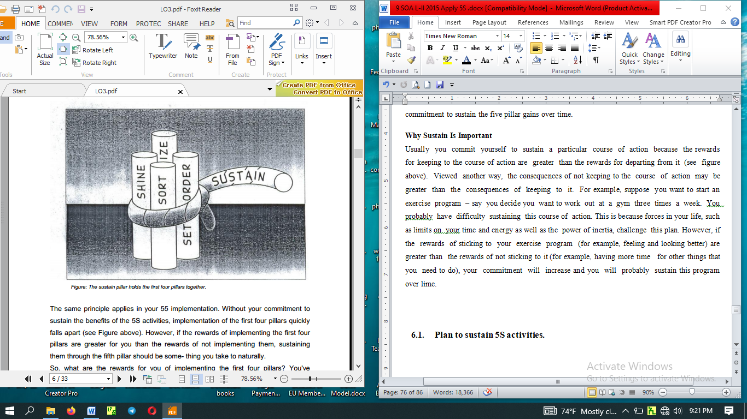
The same principle applies in your 55 implementation. Without your commitment to sustain the benefits of the 5S activities, implementation of the first four pillars quickly falls apart (see Figure above). However, if the rewards of implementing the first four pillars are greater for you than the rewards of not implementing them, sustaining them through the fifth pillar should be some- thing you take to naturally.
So, what are the rewards for you of implementing the first four pillars? You've probably discovered them for yourself at this point. Implementation of the first four pillars should make your workplace mare pleasant to work in, your job more satisfying and communication with your coworkers easier. it should also make your work more efficient and of better quality, which will hopefully lead to reward of your efforts by your company. It' true that that the five pillars take time to implement, but this investment of time will bring a great return, for both you and your company.
How to Implement Sustain
Creating Conditions to Sustain Your Plans
The implementation of the sustain pillar is different from that of the sort, set in order, shine, or standardize pillars in that the results are not visible and cannot be measured. Commitment to it exists in people's hearts and minds and only that have shown its presence. Because of this it cannot exactly be “implemented” like a technique, However, we can create conditions that encourage the implementation of the sustain pillar.
For instance, going back to our exercise program example, how could you create conditions in your own life that would encourage sustaining your plan to work out at a gym three time a week? You might:
- Join a gym with a friend so you can work out together and encourage each other (see Figure above).
- Create a workout schedule with your friend.
- Make a plan with your spouse to eat dinner later three nights a we so you can go to the gym after work.
- Get extra sleep on the nights before you work out, so that you will not be too tired by the end of the day to follow through with your exercise plan .
These conditions would make it easier for you to sustain your schedule for exercising at the gym three times a week.
Similarly, you and your company can create conditions or structure that will help sustain to the five pillars. The types of conditions that are most useful for this are:
- Awareness. You and your coworkers need to understand what the five pillars are and how important it is to sustain them.
- Time. You need to have or make enough time in your work schedule to perform 5S implementation.
- Structure. You need to have a structure for how and when 5S activities will be implemented.
- Support. You need to ha e support for your efforts from management in terms of acknowledgement, leadership, and resource
- Rewards and Recognition. Your efforts need to be rewarded.
- Satisfaction and Excitement. The implementation of the five pillars needs to be fun and satisfying for you and the company. This excitement and satisfaction gets communicated from person to person, allowing 5S implementation to build as it involves more people.
Roles in Implementation
In order to sustain 5S implementation in your company, both you and the company management have important roles to play. Part of this role involves creating the conditions that sustain 5S activities. The other part involves demonstrating a commitment to 5S yourself.
The Role of Management
The supervisors and managers in your company have a major role to play in ensuring the success of the five pillars by creating conditions that help sustain 5S activities. This role includes:
- educating you and your coworkers about 5S concepts, tools, and techniques;
- creating team for implementation
- allowing time for implementation and creating schedules for this work
- Providing resources for 5S implementation. such as supplies-s
- acknowledging and supporting 5S efforts
- Encouraging creative involvement by all workers, listening to their ideas, and acting on them.
- creating both tangible and intangible rewards for 5S efforts
- promoting ongoing 5S efforts
Your supervisors and managers also have an important role to play in implementing the fifth pillar in their own work. When they sustain the first four pillars, they perform three very important functions.
- improving the quality and efficiency of their own work
- teaching by example
- demonstrating the company's commitment to 5 implementation
Yours Role
Similarly, you have an important role to play in creating the conditions that Sustain 5S activities. This role includes:
- continuing to learn more about 5S implementation
- helping to educate your coworkers about the 5S
- being enthusiastic about 5S implementation
- helping to promote 5S implementation efforts
You also have an important role to play in order to sustain 5S activities in your own work. This role includes:
- taking the initiative to figure out ways to implement the five pillars in your work on a daily basis
- asking your supervisor or manager for the support or resources you need to implement the five pillars
- participating fully in company 5S implementation efforts
- bringing to your supervisor or manager your creative ideas for promoting or implementing the five pillars
- participating fully in company 5S promotion efforts

Plan to sustain 5S activities.
The fifth step is Sustain, or “shitsuke,” which literally means “discipline.” The idea here is continuing commitment. It’s important to follow through on the decisions that you’ve made — and continually return to the earlier steps of 5S, in an ongoing cycle.
Previously, we have discussed 5S in general, the phases Sort and Straightens, and the phases Sweep and Standardizing in previous units. This unit will discuss the final phase of 5S the sustain phase.
The fifth and final S in the 5S model is the most difficult of the stages to implement in practice. It is difficult because this stage circles back on all the prior stages to ensure that they are being appropriately maintained and updated as necessary. The sustain stage therefore has two main objectives:
- sustaining the current standard as they were agreed upon by the team and
- Identifying improvements when the standards are no longer relevant or complete.
An aid that can be used to check whether the standards are sustained is a mini-audit. By writing short questions on a T-card (a small card in the shape of a T so that it can easily fit a plan board) everyone can perform a mini audit in an area of their choosing. The cards can include questions such as; “Are all materials placed at their specified location?”, “is there something missing that you need to do your job properly or better?”, “are the tools on the shadow board cleaned according to standard?”
The easiest way to perform such an audit is by linking each T-card to the standards defined in the previous step, leading to one T-card per standard.
Sustain means to make 5S a habit and teach others to adhere to established standards. Make 5S a habit and develop a disciplined office environment.
Essentials for Sustain include:
  - Regular communication of the 5S program, e.g. monthly newsletters.
  - Regular housekeeping on your computer hard drive.
  - Hold all-together cleaning sessions.
  - Conduct monthly 5S inspections and audits.
  - Conduct monthly review by the 5S steering committee.
  - Establish 5S standards and continuous improvement of the standards.
  - Develop 5S manuals. Reward and recognize individuals and teams for good 5S practices.
For a 5S initiative to be successful, make it an organization-wide effort. Senior management must commit and involve all staff. For successful 5S implementation, you must provide sufficient resources, manpower, training and publicity. Be sure to align the 5S program to the company's goals and objectives. Finally, there must be regular 5S audits and management review, as well as recognition and reward for good 5S practices.

6.2 Implement tools and techniques

Common Tools and techniques to sustain 5s are:

There are many tools and techniques your company can use to help sustain commitment to 5S implementation. We offer these below so you will be aware of them. At some point in your 5S implementation work, you may be called upon to use or even coordinate the use of these techniques. These are:

5S slogans

5S posters

5S photo exhibits & storyboards

5S newsletter

5S maps

5S pocket manuals

5S department/benchmarking tours

5S months

5S audit

Awarding system

Big cleaning day

Patrolling system

Top management Patrol

5S Committee members and Promotion office Patrol

Mutual patrol

Self-patrol

Checklist patrol

Camera patrol

5S Slogans

5S Slogans communicate the themes of the five pillar campaign in your company. They are most effective when they are suggested by you and your coworkers. They can be displayed on buttons, stickers, flags, or posters.

It encourages all the participants.

Samples of slogan

“Refresh yourself and workplaces by 5S activity.”

“Let's maintain current 5S activity and KAIZEN for tomorrow”

“We polish “Our Minds” as well us our factories”

5S Posters

Posters displaying 5S Slogans or descriptions of 5S activities can be posted throughout the workplace. They can serve to remind everyone of the importance of the five pillars, or to communicate the results or status of 5S activities.

Samples of Poster
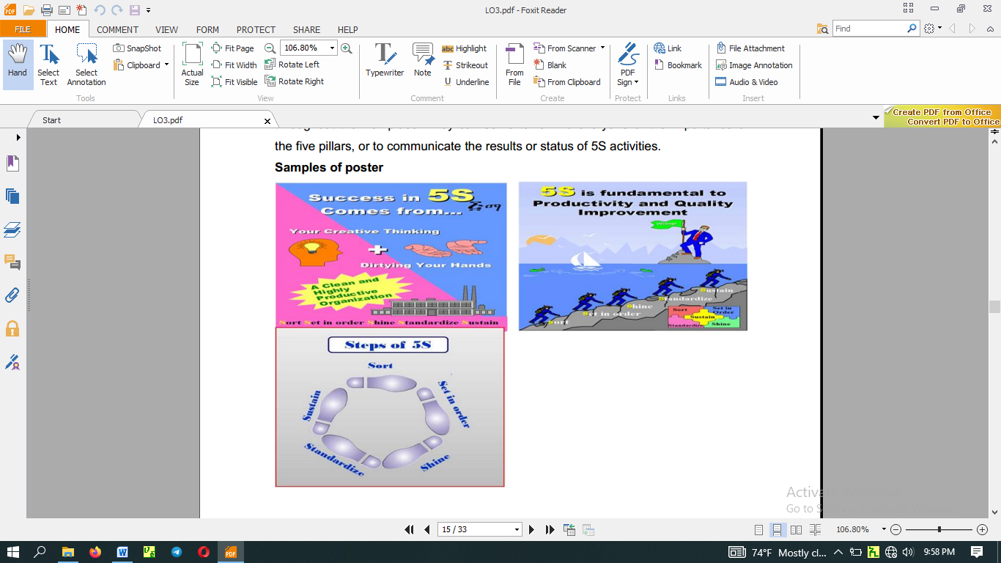

5S Photo Exhibits and Storyboards

When it comes to communication about 5S implementation, the old saying that a "picture is worth a thousand words" is definitely true. Photo Exhibits and Story boards showing the before and after of 5S implementation activities are powerful tools for promoting the five pillars. Photos and Storyboards can also communicate the status of five pillar activities.

5S Newsletters

55 Newsletters are in-house news bulletins centered on five pillar topics. They carry factory reports on 5S conditions and activities. 5S Newsletters are most effective when issued on a regular basis, perhaps once or twice a month and at staff meetings.

55 Maps

5S Maps can also be used to get employees involved in five pillar improvement on an ongoing basis. 5S improvement Maps should be hung in a central location with suggestion cards attached so anyone can suggest improvements.

55 Pocket Manuals

A 5S Pocket Manual can be created that contains five pillar definitions and descriptions, and is small enough to fit into the pocket of work clothes. Shop floor workers, supervisors, and managers can all use SS Pocket Manuals for easy reference to the 5S essentials.

55 Department Tours

When one department in a company has implemented the five pillars successfully, it can serve as a model area for other departments to come visit. Since "seeing is believing," this technique is extremely effective for promoting 5S implementation throughout a company.
55 Months
Companies should designate two, three, or four months every year as "5S Months.” During these months, various activities such as 5S seminars, field trips, and contests can be carried out of further promote 5S implementation in the company.
5s Audit
- The purpose of this audit is to outline an approach making 5S a success in industrial as well as our working areas.
- Enable 5S teams to design and establish a simple, effective and visual workplace organization, which creates a professional workplace and culture that is effective, organized and disciplined.
- Continual Improvement internal audit program enhance excellent service delivery
- Audit findings can be used to identify trends and the key issues.

5S Checklists
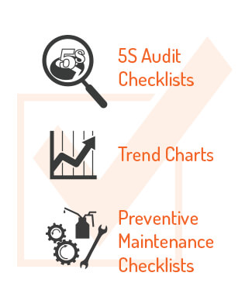

In addition to process tools, you will need other tools to help support your 5S system. These tools include checklists and charts. Some common checklists that can help keep your program focused include:
- 5S Audit Checklists: An audit checklist can help keep your program on task by making it easy to track improvements and areas that can use additional improvements. Each department should make its own checklist to best meet its needs.
- Trend Charts: These charts show trends in data over time. Trend charts help managers keep track of changes in processes, outputs, and much more. These charts can help you quickly identify areas or processes that need to be improved, as well as processes that will need to be improved in the future.
- Preventive Maintenance Checklists: Preventive maintenance is what keeps operations running smoothly without excessive downtime. Using a preventive maintenance checklist ensures that maintenance is done on time and new maintenance requirements are addressed.
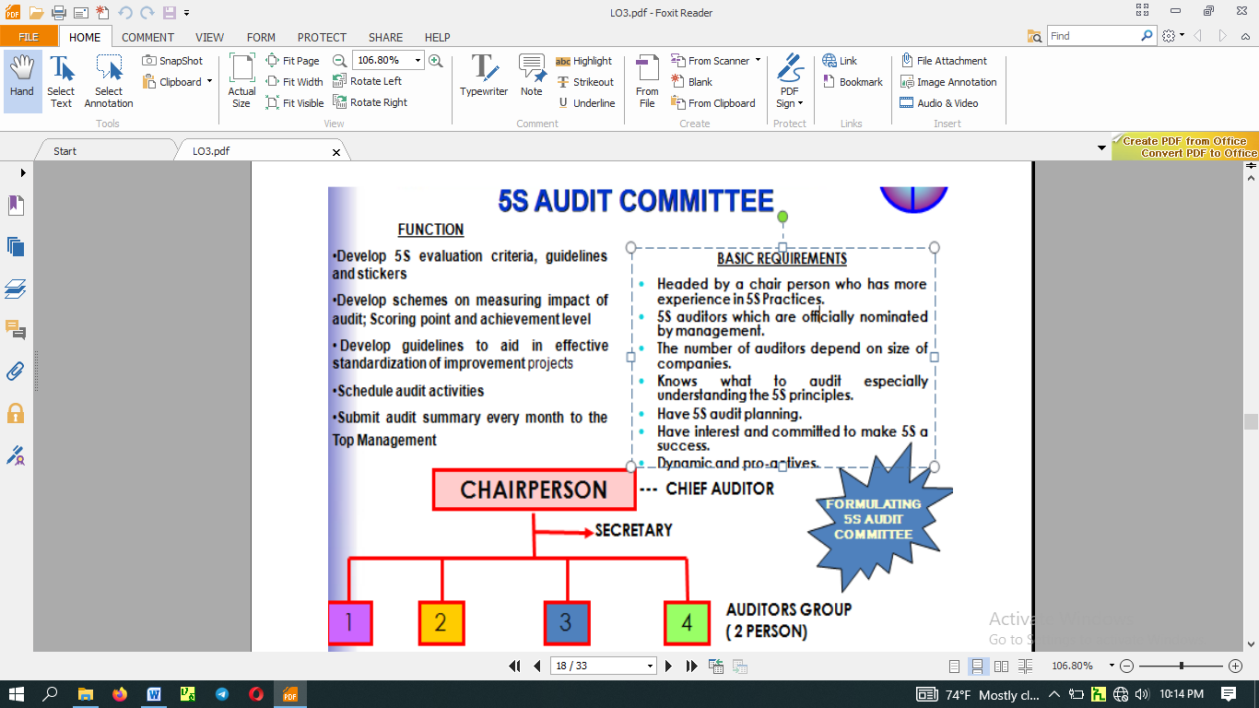

Performing Audit

Preparation

All 5S auditors gather at the meeting room ½ hour before audit

Briefing by 5S audit chairman:-

Activities of the day

Highlight any new criteria to be checked

Action date on sticker (2 weeks from audit date)

Time to report back

3. Wearing 5S auditor tag

4. Every auditor is only allowed to use up to 3 stickers at each audit to each 5S zone. It is purposely not put burden to 5S team to make improvement in very drastic manner.

5. Previous audit summary report will be distributed to the auditors’ team as a reference in order to avoid in consistency auditing.

During Audit

1. Bring all audit materials e.g. checklist, stickers, file holder & audit summary report

2. Get the KPT leader or facilitator to accompany auditor

3. Good public Relation

4. Check outstanding matter from the previous audit summary report

5. Proper issue of stickers & justified

6. Propose idea for improvement and justified.

7. Close matter when action has been taken. Remove sticker

8. Issue new sticker when action is not fully satisfied (old sticker still remain) and also for new matter noted

9. Take photo as an example in case of the 5S team has shown very creative idea to make the 5S initiative significantly effective, safe work place, cost saving

10. Only use maximum 3 stickers of each type for each working area / zone
11. Listen to the feedback given by workers
12. Provide positive suggestion for improvement if stickers is not appropriate
13. Prepare audit report of each working area on the Audit summary
14. Document must be signed by auditor & team leader
15. Audit to the next area
16. You may take 10 – 15 minutes for one zone.
Twelve Focal Points 5S Auditors Should Examine

- Do the Top and Middle managers support 5S program?
- Are people proud of their workplaces?
- Are workplaces clean and organized?
- Are workplaces safe for people to work in?
- Are machines and equipment clean and well maintained?
- Are items easy to retrieve?
- Are machines and tools conveniently located?
- Are inventories stored for FIFO retrieval?
- Are products free from dust?
- Do people clean daily without prompting?
- Are the uniforms worn by people clean and tidy?
- Is a good image of the enterprise reflected in its people?

6.3 Inspect Workplace regularly
Workplace inspections help to identify any inconsistency of the principles set to perform sustaining activities. Through a critical examination of the workplace, inspections help to identify and record inconsistency for corrective action.
- It is to make everyone practice 4S spontaneously and willingly as habit or way of life.
- There is no other way to foster such culture than practicing 4S’s regularly until such time comes when everyone becomes fond of 5S.
- It is helpful to inspect workplace before starting your morning work and leaving office regularly.
Develop 5S Evaluation Stickers

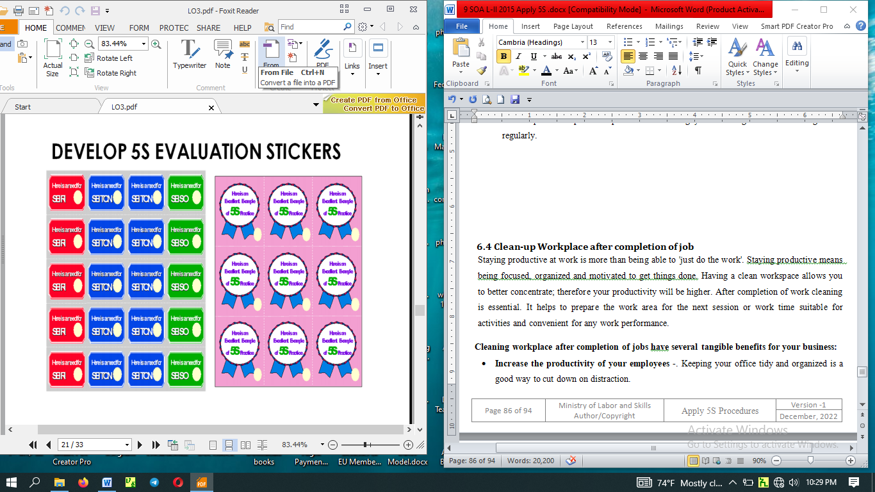

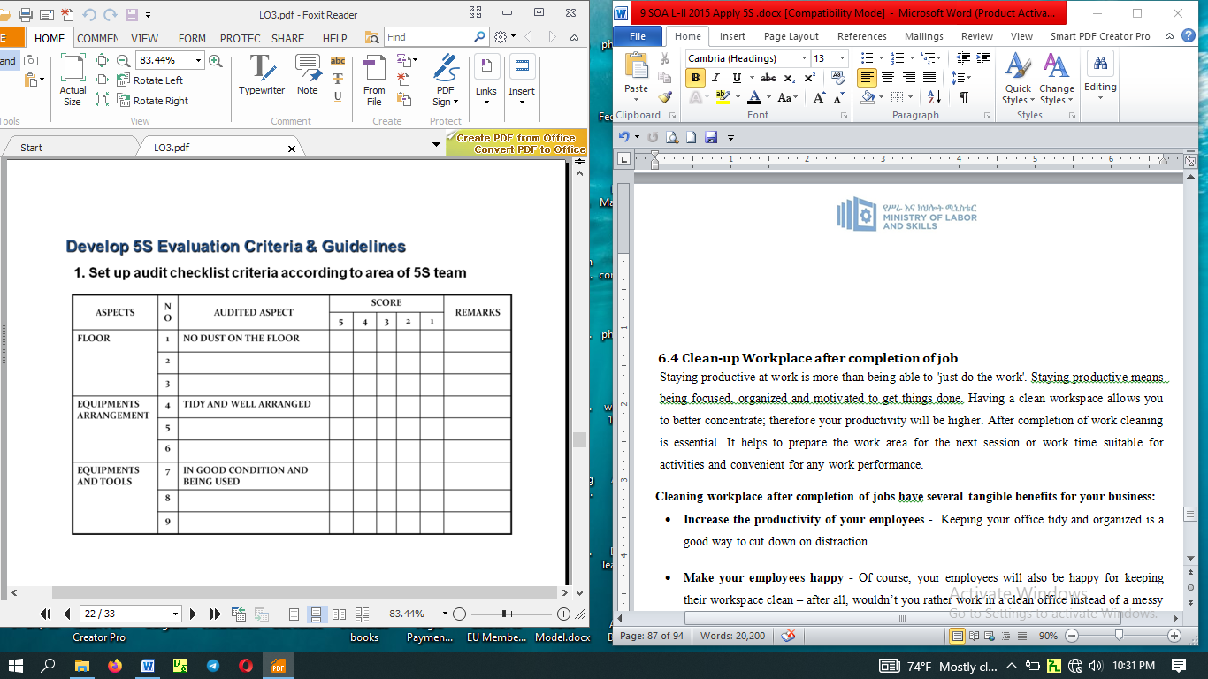

`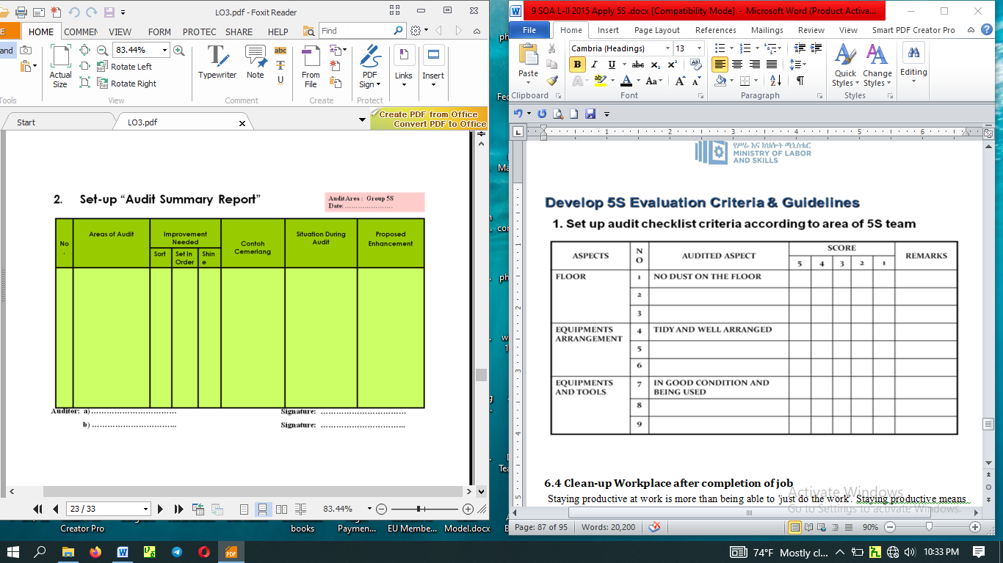

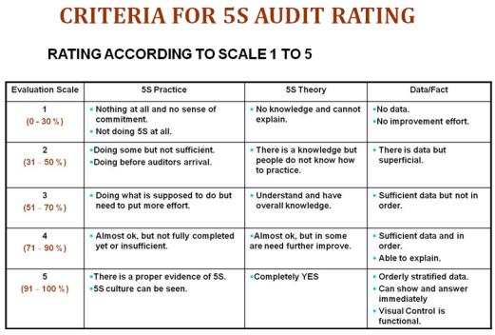

Awarding System

Awarding for 5S promotion results according to evaluation is recommended.

Awards may be:

For Good performance

Award for efforts

Award for good Ideas

Prize winner

Group

Individual

Big Cleaning Day

It is a cleaning that carried out from two to four hours by the organization.

Example: Before national holidays

Patrolling System

Top management Patrol

Check Up the activities Comprehensively

Give emphasis on sustaining of the activity

consider committees feedback

5S Committee members and Promotion office Patrol

Evaluate “5S Check List”

Record problems on”5S check findings”

Tack picture of 5S problems

Mutual patrol

Check mutually among KPT

Self patrol

5S leader and members check the results of activity by themselves.

Checklist patrol

Point out the problems by themselves at site as well as evaluate the results and encourage members to urge KAIZEN.

Camera patrol

Visibly highlight the problems and progress of the activity using photographs.

6.4 Clean-up Workplace after completion of job
Staying productive at work is more than being able to 'just do the work'. Staying productive means being focused, organized and motivated to get things done. Having a clean workspace allows you to better concentrate; therefore your productivity will be higher. After completion of work cleaning is essential. It helps to prepare the work area for the next session or work time suitable for activities and convenient for any work performance.

Cleaning workplace after completion of jobs have several tangible benefits for your business:
      - Increase the productivity of your employees -. Keeping your office tidy and organized is a good way to cut down on distraction.

Make your employees happy - Of course, your employees will also be happy for keeping their workspace clean – after all, wouldn’t you rather work in a clean office instead of a messy one?

Safeguard your employees’ health - Keeping your workplace clean can therefore reduce sickness and therefore reduce lost work days. This is why it’s important that your office has a good cleaning strategy in place.

Reduce hazards - Regular cleaning of your building can help you to keep on top of anything that might be an issue in the event of an emergency

Keep your office running smoothly - When your workplace is clean and free of clutter, you’ll find it easier to stay organised. It’s easier to keep track of papers, for one thing; documents are quicker to find when your office is tidy. It’s also less difficult to stay on top of any repairs that need to be done to machinery

6.5 Follow Checklists
Check list is a standard for follow activities regularly.
Check | Checklist
Check | yes | No
- Device and equipment are cleaned during at activity continuously?
- All obsolete, broken or unnecessary equipment not required for current projects are removed from the area or red tagged for removal?
Equipment/machinery is clearly identified (numbered, named, color-coded, etc.) and placed in a properly identified location. Critical maintenance points are clearly marked.
All tripping hazards such as electrical wires and equipment cables are removed from all working, standing, and walking areas.

6.6 Avoid Problems by sustaining activities.
If you have already been able to get your work team to leave the office in optimal conditions and have established internal regulations that include both elementary health standards and healthy coexistence, the last step is precisely to maintain this order and discipline so that your office is also like a second home.

The fifth step of a 5S program is Sustain, or “shitsuke,” which literally means “discipline.” The idea here is continuing commitment. It’s important to follow through on the decisions that you’ve made — and continually return to the earlier steps of 5S, in an ongoing cycle. Never “Once and Done”
The 5S approach was never meant to be a one-time event, but an ongoing cycle. This is key, because early successes in 5S can open the way for problems. If open space becomes available in the Sort step, but afterward, tools and materials are allowed to gradually fill in that space without any organization, the end result can be an even bigger mess. The solution is to apply the ideas of 5S over and over, as a routine part of normal work. That’s why Sustain is so important.
Sustaining a 5S program can mean different things in different workplaces, but there are some elements that are common in successful programs.
 | - Management support – Without visible commitment from managers, the 5S processes won’t stick around. Supervisors and managers should be involved in auditing the 5S work processes, and getting feedback from workers. They also need to provide the tools, training, and time for workers to get their jobs done right.
 | - Department tours – Bringing teams from one department to visit other departments will help familiarize the entire workforce with the processes of your facility. This type of “cross pollination” helps to spread good ideas, and inspires people to come up with new ways to improve the 5S implementation.
 | - Updated training – As time passes, there may be changes in your workplace, such as new equipment, new products, or new work rules. When this happens, revise your 5S work standards to accommodate those changes, and provide training on the new standards.
 | - Progress audits – The standards that are created in the 5S program should provide specific and measurable goals. Checking on those goals with a periodic audit can provide important information and guidance. Where is 5S working well? Where are teams falling behind?
 | - Performance evaluations – Once you know your goals are reasonable, make performance part of each employee evaluation. When teams and individuals perform well, celebrate it, and post overall results so each team can see how they compare to the rest of the facility.
Sustain is Not the End of 5S - While it’s the last step in the sequence, Sustain is not the end of 5S as a whole. One pass through the steps can expose problems that were hidden beforehand. Following the steps again can resolve those problems, and help discover new ways to improve. Continue through the cycle again and again to keep your facility at the top of its potential.
Generally Sustaining is the end result of how well we have performed the previous four S’s. In the sustainability stage, think of ways to eliminate effort in maintaining an area. Doing things spontaneously without being told and educate people so that 5S expands beyond initial limits and turns into natural standard behavior.

PROCESS/PROCEDURE:
Step 1: - Create reasonable rules.
- Create reasonable rules of behavior in the workplace.
- Engage everyone concerned in the creation of rules not just the department heads or supervisors.
- Discuss the rules with everyone concerned. This will result to a feeling of involvement.
- Show rules and standards clearly and attractively using illustrations, photographs and color-coding.
Step 2: - Exhibit before and after 5S photos where everyone will see them.
Step 3: - Recognize good practices and good performance.

Train people to follow good housekeeping rules autonomously.
- Enhance autonomous management activities
- Maintain the discipline needed to do a good job
- Upgrade productivity and quality consciousness
- Wash hands after going to the toilet
- Wash hands before and after meals
- Eat and smoke at designated places
- Keep workplace always clean and tidy
- Wear clean uniform and shoes
- Follow safety rules
- Put things back in their proper places
- Work according to standards
- Observe proper office decorum
5S implementation in Office Administration: sample

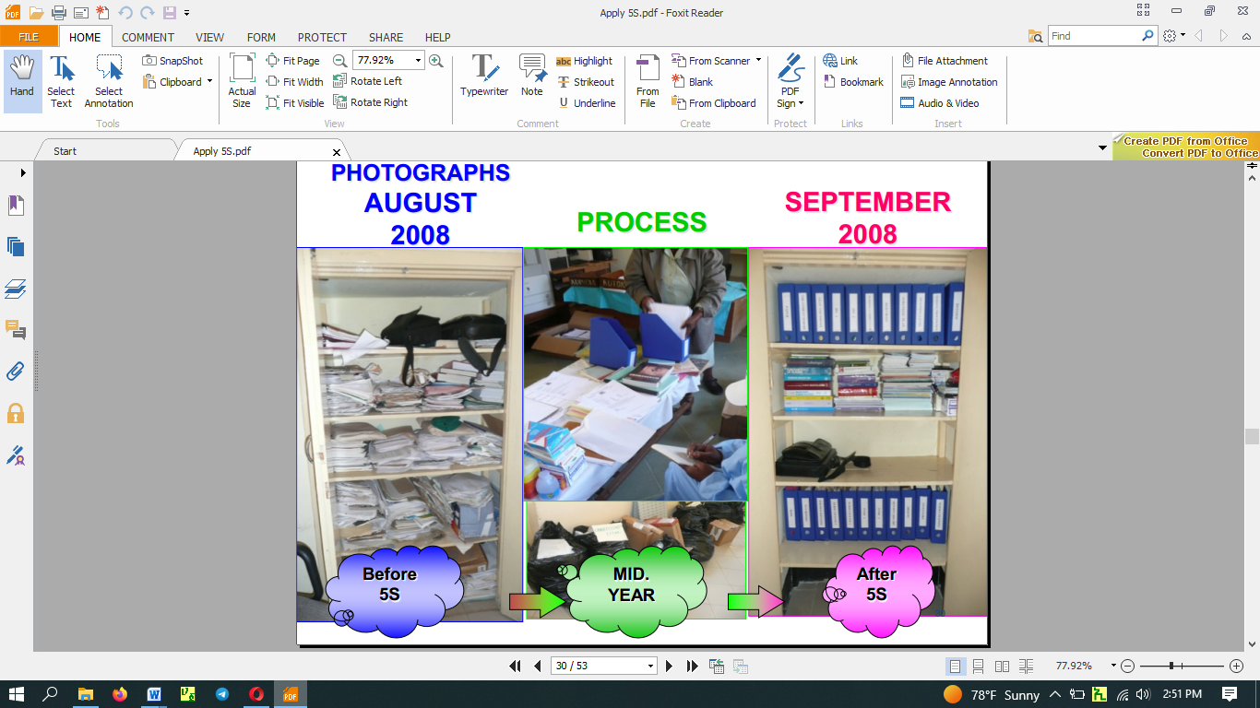

Self-check: Instruction .I: Write the correct answer on the blank space.
- ___ is a process-centered approach to ensuring that a company or organization is providing the best possible products or services.
- _____ typically require a strong knowledge of the business processes of an organization.
- Write the 5S in Japanese and English terms.
- ____________________
- ____________________
- ____________________
- ____________________
- ____________________
- 5S is a systematized approach to:
- _____________________
- _____________________
- _____________________
- What can a company gain from 5S?
P. __________________
Q. __________________
C. ___________________
D. ___________________
S. ___________________
M. ___________________
- What are the benefits of 5S?
- _______________
- _______________
- ________________
- ________________
- ________________
- ________________
- What are the common tools and techniques to sustain 3S? (13 points)
- How 5S slogans are used to sustain 3S? (2 points)
- Why 5S photo exhibits and storyboards are used to implement sustain activities (3 points)
- Describe 5S newsletters? (2 points)
- What are the 5S pocket manuals? (3 points)
- How 5S months are scheduled? (3 points)
- Describe 5S audit. (4 points)
- What are the activities performed during preparation of audit and during audit (4 points)
- Why awarding is necessary in sustain implementation? (2 points)
- List types of patrolling system. (6 points)

Operation Sheet 1: Procedures in Implementing Sustain
Sequence of Sustain
1. Planning
- Set schedules for sustaining techniques
2. Prepare sustaining Tools and Techniques
3. Implement sustaining activities
4. Feedback comments on the sustain results

LAP Test: Practical Demonstration
Instructions: Given necessary templates, workshop, tools and materials you are required to perform the following tasks within ------ hours.
Task 1: Prepare slogans and posters for your work area.
Task 2: Evaluate your work place by using the 5S check list and use stickers.
Task 3: Prepare audit summary report by using the given template.
- identify the:
- person -in-charge
- technology workshop
- work station
- consider the:
- OHS procedures
- workplace procedures and standards (work area)
- frequency of maintenance activities

Reference
1) 5S for operators (1995)
2) Ethiopia Kaizen Manual (2011)
3) Journals/publications/magazine

Developers Profile
No | Name | Qualification (Level) | Field of Study | Organization/ Institution | Mobile number | E-mail
1 | Engida Eshete Wolde | MA | BA SOA & MA in Marketing | Hawassa Tegbareid | 0916136741 | engdaeshete@gmail.com
2 | Birhanu Hailu Becho | BED | OAOT | Nekemte TVET college | 0917854441 | Obsa2013@gmail.com/  berihanuhailu41@gmail.com
3 | Estifanos Worku Tegegn | MBA | Business Admin | Harer Polytechnic C | 0920457778 | Worku.estifanos220@gmail.com
4 | Ephrem Haile | OAOT | OAOT | Tulu Bolo TVETC | 0965554581 | Ephremhaile1081@gmail.com

