BUILDING ELECTRICAL INSTALLATION
Level - I

Based on March, 2022, Curriculum Version I

Module Title: Work Safely in the Construction Industry
Module Code: EIS BEI1 M01 0922
Nominal duration: 40 hours

Prepared By: Ministry of Lobar and Skill

Month, Year
Addis Ababa, Ethiopia

Acknowledgement
Ministry of Labor and Skills and Ministry of Health wish to extend thanks and appreciation to the many representatives of TVET instructors and respective industry experts who donated their time and expertise to the development of this Teaching, Training and Learning Materials (TTLM).

Table of Contents
Acknowledgement 2
Table of Contents 3
Acronyms 5
Introduction to Work Safely in the Construction Industry 6
Unit One: OHS Legislative Requirements 7
1.1. OHS Legislative Requirements 8
1.1.1. Construction industry OHS standards and guidelines 9
1.1.7. Safety Codes Of Practice 15
1.2. Duty of Care Requirements 15
1.2.1. Duty of care to reasonably practicable 16
1.2.2. Safe work practices 17
1.2.3. OHS Requirements 17
Unit TWO: Construction Hazards and Control Measures 22
2.1. Basic principles of risk management 23
2.1.1 Assessing the risks 24
2.1.2. Consulting and reporting ensuring the involvement of relevant workers 24
2.1.3. Controlling the Hazard 24
2.1.4. Identifying Hazards 26
2.1.5. Reviewing to identify change or improvement 26
2.2. Common construction hazards 27
2.3. Measures for controlling hazards and risks 34
Self-check-2 37
Unit Three: OHS Communication and Reporting Processes 38
3.1. OHS communication processes, information and documentation 38
3.1.1. OHS Communication Processes 38
3.1.2. OHS Information and Documentation 43
3.3. Safety signs and symbols 53
3.4. Procedures and relevant authorities 57
Self-check-3 59
Operation sheet-1 60
Operation sheet-2 61
LAP Test 62
Unit Four: OHS Incident Response Procedures 63
4.1. Procedures for responding to incidents and emergencies 64
4.2. Procedures for accessing first aid 67
4.3. Selection and Use Of Relevant Personal Protective Equipment 68
Self-check-4 69
Operation sheet-3 70
LAP Test 72
References 73
Developers Profile 74

Acronyms
OHS------- Occupational safety and health
SWMS-----Safe work method statement
PCBU------ person conducting a business or undertaking
HSR-------- Health and safety representatives
MSDS------ Material Safety Data Sheet
HAVS ------Hand Arm Vibration Syndrome
TTLM------Training and Learning Materials
WHS--------Work Health and Safety
MOLSA---- Ministry of Labor and Social Affairs
NIHL------- Noise-Induced Hearing Loss

Introduction to Work Safely in the Construction Industry
Welcome to module 01. Themodule, Work Safely in the Construction Industry,helps trainees to have the required knowledge, skills and attitudes on Identifying OHS legislative requirements, construction hazards and control measures, Identify OHS communication and reporting processes andIdentify OHS incident response procedures in building electrical installation field.
This module is designed to meet the industry requirement under the Building Electrical Installation occupational standard, particularly for the unit of competencyWork Safely in the Construction Industry. This module contains training materials and activities for you to complete.
Module units
- OHS legislative requirements
- Construction hazards and control measures
- OHS communication and reporting processes
- OHS incident response procedures.
Learning objectives of the Module
At the end of this session, the students will able to:
- Identify OHS legislative requirements
- Identify construction hazards and control measures
- Identify OHS communication and reporting processes.
- Identify OHS incident response procedures.
Module Learning Instructions:
- Read the specific objectives of this Learning Guide.
- Follow the instructions described below.
- Read the information written in the information Sheets
- Accomplish the Self-checks
- Perform Operation Sheets
- Do the “LAP test”

Unit One: OHS Legislative Requirements
This learning unit is developed to provide the trainees the necessary information regarding the following content coverage and topics:
- OHS legislative requirements
- Duty of care requirements
- Safe work practices
This unit will also assist you to attain the learning outcomes stated in the cover page. Specifically, upon completion of this learning guide, you will be able to:
- Identify and explain OHS legislative requirements
- Identifyduty of care requirements
- Identify and explain safe work practices

OHS Legislative Requirements
Definition of Terms
- Occupational Healthand Safety (OHS)
According to [WHO, 2003], occupational safety and health can be defined as a multidisciplinary activity aiming at: -
- Protection and promotion of the health of workers by eliminating occupational factors and conditions hazardous to health and safety at work
- Enhancement of physical, mental and social well-being of workers and support for the development and maintenance of their working capacity, as well as professional and social development at work
- Development and promotion of sustainable work environments and work organizations.
- Legislative
Legislation means laws that are made by federal or state parliament. These are called ‘Acts’.
An Act may give particular people or agencies the power to make laws that relate to the Act, known as ‘Regulations’.
Regulations are the specific details and minimum requirements that relate to the Acts.
The legislation covers many things that are particularly relevant to construction sites, such as:
- First aid
- Personal Protective Equipment (PPE) and clothing
- Workplace Facilities
- Evacuation Procedures
- Ladders
- Warning Signs
- Electricity
- Noise Control
- Manual Handling
- Prevention of fall.
It is important to remember that just because something is not mentioned specifically in the Regulations doesn’t mean that anything goes!
The information, tools, and resources provided in these Construction Industry are designed to assist those in the industry whether worker or employer to identify, reduce, and eliminate construction-related hazards.
- The main health and safety site requirements in construction relate to tidy sites and decent welfare, falls from height, manual handling, and transport on site.
- Site operatives are normally required to plan and organize their operations, ensure that they are trained and competent and know the special risks of their trade and raise problems with their site supervisor or safety representative.

Construction industry OHS standards and guidelines
Construction is a high hazard industry that comprises a wide range of activities involving construction, alteration, and/or repair.
Construction workers engage in many activities that may expose them to serious hazards, such as falling from rooftops, unguarded machinery, being struck by heavy construction equipment, electrocutions, silica dust, and asbestos.
In a low hazard organization, health and safety may be supervised by a single competent manager.
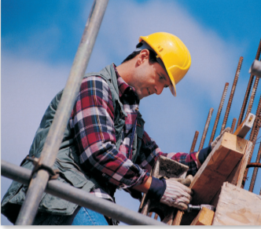
Figure 1.1. Construction Work
The following list pieces of legislation that can be applied to health and safety on construction projects:
- The Health and Safety at Work Act - not exactly a regulation, but the act under which specific health and safety regulations are formed.
- The Construction (Design & Management) Regulations - known as CDM, these construction-specific regulations apply to every project no matter how big or small.
- The Health & Safety (First Aid) Regulations - every workplace needs first aid cover, but because construction is higher risk, first aid requirements are higher too.
- The Personal Protective Equipment Regulations - PPE is important in all workplaces, it's your last line of defense against a hazard. PPE is a legal requirement under these regulations.
- The Manual Handling Operations Regulations - construction sites aren't the only places you will find lifting and carrying, but they are certainly somewhere you need to think LITE
- The Reporting of Injuries, Diseases and Dangerous Occurrences Regulations (RIDDOR) - reporting injuries is a legal requirement in every industry, including construction.
- The Electricity at Work Regulations - construction work is where electrical systems get installed, maintained and updated. And there's a set of regulations for that.
- The Gas Safety Regulations - if you're working on gas, you need to know about gas safety. It's the law.
- The Control of Vibration at Work Regulations - drills, saws, sanders, compactors, pumps, machinery. All vibration exposure needs to be within the legal limits of the control of vibration regulations.
- The Control of Noise at Work Regulations - too much noise is bad for you, so if you're carrying out noisy work on your site, check the noise action levels and legal limits.
- The Health & Safety Signs and Signals Regulations - you'll find different types of signs on construction sites, warning you of dangers and telling you what to do.
- The Confined Spaces Regulations - confined spaces are dangerous places, and you might find yourself needing to work in one on a construction site. If you do, the confined spaces regulations will apply.
- The Provision and Use of Work Equipment Regulations - often shortened to PUWER, these regulations require that equipment is safe, suitable, maintained, inspected and installed correctly.
- The Lifting Operations and Lifting Equipment Regulations - often shortened to LOLER, all lifting operations involving lifting equipment must use suitable equipment, be properly planned, appropriately supervised and carried out safely.
- The Management of Health & Safety at Work Regulations - this set of regulations apply to every workplace, and every employer, requiring work to be planned, risk assessed, organized and controlled.
- The Regulatory Reform (Fire Safety) Order - fire safely laws apply to every workplace, including construction sites. Here are 13 fire prevention tips to get you started.
- The Control of Asbestos Regulations - asbestos is constructions biggest killer, and while asbestos use is now banned, asbestos can still be found in buildings across the UK. Training, surveys and safe removal are all legal requirements.
- The Control of Lead at Work Regulations - lead is another hazardous material found on construction sites that has its own legal requirements.
- The Control of Substances Hazardous to Health Regulations - not every hazardous material has its own regulations, but many hazardous substances are covered in this set of regulations, known as COSHH.
- The Dangerous Substances and Explosive Atmospheres Regulations - known as DSEAR, these regulations place legal duties on employers and the self-employed to protect people from risks of fire, explosion and corrosion.
- The Working at Height Regulations - these regulations cover work at height which includes work or access to any place above or below ground level where a fall could cause injury.
- The Hazardous Waste Regulations - health and safety regulations don't just apply to your work on the site, you also need to make sure your waste does not cause harm or damage.
- The Supply of Machinery (Safety) Regulations - machinery supplied in the UK must meet health and safety requirements and, where necessary, be examined by an approved body. These regulations also cover CE marking.
- Ionizing Radiations Regulations - construction workers can be exposed to ionizing radiation from both natural (radon in soil) and manmade sources (industrial radiography, work at power plants etc.).
- The Corporate Manslaughter and Corporate Homicide Act - while this isn't a regulation, this law means that companies can be found guilty of corporate manslaughter as a result of a gross breach of a duty of care.

    - Health and safety representatives, committees and supervisors
- Health and safety Representatives
Health and safety representatives (HSRs) role is to facilitate communication between management and workers. This includes consulting and advising management of any health and safety concerns relating to workers, and providing assistance in cooperating with implementing and maintaining workplace safety. HSRs are responsible for:
- Inspecting the workplace or parts of the workplace
- Reporting any hazards in the workplace to the employer
- Referring health and safety matters to the WHS committee (if there is one).
If you have any health or safety concerns, you should report them to your supervisor or your WHS representatives.
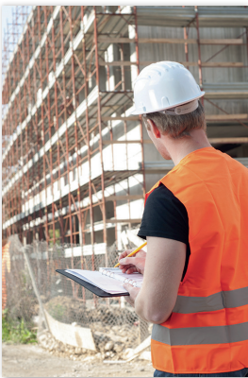
Figure 1.2. Health and safety Representatives
- Work Health And Safety (WHS) Committees
WHS committees are set up to discuss and resolve health and safety issues. They consist of the reps and the employer’s representatives. WHS committees are not responsible for the day-to-day health and safety issues in a workplace. They identify safety problems, review work processes and make the necessary recommendations to develop, monitor and improve safe work systems and procedures.

Figure 1.3. Work Health andSafety Committees
How big the committee is depends on the size of the workplace. On smaller sites an individual could be responsible for WHS issues by making sure they are discussed at all site meetings
- Supervisors
Construction supervisors oversee the construction of projects and monitor activities at worksites. They manage crews, ensure health and safety codes are observed, and that work is completed to schedule. Construction supervisors also help develop contracts, liaise with subcontractors and vendors, and perform other administrative tasks.
    - License, tickets or certificates of competency
Before contractors, architects and engineers undertake any construction work, they need to be licensed and registered. The requirements for licensing and registration may vary from country to country or from one legal system to the other.
The requirements for licensing and registration of the above mentioned individuals in the context of The Ethiopian laws.
- The present rationale for licensing of contractors in Ethiopia is to ensure that applicants for a project have the necessary capacity and capability. This requires information on the current status and past performances of the contractor.
- The current procedure of registration and issuance of graded licenses rely on ownership of relevant equipment and number of staff.
- These criteria for licensing and registration relate neither to past performance nor to the contractor’s (architect's, engineer's or consultant's) ability to lease or hire equipment; thus making it difficult for contractors, with sound technical and financial performance in other fields, to enter new markets.
    - National Code of Practice for Induction Training for Construction Work
Hazards and risks change frequently on a site as construction work progresses and as workers move from project to project.
The instruction and training required to ensure people can work safely on construction sites needs to recognize the pattern of employment and the way the construction industry operates.
Therefore, three types of OHS induction training may be required:
- General induction provides persons entering the construction industry with a basic knowledge of requirements under OHS laws, the common hazards and risks likely to be encountered on construction sites and how these risks should be controlled.
- Site induction provides information and instruction to anyone engaged on a particular construction site with a knowledge of the contractor’s rules and procedures for site safety, emergency management, the supervisory and reporting arrangements and other site-specific issues.
- Task-specific induction provides information and instruction to anyone undertaking a particular construction activity of the risk factors and control measures relating to that task.
OHS induction training ‘OHS induction training’ means construction safety awareness training undertaken prior to commencing construction work.
    - National safety standards
The objective of this code is to provide practical guidance on a legal, administrative, technical and educational framework for safety and health in construction with a view to:
- Preventing accidents and diseases and harmful effects on the health of workers arising from employment in construction;
- Ensuring appropriate design and implementation of construction projects;
- Providing means of analyzing from the point of view of safety, health and working conditions, construction processes, activities, technologies and operations, and of taking appropriate measures of planning, control and enforcement.
    - OHS and welfare Acts and regulations
- All appropriate precautions should be taken:
- to ensure that all workplaces are safe and without risk of injury to the safety and health of workers;
- To protect persons present at or in the vicinity of a construction site from all risks which may arise from such site.
- All openings and other areas likely to pose danger to workers should be clearly indicated.
- Adequate and safe means of access to and egress from all workplaces should be provided, indicated where appropriate and maintained in a safe condition.
- A suitable housekeeping programme should be established and continuously implemented on each construction site which should include provisions for:
- The proper storage of materials and equipment;
- The removal of scrap, waste and debris at appropriate intervals.
    - Safety Codes Of Practice
- This Code of Practice on construction work is an approved code of practice under section 274 of the Work Health and Safety Act (the WHS Act).
- An approved code of practice provides practical guidance on how to achieve the standards of work health and safety required under the WHS Act and the Work Health and Safety Regulation (the WHS Regulation) and effective ways to identify and manage risks.
- A code of practice can assist anyone who has a duty of care in the circumstances described in the code of practice. Following an approved code of practice will assist the duty holder to achieve compliance with the health and safety duties in the WHS Act and WHS Regulation, in relation to the subject matter of the code of practice.
- The health and safety duties require duty holders to consider all risks associated with work, not only those for which regulations and codes of practice exist.
- Codes of practice are admissible in court proceedings under the WHS Act and WHS Regulation. Courts may regard a code of practice as evidence of what is known about a hazard, risk, risk assessment or risk control and may rely on the code in determining what is reasonably practicable in the circumstances to which the code of practice relates.
- An inspector may refer to an approved code of practice when issuing an improvement or prohibition notice.
  - Duty of Care Requirements
Duty of care is the legal obligation of all employers and employees to take reasonable care that their decisions and actions do not harm others in the workplace.
The WHS Acts and Regulations set out the requirements for duty of care and the penalties applied if these requirements are not met.
Ethiopia has had a regulation on Occupational Safety and Health (OSH) since the 1940’s. The Ministry of Labor and Social Affairs (MOLSA) is the state organ that regulates workers’ safety and health in work places, both private and state owned.
- own responsibilities to comply with safe work practices, including activities that require licences, tickets or certificates of competency
- relevant state OHS requirements, including employers and self-employed persons, persons in control of the work site, construction supervisors, designers, manufacturers and suppliers, construction workers, subcontractors and inspectors.

Duty of care to reasonably practicable
'Reasonably practicable' is a legal requirement. It means doing what you are reasonably able to do to ensure the health and safety of workers and others like volunteers and visitors.
Basically, employers and businesses (and other PCBUs) always need to try to eliminate, so far as is reasonably and practicable, any health and safety risks in the workplace.
If a risk cannot be removed, you must minimize it by doing one or more of these things:
- substituting (wholly or partly) the hazard with something with a lesser risk
- isolating the hazard from any person exposed to it
- implementing engineering controls (if the risk remains you must implement administrative controls)
- Use personal protective equipment.
A combination of controls may be used to minimize a risk if a single control is not sufficient.
In determining control measures, thenyou should identify and consider everything that may be relevant to the hazards and risks and the means of eliminating or minimizing the risks.
When determining what is reasonably practicable, you should take into account:
- the likelihood of the hazard or risk occurring
- the degree of harm from the hazard or risk
- knowledge about ways of eliminating or minimizing the hazard or risk
- the availability and suitability of ways to eliminate or minimize the risk
- Cost.

Safe work practices
- All accidents, injuries or near misses, regardless of their nature, shall be promptly reported to the safety officer.
- Clothing shall be appropriate to the duties being performed. Long pants, a clean neat shirt and steel toed shoes are the minimum requirements.
- Hard hats and safety vests are provided for all warehouse staff and must be worn at all times in the warehouse, loading or unloading of vehicles in the yard.
- Running is not permitted except in extreme emergencies.
- Smoking is not permitted in any part of the warehouse or office. You may only smoke in designated areas.
- Visitors and customers are to be escorted by staff while on company property.
- Hand tools are to be used for their intended purpose only.
- Only licensed personnel may operate forklifts or other warehouse equipment and must wear a seatbelt while doing so.
- Riding on equipment is prohibited except where designated for operator.
- All spacers are to be of equal proportion and undamaged. Damaged spacers are dangerous.
- Open lifts are to be stored on the floor or in assigned bunks.
- Only solid spacers are to be used on lumber products, no particle board spacers.
- All bunked products will be placed securely in the bunks.
- All spills will be immediately cleaned up and reported.
- Drawers and filing cabinets will be kept closed when not in use.
- Filing cabinet drawers are to be filled from the bottom up or the cabinet is to be securely fastened /anchored.
- Lifts and clutter will be cleaned up before the end of your workday.
- Do not unload a truck alone under any circumstances, if someone cannot help you then wait or call someone else for help

OHS Requirements
- Duties of employers
Employers
- Provide adequate means and organization and should establish a suitable programme on the safety and health of workers consistent with national laws and regulations and should comply with the prescribed safety and health measures at the workplace.
- Provide and maintain workplaces, plant, equipment, tools and machinery and so organize construction work that as far as is reasonably practicable there is no risk of accident or injury to health of workers.
- Establish committees with representatives of workers and management or make other suitable arrangement consistent with national laws and regulations for the participation of workers in ensuring safe working conditions.
- Take all appropriate precautions to protect persons present at, or in the vicinity of, a construction site from all risks which may arise from such site.
- Arrange for regular safety inspections by competent persons at suitable intervals of all buildings, plant, equipment, tools, machinery, workplaces and systems of work under the control of the employer at construction sites in accordance with national laws, regulations, standards or codes of practice.
- Provide such supervision as will ensure that workers perform their work with due regard to their safety and health.
- Assign workers only to employment for which they are suited by their age, physique, state of health and skill.
An employer should, as far as is practicable, provide a workplace in which employees are not exposed to hazards. The legal use of the word ‘practicable’, which appears often in the Acts and Regulations, means ‘what a reasonable person would expect can be done’. It takes into account:
  - the severity of any harm that could occur and the chances of it actually happening
  - how much is known about a particular hazard or risk, and how it might be minimized or removed
  - What sorts of solutions are available, how suitable they really are and how expensive it would be to solve.

Figure 1.4. Information Sharing
If an accident happens and the case goes to court, the judge will ask the employer what they did to try and make the workplace safe, and then decide whether they did what was ‘practicable’. Employers should also:
- provide instruction to, and supervision of, employees so that they can perform their work without being exposed to hazards
- provide (free of charge) personal protective equipment (PPE) where it’s not practicable to avoid the presence of hazards at the workplace
- provide and maintain workplaces, plant and systems of work so that workers aren’t exposed to hazards
- Ensure that the use of any plant and the handling of any materials are carried out in such a way that employees are not exposed to hazards.
- Duties of self-employed persons
Self-employed persons should comply with the prescribed safety and health measures at the workplace according to national laws or regulations.
- General rights and duties of workers
- Have the right and the duty at any workplace to participate in ensuring safe working conditions to the extent of their control over the equipment and methods of work and to express views on working procedures adopted as they may affect safety and health.
- Have the right to obtain proper information from the employer regarding safety and health risks and safety and health measures related to the work processes.
- Have the right to remove themselves from danger when they have good reason to believe that there is an imminent and serious danger to their safety or health. They should have the duty so to inform their supervisor immediately.
In accordance with national legislation, workers should:
- Co-operate as closely as possible with their employer in the application of the prescribed safety and health measures;
- Take reasonable care for their own safety and health and that of other persons who may be affected by their acts or omissions at work;
- use and take care of personal protective equipment, protective clothing and facilities placed at their disposal and not misuse anything provided for their own protection or the protection of others;
- report forthwith to their immediate supervisor, and to the workers' safety representative where one exists, any situation which they believe could present a risk and which they cannot properly deal with themselves;
- comply with the prescribed safety and health measures;
- Participate in regular safety and health meetings.
Except in an emergency, workers, unless duly authorized, should not interfere with, remove, alter or displace any safety device or other appliance furnished for their protection or the protection of others, or interfere with any method or process adopted with a view to avoiding accidents and injury to health.
Workers should not operate or interfere with plant and equipment that they have not been duly authorized to operate, maintain or use.
Workers should not sleep or rest in dangerous places such as scaffolds, railway tracks, garages, or in the vicinity of fires, dangerous or toxic substances, running machines or vehicles and heavy equipment.
- General duties of designers, engineers, architects
- Those concerned with the design and planning of a construction project should receive training in safety and health and should integrate the safety and health of the construction workers into the design and planning process in accordance with national laws, regulations and practice.
- Care should be exercised by engineers, architects and other professional persons, not to include anything in the design which would necessitate the use of dangerous structural or other procedures or materials hazardous to health or safety which could be avoided by design modifications or by substitute materials.
- Those designing buildings, structures or other construction projects should take into account the safety problems associated with subsequent maintenance and upkeep where maintenance and upkeep would involve special hazards.
- Facilities should be included in the design for such work to be performed with the minimum risk.
- Obligations of designers
Anyone who by commission provides a design concerning a structure in the working environment, working premises, a working or production method, machinery, work equipment or other device shall ensure that the provisions of this Act have been taken into consideration in the design of the item in question according to its intended use as stated by the designer.
- Obligations of the installers of machinery, work equipment or other devices
Anyone who by commission installs machinery, work equipment or other device for use at a workplace shall take the manufacturer’s instructions and other instructions for installation into consideration and also otherwise for their part ensure that the machinery or device with related safety devices is put in appropriate condition.
- Obligations of persons carrying out initial and periodic inspections
Anyone who by commission carries out an initial or a periodic inspection referred to in section 43 shall ensure that the inspection is carried out in an appropriate manner and that necessary instructions are given regarding such faults and defects as are discovered which affect the safety of the work equipment and, when necessary, the repair or elimination of these.

Self-check-1
Part I. choose the best answer
Directions: Chose the best answer on the space provided to the left side of question.
_____1. One of the following legislation is not covered by of part of construction site.
  - First aid b) PPE and clothing c) Workplace Facilities d) none
_____2.Which of the following is not categorized as Duties of employers
- Establish a suitable programme on the safety and health of workers
- Establish committees with representatives of workers and management
- Self-employed persons should comply with the prescribed safety and health measures
- Arrange for regular safety inspections by competent persons at suitable intervals
____3. OHS Requirements is a concern of the one of following body.
a) Employee b) Engineer c) contractor d) Employer
____4. A suitable housekeeping programme should be established and continuously implemented on each construction site for:
      - proper storage of materials and equipment; b) The removal of scrap
c) The removal of important tools d) debris at appropriate intervals
____5. HSRs are responsible for:
- Inspecting the workplace or parts of the workplace
- Reporting any hazards in the workplace to the employer
- Referring health and safety matters to the WHS committee
- All
Part II. Give short ad precise for the following answers for the following question
Directions: Answer all the questions listed below.
- What are the duties of Employer to protect your health and safety at workplace?(4pts)
- What are the workers duties to protect health and safety at workplace?(4pts)
- Write the responsivities of Health and safety representatives (HSRs)
- What is Your Rights at workplace area? (4pts)
- List the different types OHS induction training

Unit TWO: Construction Hazards and Control Measures
This learning unit is developed to provide the trainees the necessary information regarding the following content coverage and topics:
- Basic principles of risk management
- Common construction hazards
- Measures for controlling hazards and risks
This unit will also assist you to attain the learning outcomes stated in the cover page. Specifically, upon completion of this learning guide, you will be able to:
- Identify Basic principles of risk management
- Identify and discuss Common construction hazards
- Identify measures for controlling hazards and risks

Basic principles of risk management
Riskis the likelihood, or probability, that a hazard will cause harm to a person.
Risk management means the process of systematically identifying hazards, assessing and quantifying the degree of risk associated with the identified hazard and determining appropriate control measures, and includes monitoring, maintaining and adjusting the risk management process as required.

Assessing the risks
A risk assessment is not necessary if the risk and how to control it is already known.
Assessing the risk includes considering:
  - the severity of any injury or illness that could occur, for example is it a small isolated hazard that could result in a very minor injury or is it a significant hazard that could have wide-ranging and severe effects, and
  - The likelihood or chance someone will suffer an illness or injury, for example consider the number of people exposed to the hazard.
However, in many circumstances a risk assessment will assist in determining the control measures that should be implemented. It will help to:
  - identify which workers are at risk of exposure
  - determine what sources and processes are causing risk
  - identify if and what kind of control measures should be implemented, and
  - Check the effectiveness of existing control measures.
    - Consulting and reporting ensuring the involvement of relevant workers
Workers and other persons at the workplace also have duties under the WHS Act, such as the duty to take reasonable care for their own health and safety at the workplace.
A person can have more than one duty and more than one person can have the same duty at the same time. Early consultation and identification of risks can allow for more options to eliminate or minimize risks and reduce the associated costs.
    - Controlling the Hazard
Some hazards you can control yourself, safely and immediately. However, most hazards need to be reported to your supervisor. The supervisor will refer it to the right person to deal with it and, if it’s likely to be an ongoing problem, a permanent control will be put in place to protect people
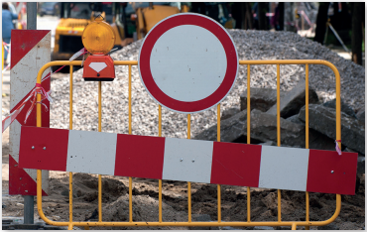
Figure 2.1. Controlling the Hazard
Normally, they refer to the ‘hierarchy of control’, which lists the options from most preferable to least preferable. A hierarchy is a list of things in order of rank. The hierarchy of risk control is as follows;
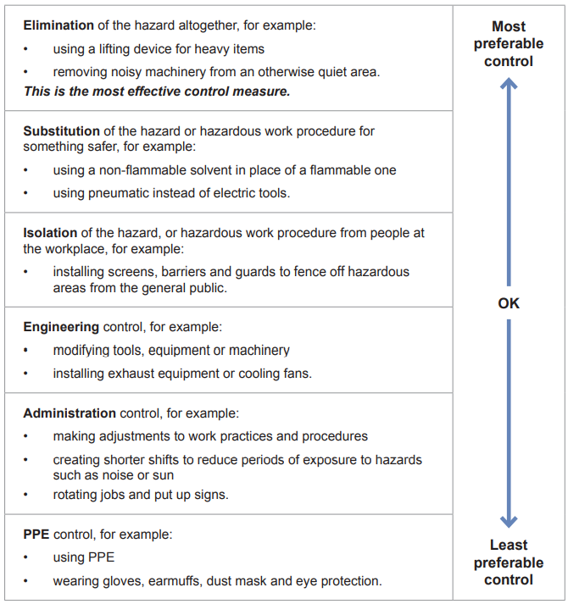
Figure 2.2. Hierarchy of Risk Control
    - Identifying Hazards
The first step in the risk management process is to identify the hazards associated with construction work. Examples of hazards include:
- the construction workplace itself, including its location, layout, condition and accessibility
- the use of ladders, incorrectly erected equipment, unguarded holes, penetrations and voids, unguarded excavations, trenches, shafts and lift wells, unstable structures such as incomplete scaffolding or mobile platforms, fragile and brittle surfaces such as cement sheet roofs, fiberglass roofs, skylights and unprotected formwork decks
- falling objects, for example tools, debris and equipment
- collapse of trenches
- structural collapse
- the handling, use, storage, and transport or disposal of hazardous chemicals
- the presence of asbestos and asbestos-containing materials
- welding fumes, gases and arcs
- hazardous manual tasks
- the interface with other works or trade activities, and
- the physical working environment, for example the potential for electric shock, immersion or engulfment, fire or explosion, slips, trips and falls, people being struck by moving plant, exposure to noise, heat, cold, vibration, radiation including solar UV radiation, static electricity or a contaminated atmosphere, and the presence of a confined space.
    - Reviewing to identify change or improvement
A review of control measures must occur as necessary so as to maintain, so far as is reasonably practicable, a work environment that is without risks to health or safety. This can be done by using the same methods as the initial hazard identification process.
A review may take place when the control measures are no longer effective in controlling the risk, before a change takes place at the workplace that is likely to give risk to new or different health and safety risks or that the measure may not effectively control, when a new hazard or risk is identified, if a review is identified as being necessary following a consultation, or if a health and safety representative requests a review.
Common methods include workplace inspection, consultation, testing and analyzing records and data. Reviewing the control measures also involves considering whether a higher order control measure is now reasonably practicable.
When reviewing control measures, the SWMS must also be reviewed and revised where necessary. If problems are found, go back through the risk management steps, review your information and make further decisions about control measures.
A change at the workplace includes:
- A change to the workplace itself or any aspect of the work environment, and
- A change to a system of work, a process or a procedure.
Where a SWMS has been developed for high risk construction work or a WHS management plan has been developed for a construction project, these documents must also be reviewed and revised (where necessary) when control measures have been reviewed.
  - Common construction hazards
- Confined spaces
A confined space is an area that is fully or partially enclosed and not designed to be worked in for long periods of time.
Drainage ditches, elevator shafts, storage tanks and ceiling cavities are examples of some of the confined spaces you may come across on a construction site.
Confined spaces can be hazardous if:
  - they are difficult to get in and out of
  - there is a chance that you become trapped
  - there is toxic or flammable gas present
  - oxygen is limited
  - There is a chance of flooding.
Working in a confined space is considered to be a specialized task. You must be trained and hold a special permit to do this.
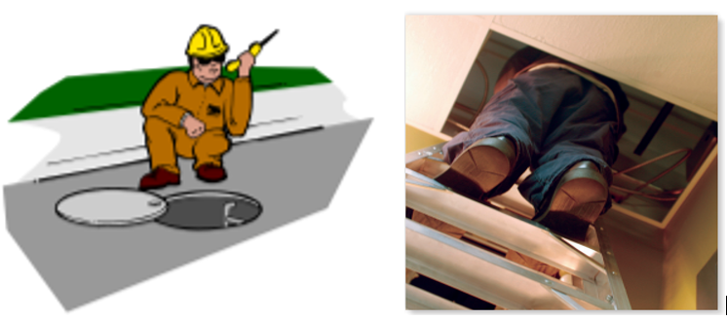
Figure 2.3. Confide Space
- Electrical safety
The installation of electrical systems into a building is a major task in any construction project and is carried out by a qualified electrician.
Electricity is also used by workers in the actual construction of the building to power tools and amenities. There are hazards and risks when using electrical equipment that must be identified and minimized to ensure a safe worksite.
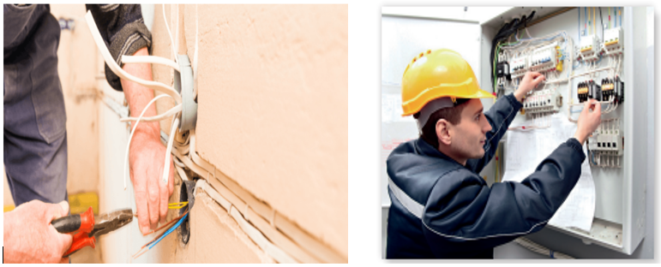
Figure 2.4. Electric Safety
Electric shocks are a common cause for falls from ladders, scaffolds, and other work platforms. There is also a growing number of electrocutions involving workers who are not qualified electricians, but who are carrying out electrical work on construction sites.
- Excavations, including trenches
Here are some safety measures that need to be put in place to prevent excavations from collapse and to reduce the risk of operatives falling into excavations.
- Never work in an unsupported excavation.
- Ensure an excavation is supported and fully secure.
- Regularly inspect the excavation both before and during the work shift.
- Always check that the edge protection of an excavation is 100% intact before you enter it.
- Always maintain a safe distance from the edge of all deep excavations
- Falling objects
The erection, alteration, use and dismantling exposes workers and others to the risk of being struck by falling objects such as scaffold components, tools, or in the event of a collapse.
The following are examples of control measures that may be used to prevent or minimize exposure to the risk of being hit by falling objects.
- Establish exclusion zones around scaffolding and adjoining areas to prevent unauthorized persons from accessing the area.
- Use perimeter containment screening scaffold fans, hoardings or gantries to contain falling objects.
- In built-up areas, erect and dismantle scaffolding during quiet times.
- Use mechanical hoists to move materials.
- Attach danger tags and warning signs such as ‘Keep Out – Falling Objects’ and ‘Danger – Incomplete Scaffolding’ in obvious locations to warn persons of hazards.
- Consult with all relevant parties before work starts.
- Implement good housekeeping practices (see Section 2.7.3 maintaining a safe work environment for further information).
When passing scaffolding from one level to another, this should be done internally within the scaffold, unless suitable exclusion zones are maintained
- Hazardous substances and dangerous goods
Hazardous substances are classified on the basis of their potential health effects, whether acute (immediate) or chronic (long-term). Dangerous goods are classified on the basis of immediate physical or chemical effects, such as fire, explosion and corrosion and poisoning.
Hazardous substances commonly used or found in the building and construction industry include paints, solvents, glues, sealants, particle fiberboard, medium-density fiberboard, insulation material, concrete, cements, cement finishes, grease, oils, fuels, asbestos and wood dust.
- Hot And Cold Working Environments
When working in a variety of industries where climate or varying degrees of temperature are a factor, the hazard cannot be readily managed using just engineering controls alone. In these circumstances some of the most effective ways of managing these environments is by introducing some simple administrative controls for example:
Cold working environments
- Ensure the personal protective equipment issued is appropriate
- Provision of mobile facilities for re-warming and encourage the drinking of warm fluids such as soup or hot chocolate
- Introduce more frequent rest breaks
- For outdoors work, can the job be delayed and undertaken at warmer times of the year without compromising on safety
- Educate workers about recognizing the early symptoms of cold stress.
Hot working environments
- Provide more frequent rest breaks and introduce shading to rest areas
- Provide free access to cool drinking water
- Encourage the removal of personal protective equipment when resting to help encourage heat loss.
- Educate workers about recognizing the early symptoms of heat stress
- For outdoors work, reschedule work to cooler times of the day and
- Introduce shading in areas where the individuals are working
- Manual handling:
Materials and equipment are constantly being lifted and moved around construction sites, whether this be manually or by equipment. Either way, handling carries a degree of risk.Where duties involve manual handling, adequate training must be provided.
If an employee is required to use lifting equipment, they must be trained in how to use this and a test should be taken to check their ability to use the equipment safely.
- Noise
Construction is noisy and, as a result, noise is a common construction hazard. Loud, repetitive, and excessive noise causes long term hearing problems, such as deafness. Noise can also be a dangerous distraction and may distract the worker from the task at hand, which can cause accidents.
It is the employer’s responsibility to carry out a comprehensive noise risk assessment, and provide appropriate PPE where necessary.
Deep inside the human ear are some very delicate mechanisms that turn the sounds transmitted through the air into vibrations and then nerve impulses that travel to the brain. This is how you hear. Excessive noise damages these mechanisms and reduces their ability to process sounds. Too much excessive noise can destroy their effectiveness completely, resulting in deafness. If this is caused by noise in the workplace, the condition is called ‘noise-induced hearing loss’ (NIHL) or more commonly ‘industrial deafness’.
People suffering from NIHL often have difficulty with communicating which can affect their personal relationships with family and friends. This can lead to social isolation and reduce their quality of life.

Figure 2.5. Noise Protection
- Plant And Equipment
The safe and efficient running of a workplace requires that all plant (machinery, appliances and tools) and equipment work as intended, when needed. In the construction industry, plant and equipment include:
- hand tools, e.g. shovels, picks, brooms, sledgehammers
- portable power tools, e.g. saws, planers, drills, jackhammers
- wheelbarrows, concrete vibrators, cement mixers, power generators, air compressors
- equipment hoists, water pumps, concrete pumps, scissor lifts • ladders, stepladders, scaffolding, saw stools
- surveying equipment, e.g. theodolites, dumpy levels
- amenities, e.g. kettles, urns, toasters, refrigerators
- Vehicles.
As a worker in this industry, you’ll be using and maintaining plant and equipment.

Figure 2.6. Plant and Equipment
- Traffic And Mobile Plant
Mobile plant and vehicular traffic are hazards which can potentially affect worker safety and the safe use and structural integrity of a scaffold. Outlined below are control measures that can be used to prevent or minimize exposure to the risk of death or injury from moving plant and traffic:
- Re-route motor vehicles and mobile plant away from the location of the scaffold (e.g. by using traffic controllers to redirect traffic).
- Use barricades, signs, posts, buffer rails, guards, or concrete or timber kerbs to prevent mobile plant and traffic from coming into contact with the scaffold.
- Ensure scaffolding does not have any unnecessary protrusions, such as over-length transoms, putlogs, tie tubes or over-height standards.
- Unplanned Collapse
A common occurrence on construction sites is the collapsing of trenches with workers inside. Further, a building that is being demolished or under construction can suddenly and unexpectedly collapse, which can seriously injure, or even kill, those inside.
Precautions for collapse need to be taken before work starts. If the project requires a trench, site managers should:
- Consider the kind of support that is best suited for the trench.
- Ensure the trench is fully secure.
- Regularly inspect the trench both before and during the work shift.
- Ultraviolet (UV) Radiation
UV radiation is a known harm which is ‘foreseeable’. This means that employers have a duty of care to protect their workers from overexposure to UV radiation while they are outdoors. Workers have an equal duty to cover up when asked by the boss. It’s the smart way to go.
People, who spend a lot of the working day near reflective surfaces, including water, roofing iron, glass and sand, are exposed to increased UV radiation. In Australia about 46% of workers reported working near reflective surfaces. Tradesmen (including painters, plumbers, carpenters, construction workers and electrical workers) are one occupational group who are more likely to work near reflective surfaces.
- Working at Heights
The most common cause of fatal injuries to workers.Suitable training is required for all employees who work at height. Employees should be trained in working on different pieces of equipment and surfaces, such as how to work safely on scaffolding, ladders, and roofs.
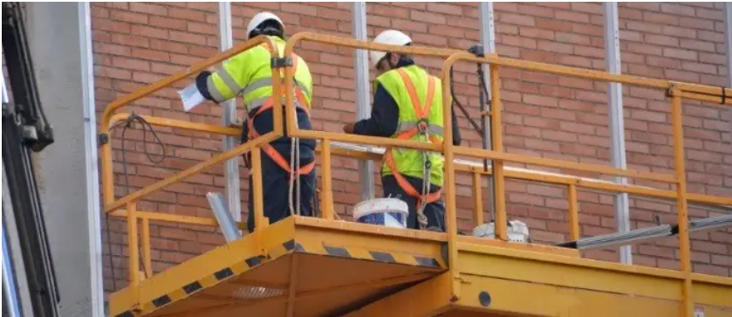
Figure 2.7. Working at Heights
Working at height must be properly planned and supervised, and certain approaches and precautions should be adopted. These are:
- Avoid working at height where possible. For example, if something can be assembled on ground level, do it there.
- Use equipment with an extra level of safety to reduce the risk of a fatal fall. For example, a scaffold with a double guard-rail.
- Minimize the consequences of a fall, for example by providing a safety net.
- Hand Arm Vibration Syndrome
HAVS (Hand Arm Vibration Syndrome) is a debilitating and painful disease of the blood vessels, nerves, and joints. It is typically caused by the continued use of hand-held power tools, including vibratory power tools and ground working equipment.
HAVS is preventable if construction works are correctly planned to minimize exposure to vibration during work and workers are monitored are given appropriate protection when using vibrating tools and equipment.

Measures for controlling hazards and risks
Hazard ‘Hazard’ means anything (including an intrinsic property of a thing), or situation with the potential to cause harm to people.
- Elimination: -of the hazard altogether, for example:
  - using a lifting device for heavy items
  - Removing noisy machinery from an otherwise quiet area.
This is the most effective control measure.
- Substitution:- of the hazard or hazardous work procedure for something safer, for example:
- using a non-flammable solvent in place of a flammable one
- Using pneumatic instead of electric tools.
- Isolation of the hazard, or hazardous work procedure from people at the workplace, for example:
  - Installing screens, barriers and guards to fence off hazardous areas from the general public.
- Engineering control, for example:
- Modifying tools, equipment or machinery
- Installing exhaust equipment or cooling fans.
- Administrative controlfor example:
- making adjustments to work practices and procedures
- creating shorter shifts to reduce periods of exposure to hazards such as noise or sun
- Rotating jobs and put up signs.
- PPE control
Depending on site conditions and what your on-site duties are, you’ll be provided with a range of PPE. You can get information about what you should be using from your supervisor and the safe work method statement (SWMS). Safety signs on site may also indicate what PPE you require.
For example:
  - using PPE
  - wearing gloves,

Figure2. 1

Figure2. 2

Hand protection: You should wear gloves for most tasks carried out on a construction site, so that your hands are protected. The material used to make the gloves may vary depending on the object or substance being handled.

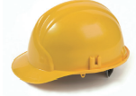
Head protection: - Where there’s a risk of a person being struck on the head by a falling object at work, a safety helmet must be worn. On sites where this hazard exists, a ‘mandatory’ safety sign will be visible to tell you that you must wear a helmet at all times.

High-visibility clothing Also known as ‘hi-vis’, these bright, fluorescent, colored vests and jackets are required on most large sites, especially where vehicles are moving about.


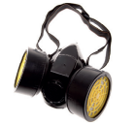
Breathing protection: - Dust masks and respirators may be required if the environment on the construction site contains hazardous dust and fibers, or fumes that can be inhaled.

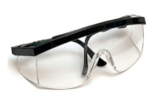
Eye protection: - Where there’s a risk of getting dust, grit, sparks, irritating liquids or the like in your eyes, you must wear eye protection. Safety glasses are suitable for most situations you’re likely to encounter, but full-face masks are available for workers who need them. Sun damage is also considered a hazard in Australia. Note that eye protection must comply with the relevant Australian Standard® so your everyday sunglasses won’t be adequate.

Hearing protection Excessive noise can damage hearing. Construction sites are very often noisy environments so there are many situations where you’ll need hearing protection. Earmuffs and/or earplugs/ear buds should be worn in any situation where you have to shout so that a person a meter away can hear you.

Foot protection
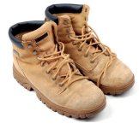
Most construction sites require all personnel to wear safety footwear. There are numerous styles of steel-cap boots and shoes available

Other PPE
Depending on site conditions and what your on-site duties are, you may be required to wear other PPE, such as aprons, overalls and arm guards.
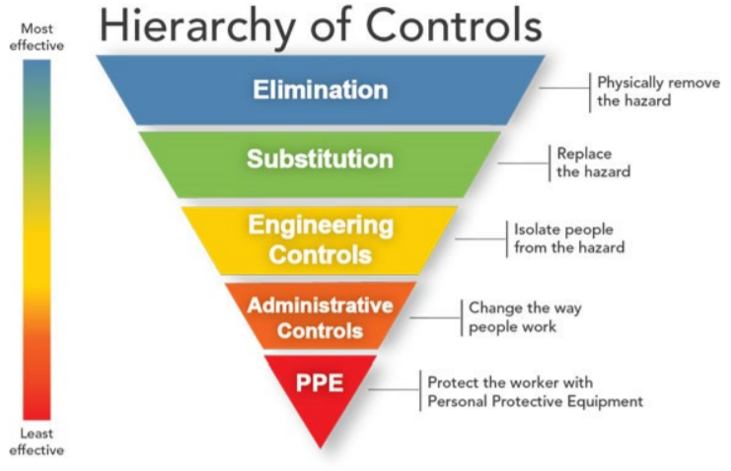
Figure 2.8. Hierarchy of controls

Self-check-2
Part I. choose the best answer
Directions: Chose the best answer on the space provided to the left side of question.
_____1.___________ is the likelihood, or probability, that a hazard will cause harm to a person.
  - First aid b) PPE c) Risk d) All
_____2.Risk assessment will assist in determining the control measures that should be implemented to:
  - identify which workers are at risk of exposure
  - determine what sources and processes are causing risk
  - identify if and what kind of control measures should be implemented
  - Check the ineffectiveness of existing control measures.
_____3.One of the following is not categorized as Measures for controlling hazards and risks
- Elimination b) PPE c) Employee d) administrative control
_____4. Confined spaces can be hazardous if:
    - they are accessible to get in and out of
    - there is a chance that you become trapped
    - there is toxic or flammable gas present
    - oxygen is limited e) All except ‘a’
______5.Oneof the following is not categorized under Common construction hazards
- falling object b) first aid c) manual handling d) hazardous materials
Part II. Give short ad precise for the following answers for the following question
Directions: Answer all the questions listed below.
- List at least four types of PPE used for construction sites.
- Mention some plants and equipment used for safe and efficient running of a workplace in construction industry
- _______________is the first step in the risk management process with construction work.

Unit Three: OHS Communication and Reporting Processes
This learning unit is developed to provide the trainees the necessary information regarding the following content coverage and topics:
- OHS communication processes, information and documentation
- Role of designated OHS personnel
- Safety signs and symbols
- Procedures and relevant authorities for reporting hazards, incidents and injuries
This unit will also assist you to attain the learning outcomes stated in the cover page. Specifically, upon completion of this learning guide, you will be able to:
- Identify and discuss OHS communication processes, information and documentation
- Identify and explain role of designated OHS personnel
- Identify and explain safety signs and symbols
- Identify procedures and relevant authorities for reporting hazards, incidents and injuries

OHS communication processes, information and documentation
    - OHS Communication Processes
- Discussions With OHS Representatives
An occupational health and safety representative (OHS representative) helps the employer and workers to improve health and safety in the workplace by identifying and resolving health and safety concerns.
OHS representatives are required in workplaces with five to nine workers who are engaged in activities that are considered highly hazardous by the regulations.
- Duties of OHS Representatives
- providing a channel of communication between the employers and workers;
- conducting regular inspections and talking with workers about their health and safety concerns;
- C (both accidents and dangerous occurrences);
- assisting the employer with the development of safety procedures, policies, and programs; and
- Meeting with the employer regularly to discuss concerns.
The employer must keep written records of meetings with the OHS representative and ensure that they are readily available to both workers and Occupational Health Officers.
- OHS Meetings
Regular health and safety meetings provide an excellent opportunity to get everyone in your workplace involved in the safety process. Maintaining communication between you, your supervisors, and your workers is crucial for the success of your occupational health and safety (OHS) program.
By integrating health and safety into the work process, you can build your workplace safety culture, encourage buy-in to your OHS program, and help keep your workers healthy and safe.
Conduct effective meetings
- Hold meetings regularly — typically monthly or more frequently, if necessary.
- Post an agenda to let workers know what will be covered in each meeting.
- Conduct productive, educational, and results-oriented meetings. Encourage active participation by everyone involved.
- Focus on making health and safety a priority and identifying and controlling hazards.
- Bring to the meeting inspection reports, recent incident investigation reports, first aid reports and new safe work procedures.
- Keep records of the meetings (i.e., minutes), and record the details of actions taken and items to follow up on. These are important ways to demonstrate due diligence.
Record of OHS Meetings
Chaired by: ____________________________ Date: ______________________
Time meeting commenced: __________Time meeting concluded: ___________
Attendees:
Apologies:
Agenda Items:
1. Workplace Inspection Report:
2. Review of objectives:
3. Hazard management and controls:
4. New hazards reported:
5. Accidents and investigations since last meeting:
6. General:
Corrective Action: | Action By: | Action Completed Date: | Action Sign Off
Tale 3.1. Record of OHS meeting
Reviewed by Managing Director: ____________________________(Signature)
________________________(Date)
- OHS Notices, Newsletters, Bulletins And Correspondence
Heads of Departments should develop procedures for effectively communicating information concerning the Policy, departmental roles and responsibilities, as well as arrangements and/or their revisions etc. to those involved or affected. This may be achieved, for example, through occupational health and safety inductions, team/section briefings, agenda items, newsletters, emails, management reports, notice boards, findings of risk assessments, safe systems of work, safety inspection reports etc.
- OHS Participative Arrangements
You must consult, cooperate and coordinate on arrangements for the consultation with the workers, so far as is reasonably practicable, with the contractor, subcontractor or labor hire company. In doing this you should consider the types of issues that may arise where you would need to consult the contractor, subcontractor or labor Hire Company and their workers.
You should establish:
- How will I inform and discuss proposed changes with the contractors’ on-hire or contractor firm?
- How will we both coordinate consultation with the affected workers?
- How will we each respond to a safety issue raised by one or more of the workers or to a request from the workers to be represented by a health and safety representative?
- Processes For Raising OHS Issues
There are a number of ways to resolve OHS issues. There are a number of questions and a number of steps that must be followed.
The first question to ask is:'Is there an immediate risk to health or safety in this situation?' and 'Does the nature of the threat and degree of risk mean that it's not appropriate to follow the normal procedures?'
If the answer to these questions is YES, then under Section 74, the rep has the right to STOP THE JOB ('direct that work shall cease') either with or without the agreement of the employer rep.
The OHS rep must, however, consult with the employer prior to issuing this direction - see details below.
If the answer is No (there is not an immediate risk) then the rep must follow first attempt to resolve the issue (as per Section 73) and if not resolved, then proceed - see the information below: Non-immediate risk.
- Toolbox Talks
Toolbox talks can be used to provide information to and receive feedback from your workers as well as assist in raising the awareness of how construction work can be carried out in a safe and healthy manner.
At a toolbox talk, the person conducting a business or undertaking can provide updates on any upcoming programming issues that may have an effect on health and safety, for example:
- new high risk construction activities
- new tower crane being erected
- dual or specialized crane lifting
- changes in access to and around the site
- Changes that may affect members of the public.
When using toolbox talks it is good practice to:
- keep a written record of the topic covered, attendees and any feedback received
- organize a program of toolbox talks to ensure workers are given sufficient opportunity to provide input into how risks should be controlled
- Monitor the effectiveness of toolbox talks through safety outcomes (e.g. control measures implemented and near misses).
- Workplace consultation relating to OHS issues and changes
- Consultation and communication is both a key component of the risk management process and a major beneficial side effect.
- Risk management decision makers have both legal and moral responsibility to provide information to people exposed to risks.
- Risk communication is not a task where bits of information are transported from the sender to the recipient of the communication but a process, where both sender and recipient interact in order to develop a common frame for an understanding of the problem.
- In both the planning and execution of the risk management process, it is essential to ensure that all those who need to be involved are given an adequate opportunity to do so and are kept informed of developments in arriving at an understanding of the risks and the measures taken to deal with them.
- One important part of risk communication is how to present the risk information.
- Different ways of presenting the same risk information can lead to different evaluations and decisions, even though they are logically equivalent.
- People in interaction with each other tend to communicate in different Ways, either formally or informally
    - OHS Information and Documentation
- Accident and incident reports
Definition of terms
An accident is an incident that resulted in injury to personnel, or loss of any kind, including the loss of materials, assets and property damage.
An Incident is an unplanned event or chain of events that has, or could have, resulted in injury or illness or damage to assets, the environment or company reputation or consequential business loss.
After an accident or incident on a worksite, a report should be completed as soon as possible so that an investigation can begin.
Most organizations will have a report form that collects details of:
- what happened
- what plant or equipment was involved
- what injuries were sustained
- Any witnesses.
If you have to fill out one of these reports, you must take it seriously and be truthful. If workers’ compensation insurance is involved, the report may end up as evidence in a court case.
- Acts and regulations
Legislation means laws that are made by federal or state parliament. These are called ‘Acts’. An Act may give particular people or agencies the power to make laws that relate to the Act, known as ‘Regulations’.
Regulations are the specific details and minimum requirements that relate to the Acts. The Act Acts of Parliament are what make up the law. Most workers are protected by a Work Health and Safety Act (WHS) that covers the duties, responsibilities and penalties of different people with regard to health and safety in the workplace.

Figure 3.1Acts and regulations
The Act is written in quite broad and unspecific terms because it must cover a diverse range of workplaces. It needs to work for everybody, with jobs as different as: librarians, farm hands, teachers, bank managers, construction workers, bus drivers, supermarket trolley collectors, Wait staff.
- Australian standards
- Australian Standards® Australian Standards® are nationally recognized documents that set the quality requirements for products and services to ensure safety, reliability and consistency of performance.
- To keep the Regulations document to a manageable size, the relevant standard is specified and should be referred to for details. Australian Standards® are not available from the state, territory or Commonwealth regulators; they must be purchased.
- Examples of topics covered by standards include safety helmets, scaffolding set-ups, electrical installations on building sites and colors of safety signs.
- Codes of practice
Codes of practice From time to time, state and federal agencies publish codes of practice with the purpose of:
- providing practical advice and guidance on how WHS hazards and risks associated with an issue can be managed in relation to legislation
- Describing the preferred method or course of action that can be taken to manage hazards and risks in order to achieve the required standard of health, safety and welfare.
However, a code of practice may be used as evidence in a court case over a failure to comply with the Regulations.
- Construction documentation and plans
- Risk assessment documents Safe work method statements (SWMSs) and job safety analyses (JSAs) are forms to be filled out by workers who are (or will be) carrying out activities that have the potential to be hazardous.
- They set out the steps involved in the activity, how potential hazards will be eliminated or minimized at each step and who’s responsible.
- Filling out these forms is a way of making sure that the people who’ll be doing the job have thought through the whole process, identified where the hazards exist and decided how each one will be controlled.
- Emergency Information Contact
- Accidents happen at work every day. It’s important to collect emergency information for each of your employees.
- In fact, OSHA estimates that one in ten construction workers are injured every year. It’s important to collect emergency information for each of your employees to have on file just in case the unthinkable happens.
- Remind employees to keep this form current in case of any life changing events (marriage, divorce, death). The forms should be reviewed annually.
- Access to the information should be given only to those on staff who have access to human resources information.
- Evacuation Plans
Evacuation is the process of moving people away from a hazard. It may involve all or some of the people on site. Evacuation procedures are developed to move people as safely and efficiently as possible.
The best thing you can do is to learn the evacuation procedures and follow them calmly.
- In any location, make sure you know the best way out of the building and off the site to the allocated assembly area.
- Know where your supervisor is likely to be at all times, and who your emergency control organization (ECO) members are.
- Obey instructions given by emergency services officers, e.g. firefighters, police and ambulance officers. They are professionals and know what’s best in the situation.
- Don’t panic. Keep calm.

Figure 3.2. Evacuation Plans
- Guidance Notes
- The Building Responsibly Guidance Notes are a set of instructions for the practical application of the Worker Welfare Principles.
- They offer a discussion around the potential issues and challenges faced by the industry on each principle and suggest good practice options for their implementation.
- The Guidance Notes have been informed by multiple consultations with external stakeholders and provide basic expectations for construction companies dealing with worker welfare issues.
- Job Safety Analyses
A job safety analysis (JSA) is completed before a task is started if:
- there is a hazard that could cause injury or loss of life
- an incident has occurred in the past while that same task was being carried out
- the task is being done for the first time in a new environment
- procedures have changed
- The worker is new.
The task is broken down into steps and the hazards for each step are identified by considering four key aspects as follows.
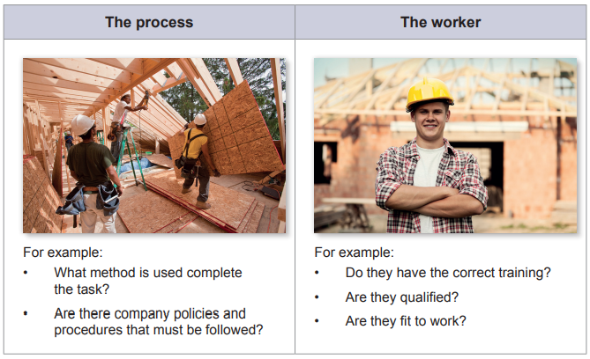
Figure 3.3. Job Safety Analyses
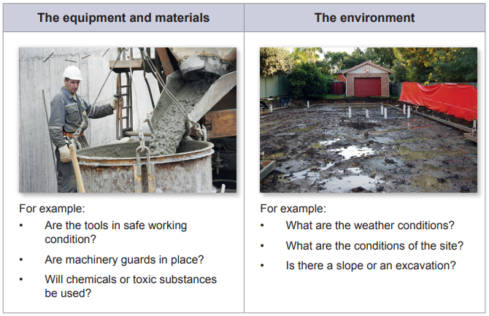
Figure 3.4. Job Safety Analyses
Once the hazards have been identified, the measures required to control the risks are listed. For example, if the first step in the task is to move a heavy load of bricks and there is a risk of muscle strain or injury, a wheelbarrow or trolley could be used.
It’s important to be specific when filling out a JSA and to record every hazard and exactly what needs to be done to correct the hazard. For example, ‘Keep a straight back and lift using your leg muscles’, is better than, ‘Be careful when lifting’.
- Labels
Construction sites can pose serious hazards for workers, including fall risks, falling objects, live power lines, and moving machines. Our heavy duty construction labels can help maintain high workplace safety standards, proper signage and visible communication that are required to provide clear instructions and warnings.
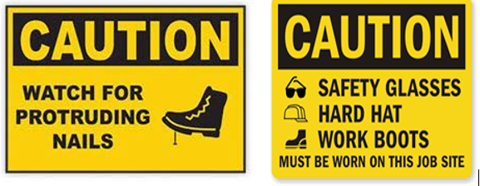
Figure 3.5. Labels
- Material Safety Data Sheets (MSDS)
Safety data sheets (SDSs) – formally known as material safety data sheets or MSDSs – explain how to use a material or substance safely, and how to deal with any hazards associated with it.
The SDS also provides information on how to dispose of hazardous materials/substances safely. Manufacturers of hazardous materials/substances are required by law to produce SDSs. These are available from the manufacturer or supplier, as well as from the internet.
Relevant SDSs should be available in any workplace where hazardous materials/substances are being used. By law, you are able to look at the SDS for any material/substance you’re using.
An SDS contains information about a material/substance such as:
- its name and any other names it’s known by
- its physical appearance, e.g. what it looks and smells like, its color, whether it’s a liquid, solid or gas, and under which conditions it is in these states
- its physical properties, e.g. whether it’s corrosive, flammable or explosive and under what circumstances
- its reaction with other substances, e.g. advice about which other substances to avoid contact with
- its toxicity, e.g. how it affects humans if swallowed, inhaled or comes into contact with skin or eyes
- safety precautions when handling or using it
- first aid measures in case of accident
- Storage, handling and disposal.
- Report Hazards, Incidents And Injuries
- Reporting Hazards
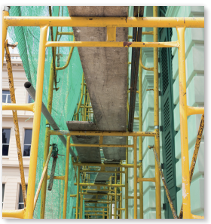
To make a worksite safe for everyone, you must report any hazard – even if it doesn’t directly affect you and the task you’re doing. For example, if you notice a faulty tool and don’t report it, a co-worker who uses the tool later, without noticing the problem, may be injured.
Many organizations have hazard report forms that can be filled in by a worker who notices a hazard on any part of the worksite.
A hazard report form provides a written record of a problem that can be followed up by your employer or WHS committee to make sure the hazard is effectively controlled.
- Reporting Incidents And Injuries
After an accident or incident on a worksite, a report should be completed as soon as possible so that an investigation can begin. As time passes, it becomes more difficult to establish or remember exactly what happened, so it’s best to do the report straight away.
Most organizations will have a report form that collects details of:
  - what happened
  - what plant or equipment was involved
  - what injuries were sustained
  - Any witnesses.
If you have to fill out one of these reports, you must take it seriously and be truthful. If workers’ compensation insurance is involved, the report may end up as evidence in a court case. Your supervisor or WHS rep can help you write a report.
- Reports Of Near Misses And Dangerous Occurrences
All near miss /incidents should be recorded by the manager or the reporting staff member
If a person has been injured, the need for first aid should be assessed and action taken as appropriate. Managers should follow the Early Intervention Guide, and contact their relevant Injury Management Coordinator if the staff member requires time off work or medical treatment as a result of an incident.
If the near miss / incident is considered to be serious, the manager should contact the WHS team for advice. The WHS team will advise regarding the notification of the incident to Work Safe.
Notifiable incidents also include those involving
- registered or licensed plant collapsing, overturning, falling or malfunctioning
- collapse or failure of an excavation, or shoring supporting an excavation
- collapse of a building structure (or partial collapse)
- implosion, explosion, or fire
- escape, spillage or leakage of any substance
- plant or objects falling from high places
- Safe Work Method Statements
A safe work method statement (SWMS) must be completed when high-risk construction is being carried out.
The tasks on a construction site that are considered high risk may involve, for example:
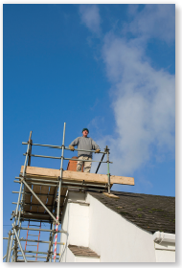
  - demolition
  - asbestos
  - working at heights over 2 m
  - an excavation more than 1.5 m deep
  - confined spaces
  - a structure that requires support to prevent collapse
  - pressurized gas pipes
  - Working near roads and railways.
A SWMS is similar to a JSA and the following details need to be provided:
- a list of high-risk tasks
- a list of the hazards that exist for each task
- a description of the safety measures to be used to reduce the risks
- a list of the equipment to be used to complete the task
- an outline of the qualifications or training the person doing the task requires
- Safety Meeting Minutes
Meetings are essential to organizations. Safety meetings aim to generate safety strategic plans to resolve the hazards and risks addressed during the session meeting.
A Safety Committee Meeting is a regularly scheduled meeting of safety committee members.
Safety committee meetings can be used to discuss issues that have been brought to the attention of committee members, review incidents, and make recommendations to prevent future occurrences.
- Site Safety Inspection Reports
The primary objective of a Workplace inspection is to identify and prevent any and all unsafe conditions or work procedures, which if left uncorrected, could result in an accident or occupational illness and disease or property damage.
Regular inspections of the workplace shall be carried out as part of the ongoing routine of supervisory staff.
In order to facilitate a complete and thorough inspection, the inspector should follow these steps:
- Always refer to previous inspection reports and information about illness, injuries, and accidents that have occurred since the last inspection.
- Identify, classify and record any unsafe conditions or actions using the inspection recording form.
- Where an unsafe condition or action exists which requires immediate attention, ask the superintendent to correct it and inform the necessary staff in the workplace of the hazard and corrective action taken.
- Using the inspection recording form, highlight any uncorrected hazards reported during previous inspections.
- Recommend corrective actions and time frames for review by the Health and Safety Committee.
- Finalize inspection report in the presence of the superintendent and have them sign it. Forward reports as provided for above in Responsibilities.
  - Role of designated OHS personnel
- First Aid Officers
First aid is the immediate treatment or care given to a person suffering from an injury or illness until more advanced care is provided or the person recovers.
First aider is a person who has successfully completed a nationally accredited training course or an equivalent level of training that has given them the competencies required to administer first aid.
- OHS committee members
To ensure that these rules and the Construction Safety and Health Program are observed and enforced at the project site, each site shall, at the start of the construction have a construction safety and health committee composed of the following personnel as described under Section 7 above:
a) Project Manager or his representative as the chairperson ex officio;
b) General Construction Safety and Health Officer;
c) Construction Safety and Health Officers;
d) Safety representatives from each subcontractor,
e) Doctors, Nurses and other Health personnel, pursuant to the requirements stated in Rule 1042 of the OSHS, who shall be members ex officio;
f) Workers’ representatives (minimum of 3, union members if organized, not necessarily from one employer).
The persons constituting the Safety and Health Committee shall, as far as practicable, be found at the construction site whenever construction work is being undertaken.
- OHS representatives
An occupational health and safety representative (OHS representative) helps the employer and workers to improve health and safety in the workplace by identifying and resolving health and safety concerns. OHS representatives are required in workplaces with five to nine workers who are engaged in activities that are considered highly hazardous by the regulations.
- Duties of OHS Representatives
Some of the duties include:
- providing a channel of communication between the employers and workers;
- conducting regular inspections and talking with workers about their health and safety concerns;
- participating in reportable incident investigations (both accidents and dangerous occurrences);
- assisting the employer with the development of safety procedures, policies, and programs; and
- Meeting with the employer regularly to discuss concerns.
The employer must keep written records of meetings with the OHS representative and ensure that they are readily available to both workers and Occupational Health Officers.
- Supervisors
Each Supervisor has the responsibility to review all of their employees’ jobs for PPE needs. The regulations, the degree of hazard, and the engineering or administrative controls that are in place will determine what PPE is needed. If departments will be using PPE for personnel hazards, the following items must be completed:
- Assess the workplace for hazards
- Select appropriate PPE
- Ensure PPE is used
- Establish inspection, maintenance and replacement procedures to make sure damaged PPE is not used
- Train employees in proper use, limitations, care and maintenance of PPE
- Document assessment, selection, and training
If all of the above mentioned items are documented in existing departmental procedures, such as a laboratory safety manual, departmental Standard Operating Procedures (SOPs) or Job Hazard Analyses (JHAs), for all employee worksites, then no further work is needed. When the hazard assessment indicates that PPE is required, employing departments must provide the PPE to employees free of charge. Exceptions are prescription safety glasses and safety shoes.

Safety signs and symbols
Construction Safety Signage must be provided to warn the workers and the public of hazards existing in the workplace.
Signage shall be posted in prominent positions at strategic location and, as far as practicable, be in the language understandable to most of the workers employed.
- Emergency information signs (e.g. exits, equipment and first aid)
Exit signs—sometimes called egress signs—help people evacuate during an emergency or simply find their way out of a building. Signs pertaining to assembly points for emergencies also fall into this category.
These signs often contain arrows to point people in the right direction. If the signs will be used to guide people during a power outage or fire, many of them are photo luminescent.Their formats reflect guidelines from the National Fire Protection Association (NFPA) and ISO.
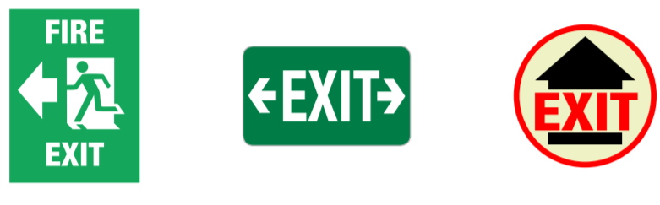
Figure 3.6. Emergency information signs
Fire Equipment Signs These signs are used to label fire-fighting equipment such as fire hoses and fire extinguishers, as well as fire alarms and phones used for communication during a fire. Over the last several decades, fire equipment signs have evolved to be more descriptive in both images and text. Sign formats were developed by the NFPA and ISO and adopted by ANSI in 2011.
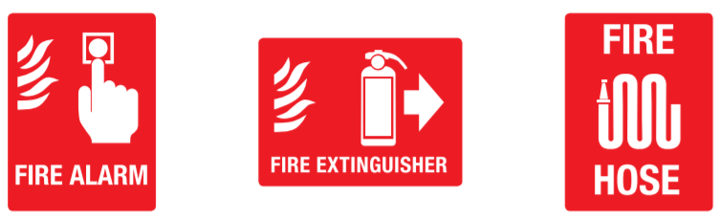
Figure 3.7. Fire Equipment Signs
- Fire signs (e.g. location of fire alarms and firefighting equipment)
Usually rectangular, fire extinguisher signs feature a description of the type of fire extinguisher present and its uses. They are found in different colors, the most common being red and green.
These signs serve as instructions, detailing what fire extinguishers can and cannot be used for. This increases the safety of extinguisher procedure and aims to reduce inappropriate use.
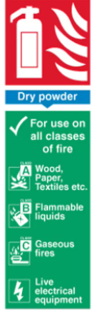
Figure 3.8. Fire signs
Fire equipment signs are normally rectangular or square and feature a white symbol and text on a red background. Red is used to denote danger and they indicate the location of fire equipment in an emergency situation.
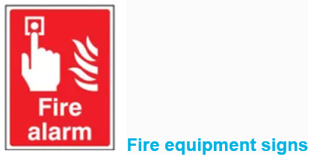
Figure 3.9. Fire Alarm
- Hazard Signs (e.g. Danger And Warning)
Hazard signs are some of the most important signs in your facility because they provide the information people need to avoid or handle safety issues. These signs should contain the new safety alert symbol, the appropriate signal word, a pertinent symbol, and a relevant text message.
Signal words available for use on these signs are “Danger,” “Warning,” and “Caution.” Symbols on these signs are generally those developed by the International Standards Organization (ISO).
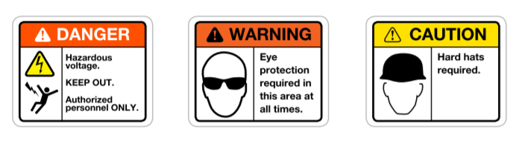
Figure 3.10. Hazard Signs
- Regulatory signs (e.g. prohibition, mandatory and limitation or restriction)
Prohibition signs are almost always red and white, signalizing danger, and feature a ‘do not’ symbol (a red circle with a line through it) with the prohibited action within it and written underneath it.
They inform occupants of the building of behaviors which are inappropriate and may pose a fire risk or hazard. They are a mandatory instruction and should be followed at all times.
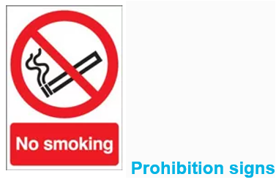
Figure 3.11. Regulatory signs
Mandatory signs are normally circular or oblong and are blue and white. These colors symbolize a specific, mandatory action or behavior which must be undertaken by the reader.
These signs have been created to reduce the risk of danger by detailing safety instructions such as ‘fire door keep shut’, ‘wash hands’ and ‘wear gloves’. They aim to eradicate hazards by commanding certain behaviors.
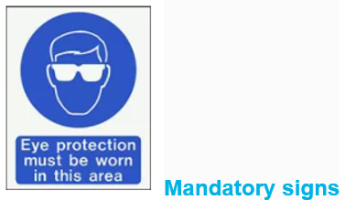
Figure 3.12.Mandatory Signs
- Safety tags and lockout (e.g. danger tags, out of service tags).
Safety instruction signs convey information about procedures or about the locations of first aid supplies such as emergency eyewash stations.
These signs may contain the signal words “Safety Instructions,” but they can also contain more specific headers such as “First Aid Instructions.” Current ANSI signs incorporate standardized symbols from the ISO.
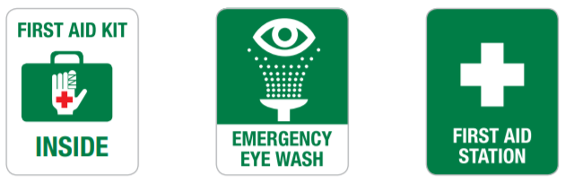
Figure 3.13. Safety Tags and Lockout
Danger – Used for a hazardous situation that will result in serious injury or death if not avoided. Reserved for extreme situations. Color: White text on red background.

A “danger” tag shall be used only in major hazard situations where an immediate hazard presents a threat of death or serious injury to employees.
Safe condition signs are green and white to denote safety procedures and no danger. They feature a white symbol and text of the action or instruction on a green background.
Safe condition signs are installed to indicate acceptable behaviors and if a course of action is safe to take. They usually detail instructions such as safe drinking water, emergency eye wash and designated smoking areas.
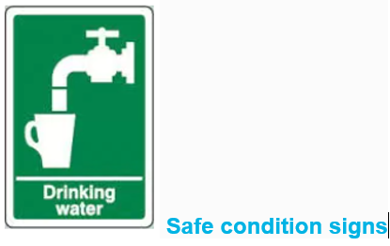
Figure 3.14. Safe Condition Signs
  - Procedures and relevant authorities
- Emergency Services
Emergency services and rescue services are organizations which ensure public safety and health by addressing different emergencies. Some of these agencies exist solely for addressing certain types of emergencies whilst others deal with ad hoc emergencies as part of their normal responsibilities. Many of these agencies engage in community awareness and prevention programs to help the public avoid, detect, and report emergencies effectively.
There are three primary emergency services that can be summoned directly by the public:
- Police — law enforcement, criminal investigation, and maintenance of public order. There are a variety of law enforcement agencies that conduct law enforcement.
- Fire and Rescue Services — fire suppression, technical rescue, and hazardous materials mitigation. These services are provided to those who need help during any type of emergency. Some Fire and Rescue services agencies also provide emergency medical services.
- EMS or Ambulance — emergency medical services and technical rescue. Emergency Medical Services agencies and Technical Rescue services agencies are responsible for immediate response to medical emergency calls as well as specialized rescue services calls.
The primary areas of police responsibility at a major incident are:
- the saving of life
- co-ordination during the Emergency Phase
- calling out of essential services
- protection and preservation of the scene
- investigation
- identification of the dead
- collation and dissemination of casualty information
- co-ordination of the media response
- application of counter measures to protect the public
- restoration of normality
- OHS regulatory authority
A regulatory authority is an autonomous enforcing body created by the government to oversee and enforce regulations regarding occupational health and safety.
The role of the regulatory authority is to establish and strengthen safety standards and ensure consistent compliance with them.
Regulatory authorities are also known as regulatory bodies, regulatory agencies, or simply regulators
- Supervisor.
Adequate supervision must be provided, taking into account where workers are unfamiliar with the site or the nature of the work. Workers in a supervisory role (e.g. leading hand or foreman) should be trained and authorized to ensure the work is carried out in accordance with relevant policies, procedures and the SWMS.
The WHS Regulations require that a person conducting a business or undertaking be responsible for: „ providing a safe working environment „ providing and maintaining adequate and accessible facilities „ providing first aid „ emergency planning „ providing workers with PPE „ remote or isolated work „ managing risks associated with airborne contaminants „ managing risks associated with hazardous atmospheres, including ignition sources „ storage of flammable and combustible substances „ managing risks associated with falling objects.

Self-check-3
Part I. choose the best answer
Directions: Chose the best answer on the space provided to the left side of question.
_____1.The primary areas of police responsibility at a major incident are:
  - Protection and preservation of the scene c) co-ordination during Emergency Phase
  - saving of lifed) All
_____2.Which of the following is not Construction Safety Signage.
  - Safety tags and lockout
  - unsafe condition signs
  - warning out of service tags d) Regulatory signs
_____3. Which one of the following is not duties of OHS Representatives?
a) Providing a channel of communication
b) Not conducting regular inspections
c) Conducting regular inspections d) all

Part II. Give short ad precise for the following answers for the following question
Directions: Answer all the questions listed below.
- _____________ has the responsibility to review all of their employees’ jobs for PPE needs
- What are the Designated OHS Personnel?
- What is OHS Meetings
- What is Toolbox talks ad its purpose
- What is the differences between incident ad accidents? Clarify by examples

Operation sheet-1
Operation Title: Making Site Safety Inspection Reports
Instruction: use the template givenby your Instructor
Purpose: to exercise making site safety inspection report
Required tools and equipment:Site Safety Inspection Template, pen, site
Precautions:Use safety equipment while inspecting sites
Procedures:
Step 1.Accept Site Safety Inspection Reports template from your instructor
Step 2.Go to construction sites
Step 3.Before entering to site use PPE properly
Step 4.Record site safety condition of the site onthe provided template
Step 5.Return your repots to your instructor

Quality criteria:your report should bereadableand clear

Operation sheet-2
Operation Title: Recording OHS meeting
Instruction: use the template givenby your Instructor
Purpose: to exercise recording ofOHS meeting at work shops
Required tools and equipment:OHS meeting Template, pen, workshop
Precautions:Use safety equipment
Procedures:
Step 1.Accept OHS meeting template from your instructor
Step 2.Go to yourworkshop
Step 3.Before entering to workshop use PPE properly
Step 4.Record workshop OHS meeting on the template
Step 5.Return your repots to your instructor

Quality criteria:your report should be readableand clear

LAP Test | Practical Demonstration

Name: __________________________ Date: ____________
Time started: ____________________ Time finished: _______________
Instruction I: Given necessary templates, tools and materials you are required to perform the following tasks within 4 hours.
Task 1:Make Site Safety Inspection Reports
Task 2:Record OHS meeting

Unit Four: OHS Incident Response Procedures
This learning unit is developed to provide the trainees the necessary information regarding the following content coverage and topics:
- Generalprocedures for responding to incidents and emergencies
- Proceduresfor accessing first aid
- Requirements for the selection and use of relevant personal protective equipment
- Firesafety equipment
This unit will also assist you to attain the learning outcomes stated in the cover page. Specifically, upon completion of this learning guide, you will be able to:
- Identify and explaingeneral procedures for responding to incidents and emergencies
- Identify procedures for accessing first aid
- Identify and demonstrate requirements for the selection and use of relevant personal protective equipment
- Identify and discuss fire safety equipment

  - Procedures for responding to incidents and emergencies
All staff will be trained on this policy and the safe and appropriate response to and reporting of emergencies.
Program sites will have contact information of a source of emergency medical care and transportation readily available for quick and easy access.
In addition, a list of emergency phone numbers will be posted in a prominent location and emergency contact information for persons served at the facility including each person’s representative, physician, and dentist.
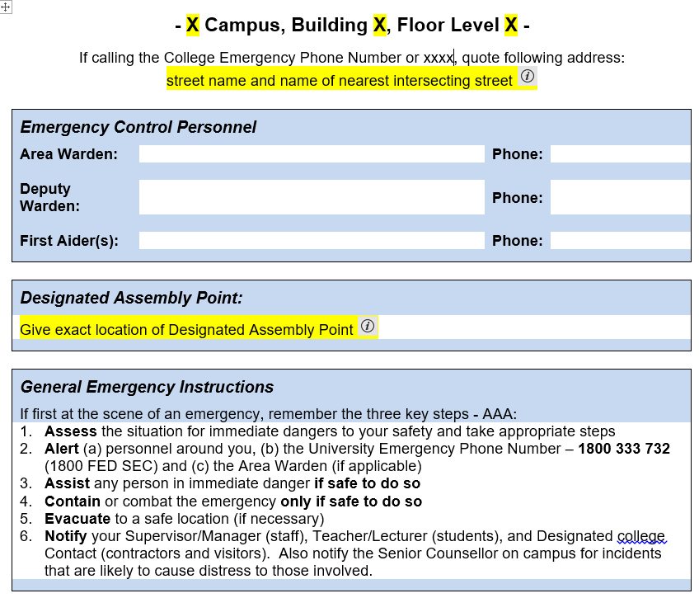
Template 4.1Emergecy response form
- Basic emergency response (keep calm, raise alarm, and obtain help)
The Office of the Information Commissioner (the Office) Emergency Response Procedure has been designed to ensure the safety of all staff and visitors to the Office in the case of fire or other emergency situations.
It is essential that persons within the Office are familiar with the procedures to be adopted in the case of any emergency. Emergency Procedures are centered on action initiated by Building Security until the arrival of the Emergency Services. All occupants must act as directed by the nominated personnel.
On hearing the fire alarm sound, or on being advised of an emergency incident, the Chief Warden will: –
- Determine the location of the alarm
- Assess the nature and extent fire or emergency
- Search the area indicated on the FIP to locate cause of the false alarm
- Ensure control room officer actions EWIS procedures located in the Control Room.
- Ensure the appropriate Emergency Service has been called
- Meet the Fire Service on arrival and inform them of the situation if they have been notified
- Evacuation
Emergency evacuation, moving to an emergency shelter, and temporary closure or relocation of the program to another facility or service site for more than 24 hours
- You will be notified of an evacuation by audible alarms and flashing lights; verbal notice from an instructor, Campus Safety officer, or other campus official; and/or the public address system.
- Walk, DO NOT RUN, to the nearest exit, then to a designated evacuation site.
- DO NOT use elevators.
- Follow the instructions of emergency personnel.
- Immediately notify emergency personnel of any disabled or injured persons needing assistance; if you are disabled or injured, ASK FOR HELP until you are rescued.
- Stay with the group you were with inside the building until emergency personnel tell you that you may leave the area.
- Notification of designated OHS personnel and authorities
Other events that threaten the immediate health and safety of persons served and that require calling “911”
- Pandemic event: Upon request, staff will cooperate with state and local government disaster planning agencies working to prepare for or react to emergencies presented by a pandemic outbreak.
- Bomb threat
- Upon receiving a bomb threat, staff at the program site should pull the fire alarm, if available.
- Staff will ensure that everyone leaves the building and assembles at the designated assembly point outside the facility.
- Staff will immediately call “911” from a neighbor’s telephone or a cell phone.
- Staff and persons will remain outside the building until further instructions are received from the police or fire department.
- If unable to re-occupy the building, staff will staff will follow the procedures in Letter E of this Responding to emergencies section.
- Notification of emergency services (e.g. when and how)
- Staff will immediately notify the manager that an incident or emergency has occurred and follow direction issued to them and will document the incident or emergency on an Incident and Emergency Report any related program or health documentation.
- If an incident resulted from the emergency situation, the manager will maintain information about and report incidents to the legal representative or designated emergency contact and case manager within 24 hours of an incident occurring while services are being provided, within 24 hours of discovery or receipt of information that an incident occurred, unless the company has reason to know that the incident has already been reported, or as otherwise directed in the person’s Coordinated Service and Support Plan and/or Coordinated Service and Support Plan Addendum.
- When the incident or emergency involves more than person served, the company and staff will not disclose personally identifiable information about any other person served when making the report to each person and/or legal representative and case manager unless the company has the consent of the person and/or legal representative.
- If a serious injury or death were to occur as a result of the emergency situation, staff will follow the response and reporting procedures as stated in the Policy and Procedures on Responding to and Reporting Incidents and, if needed, the Policy and Procedure on Death of a Person Served
  - Procedures for accessing first aid
First aid is the initial help given by a qualified first aid attendant to an injured or sick person. First aid treats injury, prevents further injury and promotes recovery. Most workplaces will have at least one first aid kit, and a trained first aider.
First aid is the immediate care given to a person who has been injured or suddenly taken ill. It includes home care if medical assistance is not available or delayed. It also includes well selected words of encouragement, evidence of willingness to help, and promotion of confidence by demonstration of competence (American red cross, 1998).
•Breathing apparatus
Respiratory emergency is one in which normal breathing stops or in which breathing is reduced so that oxygen intake is insufficient to support life. Artificial respiration is a procedure for making air to flow into and out of a person’s lungs when his natural breathing is inadequate or ceases.
•Fire blankets
A fire blanket is a safety device made from special woven fabric that is fire retardant and is designed to help extinguish small starting fires. They are particularly useful for smothering fat pan fires or for wrapping around a person whose clothing is on fire.
A fire blanket should be kept close to areas at higher risk of fire such as a kitchen or catering environment.
•Firefighting equipment
Firefighting equipment is equipment designed to extinguish fires or protect the user from fire. It may be used by trained fire fighters, untrained users at the scene of a fire, or built into a building's infrastructure (such as a sprinkler system).
Firefighting equipment includes not only fire hoses and fire extinguishers but also fire-resistant protective clothing, fire-resistant gloves, respirators, and communication equipment.
A categorized list of such equipment might look like this:
- Extinguishers – using water, dry chemical powder, foam, carbon dioxide, or other substances
- Fire fighter’s gear – fire resistant outer suit, inner lining suit, inner and outer gloves, woolen socks, fire resistant shoes, helmet (with or without headlight), communication system, and breathing apparatus
- Installed firefighting system – main water supply network, hydrant, sprinkler (automatic or manual), emergency fuel and electric cut off system, portable generators, and portable pumps
- Communication equipment – walkie-talkie, radio, broadcasts, landline telephone, sound powered telephone, cell or mobile phone, and voice pipe
- Fire detection and alarm systems – smoke, frame, spark detectors, local, centralized automatic, semi-automatic, and manual fire alarm systems
- Other accessories – water and sand bucket, shovel, hammer, fire axe, cutters, hooks, fire blanket, emergency lifesaving apparatus, and emergency lights
  - Selection and Use Of Relevant Personal Protective Equipment
All PPE clothing and equipment should be of safe design and construction, and should be maintained in a clean and reliable fashion.
Employers should take the fit and comfort of PPE into consideration when selecting appropriate items for their workplace.
PPE that fits well and is comfortable to wear will encourage employee use of PPE. Most protective devices are available in multiple sizes and care should be taken to select the proper size for each employee. If several different types of PPE are worn together, make sure they are compatible. If PPE does not fit properly, it can make the difference between being safely covered or dangerously exposed. It may not provide the level of protection desired and may discourage employee use.

Self-check-4
Part I. choose the best answer
Directions: Chose the best answer on the space provided to the left side of question.
_____1.Which of the following is not Basic emergency response
- keep calm b) raise alarm c) obtain help d) all
_____2._________ is the initial help given by a qualified first aid attendant to an injured or sick person.
a) Risk b) raise alarm c) first aid d) all
_____3. _____________fire blanket is a safety device made from special woven fabric that is fire retardant and is designed to help extinguish small starting fires.
a) Fire blanketb) First aid c) risk d) hazard
  - warning out of service tags d) Regulatory signs

Part II. Give short ad precise for the following answers for the following question
Directions: Answer all the questions listed below.
1. _____________ is equipment designed to extinguish fires or protect the user from fire.
2. What are the components of firefighting equipment?

Operation sheet-3
Operation Title: demonstrate response to emergencies
Instruction: Use the template givenby your Instructor
Purpose: practicing for emergency response
Required tools and equipment:first aid
Precautions:use safely first aid tools
Procedures:
Step 1.Assess the situation for immediate dangers to your safety and take appropriate steps
Step 2.Alert (a) personnel around you, (b) the College Emergency Phone Number – xx
Step 3.Assist any person in immediate danger if safe to do so
Step 4.Contain or combat the emergency only if safe to do so
Step 5.Evacuate to a safe location (if necessary)
Step 5.Evacuate to a safe location (if necessary)
Step 5.Notify your Supervisor/Manager (staff), Teacher/Lecturer (students),

Quality criteria:

LAP Test | Practical Demonstration

Name: __________________________ Date: ____________
Time started: ____________________ Time finished: _______________
Instruction I: Given necessary templates, tools and materials you are required to perform the following tasks within 10 hours.
Task 1:demonstrate response to emergencies
Task 2:demonstrate how to use PPE

References
- Personal Protective Equipment U.S. Department of Labor Occupational Safety and Health Administration OSHA 3151-12R 2004
- Incident and Emergency Management Procedure Policy Code: CG1867, Authorized by: University Health and Safety Policy Committee | Document Owner: Manager, Health, Safety and Wellbeing | Original Issue: 29/02/2000 | Current Version: 10/08/2022 | Review Date: 29/11/2024 | Policy Code: CG1867
- Ministry of Urban Development and Construction, August 2013,Directives for the Registration of Construction Professionals and Contractors (Amended), (Directive No 19),Addis Ababa
- The Australian Council of Trade Unions, the Australian Chamber of Commerce and Industry and the Australian Industry Group, (2009). CONSTRUCTION WORK Code of Practice, Safe Work Australia
- U.S. Department of Labor, (2004), Occupational Safety and Health Administration.Personal Protective Equipment, OSHA 3151-12R 2004
- A handbook for the construction regulations, (February 2008), Working safely in the general construction industry, Edition No. 1,
- J P Le Page,(October 2015), Potential for Combination of Ambulance and Fire Services in Guernsey, Chief Fire Officer Guernsey Fire & Rescue Service
WEB Address

Developers Profile
No | Name | Qualification (Level) | Field of Study | Organization/ Institution | Mobile number | E-mail
1 | Elias Getachew | MSc | Industrial Electrical Automation & Control Management | Misrak Poly Technique college | 0913811386 | get.elias19@gmail.com
2 | Mengistu Abiyu | MSc | Industrial Electrical Automation & Control Management | Lideta Manufacturing College | 0913948480 or 0913948480 | menabiy@gmail.com
3 | Giduma Mekonen | BSc | construction Management | Adama Poly Technique college | 0913939750 | olimosisa@gmail.com
4 | Tigist Aemiro | MSc | construction Management | Bahir Dar poly Technique college | 0918375757 | tigistaemiro4@gmail.com
5 | Yidnekachew Seboka | BSc | Electrical Automation & Control Technology | Akaki poly  Technique college | 0920137899 | www.yedine23@gmail.com
6 | Getahun Abera | BSc | Electrical Electronics Technology | Dere-dawa poly Technique college | 0910334887 | getab@yahoo.com

