

Building Electrical Installation
Level-I
Based on March 2022, Curriculum Version 1

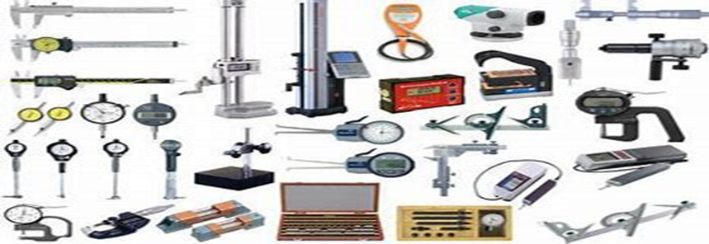
ModuleTitle:-Carry-OutMeasurementsandSimple Calculations
Module code: EIS BEI1 M02 0822
Nominal duration: 40Hour
Prepared by: Ministry of Labor and Skill Augest,2022
Addis Ababa, Ethiopia

Table ofContents
Acknowledgment 4
Acronym 5
Introduction to the Module 6
Unit one Measuring instruments 7
UNIT ONE MEASURING INSTRUMENT 8
1.1 Geometric Shape 9
1.1.1 Types of Geometric Shapes 10
1.1.2 Properties of Geometric Shapes 10
1.2 Measuring Tools & Measuring Instrument 16
1.2.1 Tape rule 17
1.2.2 Straight edge 17
1.1.3 Torque gauge 17
1. 1.4 Torque wrench 17
1.1.5 Try square 18
1.1.6 Protractor- 18
1.1.7 Combination gauge 19
1.1.8 Vernier caliper 19
1.1.9 THE MICROMETER 21
1.1.10 Spirit level 22
1.1.11 Zig-zage 22
OPERATION SHEET 1.1 Geometrical Shape measurement 24
UNIT TWO MEASUREMENTS &CALCULATION 25
2.1 Measurement 25
2.2 BASIC CALCULATION & CORRECT NUMERICAL ACCURACY 28
2.2.1, Trigonometric and algebraic computations function 28
Length 28
2.2.2 29
Thickness- 29
Diameter - 30
Displacement (s) 30
Circumference- 32
Area 32
Triangle 32
Volume 35
2.4 Measurement system convertion 36
VOLUME 39
2.5 Electrical Measure Instrument 43
Multi meter 43
Voltage 43
Current 44
Resistance 44
OHMS Law 44
Types of Electrical measuring equipment 44
Voltmeter 44
Digital voltmeter 45
Ammeter 45
Ohmmeter 46
Clamp ammeter 46

Acknowledgment
Ministry of Labor and Skills wish to extend thanks and appreciation to the many representatives of TVET instructors and respective industry experts who donated their time and expertise to the development of this Teaching, Training and Learning Materials (TTLM).

Acronym

OHS OCCUPATIONAL HEALTH & SAFTY
Kg kilogram
S second
m meter

Introduction to the Module
In carry out measurements and calculations.helps to know the quantity of work; to estimate the quantity of material required; to determine the cost of the work; to estimate the expect project completion time and to know the amount of current supplied form the source in building electrical installation field.
This module is designed to meet the industry requirement under the construction occupational standard, particularly for the unit of competency: Carry out measurements and calculations.
This module covers the units:
- Measuring instruments
- Measurements and calculations.
Learning Objective of the Module
- Select measuring instruments
- Perform Measurements & calculations.
Module Instruction
For effective use this modules trainees are expected to follow the following module instruction:
- Read the information written in each unit
- Accomplish the Self-checks at the end of each unit
- Perform Operation Sheets which were provided at the end of units
- Do the “LAP test” giver at the end of each unit and
- Read the identified reference book, Web site etc…

Unit one Measuring instruments

This unit is developed to provide you the necessary information regarding the following content coverage and topics:
  - Geometric shape
  - Measuring instruments & tools
  - Specifications from relevant sources.
This unit will also assist you to attain the learning outcomes stated in the cover page. Specifically, upon completion of this learning guide, you will be able to:
- Classify & interpret geometric shape.
- Select and identify measuring tools
- Perform alternative measuring tools.
- Understand correct specifications from relevant sources.
- Apply appropriate measuring instruments.

MEASURING INSTRUMENT
The measuring instrument selection is the most important part of the measuring process so their selections have to be done carefully. The selection of measuring instruments is complex tasks, which depend on the size, the character and the value of measured magnitude. The selection of an instrument for a specific measurement application requires the consideration of several factors the following are fundamental to entire attitude of measurement and instrument selection.
1-Maximum and minimum values the input variables are expected to assume:-
The instrument range must equal to the expected range of variable to be measured.
Excessive instrument range means a lot of readability.
For a wide range in the variable, multiple range of instrument is desired.
2-Nature of the input signal: - is it constant or time dependent?
If time variant, then whether variation is periodic, transient or random.
For transient measurement, it is to be ensured that natural frequencies and time constants are properly selected.
3 -Noninterference with measuring system: -
The basic principal of measuring is that the act shouldn't affect the quantity being measured.
Our job is to see that the instrument offers minimum interference.
4- Appropriate measuring instruments.
The demand for a high accuracy would require the use of highly sophisticated and specialized instruments having special ancillaries to compensate for ambient condition.
The more accurate instruments are more difficult to operate.
Never demand an accuracy of measurements higher than that which is really needed, and never forget that each degree of accuracy.
5-Easy calibration: -The instrument should be easy to calibrate and calibration curve must be stable for time requireCompleting a test.
6- Convenience and ease in reading the instrument: -
Scales that are properly ruled and numbered for easy legibility, proper illumination, and reading straight dials are feature that will have a decisive influence on the selection of an instrument.
Often engineer relies with experience, when making a comparison of many factors in the course of proper selection of instruments.

1.1 Geometric Shape
Geometrical shapes are the figures which represent the forms of different objects. Some figures are two-dimensional, whereas some are three-dimensional shapes. The two-dimensional figures lie on only the x-axis and y-axis, but 3d shapes lie on the x, y and z axes. The z-axis shows the height of the object. As we have already discussed in the introduction, there are different shapes defined in geometry.
To draw or design any of these figures start with a line or a line segment or a curve. Depending upon the number and arrangement of these lines, we get different types of shapes and figures like a triangle, a figure where three line segments are connected, a pentagon (five-line segments) and so on. But every figure is not a complete figure
Note A point has no dimension and a line is a one-dimensional shape. Both of these are the base of geometry. When two lines meet at a point, they form an angle where the point is said to be the vertex and lines are the arms.
- The two-dimensional and three-dimensional shapes are formed using point, lines and angles.
Shapes are nothing but simple geometric figures which have a specific boundary, and interior and exterior surface area.

1.1.1 Types of Geometric Shapes
Here is the list of different geometric shapes:-
Two Dimensional Shapes:-Triangle, Circle, Semi-Circle, Square, Rectangle, Parallelogram, Rhombus, Trapezium, Polygons (Pentagon, Hexagon, Octagon, Nonagon, Decagon, etc.)
Three Dimensional Shapes: -Sphere, Cube, Cuboid, Cone, Cylinder

1.1.2 Properties of Geometric ShapesThe different types of shapes in geometry along with definitions are:-
Triangle:-Triangle is a polygon, which is made of three sides and consists of three edges and three vertices. Also, the sum of its internal angles equals to 180º. Figure 1.1 Triangle
Circle:-Circumstance of all points at a fixed distance from a reference central point is called a CircleFigure 1. 2Circle

Square

Square is a quadrilateral where all the four sides and angles are equal and the angles at all the vertices are equal to 90° each.
Figure 1.3 Square
Rectangle-A quadrilateral has two pairs of opposite sides equal in length and interior angles are at the right angles.Figure 1.4Rectangle
ParallelogramA parallelogram is a quadrilateral with two pairs of parallel sides and opposite angles are equal in measureFigure 1. 5Parallelogram
Polygons are made up of line segments and no curves. They are enclosed structures based on different lengths of sides and different angles.
Three-Dimensional Shapes:-Most of the three-dimensional shapes can be defined as a set of vertices, lines that connect the vertices and faces enclosed by these lines including obtained interior points. For many three dimensional shapes, faces are two-dimensional. Also, some shapes in three dimensions have curves surfaces. In three dimensions, the primary shapes are:
Cube:-A cube is a three-dimensional shape which has 6 faces, 8 vertices and 12 edges. The faces of the cube are square. 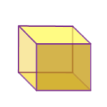Figure 1.6Cube:-
Cone:- A cone is a solid which has a circular base and narrows smoothly from the surface to the top at a point called apex or vertex. 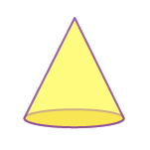Figure 1.7 Cone
CylinderA cylinder is a 3d solid shape that has two parallel circular bases connected by a curved surface. It has no vertex. 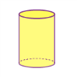Figure 1.8Cylinder
SphereA sphere is a round shape in a 3d plane,whose radius is extended to three dimensions (x-axis, y-axis and z-axis). 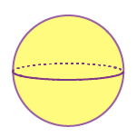Figure 1.9Sphere
Open and Closed Figures
A point is a small dot which is the starting point of a line segment. By definition, a line segment is a part of a line in which a narrow lane is connecting two points within a line. Different numbers of line segments give us different figures and such figures may be either open figures or closed shapes or figures.
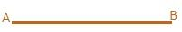
Closed Shapes
Geometric shapes such as a square, rectangles, and triangles are a few basic 2D shapes. These figures are collectively called polygons. A polygon is any flat shape or plane on a surface of a paper. They have a finite closed boundary made up of a fixed number of line segments and are called sides of the polygon. Each side meets at a common point called corners (vertex).Such bounded geometric shapes like polygons are called closed figures. tsbut also of curves. Hence, a closed figure can be defined as any geometric shape which starts and ends at the same point to form a boundary by line segments or by curves.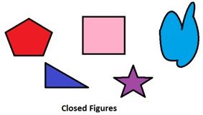
Figure 1. 10Closed Shapes

Open Shapes
Open Shapes- are incomplete shapes. To sketch a closed figure one has to meet both the starting point and ending point. Open figures are also depicted by using line segments or by curves but at least the lines will be discontinuous. An open figure’s starting and endpoints are different.
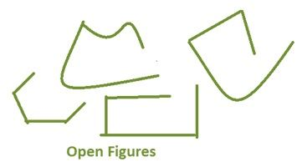Figure 1.11- Open Shapes
Different Shapes
In our daily existence, we may observe different shapes which look exactly the same as some three-dimensional geometric shapes. Apart there are other objects in our surroundings such as traffic cones, Rubik’s cubes, pyramids and so on. Observe the below figure, to understand the different shapes that relate to geometric shapes.
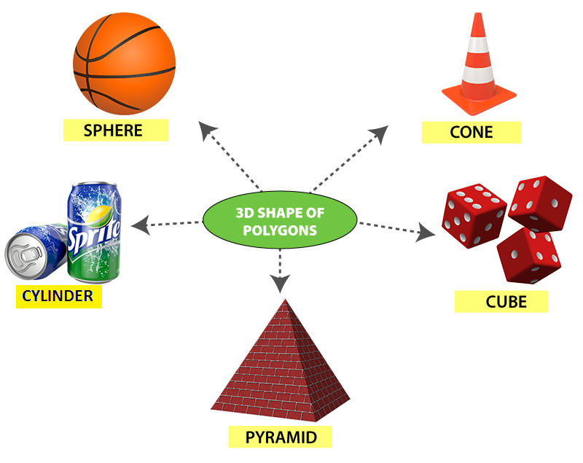
Figure 1.12Different Shapes

1.2 Measuring Tools & Measuring Instrument

Selecting of measuring instruments & Tools are the most important part of the measuring process so their selections have to be done carefully. The selection of measuring instruments &tools is a complex task, which depends on the size, the character and the value of measured magnitude. Selection of the correct measuring instrument and tools method, duty of the capabilities of measuring instruments & tools, duty of the procedures and operatorsduty of any measuring interactions, calculating the uncertainty of measuring of individual measuring instrument and tools.
The following are some measuring tools.

1.2.1 Tape rule

A tape measure or measuring tape is a flexible ruler. It consists of a ribbon of cloth, plastic, fiber glass, or metal strip with linear-measurement markings. It is easily carried in pocket or toolkit and permits one to measure around curves or corners.
Figure 1.13Tape rule

1.2.2 Straight edge

A straightedge is a tool with an edge free from curves.Used for transcribing straight lines, or checking the straightness of lines. If it has equally spaced markings along its length it is usually called a ruler.
Figure 1.14 Straight edge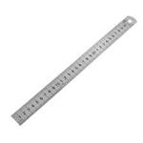
1.1.3 Torque gauge A torque gauge or torque meter is a device for measuring and recording the torque on a rotating system, such as an engine, crankshaft, gearbox, transmission, rotor, a bicycle crank or cover torque tester.

1.1.4 Torque wrench

A torque wrench is a tool used to precisely apply a specific torque to a fastener such as a nut or bolt. It is usually in the form of a socket wrench with special internal mechanisms.
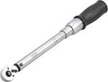
Figure 1.15Straight edge

1.1.5 Try square

The try square has a blade (straight edge) and a stock (beam) handle which are fixed together at exactly 90. The stock is much thicker than the blade. The edge of the blade and the stock are perfectly sharp and straight.
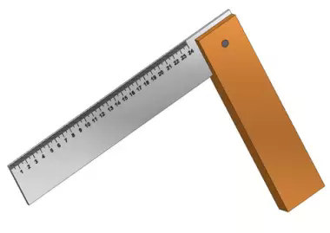Figure 1.16 Try square
The try square may be made entirely of steel or wood or it may have a stock of wood and a blade of steel.The try square is used mostly for:-Laying out lines perpendicular to an edge or side of a board
- Checking edges and ends of boards to see if they are 90 degree with adjoining surfaces
- Checking the width or thickness of narrow boards.
- Measuring short distances
- Checking flatness
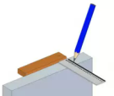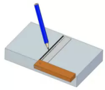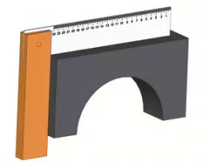
Marking on a edge Marking on a side Checking outside corner
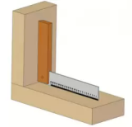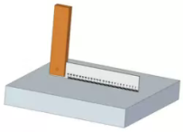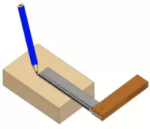
Checking inside corner short distances Checking flatness
1.1.6 Protractor- protractor is a transparent plastic tool designed to measure angles. They are usually semicircular but also are available in a full circle 360° version. Most protractors measure angles in degrees (°). Radian-scale protractors measure angles in radians.
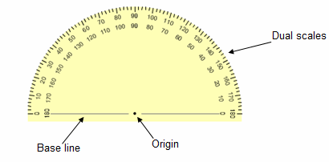Figure 1.17Protractor
Origin-the small hole near the bottom of the protractor is aligned over the vertex of the angle to be measured.
Baseline-The line along the bottom of the protractor is aligned along one of the angle's legs.
Note: It is not the edge of the protractor body itself, but parallel to it.
Scales-the angle of the other leg is read from one of the two scales, whichever is more convenient. The following are some measuring instrument.

1.1.7 Combination gauge

It is a line measuring device. It is the simplest and most common measuring instrument used in inspection. The scale can be manufactured in different sizes and styles. Various possible combinations of scales. The scale can be either 150 mm long or 300 mm or 600 mm or 1000 mm long.
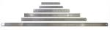Figure 1.18Combination gauge

1.1.8Vernier caliper

The Vernier Caliper is a precision instrument that can be used to measure internal and external distances extremely accurately. The example shown below is a manual caliper. Measurements are interpreted from the scale by the user. This is more difficult than using a digital vernier caliper which has an LCD digital display on which the reading appears. The manual version has both an imperial and metric scale.

Manually operated vernier calipers can still be bought and remain popular because they are much cheaper than the digital version. Also, the digital version requires a small battery whereas the manual version does not need any power source.
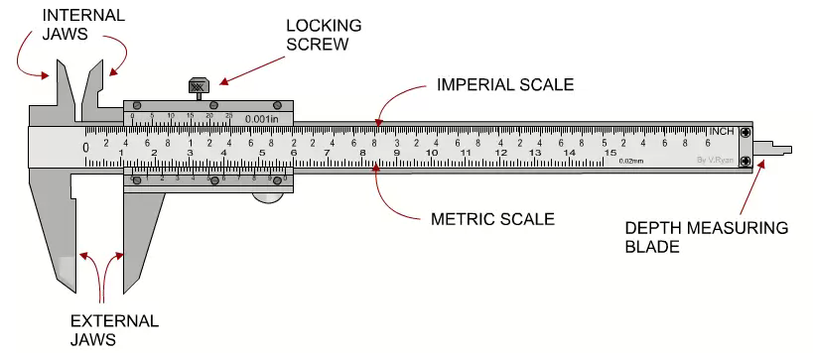
Figure 1.19Vernier caliper

HOW TO READ A MEASUREMENT FROM THE SCALES
EXAMPLE 1: The external measurement (diameter) of a round section piece of steel is measured using a vernier caliper, metric scale.
MATHEMATICAL METHOD
A. The main metric scale is read first and this shows that there are 13 whole divisions before the 0 on the hundredths scale. Therefore, the first number is 13.
B. The’ hundredths of mm’ scale is then read. The best way to do this is to count the number of divisions until you get to the division that lines up with the main metric scale. This is 21 divisions on the hundredths scale.
C. This 21 is multiplied by 0.02 giving 0.42 as the answer (each division on the hundredths scale is equivalent to 0.02mm).
D. The 13 and the 0.42 are added together to give the final measurement of 13.42mm (the diameter of the piece of round section steel.

COMMONSENSE METHOD

Alternatively, it is just as easy to read the 13 on the main scale and 42 on the hundredths scale. The correct measurement being 13.42mm.
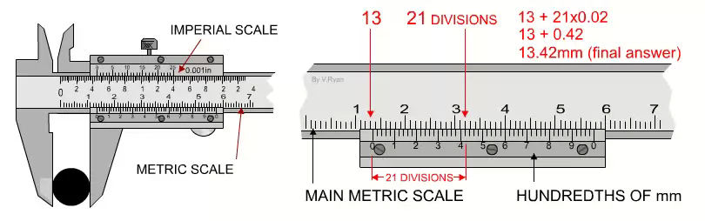
Figure 1.20Vernier caliper

1.1.9 THE MICROMETER
The micrometer is a precision measuring instrument, Each revolution of the rachet moves the spindle face 0.5mm towards the anvil face. The object to be measured is placed between the anvil face and the spindle face. The rachet is turned clockwise until the object is ‘trapped’ between these two surfaces and the rachet makes a ‘clicking’ noise. This means that the rachet cannot be tightened any more and the measurement can be read.
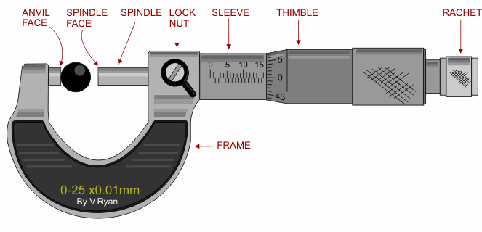
Figure 1.21micrometer
EXAMPLE MEASURE READINGS
Using the first example seen below:
- Read the scale on the sleeve. The example clearly shows12 mm divisions
- Still reading the scale on the sleeve, a further ½ mm (0.5) measurement can be seen on the bottom half of the scale. The measurement now reads 12.5mm.
- Finally, the thimble scale shows 16 full divisions (these are hundredths of a mm).
The final measurement is 12.5mm + 0.16mm = 12.66
1.1.10 Spirit level-bubble level or simply a level is an instrument designed to indicate whether a surface is horizontal (level) or vertical (plumb). Different types of spirit levels may be used by carpenters, stonemasons, bricklayers, other building trade’s workers.
1.1.11Zig-zage rule-a rule composed of light strips of wood joined by rivets so as to be foldable, all the opening and closing parts being in parallel planes. It is Also called folding rule.
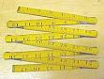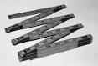Figure 1.22Zig-zage

Self-check
- Say true or false. Time allotted for each item is 30 second and each question carry 1 point.
1-A point is a small dot which is the starting point of a line segment.
2-A Tape meter & Varner caliper is a measuring instrument.
3-Triangle is a polygon.
- Choose the best Answer
4) Which one of the ff is a measuring instrument?
- micrometer b)veriner caliper c)a&b d)none
5) Rectangle is an example of
open figure B)close figure C)none D)ALL
- Fill in the blank
6------------------the small hole near the bottom of the protractor is aligned over the vertex of the angle to be measured.
7- -------------is a polygon which has three side.
8- ----------- figure has both the starting point and ending point.
9------------- simply a level is an instrument designed to indicate whether a surface is horizontal or vertical
- EXPLAIN
10-Try to mention some measuring instrument

OPERATION SHEET 1.1 Geometrical Shape measurement
- Operation title: Measuring geometrical Shape
- Purpose: To measure the dimension of geometrical shape
- Instruction:Instruction: Using the figure below and given equipments measure the diameter of each rachet. You have given rachet for the task and you are expected to write the answer on the given line.
Fig 23.1 Operation sheet 1.1

- Tools and requirement:
- Paper,
- Ruler,
- Pencil.
- Steps in doing the task
1. Read the scale on the sleeve.
2. Still reading the scale on the sleeve,
3. Finally, the thimble scale shows full divisions
- Quality Criteria: the given measured with an accuracy of 0.01mm.

NIT TWO MEASUREMENTS &CALCULATION
This unit is developed to provide you the necessary information regarding the following content coverage and topics:
  - Obtain accurate measurements and calculations.
  - Perform basic calculation.
    - Trigonometric and algebraic computations function.
    - fractions, percentages and mixed numbers
  - Check and correcting numerical computations accuracy.
  - Read accuracy of instrument tools.
  - Identify and convert system of measurement tools
  - Measure work pieces
This unit will also assist you to attain the learning outcomes stated in the cover page. Specifically, upon completion of this learning guide, you will be able to:

Module Instruction
For effective use this modules trainees are expected to follow the following module instruction:
1-Read the information written in each unit
2-Accomplish the Self-checks at the end of each unit
3-Perform Operation Sheets which were provided at the end of units
4-Do the “LAP test” giver at the end of each unit and
5-Read the identified reference book, Web site etc…

2.1 Measurement is the process of determining the amount of physical and non physical quantities. How we determine the exact capacity of something that is in solid, liquid or gas form. A direct or indirect comparison of a certain quantity with an appropriate standard or unit of measurement. A unit of measurement is a definite magnitude of a quantity, defined and adopted by convention or by law that is used as a standard for measurement of the same quantity. Any other value of that quantity can be expressed as a simple multiple of the unit of measurement. What is the definition of physical quantity? A physical quantity is a quantity in physics that can be measured, thus a physical property that can be quantified. It is a quantity that can be used in the mathematical equations of science and technology. A physical quantity has magnitude and suitable S.I Unit. Physical quantities have two types:
Base quantities:-They are undefined (unknown). The seven base quantities and their corresponding units are
Table2.1Base quantities
No | Base quantities | SI unit name | SI unit symbol
1 | Length | Meter | M
2 | Mass | Kilogram | Kg
3 | Time | Second | S
4 | Electric current | Ampere | A
5 | Temperature | Kelvin | K
6 | Amount of substance | Mole | Mol
7 | Luminous intensity | Candela | Cd
Derived quantities: -It defined based on a combination of base quantities and has a derived unit that is the exponent, product or quotient of these base units. Some common derived quantities and their corresponding units are:
Table2.2Derived quantities
No | Derived quantities | SI unit name | SI unit symbol
1 | Frequency | Hertz | Hz
2 | Area | square meter | M2
3 | Volume | cubic meter | m3
4 | Velocity | meter per second | m/s
5 | Acceleration | meter per second squared | m/s2
6 | Perimeter | Meter | M
7 | Force | Newton | N
8 | Electric charge | Coulomb | C
9 | Power | Watt | W
10 | Energy | Joule | J
11 | potential deference | Volt | V
12 | Capacitance | Farad | F
13 | Resistance | Ohm | Ω
14 | Inductance 1 | Henry | H
15 | Luminous flux | Lumen | Lm

2.2 BASIC CALCULATION& CORRECT NUMERICAL ACCURACY

A calculation is a deliberate process that transforms one or more inputs into one or more results, with variable change.
2.2.1, Trigonometric and algebraic computations function
Length-in geometric measurements, length is the longest dimension of an object.
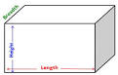Figure 1.23
The distance formula is derived from the Pythagorean Theorem. To find the distance between two points (x1, y1) and (x2, y2), all that you need to do is use the coordinates of these ordered pairs and apply the formula pictured below. The distance formula is
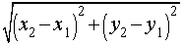----------------------------------------------------------- Eq 2.2. 1
Below is a diagram of the distance formula applied to a picture of a line segment

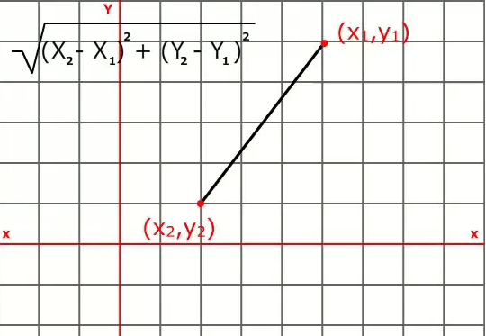Figure 1.24

2.2.2-Fractions, Percentages and Mixed numbers
Thickness-The distance between the top and bottom or front and back surfaces of circle of something:
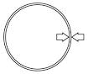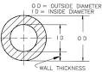
$Thickness=\frac{Outside diameter-outside diameter }{2}$Figure 1.25
Diameter - geometry the diameter of a circle is any straight line segment (part) that passes through the center of the circle and whose endpoints on the circle.
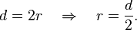
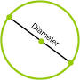Figure 1.26

Displacement (s)
A displacement is the shortest distance from the initial to the final position of a point P.
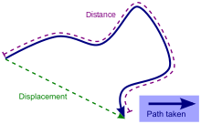Figure 1.27
A displacement may be also described as a 'relative position': the final position of a point (Rf) relative to its initial position (Ri), and a displacement vector can be mathematically defined as the difference between the final and initial position vectors:
-----------------------------------------------------------------Eq 2.2. 2
Displacement is shortestdistance between initial and final point which prefers straight line path over curved paths. If a body is moving in two different directions x and y then Resultant isplacement,It gives the short cut paths for the given original paths.Generally it is also given by:

s=vt=1/2(u+v)t=ut+1/2at2 -------------------------------------------------Eq 2.2. 3
Where u is the Initial velocity a is acceleration
t is the time taken v is the final velocity
While solving the problems if initial and final velocities both are given. we use the first formula if final velocity and time taken are given you can use second formula and if you are interested in finding area A the third formula.
Example 1: An object moves from A to D along the red path as shown below.
a) Find the total distance covered by the object
b) Find the displacement of the object
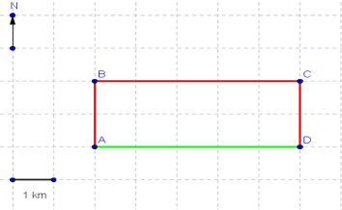Figure 1.28
Solution:
a) Using the given scale (1km per division); the total distance d is given by
d = AB + BC + CD = 2 + 5 + 2 = 9 km
b) The final and initial and positions of the moving object are used to find the displacement. The distance from A (initial position) to D (final position) is equal to AD = 5 km.
The displacement is the vector AD whose magnitude if 5 km and its direction is to the east.
Circumference-Circumference (from Latin circumferential, meaning "carrying around") is the linear distance around the edge of a closed curve or circular object.Circle illustration with circumference (C) in black, diameter (D) in cyan, radius (R) in red, and centre or origin (O) in magenta.

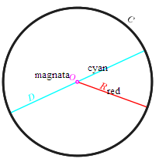Figure 1.29
Circumferenc= π × diameter = 2 × π × radius.---------------------------------------------------------Eq 2.2. 4
Area-area is the quantity that expresses the extent of a two-dimensional figure or shape.
Surface area is its analog on the two-dimensional surface of a three-dimensional object.
The area of a shape can be measured by comparing the shape to squares of a fixed size. In the International System of Units (SI), the standard unit of area is the square meter (written as m2), which is the area of a square whose sides are one meter long.
There are several well-known formulas for the areas of simple shapes such as triangles, rectangles, and circles.
Triangle A triangle is a polygon which has three sides and can be categorized into the follow types:
- An equilateral triangle has equal sides and equal angles.
- An isosceles triangle has two equal sides and two equal angles.
- A scalene triangle has three unequal sides and three unequal angles.
- A right-angled triangle has one right angle (90°).
- An acute-angled triangle has all angles less than 90°.
- An obtuse-angled triangle has one angle greater than 90°.
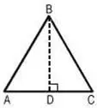
Area of a triangle is given by:
A = ½ × Base × Height --------------------------------------------------------------------Eq 2.2. 5
Any side of the triangle may be considered as its base.
Then, the length of the perpendicular line from the opposite vertex is taken as the corresponding height or altitude.
In the figure shown above the area is thus given as: ½ × AC × BD.
Area of an equilateral triangle
A= √ (3) · ¼ · side, where side = a = b = c -------------------------------Eq 2.2. 6
Area of an isosceles triangle
A = ¼ ·b · √ (4a2 – b2)-------------------------------------------------------Eq 2.2. 7
Area of the right angled triangle
A= ½× Product of the sides containing the right angle. -----------------Eq 2.2. 8
Example 1: Find the area of a triangle whose base is 14 cm and height is 10 cm.
Solution: b = 14 cm
h = 10 cm
A = ½ · 14 · 10 = 70 cm2
Example 2: Find the area of a triangle whose sides and the angle between them are given as following: a = 5cm ,b = 7cm ,C = 45o
Solution: Area of a triangle = ½ · a · b · sin C
Area = ½ × 5 ×7 × 0.707 (since sin 45 ° = 0.707)
Area = ½ × 24.745 = 12.3725 m2
Example3:Find the area (in m2) of an isosceles triangle, whose sides are 10 m and the base is12 m.
Solution: The area of an isosceles triangle is determined by:
A = ¼ ·b · √ (4a2 – b2)
A = ¼ ·12 · √ (4(10)2 – (12)2)
A = 48 m2

Rectangle
A rectangle is a four sided and closed figure. In a rectangle all opposite sides are parallel and equal. Also in a rectangle all the adjacent sides are perpendicular.
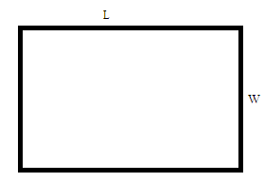Figure 1.30

Area of rectangle = L × W------------------------------------------------------------------Eq 2.2. 9
Example 1: Given a rectangle where the length is 5cm and the width is 3cm. find the area of this rectangle.
Solution: To calculate the area, we can use the formula for the area of a rectangle: A = L×W
Since the length is given as 5cm, we can substitute L with 5. Similarly, since the width is given as 3cm, we can substitute W with 3. After doing so, we can calculate A, as shown below:
A = L×W , A = 3×5 , A = 15 Now, the calculated number 15 only has a meaning if we include the unit for it. Since the given length and width are in cm, the unit for area will be cm2. HenceA = 15 cm2
Example 2: Find the area of the garden; length and width of the garden are respectively 600m and 400m. Area of garden = Length ×Width A = L×W A = 600×400 A = 240000m
Example 3: A white paper has a size of length 20 cm and width 15 cm. Jack has drawn a rectangle in the center of the paper which is 10 cm in length and 5 cm in width and painted the entire rectangle in violet color. Find the area of the violet colored portion and area of white portion.
Solution: We know that area of a rectangle is length × width.
Here the given paper has the shape of a rectangle.
So the area of the paper is = 20cm x 15cm = 300cm².
And the area of the violet colored rectangle = 10cm x 5cm = 50cm².
So the area of the white portion = 300cm² - 50cm² = 250cm².
Area of CircleThe formula to find a circle's area usually expressed as
πr2 .Where π= 3.14 -------------------------------------------------------------------------Eq 2.2.10
Volume-Volume is the quantity of three-dimensional space enclosed by some closed boundary, for example, the space that a substance (solid, liquid, or gas) or shape occupies or contains. Volume is often quantified numerically using the SI derived unit, the cubic meter. The volume of a container is generally understood to be the capacity of the container, i. e. the amount of fluid (gas or liquid) that the container could hold, rather than the amount of space the container itself displaces.
Volume of a Cube-Volume of a Cube is a measurement of the occupied units of a cube. The volume of a cube is represented by cubic units like cubic centimeter, cubic millimeter and so on. It is also defined as the number of units used to fill a cube. The cube volume
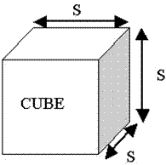
is determined by the formula as

V = S3--------------------------------Eq 2.2. 11Figure 1. 31
since it has the same length for all sides. Here, ‘S’ is the length of the side.
Volume of a sphere
A sphere is a three-dimensional solid with no base, no edge, no face and no vertex. Sphere is a round body with all points on its surface equidistant from the center. The volume of a sphere is measured in cubic units.
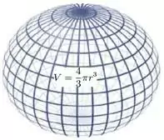Figure 1.32
The volume of the sphere is defined as: V = 4/3 × π × r3 = π × d3/6---------------------Eq 2.2. 12
The radius of the sphere can be determined by isolating r from the above mentioned formula:
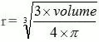--------------------------------------------------------------Eq 2.2. 13

2.4 Measurement system conversion
Conversion of units is the conversion between different units of measurement for the same quantity, typically through multiplicative conversion factors.
Metric system the metric system is an internationally agreed decimalmeasurement. From its beginning, the main features of the metric system were the standard set of inter-related base units and a standard set of prefixes in powers of ten. These base units are used to derive larger and smaller units that could replace a huge number of other units of measure in existence. The metric system is a system of measuring. It has three main units
M the meter for length
Kg the kilogram for mass
S the second for time
Common Big and Small Numbers
Table 2.3
Name | The Number | Prefix | Symbol
trillion | 1,000,000,000,000 | tera | T
billion | 1,000,000,000 | giga | G
million | 1,000,000 | mega | M
thousand | 1,000 | kilo | k
hundred | 100 | hecto | h
ten | 10 | deka | da
unit | 1
tenth | 0.1 | deci | d
hundredth | 0.01 | centi | C
thousandth | 0.001 | milli | M
millionth | 0.000 001 | micro | µ
billionth | 0.000 000 001 | nano | n
Length
standard unit of length in the metric system is the meter.
1 millimeter=0.001 meter
1 centimeter = 0.01 meter
1 decimeter = 0.1 meter
1 kilometer = 1000 meters
Abbreviations
1 millimeter = 1 mm
1 centimeter = 1 cm
1 meter = 1 m
1 decimeter = 1 dm
1 kilometer = 1 km
Mass- the standard unit of mass in the metric system is the gram.
milligram = 0.001 gram
1 centigram = 0.01 gram
1 decigram = 0.1 gram
1 kilogram = 1000 grams

TIME-time conversion. 1minute=60 seconds
1 hour=60 minutes=3600seconds
1 day=24 hours
1 week=7 days
1 year=3651/4days(the earth to travel once around the sun)
VOLUME-the standard unit of volume in the metric system is the liter.

1 milliliter = 0.001 liter
1 centiliter = 0.01 liter
1 deciliter = 0.1 liter
1 kiloliter = 1000 liters
Abbreviations
1 milliliter = 1 ml
1 centiliter = 1 cl
1 deciliter = 1 dl
1 liter = 1 l
1 kiloliter = 1 kl

SI system of measurement
The International System of Units (abbreviated SI from French: Le Système International d'Unités) is the modern form of the metric system and is the world's most widely used system of measurement, used in both everyday commerce and science. Formally agreed by the 11th General Conference on Weights and Measures (CGPM) in 1960, the SI is at the centre of all modern science and technology. The definition and realisation of the base and derived units is an active research topic for metrologists with more precise methods being introduced as they become available.
There are two classes of units in the SI: base units and derived units. The base units provide the reference used to define all the measurement units of the system, whilst the derived units are products of base units and are used as measures of derived quantities:
The seven SI base units, which comprise: -
The ampere (A) - unit of measurement of electric current
The kilogram (kg) - unit of measurement of mass
The metre (m) - unit of measurement of length
The second (s) - unit of measurement of time
The kelvin (K) - unit of measurement of thermodynamic temperature
The mole (mol) - unit of measurement of amount of substance
The candela (cd) - unit of measurement of luminous intensity

Self check-
I- Work out
1-Find the circumference of a circle with a diameter of 15 inches.
2-Find the circumference of a circle with a radius of 12 units.
3-Find the diameter of a circle with a circumference of 254.34 inches.
II-Fill in the blank
4-------------- - unit of measurement of time.
5-------------- - unit of measurement of thermodynamic temperature
6--------------- - unit of measurement of amount of substance
7---------------- - unit of measurement of luminous intensity
III-Choose the best answer
8-Which one is a quantity that can be measured a physical property
A. physical quantity B. multi-meter C. measurement D. instruments
9) One of the following is not a basic physical quantity?
A. Length B. Power C. Electric current D. Luminous intensity
10) One of the following is the sI unit of a basic physical quantity
A. Length B. Power C. Electric current D. Luminous intensity

2.5 Electrical Measure Instrument
Multi meter–is an electronic instrument used to measure the three basic electrical characteristics;voltage,current & resistance.
It has multiple function & act like ohmmeter,Voltmeter & ammeter & also used for household wiring.
The multimeter is a handheld device with a needle over a numerical LCD digital display for indication purpose.
It is also used to test continuity between two points in an electrical ckt.
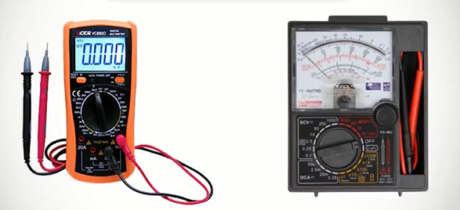
Fig multi meter
Voltage is referred to as potential difference or electromotive force (EMF)-the force that pushes electrons through the wire
Voltage like pressure in a water pipe, more voltage means more pressure, so more pressure mean that more water can flow ,therefore more voltage mean that more electron can flow.
Current-is the flow of electrons, measured in Amperes (Amps).
Current-is a flow of electrical charge
Resistance is a restriction to the flow of electrons.
It is measured in omhs (Ω)

OHMS Law E=IR POWER=EI P=I2R-----------------------------------Eq 5.1
Where E=voltage in volts(v) I=current in amperes(A)
R=resistance in ohms(Ω) P=power in watts(W)
Types of Electrical measuring equipment
Voltmeter a basic electronics device (instrument) used to measure voltage or electrical potential difference between two points in electrical circuits.
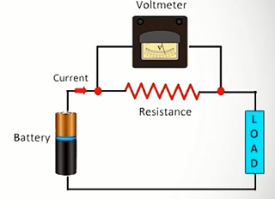
Fig connection of voltmeter
An analog voltmeter moves a pointer across a scale in proportional to the voltage of the electrical ckt.
Digital voltmeter -measures an unknown input volage by converting the voltage to a digital value by using a converter & then displays the voltage in numeric form

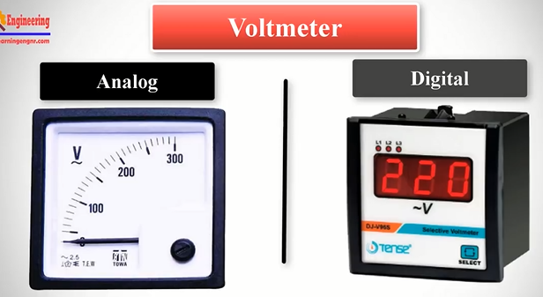

Fig Voltmeter

Ammeter is a measuring instrument which is used to measure the electric current in a circuit. 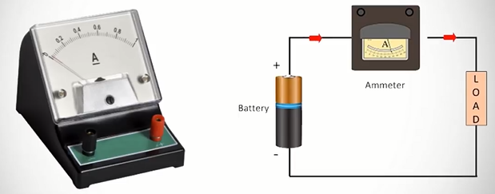
Fig Ammeter

Ohmmeter-Electrical instrument that measures electrical resistance.

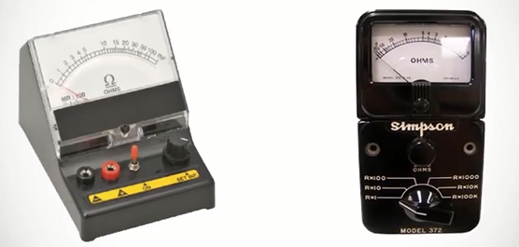
Fig Ohmmeter

Clamp ammeter-a current meter is an electrical device with jaws which open to allow clamping around an electrical conductor.This allows measure of current in a conductor without the need to make physical contact with it, or to disconnect it for insertion through the probe.
Current clamps are typically used to read the magnitude of alternating current & with additional instrumentation,the phase & waveform can be measured.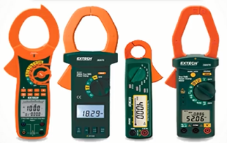
clamp ammeter
Watt meter –is an instrument for measuring the electric power in watts of any given ckt.
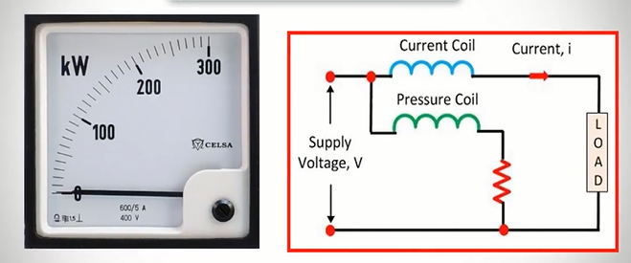
Fig 10 watt meter
Energy meter-Measures the amount of electric energy consumed by residence, a business, or an electrically powered device.
Electric utilities use electric meters installed at customers’ premises for billing purposes
-They are typically calibrated in billing unit,the most common one being the kilowatt hour(kwh).
- They are usually read once each billing period.
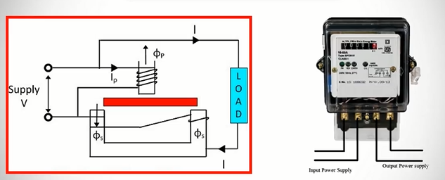
Self-check
I-Choose the best answer
1-Which one of the ff is used to measure electric energy consumed by residence
a)voltmeter b)energy meter c)ammeter d)none
2- Which one Is an instrument for measuring the electric power.
a) Watt meter b) voltmeter c) energy meter d)none
3- Which one of the ff is used to measure electriccurrent .
a)voltmeter b)energy meter c)ammeter d)none4-Which one of the ff is used to measure electric voltage.
a)voltmeter b)energy meter c)ammeter d)none
5- Which one of the ff is used to measure resistance.
a)ohmmeterb)voltmeter c)energy meter d)ammeter
II-Fill in the blank
6)-----------------Ithas multiple function & act like ohmmeter,Voltmeter & ammeter & also used for household wiring
7)--------------a current meter is an electrical device with jaws.
8)-------------------the force that pushes electrons through the wire
9)----------is the flow of electrons, measured in Amperes (Amps).
10----------is a restriction to the flow of electrons.
III Work out
11-Using the simple circuit below, assume that the voltage supplied by the battery is 10 volts and the resistance is 5 Ω, calculate the current flow in the circuit.
Using the same circuit, assume the ammeter reads 200 mA and the resistance is known to be 10 Ω, calculate the voltage supplied by source.

