Building Electrical Installation
Level-I
Based on March 2022, Curriculum Version 1

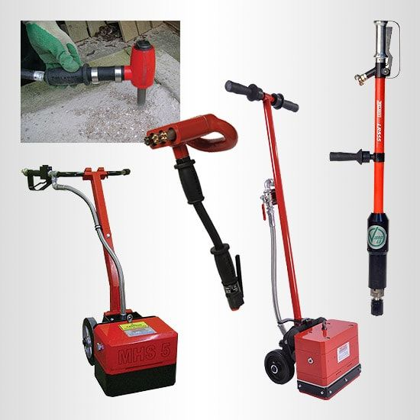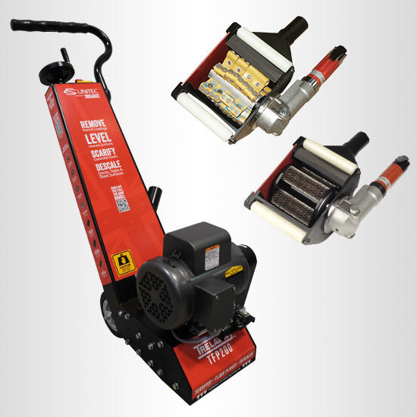

Module Title: - Prepare work place for electrical building installation work
Module code: EIS BEI1 M04 0822
Nominal duration: 64Hour

Prepared by: Ministry of Labor and Skill
August, 2022
Addis Ababa, Ethiopia

Table of Content
Acknoledgment
Introduction to the Module 5
Unit one: Plane and prepare 6
1.1. Obtain and apply work instruction 7
1.2. Occupational health and safety policies 9
1.3. Identify and implement electrical sign and symbol 16
1.4. Select toolsand equpiment 19
1.5. Calculate material quantity requirements……………………………………………28
1.6. Prepare apporoperate material to the work…………………………………………..29
1.7. Enviromental protection requirement..………………………………………………31
Self check-1.1 33
Self check 1.2..…………………………………………………………………………….34

Unit Two: Proper working plases 35
2.1. Preparation of sit inspection and plans/spacification 36
2.2 Remove hazareds,obstruction and atachements. 38
2.3. Select surface preparation tools 42
2.4. Remove loose or protrunding material 44
Self check-2 45

Unit Three: clean up work area 46
3.1. Clean work area and material 47
3.2. Clean, maintain and store electrical tols and equipment 48
Self check-3 50

Acknowledgment
Ministry of Labor and Skills wish to extend thanks and appreciation to the many representatives of TVET instructors and respective industry experts who donated their time and expertise to the development of this Teaching, Training and Learning Materials (TTLM).

Acronym

MDB Main distribution board
PPE Personal protective equipment
OHS Occupational health safety

Introduction to the Module
Prepare work place electrical building installation work helps to know plan and prepare, prepare working places and cleanup work area in building electrical installation field.
This module is designed to meet the industry requirement under the Building Electrical Installation occupational standard, particularly for the unit of competency: prepare work place electrical building installation work.
This module covers the units:
- Plan and prepare
- Prepare working places
- Clean-up work area
Learning Objective of the Module
- Planning and preparing
- Prepare working places
- Clean-up working area
Module Instruction
For effective use this modules trainees are expected to follow the following module instruction:
- Read the information written in each unit
- Accomplish the Self-checks at the end of each unit
- Perform Operation Sheets which were provided at the end of units
- Do the “LAP test” giver at the end of each unit.
- Read the identified reference book & website.

UNIT ONE: plan and prepare
This unit is developed to provide you the necessary information regarding the following content coverage and topics:
  - Obtain and apply work instructions
  - Occupational Health & Safety policies
  - Identify and implement electrical Sign and symbols.
  - Select tools and equipment
  - Calculate material quantity requirements
  - Prepare appropriate materials to the work.
  - Environmental protection requirements
This unit will also assist you to attain the learning outcomes stated in the cover page.
Specifically, upon completion of this learning guide, you will be able to:
  - Obtaining and applying work instructions
  - Obtaining and applying occupational Health & Safety policies
  - Identifying and implementing electrical Sign and symbols.
  - Selecting of tools and equipment’s
  - Calculating material quantity requirements
  - Preparing appropriate materials to the work.

  - Obtain and apply work instructions
Work Instruction
A work instruction is a document that provides specific instructions to carry out any activity.
It’s a step by step guide to perform a single instruction.
A work instruction contains more detail than a procedure and is only created if detailed step by step instructions are needed.
Information about the work
- Describe what workers need to be able to do on the job
- Work functions
- Key activities of each work function
- Performance indicators
- Describe what task to be done or work roles in a certain occupation

Work instruction is a description of the specific tasks and activities within an organization.
A work instruction in a business will generally outline all of the different jobs needed for the operation of the firm in great detail and is a key element to running a business smoothly.
In other words it is a document containing detailed instructions that specify exactly what steps to follow to carry out an activity. It contains much more detail than a Procedure and is only created if very detailed instructions are needed. For example, describing precisely how a Request for Change record is created in the Change Management software support tool.

Procedures vs. Work Instructions
Many people confuse “procedures” with “work instructions”. In fact, most people write work instructions and call them procedures. Knowing the differences of procedures vs work instructions can help you understand the documentation process much better and, therefore, procedure documentation.
Procedures describe a process, while a work instruction describes how to perform the conversion itself. Process descriptions include details about the inputs, what conversion takes place (of inputs into outputs), the outputs, and the feedback necessary to ensure consistent results. The PDCA process approach (Plan, Do, Check, Act) is used to capture the relevant information.
Questions that need to be answered in a procedure include:
- Where do the inputs come from (suppliers)?
- Where do the outputs go (customers)?
- Who performs what action when (responsibilities)?
- How do you know when you have done it right (effectiveness criteria)?
- What feedback should be captured (metrics)?
- How do we communicate results (charts, graphs and reports)?
Examples
Now we can prepare work instruction for the following tasks electrical installation layout diagram or drawing.
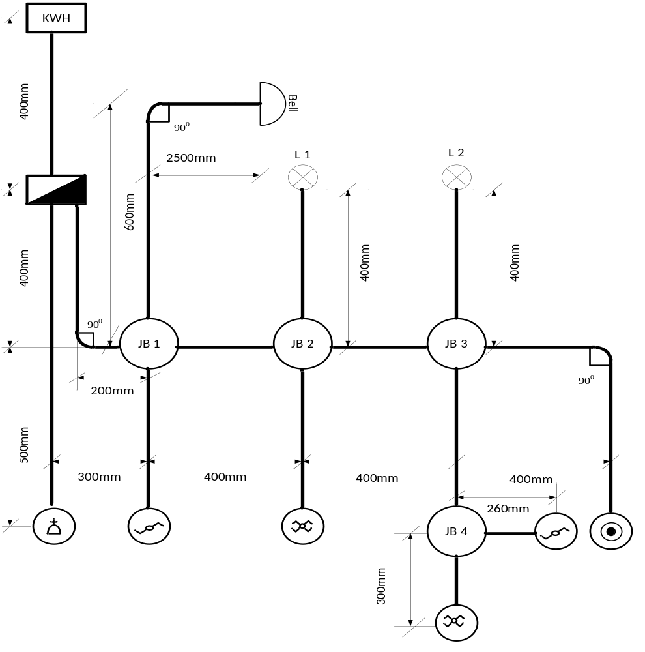
Fig 1.1 electrical installation layout diagram

Electrical Project work instruction

Project Name; Install residential Electrical Apparatus system.
Total time for the project: 5:00 hours

Based on the above given plan perform the following tasks to prepare working please to project.
- Prepare plywood which has enough space according to the project for 5 group student each has 5 student
- Prepare the necessary materials
- Prepare tools and equipment
- Prepare safety material
  - Occupational Health & Safety policies
OHS is an area concerned with the development, promotion & maintenance of the workplace environment, policies and procedures that ensure the mental, physical and emotional well-being of trainees/ employees, as well as keeping the workplace environment relatively free from actual or potential hazards that could injure trainees/employees. Trainees/employees should be trained in the proper use of all tools. Workers should be able to recognize the hazards associated hand & power tools and the safety precautions necessary. So the trainees must be applying OHS policies and procedure.
- OHS policies
- Works to ensure that every trainee gets a safe and healthy work environment.
- Require relevant regulatory requirements.
- Conducts a safety & cleanliness training program.
- Formulates policies & procedures for any activity.
- Works to reduce the levels & creating opportunity of risks.
- Provides safe hand & power tools, appropriate personal protective equipment as required any standard, guideline or relevant procedure.
- Improving professional skills with the personal development of our trainees, by providing quality and effective training.
- Access, availability and transparency of high-quality information.
- OHS procedure
Basic hazard awareness and common sense can prevent serious injuries with hand and power tools. As a general rule/procedures follow the safe practices listed below.
- Select & use the right tools for the right job.
- Use or operate tools as recommended by the manufacturer.
- Damaged or broken tools should be removed from service.
- Examine each tools whether fail or not before use & do not use damage tools.
- Never climb ladders with tools in your hand.
- Protect the cutting edges of tools when carrying them.
- Keep your hand tools clean.
- Lubricate adjustable and other moving parts
- Always properly use the right personal protecting equipment.
Common Causes of Accidents
Typical causes of hand and power tool accidents include the following:
- using the wrong tool for the job
- tools falling from overhead
- sharp tools carried in pockets
- using cheaters on tool handles
- excessive vibration
- using tools with mushroomed heads
- failure to support or clamp work in position
- carrying tools by hand up or down ladders
- using damaged electrical cords or end connectors
- Failure to use ground fault circuit interrupters (GFCIs), especially outdoors.

Personal protective equipment
- Head protection . Eye and face protection



Shafety helment Shafety glass Shafety google
- Respiratory protection:



Safety mask
- Hearing protection: Use safety head

- Hand protection: use safety gloves



- Body protection:


- Foot and leg protection



Safety shoes

Fig 1.2 personal rotective safty
HAZARDS AND RISKS
What is the difference between 'hazard' and 'risk'?
A hazard is something that can cause harm, eg electricity, chemicals, working up a ladder, noise, a keyboard, a bully at work, stress.
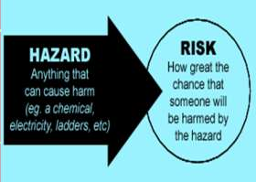
Risk is the chance or probability that a person will be harmed or experience an adverse health effect once to a hazard. It may also apply to situations with property or equipment loss.
Fig 1.3 it indicates hazard and its risk
A risk is the chance, high or low, that any hazard will actually cause somebody harm.
For example, working alone away from your office can be a hazard. The risk of personal danger may be high. Electrical repair is a hazard. If someone accidentally turned- on the power the worker’s life will be in a 'high-risk' category.

Five Basic Workplace Hazards
There are five major types of hazards which can put both your health and your safety at risk.
- Chemical hazards
- Physical hazards
- Biological hazards
- Ergonomic hazards or job related hazards
- Psychological hazards or stress

Chemical hazards

Fig 1.4 Chemical hazard
If you are working with cleaning products, bleaches, paints, and other chemical agents, you need to understand what a chemical hazard is as well as how to protect yourself.
Chemical hazards include:
  - liquids such a cleansers,
  - liquids such a cleansers,
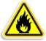
  - acids, and paints
  - vapors and fumes such as
- welding fumes
- gases such as carbon monoxide
- products that can catch fire or explode
PHYSICAL HAZARDS

Physical hazards include:
  - Machinery
  - Electrical power
  - Noise
  - Power and hand tools
  - Working and walking surfaces
  - Trip and fall hazards
  - Ladders and scaffolds
  - Heat and cold
  - Ventilation
BIOLOGICAL HAZARDS


Why be careful around ticks, mouse droppings, bird poop and wild animals? Because you might get sick from working around certain animals, including
people. Biological hazards include bacteria, viruses, insects, plants, birds, animals, and humans. The risks run from skin irritation and allergies to infections.

Dangers can come from:
    - unclean restrooms
    - mold and fungus
    - bacteria
    - insect stings
    - animal bites
    - poorly stored medical waste


ERGONOMIC HAZARDS

If your job is poorly designed, you can develop long term health problems. These problems can arise from simple things, like working
for long periods in an awkward position or having to make the same motions over and over
again.
Problems can come from:
- lighting
- chairs
- lifting
- repeated movements
- computer screens
PSYCHOLOGICAL HAZARDS
Those that are basically causing stress to a worker. This kind of hazard troubles an individual very much to an extent that his general well-being is affected. Stress can lead to long-term health problems. Headaches, anxiety, and impatience are early signs of stress.
Workplace causes of stress include:
  - heavy workloads
  - lack of control over the pace of work

  - shift work
  - noise
  - working by yourself
  - fear of job-loss
  - conﬂict with the employer

What are examples of a hazard?
 | Workplace Hazard | Example of Hazard | Example of Harm Caused
 | Thing | Knife | Cut
 | Substance | Benzene | leukemia
 | Material | Asbestos | Mesothelioma
 | source of energy | Electricity | shock, electrocution
 | Condition | wet floor | slips, falls
Process |  | Welding | metal fume fever
Practice |  | hard rock mining | silicosis
Table 1.1 examples of hazard

THRESHOLD LIMIT VALUE
One of the most critical among the hazards that one may encounter is the chemical hazard. Chemical may produce reactions that may endanger ones health and life. This is the reason why the American Conference of Governmental Hygienist (ACGIH) established a threshold limit value (tlv).
TLV is the term used by the American Conference of Governmental Hygienists (ACGIH*) to express the airborne concentration of a material to which nearly all persons can be exposed day after day, without adverse health effects.

  - Identify and implement electrical Sign and symbols
COMMON ELECTRICAL SYMBOLS
Electrical Symbols are small drawings or pictograms used to represent various electrical devices in a diagram or plan of an electrical circuit. These symbols are used in sketching schematic diagrams and electrical plans for numerous types of electrical works. Practically any electrical fixture found in a house has a symbol that coincides to said fixture on an electrical wiring diagram. These are very useful guide for an electrician or electrical contractor, thus, making the wiring easier to install as well. The following are common electrical symbols used in sketching wiring plan and diagram
Symbol | Description | Symbol | Description
 | Conductor/Wire |  | Ammeter
 | Terminal |  | Voltmeter
 | Switch |  | Galvanometer
 | Fuse |  | Wattmeter
 | Connected Wires |  | Wires Not Connected
 | Circuit Breaker |  | Push Button
 | Cell |  | Bell
 | Battery |  | Buzzer
 | Resistor |  | Speaker
 | Capacitor |  | Antenna
 | Diode |  | Male plug
 | Ground |  | Service Entrance (3 wires)
 | Lightning Arrester |  | Duplex Convenience Outlet
 | Kilowatt-Hour Meter |  | Range Outlet
 | Power Panel Board |  | Special Purpose Outlet
 | Lighting Panel Board |  | Weatherproof Outlet
 | Incandescent Lamp |  | Floor Outlet
 | Fluorescent Lamp | S₁ | Single Pole Switch

Table 1.2 electrical symbol

ELECTRICAL SIGNS
Your power tool with its manual may contain "WARNING ICONS" (a picture symbol intended to alert you to, and/or to instruct you how to avoid a potentially hazardous condition). Knowing and understanding these symbols will help you operate your tool better and more safely.
Electrical signs and stickers alert students, workers, and visitors to electrical hazards in the area. Alerting workers to high voltage areas, electrical hazards, power lines and other electrical equipment in the area, can help prevent fires and injuries. Proper electrical signs can inform workers of the dangers in the area.

 | CAUTION indicates some precautionary measures against potential hazardous situation which, if not avoided, may result to a minor or moderate injury.
 | SAFETY ALERT indicates that a person should observe extra awareness
 | PROHIBITION means that any activity is not allowed as stated by the symbol.
 | DANGER specifies hazardous situation which, if not avoided, will result to a serious injury or even death.
 | WARNING specifies a potentially hazardous situation which, if not avoided, could result to serious injury or even death.
 | READ AND UNDERSTAND  INSTRUCTION MANUAL means that a person should make some reading before doing any activity.
 | WEAR EYE PROTECTION indicates that a person should wear safety goggles or any related protection for the eyes.
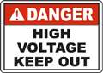 | ELECTRICAL HAZARD indicates that electrical hazard is present in the area.
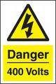 | VOLTAGE DANGER indicates high voltage in the area and surrounding equipment.

Table 1.3 safety signs
  - Select tools and equipment’s.
Classification of Tools and Equipment
A tool is a device that can be used to produce an item or accomplish a task, but that is not consumed in the process. It can be considered as extension of the human hand thus increasing speed, power, and accuracy and on the other hands equipment includes any machine powered by electricity.
- Hand tools are tools manipulated by hands without using electrical energy such as: puller, hacksaw, pull-push rule, pliers, hammer, and others.
- Machine/Power tools are tools manipulated by our hands and with the use of electrical energy such as: electric drill, grinding wheels, vacuum cleaner and others.
- Pneumatic tools are tools or instruments activated by air pressure. Pneumatic tools are designed around three basic devices: the air cylinder, the vane motor, and the sprayer.
- Hand tools
Hand tools: Have no power source, other than the physical force applied by the user. There are various types of hand tools. These are:

- Fish tape: a tool for pulling wires or cables through conduits and inaccessible spaces. A fish tape is a very long metal strip with a hook at the end, which can be used to grab a wire or another fish tape, somewhat like catching fish with a hook on a line.

Fig 1.5 Fish tape
- Hacksaw: a fine-tooth hand saw with a blade held under tension in a frame, used for cutting materials such as metal or plastics.

Fig 1.6 Hacksaw 
- Lineman pliers: a type of pliers used by electricians and other tradespeople primarily for gripping, twisting, bending, and cutting wire and cable.

Fig 1.7 Lineman pliers 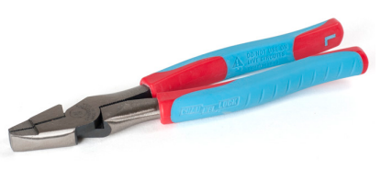
- Needle-nose pliers: pliers with long, slender jaws used for grasping small or thin objects.

Fig 1.8 Needle pliers 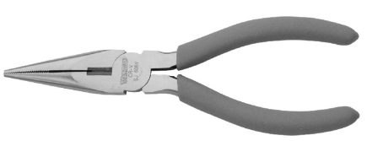
- Side cutters is used to cut electrical connections Wires on a vehicle
- Utility knife: a knife used for general or utility purposes (see Resource video).

Fig1.9 Utility knife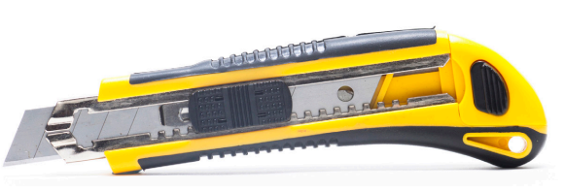
- Wire strippers: is a small, hand-held device used to strip electrical insulation from electric wires.

Fig 1.10 Wire strippers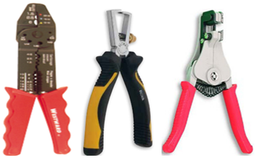
- Circuit tester (Voltage tick): Simple and inexpensive, a circuit tester plugs into a conventional outlet and will tell you whether the circuit is “hot” (charged) or whether it’s properly grounded.

Fig 1.11 Circuit striper
- Continuity tester: A small, battery-operated continuity tester costs less than $10. It can be used to determine whether wiring is broken and whether electrical circuits are complete.

Fig 1.12 Continuity tester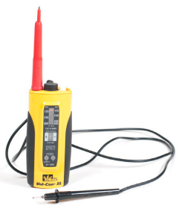

- Screw drivers: Screw drivers are a device used to insert and tighten screws or to loosen and remove screws.

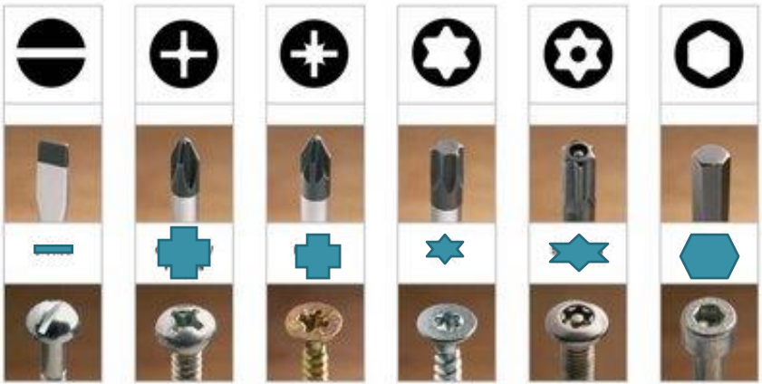

Fig 1.13 Screw drivers
- The parts of a screwdriver are the head, handle, ferrule, shank, blade, and tip. The length of the blade indicates the size of a screwdriver. Some screwdrivers may have square shanks that permit turning with a wrench when required for extra torque.

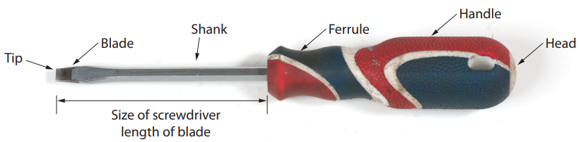
- There are many different types of screwdrivers, identified by the type of screws they fit.
- Some of the more common types of screwdrivers are:-
- Standard/Flat Screw Driver. The blade tip is wedge-shaped and resembles a negative (-) sign. It is used to drive screws with a single slot head. It’s ranges in size from $1/6inch to 1/{4 inch}$.
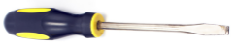

- Philips Screw Driver. This has a cross tip resembling a positive (+) sign. This is used to drive (to tighten and loosen Phillips head screws) screws with cross slot heads. It’s ranges in size from $0 to 4, 0 being the smallest.$
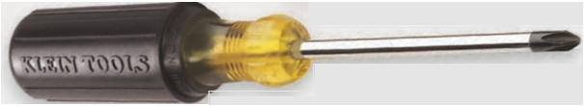
- Clutch Drive Screwdriver: - It is used to tighten and loosen clutch head screws, which are shaped like an hourglass. It has extra holding power, especially for use in cars and appliances.

- TORX Screwdriver: - It is used to tighten and loosen six-point star head screws. They are used in cars, appliances and lawn and garden equipment.
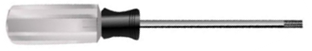
- Robertson Screwdriver:- It has a square drive that yields high torque power. It is useful to reach screws sunk below the surface of the material.
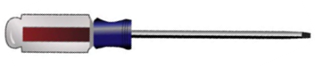
- Spiral Ratchet Screwdriver: - They are used to drive or remove small screws rapidly. The spiral ratchet screwdriver automatically drives or removes screws. It can be adjusted to turn left or right, or can be locked to act as a common screwdriver. Some spiral ratchets have a spring in the handle that automatically returns the handle for the next stroke.

- Ratchet Multi-Bit Screwdriver/Nut Driver:
- It provides high-torque capability and comfortable Cushion-Grip handles.
- Shaft holds 6 universal tips; converts to 3 nut driver sizes and 1 hex driver
- Strong, heat-treated nut drivers for improved torque.
- 3-way ratcheting mechanism for forward, reverse and locked positions
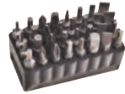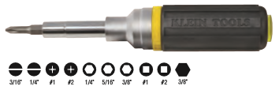
- Allen Screw Driver/Wrench: - It contains several sizes that are attached to and fold into a metal carrying case. It is also known as a hex key or hex wrench and is used on screws with hexagonal slots. It is useful for recessed socket head screws.

- Claw Hammer:

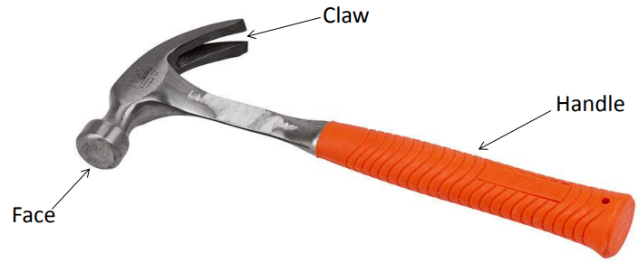

Fig 1.14 Claw hammer
- Tap meter :



Fig 1.5 Tap meter

- Machine/Power Tools

- Electric drill has an electric motor that drives a chuck. The chuck has jaws that can be opened and then closed to grip a drill kit.
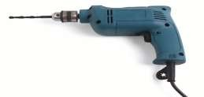
Fig 1.16 Electrical drill
- Grinding tool can be either bench-mounted or installed on a pedestal. They may either have a grinding wheel, view wheel, or two grinding wheels.`
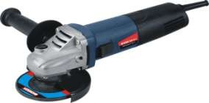
Fig 1.17 Electrical Grinding
- Vacuum cleaner is used for cleaning the floor and car interiors after service.

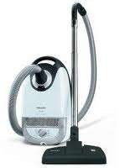

Fig1.18 Vacuum cleaner

- Pneumatic tools
- Pneumatic Torque Wrench. This wrench uses compressed air to quickly and powerfully turn nuts, bolts, and other objects.
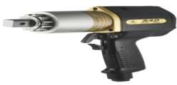
Fig 1.19 Pneumatic Torque wrench
- Air chisel uses reciprocating motion to drive a cutting hammering tool. An air hammer drives a chisel to cut off a nut that has frozen to a stud. It can be used with a variety of tools-cutters and punches to do many jobs.
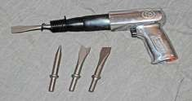
Fig 1.20 Air chisel
- Air drill is lighter than a comparable electric drill. Repeatedly stalling or overloading does not damage or overheat the air drill.
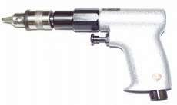
Fig 1.21 Air drill
- Air racket uses the sockets and attachments from a standard socket set.

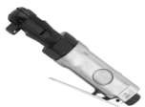
Fig 1.22 Air racket

- Pneumatic floor jack uses compressed air to flow into the jack cylinder and causes the ram to extend and raise the vehicle.
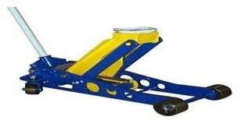

Fig 1.23 Pneumatic floor jack

  - Calculate material quantity requirements
Based on below fig 1.2 calculate or prepare material needed per one group or per one circuit board.

Fig 1.24 Electrical installation layout diagram

Calculation of material needed or the project
- We need 4 junction box
- We need six utility box
- We need PBC raged conduit 16mm diameter = (1.3+0.6+1.35+1.7+0.9+0.9+0.8)
= 7.77m or 3 pieces
- We need bell wire (2*1mm²)=(0.6+0.2+0.6+0.25+0.4+0.4+0.4+0.5)=3.35m
Total =3.35m +0.4m for termination on junction box=3.75m
- We need lighting wire(1*1.5mm²)
= ((2(0.4+0.2+0.4+0.4) +3(0.5+0.90) +4(0.5+0.8) +3(0.4) +(4(0.4))
= ((2(1.4) +3(1.4) +4(1.3) +(1.2)+(1.6))
= (2.8+4.4+5.2+1.2+1.6)
=15.2m
Total=15.2m + 6m for termination on junction box=21.2m
- We need 1 m cable(2*4mm²) from energy meter to MDB
- We need 1.5 m cable (3*4mm²) from MDB to electric mittad socket outlet.

  - Prepare appropriate materials to the work

Fig 1.25 Electrical installation layout diagram
Material needed for the above project is given as shown below

Consumable materials to be used for projects per one group

Project name:
No. | Item description | Unit | Quantity | Specification
1. | PVC conduit | Meter | 12 | Ø16mmRigid type
2. | Junction box | Pieces | 4 | Ø85 mm
2. | Junction box | Pieces | 6 | Ø65 mm
3. | Wire | Meter | 6 | 4 mm² flexible type
 |  | Meter | 25 | 1.5 mm² rigid type
 |  | Meter | 10 | 0.8 mm²
4. | Conduit clip | Packet | 1 | Ø16mm
5. | Wood screw | Packet | 1 | Ø6mm
6. | Insulation cape | Packet | 1 | Ø16mm
7. | Lamp | Pieces | 2 | Power saving type (CFL)
8. | Lamp holder | Piece | 2 | Standard
9 | Bell | Piece | 1 | Standard
10. | Push button | Piece | 1 | Standard
11. | Switches | Piece | 2 | Intermediate type
11. | Switches | Piece | 2 | Two-way type
12. | Circuit breaker | Pieces | 1 | 10A
12. | Circuit breaker | Pieces | 1 | 6A
12. | Circuit breaker | Pieces | 1 | 32A
12. | Circuit breaker | Pieces | 1 | 25A
13. | Distribution board | Pieces | 1 | A board holding capacity of 6 breakers

Table 1.4 Consumable materials to be used for projects per one group

Non consumable materials to be used for projects per one group
Project name: Install electrical System for Residential
No. | Item description | Unit | Quantity | Specification
1. | Screw driver | Piece | 2 | Flat head and cross head
2. | Combinational pliers | Piece | 1 | Standard
3. | Hammer | Piece | 1 | Claw hammer
4. | Hack saw | Piece | 1
5. | Insulation remover | Piece | 1 | Wire striper or electrician knife
6 | Side cutter | Piece | 1 | Small size
7. | Long nose pliers | Piece | 1 | Standard
8. | Multi meter | Piece | 1 | Fluke

Table 1.5 Non consumable materials to be used for projects per one group
  - Environmental protection requirements

Environmental protection is the practice of protecting the natural environment by individuals. Environmental policy is the commitment of an organization or government to the laws, the protection of natural resources. Environmental protection is balanced with other public policy concerns, such as ... and wildlife protection, such as the protection of endangered species.
Types of Environmental Issues
You are constantly surrounded by many different things on this planet earth. Most of the time, we take all these for granted. Your surroundings, be it living or non-living, the geographical area where you live etc. constituting your environment.
Do you think there is a need to protect the environment? Have you ever given thought to the after effects that will plague for not addressing the environmental issues on time? Let us analyses in brief the various environmental issues that are plaguing our current world as well as the harmful effects of these issues on the human population.
What are Environmental Issues?
Any human activity brings along with it, many side effects. One aspect of it could bring about development while the other side of the coin could be a detrimental effect. These unfavorable changes often lead to environmental issues that affect the natural balance of the environment.
We can define environmental issues as the harmful effects of any human activity on the environment. This includes both the biological and physical aspects of the environment. Air pollution, water pollution, natural environment pollution, garbage pollution, etc. are some of the major environmental issues that are causing immense concern.
To tackle these environmental issues, protecting the environment is very vital. This not only helps in preventing the detrimental effects but also helps us to conserve the natural resources and natural environment for future generations. Protection of the environment is not only a social movement but is also backed by various laws that have been passed to ensure that humans do not misuse the resources any longer.

Self check-1.1
Direction: Match Column A with Column B. Write the letter only.

A B
1. Adverse health effect a. is the chance or the probability that a
person will be harmed.
2. Hazards
3. Chemical hazards b. caused by organism such as viruses, bacteria fungi and parasites
4. Risks
5, Physical hazards c. Is a source of potential damage, harm or adverse health effects
6. Wet floor
7. Ergonomic hazards d. safety hazard
8. Psychological hazards e. Vapor or gaseous substance
.
9.Unsafe work practices f. Slips, falls
10.Biological hazards g. hot or cold condition
- decrease in life span
- those that are basically causing stress
- awkward posture arising from improper
work methods

Self check-1.2
Given below is the list of common workplace hazards. Write at least three examples of each type of hazard.
- Chemical hazard

- Physical hazard

- Biological hazard

- Ergonomic hazard or Job related

- Psychological hazards

Unit Two: Prepare working places
This unit to provide you the necessary information regarding the following content coverage and topics:
  - Preparation of site inspection and plans/specifications
  - Remove hazards, obstructions and attachments
  - Select Surface preparation tools
  - Remove loose or protruding material
This guide will also assist you to attain the learning outcomes stated in the cover page. Specifically, upon completion of this learning guide, you will be able to:
  - Preparation of site inspection and plans/specifications
  - Removing hazards, obstructions and attachments
  - Selecting and setting up Surface preparation tools .
  - Removing loose or protruding material

- Preparation of site inspection and plans/specifications

Construction site inspections are critical to ensuring that quality and safety procedures are followed correctly from the start. Construction projects involve coordinating multiple project team members, materials, and equipment, which may expose contractors to many potential risks and hazards. In order to successfully run a construction site through the entire lifecycle of the project, routine construction site inspections are necessary.

What Does A Construction Site Inspection Entail?
Progress Inspections
A construction site inspection checklist is essential in the planning phase of a construction project as it ascertains compliance with project requirements. Once the project has broken ground, progress inspections become part of the job site’s daily routine to guarantee these requirements are met.
Depending on the project size, progress inspections are conducted by one or more individuals across several trades. If a specific aspect of the project requires additional input, specialist inspectors may be brought in to perform inspections on things like the environmental policy, waste management plan, and accessibility.
Quality Inspections
Quality control inspections ensure the finished construction work meets the quality standards set in place. Quality inspections also make sure that the project complies with all the specifications and quality requirements listed in the contract documents. Quality inspections include regular site walkthroughs, and they typically result in a monthly quality report that identifies issues and monitors progress.
Building Regulation Compliance Inspections
Pre-Construction
While most construction site inspections are conducted during the construction phase, they can begin in pre-construction. Pre-construction inspections survey the property condition and neighboring areas before construction begins. Pre-construction site inspection checklists may consist of checks on planning permissions, conditions, and obligations to ensure compliance with local authorities.

During the Project
As the term suggests, construction site inspections most often occur on the construction site. The project scope, budget, and schedule are the primary measures of quality during a construction project.
Project Closeout
The final inspection and construction closeout process consists of site walkthroughs verifying everything has been completed in accordance with the contract documents. Once confirmed, the building is ready for its intended use or occupancy. This means the punch list has been completed, and submittals, lien waivers, warranties, close-out documentation, manuals, and as-built have been turned over to the owner and verified for completeness.

Construction Site Inspection
Check list for Construction Site Inspection
- Inspections of work progress compliance with plan and specifications
- Inspections of work quality and compliance standards and specifications
- Inspections of paints and coatings
- Field testing and materials sampling of soils, concrete and asphalt, etc.
- Review and completion of change order/s
- Inspections of materials delivered and used
- Performing semi-final and final inspections upon building completion
- Preparation of punch list/s and monitoring of completion works
- Handover inspection for smooth project close-out
Use Construction Site Inspection Software
Construction site inspection software can help improve your construction site inspection processes. Digital construction site safety inspection forms facilitate documentation, tracking, and collaboration. With a construction site inspection app, your teams can build out, manage, and maintain your company-wide inspection library. Standardization also allows you to baseline your current processes, identify problems, and improve your overall quality and safety program.
Conclusion
Risk is part of every construction project. Construction site inspections help mitigate some of that risk by providing a process that allows teams to deal with human error and unforeseen changes that occur throughout the project. Having a refined checklist for construction site inspections will help drive successful completion of the project and provide visibility into areas for improvement. That way, teams can stay ahead of safety issues and leave risk behind.
- Remove hazards, obstructions and attachments
If you are frequently in a workshop as part of your role, you’re likely exposed to many risks. Workshops are hazardous environments both by nature and the activities people carry out in them. Therefore, if you are required to work in a workshop as part of your job, it’s essential that you’re aware of these hazards and how to protect your, and your colleagues’, health and safety. This article outlines common workshop hazards and control measures that you can take to reduce them.
What are the Most Common Workshop Hazards?
There are many jobs associated with workshops, such as carpentry, welding, and paint spraying. Each role comes with different hazards and can make workshops very dangerous places to occupy. The top 15 workshop hazards are:
- Lack of guards or screens on equipment or around dangerous areas.
- Damaged or misused guards.
- Lack of adequate ventilation and temperature.
- No safety signs, outdated safety signs, and broken safety signs.
- Machinery left unattended while in use.
- Obstructions – of fire exits, cut out switches, etc.
- Cluttered workstations.
- Trailing wires and cables.
- Chemical substances in unmarked containers.
- Chemical splashes.
- Incorrect tools used for tasks.
- Confined spaces.
- Electric shocks, burns, or fires.
- Lone working.
- Sharps.
How to Reduce Hazards in Your Workshop
Workshops are clearly dangerous working environments and so you should do all you can to reduce the level of risk. Often, you can easily reduce risks through a few small steps, some of which we’ve outlined below.
Practice Better House keeping
You should always try to keep the premises tidy and free from obstructions. Ensure you don’t block any fire exits, cut out switches, and other things that you may need in case of emergency. Avoid the need for trailing cables by conducting activities closer to the plug socket. You should also maintain a tidy and clutter-free work area at all times.
Furthermore, it’s your employer’s responsibility to ensure that the working conditions are appropriate and fit for you to work in. As a result, you should have adequate lighting and ventilation systems and your employer must display current, undamaged safety signs.

Fig 2.1 Use correct labeling
You can easily reduce the hazard of chemicals in unmarked containers if you ensure that all chemicals are correctly labeled at all times. To reduce the risk of chemical splashes and spills, you should also make sure that chemicals are stored in appropriate containers and the lids are tightly secured
Protect Yourself from Machinery
Machinery is dangerous and your employer must train you in how to use it correctly. Follow their instructions and remember to turn off all machinery after use or if you leave it unattended. You must also ensure that any machinery is suitably turned off, isolated, or locked-off, before attempting to clean or adjust the machinery, or remove any blockages. Suitable screens and guards should be fitted to machinery where appropriate. You must follow any control measures your employer has put in place, and carry out your duties in line with the training you have received.
Follow the Findings of the Risk Assessment
By law, your employer must to carry out a risk assessment of your premises. This is to identify any hazards and implement control measures to reduce them. The risk assessment can be used to recognize a range of hazards, including:
- The risk of fire.
- Any task that requires lone working or working in confined spaces.
- Any slip, trip, or fall hazards.
- Hazardous substances, such as chemicals, and items, such as sharps.
Your employer must implement measures to reduce this level of risk, such as redesigning the workshop to avoid the need for trailing cables. They must then write down the findings of the risk assessment and share them with you. You should follow these at all times and inform your employer if they’re ineffective.

Need Risk Assessment Training?
Our Risk Assessment Training is designed to help businesses comply with the Management of Health and Safety Regulations 1999 by explaining how to complete a suitable and sufficient work place risk assessment. You can also find our Health & Safety course library here.
Report Any Problems
You should report any problems to your employer. This includes equipment defects, missing or broken guards and screens, poor housekeeping procedures, obstructions, any accidents and near misses, and anything else that you think is putting your health and safety at risk. Your employer can’t fix problems if they don’t know about them.
Wear PPE
When your employer conducts the risk assessment they should identify whether you need to wear any personal protective equipment (PPE). The type of PPE you need depends on the task at hand. Common types of PPE in workshops includes eye protection, hearing protection, gloves, respiratory protective equipment (like masks), and overalls.

Fig 2.2 safety of PPE
This article has outlined common workshop hazards and some control methods to reduce them. There are many hazards in a workshop so it’s important you’re aware of them and know how to protect yourself from harm.
- Select Surface preparation tools
Most surface preparation and application operations require the use of appropriate personal protection equipment and engineering and administrative controls. The most obvious examples of this are abrasive blast cleaning and spray painting operations. It is incumbent upon the coatings and abrasive blast cleaning contractors to ensure that all personnel are properly protected from all hazards.
Numerous OSHA regulations specify when, where and how workers are to be protected. These regulations, the coatings and equipment manufacturers, and/or local OSHA officials should be consulted as necessary to ensure proper protection, compliance with the law, and to avoid liability issues. Product labels and Safety Data Sheets should always be consulted prior to coatings operations.
Safety and health details should be addressed prior to implementing these operations.
Each year millions of dollars are wasted on good coating systems that will fail prematurely due to inadequate surface preparation or improper application. Much of this waste is needless and can be prevented through proper evaluation, specification and control of these two vital factors. The intent of this portfolio is to offer basic guidelines enabling you to maximize your coating expenditure. The information presented has been accumulated from outside technical reports and publications, as well as Tnemec’s own research and experience in this field.

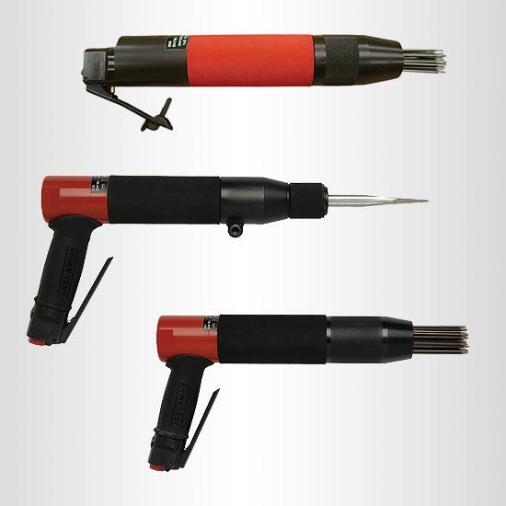

Fig 2.3 Concrete and metal scalers

Concrete & Metal Scalers
- Needle and chisel scalers for concrete and metal
- Vibro-Lo™ models with 8x less vibration than standard models
- Optional dust shroud for dust and debris collection

Fig 2.3 concrete scbblers

Concrete Scabblers
- Roughen, reduce and level concrete
- Hand-held and walk-behind models
- Optional dust shroud for dust and debris collection

Fig 2.4 concrete and metal scarifiers

Concrete & Metal Scarifiers
- Remove rust, scale, paint, adhesives and more from concrete and steel
- Peening Preparation Tool (PPT) – ideal alternative to small-area shot blasting
- Electric, pneumatic and
- Remove loose or protruding material

Removing protruding defective material are smoothed by using sand or grinder for building electrical installation. Therefore using sand or grinder is useful for the purpose of working please preparation.

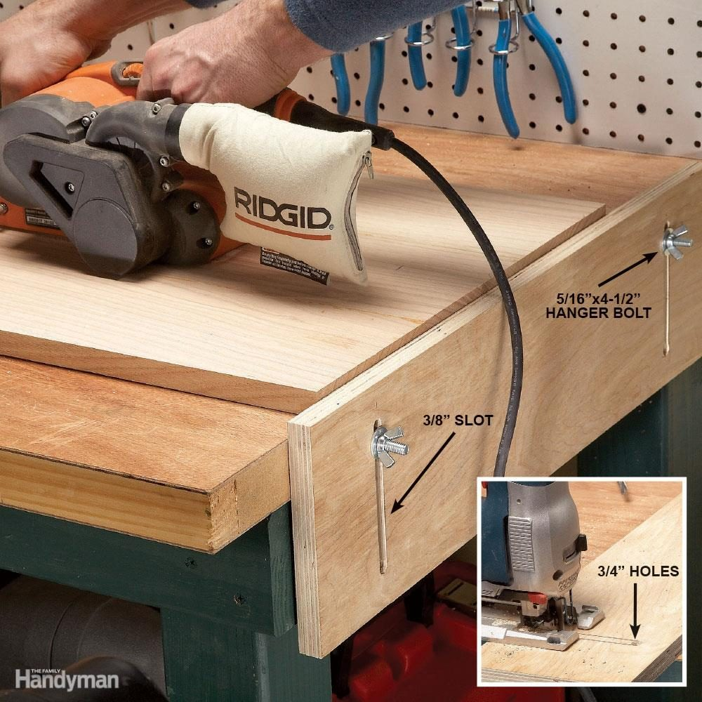

Fig 2.5 Picture which shoes how to smooth the work bench.

Self check-2
Answer the following according to the qustion. Write at least three examples of each type of hazard.
  - List kind of Construction Site Inspection Entail?

  - Write the kind of Building Regulation Compliance Inspections

  - Write at list five Check list for construction Site Inspection

  - List at list five the Most Common Workshop Hazards

Unit three Cleanup Work area
This unit to provide you the necessary information regarding the following topics content:
  - Clean work area and materials
  - Clean, maintain and store electrical tools and equipment
This guide will also assist you to attain the learning outcomes stated in the cover page. Specifically, upon completion of this learning guide, you will be able to:
  - Clearing work area and materials
  - Cleaning, maintaining and storing electrical tools and equipment

- Clean work area and materials
Working area
Keeping workshop and storage spaces unwanted things can helps save us training tools for accidents. Sparks can ignite scraps, sawdust and solvents. Water can conduct electricity. Do not stand in water, on damp floors or in the rain when working with electrical tools. Keep hands and tools dry.
Make sure workshops and storage areas have:
- Proper electrical wiring & outlets needed to run power tools.
- Install adequate wiring to handle the electrical load required.
- All outlets should have three pronged plugs or be double-insulated.
- Any outlets that may come in contact with water should have ground fault circuit interrupters.
- Never use indoor tools outside.
- Use only approved outdoor extension cords.
- Use one long extension cord instead of several short ones.
- Do not damage or cut extension cords.
- When working on ladders or scaffolding rest power tools on a flat surface or in a bin secured to the ladder itself.
- A falling tool can seriously injure a co-worker or bystander.
- Never carry heavy power tools up and down ladders.
- Stop working and turn off the power tool you are working with if distracted by something or someone.
- Never look away from your work when operating a power tool.
- Cutting tools can be particularly dangerous.
- If one stalls, switch off the power and unplug the tool before trying to restart it.
- When using a power saw, let the saw reach full speed before cutting and support the work firmly so it won’t shift.
- Never use your hands to clear scraps from a sawing worktable.
- Use a long stick instead.
- When working with metal, secure the metal material with clamps or in a machinist’s vise to keep it from moving.
- Take extra care when working with hazardous materials.
- Its particles can irritate the skin, eyes and respiratory system.
- When soldering, remember that lead solder is toxic.
- The work area should be ventilated and flammable material properly stored.

- Clean, maintain and store electrical tools and equipment
Before, during & after performing our tasks all tools & measuring equipment must be properly cleaned, checked & maintained. Building electrical installation regulations require inspections & testing of tools & measuring equipment before use. Preventive maintenance is the systematic care and protection of tools, equipment &machines in order to keep it in a safe, usable condition limit downtime and extend productivity.
We must always be aware that maintenance tasks themselves are potentially hazardous and can result in injury.
The successful maintenance program is:
- well organized and scheduled,
- controls hazards,
- defines operational procedures, and
- Trains key personnel.
The degree of detail equipment maintenance will depend on the kinds of tools/equipment used. Some installation equipment has very specific inspection and maintenance requirements. Power Tools should be maintained in good working order. This may be limited to ensuring that blades/bits are replaced when needed and those guards or other safety devices are operable and any damaged electrical cords/plugs are repaired or replaced. Damaged or defective equipment/tools should be tagged and removed from service. The trainees must have their own cleaning, checking and maintenance schedule.
    - Requirements
General requirements for equipment maintenance include:
- Obtaining a copy of the maintenance schedule recommended by the manufacturer.
- Ensuring that maintenance is performed as required.
- Ensuring that the person(s) performing the maintenance are competent.
- Retaining records of maintenance/service conducted.
- Specifying who is responsible for overseeing equipment maintenance and where the records are kept.
- Set up a system for removal and tagging of damaged or defective tools and equipment.
Complete documentation for work.
Definitions: Documentation refers to a set of records that exist online, on paper or on hard drives. It is material that provides evidence or information to serve as a record. In the workplace, documentation is retained records of employment and company actions and events as required by legal mandates and company policy. The best human resource practices involve maintaining both formal and informal records about employment events. This can include items such as:
- Actions
- Contributions
- Disciplinary actions
- Disputes
- Investigations
- Performance evaluations
- Policy violations
Documentation gives substance to a workplace's activities not only for legal matters, audits or disputes, but also for rules and regulations. It keeps an training running systematically and ethically. It would be difficult for trainees in a training program to remember everything if it was only presented orally. During an emergency, staff might not remember the proper procedure to exit the building without documentation.

Self-check-5
Directions: Answer the questions below. Say true or false
- Keeping workshop and storage spaces clean and dry can help prevent many accidents.(2points)
- Do not stand in water, on damp floors or in the rain when working with electrical tools. (2points)
- Documentation provides standards to a workplace.. (2 points)
- Posting documentation is important for employees to understand their rights and obligations to maintain a safe workplace.(2 points)

Note: Satisfactory rating –above 60% Unsatisfactory - below 60%
You can ask you teacher for the copy of the correct answers

List of Reference Materials
- Journals/publications/magazines
- Safety Manual and Guide
- Ethiopian EBCS-10

Developer Profile

No | Name | Qualification (Level) | Field of Study | Organization/ Institution | Mobile number | E-mail
1 | Mengistu Abiyu | MSc | Industrial Electrical Automation & Control Management | Lideta Manufacturing College | 0913948480 | menabiy@gmail.com
2 | Elias Getachew | MSc | Industrial Automation & Control Management | Misrak Poly Technique college | 0913811386 | get.elias19@gmail.com
3 | Giduma Mekonen | BSc | Construction Management | Adama Poly Technique college | 0913939750 | olimosisa@gmail.com
4 | Tigist Aemiro | MSc | construction Management | Bahir Dar poly Technique college | 0918375757 | tigistaemiro4@gmail.com
5 | Yidnekachew Seboka | Bsc | Electrical Automation & Control Technology | Akaki poly  Technique college | 0920137899 | www.yedine23@gmail.com
6 | Getahun Abera | Bsc | Electrical Electronics Technology | Deredawa poly Technique college | 0910334887 | gtrab@yahoo.com

