Building Electrical Installation
Level-I
Based on June 2022, Curriculum Version 1
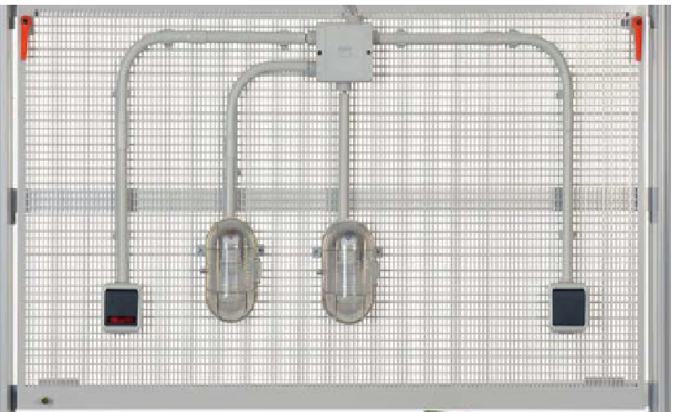
Module Title: - Perform Conduit work
Module code: EIS ID2 M30 0822
Nominal duration: 72Hour

Prepared by: Ministry of Labour and Skill
august, 2022
Addis Ababa, Ethiopia
Table of Content
Acknoledgment
Introduction to the Module 5
Unit one: Plan and prepare for installation 6
1.1. OH&S policies and procedures 7
1.2. Sequence of conduit work 15
1.3. Consulting to appropriate person 18
1.4. application of conduit installation 21
1.5. necessary material used for conduit installation 23
1.5.1 Tools and equipment 23
Self check-1 31
Operation sheet-1 32
Unit Two: conduit installation 33
2.1. OH&S policy and procedure 34
2.2. Types of conduit , site and working condition 36
2.3. installation technique for Terminating and connecting Conduits 51
2.3.1 types of installation technique 51
2.4. responding un planed events 68
Self check-3 70
Lap Test- 73
Unit Three: inspection and notify the completion of work 74
3.1. inspection of final work 75
3.2. Perform final inspection 76
3.3. Notify completion of work 80
Self check-3 81
Lap Test-3 82

Acknowledgment

Ministry of Labor and Skills wish to extend thanks and appreciation to the many representatives of TVET instructors and respective industry experts who donated their time and expertise to the development of this Teaching, Training and Learning Materials (TTLM).

Acronym
- OHS occupational health and standard
- . PVC polyvinyl chloride
- ISO international organization for standardization
- RMC Rigid metal conduit
- EMT Electrical metallic tubing
- GRC Galvanized rigid conduit

Introduction to the Module

Perform conduit work helps to know the Plan and prepare for installation, Install conduits, Inspect and notify completion of work in building electrical installation work filed
this module covers the knowledge, skills and attitude required to effectively to cut conduit, to bend and to install electrical conduit associated with electrical installation instrumentation, refrigeration, and air conditioning systems or other related area in the metal, engineering and maintenance industry. For the unit of competency: Perform Conduit work
This module covers the units:
- Plan and prepare for installation
- Conduits installation
- Inspection and notification of work completion
Learning Objective of the Module
- Plan and prepare for installation
- Install conduits
- Inspect and notify completion of work
Module Instruction
For effective use this modules trainees are expected to follow the following module instruction:
- Read the information written in each unit
- Accomplish the Self-checks at the end of each unit
- Perform Operation Sheets which were provided at the end of units
- Do the “LAP test” giver at the end of each unit and
- Read the identified reference book for Examples and exercise

Unit one: Plan and prepare for installation
This unit is developed to provide you the necessary information regarding the following content coverage and topics:
- OH&S for installation.
- Sequence of work requirements.
- Consult to appropriate personnel on working site
- location of conduit installation
- conduit installation
- necessary materials
- tool and equipment
This unit will also assist you to attain the learning outcomes stated in the above unit. Specifically, upon completion of this learning guide, you will be able to:
- plan and prepare Installation for, to ensure OH&S policies and procedures
- Appropriate sequence the work in accordance with requirements.
- Consult appropriate personnel to ensure the work is coordinated effectively with others involved on the work site.
- Install Conduits in accordance with established procedures and comply with requirements.
- Install to be Locate in which determine conduits from job requirements.
- Obtain Materials necessary to complete the work in accordance with established procedures and check against job requirements.
- Organize tools and equipment for given work and safe work practice

- OH&S policies and procedures
Introduction
Before you install the installation server products, you must prepare your system and plan for choices and make during the installation process. Installation Planning is the planning involved in case the system requires replacement or upgrade. It is always necessary to assess the status of the current system of equipment whether there is need for upgrade or replacement of the system
Steps Involved in Installation Planning
- Assessment - The performance of the current system in terms of reliability or productivity.
- Readiness- Review existing installation to identify the roadblocks,
- Benchmark- Record data on current system in order to measure the improvement in the new system to be installed,
- Design or Plan- Identify and map all work necessary to make migration and upgrades.
- Shutdown- Check and shutdown all the allied system,
- Replacement- Replace or put a new installation at the designated location.
- Testing- Do all the routine test specified in the installation guide. Also perform stress test related to the system.
- Monitoring- Monitoring the system for a specified period to evaluate performance and check issues which might arise due to installation errors
Concepts of Occupational Health and Safety (OHS)
The term of Occupational health and safety (OHS) relates to health, safety, and welfare issues in the workplace.
OHS includes the laws, standards, and programs that are aimed at making the workplace better for workers, along with co-workers, family members, customers, and other stakeholders. Improving a company's occupational health and safety standards ensures good business, a better brand image, and higher employee morale.
Occupational health and safety is concerned with addressing many types of workplace hazards, such as:
- Chemicals
- Physical hazards
- Biological agents
- Psychological fallout
- Ergonomic issues
- Employers and company management are obliged to provide a safe working environment for all of their employees.
- Accidents
Occupational health and safety standards are in place to mandate the removal, reduction, or replacement of job site hazards. OHS programs should also include material that helps minimize the effects of the hazards.
concepts of health and safety policy. a health and safety policy describes a course of action that has been chosen to influence workplace decision-making and guide actions related to workplace health and safety. health and safety policies commonly exist as a body of regulations that are defined at the level of government and are implemented by individual workplaces. in some jurisdictions, public intermediary corporations may also be used to develop policies
Occupational health and safety procedure
A planned system of working to prevent illness and injury where you work by recognizing and identifying hazards and risks. A hazard is anything that could hurt you or someone else It means working out how likely it is that a hazard will harm someone and how serious the harm could be For example, you can pick up things from the floor and put them away to eliminate a trip hazard. A hazard is a situation in the workplace that has the potential to harm the health and safety of people or to damage plant and equipment.
- One of the most common physical hazards
- When working on electronic equipment always be alert.
- Always read the warnings and instructions on the label.
- Inside computers and electronic equipment, there is a range of voltages from 3.volts to 25 volts, most of which are harmless.
- Protect people from injury • Protect equipment from damage • Protect the environment from contamination
- Know the location of fire extinguishers, how to use them and which to use for electrical fires and for combustible fires.
- Find an escape route in case a fire gets out of control. • Know how to contact emergency services quickly • Keep the workspace clean. • Keep most solvents in a separate area.
The purpose of OHS policies and procedures; The purpose of the Health and Safety policies and procedures is to guide and direct all employees to work safely and prevent injury, to themselves and others. All employees are encouraged to participate in developing, implementing, and enforcing Health and Safety policies and procedure.
The Importance of planning and Preparing Installation OH&S policies and procedures
- Consulting Appropriate/Technical Personnel to Ensure That Work is Coordinated with Others Who are Involved in the Activity.
- Determining the Location of the Devices/Systems to be used
- Obtaining Materials Necessary to Complete the Work in Accordance with Established Procedures
- Checking of Materials Received Against Job Requirements
- Complying with the Requirements in Installing Devices/Systems, and Peripherals
- Installing wiring system and Peripherals in Accordance with Job Requirements
- Performing Variations in Installing Devices and Systems in Accordance with Customer/Client’s Requirements Obtaining Approval from Appropriate Personnel before Implementing Contingency Procedures
- Responding to Unplanned Events or Conditions in Accordance to Established Procedures
- Checking the Quality of the Work Undertaken in Accordance with the Established Procedures
- OHS Policies and Procedures in Conducting Tests.
- Checking Circuits and Systems Being Isolated Using Specified Testing Procedures.
- Testing Devices, Systems and/or Installation to Determine its Conformity with the Requirements
- Conducting Final Inspections on the Installed Devices, Systems to Ensure Conformity with the Requirement.
- Accomplishing Technical Reports on the Tests Conducted.
- Procedures in Forwarding Documentation to Appropriate Personnel and/or Authority on the Test Conducted
- Obtaining Approval from Appropriate Personnel before Implementing Contingency Procedures.
Observe Occupational Health and Safety policies and procedures in planning for installation activity in accordance with requirement. Consult appropriate/ technical personnel to ensure that work is coordinated with others who are involved in the activity.
This is for your protection as well as to the people working with you, and for the devices that you are using. The basis for this process begins with Occupational Health and Safety Policies. Occupational safety and health (OSH) is a planned system of working to prevent illness and injury where you work by recognizing and identifying hazards and risks.
Accident report Forms are used to give specific details with regards to the accidents happened in the laboratory or training room during experiments.
Table 1.1 Accident reports contain the following details:
Name of the person injured
Date and time of the accident
Type of injury
First aid given
Action taken to prevent further accidents

Personal protective equipment
Personal protective equipment (PPE) is a very important safety factor that you should utilize when operating hand & power tools. There are many types of PPE, with each covering a particular form of personal protection.
Such as:
  - Goggles/face shields: to protect your eyes from flying particles and dust

Fig 1.1: Shafety glass Fig 1.2: Shafety google
  - Safety helmets: to protect the upper part of workers' heads from falling or flying objects, impact, burns and electrical hazards.

Fig1.3: Safety helmet
  - Safety ear muffs: to protect your ears from noise damage.

Fig 1.4: Safety ear muffs
  - Safety Gloves /insulating (rubber) gloves with leather protectors: to protect the user's hands & fingers from unnecessary wounds such as cuts, electric shock, splinters, skin punctures or heat and chemical burns.

Fig 1.5: Safetyglove
  - Safety mask: to protect the user's respiratory system.

Fig 1.6: Safety Mask
- Safety cloths: to protect personnel from hazards that is caused by extreme environmental conditions, or a dangerous work environment.

Fig 1.7: Safety close
- Safety belt: for work positioning shall consist of a waist belt, a work positioning cord and relevant connectors.

Fig 1.8: Safety belt
- Safety shoes: to protect foot injuries due to heavy falling or rolling objects, sharp penetrating edges, rotary machinery, hot objects, splinters, electricity, chemicals or even bad weather etc.

Fig 1.9: Safety shoes
- Safety electrical pole climber: Works at heights performed by teams of energy and telecommunication services requires appropriate protection against falling. Using pole climbers are one of the main pieces of equipment that ensures safety during such activities.
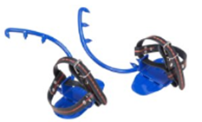
Fig 1.10: Safety pole climber
Use of firefighting equipment: it is a range of tools and appliances that are designed to extinguish fires. When used correctly, this equipment will protect the operator from harm. There are many different types of firefighting equipment, including portable extinguishers, professional firefighting tools, sprinkler systems, and alarms.
- Fire Extinguishers: Portable firefighting devices are essential in every building. It is easy to operate & can be used by anyone. A fast reaction with a portable fire extinguisher could save you thousands of birr in damage costs.

Fig 1.11: Fire extinguisher
- Fire Hose Reels: Every covered firefighting system should include a fire hose reel.
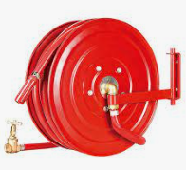
Fig 1.12: Fire hose reels
- Fire Blankets: Fire blankets are perfect for use on fires involving cooking fats and oils. They can also be wrapped around a person who is on fire. You should have a fire blanket available in all kitchen areas.

Fig 1.13: Fire blanket
- Sprinkler Systems: many commercial buildings have their own sprinkler systems. These systems can be activated by a number of things, depending on the type of sensor. Traditionally, sprinkler systems can detect smoke, temperature, or both.

Fig 1.14: Sprinkler systms
- Smoke Alarms: every building, domestic & commercial needs smoke detectors and alarms to detect smokes & send messages in order to take fast action against a fire.

Fig 1.15: smoke alarm
Note: Firefighting equipment not only the above but also includes fire-resistant protective clothing, fire-resistant gloves, respirators and communication equipment.
How to operate a fire extinguisher
There are four basic steps for using modern portable fire extinguishers. These are:
- Pull (Pin) Pull pin at the top of the extinguisher, breaking the seal.
- Aim. Approach the fire standing at a safe distance.
- Squeeze. Squeeze the handles together to discharge the extinguishing agent inside. ...
- Sweep.

- Sequence of conduit work
Electrical conduit fittings form the outer covering for most electrical wiring from one point to the next. They shield the wires from the external environment so as to make the wire last longer and also to keep humans and pets safe from electric shocks or other such vulnerabilities. Electrical conduits are predominantly made of insulating and sturdy material for optimum functionality. Although it is best suited for a professional electrician to accomplish most electrical conduit fittings, there are some minor ones that you can easily do on your own.
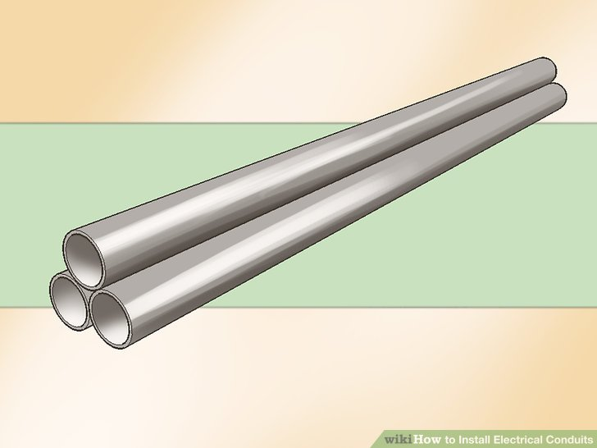
Fig 1.1: conduit
Choose the right material for installing electrical conduit fittings: The most preferred material is known as EMT (Electrical Metallic Tubing). EMT is very easy to install as you can effortlessly bend it and assemble it as per your needs. Also, you can conveniently take it off in case your wiring goes wrong somewhere. If you do not have it in your house, you can buy EMT from any of the electrical surplus stores for pretty cheap.
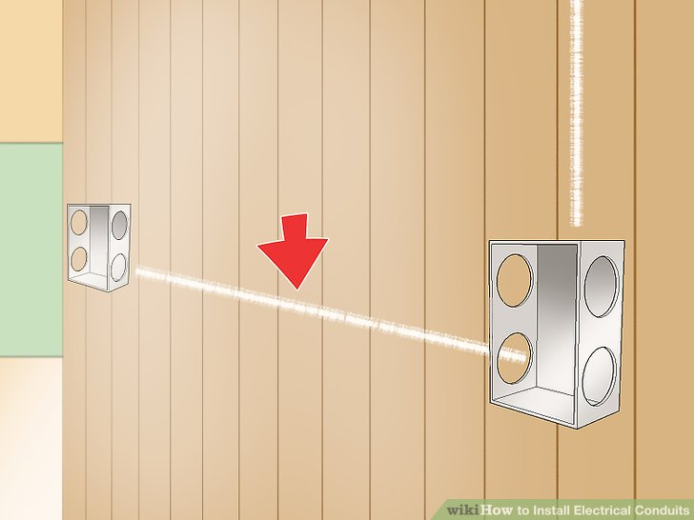
fig 1.2 electrical conduit
chalk out a wiring plan: find out the location of the electrical boxes on your wall to trace the route of the conduit. draw the path from the main power source to the electrical box.
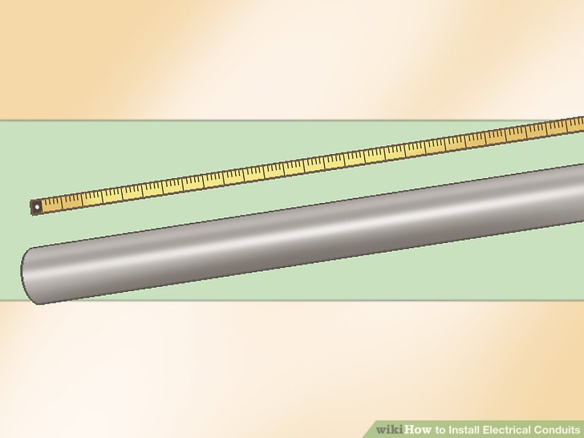
fig 1.3 measuring conduit
measure the amount of conduit that you would need: make appropriate marks in pencil wherever you think the bends should be, and measure the total length of the conduit that would be needed to finish the entire electrical conduit fittings. now cut the length that you just measured with a tool called hacksaw. the cut ends are likely to have burrs which can be removed using a deburring tool or with pliers.
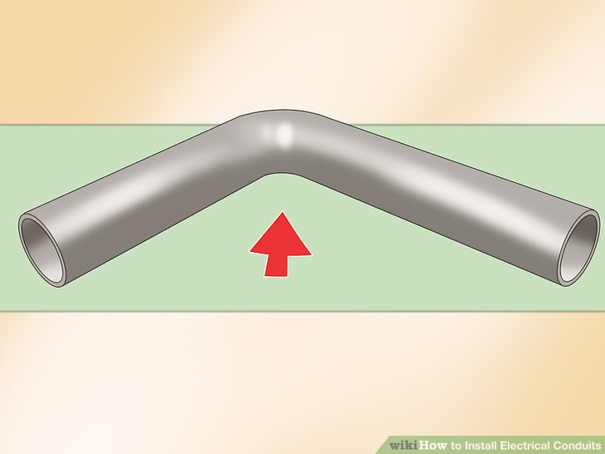
fig 1.4 conduit bend
Make the necessary bends: It is now time to make bends that you had marked on the pipe in the previous step. Owing to the easy flexibility of EMT, this should not be very difficult. Conduit benders come in handy for doing this bending.

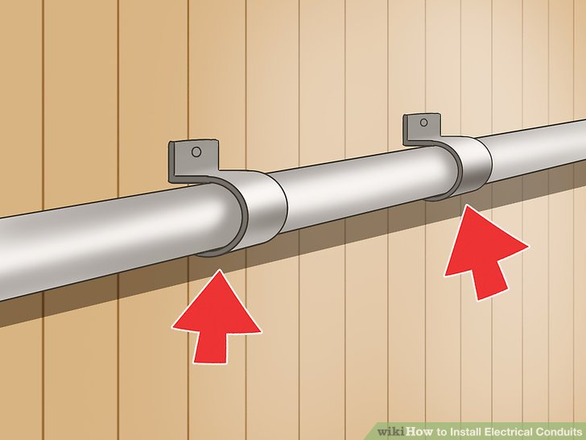
fig 1.6 clamping a conduit
Attach fittings to the wall: You can use screws and straps with either single or double holes, available at electrical surplus shops, to attach electrical conduit fittings to the wall.
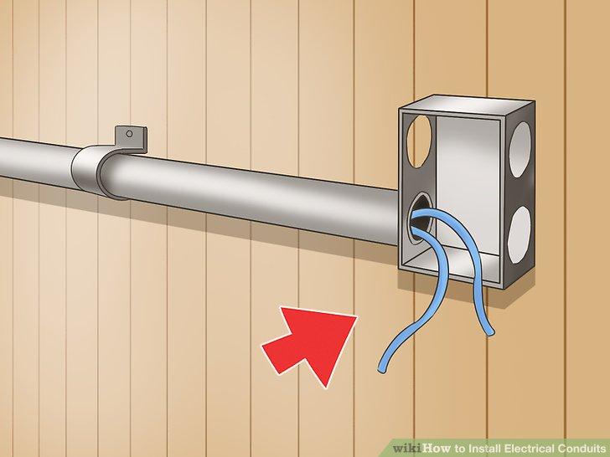
fig 1.7 terminate conduit
Tape the ends and put the wires in place: Use a widely available fish tape and run it through the entire route of the conduit fittings you just installed. Fix together the ends along with the electrical wires with the same fish tape. Give a finishing touch by pulling all the wire in the pipe in their right place.
- Consulting to appropriate person
The organizational structure of construction companies is designed to meet the needs of construction projects. As each project has a different context and content, so the roles and responsibilities of individuals will differ significantly from project to project. There are nonetheless generic definitions of typical job titles: The site manager is the senior construction company representative on site. The site manager will generally be responsible to an office-based ‘contracts manager’.
The site manager’s role is the supervision and management of all site-based staff employed by the company to ensure that the project is delivered within their contractual obligations. The major responsibilities of the role are to:
- Advise and assist in overall planning.
- Plan and coordinate resources.
- Monitor and control progress and quality.
- Communicate with the consultant team.
- Provide feedback and reports to the client.
- Ensure that all aspects of the project are carried out in accordance with statutory requirements.
- Ensure that all aspects of the project are carried out in accordance with company policy.
The contractor's site-based staff will consist of some or all of the following personnel:

- General foreman.
- Site foreman.
- Trade foreman.
- Ganger.
- Operatives.
- Site engineer.
- Site supervisor.
- Planner.
- Other support staff:
- Bonus surveyor.
- Contractor's cost controller.
- Buyer.
- Clerical staff.

Sub contractor staff
Generally, a sub-contractor's staff will be distributed across a number of different sites. A ‘contracts supervisor’ based at the sub-contractors offices will travel to each site to ensure that contract works are executed efficiently and effectively. The contracts supervisor’s main duties are to:
- Liaise with the site manager in relation to the regular progress of the works.
- Coordinate the supply of all sub-contract resources.
- Attend site meetings and progress meetings as required.
- Ensure the quality and safety of the sub-contract works.
On each site, the contracts supervisor will be assisted by a 'charge hand'. The charge hand will be based on site permanently and will have responsibility for the supervision of all sub-contractor employees. Depending on the number of sub-contractor employees this post may be a full-time supervisory post, or it may be part-time, in which case the charge hand will also work in the physical execution of the sub-contract works.
Client site instructor The client's site inspector is directly appointed by the client; however, it is usual that this person is supplied by the consultant team. In the UK the nominal term for the client’s site inspector is the clerk of works.
The main duties of the client's site inspector are:
- Inspection of materials and workmanship for compliance with contractual obligations.
- Arranging testing of material as required.
- Maintaining written records as required by the contract administrator.
- Advising the contract administrator of any outstanding information requirements.
- Verifying and endorsing records of labour and materials expended on the works.
- Verifying and endorsing records of variations to the original contractual obligations.
On smaller projects, the client’s site inspector may be an employee of the architect, and may only be based on site part time. On larger projects, this role may be a full-time site-based role. On exceptionally large projects there may be several client's site inspectors, each focusing on a different aspect of the works. Specialist inspections may also be necessary for specific aspects of the project such as; the client’s environmental policy, site waste management plan, accessibility and so on.
Other inspection It is the contractor’s obligation to ensure that the works comply with relevant legislation. This will involve liaising with the local authority building control inspector (or approved inspector) and all other government officials that have statutory rights of inspection.
In the UK, certain inspectors (such as HM Factory Inspectorate Officials) have unrestricted rights of access at any time; others (such as the building control inspector) have right of access by arrangement.
- There may also be other inspectors appointed by the client or third parties.
- The range of site inspections might include:
- Planning inspections to verify compliance with planning permissions, conditions and obligations.
- Inspections by funding bodies for the release of money.
- Inspections by insurers.
- Highways Authority inspection of roads and sewers.
- Health and Safety Executive inspections.
- Building control officer or approved inspector inspections.
Environmental Health Officer inspections related to pollution (mud, noise, smoke and water) and certain installations, such as drainage and kitchens. Fire Officer inspection of fire escapes, and for hazards, storage of certain materials and protection systems. Archaeological inspection of excavations Factory inspectorate inspections
- application of conduit installation
An electrical conduit is a tube used to protect and route electrical wiring in a building or structure. Electrical conduit may be made of metal, plastic, fiber, or fired clay. Most conduit is rigid, but flexible conduit is used for some purposes. Some early electric lighting installations made use of existing gas pipe serving gas light fixtures which had been converted to electric lamps. Since this technique provided very good mechanical protection for interior wiring, it was extended to all types of interior wiring and by the early 20th century purpose-built couplings and fittings were manufactured for electrical use.
However, most electrical codes now prohibit the routing of electrical conductors through gas piping, due to concerns about damage to electrical insulation from the rough interiors of pipes and fittings commonly used for gas
Conduit is generally installed by electricians at the site of installation of electrical equipment Conduit fill, also known as raceway fill, is the amount of a conduit's cross-sectional area occupied, or filled, by a cable or multiple cables. The fill is based on the cable outside diameter (O.D.) and the conduit inside diameter (I.D.).
Conduits are a form of cable protection, so you need to make sure you choose the right material for your application. You can go with flexible plastic conduit for cables or one with a metal base. Here are three popular options to consider.
Table 1.1 application of conduit
Material | Application | Why
HDPE conduit | Typically houses and protects electrical power and telecommunications cables, e.g. an outdoor utility cabinet or an outdoor telecom equipment cabinet | Excellent corrosion, chemical and UV resistance  Highly flexible cable protection  High-impact strength
Nylon conduit | Typically used in general machine building and automotive manufacturing | Highly flexible cable conduit  High fatigue life  Self-extinguishing  Abrasion resistant  Highly resistant to solvents and oils  Good weather resistance
PVC-coated metal conduit | Typically, general factory wiring and connections to machines | High mechanical strength  Highly flexible cable protector
Insulated conductors – or insulated wires – are your cable conduit fill. Make sure you use the right wires for your application. For instance, don’t use THHN in wet conditions; it’s rated only for dry and damp locations. Here are the most common types used.
Table 1.2 type and application of conduit
Conductor | Characteristics | Typical applications
THHW | Rated 167°F for wet locations and 90°C for dry locations  No outer coverings on its insulation | Service entrance, feeders and branch circuits for permanent installations
THHN | Rated 194°F for dry and damp locations  Nylon jacket over its insulation | Machine tools  Control circuits  Appliances
THWN | Rated 167°F for dry and wet locations  Nylon jacket over its insulation | Conduit  Machine tools  Controlled circuits  General-purpose wiring
XHHW | Rated 167°F for wet locations and 194°F for dry and damp locations  No outer covering on its insulation | Building wiring  Conduit  Feeder and circuit wiring
THW | Rated 167°F for dry and wet locations | Building wiring  Feeder and branch circuits  Internal secondary industrial distribution

- necessary material used for conduit installation

1.5.1 Tools and equipment
Plastic Pipe Cutter: it is used in plumbing for cutting plastic pipes. Precision with clean cutting is important in this area of work.

Fig 1.5.1: Plastic Pipe Cutter:

Digging Bar
Digging bar is solid metal rod with pin shape at the bottom. It is also used to dig the hard surfaces of ground.
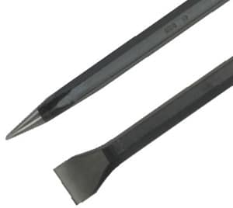
Fig 1.5.2 bar
Float
Float is made of wood which is used to smoothen the plastered concrete surface. It contains handle on its top and smooth wooden surface on its bottom.

Fig 1.5.3 float
Glove
Gloves are required to prevent the hands from direct contact with cement, paint etc. and to avoid injury while using machines, tools etc.
Fig 1.5.4 glove
Utility (Electrical) knife: A utility knife, or box cutter, is handy for cutting sheathing from non-metallic (Romex) cable, to cut off electrical tape, and to open cardboard boxes.
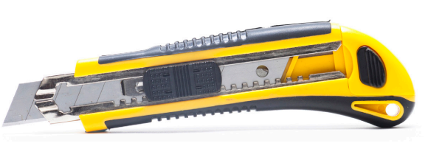
Fig 1.5.5: Utility knife

Hacksaw: a fine-tooth hand saw with a blade held under tension in a frame, used for cutting materials such as metal or plastics.
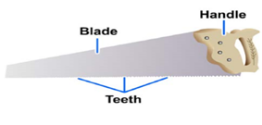
Fig 1.5.6 Hacksaw
Hoe is also used to excavate the soil but in this case the metal plate is provided with acute angle to the wooden handle.
Fig 1.5.7 Hoe 
Ladder
Ladder is also required in construction works. To check slab work, to transport material to the higher floors, to paint the walls etc.
Fig 1.5.8 ladder
Measuring Tape
Measuring tape is used to check the thickness, length, widths of masonry walls, foundation beds, excavated trenches etc.

Fig 1.5.9 tape
Pick Axe
Pick axe is used to excavate the soil. It is more suitable for hard soil which is quite difficult to dig with spade or hoe.

Fig 1.5.10 pick axe
Plumb Bob
Plumb bob is used to check the verticality of structures. It contains a solid metal bob connected to the end of a thread. It is also used inn surveying to level the instrument position.
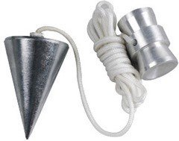
Fig 1.5.11 plumb bob
Pipe Wrenches: - used for turning pipe and other round objects. Teeth on the jaw will dig into the material being tightened and may damage. it do not use a pipe wrench to turn a bolt or a nut unless the components is already damaged. Do not use on hardened surfaces - may dull or chip the jaw teeth. There are four basic types of pipe wrenches: Still son wrench, Spud wrench, Strap wrench & Chain wrench.

Still son wrench Spud wrench
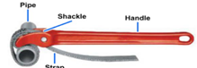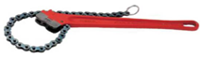
Strap wrench Chain wrench
Fig 1.5.12: Pipe wrench
Putty Knife
Putty knife is used level the putty finishing and also used to reduce the thickness of finish when it is more thick.

Fig 1.5.13 putty knife
Ball Peen (Ball Pein) Hammer: Use with cold chisels for riveting, center punching & forming unhardened metal work. Striking face diameter should be about 3/8” larger than the diameter of the head of the object being struck. Popular sizes are 12 and 16 oz. Variations include a cross-peen hammer & a straight-peen hammer.
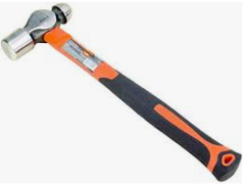
Fig 1.5.14: Ball peen hammer
- Riveting Hammer: It has a round face on one end of the head. It is used for penning rivet heads. The other end has a tapered chisel that is used for upsetting rivets.
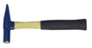
Fig 1.5.15: Riveting hammer
Spade
Spade is used to dig the soil for foundation trenches etc. It contains metal plate at the end of long wooden handle.

Fig 1.5.16 spade
Sprit level: A small level, such as a sprit level, fits easily in a tool pouch and is used to make sure your work is level and plumb. A great installation starts with level boxes and straight switch and outlet receptacles.

Fig 1.5.17: Sprit level
Pipe Cutting: There are two sizes of pipe cutters. One size can cut from 1/8 to 2 inches, while the other can cut from 2 to 4 inches. The pipe cutter has a cutting blade and two pressure rollers which are adjusted and tightened by turning the handle. Pipe cutters are used to cut steel, brass, copper, wrought iron, and lead pipe.

Fig 1.5.18: Pipe Cutter
Manual Drills: There are a number of hand drills available to create holes in wood. They include augers, and hand drills.
- Auger: itis also known as a bit brace; it is used to drill holes in wood and, with a screwdriver bit, remove and install screws.
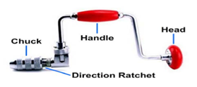
Fig 1.5.19: Auger
- Hand drill: It is used to drill holes in wood when you want total control of the drill, particularly in materials that tend to split.
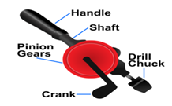
Fig 1.5.20: Hand drill

3.2 power tools and their functions
  - Electric portable drill: ​it is a tool used for making holes in metallic sheets or other surfaces. In electrical systems, it is used during the construction of various electrical equipment. It is driven by an electric motor. to consider the following points before selecting a drill:
- There should be a wide range of speeds for drill.
- Texture and contour of the drill should be such that it is easy to grip.
- The drill should be of enough rating to work comfortably with voltage s of the working are

Fig 1.5.21: Corded drill

Self check-1
Directions: choose the best answer from the given alternative :( 1 points)
1 ______________ is a tube used to protect and route electrical wiring in a building or
structure.
A. electrical conduit B. metallic conduit
C rigid D. flexible conduit
2 __________________is typically, general factory wiring and connections to machines
A aluminum B PVC-coated metal conduit
C HDPE conduit D conduit
3. Occupational health and safety (OHS) relates to
A health C. welfare issues in the workplace
B safety D. all
4. The Importance of planning and Preparing Installation OH&S policies and procedures.
A. Testing Devices B. Checking the Quality of the Work
C .Checking of Materials D. all
5. Steps Involved in Installation Planning (2 point)
A, assessment B. readiness
C, benchmark D. All
6 Review existing installation to identify the roadblocks (2 point)
A .assessment B. Readiness
C , benchmark D, all

Note: Satisfactory rating - 3 points Unsatisfactory - below 3 points
You can ask you teacher for the copy of the correct answers.

Operation sheet-1
Title: - installing steel conduit
Purpose: - To Understand the function of connector
Tools ,Equipment and Materials: - Connector, Spanner, meter,
Conditions: - A Spanner may detach the edge of screw
Procedures
- Understand the different types of edge connector
- Measure the size of connector
- Practice the adjustment of spanner
- Check the screw
- Apply safety rule during fixing
- Record the data

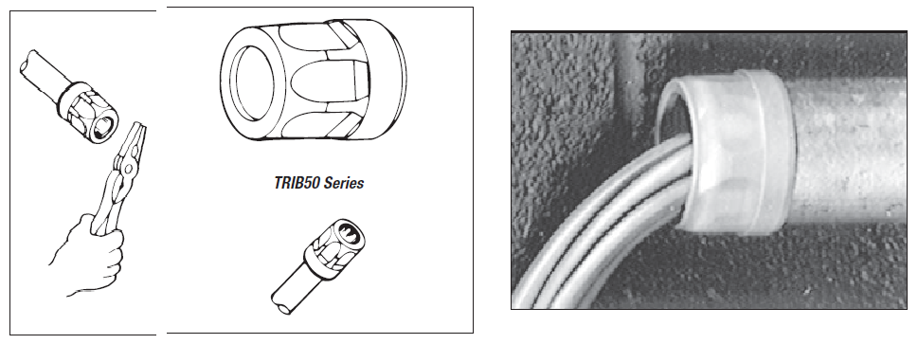
Precautions
- Consider safety rule
Criteria
- Observing the process of fixing according to the standard
- Checkpoint
- What is the purpose of connector?

Unit Two: conduit installation
This unit to provide you the necessary information regarding the following content coverage and topics:
- OH&S policies
- Types of conduits, site and working condition.
- Installation technique for Terminate and connect of conduit
- Respond to Unplanned events
- approval from appropriate personnel.
- On-going work quality checks
This guide will also assist you to attain the learning outcomes stated in the above unit. Specifically, upon completion of this learning guide, you will be able to:
OH&S policies and procedures for installing conduits are followed.
- Follow OH&S policies and procedures for installing conduits
- Install conduit in accordance with requirements, without damage or distortion to the surrounding environment or services according to type of site and working condition.
- Terminated and connect a conduit in accordance with requirements installation techniques.
- Respond unplanned events or conditions in accordance with established procedures. Before any contingencies are implemented.
- Establish procedures from appropriate personnel
- On-going checks of the quality of the work are undertaken in accordance with establishing procedures.

- OH&S policy and procedure
Introduction
Workplace safety is an important part of any job and requires that everyone in the company adhere to the safety guidelines and policies in place. Carefully following appropriate safety guidelines can go a long way toward preventing workplace injuries. Here are some ways you can work to stay safe on the job.
Be aware Always be alert to what’s happening in your surroundings; remember that your safety is your responsibility. Understand the particular hazards related to your job or workplace, and keep clear of potentially hazardous areas or situations. Be awake and attentive on the job, and be particularly aware of machinery.
Maintain correct posture Use correct posture to protect your back while at work. If you sit at a desk, keep your shoulders and hips in line and avoid hunching over. Use correct form when lifting objects and avoid twisting and stooping. The following tips provide information about lifting correctly:
Adopt a proper lifting stance by putting the strain on your legs, keeping your back straight and not bending at the waist.
- Wear a back brace for heavy work.
- Test the weight before picking up the item.
- Lift items smoothly and slowly.
- Move your feet instead of your back when traveling or turning with a heavy object.
- Hold the load close to your body.
- Ask for help to move loads that are too heavy for you.
- Take breaks regularly
Feeling tired and burned out makes you less likely to be aware of your surroundings and is a common cause of workplace injuries. Regular breaks help you stay fresh and alert on the job. It is particularly important to take short breaks when you have a task that requires repetitive movements over a long period of time.
Use equipment properly Always take the proper precautions when operating machinery or using tools. Taking shortcuts is a leading cause of workplace injuries. Use the appropriate tool for the job, and use it in the right way. When using tools and machinery, put safety first with the following tips:
- Only perform tasks you have been properly trained to perform.
- Never leave machinery unattended while it is running.
- Always obey operating instructions.
- Never remove or tamper with safety guards.
- Never place fingers or other objects into moving machinery.
- Turn off equipment before moving, cleaning, adjusting, oiling or un-jamming.
- Locate emergency exits
- Always know where emergency exits are located and keep the path to them clear. You should also have clear access to emergency shutoffs on machinery.
- Report safety concerns

- Types of conduit , site and working condition
Introduction Electrical Conduit
Electrical engineer or electrician designs electrical wiring at homes using different associated devices like sockets, switches, distribution boards, etc but the designer has to decide which type of wiring has to use. At present in modern homes, the most common type of wiring is used in nonmetallic cable form which includes a minimum of two or more separate wires that are enclosed in a protective plastic sheathing. So selecting the suitable type of wiring & the right electrical conduit is essential. This electrical conduit provides proper protection for wiring from damage. So this article discusses an overview of what is an Electrical Conduit, its types & its working with applications.
Electrical conduit definition is, it is a durable tube or enclosure where electrical wires are enclosed for protection from damage. Sometimes, these are also called wire ways or raceways. Electrical conduit is very essential where the electric wiring is exposed so that it protects the wires & individuals who may approach near the electric wires. The material used to make this conduit is plastic or metal and may be bendable or stiff. The electrical conduit diagram is shown below.

Fig 2.1 Electrical Conduit
The US NEC (National Electrical Code) as well as local building codes, make a decision when should be a conduit is used in a particular installation & which type of electrical conduit should be utilized. The installation of all electrical conduits can be done by using compatible fittings like elbows, couplings, connectors & electrical boxes which are made with similar material.
2.2.1 the use of electrical conduit
The electrical conduit works by providing adequate protection for homes, buildings from electrocution. Generally, conduits allow different wires to run current safely throughout the same pipe. The correct time to utilize an electrical conduit is whenever you are running a wire manually for electricity or when re-wiring a home.
Before using an electric conduit, we need to verify the building codes as well as its regulations, because there are some rules to install conduits. Generally, conduits are made with different materials like fiber, metal, plastic, fired clay based on the requirement. These are installed by engineers or electricians at the installation site of electrical equipment.
The specifications of the PVC Electrical Conduit include the following.

- The size of the conduit is 25 mm.
- The material used is PVC.
- Medium type.
- 3-meter length.
- The diameter is 20mm.
- Weight is 12.5 KG.
- Used for electrical wiring.
- The type of conduit is Hollow.
- Available colors are Black, Blue, Yellow, Red, Brown, Green, Cream, Grey &White.

2.2.2 Types of Electrical Conduit
There are different types of electrical conduits that are commonly used in residential and other commercial buildings. They are;
- Metallic conduit

- Electrical Metallic Tubing.
- Rigid Metal Conduit.
- Intermediate Metal Conduit.
- PVC conduit
- Flexible Metal Conduit.
- Liquid-tight Flexible Metal.
- Electrical Non-Metallic Tubing.
- Rigid PVC Conduit.

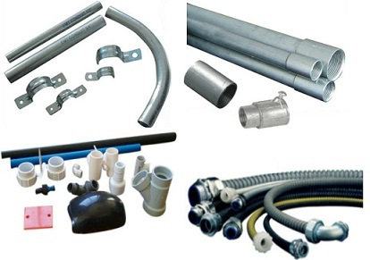
Fig 2.2 Types of Electrical Conduit
2.2.2.1 Electrical Metallic Tubing
Electrical Metallic Tubing or EMT is a common example of an unbending electric conduit. This type of conduit is made with Aluminum or Galvanized steel. As compared to Rigid Metal Conduit (RMC), it is lighter and thinner but it can also be strong and bendable with using a tube bender tool, so it is known as a thin wall conduit.
The installation of electrical metallic tubing can be done with couplings & fittings that are protected completely through setscrew or compression-type fasteners. Similar to IMC & RMC, EMT is not threaded but these are available in common sizes like ½, ¾ & 1 inch.
These conduits are used most frequently in indoor wiring like residential & commercial buildings. If these conduits are used outdoors in exposed areas, they should be connected through special watertight fittings.
2.2.2.2 Rigid Metal Conduit
The rigid metal conduit or RMC is very expensively available electrical wiring in the market because it provides extra power & strength. It is made with heavyweight Galvanized Steel and installed with threaded fittings.This type of conduit is commonly used outdoors for providing safety from damage & also provides structural support to panels, cables & different equipment. These are available in 10 to 20 feet lengths with threads on each side of them.
2.2.2.3 Intermediate Metal Conduit
A Lightweight & thinner version of RMC is IMC which is used in the same applications as RMC. Because this conduit is lighter & very easier to work as compared to RMC, it is more frequently used in new constructions.
IMC is rated for outside exposure & used for protecting conductors & insulated electrical cables. It is a very economical choice for projects wherever the price is an issue.
2.2.2.4 Flexible Metal Conduit
FMC (Flexible metal conduit) is available in a spiral construction and it is flexible so that it can simply bend throughout different structures & walls. A typical flexible metal conduit is used in indoor locations which are dried out and used at fixed appliances like a garbage disposer. These conduits are mainly guard’s electrical wiring in industrial & commercial buildings.
The FMC is the best choice to use in different areas and the best examples of basic FMC are water heaters, attic vents, & lights installations.
2.2.5 Liquid-tight Flexible Metal
The liquid-tight flexible metal conduit or LFMC is a special type of FMC. This conduit is available with a plastic coating, so used with sealed fittings to make it waterproof. It is frequently used with outdoor equipment like AC (air conditioner) units. So this type of conduit is mainly for utilizing in locations where dampness could become a problem. This type of conduit should be used in combination with liquid-tight fittings.
2.2.2.6 Electrical Non-Metallic Tubing
Electrical nonmetallic tubing or ENT is a flexible and thin-walled corrugated plastic conduit and it is flame-retardant & moisture-resistant. This type of conduit is very simple to bend & installed with glued plastic & snap-lock fittings.
Not like electrical metallic tubing (EMT), this conduit cannot be used in exposed locations but used inside walls. In addition, to use in normal metal-frame or wood walls, electrical metallic tubing can be used in concrete block constructions &can be roofed with concrete. As compared to RNC, this ENT-type conduit is very easy to use because it can be turned around the wall without welding or cutting.
2.2.2.7 PVC Conduit
PVC conduit or polyvinyl chloride conduit is related to plastic plumbing pipes. These conduits can be simply installed by plastic fittings with glue. It can be simply bent once heated within a heater box. These conduits can be used in underground and corrosive environments.
The main benefits of using these conduits are, installation is easy, versatile, less weight, not expensive, used in underground and concrete.
2.2.3 Electrical Conduit Diameter Chart
We know that there are different types of electrical conduits available in that market that are used based on the requirement. So the diameters of each type vary in terms of radius, inside and outside diameters. Here is the diameter chart for the electrical metallic tubing conduit.

Table 2.1 Conduit for Electrical Wiring
Size of Trade | Inside Diameter | Outside Diameter | Radius
½ | 0.622 | 0.706 | 0.311
¾ | 0.824 | 0.922 | 0.412
1 | 1.049 | 1.163 | 0.525
1 to ¼ | 1.380 | 1.510 | 0.690
1 to ½ | 1.610 | 1.740 | 0.805
2 | 2.067 | 2.197 | 1.034
2 to ½ | 2.371 | 2.875 | 1.366
3 | 3.356 | 3.500 | 1.678
3 to ½ | 3.834 | 4.000 | 1.917
4 | 4.334 | 4.500 | 2.164

Electrical conduits are used whenever electric wires are buried or exposed in homes or buildings. So, exposed electric wires need safety from different elements like moisture, dust, weather, extreme heat, cold, etc & also people require safety from the risk of electric shock. So it is very essential to know how to install, handle and protect electric wires by hiring an electrician or engineer.
So the main purpose of the conduit is to defend the electrical wiring at homes, offices, buildings, etc. Conduit is not required in most cases when electric wiring is installed inside the home walls or in ceilings.
2.2.4 How many wires in the conduit
The electrical wires used in an electric conduit mainly depend on different factors like cable size, type of conduit, and size of conduit. Here, the size of a wire can be defined simply by the AWG which is known as the American Wire Gauge number. When the AWG number is small then the wire diameter is larger. The following tabular form lists the type of conduit, size, and cables used.
Table2.2 number of wire that conduit handle
Conduit Size & Type | 8 AWG Wire | 10 AWG Wire | 12 AWG Wire | 14 AWG Wire
1/2-inch EMT | 3 | 5 | 9 | 12
3/4-inch EMT | 6 | 10 | 6 | 22
1-inch EMT | 9 | 16 | 26 | 35
1 1/2-inch EMT | 22 | 38 | 61 | 84
1/2-inch PVC—Sch 40 | 3 | 5 | 8 | 11
3/4-inch PVC—Sch 40 | 4 | 9 | 15 | 21
1-inch PVC—Sch 40 | 9 | 15 | 25 | 34
1 1/2-inch PVC—Sch 40 | 21 | 37 | 59 | 82
1/2-inch PVC—Sch 80 | 2 | 4 | 6 | 9
3/4-inch PVC—Sch 80 | 4 | 7 | 12 | 17
1-inch PVC—Sch 80 | 7 | 13 | 20 | 28
1 1/2-inch PVC—Sch 80 | 18 | 32 | 51 | 70
1/2-inch FMC 13 | 3 | 6 | 9 | 13
3/4-inch FMC 22 | 6 | 10 | 16 | 22
1-inch FMC | 9 | 15 | 24 | 33
2.2.5 Depth of an electrical conduit
A metal conduit can be buried as a minimum of 6 inches under the ground. They can also be buried in 4 inches depth in the concrete slab. Under private roads, these conduits should be buried under 18 inches depth whereas, under public roads, they should be buried under 24 inches.
Does underground electrical wire need to be in conduit? No, because in undergrounds, direct burial cables are directly installed without using conduit. The construction of direct buried cables has water resistance to function under the soil for many years once they are installed properly.
How does conduit work electrical A conduit is a tube where electrical wires are enclosed for various structural and building applications. It protects enclosed wires & also any individuals who may approach near to the electric wires.
What is GREY conduit used for?
The grey color conduits like electrical conduit PVC are UV Resistant & the green shade is a sign for electrical wiring used for hydraulic applications.
2.2.6 advantage and disadvantage of electrical conduit
Advantages
The advantages of electric conduit include the following.

- These wiring systems are waterproof.
- Its appearance is good.
- Long life.
- Alternation is achievable.
- It is consistent.
- It is a strong & very famous system.
- PVC type’s conduits are highly resistant to corrosion.
- There is no possibility for fire.
- Protection from electric shock.
- Easy maintenance.
- When cables are damaged, we can replace them easily.
- It provides protection from chemicals, moisture, etc.

Disadvantages
The disadvantages of electric conduit include the following.

- Installation is not easy.
- Very difficult to find the fault.
- Expensive.
- Takes more time while installation.
- Electric shock risk.
- Maintaining extra connections is complicated in the future.
- As compared to the concealed system, this wiring system beauty is less.
- Mechanical damage is possible in PVC plastic conduits.

Conduit bend

Tools for Cutting Electrical Conduit
Thin-wall metal conduit can be cut with a special electrical conduit cutter. To use the cutter, clamp it around the conduit. To cut the conduit, tighten the knurled nut in the handle. As you tighten, force the cutter around the conduit. The sharp cutting blade cuts a groove that deepens with each revolution, making a smooth, quick cut. After cutting through the conduit, file off any burrs around the edge of the cut.
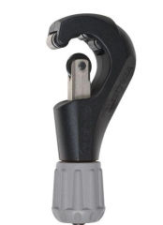
Watch out: after metal conduit is cut its cut ends must be reamed or chamfered so that the wire pulled through the conduit won't be damaged. Tools for Bending Electrical Conduit Thin-wall electrical conduit can be readily bent by using a special tool designed to make a smooth, even bend with little effort.
Below: a manual or hand-operated electrical conduit bender, this one from Ideal, widely sold at electrical suppliers. Our sketch shows the two most critical measurements when obtaining the leg length or stub-up height when bending conduit.
 ,,, 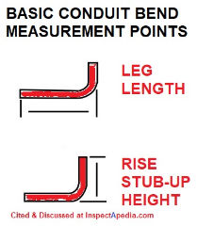
Details of the bend markings for this conduit bender are given below.
- The more bends in a run of conduit, the more it is to “fish” the wires through.
- Plan the conduit run carefully to avoid sharp bends and to make as few bends as possible.
- Illustration above: Ideal Corporation's tubing bender marks used to make proper bends in EMT.
- Never have more than four right angle bends between openings.
- Follow the manufacturer’s instructions for the type of conduit bender you use.
- Screw a 30-inch length of threaded pipe into the bender head (sometimes called a an electricians “hickey.”)
- Insert the conduit into the bender through the hook at the top of the head. The hook marks where the bend will start.
- Put one foot on the conduit near the head and lever the pipe handle backward, checking the angle of the bend as you go.
- Standard Bend Radius and Calculations for Electrical Conduit Bends
- You'll find these and more details in the electric conduit bending guides cited in this article.
- The Deduct numbers tell you how many straight-line linear inches will be occupied by the finished electrical conduit bend.
Types of Electrical or EMT Conduit Bends & How They Are Made Conduit bending tools are provided for both duct able iron rigid conduit and EMT. You'll use a different conduit bending tool depending on the conduit material.
Here we illustrate the basic bends formed in metal conduit or that can be purchased pre-bent in EMT or plastic conduit. Details of exactly where and how to measure distances to get these bends exactly right for your job are in the conduit bending guides [PDFs as free downloads] provided later on this page.
90° Stub-Up Bend in EMT
A stub bend forms a length of conduit into an L-shape or a 90° angle as shown below.
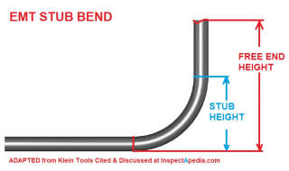
To make an L-bend that finishes with the desired free-end height that you want when the conduit has been bent to shape, you need to subtract the stub height that will be taken up by the actual 90° angle. Klein and other conduit bending tool manufacturers provide a guide that shows, for a given conduit diameter, the stub-height that must be subtracted from the total desired free-end height (given below along with the company's contact information).
For example,
- For 1/2" EMT subtract 5" stub height
- For 3/4" EMT subtract 6" stub height
- for 1" EMT subtract 8" stub height
- Back-to-Back or "U" Bends in Electrical Conduit
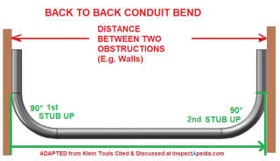
A pair of 90° Stub Bends is used to shape conduit between two obstacles, such as between two opposing walls or columns. This U-shaped conduit bend can be as short as two 90° stub bends joined together or of any greater length or distance as shown in our drawing, adapted from Klein, cited below.
To make a conduit U-bend you need to follow these steps: (see the instructions for your specific brand and model conduit bending tool) Measure the total distance between the two obstructions (the red line in our sketch). Make the first 90° stub-up bend at one end of the conduit
Measure the distance from the back-end of the first stub-up bend to find where to place the conduit bender on the other (straight) end of the conduit (green lines in our sketch) and mark this as the second conduit bend index point.
Place the bending tool on the conduit so that its index point (the "Star Point Symbol" if you're using the Klein conduit bending tool) is in line with the second-bend index point marked on the conduit
Offset Bends in Conduit An offset bend allows conduit to shift up or down, or left or right, while continuing in the same original direction, such as to zig-zag around an obstruction.
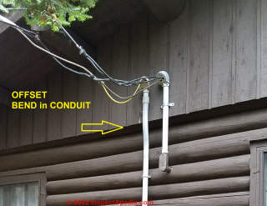
Above: we see a typical application of an offset bend in conduit: jogging around a change in wall thickness. This electrical conduit installation is on the exterior of a guest cabin on Bearskin Lake in northern Minnesota. Our illustration of an offset bend shown below is adapted from Klein Tools, cited in detail further below.
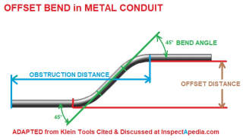
Various offset bend angles may be used depending on the space needed to clear an obstacle or change elevation and the distance over which the change must be achieved. Bending angles include 10°, 22 1/2°, 30°, 45° and 60 °. You would prefer to avoid a pair of 90° bends as pulling wire may be made too difficult. To make an offset bend the installer chooses the necessary angle to clear an obstacle over a given distance, measuring The distance to the obstacle
The offset necessary to clear the obstacle. Conduit bending guides will give a constant multiplier for each bend angle. Use the constant multiplier to increase the total conduit length needed to clear the distances involved, thus allowing for the loss in effective length that occurs when you bend (thus shortening) the conduit's travel distance.
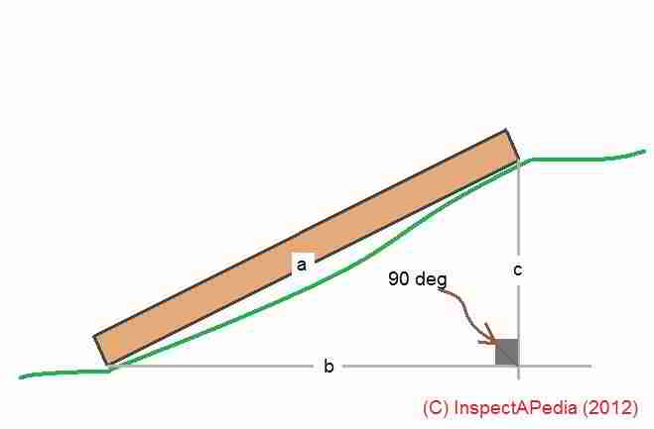
Above, from our framing article cited below, we illustrate the calculations you'd need to route conduit over a change in height or across a jog in a wall. Using that same drawing for electrical conduit bends, angle ab is the bend to leave the floor and slope up, and angle ac is the necessary angle to continue again on the flat or horizontal. The calculations of these angles always require using a "right triangle" with the 90 degree angle shown in the sketch. Since every triangle will have three angles, and we know they'll add up to 180 degrees (a straight line), if we have any two angles we calculate the third.
Example: if angle ab is 30° and we know that the right angle is 90° (by definition), and since those two add up to 90°+30°=120° we can calculate
Angle ac = (180° - 120°) = 60°
See also FRAMING TRIANGLES & CALCULATIONS for help in using simple triangles to calculate the length and rise (or drop) in conduit as well as the necessary bends shown in the table above. When your conduit needs to span a rise or fall across a surface such as a curb or step, use the table below to determine the degrees of bend necessary.
Three Point Saddle Bend in Electrical Conduit
Illustrated below is the three-point "saddle bend" in EMT, used to clear a small object such as a pipe or cross-under conduit.
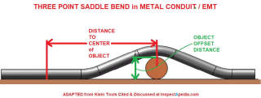
A three point saddle conduit bend is similar to the offset bend we described above. This conduit shape is useful to clear small obstacles such as a crossing pipe. Like the saddle bend, you will need to add conduit length to accommodate the distance lost from the bend itself, depending on the bending angle you choose. Detailed three point saddle bend shrinkage amount tables will be given in the instructions for your conduit bending tool, such as the Klein tool from which we adapted the image shown above.
Examples of conduit length shrinkage amounts, or the amount you need to add to the "distance to object" (red in our drawing) for every inch of height in the object offset distance (green in our drawing) include:
- Three Point Saddle Bends Using 45 ° Center
- Use two 22.5° saddle bends to get a 45°center arch (as in our drawing above)
- For each inch of obstruction height add 3/16" length (shrink amount) and 2 1/2" distance away from the center of the obstruction
- Mark the conduit with the location of the center of the object, then measure and mark the distances away from the enter of the object to the two bending tool marking points
- Three Point Saddle Bends using 60 ° Center
- Use two 30° saddle bends to get a 60° center arch
- For each inch of obstruction height add 1/4" length (shrink amount) and 2" distance away from the center of the obstruction
- Mark the conduit with the location of the center of the object, then measure and mark the distances away from the enter of the object to the two bending tool marking points
Watch out: Be sure to double check tables of shrinkage amounts (or length extensions) to allow for various bends and to see exactly where to place the bending tool according to the instructions for your specific electrical conduit or EMT bending tool's manufacturer and model.
Non-Metallic Conduit Bends
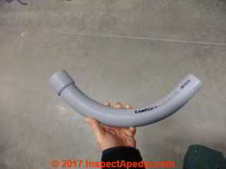
Fig 2.4 conduit bend
Sweeps and bends traversing 45 degrees and 90 degrees for non-metallic plastic conduit are sold pre-formed, such as the PVC 90-degree Bell-End elbow conduit example I'm holding in the photo above. A fish tape is a thin, flexible metal tape with a hook on one end. The tape is usually packaged on some type of reel. The tape is used to pull wires through conduit or through openings in walls. For conduit use, the tape is inserted in one conduit opening and worked through to the next opening.
- installation technique for Terminating and connecting Conduits

2.3.1 types of installation technique

- concealed conduit
- pvc conduit
- PVC trunking
- metal not exceeding
- on masonry
- with clamps
- with saddles
- on walls
- on floors
- on roof

- concealed conduit
The concealed conduit wiring system is the most popular, most common type of house electrical wiring used. Conduit wiring is a professional way if wiring a building and domestic wiring. Let us talk about what is conduit wiring, materials and tools are used in conduit wiring and how to install, uses, precautions a concealed conduit wiring system.
What is concealed conduit wiring In this method of wiring, all the conduits are installed into the wall and the conduit should be covered by the list 1/4 inch of plaster in sunken work.
Do you conceal conduit wires is used in wall, you will never spics wires together and conceal them within a wall without a junction box, it is a fire hazard. So you use proper wiring rules for how to used wires in-wall and put in an accessible junction box for the connected wires.
The procedure of concealed conduit wiring:
We all know that the concealed wiring the except meaning of that concealed conduit wiring. It is very laborious to install. The layout of this wiring is done under the wall of the building. Conduit wiring pipes are buried under the plaster of the wall with GI wire inside. After, with the uses of GI wires, the main PVC insulated cables are drawn through the conduit system.
Precautions of concealed conduit wiring:
- The interior surface of the conduit must be clean and dry otherwise the cables may suffer damage.
- Every metal box must be earthed
- Always use the looping method.
- The conduit must be installed during building construction work in the concrete ceiling.
- All the safety precautions which are taken in the surface conduit system will also be implied in a concealed system.
- Whenever conduit is to be buried by concrete special care must be taken, otherwise, liquid cement may enter the conduit.
Uses of concealed conduit wiring:

- Home
- Hospitals
- Commercial place
- Bungalows
- Cold storage
- Railway station
- Record room
- Laboratory
- Workshop
- Mosque

- PVC conduits
Steps to install electrical boxes for a new set of circuit series? It’s a must to keep wirings around the house safe with a PVC electrical conduit connecting to an electrical box— this type of enclosure is necessary for protecting wiring splices. Moreover, you as a electrical technician must comply with the National Electrical Code (NEC) rules and regulations, so it’s best to learn how to connect PVC conduit to an electrical box.
Steps to Connecting the Conduit to the Electrical Box

Step 1. Power off
Step 2. Cut the conduit
Step 3. Smoothen it out
Step 4. Install the fittings
Step 5. Apply the PVC cement
Step 6. Connect the pipe and the box
Step 7. Fish the wirings through
Steps to Connecting the Conduit to the Electrical Box
With all the items you’ve gathered from the hardware shop, gear yourself up and get to work with this PVC electrical conduit installation guide.
Step 1. Power off First, the number one safety protocol before working on electrical maintenance is switching off the main breaker. With this step, you can freely move in your workspace without the risk of touching a live wire. Later on, you’ll need full force to pull wirings from a tight tube, so going powerless is the most efficient and safe manner to do this.
Step 2. Cut the conduit While cutting your tubes, make sure they match the corners and path of your wiring system. The edges must fit through the fittings when connecting PVC conduit to metal box.
To do this precisely, you can mark a straight line where you’re supposed to cut it, then use a clamp to grip your PVC as you chop it down. However, if you’re in a rush, you can try more straightforward methods like using a PVC cutter.
Step 3. Smoothen it out Now, of course, a fresh-cut PVC will always have rough edges of plastic hanging inside or outside of the pipe. Always deburr the ends of your PVC with the help of rough-grade sandpaper or a knife. These patches of plastic can be sharp to touch at times, and with that, they can potentially damage the wiring insulations if you disregard them.
Step 4. Install the fittings If your electrical box has an in-built fitting, you can skip this part. Otherwise, before attaching the conduit to the junction box, prepare the threaded hubs, bushings, and locknuts first. Insert the proper size of PVC fitting in the box hole and use the locknut and bushing to keep it watertight. After this, you can now glue them up.
Step 5. Apply the PVC cement First of all, your electrical PVC doesn’t need a primer. Your hardware retailer has glue or cement specific for a conduit-to-fittings connection. When you do this procedure, wear a glove as you dab a small cement portion on the tip of the pipe. Do the same step inside the electrical box’s fitting, but don’t try to overfill it.
Never try to dry-fit your PVCs and their fitting for measuring purposes. It doesn’t work like a Lego or a puzzle that you can slip in and out with no problem. Always smear the PVC cement first.
Step 6. Connect the pipe and the box Once that’s all settled, connect your outdoor electrical conduit inside the fittings of the box. Remember to install one box at a time and never do multiple simultaneously, or you’ll struggle trying to run all your conduits. The trick is to connect your PVCs into one box at a time while doing a conduit run.
Step 7. Fish the wirings through Wait for 15 minutes to dry the glue and a few hours to cure, depending on the temperature, when installing PVC conduit outside the house. Then, fish your wirings through the pipes going into the junction box. You can use fish tape or what they call an electrician’s snake to draw the wire through the conduit.
So that’s it! Remember that the most crucial part of learning how to connect PVC conduit to an electrical box is debarring the rough edges after cutting the pipe. Many people forget to do this part, and once they fit the tube inside the fittings, there are still sharp plastic remains that can eventually damage circuits.
g Despite the similarity to pipes used in plumbing, purpose-designed electrical fittings are used to connect conduit.
Box connectors
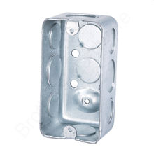
fig 2.6 box conector
Used to join conduit to a junction box or other electrical box. A typical box connector is inserted into a knockout in a junction box, with the threaded end then being secured with a ring (called a lock nut) from within the box, as a bolt would be secured by a nut. The other end of the fitting usually has a screw or compression ring which is tightened down onto the inserted conduit. Fittings for non-threaded conduits are either secured with set screws or with a compression nut that encircles the conduit. Fittings for general purpose use with metal conduits may be made of die-cast zinc, but where stronger fittings are needed, they are made of copper-free aluminum or cast iron.
Couplings Connect two pieces of conduit together. Sometimes the fittings are considered sufficiently conductive to bond (electrically unite) the metal conduit to a metal junction box (thus sharing the box's ground connection); other times,
Electrical boxes are critical components of your home's electrical system that encase wire connections to protect them from short circuits. But for many DIYers, the wide variety of boxes is bewildering. There are plastic and metal boxes; "new work" and "old work" boxes; round, square, and octagonal boxes; and boxes with load ratings for ceiling fans and heavy light fixtures. All of the most commonly used boxes for home wiring projects are available at home centers and large hardware stores, and it's important to know the differences in order to buy the correct box for each job.
Here, we'll break down the different types of electrical boxes you need to know to safely install the correct models around your home.
The Best Smart Switches for a High-Tech Home
Metal and Plastic Electrical Boxes
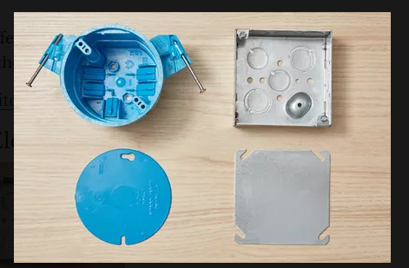
Fig 2.7 Metal and Plastic Electrical Boxes

Best for: Metal-sheathed cable or metal conduit (metal boxes), Romex or non-metallic cables (plastic boxes) Most electrical boxes are either metal or plastic: Metal boxes are generally made of steel, while plastic boxes are either PVC or fiberglass. Weatherproof metal boxes for outdoor use are generally made of aluminum. If you are using metal conduit to run wiring to the electrical box, then a metal box is required—both to anchor the conduit and because the conduit and metal box itself may be used to ground the system. Metal boxes are more durable, fireproof, and secure.
Plastic boxes are typically cheaper in price and include built-in clamps for wires. If you are using a non-metallic cable, such as Type NM-B (non-metallic sheathed cable), then you can use either plastic boxes or metal boxes, as long as the cable is secured to the box with an appropriate cable clamp. Modern wiring systems with NM-B cable usually include a ground wire inside the cable, so the box is not part of the grounding system (however, metal boxes must be connected to the system ground, usually with a short length of wire called a pig tail
When to Use a Plastic or Metal Electrical Box
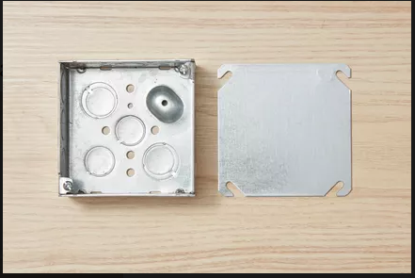
Fig2.8 Standard Rectangular Boxes
Best for: Single light fixture switches and outlet receptacles Standard rectangular boxes, also known as "single-gang" or "one-gang" boxes, are typically used for single light fixture switches and outlet receptacles. They are generally 2 x 3 inches in size, with depths ranging from 1 1/2 inches to 3 1/2 inches. Some forms are gang able—with detachable sides that can be removed so the boxes can be linked together to form larger boxes for holding two, three, or more devices side by side.
Standard rectangular boxes come in various types of "new work" and "old work" designs, and they can be metallic or non-metallic (with metallic being more durable). Some types have built-in cable clamps for securing NM cables. These boxes can range in cost, but most standard options are very affordable.
2-Gang, 3-Gang, and 4-Gang Boxes 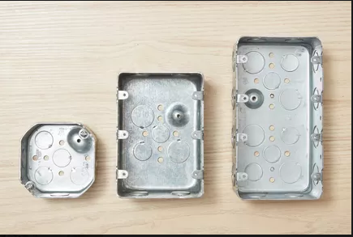
Fig 2.9 gang box
Best for: Multiple electrical devices encased together Like standard rectangular boxes, gangable electrical boxes are used to hold household switches and electrical outlets, but they are oversized so that two, three, or four devices can be mounted side-by-side. Like other boxes, these come in a variety of "new work" and "old work" designs, some with built-in cable clamps.
The same effect can be created by using standard rectangular boxes with a gangable design that allows the sides to be removed so the boxes can be joined together to form larger boxes. Gangable electrical boxes are most often made of durable galvanized steel, however, some plastic snap-together options may be found at certain hardware stores (sometimes for a slightly higher price).
Round Pan Electrical Boxes 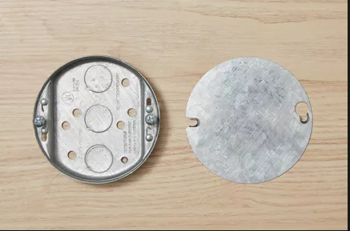
Fig 2.10 round box
Best for: Ceiling- or wall-mounted light fixtures weighing less than 50 pounds Round pan, or "pancake," options are shallow circular boxes that are most commonly used for ceiling- or wall-mounted light fixtures that weigh no more than 50 pounds. These are typically only 1/2 inch or 3/4 inch deep, and they can be made of plastic or durable metal (with similar affordable prices). Some types of specially rated metal pan boxes may be used for mounting ceiling fans, but not all pan boxes may be used for this purpose.
It's important that the fixture wires can be properly connected and fitted within the round pan box. These are shallow electrical boxes with only enough space for fitting two or three electrical connections. If there are more wire connections to be made, you will probably need a full-sized octagon or round electrical box with more volume. The number of wires in the electrical box should never exceed its safe fill capacity.
Octagon and Round Electrical Boxes 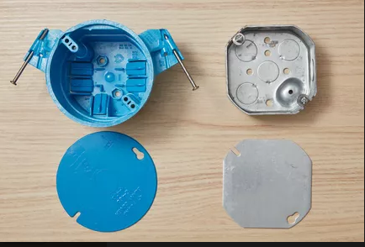
Fig2.11 octagon box
Best for: Ceiling- or wall-mounted light fixtures weighing up to 50 pounds Octagon and standard-size round boxes are deeper than round pan boxes, and they are the standard box for ceiling- or wall-mounted light fixtures weighing up to 50 pounds. These boxes range from 1 1/2 to 3 inches deep with similar costs to round pan options. They provide much more room for wiring than shallow round pan boxes and can be used as junction boxes.
Metal boxes are suitable for surface-mounted installations using metal conduit. Round plastic boxes often have "ears" for fastening to the wall or ceiling surface in existing or "old work" applications. These allow you to secure the box to the drywall (or other surface material) rather than cutting a large hole in the drywall to fasten the box to the framing.
Ceiling Fan-Rated Electrical Box 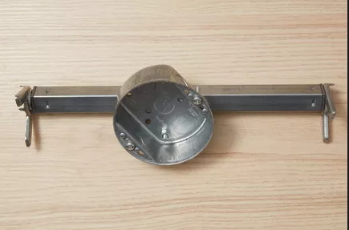
Fig2.13 ceiling box
Best for: Ceiling fans or light fixtures weighing up to 75 pounds Ceiling fan electrical boxes are used for fans or light fixtures weighing up to 75 pounds, depending on the installation method. They come in several different types and sizes, including 1/2-inch-deep "pancake" versions and standard 2 1/8-inch-deep boxes. Ceiling fan boxes are usually round but can be octagonal, and are either made of metal or durable plastic. They are often a bit pricier than other electrical boxes, but many affordable options can be found at most hardware stores.
Boxes can be mounted directly (with four screws) to a ceiling joist or wood blocking, or they can attach to adjustable braces spanning between ceiling joists.
Ceiling fan boxes must be UL-listed for ceiling fan mounting and marked “For Use With Ceiling Fans.” Do not use standard round or octagonal boxes for installing ceiling fans. Ceiling fan boxes require special fastening to withstand the dynamic loading of a rotating fan.
4-Inch Square Box
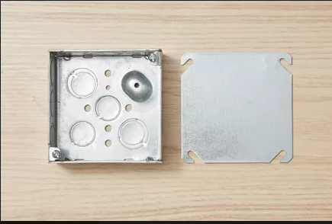
Fig 2.13 square box
Best for: Multiple conductors running in two or more directions
Square boxes come in standard depths of 1 1/4 to 2 1/8 inches, but their square corners give them additional interior space, providing maximum volume for multiple conductors and connectors. For this reason, 4-inch square boxes often are used to run several conductors in two or more directions.
They are also commonly used as junction boxes, for installation in ceilings or walls to support lighting fixtures, or to house switches or receptacles when matched with the proper cover plates. Like other types of electrical boxes, square boxes can be made of metal or plastic, and they can be found for low prices at most hardware stores.
Junction Box
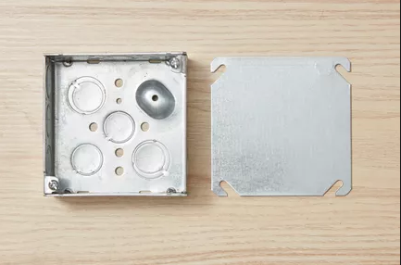
Fig 1.14 junction box
Best for: Enclosing wire splices A junction box is not a special type of box, but rather a term used to describe any standard electrical box used to enclose wire splices. The standard box used for junctions is a 4-inch square box (either metal or strong plastic), which offers plenty of space for making wire connections with multiple wires or cables, but other types of boxes can be also used for this application. Costs vary based on the type of junction box chosen.
It's important to install junction boxes where they are always accessible; never install a junction box in a concealed wall or ceiling space where the box cannot be accessed in the future. Junction boxes also must be covered with solid covers with no holes.
Electrical Box Covers
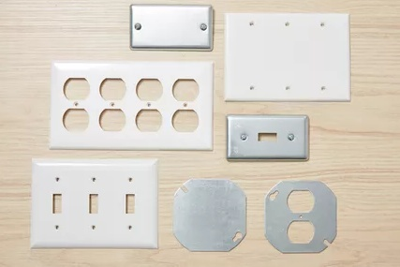
Fig 2.15 electrical box
Best for: Enclosing various types of electrical boxes
Electrical box covers are used to enclose the front of the box and are required by code; it is unsafe, and usually illegal, to leave an electrical box uncovered. Covers come in a wide variety of sizes, shapes, and materials to match different types of boxes (which can vary in price, but are typically less expensive than the box itself).
Solid, or "blank," covers have no holes and typically are used with junction boxes or for enclosing unused boxes. Covers for 4-inch square boxes may have special cutouts to accommodate switches or receptacles (outlets). These typically include a raised center area that extends the box so the opening for the switch or outlet will be flush with the exposed surface of the drywall or other wall or ceiling finish.
Outdoor Electrical Box
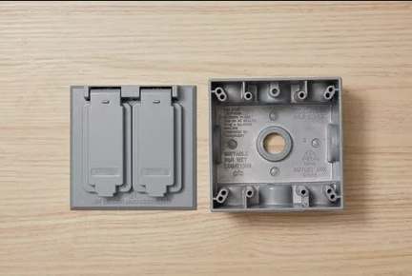
Fig 2.16 outdor box
Best for: Outdoor electrical needs Weatherproof outdoor boxes are sealed enclosures designed for mounting to the surface of exterior walls, roof overhangs, decks, and other structures. They are used for installing outdoor receptacles (outlets) and light fixtures. Outdoor boxes must have an outdoor cover or fixture rated for damp or wet locations, depending on the application.
Plastic outdoor boxes are usually made from high-impact PVC, while metal outdoor boxes are typically made from aluminum rather than steel. Prices may be higher for specialty options, but most standard outdoor boxes are comparable in cost to indoor boxes.
Choosing an Electrical Box
While there are a variety of electrical boxes to choose from, it's most important to use each box for its intended purpose. For example, round pan boxes should only be used when their capacity is large enough for the wires they must encase, and ceiling fans or heavy light fixtures should always be mounted on boxes that are rated for the fixture's weight.
If you're unsure which type of electrical box you need, it's helpful to ask an electrician or a professional at your local hardware store for guidance. In addition to choosing the type of box you need, you must also determine whether you need an "old work" or "new work" electrical box. If you are replacing an existing electrical box, an "old work" style will be needed to attach the box to the wall covering (usually drywall). When building a new house or an addition, "new work" boxes can be used to attach directly to the stud
Types Conduit body
1 L-shaped bodies ("Ells") include the LB, LL, and LR, where the inlet is in line with the access cover and the outlet is on the back, left and right, respectively. In addition to providing access to wires for pulling, "L" fittings allow a 90 degree turn in conduit where there is insufficient space for a full-radius 90 degree sweep (curved conduit section).
2 T-shaped bodies ("Tees") feature an inlet in line with the access cover and outlets to both the cover's left and right.
3 C-shaped bodies ("Cees") have identical openings above and below the access cover, and are used to pull conductors in a straight runs as they make no turn between inlet and outlet.
Electrical conduit installation tools, conduit bend types, & how to make conduit bends in EMT.
Here we describe tools used to bend, connect, cut, or install electrical conduit made of metal or non-metallic materials, and we describe each of the EMT or electrical conduit bend types: the 90° Stub-Up bend, the back to back or "U" bend in conduit, the saddle bend to run conduit around any obstacle, the offset conduit bend to zig zag around an obstacle, and the three point saddle bend to run conduit over a small obstacle.
- responding un planed events
In order to know how to respond to unplanned events or conditions, one must first start in assessing or analyzing the situation. The first response should not be making an action right away, but thinking of the situation and possible solutions. After fully understanding the situation and listing down possible solutions, it's time to take action by trying all possible means to cope with the changes or unexpected events. If working on a project, it's helpful to create a list of planned vs unplanned events so you can also think of safety measures on how to prevent the unplanned ones even before starting on the project.
What to Consider When Pulling Cable Before jumping in and haphazardly pulling wire through hundreds of feet of winding conduit lines, it’s worth asking yourself a few questions to make the job simpler in the long run.
How long is the conduit run? Shorter runs are naturally easier to pull because there isn’t as much distance involved to build up a dangerous friction coefficient. Even if they’re entirely straight lines, longer runs still make the job more difficult because the wire will continue to build friction throughout the run.
What type of conduit is being used? Conduits come in all shapes and sizes, so knowing what type is being used can help determine how difficult the pull may be. Electrical Metallic Tubing (EMT), for example, is typically straight. Other conduit options like Electrical Non-Metallic Tubing (ENT) or Flexible Metal Conduit (FMC) can bend, leading to more twists and turns for conductors to navigate through. Are there any bends in the run? How many are there, and what are their angles?
When the conduit bends, it applies added friction to the conductors. As conductors are pulled through the conduit, they will rub against the inside walls of the bend and potentially damage the wires. In some cases, a client may warn against continuous runs that exceed a certain number of degrees total.
How many cables are getting pulled? One conductor is easier to pull through a conduit than three or four. As more conductors are pulled through the conduit, the greater the chances are of jamming or other damage occurring.
What is the cable layout inside the conduit? A single conductor doesn’t pose much of a problem, but issues may arise as you add more wires. For example, a three-conductor pull could start in a triangle pattern but collapse into a cradle pattern, increasing the friction coefficient and opening the door for potential damage.
How much pressure is being applied in bends? The larger the bend, the more tension that needs to be applied. More tension means more pressure applied to the conductor as it makes its way through.
How much room are the conductors taking inside of the conduit? Conductors give off heat when they’re in use, so there needs to be enough room inside the conduit for the resulting heat to dissipate. If electrical contractors ignore conduit fill limits or assume they’re fine when they aren’t, the conductors could exceed their insulation heat ratings and melt. According to NEC Code 300.17, the following are the limits allowed for conductors based on size and number:
- One wire can fill no more than 53% of a conduit
- Two wires can fill no more than 31% of a conduit
- Three or more wires can fill no more than 40% of a conduit
It may not seem like an issue when considering how much space is left inside the conduit, but the rules also allow for easier installation and removal of the wires without damaging them.

Self check-3
Test-I Matching
Instruction: select the correct answer for the give choice. You have given 1 Minute for each question. Each question carries 2 Point.
A | B
---------1. Bend | - Used to measure length
---------2. FMC | - Used to measure outside dimension
---------3. Direct Measurement | - The capacity of an object
---------4. Volume | - Flexible metal conduit
---------5. Tap rule | - Change of conduit direction
Test II: short Answer writing
Instruction: write short answer for the given question. You are provided 3 minute for each question and each point has 5Points.
- What is the purpose of conduit bend
- Write down at least three types of conduit?
Note: Satisfactory rating – above 60% Unsatisfactory - below 60%
You can ask you teacher for the copy of the correct answers

Operation sheet 3: perform conduit work
Title: - Standard 90 degree bending
Purpose: - To Apply 90 degree bending
Tools ,Equipment and Materials: - Steel Conduit 16mm² , Hieky bender
Conditions: - A Spanner may detach the edge of screw
Procedures
- Prepare and measure steel conduit
- Check the hiaky bender
- Put the hikey bender on the marking conduit
- Apply force until to touch the 90 degree

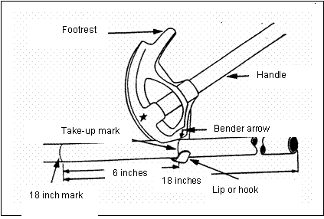

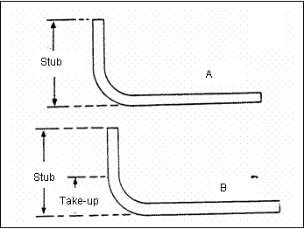

Precautions
- Consider safety rule
Criteria
- Applying the bending process according to the standard
Checkpoint
- what is the purpose 90 degree bending?

Lap Test-
Task-1: Prepare and measure steel conduit
Task-2: Check the hiaky bender
Task-3: Put the hikey bender on the marking conduit
Task-4: make 90 degree bend

Unit Three: inspection and notify the completion of work
This learning guide is developed to provide you the necessary information regarding the following content coverage and topics:
- Performing Final inspections.
- Notifying Work completion.
This guide will also assist you to attain the learning outcomes stated in the cover page. Specifically, upon completion of this learning guide, you will be able to:
- Final inspections are undertaken to the installed conduits conforms to requirements.
  - notify Work completion in accordance with established procedures

- inspection of final work
Most electrical permits require three inspections: cover, service, and final Cover inspection. Schedule this inspection when all new circuits are wired (boxes installed, wires run, grounding conductor connected or made up, nail plates installed in areas as needed). Don’t cover your work with insulation, receptacles, or wall switches until the inspector has approved it. Cover inspections also include underground installations. Don’t cover trenches, ditches, or slabs until the inspector has approved them.
- Service and feeder inspection. Schedule this inspection when the service electrical mast, meter base, service panels, grounding electrode conductors, and branch circuits (if possible) have been installed.
- Final inspections. Schedule this inspection when the electrical work has been completed. Make sure panel boxes are covered, circuits are labeled in the right spaces on the box, and all cover plates are installed. You must have all of equipment and appliances installed, grounded, and energized for final inspection.
Addressing Inspection Issues Clients cannot approve your electrical work for a number of reasons, such as:
- Your inspector could not get on site
- Your work is not complete
- There are code violations

- Perform final inspection
Inspection is the testing procedures that electricians use to ensure that a circuit is working correctly and safe for use before being energized.Inspection and testing should also be carried out for all electrical installations at regular intervals. It is carried out before the testing and the installation is normally disconnected from the supply.
The point of inspection is to verify that the installed equipment:
- Complies with relevant standards – this is normally a mark of certification by the installer or manufacturer
- Is the correct type and installed in accordance to the Regulations
- Not damaged or defective which would cause a safety issue
The Inspection includes the checking of several items which are relevant to the installation. The checking can also take place, if necessary, during installation.
Before Inspection and testing is carried Protecting yourself It is important that other people know you are carrying out inspection and testing, particularly other workers on site
Protecting Others It is important to ensure that safety precautions are carried out before starting. installations can cause. In basic terms this means assessing risk of injury from things such as:
- Electric shock
- Burns/fire
- Other moving equipment
- Power supply interruptions
- Arcing or burning
Inspect Conduit work
Use this work Procedure as a guide to help you inspect conduit as follows:
- Verify that the conduit is properly supported.
- Verify PVC coating, threaded lubricant is applied. PVC patching compound must be on sleeves.
- Verify that the conduit connections are wrench tight. Use a strap wrench for PVC-coated conduit.
- Verify that the expansion joints are installed and bonded where needed
- Verify that locknuts are installed and installed correctly.
- Verify the installation of weatherproof hubs on outside installations.
- Verify that there is no more than 360 degrees of bend between pull points.
- Verify that conduit is buried at the proper depth in underground installations.
- Verify that conduit was reamed after cutting.
- Verify that conduit threads are properly cut.
- Verify that conduits are fireproofed where needed
Inspect Junction Boxes and Pull Boxes
Use this Work Procedure as a guide to help you inspect junction boxes and pull boxes as follows:
- Knockout seals must close all unused openings in boxes or fittings.
- All metal boxes are usually required to be grounded.
- At least 6 inches of free conductors must be left at each outlet box. Three inches must
- extend from the edge of a box less than 8 inches in any dimension.
- Conduits must not be connected to the sides of round boxes, only to square smooth sides.
- Boxes may be recessed 1/4 inch or less for noncombustible material.
- Each outlet box must have a cover, faceplate, or fixture canopy to complete installation.
- Volume of original box may be increased by the cubic inches marked on the plaster ring.
- All boxes used to install lighting fixtures must be designed so that a lighting fixture may be attached.
Boxes must be rigidly fastened to the surface upon which they are mounted.
- Boxes shall not use suspended ceiling wire as a sole supporting means unless associated with electrical equipment designed for suspended ceilings.
- Boxes mounted in a wall of combustible material must be flush with surface or project from it.
- Junction boxes must be accessible without it being necessary to remove or disturb any part of the building. However, lift-out panels in suspended ceilings are considered accessible.
No | C conduit installation and junction box fixing | Items tested  by technician  *Yes/No | Items witnessed  by supervisor  *Yes/No
1 | Is the spacing between each junction box equal?
2 | Is the conduit installed correctly with the desired angel?
3 | Is the junction and outlet boxes installed in the right diameter i.e for connections 85 Ø and for outlets 65 Ø?
4 | Is the conduit left in the junction boxes between 0.5 and 1 cm?
5 | Are all conduits fix by using conduit clips?
6 | Is the diameter of the conduit is 13mm²
Table 2. inspection checklist
- Notify completion of work
h Notifying work completed to a supervisor The supervisor Provides motivation and assistance when necessary inspecting and commissioning work is done. This includes reading and interpreting design schematics to ensure the proper installation of electrical systems. Maintaining a safe and clean work area, the responsibilities of this Electrical Site Supervisor role include overseeing electrical work and site electricians, scoping work and ordering materials, issuing permits and ensuring electrical safety rules are followed
Supervisors approved the installation work by
- Inspect in detail in accordance with national standard requirements
- Insulation resistance test result i.e. should not be less than 0.5Mῼ for single phase installation
- Earthling system loop impedance
- Earthling electrode resistance test result shouldn’t be greater than 3 ohm
- Voltage level (220V/380V for our country)
- Polarity test i.e. controlling and protective only should be connected in phase wire
- Functionality of the installation
Based on the above point the supervisor notifying the installation work

Self check-3
Name…………………………………………… ID………………………… Date…….
Directions: Answer all the questions listed below
Instruction I: - write true if the statement is correct or write false if the statement is incorrect and write the answer on the space provided (6pts )
- Inspection and testing should also be carried out for all electrical installations at regular intervals?
- It is not important to protect the safety of people, livestock and property against the dangers and damage that electrical installations can cause?
- The Inspection includes the checking of several items which are relevant to the installation.

Instruction II: - Give short answer for the following questions not more than one paragraph (10 pts)
- What is the main purpose of the equipment commissioning checklist?
- What is the use of section two of the equipment commissioning checklist?
- Why we need to notify completion of our work
Note: Satisfactory rating - 3 points Unsatisfactory - below 3 points
You can ask you teacher for the copy of the correct answers.

Lap Test-3
Applying the standard installation techniques in the given circuit | Practical Demonstration
Name/ Group ________________________ Date:_____________
Time Stated:___________________ Time finished:________
Instructions:
- List down the necessary materials and tools according to the standard.
1.The necessary materials and tools are:-
- Copper solid wire (1.5mm²,2.5mm²,4mm²), connecter, Rigid steel conduit (1.5mm²,2.5mm²,4mm²), lamp, ,switch
- Electrician knife ,plier, multimeter, hack saw, connector
- You are required to:-
- Understand the different bending techniques
- Identify the type and color of wire
- Insert the wire in to rigid steel conduit
- Remove the insulation of wire according to the standard
- Terminate the wire by using the right hand tools
- Connect the given apparatus
- Test and record the dataybr

Reference
- R.K. Clidero Applications of Electrical Construction, General Publishing Co., Don Mills Ontario Canada, 1975, ISBN 0-7736-5011-3
- ^ R. S. Means Electrical Cost Data 22nd Edition, ISBN 0-87629-504-9, pages 106-107 table 16 200 Conduits
- ^ Jump up to:ª ^{b} "Benefits of Fiberglass Conduit" (PDF). Outsideplant.colonialteltek.com. Retrieved 2 October 2017.
- ^ "Five advantages of PVC coated conduit". FlexGlory.
- ^ "Reinforced Thermosetting Resin Conduit: Type RTRC" (PDF). Ul.com. Retrieved 2 October 2017.
- ^ "FRE Trademark of FRE COMPOSITES INC. - Registration Number 3043149 - Serial Number 76441251 :: Justia Trademarks". trademarks.justia.com.
- ^ "Champion Duct" (PDF). Championfiberglass.com. Retrieved 2 October 2017.
- ^ John H. Chiang, (Ed), RS Means Electrical Cost Data 30th Annual Edition, RSMeans Construction Publishers, Kingston MA USA, 2007, ISBN 0-87629-856-0
- ^ Cauldwell 2002:109.
- ^ "Precision 16 x 16mm UPVC Mini Trunking Ivory". Industricals. Retrieved 12 May 2018.
- ^ "Wallduct Medical Raceway System". Legrand.us. Retrieved 2014-10-04.
- ^ "Wall Duct - Schneider Electric United States". Schneider-electric.com. Retrieved 2014-10-04.
- ^ "Raceway Solutions - Wall" (PDF). Filgesco.com. Retrieved 2014-10-04.
- ^ "Raceway & Wiring Ducts". Icc.com. Retrieved 2014-10-04.

This TTLM prepared by

No | Name | Qualification (Level) | Field of Study | Organization/ Institution | Mobile number | E-mail
1 | Yidnekachew Seboka | Bsc | Electrical Automation & Control Technology | Akaki poly  Technique college | 0920137899 | www.yedine23@gmail.com
2 | Mengistu Abiyu | MSc | Industrial Automation & Control Managment | Lideta Manufacturing College | 0913948480 or 0913948480 | menabiy@gmail.com
3 | Elias Getachew | MSc | Industrial Automation & Control Managment | Misrak Poly Technique college | 0913811386 or 0900010390 | Get.elias19@gmail.com
4 | Giduma Mekonen | Bsc | Constraction Management | Adama Poly Technique college | 0913939750 | olimosisa@gmail.com
5 | Tigist Aemiro | MSc | Constraction Management | Bahir Dar poly Technique college | 0918375757 | Tigistaemiro4@gmail.com
6 | Getahun |  |  | Diredewa poly Technique college | 0910334887

