Building Electrical Installation
Level I

Based on month March, year 2022, Curriculum Version I
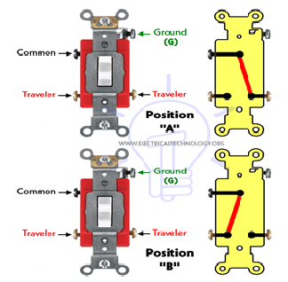
Module Title: Wiring devices, lighting and auxiliary outlets
Module Code: EIS BEI1 M11 0922
Nominal duration: 72 Hours

Prepared By: Ministry of Lobar and Skill
August, 2022
Addis Ababa, Ethiopia
Table of Contents
Acknowledgement 4
Acronyms 5
Introduction to the Module 6
UNIT ONE: WIRING DEVICES 7
1.1. Read and interpret Drawings 8
1.1.1 Definition 8
1.1.2 Types of Drawings 8
1.2. Wiring devices and Consumable items 13
1.2.1. Wiring Devices 13
1.1.3 Consumable items 20
Self-check-1 29
Operation sheet-1 31
LAP Test #1 32
UNIT TWO: INSTALL WIRING SYSTEM 33
2.1. Safety Procedures 34
2.2.1. IEE wiring regulations 39
2.2. Schedule of work 42
2.3. Quality of work 43
2.4. Further instructions from a supervisor 43
2.4.1. Unplanned events or conditions 43
Self-check #2 45
Operation sheet #2 46
LAP Test #2 46
UNIT THREE: INSTALL LIGHTING FIXTURE/ SWITCHES 48
3.1. Safety procedures 48
3.2.1 Lighting fixture and auxiliaries 49
3.2.2. Installation of lighting fixture and auxiliaries 56
3.3. Check the quality of work 60
Self-check #3 60
Operation sheet #3 61
LAP Test #3 62
UNIT FOUR: NOTIFY COMPLETION OF WORK 64
4.1. Making Final checks 64
4.2. Notify completion of work 66
4.3. Cleaning Tools, equipment’s, materials and Work area 66
4.4. Clean and make safe work area 68
Self-check-4 69
Reference Materials 70

Acknowledgement
Ministry of Labor and Skills wish to extend thanks and appreciation to the many representatives of TVET instructors and respective industry experts who donated their time and expertise to the development of this Teaching, Training and Learning Materials (TTLM).

Acronyms
PVC-------- Polyvinyl Chloride
IPE----------Insulating Protective Equipment
GFCI------- Ground Fault Circuit Interrupter
LAP Test----Learning Activity Performance Test
PPE ----------Personal Protective Equipment
SLD-----...-- Single Line diagram
NEC--------- National Electrical Code
EBCS------- Ethiopian Building Code Ad Standard

Introduction to the Module
Welcome to module 11. Themodule, Install wiring devices, lighting and auxiliary outlets helps trainees to have the required knowledge, skills and attitudes on Selecting wiring devices, Installing wiring system, and Installing lighting fixture / switches and Notifying completion of work of floor and wall mounted outlets and auxiliary outlets in building electrical installation field.
This module is designed to meet the industry requirement under the Building Electrical Installation occupational standard, particularly for the unit of competency Install wiring devices, lighting and auxiliary outlets. This module contains training materials and activities for you to complete.
This module covers the units:
- Wiring devices
- Wiring system
- Lighting fixture/ switches
- Completion of work
Learning Objective of the Module
- Select wiring devices
- Install wiring system
- Install lighting fixture/ switches
- Notify completion of work
Module Instruction
For effective use this modules trainees are expected to follow the following module instruction:
- Read the information written in each unit
- Accomplish the Self-checks at the end of each unit
- Perform Operation Sheets which were provided at the end of units
- Do the “LAP test” giver at the end of each unit.
- Read the identified reference book & website.

UNIT ONE: WIRING DEVICES
This unit is developed to provide you the necessary information regarding the following content coverage and topics:
  - Read and interpret Drawings
  - Wiring devices and consumable items
  - Selection of tools and equipment
  - PPE selection
This unit will also assist you to attain the learning outcomes stated at the above topics & contents. Specifically, upon completion of this learning guide, you will be able to:
- Read and interpret drawings to determine job requirements
- Identify Correct type and quantity of wiring devices and consumable items in line with job requirements
- Select Tools and equipment in line with job requirements
- Identify and select Correct PPE in line with safety requirement

  - Read and interpret Drawings
    - Definition
Drawing is one of the most commonly recognized forms of visual art. Drawings are created by an artist using instruments to create lines on paper or another two-dimensional surface.
The term “drawing” is a broad description that can apply to many works, which vary significantly in technique.
Electrical Drawings plays an important role in electrical installation works as they convey information about connection of various devices and equipment with mains. The information on drawings provides the complete design or plan of electrical installation and also helps to assemble the various equipment.
An electrical drawing may include all of these essential details described below:
- Interconnection of electrical wires and other parts of the system
- Connection of different components and fixtures to the system
- Power lines with details such as size, voltage, rating, and capacity
- Power transformers and also their winding connections
- The main switches, tiebreaker, and fused switches
- Other essential equipment such as solar panels, batteries, generators, air conditioning, and so on.

Types of Drawings
We use different types of drawings or diagrams to represent a certain electrical system or circuit. These electrical circuits are represented by lines to represent wires and symbols or icons to represent electrical and electronic components.
It helps in better understanding the connection between different components. Electricians rely on electrical floor plan (which is also an electrical diagram) for doing any building wiring.
Some of these electrical drawings or diagrams have been described below.
- Block Diagram
- A block diagram is a type of electrical drawing that represents the principle components of a complex system in the form of blocks interconnected by lines that represent their relation.
- It is the simplest form of electrical drawing as it only highlights the function of each component and provides the flow of process in the system.
- Block diagram is the first stage in designing a complex circuit for any project. It lacks the information about the wiring and placement of individual components.
- It only represents the main components of the system and ignores any small components. This is why; electricians do not rely on block diagram.
- The block diagram also called a functional block diagram, is used to describe the sequence of circuit operations. This diagram indicates by functional descriptions, showing which components must operate first in order to get a final outcome.
- It is a functional drawing which shows and describes the main operating principles of the equipment or devices.
Example:
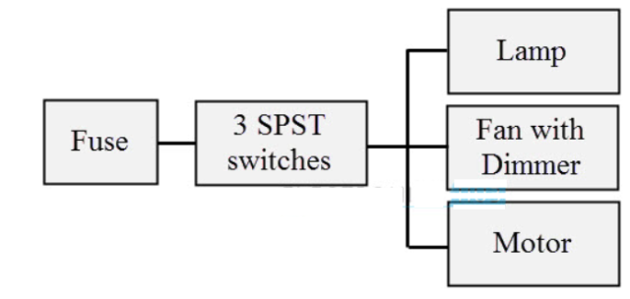
Figure 1. 1. Block Diagram
- Schematics/Circuit Diagram
- The schematic diagram of an electrical circuit shows the complete electrical connections between components using their symbols and lines. Unlike wiring diagram, it does not specify the real location of the components, the line between the components does not represent real distance between them.
- It helps in showing the series and parallel connection between the components and the exact terminal connection between them. One can easily troubleshoot certain schematic by applying electronic circuit theory.
- It is the most common type of electrical drawing and are mostly used in implementing electrical circuits by technician. Most engineering student rely of schematic diagram while developing various electrical projects.
- The electrical circuit diagram is also called Schematic Diagram.Here an electrical circuit diagram of two lamps, a fan, and switches are given below.
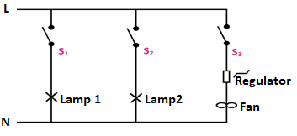
Figure 1.2 Schematics/Circuit Diagram
- Wiring Diagram
- The electrical diagram which shows the practical connection, position, and layout of each electrical appliances and all parts of an electrical installation is called Electrical Wiring Diagram.
- The wiring diagram shows the actual connection of each appliance with proper layout.
- The wiring diagram is used for the representation of electrical components in their approximate physical location using their specific symbols and their interconnections using lines.
- Vertical and horizontal lines are used to represent wires and each line represents a single wire that connects between electrical components.
- Wiring diagram shows a pictorial view of the components such that it resembles its electrical connection, arrangement and position in real circuit.
- It really helps in showing the interconnections in different equipment such as electrical panel and distribution boxes etc. they are mostly used for wiring installation in home and industries.
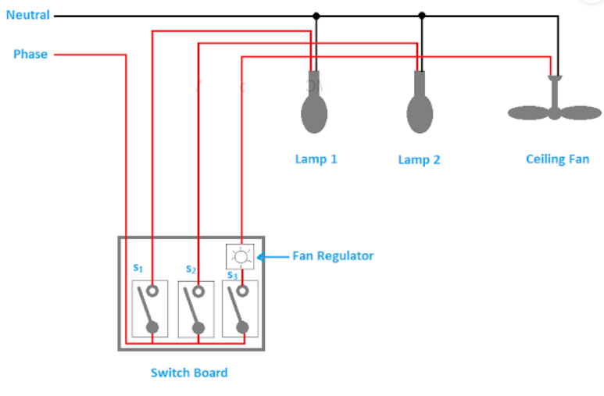
Figure 1. 2. Wiring Diagram
- Pictorial Diagram
- The pictorial diagram does not necessarily represent the actual circuit.
- In fact it shows the visual appearance of the circuit in real time.
- It cannot be used to understand or troubleshoot the actual circuit and for this reason alone, it is not commonly used.
- For someone with less knowledge of electrical, it is impossible to understand how the circuit works and diagnose it.
Example:
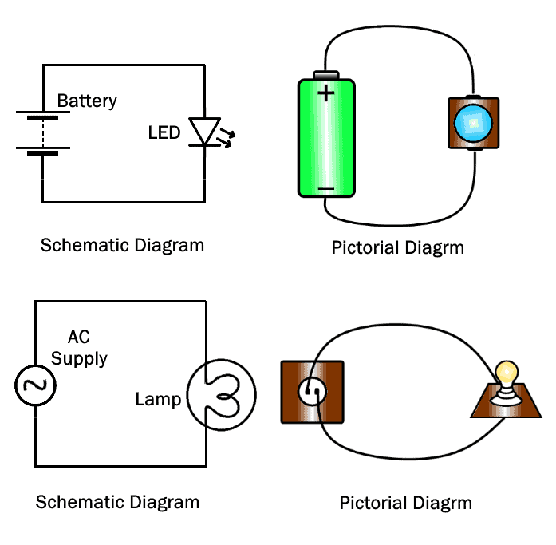
Figure 1. 3. Pictorial Diagram
As you can see, the pictorial diagram does not provide enough information regarding the electrical connection of the components.
- Single Line diagram (SLD) or one-line diagram
- Single Line diagram (SLD) or one-line diagram is the representation of an electrical circuit using a single line. As the name suggests, a single line is used to denote the multiple power lines such as in 3 phase system.
- Single line diagram does not show the electrical connections of the component but it may show the size and ratings of the components being used. It simplify complex 3 phase power circuits by showing all the electrical components and their interconnection.
- They are used for determining and isolating any faulty equipment in any power system during troubleshooting.
- The SLD diagram uses dedicated electrical symbols and icon for different components.
- Line diagram: a one-line diagram or single-line diagram is a simplified notation for representing an electrical system.
- The one-line diagram is similar to a block diagram except that electrical elements such as switches, circuit breakers, transformers, and capacitors are shown by standardized schematic symbols.
Example:
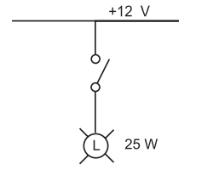
Figure 1. 4. Single Line Diagram (SLD) or One-Line Diagram
- Electrical Floor Plan
- It is a vertical representation of various appliances such as light, switch and fans etc. in a building.
- It specifies their exact location with their size and distance from each wall and ceiling.
- It shows scaled version of each room from above.
- It usually contains legend that provides a visual explanation of the symbols used in it.
- The electrical plan is sometimes called as electrical drawing or wiring diagram.
- It is a type of technical drawing that delivers visual representation and describes circuits and electrical systems.
- It consists of electrical symbols and lines that showcase the engineer's electrical design to its clients. In short, an electrical plan describes the position of all the electrical apparatus.
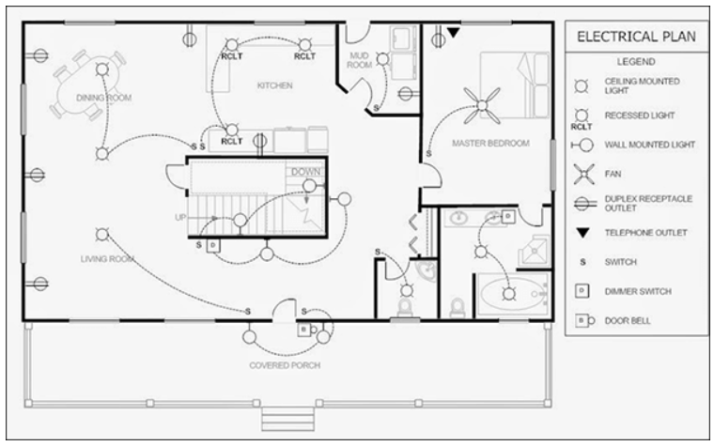
Figure 1. 5. Electrical Plan

1.2. Wiring devices and Consumable items
Quality analytical work can only be performed if all materials used are suitable for the job, properly organized and well cared for. This means that the tools are adequate and in good condition, and that sample material receives attention with respect to proper handling, storing and disposal.

Wiring Devices
According to the national electrical code (NEC), Device is a unit of an electrical system that is intended to carry, not to utilize electric energy.
Wiring devices are current-carrying electrical or electronic products that serve primarily as a connection or control point for electrical circuits within a range of 0–400 amperes, 0–600 volts (AC and DC), and AC/DC (660 watts, 1,000 volts AC fluorescent) as well as certain non-current-carrying wiring devices and supplies.
- Types of Wiring Devices
- Floor outlet
- A floor outlet is also known as a poke-through or a drop-in, and it has an incorporated mounting plate located on the surface level of a room.
- Similarly, the outlet receptacle is at floor level or just below the surface – in which case, there is yet another plate covering the socket when it is off.
- Most of the floor outlets have different covers –screw-in or flip – that protect the receptacles when they’re not in use. Some floor installation sets have all the necessary equipment included, but others only have the surface cover plate and the outlets and electrical floor box need to be purchased separately.
- Floor outlets can be so useful when it comes to powering devices such as lamps, TVs, audio sets, and kitchen appliances, but they can also be risky when they are not covered. Electrical floor outlets must be covered properly when they’re not in use, otherwise, they could cause several issues or deteriorate.
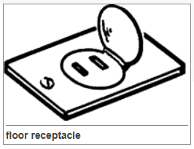
Figure 1. 6.Floor Receptacle Figure 1. 7. Single Round Floor Outlet Figure 1. 8. Single Round Floor Outlet
- Floor box receptacles
- Tamper Resistant shutters provide that all receptacles installed in dwelling units must be tamper resistant


Figure 1. 9. Floor Box Receptacles
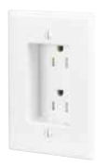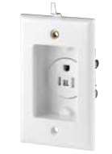
Figure 1. 10. Tamper resistant duplex receptacle Figure 1. 11. Tamper resistant single receptacle with clock hanger
- Ground fault current interrupting device
A ground fault circuit interrupter, called a GFCI or GFI, is an inexpensive electrical device that can either be installed in your electrical system or built into a power cord to protect you from severe electrical shocks.
- GFCIs have played a key role in reducing electrocutions.
- Greater use of GFCIs could further reduce electrocutions and mitigate thousands of electrical burn and shock injuries still occurring in and around the home each year.
Ground fault protection is integrated into GFCI receptacles and GFCI circuit breakers for installation into your electrical system, especially for circuit outlets in particularly vulnerable areas such as where electrical equipment is near water. Portable GFCIs are also available to provide on-the-spot ground fault protection even if a GFCI is not installed on the circuit.
- The GFCI is designed to protect people from severe or fatal electric shocks but because a GFCI detects ground faults, it can also prevent some electrical fires and reduce the severity of other fires by interrupting the flow of electric current.
- What Is A Ground Fault?
A ground fault is an unintentional electrical path between a power source and a grounded surface.
Ground faults most often occur when equipment is damaged or defective, such that live electrical parts are no longer adequately protected from unintended contact. If your body provides a path to the ground for this current, you could be burned, severely shocked or electrocuted.
- COMMON GFCI DEVICES
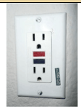  Receptacle GFCI | Receptacles This type of GFCI is used in place of the standard duplex receptacle. It fits into the standard outlet box and protects you against “ground faults” whenever an electrical product is plugged into the outlet. Most receptacle-type GFCIs can be installed so that they also protect other electrical outlets farther downstream in the branch circuit.
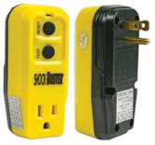  Outlet adapter GFCI | Outlet (receptacle) Adapters This type of GFCI can be plugged into a grounded receptacle to provide protection against ground faults whenever an electrical product is plugged into the adaptor. Older buildings are not equipped with receptacle type GFCIs, so outlet adaptors are a good option. The GFCI Outlet Adaptor have easy way GFCI protection.
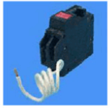  Circuit breaker GFCI | Circuit Breaker In buildings equipped with circuit breakers (not fuses), a circuit breaker GFCI may be installed in a panel box to protect selected circuits. The circuit breaker GFCI will shut off electricity in the event of a “ground-fault,” and will trip during a short circuit or overload. This protection covers the wiring and each outlet, lighting fixture or appliance served by the branch circuit protected by the GFCI in the panel box.
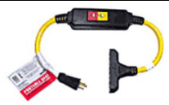  Portable GFCI | Portable Where permanent GFCIs are not practical, portable GFCIs may be used. One type contains the GFCI circuitry in a plastic enclosure with plug blades in the back and receptacle slots in the front. This is plugged into a receptacle, and then the electrical product is plugged into the GFCI. Another type of portable GFCI is an extension cord combined with a GFCI.
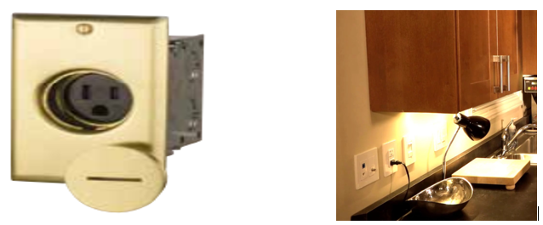
Figure 1. 12. Single Receptacle Brass Floor Box Assembly
​​​​​​​Ground Fault Circuit Interrupter (GFCI) receptacles are designed to recognize a ground fault in your wiring and immediately break the flow of electricity, thus protecting you from electrical shock.
- Grounding type convenience outlet
AC power plugs and sockets connect electric equipment to the alternating current (AC) mains electricity power supply in buildings and at other sites. Electrical plugs and sockets differ from one another in voltage and current rating, shape, size, and connector type. Different standard systems of plugs and sockets are used.
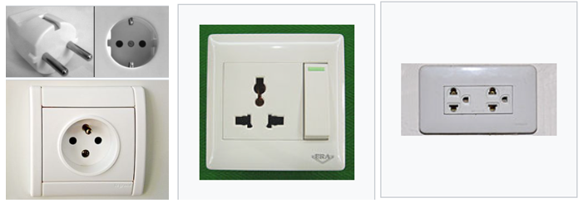
Figure 1. 13. Grounding Type Convenience Outlet
(1) Socket outlets in intermediate and critical care areas shall:
a) Meet the requirements of Clause 14.4.3; and
b) Where supplied from an isolated system, be so identified
- Light switch
- Light switch is a switch most commonly used to operate electric lights, permanently connected equipment, or electrical outlets.
- Portable lamps such as table lamps may have a light switch mounted on the socket, base, or in-line with the cord.
- Residential and commercial buildings usually have wall-mounted light switches to control lighting within a room.
Types of Switches
There are several different types of switches to choose from, based on a room’s circuit configuration, the number of lighting fixtures you need to control and the location from which you want to control those fixtures
- Single-Pole Switches
A single-pole light switch controls only one circuit. It’s the type most commonly found in homes and is simple to swap out. They're used to operate devices that consume up to 220 V of power. They're easily the most common types of light switches, the ones we've seen the most in our lives.
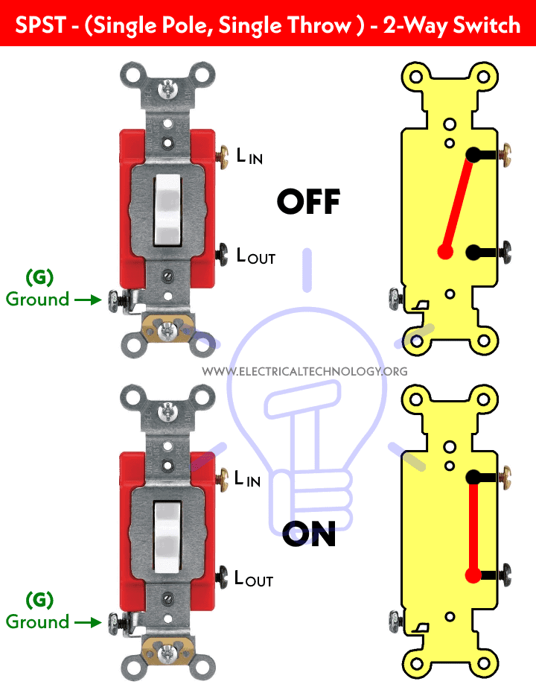
Figure 1. 14. Single-Pole Switches
- Double-Pole Switches
A double-pole light switch is designed to connect and control two individual circuits from the same location. It can be thought of as two switches joined together.
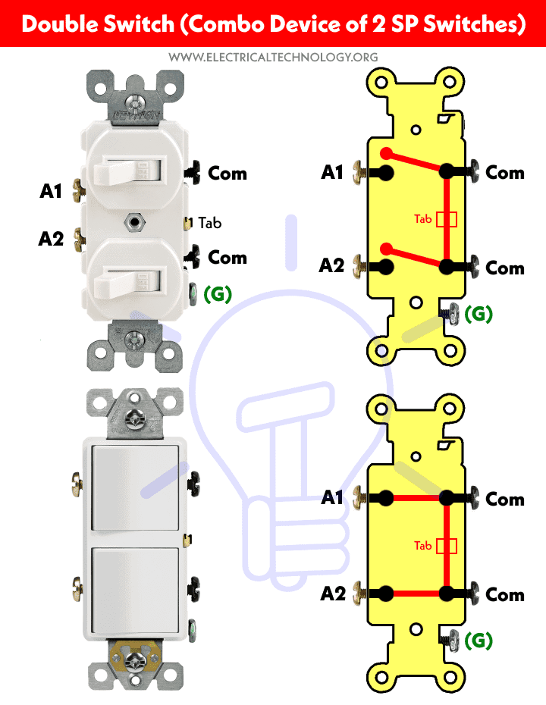
Figure 1. 15. Double-Pole Switches
- 3-Way Switches
If you need to be able to turn on a single lighting fixture from two different places, you’ll need a 3-way light switch. These types of switches are ideal for long hallways where you want to be able to flip the switch from either end, a stairway where you need to control the light from the top or bottom of the stairs, or for large rooms with multiple sitting areas.
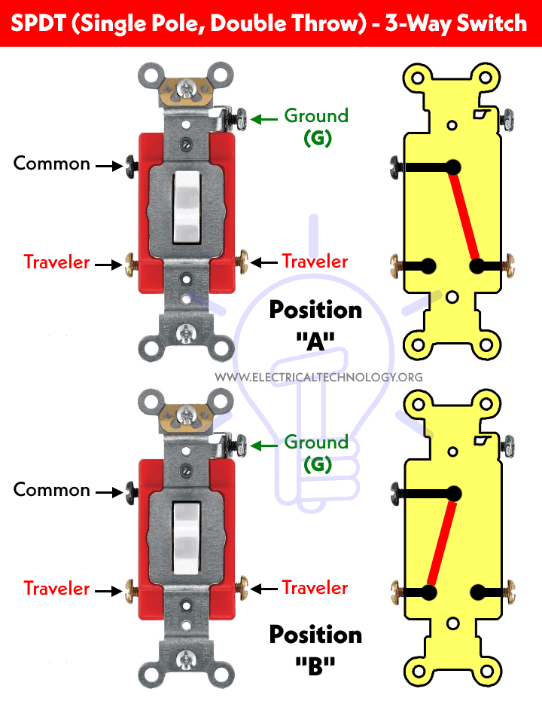
Figure 1. 16. Three Way Switches
- 4-Way Switches
In some areas, it’s necessary to control a lighting fixture from more than two locations. In this instance, a 4-way switch can be wired to two 3-way switches. This will give the user the ability to switch a light off or on from three or more different locations. The wiring for a 4-way switch is much more complicated than a single-pole or double-pole switch.
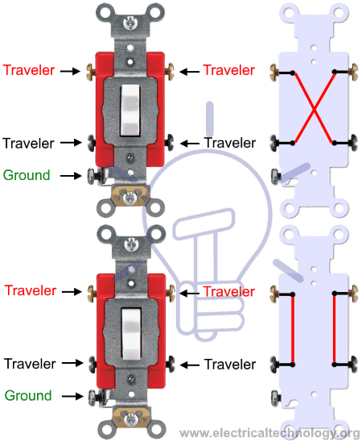
Figure 1. 17. Intermediate Switches

Consumableitems
Consumables means all items which are consumed in the execution of the Work, without being directly incorporated in the Work, such as fuel, electricity, water, POL, welding rods, electrodes and utilities.
- Wire nut
Making tight electrical connections is critical to a safe wiring job. If wires come loose, you could get arcing and overheating, which could lead to a fire. Wire nuts/ connectors and terminals, uses to make safe, strong connections.
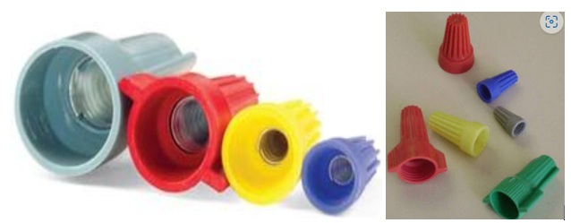
Figure 1. 18. Wire Nut
- Electrical tape
- Electrical tape (or insulating tape) is a type of pressure-sensitive tape used to insulate electrical wires and other materials that conduct electricity. It can be made of many plastics, but PVC (polyvinyl chloride, "vinyl") is most popular, as it stretches well and gives an effective and long lasting insulation. Electrical tape for class H insulation is made of fiberglass cloth.
- The primary tapes used in electrical applications are vinyl, rubber, mastic, and varnished cambric. Electricians generally use only black tape for insulation purposes.
- The other colors are used to indicate the voltage level and phase of the wire (colored tape sometimes is called "phasing tape"). This is done on large wire which is available only in black insulation.
- When wires are phased, a ring of tape is placed on each end near the termination so that the purpose of the wire is obvious. The following table(s) describe the use of electrical tape.
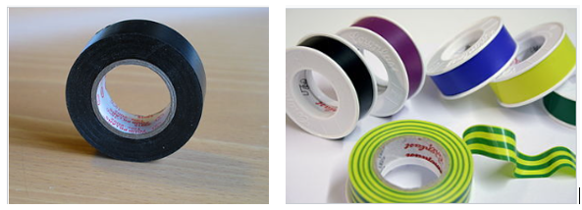
Figure 1. 19. Electrical tape, standard
Table 1.1. Electrical Tape Color Codes
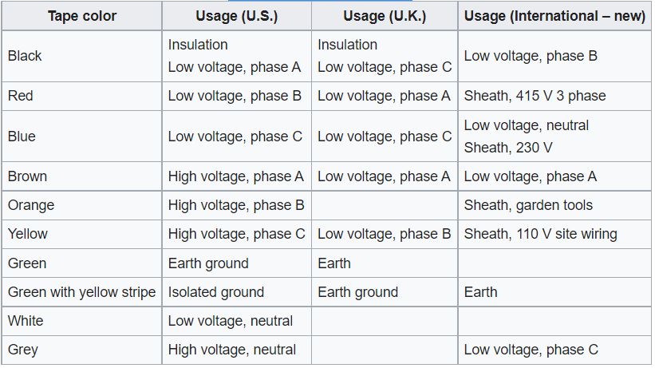
Number of Outlets per Circuit
- There shall be no more than 12 outlets on any 2-wire branch circuit except as permitted by other Sections of this Code.
- Such outlets in (1) above shall be considered to be rated at not less than 1.0A per outlet except as permitted by (3) below.
- Where the connected load is known, the number of outlets may exceed 12 provided the load current does not exceed 80% of the rating of the overcurrent device protecting the circuit.
Outlet Boxes
  - A box or an equivalent device shall be installed at every point of outlet, switch or junction of conduit and at every point of outlet and switch of concealed kllob-and-tube work.
  - Nonmetallic outlet boxes shall not be used in wiring methods using metal raceways, armored or metal sheathed cable, except where the boxes are provided with bonding connection between all conductor entry openings.
  - The box shall be provided with a cover or a fixture canopy.
  - At least 150.0mm of free conductor shall be left at each outlet for making of joints 'or connection of fixtures unless the conductors are intended to loop through lamp holders, socket outlets, or similar devices without joints.
  - Ceiling outlet boxes in concrete slab construction shall have knockouts spaced above the free or lower edge of the boxes a distance of at least twice the diameter of the steel reinforcing bars so that conduit entering the knockouts shall clear the bars without offsetting.
  - Boxes and fittings shall be firmly secured to studs, joists or similar fixed structural units.
Conductors in Boxes
  - Boxes shall be of sufficient size to provide usable space for all insulated conductors contained in the box.
  - Conductors which are connected to different power or distribution transformers or other different sources of voltage shall not be installed in the same box, cabinet or fitting

  - Selection of tools and equipment
- Wire strippers
Wire Strippers/ Cable strippers / Cable wire strippers are plier-like tools used to remove the insulating outer sheath from cables in order to attach terminals or connectors to the central core via crimping or soldering.

Figure 1. 20. Wire Strippers
- Insulated screwdrivers
Screwdrivers are one of the most traditional of tools but are still indispensable for most electricians who frequently require access to electrical containers sealed with screws. There are multiple sizes and shapes available for compatibility with the abundance of screw designs.

Figure 1. 21. Slotted Screwdrivers

Figure 1. 22. Philips Screwdrivers
- Insulated pliers
Pliers are another tool that has been with us for a long time. Their versatility means they can be used to accomplish a multitude of tasks requiring ‘torque’, working in a much more robust manner than would be possible with the use of bare hands alone.
Pliers are ideal for:Gripping, Twisting and Clipping

Figure 1. 23. Plier
- Electrical Tape
Electrical tape is used to insulate wires or other items that conduct electricity. Also known as insulation tape or electrical insulation tape, it is self-adhesive and pressure- sensitive, built to resist abrasion, heat and liquids in order to protect the sensitive conducting core within electrical wiring.

Figure 1. 24. Electrical Tape
- Hacksaws
Hacksaws are fine-toothed saws designed primarily for cutting through metal. The thin blades are held at tension in an adjustable frame, between the head of the saw and the pistol grip handle. These blades can break or become blunt but are easily replaceable.

Figure 1.0.1. Hacksaws
- Cable Cutters
Cable cutters are a staple of every electrician’s tool kit. These versatile tools feature steel blades and cut through standard wiring easily. Stronger cable shears will make short work of even thicker cabling. They also provide a handy way to strip off insulation for crimping and similar operations quickly.

Figure 1. 25. Cable Cutters
- Voltage Tester
Voltage indicators, or ‘multi-meters’, are handheld devices used for – you guessed it – testing whether a live current is present in a particular location. They are primarily employed for safety purposes when checking cabling, switches, junction boxes or similar equipment.
The presence of voltage is indicated by the illumination of a light-emitting diode. If this light appears, electricians know to shut down the current before beginning work. This is a vital safeguard and one required by health and safety legislation.

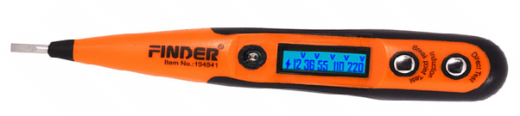
Figure 1. 26. Voltage Tester
- Safety Knife
Safety knives are not just a specialist professional tool – they are in fact familiar to most of us. We may know them as Stanley knives, utility knives, pen knives or box cutters. The principle remains the same whatever name is used: the knife blade is shielded for safety at most times and only extended when in the tool is actually in use, thereby minimizing accidents and injuries.
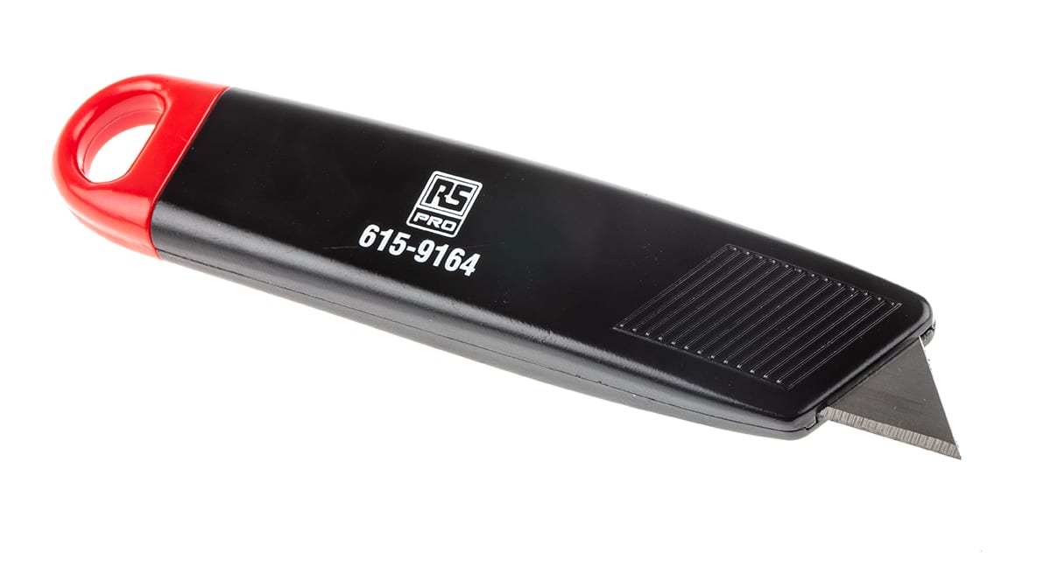
Figure 1. 27. Safety Knife
- Claw Hammer
Claw hammers feature a standard hammer on one side of the tool, primarily used for inserting fixtures like nails, and a dual steel claw at the other end, which is designed to enable the easy removal of the same nails or similar fixtures by applying a robust grip.
Claw hammers are useful to gain access to sealed spaces – for example, fuse boxes hidden behind the paneling.

Figure 1. 28. Claw Hammer
- Chisel
Chisels are another ancient tool that have lost none of their power or utility in the present day, providing a powerful and time-honored method of breaking through wood, stone, brick, concrete and similar materials. Modern chisels are made from various steel alloys.
Electrician’s chisels are a specialist variation used to cut channels in walls during installation procedures. Popular sizes to keep in your tool kit include:5mm, 10mm, 16mm, 18mm, 20mm, and 50mm.
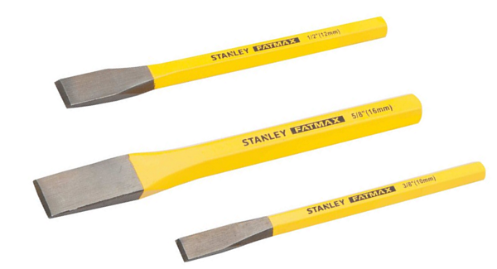
Figure 1. 29. Chisel
- Fish Tape
Fish tape is a tool used by electricians primarily for pulling electrical or other wires through conduits. It's also used for pulling NM wire through walls, ceilings, floors, and other enclosed spaces. The fish tape itself is a long, stiff, flat steel wire.

Figure 1. 30. Fish Tape
  - PPE Identification and selection
Personal Protective Equipment (PPE) refers to items typically worn by a worker to provide protection from recognized hazards. Depending on the job task to be performed, PPE for the electric power industry generally includes safety glasses, face shields, hard hats, safety shoes, insulating (rubber) gloves with leather protectors, insulating sleeves, and flame-resistant (FR) clothing.
In addition to PPE, electric power workers often use Insulating Protective Equipment (IPE), such as line hoses, rubber hoods, rubber blankets, and insulating live-line tools (for example, hot sticks, switch sticks, or shotgun sticks) for protection. However, since IPE is not worn, it is technically not considered to be PPE and is discussed in a separate section of this Tool.
Basic PPE consists of:
- Cotton protective clothing with long sleeves
- Helmet or Hard hat
- Goggles for eye protection
- Gloves (leather or rubber)
- Hearing Protectors
- Safety Footwear
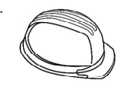
Figure 1. 31. Safety Footwear Figure 1. 32. Gloves Figure 1. 33. Helmet
Clothing provides protection from electric arcing/flash burns, flying objects and electric shock. Ideally, clothing should cover the body completely, and:
- be of appropriate material (either wool or cotton, but not synthetics)
- have non-conductive and concealed buttons
- have sleeves to wrist length, and
- Have legs which reach to your footwear.
Safety helmets should be non-conductive.They provide protection from overhead wires, structures and falling objects.
Safety glasses provide protection from electrical arcing and flying objects.
Insulating gloves provide protection from electric shock. They should be worn when accidental contact with live conductors is possible, but they must never be the sole means of insulation.
When using gloves, note:
- rated gloves are designed for live work and are rated according to the level of voltage they are able to insulate against
- Rated gloves should be tested regularly to determine their effectiveness
non-rated gloves are for mechanical protection only.
- All gloves must be inspected before each use.

Self-check-1
Part I. Multiple Choice:
Directions: Choose the letter of the correct answer. Write your answer on a space provided on the left side of each questions.
____ 1. One of the following is correct about electrical wiring plan.
        - contains legend that provides a visual explanation of the symbols
        - delivers visual representation and describes circuits and electrical systems
        - describes the position of all the electrical apparatus
        - All
____2. One of the followingis used for the representation of electrical components in their approximate physical location using their specific symbols and their interconnections using lines.
a). single lie diagram b). Wiring diagram c). Block diagram d). all
____3. It is type of switches which can be used to control lamps from one location only
a) Dimmer switches b). Two way switches c). Intermediate switches d).one way switches
____4.which tool used by electricians primarily for pulling electrical or other wires through conduits.
- Electrician Knife b. Plier c. Fish tape d. tester
Part II. Give short and precise answer for the following questions
            - What is the purpose of ground fault circuit interrupters?
            - List at list three types of wiring devices.
            - Name and explain at least 3 consumable items.
            - Explain the purpose of plier.
.

Operation sheet-1
Operation Title: SKETCHING ELECTRICAL WIRING PLAN
Instruction: follow the give steps properly
Purpose: to exercise electrical plan reading and interpretation
Required tools and equipment: Sketch pad/ A-4 papers,Pencil,Eraser, workbench, Procedure: Note: one Oslo paper/ bond paper for each required task
Precautions: check your workbenchneatness
Procedures:
Step 1. Draw a floor plan.
Step 2. Layout the position of light outlet in your floor plan.
Step 3. Lay out the position of power outlet in your floor plan.
Step 4. Connect the power outlet to its corresponding circuit branch.
Step 5. Prepare the load schedule.
Step 6. Prepare legends.
Step 7. Prepare the schematic feeder diagram (riser).
Quality criteria:
- Accuracy of Electrical Layouts

LAP Test #1 | Practical Demonstration

Name: __________________________ Date: ____________
Time started: ____________________ Time finished: _______________
Instruction I: Given necessary templates, tools and materials you are required to perform the following tasks within 10 hours.
Task 1:Draw the necessary electrical symbols in their proper locations to complete the electrical house plan
Task 2:demonstrate the connection of switches
Task 3:draw ad demonstrate the two lamps controlled from two locations simultaneously.

UNIT TWO: INSTALL WIRING SYSTEM
This unit is developed to provide you the necessary information regarding the following content coverage and topics:
- Safety procedures
- Installation of wiring devices
- IEE wiring regulations
- Schedule of work
- Quality of work
- Further instructions from a supervisor
- Unplanned events or conditions
This unit will also assist you to attain the learning outcomes stated in the cover page. Specifically, upon completion of this learning guide, you will be able to:
- Follow safety procedures based on safety regulations
- Perform correct procedures for installation of wiring devices in line with job requirements
- Follow Schedule of work on agreed time, quality standard and minimum wastage
- See further instructions if unplanned events or conditions occur
- Do on-going checking of quality of work in accordance with instructions and requirements

  - Safety Procedures
Before starting any installation work, the first and foremost thing is the concern of safety of the personnel. Electricity is dangerous and direct or indirect contact of electrical equipment or wires with the power turned ON can result in serious injuries or sometimes even cause’s death. Follow the below steps to maintain the safety at the workplace.
- Safety procedures during wiring installation
When installing any type of wire or wiring system, there is always risk involved. These risks of course include harming yourself, someone else or loss of property if the wires are not properly installed or necessary precautions are not taken.
There are a few proactive measures you should take when you are working with or installing wires. Keeping the following tips in the forefront of your mind will help to make sure you do not cause any harm to your property and keep safe you safe at the same time.
- Make Sure the Power is off
Check the breaker or power source and make sure the power is always off before starting any electrical work. Lock the breaker if possible or if cannot, make sure everyone in the area knows it is turned off for a reason and leave an easily noticeable note that you are working on the electricity. It’s logical but critical for a safe work environment.
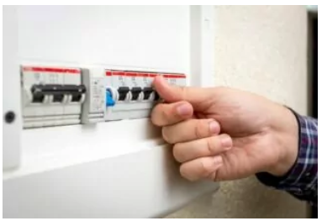
Figure 2. 1. Making Circuit Breaker Off
- Wear Safety Glasses and Protective Clothing
Covering your eyes is a must when dealing with electricity. You do not want sparks or other debris to get in your eyes. Also, wearing long shirts, pants, gloves, and thick soled shoes are also a good idea. If the environment is outdoor or large scale, working on a project like laying pipeline with tracer wire, a hard hat may also be needed along with other construction environment safety gear.
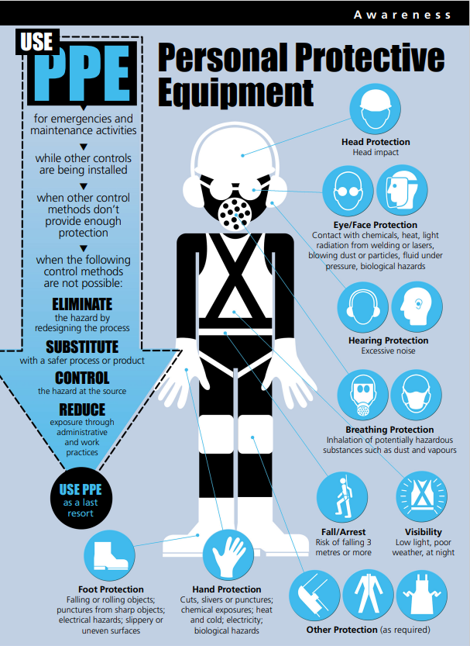
Figure 2. 2. PPE
- Always Test First
Use a voltage tester to test the wires and connections before you begin working on them to make sure they are indeed dead. This will allow you to accurately judge the work that needs to be done and select the product and tools you need to use.

Figure 2. 3. Testing
- Have the Right Tools On Hand
As with any job, you need the correct tools to complete it properly and do it with safety in mind. Having the right tools for a wire installation is detrimental. Some tools include: a voltage tester, wire cutters, wire and cable strippers, needle nose pliers, continuity tester, and others. For large scale jobs such as installing ground cables, you may need a wire trencher or other digging equipment or heavy machinery.
- Check Your Work
Before you close up the hole or call the job “done,” check your work! The last thing you want is there to be a loose connection and the whole project to go up in flames – literally. Electrical fires are known to spark at any time and cause considerable damage and tragedy. Pull on the connections to make sure they are secure. Turn on the electricity and make sure everything works correctly and starts up without incident. Also, check the casings with a voltage tester to make sure they are not electrified. Use the right insulators for longer life spans too.

  - Correct procedures for installation of wiring devices
- Procedures for Installation of wiring devices
- Bracket outlets shall be level & centered on columns or above doors when installed in these locations.
- Wires shall be tested with a500v insulation tester before installation, after marking off all the wires.
- Ensure all accessories are properly earthed.
- Ensure all accessories boxes with approved depths as specified are installed and check for correct mounting height and where accessories and similar components are shown adjust to each other the lower edges are to be in line. Proper leveling shall be checked for all accessories.
- Installed wiring accessories shall be covered by suitable protective sheets from any damages.
- Cover plates of all wiring accessories are to be fixed only after completion of painting and finishing works and shall be kept protected against dirt and damages.
- Gap between wiring accessories shall be uniform.
- All light switches unless noted are to be located on latch side of doors. Coordination with architectural drawings are required.
- All power sockets & lighting switches are to be provided with earthing terminal.
- All wiring accessories shall be fixed flush with finishing surfaces.
- Internal wiring of the lighting fittings shall be appropriate type and size and number. Conductor shall be of size not less than 1.5mm2, single core or relevant. The insulation of the cables shall be able to withstand throughout the life of the fitting and maximum temperature to which it will be subject in normal use without deterioration which could affect the safety of the fitting.
- Wiring accessories are to be installed as per approved drawings. Bottom of the wiring accessories in a group shall be maintained in same level as heights are indicated in the approved shop drawings. When different outlets on the wall, keep always the same order of outlets like 13A switches, sockets, television, telephone and data.
- Wiring accessories installed in exposed external areas shall be of weather proof type. Proper care should be take while installing the gaskets ad other accessories.
- Types of wiring accessories are to be selected as per the approved material submittal.
- Ensure that the civil works including finishing are completed for the area of installation ad released/cleared by civil section to proceed o with the installation of wiring accessories.
- Ensure that all the wiring accessories are received at site as per approved material submittal.
- Installation works shall be carried out only with respect to approved shop drawings of latest revision.
Steps/Procedures for Installation of Switches
- Prepare a single line diagram based on the layout plan, indicating the number of wires per line.
- Cable pulling based on the single line diagram.
- Strip the insulator of the wire 10mm-13mm from its tip.
- Connect lighting switches by referring on the wiring diagram
        - For single switch
        - For duplex / two gang switches
        - For triplex / two gang switches
        - For three-way switch
        - For four-way switch
Steps/Procedures for GFCI Outlet Installation
Installing a new GFCI Outlet involves, taking out the old standard receptacle, wire the new GFCI Receptacle and install GFCI Outlet into the receptacle box.
We will understand the GFCI Outlet Installation by taking a step-by-step approach.
- The first and important step is to shut-off the power to the circuit where you are installing the GFCI Outlet. After turning off the power (simply flip the circuit breaker), you can test for electricity with the help of a circuit tester.
- Now, remove the screw of the cover and also take out the cover entirely. This will expose you with the actual mounting screws of the old receptacle.
- Loosen both the mounting screws and carefully remove the receptacle without touching any wires. Double check for electricity in the wires with a circuit tester.
- Loosen the silver screws and disconnect all the neutral wires from the receptacle.
- Connect all the neutral wires using a wire nut and pigtail one neutral wire. Connect this pigtail neutral wire to the WHITE LINE terminal on the GFCI.
- Now, disconnect all the black HOT wires from the old receptacle and connect them using a wire nut. Also, pigtail one HOT wire.
- Connect the hot pigtail wire to HOT LINE terminal of the GFCI, which will be just opposite to the WHITE LINE terminal.
- Remove the bare ground wire from the old receptacle and connect it to the green grounding terminal of the GFCI. If there is no grounding connection, mark this receptacle as “No Equipment Ground” for your reference.
- Tuck in all the wires carefully into the box and slowly insert the GFCI Outlet into the receptacle box. Using the mounting screws, secure the GFCI Outlet to the box firmly.
- Reattach the cover plate and secure it with the screw. Turn on the power and test the new GFCI Outlet using the TEST and RESET buttons (follow manufacturer’s instructions on how to test).

2.2.1. IEE wiring regulations
Basic Requirements for Wiring a Residential House
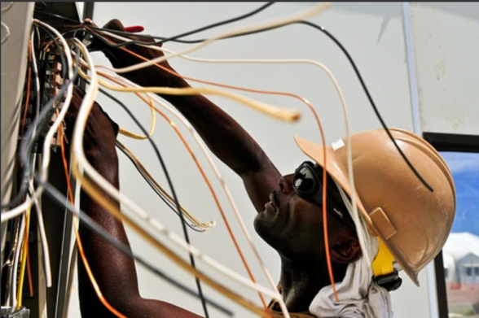
Figure 2.4. Wiring a Residential House
- Wiring is complex and very different from other aspects of home improvement. Knowing how it works is of great benefit to you.
- However, some localities only approve a licensed electrician for residential house wiring. This is because of the risks involved in making a simple error. You can do your installation under the supervision of a licensed electrician to avoid costly mistakes.
Requirements for Wiring Various Parts of the Home
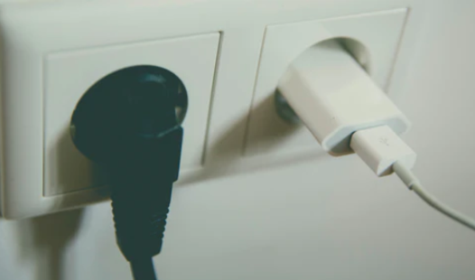
Figure 2.5. Socket outlets
These standard living areas require a moderate power supply. The living room, dining, and bedrooms are generally served by 220-volt 15 or 20amp, which can serve more than one room.
Install a wall switch beside the entry door of the room. This switch is to enable you to light the room easily when you enter it. It will control ceiling fixtures or wall light. A pull chain should not control your ceiling light; install a switch.
Your dining room requires a separate 20amp circuit for a microwave or window air-conditioner. All wall sockets must not be more than 12 feet away from one another. If you have any wall section that is wider than 2cm, install an electrical socket.
- Bathroom
- Remember that bathrooms are always wet, so be extremely careful. Bathrooms may need more than one circuit because of the lights, vent fans, and outlets for hairdryers and other appliances.
- A 20-amp circuit is recommended for the outlet sockets in the bathroom. The circuit can be used to supply the whole bathroom (a single bathroom) if there are no heaters or vent fans with built-in heaters. You can also use a 20-amp circuit for sockets and another 15amp for the lighting.
- If you plan to use a vent fan with a built-in heater, have a separate 20-amp circuit solely for it. Your sockets should be at least 220 volts for a bathroom and must have ground-fault circuit-interrupter protection (GFCI).
- All light fixtures in the shower area, if not subject to shower spray, must be rated for damp locations. You may add an extra outlet close to the door for your vacuum cleaner, depending on the size of the bathroom.

- Kitchen
- The kitchen uses more electricity than any other room in a house. A kitchen with standard appliances requires about seven circuits or more.
- Kitchen lighting requires at least one 220-volt 16-amp circuit separately. It can power ceiling fixtures, canister lights, strip light and under-cabinet lights. A switch must be installed for each set of light so that you can control lighting easily.
- For portable plug-in appliances, install two 20-amp 220volt circuits for sockets in the countertop areas. Almost all standard kitchen appliances require a circuit dedicated to them. The dishwasher, garbage disposal, refrigerator, and microwave each require 220-volt circuits.
- Install an electric range with a 240volt 50-amp circuit even if you won't need it right away. An electric range can be a selling point for you if you want to sell the house.
- Check the manufacturer's recommendations to confirm the more appropriate circuit for your dishwasher and garbage disposal between the 16-amp and 20-amp circuits. As for refrigerators and microwaves, the amperage would be 20-amp. Countertop sockets must not be placed farther than 6 feet apart.
Hallways

Figure 2.6. Hallway Lighting
- Hallways can be very long, so they need efficient lighting. You have to install enough light to avoid casting shadows.
- If your hallway is 10 feet long, you can use a general outlet. The switches should be installed three-way so that the ceiling light can be controlled from both ends. Make it four-way if the hallway serves a bedroom or any other room.

- Stairways
All steps must be adequately lighted; you don't want trips and falls. Just like the hallway, you need the switches in three-way so that you can put it on or off from both ends. If your stairway has a turn, ensure that the area is appropriately illuminated.
- Closets
Fixtures with very hot light bulbs (incandescent light) must be enclosed in a globe. They must be installed over 12 inches far from the clothes or 6 inches if they are recessed. LED bulbs can be installed at least 12 inches from the storage area or 6 inches if they are recessed. Surface-mounted fixtures should be on the ceiling or wall above the door.
- Laundry
Here, the electrical requirements are based on the type of clothes dryer you choose to use. If you wish to use a gas dryer, install at least one 20-amp circuit for the laundry equipment. On the other hand, dedicate 30-amp 240-volt wired with four conductors if you are planning to use an electric clothes dryer. It is also essential that all sockets in a laundry room be GFCI protected.
  - Schedule of work
The following details can be seen in the schedule of load:
- Number of branch circuit of electrical wiring system
- Number of light outlet, power outlet and switches per branch
- Total wattage rating of the load per circuit branch
- Total current load per circuit and size of wire used
- Computation of the total power and current of each circuit branch.
- Size of conduit used for feeder line and branch circuits. The Riser Diagram is a single line diagram presentation of the entire electrical circuit from the service entrance up to the smallest circuit branch. It shows:
- Character and type of service, single phase 2 wire/ 3 wire
- Size of service entrance conductor and the conduit used
- Type and size of wire for each branch
- Size of protective device for main circuit breaker and each branch

  - Quality of work
Installation of wiring devices must be:
- Horizontally and vertically aligned
- No gap between plate cover and wall
- Wire cut to requirement
- All bolts tightened for rigid mounting
  - Further instructions from a supervisor
- For safe installation, commissioning and operation, the instruction and legal manual with the product must be read.
- Ensure always install the product according to the local electrical code.
- Before any assembly or disassembly or replacement of the lighting fixture always switch off the circuit breaker
    - Unplanned events or conditions
Unsure what can and frequently does go wrong with electrical installations and repairs? The following list can help you understand each process and identify what may have gone wrong:
Insecure Wiring: - If the staples holding wiring in place are driven too tight around the wire, locking it into place on the beam or stud, serious damage can occur, including breakdown of the wire itself. This may lead to electrical fires and issues with the lighting or appliances powered through this wiring.
Wiring Size Issues:-Using the wrong type or size of wire can cause overheating, as the wire is carrying more current than it was built to withstand. In most cases, the thicker the wire, the more current it can safely carry. If your wires feel warm, sizing issues may be the cause.
Improper Wire Length: - In order to create a durable electrical connection, wires must be stripped to reveal their metallic core. The length of wire that can legally be stripped is subject to code regulation, and improper wire stripping can cause nicks on the metal that interrupt connections or cause short circuits. At least six inches are recommended to allow for handling within the outlet box.
Unprotected Wiring: - Wiring can become damaged if left uncovered and exposed to harsh changes in weather or tampering. For this reason, a common problem for homeowners in particular is an uncovered power box located on the outside of your home. The fix is simple. Purchase and install an outdoor-specific power box to ensure that your electrical wiring is safe and sound.
Connection: - Tight electrical connections are a major factor in safe wiring jobs. Loose connections can cause arcing and overheating, which can lead to fires and personal injury. An experienced electrician will be able to choose a connector that fits the wires and lines up the ends of each with the next, helping you avoid nicked, bent, or twisted connections.

Self-check #2
  - Choose the correct answer from the give alterative
- Installation of wiring devices must be:
          - Horizontally and vertically aligned c) No gap between plate cover and wall b) Wire cut to requirement d) All
- The electricity supply to a domestic consumer is usually protected at the incoming service position by a:
- Meter b)Double pole switch c) MCB d) HBC fuse
- To work safely and care for the safety of others is the responsibility of:
- an employee b) an employer c) everyone d) the Government
- A scale drawing showing the position of equipment by graphical symbol is a description of
- block diagram b) layout diagram or site plan c) wiring diagram d) circuit diagram
- A conductor is a material in which the electrons are:
- very large compared with the nucleus c) tightly bound to the nucleus
- positively charged to the nucleus d) loosely bound to the nucleus
- To correctly measure the current and voltage in a circuit, the meters must be connected to the load in the following way:
- ammeter in series, voltmeter across the load
- ammeter across the load, voltmeter in series
- ammeter in series, voltmeter in parallel
- ammeter in parallel, voltmeter in series e) a) & c)
  - Give short ad precise answers for the following questions
- List at list 4 advantages of personal protective equipments?
- List theSteps for Installation of Switches?

Note: Satisfactory rating – above 60% Unsatisfactory - below 60%
You can ask you teacher for the copy of the correct answers

Operation sheet #2

Operation Title: Install wiring device
Instruction:
Purpose: to install different types of wiring devices safely.
Required tools and equipment: unit one of this module, measuring devices from workshops like multi meter, clamp meter & energy meter
Precautions:
- use safety personal protective equipments properly
- Follow the instraction of the task.
- Check measuring devices weather it is functional or not
- handle measuring devices properly
Procedures:
Step 1: Prepare yourself inorder to perform the given task
Step 2: Collect the required electrical devices accessors for the given task
Step 3: before starting do the given task make sure the power is off
Step 4: Check measuring devices weather it is functional or not
Step 5: install the given wiring systems& inspect it
Step 6: finally install your wiring system & check its functionality (continuity) using multi-meter
Step 6: At the end of your work clean, return & put the hand tools &measuring devices on the previous location

LAP Test #2

Name: __________________________ Date: ____________
Time started: ____________________ Time finished: _______________

Instruction I: Given necessary templates, tools and materials you are required to perform the following tasks within 10 hours.

Task 1:change the given layout diagram to wiring diagram
Task 2:change the given electrical plan in to layout diagram

UNIT THREE: INSTALL LIGHTING FIXTURE/ SWITCHES
This unit is developed to provide you the necessary information regarding the following content coverage and topics:
- Safety procedures
- Installation of lighting fixture and auxiliaries
- On-going checks of quality of work
This unit will also assist you to attain the learning outcomes stated in the cover page. Specifically, upon completion of this learning guide, you will be able to:
- Follow safety procedures
- Perform correct procedures for installation of lighting fixture and auxiliaries in line with job requirements
- Undertake on-going checks of quality of work in accordance with instructions and requirements

Safety procedures
When installing any type of wire or wiring system, there is always risk involved. These risks of course include harming yourself, someone else or loss of property if the wires are not properly installed or necessary precautions are not taken.
There are a few proactive measures you should take when you are working with or installing wires. Keeping the following tips in the forefront of your mind will help to make sure you do not cause any harm to your property and keep safe you safe at the same time.
  - Before you reach for that busted light bulb, make sure to switch it off and allow it to cool down. Protect yourself from electrocution by wearing rubber gloves and wearing rubber soled footwear.
  - If the wires and plug of your lighting device are accessible, switch off your lamp and carefully unplug your device from the power source. Inspect the wires if they are worn out, frayed or smell burnt as these might also cause further damage if plugged in again.
  - Make sure to replace the broken or busted lamps with those of the right wattage. Once you fit the new bulb in, make sure to keep a safe distance from the light fixture before you turn it on in case the replacement accidentally falls or blows up.
  - If replacing the defective bulb with another of a proper wattage does not fix the problem, do not poke around and experiment with your wires and sockets without sufficient knowledge. Instead, call for accredited electricians who definitely know what to do.
  - Be proactive. If you notice any flickering or irregular glowing and dimming of the lights, chances are that bulb or the lighting device itself may be defective and needs to be repaired or changed. Have it checked professionally to avoid possible electrical dangers
Correct procedures for installation of lighting fixture and auxiliaries

3.2.1 Lighting fixture and auxiliaries
- Auxiliary Lights
In the traditional design, the main lamp must be blessed in the room to highlight the real lighting function and the decorative effect of the core meaning.
However, as people's aesthetic level changes, the demand for home quality and atmosphere is also increasing. Here are some of examples of auxiliary lamps
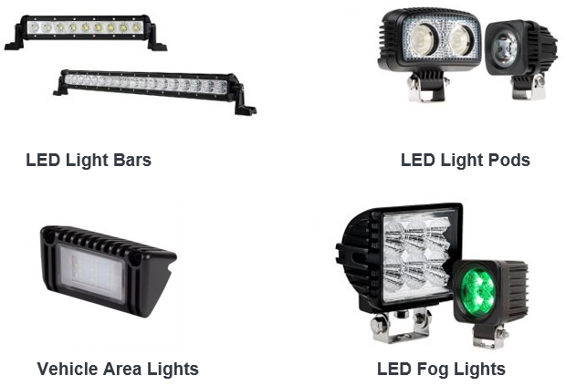
Figure 3. 1. Auxiliary Lights
- Lighting fixture
A lamp is an artificial source of light. Over the last 100 years, lamps have become an integral part of our daily lives.And also, the term ‘bulb’ is used to represent a lamp but it is an external glass part that includes the light source.
Various types of lamps are available on the market. These lamps differ in their operating principle, materials used, and importantly – their energy efficiency
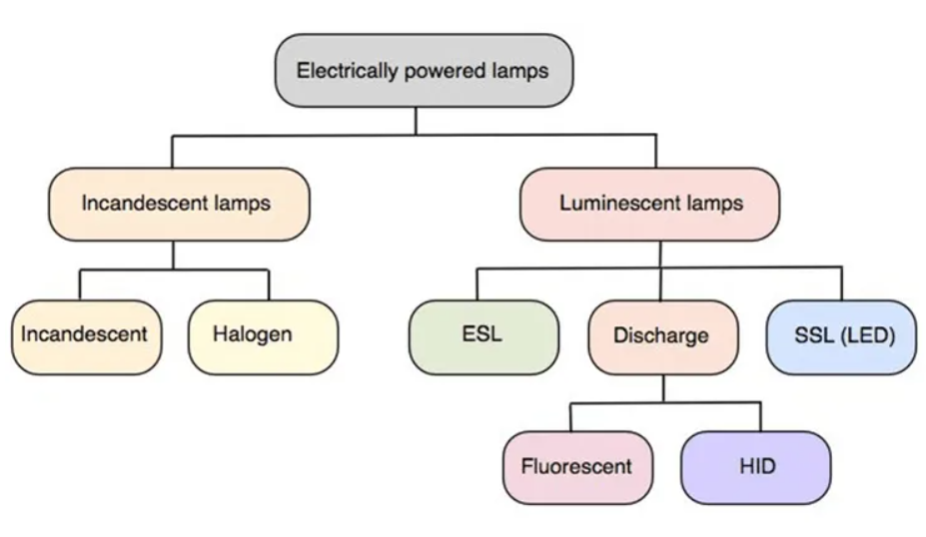
Figure 3. 2. Lighting Fixture

Types of Lamps and Their Applications
There are different types of lamps available in the market but their classification can be done based on materials used, operating principle & their efficiency of energy. The different types of lamps include the following.
Incandescent Lamps
The incandescent light or lamp is an electric light source that functions through incandescence, which means the light emission can be caused through filament heating. These are available in an extensive range of wattages, voltages & sizes.
These lamps are the original electric lightings and the inventor of this lamp is Thomas Edison. Generally, these lamps are designed with glass including a tungsten filament.
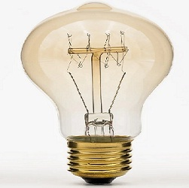
Figure 3. 3. Incandescent Lamps
Tungsten Halogen Lamps
- A tungsten halogen lamp is also called quartz iodine & quartz-halogen, is one kind of incandescent lamp that includes a tungsten filament enclosed within a solid transparent cover. This cover is packed with a combination of a halogen & an inert gas like bromine or iodine.
- As compared to fluorescent and LED, halogen incandescent & standard bulbs are less efficient.
Fluorescent Lamps
- A fluorescent lamp or bulb is a less pressure gas-discharge with mercury-vapor lamp and it generates visible light by using fluorescence. In this bulb, once the electric current supplies then the gas will excite the mercury vapor to generate short-wave UV light, and then it causes a phosphor coating within the lamp to blink.
- The main function of a fluorescent lamp is to change the energy more efficiently from electrical to as compared to incandescent lamps.
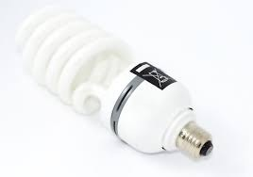
- The fluorescent lamps’ usual luminous efficiency ranges from 50 to 100 lumens/watt. In contrast, the luminous efficiency of an incandescent is simply 16 lumens/watt.
Compact Fluorescent Lamps (CFL)
- The compact fluorescent lamp is one kind of fluorescent lamp that is normally designed to replace halogen or incandescent lamps. These lamps are available in two types like screw-in & plug-in.
- Screw-in type lamps can be arranged in a screw socket without using extra equipment whereas plug-in type lamps need weight & a socket that communicates with their exact base arrangement.
- Functionally, compact fluorescent lamps are equal to linear fluorescent bulbs because these two lamps are gas discharge-based lamps.
Mercury-Vapor Lamps
- A gas discharge lamp like a mercury-vapor lamp utilizes an electric arc throughout vaporized mercury for generating light.
- These types of lamps are energy efficient as compared to incandescent. The main benefits of these bulbs are, lifespan is 24k hours, high intensity, and output is clear white light. So these are the main reasons to use these lights in large overhead lighting within warehouses, sports arenas, streetlights, factories, etc.
Metal Halide Lamps
- A metal halide lamp is also called an MH lamp & it is a high-intensity discharge lamp that means it generates its light using an electric arc in a small discharge tube.
- These lamps are mostly used in sports fields, stadiums, parking lots & street lights in urban places.
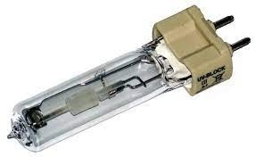
Metal Halide Lamps
- The competitors of these lamps are the HPS, mercury vapor, LPS, halogen & LEDs. These lamps have more benefits so used in various applications.
- The disadvantages of metal halide lamps include expensive, light pollution, etc.
High-Pressure Sodium (HPS) Vapour Lamps
- These lamps are mainly used in street lighting &other lightings.
- Once current supplies in between the two electrodes, then it ionizes the argon & neon to provide a red glow till the hot gas evaporates the sodium. After that, this sodium ionizes & shines almost monochrome yellow.
- These lamps provide a whiter light where extra-bright lighting is required in public places like tunnels, road intersections, sports stadiums, and where it is popular to notice a complete range of reflected colors.
Low-Pressure Sodium (LPS) Vapour Lamps
- LPS lamps are extensively used in street lights due to their efficiency & the capability of their yellow color light to go through fog.
- An LPS lamp is also called a miscellaneous discharge lamp because it possesses some HID lamps characteristics & in other areas, it looks like fluorescent lamps.
- These types are inexpensive to utilize on the road & security lightings wherever the object color is not significant. These are mostly used in foggy weather conditions.
LED Lamps
- LED lamps are electric lights that generate light through LEDs & these are extensively more energy-efficient as compared to incandescent lamps & fluorescent lamps. The commercially available & most efficient LED lamps have 200 lumens for each watt.
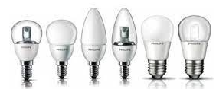
LED Lamps
As compared to incandescent lamps, the lifespan of LED lamps is more. These lamps work through a LED driver circuit to function from power lines.
- Wall lights
Wall lamp is a kind of lighting fixed on the wall. Most of them do not provide local lighting, more decorative and artistic lighting.
Common in corridors, next to bedside tables in bedrooms, gardens, art galleries and other places. Wall light adds an interior decoration and lighting assistance to the house, it looks less monotonous.


- Ceiling spot lights/ a spotlight or follow spot
- LED spots for all purposes, whether for the bedroom, the kitchen or the bathroom.
- LED spots and spotlights are robust and energy-efficient light sources that have a very long life and a low electricity consumption. The discreet, classic designs mean they will fit into any decor.
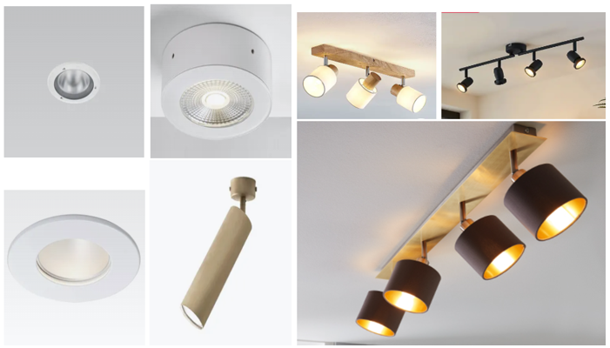
- Tape and extrusion
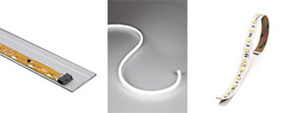
- Directional recessed fixture or downlight

- Track light
The track light is composed of a track head and a track rod. The flexibility track head is adjustable with the adjustment position are very good commercial lighting options. Inside the mall, merchants want to focus on launching some products, or focus on which part to display, direct focus of the track head lighting will attract people's eyes. The same method is used in art galleries.
The tracks come in various lengths which can be cut and connected with the use of accessories (both rigid and flexible) to change the configuration of the track system. Once the track is in place, lighting heads are then clipped into the track in their desired location. The lighting heads can then be further customized and angled to the precise position.


Installation of lighting fixture and auxiliaries
How to Install a Light Fixture
Installing a new light fixture requires careful planning and attention to detail. There's no room for error when it comes to electrical wiring, which means you've got to organize properly and learn the regulations to make sure your project is safe and up to code.
Part1 Planning the Project
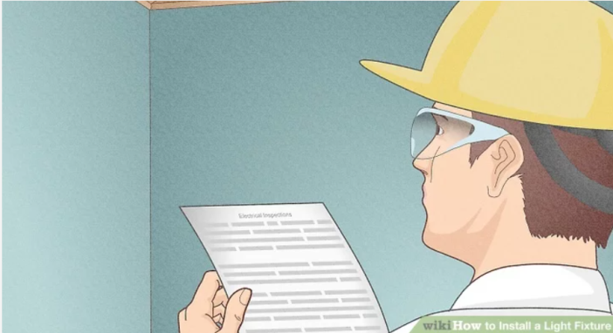
Step 1:- Check your local wiring codes and schedule inspections. Several inspections and permits are required for most residential construction projects, especially when it involves installing or replacing new wires (simply replacing a fixture usually does not require permits and inspection).
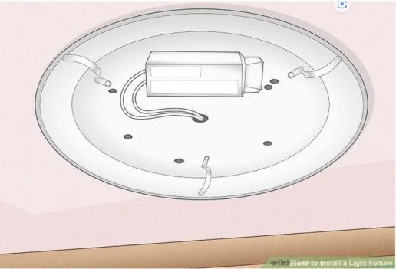
Step 2:- Decide what type of fixture will work best in the area you’re trying to illuminate. You wouldn't want to light up a workshop in the same way you'd light up a nursery, or a kitchen the same way you'd light living room. Think about the purpose of the room to determine where and how you'll light it.
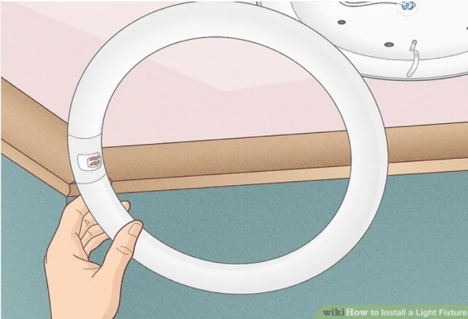
Step 3:- Decide what kind of bulb you want for your fixture. Incandescent, fluorescent, LED, mercury vapor, high pressure sodium and halogen are among the most common choices, each with its own unique color tone or range of color tones form which to choose.
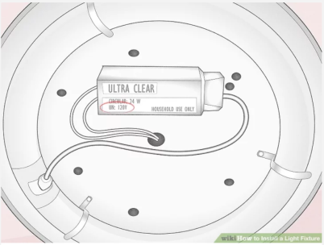
Step 4:- Determine voltage and current requirements for the fixture. The fixture must operate on a voltage available at the location. Nearly all fixtures available at home centers in Ethiopia will be the 220-volt.
- Most fixtures will list a wattage or amperage requirement to avoid overloading the circuit.
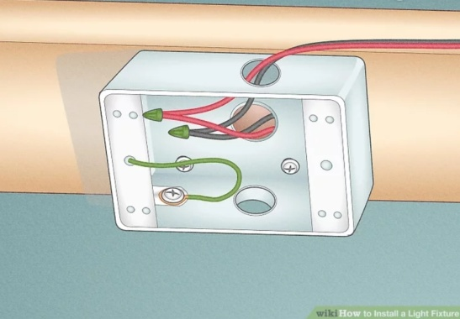
Step 5:- Locate a suitable power source. Find a nearby outlet or an existing junction box in the ceiling that's close enough to branch out from.[6] If a suitable power source isn't easily available, you might have to run a new branch from the electrical panel.
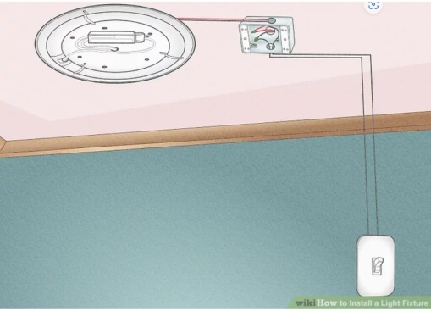
Step 6:- Plan the wiring route.[7] There are three possible ways to wire the circuit for a new installation. Power to switch, power to fixture and installing the power and load point at same switch. The three points, source, switch and fixture need to be connected together all with simple two-wire when there is one switch controlling the fixture.
- If you're wiring multiple switches to multiple fixtures, it's important to separate your wring systems to keep them straight. The fixtures need to be wired to each other with a two-wire cable, and the switches need to be wired to each other with a three-wire cable.
- The power source can be brought to either of the three-way switch boxes, or any fixture box with two-wire cable. The cable between the switch and fixture(s) is also 2 wire type, but must be run from either three way switch box to the fixture box that has the power source. Do not deviate from the requirement.
2.Installing the Fixture
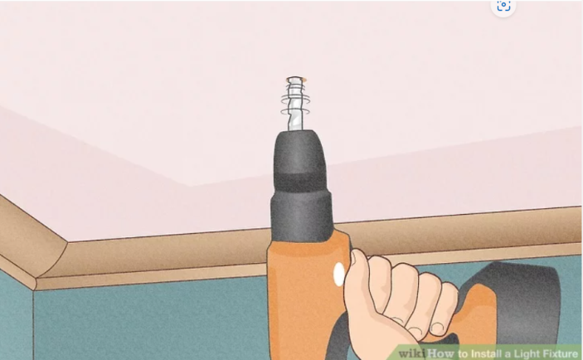
Step 1:- Cut openings for the wiring. Cut openings into the ceiling, or wall surfaces for the boxes, for the switch (es), and for the fixture support by first tracing around the box on the wall or ceiling surface.[8] Be sure to match the switch box height to those in the rest of your home.
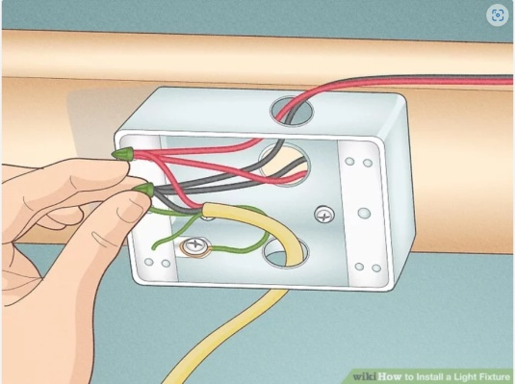
Step 2:- Install the wiring. Install the cable between the power source and boxes in the voids of the walls, ceilings, and floors with a snake or fish tape.After determining there is enough ampacity in the circuit to support the additional load, extend wiring of the same size from the power source to the switch and fixture locations. If running a new circuit directly from the electrical panel, the new wire should be sized according to the fuse or circuit breaker size.
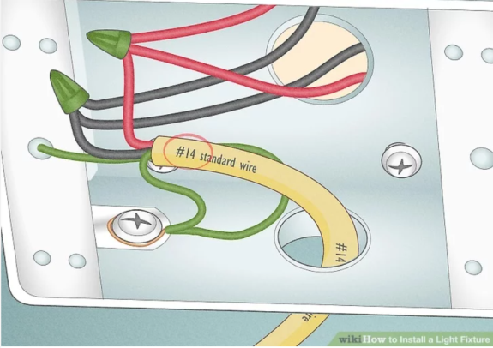
Step 3:- Make sure your wiring is up to code. National Electrical Code Requirements for wiring and (EBCS-10) need to be followed closely when you're installing a new fixture.
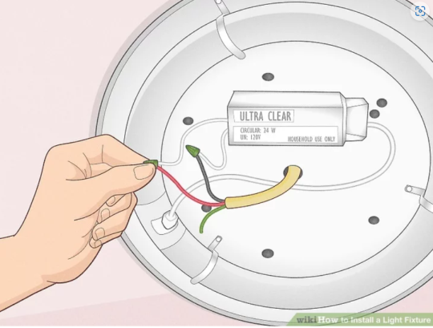
Step 4:- Connect the devices as shown in the diagram that matches your application. If you'd prefer to follow detailed instructions to wire the fixture to just two 3-way switches, please see the 3-way switch how-to guide.

Check the quality of work
Installation of lighting fixture must be:
- Horizontally aligned against wall
- No gap between ceiling and lighting fixture base
- Wiring at junction box cut to requirement as required
- Lamps securely mounted

Self-check #3
  - Choose the correct answer from the give alterative
  - _____is a lamp that its light emission can be caused through filament heating.
          - Fluorescent b) Incandescent c) halogen d) all
- Nowadays which types of lamp is more preferable by clients?
          - fluorescent b)incandescent c) CFL d) Tungsten
  - Mach column “B” to column “A”
A B
_____ 1: Lamp A. quartz iodine & quartz-halogen
_____ 2: Tungsten lamp B. used in street lighting
_____ 3: HPS Vapor lamp C. Artificial source of light

  - Give short ad precise answers for the following questions
      - What are the main functions of a fluorescent lamp?
      - List theprocedures to install lighting fixture?

Note: Satisfactory rating – above 60% Unsatisfactory - below 60%
You can ask you teacher for the copy of the correct answers

Operation sheet #3

Operation Title: Install light wiring fixture
Instruction:
Purpose: to install different light fixtures.
Required tools and equipment: unit one of this module, measuring devices from workshops like multi meter, clamp meter & energy meter
Precautions:
- use safety personal protective equipments properly
- Follow the instruction of the task.
- Check measuring devices weather it is functional or not
- handle light fixtures properly
Procedures:
Step 1: Prepare yourself in order to perform the given task
Step 2: Collect the required electrical devices assessors for the given task
Step 3: Check lighting fixtures before installing.
Step 4: install the given lighting fixtures, inspect& test it using multi-meter.
Step 6: At the end of your work clean, return & put the hand tools &measuring devices on the previous location

LAP Test #3

Name: __________________________ Date: ____________
Time started: ____________________ Time finished: _______________

Instruction I: Given necessary templates, tools and materials you are required to perform the following tasks within 10 hours.

Task 1:Install lighting fixture

UNIT FOUR: NOTIFY COMPLETION OF WORK
This unit is developed to provide you the necessary information regarding the following content coverage and topics:
- Make final checks
- Notification of work completion
- Tools, equipment and any surplus resources
- Clean and make safe work area
This unit will also assist you to attain the learning outcomes stated in the cover page. Specifically, upon completion of this learning guide, you will be able to:
- Make final checks to ensure that work conforms with instructions and to requirements
- Notify completion of work to supervisor
- Clean, check and return tools, equipment and any surplus resources and materials to storage in accordance with established procedures
- Clean and make safe work area

Making Final checks
- Survey the location of equipment/devices and/or lightings with reference to layout drawings and details as well as in the given Technical Scope of Work.
- Categorize and select lighting fittings, devices, junction boxes and related materials to include wattage, types of fixtures/devices/junction boxes, and type of mounting in accordance to the latest approved construction drawing and details, as well as with area classification requirements.
- Check that mounting heights are in accordance with the elevations shown on the plan and detail drawings as per company Technical Scope and Ethiopian Standards.
- Where manufacturer’s instructions are furnished with the lighting fittings and devices, installation detail shall conform to the requirements.
- Installation of fixtures, devices and junction boxes should consider possible clashing against nearby plant equipment, instruments, valves, pipes and flanges to be added.
- Install necessary supports and poles as per detail drawings given, and to the installation standards in accordance with the Technical Scope of Works. Ensure that the support is suitable to the lightings/devices materials in consideration to the various environmental classifications stated in layout drawings.
- Supports shall be assembled with proper fittings mounted plumb, level and rigidly secured to structure.
- Lighting fittings including lamps, covers, guards and diffusers shall be handled with care to avoid breakage or damage to the fragile.
- Mount the lighting fixture and devices in the position, elevation and location as shown on project Approved for Construction drawings.
- The elevation, level and vertical alignment of the lighting fixtures and devices shall be checked ensuring that it is securely and rigidly fixed in place.
- Lighting unit orientation shall be verified ensuring illumination in the area is sufficient and not obstructed by pipes or structures.
- The final angular displacement and aiming points shall be determined in the field, adjusting each lighting fixture in order to provide the optimum light coverage.
- Ensure that the conduit to which lighting fittings, devices, and junction boxes were attached are fixed by substantial screws so that the weight of the installed lighting fittings, devices and junction boxes will not be carried by the conduit.
- After installation following the complete drawing and details, clean the lamps, reflectors, diffusers and housing body. Dust and dirt shall be removed by using appropriate rags.
- Terminate all wiring or cable connections according to the termination schedule, installing all termination requirements including identifications required, in which non-corroding material with cable reference numbers, as noted in the cable schedule, are clearly visible. Cabling and wiring works shall be done as per EBCS-10.
- Double check all wiring and circuit connections for the lightings/ devices with respect to circuit diagram to avoid possible short- circuiting and damage.

Notify completion of work
Working safely includes considering the work procedure, the type of tools used and the type of clothing worn.
On completion of work:
- check that no tools are left on (or in) the job
- remove your own earthing equipment
- check that the work is complete and the equipment can be energized
- notify all personnel involved that the equipment will be energized
- hand in your work permit (if relevant)
- remove 'DANGER - DO NOT OPERATE' tags
- energize power supply
- Remove and store all safety barriers.

Cleaning Tools, equipment’s, materials and Work area
The efficient handling and storing of materials are vital to industry.
In addition to raw materials, these operations provide a continuous flow of parts and assemblies through the workplace and ensure that materials are available when needed. Unfortunately, the improper handling and storing of materials often result in costly injuries.

Hand Tools
- Hand tools such as screwdrivers, wrenches, hammers, pliers, levels, and wire cutters are examples of common workshop tools that are often left out in places such as basements, garages and tool sheds.
- Tools are tough, but they are not indestructible and exposure to the elements can take its toll.
- Below are some tips on how to take care of your tools and store them properly so that you get optimum use out of them.
Clean, Inspect and Care for Tools
Make it a habit to clean tools after each use before you return them to storage. Wipe them down with a rag or old towel and be sure they are free of dust, grease and debris before you put them into their proper places. This is also an opportunity to look for any damage or defects. Check your tools' handles for splinters, breaks and cracks. Also, make sure that metal parts show no signs of corrosion or rust. Repair or replace any tools that show signs of damage.
SAFETY ALERTS!
Don’t use tools that need repair or replacement. Broken tools can cause injury.
Don’t use tools inappropriately; you risk injury to yourself, others and damage to the tools.
Equipment’s:- need routine maintenance just like your hand tools. Because of their mechanical and electrical parts, equipment are more susceptible to problems caused by poor maintenance, dust and debris accumulation and general malfunction. The following are some helpful tips on how to clean and properly store your tools.
Keep Power Tools Clean
Dust and grime can bring your power tools to a grinding halt if left unchecked over time. Wipe them clean with a rag after every job has been completed and then store them. Deep clean periodically by using a damp cloth. Get into exhausts and intakes and other hard-to-clean areas with lightly oiled cotton swabs or other slender tools.
HELPFUL TIP
Using an air compressor or a can of compressed air to blow air into vents and crevices is the best way to remove dirt and dust from inside tools
  - Clean and make safe work area
- A safe work environment is not enough to control all electrical hazards. You must also work safely. Safe work practices help you control your risk of injury or death from workplace hazards. If you are working on electrical circuits or with electrical tools and equipment, you need to use safe work practices.
- All workers should be very familiar with the safety procedures for their jobs. You must know how to use specific controls that help keep you safe. You must also use good judgment and common sense.Control electrical hazards through safe work practices.
- Plan your work and plan for safety.
- Avoid wet working conditions and other dangers.
- Avoid overhead power lines.
- Use proper wiring and connectors.
- Use and maintain tools properly.
- Wear correct PPE.
- Plan your work and plan for safety
Take time to plan your work, by yourself and with others. Safety planning is an important part of any task. It takes effort to recognize, evaluate, and control hazards. If you are thinking about your work tasks or about what others think of you, it is hard to take the time to plan for safety. But, YOU MUST PLAN.

Self-check-4
Directions: Answer all the questions listed below.
Task 1. Say ‘True’, if the statement is correct and say ‘False’, if it is incorrect.
  - Lighting fittings including lamps, covers, guards and diffusers shall be handled with care to avoid breakage or damage to the fragile.
- A safe work environment is enough to control all electrical hazards.
- It is not necessary that all workers to be familiar with safety procedures.
- Doubling check all wiring and circuit connections for the lightings/ devices with respect to circuit diagram is not important.
- Safety planning is an important part of any task.
Task2. Give short ad precise answer.
        - Mention some of safety requirements while cleaning workshop.
        - What activities are done on of work completion?

.

Reference Materials

- “Haile Assegidie Minister Ministry of Works and Urban Development 1995”:Ethiopian Building Code Standard.EBCS-10
- “BRIAN SCADDAN” :Electrical Installation Work Sixth edition BS 7671:2008
- “EMSD” :Electrical and Mechanical Services Department 2020 Edition (First Print)
- "Modern Marvels: The World's First Power Tools”. History. Archived from the original on January 25, 2013. Retrieved Oct 4, 2011.
- a b NIOSH Power tools database
- "Criteria for a Recommended Standard: Occupational Noise Exposure Revised Criteria". Basis for the Exposure Standard: 24–5. 1998.
- ^ Franks, John R., ed. (1996). Appendix A: OSHA Noise Standard Compliance Checklist (PDF). Preventing Occupational Hearing Loss: A Practical Guide. U.S. Department of Health and Human Services. p. 60.
- Nagyszalanczy, Sandor (2001). Power Tools: An Electrifying Celebration and Grounded Guide. Newtown, CT: The Taunton Press. ISBN 978-1-56158-427-7.
- Scott P. Schneider (1998). "Tools". In Jeanne Mager Stellman (ed.). Chemical, industries and occupations. Encyclopaedia of Occupational Health and Safety. 3 (4th ed.). International Labour Organization. pp. 93.33–93.34. ISBN 978-92-2-109816-4 .
- a b Cacha, Charles A. (1999). Ergonomics and Safety in Hand Tool Design. CRC. ISBN 1566703085.
- Salaman, R. A. (1997 edition revised by Philip Walker; first published in 1975 by George Allen & Unwin [Publishers] Ltd). Dictionary of Woodworking Tools, c. 1700–1970 Mendham, NJ: Astragal Press ISBN 978-1-879335-79-0.
- Salaman, R. A. (1996). Dictionary of Leather- working Tools, c.1700–1950, and the Tools of Allied Trades Mendham, NJ: Astragal Press ISBN 978-1-879335-72-1.
- Russell, David R., with Robert Lesage and photographs by James Austin, cataloguing assisted by Peter Hackett (2010). Antique Woodworking Tools: Their Craftsmanship from the Earliest Times to the Twentieth Century Cambridge: John Adamson

Developers Profile
Participants of this Module (training material) preparation
No | Name | Qualification (Level) | Field of Study | Organization/ Institution | Mobile number | E-mail
1 | Elias Getachew | MSc | Industrial Electrical Automation & Control Management | Misrak Poly Technique college | 0913811386 | get.elias19@gmail.com
2 | Mengistu Abiyu | MSc | Industrial Electrical Automation & Control Management | Lideta Manufacturing College | 0913948480 | menabiy@gmail.com
3 | Giduma Mekonen | BSc | construction Management | Adama Poly Technique college | 0913939750 | olimosisa@gmail.com
4 | Tigist Aemiro | MSc | construction Management | Bahir Dar poly Technique college | 0918375757 | tigistaemiro4@gmail.com
5 | Yidnekachew Seboka | BSc | Electrical Automation & Control Technology | Akaki poly  Technique college | 0920137899 | www.yedine23@gmail.com
6 | Getahun Abera | BSc | Electrical Electronics Tecnology | Dere-dawa poly Technique college | 0910334887 | getab@yahoo.com

