Building Electrical Installation
Level II
Based on June 2022, Curriculum Version 1
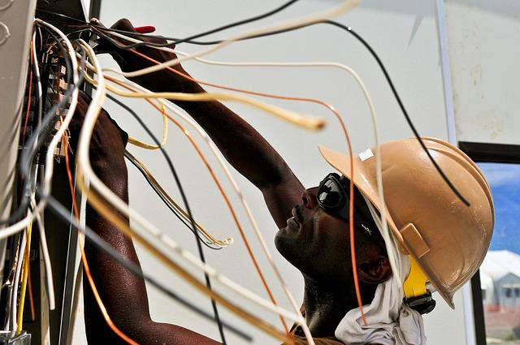

Module Title: - Installing Wiring Systems Using Conduits
Module code: EIS BEI2 M03 0322
Nominal duration: 50Hour
Prepared by: Ministry of Labor and Skill
August, 2022
Addis Ababa, Ethiopia
Table of Cont
List of figure 4
Acknoledgment 5
Introduction 7
Unit one: Electrical conduit wiring installation 8
1,1. Electrical supply system 8
1.2 electrical isolation 11
1.2.1.Identificationof Equipment and Isolation Points: 12
1.2.2.Isolation of Electrical Equipment: 13
1,3 Wiring Systems 14
1.3.1. Checking location for sensitivity: 14
1.3.2. Meg ohm meters/Insulation Test 15
locations of install wiring system 17
Self-Check -1 20
Unit Two: Install conduit Installation 21
2.1 Install conduit & cable tray 21
2.2 .Terminate and connecting conduits 28
2.3. unplanned events or conditions 32
2.4. approval from appropriate personnel 33
2.5 Undertaking final inspections 34
Self-Check -2 36
Operation Sheet-1 39
LAP Test 39
Unit Three: Install wiring system 41
3.1 wiring systems and wiring enclosures 41
3.2. test data by the job specifications 45
3.4. Install wiring system 55
Operation Sheet 2 63
LAP Test 63
Unit Four: Inspect and notify completion of work 64
4.1Report to relevant people 64
4.2 appropriate action from relevant people 67
Self-check4 70
Operation Sheet-3 71
LAP Test 71

List of figure

Figure 1. 2 single phase 10
Figure 1. 1symbols AC voltage source 10
Figure 1. 3 three phase 11
Figure 1. 4 symbols DC voltage source 11
Figure 1. 5 Digital Volt Meters 15
Figure 1. 6 Digital Volt Meters 15
Figure 1. 7 Ammeter 16
Figure 1. 8 Analog voltmeters 17
Figure 1. 9wireng diagramed 19
figure2 1 Rigid Metal Conduit (RMC 21
figure2 2 Rigid steel conduit (RSC 22
figure2 3 Galvanized Rigid Conduit 22
figure2 4 Intermediate Metal Conduit 23
figure2 5 Aluminum conduit, 24
figure2 6 Flexible conduits 24
figure2 7 Flexible Metallic Conduit 25
figure2 8 Liquidtight Flexible Metal Conduit 25
figure2 9 Flexible Metallic Tubing 25
figure2 10 Liquid tight Flexible Nonmetallic 26
figure2 11 conduit bend 27
figur3. 1 joint box system 43
figur3. 2 loop in system 44
figur3. 3 loop in system 45
figur3. 4 continuity test 47
figur3. 5 Volts, Amps, Ohms multi meter 49
figur3. 6 Measure Voltage 51
figur3. 7 Test leads and 4mm sockets on a DMM, setup to measure voltage 52
figur3. 8 Measuring Voltage - Meter in Parallel with Load 53
figur3. 9 Joint box system 59
figur3. 10 Joint box system 60
figur3. 11 Visual Inspection 61

list of table

table 3. 1 Testing record sheet 54

Acknoledgment

Ministry of Labor wish to extend thanks and appreciation to the many representatives of TVET instructors and respective industry experts who donated their time and expertise to the development of this Teaching, Training and Learning Materials (TTLM).
Acronym
(NEC) US National Electrical Code
(FMC) Flexible Metallic Conduit
IEE Regulations for Electrical Installations
Introduction to the Module
The Electrical Wiring Systems are mostly standardized with several rules, regulations and laws. Electrical Wiring must be installed correctly and safely in accordance with electrical regulations and standards. If the electrical wiring is carried out incorrectly or without confirming to any standard, then it may lead to actions like short circuits, electric shocks, damage the device / appliance or leads to the malfunctioning of device which further causes for the fall of device
This module covers the units :
- Electrical conduit wiring installation
- . conduit installation
- . Install wiring system
Learning Objective of the Module
- Perform Plan and prepare
- Install wiring system
- Inspect and notify completion of work
Module Instruction
For effective use this modules trainees are expected to follow the following module instruction:
- Read the information written in each unit
- Accomplish the Self-checks at the end of each unit
- Perform Operation Sheets which were provided at the end of units
- Do the “LAP test” giver at the end of each unit and
- Read the identified reference book for Examples and exercise

Unit one: Electrical conduit wiring installation

This unit is developed to provide you the necessary information regarding the following content coverage and topics:
- Electrical supply system
  - Electrical isolation
  - Measure and mark for wiring systems,
  - Check conduit locations for visual acceptability

This unit will also assist you to attain the learning outcomes stated in the cover page. Specifically, upon completion of this learning guide, you will be able to:
  - . identify Electrical supply system
  - .perform Electrical isolation
  - Measure and mark for wiring systems,
  - . Check conduit locations for visual acceptability

1,1. Electrical supply system

Every power supply must obtain the energy it supplies to its load, as well as any energy it consumes while performing that task, from an energy source. Depending on its design, a power supply may obtain energy from various types of energy sources, including electrical energy transmission systems, energy storage devices such as a batteries and fuel cells, electromechanical systems such as generators and alternators, solar power converters, or another power supply.
Types of power supply
1. Ac power supply
AC stands for alternating current, which means the electrical current frequently reverses direction. AC electricity is measured according to its cycles, with one complete cycle being counted each time a given current travels in one direction and then doubles back on itself.

Figure 1. 1symbols AC voltage source

Colors of conductors
Color identification of bare conductors and cable cores are given by EELPA’S regulation
- Ear thing --------------------------------------------- white
- Live of AC single-phase circuit ------------------- Green
- Neutral of ac single or three phase ac circuit ----black
- Phase R of three-phase ac circuit ------------------Green
- Phase S of three-phase ac circuit ------------------ Yellow
- Phase T of three-phase ac circuit ------------------ Red
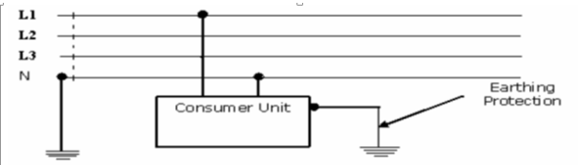
Figure 1. 2 single phase

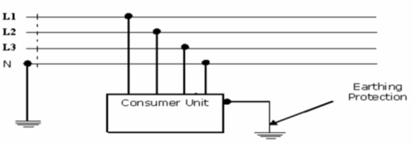
Figure 1. 3 three phase
2. DC power supply A DC power supply is one that supplies a constant DC voltage to its load. Depending on its design, a DC power supply may be powered from a DC source or from an AC source such as the power mains.
Direct current (DC) which flows only in one direction.

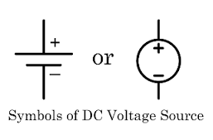
Figure 1. 4 symbols DC voltage source

1.2 electrical isolation

Electrical isolation is a method of corrosion control. Conductors are prone to corrosion from stray current that originates from dissimilar metals. Providing good isolation for these conductors manages the corrosion significantly.
Electrical isolation is achieved using a mechanical switch that isolates a section of a circuit from the main electrical power system as and when required.
Emergency switching:-Rapid cutting off of electrical energy to remove any hazard to persons, livestock or property which may occur unexpectedly.
Isolation Cutting off an electrical installation, a circuit or an item of equipment from every source of electrical energy.
Mechanical maintenance: - The replacement, refurbishment or cleaning of lamps and non-electrical parts of equipment, plant and machinery.
Switch: - A mechanical switching device capable of making, carrying and breaking current under normal circuit conditions, which may include specified overload conditions, and also of carrying, for a specified time, currents under specified abnormal conditions such as those of short circuit.
Electrical isolation is a method of corrosion control. Conductors are prone to corrosion from stray current that originates from dissimilar metals. Providing good isolation for these conductors manages the corrosion significantly.
Various electrical isolators can be used, depending on the requirements of the system. Some of types of isolators are:
Single break isolators - This type is divided into male and female contacts. The rotation of the post insulator moves the contact arms. Where both insulator stacks are rotated in opposite directions, the isolator is closed with the contact arm. Counter-rotation of both stacks causes the contact arm to open, and hence the isolator is turned off.
Double break isolators - Their constructional features are three post stacks where the central post is a tubular male contact that rotates horizontally. The rotation can be done manually using a lever at the base of the post, or by a motor that rotates the contact using a tie rod.
Pantograph isolators - This type of electrical isolation allows installation of modern switch gear with the least space required. It is comprised of an operating insulator and a post insulator.
Electrical isolators can be categorized differently, based on the position of the power system. The categorizations are:
- Line side isolator - This type of isolator is fixed at the line of a feeder.
- Bus side isolator - This kind of isolator is attached directly to the main bus.
- Transfer bus side isolator - This type of isolator is attached directly to the transfer bus.
There is no arc-quenching technique used in an isolator, hence it must be operated when the circuit is free from any current. Opening or closing any live circuit by isolator is dangerous because there can be huge arcing between the contacts. A hand isolator can operate voltages that are up to 145kV, while higher voltages that are over 245kV require motorized isolators.
1.2.1.Identificationof Equipment and Isolation Points: -
The electrical equipment to be worked on, all of its energy sources and the appropriate points of isolation must be positively identified by an electrical worker. It is not uncommon for electrical enclosures to have more than one power source supplied into the enclosure. The safety of the electrical tradespersons relies on identifying and isolating all electrical power sources that are normally present.
E.g. two electrical control panels, each with their own power supply, interconnected with low voltage control circuits – a control circuit in one of the control panels is powered from the second control panel. In this instance, both control panels would be electrically isolated.
1.2.2.Isolation of Electrical Equipment: -
All electrical equipment and electrical circuits must be isolated from all sources of electrical supply before any work is started on the equipment and circuits. This will be achieved by operating the appropriate controlling device(s) and include:
- Opening switches;
- Opening circuit breakers; or
Removal of circuit connections, after the power supply to the circuit connections has been isolated;
- Disconnection of battery
Batteries: Where a battery isolation device is installed, the device should be switched off and locked in the open position to isolate the battery power source before working on the circuits. When disconnecting a battery where one leg is earthed, always disconnect the earthed lead first then the un-earthed lead.
- . Basic isolation procedure
1 There must be an isolation procedure for each item of plant, including the application of isolation devices, locks and tags, as practicable. While isolation procedures may vary in detail because of differences in plant, power sources, hazards and processes, they must include the following steps.
Safe isolation procedures are in place to ensure that workers on site are not exposed to danger when working on or near live electrical systems. There are many reports where these procedures have not been followed correctly and sadly this has resulted in needless loss of life.
- The isolation procedures are:
1. Identify the plant involved and the corresponding energy sources.
2. Identify all other hazards.
3. Shut the plant down.
4. De-energize all stored energy sources.
5. Isolate and lock out all energy sources.
6. Tag plant controls, energy sources and other potential hazards.
7. Control other potential hazards.
8. Test by ‘trying’ to re-activate the plant, without exposing the tester or others to risk, to ensure isolation procedures have been effective, before commencing any maintenance, cleaning, inspection or repairs on the plant.
9. Carry out the work on the plant.
10. Once remedial work is complete, the people who tagged the controls are to remove the tags before the plant is returned to operational status.

1,3 Wiring Systems

Measuring to determine the exact dimensions, capacity, quantity, or force of; measure
- To appraise, estimate, or judge.
- To make conformable to a standard.
- To mark or measure off; delineate.
- To prepare or mix (plaster) with a definite proportion of plaster of Paris and mortar.
- To chip or rub (bricks or stones) to a uniform size or shape.
- Marking is putting a point for measuring is not re measuring.
1.3.1. Checking location for sensitivity: -
It is used to determine the sensitivity location.
What is a Multi meter?
Melt meters are commonly used to measure current, resistance, or voltage. Originally termed analog Volt-Ohm-Milliam meter (VOM), some models are referred to as Volt-Ohm Meters (VM). Digital Volt Meters (DVMs) measure voltage (certain oscilloscope models have this capability, as well).
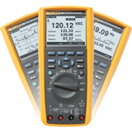
Figure 1. 5 Digital Volt Meters

1.3.2. Meg ohm meters/Insulation Test

An insulation tester is an ohmmeter that measures the electrical resistance of insulating components. The tester outputs a high DC voltage to generate a current through and over the tested insulation. Readings indicate the amount of current escaping from the insulating material. Since meter resistance values can be displayed in mega ohms, devices are also called mega ohmmeters
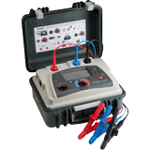
Figure 1. 6 Digital Volt Meters

Ammeter
An ammeter (from Ampere Meter) is a measuring instrument used to measure the current in a circuit. Electric currents are measured in amperes (A), hence the name. Instruments used to measure smaller currents, in the mille ampere or microampere range, are designated as mille ammeters or micro ammeters. Early ammeters were laboratory instruments which relied on the Earth's magnetic field for operation. By the late 19th century, improved instruments were designed which could be mounted in any position and allowed accurate measurements in electric power systems.
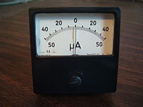
Figure 1. 7 Ammeter

A voltmeter
Is an instrument used for measuring electrical potential difference between two points in an electric circuit. Analog voltmeters move a pointer across a scale in proportion to the voltage of the circuit; digital voltmeters give a numerical display of voltage by use of an analog to digital converter.
A voltmeter in a circuit diagram is represented by the letter V in a circle.
In electrical and electronic engineering, a current clamp or current probe is an electrical device with jaws which open to allow clamping around an electrical conductor. This allows measurement of the current in a conductor without the need to make physical contact with it, or to disconnect it for insertion through the probe. Current clamps are typically used to read the magnitude of alternating current (AC) and, with additional instrumentation, the phase and waveform can also be measured. Some clamps meters can measure currents of 1000 A and more. Hall Effect and vane type clamps can also measure direct current (DC).
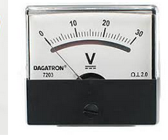
Figure 1. 8 Analog voltmeters
Wiring enclosures
In general, ordinary corrosion, accidental contact with live parts, and a limited amount of falling dirt. Some devices have been investigated for use in other operating environments
Devices having integral enclosures or installed as intended have been investigated for use indoors, in dry locations. All such listed products provide a degree of protection against

locations of install wiring system

Testing of electrical wiring system
The entire installation shall be tested in accordance with IEE regulations for:
1. Insulation resistance.
2. Earth continuity.
3. Polarity of single pole switches.
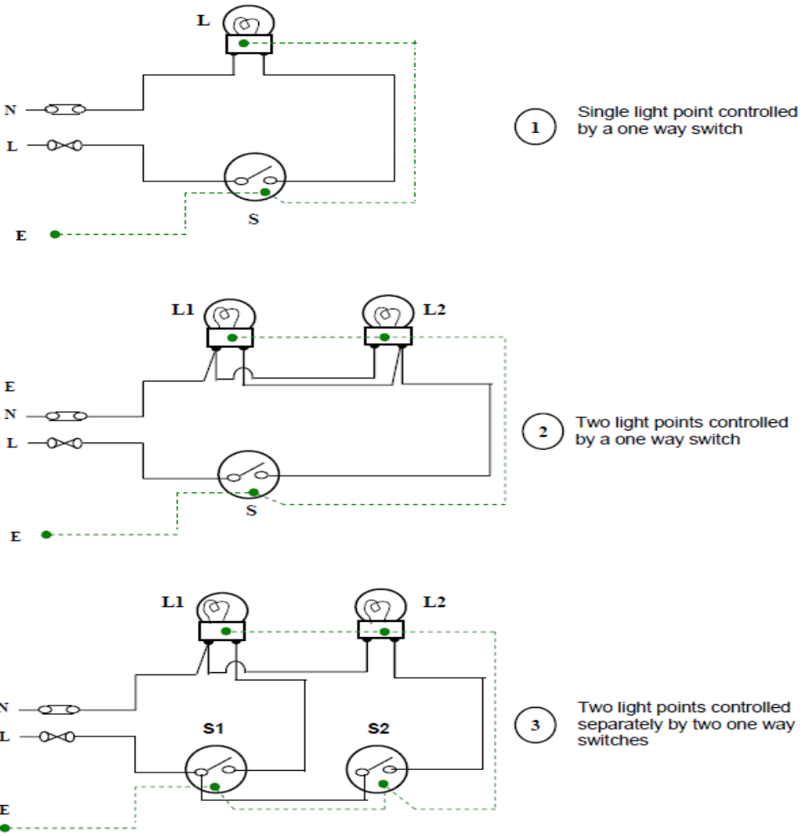
Figure1.9 single pole switches.

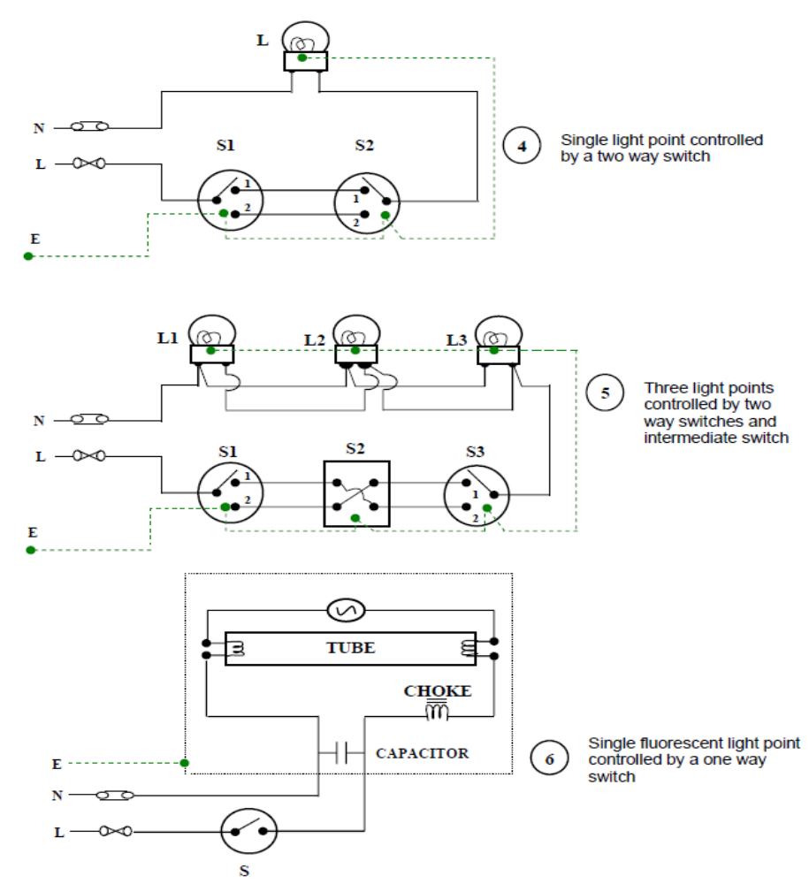
Figure 1. 9wireng diagramed

Self-Check -1

Trainer Name: ____________________________ date-------------------
Time start-------------------------------- Time finished-------------------------
- Directions: chose the best answer
    - Which is the kind of thing that is objectionable Ear thing (1 points)
A) White B) green C) black D) yellow
    - Which is the kind of thing that is objectionable Live of AC single-phase circuit (1points)
A) White B) green C) black D) yellow
    - Which is the kind of thing that is objectionable Neutral of ac single or three phase ac circuit (1points)
A) White B) green C) black D) yellow
    - What is the name of this symbol? (2 points)

A) DC B) AC C) KC D) DE
5.What is the name of this symbol? (2 points) 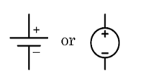
A) DC B) AC C) KC D) DE
6.. Rapid cutting off of electrical energy to remove any hazard to persons.
A. Batteries B. Electrical Equipment C. Isolation D. Emergency switching
Directions: Answer all the questions listed below. (2 points for each questions )
- Define electrical supply
- List types of electrical power supply
- What are the Electricity supply specifications for domestic consumers?
- List Voltage rating bands
5 .Describe the good approaches of determining actions to client’s fill existing gaps?
6 .Describe Process of determining actions to take clients for referral services?
7..What is isolation?
8..Write at list fife isolation procedure

Unit Two: Install conduit Installation
This unit to provide you the necessary information regarding the following content coverage and topics:
- Install conduit & cable tray
- Terminate and connecting conduits
- unplanned events or conditions
- approval from appropriate personnel
- Undertaking on-going checks to quality of work
This guide will also assist you to attain the learning outcomes stated in the cover page. Specifically, upon completion of this learning guide, you will be able to:
- Apply Install conduit & cable
- Perform Terminating and connecting conduits
- Perform Responding unplanned events or conditions
- Obtain approval from appropriate personnel
- Undertake final inspections

2.1 Install conduit & cable tray

Electrical Conduit
An electrical conduit is an electrical piping system used for protection and routing of electrical wiring. Electrical conduit may be made of metal, plastic, fiber, or fired clay. Flexible conduit is available for special purposes.
Conduit is generally installed by electricians at the site of installation of electrical equipment. Its use, form, and installation details are often specified by wiring regulations, such as the US National Electrical Code (NEC) or other national or local code. The term "conduit" is commonly used by electricians to describe any system that contains electrical conductors, but the term has a more restrictive definition when used in wiring regulations.
Electrical conduit provides very good protection to enclosed conductors from impact, moisture, and chemical vapors. Varying numbers, sizes, and types of conductors can be pulled into a conduit, which simplifies design and construction compared to multiple runs of cables or the expense of customized composite cable. Wiring systems in buildings may be subject to frequent alterations. Frequent wiring changes are made simpler and safer through the use of electrical conduit, as existing conductors can be withdrawn and new conductors installed, with little disruption along the path of the conduit. A conduit system can be made waterproof or submersible. Metal conduit can be used to shield sensitive circuits from electromagnetic interference, and also can prevent emission of such interference from enclosed power cables.
When installed with proper sealing fittings, a conduit will not permit the flow of flammable gases and vapors, which provides protection from fire and explosion hazard in areas handling volatile substances .Some types of conduit are approved for direct encasement in concrete. This is commonly used in commercial buildings to allow electrical and communication outlets to be installed in the middle of large open areas. For example, retail display cases and open-office areas use floor-mounted conduit boxes to connect power and communications cables.Both metal and plastic conduit can be bent at the job site to allow a neat installation without excessive numbers of manufactured fittings. This is particularly advantageous when following irregular or curved building profiles.
The cost of conduit installation is higher than other wiring methods due to the cost of materials and labor. In applications such as residential construction, the high degree of physical damage protection is not required so the expense of conduit is not warranted. Conductors installed within conduit cannot dissipate heat as readily as those installed in open wiring, so the current capacity of each conductor must be reduced if many are installed in one conduit. It is impractical, and prohibited by wiring regulations, to have more than 360 degrees of total bends in a run of conduit, so special outlet fittings must be provided to allow conductors to be installed without damage in such runs. Some types of metal conduit offer a useful bonding conductor for grounding (earthling), but wiring regulations may also dictate workmanship standards or supplemental means of grounding for certain types. While metal conduit can be used as a grounding conductor, the circuit length is limited.

Types of Conduits
- Rigid Metal Conduit (RMC) - is a thick threaded tubing, usually made of coated steel, stainless steel or aluminum.The installation of Rigid Steel Conduit (RSC) is covered by Article 344 of the National Electrical Code (NEC). This article is entitled "Rigid Metal Conduit (RMC) and includes all requirements for all rigid metal conduits, including steel, stainless steel, aluminium, and red brass. You will often see the following acronyms used: RSC (Rigid Steel Conduit), ERSC (Electrical Rigid Steel Conduit), or GRC (Galvanized Rigid Conduit) in place of RMC (Rigid Metal Conduit) in order to differentiate the type of metal used.
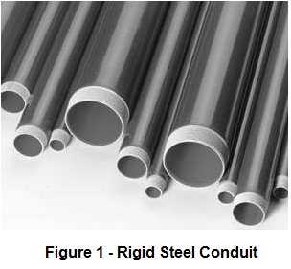
figure2 1 Rigid Metal Conduit (RMC

Rigid steel conduit (RSC) is a listed threaded metal raceway of circular cross section with a coupling which can be either a standard straight tapped conduit coupling or the integral type. Threads on the uncoupled end are covered by industry colour-coded thread protectors which protect the threads, keep them clean and sharp, and aid in trade size recognition. Rigid metal conduit is available in trade sizes 1/2 through 6. Thread protectors for trade sizes 1, 2, 3, 4, 5, and 6 are colour-coded blue, trade sizes 1/2, 1 1/2, 2 1/2, 3 1/2 are black, and trade sizes 3/4 and 1-1/4 are red. The nominal finished length of RMC with couplings is 10 feet. Twenty foot lengths are available in some trade sizes
There are different processes used to provide corrosion protection to rigid steel conduit. Rigid steel conduit can have a primary coating of zinc, a combination of zinc and organic coatings, or a non-metallic coating (such as PVC). Supplementary coatings can be applied to all three where additional corrosion protection is needed.
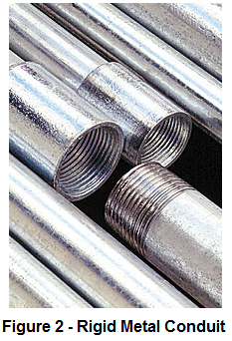
Rigid steel conduit is the heaviest-weight and thickest wall conduit. Where galvanized by the hot-dip process, it has a coating of zinc on both the inside and outside. Electro-galvanized rigid conduit has a coating of zinc on the exterior only, with approved corrosion resistant organic coatings on the interior. Rigid conduit with "alternate corrosion protection coatings" generally has organic coatings on both the exterior and the interior surfaces. Galvanized rigid metal conduit (GRC) is non-combustible and can be used indoors, outdoors, underground, concealed or exposed. Rigid steel conduit with coatings that are not zinc-based may have temperature limitations which will be noted on the manufacturer's product label and may not be listed for use in environmental air spaces; consult manufacturers’ listings and markings.
figure2 2 Rigid steel conduit (RSC

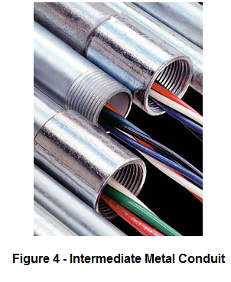
- Galvanized Rigid Conduit (GRC) - is galvanized steel tubing, with a tubing wall that is thick enough to allow it to be threaded. Its common applications are in commercial and industrial construction.
figure2 3 Galvanized Rigid Conduit
- Intermediate Metal Conduit (IMC) -. Intermediate metal conduit, or IMC for short, is a rigid steel electrical conduit that is lighter in weight than another rigid conduit. It was designed specifically to protect insulated electrical conductors and cables. It does the work of a similar conduit, galvanized rigid conduit (GRC), but with much less weight and thickness size. By utilizing IMC in areas allowed, you can all but eliminate the need for a heavier wall conduit.
IMC has other advantages over GRC. It has a larger interior diameter than Galvanized Rigid Conduit and the smoother interior of the pipe allows for easier wire pulling through the conduit. It is also coated in a hot galvanized coating on the exterior and a special corrosive-resistant coating on the inside to extend the conduit’s lifespan for reliability. Common conduit sizes range from ½” to 4”.
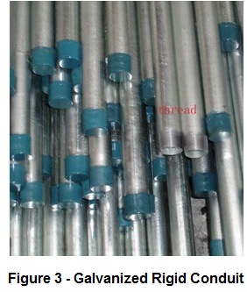
figure2 4 Intermediate Metal Conduit

- Electrical Metallic Tubing (EMT), sometimes called thin-wall, is commonly used instead of galvanized rigid conduit (GRC), as it is less costly and lighter than GRC. EMT itself may not be threaded, but can be used with threaded fittings that clamp to it. Lengths of conduit are connected to each other and to equipment with clamp-type fittings. Like GRC, EMT is more common in commercial and industrial buildings than in residential applications. EMT is generally made of coated steel, though it may be aluminum.
Electrical Metallic Tubing is light gauge steel raceway used to protect wiring from physical damage and fire. It shields electrical fields emitted by the wiring and acts as a ground. The thick coating of zinc galvanization on the interior and exterior of the conduit provides excellent corrosion resistance from environmental, chemical and mechanical degradation. Power steel Products provides UL-listed ANSI C80.3 EMT conduit in hex bundles according to the detailed specifications in the chart below. Standard length is 10 feet but other lengths are available. Each piece comes with a UL label and is closely monitored and tested during all phases of production to guarantee the highest quality.
- Aluminum conduit, similar to galvanized steel conduit, is a rigid conduit, generally used in commercial and industrial applications, where a higher resistance to corrosion is needed. Such locations would include food processing plants, where large amounts of water and cleaning chemicals would make galvanized conduit unsuitable. Aluminum cannot be directly embedded in concrete, since the metal reacts with the alkalis in cement. The conduit may be coated to prevent corrosion by incidental contact with concrete. The extra cost of aluminum is somewhat offset by the lower labor cost to install, since a length of aluminum conduit will have about one-third the weight of an equally-sized rigid steel conduit. In extreme corrosion environments where plastic coating of the tubing is insufficient, conduits may be made from stainless steel, bronze, or brass.
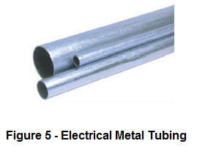
figure2 5 Aluminum conduit,

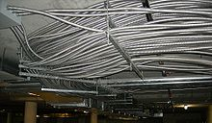
- Flexible conduits are used to connect to motors or other devices where isolation from vibration is useful, or where an excess number of fittings would be needed to use rigid connections. Electrical codes may restrict the length of a run of some types of flexible conduit. Flexible metallic conduit used in an underground parking facility
figure2 6 Flexible conduits

.
- Flexible Metallic Conduit (FMC, often informally called greenfield or flex) is made by the helical coiling of a self-interlocked ribbed strip of aluminum or steel, forming a hollow tube through which wires can be pulled. FMC is used primarily in dry areas where it would be impractical to install EMT or other non-flexible conduit, yet where metallic strength to protect conductors is still required. The flexible tubing does not maintain any permanent bend.
FMC may be used as an equipment grounding conductor if specific provisions are met regarding the trade size and length of FMC used in addition to the amperage of the circuits contained in the conduit. In general an equipment grounding conductor must be pulled through the FMC with an capacity suitable to carry the fault current likely imposed on the largest circuit contained within the FMC.
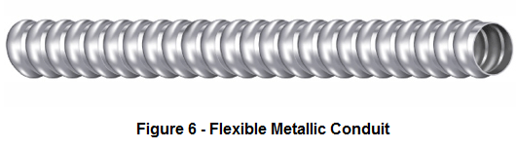
figure2 7 Flexible Metallic Conduit

- Liquidtight Flexible Metal Conduit (LFMC) is a metallic flexible conduit covered by a waterproof plastic coating. The interior is similar to FMC.
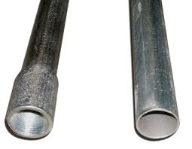

figure2 8 Liquidtight Flexible Metal Conduit

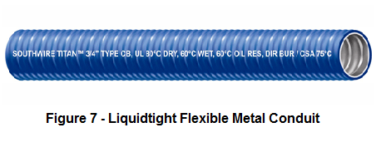
- Flexible Metallic Tubing (FMT) is not the same as Flexible Metallic Conduit (FMC) which is described in National Electrical Code (NEC) Article 348. FMT is a raceway, but not a conduit and is described in a separate NEC Article 360. It only comes in 1/2" & 3/4" trade sizes, whereas FMC is sized 1/2" ~ 4" trade sizes. NEC 360.2 describes it as: "A raceway that is circular in cross section, flexible, metallic and liquid tight without a nonmetallic jacket."
figure2 9 Flexible Metallic Tubing

- Liquid tight Flexible Nonmetallic Conduit (LFNC) refers to several types of flame-resistant non-metallic tubing. Interior surfaces may be smooth or corrugated. There may be integral reinforcement within the conduit wall. It is also known as FNMC.
Non-metallic conduit (Polyvinyl Chloride
– PVC)

PVC conduit is especially suitable for installation systems in light-industrial premises or offices where surface wiring is required. The fittings are identical to those used for metal conduit with the exception that the system is connected not by screwing but by the use of an adhesive. PVC conduit may be bent by hand using a bending spring. This spring, the same diameter as the inside of the conduit, is pushed inside the conduit. The conduit may now be bent by hand, the spring ensuring that the conduit keeps its shape. In cold weather a little warmth may need to be applied to achieve a successful bend.
figure2 10 Liquid tight Flexible Nonmetallic

Properties of Polyvinyl Chloride (PVC)
- high tensile strength;
- it can be bent by hand if warmed;
- it has high electrical resistance;
- it is weather resistant;
- it does not crack under stress at normal temperatures;
- it has a low flammability;
- it is self-extinguishing when the source of heat is removed;
- It must be used with special saddles and expansion couplers when used in fluctuating temperatures, as its expansion is five times that of steel.

2.2 .Terminate and connecting conduits

Conduit lengths are generally measured by one of the following methods:
- End of conduit thread to face of fitting
- Face of fitting to face of fitting
- End to end of the conduit
The other method, the conduit is terminated inside the box by sing a locknut and female bush.
- Female bush
- Locknut
- Conduit
Electrical installation run very often represents exchange of direction. Therefore, it must often be bent to suit any curve or angle between the different fittings.
To make the required bend at the correct position, it is most important to measure the exact distance between one of the fittings and the change of direction.
Measuring for a for a 90⁰ bend
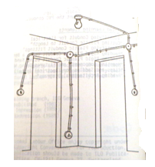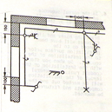
figure2 11 conduit bend

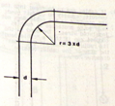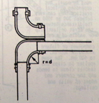

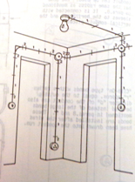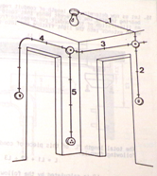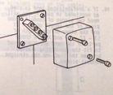
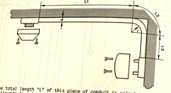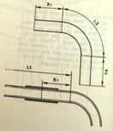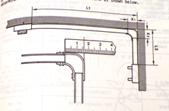

Feeding-in wires/cables into conduit is done after performing roughing in activities. A GI wire is fed in the conduit either by pushing through the conduit or by pulling it with a fish wire. The procedure in feeding in wires into conduit are discussed and illustrated below and on succeeding pages of this learning guide.
  - Insert the GI wire from one electrical box to another through conduit and their fittings.
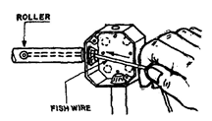
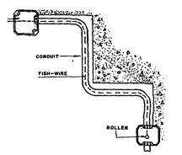

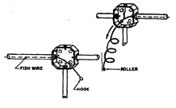
  - Push the GI wire along the installation until it comes on the other box.

  - Pull the GI wire until the hook end is one meter from electrical box as shown.

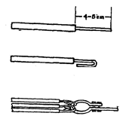

  - Tie the electric wire/cables to the hook by:
Stripping the insulation of the wire of about 50 mm long from the ends
Bending the ends as shown
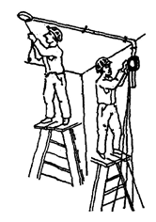

  - Tie all the electrical conductor to the GI wire hook and

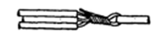

  - Bind them with bare wire tightly as shown.
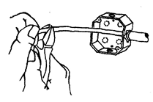

  - Feed-in the electrical conductors into the conduit with somebody pushing at one point while you are pulling at another point as shown
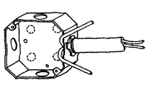

  - Pull the GI wire until the tied ends of the electrical conductor comes out. Cut the wires from the hook leaving enough free ends at the box
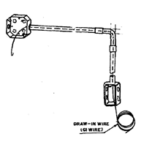

  - Bend the free ends of the wires at the box to prevent from being pulled out from the conduit.

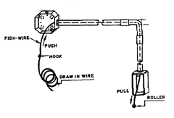

  - When electric wires are not immediately fed-in into a conduits after their installation, a draw-in (G. I. wire) are usually fed-in into the conduit between boxes.
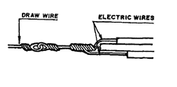

  - In feeding-in wires into the conduit, tie them to the draw wires as shown.

2.3. Unplanned events or conditions

- Events or conditions
Responding unplanned events or conditions
In order to know how to respond to unplanned events or conditions, one must first start in assessing or analyzing the situation. The first response should not be making an action right away, but thinking of the situation and possible solutions.
After fully understanding the situation and listing down possible solutions, it's time to take action by trying all possible means to cope with the changes or unexpected events.
If working on a project, it's helpful to create a list of planned vs unplanned events so you can also think of safety measures on how to prevent the unplanned ones even before starting on the project.
Based on these considerations, the potential accidents, malfunctions and unplanned events that were considered by the Study Team for the Sisson Project are
Loss of Containment from Tailings Storage Facility (TSF);
• Erosion and Sediment Control Failure
• Pipeline Leak;
• On-Site Hazardous Materials Spill;
• Release of Off-Specification Effluent from the installation.
• Failure of a Water Management Pond
• Failure of a Water Management Pond Pump;
• Off-Site Trucking Accident
• Vehicle Collision;
• Uncontrolled Explosion; and
• Fire
Respond to unplanned events or conditions in accordance with established procedures.
Establish procedures from appropriate personnel In accordance with procedures before any contingencies are implemented Test Devices / systems and/or installation is tested whether it conforms to requirements Remove parts or connections for the purpose of testing and pre-test conditions in accordance with established procedures
Final inspections are undertaken to ensure the installed devices / systems conforms to requirements Trainers Methodology.

2.4. Approval from appropriate personnel

Electrical wiring needs expertise attention to every building projects. It directly related to the safety of human beings and utilities / equipment people handle. The scope of electrical wiring shall cover supply, installation, testing and commissioning of all conduits and accessories, wiring, switches, socket outlets, spur outlets, junction boxes / pull boxes, GI pull wires, ceiling roses making connections etc. Unless otherwise indicated wiring shall consist of PVC insulated, copper conductor wires installed in heavy gauge steel galvanized conduits.

Inspection requests
You must request inspection prior to covering any electrical work, no later than 3 business days after completing the work or 1 business day after any part of the installation has been energized, whichever occurs first. Failure to request an inspection may result in civil penalties.
A permit is a vital step to a safe installation
A permit will ensure the work done on your property conforms to current safety codes. Your best protection is purchasing an electrical permit and having your electrical work inspected, as required by law.
A permit will ensure the work done on your property conforms to current safety codes. Your best protection is purchasing an electrical permit and having your electrical work inspected, as required by law.

2.5 Undertaking final inspections

The electrical contractor is charged by the IEE Regulations for Electrical Installations to test all new installations and major extensions during erection and upon completion before being put into service. The contractor may also be called upon to test installations and equipment in order to identify and remove faults. These requirements imply the use of appropriate test instruments, and in order to take accurate readings consideration should be given to the following points:
- Is the instrument suitable for this test?
- Have the correct scales been selected?
- Is the test instrument correctly connected to the circuit?
Many commercial instruments are capable of making more than one test or have a range of scales to choose from. A range selector switch is usually used to choose the appropriate scale. A scale range should be chosen which suits the range of the current, voltage or resistance being measured.
For example, when taking a reading in the 8 or 9 V range the obvious scale
- Inspection and testing techniques
The testing of an installation implies the use of instruments to obtain readings. However, a test is unlikely to identify a cracked socket outlet, a chipped or loose switch plate, a missing conduit-box lid or saddle, so it is also necessary to make a visual inspection of the installation .All new installations must be inspected and tested during erection and upon completion before being put into service. All existing installations should be periodically inspected and tested to ensure that they are safe
and meet the regulations of the IEE The method used to test an installation may inject a current into the system. This current must not cause danger to any person or equipment in contact with the installation, even if the circuit being tested is faulty. The test results must be compared with any relevant data, including the IEE Regulation tables, and the test procedures must be followed carefully and in the correct sequence, as indicated. This ensures that the protective conductors are correctly connected and secure before the circuit is energized.

Visual Inspection
The installation must be visually inspected before testing begins. The aim of the visual inspection is to confirm that all equipment and accessories are undamaged and comply with the relevant British and European Standards, and also that the installation has been securely and correctly The aim of the visual inspection is to confirm that all equipment and accessories are undamaged and comply with the relevant British and European Standards, and also that the installation has been securely and correctly erected.
Regulation 611.3 gives a checklist for the initial visual inspection of an installation, including:
● Connection of conductors;
● Identification of conductors;
● routing of cables in safe zones;
● Selection of conductors for current carrying capacity and volt drop;
● Connection of single-pole devices for protection or switching in phase conductors only;
● Correct connection of socket outlets, lamp holders, accessories and equipment;
● Presence of fire barriers, suitable seals and protection against thermal effects;
● Methods of ‘Basic protection ’ against electric shock, including the insulation of live parts and placement of live parts out of reach by fitting appropriate barriers and enclosures; Methods of ‘Fault Protection ’ against electric shock including the presence of earthling conductors for both protective bonding and supplementary bonding.
- prevention of detrimental influences (e.g. corrosion);
- presence of appropriate devices for isolation and switching;
- presence of under voltage protection devices;
- choice and setting of protective devices;
- labeling of circuits, fuses, switches and terminals;
- selection of equipment and protective measures appropriate to external influences;
- adequate access to switchgear and equipment;
- presence of danger notices and other warning notices;
- presence of diagrams, instructions and similar information;
- appropriate erection method
The checklist is a guide, it is not exhaustive or detailed, and should be used to identify relevant items for inspection, which can then be expanded upon.
For example, the first item on the checklist, connection of conductors, might be further expanded to include the following:
- Are connections secure?
- Are connections correct? (conductor identification)
- Is the cable adequately supported so that no strain is placed on the connections?
- Does the outer sheath enter the accessory?
- Is the insulation undamaged?
- Does the insulation proceed up to but not into the connection?
Summary of the condition of the installation
The summary should adequately describe the general condition of the installation in terms of electrical safety, taking into account the specific observations made. It is essential to provide a clear summary of the condition of the installation having considered, for example:
• The adequacy of the earthling and bonding arrangements
• The suitability of the consumer unit and other control equipment
• The type(s) of wiring system, and its condition
• The serviceability of equipment, including accessories
• The presence of adequate identification and notices
• The extent of any wear and tear, damage or other deterioration
• Changes in use of the premises that have led to, or might lead to, deficiencies in the installation.
Minimal descriptions such as ‘poor’, and superficial statements such as ‘recommend a rewire’, are considered unacceptable as they do not indicate the true condition of an installation. It will often be necessary or appropriate to explain the implications of an electrical installation condition report in a covering letter, for the benefit of recipients who require additional advice
and guidance about their installation.

Self-Check -2

Written Test
Trainer Name: ____________________________ date-------------------
Time start-------------------------------- Time finished-------------------------
- choose the best and write the letter of your choice on the space provided. (2pts each)
1. The replacement, refurbishment or cleaning of lamps and non-electrical parts of equipment, plant and machinery.
- Mechanical maintenance B. Single break isolators C. Emergency switching D. none
2. Rapid cutting off of electrical energy to remove any hazard to persons.
A. Batteries B. Electrical Equipment C. Isolation D. Emergency switching
3. Is a method of corrosion control?
A. Electrical isolation B. Pantograph isolators C. Pantograph isolators D. Nene
4. This type is divided into male and female contacts.
- Single break isolators B. Batteries C. Electrical Equipment D. Isolation
5. Mechanical switching device capable of making, carrying and breaking current under normal circuit conditions
- Switch B. Electrical isolation C. Pantograph isolators D. Pantograph isolators
6. An electrical piping system used for protection and routing of electrical wiring.
- Electrical Metallic Tubing
- Electrical Conduit
- Flexible Metal Conduit
- All of the above

7.A metallic flexible conduit covered by a waterproof plastic coating. The interior is similar to FMC.
- Electrical Metallic Tubing
- Flexible Metallic Conduit
- Liquid tight flexible Metal Conduit
- Polyvinyl Chloride

8.A metal conduit made by a helical coiling of a self-interlocked ribbed strip of aluminum or steel, forming a hollow tube through which wires can be pulled.
- Electrical Metallic Tubing
- Flexible Metallic Conduit
- Liquidtight flexible Metal Conduit
- Aluminum Conduit

9..A light gauge steel raceway used to protect wiring from physical damage and fire. It shields electrical fields emitted by the wiring and acts as a ground.

- Electrical Metallic Tubing
- Flexible Metallic Conduit
- Liquid tight flexible Metal Conduit
- Polyvinyl Chloride
10 A conduit coated in a hot galvanized coating on the exterior and a special corrosive-resistant coating on the inside to extend the conduit’s lifespan for reliability.
- Intermediate Metal Conduit
- Galvanized Rigid Conduit
- Electrical Metallic Tubing
- Electrical Metal Tubing
11,Rigid steel conduit is the heaviest-weight and thickest wall conduit.
- Rigid Steel Conduit
- Electrical Conduit
- Galvanized Metal Conduit
- Flexible Metal Tubing
II. Directions: Answer all the questions in the blank space (3pts each)
- _________ is type of isolator is fixed at the line of a feeder.
- _________ is kind of isolator is attached directly to the main bus.
- _________ is type of isolator is attached directly to the transfer bus
II Directions: Answer all the questions listed below. Use the Answer sheet provided in the next page
1.What is the electrical code?(3point)
2.Are electrical permits required?(3point
3. Lisle Properties of Polyvinyl Chloride (PVC)

Operation Sheet-1
install electrical wiring using Electrical Metallic Tubing
- Operation title: : Installation of Electrical Wiring Systems Using Conduits
- Purpose: Measuring for a for a 90⁰ bend
- Instructions: Given necessary templates, tools and materials you are required to perform the following tasks within 3 hours
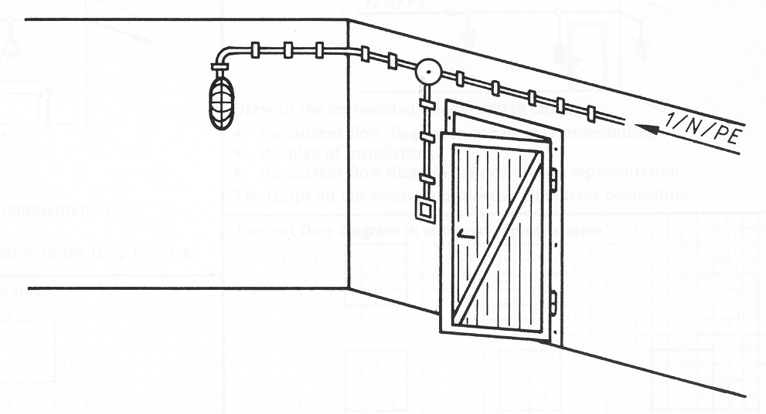
Lining/Layout Diagram
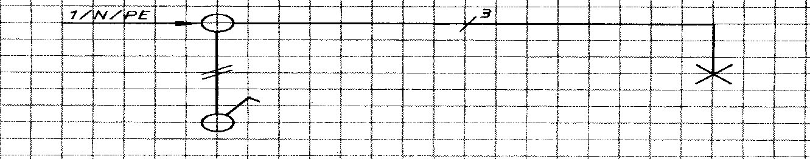
Function Diagram
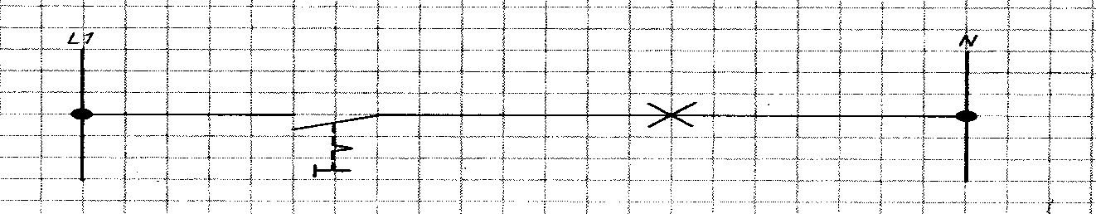
Function Diagram
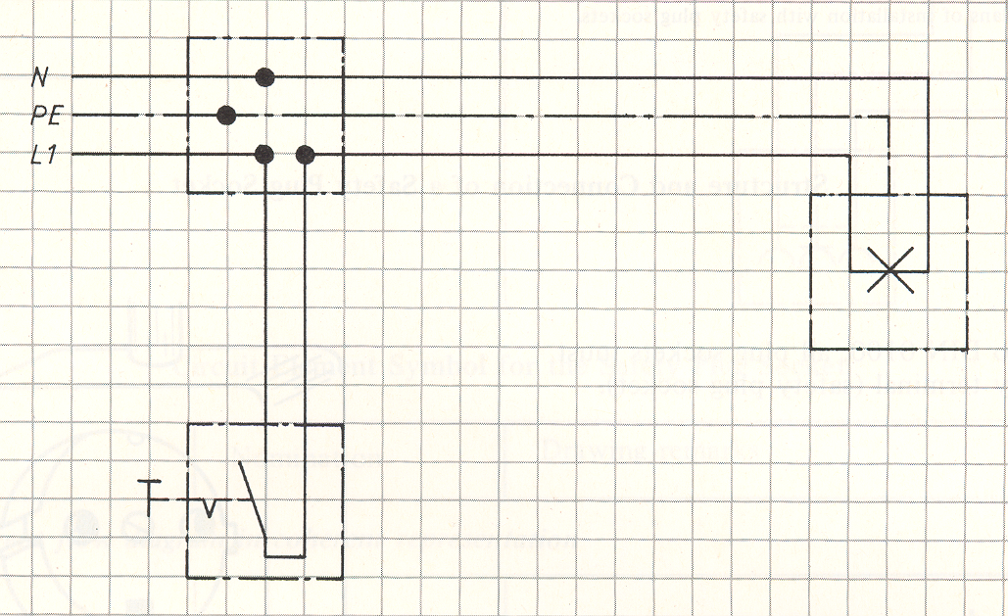
Wiring Diagram
- Tools and requirement:
1 .EMT conduit
2. Analog voltmeters

3. Measuring Tools
4. Wire
5. Wire Strippers
6 .Diagonal Cutter
7 .Screw Drivers
PROCEDURES
Step 1: Insert the GI wire from one electrical box to another through conduit and their fittings
Step 2: Push the GI wire along the installation until it comes on the other box.
Step 3: Pull the GI wire until the hook end is one meter from electrical box as shown.
Step 4: Tie the electric wire/cables to the hook by:
Step 5: Tie all the electrical conductor to the GI wire hook and
Step 6: Feed-in the electrical conductors into the conduit with somebody pushing at one point while you are pulling at another point as shown.
Step 7: Pull the GI wire until the tied ends of the electrical conductor comes out. Cut the wires from the hook leaving enough free ends at the box
Step 8: Bend the free ends of the wires at the box to prevent from being pulled out from the conduit.
Step 9: When electric wires are not immediately fed-in into a conduits after their installation, a draw-in (G. I. wire) are usually fed-in into the conduit between boxes.
Step 10: In feeding-in wires into the conduit, tie them to the draw wires as shown
- Quality Criteria: the given Wiring and Conduits Measuring for a for a 90⁰ ben

LAP Test
Practical Demonstration
Name: _____________________________ Date: ________________
Time started: ________________________ Time finished: ________________
.
Task 1: install electrical wiring using Electrical Metallic Tubing
Task 2: Lighting circuit, 1-way switch: one lamp, on-off

Unit Three: Install wiring system
This learning guide is developed to provide you the necessary information regarding the following content coverage and topics:
- wiring systems and wiring enclosures
- test data format.
- wiring system
This guide will also assist you to attain the learning outcomes stated in the cover page. Specifically, upon completion of this learning guide, you will be able to:
- Fixing wiring systems and wiring enclosures safely
- Record test data format.
- Installing wiring system

3.1 wiring systems and wiring enclosures

What is Electrical Wiring?
Electrical Wiring is a process of connecting cables and wires to the related devices such as fuse, switches, sockets, lights, fans etc. to the main distribution board is a specific structure to the utility pole for continues power supply.
Methods of Electrical Wiring Systems w.r.t Taking Connection
Wiring (a process of connecting various accessories for distribution of electrical energy from supplier’s meter board to home appliances such as lamps, fans and other domestic appliances is known as Electrical Wiring) can be done using two methods which are
Joint box system or Tee system
Loop – in system
They are discussed as follows:
Joint Box or Tee or Jointing System
In this method of wiring, connections to appliances are made through joints. These joints are made in joint boxes by means of suitable connectors or joints cutouts. This method of wiring doesn’t consume too much cables size.
You might think because this method of wiring doesn’t require too much cable it is therefore cheaper. It is of course but the money you saved from buying cables will be used in buying joint boxes, thus equation is balanced. This method is suitable for temporary installations and it is cheap.
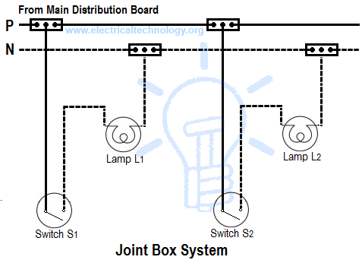
figur3. 1 joint box system
Loop-in or Looping System

This method of wiring is universally used in wiring. Lamps and other appliances are connected in parallel so that each of the appliances can be controlled individually. When a connection is required at a light or switch, the feed conductor is looped in by bringing it directly to the terminal and then carrying it forward again to the next point to be fed.
The switch and light feeds are carried round the circuit in a series of loops from one point to another until the last on the circuit is reached. The phase or line conductors are looped either in switchboard or box and neutrals are looped either in switchboard or from light or fan. Line or phase should never be looped from light or fan.

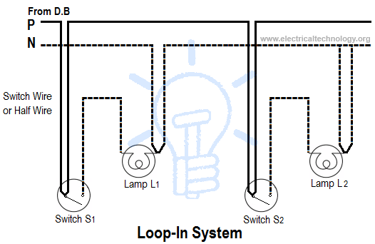
figur3. 2 loop in system

Advantages of Loop-In Method of Wiring
It doesn’t require joint boxes and so money is saved In loop – in systems, no joint is concealed beneath floors or in roof spaces. Fault location is made easy as the points are made only at outlets so that they are accessible.
Disadvantages of Loop-In Method of Wiring
Length of wire or cables required is more and voltage drop and copper losses are therefore morel oozing – in switches and lamp holders is usually difficult
Fixing wiring enclosures safely with relevant regulations and manufacturers’ instructions
An electrical enclosure
Is a cabinet for electrical or electronic equipment to mount switches, knobs and displays and to prevent electrical shock to equipment users and protect the contents from the environment? The enclosure is the only part of the equipment which is seen by users; in many cases it is designed not only for its utilitarian requirements, but also to be pleasing to the eye. Regulations may dictate the features and performance of enclosures for electrical equipment in hazardous areas, such as petrochemical plants or coal mines.
Electrical enclosures are usually made from rigid plastics, metals, particularly stainless steel, carbon steel, and aluminum. Steel cabinets may be painted or galvanized. Mass-produced equipment will generally have a customized enclosure, but standardized enclosures are made for custom-built or small production runs of equipment
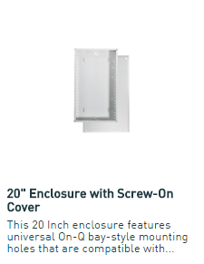

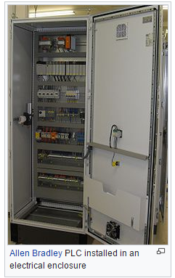
figur3. 3 loop in system

3.1.1 Fixing equipment safely with relevant regulations and manufacturers’ instructions

Electrical Equipment
An electrical equipment is an electricity consuming device or apparatus (including the cable) that is connected to the electrical installation
Electrical equipment can be classified into one of the following categories:
• Hand-held / Portable: appliance which is hand-held while in operation or can be moved easily while connected to the supply, intended to be held in the hand during normal use and the electrical motor forms an integral part of the equipment. (Excludes battery operated equipment). Examples: floor polisher, power tools, power leads, multi-outlet power board, jug, toaster, laboratory stirrer/heater, heat gun, heating mantle, etc.
• Movable: an appliance that can be moved readily from one place to another by unplugging from a general purpose outlet, but that is not moved during operation. Examples: cathode ray oscilloscope, electronic balance, personal computer, printer, portable power generating equipment, etc.
• Fixed/stationary: an appliance which in normal use is fastened to a support or otherwise secured in a specific position or is of such a size or function as to be difficult or unlikely to be moved from one place to another. Examples: large workshop machinery (lathe, band saw, etc.), oven, refrigerator, fixed power generating equipment, etc.
• Experimental: an appliance, constructed by a School/Section that does not fit into any of the other categories. Examples: immersion heater elements, furnaces, distillation control systems, laser sources, UV light sources, heater controls, etc..

3.2. test data by the job specifications

- In electronics, a continuity test is the checking of an electric circuit to see if current flows (that it is in fact a complete circuit). A continuity test is performed by placing a small voltage (wired in series with an LED or noise-producing component such as a piezoelectric speaker) across the chosen path. If electron flow is inhibited by broken conductors, damaged components, or excessive resistance, the circuit is "open".
- Devices that can be used to perform continuity tests include multi meters which measure current and specialized continuity testers which are cheaper, more basic devices, generally with a simple light bulb that lights up when current flows.
- An important application is the continuity test of a bundle of wires so as to find the two ends belonging to a particular one of these wires; there will be a negligible resistance between the "right" ends, and only between the "right" ends.
How to test for continuity
Turn the dial to Continuity Test mode (). It will likely share a spot on the dial with one or more functions, usually resistance (Ω). With the test probes separated, the multi meter’s display may show OL and Ω.
- If required, press the continuity button.
- First insert the black test lead into the COM jack.
- Then insert the red lead into the VΩ jack. When finished, remove the leads in reverse order: red first, then black.
- With the circuit de-energized, connect the test leads across the component being tested. The position of the test leads is arbitrary. Note that the component may need to be isolated from other components in the circuit.
- The digital multi meter (DMM) beeps if a complete path (continuity) is detected. If the circuit is open (the switch is in the OFF position), the DMM will not beep.
- When finished, turn the multi meter OFF to preserve battery life.
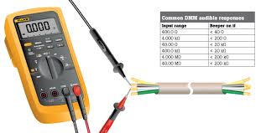
figur3. 4 continuity test

Continuity testing overview
- Continuity is the presence of a complete path for current flow. A circuit is complete when its switch is closed.
- A digital multi meter’s Continuity Test mode can be used to test switches, fuses, electrical connections, conductors and other components. A good fuse, for example, should have continuity.
- A DMM emits an audible response (a beep) when it detects a complete path.
- The beep, an audible indicator, permits technicians to focus on testing procedures without looking at the multi meter display.
- When testing for continuity, a multi meter beeps based on the resistance of the component being tested. That resistance is determined by the range setting of the multi meter. Examples:
  - If the range is set to 400.0 Ω, a multi meter typically beeps if the component has a resistance of 40 Ω or less.
  - If the range is set 4.000 kΩ, a multi meter typically beeps if the component has a resistance of 200 Ω or less.
- The lowest range setting should be used when testing circuit components that should have low-resistance value such as electrical connections or switch contacts
What is a MultiMate
digital millimeter or DMM is a useful instrument for measuring voltage, current and resistance, and some meters have a facility for testing transistors and capacitors. You can also use it for checking continuity of wires and fuses. If you like to DIY, do car maintenance or troubleshoot electronic or electrical equipment, a millimeter is a handy accessory to have in your home toolkit.
If you have any questions, just leave a comment at the end of this "how to" guide. Also if you find this article useful, please share it on Face book, Interest or other social media using the easy share buttons.
Thanks!
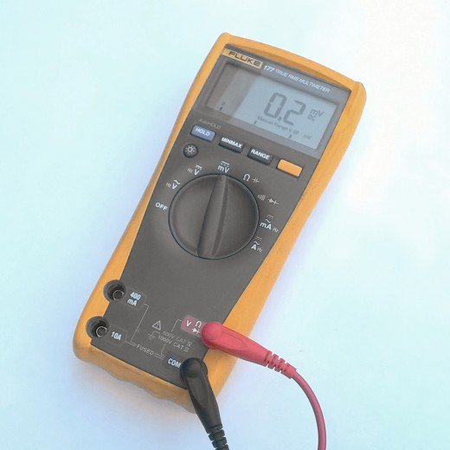
figur3. 5 Volts, Amps, Ohms multi meter

Volts, Amps, Ohms - What does it All Mean?
Volts
This is the pressure in an electrical circuit
Amps
This is a measure of the current flowing in an electrical circuit
Ohms
A measure of the resistance to flow in a circuit
Voltage Source
This produces a current flow in a circuit. It could be a battery, portable generator, mains supply to a home, alternator on your car engine or bench power supply in a lab or workshop
Load
A device or component which draws power from voltage source This could be an electronic resistor, bulb, electric heater, motor or any electrical appliance
Ground
This is usually the point in a circuit to which the negative terminal of a battery or power supply is connected
DC
Direct current. Current flows only one way from a DC source, an example of which is a battery
AC
Alternating Current. Current flows one way from a source, reverses, and then flows the other way. This happens many times a second at a rate determined by the frequency which is typically 50 or 60 hertz. The mains supply in a home is AC
Polarity
A term used to describe the direction of flow of current in a circuit or which points are positive and which are negative wart a reference point
Volts, Watts, Amps, Kilowatt Hours, What does it All Mean? - The Basics of Electricity
What Does a Multi meter Measure?
A basic multi meter facilitates the measurement of the following quantities:
- DC voltage
- DC current
- AC voltage
- AC current (not all basic meters have this function)
- Resistance
- Continuity - indicated by a buzzer or tone
In addition meters may have the following functions:
- Capacitance measurement
- Transistor HFE or DC current gain
- Temperature with an additional probe
- Diode test
- Frequency
The value measured by the instrument is indicated on an LCD display or scale. Laboratory bench DMMs sometimes have seven segment LED displays.
How Do I Setup a Multi meter to Measure Volts, Amps or Ohms?
Voltage, current and resistance ranges are usually set by turning a rotary selection dial. This is set to the quantity being measured, e.g. AC volts, DC volts, Amps(current) or Ohms (resistance).
Voltage, Current and Resistance Ranges
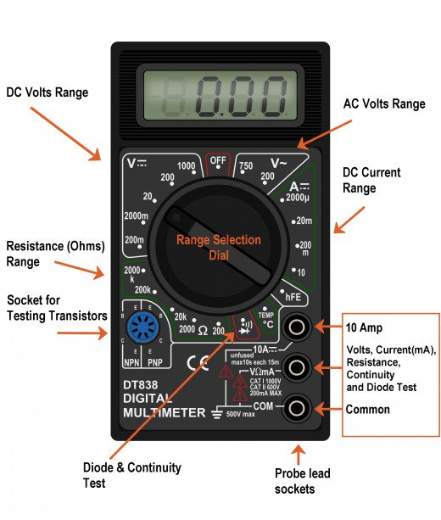
figur3. 6 Measure Voltage
How to

- Power off the circuit/wiring under test if there is a danger of shorting out closely spaced adjacent wires, terminals or other points which have differing voltages.
- Plug the black ground probe lead into the COM socket on the meter (see photo below).
- Plug the red positive probe lead into the socket marked V (usually also marked with the Greek letter "omega" Ω and possibly a diode symbol).
- If the meter has a manual range setting dial, turn this to select AC or DC volts and pick a range to give the required accuracy. So for instance measuring 12 volts on the 20 volt range will give more decimal places than on the 200 volt range.
If the meter is auto ranging, turn the dial to the 'V' setting with the symbol for AC or DC (see "What Do the Symbols on the Range Dial Mean?" below).
- A multi meter must be connected in parallel in a circuit (see diagram below) in order to measure voltage. So this means the two test probes should be connected in parallel with the voltage source, load or any other two points across which voltage needs to be measured.
- Touch the black probe against the first point of the circuitry/wiring.
- Power up the equipment.
- Touch the other red probe against the second point of test. Ensure you don't bridge the gap between the point being tested and adjacent wiring, terminals or tracks on a PCB.
- Take the reading on the LCD display.
Note: A lead with a 4mm banana plug on one end and a crocodile clip on the other end is very handy. The croc clip can be connected to ground in the circuit, freeing up one of your hands.
Connecting Probe Leads to Measure Voltage

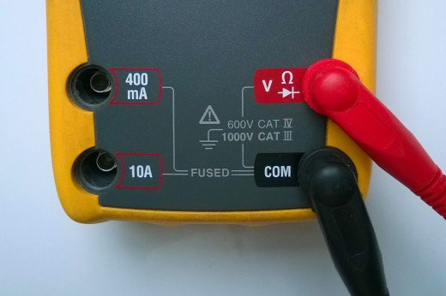
figur3. 7 Test leads and 4mm sockets on a DMM, setup to measure voltage

Recording test data by quality assurance procedures
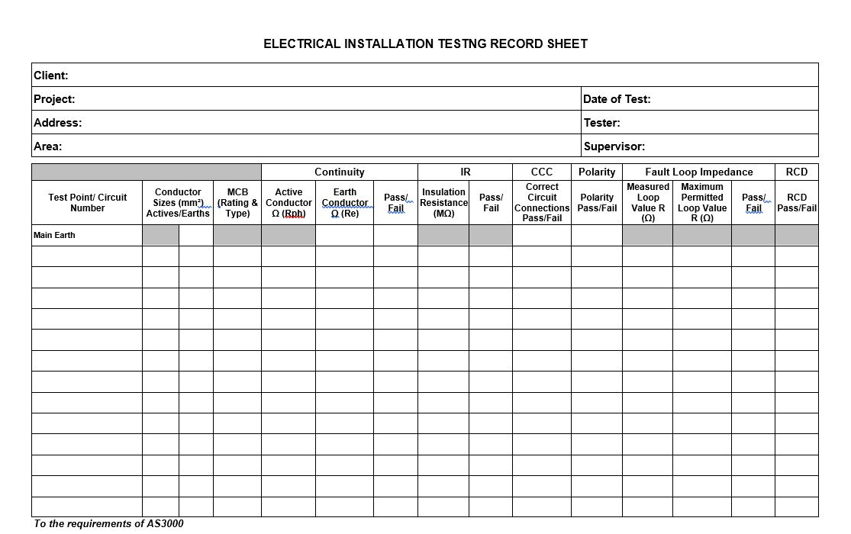
tabl3. 1 Testing record sheet
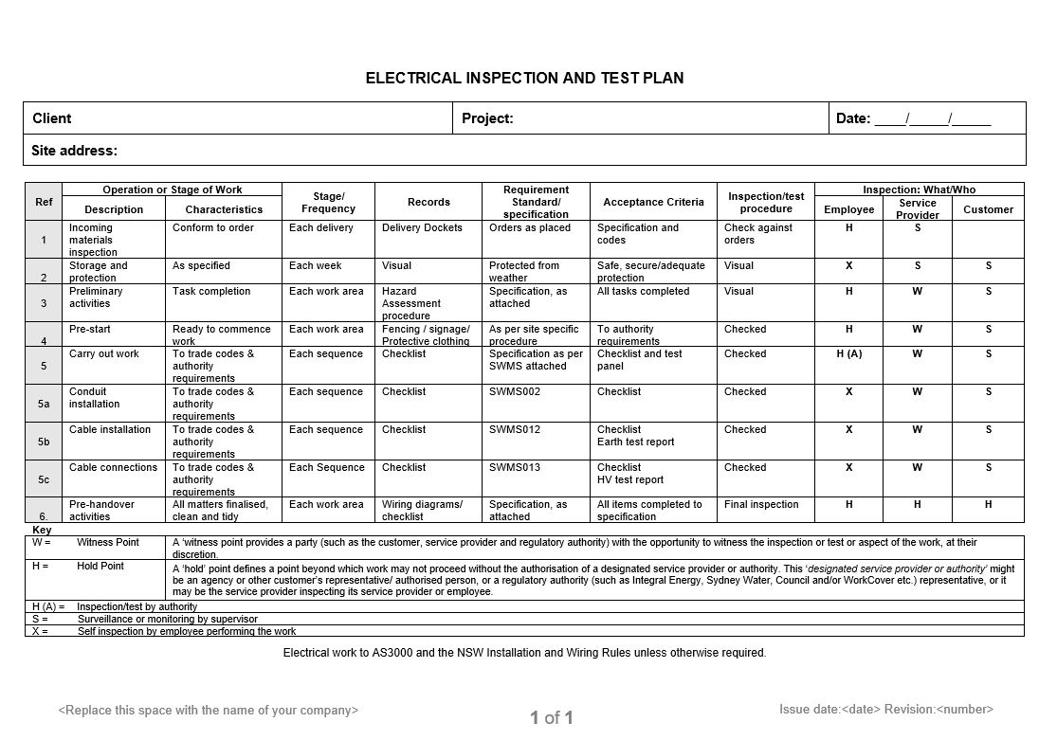

Testing record sheet
3.3. OHS policies and procedures to install wiring syste
Concepts of Occupational Health and Safety (OHS)
The term of Occupational health and safety (OHS) relates to health, safety, and welfare issues in the workplace.
OHS includes the laws, standards, and programs that are aimed at making the workplace better for workers, along with co-workers, family members, customers, and other stakeholders. Improving a company's occupational health and safety standards ensures good business, a better brand image, and higher employee morale.

3.4. Install wiring system

Introduction wiring systems
Electrical wiring is a process of connecting different accessories for the distribution of electrical energy from the supplier to various appliances and equipment(fuse, switch, lights, fan etc...) at home like television, lamps, air conditioners, etc.
The different types of electrical wiring that are used in domestic properties.
3.4.1.Types of Electrical Wiring Systems
They are different types of electrical wiring that are used in domestic properties
Different Types of House Electrical Wiring Systems
Cleat Wiring
This wiring comprises of PVC insulated wires or ordinary VIR that are braided and compounded. They are held on walls and ceilings using porcelain cleats with groves, wood or plastic. It is a temporary wiring system, therefore making it unsuitable for domestic premises. Moreover, cleat wiring system is rarely being used these days.
Casing and Capping Wiring
It was quite popular in the past but it is considered obsolete these days due to the popularity of the conduit and sheathed wiring system. The cables used in this electric wiring were PVC, VIR or any other approved insulated cables. The cables were carried through the wooden casing enclosures, where the casing was made of a strip of wood with parallel grooves cut lengthwise for accommodating the cables.
Batten Wiring
This is when a single electrical wire or a group of wires are laid over a wooden batten. The wires are held to the batten using a brass clip and spaced at an interval of 10 cm for horizontal runs and 15 cm for vertical runs.
Lead Sheathed Wiring
Lead sheathed wiring uses conductors which are insulated with VIR and are covered with an outer sheath of lead aluminum alloy which contains about 95% lead. The metal sheath gives protection to cables from mechanical damage, moisture and atmospheric corrosion.
Conduit Wiring
There are two types of conduit wiring according to pipe installation:
Surface Conduit Wiring When GI or PVC conduits are installed on walls or roof, it is known as surface conduit wiring. The conduits are attached to the walls with a 2-hole strap and base clip at regular distances. Electrical wires are laid inside the conduits.
Concealed Conduit Wiring When the conduits are hidden inside the wall slots or chiseled brick wall, it is called concealed conduit wiring. Electrical wires are laid inside the conduits. This is popular since it is stronger and more aesthetically appealing.
Advantages and Disadvantages of Concealed Conduit Wiring System
Advantages
It is a safe wiring system
Safe from chemical effects, humidity and other external factors
No risk of shock
It is aesthetically appealing
No risk of wear and tear, fire or damaged cable insulation
Quite reliable
Renovations can be easily performed as you can replace old wires easily
Disadvantages
Expensive as compared to surface conduit wiring
Changing the location of switches or appliances is difficult
Installation is complex
Hard to find defects in the wiring
Adding additional conduit in future is a tedious task
When the wiring is not done properly or isn’t maintained well, it may lead to dangerous situations such as electrical fires. Therefore, it is important that you take a lot of care while installing electrical wires and cables. If you are wondering which electrical wiring to install at your home, call us at D&F Liquidators, Inc. as we have a wide range of wiring at competitive prices and our experienced team will guide you through the selection process.
3.4,2 Methods of Electrical Wiring Systems
Wiring (a process of connecting various accessories for distribution of electrical energy from supplier’s meter board to home appliances such as lamps, fans and other domestic appliances is known as Electrical Wiring) can be done using two methods which are
3. 4,3 Wiring systems’ components
Electrical Wiring components is a device that used connecting and install full electrical project. Include wires, fuse, switches, sockets, lights, fans, boxes, circuit breaker, main distribution board , continues power supply etc....
3.4.4 checking wiring systems’ components
There are two kinds of checks that can be carried out and we recommend that you always employ a registered electrician to carry out such checks
Visual Inspection
A visual inspection is a basic check to identify any visible signs of defects, damage or deterioration. No circuit testing will be undertaken, so your electricity will likely remain on during the inspection. The electrician will need to be given access to all of the rooms in your home. The report will typically take around 1 hour to complete depending on the size of the property. Notes will be taken by the electrician as part of the visual inspection and a Visual Inspection Report (VIR) will be issued to the home owner at the end. The Visual Inspection report will record a number of observations and recommendations and provide an overall summary of the condition of the installation. Below is a check list of the things you can expect to be looked at during a visual inspection.
Consumer Unit (main fuse board)
Sockets
Plugs Light fittings Light switches Electrical cables or leads Earthling and bonding Extension leads Kitchen safety Bathroom safety Signs of wear and tear Visible signs of burning/scorching RCD protection around the home

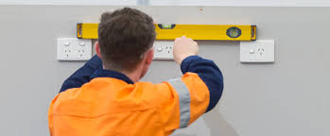
figur3. 11 Visual Inspection
3.4.5Electrical Installation Condition Report (EICR)
An electrical installation condition report (EICR) identifies any damage, deterioration, defects and/or conditions which may give rise to danger along with observations for which improvement is recommended. It is a more detailed report than a VIR and will involve the testing of various circuits which will require the turning off of the electrics at the main supply. This allows the contractor to identify any possible hidden defects or issues that cannot be identified during a VIR. The purpose of an EICR (also known as periodic inspection and testing of an electrical installation), is to determine, so far as is reasonably practicable, whether the installation is in a satisfactory condition for continued service. Homeowners often ask for, or obtain a condition report as part of a house sale. Similarly, landlords with an increasing awareness of their electrical safety obligations undertake regular periodic inspections in relation to their rental properties
3.4.6 The important Check wiring systems’ components
Test that are to be used or connected to electrical equipment should meet the following conditions: be suitable for the work in terms of their function, operating range and accuracy be in good condition and working order, clean and have no cracked or broken insulation. Particular care must be taken regarding the condition of the insulation on leads, probes and clips of test equipment pose no danger of electrocution to workers or damage to the electrical equipment during testing have suitably insulated leads and connection probes that enable connection or contact with energized parts to be made with minimal risk to the electrical worker provide suitable protection against hazards arising from over-voltages that may arise from or during the testing or measurement process. Safety Requirements for Electrical Equipment for Measurement, Control and Laboratory Use – General requirements provides a classification for instruments on the basis of their immunity to over-voltage, which is liable to be experienced in different parts of electrical equipment. Devices should be rated as Category III or IV to enable their use on all parts of the equipment.
Unit 3 Self-check3
Test 1
- Choose the one that best suitable the statement and write the letter of your choice on the space provided. (2pts each)
_________1. This is the pressure in an electrical circuit
DC B. AC C. voltage D. Volts
_________2. This is a measure of the current flowing in an electrical circuit
A. Batteries B. Ohms C. Amps D. current
_________3. A measure of the resistance to flow in a circuit
A. voltage B. Ohms C. Volts D. Nene
_________4. Direct current. Flows only one way from a DC source, an example of which is a battery
DC B. Batteries C. Electrical Equipment D. Isolation
_________5. Alternating Current. Current flows one way from a source, reverses, and then flows the other way.
A.DC B. AC C. GB D. all
II Directions: Answer all the questions listed below. Use the Answer sheet provided in the next page
1.What is the advantage and disadvantage of loop –in method of wiring?
2.What is Electrical Wiring?
3.What is electrical enclosure?
4.Write the Methods of Electrical Wiring Systems?

Operation Sheet 2

Operation title: Electrical Wiring using
Purpose: Continuity Test
Instructions: Given necessary templates, tools and materials you are required to
perform the following tasks within 30 mints.
Tools and requirement:
  - Analog voltmeters
  - Wire
  - dental voltmeters
Procedures: Step 1: Turn the dial to Continuity Test mode (). It will likely share a spot on the dial with one or more functions, usually resistance (Ω). With the test probes separated, the multi meter’s display may show OL and Ω.
Step 2: If required, press the continuity button
Step 3: First insert the black test lead into the COM jack.
Step 4: Then insert the red lead into the VΩ jack. When finished, remove the leads in reverse order: red first, then black.
Step 5: With the circuit de-energized, connect the test leads across the component being tested. The position of the test leads is arbitrary. Note that the component may need to be isolated from other components in the circuit.
Step 6: The digital multi meter (DMM) beeps if a complete path (continuity) is detected. If the circuit is open (the switch is in the OFF position), the DMM will not beep.
Step 7: When finished, turn the multi meter OFF to preserve battery life.
Quality Criteria: the given Wiring Continuity Test

LAP Test

Name: _____________________________ Date: ________________
Time started: ________________________ Time finished: ________________.
Task1; test continuity
Task 2: test voltage
Task 3: test current
Task 4: test voltage
Task 5: test current

Unit Four: Inspect and notify completion of work
This learning guide is developed to provide you the necessary information regarding the following content coverage and topics:
- Report to relevant people
- appropriate action from relevant people
This guide will also assist you to attain the learning outcomes stated in the cover page. Specifically, upon completion of this learning guide, you will be able to:
- Report to relevant people
- Obtain appropriate action from relevant people

4.1Report to relevant people

Report is done to relevant people those necessary variations to the planned programmed of work .The appropriate action is sought from the relevant people .Installing electrical wiring systems, wiring enclosures and equipment The most effective methods of measuring, cutting to length and installing wiring systems and wiring enclosures. The most effective methods of fabricating wiring enclosures. The authority issuing procedures for co-coordinating data on site services Interpret diagrams and drawings to find site services and the planned location of the wiring systems, wiring enclosures and equipment
Job Description:
A person in the first management who monitors and regulates employees in the performance of assaying or delegated tasks Supervisors are usually authorized to recommend and/or effect hiring disciplining promoting punishing rewarding and other associated activities regarding the employees in the departments.
1) Supervises and coordinates activities of electric-meter installer I and electric-meter repairer engaged in installing, testing, adjusting, and repairing meters for recording electric current consumption: Reviews work orders to verify specifications of wire sizes and metering equipment according to National Electric Code and company requirements.
2) Visits installation sites and inspects installed meters and other electrical appliances for conformance to specifications and safety standards.
3) Consults with customers, electric-wiring contractors, and commercial department representatives to determine space requirements, availability of customer-service outlets, and types of metering equipment for special installations.
4) Issues meter test or repair orders to workers.
5) Examines meters, instruments, and phase transformers to verify accuracy of tests and completion of repairs or adjustments.
6) Performs other duties as described under supervisor Master Title.

4.2 appropriate action from relevant people

What’s the difference between an “electrician” and a “Quality electrician”? Planning execution and evidence.
Although electrical contractors are only required to issue customers with a certificate of test, documented inspection and test procedures, and inspection and test records provide evidence of the actual test results which support the certificate. They also provide workers with a visual reminder of the step by step testing process. Workers can easily review the completed test record and identify if any steps have been missed
Concealed conduit electrical wiring systems are a popular choice in domestic premises as they are aesthetically appealing. They are the most commonly used house electrical wiring system as it protects the wires from external damage and increases their longevity.
The wires are installed in 4 steps.
Laying the electrical conduits in the slab
Laying the electrical conduits in the wall
Installation of Switch Boards Back Boxes
Installation of Distribution Boards
Let us look at the step-by-step installation procedure of a concealed conduit electrical wiring system.
Laying of Electrical Conduits in Slab
The slab conduits for house wiring should be 2 mm thick and 25 mm in size for PVC conduits. Lay the slab conduits between the top and bottom reinforcement Use only deep junction boxes in slabs. Properly bind the PVC conduits using the binding wire It would be ideal to follow the color coding for conduits for electrical wires and data such as LAN and telephone wire. Use grey PVC pipes for data, black PVC pipes for electrical wires and PVC solvent for joining the accessories
Check the wall drops carefully and determine the concrete thickness.
Check the conducting as per the service drawings and see where the switchboards are located and how many points need to be installed at each location
- Take special precautions while concreting the slab
- Replace all the broken pipes
- Ensure that all the joints are watertight
- Once the slab and beam are de-shuttered, pass the GI wiring immediately. Document any choke up or alternate route for future references
- Provide all the necessary sleeve in beams, columns prior to slab casting as per electrical & air-conditioning
- Provide the pull boxes at suitable locations
- Don’t cluster the pull and junction boxes at one place. Arrange them so that they can’t be seen easily from heavy movement areas as per the electrical drawings
Laying of Electrical Conduits in Wall
- Carry out the concealed conduit work after the construction of masonry walls but before the plastering work starts
- Once the curing of brickwork is completed, carry out the chasing work. Ideally, maintain a gap of 7 days between the two activities
- Do the wall chasing with wall cutters only as this would avoid damage to the walls
- Fix the electrical conduits with the approved clips to ensure proper routing and wiring
- Once the conduits, boxes and accessories are fixed, fill the chiseled surface with cement mortar and chick mesh wrapped around the conduits
- Start the wall conducting activity with level marking on the wall, keeping the height above FFL(Finished floor level) in mind
- Limit the width of chasing as per the number of conduits
- The depth of chasing should be at least 10 mm from the masonry wall to have the conduit recess
- Make sure that all the horizontal conduit runs are straight at the box level. The light point conduit should run straight vertically to the switch box. Make sure no wall conduit is taken haphazardly
- Don’t use any elbows or bends. Use a spring to bend if you want to change the direction of the pipe.
- Don’t run power conduits near any communication line
- Run the conduits above the false ceiling with proper support. Don’t rest them on the false ceiling in any case. Seal the vertical runs with open ends at the top if you have false ceiling work
Installation of Switch Boards Back Boxes
- Fix the concealed switchboard properly in level based on the architect’s design, for example, distance and height from the finished floor level (FFL)
- Ensure that the gap between the concealed switchboards is uniform. Maintain the same uniformity across all the installations.
- The switchboards must be readymade modular type metal boxes of the approved make. Fix the concealed box 3 mm below the plastered surface.
- Finish the box fixing before the plastering work while doing the wall conducting. Fill the boxes with the creosol while the plastering work is being done.
Installation of Distribution Boards
- Conceal the distribution board before the plasterwork
- Fix the DB box in a proper line and level the recess provided in the brickwork
- Ready the box as per the design such as fixing the number of conduits entering the distribution box
- Place the PVC pipes from the given entry holes only

Self-check4

I Choose the one that best suitable the statement and write the letter of your choice on the space provided. (2pts each)
1,.A conductor is a material in which the electrons are:
- very large compared with the nucleus c) tightly bound to the nucleus
- positively charged to the nucleus d) loosely bound to the nucleus
2. A ‘good insulator’ material has:
- a negative nucleus in the atoms of the material d) no free electrons
- positive electrons available for current flow
- free electrons available for current flow
3.The following materials are good conductors:
- copper, Perspex and glass c) copper, brass and wood
- copper, Silver and aluminum d) PVC, rubber and porcelain
4..The following materials are good insulators:
- PVC, copper and aluminum c) PVC, rubber and porcelain
- PVC, rubber and brass d) copper, gold and silver
5..An electric current in a circuit may also be described as a:
- flow of atoms c) resistance in the circuit
- difference of potential d) flow of free electrons
6..Most electrical cables are constructed in three parts, the:
- conductor, copper and aluminum c) conductor, insulation and sheath
- conductor, insulation and flexible cord d) conductor, outer sheath and protection
7.,The protective conductor connecting exposed conductive parts of equipment to the main earthling terminal is called:
- the general mass of earth c) exposed conductive parts
- the circuit protective conductor (CPC) d) extraneous conductive parts
8.The metalwork of a piece of electrical equipment is called:
- the general mass of earth c) exposed conductive parts
- the circuit protective conductor (CPC) d) extraneous conductive parts
9.An overload current may be defined as:
- a current in excess of at least 15 A d) a current in excess of 60 A
- a current which exceeds the rated value in an otherwise healthy circuit
- an over current resulting from a fault between live and neutral conductors
10.A short circuit may be defined as:
- a current in excess of at least 15 A d) a current in excess of 60 A
- a current which exceeds the rated value in an otherwise healthy circuit
- an over current resulting from a fault between live and neutral conductors
I. Directions: Answer all the questions (3pts each)
1.What is the purpose of an electrical installation condition reportt?
2.What is an Electrical Inspection?
4.Why is Electrical Inspection Important

Operation Sheet-3
install electrical wiring using Electrical Metallic Tubing
- Operation title: : Installation of Distribution Boards
- Purpose: To practice and demonstrate the knowledge and skill required in Installation of Distribution Boards
- Instructions: Given necessary templates, tools and materials you are required to perform the following tasks within 1 hours
Tools and requirement:
1. Analog voltmeters

2. Measuring Tools
3. Wire
4. Wire Stripper
5..Diagonal Cuter
6..Screw Drivers
Procedures:
Step 1: Conceal the distribution board before the plasterwork
Step 2: Fix the DB box in a proper line and level the recess provided in the brickwork
Step 3: Ready the box as per the design such as fixing the number of conduits entering the distribution box
Step 4: Place the PVC pipes from the given entry holes only
Quality Criteria the given Distribution Boards Installation

LAP Test
Practical Demonstration

Name: _____________________________ Date: ________________
Time started: ________________________ Time finished: ________________
.
Task 1: Install Distribution Boards

Reference
- https://buyersask.com/electrical/10-common-electrical-defects-home-inspectors-find/
- http://lsin.panasonic.com/blog/common-electrical-problems-and-solutions/
- https://www.electrical-online.com/electrical-tools-and-equipment/
- https://www.thespruce.com/top-electrical-connections-in-the-home-1152767 /
- https://inspectapedia.com/home_inspection/Curriculum_Electrical.php
- EBCS 10
- IEE Regulation 2017

Participants of this Module (training material) preparation
No | Name | Qualification (Level) | Field of Study | Intuition | Mobile Number | E-mail
1 | Bacha Wake | A(Msc) | Electrical control and Automation | Hawassa TTC | 0910780182 | bachawakejima2012@gmail.com
2 | Samuel Bekele | A(Msc) | Electrical control and Automation | Haramaya | 0910082977 | samuelbekele460@gmail.com
3 | Girma Belete | A(Msc) | Electrical power engineering | Hawassa PTC | 0938935026 | girmabetele7@gmail.com
4 | Tirusew Baye | Bsc | Building Construction | Debra tabor PTC | 0918092865 | Tirusew2014tgmail.com
5 | Saladin Abdala | Bsc | Electrical Technology | Deredawa PTC | 0920689179

