Building Electrical Installation Level II
Based on June 2022 Curriculum Version 1

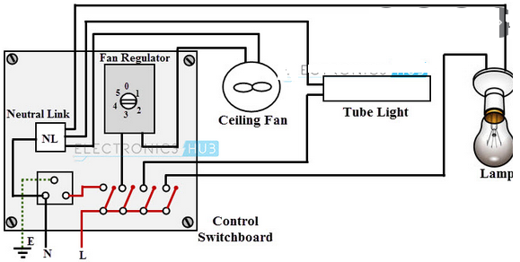
Module Title: -Connecting and Terminating Electrical Wiring System
Module code: EIS BEI2 M04 0822
Nominal duration: 80 Hours
Prepared by: Ministry of Labor and Skill

August 2022

Addis Ababa, Ethiopia

Table of Content

Acknowledgment 4
Acronym 5
Introduction to the Module 6
Unit one: installation and termination of wiring system 7
1.1 Installation based to OH&S policies 7
1.2. Personnel to ensure the work 8
1.3 Wiring systems 8
1.5 Electrical tools and equipment 21
Self-Check -1 23
Unit Two: Installation and termination of wiring system 24
2.1 Installation of Wiring systems 24
2.2. Terminatingand connecting accessories 31
2.3. unplanned events or conditions 35
Self-Check -2 36
Unit Three: Connect wiring system and equipment 39
3.1 IEE wiring regulations / Standard for Electrical Installations 40
3.2. Check the connections 40
3.3.Take safe and sensible action to remedy any identified defects 42
3.4.Fix all conduit and wiring depending on specifications. 42
Self-Check 3 46
Unit Four: Inspect and notify completion of work 48
4.1 final inspections 48
4. 2 Prepare work accomplishment report 49
Self-check-4 50
Unit five Clean up 51
.5.1 Working area 51
Self-check-5 54

figer of Content

figure 1. 1 PVC Electrical Conduit fittings 11
figuerr 1. 2 Control switch 13
figure 1. 3 Electric Switch fitting 14
figurer 1. 4 Socket outlet fitting 14
figure1. 5 Convenience Outlet, 3-pin 15
figuer1. 6 Weatherproof convenience outlet, duplex, 3-pin. 16
figure1. 7 Shako plug and socket CEE 7/4 16
figure.1 8CEE 7/16 plug and old socket 17
figure 1. 9 Electrical tools 21
figure 1. 10 testing circuit 22
figure 1. 11 voltage tester 22
Figure 2. 1 wires Color code 27
Figure 2. 2 Single Switch 28
Figure 2. 3 Wiring diagram of two bulbs controlled by two three-way switches 29
Figure 2. 4- Sch matic Diagram of one bulb controlled in 3 locatio 30
Figure 2. 5 Wiring diagram of one bulb controlled by two 30
Figure 2. 6 Wiring connection of two bulbs controlled by two 3-wayswitches Error! Bookmark not defined.
Figure 2. 7 shows a termination made off correctly. 32
Figure 2. 8 shows a termination made off incorrectly 32
Figure 2. 9 shows a termination made off incorrectly 32
Figure 2. 10 shows an incorrect termination 32
Figure 2. 11 Terminals, Clamps and Lugs 34

LIST OF TABLE
Table 1. Material needed 43
Table 2 LIST OF TOOLS & EQUIPMENT 44

Acknowledgment
Ministry of Labor and Skills wish to extend thanks and appreciation to the many representatives of TVET instructors and respective industry experts who donated their time and expertise to the development of this Teaching, Training and Learning Materials (TTLM).

Acronym
A -----------------Ampere
A.C ----------------Alternating Current
C.I -----------------Cast Iron
CFLs ----------- ----Compact Fluorescent Lamps
DB : ---------------Distribution Board
D.C --------------- Direct Current
ELCB --------------Earth Leakage Circuit Breaker
G.I ------------------Galvanized Iron
GLS----------------General Lighting Service
HF ------------------High Frequency
HID ----------------High Intensity Discharge
HRC ---------------High Rupturing Capacity
HT -----------------High Tension
I -------------------Current
ICDB ---------------Iron Clad Distribution Board
KV ----------------Kilo Volt KW : Kilo Watt
LT ----------------Low Tension
MCB --------------Miniature Circuit Breaker
MS----------------Mild Steel PVC : Polyvinyl Chloride
R ---------------- resistance
RCCB------------Residual Current Circuit Breaker
SDB ------------Sub Distribution Board S
PMCB ----------Single Pole Miniature Circuit Breaker
SPN ----------- -Single Pole & Neutral
TPN ------------Triple Pole & Neutral
V -------------- Volt W Watt

Introduction to the Module
In building electrical installation the connection of wiring and include estermination and connection of all types of cords and cables, excluding specialist cables. All testing is undertaken on completed circuits where these are not connected to main supply, using appropriate methods such as continuity and resistance checks. Specifications are obtained from electrical/electronic drawings and data sheets. Soldering/disordering of electrical/electronic components may also require the selection or Perform manual soldering/disordering -electrical/electronic components or Perform high reliability soldering and disordering) as applicable
This module covers the units:
- installation and termination of wiring system
- wiring system and equipment
- Inspection and notification of work completion
- Clean up
Learning Objective of the Module
- Perform installation and termination of wiring system
- Connect wiring system and equipment
- Inspect and notify completion of work
- Clean up
Module Instruction
For effective use this modules trainees are expected to follow the following module instruction:
- Read the information written in each unit
- Accomplish the Self-checks at the end of each unit
- Perform Operation Sheets which were provided at the end of units
- Do the “LAP test” giver at the end of each unit and
- Read the identified reference book for Examples and exercise

Unit one: installation and termination of wiring system
This unit is developed to provide you the necessary information regarding the following content coverage and topics:
  - installation based to OH&S policies
  - Personnel to ensure the work
  - Check Wiring systems
  - Fitting Accessories
  - Location of fitting accessories necessary materials
  - Tools, equipment and testing devices
  - Check Preparatory work
This unit will also assist you to attain the learning outcomes stated in the cover page. Specifically, upon completion of this learning guide, you will be able to:
  - Plan and prepare installation based to OH&S policies
  - Consult appropriate personnel to ensure the work is coordinated
  - Check Wiring systems
  - Obtain Fitting Accessories
  - Identify location of fitting accessories
  - Obtain necessary materials
  - Obtain Tools, equipment and testing devices
  - Check Preparatory work

1.1 Installation based to OH&S policies

Planning and preparing for the installation
Before you install the installation server products, you must prepare your system and plan for choices and make during the installation process.
1.1.1. Installation Planning

Installation Planning is the planning involved in case the system requires replacement or upgrade. It is always necessary to assess the status of the current system of equipment whether there is need for upgrade or replacement of the system
1.1. 2 Steps Involved in Installation Planning
1. Assessment - The performance of the current system in terms of reliability or productivity.
2. Readiness Review existing installation to identify the roadblocks.
3. Benchmark Record data on current system in order to measure the improvement in the new system to be installed.
4. Design or Plan- Identify and map all work necessary to make migration and upgrades.
5. Shutdown-Check and shutdown all the allied system.
6. Replacement- Replace or put a new installation at the designated location.
7. Testing- Do all the routine test specified in the installation guide. Also perform stress test related to the system.
8. Monitoring- Monitoring the system for a specified period to evaluate performance and check issues which might arise due to installation errors

1.2. Personnel to ensure the work
Consultation involves sharing of information, giving workers a reasonable opportunity to express views and taking those views into account before making decisions on health and safety matters.
A person conducting a business or undertaking must consult, so far as is reasonably practicable, with workers who carry out work for the business or undertaking and who are (or are likely to be) directly affected by a work health and safety matter.

1.3 Wiring systems
Electrical wiring is a process of connecting different accessories for the distribution of electrical energy from the supplier to various appliances and equipment(fuse, switch, lights, fan etc...) at home like television, lamps, air conditioners, etc
.The different types of electrical wiring that are used in domestic properties.
Different Types of House Electrical Wiring Systems
Cleat Wiring
This wiring comprises of PVC insulated wires or ordinary VIR that are braided and compounded. They are held on walls and ceilings using porcelain cleats with groves, wood or plastic. It is a temporary wiring system, therefore making it unsuitable for domestic premises. Moreover, cleat wiring system is rarely being used these days.
Casing and Capping Wiring
It was quite popular in the past but it is considered obsolete these days due to the popularity of the conduit and sheathed wiring system. The cables used in this electric wiring were PVC, VIR or any other approved insulated cables. The cables were carried through the wooden casing enclosures, where the casing was made of a strip of wood with parallel grooves cut lengthwise for accommodating the cables.
Batten Wiring
This is when a single electrical wire or a group of wires are laid over a wooden batten. The wires are held to the batten using a brass clip and spaced at an interval of 10 cm for horizontal runs and 15 cm for vertical runs.
Lead Sheathed Wiring
Lead sheathed wiring uses conductors which are insulated with VIR and are covered with an outer sheath of lead aluminum alloy which contains about 95% lead. The metal sheath gives protection to cables from mechanical damage, moisture and atmospheric corrosion.
Conduit Wiring
1.4 Fitting Accessories
Electrical accessory" means a device associated with the Electrical wiring of a domestic installation; "adaptor" means a electrical accessory which may be engaged. With a socket, being an electrical accessory which is designed
Types of electrical fittings
PVC Electrical Conduit fittings
Electrical conduit and fittings are of good quality, low cost, high safety and reliability. It has the advantages of beautiful appearance, light weight and easy bend, high strength, anti-aging, corrosion resistance, high fire resistance, good insulation and so on. It is used in the buildings and structures to protect and secure wire, cable and communication network.
An electrical conduit is a tube used to protect and route electrical wiring in a building or non building structure. Electrical conduit may be made of metal, plastic, fiber, or fired clay. Most conduits is rigid, but flexible conduit is used for some purposes.
Box connectors Box connectors join conduit to a junction box or other electrical box. A typical box connector is inserted into a knockout in a junction box, with the threaded end then being secured with a ring (called a lock nut) from within the box, as a bolt would be secured by a nut. The other end of the fitting usually has a screw or compression ring which is tightened down onto the inserted conduit. Fittings for non-threaded conduits are either secured with set screws or with a compression nut that encircles the conduit. Fittings for general purpose use with metal conduits may be made of die-cast zinc, but where stronger fittings are needed, they are made of copper-free aluminum or cast iron.
Couplings connect two pieces of conduit together. Sometimes the fittings are considered sufficiently conductive to bond (electrically unite) the metal conduit to a metal junction box (thus sharing the box's ground connection).
Grounding bushings Grounding bushings are used which have bonding jumpers from the bushing to a grounding screw on the box. Unlike water piping, if it the conduit is to be watertight, the idea is to keep water out, not in. In this case, gaskets are used with special fittings, such as the weather head leading from the overhead electrical mains to the electric meter. Flexible metal conduit usually uses fittings with a clamp on the outside of the box, just like bare cables would.
A conduit body can be used to provide pulling access in a run of conduit, to allow more bends to be made in a particular section of conduit, to make connections if the conduit body is rated for such use, to conserve space where a full size bend radius would be impractical or impossible, or to split a conduit path into multiple directions. Conduit bodies differ from junction boxes in that they are not required to be individually supported, this makes them very useful in practical applications. Conduit bodies are commonly referred to as conduits, a term trademarked by Cooper Crouse-Hinds company, a division of Cooper Industrials.
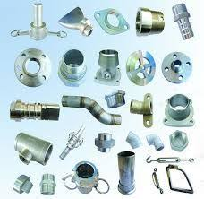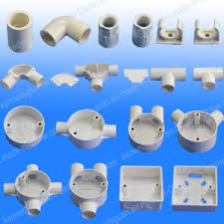
finger 1. 1 PVC Electrical Conduit fittings
Advantages:
1. Good price
2. Light and recyclable
3. Chemical resistance
4. Wide range of fittings
5. No vibration and noise
6. Easy to install and to operat
Applies to swimming pool, waste water treatment, agriculture, litigation, industrial
Electric Switch Basics
An electric switch is responsible for allowing or inhibiting the transfer of electricity in an electrical circuit. The most common form of electric power switch is a basic manual electromechanical unit. When the switch is open, the electrical contacts do not touch and electricity cannot flow. When the switch is closed, however, the electrical contacts touch and electricity flows throughout the circuit.
Types of Basic Electrical Switches
Below we list a few of the most common types of basic electrical switch.
SPST Electric Switch
This switch’s mnemonic stands for “single pole, single throw.” The switch consists of one set of electrical contacts, so it has two terminals, one from each contact. It is a simple on-off switch, so when the switch is open no electricity flows, but when it’s closed the contacts meet and electricity is transferred. A light switch is a good example of a SPST switch.
SPDT Electric Switch
A single pole double throw switch can also be called a changeover switch. In this case, there are three terminals—one terminal (A), faces two opposing terminals (B and C) and can be connected either, depending on the mode. It is said to be “double throw” because there are two positions this switch can operate—A is either connected to B, or A is connected to C.
DPST Electric Switch
In a double pole, single throw switch, there are two poles—two sets of connectors—but only one viable position they connect. Each pole’s terminals connect. The first pole is comprised of terminals A and B, which connect. Simultaneously, the second pole, comprised of terminals C and C, connects. Because there is only one position in which these poles operate, it is a single throw device. In essence, a DPST is made up of two SPSTs, but is controlled by one mechanism.
DPDT Electric Power Switch
A double pole double throw switch is comprised of two SPDTs. Each pole has two possible throws. The first pole, with three terminals, is comprised of A, B, and C. A can be connected to B, or A can be connected to C as the two possible throw positions. In the second pole, there are also three terminals, D, E, and F, and two possible throws. D can be connected to E or D can be connected to F. A, B, C, D, E, and F are all controlled by the same mechanism, making it a double pole double throw switch..
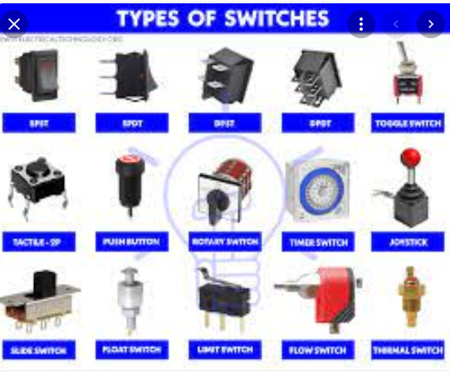

figer1. 2 Control switch
Control switch
- .A light fitting connected to an installation by means other than a socket outlet shall be controlled by a switch which shall be arranged to disconnect all the supply conductors
- The switch required by (1) above shall be separate from lighting fitting and in a readily accessible position subject to the provisions (3) and (5) below, where applicable
- Where a switch has to be situated so as to be normally inaccessible to a person who is using a bath or a shower, it 'is admissible for the switch to be placed adjacent to the normal access door of the room, or to be of the type operated by insulating cord.
- The switch or switches providing control of comprehensive lighting installation comprising more than one lighting fitting in non-domestic premises may be installed in separate rooms
- Where lighting fittings are installed over readily combustible material, every light fitting .shall be controlled by an individual wall switch
- Where way in a dwelling unit has risers, the lighting shall be controlled by intermediate wall switches or their functional equivalent located at the head .and foot of the' stairway
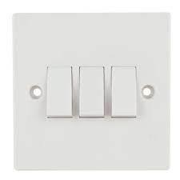

figer 1. 3 Electric Switch fitting

fig 4.4 Electric Switch fitting

C. Socket outlet fitting
What you may know as a power point is technically referred to as a 'socket outlet'. It's also less commonly referred to as a GPO, which stands for 'General Purpose Outlet' or 'General Power Outlet', depending on who you ask. The term 'GPO' is used in America (and therefore appears quite a lot online), but the term's outdated throughout the rest of the world.
Socket outlets are available in many different styles, and can only be installed or maintained by an electrician.
- Polarized outlets are different in that slot for the neutral wire is wider than the slot for the hot wire. This makes it difficult to insert the electrical plug the wrong way
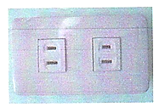

Figure 1. 4 Socket outlet fitting

- Non-Polarized outlets have two vertical slots side by side that are the same size.

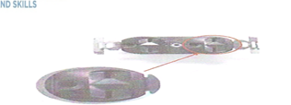

Grounded outlets have a round hole for the grounding conductor in addition to the two vertical slots. In general, electronic devices such as computers require these to provide a solid ground for the case so the electronics will work properly. It is also used as a safety feature in certain highepower appliances such as vacuum cleaners, ensuring that whatever happens to the wiring, the case will never be energized to wall voltage.
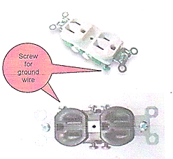

Socket outlet fitting
Some electrical outlets have a T shaped slot on the neutral instead of just a vertical slot. These outlets are rated for 20A, and can receive special plugs for appliances which draw more than 15A. This prevents people from tripping their circuit breakers by plugging them 15A outlets by mistake.
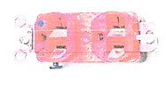

Figure 15 Convenience Outlet, 3-pin

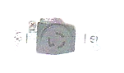

Figure 1. 6 Weatherproof convenience outlet, duplex, 3-pin.

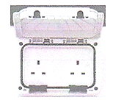

figer1. 7 Shako plug and socket CEE 7/4

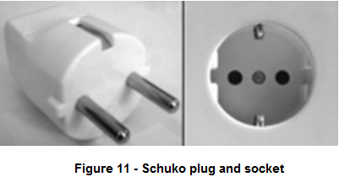
CEE 7/4, commonly called "Shako" socket, has a recessed round shape with two symmetrical round receptacles and two grounding clips on the sides of the socket. The Shako connection system is symmetrical and unpolarized by design, allowing live and neutral to be reversed. Its dimensions are compatible with CEE 7/5 (french plug/socket) except that the female ground contact is omitted.

French Socket CEErace, Belgium, Poland, Czech Republic, Slovakia and some other countries have standardized on a round plug with two round pins measuring 4.8 by 19 mm (0.189 by 0.748 in), spaced 19 mm (0.748 in) apart and with a hole for the socket's ground pin. This standard will also accept Euro plugs and CEE 7/17 plugs. Sockets are installed with the earth pin upwards. Although the plug is polarized, there is no universally observed standard for connecting the live and neutral. In the former Czechoslovakia Standard ČSN 33 2180:1979, section 6.2.2. required live to be on the left side of socket. Child-resistant outlet shutters are required by French and Belgian standards, however they are not required in all countries where this type is used.CEE 7/5 plugs are not compatible with the CEE 7/4 socket because grounding in the CEE 7/5 socket is effected by a round male pin permanently mounted in the socket.
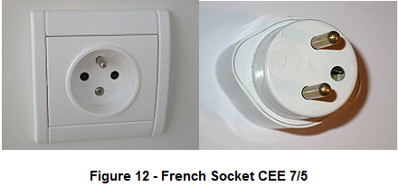

- CEE 7/7 plug
To bridge the differences between German and French standards, the CEE 7/7 plug was developed. It is polarized to prevent the live and neutral connections from being reversed when used with a French CEE 7/5 outlet, but allows polarity reversal when inserted into a German CEE 7/4 socket. The plug is rated at 16 A.
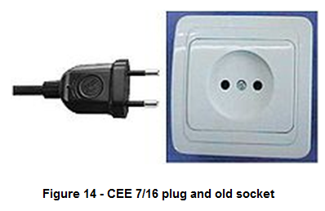
It has grounding clips on both sides to connect with the CEE 7/4 socket and a female contact to accept the grounding pin of the CEE 7/5 socket. It is used in almost all European countries. Currently, appliances are sold with non-rewriteable CEE 7/7 plugs attached. This means that the plugs are now identical between countries like France and Germany, but the sockets are different.
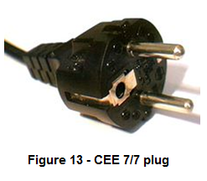

figure 1. 8CEE 7/16 plug and old socket
CEE 7/16 plug and old socket
This two-pin plug is popularly known as the Euro plug. The plug is ungrounded and has two round 4 mm (0.157 in) pins, which usually converge slightly towards their free ends. It is described in CEE 7/16 and is also defined in Italian standard CEI 23-5 and Russian standard GOST 7396. This plug is intended for use with devices that require 2.5 A or less. Because it is unpolarized it can be inserted in either direction into the socket, so live and neutral are connected arbitrarily. The separation and length of the pins allow its safe insertion in most CEE 7/5, CEE 7/4 "Shako", Israeli, CEE 7/7, Swiss, Danish and Italian outlets, as well as BS 4573 UK shaver sockets. It can be forced into BS 546 (5 A) and some BS 1363 sockets, if the shutters are opened, though the connection may be neither reliable in either case, nor safe.
The Euro plug itself is used in Class II applications throughout continental Europe. It is also used in the Middle East (Iran), most African nations, South America (Brazil, Chile, Argentina, Peru and Bolivia), Asia (India, Bangladesh, Sri Lanka, Indonesia, Pakistan, South Korea, and the Philippines) as well as Russia and the former Soviet republics, such as Ukraine, Armenia, Georgia, and many developing nations. It is also used alongside the BS 1363 in many nations, particularly former British colonies.
Unearthed socket compatible with both Shako and French plugs
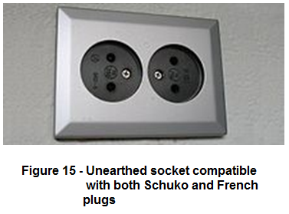
Euro plug sockets have no ground provisions and consequently have been phased out in most countries. For example, in Germany, ungrounded outlets are rare, found only in very old installations, whereas in the Netherlands they are common in "dry areas" such as in bedrooms or living rooms. Standards also vary between countries as to whether child-resistant shutters are required. Depending on the country and the age of the socket these sockets may have 4.0 or 4.8 mm receptacles. The latter accept CEE 7/5 and CEE 7/4 plugs in addition to Europlugs, though without ground

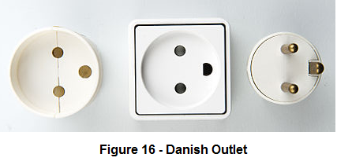
connection. Countries using the CEE 7/5 and CEE 7/4 standards vary in whether ungrounded Euro plug sockets are still permitted in environments where the need for grounding is less critical. Adaptors and trailing sockets and power strips designed to accept only Euro plugs with 4 mm (0.157 in) pins may also have plastic barriers in place to prevent CEE 7/17, Shako or French plugs from entering.

Danish 107-2-D1, standard DK 2-1a, with round power pins and half round ground pin
Outlet for Danish computer equipment plug's tilted flattened pins and half round ground pin (mainly used in professional environment), standard DK 2-5a
This Danish standard plug is described in the Danish Plug Equipment Section 107-2-D1 Standard sheet (SRAF1962/DB 16/87 DN10A-R). Unlike the French CEE 7/5 plug, the earthling pin is on the plug, not in the socket. The Danish socket need not be recessed to protect the earthling pin. The Danish standard
Side by side comparison of Italian CEI 23-16/VII plugs and sockets rated 16 A (left) and 10 A (right).
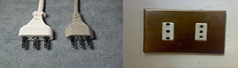
The Italian earthed plug/socket standard, CEI 23-16/VII, includes two models rated at 10 A and 16 A that differ in contact diameter and spacing (see below for details). Both are symmetrical, allowing the live and neutral contacts to be inserted in either direction. The 10 A plug is called IT1-10P or S11 and the socket is IT1-16R or P11. The 16 A plug is called IT2-16P or S17 and the socket is IT2-16R or P17.
The 10 A style extends CEE 7/16 by adding a central earthling pin of the same gauge. Thus, CEI 23-16-VII 10A sockets can accept CEE 7/16 Euro plugs. This is the plug shown in the first picture.
The 16 A style looks like a magnified version of the 10A style, identical in shape. However, the pins are 5 millimeters thick (being 4 mm thick in 10 A type), 26 mm apart (while 19 mm apart in 10 A type) and 7 mm longer. The packaging of these plugs in Italy may claim they are a "North

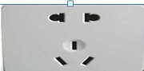
China CPCS-CCC (Chinese 10 A/250 V) plugs
The standard for Chinese plugs and sockets is set out in GB 2099.1‐2008 and GB 1002‐2008. As part of China's commitment for entry into the WTO, the new CPCS (Compulsory Product Certification System) has been introduced, and compliant Chinese plugs have been awarded the CCC Mark by this system. The plug is three wire, earthed, rated at 10 A, 250 V and used for Class 1 applications; a 16 A version also
This plug, defined in SI 32 (IS16A-R), is unique to Israel. It has three flat pins to form a Y-shape. Live and neutral are spaced 19 mm (0.75 in) apart. The plug is rated at 16 A. In 1989, the standard was revised to use three round 4.5 mm (0.177 in) pins in the same locations, allowing the socket to accept the Euro plugs used in Europe and Israel for non-earthed appliances. Sockets
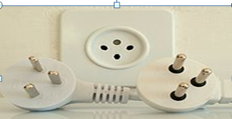
made since 1989 accept both flat and round pins for compatibility with both old and new plugs. As of 2008, pre-1989 sockets which accept only old-style plugs are very rare in Israel.
Fitting accessories necessary materials
a) Shall be located on the ceiling or on the front wall above the door of the closet unless mounted on the trim of the side walls of the doorway and approved for the application; and
b) shall not be of pendant type.
(1) Luminaries in damp or wet locations shall be approved for such locations and be so marked.
The following NEC regulations apply to Romex conductors:

1.5 Electrical tools and equipment
Tools and equipment are two words that are often used synonymously, mainly due to the similarities of their meanings. A tool can be any item that is used to achieve a goal. Equipment usually denotes a set of tools that are used to achieve a specific objective
Wiring Accessories on Board You should know the tools required for fixing the accessories on the board. You should also know the purpose of fixing the accessories. In-house wiring of the switches, holders and sockets should be fixed on wooden/sun mica boards and blocks. Therefore, it is necessary to learn how to fix these accessories. The ways to fix these accessories have been discussed in the following practical activity. the accessories on the board or round block by wooden screws after making holes on them by the poker. Then fix all covers on the accessories
Electrical tools: are a stable of any toolbox, but they're especially critical for electricians who regularly manipulate and cut wire.
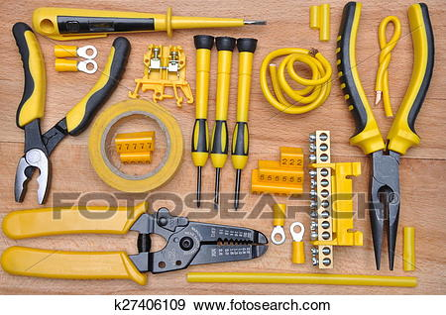
figure 1. 9 Electrical tools
Electricalequipment: Often electrical equipment refers only to components part of the electrical distribution system such as: ...
- Distribution boards
- Circuit breakers
- Disconnects/ isolator
- Electricity meter
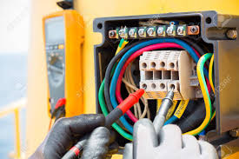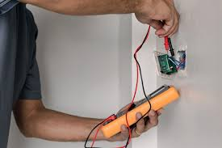
figure 1. 10 testing circuit
VOLTAGE TESTER
Is often used by the electrician to measure approximate circuit operating voltages. Its rugged construction makes it ideally suited for rough on-the-job handling
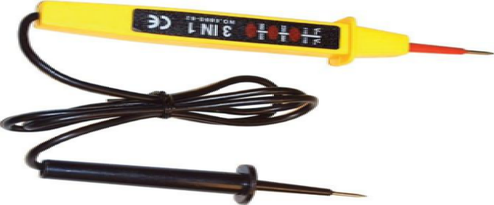
figure 1. 11 voltage tester

Self-Check -1
I .Directions: Answer all the questions listed below.
1 check wiring in your home(3point)
A. Tracking circuits B. Age and condition
C. Overloading D.ALL
2. Personal protective equipment (PPE)(3point)
A. rigid metallic B. rigid non metallic
C. Flexible metallic D .all
3.The Importance of planning and Preparing Installation OH&S policies and procedures.
A. Testing Devices B. Checking the Quality of the Work
C .Checking of Materials D.all
4..Steps Involved in Installation Planning( 2 point)
A, assessment B. readiness
C ,benchmark D.all
- -----------Review existing installation to identify the roadblocks(2 point)
A .assessment B. Readiness
C , benchmark D, all
II.Fill in the blanks
1. Wiring material is of three types __________, ________ and ____________.
2. A switch is used to make or break ___________________.
3. Open wiring is also known as _____________wiring.
4. _______are devices used to control and protect the electrical panel
from overflowing electrical power.
III..State whether the following statements are True or False
1. Silver is a bad conductor of electricity.
2. Switches are made of conducting material.
3. PVC casing and capping are used for covering the wires.

Unit Two: Installation and termination of wiring system

This unit to provide you the necessary information regarding the following content coverage and topics: following OH&S policies and procedures
- Installation of Wiring systems
- Termination/connections of wiring system and accessories
- unplanned events
This guide will also assist you to attain the learning outcomes stated in the cover page. Specifically, upon completion of this learning guide, you will be able to:
- Install Wiring systems
- Terminate/connect of wiring system and accessories
- Respond to unplanned events

2.1 Installation of Wiring systems
Electrical Installation
Electrical Installation An assembly of associated electrical equipment, to fulfill a specific purpose or purposes and having co-ordinate characteristics.
Before any wiring system is installed account must be taken of environment in which system is operate.
- Commercial
- Residential
- Industrial
There are many influences that may contribute to the final design of the installation.
All materials used for electrical installation purpose should comply with international and local Standards
IEC International Electro technicalCommission
EBCS Ethiopian Building code standard
2.1.1 Electrical wiring
Electrical wringing general refers to insulated conductors used to carry electricity, and associated devices. This article describes general aspects of electrical wiring as used to provide power in buildings and structures, commonly referred to as building wiring.
2.1.2 Wiring safety codes
Intended to protect people and property from electrical shock and fire hazards. Regulations may be established by city, county, provincial/state or national legislation, usually by adopting a model code (with or without local amendments) produced by a technical standards-setting organization, or by a national standard electrical code.
Electrical codes arose in the 1880s with the commercial introduction of electrical power. Many conflicting standards existed for the selection of wire sizes and other design rules for electrical installations. The first electrical codes in the United States originated in New York in 1881 to regulate installations of electric lighting. Since 1897 the US National Fire Protection Association, a private non-profit association formed by insurance companies, has published the (EBCS)States, counties or cities often include the NEC in their local building codes by reference along with local differences. The NEC is modified every three years. It is a consensus code considering suggestions from interested parties. The proposals are studied by committees of engineers, tradesmen, manufacturer representatives, fire fighters, and other invitees.
Since 1927, the Canadian Standards Association (CSA) has produced the Canadian Safety Standard for Electrical Installations, which is the basis for provincial electrical codes. The CSA also produces the Canadian Electrical Code, the 2006 edition of which references IEC60364 (Electrical Installations for Buildings) and states that the code addresses the fundamental principles of electrical protection in Section 131. The Canadian code reprints Chapter 13 of IEC 60364, but there are no numerical criteria listed in that chapter to assess the adequacy of any electrical installation.
Although the US and Canadian national standards deal with the same physical phenomena and broadly similar objectives, they differ occasionally in technical detail. As part of the North American Free Trade Agreement (NAFTA) program, US and Canadian standards are slowly converging toward each other, in a process known as harmonization.
In European countries, an attempt has been made to harmonize national wiring standards in an IEC standard, IEC 60364Electrical Installations for Buildings. Hence national standards follow an identical system of sections and chapters. However, this standard is not written in such language that it can readily be adopted as a national wiring code. Neither is it designed for field use by electrical tradesmen and inspectors for testing compliance with national wiring standards. By contrast, national codes, such as the NEC or CSA C22.1, generally exemplify the common objectives of IEC 60364, but provide specific rules in a form that allows for guidance of those installing and inspecting electrical systems.
In Germany, DKE (the German Commission for Electrical, Electronic and Information Technologies of DIN and VDE) is the organization responsible for the promulgation of electrical standards and safety specifications. DIN VDE 0100 is the German wiring regulations document harmonized with IEC 60364.
In the United Kingdom, wiring installations are regulated by the Institution of Engineering and Technology Requirements for Electrical Installations: IEE Wiring Regulations, BS 7671:: 2008,
Color code
Wires: Unless otherwise specified all wires shall be PVC insulated single core, stranded copper conductor conforming to BS 6004. All wires shall be colored as follows:
  - Phase : Red, Yellow, Blue Color of wire
- Neutral: Black Color of wire

- Ground: Yellow Green or Green (One color only to be used for the complete Installation).

Figure 2. 1 wires Color code

Switches
Does it matter which wire goes where on a light switch?
The white (neutral) wire connects to the silver screw, or you place it in the back wire hole on the same side of the device as the silver screw. ... This wire is sometimes red. The green or bare copper (ground) wire, if the device has one, attaches to the green screw terminal on the switch or to the electrical box.
Single Switch
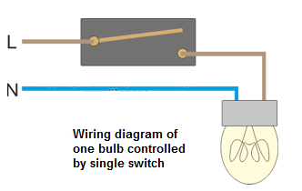

Figure 2. 2 Single Switch
Three-way Switch
Three-way switches are useful in large rooms, hallways or staircases where a light can be controlled from multiple positions. For instance, a three-way switch can control a light in a stairwell from both the top and bottom positions on the stairs.
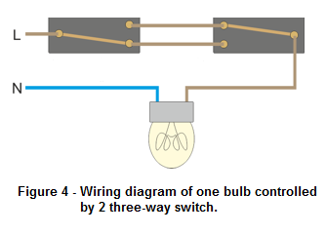

figer 2. 1 Three-way Switch

A three-way switch is part of a circuit involving an electrical fixture, be it a light or fan, and two switches. The switch itself has three posts to connect wires. One is for the electrical current and the other two are for control, or traveler wires. One wire provides current to the fixture. The other wire works in conjunction with the second switch to control whether the light can be turned on or of
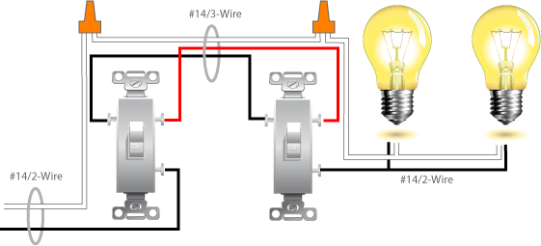

Figure 2. 3 Wiring diagram of two bulbs controlled by two three-way switches

The basic design of the three-way circuit is that one traveler wires connect to each switch and the other.
Traveler links to the fixture. Each switch must be grounded and only one switch needs a wire carrying a current. The second switch does not need a current and can be tied off to the box
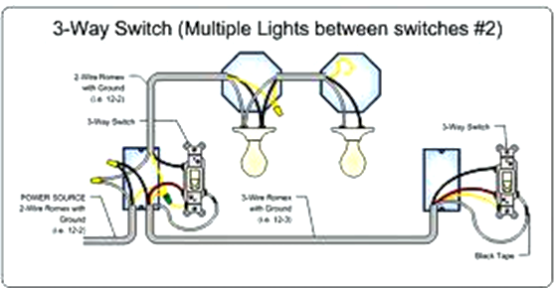

figer 2.5 Wiring connection of two three-way

– Wiring connection of two three-way switches and two bulbs on the
junction and utility boxes4-way switch
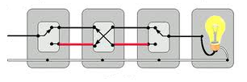

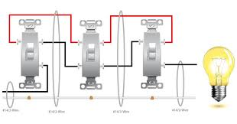

- Such mastic Diagram of one bulb controlled in 3 locatio
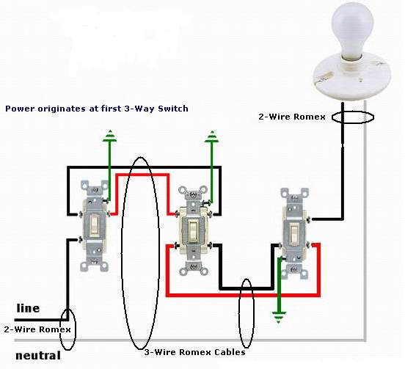

figure 2. 4- Suchmastic Diagram of one bulb controlled in 3 location
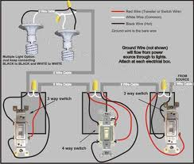
Figure 2. 5 Wiring diagram of one bulb controlled by two

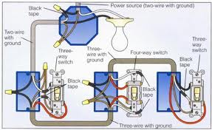
three-way switches and one 4-way switch

Figure 9 – Wiring connection of two bulbs controlled by two 3-way switches
Wiring connection of two bulbs controlled by two 3-way switchesand one 4-way switch on the junction and utility boxesfour way switches have four terminals. This switch works in combination with two three-way switches to control electricity to lights and receptacles from three locations. All of the four terminals are brass colour. They support hot conductors (traveller wires), which receive and transfer electricity from each of the three-way switches. The toggle on a four-way switch is NOT marked "OFF" and "ON”. These markings are the only way to tell the difference between it and a double-pole switch, which is labelled "OFF" and "ON."
It is advisable to use No. 12 wire for residential, indoor wiring. No. 14 wire is acceptable if the circuit is protected at 15 amperes. (Canadian and Philippine code requires the use of #14 wire for interior application

2.2. Terminatingand connecting accessories
A termination is a connector or other treatment at the end of a wire. This can be at a piece or equipment a terminal block or a patch panel
2.1.1 Terminating Techniques
There are a variety of methods used to terminate conductors.
Screw Terminal
One of the most common types is the screw terminal. Regardless of the type of terminal used it is important that the joint between the conductor and the terminal is electrically and mechanically sound, without putting undue pressure on the conductor or the terminal.
Figure 3.1
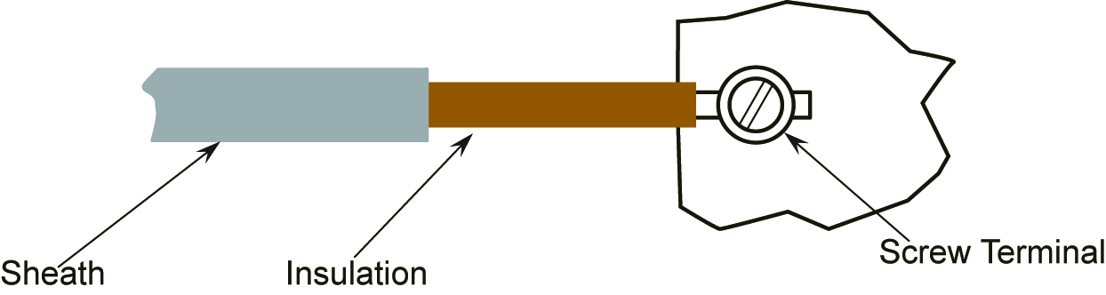
Figure 2. 6 shows a termination made off correctly.

Figure 2. 7 shows a termination made off incorrectly

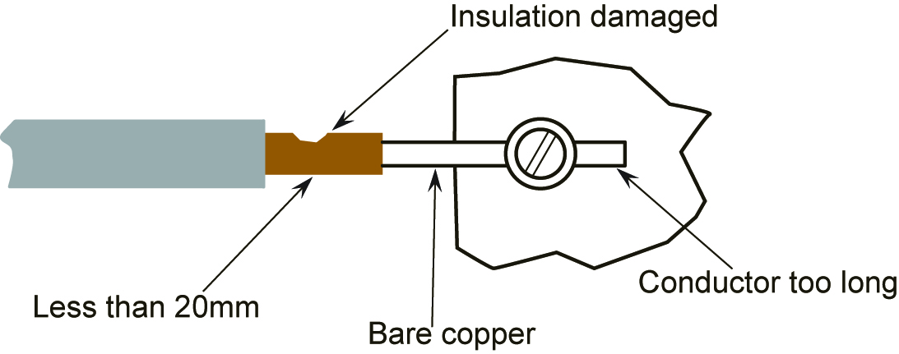
Figure 2. 8 shows a termination made off incorrectly

If the conductor is small in relation to the terminal, the conductor must be doubled back fully, neatly on itself
See Figure 3.3for a correct termination.
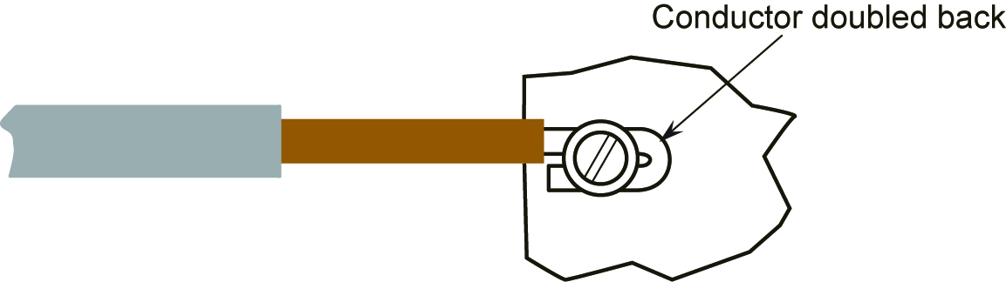
Figure 2. 9 shows an incorrect termination
Screw Head and Nut and Washer Terminals
When terminating conductors under screw-heads or nuts, it is best to form the conductor into an eye, using round nose pliers. The eye should be slightly larger than the screw diameter, but smaller than the outside diameter of the screw head, nut or washer
2.1.2 Criteria for Good Terminations
Every cable termination should be completed and checked using the following headings.
Solid Conductors – doubled back where possible.
Stranded and Flexible Conductors – all strands twisted neatly together in the right direction, and doubled back where possible. – all strands present and clamped.
No damage to conductor e.g. nicked while stripping insulation.
No damage to insulation e.g. nicked while stripping sheath or pulling in cables.
Insulation not clamped.
Conductor insulated right up to the metal of the terminal ( no bare copper ).
Sufficient slack available on cable.
Cable arranged neatly and not fouling moving parts or covers.
No makeshift terminals used.
Terminal screw tightened sufficiently
Terminals, Clamps and Lugs
There are a wide variety of conductor terminals. Typical types are as shown in Figure 9.

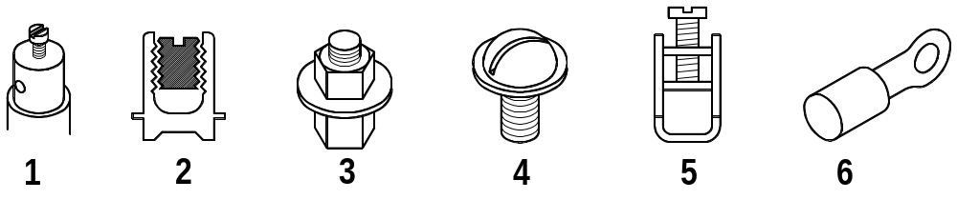
Figure 2. 10 Terminals, Clamps and Lugs
The screw terminal will be found in various accessories such as, lamp holders, batten holders and plug tops used in domestic premises. A shrouded version of this terminal is probably the most commonly used type. It will be found in switches, sockets, ceiling roses and consumer units.
The split terminal will be used in joint boxes to enable joints to be made without having to cut conductors.
The post terminal will be used mainly to make connections to earth and also in such places as the mains connection to an electric cooker or an electric motor.
The screw head terminal will also be mainly used to make connections to earth, and is also very popular in older fuse boards.
The clamp terminal is now in common use in main switches, MCB’s, RCD’s and RCBO’s.
The lug terminal comes in an extremely wide variety of shapes and sizes. They may be bare or insulated. Methods of connecting to the cable vary as follows:
Ferrules, which are used on flexible cables to prevent the strands from spreading out and are then connected using a screw or clamp terminal.
Large power cables where the lug is compressed onto the cable using a hydraulic type crimp tool. The lug is then connected to a post or screw head
2.1,3 Connecting accessories
Electrical material and devices classification of electrical material according to function
- Boxes
- Switches 11. Grounding Devices/Malts.
- Receptacle/ Convenience outlet 12.Wires/conductors
- Ceiling Lamp receptacles 13.Lighting Materials
- Fittings 14.Wiring Methods
- Supports 15.Adaptors/Connectors
- Male Plugs 16.Soldering materials
- Consults 17.Insulating Materials
- Electrical Protective Devices 18. Switch plate & covers
- Metering Devices 19. Safety switched

2.3.unplanned events or conditions
In order to know how to respond to unplanned events or conditions, one must first start in assessing or analyzing the situation. The first response should not be making an action right away, but thinking of the situation and possible solutions.
After fully understanding the situation and listing down possible solutions, it's time to take action by trying all possible means to cope with the changes or unexpected events. If working on a project, it's helpful to create a list of planned vs unplanned events so you can also think of safety measures on how to prevent the unplanned ones even before starting on the project.
Based on these considerations, the potential accidents, malfunctions and unplanned events that were considered by the Study Team for the Sisson Project are
- Loss of Containment from Tailings Storage Facility (TSF);
• Erosion and Sediment Control Failure
• Pipeline Leak;
• On-Site Hazardous Materials Spill;
• Release of Off-Specification Effluent from the installation.
• Failure of a Water Management Pond
• Failure of a Water Management Pond Pump;
• Off-Site Trucking Accident
• Vehicle Collision;
• Uncontrolled Explosion; and
• Fire
. Respond to unplanned events or conditions in accordance with established procedures.
- Establish procedures from appropriate personnel In accordance with procedures before any contingencies are implemented.
- Test Devices / systems and/or installation is tested whether it conforms to requirements
- Remove parts or connections for the purpose of testing and pre-test conditions in accordance with established procedures
- Final inspections are undertaken to ensure the installed devices / systems conforms to requirements Trainers Methodology

Self-Check -2
1.Directions: Answer all the questions listed below. Use the Answer sheet provided
- ______ is the Electrical Wiring components current situation.
A .wire B. socket
C .switch D. all
- types of electrical wiring systems.
A. cleat wiring B. conduit wiring
C .batten wiring D. all
3. Methods of Electrical Wiring Systems.
A . Joint box system B. Loop system
C . Tee system D. all
4.Types of Basic Electrical Switches.
A .SPST B. SPDT
C .DPST D. DPDT e. all
5..electrical fitting accessories.
A .lighting B. pvcelectrical conduit
C .socket D. all
II .Give short answer
1. Why is PVC casing-capping preferred over wooden casing-capping wiring?
2. How does an MCB help in managing electrical power?
3. Why is conduit wiring used in homes?
4. Discuss the importance of color codes in electrical wiring.

Operation Sheet 2
Operation title. Two Installation and termination of wiring system
Purpose Two bulbs controlled by 3-way and single switch
Procedure:-
Instruction: following the necessary templates, tools and materials you are required to
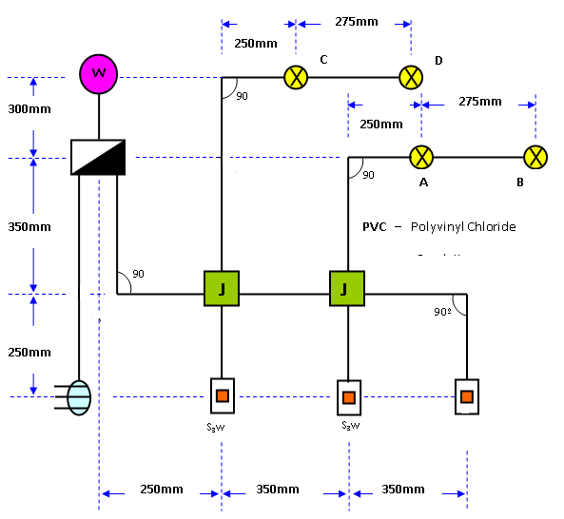

Tools and requirement:
1. A voltmeter
. 2.Analog voltmeters
3. Measuring Tools
. 4. Wire
5.Wire Strippers
. 6. Diagonal Cutter
. 7 .Screw Drivers
Steps in doing the task
Step 1 Secure working drawing (You have it when you perform rough-in activities using rigid nonmetallic conduit).
Step 2 You will be installing electrical wiring a lamp controlled in two different locations by means of 2 3-way switch. Identify the number of conductors to be inserted in each conduit run by converting the working drawing into wiring diagram
Step 3 Prepare a guide wire and insert to the utility box until it reaches the panel board.

Step 4Prepare conductors 2.0 mm², 1 black, 1 white, and 1 green.
Step 5 Fish it out on the utility box To facilitate easy pulling of fished conductors cover it with electrical tape
Step 6 Then start inserting it to the PVC conduit while being pulled on the other end until the conductors reaches the panel board.
Step 7 Provide an ample length of panel board and the utility box for the convenience outlet.
Step 8 The wire allowance for termination in utility and junction boxes at least 150 mm.
Step 9 Insert 1.6 mm² wire, black for hot and 1 red for return from junction box J1 to the utility box for lamps C, D. and E.
Step 10 Insert 1.6 mm² wires, 1 black and 1 red for hot wires from panel board to junction box J1. Since the distance between each end is shorter
Step switch. Wires on the Junction box (J1)Wires on the utility box for 3-way switch
Step 12 Insert 1.6 mm²wire, 1 red for return and 2 blue traveler wires from j box J1 to J2.
Step 13 Insert 1.6 mm²wire, 1 red for return and 2 blue for traveler wires from J2 to S₃.
Step 14 Insert 1.6 mm² wire, 1black and 1 red from J2 to utility box for lamp A and B.
Step 15 Insert 1.6 mm² wires, 2 red from J2 to utility box for S₁.
Step 16On the Junction box J1 strip off at least 30 mm from the end of the 2-black wires from the lamp and panel board and join them using rat tail joint
Step 17Join the wires using Rat Tail joint from the lamp A and B, 3-way switches and single switch on the junction box J2.
Step 18 Connect the two wires from the panel board to the AC supply line. Switch on the main circuit breaker and test the supply voltage.
Quality Criteria:the given Wiring and Conduits Measuring for AC supply
Precautions: use the given A voltmeter taste the wire centre

Unit Three: Connect wiring system and equipment
This learning guide is developed to provide you the necessary information regarding the following content coverage and topics:
- IEE wiring regulations / Standard for Electrical Installations
- Check the connections
- Take safe and sensible action to remedy any identified defects
- Fixing all conduits and wiring depending on specifications.
Marking and labeling cable and wire to specification This guide will also assist you to attain the learning outcomes stated in the cover page. Specifically, upon completion of this learning guide, you will be able to:
- Apply connections in accordance with specifications and IEE wiring regulations
- Checking the connections
- Take safe and sensible action to remedy any identified defects
- Fixing all conduits and wiring depending on specifications.

3.1 IEE wiring regulations / Standard for Electrical Installations
The electrical contractor is charged by the IEE Regulations for Electrical Installations to test all new installations and major extensions during erection and upon completion before being put into service. The contractor may also be called upon to test installations and equipment in order to identify and remove faults. These requirements imply the use of appropriate test instruments, and in order to take accurate readings consideration should be given to the following points:
Is the instrument suitable for this test?
Have the correct scales been selected?
Is the test instrument correctly connected to the circuit?
Many commercial instruments are capable of making more than one test or have a range of scales to choose from. A range selector switch is usually used to choose the appropriate scale. A scale range should be chosen which suits the range of the current, voltage or resistance being measured.
For example, when taking a reading in the 8 or 9 V range the obvious scale
Inspection and testing techniques
The testing of an installation implies the use of instruments to obtain readings. However, a test is unlikely to identify a cracked socket outlet, a chipped or loose switch plate, a missing conduit-box lid or saddle, so it is also necessary to make a visual inspection of the installation .All new installations must be inspected and tested during erection and upon completion before being put into service. All existing installations should be periodically inspected and tested to ensure that they are safe and meet the regulations of the IEE The method used to test an installation may inject a current into the system. This current must not cause danger to any person or equipment in contact with the installation, even if the circuit being tested is faulty. The test results must be compared with any relevant data, including the IEE Regulation tables, and the test procedures must be followed carefully and in the correct sequence, as indicated. This ensures that the protective conductors are correctly connected and secure before the circuit is energized.

3.2.Check the connections
checking wiring systems’ components
There are two kinds of checks that can be carried out and we recommend that you always employ a registered electrician to carry out such checks
Visual Inspection
A visual inspection is a basic check to identify any visible signs of defects, damage or deterioration. No circuit testing will be undertaken, so your electricity will likely remain on during the inspection. The electrician will need to be given access to all of the rooms in your home. The report will typically take around 1 hour to complete depending on the size of the property. Notes will be taken by the electrician as part of the visual inspection and a Visual
Inspection Report (VIR) will be issued to the home owner at the end. The Visual Inspection report will record a number of observations and recommendations and provide an overall summary of the condition of the installation. Below is a check list of the things you can expect to be looked at during a visual inspection.
Consumer Unit (main fuse board)
- Sockets
- Plugs
- Light fittings
- Light switches
- Electrical cables or leads
- Earthling and bonding
- Extension leads
- Kitchen safety
- Bathroom safety
- Signs of wear and tear
- Visible signs of burning/scorching
- RCD protection around the home
All new completed electrical installation should be tested before connection to the supply, to ensure that the installation is technically sound and free from any possible short circuits, etc. the main reasons, to test a new electrical installation or house wiring before it is switched on to the mains are as follows:
To know the cause of failure of a particular circuit or circuits or equipment and to locate the exact position of break down To ensure that it is free from faults and is as per electricity rules.
These tests will receive the attention of the owner before any possible undue damage occurs.
The tests should be made on a new electrical installation before it is switched on to the mains are as under:
- Insulation resistance test between installation and earth.
- Insulation resistance test between conductors.
- Testing of polarity.
- Testing of earth continuity paths.
- Earth resistance test.

3.3.Take safe and sensible action to remedy any identified defects
Although electrical contractors are only required to issue customers with a certificate of test, documented inspection and test procedures, and inspection and test records provide evidence of the actual test results which support the certificate. They also provide workers with a visual reminder of the step by step testing process. Workers can easily review the completed test record and identify if any steps have been missed
Install a Concealed Electrical Wiring System
A Step by Step Guide
Concealed conduit electrical wiring systems are a popular choice in domestic premises as they are aesthetically appealing. They are the most commonly used house electrical wiring system as it protects the wires from external damage and increases their longevity.
The wires are installed in 4 steps.
- Laying the electrical conduits in the slab
- Laying the electrical conduits in the wall
- Installation of Switch Boards Back Boxes
- Installation of Distribution Board

3.4.Fix all conduit and wiring depending on specifications.

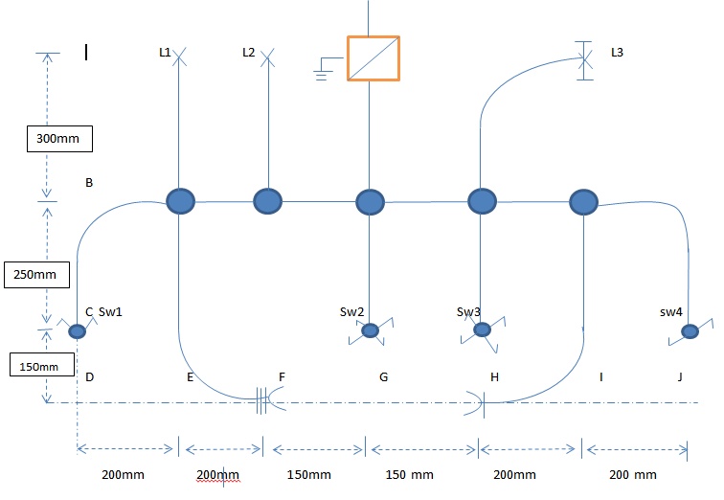

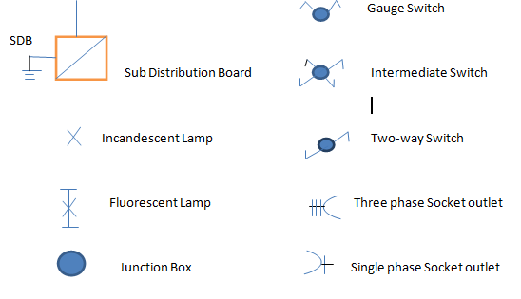

Table 1. Material needed

No. | Item description |  | Quantity | Unit | Specification
Project: Install lighting and power circuit
 |  | (PVC pipe) Poly Vinyl Chloride | 3.4 | Meters | 16mm diameter
 |  | Junction Box 65 Diameter | 6 | Pcs | Round type (standard)
 |  | Junction Box 85 Diameter | 5 | Pcs | Round type (standard)
 |  | Incandescent lamp | 2 | Pc | 25 W, 220 V
 |  | Lamp holder | 2 | PCS | Standard
 |  | Connector 7&9 | 40 | no | Standard
 |  | Conduit clip | 20 | Pcs | Standard
 |  | Electric wire 4 mm2 | 3 | Mt | Standard
 |  | Electric wire 2.5 mm2 | 2 | Mt | Standard
 |  | Electric wire 1.5 mm2 | 10 | Mt | Standard
 |  | Parker pit (nail) | 20 | no | Standard
 |  | Junction Box 15*10 cm | 1 | Pc | (standard)

Table 2 LIST OF TOOLS & EQUIPMENT
No. | Item description | Quantity | Unit | Specification
Project: Install lighting and power circuit
 | Installation board consists of  25A 3-phase ACB  20A 3-phase ACB  16A 1-phase ACB  10A 1-phase ACB | 1 | Pc | 800mm X 800mm X 20mm
 | Distribution board | 1 | Pc | (standard)
 | two way Switches | 1
 | Double two way Switches | 1 | Pc | Flush type (5 A 220 V-SPST)
 | Intermeddle Switches | 2 | pc | Flush type 10A-16A 220 V
 | Circuit Breaker | 1 | Pc | 25 A, 338 V (3 P)
 | Circuit Breaker | 1 | pc | 20A 380 V (3 P)
 | Circuit Breaker | 1 | Pc | 16 A, 220 V (1 P)
 | Circuit Breaker | 1 | Pc | 10 A, 220 V (1 P)
 | Industrial socket 3 phase | 1 | pcs | Flush type 20A-25A 380 V
 | Socket out let with ground | 1 | pcs | Flush type 10A-16A 220 V
 | Multi-tester | 1 | Pc | Analog / Digital
 | Hacksaw with blade | 1 | Pc | Standard
 | Side cutting plier | 1 | Pc | Standard
 | Long nose plier | 1 | Pc | Standard
 | Combination plier | 1 | Pc | Standard
 | Flat screw drivers | 1 | Pc | Standard
 | Philips screw drivers | 1 | Pc | Standard
 | Claw hammer | 1 | Pc | Standard
 | Electrician's knife/Wire stripper | 1 | Pc | Standard
 | Spirit/Level bar | 1 | Pc | Standard
 | Pull-push rule/measuring tape | 1 | Pc | 3 m
 | Heat blower/Elec. stove | 1 | Pc | 220 V, 1000 W
 | Pencil/Chalk liner | 1 | Pc | Standard
 | Master test light | 1 | Pc | standard

Self-Check 3
I Directions: Answer all the questions listed below. Use the Answer sheet provided
1. The reasons for testing the installation are:(5point)
A. to ensure that the installation complies with the Regulations,
B. to ensure that the installation meets the specification,
C. to ensure that the installation is safe to use
D. all
2.Checklist for the initial visual inspection of an installation,(5 points)
A. identification of conductors;
B. routing of cables in safe zones;
C. selection of conductors for current carrying capacity and volt drop
D. all
3 Electrical maintenance covers(2point)
A .testing B .fixing
C. replacing D. all
4..Maintanance of electrical equipment in building (2point)
A .photo credit B. critical power testing
C. maintenance of LLC D. all
II. Give short answer
5 Explain the steps of maintenance of Maintaining plant, tools & equipment(2point)
6.What is Important maintenance of plant and equipment?(2point)
7 Why is maintenance of plant and equipment important?(2point)
LAP Test
Practical Demonstration
Name: ______________________ Date: ________________
Time started: ________________________ Time finished: ________________
Task 1:Two bulbs controlled by 3-way and single switch

Unit Four: Inspect and notify completion of work

This learning guide is developed to provide you the necessary information regarding the following content coverage and topics:
- final inspections
- Work completions
This guide will also assist you to attain the learning outcomes stated in the cover page. Specifically, upon completion of this learning guide, you will be able to:
- Undertake final inspections to installed apparatus
- Notify Work completions

4.1 final inspections
Electrical testing
The electrical contractor is charged with a responsibility to carry out a number of tests on an electrical installation and electrical equipment. The individual tests are dealt with in Part 6 of the IEE Regulations and described later in this chapter.
The reasons for testing the installation are:
● to ensure that the installation complies with the Regulations,
● to ensure that the installation meets the specification,
● to ensure that the installation is safe to use.
Those who are to carry out the electrical tests must first consider the following safety factors:
● An assessment of safe working practice must be made before testing begins.
● All safety precautions must be put in place before testing begins.
● Everyone must be notified that the test process is about to take place, for example the client and other workers who may be affected by the tests.
● ‘ Permits-to-Work ’ must be obtained where relevant.
● All sources of information relevant to the tests have been obtained.
● The relevant circuits and equipment have been identified.
● Safe isolation procedures have been carried out – care must be exercised here, i
occupied premises, not to switch off computer system switch out first obtaining permission.

4.2 Prepare work accomplishment report
Every work must be Prepare work accomplishment report to an employer and minor accidents reported to a supervisor, safety officer or first aider and the details of the accident and treatment given suitably documented. The report should also include the following information: your name the address of the property to be inspected reason for the inspection the date of inspection the scope of the inspection
a list of any area or item that wasn't inspected, the reasons why it wasn't inspected and if necessary, a recommendation for further investigational summary of the overall condition of the property list of any significant problems that need fixing i necessary, a recommendation that a further inspection or assessment be carried out by a suitably accredited specialist, e.g. pest inspector, electricity supply authority, water supply authority, structural engineer, geotechnical engineer, surveyor or solicitor.
4.2.1 Type of Prepare work accomplishment report
1. An Electrical Installation Condition Report (EICR)
2. Accident reports
An Electrical Installation Condition Report (EICR) will provide a full summary of the condition of the electrics in your home and determine whether it complies with the current .It will record a number of observations in line with BS 7671 and make various recommendations where improvement may be necessary or beneficial to improving safety in your home. Once the EICR is completed the registered contractor will provide you with a certificate outlining the overall condition of the electrical installation. Generally, an EICR will provide coding against the condition of the installation. The classification codes are as follows: Code C1 - This code should indicates that danger exists, requiring immediate remedial action. The persons using the installation are at immediate risk Code C2 - This code indicates that, whilst an observed deficiency is not considered to be dangerous at the time of the inspection, it could become a real and immediate danger if a fault or other foreseeable event was to occur in the installation or connected equipment. Code C3 - This code indicates that, whilst an observed deficiency is not considered to be a source of immediate or potential danger, improvement would contribute to a significant enhancement of the safety of the electrical installation. You are under no obligation to have any of the issues fixed, though it is recommended that corrective action to rectify any C1 and C2s is completed as soon as possible. If you do

Self-check-4
I. Directions: Answer all the questions listed below. Use the Answer sheet provided.
1. _______Type of Prepare work accomplishment report (3 points)
A Electrical Installation Condition Report (EICR)
B. Accident reports
C. all
2 .EICR means(3point)
A .Electrical Installation Condition Report.
B. Electrical Installation Report Condition.
C. Electrical Condition Installation Report.
D. Electrical Condition Report Installation.
II. Give short answer
1.What is the electrical code?(3point)
2.Are electrical permits required?(3point)

Unit five Clean up

This learning guide is developed to provide you the necessary information regarding the following content coverage and topics:
- work area
- Tools and equipment
This guide will also assist you to attain the learning outcomes stated in the cover page. Specifically, upon completion of this learning guide, you will be able to:
- Cleaning work area
- Maintaining and storing Tools and equipment

.5.1 Working area
Keeping workshop and storage spaces unwanted things can helpssaveus training tools for accidents. Sparks can ignite scraps, sawdust and solvents. Water can conduct electricity. Do not stand in water, on damp floors or in the rain when working with electrical tools. Keep hands and tools dry.
- Make sure workshops and storage areas have:
- Proper electrical wiring & outlets needed to run power tools.
- Install adequate wiring to handle the electrical load required.
All outlets should have three pronged plugs or be double-insulated.
Any outlets that may come in contact with water should have ground fault circuit interrupters.
- Never use indoor tools outside.
- Use only approved outdoor extension cords.
- Use one long extension cord instead of several short ones.
- Do not damage or cut extension cords.
When working on ladders or scaffolding rest power tools on a flat surface or in a bin secured to the ladder itself.
- A falling tool can seriously injure a co-worker or bystander.
- Never carry heavy power tools up and down ladders.
Stop working and turn off the power tool you are working with if distracted by something or someone.
- Never look away from your work when operating a power tool.
- Cutting tools can be particularly dangerous.
If one stalls, switch off the power and unplug the tool before trying to restart it.
When using a power saw, let the saw reach full speed before cutting and support the work firmly so it won’t shift.
- Never use your hands to clear scraps from a sawing worktable.
- Use a long stick instead.
When working with metal, secure the metal material with clamps or in a machinist’s vise to keep it from moving.
- Take extra care when working with hazardous materials.
- Its particles can irritate the skin, eyes and respiratory system.
- When soldering, remember that lead solder is toxic.
The work area should be ventilated and flammable material properly stored.
Clean, check, maintain & sore hand & power tools.
Before, during & after performing our tasks all tools & measuring equipment must be properly cleaned, checked &maintained. Building electrical installation regulations require inspections & testing of tools & measuring equipment before use. Preventive maintenance is the systematic care and protection of tools, equipment &machines in order to keep it in a safe, usable condition limit downtime and extend productivity.
We must always be aware that maintenance tasks themselves are potentially hazardous and can result in injury.
The successful maintenance program is:
- well organized and scheduled,
- controls hazards,
- defines operational procedures, and
Trains key personnel.
The degree of detail equipment maintenance will depend on the kinds of tools/equipment used. Some installation equipment has very specific inspection and maintenance requirements. Power Tools should be maintained in good working order. This may be limited to ensuring that blades/bits are replaced when needed and those guards or other safety devices are operable and any damaged electrical cords/plugs are repaired or replaced. Damaged or defective equipment/tools should be tagged and removed from service. The trainees must have their own cleaning, checking and maintenance schedule.
Requirements
- General requirements for equipment maintenance include:
- Obtaining a copy of the maintenance schedule recommended by the manufacturer.
- Ensuring that maintenance is performed as required.
- Ensuring that the person(s) performing the maintenance are competent.
- Retaining records of maintenance/service conducted.
Specifying who is responsible for overseeing equipment maintenance and where the records are kept. Set up a system for removal and tagging of damaged or defective tools and equipment.
Complete documentation for work.
Definitions: Documentation refers to a set of records that exist online, on paper or on hard drives. It is material that provides evidence or information to serve as a record. In the workplace, documentation is retained records of employment and company actions and events as required by legal mandates and company policy. The best human resource practices involve maintaining both formal and informal records about employment events. This can include items such as:
- Actions
- Contributions
- Disciplinary actions
- Disputes
- Investigations
- Performance evaluations
- Policy violations
Documentation gives substance to a workplace's activities not only for legal matters, audits or disputes, but also for rules and regulations. It keeps entraining running systematically and ethically. It would be difficult for trainees in a training program to remember everything if it was only presented orally. During an emergency, staff might not remember the proper procedure to exit the building without documentation.

Self-check-5
I Directions: Answer the questions below. Say true or false
1.Keeping workshop and storage spaces clean and dry can help prevent many accidents.(2points)
2,Do not stand in water, on damp floors or in the rain when working with electrical tools. (2points)
3.Which one is the general requirement for equipment maintenance .(2 points)
4.Documentation provides standards to a workplace.. (2 points)
5/ Posting documentation is important for employees to understand their rights and obligations to maintain a safe workplace.(2 points)

.Reference
    - AN INTRODUCTION TO COMMUNITY ASSET MAPPING. Available on: https://www.countyofsb.org/ceo/asset.c/400
    - Community Asset Mapping. Available on: http://www.sustainablejersey.com/actions certification/actions/?type=1336777436&tx_sjcert_action%5BactionObject%5D=90&tx_sjcert_action%5Baction%5D=getPDF&tx_sjcert_action%5Bcontroller%5D=Action&cHash=d8896df5ca9909fc37fd61db1c3b38da
    - Community Needs Assessment. Available on: https://www.cdc.gov/globalhealth/healthprotection/fetp/training_modules/15/community-needs_pw_final_9252013.pdf
    - Buildingelectricalinstallationhttps://dps.mn.gov/divisions/ojp/forms-documents/Documents/Wilder_Program_Evaluation_8.pdf
    - Identifying Wire Splices and Joining http://www.teamreporterapp.com/information-gathering/

    - Gathering information: Available on: Information Gathering. Available on: http://www.teamreporterapp.com/information-gathering/
    - Medical Advice Disclaimer (2005-2019). The Importance of Using Community Resources in Treatment. Available on
https://www.youtube.com/watch?v=XOdPJDSTvjM

Participants of this Module (training material) preparation
No | Name of trainer | Qualification (Level) | Field of Study | Institution | Mobile number | E-mail
1 | SAMUEL BEKELE | MSC) | Electrical control and automation | Haremya | 0910082977 | samuelbekele460@gmai.com
2 | TIRUSEW BAYE | BSC | Building construction | Debretabor  PTC | 0918092865 | tirusew2014t@gmail.com
3 | BACHA WAKE | MSC | Electrical control and automation | Hawasa  TTC | 0910780182 | bachawakejima2012@gmail.com
4 | GIRMA BELETE | MSC | Electrical Power engineering | Hawassa  PTC | 0938935026 | girmabelete7@gmail.com
5 | SALADIN ABDELLA | BSC | Electrical Technology | Dire dawa  PTC | 0922010767 | Sala0767@gmail.com

