Building Electrical installation
Level II
Based on Aug, 2022, Curriculum Version I,
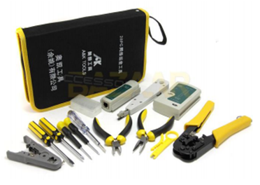
Module Title: Terminating signal and data cables
Code: EIS BEI2 M07 0822
Nominal duration: 40 Hours

Prepared By: Ministry of Lobar and Skill

Aug, 2022
Addis Ababa, Ethiopia

Acknowledgement
Ministry of Labor and Skills wish to extend thanks and appreciation to the many representatives of TVET instructors and respective industry experts who donated their time and expertise to the development of this Teaching, Training and Learning Materials (TTLM).

Table of Contents
Acknowledgement I
Table of Contents II
List of figures IV
List of tables V
Acronyms VI
Introduction 1
Module units 1
Learning objectives of the Module 1
Module Learning Instructions: 1
Unit one: Difference of conductors and cables 2
1) Identifying Cables and conductors 3
1.1. Signal cable 3
1.2. What is Network Cabling? 3
2) Labelling Cables and conductors 4
2.1 Cable-based/Guided media 4
2.1.1 the signal are guided along a solid medium 4
2.2 Crimping Twisted-Pair Cable 8
2.1.2Wireless/Unguided media the signal propagates in the atmosphere and in outer space 16
2.3 Wireless Security 17
Self-Check -1 20
Unit Two: terminal cable Prepared 21
1. Terminal requirement and specification 22
1.1 Network Cable Types and Specifications 22
2.1 Components of Coaxial cable 22
2.2 Coaxial cables in computer networks 23
2.3 Specifications of coaxial cables 24
2. Preparing Cable ends 24
2.1 Difference of Straight through and Crossover Cable 24
2.2 What Is Straight Through Cable? 25
2.3 What Is Crossover Cable? 26
2.4 Handling cables/wires 28
Self-Check -2 29
Unit three : Cable Termination 30
1. Data cable tools 31
1.1 Network cable Crimping and Testing Tools 31
1.1.1 Twisted-pair (STP and UTP) network cable crimping tools 31
2. Testing Terminations for compliance with specifications and procedures 32
2.1 Network cable testing and troubleshooting tools 32
2.2 Cable certifier 33
2.3 Time domain reflectometer 33
2.4 Basic cable tester 34
2.5 Tone generator and the probe 34
Self-Check -3 36
Unit four : Terminate and fix/secure cables 37
1. Fixing/Securing Cables with standard operating 38
1.1. Placing and securing cable 38
2. Fixing and securing appropriate techniques 40
2.1 Cable-Connector 40
2.1.1 Twisted-Pair Cable-Connector Installation 40
2.1.2 Conductor Arrangement 41
2.2 Connector Crimping Procedures 42
2.3 Installing the Connector 42
Operation Sheet-1 46
LAP Test 48
References 49

List of figures
Unit one
Figure 1.1 Transmission medium 3
Figure 1.2Unshielded twisted pair 5
Figure 1.3RJ-45 connector 6
Figure 1.4UTP and STP cables 7
Figure 1.5 RJ-45 connector 9
Figure 1.7 Coaxial cable 11
Figure 1.8Coaxial Cable Connectors 13
Figure 1.9Part of Fiber-optic cable 14
Figure 1.10Fiber Optic Connector 15
Unit two
Figure 1.1 paret of coaxial cable 22
Figure 1.2 core coaxial cable 23
Figure 2.1Straight through vs. Crossover Cable 25
Figure 2.2A straight through cable of which both ends 26
Figure 2.4Straight through and Crossover Cable 27
Figure 2.5RG6 coaxial cable 28
Unit three
Figure 1.1 network cable crimping tools 32
Figure 2.1 Cable certifier 33
Figure 2.3cable tester 34
Figure 3.2 network cable crimping tools 35
Unit four
Figure 1.1Placing and securing cable 39
Figure 2.1RJ-11 and RJ-45 connectors 41
Figure 2.2A common twisted-pair cable stripper and A crimper for RJ-11 and RJ 45 connectors 39

List of tables
Unite one
Table2.1 Categories of Unshielded Twisted Pair 8
Table 2.2Crossover Cabling Standard 10
Table 2.3Specification cable types 15
Table 1.4Wireless standards and speeds 16

Acronyms
UTP ………………………………………..Unshielded Twisted-Pair cable
STP ………………………………………..Shielded Twisted-Pair cable
LAN………………………………………..local area network
RJ …………………………………….……Registered Jack
PC………………………………………….personal computer
BNC.............................................................Bayonet Neill–Concelman
WiFi ………………………………………Wireless Fidelity
WEP ………………………………………Wired Equivalent Privacy
SSID ………………………………………Service Set Identifier
RG …………………………………………Radio Guide

Introduction

In building electrical installation filed; the knowledge, skills and attitude required to terminate signal and data cables. It includes identify conductors/cables, connect and terminate cables and fix /secure cables.The different type of cable chosen for a network is related to the network's topology, protocol, and size. Understanding the characteristics of different types of cable and how they relate to other aspects of a network is necessary for the development of a successful network.

Module units
- Difference of conductor and cable
- Cable preparation
- Network cable termination
- Termination and fix/secure cables

Learning objectives of the Module
At the end of this session, the students will able to:
- Identifying Cables and conductors
- Obtaining termination requirements and specifications.
- Testing Terminations for compliance with specifications and procedures.
- Fixing/Securing Cables with standard operating

Module Learning Instructions:
- Read the specific objectives of this Learning Guide.
- Follow the instructions described below.
- Read the information written in the information Sheets
- Accomplish the Self-checks
- Perform Operation Sheets
- Do the “LAP test”

Unit one: Difference of conductor and cable
This learning unit is developed to provide the trainees the necessary information regarding the following content coverage and topics:
  - Cables and conductors are identify
  - Cables and conductors are label
This unit will also assist you to attain the learning outcomes stated in the cover page. Specifically, upon completion of this learning guide, you will be able to:
  - Identifying Cables and conductors
  - Labelling Cables and conductors.

Identifying Cables and conductors

Signal cable
Signal cable is used in data transmission applications that demand superior signal protection. These applications require some of the smallest, most flexible and highly-screened cables on the market. Signal cables are used in a multitude of industries and can be found in everything from computers, medical equipment, and appliances.
Allied Wire and Cable carries a full line of signal cables designed for flexibility and durability in data communications cable applications. For added flexibility, our cables are stranded in layers – a low-cost solution compared to other types of stranding. To minimize signal interference and allow for the best performance possible, many of our flexible signal cables also feature overall copper screens. The signal cables in this category may be used in dry, damp, or wet locations, making them even more versatile.

What is Network Cabling?
Cable is the medium through which information usually moves from one network device to another. There are several types of cable which are commonly used with LANs. In some cases, a network will utilize only one type of cable, other networks will use a variety of cable types. The type of cable chosen for a network is related to the network's topology, protocol, and size. Understanding the characteristics of different types of cable and how they relate to other aspects of a network is necessary for the development of a successful network.
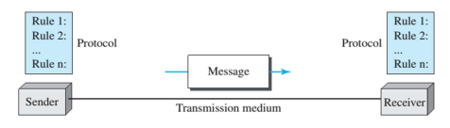
Fig.1.1 Transmission medium
- Message. The message is the information (data) to be communicated. Popular forms of information include text, numbers, pictures, audio, and video.
- Sender. The sender is the device that sends the data message. It can be a computer, workstation, telephone handset, video camera, and so on.
- Receiver. The receiver is the device that receives the message. It can be a computer, workstation, telephone handset, television, and so on.
- Transmission medium. The transmission medium is the physical path by which a message travels from sender to receiver. Cable or Air
- Protocol. A protocol is a set of rules that govern data communications. It represents an agreement between the communicating devices.

Network Cables – Types
- Transmission media carry signals between computers
- Can be divided into two broad categories:

Labelling Cables and conductors

Cable-based/Guided media

the signal are guided along a solid medium
- Twisted-pair cable
Consists of two conductors (normally copper), each with its own plastic insulation, twisted together.
- Two types twisted-Pair cable
- Unshielded Twisted-Pair cable (UTP)
- Shielded Twisted-Pair cable (STP)
- Use metallic (copper) conductors that accept and transport signals in the form of electric current. Almost all modern LAN computer networks use this cable.
– This cable is also known as Ethernet cable.
- Consists of color-coded pairs of insulated copper wires each about 1 mm thick
– Every two wires are twisted around each other
– Each pair is twisted with a different number of twists per inch to eliminate interferences which will create noise.
- Crosstalk from adjacent pairs
- Electromagnetic interference (EMI) from other electrical devices
- One potential problem with twisted-pair cable is Crosstalk
- Crosstalk is defined as signals from one line interfering with signals from another line.
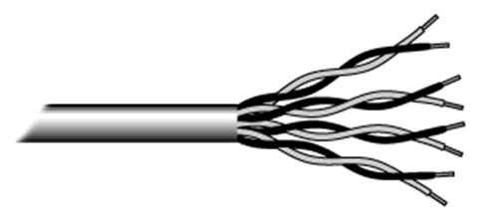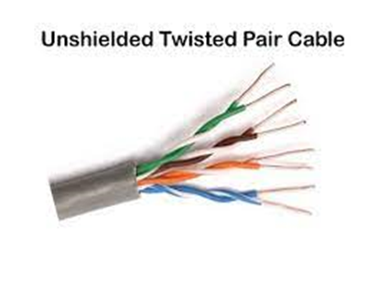
Fig.1.2 Unshielded twisted pair
Usually there are four pairs.
– Each pair has one solid color and one stripped color wire.
- Wire pair #1: White-blue, Blue
- Wire pair #2: White-orange, Orange
- Wire pair #3: White-green, Green
- Wire pair #4: White-brown, Brown
- Unshielded Twisted-Pair cable (UTP),all pairs are wrapped in a single plastic sheath. – The most common twisted-pair cable for LANs.
The quality of UTP may vary from telephone-grade wire to extremely high-speed cable. The cable has four pairs of wires inside the jacket. Each pair is twisted with a different number of twists per inch to help eliminate interference from adjacent pairs and other electrical devices. The tighter twisting, the higher supported transmission rate and the greater the cost per foot. The EIA/TIA (Electronic Industry Association/Telecommunication Industry Association) has established standards of UTP and rated six categories of wire (additional categories are emerging).

Unshielded Twisted Pair Connector
The standard connector for unshielded twisted pair cabling is an RJ-45 connector. This is a plastic connector that looks like a large telephone-style connector (See fig. 2). A slot allows the RJ-45 to be inserted only one way. RJ stands for Registered Jack, implying that the connector follows a standard borrowed from the telephone industry. This standard designates which wire goes with each pin inside the connector.
The standard connector for twisted-pair cabling is an RJ-45 connector
- RJ stands for Registered Jack
- An 8-pin connection used for Ethernet network
- A plastic connecter that looks like ordinary phone jacks (RJ-11)
- The RJ-45 is a keyed connector, meaning the connector can be inserted in only one way.
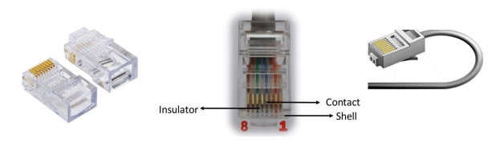
Fig.1.3 RJ-45 connector
- Shielded Twisted-Pair cable (STP)each pair is wrapped with an additional metal shield,and then all pairs are wrapped in a single outer plastic sheath.
Although UTP cable is the least expensive cable, it may be susceptible to radio and electrical frequency interference (it should not be too close to electric motors, fluorescent lights, etc.). If you must place cable in environments with lots of potential interference, or if you must place cable in extremely sensitive environments that may be susceptible to the electrical current in the UTP, shielded twisted pair may be the solution. Shielded cables can also help to extend the maximum distance of the cables.
Shielded twisted pair cable is available in three different configurations:
- Each pair of wires is individually shielded with foil.
- There is a foil or braid shield inside the jacket covering all wires (as a group).
There is a shield around each individual pair, as well as around the entire group of wires (referred to as double shield twisted pair).
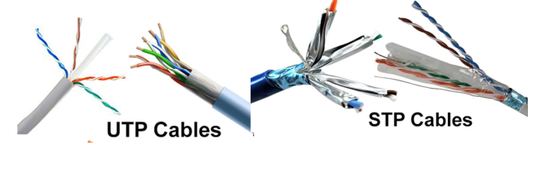
Fig.1.4 UTP and STP cables
STP vs. UTP cables
- Both STP and UTP can transmit data at 10Mbps, 100Mbps, 1Gbps, and 10Gbps.
- Since STP cable contains more materials, it is more expensive than the UTP cable.
– However, the extra shielding can make the cables quite bulky.
- UTP is susceptible to crosstalk, radio and electrical frequency interference.
– STP is more cross-talk, EMI, and attenuation resistant than the UTPcable.
– STP is suitable for environments with electrical interference
- STP is often used on networks using Token Ring topology.
- Both cables use the same RJ-45 connectors.
- The maximum segment length for both cables is 100 meters
- The EIA (Electronic Industry Association) has established standards of twisted-pair cable.
– Cat 1, 2, 3, 4, 5 are outdated and not used in any modern LAN network.
– Cat 7 is still a new technology and not commonly used.
– Cat 5e, 6, 6a are the commonly used twisted-pair cables.
Table 2.1.Categories of Unshielded Twisted Pair
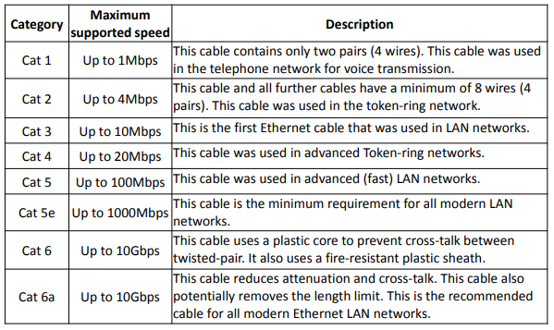

Crimping Twisted-Pair Cable
- Two types of Ethernet network cable are straight through and crossover cable.
- Straight through and Crossover cable have different wire arrangement for serving different purposes.
- Cat 5, Cat 5e or Cat 6 UTP cable
- Made of 4 pair high performance cable that twisted pair conductors that used for data transmission.
- Both end of cable is called RJ-45 connector
- Straight Through Cable
- Used to connect different type of devices and used most of the time
- Connect a computer to a switch/hub's normal port.
- Connect a computer to a cable/DSL modem's LAN port.
- Connect a router's WAN port to a cable/DSL modem's LAN port.
- Connect a router's LAN port to a switch/hub's uplink port.
(Normally used for expanding network)
- Connect 2 switches/hubs with one of the switch/hub using an uplink port and the other one using normal port.
- Uplink port special port that eliminates the need of crossover cable
Straight Through Cabling Standard
- Both side (side A and side B) of cable have wire arrangement with same color.
- Clip is pointed away from you
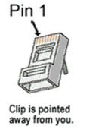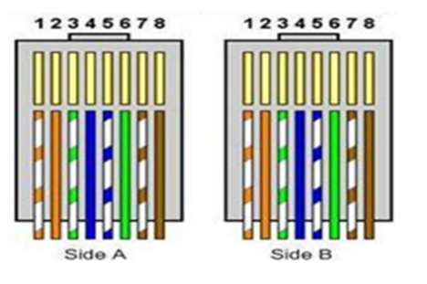
Fig.1.5 RJ-45 connector
- Crossover cable
- Used to connect same type of devices without a switch or hub.
- Connect 2 computers directly
- Connect a router's LAN port to a switch/hub's normal port
(Normally used for expanding network)
- Connect 2 switches/hubs by using normal port in both switches/hubs
Crossover Cabling Standard
- Crossover cables have different ends
- Both side (side A and side B) of cable have wire arrangement with following different color

Table2.2.Crossover Cabling Standard
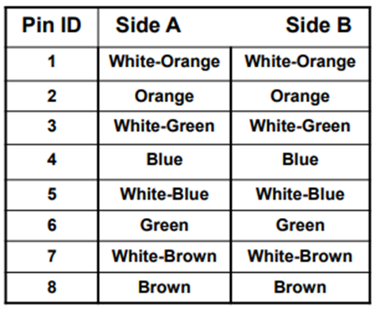
- Straight through cables have identical ends and are used for connecting computers through a hub/switch
- Crossover cables have different ends and are used for connecting devices directly with each other (e.g. PC to PC)
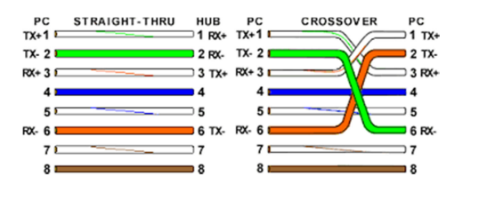
Fig.1.6Straight Through vs. Crossover Cable

- Coaxial cable:- uses copper wire to conduct the signals electronically
- Coaxial cable has a single copper conductor at its center.
- Coaxial cable can support greater cable lengths between network devices than twisted pair cable.
- Although coaxial cabling is difficult to install, it is highly resistant to signal interference.
Coaxial cabling has a single copper conductor at its center. A plastic layer provides insulation between the center conductor and a braided metal shield (See fig. 3). The metal shield helps to block any outside interference from fluorescent lights, motors, and other computers.
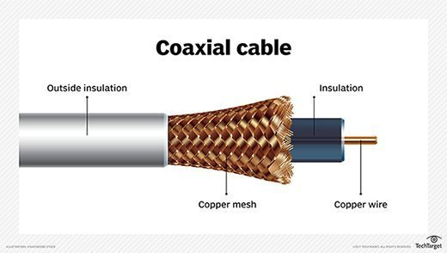
Fig.1.7 Coaxial cable
Although coaxial cabling is difficult to install, it is highly resistant to signal interference. In addition, it can support greater cable lengths between network devices than twisted pair cable. The two types of coaxial cabling are thick coaxial and thin coaxial.
Thin coaxial cable is also referred to as thinnet. 10Base2 refers to the specifications for thin coaxial cable carrying Ethernet signals. The 2 refers to the approximate maximum segment length being 200 meters. In actual fact the maximum segment length is 185 meters. Thin coaxial cable has been popular in school networks, especially linear bus networks.
Thick coaxial cable is also referred to as thicknet. 10Base5 refers to the specifications for thick coaxial cable carrying Ethernet signals. The 5 refers to the maximum segment length being 500 meters. Thick coaxial cable has an extra protective plastic cover that helps keep moisture away from the center conductor. This makes thick coaxial a great choice when running longer lengths in a linear bus network. One disadvantage o*1f thick coaxial is that it does not bend easily and is difficult to install.
- The two types of coaxial cables
- Thin coaxial cable is also referred to as thinnet
- 10Base2 refers to the specifications for thin coaxial cable carrying Ethernet signals.
- The 2 refers to the approximate maximum segment length being 200 meters. In actual fact the maximum segment length is 185 meters
- Thin coaxial cable is popular in school networks, especially linear bus networks
- Thick coaxial cable is also referred to as thicknet
- Thick coaxial cable has an extra protective plastic cover that helps keep moisture away from the center conductor
- This makes thick coaxial a great choice when running longer lengths in a linear bus network
- One disadvantage of thick coaxial is that it does not bend easily and is difficult to install
- 10Base5 refers to the specifications for thick coaxial cable carrying
Ethernet signals.
- The 5 refers to the maximum segment length being 500 meters.
Thick coaxial cable has an extra protective plastic cover that helpskeep moisture away from the center conductor.
Coaxial Cable Connectors
- The most common type of connector used with coaxial cables is the Bayonet Neill–Concelman (BNC) connector.
- Different types are available for BNC connectors, including a T-connector, barrel connector, etc.
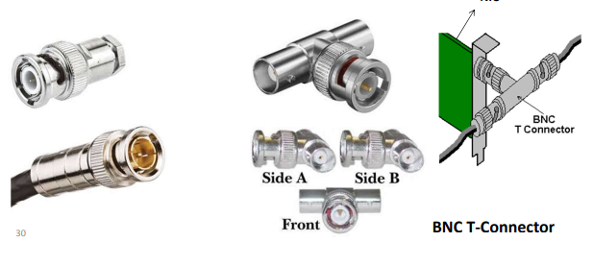
Fig.1.8Coaxial Cable Connectors
- Fiber-optic cable:- uses glass or plastic conductor and transmits the signals as light
- Fiber optic cabling consists of a center glass core surrounded by several layers of protective materials.
- Outer insulating jacket is made of Teflon or PVC.
- Kevlar fiber helps to strengthen the cable and prevent breakage.
- A plastic coating is used to cushion the fiber center.
- Center (core) is made of glass or plastic fibers.
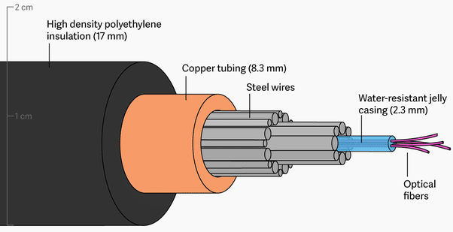
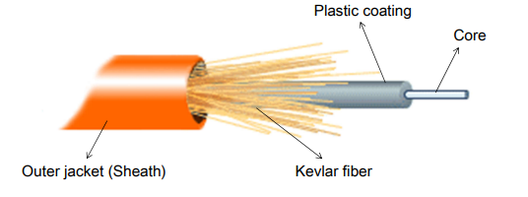
Fig.1.9 Part ofFiber-optic cable

- Transmits light rather than electronic signals eliminating the problem of electrical interference.
- Used to connect networks between buildings, due to its immunity to the effects of moisture and lighting.
- Has the ability to transmit signals over much longer distances than coaxial and twisted-pair.
- Has the capability to carry information at vastly greater speeds.
- This capacity broadens communication possibilities to include services such as video conferencing and interactive services.
- The cost of fiber optic cabling is a little bit higher; and, it is more difficult to install and modify.
Fiber Optic Connector
- There are many connectors used with fiber optic cable such as an ST and SC connector.
– The ST is barrel shaped, similar to a BNC connector.
– The SC has a squared face and is easier to connect in a confined space.
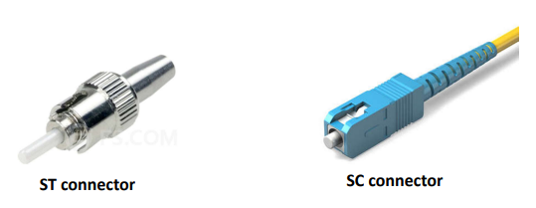
Fig.1.10Fiber Optic Connector
There are two common types of fiber cables -- single mode and multimode. Multimode cable has a larger diameter; however, both cables provide high bandwidth at high speeds. Single mode can provide more distance, but it is more expensive.
Table 2.3.Specification cable types
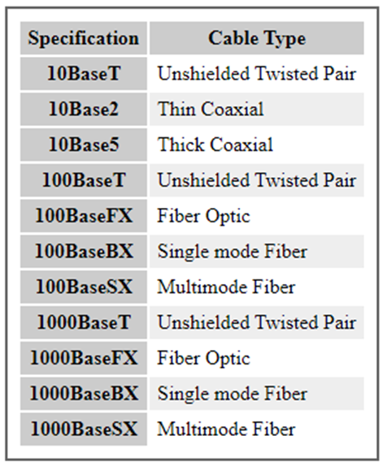
Installing Cable - Some Guidelines
When running cable, it is best to follow a few simple rules:
- Always use more cable than you need. Leave plenty of slack.
- Test every part of a network as you install it. Even if it is brand new, it may have problems that will be difficult to isolate later.
- Stay at least 3 feet away from fluorescent light boxes and other sources of electrical interference.
- If it is necessary to run cable across the floor, cover the cable with cable protectors.
- Label both ends of each cable.
- Use cable ties (not tape) to keep cables in the same location together.

Wireless/Unguided media the signal propagates in the atmosphere and in outer space
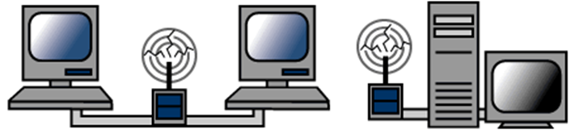

More and more networks are operating without cables, in the wireless mode. Wireless LANs use high frequency radio signals, infrared light beams, or lasers to communicate between the workstations, servers, or hubs. Each workstation and file server on a wireless network has some sort of transceiver/antenna to send and receive the data. Information is relayed between transceivers as if they were physically connected. For longer distance, wireless communications can also take place through cellular telephone technology, microwave transmission, or by satellite.
Wireless networks are great for allowing laptop computers, portable devices, or remote computers to connect to the LAN. Wireless networks are also beneficial in older buildings where it may be difficult or impossible to install cables.
The two most common types of infrared communications used in schools are line-of-sight and scattered broadcast. Line-of-sight communication means that there must be an unblocked direct line between the workstation and the transceiver. If a person walks within the line-of-sight while there is a transmission, the information would need to be sent again. This kind of obstruction can slow down the wireless network. Scattered infrared communication is a broadcast of infrared transmissions sent out in multiple directions that bounces off walls and ceilings until it eventually hits the receiver. Networking communications with laser are virtually the same as line-of-sight infrared networks.

Wireless standards and speeds
The Wi-Fi Alliance is a global, non-profit organization that helps to ensure standards and interoperability for wireless networks, and wireless networks are often referred to as WiFi (Wireless Fidelity). The original Wi-Fi standard (IEEE 802.11) was adopted in 1997. Since then many variations have emerged (and will continue to emerge). Wi-Fi networks use the Ethernet protocol.
Table1.4.Wireless standards and speeds
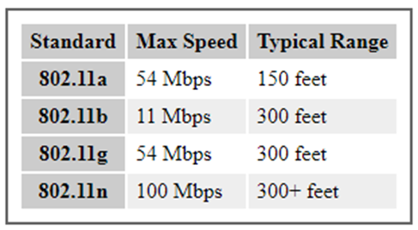

Wireless Security
Wireless networks are much more susceptible to unauthorized use than cabled networks. Wireless network devices use radio waves to communicate with each other. The greatest vulnerability to the network is that rogue machines can "eves-drop" on the radio wave communications. Unencrypted information transmitted can be monitored by a third-party, which, with the right tools (free to download), could quickly gain access to your entire network, steal valuable passwords to local servers and online services, alter or destroy data, and/or access personal and confidential information stored in your network servers. To minimize the possibility of this, all modern access points and devices have configuration options to encrypt transmissions. These encryption methodologies are still evolving, as are the tools used by malicious hackers, so always use the strongest encryption available in your access point and connecting devices.
A NOTE ON ENCRYPTION: As of this writing WEP (Wired Equivalent Privacy) encryption can be easily hacked with readily-available free tools which circulate the internet. WPA and WPA2 (Wi-Fi Protected Access versions 1 and 2) are much better at protecting information, but using weak passwords or passphrases when enabling these encryptions may allow them to be easily hacked. If your network is running WEP, you must be very careful about your use of sensitive passwords or other data.
Three basic techniques are used to protect networks from unauthorized wireless use. Use any and all of these techniques when setting up your wireless access points:
Encryption.
Enable the strongest encryption supported by the devices you will be connecting to the network. Use strong passwords (strong passwords are generally defined as passwords containing symbols, numbers, and mixed case letters, at least 14 characters long).
Isolation.
Use a wireless router that places all wireless connections on a subnet independent of the primary private network. This protects your private network data from pass-through internet traffic.
Hidden SSID.
Every access point has a Service Set Identifier (SSID) that by default is broadcast to client devices so that the access point can be found. By disabling this feature, standard client connection software won't be able to "see" the access point. However, the eves-dropping programs discussed previously can easily find these access points, so this alone does little more than keep the access point name out of sight for casual wireless users.

Advantages of wireless networks:
- Mobility - With a laptop computer or mobile device, access can be available throughout a school, at the mall, on an airplane, etc. More and more businesses are also offering free Wi-Fi access ("Hot spots").
- Fast setup - If your computer has a wireless adapter, locating a wireless network can be as simple as clicking "Connect to a Network" -- in some cases, you will connect automatically to networks within range.
- Cost - Setting up a wireless network can be much more cost effective than buying and installing cables.
- Expandability - Adding new computers to a wireless network is as easy as turning the computer on (as long as you do not exceed the maximum number of devices).

Disadvantages of wireless networks:
- Security - Be careful. Be vigilant. Protect your sensitive data with backups, isolated private networks, strong encryption and passwords, and monitor network access traffic to and from your wireless network.
- Interference - Because wireless networks use radio signals and similar techniques for transmission, they are susceptible to interference from lights and electronic devices.
- Inconsistent connections - How many times have you hears "Wait a minute, I just lost my connection?" Because of the interference caused by electrical devices and/or items blocking the path of transmission, wireless connections are not nearly as stable as those through a dedicated cable.
- Speed - The transmission speed of wireless networks is improving; however, faster options (such as gigabit Ethernet) are available via cables. If you are only using wireless for internet access, the actual internet connection for your home or school is generally slower than the wireless network devices, so that connection is the bottleneck. If you are also moving large amounts of data around a private network, a cabled connection will enable that work to proceed much faster.

Self-Check -1
Directions: Answer all the questions listed below. Use the Answer sheet provided in the next page:
Part I. Choose the best answer from the question below
- ________is all pairs are wrapped in a single plastic sheath. – The most common twisted-pair cable for LANs.
- Coaxial cable C. Unshielded Twisted Pair Connector
- Shielded Twisted-Pair cable D. Fiber-optic cable
- One of the following is uses copper wire to conduct the signals electronicalls
- Coaxial cable C. Unshielded Twisted Pair Connector
- Shielded Twisted-Pair cable D. Fiber-optic cable
- _________are each pair is wrapped with an additional metal shield, and then all pairs are wrapped in a single outer plastic sheath.
- Coaxial cable C. Unshielded Twisted Pair Connector
- Shielded Twisted-Pair cable D. Fiber-optic cable
- __________is uses glass or plastic conductor and transmits the signals as light?
- Coaxial cable C. Unshielded Twisted Pair Connector
- Shielded Twisted-Pair cable D. Fiber-optic cable
- Wich one of the following is popular in school networks, especially linear bus networks?
- Thin coaxial cable C. Straight Through Cable
- Thick coaxial cableD. Crossover cable
Part ll. Say true and false for the following question below
- UTP is susceptible to crosstalk, radio and electrical frequency interference.
- UTP cable contains more materials, it is more expensive than the STP cable.
- Crossover cables have different ends and are used for connecting devices directly with each other (e.g. PC to PC).
- Crossover cables cables have identical ends and are used for connecting computers through a hub/switch.
- Signal cable is used in data transmission applications that demand superior signal protection.

Unit Two: Cable preparation
This learning unit is developed to provide the trainees the necessary information regarding the following content coverage and topics:
  - Termination requirements and specifications
  - Cable ends to specifications
This unit will also assist you to attain the learning outcomes stated in the cover page. Specifically, upon completion of this learning guide, you will be able to:
  - Obtaining termination requirements and specifications
  - Preparing Cable ends

Terminalrequirement and specification

Network Cable Types and Specifications
This experiment explains the types of network cables used in computer networks in detail. Learn the specifications, standards, and features of the coaxial cable, twisted-pair cable, and the fiber-optical cable. To connect two or more computers or networking devices in a network, network cables are used. There are three types of network cables; coaxial, twisted-pair, and fiber-optic. Coaxial cable
This cable contains a conductor, insulator, braiding, and sheath. The sheath covers the braiding, braiding covers the insulation, and the insulation covers the conductor.
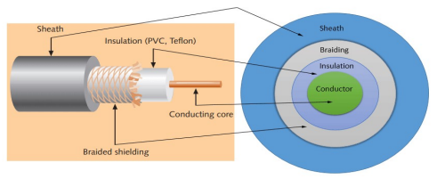
Fig 1.1.paret of coaxial cable

Components of Coaxial cable
Sheath
This is the outer layer of the coaxial cable. It protects the cable from physical damage.

Braided-shield

This shield protects signals from external interference and noise. This shield is built from the same metal that is used to build the core.
Insulation
Insulation protects the core. It also keeps the core separate from the braided-shield. Since both the core and the braided-shield use the same metal, without this layer, they will touch each other and create a short- circuit in the wire.
Conductor
The conductor carries electromagnetic signals. Based on conductor a coaxial cable can be categorized into two types; single-core coaxial cable and multi-core coaxial cable.
A single-core coaxial cable uses a single central metal (usually copper) conductor, while a multi-core coaxial cable uses multiple thin strands of metal wires. The following image shows both types of cable.
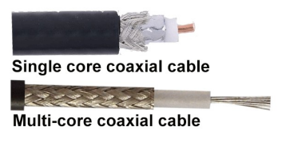
Fig 1.2.core coaxial cable

Coaxial cables in computer networks
The coaxial cables were not primarily developed for the computer network. These cables were developed for general purposes. They were in use even before computer networks came into existence. They are still used even their use in computer networks has been completely discontinued. At the beginning of computer networking, when there were no dedicated media cables available for computer networks, network administrators began using coaxial cables to build computer networks. Because of low-cost and long durability, coaxial cables were used in computer networking for nearly two decades (80s and 90s). Coaxial cables are no longer used to build any type of computer network.

Specifications of coaxial cables
Coaxial cables have been in use for the last four decades. During these years, based on several factors such as the thickness of the sheath, the metal of the conductor, and the material used in insulation, hundreds of specifications have been created to specify the characteristics of coaxial cables.
Coaxial cable uses RG rating to measure the materials used in shielding and conducting cores. RG stands for the Radio Guide. Coaxial cable mainly uses radio frequencies in transmission. Impedance is the resistance that controls the signals. It is expressed in the ohms. AWG stands for American Wire Gauge. It is used to measure the size of the core. The larger the AWG size, the smaller the diameter of the core wire.
From these specifications, only a few were used in computer networks. The following table lists them.
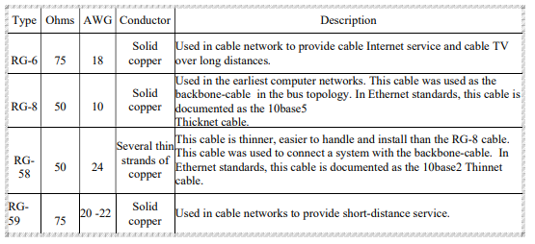

Preparing Cable ends

Difference of Straight through and Crossover Cable
Ethernet cables can be wired as straight through or crossover. The straight through is the most common type and is used to connect computers to hubs or switches. They are most likely what you will find when you go to your local computer store and buy a patch cable. Crossover Ethernet cable is more commonly used to connect a computer to a computer and may be a little harder to find since they aren’t used nearly as much as straight through Ethernet cable. Then, what’s the difference between straight through vs crossover cable? Read through this post to find the answer
T568A and T568B Wiring Standard Basis
A RJ45 connector is a modular 8 position, 8 pin connector used for terminating Cat5e patch cable or Cat6 cable. A pin out is a specific arrangement of wires that dictate how the connector is terminated. There are two standards recognized by ANSI, TIA and EIA for wiring Ethernet cables. The first is the T568A wiring standard and the second is T568B. T568B has surpassed 568A and is seen as the default wiring scheme for twisted pair structured cabling. If you are unsure of which to use, choose 568B.

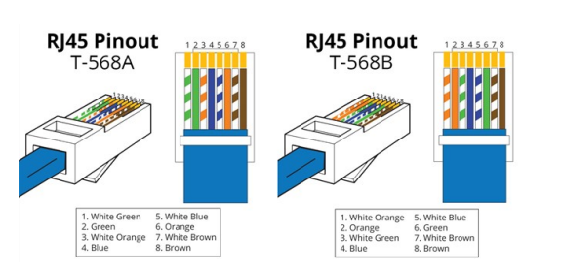
Fig 2.1.Straight throughvs. Crossover Cable

What Is Straight Through Cable?
A straight through cable is a type of twisted pair cable that is used in local area networks to connect a computer to a network hub such as a router. This type of cable is also sometimes called a patch cable and is an alternative to wireless connections where one or more computers access a router through wireless signal. On a straight through cable, the wired pins match. Straight through cable use one wiring standard: both ends use T568A wiring standard or both ends use T568B wiring standard. The following figure shows a straight through cable of which both ends are wired as the T568B standard.
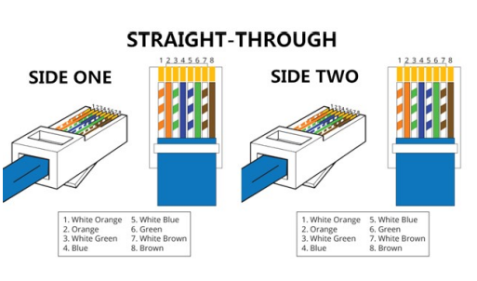
Fig 2.2.A straight through cable of which both ends

What Is Crossover Cable?
A crossover Ethernet cable is a type of Ethernet cable used to connect computing devices together directly. Unlike straight through cable, the RJ45 crossover cable uses two different wiring standards: one end uses the T568A wiring standard and the other end uses the T568B wiring standard. The internal wiring of Ethernet crossover cables reverses transmit and receive signals. It is most often used to connect two devices of the same type: e.g. two computers (via network interface controller) or two switches to each other.
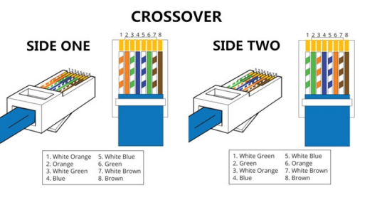
Fig 2.3.A Crossover cable of which both ends
Straight throughvs.Crossover Cable, which to choose?
Straight through vs. crossover cable, which one should I choose? Usually, straight through cables are primarily used for connecting unlike devices. And crossover cables are used for connecting alike devices.
Use straight through Ethernet cable for the following cabling:
Switch to router
Switch to PC or server
Hub to PC or server
Use crossover cables for the following cabling:
- Switch to switch
- Switch to hub
- Hub to hub
- Router to router
- Router Ethernet port to PC NIC
- PC to PC
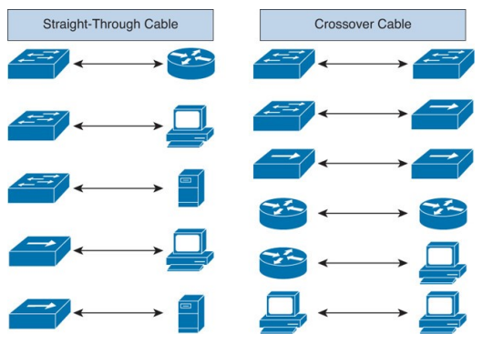
Fig 2.4.Straight through and Crossover Cable

Handling cables/wires
The primary cable handling equipment of a typical cable-layer is designed to load cable from ashore into cable tanks and discharge it from the tanks onto the seabed. Central to effective cable handling is the wheel pair – two tires on wheel rims mounted on hydraulically operated arms opposed to each other.
- The electric power line enters our house through three wires- namely the live wire, the neutral wire and the earth wire.
- To avoid confusion we follow a colour code for insulating these wires.
- The red wire is the live wire, and the black wire is neutral.
- The earth wire is given green plastic insulation
The most common type of wiring in modern homes is in the form of nonmetallic (NM) cable, which consists of two or more individual wires wrapped inside a protective plastic sheathing. NM cable usually contains one or more “hot” (current-carrying) wires, a neutral wire, and a ground wire
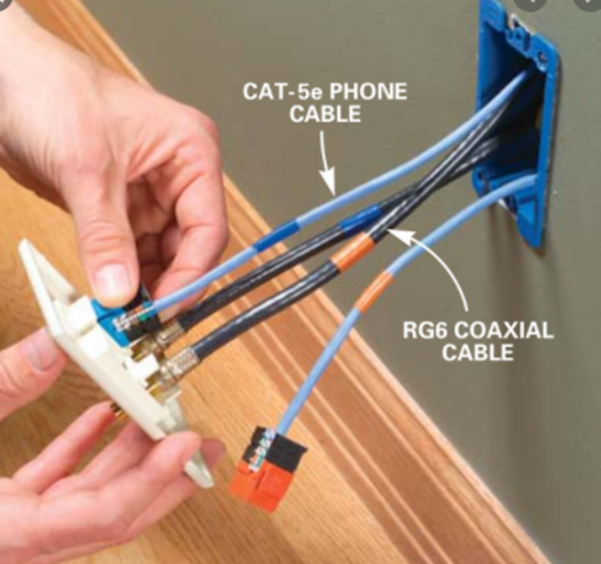
Fig 2.5.RG6 coaxial cable

Self-Check -2
Directions: Answer all the questions listed below. Use the Answer sheet provided in the next page:
Part I. Choose the best answer from the question below
- ______the outer layer of the coaxial cable. It protects the cable from physical damage?
- SheathC. Braided-shield
- Insulation D.All
- One of the following is shield protects signals from external interference and noise.
- Sheath C. Braided-shield
- Insulation D.All
- ______are uses a single central metal (usually copper) conductor?
- multi-core coaxial cable C. Conductor
- single-core coaxial cable D. All
Part ll. Say true and false for the following question below
- The coaxial cables were not primarily developed for the computer network. T
- Conductor protects the core. It also keeps the core separate from the braided-shield. F

Unit three : Network cable termination
This learning unit is developed to provide the trainees the necessary information regarding the following content coverage and topics:
- Cables are terminate
- Terminations are tested /examined for compliancewith specifications
This unit will also assist you to attain the learning outcomes stated in the cover page. Specifically, upon completion of this learning guide, you will be able to:
- Terminating Cables
- Testing Terminations for compliance with specifications and procedures.

Data cable tools

Network cable Crimping and Testing Tools
In This part of experiment explains the most common twisted-pair network cable testing and crimping tools in detail. Learn the tools that you can use to crimp and test twisted-pair network cables. Cables are the backbone of a wired network. The stability, reliability, and performance of a wired network depend on cables. Installing and maintaining cables in a wired network is a difficult task. To make this task easier, a variety of network cable crimping and testing tools are available. In this tutorial, we will not only discuss some of the most common network cable crimping and testing tools but also understand their features and functions.

Twisted-pair (STP and UTP) network cable crimping tools
Crimping tools are used for the following purposes.
- To cut the network cable of the required length from the bundle.
- To remove the outer and inner jackets of the network cable.
- To attach the connectors on both ends of the cable.
Some crimping tools provide all the functionality while others provide one or two functionalities. The most common twisted-pair network cable crimping tools are described below.
Wire Cutter: - To cut the network cable of the required length from the bundle, you can use any standard wire cutter tool or can use a wire cutter tool that is specially designed for the twisted-pair cable. A twisted-pair wire cutter usually includes additional blades for stripping the wire.
Wire Stripper: - This tool is used to remove the outer and inner jackets of the network cable. Typically, you do not need to purchase this tool separately as all standard twisted-pair wire cutters are equipped with wire-strippers.
Crimp tool: - This tool is used to attach the connectors to the cable. Typically, this tool also includes a wire-cutter and wire-stripper. So if you buy a crimp tool, you don't have to buy a wire-cutter and wire-striper separately.

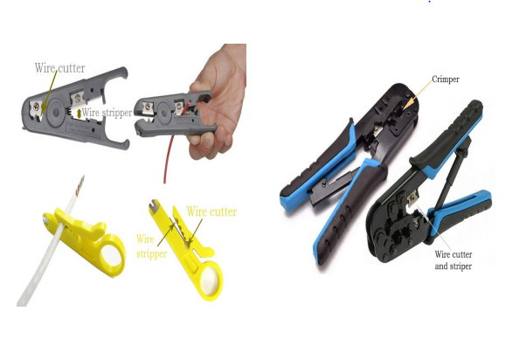
Fig.1.1.network cable crimping tools
Which tool you should buy depends on your requirements and budget. For example, if you want to install a dozen network cables, you can buy less expensive tools such as a low-cost wire stripper and a cheap crimp device. But if you are in a network cable setting up business or have a medium or large-sized network, you should buy a crimping tool that has a built-in a wire stripper and wire cutter. A high-quality twisted-pair cable crimping tool will cost you around $100 but will save you many headaches in the long run.

Testing Terminations for compliance with specifications and procedures

Network cable testing and troubleshooting tools
A network cable testing and troubleshooting tool is used for the following purposes.
To measure the length of a segment or network cable
To detect loose connectors
To identify an un-labeled network cable from all network cables.
To find a break in the network cable
To certify the cable installation
The following section describes the most common network cable testing and troubleshooting tools.

Cable certifier
This device thoroughly tests a network cable and certifies that the cable installation meets a special wiring standard such as Cat 5e, Cat 6, Cat 6a, and so forth. This device can check and test total segment length, crosstalk, noise, wiremap, resistance, impedance, and the capability to transfer data at the maximum frequency rated for the cable.
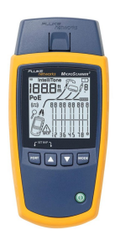
Fig.2.1.Cable certifier

Time domain reflectometer
This device is used to measure the length of a network cable as well as the breaks in the cable. This device transmits a signal on one end and measures the time the signal takes to reach the end of the cable. You can also use this device to find breaks in the cable. For example, this device can tell you approximately how far the break is located in the cable.
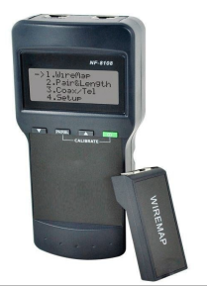
Fig.2.2.Time domain reflectometer

Basic cable tester
If you can't afford a network cable certifier, you can buy and use this device to manage your network cables. Besides certifying the cable installation, this device provides all remaining functionalities of a network cable certifier. It can test cable length, cross talk, and breaks in the cable. It can also check whether the connectors on both ends of a network cable are properly attached or not.
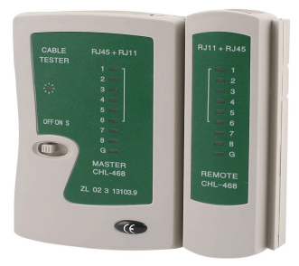
Fig.2.3.cable tester

Tone generator and the probe
Besides certifying the cable installation, this device provides all remaining functionalities of a network cable certifier. It can test cable length, cross talk, and breaks in the cable. It can also check whether the connectors on both ends of a network cable are properly attached or not.For example, if you are working on a patch-panel or switch and trying to figure out which network cable connects back to an end-device (such as a PC), then you can use this device. Place a tone generator at one end of the connection (end device), and use the probe on another side (switch or patch-panel) to determine which network cable the tone generator is connected to.
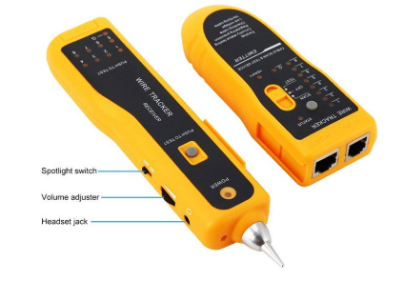
Fig.2.4.network cable crimping tools

Self-Check -3
Directions: Answer all the questions listed below. Use the Answer sheet provided in the next page:
Part I. Choose the best answer from the question below
1. This tool is used to remove the outer and inner jackets of the network cable.
- Wire CutterC. Crimp tool
- Wire Stripper D. All
2. This tool is used to attach the connectors to the cable. Typically, this tool also includes a wire-cutter and wire-stripper.
- Wire CutterC. Crimp tool
- Wire Stripper D. All
3. _________is to cut the network cable of the required length from the bundle compliant.
- Wire CutterC. Crimp tool
- Wire Stripper D. All
4. This device is used to measure the length of a network cable as well as the breaks in the cable
- Cable certifier C. Basic cable tester
- Time domain reflectometer. D. All
5. This device can check and test total segment length, crosstalk, noise, wire map, resistance, impedance, and the capability to transfer data at the maximum frequency rated for the cable.
- Cable certifierC. Basic cable tester
- Time domain reflectometer. D. All
Part II. Answer the following question
- What is Tone generator and the probe?
- Write the difference between Basic cable tester and Time domain reflectometer?

Unit four : Termination and fix/secure cables
This learning unit is developed to provide the trainees the necessary information regarding the following content coverage and topics:
- Cables are fixed/secured in accordance
- Appropriate fixing/securing techniques
This unit will also assist you to attain the learning outcomes stated in the cover page. Specifically, upon completion of this learning guide, you will be able to:
- Fixing/Securing Cables with standard operating
- Utilizing appropriate fixing/securing techniques

Fixing/Securing Cables with standard operating

Placing and securing cable
The simplest way to bond your coaxial cable to the rest of the house is to run the cables through a grounding block, and then run a wire from the block to the grounding electrode (ground rod) or other qualifying grounding connection point
Securing Cables
- Use the proper size of fastener for the size and number of cables being secured.
- Use insulated staples and fasteners. ...
- Position cables flat against framing before securing them; do not fasten cables on-edge.
- Secure cables snugly but not so tightly that the cable is damaged or indented from the fastener.
Cable management refers to management of electrical or optical cable in a cabinet or an installation. The term is used for products, workmanship or planning. Cables can easily become tangled, making them difficult to work with, sometimes resulting in devices accidentally becoming unplugged as one attempts to move a cable. Such cases are known as "cable spaghetti", any kind of problem diagnosis and future updates to such enclosures could be very difficult.

Cable management both supports and contains cables during installation, and makes subsequent maintenance or changes to the cable system easier. Products such as cable trays, cable ladders, and cable baskets are used to support a cable through cabling routes
Measure: Measure the wall to determine the length of the cords you want to cover.
- Cut: Cut the base and cord cover to match the length you just measured.
- Mark anchor points: Use a pencil to mark the anchor points on the wall. ...
- Mount base: ...
- Lay the cables: ...
- Paint:
Color-coding of cables is sometimes used to keep track of which is which. For instance, the wires coming out of ATX power supplies are color-coded by voltage. Documenting and labeling cable runs, tying related cables together by cable ties, cable lacing, rubber bands or other means, running them through cable guides, and clipping or stapling them to walls are other common methods of keeping them organized. Above drop ceilings, hooks or trays are used to organize cables and protect them from electrical interference
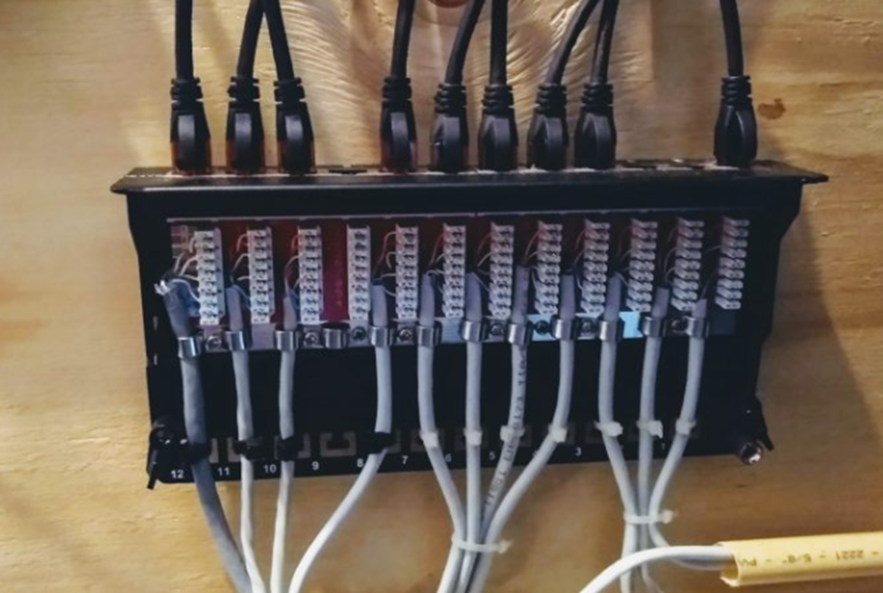
Fig1.1. Placing and securing cable
To do that, you need to use waterproof cable cap to make sure you cover the jack and the port with protective cover. As for the cable exposing outside, use protective tape to make sure the cable is not easily exposed to the element but not too much to cause heat.
- Installing cables as catenaries
In our world, a catenary is a system of overhead wires used to supply electricity to a locomotive, streetcar, or light rail vehicle which is equipped with a pantograph. The pantograph presses against the underside of the lowest overhead wire, the contact wire.
Current collectors are electrically conductive and allow current to flow through to the train and back to the feeder station through the steel wheels on one or both running rails. Unlike simple overhead wires, in which the uninsulated wire is attached by clamps to closely spaced cross wires supported by poles, catenary systems use at least two wires. The catenary or messenger wire is hung at a specific tension between line structures, and a second wire is held in tension by the messenger wire, attached to it at frequent intervals by clamps and connecting wires known as droppers. The second wire is straight and level, parallel to the rail track, suspended over it as the roadway of a suspension bridge is over water.
Simple wire installations are common in light rail, especially on city streets, while more expensive catenary systems are suited to high-speed operations.
The Northeast Corridor in the United States has catenary over the 600 miles (1000 km) between Boston, Massachusetts and Washington, D.C. for Amtrak's high-speed Acela Express and other trains. Commuter rail agencies including MARC, SEPTA, NJ Transit, and Metro-North Railroad utilize the catenary to provide local service.
Overhead line equipment can be adversely affected by strong winds causing swinging wires. Power storms can knock the power out with lightning strikes on systems with overhead wires, stopping trains if there is a power surge. During cold or frosty weather, there is a risk of ice build-up on overhead lines. This can result in poor electrical contact between the collector and the overhead line, resulting in electrical arcing and power surges

Fixing and securing appropriate techniques

Cable-Connector

Twisted-Pair Cable-Connector Installation
The main method to put connectors on twisted-pair cables (both UTP and STP) is crimping. You use a tool called a crimper to push the metal contacts inside the connector onto the individual conductors in the cable, thus making the connection
- Types of Connectors
Two main types of connectors (often called plugs) are used for connectorzing twisted-pair cable in data-communications installations: the RJ-11 and RJ-45 connectors. These are more accurately referred to as sixposition and eight-position modular plugs, but the industry is comfortable with the RJ labels. Figure 2.1 shows an example of both an RJ-11 and RJ-45 connector for twisted-pair cables. Notice that these connectors are basically the same, except the RJ-45 accommodates more conductors and thus is slightly larger.
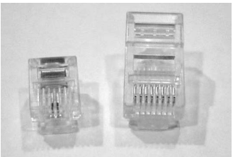
Fig2.1.RJ-11 and RJ-45 connectors
RJ-11 connectors, because of their small form factor and simplicity, are primarily used in telephone applications. RJ-45 connectors, on the other hand, because of the number of conductors they support (eight total), are used primarily in LAN applications. It should be noted, however, that many cable workers will install RJ-45 jacks for telephone applications because those jacks support both RJ-11 and RJ-45 connectors.

Conductor Arrangement
When making solid-conductor UTP patch cords with crimped ends, you can make many different types, determined by the order in which their color-coded wires are arranged. Inside a normal UTP cable with RJ-45 ends are four pairs of conductors (eight total). Each pair is color coded blue, orange, green, and brown. Each wire will either be the solid color or a white wire with a stripe of its pair’s solid color (e.g., the orange and the white/orange pair). Table 2.1 illustrates some of the many ways the wires can be organized.
TABLE 2.1: Color-Coding Order for Various Standards
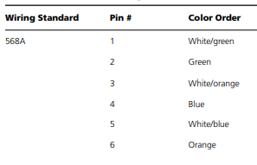

Connector Crimping Procedures
- Prerequisites
As with any project, you must first gather all the items you will need. These items include the following:
- Cable
- Connectors
- Stripping and crimping tools
By now, you know about the cable and connectors, so we’ll discuss the tools you’ll need for RJ-connector installation. The first tool you’re going to need is a cable-jacket stripper, as shown in Figure 2.2. It will only cut through the outer jacket of the cable, not through the conductors inside. Many different kinds of cable strippers exist, but the most common are the small, plastic ones (as in Figure 2.2) that easily fit into a shirt pocket. They are cheap to produce and purchase.
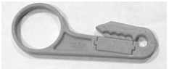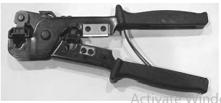
Fig2.2.A common twisted-paircable stripper and A crimper for RJ-11 and RJ45 connectors
Installing the Connector Now we’ll go over the steps for installing the connectors. Pay particular attention to the order of these steps and make sure to follow them exactly.

Installing the Connector
Now we’ll go over the steps for installing the connectors. Pay particular attention to the order of these steps and make sure to follow them exactly.
- Measure the cable you want to put ends on and trim it to the proper length using your cable cutters (as shown here). Cut the cable about 3 inches longer than the final patch-cable length. If you want a 10-foot patch cable, cut the cable to 10 feet, 3 inches.
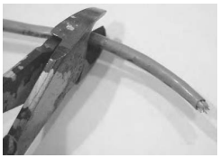
- Using your cable stripper, strip about 1.5 inches of the jacket from the end of the cable. To do this, insert the cable into the stripper so that the cutter bar in the stripper is 1.5 inches from the end of the cable (as shown in the graphic). Then, rotate the stripper around the cable twice. This will cut through the jacket. Remove the stripper from the cable and pull the trimmed jacket from the cable, exposing the inner conductors (as shown in the second graphic).
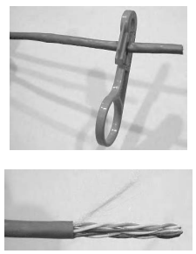
- Untwist all the inner conductor pairs and spread them apart so that you can see each individual conductor, as shown here.
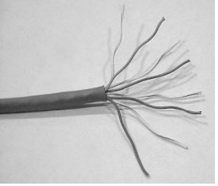

- Line up the individual conductors so that the color code matches the colorcoding standard you are using (see Table 2.1, shown previously). The alignment in the graphic shown here is for 568B, with number 1 at the top
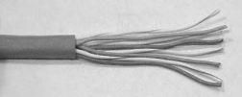
- Trim the conductors so that the ends are even with each other, making sure that the jacket of the cable will be inside the connector (as shown here). The total length of exposed connectors after trimming should be no longer than 1 ⁄2 " to 5 ⁄8" (as shown in the second graphic)
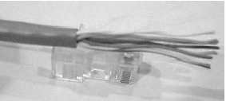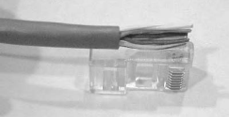
- Insert the conductors in the connector, ensuring that all conductors line up properly with the pins as they were aligned in the last step. If they don’t line up, pull them out and line them up. Do this carefully, as it’s the last step before crimping on the connector.
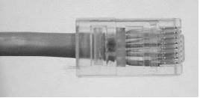
- Carefully insert the connector and cable into the crimping tool (as shown in the following graphic). Squeeze the handle firmly as far as it will go and hold it with pressure for three seconds. As you will see in the second graphic, the crimping tool has two dies that will press into the connector and push the pins in the connector into the conductors inside the connector. A die in the crimping tool will also push a plastic divider into the cable jacket of the cable to hold it securely inside the connector
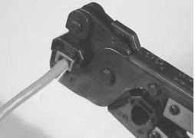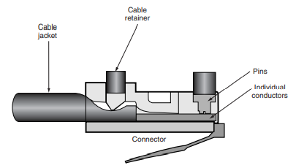
- Now that you’ve crimped the connector, remove it from the crimping tool and examine it (as shown in the next graphic). Check to ensure all conductors are making contact and that all pins have been crimped into their respective conductors. If some of the pins did not crimp all the way into their respective conductors, reinsert the connector into the crimping tool and recrimp it. If the connector didn’t crimp properly, cut off the connector and redo it.
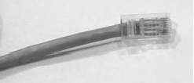
- To finish the patch cable, put a connector on the other end of the cable and follow these steps again, starting with step 2.
- Testing
You should ensure that the connectorization was done correctly by testing the cable with a cable tester. Put the injector on one end of the cable and put the tester on the other end. Once you have the tester hooked up, you can test the cable for continuity (no breaks in the conductors), near-end crosstalk (NEXT), and Category rating (all quality-of-transmission issues). The specific procedures for testing a cable vary depending on the cable tester.

Operation Sheet-1
Operation Title:Step’s-by-step: twisted-pair cable preparation and connector termination
Instruction:The following procedure elaborate the Cross over connection system
- Tools and requirement:
- Cable
- Connectors
- Stripping and crimping tools
- Precautions:The following steps will guide you through the preparation and termination process for UTP cable. Following these guidelines will help give you the optimum performance from the twisted pair cabling.
- Connector Crimping Procedures
Step1.Prepared tools you will need
Step2.Insert cable into stripping tool to the desired strip length. Strip off only as much cable jacket needed to properly terminate the pairs (1 to 1½ inches should be sufficient to terminate pairs).
Step3.Holding the cable near the tool, rotate the tool around the cable several times.
Step4.Slightly bend the outer jacket and manually remove the cut piece or slide the cut outer jacket with the stripper.
Step5.Bend each pair in one direction to expose the rip cord, binder or cross-web filler on the cable.
Step6.Remove the rip cord, binder or cross web filler if they are present on the cable, leaving only the twisted pairs of wire. The cross-web filler should be cut as flush as possible to the jacket.
Step7.Determine the wiring scheme and properly align all four cables accordingly on the jack. Keep the cable jacket as close to the connector as possible. Always use connectors, wall plates and patch panels that are compatible (same rating or higher) with the grade of the cable used.
Step8.Preserve the wire pair twists as close as possible to the point of termination. When connecting jacks and plugs, do not untwist the cable more than 0.5 inches for Category 5e, 6 and 6A cable.
Step9. Insert wires down into IDC terminal slots to position them before punching down. Maintain the twist. To “future-proof” an installation, terminate all four pairs.
Step10.When using a punch-down tool, make sure the tool is straight before punching down on the connector. Make sure the cut-side of the tool is facing outward.
Step11.Inspect the connector to verify that the wires are fully engaged in the IDC terminals and they are cut properly.
Step12.Place a dust cover on the jack for protection.
Step13.This is how your assembled jack should look.

LAP Test | Practical Demonstration

Name: _____________________________ Date: ________________
Time started: ________________________ Time finished: ________________
Instructions: Given necessary templates, tools and materials you are required to perform the following tasks within 1:00 hours.

Task1. Demonstrate twisted-pair cable preparation and connector termination
Task2. Demonstrate by testing the cable with a cable tester.

References
- (https://www.armypubs.army.mil),and the Central Army Registry site (https://atiam.train.army.mil/catalog/dashboard).
- Cabling. Part 2, Fiber-optic cabling and components ( PDFDrive )
- cabling_-_the_complete_guide_to_network_wiring_2nd_ed_malestrom.David Groth Jim McBee David Barnett
- Advances in Signal and Data Processing Select Proceedings of ICSDP 2019 (0009172) (z-lib.org)

Participants of this Module (training material) preparation
No | Name of trainer | Qualification (Level) | Field of Study | Institution | Mobile number | E-mail
1 | SAMUEL BEKELE | MSC) | Electrical control and automation | Haremya | 0910082977 | samuelbekele460@gmai.com
2 | TIRUSEW BAYE | BSC | Building construction | Debretabor  PTC | 0918092865 | tirusew2014t@gmail.com
3 | BACHA WAKE | MSC | Electrical control and automation | Hawasa  TTC | 0910780182 | bachawakejima2012@gmail.com
4 | GIRMA BELETE | MSC | Electrical Power engineering | Hawassa  PTC | 0938935026 | girmabelete7@gmail.com
5 | SALADIN ABDELLA | BSC | Electrical Technology | Dire dawa  PTC | 0922010767 | Sala0767@gmail.com

