BUILDING ELECTRICAL INSTALLATION
LEVEL III
Based on October, 2023, Curriculum Version II,
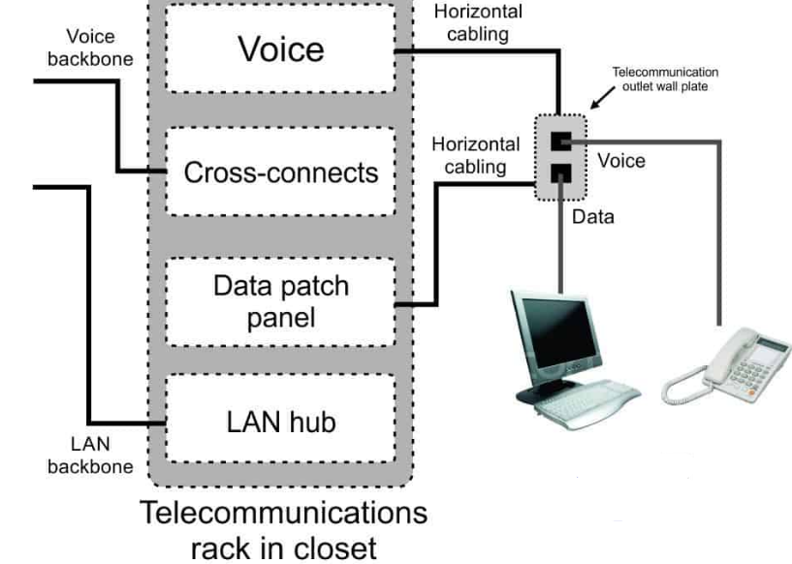
Module Title: Installation and Maintenance For
Telecommunication and Data Services Cable
Code: EIS BEI3 M3 10 23
Nominal duration: 64 Hours

Prepared By: Ministry of Lobar and Skill
October, 2023
Addis Ababa, Ethiopian

Table of Contents
Contents
Table of Contents i
Acknowledgement iii
Acronyms iv
Introduction 1
Unit one: telecommunication and data service cabling Requirement 2
1.1 OHS procedures and Requirement 3
1.2 Nature, location and scope of the work 5
1.4 Installation of earthing conductors 21
1.5 The work coordination with others infrastructure. 27
1.6 Material, Tools, equipment and testing devices 28
Self-Check -1 41
Operation sheet 1 42
LAP Test 1 42
Unit two: Installation and Maintenance of cabling 43
2.1. Structural support and cable management for catenaries system 44
2.2 Protective earthing of metal work 49
2.3 Cables and wires handling 50
2.4 Cables for interference segregation 51
2.5 Install Cables in accordance with telecommunication regulation 52
2.6 Over-voltage protection to suppress voltage surges with standard devices 54
Self-Check -2 57
Unit three: Termination and testing of cables and earth wires 58
3.1 Cable sheath for correct termination length 59
3.2 Terminating modules (cables pairs) with recommended color code 60
3.3 Terminating conductors 72
3.4 Earthing cable shield 74
3.5 Test and clearly labels of cable pairs 77
3.6 Terminate TRC/CES/Earth wires with connectors. 84
3.7 Test Reference Cord (TRC) / Communications Earth System (CES) /Earth wire continuity 85
3.8 Testing TRC/CES /Earthling system 86
3.9 Labeling of earthling system 90
3.10 Testing and confirming Compatibility of alterations with existing systems 99
3.11 Direction for non-routine events 101
3.12 Routine quality termination of cables and devices 102
Self-Check -3 103
Operation sheet 3 104
LAP Test 3 104
Unit four: Complete cabling work, records and reporting 105
4.1 OHS work completion risk control measures and procedures 106
4.2 Work site safety 115
4.3 Record sheets and plans of cable 116
4.4 Cable pair record books 120
4.5. Documentation and report completion of installing work 120
Self-Check -4 124
References 126

Acknowledgement

Ministry of Labor and Skills wish to extend thanks and appreciation to the many representatives of TVT instructors and respective industry experts who donated their time and expertise to the development of this Teaching, Training and Learning Materials (TTLM).
.

Acronyms
OHS Occopational health and safety
DSL Digital subscriber line
VoIP Voice over Internet protocol
CSP Carriage service provider
MDF main distributor frame
IPTV Internet Protocol Television
TV Television
ADSL Automatic Data System Location
ONT Optical Network Termination unit
PC Personal computer
LAN Local Area Network
RG Radio Guide
RJ Registered Jack
NTD Network Termination Device
NBN National Broadband Network
CES communication earthing system
CCP Costumer connection Premises
FTTP Fiber to the premises

Introduction to the Module
In building electrical installation filed; Telecommunication and data services cable unit of competence helps the trainees to complete communication and data services requirements in parallel with communication. This module covers the knowledge, skills and attitude required for installation and maintenance of telecommunications cabling in buildings and premises. It encompasses working safely and to Ethiopian telecommunications and Media Authority's ‘Open’ Cabling Provider Rule, installing multiple telephone line, multi-pair cables, backbone cabling, terminating in socket outlets, termination modules and distributors, testing and compliance checks and completing cabling documentation.
This module is designed to meet the industry requirement under the Building electrical installation occupational standard, particularly for the unit of competency: installation and maintenance of Telecommunication and data services cable.
Module units
- Telecommunication and data service cabling Requirement
- Installation and maintenance of cabling
- Termination and testing cables and earth wires
- Complete cabling work, records and reporting
Learning objectives of the Module
At the end of this session, the students will able to:
- explain telecommunication and data service cablingRequirement
- Install and maintain cabling
- Terminate and test cables and earth wires
- Complete cabling work, record and report
Module Learning Instructions:
- Read the information written in each unit
- Accomplish the Self-checks at the end of each unit
- Perform Operation Sheets which were provided at the end of units
- Do the “LAP test” giver at the end of each unit and
- Read the identified reference book for Examples and exercise

UNIT ONE: Telecommunication and Data Service Cabling Requirement
This learning unit is developed to provide the trainees the necessary information regarding the following content coverage and topics:
  - OHS procedures and Requirement
  - Nature, location and scope of the work
  - Cable routes plan based on building structure and regulations
  - Installation of Earthing conductors
  - The work coordination with others infrastructure.
  - Tools, equipment and testing devices
This unit will also assist you to attain the learning outcomes stated in the cover page. Specifically, upon completion of this learning guide, you will be able to:
- Follow OHS procedures and Requirement
- Determine Nature, location and scope of the work
- Apply Cable routes plan based on building structure and regulations
- Determine Installation of earthing conductors
- Explain the work coordination with others infrastructure.
- Obtain and check material, Tools, equipment and testing devices

OHS procedures and Requirement
1.1.1 OHS procedures for a given cabling work
This information is intended to assist installer of telephone service to understand the telephone wiring in residential and their home. This information, if used properly, can be helpful in fixing or installing telephone wiring in residential or your home. Use of this OHS guide is at your own risk. Improperly installed wiring could impair your phone service.
Although the voltage on active telephone wiring is typically very small, it can be hazardous to some individuals and materials. In addition, telephone wiring can conduct dangerous electrical shocks if it comes into contact with power wires. Caution should be used at all times. The Public Service or your telephone service provider has no responsibility for any personal injury or property damage which may result from your installation or attempted installation of inside wiring. By proceeding with installation, you assume all risk of personal injury or property damage, including but not limited to: loss of service, damage to property, or injury. If you do not fully understand the concepts lay out in this OHS guide and are not completely comfortable performing the work, do not attempt the installation or repair. Instead contact a professional such as your telephone service provider.
1.1.2 Health and safety risks
Telephone installation work is generally safe provided you follow these guidelines:
- Do not work with outlets and wires that you are not sure are telephone facilities. If you are unsure which facilities are or are not telephone facilities, you should consult with an experienced professional.
- Do not connect household electrical power to telephone lines.
- Do not work on any telephone wires (or any wires) during a thunderstorm.
- Work with insulated tools.
- Touch only one wire at a time.
Note: When working with telephone wires and connections, there is always the possibility of an electrical shock. It is generally recommended that premises wiring be disconnected fromincoming telephone lines. Do this at the NID. You may also choose to lift the handset of one telephone connected to the line as a means of avoiding electrical power surges which occur when your telephone rings
Compliance with Local Building and Safety Codes
When planning and installing your telephone wiring and outlets, you must observe and comply with any applicable state and local codes. Before doing any significant wiring work, you may want to consult with your municipal government to determine if permits are necessary for the work you plan to do.Before starting any telephone installation work, familiarize yourself with the products, procedures and safety precautions outlined in this brochure. Be sure to review the safety precautions included with any equipment you have purchased as well. As you work on your telephone wiring (or any wiring) the “safety first” should be your guide. The telecommunications industry has become increasingly diverse with the types and number of services that are available, as well as the types and number of service providers. This information is intended to be a guide for the “typical” situation involving telephone wiring. However, depending on the type of service you are using (i.e., cable modem, digital subscriber line (DSL) or any high-speed internet service, VoIP etc…) you may need to refer to other materials.
This guide will be particularly helpful if you wish to change phones, add an extension, or install your own wiring system using the safety outlined.
1.1.3 Remote power feeding and risk control measures
Registered cablers working with telephone lines carrying broadband services need to take precautions to avoid electric shock. Carriage service provider (CSP) broadband equipment within the customer’s premises requires increased voltage, which is called power feeding. The risk of electric shock increases when working with these higher voltages. Network cables carrying power feeding circuits may bypass the main distributor frame (MDF) to extend through to the CSP’s equipment or they may be installed on the MDF. Usually the power feeding network cable will be laid in areas accessed by cablers. With broadband services, carriers and CSP’s may install terminal equipment that is remotely fed using a current limited circuit. This has an open circuit
voltage which is higher than normal telecommunications network voltage. Authorization from the relevant carrier of CSP is required to work on these network cables and should exercise caution when working near any accessible termination.The increased voltage also has the capacity to damage test equipment.

1.2 Nature, location and scope of the work
Telecommunications are the means of electronic transmission of information over distances. The information may be in the form of voice telephone calls, data, text, images, or video. Today, telecommunications are used to organize more or less remote computer systems into telecommunications networks.
This is a broad term that includes a wide range of information-transmitting technologies and communications infrastructures. Examples include wired phones, cell phones, microwave communications, fiber optics, satellites, radio and television broadcasting, the internet and telegraphs.
Data service cabling is the wiring that connects your devices to your network and the internet. It is essential for any business or organization that relies on data to operate.
When cabling a building for data services, it is important to choose the right type of cable and to install it properly. The most common type of cable used for data services is twisted pair cable. Twisted pair cable comes in two categories: Cat5e and Cat6. Cat6 cable is the newer and faster type of cable, and it is recommended for new installations.
When installing twisted pair cable, it is important to follow these guidelines:
- Use cable ties to secure the cable to walls and ceilings.
- Avoid running the cable near electrical wires or other sources of interference.
- Terminate the cable using RJ-45 connectors.
The following diagram shows an example of how to cable a building for data services using switches, routers, and hubs:
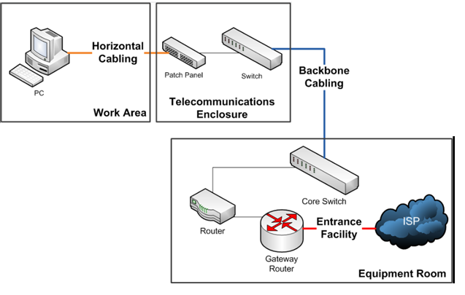
Figure 1.1 How to cable building for data services using switches, routers, and hubs:

There are two main types of data service cabling: copper and fiber optic

Figure 1. 2 Copper data cable
Copper cabling is the most common type of data service cabling. It is relatively inexpensive and easy to install. However, copper cabling has a limited bandwidth and can be susceptible to interference.

Figure 1. 3 Fiber optic data cable
Fiber optic cabling is a newer type of data service cabling that offers much faster speeds and bandwidth than copper cabling. However, fiber optic cabling is more expensive and difficult to install.
The type of data service cabling that you need will depend on your specific needs and requirements. If you need a high-speed and reliable network, then fiber optic cabling is the best option. However, if you are on a budget or need to install the cabling yourself, then copper cabling may be a better choice.
Here are some of the benefits of using data service cabling:
- Speed: Data service cabling can provide very fast speeds, especially when using fiber optic cabling.
- Reliability: Data service cabling is very reliable and can provide a consistent connection to your network and the internet.
- Scalability: Data service cabling is scalable to meet the needs of your growing business.
- Security: Data service cabling can help to improve the security of your network by making it more difficult for unauthorized users to access your data.
If you are considering using data service cabling, it is important to have a qualified professional design and install the cabling system. This will ensure that the system is installed correctly and that it meets your specific needs.
Here are some tips for choosing and installing data service cabling:
- Choose the right type of cabling for your needs. If you need a high-speed and reliable network, then fiber optic cabling is the best option. However, if you are on a budget or need to install the cabling yourself, then copper cabling may be a better choice.
- Have a qualified professional design and install the cabling system. This will ensure that the system is installed correctly and that it meets your specific needs.
- Test the cabling system after it is installed to make sure that it is working properly.
- Label the cabling so that it is easy to identify and troubleshoot.
- Document the cabling system so that you can easily make changes or repairs in the future.
Cabling System Documentation
The most often overlooked item during cable installation is the documentation of the new cabling system. Cabling system documentation includes information about what components make up a cabling system, how it is put together, and where to find individual cables.
This information is compiled in a set of documents that can be referred to by the network administrator or cabling installer any time moves, adds, or changes need to be made to the cabling system.
The most useful piece of cabling system documentation is the cabling map. Just as its name implies, a cabling map indicates where every cable starts and ends. It also indicates approximately where each cable runs. Additionally, a cabling map can indicate the location of workstations, segments, hubs, routers, closets, and other cabling devices. To make an efficient cabling map, you need to have specific numbers for all parts of your cabling system.
For example, a single cable run from a cabling closet to wall plate should have the same number:
- on the patch panel port,
- patch cable,
- wall cable, and
- Wall plate.
This way, you can refer to a specific run of cable at any point in the system, and you can put numbers on the cabling map to refer to each individual cable run.
Wire mapping is the most basic and obvious test for any twisted-pair cable installation. For twisted-pair cables, you must test each cable run to make sure that the individual wires within the cable are connected properly; you can select either the T568-A or T568-B pin out configurations for a twisted-pair installation. Because all of the pairs are wired straight through and the difference between the two configurations is minimal, there is no functional difference between them. However, you should select one pin out and stick to it throughout your entire installation. This way you can perform end-to-end tests as needed without being confused by mixed wire-pair colors. A perfunctory wire-mapping test can be performed visually by simply checking the pin outs at both ends of the cable. However, problems can occur that are not visible to the naked eye. A proper wire-mapping tester can detect any of the following faults: Open pair occurs when one or more of the conductors in the pair are not connected to a pin at one or the other end. In other words, the electrical continuity of the conductor is interrupted. This can occur if the conductor has been physically broken, or because of incomplete or improper punch down on the IDC connector.
Shorted pair: A short occurs when the conductors of a wire pair are connected to each other at any location in the cable.
Short between pairs: A short between pairs occurs when the conductors of two wires in different pairs are connected at any location in the cable.
Reversed pair: A reversed pair (sometimes called a tip/ring reversal) occurs when the two wires in a single pair are connected to the opposite pins of the pair at the other end of the cable.
For example, if the W-BL/BL pair is connected on one end with W-BL on pin 5 and BL on pin 4 of the connector, and at the other end of the cable, W-BL is connected to pin 4 and BL is punched down on pin 5, the W-BL/BL pair is reversed.
Crossed pairs Crossed (or transposed) pairs occur when both wires of one color pair are connected to the pins of a different color pair at the opposite end.
Split pairs Split pairs occur when one conductor from at both ends of the run. Because this type of faultessentially requires that the same mistake be made at both ends of the connection, accidental occurrence of split pairs is relatively rare.
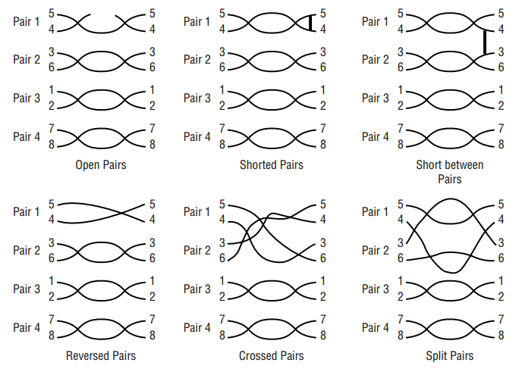
Figure 1. 4 Wire-mapping to show faults

Wire-mapping faults are usually caused by improper installation practices, although some problems like opens and shorts can result from faulty or damaged cable or connectors.
The process of testing a connection’s wire mapping is fairly straightforward and requires a remote unit that you attach at one end of the connection and a main unit for the other end. Wire-map testing is usually included in multifunction cable testers, wire-map testers that are far less expensive.
The main unit simply transmits a signal over each wire and detects which pin at the remote unit receives the signal. The problem of split pairs (two wires in different pairs transposed at both ends of the connection) is the only one not immediately detectable using this method.
Because each pin is connected to the correct pin at the other end of the connection, the wire map may appear to be correct and the connection may appear to function properly when it is first put into service. However, the transposition causes two different signals to run over the wires in a single twisted pair. This can result in an excess of near-end crosstalk that will cause the performance of the cable to degrade at high data rates.
Although the occurrence of split pairs is relatively unlikely compared to the other possible wire-mapping faults, the ability to detect split pairs is a feature that you may want to check for when evaluating cable-testing products.
Wiring Elements of telecommunication consists of the elements that make up home wiring are:

- Telephone Cabling
- Data cable
- Free to air TV
- Pay TV
- IPTV (Internet Protocol Television)
- Distributed audio

Telephone Cabling
The dial tone arrives at your home on two wires which are typically twisted together to form a “twisted pair.” While twisted pairs can be bunched together to form large cables, by the time the connection reaches your home, it has typically been reduced to an aerial drop wire (which contain 1 to 6 pair), or a buried drop wire (which contain 1 to 6 pair). In order to tell the various wires and pairs apart, there is an industry standard color coding system. Be aware, however, depending on who installed the wire, there may be variances. However, if a professional installed the wiring, they should have followed this color coding system. Your single-line phone system will work properly when the wire color pattern is consistent with each wire secured to its proper terminal on a jack or spliced to the same color (as in a junction block where a system branches).
In many of the new homes this is typically located near the electrical switch board but not always. You need to identify where you want the phone system or handset physically connected. Telephone wire normally used for inside installation contains four individually colored conductors. The wire is solid copper in either 22 or 24 gauge. See Tables A and B for wire color codes and spacing from other wire conductors.
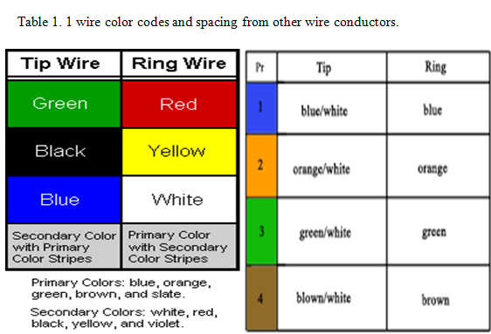

Table 1. 2 wire connection and conduit chart
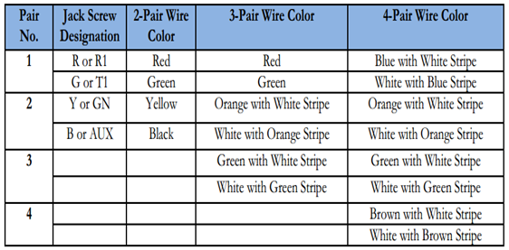

Data cable
Data wiring has two components, these are:
- Data service delivery
- Data network cable
The three most common ways data services are delivered to the home:
ADSL (Automatic Data System Location): ADSL services are typically delivered using the telephone cabling. So wherever you have a telephone point you can install your ADSL modem. When you have an ADSL modem you also need to install a filter at every location where you have a phone plugged in. If you want to install the ADSL modem in a room where you don’t have any phone point you will need to install a phone point by extending the phone cabling from the nearest existing phone point.
Cable Modem:cable modems are typically installed in location where there is an existing Pay TV service outlet. The installation requires the installation of a Pay TV outlet at which point you connect the cable modem.
Fiberis the least common but it is growing in numbers. If the home has fiber to it, then the fiber terminates on what is known as an Optical Network Termination unit (ONT) and it has a data port on it. Cabling from the street to the point where the ONT is installed is fiber and is typically installed by the service provider.
In all three cases the modem supplied or the ONT will have a data port which is an RJ45 socket and this is the port that needs to be connected to the devices you need to connect to the internet. This is the data network cabling or LAN cabling.
Data Cable (Network cabling)
To extend the data service from the data port on the ADSL modem, Cable Modem or ONT to your networking devices (PC, printers, TV etc.) you need to install data cabling also referred to as LAN (low area networking)) cabling. The cabling used for data networking is similar to the phone cabling as it is twisted pair but of a much higher quality. The cable is known as Cat 5 or Cat 6 where Cat stands for Category.
What you need to do is decide where networking devices are and install cabling from the location where the data modem is located to where you have your PCs or TVs that need to connect to the internet. The cabling must be installed as a start wired configuration that is the cabling runs from the point next to the modem uninterrupted up to where you install the outlet next to the device that needs to be connected to the internet. So unlike the phone wiring where you could wire from one outlet to the next, here each outlet is wired individually back to the location next to the modem. Therefore next to the modem you will have what is known as a patch panel. Note, if all you need to plug into the modem is one computer then you can simply buy an Ethernet cable of the desired length and connected to between the modem and the PC.
Free to air TV
Cabling for free to air TV requires the following:
- An antenna
- Coaxial cable
- TV outlets
There are a range of television antennas for a range of different locations, it is best to consult with your local supplier as to which one is best in your situation. The antenna is typically mounted external to the building most commonly on the roof.
From the antenna you need to run a coaxial cable from the antenna to the location where the television is located. The two types of cable that may be used for coaxial cabling installations are
commonly referred to as “RG6”RG" Radio Guide (7 mm - 8 mm diameter) and “RG11” (10 mm – 11 mm diameter). Like the “RJ” (Registered Jack) designations used for modular plugs and sockets, the “RG” (Radio Guide) designations have no formal status and care needs to be exercised when selecting cables purported to be “RG6” or “RG11”. (The use of RG11 coaxial cable is not recommended in homes.)
Today the most common type of cable used for this purpose is RG-6 Tri-shield or quad-shield cable. The cable is terminated on television outlets. The television outlets are typically an F connector mounted on a face plate. In cases where you need multiple television outlets then you run the cable from the antenna to an RF splitter. The RF splitter typically has one input for the cable from the Antenna and two or more outlets depending on the splitter.
From the splitter you then run a coaxial cable to each outlet you are installing.
‘Additional notes’ On RF splitters, there are a few different types depending on the application. They range from very basic splitters to active splitters when you install many TV outlets throughout the home. While most TV outlets use the F connector the Television or digital set top box usually come with a connector known as Belling Lee so the cable used to connect from the TV outlet to the television will need to have an F connector in one end and a Belling Lee connector at the other end.

TV outlets connected to an FTTP NTD or external TV antenna
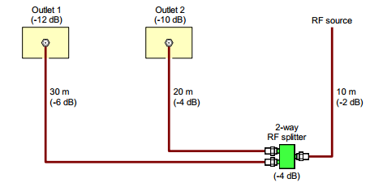
Figure 1. 5 Two TV outlets connected to an FTTP NTD or external TV antenna

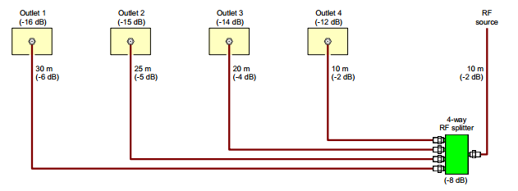
Figure 1. 6 Four TV outlets connected to an FTTP NTD or external TV antenna

Pay TV: The distribution of pay TV through the home uses the same type of cabling used for Free to Air TV with some variations. The variations are:
- There is no antenna as there is either a satellite dish or a cable from the street.
- The cabling must be RG-6 quad shield
- You may be required to use the cable and cabling connectors approved by your pay TV provider
- A Pay TV Set Top Box needs to be installed at each television where you want to have access to Pay TV services.
In most cases the Pay TV Company will supply and install the satellite dish or cable from the street and the cabling to the various locations where your televisions are. While you can pre-wire for it if you do it must comply with the requirements detailed by the Pay TV Company you choose. In many cases Pay TV services also require a telephone point so you can access movies on demand, so if you have a Pay TV point you also need a phone plug.

IPTV: IP TV is television delivered to your home via the internet. So on any device you want to watch IPTV on must be connected to the internet. To be connected to the internet it must be connected to your data network.
Distributed Audio: Distributed audio refers to having the ability to have music throughout the house where the music sources are all centralized. In every room and hallways you have a pair of speakers and you can select to have all speakers play the same music throughout the house or have different music in different location or zones as they are referred to. You can also remotely control the music sources and volume throughout the house. There are a wide range of distributed audio systems in the market and therefore the cabling you need depends on the system you are installing. When wiring a distributed audio system the first step is choose your equipment” and check what wiring is required by the equipment you have purchased.
In summary there are a few ways to wire up the system:
- Spear cabling is installed from the central equipment to the speaker location.
- Cat 5 or Cat 6 cable is installed from the Central equipment to the speaker location.
- Cat 5 or Cat 6 cable is installed to each room where you want the distributed audio and in each room you have an amplifier and speaker.
1.3.1 Wire Routing Strategies
There are two standard routing strategies:
    - Continuous Loop: In this method a single wire runs from the demarcation point to a jack, and then another wire runs to the next jack and so on, forming one continuous loop. But, like Christmas tree lights, if the wire gets cut somewhere, all the jacks beyond the cut will be disabled. This method may also make it more difficult to add a 2nd or 3rd line somewhere in the house.
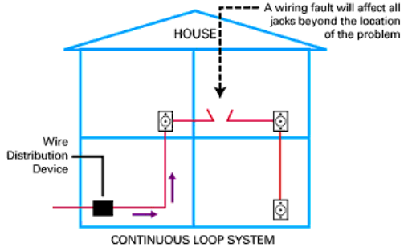
Figure 1. 7 Continuous Loop
    - Star Pattern or “Home Run:” As the name implies each jack is wired separately and directly to a central point where they can be connected to the telecommunications company’s wiring. This system may take more time and use more wire, but it more easily accommodates future growth and trouble-shooting problems.
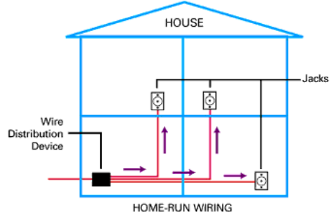
Figure 1. 8 Star Pattern or “Home Run”

You may find a combination of these strategies where there is a continuous loop on a floor of a house, but each floor feeds independently to the demarcation point. In older condo and apartment buildings you are likely to find a continuous loop, but newer buildings incorporate the “home run” method.
1.3.2 Traditional cabling methods used for telephone and ADSL services
Traditionally, telephone and ADSL (Asymmetric Digital Subscriber Line)access points (outlets) have been wired sequentially from an external connection point (e.g. a wall box), as shown in Figure below. In some cases, a separate cable may be installed between an external Network Termination Device (NTD) or a central ADSL splitter and an access point for connection of an ADSL modem (also shown in Figure below).
Either telephone cable (two to three pairs) or data cable (four pairs) could be used with this cabling method.
This type of cabling is often referred to as “legacy cabling” because it is a legacy from a bygone era when telephones were the primary means of communicating with other persons outside the home.
This method of cabling is unsuitable for new homes as it will not support modern telecommunications services, especially data services supplied via the NBN.
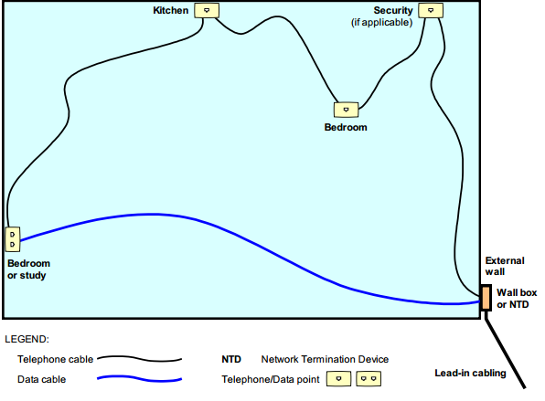
Figure 1. 9 An example of conventional telephone/ADSL home cabling
1.3.3 Modern telecommunications services
NBN (National Broadband Network) services – require the installation of locally powered electronic devices that are located inside the customer’s building, unit or apartment. With modern telecommunications services, access points (outlets) should be cabled radially (“star wired”) from an internal central connection point (CCP) located next to the powered electronic devices, as shown in Figure below (some cabling providers may prefer to call the CCP a “cross-connection point”).
Data cable (four pairs) rated at Category 5 or better must be used with this cabling method to support both telephone and Ethernet (data) connections.
Note:Category 5 is the minimum required to support 100 Mbps Ethernet; however, telecommunications recommends the installation of Category 6 cable as a minimum.
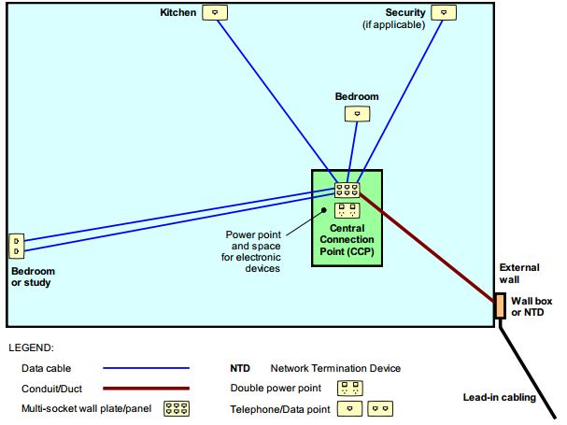
Figure 1. 10 Home cabling method for modern telecommunications services (e.g. NBN)

1.3.4 Telecommunications (telephone) network architecture

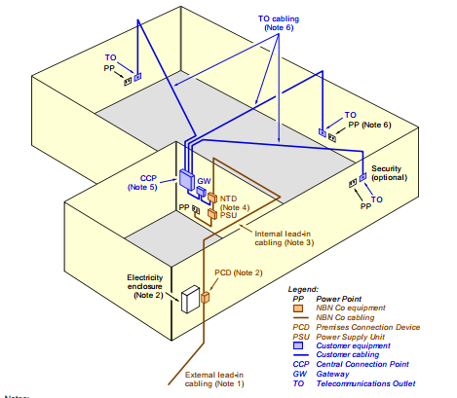
Figure 1. 11 Telecommunications (telephone) network architecture in building
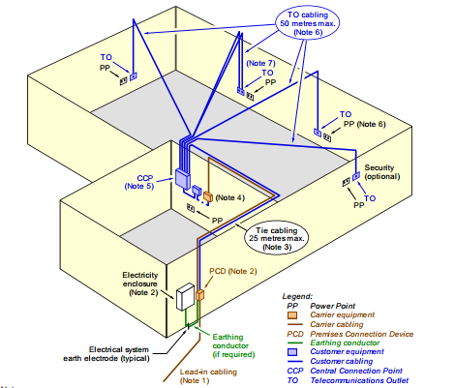
Figure 1. 12 Typical in building copper twisted pair network architecture

1.3.5 Cabling system classes and component categories (AS/NZS 3080)
Table 1. 3 Cabling system classes and component categories
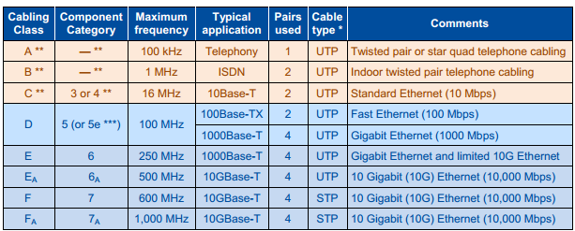
* UTP = Unscreened Twisted Pair,
STP = Screened Twisted Pair (see 4.14.4.4)
** While it could be assumed that Category 1 and Category 2 are the corresponding component categories for
Class A and Class B cabling respectively, component categories were never assigned to Class A and Class B.
Specifications for Classes A, B and C and Categories 3 and 4 have been removed from AS/NZS 3080.
*** Category 5e (“Category 5 enhanced”) was an interim specification issued to support Gigabit Ethernet on aClass D cabling system using bidirectional transmission over four cable pairs.

1.4 Installation of earthing conductors
1.4.1 PCD (Premises Connection Device)
Where the outdoor PCD is an FTTP NTD or an ADSL NTD, an earthing conductor will be required at the PCD location. In the case of an FTTP NTD, the earth is required for electrical safety purposes whereas, for the ADSL NTD, the earth is for lightning surge suppression purposes.

1.4.2. Coaxial cabling
Where a TV antenna distribution system is installed; the outer conductor of the coaxial cabling may be earthed. Note: HFC coaxial cabling is separate, does not form part of the TV antenna system and should not be earthed
1.4.3. Data cable screens
Current flow in a cable screen is a result of inductive and capacitive coupling between cable cores and cable screens. Capacitive coupling is a source of screen and earth currents under no-load conditions and load conditions. Inductive coupling is a major source of current under load conditions.
Cable screens are used to control the electric field stress in the cable insulation, provide a return path for cable neutral and fault current, and shield against electromagnetic radiation. If the screen is earthed at both ends, it provides shielding for electromagnetic radiation.
If the cable screen is single point bonded, there is no electrical continuity, and mmf generates a voltage. If the cable screen is bonded at both ends, the mmf will cause circulating current to flow if there is electrical continuity. If screened data cables are installed, the cable screens should be earthed at the CCP.
1.4.4. Metallic parts
Metallic parts such as cabling or equipment enclosures do not normally need to be earthed but may be earthed for screening purposes or additional safety if required. In such cases, it is important to avoid “fortuitous bonding” (accidental multiple ear thing) of components, which may create “earth loop” currentsthat could cause noise in the cabling system. For example, if cable screens and metallic parts need to be earthed, they should be earthed by a single connection to a common point (such as a metallic enclosure that is earthed) and should not be earthed at any other point.
1.4.5. Equi-potential bonding
In all cases where earthing is required, the earth should be derived from the electrical earthing system. This is an important safety requirement to ensure that there is no earth differential at or in the building.
Earthing should not be achieved by driving a separate earth electrode unless that electrode is also bonded (connected) to the electrical earth electrode or is for the sole purpose of providing a lightning protection earth for an external antenna.
Telecommunications earthing is obtained from the electrical earthing system by means of “equipotential bonding”, i.e. by “bonding” (connecting) the two earthing systems together to ensure that they are at “equal potential”. The equipotential bonding must be done at the electrical switchboard either inside the switchboard itself by connection to the main earthing bar or main ear thing conductor, or outside the switchboard by connection to the main ear thing conductor or to the electrical earth electrode. The three allowable methods of equipotential bonding are illustrated in Figure below.
It is important that there is a demarcation point between the electrical earthing system and the telecommunications earthing system so that:
- the telecommunications earth can be isolated from the electrical earth at a single, readily accessible point by either a telecommunications worker or an electrical worker; and
- Earthing of telecommunications equipment can be legally performed by a telecommunications worker who is not also a licensed electrical worker.
This demarcation point will be either a Communications Earth Terminal (CET) located outside the electrical switchboard or a distinct, removable connection device on the electrical earth electrode.
Equipotential bonding methods
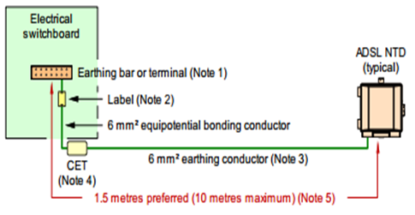
Figure 1. 13 Equipotential bonding to the earthing bar or terminal of the electrical switchboard (method 1)
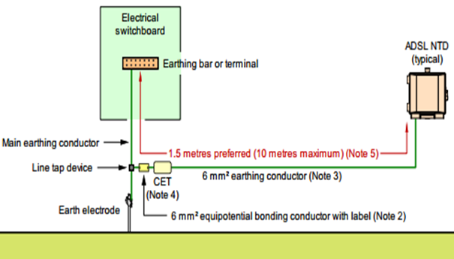
Figure 1. 14 Equipotential bonding to the main earthing conductor outside the electrical switchboard (method 2)
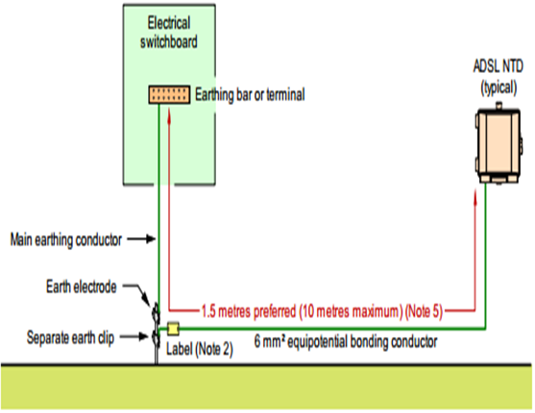
Figure 1. 15 Equipotential bonding to the electrical earth electrode (method 3)
1.4.6. Earthing conductor size and colour
The equipotential bonding conductor must be at least 6 mm² in cross-sectional area (7/1.04 mm) with green/yellow insulation. Any earthing conductor required for end-user lightning protection purposes (such as to an ADSL NTD) must also be 6 mm² with green/yellow insulation. In all other cases, a minimum 2.5 mm² (7/0.67 mm) green/yellow earthing conductor is required, which must be cabled from the CET or other ear thing terminal. Earthing and bonding conductors do not need to be installed in conduit within building cavities. The recommended ear thing conductor arrangement for a generic cabling system is shown in Figure below.
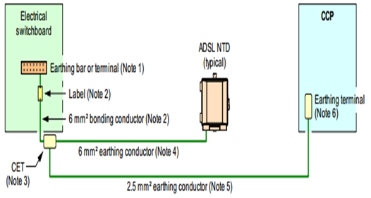
Figure 1. 16Recommend earthing conductor cabling for generic home cabling
Notes:
- Only a licensed electrical worker may access the internals of an electrical switchboard.
- The equipotential bonding conductor between the ear thing bar or terminal of the electrical switchboard and the CET must be at least 6 mm² (7/1.04 mm) copper conductor with green/yellow insulation and labeled “Telecommunications Bonding Conductor” or “Communications Bonding Conductor”
- The CET should be located in the telecommunications compartment of the CUE, if provided, in accordance with Figure above or, if a CUE is not provided, the CET should be located immediately below the electrical switchboard.
- The ear thing conductor between the CET and the PCD should be at least 6 mm² (7/1.04 mm) copper conductor with green/yellow insulation. There is no need to label this conductor. The total length of bonding/ear thing conductor between the ear thing bar/terminal in the electrical switchboard and the PCD should preferably be less than 1.5 m but, in any case, should not exceed a length of 10 m.
- The earthing conductor between the CET and the ear thing terminal at the CCP must be at least 2.5 mm² (7/0.67 mm) copper conductor with green/yellow insulation. There is no need to label this conductor. The length of this conductor must not exceed 135 m to ensure that it does not exceed the maximum specified CES resistance of 1 ohm.
- For a home networking system, an earthing terminal should be provided at the CCP. All telecommunications earthing connections (e.g. to cable screens) should be made at the CCP.

1.5 The work coordination with others infrastructure.
1.5.1 Clearance from other services
a. At poles and in-span: The minimum separation distances required from low voltage (230 V AC single-phase or 400 V AC three-phase) power mains, associated fittings and terminations on poles or in-span are set out.
b. At the building: sufficient separation must be provided at the building between the lead-in cable attachment point and any insulated low voltage power service lead such that 600 mm can be maintained between the power cables and fittings and the body of a person working on the lead-in cabling. This means that if the telecommunications worker cannot safely access the lead-in cable or attachment on the side of the cable or attachment furthest from the power cables and fittings, a separation of at least 1200 mm will be required between the power cables and fittings and the lead-in cables and fittings at the building..
c. Use of telecommunication poles for power mains: While telecommunication will not use any poles installed by the customer to support the LV power mains, telecommunication will allow telecommunication -owned lead-in poles to be used to support the customer’s low voltage (LV) power mains (i.e. 230 V AC single-phase or 400 V AC three-phase) under the following conditions:
      - Over any private land not traversable by road vehicles--------------------- 2.7 m
      - Over any residential driveway --------------------------------------------------3.5 m
      - Over any commercial/industrial driveway or private roadway ------------4.9 m
The power mains, associated fittings and terminations must be separated from the aerial telecommunication cabling, associated fittings and terminations by the following minimum distances:
- Insulated power mains -----------------------------------------At the pole 600 mm
------------------------------------- In span 600 mm
- Un insulated power mains -------------------------------------At the pole 1200 mm
---------------------------------In span 600 mm
- Light fitting, stay fitting or power conduit ------------------At the pole 50 mm
Clearance of aerial lines from the ground
The minimum ground clearances required for aerial lead-in cabling in residential areas are as follows (see Figure below):
- Over any private land not traversable by road vehicles…….. ………………….2.7 m
- Over any residential driveway…………………………………………………..3.5 m
- Over any commercial/industrial driveway or private roadway ………………....4.9m.

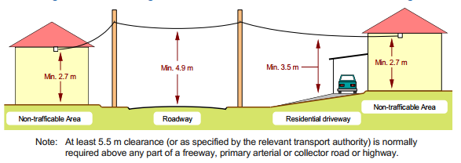
Figure 1. 17Minimum ground clearances for residential aerial lead-in cabling

1.6 Material, Tools, equipment and testing devices
1.6.1 Materials 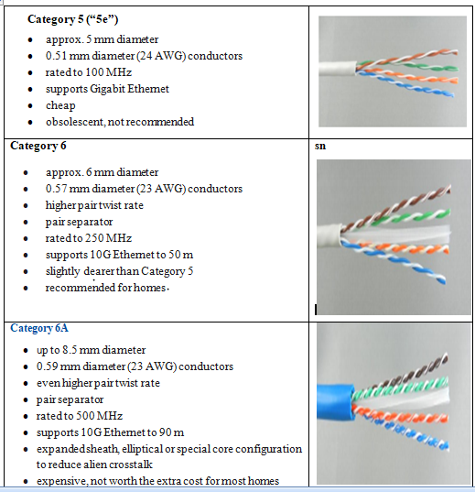
a. 4-pair Unscreened Twisted Pair (UTP) data cables

    - Coaxial cable elements
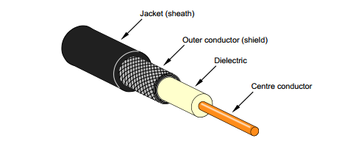
Figure 1. 18 Coaxial cable elements
Coaxial Cable Connectors
Coaxial connectors should be suitable for the type of cable used.
The standard connector for use with RG6 and RG11 cables used for generic cabling systems is the F-type connector (“F-connector”). This connector has a threaded body (for the outer conductor connection) and uses the center conductor of the coaxial cable as the center pin of the male connector. The body of the female connector is threaded while the center pin connection comprises a pair of “fingers” designed to clasp onto the center conductor of the cable terminated in the male connector.
F-type coaxial connectors (F-connectors)
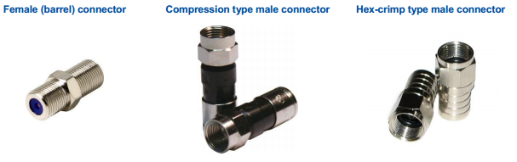
Figure 1. 19F-type coaxial connectors (F-connectors)

Splitters and diplexers
Splitters are used to provide two or more access points (outlets) in the home. Cables to multiple outlets cannot be simply connected together like telephone cables, as this will cause impedance mismatches, signal reflections and excessive signal loss. Splitters provide a proper termination for each cable maintain impedance balance and also provide some isolation (called “RF isolation” or “mutual isolation”) between the outputs of the splitter to prevent mutual interference between the output cables and the equipment connected to them.
Because splitters divide the signal, they incur signal loss between the input and each output leg. For example, if the signal is split two ways, each output leg should get half the input signal level, which equates to a 3 dB loss between the input and the output.

Typical RF splitters
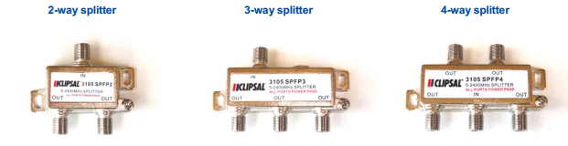
Figure 1. 20Typical RF splitters
RF amplifiers for terrestrial free-to-air TV
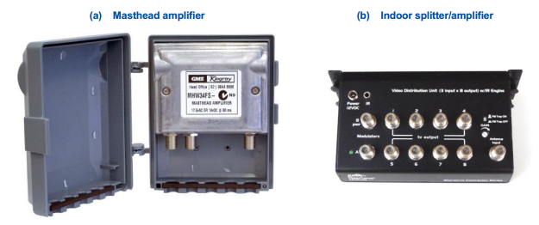
Figure 1. 21Typical RF amplifiers for terrestrial free-to-air TV
A domestic “multiswitch” for distribution of satellite TV and other RF sources
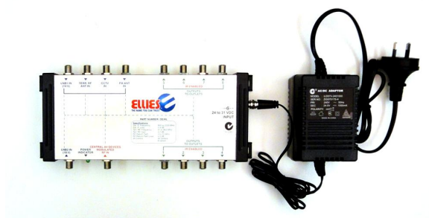
Figure 1. 22A domestic “multiswitch” for distribution of satellite TV and other RF sources
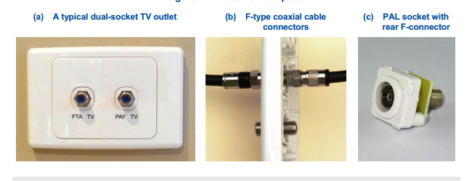
Figure 1. 23Coaxial wall plate
TV outlet (wall plate)
The wall plate containing the coaxial connector should be mounted at the same height as the power outlets and TOs, which should not be less than 300 mm from the floor. Coaxial connectors may be mounted on the same wall plate as data sockets but it is recommended that no more than three coaxial connectors be fitted to any wall plate.
Adaptors
Various F-type adaptors are available for different applications. Examples are shown.
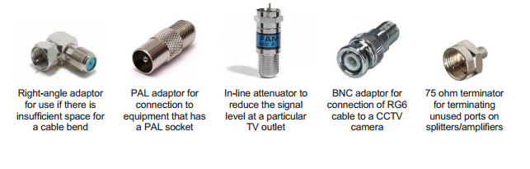
Figure 1. 24Some F-type adaptors
Socket type
8-position 8-contact (8P8C) modular sockets (commonly called “RJ45”) should be used for all voice/data TOs to ensure compatibility with consumer Ethernet equipment (other types of socket are available but may not be compatible with RJ45 plugs). The TO sockets should be rated to match or exceed the cable rating (e.g. if Category 6 cable is installed, the sockets should be rated at Category 6 or Category 6A).
6-position (6P) modular sockets (commonly called “RJ11” and used for telephone equipment connections) should not be used as these will negate the generic nature (flexibility) of the cabling system.
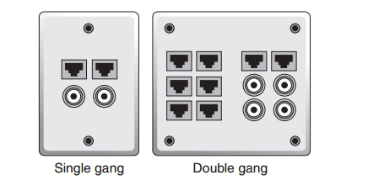
Figure 1. 25typical modular sockets and a typical to with two colour-coded sockets
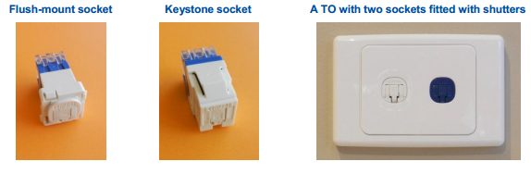
Figure 1. 26 Socket Terminal unit
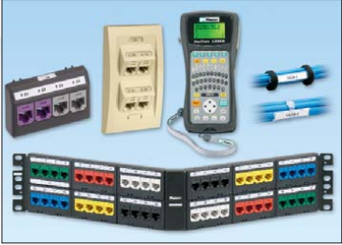
Figure 1. 27 testing and different data cable sockets

1.6.2 Typical cable Installation Tools
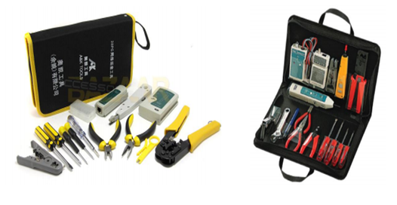
Figure 1. 28 kits of data cable tools
- Cable Stripper
Cable strippers themselves are inherently relatively safe due to their design. Only use them on the materials they are intended to strip and they will last a long time.
Cable strippers designed for use on coax can be used on structured cables with care.
A coaxial cable stripper has two appropriately spaced cutting blades to prepare the cable for termination in the connector. A coaxial cable stripper may have adjustable blades for use with different types of cable. A stripper with incorrect blade settings can score the center conductor or remove excess outer conductor and degrade cabling performance. A stripper with fixed blades designed exclusively for use on the type of cable being installed is recommended.
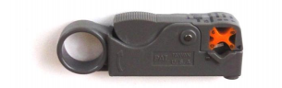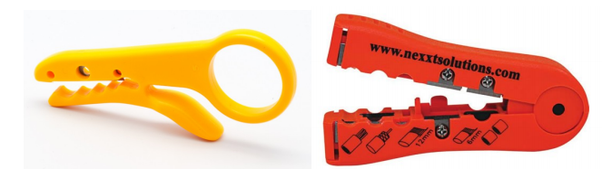

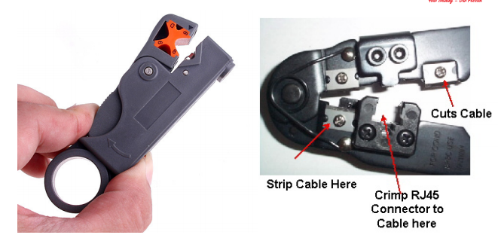
Figure 1. 29A typical coaxial cable stripper

- Wire-Map Tester
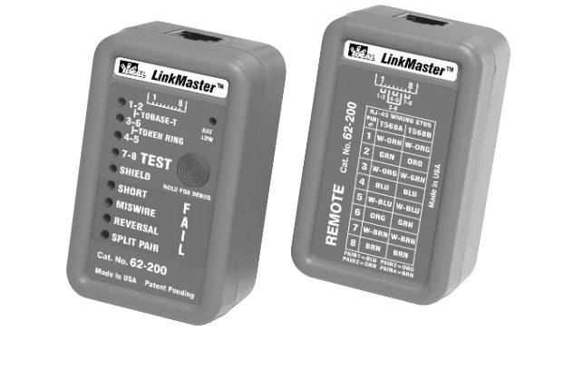
Figure 1. 30 Wire-Map Tester
- Pair Continuity tester
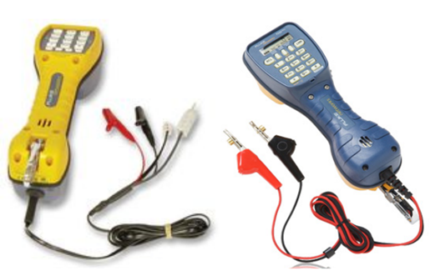
Figure 1. 31 Pair Continuity tester

- Voltage Meter
There is a right way and a wrong way to determine if an electrical circuit has a live voltage on it. Touching it is the wrong way. A simple voltage meter such as the one pictured in Figure 6.18 is a much better solution, and it won’t put your health plan to work. Though not absolutely necessary in the average data-cabling tool kit, a voltage meter is rather handy.
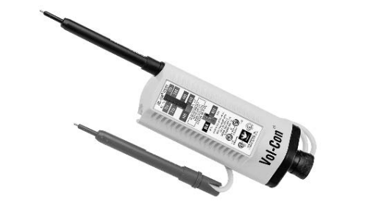
Figure 1. 32 voltage meter

- Punch Down Tool or Insertion Tool
A punch down tool, also called a punch down tool or a krone tool (named after the KRONE LSA-PLUS connector), is a small hand tool used by telecommunication and network technicians. It is used for inserting wire into insulation-displacement connectors on punch down blocks, patch panels, keystone modules, and surface mount boxes (also known as biscuit jacks)
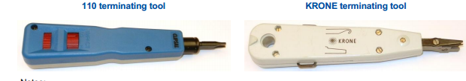
Figure 1. 33 Punch down Tool or Insertion Tool
- RF field strength meter
RF field strength meters are an essential tool to test signal strength (“RF power level”) and signal quality at the RF source, wall plates and intermediate points where necessary. Different meters are generally required to measure HFC (Cable internet/pay TV), TV antenna (and FTTP NTD) and satellite signals — although some meters are available that are capable of testing more than one type of RF source.
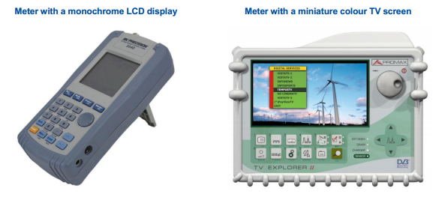
Figure 1. 34 meter with a monochrome LCD display and meter with a miniature colourTVscreen

- Cable cutter
Coaxial cable should be cut squarely prior to termination using a cutting tool that does not appreciably distort the end of the cable so that it may be properly prepared using a cable stripper designed for the purpose. Coaxial cable cutters have concave cutting jaws that tend to slice, rather than crush, the cable.
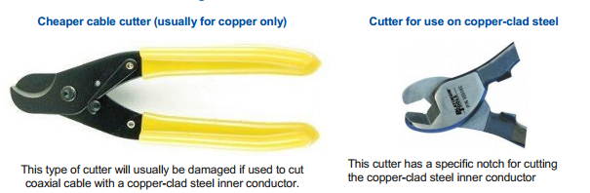
Figure 1. 35 cheaper cable cutter and cutter for use on copper-clad steel

- Compression tool
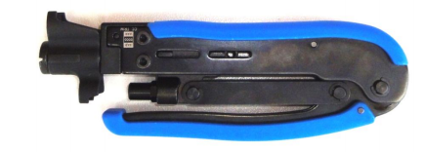
Figure 1. 36A typical compression tool
Compression Tools are a type of utility software. Furthermore, these tools help us to compress and decompress files. An important part of a computer is storage space, it is very important to maintain this storage. Therefore, we use compression tools to compress big files and decrease their size.

1.8.3 Testing devices
Test equipment must be in correct operating order. To maintain insulation resistance insulation must be clean and in very good condition. Ensure that any calibrated equipment is in current test date.
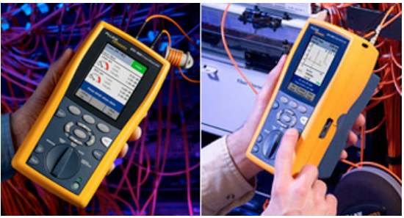
Figure 1. 37 testing device
Testing devicesis generally more fragile than ordinary hand tools and more care must be taken. Always return it to its protective case, keep clean and dry and do not use cleaning chemicals as this may damage the plastic and seals, use a clean dry cloth.
1.8.4 Tone Generators and Amplifier Probes
The Tone Generator applies a tone signal to a wire pair or single conductor. Amplifier Probe will trace wires and cables allowing for pin-point identification in cable bundles, a cross connect or remote end. Cable Tracing Kit is ideal for twisted pair, coax and de-energized AC wiring.
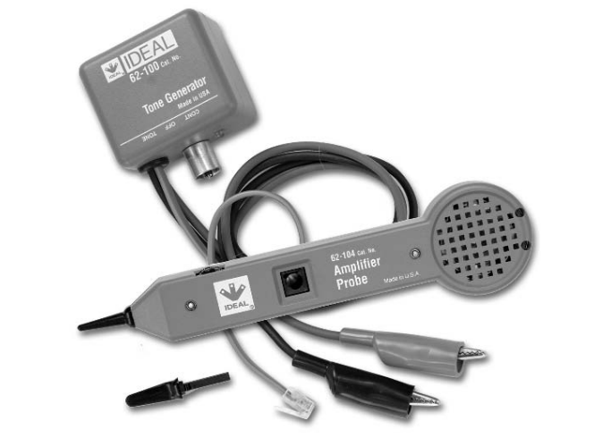
Figure 1. 38 Tone Generators and Amplifier Probes

Self-Check -1
Directions: Answer all the questions listed below. Use the Answer sheet provided in the next page:
Part I. Choose the best answer from the question below
- Which of the following is the most useful piece of cabling system documentation?
A. cabling map B. cable connector C. wiring system D. all
- Which of the following is the most common twisted-pair cable for LANs?
- Fiber-optic cable C. Unshielded Twisted Pair Connector
- Shielded Twisted-Pair cable D.Coaxial cable
- Which of the following component is requires for free to air TV Cabling?
- An antenna B. Coaxial cable C. TV outlets D. All
- Wich of the following tools are used for cable installation ?
- Cable striper C. cable map tester
- Pair countinutiy tester D.all

Part II. Say true and false for the following question below
- Straight through cables cables have identical ends and are used for connecting computers through a hub/switch.
- UTP is susceptible to crosstalk, radio and electrical frequency interference.
- Signal cable is used in data transmission applications that demand superior signal protection.
- Crossover cables are used for connecting the same devices directly with each other.
- UTP cable are used for data service and Telephone wiring.
PartIII. Answer the correct for the following question below
- List at least two the types of F-type coaxial connectors (F-connectors).
- List at least two Frequency Range (RF) splitters.
- List at least 5 Typical cable Installation Tools.

Operation sheet 1

Operation Title: Identifying RF splitters
Instruction: Using the types and application of splitters Identifying RF splittersUsed in telecommunication and data service for TV coaxial cable installationinstructor must check the installation before you applies power.
Purpose: When you have completed this Unit, the trainee should be able to identify the equipment used in TV coaxial cable installation.
Required tools and equipment: unit one of this module, tools from workshops like screw drivers, pliers, measuring instrument,
Precautions:
- Safe handling of hand tools, testing instruments and components
Procedures:
Step 1: Properly identify TV coaxial cable installation RF splitters
Step 2: Prepare electricalequipment for the given task
Quality criteria: Reading the circuit properly, safety procedures were followed & all hand tools were cleaned.

LAP Test 1

Name: __________________________ Date: ____________
Time started: ____________________ Time finished: _______________

Instruction I: Given necessary templates, tools and materials you are required to perform the following tasks within 1hour.

Task 1: Identify RF splitters forTV coaxial cable installation properly

Unit two: Installation and Maintenance of cabling
This learning unit is developed to provide the trainees the necessary information regarding the following content coverage and topics:
- structural support and cable management for catenaries system
- Protective earthing of metal work
- Cables and wires handling
- Cables for interference segregation
- Cables in accordance with telecommunication regulation
- Over-voltage protection to suppress voltage surges with standard devices
This unit will also assist you to attain the learning outcomes stated in the cover page. Specifically, upon completion of this learning guide, you will be able to:
- Check structural support and cable management for catenaries system
- Install Protective earthing of metal work
- Handling Cables/wires in accordance with manufacturer's specifications
- Allow sufficient cable ends to facilitate termination and tie Cable safely without damage the sheath.
- Maintain Cables for safety and interference segregation
- Label Cables in accordance with telecommunication regulation
- Fitting Over-voltage protection to suppress voltage surges with standard devices

2.1. Structural support and cable management for catenaries system

Structural support and cable management for catenary systems are two important considerations for ensuring the safe and reliable operation of these systems.
Structural support
Catenary systems are typically supported by a series of structures, such as poles, towers, or gantries. These structures must be strong enough to support the weight of the catenary wires and any associated hardware, as well as any additional loads that may be applied, such as wind, snow, or ice.
The structural support system must also be designed to allow for the thermal expansion and contraction of the catenary wires. Catenary wires can expand and contract significantly due to changes in temperature, so it is important to provide enough slack in the wires to accommodate this movement.
Cable management
Catenary wires must be carefully managed to ensure that they are properly tensioned and aligned. This is important for maintaining the electrical conductivity of the wires and preventing them from contacting other objects.
Catenary wires are typically supported by a series of hangers, which are attached to the structural support system. The hangers must be spaced at regular intervals and adjusted to ensure that the wires have the correct tension.
The catenary wires must also be aligned to prevent them from arcing or contacting other objects. This can be done by using insulators and spacers to keep the wires at a safe distance from each other and from any other conductive objects.
Additional considerations
In addition to structural support and cable management, there are a few other considerations that should be taken into account when designing and installing a catenary system. These include:
- Grounding: Catenary systems must be properly grounded to prevent the buildup of static electricity and to protect workers and equipment from electrical shock.
- Lightning protection: Catenary systems must be protected from lightning strikes. This can be done by using lightning rods and surge suppressors.
- Maintenance: Catenary systems must be regularly inspected and maintained to ensure their safe and reliable operation. This includes checking the condition of the structural support system, the catenary wires, and the hangers.

2.1.1 Cable supports
a. Use of PVC trunking
The selection and use of PVC trunking shall comply with the following;
- All PVC trunking to be used shall be manufactured in accordance with BS 4678 where applicable;
- All necessary trunking fittings, i.e. Tees, bends, end-caps shall be used. Such fittings shall be of proprietary manufacture and installed to manufacturer’s instructions;
- In corridors where installed PVC trunking is visible, every effort shall be made to conceal individual cable exit points by making such exit points through the rear of the trunking;
- Horizontal trunking runs in decorated areas shall be located at ceiling level where fixed ceilings exist
- PVC trunking (including mini-trunking) shall be securely fixed with screws as per the manufacturer’s instructions.
- The of use self-adhesive trunking is not recommended unless compelling reasons exist
- New PVC pathways shall not be more than 50% occupied at installation
- Newly installed PVC trunk should be selected to have 50% spare capacity after completion of the works.
- Use of Steel Conduit
While using steel conduits ensure that:
- All bends, tees, etc. shall be radius or gusset type suitable to allow the installation of the cables without exceeding the cable bending radii.
- All lengths of Conduit shall be earth bonded to meet the 16th Edition IEE wiring Regulations.
- New steel conduits are able to accommodate a 50% increase in occupancy at installation.
- Newly installed conduits should be selected to have 50% spare capacity after completion of the works.
- Use of Steel Trunking
While using steel trunking it is important to ensure that:
- All trunking is free from sharp edges and projections likely to cause damage to the cables contained.
- All bends, tees, etc. is of radius or gusset type suitable to allow the installation of the cables without exceeding the cable bending radii.
- Fixings are spaced according to the manufacturer’s recommendations.
- All lengths of Steel trunking are earth bonded to meet the 16th Edition IEE Regulations.
- New steel conduits should be able to accommodate a 50% increase in occupancy at installation.
- Newly installed steel trunking shall be selected to have 50% spare capacity after completion of the works.
- Use of Cable Trays
In using cable trays the following should be considered:
- All bends, tees, etc. shall be radius or gusset type suitable to allow the installation of the cables without exceeding the cable bending radii.
- Fixings shall be spaced according to the manufacturer’s recommendations.
- All lengths of Cable Tray shall be earth bonded to meet the 16th Edition IEE regulations.
- New cable trays shall not be no more than 50% occupied at installation.
- Cable trays shall be perforated galvanized mild steel sheet.
- Minimum steel thickness for cable tray shall be:
- 1.0mm for trays up to 150mm wide and
- 1.2mm for trays up to 300mm wide
- Trays shall have folded edges with minimum height of 20mm.
- Electrical continuity shall be maintained along the full length of cable trays.
- Use of Cable Basket
The following are considerations for using Cable baskets
- All bends, tees, etc. shall be radius or gusset type suitable to allow the installation of the cables without exceeding the cable bending radii.
- Fixings shall be spaced according to the manufacturer’s recommendations.
- All lengths of Cable Basket shall be earth bonded to meet the 16th Edition IEE Regulations.
- New cable trays shall not be more than 50% occupied at installation.

2.1.2. Separation from electricity exclusive trench
Table2. 1 Separation from electricity exclusive trench
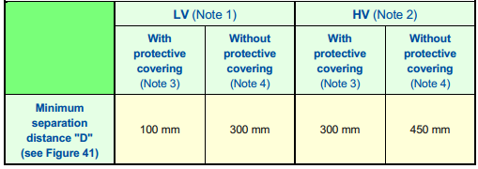

2.1.3 Correct locations of cables
- Review any property documentation (e.g. building plans, electrical specifications, and plumbing plan).
- Visually inspect the site noting the location of conduits, pipes or cables emerging from the ground at buildings, sheds, swimming pools, fountains, electric barbecues, garden lights, external power outlets, etc.
- Visually inspect the footway and verge for the location of any power, water, gas’ sanitation, storm water, drainage or telecommunications facilities (e.g. pedestals, pits, poles, meters, kerb markers, drains, conduits/pipes, cables).
- Ascertain the likely path of underground services using the above indicators.
- Verify the location of services using a cable locator or similar equipment, if available (note that existing services may not have been installed in a straight line).
- Verify the presence or absence of underground services at appropriate points along the chosen trenching route by careful hand digging.
Where there is evidence of underground services along the chosen trench route but their position cannot be verified with reasonable accuracy, look for a more suitable route or excavate by careful hand digging where uncertainty exists. Apply the following precautions when digging the trench:
- Allow for at least one 1 m separation from any suspected underground service.
- Except where otherwise required by this document, keep at least one 1 m away from any pole (to avoid disturbance of the pole footings and to allow for future replacement of the pole without disturbing the lead-in cabling that will be installed in the trench).
- When hand digging, use non-conductive tools (e.g. with wooden handles) and wear insulating (rubber) boots.
- Do not dig the trench any deeper than the recommended depth (see Table below)
Trench depth required telecommunication cable wiring:
Table2. 2 Trench depth required telecommunication cable wiring
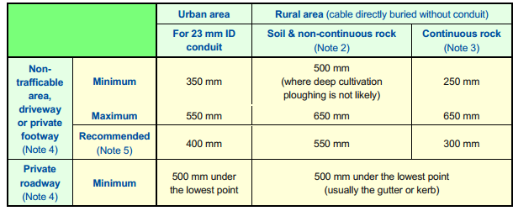
2.1.4 Securing catenaries supports to building structure
Catenary is wire or chain hung and supported at its end, such as wires used in decorative lighting, electrical cable suspension, train lines and fiber optics.
Catenary: A cable carrying a uniform load along its length, such as its own weight, assumes the shape of a centenary or a hyperbolic cosine curve. Under the influence of gravity, flexible elements that are freely suspended in space develop this typical suspended form.
The centenary or messenger wire is hung at a specific tension between line structures, and a second wire is held in tension by the messenger wire, attached to it at frequent intervals by clamps and connecting wires known as droppers

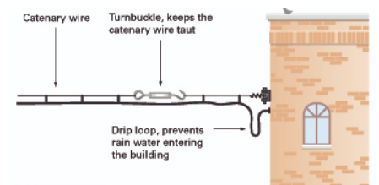
Figure 2. 1use of catenary wire supported to building structure

2.2 Protective earthing of metal work
In telecommunication systems with peripheral equipment powered directly from mains, the system is earthed via all protective conductors (PE) and via the functional earth conductor (FE). This arrangement fulfils the requirements against electrical shock.
- Telecommunication room conductor (TRC) and Protective earthing (PE)
The TRC and the PE must be connected to the equipment on separate terminals, in accordance with the individual TRC and PE requirements. The manufacturer will indicate this in the installation manual.
- TRC or PE Either a PE or a TRC must be connected to this equipment. However in some uses of the type of equipment, a TRC must be used. (E.g. a CAE mounted behind another CAE may need earth recall to access the first CAE.
Communication Earth System (CES)
Communication Earth System as defined in AS/CA S009:2013 may be used for any functional or PE reference. Where either a TRC or a protective earth or both TRC and PE are specified, the CES can be substituted for these requirements. If a TRC is specified and the CES in not suitable (noisy, etc.) a TRC compliant to AS/CA S009:2013 will need to be installed.
Reinstalling Recovered CAE
If a system is recovered from an installation, which originally required aTelecommunications Service Earth (TSE) – then that system, when reinstalled must use the TRC in place of the TSE.

2.3 Cables and wires handling
General guidelines
While running or installing cables it is important that the following general guidelines are adhered to;
- All UTP cables are to be run internally to the building and must not run between buildings;
- No UTP cable is to be run on the exterior of any building;
- No cabling is to be run in lift shafts or airflow areas;
- A comprehensive survey or an assessment of the cable routes shall be agreed upon prior to installation of the cable;
- All vertical cables shall be secured to installed trays at intervals as recommended by the cabling manufacturer;
- Care must be taken to avoid close proximity of cabling to water pipe work.
2.3.1. Walls and Floors
The following guidelines shall apply to cable runs made through walls and floors;
- Holes drilled through walls and floors for the routing of cables shall be suitably covered to prevent damage to the installed cables. Where cables pass through floors, such protection shall be extended to at least skirting height.
- Where cables, trunking, tray-work or conduit pass through floors or walls, suitable fire sealing shall be provide

2.4 Cables for interference segregation
2.4.1 Precautions during Installation of Cables
  - Precautions shall be observed to eliminate cable stress caused by tension in suspended cable runs and tightly strapped bundles.
  - Care shall be taken not to distort the twists by excessive pulling or bending of cables.
  - Cable bundles shall not rub on or be unduly compressed against or by any cable tray, building or enclosure penetrations, equipment racking, or other cable support. Similar forms of protection shall be provided where cables traverse sharp edges.
  - The weight of vertically installed cabling shall be adequately supported.
  - At minimum Cat 5E cables shall be securely fixed to cable trays using Velcro or manufacturer recommended cable ties only.
  - Cables shall be neatly grouped together based on their destination and bound at regular intervals.
  - Where cabling is run in cavity walls, surface mounted ducting and similar enclosures, cables shall be installed in areas free from protrusion of screws and similar fasteners
  - Care shall be taken to avoid tight twisting of the cable, tearing of the outer jacket, cutting or wearing through due to abrasion of the cable.
  - When drawing cable through underground conduit, care must be taken to ensure that the conduit is clear of water and other obstacles and appropriate action taken to protect the cable from water and soil damage. Cable ends must be sealed appropriately when being drawn though underground ducts.
2.4.2. Segregation
- Care shall be taken to ensure UTP Cat 5E cables are not routed adjacent to other services where electro-magnetic emissions may be generated. UTP Data cable must never be run in the same containment as mains voltage cables or fire alarm circuits. Where data cables are run in trunking containing mains cables and outlets the data cable must be segregated in a separate part of the trunking.
- Minimum segregation distances shall also comply with the standards laid down by the cable manufacturer
- Cat 5 E (4 pair UTP) cables shall be kept in separate bundles from the multi-pair voice or fiber cable.

2.5 Install Cables in accordance with telecommunication regulation
2.5.1 Installation Guidelines for Telecommunications Cable
      - The minimum horizontal cable bend radius, under no-load conditions, shall be four times the diameter of the Category 6 cable. The minimum inside bend radius, under no load conditions, for 4-pair UTP patch cable shall be .25 inches.
      - The maximum tensile loading shall not exceed 25 pounds on the Category 6 cable.
      - Cable ties shall not be installed as to place a strain or compression on the cable jacket.
      - Cables that serve several adjacent rooms shall be grouped together into bundles. A single large cable bundle is preferable to several small bundles. It is preferred that the cables be grouped in a way that reduces the quantity of bundles.
      - Cables in service areas such as attics, crawl spaces, mechanical chases, and above lay-in ceilings shall be held in place with metal J-hooks or cable tray. The J-hooks shall keep cables neatly bundled and shall be located so as to reduce interference with future maintenance and construction projects. Cables shall be mounted at least 1' above drop tile ceilings, shall never lie on the ceiling, and shall always be supported every 4 feet.
      - In areas where the installation of hooks is impossible, a discussion with an ITC Communication Wiring representative should be initiated. The cables may be bundled with plastic tie-wraps spaced no more than four feet apart, so long as the tie-wraps are tight enough to neatly bundle the cables together, but loose enough to permit the pulling of individual cables within the bundle.
      - Electrical or other tape, used for bundling cables during installation, shall be removed once the cables are in place, to allow the slack in individual cables to be more easily removed. Duct tape should not be used for this purpose.
      - It is preferred that pull string be left in conduits, cable trays and cable hooks, after initial cable installation, to allow for future cabling needs. Pull string shall be left in places that will be difficult to access in the future.
      - Cables that are part of a bundle shall be of uniform length. Uniform cable length is achieved by pulling on individual cables in a bundle after the bundle has been placed in the hooks or raceway and before the cables are terminated.
      - Cable bundles shall hang with minimal tension between the hooks. Check cable bundles to verify that individual cables do not have excessive tension, or are supporting the weight of several other cables.
      - At vertical to horizontal transitions, cable bundles shall have a uniform loop containing one to three feet of recoverable slack. Additional hooks may be required to support this slack.
      - Long open vertical runs shall require intermediate support. These shall support the weight of the cable between horizontal transitions. One foot of slack shall be left at each strain-relief hook so as to insure proper loading of the hooks. Vertically mounted cable tray is preferred for long vertical runs.
      - Four inches of service slack shall be left at each outlet box.
      - Twenty-four inches of recoverable slack in each cable shall be neatly bundled and secured in the vertical wire management units located adjacent to the patch panel rack.
      - Slack or extra cable not mentioned in this section is unacceptable and shall be eliminated prior to termination.
      - Patch cables will be neatly dressed in wire managers from the patch panel insert to network switch and telephone patch panel. The upper one-half of a patch panel will have patch cables go directly up to the horizontal wire manager, then right or left to the vertical wire manager, then up or down to the network switch. The lower one-half of the patch panel will have patch cables go directly down to the horizontal wire manager, then right or left to the vertical wire manager, then up or down to the network switch
2.5.2 Manufacturers Recommendations
- All cabling shall be installed in full accordance with the manufacturer’s recommendations and instructions. Cables shall be installed with due skill and care so that:
1. Maximum permitted hauling tension is not exceeded
2. Minimum bending radius of the cable is not exceeded
3. Maximum permitted crush rating is not exceeded
- Cable bundles shall not obstruct the installation and removal of equipment within equipment enclosures.
- Jumper wires on wiring frames shall follow clear paths to minimize jumper lengths and avoid obstructing jumper fields.
- Equipment and patch panels shall be laid out to minimize patch cord length. Patch cords shall follow clear paths to avoid patch field obstruction.

2.6 Over-voltage protection to suppress voltage surges with standard devices
Power problems can be traced to various sources. The most dramatic ones are natural disasters as they completely knock out the power supply by severing the utility lines. The less dramatic sources include overburdened circuits, the introduction of unseen threats, such as surges, brownouts, and line noise.
Therefore, every unprotected line that enters the equipment, whether it carries data or power, represents a potential conduit for power problems.
Surges and spikes refer to the short-term voltage increases. They cause data corruption, catastrophic equipment damage, and incremental damage that degrade the performance of the equipment. Surges and spikes occur mostly due to lightning strikes, thunderstorms, ground faults, and sudden power restoration after an outage.
Surge Protection
Surge protectors trap the voltage that exceeds certain limits.When spikes occur for certain duration of time, a trapping device known as a Metal Oxide Varistor (MOV) that is present in the surge protector gets activated. Every surge protector has an MOV, which helps in diverting the surge current.
The lifespan of an MOV shortens with use as more surge currents are diverted. They do not display any indication of wear and tear, nor do they provide any forewarning of failure. So, when they suddenly fail, their temperatures increase rapidly and cause fires.
Most surge protector’s function as a power strip even after their surge trap mechanism is degraded by power spikes.
This can cause the following dangers:
- If another power surge occurs, it damages the equipment that is plugged into this surge protector.
- If sufficient voltage passes through the surge protector during a second power spike, a resistant short is formed that produces heat and can lead to fire.

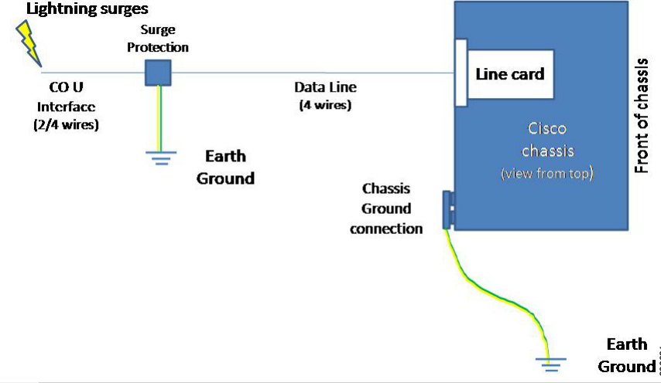
Figure 2. 2Surge Protection on an ISDN Line Card Installed in a Cisco Chassis

Self-Check -2
Directions: Answer all the questions listed below.
Part I. Choose the best answer from the question below.
    - Which of the following is used for cable supports?
- PVC trunking B. Steel Conduit C. steel trunking D all
    - Which of the following documentation is reviewed for correct location of cable at installation?
A. building plans B. electrical specifications C. plumbing plan D. all
    - _________are wire or chain hung and supported at its end, such as wires used in decorative lighting, electrical cable suspension, train lines and fiber optics.
- Wire mapping B. Catenaries C.Segregation D. cable support
    - _____________must never be run in the same containment as mains voltage cables or fire alarm circuits.
- UTP Data cable B. Telephone cable C. Coaxial cable d. all

Part ll. Say true and false for the following question below
- New PVC pathways shall not be more than 50% occupied at installation.
- All trunking is not free from sharp edges and projections likely to cause damage to the cables contained.
- New cable trays shall not be more than 50% occupied at installation.
- No UTP cable is to be run on the exterior of any building.
- The lifespan of an MOV shortens with use as more surge currents are diverted.

PartIII. Answer the correct for the following question below
- List at least 3 methods of cable support.
- List at least 3 considerations for using Cable baskets.

Unit three: Termination and testing of cables and earth wires
This learning unit is developed to provide the trainees the necessary information regarding the following content coverage and topics:
- Cable sheath for correct termination length
- Terminating modules (cables pairs) with recommended color code
- Terminating conductors
- Earthing cable shield
- test and clearly labels of cable pairs
- Terminate TRC/CES/Earth wires with connectors.
- TRC/CES /Earth wire continuity
- Testing TRC/CES /Earthling system
- Labeling of earthling system
- The Compatibility of alterations with existing systems
- direction for non-routine events
- Routine quality termination of cables and devices.
This unit will also assist you to attain the learning outcomes stated in the cover page. Specifically, upon completion of this learning guide, you will be able to:
- remove Cable sheath for correct termination length
- Install Terminating modules (cables pairs) with recommended color code
- Terminating conductors
- Earthing cable shield
- Testing and clearly labeling of cable pairs
- Terminate TRC/CES/Earth wires with connectors.
- Maintain and observe TRC/CES /Earth wire continuity
- Testing TRC/CES /Earthing installation
- Labeling of earthing system
- Testing and confirming Compatibility of alterations with existing systems
- Referring direction for non-routine events
- Checking and rectifying Routine quality termination of cables and devices.

3.1 Cable sheath for correct termination length
For Cat 5/5e/6/6A cable, the maximum amount of untwisted wire is specified as 0.5" (13 mm) but it's good practice to minimize the amount of untwist and the length of cable jacket removed.
So, when wires are not tightly twisted, crosstalk happens. To prevent crosstalk, wire pairs in a Cat5e cable should not be untwisted more than 0.5 inches and not more than 0.375 inches for Cat6 cables.
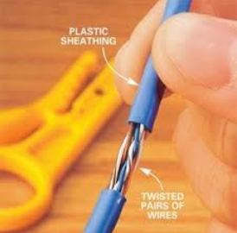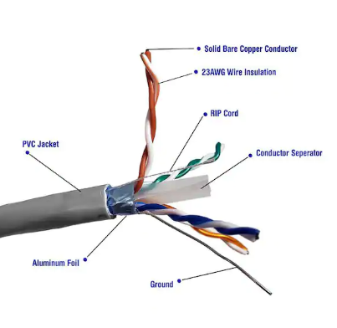
Figure 3. 1 Cable sheath for correct termination length UTP cable for installation

Coaxial cable is a type of transmission line, used to carry high-frequency electrical signals with low losses. It is used in such applications as telephone trunk lines, broadband internet networking cables, high-speed computer data busses, cable television signals, and connecting radio transmitters and receivers to their antennas. It differs from other shielded cables because the dimensions of the cable and connectors are controlled to give a precise, constant conductor spacing, which is needed for it to function efficiently as a transmission line

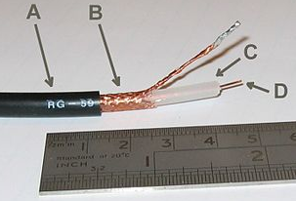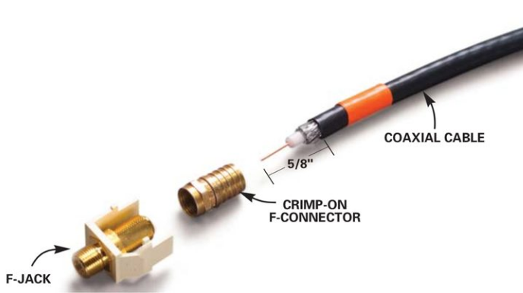
Figure 3. 2 Cable sheath for correct termination length and connection for coaxial cable

3.2 Terminating modules (cables pairs) with recommended color code
Terminating the cables involves installing some kind of connector on each end (either a connector or a termination block) so that the cabling system can be accessed by the devices that are going to use it. This is the part of cabling-system installation that requires the most painstaking attention to detail, because the quality of the termination greatly affects the quality of the signal being transmitted.
Though many termination methods are used, they can be classified one of two ways: connect or patch-panel termination. There are many different types of patch panels, some for copper, some for fiber. Coppercable patch panels for UTP all have a few similar characteristics, for the most part.

3.2.1 Step-by-step: twisted-pair cable preparation and connector termination
The following steps will guide you through the preparation and termination process for UTP cable. Following these guidelines will help give you the optimum performance from the twisted pair cabling.
  - How to wire Ethernet Cables (data cables for socket outlet connection)

The following procedure elaborates the procedure at socket outletconnection.

Table 3. 1 procedure elaborates at socket outlet connection
Step 1: The tools you will need:  • Jacket stripper  •Punch-down tool (not shown)  • Wire cutters (not shown) | 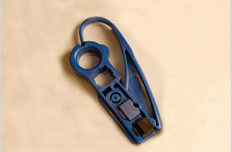
Step 2: Insert cable into stripping tool to the desired strip length. Strip off only as much cable jacket needed to properly terminate the pairs (1 to 1½ inches should be sufficient to terminate pairs). | 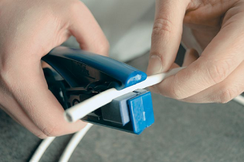
Step 3: Holding the cable near the tool, rotate the tool around the cable several times. | 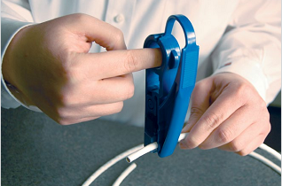
Step 4: Slightly bend the outer jacket and manually remove the cut piece or slide the cut outer jacket with the stripper. | 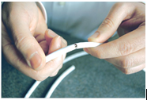
Step 5: Bend each pair in one direction to expose the rip cord, binder or cross-web  filler on the cable. | 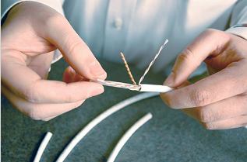
Step 6: Remove the rip cord, binder or crossweb filler if they are present on the cable, leaving only the twisted pairs of wire. The cross-web filler should be cut as flush as possible to the jacket. | 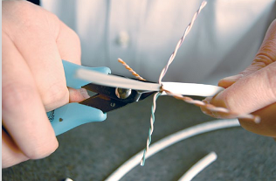
Step 7: Determine the wiring scheme and properly align all four cables accordingly on the jack. Keep the cable jacket as close to the connector as possible. Always use connectors, wall plates and patch panels that are compatible (same rating or higher) with the grade of the cable used. | 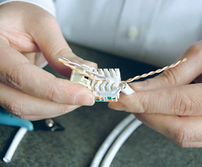
Step 8: Preserve the wire pair twists as close as possible to the point of termination. When connecting jacks and plugs, do not untwist the cable more than 0.5 inches for Category 5e, 6 and 6A cable. | 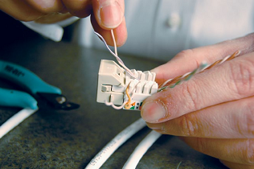
Step 9: Insert wires down into IDC terminal slots to position them before punching down. Maintain the twist. To “future-proof” an installation, terminate all four pairs. The Picture above shows an outlet being wired to the T568B wiring scheme. | 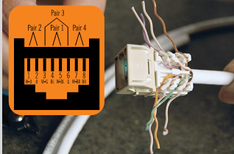
Step 10: When using a punch-down tool, make sure the tool is straight before punching down on the connector. Make sure the cut-side of the tool is facing outward. | 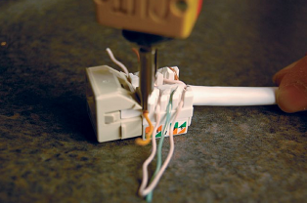
Step 11: Inspect the connector to verify that the wires are fully engaged in the IDC terminals and they are cut properly. | 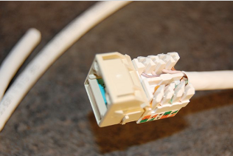
Step 12: Place a dust cover on the jack for protection. | 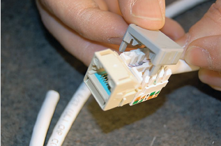
Step 13: This is how your assembled jack should look. | 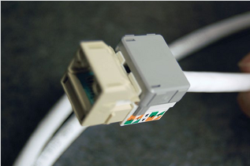

  - How to wire Ethernet Cables (data cables for Cross over connection)
The following procedure elaborates the Cross over connection procedure at RJ 45.
Things you'll need:
- RJ-45 Crimp Tool
- Cat-5e Cable
- RJ-45 Jacks
Table 3. 2 procedure elaborates the Cross over connection procedure at RJ 45.
Step 1.Prepare your workspace. Take the roll of UTP cable and cut the cable to length using the cutting blade on the crimp tool.Splice the end by using the splicing blades to expose the unshielded twisted pairs. | 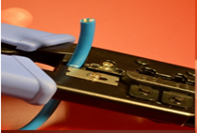
Step 2 Take each twisted pair and make four wire strands, each going out from the center of the wire. | 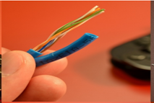
Step 3 Now take the individual twisted wire pairs and untwist them down to individual wires in the following order: Striped Orange, Orange, Striped Green, Blue, Striped Blue, Green, Striped Brown, and Brow | 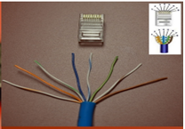
Step 4: grasp the wires with your thumb and index finger of your non-dominant hand. Take each wire and snug them securely side by side | 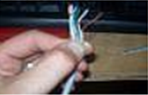
Step 5 Using the cutting blade of the crimp tool, cut the ends off of the wires to make each wire the same height | 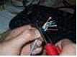
Step 6 once the first head is made, repeat steps two through eight. When untwisting the wires down to sing strands, use the following order: Striped Orange, Orange, Striped Green, Blue, Striped Blue, Green, Striped Brown, and Brown. | 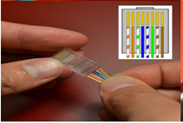
Step 7.Insert the jack into the crimper and press down tightly on the tool to seal the wires in place. | 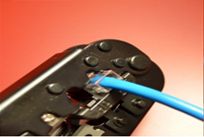
Step 8: the finally climped cable ready for use is shown below. | 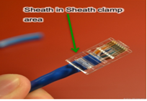

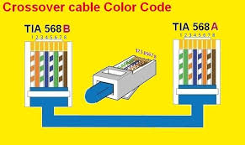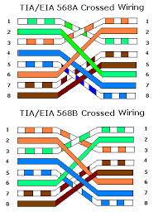
Figure 3. 3 crossover cable color code for both end of cable
  - How to wire Ethernet Cables (data cables for straight through connection)
Instructions to prepare a straight through cable
Things you'll need:
• RJ-45 Crimp Tool
• Cat-5e Cable
• RJ-45 Jacks
Table 3. 3 procedure elaborates the straight through connection procedure at RJ 45.
Step 1Prepare your workspace. Take the roll of UTP cable and cut the cable to length using the cutting blade on the crimp tool. | 
Step 2 Splice the end by using the splicing blades to expose the unshielded twisted pairs. | 
Step 3 Take each twisted pair and make four wire strands, each going out from the center of the wire. | 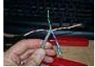
Step 4 Now take the individual twisted wire pairs and untwist them down to individual wires in the following order: Striped Orange, Orange, Striped Green, Blue, Striped Blue, Green, Striped Brown, and Brow | 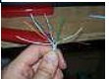
Step 5 Next, grasp the wires with your thumb and index finger of your non-dominant hand. Take each wire and snug them securely side by side | 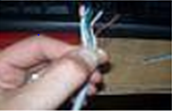
Step 6 Using the cutting blade of the crimp tool, cut the ends off of the wires to make each wire the same height.

Step 7 once the first head is made, repeat steps two through eight. When untwisting the wires down to sing strands, use the following order: Striped Green, Green, Striped Orange, Blue, Striped Blue, Orange, Striped Brown, and Brown. | 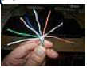
Step 8 still grasping the wires; insert the RJ-45 jack on the wires with the clip facing away from you. | 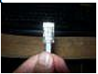
Step 9 Insert the jack into the crimper and press down tightly on the tool to seal the wires in place. | 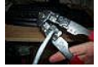
Step 10 Plug in the cable to test connectivity. | 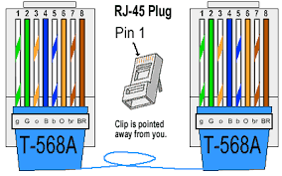

  - Terminating Category 5 or Category 6 cable on a socket

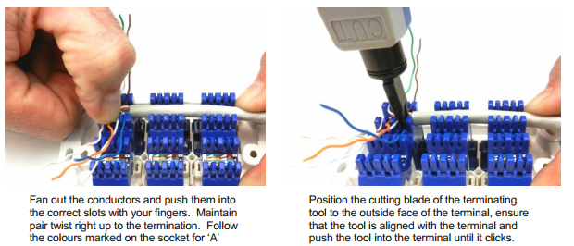

Figure 3. 4 Terminating Category 5 or Category 6 cable on a socket
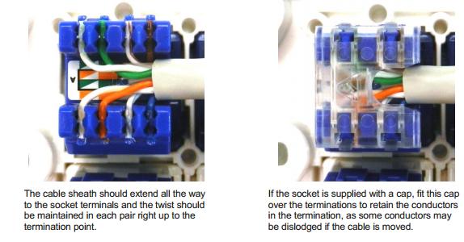
Figure 3. 5 Crimped Category 5 or Category 6 cable on a socket
3.2.2 Visual inspection to confirm termination color code
Cable colour and marking
There are no mandatory requirements for cable sheath colours. However, cables with red sheath should not be used, as red is normally associated with fire detection/alarm systems. Also, cables with orange, white, pink or violet sheath should be avoided as they may be mistaken for power cabling or cabling associated with power control (“home automation”).
It may be beneficial to the installer to use cables with different sheath colours (e.g. blue, grey, yellow, green) to cable different sockets on the same TO. Alternatively, the cable sheaths may be marked at each end with the TO socket colours, e.g. “Blue” and “White”, for the corresponding socket colours, if different coloured sockets are to be used at each TO. In addition, mark the TO cables at each end by room designation (e.g. “Kitchen”, “Family”, Bed 1”, etc.) or in numerical sequence (i.e. “1”, “2”, “3”, and so on). The TO wall plates and the corresponding patch panel sockets at the CCP should be coloured and designated in the same manner so that the end-user will be able to readily identify them.

How to wire telephone cable (Telephone cable):
Step: 1. using a wire stripping tool remove about 4 inches of the outside plastic Sheath (usually beige or grey) that bundles the wires together. Be careful not to nick insulation or cut the wires beneath the sheath
Step: 2.using a wire stripping tool, remove about 1 inch of the plastic insulation fromeach of the colored wires to expose the copper as shown here

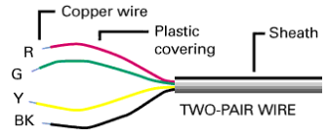
Today, it is more common to see 4-twisted pair wiring like this:

It is called “Cat 5” cable and is the national standard for all new telephone wiring projects.
Step:3. Fasten the jack casing securely to the wall or baseboard using the appropriate metal or wood screws. Pull the wire through the opening in the jack casing and connect it as depicted here
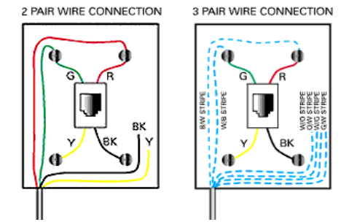
Step 4.4-Pair Wire Connection: A 4-pair cable is wired to a standard jack as shown in the 3-pair wire diagram above but also leaving the brown wires aside.
Step 5. Match each colored wire to the appropriate terminal on the jacks as shown inthe diagrams. In the old standard color scheme the first pair has one greenwire ("tip") and one red wire ("ring"). The second pair has one black wire("tip")and one yellow wire ("ring"). For a single phone line, only the green andred pair is normally used. The black and yellow pair is normally spare and available to install a second phone line.
Step: 6. Ensure that no copper wire is touching any exposed metal inside the jack or electrical box.
Step: 7. Ensure that all connections are secure.
Step: 8. Place the jack cover over the casing and either snap or screw it into place.
At the Demarcation Point:
Step :9. Strip the wire sheath and colored wires the same way you did for the jacks.
Step: 10. Connect the wires that come from each jack location to the entry wiring at the demarcation point. Be sure to match the colors correctly
.How to wire coaxial Cables

Step-by-step: coaxial cable preparation and compression connector termination
The following steps will guide you through the preparation and termination process for coaxial cable with compression connectors. Following these guidelines will help make sure that.you receive the optimum performance from the coaxial cable.

Table 3. 4 coaxial cable preparation and compression connector termination
Step 1: The tools you will need:  •Compression tool  •Cable stripper  •Compression connectors | 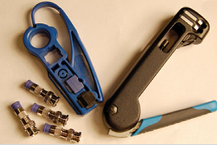
Step 2: Adjust the blades of the stripper to expose ¼ inch of the conductor and ¼ inch  of the insulation. Insert the coax cable into the strip cartridge to the adjusted length. | 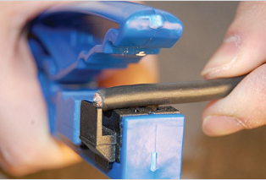
Step 3: Holding the cable near the tool, rotate the cutter around the cable (three to five full turns) to score the jacket and cut through the insulation. Be sure the braid is cut (you can hear when the wires of the braid have all been cut). Then flex the jacket to separate and slide it off to expose the center conductor. | 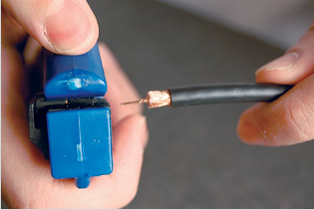
Step 4: Flare and bend back the remaining outer braid onto the cable outer jacket. Make sure to remove any stray or loose braids. Stray or loose braids can cause shorts if they touch the center conductor. Verify that the center conductor and the insulation are not nicked or scored.  (Note: When handling cables with multiple braids, such as quad-shield, refer to the manufacturer’s literature for proper braid handling techniques.) | 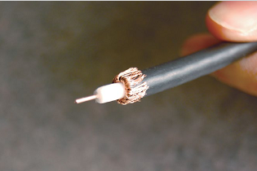
Step 5: Insert the sleeve ferrule and BNC body onto the coaxial cable. Firmly push the  cable as far as possible or until 1⁄8inch of the center conductor is protruding from the connector.  • Make sure the connector is fully seated and the white dielectric Material is firmly pushed against the inner stop of the connector .You can see this by looking into the open end of some connectors. | 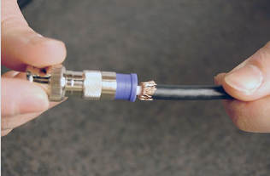
Step 6: Insert the cable and connector into the crimping device, making sure that it is positioned firmly. Squeeze the crimp handle tightly. Use a ratcheting tool that does not release until the proper crimping displacement has been applied for the specific cabling and connector type. Once the tool releases after the final “click,” the crimp should be complete. | 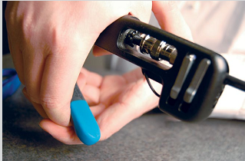
Step 7: Inspect the connection making sure no braiding is exposed and that the connector is firmly attached to the cable. | 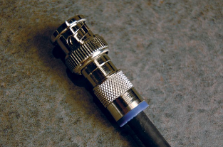

3.3 Terminating conductors
A wire termination is the work performed to the end of a wire that allows it to connect to a device (connector, switch, terminal, etc.).
Wire Terminations – The Two Main Types
- Solder termination. Solder termination is when the open connector is melted and sealed to create an extremely strong bond, thus forming a permanent connection.
- Crimp termination. A crimp termination is performed when the device requires a contact or terminal. The wire insulation is stripped, and the contact or terminal is attached to the wire using a crimp tool. The tool crimps the contact or terminal onto the wire conductor.
CCTV operates in a lower frequency range than CATV and requires different cable constructions. Be sure that the cable used is chosen accordingly. The primary differences are based on the frequency range differences as shown below
Table 3. 5 Types of Conductor

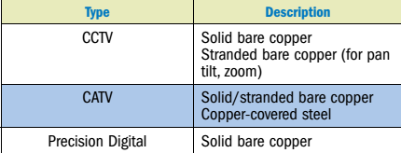

Table 3. 6 Shield Types conductor

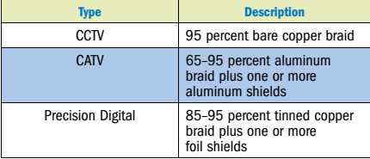
CATV requires a foil shield to contain high-frequency noise in order to comply with FCC regulations. CATV sometimes uses copper-covered steel. Because of this conductor type, care should be given to not damage cutters when handling the steel in CATV coax.

3.4 Earthing cable shield
Earthing of Cable Shields and Drain Wires.
Cable shields are for signal protection from external influences. This is of a protectivenature not a functional one associated with the operation of equipment. Hence shields and drain wires shall not be connected to the TRC except where the TRC is equipotential bonded to the main earthing bar,Conductor or electrode. The cable shield may be connected to any point on the CES.
Earthing Telecommunication Systems
Definition
The Communications Earth System (CES) is a dual-purpose telecommunications earthing
system used for both functional and protective purposes. Earthing conductors used for this
system have green/yellow insulation. The CES is available for any communications system that requires and earth, fire, security, data, video or voice equipment/cabling etc. CES wires are Green/Yellow earthingcolours. The Shield or drain wire of cables is connected to this earth and the punch down module used for earthing is coloured green.
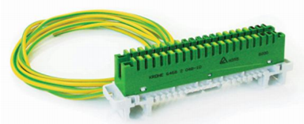
Figure 3. 6 punch down module
- Customer Network and Earthing Definitions ,Building Distributor (BD) or main distribution frame (MDF) – a distributor in which the building backbone cables terminate
- Floor Distributor (FD) – the distributor used to connect between the horizontal cables and other cabling subsystem or equipment. In most large buildings, large cables are run from the BD to the FD where smaller cables then run out to other points
- Local Distributor (LD) is the distributor in which horizontal cables emanating from the floor distributor may connect prior to connecting to telecommunications outlets. Small cables may run from the LD to each individual phone outlet
- Customer Switching System (CSS) - A switching system in an installation that can switch voice, digital data, images, video or any other information. One example is a PABX. The figure below shows where these components fit into a distributed cabling system.
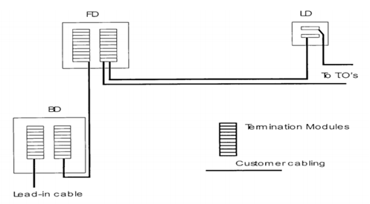
Figure 3. 7 Distributed cabling system component
The Telecommunications Reference Conductor (TRC) is a conductor used exclusively for signaling and other functional telecommunications purposes. It is separate and distinct from the protective earth and other building earth systems. It is not used for providing protection of personnel. A TRC is an earthing system available for use where a functional earth is required by customer equipment.
A TRC may be installed in new buildings when the telecommunications cabling is installed or in an existing building if newly installed equipment requires a TRC to operate. If a TRC system is installed, Technical Standard TS 009 (or its replacement) requires that it be connected to an earth reference regardless of whether it is in use or not. Although the TRC system is connected to earth, it is essential that you realise its true purpose. It is installed to make telecommunications equipment function correctly. The TRC has no protective status what so ever.
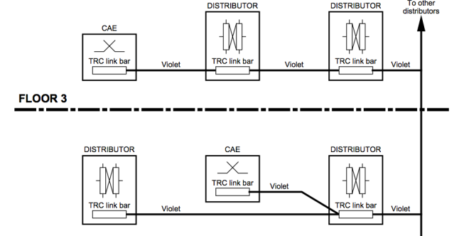
Figure 3. 8 A TRC in new buildings when the telecommunications cabling is installed

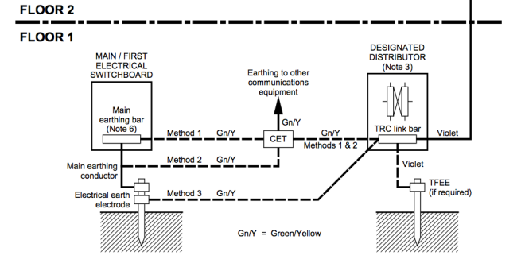
Figure 3. 9 distance between electrical switchboard and telecommunication distributor when earthing
The ‘designated distributor’ is a distributor, near the main or first electrical switchboard in the building, designated by the cabling provider as the most appropriate distributor for distribution of the TRC system. Where surge suppression devices are installed at the designated distributor, the total earthing conductor length between the device and the main earthing bar in the electrical switchboard should not exceed 10 m. A total earthing/bonding conductor length of 1.5 m or less is preferred for more effective end-user protection and for protection of customer equipment connected to the telecommunications line.
TFEE Definition A Telecommunications Functional Earth Electrode (TFEE) may be provided for operational purposes or to limit the direct current flowing in the communications bonding conductor.

3.5Test and clearly labels of cable pairs
Ensure that your inside wire is connected properly at the demarcation point. You can determine a lot about the trouble by listening to sounds on your telephone line:
Static:Wires could be wet or pierced. Wires could be loose at a connecting point. Carefully check all wires and connections.
Buzzing or Humming:A wire may have come into contact with metal, other than the connection terminals. Is any exposed copper wire touching the box or other metal around the jack? Check that colors have been matched correctly. Also, if you are using a cordless phone, you should try plugging in a wired telephone to ensure that the problem is not with your equipment. Given the nature of a cordless phone, it is possible that buzzing or humming is coming from the phone itself and not your wiring.
Dead Air:Wires may be crossed. Is there a contact between any exposed copper from wires of different colors (red crossed with green if 2-pair wire is being used; or blue crossed with white if 3-pair wire is being used)
Cross Talk:Be sure you are not using a cordless phone, since cross talk is likely from the wireless nature of the phone. If you have multiple phone lines in the home or are in a multi-unit dwelling, cross talk could be the result of damages or faulty wiring.
Check that all connections have been made properly.
- Are all the colored wires connected to the right terminals?
- Is the exposed copper wiring making a solid contact with the right terminals?
- Check the wire. Is it broken or split?
- Is it pierced by a staple, nail, screw or other object?
If it is, replace the entire section of wire from end to end.
Check that the pins or connecting terminals inside the jacks are not touching each other and that a jack itself is not damaged.
How many phones do you have? It may be possible that your phones are drawing too much energy and compromising the system as a whole. Unplug a few phones a see if the problems persist.
Modem problems? If you are having problems connecting to the Internet, the problem may be with the modem. Try disconnecting the computer and use a standard telephone and see if there are problems on the line. If the line does not show a problem, the issue is likely with your computer equipment. This is also trueif you are using a Digital Subscriber Line (DSL) (or other high speed internet service) which may involve separate filters that could cause problems on the line, even though the line is working properly.
3.5.1. Visual inspection to confirm termination colour code sequence for Data line
(Data cable)
You should ensure that the connection was done correctly by testing the cable with a cable tester. Put the injector on one end of the cable and put the tester on the other end. Once you have the tester hooked up, you can test the cable for continuity (no breaks in the conductors), near-end
crosstalk (NEXT), and Category rating (all quality-of-transmission issues). The specific procedures for testing a cable vary depending on the cable tester. Usually you select the type of cable you are testing, hook up the cable, and then press a button labeled something like Begin Test. If the cable does not work or meet the testing requirements, reconnect the cable.
  - Locating Cable Faults
Time domain reflectometry has other applications in cable testing as well, such as the detection and location of cable breaks, shorts, and terminators. The reflection of the test pulse back to the transmitter is caused by a change in impedance on the cable. On a properly functioning cable, the open circuit at the opposite end produces the only major change in impedance. But if an open or short exists at some point midway in the cable run, it too will cause a reflection back to the transmitter. The size of the pulse reflected back is in direct proportion to the magnitude of the change in impedance, so a severe open or short will cause a larger reflection than a relatively minor fault, such as a kink, a frayed cable, or a loose connection. If there is no reflection at all, the cable has been terminated at the opposite end, which causes the pulse signal to be nullified before it can reflect back.
Cable testers use TDR to locate breaks and faults in cable by distinguishing between these various types of reflections. The problem may be caused by a cable that has been entirely severed or by faulty or damaged wires inside the cable sheath. Sometimes you can’t tell that a cable is faulty by examining it from the outside. This is why a test of each cable run during the installation process is so important
  - Resistance measuring
The second method for determining the length of a cable is to measure its resistance using a digital multimeter (DMM). All conductors have a resistance specification, expressed in ohms per meter (or sometimes ohms per 100 meters or ohms per foot). If you know the resistance specification for the conductor per unit of length, you can measure the cable’s resistance and divide the result by the manufacturer’s specification to determine the cable’s length. In the same way, if you already know the length of the cable from a TDR test, you can use the rating to determine the cable’s total resistance.
Environmental factors can affect resistance as can the cable’s design and improper installation. Resistance increases with temperature, so your length calculations will suffer accordingly if you are measuring in a high- or low-temperature environment too far from the 20˚ C (68˚ F) temperature the resistance specification is based on. The twist intervals of the pairs also will influence your resistance measurement. Because the twists increase the actual length of the conductors, the resistance reading will be higher and result in a longer-than-actual cable length. And, if the conductor was stretched during installation, high resistance readings will result, again producing longer-than-actual lengths for the cable.
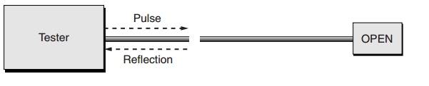
Figure 3. 10 TDRs are also used to locate breaks and other faults in a cable
Tester OPEN Pulse Reflection

  - Performance Testing
The tests we’ve discussed so far all relate to physical properties of the cable and ascertain if the cable has been terminated properly and is an acceptable length. They can be performed quickly and with relatively unsophisticated and inexpensive test devices. They are the basic, minimum levels of testing that should be performed to ensure your network will work.
But to properly characterize your cabling’s performance, a battery of transmission tests must be administered; they determine the data-carrying capability of your cables and connectors.
The following characteristics were all defined in Chapter 1, so we won’t explain them further here other than to note issues related to their testing.
All of the copper-cable tests discussed in the following sections, except for Propagation
Delay and Delay Skew, have formula-based performance requirements along a continuous frequency spectrum. In the case of Category 5 and 5e, this range is 1MHz through 100MHz.
For Category 6, requirements at additional frequencies up to 250MHz are specified. If at any
point along the spectrum the cable exceeds the specification limits, the cable fails. This is called
sweep testing because the entire frequency range is being scanned.
Testing for transmission performance requires much more sophisticated equipment than
that used for wire mapping, opens, shorts, and crosses—equipment that can cost several
thousands of dollars per test set. However, the testing is essential for qualifying your cabling
installation to a particular level of performance, e.g., Category 5e. If you can’t afford such a
set, either contract with an installation-and-testing company that has one, or rent an appropriate unit.
  - Impedance
As you learned earlier, variations in impedance cause signal reflections that a TDR uses to measure the length of a cable. However, these signal reflections can be caused by different factors, including variations in the cable manufacture, structural damage caused during installation, or connectors that are a poor match for the cable. The statistic that measures the uniformity of the cable’s impedance is called its structural return loss (SRL), which is measured in decibels (dB), with higher values indicating a better cable. Even when the SRL of a particular cable is acceptable, it is still possible for an installation of that cable to suffer from variations in impedance that cause signal reflections. When you construct a network to conform to a particular cabling specification, such as Category 5e UTP, to maintain a consistent level of impedance throughout the entire length of the cable run you have to use connectors and other hardware that have the same rating as the cable.
If, for example, during a twisted-pair installation, you fail to maintain the twist of the wire pairs up to a point no more than 0.5 inches for Category 5 and 5e, and 0.375 inches for Category 6, from each connection, you run the risk of varying the impedance to the point at which a reflection occurs (as well as causing additional crosstalk). The cumulative amount of reflection caused by variations in impedance on a cable run is called its return loss, which, like impedance, is measured in ohms. If the return loss is too large, signal-transmission errors can occur at high transmission speeds. The worst-pair performance is reported at the frequency where the result came closest to the specified limits.
f. Attenuation
Attenuation is one of the most important specifications for high-speed networks; if it is too high, the signals can degrade prematurely and data can be lost. This is especially true if your network uses cable lengths that approach the maximum permitted by your networking protocol. Testing the attenuation of a cable run requires a unit at both ends of the connection: one to transmit a calibrated signal and another to receive the signal and calculate how much it has degraded during the trip. Attenuation is measured in decibels (dB), and most good-quality cable testers include the secondary module needed to perform the test. The worst-case result is reported.
g. Near-End Crosstalk (NEXT)
Along with attenuation, near-end crosstalk (NEXT) is one of the major impediments to successfully installing and running a high-speed data network on twisted-pair cabling. Figure below shows NEXT. Testing for NEXT is a relatively simple process with today’s sophisticated test sets. After terminating the far end of the cable run to prevent any reflections from interfering with the test, a signal is transmitted over one pair, and the magnitude of the crosstalk signal is measured on the other pairs (in decibels). For a complete assessment, you must test each wire pair against each of the three other pairs, for a total of six tests, and you must perform the six tests from both ends of the cable. The worst-case combination is reported as the cable’s performance result.
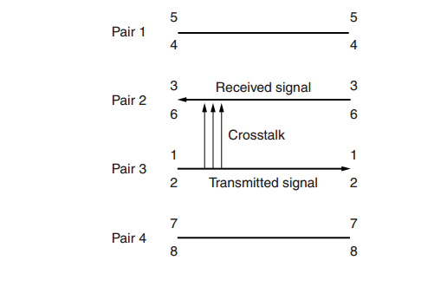
Figure 3. 11 Near-end crosstalk
.3.5.2 Cable-Testing Tools
The best method for addressing a faulty cable installation is to avoid the problems in the first
place by purchasing high-quality components and installing them carefully. But no matter how careful you are, problems are bound to arise. This section covers the tools that you can use to test cables both at the time of their installation and afterwards, when you’re troubleshooting cable problems. Cable-testing tools can range from simple, inexpensive, mechanical devices to elaborate electronic testers that automatically supply you with a litany of test results in an easyto-read pass/fail format.
The following sections list the types of tools available for both copper and fiber-optic cable
testing. This is not to say that you need all of the tools listed here. In fact, in some of the following sections, we attempt to steer you away from certain types of tools. In some cases, both high-tech and low-tech devices are available that perform roughly the same function, and you can choose which you prefer according to the requirements of your network, your operational budget, or your temperament. Some of the tools are extremely complicated and require extensive training to use effectively, where others are usable by anyone who can read. You should select the types of tools you need based on the descriptions of cable tests given earlier in this chapter, the test results required by the standards you’re using, and the capabilities of the workers—not to mention the amount of money you want to spend.
        - Wire-Map Testers
Awire-map tester transmits signals through each wire in a copper twisted-pair cable to determine if it is connected to the correct pin at each end. Wire mapping is the most basic test for twisted-pair cables because the eight separate wire connections involved in each cable run are a common source of installation errors.
Wire-map testers detect transposed wires, opens (broken or unconnected wires), and shorts (wires or pins improperly connected to each other)—all problems that can render a cable run inoperable.
Wire-map testing is nearly always included in multifunction cable testers, but in some cases
it may not be worth the expense to spend thousands of dollars on a comprehensive device
        - TDR length testing
A wire-map tester consists of a remote unit that you attach to the far end of a connection and
the battery-operated, handheld main unit that displays the results. Typically, the tester displays various codes to describe the type of faults it finds. In some cases, you can purchase a tester withmultiple remote units that are numbered, so that one person can test several connections without constantly traveling back and forth from one end of the connections to the other to move the remote unit.
WARNING The one wiring fault that is not detectable by a dedicated wire-map tester is a split pair, because even though the pinouts are incorrect, the cable is still wired straight through. To detect split pairs, you must use a device that tests the cable for the near-end crosstalk that split pairs cause.
        - Continuity Testers
A continuity tester is an even simpler and less expensive device than a wire-map tester. It is designed to check a copper-cable connection for basic installation problems, such as opens, shorts, and crossed pairs. These devices usually cannot detect more complicated twisted-pair wiring faults such as split pairs, but they are sufficient for basic cable testing, especially for coaxial cables, which have only two conductors that are not easily confused by the installer.
Like a wire-map tester, a continuity tester consists of two separate units that you connect to each end of the cable to be tested. In many cases, the two units can snap together for storage and easy testing of patch cables.
        - Tone Generators
The simplest type of copper-cable tester is also a two-piece unit, a tone generator and probe, also sometimes called a fox and hound wire tracer. With a standard jack, you connect to the cable the unit that transmits a signal; or, with an alligator clip, you connect the unit to an individual wire. The other unit is an inductive amplifier, which is a penlike probe that emits an audible tone when touched to the other end of the conductor. This type of device is most often used to locate a specific connection in a punch-down block. For example, some installers prefer to run all of the cables for a network to the central punchdown block without labeling them. Then they use a tone generator to identify which block is connected to which wall plate and label the punch-down block accordingly.

3.6 Terminate TRC/CES/Earth wires with connectors.
Communications Earth System (CES) a system of ear thing using common elements to provide for ear thing of electrical and communications equipment within premises. A CES may be used for protective and functional ear thing for telecommunications purposes. Communications Earth Terminal (CET) a terminal provided for the purpose of equipotential bonding of the CES or the TRC(telecommunications referenceconductor) to the main ear thing bar, main ear thing conductor or sub-main ear thing conductor of the electrical installation
The CET provides a demarcation between the electrical ear thing system and the telecommunications ear thing system and was formerly known as a ‘bonding terminal’.
This conductor is generally supplied via the third pin of a power cord. However in some systems this must be hard wired to the equipment by a licensed electrician. A hard wired PE connection is specified in those instances where it is required.
Earthing Options
1. TRC and PE
The TRC and the PE must be connected to the equipment on separate terminals, in accordance with the individual TRC and PE requirements listed above.
2. None. Neither a PE nor a TRC is required to be connected to this equipment.
3. TRC or PE Either a PE or a TRC must be connected to this equipment. However in some uses of the type of equipment, a TRC must be used. (E.g. a CAE mounted behind another CAE may need earth recall to access the first CAE. A TRC is required for this functional use).

3.7 Test Reference Cord (TRC) / Communications Earth System (CES) /Earth wire continuity
Why use a TRC? If you are installing low loss connectors, those connectors may have a loss of ≤ 0.15 dB. So testing it with a connector that has a loss greater than 0.15 dB will yield a pessimistic result. More importantly, if your link is an engineered link operating to custom test limits - you could be failing a perfectly good link. Another advantage is consistent and predictable results - something installers often complain about when certifying a cabling system.
Pair Continuity Testers
Continuity testers can be used to check that pairs are not open circuit. They work on a similar principle to an ohmmeter but usually use light emitting diode or audible tone indicators. Many modern digital multimeters have built in continuity testers.
Other devices
There are several instruments that can be used to identify low resistance faults such as the Riser Bond, PET or C2300.Multimeters Two main types of multimeters are in common use, analogue or digital. Both types share many common features and are equally good for general purpose testing. The digital multimeter is a battery operated instrument that uses a digital display. The analogue type is a simpler in design and has an analogue meter display. All multimeters combine the operations of voltmeters, ammeters and ohmmeters and usually offer the following:
- AC and DC voltage ranges from less than one to many hundreds of volts
- AC and DC current ranges from a few milliamps to several amps
- Resistance ranges from ohms to megohms
Inspection of Work
Inspection of work by a carrier the carriers are responsible for their networks. They also have the right to inspect cabling work. They may inspect work to ensure it satisfies current AS/CA technical standards in relation to network integrity, personal safety and proper network functioning. If a carrier inspection reveals a threat to safety or integrity of their network then they may disconnect or refuse to connect some or all services.
Maintenance of cabling advice It is the responsibility of the registered cabler to maintain all necessary installation records. The registered cabler(maintenance licensed person) must maintain these ‘cabling advices’ in a clear and legible fashion.

Testing TRC/CES /Earthling system
TRC/CES /Earthing installation is tested for continuity, insulation resistance and conductive resistance as per relevant industry standards including AS/ACIF S009. Earthing system is labeled in accordance with requirements.
What is TRC earthing?
Telecommunications Reference Conductor (TRC) A low noise earthing system providing a zero-voltage reference point for telecommunications signaling and other functional purposes.
Continuity test
The earth continuity test is a designed to test the resistance of the protective earth of an appliance and/or the supply lead. It is measured between any accessible earthed parts and the earth pin of the plug. The test is based on the principles of Ohm's Law.
Insulation resistance test
Insulation resistance can be determined between live, neutral and earth connections with no loads or appliances connected to any sockets or wiring. Any problems would be shown by a lower-than-expected resistance being present between them. In domestic wiring anything above 2 megohms is acceptable.
Acabler can determine the approximate resistance of the CES by cable length. If the value is close to the limit then a measurement will have to be taken which will account for any resistance included at termination points.
Step 1 – Resistance measurement
(a) Select a pair (or extend one) to run from the:
(i) Protective earth bonding point (or CET if it is adjacent to the point of bonding) to,
(ii) The termination point of the CES at the CSS or LD To use in your measurements
(b) Connect each wire of the reference pair using an appropriate test lead, to the CES cable at the CSS or LD after removing it from its termination point.
(c) Using a multimeter at the protective earth end, measure and record the loop resistance of the reference pair. Record this value in the space below.
(i) R1 = _________Ω
(d) Now measure the resistance of each leg of the reference pair to the CES cable. Record this value below
i) R2 = _________Ω R3 = _________Ω
(e) Before calculating the CES resistances removes all test conductors and reconnect the CES cable to the earth terminal.
(f) Substitute your values of R1, R2 and R3 into the following formula to calculate the CES resistance
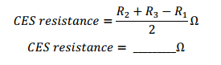
You should remember that the resistance from the point of connection to the protective earth and furthermost end of the CES cable should be no more than 1 ohm.
Terminate at CET’s Remove the insulation from the ends of all conductors and terminate them in the CET’s. Be sure to consolidate all bared conductors by twisting or folding them in two. Make sure both screws clamp on the conductor in the CET. Alternatively, if you are terminating using cable lugs, use a sustainable crimp too to fit the lug to the TRC cable.
Joining to the sub main or Main earthing conductor To connect a bonding cable from a CET to the sub main or main earthing conductor, use a line tap or an equivalent. Do not cut the earthing conductor and be user to re-insulate the connection. Connecting to the Protective earth electrode To connect a bonding conductor to an electrode, use an appropriate clamp and fit this below the protective earth connection. Extend the CES to CSS To extend the CES to the CSS, run the minimum sized CES cable to the earth terminal of the CSS (or a LD if a CSS is not available).
ACTIVITY – TESTING A CES Test the installation using Section 20 of AS/CA S009:2013 as a guide. By using table 6 of AS/CA S009:2013 a cabler can determine the approximate resistance of the CES by cable length. If the value is close to the limit then a measurement will have to be taken which will account for any resistance included at termination points.
Testing A TRC Test your TRC installation using the testing procedure in AS/CA S009:2013.
The cable tray should still be earthed to the protective earth from the previous CES activity.
      - Resistance Measurement
(a) Select a cable pair from the BD-FD riser to use in your measurements.
(b) Connect each wire of the reference pair to the TRC connection at the FD using an appropriate test lead
(c) Disconnect the TRC riser from the earth bar at the BD
(d) Using a digital multimeter measure and record the loop resistance of the reference pair from the
BD. Record this value in the space below.
(i) R1 = _________Ω
(e) Now at the BD measure the resistance of each leg of the reference pair to the TRC cable. Record this value below.
(i) R2 = _________Ω R3 = _________Ω
(f) Before calculating the TRC reisitance remove all test short circuits and reconnect the TRC to the BD earth bar
(g) Substitute your values of R1, R2 and R3 into the following formula to calculate the TRC resistance
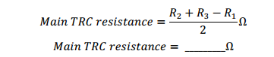
You should remember that the resistance from the BD link bar to the FD should be no more than 2 ohms. If it was required to test the resistance from the BD link bar to a LD the reference pair would have to be extended to the LD and the testing process repeated. In this case 5 ohms is the maximum permissible reading.
Accidental bonding
Once you have measured the resistance of the TRC and found it to be within the limits, it is necessary to check for accidental equipment bonding.
(a) Remove the main TRC cable from the BD earth bar
(b) Make sure the BD earth bar is connected tot the protective earth at the CET
(c) Set the voltage on the insulation resistance tester to 500Vdc and connect the test leads tothe TRC cable and the BD earth bar
(d)Measure the resistance and record the result below.
(e) Reconnect the main TRC cable to the BD earth bar the value you measure should be greater than 1MΩ to comply with the standards.

3.9 Labeling of earthling system
With the increasing demand for computer network installations, telecommunications grounding and bonding has become a growing opportunity for electrical contractors. Although similar grounding principles apply, understanding the telecommunications terminology and special considerations has been a challenge. As with traditional electrical grounding, telecommunications networks and equipment should be grounded to the electrical service. However, simply grounding to structural steel isn’t enough when tackling telecommunications systems. The sensitivity of the electronic equipment requires that the telecommunications cabling and power be effectively equalized to prevent loops or transients that can damage the equipment. This means designing a complete grounding and bonding system that goes beyond the basic "green-wire
3.9.1. Grounding
The NEC article 100 defines ground as:
“A conducting connection, whether intentional or unintentional, between electrical circuits or equipment and the earth, or some conducting body that serves in place of the earth".”
Electrical systems and communication cabling systems that are required to be grounded must be connected to the earth. The grounding mechanism must provide a reliable means to safely conduct the voltages imposed by lightning, line surges, or unintentional contact with high voltage lines or equipment to ground.

3.9.2. Bonding
The NEC article 100 and 250-70 defines bonding as:“The permanent joining of the metallic conducting parts of equipment and conductor enclosures to assure and electrically conductive path between them that will ensure electrical continuity and have sufficient capacity to safely conduct any foreign current likely to be imposed to ground.”
Bonding is required because electrically conductive materials such as structural steel, metal cable trays, and metallic supporting structures may become energized in the event of making contact with: lightning, line surges, or unintentional contact with high voltage lines.
The practice of creating effective bonding is to create a reliable path for such fault currents to the electrical system ground. Effective bonding practices help to equalize potential caused by either lightning and electrical system faults that would otherwise damage equipment and harm individuals. The NEC requires that metal raceways, cable trays, racks, enclosures, or metal cable armoring must be effectively bonded to ensure the capacity to conduct any fault current to ground.
The NEC Article 250-96 states: “Metal raceways, cable trays, cable armor, cable sheath, enclosures, frames, fittings, and other metal noncurrent carrying parts that are able to serve as grounding conductors, with or without the use of supplementary equipment grounding conductors, shall be effectively bonded where necessary to ensure electrical continuity and the capacity to conduct safely any fault currents likely to be imposed on them. Any nonconductive paint, enamel, or similar coating shall be removed at threads, contact points, and contact surfaces or be connected by means of fittings designed so as to make such removal unnecessary.”

3.9.3. Electrical exposure
Communication cables have exposure to electrical currents. The NEC Article 800-2 defines a communication cable as “exposed” when
“The cable or circuit is in such a position that, in case of failure of supports or insulation, contact with another cable or circuit may result.”
All communication cables are considered exposed to electrical current because of where these cables are installed in a building or in a campus configuration. Communication cables are installed in very close proximity to electrical conductors on walls and above ceilings.
The degree of expose is also determined by where the cable is installed. Exposure can be defined in the following two areas:
- Outside building exposure
- Inside building exposure
- outside Building Exposure
All copper communication cables, or any dielectric cables that have a conductive element, are conductors of electrical energy. When these types of cables are run between buildings, they are electrically exposed to lightning. These cables would carry a lightning strike along the cable and into any cables that are connected to these cables.
- Inside Building Exposure
Communication cables are exposed to electrical hazards inside a building. Copper communication cables are installed in the same vicinity as electrical power conductors. These is the possibility of accidental contact with power conductors, which would cause power fault induction.
3.9.4. Telecommunications grounding and bonding standard
The ANSI/EIA/TIA-607 standard is the commercial building grounding and bonding requirements for telecommunications. The primary objective of this standard is to provide guidance around the issue of bonding and grounding as it relates to building telecommunications infrastructure.
The ANSI/EIA/TIA-607 standard defines telecommunications grounding and bonding system and the interconnections to the building electrical grounding system. The recommendations made in this standard do not supersede the bonding and grounding requirements of national and local electrical code.
Key Terms:
Bonding means permanent joining of metallic parts for the purpose of forming an electrically conductive path to ensure electrical continuity and capacity to safely conduct any current likely to be imposed.
Bonding conductor for telecommunications is a conductor used to interconnect the telecommunications bonding infrastructure to the service equipment (power) ground of the building.
Effectively grounded refers to an intentional connection to earth through a ground connection of sufficiently low impedance. It must have sufficient current-carrying capacity to be able to prevent the buildup of voltages that could potentially result in unnecessary hazard to connected equipment or persons.
Ground is an intentional or accidental conducting connection between an electrical circuit or equipment and earth or conducting body serving in place of earth.
Ground electrode conductor is a conductor used to connect the grounding electrode to:
- The equipment grounding conductor
- The grounded conductor of the circuit at the service equipment
- The source of a separate system.
3.9.5.Telecommunication grounding system components
The telecommunications grounding and bonding system starts with a physical connection to the building grounding electrode system and extends to every telecommunications room (TR) in the building (see the following figure).
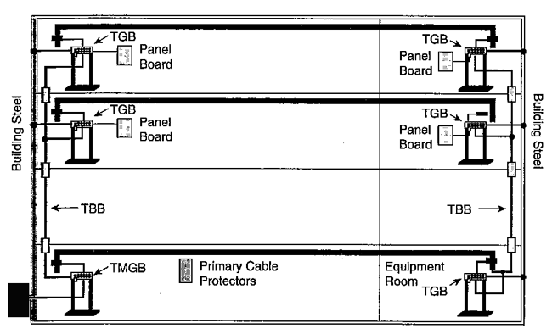
Figure 3. 12 The telecommunications grounding and bonding system
In general, a telecommunications grounding system defined by the ANSI/TIA/TIA-607 standards contains the following components:
- Telecom bonding conductor
- Telecom main grounding busbar (TMGB)
- Telecom bonding backbone (TBB)
- Telecom grounding busbar (TGB)
- Telecom bonding backbone interconnecting bonding conductor (TBBIBC)
The system begins at the electrical service entrance, travels to the TMGB and continues through to each TGB located in individual telecommunications closets on each floor of the building structure, finally looping back around to the original TMGB.
3.9.6. Telecom Entrance Facility (TEF)
The telecommunications entrance facility (TEF) includes the entrance point at the telecommunications service and also the space where the inter- and intra-building backbone facilities join. Telecommunication-related antenna entrances and electronic equipment may be located in the TEF.
  - Telecom Bonding Conductor
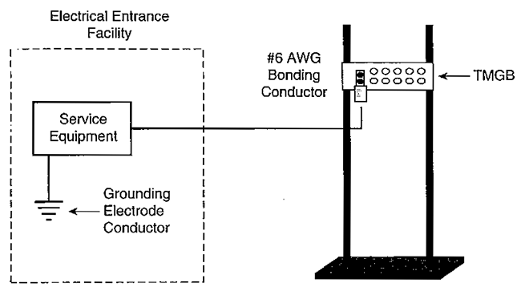
Figure 3. 13 Telecom Bonding Conductor
The ANSI/EIA/TIA-607 standard requires that all communications bonding conductors be listed for the intended purpose and approved by a nationally recognized testing laboratory such as UL or ETL.Bonding conductors must always be insulated wires. The standard also requires that bonding conductors be made of copper metal. Other metal types are not supported for use aa bonding conductor by the ANSI/EIA/TIA-607 standard. In addition, the minimum size of all bonding conductors must be at least a #6 AWG wire.
The ANSI/EIA-TIA-607 standard prohibits placing bonding conductors in a metallic conduit made of iron. This standard requires that if the bonding conductor must be placed in an iron conduit longer than 1m (3 ft.) in length, then bonding conductor must be bonded at each end of the conduit. The wires used for bonding the bonding conductor must be at least a #6 AWG wire.
  - Telecom Main Grounding Busbar (TMGB)
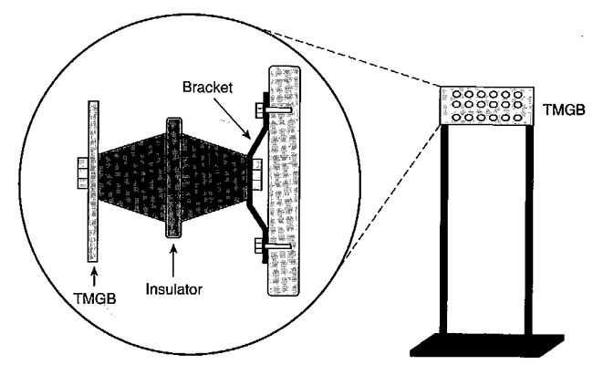
Figure 3. 14 Telecom Main Grounding Busbar (TMGB)
The TMGB is the dedicated extension of the building grounding electrode system for the telecommunications infrastructure. Because it is the central attachment point for TBBs and equipment, the TMGB should provide easy access for telecommunications personnel.
The TMGB is predrilled copper bus bar with standard NEMA bolt-hole sizing and spacing for the particular lug connection that will be used. It should be large enough to satisfy today’s applications and accommodate future growth. A minimum of 6-mm thickness and 100-mm width is required. Many varieties of ground bars are available, and some come as a kit and can be customized to meet the specific requirements of the application. Pre-weldedCadweld pigtails are available in a variety of conductor sizes and lengths, insulated or bare, ready to be attached to the building ground.
For reduced resistance, electro tin plating is preferred. However, if not plated, the mating surfaces must be completely cleaned. Where telecommunications panelboards are located with the TMGB, they must have the alternating current equipment ground bus (or a metallic enclosure) bonded to the TMGB/TGB. All appropriate clearances should be maintained while locating TMGBs as close as possible to the panel boards.
Connections to the TMGB or lugs should be exothermic welds. Exothermic welds provide a connection that helps ensure the long-term integrity of the grounding system.
  - Telecom bonding backbone (TBB)
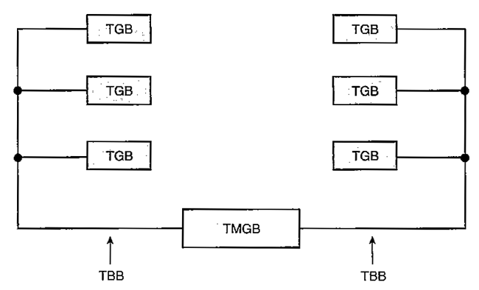
Figure 3. 15 Telecom bonding backbone (TBB)
The TBB is a conductor that connects all TGBs with the TMGB. It reduces or equalizes potential differences between the telecommunications systems to which it is bonded. The TBB should not be the only conductor that provides a ground fault current return path.
Starting at the TMGB, the TBB loops throughout the building via telecommunications backbone pathways. It connects TGBs in every telecommunications closet and equipment room within the building. Multiple TBBs may be necessary, depending on the size of the structure and the number of TGBs in the building. Water pipes or metallic cable shield should not be used as telecommunications bonding backbone. Each TBB should be an insulated copper conductor, a minimum of No. 6 AWG and possibly as large as 750 kc mil often used by telephone and communications companies. In a multi-story building where more than one TBB is used, the TBBs must be bonded together with a TBB interconnection bonding conductor (TBBIBC) located on the top floor and at least every third floor.
  - Telecom Grounding Busbar (TGB)
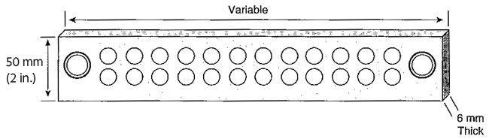
Figure 3. 16 Telecom Grounding Busbar (TGB)
A TGB is a predrilled copper bus bar with standard NEMA bolt hole sizing and centrally connected systems and equipment served by a telecommunications closet. It should be at least 6-mm thick by 50-mm wide. Just like the TMGB, the TGB should be electrotin-plated or cleaned prior to connecting the conductors to the bus bar. The bonding conductor between the TBB and the TGB should be continuous and run in the most direct path possible.
Often, the TGB is installed to the side of the panel board. When the building’s structural steel is effectively grounded, each TGB should be bonded to the steel within the same room with a No. 6 AWG conductor. Always use the shortest distance possible in the grounding system.
  - Telecom Bonding Backbone Interconnecting Bonding Conductor (TBBIBC)
The ANSI/EIA/TIA-607 standard requires that when two or more TBBs are installed vertically in the intrabuilding backbone pathway, the TBBs must be bonded together. The telecommunications bonding backbone interconnecting bonding conductor (TBBIBC) is the component used for this function (see the figure above).The ANSI/EIA/TIA-607 standard requires that the TBBIBC be installed at the top floor and a minimum of every third floor. The minimum size of the TBBIBC must be no smaller than the TBB conductor size.
The TBBIBC would also be used to bond two or more TGBs installed in the same TR together. The TBBIBC is also used to bond the TGBs installed in different TRs that reside on the same floor of the building. This connection would follow the same requirements as bonding multiple TBBs at the top floor and a minimum of every third floor.

3.10 Testing and confirming Compatibility of alterations with existing systems
Before testing a cable pair the following procedure should be followed:
- Remove any telecommunications equipment from both ends.
- Avoid actual contact with the conductors of the pairs where possible.
- With a voltmeter, check that no stray DC or AC voltages are present on the pair.
- Test between legs and each leg to earth. If a hazardous voltage is detected, the pair should be isolated and expert assistance obtained.
- Discharge any stray capacitive charges by briefly short circuiting the legs of the pair together and to earth with an insulated wire, avoiding actual contact with the conductors of the pair where possible.
- Test telephones – Buttinski’s Test telephones are similar in operation to normal telephones. They are portable and used to check the operation of telephone circuits. Test telephones are robust and conveniently shaped and usually have additional features to normal telephones. These features of test telephones include monitoring facilities, polarity testing and earth recall. Test telephones are often called “Buttinski’s” or “Butts” for short. This name derives from their ability to “butt in” on telephone lines.
The following best practices are recommended during the installation of cables:
- Install higher cable categories to meet the application requirements that may arise in the future.
- Use thin and high-density cables as necessary to enable more cable runs in tight spaces.
- Use modular cabling systems to map the ports from equipment with high density port counts.
- Avoid leaving loose cables on the floor, as this could constitute as a major safety hazard. Instead, use the vertical, horizontal, or overhead cable managers.
- Store a few spare patch cables. The type and quantity of the patch cables can be determined from the installation and projected growth. Ensure to store all the unused cables in a bagged and capped condition when not in use.
- Use the patch cable of exact length, and leave some slack at each end for end device movements.
- Use vertical and horizontal cable guides for routing cables within and between the racks.
- Use cable spool devices in the cable managers to prevent kinks and sharp bends in the cable.
- Bundle the related cables together in groups (for example, bundle the ISL cables and uplinks to their core devices), as this eases management and troubleshooting.
- Use the Velcro-based ties every 1 to 2 meters for bundling or securing the cables, and avoid using the zip ties as they apply pressure on the cables.
- Regularly maintain the cabling documentation, labeling, and physical or logical cabling diagrams.
Testing of the completed installation
The generic cabling system should be inspected and tested after completion to ensure that:
- there are no open circuits
- there are no short circuits
- all sockets are correctly terminated
- the CCP is correctly labeled
- TO sockets are correctly colour-coded or labelled in relation to the CCP colour-coding or labeling
- end-user information is clear, concise and corresponds to the actual installation
- the “as-built” cabling plan is neat and accurate.

3.11 Direction for non-routine events
Qualifications of Installer
The Structured Cabling System shall be installed only by accredited firms of the cabling system components and by suitable qualified personnel(s)
a) Cabling system installation shall be performed in a safe manner.
b) Personnel undertaking installation works shall be equipped with appropriate personal protection equipment, tools and mechanical aids.
c) Appropriate barriers and warning signs shall be used to restrict access and draw attention to potential hazards such as open trenches and the like.
Best Practices
The following best practices are recommended during the installation of cables
- Install higher cable categories to meet the application requirements that may arise in the future.
- Use thin and high-density cables as necessary to enable more cable runs in tight spaces.
- Use modular cabling systems to map the ports from equipment with high density port counts.
- Avoid leaving loose cables on the floor, as this could constitute as a major safety hazard. Instead, use the vertical, horizontal, or overhead cable managers.
- Store a few spare patch cables. The type and quantity of the patch cables can be determined from the installation and projected growth. Ensure to store all the unused cables in a bagged and capped condition when not in use.
- Use the patch cable of exact length, and leave some slack at each end for end device movements.
- Use vertical and horizontal cable guides for routing cables within and between the racks.
- Use cable spool devices in the cable managers to prevent kinks and sharp bends in the cable.
- Bundle the related cables together in groups (for example, bundle the ISL cables and uplinks to their core devices), as this eases management and troubleshooting.
- Use the Velcro-based ties every 1 to 2 meters for bundling or securing the cables, and avoid using the zip ties as they apply pressure on the cables.
- Regularly maintain the cabling documentation, labeling, and physical or logical cabling diagrams.
• Document and regularly update all the cabling components and their mapping.
- For new installations or re-cabling of the existing equipment, install the cable guides to reduce mechanical stress and bending of the data cables, and to enhance the maintainability.
The installation and usage of cable guides should be independent of the number of cables that are installed. However, there are products that do use cable guides, or where the cable guides cannot be installed.

3.12 Routine quality termination of cables and devices
Locate your wire distribution device (connector block) at your demarcation point;
• Disconnect one pair of wires from the distribution device;
• Check to see if your service has been restored at other jack locations in your home;
• Continue disconnecting wire pairs, one pair at a time, to determine which wire is the cause of the trouble;
Once you have isolated the problem circuit, it is suggested that you replace the entire section of wire that is defective or the jack if it is causing the problem.
If you are unable to repair or isolate an inside wire trouble yourself, repair service is available from your local telephone company or an independent contractor.

Self-Check -3
Directions: Answer all the questions listed below. Use the Answer sheet provided in the next page:
Part I. Choose the best answer from the question below
- ________________is a type of transmission line, used to carry high-frequency electrical signals with low losses.
- Coaxial cable B. UTP cable C. Telephone wire D. none
- To prevent crosstalk, wire pairs in a Cat5e cable should not be untwisted more than_____ inches.
- 0.5 B. 0.4 C. 0.45 D. 0.375
- To prevent crosstalk, wire pairs in a Cat6 cables should not be untwisted more than_____ inches.
- 0.375 B. 0.5 C. 0.35 D. 0.475
- Which of the following colour is used for earthing conductors for CES
system?
- green/yellow insulation B. blue/yellow insulation C. white/yellow insulation
- ____________is one of the most important specifications for high-speed networks.
- Crosstalk B. Attenuation C. Dead air D. Humming

Part II. Fill the blank for the following question

- ____________is the most basic test for twisted-pair cables.
- All conductors have a________________ specification, expressed in ohms per meter.
- ______________ and _____________________ systems that are required to be grounded must be connected to the earth.
- _____________________is a designed to test the resistance of the protective earth of an appliance and/or the supply lead.
- __________________ refers to an intentional connection to earth through a ground connection of sufficiently low impedance.

Operation sheet 3

Operation Title: Identifying data cables for socket outlet connection.
Instruction: Using the Flip chart and given equipments Identifying material Used in data cable for socket outlet connection instructor must check the connection after you finished connection .
Purpose: When you have completed this Unit, the trainee should be able to identify the material used in data cable for socket outlet connection.
Required tools and equipment: unit one of this module, tools from workshops like Jacket stripper,
Punch-down tool, Wire cutters, testing instrument.
Precautions: Safe handling Jacket stripper, Punch-down tool, Wire cutters, testing instrument and components
Procedures:
Step 1: Properly identify data cables for socket outlet connection
Step 2: Prepare materialfor the given task
Quality criteria: Reading the circuit properly, safety procedures were followed & all hand tools were cleaned

LAP Test 3

Name: __________________________ Date: ____________
Time started: ____________________ Time finished: _______________

Instruction I: Given necessary templates, tools and materials you are required to perform the following tasks within 2 hours.
Task 1: Identify data cables for socket outlet connectiondevices properly
Task 2- Prepare material for the given task

Unit four: Complete cabling work, records and reporting
This learning unit is developed to provide the trainees the necessary information regarding the following content coverage and topics:
- OHS work completion risk control measures and procedures
- Work site safety
- record sheets and plans of cable
- cable pair record books
- Documentation and report of cabling completion
This unit will also assist you to attain the learning outcomes stated in the cover page. Specifically, upon completion of this learning guide, you will be able to:
- FollowOHS work completion risk control measures and procedures
- ClearWork site safety
- Create or updaterecord sheets and plans of cable
- Create /updatecable pair record books
- Prepare Document and report of cabling completion

4.1 OHS work completion risk control measures and procedures
4.1.1 Occupational Health and Safety (OHS)
The Installer shall comply with all rules and Regulations, Approved Codes of Practice, all relevant Standards, Work Safe. Guidelines, Occupational Health and Safety requirements, accepted codes of practice, manufacturer’s instructions and any temporary rules and restrictions that may be in force at the time. The installer shall also comply with the collage and Ministry of Education Health and Safety policy ( of the country), guidelines and rules when engaged in work on Ministry of Education sites and equipment, and shall confirm to all site specific requirements including safety requirements. Prior to the commencement of any design or construction work on collage property involving access to grounds or buildings the installer shall ensure they have received:
a) A copy of the collage safety plan, including the location of collage safety and first-aid equipment
b) A collage vehicle access plan including safe access and parking for cabler and delivery vehicles
The installer shall ensure that all its personnel working on collage of vocational Education or working on laboratory safe working on networks have undertaken appropriate training and have a Recognized site safety accreditation for both the site and work to be undertaken at practical training time. No open pits, holes, trenches, or access areas, are to be left unattended at any time. All are to be clearly marked and secured in accordance with OSH regulations and all ground or structural disturbances are to be secured and/or removed at the end of each day’s work in accordance with OSH regulations.
Cable Management in the Workplace.
Trailing cables can be very costly around half the UK’s working population work in offices
(1) Expecting environments to be safe, healthy and comfortable, yet efficient and productive also. This trust has for some years been challenged by a variety of pressures which have squeezed personal space
(2) - while, at the same time, cables have proliferated. Each of these trends has significant consequences, but when combined they can impact on health & safety, and ergonomic planning, to makeable management a critical issue which requires a pro-active and responsible approach. It is not always possible to route cables neatly along walls, using trunking; above suspended ceilings and down power poles, or under raised floors; to integrate desk electrics, or locate workstations closer to power supplies to minimize the lengths of trailing cables. More often cables are all around us and under our feet! We’ve more electrical equipment and wired appliances than ever before - the typical workstation will have at least six cables - so the average UK office worker today accounts for over twenty metres of exposed cabling.

Figure4. 1 typical work station and cord without cover which make electrical hazard
It is important to consider how a trip can be exacerbated by crashing on an awkward surface, such as a desk-edge, copier or filing cabinet; a danger made more acute for employees in tight work areas. Recently in the UK there have been significant compensations paid to trip-victims who have suffered fractures, dislocations, loss of earnings, facial scarring disfigurements, fractured skulls and brain injury. On average two people per year die as a result of a slip, trip or fall at work.

Figure4. 2 accident of brain injury
The HSE guide ‘Preventing slips and trips at work’ spells out the duty of employers…
The Health & Safety at Work Act 1974 (HSW Act)requires all employers to ensure the health & safety of all employees and anyone who may be affected by their work, so far as is reasonably practicable. This includes taking steps to address trip risks.
The HSW Act also states ‘Employees have a duty not to put themselves or others in danger’. A robust Health & Safety policy should make an example that employees do not leave cables trailing as a danger to their fellow workers, and that any breach is reported immediately.
The Workplace (Health, Safety and Welfare) Regulations 1992require floors to be
Suitable, in good condition and free from obstructions. People should be able to move around safely. The Management of Health & Safety at Work Regulations 1999 require employers to assess risks (including trip hazards) and, where necessary, take action to address them.
In all instances, specific references are made to trip and fall risks posed by trailing cables. Also that ‘cables, plugs, sockets and fittings must be robust enough and adequately protected for the working environment’
4.1.2 Cable Tidy Units
‘To comply with health & safety legislation and for best practice, containingextension blocks in Cable Tidy Units under desks makes common sense - and a realdifference!’ Safety Overloading socket outlets, especially socket extensions cancause excessive heat buildup and is a major cause of fires from electricity.
Floor boxes fitted in screed or cavity floors can provide 13amp 240v socket outlets plus telephone and data points, but, where the workstations using that box require additional socket outlets, adding socket extension blocks is the most popular solution. A danger arises if these extension blocks are overloaded.

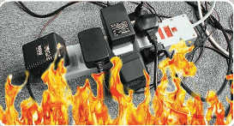
Figure4. 3A danger arises if these extension blocks are overloaded.
Most socket extensions are rated 13A (3120w capacity), but many have only 10A (1800w capacity), or even lower rating. Plugging-in most popular desk equipment should not pose a problem; laptops and desktop computers generally consume less than 250w each. Note printers can use up to 800w during printing. While employers might prohibit the use of personal electric appliances - a kettle or personal heater can eachconsume 3000w, so would instantly overload and blow the fuse of an extension block - there remains a more serious risk if employees wanting yet more outletsdecide to plug a second extension block into the first one, so increasing the risk of overheating; or plug an adaptor into an extension block, especially as blocky-type adaptors are usually unfused. Accepting the danger of a breach in H&S policy, putting each rectangular-style socket extension block inside a D-Line Cable Tidy Unit represents a practical way to reduce such risk; making the socket block lessaccessible or less inviting to employees, and an adaptor more awkward to fit.
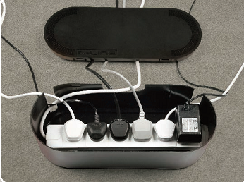
Figure 4. 4 enclosing the extension block reduce the possibility of any drink spill on to live sockets.
It should be considered that however small the risk assessed, enclosing the extension block reduces the possibility of any drink spill on to live sockets. While circuit protection should be effective, all steps should be taken to avoid the surge and heat that can arise should liquids (conductive) contact with electricity.
Similarly best practice should consider that when copper cables are fully loaded and form a tight coil to nest around an extension block, some cables can be fully entrapped so their heat cannot disperse; a danger eliminated by using Cable Tidy Units (note 17th Edition of IET Wiring Regulations state in BS7671:2008 section Cable
Enclosures that when containing pvc insulated cables ‘not more than 45% of space within a conduit or trunking must be occupied by cables’; a principle transferable to Cable Tidy Units). Cable Tidy Units should provide ample space, and require also that the cable from each plug-top must be routed via one of the three rear exit slots… so further minimizing risks from ‘excessive’ heat build-up. These slotted exits are vents also. Entry and exit cables should be concealed in D-Line Spiral Wrap, Cable Tidy Tubes or Trunking. D-Line Cable Tidy Units are produced in the UK using electrically safe material, and have been fully safety tested (when overloaded with cables, and vents blocked!)
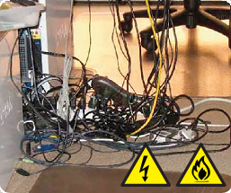
Figure4. 5Cable Tidy Units

4.1.3 Split insulation, and damaged conductors
Frayed or split insulation on power cables give a leakage point for current to electrocute. At worst a shock of 240v can be fatal. A similar risk occurs if cables are pulled to strain or loosen a termination point, to leave either an exposed ‘live’ conductor or broken conductor strands.
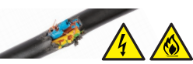
Figure4. 6 Risk occurs if ‘live’ conductor or broken conductor strands.

Broken conductor strands disrupt the natural flow of current, creating resistance by forcing high wattages over a smaller conductor area, and, over periods, where perhaps power is on 24/7, excessive heat builds up. Becoming glowingly-hot can ignite common office materials such as paper and waste, to start a fire.
Cable management products — that can protect insulation; stop cords twisting and knotting; and prevent tugs and pulls — are a small price-to-pay for safeguarding from the worst consequences.
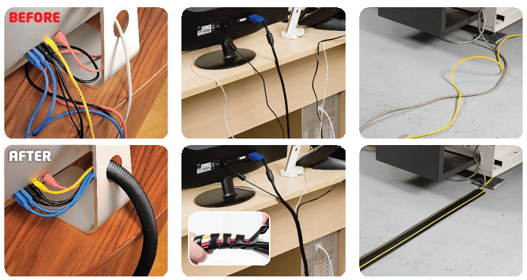
Figure4. 7 Cable management before and after in office

4.1.4. Desk Trunking or Wire Basket trays
- D-Line Desk Trunking is produced from self-extinguishing pvc which can easily be cut with a junior hacksaw. A reliable self-adhesive backing enables quick peel-and-stick installation to a desk, for example up a desk-leg, vertically from a Cable Tidy Unit up a rear panel, or horizontally between grommet exits on the desk-top. The click-lock lid makes it easy to add or remove cables; while the half-round shape and hinge-effect combine to make D-Line Desk Trunking gentler on impact.
- By comparison Wire Basket trays require screw-fixing; are not suited to bespoke sizing; are more prone to snagging and more awkward on impact if knocked.

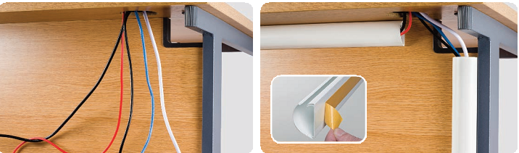
Figure4. 8 Desk Trunking or Wire Basket trays

4. 1.5. How to choose Floor Cable Protectors
- The Floor Cable Cover should be sufficiently long to cover the full length of cable(s)across the floor.
- Where a longer length is required, any link to a subsequent strip should be mechanically secure to avoid the run breaking in the event of a kick or knock.
Note D-Line’s Medium Duty profiles can uniquely be joined by patent-pending push-in pull-out connector rods that fit the continuous grip- holes along the lengths so the runs can be as long as needed… 50 metres+ if necessary. The lengths can be cut too, so continuous runs can perfectly match the requirement.

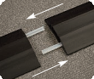
Figure4. 9 continuous runs can perfectly match the requirement
- The Floor Cable Cover must not itself be a trip hazard!
• This means it should have a tapered design, and not a sharp kerb-effect that could be potentially obtrusive
• The strip must be able to lie flat on the floor. Beware versions that are overly stiff, prone to curl or twist and never uncoil to lie flat
• Avoid alternatives that are overly thin and flimsy, too lightweight to lay flat and vulnerable to movement after minor knocks
- Consider the size and volume of cables that need to be covered, then select a Floor Cable Cover with a cavity-size that can accommodate the relevant cables.

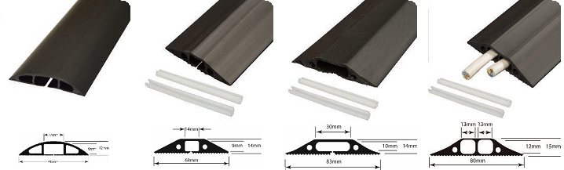
Figure4. 10 select a Floor Cable Cover with a cavity-size that can accommodate the relevant cables
Mains voltage and low-voltage cables should be segregated in a compartmentalized profile.
- Value-added features such as a ribbed back can make a strip less likely to slip after being knocked. Likewise a pre-split rear cavity makes it quick and easy to fit the strip over the cables.
Caution 1 - if preferred, after inserting cables, users can affix Floor Cable Covers to a floor by applying heavy-duty double-sided tape. Take care to ensure the floor is clean and dry so an effective bond can be made.
Beware such tapes may leave a residue on removal.
Caution 2 - do not put cables under carpet tiles, or under surface tapes. This will provide less protection for the cable, with a greater likelihood that ‘wear’ will lead to a ‘tear’ in the outer sheath of the cable, especially any thin rubberized insulation.
- Using only a tape will not offer the same protection against the cable becoming frayed, or pinched under the leg of a chair or desk. As previously, beware the electrocution risk of exposed conductors and how brokenconductors can lead to power failures, heat build-ups and fires.
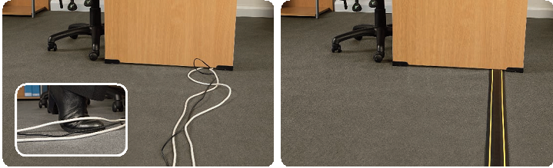
Figure4. 11 beware the electrocution risk of exposed conductors and covered conductors
4.1.6. Make your work place cable-safe!
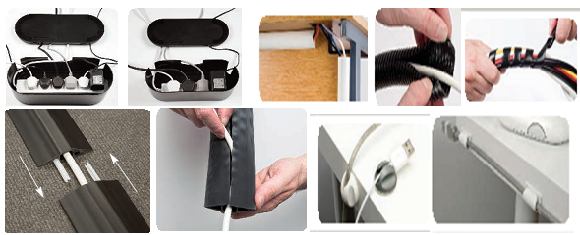
Figure4. 12 Make your work place cable-safe!
Advice
The installer(students)shall advise his teacher for the gain approval before undertaking any work at the practical workstation or on site follow up ,that may or will result in voice, data, security or other ICT network service disruption or network downtime to existing network infrastructure. Any work that may result in network down time will require scheduling with school representatives

4.2Work site safety
Site conditions
The installer shall familiarize themselves with the site conditions prior to undertaking or providing quote or estimate prices for any work. Specific conditions to be observed at collage work station during practical session or on site work of cablings OSH requirements, qualification and identification of personnel and onsite legacy equipment and configurations. Installers are required to undertake all necessary investigations to fully inform themselves of the site conditions and other factors that could impact the cost and execution of works
This includes but is not restricted to:
- Hazards that may be present at the collage practical work station or onsite cabling
- Heritage registration of buildings
- Environmental conditions including special precautions for the protection of flora and fauna
- Local site conditions including weather hazards and cultural significance
- Easements
- Safety of students and staff with respect to pit covers and location
- Existing and projected underground services, note that site maps may not be complete or available

4.3 Record sheets and plans of cable
The record sheets are generally established and maintained by the carrier or installer (supervisor) of the cable installation. Network jumpers, distribution line, mainline, color code mark ,identification at each terminal that is input and output all these and the ext. connection records will be recorded and established on the sheet and provided for owner and set for future extension or remove and add
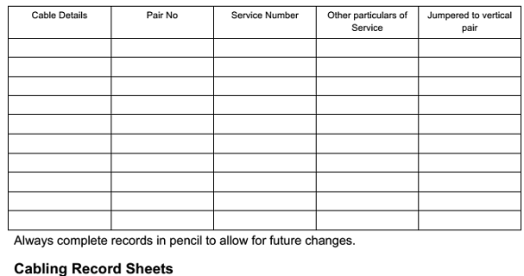
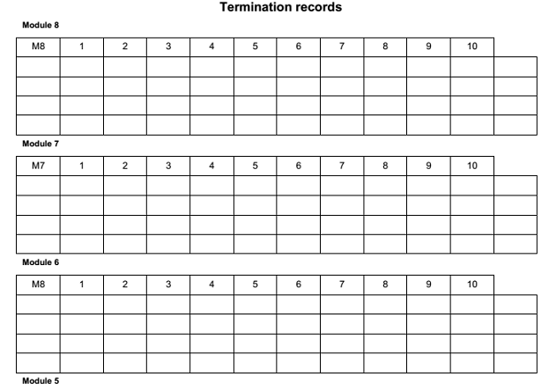

Please note that this frame does/ does not leave each 11th module position blank
Termination records-----------------
Records correct as of______________sheet______________________

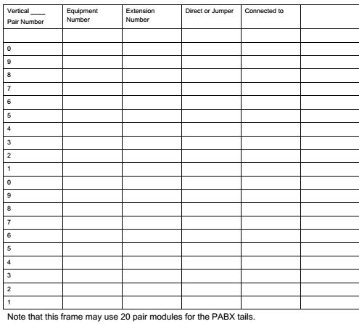

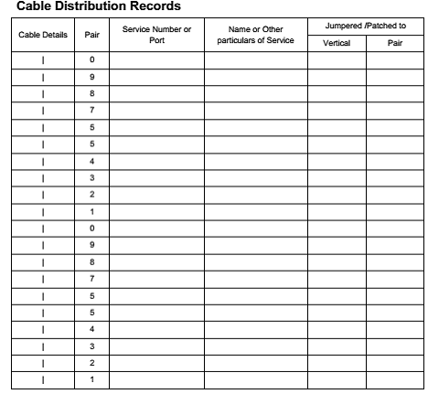

4.4Cable pair record books
Creating Cable pair record books to provide accurate record information
In an installation of data cable, Telephone cable, coaxial cable, CCTV- cable, Fiber optics and all other cable for signal transfer whether for high or low speed Planning is the first critical issue that discussed at first of all. By doing this all data survey of the area, environment, length, type of the building and all other information required to for the routing of the cable must be organized each step by step for the next removal, addition, re installation of the existing or for new construction of the system, all this records are recorded to the book form for the next option of constructing to much the coming technology or for better decision of the cost, louber , management analysis.

Documentation and report completion of installing work
A comprehensive strategy for managing power and data cables within IT racks in telecommunication is critical for the uptime, safety, and cooling efficiency of data centers. Advancements in IT rack designs have improved power and data cable management (documentation):
Effective rack power and data cable management leads to a number of IT infrastructure Benefits including: Enhanced availability through reduced downtime. A system operator or employee can be easily confused by a mess of cables, which often results in human error. Human error is widely regarded as the leading cause of data center downtime based on a study by The Uptime Institute
- Effective cable management can help system operators to manage cables and IT devices easily, so as to reduce human error.
- Improved system performance through reduced crosstalk and interference between power and data cables. Power and data cables in close proximity to each other can create electromagnetic interference (EMI), which can result in erratic or error-prone data transfer in network cables. Cable management tends to separate power and data cables within the racks, which can help reduce the risk of interference.
- Improved maintenance and serviceability by allowing easier and safer access to individual components.
- Increased cooling efficiency by allowing hot exhaust air to escape out the back of the rack. Cable management keeps cables organized and out of critical airflow paths.
- Improved scalability by simplifying moves, adds, and changes. Cable management can make it easier to integrate additional racks and components in the future as the data center grows
This documentation or guidance on power and data cable management that will improve
Physical appearance, cable traceability, airflow, cooling efficiency, and troubleshooting time while reducing the risk of human error. Following the steps outlined below can help you achieve a clean and well organized data center(documentation):
- Plan
- Determine the routes for power and data cables
- Identify cables
- Route and retain cables
- Secure cables and connectors
- Avoid thermal issues
- Document and maintain organization
Plan
Planning is the first step for power and data cable management in IT racks, and when done properly, it facilitates all of the steps below. Planning plays a critical role in any successful cable management project. If this is your first structured cabling project, we recommend that you hire a professional cab ling contractor like Schneider Electric to complete the entire project. Table below shows an example statement of work (SOW) for cable management in documentation. A key output of the planning step is to determine the number of cables needed. This is done by calculating the number and type of connections per device and the total number of devices

Activities | Description
Management | will provide cable management for the servers migrating over to the  new racks in existing and for new installation
Management | will dress cabling into neat and presentable bundles in all locations Install
Installation | will install and manage all patch cords into the rack and organize them with a specific cable management system that allows for proper airflow in the rack
Labels | will professionally label primary and secondary data cables, and primary and secondary power cables.
Logistics | will provide the knowledge and labor required for a well-organized  and professionally maintained data center with minimal downtime.
Logistics | will utilize a fully tested cable management system.

Activities | Description
Advanced coppertesting | will physically test each port from the Data Distribution Cables (DDC) to the switch for compliance to current standards, with customer approval.
Advanced coppertesting | will use a network cabling certification tester, compliant to TIA/EIA TSB67 Level III specifications.
Advanced crossover and strait through(wide-networkng) | install and manage all patch cords into the rack and organize them with a specific cable management system that allows for proper airflow in the rack
Basic copper testing | Perform a continuity port test and wire map of each port of the cables (digital mult meter)
Basic coaxial testing | Coaxial cable testing

Cabling System Documentation
The most often overlooked item during cable installation is the documentation of the new cabling system. Cabling system documentation includes information about what components make up a cabling system, how it is put together, and where to find individual cables.
This information is compiled in a set of documents that can be referred to by the network administrator or cabling installer any time moves, adds, or changes need to be made to the cabling system.
The most useful piece of cabling system documentation is the cabling map. Just as its name implies, a cabling map indicates where every cable starts and ends. It also indicates approximately where each cable runs. Additionally, a cabling map can indicate the location of workstations, segments, hubs, routers, closets, and other cabling devices. To make an efficient cabling map, you need to have specific numbers for all parts of your cabling system. For example, a single cable run from a cabling closet to wall plate should have the same number on the patch panel port, patch cable, wall cable, and wall plate. This way, you can refer to a specific run of cable at any point in the system, and you can put numbers on the cabling map to refer to each individual cable run.

Self-Check -4
Directions: Answer all the questions listed below. Use the Answer sheet provided in the next page:
Part I. Choose the best answer from the question below
- Which of the following must be robust enough and adequately protected for the working environment?
- Cables B. Plugs C. sockets D. fittings E. all
- The telecommunication and data service Installer shall comply with_______________
- all rules and Regulations C. Approved Codes of Practice,
- All relevant Standards D. Work Safe E. all
- Safety Overloading socket outlets, especially socket extensions can cause excessive heat buildup and is a major cause of ___________ from electricity.
- Overload B. fire C. burn D. heat
- The record sheets of cables are generally established and maintained by the ______________of the cable installation.
- carrier or installer B. technician C. Manager D. shopkeeper
- In creating data book for information about cable installed.
- Planning is the first pinot of view. C.Condition of the area
- Information analysis of environmentD. All
- The cable record book is used for_________
- Adding cable to the existing C. For extension of the existing
- For removal of the installed cable D. All of the above

Part II. If statement correct write True and if statement is incorrect write False for the following question.
      - Record sheet controlling is the mandate of electrical.
      - The owners the network can manage data power cable using the record sheet.
      - The installer shall familiarize themselves with the site conditions prior to undertaking or providing quote or estimate prices for any work.
      - Installers are required to undertake all necessary investigations to fully
Inform themselves of the site conditions.

.

References

- Refer to Australian Standard AS/CA S009:2013, Installation requirements for customer cabling (Wiring rules).
- Using Anixter’s online catalog at anixter .com/catalog.
- From AS/CA S009:2013 Appendix F.2,: From AS/CA S009:2013)
- www.telstra.com.au/customer-terms/
- http://www.schneider-electric.com/ww/en/download/document/APC_TESS-6W9KFF_R1_EN_SRC?showAsIframe=true&xtmc=cable%20management%20statement&xtcr=1
- (https://www.armypubs.army.mil),and the Central Army Registry site (https://atiam.train.army.mil/catalog/dashboard).
- Cabling. Part 2, Fiber-optic cabling and components ( PDFDrive )
- cabling_-_the_complete_guide_to_network_wiring_2nd_ed_malestrom.David Groth Jim McBee David Barnett
- Advances in Signal and Data Processing Select Proceedings of ICSDP 2019 (0009172) (z-lib.org)

Developer profile

No | Name | Qualification (Level) | Field of Study | Region | Organization/ Institution | Mobile number | E-mail
1 | Mengistu Abiyu | MSc | Industrial Automation & Control Management | A.A | Lideta Manufacturing College | 0913948480 | menabiy@gmail.com
2 | Samuel Bekele | MSc | Industrial Automation & Control Management | Oromia | Haramaya PTC | 910082977 | samuelbekele460@gmail.com
3 | Yidnekachew Seboka | BSc | Electrical Automation & Control Technology | A.A | Akaki PTC | 920137899 | www.yidne23@gmail.com
4 | Zegeye Girma | BSc | Electrical Automation & Control Technology | A.A | Addis KetemaIn.College | 926805563 | zegeyegirma2@gmail.com
5 | Bacha Wake | MSc | Industrial Automation & Control Management | Sidama | HawassaTegibarid PTC | 987065251 | bachawake@gmail.com

