BUILDING ELECTRICAL INSTALLATION LEVEL-III
Based on October 2023, Curriculum Version II
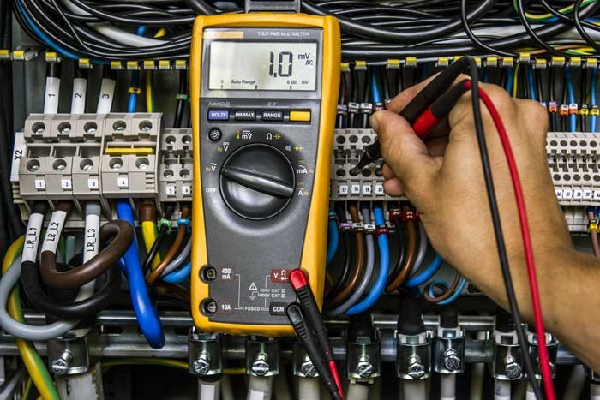

Module Title: - Maintenanceof Electrical Equipment
Module code: EIS BEI3M91023
Nominal duration: 64 Hours

Prepared by: Ministry of Laboure and Skill
October, 2023

Addis Ababa, Ethiopia
Contents
Acknowledgment 3
Acronym 3
Introduction to the Module 4
UNIT ONE: CONCEPT OF MAINTENANCE OF ELECTRICAL EQUIPMENT 6
1.1. Concept of Maintenance 7
1.2. Equipment reliability and failure modes 16
1.3. Maintenance schedule 17
1.4. WHS and OHS consideration 17
Self-check 1 19
UNITTWO: MAINTAINANCE ELECTRICAL EQUIPMENT AND ASSOCIATED CIRCUITS 21
2.1. Visual inspection and condition assessment 22
1.1. Cleaning and lubrication procedures 34
2.2. Testing and diagnostic techniques 36
2.3. Troubleshoot and fault finding 43
2.4. Repair and replacement of components 51
2.5. Calibration and adjustment of equipment 58
2.6. preventive maintenance tasks 60
Self-check 2 61
Operation Sheet 1- Troubleshooting circuit breaker 63
Operation Sheet 2- replacing circuit breaker 64
LAP TEST 65
UNITTHREE: NOTIFY COMPLETION AND DOCUMENT RESULTS 66
3.1. Importance documenting maintenance activities 67
3.2. Completion checklist and sign-off procedures 68
3.3. Recording and reporting any identified issues or abnormalities 70
Self-check 3 72
Reference Materials 73
Developer’s Profile 74

Acknowledgment

Ministry of Labor and Skills wish to extend thanks and appreciation to the representatives of TVET instructors, General Winget Poly Technique College experts who donated their time and expertise to the development of this Trainee’s Guide (LG).

Acronym

WHS- Workplace Health and Safety
OHS- Occupational Health and Safety
PPE- personal protective equipment
CB- Circuit Breakers
DMM- Digital multi-meters
AMM- Analog multi-meters
RPM - revolutions per minute
UPS- uninterruptible power supply
AC- Alternative Current
DC- Direct Current

Introduction to the Module

In building electrical installation field understanding of Maintenance of Electrical Equipment, is very important for maintenance of electrical equipment. It helps to know basic Concept of maintenance of electrical equipment, types of maintenance, testing and diagnostic techniques, Repair and replacement of components
This module is designed to meet the industry requirement under the building electrical installation occupational standard, particularly for the unit of competency: Install and connect extra low voltage wiring systems.
Module covers the units:
- Concept of maintenance of electrical equipment
- Maintain electrical equipment and associated circuits
- Notify completion and document results
Learning Objective of the Module
- Understand concept of Maintenance of electrical equipment
- Identify types of maintenance
- Understand OHS
- Testing and diagnostic techniques
- Notify completion and document results.
Module Instruction
For effective use these modules trainees are expected to follow the following module instruction:
- Read the information written in each unit
- Accomplish the Self-checks at the end of each unit
- Perform Operation Sheets which were provided at the end of units
- Do the “LAP test” giver at the end of each unit and
- Read the identified reference book for Examples and exercise

UNIT ONE: CONCEPT OF MAINTENANCE OF ELECTRICAL EQUIPMENT
This unit is developed to provide you the necessary information regarding the following content coverage and topics:
- Concept of Maintenance
- Equipment reliability and failure modes
- Maintenance schedules
- WHS and OHS consideration
This unit will also assist you to attain the learning outcomes stated in the in the above unit. Specifically, upon completion of this learning guide, you will be able to:
  - Understand basic concepts of maintenance
  - Evaluate of equipment reliability and failure modes
  - Follow the procedures of maintenance schedules
  - Follow WHS and OHS consideration

Concept of Maintenance
The concept of maintenance of electrical equipment refers to the activities and practices carried out to ensure the proper functioning, reliability, and safety of electrical equipment over its operational lifespan. It involves a systematic approach to inspect, test, clean, repair, and replace components or systems as needed to prevent equipment failure, minimize downtime, and optimize performance.
Maintenance of electrical equipment is essential for several reasons:
- Safety: Electrical equipment poses potential risks such as electrical shocks, short circuits, and fire hazards. Regular maintenance helps identify and address safety issues, such as loose connections, worn-out insulation, or faulty components, reducing the risk of accidents or injuries.
- Reliability: Well-maintained electrical equipment is more reliable and less likely to experience unexpected breakdowns or failures. Regular inspections and preventive maintenance activities help detect and address potential issues before they escalate into major problems, ensuring uninterrupted operation and productivity.
- Efficiency: Properly maintained electrical equipment operates more efficiently, consuming less energy and reducing operational costs. Maintenance activities include cleaning, lubrication, and calibration of equipment, ensuring optimal performance and minimizing energy waste.
- Compliance: Many industries have specific regulations and standards governing electrical equipment maintenance to ensure compliance with safety and quality requirements. Regular maintenance helps organizations meet these standards and avoid penalties or legal consequences.
Maintenance of electrical equipment typically involves the following activities
- Inspections: Regular visual inspections and functional checks to identify any visible signs of damage, wear, or abnormalities. This may involve checking for loose connections, signs of overheating, or damaged insulation.
- Cleaning: Removing dust, dirt, and debris from equipment surfaces, ventilation systems, and electrical contacts. Clean equipment operates more efficiently and reduces the risk of overheating or electrical faults.
- Lubrication: Applying appropriate lubricants to moving parts, such as motors or bearings, to reduce friction and prevent premature wear.
- Testing: Conducting electrical tests to assess the performance and integrity of the equipment. This may include voltage tests, insulation resistance tests, or load testing.
- Repairs and replacements: Addressing identified issues by repairing or replacing faulty components, such as damaged cables, fuses, switches, or circuit breakers.
- Preventive maintenance: Following a scheduled maintenance plan that includes routine tasks to prevent problems before they occur. This may involve replacing consumable parts, conducting preventive inspections, or performing regular maintenance based on manufacturer recommendations.
- Documentation:Keeping records of maintenance activities, including inspection results, repairs, and replacements. Documentation helps track the history of equipment, plan future maintenance, and demonstrate compliance with regulations.
    - Importance and benefits of maintenance
Maintenance plays a crucial role in ensuring the optimal performance, reliability, and longevity of electrical equipment. there are some key importance and benefits of maintenance:
- Equipment Reliability and Availability: Regular maintenance helps identify and address potential issues before they lead to equipment failures or breakdowns. By conducting preventive maintenance activities, equipment downtime can be minimized, ensuring that the equipment is available and operational when needed. This is particularly important in critical applications or industries where equipment failure can have severe consequences, such as power generation, healthcare, or manufacturing.
- Safety: Maintenance activities help identify and mitigate safety hazards associated with electrical equipment. By inspecting and addressing issues like loose connections, insulation degradation, or faulty components, the risk of electrical shocks, fires, or other accidents can be significantly reduced. This ensures a safer working environment for personnel who operate or work near electrical equipment.
- Cost Savings: Well-maintained electrical equipment tends to have lower life cycle costs. Regular inspections and preventive maintenance can help detect and rectify issues at an early stage, preventing costly breakdowns or major repairs. Additionally, properly maintained equipment operates more efficiently, leading to energy savings and reduced operating costs over time.
- Enhanced Equipment Performance: Maintenance activities such as cleaning, lubrication, and calibration can optimize the performance of electrical equipment. Clean and well-lubricated components operate more efficiently, resulting in improved energy efficiency and reduced wear and tear. Calibration ensures accurate performance, which is critical for equipment that relies on precise measurements or controls.
- Compliance with Standards and Regulations: Many industries have specific regulations and standards governing the maintenance of electrical equipment to ensure safety, reliability, and compliance. By implementing regular maintenance practices, organizations can meet these requirements and avoid penalties, legal issues, or reputational damage.
- Extended Equipment Lifespan: Proper maintenance can contribute to extending the lifespan of electrical equipment. By identifying and addressing issues early on, preventing excessive wear, and ensuring proper functioning, equipment longevity can be significantly improved. This can help organizations maximize their return on investment and delay the need for costly equipment replacements.
- Improved Operational Efficiency: Well-maintained equipment operates at its optimal level, resulting in improved operational efficiency. This can lead to increased productivity, reduced downtime, and smoother workflow processes. By minimizing disruptions caused by equipment failures or malfunctions, maintenance contributes to overall operational effectiveness.
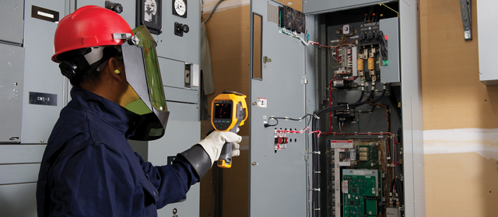

Fig 1.thermography scan of all electrical systems
Infrared thermography is an advanced precautionary maintenance program for Electrical System. Thermography is ideal to see beyond what is visible to the naked eye.
Care labs offers thermography scan of all electrical systems to identify too hot or too cold areas. The primary application for infrared thermography is electrical applications. Thermal imaging is the method utilized for detecting and visualizing the electrical faults.
    - Types of maintenance
Maintenance activities can basically be divided into two types: planned maintenance activities and unplanned maintenance activities.
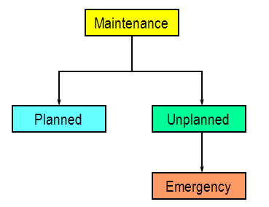
1.Unplanned Maintenance: -Maintenance performed unexpectedly.
Example: A band saw blade breaks during its operation, this is unplanned what will you do, buy a new blade and replace it.
EmergencyMaintenance is performed to avoid serious consequences, such as loss of production and extensive damage to assets or for safety reasons.
Example: A car broke down in an unexpected place (in front of a cemetery) at an unexpected time (midnight).
2.Planned maintenance is maintenance that is organized and carried out with thought to the future, control and recording in accordance with the plans that have been determined previously
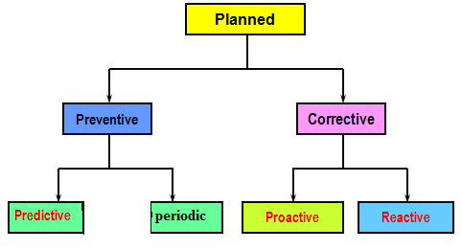

- Preventive Maintenance:
It is a method for preventing damage to equipment by periodically replacing parts based on time of use and carrying out minor maintenance and inspections to find out the current state of the equipment / machinery.There are a set of activities that are performed on plant equipment, machinery, and systems before the occurrence of a failure in order to protect them and to prevent or eliminate any degradation in their operating conditions.

Example: Cleaning, checking, lubricating, bolt tightening Periodic inspection Periodic and small over haul restorations
- Predictive Maintenance:
Predictive maintenance is a method for doing maintenance by replacing parts based on predictions using a tool. The point is if the preventive method is only based on the schedule, then the predictive method is based on the results of the measurement.
This method can also use the five senses, for example in bearing inspection can be distinguished from the sound produced. Or checking temperature, by touching it we can feel the difference or abnormality of the equipment.
- Corrective Maintenance:
It is a method intended to improve the reliability of equipment/machines by improvising. In addition to equipment, it is also intended for parts that have a short life cycle (reduce the frequency of damage) and speed up repair time.
- Breakdown Maintenance
It is a method where inspection and replacement of parts are not carried out, so with this method we leave the equipment damaged and then we fix it or replace it
Usually, this method is applied to equipment / machines with consideration:
- Equipment is only optional (additional) so that if it is damaged it does not interfere with production
- The cost of repairing / replacing cheap parts
- Insignificant damage
- Easy and fast repair.
- Maintenance Objectives
Maintenance objectives should be consistent with and subordinate to production goals.
- Maximising production or increasing facilities availability at the lowest cost and at the highest quality and safety standards.
- Reducing breakdowns and emergency shutdowns.
- Optimising resources utilisation.
- Reducing downtime.
- Improving spares stock control.
- Improving equipment efficiency and reducing scrap rate.
- Minimising energy usage.
- Optimising the useful life of equipment.
- Providing reliable cost and budgetary control.
- Identifying and implementing cost reductions.
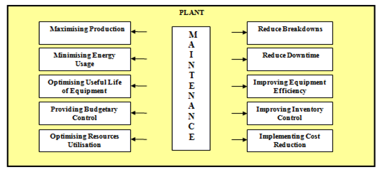
- Planning maintenance work
Many electrical accidents are due to a failure to plan ahead. Planning should consider the management, supervision, implementation and completion of the work, and should lead to a formal system of work based on information in the safety rules and a task-specific risk assessment. You should consider the following:
- The work to be done;
- The hazards of the system or equipment to be worked on and the risks associated with the work;
- The people doing the work, their competence and the level of supervision necessary;
- The precautions to be taken and the system of work to be employed;
- The possibility that the nature of the work may change, e.g. a testing job may turn into fault finding.
There must be adequate information available about the electrical system and the work to be done. In the case of a newly constructed electrical system (or newly installed equipment), there should be drawings and schedules relating to the design and these should have been updated, if necessary, by the people carrying out the installation.
- Advantages of a Planned Maintenance
- Planned maintenance is the routine of performing inspections, minor repairs, cleaning, and upkeep, rather than waiting until something breaks down to take action. In fewer words, planned maintenance, also known as preventive maintenance, is a proactive rather than reactive approach.
- Failure to timely diagnose any potential malfunction and operational issues with machines or buildings can have dire costs, both in terms of time and money.
    - Characteristics of maintenance
Maintenance refers to the activities and processes undertaken to ensure the proper functioning, reliability, and longevity of equipment, systems, or facilities. there are some key characteristics of maintenance:
- Preservation: The primary goal of maintenance is to preserve the functionality, reliability, and performance of equipment, systems, or assets. It involves taking practical measures to prevent deterioration, minimize wear and tear, and address issues that could lead to failures or breakdowns.
- Proactive and Reactive: Maintenance activities can be both proactive and reactive. Proactive maintenance focuses on preventing failures by implementing preventive and predictive measures, while reactive maintenance involves responding to failures or breakdowns and restoring functionality.
- Asset Lifecycle Management: Maintenance is an integral part of the asset lifecycle management process. It starts with the acquisition or installation of assets, continues with regular maintenance activities throughout their operational life, and often includes decommissioning or replacement when assets reach the end of their useful life.
- Cost Optimization: Maintenance aims to achieve a balance between the cost of maintenance activities and the consequences of failure.

It involves optimizing maintenance strategies, scheduling, and resource allocation to minimize costs associated with downtime, repairs, and replacement, while ensuring the desired level of reliability and performance.
- Risk Management: Maintenance plays a crucial role in managing risks associated with equipment or system failures. It involves identifying potential risks, assessing their likelihood and impact, and implementing appropriate maintenance measures to mitigate or control those risks.
- Continuous Improvement: Maintenance practices emphasize continuous improvement and learning from past experiences. By analyzing failure data, performance metrics, and feedback, maintenance processes can be refined and optimized to enhance reliability, reduce costs, and increase efficiency.
- Multidisciplinary Nature: Maintenance requires collaboration and coordination among various disciplines, including engineering, operations, maintenance technicians, and management. It involves a combination of technical knowledge, diagnostic skills, planning, and execution to effectively maintain and manage assets.
- Compliance and Regulations: Depending on the industry and the type of equipment or systems involved, maintenance activities may need to comply with specific regulations, standards, or legal requirements. These can include safety regulations, environmental standards, or industry-specific guidelines.
- Documentation and Record Keeping: Maintenance activities are often documented and recorded to track maintenance history, facilitate troubleshooting, and support decision-making. This includes maintenance logs, work orders, equipment records, and reports.
- Integration with Operations: Maintenance is closely intertwined with operations. Effective maintenance practices consider operational requirements, production schedules, and equipment utilization to minimize disruptions, optimize maintenance windows, and ensure the availability of assets when needed.

Equipment reliability and failure modes
Equipment reliability refers to the ability of equipment or systems to perform their intended functions without failures or breakdowns, over a specific period of time and under given operating conditions. It is a measure of the equipment's dependability and consistency in delivering expected performance.
- Reliability is influenced by various factors, including design, manufacturing quality, maintenance practices, operating conditions, and environmental factors. High reliability indicates that the equipment is less prone to failures and can perform consistently over time.
- Failure Modes: Failure modes refer to the different ways in which equipment or systems can fail or cease to function properly. Understanding failure modes helps in identifying potential risks and developing strategies to prevent or mitigate failures. Some common failure modes include:
- Mechanical Failure: Mechanical failures occur when components or parts of the equipment break, deform, or wear out due to excessive stress, fatigue, or inadequate maintenance. Examples include bearing failure, gear tooth breakage, or shaft misalignment.
- Electrical Failure: Electrical failures involve issues with electrical components, circuits, or connections. This can include short circuits, insulation breakdown, component burnout, or electrical arcing.
- Environmental Failure: Environmental failures occur when equipment is exposed to harsh or unsuitable conditions, such as extreme temperatures, humidity, corrosive substances, or excessive vibrations. These conditions can lead to degradation, corrosion, or malfunctioning of equipment components.
- Software or Control Failure: For equipment with embedded software or control systems, failure modes can include software glitches, programming errors, or control system malfunctions. These failures can lead to incorrect operation, system crashes, or loss of control.
- Human Error: Human error can contribute to equipment failures, such as incorrect operation, inadequate maintenance, or failure to follow safety procedures. Improper handling, installation, or troubleshooting can also lead to failures.
- Wear and Tear: Over time, equipment components can naturally degrade or wear out due to normal usage. This can result in reduced performance, increased friction, or component failure. Examples include worn-out seals, corroded pipes, or worn-out belts.

Maintenance schedule
A maintenance schedule can be defined as an important document that can be used for recording the weekly, monthly and yearly schedule of the maintenance if home or office and their possessions. It is usually found in offices and homes that are huge and need a schedule to maintain them properly. A maintenance schedule represents the routine services and or inspections that are to be performed on a plant item. Each maintenance schedule consists of multiple intervals which are assigned a service or inspection procedure. The maintenance schedule is a useful tool that keeps cost down and property function and appearance up. This allows work to get done in the most efficient, economical way.
Maintenance schedule
Equipment | Daily | Weekly | Monthly | Quarterly | Annually
All electrical equipment | Visual inspection | Clean | Test circuit breakers | Perform a more detailed inspection, | Have inspected and serviced by a qualified electrician
All electrical equipment | Checkfor unusual noisesor smells | check for loose connections | Test fuses | clean and lubricate electrical contacts, | Have inspected and serviced by a qualified electrician
All electrical equipment | test emergency stops buttons | lubricate moving parts | check insulation resistance, | Have inspected and serviced by a qualified electrician | Have inspected and serviced by a qualified electrician
All electrical equipment | Testsafety devices | lubricate moving parts | test grounding system

WHS and OHS consideration
Workplace Health and Safety (WHS), also known as Occupational Health and Safety (OHS), refers to the practices, procedures, and regulations aimed at ensuring the health, safety, and well-being of workers in the workplace. It involves identifying and controlling workplace hazards, promoting safe work practices, and complying with applicable laws and regulations.
- Hazard Identification and Risk Assessment: WHS involves identifying potential workplace hazards and assessing the risks associated with them. This includes conducting regular inspections, risk assessments, and audits to identify hazards such as physical, chemical, biological, and ergonomic risks.
- Risk Control Measures: Once hazards are identified, appropriate control measures must be implemented to eliminate or minimize the risks. This can include engineering controls, administrative controls, and personal protective equipment (PPE) to mitigate hazards and create a safe working environment.
- Training and Education: Proper training and education are essential for promoting WHS in the workplace. Workers should receive training on safe work practices, emergency procedures, proper use of equipment and machinery, and awareness of potential workplace hazards. Regular refresher training is also important to keep workers up to date with the latest WHS practices.
- Incident Reporting and Investigation: WHS requires the establishment of a robust incident reporting and investigation system. Workers should be encouraged to report incidents, near misses, and hazards. Thorough investigations should be conducted to determine the root causes of incidents and take corrective actions to prevent future occurrences.
- Consultation and Participation: Effective WHS involves worker consultation and participation. Workers should have the opportunity to provide input on WHS matters, participate in workplace inspections, and be involved in decision-making processes. This helps foster a culture of safety and ownership among workers.
- Compliance with Laws and Regulations: Employers have a legal obligation to comply with WHS laws and regulations applicable to their jurisdiction. This includes understanding and adhering to relevant legislation, codes of practice, and industry standards to ensure a safe and healthy working environment

Self-check 1

I. Choose the correct answer from the give alterative
- Which of the following best describes the concept of maintenance?
a) Repairing equipment after it fails
b) Preventing equipment failure through proactive actions
c) Replacing equipment with new ones
d) Ignoring equipment until it breaks down
- Equipment reliability refers to:
a) The probability of an equipment failure occurring
b) The age of the equipment
c) The cost of maintaining the equipment
d) The efficiency of the equipment
- Failure modes refer to:
a) The different ways equipment can be used
b) The methods used to prevent equipment failure
c) The specific ways in which equipment can fail
d) The cost associated with equipment maintenance
- Maintenance schedules are developed to:
a) Minimize the cost of maintenance
b) Maximize equipment downtime
c) Ensure equipment operates at peak efficiency
d) Randomly perform maintenance tasks
- .WHS and OHS considerations in maintenance activities primarily focus on:
a) Maximizing equipment performance
b) Reducing maintenance costs
c) Ensuring the safety and well-being of workers
d) Extending equipment lifespan

II Match column “B” to column “A”
Colmen AColmenB
1. Corrosion A. unexpected power loss
2. Overheating B. Physical damage to equipment
3. Wear and tear C. Gradual degradation of material due to chemical reactions
4. Impact or shock D. Excessive heat generation
5. Power outage E. Deterioration caused by repeated use or friction
III Give short and precise answers for the following question

- Define the concept of maintenance?
- Explain the importance of equipment reliability in industrial operations?
- List three key WHS or OHS considerations in maintenance activities?

UNITTWO: MAINTAINANCE ELECTRICALEQUIPMENTAND ASSOCIATED CIRCUITS
This unit is developed to provide you the necessary information regarding the following content coverage and topics:
  - Visual inspection and condition assessment
  - Cleaning and lubrication procedures
  - Testing and diagnostic techniques
  - Troubleshoot and fault finding
  - Repair and replacement of components
  - Calibration and adjustment of equipment
  - preventive maintenance tasks
This unit will also assist you to attain the learning outcomes stated in the cover page. Specifically, upon completion of this learning guide, you will be able to:
  - InspectVisual inspection and condition assessment
  - Clean and lubrication procedures
  - InspectTesting and diagnostic techniques
  - Identify troubleshooting and fault finding
  - Repair and replacement of components
  - Calibrate and adjustment of equipment
  - Inspect preventive maintenance tasks

Visual inspection and condition assessment
Visual inspection and condition assessment are essential activities for evaluating the condition, integrity, and performance of equipment, structures, or systems. They involve visually examining components, surfaces, and other relevant elements to identify any signs of damage, wear, deterioration, or abnormalities. there is an overview of the process:
- Preparation: Before conducting a visual inspection, it's important to gather relevant information about the equipment or structure being assessed. This can include maintenance records, historical data, specifications, and any known issues or concerns. It's also important to ensure safety measures are in place, such as wearing appropriate personal protective equipment (PPE) and following safety protocols.
- Visual Examination: A systematic visual examination is performed to observe and assess the condition of the equipment or structure. It involves visually inspecting various components, surfaces, joints, connections, and areas where potential issues or deterioration may occur. Inspection can be done using the naked eye or with the assistance of specialized tools such as magnifying glasses, borescopes, or cameras.
- Documentation: During the visual inspection, any observed issues, abnormalities, or areas of concern should be documented. This can include taking notes, capturing photographs, or creating sketches to record the findings. Documentation helps in tracking changes over time, comparing inspection results, and facilitating decision-making.
- Condition Assessment: Based on the visual inspection findings, a condition assessment is performed. This involves evaluating the severity, extent, and potential impact of any observed abnormalities or defects. The assessment can be qualitative, providing a general assessment of the condition, or quantitative, involving measurements or rating systems to assign a specific condition score.
- Recommendations: After completing the visual inspection and condition assessment, a report is prepared summarizing the findings. The report may include descriptions of observed issues, photographs or diagrams illustrating the identified conditions, and recommendations for further actions. Recommendations can range from routine maintenance tasks to more extensive repairs, replacements, or additional diagnostic tests.
Maintaining different equipment
Circuit Breaker maintenance
Role of a Circuit Breaker: Most electrical systems in flats have a circuit breaker which ensures that users do not overload the power circuits and that wires do not carry more power than the wires can safely handle. When excessive power is drawn from a given circuit (due to a defective electrical appliance or when too many devices are plugged into the same circuit), the circuit breaker will trip the circuit and cut off all electricity to prevent damage to the device, electrocution of the user, and overheating of the device or even electrical fires. Circuit breakers and fuses both provide the same protection. During a power surge, they stop the power flow. However, the downside of fuses is that they have to be replaced every time they have been operated in an open circuit, while a circuit breaker simply needs to be reset.
Typical Circuit Breakers Problems
- Bad Wiring or loose connections- This could cause flickering lights and power failures. Loose connections may be caused by general wear and tear of the electrical wiring, which can cause increased resistance. This increased resistance then generates heat that can lead to overheating of the wires. If faced with such problems, look for visible loose wiring.
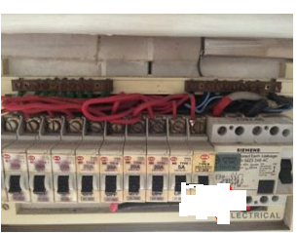
Fig 2. Bad Wiring or loose connections

- Overloaded circuit –This can lead to power failures, electrical fires which could put people at risk of injury.
- Short circuit – Live electrical wires may overheat and melt the outer insulation case protecting the wire, leading to short circuits. Also, when live wires touch a grounded or neutral wire or other unintended conductors, a short circuit might occur, and this might lead to electrical fires.
- . Defective electrical devices – These devices may draw excess electricity in surges, tripping circuit breakers.
Replacing a Faulty Circuit Breaker
Circuit breakers tend to last a long time, but circuit breakers can get worn out over time and after several reuses and can break or malfunction. It is very dangerous to replace the blown fuse or faulty circuit breaker with a circuit breaker that has a higher rating. If the wiring in that circuit is not the appropriate rating/size for that higher rating, the excessive current carried will cause overheating or electrical fires. When replacing a circuit breaker, you will need:New circuit breaker (same brand, make, model and size as the one you're removing)
Test the breakers with a voltage tester to make sure everything is in order
Figure 3. Correct circuit breaker installation

prevent circuit breaker trips
Unplug electrical appliances that are not being used. Electricity can still flow through electrical wirings in an appliance even when turned off.
- During hotter weather, be aware of the number of electrical appliances plugged in as it may worsen the problem of overheating.
- Look for damaged, melted, scorched or frayed wires/cords for appliances. Keep the cords in the best condition possible. Avoid overstretching wires, bending them or placing heavy or sharp objects in contact with them.
Signs of a Faulty Circuit Breaker
- It stays in the “ON” position but supplies no current to the circuit. Use a multi-meter to measure the voltage at the circuit breaker. There will be no voltage if the circuit breaker is bad.
- It trips, and after reset, trips again immediately.
- It trips, and after reset, stays on, then trips again within a few hours
- It is hot in temperature or giving a burning smell
- It is showing signs of damage such as charred material or frayed wires.
Light installation, relocation or fitting services maintenance
Appropriate lighting enables homeowners to complete tasks efficiently, feel safer and create an aesthetically-pleasing haven after a long day at work. However, based on the size of each room in the house, there are specific lighting needs. Faulty installations may sum up to a larger amount than the installation cost you saved while doing it yourself.
Different types of light installation for different parts of your house
This is a general guide on the types of light installations for various parts of your house. Based on the functionalities or aesthetic purpose of the lights, there are some lighting inspirations:
It is crucial for lightings in the kitchen and bathroom to be well-lit at any time of the day since we are constantly completing tasks in that area. Having multiple lights would serve to complete the aesthetic look of the area, while providing sufficient lightings to remove any dark areas which could lead to injuries. Light installations here would include LED light installation, ceiling light installation and wall lighting at the corners. However, lights installation at this area is tricky since these lights will be exposed to water. It is crucial to have a certified professional electrician to ensure that the electrical wiring is done with caution. Electricians are well-trained in handling electrical wirings to ensure no breach of safety for lightings in areas that will be exposed to water.
Common Light Installation problems
These are some of the common light installation and fixture problems you should be aware of:
Faulty Wiring
Lighting components comprises of many parts, including the wires and tube casings. These wires are usually very delicate, which might be prone to damage upon any mishandling. Electricians must be extremely careful when dealing with these light bulbs even when they are brand new removed from the package. During installation, it is crucial to check that the wirings are in their original placing. Should the wires be out of their places, there are possibilities that they can get frayed, bent, broken or detached from their terminals, causing the common household phenomenon of “my lights are not working”.
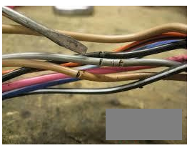
Fig 4.Broken lines

Light Bulbs burning out quicker
Light bulbs are supposed to be quite long lasting, providing you with lights for many years without replacements. Hence, regular burning out of light bulbs is a serious issue which is not supposed to happen. Reasons include low quality bulbs usage, switch problems or wiring issues. After a proper and comprehensive troubleshooting, provide the diagnostic of the problem; recommend the most suitable repairs and replacement of light fixtures.
. Flickering and Dim lights
It is common for households to experience flickering and dim lights one fine day when you’ve turned on the switch. There are various reasons why the lights will be flicker, including poor wiring, damaged starters and faulty switches. If your lights are flickering, you should troubleshoot the actual cause and the light fixture for proper replacement.
Damaged light switch
These light fixtures are controlled by various types of switches, which should also be functioning well to ensure the lights are working. Switches can be damaged because of various reasons including loose wires, overheating, wear and tear after a prolonged period of usage. It is advisable to fix the damaged light switches to ensure smooth running of your lights again.
Replacement of light fixtures
However, do take note of the safety precautions to take prior to fixing. The great part about light fixtures replacement is that it’s a pretty universal process. These are the steps to take:
1. Turn off power to the old fixture
2. Remove the canopy to expose the wiring and fixture hardware
3. Unscrew the three wires (Black, white and copper)
4. Remove the old light fixture
5. Install the new bracket
6. Connect new fixture wires
7. Secure the new fixture
8. Restore power and test out the new fixture
Note that at any point of the replacement of light fixtures, ensure that your hands are totally dry and always standby for sufficient lighting such as torch lights should you be replacing the lights at night. After attempting to replace the light fixtures, should complications arise from the unsuccessful installations,
Power Socket/Power point installation services
Faulty power sockets are one of the most common and inevitable issues faced. Since it is the only viable way for us to get our electrical appliance to work, it is definitely troublesome whenever one stops working. Although the most common problem occurs from an electrical wiring issue, it is not surprising to see a power point malfunctioning just for no apparent reason. As complicated as it sounds, replacing the electrical outlet may or may not solve the problem entirely and you might need to take an extra step: A complete rewiring of your electrical switch. This is to prevent any fire hazards or any trigger of a shock.
Unplanned events or conditions
Portable equipment and the electrical connections to it (eg the plug and flexible cable and its terminations) are likely to be subjected to, and more vulnerable to, physical damage and wear or harsh treatment in use than equipment which forms part of the fixed installation. The fixed installation is usually provided with a significant degree of protection against damage by the fabric of the building or fixed enclosure. (But the same legal requirements apply to both portable and fixed equipment).
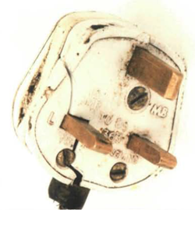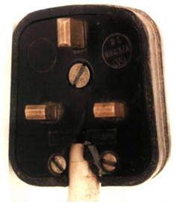
Fig 5.Damage plug casing fig 6.Cracked casing and damaged cable sheath
Equipment that is held by hand or handled when switched on will present a greater degree of risk because, if it does develop a dangerous fault, the person holding it will almost certainly receive an electric shock.
Construction of the equipment
For safety reasons some electrical equipment relies on the metallic (exposed conducting) parts of the equipment being effectively earthed. This type of equipment is known as 'Class I'. If this earth connection islost there is a possibility of the exterior of the equipment becoming live, with a potentially fatal result. Anyone touching live metal will be in contact with electricity.
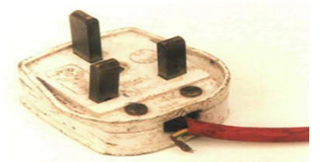
Fig 7 lost earth connection
Reasons of power socket failures:
It comes as a shock when you find out that your power socket stopped working without knowing what is the underlying reason. These are some of the most common reasons behind power socket failures:
Open circuits:
An open circuit is an electrical circuit that is not completed. The most common cause of open circuits is loose wires, leading to the incompletion of the entire electrical circuit. Poor socket installation can also result in a gap or break in the electrical wiring.
Overloaded circuits:
An overloaded circuit is an electric circuit that is carrying more current that it is designed to handle, creating a danger through overheating Whenever a circuit is overloaded, the circuit breaker trips, causing the flow to fuse, to prevent the overheating of electrical wires. As a result, the connection breaks and the circuit fail.
Short circuits:
A short circuit is a low resistance connection between 2 conductors supplying electrical power to any circuit. It results in excessive current flow through the ‘short’, and may cause the power source to be destroyed. This also occurs when a hot wire accidentally touches a ground wire. This eventually leads the current to the circuit breaker, tripping the circuit.
Faulty outlets:
If the above does not describe any of the problems that you are currently facing, it is possible that the outlet was faulty to begin with. It is easy and cheap to replace the outlets. However, it is important to shut off any circuit before doing replacement works as it is dangerous to do so with the circuit running.
Possible consequences of faulty power sockets usage:
It is important to know the consequences of using a faulty power socket. Electrical outlets provide such constant and convenient use that it is easy to forget that it is only protected by a thin layer of rigid plastic beneath the outlet receptacle. Over time, the plastic could melt or crack, exposing the current.
Shock risk:
It is most commonly known to all that exposed hazards can provide a shock risk to the user especially if you’re not careful with the sockets. These shocks can be deadly, and it is extremely dangerous.
Fire hazard:
Whenever a socket is faulty, overheating is commonly the plausible problem underlying in the socket. When it is overheated, the socket can prove to be a potential fire hazard.At the work place, safety is our utmost priority.
Fixing power socket problems:
Remember, it is very importantto switch off all power to your circuits before attempting any of the solutions.
Circuit Breaker:
Switch off the circuit breaker and switch it back on after 5 minutes. If you’re unsure which is the faulty ones, turn them all off and experiment to see which causing the problem.
Ground Fault:
This could occur due to damaged wiring, faulty power tools or even through water damage. This fault is usually cleared after it dries completely.
Loose Connections
Connections between electrical switches and wires may loosen up due to frequent usage, old age and general wear and tear.
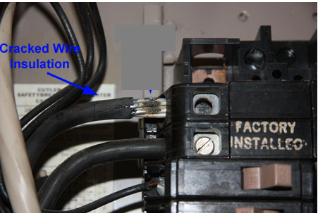
Fig 8. Loose Connections
Faulty/Broken light switches Repair
Switches are found in many household appliances, generally used to control common household appliances such as the lights, television, air conditioning, and hairdryer. The main types of switches used in homes to activate electrical appliances are the toggle switch and rocker switch. Light switches are often mounted on the wall near a doorway, allowing a person entering a room to flip the switch to turn on the lights.
Motor Maintenance
Testing, and Repair
An electric motor must be checked, maintained, and repaired just like any other piece of mechanical equipment. With proper servicing, a motor will last longer and give more efficient service. Included in maintenance services are cleaning, lubrication, ventilation, and testing.
Cleaning
- Inspect motors internally and externally for foreign materials, such as dust, dirt, corrosion, and paint. Open frame motors may be blown out with compressed air. You should not apply too many coats of paint to motors. A thick coat of paint will interfere with heat dissipation
- Air pressure used for cleaning should not exceed 25 psi nozzle pressure. Excessive pressure can damage the insulation on the windings.
- Wipe all excess dirt, grease, and oil from the surfaces of a motor with a cloth moistened with an approved solvent
- Do not use flammable or toxic solvents when cleaning motors. Solvents may cause injury to personnel or damage to equipment
Lubrication
- Lubrication should be done according to the manufacturer’s instructions. Improper lubrication causes motor bearings to overheat and eventually causes bearing failure.
- Check a motor for signs of grease and oil-seal failure. If an inside seal fails, the lubricant can get into the motor windings and deteriorate the insulation.
- This condition also allows dust to adhere to the windings and restricts air circulation, then the motor windings heat and burn out.
- Inadequate lubrication causes the bearings to wear excessively and, eventually, to seize. When lubricating a motor, refer to the manufacturer's manual to determine the correct type of lubricant to use.
- Some motors have bearings lubricated with oil, while others require grease. Many motor bearings are lubricated and sealed at the factory and usually last the life of the bearing

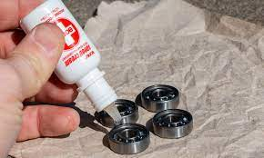
Fig 9.cleaning skateboard bearings
Ventilation
- Check the running temperature of all motors.
- If the motor temperature is hotter than specified on the nameplate, you must find the problem.
- The normal procedure for diagnosing motor overheats is to check the motor for restricted ventilation.
- Inspect the area around the motor for any obstructions which could hamper free air circulation.
- If air circulation is not hampered in any way and the motor continues to run hot, reduce the load on the motor or use a motor with more power capability
Testing
- The proper testing of a motor has a logical sequence. Proper testing can prevent unnecessary labor and parts. Testing motors is generally classed under two major methods: visual tests and operational tests.
Visual Tests
- A visual test can discover a great deal about the condition of a motor and the possible causes of trouble. Read the nameplate data and be sure that the motor connections are correct for the supplied voltage. Look at the windings to see if the insulation has overheated (or has been overheating).
- You can tell when the insulation is burned by the odor within the motor.
- If you aren’t sure of the condition of the windings, test them with a megger to determine if they have been damaged beyond use. Connect the leads of the megger to each set of windings.
- Disconnect the motor leads from each other to ensure reading only one winding at a time. If the winding is good, you will get a reading of continuity.
If the winding indicates a large amount of resistance, it is damaged and must be replaced
- Now connect one lead from the megger to the frame of the motor. Connect the other lead of the megger to each lead of the motor, one at a time.
- A low-resistance reading means insulation breakdown or a short to the motor frame, and replacement of the winding is necessary
- Check the condition and operation of the starting rheostat in DC motors and the starting and control equipment used with AC motors. Also check the terminal connections on all of the control equipment to ensure they are correct and secure. Make sure the proper voltage is at the terminal lead of the motor.
- If the visual tests have not revealed the trouble, perform some operational tests on the motor
Operational Tests
- Perform a heat run test, observing the manufacturer’s recommendations for that particular motor
- Do not attempt to operate a series DC motor without a load
- If the temperature of the motor in normal operation does not exceed the maximum recommended by the manufacturer, the motor is operating satisfactorily.
- Always refer to the manufacturer’s manual for definite specifications for the motor you are inspecting
- Be sure the master switch is in the off position before connecting or disconnecting any motor lead connections
- The nameplate on the motor usually specifies its normal running temperature in degrees centigrade. Check the current draw of the motor against the data on the nameplate. Excess current causes heating and, in time, will destroy the windings.
- After you have performed visual and operational tests on a motor and isolated the problem, you may have to disassemble the motor to make the repairs. You should know the procedures and precautions for motor repair.

Cleaning and lubrication procedures
Cleaning and lubrication are important preventive maintenance tasks to ensure the proper functioning and longevity of electrical equipment. there is a general overview of the process
Cleaning Procedures:
- Power off and disconnect the equipment: Before starting the cleaning process, make sure to power off and disconnect the equipment from its power source. This is crucial for safety purposes.
- Remove dust and debris: Use a soft brush, compressed air, or a vacuum cleaner with appropriate attachments to remove dust and debris from the equipment. Pay attention to cooling vents, fans, and other areas where dust can accumulate.
- Wipe surfaces: Use a lint-free cloth or a mild cleaning solution (if recommended by the equipment manufacturer) to wipe the surfaces of the equipment. Be careful not to use excessive moisture, as it can damage sensitive components.
- Clean electrical contacts: If applicable, clean electrical contacts or connectors using an appropriate contact cleaner or isopropyl alcohol. Use a lint-free cloth or a specialized cleaning tool to gently remove dirt or oxidation from the contacts.
- Inspect for damage: While cleaning, visually inspect the equipment for any signs of damage, loose connections, or worn-out components. Document any abnormalities or issues for further evaluation or repair.
Lubrication Procedures
- Refer to equipment documentation: Consult the equipment's technical documentation or manufacturer guidelines to determine if lubrication is required and the recommended lubrication points.
- Use the appropriate lubricant: Select the correct type of lubricant recommended for the specific equipment and application. This can include lubricating oils, greases, or silicone-based lubricants.
- Apply lubricant to moving parts: Apply a small amount of lubricant to the designated lubrication points of the equipment. This can include bearings, gears, pulleys, or other moving parts. Follow the manufacturer's instructions for the proper amount and method of lubrication.
- Avoid over-lubrication: Be cautious not to over-lubricate, as excess lubricant can attract dust and debris, leading to potential issues.
- Clean up excess lubricant: Wipe off any excess lubricant that may have dripped or accumulated on surfaces or around lubrication points using a lint-free cloth.
Example lubrication of fan motor
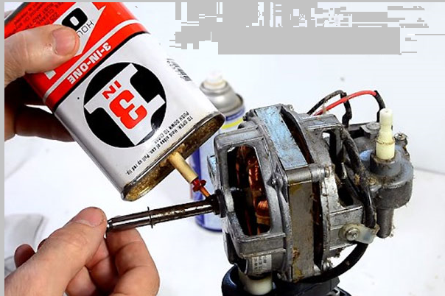
Fig 10.Cleaning and lubrication of fanmotor

Testing and diagnostic techniques
Testing and diagnostic techniques are used to assess the performance, functionality, and condition of equipment or systems. These techniques involve conducting various tests and measurements to identify any issues, malfunctions, or abnormalities. there are some common testing and diagnostic techniques:
Visual Inspection
Visual inspection involves visually examining the equipment or system for any visible signs of damage, wear, or anomalies. It can help identify loose connections, broken components, leaks, or other visible issues.

fig11. visual inspection
Performance Testing
Performance testing involves measuring and evaluating the performance of equipment or systems under normal operating conditions. This can include measuring parameters such as speed, temperature, pressure, flow rate, or electrical characteristics to ensure they are within acceptable ranges.
Diagnostic Tools and Instruments
Various diagnostic tools and instruments can be used to assess the condition and functionality of equipment or systems. These may include multimeters, infrared cameras, vibration analyzers, thermal imaging devices, or pressure gauges, depending on the specific application.
Multi-meters: -It works like an ammeter; ohmmeter and voltmeter for it can measure current, voltage as well as resistance. A multi-meter or a multi-tester, also known as a VOM (Volt-Ohm meter or Volt-Ohm-mill ammeter), is an electronic measuring instrument that combines several measurement functions in one unit. A typical multi-meter can measure voltage, current, and resistance. Analog multi-meters use a micro ammeter with a moving pointer to display readings. Digital multi-meters (DMM, DVOM) have a numeric display, and may also show a graphical bar representing the measured value. Digital multi-meters are now far more common but analog multi-meters are still preferable in some cases, for example when monitoring a rapidly varying value.
A multi-meter can be a hand-held device useful for basic fault finding and field service work, or a bench instrument which can measure to a very high degree of accuracy. They can be used to troubleshoot electrical problems in a wide array of industrial and household devices such as electronic equipment, motor controls, domestic appliances, power supplies, and wiring systems.
A multi-meter is a combination of a multi-range DC voltmeter, multi-range AC voltmeter, multi-range ammeter, and multi-range ohmmeter. An un-amplified analog multi-meter combines a meter movement, range resistors and switches.
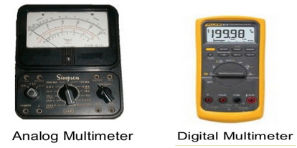
Figure 12.Analog and digital multimeter

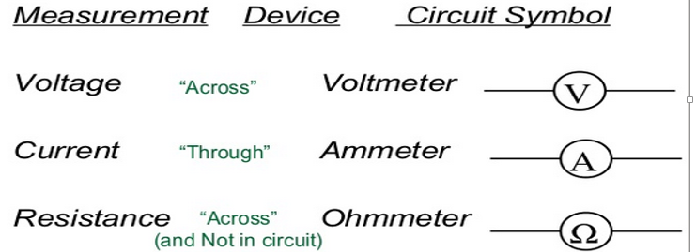
.
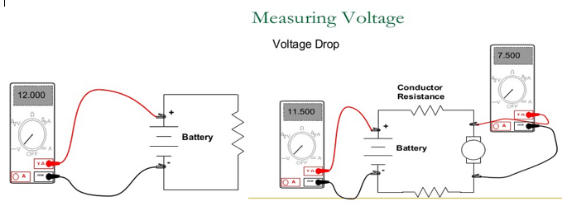
Fig13. Measuring voltage

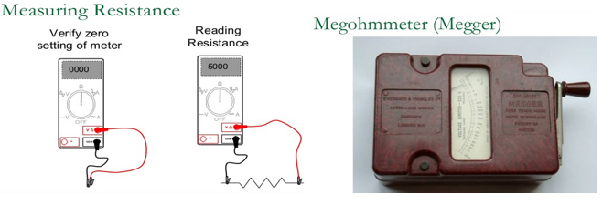
Fig14. Measuring resistance

Insulation resistance tester (meager): -Megger is basically a DC generator operated manually and ammeter calibrated as kilo-ohm and mega ohm is generally used to measure the insulation. Megger has become the generic description for a high voltage, low current insulation tester.
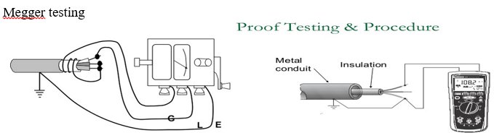
Fig15. insulation tester

Clamp meters:- Meters which measure high voltages or current may use non-contact attachment mechanism to trade accuracy for safety. Clamp meters provide a coil that clamps around a conductor in order to measure the current flowing through it.
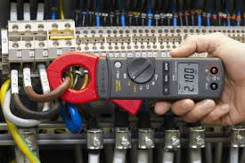
Fig16. Measure current use clamp meter
Wattmeter
The wattmeter is an instrument for measuring the electric power (or the supply rate of electrical energy) in watts of any given circuit.
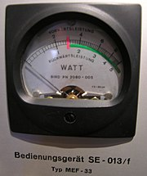
Fig17. wattmeter
Test light:-A test light, test lamp, or mains tester is a very simple piece of electronic test equipment used to determine the presence or absence of an electricvoltage in a piece of equipment under test.
The test light is simply an electric lamp connected with one or two insulatedwire leads. Often, it takes the form of a screwdriver with the lamp connected between the tip of the screwdriver and a single lead that projects out the back of the screwdriver. By connecting the flying lead to an earth (ground) reference and touching the screwdriver tip to various points in the circuit, the presence or absence of voltage at each point can be determined and simple faults detected and traced to their root cause.
For low voltage work (for example, in automobiles), the lamp used is usually a small, low-voltage incandescent light bulb. These lamps usually are designed to operate on approximately 12 V.
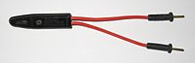
Fig18. Neon test lamp
Tachometer:-Tachometer showing engine RPM (revolutions per minute), and a red-line from 6000 and 7000 RPM. A tachometer is an instrument that measures the rotation speed of a shaft or disk, as in a motor or other machine. The device usually displays the revolutions perminute (RPM) on a calibrated analog dial, but digital displays are increasingly common.
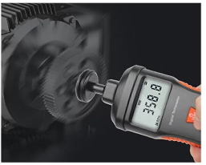
Fig19. Measure motor speed use Tachometer
Pressure gauge
A pressure gauge can be used to measure the pressure of a gas or liquid. This can be useful for troubleshooting problems with hydraulic and pneumatic systems.

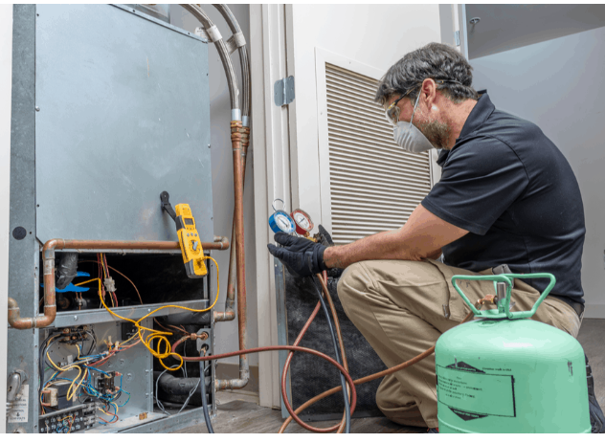
fig20. CheckRefrigerantGauges
there are some examples of how a pressure gauge can be used to troubleshoot hydraulic and pneumatic systems:
- Low pressure: If a hydraulic or pneumatic system is not operating properly, it may be due to low pressure. A pressure gauge can be used to measure the pressure at different points in the system to identify where the pressure is low. This can help you to identify the source of the problem, such as a leak, a clogged filter, or a faulty pump.
- High pressure: High pressure can also cause problems with hydraulic and pneumatic systems. A pressure gauge can be used to measure the pressure at different points in the system to identify where the pressure is high. This can help you to identify the source of the problem, such as a faulty relief valve or a blocked return line.
- Fluctuating pressure: Fluctuating pressure can also cause problems with hydraulic and pneumatic systems. A pressure gauge can be used to monitor the pressure at different points in the system to identify where the pressure is fluctuating. This can help you to identify the source of the problem, such as a faulty pump or a leak.

Troubleshoot and fault finding
Troubleshooting and fault finding are the processes of identifying and fixing problems with equipment and systems.
there are some general steps involved in troubleshooting and fault finding:
- Gather Information: Start by gathering relevant information about the equipment or system experiencing the issue. This can include any available documentation, maintenance records, error messages, or input from operators or maintenance personnel.
- Define the Problem: Clearly define the problem or symptom you are trying to troubleshoot. Identify any specific error codes, abnormal behavior, or performance issues associated with the equipment or system.
- Identify Possible Causes: Based on the defined problem, create a list of potential causes. Consider both common and uncommon causes that could be contributing to the issue. Use your knowledge and experience along with the available information to generate a comprehensive list.
- Systematic Investigation: Begin investigating the potential causes one by one. Start with the most likely or easiest to check. This may involve inspecting specific components, measuring electrical or mechanical parameters, or running diagnostic tests.
- Analyze Results: As you investigate each potential cause, analyze the results of your tests or inspections. Compare the observed values or behavior with the expected or normal values. Look for any deviations or anomalies that could indicate a fault or problem.
- Narrow Down the Cause: Based on your analysis, eliminate potential causes that are not contributing to the issue. Focus on the remaining potential causes that align with the observed symptoms.
- Test and Verify: If necessary, perform additional tests or experiment to verify the remaining potential causes. This may involve using specialized diagnostic equipment, simulating operating conditions, or conducting controlled experiments.
- Resolution and Corrective Action: Once the root cause of the problem is identified, determine the appropriate corrective action. This could involve repairing or replacing faulty components, adjusting settings, updating software, or implementing process improvements.
    - Importance and objectives of troubleshooting

Importance of Troubleshooting:
Troubleshooting is a critical aspect of maintenance and problem-solving in various industries. It plays a vital role in ensuring the smooth operation, reliability, and efficiency of equipment, systems, and processes. Here are some key reasons why troubleshooting is important:
- Minimizing Downtime: Effective troubleshooting helps identify and resolve issues promptly, minimizing equipment or system downtime. By quickly restoring normal operation, it reduces the impact on productivity, production schedules, and customer satisfaction.
- Cost Reduction: Timely troubleshooting can prevent minor issues from escalating into major problems. By addressing faults early on, it helps avoid costly repairs, component replacements, or system failures. Troubleshooting also helps optimize maintenance activities by targeting specific areas of concern, saving time and resources.
- Safety Enhancement: Equipment or system malfunctions can pose safety risks to operators, maintenance personnel, and the surrounding environment. Troubleshooting helps identify and rectify potential safety hazards, ensuring a safe working environment and compliance with regulatory requirements.
- Performance Optimization: Troubleshooting aims to identify the underlying causes of performance issues or deviations from desired specifications. By addressing these issues, troubleshooting helps optimize equipment or system performance, ensuring efficient operation and desired outcomes.
- Root Cause Analysis: Troubleshooting involves identifying the root cause of a problem rather than simply addressing symptoms. This allows for a more comprehensive understanding of the issues and helps prevent recurring problems in the future.
Objectives of Troubleshooting
The objectives of troubleshooting can vary depending on the specific situation, equipment, or system being addressed. However, the following objectives are commonly pursued:
- Identify the Problem: The primary objective of troubleshooting is to accurately identify the problem or fault affecting the equipment or system. This involves understanding the symptoms, analyzing available data, and gathering information to define the issue.
- Determine the Root Cause: Troubleshooting aims to determine the underlying cause of the problem. By investigating potential causes and analyzing data, it helps identify the primary factors contributing to the issue.
- Develop Solutions: Once the root cause is identified, the objective is to develop effective solutions to address the problem. This may involve repairing or replacing faulty components, adjusting settings, implementing process changes, or applying software updates.
- Verify and Validate: After implementing solutions, troubleshooting aims to verify the effectiveness of the applied corrective measures. This involves testing and validating the equipment or system to ensure that the problem has been resolved and that normal operation has been restored.
- Prevent Recurrence: Troubleshooting strives to prevent the recurrence of the problem. By understanding the root cause, troubleshooting can help implement preventive measures, such as improved maintenance practices, training programs, or design modifications, to minimize the likelihood of similar issues in the future.

    - Key principles of effective troubleshooting

Effective troubleshooting relies on several key principles to ensure efficient and successful resolution of equipment issues. there are some important principles to keep in mind:
- Systematic Approach: Adopt a systematic and structured approach to troubleshooting. Follow a logical sequence of steps, starting from problem definition to hypothesis generation, testing, analysis, and solution implementation. This helps prevent overlooking potential causes and ensures a comprehensive troubleshooting process.
- Gather Sufficient Information: Collect as much relevant information as possible about the equipment, its specifications, operating conditions, and the observed problem. Consult equipment documentation, maintenance records, and subject matter experts to acquire necessary information. A thorough understanding of the equipment and its context is crucial for effective troubleshooting.
- Clear Problem Definition: Clearly define the problem or symptom you are experiencing with the equipment. Be specific about the observed behavior, error messages, or abnormalities. A well-defined problem statement helps in focusing troubleshooting efforts and avoids wasting time on unrelated issues.
- Ask Questions and Listen: Ask questions to gather additional information and listen attentively to operators, maintenance personnel, or other stakeholders who have interacted with the equipment. Their insights and observations may provide valuable clues or context that can lead to the identification of the root cause.
- Logical Hypothesis Generation: Develop hypotheses or potential causes based on the gathered information and observations. Consider both common and less common causes, and rank them based on likelihood or relevance. Use deductive reasoning, past experience, or available data to generate hypotheses.
- Test Hypotheses: Devise a plan to systematically test each hypothesis. Perform diagnostic tests, measurements, inspections, or simulations to gather data and validate or eliminate potential causes. Use appropriate tools, instruments, or techniques for the tests. Be objective and rely on data-driven evidence to evaluate hypotheses.
- Data Analysis and Interpretation: Carefully analyze the data and observations from the tests to determine the validity of each hypothesis. Look for patterns, trends, or abnormalities that may help narrow down the cause of the problem. Use critical thinking skills and apply technical knowledge to interpret the data accurately.
- Occam's Razor: Apply the principle of Occam's Razor, which suggests that the simplest explanation is usually the correct one. When evaluating hypotheses, favor the explanation that requires the fewest assumptions or complexities, as it is more likely to be the accurate cause of the problem.
- Document and Share Knowledge: Document the entire troubleshooting process, including problem definition, hypotheses, tests performed, results, solutions implemented, and final outcomes. This documentation serves as a reference for future troubleshooting efforts and knowledge sharing. Share lessons learned and best practices with colleagues or relevant stakeholders.
- Continuous Improvement: Embrace a culture of continuous improvement in troubleshooting. Analyze past troubleshooting experiences, identify areas for improvement, and implement changes to enhance efficiency and effectiveness. Encourage feedback and collaboration among team members to foster a learning environment.
    - Understanding the troubleshooting process

Understanding the troubleshooting process is crucial for effectively identifying and resolving equipment issues. While specific troubleshooting methodologies may vary depending on the industry and equipment involved, the following steps provide a general framework for the troubleshooting process:
- Define the Problem: Clearly define the problem or symptom you are experiencing with the equipment. This includes identifying the specific issue, its impact on operations, and any error messages or abnormal behavior observed.
- Gather Information: Collect relevant information about the equipment, such as its specifications, operating conditions, maintenance history, and any recent changes or events that may be related to the problem. Consult equipment manuals, documentation, or subject matter experts to acquire necessary information.
- Formulate Hypotheses: Based on the gathered information, generate several possible hypotheses or potential causes for the problem. Consider both common and less common causes, and rank them based on likelihood or relevance.
- Test the Hypotheses: Develop a plan to systematically test each hypothesis. This may involve performing diagnostic tests, measurements, inspections, or simulations to gather data and validate or eliminate potential causes. Use appropriate tools, instruments, or techniques for the tests.
- Analyze the Results: Evaluate the data and observations from the tests to determine the validity of each hypothesis. Compare the results with expected or normal behavior, reference values, or known standards. Identify any patterns, trends, or abnormalities that may help narrow down the cause of the problem.
- Refine or Generate New Hypotheses: Based on the analysis of the results, refine or generate new hypotheses if necessary. Adjust the troubleshooting approach to focus on the most promising causes or areas.
- Implement Solutions: Once the root cause of the problem is identified, develop and implement appropriate solutions. This may involve repairing or replacing faulty components, adjusting settings or parameters, updating software, or implementing preventive measures to avoid future occurrences.
- Test and Verify: After implementing the solutions, conduct tests to verify that the problem has been resolved. Monitor the equipment's performance, collect data, and compare the results with expected or desired outcomes. Ensure that the equipment operates as intended and that the problem no longer persists.
- Document and Follow-Up: Document the entire troubleshooting process, including the identified problem, hypotheses, tests performed, results, solutions implemented, and final outcomes. This documentation serves as a reference for future troubleshooting efforts, knowledge sharing, and continuous improvement. Follow up with any necessary preventive actions, such as updating maintenance procedures, providing additional training, or implementing system enhancements.
    - Preparing for Troubleshooting
Preparing for troubleshooting is an important step to ensure an effective and efficient resolution of equipment issues. Here are some key steps to consider when preparing for troubleshooting:
- Gather Information: Collect as much relevant information as possible about the equipment and the problem at hand. This may include equipment manuals, technical specifications, error codes or messages, maintenance records, and any available documentation related to the issue.
- Understand the Equipment: Familiarize yourself with the equipment's operation, components, and subsystems. This understanding will help you identify potential areas of concern and narrow down the troubleshooting process.
- Safety Precautions: Prioritize safety when preparing for troubleshooting. Identify and follow any necessary safety procedures, such as wearing personal protective equipment (PPE) or ensuring proper lockout/tagout procedures are in place.
- Review Previous Maintenance or Repair History: Examine any previous maintenance or repair activities related to the equipment. Understanding past issues and resolutions can provide valuable insights and help identify possible recurring problems.
- Consult Documentation: Review the equipment's troubleshooting or diagnostic documentation provided by the manufacturer. This may include flowcharts, troubleshooting guides, or specific guidelines for addressing common issues. Follow the recommended steps and procedures outlined in the documentation.
- Establish a Troubleshooting Plan: Develop a systematic plan or strategy for troubleshooting. This plan should include steps to isolate the problem, identify potential causes, and prioritize the troubleshooting efforts. Consider using a logical and structured approach, such as starting with the most likely causes before moving to more complex or less common issues.
- Gather Tools and Resources: Ensure you have the necessary tools, equipment, and resources to carry out the troubleshooting process effectively. This may include diagnostic tools, meters, software, spare parts, or access to technical support or subject matter experts.
- Create a Test Environment: If applicable, set up a controlled test environment to replicate the problem or simulate the operational conditions. This can help in isolating the issue and verifying potential solutions.
- Document Observations: Keep a detailed record of your troubleshooting process, including observations, measurements, test results, and any relevant findings. This documentation will be valuable for future reference, collaboration with others, or tracking the progress of troubleshooting efforts.
- Time Management: Allocate sufficient time for troubleshooting activities, considering the complexity of the issue and the potential impact on operations. Prioritize troubleshooting efforts based on the criticality of the equipment and its impact on production or safety.
- Assemble and disassemble of equipment’s

Assembling and disassembling equipment are common tasks performed during installation, maintenance, repair, or reconfiguration processes. there's an overview of the steps involved in assembling and disassembling equipment:
- Assembling Equipment:
- Preparation: Review the equipment's assembly instructions, technical documentation, or manufacturer's guidelines to familiarize yourself with the process. Ensure that you have all the necessary tools, components, and safety equipment required for assembly.
- Organize Components: Lay out all the components and parts in an organized manner. This makes it easier to identify and access the required parts during the assembly process.
- Sequence of Assembly: Follow the recommended sequence of assembly provided in the equipment's documentation. This ensures that components are assembled in the correct order, avoiding rework or potential errors.
- Fastening and Connections: Assemble the components, following the appropriate fastening methods such as screws, bolts, nuts, or clips. Ensure that connections are secure but not over-tightened, as this may cause damage or affect functionality.
- Alignment and Calibration: Align the components accurately to ensure proper fit and functionality. In some cases, calibration or adjustment may be required to optimize performance or ensure accurate operation of sensors, gauges, or other critical components.
- Electrical and Wiring Connections: If the equipment involves electrical connections, follow the wiring diagrams or instructions provided. Pay attention to proper grounding, insulation, and routing of wires to ensure safety and proper functionality.
- Testing and Verification: Once the equipment is assembled, perform functional tests or verification procedures to ensure that it operates as intended. This may involve powering on the equipment, checking for proper operation of controls, sensors, or other features, and validating performance against specified criteria.
- Disassembling Equipment:
- Safety Measures: Before starting the disassembly process, ensure that the equipment is powered off, disconnected from electrical sources, and any relevant safety measures are taken. This may include wearing personal protective equipment (PPE) and following lockout/tagout procedures if necessary.
- Documentation and Labeling: Take photos or create drawings if needed to document the arrangement and connections of components before disassembly. Label or mark components or connections if necessary to aid in reassembly.
- Reverse Assembly Sequence: Follow the reverse order of the assembly sequence to disassemble the equipment. Refer to the equipment's documentation or guidelines for any specific instructions or precautions.
- Component Removal: Remove fasteners, connectors, or any other parts that hold the components together. Use appropriate tools and techniques to avoid damage to the equipment or its components during the disassembly process.
- Packaging and Storage: Properly package and store the disassembled components, ensuring that they are protected from damage, contamination, or loss. This may involve using appropriate containers, labels, or protective materials.
- Documentation: Document the disassembly process, including any observations, issues encountered, or special instructions for reassembly. This documentation will be valuable during reassembly or future maintenance activities.

Repair and replacement of components
Electrical equipment can sometimes fail, and when it does, it is important to repair or replace the faulty components as soon as possible. This will help to prevent further damage to the equipment and ensure the safety of users.
Some common electrical components that may need to be repaired or replaced include:
Fuses
Fuses are designed to protect circuits from overloads and short circuits. When a fuse blows, it needs to be replaced with a new fuse of the same rating.

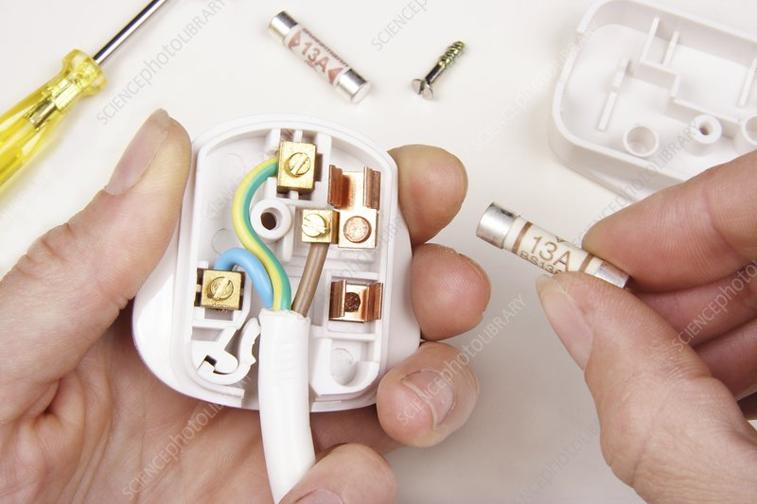

Fig 21.Replacefuse

When a fuse blows, it needs to be replaced with a new fuse of the same rating. The rating of a fuse is the amount of current that it can safely carry. If a fuse with a higher rating is used, it may not melt when too much current flows through it, which could damage the circuit and any devices connected to it.
there are some instructions for using fuses safely and effectively
- Always use the correct fuse rating.
- Never replace a blown fuse with a fuse of a higher rating.
- If a fuse blows repeatedly, there may be a problem with the circuit. Have the circuit inspected and repaired by a qualified electrician.
- Do not attempt to repair a blown fuse.
Circuit breakers
Circuit breakers also protect circuits from overloads and short circuits, but they can be reset instead of replaced. If a circuit breaker trips repeatedly, it may need to be repaired or replaced.

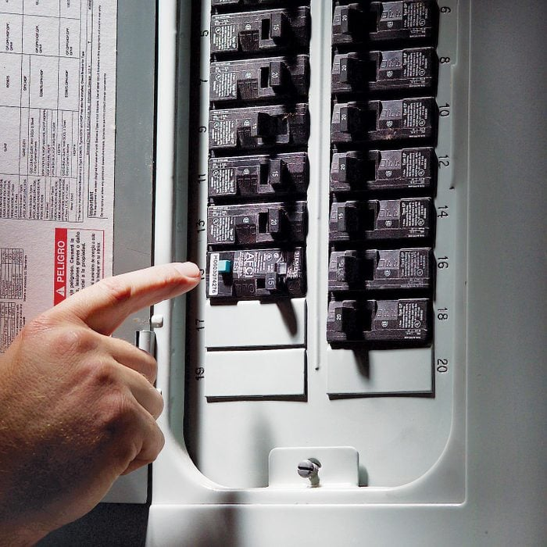

Fig 22.ReplaceCircuit breakers
Circuit breakers contain a bimetallic strip and a magnetic trip unit. The bimetallic strip is made of two different metals that expand at different rates when heated. When too much current flows through the circuit breaker, the bimetallic strip heats up and bends. This bending causes the trip unit to release a latch, which opens the circuit.
Circuit breakers can be reset by simply pushing the reset button. However, if a circuit breaker trips repeatedly, there may be a problem with the circuit. Have the circuit inspected and repaired by a qualified electrician.
there are some tips for using circuit breakers safely and effectively:
- Do not overload circuits.
- Do not attempt to repair a circuit breaker.
- If a circuit breaker trips repeatedly, have the circuit inspected and repaired by a qualified electrician
Wires
Wires can become damaged due to wear and tear, or from exposure to heat, moisture, or chemicals. Damaged wires need to be replaced to prevent electrical hazards.such as fires, shocks, and arcs
there are some signs of damaged wires:
- Frayed insulation: The insulation on wires can become frayed or cracked due to wear and tear, or from exposure to heat, moisture, or chemicals. Frayed insulation exposes the live wires inside, which can cause shocks and arcs.
- Discoloured insulation: The insulation on wires may become discoloured due to overheating. Discoloured insulation is a sign that the wire is damaged and needs to be replaced.
- Overheated wires: Wires can overheat if they are carrying too much current or if they are not properly ventilated. Overheated wires can cause fires and shocks.
- Damaged connectors: The connectors on wires can become damaged due to wear and tear, or from exposure to heat, moisture, or chemicals. Damaged connectors can cause arcing and overheating.
Repairing Cut or Damaged Wiring
If only a small portion of the wiring is exposed (the wire has not been cut completely through), you can repair the insulation with liquid electrical tape or silicone adhesive.
If the wire has been completely cut or it's hanging on by a few strands of copper wire and you’re skilled with a soldering iron you can repair the cut wire yourself. Repairing damaged wiring is easy and it can save you time and money, but care must be taken any time a soldering iron is used.
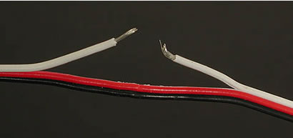
First, slide a piece of thin gauge heat shrink tubing over the wires.

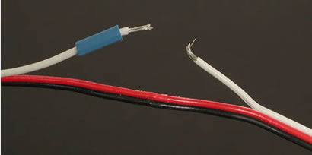

Next, splice the wires together and tin the wire with a small amount of solder.

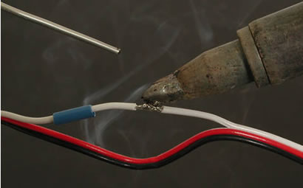

Finally, cover the solder joint with the heat-shrink tubing and heat the area with a heat gun or blow dryer.
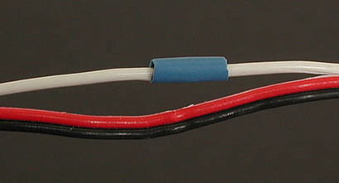

Fig 23. Wire repairstipe

Switches
Switches can fail due to wear and tear, or from exposure to dust, dirt, or moisture. Faulty switches need to be repaired or replaced to ensure the safe operation of electrical equipment.
there are some signs of faulty switches
- Sparks or arcing: Sparks or arcing can occur when a switch is faulty. This can be caused by loose connections, worn contacts, or damaged insulation.
- Switch is hot to the touch: A faulty switch may become hot to the touch. This is a sign that the switch is overheating and needs to be replaced immediately.
- Switch is difficult to operate: A faulty switch may become difficult to operate. This may be due to worn components or loose connections.
- Switch does not work: A faulty switch may simply not work at all.

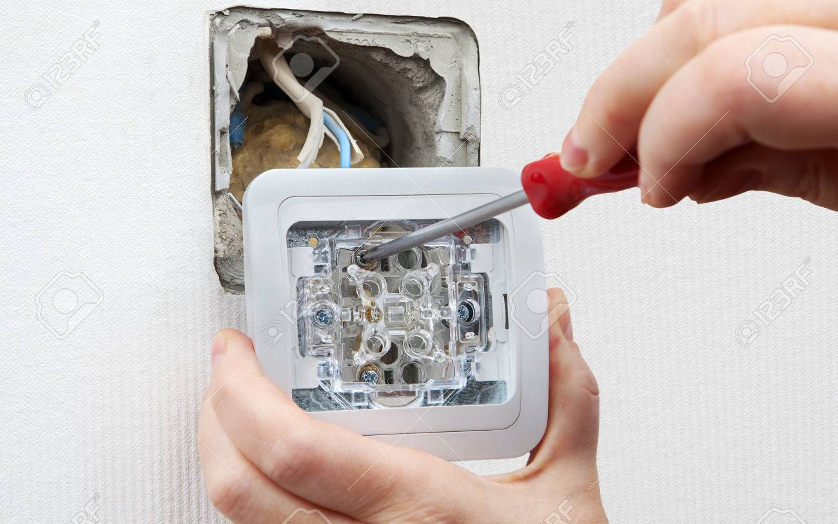

Fig 24.switchrepair or replace

Motors
Motors can fail due to wear and tear, or from overheating or overloading. Faulty motors need to be repaired or replaced to prevent further damage to the equipment.
Circuit breakers Opens in a new window

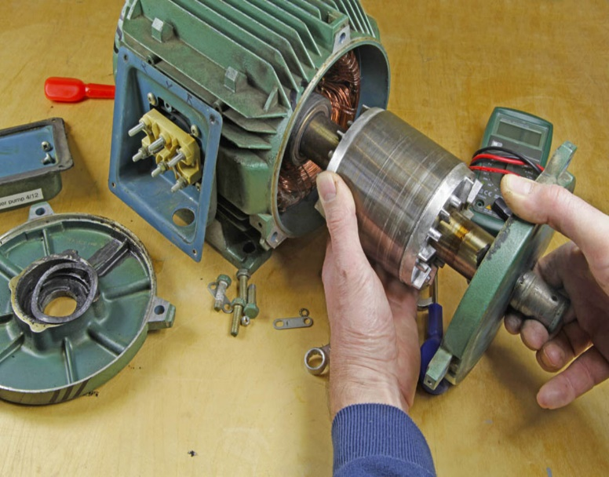

Fig 25.Motors repair

Wear and tear
Motors are made up of many moving parts, and over time, these parts can wear and tear. This can lead to problems such as:
- Increased friction: As the parts wear down, they can create more friction. This can lead to overheating and premature failure.
- Reduced efficiency: As the parts wear down, the motor becomes less efficient. This means that it will use more energy to do the same amount of work.
- Increased noise: Worn parts can produce more noise. This can be a nuisance and can also be a sign that the motor is failing.
Overheating
Motors can overheat for a number of reasons, such as:
- Poor ventilation: If the motor is not properly ventilated, it can overheat. This can happen if the motor is enclosed in a small space or if it is exposed to direct sunlight.
- Excessive load: If the motor is overloaded, it can overheat. This can happen if the motor is trying to do too much work or if the load is not evenly distributed.
- Electrical problems: Electrical problems such as short circuits and ground faults can also cause motors to overheat.
Overloading
Motors can be overloaded if they are trying to do too much work. This can happen if the motor is too small for the application or if the load is not evenly distributed. Overloading can cause the motor to overheat and fail.
Preventing motor failure
There are a number of things that can be done to prevent motor failure, such as:
- Proper maintenance: Motors should be inspected and serviced regularly to identify and correct any problems early on. This includes tasks such as lubricating moving parts, cleaning the motor, and checking the electrical connections.
- Proper ventilation: Motors should be properly ventilated to prevent overheating. This means ensuring that the motor has enough space around it and that it is not exposed to direct sunlight.
- Avoiding overloading: Motors should not be overloaded. This means using the correct size motor for the application and ensuring that the load is evenly distributed.

Calibration and adjustment of equipment
Calibration and adjustment of equipment are important maintenance tasks that ensure the accuracy, reliability, and optimal performance of various types of instruments and machinery. there's an overview of calibration and adjustment.
Calibration
Calibration is the process of comparing the measurements or output of a device or instrument to a known reference standard. It involves adjusting the instrument to bring its measurements in line with the reference standard. Calibration is essential for ensuring accurate and reliable measurements. Some key points about calibration include:
- Purpose: Calibration ensures that the instrument's measurements are traceable, accurate, and consistent with recognized standards or specifications.
- Reference Standards: Calibration requires the use of calibrated reference standards that have a known level of accuracy. These standards can be devices specifically designed for calibration purposes or certified reference materials.
- Calibration Procedure: The calibration procedure involves comparing the measurements of the instrument being calibrated to the measurements of the reference standard. If there are any discrepancies, adjustments are made to align the instrument's readings with the reference standard.
- Calibration Intervals: The frequency of calibration depends on factors such as the instrument's stability, usage conditions, manufacturer's recommendations, and industry regulations. Calibration intervals can range from daily to annually, depending on the instrument and its criticality.
- Calibration Certificates: After calibration, a calibration certificate is issued that documents the instrument's readings, the reference standard used, and the adjustments made. The certificate serves as proof of calibration and is often required for regulatory compliance or quality assurance purposes
Adjustment
Adjustment involves modifying the settings or components of an instrument or equipment to bring it into proper alignment or functioning. Unlike calibration, which focuses on accuracy, adjustment primarily aims to optimize performance. Here are some key points about adjustment:
- Purpose: The purpose of adjustment is to fine-tune or optimize the instrument's performance, rather than aligning it with a reference standard.
- Components or Settings: Adjustment may involve modifying various components, parameters, or settings of the equipment, such as tension, alignment, pressure, temperature, or other factors that affect its operation.
- Manufacturer Guidelines: Adjustment procedures are typically outlined in the equipment's user manual or provided by the manufacturer. It's important to follow the manufacturer's instructions to ensure adjustments are made correctly and safely.
- Expertise and Training: Adjustments may require technical expertise and specialized training. It's important that adjustments are carried out by qualified personnel who have the necessary knowledge and skills.
- Documentation: Like calibration, adjustments should be documented, including the specific adjustments made, any changes to settings or components, and the results of the adjustment.

preventive maintenance tasks
Preventive maintenance tasks are proactive measures taken to prevent equipment failures, reduce downtime, and extend the lifespan of the equipment. These tasks are performed at regular intervals based on manufacturer recommendations, industry best practices, and the specific needs of the equipment and facility. Here are some common preventive maintenance tasks:
- Inspecting and cleaning electrical panels: Regularly inspect electrical panels for signs of damage, loose connections, or overheating. Clean panels to remove dust and debris that can affect performance and safety.
- Testing and calibrating electrical meters: Test and calibrate electrical meters to ensure accurate measurements. This helps maintain accuracy in monitoring power consumption, voltage levels, and other electrical parameters.
- Checking and tightening electrical connections: Inspect electrical connections, such as wire terminations and terminal blocks, to ensure they are tight and secure. Loose connections can lead to voltage drops, overheating, and equipment failure.
- Lubricating moving parts: Apply lubrication to moving parts of electrical equipment, such as motors or switches, to reduce friction and wear. This helps prolong the lifespan of the equipment and ensures smooth operation.
- Inspecting and replacing worn-out cables and wiring: Regularly inspect cables and wiring for signs of wear, damage, or deterioration. Replace any damaged or worn-out cables to prevent electrical hazards and ensure reliable operation.
- Testing and replacing backup batteries: Test and replace backup batteries in uninterruptible power supply (UPS) systems or emergency lighting systems. This ensures that these systems will function properly during power outages or emergencies.

Self-check 2

I.Choose the best answer from the give alterative:
- Visual inspection and condition assessment involve:
a) Assessing the performance of equipment through data analysis
b) Cleaning and lubricating equipment components
c) Evaluating the physical condition of equipment through visual examination
d) Repairing or replacing faulty components
- Cleaning and lubrication procedures are essential for:
a) Reducing the need for preventive maintenance
b) Improving equipment aesthetics
c) Removing dust and debris from equipment
d) Increasing the risk of equipment failure
- Testing and diagnostic techniques are used to:
a) Verify the accuracy of maintenance records
b) Identify potential equipment failures before they occur
c) Determine the cost of maintenance tasks
d) Perform routine equipment calibration
- Troubleshooting and fault finding involve:
a) Performing routine inspections to identify equipment wear and tear
b) Analyzing data from equipment sensors to detect abnormalities
c) Repairing or replacing faulty components to restore equipment functionality
d) Adjusting equipment settings to improve performance
- Repair and replacement of components are necessary when:
a) The equipment is operating at peak efficiency
b) Cleaning and lubrication procedures have been performed
c) Visual inspection reveals no abnormalities
d) Components are damaged or no longer functioning correctly

II MatchingMatch Column B to Column A.
Column A
  - Calibration and adjustment of equipment
  - Visual inspection and condition assessment
  - Cleaning and lubrication procedures
  - Testing and diagnostic techniques
  - Troubleshoot and fault-finding
Column B.
- Identifying and correcting equipment malfunctions
- Evaluating equipment performance and functionality
- Ensuring equipment operates within specified limits
- Removing dirt and debris, and applying lubricants
- Assessing equipment condition through visual examination
III Give short and precise answers for the following question

- Explain the importance of preventive maintenance tasks.
- Describe the process of calibration and adjustment of equipment.
- Provide an example of a diagnostic technique used in maintenance.

Operation Sheet 1- Troubleshooting circuit breaker

Sequence for troubleshooting faulty circuit breaker
General Troubleshoot Steps
1. Ensure that customer is safe and evacuate them outside the house in the worst case of an electrical fire. Ensure that children are not in the vicinity while trying to troubleshoot your circuit breaker.
2. Look for a Distribution Box – which is usually on the collider, and then look for the circuit breaker.
3. Turn off the lights and all other appliances.
4. Test the electrical breaker – The circuit breaker might have labels for which part of the house it supplies the electricity to (e.g., Bedroom, Kitchen). Switch to the ON position for the relevant lever. A loose lever might indicate that your circuit breaker should be replaced.
5. Please be careful that the floor is not wet when touching any electrical panels as there may be a risk of electrocution.
6. Typically, circuit breakers trip because of excess energy drawn from too many appliances and overloading of the circuit happens. If the circuit breaker trips regularly, try disconnecting heavy power consuming appliances like the fridge to see if it helps.
7. If the circuit no longer trips, try to connect the heavy power consuming appliances to a different source to resolve the problem of overloading.

Operation Sheet 2- replacing circuit breaker

Steps on how to replace damaged circuit breaker:
- Shut off the branch circuit breakers one at a time.
- Shut off the main circuit breaker.
- Test all the wires with a voltage tester to make sure they're dead before proceeding.
- Remove the panel cover.
- Disconnect the wire of the breaker you're removing from the load terminal.
- Carefully pry out the old breaker, paying careful attention to how it's positioned.
- Insert the new breaker and push it into position.
- Attach the circuit's wire to the load terminal. Strip a bit of insulation off the wires, if necessary.
- Inspect the panel for any other problems. Tighten any loose terminals.
- Replace the panel cover.
- Turn on the main breaker.
- Turn on the branch breakers one by one.

LAP TEST

Name………………………………. ID……………………………. Date…………………………………….

Time started: ________________________ Time finished: ________________

Instructions: By Using necessary resources, templates, tools and materials you are required to perform the following tasks within 2 hours. The project is expected from each trainee to do it.

Task-1 Troubleshoot faulty circuit breaker

Task-2 Replace damaged circuit breaker

UNITTHREE: NOTIFY COMPLETION AND DOCUMENT RESULTS
This unit is developed to provide you the necessary information regarding the following content coverage and topics:
- Importance documenting maintenance activities
- Completion checklist and sign-off procedures
- Recording and reporting any identified issues or abnormalities
This unit will also assist you to attain the learning outcomes stated in the cover page. Specifically, upon completion of this learning guide, you will be able to:
- importance documenting maintenance activities
- Complete checklist and sign-off procedures
- Record and reporting any identified issues or abnormalities

Importancedocumenting maintenance activities
Documenting maintenance activities is critical for several reasons:
- Historical Record: Documentation provides a historical record of maintenance activities performed on electrical systems and equipment. It helps track the maintenance history, including inspections, repairs, replacements, and adjustments, allowing for analysis of trends, patterns, and recurring issues. This information is invaluable in troubleshooting, identifying root causes of problems, and making informed decisions about future maintenance strategies.
- Compliance and Audits: Documentation serves as evidence of compliance with regulations, industry standards, and safety requirements. It provides proof that maintenance activities have been conducted in accordance with established guidelines and procedures. During audits or inspections, documented records demonstrate that electrical systems are properly maintained, reducing the risk of non-compliance penalties or safety violations.
- Maintenance Planning and Scheduling: Documented maintenance activities aid in planning and scheduling future maintenance tasks. By referring to past records, maintenance managers can determine the frequency of inspections, identify critical components that need regular attention, and establish appropriate maintenance intervals. This helps optimize maintenance resources, minimize downtime, and ensure that equipment remains in optimal working condition.
- Knowledge Transfer and Training: Documentation facilitates knowledge transfer from experienced technicians to new or less experienced personnel. It serves as a reference guide for maintenance procedures, troubleshooting techniques, and best practices. Documented information can be used for training purposes, ensuring that maintenance activities are carried out consistently and correctly, regardless of personnel changes.
- Warranty and Insurance Claims: Documentation is essential for warranty claims and insurance purposes. In the event of equipment failure or damage, having detailed records of maintenance activities can support warranty claims by demonstrating that maintenance has been performed in accordance with manufacturer recommendations. Additionally, insurance companies often require documented evidence of regular maintenance to validate coverage and process claims efficiently.
- Safety and Risk Management: Documented maintenance activities contribute to safety and risk management efforts. It allows for the identification of potential hazards, safety concerns, or recurring issues that may pose risks to personnel, equipment, or operations. By documenting maintenance tasks, safety protocols, and risk assessments, organizations can proactively address safety concerns, implement preventive measures, and minimize the likelihood of accidents or incidents

Completion checklist and sign-off procedures
Completion checklists and sign-off procedures are important steps in documenting the completion of electrical maintenance activities. They ensure that all necessary tasks have been performed and provide a record of accountability. there's an outline of completion checklist and sign-off procedures with electrical maintenance:
Completion Checklist:
A completion checklist is a comprehensive list of tasks and activities that need to be completed during electrical maintenance. It serves as a guide to ensure that all necessary steps have been taken.
The checklist may include items such as:
- Visual inspection of electrical components and connections
- Testing of electrical circuits and equipment
- Cleaning and lubrication of electrical contacts
- Calibration of measuring instruments, if applicable
- Replacement or repair of faulty components
- Documentation of maintenance activities and findings
The completion checklist should be tailored to specific maintenance requirements and can be customized based on the complexity and scope of the electrical system being maintained.

Sign-off Procedures:
Sign-off procedures involve obtaining formal approval or acknowledgement that the maintenance activities have been completed satisfactorily. This step typically involves the following:
- Responsible Party: Clearly identify the person or team responsible for performing the maintenance tasks. This may include maintenance technicians, electricians, or other authorized personnel.
- Verification: The responsible party should verify that all tasks on the completion checklist have been completed as specified. They should ensure that all necessary tests have been conducted, inspections have been performed, and any required repairs or replacements have been carried out.
- Documentation: Once the verification is complete, the responsible party should document the completion of the maintenance activities. This documentation may include maintenance reports, work orders, logbooks, or electronic records. It should capture important details such as the date and time of completion, the personnel involved, and any relevant observations or recommendations.
- Sign-off: The responsible party should sign off or provide their electronic approval to indicate that the maintenance activities have been completed. This sign-off serves as a formal acknowledgement of the work done.
- Review and Approval: In some cases, a supervisor, manager, or designated authority may need to review and approve the completed maintenance activities. This additional layer of review ensures quality control and provides oversight.
- Record Keeping: The completed documentation, including the signed-off completion checklist, should be stored in a secure and easily accessible location. This allows for future reference, audits, warranty claims, and other documentation needs.

Recording and reporting any identified issues or abnormalities
When recording electrical issues or abnormalities, it is important to be as specific and detailed as possible. This will help to ensure that the issue can be properly diagnosed and resolved.
there are some tips for recording electrical issues or abnormalities:
- Date and time: Record the date and time that you noticed the issue. This will help to track the progression of the issue and to identify any patterns.
- Location: Identify the specific location of the issue. This could be a room, a circuit, or a specific device.
- Description: Describe the issue in as much detail as possible. What exactly are you seeing, hearing, or smelling? What have you tried to do to resolve the issue?
- Any other relevant information: Include any other relevant information that may help to diagnose the issue, such as the type of electrical device involved, the age of the wiring, or any recent changes to the electrical system.
You can record electrical issues or abnormalities in a variety of ways, such as in a notebook, on a spreadsheet, or in a dedicated electrical maintenance software program.
Reporting electrical issues or abnormalities
Once you have recorded an electrical issue or abnormality, you need to report it to the appropriate person or organization. This may be your landlord, a maintenance technician, or a licensed electrician.
When reporting an electrical issue or abnormality, be sure to provide as much information as possible, including the date and time of the issue, the location of the issue, a description of the issue, and any other relevant information.
If the electrical issue or abnormality is a safety hazard, you should report it immediately.
there are some examples of electrical issues or abnormalities that should be reported immediately:
- Sparking or arcing
- Burning smell
- Smoke
- Hot to the touch
- Electrical shock
- Power outage
- Unexplained tripping of breakers or fuses

Self-check 3

I. If the statement is correctsay true if not correctsay false
- Documenting identified issues or abnormalities with electrical systems is important for maintaining a historical record of maintenance activities.
- Maintenance activities completion checklist helps ensure that all necessary maintenance tasks are performed and completed.
- Recording and reporting any identified issues or abnormalities with electrical systems are an essential part of proactive maintenance management.
II. Choose the best answer from the give alterative:
- When recording and reporting any identified issues or abnormalities with electrical systems, the primary objective is to:

a) Ensure proper functioning of the system
b) Document safety violations
c) Meet regulatory compliance requirements
d) Identify potential cost savings

- The purpose of a maintenance activities completion checklist is to:
a) Ensure all maintenance tasks have been completed
b) Track the time spent on maintenance activities
c) Document the costs associated with maintenance activities
d) Evaluate the performance of maintenance staff
- Sign-off procedures for recording and reporting identified issues or abnormalities are important because they:
a) Hold individuals accountable for their actions
b) Streamline the reporting process
c) Provide a record of actions taken to address the issues
d) Ensure legal compliance with reporting requirements
III.Give short and precise answers for the following question

1.Explain the importance of documenting identified issues or abnormalities with electrical systems.
2.What are the benefits of using a maintenance activities completion checklist?

Reference Materials

1.Electrical Equipment Maintenance and Testing by Paul Gill, published in 2019
2.Maintenance of Electrical Equipment by H. P. Mehta, published in 2017
3.Electrical Equipment Installation and Maintenance by George E. Traister, published in 2015
4.Maintenance of Electrical Equipment: A Practical Guide by R. Kelly, published in 2014
5.Electrical Equipment Maintenance and Troubleshooting by John E. Traister, published in 2013

Developer’s Profile
No | Name | Qualification (Level) | Field of Study | Organization/ Institution | Mobile number | E-mail
1 | Mengistu Abiyu | MSc | Industrial Automation & Control Management | Lideta Manufacturing College | 0913948480 | menabiy@gmail.com
2 | Samuel Bekele | MSc | Industrial Automation & Control Management | Haramaya PTC | 910082977 | samuelbekele460@gmail.com
3 | Yidnekachew Seboka | BSc | Electrical Automation & Control Technology | Akaki PTC | 920137899 | www.yidne23@gmail.com
4 | Zegeye Girma | BSc | Electrical Automation & Control Technology | Addis KetemaIn.College | 926805563 | zegeyegirma2@gmail.com
5 | Bacha Wake | MSc | Industrial Automation & Control Management | HawassaTegibarid PTC | 987065251 | bachawake@gmail.com

