Finishing Construction Work
Level-II
Based on March, 2022, Curriculum Version 1


Module Title: - Operate application software packages
Module code: EIS FCW2 M11 0822
Nominal duration: 100Hour

Prepared by: Ministry of Labor and Skill
August, 2022
Addis Ababa, Ethiopia

Acknowledgment 5
Acronym 6
Introduction to the Module 7
Unit one: Word-processing software 9
1.1. Word-Processing Software 9
1.2. Open word-processing application 11
1.3. The purpose Document 13
1.4. Organisational requirements and design document structure and layout 14
1.5. Match document requirements with software functions 16
Self-check-1.1 19
Operation sheet 1.1. Word-Processing Software 20
LAP /learning activity performance/ test 20
Unit Two: Customize basic settings and format documents to meet page layout 22
2.1. Adjust Page Layout 23
2.2. Open and View Different Toolbars 28
2.3. Change Font Format and Settings 33
2.4. Change and Modify Alignment, Line Spacing, Margins 36
2.5. Align Information in A Selected Cell 39
3.6. Open and Switch Between Different Documents 40
3.7. Formatting Features and Styles to Customize Basic Settings and Format Cell 44
3.8. Use technical functions, other data and formatting tools 48
3.9. Highlight, Copy Text and Select Formatting Features 51
3.10. Insert Headers and Footers 52
3.11. Save Document in Another File Format and Storage Device 55
Self-check-2.1 61
Operation sheet 2.1 Customize basic settings and format documents to meet page layout 62
LAP /learning activity performance/ 2 67
Unit Three: Create Tables and Add Images to Word Document 68
3.2. Change Cells (Insert and Delete Columns and Rows) 70
3.3. Insert and customize appropriate images into documents 72
3.4. Position and Resize Images to Meet Document Formatting Needs 72
3.5. Ensuring The Naming, Storing, Saving and Printing of Different Documents 76
Self-check-3.1 79
Operation sheet 3.1. Create Tables and Add Images to Word Document 80
LAP /learning activity performance/ test 3 81
Unit Four: Use Appropriate Spread Sheet Software 82
4.1. Select Spread Sheet Software 83
4.2. Identify Document Purpose, Audience 85
4.4. Enter Simple Formulas and Functions 87
4.5. Use A Range of Common Tools During Spreadsheet Development 95
4.6. Editing The Spreadsheet 100
4.7. Using The Auto-Fill Function to Increment Data 101
4.8. Naming, Storing and Printing of Documents Appropriate Directories 105
Self-check-4.1 110
Operation sheet 2.1 Use a worksheet 111
Operation sheet 2.2 Use a worksheet 112
Operation sheet 2.3 Formulas and functions 114
Operation sheet 2.4 Formulas and functions 116
Operation sheet 2.5 using a worksheet 117
Operation sheet 2.6 Access help 119
Lap Test 4 121
Unit Five: Incorporate Object and Chart in Spreadsheet 123
5.1. Import an object into an active spreadsheet 124
5.2. Import Manipulate object by using formatting features 128
5.3. Create a chart using select data in the spreadsheet 132
5.4. Display Selected Data in A Different Chart 133
5.5. Modify chart using formatting feature 134
Self-check 5 135
Operation sheet 5.1 Produce simple charts 136
Unit Six: Create database 139
6.1. Open a database application and basic design principles 140
6.2. Develop a table with fields and attributes 141
6.3. Create a primary key 142
6.4. Modify table layout and field attributes 144
6.5. Create a relationship between the two table 145
6.6. Add and modify data in a table 151
6.7. Add and delete records 152
6.8. Save and close down database to storage area 154
Operation Sheet 6.1. DB application and principles 156
Operation Sheet 6.2. Database Objects (Tables) 157
Operation sheet 6.3. Modify Database Objects 161
Operation sheet 6.4. Database Relationship 162
LAP Test 165
Unit Seven: Create reports and forms 166
7.1. Design reports in a logical sequence 166
7.2. Modify reports 168
7.3. Distribute reports 169
7.4. Create a simple form 171
7.5. Rearrange objects within the form 172
Self-check 7 173
Operation sheet 7.1. Create Form using wizard 173
Operation sheet 7.2: Modify Existing database 179
Operation sheet 7.3. Rearranging objects 181
Operation sheet 7.4: Design report 183
Operation sheet 7.5: Switch Report between views 186
LAP Test 189
Unit eight: Retrieve information 190
8.1. Locate Database Record 190
8.2. Retrieve information using query 192
8.3. Query Development 194
8.4. Data Selection 196
Self-check-8 197
Operation sheet-8.1. customize record 197
Operation sheet-8.2 Creating Simple Query to Retrieve Information 200
LAP Test 206
Unit Nine: Print documents 207
9.1. Preview Document/ Spreadsheet 208
9.2. Basic Print Settings 210
9.3. Print document 215
9.4. Submit The Spreadsheet to Appropriate Person 216
Self-check 9 217

Acknowledgment

Ministry of Labor and Skills wish to extend thanks and appreciation to the many representatives of TVET instructors and respective industry experts who donated their time and expertise to the development of this Teaching, Training and Learning Materials (TTLM).

Acronym

TTLM-------- Teaching, Training and Learning Materials
LAP ---------- learning activity performance

Introduction to the Module

The Operating application software packages helps to know the Use appropriate word-processing software, customize basic settings and format documents to meet page layout conventions, create tables and add images to word document, use appropriate spread sheet software, Incorporate object and chart in spreadsheet, create database, create reports and forms, retrieve information, Print documents for finishing construction field. This module covers skill, knowledge and attitude required to identify, select and operate three commercial software packages basic operations, including a word-processing application (creating and formatting documents, creating tables and printing labels); spread sheet applications( creating and formatting spread sheet data, incorporating charts and objects, and customizing and printing spread sheets); and database applications and create and develop simple relational databases using pre-existing data.
This module is designed to meet the industry requirement under the finishing construction work occupational standard, particularly for the unit of competency: Operating application software packages
This module covers the units:
- word-processing software
- Customize basic settings and format documents to meet page layout conventions
- Create tables and add images to word document
- Use appropriate spread sheet software
- Incorporate object and chart in spreadsheet
- Create database
- Create reports and forms
- Retrieve information
- Print documents.

Learning Objective of the Module
- Use appropriate word-processing software
- Customize basic settings and format documents to meet page layout conventions
- Create tables and add images to word document
- Use appropriate spread sheet software
- Incorporate object and chart in spreadsheet
- Create database
- Create reports and forms
- Retrieve information
- Print documents.
Module Instruction
For effective use this modules trainees are expected to follow the following module instruction:
- Read the information written in each unit
- Accomplish the Self-checks at the end of each unit
- Perform Operation Sheets which were provided at the end of units
- Do the “LAP test” giver at the end of each unit and
- Read the identified reference book for Examples and exercise

Unit one: Word-processing software
This unit is developed to provide you the necessary information regarding the following content coverage and topics:
- Word-processing software
- Open word-processing application
- Document purpose, audience
- Organisational requirements and design document structure and layout
- Match document requirements with software functions

This unit will also assist you to attain the learning outcomes/unit/ stated in the coverage. Specifically, upon completion of this learning guide, you will be able to:
- Select word-processing software appropriate to perform activity
- Open word-processing application, create document and add data according to information requirements
- Identify document purpose, audience and presentation requirements, and clarify with require personnel
- Identify organizational requirements for text-based business documents, and design document structure and layout to ensure consistency of style and image
- Match document requirements with software functions to provide efficient production of documents
.

Word-Processing Software
Word Processing
Word processing software is used to manipulate a text document, such as a resume or a report. You typically enter text by typing, and the software provides tools for copying, deleting and various types of formatting. Some of the functions of word processing software include:
- Creating, editing, saving and printing documents.
- Copying, pasting, moving and deleting text within a document.
- Formatting text, such as font type, bolding, underlining or italicizing.
- Creating and editing tables.
- Inserting elements from other software, such as illustrations or photographs.
- Correcting spelling and grammar.
Word processing includes a number of tools to format your pages. For example, you can organize your text into columns, add page numbers, insert illustrations, etc. However, word processing does not give you complete control over the look and feel of your document. When design becomes important, you may need to use desktop publishing software to give you more control over the layout of your pages.

Word processing software typically also contains features to make it easier for you to perform repetitive tasks. For example, let's say you need to send a letter to all your customers regarding a new policy.
The letter is the same for all customers except for the name and address at the top of the letter. A mail merge function allows you to produce all the letters using one template document and a table with customer names and addresses in the database.
Word Processing Software
    - Apple Work
Pages is a powerful word processor that lets you create stunning documents, and comes included with most Apple devices. And with real-time collaboration, your team can work together from anywhere, whether they're on Mac, iPad, iPhone, or a PC.
    - Microsoft Word
What is Microsoft Word?
Using a computer to create, edit, and print documents. Of all computer applications, word processing is the most common. To perform word processing, you need a computer, a special program called a word processor, and a printer. A word processor enables you to create a document, store it electronically on a disk, display it on a screen, modify it by entering commands and characters from the keyboard, and print it on a printer. There are a number of word processing packages (software). Among these are WordPerfect, AmiPro, Microsoft Word 2003 and 2007 versions. Some of them run under MS-DOS and others under MS-Windows Operating System environment.
    - Open Office.
OpenOffice is an Open Source product and a project. The product is a multi-platform office productivity suite. It includes the key desktop applications, such as a word processor, spreadsheet, presentation manager, and drawing program, with a user interface and feature set similar to other office suites. Sophisticated and flexible, OpenOffice.org also works transparently with a variety of file formats, including those of Microsoft Office

Writer - Free Word Processor for Mac
OpenOffice is an open-sourced productivity suite. It offers many essential desktop tools such as a word processor, spreadsheet, presentation manager, and a drawing program. The app is free and is a great way to get access to similar features as Microsoft Office but without having to pay for it.

Open word-processing application

Starting word
To begin by showing you how to start up Word!
Correct use of the mouse
Whenever we talk about clicking, you should screw up your courage and click
the left mouse button ONCE. To double-click, click the left button twice in quick succession. Whenever you’re supposed to use a mouse button other than the left one, I’ll tell you!

Starting Word
How to start Microsoft word?
1. Click the Start button - the Start menu appears
2. Point to the entry for All app
3. Click on the entry for Microsoft Office – Word 2016
Or First Click on Start buttonClick on Run Write WinWordOk.
The Microsoft Word program will load, and a blank document will appear on your screen window that looks similar to Figure.
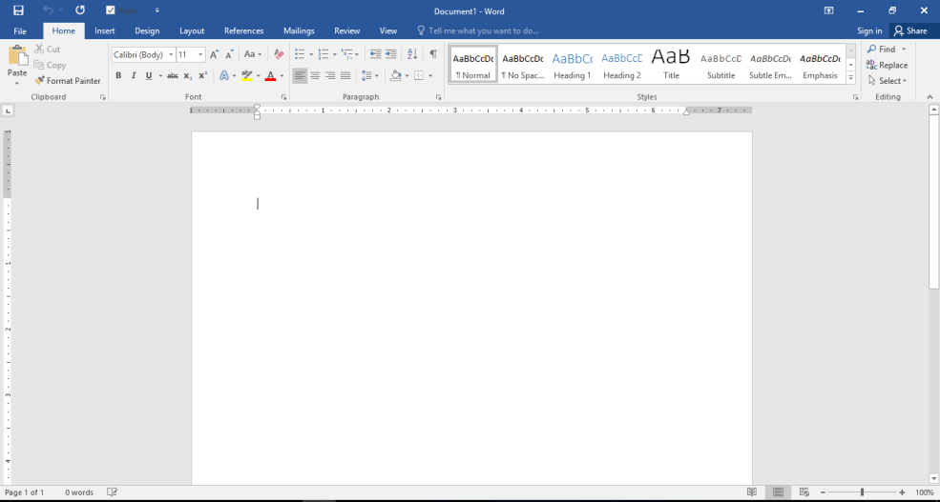

Create a document in Word
With Word on your PC or Mac:
- Create documents from scratch, or a template.
- Add text, images, art, and videos.
- Research a topic and find credible sources.
- Access your documents from a computer, tablet, or phone with OneDrive.
- Share your documents and work with others.
- Track and review changes.
Create a document
- On the File tab, click New.
- In the Search for online templates box, enter the type of document you want to create and press ENTER.
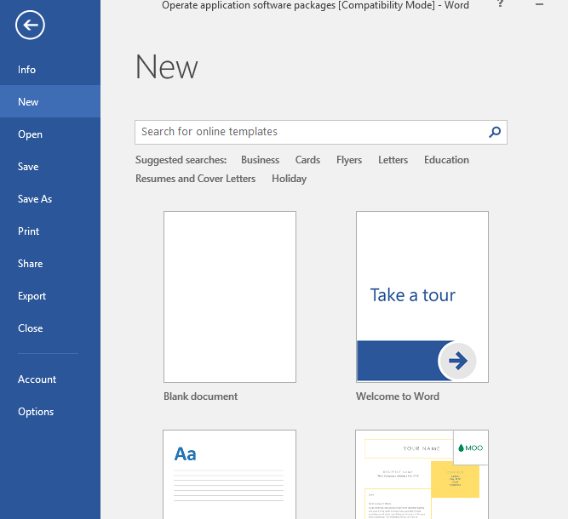
Add and format text
Place the cursor and type some text.
- To format, select the text and then select an option: Bold, Italic, Bullets, Numbering, and more.
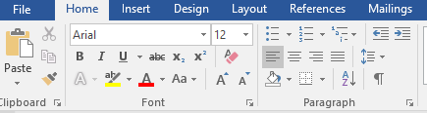
Add Pictures, Shapes, SmartArt, Chart, and more
- Select the Insert tab.
- Select what you want to add:
  - Tables - select Table, hover over the size you want, and select it.
  - Pictures - select Pictures, browse for pictures from your computer, select a stock image, or even search Bing.

The purpose Document

Microsoft Word is a word processing program that is part of the Microsoft Office Suite package. The main purpose of Word is to create text documents that can be saved electronically, printed on paper or saved as PDF files.
Composition and Editing
Microsoft Word allows users to type words, sentences and paragraphs much like a typewriter. However, Microsoft Word allows you to edit your words after typing them. For example, you can correct spelling, grammar, change words, delete or add words or even move entire blocks of text to other parts of the document.
Formatting and Saving
Microsoft Word contains many features that will allow you to format your text using boldface type, italics, underlining, headers and footers, bullets and numbering. The program will also allow you to save your document electronically to the computer's hard drive so that the document can be re-opened at a later date.

Printing
Microsoft Word can also help print your document. With Word, you can select printing options, such as choosing the printer you wish to print on or selecting how many copies of the document you want to print
Additional information
Types of information should cover text, numbers, images and other graphic elements. Sources should include internet documents, printed material, other word processing documents generally confined to simple and compatible data formats

Organisational requirements and design document structure and layout
    - Organisational requirements
Some organizations have information on their requirements presented in a style guide or procedures manual. These may set down the standards for:
- visual presentation, including margins, fonts and style
- spelling, grammar, punctuation and writing style
- graphics standards, including the use of logos and brands
- document naming conventions and filing protocols.
A style guide or procedures manual enables an organization to achieve consistency and quality in its documentation, enables staff to efficiently produce material without having to spend time thinking about style issues and enables the organization to have control over the image presented by its communications. In small organizations, these guides may not exist. In this case, a new member of staff should check the style and layout of previous documents or ask for advice on the usual practices from more experienced colleagues.
    - Design document structure and layout
The element of design
There are a variety of graphic design elements to consider when creating any visual work of art, whether it be for interior design, a logo, an advertisement, or web design. The basic elements of design are:
- Color: Color helps establish a mood for your composition. When light waves strike an object and reflect back to the optic nerve in a human’s eyes, the sensation they perceive is called color. Artists and designers use color to depict and describe the subject. Color is used by designers to portray mood, light, depth, and point of view. Designers use the color wheel and the tenets of color theory—a set of guidelines for mixing, combining, and manipulating colors—to create color schemes.
- Line: Line refers to the way that two points in space are connected. Whether they’re horizontal lines, diagonal lines, or vertical lines, lines can help direct the eye toward a certain point in your composition. You can also create texture by incorporating different types of lines such as curved or patterned lines instead of just straight lines.
- Value: In design, value refers to the lightness or darkness of a color. The values of a color are often visualized in a gradient, which displays a series of variations on one hue, arranged from the lightest to the darkest. Artists can use the various values of color to create the illusion of mass and volume in their work.
- Space: Making proper use of space can help others view your design as you intended. White space or negative space is the space between or around the focal point of an image. Positive space is the space that your subject matter takes up in your composition.
- Shape: In its most basic form, a shape is a two-dimensional area that is surrounded by an outline. Graphic artists can use other elements including line, color, value, and shadow to give a shape the appearance of a three-dimensional shape. There are three types of shapes: organic shapes which occur naturally in the world, geometric shapes which are angular and mathematically consistent, and abstract shapes that represent things in nature but aren’t perfectly representative.
- Form: Form pertains to the way that a shape or physical configuration occupies space. Instead of creating form through three-dimensional physical shape, designers create the appearance of form on a flat surface by using light, shadow, the appearance of an object’s contours, negative space, and the surrounding objects around the subject matter.
- Texture: Texture is one of the elements of design that is used to represent how an object appears or feels. Tactile texture is a physical sense of touch, whether it’s rough, smooth, or ribbed. Visual texture, on the other hand, refers to the imagined feel of the illustrated texture, which can create more visual interest and a heightened sensory experience.
What Are the Differences Between the Elements and Principles of Design?
The elements of design refer to the basic building blocks of any composition. The principles of design refer to how the elements are used, like the symmetrical and asymmetrical balance, pattern, emphasis, movement, and proportion. The principles of design are a set of cardinal rules and techniques for composing the various elements of design.

Match document requirements with software functions

How to match or compare two Microsoft Word Documents
There are many reasons that you may need to compare two Microsoft Word Documents. Maybe you have ended up with two different versions of the same document due to simultaneously editing, or you work in the legal profession and are required to create a legal backline document.
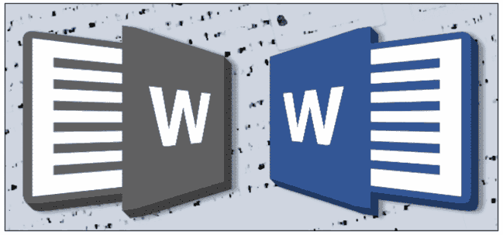
For whatever reason, you have two or more Word Documents and don’t have the time (or the sanity) to manually compare them.
In this post we will walk you through the best way to compare two Microsoft Word Documents, saving you a whole heap of time and frustration. It’s as easy as a click of a button!
Comparing two Word Documents
Microsoft Word does have a built-in document comparison tool called ‘Compare’. The tool allows you to compare two Word Documents at once, highlighting any changes or differences between the two, leaving you to edit, approve and accept the changes.
You may not want to merge the documents together if you are reviewing a contract and simply need to see what was changed between the two versions you can review this by following the first few steps below and not making any further changes.
If you would like to merge the documents, follow the steps below and continue moving your approved changes across into a ‘Master File’. Before saving this as a new version.

Steps to compare two Word Documents using Word Compare
- Open Word
- Open one of the Word Documents you want to compare
- Click Review in the menu
- Find and Click Compare under Tools
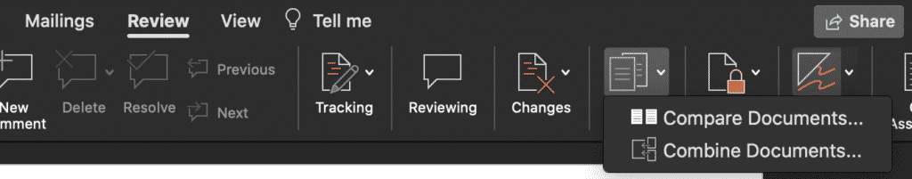
- Click Compare Documents
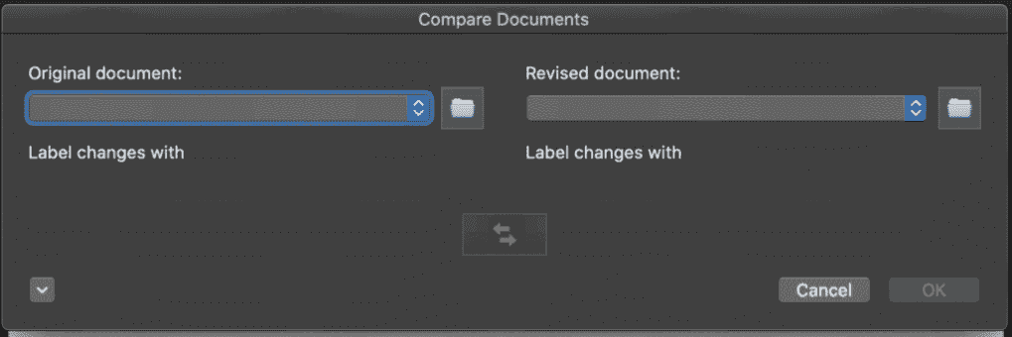
- Under Original Document, select the original word file (or one of the word files)
- Under Revised Document, select the document you wish to compare to the document selected above
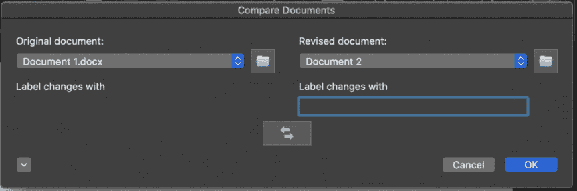
- Select a label for the changes (optional)
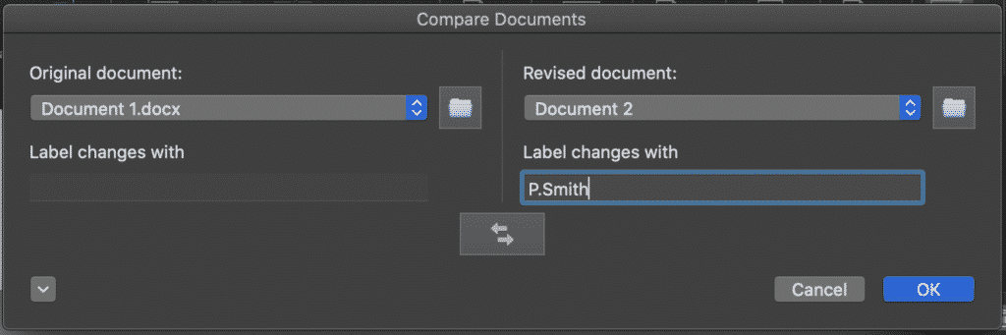
- Click OK

Self-check-1.1
Part 1: Choose the best answer
- ------- is used to manipulate a text document, such as a resume or a report.

  - word process software
  - database access software
  - publisher software
  - none

- Which of the following is the functions of word processing software?
- Creating, editing, saving and printing documents.
- Copying, pasting, moving and deleting text within a document.
- Formatting text
- Creating and editing tables.
- Correcting spelling and grammar
- All
- One of the following isn’t types of word proses software

- Apple work
- Microsoft word
- Open office
- None

- Which one of the following is correct procedure for starting Microsoft Word?
- Start --- all app------Microsoft office---------word 2016
- Start ----Microsoft office---- all app ---------word 2016
- all app---- start----- Microsoft office----------word 2016
- none
Part 2: Give short answer
- Explain the basic elements of design document structure

  - Color
  - Line
  - value
  - space
  - shape
  - form
  - texture

Operation sheet 1.1. Word-Processing Software
- Operation Title: Match or compare two Microsoft word Documents
- Purpose: The tool allows you to compare two Word Documents at once, highlighting any changes or differences between the two, leaving you to edit, approve and accept the changes.
- Instruction: Follow the procedures below
- Tools and requirement:
- This operation sheet
- Resource files
- computer
- Precautions:
- Procedures in doing the following task.
Step1: Use Windows Taskbar
Step1: Open Word
Step2: Open one of the Word Documents you want to compare
Step3: Click Review in the menu
Step4: Find and Click Compare under Tools
Step5: Click Compare Documents
Step6: Under Original Document, select the original word file (or one of the word files)
Step7: Under Revised Document, select the document you wish to compare to the document selected above
Step8: Select a label for the changes (optional)
Step9: Click OK

LAP /learning activity performance/ test

Name: _____________________________ Date: ________________
Time started: ________________________ Time finished: ________________ Instructions:
Given necessary templates, tools and materials you are required to perform the following tasks within 8hours.

Task 1: Match or compare two Microsoft word Documents

Unit Two: Customize basic settings and format documents to meet page layout
This unit is developed to provide you the necessary information regarding the following content coverage and topics:
- Adjust page layout
- Open and view different toolbars
- Change font format and settings
- Change and modify alignment, line spacing, margins of documents
- Align information in a selected cell
- Open and switch different documents
- Use formatting features and styles to customise basic settings and format cell
- Use technical functions, other data and formatting tools, document templates
- Highlight and copy text from another area in the document
- Insert headers and footers
- Save document in another file format and storage device
This unit will also assist you to attain the learning outcomes stated in the cover page. Specifically, upon completion of this learning guide, you will be able to:
- Adjust page layout to meet information requirements or special needs
- Open and view different toolbars
- Change font format /font settings to suit document purpose of the word document/spreadsheets/ database entries
- Change alignment and line spacing, and modify margins of the document (word / spreadsheet/ database/ according to document information requirements and formatting features
- Require Align information in a selected cell
- Open and switch between several word documents / spreadsheets/ database/
- Use formatting features and styles to customise basic settings and format cell or documents, create table and add images as required
- Use technical functions, other data and formatting tools, document templates as required to finalise documents/or within the spreadsheet
- Highlight and copy text from another area in the document or from another active document; or selected formatting features from another cell in the spread sheet or from another active spread sheet
- Insert headers and footers to incorporate necessary data using formatting features
- Save document in another file format or spread sheet as another file type and close document and spread sheet to a storage device

Adjust Page Layout

Introduction
Word offers a variety of page layout and formatting options that affect how content appears on the page. You can customize the page orientation, paper size, and page margins depending on how you want your document to appear.
Optional: Download our practice document.
Watch the video below to learn more about page layout in Word.
Page orientation
Word offers two-page orientation options: landscape and portrait. Compare our example below to see how orientation can affect the appearance and spacing of text and images.
Landscape means the page is oriented horizontally.
Portrait means the page is oriented vertically.
To change page orientation:
- Select the Layout tab.
- Click the Orientation command in the Page Setup group.
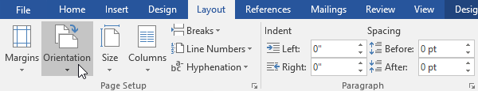
- A drop-down menu will appear. Click either Portrait or Landscape to change the page orientation.
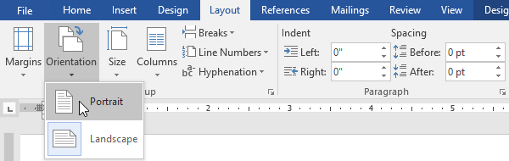
The page orientation of the document will be changed.
Page size
By default, the page size of a new document is 8.5 inches by 11 inches. Depending on your project, you may need to adjust your document's page size. It's important to note that before modifying the default page size, you should check to see which page sizes your printer can accommodate.
To change the page size:
Word has a variety of predefined page sizes to choose from.
- Select the Layout tab, then click the Size command.
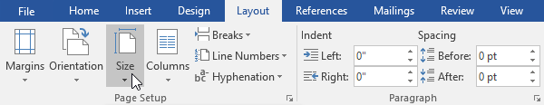
- A drop-down menu will appear. The current page size is highlighted. Click the desired predefined page size.
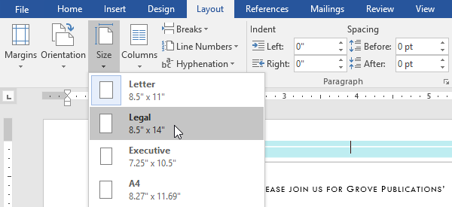
- The page size of the document will be changed.
To use a custom page size:
Word also allows you to customize the page size in the Page Setup dialog box.
- From the Layout tab, click Size. Select More Paper Sizes from the drop-down menu.
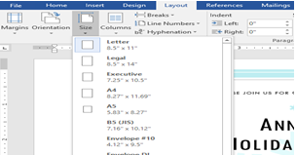
- The Page Setup dialog box will appear.
- Adjust the values for Width and Height, then click OK.
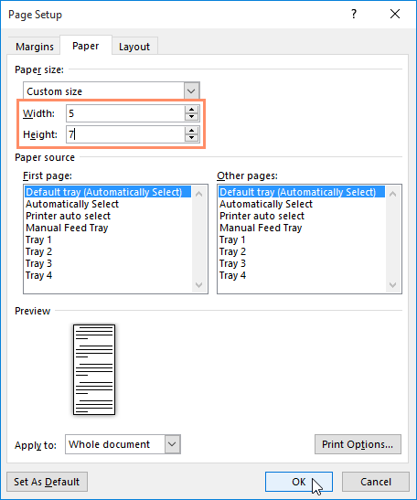
- The page size of the document will be changed.
Page margins
A margin is the space between the text and the edge of your document. By default, a new document's margins are set to Normal, which means it has a one-inch space between the text and each edge. Depending on your needs, Word allows you to change your document's margin size.
To format page margins:
Word has a variety of predefined margin sizes to choose from.
- Select the Layout tab, then click the Margins command.
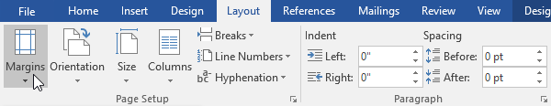
- A drop-down menu will appear. Click the predefined margin size you want.
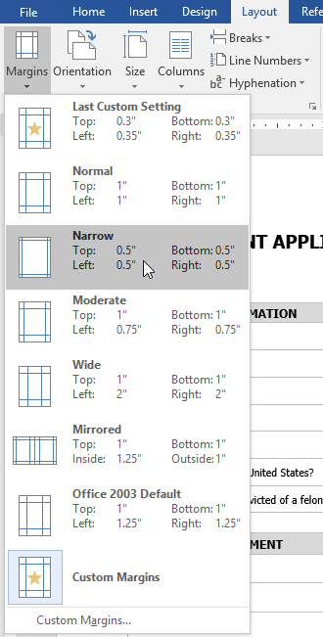
- The margins of the document will be changed.
To use custom margins:
Word also allows you to customize the size of your margins in the Page Setup dialog box.
      - From the Layout tab, click Margins. Select Custom Margins from the drop-down menu.
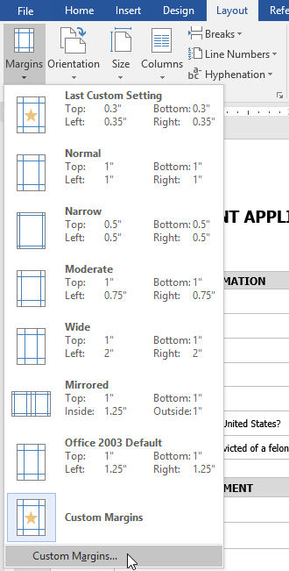
      - The Page Setup dialog box will appear.
      - Adjust the values for each margin, then click OK.
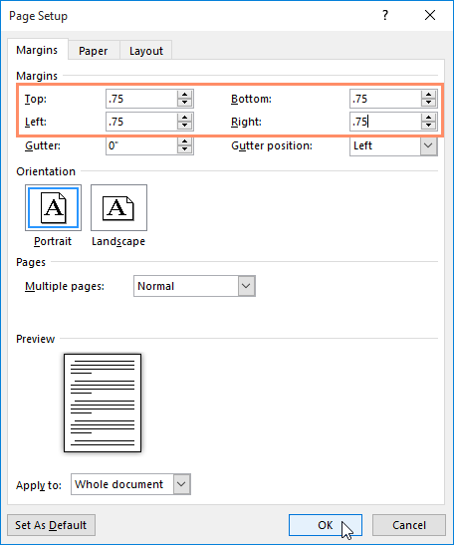
      - The margins of the document will be changed.
You can also open the Page Setup dialog box by navigating to the Layout tab and clicking the small arrow in the bottom-right corner of the Page Setup group.
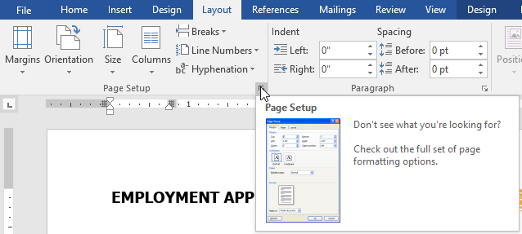
You can use Word's convenient Set as Default feature to save all of the formatting changes you've made and automatically apply them to new documents. To learn how to do this, read our lesson on Changing Your Default Settings in Word.

Open and View Different Toolbars

Introduction
Microsoft Word 2016 is a word processing application that allows you to create a variety of documents, including letters, resumes, and more. In this lesson, you'll learn how to navigate the Word interface and become familiar with some of its most important features, such as the Ribbon, Quick Access Toolbar, and Backstage view.
Getting to know Word 2016
Word 2016 is similar to Word 2013 and Word 2010. If you've previously used either version, then Word 2016 should feel familiar. But if you are new to Word or have more experience with older versions, you should first take some time to become familiar with the Word 2016 interface.
The Word interface
When you open Word for the first time, the Start Screen will appear. From here, you'll be able to create a new document, choose a template, and access your recently edited documents. From the Start Screen, locate and select Blank document to access the Word interface. Click the buttons in the interactive below to learn more about the Word interface:
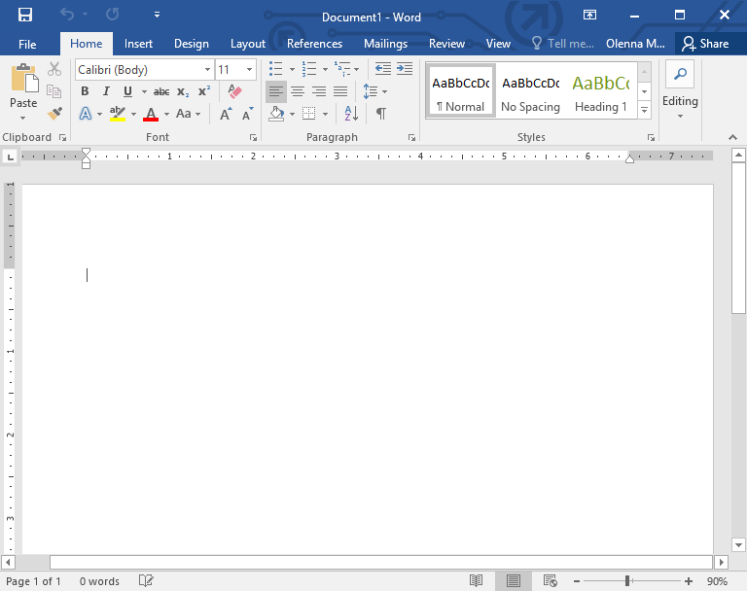

Working with the Word environment
Like other recent versions, Word 2016 continues to use features like the Ribbon and the Quick Access Toolbar—where you will find commands to perform common tasks in Word—as well as Backstage view.
The Ribbon
Word uses a tabbed Ribbon system instead of traditional menus. The Ribbon contains multiple tabs, which you can find near the top of the Word window.
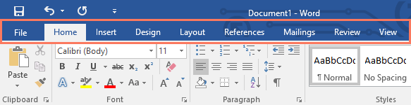
Each tab contains several groups of related commands. For example, the Font group on the Home tab contains commands for formatting text in your document.
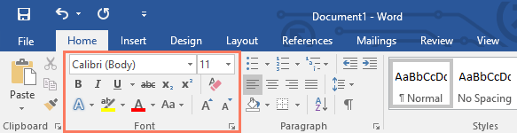
Some groups also have a small arrow in the bottom-right corner that you can click for even more options.
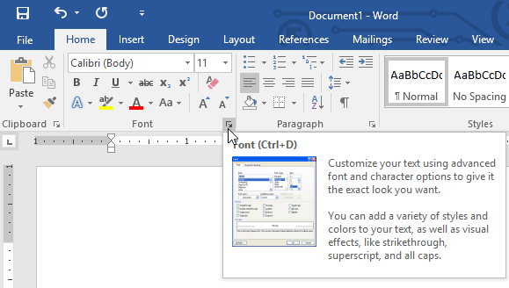
Showing and hiding the Ribbon
If you find that the Ribbon takes up too much screen space, you can hide it. To do this, click the Ribbon Display Options arrow in the upper-right corner of the Ribbon, then select the desired option from the drop-down menu:
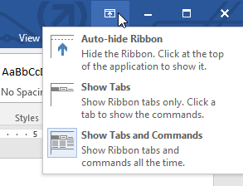
- Auto-hide Ribbon: Auto-hide displays your document in full-screen mode and completely hides the Ribbon from view. To show the Ribbon, click the Expand Ribbon command at the top of screen.
- Show Tabs: This option hides all command groups when they're not in use, but tabs will remain visible. To show the Ribbon, simply click a tab.
- Show Tabs and Commands: This option maximizes the Ribbon. All of the tabs and commands will be visible. This option is selected by default when you open Word for the first time.
To learn how to add custom tabs and commands to the Ribbon, review our Extra on Customizing the Ribbon.
Using the Tell me feature
If you're having trouble finding command you want, the Tell Me feature can help. It works just like a regular search bar: Type what you're looking for, and a list of options will appear. You can then use the command directly from the menu without having to find it on the Ribbon.
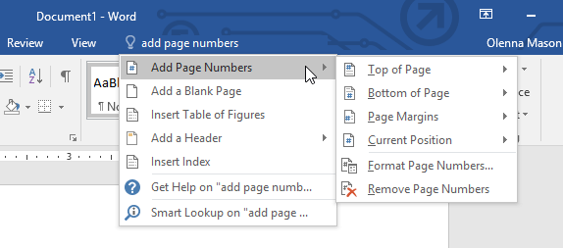
The Quick Access Toolbar
Located just above the Ribbon, the Quick Access Toolbar lets you access common commands no matter which tab is selected. By default, it shows the Save, Undo, and Redo commands, but you can add other commands depending on your needs. To add commands to the Quick Access Toolbar:
- Click the drop-down arrow to the right of the Quick Access Toolbar.
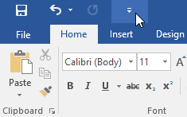
- Select the command you want to add from the menu.
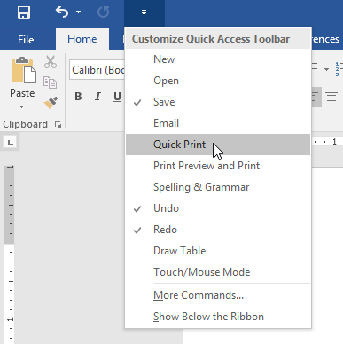
- The command will be added to the Quick Access Toolbar.
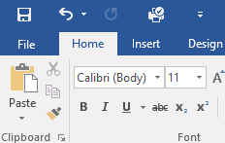

Change Font Format and Settings

Introduction
Formatted text can draw the reader's attention to specific parts of a document and emphasize important information. In Word, you have several options for adjusting text, including font, size, and color. You can also adjust the alignment of the text to change how it is displayed on the page.
To change the font size:
- Select the text you want to modify.
- On the Home tab, click the Font size drop-down arrow. Select a font size from the menu. If the font size you need is not available in the menu, you can click the Font size box and type the desired font size, then press Enter.
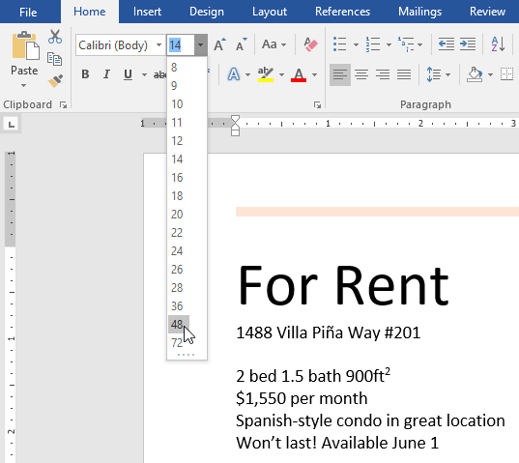
- The font size will change in the document.
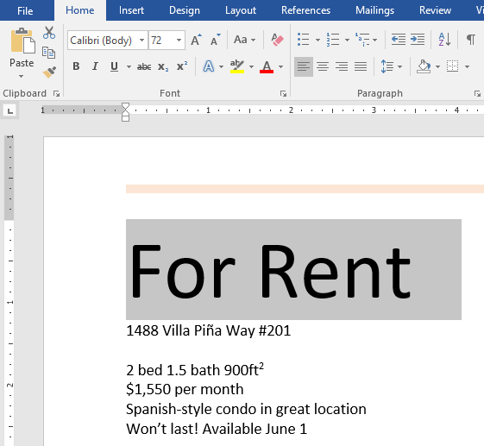
You can also use the Grow Font and Shrink Font commands to change the font size.
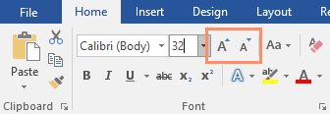
To change the font:
By default, the font of each new document is set to Calibri. However, Word provides many other fonts you can use to customize text.
Select the text you want to modify.
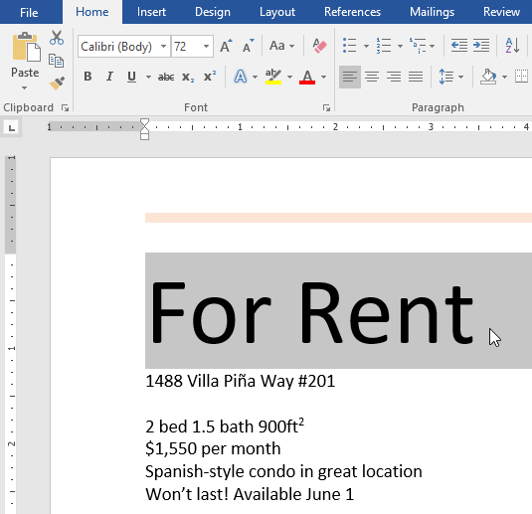
On the Home tab, click the drop-down arrow next to the Font box. A menu of font styles will appear.
      - Select the font style you want to use.
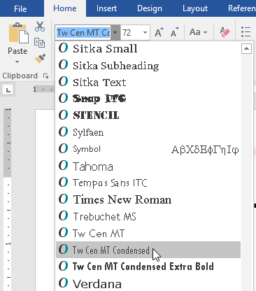
      - The font will change in the document.
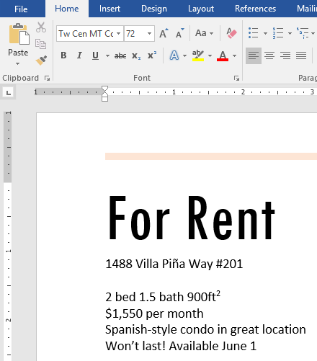
When creating a professional document or a document that contains multiple paragraphs, you'll want to select a font that's easy to read. Along with Calibri, standard reading fonts include Cambria, Times New Roman, and Arial.
To change the font color:
- Select the text you want to modify.
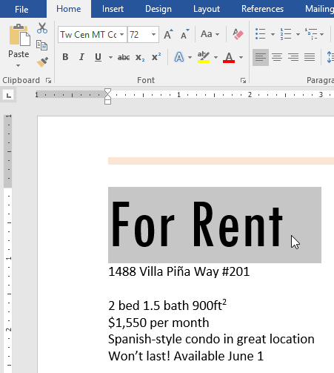
- On the Home tab, click the Font Color drop-down arrow. The Font Color menu appears.
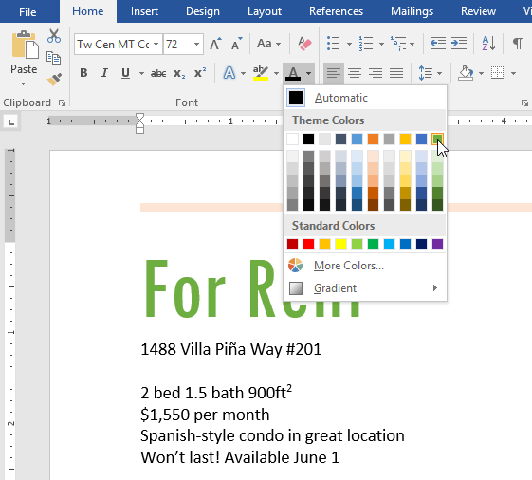
- Select the font color you want to use. The font color will change in the document.
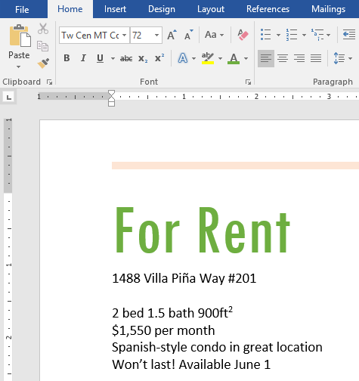
Your color choices aren't limited to the drop-down menu that appears. Select More Colors at the bottom of the menu to access the Colors dialog box. Choose the color you want, then click OK.
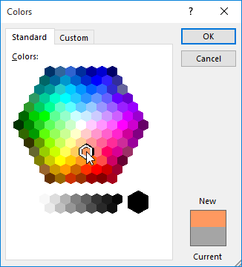

Change and Modify Alignment, Line Spacing, Margins

To change text alignment:
By default, Word aligns text to the left margin in new documents. However, there may be times when you want to adjust text alignment to the center or right.
- Select the text you want to modify.
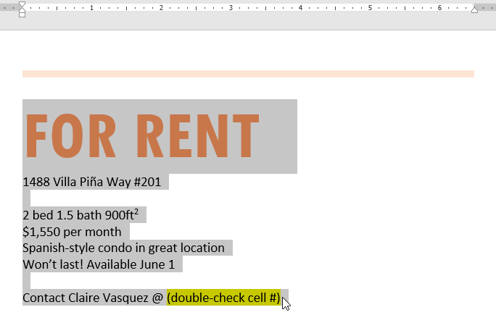
- On the Home tab, select one of the four alignment options from the Paragraph group. In our example, we've selected Center Alignment.
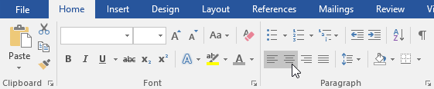
- The text will be realigned in the document.
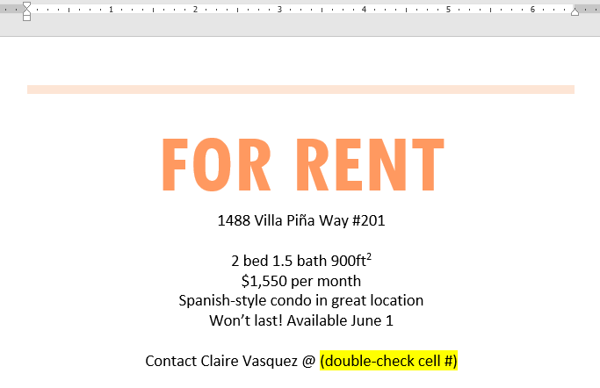
Click the arrows in the slideshow below to learn more about the four text alignment options.
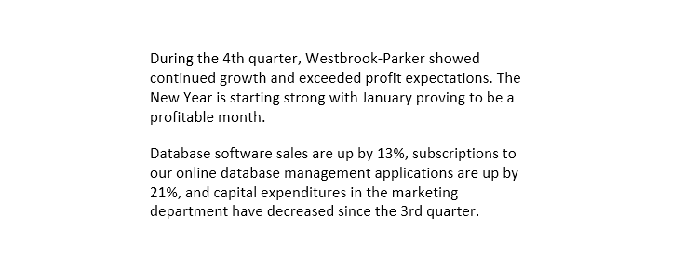
Align Text Left: This aligns all selected text to the left margin. The Align Text Left command is the most common alignment and is selected by default when a new document is created.

Center: This aligns text an equal distance from the left and right margins.

Align Text Right: This aligns all selected text to the right margin.
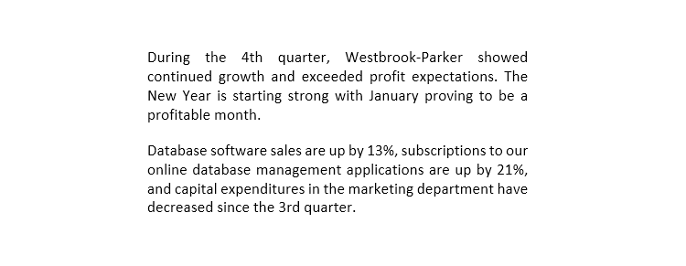
Justify: Justified text is equal on both sides. It lines up equally to the right and left margins. Many newspapers and magazines use full justification.
Changing line spacing
1. With the first paragraph still selected, in the Paragraph group, click the Dialogue Box Launcher to access more paragraph formatting options.
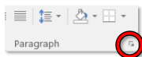
2. On the Indents and Spacing tab, in the Spacing section, click the Line spacing drop-down arrow, and click Double.
3. Click OK.

Align Information in A Selected Cell

Align text in a cell
Excel for the web
If you’d like to realign text in a cell to enhance the visual presentation of your data, here’s how you can do it:
- Select the cells that have the text you want aligned.
- On the Home tab choose one of the following alignment options:
- 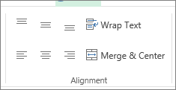
- To vertically align text, pick Top Align , Middle Align , or Bottom Align .
- To horizontally align text, pick Align Text Left , Center , or Align Text Right .
- When you have a long line of text, part of the text might not be visible. To fix this without changing the column width, click Wrap Text.
- To center text spanning several columns or rows, click Merge & Center.
Undo alignment changes
- To remove an alignment, change immediately after you apply it, click Undo.
- To make alignment changes later, select the cell or cell range you want to change, and click Clear > ClearFormats.
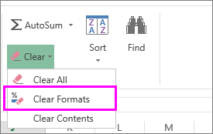
Note: in Excel for the web you can’t rotate the angle of text in a cell

Open and Switch Between Different Documents

Now and then, it’s quite often to conduct multiple tasks at one time. And when it comes to Word, opening several documents at the same time is not unusual. However, living in an age when time is one of our greatest assets, to do things quick and fast is required everywhere. So, a little time squeezed can mean a lot to us. Now let’s take a look at how we can save time by quickly switching between document windows.
Method 1: Use Windows Taskbar
Once you hover your cursor over the Word icon on Windows taskbar, you can see all currently open documents displayed in small windows, such as below:
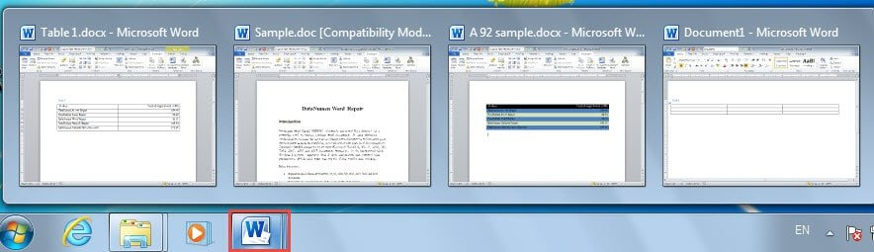
You just need to click on the target window to have it maximized. This is perhaps the most commonly used way to complete the task. However, this method is based on some preset settings. To make sure all document windows can be shown on the taskbar, here are what you have do first:
- In Word, click “File”, and then “options” to open “Word Options” dialog box
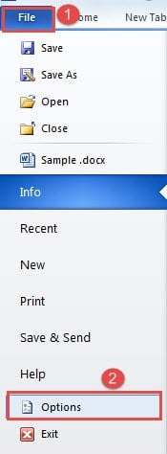
- Next, click “Advanced”.
- Then scroll down to “Display” page and check the “Show all windows in the Taskbar” box.
- Lastly, click “OK”.
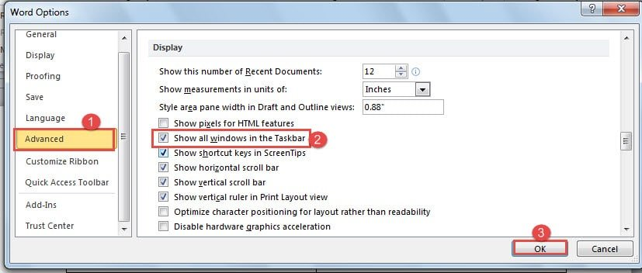
Method 2: Change Windows inside Word
Inside Word, there is already the feature for you to jump to your wanted document window.
- Firstly, click “View” tab.
- Then click “Switch Windows” in “Window” group.
- On the drop-down list, there are names of all open documents. Just click on the name is all you need to do.
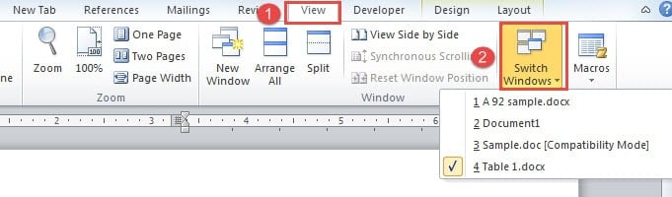
Method 3: Add Commands to “Quick Access Toolbar”
Word has some hidden functions that need you to bring it out. For instance, you can choose to add either “Previous Window” or “Next Window” to “Quick Access Toolbar”.
- To begin with, go to open “Word Options” dialog box through steps in method 1.
- Only this time, you choose to click “Quick Access Toolbar”.
- Then continue to choose “Commands Not in the Ribbon”.
- Next find and click on either “Previous Window” or “Next Window”.
- And click “Add”.
- At last, click “OK”.
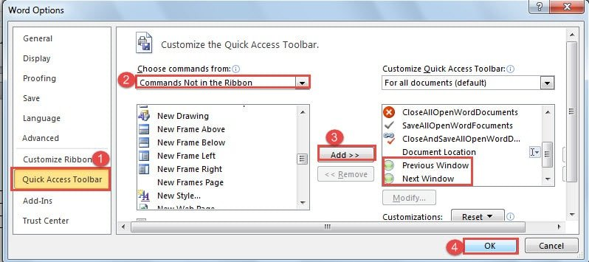
Now click on the command to go to the right window. If you are a keyboard shortcuts guy, you can save the adding command time by remembering the combination of “Ctrl+F6” or “Ctrl+ Shift+ F6”.
Method 4: Press “Alt+ Esc”
Press “Alt” and hold on. Then press “Esc” to cycle through open document windows. And stop on the right one by releasing “Alt”.
Method 5: Press “Alt+ Tab”
Here is another similar combination. That is to press and hold on “Alt”, and press “Tab”. Then all windows including those of other programs will show on the screen. Now press “Tab” to pick one and finally loose “Alt”.
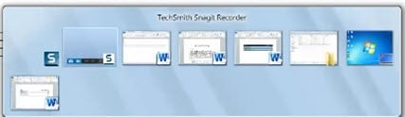
Method 6: VBA Codes
- Firstly, press “Alt+ F11” to open the VBA editor.
- Then you can click “This Document”.
- And click “Insert” on toolbar.
.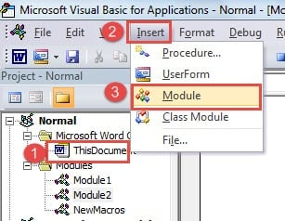
- Then choose “Module”

Formatting Features and Styles to Customize Basic Settings and Format Cell
The styles covered in this article are located in the Styles gallery, a visual menu located on the Home tab. To apply a style, simply select the text you want to format, and then click the style you want in the Styles gallery.
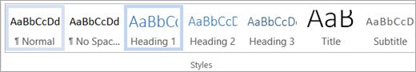
Modify an existing style
You can modify an existing style in the Styles gallery in two ways:
- Modify a style by updating it to match formatting in your document
- Modify a style manually in the Modify Style dialog box
Modify a style by updating it to match formatting in your document
If you have text in your document that already has a style applied, you can change the formatting of that text and apply it to the style in the Styles gallery.
- Select text in your document that has the style applied, such as Heading 1.
- When you select text that has a style applied, that style is highlighted in the Styles gallery.
- Format the selected text with the new attributes that you want.
For example, you might want to change the point size for the Heading 1 style from 16 points to 14 points.
On the Home tab, in the Styles group, right-click the style that you want to change, and then click Update [Style Name] to Match Selection.

Modify a style manually in the Modify Style dialog box
You can modify a style directly in the Styles gallery, without using the text in your document.
- On the Home tab, right-click any style in the Styles gallery and click Modify.
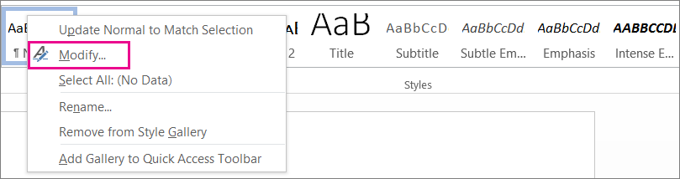
- In the Formatting section, make any formatting changes you want, such as font style, size, or color, alignment, line spacing, or indentation.
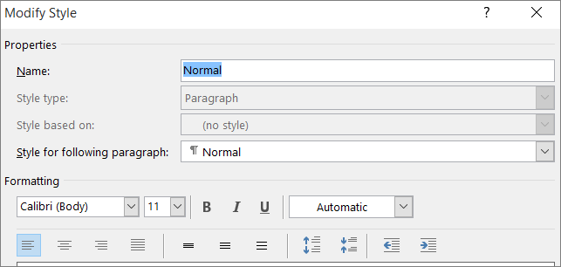
- Choose whether the style change applies to the current document or to all future documents.
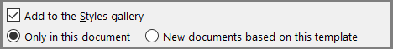
Create a new style based on document formatting
You can select formatted text in your document to create a new style that you add to the Styles gallery.
- Right-click the text on which you want to base a new style.
- In the mini toolbar that appears, click Styles, and then click Create a Style.
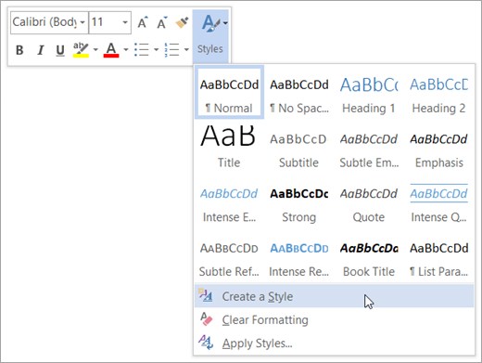
- In the Create New Style from Formatting dialog box, give your style a name and click OK.

To use the Bold, Italic, and Underline commands
The Bold, Italic, and Underline commands can be used to help draw attention to important words or phrases.
- Select the text you want to modify.
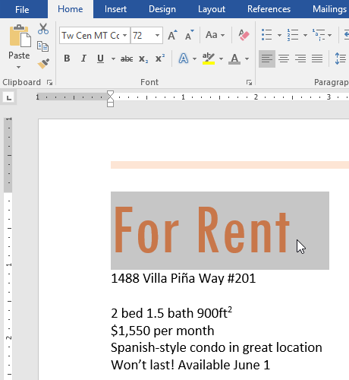
- On the Home tab, click the Bold (B), Italic (I), or Underline (U) command in the Font group. In our example, we'll click Bold.
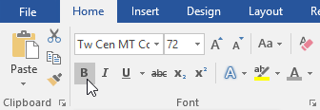
- The selected text will be modified in the document.
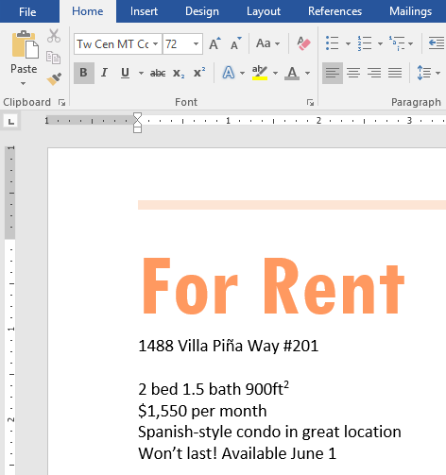
To change text case:
When you need to quickly change text case, you can use the Change Case command instead of deleting and retyping text.
- Select the text you want to modify.
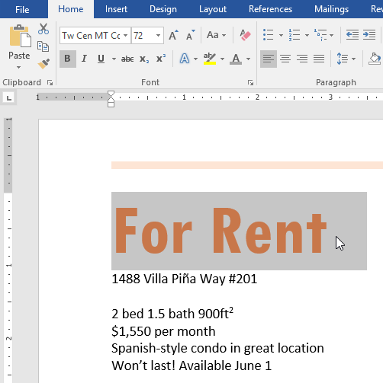
- On the Home tab, click the Change Case command in the Font group.
- A drop-down menu will appear. Select the desired case option from the menu.
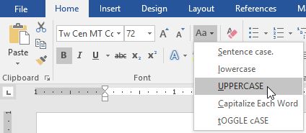
- The text case will be changed in the document.
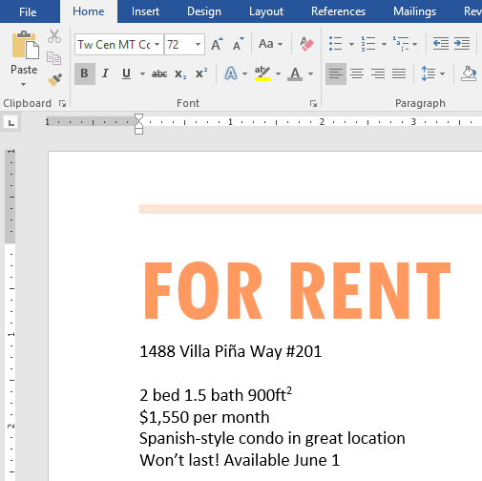

Use technical functions, other data and formatting tools
    - Undo, Redo and Repeat
Word keeps track of most tasks you perform until you exit. Tasks such as formatting and deleting, can be undone. From the Quick Access Toolbar click the button ( ), or use the shortcut key Ctrl-Z.
Most windows programs have an Undo feature; many only allow you to undo one task. Word keeps track of each step that you have done since the document was opened.
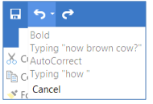
There is a drop-down arrow next to the Undo button, on the standard toolbar. This allows you to see a list of every step you have done so far. If you want to undo something that you have done several steps ago, you must undo every step between now and then. You cannot go back and undo a single task without undoing everything back to that point.
If you undo too far, or you change your mind about the undoing of that task, Word allows you to Redo. On the Quick Access Toolbar, you will find the redo button or use the shortcut key Ctrl-Y.
If there is nothing to redo, Word puts a Repeat feature in Redo’s place ( ) and assigns the shortcut key (Ctrl-Y) to Repeat.
    - Cut, Copy and Paste
Cut, Copy and Paste are clipboard features built into windows. The clipboard is a temporary storage location where an item is stored for later recall. The windows clipboard can only store one item at a time. Microsoft Office has a Multi-Clipboard that can store 24 items You can open the multi-clipboard from the "more" button.

Cut will copy the selected text to the clipboard and remove it from the current location. This button appropriately shows a pair of scissors for the cut option. The shortcut key is Ctrl-X. To use the Cut command, you need to select the text or object you wish to move then choose the option. Move the cursor where you want the text or object to appear and choose Paste.

Move: Instead of Cut/Paste, try selecting the text, then click and dragging to a new location.
Copy will place the selected text on the clipboard; nothing will appear to happen on the
window. The button shows two sheets of paper for the copy option. The shortcut key is Ctrl-C. To use the Copy command, you need to select the text or object, and then choose copy. Move the cursor where you want the text or object to appear and choose Paste.
Duplicate: Instead of Copy/Paste, try selecting the text, and then drag to a new location
while holding down the Ctrl key. Be sure to let go of the mouse before you let go of the
keyboard, and you will produce a duplicate.
Paste will produce the last option copied or cut to the clipboard. This button shows a sheet of paper coming from a clipboard for the paste option. The shortcut key is Ctrl-V, or Shift-Insert. You can usually paste the same item over and over again, until the computer has been restarted or you copy/cut something else.

Paste Special: The drop-down menu under the Paste button shows the Paste Special
options. These options will change depending on what is currently in the clipboard. It can be a very useful tool to do things such as Paste as unformatted text. Unformatted text will get rid of hidden HTML codes from a webpage or the hidden formatting from another Word Document.
Formatting Paragraphs
In Microsoft Word, a paragraph is any text which ends with a (paragraph mark). These are created when you press the Enter key on the keyboard. You can see the hidden charters such as the paragraph mark by using the show/hide button in the upper right-hand corner of the Paragraph group (#7).
- Bullets – Start a bulleted list or click the drop-down arrow to choose a bullet style
- Numbering – Start a numbered list or click the drop-down arrow to choose a number style
- Multilevel List – Start a multileveled list or click the drop-down arrow to choose different styles
- Decrease Indent – Decrease the indent level of the current/selected paragraph(s)
- Increase Indent – Increase the indent level of the current/selected paragraph(s)
- Sort – Alphabetize the selected text
- Show/Hide – Show or hide the non-printing characters such as paragraph breaks, spaces and tabs
- Align Text Left – Align the current/selected paragraph(s) on the left side
- Justify – Align the current/selected paragraph(s) on both sides
- Line Spacing – Change the spacing between the lines of the current/selected paragraph(s)
- Shading – Change the background color behind the text
- Borders – Change the borders around the text, click the arrow to choose different styles
- More Paragraph – Opens the Paragraph
- Window to find most of the paragraph formatting options

Highlight, Copy Text and Select Formatting Features
To highlight text:
Highlighting can be a useful tool for marking important text in your document.
- Select the text you want to highlight.
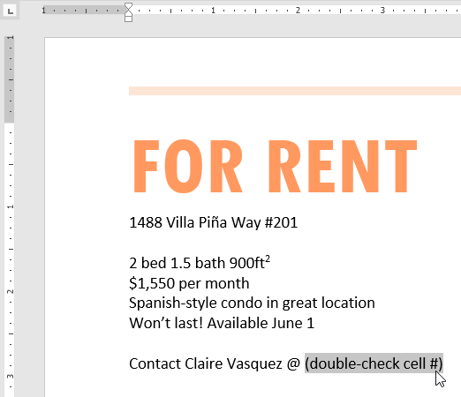
- From the Home tab, click the Text Highlight Color drop-down arrow. The Highlight Color menu appears.
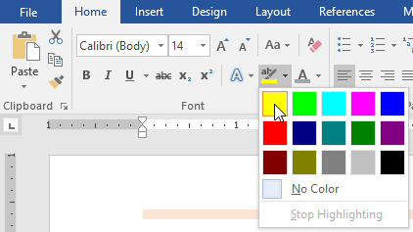
- Select the desired highlight color. The selected text will then be highlighted in the document.
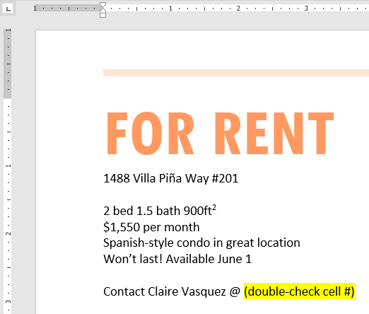
To remove highlighting, select the highlighted text, then click the Text Highlight Color drop-down arrow. Select No Color from the drop-down menu.
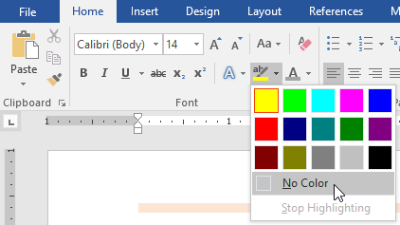
If you need to highlight several lines of text, changing the mouse into a highlighter may be a helpful alternative to selecting and highlighting individual lines. Click the Text Highlight Color command, and the cursor changes into a highlighter. You can then click and drag the highlighter over the lines you want to highlight.

Insert Headers and Footers

Insert a header or footer
A header or footer can contain text, information about the document, or even images. You can create one header or footer for the whole document, or have a different header or footer for the first page, odd. and even pages, or even multiple sections

Headers and Footers
A header is text that appears at the top of every page in your document. Similarly, a footer is text that appears at the bottom of every page.
- First, let’s insert a header.
- Open Internet Policy.docx.
Ctrl | + | Home
- Tap to get to the top of the document.
- Click the Insert tab. In the Header & Footer group, click Header to open a list of different header options.
- Scroll down the menu to view all the options and click Blank.
- Notice that a new contextual ribbon has opened called Header & Footer Tools. It has one tab - Design.
- Notice how Word is calling out the header section with a dotted-line.
- Notice the words “Type here” enclosed in brackets on the left. This is a placeholder for an area of the header into which we can enter content. It is colored gray, which means it is already selected and ready for us to populate it with content.
- Type “Internet Policy”.
- Close header. This can be done in two ways:
- On the Header & Footer Tools contextual ribbon, on the Design tab, click Close Header and Footer.
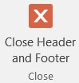
- By double-clicking anywhere within the body of the document. (We’ll try this in a minute)
- Scroll down and notice that “Internet Policy” appears at the top of every page.
- Also notice that the font color of the text in the header is light gray. This is not the actual font color. Microsoft Word makes the header text display in light grey to show that the header is not currently active.
- Double-click on the header to make it active. Notice how the font color has changed to its real color (black) and the document body text is now dimmed. Again, this is to show that the header/footer is active, and the document body is not active.
- Next, let’s insert a footer.
  - Note that, when the header is active, the footer is active as well. Scroll down to the bottom of the current page and notice that there is a Footer section called-out with a dotted-line.
  - On the Header & Footer Tools contextual ribbon, on the Design tab, locate the Header & Footer group. Click Footer to open a list of different footer options.
  - Again, scroll down the list to view all the options and then click Blank (Three Columns).
  - What we’re going to do is, put our name in the left placeholder, the current date in the center placeholder, and the page number in the right placeholder. There are tools on the Header & Footer Tools contextual ribbon to facilitate this.
  - Click on the left placeholder to select it and type your name. Do not tap Enter .
  - Let’s make our name bold. How would we do this? Because there is no Bold button visible, we have to switch to another ribbon. Click the Home tab, locate the Font group and click
Bold. (no need to highlight the name)
  - Note how our Header & Footer Tools contextual ribbon is no longer active since we switched to the Home tab. To bring the Header & Footer Tools contextual ribbon back, click on its Design tab.

  - Click on the middle placeholder in the footer to select it. On the Header & Footer Tools ribbon, locate the Insert group and click Date & Time. When the dialogue box opens, click any date format you wish under the Available Formats in the left pane.
  - Note the empty checkbox that says “Update automatically”. This would need to be checked if you want the inserted date to change to the current date every time you open this document.
  - Click OK.
- Click on the right placeholder. On the Header & Footer Tools ribbon, locate the Header & Footer group and click Page Number. A list of options will be shown about where you want to insert the page numbers (see table below).
Top of Page Puts the page number in the header.
Warning: This will replace your entire header with
a new header!

Warning: This will replace your entire footer with
a new footer!

Page Margins | Puts the page number in the left or right margins.
Current Position | Puts the page number wherever your insertion point is.
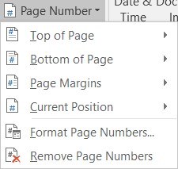 Bottom of Page Puts the page number in the footer.
  - Move your pointer to Current Position and a list of options will open. Scroll down the list to the “Page X of Y” section and click Bold Numbers.
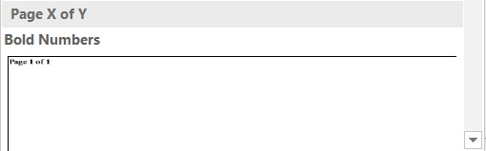
  - Double-click in the body of the document to close the Header and Footer Tools.

Save Document in Another File Format and Storage Device

File formats that are supported in Excel
Excel for Microsoft Excel 2021 Excel 2019 Excel 2016
You can save an Excel file in another file format by clicking the File > Save As. The file formats that are available in the Save As dialog box vary, depending on what type of sheet is active (a worksheet, chart sheet, or other type of sheet).
Note: Whenever you save a file in another file format, some of its formatting, data, and features might not be transferred.
To open a file that was created in another file format, either in an earlier version of Excel or in another program, click File > Open. If you open an Excel 97-2003 workbook, it automatically opens in Compatibility Mode. To take advantage of the new features of Excel 2010, you can save the workbook to an Excel 2010 file format. However, you also have the option to continue to work in Compatibility Mode, which retains the original file format for backward compatibility.
Excel file formats
Format | Extension | Description
Excel Workbook | .xlsx | The default XML-based file format for Excel 2010 and Excel 2007. Cannot store Microsoft Visual Basic for Applications (VBA) macro code or Microsoft Office Excel 4.0 macro sheets (.xlm).
Excel Macro-Enabled Workbook (code) | .xlsm | The XML-based and macro-enabled file format for Excel 2016, Excel 2013, Excel 2010, and Excel 2007. Stores VBA macro code or Excel 4.0 macro sheets (.xlm).
Excel Binary Workbook | .xlsb | The binary file format (BIFF12) for Excel 2010 and Excel 2007.
Template | .xltx | The default file format for an Excel template for Excel 2010 and Excel 2007. Cannot store VBA macro code or Excel 4.0 macro sheets (.xlm).
Template (code) | .xltm | The macro-enabled file format for an Excel template Excel 2010 and Excel 2007. Stores VBA macro code or Excel 4.0 macro sheets (.xlm).
Excel 97- Excel 2003 Workbook | .xls | The Excel 97 - Excel 2003 Binary file format (BIFF8).
Excel 97- Excel 2003 Template | .xlt | The Excel 97 - Excel 2003 Binary file format (BIFF8) for an Excel template.
Microsoft Excel 5.0/95 Workbook | .xls | The Excel 5.0/95 Binary file format (BIFF5).
XML Spreadsheet 2003 | .xml | XML Spreadsheet 2003 file format (XMLSS).
XML Data | .xml | XML Data format.
Excel Add-In | .xlam | The XML-based and macro-enabled Add-In format for Excel 2010 and Excel 2007. An Add-In is a supplemental program that is designed to run additional code. Supports the use of VBA projects and Excel 4.0 macro sheets (.xlm).
Excel 97-2003 Add-In | .xla | The Excel 97-2003 Add-In, a supplemental program that is designed to run additional code. Supports the use of VBA projects.
Excel 4.0 Workbook | .xlw | An Excel 4.0 file format that saves only worksheets, chart sheets, and macro sheets. You can open a workbook in this file format in Excel 2010, but you cannot save an Excel file to this file format.
Works 6.0-9.0 spreadsheet | .xlr | Spreadsheet saved in Microsoft Works 6.0-9.0.  Note: This format is supported in Excel Starter only.

Text file formats
Format | Extension | Description
Formatted Text (Space-delimited) | .prn | Lotus space-delimited format. Saves only the active sheet.
Text (Tab-delimited) | .txt | Saves a workbook as a tab-delimited text file for use on another Microsoft Windows operating system, and ensures that tab characters, line breaks, and other characters are interpreted correctly. Saves only the active sheet.
Text (Macintosh) | .txt | Saves a workbook as a tab-delimited text file for use on the Macintosh operating system, and ensures that tab characters, line breaks, and other characters are interpreted correctly. Saves only the active sheet.
Text (MS-DOS) | .txt | Saves a workbook as a tab-delimited text file for use on the MS-DOS operating system, and ensures that tab characters, line breaks, and other characters are interpreted correctly. Saves only the active sheet.
Unicode Text | .txt | Saves a workbook as Unicode text, a character encoding standard that was developed by the Unicode Consortium.
CSV (comma delimited) | .csv | Saves a workbook as a comma-delimited text file for use on another Windows operating system, and ensures that tab characters, line breaks, and other characters are interpreted correctly. Saves only the active sheet.
CSV (Macintosh) | .csv | Saves a workbook as a comma-delimited text file for use on the Macintosh operating system, and ensures that tab characters, line breaks, and other characters are interpreted correctly. Saves only the active sheet.
CSV (MS-DOS) | .csv | Saves a workbook as a comma-delimited text file for use on the MS-DOS operating system, and ensures that tab characters, line breaks, and other characters are interpreted correctly. Saves only the active sheet.
DIF | .dif | Data Interchange Format. Saves only the active sheet.
SYLK | .slk | Symbolic Link Format. Saves only the active sheet.
Note: If you save a workbook in any text format, all formatting is lost.

Other file formats
Format | Extension | Description
DBF 3, DBF 4 | .dbf | dBase III and IV. You can open these files formats in Excel, but you cannot save an Excel file to dBase format.
OpenDocument Spreadsheet | .ods | OpenDocument Spreadsheet. You can save Excel 2010 files so they can be opened in spreadsheet applications that use the OpenDocument Spreadsheet format, such as Google Docs and OpenOffice.org Calc. You can also open spreadsheets in the .ods format in Excel 2010. Formatting might be lost when saving and opening .ods files.
PDF | .pdf | Portable Document Format (PDF). This file format preserves document formatting and enables file sharing. When the PDF format file is viewed online or printed, it retains the format that you intended. Data in the file cannot be easily changed. The PDF format is also useful for documents that will be reproduced by using commercial printing methods.  Note: This format is not supported in Excel 2007.
XPS Document | .xps | XML Paper Specification (XPS). This file format preserves document formatting and enables file sharing. When the XPS file is viewed online or printed, it retains exactly the format that you intended, and the data in the file cannot be easily changed.  Note: This format is not supported in Excel 2007.

File formats that use the Clipboard
You can paste data from the Microsoft Office Clipboard into Excel by using the Paste or Paste Special command (Home tab, Clipboard group, Paste button) if the Office Clipboard data is in one of the following formats.
Format | Extension | Clipboard type identifiers
Picture | .wmf or .emf | Pictures in Windows Metafile Format (WMF) or Windows Enhanced Metafile Format (EMF).  Note If you copy a Windows metafile picture from another program, Excel pastes the picture as an enhanced metafile.
Bitmap | .bmp | Pictures stored in Bitmap format (BMP).
Microsoft Excel file formats | .xls | Binary file formats for Excel versions 5.0/95 (BIFF5), Excel 97-2003 (BIFF8), and Excel 2010 (BIFF12).
SYLK | .slk | Symbolic Link Format.
DIF | .dif | Data Interchange Format.
Text (tab-delimited) | .txt | Tab-separated text format.
CSV (Comma-delimited) | .csv | Comma-separated values format.
Formatted text (Space-delimited) | .rtf | Rich Text Format (RTF). Only from Excel.
Embedded object | .gif, .jpg, .doc, .xls, or .bmp | Microsoft Excel objects, objects from properly registered programs that support OLE 2.0 (OwnerLink), and Picture or another presentation format.
Linked object | .gif, .jpg, .doc, .xls, or .bmp | OwnerLink, ObjectLink, Link, Picture, or other format.
Office drawing object | .emf | Office drawing object format or Picture (Windows enhanced metafile format, EMF).
Text | .txt | Display Text, OEM Text.
Single File Web Page | .mht, .mhtml | Single File Web Page (MHT or MHTML). This file format integrates inline graphics, applets, linked documents, and other supporting items referenced in the document.  Note: This format is not supported in Excel 2007.
Web Page | .htm, .html | Hypertext Markup Language (HTML).  Note: When you copy text from another program, Excel pastes the text in HTML format, regardless of the format of the original text.

Self-check-2.1
- Saves a workbook as unicode text, a character encoding standard that was developed by the unicode consortium.
  - Text Macintosh
  - Text MS-DOS
  - Unicode text
  - None the above
- Word offers two-page orientation options is------- and ----------.
- Landscape
- Portrait
- Table
- A and B
- ------- is text that appears at the top of every page in your document.
- Page margin
- Header
- Footer
- All
- ------- is text that appears at the bottom of every page.
- Page margin
- Header
- Footer
- All
- Which of the following is not correct procedure predefined page sizes?
- Layout ---- Size------drop-down menu ---highlight current page size--predefined page size
- predefined page size ----Layout ---- Size---drop-down menu ---highlight current page size
- Size------drop-down menu -----Layout ---highlight current page size--predefined page size
- All

Operation sheet 2.1 Customize basic settings and format documents to meet page layout
Operation Title: Customize basic settings and format documents to meet page layout
- Purpose: To know customize basic setting and format documents and page layout conversation
- Instruction: Follow the procedures below
- Tools and requirement:
- This operation sheet
- Resource files
- computer
- Precautions:
- Procedures in doing the task.
Step1: To change page orientation:
- Select the Layout tab.
- Click the Orientation command in the Page Setup group.
- A drop-down menu will appear. Click either Portrait or Landscape to change the page orientation.
Step2: To change the page size:
- Select the Layout tab, then click the Size command.
- A drop-down menu will appear. The current page size is highlighted. Click the desired predefined page size.
- The page size of the document will be changed.
Step3: To use a custom page size:
Word also allows you to customize the page size in the Page Setup dialog box.
- From the Layout tab, click Size. Select More Paper Sizes from the drop-down menu.
- The Page Setup dialog box will appear.
- Adjust the values for Width and Height, then click OK.
- The page size of the document will be changed.
Step4: To format page margins:
Word has a variety of predefined margin sizes to choose from.
- Select the Layout tab, then click the Margins command.
- A drop-down menu will appear. Click the predefined margin size you want.
- The margins of the document will be changed.
Step5: To use custom margins:
Word also allows you to customize the size of your margins in the Page Setup dialog box.
      - From the Layout tab, click Margins. Select Custom Margins from the drop-down menu
      - The Page Setup dialog box will appear.
      - Adjust the values for each margin, then click OK.
      - The margins of the document will be changed
Step6: To change the font size:
- Select the text you want to modify.
- On the Home tab, click the Font size drop-down arrow.
- Select a font size from the menu. If the font size you need is not available in the menu, you can click the Font size box and type the desired font size, then press Enter.
Step7: To change the font:
Select the text you want to modify.
- On the Home tab, click the drop-down arrow next to the Font box.
- A menu of font styles will appear.
      - Select the font style you want to use.
      - The font will change in the document.
Step8: To change the font color:
- Select the text you want to modify.
- On the Home tab, click the Font Color drop-down arrow. The Font Color menu appears.
- Select the font color you want to use. The font color will change in the document.
- Your color choices aren't limited to the drop-down menu that appears. Select More Colors at the bottom of the menu to access the Colors dialog box. Choose the color you want, then click OK.
Step9: To change text alignment:
By default, Word aligns text to the left margin in new documents. However, there may be times when you want to adjust text alignment to the center or right.
- Select the text you want to modify.
- On the Home tab, select one of the four alignment options from the Paragraph group.
- The text will be realigned in the document.

Operation sheet 2.2 open and switch between different documents
- Operation Title: open and switch between different documents
- Purpose: To open, close or switch different document
- Instruction: Follow the procedures below
- Tools and requirement:
- This operation sheet
- Resource files
- computer
- Precautions:
- Procedures in doing the task.
Step1: Use Windows Taskbar
To make sure all document windows can be shown on the taskbar, here are what you have do first:
- In Word, click “File”, and then “options” to open “Word Options” dialog box
- Next, click “Advanced”.
- Then scroll down to “Display” page and check the “Show all windows in the Taskbar” box.
- Lastly, click “OK”.
Step2: Change Windows inside Word
Inside Word, there is already the feature for you to jump to your wanted document window.
- Firstly, click “View” tab.
- Then click “Switch Windows” in “Window” group.
- On the drop-down list, there are names of all open documents. Just click on the name is all you need to do.
Step3: Add Commands to “Quick Access Toolbar”
Word has some hidden functions that need you to bring it out. For instance, you can choose to add either “Previous Window” or “Next Window” to “Quick Access Toolbar”.
- To begin with, go to open “Word Options” dialog box through steps in method 1.
- Only this time, you choose to click “Quick Access Toolbar”.
- Then continue to choose “Commands Not in the Ribbon”.
- Next find and click on either “Previous Window” or “Next Window”.
- And click “Add”.
- At last, click “OK”.
Now click on the command to go to the right window. If you are a keyboard shortcuts guy, you can save the adding command time by remembering the combination of “Ctrl+F6” or “Ctrl+ Shift+ F6”.
Step 4: Press “Alt+ Esc”
Press “Alt” and hold on. Then press “Esc” to cycle through open document windows. And stop on the right one by releasing “Alt”.
Step 5: Press “Alt+ Tab”
Here is another similar combination. That is to press and hold on “Alt”, and press “Tab”. Then all windows including those of other programs will show on the screen. Now press “Tab” to pick one and finally loose “Alt”.
Step 6: VBA Codes
- Firstly, press “Alt+ F11” to open the VBA editor.
- Then you can click “This Document”.
- And click “Insert” on toolbar.
- Then choose “Module”

LAP /learning activity performance/ 2

Name: _____________________________ Date: ________________
Time started: ________________________ Time finished: ________________ Instructions:
Given necessary templates, tools and materials you are required to perform the following tasks within 2hours.
Task1: Customize basic settings and format documents to meet page layout conventions
Task2: open and switch between different documents

Unit Three: Create Tables and Add Images to Word Document
This unit is developed to provide you the necessary information regarding the following content coverage and topics:
  - Insert standard table
  - Change cells (insert and delete columns and rows)
  - Insert and customize appropriate images into documents
  - Position and resize images to meet document formatting needs
  - Ensuring the naming, storing, saving and printing of different documents
This unit will also assist you to attain the learning outcomes stated in the coverage. Specifically, upon completion of this learning guide, you will be able to:
  - Insert standard table into document
  - Change cells (insert and delete columns and rows) to meet information requirements
  - Insert appropriate images into document and customise as necessary
  - Position and resize images to meet document formatting needs
  - Ensure the naming and storing/ saving of documents in appropriate directories or folders and the printing of documents to the required specifications

  - Insert Standard Table

Insert a table
For a basic table, click Insert > Table and move the cursor over the grid until you highlight the number of columns and rows you want.
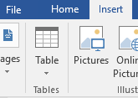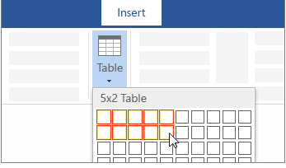

For a larger table, or to customize a table, select Insert > Table > Insert Table.
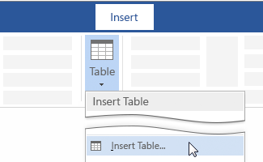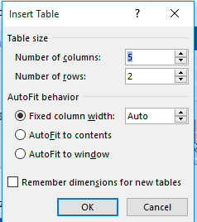
Tips:
- If you already have text separated by tabs, you can quickly convert it to a table. Select Insert > Table, and then select Convert Text to Table.
- To draw your own table, select Insert > Table > Draw Table.

  - Change Cells (Insert and Delete Columns and Rows)
What is a cell?
A cell, outlined in green below, is an individual block within a table in which you can enter values, such as words or numbers.
What are rows and columns?
Rows, outlined in red below, are a horizontal group of cells. Columns, outlined in blue below, are a vertical group of cells.
Selecting Parts of a table

- Sometimes you need to select parts of a table so that you will be able to make some structural adjustment, edit the text inside the cells, and apply formats.

To select a cell:

  - Point at the left side within the cell Click once.
To select group of cells:

  - Click in the first cell of the group pressing the Shift key, click the last cell of the group and release the Shift key.

To select a row:

  - Point at the left side of the row outside the table Click once.

To select a column:

  - Point just above the column you want to select Click once.

To select multiple contiguous rows/columns:

  - Select the first row or column pressing the Shift key select the last row or column.

To insert a new row at the bottom of the table:
- If you want to insert a row at the bottom of the table, just click in the last cell of the table (the lower-right cell) and press the Tab or Enter key.
To insert a new row in the middle of the table:
  - Select the row where you want to insert the new one Click on Table tools tab, Click layout tab, Under Row & column click on Insert Above or Below button.
To insert a new column in the middle of the table:
  - Select the column where you want to insert the new one Click on Table tools tab, Click layout tab, Under Row & column group click on Insert Left or Right button.
To delete a Row or Column:
  - First select the Row or Column Click on Table tools tab, Click layout tabUnder Row & column group click on Delete Row or Column button.
To delete an entire Table:
  - Select the entire table Click on Table tools tab, Click layout tabUnder Row & column group click on Delete table button.
Merging Cells:
  - Select the Cells to merge Click on Table tools tab, Click layout tabUnder Merge group click on Merge cells button.
Deleting rows and columns
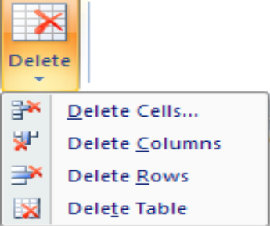
You’d like to delete a row? Or a column? Here’s how:
1. Position the cursor in the row or column that you want to get rid of.
2. Click on the Layout ribbon tab.
3. Click on the Delete button, and a drop-down menu will appear.
4. Select an option to delete cells, columns, rows, or even the entire table.
Adding rows and columns
You need to have the Layout ribbon visible for this too.
1. Position the cursor in the row (column) next to which you want add another row (column).
2. Click on one of the Rows & Columns options (located on the right of the Delete button). The new row or column will be included in your table.
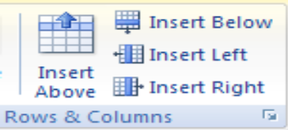
  - Insert and customize appropriate images into documents

Insert pictures
- Do one of the following:
  - Select Insert > Pictures > This Device for a picture on your PC.
  - Select Insert > Pictures > Stock Images for high quality images or backgrounds.
  - Select Insert > Pictures > Online Pictures for a picture on the web.
Tip: For a picture from your OneDrive, go to the drop-down list at the top left, and switch from Bing to OneDrive.
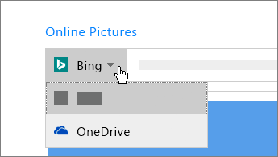
- Select the picture you want, and then select Insert.

  - Position and Resize Images to Meet Document Formatting Needs

Resize or move pictures
- To resize a picture, select the picture and drag a corner handle.
- To wrap text around a picture, select the picture, and then select a wrapping option.
- Resize an image to shrink it down to fit in a tight spot in a document or to make it larger to fill up more space. Any type of object can be resized, including images, shapes, SmartArt, WordArt, charts, and text boxes.
- In the Word document, select the object you want to resize.

- Use the mouse or touchpad to select and drag a Sizing handle. The Sizing handles are located on each corner of the object, as well as on the top, bottom, left, and right borders.

- To keep the proportions of the object the same, press and hold the Shift key while you select and drag. To keep the object centered in its current location, press and hold the Ctrl key while you select and drag. Press and hold both keys together to perform both functions.
Resize an Image by Setting an Exact Height and Width
Resize an object based on an exact size if you need to make two or more images the same size or if images must be a certain size to fit a template or other requirement.
- In the Word document, select the object you want to resize. Then, on the ribbon, select Picture Format.
Important: When resizing something other than an image, the name of the tab will differ. For example, for WordArt, text boxes, or shapes, go to the Shape Format tab. For SmartArt or charts, go to the Format tab.
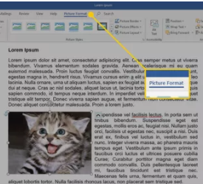
- To resize the object to an exact size, go to the Size group and enter the values you want in the Height and Width boxes. Or, use the arrows to change the height and width of the object.
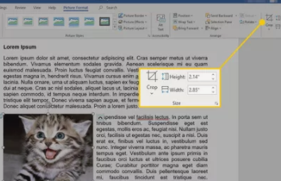
- To resize the object to an exact proportion, select the dialog box launcher.
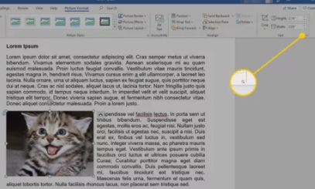
- In the Layout dialog box, select the Size tab.
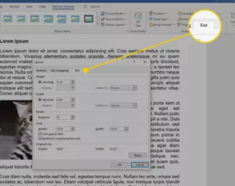
- In the Scale section, select Lock Aspect Ratio. In the Height or Width section, use the controls to change the height or width. The other dimension automatically changes to maintain the ratio.
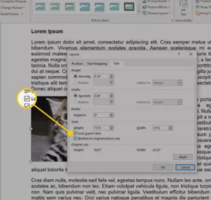
- Select OK.

  - Ensuring The Naming, Storing, Saving and Printing of Different Documents

Save and Save As
Word offers two ways to save a file: Save and Save As. These options work in similar ways, with a few important differences.
Save: When you create or edit a document, you'll use the Save command to save your changes. You'll use this command most of the time. When you save a file, you'll only need to choose a file name and location the first time. After that, you can click the Save command to save it with the same name and location.
Save As: You'll use this command to create a copy of a document while keeping the original. When you use Save As, you'll need to choose a different name and/or location for the copied version.
To save a document:
It's important to save your document whenever you start a new project or make changes to an existing one. Saving early and often can prevent your work from being lost. You'll also need to pay close attention to where you save the document so it will be easy to find later.
- Locate and select the Save command on the Quick Access Toolbar.
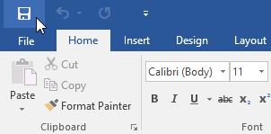
- If you're saving the file for the first time, the Save As pane will appear in Backstage view.
You'll then need to choose where to save the file and give it a file name. Click Browse to select a location on your computer. Alternatively, you can click OneDrive to save the file to your OneDrive.
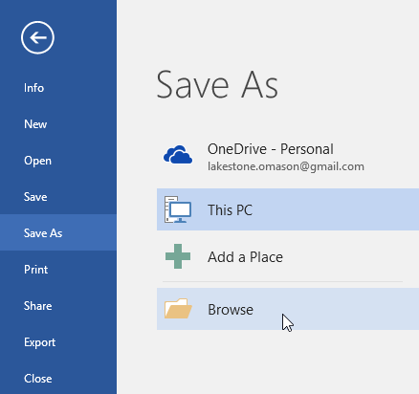
- The Save As dialog box will appear. Select the location where you want to save the document.
- Enter a file name for the document, then click Save.
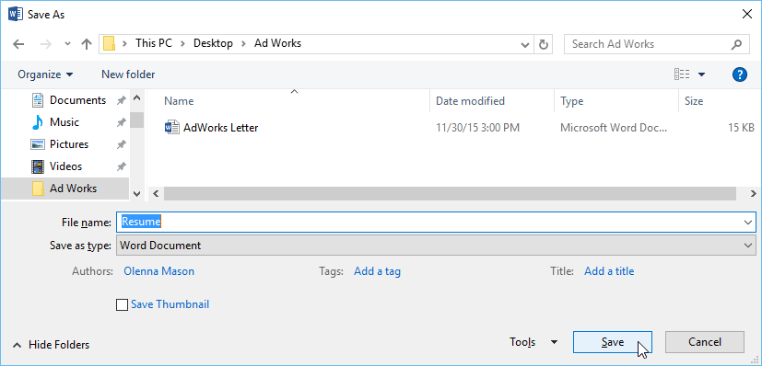
The document will be saved. You can click the Save command again to save your changes as you modify the document.
Storage in folders and sub-folders
In a computer file system, a subdirectory is a directory that is contained another directory, called a parent directory. A parent directory may have multiple subdirectories. In operating systems with a GUI (graphical user interface) such as Microsoft Windows, a directory is called a folder, and a subdirectory is called a subfolder.
Subfolder
Like a subdirectory, a subfolder is any folder that is a child of another folder. In the example below, Fonts and System32 are subfolders of the Windows folder.

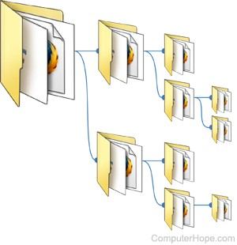

Self-check-3.1
- The outlined in green below, is an individual block within a table in which you can enter values, such as words or numbers.
  - Cell
  - Row
  - Column
  - All
- One of the following is correct steps to select a row.

  - Point at the left side of the row outside the table Click once.
  - Point just above the column you want to select Click once.
  - Point at the left side within the cell Click once.
  - None of the above

- One of the following is correct steps to select a cell.

- Point at the left side of the row outside the table Click once.
- Point just above the column you want to select Click once.
- Point at the left side within the cell Click once.
- None of the above
- One of the following is correct steps to select a column.

- Point at the left side of the row outside the table Click once.
- Point just above the column you want to select Click once.
- Point at the left side within the cell Click once.
- None of the above
- Which one of the following is not function of resize or move pictures?
- To resize a picture, select the picture and drag a corner handle.
- To wrap text around a picture, select the picture, and then select a wrapping option.
- Resize an image to shrink it down to fit in a tight spot in a document or to make it larger to fill up more space.
- All

Operation sheet 3.1. Create Tables and Add Images to Word Document
- Operation Title: inserting and Insert pictures
- Purpose: To inserting and customize the image.
- Instruction: Follow the procedures below
- Tools and requirement:
- This operation sheet
- Resource files
- computer
Precautions:
- Procedures in doing inserting picture
Step1: Do one of the following:
- Select Insert > Pictures > This Device for a picture on your PC.
- Select Insert > Pictures > Stock Images for high quality images or backgrounds.
- Select Insert > Pictures > Online Pictures for a picture on the web.
Tip: For a picture from your OneDrive, go to the drop-down list at the top left, and switch from Bing to OneDrive.
Step2: Select the picture you want, and then select Insert.
- Procedures in doing Resize or move pictures
Step1: In the Word document, select the object you want to resize.
Step2: Use the mouse or touchpad to select and drag a Sizing handle. The Sizing handles are located on each corner of the object, as well as on the top, bottom, left, and right borders.
Step3: To keep the proportions of the object the same, press and hold the Shift key while you select and drag. To keep the object centered in its current location, press and hold the Ctrl key while you select and drag. Press and hold both keys together to perform both functions

LAP /learning activity performance/ test 3

Name: _____________________________ Date: ________________
Time started: ________________________ Time finished: ________________ Instructions:
Given necessary templates, tools and materials you are required to perform the following tasks within 2hours.

Task 1: inserting picture
Task 1: Resize or move pictures

Unit Four: Use Appropriate Spread Sheet Software
This unit is developed to provide you the necessary information regarding the following content coverage and topics:
  - Select spread sheet software
  - Identify document purpose, audience
  - Opening, creating of the spread sheet application and files
  - Enter simple formulas and functions using cell referencing
  - Use a range of common tools during spreadsheet development
  - Editing the spreadsheet
  - Using the auto-fill function to increment data
  - Ensuring, naming, storing and printing of documents appropriate directories
This unit will also assist you to attain the learning outcomes stated in the coverage. Specifically, upon completion of this learning guide, you will be able to:
  - Select spread sheet software appropriate to perform activity
  - Identify document purpose, audience and presentation requirements, and clarify with require personnel
  - Open the spread sheet application, create spread sheet files and enter numbers, text and symbols into cells according to information requirements
  - Enter simple formulas and functions using cell referencing where required and correct formulas when error messages occur
  - Use a range of common tools during spreadsheet development
  - Edit columns and rows within the spreadsheet
  - Use the auto-fill function to increment data where required
  - Ensure the naming and storing of documents in appropriate directories or folders and the printing of documents to the required specifications

  - Select Spread Sheet Software
Spreadsheet is an electronic worksheet display on the VDU, which is manly used for accounting purpose, such as preparing payroll, financial analysis and other mathematical calculation. You can quickly create a model of a situation on a spreadsheet by entering labels, numbers & formulas.
An Excel Workbook (also called a file) consists of a collection of worksheets (also called spreadsheets) that are used to enter and work with data. An Excel workbook can contain as many worksheets as the amount of RAM (memory) and Hard Drive space that the computer contains. There are 2 different types of sheets available in an Excel workbook. They are Worksheets and Chart Sheets (for graphing). Each worksheet is named Sheet1, Sheet2, Sheet3, etc. but custom names can be given to the worksheets.
An Excel 2007 worksheet consists of a grid of columns and rows. There are 16,384 columns in each worksheet, lettered consecutively from A to XFD. The rows are numbered consecutively from 1 to 1,048,576.
The intersection of each column and row form a cell. The cell is designated by the column letter and then the row number. For example, you might be in cell D5, that is the intersection between column D and row 5. Cells are where data is entered. The selected cell is known as the Active Cell.
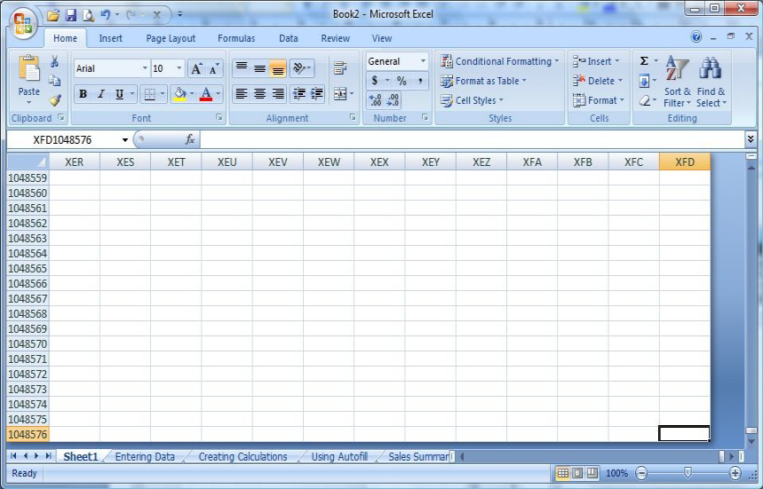
Spreadsheet software
Although there are several spreadsheet software solutions that offer more than a traditional spreadsheet, such as Jot Form Tables, spreadsheet software is still indispensable for many businesses.
The right spreadsheet software can not only help you sift through thousands of data sets but also keep you on track for setting and completing goals. the best spreadsheet software options currently on the market.
    - Microsoft Excel
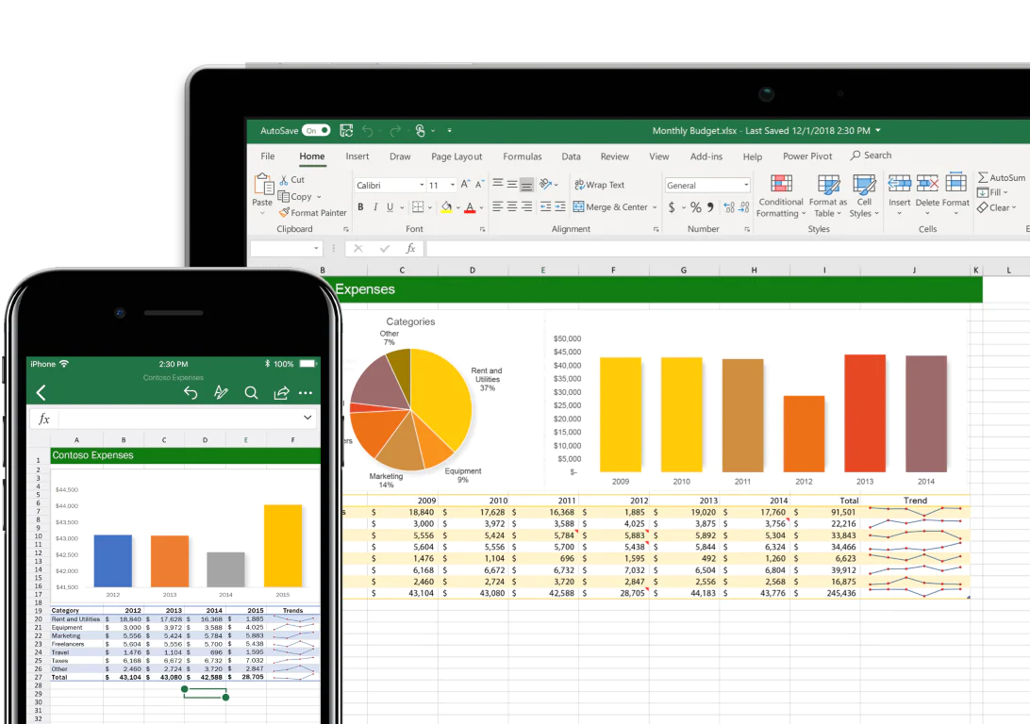
To date, Excel boasts a maximum cell count of a whopping 17,179,869,184 and offers more functions and features than any other spreadsheet software available on the market.
While the Excel interface is simple enough for even elementary school students to use, the program has also pioneered cutting-edge filters to sift through massive data sets. Add in the customizability of a Quick Access toolbar to pin your most-used functions and the availability to collaborate with other users seamlessly, and you can see why Excel is still so popular.
    - Apple Work
Pages is a powerful spreadsheet that lets you create stunning documents, and comes included with most Apple devices. And with real-time collaboration, your team can work together from anywhere, whether they're on Mac, iPad, iPhone, or a PC.
    - Open Office.
OpenOffice is an Open Source product and a project. The product is a multi-platform office productivity suite. It includes the key desktop applications, such as a word processor, spreadsheet, presentation manager, and drawing program, with a user interface and feature set similar to other office suites. Sophisticated and flexible, OpenOffice.org also works transparently with a variety of file formats, including those of Microsoft Office
Writer - Free Word Processor for Mac
OpenOffice is an open-sourced productivity suite. It offers many essential desktop tools such as a word processor, spreadsheet, presentation manager, and a drawing program. The app is free and is a great way to get access to similar features as Microsoft Office but without having to pay for it.
  - Identify Document Purpose, Audience

Purpose of excel

Microsoft Excel is a spreadsheet application that is commonly used for a variety of uses. At its core, Excel is a table consisting of rows and columns. Excel is composed of rows and columns and uses a spreadsheet to display data. Features include: calculation, graphing tools, pivot tables, and a macro programming language called Visual Basic for Applications.
What can I do with this?
The data within a table can be sorted by any column, which means that the rows can be ordered by last name or first name alphabetically, by the ID number ascending or descending, by the amount paid ascending or descending, or by the date.
Formatting and Saving
Microsoft excel contains many features that will allow you to format your text using boldface type, italics, underlining, headers and footers, bullets and numbering. The program will also allow you to save your document electronically to the computer's hard drive so that the document can be re-opened at a later date.

Printing
Microsoft excel can also help print your document. With excel, you can select printing options, such as choosing the printer you wish to print on or selecting how many copies of the document you want to print

  - Opening, Creating of The Spread Sheet Application and Files
Starting Excel
To start up the program:
1. Open the Windows Start menu
2. Choose All Programs then Microsoft Office followed by Microsoft Office Excel 2016
Tip: To create a shortcut to this software on the Desktop, right click on Microsoft Office Excel 2007 then choose Send To followed by Desktop (create shortcut). You’ll then be able to load Excel using the icon on the Desktop.
Creating an Excel file
- When Excel opens, it will display a blank worksheet ready for you to enter data. The data that you enter and the formatting that you use become your document.

A1
- In cell type “My first spreadsheet.”
- Each spreadsheet you create is temporary unless you save it as a file with a unique name and location.
The Excel 2016 Workbook Screen
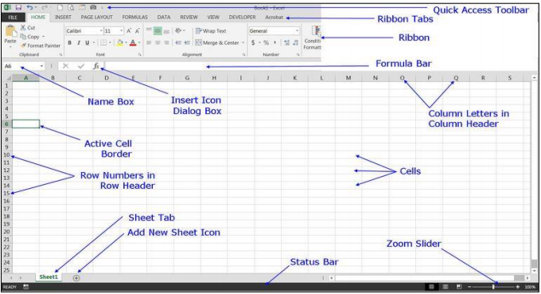
  - Enter Simple Formulas and Functions

10 basic formulas and functions in Excel.

- SUM
- COUNT
- COUNTA
- COUNTBLANK
- AVERAGE
- MIN Excel
- MAX Excel
- LEN Excel
- TRIM Excel
- IF Excel

#1 SUM in Excel
This basic Excel formula is used to get the sum of the value in one or more cells or ranges.
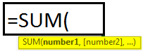
Example
=SUM(A1:A5)
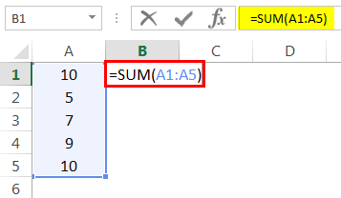
Result = 41 (See Image below)
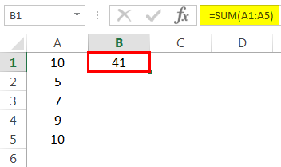
#2 COUNT Excel Function
This basic Excel function counts the numeric value in one or more cells or ranges.
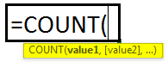
Example
=COUNT(A1:A5)
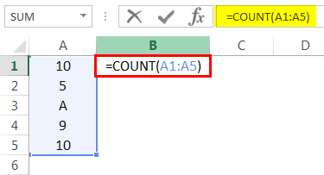
Result = 4 (This will exclude cell A3 since this formula calculates the only numeric value. Please see the image below).

#3 COUNTA in Excel
This formula counts the value in one or more cells (This will measure the cells irrespective of the number or text value).
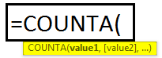
Example
=COUNTA(A1:A5)
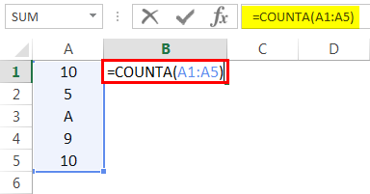
Result = 5 (This will Include Cell A3 since this formula calculates both text and numeric value. See Image below).
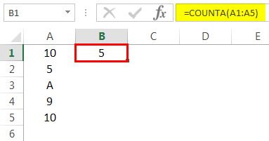
#4 COUNTBLANK in Excel
This Excel basic function counts the blank value in the range. (Note: We will not consider only space in a cell a blank cell).
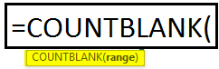
Example
=COUNTBLANK(A1:A5)
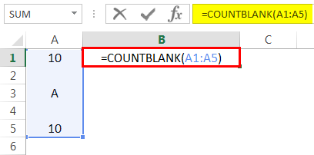
Result = 2 (This will calculate the number of blank cells in the range. See image below).
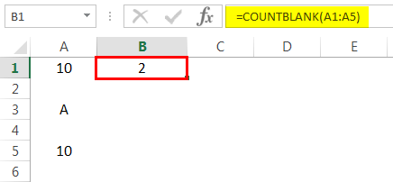
#5 AVERAGE in Excel
This basic formula in Excel is used to get the value average in one or more cells or ranges.
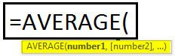
Example
=AVERAGE(A1:A5)
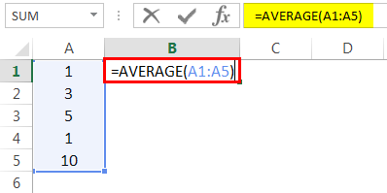
Result = 4 (See Image below)
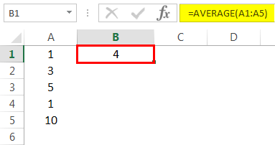
#6 MIN Formula in Excel
This Excel basic function is used to get the minimum value in cells or range.
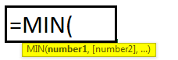
Example
=MIN(A1:A5). Result = 2 (See Image below)
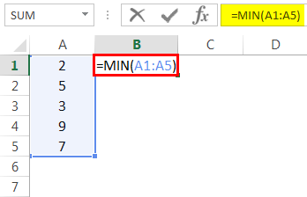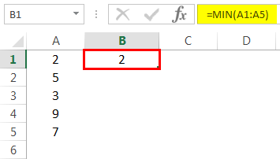
#7 MAX Formula in Excel
This basic Excel function is used to get the maximum value in cells or range.
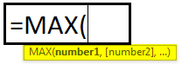
Example
=MAX(A1:A5)
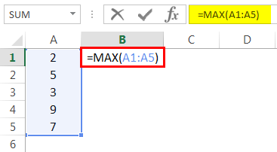
Result = 9 (See Image below)
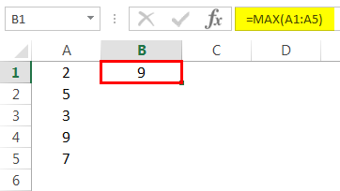
#8 LEN in Excel
This basic function of Excel is used to calculate the number of characters in a cell or text.
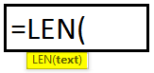
Example
=LEN(A1)
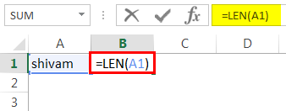
Cell A1 value is Shivam, which has a 6-character length. So, the result would be 6 (See image below).
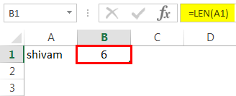

#9 TRIM in Excel
This basic Excel function removes unnecessary space in a cell or text.
SYNTAX: TRIM(TEXT)
Example
=TRIM(A1)
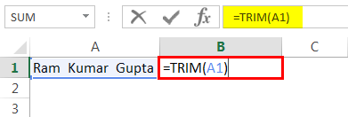
Cell A1 has two spaces between first, middle, and last names. This function will remove extra space to give the result. (See image below).
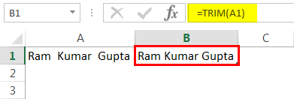
#10 IF in Excel
IF function can perform a logical test in excel.

Example
=IF(A1>33,” P”,” F”). A value in cell A1 is 50, and a logical test is if the value is greater than 33. Then the result would be P. Else, the result would be F.
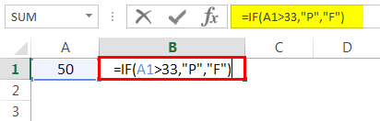
Since the value 50 is greater than 33, the result would be P. (See image below).

  - Use A Range of Common Tools During Spreadsheet Development
    - Find or replace text and numbers on a worksheet
Replace features in Excel to search for something in your workbook, such as a particular number or text string. You can either locate the search item for reference, or you can replace it with something else. You can include wildcard characters such as question marks, tildes, and asterisks, or numbers in your search terms. You can search by rows and columns, search within comments or values, and search within worksheets or entire workbooks.
Find
To find something, press Ctrl+F, or go to Home > Editing > Find & Select > Find.
Note: In the following example, we've clicked the Options >> button to show the entire Find dialog. By default, it will display with Options hidden.
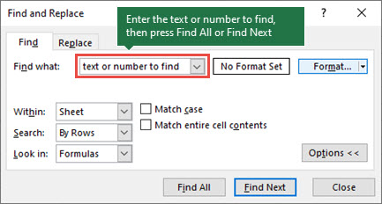
- In the Find what: box, type the text or numbers you want to find, or click the arrow in the Find what: box, and then select a recent search item from the list.
Tips: You can use wildcard characters — question mark (?), asterisk (*), tilde (~) — in your search criteria.
- Use the question mark (?) to find any single character — for example, s?t finds "sat" and "set".
- Use the asterisk (*) to find any number of characters — for example, s*d finds "sad" and "started".
- Use the tilde (~) followed by ?, *, or ~ to find question marks, asterisks, or other tilde characters — for example, fy91~? finds "fy91?".
- Click Find All or Find Next to run your search.
Tip: When you click Find All, every occurrence of the criteria that you are searching for will be listed, and clicking a specific occurrence in the list will select its cell. You can sort the results of a Find All search by clicking a column heading.
Click Options>> to further define your search if needed:
- Within: To search for data in a worksheet or in an entire workbook, select Sheet or Workbook.
- Search: You can choose to search either By Rows (default), or By Columns.
Look in: To search for data with specific details, in the box, click Formulas, Values, Notes, or Comments.
Note: Formulas, Values, Notes and Comments are only available on the Find tab; only Formulas are available on the Replace tab.
- Match case - Check this if you want to search for case-sensitive data.
- Match entire cell contents - Check this if you want to search for cells that contain just the characters that you typed in the Find what: box.
- If you want to search for text or numbers with specific formatting, click Format, and then make your selections in the Find Format dialog box.
Tip: If you want to find cells that just match a specific format, you can delete any criteria in the Find what box, and then select a specific cell format as an example. Click the arrow next to Format, click Choose Format From Cell, and then click the cell that has the formatting that you want to search for.
Replace
To replace text or numbers, press Ctrl+H, or go to Home > Editing > Find & Select > Replace.
Note: In the following example, we've clicked the Options >> button to show the entire Find dialog. By default, it will display with Options hidden.
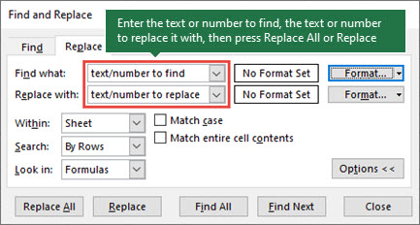
  - In the Find what: box, type the text or numbers you want to find, or click the arrow in the Find what: box, and then select a recent search item from the list.
Tips: You can use wildcard characters — question mark (?), asterisk (*), tilde (~) — in your search criteria.
- Use the question mark (?) to find any single character — for example, s?t finds "sat" and "set".
- Use the asterisk (*) to find any number of characters — for example, s*d finds "sad" and "started".
- Use the tilde (~) followed by ?, *, or ~ to find question marks, asterisks, or other tilde characters — for example, fy91~? finds "fy91?".
- In the Replace with: box, enter the text or numbers you want to use to replace the search text.
- Click Replace All or Replace.
Tip: When you click Replace All, every occurrence of the criteria that you are searching for will be replaced, while Replace will update one occurrence at a time.
- Click Options>> to further define your search if needed:
Within: To search for data in a worksheet or in an entire workbook, select Sheet or Workbook.

Search
Search: You can choose to search either By Rows (default), or By Columns.
Look in: To search for data with specific details, in the box, click Formulas, Values, Notes, or Comments.
Note: Formulas, Values, Notes and Comments are only available on the Find tab; only Formulas are available on the Replace tab.
- Match case - Check this if you want to search for case-sensitive data.
- Match entire cell contents - Check this if you want to search for cells that contain just the characters that you typed in the Find what: box.
- If you want to search for text or numbers with specific formatting, click Format, and then make your selections in the Find Format dialog box.
Tip: If you want to find cells that just match a specific format, you can delete any criteria in the Find what box, and then select a specific cell format as an example. Click the arrow next to Format, click Choose Format from Cell, and then click the cell that has the formatting that you want to search for.

  - Editing The Spreadsheet
Insert or delete a worksheet
In Excel, you can easily insert, rename, and delete worksheets in your workbook.
Insert a worksheet
- Select the New Sheet plus icon at the bottom of the workbook.
- Or, select Home > Insert > Insert Sheet.
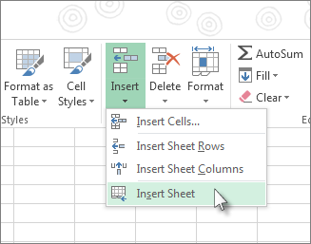
Rename a worksheet
- Double-click the sheet name on the Sheet tab to quickly rename it.
- Or, right-click on the Sheet tab, click Rename, and type a new name.
Move a worksheet
- To move the tab to the end, right-click the Sheet tab then Move or Copy > (move to end) > OK .
- Or, click and drag to tab to any spot.
Delete a worksheet
- Right-click the Sheet tab and select Delete.
- Or, select the sheet, and then select Home > Delete > Delete Sheet.
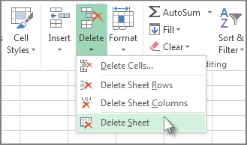

  - Using The Auto-Fill Function to Increment Data

How to Automatically Fill Increment Cells in Excel?
In our daily Excel work, it’s quite frequent to automatically fill increment cells, for instance, auto fill cells down with 1, 2, 3…. But in some times, you need to fill increment cells with a fixed interval, for instance, 10001, 10012, 10023…, how can you quickly automatically fill increment these cells? Now this tutorial can tell you the solutions.
Automatically Fill Increment Cells with Autofill Function
Actually, in Excel, you can use the Autofill function to quickly fill the increment cells.
- Select the cell you want to place your starting number, for instance, in A1, I type 10001, see screenshot:
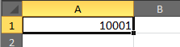
- Then in the cell below the starting number, here is A2, and type the second number you want into it.
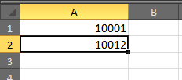
- Then select the A1 and A2, and drag the autofill handle down until below cells are filled with the increment numbers as you need. See screenshots:
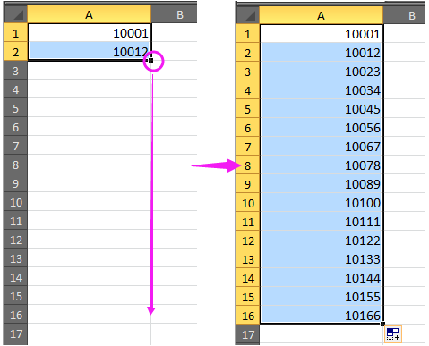
Automatically Fill Increment Cells with Formula
Besides, you can use a formula to solve this autofill.
- Select a blank cell and type the starting number into it, and then in the cell below the starting number, type this formula =A1+11 (A1 is the starting number, and 11 is the interval, you can change them as you need). See screenshot:
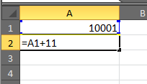
- Then press Enter key, and drag this formula down to the cells you want to fill with the numbers with fixed interval.
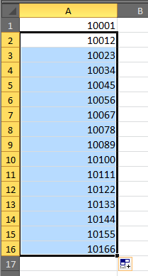
Automatically Fill Increment Cells with Kutools for Excel
With Kutools for Excel’s Insert Sequence Number utility, you also can quickly automatically fill increment numbers, and moreover, you can add the prefix or suffix to every number.
After free installing Kutools for Excel, please do as below:
- Select a list or a range you want to fill the increment cells, then click Kutools > Insert > Insert Sequence Number. See screenshot:
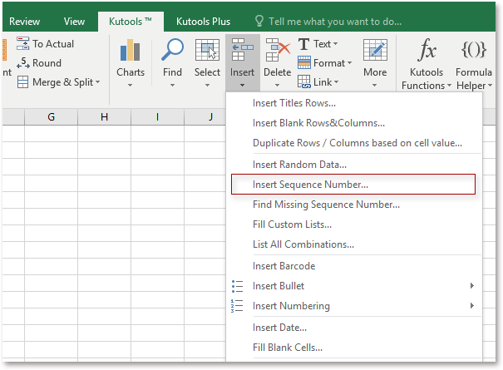
- In the popping Insert Sequence Number dialog, click New to add a new sequence into the dialog. See screenshot:
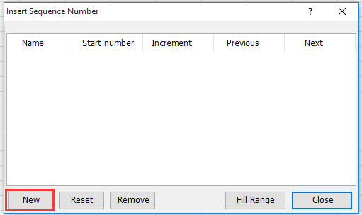
- In the expanding dialog, do below operations:
- Name the sequence;
- Enter the starting number of your increment numbers in Start number textbox;
- Type the interval number into the Increment textbox;
- Specify the number of digits of your filled numbers in No. of digits’ textbox;
Type the prefix or suffix into the Prefix (optional) or Suffix (optional) textbox as you need.
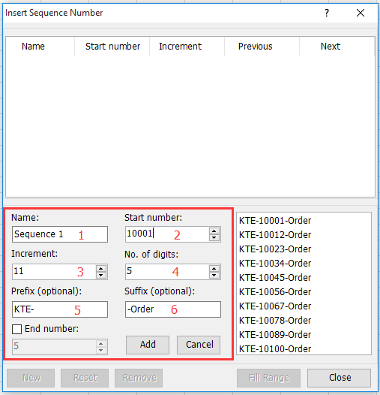
- Click Add to add this new incremental sequence number in to the dialog, and then click Fill Range. See screenshot:
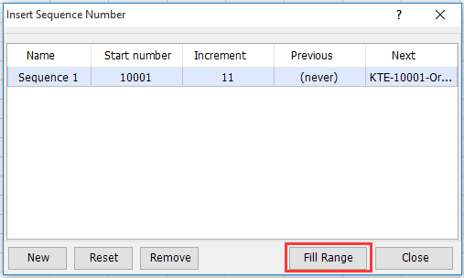
Now you can see the selected cells are filled with increment number.
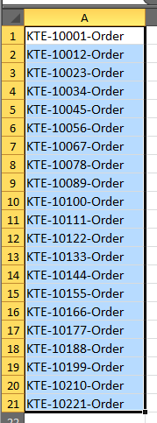
Note:
- If you want to reset this incremental sequences, and insert it from the start number again, you can go to the Insert Sequence Number dialog, and select this sequence, and click Reset > Ok.
- If you want to end the sequence number at a specific number, then repeat insert this sequence from starting number, check End number in the dialog, and type the ending number you want into below textbox, and you can preview that the numbers is end with this number, and then restart the sequence.
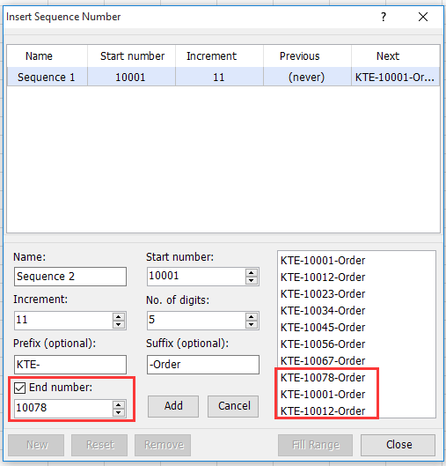.
  - Naming, Storing and Printing of Documents Appropriate Directories

When you choose to save a workbook for the first time, Excel displays the Save As dialog box, which you use to name the spreadsheet and specify where you want it stored. Unless you specify otherwise, Excel saves all workbooks in the My Documents folder. I strongly recommend that you store all workbooks in My Documents, so you know where to look for them later.
Assuming you are saving your workbooks in the My Documents folder, the steps for saving a workbook are straightforward:
- Open Excel's File menu and choose Save. The Save As dialog box displaying the contents of the My Documents folder.
- Click in the File Name text box.
- Type a descriptive and unique name for your workbook.
- Click the Save button. Excel saves your workbook to disk and assigns it the filename you typed.
If you have created your own folders for managing your documents, you need to know a little more about how to use the various controls in the Save As dialog box. These controls can seem a little confusing at first. The following list explains the various controls to help you better understand them and expertly navigate the drives and folders on your computer:
Save In drop-down list, near the top of the dialog box, displays the name of the currently opened disk drive or folder. To change to a different disk drive or folder, open the Save in drop-down list and click the letter of the disk drive or name of the folder.
Folder/File list (the largest portion of the dialog box) displays the contents of the selected disk drive or folder. In this list, you can double-click a folder to open it and display its contents.
Back button displays the contents of the previous file/folder list.
Up One Level button displays the contents of the folder or drive that holds the currently displayed folder. For example, if you open the My Documents folder on drive C and then click the Up One Level button, you open your username folder (where username is the name you enter to log in to Windows).
Create New Folder button creates a new, empty folder on the currently selected drive or in the currently opened folder. For example, if My Documents is selected, click Create New Folder to make a folder inside the My Documents folder. When you click Create New Folder, the Create New Folder dialog box appears, asking you to type a name for the folder. Type a name that's unique and descriptive—but brief—and click OK.
Views button displays a list of available ways the Save As dialog box can display the contents of the currently selected disk drive or folder: Thumbnails (small pictures of the first page of each file), Tiles (large icons that represent folders and file types), Icons (small icons that represent folders and file types), List (filenames), Details (filenames, sizes, and dates), Properties (filenames and information), Preview (filenames with a preview of the currently selected file), or Arrange Icons (by name, file type, or date).
Tools button provides options for deleting the selected item, renaming it, adding it to your My Places list, and performing other housekeeping chores.
File Name text box provides a space in which you can type a name for the file.
Save as Type drop-down list provides options for saving the workbook as an Excel workbook or a template.
Save button tells Excel to save the workbook in the selected folder, using the filename you typed.
Cancel button cancels the save operation and closes the dialog box without doing anything.
After you have saved and named a workbook, Excel assumes you always want to save this workbook in the same folder, using the same filename. Rather than select a folder and type a filename, you simply open the File menu and choose Save or click Excel's Save button.
NOTE
To enable the Save As or Open dialog box to display a one-page preview of a workbook, you must turn on the Preview option for the workbook. With the workbook open in Excel, open the File menu and click Properties. Click the Summary tab and click the Save Preview Picture check box. Click OK.

Printing a worksheet
We are now ready to print our January budget. Printing an Excel worksheet can have its challenges, a few of which will be noted and addressed below.
Viewing the Preview
            - Make sure the January worksheet is the active sheet.
            - Click the File tab. Click on Print and look at the Preview on the right.
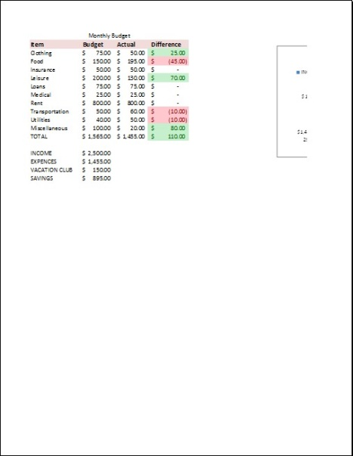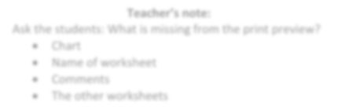
3.

Note

how the
chart
is

not entirely displayed on page

1
.

a.

Click

the navigation arrow at the bottom to view page 2.
The
rest of the chart is on page 2.

b.

Click

back to page 1.

4.

Note

that

it
doesn’t show the name of the worksheet

anywhere
(
).
“January”

5.

Note

that the

c
omments are
missing
.

6.

Also note

that it’s just printing our
January

worksheet. By
default, Excel only prints the
active worksheet
. This can be
changed
by clicking the
top
button

in the
Settings

area
on the
left side of the screen

where it says “Print Active Sheets”
.

Teacher’s note:

Ask the students: What is missing from the print preview?

Chart

Name of worksheet

Comments

The other worksheets

Teacher’s note:

If all they see is the chart,
then they forgot to
deselect their chart before doing a File > Print.

Scaling a printout
We can use a method called scaling to make our data and our chart fit all on one page. Scaling refers to shrinking a printout so that it will print on only one page.
      - To the left of the preview is the Print Settings section. At the bottom of the section is a setting that says No Scaling. This means the worksheet is set to print at 100% of its actual size. Click the list arrow and select Fit Sheet on One Page.
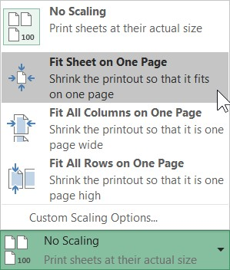
Note the data and chart sections of the worksheet are all on one page. However, the print is smaller.
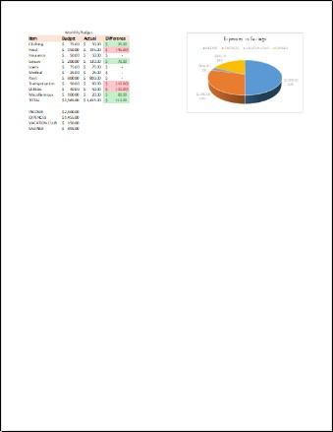

Self-check-4.1
Test-I Multiple choose

- How many worksheets does a new Excel 2016 workbook open with?
  - Three C. Two
  - One D. Four
- Which function in Excel tells how many numeric entries are there?
A. NUM C. SUM
B. COUNT D. CHKNUM

- Which of the following is the intersection of a row and column?
  - Range C. bar chart
  - tab D. cell
- Which tab of the ribbon should you go to for removing gridlines on a worksheet?
  - Formula C. review
  - View D. developer
- Out of the following alternatives a valid formula on excel
A. B2+C2 C. =C2+D2
B. A1*B1 D. E1/F1

Operation sheet 2.1 Use a worksheet
- Operation Title: customize worksheets
- Purpose: To create, rename, delete, copy/move worksheet
- Instruction: Follow the procedures below
- Tools and requirement:
- This operation sheet
- Resource files
- a computer with spreadsheet software
- Precautions:
- Procedures in doing the task.
  - Open your spreadsheet program.
  - Go to File/New, then in the dialogue box select ‘Blank workbook’.
  - The bottom of the screen shows three tabs for the three worksheets this blank workbook contains. (By default, a new workbook usually has one worksheets, but you can add more or delete some.)
  - Right-click on the Sheet1 tab and select ‘Rename’ from the pop-up menu. Type ‘January’ and press Enter.
  - The first sheet should now be named January.
  - Right-click on the Sheet1 tab and select ‘Insert’ from the pop-up menu. Select ‘Worksheet’ from the dialogue box and press OK.
  - An extra worksheet should have been added to the workbook.
  - Rename the second sheet ‘Feb’, the third ‘Mar’ and the fourth ‘Apr’.
  - Right-click on the ‘Mar’ tab and select ‘Delete from the pop-up menu. ‘Mar’ Tab should have been deleted from workbook.
  - Right-click on the ‘Apr’ tab and select ‘Move or Copy’ from the pop-up menu. Select ‘Feb’ Tab. Then where you want to place the copied worksheet. Tick Check the box for the Create a copy option at bottom of pop-up menu, then click OK.
  - You are found copy Apr on workbook
  - Save the workbook by selecting File/Save As and giving it the filename ‘Wages’. Make sure you save the file to your ‘Projects’ folder on my document or your USB thumb drive.
  - Close the file (File/Close).

Operation sheet 2.2 Use a worksheet

- Operation Title: Text formatting
- Purpose: To formatting data on worksheet
- Instruction: Follow the procedures below
- Tools and requirement:
- This operation sheet
- Resource files
- a computer with spreadsheet software
- Precautions:
- Procedures in doing the task.
  - Open the file formatting.
  - Select cells A4 to D4. Click the Bold button on the Formatting toolbar.
  - Repeat for cells A19 to D19 and cells C27 to D27.
  - Select cells C17 to D17. Click the Italics button on the Formatting toolbar.
  - Repeat for cells C25 to D25 and cells C27 to D27.
  - Select cells A1 to D1. Click the Merge and Centre alignment button on the Formatting toolbar.
  - Select cells B4 to D4. Click the Centre alignment button on the Formatting toolbar. Repeat for cells B19 to D19.
  - Select cell C17. Click the Align Right button on the Formatting toolbar. Repeat for cells C25 and C27.
  - Select cells A5 to A15. On the menu bar, go to Format/Cells (shortcut Ctrl+1).
  - When the Format Cells dialogue box appears, click on the Alignment tab (if it’s not already selected).
  - Use the up arrow key to increase the indent to 2.
  - Repeat for cells A20 to A23.
  - Select cell A1. Click the Font Size drop-down menu on the Formatting toolbar, and choose 14 point.
  - Select cell A1 again. Click the Font Colour drop-down on the Formatting toolbar, and choose a dark colour.
  - Repeat for row 4 and row 19. (Clicking on a row number on the left-hand side of the screen will select the whole row).
  - Select cells A4 to D4. Click the Fill colour button on the Formatting toolbar, and select a pale colour. Repeat for cells A19 to D19 and for cell A1.
  - Select cell A1. Click the Borders drop-down menu on the Formatting toolbar, and choose the Outside borders button.
  - Repeat for Cells C27 to D27.
  - Select cell D17. On the menu bar, go to Format/Cells.
  - When the Format Cells dialogue box appears, click on the Number tab.
  - Select Currency. Check that the Decimal places window is showing ‘2’, and click OK.
  - Repeat for cells D25 and D27.
  - Save your file
- Quality Criteria: Your worksheet should now look something like this
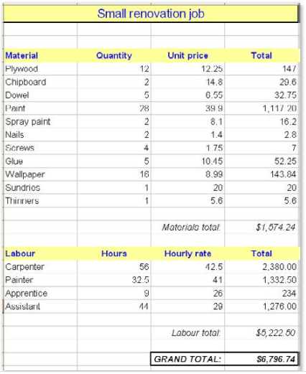
- Precautions: use the formatting file from resource folder.

Operation sheet 2.3 Formulas and functions
- Operation Title: Basic formulas
- Purpose: Applying basic formulas in worksheet
- Instruction: Follow the procedures below
- Tools and requirement:
- This operation sheet
- Resource files
- a computer with spreadsheet software
- Precautions:
- Procedures in doing the task.

  - Open a new workbook (go to File/New/Workbook).
  - Save the workbook by going to File/Save as and giving it the file name ‘Formulas 1’.
  - In cell B5, type 12. In cell C5, type 6.
  - Note: Before entering a formula, you must select the cell where you want the result of the calculation to appear.
  - All formulas in a spreadsheet must start with an equals sign (=). When you type an equal’s sign into a cell, the program knows to treat whatever follows as a formula.
  - In cell D5, type =b5+c5 and press Enter. Cell D5 should now contain the sum of cells B5 and C5. With cell D5 selected, look at the formula bar. It should show the formula in that cell.
  - Note: Capital and lower-case letters don’t matter in formulas. Whether you type ‘b5’ or ‘B5’ in a formula, the program will treat them the same.
  - Select cells B5 and C5 and drag downwards to fill the next four rows (down to row 9).
  - Select cell D6. Type = (the equals sign) and then click on cell B6. Type + (the plus sign) and then click on cell C6. Press Enter.
  - Cell D6 should now contain the sum of cells B6 and C6. Note that when you were entering the formula, clicking on a cell resulted in the same thing as typing the cell’s address – it was entered into the formula. That’s the easy way to do it.
  - Select cell D7. Type = and then click on cell B7. Type - (the minus sign) and then click on cell C7. Press Enter.
  - Do the same thing in cells D8 and D9, but make the formula multiply ( * ) and divide ( / ) the two preceding cells.
- Quality Criteria: You should end up like this.
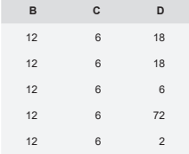
- Precautions: The result D should be 18, 18, 6, 72, 2

Operation sheet 2.4 Formulas and functions
- Operation Title: functions
- Purpose: Applying basic functions in worksheet
- Instruction: Follow the procedures below
- Tools and requirement:
- This operation sheet
- Resource files
- a computer with spreadsheet software
- Precautions:
- Procedures in doing the task.
  - Open the file Rows and columns from resource folder.
  - Select cell B15.
  - Click on the Functions button.
  - From the ‘Or select a category’ list, select All. In the ‘Select a function’ box, select Average, then click OK.
  - The spreadsheet program assumes you want to find the average of cells B5 to B14. This includes the total in B13, which would skew the average.
  - Override this by changing the B14 in the dialogue box to B12, then click OK.
  - The spreadsheet program has found the average revenue for all branches for January. Find the averages for the other months by grabbing the handle of cell B15 and filling its contents across to the right.
  - Select cell H18.
  - Click on the Functions button and, from the Statistical category, select Max.
  - Change the suggested function arguments in the dialogue box by clicking and dragging so that you select the cells from B5 to G12. Click OK.
  - The spreadsheet program has found the cell in that range that holds the largest number.
  - Repeat the steps to find the lowest revenue by using Min function.
  - Save and close the file

Operation sheet 2.5 using a worksheet
- Operation Title: Adjust Rows and columns
- Purpose: Row heights and column width can be adjusted
- Instruction: Follow the procedures below
- Tools and requirement:
- This operation sheet
- Resource files
- a computer with spreadsheet software
- Precautions:
- Procedures in doing the task.
  - Open the file Rows and columns.
We’re going to amend this worksheet to include the figures for June.
  - Right-click anywhere in column G. From the pop-up menu, select Insert.
  - From the choices available, select Entire column, then click OK.
  - The data that was in column G is now in column H, and we have a new, empty column G.
  - Select cells E4 and F4, and fill their contents across to G4 (the heading should be ‘Jun’).
  - Click on H5 to see the formula in that cell – at the moment it’s =SUM (B5:F5).
  - In cell G5, type 1234567 (Perth’s revenue for the month of June). Then press Enter.
  - The total for row 5 has updated. If you click on cell H5, you’ll see that the formula has automatically updated to include our new column.
  - Put some data in the rest of column G’s cells. Make them seven-digit figures so that the data remains meaningful.
  - Select cell F12 and fill the formula across to cell G12 (i.e. drag the cell’s handle).
  - Right-click anywhere in row 8. From the pop-up menu, select Insert.
  - From the choices available, select Entire row, then click OK.
  - The spreadsheet program has moved all the data below down one row, so we now have an empty row 8.
  - Type the word ‘Canberra’ in cell A8.
  - Type 1234567 into cell B8.
  - To save time, rather than type figures into the rest of Canberra’s Feb to Jun cells, just use the Fill function to fill January’s figures across to June (very steady sales in Canberra!).
  - Select cell H7, and fill its formula into cell H8.
Notice that grand total in cell H13 is automatically updating each time you add data to the worksheet.
Setting column widths
  - Right-click on the letter ‘F’ at the top of column F.
  - From the pop-up menu, choose Column width and change the width from 11 to 8, then click OK.
Notice how some of the data in column F has turned to hash symbols (######). This is because the program can’t fit the data in those cells into the narrower column width.
  - We could fix the width of the column by entering a different width (as we did above), but we’ll do it differently.
  - Hover the cursor over the border between the ‘F’ and the ‘G’ at the top of column F. Notice that the cursor changes to a double-headed arrow.
  - Left-click and hold. A box appears showing the width of column F. Drag the cursor to the right until the box shows 15.00, then let go. The column is now wider than it was to start with.
  - Double-click on the border between the ‘F’ and the ‘G’ at the top of column F. The column is automatically resized to suit the widest data in it.
  - To test this, click on cell D20 and type some characters so that they spill well to the right of the cell.
  - Go to the top of column D and double-click its right-hand border. The column will resize itself to fit the data in cell D20.
  - Delete the data in cell D20 and resize the column width using the double-click method.
Setting row heights
You probably won’t be surprised to learn that row heights can be adjusted too.
  - Select row 13 by right-clicking on the ‘13’ at the left-hand edge of the worksheet. From the pop-up menu, select Row height and change the value to 20, then click OK.
  - Row 13 is now higher than it was.
  - Hover the cursor between the ‘13’ and the ‘14’ on the left-hand side of the worksheet. Click and drag downwards, then let go. You’ve manually changed the row height.
  - Select an empty cell in row 20. Type a small number into it (such as 23).
  - With the cell still selected, change the font size to 24 point.
Notice that the row height has automatically increased to fit the larger font size.
  - Compare this to column widths, which may need to be manually increased after a large number has had its font size increased.
  - Save the file, then close it.

Operation sheet 2.6 Access help
- Operation Title: Add a help shortcut to the Quick Access Toolbar
- Purpose: Add a help shortcut to Quick Access Toolbar to get easily
- Instruction: Follow the procedures below
- Tools and requirement:
- This operation sheet
- Resource files
- a computer with spreadsheet software
- Precautions:
- Procedures in doing the task.
- Select File > Options > Quick Access Toolbar.
- Under the dropdown where it says Choose commands from, select All Commands.
- Select Help from the list of commands to add to the Quick Access Toolbar.
- Click Add.
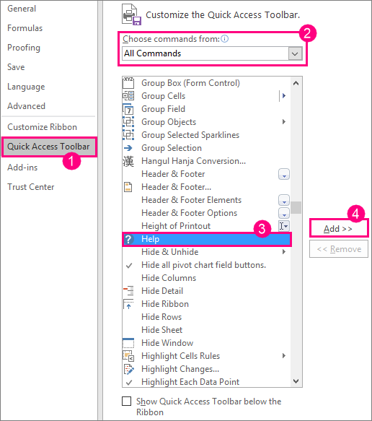
- When you're done, click OK. The shortcut to help will be added to your Quick Access Toolbar in the upper-left corner.
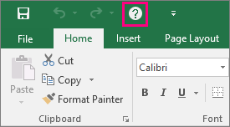

Lap Test 4
Name: _____________________________ Date: ________________
Time started: ________________________ Time finished: ________________ Instructions:
Given necessary templates, tools and materials you are required to perform the following tasks within 1hours.
- Adjust your workstation to suit OHS requirements and energy and resource conservation techniques.
- Open a new workbook, and create a spreadsheet that will calculate the weekly wages for A1 Constructions.
Below is the information for their six employees for the week ending 19 April.
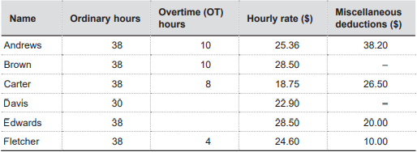
The overtime (OT) rate is 1.5 times the ordinary rate. Tax is calculated at 32 cents in the dollar, after the $104 tax-free deduction.
Layout
- Your spreadsheet columns should be laid out something like this example.
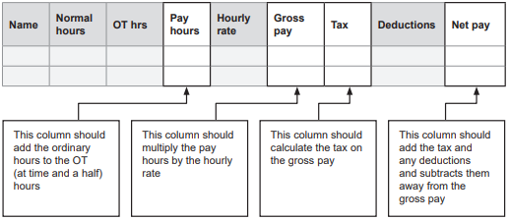
Your spreadsheet should have the nine columns shown above, and formulas should calculate amounts for the Pay hours, Gross pay, Tax and Net pay columns.
Formatting
- Finally, give your spreadsheet a heading, and apply some formatting to enhance the appearance of your worksheet, such as bold, text colour, text size, borders, etc
be imaginative!
Before printing your spreadsheet, put your name in cell J3.
Printing
- When your worksheet is complete, preview, adjust, save and print it and give the printout to your trainer

Unit Five: Incorporate Object and Chart in Spreadsheet
This unit is developed to provide you the necessary information regarding the following content coverage and topics:
  - Import an object into an active spreadsheet
  - Import Manipulate object by using formatting features
  - Create a chart using select data in the spreadsheet
  - Display selected data in a different chart
  - Modify chart using formatting features.
This unit will also assist you to attain the learning outcomes stated in the cover page. Specifically, upon completion of this learning guide, you will be able to:
  - Import an object into an active spreadsheet
  - Import Manipulate object by using formatting features
  - Create a chart using selected data in the spreadsheet
  - Display selected data in a different chart
  - Modify chart using formatting features.

Import an object into an active spreadsheet

Import Data into spreadsheet
Excel can import data from external data sources including other files, databases, or web pages.
- Click the Data tab on the Ribbon.
- Click the Get Data button.
Some data sources may require special security access, and the connection process can often be very complex. Enlist the help of your organization’s technical support staff for assistance.
- Select from File.
- Select from Text/CSV.
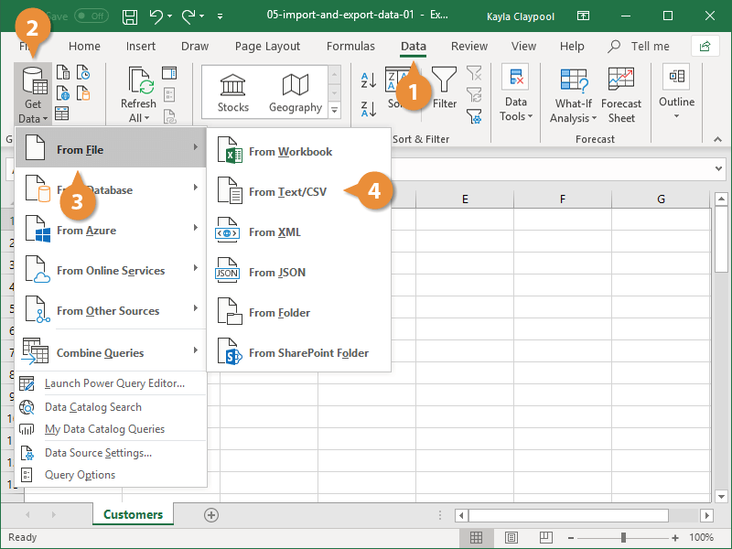
If you have data to import from Access, the web, or another source, select one of those options in the Get External Data group instead.
- Select the file you want to import.
- Click Import.
If, while importing external data, a security notice appears saying that it is connecting to an external source that may not be safe, click OK.
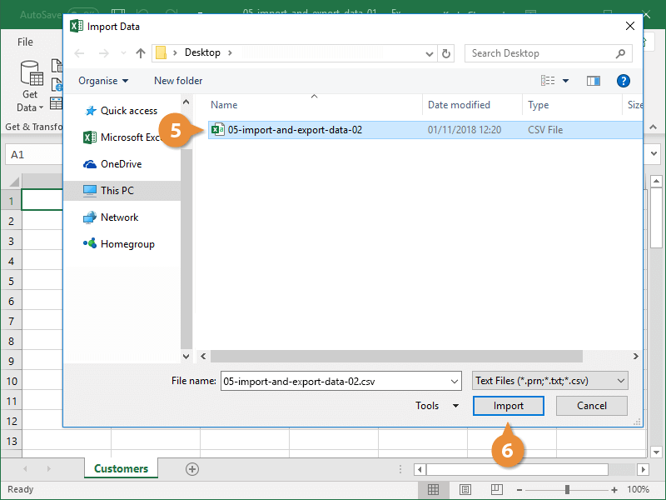
  - Verify the preview looks correct.
Because we have specified the data is separated by commas, the delimiter is already set. If you need to change it, it can be done from this menu.
  - Click Load.
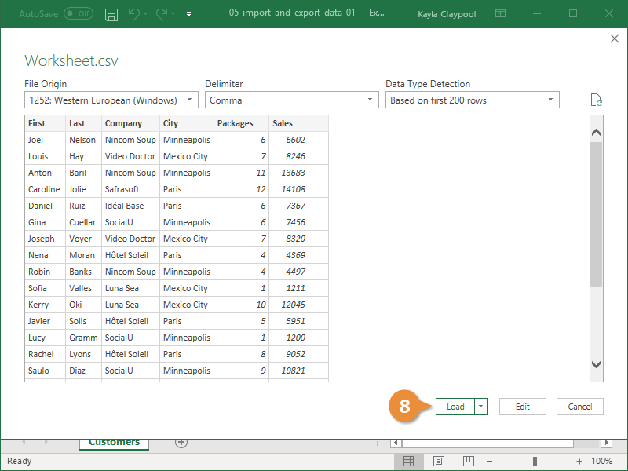

    - Insert an object in your Excel spreadsheet
You can use Object Linking and Embedding (OLE) to include content from other programs, such as Word or Excel.
OLE is supported by many different programs, and OLE is used to make content that is created in one program available in another program. For example, you can insert an Office Word document in an Office Excel workbook. To see what types of content that you can insert, click Object in the Text group on the Insert tab. Only programs that are installed on your computer and that support OLE objects appear in the Object type box.

Embed an object in a worksheet
- Click inside the cell of the spreadsheet where you want to insert the object.
- On the Insert tab, in the Text group, click Object .
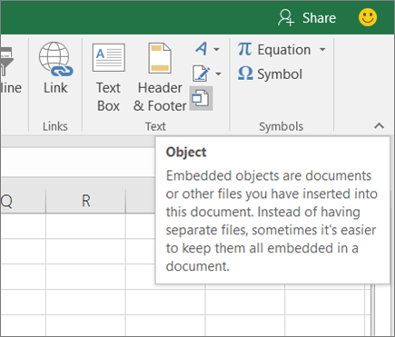
- In the Object dialog box, click the Create from File tab.
- Click Browse, and select the file you want to insert.
- If you want to insert an icon into the spreadsheet instead of show the contents of the file, select the Display as icon check box. If you don’t select any check boxes, Excel shows the first page of the file. In both cases, the complete file opens with a double click. Click OK.
Note: After you add the icon or file, you can drag and drop it anywhere on the worksheet. You can also resize the icon or file by using the resizing handles.
To find the handles, click the file or icon one time.
Insert a link to a file
You might want to just add a link to the object rather than fully embedding it. You can do that if your workbook and the object you want to add are both stored on a SharePoint site, a shared network drive, or a similar location, and if the location of the files will remain the same. This is handy if the linked object undergoes changes because the link always opens the most up-to-date document.
Note: If you move the linked file to another location, the link won’t work anymore.
- Click inside the cell of the spreadsheet where you want to insert the object.
- On the Insert tab, in the Text group, click Object .
- Click the Create from File tab.
- Click Browse, and then select the file you want to link.
- Select the Link to file check box, and click OK.
Create a new object from inside Excel
You can create an entirely new object based on another program without leaving your workbook. For example, if you want to add a more detailed explanation to your chart or table, you can create an embedded document, such as a Word or PowerPoint file, in Excel. You can either set your object to be displayed right in a worksheet or add an icon that opens the file.
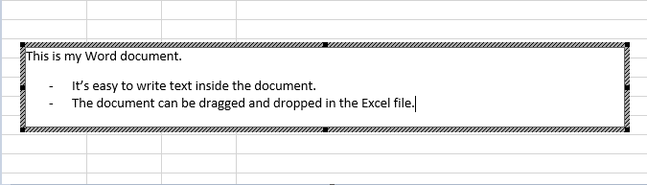
- Click inside the cell of the spreadsheet where you want to insert the object.
- On the Insert tab, in the Text group, click Object .
- On the Create New tab, select the type of object you want to insert from the list presented. If you want to insert an icon into the spreadsheet instead of the object itself, select the Display as icon check box.
- Click OK. Depending on the type of file you are inserting, either a new program window opens or an editing window appears within Excel.
- Create the new object you want to insert.
When you’re done, if Excel opened a new program window in which you created the object, you can work directly within it.
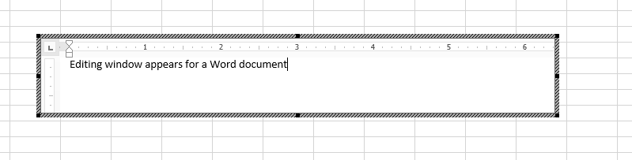
When you’re done with your work in the window, you can do other tasks without saving the embedded object. When you close the workbook your new objects will be saved automatically.
Note: After you add the object, you can drag and drop it anywhere on your Excel worksheet. You can also resize the object by using the resizing handles. To find the handles, click the object one time.

Import Manipulate object by using formatting features

    - Basic data manipulation techniques in Excel
Data analysis is a challenging task, especially if you don't have the data manipulation skills. In this article, we will discuss some of the most common data manipulation techniques that can be used in Excel for data analysis.
The power of these techniques will be demonstrated by using some real-life examples. The 9 common data manipulations techniques discussed are:
  - Filtering
  - Sorting
  - Grouping
  - Pivoting
  - Transposing
  - Changing Data Types
  - Adding Columns and Rows
  - Naming Columns or Rows
  - Inserting Columns or Rows.
Each of these techniques will provide you with a better understanding of your data and how it works - from getting your head around different types of visualization to exploring outliers. These simple tricks will not only improve your efficiency, but also make it easier for people who don't know Excel as well to understand what you're doing.
- Filtering
Filtering is a process of sorting data by a certain criterion. It's an effective way to identify subsets of data from the larger dataset.
In the following example, we have a dataset with monthly sales data from 2012-2015. Filtering is useful if you want to see the total sales for the year only, or if you want to know how many months had positive growth.
First, identify which column contains the filter criteria that will be used to filter your data. In this case, I have created a new column called "Sales Growth." Next, highlight your "Sales Growth" column and select "Filter" from the Data menu on the toolbar. This will open a dialogue box where you can input your filtering criteria. In this example, I am using ">0%" as my filter criterion to calculate total sales for years with positive revenue growth > 0%.
- Sorting
Sorting is another technique of data analysis and is used to rearrange the order of your data. It's an easy way of exploring and understanding your data.
For example, let's say you had a list of 5 different numbers: 1, 10, 2, 3, 4
If we wanted to sort this list in ascending order (from lowest to highest), we would click on the column heading for this list and then select "Sort Ascending". This will arrange the list like this: 1, 2, 3, 4, 10.
By sorting the numbers in ascending order we can see that they are increasing in size. If we wanted to change the sort order to descending (highest to lowest) we would click on Column A and select "Sort Descending" like so: 4, 3, 2, 10, 1.
Again by sorting in descending order from highest number to lowest number we can see that they're decreasing in size.
- Grouping
Grouping is an excellent way to analyze your data. Grouping is when you organize data into smaller sets. You can use this technique to make it easier to analyze the relationships in your data like quantifying averages, totals, and percentages.
Grouping makes it easy for you to identify patterns in your data. For example, if you wanted to know how many people are in each age group (20-25, 26-30 etc.), then you can group that information by age group and then count the number of people in each one.
The best thing about grouping is that it helps you quickly identify relationships in your data set because it shows you which items are grouped together. This means that if there's a trend between two different groups of data, then grouping will be able to show you this connection.
- Pivoting
Pivoting data involves taking a table and turning it on its side to show a different perspective.
For example, let's say you have a list of monthly income brackets and want to see the monthly income distribution for each bracket. You can do this by pivoting your table from column to column.
In our example, we would start with one column containing all of the monthly income brackets. In the next column, we would add a pivot table that contains the percentages for each income bracket.
Pivoting is very helpful in filtering out irrelevant data so you can focus on the important information. If you have a huge dataset, extracting relevant information can be time-consuming without using pivots.
- Transposing
Data can be transposed by using the TRANSPOSE function in Excel. It is a very efficient way to take any data, for example: 5 10 15 20 25 30 35 40 45 and turn it into this: 1 5 10 15 20 25 30 35 40 45
This is helpful when you want to switch rows and columns or swap columns or rows with each other.
- Changing Data Types
One thing that might be useful to know is how changing data types can affect your data analysis.
Two different types of data are text and number. Text data is any kind of information that isn't numerical. For example, a person's name or the title of a book. Numberic data will always be numerically based and may only have numbers in them, such as 3.1, 4.9, and so on.
If you want to change the type of your data from one type to another, you will need to use the function Data→Data Type→Text or Number.
Changing Data Types
Once you select this command, the "Select Data Type" window will appear. There are three general categories of data: Text Data
only; Numeric Data only; and Mixed Data (text and numeric).
You can further refine your selection by selecting one or more options from each of these categories: Text; Numeric; Date & Time; Logical; and Object Linking & Embedding
- Adding Columns and Rows
Adding columns or rows to your data is a great way to make your work more efficient. For instance, if you were working with a table of data on different subjects and wanted to look at their answers in relation to each other, it would be more convenient for you (and the people you're sharing the data with) if you had both answers in one column.
Naming Columns and Rows
To name columns and rows in Excel, first select the cells that need naming. Then go to Data > Data Tools > Name Columns and Rows and type the name of the first cell into the first dialogue box. Continue typing or clicking until all of your cells are named.
- Naming Columns or Rows
Every column and row in a spreadsheet has a default name, but these names can be changed. This is helpful when you're summarizing data and want to apply the same column or row title consistently.
To rename a column, right-click on any cell in that column and select "column name." Type in the new name and press enter. To rename a row, right-click on any cell in that row and select "Row Labels." Type in the new name and press enter.
- Inserting Columns or Rows
One of the simplest data manipulation techniques in Excel is inserting columns or rows.
This technique lets you analyze your data with more clarity and precision by adding more columns or rows to your spreadsheet. It can be used to show different aspects of your data, such as different years, regions, products etc.
Two examples where this technique can be used are:
1) You want to compare different years for a specific region.
2) You want to look at how a product performs across different regions.

Create a chart using select data in the spreadsheet
    - Create a chart from start to finish
Charts help you visualize your data in a way that creates maximum impact on your audience. Learn to create a chart and add a trend line. You can start your document from a recommended chart or choose one from our collection of pre-built chart templates.
Create a chart
- Select data for the chart.
- Select Insert > Recommended Charts.
- Select a chart on the Recommended Charts tab, to preview the chart.
Note: You can select the data you want in the chart and press ALT + F1 to create a chart immediately, but it might not be the best chart for the data. If you don’t see a chart you like, select the All Charts tab to see all chart types.
- Select a chart.
- Select OK.
Add a trend line
- Select a chart.
- Select Design > Add Chart Element.
- Select Trend line and then select the type of trend line you want, such as Linear, Exponential, Linear Forecast, or Moving Average.

Display Selected Data in A Different Chart

There are three basic principles of Microsoft excel data display.
      - Show the Data
People read will read the graphs in your report, article, or blog post to better understand your argument. The data are the most important part of the graph and should be presented in the clearest way possible. But that does not mean that all of the data must be shown indeed, many graphs show too much.
      - Reduce the Clutter
Cart clutter, the use of unnecessary or distracting visual elements, tends to reduce effectiveness of the graph. Clutter comes in many forms: dark or heavy gridlines; unnecessary tick marks, labels, or text; unnecessary icons or pictures; ornamental shading and gradients; and unnecessary dimensions. Too many graphs use textured or filled gradients when simple shades of a color can accomplish the same task.
      - Integrate the Text and the Graph
As a first, simple step, legends that define or explain a series on a graph are often placed far away from the content off to the right or below the graph. Integrated legends either right below the title or directly on the chart are more accessible.
To display and hide chart elements
- Click the chart, and then click the Chart Elements button (labeled with a plus sign) that appears in the upper-right corner of the chart. In the Chart Elements pane, select the check boxes of the elements you want to display, and clear the check boxes of the elements you want to hide.
- On the Design tool tab, in the Chart Layouts group, click Add Chart Element, click the element type, and then click the specific element you want to display or hide.
- On the Design tool tab, in the Chart Layouts group, click Quick Layout, and then click the combination of elements you want to display.
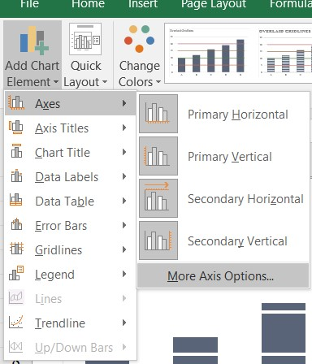
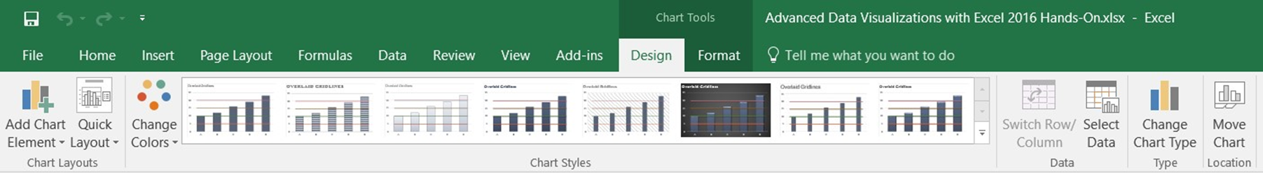

Modify chart using formatting feature

    - Modifying charts
Once your chart appears in Excel, there are many ways to modify the way it looks and its location. A few ways are described below, but explore to find more! In all cases, you have to select the chart first to access Chart Tools.
- To add any labels (for example, the title or axes), under the Design ribbon, click Add Chart Element in the Chart Layouts group and select the desired label.
- To change the chart type, data, or location, use the Chart Tools Design ribbon.
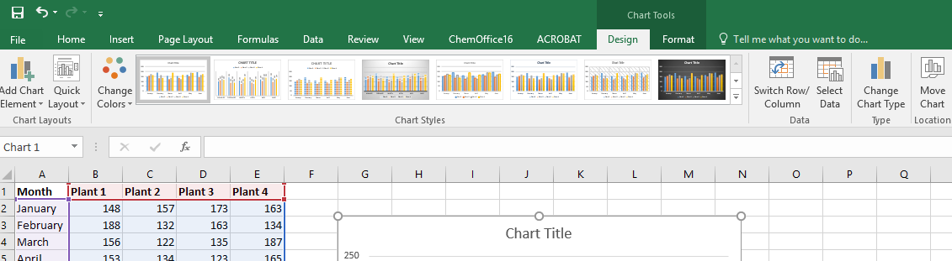

From the Chart Tools Format ribbon, you can select an element on the chart (for example, a series), then choose the Format Selection icon in the Current Selection group. With the Formatting Task pane, you can change the shape, style and color.

Self-check 5
- ----- is a challenging task, especially if you don't have the data manipulation skills.
  - Data analysis
  - Filtering
  - Grouping
  - All
- Which one of the following is not used manipulate the data?
- Filtering
- Grouping
- Transporting
- None
- ------ is a process of sorting data by a certain criterion
  - Filtering
  - Grouping
  - Transporting
  - None
- ------ is an excellent way to analyze your data.

  - Filtering
  - Grouping
  - Transporting
  - None

- One of the following to help you visualize your data in a way that creates maximum impact on your audience.
  - Manipulating
  - Chart
  - Filtering
  - all

Operation sheet 5.1 Produce simple charts
- Operation Title: Charts
- Purpose: Create and modify charts
- Instruction: Follow the procedures below
- Tools and requirement:
- This operation sheet
- Resource files
- a computer with spreadsheet software
- printer with A4 paper
- Precautions:
- Procedures in doing the task.
  - Open the file Rows and columns.
  - Select cells A4 to G11. This range includes the branch names, the months, the sales figures and the branch totals (a deliberate mistake which we’ll fix later).
  - Click the Chart Wizard button (on the Standard toolbar). (The Chart Wizard button might be in a different place in your spreadsheet program. If you can’t find it, ask your trainer for help.)
A dialogue box will appear, showing a range of chart types. Clicking on one of these reveals several sub-types. The first sub-type will already be highlighted.
- Press the ‘Press and hold to view sample’ button, and a preview of what the chart would look like using that sub-type appears.
- Experiment with various chart types and sub-types. Some chart types will be inappropriate for the type of data to be used. For our current spreadsheet, the ‘Clustered Column’ sub-type will be best. Select this, then press the Next button.
- Press the Next button again, then Next again, then the Finish button.
The chart should appear, superimposed on the spreadsheet.
- Save the file with the ‘Save as’ command, and give it the name ‘Rows and columns with chart’, but don’t close the file.
Note the following.
- The cell range you selected is highlighted with three coloured boxes (if you look carefully).
- The Value axis at the left-hand side of the chart shows dollar amounts.
- The Category axis at the bottom shows the branches.
- The legend shows the colour-coded months.
- You can move the chart around or resize it, just like any other graphic.
You can edit the chart, which we’ll do now.
Because we selected data in column G (the branch totals), the chart is skewed (the Totals data is forcing the monthly data to appear too small).
Note: You may need to shift the chart if it’s in the way of the spreadsheet data.
- On the spreadsheet, ‘grab’ the bottom right-hand handle on the blue box and move it to the left so that only columns A to F are selected.
The chart automatically updates, and now shows the data more meaningfully.
You can now see how useful charts can be. We can see at a glance which branch had the most sales, and in which month, etc. We can also see that some branches’ January figure was their highest, while for some it was their lowest. Very interesting to the general manager!
- Try right-clicking on various parts of the chart – pop-up menus for those parts will appear.
- Right-click on the Legend at the right-hand side. Choose Format Legend and, from the choices available, change the border colour and line weight and the font size and font. Click OK. The legend now looks different.
- Do something similar to the Category axis (across the bottom of the chart).
- Right-click and select Format Axis for the Value axis at the right-hand side of the chart.
- Select the Number tab, then Currency from the category. Choose the $ symbol and reduce the decimal places to zero. Change the font, font colour and alignment if you want. Then click OK.
- Right-click in a blank area just inside the chart border, and select Format Chart Area.
- Change the border of the chart, and select a pale colour in the Area options section. Click OK. Now our chart’s looking quite good, but it still lacks a title!
- Click in a clear area, and choose Chart Options.
- Give the chart a title (perhaps ‘Sales figures’) and try other options, including selecting the two options on the data table tag.
- Move the chart across so that it’s under the data in the spreadsheet, then resize it so it fits on the page.
- Click anywhere in row 1 and click Print Preview. Your chart would be printed on top of your spreadsheet.
- Press the Escape key, then select the chart. Press Print Preview and you will see that just your chart would be printed.
- Save and close the file.

Unit Six: Create database
This unit to provide you the necessary information regarding the following content coverage and topics:
  - Open a database application and basic design principles
  - Develop a table with fields and attributes
  - Create a primary key
  - Modify table layout and field attributes
  - Create a relationship between the two tables
  - Add and modify data in a table
  - Add and delete records
  - Save and close down database to storage area
This guide will also assist you to attain the learning outcomes stated in the coverage. Specifically, upon completion of this learning guide, you will be able to:
  - Open a database application and design a two-table, simple relational database incorporating basic design principles
  - Develop a table with fields and attributes according to database usage, as well as user requirements
  - Create a primary key and establish an index for each table
  - Modify table layout and field attributes as required
  - Create a relationship between the two tables
  - Add and modify data in a table according to information requirements
  - Add and delete records as required
  - Save and close down database to storage area

  - Open a database application and basic design principles
    - The Database Design Principles
Usability: Any information which we are storing in any organization should be meaningful for that organization. If we are storing those factors which are actually not fit with organization’s requirement, then this is just waste of resources.
Extensibility: As we know that everyday new business requirements come up and every day there is a need to change or enhance information system to capture new requirements. So information design should be extensible so that it can adopt new requirements without much efforts or without major breaking changes.
Data Integrity: Now at this point we understand that information is very much important for any organization. Based on the historic information, every organization makes different strategies, decisions for growth. One small mistake in data can lead to major issues with any organization’s key decision and hence a big risk for growth.
Entity Integrity: Involves the structure (primary key and its attributes) of the entity. If the primary key is unique and all attributes are scalar and fully dependent on the primary key, then the integrity of the entity is good. In the physical schema, the table’s primary key enforces entity integrity.
Domain Integrity: It defines that data should be of correct type and we should handle optional data in correct way. We should apply Null ability to those attributes which are optional for organization. We can define proper data types for different attributes based on organization’s requirement so that correct format data should present in system.
Referential Integrity: This defines if any entity is dependent on another one then parent entity should be there in the system and should be uniquely identifiable. We can do this by implementing foreign keys.
User defined integrity: There are few business rules which we cannot validate just by primary keys, foreign keys etc. There has to be some mechanism so that we can validate complex rules for integrity. We can implement these rules in following ways:

Performance: As we know that information should be readily available as requested. Performance of the system should be up to the mark. As data in increasing day by day so at some time there will be impact on performance if database design is poor or we’ll not take any actions to improve performance.
Availability: The availability of information refers to the information’s accessibility when required regarding uptime, locations, and the availability of the data for future analysis. Disaster recovery, redundancy, archiving, and network delivery all affect availability.
Security: For any organizational asset, the level of security must be secured depending on its value and sensitivity. Sometime organizations has suffered a lot because of data leaks which results in loss of faith and tends to business risk. So security is one of the most important aspect of good database design.
  - Develop a table with fields and attributes
    - Create a table and add fields
When you create an Access database, you store your data in tables subject-based lists that contain rows and columns. For instance, you can create a Contacts table to store a list of names, addresses, and telephone numbers, or a Products table to store information about products. This article explains how to create a table, add fields to a table, set a table's primary key, and how to set field and table properties.
Before you create tables and add fields, make sure you understand the background concepts
Creating a table
A simple database, such as a contact list, might use only a single table. Many databases, however, use several tables. When you create a new database, you create a new file on your computer that acts as a container for all of the objects in your database, including your tables.
You can create a table by creating a new database, by inserting a table into an existing database, or by importing or linking to a table from another data source — such as a Microsoft Excel workbook, a Microsoft Word document, a text file, or another database. When you create a new, blank database, a new, empty table is automatically inserted for you. You can then enter data in the table to start defining your fields.
Designing a table involves:
- Entering unique names of the columns of the table in the “field name” column of the design view. N
- Names of fields and objects in Microsoft Access can be up to 64characters long.
- They can include any combination of letters, numbers, spaces, and special characters except a period (.), an exclamation point (!), an accent grave (`), and brackets ([ ]). They also can't begin with leading spaces
    - Create a new table in a new database
- Click File > New, and then select Blank desktop database.
- In the File Name box, type a file name for the new database.
- To browse to a different location and save the database, click the folder icon.
- Click Create.
The new database opens, and a new table named Table1 is created and opens in Datasheet view.
    - Create a new table in an existing database
Click File > Open, and click the database if it is listed under Recent. If not, select one of the browse options to locate the database.
- In the Open dialog box, select the database that you want to open, and then click Open.
- On the Create tab, in the Tables group, click Table.
- A new table is inserted in the database and the table opens in Datasheet view.

  - Create a primary key
When you create a Microsoft Access table, Access will automatically create a primary key to your database table, but you can also specify the field you want as the primary key for your database table.
The Primary key in Microsoft Access is a field or set of fields with unique values throughout the table. The primary key offers several characteristics, such as it uniquely identifies each row in the database, It always contains a value, it is never empty, and the value contains never change.
Primary key
- A table can have only one primary key.
- A primary key is used to identify each record that you store in the table.
- It will not allow a duplication of the Primary Key thus make it unique.
- Primary Key is the unique identification of one record. There is a uniquely identification number, such as
- ID number
- A serial number
- A code that serves as a primary key
Add a primary key to a table
Create a primary key to associate data between multiple tables.
- In the Navigation Pane, right click a table, and select Design View.
- Select the field or fields you want to use as the primary key.
- Select Design > Primary Key.
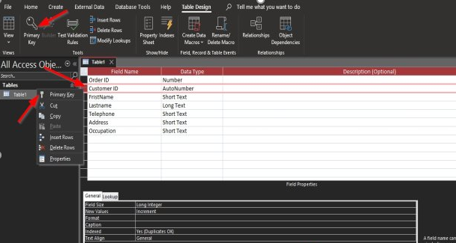
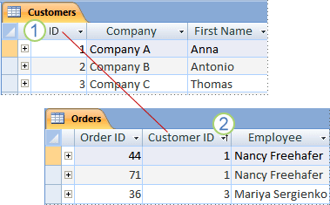
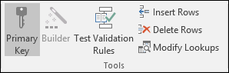

  - Modify table layout and field attributes
Modify Data Base object
Every template that is included with Access is a complete tracking application that contains predefined tables, forms, reports, queries, macros, and relationships. These templates are designed to be immediately useful out-of-the-box, so that you can create a new database that is based on a template and get up and running quickly. However, there might be times when you want to modify your new database — for example, to add or rename a field, or change a report. You can easily add a field to a table in Datasheet view. However, you can also add a field to a table in Design view. To learn more about adding a field to a table in Datasheet view, see the article Add or delete a column in a datasheet. When you add a new field to a table, the field is not automatically added to your existing forms and reports. You must manually add the field to those forms and reports in order for it to appear in them.
If possible, you should avoid deleting a field from a database that was generated from one of the supplied templates — it is likely that the field is employed in other database objects, such as forms and reports. Thus, deleting the field will create consequences when you attempt to use the other database objects that employ the field — the database objects will not work as expected. You will have to remove any references to the field from all of the objects that employ it in order for those other objects to work correctly.
When you decide that you must delete a field from a database that was generated from a template, you can do so in either Datasheet view or Design view. Remember that if other database objects reference the deleted field, you must modify those other objects to remove the reference. For example, if a report includes a control that is bound to the deleted field and you run the report, an error message appears, because Access cannot find the data for the field.
Before you can delete a field, you must ensure that it doesn't participate in any table relationships. If you try to delete a field for which relationships exist, Access warns you that you must first delete the relationships.

  - Create a relationship between the two table
Types of Database Relationships

- One-to-one relationships: occur when each entry in the first table has one, and only one, counterpart in the second table.
- One-to-many relationships: Is the most common type of database relationship. .
Many-to-many relationships: occur when each record in the first table corresponds to one or more records in the second table and each record in the second table corresponds to one or more records in the first table.
ER Diagrams (Entity Relationship Diagrams)
An Entity Relationship Diagram (ERD) is a visual representation of different data using conventions that describe how these data are related to each other.
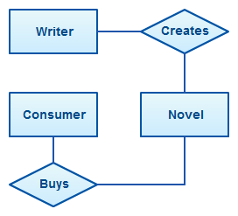
For example, the elements writer, novel, and consumer may be described using ER diagrams this way:

ER diagram with basic objects
In the diagram, the elements inside rectangles are called entities while the items inside diamonds denote the relationships between entities.
This ER diagram tutorial for beginners covers most things related to ER diagram, for quick navigation use the links below.
- ER Diagram Usage
- ER Diagrams Symbols and Notations
- How to Draw ER Diagrams
- ER Diagram Templates
Benefits of ER Diagrams
ER Diagrams Usage
ER diagrams are most often associated with complex databases that are used in software engineering and IT networks.
In particular, ER diagrams are frequently used during the design stage of a development process in order to identify different system elements and their relationships with each other.
For example, inventory software used in a retail shop will have a database that monitors elements such as purchases, item, item type, item source and item price. Rendering this information through an ER diagram would be something like this:
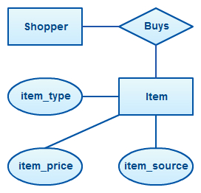

ER diagram example with entity having attributes
In the diagram, the information inside the oval shapes is attributes of a particular entity.
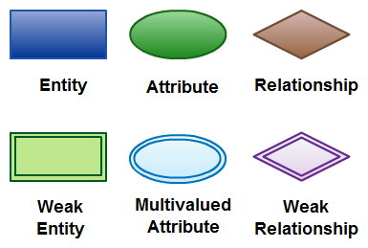
ER Diagram Symbols and Notations

Elements in ER diagrams
There are three basic elements in an ER Diagram:
1. Entity
2. Attribute
3. Relationship
There are more elements which are based on the main elements.
- Weak entity
- Multivalve attribute
- Derived attribute
- Weak relationship and
- Recursive relationship.
Cardinality and ordinarily are two other notations used in ER diagrams to further define relationships.
Entity
- An entity can be a person, place, event, or object that is relevant to a given system.
- For example, a school system may include students, teachers, major courses, subjects, fees, and other items.
- Entities are represented in ER diagrams by a rectangle and named using singular nouns.
Weak Entity
- A weak entity is an entity that depends on the existence of another entity.
- In more technical terms it can defined as an entity that cannot be identified by its own attributes.
- It uses a foreign key combined with its attributed to form the primary key.
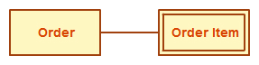
- An entity like order item is a good example for this. The order item will be meaningless without an order so it depends on the existence of order.

Weak Entity Example in ER diagrams
Attribute
An attribute is a property, trait, or characteristic of an entity, relationship, or another attribute.
For example, the attribute Inventory Item Name is an attribute of the entity Inventory Item. An entity can have as many attributes as necessary.
Meanwhile, attributes can also have their own specific attributes.
- For example, the attribute “customer address” can have the attributes number, street, city, and state.
These are called composite attributes.
Note that some top level ER diagrams do not show attributes for the sake of simplicity.
In those that do, however, attributes are represented by oval shapes.
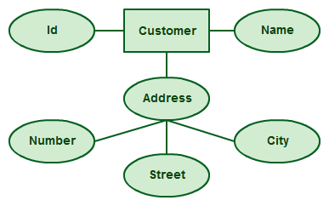

Attributes in ER diagrams, note that an attribute can have its own attributes (composite attribute)
Multivalued Attribute
If an attribute can have more than one value it is called a multivalued attribute.

It is important to note that this is different to an attribute having its own attributes. For example, a teacher entity can have multiple subject values.

Example of a multivalued attribute
Derived Attribute
- An attribute based on another attribute.
- This is found rarely in ER diagrams.
- For example, for a circle the area can be derived from the radius.
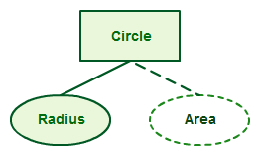

Derived Attribute in ER diagrams
Relationship
- A relationship describes how entities interact.
- For example, the entity “carpenter” may be related to the entity “table” by the relationship “builds” or “makes”.
- Relationships are represented by diamond shapes and are labeled using verbs.
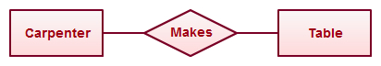
Using Relationships in Entity Relationship Diagrams
Recursive Relationship
If the same entity participates more than once in a relationship it is known as a recursive relationship.
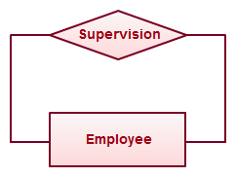
In the below example an employee can be a supervisor and be supervised, so there is a recursive relationship.

Example of a recursive relationship in ER diagrams
Cardinality and Ordinarily
These two further defines relationships between entities by placing the relationship in the context of numbers.
In an email system, for example, one account can have multiple contacts.
The relationship in this case follows a “one to many” model.
There are number of notations used to present cardinality in ER diagrams.
Chen, UML, Crow’s foot, Bachman are some of the popular notations. Creately supports Chen, UML and Crow’s foot notations.The following example uses UML to show cardinality.
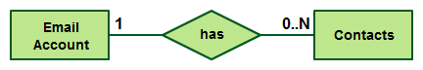
Cardinality in ER diagrams using UML notation
ER Diagram Templates
Below are some ER diagram templates so you can get started quickly.
Clicking on the image and in the new page that opens click the “Use as Template” button.
For more templates check out ER diagram templates article.
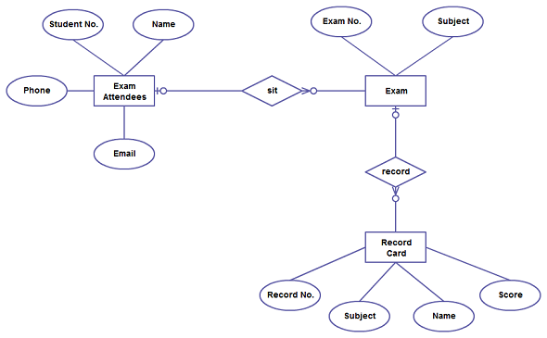
ER Diagram Template of exam database (Click on the image to use as template)
A basic ER diagram template for a quick start
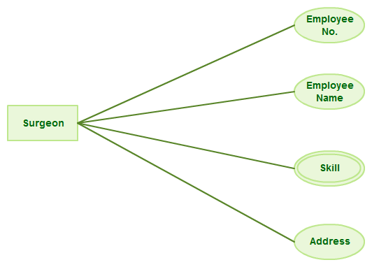
Basic ER Diagram template (Click to use as template)
Benefits of ER diagrams
ER diagrams constitute a very useful framework for creating and manipulating databases.
First, ER diagrams are easy to understand and do not require a person to undergo extensive training to be able to work with it efficiently and accurately.
This means that designers can use ER diagrams to easily communicate with developers, customers, and end users, regardless of their IT proficiency.
Second, ER diagrams are readily translatable into relational tables which can be used to quickly build databases.
In addition, ER diagrams can directly be used by database developers as the blueprint for implementing data in specific software applications.
Lastly, ER diagrams may be applied in other contexts such as describing the different relationships and operations within an organization.

  - Add and modify data in a table
Ways to Add, Edit records
There are several ways to update data in an Access database. You add a record to your database when you have a new item to track, such as a new contact to the Contacts table. When you add a new record, Access appends the record to the end of the table. You also change fields to stay up-to-date, such as a new address or last name.
To maintain data integrity, the fields in an Access database are set to accept a specific type of data, such as text or numbers. If you don't enter the correct data type, Access displays an error message. Finally, you can delete a record when it is no longer relevant and to save space.
You use a form to manually update data. Data entry forms can provide an easier, faster, and more accurate way to enter data. Forms can contain any number of controls such as lists, text boxes, and buttons. In turn, each of the controls on the form either reads data from or writes data to an underlying table field.
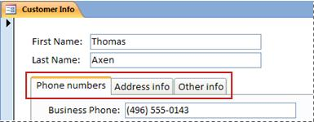
Datasheets are grids of data that look like Excel worksheets. You can change data by working directly in Datasheet view. If you are familiar with Excel, datasheets should be relatively easy to understand. You can change data in tables, query result sets, and forms that display datasheets. Typically, you use datasheets when you need to see many records at once.
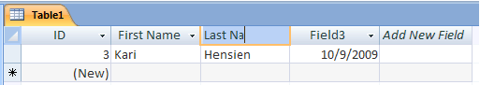

Understanding data entry symbols
The following table shows some of the record selector symbols you might see when updating data and what they mean.
Symbol | Meaning
 | This is the current record; the record has been saved as it appears. The current record is indicated by a change in color in the record selector.
 | You are editing this record; changes to the record aren't yet saved.
 | This record is locked by another user; you can't edit it.
 | This is a new record in which you can enter information.
 | This is the primary key field and contains a value that uniquely identifies the record.

  - Add and delete records
Add a Record
  - Click the New Record button on the Record Navigation bar. You can also add a new record by entering it in the New record row the last row in the table.
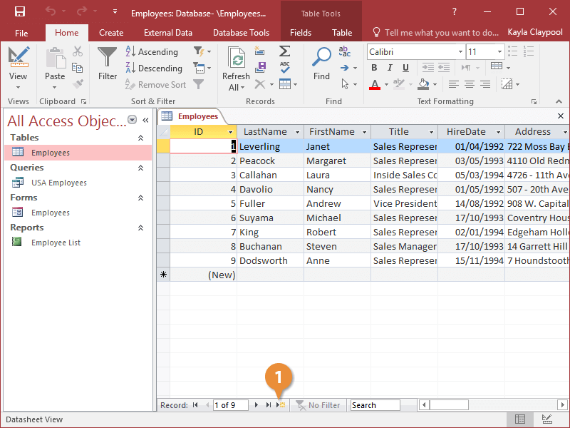
- Click the Delete button on the ribbon.
- Click a field value in the new record and enter data as desired.
As you enter data, you don’t have to click a Save button to save the information—Access automatically saves the information as you enter it.
Press Tab to move to the next field value in a record, or press Shift+ Tab to move back to the previous field value in a record.
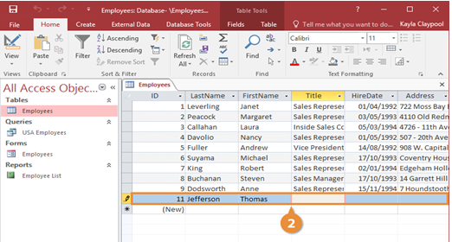

Delete a Record
You can permanently delete records that you no longer need from a table.
- Click the record selector next to the record you want to delete.
- Click the Delete button on the ribbon.
- Click Yes to confirm the deletion.
You can also delete a record by clicking the record selector next to the record you want to delete, pressing the Delete key, and clicking the Yes button.
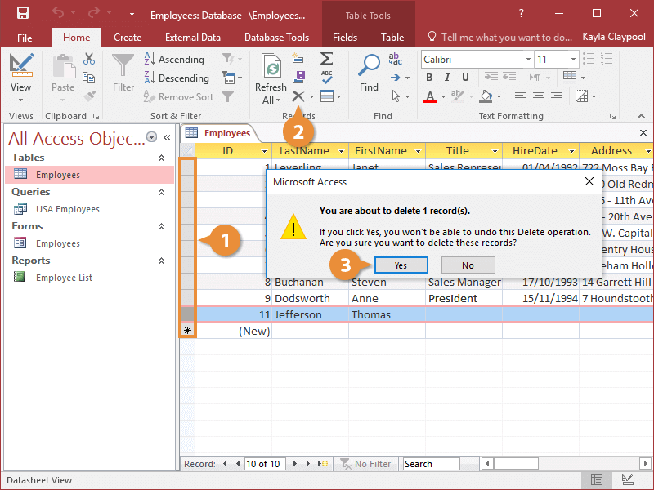
The record is deleted from the table.

  - Save and close down database to storage area
Saving a database
Saving your work in Access is a little different from saving in most Office apps. Changes to data, the primary reason for saving your work in most apps, are automatically saved in in Access, instead of saving data changes, you save changes to the database design, or you save the whole database, data and all, with a new filename as a backup, or in a different format, such as an earlier Access file format, a database template, or a compiled database (a database where you can't change the design). You can also save individual database objects as new objects.

Self-check 6
1. One of the following is not Database Design Principles
    - Usability
    - Data integrity
    - Entity integrity
    - All
2. ------- any organizational asset, the level of security must be secured depending on its value and sensitivity.
    - Usability
    - Data integrity
    - Security
    - Entity integrity
    - All
3. -------- is used to identify each record that you store in the table.
    - Primary key
    - Foreign key
    - Entity
    - Table
4. The right procedure to create a primary key to associate data between multiple tables
    - Primary key-----. Navigation Pane-----Design View----Select the field
    - Navigation Pane-----Design View----Select the field----- primary key.
    - Design View----navigation pane---Select the field----- primary key.
    - none
5. one of the following isn’t basic elements in an ER Diagram:
    - Entity
    - Attribute
    - Relationship
    - none

Operation Sheet 6.1. DB application and principles
- Operation title: Opening and designing DB application
- Purpose: To create and open DB application
- Instruction: Using the given application software (ms access) create and open database. You have given 30Minut for the task and you are expected to create database.
- Tools and requirement:
- Personal computer
- Microsoft office
- Steps to doing the task
On the Getting Started with Microsoft Office Access page, under New Blank Database, click Blank Database.
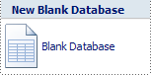
- In the Blank Database pane, type a file name in the File Name box. If you do not supply a file name extension, Access adds it for you. To change the location of the file from the default, click Browse for a location to put your database (next to the File Name box), browse to the new location, and then click OK.
- Click Create.
- Access creates the database with an empty table named Table1, and then opens Table1 in Datasheet view. The cursor is placed in the first empty cell in the Add New Field column.
- Begin typing to add data, or you can paste data from another source, as described in the section Copy data from another source into an Access table.

- Steps to doing the task
- Click the Microsoft Office Button ,
- Click Open. In the Open dialog box, browse to the database that you want to open.
- Double-click the database to open it in the default mode specified in the Access
- Options dialog box or the mode that was set by an administrative policy.
- Click Open to open the database for shared access in a multi-user environment so that you and other users can read and write to the database.
- Click the arrow next to the Open button and then click Open Read-Only to open the database for read-only access so that you can view but not edit it. Other users can still read and write to the database.
- Click the arrow next to the Open button
- Click Open Exclusive to open the database with exclusive access. When you have a database open with exclusive access, anyone else who tries to open the database receives a "file already in use" message.
- Quality Criteria: create and open database
- Precautions: OHS

Operation Sheet 6.2. Database Objects (Tables)
- Operation title: Creating Database object
- Purpose: To create and access and customize table with different option
- Instruction: Using the given application software (ms access) create database object table. You have given 30Minut for the task and you are expected to create database
- Tools and requirement:
- Personal computer
- Microsoft office(ms access application)
- Steps to Create a new table in a new database
- Click the Microsoft Office Button, and then click New.
- In the File Name box, type a file name for the new database.
- To browse to a different location to save the database, click the folder icon.
- Click Create.
- Steps to Create a new table in an existing database
- Click the Microsoft Office Button, and then click Open.
- In the Open dialog box, select the database that you want to open, and then click Open.
- On the Create tab, in the Tables group, click Table.
- Steps to Create a new table by using a table template
- Click the Microsoft Office Button, and then click Open.
- In the Open dialog box, select and open the database in which you wish to create a table.
- On the Create tab, in the Tables group, click Table Templates and then select one of the available templates from the list.

- Steps to Create a new table by importing or linking to external data
- Click the Microsoft Office Button, and then click Open.
- In the Open dialog box, select and open the database in which you wish to create a new table.
- On the External Data tab, in the Import group, click one of the available data sources.
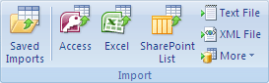
- Follow the instructions in the dialog boxes that appear at each step.
- Steps to Use a SharePoint site to create a table
- Click the Microsoft Office Button , and then click Open.
- In the Open dialog box, select the database in which you want to create the new table, and then click Open.
- On the Create tab, in the Tables group, click SharePoint Lists.
- Steps to Create a SharePoint list that is based on a template
- Click either Contacts, Tasks, Issues, or Events.
- In the Create New List dialog box, type the URL for the SharePoint site where you want to create the list.
- Enter a name for the new list and its description in the Specify a name for the new list and Description boxes.
- To open the linked table after it is created, select the Open the list when finished check box (selected by default).
- Steps to Create a new custom list
- Click Custom.
- In the Create New List dialog box, type the URL for the SharePoint site where you want to create the list.
- Enter a name for the new list and its description in the Specify a name for the new list and Description boxes.
- To open the linked table after it is created, select the Open the list when finished check box (selected by default).
- Steps to import the data from an existing list
- Click Existing SharePoint List.
- In the Get External Data dialog box, type the URL for the SharePoint site that contains the data that you want to import.
- Click Import the source data into a new table in the current database, and then click Next.
- Select the check box next to each SharePoint list that you want to import.
- Steps to Link to an existing list
- Click Existing SharePoint List.
- In the Get External Data - SharePoint Site dialog box, type the URL for the SharePoint site that contains the list to which you want to link.
- Click Link to the data source by creating a linked table, and then click Next.
- Select the check box next to each SharePoint list to which you want to link.
- Steps to set or change a table's primary key
- Select the table whose primary key you want to set or change.
- On the Home tab, in the Views group, click View, and then click Design View.
- In the table design grid, select the field or fields that you want to use as the primary key.
- On the Design tab, in the Tools group, click Primary Key.
- A key indicator appears to the left of the field or fields that you specify as the primary key.
- Steps to Remove the primary key
- Select the table whose primary key you want to remove.
- On the Home tab, in the Views group, click View, and then click Design View.
- Click the row selector for the current primary key. If the primary key consists of multiple fields, hold down CTRL, and then click the row selector for each field.
- On the Design tab, in the Tools group, click Primary Key.
- Steps to Set a table's properties
- Select the table whose properties you want to set.
- On the Home tab, in the Views group, click View, and then click Design View.
- On the Design tab, in the Show/Hide group, click Property Sheet.The table property sheet is shown.
- On the property sheet, click the General tab.
- Click the box to the left of the property that you want to set, and then enter a setting for the property.
- To save your changes, press CTRL+S.

- Steps to Add a field by using a field template
- On the Home tab, in the Views group, click View, and then click Datasheet View.
- On the Datasheet tab, in the Fields & Columns group, click New Field.
- Select one or more fields in the Field Templates pane, and then drag them to the table where you want to insert the new column.
- Steps to Rename a field
- Right-click the heading of the field that you want to rename (for example, Field1).
- On the shortcut menu, click Rename Column.
- Enter the new name in the field heading.
- Steps to Set other field properties
- In Datasheet view, click the field for which you want to set the property.
- On the Datasheet tab, in the Data Type & Formatting group, select the properties that you want.
- Steps to Set field properties in Design view
- Open a table in Design view
- In the Navigation Pane, right-click the table.
- On the shortcut menu, click Design view.
- Change a field's data type
- In the table design grid, locate the field for which you want to set the data type.
- In the Data Type column, choose a data type from the list.
To save your changes, press CTRL+S.
- Quality Criteria: create table
- Precautions: OHS

Operation sheet 6.3. Modify Database Objects
- Operation title: modifying Database object
- Purpose: To rename a Database object Table
- Instruction: Using the given application software (ms access) modify database object table. You have given 30Minut for the task and you are expected to create database
- Tools and requirement:
- Personal computer
- Microsoft office
- Steps to turn on the Name AutoCorrect option
- Click File>Options.
- In the Access Options dialog box, in the left pane, click Current Database.
- Under Name AutoCorrect Options, select the Track name AutoCorrect info check box, and then select the Perform name AutoCorrect check box.
- If you want to keep a table that logs each change that is performed by Name AutoCorrect, select the Log name AutoCorrect changes check box.
- Click OK.
- To save your changes, click Save on the Quick Access Toolbar.
- Steps to rename a field in Datasheet view
- In the Navigation Pane, double-click the table in which you want to rename the field.
- Right-click the column heading for the field that you want to rename, and then click Rename Field on the shortcut menu.
- Type the new name for the field and then press ENTER.

- Steps to rename a field in Design view
- In the Navigation Pane, right-click the table in which you want to rename the field, and then click Design View on the shortcut menu..
- Click the cell in the Field Name column for the field that you want to rename.
- Edit the text to rename the field.
- To save your changes, click Save on the Quick Access Toolbar.
- Steps to rename a table
- In the Navigation Pane, right-click the table that you want to rename and then click Rename on the shortcut menu.
- Type the new name and then press ENTER.
- To save your changes, click Save on the Quick Access Toolbar
Quality Criteria: rename database object table
Precautions: OHS

Operation sheet 6.4. Database Relationship
- Operation title: creating Database relationships
- Purpose: To create relationships
- Instruction: Using the given application software (ms access) Create relationship. You have given 30Minut for the task and you are expected to create relation ship between tables.
- Tools and requirement:
- Personal computer
- Microsoft office
- Steps to Create a table relationship

- Click the Database Tools tab.
- Click the Relationships button.

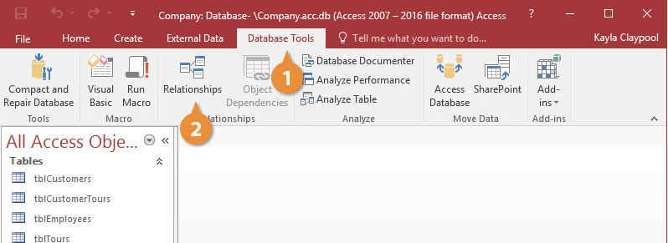
- Click the Show Table button
- Double-click the table(s) you want to add.
- Click Close

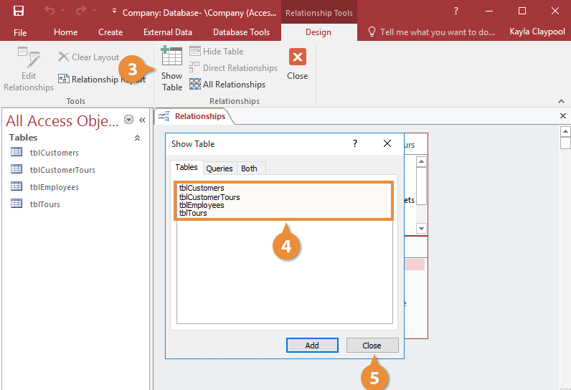
- Click the related field in the first table and drag it to the related field in the second table.
Whenever you link a primary key from one table to a field from another table, you create a foreign key.

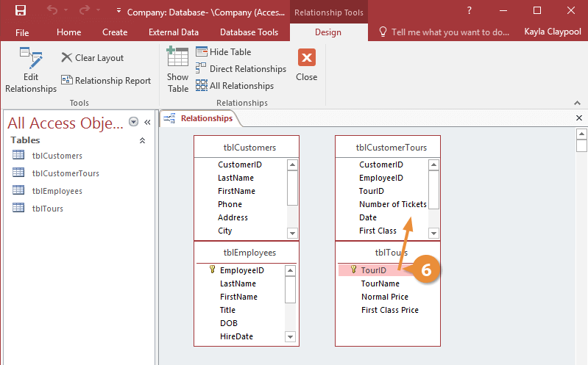
- Check the Enforce Referential Integrity option (optional).
Click Create

Steps to delete a table relationship
- Click the join line that connects the tables
- Press the Delete key. Access asks you to confirm that you really want to delete the relationship.
- Click Yes.
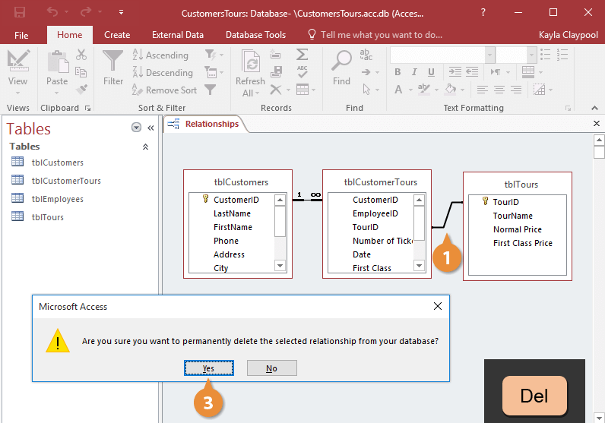
- Steps to print relationship window
- Click the Database Tools tab.
- Click the Relationships button

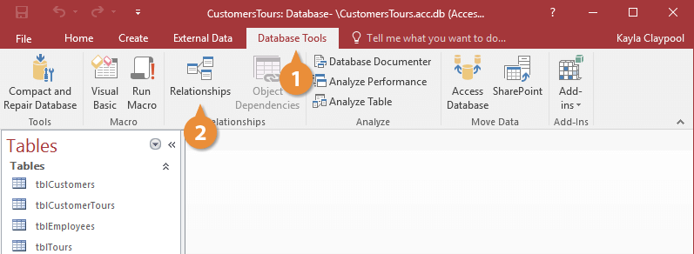

- Click the Relationship Report button.

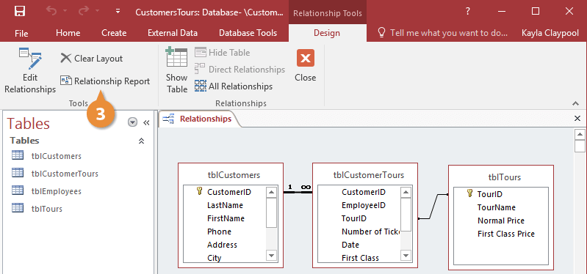
- Click the Print button.
The Print dialog box appears.
- Select the desired print settings and click OK.
The Relationships report is printed.
- Click the Close Print Preview button.
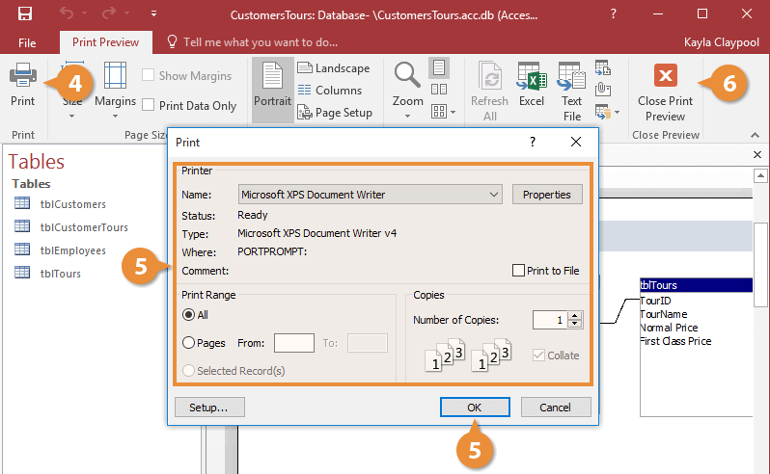

- Click the Relationships report's Close button.
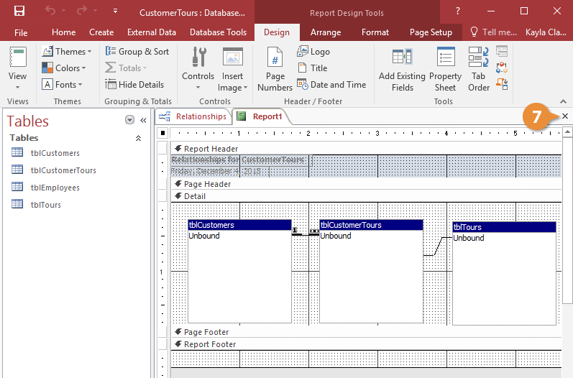

Quality Criteria: create database relationship
Precautions: OHS

LAP Test

Name: __________________________ Date: ____________
Time started: ____________________ Time finished: _______________
Instruction I: Given necessary templates, tools and materials you are required to perform the following tasks within 3 hours.

Task-1: Database Relationship
Task-2: Modify Database Objects
Task-3: Database Objects (Tables)
Task-4: DB application and principles

Unit Seven: Create reports and forms
This unit is developed to provide you the necessary information regarding the following content coverage and topics:
- Design reports in a logical sequence
- Modify reports
- Distribute reports
- create a simple form
- Open existing database and modify records through a simple form
- Rearrange objects within the form to accommodate information requirements
This unit will also assist you to attain the learning outcomes/unit/ stated in the coverage. Specifically, upon completion of this learning guide, you will be able to:
- Design reports to present data in a logical sequence
- Modify reports to include or exclude additional requirements
- Distribute reports to appropriate person in a suitable format
- Use a wizard to create a simple form
- Open existing database and modify records through a simple form

Design reports in a logical sequence

Report
A report is an object in Microsoft Access that is used to display and print your data in an organized manner. Reports provide a means of organizing and summarizing data. Reports are often used to present an overview highlighting main points and trends. A report can be a simple list, a status report or a monthly production report. A report is made from the data available.
Technique to create report
- Creating Reports using a wizard Creation of a report by using a wizard is a fastest and easy way to create a report by following the series of steps and choosing a pre-defined template for your report.
- Creating Reports using design view Creation of a report by design view is a user customized way setting-up your report so to meet the users desired output and format.
When you design a report, you must first consider how you want the data arranged on the page and how the data is stored in the database. During the design process, you might even discover that the arrangement of data in the tables will not allow you to create the report that you want. This can be an indication that the tables are not normalized this means that the data is not stored in the most efficient manner.
Make a sketch of your report this step is not required — you might find that the Access Report Wizard or the Report tool(both of which are available on the Create tab, in the Reports group) provide a sufficient starting design for your report
Decide which data to put in each report section Each report has one or more report sections. The one section that is present in every report is the Detail section. This section repeats once for each record in the table or query that the report is based on. Other sections are optional and repeat less often and are usually used to display information that is common to a group of records, a page of the report, or the entire report
Decide how to arrange the detail data Most reports are arranged in either a tabular or a stacked layout, but Access gives you the flexibility to use just about any arrangement of records and fields that you want.
Types of lay out
Tabular layout A tabular layout is similar to a spreadsheet. Labels are across the top, and the data is aligned in columns below the labels. Tabular refers to the table-like appearance of the data. This is the type of report that Access creates when you click Report in the Reports group of the Create tab. The tabular layout is a good one to use if your report has a relatively small number of fields that you want to display in a simple list format.
Stacked layout A stacked layout resembles a form that you fill out when you open a bank account or make a purchase from an online retailer. Each piece of data is labeled, and the fields are stacked on top of each other. This layout is good for reports that contain too many fields to display in a tabular format — that is, the width of the columns would exceed the width of the report. The following illustration shows an employee report that was created by using a stacked layout.
Mixed layout You can mix elements of tabular and stacked layouts. For example, for each record, you can arrange some of the fields in a horizontal row at the top of the Detail section and arrange other fields from the same record in one or more stacked layouts beneath the top row. The following illustration shows an employee report that was created by using a mixed layout. The ID, Last Name, and First Name fields are arranged in a tabular control layout, and the Job Title and Business Phone fields are arranged in a stacked layout. In this example, gridlines are used to provide a visual separation of fields for each employee.
Justified layout If you use the Report Wizard to create your report, you can choose to use a justified layout. This layout uses the full width of the page to display the records as compactly as possible. Of course, you can achieve the same results without using the Report Wizard, but it can be a painstaking process to align the fields exactly. The following illustration shows an employee report that was created by using the Report Wizard's justified layout.

Modify reports

Modifying or customizing reports, in many cases, is much the same as modifying or customizing any other form. It depends, however, on what type of report you want to modify/customize and whether you want to modify the report object or the report criteria form.
Understand Layout view
Layout view is the most intuitive view to use for report modification, and can be used for nearly all the changes you would want to make to a report in Access. In Layout view, the report is actually running, so you can see your data much as it will appear when printed. However, you can also make changes to the report design in this view. Because you can see the data while you are modifying the report, it's a very useful view for setting column widths, add grouping levels, or performing almost any other task that affects the appearance and readability of the report.
The report you see in Layout view does not look not exactly the same as the printed report. For example, there are no page breaks in Layout view. Also, if you have used Page Setup for format your report with columns, the columns are not displayed in Layout view. However, Layout view gives you a very close approximation of the printed report. If you want to see how the report will look when printed, use Print Preview.

Understand Design view
Design view gives you a more detailed view of the structure of your report. You can see the header and footer bands for the report, page, and groups. The report is not actually running in Design view, so you cannot see the underlying data while working; however, there are certain tasks you can perform more easily in Design view than in Layout view. You can:
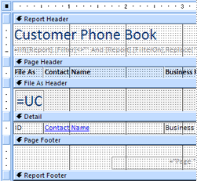
Figure 1 design view

Distribute reports

Report is a document containing information organized in a narrative, graphic, or tabular form, prepared on ad hoc, periodic, recurring, regular, or as required basis. Reports may refer to specific periods, events, occurrences, or subjects, and may be communicated or presented in oral or written form. Liberate your Access reports and distribute them far and wide. For example, email them to one or more users, export them to SharePoint document libraries, and archive them on network folders.
When you distribute an Access report, you create a static report of data at a certain moment in time, such as daily, weekly, or monthly. By doing so, you have a single point of truth that information workers can use to make good business decisions, answer questions, find alternatives, determine best plans, evaluate risks, and improve quality. The term "business representative" is often used as a general reference for sales professionals, customer service professionals or anyone serving as an interface between customers and a company However, this term has a very specific meaning and application in the business world.
Methods to distribute report
Personalized emails: Segment your email list down to the exact audience that would benefit most from your piece of content. Write a custom email to each of these audience members to add a level of personalization to your message. Explain what the content is, and why you think he or she will enjoy it..
Guest posting: Write an article that discusses -- in a non-promotional way -- the key findings or points within your content, and send it to the editor of an online publication that reaches your target audience. But be strategic about it. Make sure the publication not only helps you achieve your own reach goals, but also, has something to gain by sharing your insights, from your particular brand
- Follow-up emails: Encourage your sales team to include a link to your content in their follow-up emails to prospective clients, to answer their questions and position your company as a resource they can trust.
- Lead interviews: Work with your sales reps to identify prospective clients you can interview for your content. Include a quote in your content, and share it with them once it's published. Not only can that keep your leads engaged over time, but they'll appreciate the opportunity to be featured -- and you benefit from the additional exposure to their networks when the content is shared with that audience.
- Proposal references: The best proposals are often supported with relevant data that corroborates the solutions you’re suggesting to a prospect. And while we suggest citing a variety of authentic, reliable sources -- otherwise, you might look biased -- referencing your own research content can be effective. Not only is it another way to distribute your work, but also, it illustrates the time and thought your company has invested in this school of thought.
That said, some prospective clients like proposals to be brief. In these cases, if you preemptively anticipate additional questions, you can amend your proposal with a link to the content as a source of further reading and information.
Client drip campaigns
If your content is related to your clients’ respective industries, or products and services, sharing it with them can enhance your collaborations and further nurture that relationship. Remember, it’s called client retention for a reason

Create a simple form

Form
A Form is a database object that you can use to create a user interface for a database application. A "bound" form is one that is directly connected to a data source such as a table or query, and can be used to enter, edit, or display data from that data source.
Forms are made up of controls, such as text boxes, buttons, document tabs, and drop-down lists, grouped in a way that makes them easy to use and helps you get work done. The controls in the form are usually bound, or connected, to the tables or queries in your database — but not always. For example, a control that displays your corporate logo doesn't have to be bound to a table field. It can just point to the image it displays. In addition to entering data, you can use forms in other ways. For example, you can create a form that asks for input, and then generates a custom report based on that input.
In Access a form is an object that generally serves three purposes:
- To allow users to perform data entry. Data can be inserted, updated, or deleted from a table using a Form object.
- To allow users to enter custom information, and based on that information perform a task. For example, you may want to ask a user for parameters before running a report.
- To allow users a method of navigating through the system. For example, you may create a form where a user can select a form to load, a report to run, etc.
Creation of a form by using a wizard is the Ms Access pre-defined way of creating a form by simply following the series of steps and choosing which field and format you would want for your Form.
Modify records through a simple form

Modifying or customizing reports, in many cases, is much the same as modifying or customizing any other form. It depends, however, on what type of report you want to modify/customize and whether you want to modify the report object or the report criteria form.

Rearrange objects within the form

Form Object
A Form object refers to a particular Microsoft Access form. A Form object is a member of the Forms collection, which is a collection of all currently open forms. Within the Forms collection, individual forms are indexed beginning with zero.
Forms are made up of controls, such as text boxes, buttons, document tabs, and drop-down lists, grouped in a way that makes them easy to use and helps you get work done.The controls in the form are usually bound, or connected, to the tables or queries in your database — but not always. For example, a control that displays your corporate logo doesn't have to be bound to a table field. It can just point to the image it displays. In addition to entering data, you can use forms in other ways. For example, you can create a form that asks for input, and then generates a custom report based on that input.

Self-check 7
Test I.
Instruction: Answer all the questions listed below. You have given 1 Minute for each question. Each question carries 2 Point.
1------- provide a means of organizing and summarizing data.

- Form
- Report
- Table
- All

2.Which layout uses the full width of the page to display the records as compactly as possible?
- Mixed
- Justified
- A&B
3---------is the most intuitive view to use for report modification
- Layout view
- Mixed view
- Justified view
4.Which view gives you a more detailed view of the structure of your report.

- Design
- Mixed
- Justified
- none

5----- is a document containing information organized in a narrative, graphic, or tabular form?

- Form
- Report
- Query
- Table

6.When you distribute an Access report, you create (2)

- A static report
- mixed view
- Normal report
- justified view

Test II.
Instruction: Say True or False the questions listed below. You have given 1 Minute for each question. Each question carries 2 Point
- Creation of a report by using a wizard is a fastest and easy way to create a report.
- Layout view is the most intuitive view to use for report modification.
- Reports may not refer to specific periods, events, occurrences, or subjects, and may be communicated or presented in oral or written form.

Operation sheet 7.1. Create Form using wizard

- Operation title: customize forms using wizard
- Purpose: To create simple form by using wizard
- Instruction: Using the given application software (ms access)to Create simple forms by using wizard. You have given 30Minut for the task and you are expected to create simple forms by using wizards.
- Tools and requirement:
- Personal computer
- Microsoft Window
- Steps to create a form
- Click the Create tab on the ribbon.
- Click Form Wizard.
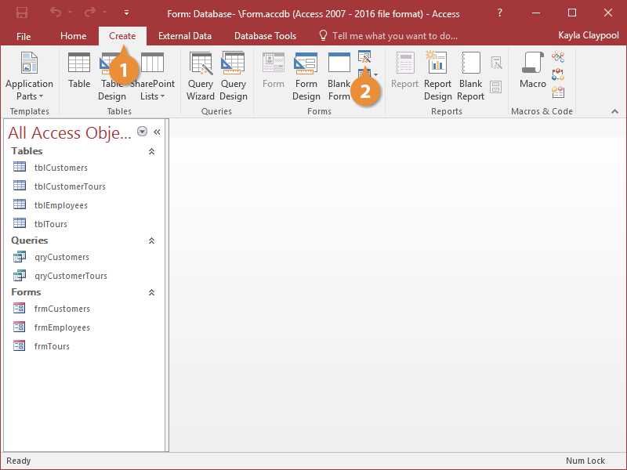
The Form Wizard appears. Anytime you create a form, you must tell Access which table or query you want to use for your form
- Click the Tables/Queries list arrow and select the table or query you want to use to create your form.
- Click the Tables/Queries list arrow and select the table or query you want to use to create your form
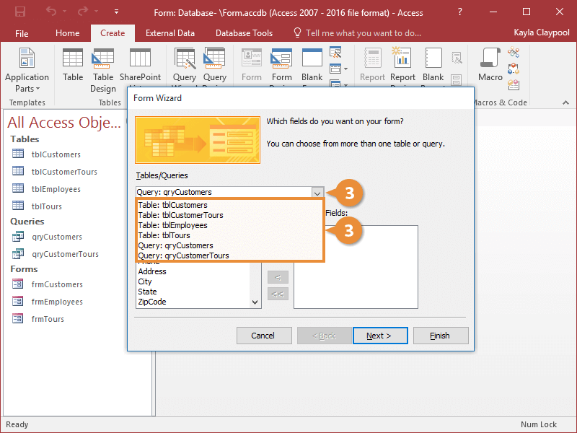
Now that you have specified the table, you need to tell the Wizard which fields you want to display on the form. To add a field to the form, you can either double-click the field or select the field and click the right arrow button
- Double-click the fields that you want to appear on the form.
- Click Next
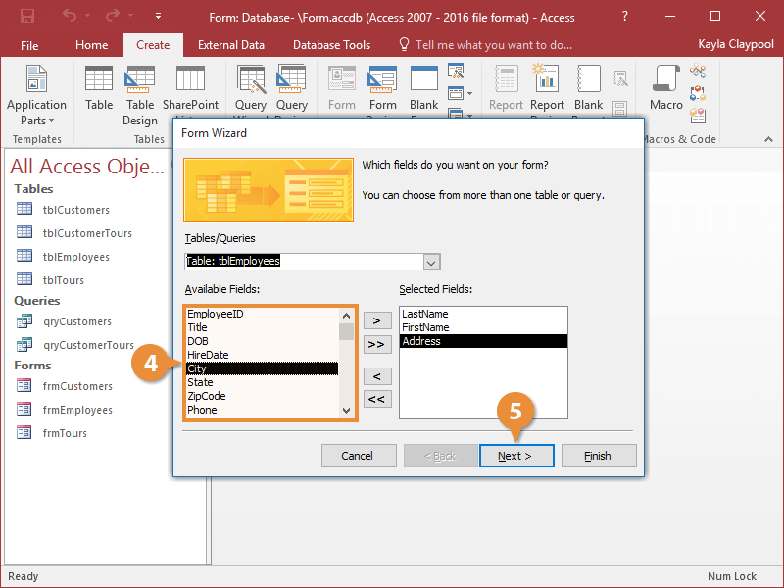
Next the Form Wizard asks how you want to lay out the data on the form. There are a few different layout options:
- Columnar: Displays one record at a time in a format that's easy to read.
- Tabular: Displays multiple records at a time.
- Datasheet: Displays multiple records at a time and looks like a table in Datasheet view.
- Justified: Displays one record at a time. The format usually creates complicated forms that are difficult to work with.
- Select a layout option and click Next.
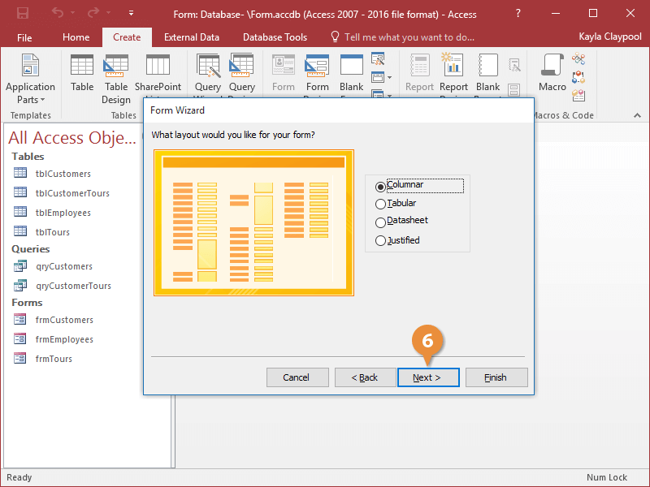
- Enter a title for your form and click Finish
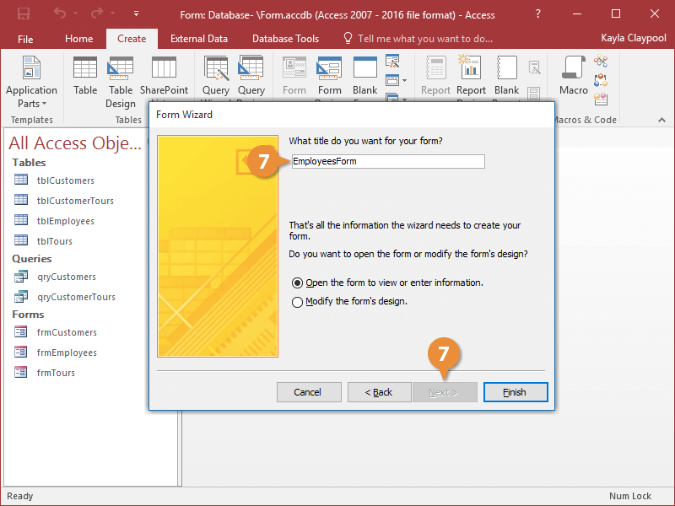
- Steps to save a form
- Click the Save button on the Quick Access toolbar. Access saves the form unless you are saving for the first time. If you are saving for the first time, the Save As dialog box appears.
- Type the name you want to give the form.
- Click OK. Access saves the form. You can now access the form by using the Navigation pane.
- Step to Create a Split Form
In the Navigation Pane, click the table or query that contains the data that you want on your form.
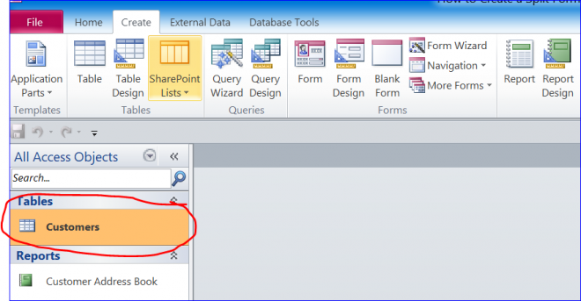
- On the Create tab, in the Forms group, click More Forms, and then click Split Form
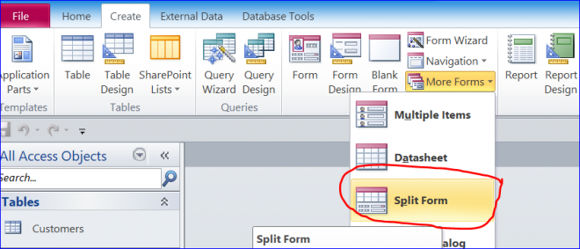
The default split form will open as shown below. The Form view is on top of the Datasheet view. However, you can change the settings under the form property.
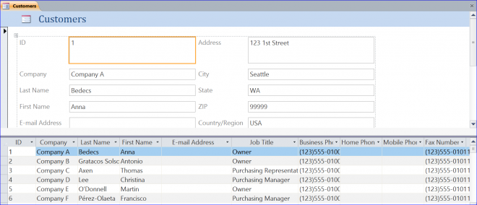
- Step to create a multiple items form
- Open the Navigation pane.
- Click the table or query on which you want to base your form.
- Activate the Create tab.
- Click Multiple Items in the Forms group. Access creates a multiple items form
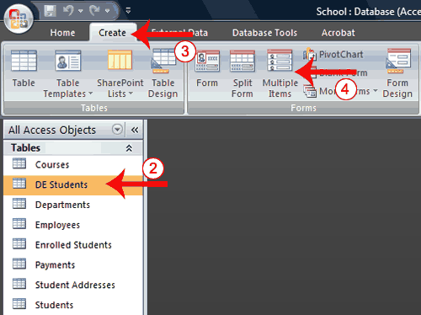

- Steps to change the view
- Open the form.
- Activate the Format tab.
- Click the down-arrow under the View button. A menu appears.
- Click the view you want.
- Steps to change the size of a field
- Click a side of the field and drag to change the width of the field.
- Click the top or bottom of a field and drag to change the height of a field.
- Steps to move a datasheet
- Click the datasheet to select it.
- Click and drag the four-sided arrow in the upper-right corner to move the datasheet.
- Steps to resize a datasheet
- Click the datasheet to select it.
- Click a side of the datasheet and drag to change the width.
- Click the top or bottom of the datasheet and drag to change the height.
- Steps to apply an AutoFormat
The AutoFormat option on the Format tab enables you to apply formats quickly, such as background colors, field colors, field label colors, and fonts.
- Activate the Format tab.
- Click AutoFormat. The AutoFormat menu appears.
- Click the format you want to apply.
- Steps to change a form title
When you create a form, by default, Access uses the form name as the title. You can change the title.
- Activate the Format tab.
- Click the Title button.
- Type the new title.
- Steps to add the date and time
You can easily add the date and time to your form.
- Activate the Format tab.
- Click the Date and Time button. The Date and Time dialog box appears. Select the date and time format you want. The date and time appear on your form.
Quality Criteria: create form using wizard
Precautions: OHS

Operation sheet 7.2: Modify Existing database
- Operation title: access Existing database
- Purpose: To open ad Modify Existing database
- Instruction: Using the given application software (ms access) to access existing database. You have given 30Minut for the task and you are expected to open and modify existing database.
- Tools and requirement:
- Personal computer
- Microsoft Window
- Step to open a database from within Access
- Select the File tab to go to Backstage view.
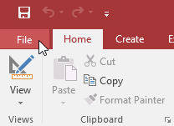
- Click Open
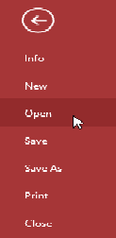
- Click Browse.
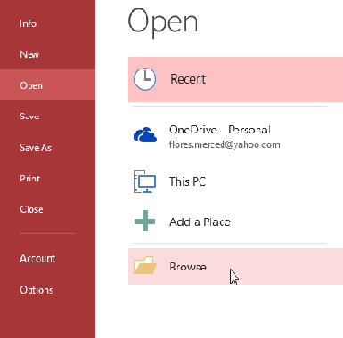
- The Open dialog box will appear. Locate and select the database, then click Open.
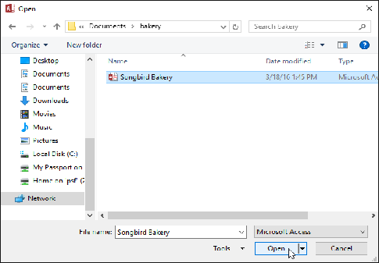
- Step to create a desktop shortcut to open a database object
- Open the database containing the object for which you want to create a shortcut.
- Resize the Access window and minimize any other open windows so that you can see the desktop behind the Access window.
- In the Navigation Pane, find the object for which you want to create the shortcut.
- Drag the object from the Navigation Pane to the desktop. When you release the mouse button, the shortcut is created on the desktop.
- If you want the shortcut in a location other than the desktop, use Windows Explorer to move the shortcut to the location you want.
Quality Criteria: modify existing Database
Precautions: OHS

Operation sheet 7.3. Rearranging objects
- Operation title: Rearrange objects within the form
- Purpose: To Rearrange objects within the form
- Instruction: Using the given application software (ms access) to rearrange objects. You have given 20Minute for the task and you are expected to rearrange objects.
- Tools and requirement:
- Personal computer
- Microsoft Window
- Step to create command button
- In Form Layout view, select the Design tab, then locate the Controls group.
- Click the Button command.
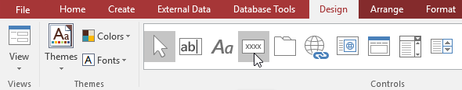
- choose the desired location for the command button, then click the mouse.
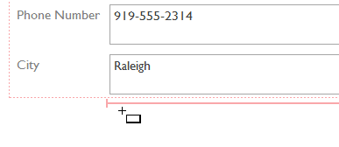
- The Command Button Wizard will appear. In the Categories pane, select the category of button you want to add. We want to find a way to move more quickly to specific records, so we'll choose the Record Navigation category.
- The list in the Actions pane will update to reflect your chosen category. Select the action you want the button to perform, then click Next. In our example, we'll choose Find Record.
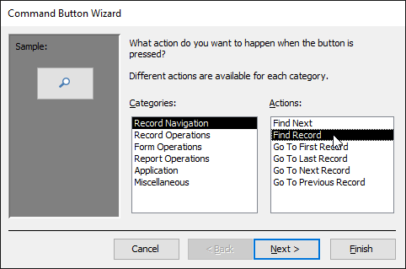

- You can now decide whether you want your button to include text or a picture. A live preview of your button appears on the left.
- To include text, select the Text option, then type the desired word or phrase into the text box.
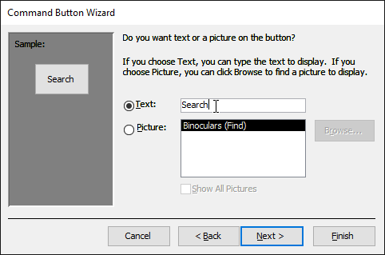
- To include a picture, select the Picture option. You can decide to keep the default picture for that command button or select another picture. Click Show All Pictures to choose from another command button icon or Browse to choose a picture from your computer.
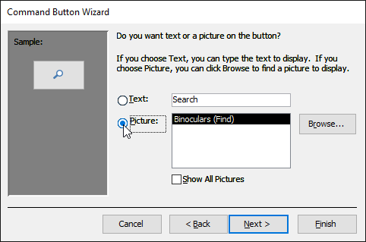
- When you are satisfied with the appearance of your command button, click Next.
- Type a name for the button. This name won't appear on the button, but knowing the name will help you quickly identify the button if you ever want to modify it with the Property Sheet. After adding the button name, click Finish.
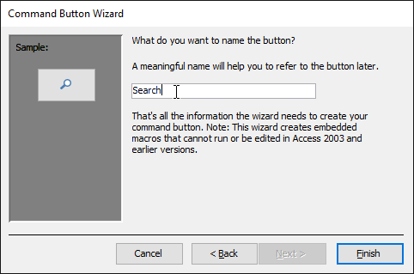

Operation sheet 7.4: Design report
- Operation title: customize Database report
- Purpose: To design Database design
- Instruction: Using the given application software (ms access) to customize database report. You have given 20Minute for the task and you are expected to design database.

- Tools and requirement:
- Personal computer
- Microsoft Window
- Step to Create Reports Using the Report Button
- Open the table or query you want to use in your report. We want to print a list of cookies we've sold, so we'll open the Cookies Sold query.
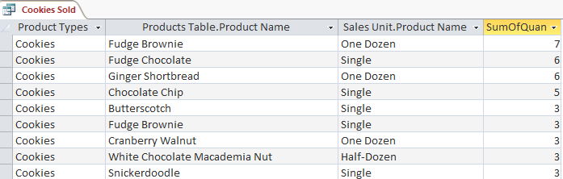
- Select the Create tab on the Ribbon. Locate the Reports group, then click the Report command.
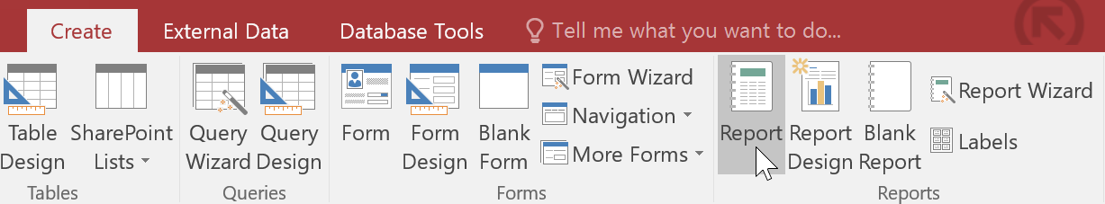
Access will create a new report based on your object
It's likely that some of your data will be located on the other side of the page break. To fix this, resize your fields. Simply select a field, then click and drag its edge until the field is the desired size. Repeat with additional fields until all of your fields fit.

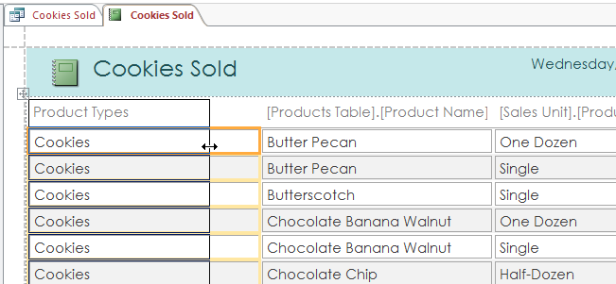

To save your report, click the Save command on the Quick Access Toolbar. When prompted, type a name for your report, then click OK.
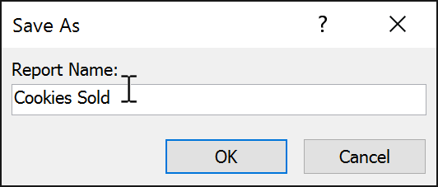
- Step to create a report by using the Report Wizard:
Open the Report Wizard
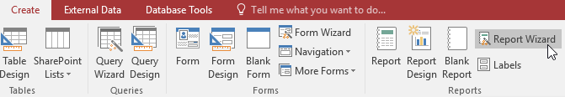
On the Create tab in the Reports group, click Report Wizard. The wizard starts
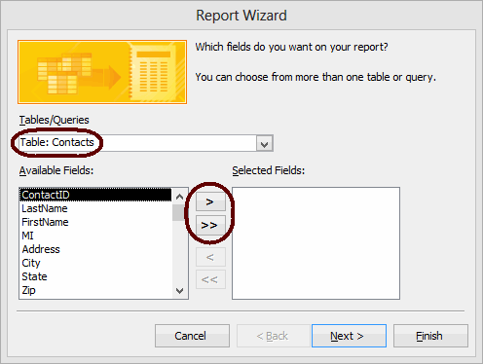
- From the Tables/Queries drop-down list, select the table (or query) to base the report on. The fields for the selected table load in the Available Fields list box.
- Move the fields to include on the report from the Available Fields list box to the Selected Fields list box. To do so, double-click a field name to move it or highlight the field name and click >. To move all fields at once, click >>.
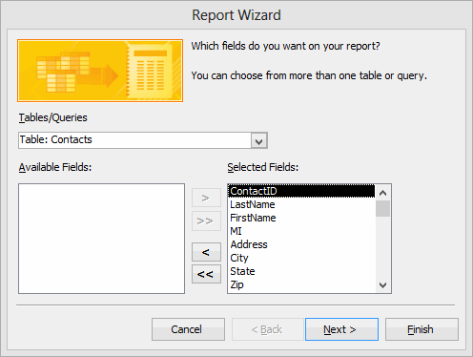
- Click Next
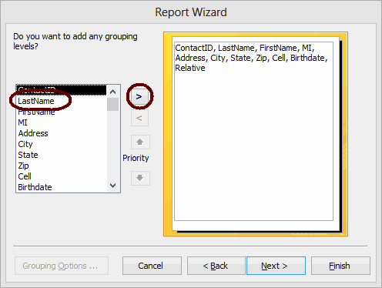
- To group records on the report by a particular field, highlight the field in the list box and click.
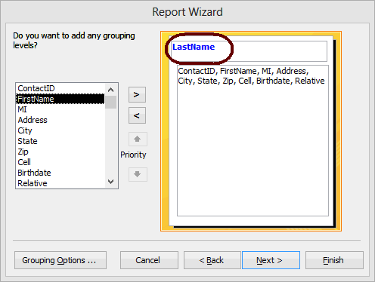
- Add more grouping levels if desired. You can use the arrows to change the order of the grouping levels if needed.
- When you finish defining how you want records grouped, click Next
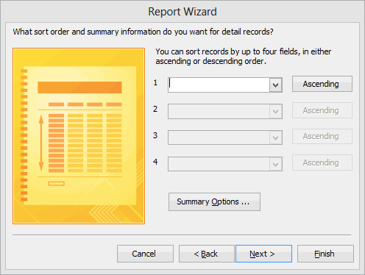

Operation sheet 7.5: Switch Report between views
- Operation title: modifying Report
- Purpose: To modify and switch reports between views
- Instruction: Using the given application software (ms access) to modify and switch reports. You have given 20Minute for the task and you are expected to modify and switch reports.
- Tools and requirement:

- Personal computer
- Microsoft Window

- Step to Modify report in Layout view
Click the View list arrow on the ribbon and select a view option
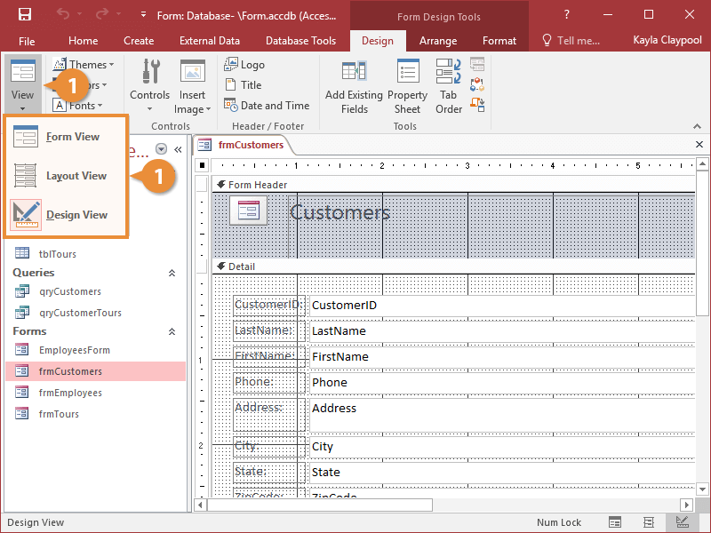

- Step to add a field in Layout view
- Click the Add Existing Fields button on the ribbon.
The Field List pane appears and lists the available fields that you can add to the form.
- Double-click the field you want to add

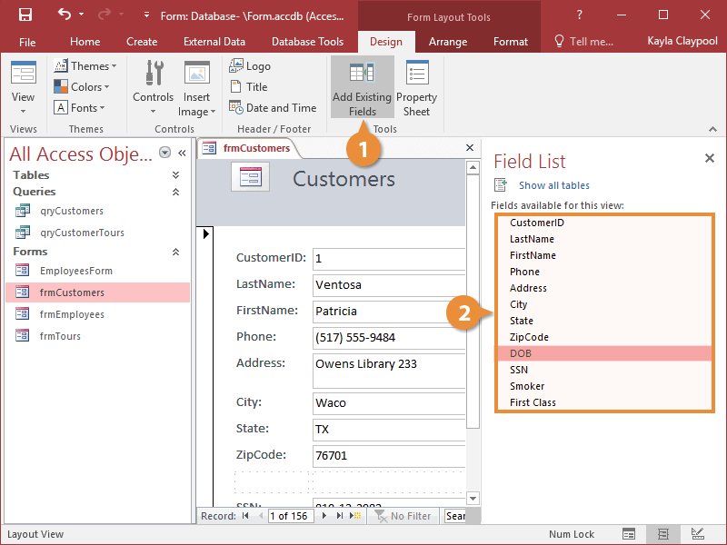
- Step to Create a new control layout
- Click Reportin the Reports group on the Create tab.
- Click Blank Reportin the Reports group on the Create tab, and then dragging a field from the Field List pane to the report.
- Step to create a new control layout by doing the following:
- Select a control that you want to add to the layout.
- If you want to add other controls to the same layout, hold down the SHIFT key and also select those controls.
- Do one of the following:
- On the Arrange tab, in the Table group, click Tabular or Stacked.
- Right-click the selected control or controls, point to Layout, and then click Tabular or Stacked.
- Step to Change page setup
- Click the Page Setup tab.
- In the Page Size group, click Size to select a different paper size.
- In the Page Size group, click Margins to make adjustments to the report's margins.
- In the Page Layout group, click Portrait or Landscape to change the paper orientation.
- Step to Change the formatting of a field
- Select the field that you want to format.
- On the Format tab, use the tools in the Font group to apply the formatting you want.
- Step to add or modify a logo or other image
On the Design tab, in the Header/Footer group, click Logo.
Browse to the folder where your logo file is stored, and double-click the file.
- Step to add or edit a report title
On the Design tab, in the Header/Footer group, click Title.
A new label is added to the report header, and the report name is entered for you as the report title.
- When the label is created, the text in the label is selected for you so that if you want to change the text, you can just begin typing the title you want.
- Press ENTER when you have finished.
- Step to add page numbers
- On the Design tab, in the Header/Footer group, click Page Numbers.
- The Page Numbers dialog box is displayed.
- Choose the format, position, and alignment you want for the page numbers.
- Clear the Show Number of First Page check box if you do not want a number on the first page.
- Click OK.
- Step to add the date or time
- On the Design tab, in the Header/Footer group, click Date and Time.
- The Date and Time dialog box is displayed.
- Clear the Include Date check box if you do not want to include the date.
- If you want to include the date, click the date format you want.
- Clear the Include Time check box if you do not want to include the time.
- If you want to include the time, click the time format you want.
- A sample of the date and time, in the formats you have chosen, appears in the Sample area of the dialog box.
- Click OK.
- Step to add line numbers
On the Design tab, in the Controls group, click Text Box.
- Click in an open area of the section where you want the line numbers to appear. In most cases, this will be the Detail section. You will move the text box to its final location later. When you click the report, Access creates a new, unbound text box.
- Click the label (just to the left of the new text box), and press DELETE.
- Click once in the new text box to select it, and then click again to position the cursor in the text box.
- Type =1 and then press ENTER.
- If the property sheet is not already displayed, press F4 to display it.
- On the Data tab of the property sheet, set the Running Sum property to Over All.
- Resize the text box to a smaller width by positioning the pointer over the sizing handle on the right edge of the text box and dragging it to the left. Leave enough room for the largest line number you expect to see on this report.
- If needed, make room for the text box on the far left edge of the Detail section by dragging the existing controls in that section to the right, or by resizing the leftmost control in that section.
- Drag the new text box to the location that you want it on the report.
- Switch to Report view, Print Preview, or Layout view to see the line numbers.
- Quality Criteria: Design Report
- Precautions: OHS

LAP Test

Name: __________________________ Date: ____________
Time started: ____________________ Time finished: _______________
Instruction I: Given necessary templates, tools and materials you are required to perform the following tasks within 20 hours.

Task-1: Create Form using wizard
Task-2: Modify Existing database
Task-3: Rearrange objects within the form
Task-4: Design report
Task-5: Switch Report between views

Unit eight: Retrieve information
This learning guide is developed to provide you the necessary information regarding the following content coverage and topics:
- Locate Database Record
- retrieve information using query
- Develop query
- Select data and display appropriately
This guide will also assist you to attain the learning outcomes/unit/ stated in the coverage. Specifically, upon completion of this learning guide, you will be able to:
- Access existing database and locate required records
- Create simple query and retrieve required information
- Develop query with multiple criteria and retrieve required information
- Select data and display appropriately

Locate Database Record

    - Record in Database
In a database, a record (sometimes called a row) is a group of fields within a table that are relevant to a specific entity. For example, in a table called customer contact information, a row would likely contain fields such as: ID number, name, street address, city, telephone number and so on.
A record in a database is a collection of information organized in a table that pertains to a specific topic or category. Another name for a database record is a tuple. A set of records can be referred to as a data set, a data file, and a table. The data in the table can come in a variety of forms. It can be numeric, such as an individual's weight or financial records related to a company's yearly spending. The data may also include non-numeric information, such as an individual's name and a person's job title.
As your database grows, locating specific records will involve more than a quick glance at a datasheet. In this article, learn five ways to locate specific records based on your needs.
You can browse through records by using the TAB key when you want to move through one record at a time, in order, to locate a specific record. You can also browse through records in a table in Datasheet view using the record navigation buttons. The record navigation buttons are available at the bottom of the table or form.
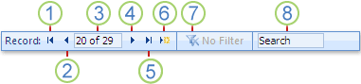
Browse through all recordsYou can browse through records by using the TAB key when you want to move through one record at a time, in order, to locate a specific record. You can also browse through records in a table in Datasheet view using the record navigation buttons. The record navigation buttons are available at the bottom of the table or form.
The techniques that you can use to search and filter records are very useful for finding specific records for the case at hand. However, you might want to perform the same search or filter operation regularly. Instead of reproducing a set of search and filter steps every time, you can create a query. A query is a powerful and flexible way to locate specific records because it lets you perform customized searches, apply customized filters, and sort records. You can build your own queries to help you focus on specific records and to answer specific questions. Once created, a query can be saved and reused, and can also be used in building forms and reports.

Retrieve information using query

Query
A query is a request for data results, for action on data, or for both. You can use a query to answer a simple question, to perform calculations, to combine data from different tables, or even to add, change, or delete table data.
A query is a derived item in the database meant to answer specific questions that relate to the information in the database.
It is the means to retrieve relevant information in one or more tables.
Types of queries
Select Query
is the simplest type of query and because of that, it is also the most commonly used one in Microsoft Access databases.
- is the most common type of query.
- It retrieves data from one or more tables and displays the results in a datasheet where you can update the records (with some restrictions).
- is used to group records and calculate sums, counts, averages, and other types of totals.
- can be used to select and display data from either one table or a series of them depending on what is needed.
- is the user-determined criteria that tell the database what the selection is to be based on.
After the select query is called, it creates a "virtual" table where the data can be changed, but at no more than one record at a time.
Action Query
- are very popular in data management because they allow for many records to be changed at one time instead of only single records like in a select query.
- When the action query is called, the database undergoes a specific action depending on what was specified in the query itself.
- This can include such things as creating new tables, deleting rows from existing ones and updating records or creating entirely new ones.
There are four kinds of Action Query. These are
- Append Query
An append query adds a group of records from one or more tables to the end of one or more tables. For example, suppose that you acquire some new customers and a database containing a table of information on those customers. To avoid typing all this information into your own database, you'd like to append it to your Customers table.
- Delete Query
A delete query deletes a group of records from one or more tables. For example, you could use a delete query to remove products that are discontinued or for which there are no orders. With delete queries, you always delete entire records, not just selected fields within records.
- Make Table Query
As the name suggests, it creates a table based on the set results of a query. A make-table query creates a new table from all or part of the data in one or more tables. Make-table queries are helpful for creating a table to export to other Microsoft Access databases or a history table that contains old records.
- Update Query
Allows for one or more field in your table to be updated.
An update query makes global changes to a group of records in one or more tables. For example, you can raise prices by 10 percent for all dairy products, or you can raise salaries by 5 percent for the people within a certain job category. With an update query, you can change data in existing tables.
- Parameter query
In Microsoft Access, a parameter query works with other types of queries to get whatever results you want. This is because, when using this type of query, you are able to pass a parameter to a different query, such as an action or a select query.
It can either be a value or a condition and will essentially tell the other query specifically what you want it to do.
It is often chosen because it allows for a dialog box where the end user can enter whatever parameter value they wish each time the query is run. The parameter query is just a modified select query.
A parameter query is a query that when run displays its own dialog box prompting you for information, such as criteria for retrieving records or a value you want to insert in a field.
You can design the query to prompt you for more than one piece of information; for example, you can design it to prompt you for two dates.
Access can then retrieve all records that fall between those two dates.
Parameter queries are also handy when used as the basis for forms, reports, and data access pages.

Query Development

Query criteria
A query criterion is an expression that Access compares to query field values to determine whether to include the record that contains each value.
The following tables shows some sample criteria and explains how they work.

Table 1. Simple criteria for all data types
Criteria Name | Write it like... | Function
Equals | "x" | Searches for values equal to x
Does Not Equal | Not in ("x") | Searches for all values except those equal to x
Null | Is Null | Searches for empty fields
Not Null | Is Not Null | Searches for non-empty fields

Table 2. Simple criteria for text
Criteria Name | Write it like... | Function
Contains | Like "*x*" | Searches for all values that contain x
Does Not Contain | Not like "*x*" | Searches for all values except those that contain x
Begins with | Like "x*" | Searches for all values beginning with x
Ends with | Like "*x" | Searches for all values ending with x
Comes After | >= "x" | Searches for all values that come after x in alphabetical order.
Comes Before | <= "x" | Searches for all values that come before x in alphabetical order.

Table 3. Simple criteria for numbers
Criteria Name | Write it like... | Function
Between | Between "x" and "y" | Searches for values in the range between x and y
Less Than | < x | Searches for all values smaller than x
Less Than or Equal To | <= x | Searches for all values smaller than or equal to x
Greater Than | > x | Searches for all values larger than x
Greater Than or Equal To | >= x | Searches for all values larger than or equal to x
Between | Between "x" and "y" | Searches for values in the range between x and y

Table 4. Simple criteria for dates
Criteria Name | Write it like... | Function
Between | Between "#mm/dd/yy#" and "#mm/dd/yy#" | Searches for dates that fall between two dates.
Before | <#mm/dd/yy# | Searches for dates before a certain date
After | >#mm/dd/yy# | Searches for dates after a certain date.
Today | =Date() | Searches for all records containing today's date
Days Before Today | <=Date()-x | Searches for all records containing dates x or more days in the past

Data Selection

Data selection is defined as the process of determining the appropriate data type and source, as well as suitable instruments to collect data. The primary objective of data selection is the determination of appropriate data type, source, and instrument(s) that allow investigators to adequately answer research questions.
The function of displaying data is:
- It is important to display data accurately because it helps in presenting the findings of the research effectively to the reader.
- To make the findings more visible and make comparisons easy
- Displaying data in research is the last step of the research process.

Self-check-8
Test I.
Instruction: select the correct answer for the give choice. You have given 1 Minute for each question. Each question carries 2 Point
1………is a collection of information organized in a table that pertains to a specific topic or category.
- Record
- Query
- Font
2………. is a request for data results, for action on data, or for both?
- Table
- Query
- Database
3…………. is an expression that Access compares to query field values to determine whether to include the record that contains each value.
- Simple query
- Design
- Font
Test II.
Instruction: Instruction: select the correct answer for the give choice. You have given 1 Minute for each question. Each question carries 2 Point.
A | B
...........1. Select Query | A. makes global changes to a group of records
...........2. Update Query | B. the process of determining the appropriate data type and source
...........3. Data selection | C. derived item in the database
...........4. Query | D. is used to group records and calculate sums
 | E. Searches for dates after a certain date.

Operation sheet-8.1. customize record
- Operation title: Access &Locate Records
- Purpose: To access and locate resource
- Instruction: Using the given application software (ms access) to access and locate records. You have given 20Minute for the task and you are expected to access and locate records.
- Tools and requirement:
- Personal computer
- Microsoft Window
- Steps to browse through all records
You can browse through records from the Datasheet view by using the record navigation buttons at the bottom of the table or form.
1. Go to the first record
2. Go to the previous record
3. Current Record box
4. Go to the next record
5. Go to the last record
6. Open a new (blank) record
7. Filter indicator
8. Search box
You can also use the TAB key to move through one record at a time.
- Steps to Search for a specific record
- Open the table or form you want to search.
- Click in the field that you want to search
- Start the Find command
- You can either click the Find button in the Find section of the Home tab or press Ctrl+F.
- The Find and Replace dialog box opens, ready to serve you.

- Type the text you’re looking for in the Find What box.

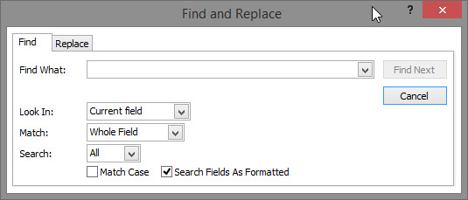
- Click Find Next to run your search

Quality Criteria: access and locate Resource
Precautions: OHS

Operation sheet-8.2 Creating Simple Query to Retrieve Information
- Operation title: Query to retrieve information
- Purpose: To create simple query to retrieve information
- Instruction: Using the given application software (ms access) to create simple query to retrieve information. You have given 20Minute for the task and you are expected to create simple query.

- Tools and requirement:
- Personal computer
- Microsoft Window
- Step to create Query using query Wizard
- In the Database window, click the Create tab on the Ribbon and then click the Query Wizard button from the Queries section.
- The New Query Wizard dialog box appears, asking you what kind of Query Wizard you want to run. Choose Simple Query Wizard and click OK.

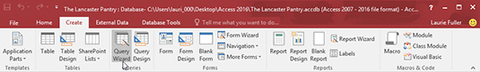
- Choose the first table you want to include in the query.
You'll use the Tables/Queries drop-down menu, which shows all the tables (and any existing queries) in your database. Click the down arrow next to the Tables/Queries drop-down menu. Click the name of the table or query to include in this query.

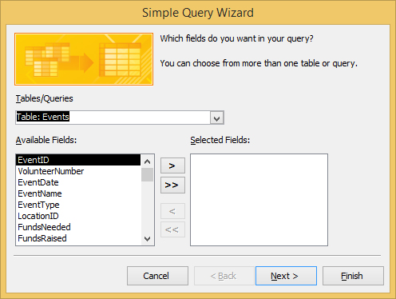

- Select the fields from that table for your query.
For each field you want included in your query, click the name of the table or query to include in this query, and in the Available Fields list, double-click each field from this table or query that you want to include in the query you're creating.

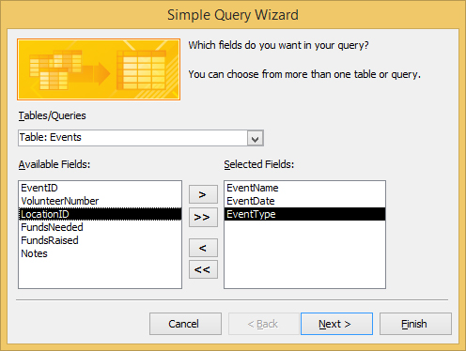

- After you select all the fields, click Next.
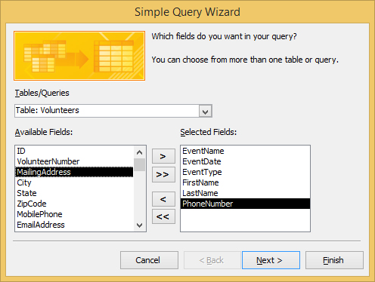
- If the wizard asks you to choose between a Detail and a Summary query, click the radio button next to your choice and then click Next.
- in the wizard page that appears, select a radio button for what you want to do next
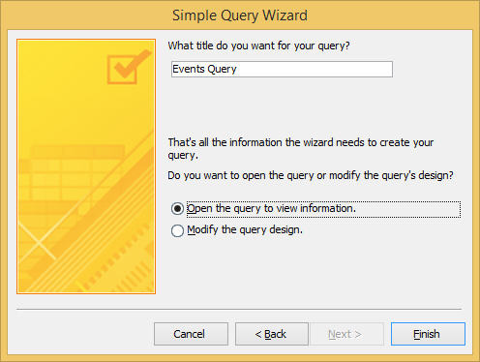
- Type a title for your query in the text box and then click Finish.
The wizard builds your query and saves it with the title you entered; then Access displays the results.
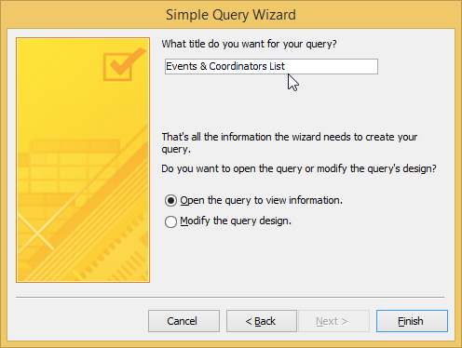

- Steps to create Query in Design view
      - Click Query Design from the Create tab in the Ribbon.
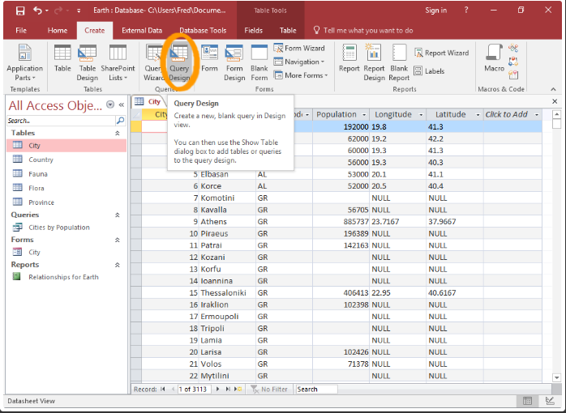
      - Select each table that you need in the query and click Addto add it to the query.
Once you've added all the tables you need, click Close to close the dialog box.
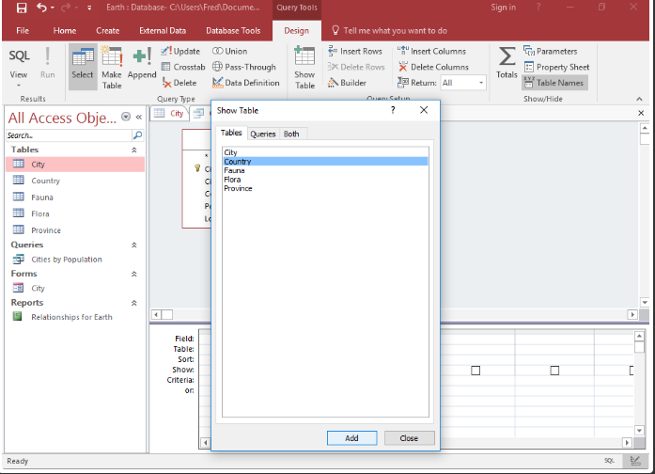
      - Add fields. We are in design view
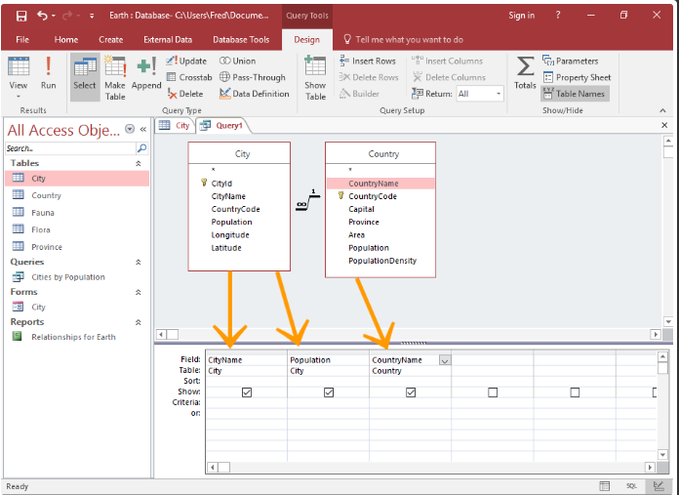
      - Create criteria
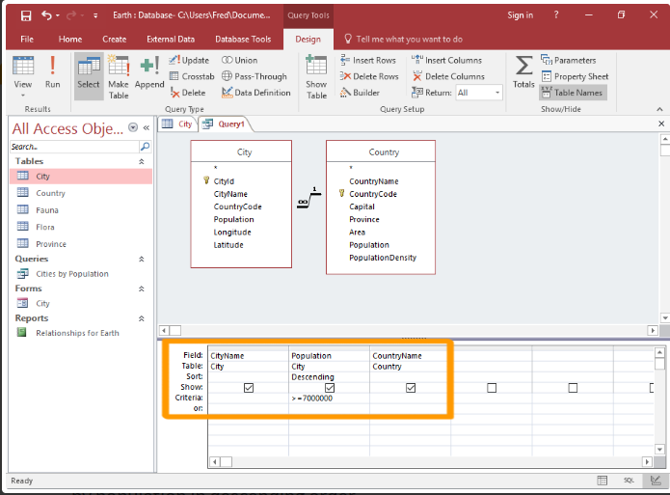
- Run the query
Click ! in the ribbon to run the query
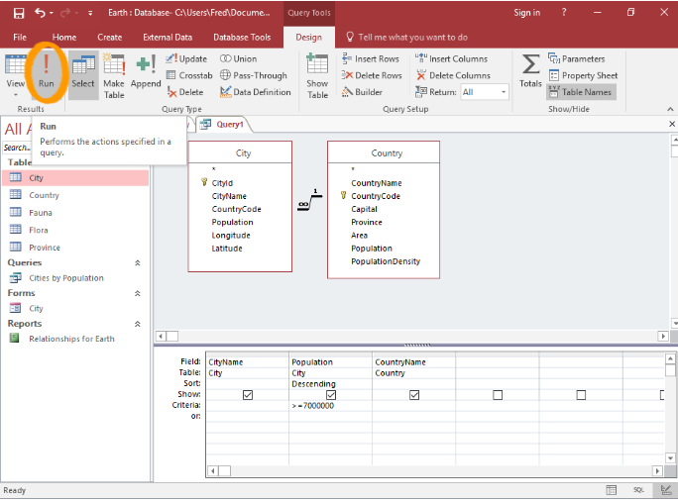
Initiate the "Save" Prompt
Initiate the ”save” prompt
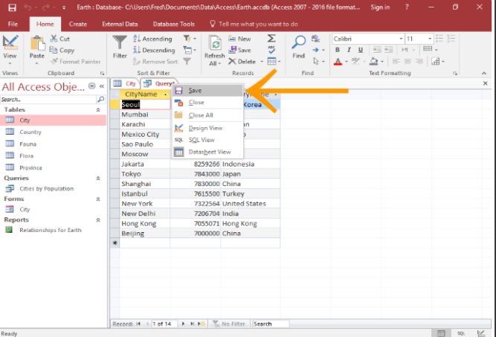
Name the query
Provide a name for the query and click OK.
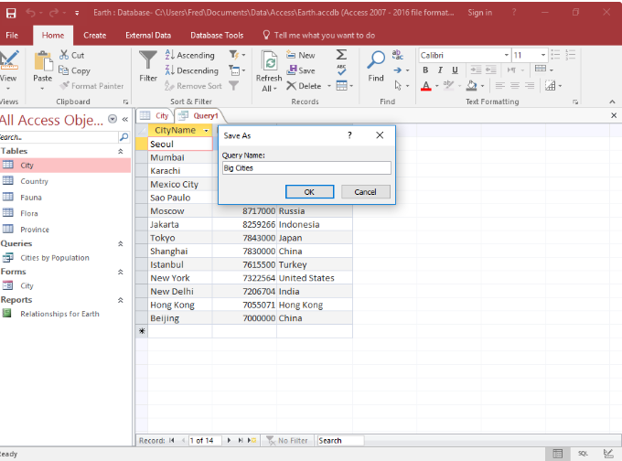

- Step to update a query
- Click the Create tab on the ribbon.
- Click the Query Design button
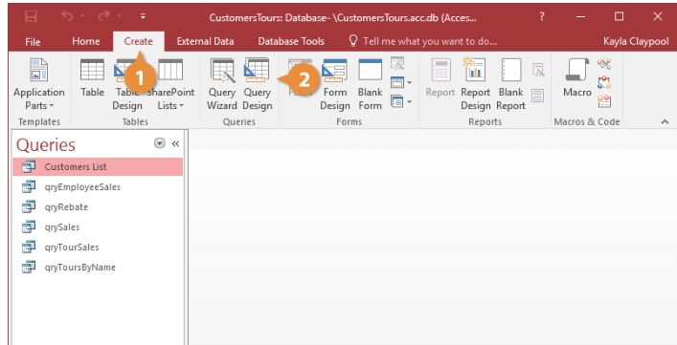
- Double-click the tables and queries you want to add and click Close
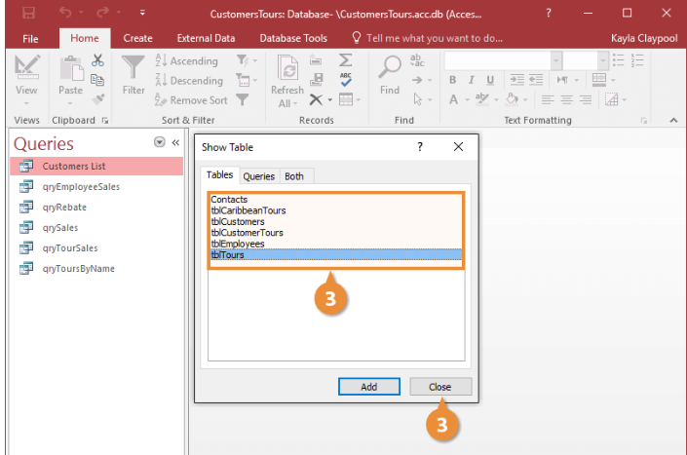
- Click the Update button.
- Click the Update To row for the field you want to update and type an expression.
- Click the Run button
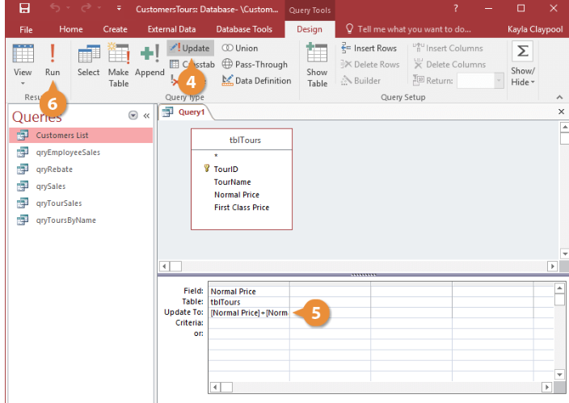
- Click Yes
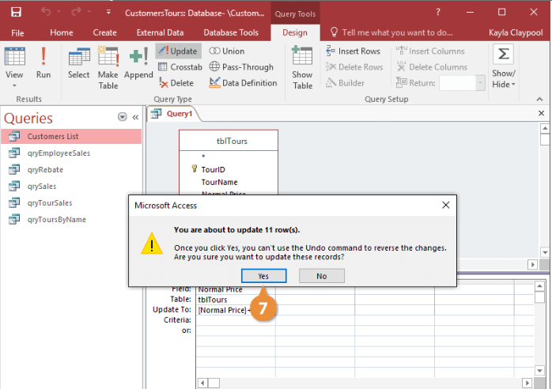

Quality Criteria: create simple query to retrieve information
Precautions: OHS

LAP Test
Name: __________________________ Date: ____________
Time started: ____________________ Time finished: _______________
Instruction I: Given necessary templates, tools and materials you are required to perform the following tasks within 5 hours.
Task-1: Customize record
Task-2: Creating Simple Query to Retrieve Information

Unit Nine: Print documents
This learning guide is developed to provide you the necessary information regarding the following content coverage and topics:
- Preview document/ spreadsheet
- basic print settings
- Print document/spreadsheet
- Submit the spreadsheet to appropriate person
This guide will also assist you to attain the learning outcomes stated in the cover page. Specifically, upon completion of this learning guide, you will be able to:
- Preview document/ spreadsheet in print preview mode
- Select basic print settings/ options
- Print document/spreadsheet or part of document/ spreadsheet from printer
- Submit the spreadsheet to appropriate person for approval or feedback

Preview Document/ Spreadsheet

Preview worksheet pages before you print
You can avoid unexpected results and wasted paper by previewing your worksheet before printing.
When you select one or more sheets and then click File > Print, you'll see a preview of how the data will appear on the printout.
- Select the worksheet(s) you want to preview.
- Click File, and then click Print to display the Preview window and printing options.
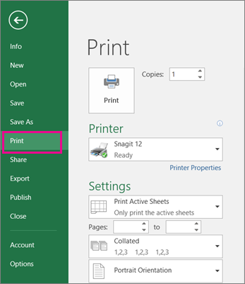
Keyboard shortcut You can also press Ctrl+F2.
Notes: Unless you're using a color printer, the preview will appear in black-and-white, even if there is color in your sheet(s).
Next Page and Previous Page are available only when you select more than one sheet, or when a sheet contains more than one page of data. To view multiple worksheets, under Settings, click Entire workbook.
More useful information
- To preview the next and previous pages, click the arrows for Next Page and Previous Page at the bottom of the Print Preview window—or type the page number.
- To exit Print Preview and return to your workbook, click any the arrow in the upper-left of the Print Preview window.
- To view page margins, click the Show Margins button in the lower right corner of the Print Preview window.
- To change margins, drag the margins to the height and width that you prefer. You can also change the column widths by dragging the handles at the top or bottom of the print preview page.
Tip: To make page setup changes, such as changing page orientation and page size, select the appropriate options under File > Print > Settings.
To select one or more sheets
To select | Do this
A single sheet | Click the sheet tab.  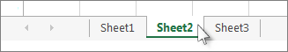  If you don't see the tab that you want, click the scrolling buttons to display the tab, and then click it.  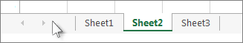
Two or more adjacent sheets | Click the tab for the first sheet. Then hold down the SHIFT key and click the tab for the last sheet that you want to select.
Two or more nonadjacent sheets | Click the tab for the first sheet. Then hold down CTRL while you click the tabs of the other sheets that you want to select.
All sheets in a workbook | Right-click a sheet tab, and then click Select All Sheets.
Tip: When selecting multiple sheets, [Group] appears in the title bar at the top of the sheet. To cancel a selection of multiple sheets in a workbook, click any unselected worksheet. If no unselected sheet is visible, right-click the tab of a selected sheet, and then click Ungroup Sheets.

Basic Print Settings

Print in Excel
This content teaches you how to print a worksheet and how to change some important print settings in Excel.
Print a Worksheet
To print a worksheet in Excel, execute the following steps.
      - On the File tab, click Print.
      - To preview the other pages that will be printed, click 'Next Page' or 'Previous Page' at the bottom of the window.
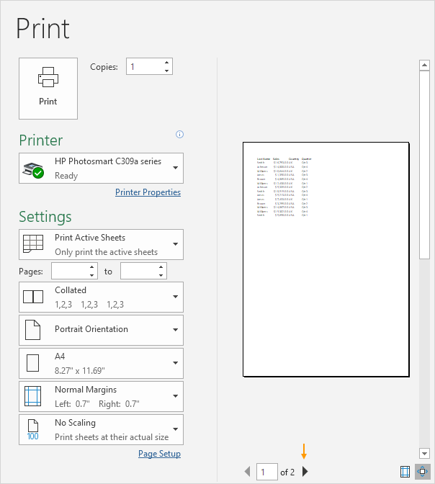
3. To print the worksheet, click the big Print button.
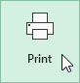
What to Print
Instead of printing the entire worksheet, you can also print the current selection.
1. First, select the range of cells you want to print.
2. Next, under Settings, select Print Selection.
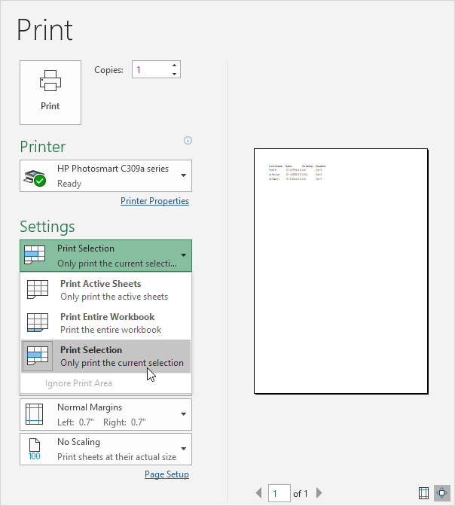
3. To print the selection, click the big Print button.
Note: you can also print the active sheets (first select the sheets by holding down CTRL and clicking the sheet tabs) or print the entire workbook. Use the boxes next to Pages (see first screenshot) to only print a few pages of your document. For example, 2 to 2 only prints the second page.
Multiple Copies
To print multiple copies, execute the following steps.
1. Use the arrows next to the Copies box.
2. If one copy contains multiple pages, you can switch between Collated and Uncollated. For example, if you print 6 copies, Collated prints the entire first copy, then the entire second copy, etc. Uncollated prints 6 copies of page 1, 6 copies of page 2, etc.
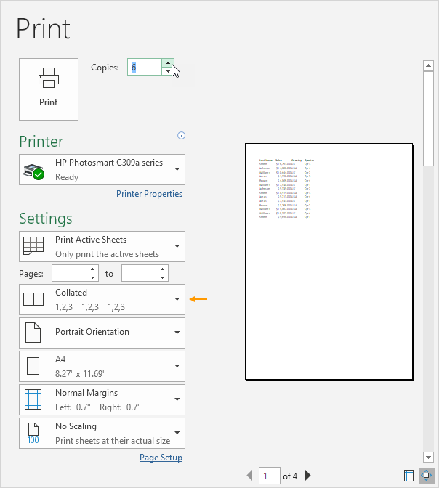
Orientation
You can switch between Portrait Orientation (more rows but fewer columns) and Landscape Orientation (more columns but fewer rows).
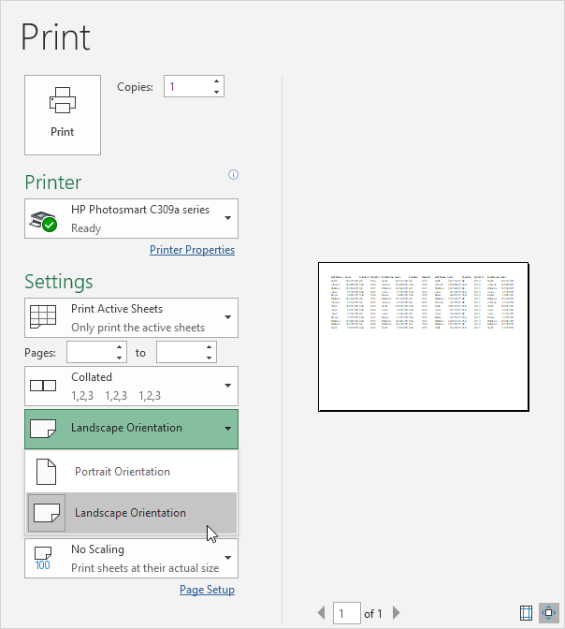

Page Margins
To adjust the page margins, execute the following steps.
1. Select one of the predefined margins (Normal, Wide or Narrow) from the Margins drop-down list.
2. Or click the 'Show Margins' icon at the bottom right of the window. Now you can drag the lines to manually change the page margins.
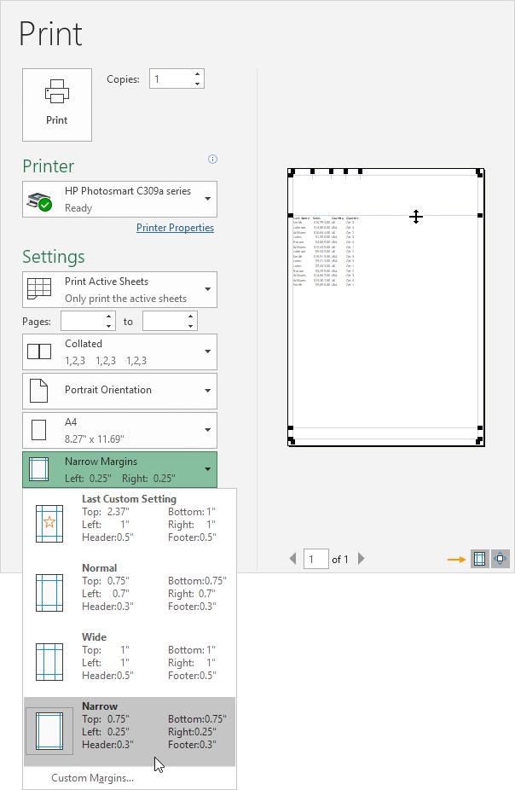

Scaling
If you want to fit more data on one page, you can fit the sheet on one page. To achieve this, execute the following steps.
1. Select 'Fit Sheet on One Page' from the Scaling drop-down list.
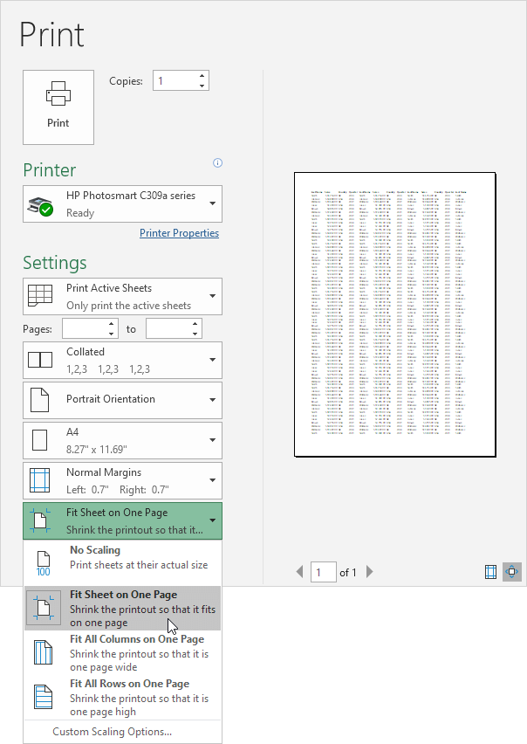
Note: you can also shrink the printout to one page wide or one page high. Click Custom Scaling Options to manually enter a scaling percentage or to fit the printout to a specific number of pages wide and tall. Be careful, Excel doesn't warn you when your printout becomes unreadable.

Print document

Print a workbook to a file
- Select File, and then select Print, or press Ctrl+P.
- Under Printer, select Print to File.
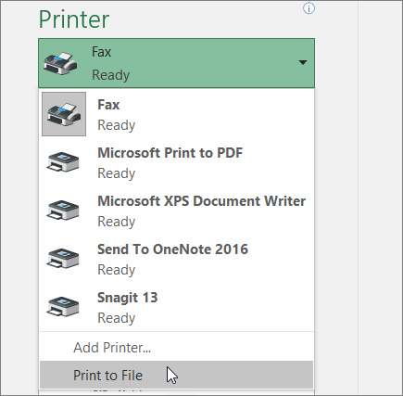
- Select Print.
- In the Save Print Output as dialog box, enter a file name and then select OK. The file will be saved in your Documents folder
Important: If you print the saved file on a different printer, the page breaks and font spacing may change.

Submit The Spreadsheet to Appropriate Person

Share your Excel workbook with others
Share a workbook with others, right within Excel. You can let them edit the workbook or just view it.
- Select Share.
- Select permissions and then Apply.
- Add people.
- Type a message if you like.
- Select Send.

Self-check 9
Part I: choose the best answer
- Which one of the following is not correct Preview worksheet pages before you print?
- File ------ Print----- preview the work sheet.
- Print --- Print----- preview the work sheet.
- File -------preview the work sheet------Print
- none
- The presses of changing the soft copy to hard copy?
- Writing
- Printing
- File
- All
- Which of the following is to make page setup changes, such as changing page orientation and page size, select the appropriate options
  - Setting ------ Print ---- file
  - File -----Print -------Settings
  - Print ---File ------ Settings
  - None
- The correct procedure for Share a workbook with others, right within Excel.
- Share---Select permissions and then Apply----Add people---Type a message --Send.
- Send---Select permissions and then Apply----Add people---Type a message --Share.
- Apply---Select permissions and then Share ---Add people---Type a message --Send.
- None of the above
Reference

https://www.pdfdrive.com/access-2016-books.html
https://www.myamcat.com/samplePapers/SP_MS-EXCEL.pdf
https://microsoft-word-2016.en.softonic.com/
https://edu.gcfglobal.org/en/topics/excel/
https://aspire-solidus-production.s3-ap-southeast-2.amazonaws.com
https://edu.gcfglobal.org/en/word2016/getting-started-with-word/1/
https://www.tutorialspoint.com/
https://www.dtwd.wa.gov.au/sites

Participants of this Module (training material) preparation
No | Name | Qualification (Level) | Field of Study | Organization/ Institution | Mobile number | E-mail
1 | Betel Tariku | BSC | COTM | Sidama (Hawasa poly technic college) | 0926298840 | betelbotora2@gmail.com
2 | Yazachew Geneti | MSC | COTM | BGRS (Assosa poly technic college) | 0917858176 | Yazachew17@gmail.com
3 | Shiferaw Yohannes | BSC | COTM | Sidama (Daye poly technic college) | 0932425937 | shiferawyohannes@gmail.com
4 | Mihiretab Gashaw | BSC | BCT | Addis abeba (Addis ketema industrial college) | 0922079011 | mihiretabgashaw@gmail.com

