FINISHING CONSTRUCTION WORKS
Level – I
Based on March, 2022 (V- I) Occupational standard (OS)
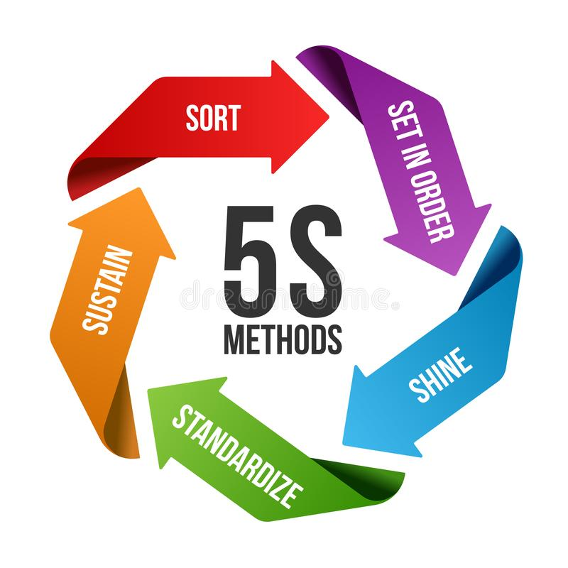
Module Title: - Apply 5S
Module Code: - EIS FCW M10 08 22
Nominal Duration: - 40Hour
Prepared by: Ministry of Labour and Skill

March, 2022
Addis Ababa, Ethiopia

Table of Content Page
Acknowledgment 5
Acronym 6
Introduction to the Module 7
Unit One: Prepare for work 10
1.1. Work Instruction 10
1.2. Job Specification 11
1.2.1. Purpose of Job Specification 11
1.2.2. Job Requirements 12
1.3. Use OHS Requirements 14
1.3.1. Personal Safety Equipment 15
1.4. Select and prepare tools and equipment to implement 5s 18
1.4.1. Tools and materials used to implement Sort activity 18
1.4.2. Tools and materials used to implement set in order 18
1.4.3. Tools and materials used to implement shine 19
1.5. Identify and check safety equipment and tools. 20
1.5.1. Tools used to evaluate the effectiveness of Kaizen 20
1.6. Prepare Kaizen Board for Work Place 22
1.6.1. Kaizen Basics 22
1.6.2. The Origin of Kaizen 24
1.6.3. The Dissemination of Kaizen in Ethiopia 24
1.6.4. Kaizen Tools 25
1.6.5. Characteristics of Kaizen 29
1.6.6. Benefits of Kaizen 30
1.6.7. Principles of Kaizen 30
1.6.8. Elements of the Kaizen approach 31
1.6.9. Kaizen board 31
Self-Check- 1 33
Unit Two: Sort 35
2.1. Definition of Sort 36
2.1.1. Benefits of sort activity 37
2.2. Prepare plan for implementing sorting activities 38
2.2.1. Implementing sort activity 38
2.2.2. Plan and procedures for sort activity 39
2.3. Identify all items in the work area follow procedures 39
2.4. list necessary and unnecessary items in the appropriate format. 40
2.5. Record and quantify all items in the work area 41
2.5.1. A sample format for recording all items at the workplace. 42
2.5.2. A sample format for recording necessary items. 42
2.5.3. A sample format for recording unnecessary items. 44
2.6. Evaluate and place unnecessary items. 45
2.6.1. Types of unnecessary items 45
2.6.2. Places where unnecessary items accumulate 45
2.7. Red tag strategy for unnecessary items 46
2.7.1. Red-tag Holding areas 46
2.7.2. Steps/procedures in red tagging 47
Self-Check - 2 54
Operation Sheet: - 55
LAP Test: 61
Unit Three: Set in order 63
3.1. Definition of set-in order 64
3.1.1. Benefits of set-in order 64
3.2. Prepare plan for implementing Set-in order activities. 65
3.2.1. Implementing Set-in order Activities 66
3.2.2. Plan and procedures for set in order 66
3.3. Report performance results using appropriate formats. 67
3.3.1. Set-in order activity plan sheet (sample) 67
3.3.2. Procedures for Set in order 67
3.4. Place items in their assigned location. 68
3.5. Return immediately the items to their assigned location after use. 70
3.6. Place items in their assigned locations. 75
3.6.1. Evaluating current locations and deciding best locations 75
3.6.2. The steps of using the 5S Map: 75
3.6.3. Set in order strategies 76
3.7. Return immediately the items to their location after use. 78
Self-Check -3 83
Unit Four: Shine 85
4.1. Definition of Shine 85
4.1.1. Benefits of shine 86
4.2. Prepare plan for implementing shine activities 88
4.3. Implement shine activity according to the prepared procedure 89
4.3.1. Plan and procedures for shine activities 89
4.4. Conduct regular shinning activities. 98
Self-Check - 4 99
Operation Sheet: - 100
LAP Test: - Practical Demonstrations 103
Unit Five: Standardize 5S 105
5.1. Definition of the Fourth Pillar 105
5.1.1. Benefits from Standardize 105
5.2. Prepare plan for the implementation of standardize 106
5.2.1. How to Implement Standardize 106
5.3. Prepare and use tools and techniques to standardize 5s 107
5.4. Keeping workplace to the specify standard. 113
5.5. Problems avoid by standardizing activities. 119
Self-Check -5 123
Operation Sheet: - 124
LAP Test: - 125
Unit Six: - Sustain 5S 127
6.1. Definition of the Fifth Pillar 127
6.1.1. Benefits of Sustaining 5S 127
6.2. Prepare plan for the implementation of sustaining 5S 129
6.2.1. How to Implement Sustain 130
6.2.2. Roles in Implementation 131
6.3. Implement tools and techniques for sustaining 5s 134
6.3.1. Common Tools and techniques to sustain 5s are: 134
6.4. Workplace standard and sustainability of 5S techniques 138
6.5. Clean up workplace after completion of job. 139
6.6. Improvements recommend to lift compliance in the workplace. 146
6.7. Problems Avoided by Implementing Sustaining activities 147
6.8. Checklists to Sustaining activities 148
Self-Check - 6 152
Operation Sheet: - 153
LAP Test 154
Reference: 155

Acknowledgment
Ministry of Labor and Skills wish to extend thanks and appreciation to the many representatives of TVT instructors and respective industry experts who donated their time and expertise to the development of this Teaching, Training and Learning Materials (TTLM).

Acronym

OHS:
5S:
JIT:
WHO:
QC:
PDCA:
CQI:

TQM:

Occupational Health Safety
Sort, Set, Shine, Standardize and Sustain.
Just in time
World Health Organization
Quality Control
Plan, Do, Check and Act
Continuous Quality Improvement (KAIZEN)
Total Quality Management
FIFO:
ISO:

KPT:
KPT:
IPD:

First In First Out
International Organization for Standardization
Kitchen Performance Test
Junior Kaizen Promotion Team
Initiative for Policy Dialogue

Introduction to the Module
5S: -helps in creating a safe and organized workplace and to reduce waste and optimize productivity through maintaining an orderly workplace and using visual cues to achieve more consistent operational results.
This module covers knowledge, skills and attitude required to apply 5S techniques to the workplace. It covers responsibility for the day-to-day operations of the workplace and ensuring that continuous improvements of Kaizen elements are initiated and institutionalized.
This module is designed to meet the industry requirement under the finishing construction field occupational standard, particularly for the unit of competency: Apply 5s.
This Module Covers the Units:
- Prepare for work
- Sort/Seiri
- Set in order/ Seiton
- Shine/Seiso
- Standardize 5S/Seiketsu
- Sustain 5S/Shitsuke
Learning Objective of the Module
- Prepare for work
- Apply Sort items.
- Apply Set all items in order
- Apply shine activities
- Apply Standardize 5S
- Apply Sustainability of 5S

Module Instruction
For effective use these modules trainees are expected to follow the following module instruction:
- Read the information written in each unit
- Accomplish the Self-checks at the end of each unit
- Perform Operation Sheets which were provided at the end of units
- Do the “LAP test” giver at the end of each unit and
- Read the identified reference book for Examples and exercise

Unit one: - Prepare for work
This unit is developed to provide you the necessary information regarding the following content coverage and topics:
- Work instruction
- Job specifications
- Use OHS requirements
- Tools and equipment to implement 5s
- Safely equipment and tools
- Kaizen Board
This unit will also assist you to attain the learning outcomes stated in the above coverage. Specifically, upon completion of this learning guide, you will be able to:
- Use work instructions to determine job requirements, including method, material and equipment.
- Read and interpret job specifications following working manual.
- Use OHS requirements, including dust and fume collection, breathing apparatus, eye and ear personal protection throughout the work.
- Select and prepare tools and equipment to implement 5s
- Identify and check safety equipment and tools for safe and effective operation.
- Prepare Kaizen board for work Place

Unit One: Prepare for work

Work Instruction
Work instruction is a description of the specific tasks and activities within an organization.
A work instruction in a business will generally outline all of the different jobs needed for
the operation of the firm in great detail and is a key element to running a business
smoothly.
In other words, it is a document containing detailed instructions that specify exactly what
steps to follow to carry out an activity. It contains much more detail than a Procedure and
is only created if very detailed instructions are needed. For example, describing precisely
how a Request for Change record is created in the Change Management software support
tool.
Procedures vs. Work Instructions
Many people confuse “procedures” with “work instructions”. In fact, most people write
work instructions and call them procedures. Knowing the differences of procedures vs
work instructions can help you understand the documentation process much better and,
therefore, procedure documentation.
Procedures describe a process, while a work instruction describes how to perform the
conversion itself. Process descriptions include details about the inputs, what conversion
takes place (of inputs into outputs), the outputs, and the feedback necessary to ensure
consistent results. The PDCA process approach (Plan, Do, Check, Act) is used to capture
the relevant information.

Job Specification
A statement of employee/workers characteristics and qualifications required for satisfactory performance of defined duties and tasks comprising a specific job or function.
Also known as employee specifications, a job specification is a written statement of educational qualifications, specific qualities, level of experience, physical, emotional, technical and communication skills required to perform a job, responsibilities involved in a job and other unusual sensory demands. It also includes general health, mental health, intelligence, aptitude, memory, judgment, leadership skills, emotional ability, adaptability, flexibility, values and ethics, manners and creativity, etc.

Purpose of Job Specification
- Described on the basis of job description, job specification helps candidates analyze whether are eligible to apply for a particular job vacancy or not.
- It helps recruiting team of an organization understand what level of qualifications, qualities and set of characteristics should be present in a candidate to make him or her eligible for the job opening.
- Job Specification gives detailed information about any job including job responsibilities, desired technical and physical skills, conversational ability and much more.
- It helps in selecting the most appropriate candidate for a particular job.
Job description and job specification are two integral parts of job analysis. They define a job fully and guide both employer and employee on how to go about the whole process of recruitment and selection. Both data sets are extremely relevant for creating a right fit between job and talent, evaluate performance and analyze training needs and measuring the worth of a particular job.

Job Requirements
A Job can be defined as:
- A piece of work, especially a specific task done as part of the routine of one's occupation or for an agreed price.
- A post of employment; full-time or part-time position
- Anything a person is expected or obliged to do; duty; responsibility
- An affair, matter, occurrence, or state of affairs.
- The material, project, assignment, etc., being worked upon.
- The process or requirements, details, etc., of working.
- The execution or performance of a task.
The basic requirements for a job remain the same no matter what the job is, where it is located or what professional and educational qualifications are required for it. These are as follows:
- Discipline: Nothing is possible without discipline. Any job requires a fundamental core of discipline from the worker or the employee and this is a quality which is independent of age, post, stature, job and so on.
- Enthusiasm: Enthusiasm for work is also a pre-requisite for any job. An innate love for the job, which in modern parlance is known as job satisfaction, is a core requirement for any job.
- Qualifications: This is a more material, tactile need for a job which can be conveyed through degrees and certificates. However, education is not limited to what is taught in colleges or vocational training courses.
- Soft Skills: Soft skills include those skills which ensure that a job is executed well, and the employee can carry himself in the proper manner too. For example, good and smooth communication, computer skills, proficiency in language if needed, presentable appearance, the ability to manage crises are all soft skills which are fundamentally important in any job and which must be cultivated consciously.

Specification Sample
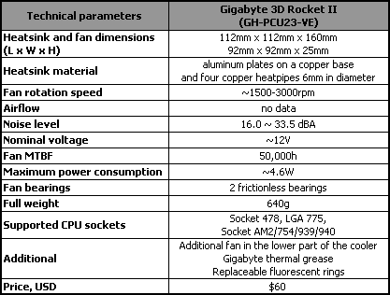

Use OHS Requirements
OHS requirements are legislation/regulations/codes of practice and enterprise safety policies and procedures. This may include protective clothing and equipment, use of tooling and equipment, workplace environment and safety, handling of material, use of firefighting equipment, enterprise first aid, hazard control and hazardous materials and substances.
Personal protective equipment includes those prescribed under legislation/ regulations/codes of practice and workplace policies and practices.
Safe operating procedures include the conduct of operational risk assessment and treatments associated with workplace organization.
Emergency procedures include emergency shutdown and stopping of equipment, extinguishing fires, enterprise first aid requirements and site evacuation.
Occupational safety and health (OSH) also commonly referred to as occupational health and safety (OHS) or workplace health and safety (WHS) is an area concerned with the safety, health and welfare of people engaged in work or employment.
The goals of occupational safety and health programs include fostering a safe and healthy work environment. OSH may also protect co-workers, family members, employers, customers, and many others who might be affected by the workplace environment.
In the United States the term occupational health and safety is referred to as occupational health and occupational and non-occupational safety and includes safety for activities outside work. Occupational safety and health can be important for moral, legal, and financial reasons. In common-law jurisdictions, employers have a common law duty (reflecting an underlying moral obligation) to take reasonable care for the safety of their employees. Statute law may build upon this to impose additional general duties, introduce specific duties and create government bodies with powers to regulate workplace safety issues: details of this will vary from jurisdiction to jurisdiction.
Good OSH practices can also reduce employee injury and illness related costs, including medical care, sick leave and disability benefit costs. As defined by the World Health Organization (WHO) "occupational health deals with all aspects of health and safety in the workplace and has a strong focus on primary prevention of hazards." Health has been defined as "a state of complete physical, mental and social well-being and not merely the absence of disease or infirmity.
Care of Hand Tools
Tools are expensive; tools are vital equipment. When the need for their use arises, common sense plus a little preventive maintenance prolongs their usefulness.
The following precautions for the care of tools should be observed:
  - Clean tools after each use. Oily, dirty, and greasy tools are slippery and dangerous to use.
  - Never hammer with a wrench.
  - Never leave tools scattered about. When they are not in use, stow them neatly on racks or in toolboxes.
  - Apply a light film of oil after cleaning to prevent rust on tools.
  - Inventory tools after use to prevent loss.

Personal Safety Equipment
To protect you from danger, protective equipment such as safety shoes, goggles, hard hats, and gloves are issued. The use of this equipment is mandatory on certain jobs. Their use is a must, and there is no question about that. Be sure to use them on any job where they are required. They can protect you from a lot of harm.
- Safety Shoes
Some safety shoes are designed to limit damage to your toes from falling objects. A steel plate is placed in the toe area of such shoes so that your toes are not crushed if an object impacts there. Such danger is minimized by elimination of all metallic nails and eyelets and by the use of soles that do not cause static electricity.

- Goggles
Proper eye protection is of the utmost importance for all personnel. Eye protection is necessary because of hazards posed by infrared and ultraviolet radiation, or by flying objects such as sparks, globules of molten metal, or chipped concrete and wood. These hazards are ever-present during welding, cutting, soldering, chipping, grinding, and a variety of other operations. Appropriate use of goggles will limit eye hazards. radiation from arcs or flames by use of appropriate filter lenses. Remember, eye damage can be excruciatingly painful.
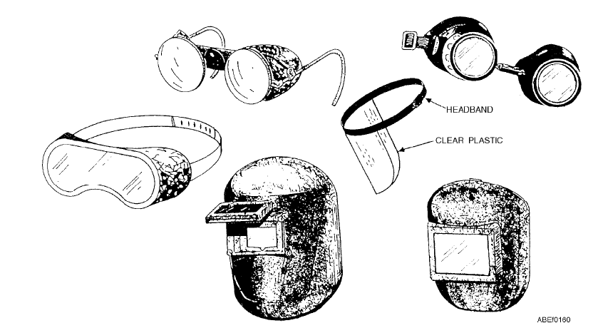
Fig.1 Eye-protection devices
- Gloves
Use gloves whenever you are required to handle rough, scaly, or splintery objects. Special flameproof gloves are designed for gas and electric-arc welding to limit danger and damage from sparks and other hot flying objects. Personnel in the electrical fields are usually required to wear insulating rubber gloves. Be sure to follow all regulations prescribed for the use of gloves. Gloves must not be worn around rotating machinery unless sharp or rough material is being handled. If such is the case, extreme care should be exercised to prevent the gloves from being caught in the machinery.
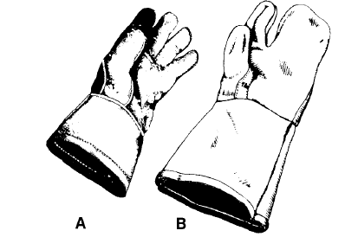
Fig.2 Gas and electric-arc welding gloves

- Safety Belts and Straps
The safety strap and body belt are what might be called your extra hands when you work alone. The body belt, strapped around your waist, contains various pockets for small tools. The safety strap is a leather or neoprene-impregnated nylon belt with a tongue-type buckle at each end. While you are climbing you will have the safety strap hanging by both ends from the left ring (called a D-ring because of its shape) on the body belt. When you are at working position, you unsnap one end of the safety strap, pass it around the supporting structure so there is no danger of its slipping (at least 18 inches from the top of the part on which it is fastened), and hook it to the right D-ring on the body belt. The safety strap must be placed around a part of the structure that is of sufficient strength to sustain an Abs weight and his or her equipment, and must rest flat against the surface without twists or turns. It must not be placed around any part of a structure that is being removed.
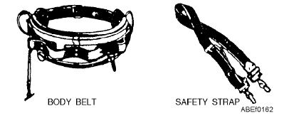
Fig.3 Safety equipment

Select and prepare tools and equipment to implement 5s

Tools and materials used to implement Sort activity
Tools and materials are required to implement sort, set in order and shine activities in work stations. The following are some tools and materials used to implement the first pillar of 5S-Sort.

- red tags
- sticker
- hook
- nails
- shelves
- chip wood
- sponge
- broom
- pencil
- shadow board/ tools board
- formats (for recording necessary and unnecessary items, plans etc…)

Tools and materials used to implement set in order
The following are some tools and materials used to implement the second pillar of 5S-Set
in order.
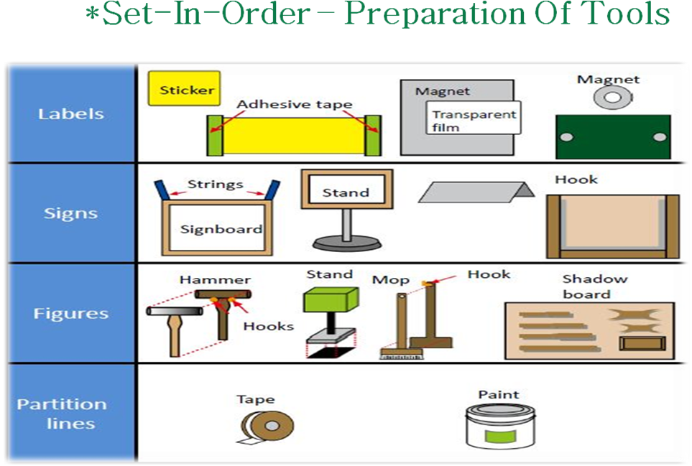
Fig. Guide lines set in order

Tools and materials used to implement shine
The following are some tools and materials used to implement the third pillar of 5S-Shine.

● sponges
● brooms
● brushes
● spades
● vacuum cleaners
● waste baskets
● dust bins
● gloves
● dust masks
● detergents
● containers
● oils
● bolts
- boots shoes

● screws
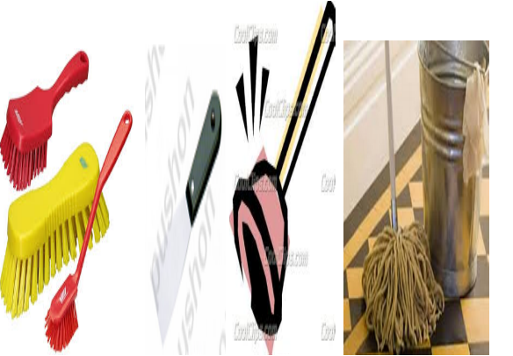

Fig. Tools and materials used to implement shine

Identify and check safety equipment and tools.

Tools used to evaluate the effectiveness of Kaizen
There are many methods for evaluation. According to for 5S-KAIZEN-TQM approach, we also recommend three methods for monitoring and evaluating with the qualitative point of view; Time survey, Employee satisfaction survey and Patient satisfaction survey.
    - PDCA Cycle: PDCA cycles are cycle that is often implemented when completing Kaizen strategies. This cycle can be used employees of all levels in the organization and is an effective introduction to Lean manufacturing. There are 4 phases of the cycle: Plan > Do > Check > Act that allows a continuous structure for kaizen strategies to be implemented and assessed while providing a framework for continuous Improvement.

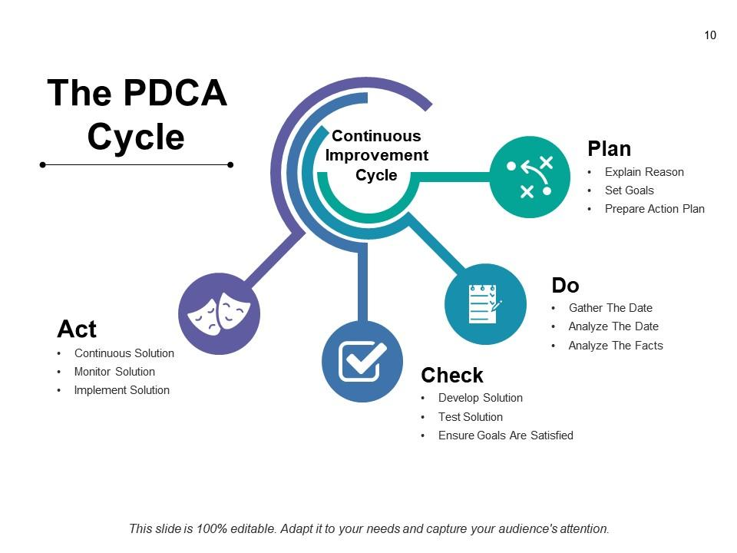
Fig. PDCA Cycle

    - Gemba: Gemba means the real place. Often managers and supervisors can get valuable information by actually going down to the production line and talking with employees. Gemba is often used in the form of Gemba walks, which are scheduled walks for managers and supervisors observe processes up close and talk with frontline employees.
    - Jishuken: Jishuken can be translated into an autonomous study groups or self-study. This concept encouragers managers to be more directly involved and learn about the processes they are responsible for and how they can work to improve them.
    - 5 Whys: This is an important tool when it comes to identifying the root cause of an issue. It is difficult to make an impactful change in the workplace if the root cause has yet to be considered. The 5 Whys is exactly like the name implies; after a problem arises you should ask yourself why five times.
    - Value Stream Mapping: Mapping out processes and streams in a facility can be very beneficial for a business practicing Kaizen. These maps are usually hand-drawn and include a diagram of materials moving through the different areas of the workplace. Value stream maps aim to identify wastes in the manufacturing process and find areas where improvement within a process is possible, these potential improvements can be the subject of future Kaizen activities and events.

Prepare Kaizen Board for Work Place

Kaizen Basics
Mr. Masaaki Imai is one of the Japanese people who contributed to spreading of the term Kaizen throughout the world. Mr. Imai today serves as the president of a consulting company Cambridge Research Institute. In his book entitled “Kaizen: The Key to Japan’s Competitive Success’ published in 1986, defined Kaizen as “a Japanese business philosophy that assumes our way of life be it our working life, our social life, or our home life should focus on continual improvement efforts”. The Oxford English Dictionary also gives the following definition of Kaizen “a Japanese business philosophy of continuous improvement of working practices, personal efficiency, etc.”

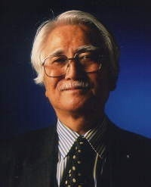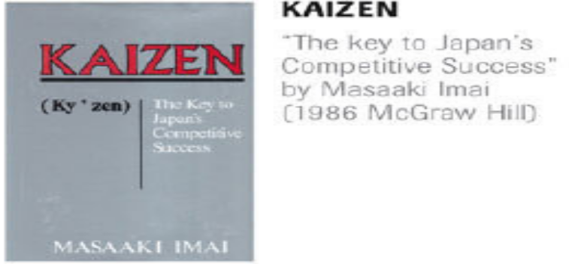
Cambridge Research Institute, President. Mr. Imai’s 1st book on Kaizen.
Kaizen is a Japanese philosophy for improvement that can be traced to the meaning of the Japanese words ‘Kai’ and ‘Zen’, which translate roughly into:
‘Kai’ - change, alter ‘Zen’ - better, right
The above two words combine to mean “change for better” or “Continuous improvement.” Kaizen means improvement, continuous improvement involving everyone in the organization from top management, to managers then to supervisors, and to workers. It is a philosophy of never being satisfied with what was accomplished last week, last year or last time.

Mr. Imai also stated “Kaizen is not just a management technique but a philosophy which instructs how a human should conduct his or her life. Kaizen focuses on how people conduct their work. It shows how management and workers can change their mindset together to improve their productivity”. Not a day should go by without some kind of improvement being made. We have to ask always: how can we do the job better tomorrow, than we are doing it today? Engineers at Japanese plants are often warned, “There will be no progress if you keep on doing things exactly the same way all the time.”
For the U.S., Kaizen’s clear message is “do it better, make it better, improve it even if it isn’t broke, because if we don’t, we can’t compete with those who do.”
The Ethiopian Kaizen Institute developed its own working definition as follows:
"Kaizen is a philosophy of continual, participatory and self-disciplined innovation management having its own integrated systems and problem-solving tools, implemented with the highest level of commitments at all levels of owners, leaders and employees through enhancing their absorptive capability step by step aiming at creating new and advanced corporate culture to catch-up and attain world class competitiveness".

The Origin of Kaizen
Kaizen developed and spread in Japan and later to the world in four phases.
Phase I - 1950s (end of World War II): This phase was the absorption of foreign technique by Japan to make improvements and catch-up with the international industrial development.
Phase 2- 1970s -180s: This phase was the diffusion of Kaizen among Japanese companies, including small and medium sized companies. This led to a rapid increase in the number of Quality Control Circles (QCC).
Phase 3 - mid 1980s: through Japanese firms abroad and various public organizations Kaizen spread in the world. In 1985 Japanese manufacturing companies shifted their production bases to East Asia where they introduced kaizen philosophy and practices.
Phase 4 – In this phase Kaizen diffused to developing regions in Latin America & Eastern Europe including Africa (mainly in Sub-Saharan Africa). Kaizen also spread through Imai’s first book- ‘Kaizen: The Key to Japan’s Competitive Success’ published on 1986. Most Japanese enterprises are now endowed with world-leading capability.

The Dissemination of Kaizen in Ethiopia
Kaizen was driven to Ethiopia by the strong commitment of the Late Prime Minister H.E.Meles Zenawi. After listening to the Kaizen experience of Egypt and Tunisia at the African Taskforce meeting of the Initiative for Policy Dialogue (IPD) held in Addis Ababa on July 2008, the Prime Minister requested the government of Japan for Kaizen project in Ethiopia.
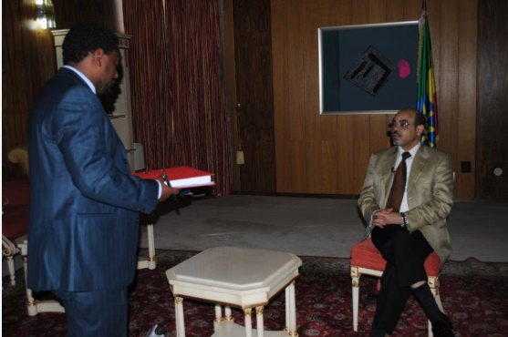
The Late PM H.E Meles Zenawi The Late PM Meles Zenawi receiving Kaizen manual produced by the pilot project, 2011.
The Ethiopian Kaizen institute is established with various objectives and functions of formulating policies, plans, strategies and programs for Kaizen dissemination; providing trainings; developing authorized and standardized training materials and manuals; conducting consulting services; and establishing mechanisms for nationwide outreach. EKI has designed Ethiopian Kaizen model consisting of five stages: Testing, Institutionalization, Implementation, Sustain and Ownership (TIISO). At each of these stages’ awareness raising, experiencing best practices and customization are done.
In general Kaizen is indispensable to:
  - Make optimal use of peoples’ skills
  - Reduce overall cost
  - Maintain high quality (or improve quality)
  - Reduce or eliminate wastes (MUDA)
  - Improve productivity
  - Improve Safety
  - Shorten lead time & improve delivery time
  - Improve space utilization etc

Kaizen Tools
As presented by Masaaki Imai, Kaizen is an umbrella concept that embraces different continuous improvement activities on an organization as shown in the figure below. There are a large number of related and often overlapping implementation methods and technical tools that belong to the kaizen Toolkit. Basing on kaizen philosophy and through following kaizen systems, Kaizen tools bring continuous improvement.
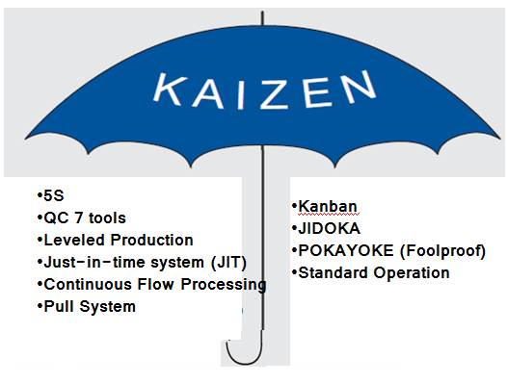
Fig. Some basic Kaizen techniques.
5S is a systematized approach to standardize work environment of an organization so as to create a workplace that is more organized, more efficient, safer, cleaner, and more pleasant to work in, and to maintain it on an on-going basis. It consists of Sort, Set in Order, Shine, Standardize and Sustain.
QC 7 tools are the most frequently used analytical tools for QC activities and Kaizen activities. They are: (1) graphs; (2) check sheets; (3) histogram; (4) control charts; (5) Pareto charts; (6) fish-bone charts (cause-and-effect diagrams); and (7) scatter diagram.

Leveled production means levelling of type and/or volume of items produced at any time. It is avoiding variance in product types and/or volume.
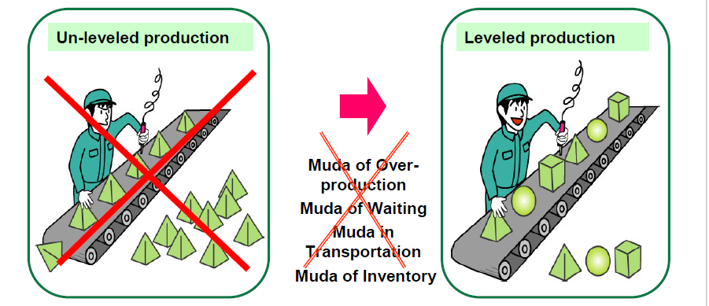
Just-in-time is a method of production in which a production line produces just what is needed, only when needed, and in exact quantity needed.
Continuous flow processing is a method of production in which products move from one work station to the next piece by piece in succession and in Correct sequence of processing to complete a process.
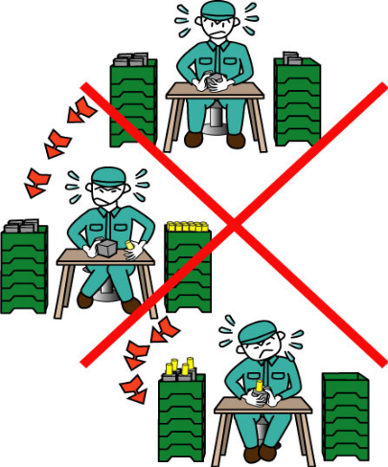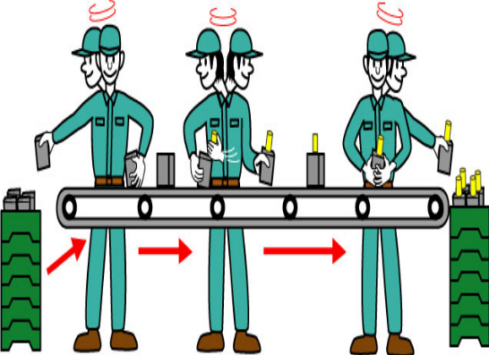

Pull System is when products in the previous process are taken by the workers in the next process when needed and in the amount needed. In the previous process operation, only the amount taken is produced. Kanban is used as the communication tool to request parts, semi-products or materials from the upstream process (previous process) in exact quantity & specifications needed.
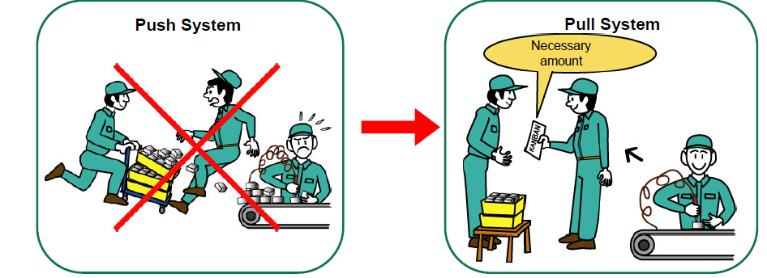
JIDOKA is a systematic approach to prevent defects or abnormalities from passing to the next process. Operation stops automatically by a programmed machine at the time of detection of an abnormality or stopped by the worker who detected the abnormality.
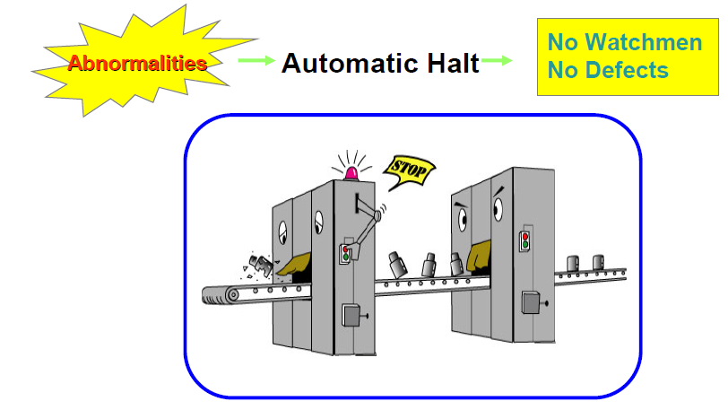

POKAYOKE (Foolproof) means error prevention. It is a method which avoids mistakes and defects from being produced. e.g., only one type of bolt used within a specific work-station to prevent wrong part usage.

Standard operation is an efficient production method/procedure that can be followed by anyone assigned for a task. It helps to clarify the rules for the production method and find out what is wasteful, uneven, and overburdening.
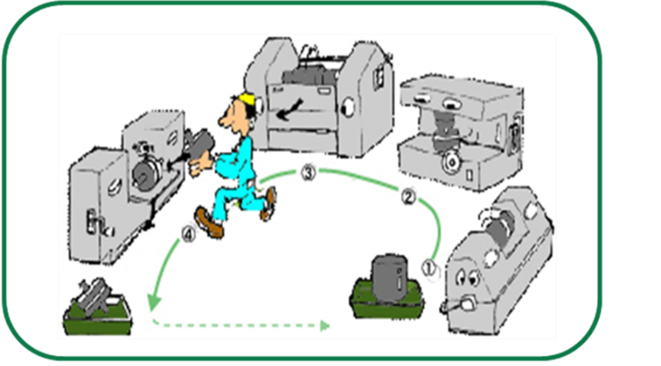
Fig. Shows “All I need to do is to follow the same cycle!”

Characteristics of Kaizen
Some of the key objectives of the kaizen philosophy include quality control, just-in-time delivery, standardized work, the use of efficient equipment, and the elimination of waste. The overall goal of kaizen is to make small changes over a period of time to create improvements within a company.

Benefits of Kaizen
Kaizen is about decreasing waste by eliminating overproduction, improving quality, being more efficient, having less idle time, and reducing unnecessary activities. All these translate to cost savings, and can turn potential losses into profits.
- Improve quality.
- Improve manpower productivity.
- Reduce inventory.
- Shorten the production line:
- Reduce machine downtime:
- Reduce space:
- Reduce lead time:

Principles of Kaizen
There are 5 Fundamental KAIZEN Principles that are embedded in every KAIZEN tool and in every KAIZEN behavior. The 5 principles are: Know your customer, let it Flow, Go to Gemba, Empower People and Be Transparent.
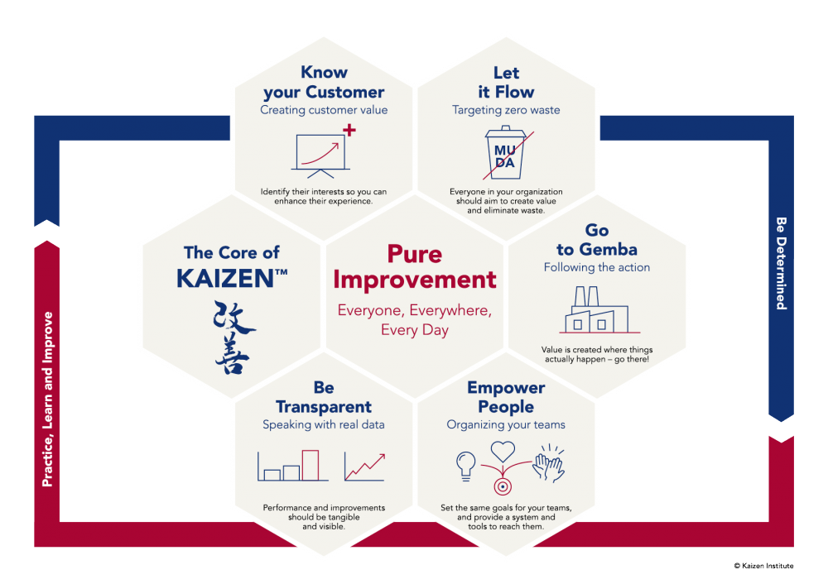
Fig. KAIZEN Principles

Elements of the Kaizen approach
- teamwork,
- personal discipline,
- improved morale,
- quality circles,
- suggestions for improvement

Kaizen board
A Kaizen board is a visual tool that helps teams and organizations manage their continuous improvement efforts. Kaizen boards and Kanban boards can be easily confused, and in fact, some teams choose to represent their Kaizen work on their Kanban boards.
This is where a Kaizen board becomes useful. It’s difficult to make time and devote energy to work that isn’t treated like work, but rather, a side project. Using a Kaizen board at the team or organizational levels can help turn good ideas into actionable cards, which the group collectively manages. As long as the team (or organization) commits to reviewing the board as a group (and prioritizing the work alongside other work), a Kaizen board can make your improvement ideas a reality.

Corners of Kaizen board
- Visualize – tools that will help you visualize what your change process will look like. ...
- Measure – Being consistent is key to making improvements. ...
- Improve – The principles of kaizen are split into four categories: process, product, people, and environment. ...
- Repeat – Repeat the process.
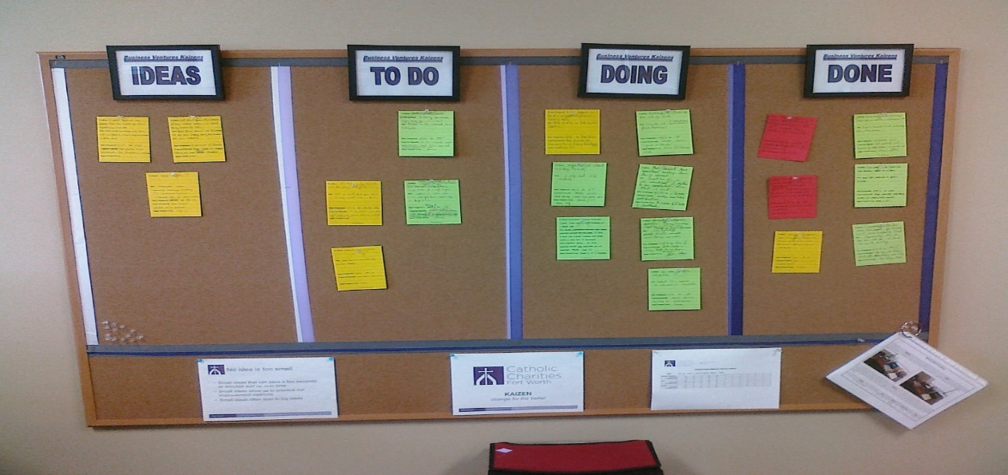
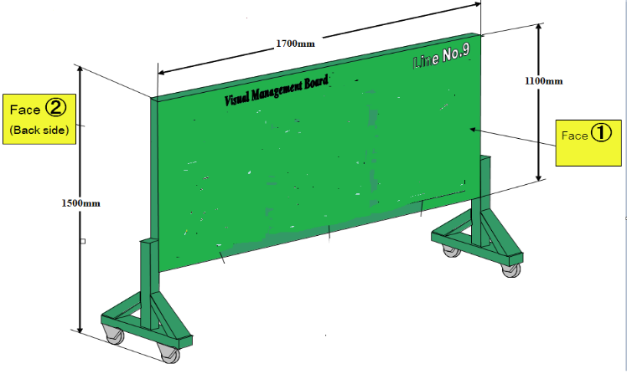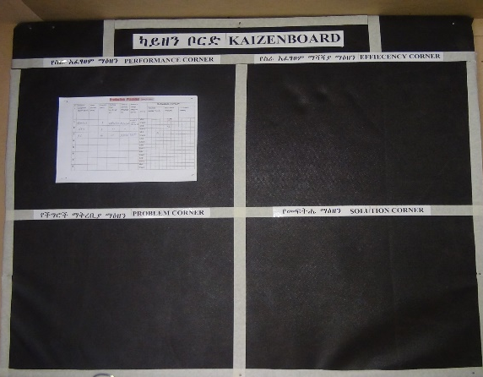
Fig. Visual Management Board (Kaizen board) Strategy

Self-Check- 1 | Written Test
Directions: Answer all the questions listed below.
- What is the meaning of job? (2 points)

List the requirements of job. (5 points)

What is the meaning of work? (2 points)

Describe work instruction in your own words. (5 points)

Explain the difference between procedure and work instruction? (5 points)

Define job specification? (3 points)

What is OHS represents for (2 point)

What is OSH representing for? (1 point)

What is WHS represents for? (1 point)

What are the goals of OHS? (2 points)

List some examples of OHS requirements in your work areas. (10 points)

List at least four workplace hazards? (4 points)

List at least fivetools and materials used to implement Sort. (5 points)

List at least six tools and materials used to implement Set in order. (6 points)

List at least seven tools and materials used to implement Shine. (7 points)
- Define the word, Kaizen? (3 points)
- Write the origin of Kaizen and its emergence and dissemination in Ethiopia? (6 points)
- What are the three pillars of Kaizen? (3 points)
- What are the characteristics of Kaizen? (5 points)
- What are the principles and benefits of Kaizen? (6 points)
- List the elements of Kaizen. (8 points)
Note: Satisfactory rating – 46 points Unsatisfactory - below 46 points
You can ask you trainer for the copy of the correct answers.
Score = ___________
Rating: ____________

Name: _________________________ Date: _______________

Unit Two: - Sort
This unit is developed to provide you the necessary information regarding the following content coverage and topics:
  - Plan for sorting activities
  - Cleaning activities
  - Work place procedures
  - list necessary and unnecessary items
  - Red tag strategy
  - Evaluate unnecessary items
  - Record necessary items
  - Report performance results
  - Check necessary items regularly
This guide will also assist you to attain the learning outcomes stated in the above coverage. Specifically, upon completion of this learning guide, you will be able to:
- Prepare plan for implementing sorting activities.
- Perform cleaning activities, in parallel.
- Identify all items in the work area follow procedures.
- List necessary and unnecessary items using the appropriate format.
- Use red tag strategy for unnecessary items.
- Evaluate and place unnecessary items in an appropriate place other than the workplace.
- Record and quantify necessary items using appropriate format.
- Report performance results using appropriate formats.
- Regularly check necessary items in the work area.

Unit Two: Sort
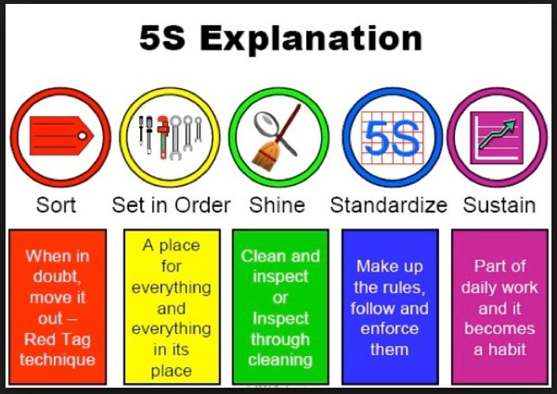
Fig. 5S Explanations

2.1. Definition of Sort
Sort, the first pillar of 5S, means classifying items in the workplace in to two categories necessary and unnecessary and removing all the unnecessary items that are not needed for current operations. It corresponds to the just in time (JIT) principle of “only what is needed, only in the amount needed, and only when it is needed.” The workplace is full of unused machines, jigs, dies, rejects, work-in-process, raw materials, supplies, parts, shelves, containers, desks, workbenches, files, carts, racks, pallets and other items.
People tend to hang onto parts, thinking that they may be needed for the next time. They see an inappropriate machine or equipment and think that they will use it somehow. In this way, inventory and equipment tend to accumulate and get in the way of everyday activities. This leads to a massive build of waste in companywide or in the whole workshop. An easy rule is to remove anything that will not be used within the next 30 days. A ceiling on the number of necessary items should be established.
Red-tag holding area can also help to evaluate the need of an item instead of simply getting rid of it. This greatly reduces the risk of disposing of an item that is needed later that will be explained in detail in the next contents.

Benefits of sort activity
Implementing this first pillar creates a work environment in which space, time, money, energy, and other resources can be managed and used most effectively. Sorting can lead to a much safer workplace. By clearing out the items you no longer need, people will have more room to work and things like trip hazards and items falling off shelves will be greatly reduced. Sorting also improves work flow since there is less clutter to deal with and will most definitely increase productivity in both production and office environments.

Problems and annoyances in the work flow are reduced, communication between workers is improved, and product quality is increased, and productivity is enhanced. If the first pillar is not well implemented, the following types of problems occur:
- The factory or a workshop becomes increasingly crowded and hard to work in.
- Unnecessary lockers, shelves, cabinets and items make communication between employees difficult.
- Time is wasted in searching for parts and tools.
- Increase unnecessary maintenance cost of unneeded inventory and machinery.
- Excess stock-on-hand hides other types of problems in production.
- Unneeded items and equipment make it harder

Prepare plan for implementing sorting activities

Implementing sort activity
It is not always easy to identify unneeded items in a factory or workshop. Workers seldom know how to separate items needed for current production from unnecessary items. The following procedures will help in implementing sort activity.

2.2.2. Plan and procedures for sort activity
Sort activity plan sheet (sample)
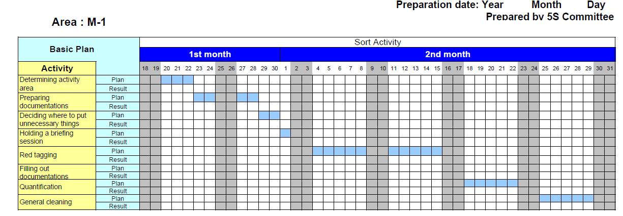

Identify all items in the work area follow procedures
Procedure for sort activity
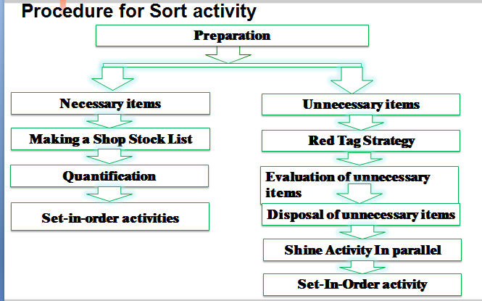
Step 1- Evaluate and take pictures of the work area. It’s extremely important to take pictures during this evaluation step since referencing them after improvements have been made can be very enlightening. To help you get started use also a 5S evaluation form.
Step 2 - Identify and red tag the items you no longer need.
Step 3 - Decide what to do with the tagged items.

list necessary and unnecessary itemsin the appropriate format.
- Place “Red tag” for categorization of items to identify unnecessary items
- Move unnecessary items (broken tools, obsolete jigs and fixtures, scrap and excess raw material etc.) to central stored area
- Free up valuable floor space (Space utilization)
- Finding abnormality of equipment and tools (Out of order, missing parts etc.)
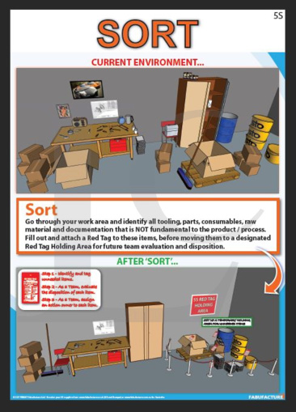
Fig. Sorting activities

Record and quantify all items in the work area
The following sample formats can be used to record all necessary and unnecessary items.

2.5.1. A sample format for recording all items at the workplace.
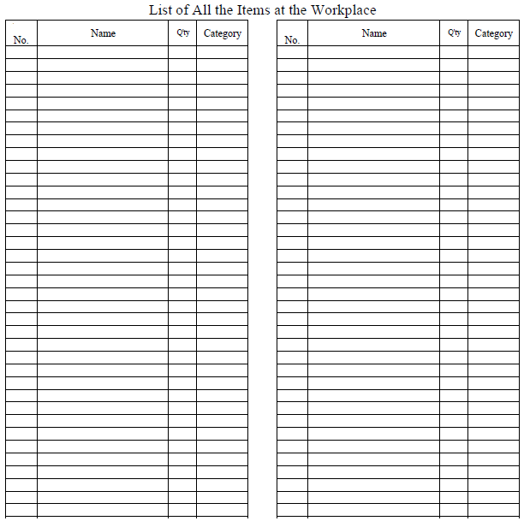

2.5.2. A sample format for recording necessary items.
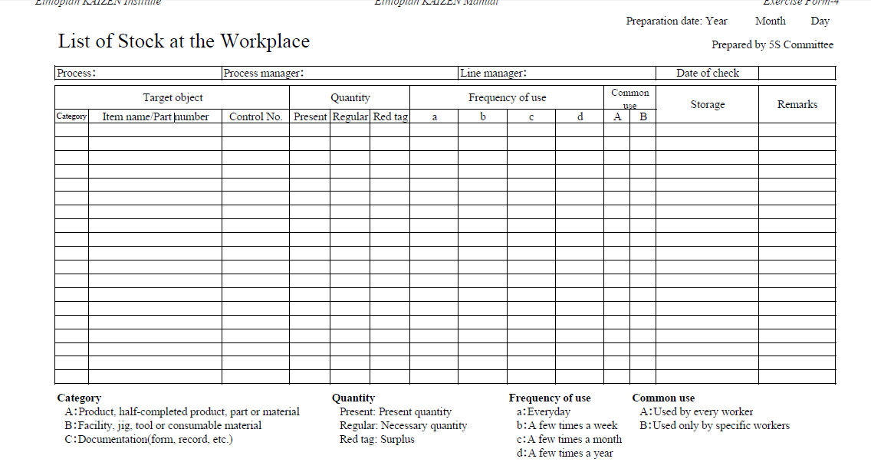

2.5.3. A sample format for recording unnecessary items.
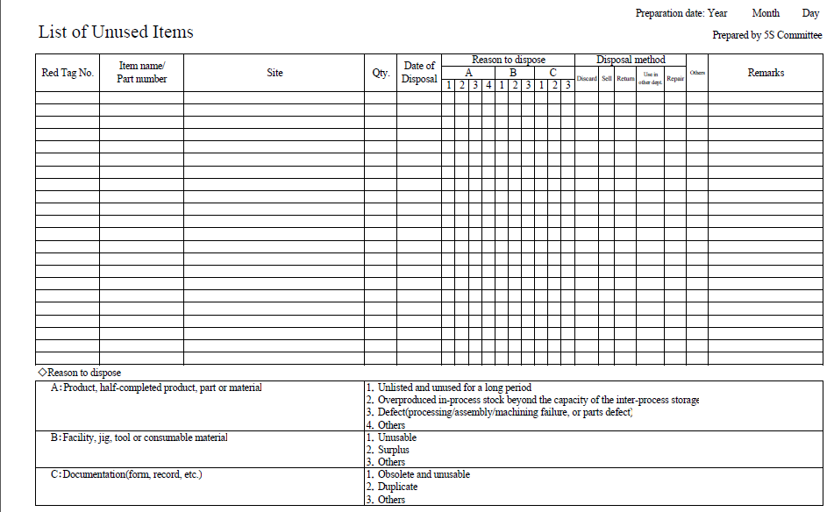

Evaluate and place unnecessary items.

Types of unnecessary items
Some of types of unnecessary items are:
- Defective or excess quantities of small parts and inventory
- Outdated or broken jigs and dies
- Worn-out bits
- Outdated or broken tools and inspection gear
- Old rags and other cleaning supplies
- Electrical equipment with broken cords
- Outdated posters, signs, notices, and memos
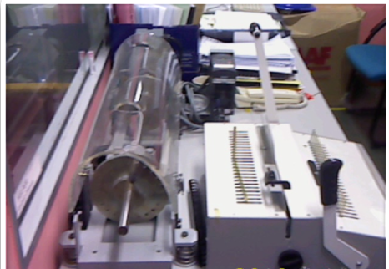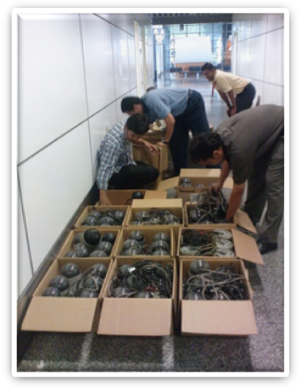
Unused machinery or equipment Obsolete equipment

Places where unnecessary items accumulate
Some locations where unneeded items tend to accumulate are:
- in rooms or areas not designated for any particular purpose
- in corners next to entrances or exists
- along interior and exterior walls, next to partitions, and behind pillars.
- under the eaves of warehouses.
- under desks and shelves and in desk and cabinet drawers
- near the bottom of tall stacks of items
- on unused management and production schedule boards
- in tools boxes that are not clearly sorted

Red tag strategy for unnecessary items
Overview of red tagging
The Red-Tag Strategy is a simple method for identifying potentially unneeded items in the factory or workshop, evaluating their usefulness and dealing with them appropriately. Red-tagging means putting red tags on items in the factory or workshop that need to be evaluated as being necessary or unnecessary. A Red tag is a red colored tag used to identify items no longer needed in a particular work area. The red tags catch people’s attention because red is a colour that stands out. An item with a red tag is asking three questions:
- Is this item needed?
- If it is needed, is it needed in this quantity?
- If it is needed, does it need to be located here?
Once these items are identified, they can be held in a “Red Tag Holding Area” for a period of time to see whether they are needed, disposed of, relocated, or left exactly where they are.

Red-tag Holding areas
In order to implement the red-tag strategy effectively, a red-tag holding area must be created. A red-tag holding area is an area set aside for use in storing red-tagged items that need further evaluation. Red-tagging is helpful when the need or frequency of need for that item is unknown. When an item is set aside in a red-tag holding area and watched for an agreed-upon period of time people tend to be more ready to let it go when that time is over.

There are two red-tag holding areas: local and central holding areas. Local red-tag holding area is used to manage the flow of red-tagged items with in a local department or production area. Central red-tag holding area is used to manage the flow of items that cannot or should not be disposed of by individual departments or production area. Usually central red-tag holding area is used by an organization that is launching a companywide red-tagging effort.
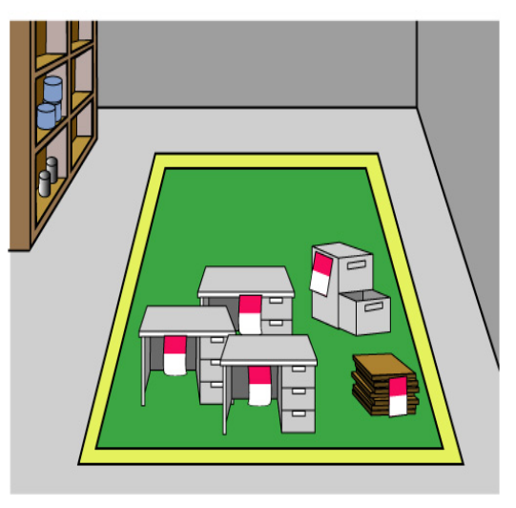
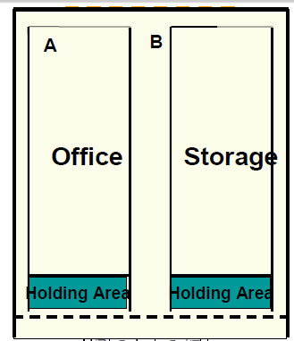
Fig. Red-tag Holding Area

Steps/procedures in red tagging
The red-tagging process in a department or work area can be broken down into seven steps.
Step 1: Launch the red-tag project.
Step 2: Identify the red-tag targets.
Step 3: Set red-tag criteria.
Step 4: Make red tags.
Step 5: Attach red tags.
Step 6: Evaluate red-tagged items.
Step 7: Document the results of red-tagging.

Step 1: Launch the red-tag project
Red-tag campaigns are started and coordinated by the upper-level management of a company. Even when a red-tag campaign is companywide, local campaigns need to be organized in each department or production area. This involves
- Organizing a team
- Organizing supplies
- Organizing a time or schedule to perform red-tagging
- Deciding a local-tag holding area
- Planning for disposal of red-tagged items
People from outside a department can be valuable members on a red-tagging team since they tend to see the area with a fresh eye. Hence, it is helpful to partner with other departments or production areas in creating red-tagging teams.
Step 2: Identify red-tag targets
There are two red-tag targets:
- Items: in the manufacturing area items like inventory (warehouse and in-process inventory), equipment, and space are targets for red tags. Warehouse inventory include material, parts, products etc.
- Areas: It is better to define a smaller area and evaluate it well than to define a larger area and not be able to evaluate it fully in available time.

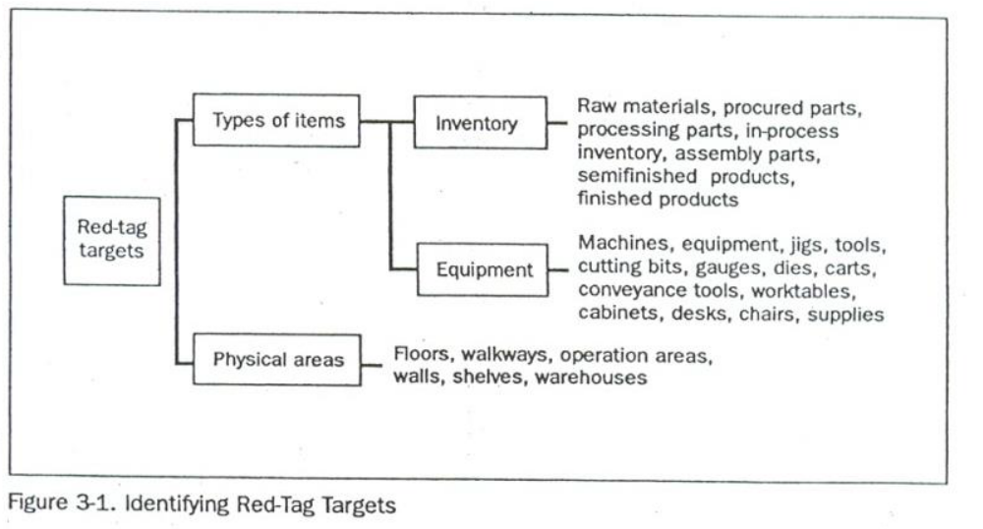

Step 3: Set red-tag criteria
As already mentioned, the most difficult thing about red-tagging is differentiating what is needed from what is not. This issue can be managed by establishing clear-cut criteria for what is needed in particular area and what is not. The most common criterion is the next month’s production schedule.
- Items needed for that schedule are kept in that location.
- Items not needed for the schedule can be disposed of or stored in a separate location.
Three main factors determine whether an item is necessary or not. These factors are:
- The usefulness of the item to perform the work at hand. If the item isn’t needed it should be disposed of.
- The frequency with which the item is needed. If it is needed infrequently, it can be stored away from the work area.
- The quantity of the item needed to perform this work. If it is needed in limited quantity the excess can be disposed or stored away from the work area.
Each company must establish its own red-tagging criteria and each department may customize this standard to meet its local needs.
Step 4: Make red-tags
Each company has specific needs for documenting and reporting the movement, use, and value of materials, equipment, tools, inventory and products. The company’s red tags should be designed to support this documentation process.
Various types of information on a red-tag may include:
- Category: provides a general idea of the type of item (e.g., a warehouse item or machine). Categories include raw materials, in-process inventory, products, equipment, jigs, tools and dies.
- Item name and manufacturing number.
- Quantity: indicates the number of items included under this red tag.
- Reason: describes why a red tag has been attached to this item.
- Division: includes the name of the division responsible for managing the red-tagged item.
- Value: includes the value of the red-tagged item.
- Date: includes the red-tagging date.

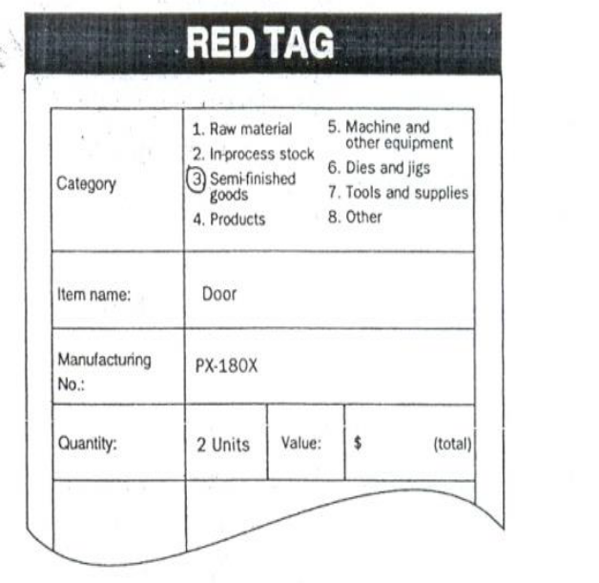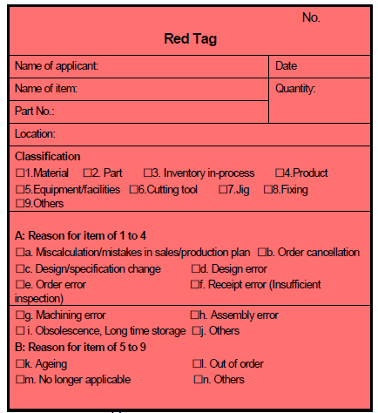
Fig. Red-tag

The material used for red tags can be red paper, thick red tape, or others. Red tags can be laminated with plastic or another material to protect them during repeated use.
Step 5: Attach the red tags
The best way to carry out red-tagging is to do the whole target area quickly, if possible, in one or two days. In fact, many companies choose to red-tag their entire factory during a one- or two-day period. Red-tagging should be a short and powerful event. You should red-tag all items you question, without evaluating what to do with them.
Step 6: Evaluate the red-tagged items
In this step, the red-tag criteria established in step 3 are used to evaluate what to do with red-tagged items. Options include:
- Keep the item where it is.
- Move the item to a new location in the work area.
- Store the item away from the work area.
- Hold the item in the local red-tag holding area for evaluation.
- Dispose of the item.

Disposal methods include:
- Throw it away.
- Sell it.
- Return it to the vendor.
- Lend it out.
- Distribute it to a different part of the company.
- Send it to the central red-tag holding area.
The next table shows disposal methods.
Treatment | Description
Throw it away | Dispose of as scrap or incinerate items that are useless or unneeded for any purpose.
Sell | Sell off to other companies’ items that are useless or unneeded for any purpose.
Return | Return items to the supply company.
Lend out | Lend items to other sections of the company that can use them on a temporary basis.
Distribute | Distribute items to another part of the company on a permanent basis.
Central red-tag area | Send items to the central red-tag holding area for redistribution, storage, or disposal.

Evaluation format for red-tag items (sample)
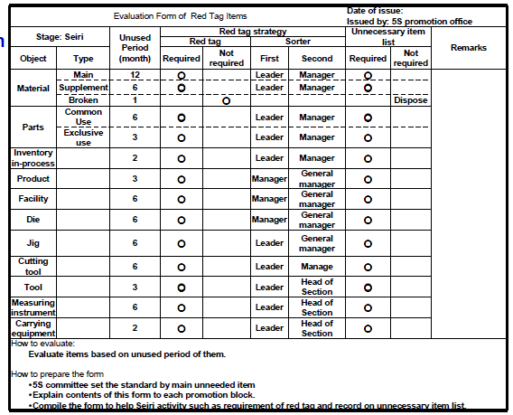
Ideally, unnecessary equipment should be removed from areas where daily production activities take place. However, large equipment and equipment or machine attached to the floor may be expensive to move. It is sometimes better to leave this equipment where it is unless it interferes with daily production activities or prevents workshop improvements. Label this unneeded and difficult to move equipment with a “freeze” red tag, which indicates that its use has been “frozen,” but that it will remain in place for the time being.
Step 7: Document the results of red-tagging
Each company or organization needs to create its own system for logging and tracking necessary information as red-tagging takes place. The documentation system may involve a written logbook in each department and in the central red tag holding area. Or it may involve entering data from the red-tags into a computer system. Whatever the system, documenting results is an important part of the red-tagging process.
It allows the company to measure the improvement and savings produced as a result of the red-tagging effort. As it is indicated in step 4, the red-tags should be designed to support the documentation process.
Determine in advance approximately how many red-tags each workplace should use. An average of four red-tags per employee should be used. This means a workshop with 30 employees should need about 120 red tags. In addition, when you find a shelf full of items which are difficult to decide, we don’t have to be tempted to attach one red-tag for the whole shelf. Because this can lead to confusion when we want to dispose of these items in the shelve. Therefore, avoid this temptation and attach individual tags to individual items.
When red-tagging is completed the factory or workshop is usually dotted with empty spaces a sign of real progress. Then the layout of equipment and worktables can be changed to occupy the free space. Companies or organizations who think they need to build a new factory for a production of new products/ services should first apply the sort activity or the red-tag strategy so that they could get plenty of free space.

Self-Check -2 | Written Test
Instructions: Answer all the questions listed below. Illustrations may be necessary to aid some explanations/answers.
- Give definition of the first pillar of 5S – Sort. (3 points)
- What are the benefits of implementing sort activity? (4 points)
- What problems occur in a workshop if sort activity is not implemented? (6 points)
- What are the reasons for the accumulation of unnecessary items in a workshop? (3 points)
- What are the procedures for sort activity? (5 points)
- What is red-tagging strategy? (3 points)
- What are red-tag holding areas and explain the types? (4 points)
- List the steps of red-tagging strategy. (7 points)
- List at least seven items that are considered as unnecessary. (7 points)
- Name places where unnecessary items are accumulated? (6 points)

Note: Satisfactory rating – 24 points Unsatisfactory - below 24 points
You can ask you trainer for the copy of the correct answers.
Score = ___________
Rating: ____________

Name: _________________________ Date: _______________

OPERATION TITLE: -APPLY – 5S
Purpose: -Implementing Sort activity is important for optimizing the efficiency of other algorithms (such as search and merge algorithms) that require input data to be in sorted lists. Sorting is also often useful for canonicalizing data and for producing human-readable output. The goal of the Sort step is to eliminate clutter and clear up space by removing things that don't belong in the area.
Operation Sheet: -Implementing Sort Activity
- PreparePlan for Sort Activity
Sampleplanfor Sortactivity.

- Procedure for sort activity
List all items at the work place using the following sample format.

- Red-Tagging
Steps/procedures in red-tagging
Step 1: Launch the red-tag project
Step 2: Identify red-tag targets
Step 3: Set red-tag criteria
Step 4: Make red-tags
Step 5: Attach the red tags
Step 6: Evaluate the red-tagged items
Step 7: Document the results of red-tagging
Sample red-tags
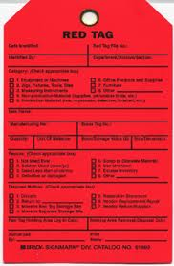
- Record and quantify all items in the work area using the following formats.
Reporting quantitative and qualitative results gained by implementing the 1st S – Sort using the following formats. All or some of the improvement indicators can be used.

Quantitative Results
Record tangible/quantitative results and changes that are achieved by applying Sort activity using the following indicators.
No | Improvement Indicators | Before Kaizen | Target | After Kaizen | Improvement  (%) | Remark
1 | Free floor space
2 | Searching time for tools, materials, etc
3 | Transaction made/income generated
4 | Labor saving
5 | Parts saving
6 | Tools& Equipment found
7 | Raw Material saving
8 | Transportation/travel
9 | Inventory
10 | Lead time
11 | Machine down time
12 | Frequency of Machine failure
13 | Production volume per day
14 | Labour productivity
15 | Delivery Time
16 | Defect rate
17 | Number of Customer complaints
18 | Minimized Cost of Production

Qualitative Results
Record intangible/qualitative results and changes that are achieved by applying Sort activity using the following indicators.
No | Improvement Indicators | Description of the Result
1 | Knowledge of the 1st S - Sort
2 | Team work
3 | Morale of workers
4 | Communications between workers by removing unnecessary materials
5 | Corporate culture of kaizen
6 | Fatigue or stress
7 | Relationship with customers
8 | Awareness of safety
9 | Orderliness of work place
10 | Other

LAP Test: Practical Demonstration
Name: _____________________________ Date: ________________
Time started: ________________________ Time finished: ________________
Instructions: Given necessary templates, workshop, tools and materials you are required to perform the following tasks.
Task 1: Using the given template, prepare a plan for sort activity in your workshop.
Task 2: Using the given templates, list necessary and unnecessary items.
Task 3: Make red-tags appropriate for your workshop.
Task 4: Following the procedures of sort activity, perform sort activity in the assigned workshop.

Unit Three: - Set in order
This unit is developed to provide you the necessary information regarding the following content coverage and topics:
- Plan for implementing set-in order activities
- Cleaning activities for set in order
- Decide Layout/Locations
- Necessary tools and equipment.
- Place items in their assigned locations.
- Return items immediately use.
- Reporting performance results.
- Check each item in its assigned location and order
This guide will also assist you to attain the learning outcomes stated in the above coverage. Specifically, upon completion of this learning guide, you will be able to:
- Prepare plan for implementing set in order activities.
- Perform general cleaning activities, in parallel with set in order activity.
- Decide location/layout, storage and indication methods for items.
- Prepare and use necessary tools and equipment for setting in order activities.
- Place items in their assigned location.
- Return immediately the items to their assigned location after use.
- Report performance results using appropriate formats.
- Regularly check each item in its assigned location and order.

Unit Three: Set in order

3.1. Definition of set-in order
The second pillar of 5S – Set-in order: Set-in order means arranging necessary items so that they are easy to use and labelling them so that anyone can find them and put them away. The key word in this definition is “anyone”. Set in order can be implemented only when the first pillar- sort is done first. No matter how well you arrange items, set in order can have little impact if many of the items are unnecessary and not sorted. Similarly, if sorting is implemented without setting in order, it is much less effective. Where necessary items should be placed should be made clear for anyone to immediately find them and return them easily. Hence, Sort and Set-in order work best, when they are implemented together.
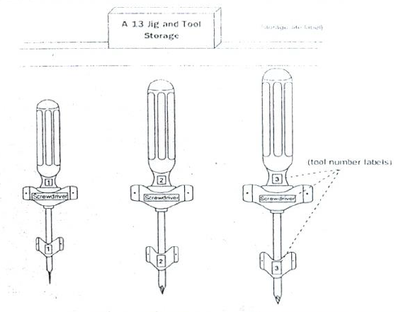
Fig. Set in order of tools

3.1.1. Benefits of set-in order
Setting in order is important because it eliminates many kinds of waste from operations in a workplace. These include searching time waste, waste due to difficulty in using items, and waste due to difficulty in returning items. In general, the following problems and wastes are avoided when set in order is well implemented.
- Motion wastes
- Searching time wastes
- The waste of human energy
- The waste of excess inventory
- The waste of defective products
- The waste of unsafe conditions
The set-in order step is actually at the core of so many important business principles such as safety, ergonomics, quality, inventory control, productivity, standard work, the visual workplace and employee morale. Also, it is the core of standardization. This is because the workplace must be organized before any type of standardization can be implemented effectively. Standardization means creating a consistent way of doing or carrying out tasks.
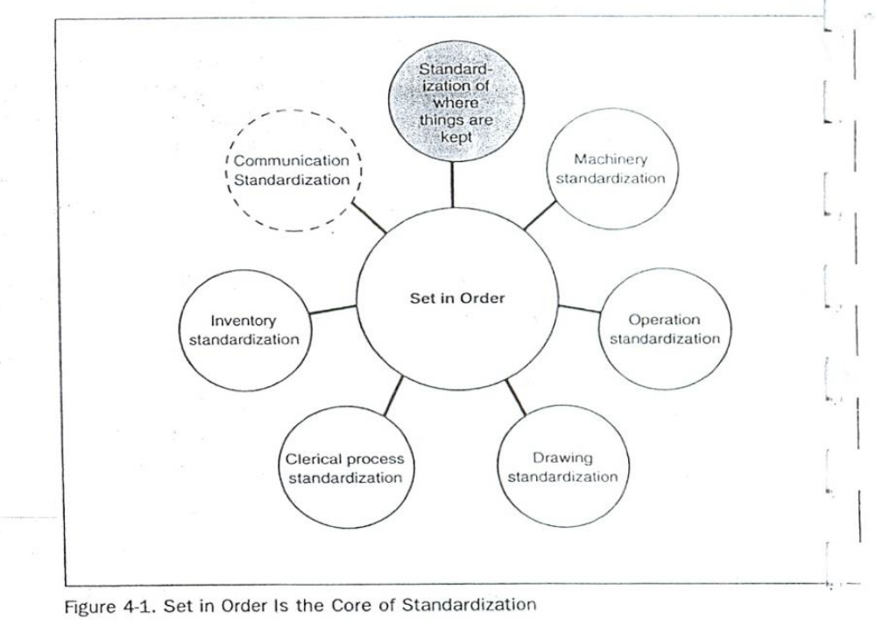

Fig. Set in order is the core of standardization.

3.2. Prepare plan for implementing Set-in order activities.
In implementing set in order pillar, we use visual controls so that communications became easy and smooth. For example, we can visually know where items are placed and where to return them and so on. A visual control is any communication device used in the workplace that tells us at a glance how work should be done. Through visual controls, information such as where items belong, how many items should be placed there, what the standard procedure is for doing something, the status of work in process etc. can be communicated.

3.2.1. Implementing Set-in order Activities
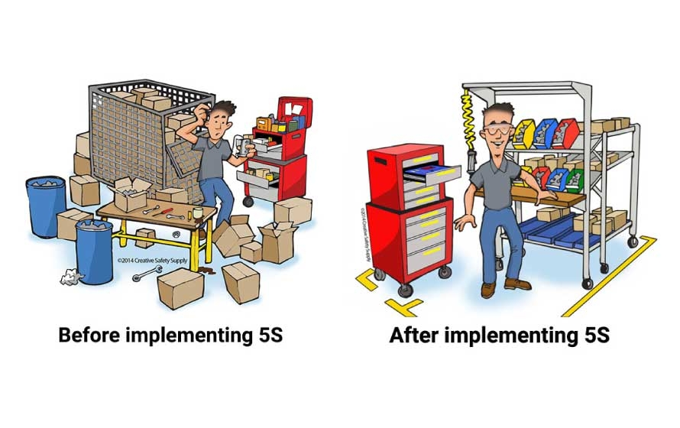
Fig. Before and After Implementing Set-in order

3.2.2. Plan and procedures for set in order
In the Set-in Order step, companies should match the place of an item with its amount of use. Items used more frequently should be designated first and should be placed near where they will be used. By moving items not frequently used out of the way, the workplace will become more efficient.

3.3. Report performance results using appropriate formats.

3.3.1. Set-inorder activity plan sheet (sample)
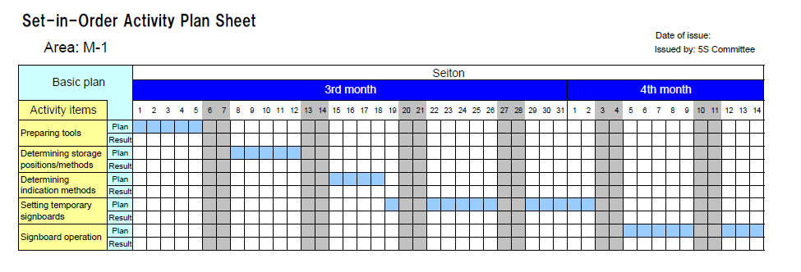

3.3.2. Procedures for Set in order
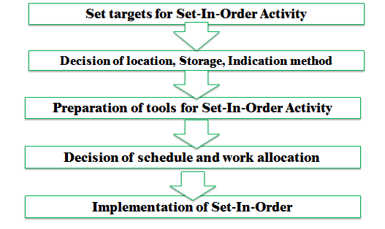
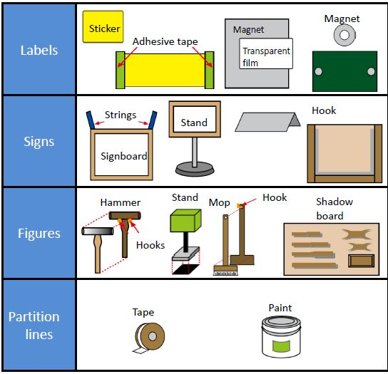

Fig. Guide lines

3.4. Place items in their assigned location.
There are some principles for deciding best locations for tools and equipment. Jigs, tools and dies differ from materials, equipment, machinery and parts in that they must be put back after each use. Some of the principles for jigs, tools and dies also apply to parts, equipment, and machinery. These are:
- Locate items in the workplace according to their frequency of use. Place frequently used items near the place of use. Store infrequently used items away from the place of use.
- Store items together if they are used together, and store them in sequence in which they are used.
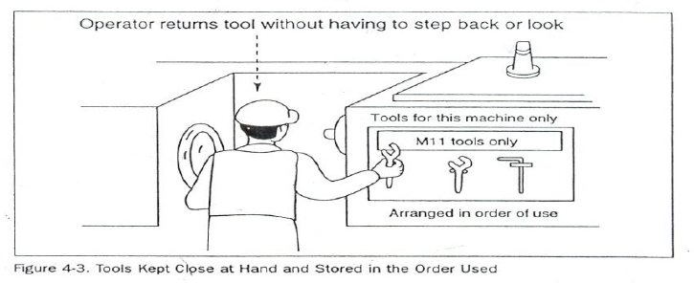
Fig. Tools kept at hand and stored in the order used.
- Device a “just let go” arrangement for tools. This approach involves suspending tools from a retractable cord just within reach so that they will automatically go back in to their correct storage position when released.
- Make storage places larger than the items stored there so that they are physically easy to remove and put back.
- Eliminate the variety of jigs, tools and dies needed by creating a few jigs, tools and dies that serve multiple functions.

- Store tools according to function or product. Function-based storage means storing tools together when they have similar functions. This works best for job-shop production.
- Product-based storage means storing tools together when they are used on the same product. This works best for repetitive production.

3.5. Return immediately the items to their assigned location after use.
There are principles helpful in deciding the best locations for parts, equipment, and machinery, as well as tools by removing motion wastes. Motion wastes are unnecessary movements created when people move their trunks, feet, arms, and hands more than needed to perform a given operation. These wastes lead to waste of time, energy and effort. These motion wastes can be minimized by locating parts, equipment, and machinery in the best locations possible. More important than removing motion wastes is asking why it occurs. By asking ‘why’ we can find the methods of manufacturing that work and approach the zero-waste mark. Eliminating the unnecessary motions from existing operations is called Motion improvement. And finding ways to eliminate the whole operations to remove the wastes is called Radical improvement.
The principles that are helpful to eliminate or reduce motions that operators make are:
Principle 1: Start and end each motion with both hands moving at once.
Principle 2: Both arms should move symmetrically and in opposite directions.
Principle 3: Keep trunk motions to a minimum.
Principle 4: Use gravity instead of muscle.
Principle 5: Avoid zigzagging motions and sudden changes in direction.
Principle 6: Move with a steady rhythm.
Principle 7: Maintain a comfortable posture with comfortable motions.
Principle 8: Use the feet to operate on and off switches for machines where practical.
Principle 9: Keep materials and tools close and in front.
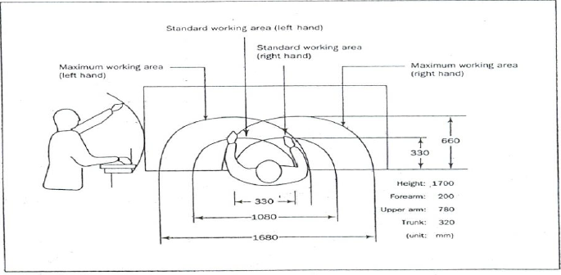
Fig. Guidelines for locating parts, equipment, and machinery to maximize motion efficiency.
Principle 10: Arrange materials and tools in the order of their use.
Principle 11: Use inexpensive methods for feeding in and sending out materials.
Principle 12: Stand at a proper height for the work to be done.
Principle 13: Make materials and parts easy to pick up.
Principle 14: Make handles and grips in efficient, easy-to-use shapes and positions.
Example of eliminating motion wastes
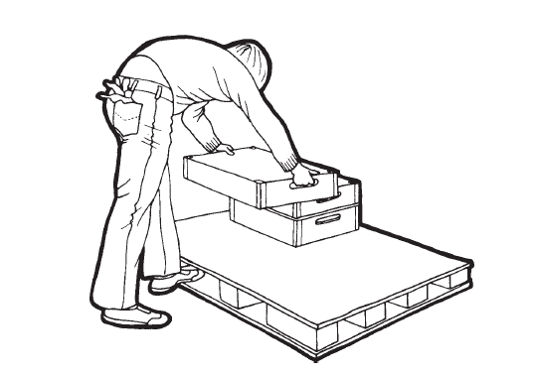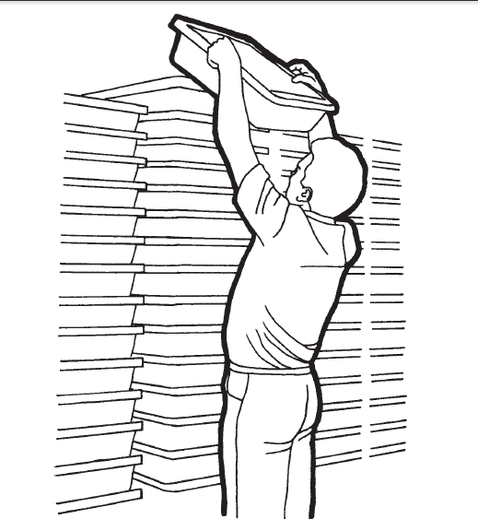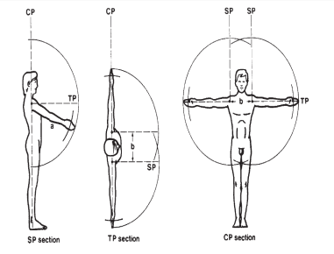
Fig. Motion wastes Fig. No waste of motion

Improving the retrieval of parts
The figure below shows an improvement in picking up parts in an assembly work. Before improvement, the worktable was so large that the assembly worker had to stretch to pick up parts. Also, the parts boxes were laid flat at table level, making it difficult to reach inside them. After improvement, the decreased width of the worktable enabled the assembly worker to reach the parts without stretching his arm too far. Also, the parts boxes set on an inclined surface to make their contents more accessible.
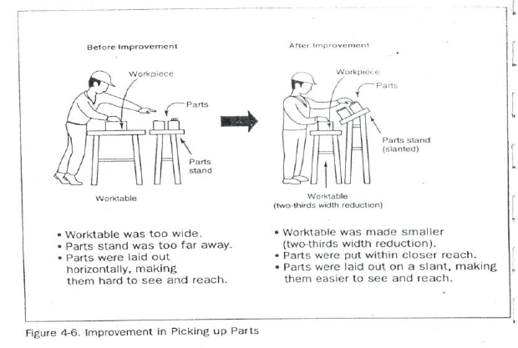
Fig. Improvements in picking up parts
Improving the layout of parts
The following figure shows an improvement in how plastic packaging sheets are used. The sheets are moved from a rack behind the operator to a hook in front of the operator and above the production line. This improvement eliminates four seconds of motion waste from each unit of packing work.

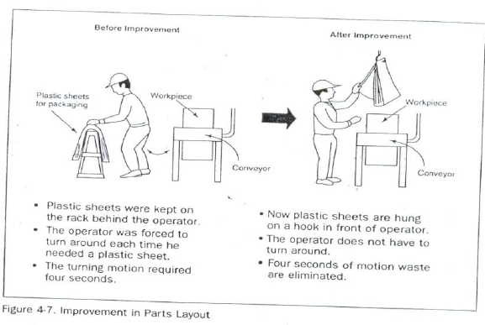
Fig. Improvement in parts layout

3.6. Place items in their assigned locations.

3.6.1. Evaluating current locations and deciding best locations
The 5S Map is a tool that can be used to evaluate current locations of parts, jigs, tools, dies, equipment, and machinery, and to decide best locations. 5S Map involves creating two maps ‘before map’ and ‘after map’. The ‘before map’ shows the layout of the workplace before implementing set in order. The ‘after map’ shows the workplace after implementing set in order. The 5S Map can be used to evaluate the locations in a small or large workplaces, like in a single workstation, on a production line, or in a department.

3.6.2. The steps of using the 5S Map:
- Make a floor plan or area diagram of the workplace you wish to study. Show the location of specific parts, inventory, tools, jigs, dies, equipment and machinery.
- Draw arrows on the plan showing the work flow between items in the workplace. There should be at least one arrow for every operation performed. Draw the arrows in the order that the operations are performed, and number them as you go.
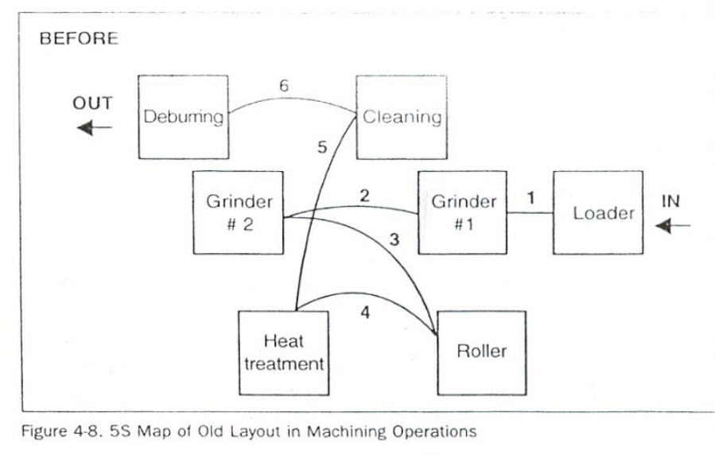
Fig. 5S Map of old layout in machining operations (‘before map’)

- Look carefully at the resulting “spaghetti diagram”. Can you see places where there is congestion in the work flow? Can you see ways to eliminate waste?
- Make a new 5S Map to experiment with a better layout for this work place. Again, draw and number arrows to show the flow of operations performed.
- Analyze the efficiency of the new layout (the after map), based on the principles explained in the above.
- Continue to experiment with possible layouts (after maps) using the 5S Map until you find one which you think will work well.
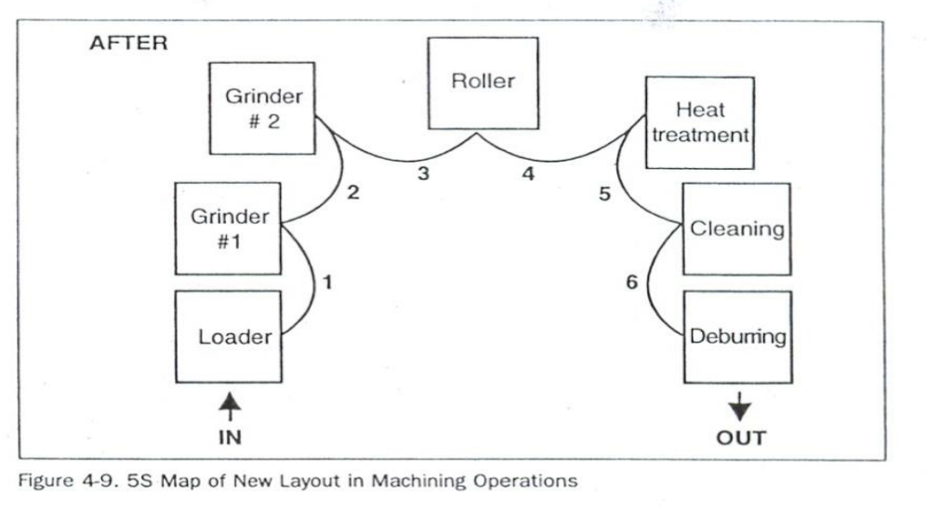
Fig. 5S Map of new layout (the after map) in machining operations.
- Implement this new layout in the work place by moving parts, tools, jigs, dies, equipment, and machinery to their new locations.
- Continue to evaluate and improve the layout in the workplace.

3.6.3. Set in order strategies
Once best locations have been decided, it is necessary to mark these locations so that everyone knows what goes where, and how many of each item belongs in each location. There are several strategies for marking or showing what, where and how many.
Motion Economy strategy
Following the principles explained in the above, we can remove motion waste from existing operation. By using human body appropriately, by organizing the workplace and by redesigning of tools and equipment, we can minimize motion waste.
Visual control Strategy
A visual control is any communication device used in the work environment that tells us at a glance how work should be done. There are several strategies for setting in order items so that to easily identify what, where and how many (visual control). These visual control strategies are discussed in the next contents.
Signboard strategy: uses signboards to identify what, where, and how many. The three main types of signboards are:
- Location indicators that show where items go.
- Item indicators that show what specific items go in those places.
- Amount indicators that show how many of these items belong there.
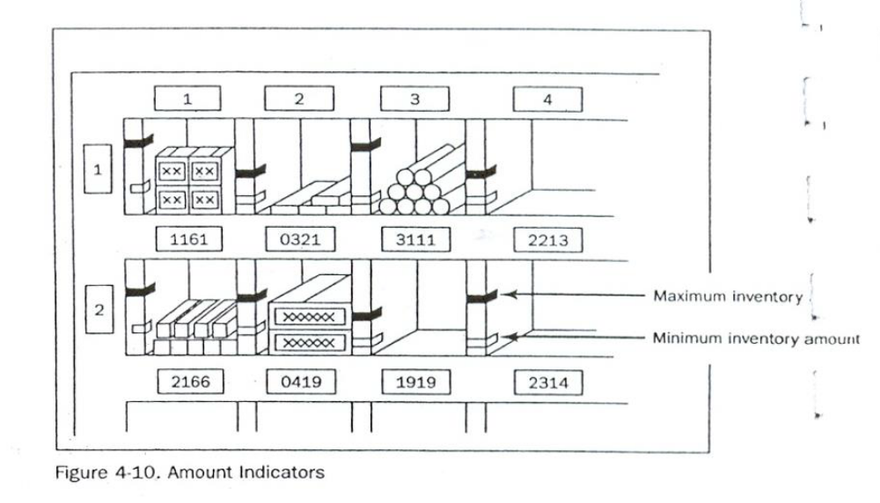
Fig. Amount indicators
Signboards are often used to identify:
- Names of work areas
- Inventory locations
- Equipment storage locations
- Standard procedures
- Machine layout

Return immediately the items to their location after use.
For example, in order to identify inventory stored on shelves in a warehouse, a whole system of signboards may be used. Every section of shelving may have a signboard identifying the section. Within that section, vertical and horizontal addresses on shelves can be identified with additional signboard. Each item stored on the shelve may also have a signboard showing the “return address” for that item. The “return address” allows the item to be put back in the proper location once it has been removed.
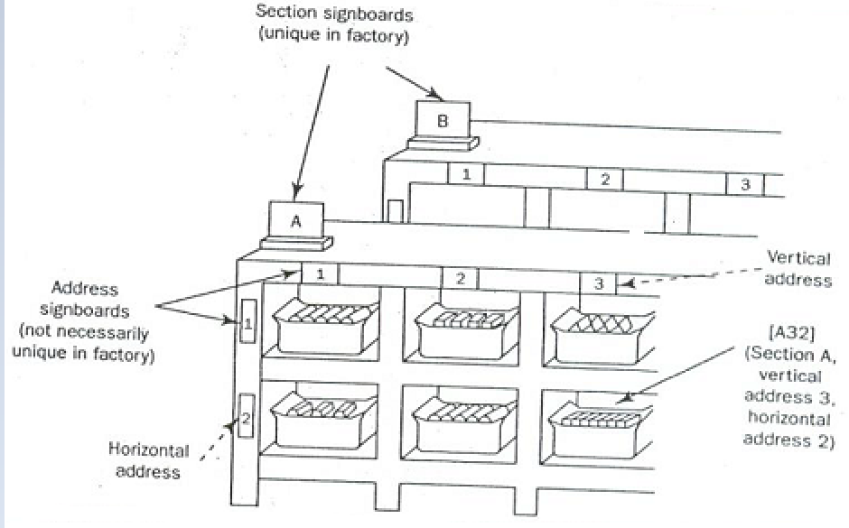
Fig. Location indicators on shelves
The ‘after 5S Map’ discussed before is a kind of signboard. It shows the location of parts, tools, jigs, dies, equipment, and machinery in a given work area after set in order is implemented. When posted in the work place, it is useful in communicating the standard for where items are located.
Painting strategy: is a method for identifying locations on floors and walkways. It is called the Painting strategy because paint is the material generally used. But also, plastic tape, cut in to any length, can be used. Plastic tape, although more expensive, shows up just as clearly as paint and can be removed if the layout is changed.
The painting strategy is used to divide the factories or workshop’s walking areas (walkways) from the working areas (operation areas). When putting lines to divide walkways from operation areas, the following factors should be considered:
- U-shaped cell designs are generally efficient that straight production lines.
- In-process inventory should be positioned carefully for best production flow.
- Floors should be levelled or repaired before we put lines.
- Walkways should be wide enough to avoid twists and turns and for safety and a smooth flow of goods.
- The dividing lines should be between 2 and 4 inches in width.
- Paint colors should be standardized. For example
- operation areas are painted by green;
- walkways are fluorescent orange or red;
- Lines that divide the walkways from operation areas are yellow in color.
Dividing lines can be used to show:
- Cart storage locations,
- aisle directions,
- door range, to show which way a door swings open,
- for worktables,
- Tiger marks, to show areas where inventory and equipment should not be placed, or to show hazardous areas.
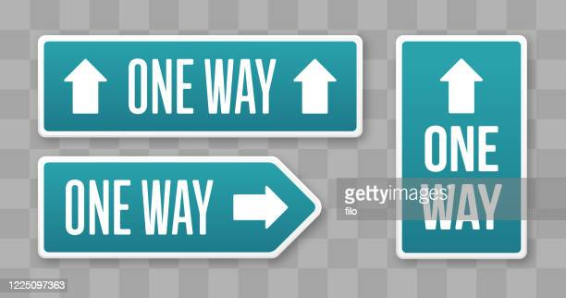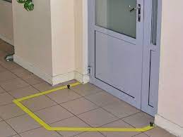
Fig. Aisle direction line Fig. Door-range line
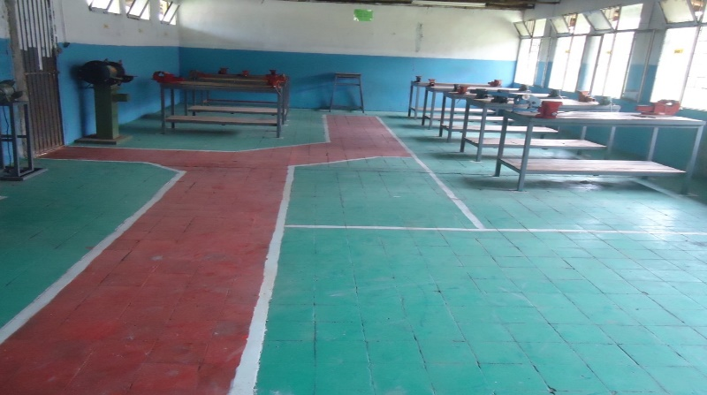
Color-code strategy: is used to show clearly which parts, tools, jigs and dies are to be used for which purpose. For example, if certain parts are to be used to make a particular product, they can all be color-coded with the same color and even stored in a location that is painted with that color. Similarly, as shown the picture in below, if different types of lubricants are to be used on different parts of a machine, the supply containers, oil cans, and machine parts can be color-coded to show what is used where.
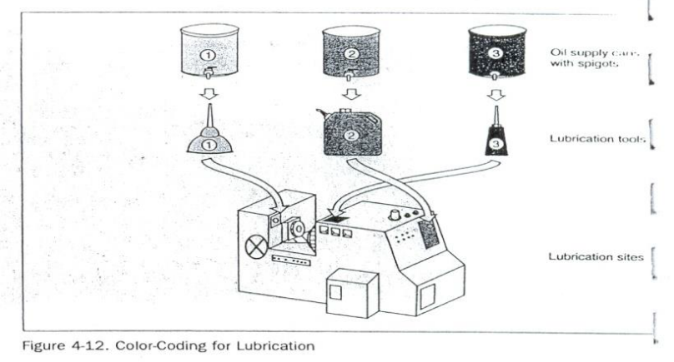
Fig. Color-coding for lubrication
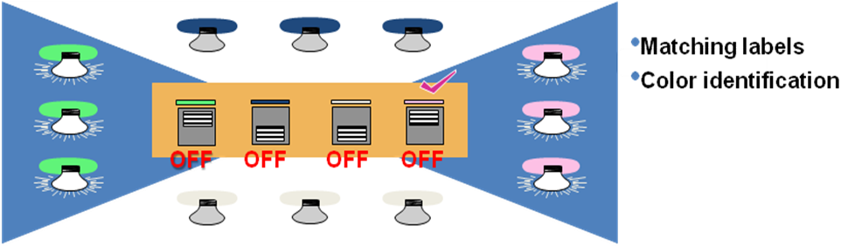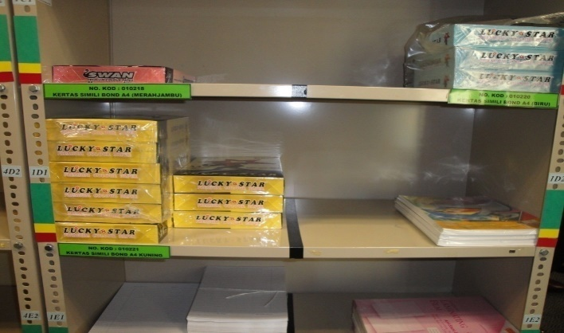

WORK ZONE | GREY
STORAGE SITE | WHITE
COMPARTMENT LINE | YELLOW
PASSAGE / PATHWAY | GREEN
HAZARDOUS INDICATION
Fig. Separation of location paint operation
Outlining strategy: is used to show which jigs and tools are stored where. Outlining simply means drawing outlines of jigs and tools in their proper storage positions. When you want to return a tool, the outline provides an additional indication of where it belongs.
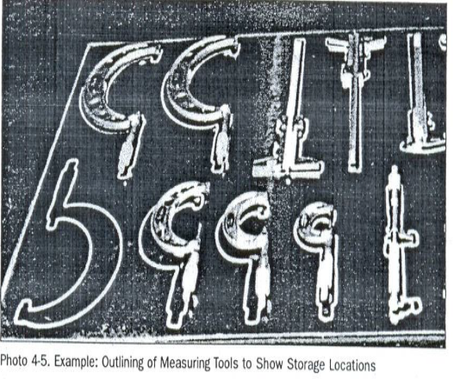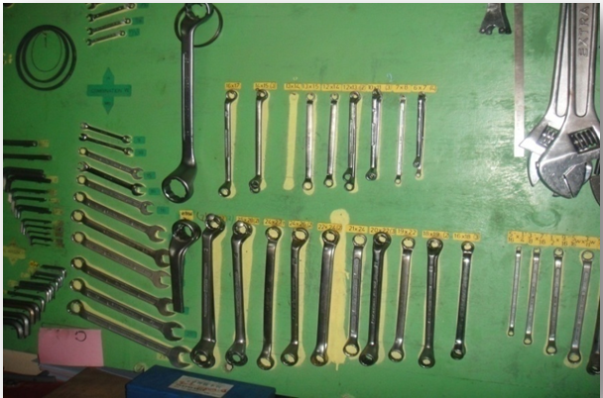
Fig. Outlining of tools to show their locations
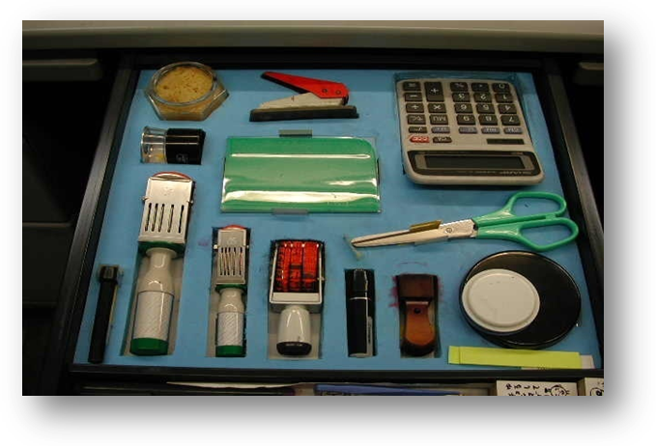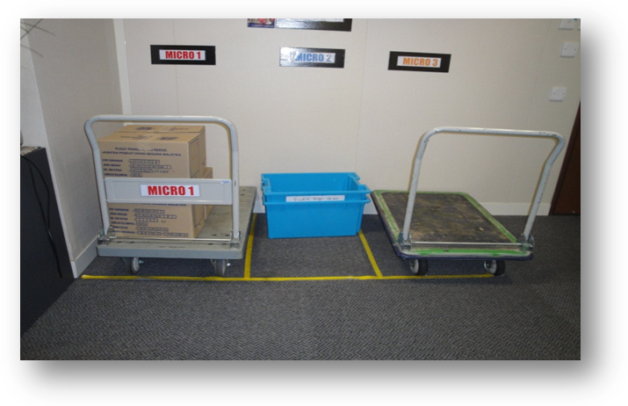
Fig. Outlining of tools and equipment to show their locations

Self-Check -3 | Written Test
Instructions: Answer all the questions listed below. Illustrations may be necessary to aid some explanations/answers.
- Give definition of the second pillar of 5S – Set in order. (3 points)
- What are the benefits of implementing set in order? (4 points)
- What are the procedures for set in order? (5 points)
- What are the principles for deciding best locations of tools and equipment? (6 points)
- What is 5S Map? (2 points)
- List the steps of using the 5S Map? (4 points)
- What are the strategies for implementing set in order? (3 points)
- What factors should we follow when applying the painting strategy? (6 points)
- What are the three standardized colors used for dividing and marking walkways and operation areas? (3 points)
Note: Satisfactory rating – 18 points Unsatisfactory - below 18 points
You can ask you trainer for the copy of the correct answers.
Score = ___________
Rating: ____________

Name: _________________________ Date: _______________

Unit Four: - Shine
This unit is developed to provide you the necessary information regarding the following content coverage and topics:
- Plan for implementing shine activities
- Necessary tools and equipment for shine activities
- Implement shine activity.
- Report performance results
- Conduct regular shining activities
This guide will also assist you to attain the learning outcomes stated in the above coverage.Specifically, upon completion of this learning guide, you will be able to:
- Prepare plan for implementing shine activities.
- Prepare and use necessary tools and equipment for shine activities.
- Implement shine activity according to the prepared procedure.
- Report performance results using appropriate formats.
- Conduct regular shinning activities.

Unit Four:Shine

4.1. Definition of Shine
The third pillar of 5S is shine. Shine means sweeping floors, wiping off machinery and generally making sure that everything in the factory stays clean. In a manufacturing company, shine is closely related to the ability to produce quality products. Shine also includes saving labor by finding ways to prevent dirt, dust, and debris from piling up in the workshop. Shine should be integrated in to daily maintenance tasks to combine cleaning checkpoints with maintenance checkpoints.
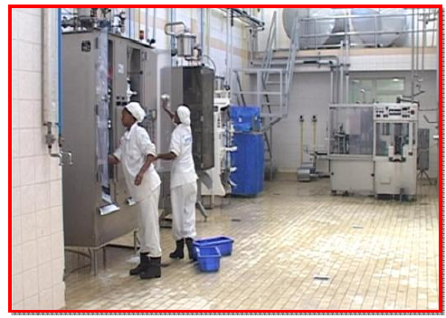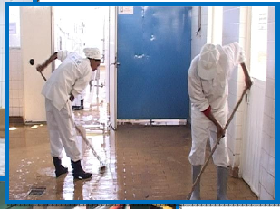
Fig. Workers shinning machines. Fig. Workers shinning the floor
Cleaning is so important because when we clean an area, we are also doing some inspection or checking of machinery, equipment, and work conditions. An operator cleaning a machine can find many mal-functions. When a machine is covered with oil, soot, and dust, it is difficult to identify any problems that may be developing. While cleaning the machine, however, one can easily spot oil leakage, a crack developing on the cover, or loose nuts and bolts. Once these problems are recognized, they are easily fixed.
It is said that most machines breakdowns begin with vibration (due to loosen nuts and bolts), with introduction of foreign particles such as dust (due to the crack on the cover, for instance), or with inadequate oiling and greasing. For this reason, shine is useful to make discoveries while cleaning machines. Hence, shine means cleaning the workplace’s floors, equipment and facilities, provide inspection at the same time, and ensure that they are in good operating condition.

4.1.1. Benefits of shine
One of the more obvious purposes of shine is to turn the workplace in to clean, bright place where everyone will enjoy working. Another key purpose is to keep everything in top condition so that when someone needs to use something, it is ready to be used. Companies or organizations should avoid the tradition of annual at the end of the year or on spring cleanings. Instead, cleaning should become a deeply ingrained part of daily work habits, so that tools, equipment, and work areas will be ready for use all the time.
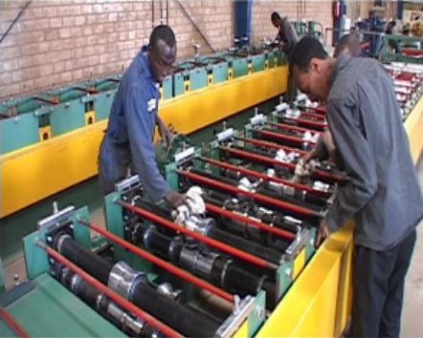
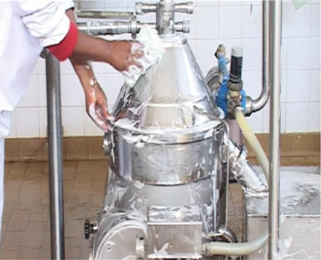

Fig. Workers cleaning machines
Cleanliness for factories and offices is a lot like bathing for human beings. It relieves stress and strain, removes sweat and dirt, and prepares the body and mind for the next day. Cleanliness is important for physical and mental health. Just as you would not bath only once a year, performing shine procedures in a factory should not be an annual activity. Cleaning should be done on daily basis.
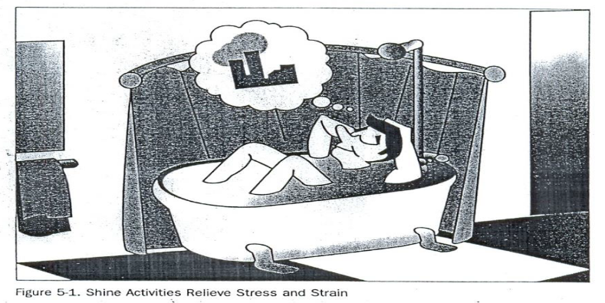
Fig. Shine activities relieves stress and strain
Shine activities can play an important part in bringing work efficiency and safety. Cleanliness is also linked with the morale of employees and their awareness of improvements. Factories or workshops that do not implement the shine pillar suffer the following types of problems:
- Poor morale and inefficiency at work. This could be due to dirty windows that can pass only little light.
- Unable to see or find defects in dark and messy workplaces.
- Slipping and injuries can be created due to puddles of oil and water on the floor.
- Frequent breakdown of machines due to insufficient check-ups and maintenances which in turn leads to late deliveries.
- Low and unsafe operating machines due to insufficient checkups and maintenance which in turn leads to hazard and accidents.
- Defects will result due to shaving cuts getting mixed in to production or assembly processes.
- Shaving cuts can get in to people’s eyes and create injuries.
- Low morale due to filthy work environments.

4.2. Prepare plan for implementing shine activities
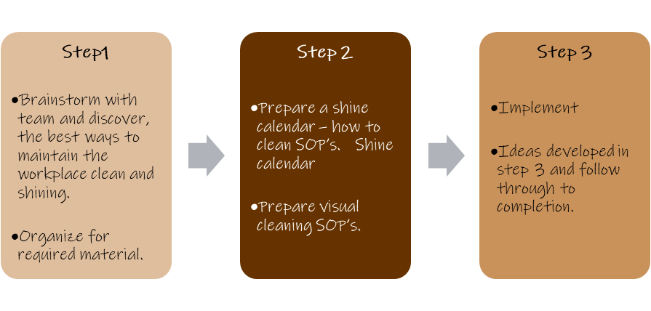
Fig. Steps to implement ‘shine’

4.3. Implement shine activity according to the prepared procedure

4.3.1. Plan and procedures for shine activities
Shine activities should be taught as a set of steps and rules that employees learn to maintain with discipline. The following sample format can be used to prepare a plan for implementing shine activities.

4.3.1.1. Shine activity plan sheet (sample)
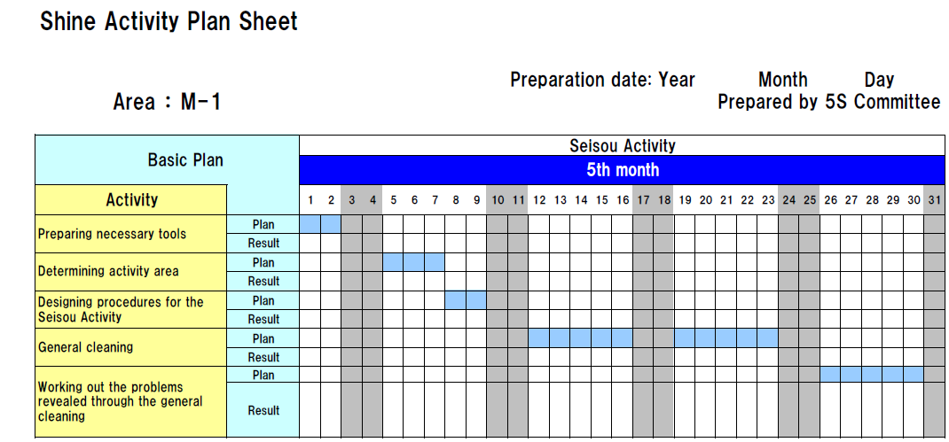

4.3.1.2. Procedures for Set in order
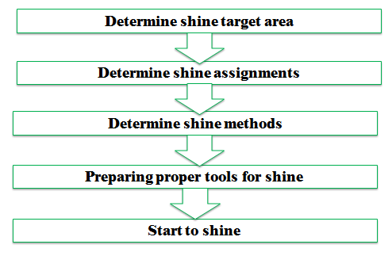
Step 1: Determine shine target areas
Shine target areas are grouped in to three categories: warehouse item, equipment’s and space. Warehouse items include raw materials, procured subcontracted parts, parts made in-house, and assembly components, semifinished and finished products. Equipment includes machines, welding tools, cutting tools, conveyance tools, general tools, measuring instruments, dies, wheels and casters, worktables, cabinets, desks, chairs and spare equipment. Space refers to floors, work areas, walkways, walls, pillars, ceilings, windows, shelves, closets, rooms and lights.
Step 2: Determine Shine Assignments
Workplace cleanliness is the responsibility of everyone who works there. Each employee should be assigned specific area to clean. To do these two methods can be used:
- A 5S Assignment Map – shows all the target areas for shine activity and who is responsible for cleaning them. By marking on 5S Map, the shine assignments can be shown.
- A 5S schedule – shows in detail who is responsible for cleaning which areas on which days and times of the day. Then this schedule should be posted in the work area.
Example 1:
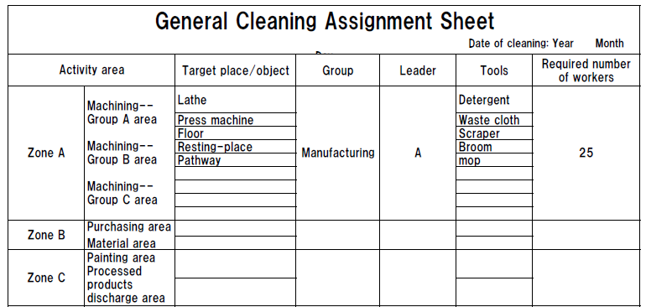
Example 2:
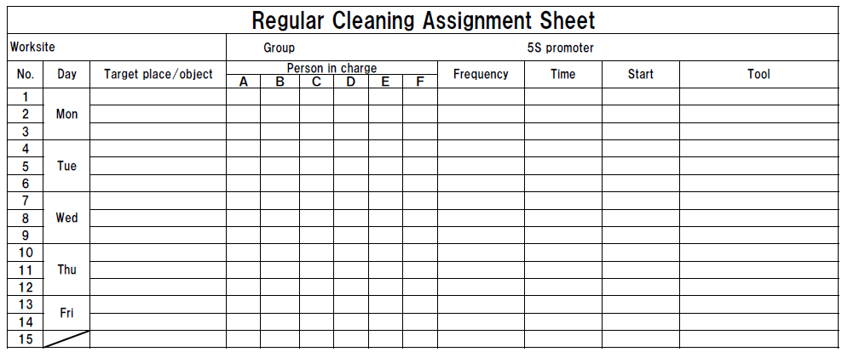
Step 3: Determine shine methods
Shine activities should be a natural part of the daily work. Shine activities and inspection should be done before a shift starts, during work time and at the end of the shift.

Determining shine methods include:
- Choosing targets and tools – define what will be cleaned in each area and what supplies and equipment will be used.
- Performing the five-minute shine – cleaning should be practiced daily and should not require a lot of time.
- Creating standards for shine procedures – people need to know what procedures to follow in order to use their time efficiently. Otherwise, they are likely to spend most of their time getting ready to clean.
Step 4: prepare tools
The cleaning tools should be placed properly or set in order where they are easy to find, use and return.
Step 5: Start to shine
When implementing the shine procedures, consider the following suggestions:
- Be sure to sweep dirt from floor cracks, wall corners, and around pillars.
- Wipe off dust and dirt from walls, windows, and doors.
- Be thorough about cleaning dirt, scraps, oil, dust, rust, cutting shavings, sand, paint, and other foreign matter from all surfaces.
- Use cleaning detergents when sweeping is not enough to remove dirt.
Inspection
As discussed earlier, it is natural to do a certain amount of inspection while implementing shine activities. Once daily cleaning and periodic major cleanups become a habit, we can start incorporating systematic inspection procedures in to the shine procedures. Even when equipment in the workplace appears to function normally, it may be developing many problems. Always when machines or other equipment begin to show sign of minor, sporadic malfunctions, the operators not the maintenance people notice it first. Therefore, it is important to consider the operators information about the equipment.

The following types of equipment problems frequently exist in factories:
- Oil leaks from the equipment on to the floor.
- Machines are so dirty that operators avoid touching them.
- Gauge displays and other indicators are too dirty to be read.
- Nuts and bolts are either loose or missing.
- Motors overheat.
- Sparks flare from power cords.
- V-belts are loose or broken.
- Some machines make strange noises.
Daily cleaning or inspection can help to find these problems and solve them.
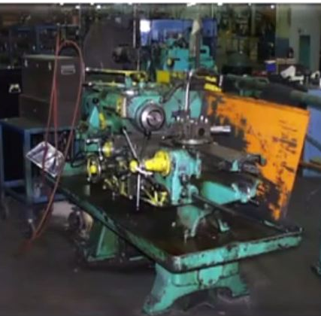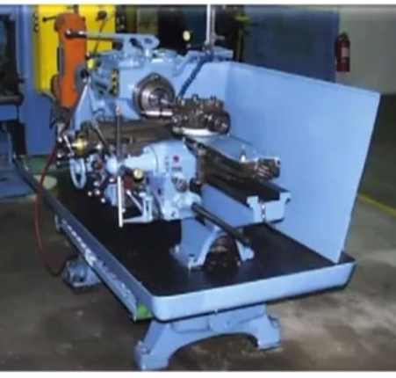
Fig Before shine fig. After shine

Inspection steps
The steps of inspection and shine procedures are parallel. But the steps of inspection give greater emphasis on the maintenance of machines and equipment. These steps are:
Step 1: Determine inspection targets
The targets for inspection are similar to the targets of shine activities. These include machines, equipment, jigs, dies, cutting tools and measuring instruments.
Step 2: Assign inspection activities
In principle, the people who carry out inspection on a particular machine should be the same people who operate the machine. But most often one person can operate several machines at a time (as in multi-process handling). In this case, it is good to involve line supervisors and group leaders in the inspection duties. Once inspection activities are assigned, they have to be written up on a large signboard for the workshop or on small signboards that are attached to each target machine.
Step 3: Determine inspection methods
First all of the items to be inspected should be listed then an inspection checklist should be prepared based on the listed inspection items. The following shows an example of an inspection checklist.

Table: Sample of inspection checklist
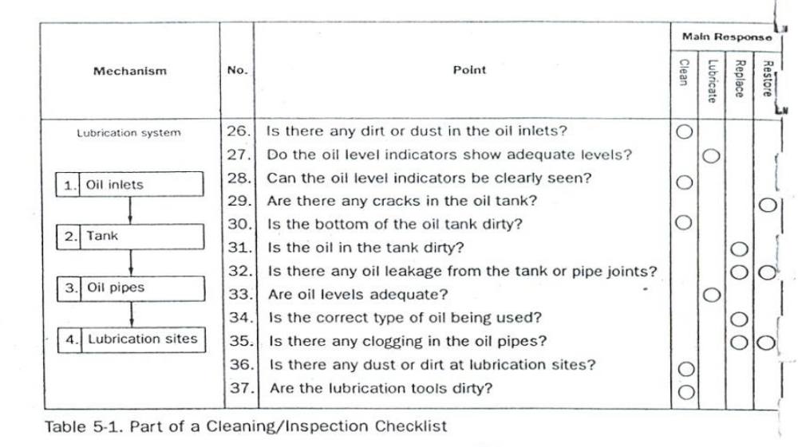
Step 4: Implement inspection
When implementing inspection, use all your senses to detect abnormalities. Inspection is not simply a visual activity. There are some ways to detect abnormalities. These are:
- Look closely at how the machine works and watch for slight defects (e.g., oil leakage, debris scattering, deformation, wear, warping, mold, missing items, lopsidedness, inclinations, color changes).
- Listen closely for changes in the sounds the machine makes while operating (e.g., sporadic sounds, odd sounds).
- Use your nose to detect burning smells or other unusual odors (e.g., burning rubber)
- Touch the machine where it is safe during operation and during downtime to detect deviations from normal conditions (e.g., strange vibrations, wobbling, looseness, excessive heat, shifting).
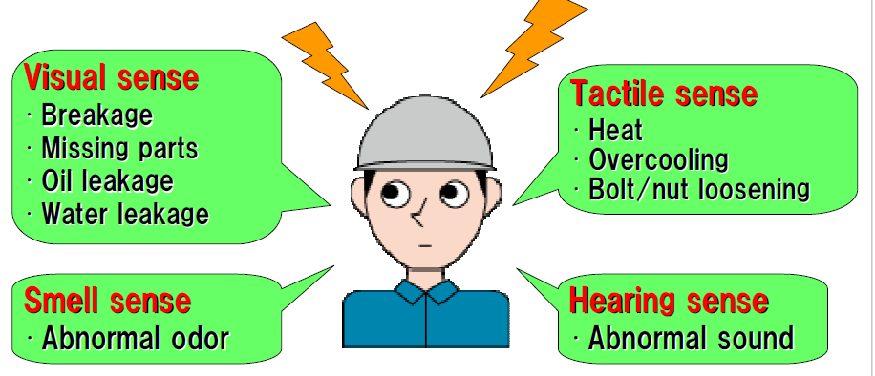
Step 5: Correct equipment problems
All equipment abnormalities or slight defects should be fixed or improved. There are two approaches to do these:
Instant Maintenance: whenever possible, an operator should immediately fix or improve a problem he or she discovers during inspection. But the operators should know what level of maintenance work they can handle by themselves and immediately.
Requested Maintenance: In some cases, a defect or problem may be difficult for the operator to hand alone and immediately. In this situation, the operator should attach a maintenance card to the site of the problem in order to make it visible. He or she can also issue a maintenance Kanban to request help from the maintenance department. It is also good to log requested maintenance on to a checklist of needed maintenance activities. Once a requested maintenance is taken care and its result confirmed, the activity should be checked off in the ‘confirmation’ column of the checklist. The maintenance card should then be retrieved from the machine where it is attached.
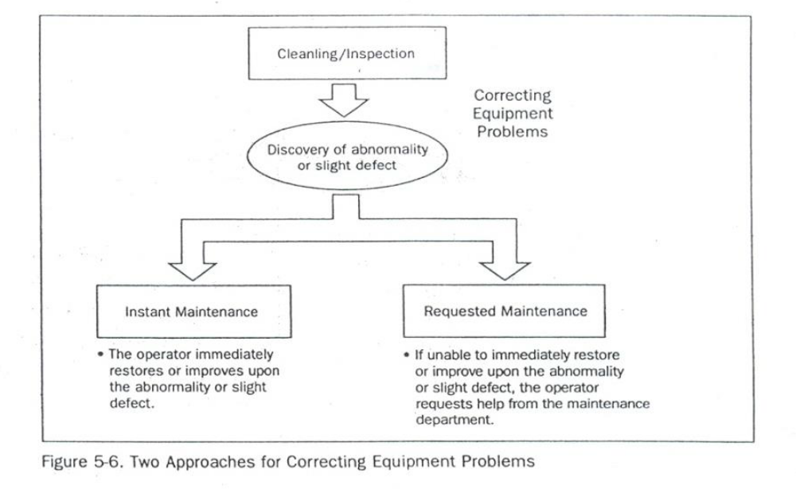
Fig. Two approaches for solving equipment problems

4.4. Conduct regular shinning activities.
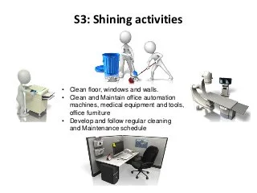
Fig. Shining Activities

Self-Check - 4 | Written Test
Instructions: Answer all the questions listed below. Illustrations may be necessary to aid some explanations/answers.

Give definition of the third pillar shine. (2 points)

What problems occur in a workshop if shine is not implemented? (8 points)

What are the steps/procedures for implementing shine? (5 points)

What are the two methods used to assign shine activities to employees? (2 points)

What are the most frequent problems of equipment/machines? (4 points)

List the steps of inspection. (5 points)

How do you detect abnormalities in a workplace or machine? (4 points)
Note: Satisfactory rating - 15 points Unsatisfactory - below 15 points
You can ask you teacher for the copy of the correct answers.

Score = ___________
Rating: ____________

Name: _________________________ Date: _____________________

OPERATION TITLE: - APPLY 5S
PURPOSE: - When practicing Shine, employees maintain the currently organized workspace, clean machines and equipment, and ensure safe working condition.
Operation Sheet: - implementing Shine
- Procedures for implementing Shine
- Prepare plan for shine
Sample plan for shine
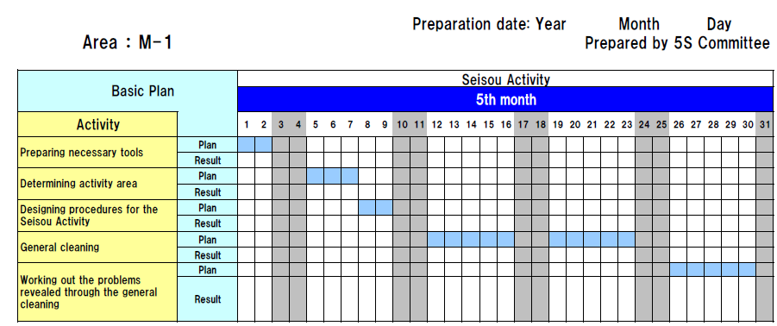
Sample format for general cleaning assignment
Sample format for regular cleaning assignment

- Steps in inspection
Step 1: Determine inspection targets
Step 2: Assign inspection activities
Step 3: Determine inspection methods
Step 4: Implement inspection
Step 5: Correct equipment problems

LAP Test: - Practical Demonstrations
Name: _____________________________ Date: ________________
Time started: ________________________ Time finished: ________________
Instructions: Given necessary templates, workshop, tools and materials you are required to perform the following tasks.
Task 1: Using the given template, prepare a plan for shine activity in your workshop.
Task 2: Following the shine procedures, perform shine activity in the assigned workshop.
Task 3: Following the steps for inspection, perform inspection of equipment, tools and machines in your workshop.

Unit Five: - Standardize 5S
This unit is developed to provide you the necessary information regarding the following content coverage and topics:
- Prepare plan for the implementation of standardize
- Prepare and use tools and techniques to standardize 5s
- Checklists follow for standardize activities and reported to relevant personnel.
- Keeping workplace to the specify standard.
- Problems avoid by standardizing activities.
This guide will also assist you to attain the learning outcomes stated in the above coverage. Specifically, upon completion of this learning guide, you will be able to:
- Prepare plan for the implementation of standardize
- Prepare and use tools and techniques to standardize 5s
- Checklists follow for standardize activities and reported to relevant personnel.
- Keeping workplace to the specify standard.
- Problems avoid by standardizing activities.

Unit Five: Standardize 5S

Definition of the Fourth Pillar
Standardize, the fourth pillar of our visual workplace, differs from Sort, Set in Order, and Shine. This is because it is the method- you use to maintain the first three pillars of 5S. Buildingon this definition, we may define Standardize the result that exists when the first three pillars-Sort, set in order and Shine-are properly maintained.

5.1.1. Benefits from Standardize
1. Lead to workplace standardization
    - prevent setbacks in the first three pillars
    - Make implementing them a daily habit
    - Ensure that all the three pillars are maintained in their fully implemented state.
2. Lead to work standardization
- Muda elimination
- Quality improvements
- Cost improvements
- Delivery time improvements
- Process improvements

Prepare plan for the implementation of standardize
Here are some of the problems that result when we do not implement Standardization well:
- Conditions go back to their previous and undesirable levels even after a companywide 5S implementation campaign.
- At the end of the day, piles of unneeded items are left from the day's production and lie scattered around the production equipment.
- Tool storage sites become disorganized and must be put back in order at the end of the day.
- Cutting shavings constantly fall on the floor and must be swept up.
- Even after implementing Sort and Set in order, it does not take long for office workers to start accumulating more stationery supplies than they need.
These problems and others reveal backsliding in gains made from implementing Sort Set in Order, and Shine Activities. The basic purpose of the Standardize pillar is to prevent setbacks in the first three pillars, to make implementing them a daily habit, and to make sure that all three pillars are maintained in their fully implemented state.

How to Implement Standardize
The three steps to making Sort, Set in Order and Shine activities (the three pillars or 3S) a habit is:
Step 1: Decide who is responsible for which activities with regard to maintaining3S conditions.
Step 2: To prevent backsliding, integrate 3S maintenance duties in to regular work activities.
Step 3: Check on how well 3S conditions are being maintained.
As you read this section, you will discuss some of the tools for implementing Standardize of the Sort, Set in Order, and Shine activities. This is because in order to standardize we must use these same tools in a more systematic way to make sure that the first three pillars are maintained.

Prepare and use tools and techniques to standardize 5s
Common Tools and Techniques to standardize 5S are:

- 5S Job Cycle Charts
- Visual 5S
- The Five Minute 5S
- Standardization level checklist
- 5S checklist
- The five Whys and one How approach(5W1H)
- Suspension
- Incorporation
- Use Elimination

The Three Steps to Make the 3S Activities a Habit/Standardize using the Tools and Techniques of 3S Standardization
- Assign 3S Responsibilities
When it comes to maintaining three pillar conditions, everyone must know exactly what they are responsible for doing and exactly when, where and how to do it. If people are not given clear 3S job assignments based on their own workplaces, the Sort, Set in Order, and Shine activities will not have much meaning. Similarly, clear 3S instructions must be given to the people who deliver goods from outside suppliers. The delivery sites should be clearly marked and a 5S Map posted to show where each supplier's goods are to be unloaded. At each unloading site, signboards should make it clear whose things go where and in what amount. The suppliers should be made responsible for maintaining 3S conditions at their own unloading sites and encouraged to join in full 5S implementation.
Tools for assigning 3S responsibilities include:
- 5S Maps
- 5S schedules
- 5S job cycle charts, which list the 5S jobs to be done in each area, and set frequency cycle for each job (see the figure below). In the example shown in the figure below, 5S duties are sorted out according to the first three pillars and the scheduling cycle. In the figure, code letters are used for the various cycle periods:

A is for 'continuously," B for "daily (mornings)," C for "daily (evenings), " D for "weekly," E for "monthly" and F for "occasionally." Each 5S job assignee can then use these charts as 5S Checklists. This particular example shows clearly who is responsible for each job, which area, what to do, and when to do it.
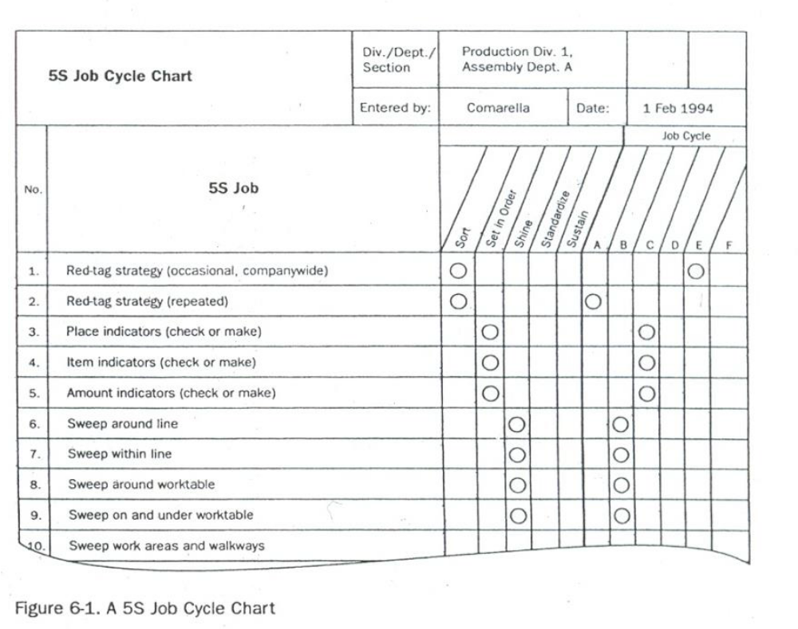
Figure: A 5S Job Cycle Chart

2. Integrate 3S Duties into Regular Work Duties
If people carry out three pillar maintenance duties only when they see three pillar conditions slipping, then the five-pillar implementation has not yet taken root. Maintenance must become a natural part of everyone’s regular work duties. In other words, the five pillars -centered on maintaining3S conditions-must be part of the normal work flow. We sometimes refer to this as "5S line integration" or establishing a five pillars flow. Visual 5S and Five-Minute 5S are two approaches that help make maintenance work part of the everyday work routine.

Visual 5S
The Visual 55 approach makes the level of five pillar conditions obvious at a glance. This is particularly helpful in factories that handle a great variety and number of materials.
The main point of Visual 5S is that anyone should be able to distinguish between abnormal and normal conditions at a glance.
As a factory example, consider a drill-press process where Set in order has been applied so that the position and amount of each finished work piece is clearly indicated. As an additional visual aid, the place where the last batch item goes can be marked with a thick red line to indicate that it is time to stop and send the batch to the next process.

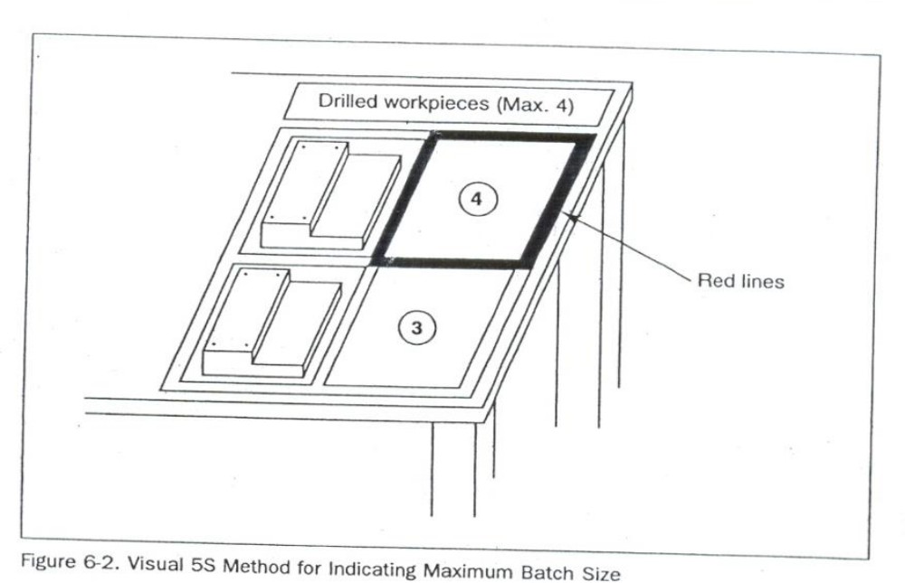
Figure: Visual 5s Method for Indicating Maximum Batch Size
Five-Minute 5S
When using the Visual 5S approach, instant visibility can act as a trigger for taking immediate three pillar action (Sort, Set in Order, and Shine activities) against the discovered abnormalities (i.e., overproduction, disorder, and contamination). We must also deal with the question of how skillfully and efficiently these actions are carried out. Instead of following two hours for removing all of the cutting shavings from the floor, we can set up a half-hour or a one-hour Shine procedure that accomplishes the same task. The term "Five-Minute 5S" is a loose one-the actual time can be three minutes, six minutes, or whatever is appropriate. The point is to make the five-pillar work brief, efficient, and habitual. In figure below shows a signboard that was made as part of a Five-Minute 5 campaign.
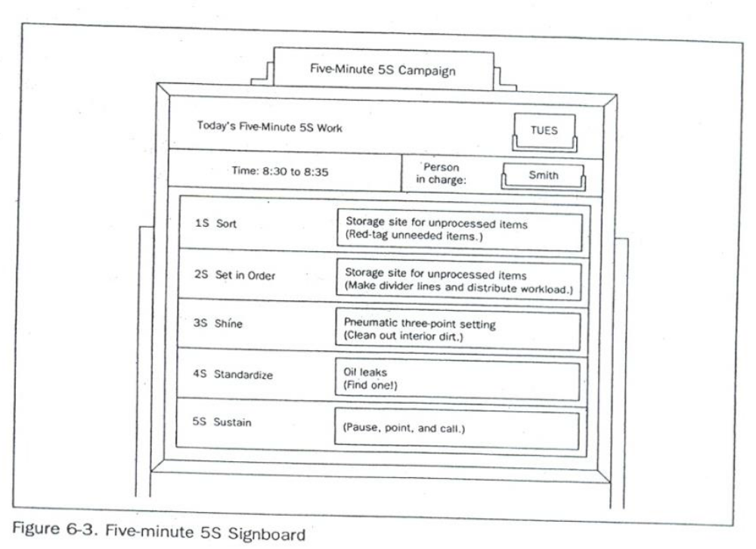
Figure: Five-Minute 5s Signboard

3. Check on 3S Maintenance Level
After we have assigned the three pillar jobs and have incorporated the three-pillar maintenance into the everyday work routine, we need to evaluate how well the three pillars are being maintained. For this, we can use a Standardization-level Checklist as shown in the figure below.
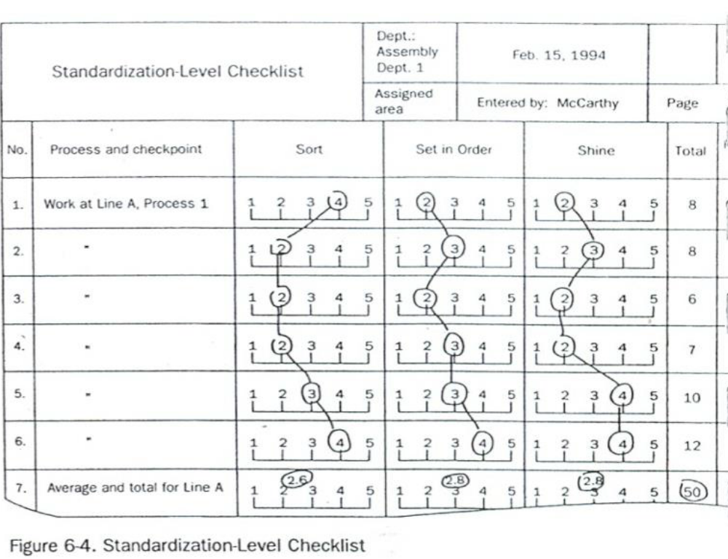
Figure: Standardization Level Checklist

To evaluate the effectiveness of the maintenance activities, the evaluator ranks the Sort, Set in order, and Shine levels on a scale of 1 to 5. Such checklists can be made for specific workshop and/or production processes. One example is shown in the Figure below. 5S Checklists like the one in the figure are used to check five pillar levels in the factory as a whole. When a company implements 5S Month of intensive activities, 5S Checklists should be used to make weekly evaluation of five pillar conditions.

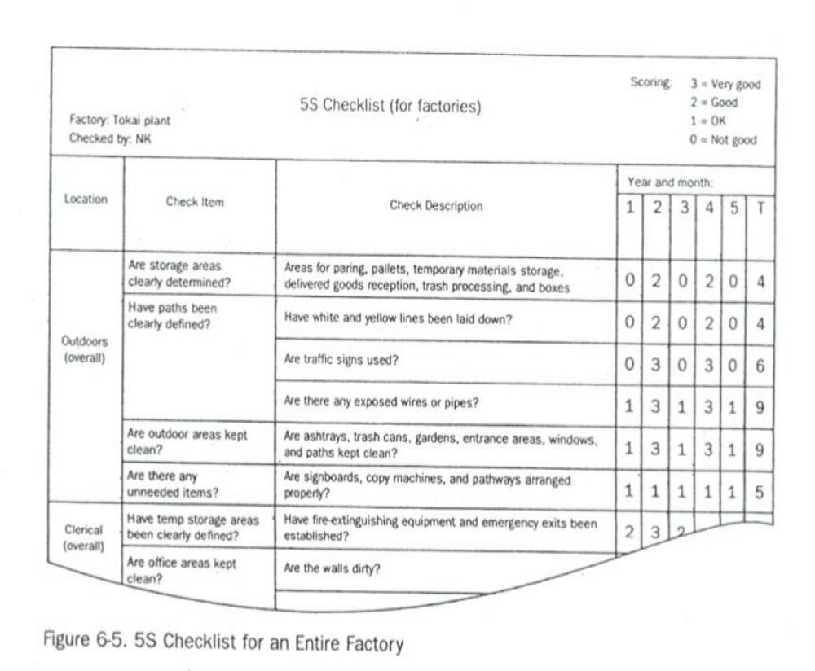
Figure: checklists for an entire factory

Keeping workplace to the specify standard.
The Concept of Prevention
When we find that tools have not been put back correctly, we immediately take care of them. When we find an oil puddle on the floor, we immediately mop it up. Making these actions habit is the foundation of Standardize. However, when the same problems keep on happening over and over again, it is time to take the concept of Standardize to the next level: prevention.
To take this pillar to a higher level, we must ask "why?" Why do unneeded items accumulate (despite Sort procedures)? Why do tools get put back incorrectly (despite Set in order procedure? Why do floors get dirty (despite Shine procedures)? When we ask "why" repeatedly, we eventually find the source of the problem and can address that source with a fundamental improvement. Such improvements can help us develop Unbreakable standardization, which means:
- Unbreakable sorting
- Unbreakable setting in order
- Unbreakable setting shining

Unbreakable  Standardization | = | Unbreakable Sorting  +  Unbreakable Set-in order  +  Unbreakable Shining

Prevent unneeded items from Accumulating (Preventive Sort Procedures)
The Red-Tag Strategy described sorting out unneeded items. This strategy is a visual control method that enables anyone to see at a glance which items are no longer needed. However, we should note that the Red-Tag Strategy is an after-the-fact approach that deals with unneeded items that have accumulated. No matter how often we implement this strategy, unneeded items will accumulate in the interim.

Nowadays, smart companies are shifting from this type of "alter the-fact" sorting to preventive sorting. Preventive sorting means that instead of waiting until unneeded items accumulate; we find ways to prevent their accumulation. We could also call this approach "unbreakable' sorting because once sort procedures have been implemented, having only needed items in the workplace becomes an "unbreakable" condition.
To achieve unbreakable sorting, we must prevent unneeded items from even entering the workplace. These words- «only what is needed" -have a familiar ring to anyone acquainted with the just-in- time (JIT) philosophy and program. To prevent the accumulation of unneeded inventory, we must find a way to procure and produce only those materials that are needed, only when they are needed, and only in the amount needed.

For example, suppose your company is scheduled to produce a certain number of units of a product during a particular month. Ideally, at the beginning of this month, only the parts needed to produce the scheduled number of units would be delivered to you from your suppliers. For any given part, your company might even receive the part in several deliveries, depending on the type of part and the delivery considerations.
Receiving parts just-in-time for production rather than storing large quantities of parts in advance eliminates many of the potential costs associated with maintaining inventory. As well, receiving parts just-in- time is a preventive measure that avoids the accumulation of parts that needed to be sorted.
Prevent Things from Having to Be Put Back (Preventive Set in Order Procedures)
Preventive setting in order means keeping set in order procedure from breaking down. To achieve preventive setting in order, we must somehow prevent the inefficiency that results from the lack of orderly control of any specific item. There are two ways to do this: (1) make it difficult to put things in the wrong place and (2) make it impossible to put things in the wrong place.

The first method relies heavily on discipline and visual controls. Clearly marked storage sites show at a glance what goes where and in what amount. When it is obvious what goes where and in what amount. When it is also obvious that things are not put back properly. As people practice returning things, such visual setting in order becomes habitual. This condition supports setting in order that is difficult to break. However, there is still a big difference between setting in order that is difficult to break and setting in order that is unbreakable. 'Why settle for the first when the second is possible? But how we achieve unbreakable setting in order?
The 5 Whys and 1How (5W1H) Approach
We begin by asking "why?" until we identify the underlying causes- for every answer we gel we must ask "why" again. Usually we ask "why" at least five times to get to the root of the problem. When we do find the underlying cause, we ask "how" we call fix it. Accordingly, this method is called the "5W1H' approach.
When we ask "why" setting in order is breakable, we find that one answer is because people make mistakes putting things back. At this point, we need to identify what types of items are not being returned correctly. Once we identify this, the question is how to achieve unbreakable setting in order by making it impossible to return them to the wrong place. If we can somehow eliminate the need to return items at all, we can achieve unbreakable setting in order.
Three techniques for doing this are:
- Suspension
- Incorporation
- Use elimination.

Suspension
In the Suspension technique, tools are literally suspended from above, just within reach of the user. Figure above shows this method in practice. Here a weighted pulley device is used to suspend tools from an overhead rack. When the operator finishes using the tool, he merely releases it and it automatically returns to its proper storage place.
While this technique does not eliminate the need to return items to a specific place, it does effectively eliminate the need for people to return them. People may make mistakes in returning things, but suspension devices do not. This technique achieves unbreakable setting in Order.
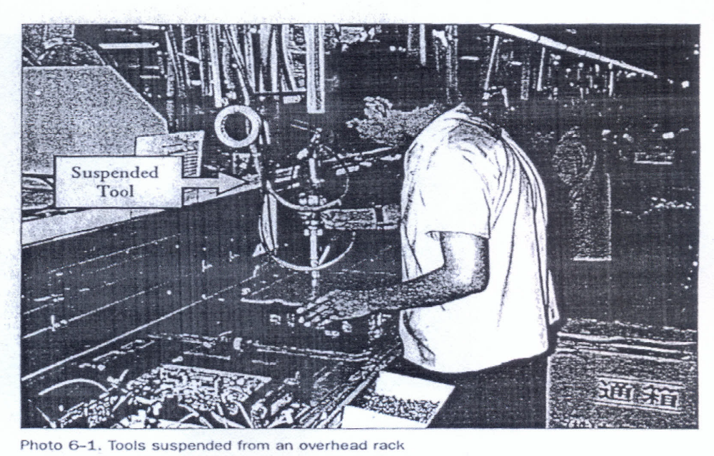
Figure: Tools Suspended from an Overhead Rack
Incorporation
Incorporation means creating a flow of goods or operations in a factory process in which (1) jigs, tools, and measuring instruments are smoothly integrated into the process and (2) such devices are stored where they are used and therefore do not have to be returned after use. The figure below shows an example where a measuring gate has been incorporated into a cutting process for an automobile part. The measuring gate catches any pieces that have not been machined to the correct height. This measuring procedure is an example of "mistake-proofing’' (or poka-yoke). The incorporation of the measuring gate into the cutting process means that its storage place is also its place of use. It is therefore used (for full-lot inspection) without having to be put back anywhere.
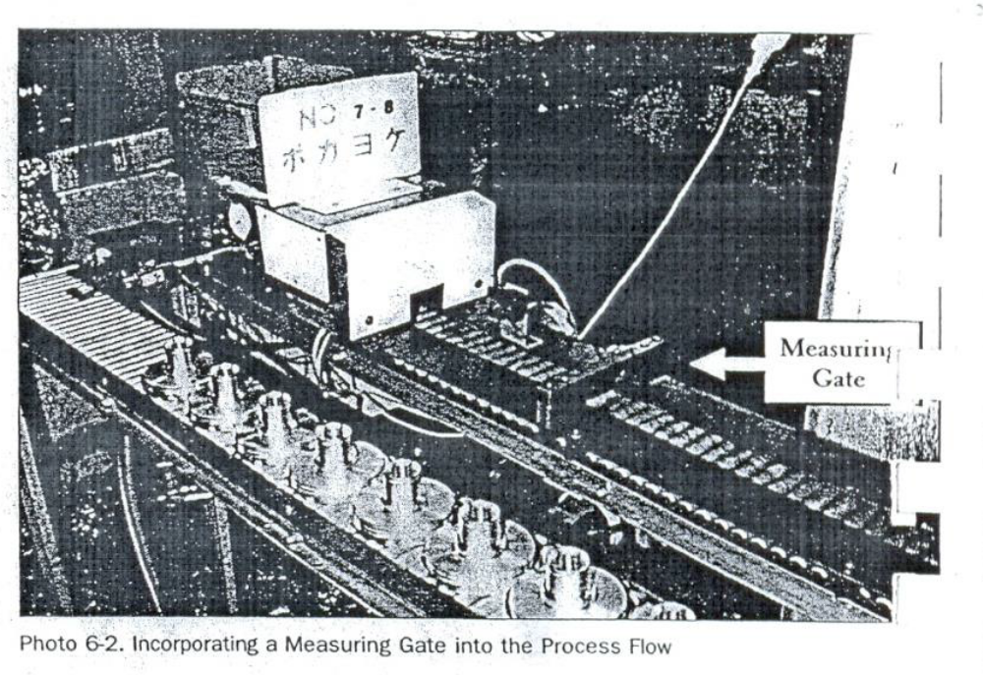
Figure: Incorporating a Measuring Gate into the Process Flow
Use Elimination
Suspending or incorporating jigs, tools, or measuring instruments effectively eliminates theneed to return them after each use. However, these items are still being used. The question is whether there is some way to serve the function of the tool without using the jig, tool or measuring instrument. A set-in order approach that eliminates the use of a particular jig, tool or measuring instrument is in fact unbreakable setting in order.

There are three techniques for eliminating the use of certain tools:
- Tool unification
- Tool substitution
- Method substitution
Tool unification
Tool unification means combining the functions of two or more tools into a single tool. It is an approach that usually reaches backto the design stage. For example, we can reduce the variety of die designs to unify dies or make all fasteners that require a screw-driver conform to the same kind of screw-driver, flat-tip or Phillips.
Tool substitution
Tool substitution means using something other than a tool to serve the tool's function, thereby eliminating the tool. For example, it is sometimes possibleto replace wrench-turned bolt withhand-turned butterfly-grip bolts, thereby eliminating the needfor a wrench.
Method substitution
If we substitute ordinary wrench-turned bolts with hand-turned butterfly-grip bolts, we have eliminated the wrench, but we have not eliminated the method (bolt fastening).
Bolt fastening is just one way to fasten things. Fastening pins, clamps and cylinders can also be used for this purpose. We mayfind we can improve efficiency even more by replacing one method with another. This is "method substitution."

Problems avoid by standardizing activities.

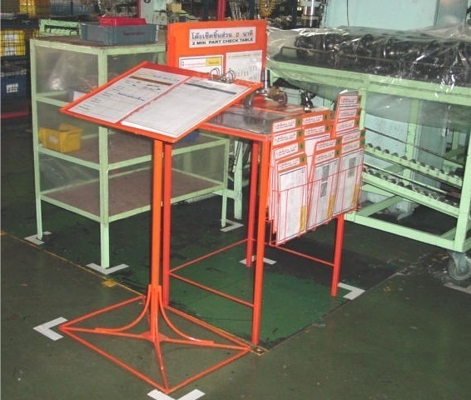
fixed position Indications

Indications on Shelves

C4
C3
C2
C1
C7
C6
C5
B4
B1
B2
B3
B5
B6
B7
A4
A5
A6
A7
A1
A2
A3
A4
A5
A6
A7
A1
A2
A3
B4
B1
B2
B3
B5
B6
B7
C4
C3
C2
C1
C7
C6
C5

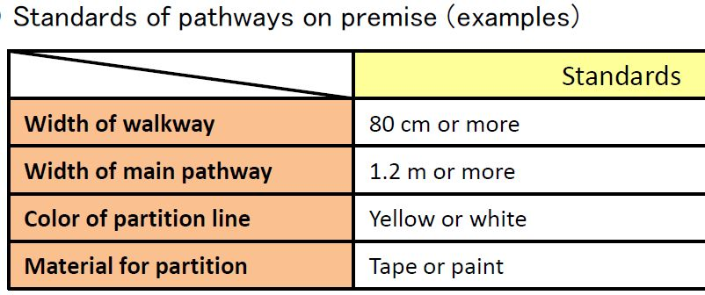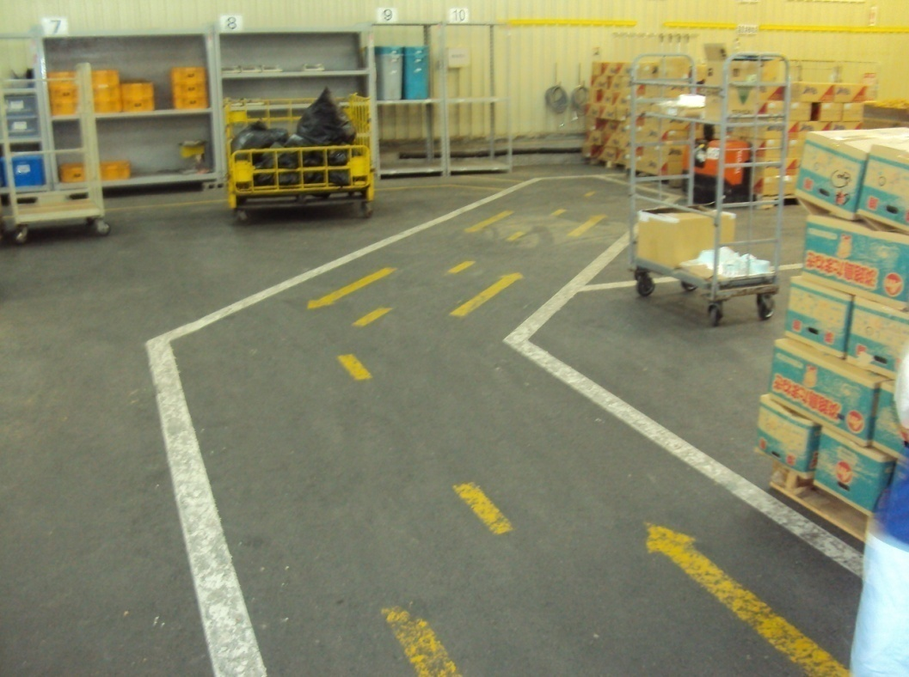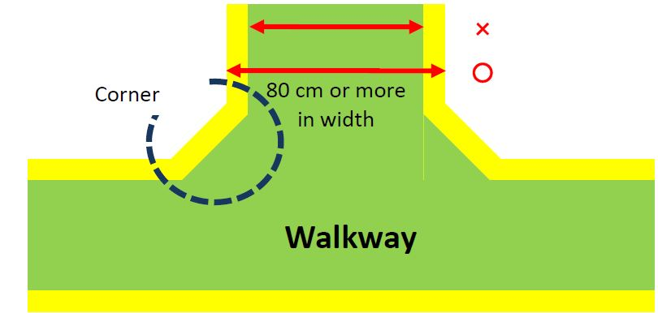

Prevent Things from Getting Dirty (Preventive Shine Procedures)
Preventives shine Procedures will prevent things from getting dirty to begin with. Anyone has participated in 5S implementation can tell you that the initial cleanup is very hard work. To minimize the drudgery of cleaning up, the key is to treat contamination problems at their source. The 5Why approach can be applied in figure out why dirt is being generated, and how this problem can be fixed. For example, instead of mopping up oil puddles, figure out where the oil is leaking from and repair the leak.
- Question: Why mop the floor every day?
Answer: Because oil collects on the floor.
- Question: does oil collect on the floor every day?
Answer: Because there's a leak from the drill press machine
- Question: Why is there a leak from the drill press machine?
Answer: Because oil is leaking from a valve.
- Question: Why is oil leaking from a valve?
Answer: Because it's broken.
- Question: Why hasn’t the valve been replaced?
Answer: because we didn’t notice it was broken
- Question: How can we coordinate getting the valve fixed?
Answer: The maintenance team will order the part and the operator will replace it.
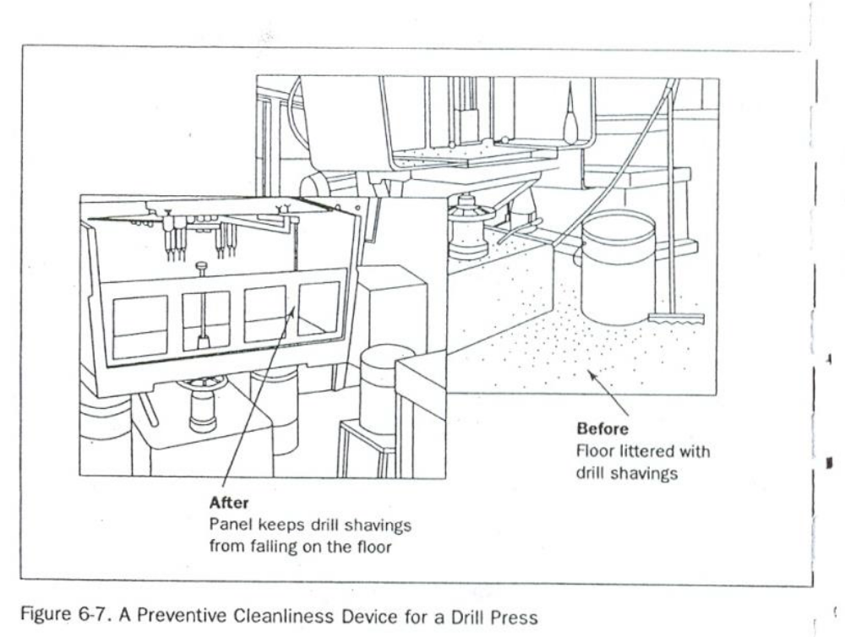
Figure: A Preventive Cleanliness Device of a Drill Press

Self-Check -5 | Written Test

Directions: Answer all the questions listed below.
- What is the result of implementing 3S without standardization? (4 points)
- List at least five tools and techniques used to standardize the 3S.(2 points)
- What are the tools used to assign 3S responsibilities? (3 points)
- How the 5 whys and 1 how (5W1H) approach are used to sustain the 3S? (6 points)
- What is suspension in terms of sustaining of the 3S? (3 points)
- Define incorporation. (3 points)
- Describe Use Elimination in sustenance of the 3S. (3 points)
- What will result implementing 3S without standardization? (4 points)

Note: Satisfactory rating – 14 points Unsatisfactory - below 14 points
You can ask you trainer for the copy of the correct answers.
Score = ___________
Rating: ____________

Name: _________________________ Date: _______________

OPERATION TITLE: - APPLY 5S
PURPOSE: - standardized work forms the baseline for kaizen or continuous improvement. As the standard is improved, the new standard becomes the baseline for further improvements, and so on. Improving standardized work is a never-ending process.
Operation Sheet: -Procedures in Implementing Standardize
Sequence of Standardize
- Planning for Standardization
- Assign 5S Responsibilities for everyone in the work place by using the tools: such as 5S Maps, 5S schedules, 5S job cycle charts
- Integrate 5S Duties into Regular Work Duties by using the two approaches: visual 5S and five- minute 5S
- Check on 5S Maintenance Level by using Standardization-level Checklist and 5S checklist and make maintenance/correction on back sliding the 5S.
- Prevention of back sliding of the first three pillars by using 5W1H approach, suspension, incorporation and use elimination.

LAP Test: - Practical Demonstration
Name: _____________________________ Date: ________________
Time started: ________________________ Time finished: ________________
Instructions: Given necessary templates, workshop, tools and materials you are required to perform the following tasks within -------- hours.
Task 1: Prepare standard to the sort activities in your workplace.
Task 2: Prepare standard to the set-in order activities in your workplace.
Task 3: Prepare standard to the shine activities in your workplace.
- Consider the:
    - OHS procedures

Unit Six: - Sustain 5S
This learning guide is developed to provide you the necessary information regarding the following content coverage and topics:
- Prepare plan for the implementation of sustaining 5S
- Implement tools and techniques for sustaining 5s
- Workplace standard and sustainability of 5S techniques
- Clean up workplace after completion.
- Identify situations to compliance standards actions.
- Improvements recommend to lift compliance in the workplace
- Follow checklists to sustaining activities and report to relevant personnel.
- Avoid problems by sustaining activities.
This guide will also assist you to attain the learning outcomes stated in the cover page. Specifically, upon completion of this learning guide, you will be able to:
- Prepare plan for the implementation of sustaining 5S
- Implementtools and techniques for sustaining 5s
- Workplace standard and sustainability of 5S techniques
- Clean up workplace after completion of job and before commencing next job or end of shift
- Identify situations to compliance standards actions.
- Improvements recommend to lift compliance in the workplace
- Follow checklists to sustaining activities and report to relevant personnel.
- Problems avoided by implementing sustaining activities

Unit Six: - Sustain 5S

6.1. Definition of the Fifth Pillar
The fifth pillar is Sustain. In the context of the five pillars, to sustain means to make a habit of properly maintaining correct procedures. In your life in general, what do you mean when you talk about sustaining something? Usually, you think of it as drawing on something from inside yourself in order to maintain a course of action-even when forces in your life challenge in this effort.

6.1.1. Benefits of Sustaining 5S
Why Sustain Is Important
Usually, you commit yourself to sustain a particular course of action because the rewards for keeping to the course of action are greater than the rewards for departing from it (see figure above). Viewed another way, the consequences of not keeping to the course of action may be greater than the consequences of keeping to it.
For example, suppose you want to start an exercise program say you decide you want to work out at a gym three times a week. You probably have difficulty sustaining this course of action. This is because forces in your life, such as limits on your time and energy as well as the power of inertia, challenge this plan.
However, if the rewards of sticking to your exercise program (for example, feeling and looking better) are greater than the rewards of not sticking to it (for example, having more time for other things that you need to do), your commitment will increase and you will probably sustain this program over lime.

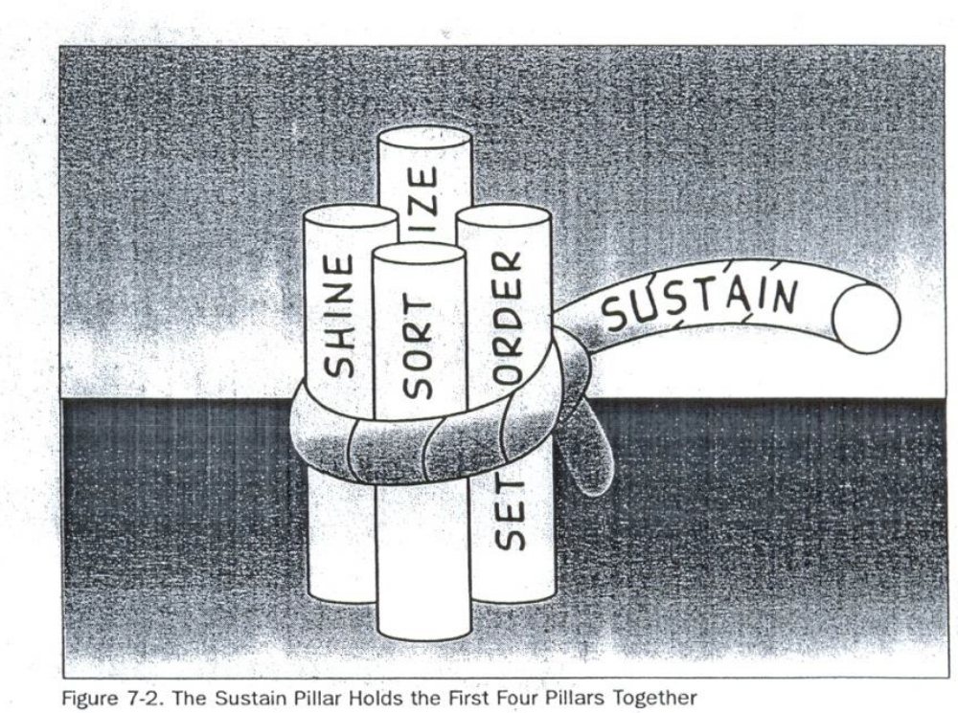
Figure: The sustain pillar holds the first four pillars together.

6.2. Prepare plan for the implementation of sustaining 5S
The same principle applies in your 5Simplementations. Without your commitment to sustain the benefits of the 5S activities, implementation of the first four pillars quickly falls apart (see Figure above). However, if the rewards of implementing the first four pillars are greater for you than the rewards of not implementing them, sustaining them through the fifth pillar should be some- thing you take to naturally.
So, what are the rewards for you of implementing the first four pillars? You've probably discovered them for yourself at this point. Implementation of the first four pillars should make your workplace mare pleasant to work in, your job more satisfying and communication with your coworkers easier. it should also make your work more efficient and of better quality, which will hopefully lead to reward of your efforts by your company. It' true that that the five pillars take time to implement, but this investment of time will bring a great return, for both you and your company.

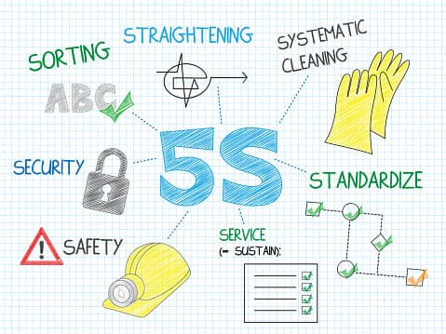

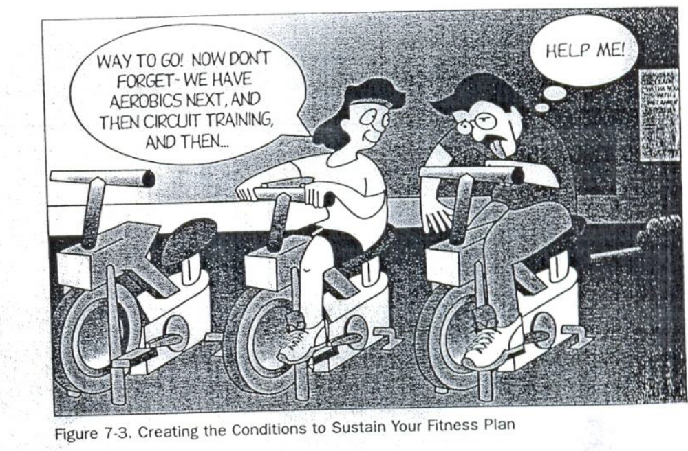
Figure: creating the conditions to sustain your fitness plan

How to Implement Sustain
Creating Conditions to Sustain Your Plans
The implementation of the sustain pillar is different from that of the sort, set in order, shine, or standardize pillars in that the results are not visible and cannot be measured. Commitment to it exists in people's hearts and minds and only that have shown its presence. Because of this it cannot exactly be “implemented” like a technique, However, we can create conditions that encourage the implementation of the sustain pillar.
For instance, going back to our exercise program example, how could you create conditions in your own life that would encourage sustaining your plan to work out at a gym three time a week? You might:
- Join a gym with a friend so you can work out together and encourage each other (see Figure above).
- Create a workout schedule with your friend.
- Make a plan with your spouse to eat dinner later three nights a we so you can go to the gym after work.
- Get extra sleep on the nights before you work out, so that you will not be too tired by the end of the day to follow through with your exercise plan.
These conditions would make it easier for you to sustain your schedule for exercising at the gym three times a week.
Similarly, you and your company can create conditions or structure that will help sustain to the five pillars. The types of conditions that are most useful for this are:
- Awareness. You and your coworkers need to understand what the five pillars are and how important it is to sustain them.
- Time. You need to have or make enough time in your work schedule to perform 5S implementation.
- Structure. You need to have a structure for how and when 5S activities will be implemented.
- Support. You need to ha e support for your efforts from management in terms of acknowledgement, leadership, and resource
- Rewards and Recognition. Your efforts need to be rewarded.
- Satisfaction and Excitement. The implementation of the five pillars needs to be fun and satisfying for you and the company. This excitement and satisfaction get communicated from person to person, allowing 5S implementation to build as it involves more people.

Roles in Implementation
In order to sustain 5S implementation in your company, both you and the company management have important roles to play. Part of this role involves creating the conditions that sustain 5S activities. The other part involves demonstrating a commitment to 5S yourself.
The Role of Management
The supervisors and managers in your company have a major role to play in ensuring the success of the five pillars by creating conditions that help sustain 5S activities. This role includes:
- educating you and your coworkers about 5S concepts, tools, and techniques;
- creating team for implementation
- allowing time for implementation and creating schedules for this work
- Providing resources for 5S implementation. such as supplies-s
- acknowledging and supporting 5S efforts
- Encouraging creative involvement by all workers, listening to their ideas, and acting on them.
- creating both tangible and intangible rewards for 5S efforts
- promoting ongoing 5S efforts
Your supervisors and managers also have an important role to play in implementing the fifth pillar in their own work. When they sustain the first four pillars, they perform three very important functions.
- improving the quality and efficiency of their own work
- teaching by example
- demonstrating the company's commitment to 5S implementation.
Yours Role
Similarly, you have an important role to play in creating the conditions that Sustain 5S activities. This role includes:
- continuing to learn more about 5S implementation
- helping to educate your coworkers about the 5S
- being enthusiastic about 5S implementation
- helping to promote 5S implementation efforts
You also have an important role to play in order to sustain 5S activities in your own work. This role includes:
- taking the initiative to figure out ways to implement the five pillars in your work on a daily basis
- asking your supervisor or manager for the support or resources you need to implement the five pillars
- participating fully in company 5S implementation efforts
- bringing to your supervisor or manager your creative ideas for promoting or implementing the five pillars
- participating fully in company 5S promotion efforts
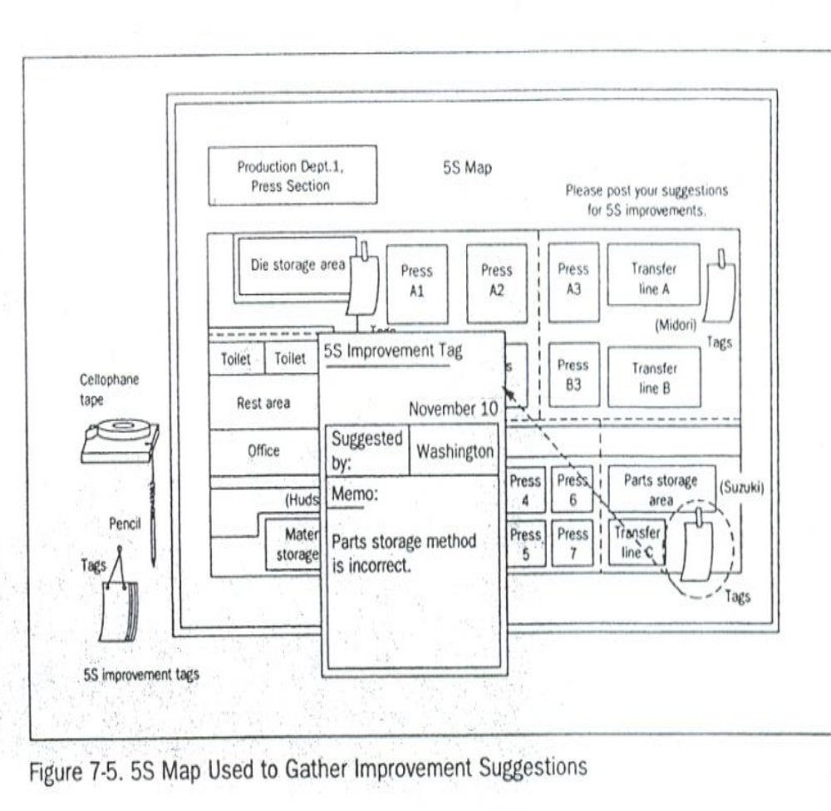
Figure: 5S map used to gather improvement suggestions

Implement tools and techniques for sustaining 5s

Common Tools and techniques to sustain 5s are:
There are many tools and techniques your company can use to help sustain commitment to 5S implementation. We offer these below so you willbe aware of them. At some point in your 5S implementation work, you may be called upon to use or even coordinate the use of these techniques. These are:

- 5S slogans
- 5S posters
- 5S photo exhibits & storyboards
- 5S newsletter
- 5S maps
- 5S pocket manuals
- 5S department/benchmarking tours
- 5S months
- 5S audit
- Awarding system
- Big cleaning day
- Patrolling system
- Top management Patrol
- 5SCommittee members and Promotion office Patrol
- Mutual patrol
- Self-patrol
- Checklist patrol
- Camera patrol

5S Slogans
5S Slogans communicate the themes of the five-pillar campaign in your company. They are most effective when they are suggested by you and your coworkers. They can be displayed on buttons, stickers, flags, or posters.
- It encourages all the participants.
Samples of slogan
“Refresh yourself and workplaces by 5S activity.”
“Let's maintain current 5S activity and KAIZEN for tomorrow”
“We polish “Our Minds” as well as our factories”

5S Posters
Posters displaying 5S Slogans or descriptions of 5S activities can be posted throughout the workplace. They can serve to remind everyone of the importance of the five pillars, or to communicate the results or status of 5S activities.
Samples of poster
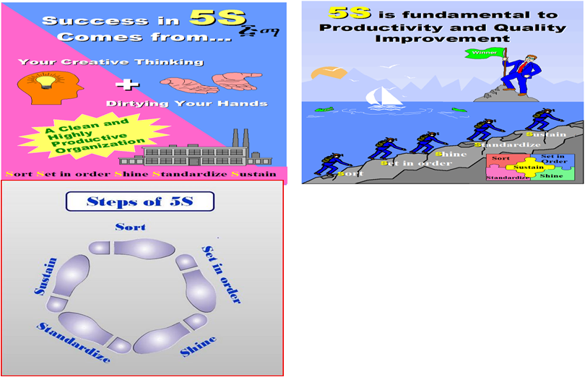
5S Photo Exhibits and Storyboards
When it comes to communication about 5S implementation, the old saying that a "picture is worth a thousand words" is definitely true. Photo Exhibits and Story boards showing the before and after of 5S implementation activities are powerful tools for promoting the five pillars. Photos and Storyboards can also communicate the status of five pillar activities.

5S Newsletters
55 Newsletters are in-house news bulletins centered on five pillar topics. They carry factory reports on 5S conditions and activities. 5S Newsletters are most effective when issued on a regular basis, perhaps once or twice a month and at staff meetings.
5s Maps
5S Maps can also be used to get employees involved in five pillar improvement on an ongoing basis. 5S improvement Maps should be hung in a central location with suggestion cards attached so anyone can suggest improvements.
5s Pocket Manuals
A 5S Pocket Manual can be created that contains five pillar definitions and descriptions, and is small enough to fit into the pocket of work clothes. Shop floor workers, supervisors, and managers can all use SS Pocket Manuals for easy reference to the 5S essentials.
5s Department Tours
When one department in a company has implemented the five pillars successfully, it can serve as a model area for other departments to come visit. Since "seeing is believing," this technique is extremely effective for promoting 5S implementation throughout a company.
5s Months
Companies should designate two, three, or four months every year as "5S Months.” During these months, various activities such as 5S seminars, field trips, and contests can be carried out of further promote 5S implementation in the company.

5s Audit
  - The purpose of this audit is to outline an approach making 5S a success in industrial as well as our working areas.
  - Enable 5S teams to design and establish a simple, effective and visual workplace organization, which creates a professional workplace and culture that is effective, organized and disciplined.
  - Continual Improvement internal audit program enhance excellent service delivery
  - Audit findings can be used to identify trends and the key issues.
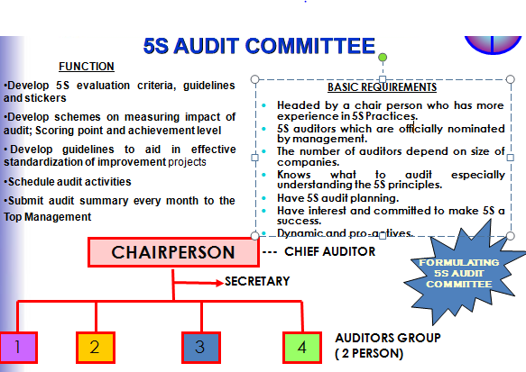

Workplace standard and sustainability of 5S techniques
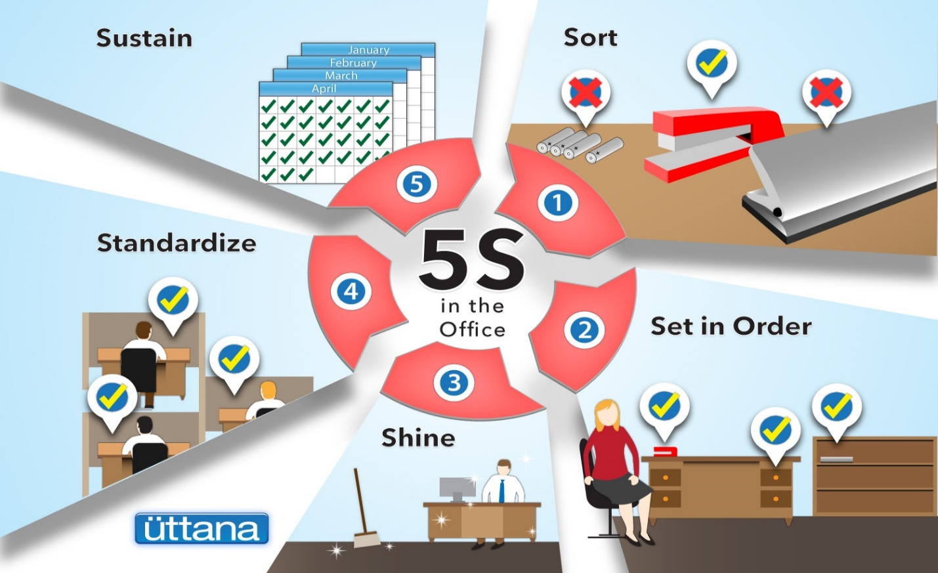
Fig. Workplace standard and sustainability

Clean up workplace after completion of job.
Why a Clean Workplace Matters
Having a cleaner workplace will make you appear more professional. Thus, it will be much more appealing for clients and potential business partners to work with you.
Employees will also respect their jobs a lot more. Aside from that, a clean workplace will also reduce the chances of viruses and germs spreading all over.
If you don’t keep your workplace clean, you don’t only end up with a dirty environment. You also get an unhealthy work environment for everyone in the office.
Here are six ways cleanliness in the office has a positive effect on employees:

Fig. Team motivation
1. Motivates Them
Motivation is a fickle thing. It can be hard to get and easy to lose.
Thus, if you have it, you need to make the most of it.
Once your employee enters the office and it’s greeted by a big mess, it doesn’t feel like a fresh new start is open to them.
If you care about employee motivation, clean your office on a regular basis.

Fig. Helps Them Focus
2. Helps Them Focus
Focus, much like motivation, is easy to lose. There are a lot of elements that are working against you to keep your focus.

Fig. Make them happy
3. Makes Them Happy
Employee satisfaction is important when it comes to improving work quality, as well as sustaining work motivation. You should try and do everything that will make your employees happier while they’re at work so they do their jobs with relative ease.
With that said, a dirty and cluttered office is not the way to go to make employees happy. If you keep a clean office, it makes employees happy to get the job done.

Fig. Reduces Absenteeism
4. Reduces Absenteeism
With an unclean workplace, you also get the added effect of an unhealthy workplace. Germs and bacteria can spread everywhere if you don’t clean properly. If diseases and viruses spread, then your employees will get sick more often.
If you want to reduce absenteeism in your employees, then regularly clean your office.

Fig. Helps Them De-stress
5. Helps Them De-stress
There may be external factors outside of work that are stressing out your employees.
Sometimes, work itself can be stressful. And having a dirty office will certainly not help.
Keeping the office clean will have employees less distracted and they will be able to get their work done without them being overwhelmed by the stress that they get from other external factors.

Fig. Boosts Team Efficiency
6. Boosts Team Efficiency
Having everything working as it’s supposed to and where it’s supposed to helps employees get more work done. At the same time, they aren’t plagued by office issues that are outside of their scope.
A cleaner and healthier environment in the workplace is appealing to potential clients and attractive to look at overall.
Remember to get the office cleaned regularly so that you don’t compromise on health as well as the overall well-being of everyone in the office.

Performing Audit
Preparation
- All 5S auditors gather at the meeting room ½ hour before audit
- Briefing by 5S audit chairman: -
- Activities of the day
- Highlight any new criteria to be checked
- Action date on sticker (2 weeks from audit date)
- Time to report back
- Wearing 5S auditor tag
- Every auditor is only allowed to use up to 3 stickers at each audit to each 5S zone. It is purposely not put burden to 5S team to make improvement in very drastic manner.
- Previous audit summary report will be distributed to the auditors’ team as a reference in order to avoid in consistency auditing.
During Audit
- Bring all audit materials e.g., checklist, stickers, file holder & audit summary report
- Get the KPT leader or facilitator to accompany auditor
- Good public Relation
- Check outstanding matter from the previous audit summary report
- Proper issue of stickers & justified
- Propose idea for improvement and justified.
- Close matter when action has been taken. Remove sticker
- Issue new sticker when action is not fully satisfied (old sticker still remain) and also for new matter noted
- Take photo as an example in case of the 5S team has shown very creative idea to make the 5S initiative significantly effective, safe work place, cost saving
- Only use maximum 3 stickers of each type for each working area / zone
- Listen to the feedback given by workers
- Provide positive suggestion for improvement if stickers are not appropriate
- Prepare audit report of each working area on the Audit summary
- Document must be signed by auditor & team leader
- Audit to the next area and You may take 10 – 15 minutes for one zone.
Twelve Focal Points 5S Auditors Should Examine
- Do the Top and Middle managers support 5S program?
- Are people proud of their workplaces?
- Are workplaces clean and organized?
- Are workplaces safe for people to work in?
- Are machines and equipment clean and well maintained?
- Are items easy to retrieve?
- Are machines and tools conveniently located?
- Are inventories stored for FIFO retrieval?
- Are products free from dust?
- Do people clean daily without prompting?
- Are the uniforms worn by people clean and tidy?
- Is a good image of the enterprise reflected in its people?
Awarding System
- Awarding for 5S promotion results according to evaluation is recommended.
Awards may be:
- For Good performance
- Award for efforts
- Award for good Ideas
- Prize winner
- Group
- Individual
Big Cleaning Day
It is a cleaning that carried out from two to four hours by the organization.
Example: Before national holidays

Patrolling System
- Top management Patrol
  - Check Up the activities Comprehensively
  - Give emphasis on sustaining of the activity
  - Consider committees’ feedback
- 5S Committee members and Promotion office Patrol
- Evaluate “5S Check List”
- Record problems on”5S check findings”
- Tack picture of 5S problems
- Mutual patrol
- Check mutually among KPT
- Self-patrol
- 5S leader and members check the results of activity by themselves.
- Checklist patrol
    - Point out the problems by themselves at site as well as evaluate the results and encouragememberstourgeKAIZEN.
- Camera patrol
    - Visibly highlight the problems and progress of the activity using photographs.

Improvements recommend to lift compliance in the workplace.
How To Ensure Compliance in The Workplace:
- Documenting policies and procedures is key.
If something is important to the success of your business, then it should be documented in your employee handbook.
The most important aspect is having documentationestablishing the procedures and policies in writing, and then continually tweaking them over time.
- Consistently apply your policies and procedures.
Your policies and procedures should be implemented from the top down, and everyone in your organization should be expected to adhere to them. To set the expectation for consistency, review your policies regularly with your entire staff throughout the year.
- Remove barriers to compliance.
Getting staff to take compliance seriously will not happen unless your policies and procedures are easily accessible, so make sure every person on your team has a paper or electronic copy available. Then make sure everyone has time to read it:
Finally, reinforce your policies with checklists.
- Reinforce with training.
Reinforce your compliance procedures and policies by making training a regular event. The more familiar your team is with what’s expected of them, the less likely they will be to make those mistakes.
- Stay current with ever-changing laws and regulations.
Compliance doesn’t just happen it requires the organization, specifically its HR functions, to continually and consistently review the current compliance environment; update processes and practices based on new and changing laws as well as industry best practices; implement policy changes when necessary; and see those changes through, which ultimately guarantees compliance.
- Make sure all employees are following procedures.
Ensuring employees comply with policies and procedures is one of the most difficult aspects.

Problems Avoided by Implementing Sustaining activities
Here are some of the things that happen in a company when Commitment to the five pillars is not sustained.
- Unneeded items begin piling up as soon as sorting is completed
- No matter how well Set in Order is planned and implemented, tools and jigs do not get returned to their designated place after use.
- No matter how dirty equipment becomes, little or nothing is done to clean it.
- Terms are left protruding into walkways, causing people to trip and get injured.
- Dirty machines start to malfunction and produce defective goods.
- Dark, dirty, disorganized workplaces lower workers' morale.
These 5S related problems and others are likely to occur in any factory or office that lacks a commitment to sustain the five pillar gains over time.
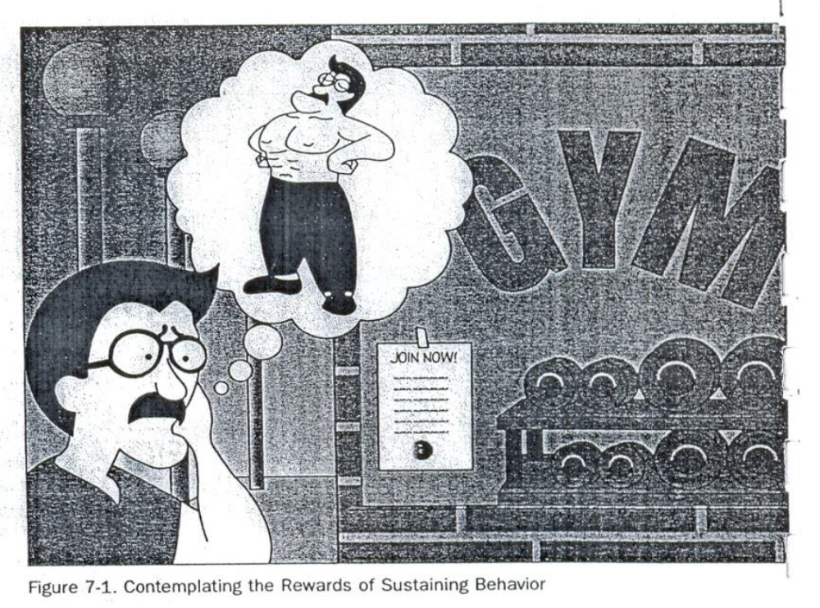
Figure showing contemplating the rewards of sustain behavior

Checklists to Sustaining activities
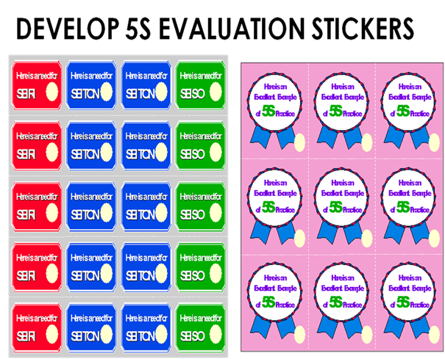

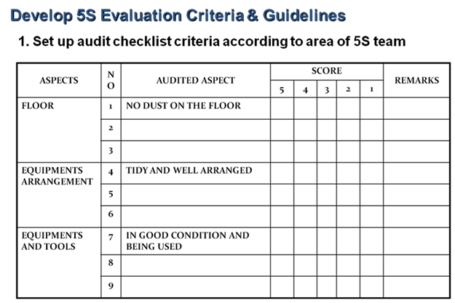

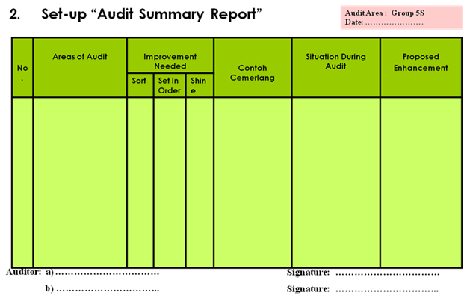

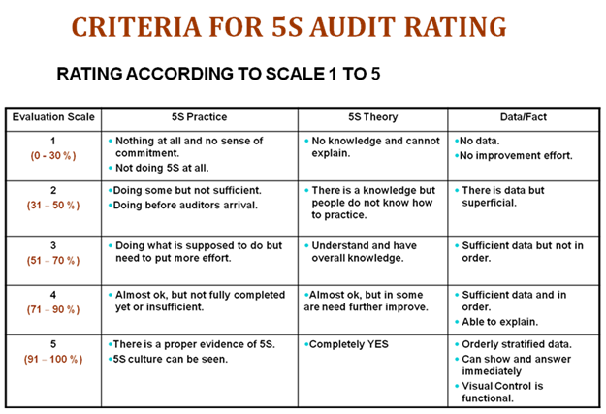

Self-Check - 6 | Written Test
Directions: Answer all the questions listed below.
- What are the common tools and techniques to sustain 3S? (13 points)

How 5S slogans are used to sustain 3S? (2 points)

Why 5S photo exhibits and storyboards are used to implement sustain activities (3 points)

Describe 5S newsletters? (2 points)

What are the 5S pocket manuals? (3 points)

How 5S months are scheduled? (3 points)

Describe 5S audit. (4 points)

What are the activities performed during preparation of audit and during audit (4 points)

Why awarding is necessary in sustain implementation? (2 points)

List types of patrolling system. (6 points)

Define the fifth pillar of 5S? (2 point)

List problems avoided by implementing sustain. (6 points)

Why sustain is important? (4 points)

Explain how to implement sustain? (7points)

What are the roles of you and your management in implementation of sustain? (9points)
Note: Satisfactory rating - 35points Unsatisfactory - below 35 points
You can ask you trainer for the copy of the correct answers.
Score = ___________
Rating: ____________

Name: _________________________ Date: _______________

OPERATION TITLE: - APPLY 5S
PURPOSE:- A sustainable interior fit out is the essential first step in creating an environmentally sustainable workplace.

- Energy Management.
- Water Efficiency & Conservation.
- Waste Reduction.
- Go Digital.
- Employee Engagement & Awareness.
- Procurement & Supply Chain.

Operation Sheet: - Procedures in Implementing Sustain
Sequence of Sustain
  - Planning
- Set schedules for sustaining techniques
  - Prepare Sustaining Tools and Techniques
  - Implement sustaining activities
  - Feedback comments on the sustain results

LAP Test: - Practical Demonstration
Name: _____________________________ Date: ________________
Time started: ________________________ Time finished: ________________
Instructions: Given necessary templates, workshop, tools and materials you are required to perform the following tasks within ------ hours.
Task 1: Prepare slogans and posters for your work area.
Task 2: Evaluate your work place by using the 5S check list and use stickers.
Task 3: Prepare audit summary report by using the given template.
- Identify the:
    - Person -in-charge
    - Technology workshop
    - Work station
- Consider the:
    - OHS procedures
    - Workplace procedures and standards (work area)
    - Frequency of maintenance activities

Reference:
5S for operators (1995)
Ethiopia Kaizen Manual (2011)
Journals/publications/magazine
https://www.simplilearn.com/implementing-5s-methodology-to-achieve-workplace-efficiency-article
https://rotho.com/blog/en/cleaning-up-made-easy-7-steps-to-a-tidy-home/
https://www.sixsigmadaily.com/5s-sort-set-shine-standardize-sustain/
https://asq.org/quality-resources/lean/five-s-tutorial
https://www.techtarget.com/searcherp/definition/kaizen-or-continuous-improvement
https://www.mindtools.com/pages/article/newSTR_97.htm
https://safetyculture.com/topics/kaizen-continuous-improvement/10-kaizen-rules/
https://6sigma.com/kaizen-5s-beginners-sort/
https://6sigma.com/kaizen-5s-beginners-shine/
https://www.universalclass.com/articles/business/the-three-pillars-in-kaizen.htm
https://6sigma.com/kaizen-5s-beginners-sustain/
https://in.kaizen.com/blog/post/2013/12/05/standardization

Participants of this TTLM (training material) preparation
No | Name | Qualification (Level) | Field of Study | Organization/ Institution | Mobile number | E-mail
1 | Fikadu Girma | BSC | Construction Technology | EthioPoly Technic  College | 0975284843 | Fike girma13@Gmail.com
2 | Yonannes Tadesse | MSC | Construction Technology | Sebet Poly Technic College | 0913328144 | Yohannese44@gmail.com
3 | Abdulmenan Muhaba | MSC | Urban Planning and Development | General wingat poly technic college | 0921779179 | abmuhaba1@gmail.com
4 | Lakew Girma | BSC | Construction management | a/mpoly tecnic college | 0916852674 | Lakewgir8@gmail.com
5 | Jamel Abdulahi | BSC | Construction technology |  | 0921228986 | jemalabdulahi@gmail.com

