Finishing Construction Works
Level-II
Based on March 2022, Curriculum Version 1
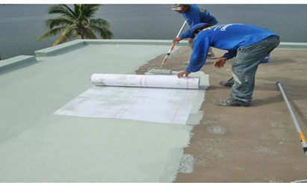
Module Title: - Apply Water Proofing Process
Module code: - EIS FCW2 M08 0422
Nominal duration: - 40 Hours

Prepared by: Ministry of Labor and Skills
August, 2022
Addis Ababa, Ethiopia
Acknowledgment 3
Acronym 4
Introduction to the Module 5
1.1. Work instruction of water proof 7
1.2. Occupational Health and Safety (OHS) requirements 11
1.3. Signage and barricade requirements 16
1.4. Tools and equipment for water proof 20
1.5. Materials for water proof 27
1.6. Material quantity of water proof 32
1.7. Environmental protection 35
Self check-1 (Unit one) 38
2.1. Internal and external area of water proof 40
2.2. Defects and soundness of structure area 42
2.3. Waterproofing systems 44
2.4. Check waterproofing materials 46
2.5. Determine termination detailing 47
2.6. Waterproofing material 49
Self-Check -2 54
Operation sheet 1: Water proofing system 55
LAP Test -1 57
3.1. Checking Internal and external wet area 59
3.2. Check substrate sound and moisture content 66
3.3. Check moisture content 67
3.4. Check flooring installation levels and waste outlets 74
3.5. Install corner flashing 75
3.6. Check rebates for baths 79
3.7. Prepare and coating prime surface of structure 81
3.8. Install water stops and hobs 83
Self-Check -3 87
Operation sheet 2: Water proofing system 88
LAP Test -2 90
4.1. Water proofing membrane to surface of structure 92
4.1. Bond breakers and fillets 94
4.2. Curing waterproofing membrane 96
4.3. Curing waterproofing membrane 98
4.4. Conduct flood testing of installation 100
4.5. Protect waterproofing material 102
4.6. Carry out final site inspection 103
Self-Check -4 105
Operation sheet 3: Apply Water proof 106
LAP Test -3 107
Reference 108

Acknowledgment
Ministry of Labor and Skills wish to extend thanks and appreciation to the many representatives of TVET instructors and respective industry experts who donated their time and expertise to the development of this Teaching, Training and Learning Materials (TTLM).

Acronym
OHS = Occupational Health Standard
PPE = Personal Safety Equipment
MSDS = Material Safety Data Sheet
TTLM = Teaching, Training and Learning Materials

Introduction to the Module
Apply Water Proofing Process helps to know how to Plan and prepare, Identify waterproofing system, Prepare for waterproofing installation and Apply waterproofing in finishing construction field. This module covers skill, knowledge and attitude required to apply waterproofing practices and principles to internal and external wet areas.
This module is designed to meet the industry requirement under the Finishing construction work occupational standard, particularly for the unit of competency: Applying Water Proofing Process.
This module covers the units:
- Plan and prepare
- Waterproofing system
- Waterproofing installation and
- Waterproof application
Learning Objective of the Module:
- Perform Plan and prepare
- Identify waterproofing system
- Prepare for waterproofing installation and
- Apply waterproofing
Module Instruction
For effective use this modules trainees are expected to follow the following module instruction:
- Read the information written in each unit
- Accomplish the Self-checks at the end of each unit
- Perform Operation Sheets which were provided at the end of units
- Do the “LAP test” giver at the end of each unit and
- Read the identified reference book for Examples and exercise

Unit one: Plan and Prepare
This unit is developed to provide you the necessary information regarding the following content coverage and topics:
- Work instruction
- OHS requirements
- Signage and barricade
- Tools and equipment
- Materials quantity Work materials
- Environmental protection
This unit will also assist you to attain the topics in this unit. Specifically, upon completion of this unit, you will be able to:
- Obtaining, confirming and applying work instructions of water proof
- Following OHS requirements with safety plans and policies
- Implementing signage for water proof
- Selecting tools and equipment
- Calculating materials quantity
- Preparing and handling work materials
- Identifying environmental protection

  - Work instruction of water proof
    - Obtaining, confirming and applying work instructions
Work Instructions are instruction which is issued by authorized organizational or external personnel’s.
Under this unit you have to know to read plans and quality requirement .when do your work you must have to depend on your plan.
Unless otherwise if you not depend the plan you can fall down your work and economic and your work is not get the acceptance and quality requirement.
Doings the work without plan is take your under the risk wasting of your money, materials your effort your times and etc so that to do your work in proper manner and accurate you must work with plan and specification.
A well planned project will be completed quickly and cost less than a poorly planned job that takes a long time. Customers will appreciate how quickly you can complete a good quality job.
Diagrams or sketches
A sketch is a very simple type of diagram. The elements in a sketch include shapes such as rectangles, circles, cylinders, stick figures that represent people, and text labels.
Unlike other types of UML diagrams, sketches have only a few types of elements and only one type of relationship between elements.
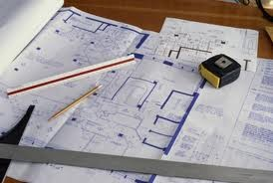
Fig: 1.1 water proof roof structure
Plan
Plan is a set of drawings or two-dimensional diagrams used to describe a place or object, or to communicate building. Usually plans are drawn or printed on paper, but they can take the form of a digital file.
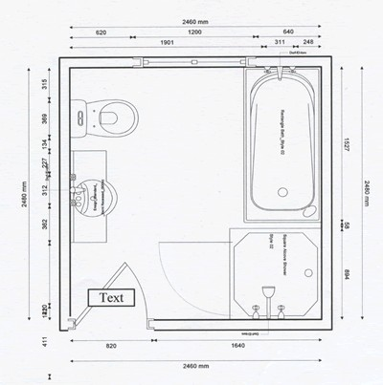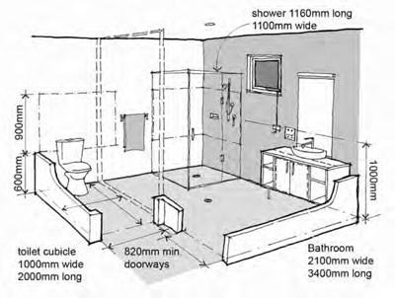
Fig: 1.2 Bath room and toilet plan
By sequencing the bathroom renovation or new construction in the right order, it allows the right trades people to be on site at the right time.
A bathroom construction involves waterproofing, tiling, installing vanities, sorting the plumbing system, rough-in, and changing lighting to name a few things.
By breaking down the job into each step of the process onto paper, you will realize just how much is involved and why a detailed plan is so important to avoid dramas and budget blowouts.
Construction drawings are necessary in most spheres of the building industry, as being the best means of conveying detailed and often complex information from the designer to all those concerned with the job.
Building trades people, especially carpenters and joiners, should be familiar with the basic principles involved in understanding and reading drawings correctly.
A bathroom plan will help you work out the square meters to be waterproofed and the linear meters to be silicone.
Work Instructions are documents that clearly and precisely describe the correct way to perform certain tasks that may cause inconvenience or damage if not done in the established manner. That is, describe, dictate or stipulate the steps that must be followed to correctly perform any specific activity or work.
However, most work instructions consist of these essential parts:
- Title and short description of the task.
- Objectives or expected results.
- Purpose of the task.
- Scope of the task.
- Tools or skills required.
- Safety requirements.
- Step-by-step instructions for the task.
- Expected outcome for each step.
Work schedules
Work schedule generally refers to the days per week and the hours per day that an employee is expected to be at their job.
Specifications are a general term applying to all directions, provisions, and requirements pertaining to the performance of the work and payment for the work.
A well planned project will be completed quickly and cost less than a poorly planned job that takes a long time.

Customers will appreciate how quickly you can complete a good quality job.
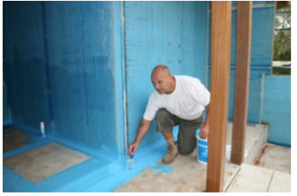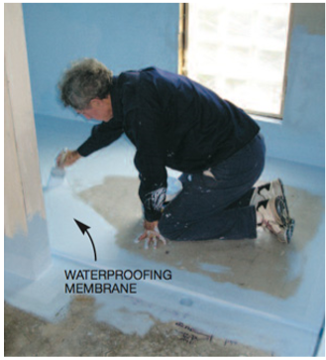
Fig: 1.3 water proof working orientation

  - Occupational Health and Safety (OHS) requirements
1.2.1 Safety requirements
Safety in the workshops is subject to a number of various risk assessments and safe codes of working practices which have to be observed and adhered to by all workshop users and enforced by the person in charge of these areas.
Due to high risk activities taking place in the workshops access to these areas is restricted to authorized personnel only. No other person may enter the workshops without permission.
OHS requirements are followed in accordance with safety plans and policies. Plant, tools and equipment selected to carry out tasks are consistent with the requirements of the job, checked for serviceability and any faults are rectified or reported prior to commencement.
Before starting work:-
- Wear Protective clothing and equipment,
- Use functional tools and equipment and know handling of materials
- Keep Workplace environment and safety,
- Prepare Organizational first aid, Hazard control and hazardous materials and substances
1.2.2. Personal Protective Equipment (PPE)
Some of the commonly used PPE include the following:
Eye protection (goggles)

It is required to use eye protection equipments like goggle, eye shield, to protect our eye from dusts, chemicals, etc by all workers engaged in hazardous activities or are exposed to identify eye hazards.

Fig: 1.4 goggles

Hand Protection (leather glove)
It is required to use appropriate hand protection when hands are exposed to hazards, such as:
- Skin absorption from harmful substances;
- Cuts, lacerations or abrasions;
- Chemical exposure;
- Thermal burns and/or temperature extremes
- Potentially infectious material.


Fig: 1.5 hand gloves
Body Protection
Chemical Resistant Clothing: Protective apparel designed to provide a barrier against a variety of chemical hazards. Chemical resistive clothing may be required for tasks where chemical splashing is anticipated or large volume transfers are conducted. Prior to selection of chemical resistant clothing, Laboratory Apparel and Scrub Suits:
A wide variety of styles and materials are available to protect employees during laboratory operations.
The selected type of lab coat or other apparel is designed to protect the wearer against accidental splashes or day-to-day handling of chemicals;
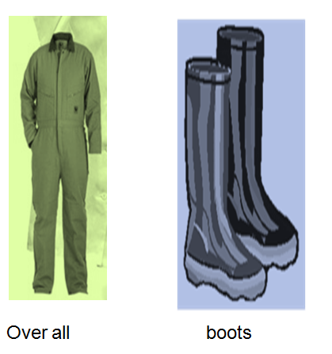
Fig: 1.6 Over all Fig: 1.7 Boots
Ear and Hearing Protection
Ear plugs and muffs are available for any employee potentially exposed to noise levels
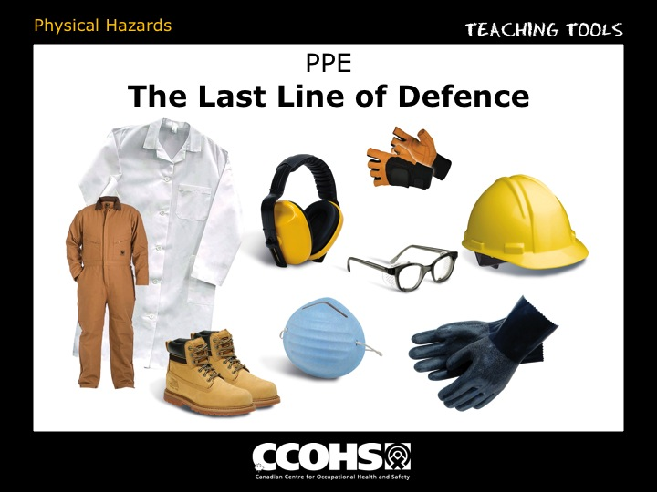fig: 1.7 ear protetion
Head protector (hard hat)
fig: 1.8 hard hat
Personal Protective Equipment (PPE) is the method of following the occupational standard which includes;
Safety Boots & Shoes: Super range of work safety boots & shoes from Redwood, Capps Composite & Panoply. Redwood is the premier brand for comfortable and reliable safety boots. Capps is the premium brand for sports-style safety boots.
Hard Hats: Safety hard hat are used to protect our head from accident during construction work.
Safety Glasses: Safety glass and safety goggle used from eye protection. All safety glasses and goggles are close fitting and comfortable.
Dust Mask: Mask reduces cost and optimizes comfort for mouse.
Ear Defenders: Venire Ear Defenders -news! Radio electronic ear defenders, adjustable ear muffs, noise reducing foam ear plugs and reusable silicone earplugs. Compliant with the hearing protection standard. We supply the full Venire ear protection range. Please contact us if you can’t find what you’re looking for!
Gloves: Protective glove from Venire range includes cotton/polyester gloves, polyamide gloves and thermal polyester/acrylic gloves. With coated palm and fingers for exceptional grip. These protective gloves comply with the standard for hand protection.
Emergency procedures: Emergency plan is a written set of instructions that outlines what workers and others at the workplace should do in an emergency. An emergency plan must provide for the following: emergency procedures, including: an effective response to an emergency.
Extinguishing fires: Carbon Dioxide fire extinguishers extinguish fire by taking away the oxygen element of the fire triangle and also are removing the heat with a very cold discharge. Carbon dioxide can be used on Class B & C fires.
First aid Hazard control; Refers to workplace procedures adopted to minimize injury, reduce adverse health effects and control damage to plant or equipment. Hazard control practices are often standardized and taught to managers and safety personnel in a given industry. First aid is medical attention that is typically administered immediately after an injury or illness occurs. It usually consists of one-time, short-term treatment, such as cleaning minor cuts, treating minor burns, applying bandages
. 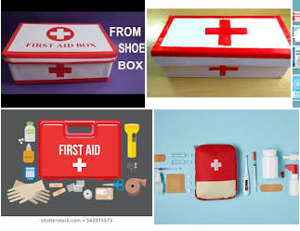

fig 1.9 first aid kit

  - Signage and barricade requirements
    - Safety Messages and Signs
Manufacturers put important safety messages on each piece of equipment and in the operator's manual. It is critical to read, understand and follow all safety messages. Many safety messages use the words Caution, Warning and Danger to get your attention.
Following are safety messages and their meanings.
Each of these signs will have a written message
CAUTION means you need to be careful. Follow the directions on the sign or you could get hurt.
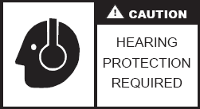
Fig: 1.10 Signs
WARNING is more serious and means you need to follow the directions on the sign or you could be badly hurt or killed.
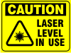
Fig: 1.11caution
People working with waterproofing materials should be aware of the potential for adverse skin reaction.
Always wear your safety shoes as a major cause of accidents is through not wearing correct footwear. Avoid contact with eyes and mouth. Read the MSDS always! First Aid Summary Quickly but carefully remove contaminated clothes. Make sure you don't get more liquid on unaffected areas of your skin. Once removed, make sure to carefully rinse out the garments if you have a reaction to the material. Immediately seek medical attention. It is important for you to seek more complete medical care as soon as possible to address the potential skin damage you have incurred. Whenever working in a publicly accessible area then they must be informed and kept away from any Danger to their Health. This can be done using signs & barricades. People will not always read signs so barricades are the better solution, especially in keeping children away.
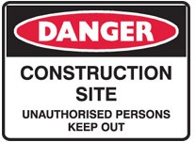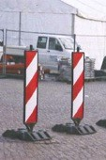
Fig: 1.12 Construction Signs
These play a crucial role in ensuring the safety of workers and the public on a construction site. In fact, they are so important that if a site has inadequate signage, the company or contractor involved could be severely penalized by authorities through large fines or
Barricades and signage
Barricades and signage that are no longer required are removed as soon as practicable. Barricading controls shall be implemented and authorized as part of barricaded area it shall have its own barricading and label to identify the hazard. Installation and dismantling for edges other than roof edges.
Signage and barricade solid plastering material and components are sorted to suit material barricade and size, stacked for ease of identification, retrieval for task sequence and job location.
Signage implementation is no exception. Setting up a digital signage system can be a complex undertaking. It involves expert knowledge of web-based infrastructures, and multiple vendors and service providers such as: Hardware (digital signage media players, displays, mounts)
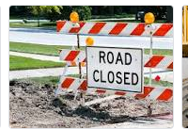
Fig: 1.13 Direction indicators
Signage Classification and Use
Safety signage’s are classified and shall be used according to their function as follows:
Table 1.1 safety signs
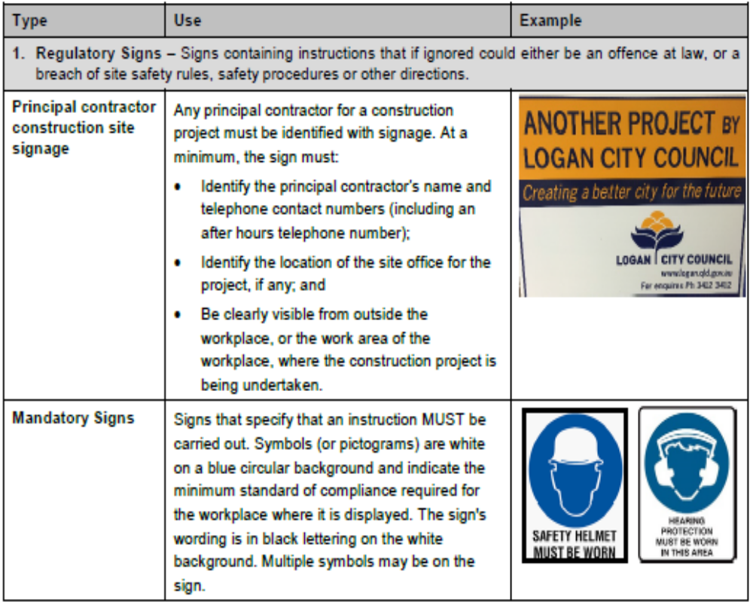

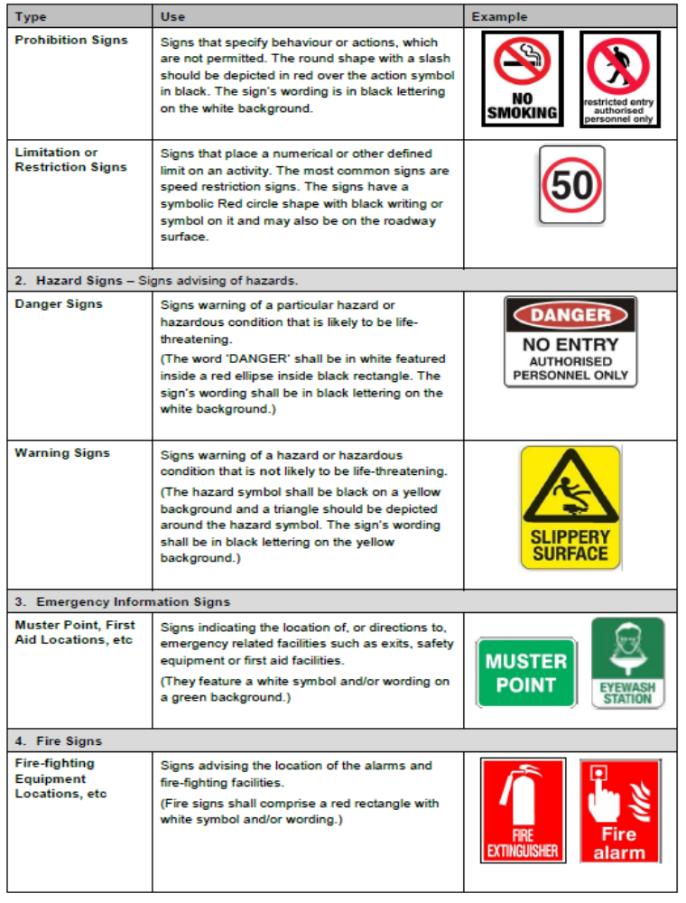

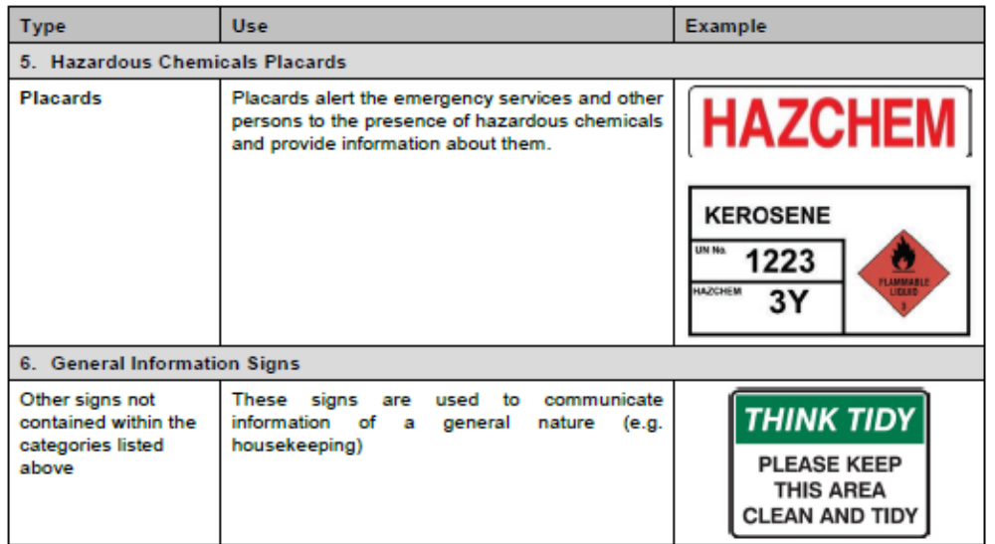

  - Tools and equipment for water proof
Some of the latest waterproofing products do not require the use of fabric on floors, walls, coves or corners and may be applied directly onto a bathroom substrate. These include LaTourette’s Hydro Ban, a self-curing liquid rubber polymer that forms a flexible, seamless waterproofing membrane.
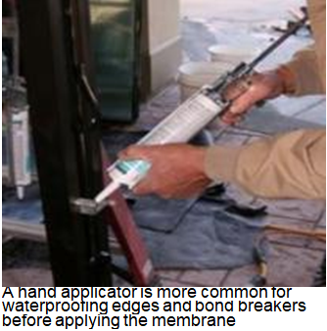
Fig: 1.14 liquid rubber polymer
Other Hand tools and Equipment
The following is a list of other hand tools commonly used in silicone:
- Soap spray bottle
- Stanley knife
- Paper towels
- Paddle Pop sticks
- Newspaper
- Vacuum Cleaner
- Brush and shovel
- Old Towel
- Brush
- Roller and Pan
- Knee guards (PPE)
- Small trestle for heights
- Broom & rubbish bin
Again, it is very important that these tools are kept clean of waterproofing materials and dried residues.
There are different kinds of tools and equipments used for pointing work.
Hand tools come in many shapes and forms, each designed for a specific purpose
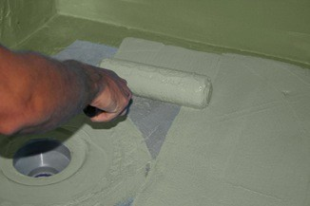
Fig: 1.15 Roller tools
A roller will help save application time whilst a paint brush is handy for hard to get at areas such as corners Some of the latest waterproofing products do not require the use of fabric on floors, walls, coves or corners and may be applied directly onto a bathroom substrate.
Steel tape

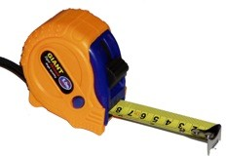
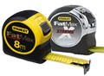
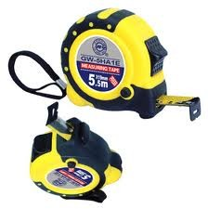
Steel tapes vary in length from 3 to 30 meters long. You can use them to measure distances,such as when you are setting out and checking wall and building sizes.
Fig 1.16 Spirit Level
Spirit levels vary in length and quality. A trade’s person usually purchases a reputable brand that guarantees a long life and remains accurate. Cheap levels will rarely provide a long accurate life.

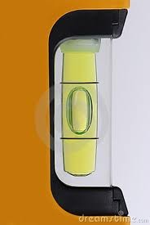
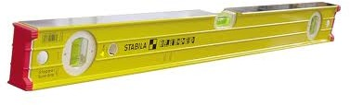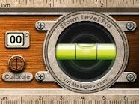
Fig 1.17 Spirit level
Straight Edges
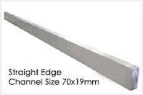
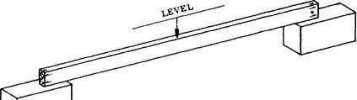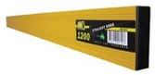Straight edges are used to align materials, mark pencil lines on walls or floors, to extend the length of a spirit level and many other uses.
Fig: 1.17 Straight Edges
Straight edge
They need to be handled carefully so as not to cause damage to the edges or face of the straight edge. Straight edges are very useful to check the alignment of wall framing members.
It is recommended to have at least two straight edges so that it is possible to use the tool in restricted work areas.
Trowel - Gauging
A tool used to apply cement mortar or waterproofing in awkward areas where a floating or setting trowel cannot be used. Often used when doing mould work. Gauging trowels are like a smaller version of the large trowel used in bricklaying but with a rounded end. They come in sizes from 100 mm to 225 mm.
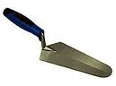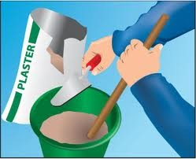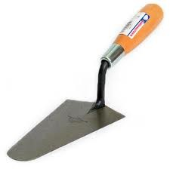
Fig 1.18 trowel

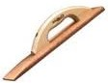
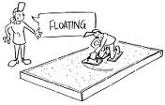
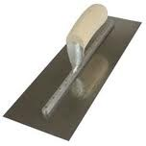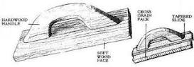Floats
Fig 1.19 float
Steel floats are used to spread mortar bedding materials of sand and cement. A wooden float is best to move the mortar to shape the concrete material and the steel float is useful for finishing to a smooth finish.
Broom

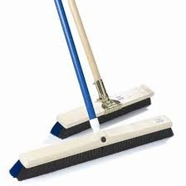
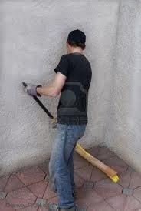
A broom is an essential piece of equipment. A tidy worksite involves keeping areas swept clean of mud, dirt and rubble.Ensure you have a decent broom to clean up your site after completion of all your work
Fig: 1.20 Brooms
Equipment’s
Wheel Barrow
Wheel barrows come in various size and quality. They are ideal for moving materials such as sand and cement and tiles on a building site.
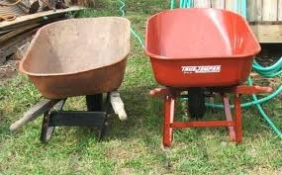
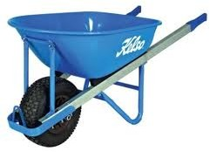
Fig 1.21 wheel barrow
Compressors
Sometimes the words "pump" and "compressor" are used interchangeably, but there is a difference: A pump is a machine that moves a fluid (either liquid or gas) from one place to another.
A compressor is a machine that squeezes a gas into a smaller volume and (often) pumps it somewhere else at the same time.
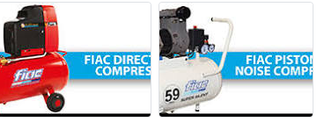
Fig 1.22 compressor
Blade
Blade are typically made from materials that are harder than those they are to be used on blade work by concentrating force on the cutting edge.
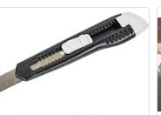
Fig 1.23 blades
Water levels
It is a transparent PVC hose. It is used to transfer or mark vertical levels on surface of wall when it is filled with water, but without any air bubbles.
The water level in each end of the hose is equal. It is an instrument to mark equal levels on site. It is very accurate but not eases to handle
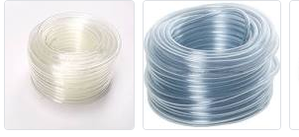
Fig 1.24 water level
Mixers
Mixers are used to mix an ingredient by the standard ratio. Such as mortar and concrete
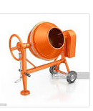
Fig1.25 Mixers
Scissors
Scissors are used to cut paper for waterproofing work.

Fig 1.26 scissors

  - Materials for water proof
    - Preparing and handling materials used for water proof
Handling is the act of touching, feeling, holding and moving something.
The act or process of packing and shipping something to someone (such as a customer).
It includes the preparation, handling, sorting, stacking and disposal of waterproofing products, materials and components in the application of waterproofing systems, including the disposal of waste.
Davao K10 Plus is a, single pack water based polyurethane waterproofing membrane which is capable of drying in approx. 6-8 hrs. At 20° C depending on the number of coats required.
K 10 plus is a tough flexible membrane which eliminates the need for a reinforcing layer. K 10 plus is UV stable and foot trafficable.
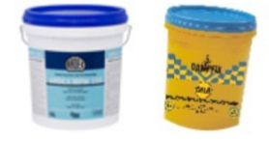
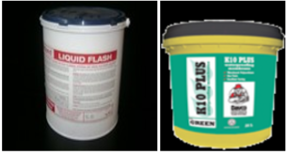
Fig: 1.27 Liquid Flashes
Liquid Flash Liquid Flash is a premixed one pack white water based reinforced acrylic flexible waterproofing membrane that is easily applied
Liquid Flash is used as a waterproofing membrane on roofs, in bathrooms, balconies is good as a flashing material, is uv resistant, is permanently flexible with excellent adhesion to correctly prepared surfaces.
Liquid Flash is available in 4L, 10L and 15L buckets and covers 1m² per liter per coat, 2 coats recommended.
Under tile PU Acrylic Hybrid Membrane. Water based polyurethane acrylic waterproofing membrane developed for high performance under tile waterproofing.
Tough flexible film UV stable when left exposed (non-Trafficable)
Damp fix Gold is an elastic meric one part fibre reinforced water based polyurethane membrane used for waterproofing shower recesses, bathrooms, laundries and roof tops.
Fiberglass
Fiberglass matting used to reinforce liquid membranes, is available in 100, 150, 1000 mm wide x 148m rolls
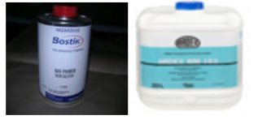
Fig:1.28 Fiberglass
Batik N49 Primer
Bestir N49 is a transparent yellow colored primer for use as an adhesion promoter on porous surfaces as well as some metals. It is suitable for both 1 and 2 component polyurethane sealant systems.
There are different types of materials used for waterproofing described below;
Cementations waterproofing
Cementations waterproofing is often used in the internal wet areas such as toilets.
Most of the time the type of cementations waterproofing is semi-flexible, some even toward rigid type.
It is still good to use because internal toilets are not exposed to sunlight and weathering and so it do not go through the contraction and expansion process continuously.
Liquid waterproofing membrane
Liquid membrane is a thin coating which consists of usually a primer coat and two coats of top coats.
Bituminous membrane
Is bituminous waterproofing coating made up of bitumen based materials and it is not suitable for expose to sunlight. It became very brittle and fragile when long exposure to the sunlight unless it is modified with more flexible material such as polyurethane or acrylic based polymers.
The flexibility of the finished products always depends on the solid content of the polymer added to the bitumen.
Bituminous waterproofing membrane has Torch (welding light) on membrane and self-adhesive membrane. Torch on membrane is the more preferred one use because of its shelf life and ease of use during application.
The self-adhesive type must be use fast as the bonding properties of the membrane is reducing through time. Very often applicators find the self-adhesion membrane already lose its bonding properties when they want to apply. Therefore, they have to use one additional primer to prevent the deboning problem in the near future.
Betonies
Betonies is a popular waterproofing system for earth s h e l t e red structure principally because it is relatively easy to apply at a modest cost. Betonies are natural clay that will swell up to sixteen times its original volume when it comes in contact with water. As the swelling occurs, the betonies become impervious to the penetration of additional water.
Sheet and sprayed material membranes sheet based waterproofing membranes. The most common type of sheet based membrane is a bituminous waterproofing membrane. This type of membrane is stuck to the substrate with a hot tar based adhesive using blowtorches.
Joints between adjacent membranes are also made with the same hot adhesive.
Bitumen based – Has a better drying time then Latex but is not as flexible.
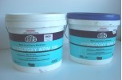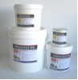
Fig 1.29 Bitumen
Many tillers will have a supply of 2 common colors.
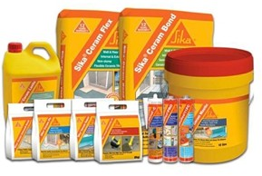
1 x Pair chemical gloves: chemically resistant neoprene to be worn whilst performing
the work. 1 x 100mm paint brush: For application of the primer and the waterproofing membrane.
Sikas range of waterproofing & tiling products
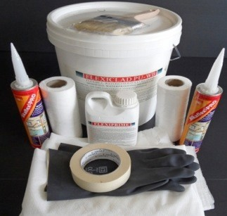

Fig 1.30 moisture protect materials
Its high impact resistance makes it suitable for high traffic areas in both residential and commercial applications. The moisture resistant properties make it suitable for wet area linings in bathrooms, laundries and kitchens.
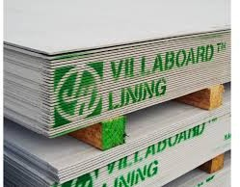
Figure 1.31 moisture resistant
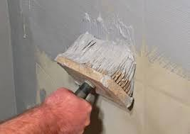
Able to resist damage from steam and moisture when installed and maintained correctly, and is ideal for use in bathrooms, laundries, or any other steamy, wet areas.

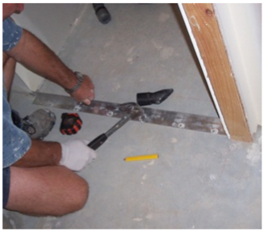
Fig 1.31 material handling

  - Material quantity of water proof
A. Wall water proofing
i. One coat of bitumen for plastered wall surface i. Bitumen emulsion for primer coat
With 5% wastage =0.42kgs/m2
ii. One coat of bitumen emulsion
With 5% wastage =0.79kgs/m2
n. Ditto but two coats
i. bitumen emulsion for primer coat
With 5% wastage =0.42kgs/m2
ii. Two coat of bitumen emulsion
With 5% wastage =1.58kgs/m2
B. Slab water proofing
a. One coat of bitumen for ground slab i. Bitumen emulsion for primer coat
With 5% wastage =0.42kgs/m2
ii. One coat of bitumen emulsion
With 5% wastage =0.79kgs/m2
b. Ditto but two coats
i. bitumen emulsion for primer coat
With 5% wastage =0.42kgs/m2
ii. Two coat of bitumen emulsion
With 5% wastage =1.58kgs/m2

C. Roof water proofing
a. One coat of bitumen for roofing
i. Bitumen emulsion for primer coat
With 5% wastage =0.32kgs/m2
ii. One ply of glass fiber
With 10% wastage & overlap =1.20m2/m2
iii. One coat of bitumen emulsion
With 5% wastage =2.5kgs/m2
b. Ditto but two coats
a. Bitumen emulsion for primer
Coat with 5% wastage =0.32kgs/m2
b. Two plies of glass fiber
With 10% wastage & overlap =2.41m2/m2
c. Two coat of bitumen emulsion
With 5% wastage =4.5kgs/m2
d. Two coat of reflecting
Finish with 5% wastage =0.32kgs/m2
Estimating quantities of water proof
Part of the job includes estimating the amount of waterproofing material that is required for a particular job.
The calculation of material will grow with experience. As a general rule of thumb read the bucket and follow manufacturers guide lines. Usually 1 bucket = 20m² with 2 coats
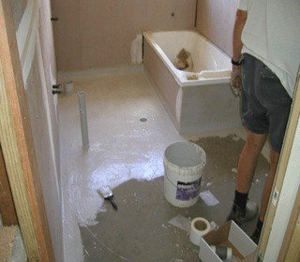
Fig 1.33 material quantity for water proof area

  - Environmental protection
Environmental protection is the practice of protecting the natural environment by individuals, organizations and governments.
Its objectives are to conserve natural resources and the existing natural environment and, where possible, to repair damage and reverse trends.
7(seven) Identifying Environmental requirements
Clean up management cleaning: - Ensure all surfaces to be coated are sound, clean, dry, and free from dust, oil, release agents, loose material, efflorescence and/or other contaminants.
Remove all mortar digs and protrusions and either brush down with a stiff broom or wash/pressure clean substrate as required, prior to the application of any products.
Cleaning during application should any render get onto surfaces that are not to be coated, clean the surface immediately with clean water.
Storm water management: groundwater recharge is an important part of storm water management as it helps maintain the base flow in nearby stream and wetlands, replenishing drinking water supplies and reducing the overall volume of runoff helping to reduce or eliminate erosion.
Vibration is mechanical phenomenon whereby oscillations occur about an equilibrium point.
Waste management is the precise name for the collection, transportation, disposal or recycling and monitoring of waste. This term is assigned to the material, waste material that is produced through human being activity.
Waste management, Noise, dust, vibration and clean-up management
Environmental protection saves lives
Its objectives are to conserve natural resources and the existing natural environment and, where possible, to repair damage and reverse trends.
Environmental protection requirements are identified for the project in accordance with environmental plans and regulatory obligations and applied tools and equipment selected to carry out tasks are consistent with the requirements of the job.
Environment = surroundings which can be natural, man-made or a combination of these.
Built Environment = created by man with or without the aid of the Natural environment.
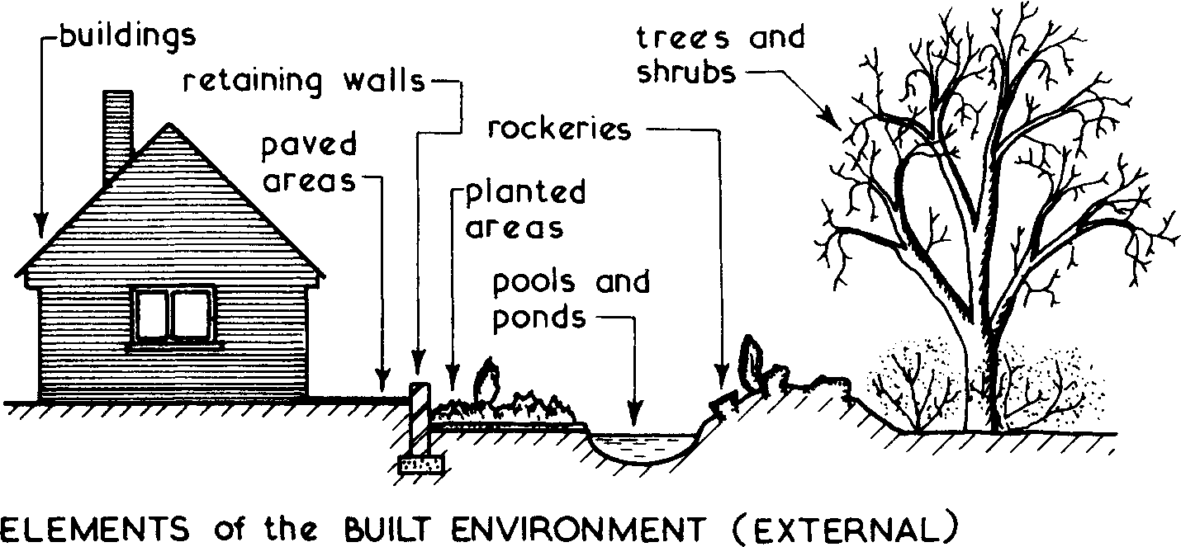
Figure 1.1
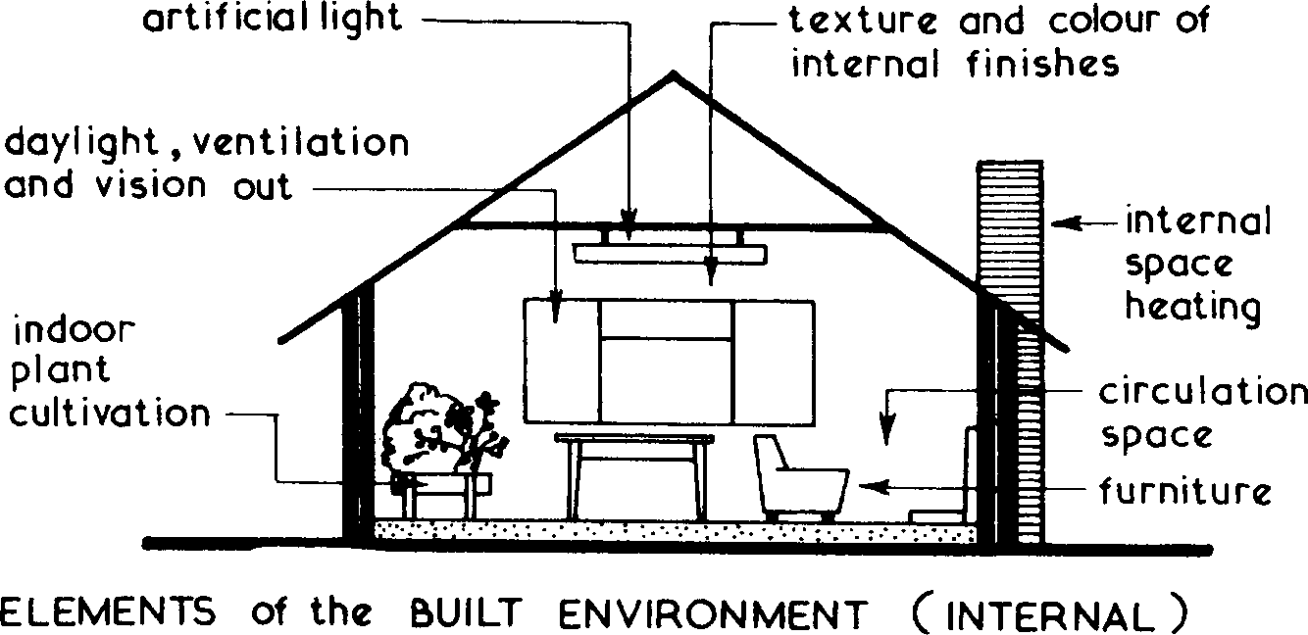
Fig: 1.34

Environmental Considerations
- Planning requirements.
- Building Regulations.
- Land restrictions by vendor.
- Availability of services.
- Local amenities including transport.
- Subsoil conditions.
- Levels and topography of land.
- Adjoining buildings or land.
- Use of building.
- Daylight and view aspects
Here are some ways in which you can take control of your future, and protect our environment and ecosystems:
- Start Your Own Initiative or Volunteer With Environmental Organizations.
- Reduce/Recycle Paper.
- Recycle More Often.
- Save Resources.
- Buy Sustainable Products.
- Decrease Meat & Dairy Consumption.
- Only Buy What You Need.

Self check-1 (Unit one)
Test-I Matching
Instruction: select the correct answer for the given choice. You have given 1 Minute for each question. Each question carries 2 Point.
A | B
---------1. Trowel | A. Eye protection
---------2. goggle | B. Occupational Health Standard
---------3. OHS | C. Mixture of cement + sand + water
D. Safety
E. Used to spread mortar
Test II: Short Answer writing
Instruction: write short answer for the given question. You are provided 3 minute for each question and each point has 5 Points.
What is safety?
Write down at least five hand tools for water proof?
Part III: Short answer writing
Direction: Give short answer to the following questions. Time allotted for each item is 2minute and each question carry 4 point.
- Personal Protective equipment
- Type of water proofing materials
Note: Satisfactory rating – above 60% Unsatisfactory - below 60%
You can ask you teacher for the copy of the correct answers

Unit Two: Waterproofing system
This unit to provide you the necessary information regarding the following content coverage and topics:
- Internal and external area of water proof
- Defects and soundness of structure area
- Waterproofing systems
- Waterproofing materials
- Determine termination detailing
- Types of waterproofing material
This unit will also assist you to attain the topics stated in this unit. Specifically, upon completion of this unit, you will be able to:
- Waterproofing internal and external area
- Inspecting defects and soundness of structure area
- Analyzing and selecting waterproofing systems
- Checking waterproofing materials
- Determining termination detailing
- Identifying types of waterproofing material

  - Internal and external area of water proof
    - Internal water proofing area
Before doing so however you will need to inspect the bathroom to ensure that there are no protruding sharp nails and the amount of dust that needs to wiped away will have to be considered.
Dust reacts as a release agent to any surface application so it must be remove with sponge and clean water. There should also be no gaps or areas where fibro has not been used. All joins in fibro should be sealed preferably with silicone.
Sikas range of waterproofing & tiling products
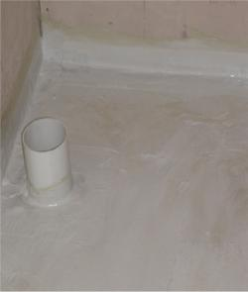
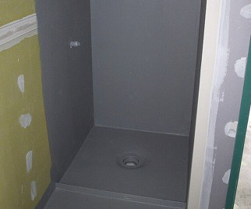
Fig: 2.1 sikas range water proof
This is handy eg with Davco K10 paint grey over green so that you do not miss any areas.
    - External water proofing area
This is then waterproofed with a waterproofing membrane.
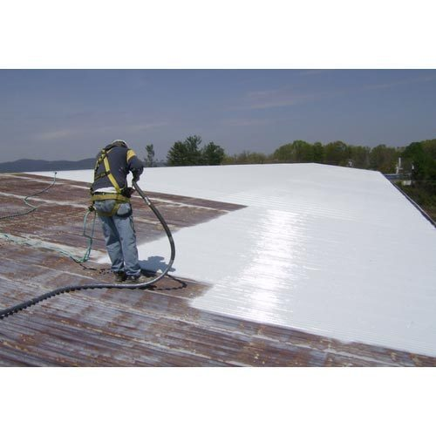
Fig: 2.2 external waterproofed with a waterproofing membrane.
  - Defects and soundness of structure area
    - Inspect defects and soundness of structure area
When it comes to homes and commercial buildings, waterproofing is a critical element for protecting the building and preserving its value.
Poor waterproofing can fail, leading to cracks, mould issues, and structural defects like concrete cancers.
Failure of your waterproofing can cause safety issues, significantly reduce the value of your property, and lead to unfitness for occupation.
Fortunately, if you catch waterproofing issues earlier rather than later, you could remedy the problem so it’s as good as new.
What happens when waterproofing fails?
Waterproofing might account for just 2-3% of a building’s total costs, but waterproofing defects can end up causes 80% of a building’s defects. When waterproofing fails, the implications are significant.
Uninhabitable – Waterproofing failures can lead to concrete cancer, mould, and serious structural issues that make a home, office, or other site uninhabitable. This can mean loss of rental income and major repair costs.
Leaks – Leaking water can damage furniture, carpeting, and other items in addition to the building’s structure.
Concrete cancer – Concrete in buildings are typically reinforced with steel bars or mesh, and exposure to air and water can lead to corrosion of the steel. The steel then expands, which results in spelling, or the surrounding concrete cracking.
The steel is now further exposed to the elements, and the level of corrosion accelerates. This concrete cancer is a common outcome of severe waterproofing failure.
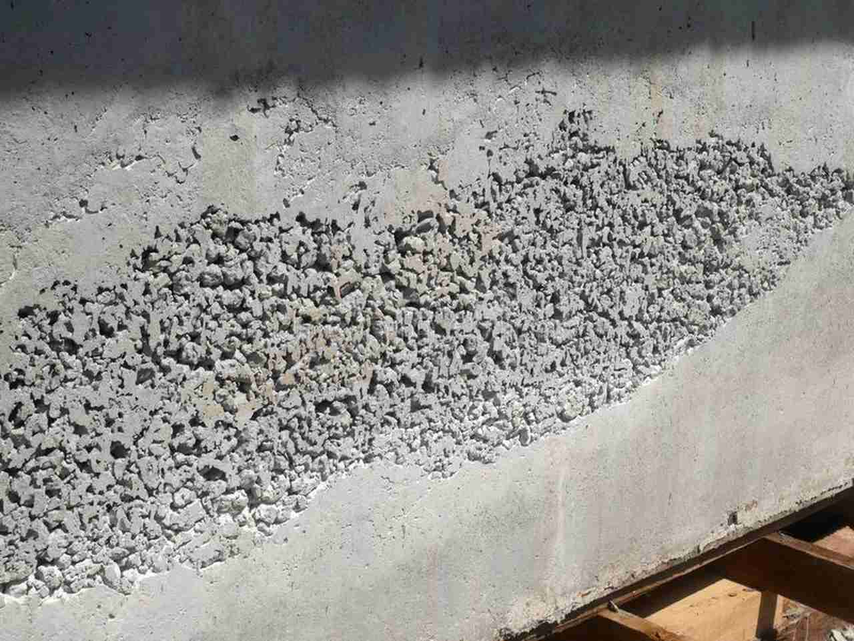
Fig: 2.3 Causes and Repairs of Concrete Surface Defects

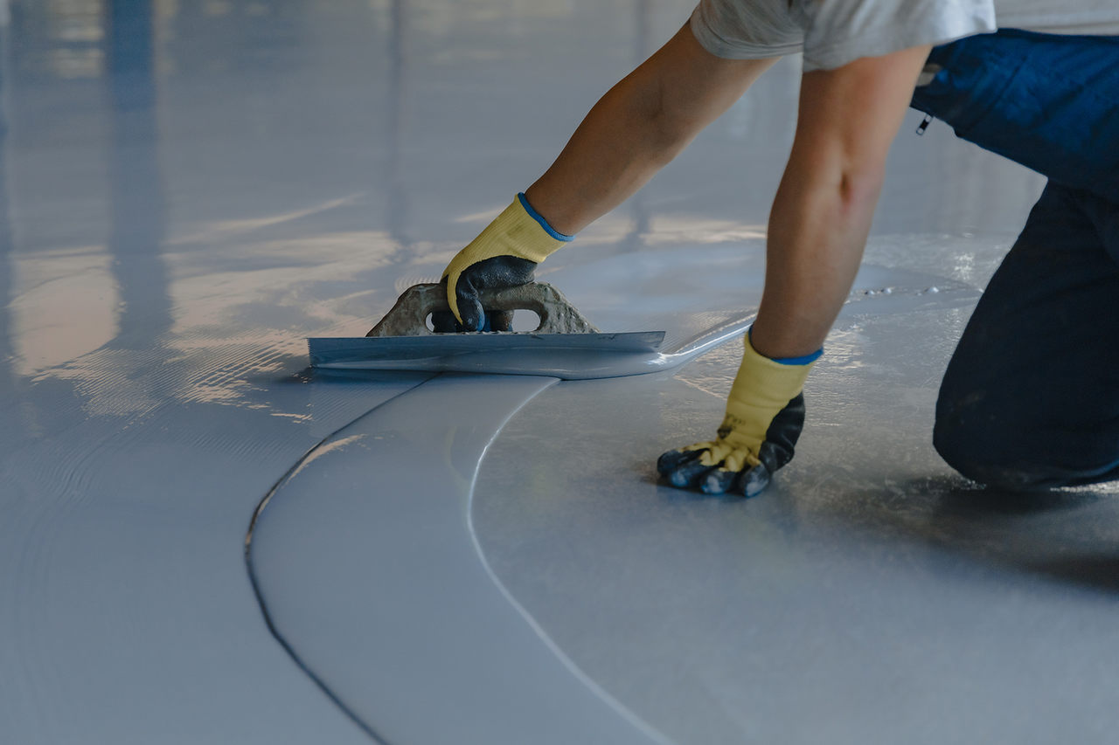
Figure 2.4 how to remove cracks

Common causes of waterproofing failure
Waterproofing failure has different potential causes, but poor workmanship and the use of a membrane that is not fit for the purpose or is not part of an entire system are the leading causes.
- Poor waterproofing work
Poor workmanship, including incorrect installation methodology, can lead to leakage issues due to waterproofing failure. Tricky places like balconies and windows need professional work when applying waterproofing. Poor workmanship also includes wrong product specifications, when the wrong product is used; and insufficient substrate preparation, which means poor preparation before the waterproofing membrane is applied.
- Lack of maintenance
Ongoing maintenance in the form of checks and remedial waterproofing enables you to catch problems early and avoid significant issues like concrete cancer.
Even tiny leaks and cracks should be dealt with right away as water damage can escalate quicker than expected, leading to major problems.
Maintaining existing seals on your windows, doors, and wall systems is also recommended. Checking balconies, roofs, windows, cracks, and leaks as soon as you become aware of them and taking a proactive approach to maintenance minimizes the risk that it develops into a major problem.
- Wrong choice of waterproofing membrane
Make sure to choose a complete waterproofing system that includes a sheet membrane with all the ancillaries.
It is also important to consider how flexible the membrane is to allow building movements and how resistant it is to the UV, chemicals, harsh salt air and in the case of green applications, to root penetrations.
Tile substrate is an important part of tiling. In fact before you tile the sub straight must be correct so that the finished tile work will look right and last for years. For bathroom walls the substrate must be able to handle water without rotting.
For timber walls villa board (fiber cement sheeting) is nailed to the wall making sure it is flat and that the walls are as square as possible.
  - Waterproofing systems
    - Analyzing and selecting waterproofing systems
Most modern types of waterproofing are good because they have been manufactured to a building industry standard. This makes them good to use as long as they can be used for bathrooms.
However I have found the two part waterproof great because it sets chemically and I don’t have to wait for long periods before moving on with the next part of the renovation.
Latex based are good however they can take a long time to dry in cooler climates and you may need a heat source in the room so they completely dry.
Also the Latex is not as durable to foot traffic as the cement based and thus more care must be taken so it is not damaged before it is covered with cement or tiles.
There are many brands and prices and I don’t wish to recommend a particular one as there are many that would do the same job.
So check with your waterproofing supplier or hardware for more information.
For best results buy from a waterproofing supplier as they know their products and specialize in them every day.
Waterproofing in the Australian code:
The Australian building codes requires waterproofing for all new wet areas with a flexible membrane system (toilet, laundry, bathroom) prior to fix tiles. Inspections are even required.
Generally as per Australian building code the walls for the shower recess require waterproofing up to 1800mm, the shower floor at least 100mm over the hob. The entire floor requires waterproofing when:
- There is a drain located in the bathroom floor.
- The floor is made out of timber or plywood.
- The bathroom is above ground level.
The walls in the bathroom need to be waterproofed at least 150mm up the wall these are the minimum requirements, it is recommended to waterproof the entire floor in every situation. Also is it advisable to waterproof full height of the walls in the shower.

  - Check waterproofing materials
Waterproofing the bathroom is one of the most important jobs in the construction process. Ensure the waterproof membrane is applied correctly and carefully.
Incorrect applied waterproofing can cause leaks, mildew and even the damage the structure.
To repair, this will be annoying, time- consuming and costly. Naturally you have to choose the correct materials for your particular job.
You will need suitable primer, waterproofing material (1 or 2 pack), and flexible waterproof silicone. When required: Aluminum angles, Cement fiber sheets or compressed sheeting.
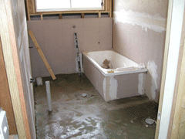Figure 2.3
Preventing Moisture Problems in Bathrooms A poorly designed bathroom is no better than a leaky roof; an experienced bath designer tells where the worst problems occur and how to prevent them.

  - Determine termination detailing
Checking Points of connection, termination detailing and over flashings as required.
BSA regards leaking showers as a serious and recurring problem that results from poor attention to detail during construction.
Supervisors and installers should be aware of how the selected water proofing system is designed to work in conjunction waterproofing of Wet Areas within Residential Buildings.
General Notes
To protect the structure of the building and to maintain the amenity of the occupants, water must be prevented from penetrating
Behind fittings and linings; or
Into concealed spaces, of sanitary facilities, bathrooms, laundries and the like.
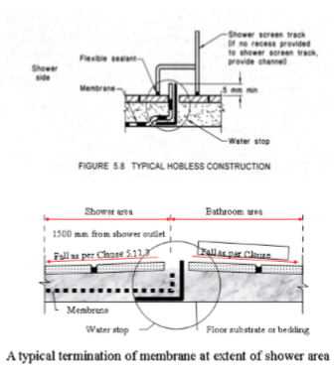
Flashing in all wet areas apply to bathrooms and toilets, but do not apply to kitchens.
Frameless shower screens require a full floor waterproofing system or 1.5m radius.
where water stop angles are installed angles must be made visible through tile bed.
Water stop must be installed in all wet-areas doorways.
Tap washers must be able to be changed without disturbing waterproofing seals.
Full floor waterproofing will be required when using particle board and plywood sub-base.
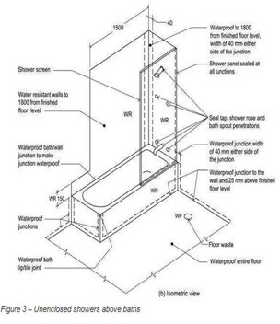

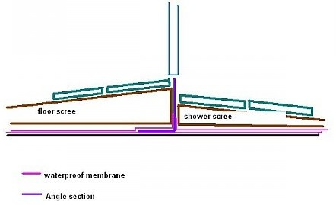
Fig: 2.5 typical bath room door detail whole bathroom waterproofing
Setting out your waterproofing perimeters with masking tape will give a much more professional looking finish.
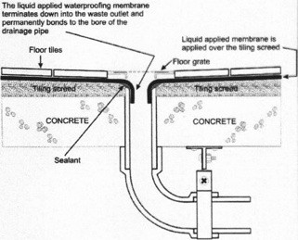Fig: 2.6 detail whole

  - Waterproofing material
    - Type of waterproofing material
Cement-based waterproofing
Waterproofing concrete structures is essential to ensure a long and effective working.
Cementations waterproofing is a waterproofing method for concrete that uses cement- based polymer coatings to create a barrier to water and moisture.
Systems polymer modified (PM) Structural Repair is a multi-use product that can be used to fix damage to concrete and masonry surfaces. It is a pre-blended cement and sand mixture that also has the addition of a polymer as a bonding and application agent.
Hydrophobic Cement is most suitable for basements and for making water tight concrete
Types of Waterproofing Methods for Building
Cementations waterproofing is a waterproofing method for concrete that uses cement-based polymer coatings to create a barrier to water and moisture.
Liquid waterproofing membrane is available in the form of liquid and is sprayed or applied by brush or roller to the concrete surface which forms a thick joint free membrane.
Bituminous Membrane is bituminous waterproofing systems are designed to protect residential and commercial buildings.
Bituminous coating is a type of coating used for waterproofing and flexible protective coat in accordance with its formulation and polymerization grade.
Polyurethane liquid roofing membranes are the professional, durable, waterproofing solution used together; this system creates a seamless polyurethane liquid roof membrane across flat roofs, terraces, or decks – reliably protecting building structures over the long term, even under the most demanding of conditions.
Types of Waterproofing
Latex – Latex rubber based – this air dry, but in winter can take up four days to dry.
Cement based two parts – Cement polymer – add dry and wet parts and mix - 2 hours to re- coat – 6 hours to fully set.
Various terminologies is used within the regulations and this manual.
AS 3740 provides the following definitions:
Enclosed shower - A shower designed and installed to control the spread of water from the shower enclosure.
Floor waste - A grated inlet within a graded floor intended to drain the floor surface.
Maximum retained water level - The point where surface water will start to overflow out of the shower area.
Membrane - A barrier impervious to moisture.
Membrane, external (external flashing) - A membrane that is installed behind the wall sheeting or render. Usually external membranes are preformed trays or sheet material systems.
Membrane, internal (internal flashing) - A membrane that is installed to the face of the wall sheeting or render. Usually internal membranes are liquid systems applied in situ.
Shower area - The area affected by water from a shower, including a shower over a bath.
Shower area, enclosed - The area enclosed by walls or screens including hinged or sliding doors that control the spread of water to within the enclosure.
Shower area, unenclosed - The area that is open on one or more sides, extending in an arc on the open sides, 1500mm from the shower connection at the wall.
Shower tray - An internal or external liquid or sheet membrane system used to waterproof the floor and the wall/floor junctions of a shower area.
Waterproof (WP) - The property of a material that does not allow moisture to penetrate through it when tested in accordance with AS/NZS 4858.
Water resistant (WR) - The property of a system or material that restricts moisture movement and will not degrade under conditions of moisture.
Wet area - An area within a building supplied with water from a water supply system and includes bathrooms, showers, laundries and sanitary compartments. Excludes kitchens, bar areas, kitchenettes or domestic food and beverage preparation areas.
Hot mix bituminous felt material membranes: Bituminous felt is waterproof sheeting used for surfacing roofs or as an underlay beneath tiles or slates.
The felt may be finished with a coating of sand or fine gravel to give a decorative finish. Bituminous felt is a cost-effective and convenient way of providing waterproof covering to roofs.
Injection Molding Materials
Material | Description
Polypropylene Polio | Thermoplastic polymer used for a wide number of applications.
Methylene Friction. | Dimensionally stable thermoplastic with high stiffness.
Polycarbonate  Impact strength. | Thermoplastic material with good temperature resistance.
Table1. Injection Molding Materials
The material is made of strong, hard wearing woven polyethylene and is double laminated for better protection against weather.
As it is waterproof it is easily washable and the design of the cover allows you to fold it away compactly for storage.
Sorting cards are a great way to reinforce the properties of waterproof and non-waterproof materials. Use them in your classroom for a fun-filled session! Handling Waste waterproofing materials.
The following materials are commonly used for damp-proofing
Hot bitumen
This is a highly flexible material, which can be applied with a minimum thickness of 3mm.
It is placed on the bedding of concrete or mortar, while in hot condition.
Mastic asphalt
Mastic asphalt is semi rigid material which is quite durable and completely impervious.
It is obtained by heating asphalt with sand and mineral fillers. However it should be laid very carefully, by experienced persons.
It can withstand only very slight distortion. It is also liable to squeeze out in very hot climate or under heavy pressure.
Bituminous or asphaltic felt
This is a flexible material which is available in rolls of various wall thicknesses.
It is laid on a levelled flat layer of cement mortar.
An overlap of 10cm is provided at joints and full width overlap is provided at angles, junctions and crossings. The laps should be sealed with bitumen.
Bituminous felts cannot withstand heavy loads, though they can accommodate slight movements.
Metal sheets
Sheets of lead, copper and aluminium can be used as D.P.C. These sheets are of flexible type.
Lead sheets
Lead sheets are quite flexible. They are laid similar to the bituminous felts.
They have advantages of being completely impervious to moisture, resistant to ordinary atmospheric corrosion, and capability of taking complex shapes without fracture and resistant to sliding action.
Copper sheets
Copper sheets of minimum 3mm thickness, are embedded in lime or cement mortar.
It has high durability, high resistance to dampness, high resistance to sliding and reasonable resistance to ordinary pressure.
Aluminium sheets
If used it should be protected with a layer of bitumen.
It is not as good as lead or copper sheets.
Combination of sheets and bituminous felts
Lead foil sandwiched between asphaltic or bituminous felts can be effectively used as D.P.C.
The combination, known as lead core possesses characteristics of easy laying, durability, efficiency, economy an resistance to cracking.
Bricks
Special bricks, which have less water absorption capacity, may be used as D.P.C. in locations where damp is not excessive.
This bricks are laid in two to four courses in cement mortar.
Stones
Dense and sound stones, such as granite, can be laid in cement mortar (1:3) in two courses or layers to form effective D.P.C.
The stones should extend to the full width of the wall.
Mortar
Cement mortar (1:3) is used as bedding layer for housing with other D.P.C. materials.
Cement concrete
Cement concrete of 1:2:4 mix or 1:1½:3 mix is generally provided at plinth level to work as D.P.C. The thickness may vary from 4cm to 15 cm.
Such a layer can effectively check the water rise due to capillary action.
Where dampness is more, two coats of hot bitumen paint may be applied on it.
Plastic sheets
This relatively a new type of D.P.C. Material made of black polyethylene, 0.5 to 1mm thick in the usual walling width and wall length of 30m.
The treatment is cheaper but is not permanent.

Self-Check -2 | Written Test
Directions: Part I choose the best answer
1. The great majority of wet areas are constructed on floors built of :
A. Concrete slabs on ground,
B. Suspended concrete floor slabs,
C. Suspended timber floors. And with walls constructed of:
D.Timber or steel studs sheeted in fiber cement or plasterboard,
2. The lining of wet areas with plasterboard should be carried out with the sheets laid_________
A. Horizontally
B. Vertically
C. Diagonally
D. None
Directions: Answer all the questions listed below. Use the Answer sheet provided in the next page:
I. Give short answer (each 5point)
1. Write water proofing materials (5%)
_____________________________________________________________________________________________________________________________________
- What is cementations water proof? (5%)
__________________________________________________________________________________________________________________________
Explain requirements of water proof (5%) ________________________________________________________________________________________________________________________________________
Write type of water proofing method (3%) ______________________________________________________________________________________________________________________________________

Operation sheet 1: Water proofing system

Operation title: Identify water proofing system
Purpose: To practice and demonstrate the knowledge and skill required to apply water proofing system
Instruction: Apply water proofing system. You have given 4hours for the task/practical work
Tools and equipment
- Brush
- Trowel
- Measuring tape
- Sponge
- Float
- Straight edge
Steps in doing the task/procedure
- Clean the area of water proofing
- Use the functional tools
- Prepare mortar or adhesive
- Apply required materials by using tools
- Check your work
- Complete Your work and cleaning working area
Quality Criteria: the given tasks of water proofing area must have good appearance and strength.
Precautions: use the given tools and materials for a task.

LAP Test -1 | Practical Demonstration

Name: _____________________________ Date: ________________
Time started: ________________________ Time finished: ________________
Instructions: Given necessary templates /guide, workshop, tools and materials you are required to perform the following tasks within 1:00 hours.
Task 1: Identify Selecting and checking the required tools and equipment
Task 2: Identifying type of water proofing material
Task 3: Identify Job Specifications From The Drawing.
Task 4: Identify the Necessary Raw Materials to water proofing.
Task 5: Know Environmental Condition To The Site.

Unit Three: Prepare for waterproofing installation
This learning guide is developed to provide you the necessary information regarding the following content coverage and topics:
- Internal and external wet area
- Substrate sound and moisture content
- Floor installation levels and waste outlets
- Install corner flashing
- Points of connection and termination
- Check rebates for baths
- Coat prime surface of structure
- Install water stops and hobs
This unit will also assist you to attain the topics stated in this unit. Specifically, upon completion of this unit, you will be able to:
- Check Internal and external wet area
- Check substrate sound and moisture content
- Check flooring installation levels and waste outlets
- Install corner flashing
- Check points of connection and termination
- Check rebates for baths
- Prepare and coat prime surface of structure
- Install water stops and hobs
  - Checking Internal and external wet area
    - How to water proof internal wet area
Check with Total Waterproofing Supplies for the correct membrane to use in your area if you are not sure.
This is a generic guide only, giving a basic overview of how to install a membrane. This information is given in good faith and should NOT be used as a Technical Data Sheet (TDS) or Instruction Sheet.
When purchasing membranes always download the full TDS sheet and MSDS sheet applicable. All membranes have their own manufacturer’s instruction guide/s, these must be used when installing membranes.
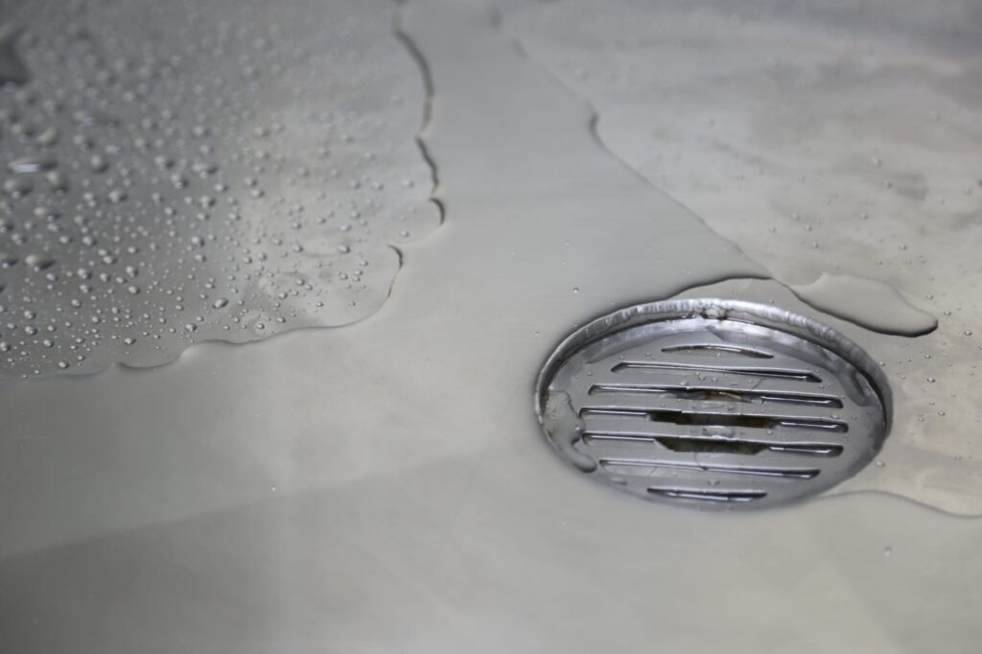
Fig 3.1 internal wet area water proof
Ensure the area to be waterproofed is clean and is free of any mould, dirt and dust. Use a vacuum cleaner is the best way to clean the area as sweeping will not pick up all the powder left by the plasters.
Ensure the area is completely dry.
Prime the wet area with a suitable primer for the membrane that is to be used (see data sheet).
Allow the primer to dry. (Times will vary depending on the heat and weather at the time of application).
Apply a fillet to all wall and floor junctions, and if a timber or cement based sheet has been used apply a sealant to the joint between the sheeting. (See data sheet for the type of sealant to be used).
Install shower angles and door angle, glue into position with sealant.
Install tap flanges.
Apply a coat of water based membrane to the shower walls and bath walls.
If using a water based membrane you will first need to apply some waterproofing membrane to any fillet or joint which you have sealed followed by imbedding reinforcing material into the wet membrane, then coat over the reinforcing material with waterproofing membrane (make sure that there are no creases or air trapped in the reinforcing material).
If you are using solvent based polyurethane apply a coat over the floor area with a 150mm return up the walls of the room. (Reinforcing cloth is not needed with this type of membrane).
Allow the product to dry before applying the second coat. (This will vary depending on the room temp and weather, see data sheet for a guide to drying times).
Apply a second coat of membrane to the walls of the shower and then second coat the floor. (Reinforcing cloth is not required in this coat). Allow the membrane to fully cure before laying tiles on the membrane. (See data sheet for curing times).
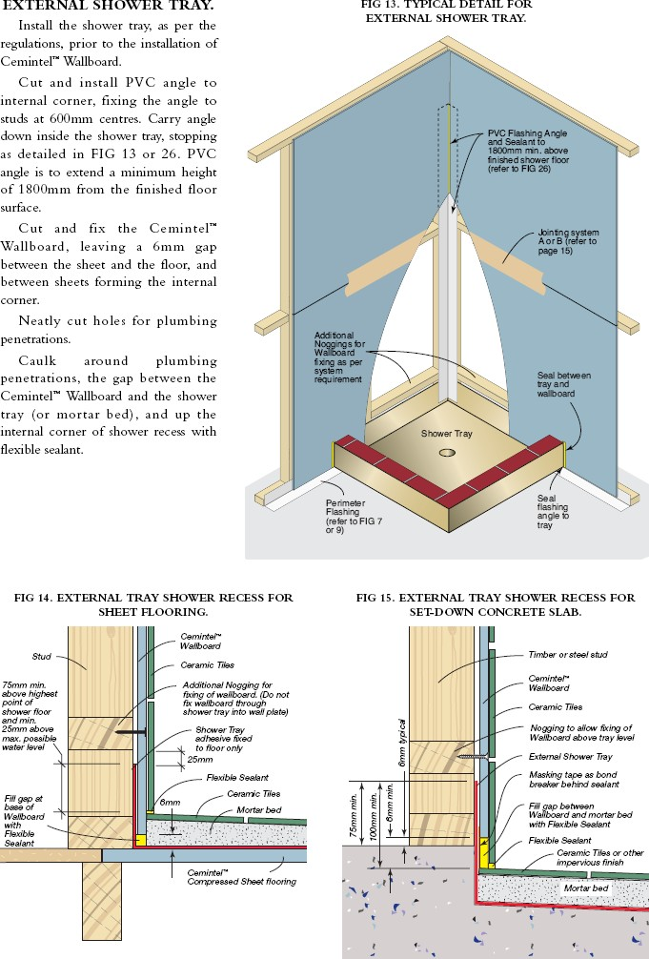
Fig 3.2. Shower walls and bath walls

Waterproofing installation procedure:
There are many products on the market, always follow the manufacturer specifications for a correct finish and to remain the warranty on the product.
Measure square meters of the area that needs waterproofing, add 10 % for purchasing sufficient waterproofing material.
Waterproofing needs to be done in 1 go, you are better off buying some more to avoid the chance of running out. Also purchase sufficient linear meter waterproof bandage strips, polyester reinforcing mats or fabric (200mm wide) for the wall-floor, wall-wall, hob joints.
Clean the area from all loose material. Vacuum cleaning is recommended to remove dust. Scrape and remove sharp items and lumps to avoid them protruding through the waterproof membrane.
Make sure all the walls and floor are completely dry. Check if the drains are connected, pipes need to be set down approx. 3mm and the flanges are flush with the floor.
Apply flexible and waterproof silicone to all vertical and horizontal joints around the perimeter as well as the joints between the floor and the shower hob.
The flexible silicone will keep the joints waterproof and allows the building materials to expand.
An aluminum edge to the tile height can be fixed with sealant across door openings when preferred.
Treat the floor and walls with a primer agent, recommended by the waterproofing manufacturer (multi-primer or water based primer), this will help to bond the waterproof membrane to the walls and floors and is often required for the warranty of the waterproofing.
Apply the primer with a brush and roller over the entire floor, up to the full height for the shower walls, 300mm up the bathroom walls and over the hob.
Start with the walls, then the floor. It is recommended to waterproof before fixing the bathtub, at least you cannot spill any primer agent on the bath because it is difficult to get off. Work your way to the door so you can get easily out.
Let the primer dry as per manufacturer specifications.
Apply the waterproofing membrane. This is a liquid stiffly paint, use a brush and roller. Start with the horizontal perimeter joint and hob, after this the vertical corners and walls and finally the entire floor. Work your way to the door.
The waterproofing requires a thickness of approx. 1 mm. Be careful not to create too much of a mess, ensure to apply waterproofing also to pipes and drains.
Apply the waterproof bandage strips or woven polyester reinforcing math’s over the perimeter joints first, the shower hob, and finally over the vertical joints (walls-walls and walls to floor). At least 100mm up the wall and 100mm across the floor, ensure for a 200mm overlap near corners.
Dab it in position with a brush, it is advisable to use rubber gloves. You can apply a full coat over these strips afterwards.
Let the waterproofing dry as per manufacturers specification. Apply a second coat as above in the opposite direction.
Do not use the bathroom until the waterproofing membrane is fully cured, this can take a couple of days, depending on the product and climate.
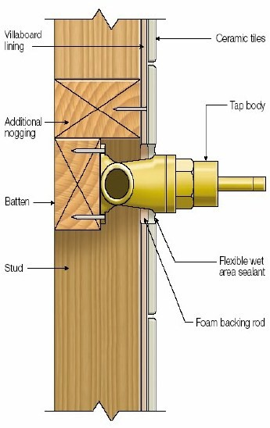
Fully cured bath room Figure 3.3
Water-proofing wet areas
All buildings contain areas in which there will be the presence of water either as the result of washing or showering or because appliances that use water are located in them.
From the beginning, it is important to distinguish between the two degrees of wetness present in wet areas.
‘Wet areas’ are those rooms which provide accommodation for appliances of either category. Typically these include:- Bathrooms, Toilets, Laundry’s, Kitchens
In domestic construction, the kitchen can largely be discounted from treatment as a wet area since the presence of water is highly localized (to the kitchen sink) and it is unusual to have any significant quantities, of free-water present. It’s incorporation into the ‘living areas’ of the home means that the kitchen is a well supervised area. Laundries, toilets and bathrooms are different in that considerable quantities of free water can be present, there is commonly the presence of humidified air and the supervision of such rooms is occasional. For these reasons, the Building Code requires that these areas be lined with water resistant finishes and that the floors be equipped with drainage (floor waste or floor grate), to dispose of free water. The treatment of Category 1 areas - shower compartments and baths with showers over
Regulatory authorities report that failures in adequate water proofing to wet areas are amongst the more common of complaints from new home-owners. It follows therefore that waterproofing is frequently the subject of short- cuts and bad workmanship.
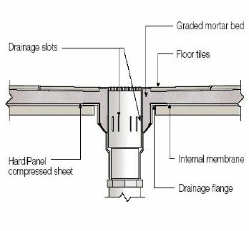
Under ground water proof area Figure 3.4
Waterproofing Requirements
Different waterproofing requirements are applicable to different wet area applications. Some of those typical applications are shown in The various requirements for each application is covered in the following sections of this manual.
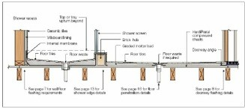
Figure 3.5 Typical bathroom cross
  - Check substrate sound and moisture content
Tile substrate is an important part of tiling. In fact before you tile the sub straight must be correct so that the finished tile work will look right and last for years. For bathroom walls the substrate must be able to handle water without rotting.
For timber walls villa board (fiber cement sheeting) is nailed to the wall making sure it is flat and that the walls are as square as possible. These are then waterproofed with a waterproofing membrane.
As structural flooring alternative to timber, particle board or plywood flooring, Hard Panel compressed sheets provide an excellent substrate for ceramic tiles in wet areas.
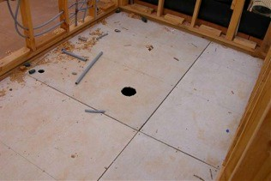 fig 3.2
Hard panel 19mm sheets must be screwed down. Absolutely (no nails to be used) and all joins must be sealed with an epoxy sealant before it is waterproofed.
An extremely dense hard-wearing and long lasting floor substrate for use on decks, balconies and verandas and as internal flooring.
Before doing so however you will need to inspect the bathroom to ensure that there are no protruding sharp nails and the amount of dust that needs to wiped away will have to be considered.
Dust reacts as a release agent to any surface application so it must be remove with sponge and clean water. There should also be no gaps or areas where fibro has not been used. All joins in fibro should be sealed preferably with silicone.
Preventing Moisture Problems in Bathrooms A poorly designed bathroom is no better than a leaky roof; an experienced bath designer tells where the worst problems occur and how to prevent them.
Figure 3.6 design of water proofing area

  - Check moisture content
A poorly designed bathroom is no better than a leaky roof; an experienced bath designer tells where the worst problems occur and how to prevent them.
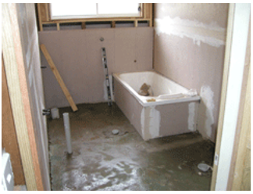
Fig 3.7 Preventing Moisture Problems in Bathrooms
As just mentioned many new projects will have the waterproofing products to be used listed in the Specifications. Those delivered on site should be checked that they match the quality of those in the Specifications.
The following bundle of products are all the products that are required to waterproof a bathroom, laundry, shower or toilet area up to 8- 10 square meters in size.
The same sort of products can be bought from many different manufacturers.
x 1 liter Flexi prime acrylic sealer:-
For application to the area to be waterproofed, 1 coat is required. Flexi prime is rapid drying, normally within 1 hour. Coverage of 1 liter is 8-10 square meters.
x Sika flex Pro 310ml polyurethane cartridges. A high performance polyurethane joint sealant. Used to seal the floor wall junction, and any other horizontal and vertical joints / cracks prior to application of membrane coatings. Used to seal around taps, shower rose and bath spout penetrations. Used to waterproof around baths and shower trays.
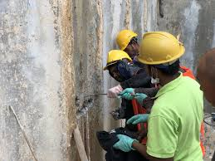
Fig 3.8 those three images indicates how to protect moisture by using water proofing materials
x 36mm x 50m roll separation bond breaker tape for applying above Sikaflex sealant.
x 190mm wide x 10m long rolls Deck web Polyester Fabric matting used around the floor wall junction and embedded in the first coat of the Flexi clad PUWB membrane for extra reinforcement and strength 3m x 1.2m wide roll Deck web used for waterproofing the floor of the shower area, as an extra reinforcement for this area. It is embedded into the first coat of the Flexiclad PUWB membrane.
1 x 15 litre Flexiclad PUWB membrane. 2 coats are required. This is a quality flexible water based modified polyurethane waterproofing product. It is UV stable and fast drying. Can normally be over coated after 1-2 hours. Coverage of 1 x 15 liter is around 10 square meters for two coats.
Application Silatex® Reflect is applied after thorough stirring, in at least 2 coatings. Apply it with brush or roller. The first coating is diluted with water (5%). The second is applied after 24 hours, undiluted.

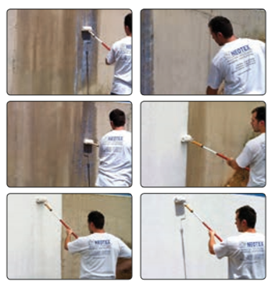
Figure 3.8 checking protecting moisture area

The great majority of wet areas are constructed on floors built of:
- Concrete slabs on ground,
- Suspended concrete floor slabs,
- Suspended timber floors.
- And with walls constructed of: Timber or steel studs sheeted in fibre cement or plasterboard,
- Masonry walls sheeted as (a) using battens,
- Masonry walls rendered.
Plasterboard (water resistant): The lining of wet areas with plasterboard should be carried out with the sheets laid horizontally.
An exception to this rule is where the whole wall can be covered with a single sheet. Where the sheet is not to be tiled, water resistant plasterboard can be fixed using the normal combination of nails or screws and adhesive.
Where the surface is to be tiled, adhesive fixing must not be used and the board must be fixed with nails or screws at 200crs (generally) and 150crs at butt joints. Screws are the industry preferred method of fixing.
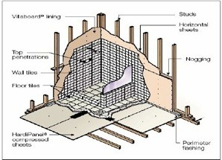Figure 3.9
Villa board Description
A flat internal wall lining that provides an excellent foundation for a durable, impact-resistant, professional finish that is resistant to moisture or tiled to create or complement a wide range of design looks.
An excellent substrate for tiling and performs well with painted or wallpapered finishes.
High impact resistance makes it ideal for high-traffic, damage-prone areas, for example, hallways, rumpus rooms and kids' bedrooms.

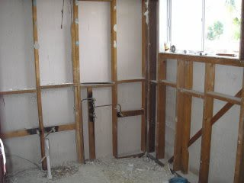
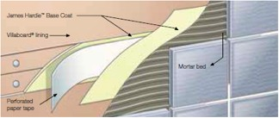
Figure 3.10 Excellent tile adhesion and less paint required for painted finishes water proof

  - Check flooring installation levels and waste outlets
Before starting work, sand bags or hay bales must be used to surround drains and the perimeter of sloping land. This will prevent sand and soil and cement slurry from being washed off site, entering storm water drains and polluting local creeks and rivers.
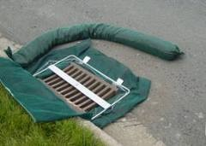 Figure 3.11 Filtering drains
All run off must be filtered before entering drains, all rubbish
E.g. Silicone cartridges must go in the rubbish container etc.
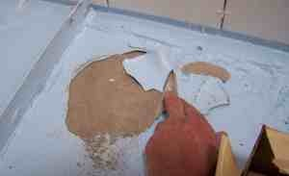
Removed water proofing membrane Figure 3.12
This is what happens when a waterproofing membrane does not adhere as it should. This can always be traced back to the incorrect preparation of the substrate by the tiller/water proofer most likely dust which prevents adhesion of the membrane.
The intent of this provision is to provide protection to those other buildings and areas outside the immediate building, potentially being separation occupancies, in the event of flooding.
Falls to floor wastes
It is important to note that although a floor waste is generally not required in a Class 1 building, if one is provided, the bathroom floor must be graded to that waste.
This is noted in AS 3740 which states “Where a floor waste is provided the floor shall be graded to the waste’”. BCA Volume 2 also notes this in its definition of a floor waste.
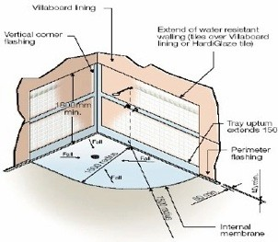Figure 3.14
Falls to drains should be 1:80 with the exception of handicapped showers where the fall should be 1:60.
  - Install corner flashing
Installation of corner flashings note: This description has centered upon showers as these require the most critical attention. Other fittings can also now be addressed.
All corners and junctions between bath and walls or bath and floor require flashing. This can now proceed. These flashings should extend 150 mm along each face.
Corner Flashings are commonly of:-
(a) Hyperion
(b) PVC
(c) Vasquez plastic
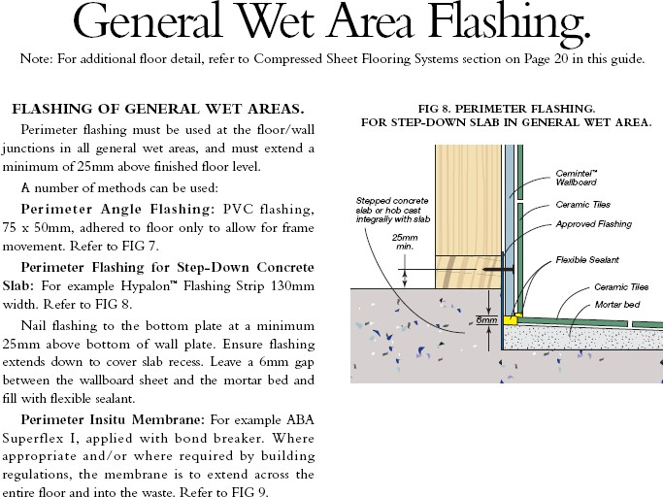
Figure 3.13 bath and walls or bath and floor
A durable wet area wall and ceiling lining sheet which is a suitable surface for tiled or painted finishes. Available in 6mm (usually residential), 9mm and 12mm (for commercial use, e.g. hotels and kitchens). Villaboard lining has its long edges recessed for easy flush-jointing.
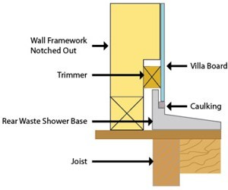Fig: 3.14 HardiGlaze® tile sheet
A 6mm thick pre-finished fibre cement wall lining with a 150mm square tile pattern embossed into a hard-wearing high-gloss polyurethane coating.

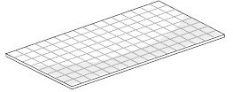
Fig 3.15 Structural flooring sheets
Interior wet area flooring
These are available from most waterproofing shops or alternatively you can buy a 50m roll and form your own corners and tapes.
- External Flashing

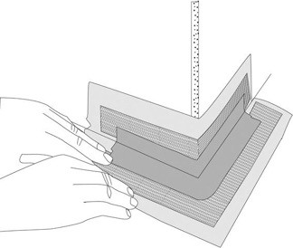
Figure 3.16
Above, an external corner is installed before the long strips
All junctions in the general wet areas beyond the shower, including bathrooms, toilets and laundries (except kitchens), must be sealed with a flashing or skirting. We recommended this area is sealed with an external flashing.
The horizontal leg of flashing must be 50mm minimum, and the vertical leg must project 25mm minimum above the highest point of the finished floor surface, except at doorways. Across a doorway, the perimeter flashing angle must finish flush with the top surface of the finished floor. Adhere flashing to floor only. The floor surface must be clean of all waste and dust.
When using external flashing with Villaboard lining, use a 75 x 50mm or 100 x 50mm PVC preformed angle flashing, in conjunction with adhesive.

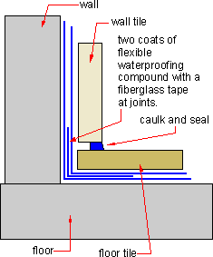
Note Do not fix PVC angles with HydrEpoxy 501.
Figure 3.17 Above is how the installation looks when a fiber glass matting is used to seal the corners between floor and walls.

  - Check rebates for baths
When inspecting a new project we allow for preliminary site inspections and analysis in order to determine the most appropriate waterproofing solution. This selected system is supported by the manufacturer’s warranties where applicable
Checking rebates for baths and basins for compliance with standards.
Where I live bathroom waterproofing or indeed waterproofing any wet area is not a matter of choice, but it is the law. All new work has to be inspected and certified correct under the provisions of the BCA
Installation of internal trays
Internal trays are frequently of liquid or thin plastic sheet materials and are constructed or assembled on site.
They are installed after the linings. Install bond breakers where required. Where an internal tray or membrane system is used, this can now be installed
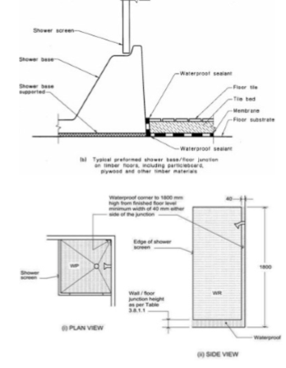
Figure 3.18 Internal tray or membrane
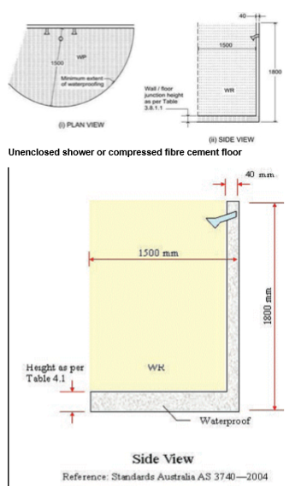
Design
Figure 3.20 Fiber Cement Floor
Shower walls – are to be waterproofed to 150mm above shower floor substrate, or 25mm above maximum retained water level. Shower walls are to be water resistant to 1800mm from finished floor level.
All internal and external corners and horizontal joints are to be waterproofed within the shower area. Plasterboard joints (outside shower) that extend inside shower areas must be waterproof.
Unenclosed shower areas are to be waterproofed to 1500mm from shower.
Tap-penetrations are to be sealed. Further, tap washers must be accessible without damaging the seal around tap penetrations.
Floors and horizontal surfaces adjoining an insert bath are to be waterproofed.
Where the floor is waterproofed, the tanking of the walls is to be a minimum of 25mm above the finished floor level.
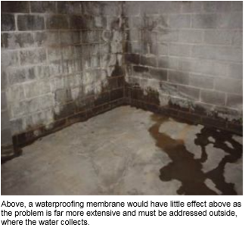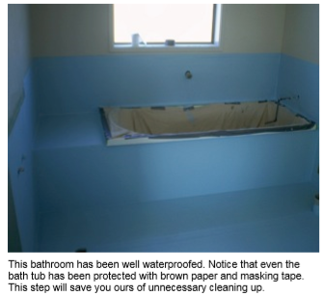
Figure 3.21Waterproofing
  - Prepare and coating prime surface of structure
Applying the correct Primer to your waterproofing job is almost as important as installing the waterproofing membrane itself Primers are usually single component and water based used to prime concrete, masonry and fiber cement sheeting surfaces.
When dry, it forms a sealed surface suitable for the application of water based membranes.
Primers
The definition of a primer is rather general. It is generally considered to be a coating that improves the adhesion or perhaps more important, the performance, of the topcoat coating in this instance a waterproofing membrane.
On porous surfaces, such as fibro wallboard, cement flooring, etc. the waterproofing membrane may soak into the surface and not evaporate when, where, or how it should for the waterproofing membrane to achieve it designed properties.
A primer coat is used to 'seal' the surface so that the wet membrane will be able to evaporate away as it was designed to.
Secondly, primers DO soak into porous surfaces and thus provide a really strong bond between the primer and the substrate, with the primer then providing a clean, fresh non-porous surface for the top coating membrane to adhere to. This is sometimes called a Tie Coat.
Tie coats can also provide a sticky bonding coat used when a very ‘dry' coating is applied to a dry surface.
For example, when applying a waterproof membrane after the primer, best results will be achieved if you wait until the coat is tacky but not 100% dry. Here we have ‘wet on tacky'.
A tie coat could be a wet sticky, or still tacky coating of ‘regular' epoxy membrane. Many commercial primers also have anticorrosion additives in them for use on metallic surfaces.
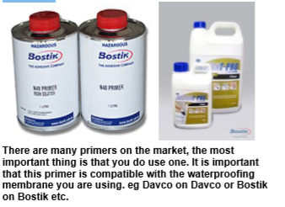Figure 3.22 Sostik

  - Install water stops and hobs
Installing water stops and hobs in required location
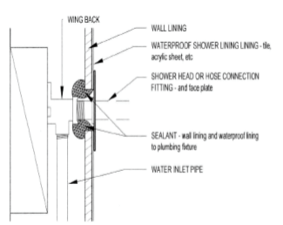fig 3.23 water stops and hobs
Because showers are subject to very significant water splash, penetrations in shower linings require particularly effective waterproofing. Showers range from proprietary single piece acrylic units to on-site constructed tiled-lined showers.
The penetrations for shower taps or mixing valves, roses or flexible hoses should be waterproofed with a proprietary system, or sealant compatible with all adjacent building elements.
The diagram shows how this could be done using sealant or a proprietary flange system around the penetration. No matter what system is used, the waterproofing must allow for easy access when replacing tap washers, ceramic disks and O-rings.
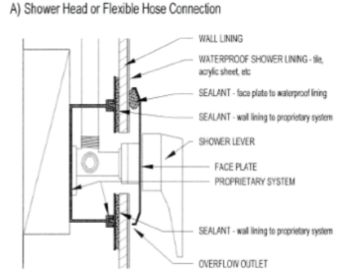
fig 3.24 Shower taps or mixing valves
Hobs must be constructed of masonry, concrete or similar material. Hobs should not be constructed of timber. Hobs must be adequately secured to the floor.

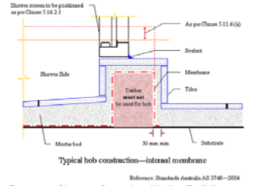
Fig 3.25 Hobs
Does my Shower Comply with the Building Code?
Shower Screens Constructed on Hobs
(a) Where the membrane is fabricated from a flexible material—
(i) The top edges must be fixed to the wall; and
(ii) Fixing penetrations must be not less than100mm above the finished tile level of the shower area; and
(iii) All fixings must be compatible with the membrane and be non-corrosive.
(b) For showers with hobs, the hob must be included within the finished size of the shower membrane and the membrane must finish at the underside of the tile that forms the top of the hob.
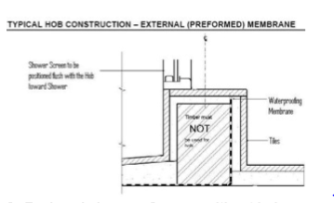
Fig 3.25
Enclosed showers Screens without hobs or set downs
(a) where a shower screen is to be installed, not less than 5 mm above the finished floor level
(b) where the water stop intersects with a wall or is joined, the junction must be waterproof.
Frameless Shower Screens Shower area must be stepped down not less than 25 mm lower than the finished floor level outside the shower.
Water-stop angle to shower area must be finished flush with the top of the finished floor level. This angle forms part of the waterproofing system and must be installed prior to the installation of the waterproofing system.
Enclosed hob-less showers must be fitted with water-stop angles. The vertical leg of the angle must finish a minimum of 5mm above the level of the finished floor.
Unenclosed hob-less showers must be fitted with water-stop angles. The vertical leg of the angle must finish flush with the level of the finished floor.
The membrane must extend a minimum of 50mm (onto the floor) over the outside of the hob face.
Shower screens must be fitted flush to the inside (shower side) of the hob.
Fixing penetrations must be sealed.

Self-Check -3 | Written Test
Directions: Answer all the questions listed below.
Shower walls are to be water resistant to 1800mm from finished floor level.
1500mm B. 2000mm C. 1800mm D. None
Membrane systems are commonly:-
- Fiber glass Reinforced Plastic
- Epoxy Resin.
- Acrylic Emulsions.
- Synthetic rubber or plastic sheet.
- All
Directions: Answer all the questions listed below. Use the Answer sheet provided in the next page:
I. Give short answer (each 1point)
What is Primers? (5%)
_____________________________________________________________________________________________________________________________________________________________________________________________
Write the difference between Internal and external corner flashing?(5%)
_________________________________________________________________________________________________________________________________________________________________________________
Explain requirements of water proof (5%) __________________________________________________________________________________________________________________________________________________________________________________________________________________________________________

Operation sheet 2: Water proofing system
Operation title: Identify water proofing system
Purpose: To practice and demonstrate the knowledge and skill required to apply water proofing system
Instruction: Apply water proofing system. You have given 4hours for the task/practical work
Tools and equipment
- Brush
- Trowel
- Measuring tape
- Sponge
- Float
- Straight edge
Steps in doing the task/procedure
- Clean the area of water proofing
- Use the functional tools
- Prepare mortar or adhesive
- Apply required materials by using tools
- Check your work
- Complete Your work and cleaning working area
Quality Criteria: the given tasks of water proofing area must have good appearance and strength.
Precautions: use the given tools and materials for a task.

LAP Test -2 | Practical Demonstration

Name: _____________________________ Date: ________________
Time started: ________________________ Time finished: ________________

Instruction: Given necessary templates /guide , workshop, tools and materials you are required to perform the following tasks within 1:00 hours.
Task1: Preparing materials for water proof
Task 2: Preparing surface of structure to be waterproofed
Task 3: Installing water stops and hobs in required location
Task 4: Installing corner flashing

Unit Four: Apply waterproofing
This learning guide is developed to provide you the necessary information regarding the following content coverage and topics:
- Water proofing membrane to surface of structure
- Bond breakers and fillets
- Cure waterproofing membrane
- Conduct flood testing of installation
- Waterproofing material
- Carry out final site inspection
This unit will also assist you to attain the topics stated in this unit. Specifically, upon completion of this unit, you will be able to:
- Applying water proofing membrane to surface of structure
- Applying bond breakers and fillets
- Curing waterproofing membrane
- Conducting flood testing of installation
- Protecting waterproofing material
- Carrying out final site inspection

4.1. Water proofing membrane to surface of structure

The waterproofing membrane application is the basic protection system for buildings. Depending on the structure and need, the waterproofing membrane can either be applied to the interior (negative side) and, the exterior (positive side), or in places inaccessible by people (blindside).
A waterproofing membrane is a layer of water-tight material that is laid onto a surface to prevent water leaks or damage.
Waterproofing membranes generally consist of liquid applied or pre-formed sheets. They can be adhered to or installed around the foundations (like a structural slab) to prevent water penetration.
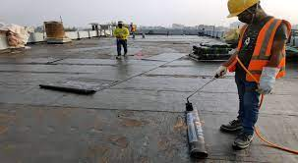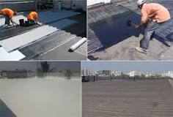
Figure 4.1 Structural slab
Waterproofing membranes are commonly used to protect structures against hydrostatic pressure. The idea behind them is simple. They keep the water outside the structure (in the case of a basement or tunnel) or inside the structure (in the case of a water tank or canal) by using a physical barrier and areas adjoining other vessels such as sinks, basins or tubs.
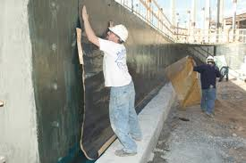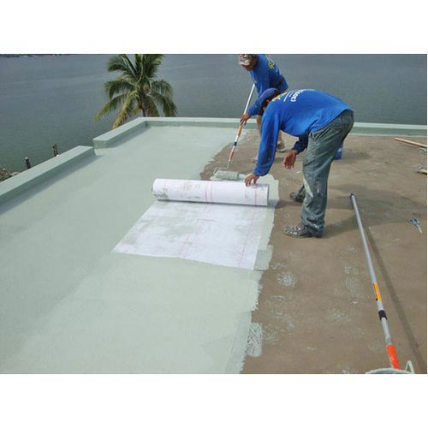
Fig: 4:3 water proof materials application

4.1. Bond breakers and fillets

4.1.1. Apply appropriate bond breakers and fillets as required
Bond-breakers must be installed, in cases where the membrane is bonded to the substrate, at all wall to-floor and hob-to-wall junctions and at movement joints.
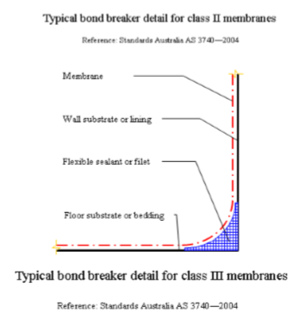

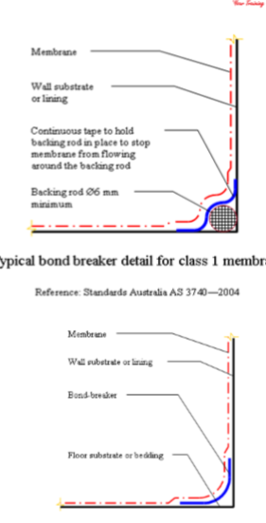
Figure 4.3 Bond breakers
The top backing rod system is rarely used now days as the new Class 3 waterproofing membranes have much more expansion qualities than
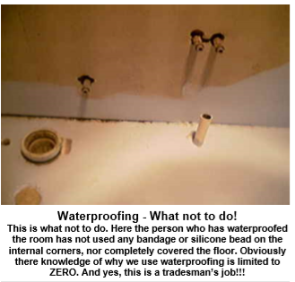
Figure 4.4 Waterproofing

4.2. Curing waterproofing membrane

When building a new building where below grade structures may be at risk for water intrusions, such as basements, elevator pits, or underground garages, waterproofing is essential to keep these areas dry. Here is an article describing the installation of sheet applied waterproof membrane
Figure 4.5 Waterproofing
There are many external junctions and surfaces on a building or structure that need to be protected from water penetration. An issue during construction however is that this protection, commonly a waterproof membrane or coating, is either punctured or not installed correctly, or that it has not been designed to allow for the natural movement of a building.
Failure of this barrier can lead to a variety of problems ranging from rising damp, concrete cancer and spelling of render.
When these problems arise consideration needs to be given as to the likely cause of the failure, and then of the appropriate strategy for remedy and repair.
There are various systems, coatings and membranes that will suit the particular area will suit the particular area of a building or structure requiring the waterproofing.
Preliminary inspection of the project will indicate the waterproofing system to be used and this system is commonly selected based on the following usage types:-Car parks, Concrete roofs, Swimming pool repairs, Foundations and underground works, Tanks and storage silos, Dams aqueducts and catchments, Gas and watertight sealing, Common access walkways, Private balconies.
Consideration must then be given to where the waterproofing is to be applied, how the area is going to be used, and whether it will be exposed to the elements.
In most cases, when selecting a waterproof membrane for a project it is preferable to use a membrane or coating with the following properties:
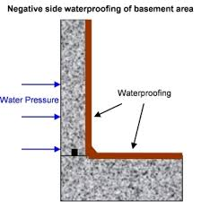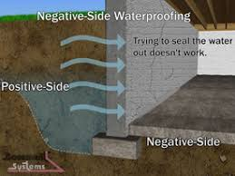
Figure 4.6 negative side of water proofing
Above, a waterproofing membrane would have little effect above as the problem is far more extensive and must be addressed outside, where the water collects.

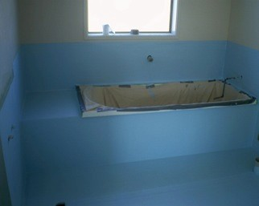
Figure 4.7 water collects
This bathroom has been well waterproofed. Notice that even the bath tub has been protected with brown paper and masking tape. This step will save you ours of unnecessary cleaning up.
Most building plans will have a waterproofing system already selected by the architect. You will find this in the Specifications which detail the quality of the products you must use. Many new projects will already have materials on site.
Post Mix Concrete is a rapid setting pre-mixed formulation that is specially designed for the use on a variety of posts. This high-quality product is extremely versatile and can be used for the fast setting of concrete, wooden and metal fence posts; including gate posts, decking posts, washing lines and even garden ornaments.
In addition to setting in as little as 5-10 minutes, our Post Mix Concrete has other benefits such as providing a durable, hardwearing blend of materials that require little mixing and will guarantee long-lasting results.
Post Mix is simple and easy to use, requiring only the addition of water which is why this is the perfect product for all homeowners.
Application is used for fixing posts, road signs and bollards No requirement for mixing – just add water after placing. As a guide a 2.4m post should have 0.6m below and 1.8m above ground level. One 20kg bag of Reader Post Fast will secure a standard size fence post. Setting is normally in 10-15 minutes but may be longer in cold weather.
Testing: Pro-Mix is tested in accordance with specific procedures to ensure compliance to specification prior to dispatch and are subject to the controls. Applying a masonry waterproofing product to bare interior basement walls.
If your foil test showed that water is soaking through your basement walls and leaving them wet, seal the interior of the walls with a high-quality waterproof paint, such as DRYLOK White Extreme Waterproofed (available from Home Depot). Materials for installation of a sloped roof. Within this sphere we offer you roofing and waterproof materials, which are guaranteed to be of high safety

4.3. Curing waterproofing membrane

Most waterproofing systems should have the following properties. Most important is to read the instructions on the packaging and to work according to the manufacturers recommendations.
" A rapid cure
" Long term waterproofing protection of the structure
" Seamless application to the subset
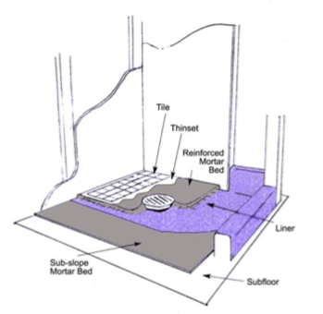
Figure 4.8 Curing waterproofing
The liner above is our waterproof membrane. No tiles may be applied until the membrane has dried or cured. For this time refer to the manufacturers recommendations as times will vary greatly according to the weather. Very wham weather may be only 24 hrs, where as cold may be up to 1 week. You may need to help this process at times with a fan or small heater
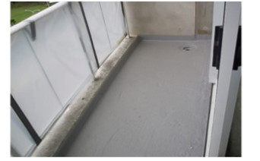Figure 4.9
If concrete bedding is applied before the membrane is cured or dry, a failure will be the result. In time the steel reinforcing will rust and possibly collapse the balcony.

4.4. Conduct flood testing of installation

4.1.1. Installation of waste pipes
Floor wastes should be installed before proceeding. Suitable wastes have a flange which sits against the base of the floor and over which the membrane can be dressed and sealed.
In fitting floor wastes it is important that there is a good seal between the waste outlet and the floor, particularly in a shower recess.
In the installation of PVC pipes and fittings a PVC flange must be bonded to the flooring and the waste pipe before fitting of grates and other fixtures. Use an Epoxy adhesive to ensure a good watertight bond between the flange and the floor.
The use of a waste fitting which also drains the moisture from beneath the floor tiles, often called a “leak control” flange is recommended. These have holes below the grate.
In the case of in-situ formed trays, the use of a system providing a drainage passage for water held in the tile bed is a requirement of AS 3740. NOTE: Where fixing into fully compressed floor sheeting, the flanges of the waste can be bonded to the floor with an approved epoxy adhesive.
Installation of membrane systems
There has been a significant change in industry practice in recent years. Traditionally, the lining contractor (plasterer) would install the linings, flashings, the plumber would install pipe work and wastes and the tilt
This procedure was flawed and produced many defective and leaking showers. To this day, the components are available for tradespersons to purchase what is necessary to waterproof a shower base. Invariably, these do not produce the best results. This is not because the materials are defective, it is usually because of defective installation. External shower trays are straight forward.
They are a plumbing fixture, installed by the plumber. Similarly, pre-formed shower bases are a plumbing fixture and are installed along with the bath, the hand basin and the W.C. Providing the lining contractor installs the necessary flashings and angles the use of these components is relatively defect free.
To resolve the high incidence of waterproofing failures, the Water Industries Council of Australia (WICA) was formed to set standards for waterproofing, and in particular membrane systems, in the building industry. At the time of writing these notes, AS 3740 is under review.
The new standard may supersede some of these notes. It is strongly recommended that no lining contractor should attempt to install a waterproof membrane.
The responsibility of plasterers (lining contractors) should end with the installation of linings (board systems) and flashings.
Many tiling contractors are entering the membrane industry and receive the specialized ‘system’ training provided by manufacturers of membrane systems.
The consequence of this is the installation of membrane systems is now in most cases as manufacturer specific post trade training. In some states the installation of membrane systems if subject to a specialist licensed category and can only be performed by licensed contractors.
The practical activity provided with this resource is only provided to give you experience in installing wet area membrane systems.
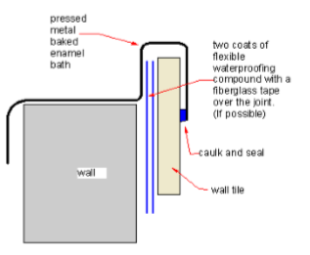
Figure 4.10 Wall tile

4.5. Protect waterproofing material

Waste waterproofing materials and components are handled in accordance with material safety data Handle waterproofing materials Waste waterproofing materials and components are handled in accordance with material Waterproofing: Yet another efficient use for recycled rubber.
Material Handling · Intro to our Services Because old scrap tires have become one of the world's largest waste problems, society has had to get tires are also extremely valuable in creating products that waterproof foundations.
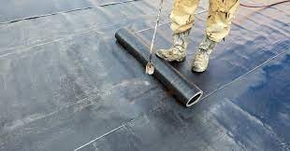
Fig: 4:11 protect and handling of water proofing materials

4.6. Carry out final site inspection

4.6.1. Water proofing Inspection
Use inspection checklists to ensure waterproofing installations comply with relevant building codes
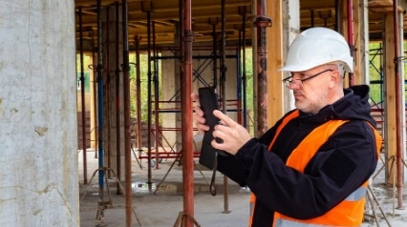
Figure 4.11 waterproofing installations
Waterproofing is the construction method of making building surfaces water-resistant and waterproof to protect structures from water ingress and prevent water penetration.
It is crucial for structures to be waterproofed from basement to roof to prevent damages such as insect infestation mold, and other structural defects like concrete cancer caused by water infiltration.
Fix and waterproofing inspection checklist is used when conducting checks on the progress of works and the quality of workmanship at a specified construction stage.
Download and use this checklist to identify defects or faults in the project that do not comply with the building code standards in your region. Maximize the use of this template by following the points below:
Fill out details on the title page and indicate construction stage in the ‘Inspection Notes’ field.
Perform a visual inspection of the waterproofing in the construction site with this template using your mobile or tablet device
Take or attach photo evidence of areas/items that requires attention by the builder and assign the appropriate corrective action to the appropriate personnel.
Sign-off with digital signature at the end of the inspection.
Inspections are important as they allow you to: listen to the concerns of workers and supervisors. gain further understanding of jobs and tasks. identify existing and potential hazards.
Waterproofing inspection is an assessment conducted by a qualified building inspector or a waterproofing specialist to check on the workmanship quality of waterproofing works and to determine that a structure complies with waterproofing requirements and standards (e.g., Australian Standard AS 3740, and BCA Performance Requirement for Wet Areas). Waterproofing inspections are conducted through visual inspections of building structures to help identify any damages caused by improper waterproofing installation.
In some cases, waterproofing issues can seemingly be a small one masking a larger issue. These types of issues can be overlooked and undetected.
Catching these defects too late can result in complicated and invasive repair. That said, below are some warning
signs to look out for that may indicate a waterproofing issue:
- Blistering or peeling paint
- Bubbles in the paint that hold water
- Mold, mildew and vegetative growth
- Rust stains on the concrete façade
- Efflorescence
- Cracked walls
- Internal and rising damp
- Sagging floors
- Wood rot
- Water in crawl space
- Waterproofing failures can happen anywhere in a building
Self-Check -4 | Written Test
Directions: Answer all the questions listed below. Use the Answer sheet provided in the next page:
I. Give short answer (each 1point)
What is Primers? (5%)
_____________________________________________________________________________________________________________________________________________________________________________________________
Write the difference between Internal and external corner flashing?(5%)
_________________________________________________________________________________________________________________________________________________________________________________
Explain requirements of water proof (5%) __________________________________________________________________________________________________________________________________________________________________________________________________________________________________________

Operation sheet 3: Apply Water proof
Operation title: Apply water proof
Purpose: To practice and demonstrate the knowledge and skill required to apply water proofing
Instruction: Apply water proofing. You have given 4hours for the task/practical work
Tools and equipment
- Brush
- Trowel
- Measuring tape
- Sponge
- Float
- Straight edge
Steps in doing the task/procedure
- Clean the area of water proofing
- Use the functional tools
- Prepare mortar or adhesive
- Apply required materials by using tools
- Check your work
- Complete Your work and cleaning working area
Quality Criteria: the given tasks of water proofing area must have good appearance and strength.
Precautions: use the given tools and materials for a task.
LAP Test -3 | Practical Demonstration

Name: _____________________________ Date: ________________
Time started: ________________________ Time finished: ________________

Instruction: Given necessary templates /guide , workshop, tools and materials you are required to perform the following tasks within 1:00 hours.
Task1: Preparing materials for water proof
Task 2: Preparing surface of structure to be waterproofed
Task 3: Installing water stops and hobs in required location
Task 4: Installing corner flashing

Reference
https://www.google.com/search?sa=X&source=univ&tbm=isch&q=WWW.COM+FINISHING+CONSTRUCTION+WORK&hl=en-US&ved=2ahUKEwjpg6qGu4LuAhXTUBUIHcL4AsYQ7Al6BAgLEAo&biw=1366&bih=600
Barricading and Signage Document Number – OHS-PROC-134
[2] J. Broomfield, Corrosion of Steel in Concrete: Understanding, Investigation and Repair, Taylor & Francis, New York, NY, USA, 2nd edition, 2007.
BUILDING CONSTRUCTION HANDBOOK Tenth edition Roy Chudley And Roger Greeno
BUILDING CONSTRUCTION HANDBOOK Seventh edition R. Chudley MCIOB and R. Greeno BA (Hons) FCIOB FIPHE FRSA

Participants of this Module (training material) preparation
No | Name | Qualification (Level) | Field of Study | Organization/ Institution | Mobile number | E-mail
1 | Betel Tariku | BSC | COTM | Sidama (Hawasa poly technic college) | 0926298840 | betelbotora2@gmail.com
2 | Yazachew Geneti | MSC | COTM | BGRS (Assosa poly technic college) | 0917858176 | Yazachew17@gmail.com
3 | Shiferaw Yohannes | BSC | COTM | Sidama (Daye poly technic college) | 0932425937 | shiferawyohannes@gmail.com
4 | Mihiretab Gashaw | BSC | BCT | Addis abeba (Addis ketema industrial college) | 0922079011 | mihiretabgashaw@gmail.com
5 | Adisu Ruda | BSC | BCT | Oromia (Nekemte poly technic college) | 0924227161 | adisunagari@gmail.com

